Data Management Guidance for
North Florida Regional Operation Centers

Division of Environmental Assessment and Restoration
Florida Department of Environmental Protection
November 18, 2020


2600 Blair Stone Road
Tallahassee, FL 32399-2400
floridadep.gov

Table of Contents
Table of Contents 2
Table of Figures 3
1. Intended Use of this Document 4
2. The Data Management Process 4
2.1 Tools, Trackers, and Templates Utilized During Data Management Process 4
2.2 Common Field Measurements Collected and Reporting Units (Required to upload data to WIN) 5
2.3 Information Entered by DEP Lab staff and Made Available to the DMT 5
3. Sample Processing Overview 5
4. Data Archiving Overview 6
5. Data Processing Overview 6
5.1 Data Management Process by Role 6
5.2 Nomenclature and Document Organization 7
5.3 Data Management Folders Hierarchy 8
5.4 DMT Data Entry Information 8
5.5 Quality Assurance and Data Upload Steps 9
5.6 Data Archive Folders (SMP FTP Network) 12
6. Data Tracking Documents 13
6.1 SMP Tracker 13
6.2 ROC ORG Data Trackers 13

Table of Figures
Figure 1 - Data management process for ROC field staff 6
Figure 2 - Data management process for DMT specialist 6
Figure 3 - Data management process for WIN specialist 8
Figure 4 - Data management folder hierarchy 9
Figure 5 - SMP Field Sheet (first page) 9
Figure 6 - SMP Field Sheet (second page) 10
Figure 7 - Verify the Station in WIN 11
Figure 8 - Equipment Blank Batch ID example 12
Figure 9 - DMT Generate WIN button activation 12
Figure 10 - DMT Generated EDD example 13
Figure 11 - SMP Tracker example 14
Figure 12 - Data tracker example 15
Figure 13 - Data tracker notes example 15

Intended Use of this Document
This guidance is published to assist the Florida Department of Environmental Protection’s (DEP) Division of Environmental Assessment and Restoration (DEAR) North Florida Regional Operation Centers (ROCs) in the documentation and storage of data generated for the Strategic Monitoring Program’s annual plan (SMP). Monitoring locations, monitoring data and associated quality assurance information is archived and uploaded to DEAR’s web-based public access database, the Watershed Information Network (WIN), where a monitoring site’s geographic location can be mapped and viewed, and associated data can be retrieved.
Current Staff and Roles under WIN Organization Codes (ORG ID)

WIN Administrator (21FLA, 21FLTLHR, 21FLPNS)
Alicia Hogue, Environmental Administrator
21FLA Northeast Regional Operation Center (NEROC)
Jeremy Parrish (Team Lead), Brian Davis, Kelly McDonald, Kimberly Appleby
21FLTLHR Tallahassee Regional Operation Center (TLHROC)
Mike Eckles (Team Lead), Chris Green, Benjamin Harden, Paul Blair, Jade Burtchett, Jonathan Woods
21FLPNS Northwest Florida Regional Operation Center (NWROC)
Mike King (Team Lead), Stopher Slade, Nathan Mulkey, Frank Butera, Heather Schmuki, Cheryl Bunch, Myranda Clark
Data Management Team
Cheryl Bunch (WIN Specialist), Myranda Clark (DMT Specialist), Heather Schmuki (DMT Specialist)

The Data Management Process

2.1 Tools, Trackers, and Templates Utilized During Data Management Process
- WIN website http://prodenv.dep.state.fl.us/DearWin/win/welcome
- Laboratory Information Management System (LIMS)
- Data Merge Tool (DMT) User Guide -Available within the LIMS DMT WIN_Data_Form
- WQAP_DMT-WIN _Help_Guide
- ROC Data Trackers-Assessible within the current year Scans_to_be_Processed ROC ORG folder
- SMP network folder - tracker, documentation guidance, templates and archive
\\publicfiles\pubfds\DEAR\WQAPmonitoring\StrategicMonitoring

2.2 Data Entered into LIMS by DEP Lab staff
- Date sample collected
- Time sample collected
- Field ID/WIN ID
- Type of sample collection (Grab or Composite)
- Matrix
- Dissolved Oxygen (mg/L of % Saturation)
- Water Temperature (°C)
- Specific Conductance (µmhos/cm) or Salinity (ppt)
- pH (Standard Units)
- Sample Depth
- Field Comments
- Bottle Group

2.3 Data Entered by DMT Specialist into DMT (Required programmatically for WIN upload)
- Percent DO Saturation (%)
- Salinity (PPT)
- Sample Depth (meters)
- Total Depth (meters)
- Secchi Depth (meters)

Sample Processing Overview
The SMP annual plan is developed, coordinated and managed by the Watershed Assessment Section in Tallahassee. The sites identified as needing additional data are placed on the annual plan and provided to ROCs for the implementation of monitoring strategies. Sample analysis is scheduled with the Florida DEP Laboratory’s (DEP Lab) Laboratory Information Management System (LIMS) and assigned a Request ID (RQ). Samples are collected and delivered or shipped to the DEP Lab and/or a contracted overflow laboratory by ROC field staff for analysis. Documents submitted via email to the DEP Lab include an electronic chain of custody form and field sheet(s). The chain of custody form includes information that links the samples to the station with a unique Field ID, laboratory RQ, sampling agency, collector, number of coolers, and signatures of the person relinquishing and the person receiving the samples. The field sheet provides the field measurements to the receiving staff along with bottle types noted for test groups and number of bottles collected with station information linking the site and collection date and time with the samples, as well as preservation information.
Microbiology samples that cannot be processed by the DEP Lab within the required holding time are delivered to a local overflow laboratory, and those sample requests are part of the RQ scheduled in LIMS. Overflow laboratory submittal documents are received directly by the overflow laboratory along with the samples. Copies of the overflow laboratory submittal documents are also sent electronically to the DEP Lab. DEP Lab staff receive and process the samples, then create corresponding events within the DMT application. Additionally, they input field parameters (listed in 2.3 above).

Data Archiving Overview
ROC Staff are responsible for electronically providing documentation of all data collection activities recorded during the sampling event(s). Bioassessment data are entered into
the Statewide Biological Database 2 (SBIO2) and field measurements are entered into the DMT and uploaded to WIN. Scanned field sheets, electronically generated field sheets, DEP Lab submittal and receipt documents, and Lab data reports are archived in folders on a network FTP site for the SMP and filed under calendar year and Agency Organization Code
\\publicfiles\pubfds\DEAR\WQAPmonitoring\StrategicMonitoring\ with naming convention and
folder hierarchy delineated as in
\\publicfiles\pubfds\DEAR\WQAPmonitoring\StrategicMonitoring\Guidance\Folder_HierarchyGuidance.pdf.

Data Processing Overview
The North Florida ROCs field staff begin the data management process by recording data collected for the SMP on electronic field sheets. The data management team is responsible for data entry, additional archiving, quality assurance and uploading data from the DMT into Florida’s WIN public access database. See Data Management Process by Role (Figure 1-3).

5.1 Data Management Process by Role
Figure 1 - Data management process for ROC field staff

Sample
Collection
Bio? No
Bio? Yes
ROC Staff

Figure 2 - Data management process for DMT specialist

Figure 3 - Data management process for WIN specialist
WIN Specialist

5.2 Nomenclature and Document Organization
Field Sheets are archived in the following format:
RQ-YYYY-MM-DD-XX_(MMDDYYYY) – the scheduled RQ, underscore, date sampled
Example:
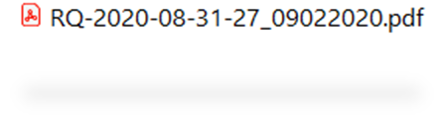
The scanned RQ is organized in a specific order to aid the data management team in locating the RQ and associated sampling event within the LIMS for DMT data entry, quality control checks, WIN uploads and archiving.
Electronic documents associated with a RQ are organized in a specific order to aid the data
management team in locating records of the sampling event for DMT data entry, WIN uploads, quality control checks, and archiving. These electronic documents should be attached to the pdf in the following order.

- Calibration Log
- Laboratory submittal sheet for Florida DEP Laboratory (Chain of Custody)
- DEP Electronic SMP Field Sheets
  - Duplicate and Blank reporting is linked to the electronic SMP Field Sheet
- Bioassessment field sheets, as needed
  - FD 9000-3 Physical/Chemical Characterization
  - FD 9000-4 Stream/River Habitat Sketch Sheet
  - FD 9000-5 Stream/River Habitat Assessment Field Sheet
  - FD 9000-32 Linear Vegetation Survey Field Sheet
  - FD 9000-25 Rapid Periphyton Survey Field Sheet
  - FD 9000-27 Lake Vegetation Index Field Sheet
- Overflow laboratory submittal sheet (Chain of Custody)
- Laboratory submittal sheet for Florida DEP Laboratory
- DEP Electronic SMP Field Sheets
  - Duplicate and Blank reporting is linked to the electronic SMP Field Sheet
- Bioassessment field sheets, as needed
  - FD 9000-3 Physical/Chemical Characterization
  - FD 9000-4 Stream/River Habitat Sketch Sheet
  - FD 9000-5 Stream/River Habitat Assessment Field Sheet
  - FD 9000-32 Linear Vegetation Survey Field Sheet
  - FD 9000-25 Rapid Periphyton Survey Field Sheet
  - FD 9000-27 Lake Vegetation Index Field Sheet
- Overflow laboratory submittal sheet

5.3 Data Management Folders Hierarchy
The North Florida ROCs data management folders are maintained on the following FTP link: \\publicfiles\pubfds\DEAR\WQAPmonitoring\StrategicMonitoring with naming convention and folder hierarchy delineated in
\\publicfiles\pubfds\DEAR\WQAPmonitoring\StrategicMonitoring\Guidance\Folder_Hierarchy_Guidance.pdf
In the current year folder (e.g. 2020) there is a subfolder named NFL_DataManagement that contains the folder Scans_to_be_Processed, and a subfolder for each Org ID. The data management folder hierarchy is detailed in figure 4 below.

Figure 4 - Data management folder hierarchy

5.4 DMT Data Entry Information
Data entry for the DMT is described in the WQAP_DMT-WIN _Help_Guide and
provided for reference in the Strategic Monitoring Guidance folder. Select topics of data
management are included in this Guidance folder including SBIO2 guidance documents.
The electronic SMP Field Sheet’s first page (Figure 5) references the assigned LIMS RQ, WIN
Station Location, WBID, ORG code, date sampled, data qualification declaration, sampling
Equipment Type, as well as any additional waterbody information. Enter these required fields into the DMT.

After data entry is accomplished click 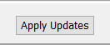 to save data entered.
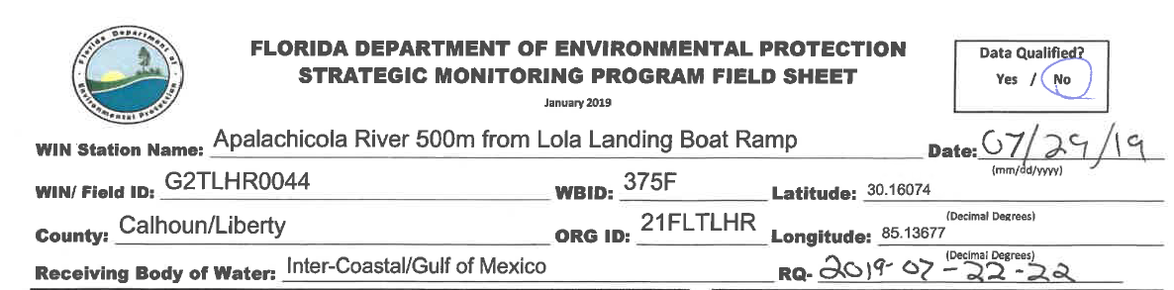
Figure 5 - SMP Field Sheet (first page)

The DMT Specialist obtains the SMP Field Sheet for the associated RQ, and the recorded information is entered into the DMT. The electronic SMP Field Sheet’s second page (Figure 6) includes the field meter measurements and associated depths. See the WQAP_DMT-WIN_Help Guide or DMT User Guide link within the DMT module to address adding data when field measurements are taken at multiple depths.
Figure 6 - SMP Field Sheet (second page)

5.5 Quality Assurance and Data Upload
5.5.1 Verifying WIN Stations- The WIN Specialist checks if a station has been created in
WIN. In WIN, the station is recognized for that ORG ID (ex. 21FLA, 21FLPNS, 21FLTLHR)
(Figure 7), LIMS can verify that relationship within the DMT. If a station does not verify,
contact the ROC Team Lead under that specific ORG ID.

Figure 7 - Verify the Station in WIN
Verify stations per Org ID
Click
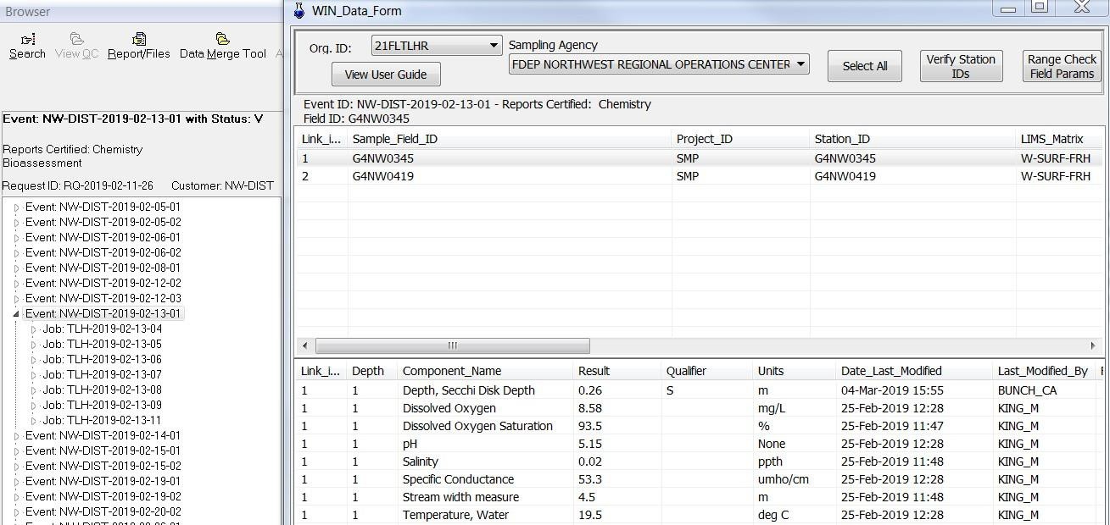

5.5.2 Assigning Field Blank Batch IDs - If a sampling event includes a blank, as required
for 5% of samples collected, a Batch ID is assigned to the blank collected and the stations associated with the blank.
For SMP, two types of blanks can be used, the Field Blank and the Equipment Blank.

If a Field Blank is collected using only sample bottles provide by the laboratory and all the samples collected were also collected with these sample bottles this is identified by a Field Blank Batch ID.
Assign the Field Blank within the sampling event by selecting the Field Blank and all stations in the top grid of the DMT event that utilizes the Direct Grab type of water collection, click on the Field Blank Batch ID menu bar and assign the appropriate ID using a format that identifies project, sample date and type of blank.
Figure 8 includes examples for a Field Blank Batch ID and two different Equipment Blank Batch IDs incorporating this format.

If an intermediate sampling device is used to collect a sample and an Equipment Blank is performed utilizing that equipment, an Equipment Blank Batch ID is assigned to that blank and associated stations using the format (see Figure 8) that identifies project, sample date and type of blank.
The Equipment Blank Batch ID must be assigned only to the Equipment Blank and to the stations that use that equipment in the sample collection. Each monitoring location within the event is reviewed for data and station accuracy.
If multiple blanks are collected on the same day, a number is added to Batch ID to allow for unique uploads to WIN.
Figure 8 – Equipment and Field Blank Batch ID example
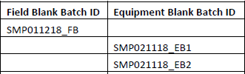

5.5.3. Activate DMT Generate WIN Button When all laboratory data is approved and reported
by the DEP Lab, the DMT “Generate WIN” button will become activated, and a result grid will
be displayed when clicked (Figure 9). Select all stations to assure they will be included in the
upload file.

Figure 9 - DMT Generate WIN button activation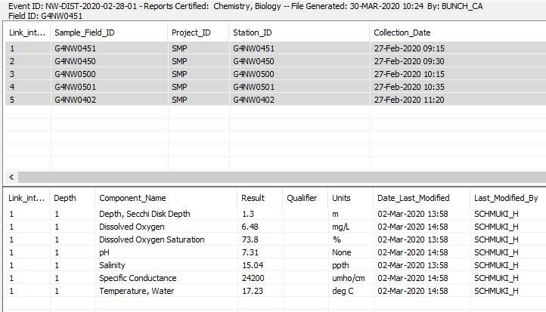

5.5.4 Adding Metadata and Electronic Data Deliverable (EDD) Generation Required
metadata (Collection Type, Collection Equipment, and G qualifier, if applicable, from blank
detections) is added in the WIN EDD by the WIN Specialist. A “G” Value Qualifier is added
when detection is reported for a station in the event and its associated blank at a concentration greater than one-tenth the concentration in the sample, per FAC 62-
160.700 utilizing a drop menu in the Value_Qualifier header.

An EDD text file will be generated (Figure 10), and the file can be saved uploaded by the WIN Specialist to WIN under the appropriate ORG Code and Project.

Figure 10 - DMT Generated EDD example
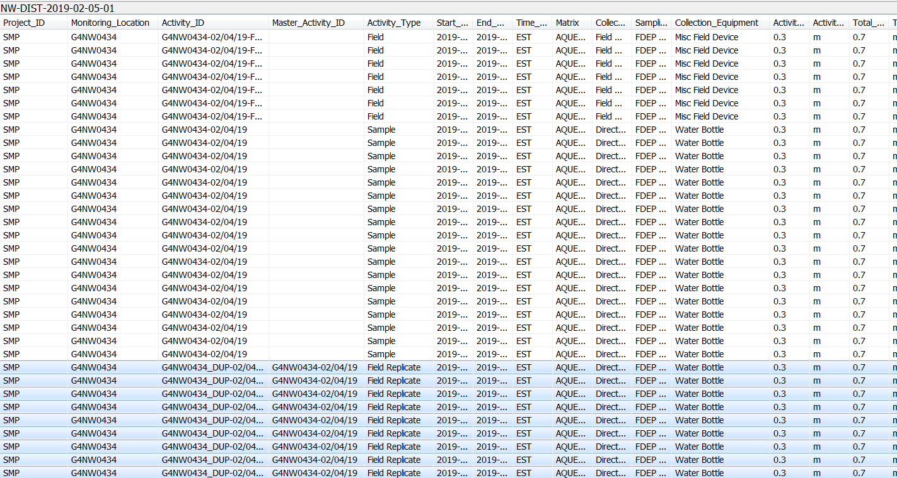
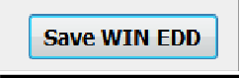

5.6 Data Archive Folders (SMP FTP Network)
After data for an RQ have been entered into LIMS and checked for accuracy, the DMT Specialist archives these data elements within the identified ORG ID folders utilizing the hierarchy guidance document (\\publicfiles\pubfds\DEAR\WQAPmonitoring\StrategicMonitoring\Guidance\Folder_Hierarchy_Guidance.pdf). ORG ID folders under the current year’s Strategic Monitoring Program folder contain subfolders for laboratory reports (by RQ), calibration logs, and Waterbody Identifications (WBIDs). The WBID folders have subfolders for each WIN station being monitored in the WBID, and they contain all field sheets (including calibration and cleaning logs) and pictures collected.

Data Tracking Documents

6.1 SMP Tracker
As data assessment needs are met with each sampling event, ROC field staff update the SMP
Tracker (Figure 11) at least weekly to document monitoring progress. If unable to collect a sample, a letter should be inserted for the event under the nutrients row, with a description in the notes. The following abbreviations with their descriptions are used to denote sample conditions:

- F – Flooded
- D – Dry
- IF – Insufficient Flow
- S – Shipping Issue
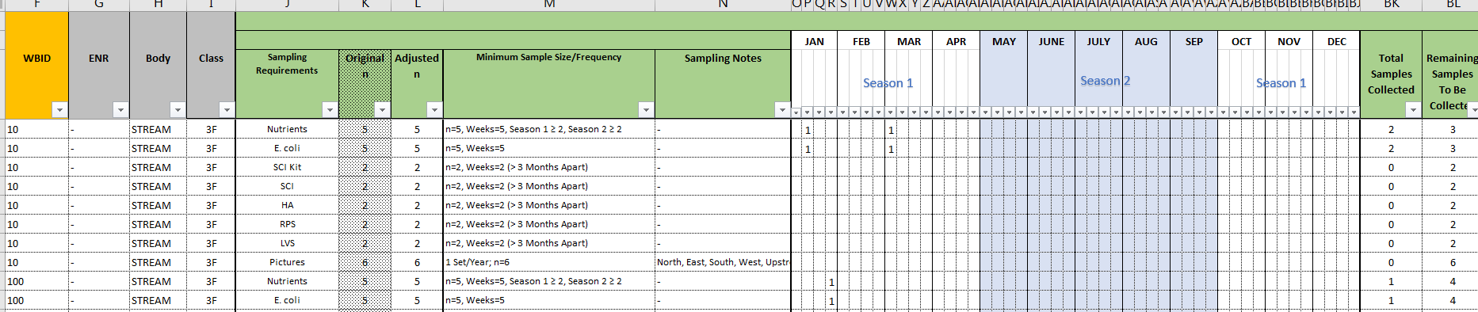
Figure 11 - SMP Tracker example

6.2 ROC ORG Data Trackers
A data tracker (Figure 12) is maintained by the ROC field staff and the data management team
to track the completion of each data management task. Documentation is provided for each
sampling event, including date sampled, date entered into SMP tracker. It is updated and initialed each step of the process (date scanned, DMT entry, QC, Win migrated). Each ORG Code has a data tracker in which the RQ IDs generated from the
LIMS Scheduler are listed.
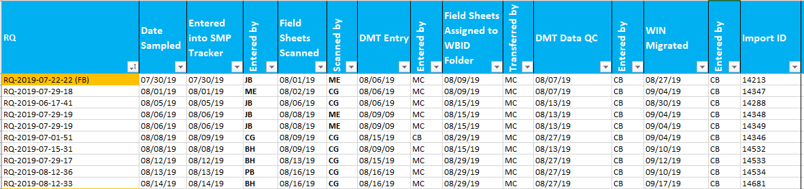
Figure 12 - Data tracker example

There is a notes column for each RQ (Figure 13). Notes are added by the field staff to address
sample event comments that can clarify issues affecting data management and field staff.
Figure 13 - Data tracker notes example
