Data Management Guidance Document North Florida Regional Operation Centers

Prepared by
Division of Environmental Assessment and Restoration Northwest Regional Operation Center



October 2020

Intended Use of This Document
This guidance is published to assist the Florida Department of Environmental Protection’s Division of Environmental Assessment and Restoration (DEAR) North Florida Regional Operation Centers (ROCs) in the documentation and storage of data generated by the Strategic Monitoring Program. Waters of the state in the northern region of Florida are monitored by three regional offices: Northwest Regional Operation Center (NWROC), The Northeast Regional Operation Center (NEROC) and the Tallahassee Regional Operation Center (TLHROC). Monitoring locations, monitoring data and associated quality assurance information is archived and uploaded to DEAR’s web- based public access database, the Watershed Information Network (WIN), where geographic locations can be mapped, and the data retrieved.

Current Staff for WIN Organization Codes (ORG ID)

North Florida Division of Environmental Assessment & Restoration Environmental Administrator
Alicia Hogue-WIN Administrator for 21FLA, 21FLTLHR, 21FLPNS

21FLA (NEROC) – Jeremy Parrish (Team Lead), Brian Davis, Kelly McDonald, Kimberly Appleby
21FLTLHR (TLHROC) – Mike Eckles (Team Lead), Chris Green, Benjamin Harden, Paul Blair, Jade Burtchett, Jonathan Woods
21FLPNS (NWROC) – Mike King (Team Lead), Stopher Slade, Nathan Mulkey, Frank Butera, Heather Schmuki, Cheryl Bunch, Myranda Clark

Utilized During Data Management Process

- WIN website http://prodenv.dep.state.fl.us/DearWin/win/welcome
- Tallahassee Central Laboratory Information Management System (LIMS)
- LIMS Data Merge Tool (DMT) User Guide
- ROC Data Trackers
- ROC SMP Trackers
- SMP network-documentation guidance, templates and archive
\\publicfiles\pubfds\DEAR\WQAPmonitoring\StrategicMonitoring

Common Field Measurements Collected and Reporting Units

Dissolved Oxygen (mg/L) Percent Saturation (%) Water Temperature (ºC) Salinity (PPT)
Specific Conductance (µmhos/cm) Sample Depth (Meters)
Total Depth (Meters) Secchi Depth (Meters) pH (Standard Units)

Required to enter event into LIMS DMT

Date sample collected Time sample collected Sample Depth
Field ID (used to create Activity ID in WIN)

Requested field data for laboratory analysis

Dissolved Oxygen (mg/L) Or Percent Saturation (%)
Water Temperature (ºC) Salinity (PPT) Or
Specific Conductance (µmhos/cm) pH (Standard Units)

Sample Processing overview

The SMP annual plan is developed, coordinated and managed by the Watershed Assessment Section
in Tallahassee. The sites identified as needing additional data are placed on the annual plan and
provided to ROCs for the implementation of monitoring strategies. Sample analysis is scheduled
within the Central Laboratory Information Management System (LIMS), assigned a Request ID and samples are collected and shipped by ROC staff for analysis at the Central Laboratory in Tallahassee and/or contracted overflow laboratories. Chain of custody (COC) sheets along with field sheets are generated via tablet applications and emailed to the Tallahassee Central Laboratory. Overflow laboratory COCs are received directly by overflow laboratory along with samples. Tallahassee staff receive and process these samples, create sampling events under assigned Request ID within the LIMS
application and document requested field data for laboratory analysis within the DMT application.
ROC staff collates all chain of custody documents, field sheets and calibration log and then scans these documents under the assigned RQ for data management purposes.

Data Archiving Overview

ROC Staff are responsible for providing an electronic paper trail of activities and documents generated during the sampling process. This includes bioassessment site visits for the Florida Department of Environmental Protection (FDEP) Statewide Biological Database (SBIO) and LIMS monitoring Request IDs for WIN. Scanned field sheets and data reports are archived in folders on a network FTP site for the Strategic Monitoring Program (SMP) under calendar year and Agency Organization Code
\\publicfiles\pubfds\DEAR\WQAPmonitoring\StrategicMonitoring with naming convention and folder hierarchy delineated in \\publicfiles\pubfds\DEAR\WQAPmonitoring\StrategicMonitoring\Guidance\Folder_Hierarchy_Guidance.pdf

Data Processing Overview

NWROC staff are responsible for data entry, additional archiving, quality assurance and uploading data from the LIMS Data Merge Tool into Florida’s WIN public access database.
See Data Management Flow Chart.

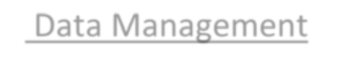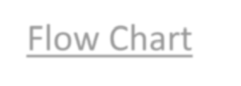
Check Scans to be Processed for field sheets in RQ folder
Enter field data into LIMS DMT
DMT
specialist
Upload EDD to WIN
QC DMT
Check FTP site for field sheets
Check Data Tracker for RQs
Enter RQ into Data Tracker

Check Data Tracker for RQs with completed by DMT specialist
WIN
specialist
Bioassessment field sheet with SBIO ID (site visit, RPS, macrophyte, HA, LIMS ID) scanned by Friday & attached to WQ field sheet
Data Management Flow Chart

Bio? No
Sample Collection
ROC staff
Scan sampling event worksheets under RQ ID “Scans_ToBeProcessed”
Copy RQ PDF to Agency Code
Bio? Yes

Enter Events into SMP Tracker

After QC DMT, move field sheets to the appropriate org folder and rename following folder hierarchy guidance document
\\publicfiles\pubfds\DEAR\WQAPmonitoring\StrategicMonitoring\Guidance\Folder_Hierarchy_Guidance.pdf
Update Data Tracker

Update
Data Tracker
Complete WIN migration
Updates Data Tracker

Update
Data Tracker

Data Archive Folders (SMP FTP Network)

ORG ID folders under the current year’s Strategic Monitoring Program folder
contain RQ (LIMS sampling request number) listing analysis and bottle groups, laboratory reports per RQ, Calibration Logs and Waterbody ID (WBID) folders with subfolders for each WIN station being monitored in the WBID. After LIMS data entry for an RQ has undergone QA oversite, staff archives these data elements within the identified ROC folders utilizing the hierarchy guidance document referenced in the Data Management Flow Chart.

Data Management Folders (SMP FTP Network)
NFL_DataManagement folders under the current year’s Strategic Monitoring Program contain a Scans to be Processed Folder for each ROC where Field sheets are archived in the following format:
RQ-YYYY-MM-DD-XX_(MMDDYYYY) – the scheduled RQ, underscore, date sampled
Example:

The scanned RQ is organized in a specific order to aid the data management team in locating the RQ and associated sampling event within the LIMS for DMT data entry, quality control checks, WIN uploads and archiving.

- Calibration Log
- Laboratory submittal sheet for Florida DEP Laboratory (Chain of Custody)
- DEP Electronic SMP Field Sheets
  - Duplicate and Blank reporting is linked to the electronic SMP Field Sheet
- Bioassessment field sheets, as needed
  - FD 9000-3 Physical/Chemical Characterization
  - FD 9000-4 Stream/River Habitat Sketch Sheet
  - FD 9000-5 Stream/River Habitat Assessment Field Sheet
  - FD 9000-32 Linear Vegetation Survey Field Sheet
  - FD 9000-25 Rapid Periphyton Survey Field Sheet
  - FD 9000-27 Lake Vegetation Index Field Sheet
- Overflow laboratory submittal sheet (Chain of Custody)

Data Management Activities
Data management within the LIMS is delineated in the WQAP_DMT-WIN _Help_Guide and
provided for reference in the NFL_Datamanagement folder. Some select topics of data management is included in this guidance.

Data Entry Information
The SMP Field Sheet’s first page references the assigned LIMS RQ, WIN Station Location, WBID, ORG,
date sampled, data qualification declaration, sampling equipment as well as additional waterbody information.
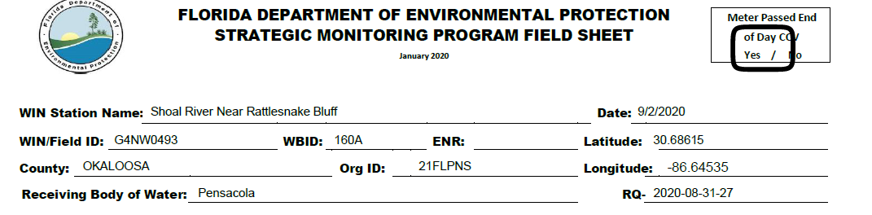
The SMP Field Sheets second sheet contains field measurements and associated depths:
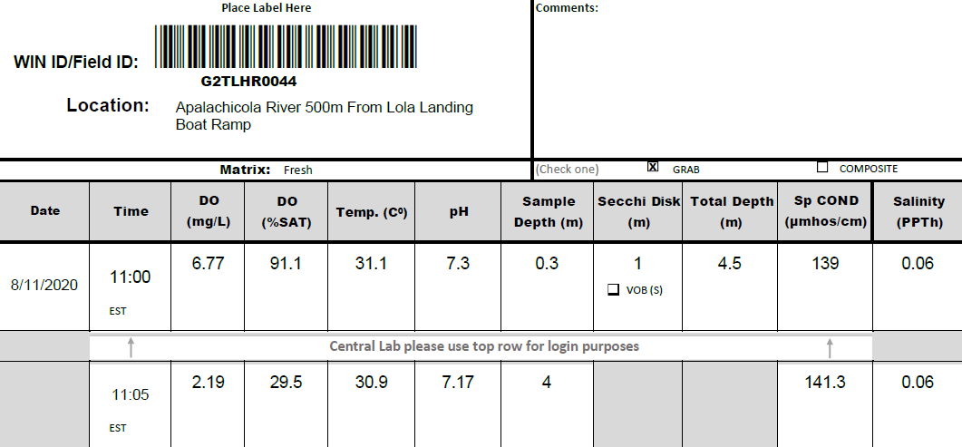
The Comments box of the field sheet can be used for sampler comments including rainfall and field data information information.
See the WQAP_DMT-WIN_Help Guide or User Guide link within the DMT to address adding data when field measurements are taken at multiple depths.
After data entry is accomplished click 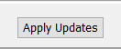 to save data entered.

Quality Assurance and Data Upload

Verifying WIN Stations-If a station has been created in WIN the station then becomes recognized as
as a station within that ORG ID (ex. 21FLA, 21FLPNS, 21FLTLHR). LIMS can verify that relationship
within the DMT. If a station does not verify, contact the applicable ROC Team Leader.

Verify stations per Org ID Click 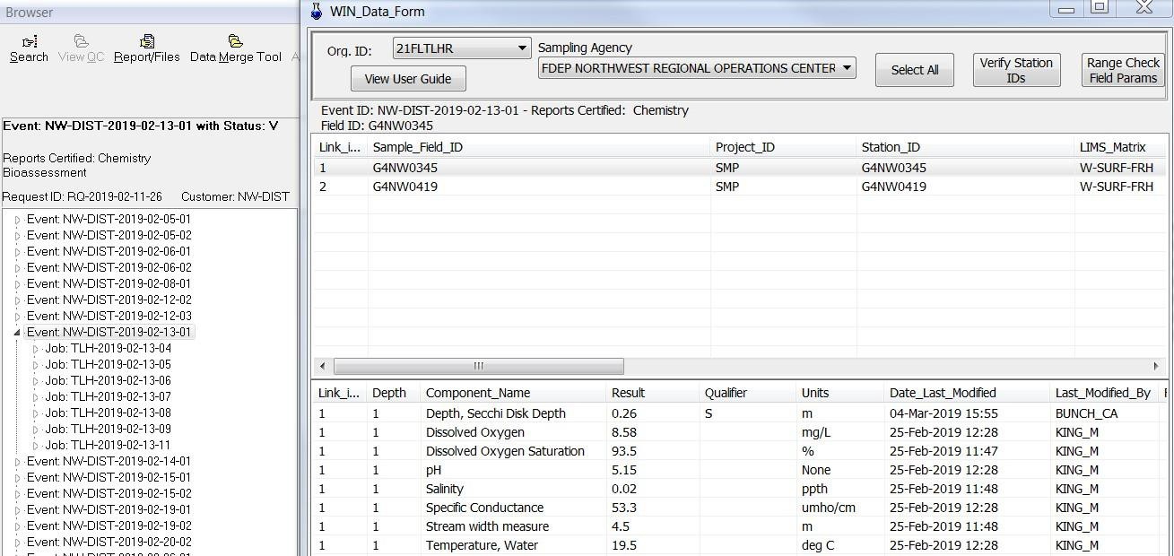

Assigning Field Blank Batch IDs -If a sampling event has included a blank as required for 5% of

samples collected, a batch ID is assigned to all stations and the field blank within the sampling event
by selecting all in the top grid of the LIMS event, clicking on the Blank Batch ID menu bar and
assigning the appropriate ID using a format that identifies project, sample date and type of field blank. For SMP two blank types are incorporated, the Field Blank and the Equipment Blank.

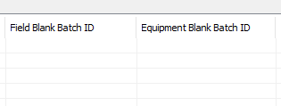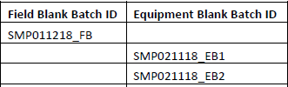

This example includes the possibility of two different equipment blanks collected. Note that the

Equipment Blank Batch ID must be assigned only to the stations that use that equipment in the

sampling.

Each monitoring location within the event is reviewed for data and station accuracy. Field data qualifiers
and data qualifier comments are added as needed in the data entry grid.
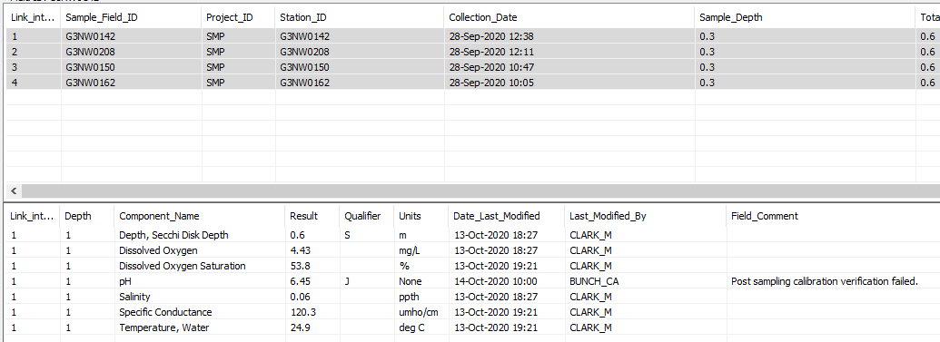
When all laboratory data is approved and reported by Tallahassee staff, the DMT’s, select all and the “Generate WIN” button will become activated, and a result grid will be displayed when clicked.
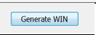
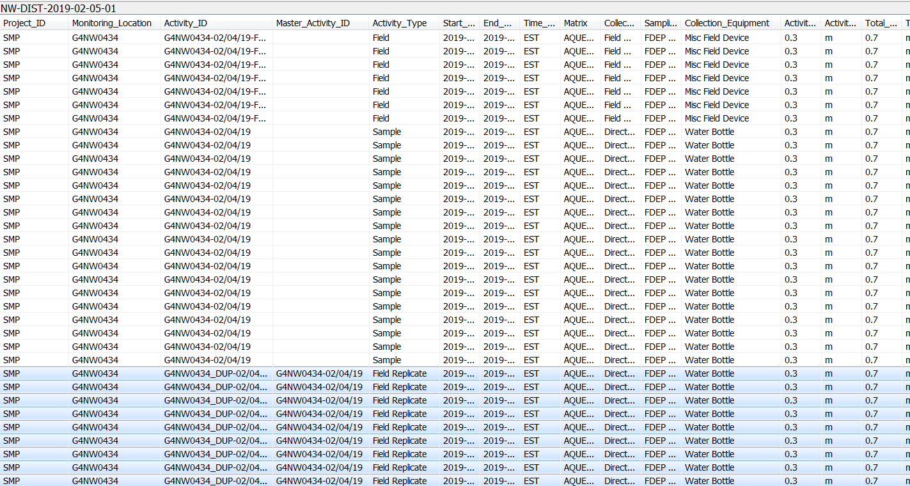

Required data elements are added to the data grid, including Collection Type and Collection Equipment, utilizing drop menus provided in the header column. A “G” Value Qualifier is added when detection
is reported in the event’s field blank and is deemed applicable under FAC 62-160.700.
When metadata is added to the WIN EDD, click
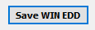
An Electronic Data Deliverable (EDD) text file will be generated and the file can be uploaded to WIN database under the appropriate ORG and Project. (WIN specialist)

Data Tracking Documents

SMP Tracker

As data assessment needs are met with each sampling event, ROC field staff update the SMP
Tracker at least weekly to document monitoring progress. If unable to collect a sample, a letter should be inserted for the event under the nutrients row, with a description in the notes. The following abbreviations
with their descriptions are used to denote sample conditions:

- F – Flooded
- D – Dry
- IF – Insufficient Flow
- S – Shipping Issue
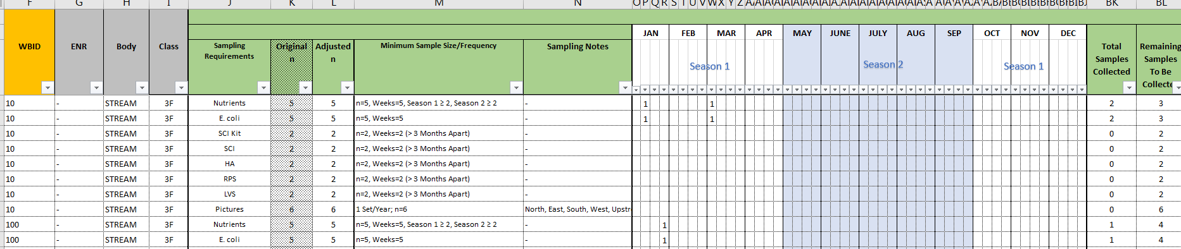

ROC ORG Data Trackers

A data tracker is maintained by the ROC field staff and the data management team
to track the completion of each data management task. Documentation is provided for each
sampling event, including date sampled. The date each data management task is accomplished is entered into the SMP tracker and the initials of the person who performed the task. Each ORG Code has a data tracker in which the RQ IDs generated from the LIMS Scheduler are listed.

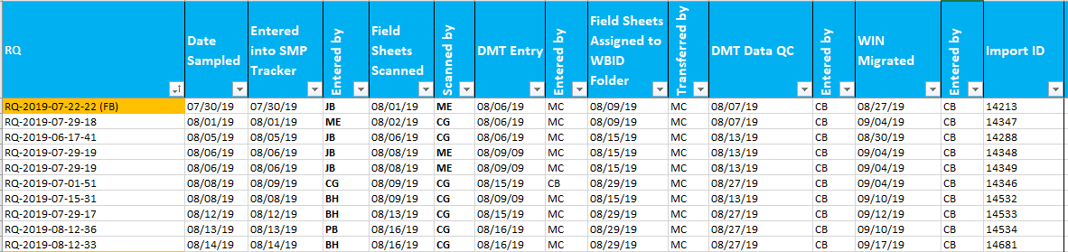

Additional rows are added by Team Leader to address sample event comments that can clarify issues affecting data management and field personnel:
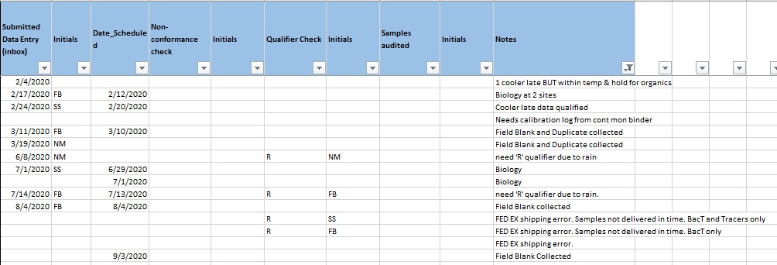
Rainfall qualifier should also be noted in the Comments section of the field sheet for archived station record to be complete in the data archive.

