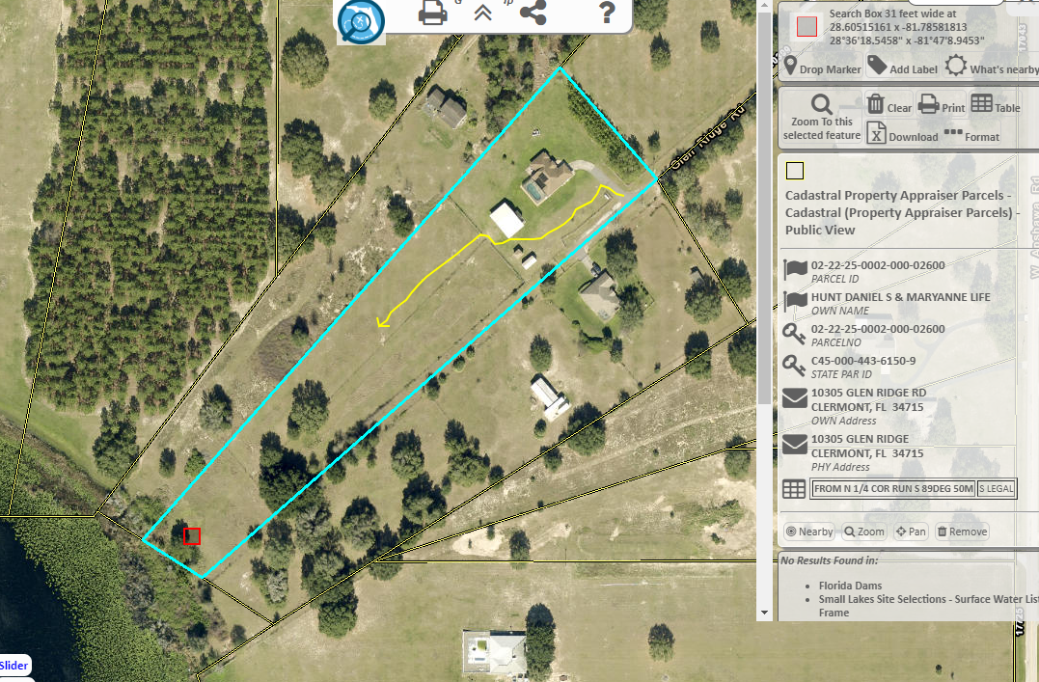
From the Apopka Field Station Head North on County Rd 448A, turn left onto County Rd 48 go ~4.3 miles, turn left
onto County Rd 561/Monroe St, at traffic circle take 2nd exit continue on County Rd 561 go ~3.9 miles, turn left onto
US-27S go ~0.7 miles, turn right onto E Apshawa Rd go ~1.9 miles, turn right onto Cherry Lake Rd go ~0.8 miles,
Turn right onto W Apshawa Rd go ~0.9 miles, turn left onto Glen Ridge Rd go ~0.2 miles, turn into 10305 Glen
Ridge Rd, house is brown with a large silver propane tank out front. Let owners know you are there. Drive down left
side of house stay near fence to avoid septic tank on left side of house (See Map). Drive behind larger of workshops
turn into open fence opening with fire pit in it. Drive down to lake access to lake is slightly overgrown may need machete.

