2068 Buck Creek
26.890364, -82.308962
Kit B
Deploy upstream of 41 bridge in deep section of water. Deploy via park and kayak launch off Placida.

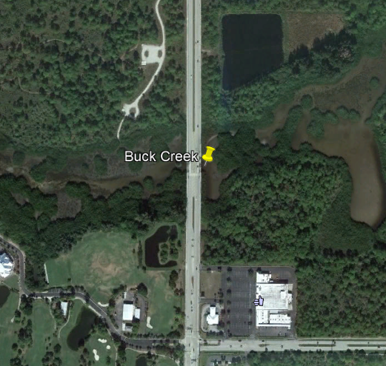

2067 Oyster Creek
26.924811, -82.321638
Kit B
Park at Ann Dever Memorial Park. Walk over boardwalk enter water and walk under boardwalk to site. Possible to obtain key from park services to shorten walk.

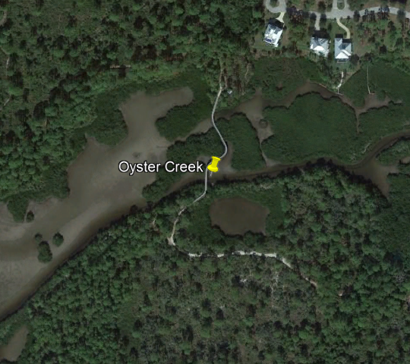

2026 Little Salt Creek (REMOVED FOR 2018)
27.048049, -82.275498
Kit B
Pull off west of bridge and enter water at rock. Deploy upstream
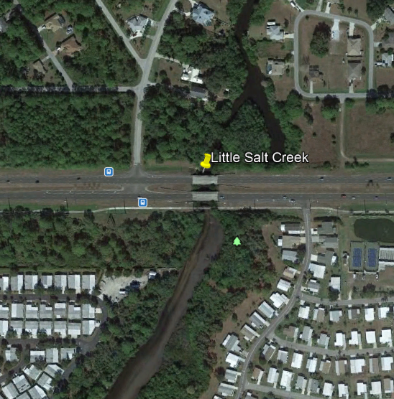

3240A4 Deep Lagoon Canal (REMOVED FOR 2018)
26.531853, -81.926718
Kit B
Pull off on McGregor Blvd and mount curb. Channel is over 1.5m deep. Deploy from left side of channel.
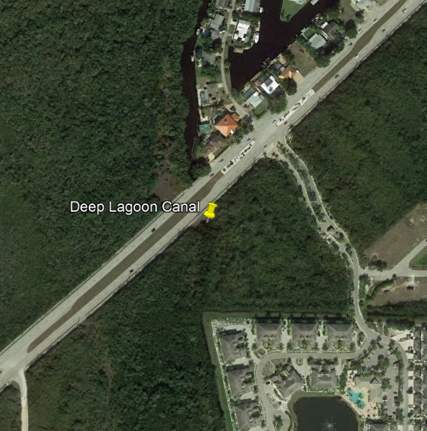

3258B Imperial River (Marine)
26.33898, -81.805676
Kit B
Park at boardwalk and deploy upstream of floating dock in mangroves

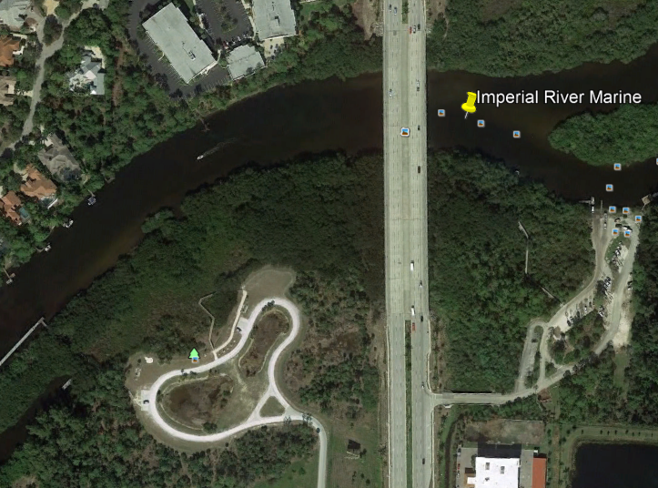

3240J Billy Creek
Kit B
26.652686, -81.845156
Enter Shady Oaks Park. Deploy N of footbridge on E bank in mangroves

