SWFWMD/USGS gage – WBID 1443E – Will need to contact WMD for permission
Good, works for me
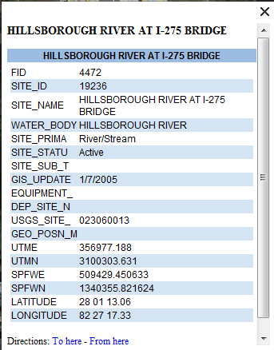

SWFWMD/USGS gage – WBID 1443F – Will need to contact WMD for permission
Good, works for me
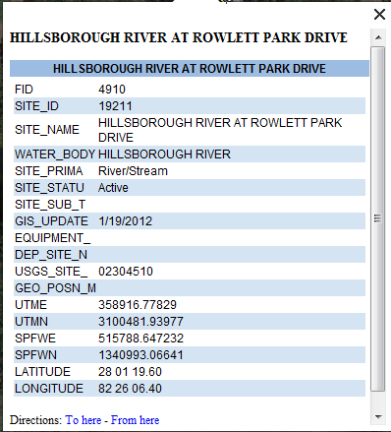

WBID 1513F – Double Branch
2 possible deployment locations, no established stations within WBID.
Upper Tampa Bay Park boardwalk – existing structure, park manager willing to work with us as needed.
End of State St. – Less traffic, at end of street, possibly used as a boat launch for small boats. No existing structures for deployment, lots of mangroves.
State street site is better. 90% of DO data is from SR 580
WBID 1579 – USGS gage – Will need to contact USGS
3 established stations within WBID. Flashiness of system may not support monitoring efforts, due to risk of Sondes being washed away with high flow during rainy season and being stagnant or dry during dry season.
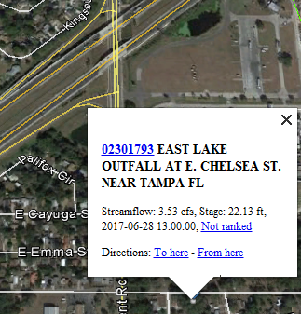
Established site G1SW0060 was dry or stagnant Jan. – June 2017.
Established site TP381 – at creek intersection with Dr. MLK Jr. Blvd. Less foot traffic than Danny Bryan Blvd. which is in a neighborhood. Banks are heavily vegetated and there are no preexisting structures for deployment.
Established site TP382 – at creek intersection with Danny Bryan Blvd. (residential).
Remove from continuous monitoring work plan, flashy and dry.
WBID 1587A – Woods Creek
No established stations within this WBID. Creek becomes canal system south of Hillsborough Rd. Will need to find property owner to allow deployment from dock structure.
Deploy in the canal as close to the bat as possible, if possible. If site logistics ar to great you can remove this form the continuous monitoring plan.

WBID 1628A – Archie Creek Tidal
2 established sites within WBID.
Established site TP11048E – at creek intersection with Old US 41. Less trafficked area near Mosaic properties. No preexisting structures for deployment. Pros: 90% of DO data is from this site. Off a low traffic road. Con it is further upstream.
Established site TP11049E – at stream intersection with US 41. Located on busy road. No preexisting structures for deployment. Pros: Further downstream. Looks canoeable. Heavily vegetated. CONS: busy road.
Is the area between the two sites accessible with a canoe? Both sites work, your call.
WBID 1632 – USGS gage – also near current SMP site – Will need to contact USGS
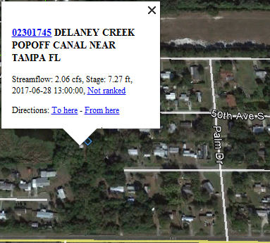
Established site TP11047S - Water level at USGS gauge may be too low for dry season sonde deployment. Too far up stream
Established site TP11046E – at creek intersection of Old US 41. No clear attachment points for deployment. Looks good to me.

WBID 1708 – Newman Branch
Purposed site at Elsberry Rd., off Dickman Rd., existing dock structure with easy access. Property owned by Timothy Donovan (Cadasteral 2016). Elderberry near Dickman is not appropriate. All the DO data is form the residential canal downstream between Bimini Ct. and Dolphin Cove Dr.

WBID 1771 – Heritage Park Creek
NO DEFINED CREEK VISIBLE at stream intersections of John Sherman Way (South County Career Center property), Universal Dr., or 41. Some wetland plants were observed along Universal Dr. but system was marshy at best. Remove form continuous workplan.

Pictures available for reconed stations in the Continuous Monitoring folder.

WBIDs to be sampled:
- 1443E – GTG with USGS
- 1443F – GTG with USGS
- 1708 – Will need to get permission for deployment
- 1513F - @State St
- 1474W – Homeowner we use for typical SMP sampling access?
- 1587A - ?
- 1628A?
- 1632

