AQUARIUS Time-Series How to Document for Adding Qualifiers
January 18, 2022
Preface
This “How to Document for Adding Qualifiers” is copied from sections of the Continuous Monitoring Data Management Guidance document which is currently being updated. References to table and figure numbering and to the Appendix of that guidance document have been maintained in this “How to” document.
Qualifier Protocol
Data Qualifiers and associated notes may be applied to data stored in AQUARIUS using the Data Review Tool (DRT). Once raw data are uploaded to AQUARIUS, they should be reviewed and qualified as appropriate as soon as possible. Field visit information and calibration logs, as well as inspection of the loaded data through the DRT should be conducted to determine the appropriate Qualifiers, Notes and portions of the data that may need to be qualified. Application of a Qualifier in AQUARIUS does not exclude data from the time-series record, it annotates them for use determinations by the individual data consumer. Guides to Adding Qualifiers in AQUARIUS and to Adding Notes in AQUARIUS are provided in the Appendix to this “How to” document. This Qualifier Protocol section addresses the qualifiers that DEAR staff will apply in AQUARIUS if relevant to a time-series or region(s) of a time-series.
- Four qualifiers from Table 1 (Data Qualifier Codes) of Rule 62-160.700, F.A.C., the DEP QA Rule, may be applied to continuous monitoring data in AQUARIUS (see Table A-4 in the Appendix):
  - the “J” qualifier (estimated value);
  - the “R” qualifier (significant rain in the last 48 hours);
  - the “!” qualifier (data deviate from historically established concentration ranges);
  - the “?” qualifier (data are rejected and should not be used).
When either the “J” or “?” qualifier is applied, a detailed explanation (Note) must be added to justify the reason(s) for indicating the value(s) as estimated or rejected. Table A-5 and Table A-6 in the Appendix contain standard Notes to apply for “J” or “?” qualified data, respectively. Additional text or other notes may be added, but the Table A-5 and Table A-6 Notes should be used when they apply.
The “R” and “!” qualifiers are specific to field activities that shall be used if the data loader has knowledge of the specific sampling event.
- Qualifiers should be applied for each relevant parameter and for each relevant region of the time-series data. A qualifier may be for only one parameter (e.g., failed parameter-specific calibration verification), or across multiple parameters (e.g., a failure of temperature verification would necessitate qualification of all other temperature-dependent collected parameters). A qualifier may be relevant to only a specific region(s) of the time-series (e.g., sonde out of water for some portion of the monitoring event), or it may apply to an entire time-series event (e.g., failed CCV for the event).
- Apply a “J” qualifier for the following examples:
  - Calibrations or calibration verifications did not meet calibration acceptance criteria, including quantitative or chronological bracketing requirements for field testing data. Minimum calibration and data QA/QC requirements are addressed in the DEAR Continuous Monitoring SOP for Environmental Field Deployments document, and are consistent with discrete surface water sampling DEP SOPs FT 1000, FT 1100, FT 1200, FT 1300, FT 1400, FT 1500, and FT 1600. Table A-7 in the Appendix lists the acceptance criteria for commonly collected parameters.
  - Other quality control items associated with the reported value(s) failed to meet the established QC criteria (identify the specific failure in the Note). For example, apply “J” if calibration standards were expired. The acceptance of standards used to calibrate continuous monitoring devices is based on documentation including certificates of analysis, expiration dates for buffers, and National Institute of Standards and Technology (NIST) certifications.
  - Instances when data are questionable because of improper field protocols (e.g., guard not attached correctly to meter, improper installation or deployment such as meter rested on waterbody bottom where sedimentation is likely to occur and affect accuracy of readings instead of the water column, etc.).
  - For all parameters for the YSI 6000 and for all parameters except turbidity for the YSI EXO, instances where the temperature sensor failed verification (i.e., apply a “J” qualifier to temperature and to all parameters except turbidity).
  - Instances when the sample matrix interfered with the ability to make an accurate determination (e.g., turbidity interference).
  - Sensor fouling is observed.
  - Sensor drift is suspected.
  - Sensor diagnostics are yellow/warning.
  - Vandalism/tampering is suspected.

- Data may need to be qualified as rejected for many reasons. Apply a “?” for the following examples:
- Reject data if a sensor is registering values even if there was no sensor installed on the data logger.
- Reject data for all parameters when the readings are known to have occurred when the meter is out of the water (such as when there are tidal or tampering issues). Include a Note explaining what interruption occurred in the data.
- Reject data for values outside the listed range specifications of the instrument.
- Reject data if the sensor is damaged, if the data are erratic (e.g., from water intrusion, even if the sensor passes the CCV), or if the sensor diagnostics are red/indicate failure.
- Reject data for a power failure/low battery.
- Consistent with the National Estuarine Research Reserve SOP, reject ALL data on YSI 6600 when the temperature sensor malfunctions, and reject all data except turbidity when the temperature sensor malfunctions on the YSI EXO.
- Vandalism/tampering of the sonde was confirmed.

Figure 12 shows an example of “?” qualified time-series data.
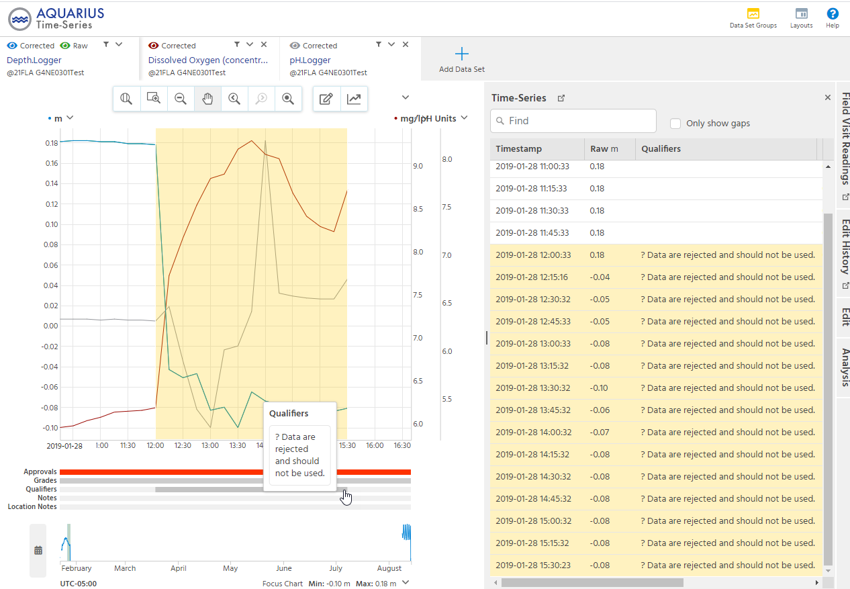
Figure 12. Data Review Tool showing "?" qualified data

Appendix

Table A-4. DEAR qualifier codes for CM data

(as excerpted from Table 1: Data Qualifier Codes, Rule 62-160.700, F.A.C.)
Code | Definition
J | Estimated value. A "J"-qualified sample value shall be accompanied by a detailed explanation to justify the reason(s) for designating the value as estimated. Where possible, the organization shall report whether the actual sample value is estimated to be less than or greater than the reported value, to assist data users in any evaluation of the usability of the sample value.
? | Data are rejected and should not be used. Some or all of the quality control data for the analyte were outside criteria, and the presence or absence of the analyte cannot be determined from the data.
R | Significant rain in the past 48 hours. (Significant rain typically involves rain in excess of 1/2 inch within the past 48 hours.) This code shall be used when the rainfall might contribute to a lower or higher than normal value.
! | Data deviate from historically established concentration ranges.

Table A-5. Standard “J” Qualifier Notes for CM data
Note
Calibration was not successful for (pH, specific conductance, DO, temperature, turbidity).
Calibration verification did not meet the acceptance criteria for (pH, specific conductance, DO, temperature, turbidity).
Calibration verifications did not bracket the field measurements for (pH, specific conductance, temperature, turbidity).
Calibration standards were expired and not verified against non-expired standards for (pH, specific conductance, turbidity).
Improper field protocol (indicate what was improper. E.g., Guard not attached correctly to sonde ).
Temperature sensor failed verification (include this note for all parameters for YSI 6000 and for all parameters except turbidity for the YSI EXO).
Sample matrix interfered with the ability to make an accurate determination.
Sensor fouling is observed. X amount of change suspected in (positive, negative) direction.
Sensor drift is suspected. X amount of change suspected in (positive, negative) direction.
Sensor diagnostics are yellow/warning.
Vandalism/tampering is suspected.

Table A-6. Standard “?” Qualifier Notes for CM data
Note
Sonde is known to have been out of the water (include a note explaining what interruption occurred. E.g.; Sonde no longer submerged). Data for all parameters are rejected.
Values outside the listed range specifications for the instrument.
Sensor is damaged.
Data are erratic, even if the sensor passes CCV.
Sensor diagnostics are red/indicate failure.
Power failure/low battery.
Temperature sensor malfunction, even if the sensor passes CCV (include this note for all parameters for YSI 6000 and for all parameters except turbidity for the YSI EXO).
Vandalism/tampering was confirmed.

Table A-7. Calibration acceptance criteria

(as defined in Table FT 1000-1, DEP SOP FT 1000)
Parameter | Calibration Verification Acceptance Criteria
pH | ± 0.2 unit
Specific Conductance | ± 5 %
Temperature, Water | ± 0.5°C
Dissolved Oxygen | ± 0.3 mg/L
Turbidity | 0.1 – 10 NTU: ± 10 % of standard value
 | 11 – 40 NTU: ± 8 % of standard value
 | 41 – 100 NTU: ± 6.5 % of standard value
 | > 100 NTU: ± 5 % of standard value

Adding Qualifiers in AQUARIUS
As noted previously, data loaded to AQUARIUS should be reviewed for application of data qualifiers as soon as possible once uploaded. Field visit information and calibration logs, as well as inspection of the uploaded time-series data through the DRT should be conducted to determine the appropriate Qualifiers, Notes and portions of the data that may need to be qualified.
One or multiple Qualifiers may be added to a specified date/time range of a time-series for a parameter using the Edit feature of the DRT. If applicable, the same Qualifier(s) may be applied simultaneously to the same data/time range of the time-series for other parameters. The following example demonstrates how to apply Qualifiers simultaneously to several parameters for a time-series.
1. From the Springboard, select the desired location, select the parameter(s) of interest, then click the DRT icon. Three parameters were chosen for this example (Figure A-1).
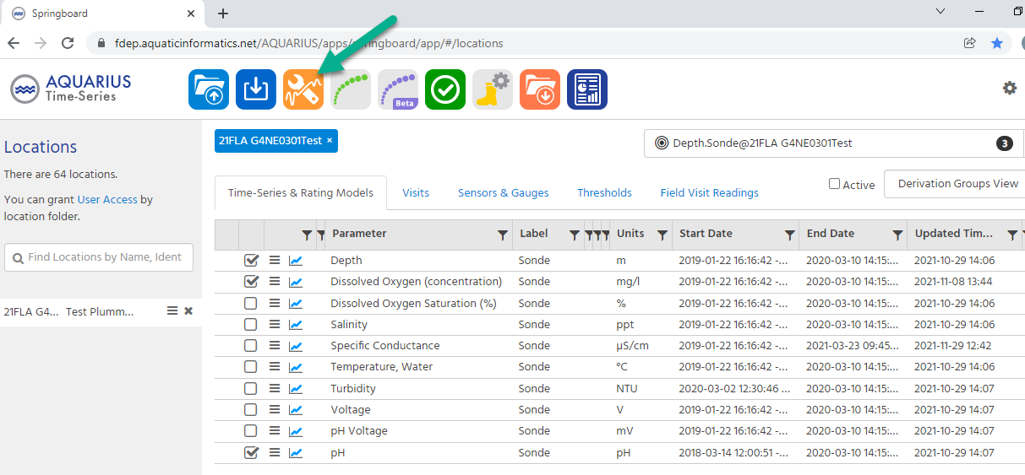
Figure A-1. Springboard Menu with Data Review Tool (DRT)
- Zoom to the horizontal resolution displaying a date/time range of interest in the time-series. Select the Edit tab on the right margin of the screen (Figure A-2).
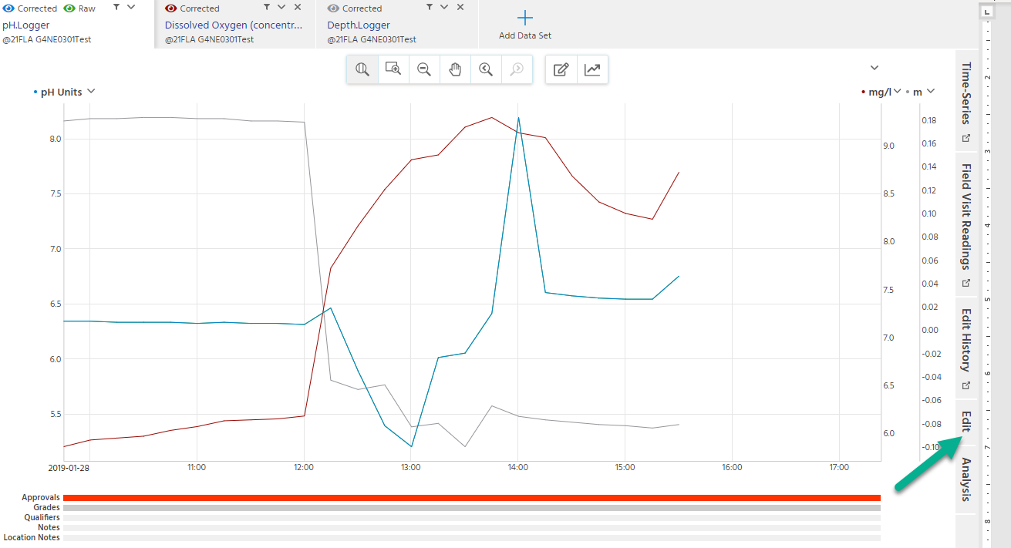
Figure A-2. DRT screen
- Either use the edit selection tool on the time-series graph to highlight the desired date/time range or use the Start Point and End Point calendars to specify the range (Figure A-3).
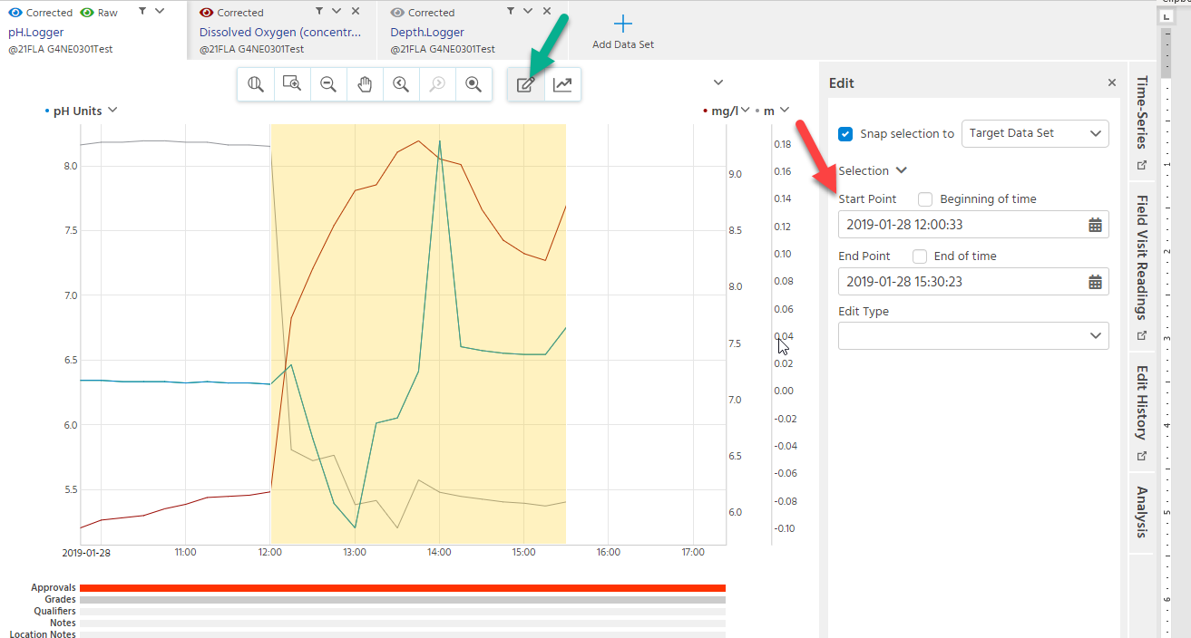
Figure A-3. DRT Edit screen showing selection of the date/time range of interest
- Select Edit Type of Qualifier from the dropdown menu (Figure A-4).
- For Applies to, select each parameter time-series to which you want the Qualifier to be applied. The first parameter in focus is defaulted (i.e., no need to select it).
- Select DEAR for Filter Qualifier by Group and deselect Default (Default contains the AQUARIUS stock Qualifiers, which DEAR is not using).
- From the dropdown menu, select the Qualifier to be applied. For this example, ? Data are rejected and should not be used was selected.
- Select Apply towards the bottom right of the screen.

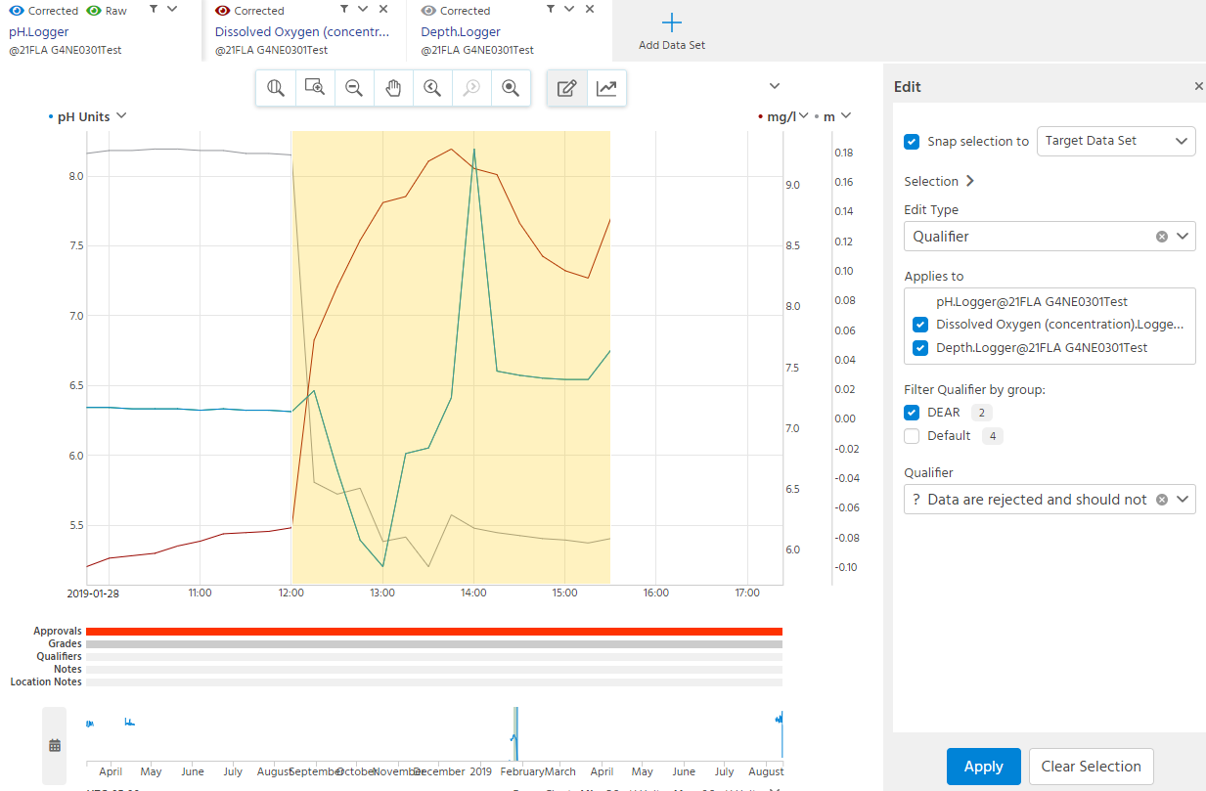
Figure A-4. DRT screen showing Edit selection choices
- Pointing to the Qualifiers line below the time-series plot will display the Qualifiers for the time-series area of focus (Figure A-5). Select Save at the top right of the screen to keep the resulting changes.
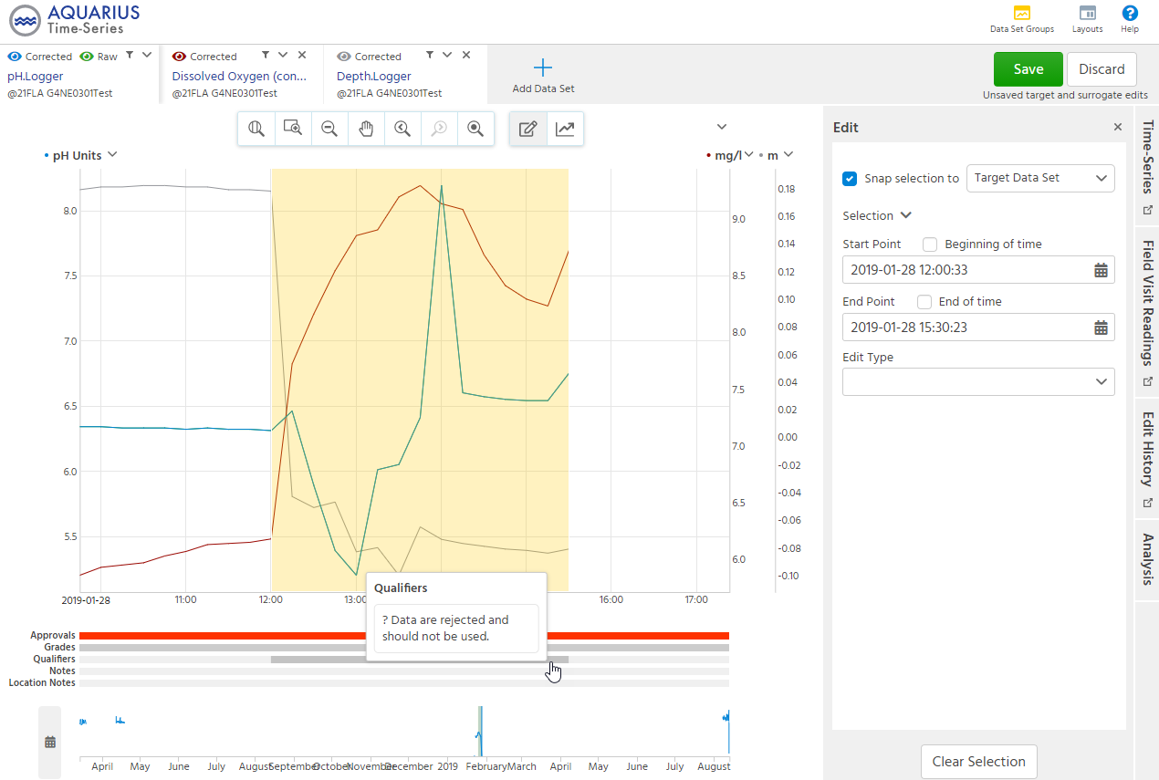
Figure A-5. DRT screen displaying resulting Qualifiers
If a Qualifier was applied in error, it can be removed by selecting the Edit History tab on the right margin of the screen.
- Select the Discard (trashcan) icon for the Edit to be removed (Figure A-6). If a Qualifier was applied to multiple parameters simultaneously, the removal of the Qualifier also applies to all the parameters.

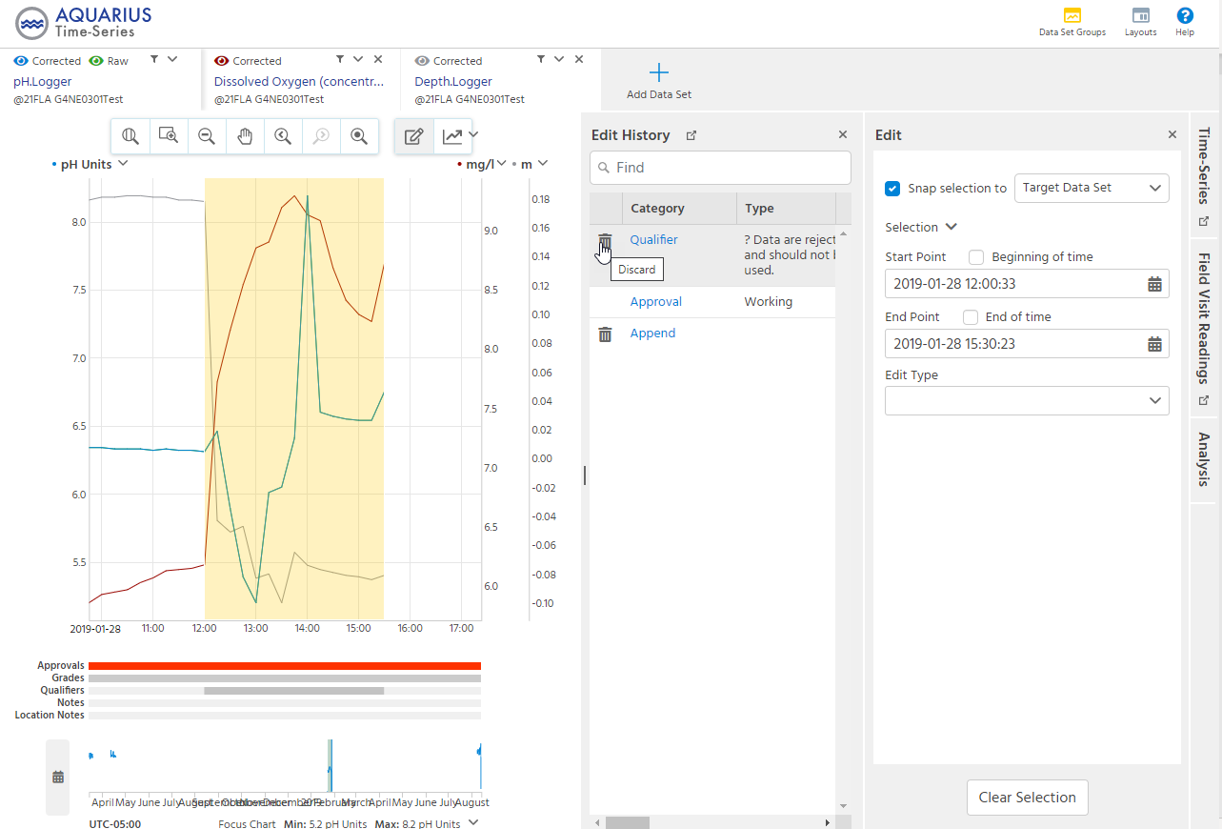
Figure A-6. DRT Edit History screen
- Select Save to remove the Edit or click the Restore icon to retain (i.e., not remove) the Edit (Figure A-7).
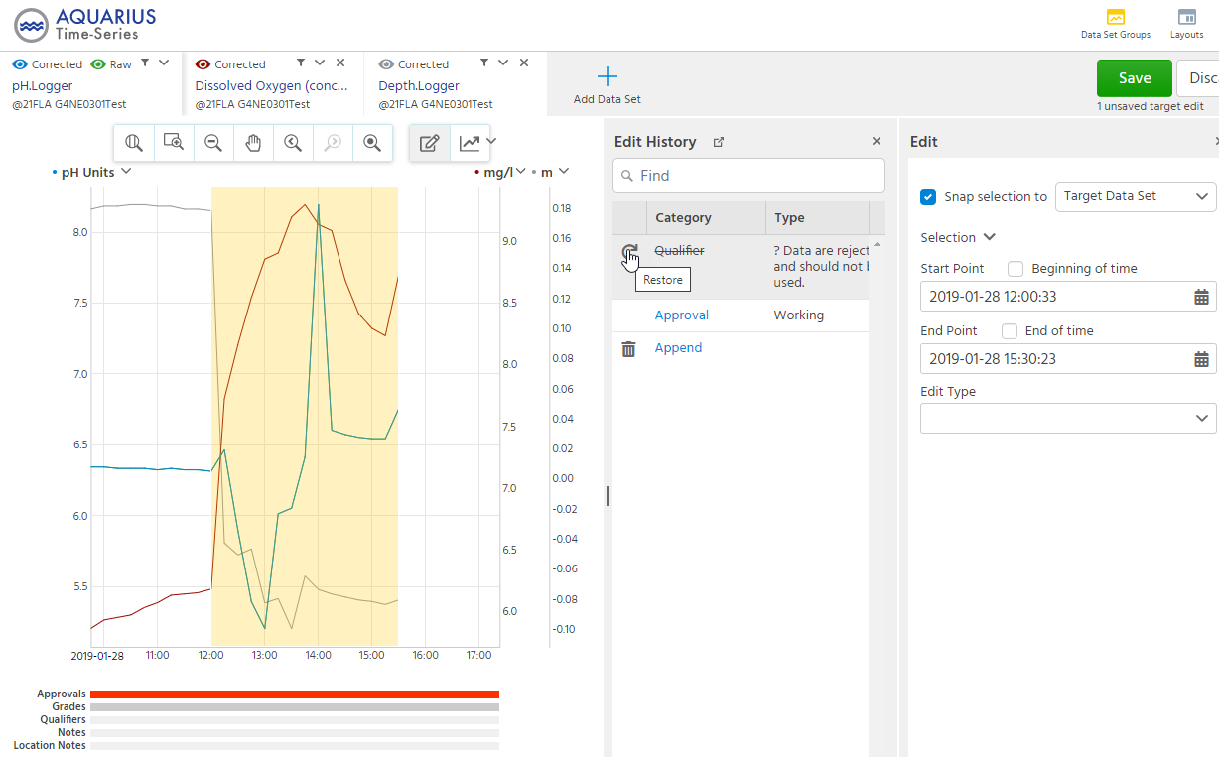
Figure A-7. DRT Edit History Save screen

Adding Notes in AQUARIUS
Notes may be added to a specified date/time range of a time-series for a parameter (s) using a similar process as for Qualifiers. If applicable, the same Note(s) may be applied simultaneously to the same data/time range of the time-series for other parameters. This example describes how to apply Notes simultaneously to several parameters for a time-series. It is recommended that Notes relevant to “J” and “?” Qualifiers be applied directly after the Qualifiers are added.
- To add Notes, follow steps 1-3 of the Adding Qualifiers in AQUARIUS section of the Appendix. If Qualifiers were just added, the area of focus for Notes relevant to those Qualifiers should already be available for use.
- Select Edit Type of Note from the dropdown menu (Figure A-8).
- For Applies to, select each parameter time-series to which you want the Note to be applied. The first parameter in focus is defaulted (i.e., no need to select it).
- In the Note box that is rendered on screen, type in the desired note. In this example the note was “Sonde is known to have been out of the water. Sonde was no longer submerged. Data for all parameters are rejected.”
- Select Apply towards the bottom right of the screen.
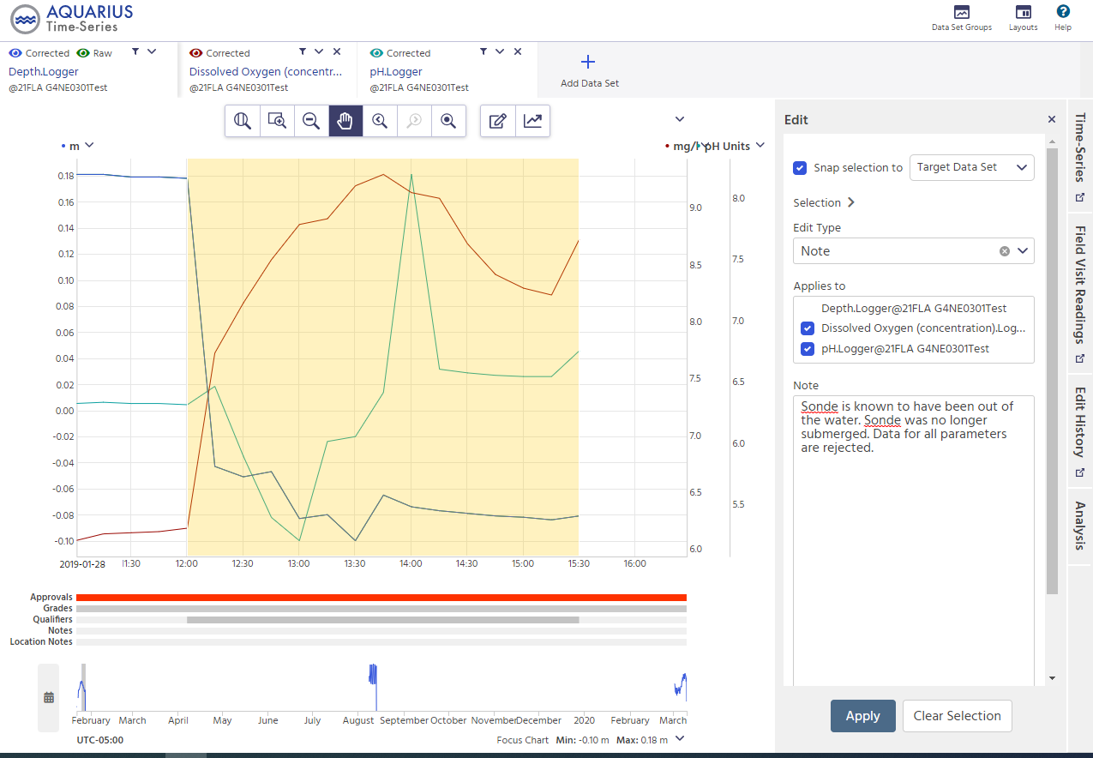
Figure A-8. DRT screen showing Note selection choices
- Pointing to the Notes line below the time-series plot will display the Notes for the time-series area of focus (Figure A-9). Select Save at the top right of the screen to keep the resulting changes.
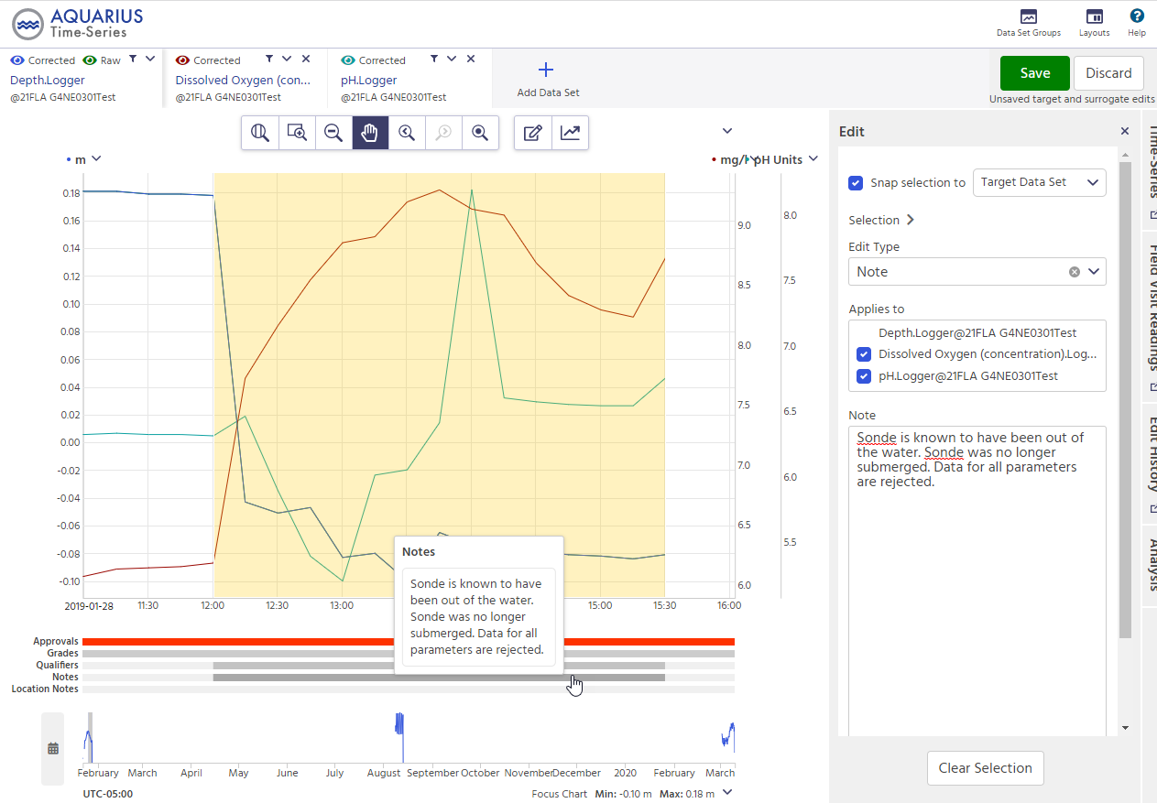
Figure A-9. DRT screen displaying resulting Notes
If a Note was applied in error or contains an error, it can be removed by selecting the Edit History tab on the right margin of the screen.
- Select the Discard (trashcan) icon for the Edit to be removed. If a Note was applied to multiple parameters simultaneously, the removal of the Note also applies to all the parameters.
- Select Save to remove the Edit or click the Restore icon to retain (i.e., not remove) the Edit (Figure A7. DRT Edit History Save screen).

