DO Continous Monitoring Meeting
6/12/2017

Participants
Curtis Musson
Alicia Hogue
Kalina Warren
NW ROC: Ben R.
TLH ROC: Chris G., Mike E.
NE ROC: Jeremy P., Amy K.
SW ROC: Matt B., Sarah M.
SO ROC: Kirby W.
SE ROC: Matt S.
CEN ROC: Mike D., Natalie A.

- Getting meters ready for deployment
  - We want DO, pH and Cond probes for the deployable sonds.
  - If you are buying a new DO probe for this project buy an optical DO probe.
  - Everybody has sondes that can be used for deployment but most need probes or maintenance.
  - Most ROCs have new probes ordered.
  - Order any probes and schedule maintenance if needed.
  - GeoTech is certified to repair YSI and work faster than YSI. If your YSI needs maintenance consider using GeoTech.
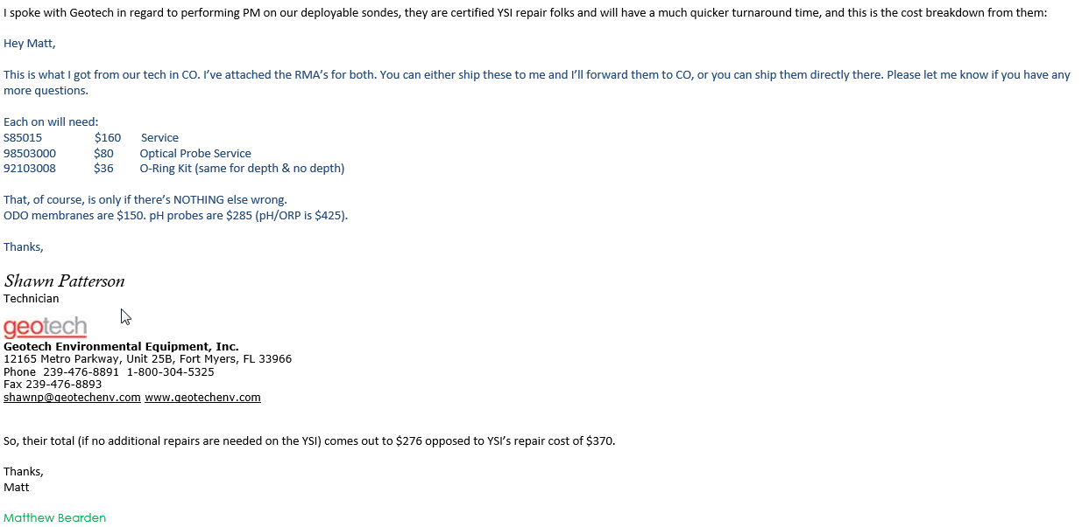
- Deployment
  - Refer to the YSI manual for deployment instructions.
  - YSI manuals are on YSIs website.
  - When deploying attach a DEP label with our contact info on it. (Alicia and Curtis)
  - Armoring during deployment is critical so the YSI is not lost and is held at a constant depth (0.3m). Materials discussed include perforated PVC pipe, fence posts, bike locks, cable, chains.
  - Sonds should not be deployed during storm events because we don’t want to lose the sonds in high flow conditions and storm events are not representative.
  - Spot checks to be done at deployment and pick up. Refer to DEPs Draft Continuous Monitoring SOP.
  - Don’t use anti-fowling solution. It does not work.
  - Putting a piece of copper tape around the probes helps to prevent fowling
  - The built-in wipers do help.
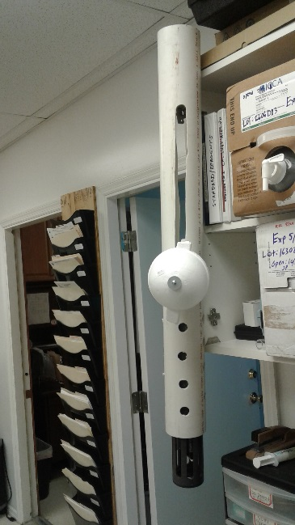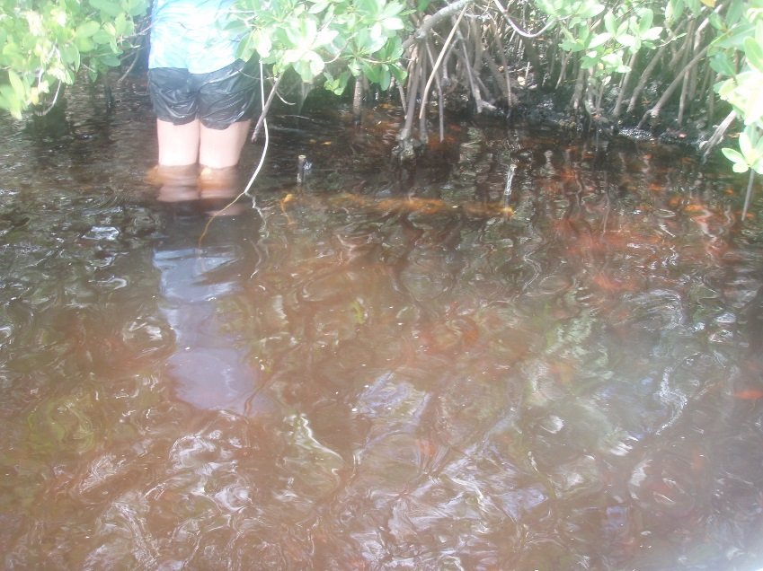

- Data Goals
  - 5 Events
  - 20 full days of readings (minimum)
  - 4 quarters
  - 1 water chemistry sample with each deployment event collected during pickup.
  - A minimum of 1 reading every 30 min.
  - It was decided that readings should be collected at 15 minute intervals. After the meeting, some members of the group contacted me with concerns and recommended we use 30 minute intervals. Further direction is required on this subject. Can you point out the concerns?
- Field Sheets
  - Ben R. and Amy K. are modifying existing calibration logs and field sheets for CM.
- WBIDs
  - A draft list of WBIDs was shared with the group. Send any comments you have to Curtis.
  - Most WBIDs are in Group 1 basins. The data for Group 1 WBIDs needs to be collected by the end of the Cycle 4 Verified period, 6/30/2018.
- Data
  - EcoWatch is the program used to take data off the sonde.
  - All groups except WAS and TLHR have EcoWatch and are trained on it.
  - Data is output in a text file and, for now, will be saved on the FTP.
  - Tallahassee staff will enter the data into Aquarius.
  - CM data from previous project exist and should be sent to Curtis.
- Homework
  - Read the Draft DEP Continuous Monitoring SOP.

