SMP Continuous Monitoring Folder Hierarchy and Naming Convention

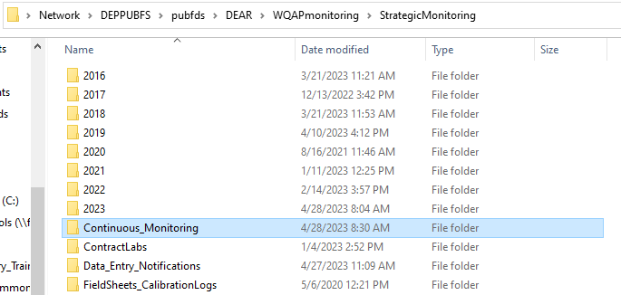
The Continuous Monitoring folder is located within the Strategic Monitoring folder:
Network Files hyperlink:
\\Deppubfs\pubfds\DEAR\WQAPmonitoring\StrategicMonitoring\Continuous_Monitoring
Web hyperlink:
https://publicfiles.dep.state.fl.us/DEAR/WQAPmonitoring/StrategicMonitoring/Continuous_Monitoring/

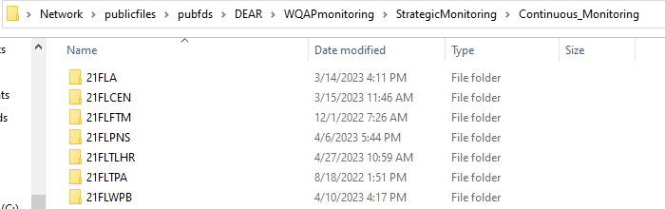
Open your Org (Please note that these Orgs were previously housed in the “Data” folder within this subfolder)

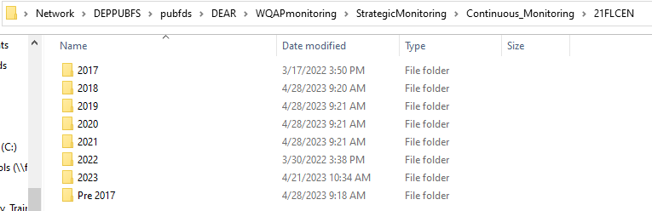
SMP began collecting CM data in 2017. Non-SMP CM data should also be housed here.

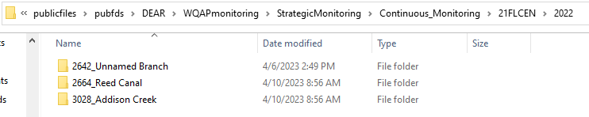
Folder naming convention: WBID-Number_WBID-Name

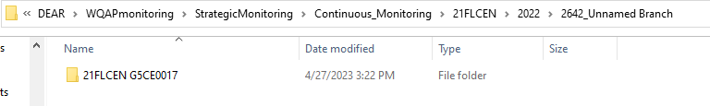
Folder naming convention: Eight Character Org Code and G-number (i.e. IWR Station)
- 21FLA , ORG_ID + 3 Spaces
- 21FLCEN , ORG_ID + 1 Space
- 21FLPNS , ORG_ID + 1 Space
- 21FLFTM , ORG_ID + 1 Space
- 21FLTPA , ORG_ID + 1 Space
- 21FLWPB , ORG_ID + 1 Space
- 21FLTLHR, ORG_ID + 0 Spaces

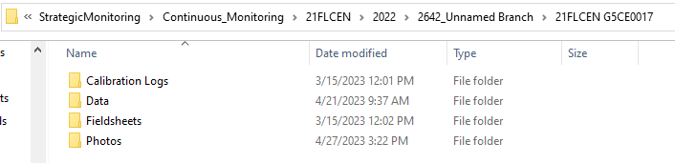

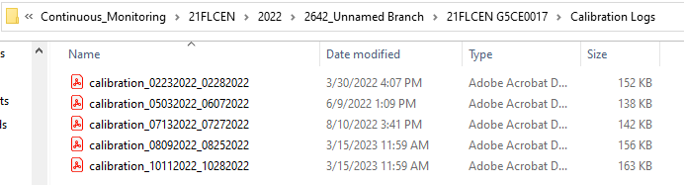
File naming convention: calibration_DeploymentDate_RetrievalDate

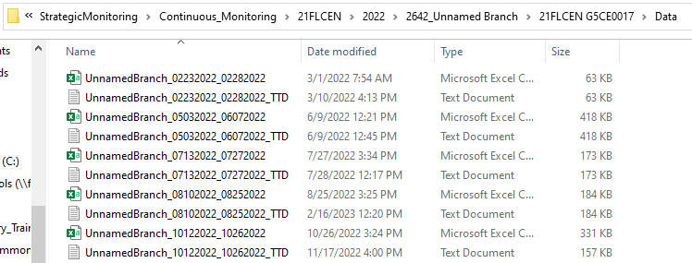
File naming convention: WBID-Name_DeploymentDate_RetrievalDate

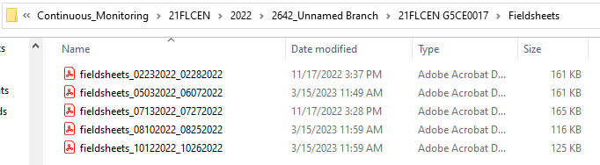
File naming convention: Fieldsheets_DeploymentDate_RetrievalDate

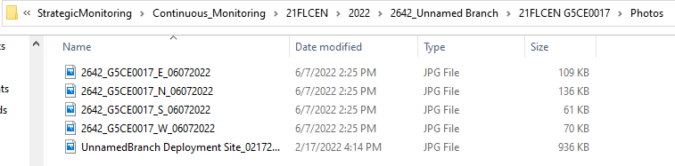
File naming convention: WBID-number_G-Number_CardinalDirection_Date

