AQUARIUS Time-Series Sign in and Data Loading How to Document
January 18, 2022
This document provides guidance for signing into AQUARIUS Time-Series (AQTS) Cloud and loading DEAR continuous monitoring (CM) data. The term AQUARIUS and the acronym AQTS are used interchangeably throughout.
Orienting AQUARIUS Time-Series
Sign in to AQUARIUS at https://fdep.aquaticinformatics.net/AQUARIUS (Figure 1).
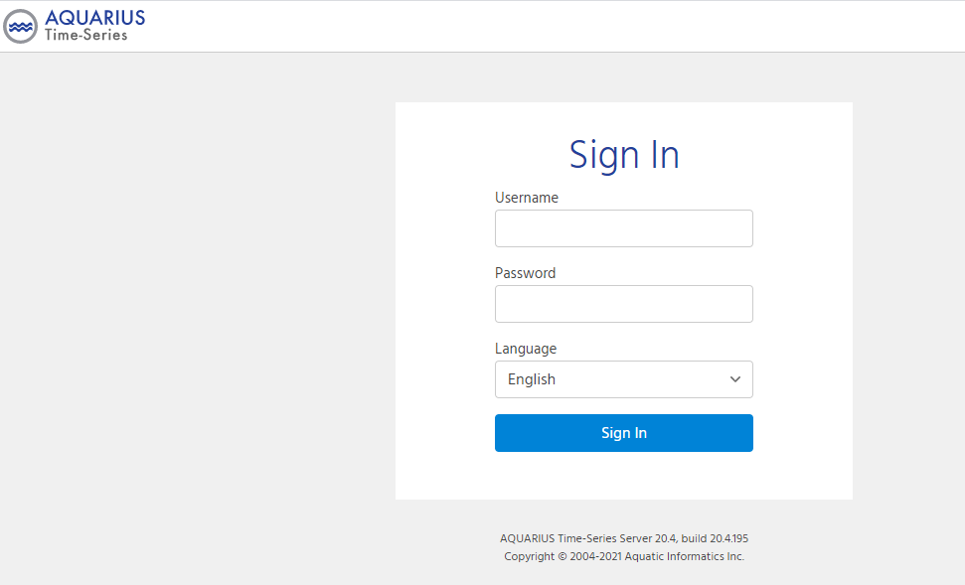
Figure 1. AQTS Sign In screen
Enter the Username and Password for your ROC.
Each ROC has been assigned its own license, with Username as the ROC name (e.g., NEROC). The license is usable by all staff data loaders (the Hydrologist role per AQUARIUS) who are provided the Password for that license. One individual from each ROC is the “named” user of the ROC, and any data loaded or edited (e.g., addition of qualifiers, etc.) under that ROC name will show that person’s name as the data loader for database actions. The named user for each license is provided here (AQTS_ROC_License).
Once signed in, you should see the following Locations screen (Figure 2). Note the “?” icon on the top right of the AQUARIUS ribbon. Clicking on “?” will enable you to select Help. Selecting Help takes you to the AQTS user guide (Figure 3) where you can explore a range of topics.
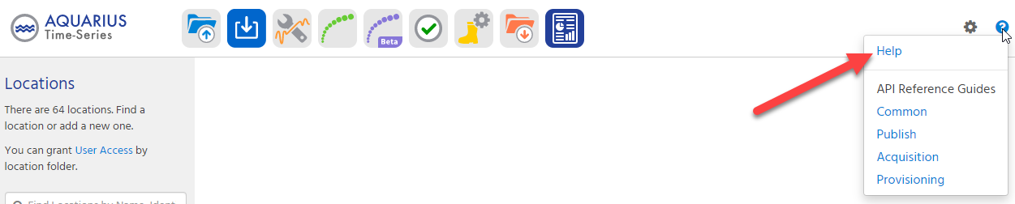
Figure 2. AQTS Locations Screen at Sign In
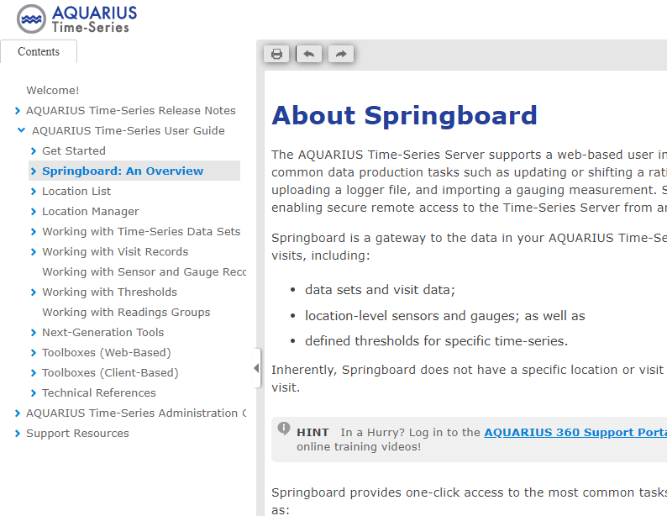
Figure 3. AQTS User Guide
Return to the Locations screen (Figure 4):

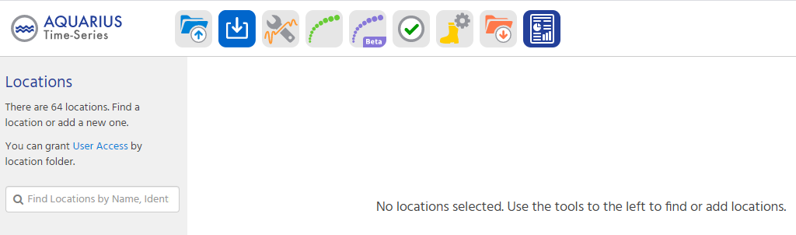
Figure 4. AQTS Locations Screen
Currently there are 64 monitoring locations loaded to AQUARIUS; 58 locations are from the DEAR CM Monitoring Location Inventory; 6 test locations are for use during data loading training. Through its license, each ROC has data loading access only to the monitoring locations in its AQUARIUS Location Folder and to the monitoring locations in the Test folder (see folder names and permissions in Table 1 below). Anyone who has the web site address for the DEAR AQTS site may access AQTS reports and may extract time-series data from any monitoring location through the Username of DEARGuest and the Password of Guest.
Folder Location Name | Write permission (AQTS Hydrologist Role) | Public permission (view, reporting, data extraction)
All Locations.CEROC | CEROC | DEARGuest
All Locatons.NEROC | NEROC | DEARGuest
All Locations.NWROC | NWROC | DEARGuest
All Locations.SEROC | SEROC | DEARGuest
All Locations.SOROC | SOROC | DEARGuest
All Locations.SWROC | SWROC | DEARGuest
All Locations.TLHROC | TLHROC | DEARGuest
All Locations.DEAR | (admin) | DEARGuest
All Locations.TEST | All ROCS | DEARGuest
Table 1. AQTS folder names
The AQUARIUS Hydrologist role (data loader) currently is configured as follows (Figure 5):
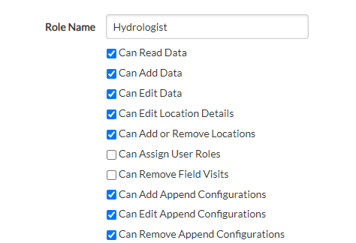
Figure 5. Hydrologist Role
The Hydrologist role for your work must be assigned the ability to Edit Location Details and to Add or Remove Locations for you to be able to set up New Basic Time-Series (NBTS - the NBTS process is described later in this training document). However, per the DEAR CM Data Management Standard Operating Procedure (SOP), if a monitoring location needs to be added to AQUARIUS, please send the WIN Org ID and WIN Monitoring Location ID to the DEAR AQUARIUS Administrator with a request to add it to AQUARIUS. Please do not load (or remove) monitoring locations manually. Loading or removing monitoring locations manually may create referential integrity or data loss problems that we must avoid.
Additionally, if you need to Edit Location Details for any fields for a monitoring location, please also send a request to the DEAR AQUARIUS Administrator and include the Org ID and Monitoring Location ID and detailing what needs to be modified.
For this initial training exploration, type Test into the Find Locations by Name, Ident search box (refer to Figures 4 & 6) and select XXTEST21FLPNS G4NW0358Test-XXTest Clear Creek @ Tecumseh Trail from the dropdown list.

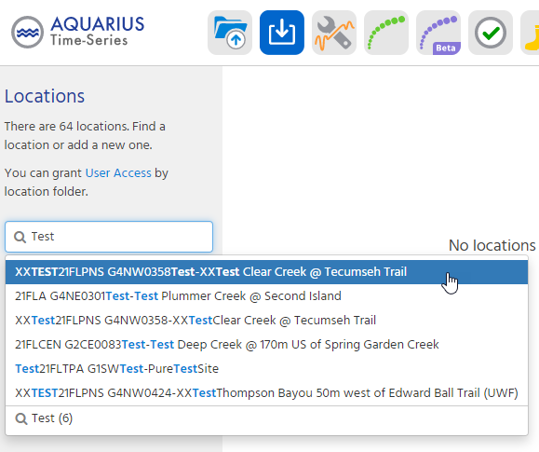
Figure 6. Selecting a Location
Click on the icon with 3 horizontal bars (Figure 7). You’ll see the options available (left column) for exploration and data entry for that location.
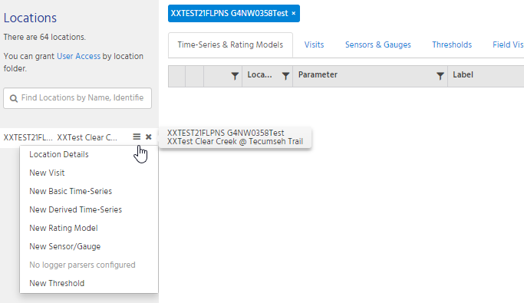
Figure 7. Location Options
Click on Location Details if you want to view them (Figure 8).
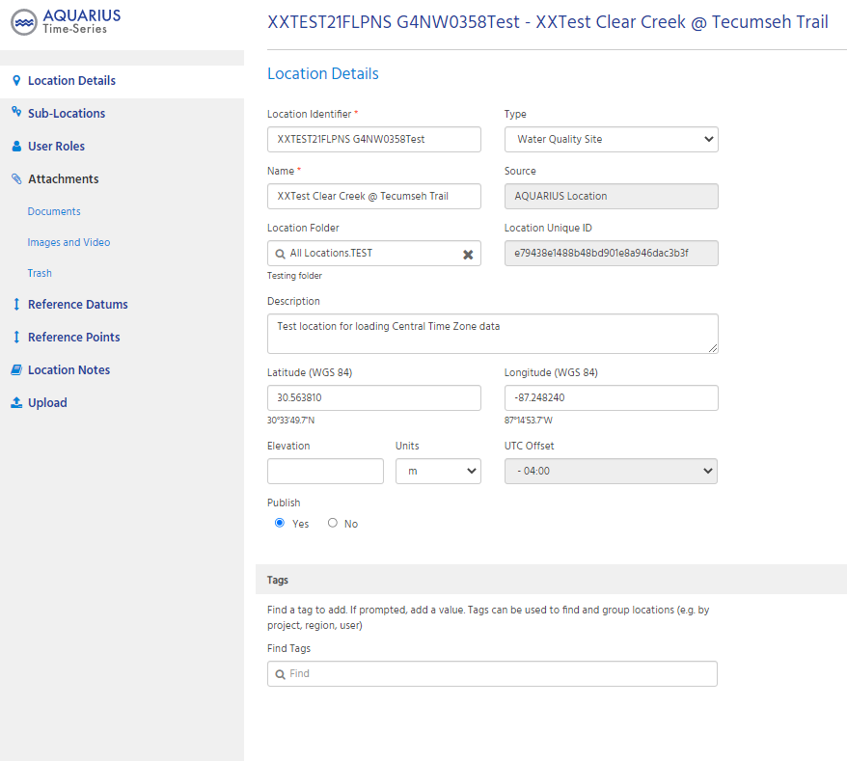
Figure 8. Location Details
Next, type Test again into the Find Locations by Name, Ident box and this time select the Test (6) entry in the dropdown. Alternatively, type in your ROC folder name. From there, toggle the chevron which will show you a list of all locations in the Test folder (Figure 9) or in your ROC folder.
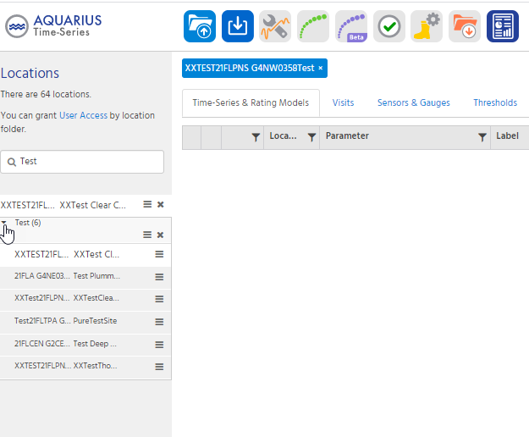
Figure 9. Test Locations
Creating an AQUARIUS Time-Series
This portion of the training document addresses setting up New Basic Time-Series (NBTS) and subsequently loading data to those time-series.
A New Basic Time-Series must be created for each parameter for which time-series data are to be loaded to a monitoring location, if one does not already exist for that parameter. The AQUARIUS default process currently requires establishing a New Basic Time-Series individually for each parameter for a given location. DEAR is exploring Application Programming Interfaces (APIs) as a means of potentially bulk-creating New Basic Time-Series for common parameters across locations, when a location(s) is first loaded to AQUARIUS.
To create a new time-series data set for a location (first file loaded for a parameter, select the monitoring location of interest from the Find Locations by Name, Ident search box.
Click the button and select the New Basic Time-Series option from the dropdown (Figure 10).
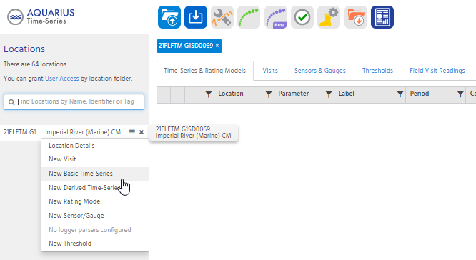
Figure 10. AQTS application showing New Basic Time-Series selection option
DEAR has determined the defaults desired to populate Time-Series Attributes for creation of each New Basic Time Series. DEAR hydrologists can proceed to populate the Time-Series Attributes (Figure 11) as described in Table 2 and Table 3 and click Save.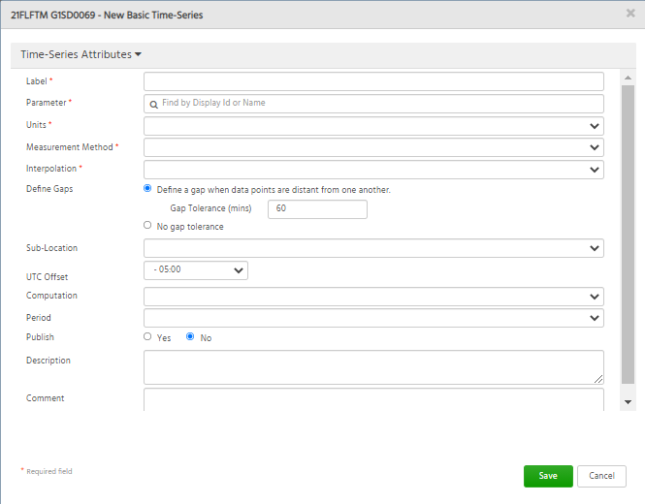Figure 11. AQUARIUS application showing New Basic Time-Series screen

AQTS New Basic Time-Series Attribute | Required? | Populate with | Comment
Label | Yes | Sonde
Parameter | Yes | Select from the dropdown list | Populate from the dropdown list with the relevant parameter name listed in Table 3 of this training document.
Units | Yes | Auto populates once Parameter is populated. | This field should auto populate with the unit shown for the parameter in Table A-6 of this SOP. If it doesn't auto populate, select the unit in the dropdown list that matches with what is in Table 3 for that parameter. If the auto populate unit is incorrect for the parameter being loaded, notify the AQUARIUS Administrator before proceeding.
Table 2. Populating New Basic Time-Series Attributes

AQTS New Basic Time-Series Attribute | Required? | Populate with | Comment
Measurement Method | Yes | Select "None" from the dropdown list
Interpolation | Yes | Select "Instantaneous Value" from the dropdown list. | For most of the DEAR parameters, AQUARIUS queues up "Instantaneous Value". AQUARIUS queues up a default selection of Discrete Value for the Depth parameter. Instead, select "Instantaneous Value" for the Depth parameter, because this field will hold the logger (instantaneous) water depth data (i.e., it is not the depth at which the meter was deployed.
Define Gaps | Yes- DEAR; No- AQUARIUS | Toggle on
Gap tolerance (mins) | Yes – DEAR, Conditional- AQUARIUS | Populate with 16 if results are collected at 15-minute intervals, 31 for 30-minute collection intervals, etc. (i.e., use a 1-minute increment to the collection interval). | Gap tolerance is required if Define Gaps is toggled on. DEAR has determined to Define Gaps, so a Gap tolerance must be populated. AQUARIUS suggests a 1-minute increment to the collection. DEAR also has determined to use a 1-minute Gap tolerance.
Sub-Location | No | Leave blank
UTC Offset | Yes, but auto populated | Auto populates with the UTC Offset of the monitoring location (either -05:00 or -06:00 for DEAR locations). An alternate selection can be made from the dropdown list for the reason noted in the comment field of this table (Table 2) of this training document. | If all sonde results for a given monitoring location will be recorded in a different time zone than where it is located, that different time zone UTC Offset can be selected from the dropdown. E.g., if TLH ROC always records date, time and sonde parameters for a Central Time Zone site using Eastern time, this field can be populated with a UTC Offset of -5:00, IF no sonde files recorded as Central Time Zone are ever anticipated for this time-series. Otherwise, always populate this field for the New Basic Time-Series with the time zone for the location. AQUARIUS defaults this to the established UTC Offset for the monitoring location.
Table 2 (continued). Populating New Basic Time-Series Attributes

AQTS New Basic Time-Series Attribute | Required? | Populate with | Comment
Computation | No | Leave blank
Period | No | Leave blank
Publish | Yes | "No" button | Leave as default selection of “No”.
Description | No | Leave blank
Comment | No | Leave blank
Table 2 (continued). Populating New Basic Time-Series Attributes

Parameter | Units
Temperature, Water | °C
Specific Conductance | µS/cm
Salinity | ppt
pH | pH
Dissolved Oxygen Saturation (%) | %
Dissolved Oxygen (concentration) | mg/L
Depth | m
Turbidity | NTU
pH voltage | mV
Voltage | V

Table 3. DEAR parameters for upload* to AQUARIUS
*Upload each parameter when available; not all meters have all sensors.

°C. = degrees Celsius; µS/cm = micro Siemens per centimeter; ppt = parts per thousand; pH = standard pH unit; % = percent saturation; mg/L = milligrams per liter; m = meters; NTU = Nephelometric turbidity units; mV = millivolts; V = volts.

Once a NBTS has been created for a parameter, it is visible in Springboard after the station location has been selected. Figure 12 shows an example of a monitoring locations where NBTS have been created for all DEAR parameters.
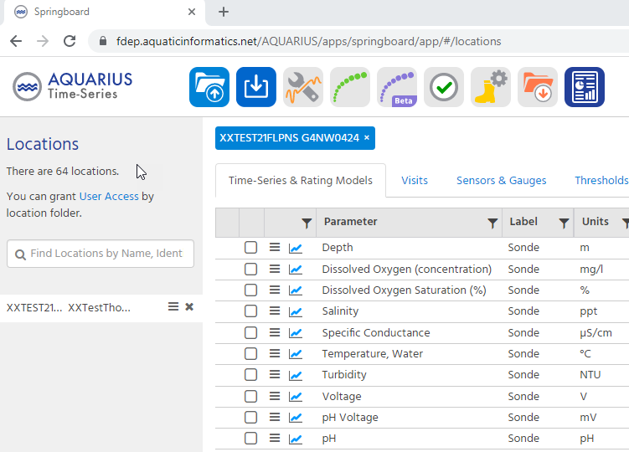
Figure 12. Springboard New Basic Time-Series example for Monitoring Location XXTEST21FLPNS G4NW0424
Loading data to an AQUARIUS Time-Series
DEAR has determined that data files must be trimmed before they are loaded to AQUARIUS to remove any pre- and post-deployment data that were recorded when the sonde was out of the water while being transported to and from the deployment site.
To load the trimmed data to a time-series, select the location of interest and click the Data Import icon (green arrow) on the top tool bar (Figure 13).
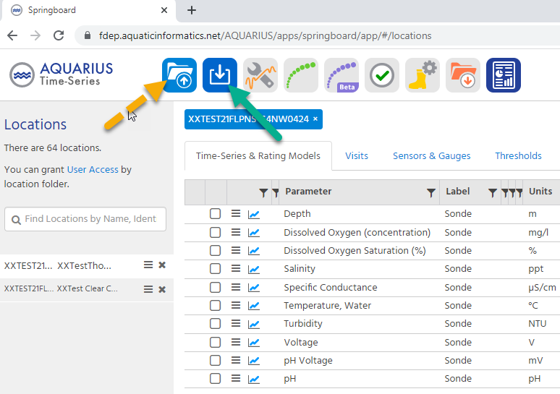
Figure 13. AQUARIUS Data Import icon
The Append tool has been deprecated by AQUARIUS (replaced by the Data Import tool), and the Append icon (orange dotted arrow) will be removed from the tool bar in a future update by the software vendor (Aquatic Informatics or AI).
Select the location of interest, if it is not already populated in the Location field.
If no saved configuration exists for the selected location or if a configuration does not include the parameter and format of interest, click the Choose File button, select the desired file import (on network or your computer), and click Next (Figure 14).
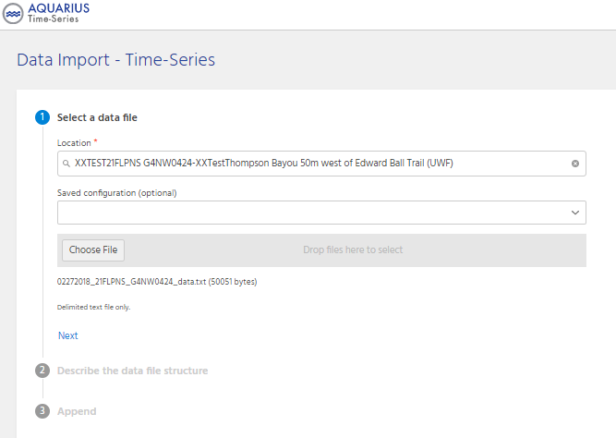
Figure 14. Initial Data Import Screen

Populate the Describe the data file structure fields for the selected file (Figure 15).
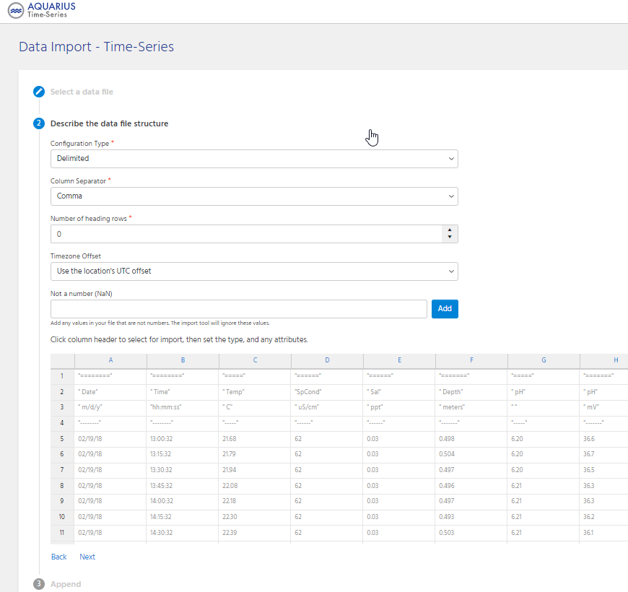
Figure 15. Describe the Data File Structure Screen
For the Timezone Offset field, select the Use the location’s UTC offset default.
As noted, click each column header intended for import, then set the type, and any attributes.
The selected file will contain either separate Date and Time fields, or it will contain a single TimeStamp field for date and time. Select the applicable Column type for the field.
Select the appropriate date, time or timestamp format, based on the data in the file, rather than what shows in the file header. For the example file shown (Figure 16), the date format is MM/dd/yy and the time format is HH:mm:ss. Click Apply.
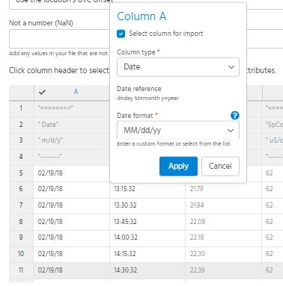
Figure 16. AQUARIUS Data Import configuration screen showing Date field
The following are some tips for date, time and timestamp formatting (Figure 16):
- Upper case M indicates month and lower case m indicates minute
- Upper case H indicates hour in 24-hour format, lower case h indicates hour in 12-hour format (a.m., p.m.)
- Review your data file for import to determine if it spans a date or time format.
  - If a data file for import contains results that are a mix of single- and double-digit months and/or days (e.g., 9/31/20 and 10/1/20), the date format must include MM and dd, rather than the single M and d only.
  - If a data file for import contains results that are only a single digit month and/or day (e.g., 9/1/20 and 9/2/20), the date format must include M and/or d only for single digit only.
  - If the format dropdown does not contain a date, time or timestamp format relevant to the file to be loaded, an applicable custom format can be added and applied.
For time-series parameter column(s), select the Column type of Time-Series point, then select the time-series to which to import the data Figure 17). This will be the named New Basic Time-Series setup previously, which can be selected by typing the first few letters of its name in the lookup box. Click Apply.
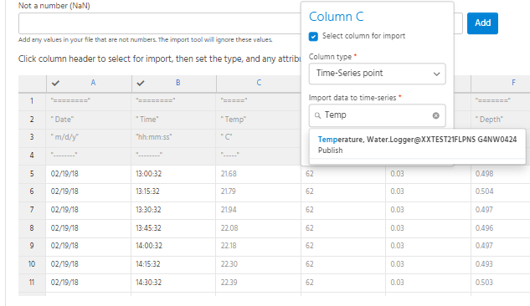
Figure 17. AQUARIUS Data Import configuration screen showing Time-Series point field for Water Temperature
Once all date, time and desired time-series parameter fields for import are selected, click Append at the bottom left of the screen. There is an option to save the configuration file for reuse at this point. Click Append Data. If there are any errors in the data or mismatches with the configuration, AQTS will display error messages for troubleshooting.
When the append is successful, AQTS displays information on what was appended, including number of rows for comparison with the data file chosen for append (Figure 18 append example). AQTS also provides the option to view the files using the Data Review Tool (DRT) to explore and ensure the appended data are as expected. Additional files also may be appended at this point.

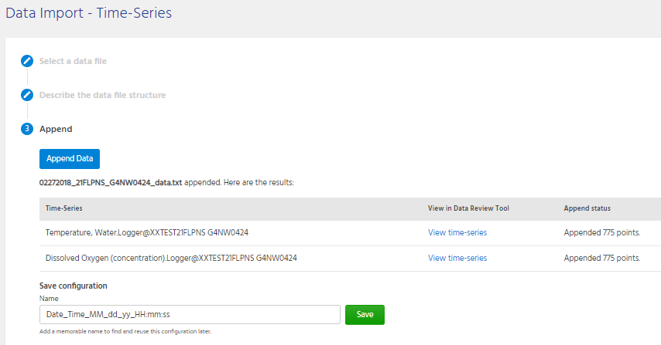
Figure 18. AQUARIUS Data Import append example
Once data have been loaded to a NBTS, the start and end dates and date of the loaded data, and date of update to the NBTS are visible in the Springboard for the selected monitoring location. In the Figure 19 example, data have been loaded to 3 time-series parameters for the location.
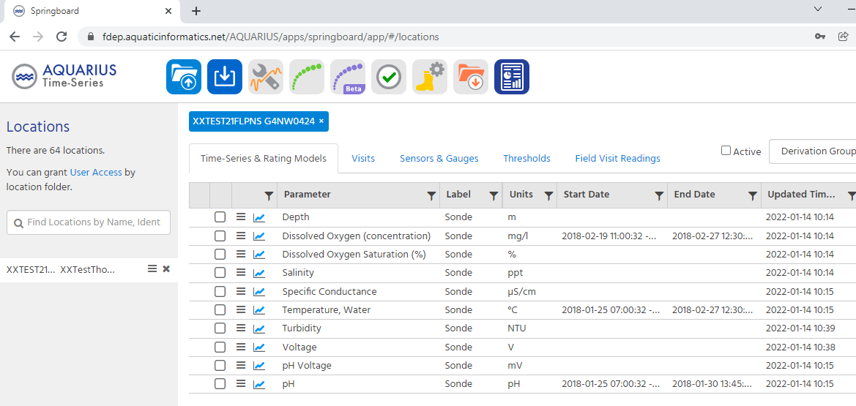
Figure 19. Data loaded example for Monitoring Location XXTEST21FLPNS G4NW0424
If there is a problem with a data file that was uploaded (e.g., data were loaded to the wrong location, you didn’t pre-/post-trim the file, all results didn’t load), the file may be removed (the specific Append may be removed). The following example demonstrates how to remove an appended file.
From the Springboard, select the desired location, select the parameter of interest, then click the Data Review Tool (DRT) icon. pH was chosen for this example (Figure 20).
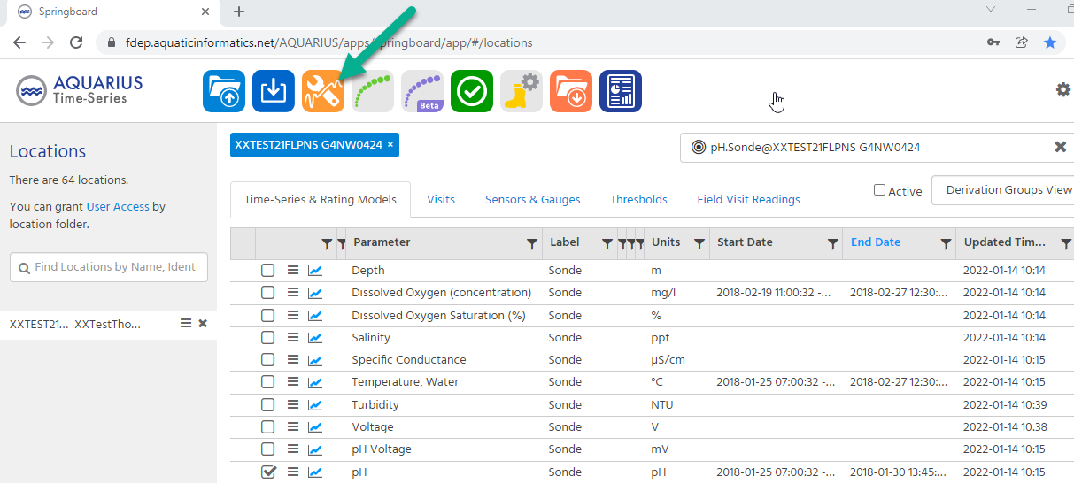
Figure 20. Springboard Menu showing the Data Review Tool (DRT) icon

On the DRT screen, click on the Edit History tab at the right margin of the screen (Figure 21).
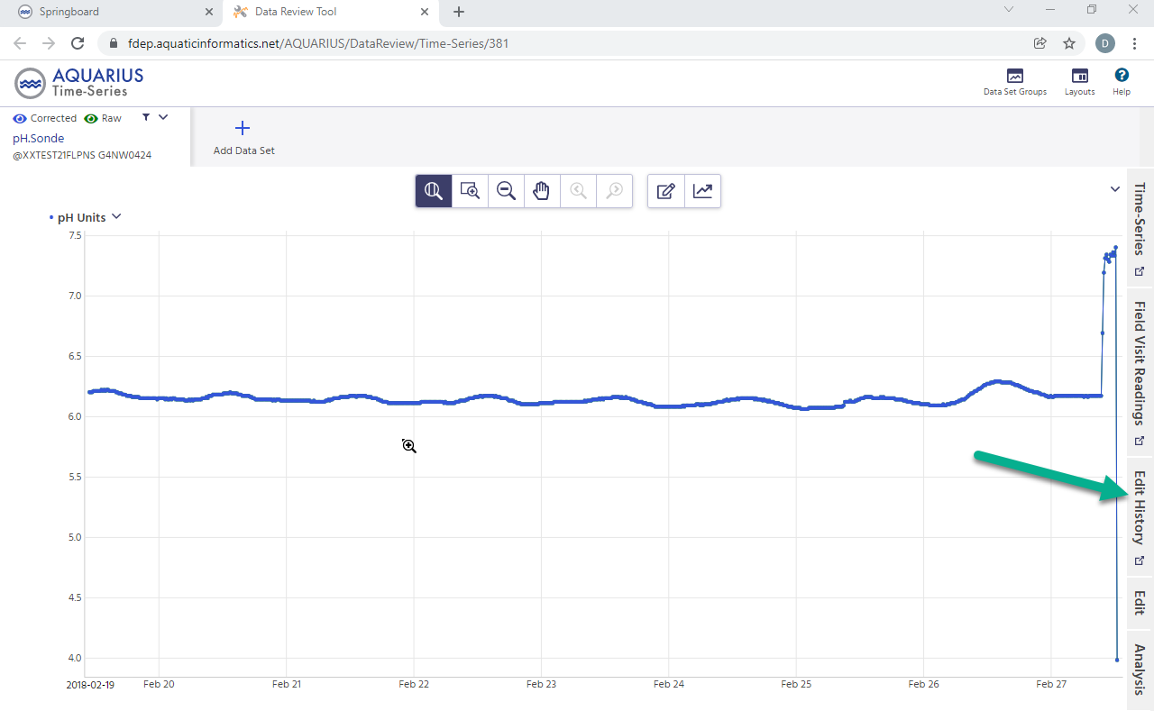
Figure 21. DRT screen

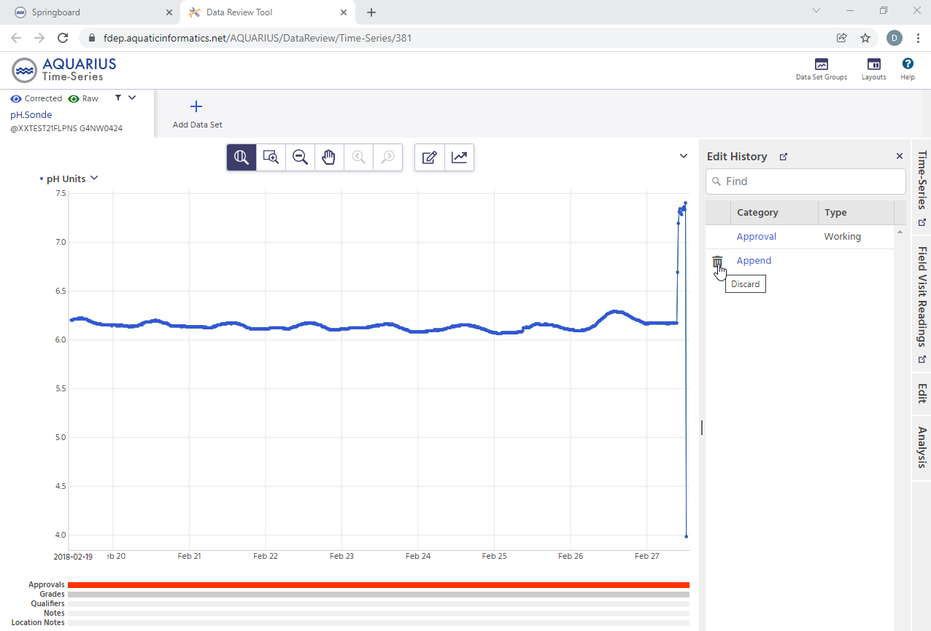
Figure 22. DRT Edit History screen
Select the Discard (trashcan) icon for the appended file to be removed (Figure 22). In this case, there is only one appended file, and it is chosen for removal.
AQUARIUS provides a warning message to ensure you want to proceed with removing the data Figure 23). Select Undo Append if you want to remove the appended file. Select Cancel if you want to retain the appended file.
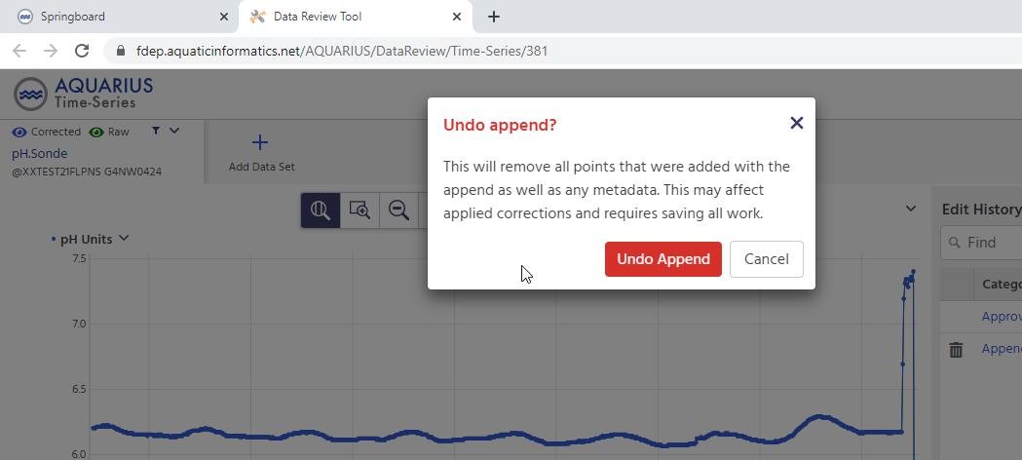
Figure 23. DRT Edit History Undo append message
4

If your data file was recorded for a different UTC than the monitoring location (e.g., if TLHROC records sonde data for Eastern Time Zone, and the location is in the Central Time Zone), please select a Timezone Offset of the sonde record (-5:00 in this example) for the configuration.

