SMP Continuous Monitoring Guidance

June 09, 2022
Minimum Data Sufficiency:
- Measurements from 3 calendar weeks in the same calendar month.
- At least 3 full days from each calendar week.
- At least 13 full days per event.
- Deployment and retrieval days can be from a different calendar month than the full days.
- Deployment and retrieval days can be different weekdays (Mon., Tue., Wed., etc...).
- 15-minute measurement intervals
- At least 1 deployment in each quarter
- 5 deployments events per calendar year
- To the best of your ability, the length of time between deployment events should not exceed 12 weeks, 62-302.533 (2) F.A.C. The 12-week period starts with the first full day of Deployment-A and end with the last full day of Deployment-B (Figure 1).
- Dissolved Oxygen, Specific Conductance and temperature probes required. pH probe informative but optional.
- In Estuary, Coastal and Stream (NOT Lake) Type WBIDs, Sondes should be placed in the bottom half of the water column, ideally 0.5 m off the bottom, to capture the denser sea water, “Salt wedge” on the bottom, 62-302.200 (30) F.A.C.
- In Lake Type WBIDs, sondes should be deployed a depth between 0.3 and 2.0 meters.
All deployments will follow this protocol – we will no longer have 6-day “Week” deployments or 30+ day “Month” long deployments.
Definitions:
Calendar day: Midnight to Midnight
Calendar week: Sunday – Saturday
Table 1: Option 1, Deploy Before Wednesday or Earlier, 3-7-3 Approach
Sunday | Monday | Tuesday | Wednesday | Thursday | Friday | Saturday | Week
NA | Deploy  Month  A or B | Deploy  Month  A or B | Deploy  Month  A or B | Full Day  Month B | Full Day  Month B | Full Day  Month B | 1
Full Day  Month B | Full Day  Month B | Full Day  Month B | Full Day  Month B | Full Day  Month B | Full Day  Month B | Full Day  Month B | 2
Full Day  Month B | Full Day  Month B | Full Day  Month B | Retrieval  Month  B or C | Retrieval  Month  B or C | Retrieval  Month  B or C | NA | 3
Deployments that start no later than Wednesday will capture 3 full days of measurements, meeting the week data sufficiency requirements in Week 1. To meet all data sufficiency requirements, retrievals should not take place earlier than Wednesday of Week 3 to capture the 3 full days of measurements needed to meet the week data sufficiency in Week 3.

Table 2: Option 2, Deploy After Thursday or Later, 1-7-7-3 Approach
Sunday | Monday | Tuesday | Wednesday | Thursday | Friday | Saturday | Week
NA | - | - | - | Deploy  Month  A or B | Deploy  Month  A or B | Full Day  Month  A or B | 1
Full Day  Month B | Full Day  Month B | Full Day  Month B | Full Day  Month B | Full Day  Month B | Full Day  Month B | Full Day  Month B | 2
Full Day  Month B | Full Day  Month B | Full Day  Month B | Full Day  Month B | Full Day  Month B | Full Day  Month B | Full Day  Month B | 3
Full Day  Month B | Full Day  Month B | Full Day  Month B | Retrieval  Month  B or C | Retrieval  Month  B or C | Retrieval  Month  B or C | NA | 4
Deployments that take place after Wednesday will not meet the week data sufficiency, 3 full days, in Week 1. To meet all data sufficiency requirements, retrievals should not take place earlier than Wednesday of Week 4 to capture the 3 full days of measurements from at least 3 calendar weeks, needed to meet the month's data sufficiency.
Figure 1: 12-Week Event Spacing, 3-7-3 Approach
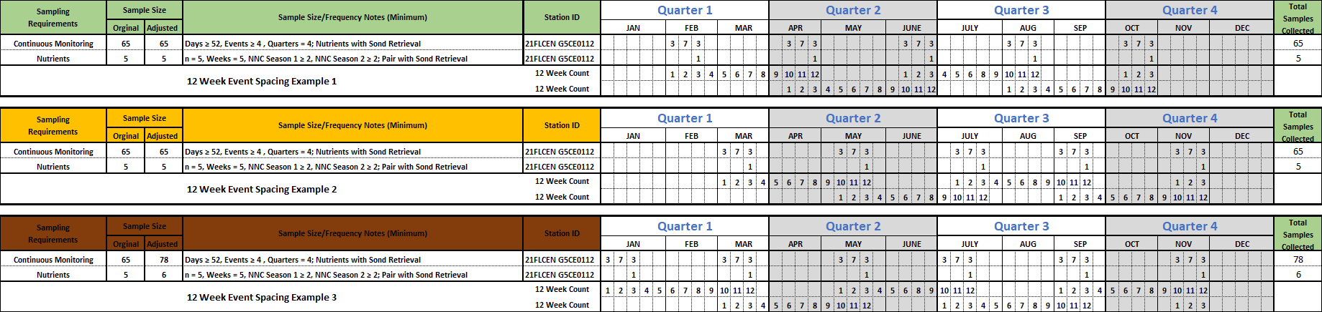
This is a factious calendar year. The number of calendar weeks, 4, 5, or 6, in each month varies year to year. You will need to map out a new deployment schedule each year. If the first event is done too early in the year 6 events will be necessary to meet both the ≥ 1 event per quarter and 12-week event spacing data sufficiency requirements, Figure 1 Example 3.
Figure 2: Week Event Spacing, Mix 1-7-7-3 Approach and 3-7-3 Approach

