Standard Operating Procedure
for using the DEP LIMS Browser and Cost Projector

1. SCOPE

The Laboratory Information Management System (LIMS) Browser is a tool used for searching and viewing data. The Browser also can be used to create electronic or hard copy reports.

2. BROWSER ACCESS

To access the Browser go to the General menu and select LIMS Browser.

2.1 LIMS Browser: Screen 1 – Searching for Data

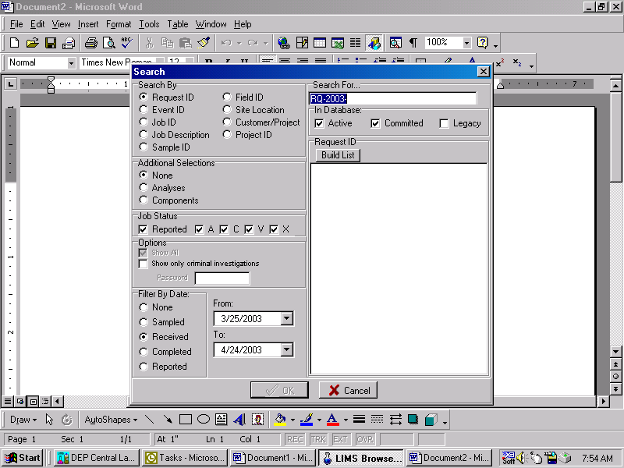

Search By
Records can be searched by selecting any one of the parameters listed.
- Request ID: ID number generated when the event gets scheduled.
- Event ID: Report name. The event name is generated when the samples are logged into the LIMS.
- Job ID: Within each event there are one or more job IDs. Each job ID contains data related to a specific analytical group.
- Job Description: Refers to the description that is created in the scheduler under “Sampling Event Description.”
- Sample ID: The unique number that is assigned to a container by the LIMS system.
- Field ID: The label assigned to one or more containers linked to a site identifier assigned at the time of sample collection.

If the entire search parameter number or name is not known, then a portion of the parameter can be typed and the browser will perform a wildcard search. After typing the parameter in the Search By box, click Build List. If more than one item is returned they can be multi-selected. After selecting the chosen items click OK.
Note: The search by customer will also bring up a project list. Click Build List for the projects then select one or more projects.

Additional Selections
The search can be narrowed down to specific analytes or components. If the Analyses or Components option is selected an analyses/component list will display after the data have been retrieved. The analyses/components of interest can then be selected.

Job Status
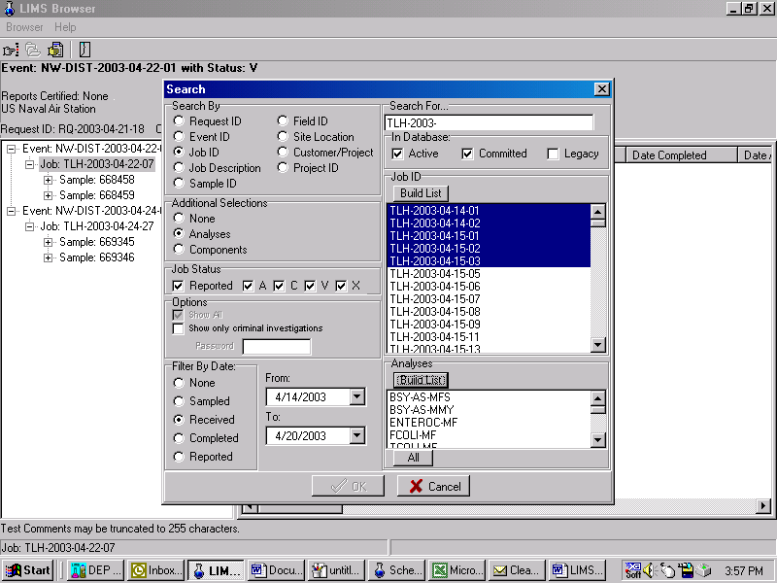The data search can filter out certain job statuses. For example, if only V status jobs are needed then check only that status. For general data searches it is recommended that all statuses be checked.
Statuses:
- Reported: All jobs in the event are A status but the event may or may not have been reported to the client. This is a remnant of when the lab reported final results at the job level.
- A: The job is A status but the event may or may not have been reported if there are other jobs in the event that are not A status.
- C: The analyst has uploaded the data but they have not been reviewed and authorized by a supervisor.
- V: The job does not have all the data uploaded yet.
- X: The job has been cancelled. Samples in a cancelled job do not get analyzed.

Options
- Show All: If the Show All box is checked, the program will retrieve all events associated with the Request IDs identified by the search criteria. This option is available when searching by Event, Job, Job Description, Sample ID, Field ID or Site Location and no additional selections (Analyses or Components) are indicated.

- Show Only Criminal Investigations: The only staff that have access to data from criminal cases are the individuals who scheduled the analyses and laboratory staff. Any others that need access may contact the Laboratory or the project manager to obtain the password. If this box is checked the search will bring up only the criminal case events.

- Filter by Date: By selecting one of these items and using a small date range you can narrow the search. For example, if you know the date collected but have no other information you can bring up a list of all samples collected on that day and then select from the list. If “None” is selected the search may encompass many years so it is best to select a type of date range when searching for data.

- In Database: Below the box where the search parameter is entered there are several selections: Active, Committed and Legacy. The Active database contains data for events not reported and those certified within the past 90 days. Older events are transferred to an identical set of tables called the committed database. This construct allows faster retrievals for more recent data. The Legacy database accesses records from an older version of LIMS (pre-1999) and some of the search parameters are not applicable.

2.2. LIMS Browser Screen 2 – Viewing Data

After clicking OK on one or more selected items the screen below will display.
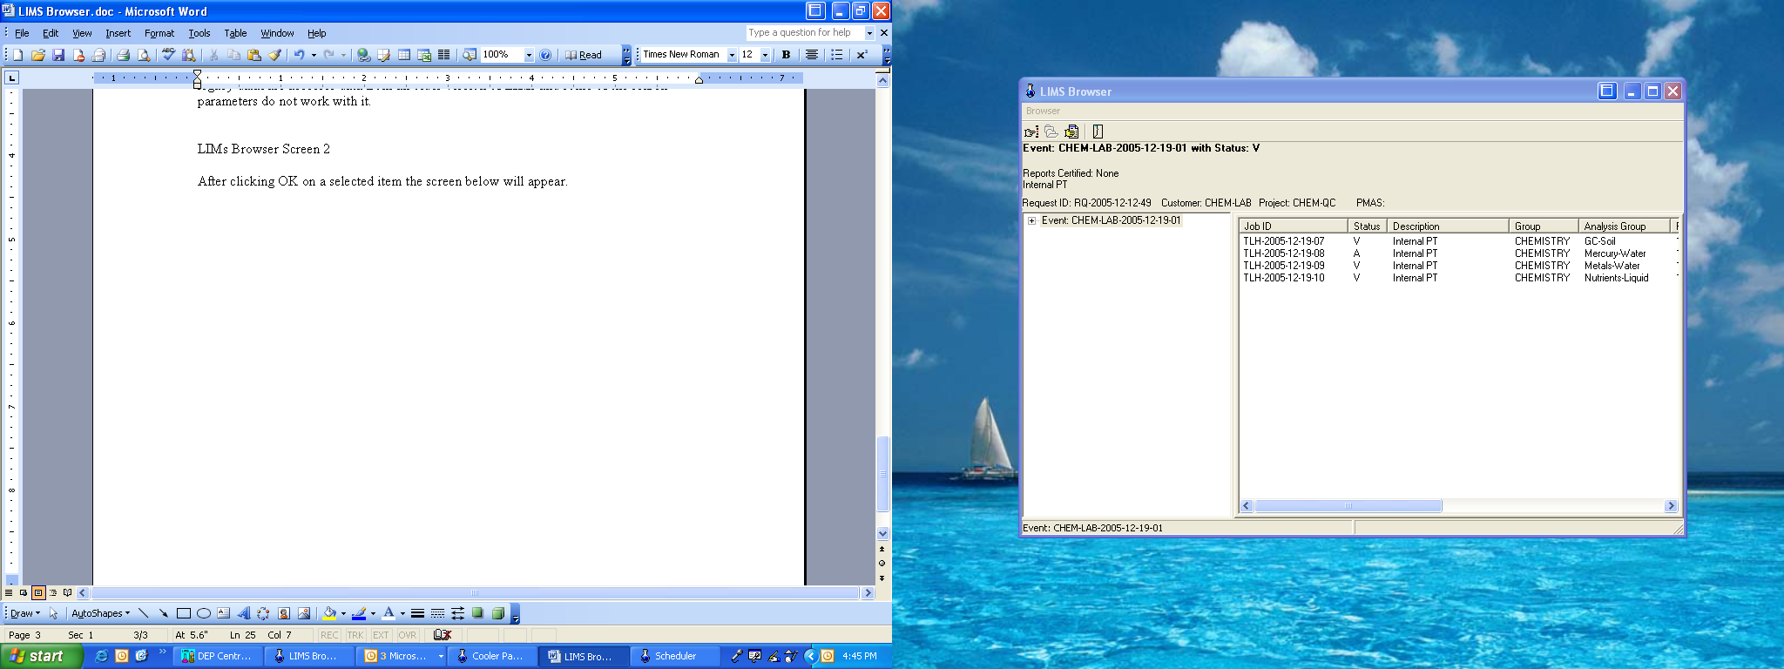

The information can be viewed by clicking on the event ID. As each new level appears the item can be clicked on to go to the next level down. This is not suited to data review but more for a quick lookup of information for one item in an event.

For data review tools click on the Report/Files button. The screen below will appear.

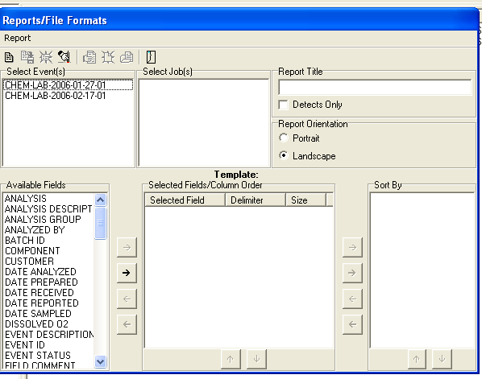

Highlight the event(s) of interest. Then highlight the job(s) to retrieve.
Under the Available Fields choose the fields that are needed in the report. Highlight each field and click on the top arrow or double-click to move the parameter to the middle window.

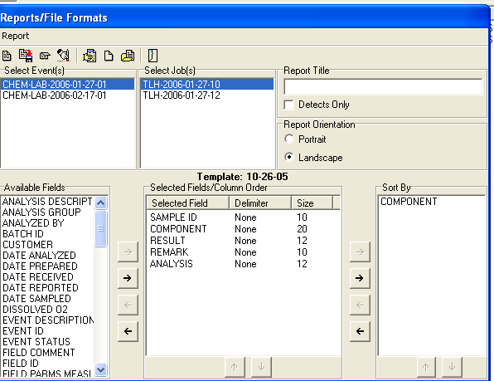
The program will display the fields in the order they are selected. It will also sort by the parameters in the order they are selected unless a different sort is chosen by highlighting a parameter in the middle window and clicking on the top arrow by the Sort By window.

The size of the fields (column width) can be customized by selecting the fields of interest and clicking on “Size” in the header. Increase or decrease the number to enlarge or shrink the column width.

After the fields have been selected a report can be displayed by clicking on the View/Print button or choosing that menu option. The parameters can also be assigned a delimiter to create a file which can be loaded into Excel.

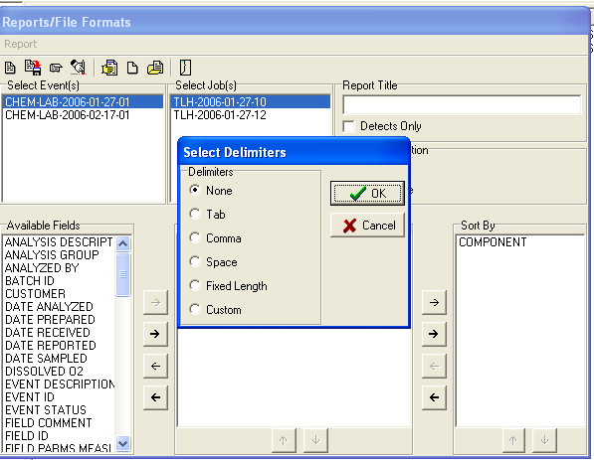
To create a delimited file, highlight the parameters in the middle window and click on the Delimiter header. A window will pop up with delimiter options. Click the delimiter of interest.

After choosing the delimiter, click OK. Click on the Create Delimited File button or choose the menu option. A dialog box will be displayed, prompting the user to save the file. Select the directory for saving and name the file. Click OK to save.

The customized field selections can be saved as a template. After the fields, the sort by and the delimiter selections have been made, click on the icon pictured to the left. In the window that pops up name the template.

To use an existing template, highlight the events/jobs of interest and click the Open Template button. Select the template of interest and click OK.

Other features
To view results of only values above the detection limits then check the box Detects Only.

To exclude results that have been cancelled, check the Exclude Cancelled box.

To retrieve field parameters that were entered using the SIM Data Merge Tool, check the Additional Field Parameters box.

Viewing Final Reports
For events that have been reported you can view a copy of the signed final report using the LIMS browser.

To view the final report, from the same window used to customize data, highlight the event and all of the job IDs. Click on Report in the upper left corner. On the drop down menu that appears click on Show Final Report.
If there are both chemistry and biology analyses in the event there will be two separate reports. The selection box to choose chemistry or biology will appear if both reports are available. A PDF file of the final report will open.

3.0 LIMS COST PROJECTOR

The Cost Projector can be used to obtain the value of scheduled samples (samples requested but not yet submitted) and events (samples that have been submitted to the lab).
3.1 Go to the General menu and select Cost Projector.
3.2 To get the cost of samples which have been submitted to the lab:
Click on the Event button. Select or enter the event name. If you don’t know the event name but know the request ID (RQ), use the Browser to look up the event name.
Don’t look the cost up using the RQ. You may get an incorrect cost by using the Scheduler button, cost by RQ. Cost by RQ gives the cost of what was scheduled not what was submitted to the lab.
3.3 To get the cost of samples that have been scheduled but not submitted to the lab:
Click on the Scheduler button and enter or select the RQ of interest.

Appendix of Changes
02/11/2016 – Updated language and substituted screen shots of buttons to replace verbal descriptions.

