DMT-WIN Help Guide
Water Quality Assessment Program

2019
Contents
1 Purpose 9
2 Scope 11
3 References 11
4 Definitions 11
5 Responsibilities 12
5.1 DMT User 12
5.2 WIN Coordinator (WC) (See Contact Link) 12
5.3 DMT Lead - (Kathy Lurding, Devan Cobb) 12
5.4 Policy Managers (Julie Espy, Nia Wellendorf, Denise Miller) 12
6 Water Assessment Programs 13
6.1 Organization Affiliation 13
6.2 General Rules/Constraints 14
7 Using the DMT-WIN: Flowchart Steps 15
7.1 Step 1. Search in LIMS Browser for Request ID 16
7.2 Step 2. Check Events are Certified 17
7.3 Step 3. DMT - Launch Site Grid 17
7.4 Step 4. Org ID and Sampling Agency 18
7.4.1 Org ID 18
7.4.2 Sampling Agency 18
7.4.3 “Verify Station IDs” Button 19
7.4.4 “Range Check Field Params” Button 19
7.5 Step 5. Update Site Grid 20
7.5.1 Upper Grid 20
7.5.1.1 Sample_Field_ID (Text Box) 21
7.5.1.2 Project_ID (Pull-down List) 21
7.5.1.3 Station_ID (Text Box) 22
7.5.1.4 Collection_Date (Not Editable) 22
7.5.1.5 Sample_Depth (Text Box) 23
7.5.1.6 Total_Depth (Text Box) 23
7.5.1.7 Depth_Units (Pull-down List) 24
7.5.1.8 Rainfall Indicator (Pull-down List) 24
7.5.1.9 Representative Indicator (Pull-down List) 24
7.5.1.10 Field Blank Batch IDs 26
7.5.1.10.1 Associating Single Field Blank (Example) 26
7.5.1.11 Equipment Blank Batch ID 27
7.5.1.11.1 Associating Multiple Equipment Blanks taken on the same day (Example) 28
7.5.1.12 Trip Blank Batch IDs 29
7.5.2 Lower Grid 29
7.5.2.1 Add Field Parameter(s) 30
7.5.2.2 Setting the Parameter 32
7.5.2.3 Add Field Parameters at Existing Depth or New Depth 33
7.6 Step 6. Save to LIMS (Critical Step) 34
7.7 Step 7. Generate Results Grid (Critical Step) 35
7.8 Step 8. Update Results Grid 36
7.8.1 Associate Replicates (Activity_ID, Activity_Type, Master_Activity_ID) 36
7.8.1.1 Delete duplicate field measurements 39
7.8.2 Activity_Type 40
7.8.3 Collection_Type 41
7.8.4 Collection_Equipment 41
7.8.5 Sampler_Name 42
7.8.6 Value_Qualifier 42
7.8.7 Target_Species 43
7.8.8 Finfish_Size 43
7.8.9 Finfish_Size_Units 43
7.9 Step 9. Save EDD 44
7.10 Step 10. Upload file to WIN Staging 45
7.10.1 Internet Browser Setting for WIN 45
7.11 Step 11. Review and Correct Errors 47
7.11.1 Errors correction 48
7.11.1.1 Correcting by Process - Basic Error - Translation Error 48
7.11.1.2 Correcting by Resolving - Basic Error - Translation Error 49
7.11.1.3 Correcting Advanced Error by Lab - Repeated Analyte 49
7.11.1.4 Correcting Advanced Error in WIN - Extra Master Activity ID 49
7.11.1.5 Correction Advanced Error in WIN - Missing Field Blank Batch ID (Edit) 49
7.11.1.6 Correcting Advanced Error in WIN - Rows that are already Migrated to WIN 50
7.11.1.7 Correcting Advanced Error in WIN – Incomplete set of data 51
7.11.1.8 Correcting Advanced Error by Lab - Missing Prep Date/Time 51
7.11.2 Errors to ignore 52
7.11.3 Errors to follow-up 53
7.12 Step 12. Promote staged data to WIN Migrated 54
7.12.1 “Migrate and Export” vs “Migrate Only” 55
7.13 Step 13. Migrated data automatic refresh to WIN Warehouse 55
8 Guidance-DMT/WIN by Policy Managers 55
8.1 Field QC Collection, Batching, and Evaluation 55
8.1.1.1 Equipment Blanks 55
8.1.1.2 Field Blanks 56
8.2 Field Replicates 56

Table of Figures
Figure 1 - Function of Data Merge Tool (DMT) in Data Upload 10
Figure 2 - DMT Users 13
Figure 3 - High Level Overview - DMT-WIN 15
Figure 4 - LIMS 16
Figure 5 - LIMS Browser 16
Figure 6 - DMT access from LIMS Browser 17
Figure 7 - Site Grid 17
Figure 8 - Org ID 18
Figure 9 - Sampling Agency 18
Figure 10 - Verify Station IDs 19
Figure 11 - “Range Check Field Params” 19
Figure 12 - Sample Field ID 21
Figure 13 - Project ID 21
Figure 14 - Station ID 22
Figure 15 - Collection Date 22
Figure 16 - Sample Depth 23
Figure 17 - Total Depth 23
Figure 18 - Depth Units 24
Figure 19 - Rainfall Indicator 24
Figure 20 - Representative Indicator 24
Figure 21- Example Field/Equipment/Trip Blank 25
Figure 22 - Lab Submittal Form - Example Field Blank 25
Figure 23 - Example Adding Field/Equipment/Trip Blank to Upper Grid 25
Figure 24 - Field Blank Batch ID 26
Figure 25 - Equipment Blank Batch ID 27
Figure 26 - Trip Blank Batch ID 29
Figure 27 - Lower Grid does not have measurements for QC data 30
Figure 28 - Lower Grid showing Field Measurements 30
Figure 29 - Lower Grid Add Parameter 31
Figure 30 - Lower Grid, showing parameter is inserted 31
Figure 31 - Set the Parameter Value 32
Figure 32 - Set the Qualifier 32
Figure 33 - Add the Units 33
Figure 34 - Add Field_Comment 33
Figure 35 - Add Parameter at New Depth 34
Figure 36 - Lower Grid, showing parameter inserted at different Depth 34
Figure 37 - Selecting Field Measurements to All Rows 35
Figure 38 - Update Field Measurements to Selected Rows 35
Figure 39 - Select All before generating Results Grid 35
Figure 40 - Generate Results Grid 35
Figure 41 - Results Grid: Master_Activity_ID, Activity_Type 36
Figure 42 - Master Activity ID Guidance 37
Figure 43 - Associating Master Activity ID 38
Figure 44 - Example Duplicate Observations logged in Lab Submittal Form 38
Figure 45 - Activity Type 40
Figure 46 - Results Grid: Collection Type, Collection Equipment 40
Figure 47 - Collection Equipment Name 41
Figure 48 - Results Grid: Sampler_Name, Value_Qualifier 42
Figure 49 - Lab Results Qualifier 42
Figure 50 - Results Grid: Target_Species, Finfish_Size, Finfish_Size_Unit 42
Figure 51 - Finfish Target Species 43
Figure 52 - Finfish Size 43
Figure 53 - Finfish Size Units 43
Figure 54 - Saving WIN EDD 44
Figure 55 - Internet Browser Setting for WIN 45
Figure 56 - Uploading Import File 46
Figure 57 – Step 11. Review and Correct Errors 47
Figure 58 - Translation Error - Column Headings Imported 48
Figure 59 - Adv. Error, Data already in Migrated 50
Figure 60 - Verifying Data Exists in WIN Migrated 51
Figure 61 - Translation Error - Discontinued Analyte 52
Figure 62 - Folder for exporting errors 53
Figure 63 - Migrating Rows with no errors 54
Figure 64 - Relative Percent Difference 57

List of Tables
Table 1 - Range for Field Measurements 20
Revision History
Date | Comments | Updated By
3/11/2019 | Release of version 1 | Lina Sengupta

Purpose
This document describes the process for loading water and sediment sampling data from Laboratory Information Management System (LIMS) to the Water Information Network (WIN) web application using the Data Merge Tool (DMT). The DMT is a module in LIMS developed by Florida Department of Environmental Protection (FDEP) Laboratory staff. There is an option in the LIMS Browser to run the DMT function which facilitates the integration of data generated or procured by the FDEP Laboratory with associated field measurements and creates a file that can be imported to the Watershed Information Network (WIN).
Sample data produced by analysis performed by the FDEP Laboratory are entered in LIMS by FDEP Laboratory staff. The DMT is used to merge Field data with Lab data and create a text file. This text file is the Electronic Data Deliverable (EDD) for loading into WIN. Before merging, information needs to be edited manually in the DMT. Editing consists of adding associations according to WIN data standards and suggested policies and, verifying data entered from Sampling Field Sheets are accurate. Additional data edits are also needed after the merge. Once an EDD is created, it is uploaded to temporary storage in WIN Staging. WIN performs data integrity checks. Error messages from WIN are resolved through collaboration of DMT users, WIN Coordinators, DMT Leads and Policy Managers. After errors are resolved, error free data are uploaded to permanent storage in WIN Migrated. Data in WIN Migrated is automatically refreshed into WIN Warehouse. See Function of Data Merge Tool (DMT) in Data Upload in the following figure.
This document is primarily for Water Quality Assessment Program (WQAP) staff. Throughout this document, guidance from the WQAP Administrator will be followed. This document may evolve in the future as guidance for all DEAR programs if one set of instructions can be agreed upon.

``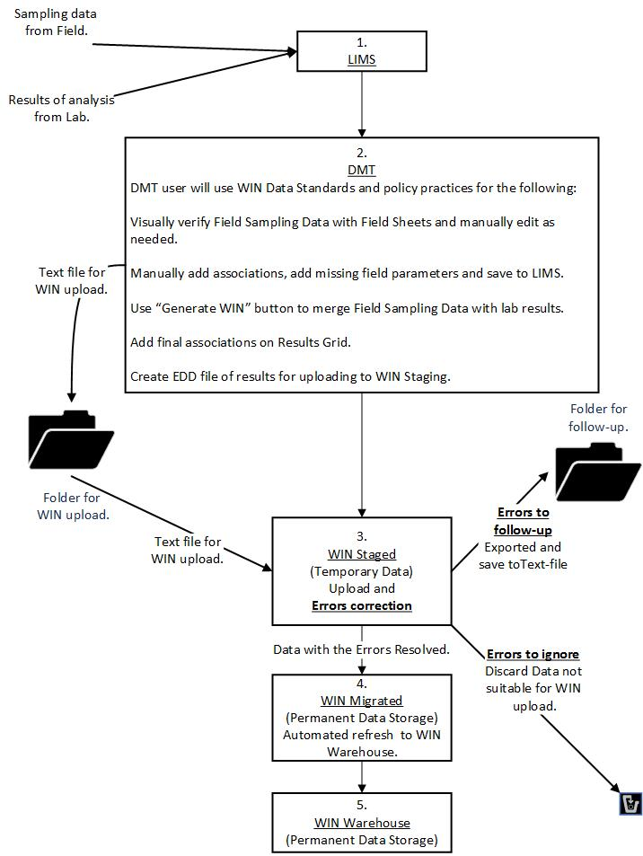
Figure 1 - Function of Data Merge Tool (DMT) in Data Upload

Scope
Consolidate information to create an EDD file from LIMS and upload it successfully into WIN. There are examples on the approach for resolving some common WIN Staging errors while using policies established by the WQAP. Other DEAR programs may choose to adopt these same policies. The current policies are in the section Guidance-DMT/WIN by Policy Managers

References
- WIN User Manual
http://publicfiles.dep.state.fl.us/DEAR/WIN/WIN_Manuals/WIN_User_Manual_2.0.pdf
- MDQS
http://publicfiles.dep.state.fl.us/DEAR/WIN/MDQS/
- Lab Quality Manual
http://publicfiles.dep.state.fl.us/dear/labs/lab_qualitymanual_18.pdf

Definitions
EDD - Electronic Data Deliverable
WIN - Watershed Information Network. This is a web application
LIMS - Laboratory Information Management System
DMT- Data Merge Tool
DEAR - Division of Environmental Assessment and Restoration
QC - Quality Control
Field Sheet- Samplers document observations and measurements made at Monitoring Locations, usually while collecting samples.
Laboratory Submittal Form- This serves as the Chain of Custody form, where samplers document required information about samples to the laboratory which will analyze those samples.
WC – WIN Coordinator
WQAP - Water Quality Assessment Program

Responsibilities
Following roles are responsible for using the DMT and loading EDDs successfully into WIN:

DMT User
- Verifies and corrects errors displayed in DMT introduced while verifying data from Field Data Sheet in LIMS.
- Manually adds missing field parameters from Field Sample Sheets into DMT table.
- Manually applies associations between Field QC and sampling data.
- Creates results merging Lab with Field data using the DMT’s automated feature.
- DMT User needs to have Data Loader privilege to upload data to WIN
- Loads the EDD to WIN and handles unresolved errors as per specified guidance.
- Consults with WIN Coordinator on errors that need assistance.
- Migrates staged data to WIN Migrate using the WIN application after all the errors in the EDD file uploaded to WIN Staging are resolved

WIN Coordinator (WC) (See Contact Link)
- Assists DMT Users to resolve the WIN errors
- Communicates with the team for error resolution
- Ensures that guidelines in this document are approved

DMT Lead - (Kathy Lurding, Devan Cobb)
- Responsible for DMT/LIMS issues.

Policy Managers (Julie Espy, Nia Wellendorf, Denise Miller)
- Decides on policy related issues

Water Assessment Programs
This section has information about the WQAP. Organization affiliation, General Rules/Constraints, and Field Collection General Guidelines

Organization Affiliation
Following figure provides an overview of the affiliations using DMT.
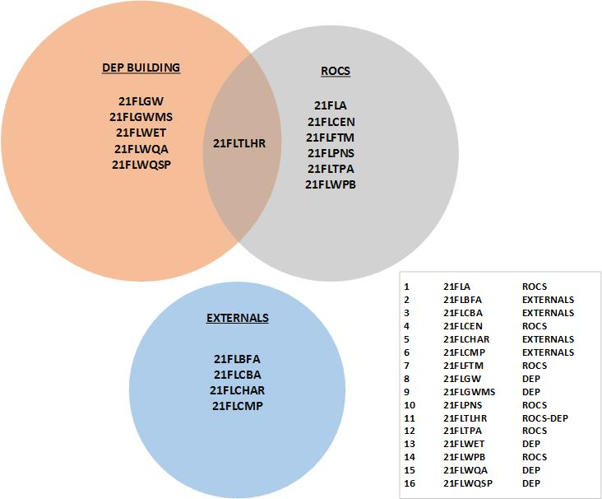

Figure 2 - DMT Users

General Rules/Constraints
This section has important points which will be re-iterated in appropriate sections. These give users the background to avoid pitfalls.
- Users are encouraged to archive/save their EDDs from the DMT to a designated folder.
- Issues due to data entered from Sampling Field Sheets can be corrected in the DMT (or WIN).
- If DMT users miss making the expected edits in DMT, it is possible to make certain types of data edits in WIN. Correction/Edits can be made to Staged Errors and also to Staged Clean data.
- Some updates may not be made in DMT and/or WIN by DMT User. These require the DMT Lead to edit in LIMS. LIMS data and WIN data need to match. Changes to Lab data are the responsibility of the DMT Lead. Lab data, especially Lab Qualifiers, should NOT be modified, added, or removed without the explicit approval of the DMT Lead. If LIMS is updated to fix issues, EDD may need to be regenerated.
- When updates are made in LIMS by DMT Lead, it will require the EDD to be regenerated in DMT.
- DMT users need to be familiar with Issues that have no solution such as unsupported analytes and duplicated rows, are typically left to purge after the purge duration. Alternate options are to export out from WIN Staging and discard or delete in WIN using the edit feature of WIN.
- Only files without errors are loaded into WIN Migrate except for errors that can be ignored, as stated in Section Errors to ignore.
- Avoid loading partial events by making sure to select all rows in the DMT and uploading the entire EDD in a single migration.
- Avoid editing the EDD outside DMT as this may introduce errors with data format.
- Once a record is flagged with an advanced error in WIN, the validation process stops for that record and moves to the next row until each row in the dataset is validated. When an advanced error is corrected and check errors process is restarted by the user, the validation process will determine if the error is resolved and will report on the next advanced rule failure until the row passes all validation checks.
- If necessary, WIN Coordinators can extend the Purge Duration.

Using the DMT-WIN: Flowchart Steps
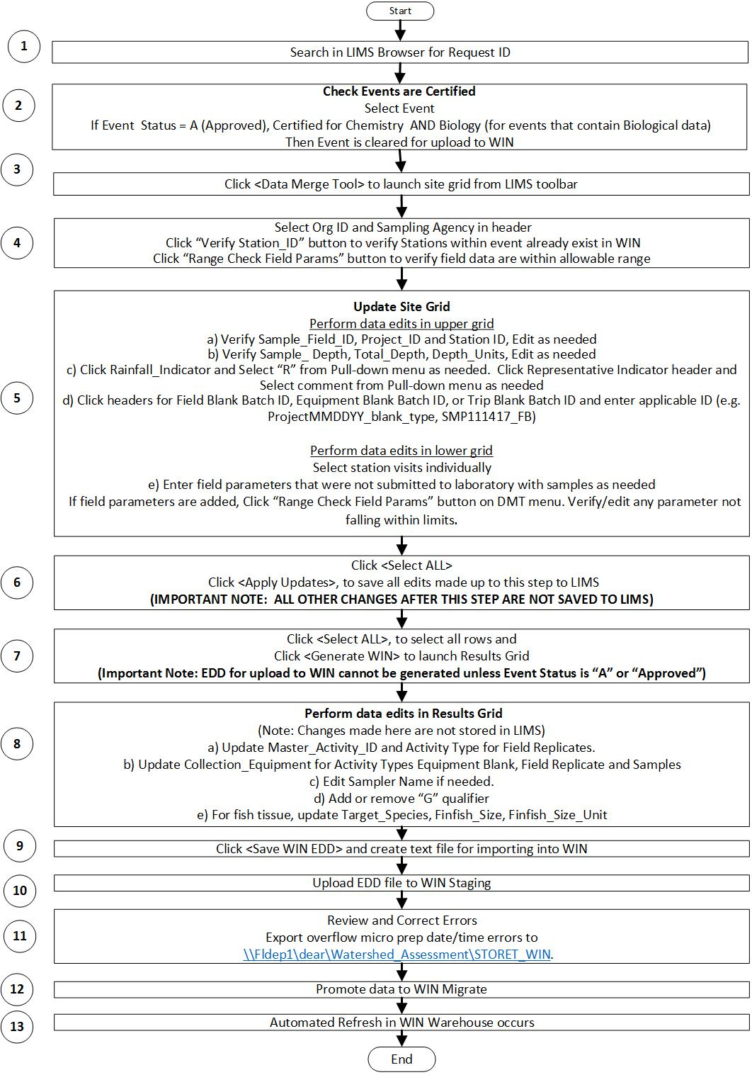
Figure 3 - High Level Overview - DMT-WIN
This section describes the Flowchart Steps: High Level Overview – DMT-WIN.

Step 1. Search in LIMS Browser for Request ID
Context/Procedure | Screens(s)Displayed
Launch LIMS application. Screen to the right will be displayed | 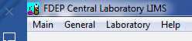  Figure 4 - LIMS
Select LIMS Browser from the menu under “General”.  LIMS Browser Screen to the right will be displayed.  On the left side there is “Search By” and to the right side is “Search For...” text box. Common approach to accessing a sampling event is by “Request ID”.  Click “Search by” Request ID, enter Request ID in “Search For...” text box and click “Build List”. Once the requested ID is selected, click “OK”.  Multiple sampling events may be listed for an individual RQ.  (Requests are identified on Field Sheets and Laboratory Submittal Forms) | 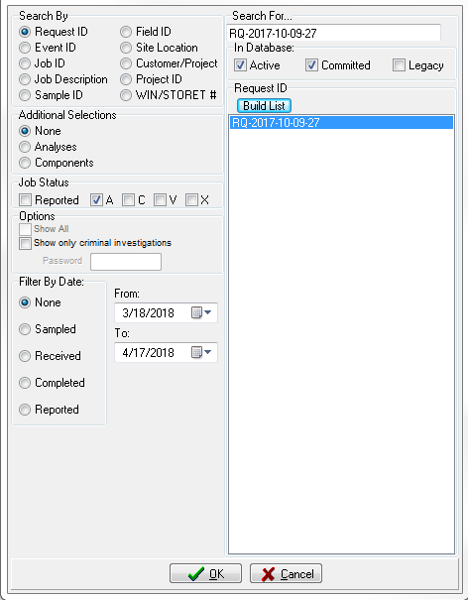  Figure 5 - LIMS Browser

Step 2. Check Events are Certified
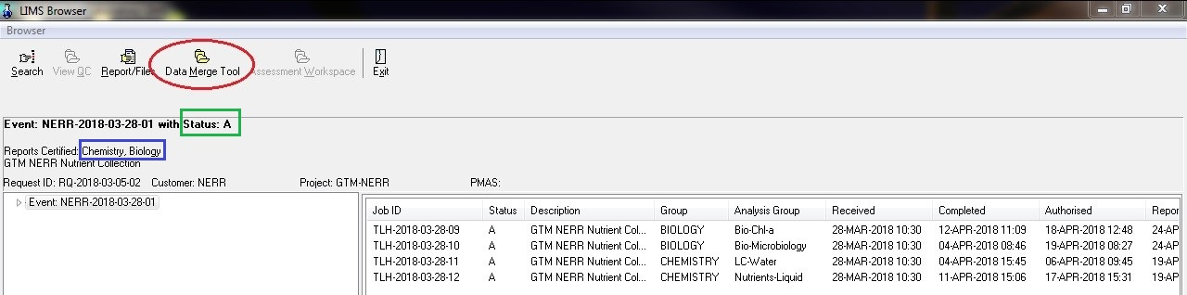
The DMT will be displayed in LIMS Browser as shown in figure below. If this icon is not visible, contact the DMT Lead and request access to the LIMS function.
Figure 6 - DMT access from LIMS Browser
Before the WIN file can be generated, all the field parameters and metadata must be entered, verified and saved. Also, the FDEP Laboratory must have certified and reported the analytical work. If samples from both the Chemistry and Biology programs were included in the events, both the Chemistry and Biology Jobs in the event must be certified (i.e. Status set to “A”). This is easily determined by checking the header information on the form that displays following the initial search. The ‘Reports Certified:’ area will indicate Chemistry and/or Biology, or None, as noted by the blue box in the above picture. DMT Users may contact the FDEP Laboratory if there appears to be a delay in certifying a job. The second item to check is the event status, indicated by the green box in the above figure. The event must be status ‘A’, indicating all the jobs associated with the event have been authorized.
Click the “Data Merge Tool” icon to launch Site Grid.

Step 3. DMT - Launch Site Grid
The Site Grid has two parts, Upper Grid and Lower Grid as shown below:
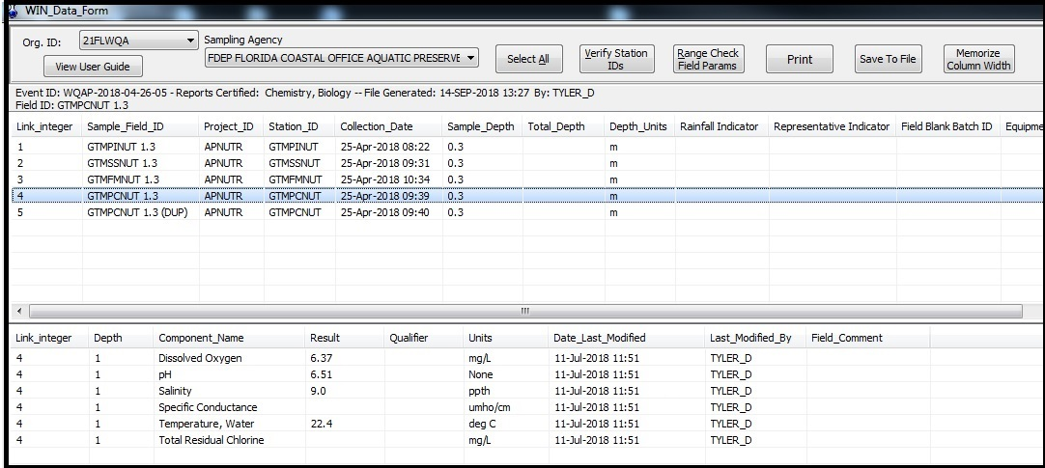
Figure 7 - Site Grid

The DMT interface will display information that was entered in LIMS from the sample submittal form when the event was logged in. Each row in the Upper Grid corresponds to a LIMS Field ID. The LIMS project is also listed in the grid, along with the collection date/time, Station ID and the sample depth. Click on any row in the Upper Grid to display the field measurements that were included on the submittal form in the Lower Grid.

Step 4. Org ID and Sampling Agency
The Org ID and Sampling Agency are displayed in the header of the DMT interface above the Upper Grid. In case when these are not set automatically, they can be selected from a pull-down List.
(In the scenario when the desired selections are not available, request needs to be made to add them to the DMT and WIN, as needed.)

Org ID
Context/Procedure | Screens(s)Displayed
The WIN-EDD generator uses the WIN Org ID to filter certain choice lists. Select the appropriate value from the pull-down List in the upper left corner of the form. The Org IDs are associated with the LIMS User ID, so if the one you need to select is not on the list, contact the DMT Lead. | 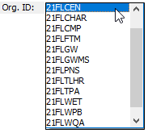  Figure 8 - Org ID

Sampling Agency
Context/Procedure | Screens(s)Displayed
Select the appropriate sampling agency name from the pull-down List. If the one you need is not on the list, contact the DMT Lead. | 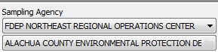  Figure 9 - Sampling Agency

“Verify Station IDs” Button
Context/Procedure | Screens(s)Displayed
Click the “Verify Station IDs” button in the header section to perform WIN Station ID check. This will identify any stations that have not been created for the selected Org ID in WIN. If any are identified, the station must be uploaded to WIN prior to upload of activities and results.  Note: When a new station is added to WIN, it is saved in WIN but not available immediately in LIMS. The station will be seen in LIMS after the WIN Warehouse is refreshed. This typically takes 1-2 business days. | 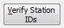  Figure 10 - Verify Station IDs

“Range Check Field Params” Button
A button “Range Check Field Params” is available to verify if parameter values are within range. This check should also be made after field data are entered, as noted in Section 7.5.2.1. If an error is detected and you need help correcting the issue, you may notify the WIN Coordinator.
Note: WIN Coordinator will communicate with FDEP Laboratory when there is a change to the WIN parameter limits so that the DMT limits will always align WIN limits.
Context/Procedure | Screens(s)Displayed
“Range Check Field Params” checks to see if the following parameters are within the minimum and maximum values that are listed in WIN.  Note: The “Range Check Field Params” Button will check all field ids in the Upper Grid.  See Table 1- Range for Field Measurements | 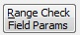  Figure 11 - “Range Check Field Params”

 | Analyte Name | Media | Result  Unit | Low  Threshold | High  Threshold | Threshold  Checked in
1 | pH | Water | SU | 0 | 14 | DMT & WIN
2 | Temperature, Water | Water | deg C | -2 | 50 | DMT & WIN
3 | Dissolved Oxygen | Water | mg/L | 0 | 22 | DMT & WIN
4 | Dissolved oxygen saturation | Water | % | 0 | 270 | DMT & WIN
5 | Salinity | Water | PSU | 0 | 70 | DMT & WIN
6 | Specific Conductance | Water | umho/cm | 0 | 110000 | DMT & WIN
7 | BOD | Water | mg/L | 0 | 500 | DMT & WIN
8 | COD | Water | mg/L | 0 | 500 | WIN
9 | Depth, Secchi Disk Depth | Water | m | 0 | 50 | DMT & WIN
10 | Gage height | Water | ft | -50 | 350 | WIN
11 | Depth to Water (from bottom of meter box) | Water | ft | -100 | 500 | WIN
12 | Depth to Water (from land surface elevation) | Water | ft | -100 | 500 | WIN
13 | Depth to Water (from shutoff valve) | Water | ft | -100 | 500 | WIN
14 | Depth to Water (from top of casing) | Water | ft | -100 | 500 | WIN
15 | Depth to Water (from measuring point) | Water | ft | -100 | 500 | WIN
16 | Water Level Elevation (Relative to NGVD29) | Water | ft | -100 | 500 | WIN
17 | Water Level Elevation (Relative to NGVD88) | Water | ft | -100 | 500 | WIN
18 | Water Level Elevation (Relative to MSL) | Water | ft | -100 | 500 | WIN
19 | Water Level Elevation (Relative to relative to unknown datum) | Water | ft | -100 | 500 | WIN
20 | Flow (Daily Mean) | Water | cfs | -250000 | 250000 | DMT & WIN
21 | Flow (Instantaneous) | Water | cfs | -250000 | 250000 | DMT & WIN
22 | Temperature, air | Water | deg C | -18 | 50 | WIN
23 | Velocity | Water | m/sec | -3 | 3 | DMT & WIN
24 | Stream width measure | Water | m | 0 | 300 | DMT & WIN
25 | Purge Volume | Water | gal | 0 | 55000000 | DMT & WIN
Table 1 - Range for Field Measurements

Step 5. Update Site Grid
Column widths on Site Grid, can be resized and saved by clicking “Memorize Column Width”.

Upper Grid
Site Grid data are verified and updated as needed. Most of the data are pre-populated with data from Field Sheets and Laboratory Submittal Form. There are several items that can be added or edited in the Upper Grid. This is accomplished by clicking on the row(s) to be changed and then the relevant column header. Edits and additions made in the DMT do not alter the values in LIMS. The new value(s) will be saved to a different table and propagated through to the WIN EDD. The columns in Upper Grid are explained in this section.

Sample_Field_ID (Text Box)
Context/Procedure | Screens(s)Displayed
Field IDs may be edited in the DMT (up to 22 characters) for storage in a table outside of the LIMS proper. That means that any changes you make in the DMT will not be reflected in any other part of the LIMS. Also, the WIN EDD generator uses the Field ID to construct an Activity ID which appends the sample date. If the date sampled was part of the Field ID submitted to the FDEP Laboratory, you can delete it here to reduce redundancy. | 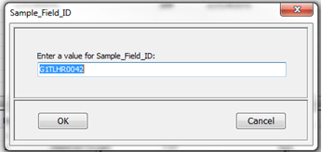  Figure 12 - Sample Field ID

Project_ID (Pull-down List)
Context/Procedure | Screens(s)Displayed
If the LIMS project does not match a WIN standard value, it must be changed before the file is generated. Click the “Select All” button to highlight each of the Field ID rows, and then click the Project_ID column header. A form will be displayed with a pull-down List of Project IDs associated with the Org ID. If no Project IDs appear in the menu, make sure an Org ID has been selected. If the project needed for WIN upload is not present, contact the DMT Lead to request that it be added to the LIMS. | 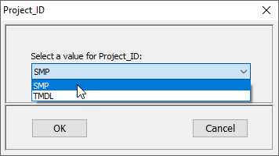  Figure 13 - Project ID

Station_ID (Text Box)
Context/Procedure | Screens(s)Displayed
If WIN Station IDs were provided on the Laboratory Submittal Form, they are also displayed in the Upper Grid. Review them to make sure they were correctly entered. To add a new value or edit an existing one, highlight the row and click on the Station ID column header and enter the correct value in the edit box. You may also double-click the cell with the incorrect value to bring up the edit box.  Utilize field sheets and WIN Station list to verify that Station ID is assigned correctly. Edit as needed. | 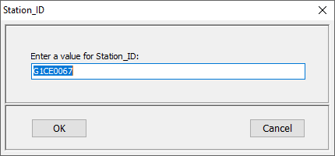  Figure 14 - Station ID

Collection_Date (Not Editable)
Context/Procedure | Screens(s)Displayed
This is the Date and Time when sample was collected in the field. Samplers are required to record the start time of this activity on a Laboratory Submittal Form. Date and Time are entered into LIMS from the submittal form by Lab personnel when the event is checked in.  Review that the information is correct.  This is Not Editable in the DMT.  Note: If it was entered or submitted incorrectly, contact the DMT Lead to request that it be changed. | 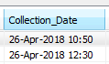  Figure 15 - Collection Date

Sample_Depth (Text Box)
Context/Procedure | Screens(s)Displayed
Sample depth is entered into LIMS from the Laboratory Submittal Form when the event is checked in. The depth at which samples are collected depends on the total depth and/or parameter. Samples can be collected from different depths.  This is Editable in the DMT.  Note: If it was entered or submitted incorrectly, edit it here. | 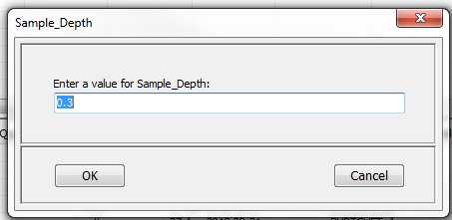  Figure 16 - Sample Depth

Total_Depth (Text Box)
Context/Procedure | Screens(s)Displayed
Total_Depth may be set on Field, Sample, Sample-Composite, and Field Replicate activity types. Total_Depth does not apply to Quality Control Samples. This value must be confirmed using the Field Sheets and can be added by the DMT User. To add a new value or edit an existing one, highlight the row in the Upper Grid appropriate and click on the Total_Depth column header and enter the correct value in the edit box.  Note: It is possible that Total depth is not the same for all rows.  Note: This is not a required measurement. There are instances when WQA do not collect Total Depth. | 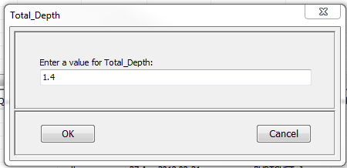  Figure 17 - Total Depth

Depth_Units (Pull-down List)
Context/Procedure | Screens(s)Displayed
Depth Units must be set on every row. Depth_Units are entered into LIMS from the submittal form when the event is checked in. If it was entered or submitted incorrectly, edit it here by selecting all rows in the Upper Grid, clicking the Depth Units header, and selecting the units from selection value list. Depth_Units can also be edited by selecting rows individually in the Upper Grid, clicking the Depth Units header, and selecting the units from selection value list. | 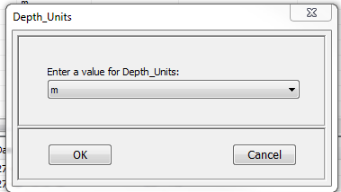  Figure 18 - Depth Units

Rainfall Indicator (Pull-down List)
Context/Procedure | Screens(s)Displayed
From pull-down List, you may enter or remove an ‘R’ to indicate a significant rainfall event occurred within the 48 hours prior to sampling. Addition of this element will add a qualifier to all associated lab and field results. | 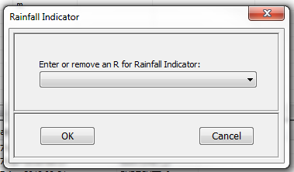  Figure 19 - Rainfall Indicator

Representative Indicator (Pull-down List)
Context/Procedure | Screens(s)Displayed
This indicator denotes whether the site conditions were typical or not. If you encounter abnormal conditions while sampling, this field can be updated to “Not Representative”. Otherwise, the field can be updated as needed to “Representative” from pull-down List or left blank. | 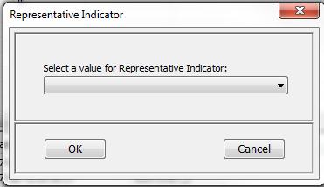  Figure 20 - Representative Indicator

Overview Blank QC
Field QC blank information is available on Laboratory Submittal Form and Sampling Field Sheet. Field, Equipment and Trip Blank Batch IDs are entered where appropriate according to syntax guidance provided by the WQAP. Please make sure to include ‘Field Blank’, ‘Equipment Blank’, or ‘Trip Blank’ in the matrix field of the FDEP Laboratory Submittal Form for each respective Field QC sample.
Follow the below format when assigning a Field ID to Field QC. Notice, in the below example, 2 equipment blanks were taken on the same day. In this case, the Field ID should begin with EB1, EB2, etc.
Activity Type | Date blank was taken | Field ID
Field Blank | 1/12/2018 | FB_01122018
Equipment Blank | 2/11/2018 | EB1_02112018
Equipment Blank | 2/11/2018 | EB2_02112018
Trip Blank | 3/15/2018 | TB_03152018
Figure 21- Example Field/Equipment/Trip Blank

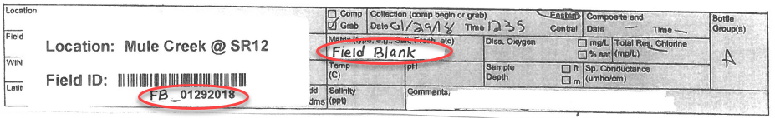
Figure 22 - Lab Submittal Form - Example Field Blank
When creating a Field Blank Batch ID, Equipment Blank Batch ID, or Trip Blank Batch ID in the DMT and assigning that same value to Samples or Field Replicates, the following format should be used.
Project | Activity Type | Date blank was taken | Field Blank Batch ID | Equipment Blank Batch ID | Trip Blank Batch ID
SMP | Field Blank | 1/12/2018 | SMP011218_FB
SMP | Equipment Blank | 2/11/2018 |  | SMP021118_EB1
SMP | Equipment Blank | 2/11/2018 |  | SMP021118_EB2
SMP | Trip Blank | 3/15/2018 |  |  | SMP031518_TB
Figure 23 - Example Adding Field/Equipment/Trip Blank to Upper Grid

Field Blank Batch IDs
Context/Procedure | Screens(s)Displayed
According to guidance established by the Water Quality Assessment Program, sampling teams decide how to batch samples with field blanks. Most commonly, a field blank will be associated with samples collected during the same sampling run (i.e. samples collected on the same day by a sampling team). Field Blanks should not be associated to Field data, Field QC (such as Equipment Blank) or Lab QC  Examples are provided for the following:  Associating Single Field Blank  and Associating Multiple Field Blanks | 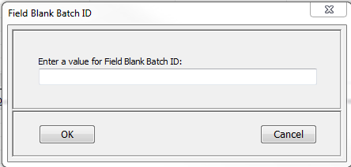  Figure 24 - Field Blank Batch ID

Associating Single Field Blank (Example)
A Field Blank was taken on September 10, 2018 (09/10/18) during the same sampling run as sample collected at G2TLHR0005 and G2TLHR0004. If these were done for project SMP, then the Field Blank Batch ID for all environmental samples (Sample, Field Replicates) as well as the Field Blank must be populated with “SMP091018_FB”.
Example of a Field Blank and Environmental Samples before the association is made:
Sample_Field_ID | Project_ID | Station_ID | Collection_Date | Field Blank Batch ID
G2TLHR0005 | SMP | G2TLHR0005 | 10-Sep-2018 11:45
G2TLHR0004 | SMP | G2TLHR0004 | 10-Sep-2018 12:35
G2TLHR0004_DUP | SMP | G2TLHR0004 | 10-Sep-2018 12:45
FB_09102018 | SMP |  | 10-Sep-2018 12:55

Example of a Field Blank and Environmental Samples after the association is made:
Sample_Field_ID | Project_ID | Station_ID | Collection_Date | Field Blank Batch ID
G2TLHR0005 | SMP | G2TLHR0005 | 10-Sep-2018 11:45 | SMP091018_FB
G2TLHR0004 | SMP | G2TLHR0004 | 10-Sep-2018 12:35 | SMP091018_FB
G2TLHR0004_DUP | SMP | G2TLHR0004 | 10-Sep-2018 12:45 | SMP091018_FB
FB_09102018 | SMP |  | 10-Sep-2018 12:55 | SMP091018_FB

Steps – Associating Field Blank Batch ID
- Select the Field Blank row and assign Field Blank Batch ID value “SMP091018_FB”as per guidance.

Select the Field Blank row. Click the Field Blank Batch ID header. Type “SMP101018_FB” into the text box and click “OK”.

- Associate the Field Blank to environmental samples:

Select the rows of all environmental samples batched with the Field Blank. Click the Field Blank Batch ID header. Type “SMP091018_FB” into the text box and click “OK”.

Example of a Field Blank and Environmental Samples after the association is made with steps identified:
Sample_Field_ID | Project_ID | Station_ID | Collection_Date | Step | Field Blank Batch ID
G2TLHR0005 | SMP | G2TLHR0005 | 10-Sep-2018 11:45 | (b)-> | SMP091018_FB
G2TLHR0004 | SMP | G2TLHR0004 | 10-Sep-2018 12:35 | (b)-> | SMP091018_FB
G2TLHR0004_DUP | SMP | G2TLHR0004 | 10-Sep-2018 12:45 | (b)-> | SMP091018_FB
FB_09102018 | SMP |  | 10-Sep-2018 12:55 | (a)-> | SMP091018_FB
To accomplish Steps a and b at the same time, use Shift+click to highlight a group of rows (or Ctrl+Click to select or de-select individual rows.)

Equipment Blank Batch ID
Context/Procedure | Screens(s)Displayed
According to guidance established by the Water Quality Assessment Program, Equipment Blank Batch ID should be associated to the Equipment Blank as well as to all sample results (except chlorophyll-a and bacteria) that were collected using the equipment on the day of sampling. | 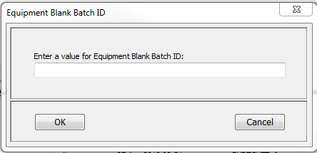  Figure 25 - Equipment Blank Batch ID

Associating Multiple Equipment Blanks taken on the same day (Example)
Two Equipment Blanks were taken on 09/09/18. Before associating the Equipment Blanks to environmental samples, each individual Equipment Blank must be assigned a unique Equipment Blank Batch ID. Then all environmental samples can be associated to both Equipment Blanks as noted in the following steps.
Example of two Equipment Blanks and Environmental Samples before the association is made:
Sample_Field_ID | Project_ID | Station_ID | Collection_Date | Field Blank Batch ID
G2TLHR0005 | SMP | G2TLHR0005 | 8-Sep-2018 11:45
G2TLHR0004 | SMP | G2TLHR0004 | 9-Sep-2018 12:35
G2TLHR0004_DUP | SMP | G2TLHR0004 | 9-Sep-2018 12:45
G2TLHR0006 | SMP | G2TLHR0006 | 10-Sep-2018 11:45
EB1_09092018 | SMP |  | 9-Sep-2018 12:50
EB2_09092018 | SMP |  | 9-Sep-2018 12:55

Example of two Equipment Blanks and Environmental Samples after the association is made:
Sample_Field_ID | Project_ID | Station_ID | Collection_Date | Field Blank Batch ID
G2TLHR0005 | SMP | G2TLHR0005 | 8-Sep-2018 11:45 | SMP090918_EB1/SMP090918_EB2
G2TLHR0004 | SMP | G2TLHR0004 | 9-Sep-2018 12:35 | SMP090918_EB1/SMP090918_EB2
G2TLHR0004_DUP | SMP | G2TLHR0004 | 9-Sep-2018 12:45 | SMP090918_EB1/SMP090918_EB2
G2TLHR0006 | SMP | G2TLHR0006 | 10-Sep-2018 11:45 | SMP090918_EB1/SMP090918_EB2
EB1_09092018 | SMP |  | 9-Sep-2018 12:50 | SMP090918_EB1
EB2_09092018 | SMP |  | 9-Sep-2018 12:55 | SMP090918_EB2

Steps - Associating Multiple Equipment Blank Batch ID
- Select the first Equipment Blank and assign Equipment Blank Batch ID value “SMP090918_EB1” as per guidance.

Select the Equipment Blank row taken on 09/09/2018 at 12:50. Click the Equipment Blank Batch ID header. Type “SMP090918_EB1” into the text box and click “OK”.

- Select the first Equipment Blank and assign Equipment Blank Batch ID value “SMP090918_EB2” as per guidance.

Select the Equipment Blank row taken on 09/09/2018 at 12:55. Click the Equipment Blank Batch ID header. Type “SMP090918_EB2” into the text box and click “OK”.

- Associate Equipment Blanks to environmental samples.

Next, select the rows of all environmental samples (Samples, Field Replicates) within the same week as the two Field Blanks. Click the Field Blank Batch ID header. Type the first Field Blank Batch ID into the popup box, followed by a forward slash (/), then add the second Field Blank Batch ID. Using this example, the following should be entered: “SMP090918_FB/SMP091018_FB”. Then click OK. WIN will use the forward slash (/) as a delimiter and will associate these environmental samples to each individual Field Blank.
Shown below example of typical Field Blank steps associating Field Blank with environmental samples:
Sample_Field_ID | Project_ID | Station_ID | Collection_Date | Step | Field Blank Batch ID
G2TLHR0005 | SMP | G2TLHR0005 | 8-Sep-2018 11:45 | Step c | SMP090918_EB1/SMP090918_EB2
G2TLHR0004 | SMP | G2TLHR0004 | 9-Sep-2018 12:35 | Step c | SMP090918_EB1/SMP090918_EB2
G2TLHR0004_DUP | SMP | G2TLHR0004 | 9-Sep-2018 12:45 | Step c | SMP090918_EB1/SMP090918_EB2
G2TLHR0006 | SMP | G2TLHR0006 | 10-Sep-2018 11:45 | Step c | SMP090918_EB1/SMP090918_EB2
EB1_09092018 | SMP |  | 9-Sep-2018 12:50 | Step a | SMP090918_EB1
EB2_09092018 | SMP |  | 9-Sep-2018 12:55 | Step b | SMP090918_EB2

Trip Blank Batch IDs
Context/Procedure | Screens(s)Displayed
Guidance for batching Trip Blanks has not yet been established. If you are collecting Trip Blanks, please contact your WIN Coordinator. | 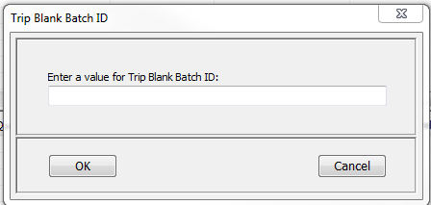  Figure 26 - Trip Blank Batch ID

Lower Grid
Field measurement values are entered in LIMS from the Laboratory Submittal Form when the event is checked in and is displayed on the Lower Grid. Data providers add additional data from their field sheets in the “Lower Grid”. Any data that were entered incorrectly can be edited by double clicking the appropriate cell in the result column and typing the correct value. This will not alter the value stored in LIMS; the new value will be saved to a different table and propagated through to the WIN EDD. Lab data will be displayed on the Results Grid described later in the document.
Field measurements for each Field ID in the Upper Grid need only to be entered in the Lower Grid once. Field ID in Upper Grid that do not have field measurements in Lower Grid are QC data as shown below.

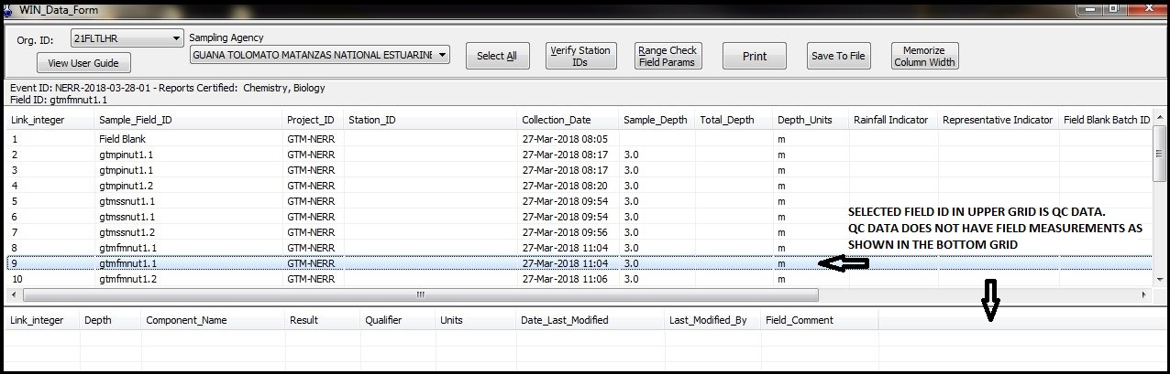
Figure 27 - Lower Grid does not have measurements for QC data

Field measurement data are displayed in the Lower Grid for the Field ID selected in the Upper Grid. Screen below shows Field data where row in the Upper Grid has corresponding measurements from field in Lower Grid.

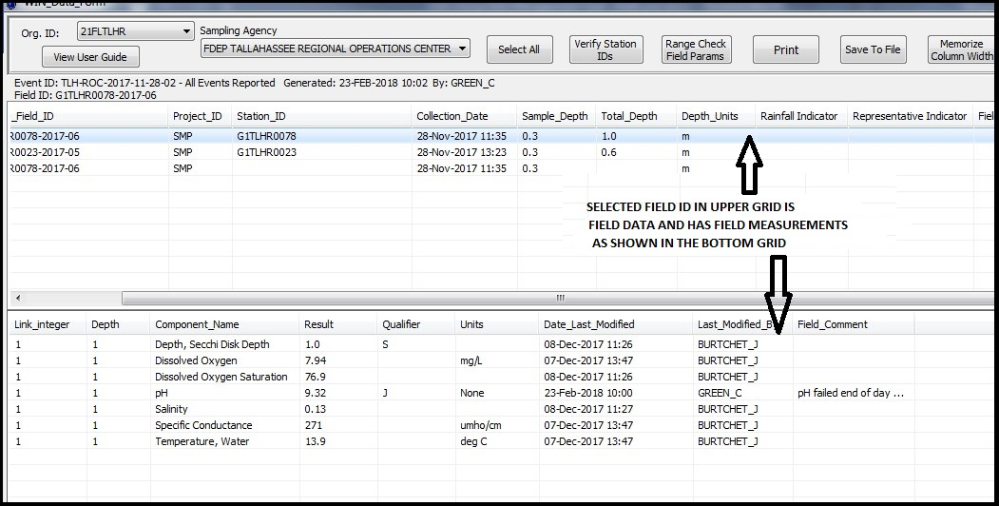
Figure 28 - Lower Grid showing Field Measurements
Additional field measurements (ex. Secchi) from field sheets that have not been recorded on the Lab Submittal Form may be added into the Lower Grid for any Field ID selected from the Top Grid.

Add Field Parameter(s)
To add a field parameter to a station, select the appropriate row or rows. Then click the “Add Parm” button in the lower left corner as noted by the blue box below. A form will display to allow selection of one or more field parameters. Ctrl+click to select multiple parameters and then click “OK” button. These additional field parameters will be associated with the sample depth included on the Laboratory Submittal Form (Depth 1). See figure below.
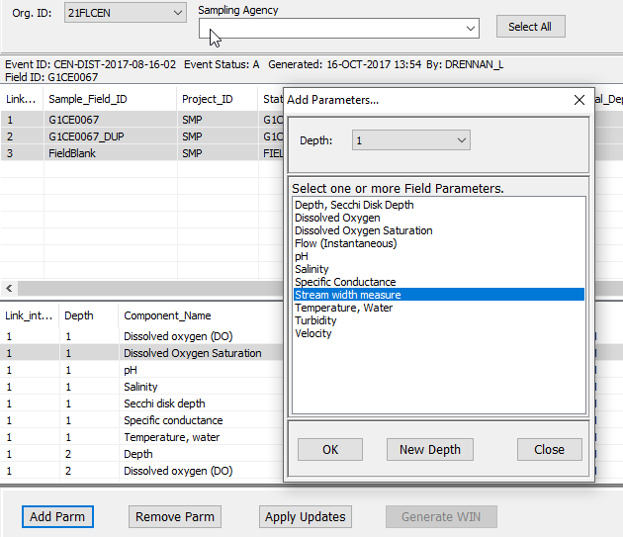
Figure 29 - Lower Grid Add Parameter
The parameter is inserted into the Lower Grid. See figure below.
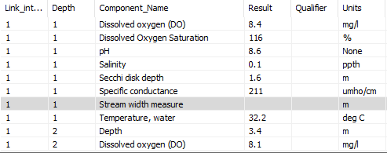
Figure 30 - Lower Grid, showing parameter is inserted

Setting the Parameter
Context/Procedure | Screens(s)Displayed
- Result (Value)  Select the row in the Lower Grid for the parameter just added. Double-click in the result cell to enter a value. Click OK. | 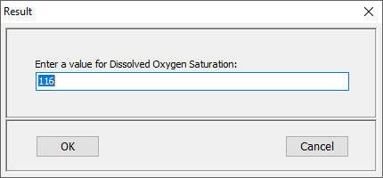  Figure 31 - Set the Parameter Value
- Qualifier  A column has been included in the Lower Grid to enter qualifiers for the field measurements. To add a qualifier, highlight the appropriate row and click on the Qualifier column header to display the form for data entry. Add the qualifier and click OK.  DMT does not check and constrain the Qualifiers. These checks are done in WIN.  Value Qualifiers DMT User can add are:  - “J” Qualifier - is related to Field Measurement. When a “J” Qualifier is added, a Field Comment is mandatory.  - “S” Qualifier - Secchi disk visible to bottom of waterbody. The value reported is the depth of the waterbody at the location of the Secchi disk measurement.  All other Qualifiers can be added/edited only by DMT Lead. | 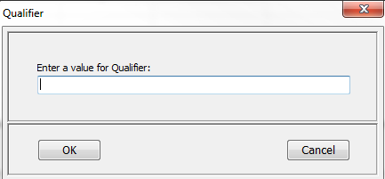  Figure 32 - Set the Qualifier
- Units  The DMT stores a default value for units for each field parameter, but in a few cases, there is an alternative unit. To edit the unit, select the field parameter row and click on the Units column header to display the choice list. | 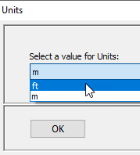  Figure 33 - Add the Units
- Field_Comment  Field comment can be added as needed.  Click the row that is qualified, then click on the Field_Comment header to display the form for data entry. Add the comment and click Ok.  Example: When Value Qualifier “J” is added, it is required to justify the reason(s) for designating the value as estimated. | 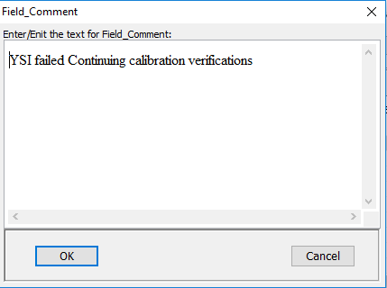  Figure 34 - Add Field_Comment

Add Field Parameters at Existing Depth or New Depth
To add parameters to an existing depth other than the depth included on the submittal form (Depth 1), click the pull-down List at the top of the “Add Parameters” form and select the appropriate depth. Values for field parameters measured at multiple depths may be added using the DMT interface. First, select all rows in the Upper Grid that represent stations for which depth profile data are relevant. Then, click the “Add Parm” button. The “Add Parameters” form will display, allowing selection of field parameters. After choosing the parameters to add, click on “New Depth” button as shown below.
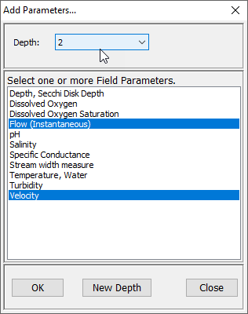
Figure 35 - Add Parameter at New Depth
The new list of field parameters is inserted at the bottom of the grid. Note that the Depth parameter is automatically inserted as well. Enter the relevant depth along with the rest of the field measurements, results and appropriate units. Continue this process until all the depths for which field parameters were measured have been entered.
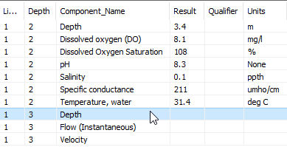
Figure 36 - Lower Grid, showing parameter inserted at different Depth

Step 6. Save to LIMS (Critical Step)
It is critical to save your changes. These changes are saved to a separate set of tables and will not be reflected in LIMS outside of the DMT. “Generate WIN” button will be enabled only after the changes are saved. Field ID, Station ID values added or changed in the Upper Grid and all Field measurements/data entered or changed in the Lower Grid in DMT will only be saved when “Apply Updates” button is pushed.

Context/Procedure | Screens(s)Displayed
Click the “Select All” button to highlight all rows. | 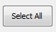  Figure 37 - Selecting Field Measurements to All Rows
To save these updated values, click on the “Apply Updates” button at the bottom of the form. | Figure 38 - Update Field Measurements to Selected Rows

Step 7. Generate Results Grid (Critical Step)
Generate the Results Grid, by clicking on rows in the Upper Grid that are to be included for uploading to WIN. The program will include ONLY those data associated with the highlighted field locations in the file, so this is a critical step to select all rows.
Context/Procedure | Screens(s)Displayed
Click the “Select All” button to highlight all rows.  (and Ctrl-Click to deselect individual field locations.) | Figure 39 - Select All before generating Results Grid
The next step is to Click the “Generate WIN” button at the bottom of the form. The resulting grid contains all of the metadata necessary for entry to WIN, as long as the standard values are in place for the relevant Org ID. LIMS component names and methods have been translated to the WIN compliant names, as have expressions for units. | Figure 40 - Generate Results Grid

Step 8. Update Results Grid
There are a few items that need to be added in the Results Grid, or they can be added in WIN once the EDD has been imported to WIN. IT IS IMPORTANT TO REMEMBER that the edits made to this grid are not stored in the DMT. If additional changes need to be made to the Site Grid or the EDD needs to be regenerated, updates to the Results Grid will need to be done again.
Dataset attributes can be added/edited in the Results Grid as explained in the following section.
Following columns in Results Grid are editable in DMT.
• Master_Activity_ID
• Activity_Type
• Collection_Type
• Collection_Equipment
• Sampler_Name
• Value_Qualifier
• Target_Species
• Finfish_Size
• Finfish_Size_Unit

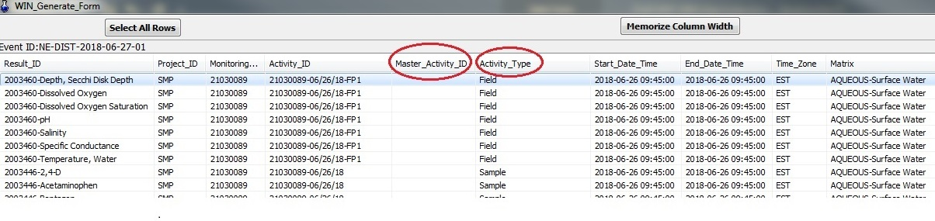
Figure 41 - Results Grid: Master_Activity_ID, Activity_Type

Associate Replicates (Activity_ID, Activity_Type, Master_Activity_ID)
In order to easily identify replicates in the DMT, please append “_DUP” to the end of the Field ID for a replicate sample. If more than one replicate is collected, append “_DUP2”, “_DUP3”, etc. In order to associate all replicates to the parent sample, the Master Activity ID field must be populated with the Activity ID of that parent sample. The Activity Type must also be updated to ‘Field Replicate’ for all replicate samples. The steps are described below.
Shown below example of typical Field Replicates that have no association with parent sample:
 | Activity ID | Activity Type | Master Activity ID
Parent -> | G1CE0067-08/15/17 | Sample
1st field replicate-> | G1CE0067_DUP-08/15/17
2nd field replicate-> | G1CE0067_DUP2-08/15/17

Shown below example of typical Field Replicates after association with parent sample:
 | Activity ID | Activity Type | Master Activity ID
Parent -> | G1CE0067-08/15/17 | Sample
1st field replicate-> | G1CE0067_DUP-08/15/17 | Field Replicate | G1CE0067-08/15/17
2nd field replicate-> | G1CE0067_DUP2-08/15/17 | Field Replicate | G1CE0067-08/15/17
Figure 42 - Master Activity ID Guidance
Steps - Associating Master Activity ID
- Select all the Field Replicates and set Activity Type to “Field Replicate”:
Select the result row of the first replicate sample where Activity ID contains ‘DUP’. Shift+click can be used to highlight a group of rows (or Ctrl+Click to select or de-select individual rows.) Click the Activity_Type header. A pull-down List will be presented. Select ‘Field Replicate’ and click OK.
- Associate the Field Replicates to the parent sample by assigning Master Activity ID:

Next, select the result row of all field replicates in this batch. Make sure the associated Parent Sample (Activity Type = Sample) is not selected. Click the Master_Activity_ID header. Select the Activity ID that is associated to the Parent Sample from the pull-down List. Click OK.

 | Activity ID | Step | Activity Type | Step | Master Activity ID
Master -> | G1CE0067-08/15/17 |  | Sample
1st field replicate-> | G1CE0067_DUP-08/15/17 | (a)-> | Field Replicate | (b)-> | G1CE0067-08/15/17
2nd field replicate-> | G1CE0067_DUP2-08/15/17 | (a)-> | Field Replicate | (b)-> | G1CE0067-08/15/17
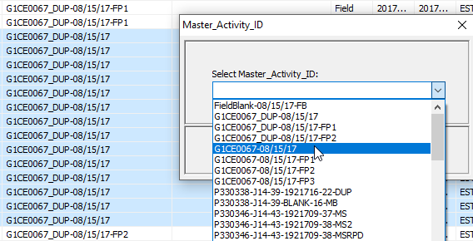
Figure 43 - Associating Master Activity ID

Note: In order to avoid the logging of duplicate observations taken in the field (e.g., Water Temperature, pH, DO, etc.), only associate these field observations to the Parent Sample (Master Sample) on the FDEP Laboratory Submittal Form. They should not be associated to Field Replicates.
Form below shows on Duplicate Sample. Spaces are left BLANK for all field measurements such as Temp, pH, Sample Depth, Salinity, Diss. Oxygen etc.
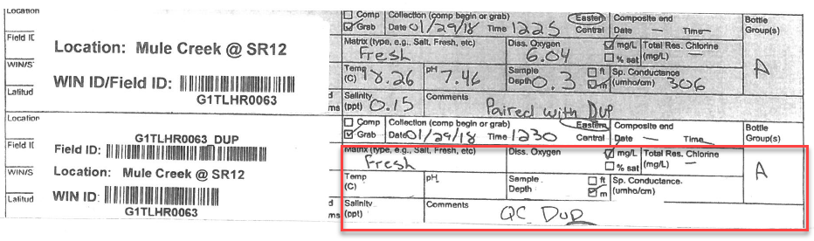
Figure 44 - Example Duplicate Observations logged in Lab Submittal Form

Delete duplicate field measurements
As noted above, field observations should not be written on the FDEP Laboratory Submittal Form when a second (or replicate) sample is taken. If field observations were logged more than once either because this policy was not followed or because duplicates were logged by the laboratory, the duplicated field measurements need to be deleted.
Field Measurements displayed for the highlighted row in Upper Grid (Parent Sample)
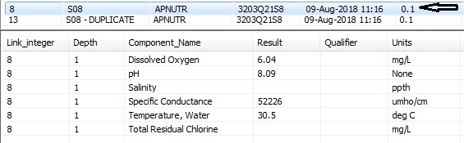

Field Measurements displayed for the highlighted row in Upper Grid (Field Replicate)
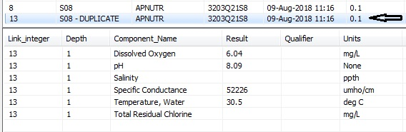

Highlight each row on Lower Grid which has measurement entered twice for the Field Replicate and follow steps to clear the value.
- Click “Results” on header row
- On the pop-up box, “Enter a value for <Component Name>”
- Delete value by using the “Backspace” Button
- Click “OK” Button
Once the values are cleared, follow the steps below:
- Click “Apply Updates” Button below the Lower Grid
- Click “Close” Button below the Lower Grid
- Click “Yes”

Activity_Type
The program translates the Activity Type from the LIMS matrix entered for the event at login from the Laboratory Submittal Form as shown below. If it is not correct, you will need to be change it in the DMT.
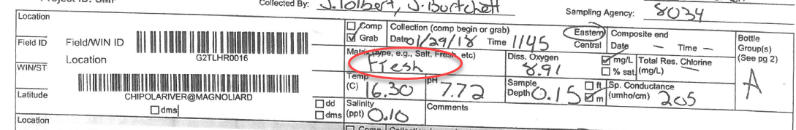
The only time that it must be changed is for those occasions where a field replicate has been collected as shown in Figure 44 - Example Duplicate Observations logged in Lab Submittal Form.
Highlight the result rows of the replicate sample (the same ones that were assigned a Master Activity ID) and click on the Activity Type column header and select Field Replicate.
Please refer to Figure 45 - Activity Type.
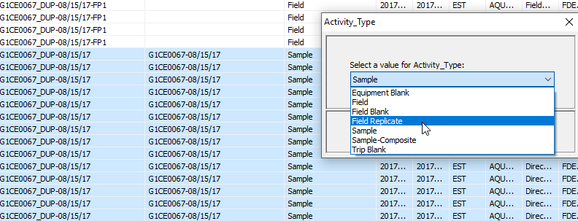
Figure 45 - Activity Type

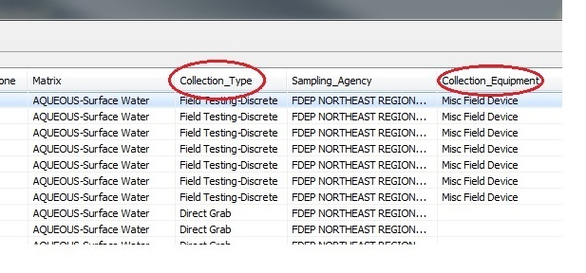
Figure 46 - Results Grid: Collection Type, Collection Equipment

Collection_Type
Collection_Type must be assigned for the following Activity_Types:
- Field,
- Equipment Blank,
- Field Replicate,
- Sample,
- Sample Composite.
The combination of Activity_Type with Collection_Equipment needs to be compatible.

Collection_Equipment
This value must be assigned for Equipment Blanks, Field Replicates, and Samples only. It must be left blank for Field Blank, Trip Blanks, and all Lab QC. Highlight the rows to edit, click the Collection_Equipment header, and select the appropriate collection equipment name. For ‘Field’ activities, the DMT automatically populates this column with ‘Misc Field Device’.
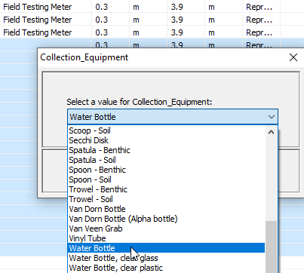
Figure 47 - Collection Equipment Name

Sampler_Name
Sampler Name is entered from the Laboratory Submittal Form. It can be edited here by highlighting the rows of interest, clicking on the header, and entering the new information into the popup box.

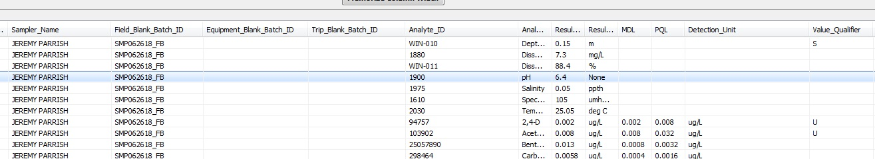
Figure 48 - Results Grid: Sampler_Name, Value_Qualifier

Value_Qualifier
Context/Procedure | Screens(s)Displayed
The laboratory results qualifier field is editable, but only on a limited basis. Users may only add or remove a ‘G’ to the current list of qualifiers. As with the other editable fields, highlight the row(s) that need to be edited then click the column header.  Review data reported for any blanks collected and add the “G” qualifier as needed to station and parameters via Value Qualifier pull-down List in EDD | 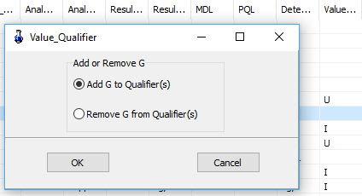  Figure 49 - Lab Results Qualifier

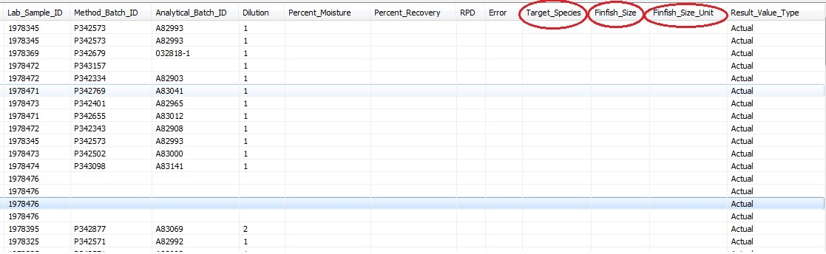
Figure 50 - Results Grid: Target_Species, Finfish_Size, Finfish_Size_Unit
When measurements are made for fish tissue, Target Species, Finfish Size, and Finfish Size Units need to be entered.

Target_Species
Context/Procedure | Screens(s)Displayed
Finfish Target_Species type needs to be assigned from the list in DMT. | 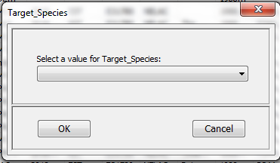  Figure 51 - Finfish Target Species

Finfish_Size
Context/Procedure | Screens(s)Displayed
Finfish Finfish_Size needs to be assigned. | 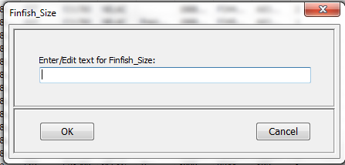  Figure 52 - Finfish Size

Finfish_Size_Units
Context/Procedure | Screens(s)Displayed
- Finfish Size Units  Finfish Size Units needs to be assigned from the list in DMT. | 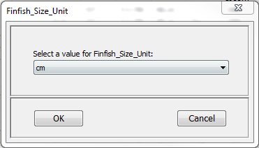  Figure 53 - Finfish Size Units

Step 9. Save EDD
Context/Procedure | Screens(s)Displayed
When all the field measurements and WIN metadata have been entered, verified and saved, the EDD can be generated. Click on the “Save WIN EDD” button at the bottom of the Results Grid. A dialog box will be displayed, allowing the user to select a directory for file storage. A default file name is provided, which represents the LIMS event and the file generation date (e.g., CEN-DIST-2017-08-16-02_11-29-2017.txt). This file name may be edited.  The file is now ready to be imported to WIN.  Default File Name Format:  [EVENT ID]_[Report Run Date MM-DD-YYYY ]  Example CEN-DIST-2017-08-24-01_02-22-2018.TXT.  There are other EDD file names used by DMT Users - | 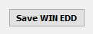  Figure 54 - Saving WIN EDD

The subsequent steps are performed on WIN.

Step 10. Upload file to WIN Staging
This section has brief description on the steps for uploading and migrating files. For more information, see Reference WIN User Manual

Internet Browser Setting for WIN
It is recommended Internet Explorer be used with the following setting. To modify or confirm this setting: open Internet Explorer. Click the wheel icon () in the upper right-hand corner and then select Internet Options. Click Settings. In the Temporary Internet Files tab, set ‘Check for newer version of stored pages’ to ‘Every time I visit the webpage’.
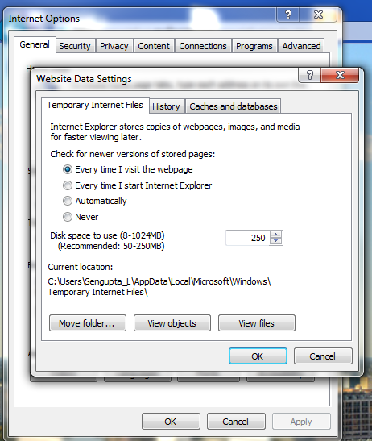
Figure 55 - Internet Browser Setting for WIN

Follow steps to launch WIN. From WIN Menu select “Manage Data” -> “Staged Data”->”Upload Data”. Select the Organization ID, ‘Activity and Results’ in the Type pull-down List, and the corresponding Config Name. Details are available in Reference (a) WIN User Manual.
Browse to file location and Select EDD file to upload.
EDD files created by DMT by default have column names on top row. Be sure to check the box to Ignore Leading Header Row in Upload File and then Click Submit and View File Status.
WIN will return an error in case the Config does not match EDD. Once there is a match, the EDD will be loaded. The Status will change to Uploading as shown below.
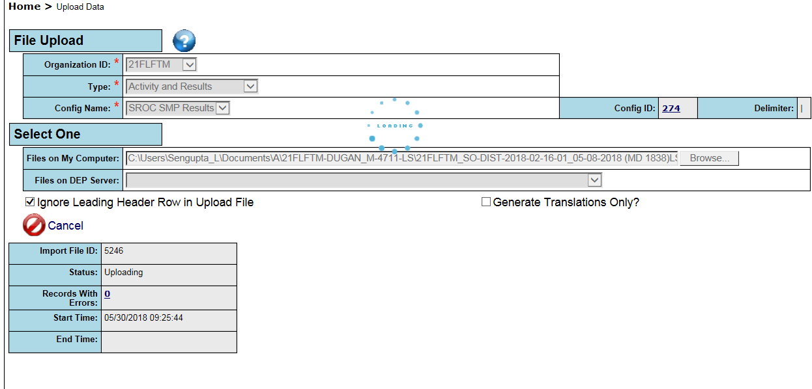
Figure 56 - Uploading Import File
As soon as the ‘Status’ changes from ‘Uploading’ to any other status, the user is redirected to the dataset list. If there are errors, user will be able to view them by following the link on Import File ID to the upload data screen. see Reference WIN User Manual.

Step 11. Review and Correct Errors
The Figure below shows the overview of error corrections. For a summary of error review table see
Error! Reference source not found. The errors corrections are described with screen shots under the following sections:
- Errors correction
- Errors to ignore
- Errors to follow-up

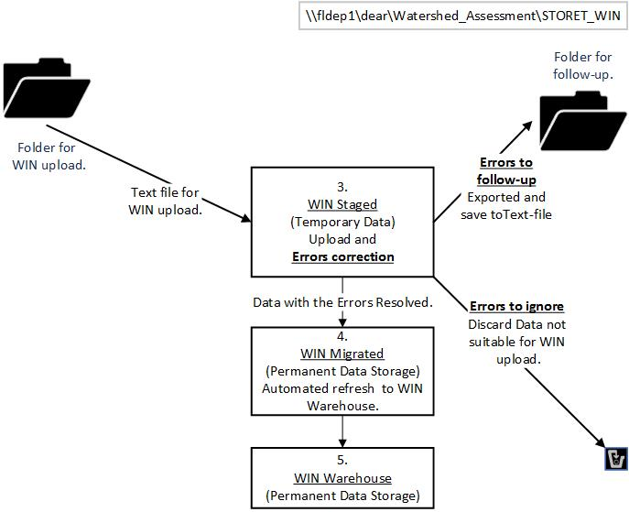

Figure 57 – Step 11. Review and Correct Errors

Errors correction
WIN Coordinators are available to help clarify any questions you may have. Some typical examples of errors that can be corrected are:

Correcting by Process - Basic Error - Translation Error
Error: Translation Error
Error resolution by: DMT User can resolve this error.
Reason: Example shows the column names as errors when user forgot to click “Ignore Leading Header Row in Upload File” button before uploading file.
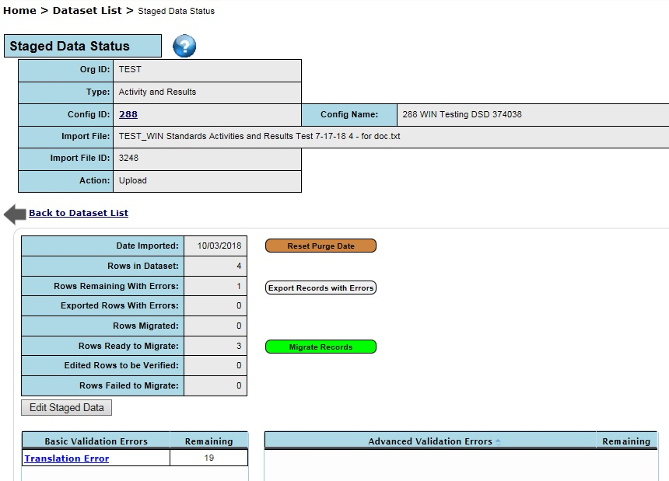
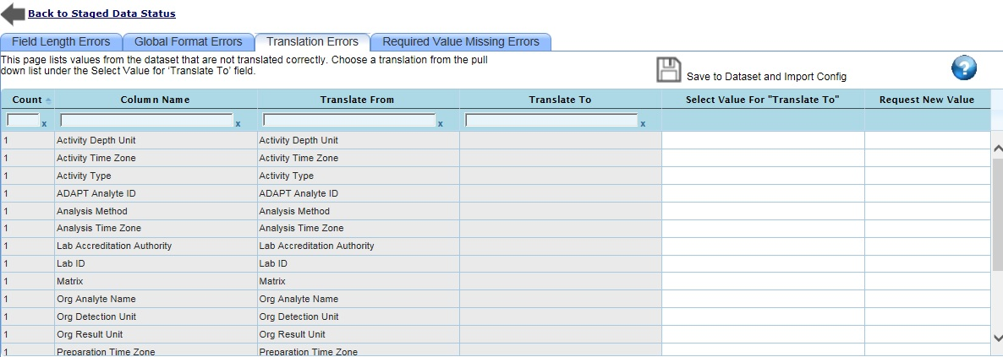
Figure 58 - Translation Error - Column Headings Imported
Action: Delete and reload the import. Make sure to click “Ignore Leading Header Row in Upload File” before uploading the file.

Correcting by Resolving - Basic Error - Translation Error
Error: Translation Error
Error resolution by: WIN Coordinator/DMT Lead needs to be notified for resolution.
Reason: Example when a new analysis has been added in LIMS and did not have the translator added.
Action: Issue will be reviewed and resolved as directed by WC and DMT Lead.

Correcting Advanced Error by Lab - Repeated Analyte
Error: Analyte/Sample Fraction must be unique within an Activity in the import file
Error resolution by: WIN Coordinator/DMT Lead needs to be notified for resolution.
Reason: This error occurs if more than one sample fraction-analyte combination is contained within the same Activity_ID. On Results Tab, see the DEP Analyte Names within that Activity ID. The file with two result rows, example two rows of (DEP Analyte Name = “Phosphorous- Total” and Sample Fraction = ‘Total’) will generate this error.
Action: This type of error would likely involve edits to be performed in LIMS and needs to be resolved by informing the WIN Coordinator. The WIN Coordinator will relay this to the DMT Lead who will advise the team on how to proceed with resolution. Once the suggested changes are made, click “Save” and then the ‘Check Adv Errors’ to verify that error was resolved.

Correcting Advanced Error in WIN - Extra Master Activity ID
Error: Master Activity ID must be null
Error resolution by: DMT User can resolve this error.
Reason : As noted in Section Associate Replicates (Activity_ID, Activity_Type, Master_Activity_ID),
the Activity Type field for duplicate samples must be ‘Field Replicate’. If the Activity Type was not updated to ‘Field Replicate’, but the Master Activity ID field was assigned to the parent sample, this error will be flagged.
Action: This error can be resolved by updating the Activity Type field to ‘Field Replicate’ in the Advanced Validation Errors screen. WIN has a feature “REMOVE VALUE” to set the data to null. Once the edit is made, click “Save” and then the ‘Check Adv Errors’ to verify that error was resolved.

Correction Advanced Error in WIN - Missing Field Blank Batch ID (Edit)
Error: Field Blank Batch ID is conditionally required
Error resolution by: DMT User can resolve this error.
Reason: As noted in Section Field Blank Batch IDs, Field Blanks are required to have a Field Blank Batch ID. This Field Blank Batch ID should also be assigned to associated Samples. An example of this scenario is a file uploaded to staging where Activity_Type had “Field_Blank” and the Field_Blank_Batch_ID was not populated.
Action: This error can be resolved by updating the Field Blank Batch ID field for the Field Blank and any associated Sample data (i.e., Samples or Field Replicates) using the guidance provided in Section Field Blank Batch IDs. Once the edit is made, click “Save” and then the ‘Check Adv Errors’ to verify that error was resolved.

Correcting Advanced Error in WIN - Rows that are already Migrated to WIN
Error: Analyte/Sample Fraction combination already exists for this Activity ID in Migrated
Error resolution by: DMT User. WIN Coordinator/DMT Lead needs to be notified for resolution.
Reason: When an import file was uploaded again, all the data rows already exist in Migrated. Example below shows errors due to some imported data which already existing in WIN. These can be viewed on Advanced Validation Screen.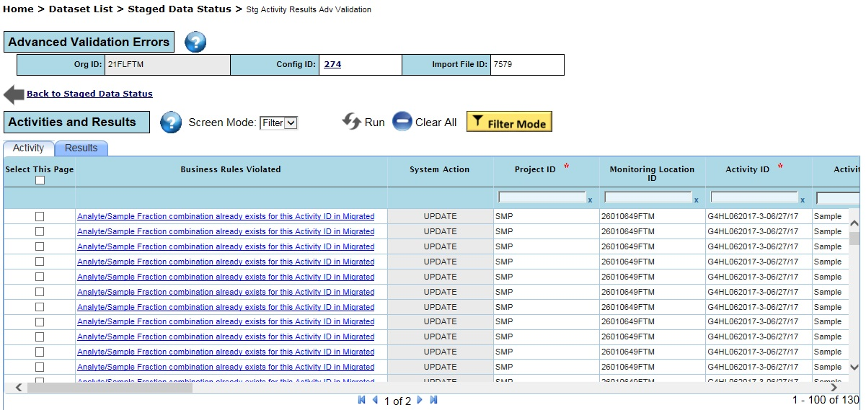
Figure 59 - Adv. Error, Data already in Migrated
Action: WIN Coordinators and DMT Users can verify if the records are present in WIN Migrated. To do this, navigate to the “Manage Data”-> “Migrated Data” -> “Search Data” menus. Open the “Organizations and Contacts” filters and select your “Organization ID”. Open the “Activities and Results” filters and enter one of the Activity IDs that failed this check in the Activity ID field. Click “List Results”.
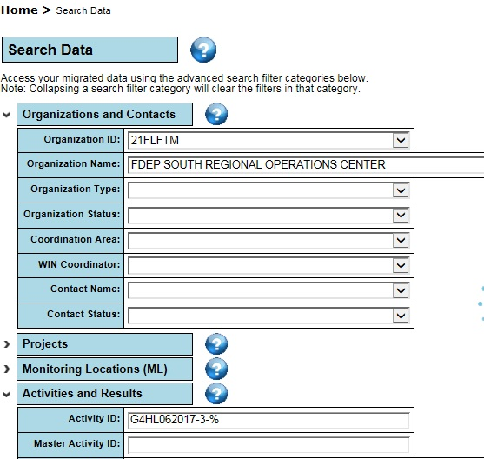

Result List will be displayed
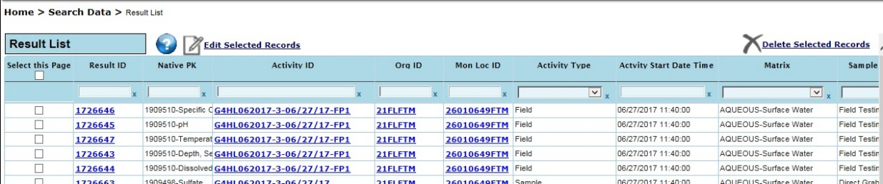
Figure 60 - Verifying Data Exists in WIN Migrated

If duplicate results are found, DMT Users and WIN Coordinators should work together to identify the cause. Duplicates can be deleted from staging by navigating to Advanced Validation Errors screen using the following menus: “Manage Data” -> “Dataset List”. Click on “Import File ID”. Click on “Analyte/Sample Fraction combination already exists for this Activity ID in Migrated” error. Switch Screen Mode to Edit. Click “Select this page” or individually select each check box associated to the rows you want to delete. Then click the “Delete” button. Once the deletes are complete, click the ‘Check Adv Errors” to revalidate the data.

Correcting Advanced Error in WIN – Incomplete set of data
Error: Lab QC result must be associated to at least one sampled result for the same DEP Analyte Name
Error resolution by: WIN Coordinator/DMT Lead needs to be notified for resolution.
Reason: This error will occur when a Lab QC record does not have a corresponding Environmental Sample ('Sample', 'Sample-Composite', 'Field Replicate', 'Trip Blank', 'Equipment Blank', OR 'Field Blank') in the Import File or in WIN Migrated with the same DEP Analyte Name and Method Batch ID. This error may occur if a partial event was loaded because not all rows were selected in the DMT before generating the file. It is also possible that not all analyses were run at all sites.
Action: Using the DMT, DMT users should double check that all rows from the event were included in their upload file. If data is still missing, the issue will be reviewed and resolved as directed by WC and DMT Lead.

Correcting Advanced Error by Lab - Missing Prep Date/Time
Error: Prep Date Time is conditionally required
Error resolution by: DMT User. WIN Coordinator/DMT Lead needs to be notified for resolution.
Reason: Prep Date/Time is not provided by an overflow lab for microbiological data.
Action: The error will be flagged Preparation Date Time is conditionally required.
For microbiological data collected on or after July 1, 2017, please contact the FDEP Laboratory for this information. The event (entire upload file) should remain in WIN staging until the issue is resolved. When the issue is resolved, the complete event should be migrated. Microbiological data with Missing Prep Date/Time collected before July 1, 2017 cannot be loaded to WIN.

Errors to ignore
Error: Translation Error
Error resolution by: DMT User can resolve this error.
Reason: Analyte “Chlorophyll/Phaeophytin Ratio” and associated “FL-BIO-005” ADAPT Analyte ID are not supported by WIN. The FDEP Laboratory discontinued this analyte, but older events may still contain it. If this issue exists in the upload file, it will be identified as a translation error as shown below.
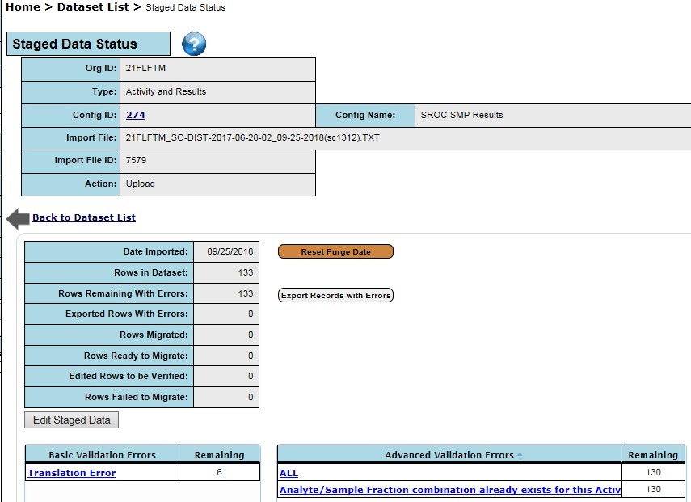

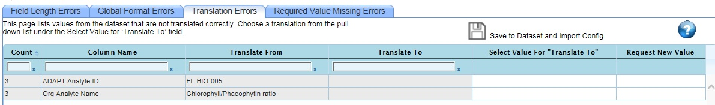
Figure 61 - Translation Error - Discontinued Analyte
Action: Resolve all other errors that can be corrected. If this is the only error that remains, it can be exported and discarded.

Errors to follow-up
This section will be expanded if there are scenarios that require extensive research to resolve errors. Currently, no such scenarios exist.

Step 12. Promote staged data to WIN Migrated
After Errors in WIN Staging are resolved, the “Migrate Records” button shows up in green next to “Rows Ready to Migrate” (all rows are now error free).
Example below shows 9 rows with errors were already exported and remaining 1130 rows are error free.
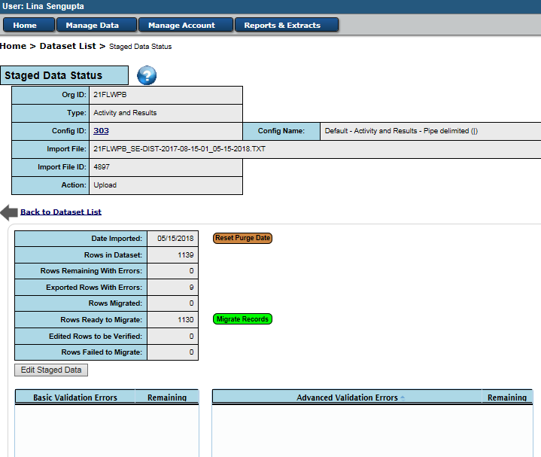
Figure 63 - Migrating Rows with no errors

“Migrate and Export” vs “Migrate Only”
When the “Migrate Records” option is selected, the following options are available: “Migrate and Export”, “Migrate Only”, or “Cancel”.
Note: It is recommended that “Migrate and Export” option be used. There are occasions when there is a need to check if some specific data was already uploaded. It serves as a check for the number of rows migrated. Receiving the emails with the Migrated data information is a built-in logging mechanism for the DMT User.

Step 13. Migrated data automatic refresh to WIN Warehouse
After an import file is uploaded and migrated to WIN, it resides in WIN Migrated. There is a regular preset schedule which refreshes data from Migrated WIN to WIN Warehouse. The data updates will only be available for running the latest reports after this update.

Guidance-DMT/WIN by Policy Managers
This section captures the guidance from Policy Managers.

Field QC Collection, Batching, and Evaluation

Equipment Blanks

Collection: these should be collected any time samples are collected using equipment or an intermediate device, at a minimum frequency of 5% for the project. The analytes collected for the blank should be the same as the samples collected using that equipment with the exceptions of chlorophyll-a. If more than one type of equipment is used, the blank should be collected using the same equipment as the samples (e.g. VanDorn used and sample filtered).

Batching: See Section Equipment Blank Batch ID.

Data Evaluation: If there is a detection in any blank, you should take extra care to minimize contamination and keep an eye out for possible causes. For evaluating blanks relative to samples in the same batch, we use the “10% rule”. If there are detections of an analyte in both the sample(s) and the equipment blank, you need to evaluate whether the detection in the blank is >10% of the detection in the sample(s). If the blank result is >10% of the sample result for a given analyte, then all samples associated with that equipment AND that analyte should be G-qualified. You can add the G in the DMT or WIN.

Example 1:
NO3+NO2 results – Equipment Blank = 0.08 mg/L Sample = 0.02 mg/L; samples should be G-qualified.
Example 2:
- The blank value and the associated sample value are both detects (neither are “U” qualified).
- Result Value associated to the Sample = 100 mg/L
- A “G” qualifier would need to be applied to that sample if the associated blank value is > 10 mg/L.

Example 3:
- The blank value and the associated sample value are both detects (neither are “U” qualified).
blank value = 10 mg/L
- A “G” qualifier would need to be applied to any samples associated with this blank where the sample value is < 100 mg/L.

Field Blanks

Collection: Field blanks should be collected at a minimum of 5% of a project. Most ROC staff are collecting at least one field blank per sampling run for SMP. You may collect additional blanks associated with other projects, as necessary. Exceptions to field blank collection are chlorophyll-a and bacteria. Field blanks are not required for these parameters.

Batching: Field Blank Batch IDs.

Data Evaluation: If there is a detection in any blank, you should take extra care to minimize contamination and keep an eye out for possible causes. For evaluating blanks relative to samples in the same batch, we use the “10% rule”. If there are detections of an analyte in both the sample(s) and the equipment blank, you need to evaluate whether the detection in the blank is >10% of the detection in the sample(s). If the field blank result is >10% of the sample result for a given analyte, then all samples collected for that analyte during that week should be G-qualified. You can add the G in the DMT or WIN.

Field Replicates

Collection: Field replicates (dups) should be collected at a minimum of 5% of samples for a project. Most ROC staff are collecting at least one field replicate per week for SMP, and this should be sufficient. Field replicates should be collected for all analytes, including chlorophyll-a and bacteria.

Batching: See Section Associate Replicates (Activity_ID, Activity_Type, Master_Activity_ID).

Data Evaluation: For evaluating replicates, you need to calculate a relative percent difference (% RPD). The excerpt from the DEP Lab QA Manual is provided just below. The %RPD should be calculated for each analyte and it should be compared to those percentages in Table 5.1, also in the DEP Lab QA Manual found at this link: http://publicfiles.dep.state.fl.us/dear/labs/lab_qualitymanual_18.pdf
If both results are U or I-qualified, you do not need to calculate RPD and the samples are considered to pass QA/QC. The RPD% is not required by DEP SOPs and is collected by ROC staff as part of the internal quality control. If RPD% is higher than expected it is recommended that field procedures are reviewed.

Replicate analyses are used to evaluate precision. Precision is expressed by the relative
percent difference (RPD) to compare duplicate samples/spikes A and B and is based on the
formula:
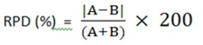
Figure 64 - Relative Percent Difference

If the calculated RPD values exceeds the limits, then field methods should be reviewed. Data does not need to be qualified.

