SMP Guidance
Labels and Lab Submittal Form

The site location used on the labels and on the lab submittal form must be identical to the Monitoring Location Name in the Watershed Information Network (WIN) Database.

The same Field ID cannot be used more than one time during the same sampling event. Field ID issues could arise when more than one sample is collected at the same station (ex. Duplicates which are referred to as Field Replicates in WIN) because the Station ID is used for the Field ID for field samples.

Field Samples:

The WIN ID and the Field ID are the same for field samples.

Field Sample Option 1: Text and Barcode Monitoring Location Name
Field ID: WIN ID, Barcode required
WIN ID: WIN ID, Barcode required
Location: WIN Monitoring Location Name, Barcode
Using a Barcode for the monitoring location name is preferred but optional because a barcode can only contain a limited number of characters. If the WIN Monitoring Location Name is not too long, use this format.

Label for Field Sample (Option 1):
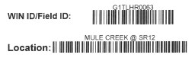
The number of characters that can fit in a barcode is limited (20‐40). The barcode length for each symbol (numbers, letters, punctuation mark, space) is different.

Field Sample Option 2: Text Monitoring Location Name
If the WIN Monitoring Location Name id is too long to fit in a barcode, use this label format.

Field ID: WIN ID, Barcode required
WIN ID: WIN ID, Barcode required
Location: WIN Monitoring Location Name, text
Matrix: Fresh or Salt

Label for Field Sample (Option 2):
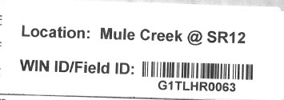

QC Duplicate Samples:

The WIN ID and the Field ID are not the same for duplicate samples.

In order to easily identify replicates in the DMT, please include ‘DUP’ in the Field ID for a replicate sample. If more than one replicate is collected, include ‘DUP2’, ‘DUP3’, etc. in the Field ID. In order to associate all replicates to the parent sample, the Master Activity ID field must be populated with the Activity ID of that parent sample. The Activity Type must also be updated to ‘Field Replicate’ for all replicate samples. The steps are described below.
Shown below example of typical Field Replicates that have no association with parent sample:
 | Activity ID | Activity Type | Master Activity ID
Parent -> | G1CE0067-08/15/17 | Sample
1st field replicate-> | G1CE0067_DUP-08/15/17
2nd field replicate-> | G1CE0067_DUP2-08/15/17

Shown below example of typical Field Replicates after association with parent sample:
 | Activity ID | Activity Type | Master Activity ID
Parent -> | G1CE0067-08/15/17 | Sample
1st field replicate-> | G1CE0067_DUP-08/15/17 | Field Replicate | G1CE0067-08/15/17
2nd field replicate-> | G1CE0067_DUP2-08/15/17 | Field Replicate | G1CE0067-08/15/17

QC Duplicate Option 1: Text and Barcode Monitoring Location Name
Field ID: WIN ID_DUP, barcode required
WIN ID: WIN ID, barcode required
Location: WIN Monitoring Location Name, barcoded
Comment: QC Dup

Label for QC Duplicate Option 1:
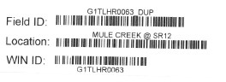

QC Duplicate Option 2: Text Monitoring Location Name
Field ID: WIN ID_DUP, Barcode required
WIN ID: WIN ID, Barcode required
Location: WIN Monitoring Location Name, Text
Comment: QC Dup
Matrix: Fresh or Salt

Label for QC Duplicate Option 2:
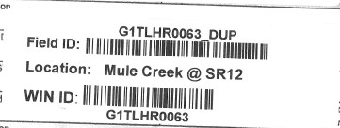

QC Duplicate label on lab submittal form with comment:
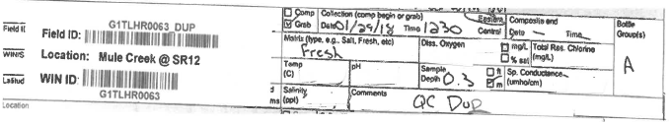

QC Blank Samples:

There is no WIN ID for QC Blank Samples, only a Field ID.

QC Blank Label: Blank Type Specific
Field Blank Field ID: FB_MMDDYYYY, barcode required
Equipment Blank Field ID: EB_MMDDYYYY, barcode required
Trip Blank Field ID: TB_MMDDYYYY, barcode required
WIN ID: None, there is no station (ID/Location) for blank samples.
Location: Location where the bottles were filled. barcode optional
Matrix: Blank Type
Field Blank
Equipment Blank
Trip Blank

Comment: No comment required
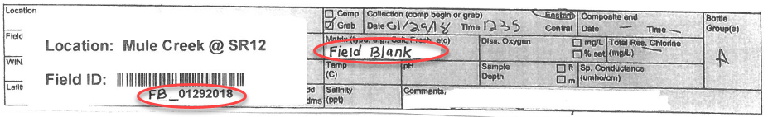

Follow the below format when assigning a Field ID to Field QC. Notice, in the below example, 2 equipment blanks were taken on the same day. The Field ID should begin with EB1, EB2, etc. in this case.
Activity Type | Date blank was taken | Field ID
Field Blank | 1/12/2018 | FB_01122018
Equipment Blank | 2/11/2018 | EB1_02112018
Equipment Blank | 2/11/2018 | EB2_02112018
Trip Blank | 3/15/2018 | TB_03152018

