Assigning A LIMS ID to Macrophyte Samples in SBIO (LVI and LVS)

Note: LIMS IDs are not associated with LVS bioassessments when there are less than 2m² of macrophytes. Note: The RQ for the water quality samples associated with the macrophyte bioassessment is needed for the guidance below. It is possible to find the LIMS Sample ID without the RQ but those methods are not described here.
Samples Not Marked Complete, SBIO2
Finding the LIMS ID (Sample ID) in LIMS
- Open the LIMS Browser.
- Search for the samples associated with your Macrophyte sample using the “Search By Request ID” and type in at least a portion of the associated RQ into the “Search For” box and click the Build List button. 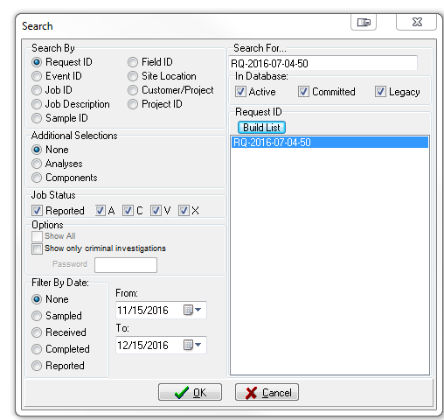
- Your search will return a list of RQ’s. Choose the RQs you are interested in (you can choose more than one) and click OK. If your search does not yield the RQ you are looking for, see if the search is being limited by the “Additional Selections”, “Job Status”, or “Filter By Date” search options.
- Your result will be a list of events and jobs associated with the RQ. The event and job numbers include the date the samples were received and an order numeral (e.g. 2016-07-12-02). Expand the EVENT so the JOB numbers are visible and click on one of the JOB numbers.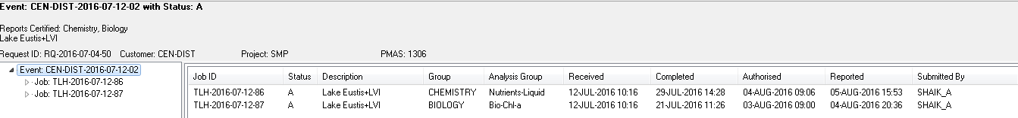

- Look for the station location and or the Field ID for your Macrophyte sample.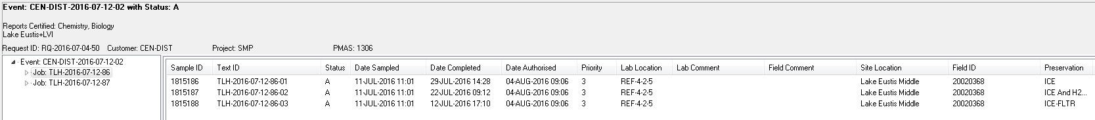
The LIMS Number a.k.a Sample ID is the value in the first column. It is import to make sure you pick a Sample ID associated with the appropriate Site Location. There will be multiple sample IDs from each site, because each bottle submitted to the lab under the RQ in question will get its own Sample ID. It does not matter which Sample ID you pick, because Kathy’s super smart button will use the Sample ID to find the Event, as long as the Station ID is associated with the correct visit (time and place).

Entering the LIMS ID in SBIO2
- Open the Vascular Module in SBIO2.
- Enter the macrophyte data as you normally would.
- Before you save the entry, enter the Sampling Agency, Identifier, and the LIMS ID. 