Strategic Monitoring Program

Sampling Manual

Watershed Assessment Section
Florida Department of Environmental Protection
2600 Blair Stone Road, Tallahassee, FL 32399
June 2020

Section 1. Introduction

Strategic Monitoring Program
The annual strategic monitoring plan provides critical monitoring needs to fulfill the department’s responsibility for monitoring the State’s waters to meet Section 303(d) requirements of the Clean Water Act. The Florida Department of Environmental Protection (DEP) routinely monitors the quality of Florida’s fresh and marine waters. Florida conducts statewide monitoring under the direction of the Strategic Monitoring Program’s (SMP) annual monitoring plan. The SMP addresses waterbodies that need data collected to make determinations on the health of the system. This document provides guidance on DEP procedures for field sample collection and promotes the importance of quality assurance in the implementation of monitoring for the SMP.

The Watershed Assessment Section (WAS) develops the SMP annual plan to assist in assessing the health of surface waters by conducting hydrological and biological watershed-based monitoring activities annually. The SMP annual plan is developed, coordinated and managed by the WAS in Tallahassee. Monitoring is conducted by staff from the seven Regional Operation Center (ROC) offices and the WAS. Some monitoring effort is accomplished through coordination with local governments. The primary objective of the SMP annual plan is to ensure that all waters identified on previous Planning or Study Lists (Table 1), as well as any additional waters based on more recent data identified through preliminary assessments that meet the listing requirements for the Planning or Study Lists, will achieve the additional data sufficiency requirements in the applicable assessment period. These data are then used to assess the waterbody’s health.

Data sufficiency requires is at least ten samples with a minimum of five temporally independent sampling events during the assessment period for non-nutrient (field parameters, metals, pesticides) and analytes. Data sufficiency for microbiological analytes (E. coli, enterococci, fecal coliforms) require is at least twenty samples with a minimum of five temporally independent sampling events during the assessment period. Samples should be collected at least a week apart when collected at the same sampling station to be considered temporally independent. To be considered as separate sites within the waterbody reach, the monitoring stations must be at least 200 m apart.

When 10 percent or more of non-nutrient sample do not meet the applicable criteria with a minimum of an 80 percent confidence level using a binomial distribution, as described in Chapter 62-303.320, F.A.C., data indicate potential impairment, are placed on a “Planning List” in the assessment category 3c, and are targeted for additional sampling. When 10 percent or more of microbiological sample do not meet the applicable criteria with a minimum of a 90 percent confidence level using a binomial distribution, as described in Chapter 62-303.420, F.A.C., and the sample size is less than twenty, data indicate water quality standards are not met, are placed on Florida’s “Study List” in the assessment category 4d and are targeted for additional sampling. When 10 percent or more of non-nutrient sample do not meet the applicable criteria with a minimum of a 90 percent confidence level using a binomial distribution, as described in Chapter 62-303.420, F.A.C., data indicate impairment, are placed on Florida’s “Verified List” in the assessment category 5. Categories 4e (Pollution Reduction Plan) are also targeted for additional sampling. When sufficient data are collected, the WAS identify WBIDs that are not meeting the applicable water quality standards and their designated uses (Table 2) based on the Impaired Waters Rule Chapters 62-303 and 62-302, Florida Administrative Code (F.A.C.).

Beginning 2011 the department adopted numeric nutrient criteria (NNC) for Florida’s all Class I, Class II, and Class III waters (Table 2). NNC data sufficiency requires at least two years of annual geometric means (AGMs) or annual arithmetic means (AAMs) in a three consecutive calendar year period. To calculate an AGMs or AAMs for TN, TP, NO3-NO2, or corrected chlorophyll a, there shall be at least four temporally independent samples per year with at least one sample collected between May 1 and September 30 and at least one sample collected during the other months of the calendar year. To be treated as temporally independent, samples must be collected at least one week apart, as described in Chapter 62-303.350, F.A.C. Stream waterbodies and water segments (WBIDs) have the additional requirement of at least two temporally independent Biological Health Assessments (Stream Condition Index, Rapid Periphyton Survey, Linear Vegetation Index). To qualify as temporally independent each Biological Health Assessment shall be conducted at least three months apart. If there is one NNC exceedance and there is not three consecutive years of data, the data indicate potential impairment, are placed on a “Planning List” in the assessment category 3c and are targeted for additional sampling. In Stream WBIDs if there are two or more NNC exceedance and in a three consecutive year period the data indicate potential impairment, are placed on a “Study List” in the assessment category 4d and are targeted for Biological Health Assessments. In non-stream WBIDs if there are two or more NNC exceedance and in a three consecutive year period, data indicate impairment, are placed on Florida’s “Verified List” in the assessment category 5.

SMP annual plans are developed in the fall prior to the year of sampling, relying on data extracted from the Watershed Information Network (WIN), Florida STORET, the USGS database, external biological data provided to the department, and biological data from the Statewide Biological Database (SBIO). The core schedule is designed such that each of the five basin groups situated throughout Florida are addressed on a five-year cycle (Table 3). Prioritizing monitoring efforts in specific basins allows for a focus on collecting data where there may be shortfalls and to combine with critical ongoing sampling needed for assessments.

DEP Standard Operating Procedures
The DEP Standard Operating Procedures (SOPs) were revised in March 2014 and were approved on July 30, 2014, under Chapter 62-160, F.A.C. rule requirements. The procedures in this manual are based on the DEP SOPs, as specifically applied to the Strategic Monitoring Program. Additional information is available at:
http://www.dep.state.fl.us/water/sas/sop/index.htm and http://www.dep.state.fl.us/water/bioassess/training.htm.

Sections of special interest for the Strategic Monitoring Program include:

Table 1. DEP Sampling Standard Operating Procedures
SOP Section | Description
FA 1000 | Administrative (includes Quality System, Quality Manual)
FC 1000 | Field Decontamination
FD 1000 | Documentation
FM 1000 | Field Mobilization (Trip Planning, Equipment and Supply Preparation)
FQ 1000 | Quality Control
FS 1000 | General Sampling
FS 2000 | General Water Sampling
FS 2100 | Surface Water Sampling
FS 2200 | Ground Water Sampling
FS 4000 | Sediment Sampling
FS 7000 | Biological Communities (includes RPS, LVS)
FT 1000 | Field Testing General
FT 1100 | Field pH
FT 1200 | Field Specific Conductance
FT 1400 | Field Temperature
FT 1500 | Field Dissolved Oxygen
FT 1600 | Field Turbidity
FT 1700 | Field Light Penetration (Secchi depth)
FT 3000 | Habitat Assessment
SCI 1000 | Stream Condition Index
LVI 1000 | Lake Vegetation Index

Additional Information
Please contact Curtis Musson, the DEP Watershed Assessment Section (WAS) Strategic Monitoring Program Coordinator at (850) 245-8553 or email curtis.musson@floridadep.gov if you have any questions about the procedures outlined in this manual. You may also visit the Watershed Assessment Section website (https://floridadep.gov/dear/watershed-assessment-section) for the latest IWR Runs and, Assessment Lists.

Section 2. Site Selection

General
All Strategic Monitoring Program (SMP) annual plan stations are approved by Watershed Assessment Section (WAS) staff before monitoring begins. The WAS reserves the right to select sampling sites. Samples collected within 200 meters of each other will be considered the same station, unless there is a tributary, an outfall, or significant change in the hydrography of the water F.A.C 62-303.320(3)e.

There can be more than one site in a waterbody or water segments (WBID) that is arguably the ideal candidates because there are many factors to consider when sampling a site for the SMP. All sampling sites need to be both representative of the WBID, such that the sample collected can be used to infer information about the rest of the WBID and meet project objectives (sample size, target parameters). Each year before monitoring begins in a WBID, use the most recent IWR Database to review the data for the target parameter(s). The IWR Database can be downloaded from the WAS web page (http://publicfiles.dep.state.fl.us/DEAR/IWR/). If representative, the site(s) with exceedances of the target parameter(s) should be targeted. The site chosen should be replicated, such that the collection point does not change over time.

Access and Sampling Permission
Samplers need to gain property owner permission to access before attempting to sample on private property. Arrangements may be made prior to visiting the property for sampling (during recon, for example) or as a last resort, immediately before sampling. Either verbal or written permission is acceptable, but it must be documented. For circumstances which require samplers to seek permission immediately before sampling once on the property, extra copies of permission forms (Figure 1) should be kept on hand. If permission to access the property or to sample is denied, the site can be excluded. When mailing permission letters, DEP staff must use the standardized letter and legal agreement (below).

If permission is granted through a phone conversation, please document the following information:
- First and last name of person spoken with (obtaining a signature is not required),
- Relation of person to property (owner, land manager, spouse of owner, etc.),
- Time and date of conversation,
- Contact phone number,
- Comments (owner requests to be on site during sampling, meet at a specific place or time, watch out for dogs, gate locked, etc.),
- Approximate date for sampling, and
- Mailing address and / or email address for sending requested results.

For owners who request that their personal information not be officially documented for privacy reasons, samplers may document a statement such as “verbal approval granted, personal information not documented as requested” and do not have to keep the personal information on file.

Coastal WBID Site Selection
Coastal WBID sites should be in open water that is both safe and representative of the WBID. Sites in a coastal WBID must be greater than 100 m offshore. It is not necessary to sample the center of the WBID to find an area that is representative. To be safe, land should be visible from coastal WBID sites. All coastal WBIDs have Estuary Nutrient Region (ENR) coverage, and the ENR(s) will be specified on the monitoring plan. Be aware ENR and WBID boundaries may not be the same. Some ENRs are large and cover multiple WBIDs, some are smaller than a single WBID. Samples collected outside the target ENR will need to be resampled.

Estuary WBID Site Selection
Follow the Coastal WBIDs guidelines above for open water Estuary WBIDs in the Gulf of Mexico or Atlantic Ocean. Sites in tidal areas that resemble streams or rivers, “tidal creeks”, should be in the middle of the WBID, not at the bottom of the catchment. The water in the middle of these systems will be most representative. In theory, there is a 50/50 mix of the upstream and downstream WBID waters as they mix with the ride and fall of the tides. For WBIDs in protected marine waters, like bays and sounds, the site should be offshore and only accessible by boat. If there is ENR coverage in the WBID, the site must be in the ENR specified on the monitoring plan. Be aware ENR and WBID boundaries may not be the same. Some ENRs are large and cover multiple WBIDs, some are smaller than a single WBID. Samples collected outside the target ENR will need to be resampled.

Lake WBID Site Selection
Lake WBID sites should be in the deepest part of the lake or if applicable, over the sink. If the lake depth is uniform and there is no outlet, the site should be at the geographic center. Sites in lakes with uniform depth and an outlet should be in the lower or downstream third of the WBID. Emergent and floating vegetation need to be considered when setting up sites in Lake WBIDs because the ideal lake site is clear of emergent and floating vegetation. If there are no accessible areas clear of vegetation, a site can be established in an area clear of emergent vegetation but not clear of floating vegetation (ex. Nuphar sp.). If vegetation prevents access to a lake or there are no areas free of emergent vegetation contact the SMP coordinator. Additional sites should be established in lakes with lobes that resemble individual lakes. Contact the SMP coordinator if a lake WBID on your monitoring plan has multiple lobes that resemble individual lakes.

Spring WBID Site Selection
Spring WBIDs with a single vent, the site must be directly over the vent. If the spring has multiple vents of different magnitude, the site should be over the vent with the greatest magnitude. If the spring has multiple vents of equal magnitude and some have sufficient discharge to make surface boils choose anyone for your sampling site. If the spring has multiple vents of equal magnitude and insufficient discharge to make a surface boil the, site should be near the center of the spring pool over one of the vents. Whichever vent is chosen it should be replicated, such that the collection point doesn’t change over time. The spring sites should not be along the edge of the pool or run near the shore.

Stream WBID Site Selection

Water Chemistry Sites
Use the decision tree below and the IWR Database when selecting water chemistry sites in stream WBIDs. Review the target parameter data in the most recent IWR Database to determine what site(s) from which the exceedances were collected. The IWR Database can be downloaded from the WAS web page (http://publicfiles.dep.state.fl.us/DEAR/IWR/). If the system is tidally influenced, or the target waterbody in the WBID is not apparent contact the SMP Coordinator. Additional samples may be requested if there are multiple waterbodies within the WBID.
Stream WBID Site Decision Tree:
- Are there accessible, predominantly fresh sites in the WBID with exceedance for the target parameter?
  - Yes: Select this site for your sample station.
    - If a second site is needed to meet objectives proceed to couplet 2.
  - No: Proceed to couplet 2.
- Is the downstream third of the WBID catchment accessible and predominantly fresh?
  - Yes: Select this for your sample site.
    - If an additional site is needed proceed to couplet 5.
  - No: Proceed to couplet 3.
- Is the middle third of the WBID catchment accessible and predominantly fresh?
  - Yes: Select this for your sample site.
    - If an additional site is needed proceed to couplet 5.
  - No: proceed to couplet 4.
- Is the upstream third of the WBID accessible and predominantly fresh?
  - Yes: Select this for your sample site.
    - If an additional site is needed proceed to couplet 5.
  - No: Contact the SMP Coordinator
- Are there any contributing waters in an accessible, predominantly fresh reach of the WBID?
  - Yes: Select a site immediately below the largest accessible contributing water.
    - If an additional site is needed proceed to couplet 6.
  - No: Proceed to couplet 7.
- Are there two or more contributing waters in the accessible, predominantly fresh reach of the WBID?
  - Yes: select a site immediately below the second largest contributing water.
  - No: Proceed to couplet 7.
- Is the middle third of the WBID catchment accessible and predominantly fresh?
  - Yes: Select this for your sample site.
    - If additional sites are needed proceed to couplet 8.
  - No: proceed to couplet 8.
- Is the upstream third of the WBID accessible and predominantly fresh?
  - Yes: Select this for your sample site.
    - If additional sites are needed proceed to couplet 9.
  - No: Contact the SMP Coordinator.
- Add sites anywhere that are accessible, predominantly fresh, and > 200 m from other sites.

Bioassessment Sites
Select a Stream Condition Index (SCI) site in the target WBID with the highest habitat assessment score. This may be a different site used for repeated water chemistry monitoring. The objective of biological assessment is to isolate water quality factors causing degradation; efforts should be taken to establish sites where habitat is not a substantial factor limiting potential biological health. This means that the sampler must establish sampling sites, where possible, in stream reaches with adequate substrate diversity and availability, intact stream morphology (little or no artificial channelization), adequate flow, and optimal riparian buffer zones. The stream or river must be a definable, freshwater, continuously flowing system that is functioning as a “stream” or “river” in order for an SCI to be performed. For example, do not perform the SCI if:

- the system is not functioning as a stream or river (it is more like a lake, estuary, wetland, marsh, prairie, canal, ditch, etc.).
- the system is currently dry or disconnected or has been completely dry within 6 months prior to the site visit. If this cannot be determined with confidence, do not sample.
- flood conditions exist and water levels are > 0.5 m above normal. If you are not confident that the reachable substrates have been inundated for greater than 28 days, do not sample.
- the system is tidally influenced (regardless of conductivity values).
- the average water velocity is < 0.05 m/s or has been < 0.05 m/s within 28 days prior to the site visit. If this cannot be determined with confidence, do not sample.
- conditions are unsafe.
- the system is in the South Florida / Everglades Bioregion (south of Lake Okeechobee)

When the Linear Vegetation Survey (LVS) and Rapid Periphyton Survey (RPS) are requested and the SCI is not, select a site that is:

- not influenced by a road crossing
- has an open canopy, if available
- has herbaceous aquatic vegetation, if available
- safe to access
- not in the South Florida / Everglades Bioregion
- sufficiently wetted, not disconnected

Road Crossing
Road crossings can impact water chemistry values. Water impacted by road crossings may not be representative of the target waterbody. To minimize the impact and get representative results, sites should not be at road crossings or in the areas impacted by them. The following scenarios are ranked from best to worst.
- >100 m upstream of a road crossing.
- <100 meters upstream of a road crossing, upstream of the crossings influence.
- >100 m downstream of a road crossing
- <100 m downstream of a road crossing, but downstream of the crossings influence.
- Immediately upstream of the road crossing*
- Immediately downstream of the road crossing*
*If the only accessible portion of the stream is immediately up or downstream of a road crossing contact the SMP coordinator before sampling.

Section 3. Sample Scheduling
If there are any questions or concerns regarding the scheduling of an event, call the DEP Central Laboratory staff for assistance.

Scheduling Analyses in LIMS
Log into the DEP LIMS and from the menu choose “General” then “Scheduler”.

LIMS menu bar.

Select “Schedule New Request” then “Next” (Screen 1).

Screen 1 – Scheduling a new request.

If you have saved templates from previous scheduling events, please choose Load Templates and highlight the correct template. Choose the week for the sampling event (Screen 2).

Screen 2 – Choosing the sampling week.

Choose the week of sample collection. If the same event is going to be scheduled several times, then multiple weeks can be selected for up to six months. There will be a different Request ID generated for each week selected, and each RQ will have its own set of scheduled/Shipping/Return dates. Laboratory capacities are displayed by group below the calendar. If any groups have capacities over 150%, check with the lab before scheduling the analyses. Choose “Next” to move to the next screen. Enter sampling event information (Screen 3).

Screen 3 – Enter sampling event information.

Select your Customer ID from the dropdown list (CEN-DIST, NE-DIST, NW-DIST, SE-DIST, SO-DIST, SW-DIST, TLH-ROC, WAS-SECT). Never use the WQAP customer code to schedule Strategic Monitoring events.
Select the Project ID from the popup window. Do not use the SMP Project ID for other projects (Special Projects, Discretionary, etc.). If requirements for SMP overlap with other projects (BMAP, LAKEREF, SCIREF, TMDL, etc.), use the non-SMP Project ID when scheduling events.

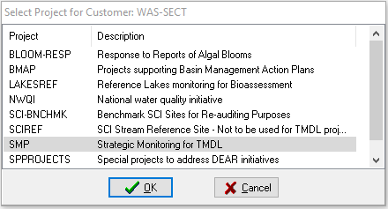
Project ID pop up window.

PMAS is a legacy detail and is no longer applicable to the LIMS scheduling process. In the past projects were assigned to specific modules, which required this input. Select a priority for the report turnaround time. The scheduler defaults to Priority 3. SMP events are Priority 3. The priority indicates how soon the data are needed. Choose a different priority if needed. For priorities 1 and 2 there is a prompt to enter a comment. Turnaround time = Priority# plus one week (Priority 1: Two-week turnaround, Priority 3: Four-week turnaround, etc.).

  - If less than a two-week turnaround time is needed, please contact the laboratory.
  - Make sure the Criminal Investigation box is not checked.
  - Check the designated box if a sampling kit is required. Uncheck if building your own kits with spare bottles and only require new bottle labels (Figure 2). If the event being scheduled does not require a bottle kit and is for labels only add “Labels only, no bottles” to the comment field.
  - Check the designated box if a sampling kit is being picked up in Tallahassee. If this box is not checked, the sample kits (or labels) will be shipped to the address on this, the Sampling Event Information, page.
  - Check the designated box to request acid preservation be shipped with this sample kit. If checked, then a comment must specify what kind of preservative and how many cases. Sulfuric and nitric acid cases contain 24 ampules each.
  - Enter a description of the sampling event. The “Run” name for example.
  - Comments: If scheduling more than one bottle group, it is recommended that the site or WBID and analyte groups be listed.

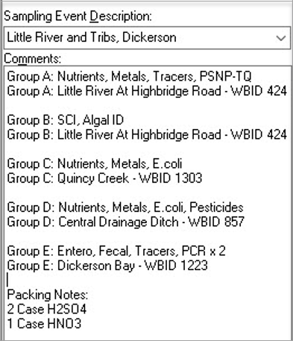
Example of comments in Sampling Event Description box for laboratory staff.

Comments: Enter any special instructions for the laboratory staff. These comments could include:

  - Preservatives types and number of cases
  - Analyte-free water for Field Blanks
  - Paperwork and shipping bills
  - Labels only instructions
  - Special delivery or pickup dates
  - Number of coolers to use, if designated
  - Special containers instructions (more/fewer)
  - Login instructions (separate events)
  - Special handling or importance

Schedule/Shipping/Return Dates: The system defaults to a kit ship date of 2 weeks prior to the sampling week. The return date indicates the week of sampling. The Receiving Room staff require 2 full weeks to schedule a kit for delivery. The Ship Date cannot be modified. Please modify the sample Return Date if you know when you plan to ship the samples back to the lab. If you need your kit prior to the mandatory 2-week fulfillment period, contact the lab.

Under Send Coolers To, enter the name, email address, address and phone number of the person receiving the kit. When kit preparation is complete, this person will receive an email indicating it is ready for pickup or that is has shipped, including the common carrier tracking codes. The lab will contact this person if there are issues (improperly preserved samples, lost/late coolers, cracked/broken bottles. Etc.) during login.

Under Send Final Report To, enter the name and address of the person getting the data. Reports are transmitted via e-mailed with electronic signatures.

  - E-mail: Enter the correct e-mail address(es) of the person(s) receiving the report. Multiple e-mail addresses need to be semicolon (;) separated. The E- mail row is a required field. All report notifications are e-mailed so an incorrect address will delay the reporting process.
  - If using a cloned template, verify all field (customer, project, Sampling kits for pickup check box, send coolers to, e-mail notifications to) on this page have been updated.
  - If the “Next” button is not highlighted, choose the “Required Customer Info” button to find out what required information is missing.
  - Choose “Next” to go to the analysis selection screen.

Selecting the Analyses
There are 3 icons for working with Bottle Groups:
  - A. Add a Bottle Group
  - D. Delete a Bottle Group
  - C. Clone a Bottle Group

Icons for selecting bottle groups.

Choose the A icon to create a Bottle Group. Then select a matrix, water or biological, from the five options. The other matrixes soil, sediment, waste, tissue, and air are not collected for the SMP project. If samples of more than one matrix type will be collected, then each matrix group needs a Bottle Group. The number of Bottle Groups scheduled depends on whether different tests are being requested for various sites and if there is more than one matrix group being sampled.

Enter the number of samples that are in the selected Bottle Group.

Selecting the Tests
Tests can be selected three ways, using the 3 tabs at the top:
  - By LIMS Analysis ID (e.g. W-Cl-IC). Recommended, the Analyte List in the SMP Tracker (Section 21) is organized by Analysis ID.
  - By Method ID (e.g. EPA Method, Standard Method or SOP).
  - By Analyte Name (not recommended for analysis selection, just for analysis identification). If a component is selected under the Analyte Name option, no other components in the selected analysis will appear. Use this function to identify the LIMS analysis then choose the LIMS Analysis tab and select the analysis, then choose the component from the dropdown list.

To narrow down the selection, choose the appropriate Analyses Group (metals, nutrients, molecular, pesticides, etc.).

Analysis group selection.

Highlight the analyses of interest from the list of Available Analyses and click “Add” . The required analyses (nutrients, metals, qPCR, etc.) for each WBID are listed in the SMP Tracker (Section 21). The specific Analysis IDs for the analyses (Table 4) can be viewed in the “Kit Test Codes” tab of the SMP Tracker.

Highlight analysis of interest and click add.

If an undesired analysis is added it can be removed from the Selected Analyses list using the “Remove” button .
All nutrient, pesticide, and tracer analytes in the default templates are required. For these three analyses groups use the “Add All” button to add the analytes.

Add all nutrient, pesticide, and tracer analytes

Individual analytes need to be selected for metal, molecular, overflow, microbiology, SCI, Algal-ID analyses. The required analytes for these analyses are listed in (Table 4) and the “Kit” tab in the SMP Tracker (section 21). Select the desired analytes from the Select Analyte for Analysis menu and click the “Add” button, .

Individual analytes for selection.

To add or remove individual analytes of a multi-analyte analyses select the Analysis ID from the list of Selected Analyses and click the “Selected Analytes” button, . Then add or remove analytes using the “Add”, “Remove” or Remove All” buttons.

Analytes to add or remove from selection.

Note: When requesting qPCR samples make sure the selected analytes have the “PCR” prefix and not the “PMA”, or “PUR” prefix.

Note: Analyses with the suffix “-F” need to be field filtered. The only field filtered analysis for the SMP is Orthophosphate, W-PO4-F. Verify the other Selected Analyses do not have a “-F” suffix.

For SMP the target analytes will always be in the default template. If the desired analyte is not in the default template, contact the SMP Coordinator. Repeat the steps in section 1.5 for all additional (LIMS) Bottle Groups. If the additional (LIMS) Bottle Groups have the same matrix as an existing Bottle Group but the test list is different, the Bottle Group can be cloned with the “Clone Bottle Group” button , and the appropriate tests added or deleted. Note the number sites is cloned too. Verify the number of samples in each Bottle Group is correct before submitting the request.

Optional: Save the request as a template before submitting the request by clicking the “Save Template” button, . The Save Template button will create a template of what has been scheduled, including the project, priority, contact information, Bottle Groups and analyses. Templates can be loaded by clicking the “Load Template” button on the first page, Screen 1 of the Scheduler.

  - Submit the request by clicking the “Finish” button, at the bottom.
  - A popup window with the RQ Number will be generated.
    - Copy the RQ Number
    - Open the applicable Year and ORG Folders in the SMP FTP (Section 23)
    - Make a new folder
    - Rename the new folder by pasting the copied RQ Number
    - Display the request in the LIMS Scheduler, see 2.0 below
    - Paste the RQ Number into the Display/Print Request search field
  - Save the request in the new folder with the corresponding name
    - Paste the RQ Number into the file name field

Viewing and Printing (Saving to PDF) Request
From the LIMS Scheduler dropdown menu, Screen 1, select Display/Print Request. Requests can be displayed at any time.

Screen 4 – Display Print/Request

Display Request: Enter the RQ Number in the field labeled “6 Select Request ID”. If the RQ Number is not know us fields 2, 3, 4, and 5 to search for the desired request. Select the desired request and click the “Next” button, .The request summary will open. Save the file in the appropriate Year and ORG file in the SMP FTP folders. The file name needs to the RQ Number. See Section 23 for guidance on SMP folders and file nomenclature requirements. All requests for DEAR projects (SMP, BMAP, TMDL, Algal Bloom Response, Reference Lakes, SCI Reference Streams, Special Projects) need to be saved in the applicable folder on the DEAR FTP (http://publicfiles.dep.state.fl.us/DEAR/WQAPmonitoring/).

Cancel Existing Request/Edit Existing Request
From the dropdown menu on Screen 1, the requests can be opened to edited or canceled. Edits and cancellations have limited access, typically two weeks prior to the scheduled sample date. Once a request is approved, only the laboratory staff can edit or cancel it. The status can be viewed in the Display/Print Request Module. If a request is in approved status and needs to be edited or canceled contact the laboratory.

- Request status P or T: the person who created the request can edit or cancel it.
- Request status A, W, S or R: contact the lab staff for edit or cancellation requests.
- Request status X: The request has been canceled.

Section 4. Barcoded Station Labels

General
Barcoded Station Labels (Figure 1 - Figure 8) must be on all sample bottles, DEP Laboratory Chain of Custody (Figure 9), and the SMP Field Sheets (Figure 10, Figure 11, Figure 12). It is recommended to use Barcoded Station Labels (label) on Overflow Custody Sheets. The station location description on the labels must be identical to the Monitoring Location Name in the Watershed Information Network (WIN) Database. No other information (date, RQ, etc.) should be on the label (Figure 3, Figure 4). When creating labels, it is recommended to have a WIN station table (http://publicfiles.dep.state.fl.us/DEAR/WQAPmonitoring/StrategicMonitoring/Stations/) open so the WIN ID, and station description can be copied and pasted into the label design program. The WIN ID and Field ID must be barcoded. Labels for QC Blanks will not have a WIN ID. Do not add the text “DUP” to the station description for field duplicate (DUP) samples. If the station description is short, 20 – 25 characters, it too should be barcoded. The number of characters that fit into a three-inch barcode are limited. Save the site Barcoded Station Labels file so it can be used for future site visits. A WIN station table is extracted every Friday and posted in the SMP FTP Station folder.

The same Field ID cannot be used more than one time during the same sampling event. Field ID issues could arise when more than one sample is collected at the same station on the same day (ex. Field Duplicates which are referred to as Field duplicates in WIN) because the WIN Station ID is used for the Field ID for field samples.

When in the field, if an error in a barcoded value is identified, do not use the flawed label on the DEP Laboratory Chain of Custody (DEP CoC), or an Overflow Custody Sheet. The flawed label should be corrected per the procedures in DEP SOP FD-1100 (2.6) (see Section 12) and used on the SMP Field Sheet. Make corrections by marking a line through the error so that it is still legible. Initial or sign the marked error and its correction. If the error in is discovered after the label is affixed to the custody sheet, edit the value and obliterate the barcode so it cannot be read. If the barcode is not obliterated, receiving staff may scan it during login.

Field Sample Labels
The WIN ID and the Field ID are the same for field samples.

Field Sample Option 1: Text and Barcode Monitoring Location Name
Field ID: WIN ID - Barcode Required
WIN ID: WIN ID - Barcode Required
Location: WIN Monitoring Location Name - Barcode Preferred

Using a Barcode for the monitoring location name is preferred but, is optional because a the number of characters that can fit in a three inch barcode is limited, between 20 and 40. If the WIN Monitoring Location Name is not too long to fit in a three inch barcode, use Field Sample Option 2 formatting.

Label for Field Sample, Option 1:
Figure 3. Barcoded Station Label - Field Sample
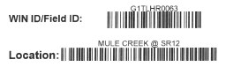
The number of characters that can fit in a barcode is limited (20‐40). The barcode length for each symbol (numbers, letters, punctuation mark, space) is different.

Field Sample Option 2: Text Monitoring Location Name
Field ID: WIN ID - Barcode Required
WIN ID: WIN ID - Barcode Required
Location: WIN Monitoring Location Name - Text

Label for Field Sample, Option 2:
Figure 4. Barcoded Station Label - Field Sample, Option 2
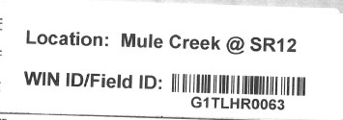

Field Duplicates QC Labels
The WIN ID and the Field ID are not the same for duplicate samples.
In order to easily identify field duplicate (DUP) samples in the LIMS DMT (Section 22), include ‘DUP’ in the Field ID for a duplicate sample. If more than one duplicate is collected, include ‘DUP2’, ‘DUP3’, etc. in the Field ID. In order to associate all duplicates to the parent sample, the Master Activity ID field must be populated with the Activity ID of that parent sample. The Activity Type must also be updated to ‘Field Duplicate’ for all duplicate samples. The steps are described below.

Shown below example of typical Field Duplicates that have no association with parent sample:
Type | Field ID | Activity ID | Activity Type | Master Activity ID
Parent -> | G1CE0067 | G1CE0067-08/15/17 | Sample
1st Field Duplicate | G1CE0067_DUP | G1CE0067_DUP-08/15/17
2nd Field Duplicate | G1CE0067_DUP2 | G1CE0067_DUP2-08/15/17

Shown below example of typical Field Duplicates after association with parent sample:
Type | Field ID | Activity ID | Activity Type | Master Activity ID
Parent -> | G1CE0067 | G1CE0067-08/15/17 | Sample
1st Field Duplicate | G1CE0067_DUP | G1CE0067_DUP-08/15/17 | Field Duplicate | G1CE0067-08/15/17
2nd Field Duplicate | G1CE0067_DUP2 | G1CE0067_DUP2-08/15/17 | Field Duplicate | G1CE0067-08/15/17

Field Duplicate Option 1: Text and Barcode Monitoring Location Name
Field ID: WIN ID_DUP - Barcode Required
WIN ID: WIN ID - Barcode Required
Location: WIN Monitoring Location Name - Barcode Preferred
Comment: QC Dup
Matrix: Fresh or Marine

Label for Field Duplicate, Option 1:
Figure 5. Barcoded Station Label - Field Duplicate, Option 1
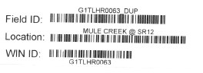

Field Duplicate Option 2: Text Monitoring Location Name
Field ID: WIN ID_DUP - Barcode Required
WIN ID: WIN ID - Barcode Required
Location: WIN Monitoring Location Name - Text
Comment: QC Dup
Matrix: Fresh or Marine

Label for Field Duplicate Option 2:
Figure 6. Barcoded Station Label - Field Duplicate, Option 2
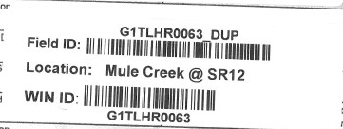

Figure 7. Field duplicate label on lab submittal form with comment
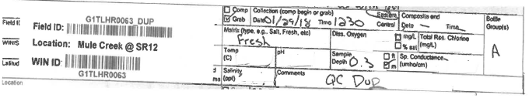
Sample depth, date and time are required field measurements. Do not add additional field measurements, pH, dissolved oxygen, specific conductance, salinity.

Quality Control (QC) Blank Labels
There is no WIN ID for QC Blank Samples, only a Field ID.

QC Blank Label: Blank Type Specific
Field Blank Field ID: FB_MMDDYYYY - Barcode Required
Equipment Blank Field ID: EB_MMDDYYYY - Barcode Required
Trip Blank Field ID: TB_MMDDYYYY - Barcode Required
WIN ID: None, there is no WIN Station ID for blank samples.
Location: Location where the bottles were filled. barcode preferred
Matrix: Blank Type (Field Blank, Equipment Blank, Trip Blank)
Comment: No comment required

Figure 8. Field blank label on lab submittal form with comment
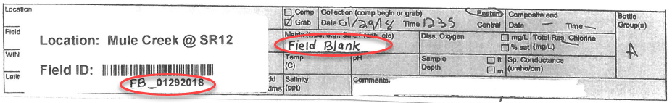

Follow the below format when assigning a Field ID to Field QC. Notice, in the below example, 2 equipment blanks were taken on the same day. The Field ID should begin with EB1, EB2, etc. in this case.
Activity Type | Date blank was taken | Field ID
Field Blank | 1/12/2018 | FB_01122018
Equipment Blank | 2/11/2018 | EB1_02112018
Equipment Blank | 2/11/2018 | EB2_02112018
Trip Blank | 3/15/2018 | TB_03152018

Section 5. Project Preparation

Sampling Schedule
Sampling schedules are prepared Monthly by the Strategic Monitoring Program (SMP) Sampling Coordinator for each ROC and lists the numbers of samples and blanks to be collected. Sample kits need to be requested a minimum two weeks, preferably more prior to the scheduled sampling week, so the DEP laboratory haves time to review, approve, pack, and ship the sample kits. See Section 3, Laboratory Information Management System (LIMS) Scheduler Module, for more information on scheduling sample kits. Waterbodies or water segment (WBID) and Estuary Nutrient Region (ENR) specific sampling requirements can be found on the current years Monitoring Plan (http://publicfiles.dep.state.fl.us/DEAR/WQAPmonitoring/StrategicMonitoring/) and the current years SMP Trackers (Section 21). There is a SMP Tracker for each ROC.

Sampling Kit Shipments
The DEP Laboratory typically ships sampling kits and pre-printed FedEx return shipping labels for each RQ to the sampling agency 1-2 weeks before the scheduled sampling week. Upon receipt, the coolers and sample kits should be inventoried against the sampling schedule and the container inventory list on the back side of the lab submittal form, to ensure that you have enough kits for samples, field duplicate (DUP) samples, and quality control (QC) blanks. If you do not receive the container shipment seven days before the first day of sampling, or if items are missing, notify your Regional Operations Center (ROC) SMP Sampling Coordinator as soon as possible.

Project Paperwork
The current version of the SMP Field Sheets (Figure 10, Figure 11, Figure 12 ) can be downloaded from the Field Sheets and Calibration Logs folder in the Strategic Monitoring FTP folders. Bioassessment field sheets are available on the Quality Assurance SOP and Forms web page (https://floridadep.gov/dear/quality-assurance/content/sop-forms). The most recent versions of all required forms must be used. Before the start of each project, inventory your project paperwork to make sure that you have all necessary forms (Figure 13):

  - SMP Field Sheet (Figure 10)
  - SMP DUP Field Sheet (Figure 11)
  - SMP Blank Field Sheet (Figure 12)
  - Barcoded Station Labels (Figure 3 - Figure 8)
  - DEP Central Lab Chain of Custody (Figure 9) comes with sample kits
  - Overflow lab Custody Sheets (https://floridadep.sharepoint.com/dear/biology/overflow/SitePages/Home.aspx)
  - Stream Habitat Assessment Sketch Field Sheet (Figure 14)
  - Stream Habitat Assessment Score Field Sheet (Figure 15)
  - Rapid Periphyton Survey Field Sheet (Figure 16)
  - Linear Vegetation Survey Field Sheet (Figure 17)
  - Physical Chemical Characteristic Field Sheet (Figure 18)
  - Lake Habitat Assessment Field Sheet (Figure 19)
  - Lake Observation Field Sheet (Figure 20)
  - Lake Vegetation Index Field Sheet (Figure 21)

Supplies and Equipment Inventory
Use a checklist to inventory all sampling supplies and equipment needed. Examples of checklists are shown in (Figure 22). Always retain a copy of the current SMP Sampling Manual in the vehicle for access in the field. If operating a boat during sampling, bring the SMP Sampling Manual with you on the boat.

Preservatives
The DEP laboratory supplies acid preservatives, sulfuric acid for preserved nutrients and nitric acid for metals. The carbamates bottle, test code W-CARB-AA in the pesticide suite is pre-preserved with 5mL of monochloroacetic acid buffer solution (CH2ClCOOH) by lab staff before sample kits are shipped out. The sulfuric acid and nitric acid preservatives are ordered by the ROC SMP Sampling Coordinator when scheduling sampling events in the LIMS Scheduler Module. Each ampule has enough pre-measured sulfuric acid or nitric acid (2.0 ml) to preserve one sample container. Teams should always have more acid vials on hand in case the preservation verification indicates that one ampule was not enough to properly preserve the sample. Any time more than one ampule is needed, or if the preservation protocol described on the field sheets is altered in any way, this information must be documented on the SMP Field Sheet per SOP FD-5100 (1.3). The DEP lab ships acid preservative by the case. There are 24 acid preservative ampules in each case.

For Stream Condition Index (SCI) samples, the DEP Laboratory supplies 10 % recycled buffered formalin preservative. Formalin can be distributed at meetings, training events, or field audits, as needed. Please note that formalin will not be shipped through the mail and monitor your supply accordingly to ensure you will always have plenty in stock. To order more recycled buffered formalin, contact the DEP Biology Program.

Filters
Each ROC orders their own filters for samples that must be filtered in the field. A 0.45 µm disposable in-line filter capsule is used to filter ortho-phosphate, Test Code W-PO4-F, samples in the nutrient suite. Check your filter inventories monthly and order additional filters as needed.

Conductance Standards
Potassium chloride (KCl) conductance standards should be purchased independently from a commercial vendor. Before switching to a new brand of conductivity standards, the SMP Program Coordinator should be contacted to verify that the new standards are of comparable quality. Be sure to maintain enough inventory of conductivity standard 100, 1,000, 10,000, 50,000 or close to those ranges.

pH Buffers
Buffers used for pH calibration and verification should be purchased independently from a commercial vendor. Be sure to maintain enough inventory of pH buffer 4.0, 7.0 and 10.0 Standard Units (SU), as well as small quantities of buffers less than 4.0 and greater than 10.0 SU for use when field measurements extend beyond the 4.0-10.0 range (see Section 7).

Miscellaneous Supplies
All miscellaneous supplies such as pH test paper, gloves, syringes, Kimwipes®, cleaning solutions, plastic bags, brushes, deionized (DI) water carboys, etc. should be purchased independently from a commercial vendor.

Historical Site Data
Review documentation (field sheets) or results (WIN, STORET, IWR Databases) from previous visits, if available, before visiting a sampling site. This can give you important information on calibration ranges, and expected field measurements. Take the historic information to the site and compare it with the current observations.

Access and Sampling Permission
Samplers need to gain access and sampling permission before attempting to sample on private property (Section 2). Arrangements may be made prior to visiting the property for sampling (during recon, for example) or as a last resort, immediately before sampling. Either verbal or written permission is acceptable, but it must be documented. For circumstances which require samplers to seek permission immediately before sampling once on the property, extra copies of permission forms should be kept on hand. If permission to access the property to sample is denied, proceed to an alternate site in the WBID. When mailing permission letters, DEP Water Quality Assessment Program (WQAP) staff must use the standardized letter and legal agreement (Figure 1). If permission is granted through a phone conversation, please document the following information:
- First and last name of person spoken with (obtaining a signature is not required)
- Relation of person to property (owner, land manager, spouse of owner, etc.)
- Time and date of conversation
- Contact phone number
- Comments (owner requests to be on site during sampling, meet at a specific place or time, watch out for dogs, gate locked, etc.)
- Approximate date for sampling
- Mailing address and / or email address for sending requested results

For owners who request that their personal information not be officially documented for privacy reasons, samplers may document a statement such as “verbal approval granted, personal information not documented as requested” and do not have to keep the personal information on file.

Team Organization
For all sampling events, a team must be comprised of at least two individuals. Every attempt must be made to secure two individuals, even if the accompanying individual is from a different agency, an intern, lab personnel, etc. DEP District staff (Figure 23) may be available to assist samplers as needed. This is for safety, efficiency and quality assurance reasons. However, on a case by case basis, extenuating circumstances may require solo sampling. In these instances when there is absolutely no one else available to accompany the solo sampler, a float plan must be completed (planned sites to visit, a field contact phone number, an office contact person, etc.), and constant communication between the solo sampler and an individual in the office must be in place throughout the sampling event. Every solo sampling event, prior to sampling, must be approved by the Program Administrator.

Watercraft Utilization
Any employee/volunteer or other authorized personnel operating a departmental watercraft must file an electronic or hard-copy float plan with their immediate supervisor or designated alternate prior to departure from the launch or mooring location, unless responding to an immediate emergency where there exists a threat to life, safety or injury. An example float plan can be found on the DEP Boater Safety Information website. See Directive DEP-270 for full standards and procedures (https://www.fldepnet.org/content/adm/watercraft-assignment-and-utilization).

Section 6. Sample Coordination

General
Sample coordination helps to reduce sampling overlap, reduce DEP Central Laboratory (DEP Lab) workload, maximize the data in the Watershed Information Network Database (WIN) and build relationships with other sampling organizations. Sample coordination can be accomplished in different ways.

Sample Coordination Between Regional Operation Centers
When the draft and final versions of the Strategic Monitoring Programs (SMP) annual plan are released use the provided GIS, or KMZ WBID files to look along the boundaries of the waterbodies or water segments (WBIDs) assigned to your Regional Operating Center (ROC). Some of these WBIDs may be more convenient for a neighboring ROC to sample. Communicate with your neighboring ROC(s) and work out who will accept the sampling responsibilities for the boundary WBIDs. Notify the SMP Coordinator of any WBID swaps so the plan can be updated.
The boundaries of the SMP ROC Regions (Figure 24) are not perfect or permanent. The SMP ROC Regions (regions) started with a distance-based GIS analysis. The boundaries have been updated by integrating ROC-WBID assignments from each year’s annual plan. If there are flaws in the boundaries notify the SMP Coordinator.

Sample Coordination with Organizations Outside of DEAR
If there are WBIDs within another organizations jurisdiction there are different ways, they can assist. If an organization is actively sampling, they can add WBID(s), or additional analytes to their sampling plan and upload the results to WIN. Other organization cannot add additional samples to their sampling plan, but are willing to fill bottles provided by, and analyzed by the DEP Central laboratory (or Overflow Lab under DEP contract or P.O.). In this scenario ROC staff need to schedule the sample kits (Section 3), provide Barcoded Station labels (Section 4), provide acid preservatives, edit the field result in the LIMS Data Management Tool (Section 22), and upload the data into WIN (Sections 25 & 26). ROC staff must provide the coordinating organization with documentation (section 12) and shipping (Section13) guidance.

Strategic Monitoring Program Annual Plan Kickoff Meetings
One way of connecting with different organizations is the annual SMP Kickoff Meeting. Kickoff Meetings are held shortly after the new year’s SMP annual plan is finalized. Each ROC invites representatives from sampling organizations in their region to review the SMP annual plan as a group and provide feedback.

Any organization that is actively collecting water quality samples in your region should be invited to the Kickoff Meeting. You can use the IWR Assigned Stations Layer (available in MapDirect) and the PDF maps provided with the draft SMP annual plan to identify sampling organizations working in your region. Often word of mouth helps as well. When inviting a sampling organization to the Kickoff Meeting, they may suggest other organizations that should be invited too.

By going through the WBIDs on the plan with the representatives, you can find out what organizations are actively sampling in or near WBIDs assigned to your ROC. WBID maps with your ROCs proposed and current sampling stations are useful visual aids for this meeting. If an organization is sampling a WBID on the SMP annual plan, find out their sampling frequency, analytes tested, and if they are uploading results to WIN. It is not uncommon to find out that an organization is sampling but not uploading their results to WIN. If this happens make sure the organization representative is connected with the WIN coordinators (Figure 25) so their results can be uploaded.

There can be a varying number of organizations working in different areas of the state. Less populated areas may not have established sampling programs, but individuals working in these areas can be knowledgeable about site access, hydrologic conditions, historic, and future sampling efforts. Most organizations are willing to help collect samples if they are already working in the area. After the kickoff meeting you should have a list of potential organizations that want to coordinate.

Sample Kits
ROC staff must provide coordinating organizations with the following items:
- SMP Field Sheets (Sample, QC Blank, QC DUP)
- chain of custody (DEP Lab COC, overflow lab custody sheet)
- sample kits (bottles, coolers, FedEx shipping labels, temperature control bottle)
- Barcodes Station Labels
- acid preservatives (if applicable)
- filters and syringes* (if applicable)
- Analyte-free (deionized) water
It is recommended to send the SMP Field Sheets and the DEP COC (Figure 9) prepopulated with the station information (WIN ID, WBID, WIN Monitoring Location Description) and with the Barcoded Station Labels attached.

Acid preservatives and analyte-free water can be requested with sample kits in the comment field of the LIMS Scheduler Module.

*Orthophosphate can be omitted from sample kits collected by coordination organizations.

Field QA/QC Samples
A minimum of one field blank needs to be collected by coordinating organizations sending samples to the DEP Lab each calendar year. Additional field blanks are required if the coordinating organization collects more than 20 samples in a calendar year. Per DEP SOP (FQ-1230) field blanks need to be collected at a 5 % frequency, or once every 20 samples. See Section 10 for equipment blank sampling requirements and additional information about field blank requirements. Analyte-free (deionized) water can be requested with sample kits when scheduling by adding a comment such as “5 L of DI water for Field Blank, Group D” in the LIMS Scheduler Module.

Data Management
After a coordinating organization completes a sampling event obtain (copies of) the completed SMP Field Sheets and custody document(s). If uploading their field readings, the coordinating organizations must submit the calibration records for the sampling event. Use the field sheets to log the samples into the SMP Tracker (Section 20) and update the total depth, sample depth and field readings for each sample in the LIMS Data Management Tool (DMT). Review the calibration records (Section 8). Verify the pH and conductivity standards used were not past expiration and that all field readings were bracketed between acceptable calibration/verification results, at no more than 24-hour intervals. All field reading values that fall outside of the bracketed range or calibrated with standards past expiration must be reported with a “J” qualifier (Table 5) and a comment. A “J” qualifier must always include a description of the problem.
Note: Do not upload field readings without reviewing the calibration records.

When sending partial sample kits to supplement another organization’s analyte suite (ex. tracers and markers), it is critical steps are taken by ROC staff to prevent the field readings being uploaded to WIN twice. The field readings submitted by the coordinating organization on the DEP COC will be entered into LIMS during login and paired with the analytical results generated by the DEP lab. If the coordinating organization uploads these field readings with the analytical results generated by their lab, we cannot upload the same field readings when uploading the results generated by the DEP lab. To prevent duplicate field readings from being uploaded to WIN all field readings (dissolved oxygen, pH, salinity, temperature, and specific conductivity) that are uploaded by the coordinating organization need to be removed before generating the WIN Upload File.

Note: Total depth and sample depth field measurements are required for WIN uploads so these values will be uploaded by both your WIN ORG and the coordinating organization.

Before scheduling partial sample kits to supplement another organization’s analyte suite, find out what field readings they upload to WIN. Find out by asking the coordinating organization and reviewing field reading data from that station in the WIN or IWR Database. Use the list of field readings the coordinating organization uploads to make a data management plan for that organization so duplicate field readings are not uploaded. It is recommended to instruct coordinating organizations to limit the field readings they submit on the DEP COC to those required by the DEP lab for LIMS login. The DEP lab requires the matrix and specific conductivity to be documented on the DEP COC.

Scan and save the samplings documents (Section 23) to the appropriate network folder. If a field or equipment blank was collected the blank result need to be evaluated (Section 24). When the results for an analyte in a blank is >10 % the results in the field sample, a “G” qualifier needs to be added to that analyte in the field sample. The first time a station is sampled create a WIN station under your WIN ORG ID. When the LIMS results are authorized, in “A” Status, upload them to WIN.

Field Standard Operating Procedure Training
Anyone collecting samples for DEP must follow the protocols in the Field Sampling Standard Operating Procedures (SOPs) and the guidelines in this manual when sampling for SMP. DEP Field Sampling SOPs can be downloaded from the Quality Assurance web site (https://floridadep.gov/dear/quality-assurance/content/dep-sops). Field staff are encouraged to participate in DEP SOPs for Water Sampling and Meter Testing course at the University of Florida Training, Research and Education for Environmental Occupations (UF TREEO).

When coordinating with an organization for the first time you should go into the field with the coordinating organization and perform a calibration, documentation, collection, preservation and shipping training. Additional trainings may be necessary when requested by the coordinating organization or if issues are identified by DEP staff. If they will be providing field readings, check the units on their meter. Don’t assume they are the same units on the DEP Chain of Custody.

Section 7. Equipment Cleaning

Introduction
Cleaning and decontamination procedures must remove the analytes (Table 4) we measure from all equipment that contacts a sample during the sample collection process. Detergents and cleaning supplies cannot contain these analytes unless they are removed in a subsequent step. Cleaning procedures will be measured with equipment blanks, which should have undetectable levels of the measured analytes. Cleaning procedures and frequencies are summarized in (Table 6).

Specifications for Cleaning Materials
Analyte-Free Water: Deionized (DI) water or Milli-Q water are acceptable for use with Strategic Monitoring Program (SMP) sampling. Quantities of all analytes of interest are below the method detection limits in these types of water. Use analyte-free water for final rinse of equipment and to prepare blanks. Empty and refill small containers of analyte-free water (such as squirt bottles) daily. Do not store analyte-free water in larger containers for more than one week.

Soap / Detergent: Luminox® (or a non-phosphate solvent based equivalent) is recommended for blanks that include organic compounds (pesticides and tracers) in the analyte suite. If a solvent-based detergent is used during cleaning, additional solvent rinses are not required. Luminox® or Liquinox® (or another non-phosphate laboratory detergent) can be used for blanks that do not include organic compounds in the analyte list. Luminox® and Liquinox® may be diluted with analyte-free water and stored in a squirt bottle.

Solvent rinses: If the detergent being used is not solvent-based, pesticide-grade isopropanol must be used as a rinse solvent when extractable organic compounds are collected.

Acid Rinses: Reagent-grade hydrochloric acid (HCl) should be used as a rinse when metals or inorganic analytes are collected. Rinse all non-stainless-steel equipment with 10% hydrochloric acid (1 volume concentrated HCl and 3 volumes de-ionized water). You may use 10-15% nitric acid (one volume concentrated nitric acid and 5 volumes de-ionized water) as a rinse but must follow it with an HCl rinse to avoid influencing the nitrogen samples. Dispose of acids properly, as described in the “Storage and Disposal of Acid Preservatives”, (Section 11).

Handling and Containers for Cleaning Solutions
Improperly handled cleaning solutions may easily become contaminated. Storage and application containers must be constructed of the proper materials to ensure their integrity. The following are acceptable materials used for containing the specified cleaning solutions:
- Soap must be kept in the original container, or in clean high-density polyethylene (HDPE) or polypropylene (PP) containers until used.
- Tap water may be kept in clean tanks, hand pressure sprayers, squeeze bottles, or applied directly from a hose. Clearly label all tap water containers, to ensure that they are not confused with analyte-free water containers.
- Analyte-free water must be stored in clean glass, Teflon®, HDPE or PP containers that can be closed to the environment. Place a label with the date on the container when filling it and discard water after one week. Empty and refill all analyte-free water storage containers daily, if possible. Analyte-free water may be stored in large containers, such as carboys, for up to one week when conducting multiple-day sampling trips. Small containers such as squirt bottles must be emptied daily, regardless of sampling trip length.

General Cleaning Requirements
Some of the materials used to implement the cleaning procedures can be harmful if used improperly. Use caution and follow safety procedures. Wear safety glasses with splash shields or goggles, and latex gloves. Avoid touching your mouth or eyes during cleaning operations and do not eat, drink or smoke.

Clean equipment in a designated area of a controlled environment. Take pre-cleaned equipment to the field whenever possible, so that the sampling can be conducted without cleaning equipment in the field.

Wrap clean equipment in aluminum foil, untreated butcher paper or clean plastic bags. Keep separate from used equipment. After sampling, immediately rinse all equipment with tap water. If necessary, clean on site, or return to base of operations for cleaning.

The general cleaning procedure:
- Rinse with hot tap water
- Soak in hot soapy tap water (Luminox® recommended if sampling for organics).
- Scrub with brush to remove particulates or surface film.
- Rinse with hot tap water.
- Rinse with hydrochloric acid (do not use on stainless steel equipment).
- Rinse thoroughly with analyte-free water.
- Rinse with isopropanol (This step only required if sampling for organics and Luminox® is not used in step 2.)
- Air dry.
- Wrap and store properly.

For field cleaning, use ambient-temperature water and omit the acid rinse. In-house cleaning with hot water and the acid rinse is recommended whenever possible. If the equipment is heavily contaminated, it may be necessary to steam clean the field equipment before cleaning with soap and water. If the equipment cannot be cleaned with these procedures, it should be discarded unless further cleaning with stronger solvents and/or oxidizing solutions are effective.

NOTE: If metals are detected in equipment blanks after the cleaning procedure, then sampling equipment (excluding stainless steel equipment) will have to be rinsed with 10% reagent grade HCl, prior to rinsing with analyte-free water, when field cleaning.

Cleaning Procedures for Specific Equipment

Van Dorn Horizontal Sampling Device
Follow the cleaning procedure under General Cleaning Requirements found earlier in this section. In-house cleaning is recommended.

Analyte-free Water Containers (In-House Cleaning Only)
New Containers
- Clean with hot tap water and lab-grade soap (Liquinox® or equivalent).
- Rinse thoroughly with hot tap water.
- Rinse with 10% reagent-grade HCl.
- Rinse thoroughly with analyte-free water. Use enough water to flush all surfaces well with water.
- Allow to air dry as long as possible.
- Cap with Teflon® film, aluminum foil or the bottle cap. Note: the bottle cap shall be equipped with a Teflon® liner. Aluminum foil or Teflon® film may be used as liner material.

Reused Containers
- Cap with aluminum foil, Teflon® film or the container cap after discarding water.
- Wash container exterior with lab-grade detergent and hot tap water.
- Rinse exterior and interior thoroughly with analyte-free water.
- Invert and allow to drain and dry.
- Fill container with analyte-free water and cap tightly with aluminum foil, Teflon® film or the container cap. Note: the bottle cap shall be equipped with a Teflon® liner. Aluminum foil or Teflon® film may be used as liner material.
- Do not store analyte-free water for more than one week in a polyethylene container.

Handling and Storage of Cleaned Equipment
After cleaning, handle equipment with clean gloves to prevent re-contamination. Move the equipment away (preferably upwind) from the cleaning area to prevent recontamination. Cover with plastic sheeting or wrap in aluminum foil, after air drying to prevent re-contamination. Label clean equipment and keep it in a clean area until the next use.

Disposal of Cleaning Materials
Dispose of cleaning materials properly. Used detergents may be rinsed down the drain into a sanitary sewer system. Dilute/neutralize hydrochloric acid cleaning solutions to a pH between 5 and 9, and flush down the drain. If used in the field, capture the waste material, dilute/neutralize, and flush down a sanitary sewer system. Any solvents must be collected and handled by a commercial disposal or recycling contractor.

Cleaning Documentation
Document cleaning for each item of sampling equipment in a cleaning log book, whether performed in the lab or in the field (Figure 26). Refer to Section 12 for full details.

Section 8. Instrument Calibration Procedures

Definitions
- Initial Calibration (IC): The instrument or meter electronics are adjusted (manually or automatically) to a theoretical value or a known value of a calibration standard.
- Initial Calibration Verification (ICV): The instrument or meter calibration is checked or verified directly following the initial calibration by measuring a calibration standard of known value as if it were a sample and comparing the measured result to the calibration acceptance criteria.
- Continuing Calibration Verification (CCV): The instrument or meter calibration is checked or verified by measuring a calibration standard of known value as if it were a sample and comparing the measured result to the calibration acceptance criteria.
- Chronological Calibration Bracket: The interval of time between verifications (recommended maximum of 24 hours) within which environmental sample measurements must occur. The instrument or meter is calibrated (or verified) before sample measurements and verified after sample measurements.
- Quantitative Calibration Bracket: The instrument or meter is calibrated or verified at two known values that encompass the range of observed sample measurements.
- Acceptance Criteria: The numerical limits within which calibration verifications are acceptable.
- For pH, specific conductance, dissolved oxygen, and temperature, record the instrument reading to the resolution stated by the instrument manufacturer for the measurement range (i.e. record all digits displayed).

Parameter | Number of Decimal Places to Record | Calibration/ Verification Frequency | Acceptance Criteria
pH (FT 1100) | All Digits Displayed | Daily: IC, ICV, CCV | ± 0.2 SU
Specific Conductance (FT1200) | All Digits Displayed | Daily: IC, ICV, CCV | ± 5%
Dissolved Oxygen (mg/L) (FT 1500) | All Digits Displayed | Daily: IC, ICV, CCV | ± 0.3 mg/L
Dissolved Oxygen (% saturation) | All Digits Displayed | N/A | N/A
Temperature (FT 1400) | All Digits Displayed | Quarterly: CCV | ± 0.5°C
Depth | Calibration & Verification:  2 for electronic devices;  1 for manual devices  Field Measurements:  2 if total depth < 0.6 m;  1 if total depth ≥ 0.6 m | Daily: IC, ICV for Sondes.  Quarterly: Verify Sondes & Electronic Devices.  Every 6 months: Inspect Manual Devices | ICV: ± 5% or ±0.05 m, whichever is greater.  Electronic Device Verification: ± 10%  Line Increments: ± 10%  Total Length of Lines: ± 5%

General Calibration Considerations
Before collecting data, the samplers must verify that the equipment is in proper working condition, calibrated, and the batteries are charged. Refer to equipment manufacturer’s recommendations for calibration procedures. For sonde storage, YSI recommends that short-term storage of all multi-parameter instruments (overnight or over the weekend) be done by placing the sonde with all sensors attached into the calibration or storage cup with approximately 0.5 inches of tap water or pH 4.0 buffer. Deionized water is not recommended for sonde storage. Refer to the equipment’s user’s manual for additional guidance on long-term storage.

All field sampling measurements must be bracketed between acceptable calibration/verification results, at no more than 24-hour intervals. Calibrate the equipment before sampling following the specific procedures for pH, specific conductance, dissolved oxygen (DO), and depth. Samplers are encouraged to check the instruments’ calibration during the day and are required to perform an end-of-day CCV. Temperature meters do not require calibration but must be verified quarterly.

Records of each meter calibration and verification must be maintained in a Calibration Log. All sampling teams should use the standardized Calibration Log forms (Figure 28). Cooperating sampling teams may use their own Calibration Log forms, as long as all required information is documented. The following information must be documented:
- unique name or code of instrument used (YSI #1, etc.)
- method used to calibrate (citation of or reference to the specific DEP SOPs used for calibration and verification procedures)
- time and date of all calibrations, ICVs, and CCVs,
- standard(s) used (including units, expiration date and lot number),
- resulting meter response (including units)
- indication of pass or failure
- corrective actions performed
- name of analyst performing operation
- RQ number(s)
- Project Name(s)

Per SOP FT 1000 (4.2) calibration and verifications records must be linked to field readings. To directly link each calibration and verification to affected samples record the project name(s), RQ number(s) on the calibration record. Retain manufacturer’s instrument specifications for each meter, instruction manuals, and certificates of assay for standards or buffers not supplied by the DEP Laboratory (only one vendor assay certificate per concentration, per lot number is needed for retention). See Section 12 for full details.

If a meter fails a calibration verification, immediately reattempt the verification (with a fresh aliquot of standard or buffer) within the chronological bracket time interval without changing the instrument calibration. If this on-site verification still fails, recalibrate the meter, perform an ICV, recollect the field readings, and perform a post verification (CCV). However, if a meter fails a calibration verification and the field readings cannot be reanalyzed, report all results between the last acceptable calibration verification and the failed verification as “estimated”, using a “J” qualifier (Table 5) and a comment. A “J” qualifier must always include a description of the problem. The meter must be recalibrated and repaired if necessary.

Documentation on calibration standards (e.g., pH buffers, potassium chloride (KCl) conductivity standards, and other reagents) must be maintained in a Standards, Buffers, and Reagents Log (Figure 27), as described in Section 12. Note the vendor, date of receipt, expiration dates, and date of first use directly on the standard container and in a Standards, Buffers, and Reagents Log.
Follow expiration dates for all standards, with the following exceptions:
Other standards may be used beyond their expiration date if acceptable verifications have been documented, according to DEP SOP FT1000.

Calibration of Specific Meters

pH
- Calibrated meters must read within ± 0.2 standard units of the actual buffer values.
- Record all initial calibrations (IC), initial calibration verifications (ICV), continuing calibration verifications (CCV), and maintenance in the Calibration and Equipment Maintenance Logs (Figure 28, Figure 29).
- Calibrate the meter daily before collecting field data. Calibrating in the field is recommended. If the meter is calibrated in the office or lab, it is recommended that you check the pH 7 buffer on-site before collecting field data since calibration may change during transport.
- Use buffer solutions (pH of 4, 7, 10 SU) purchased from commercial vendors for calibration. Buffers that extend beyond the 4.0-10.0 SU range will be needed if ambient readings at sampled sites are below 4.0 or above 10.0 SU.
- Do not reuse buffers. Discard each aliquot of buffer immediately after use and obtain a fresh aliquot for the next calibration or verification activity.
- Rinse the sensor with DI water before beginning calibration and between each buffer. Rinse with a small portion of buffer before calibrating (or verifying) with that buffer.
- Report meter readings in pH units to the full resolution. The meter reading and the standard value must be rounded to the tenths before the pass/fail result is determined (rounding doesn’t need to be recorded). If the second decimal place is 0, 1, 2, 3, or 4, the value is rounded down (e.g. 5.14 becomes 5.1). If the second decimal place is 5, 6, 7, 8, or 9, the value is rounded up (e.g. 5.15 becomes 5.2).
- Always start with the pH 7 buffer. Each meter/electrode system must be calibrated at a minimum of two points, at least three pH units apart, bracketing the expected sample pH (quantitative calibration bracket). If the meter is capable, perform a three-point calibration is required.
- After initial calibration with at least 2 buffers, immediately perform an ICV. To do this, put the meter in run mode and read any buffer as a sample. The measured value must meet the calibration acceptance criteria.
- After sample measurements, perform a CCV. This is required to be done at the end of the day, after the last sample collection (chronological calibration bracket) but can also be performed anytime throughout the day to verify that the meter is functioning properly. A mid-day CCV is recommended if more than 2 sites are being sampled in the same day. To perform a CCV, read any buffer as a sample. The measured value must meet the calibration acceptance criteria.
- All field reading data should be reviewed before performing the end-of-day CCV to ensure that proper buffers are selected to meet quantitative bracketing requirements. If quantitative bracketing requirements are not met, all field reading values that fall outside of the bracketed range must be reported with a “J” qualifier and a comment such as “Value not properly bracketed during calibration verification.”
- Follow the manufacturer’s recommendation for maintaining optimum meter performance. Check the % theoretical slope or millivolt readings on a weekly basis and record it in the Calibration Log. The actual slope should be greater than 90% of the theoretical slope, as indicated by the manufacturer. A slope of less than 90% indicates a bad electrode. For millivolt (mV) readings, the acceptance criteria are as follows:
- The millivolt response for pH 4 buffer should be +180 ± 50 mV.
- The millivolt response for pH 7 buffer should be 0 ± 50 mV.
- The millivolt response for pH 10 buffer should be -180 ± 50 mV.
- The millivolt span between the pH 4 and 7 buffers should be between 165 and 180 mV.
- The millivolt span between the pH 7 and 10 buffers should be between 165 and 180 mV.

Specific Conductance
- Calibrated meters must read within ± 5% of the standards’ values.
- Record all initial calibrations (IC), initial calibration verifications (ICV), continuing calibration verifications (CCV), and maintenance in the Calibration and Equipment Maintenance Logs (Figure 28, Figure 29).
- Calibrate the meter daily before collecting field data. Use potassium chloride (KCl) standards purchased from commercial vendors. Calibration in the field is recommended. If calibration is performed at the office or lab, it is recommended that you check a standard on-site before field readings since calibration may change during transport.
- Do not reuse standards. Discard each aliquot of standard immediately after used and obtain a fresh aliquot for the next calibration or verification activity.
- Rinse the meter with DI water before beginning calibration and between each standard. Rinse with a small portion of standard before calibrating (or verifying) with that standard.
- Report readings in units of μmhos /cm to the full resolution. The meter reading and the standard value must be rounded to the nearest whole number for pass/fail verification (rounding does not need to be recorded). If the first decimal place is 0, 1, 2, 3, or 4, the value is rounded down (e.g. 5.4 becomes 5). If the first decimal place is 5, 6, 7, 8, or 9, the value is rounded up (e.g. 5.5 becomes 6). Calibrate the instrument with at least one standard.

- Verify the calibration of the instrument (ICV) with a second standard (not the same as the standard used for the calibration), bracketing the range of expected sample values. Do this by placing the meter in run mode and reading the second standard as a sample. When the sample measurements are expected to be 100 μmhos /cm or greater, use two standards that bracket the range of expected sample conductivities (quantitative calibration bracket). When the sample measurements are expected to be less than 100 μmhos /cm, a lower bracket is not required, but a 100 μmhos /cm standard must be used for the CCV.

- Conductivity varies with temperature so all meters must compensate for temperature automatically. The meter must be checked (CCV) with at least one conductivity standard at the end of the sampling day (chronological calibration bracket). The value must meet the calibration acceptance criteria. A mid-day CCV is recommended if more than 2 sites are being sampled in the same day.
- All field reading data should be reviewed before performing the end-of-day CCV to ensure that proper standards are selected to meet quantitative bracketing requirements. If quantitative bracketing requirements are not met, all field reading values that fall outside of the bracketed range must be reported with a “J” qualifier and a comment such as “Value not properly bracketed during calibration verification.”

Dissolved Oxygen (DO)
- Calibrated meters must be accurate to ± 0.3 mg DO/L.
- Compare results to the values listed in Table ## for the solubility of oxygen in water at various temperatures. This “Solubility of Oxygen in Water at Atmospheric Pressure” chart (or similar) must be used in order to determine the pass / fail status of all DO calibrations and verifications.
- Record all initial calibrations (IC), initial calibration verifications (ICV), continuing calibration verifications (CCV), and maintenance in the Calibration and Equipment Maintenance Logs (Figure 28, Figure 29).
- If using an electrochemical membrane, check to make sure there are no air bubbles, wrinkles or tears in the sensor membrane. If any of these are present, replace the membrane and KCl filling solution. Check the leads, contacts, etc. for corrosion and/or shorts. Record this and any other maintenance in the Equipment Maintenance Log.
- Report meter readings in units of mg/L to the full resolution. Both the meter reading and the standard value must be rounded to the tenths before the pass/fail result is determined. The rounding can be performed mentally. If the second decimal place is 0, 1, 2, 3, or 4, the value is rounded down (e.g. 8.84 becomes 8.8). If the second decimal place is 5, 6, 7, 8, or 9, the value is rounded up (e.g. 8.85 becomes 8.9). Report readings in units of percent saturation to the meter’s full resolution.
- Calibrate the meter daily before collecting field data, following the manufacturer’s instructions. Allow the meter to warm up before calibrating DO. Calibration in the field is recommended, using water-saturated air. If calibration is performed at the office or lab, it is recommended that you check the DO on-site since calibration may change during transport.
- Wet the inside of the calibration chamber with water. Pour out the excess water (leave a few drops) and insert the sensor into the chamber (this ensures 100-percent humidity). Be sure to gently remove any droplets of water from the membrane/sensor.
- Allow adequate time for the DO sensor and air inside the calibration chamber to equilibrate. Make sure the sensor is not in direct sunlight, which prevents proper stabilization.
- Measure the temperature in the calibration chamber and observe the readings until the instrument stabilizes.
- Compare DO meter reading with value obtained from (Table 7).
- Verify the calibration of the instrument (ICV) by keeping the sensor in the water-saturated air environment inside of the calibration cup. Place the instrument in run mode, allow the DO and temperature readings to stabilize, and compare the DO (mg/L) meter reading with value obtained from Table 7. The value must meet the calibration acceptance criteria.
- Check the calibration of the DO meter with water-saturated air at the end of the sampling day (chronological calibration bracket). If a DO meter fails the calibration verification, then recalibrate the meter before taking any more DO measurements. Remember to report all DO readings that could not be properly bracketed with an acceptable verification with a “J” qualifier and a comment such as “value not properly bracketed during calibration verification” or “DO meter failed calibration verification.”
- Follow the manufacturer’s recommendation for maintaining optimum meter performance.
- Check the dissolved oxygen (DO) charge on rapid-pulse sensors at least once per week and record it in the Calibration Log. The acceptable range for DO charge on rapid-pulse sensors is between 25 and 75. DO charge outside of this range may indicate insufficient filling solution or roughness on the surface of the -sensor electrodes.
- Check the dissolved oxygen (DO) gain on rapid-pulse and optical sensors at least once per week and record it in the Calibration Log. The DO gain for rapid-pulse sensors should be +1.0, with an acceptable range between +0.7 and +1.4. The DO gain for optical sensors should be +1.00, with an acceptable range between +0.85 and +1.15. DO gain outside of this range may indicate the presence of connector contamination or internal leakage.
- Refer to the equipment’s user’s manual for guidance on troubleshooting these issues and other problems that may affect DO charge and gain.
- Samplers should be aware that the presence of hydrogen sulfide can cause interference with the DO electrode. If high concentrations of hydrogen sulfide are suspected to be present at a sampling site, the sonde should be removed from the waterbody and rinsed well with tap water, DI water, or pH buffer immediately after all required data has been recorded. If DO readings do not stabilize easily and DO values seem unusually high, the DO electrode may be suffering from sulfide poisoning. Refer to the equipment’s user’s manual for guidance on cleaning the DO sensor when sulfide poisoning has occurred.

Temperature
- Temperature measurements should read within + 0.5º C of the value given by the NIST (National Institute of Standards and Technology)-traceable thermometer. If the difference is shown to be constant (ex., + 0.7º C) over the temperature range of the thermometric device, it may still be used provided that the difference is documented (in the Calibration Log) for 10 degree increments, and the correcting factor is used in all measurements.
- Temperature determinations can be made with any field-grade, mercury-filled, alcohol-filled, or dial-type Celsius thermometer, or with an electronic thermistor.
- Record all temperature CCVs and maintenance in the Calibration and Equipment Maintenance Logs (Figure 28, Figure 29).
- Report temperature readings in units of °C to the meter’s full resolution. Temperature sensors must be regularly verified (CCV). Calibration should only be performed by the instrument’s manufacturer or service representative.
- On a quarterly basis, temperature sensors must be checked (CCV) against a NIST-traceable thermometer with a valid certificate for the period of measurement. The CCV should be performed using at least two different temperatures of water that quantitatively bracket the range of temperatures expected to be encountered in the field (e.g. a warm water bath and an ice bath). The values must meet the calibration acceptance criteria. The thermometer or thermistor should be allowed to equilibrate to the temperature of the sample before readings are recorded.

Depth
- Record all initial calibrations (IC), initial calibration verifications (ICV), quarterly checks, and maintenance in the Calibration and Equipment Maintenance Logs (Figure 28, Figure 29).
- Record all depth readings to one decimal place, except for field multi-parameter meter zeroing and the ICV, which may be recorded to three decimal places.
- If a field multi-parameter meter is equipped with a depth sensor, the sensor must be zeroed and checked (ICV) daily according to the instructions in the equipment’s user’s manual. An offset may be used during the calibration instead of zero. All daily calibration and verification information must be recorded in the Calibration Log. The acceptance criteria for the ICV is ± 5% or ± 0.05 m, whichever is greater. If the difference between the zeroed value and the ICV value is greater than the range listed above, the instrument must be re-zeroed and maintenance may need to be performed before the depth sensor can be used for field data collection.
- On a quarterly basis, use a meter stick or metal measuring tape to check the accuracy of the incremental markings on all secchi disk lines and weighted lines used for depth measurements. If the difference between the reference device and the individual increments on the line being checked is greater than 10% of the measurement, the marking should be redone. On a quarterly basis, the total length of the line (up to greatest anticipated depth encountered in field) should also be checked using a meter stick or metal measuring tape. If the difference between the reference device and the line being checked is greater than 5% of the measurement, the marking should be redone.
- On a quarterly basis, electronic depth sensors must be checked (CCV) against a weighted line or secchi disk line that has been checked for accuracy as described above. This check can be performed in a controlled environment in the lab or at a field site where there is minimal interference from wind, waves, current, or submerged aquatic vegetation. If the difference between the reference line and the electronic device is greater than 10% of the measurement, the electronic device must be serviced or adjusted according to the equipment’s user’s manual before it can be used for field data collection. All quarterly verification information must be recorded in the Calibration Log.

Section 9. Sampling Protocols

Sampling Locations and Criteria – General Information
- Water must be at least 10 cm deep to collect samples.
- Water must be visibly flowing in stream waterbody segments (WBIDs) unless they functioning as a canal, as defined Florida Administrative Code F.A.C. When performing more than one site visit in the same watershed, work downstream to upstream to prevent drift. Sample the most downstream station first, then the second furthest downstream site etc., working your way upstream.
- When sampling from a bridge or dock, collect samples on the upstream side whenever possible.
- When wading into a waterbody, enter the water carefully to avoid disturbing the sediments, and allow any material that has been disturbed to settle before collecting the sample.
- Always collect water samples upstream from your body or upstream from the boat.
- If any confusion exists as to where to sample, contact the SMP Program Coordinator.
- For Stream WBIDs (streams, rivers, and canals) sites, if the system is flooded and out of its banks, do not collect the water chemistry samples or conduct bioassessments. Water chemistry samples should be collected if water is now present in a system that was previously documented as being dry.
- If a Class 1 or Class 3F (Table 2) WBID is tidally influenced, the water chemistry sample must be collected during a falling tide (heading toward low tide) in order to capture freshwater representative of the watershed. Tide predictions are available at the NOAA Tides and Currents website (http://tidesandcurrents.noaa.gov/tide_predictions).
- In stream WBIDs, establish sites in an area that best represents the system regarding flow conditions.
- Navigate to the selected station using a GPS unit, and collect the field measurements and samples at the selected station.
- Recorded stage height if it is available.

Emergent vegetation: A site is deemed accessible if it can be reached by conventional means, such as a boat, airboat, wading, etc. Samples should be collected at the closest area relatively free from vegetation. This area should be at least 0.5 m² and 10 cm deep and allow collection of the samples without disturbing the sediments and vegetation.

Field Measurements
Measure total depth to the nearest 0.1 m using metric tape or an electronic measuring device. Take and average two readings to ensure accuracy. See Figure 30 for illustrations of the scenarios described in this paragraph.
- If the total depth is < 0.1 m (10 cm), the site is excluded due to insufficient water levels and no samples or field analyte measurements (pH, DO, specific conductance, and temperature) are taken.
- If the total depth is ≥ 0.1 m but < 0.6 m, take field analyte measurements and water samples at mid-depth. Do not collect a second set of field measurements.
- If the total depth is ≥ 0.6 m but < 1.5 m, collect field analytes and water samples at 0.3 m below the surface. Do not collect a second set of field measurements.
- If the total depth is ≥1.5m, collect field analytes and the water samples at 0.3 m below the surface. Collect a second set of field analyte measurements at 0.5m from the bottom.
Separate sampling times need to be recorded for surface and bottom field analyte measurements. The sample collection time entered on the DEP Laboratory Chain of Custody (Figure 30) and on the sample containers needs to be documented as the same time as the field measurement time. Only the surface field measurement should be recorded on the DEP Laboratory Chain of Custody (DEP COC). Report field measurements as they appear on the handheld display. Do not round field measurement on the SMP Field Sheet (Figure 10, Figure 11, Figure 12), the DEP COC, or the LIMS Data management Tool (DMT).

Secchi depth gives an indication of water clarity. The secchi disk is a circle, 20 cm in diameter, with alternating black and white quadrants on the upper surface. It is attached to a rope marked in 0.1 m increments. To measure Secchi depth:
- Remove polarized sunglasses.
- Lower the secchi disk slowly (on the shaded side of a boat or with the sun to the observer’s back) and record the depth at which it disappears, to the nearest 0.1 m.
- Lower the disk slightly farther.
- Raise the disk until it reappears, and record this reappearance depth to the nearest 0.1 m.
- Average these two depths to obtain the Secchi depth.
- In clear or shallow water, the disk may be visible to the bottom. Note this in the secchi disk field of the SMP Field Sheet by checking the “VOB (S)” box, indicating the secchi disk was visible on the bottom and the actual transparency value is greater than the reported value.
- Document any factors that might affect the accuracy of this measurement, such as swift currents or choppy water, in the comments section of the Field Sheet, and add a “J” value qualifier to any measurements recorded with reduced accuracy.

Sample Container Labels
Work with only one set of containers at a time. Label all the sample containers for a site prior to filling sample containers. The Lab places two labels on the containers. The analyte label (Figure 2) and the laboratory production and container bar code label (Figure 31). Place a Barcoded Station Label (Section 4) on the blank spot of the analyte label. Write the time (24-hour format) and date at which a station is sampled on the analyte label.

If the analyte list for a site includes laboratory tests that require multiple containers, such as SCI, organonitrogen and organophosphorous pesticides (test code W-PSNP-TQ), those bottles must be numbered (“1 of 2”, “2 of 2”, “1 of 4”, etc.).

Sample Collection

Always collect surface water samples prior to conducting bioassessments.

Wear clean disposable gloves to collect the microbiological or quantitative polymerase chain reaction (qPCR) samples.

Use only the appropriate sample containers. Do not use a sample bottle to collect and pour water into the microbiology or qPCR sample containers.

Do not rinse the bottles before collecting the samples.

Leave some headspace in all bottles.

The sample time for the water chemistry samples should match that of the field measurements. For example, if field measurements are taken at 0.3 m below the surface and 0.5 m above the bottom, the sample collection time should match the time for the 0.3 m field measurements.

Stream WBIDs stations represent a cross-section of the waterbody. The deepest part of the cross-section should be targeted for field measurements and water sample collection.
- If the total depth is < 0.1 m (10 cm), no samples or field measurements should be taken.
- If the total depth is ≥ 0.1 m but < 0.6 m, collect water samples directly into the sample containers at mid-depth.
- If the total depth is ≥ 0.6 m collect water samples directly into the sample containers at 0.3 m below the surface. Alternatively, a Van Dorn horizontal sampling device (Beta bottle) may be used if water depth is sufficient to allow for deployment without disturbing the sediments. The Van Dorn must be constructed of appropriate materials for the analytes scheduled to be collected for each project (refer to SOP FS 1000). If extractable organic analytes (e.g. pesticides or tracers) are scheduled to be collected, all equipment that contacts the sample or formation water must be constructed of Teflon®, stainless steel, polyethylene (PE), or polypropylene (PP). If extractable organics are not scheduled to be collected, polyvinyl chloride (PVC) or acrylic are also acceptable construction materials.

If the analyte list for a project includes laboratory tests that require additional bottles to be collected for laboratory matrix spikes (LMS), such as organonitrogen and organophosphorous pesticides (test code W-PSNP-TQ), additional bottles (typically 2) must be filled once for every 10 samples (sites plus blanks) that are scheduled in each lab request (RQ). For example:
- If a sampler is scheduled to collect 1-10 samples for a particular RQ, 2 additional bottles will need to be filled at one of the sites. It doesn’t matter which site is used for the extra LMS bottles.
- If 11-20 samples are scheduled, 4 additional bottles will need to be filled. Two of those bottles will be filled at one site, and the other two will be filled at the second site. It doesn’t matter which sites are used for the extra laboratory method spike (LMS) bottles, but if you will be collecting samples over several days, try to space the LMS bottles out so that there is one near the start and one near the end of the project.

Direct Grab Technique
- Slowly submerge the bottle neck first into the water to the appropriate depth.
- Invert the bottle such that its neck is upright pointing into the water flow if any. Fill bottle, leaving some headspace.
- Bring bottle to the surface. Pour out a little water if necessary, downstream from the sampling site. Cap tightly.
- Repeat steps 2 through 4 for the remaining bottles.
- Collect the chlorophyll sample quickly to avoid degradation by light.
- Preserve the nutrients bottle with sulfuric acid as detailed in Section 11. These samples are always preserved first, to avoid contaminating the nutrients bottle with nitric acid.
- Preserve the metals bottle with nitric acid, as described in Section 11.
- For pre-preserved samples, test code W-CARB-AA, an amber glass intermediate sample container should be used to collect the sample such that the preservative already in the container is not lost by inverting the bottle.
- Fill bottle to appropriate level leaving a head space. Replace cap before removing sample bottle from the water.
- Place all bottles in wet ice to ≤ 6°C within 15 minutes of collection, as described in Section 11.
- Pack and ship the samples to the DEP Laboratory, as described in section 13.

Sample Collection with an Intermediate Collection Device
Samples may be collected at 0.3 m below the surface with a Van Dorn horizontal sampling device (Beta bottle), when the water depth is sufficient to allow for deployment without disturbing the sediments. Place a mark on the line attached to the sampling device to collect the sample at the proper depth.
- Lower the Van Dorn to the appropriate depth below the surface. Do not disturb the sediments.
- Rinse the sampling device with site water. This can be done by either allowing the opened device to flush for a few minutes (only applicable in systems with good velocity), or by deploying the device and capturing water that is representative of the sample water (same depth) and discarding the rinse water away from the sample location point. Be sure to flush some water through the spigot/stopcock. If the second method is used, after rinsing, lower the opened device back into the water in preparation for sample collection.
- Send the messenger down to close the ends.
- Retrieve the device slowly.
- Use the spigot / stopcock to control the flow of water from the Van Dorn bottle. Always allow some water to pour through the spigot before filling any sample containers. Sample bottles should be filled using either of the techniques described below to minimize settling of particulates.
- Fill the sample containers in rapid succession, allowing the water to run continuously between containers. (Do not repeatedly open and close the spigot.)
- Alternatively, stop the flow of water between each sample container and shake the Van Dorn to ensure uniform mixing of the device’s contents.
- Pour the water directly from the Van Dorn bottle into the sample containers. Leave some headspace in all bottles.
- Collect the chlorophyll samples quickly to avoid degradation by light.
- Microbiology sample containers should be filled last to ensure that the Van Dorn and its spigot have been adequately rinsed with sample water. When filling the microbiology sample containers, begin pouring the sample before collecting into the container. Do not stop flow before or during the filling process. Care should be taken when handling these containers to avoid touching the inside of the containers. After filling the containers, care must also be exercised when replacing the container lid, to ensure that it is securely positioned.
- Preserve the nutrients bottle with sulfuric acid as detailed in Section 11. These samples are always preserved first, to avoid contaminating the nutrients bottle with nitric acid.
- Preserve the metals bottle with nitric acid, as described in Section 11.
- Place all bottles in wet ice to ≤ 6°C within 15 minutes of collection, as described in Section 11.
- Pack and ship the samples to the DEP Laboratory, as described in section 12.

When possible, all containers from a site should be filled using a single Van Dorn grab. However, it is permissible to collect multiple Van Dorn grabs if a single grab will not provide enough volume to fill all containers for the site. Fill as many bottles as possible with the first Van Dorn grab. Deploy the Van Dorn a second time in the same location and manner as the first was collected and fill the remaining bottles. All sample containers must be filled and preserved (including thermal preservation in wet ice) within 15 min from the time that the first Van Dorn grab was deployed. On the SMP Field Sheet, be sure to document the number of Van Dorn grabs that were required to fill all the sample containers for each site.

Field Sheets
Be sure to use the most current version of the SMP Field Sheet. SMP Field Sheets can be downloaded from the SMP FTP Field Sheet Folder. Enter data using waterproof ink. Field sheets must be completed and signed by all samplers before leaving the site.

Photo Documentation
For all sites, take pictures once a year or as needed based on changing conditions. For all stream WBID sites, document conditions by taking photographs from the sample collection point facing north, east, south, west, upstream, and downstream (in that order). For all non-stream WBIDs sites, document conditions by taking photographs from the sample collection point facing north, east, south, and west (in that order). Save the pictures in the applicable station folders in the SMP FTP folders using following the nomenclature and folder hierarchy described in Section 22.

Section 10. Quality Assurance / Quality Control

General
Quality control (QC) blank samples assess the accuracy and duplicates assess the precision of sampling and analytical techniques. QC samples consist of field blanks, equipment blanks, and field duplicate (DUP) samples. DUP samples are sometime referred to as replicates. The sampling program is also monitored through annual field audits.
Figure 32. Quality Assurance, Precision and Accuracy

Quality Control Sample Requirements
One QC sample (field blank and DUP) is required for every twenty (5 %) field samples collected, or one every six months, whichever is more frequent. When intermediate sampling equipment is used, then pre-cleaned (Section 7) equipment blank is collected in lieu of field blank. QC samples need to be scheduled (Section 3) in the Laboratory Information Management System (LIMS) with the paired field sample(s). That is field samples and QC samples need to be on the same RQ.

DUP samples are required for all analyte groups (Table 4) collected for the SMP with two exceptions, the Stream Condition Index (SCI) and Algal-ID. Blanks are required for all non-biological analyte groups. The biological analyte groups are microbiologicals, qPCR, Chlorophyll-a, SCI, and Algal ID.

Analyte Group QC Requirements
Analyte Group | QC Blank | QC DUP
Nutrients | Required | Required
Metals | Required | Required
Organics* | Required | Required
Chlorophyll-a | na | Required
Microbiologicals | na | Required
qPCR | na | Required
SCI | na | na
Algal-ID | na | na
* Pesticides, Tracers

Additional reference- DEP SOP FQ 1230- Mandatory Field Controls

Note: Field samples, field blanks, equipment blanks and field duplicates all have different field ID nomenclature and different Barcoded Station Label (Section 4) formatting requirements.

Note: QC sample collection should be logged in the “QC Tracking” tab in your Regional Operation Centers (ROC) SMP Tracker (Section 21).

Quality Control Field Sheets
Site visits where field and QC samples are collected multiple field sheets are required. Each type, field, DUP, Blank, has its own field sheet.

- The SMP Field Sheet (Figure 10) to document field samples.
- The SMP DUP Field Sheet (Figure 11) to document DUP samples.
- The SMP Blank Field Sheet (Figure 12) to document field or equipment blank samples.

Coordinating Organizations Quality Control Sample Requirements
A minimum of one field blank needs to be collected by coordinating organizations sending samples to the DEP Lab each calendar year. Additional field blanks are required if the coordinating organization collects more than 20 samples in a calendar year. Blanks need to be collected at a 5 % frequency, or once every 20 samples. Analyte-free (deionized) water can be requested with sample kits when scheduling by adding a comment such as “5 L of DI water for Field Blank, Group D” in the LIMS Scheduler Module (Section 3).

Deionized (DI) Water Source Blanks
Quality of analyte-free (deionized) water is confirmed by semiannual analysis for all analytes that will be samples within that period. Analyte-free source water blanks are scheduled as needed to investigate suspected problems. Use the LIMS project “Discretionary” when scheduling bottles for DI source water blanks. When collecting a DI source blank, fill the sample containers with analyte-free water directly from the source used to fill the large carboys that are taken into the field. Do not use any intermediate sample collection devices or carboys. Use the same techniques that are used for regular sample collection when filling and preserving DI source blank sample containers. Do not stop water flow from the DI source between sample containers.

Field and Equipment Blanks
Blanks assess the cleanliness of the entire sampling system. Samples of analyte-free water are collected in the same manner as the field samples. If compounds are detected in the blank, it indicates a problem in the sampling system that may also be affecting actual samples. The major reasons for detections in blanks are:
- The analyte-free water treatment system needs maintenance or replacement.
- The containers used to transport the analyte-free water into the field were not clean.
- The sampling equipment was not cleaned properly.
- Improper sampling equipment was used.
- The filter was contaminated (filtered samples only).
- The sample containers were contaminated.
- The preservatives were not pure.
- The sampling process itself exposed the blank sample to contaminants.

Field blanks refer to blanks where the only sampling equipment is the sample container, such as a water bottle used in surface water grab samples. Field blanks are also collected if analytes are detected at high levels in equipment blanks. This type of blank helps determine if the contamination is a result of impure acid preservatives or analyte-free water instead of unclean sampling equipment.

Equipment blanks are collected with pre-cleaned equipment. Pre-cleaned equipment refers to equipment cleaned in-house prior to sampling. Equipment blanks are prepared in the field during the course of the day’s sampling. Each piece of equipment that will come in contact with the sample needs to be included in the equipment blank collection. This includes all sampling equipment such as Van Dorns, and dippers.

Additional reference- DEP SOP FQ 1211 Precleaned Equipment Blanks
Additional reference- DEP SOP FQ 1214 Field Blanks

Field blank and equipment blank procedures consist of filling on-site the suite of sample containers with analyte-free water, filtering as with actual samples, preserving as with actual samples, sealing the containers, documenting it as a quality assurance sample / blank, and shipping it to the laboratory as is done with actual field samples. The DEP laboratory Chain of Custody (DEP COC) should indicate that a blank sample was collected and the SMP Blank Field Sheet used to document the sample. Note the type of blank (field or equipment) on the SMP Blank Field Sheet and the in the matrix field of the DEP COC (Sections 3 and13) for the site where the blank was collected. Field samples and blanks have different Barcoded Station Label (Section 4) formatting and nomenclature requirements. QC blank samples do not have a WIN ID. Follow the below format when assigning a Field ID to QC blanks. Notice, in the below example, 2 equipment blanks were taken on the same day. The Field ID should begin with EB1, EB2, etc. in this case.
Activity Type | Date blank was taken | Field ID
Field Blank | 1/12/2018 | FB_01122018
Equipment Blank | 2/11/2018 | EB1_02112018
Equipment Blank | 2/11/2018 | EB2_02112018
Trip Blank | 3/15/2018 | TB_03152018

Blank Collection

Field Blanks (for sites with direct grab samples)
- Fill a large clean HDPE or PP container with analyte-free water and transport it into the field. This water should be from the same source as the analyte-free water used in the final rinse of the equipment cleaning process (Section 7).
- Collect analyte-free water directly into the sample containers. Do not stop the water flow from the carboy between sample containers.
- Use the same preservation and filtering methods as with an actual sample.

Equipment Blanks (for sites with Intermediate Sampling device)
- Fill a large clean HDPE or PP container with analyte-free water and transport it into the field. This water should be from the same source as the analyte-free water used in the final rinse of the equipment cleaning process.
- Rinse the pre-cleaned or field-cleaned sampling device (e.g. Van Dorn), with analyte-free water, and discard the water.
- Refill, and use this water to fill the sample containers.
- Use the same preservation and filtering methods as with an actual sample.

Blank Result Evaluation
Field and equipment blank results should be reviewed when Lab Reports are posted. Lab Reports are emailed to the person(s) indicated in the LIMS Scheduled Module (Section 3) and are saved in the SMP folders on the network (Section 23). (http://publicfiles.dep.state.fl.us/DEAR/WQAPmonitoring/StrategicMonitoring/).

Compounds detected in the blank may also be affecting the actual sample. A “G” data qualifier (Table 5) needs to apply to the paired (field and DUP) sample results when contamination in the blank is above 10% of sample result. (Figure 33). Blank evaluation should be completed prior to the WIN upload. The “G” data qualifier can be added to the result(s) in the LIMS DMT (Section 22) prior to a WIN upload. Blank results are paired with all samples with the same RQ and sample date.

Duplicates
Field duplicate (DUP) samples measure precision and are used to evaluate sampling technique. DUP samples are collected in the same manner as the field sample. If analytical results between the field sample and the DUP are significantly different, it indicates a problem in the sampling technique that may also be affecting actual samples. The major reasons for differences in the field sample and the duplicate sample are:
- Inconsistent collection technique between the field and DUP samples.
- Inconsistent preservation between the field and DUP sample.

DUP procedure consist of filling a second suite of sample containers immediately after the field sample with site water, filtering as with actual samples, preserving as with actual samples, sealing the containers, documenting it as a quality assurance sample / DUP, and shipping it to the laboratory as is done with actual field samples. The field sample and DUP should be collected, filtered and preserved by the same person that preformed these actions for the field sample. Document the field sample on the SMP field Sheet. Document the DUP sample on the SMP DUP Field Sheet. Document the field and DUP samples on DEP laboratory Chain of Custody (DEP COC). No field readings should be taken or submitted on the DEP COC for the DUP. Field samples and DUP samples have different Barcoded Station Label (Section 4) formatting and nomenclature requirements. The Field ID and the WIN ID are the same for the field samples. The Field ID and WIN ID for DUP samples are different. The Field ID for DUP samples is the WIN ID with the suffix “_DUP”.

The analytes in the DUP need to be represent in the paired field sample. Field and DUP samples need to have different collection times. Sampling, filtering and preservation techniques are consistent between the field and DUP sample. If the field samples were collected without sampling equipment (direct grab samples), then the DUP samples must be collected using the direct grab sampling technique. If the field samples are collected using equipment (Van Dorn or Dipper), then the DUP samples must be collected with the equipment used (Van Dorn, or Dipper). When possible, all containers from a site should be filled using a single Van Dorn grab. However, it is permissible to collect multiple Van Dorn grabs if a single grab will not provide enough volume to fill all containers for the site. Fill as many bottles as possible with the first Van Dorn grab. Deploy the Van Dorn a second time in the same location and manner as the first was collected and fill the remaining bottles.

DUP Collection
- Collect field sample suite of containers, including ortho-P
- Collect DUP suite of containers, including ortho-P
- Preserve both samples.

Additional Reference- DEP SOP FQ 1220 Field Duplicates

Field Duplicate Result Evaluation
DUP analyses are used to evaluate precision. Precision is express by the relative percent difference (RPD) between the field and the DUP sample result for an analyte. RPD is calculated for each analyte and compared to allowable percentages defined in the analytical method (Table 8). If both the DUP and field sample results are U or I-qualified (Table 5), you do not need to calculate RPD and the samples are considered to pass QA/QC. If the calculated RPD values exceeds the defined limits the samples are considered to fail QA/QC. The sampler should be notified of the QA/QC failure so their field methods can be reviewed. Results that fail DUP QA/QC do not need to be qualified. To calculate the RPD between a field sample result “A” and a DUP result “B” for an analyte use the formula:

$$RPD=\frac{\left|A-B\right|}{(A+B)}x 200$$
Figure 34. Relative Percent Difference Formula

Field DUP collection and RPD evaluation is not required by DEP SOPs. QC DUP samples are collected for the SMP for internal quality control.

Field Audits (refer Field Laboratory Audits F.A.C. 62-160.650)
The DEP QA officers for the North Florida and South Florida Regional Operation Centers (ROC) conduct internal audits for a sampling team at each ROC annually. Organizations coordinated by ROCs to perform SMP sampling, could be requested to participate in a field audit. The field audit performed by FDEP staff would be used to evaluate the organization’s technical performance associated with SMP sample collection for the ROC’s. The results of the audit are documented on the Audit Checklist Form and discussed in the annual Audit Report.

Audits are an on-site review of project preparation, calibration and verification procedures, field measurements, site selection, sample collection and preservation, sample custody, equipment cleaning, all logbooks, and QA measures. The auditor uses a checklist to record and summarize the results. Any problems identified during the audit are discussed with the samplers. Copies of the completed audit report are given to the samplers, team lead, SMP coordinator, and Program Administrator within 90 days. Within 45 days of receipt, samplers must submit a written acknowledgement addressing each corrective action that will be implemented as a result of the deficiencies stated in the final audit report.

Quality System Audits
Annually, the DEP ROC QA Officers will perform a quality system audit to ensure compliance with all quality assurance plans and standard operating procedures (not a field audit). This audit will be performed with data selected from the field audit site and date. All records from the field audit site and date will be reviewed for compliance from moment of collection (including all associated documentation records such as calibration logs, cleaning logs, etc.) to data reporting. A report will be issued identifying any deficiencies and recommended corrective actions. Problem areas and corrective actions concerning the affected sampling entities should be documented in the annual QA Report.

Section 11. Sample Preservation
(as per FS 1006, and FD 1000) All samples must be preserved within 15 minutes of collection.

Acid Preservation
The acid preservation sequence is designed to reduce cross-contamination. Exposure of the nitric acid preservative to the nutrients sample will result in improperly preserved, “Y” qualified, (Table ##) results. The nutrients bottle should be preserved first, and set aside, before preserving the metals. “Y” qualified results are “fatal” and excluded from the IWR assessment. Remember:

- Always read the Laboratory Project and Sample Identification label (Figure 2) to ensure that you are using the correct type of acid to preserve each sample.
- Preserve nutrients with sulfuric acid first and check the pH. Set aside.
- Preserve metals with nitric acid last and check the pH.

The acids will be provided in polypropylene ampules by the DEP Laboratory. Each ampule contains 2 mL of 2:1 American Chemical Society grade nitric or sulfuric acid. After adding the acid, check the pH of the samples with narrow-range pH paper (usually pH 0-3 range paper) to verify the pH of the samples is less than 2. It is assumed one ampule of acid preservative is used, see foot notes on the SMP Field Sheet (Figure 10). If more than one ampule is needed to bring the pH below 2, the number of ampules used must be noted on the SMP Field Sheet and DEP Laboratory Chain of Custody (DEP COC). The type concentration and total volume of acid preservative used must be recorded (FD 5100 1.1 -1.3) on the SMP Field Sheet. If acids supplied from a source other than the DEP Laboratory are used for preservation, this information must be documented on field sheets and in the appropriate logbooks.

- Wear clean powder-free disposable gloves and eye protection when handling acids.
- First preserve the nutrients sample(s) with sulfuric acid. This sample is a 500 mL white plastic bottle. There should be headspace in this bottle to allow mixing, if it is full to the rim, pour out a little. Use one ampule of acid for each sample bottle.
- Unscrew the cap on one sulfuric acid ampule and pour the contents into the sample bottle. Use care to ensure that the ampule does not contact the lip or inside of the sample bottle.
- Discard the ampule and its cap in an acid waste container.
- Cap the sample bottle tightly and invert it to mix the acid with the sample.
- Confirm that the pH of the sample is now less than 2. Uncap the sample bottle and pour a small amount of sample directly onto the narrow range pH paper over a small disposable cup. Do not dip the pH paper into the sample bottle or into the lid.
- Discard the aliquot and disposable cup into the acid waste container after measuring the pH. Do not pour the aliquot back into the sample bottle.
- If the pH is still over 2, add about half of an ampule of acid and recheck the pH until the pH is lowered adequately. Do not add more than 2 ampules of acid to any sample. Document this deviation in typical preservation procedure and resulting pH on the SMP Field Sheet and DEP COC.
- Tightly cap the nutrients bottle when the pH is below 2 and set aside. This is important to avoid contaminating the nutrients sample with nitric acid.
- Preserve the metals bottle with nitric acid. Like the preserved nutrients bottle the metals bottle is also a 500 mL white plastic bottle. Verify the bottle by looking at the test codes (W-ICP, W-ICPMS) and the required preservative type printed on the lab label (Figure 2).
- Follow the same procedure (steps 2-9), using nitric acid, and check that the pH is less than 2.

Storage and Disposal of Acid Preservatives
Acid preservatives are carried in sealed ampules and are not opened until the time of sampling. Store the sealed ampules away from direct sunlight. Place empty used ampules into a sealed container and dispose of them in the lab. The acid should be diluted/neutralized to a pH between 5 and 9 and be poured down a sanitary sewer system. The ampules should be rinsed several times with tap water, and the water discarded down the drain. The rinsed ampules can be discarded in the trash.

Pre-preserved Samples
The carbamates bottle, test code W-CARB-AA in the pesticide suite is pre-preserved with 5 mL of monochloroacetic acid buffer solution (CH2ClCOOH) by lab staff before sample kits are shipped out. These bottles have the lids taped down by lab staff to flag it and make it immediately recognizable. An amber glass intermediate sample container should be used to collect the sample such that the preservative already in the container is not lost, the typical inverted bottle method is not acceptable for these types of samples.

SCI Sample Preservation
- Reduce the sample volume after each discrete sample by dislodging organisms from larger debris (but retaining invertebrates in the net) and discarding the debris. Save finer debris plus organism mixture in large wide-mouth jugs. Every effort should be made to reduce enough of the sample volume in the field so that no more than four liters (two 2-liter jugs) of material are collected. If this is not possible due to unusual circumstances, put the material into additional jugs. Additional sample reduction will occur in the laboratory. The relative proportions of the organisms collected must be maintained intact to calculate many community metrics. Indicate on the label in how many jugs the entire sample is contained (e.g., “1 of 2,” “2 of 2”).
- All SCI samples are preserved with recycled 10 % buffered formalin (formalin) as described in Section 14. Once the samples are reduced drain any water that has accumulated in the jugs, making sure to retain invertebrates and preserve with formalin. Fill the jugs to the neck, regardless of the amount of material. There should be an inch of headspace in the jug, and at least one inch of formalin covering the material to be preserved (Figure 35).
- If samples are immediately iced and can be sorted within 24 hours, the use of a chemical fixative is optional. Use formalin, as above, to preserve iced samples that will not be sorted within 24 hours.
- Once the samples are preserved with formalin, they do not need to be placed in wet ice, but doing so will not alter the sample. Always transport buffered formalin and preserved SCI samples in an upright position. Tape, such as paraffin tape, may be used to seal the lid before placing the SCI containers into a large zip top bag. If tape is used, leave a pull tab so the lab staff can easily find the end to remove it.

Filtration
Filtration, when performed, must be completed within 15 minutes of sample collection. Ortho-phosphate samples should be filtered in the field using a 0.45 μm polypropylene or cellulose filter, then placed on ice. Recorded the lot number and expiration date of both the filter and syringe on the SMP Field Sheet.

Preservation in Wet Ice
All water quality chemistry samples must be quickly bagged and placed in wet ice after collection and acid preservation within 15 minutes after sample collection. Limit the exposure to sunlight before and after sample collection to prevent warming.

- Place large glass bottles into plastic bubble wrap bags.
- Put all plastic sample containers from a single station into a large zip top bag. Use caution and handle the bagged bottles from the bottom. If full bags are handled from the top, the bottom of the bag may not be strong enough to support the weight of its contents.
- Place the sealed bubble wrap bag(s) and the sealed large zip top bag of samples into a large garbage bag inside of a cooler. Pack loose wet ice around the sample bag(s) to quickly chill the samples to ≤ 6 °C. Be sure to secure the cooler spigot with tape to prevent leaking.
- Document and ship the samples as described in Section 12 and Section 13.

Holding Times
The holding time begins at the time (hours and minutes) the sample is collected and ends at the time that the sample is placed in the incubator or water bath. Consult (Table 9) for holding times. Every effort should be made to turn in microbiology samples to the lab two hours before the end of the hold time. This will give the lab time to login and prep the sample.

Section 12. Sample Documentation

Introduction
Sample documentation is of critical importance to the objectives of the Strategic Monitoring Program (SMP). Data gathered are entered into an existing statewide water quality database and must be properly linked to historical data. The database is also a source of public information and is used for a variety of purposes. The data must be accurate to avoid incorrect evaluations and decisions on the State’s water resources. All DEP SMP documentation requirements are based on DEP SOPs (Table 1).

Sample documentation begins in the DEP Laboratory. A label is placed on each container with the RQ number, the major analyte group, a notation if filtration is required, and the required preservation method(s) (Figure 2). Samplers place in house made Barcoded Station Labels (Section 4) sample containers, the DEP Laboratory Chain of Custody (DEP COC), and the SMP Field Sheet. This links the containers, the field sheets and the DEP COC. Refer to Section 13 for more information concerning custody sheets and sample shipping.

The current version of the SMP Field Sheets (Figure 10, Figure 11, Figure 12) can be downloaded from the Field Sheets and Calibration Logs folder in the SMP FTP. Bioassessment field sheets are available on the Quality Assurance SOP and Forms web page (https://floridadep.gov/dear/quality-assurance/content/sop-forms). DEP COC sheets and overflow custody sheets are supplied by DEP Lab with sampling kits. DEP COC sheets are also available through the Field Sheets LIMS Module. Overflow lab custody sheets can be downloaded for the DEP Biology Lab SharePoint Site (https://floridadep.sharepoint.com/dear/biology/overflow/SitePages/Home.aspx). Agencies should retain a copy (digital or paper) of all paperwork sent to Tallahassee and overflow laboratories.

All documentation records (field sheets, calibration sheets, etc.) must be maintained for a minimum of 10 years after the date of project completion (Section 27). Digital copies of these will be kept on the SMP FTP in their respective archived folder (Section 22).

General
All paper documentation records must be recorded in waterproof ink (except the HA sketch map, which may be drawn in pencil). Do not erase or obliterate records. Make corrections by marking a single line through the error so that it is still legible and include the initials of the individual performing the correction. All documentation must be legible.

All sections of forms must be complete. Do no leave any portions blank. If a section or item does not apply to a particular sampling event, draw a single line through it or write “N/A”.

Standards, Buffers and Reagents
Documentation on calibration standards (e.g., buffers, KCl, and other reagents) must be maintained in a Standards / Buffers / Reagents Logbook (Figure 27). Record the following for each bottle:

- standard value
- vendor
- date of receipt
- expiration date
- date of first use
- lot number

- date of passing verification for any standard used beyond its expiration date or bottles that have identical information, designate each bottle with a letter or number to differentiate them from each other (“A”, “B”, “C” or “1”, “2”, “3”, etc.).

Note the date of receipt, expiration dates, and date of first use directly on the standard/buffer container. If provided, retain vendor assay specifications for standards and buffers (only one vendor assay certificate per concentration, per lot number is needed for retention).

All DEP SMP sampling teams must use a Standards and Reagents Log form (Figure 27) that can be downloaded from the SMP FTP. A SharePoint Standards and Reagents Log is available at: https://floridadep.sharepoint.com/dear/wqap/Lists/Standard%20and%20Reagent%20Log/AllItems.aspx.

Filters and syringes
The following documentation must be maintained for the filters and syringes used for orthophosphate collection and filtration in an in-house Standards Reagents Filters and Syringe Logbook or on the SharePoint Standards and Reagents Log which are both mentioned above. Record each for the purchased batches:

- vendor
- date of receipt
- expiration date
- lot number
- date of first use

Note the date of receipt, expiration dates, and date of first use directly on the containers.

Calibrations and Verifications
Document all acceptable and non-acceptable calibrations and verifications on daily Calibration Sheets (Figure 28) The following information must be linked to a specific site and include:

- unique identifier for instrument used
- time and date for all calibrations and verifications
- value of standard or buffer being used, including units
- lot numbers and expiration dates (or unique chemical identification number) for standards or buffers used
- instrument reading, including units
- indication of pass or failure
- name of analyst(s) performing the calibration or verification
- time and date of any corrective actions

All SMP sampling teams must use the Calibration Log forms for multi-parameter meters (Figure 28) and quarterly verifications (Figure 38, Figure 38) that can be downloaded from the SMP FTP. Non-DEP sampling teams assisting with SMP monitoring may use their own Calibration Log forms, as long as all required information is documented.

Equipment Maintenance
Log all maintenance and repairs performed for each instrument or piece of sampling equipment, including routine procedures, corrective actions, and solution or parts replacement for instrument sensors in an Equipment Maintenance Log book (Figure 29). For any equipment that is serviced outside of the agency, vendor service records need to be retained for all affected equipment. For rental equipment, dates of use, type and a unique description needs to be documented. Manufacturers’ operation and maintenance manuals and instructions need to be retained for all equipment and instruments. The following information must be included in the Equipment Maintenance Log:

- specific piece of equipment or instrument
- serial number
- unique identifier
- date
- description of procedure performed
- comments, including indication if the instrument/equipment was removed from service, maintenance performed in the field or lab, etc.
- initials of analyst performing maintenance

All SMP sampling teams must use the Maintenance Log form (Figure 29) that can be downloaded from the SMP FTP. A SharePoint version of the Maintenance Log is available at https://floridadep.sharepoint.com/dear/wqap/Lists/Equipment%20Maintenance%20Log/AllItems.aspx. Coordinating agencies may use their own Maintenance Log forms, as long as all required information is documented.

Equipment Cleaning
For all equipment and supplies, document any and all cleaning procedures, performed in the lab or in the field, in a Cleaning Log book (Figure 26). The following information must be included:
- specific piece of equipment / supplies (duplicate items must be entered separately)
- equipment unique identifier
- date (if items are cleaned in the field, document the time of field cleaning, as well)
- indication of where the cleaning was performed (lab or field)
- step by step description of cleaning procedure are in Section 7.
- initials of analyst performing cleaning

If you obtain DI water from an alternate source other than your own lab, you must record the source, the date received and the inclusive dates of use for each batch of DI water.

All SMP sampling teams must use the Cleaning Log form (Figure 26) that can be downloaded from the SMP FTP. Contracted sampling teams may use their own Cleaning Log forms, as long as all required information is documented.

Biological Sampling
All information listed on the current versions of the SMP field Sheet, Physical/Chemical Characterization Field Sheet (Figure 18), the Stream/River Habitat Sketch Sheet (Figure 14), the Stream/River Habitat Assessment Score Field Sheet (Figure 15), the Rapid Periphyton Survey Field Sheet (Figure 16), the Linear Vegetation Survey Field Sheet (Figure 17), the Lake Vegetation Index Field Sheet (Figure 21), Lake Habitat Assessment Field Sheet (Figure 19), and the Lake Observation Field Sheet (Figure 20) is required documentation, as applicable. For all relevant information, units are required.
Figure 40. Required Bioassessment Documentation
Bioassessment | Stream WBID |  |  |  | Lake WBID
Bioassessment | RPS Field Sheet | LVS Field Sheet | HA Sketch  HA Score | PhysChem Form | LVI Data Sheet | Lake HA Field Sheet | Lake Observation Field Sheet
SCI | X | X | X | X
RPS | X | X | X | X
LVS | X | X | X | X
HA |  |  | X | X
PhysChem |  |  | X | X
LVI |  |  |  |  | X | X | X

Water Sampling
All information listed on the current version of the SMP Field Sheets is required documentation. For all relevant information, units are required. Specifically, the following information must be included:

- WIN station name
- WIN station ID
- Date
- WBID
- ORG ID
- Barcoded Station Label
- GPS coordinates
- total water depth
- secchi depth
- tidal stage
- stream flow
- water level
- water sample collection device and equipment ID
- type of QA/QC samples collected, time, and equipment ID
- personnel or visitors on site
- field measurements, including: time, unique meter ID, initials of analyst reading measurements, surface & bottom depth collected, surface & bottom pH / dissolved oxygen, temperature, salinity, conductivity
- preservation information, including verification
- comments
- printed samplers’ names and signatures
- site photo information
- use of fuel-powered equipment, including a boat (if applicable)
- SCI, HA, RPS, LVS, LVI, Algal ID information
- Bottle and test codes information
- applicable data qualifiers

Custody Sheets
All information listed on the DEP COC is required documentation (Figure 9). For all relevant information, units are required. Specifically, the following information must be included:

- sampling agency
- Project
- RQ Number
- sampler names
- shipping method
- shipping date
- number of coolers
- lab project code
- bottle group
- Barcoded Station Label (Figure 3, Figure 4) with WIN ID, Field ID and station location description.
- sample collection date and time
- matrix (“Fresh” for sampled conductivities below 5000 µmohs/cm, “Salt” for sampled conductivities equal to or above 5000 µmohs/cm, “biology” for SCI and Algal ID samples, “field blank” field blank samples and ‘equipment blank’ for equipment blank samples)
- field readings: specific conductance, pH, dissolved oxygen (mg/L) and temperature (°C)

On the back of the DEP COC the analytes to be measured, the container type that will hold the water sample for a group of analytes, and the methods for preserving the water sample from each bottle group are listed. If the exact bottles listed on the reverse of the custody sheet are not submitted as indicated per project, or if filtration or preservation protocols differed than what is listed, this information must be noted in the comments section. The acid preservative lot number and expiration date need to be added to the back of the custody sheet below the methods for preserving type. Labels with the acid preservative lot number and expiration date are shipped with acid preservatives. If labels are not available, the lot number and expiration date can be handwritten.

Retention Requirements
Keep all Strategic Monitoring Program documentation needs to be stored for a minimum of 12 years after the date of generation or completion.

Keep all applicable documentation available for inspection. Keep records of all original data as well as records of all reduced or manipulated forms of the original data.

Electronic records (Section 23) are acceptable as documentation and are considered to be equivalent in status and function to original records, documents or papers, unless otherwise specified in a DEP contract, order, permit or Title 62 rule.

All documentation requirements in the DEP SOPs (DEP-SOP-001/01, DEP-SOP-002/01 and DEP-SOP-003/11) shall apply equally to paper and electronic records.See part FD 1200, below for additional requirements.

Electronic copies of original records can be designated as master copies for storage purposes. Electronic copies designated as master copies can serve the same function as original records.
Electronic copies intended to replace original records must contain the same information as the original records, regardless of whether the electronic copies are designated as master or duplicate records.

Retain copies of all revisions of all cited documents as part of the documentation archives.
Employ straightforward procedures for the storage of records to facilitate documentation tracking and retrieval of all current records and archives for purposes of inspection, verification, and historical reconstruction of all procedures and measurement data.

Keep copies or original records of all documentation, including documentation sent to or received from external parties.

Store media such as photographs, photographic negatives, microfilm, videotape, etc. under conditions generally prescribed for these media by manufacturers and conducive to long-term storage and protection from deterioration.

Section 13. Sample Custody and Shipment

Chain of Custody
Florida DEP Laboratory chain of custody (DEP COC) must be used for all sample submittals to the Florida DEP Laboratory (DEP Lab) for the Strategic Monitoring Program (SMP). Overflow lab chain of custody forms (overflow COC) must be used for all microbiology sample submittals to overflow labs for the SMP. On the back of the DEP COC (Figure 9), note the number of bottles submitted to the lab for each test. For overflow tests write the name of the overflow lab below the number of bottles submitted. Send a copy of the overflow COC to the DEP Lab with the DEP COC.

The DEP COC and overflow COC are provided by the DEP Lab and shipped with the sample kits. If additional DEP COCs are needed, they can be printed through the “Field Sheet” LIMS Module under the, General Tab. Overflow lab custody forms can be downloaded for the DEP Biology Lab SharePoint Site (https://floridadep.sharepoint.com/dear/biology/overflow/SitePages/Home.aspx).

Barcoded Station Labels (Section 4) must be used on the DEP COC. Barcoded Station Labels (Figure 3, Figure 4) must be on all sample bottles, DEP COC, and the SMP Field Sheet (Figure 10, Figure 11, Figure 12). It is recommended to use Barcoded Station Labels (label) on the overflow COC. The WIN ID and Field ID must be barcoded. The station location description on the labels must be identical to the Monitoring Location Name in the Watershed Information Network (WIN) Database. If the station description is short, 20 – 25 characters, it too should be barcoded. The number of characters that fit into a three-inch barcode are limited. Save the site Barcoded Station Labels file so it can be used for future site visits.

Record the surface field measurements on the lab submittal form. The sample collection time recorded on the custody sheets must match the surface field measurement time. This is also the time that must be recorded on the sample containers. Field measurements (pH, DO, temperature, etc.) should not be recorded for biology, field duplicate, or blank samples, but a separate collection time must be recorded.

Recorded the matrix on the lab submittal form. The chart below lists the five matrix applicable to SMP samples.

Matrix | Scenario
Fresh | Surface specific conductivity readings are < 5000 µmhos.
Salt | Surface specific conductivity readings are ≥ 5000 µmhos.
Biology | Biology (SCI and Algal ID) samples.
Field Blank | Field Blanks
Equipment Blank | Equipment Blanks

Biology samples must be recorded as separate entries from the water chemistry samples on the DEP COC because the matrix is different. Write “fresh” in the matrix field for the water chemistry samples and write “biology” in the matrix field for SCI and / or Algal ID samples. Please note, the RQ used for the SCI must match the associated water chemistry samples for each site.

Please note, the RQ used for the quality control samples must match the associated water chemistry samples for each site.

The back of the DEP COC lists the Analysis ID (AKA Test Code), the bottle type, the number of bottles, and the methods for preserving the water sample per bottle group. If filtration or preservation protocols differed than what is listed, this information must be noted in the comments section. The acid preservative lot number and expiration date need to be added to the back of the DEP COC the methods for preserving type. Labels with the acid preservative lot number and expiration date are shipped with acid preservatives. If labels are not available, the lot number and expiration date can be handwritten.

After all information is completed, the DEP COC and a copy of the overflow COC, if applicable, is placed in a sealed plastic bag and taped to the inside top of the cooler for shipment back to the DEP Lab with the samples. At the DEP Lab, information on the DEP COC and overflow COC is used to log the samples into the Laboratory Information Management System database (LIMS).

Packing and Shipping Procedures for Coolers
- Line the inside of the cooler with a large garbage bag prior to filling it with ice. If the cooler has a spigot, ensure that it has been plugged to prevent it from leaking water during shipment. Most coolers have been plugged with silicon. Place the lab supplied temperature check bottle outside the liner bag so the receiving room can quickly access and confirm that the temperature is at an appropriate level.
- For each station:
- Place large glass bottles into plastic bubble wrap bags.
- Put all plastic sample containers from a single station into a larger zip top bag.
- Use caution and handle the bagged bottles from the bottom. If full bags are handled from the top, the bottom of the bag may not be strong enough to support the weight of its contents.
- Place the bubble wrap bag(s) and bag of samples into the cooler of ice. Make sure to pack the ice completely around the samples to quickly chill them to ≤ 6 °C.
- The DEP Lab provides pre-printed FedEx airway bills to sampling agencies for use when shipping the samples back to Tallahassee. These airway bills will be pre-printed with DEP’s FedEx account number (to which the shipping charges are invoiced) and the DEP Laboratory’s shipping address. Always use the pre-printed FedEx bills provided. Handwritten ‘ship to’ and account information should be avoided to minimize transcription errors.
- If a pre-printed shipping bill is not available, always fill out one FedEx airway bill per cooler. Complete the “Sender Information” section of the form and indicate “Priority Overnight” as the desired service. The top copy of the airway bill is the “Sender” copy and should be retained for the preparer’s files.
- If you are shipping multiple coolers at once, document the number of coolers being shipped on the DEP COC it in one cooler. Be sure to include a copy of the contract lab custody sheet if one was used during this sampling event.
- Twist or tie the large cooler liner (garbage bag) at the top to prevent leaking.
- Thoroughly tape the lid closed to prevent opening during shipment.
- Place the FedEx airway bill inside the plastic sleeve provided and attach it to the top of the cooler. Securely tape the sleeve on three sides leaving the opening unobstructed. Alternatively, if provided, samplers may use the luggage-tag style airway bill sleeve as long as the handles for the cooler appear to be sturdy and in acceptable condition.

Shipping the Cooler
- Ship all samples to the DEP Laboratory in Tallahassee.
- Ship samples on the same day of collection. Notify the Lab and the DEP SMP Coordinator if samples will be arriving late. The DEP Laboratory can watch for these samples and schedule the analyses to meet holding times.
- Samples must be shipped so they are received at the DEP Laboratory Monday through Friday. The Laboratory does not receive or analyze samples on holidays or weekends, so samples received on Saturday, Sunday, or on a holiday will not be analyzed within holding times. Late samples will be discarded, and samplers may be required to recollect the samples at the discretion of the SMP Coordinator. If samples are anticipated to arrive at the DEP Laboratory after 3:00 p.m., be sure to notify the Laboratory.
- A list of available staffed FedEx-authorized shipping centers should be researched and compiled. Be sure to have this list available at all times while in the field. Samplers should refer to this list to determine the nearest staffed drop-off location at which they need to relinquish the coolers for overnight shipment. The drop-off cut-off times for each center will vary, so samplers will need to contact the drop-off location ahead of time to find out the latest time that items may be dropped off for overnight shipment. Do not leave any coolers at an unmanned FedEx drop-box.
- Samplers may also call 1-800-463-3339 (1-800-GOFEDEX) to find the nearest drop-off location. The call is received by an automated FedEx answering system. When the options are provided, indicate “option 0” in order to speak to a representative who can give you the locations for a staffed drop-off location. By using the automated system, you will be given locations that include unmanned drop-boxes, which may not be used for shipping coolers. Be prepared to give a zip code or phone number for the area in question. Otherwise, samplers can find all staffed locations by visiting www.fedex.com.
- Samplers also have the option of calling and scheduling an arranged pick-up at their base of operations. To make these arrangements, samplers should call the FedEx Customer Service number at 1-800-463-3339 (1-800-GOFEDEX). When calls for scheduled pick-ups are routine, be sure the coolers are left in the same location consistently. Pick-ups should not be scheduled for any time after the base of operations (building) is closed to the public. Coolers that are not picked up before the building closes to the public should either be dropped off at a FedEx-authorized shipping center (or partnered facility), or the sampler must wait at the building to ensure after-hours pick-up by FedEx personnel.
- Samplers working at facilities where a regular daily FedEx pick-up occurs should be aware of the normally scheduled pick-up “window” during which the FedEx driver is scheduled to arrive. If possible, coolers should be placed at the central, designated pick-up point by the prescribed time. Shipping activities should be coordinated with other staff at the facility that may need items picked up. Wherever possible, have one pickup spot for all outbound FedEx items.
- Use of UPS or Greyhound is permissible in areas of the state where reliable FedEx Express service is unavailable.

Shipping Problems
- At the first sign of a problem, samplers should call FedEx Customer Service at 1-800-463-3339 (1-800-GOFEDEX).
- Samplers should then contact the DEP SMP Coordinator.
- Be prepared to provide: the airway bill number for the cooler, name and telephone number of the person who prepared the cooler for shipping, location where the cooler was dropped off or left for FedEx pickup, and the time of day the cooler was dropped off or left for pickup.
- Information regarding how many samples were affected, the site/station name, and the project should be transmitted immediately to the DEP SMP Coordinator to determine if resampling should occur.

Important Phone Numbers
- FEDEX Customer Service 1-800-463-3339 (1-800-GOFEDEX)
- Dep SMP Program Coordinator, Curtis Musson 850-245-8453
- DEP Laboratory Scheduling Manager, John Watts 850-245-8077
- DEP Laboratory Sample Receiving primary contact Josh Ayres 850-245-8206
- DEP Laboratory Sample Receiving Room 850-245-8153

Resampling
When SMP samples are received out of holding time or improperly preserved (out of temperature compliance, above pH of 2, or preserved with the wrong acid) the DEP Laboratory receiving staff notifies the samplers and / or the DEP SMP Coordinator of the incident. Details regarding the notification normally include the following: RQ number, effected analytes, the sample collection date and time, the received date and time, the analysis date and time (if performed), and any qualifiers or non-compliance reports (NCR) that will be attached to the analytes of concern. If you receive a notification from the DEP Laboratory regarding a problem with any samples submitted, contact the DEP SMP coordinator.

If samples are received exceptionally late, the receiving staff will ask the DEP SMP Coordinator and / or the sample owner, if the analyses should be cancelled. If analyses are cancelled, notify the SMP Coordinator to discuss if scheduling a resampling is needed.

The decision to resample depends on several factors. If the out of hold or improperly preserved analytes are listed as a “parameter of concern” or needed to complete an assessment. Contact the SMP program coordinator to confirm if resampling is necessary. Time and logistics will determine if the samplers can get back out to the site(s) to resample. Furthermore, the decision to resample also depends on the number of affected analytes for the sampling event. The option to resample will be discussed with the samplers to determine if time and logistics will permit resampling. The chart below lists the maximum holding times (with proper preservation).

Table 9. Analyte Hold Times
Analyte | Maximum holding time
Microbiologicals (bacteria) | 6 hours; not analyzed if > 48 hours
Chlorophyll | 48 hours without filtering
Color | 48 hours
Turbidity | 48 hours
Orthophosphate | 48 hours
Residue (TSS and TDS) | 7 days
Tracers and Pesticides | 7 days
Alkalinity | 14 days
Ammonia | 28 days
Chloride | 28 days
Fluoride | 28 days
Kjeldahl and organic nitrogen (TKN) | 28 days
Nitrate-nitrite | 28 days
Organic Carbon (TOC) | 28 days
Phosphorus, total | 28 days
Sulfate | 28 days
Hardness | 6 months
Metals | 6 months
qPCR | 48 Hours

Do not log lost or delayed samples in the SMP Tracker (Section 20) until they are received and logged into LIMS. Remove SMP Tracker entries if the DEP Lab notifies you of improperly preserved samples. DEP Laboratory receiving staff have been instructed not to login nutrient or chlorophyll samples collected for the SMP that are out of hold time. DEP Laboratory receiving staff have been instructed not to login nutrient, chlorophyll, metal, qPCR, or microbiology samples if they are improperly preserved (out of temp, pH > 2) samples collected for SMP. Non-microbiological analytes analyzed out of hold time and improperly preserved samples results will be excluded from assessment.

Delayed Sampling
Individual RQs correspond to a specific week in which the samples are scheduled for collection, and likewise expected to be received at the lab. For example, RQ 2020-01-12-35 means the samples are scheduled for collection during the week of January12, 2020 (the two digits at the end signify a unique identifier for that RQ in the LIMS for that week). If sampling is delayed by more than a week from the RQ date, notify the DEP Laboratory and provide the new sample date /sample week. Since the lab schedules and coordinates their analytical activities (especially biological samples including bacteria, chlorophyll, SCI, etc.) based on the RQ date that is scheduled in LIMS, the lab needs to be notified of delays and cancellations so other priorities can be addressed or staff schedules adjusted.

Section 14. Habitat Assessment

Introduction
The purpose behind Habitat Assessment (HA) is to collect key physical data components that can assist in interpreting biological community results. Stream/River HA data must always be paired with Physical Chemical Characterization (PhysChem) data. Stream/River HA data must accompany all Stream Condition Index (SCI), Rapid Periphyton Survey (RPS), or Linear Vegetation Survey (LVS) data, but the HA and PhysChem can also be performed when other bioassessment surveys are not being conducted. Lake HA (Figure 19) data must accompany the Lake Vegetation Index (LVI) and the Lake Observation data (Figure 20).
Figure 40. Required Bioassessment Documentation
Bioassessment | Stream WBID |  |  |  | Lake WBID
Bioassessment | RPS Field Sheet | LVS Field Sheet | HA Sketch  HA Score | PhysChem Form | LVI Data Sheet | Lake HA Field Sheet | Lake Observation Field Sheet
SCI | X | X | X | X
RPS | X | X | X | X
LVS | X | X | X | X
HA |  |  | X | X
PhysChem |  |  | X | X
LVI |  |  |  |  | X | X | X

Stream/River Habitat Assessment Training
Stream/River HA requires specific training and a demonstration of competency due to the expert judgment exercised during field sampling in accordance with SOP FT3100. Individuals conducting this procedure must train DEP staff who are currently in “pass” status per FA 5720. It is recommended to train with DEP staff via workshops and/or participating in field sampling. It is required that samplers complete the training (see Form FD 9000-34 Stream Habitat Assessment Training Checklist and Event Log) and testing requirements listed in FA 5720. Stream/River HA testing will be conducted at select streams/rivers benchmark sites located throughout the state on a regional basis. New benchmark sites are established every two years by the DEP Aquatic Ecology and Quality Assurance (AEQA) section. Samplers are required to demonstrate proficiency at benchmark sites every two years. First time Stream/River HA testers must have the completed Training Checklist with all applicable signatures before testing. The completed Training Checklist is provided to the AEQA Section for review. When samplers are ready to test, the site locations can be obtained by visiting the bioassessment training, evaluation, and quality assurance website, https://floridadep.gov/dear/bioassessment/content/bioassessment-training-evaluation-and-quality-assurance#Stream. If you fall out of pass status, you will not be able to submit Stream/River HA observations until you are once again in pass status. At all times, a minimum of one sampler from each field team must be in pass status in order to perform a Stream/River HA.

Equipment and Supplies
The following will be needed in order to perform a Stream/River HA:
- Physical/Chemical Characterization Field Sheet (Figure 18)
- Stream/River Habitat Assessment Score Field Sheet (Figure 15)
- Stream/River Habitat Sketch Sheet (Figure 14)
- Meter stick marked in 0.1 m increments
- Depth sonar (non-wadable systems)
- Tape measure (100 m)
- Watch or stopwatch or flow meter
- Flagging tape or station flags

Stream/River Habitat Assessment Site Selection
The stream, river, or canal must be a definable, continuously flowing system that is functioning as a stream, river or canal for a HA to be performed. The HA site should be in a representative section of the water segment (WBID) with adequate habitat that can be safely reached. Efforts should be taken to establish sites where habitat is not a substantial factor limiting potential biological health. This means that the investigator must establish sampling sites, where possible, in stream reaches with adequate substrate diversity and availability, intact stream morphology (little or no artificial channelization), adequate flow, and optimal riparian buffer zones. Do not perform the HA if:
- the system is not functioning as a stream, river or canal (it is more like a lake, estuary, wetland, marsh, prairie, ditch, etc.),
- the system is dry or disconnected, or conditions are unsafe.

The HA can be performed in systems that are not appropriate for the SCI as the information is valuable in characterizing the habitat and hydrology of the system. If the site is in the South Florida / Everglades Bioregion (south of Lake Okeechobee), is tidally influenced, is a spring run with conductivity values >600 µmhos/cm, or has an average velocity of < 0.05 m/s (or has been < 0.05 m/s in 28 days prior), the site would not be appropriate to collect an SCI, but it is acceptable to perform the HA. See Section 2 and Section 15 for more details on SCI site selection.

The HA must be conducted after the water chemistry samples are collected. If the site is unsuitable for collecting water chemistry samples, do not perform the HA. If the system is dry or disconnected the HA should not be performed.

Methods for the Stream/River Habitat Assessment Sketch Sheet
- Fill in the information requested at the top of the Stream/River Habitat Sketch Field Sheet (Figure 14) including, date, location description and sampler. In addition, adding a Barcoded Station Label (Section 4) is recommended.
- Start at the downstream end of the reach and draw a sketch of the site on the Stream/River Habitat Sketch Sheet. In your sketch, show the observable (by sight or touch) location and amount of each productive substrate type in the 100 m reach. The following substrates are considered productive:
- Snags (woody debris or logs larger than thumb diameter).
- Roots (less than thumb diameter, with finer roots usually being more productive).
- Aquatic vegetation (in contact with the water).
- Leaf packs/mats in association with flow (leaves must be partially decomposed to be better habitat; leaf mats at the bottom may be productive if sufficient oxygen is present, but anaerobic leaf mats are not considered productive habitat).
- Rocky substrate (usually limestone outcrops with rock diameters greater than 5 cm).

Do not map habitats that are completely smothered by sand, silt, or algae; some smothering will still allow habitat use, but complete smothering will preclude use. Do not map leaf mats that are anaerobic. On the map, note pools in the 100 m reach and note areas of smothering. A pool is defined as an area where the depth is at least 2 times the prevailing depth and is expected to maintain that depth throughout rain events. Using the grid on the map form, count the number of grid spaces for each substrate type. Divide each of these substrate numbers by the total number of grid spaces contained within the site sketch. Use the full area of the 100m stretch for the denominator in this calculation. Add a comment on the sketch sheet if you cannot observe portions of the system (e.g. due to depth). Record this percent coverage value for each substrate type. GPS coordinates and photographs of the sampling area are also useful tools for documenting habitat conditions and identifying station locations.

Methods for the Stream/River Habitat Assessment Field Sheet
- Fill in the information requested at the top of the Stream/River Habitat Assessment Score Field Sheet (Figure 15), including the sampling date, sampling location description, WIN Station ID, county and receiving body of water. In addition, adding a Barcoded Station Label is recommended.

- Score the Substrate Diversity by evaluating the number of productive substrates present. Refer to the completed Stream/River Habitat Sketch Sheet. The following substrates are considered productive:
Snags (woody debris or logs larger than thumb diameter).
Roots/undercut banks (less than thumb diameter, with finer roots usually being more productive).
Aquatic vegetation (in the flow, in contact with the water, structurally complex).
Leaf packs/mats in association with flow (leaves must be partially decomposed to be considered habitat). Leaf mats at the bottom may be productive if sufficient oxygen is present (top 2cm), but anaerobic leaf mats are not considered productive habitat).
Rocky substrate (usually limestone outcrops with rock diameters greater than 5 cm).

- Assign a score for substrate diversity in the appropriate spot on the sheet. Higher values indicate a better condition than lower values. First use the number of productive substrates to determine the result category, Optimal, Suboptimal, marginal, poor. Then the quality of the substrates present should then be given consideration in the scoring process. For example, partially decomposed leaf packs and older snags are better than fresh substrates and should be given higher scores within the same category. In order for a productive habitat to be considered present and counted as a “major” productive habitat in the Substrate Diversity score, a minimum occurrence of two square meters of that particular substrate in the reach is necessary. For example, if the 100 m stretch contains only 1 square meter of snags, snags would not be a present as a major productive habitat when determining the score. Snags could still be sampled, however, as a minor habitat.

- Substrate Availability is the relative spatial abundance of productive habitats present. Refer to the entry determined from the Habitat Sketch Sheet. For a productive habitat to be considered present and counted as a “major” productive habitat in the Substrate Availability score, a minimum occurrence of two square meters of a particular substrate in the reach is necessary. Include only major productive habitats in the scoring process, even if your map included minor habitats (productive habitats that had less than two square meters coverage). Score substrate availability on the HA Field Sheet based on the sum of the percentages of major productive habitats in the stream reach.
- Optimal: 24 % - ≥ 30 % of major productive habitats
- Suboptimal: 16 % - 23 % of major productive habitats
- Marginal: 6 % - 15 % of major productive habitats
- Poor: Less than 5 % of major productive habitats

- Using the ranges given on the HA Field Sheet, assign a Water Velocity score based on the maximum velocity observed at the sampling transect of the stream or river. Avoid areas immediately before or after snags or other material that restrict or enhance the velocity unless this is typical of the majority of the 100 m stretch. Note that in the majority of Florida streams,
- velocities over 1 m/s are considered unusually high and should be included in the “poor” category. An exception to this policy would be in narrow or shallow areas of streams with natural limestone bottoms, where velocities approaching 1 m/s may be normal and, thus, would be scored in the “optimal” category. A score of 20 is appropriate for a velocity of 0.33 m/s or greater but less than 1 m/s.

- The Habitat Smothering parameter is an assessment of sand and silt deposition onto what would otherwise be productive habitats. Scoring is a two-step process. Assign a habitat smothering score by adding the percent of habitats smothered as determined by the following two steps:

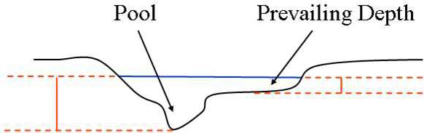
  - First, determine, by referring to the completed Stream/River Habitat Sketch Sheet. If adequate stable pools are present. For large, wide rivers it may be more appropriate to base the estimate on the actual amount of smothering on the habitats rather than the number of pools. A pool is defined as an area where the depth is at least 2 times the prevailing depth and is expected to maintain that depth throughout rain events.
A natural system should have 1 to 2 pools every 12 times the width of the stream. For example, a 3 m wide stream should have at least 1 pool every 36 meters or a total of 3-6 pools per 100 m reach (100m/36m = 2.8 segments). If there are no stable pools; i.e., the stream depth is nearly the same throughout the 100 m reach, assign a score in the “poor” category. If there are minimal (less than 1 pool every 12 times the width) or shallow pools (a shallow pool is any pool where the depth is less than 2 times the prevailing depth), score the stream in the “marginal” category.
Pools should occur on the outside of curves in the stream and on the downstream side of large, woody debris. A score in the “suboptimal” or “optimal” categories should be assigned to a stream with adequate pools based on the percent smothering as described in step b, below.

  - Second, check for deposition of sand or silt, or excessive growth of algae (> 6 mm thick) on visible habitats. While a light dusting of sand or silt and some algal growth is normal, excessively thick coatings will reduce habitability of the substrate. Smothering on visible habitats is indicated if sand, silt, or algae is present on a substrate in an amount greater than typically expected. Silt smothering is indicated if a substantial turbidity plume results from agitating the substrate, especially fine roots and leaf packs. Silt smothering can sometimes also be determined by direct observation of the silt coating. Determine a percentage value for visible habitats that are not habitable due to sand and/or silt and/or algal smothering. To score the habitat smothering category, add the percent habitats smothered as determined by these two steps. If less than 25% of habitats are smothered and adequate stable pools are present, score in the optimal category, and score in the suboptimal if more than 25% of habitats are smothered, for any kind of smothering (including algal). If there is a high degree (> 50%) of algal smothering but adequate stable pools are present, score in the suboptimal category.

- Add the scores for the primary habitat components (see numbers 2-5 above) and record this Primary Score on the form. The primary habitat components refer to in-stream features.

- Observe whether the reach of stream or river in the sampling area is artificially channelized. Assign a score for Artificial Channelization using the following guide:
Poor - A highly altered system with ALL the following: straightened stream channel, trapezoidal or box-cut cross-section, and a monotypic (unvarying) depth lacking the pools described in step 5a. Spoil banks or other indications of dredging may be visible.
Marginal - A physically altered, channelized system with a trapezoidal or box-cut cross-section, but with some sinuosity in stream channel, often developed within the old dredged area. Spoil banks or other indications of dredging may be visible.
Suboptimal - Good sinuosity has developed within and outside of the old channelized area. Spoil banks may be visible but may have established vegetation growing on them.
Optimal - A system with expected stream channel sinuosity given the width and slope of the stream; a stream should have as many bends as pools (as described in step 5a), unless the pools were formed solely by scouring behind trees or snags.
No evidence of dredging or artificial straightening.

- Refer to the completed Stream/River Habitat Sketch Sheet for areas along the bank that have eroded or have the potential for bank sloughing (partial collapse). Determine the extent of erosion potential for the site and assign a Bank Stability score for each bank. Score artificially stable banks such as concrete according to bank stability, not according to natural vs. artificial stability. The “left bank” is on your left when you are looking upstream.
  - First, determine where “bankfull” is in relation to the height of each bank. Bankfull is defined as the stage at which channel maintenance is most effective and occurs on average every 1-2 years. For most natural Florida streams, bankfull is the height of the lowest bank, where the stream is connected to the floodplain. For stream sites with a wetland floodplain, bankfull is usually the elevation of the flat floodplain. For stream sites with an upland floodplain, bankfull is usually the inflection point on the bank.

Other indicators of bankfull (especially in larger systems) are the tops of point bars, staining and vegetation lines. If the substrate at bankfull is limestone, pipe clay or concrete, then automatically score the bank in the “optimal” category and skip the second and third steps below. Ideally, bankfull should be greater than 60% of the bank height or above the woody root zone. If this is the case, the bank gets a “plus” for this subcomponent. Otherwise, bankfull is less than 60% of bank height and below the woody root zone and it should receive a “minus”.
  - Second, determine the slope of the portion of bank above bankfull. The gentler the slope the more stable the bank. Score a bank with a slope less than 60° with a plus for this subcomponent. A bank with a slope of greater than 60° warrants a minus.
  - Third, determine if bankfull is above or below the root zone. If bankfull is above the root zone and there are few raw or eroded areas, score this subcomponent a plus. Otherwise, score it a minus. Woody vegetation/roots are more stable than herbaceous and should be scored accordingly.
  - Lastly, count up the number of pluses from each subcomponent (a total of 3 possible) and score within each category as described below:
Poor: 0 pluses
Marginal: 1 plus
Suboptimal: 2 pluses
Optimal: 3 pluses

- Assign a score for the Riparian Buffer Zone Width that best characterizes the width of vegetation on each side of the channel. This zone is measured from the edge of the stream bank to where clearing or other adverse human activity begins. Consider the intensity of the disturbance and score accordingly. For example, a footpath that runs along one bank for 20 m is much less intense than a paved road that runs along the same 20 m stretch. A native vegetated buffer zone of greater than 18 m (approximately 60 feet) is currently considered optimal. A riparian zone that is vegetated but mowed regularly is considered poor
- Identify the plants in the riparian zone, determining the extent of coverage and whether the vegetation is native or exotic. Look for these classes of plants: bottomland or mesic hardwoods trees, understory shrubs, herbaceous plants, and non-woody macrophytes. Assign a Riparian Zone Vegetation Quality score based on the classes of plants present, the degree of bank vegetative cover, and how closely the plant community at the site approaches that expected of an undisturbed community in the region.

- Add the scores for the secondary habitat components (see steps 7-10) and record this secondary score on the form. The secondary habitat components refer to morphological and riparian zone features.

- Add the primary score (see step 6) and the secondary score (see step 11) to get the habitat assessment total score. Record the habitat assessment total score on the form.

- Sign and date the form.

Habitat Assessment Data Entry, Data Verification
Sampling teams are responsible for entering their own bioassessment observations in SBIO2. Before bioassessment observations can be entered into SBIO2 the associated station needs to be created. Stations must be created in the Watershed Information Network (WIN) (Section 25), before they are created in SBIO2. To create a SBIO2 station, login to SBIO2 and open the Station Creation and Editing Module in the Administrative Tab. In the Station Creation and Editing Module click the Create New Station radio button (selected by default), select your Org ID from the dropdown list, enter the station ID, select a waterbody type, and click the Get WIN Station Info button. This will import the station attributes from WIN. Then click the Get GIS Info button and save. Permissions to the Administrative Tab are limited to few individuals in each office. If you do not have the Administrative Tab, ask your team lead to create the SBIO2 station.

Station Visit
Before entering bioassessment (HA, LVS, LVI, PhysChem, RPS, etc.) observations into the applicable SBIO2 module, the Station Visit must be created in the Station Visit Module. When the Station Visit is created a Visit ID (aka SBIO ID) is generated. Record the Visit ID on the SMP Field Sheet, Stream/River Habitat Sketch Sheet, Habitat Assessment Field Sheet, Physical/Chemical Characterization Field Sheet, and if conducted the Linear Vegetation Survey Field Sheet, and Rapid Periphyton Survey Field Sheet.

Note: Data entry and date validation (QC) need to be completed by different people.

Data Entry
In SBIO2 open the Habitat Assessment Module in the Field Activities Tab. In the Enter Data Tab type the Visit ID in the Search box. Select the Visit ID in the result box below. One of two popup windows will appear.
- Do you want to add HA data to SBIO Visit ID #####?
- Select “Yes”
    - The Stream/River Habitat Assessment data entry module will open if the waterbody type of the SBIO2 station associated with the Visit ID is stream or canal.
    - The Lake Habitat Assessment data entry module will open if the waterbody type of the SBIO2 station associated with the Visit ID is lake.
- A HA ID is generated by SBIO2. Record it on the SMP Field Sheet and the:
    - Stream/River Habitat Sketch Sheet, Habitat Assessment Field Sheet for stream WBIDs
    - Lake Observation Field Sheet, and Habitat Assessment Field Sheet for lake WBIDs.
- Verify the Existing Station Visit Information (Station, Date, Waterbody, and Lead Sampler) is correct.
- Add the Sampling Agency, Analyst, and comments.
- Add the HA observations from the field sheet to SBIO2.
    - If you have questions about HA data entry refer to the module user guide. To open the module user guide, click the icon at the bottom left of the HA data entry module.
- Write “Entered”, the date and the initials of the data entry person on the HA field sheet(s).
- Save and close the data entry module.
- The HA is now in “C” status. The data entry for HA events in “C” status needs to be verified. Proceed to Data Verification below.

- There is 1 (2, 3, 4 etc.) existing HA Data entry for SBIO Visit #####, collected dd/mm/yyyy, would you like to enter additional data?
- Select “No” because the HA observations have been entered in to SBIO2.
- Close the Habitat Assessment Data Entry Module.
- Open the Reports Module and query habitat assessment data using the Visit ID to view the existing HA events associated with the Visit ID.
- Note the Habitat Assessment ID(s) and the data entry status of the existing habitat assessment event(s).
- Complete the data entry for the habitat assessment event identified in the previous step. If there are multiple habitat assessment events associated with the Visit ID, complete the data entry for one habitat assessment event and delete the others.
  - If the existing habitat assessment event is “C” Status record the Habitat Assessment ID on the SMP field Sheet and the Habitat Assessment Field Sheet(s). Proceed to Data Verification below.
  - If the existing habitat assessment event is “A” Status record the Habitat Assessment ID on the SMP field Sheet and the Habitat Assessment Field Sheet(s). Data entry is complete.

Data Verification
Data verification needs to be completed by someone other than the data entry person. In SBIO2, open the Habitat Assessment Module in the Field Activities Tab. In the Review Existing Data Tab type the Visit ID in the Search box.
- Select the Habitat Assessment ID in the result box.
- Verify the Station Visit Information (Station ID, Date, Lead Sampler, and Analyst) and comments are correct.
- Verify the habitat assessment observations.
- If there are any discrepancies between the field sheet and the information in the Habitat Assessment module:
  - Note the discrepancies
  - Close the Module.
  - Have the data entry person correct the discrepancies.
  - Start Data Verification procedure over.
- If all values are correct, select a reviewer (your name) from the dropdown list.
- Write “Data QC”, the date and the initials of the reviewer on the HA Field Sheet(s).
Click the Updates Are Correct Button. The HA event is now in “A” status. Data entry is complete.

Section15. Stream Condition Index Sampling Protocols

Introduction
The Stream Condition Index (SCI) is a biological assessment procedure that measures the degree to which flowing fresh waters support a healthy, well-balanced biological community, as indicated by benthic macroinvertebrates. Macroinvertebrate samples are collected as described below and shipped to the DEP Laboratory for identification.

The Stream Condition Index (SCI) is an integral component of Numeric Nutrient Criteria (NNC) in Florida streams. To assess whether a stream attains the NNC in paragraph 62-302.530(47)(b), F.A.C., pursuant to the provisions in paragraph 62-302.531(2)(c), F.A.C., an evaluation of water chemistry, biological data (flora and fauna), and physical information is used to determine if a stream’s nutrient concentrations are protective of balanced flora and fauna. The minimum date sufficiency requirement for the SCI is two temporally independent (greater than 3 months) SCI results in the assessment period. If there are only two SCIs and the difference between the two scores is greater than 20 points, then an additional SCI shall be required.

All SCI sampling and analysis shall be conducted according to the requirements listed below, DEP SOP SCI 1000, and the SCI Primer (Sampling and Use of the Stream Condition Index [SCI] for Assessing Flowing Waters: A Primer [DEP-SAS-001/11]). The SCI Primer provides comprehensive guidance on use of the SCI and other biological measures in the context of specific study objectives. SCI sampling must adhere to the assessment principles discussed in the SCI Primer. Additional bioassessment quality assurance information, including copies of the documents references above is available at http://www.dep.state.fl.us/water/bioassess/training.htm.

The SCI is used in conjunction with the Habitat Assessment (HA) and requires specific training and a demonstration of competency due to the expert judgment exercised during field sampling. Individuals conducting physical/chemical characterization, HA, and SCI sampling must train with DEP staff (via workshops and/or participating in field sampling) and pass a field performance test to demonstrate competence. Training should be conducted using the SCI Training Checklist (Appendix SCI 1000-1). When sufficient training is complete (SCI Training Checklist has been completed with all applicable signatures), contact the DEP Aquatic Ecology and Quality Assurance (AEQA) Section (Ashley O’Neal, Ashley.ONeal@dep.state.fl.us,
850-245-8070) to take the online SCI test and to schedule an SCI performance audit. After passing the initial performance audit, “check-up” audits will be performed every 5 years by the DEP AEQA Section to ensure that proper techniques are followed. Details are described in SCI 1000 (sections SCI 1200 and SCI 1300)

Equipment and Supplies
The following will be needed in order to perform an SCI:
- Completed Stream/River Habitat Sketch Sheet (Figure 14)
- Completed Stream/River Habitat Assessment Score Field Sheet (Figure 15)
- Rapid Periphyton Survey Field Sheet (Figure 16)
- Linear Vegetation Survey Field Sheet (Figure 17)
- Physical/Chemical Characterization Field Sheet (Figure 18)
- D-frame Dipnet with No. 30 mesh and handle marked in 0.1-m increments
- Four 2-liter wide-mouth plastic jugs (take extra in case more are needed)
- 10 %Buffered formalin (see below)
- Brush

Buffered Formalin:
Buffered formalin (formaldehyde with sodium bicarbonate added) is necessary for preserving the organisms for laboratory identification. The DEP Laboratory supplies 10 % recycled buffered formalin preservative. The 10 % recycled buffered formalin can be distributed at meetings, training events, or field audits, as needed. Buffered formalin is considered hazardous and will not be shipped through the mail. Please take this into consideration and monitor your levels accordingly to ensure you will always have plenty in stock. To order more recycled buffered formalin, contact the Biology Laboratory.

Always transport recycled 10% buffered formalin carboys upright to prevent leakage, in a container (cooler) with a top that can close. The bottom of container used to transport must be lined with absorbent materials, bentonite clay or absorbent pads. The container and carboys must be labeled “10% or less formalin”. Each container also needs a Material Safety Data Sheet (MSDS).

Caution! Formalin can cause skin, eye and breathing irritation. Wear appropriate protective gear (gloves, safety glasses and respirator, if available), and work in a well-ventilated area (preferably outside).

Site Selection
Select a site in the target waterbodies or water segment (WBID) with the highest habitat assessment score. This may be a different site used for repeated water chemistry monitoring. The objective of biological assessment is to isolate water quality factors causing degradation, efforts should be taken to establish sites where habitat is not a substantial factor limiting potential biological health. This means that the sampler must establish sampling sites, where possible, in stream reaches with adequate substrate diversity and availability, intact stream morphology (little or no artificial channelization), adequate flow, and optimal riparian buffer zones. The stream or river must be a definable, freshwater, continuously flowing system that is functioning as a “stream” or “river” in order for an SCI to be performed. For example, do not perform the SCI if:

- the system is not functioning as a stream or river (it is more like a lake, estuary, wetland, marsh, prairie, canal, ditch, etc.).
- the system is currently dry or disconnected or has been completely dry within 6 months prior to the site visit. If this cannot be determined with confidence, do not sample.
- flood conditions exist and water levels are > 0.5 m above normal. If you are not confident that the reachable substrates have been inundated for greater than 28 days, do not sample.
- the system is tidally influenced (regardless of conductivity values).
- the average water velocity is < 0.05 m/s or has been < 0.05 m/s in 28 days prior to the site visit. If this cannot be determined with confidence, do not sample.
- conditions are unsafe.
- the system is in the South Florida / Everglades Bioregion (south of Lake Okeechobee).

Water chemistry samples (SCI Kit) and water quality parameters (DO, pH, etc.) must be collected before performing the SCI, just prior to the Habitat Assessment (see Sections 8 and 13). With each SCI, complete the Rapid Periphyton Survey, Linear Vegetation Survey and Physical/Chemical Observation Field Sheet (see Sections 15, 16, and 18). For the Strategic Monitoring Program and the Reference Stream Project, SCIs are paired with a suite of water chemistry samples referred as a SCI Kit. The SCI Kits includes nutrients, chlorophyll-a, metals, wastewater tracers, organonitrogen pesticides, and phosphorus pesticides (See Section 2).

Sample Container Labels
Place a Barcoded Station Label (Figure 3, Figure 4) and write, using a permanent marker, the time (24-hour format) and date of sample collection on the laboratory project and sample identification label (Figure 2). If multiple containers are being submitted for the same SCI sample, number the containers (e.g. “1 of 2”, “2 of 2”, etc.).

- the SCI will need to be recorded as a separate entry on the DEP Chain of Custody (DEP COC) (Figure 9), under the associated water chemistry sample.
- underneath the entry for the water chemistry samples, place a barcoded station label in the appropriate space.
- enter “NA” or place a dash for the field measurement information (pH, DO, etc.),
- record the matrix as “Biology” and “SCI” in the comments section.
- see Section 12 for full details.
- the RQ used for the SCI sample must match the associated water chemistry samples for each site.

Sample Collection
- After completing the HA, following all instructions in Section 13, and determining that an SCI can be performed as described above, visually examine the area or reach to be sampled. Walk or boat throughout the aquatic system, paying close attention to its physical and habitat characteristics. If you are walking through the system, be very careful to not disturb aquatic habitats. Such disturbances could lead to inaccurate SCI and/or habitat assessment results. The length of a discrete SCI station consists of a 100-m stretch of stream, and the width is from bank to bank. Establish the 100-m stretch in stream reaches with adequate substrate diversity and availability, intact stream morphology (little or no artificial channelization), adequate flow, and optimal riparian buffer zones. Do not sample if site conditions (habitat, hydrology, etc.) are not consistent with study objectives, as described in the SCI Primer. If antecedent hydrologic conditions are met the SCI can be performed when there is adequate substrate availability for 20 sweeps, even when the HA score is below 80.

- You must be familiar with the rainfall, stage height patterns, and stream flows in the area to be sampled. If you are unable to obtain information about how the water has fluctuated in the stream, do not sample. This could take a few years of observation and doing HA’s at multiple sites in the WBID to make the best judgment to determine if the WBID is SCI appropriate.
  - If information indicates that the stream has been completely dry (i.e., with no refuges for the aquatic organisms), wait a minimum of six months (180 days) after dry conditions have abated and ensure that the stream has maintained a minimum of 0.05 m/sec velocity for 28 days before performing the SCI.
  - Do not conduct SCI sampling if the water velocity is less than 0.05 m/sec. If the stream has had low flow with insufficient habitat or velocity for sampling, do not perform the SCI until sufficient habitat has been wetted and the stream has maintained a minimum of 0.05 m/sec velocity for at least 28 days.
  - If the water level is > 0.5 meters above recent levels, preventing access to substrates that are inhabited by invertebrates, delay sampling until those substrates are accessible or wait 28 days for the invertebrates to colonize the newly inundated substrates. If you are not confident that the reachable substrates have been inundated for greater than 28 days, do not sample. If water levels have risen, but are < 0.5 meter above the previous level, sample only the ‘deep’ habitats where organisms are expected. If the normal stream channel is not accessible (water in floodplain), postpone SCI sampling until the normal stream channel and habitats may be accessed.
  - If it is determined that a SCI is not appropriate for the entire WBID per the requirements establish in the SCI Primer and SOP SCI -1000, then you must complete a SMP SCI Site Evaluation Form (Figure 41). A SMP SCI Site Evaluation Form is needed from each accessible site within a WBID. Attach the following items to the form.
- A SMP SCI Site Evaluations Form for each accessible site within the WBID
- A map showing the following relevant information, but not limited to:
  - IWR Assigned Stations
  - Waterbody IDs (WBIDs)
  - FL NHD
  - primary access corridors (such as roads, boat launches, railroad lines, utility right of ways, etc.)
  - aerial imagery
- the most recent Habitat Assessment Score Field Sheet (Figure 15),
- the most recent Habitat Assessment Sketch Sheet (Figure 14)
- Additional documentation that supports a SCI site evaluation, such as hydrographs, rain data, specific conductivity observations, analytical results, email correspondence, historic photos, and field sheets.
Submit completed SMP SCI Site Evaluation Forms to your Environmental Administrator (EA) for review.

- Complete the Physical/Chemical Characterization Field Sheet (Figure 18), Stream/River Habitat Sketch Sheet (Figure 14), and Stream/River Habitat Assessment Score Field Sheet (Figure 15), as described in Sampling Manual Section 713 and DEP SOP FT 3000-FT 3101. The percent coverage of substrate type refers to how much of each habitat type is actually present and, in the water (able to be sampled) at the sampling site.

- Determine which productive habitats can be considered “major” and the number of sweeps to perform in each habitat type out of the 20 total sweeps per station. First, use the Stream/River Habitat Sketch Sheet and the Physical/Chemical Characterization Field Sheet to determine the number of major productive habitats at the site. To be considered “major” productive substrate, the habitat must be a productive habitat type and have at least 2 m² area. Generally, the most productive habitat types are as follows: leaf packs, roots, snags, aquatic vegetation, and rocky outcrops. Fine fibrous roots are preferred over larger diameter roots, since they have more surface area, and therefore more areas for organisms to hide. Snags with rough, peeling bark are preferred because they have more hiding places and attachment points for organisms than fresh, smooth snags (e.g., cypress knees). Jagged rocks with a rough architecture (i.e., with nooks and crannies for organisms to hide) are preferred over smooth rocks.

Then, use the following table to determine the number of sweeps to perform in each habitat type:
Table 10. Number of SCI Sweeps to Perform
# Productive Habitats | # Productive Habitat Sweeps | # Minor Habitat Sweeps
1 | 10 | 10
2 | 7 of each habitat | 6
3 | 5 of each habitat | 5
4 | 4 of each habitat | 4
5 | 3 of each habitat | 5

Sand, mud/muck, pebbles, and shell hash are sampled as “minor” habitats. Any productive habitats that are present but not abundant enough to be considered “major” must be swept as part of the minor habitats. If sufficient material is not available for performing the specified number of sweeps in a given major productive habitat (e.g., if only 5 sweeps of habitat were available but 7 sweeps are required as per above), do as many as possible in that habitat type, and perform extra sweeps (in this example, 2 more sweeps) in the other productive habitats. Proper interpretation of benthic collections requires that samples be collected from multiple, best available habitats that are representative of the site.

- Perform 20 discrete 0.5 m sweeps with the D-frame dip net. A sweep is defined as the area sampled based on the width of the net (approximately 0.25 m) by a 0.5 m length of habitat. Sample the available substrates as determined by the above table. See the SCI Primer for addition sampling technique information.
- The most effective way to capture invertebrates is to place the bottom rim of the dip net directly downstream of the area to be sampled. Disturb, agitate, or dislodge organisms (with hands or brush, where appropriate) from substrates (snags, etc.) working as closely to the net (within 10 cm) as possible. Use your hands or the brush to create water flow into the net and make sure the disturbed material and organism mixture is completely collected by the net. Start with the net at the downstream portion of the habitat and move in an upstream pattern until organisms from the 0.5 m area have been captured. Three passes over the same 0.5 m area is required to capture all organisms. This sampling effort in a discrete 0.5 m spot is considered to be one sweep. Where a continuous 0.5 m sweep is not available, take two 0.25 m sweeps or three 0.17 m sweeps of the same habitat type to obtain a full 0.5 m sweep.
- To avoid organism loss, agitate roots, removable rocks and snags, and submersed macrophytes inside the bag of the dip net. Sample large snags, rocks, macrophytes, and sand as close to the dip net opening as possible. Capture organisms by using your hands or a brush to dislodge them from the substrate and by creating a flow of water into the net. Make sure the disturbed material and organism mixture is completely collected by the net.
- To sample aquatic vegetation, place the net downstream of the vegetation and dislodge organisms using your hand, covering a 0.5 m area. Do not sample inundated terrestrial vegetation; if terrestrial vegetation has been inundated due to elevated water level, sampling may not be appropriate.
- Leaf packs (leaves caught on snags above the substrate) are preferred over leaf mats (leaves on the bottom), but if you collect all the leaf packs in your 100 m sampling area and still need additional sweeps of leaf material, you may finish with leaf mats. Sample leaf packs by placing the net downstream of the leaf pack and use your hands to directly transfer the leaves into the net. The volume of leaves collected must be equivalent to an area described by the width of the dipnet by 0.5 m long, with a 1 to 2 cm thickness of leaf material. Once the appropriate volume of leaf material is in the net, leaf material must be reduced in the field so that the entire 20 sweep sample will fit into two 2-liter jugs. The organisms must be dislodged “one leaf at a time” before discarding “cleaned” leaves. It is critical that there be NO LOSS of organisms during any field reduction of leaf material. When sampling leaf mats, make sure that only the top 1-2 cm of material is collected, and especially make sure that anaerobic leaf material is not included.
- When sampling sand or finer sediment, penetrate the sand/sediment with fingers, to approximately 2 cm deep, and lift the organisms from the sand into the waiting dip net. If the flow is weak, create a flow toward the net with your fingers. Feel for partially buried bivalves and ensure they are placed in the net. If the net is pushed into coarse sand or coarse detritus, very little of the sand or detritus will be washed through the net, resulting in a sample that contains few organisms and is hard to process, thus compromising the quality of the entire sample.
- When performing more than one SCI in the same watershed sample the downstream station first to prevent upstream invertebrates from drifting into a location they did not originally inhabit. If you are sampling from a boat, you can get out of the boat and wade in shallow shore areas to obtain the sweeps. You can also approach a habitat with the boat from downstream, agitate and sweep the reachable portion of the habitat (typically by leaning from the bow of the boat), to capture organisms.

- Record the number of sweeps performed for each habitat on the Physical/Chemical Characterization Field Sheet, in the INVERT column of the “Substrate Types” section.
- Record the formalin lot number and expiration date on the SMP Field Sheet (Figure 10) and the Physical/Chemical Characterization Field Sheet.

- Reduce the sample volume after each discrete sample by dislodging organisms from larger debris (but retaining invertebrates in the net) and discarding the debris. Save finer debris plus organism mixture in large wide-mouth jugs. Make every effort to reduce enough of the sample volume in the field so that no more than four liters of material are collected. If this is not possible due to unusual circumstances, put the material into additional jugs. Additional sample reduction will occur in the laboratory. The relative proportions of the organisms collected must be maintained intact to calculate many community metrics. Indicate the number of jugs used for the entire sample on the label, e.g., “1 of 2,” “2 of 2.” The RQ on each SCI jug must correspond with the RQ for the water chemistry samples collected at that site.

Sample Preservation and Handling
Drain any water that has accumulated in the jugs, making sure to retain invertebrates and preserve with 10% buffered formalin. Do not overfill or stuff the SCI containers with material because it can expand, exposing material in the headspace above the formalin. Leave headspace so that the area above the neck remains empty. Make sure that there is approximately an inch of formalin above the material (Figure 35). Tape, such as paraffin tape, may be used to seal the lid before placing the SCI containers into a large zip top bag. If tape is used, leave a pull tab so the lab staff can easily find the end to remove it. Always transport preserved SCI samples in an upright position. Containers should be arranged in the cooler in a manner that will minimize shifting during transport. SCI samples may be submitted to the laboratory at a separate time from the water chemistry samples if it is more convenient but be sure to include a DEP COC with a comment indicating water samples were shipped separately. Please note, the RQ used for the SCI samples must match the associated water chemistry samples for each site.

Section 16. Rapid Periphyton Survey Protocols

Introduction
The Rapid Periphyton Survey (RPS) is a rapid method to quantify the extent and abundance of attached periphyton (a complex mixture of algae, cyanobacteria, diatoms, heterotrophic microbes, and detritus attached to submerged surfaces in most aquatic ecosystems) in a stream or river, and to evaluate the autecological information associated with the dominant periphyton. The RPS is a tool to quantify abundance of nuisance or problematic periphyton growth.

The RPS accompanies the Stream/River Habitat Assessment (HA), Linear Vegetation Survey (LVS), Physical Chemical Characterization (PhysChem), and if applicable, the Stream Condition Index (SCI). Water chemistry sample (Nutrients and Chlorophyll-a) and field parameters must be paired with all RPS. All bioassessments including the RPS need to be conducted at least three months apart to be considered temporally independent. In the IWR Database, three months apart is defined by adding three to the month number and adding one to the day number. January 1, 2020 and April 1, 2020 are not temporally independent. January 1, 2020 and April 2, 2020 are temporally independent. The only justifications for omitting the RPS is if the system is unsafe, there are access issues, or the site is in the South Florida / Everglades Bioregion. Contact the SMP Coordinator if the RPS is omitted from a site. Water chemistry samples and field parameters (DO, pH, specific conductance, and temperature) must be collected before performing the RPS.

This sampling procedure requires specific training and a demonstration of competency due to the expert judgment exercised during field sampling. For the Strategic Monitoring Program (SMP) individuals conducting this survey need to train with Department of Environmental Protection (DEP) staff via workshops and/or participate in field sampling, and pass the online RPS test. It is required that at least one sampler in each team collecting RPS data read the RPS SOP (FS 7110), read the RPS Sampling Method presentation available on the Bioassessment Training, Evaluation, and Quality Assurance web page, and receive a passing score on the online RPS test administered by the DEP Aquatic Ecology and Quality Assurance (AEQA) Section. To receive a link to the online RPS test, contact Ashley O’Neal (Ashley.ONeal@dep.state.fl.us, 850-245-8070).

Equipment and Supplies
The following will be needed in order to perform the Rapid Periphyton Survey (RPS):
- Ruler to measure a 10 cm distance
- Rapid Periphyton Survey Field Sheet (Figure 16)
- Physical/Chemical Characterization Field Sheet (Figure 18)
- Stream/River Habitat Sketch Sheet (Figure 14)
- Stream/River Habitat Assessment Score Field Sheet (Figure 15)
- Linear Vegetation Survey Field Sheet (Figure 17)
- SMP Field Sheet (Figure 10)
- Waterproof Pen
- Multi-Parameter Water Quality Meter
- Water chemistry sample kit (Nutrients and chlorophyll-a).
- Acid Preservative (Sulfuric Acid, H₂SO₄)
- Barcoded Site Labels (Section 4)
- Concave or convex spherical densitometer
- 100 m measuring tape
- Flagging tape or station flags
- Secchi disk with at least three meters of rope marked in 0.2 m sections
- Depth sonar (non-wadable systems)
- View scope (to aid visual estimation of periphyton thickness)
- Clean plastic or glass containers (e.g. 60 mL plastic centrifuge tubes)
- ALGAL-ID bottle
- Barcoded Station Labels (Section 4)
- Cooler and ice

Method
- Measure a 100 m segment of stream, placing flags every 10m. Conduct a standard Stream / River Habitat Assessment (Section 13) and a fill out a Physical / Chemical Characterization Field Sheet. The following Periphyton observations can be done during the habitat mapping process or following the habitat assessment.

- Beginning at the “0” meter mark flag, establish a transect of 9 approximately equidistant points across the stream. Point 1 would be located approximately 0.1 m from the right bank, point 5 is at the middle, and point 9 located 0.1 m from the left bank (Figure 45). The remaining points are sequentially distributed between these points, approximately equidistantly.

- Each observation point, within the above distance parameters should be chosen as haphazardly as possible. While it is recommended to observe the general area prior to sampling as a safety precaution, the actual sampling point shall be selected haphazardly, without biasing your selection for or against periphyton presence.

- After selecting the observation point:
- If the substrate can be reached, grab a handful of material at the observation point, being careful not to lose material when bringing it to the surface. Examine the material, first out of the water, and then with the hand located just below the surface. Determine if periphyton are present or absent, and if present, measure the average thickness, perpendicular to the substrate, with a ruler. For filamentous periphyton, measure the average length of filaments rather than thickness of a mat (i.e., a 3 cm thick mat made up of attached filaments that are 20 cm long would be recorded as a “6”). Record these data using the rank thickness classifications described below and on the data sheet.
“N” = Non-problematic; periphyton are absent, or present at thickness up to 1mm (includes rough surface with no periphyton, slimy surface, and periphyton present with thickness less than or equal to 1 mm),
“3” = greater than 1 mm to 6 mm,
“4” = greater than 6 mm to 20 mm,
“5” = greater than 20 mm to 10 cm, and
“6” = periphyton greater than 10 cm.

NOTE: Examine the first substrate you encounter, which may not always be the stream bed (e.g., snag, plants, roots). Make your observations at the point where the hand encounters the substrate (i.e., if a 0.5 m long snag is grabbed, record the periphyton thickness based on where the hand touches it, not elsewhere). Take the measurement where the periphyton is representative of the entire amount in your hand (i.e. avoid measuring a single long filament when most of substrate has only a thin coating).
Note: Periphyton is a general term used to describe many different taxa (algae, cyanobacteria, diatoms, heterotrophic microbes). The color, texture and growth form of periphyton varies greatly because there is much diversity in taxa that make up periphyton, and variability in environmental conditions. Periphyton is not always green. There is extensive diversity in periphyton color, white, purple, green, yellow, red, and brown black. Macroalgae that are structurally more similar to macrophytes (e.g. Chara, Nitella) are not considered to be periphyton for RPS purposes. Aquatic mosses (e.g., Fontinalis, Sphagnum) or liverworts are not periphyton and are not measured as periphyton in the RPS.
- If the substrate cannot be seen (e.g., in tannic waters) in depths greater than the Secchi depth, then the thickness can be presumed to be less than or equal to 1 mm and “N” should be recorded. If the substrate cannot be seen, and the depth is less than the Secchi depth, but cannot be reached with the hand, record an “X” for that point, indicating that observations and measurements are not possible using this method. If the substrate cannot be accessed or seen record an “X”. Leaving the cell blank indicates the point was not evaluated, so please remember to record the “N” or “X” as appropriate.
- If the substrate can be seen but not reached, estimate the thickness rank based on visual similarity to other substrates within the stream that were reachable. Use of a view scope is recommended to aid visual estimation of periphyton thickness. Note on the datasheet which points were visually estimated. This visual estimation should only be conducted when you cannot reach the substrate.
- If the substrate cannot be brought to the surface (e.g., a large rock or snag) but it is reachable, then rub the surface of the substrate and visually inspect to determine the presence/absence of periphyton and approximate thickness.

- Measure canopy cover using a spherical densitometer between points 4 and 6 (ideally at point 5) on each transect. Do not take a canopy cover measurement if this section of the transect is unreachable. Only perform one canopy cover reading per transect.
- The densitometer consists of a concave or convex mirror with gridwork delineating 24 etched boxes, each 0.25” squared. Each 0.25“square box can be subdivided into 4 smaller quadrants, to create a total of 96 quadrants. The densitometer instructions refer to these quadrants as dots.
- While facing upstream, hold the instrument level (a bubble on the face of the densitometer indicates when the instrument is level), approximately 12-18” away from the body so your head is just outside the grid. It is more important to hold the instrument level, at approximately waist height, than at a specific distance above the water’s surface.
- Count the number of quadrants (out of a total of 96) for which at least half of the quadrant is filled by tree canopy cover (branches and/or leaves). Record this number (number of quadrants WITH canopy cover) for each transect in the Canopy column for point 4, 5, or 6.

- Repeat the above procedures every 10m, including the 100m mark, for a total of 99 periphyton observation points and 11 canopy cover readings.

- Upon completion of the RPS, determine the percentage of sampled points (exclude points assigned an “X”) which have an periphyton thickness rank of 4, 5, or 6. If this value is 20 % or greater, collect a composite sample (Algal-ID) of periphyton from the 100 m reach, as described below.
- Place a Barcoded Station Label (Figure 3) on the ALGAL-ID bottle. Write the sample date and time the ALGAL-ID label.
- Collect periphyton filaments from as many different substrates as are covered by periphyton mats of excessive periphyton growth, to get a representative sample of the periphyton mats of interest. Sometimes the bases of the filaments are necessary for identification, so be sure to collect the periphyton where it is attached to the substrate whenever possible.
- Target any material that is dominant or co-dominant and appears to represent a distinct taxonomic group (e.g. diatoms, algae, masses of cyanobacteria, or distinct taxa within these major groups). The purpose of this collection is to identify the dominant periphyton taxa for additional autecological analyses (i.e., to determine if the type of periphyton present represents an acceptable vs. adverse condition).
- Place all periphyton aliquots into the container with enough site water to keep the periphyton submerged. Do not add preservative to the sample. Bag the sample container and place it in wet ice.

Rapid Periphyton Survey Data Entry, Data Verification and Data Authorization
Sampling teams are responsible for entering their own bioassessment observations in SBIO2. Before bioassessment observations can be entered into SBIO2 the associated station needs to be created. Stations must be created in the Watershed Information Network (WIN) (Section 25), before they are created in SBIO2. To create a SBIO2 station, login to SBIO2 and open the Station Creation and Editing Module in the Administrative Tab. In the Station Creation and Editing Module click the Create New Station radio button (selected by default), select your Org ID from the dropdown list, enter the station ID, select a waterbody type, and click the Get WIN Station Info button. This will import the station attributes from WIN. Then click the Get GIS Info button and save. Permissions to the Administrative Tab are limited to few individuals in each office. If you do not have the Administrative Tab, ask your team lead to create the SBIO2 station.

Station Visit
Before entering bioassessment (HA, LVS, LVI, PhysChem, RPS, etc.) observations into the applicable SBIO2 module, the Station Visit must be created in the Station Visit Module. When the Station Visit is created a Visit ID (aka SBIO ID) is generated. Record the Visit ID on the SMP Field Sheet, Rapid Periphyton Survey Field Sheet, Linear Vegetation Survey Field Sheet Physical/Chemical Characterization Field Sheet, Stream/River Habitat Sketch Sheet, Habitat Assessment Field Sheet.

Note: If and Algal ID sample is submitted to the DEP Laboratory the SBIO2 Station Visit needs to be created no later than four days after the sampling event. The algal taxonomist Process Algal_ID samples quickly. If the Station Visit is not created, they cannot input their observations/results.

Note: Data entry and date validation (QC) need to be completed by different people.

Data Entry
In SBIO2, open the RPS Data Manager Module in the Field Activities Tab. In the Enter Data tab type the Visit ID in the Search box. Select the Visit ID in the result box below. One of two popup windows will appear.
- Do you want to add RPS data to SBIO Visit ID #####?
  - Select “Yes”
  - A RPS ID is generated by SBIO2. Recorded it on the SMP field Sheet and the Rapid Periphyton Survey Field Sheet.
  - Add the secchi depth, total depth, collector agency, and RPS collector.
  - Verify the station, date and lead sampler information is correct.
  - Add the RPS observations from the field sheet to SBIO2.
    - If you have questions about periphyton data entry, refer to the module user guide. To open the module user guide, click the icon at the top right of the RPS data entry module.
  - Write “Entered”, the date and the initials of the data entry person on the RPS Field Sheet.
  - Save and close the data entry module.
  - The RPS event is now in “V” status. The data entry for RPS events in “V” status needs to be verified. Proceed to Data Verification below.
- There is 1 (2, 3, 4 etc.) existing RPS Data entry for SBIO Visit #####, collected dd/mm/yyyy, Would you like to enter additional data?
  - Select “No” because the RPS observations have already been entered in to SBIO2.
  - Close the RPS Data Entry Module.
  - Open the Reports Module and query RPS data using the Visit ID to view the existing RPS events associated with the Visit ID.
  - Note the RPS ID(s) and the data entry status of the existing RPS event(s).
  - Complete the data entry for the RPS event identified in the previous step. If there are multiple RPS events associated with the Visit ID, complete the data entry for one RPS ID and delete the others.
  - If the existing RPS event is in “V” Status record the RPS ID on the SMP field Sheet and the Rapid Periphyton Survey Field Sheet. Proceed to Data Verification below.
  - If the existing RPS event is “C” Status record the RPS ID on the SMP field Sheet and the Rapid Periphyton Survey Field Sheet. Proceed to Data Authorization below.
  - If the existing RPS event is “A” Status record the RPS ID on the SMP field Sheet and the Rapid Periphyton Survey Field Sheet. Data entry is complete.

Data Verification
Data verification needs to be completed by someone other than the data entry person. In SBIO2, open the RPS Data Manager Module in the Field Activities Tab. In the Existing Info Tab type the RPS ID in the Search box.
- Select the RPS ID in the result box.
- Verify the Station Visit Information (Station ID, Date, Lead Sampler, RPS Collector, total and secchi depth values) is correct.
- Verify the RPS observations.
- If there are any discrepancies between the field sheet and the information in the RPS Data Manager Module:
  - Note the discrepancies
  - Close the Module.
  - Have the data entry person correct the discrepancies.
  - Start Data Verification procedure over.
- If all values are correct, select a reviewer (your name) from the dropdown list.
- Write “Data QC”, the date and the initials of the reviewer on the RPS Field Sheet.
- Click the Updates Are Correct Button. The RPS event is now in “C” status. SBIO2 events in “C” status need to be authorized (aka Marked Complete). Proceed to Data Authorization below.

Data Authorization
Permissions to the Administrative Tab are limited to few individuals in each office. If you do not have the Administrative Tab, ask your team lead to authorize the RPS event.
- Open the Authorize Data Module in the Administrative Tab.
- Select the Rapid Periphyton Survey (RPS) radio button.
- Select the Visit ID from the To Be Authorized Table.
- Confirm the dates and initials of the data entry person and the reviewer are on the RPS field sheet.
- Click the Authorize button. The RPS event is now authorized, in “A” status.

Section 17. Linear Vegetation Survey Protocols

Introduction
The Linear Vegetation Survey (LVS) is a rapid screening tool for ecological condition, designed to determine how closely a site’s flora resembles that of an undisturbed condition. The LVS accompanies the Stream/River Habitat Assessment (HA), Rapid Periphyton Survey (RPS), Physical Chemical Characterization (PhysChem), and if applicable, the Stream Condition Index (SCI). Water chemistry sample (Nutrients and Chlorophyll-a) and field parameters must be paired with all LVS. All bioassessments including the LVS need to be conducted at least three months apart to be considered temporally independent. In the IWR Database, three months apart is defined by adding three to the month number and adding one to the day number. January 1, 2020 and April 1, 2020 are not temporally independent. January 1, 2020 and April 2, 2020 are temporally independent. The only justifications for omitting the LVS is if the system is unsafe, there are access issues, or the site is in the South Florida / Everglades Bioregion. Contact the SMP Coordinator if the LVS is omitted from a site. Water chemistry samples and field parameters (DO, pH, specific conductance, and temperature) must be collected before performing the LVS.

This sampling procedure requires specific training and a demonstration of competency due to the expert judgment exercised during field sampling. For the Strategic Monitoring Program (SMP) individuals conducting this survey need to train with Department of Environmental Protection (DEP) staff via workshops and/or participate in field sampling, and pass the online LVS test. It is required that at least one sampler in each team collecting LVS data read the Macrophyte Sampling SOP (FS 7100), read the LVS Sampling Method presentation available on the Bioassessment Training, Evaluation, and Quality Assurance web page, and receive a passing score on the online LVS test administered by the Aquatic Ecology and Quality Assurance (AEQA) Section. To receive a link to the online LVS test, contact Ashley O’Neal (Ashley.ONeal@dep.state.fl.us, 850-245-8070).

Note: The Linear Vegetation Survey Field Sheet is required documentation if the total area of macrophytes is < 2 m² within the 100m sampling reach. Document the lack of aquatic macrophytes in the SBIO Station Visit Module by selecting the LVS < 2 SQM check box.

Equipment and Supplies
The following will be needed in order to perform the Linear Vegetation Survey:
- Linear Vegetation Survey Field Sheet (Figure 17)
- Completed Physical/Chemical Characterization Field Sheet (Figure 18)
- Completed Stream/River Habitat Sketch Sheet (Figure 14)
- Completed Habitat Assessment Score Field Sheet; FD 9000-5 (Figure 15)
- Completed Rapid Periphyton Survey Field Sheet (Figure 16)
- SMP Field Sheet (Figure 10)
- Water Chemistry Sample Kit (Nutrients and chlorophyll-a)
- Acid Preservative (Sulfuric Acid, H2SO4)
- Barcoded Station Labels (Section 4)
- Multi-Parameter Water Quality Meter
- Waterproof Pen
- Flagging tape or station flags
- Cooler and ice
- Aquatic & wetland plant identification manuals
- Hand lens
- Boat (non-wadeable sites)
- Depth sonar (non-wadable systems)
- Frotus (non-wadeable sites)
- Plastic bags
- PLANT-ID labels (Figure 46)

Method
- Measure a 100 m segment of stream, placing flags every 10 m. Conduct a Stream/River Habitat Assessment (Section 14). If desired, the following vegetation observations can be done during the habitat passement mapping process.

- Divide the 100 m reach into 10 sampling units 10 m in length. Within each 10m sampling unit, visually assess and identify the non-woody plants present in the wetted area, either from a boat or by wading. Record the presence of all non-woody plant species within this 10m sampling unit on the Linear Vegetation Survey Field Sheet (FD 9000-32). Include all submersed, floating, and emergent plants present in the sampling unit. In non-wadeable sites, deploy the frotus as needed to ensure that all submersed species are assessed. If you observe species that are not on the Linear Vegetation Survey Field Sheet, add them in the empty spaces provided or on an additional Linear Vegetation Survey Field Sheet. Identify aquatic and wetland plants to the lowest practical taxonomic level, as described below and in Section 4.2 of the LVI Primer. Include macroalgae and mosses that are structurally similar to macrophytes (e.g. Chara, Nitella, Fontinalis). Do not include trees, shrubs, or plants on the banks above the typical water level.
  - Most of the plant attributes that contribute to the LVS metrics apply to species, not genera, so it is important to make species-level identifications of plants whenever possible, even if you need to take the plant back to the lab or send it to an expert for verification. It is especially important to be able to identify the Category I and Category II FLEPPC taxa (www.fleppc.org) to species level.

  - Coefficient of Conservatism (C of C) scores have been assigned at taxonomic levels higher than species level for certain genera where species within the genus all have similar C of C scores or for subsets of genera that often are not possible to identify to species due to lack of flowers or fruits. Identification of the following to genus level is acceptable, if identifying structures are not available. However, samplers should make an effort to obtain a species level identification from their expert botanist if identifying characteristics are available.
- Submersed viviparous Eleocharis species lacking rhizomes (identity either E. baldwinnii, E. vivipara, E. acicularis)
- Utricularia, only if species level identification is not possible.

  - The following genera may be left at genus level because all species within the genus all have similar C of C scores.

- Hydrocotyle
- Lemna
- Nuphar
- Peltandra
- Typha

  - The following genera, which include numerous species with similar characteristics, should be identified to species-level with magnification. Some species of these genera may be readily apparent in the field, while others require more careful inspection, either with a hand lens (10X) or a dissecting microscope.

- Commelina
- Cyperus
- Echinochloa
- Eleocharis
- Eriocaulon
- Fuirena
- Hypericum
- Juncus
- Ludwigia
- Myriophyllum
- Najas
- Panicum
- Paspalum
- Persicaria (New Genus name for many former Polygonum species)
- Polygonum
- Potamogeton
- Rhexia
- Rhynchospora
- Sagittaria
- Schoenoplectus
- Sesbania
- Utricularia

- Within each 10 m sampling unit, determine the dominant species by estimating the plant with the largest areal extent. Dominance can be a submersed, floating, or emergent species. If unable to determine a dominant species, it is acceptable to assign two species co-dominance. All dominant or co-dominant species must occupy at least 1 m² of the survey area. If no species are present at this abundance or if you are unable to decide which species are dominant or co-dominant species, then do not assign a dominance code for that 10m sampling unit.

- Rate the total abundance of macrophytes in each 10m length of stream into one of the following categories: 0-5%, > 5 and ≤10%, > 10 and ≤ 25%, > 25 and ≤ 50%, > 50%.

- If a macrophyte encountered cannot be readily identified in the field, pictures and notes should be taken and a PLANT-ID specimen should be collected, for identification by an expert botanist.
  - When collecting a PLANT-ID specimen, it is best to collect whole plants, including roots (rinsed), stem base, flowers, and fruits. If a plant is too large for full collection, make notes and take several photos of the plant, including its habit and base. Place all plant material from a single specimen in a plastic bag and do not put water in the bag with the specimen, as this can cause it to rot. If multiple unknown macrophytes are present at a site, place each specimen in a separate bag.
  - Document all the organs (leaves, stems, flowers, fruits, roots) and habit when taking pictures of a PLANT-ID specimen.
  - Place a PLANT-ID label (Figure 46) on each specimen’s bag, and indicate the specimen number (e.g. “Unknown Rush #1”, “Polygonum sp. #1), date, time, and samplers’ initials. Place all individually bagged specimens from a single site in a large plastic bag, and place a Barcoded Station Label (Figure 36, Figure 37) and a PLANT-ID label on the outside of the large bag.
  - Store bags on ice. Plants kept refrigerated or on ice can be identified fresh within a day or two.
  - If an expert botanist is available in the sampling agency’s office, PLANT-ID specimens may be taken directly to the local expert. If a local expert is not available, PLANT-ID specimens may be shipped to DEP in the cooler with the water chemistry samples. If you are shipping PLANT-ID specimens to DEP you MUST call or email the SMP Coordinator, to ensure that staff are aware of these incoming time-sensitive samples.
  - If collecting specimens for identification in the lab, by DEP botanist, or external botanist, it is best to keep the plant fresh (refrigerated) and identify or ship immediately. If this is not possible, specimens may be pressed and sent for identification.
  - Specimens for reference herbarium collection identification or verification should be pressed.
- Repeat steps 2-5 for each of the remaining 10 m sampling units.

- Once unknown specimens have been identified, finalize the Linear Vegetation Survey Field Sheet with correct taxa names.

Linear Vegetation Survey Data Entry, Data Verification and Data Authorization
Sampling teams are responsible for entering their own bioassessment observations in SBIO2. Before bioassessment observations can be entered into SBIO2 the associated station needs to be created. Stations must be created in the Watershed Information Network (WIN) (Section 25), before they are created in SBIO2. To create a SBIO2 station, login to SBIO2 and open the Station Creation and Editing Module in the Administrative Tab. In the Station Creation and Editing Module click the Create New Station radio button (selected by default), select your Org ID from the dropdown list, enter the station ID, select a waterbody type, and click the Get WIN Station Info button. This will import the station attributes from WIN. Then click the Get GIS Info button and save. Permissions to the Administrative Tab are limited to few individuals in each office. If you do not have the Administrative Tab, ask your team lead to create the SBIO2 station.

Note: Data entry and date verification (QC) need to be completed by different people.

Station Visit
Before entering bioassessment (HA, LVS, LVI, PhysChem, RPS, etc.) observations into the applicable SBIO2 module, the Station Visit must be created in the Station Visit Module. When the Station Visit is created a Visit ID (aka SBIO ID) is generated. Record the Visit ID on the SMP Field Sheet, Linear Vegetation Survey Field Sheet, Rapid Periphyton Survey Field Sheet, Physical/Chemical Characterization Field Sheet, Stream/River Habitat Sketch Sheet, Habitat Assessment Field Sheet.

Data Entry
In SBIO2, open the Vascular Module in the Field Activities Tab. In the Enter Data tab type the Visit ID in the Search box. Select the Visit ID in the result box below. One of two popup windows will appear.

- Do you want to add Macrophyte data to SBIO Visit ID #####?
  - Select “Yes”.
    - The LVS data entry module will open if the waterbody type of the SBIO2 station associated with the Visit ID is stream or canal.
    - The LVI data entry module will open if the waterbody type of the SBIO2 station associated with the Visit ID is lake.
  - A Macrophyte ID is generated by SBIO2. Record it on the SMP Field Sheet and the Linear Vegetation Survey Field Sheet.
  - Add the Sampling Agency, Identifier, comments and a LIMS Sample ID from the paired water chemistry sample.
  - Write the LIMS Sample ID on the SMP Field Sheet and LVS Field Sheet.
  - Verify the Existing Station Visit Information (Station, Date, Waterbody, Lead Sampler, and Waterbody Type) is correct.
  - Add the LVS macrophyte observations from the field sheet to SBIO2.
    - If you have questions about vascular data entry, refer to the module user guide. To open the module user guide, click the icon at the top right of the vascular data entry module.
  - Add the LVS Percent Cover Observations from the field sheet.
  - Write “Entered”, the date and the initials of the data entry person on the LVS Field Sheet.
  - Save and close the data entry module.
  - The LVS event is now in “V” status. The data entry for LVS events in “V” status needs to be verified. Proceed to Data Verification below.

- There is 1 (2, 3, 4 etc.) existing Vascular Data entry for SBIO Visit #####, collected dd/mm/yyyy. Would you like to enter additional data?
- Select “No” because the LVS observations have already been entered into SBIO2.
- Close the Vascular Data Entry Module.
- Open the Reports Module and query macrophyte data using the Visit ID to view the existing vascular events associated with the Visit ID.
- Note the Macrophyte ID(s) and the data entry status of the existing vascular event(s).
- Complete the data entry for the vascular event identified in the previous step. If there are multiple vascular events associated with the Visit ID, complete the data entry for one Macrophyte ID and delete the others.
  - If the existing vascular event is in “V” Status record the Macrophyte ID on the SMP field Sheet and the Linear Vegetation Survey Field Sheet. Proceed to Data Verification below.
  - If the existing vascular event is “C” Status record the Macrophyte ID on the SMP field Sheet and the Linear Vegetation Survey Field Sheet. Proceed to Data Authorization below.
  - If the existing vascular event is “A” Status record the Macrophyte ID on the SMP field Sheet and the Linear Vegetation Survey Field Sheet. Data entry is complete.

Data Verification
Data verification needs to be completed by someone other than the data entry person. In SBIO2, open the Vascular Module in the Field Activities Tab. In the Existing Data Tab type the Macrophyte ID in the Search box.
- Select the Macrophyte ID in the result box.
- Verify the Station Visit Information (Station ID, Date, Waterbody, Lead Sampler, and Waterbody Type) is correct.
- Verify the LVS Percent Cover Observations.
- Verify the LIMS Sample ID is associated with the water chemistry sample paired with the LVS.
- Verify the macrophyte observations.
- If there are any discrepancies between the field sheet and the information in the Vascular module:
  - Note the discrepancies
  - Close the Module.
  - Have the data entry person correct the discrepancies.
  - Start Data Verification procedure over.
- If all values are correct, select a reviewer (your name) from the dropdown list.
- Write “Data QC”, the date and the initials of the reviewer on the LVS Field Sheet.
- Click the Updates Are Correct Button. The LVS event is now in “C” status. SBIO2 events in “C” status need to be authorized (aka Marked Complete). Proceed to Data Authorization below.

Data Authorization
Permissions to the Administrative Tab are limited to few individuals in each office. If you do not have the Administrative Tab, ask your team lead to authorize the vascular event.
- Open the Authorize Data Module in the Administrative Tab.
- Select the Linear Vegetation Survey (LVS) radio button.
- Select the Visit ID from the To Be Authorized Table.
- Confirm the dates and initials of the data entry person and the reviewer are on the LVS field sheet.
- Click the Authorize button. The LVS event is now authorized, in “A” status.

Section 18. Lake Vegetation Index Protocols

Introduction
The Lake Vegetation Index (LVI) method is a rapid screening tool for ecological condition; it determines how closely a lake’s flora resembles that of an undisturbed lake. The LVI shall be used from April 1 to November 30 in the South LVI region and May 1 to October 31 in the North LVI region (Figure 49), due to the lack of identifying characteristics associated with seasonal senescence and the potential impacts of freezing events on the macrophyte community.

This sampling procedure requires specific training and a demonstration of competency due to the expert judgment exercised when preforming an LVI. All LVI sampling and analysis shall be conducted according to the requirements of this LVI method and the LVI Primer (Sampling and Use of the Lake Vegetation Index (LVI) for Assessing Lake Plant Communities in Florida: A Primer [DEP-SAS-002/11; October 24, 2011]). Additionally, the use of this LVI method must adhere to the assessment principles discussed in the LVI Primer. Each organization that performs LVI sampling must follow quality assurance guidelines per LVI 2100.

For the Strategic Monitoring Program (SMP) water chemistry samples (Nutrients and Chlorophyll-a), field parameters (DO, pH, specific conductance, and temperature), the Lake Observation Form and the Lake Habitat Assessment must accompany the LVI. In order to perform the LVI method and submit LVI data, teams must demonstrate proficiency in plant identification by receiving a passing score on the LVI online plant test administered by the AEQA Section and pass the LVI Field Proficiency Exercise. Each team shall contain at least one individual who maintains “pass status” for the LVI Field Proficiency Exercise and the online plant identification test. The LVI Field Proficiency Exercise is conducted every two years at lakes selected by the AEQA Section. The online plant test can be taken anytime. To receive a link to the online plant test, contact Ashley O’Neal (Ashley.ONeal@dep.state.fl.us), 850-245-8070).

Individuals conducting this LVI method must have trained with DEP staff (via workshops and/or field sampling). Samplers can become competent in plant identification by attending training workshops, reviewing plant ID resources and training presentations on the Aquatic Ecology and Quality Assurance (AEQA) Section’s website (http://www.dep.state.fl.us/water/bioassess/plantid.htm), and practicing with experienced samplers.

Equipment and Supplies
The following will be needed in order to perform the lake Vegetation Index (LVI):
- Lake Vegetation Index Field Sheet (Figure 21)
- Lake Observation Field Sheet (Figure 20)
- Lake Habitat Assessment Field Sheet (Figure 19)
- Map of Lake divided into 12 equal sections (see methods in SOP LVI 1000)
- SMP Field Sheet (Figure 10)
- Water Chemistry Sample Kit (Nutrients and chlorophyll-a)
- Acid Preservative (Sulfuric Acid, H2SO4)
- Barcoded Station Labels (Section 4)
- Multi-Parameter Water Quality Meter
- Waterproof Pen
- Cooler and ice
- Aquatic & wetland plant identification manuals
- Hand lens
- Boat and associated Personal Protective Equipment
- Frotus
- Depth sonar
- Secchi disk with at least three meters of rope marked in 0.2 m sections
- Plastic bags
- PLANT-ID labels (Figure 46)
- GPS unit
- Binoculars

Prior To Visiting the Lake
  - Generate a GIS map of the lake. (An aerial photo is helpful for locating features on the lake). Draw a north-south line in the center of the lake to begin the divisions. Divide the entire lake into twelve total sections (three in each quadrant), with approximately equal distances and known latitude/longitude coordinates along the shoreline, generated from the GIS mapping effort.
  - Number the sections 1-12 in a clockwise fashion, starting with 1 as the section immediately clockwise from the north-south line in the northeast quadrant.

Select section 1, 2, or 3 as the starting section by using a random numbers table or some other random number generator (e.g. rolling a die, or a website www.random.org).
  - If section 1 is selected as the starting section, sections 1, 4, 7, and 10 will be sampled. If section 2 is selected, sections 2, 5, 8, and 11 are sampled. If section 3 is selected, sections 3, 6, 9, and 12 are sampled. On the LVI Field Sheet (FD 9000-27) or other datasheet, record which four sections of the lake are to be sampled, and record the section number associated with the individual data columns. See Figure 47 for examples of dividing differently shaped lakes, and determining sampling strategies.

Figure 47. Lake Vegetation Index Quadrants
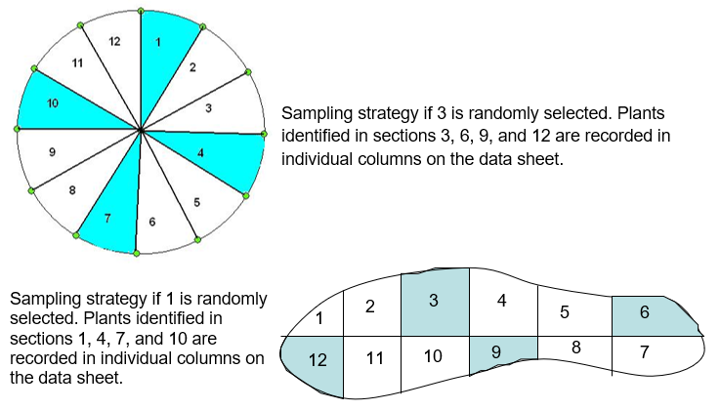

Method
- Complete the Lake Observation Form (FD-9000-31) and the Lake Habitat Assessment (FD 9000-6) according to FT3200.
- Use the map of the lake and GPS unit to go to the emergent zone of the first sampling section. Travel at idle or slow speed and, in the data column for the sampling section, record the presence of aquatic and wetland plant species observed from the boat. Record only taxa that are either aquatic or have OBL, FACW, or FAC wetland status (as listed in Chapter 62-340.450, F.A.C.). For LVI purposes, also include Pinus elliottii, and vines that are growing in the water or saturated soils and are functioning as part of the lake plant community. If you observe species that are not on the datasheet, add them in the empty spaces provided or on an additional field sheet. Identify plants to the lowest practical taxonomic level, as described in Section 4.2 of the LVI Primer. Binoculars may be used to aid in observation. If it is not possible to identify a specimen to the appropriate taxonomic level by observation from the boat, collect the specimen for further examination in the field or laboratory. Specimens collected for laboratory identification by samplers or experts should be handled according to 3.2.10, below. Do not leave the boat or spend effort on difficult to access areas. Continue these identifications throughout the section.

  - Most of the plant attributes that contribute to the LVI metrics apply to species, not genera, so it is important to make species-level identifications of plants whenever possible, even if you need to take the plant back to the lab or send it to an expert for verification. It is especially important to be able to identify the Category I and Category II FLEPPC taxa (www.fleppc.org) to species level.
  - Coefficient of Conservatism (C of C) scores have been assigned at taxonomic levels higher than species level for certain genera where species within the genus all have similar C of C scores or for subsets of genera that often are not possible to identify to species due to lack of flowers or fruits. Identification of the following to genus level is acceptable, if identifying structures are not available. However, samplers should make an effort to obtain a species level identification from their expert botanist if identifying characteristics are available.
- Submersed viviparous Eleocharis species lacking rhizomes (identity either E. baldwinnii, E. vivipara, E. acicularis)
- Utricularia, only if species level identification is not possible.

  - The following genera may be left at genus level because all species within the genus all have similar C of C scores.

- Hydrocotyle
- Lemna
- Peltandra
- Typha

- Nuphar

  - The following genera, which include numerous species with similar characteristics, should be identified to species-level with magnification. Some species of these genera may be readily apparent in the field, while others require more careful inspection, either with a hand lens (10X) or a dissecting microscope.

- Commelina

- Cyperus
- Echinochloa
- Eleocharis
- Eriocaulon
- Fuirena
- Hypericum
- Juncus
- Ludwigia
- Myriophyllum
- Najas
- Panicum
- Paspalum
- Persicaria
- Polygonum
- Potamogeton
- Rhexia
- Rhynchospora
- Sagittaria
- Schoenoplectus
- Sesbania
- Utricularia

- Identify and choose a location within the sampling unit to set up a transect 5 m in width where you will be able to navigate the boat approximately perpendicular to the shoreline. Where possible, choose a location that is species rich and/or contains species which were not identified in step 3 above. At the shoreline, estimate 5 m for transect width. Orient the transect perpendicular to the shoreline, using the boat as the transect centerline. Record the presence of all aquatic and wetland plant species within the 5 m transect landward to the estimated seasonal high-water mark of the lake (Figure 48). If practical, get out of the boat and wade to identify plants that are small, hidden or in areas too shallow to reach by boat. Record the presence of new species in the transect (species not already recorded in the “drive-by” portion described in 3.2.3 above).

- Deploy the frotus a minimum of five times per section within the 5 m transect, moving from the shoreline to open water. Deploy the frotus additional times as necessary to assess the extent of additional new plant taxa. Record the presence of new plant taxa from the frotus deployments. NOTE: For each sampling section, plant species for the “drive-by,” transect, and frotus portions of the sampling section are recorded in a single column.

Figure 48. Lake Vegetation Index Sampling Section
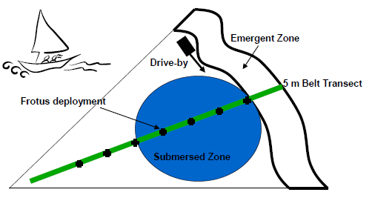

- Determine one dominant or two co-dominant taxa for the sampling section as follows:
  - If a single taxon comprises a clear, overwhelming majority of the areal coverage of plants (e.g., if one taxon is twice as abundant as all others), record it as dominant.
  - Assign two co-dominant taxa if there are two taxa that are abundant and one taxon is not twice as abundant as the other.
  - Record dominance or co-dominance. Dominance can be observed for woody, emergent, floating, or submersed species. For woody species, consider the canopy overhanging the lake in the determination of areal coverage. Deploy the frotus additional times if necessary to determine potential dominance of submersed taxa.
- If no one dominant or two co-dominant species are present, do not assign a dominance code for that sampling section and note that no dominant or co-dominant was assigned.
- Collect specimens of dominant and co-dominant taxa from groups which typically require further examination for identification (e.g. grasses, submersed plants, “look-alike” species) for verification in the laboratory or by an independent taxonomist. Take photos of dominant and co-dominant taxa which are easily identified and frequently encountered (e.g.Taxodium spp., Nymphaea odorata) and verify the ID; these do not need to be collected for verification.
- If a macrophyte encountered cannot be readily identified in the field, pictures and notes should be taken and a PLANT-ID specimen should be collected, for identification by an expert botanist.
  - When collecting a PLANT-ID specimen, it is best to collect whole plants, including roots (rinsed), stem base, flowers, and fruits. If a plant is too large for full collection, make notes and take several photos of the plant, including its habit and base. Place all plant material from a single specimen in a plastic bag and do not put water in the bag with the specimen, as this can cause it to rot. If multiple unknown macrophytes are present at a site, place each specimen in a separate bag.
  - Document all the organs (leaves, stems, flowers, fruits, roots) and habit when taking pictures of a PLANT-ID specimen.
  - Place a PLANT-ID label (Figure 46) on each specimen’s bag, and indicate the specimen number (e.g. “Unknown Rush #1”, “Polygonum sp. #1), date, time, and samplers’ initials. Place all individually bagged specimens from a single site in a large plastic bag, and place a Barcoded Station Label (Figure 3) and a PLANT-ID label on the outside of the large bag.
  - Store bags on ice. Plants kept refrigerated or on ice can be identified fresh within a day or two.
  - If an expert botanist is available in the sampling agency’s office, PLANT-ID specimens may be taken directly to the local expert. If a local expert is not available, PLANT-ID specimens may be shipped to DEP in the cooler with the water chemistry samples. If you are shipping PLANT-ID specimens to DEP you MUST call or email the SMP Coordinator, to ensure that staff are aware of these incoming time-sensitive samples.
  - If collecting specimens for identification in the lab, by DEP botanist, or external botanist, it is best to keep the plant fresh (refrigerated) and identify or ship immediately. If this is not possible, specimens may be pressed and sent for identification.
- Repeat steps 3 - 8 for the three other sampling sections, to produce a total of four taxa lists for the lake.
- Before leaving the lake, clean any plant fragments from the boat hull and trailer. Rinse the boat and trailer well before sampling another lake to prevent the inadvertent and detrimental spread of invasive exotic plants to other lakes.
- Once unknown specimens have been identified, finalize the Lake Vegetation Index Field Sheet with correct taxa names.

Lake Vegetation Index Data Entry, Data Verification and Data Authorization
Sampling teams are responsible for entering their own bioassessment observations in SBIO2. Before bioassessment observations can be entered into SBIO2 the associated station needs to be created. Stations must be created in the Watershed Information Network (WIN) (Section 25), before they are created in SBIO2. To create a SBIO2 station, login to SBIO2 and open the Station Creation and Editing Module in the Administrative Tab. In the Station Creation and Editing Module click the Create New Station radio button (selected by default), select your Org ID from the dropdown list, enter the station ID, select a waterbody type, and click the Get WIN Station Info button. This will import the station attributes from WIN. Then click the Get GIS Info button and save. Permissions to the Administrative Tab are limited to few individuals in each office. If you do not have the Administrative Tab, ask your team lead to create the SBIO2 station.

Note: Data entry and date verification (QC) need to be completed by different people.

Station Visit
Before entering bioassessment (HA, LVS, LVI, PhysChem, RPS, etc.) observations into the applicable SBIO2 module, the Station Visit must be created in the Station Visit Module. When the Station Visit is created a Visit ID (aka SBIO ID) is generated. Record the Visit ID on the SMP Field Sheet, Lake Vegetation Index Field Sheet, Lake Observation Field Sheet, and Lake Habitat Assessment Field Sheet.

Data Entry
In SBIO2, open the Vascular Module in the Field Activities Tab. In the Enter Data tab type the Visit ID in the Search box. Select the Visit ID in the result box below. One of two popup windows will appear.

- Do you want to add Macrophyte data to SBIO Visit ID #####?
- Select “Yes”.
    - The LVI data entry module will open if the waterbody type of the SBIO2 station associated with the Visit ID is lake.
    - The LVS data entry module will open if the waterbody type of the SBIO2 station associated with the Visit ID is stream or canal.
- A Macrophyte ID is generated by SBIO2. Record it on the SMP Field Sheet and the Lake Vegetation Index Field Sheet.
- Add the Sampling Agency, Identifier, comments and a LIMS Sample ID from the paired water chemistry sample.
- Write the LIMS Sample ID on the SMP Field Sheet and LVI Field Sheet.
- Verify the Existing Station Visit Information (Station, Date, Waterbody, Lead Sampler, and Waterbody Type) is correct.
- Add the LVI macrophyte observations from the field sheet to SBIO2.
    - If you have questions about vascular data entry, refer to the module user guide. To open the module user guide, click the icon at the top right of the vascular data entry module.
- Write “Entered”, the date and the initials of the data entry person on the LVI Field Sheet.
- Save and close the data entry module.
- The LVI event is now in “V” status. The data entry for LVI events in “V” status needs to be verified. Proceed to Data Verification below.

- There is 1 (2, 3, 4 etc.) existing Vascular Data entry for SBIO Visit #####, collected dd/mm/yyyy. Would you like to enter additional data?
- Select “No” because the LVI observations have already been entered into SBIO2.
- Close the Vascular Data Entry Module.
- Open the Reports Module and query macrophyte data using the Visit ID to view the existing vascular events associated with the Visit ID.
- Note the Macrophyte ID(s) and the data entry status of the existing vascular event(s).
- Complete the data entry for the vascular event identified in the previous step. If there are multiple vascular events associated with the Visit ID, complete the data entry for one Macrophyte ID and delete the others.
  - If the existing vascular event is in “V” Status record the Macrophyte ID on the SMP field Sheet and the Lake Vegetation Index Field Sheet. Proceed to Data Verification below.
  - If the existing vascular event is “C” Status record the Macrophyte ID on the SMP field Sheet and the Lake Vegetation Index Field Sheet. Proceed to Data Authorization below.
  - If the existing vascular event is “A” Status record the Macrophyte ID on the SMP field Sheet and the Lake Vegetation Index Field Sheet. Data entry is complete.

Data Verification
Data verification needs to be completed by someone other than the data entry person. In SBIO2, open the Vascular Module in the Field Activities Tab. In the Existing Data Tab type the Macrophyte ID in the Search box.
- Select the Macrophyte ID in the result box.
- Verify the Station Visit Information (Station ID, Date, Waterbody, Lead Sampler, and Waterbody Type) is correct.
- Verify the LIMS Sample ID is associated with the water chemistry sample paired with the LVI.
- Verify the macrophyte observations.
- If there are any discrepancies between the field sheet and the information in the Vascular module:
  - Note the discrepancies
  - Close the Module.
  - Have the data entry person correct the discrepancies.
  - Start Data Verification procedure over.
- If all values are correct, select a reviewer (your name) from the dropdown list.
- Write “Data QC”, the date and the initials of the reviewer on the LVI Field Sheet.
- Click the Updates Are Correct Button. The LVI event is now in “C” status. SBIO2 events in “C” status need to be authorized (aka Marked Complete). Proceed to Data Authorization below.

Data Authorization
Permissions to the Administrative Tab are limited to few individuals in each office. If you do not have the Administrative Tab, ask your team lead to authorize the vascular event.
- Open the Authorize Data Module in the Administrative Tab.
- Select the Lake Vegetation Index (LVI) radio button.
- Select the Visit ID from the To Be Authorized Table.
- Confirm the dates and initials of the data entry person and the reviewer are on the LVI field sheet.
- Click the Authorize button. The LVI event is now authorized, in “A” status.

Section 19. Physical/Chemical Characterization

Introduction
The purpose behind Physical/Chemical Characterization (PhysChem) is to collect key data components that can assist in interpreting biological community results. PhysChem data must accompany all Stream bioassessments, Stream Condition Index (SCI), Rapid Periphyton Survey (RPS), Linear Vegetation Survey (LVS) data, and Stream/River Habitat Assessment (HA). The HA must be paired with PhysChem. PhysChem requires both field and desktop mapping observations.

This sampling procedure requires specific training due to the expert judgment exercised during field sampling. It is recommended that individuals conducting this procedure train with DEP staff (via workshops and/or participating in field sampling). Training should be conducted in conjunction with SCI and HA training.

Equipment and Supplies
The following will be needed in order to perform a Habitat Assessment:
- Mapping software (ArcGIS or equivalent)
- Spreadsheet software (Microsoft Excel or equivalent)
- Physical/Chemical Characterization Field Sheet (Figure 18)
- Stream/River Habitat Sketch Field Sheet (Figure 14)
- Stream/River Habitat Assessment Score Field Sheet (Figure 15)
- Waterproof pen
- Watch, stopwatch or flow meter
- Meterstick or D-frame dipnet handle marked in 0.1 m increments
- Depth sonar (non-wadable systems)
- Concave or convex spherical densitometer
- Secchi disk with at least three meters of rope marked in 0.2 m sections
- 100 m measuring tape
- Flagging tape or station flags
- Multi-Parameter Water Quality Meter

Physical Chemical Characterization Methods: Prior to Visiting the Stream
The station must be created in the Watershed Information Network (WIN) before proceeding.

- Fill in the information at the top of the Physical/Chemical Characterization Field Sheet that can be prefilled:
  - ORG ID (Watershed Information Network (WIN) Organization Identification)
  - Latitude / Longitude (Decimal Degrees)
  - County
  - STORET # (WIN Monitoring Location ID)
  - Sampling Agency (FDEP)
  - Site Name (WIN monitoring location name)
  - Field ID/Name (WIN Monitoring Location ID)
  - Receiving Body of Water

- In the “Predominant Land Use In Watershed” and “Watershed Landscape Development Intensity Index (LDI)” sections recorded the calculated values. The following steps are for ArcGIS. The basic procedure is the same for ArcGIS Online but some of the steps for extracting the land use data may be different.
  - Delineate the stations watershed and extract the watershed LDI data.
  - Open GIS and add the following layers using the DEP Data Miner .
    - Impaired Waters Rule (IWR) Stations
    - Florida NHD
    - Waterbody IDs (WBIDs)
    - Current Land Use LDI and LSI
  - Navigate to the sample station.
  - Delineate the sample stations watershed. Identify the WBID or HUC (Florida NHD sublayer, NHD WBD) polygon(s) that capture the sample station and all upstream tributaries. The selected polygon(s) will be used to intersect the LDI layer.
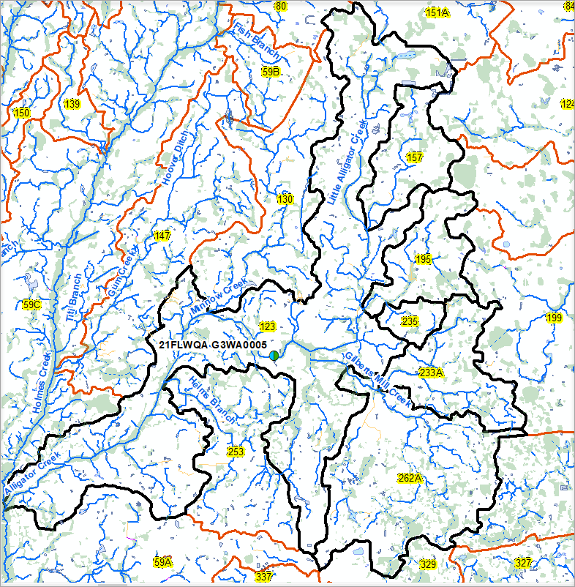
  - Select the polygon(s) that capture the sample station and all upstream tributaries with the Select Features Tool. Multiple features (polygons) can be selected if the Shift key is pressed when selecting.
  - Create a layer from the selected features (WBIDs in this example). In the Table of Contents, right click the polygon layer discussed in the previous two steps. Go to “Selections” and then “Create Layer From Selected Features”.
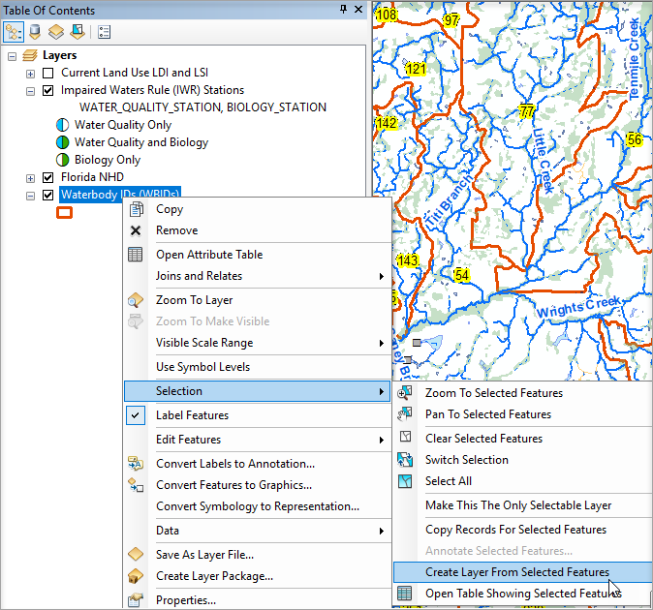
  - The selected features will be added to the Table of Contents as a new layer. Turn on the new (watershed) layer and turn off the WBID or HUC layer.
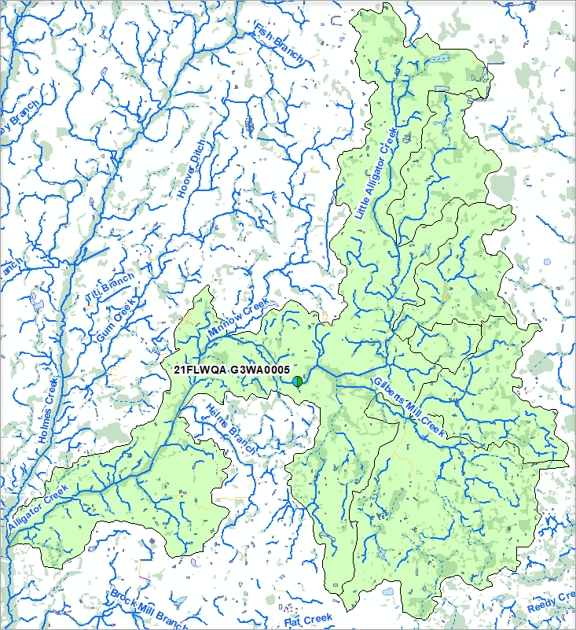
  - Intersect the watershed layer created in the previous steps with the Landscape Development Intensity (LDI) layer.
    - Arc Toolbox , Analysis Tools, Overlay, Intersect
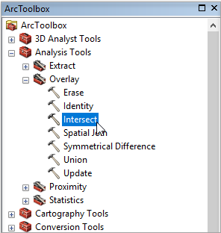
    - Add the “Input features” from the dropdown menu.
      - The watershed layer created in the previous steps
      - The Landscape Development Intensity (LDI) layer
    - Click the “OK” button. The intersect results will be added to the map.
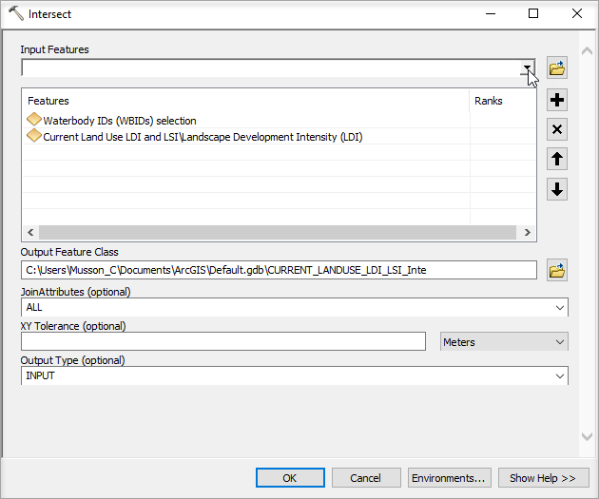
  - Select the LDI intersect features upstream of the sample station with the Select Features Tool.
  - Copy the records of the selected LDI intersect features. In the Table of Contents, right click the LDI intersect layer discussed in the previous two steps. Go to “Selections” and then “Copy Records For Selected Features”.
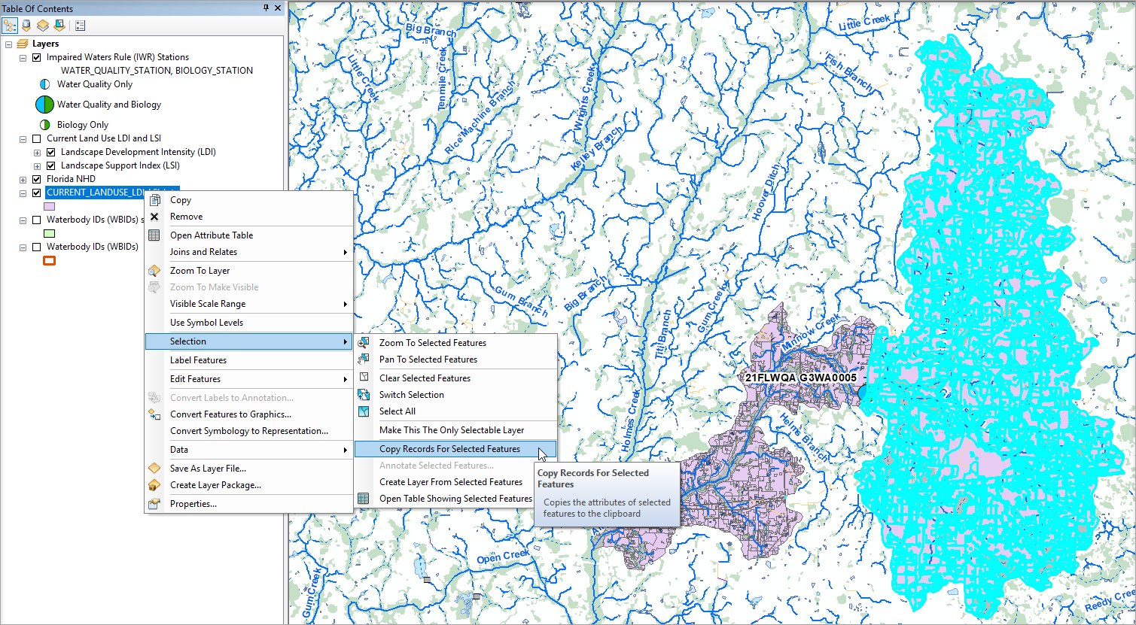
  - Open a new Excel spreadsheet.
  - Paste the copied records into Excel, cell A1.

  - Calculate the watershed LDI.
- Calculate the LDI-Area Product by multiplying the LDI value by the GEOMETRY_Area.
  - In the top first row of a blank column Type “LDI-Area Product”.
  - Below that in the second row of the blank column, multiply the value in the LDI column by the value in the GEOMETRY_Area.
  - Apply (fill down) the formula to the entire column.
- Calculate the sum of the values in the LDI-Area Product column to find the sum of the LDI-Products.
- Calculate the sum of the values in the GEOMETRY_Area to find the total area.
- Divide the sum of the LDI-Products by the total area. The result is the Watershed LDI. Add the result to the PhysChem Field Sheet.

$$LDI=\frac{Sum of the LDI Products}{Total Area}$$

- Alternatively, the SUMPRODUCT and SUM formulas can be used to calculate the LDI.
“=SUMPRODUCT(LDI Column, Area Column)/SUM(Area Column)”

  - Calculate the percent cover for the predominant land use types in the watershed.
- Label each row with one of the land use types (Forest/Natural, Silviculture, Field/Pasture, Agriculture, residential, Commercial, Industry, Other) on the PhysChem Field Sheet.
  - In the top first row of a blank column Type “Land Use Type”.
  - Add a Data Filter to the Excel spread sheet; Data Tab, Sort & Filter, Filter
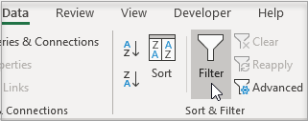
  - To identify the different land use types, use key words to filter the Description Column. (Table ## LDI for PhysChem table)

Land Use Type | Description Column Key Words Examples
Forest/Natural | Cypress, Flatwoods, Forest, Hardwood, Lake, Marsh, Oak, Palm, Pine, Pond, Prairie, Spring, Stream, Swamp, Wetland, Woodland
Silviculture | Forest Regeneration Area, Plantations
Field/Pasture | Field, Open Land, Pasture
Agriculture | Aquaculture, Crop, Grove, Farm, Feeding Operations, Nurseries
Residential | Low Density, Medium Density, High Density
Commercial | Commercial, Correctional, Institutional, Services, Shopping Centers, Medical and Health Care, Governmental
Industry | Electrical, Industrial, Mine, Mill, Military Oil, Port, Processing, Utilities

  - Type the corresponding land use type in the “Land Use Type” column. Continue until a land use type has been identified for all rows.
- Calculate the percent area of each land use type in the watershed.
  - Divide the area of each land use type by the total area and multiply by 100. Add the result to the PhysChem Field Sheet.

- Use the map and the land use information from Step 2 with aerial imagery, to identify features that impact hydrology in the watershed.
  - Flow regime alterations (draining, ditching, impoundments, anthropogenic land uses)
    - Estimate the proportion of the watershed affected by draining or ditching. Use the Florida NHD sublayer, NHD 24K flowline to identify ditches and canals.
    - Estimate the proportion of the watershed affected by impoundments. Use the Florida NHD sublayer, NHD 24K Line to identify impoundments (dams, weirs, gates, locks, etc.). Not all impoundments are captured in the NHD layers. Look for overlap between Florida NHD sublayers, NHD 24K Waterbody (lake, pond, reservoir) and NHD 24K Flowline.
    - Use the land use percentages calculates in Step 2 to evaluate the impact on flow in the watershed.
      - Forest/Natural: No Impact
      - Silviculture: Low Impact
      - Field/Pasture and Agriculture: Low, medium or high impact.
      - Residential: Medium to high impact
      - Commercial and Industrial: High impact
    - Make observations of flow regime alteration while at the site and while conducting reconnaissance in the watershed.
  - Impervious surface coverage
    - Impervious surface coverage will be correlated to residential, commercial and industrial land use types.
  - Water withdrawals
    - Evaluate the potential for surface and ground water withdrawals in the watershed. Water withdrawals will be correlated to agricultural, residential, commercial and industrial land use types. Look for row crops in aerial imagery.
  - Ground water delivery features
    - Estimate the portion of the watershed that is wetted lands using the Florida NHD sublayer, NHD 24K Swamp Marsh.

Assign a hydrologic modification score from one to ten using the following scale. Score at the low end of the category if only some of the impacts are realized, and at the high end if all conditions apply.

  - Best (1-2 points): Flow regime as naturally occurs (slow and fairly continual release of water after rains), few impervious surfaces in watershed (<5%), high connectivity with ground water and surface features delivering water (e.g., sand hills, wetlands; no ditches, berms, other impediments)
  - Slight Disturbance (3-4 points): Flow regime minimally changed; hydrograph resembles normal hydrologic curve; some water withdrawals; some wetland drainage, some ditching, some impoundments; some impervious surfaces in watershed (5-<10%),
  - Moderately altered (5-6 points): Flow regime moderately altered; hydrograph moderately flashy (scouring after rain events with subsequent reductions in flow); groundwater pumping evident; much wetland drainage, topographic alterations reduce natural water input; more impervious surfaces throughout watershed (10-<20%), dams/control structures change normal water delivery schedule
  - Poor (7-8 points): Flow regime highly altered; hydrograph very flashy (scouring after rain events with subsequent reductions in flow, leading to stagnant or dry conditions, related to large amounts of impervious surfaces and/or ditching throughout watershed); water withdrawals & impoundments/control structures severely alter flows, large amounts of impervious surfaces (20-<30%)
  - Very Poor (9-10 points): Flow regime entirely human controlled; hydrograph very flashy (scouring after rain events with subsequent reductions in flow, leading to stagnant or dry conditions, related to impervious surfaces and ditching throughout watershed); water withdrawals and impoundments fundamentally alter the nature of the ecosystem; impervious surfaces ≥ 30%.

- Indicate the presence or absence of impoundments in the area of the sampling station that may alter the natural flow regime or the movement of biota.

Physical Chemical Characterization Methods: In the Field
- Fill in the sample date and time information at the top of the Phys/Chem Field Sheet:
  - Date (Sampling date)
  - Sample Time (Time when water chemistry samples are taken)

- Collect water chemistry samples (Section 9)

- In the “Water Quality” section record field measurements and the Multi-Parameter Water Quality Meter ID.
  - Total depth and Secchi depth
  - Surface and bottom (Figure 30) field parameter measurements (depth, temperature, pH, dissolved oxygen (Mg/L), dissolved oxygen percent saturation, specific conductance, and salinity).
  - Mid field measurements are recommended for sites with total depth ≥ 1.5 m.

- Perform the HA (Section 14) and if required and appropriate, the SCI (Section 15), RPS (Section 16), and LVS (Section 17).

- In the “Substrate Type” document the assessment tools (bioassessments preformed), the substrate percent coverage (From the HA), if preformed the SCI sweep counts and PERI (Algal ID) sample counts:

- In the “Substrate Type” section, check the boxes for which assessment(s) is/are being performed. Fill in the % coverage of each habitat/substrate (much of this information can be transferred from the Habitat Assessment Sketch form). If an SCI is being performed, the INVERT column of the Substrate Type section will be used to indicate the number of times each habitat/substrate type was sampled. The PERI column is reserved for Qualitative Periphyton Sampling information, and does not need to be completed at Strategic Monitoring Program (SMP) sites.

- In the “Local Watershed Erosion” section, rate and record the potential for erosion within the portion of the watershed that affects the site.

- “Local Watershed NPS pollution” refers to contamination introduced by non-point sources (stormwater runoff). Estimate the NPS pollution with observation made in the watershed combined with the LDI and watershed land use information calculated prior to the site visit and record this information.

- Measure or estimate the width of the stream or river, from bank to bank, at a transect representative of the site. Record this information in the “Typical Width” section.

- Take three measurements of water depth across this transect using the meterstick or ruled rope of the Secchi disk and record.

- Take three measurements of water velocity (one at each location where water depth was measured) using either a flow meter or the meterstick, watch/stopwatch, and a floating leaf or other object. Record this information on the “Typical Width (m) Depth (m)/Velocity (m/sec) Transect” section.

- Measure or estimate the vegetated riparian buffer zone width on each side of the stream or river (the “left bank” is on your left when looking upstream) and record the values in the “Width of Riparian Vegetation (m) on Each Buffer Side” section. This is the distance from the edge of the water to where clearing or other human activities begin. If the vegetated buffer zone width is greater than 18 m, record “>18 m”. These values are documented for the HA.

- In the “Artificially Channelized” section, indicate whether or not the area in the vicinity of the sampling station has been artificially channelized and to what extent the system has recovered.

- Indicate the presence or absence of impoundments in the area of the sampling station that may alter the natural flow regime or the movement of biota.

- In the “High Water Mark” section, where applicable, estimate and record the vertical distance from the current water level to the peak overflow level. Peak overflow level is indicated by debris hanging in bank, floodplain vegetation, or deposition of silt or soil. (When bank overflow is rare, a high water mark may not be apparent.) Add this distance to the current water depth (see step 8 above) to determine the distance of the high water mark above the streambed and record this value.

- In the “Canopy Cover %” section, check the box for the percentage range that best describes the degree of shading in the sampling area. This percentage should be an integration over the entire 100 m reach and is not influenced by the season (for example, in the fall or winter when leaves are not present on surrounding trees, this is not to be interpreted as an “open” canopy cover). If the RPS was preformed calculate the average the densitometer observation. Multiply the average densitometer observation by 1.04. The result is the percent canopy cover.

- In the “Sediment / Substrate” sections, note any odors associated with the bottom sediments and check the appropriate box. Note the presence or absence of oils in the sediment; for this step, it may be helpful to observe the extent of sheen on the water after the substrate has been disturbed. Finally, note any deposits in the area, including the degree of smothering by sand, silt, or algae.

- In the “System Type” section indicate the type of aquatic system(s) being sampled.

- Indicate if the water sample and/or algae sample were taken and check the boxes to indicate that the samples were properly preserved, pack in loose wet ice and quickly chilled to ≤ 6 °C within 15 minutes of collection.
  - Lot Number (Ice), Exp (N/A)

- In the “Water Odors” section note if a water sample was taken and the presence and types of any noticeable water odors and check the appropriate box. Fill in the lot number and expiration date with the sulfuric acid preservative information. Additional water sample preservation information is documented on the SMP Field Sheet.

- In the “Water Surface Oils” section note the term that best describes the relative coverage of any oil on the water surface.

- In the “Clarity’ section check the term that best describes the water clarity before it was disturbed by sampling. Clarity is based on visual observation. Using a turbidimeter is not needed for this determination.

- In the “Color” section check box for the term that best describes the color of the water, indicating whether the water is tannic, green, clear or other. (If “other” is checked, indicate what the color is.)

- In the “Abundance” section estimate and record the relative abundances of the following: periphyton, fish, aquatic macrophytes and iron/sulfur bacteria. If any are absent, please do not leave the categories blank; mark the “Not Observed” box. Periphyton and aquatic macrophytes observations should not contradict the observation on the RPS and LVS field sheet.

- In the “Ambient Field Conditions / Notes” section

  - describe the weather conditions during the time of sampling, particularly the relative amount of sunshine/cloud cover, temperature, and wind speed and direction. Record any other conditions/observations that may be helpful in characterizing the site.
  - If the antecedent hydrologic conditions were met, check the box to indicate that the hydrological conditions were appropriate for sampling.

- Reevaluate the hydrologic modification score with observations made in the watershed and from within the stream. Flow regime alterations may not be detected in the desktop evaluation.

- Fill in the names of the sampling team, sign and date the form.

Physical/Chemical Characterization Data Entry
Sampling teams are responsible for entering their own bioassessment observations in SBIO2. Before bioassessment observations can be entered into SBIO2 the associated station needs to be created. Stations must be created in the Watershed Information Network (WIN) (Section 25), before they are created in SBIO2. To create a SBIO2 station, login to SBIO2 and open the Station Creation and Editing Module in the Administrative Tab. In the Station Creation and Editing Module click the Create New Station radio button (selected by default), select your Org ID from the dropdown list, enter the station ID, select a waterbody type, and click the Get WIN Station Info button. This will import the station attributes from WIN. Then click the Get GIS Info button and save. Permissions to the Administrative Tab are limited to few individuals in each office. If you do not have the Administrative Tab, ask your team lead to create the SBIO2 station.

Station Visit
Before entering bioassessment (PhysChem, HA, LVS, LVI, RPS) observations into the applicable SBIO2 module, the Station Visit must be created in the Station Visit Module. When the Station Visit is created a Visit ID (aka SBIO ID) is generated. Record the Visit ID on the SMP Field Sheet, Physical/Chemical Characterization Field Sheet, Stream/River Habitat Sketch Sheet, Habitat Assessment Field Sheet, and if conducted the Linear Vegetation Survey Field Sheet, and Rapid Periphyton Survey Field Sheets.

Data Entry
In SBIO2 open the Phys-Chem Module in the Field Activities Tab. Type the Visit ID in the Search box. Select the Visit ID in the result box to the right. A popup windows will appear, “Do you want to add or edit Phys-Chem data for SBIO Visit ID #####?

- Select “Yes”
- Verify the Existing Station Visit Information (Station, Sample Date, Waterbody, and Lead Sampler) is correct.
- Add the PhysChem observations from the field sheet to SBIO2.
    - If you have questions about PhysChem data entry refer to the module user guide. To open the module user guide, click the icon at the bottom right of the Phys-Chem data entry module.
- Write “Entered”, the date and the initials of the data entry person on the PhysChem Field Sheet.
- Save and close the data entry module.

Data Verification
Data verification needs to be completed by someone other than the data entry person. In SBIO2, open the Phys-Chem Module in the Field Activities Tab. Type the Visit ID in the Search box.
- Select the Habitat Visit ID in the result box to the right.
- A popup windows will appear, “Do you want to add or edit Phys-Chem data for SBIO Visit ID #####?
- Select “Yes”
- A second popup window will appear, “There is # existing entry for SBIO Visit ID #####, collected dd/mm/yyyy. Would you like to enter additional or edit existing data?”
- Select “Yes”
- Verify the Station Visit Information (Station ID, Date, Lead Sampler, and Analyst) and comments are correct.
- Verify the PhysChem observations.
- If there are any discrepancies between the field sheet and the information in the data entry module:
  - Note the discrepancies
  - Close the Module.
  - Have the data entry person correct the discrepancies.
  - Start Data Verification procedure over.
- If all values are correct write “Data QC”, the date and the initials of the reviewer on the HA Field Sheet(s).
- Data entry is complete.

Section 20. Continuous Monitoring

Project Overview
Dissolved oxygen (DO), specific conductance, and temperature will be collected with a multi-parameter water quality Meter (e) at 15-inute intervals 30 minute intervals.. The State of Florida has fresh and saltwater DO water quality standards. The DO water quality standard used to assess tidal (diurnal fluctuation of specific conductance) systems is specific conductance dependent. pH should be included if available but is not a required parameter. Sondes must be deployed 5 times throughout the sampling period (one calendar year) with a minimum length of 4 full days per deployment. . At least one deployment should be within each quarter. A water chemistry kit (Nutrient and Chlorophyll-a) must be collected when the sonde is retrieved.
Make sure all sensors are designed for long term deployments. Fouling, flow rate, and other physical restraints limit the types of sensors that can be used for continuous monitoring. Much of the details needed to run sonds, build appropriate housing, and use appropriate data management software are found within the Continuous Monitoring SOP.

Multi-parameter Water Quality Meter
Strategic Monitoring Program (SMP) projects will use YSI EXO and 6-series multi-parameter water quality meters capable of being deployed for long term in the environment. For exact details on materials needed for meters, like sensors and computer software, see the Continuous Monitoring Data Management SOP(Needs hyperlink).

Calibration
See Section 8, Calibration and the following DEP SOPs:
- FD 4100 for general calibration information and documentation
- FT 1100 pH
- FT 1200 Conductivity
- FT 1500 Dissolved Oxygen

Documentation
During the continuous monitoring process appropriate information will be recorded on the SMP Continuous Monitoring Field Sheet (Figure 51). All calibrations will be documented on calibration logs that meet the requirements in Section 8. All data recorded during the water quality sample event at retrieval (see Sonde Retrieval below) will be recorded on SMP Field Sheets (Figure 10).

Site Selection
Selected sites must follow all SMP site selection guidelines (Section 2). Furthermore, when selecting a site consider the safety of the sonde and quality of the data. If you are deploying in an area heavily trafficked by the public for fishing or boating the sonde is more likely to disturbed. Try to choose a site where smothering will be limited. While water quality sampling events happen often in water infested with algae you would not like to find the sonde itself encased in green goo. Ephemeral sites should not be chosen for continuous monitoring. Sites that go dry during a deployment will cause damage to the expensive sensors of the sonde and may need to be maintenanced or replaced after such a deployment.

Deployment
Each waterbodies or water segment (WBID) is different, so a host of considerations need to be taken when deploying a sonde. Not all of which will be covered here as there are too many to predict. The following considerations will help you design the appropriate housing the sonde. For more details on the kinds of designs that may be used see the Continuous Monitoring Data Management SOP(Needs Hyperlink).

The first consideration is the safety of the sonde. The sonde or housing must be secured to a solid object that is not likely to move, be it a permanent structure like a tree or a metal post (rebar, fence post etc.) driven into the ground. Where applicable the housing or sonde should be secured to the substrate in addition to any on land permanent anchor point. This will keep the instrument anchored in the waterbody and can be done with a heavy or secured object like a rod jammed into the bottom.

If possible the data recorded should be from a depth of 0.3 m section, much like a standard grab sample (Section 9). Keep this in mind when designing your housing for the sonde. Keeping the sonde at this depth can be achieved with various floating mechanisms. For standalone designs this could be a float to which the sonde is connected. For housings secured to a structure, like a pipe on a bridge piling, a float can be attached to the sonde inside the housing. Keep in mind not all the housing itself needs to stay at this depth.

When possible, YSI recommends that the sonde be angled 45 degrees to the flow of the waterbody. This is to direct the flow towards the sensors and will stop the body of the sonde from blocking flow during reverse tidal conditions. If the sonde is tilted upward toward the surface the depth of the sonde/sensors should be considered along with the tilt, making sure the tilt does not adversely offset of the depth.
Figure 50. Continuous Monitoring Sond Deployment

Sonde Retrieval
At the end of the data recording period, during sonde retrieval while the sonde is still in the water, a water quality sample (nutrients and chlorophyll-a) must be taken. A second sonde will be used to measure field parameters of the water quality sample. If a sample can not be taken on the day of retrieval, or the sonde must stay deployed, a sample can be taken before the sonde’s retrieval day while it is deployed in the water. This data should be readily available Document the water quality sample and the field parameters (dissolved oxygen, specific conductance, pH, total dept, etc.) on the SMP Field Sheet. Mark the date and time out of water on the sonde retrieval section of the SMP Continues Monitoring Field Sheet.
Preform post calibration verifications (Section 7). If the post calibration verification fails, clean the sensor. Perform a second post calibration verification. If the sensor passes the second post calibration verification attempt, after the probe is cleaned the values must be reported with a “J” qualifier and the comment “Passed CCV only after sensor was cleaned”.

Data management
The data are downloaded from sondes using either K or (EXO) or Ecowatch Lite (6-series) software. Files should be saved as either comma delimited .txt or .xlsx extensions. The raw data files are to be saved on the SMP, Continuous Monitoring network folder.

Section 21. Sample Tracker

Introduction
The Strategic Monitoring Program (SMP) annual monitoring plan sample tracker (SMP Tracker) is used to document the sampling activities of the SMP annual monitoring plan. The SMP Tracker ties together the field information that is vital for data review and data management. The accuracy of the SMP Tracker is paramount because it is used by sampling coordinators, data reviewers, and managers.

Column Descriptions

Waterbody / Waterbody Segment (WBID) characterization
This section describes the type of waterbody.
- Group: Assessment Group number.
- Group Name: Assessment Group watershed (USGS 8-digit HUC) name
- Water Segment Name: The WBID name. This usually signifies the target waterbody, however some WBIDs cover a large area with multiple small waterbodies, so they may not match the name of the waterbody to be sampled.
- County: County(s) the WBID is in.
- Group Responsible for Sample Collection: The Regional Operation Center (ROC) responsible for sampling the WBID.
- WBID: Water segment (WBID) identification number.
- ENR: Estuary Nutrient Region. A geographic area with specified nutrient criteria. Samples must be collected within the boundaries of the listed ENR. There are also notes about sampling outside ENR regions, so this is important during the recon and when establishing new stations.
- Body: The waterbody type assignment to the WBID. For Clean Water Act water quality assessment, the State of Florida recognizes five waterbody types, Stream, Lake, Spring, Estuary, and Costal. The listed waterbody type should match the field conditions of the waterbody that you are sampling because different waterbody types have different water quality standards. If the waterbody type and field conditions do not match notify the SMP Coordinator, WBID edits may be needed.
- Class: The waterbody Class assigned to the WBID. For Clean Water Act water quality assessment, the State of Florida recognizes six waterbody Classes (Table 2), four are represented on the SMP annual monitoring plan. The Class listed on the plan should match the field conditions of the waterbody that you are sampling because different waterbody classes have different water quality standards. If the waterbody class and field conditions do not match notify the SMP Coordinator, WBID edits may be needed.

Sampling Requirements
- Sampling Requirements: Analyte (suite) name - The required analyte(s) for a WBID. Make sure the Bacteria match up with the Class.

Table 11. Microbiology water quality standard by waterbody Class
Matrix | Class | Analyte(s)
Fresh | 1 | Escherichia coli
Marine | 2 | Enterococci, Fecal Coliform (membrane filtration)
Fresh | 3F | Escherichia coli
Marine | 3M | Enterococci

- Original n: The sample size on January 1 of the sampling year.
- Adjusted n: The required sample size. Throughout the year the sample size may increase or decrease.
- Sample Size/Frequency Notes (Minimum): Notes specifically tied to the Sampling Requirements. These will include sample size (n), number of sampling trips per WBID (Weeks), seasonality notes (Season 1, Season 2), analytes to pair, and if the sampling requirement has been removed.
- Sampling Notes: This section is for the SMP Coordinator to clarify any questions with the sampling requirements. This could include number of sites needed, site specific information, contact information, picture direction requirements, etc.

Sample Tracking
The columns designated by month names and week numbers. After a WBID is sampled log the bioassessments completed, pictures taken, and samples collected after the samples are logged into LIMS. Do not log samples that are lost by FedEx or rejected by the lab.

Find the cell that corresponds to the sample date, WBID, and sampling requirement (nutrients, HA, pesticides, etc..). Type the number of samples collected in that cell. Repeat this for all WBIDs and sampling requirements. Tracking numbers should be added within one week of sampling event to ensure proper QC and scheduling.

Nonnumeric nomenclatures can be used to show a visit happened even if no samples were taken, or samples were lost. Using alphabetic letters in the tracking section is a concise way to convey sampling notes. Conditions can be summed up with one character and it will show an attempted sampling event within the given date range. Do not use special characters (!@#$%^&*)(<>?”{},./;’][-\|) in the Tracker.

Table 12. Tracker Non-Numeric Characters
Tracker Code | Definition
O | "O" qualified, Analysis cancelled
X | No results for bottle group
D | Dry - no standing water
F | Flooded - out of banks
IF | Insufficient Flow
P | Pooled - no flow between pools
NF | No Flow
S | Shipping issue

Sampling Summary: Sample, Week, and Seasonality Counts
- Total Samples Collected: The number of samples, bioassessment, pictures collected, taken.
- Remaining Samples To Be Collected: The number of samples, bioassessment, pictures needed to fulfil yearly sampling requirement
- Week Count: The number of separate weeks that have been sampled. At the end of the sampling period this needs to be greater than or equal to the number of weeks designated in the Sample Size/Frequency Notes (Minimum) column.
- Season 1 Count: The number of samples collected in Numeric Nutrient Criteria (NNC) Season 1. NNC requires at least one sample be collected in each nutrient session. Seasonality requirements are listed in the Sample Size/Frequency Notes (Minimum) column.
- Season 2 Count: The number of samples collected in Numeric Nutrient Criteria (NNC) Season 2. NNC requires at least one sample be collected in each nutrient session. Seasonality requirements are listed in the Sample Size/Frequency Notes (Minimum) column.

Notes
The note section connects what was observed at a site with those reviewing the data. It is important to record notes when a sampling site’s hydrology changes, sampling could not occur, or anything is observed that could cause abnormal results. If the sample size changes the SMP Coordinator will note the reason why.

Run Name
This Column is for the SMP scheduler to break up the WBIDs into sampling ‘Runs’. These can have any name but if using during scheduling LIMS RQ events (Section 3) they need to be mixed case and abbreviations are not preferred.

Kits Test Codes Tab
A table of the analytes and LIMS Analysis Codes (aka Test Codes) used for SMP monitoring. The table is divided up by matrix (fresh, marine), Class (1, 2, 3F, 3M) and analyte group (nutrients, metals, pesticides etc.). Staff scheduling events in LIMS (Section 3) need to reference this table to insure the proper test and analytes are requested.

QC Tracking Tab
The QC (Quality Control) Tracking Tab on the SMP Tracker Worksheet is used to track blanks (field or equipment) and field duplicates (Section 10). For each QC sample, there is a monthly tracking column. After each QC event, add the cumulative total to the correct analyte row.
As the tracker is filled out the percent collected for the year will be updated in Column J for the duplicates and Column Y for the blanks. Please note for each analyte the total percentage should be greater to or equal 5% for the year. The total number needed as well as percent per quarter is displayed to help the SMP sampling scheduler, schedule the appropriate amount of QC samples per month.

Summary Tab
A table and set of histograms summarizing samples and bioassessments collected.

Section 22. LIMS Data Merge Tool

Introduction
The Date Merge Tool (DMT) is a module in The Laboratory Information Management System Database (LIMS) developed by Florida Department of Environmental Protection (FDEP) Laboratory staff. Sample results produced by analysis performed by the FDEP Laboratory are entered in LIMS by FDEP Laboratory staff. The DMT is used to merge field measurements associated with lab results, apply field data qualifiers “J”, “G”, “R” (Table 5), and create an Electronic Data Deliverable (EDD) text file formatted for Watershed Information Network (WIN) uploading.

Before uploading to WIN, values in the DMT need to be added manually, edited and, verified by sampling staff. For each LIMS Event the WIN Org ID, sampling agency, field measurements and if applicable data qualifiers need to be added. The Station ID(s) need to be verified against the field sheets and a WIN station table to verify the correct Station ID(s) are correct. A LIMS Event is defined by RQ, sample date and login date. All samples from the same RQ, collected on the same day and, logged in on the same day will be on the same Event. If samples from an RQ collected on the same day will be on different Events if they are logged in on different days.

Accessing the Data Merge Tool - LIMS Browser
The Laboratory Information Management System Database (LIMS) Browser module allows users to query the data in LIMS. The LIMS Data Merge Tool (DMT) is an option in the LIMS Browser. To access the Browser, go to the General menu and select LIMS Browser.

LIMS menu bar.
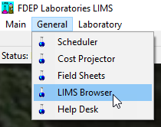

Searching for Data
Records can be searched by selecting a parameter option, such as the RQ or Lab Event ID (SOP LB-005-2.6). If the entire search parameter number or name is not known, then a portion of the parameter can be typed and the browser will perform a wildcard search. After typing the parameter in the Search By box, click Build List. If more than one item is returned they can be multi-selected. After selecting the chosen items click OK.

Note: The search by customer will also bring up a project list. Click Build List for the projects then select one or more projects.

The search can be narrowed down to additional selections, including specific analytes or components, job statuses, or date ranges (SOP LB-005-2.6).

Viewing Data
After clicking OK on one or more selected items the screen will display search results (SOP LB-005-6.2).

DATA ENTRY
Data can be entered by selecting an event and clicking the Data Merge Tool (DMT) button. A WIN_Data_Form window will open with the event-associated Sample Field IDs and parameters. By selecting individual Sample_Field_ID lines, associated editable components will be displayed. Data entry is to be completed for field samples, field replicates, and blanks.

Entering Field Data
Recorded data from field sheets should be used to enter data for each Sample ID. The following steps are necessary for initial data entry:

- Delete Chlorine parameter from each site
- Enter all field parameters not entered by Tallahassee Lab:
  - Total Depth (meters)
  - DO Saturation (%)
  - Salinity (ppt)
  - Qualifiers and explanatory descriptions (if applicable). Common qualifiers include:
    - “J” qualifier (estimated value) if the sample measurement is not chronologically and quantitatively bracketed by acceptable calibrations and verification per requirements in FT 1000, section 2.2.
    - “S” qualifier (Secchi disk visible to bottom of waterbody) does not need an explanatory description for “Depth, Secchi Disk Depth”.
    - “R” qualifier (Significant rain in the past 48 hours) if it rained in excess of 1/2 inch within the past 48 hours.
    - See 62-160.700 for full list of Data Qualifier Codes.
- Enter field parameters for second depth reading (if applicable)
  - Select Add Parm
  - Select: Dissolved Oxygen; Dissolved Oxygen Saturation; pH; Salinity; Specific Conductance; Temperature, Water
  - Select New Depth
- Enter Sampling Agency
- Enter Representative Indicator (Representative/Not Representative)
- Select Apply Updates

Additional Steps for Blanks
Additional steps are needed for field blanks, equipment blanks, and trip blanks (Figure 1). Steps included are:
- Sample_Field_ID: FB_mmddyyyy
- Station_ID: leave blank!
- No field measurements should be recorded or entered in the DMT.
- Blank_Batch_ID: Applied to all sites on the run, including the blank
  - Field: SMPmmddyy_FB
  - Equipment: SMPmmddyy_EB
  - Trip: SMPmmddyy_TB

Figure 52. DMT Field Blank example
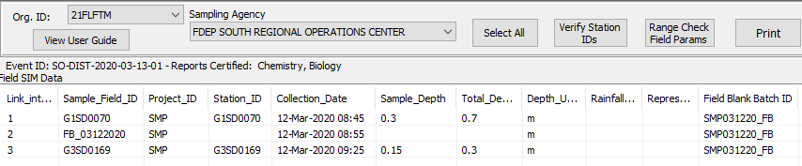

Additional Steps for Field Replicates
Additional steps are needed for field replicate samples (Figure 2). Steps included are:

- Sample_Field_ID: G#XX####_DUP
- Station_ID: G#XX#### (where duplicate was taken)
- No field measurements should be entered for the duplicate except Sample_Depth

Figure 53. DMT Duplicate example
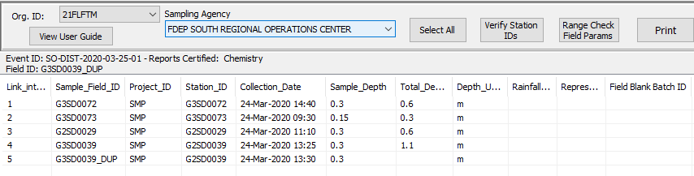

DATA QUALITY CONTROL
After sampling data has been added to the DMT, the data must be verified by an individual who did not perform the initial data entry.

Data Verification
There are steps necessary for data verification including:

- Verify that LIMS data entry steps were completed (See Section ## above).
- Compare LIMS entry to field sheets from the sampling event:
  - Change errors, add missing data, insert qualifiers
- After updates are applied, click SELECT ALL and then click each button in order:
  - Verify Station IDs
  - Range Check Field Params
  - Apply Updates

DATA COORDINATION WITH OTHER AGENCIES
When coordinating sampling efforts with other agencies, FDEP may provide full kits or additional bottles for analytes that are not already being sampled for by the partnering agency. When this occurs, there are modified steps in the data management process to prevent duplicate data entries.

Data Entry for Other Agencies
If FDEP provides full kits for the partnering agency and the agency is not migrating the associated field measurement data and analyte results to the Watershed Information Network (WIN), FDEP is responsible for acquiring and filing field measurement data as well as LIMS and WIN data management. If the coordinating agency is already uploading and migrating field measurement data and analyte results to WIN, the following LIMS data entry is applicable for requested additional bottles:

- Enter the Sample Depth for additional requested analytes.
- Do not enter additional field measurements.

Please see Chapter # : [Coordination with Other Sampling Agencies] for additional coordination protocol.

Section 23. Document Nomenclature, Folder Hierarchy
Strategic Monitoring – located within the WQAP monitoring folder on the FTP site
- Year starting with 2016
- One folder per Org code – all the SMP data will be stored under the respective ORG code.
  - 21FLA
  - 21FLCEN
  - 21FLFTM
  - 21FPNS
  - 21FLTLHR
  - 21FLTPA
  - 21FLWPB
  - 21FLWQA
  - 2019SMP – Excel file of the most current SMP for that year for reference
ORG
- WBIDs – One folder per WBID, labeled as WBID#_WBID name with underscores instead of spaces. Example (3314_LITTLE_AUCILLA_RIVER)
  - Station – One folder per sampling station labeled as the STORET Station ID
Example (G1TLHR0029)
    - Field Sheets – All of the field sheets from that site (SMP field sheet, SCI, Phys Chem etc.) should be scanned as a single PDF file with the SMP field sheet on top labeled as FieldSheets_mmddyyyy. Example (FieldSheets_08272019)
    - Photos – One photo for each cardinal direction and upstream/downstream as appropriate. Label as Direction_mmddyyyy Example (E_08272019, Downstream_08272019) If a special photo needs to be taken that doesn’t fit this nomenclature use a brief description using underscores as spaces. (Big_Branch_Upstream_of_SR67.jpg)
  - Recon – One folder per WBID labeled as Recon
    - Maps – This initial map has been provided by Curtis Musson. If additional maps are created in ArcGIS export them as jpg files labeled as WBID#Consecutive Number (809A_Map1, 809A_Map2)
    - Photos – Label using a brief description using underscores as spaces. (Big_Branch_Upstream_of_SR67.jpg)
    - Notes – Field notes if necessary should be scanned as a pdf and labeled Notes.pdf.
- RQs – One RQ Number folder per RQ Request labeled as the RQ Number (2019-06-24-37)
  - RQ Sheet – The initial RQ Request saved as pdf, labeled as the RQ Number (RQ‐2019‐06‐24‐37.pdf)
  - Lab Results – All lab results copied and pasted from the link they send you, this would be the Chain of Custody and Biology and/or Chemistry results (TLH-ROC-2019-08-27-02 RUN 1 08-27.pdf, TLH-ROC-2019-08-27-02-B-0117059.pdf)
- Calibration Logs – One Calibration Log folder per Org Code, labeled as Calibration_Logs
  - Calibration logs – Daily meter calibration logs should be scanned as a pdf, labeled as Calibration_mmddyyyy and all RQ numbers associated with it should be written on the calibration log sheet. Temperature calibration logs should be labeled Calibration_mmddyyyy_Temp. Depth calibration logs should be labeled Calibration_mmddyyyy_Depth.
- SMP_Tracker – The SMP tracker should be updated at the end of the day and reasons for not sampling should be included in the Notes section.

Section 24. Data Review

LIMS Data extraction

Review QA Blank results

Review Field Replicate results

Qualifier review

Station ID vs. Station description verification

Section 25. Watershed Information Network

General
Refer to WIN User Manual, version 2.01, for more information.

Permissions will need to be requested to be a WIN user for your region, refer to the WQAP Help Guide for more information.

To input data in WIN, select “Manage Data”, “Staged Data”, “Upload Data”. The Organization ID will be preset to who you are affiliated with, ex. 21FLTPA. Next, select the “Type” of data being uploaded: “Activity and Results” to upload WQ data from LIMs generated EDD file and “Monitoring Locations (SW)” to create stations – the other options are not applicable for the SMP program. “Config Name” are templates used when uploading different files, either stations or WQ data, where specific parameters are defined and needed. These templates can be cloned from other users, refer to the WIN User Manual or contact your WIN coordinator for assistance.

Assigning a Station Identification Number, G-number
Before water quality data can be uploaded into WIN, stations will need to be created to associate the water quality data to. A standardized naming convention for all SMP related samples have been created to allow for a unique and distinguishable naming:
- Field ID/WIN name will always be the same G-number for field Samples.
  - The Field ID and WIN ID for quality control samples (QC), field duplicates, field blanks and equipment blanks will be different.
- Basin group number (Table 3) is assigned based on where the WBID is located within Florida
- Region of sampling team that is collecting the samples for the station

  - Northwest ROC: NW
  - Tallahassee ROC: TLH
  - Northeast ROC: NE
  - Southwest ROC: SW
  - Central ROC: CE
  - South ROC: SD

  - Southeast ROC: SE
- Unique number of the station. Numbers in a Basin Group will not be repeated. A different basin group (ex. G1SW0001, G2SW0001, G3SW0001, etc.) can have the same number.
- Site name needs to describe what waterbody is being sampled and a distinguishing characteristic about the site. This can be a location or direction, a road crossing, channel marker, etc.
To track what WIN IDs (G#s) that have been used, a tracking system will need to be created to ensure a duplicative number is not used.

Station Formatting for Upload
Once a G# has been assigned for the given site, site information will need to be inputted in a specific format to properly upload the site into WIN without errors in Excel.

- Mon Loc ID and STORETStation ID are the WIN ID (G#)
- Station_Name and Description is the Site Name
- Primary type will be Surface Water unless samples are taken directly from the spring vent. If sample is collected from the vent, the Primary type will be Ground Water.
- Secondary type is the subcategory for Primary type. The main options used for this category are: Lake, Estuary, River/Stream, and Canal Drainage. If you are unsure which option to designate, seek a second opinion or use best professional judgement – just make sure you are consistent.
- Decimal degree is the preferred format for entering latitude and longitude coordinates. There is no need to designate a cardinal direction or assign a “-“ value to the longitude, this is already presumed in WIN.
- It is crucial to follow the capitalization, spacing, and spelling for the Primary, Secondary, Geo_Method, and Geo_Datum categories. If not, there will be errors when these stations are uploaded.

Once this information has been entered into the station creation template in Excel, “Save As” a text tab delimited file.

To format the text tab delimited file, open it and highlight the voided space between 2 categories.

Press Ctrl+C. Go to Edit, Replace, Paste copied tab in “Find what”, Enter pipe bar (|) in “Replace with”, Select “Replace All”

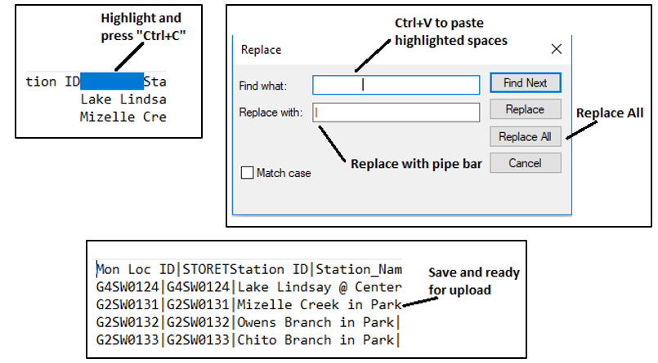

Uploading Stations into WIN
The stations are now ready to be uploaded and verified in WIN. Navigate to the Watershed Information Network (WIN). Login, Manage Data, Staged Data, Upload Data
- Type: “Monitoring Locations (SW)”
- Config Name: “Monitoring Locations (SW) – Pipe delimited (|)”
- Select saved file on your computer or network drives, you will not use the “Files on DEP Server” option
- Select “Ignore Leading Header Row in Upload File” box
- Select “Submit and View File Status”
- When data has uploaded, the page will be redirected to the “Dataset List” to validate and migrate data - to manually navigate to the dataset list you will need to follow: Manage Data, Staged Data, Dataset list
- Verify stations by selecting the Import File ID number associated with the station list uploaded. If there are errors, these will need to be resolved before stations are verified.
- Scroll to bottom of loaded page and select “Surface Water” hyperlink within the “Verify Monitoring Locations” box

- Select the first station under “Locations to Verify” tab to visually confirm the location is accurate and to assign a “Reach Code ID” (if applicable). The station can be moved here to a more precise location if necessary.
- Once the station has been visually verified and the Reach Code ID assigned (if applicable), Verify the station. If additional stations need to be verified, select “Verify and Map Next Location”. If there are no other stations to verify, select “Verify and Return to List”
- Select “Back to Staged Data Status” hyperlink, select “Migrate Records”, and “Migrate Only”

WIN Water Quality Data Uploads
To generate the EDD file to upload into WIN, follow the steps outlined in the LIMS Data Merge Tool section (Section 22).
- Navigate to “Upload Data” page within WIN
- Type: “Activity and Results”
- Config Name: “Activity and Results – Pipe delimited” or some variation of this
- Choose file to be uploaded from computer or network drives, do not use “Files on DEP Server” option
- Select “Ignore Leading Header Row in Upload File” box and click “Submit and View File Status”
- If there are errors, these will need to be resolved before migration. No partial migrations!
- If there are no errors after the validation process, select Import File ID number associated with data to be uploaded
- Select “Migrate Records” and either “Migrate Only” or “Migrate and Export”. The export option allows you to have a record of the data uploaded emailed to you for record keeping purposes.

Section 26. Appendix

Tables
Table 1. Description of planning list and study list assessment categories 21
Table 2. Descriptions of waterbody classes and their designated use. 21
Table 3. FDEP district names and their corresponding basin names. 22
Table 4. Analytes and Test Codes 23

Table 1. DEP Sampling Standard Operating Procedures
SOP Section | Description
FA 1000 | Administrative (includes Quality System, Quality Manual)
FC 1000 | Field Decontamination
FD 1000 | Documentation
FM 1000 | Field Mobilization (Trip Planning, Equipment and Supply Preparation)
FQ 1000 | Quality Control
FS 1000 | General Sampling
FS 2000 | General Water Sampling
FS 2100 | Surface Water Sampling
FS 2200 | Ground Water Sampling
FS 4000 | Sediment Sampling
FS 7000 | Biological Communities (includes RPS, LVS)
FT 1000 | Field Testing General
FT 1100 | Field pH
FT 1200 | Field Specific Conductance
FT 1400 | Field Temperature
FT 1500 | Field Dissolved Oxygen
FT 1600 | Field Turbidity
FT 1700 | Field Light Penetration (Secchi depth)
FT 3000 | Habitat Assessment
SCI 1000 | Stream Condition Index
LVI 1000 | Lake Vegetation Index

Table 2. Description of planning list and study list assessment categories
3c | Enough data and information are present to determine that one or more designated uses may not be attained according to the Planning List methodology.
4d | Waterbody indicates non-attainment of water quality standards, but the Department does not have enough information to determine a causative pollutant; or current data show a potentially adverse trend in nutrients or nutrient response variables; or there are exceedances of stream nutrient thresholds, but the Department does not have enough information to fully assess non-attainment of the stream nutrient standard. Placed on Study List.
4e | Waterbody indicates non-attainment of water quality standards and pollution control mechanisms or restoration activities are in progress or planned to address non-attainment of water quality standards, but the Department does not have enough information to fully evaluate whether proposed pollution mechanisms will result in attainment of water quality standards. Placed on Study List.

Table 2. Descriptions of waterbody classes and their designated use.
Waterbody Class | Designated Use | Description
Class I | Potable Water Supplies | Includes 14 areas throughout the state that are used as a source of potable water.
Class II | Shellfish Propagation or Harvesting | Generally coastal waters where shellfish harvesting propagation occurs.
Class III | Fish Consumption; Recreation, Propagation and Maintenance of a Healthy, Well-Balanced Population of Fish and Wildlife | The surface waters of the state are Class III unless described in Rule 62-302.400, F.A.C.
Class III Limited | Fish Consumption; Recreation or Limited Recreation; and/or Propagation and Maintenance of a Limited Population of Fish and Wildlife | This classification is restricted to waters with human-induced physical conditions that, because of those conditions, have limited aquatic life support and habitat that prevent attainment of Class III status.
Class IV | Agricultural Water Supplies | Generally located in agricultural areas around Lake Okeechobee.
Class V | Navigation, Utility and Industrial Use | Currently, there are no waterbodies designated as Class V waters. The Fenholloway River was reclassified as Class III in 1998

Table 3. FDEP district names and their corresponding basin names.
DEP District | Group Number and Basin
Northwest | 1 - Ochlockonee - St. Marks  2 - Apalachicola - Chipola  3 - Choctawhatchee - St. Andrews  4 - Pensacola  5 - Perdido
Northeast | 1 – Suwannee  2 – Lower St. Johns  4 – Nassau – St. Mary’s  5 – Upper East Coast
Central | 1 – Ocklawaha  2 – Middle St. Johns  3 – Upper St. Johns  4 – Kissimmee River  5 – Indian River Lagoon
Southwest | 1 – Tampa Bay  2 – Tampa Bay Tributaries  3 – Sarasota Bay – Peace Myakka  4 – Withlacoochee  5 – Springs Coast
South | 1 – Everglades West Coast  2 – Charlotte Harbor  3 – Caloosahatchee  4 - Fisheating Creek  5 - Florida Keys
Southeast | 1 – Lake Okeechobee  2 – St. Lucie - Loxahatchee  3 – Lake Worth Lagoon - Palm Beach Coast  4 - Southeast Coast - Biscayne Bay  5 - Everglades

Table 4. Analytes and Test Codes
Matrix | Class | Analyte Group | LIMS Test Code | Analyte(s)
Fresh | All | Chemical Tracers | W-E8321-DI | Default List:  AMPA; Endonthall; Glufosinate; Glyphosate; Sucralose; Acesulfame-potassium
Fresh | All | Chemical Tracers | W-E8321-MS | Defult List:  2,4-D, Acetaminophen, Acetamiprid, Afidopyropen, Bentazon, Benzovindiflupyr, Carbamazepine, Clothianidin, Dinotefuran, Diuron, Fenuron, Fluridone, Hydrocodone, Ibuprofen, Imazapyr, Imidacloprid, Linuron, Mandestrobin, MCPP, Naproxen, Primidone, Pyraclostrobin, Thiamethoxam, Tolfenpyrad, Triclopyr
Fresh | All | Field Parameters | NA | Dissolved Oxygen; pH; Salinity; Sample Depth; Secchi Depth; Specific Conductivity; Temperature, Total Depth
Fresh | All | Genetic Markers (qPCR) | PCR-BACR | Ruminant specific Bacteroidetes BacR genetic marker with quantitative polymerase chain reaction
Fresh | All | Genetic Markers (qPCR) | PCR-DG3 | Canine-specific DG3 Bacteroides genetic marker with quantitative polymerase chain reaction
Fresh | All | Genetic Markers (qPCR) | PCR-GFD | Bird specific Helicobacter GFD genetic marker with quantitative polymerase chain reaction
Fresh | All | Genetic Markers (qPCR) | PCR-GULL2 | Coastal bird specific Catellicoccus marimammalium Gull2 genetic marker with quantitative polymerase chain reaction
Fresh | All | Genetic Markers (qPCR) | PCR-HF183 | Human-specific HF183 Bacteroides genetic marker with quantitative polymerase chain reaction
Fresh | All | Nutrients | ALKALINITY | Total Alkalinity
Fresh | All | Nutrients | CHLSUITE-W | Chlorophyll-a Corrected, Chlorophyll-a Uncorrected, Phaeophytin-a
Fresh | All | Nutrients | TURBIDITY | Turbidity
Fresh | All | Nutrients | W-F | Fluoride
Fresh | All | Nutrients | W-NH3 | Ammonia-N
Fresh | All | Nutrients | W-NO2NO3 | NO2NO3-N
Fresh | All | Nutrients | W-PO4-F | O-Phosphate-P
Fresh | All | Nutrients | W-S-A-TP | Total-P
Fresh | All | Nutrients | W-TKN | Kjeldahl Nitrogen
Fresh | All | Nutrients | W-TOC | Organic Carbon
Fresh | All | Nutrients | W-TSS | TSS
Fresh | All | Pesticides | W-CARB-AA | Defult List:  Aldcarb; Aldcarb Sulfone; Aldcarb Sulfoxide; Carbaryl; Carbofuran; 3-Hydroxycarbofuran; Methiocarb; Methomyl; Oxamyl; Propoxur
Fresh | All | Pesticides | W-CT-CI-R | Defult List:  Chlordane, Toxaphene
Fresh | All | Pesticides | W-E8321-DI | Defult List:  AMPA; Endonthall; Glufosinate; Glyphosate; Sucralose; Acesulfame-potassium
Fresh | All | Pesticides | W-E8321-MS | Defult List:  2,4-D, Acetaminophen, Acetamiprid, Afidopyropen, Bentazon, Benzovindiflupyr, Carbamazepine, Clothianidin, Dinotefuran, Diuron, Fenuron, Fluridone, Hydrocodone, Ibuprofen, Imazapyr, Imidacloprid, Linuron, Mandestrobin, MCPP, Naproxen, Primidone, Pyraclostrobin, Thiamethoxam, Tolfenpyrad, Triclopyr
Fresh | All | Pesticides | W-PCL-SQ-R | Defult LIst:  Aldrin; Alpha-BHC; Alpha-Chlordane; Beta-BHC; Beta-Cyfluthrin; Bifenthrin; Carbophenothion; Chlorothalonil; Cis-Nonachlor; Cypermethrin; Dacthal; DDD-p,p'; DDE-p,p'; DDT-p,p'; Delta-BHC; Dicofol; Dieldrin; Endosulfan I; Endosulfan II; Endosulfan Sulfate; Endrin; Endrin Aldehyde; Endrin Ketone; Ethalfluralin; Gamma-BHC; Gamma-Chlordane; Heptachlor; Heptachlor Epoxide; Hexachlorobenzene; Lambda-Cyhalothrin; Methoxychlor; Mirex; Permethrin; Prallethrin; Trans-Nonachlor; Trifluralin
Fresh | All | Pesticides | W-PSNP-TQ | Defult List:  Acetochlor; Alachlor; Ametryn; Atrazine; Atrazine Desethyl; Azinphos Methyl; Bromacil; Butylate; Carbophenothion; Chlorpyrifos Ethyl; Chlorpyrifos Methyl; Cyanazine; Demeton; Diazinon; Dimethenamid; Dithiopyr; Disulfoton; EPTC; Ethion; Ethoprop; Fenamiphos; Fipronil; Fipronil Desulfinyl; Fipronil Sulfide; Fipronil Sulfone; Flumioazin; Fonofos; Hexazinone; Imazalil; Malathion; Metalaxyl; Metolachlor; Metribuzin; Mevinphos; Molinate; Norflurazon; Oxadiazon; Parathion Ethyl; Parathion Methyl; Pendimethalin; Phorate; Prodiamine; Prometon; Prometryn; Pronamide; Propiconazole; Simazine; Sulfentrazone; Tebuconazole; Terbufos; Terbuthylazine
Fresh | 1 & 3F | Bacteria - Overflow | Hyperlink | Escherichia coli
Fresh | 1 & 3F | Bacteria – DEP  Lab | ECOLI-18QT | Escherichia coli
Fresh | 1 & 3F, SCI Kit | Metals | W-ICP | Barium, Calcium, Iron, Magnesium, Potassium, Sodium, Zinc
Fresh | 1 & 3F, SCI Kit | Metals | W-ICPMS | Aluminum, Antimony, Arsenic, Boron, Cadmium, Chromium, Copper, Lead, Nickel, Selenium, Silver, Thallium
Fresh | 1 & 3F, SCI Kit | Metals | W-HARD | Hardness By Calculation
Fresh | 1, 3F, SCI Kit | Nutrients | W-CL-IC | Chloride
Fresh | 1, 3F, SCI Kit | Nutrients | W-COLOR | Color (True)
Fresh | 1, 3F, SCI Kit | Nutrients | W-SO4-IC | Sulfate
Fresh | 1, 3F, SCI Kit | Nutrients | W-TDS | Total Dissolved Solids
Fresh | SCI Kit | Bioassessment | NA | HA - Habitat Assessment
Fresh | SCI Kit | Bioassessment | NA | RPS - Rapid Periphyton Survey
Fresh | SCI Kit | Bioassessment | NA | LVS - Linear Vegetation Survey
Fresh | SCI Kit | Bioassessment | MI-FW-QLDC | SCI - Stream Condition Index
Fresh | SCI Kit | Bioassessment | Algale_ID | Qualitative Assessment of Algal Taxa
Marine | 2 & 3M | Metals | W-ICP | Iron, Manganese, Zinc
Marine | 2 & 3M | Metals | W-ICPMS | Aluminum, Antimony, Arsenic, Cadmium, Chromium, Copper, Lead, Nickel, Selenium, Silver, Thallium
Marine | 2 & 3M | Nutrients | W-BR-IC | Bromide
Marine | 3M | Bacteria - Overflow | Hyperlink | Enterococci
Marine | 3M | Bacteria – DEP  Lab | ENT-24QT | Enterococci
Marine | 2 | Bacteria - Overflow | Hyperlink | Enterococci, Fecal Coliform (membrane filtration)
Marine | 2 | Bacteria – DEP Lab | ENT-24QT, FCOLI-MF | Enterococci, Fecal Coliform (membrane filtration)

Table 5. Data Qualifier Codes
Symbol | Potentially Fatal | Meaning
A |  | Value reported is the average of two or more determinations.
B |  | Colony counts were outside acceptable range. The value reported is an estimated count (This code applies to microbiological tests and specifically to membrane filter colony counts.)
G | Yes | Indicates that the analyte was detected at or above the method detection limit in both the sample and the associated field collected blank, and the value of the blank is greater than 10% of the associated sample value.
I |  | The reported value is greater than or equal to the laboratory method detection limit but less than the laboratory practical quantification limit.
J |  | Estimate value. Shall be accompanied by a detailed explanation to justify the reason(s) for designating the value as estimated. Examples of situations in which a “J” code must be reported include: instances where a quality control item associated with the reported value failed to meet the established quality control criteria (the specific failure must be identified); instances when the sample matrix interfered with the ability to make any accurate determination; instances when data are questionable because of improper laboratory or field protocols (e.g., composite sample was collected instead of a grab sample); instances when the analyte was detected at or above the method detection limit in an analytical laboratory blank other than the method blank (such as calibration blank) and the value the blank is greater than 10% of the associated sample value; or instances when the field or laboratory calibrations or calibration verifications did not meet calibration acceptance criteria.
K |  | Off-scale low. The actual value is known to be less than the value given.
L |  | Off-scale high. The actual value is known to be greater than the value given.
N | Yes | Presumptive evidence of presence of material; component tentatively identified based on mass spectral library search or there is an indication that the analyte is present, but quality control requirements for the confirmation were not met.
O | Yes | Sampled but analysis lost or not performed.
Q | Yes | Sample held beyond the accepted holding time.
R |  | Significant rain (typically in excess of ½ inch) in the past 48 hours, which might contribute to a lower or higher than normal value.
S |  | Secchi disk visible to bottom of waterbody. The value reported is the depth of the waterbody at the location of the Secchi disk measurement.
T |  | Value reported is less than the laboratory method detection limit.
U |  | Indicates that the compound was analyzed for but not detected. The reported value shall be the method detection limit.
V | Yes | Indicates that the analyte was detected at or above the method detection limit in both the sample and the associated method blank and the blank value was greater than 10% of the associated sample value.
X |  | Indicates, when reporting results from a Stream Condition Index Analysis (LT 7200 and FS 7420), that insufficient individuals were present in the sample to achieve a minimum of 280 organisms for identification (the method calls for two aliquots of 140-160 organisms), suggesting either extreme environmental stress or a sampling error.
Y | Y | The laboratory analysis was from an unpreserved or improperly preserved sample. The data may not be accurate.
Z |  | Too many colonies were present for accurate counting. Historically, this condition has been reported as “too numerous to count” (TNTC). The “Z” qualifier code shall be reported when the total number of colonies of all types is more than 200 in all dilutions of the sample. When applicable to the observed test results, a numeric value for the colony count for the microorganism tested shall be estimated from the highest dilution factor (smallest sample volume) used for the test and reported with the qualifier code
! |  | Indicates that the reported value deviates from historically established concentration ranges.
? | Yes | Data are rejected and should not be used. Some or all of the quality control data for the analyte were outside criteria, and the presence or absence of the analyte cannot be determined from the data.

Table 6. Cleaning Procedures and Frequencies
Equipment | Cleaning Procedure | Frequency
Van Dorn | FC 1000, FC1130, FC 1140 | Between sample sites
Analyte-free water containers | FC 1000, FC 1180 | Prior to refilling
Water Measuring Device | FC 1000, FC 1210 | Between sample sites

It is recommended all cleaning take place in a controlled environment (in-house). Field cleaning between sample sites is allowed as long as equipment blanks document that cleaning procedures are removing the analytes of interest to our sampling program. An acid rinse is not required during field cleaning unless metals are detected in equipment blanks. If metals are detected, the equipment, excluding stainless steel equipment, will have to be rinsed with 10% HCl prior to rinsing with analyte-free water.
Table 7. Solubility of Oxygen in Water at Atmospheric Pressure
Page 1 of 12
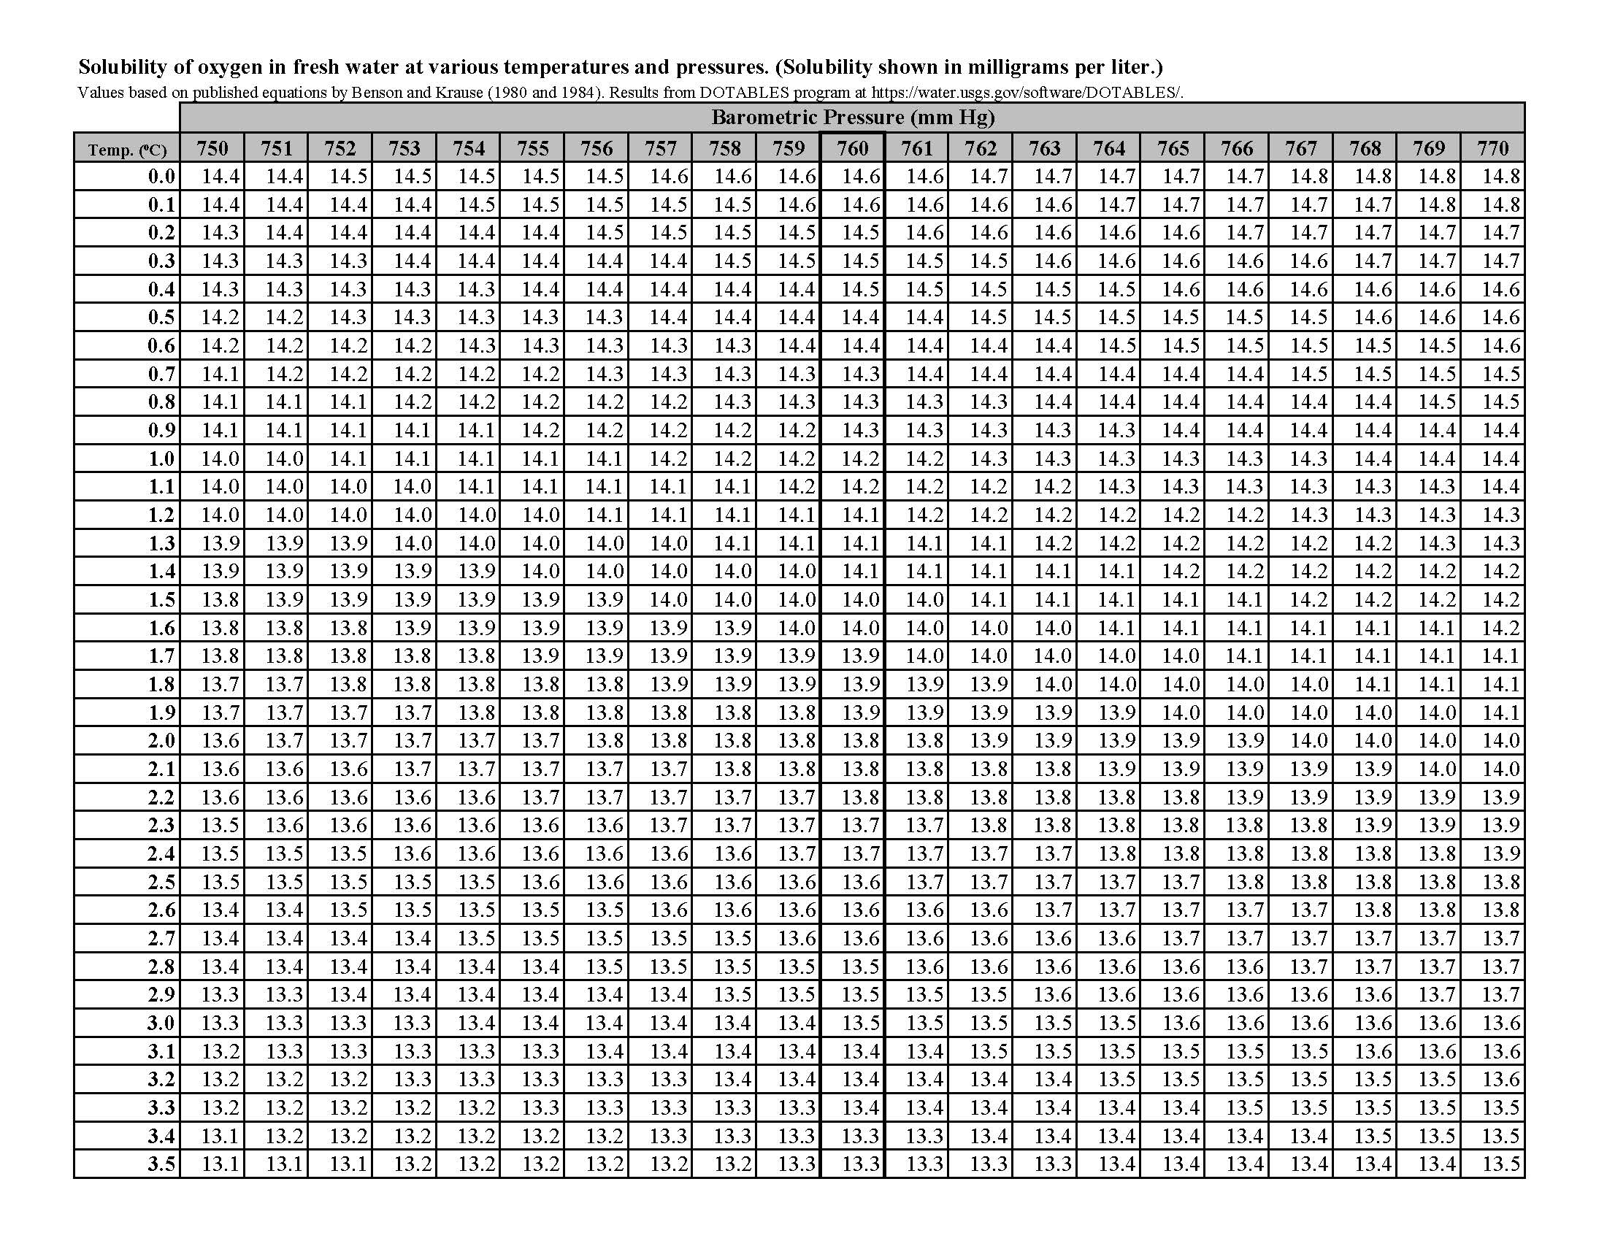
Table 7 Continued
Solubility of Oxygen in Water at Atmospheric Pressure Page 2 of 12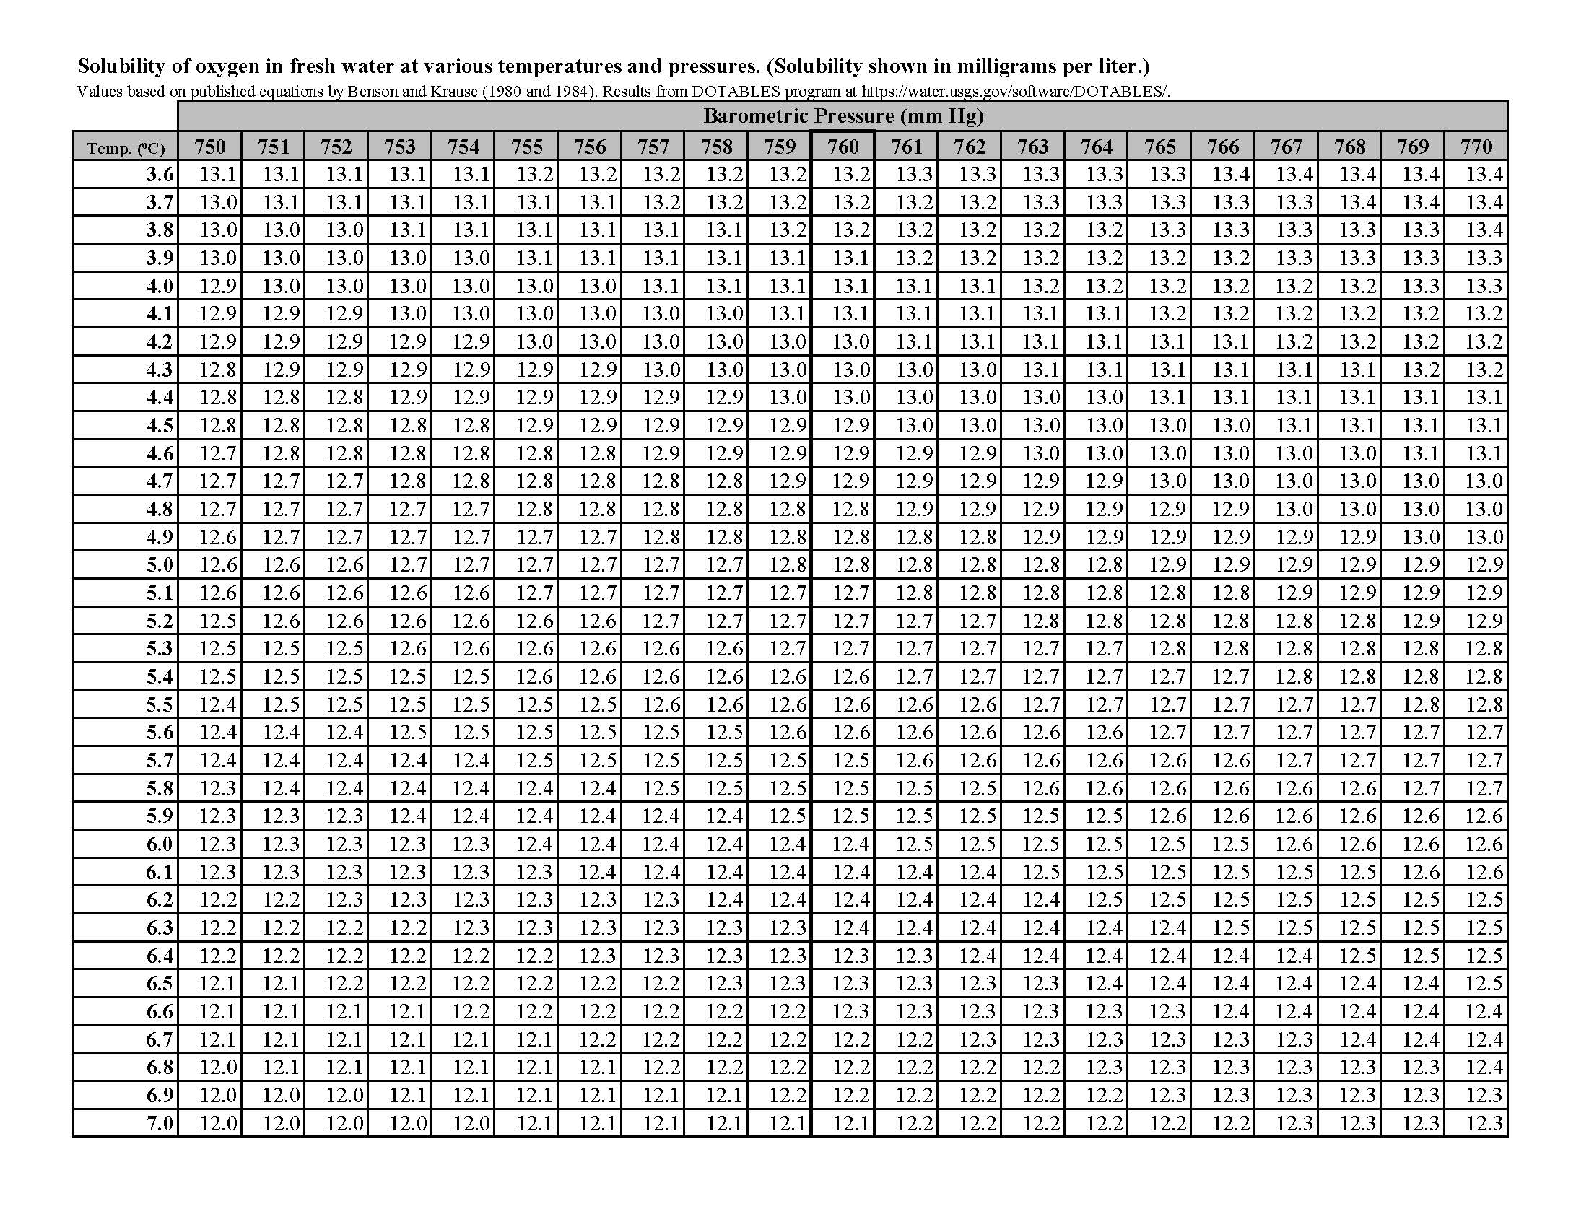
Table 7 Continued
Solubility of Oxygen in Water at Atmospheric Pressure Page 3 of 12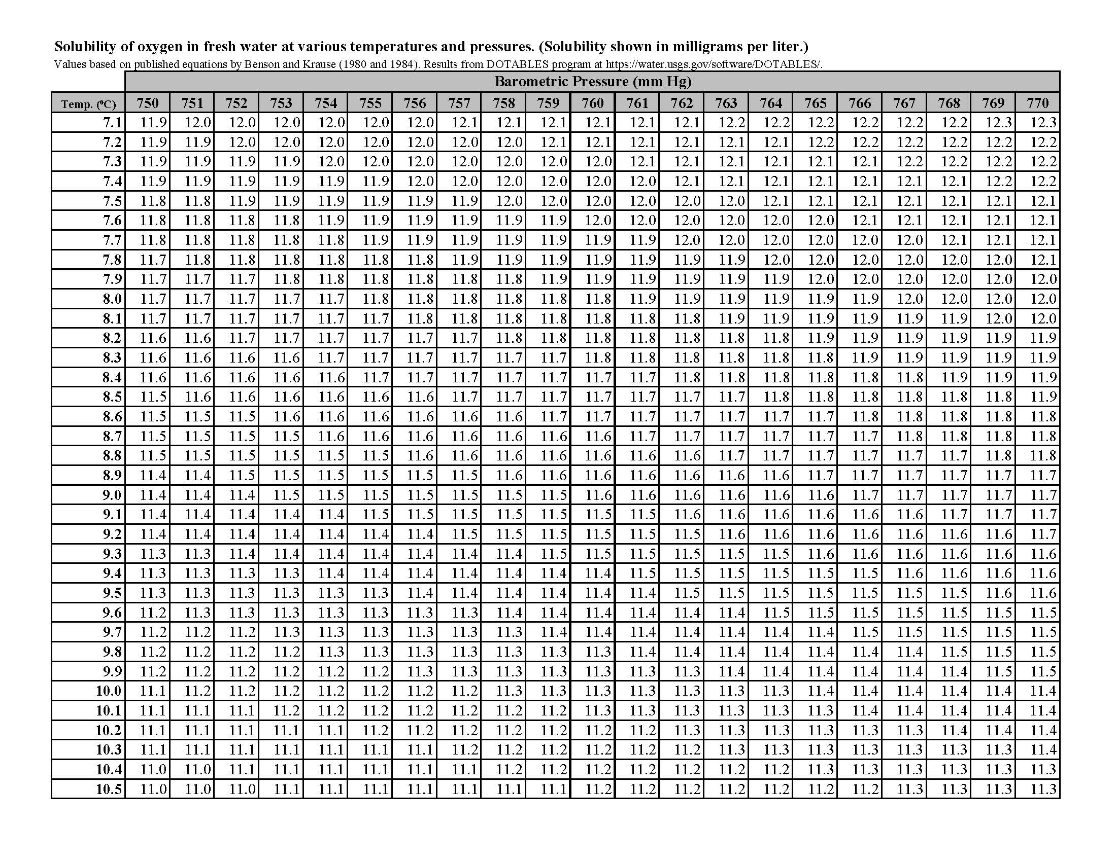
Table 7 Continued
Solubility of Oxygen in Water at Atmospheric Pressure Page 4 of 12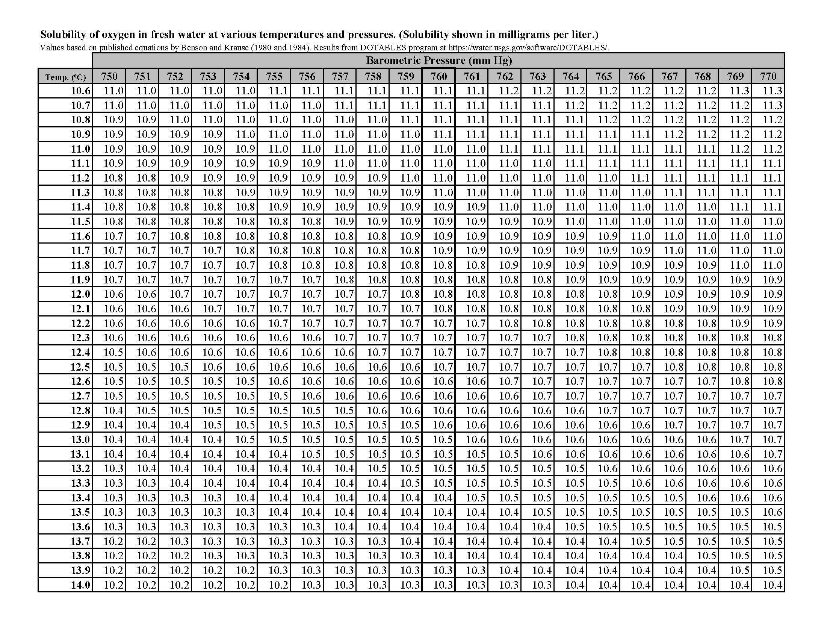
Table 7 Continued
Solubility of Oxygen in Water at Atmospheric Pressure Page 5 of 12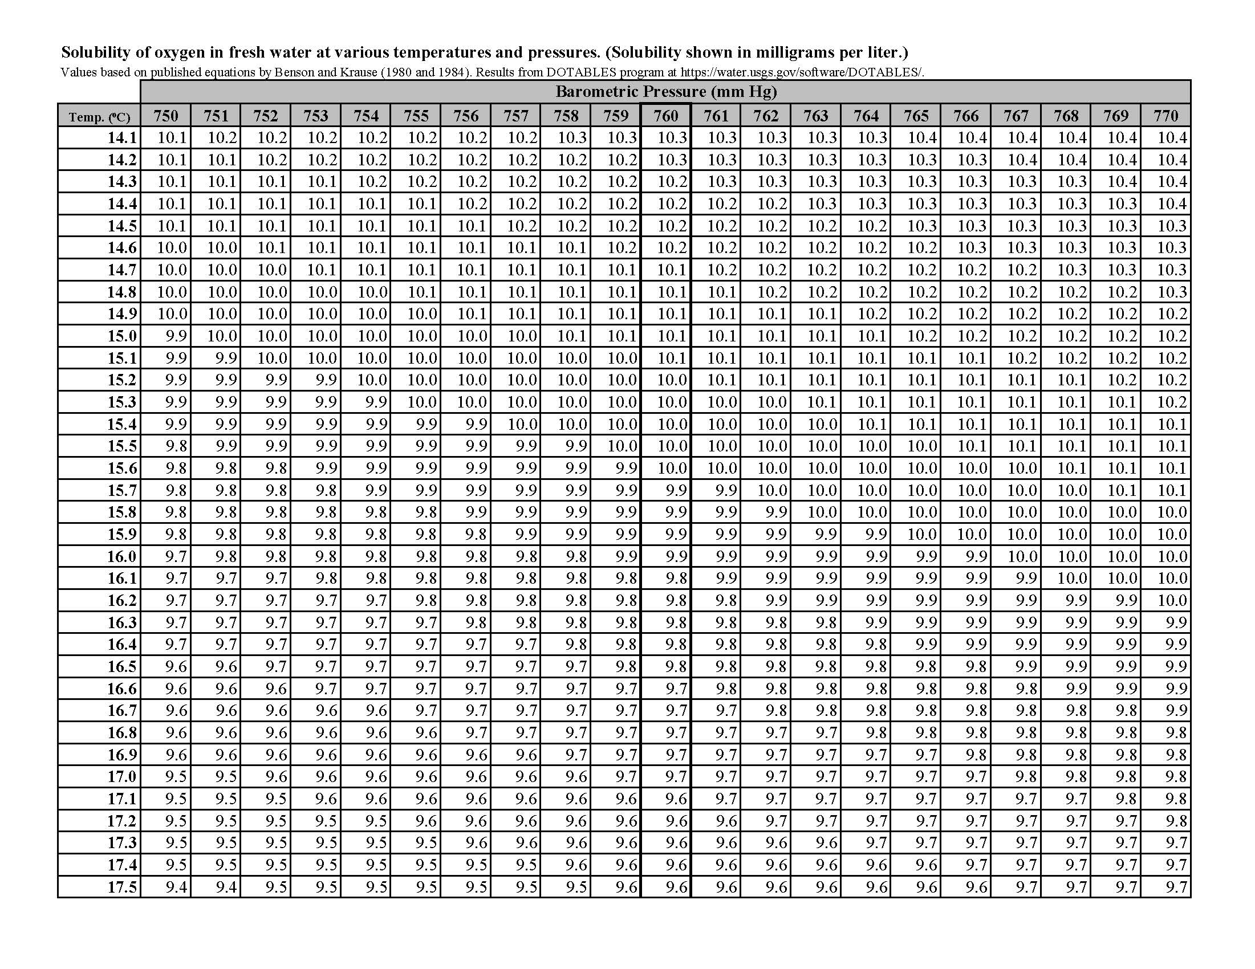
Table 7 Continued
Solubility of Oxygen in Water at Atmospheric Pressure Page 6 of 12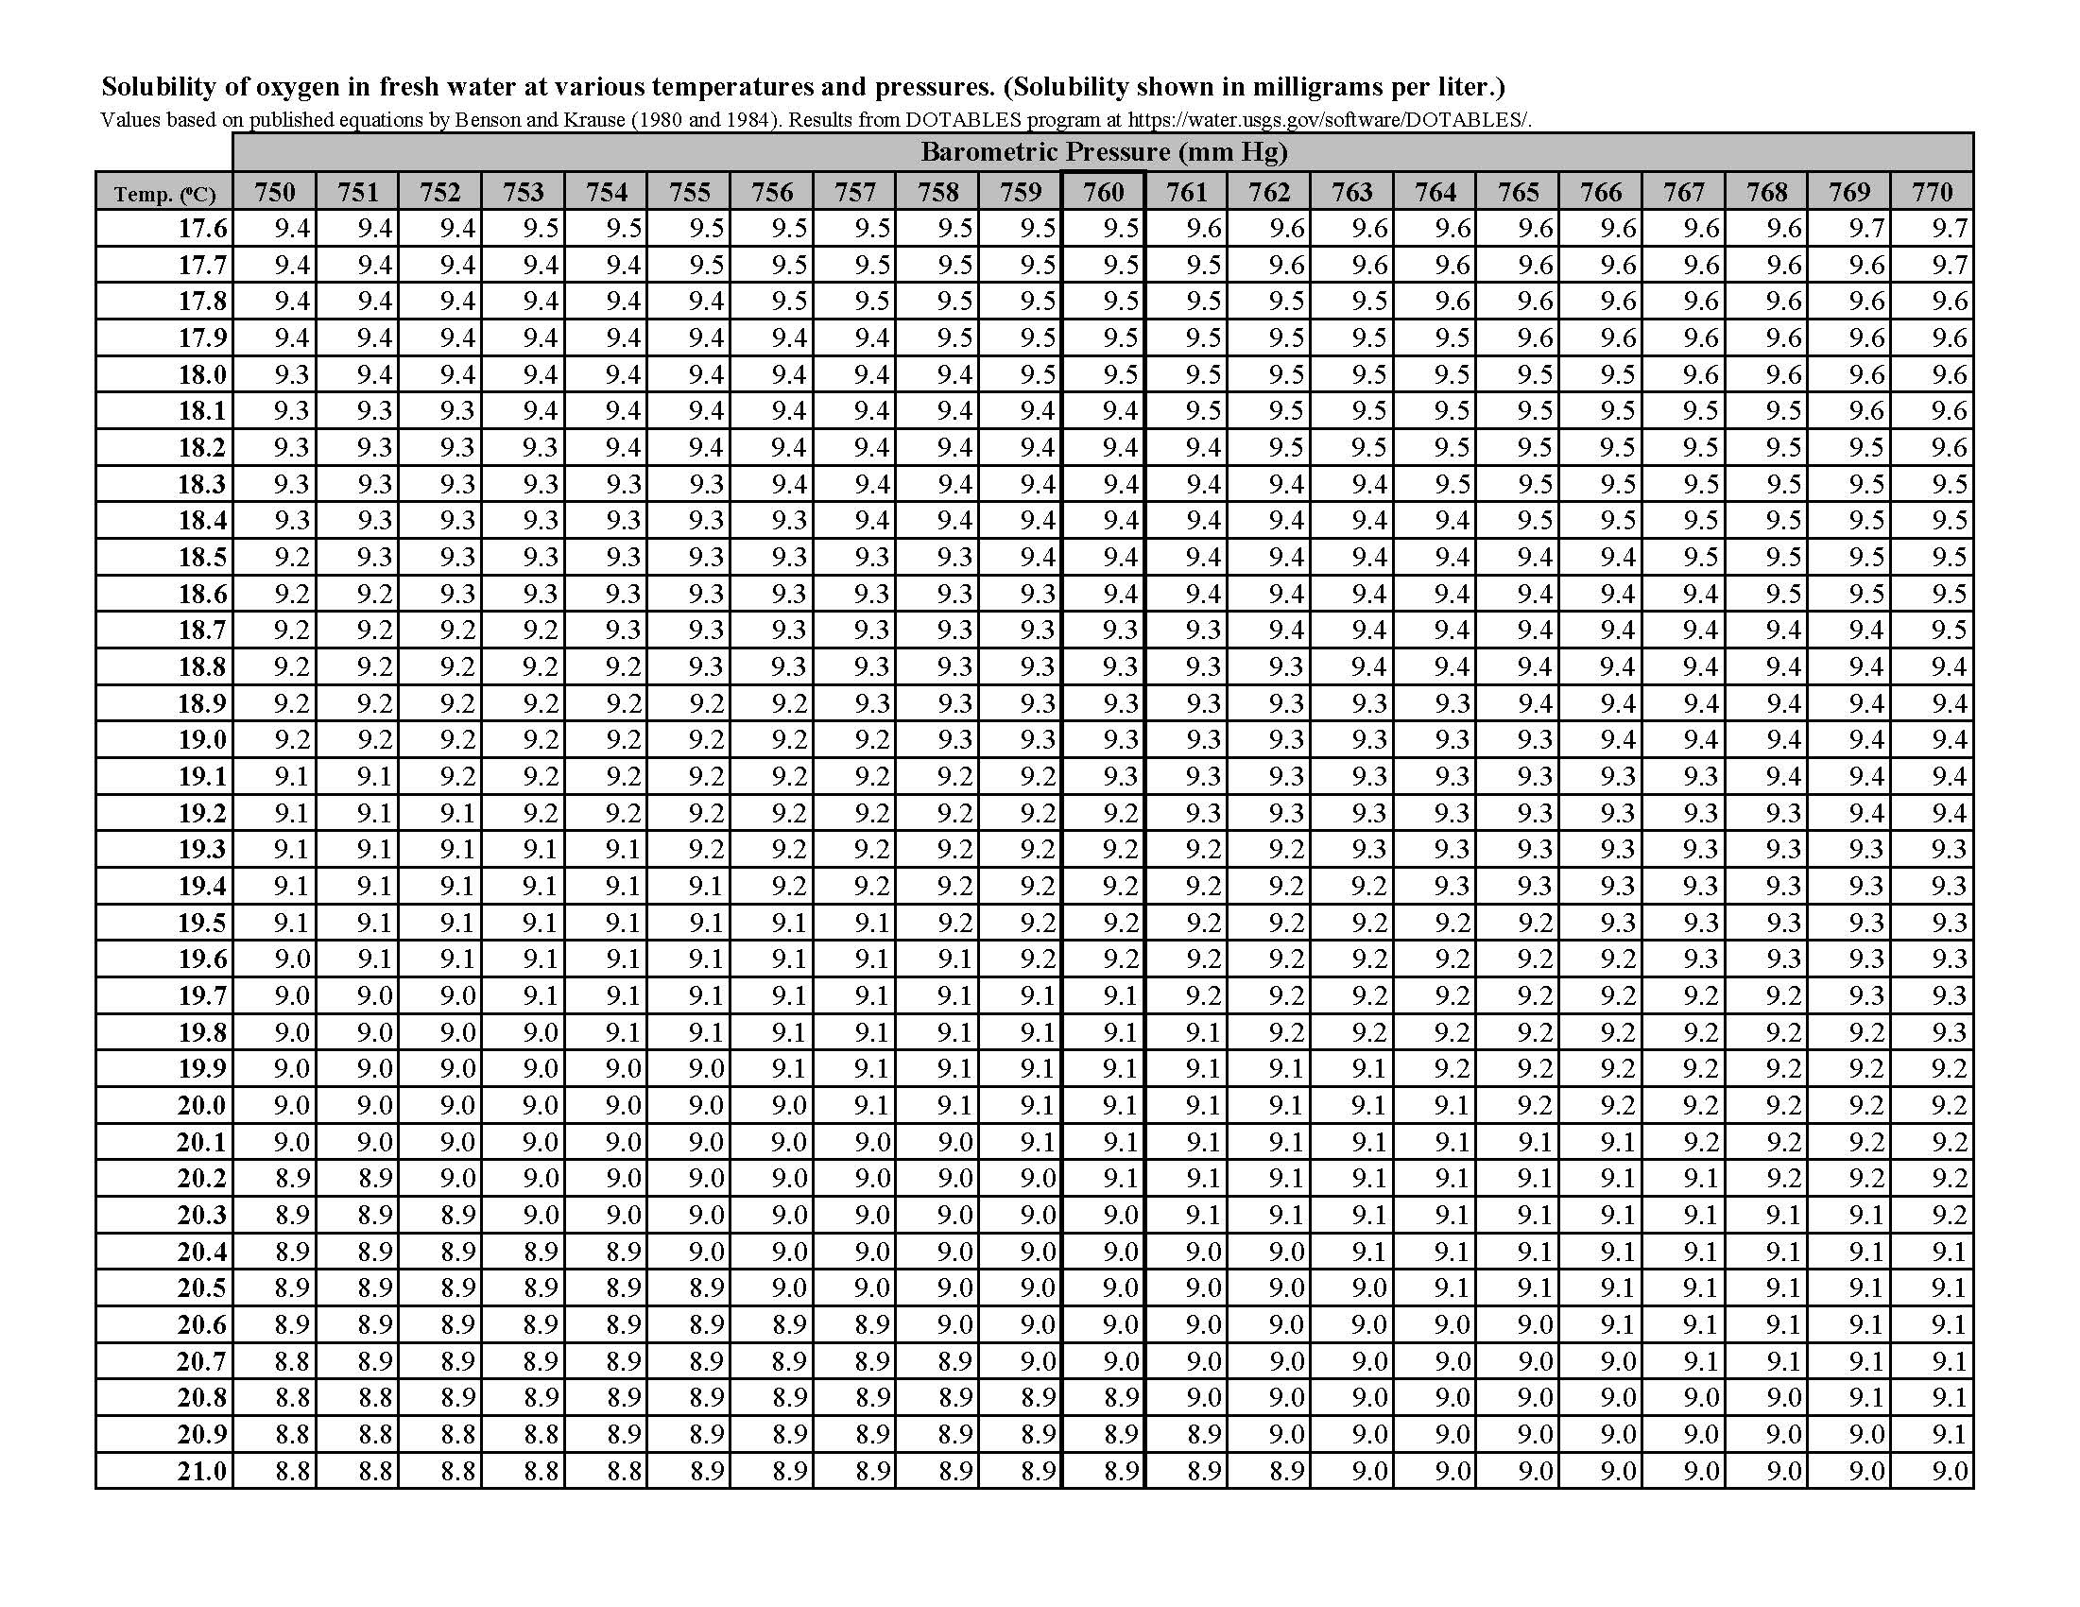
Table 7 Continued
Solubility of Oxygen in Water at Atmospheric Pressure Page 7 of 12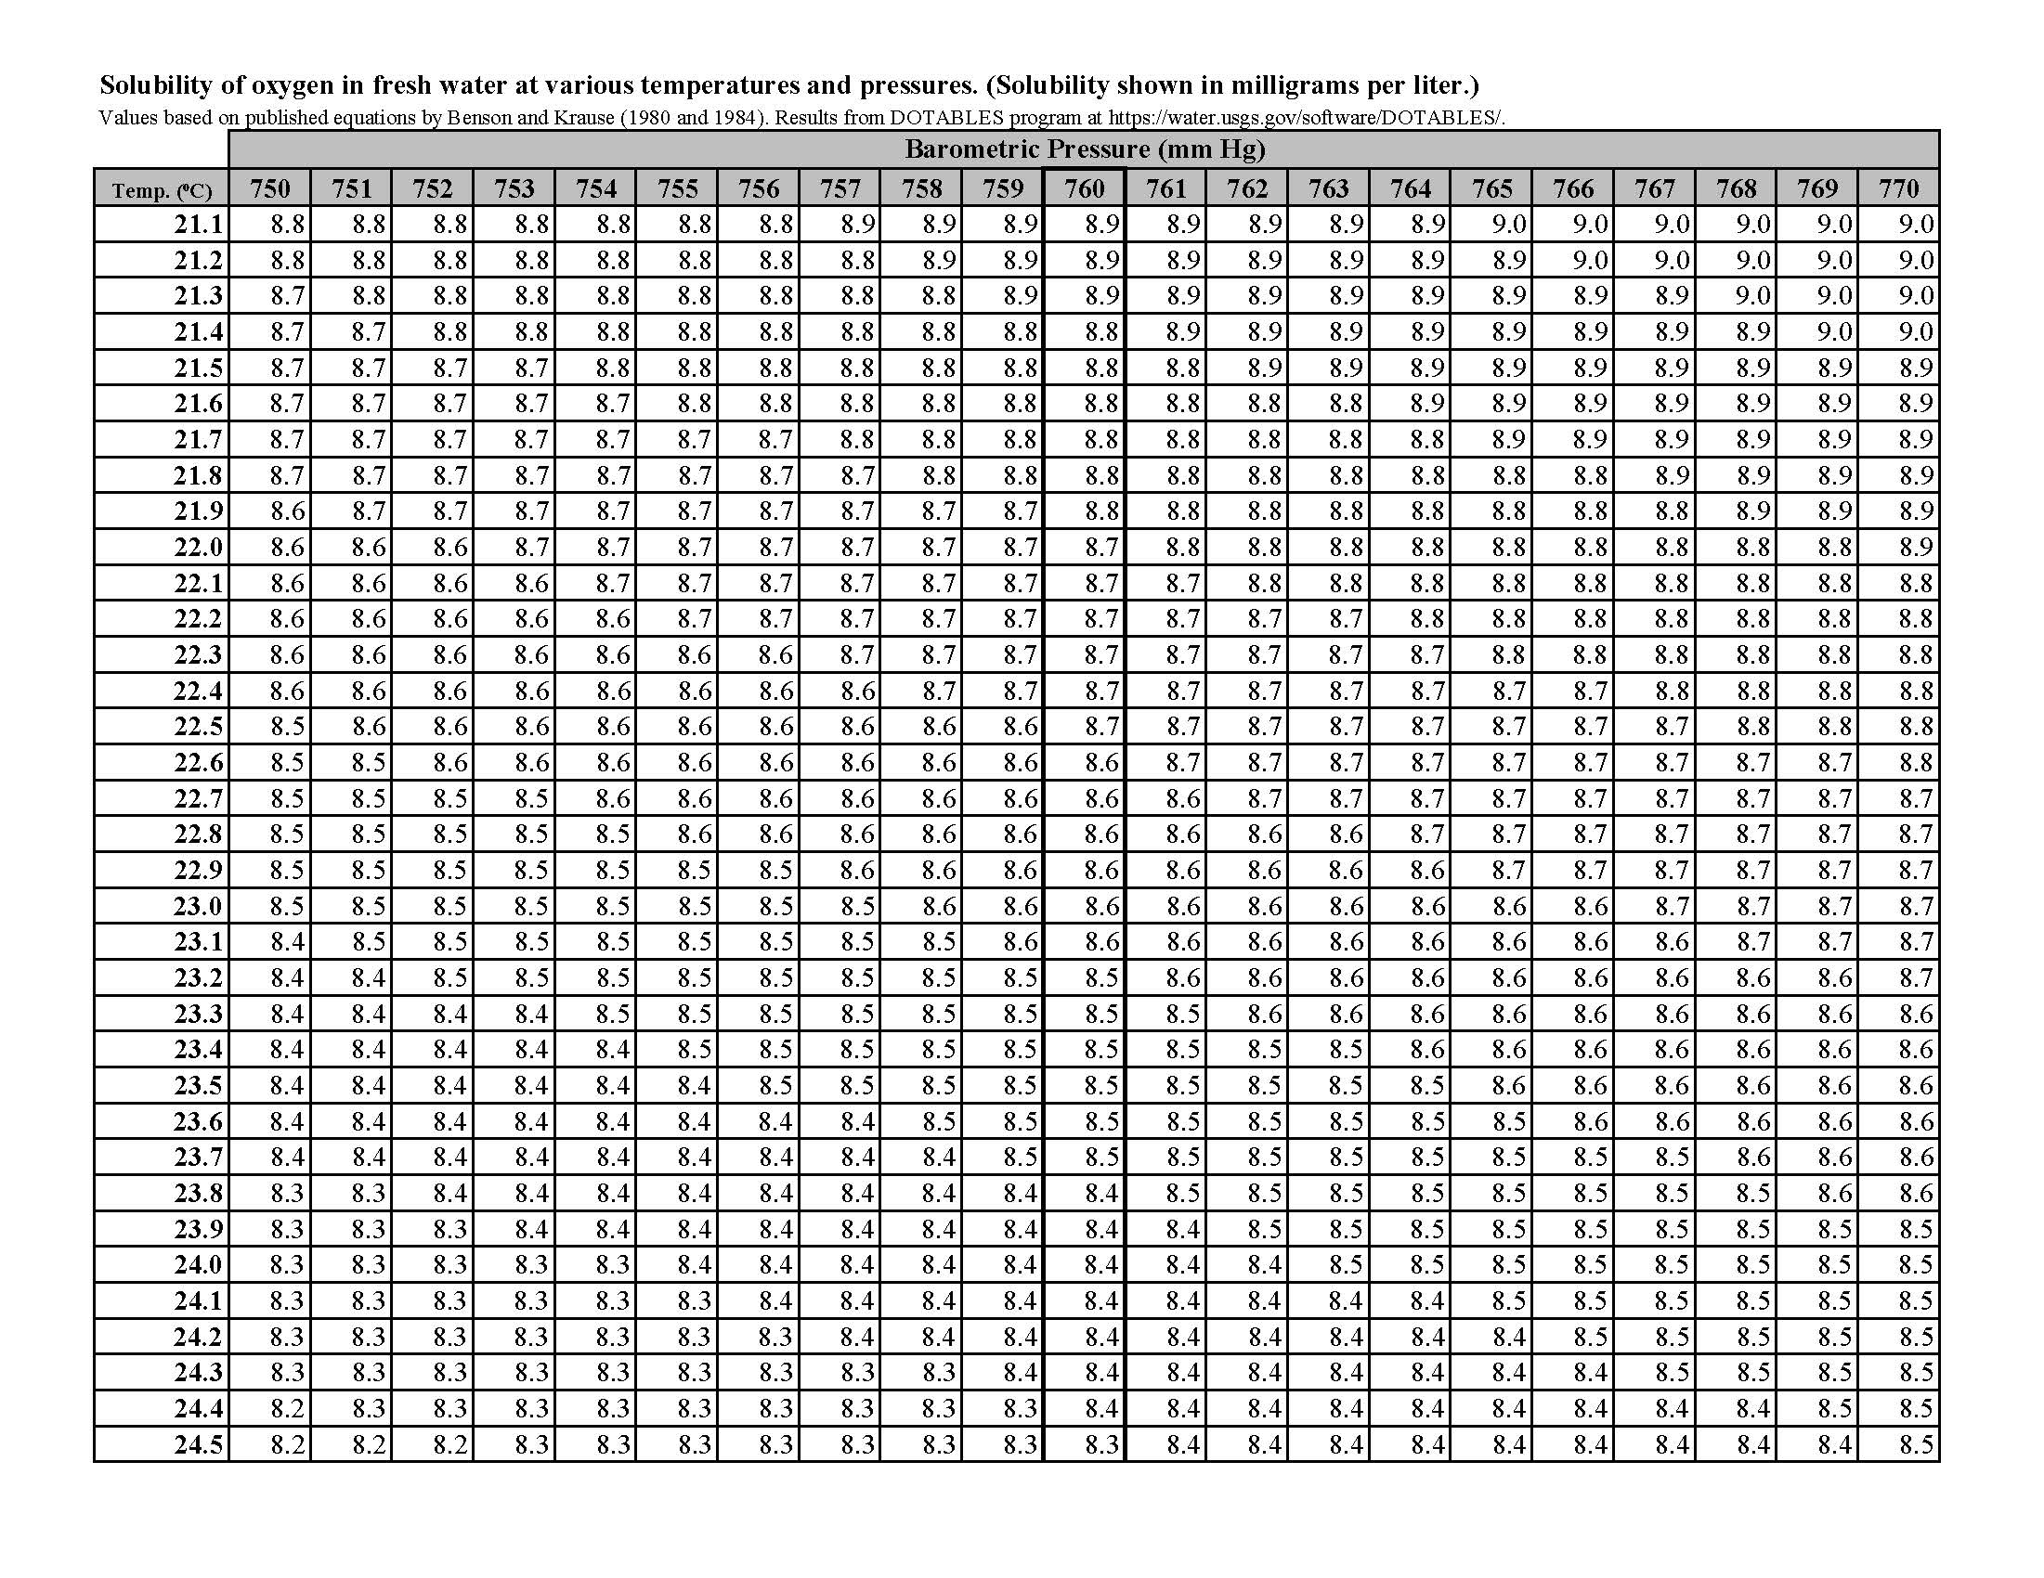
Table 7 Continued
Solubility of Oxygen in Water at Atmospheric Pressure Page 8 of 12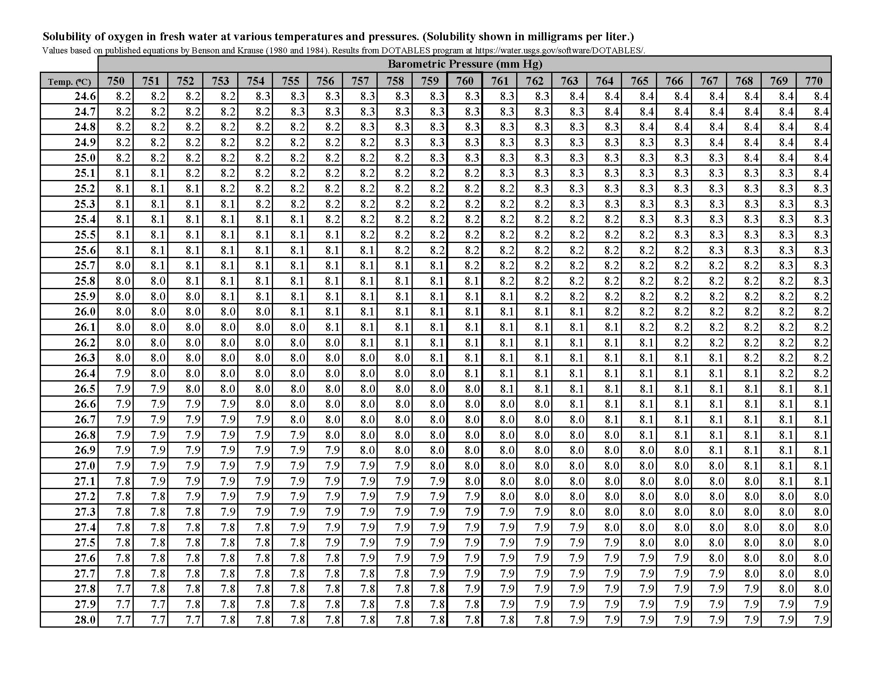
Table 7 Continued
Solubility of Oxygen in Water at Atmospheric Pressure Page 9 of 12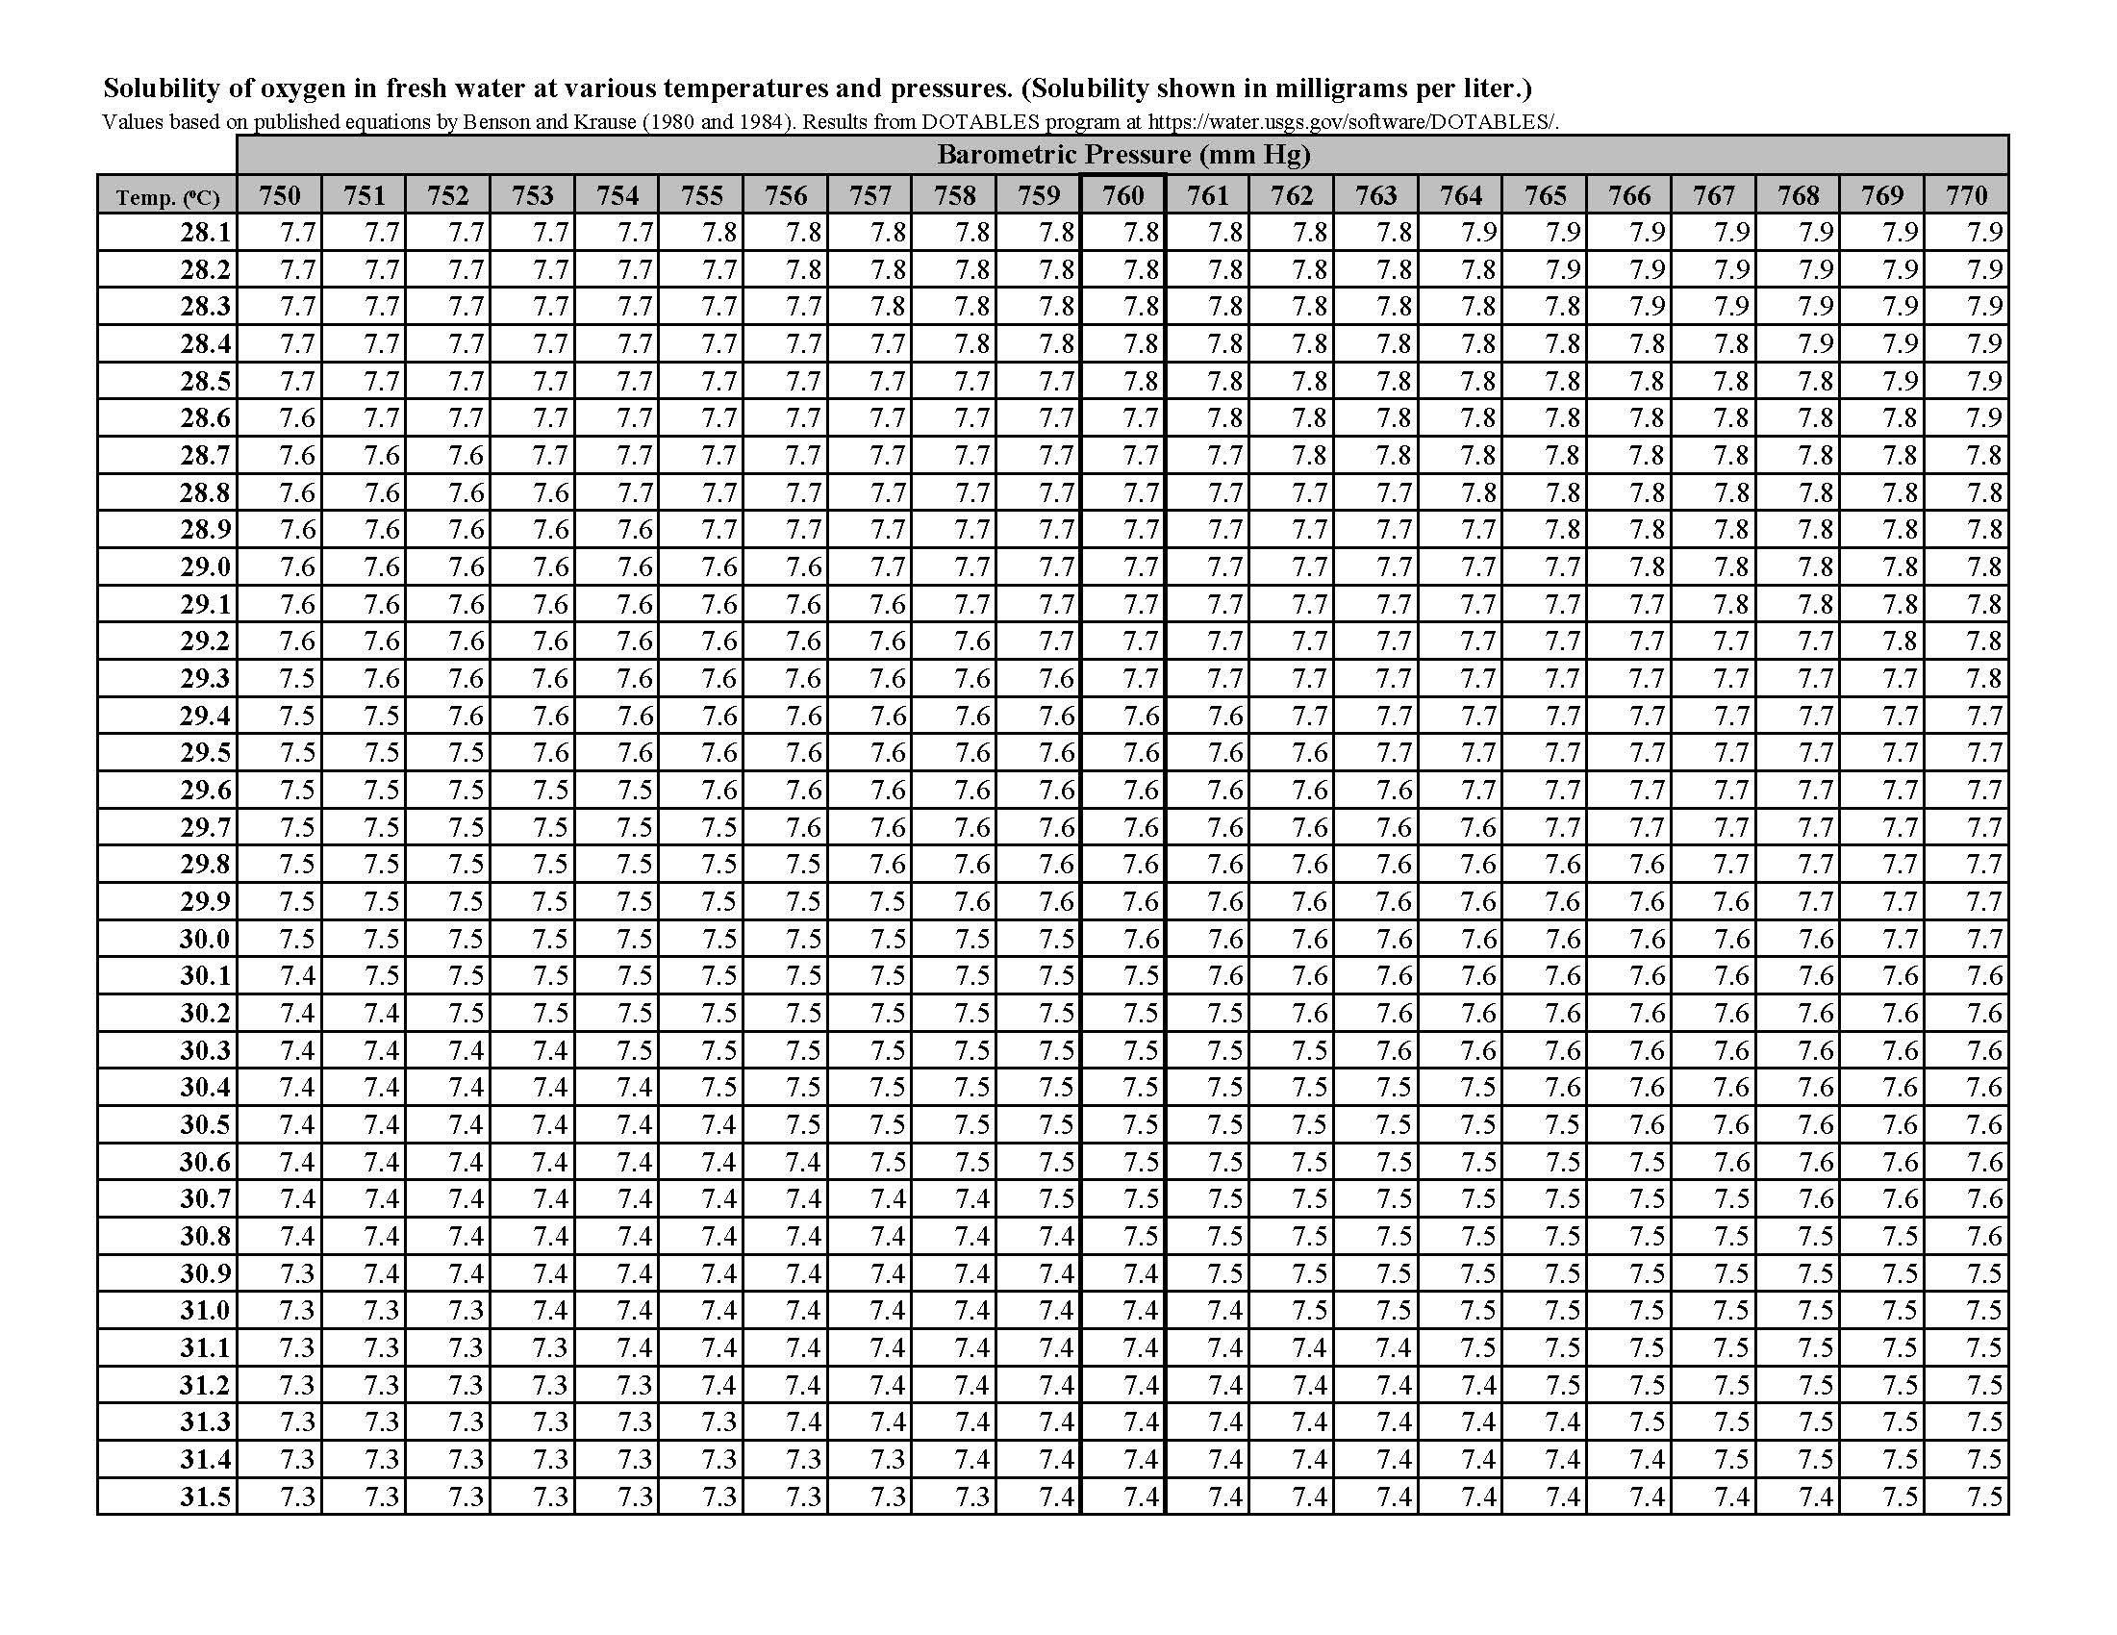
Table 7 Continued
Solubility of Oxygen in Water at Atmospheric Pressure Page 10 of 12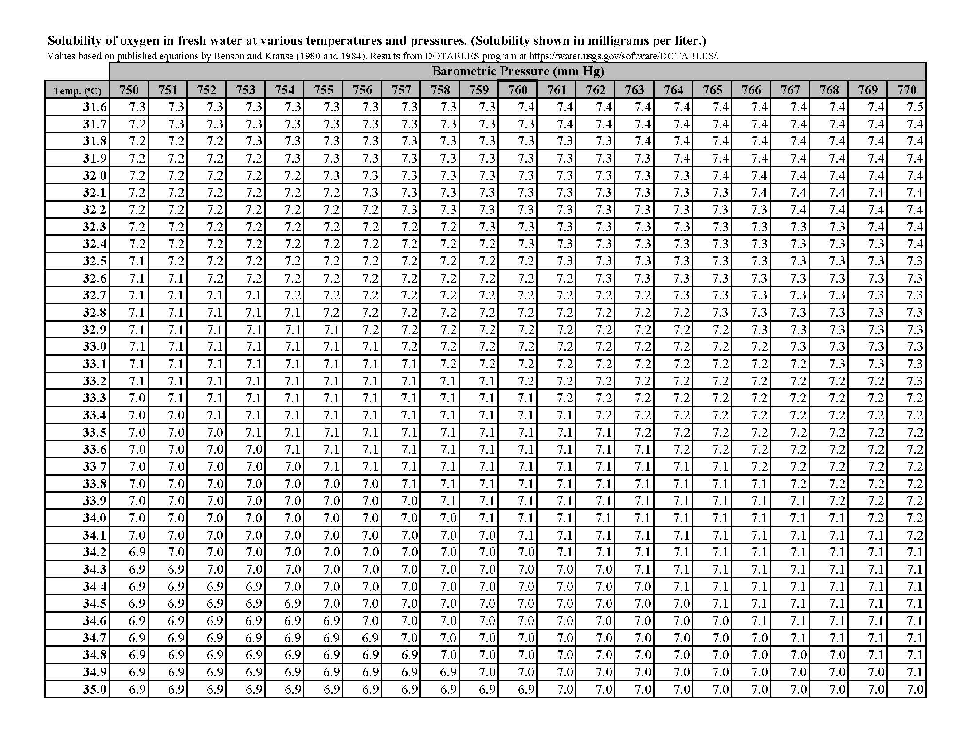
Table 7 Continued
Solubility of Oxygen in Water at Atmospheric Pressure Page 11 of 12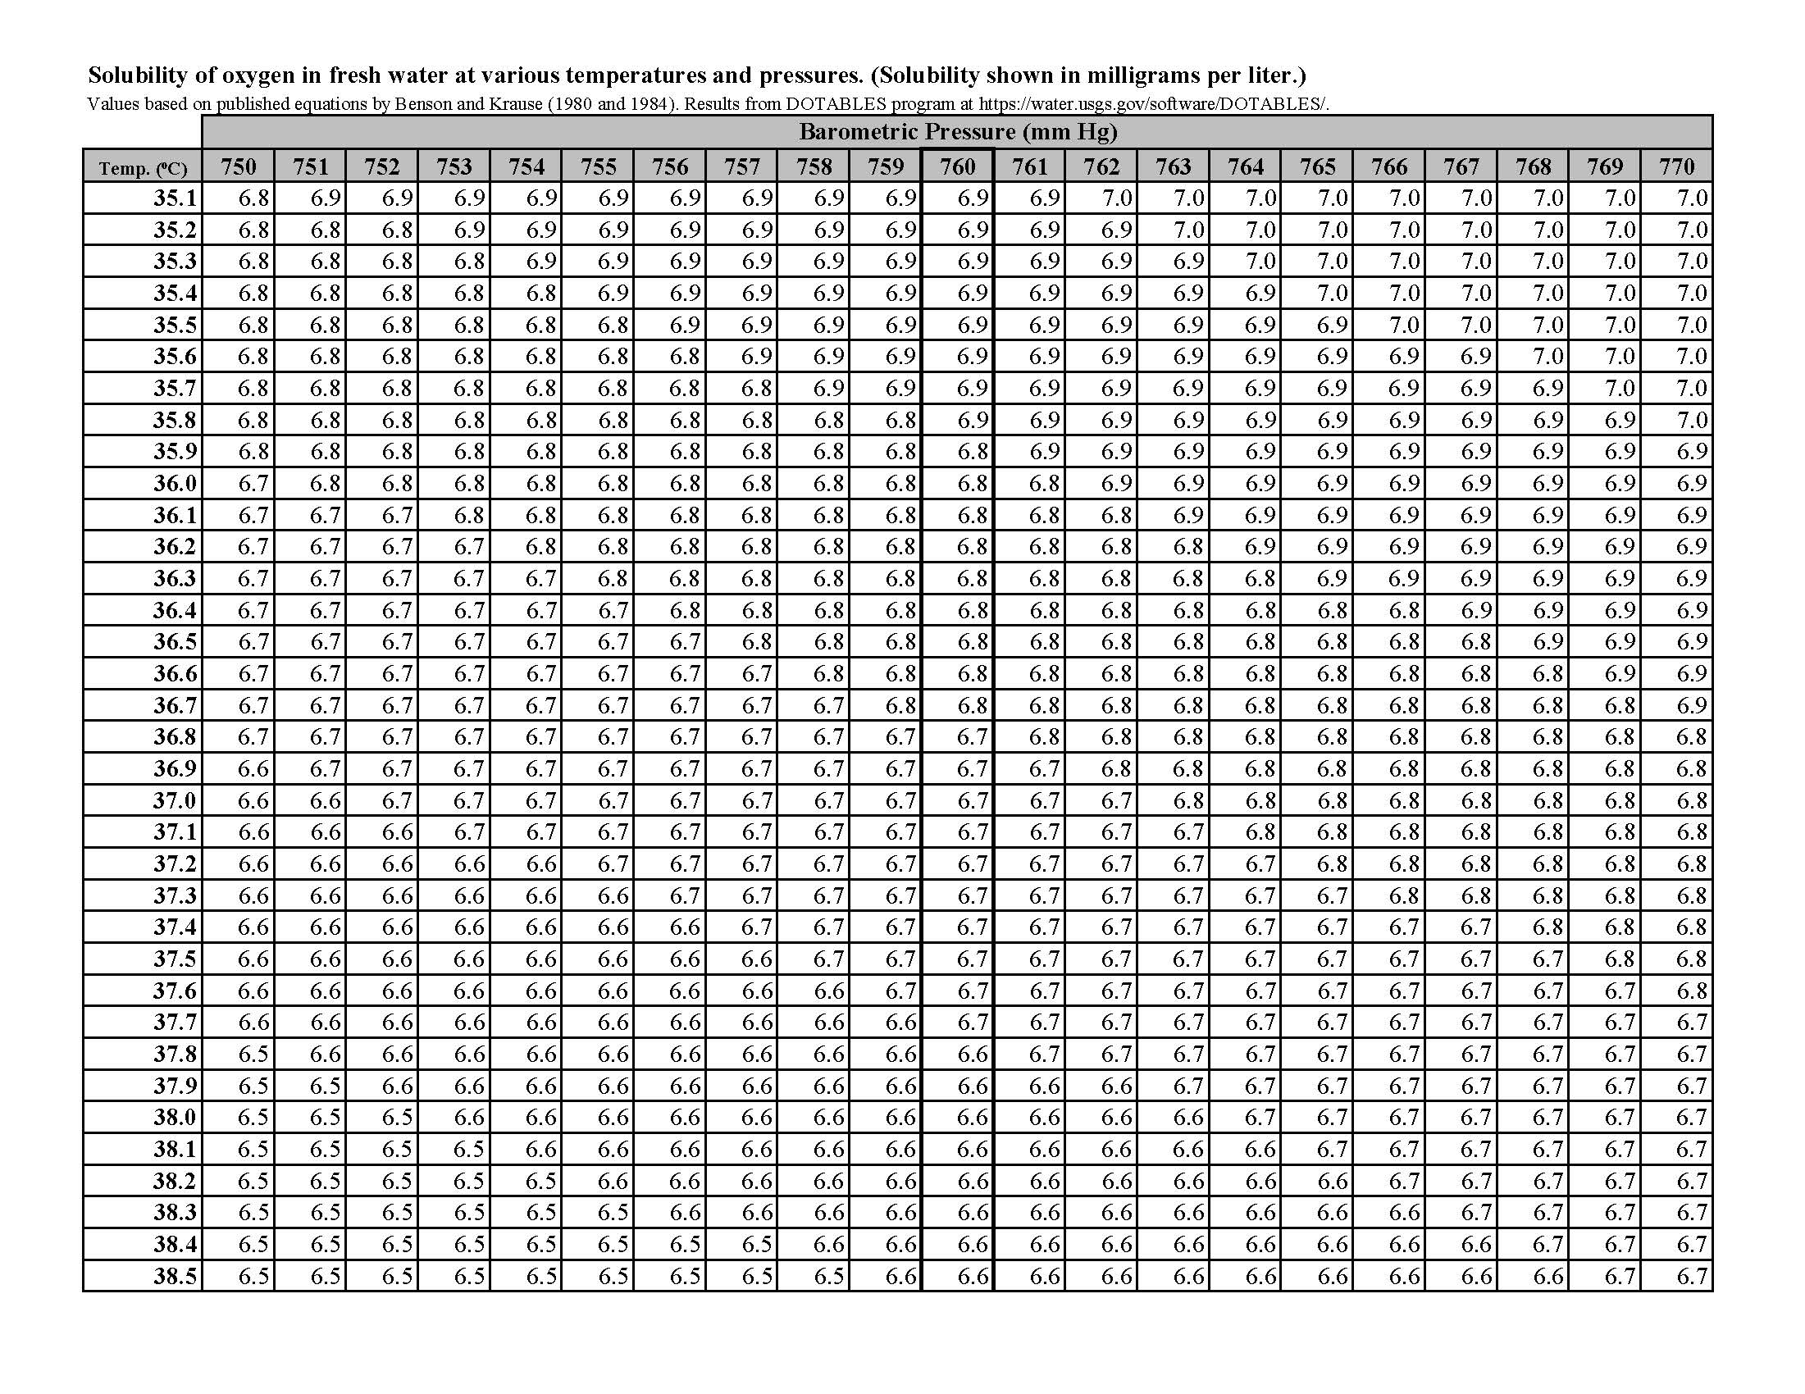
Table 7 Continued
Solubility of Oxygen in Water at Atmospheric Pressure Page 12 of 12
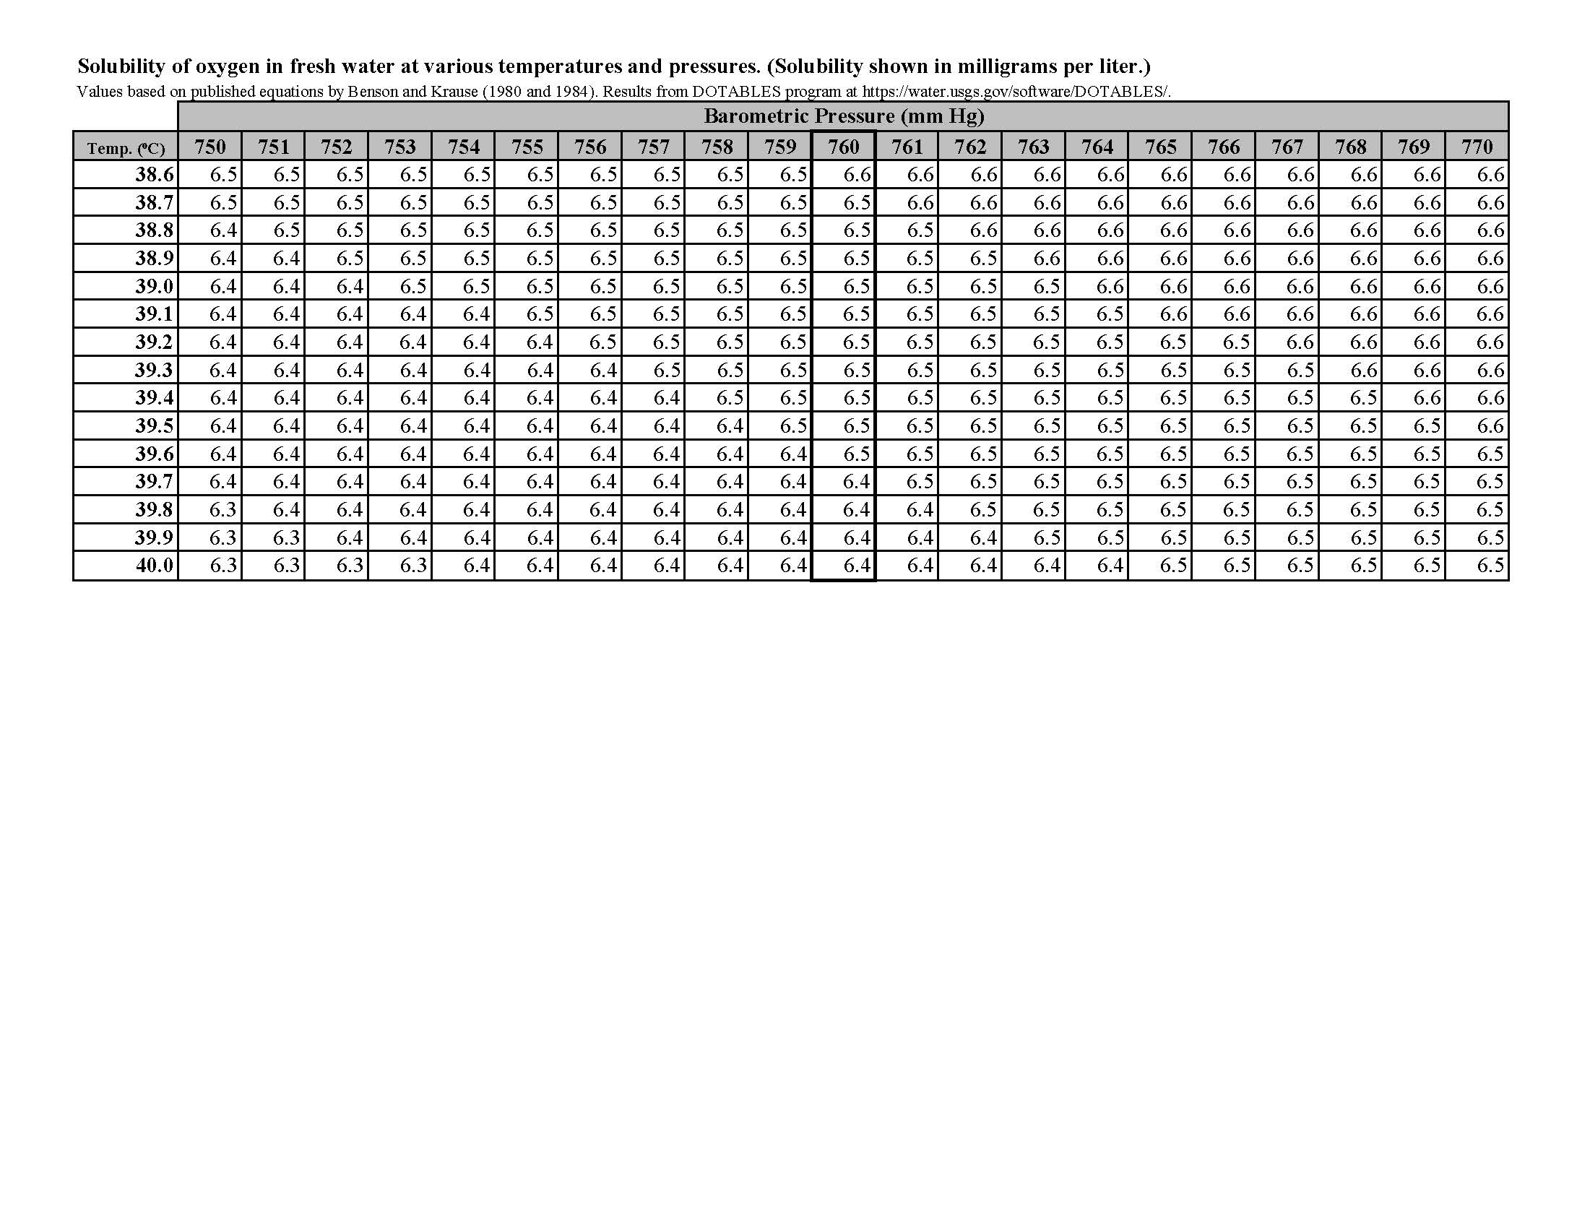
Table 8. Allowable Relative Percent Difference
LIMS COMPONENT | REFERENCE METHOD | RPD
2,4-D | 8321B | 30%
3-Hydroxycarbofuran | 8321B | 30%
Acesulfame K | 8321B | 30%
Acetaminophen | 8321B | 30%
Acetamiprid | 8321B | 30%
Acetochlor | 8270E | 30%
Afidopyropen | 8321B | 30%
Alachlor | 8270E | 30%
Aldicarb | 8321B | 30%
Aldicarb Sulfone | 8321B | 30%
Aldicarb Sulfoxide | 8321B | 30%
Aldrin | 8270E | 30%
Alpha-BHC | 8270E | 30%
Alpha-Chlordane | 8270E | 30%
Aluminum | 200.7 Rev. 4.4 | 20%
Aluminum | 200.8 Rev. 5.4 | 20%
Ametryn | 8270E | 30%
Ammonia-N | 350.1 Rev. 2.0 | 20%
AMPA | 8321B | 30%
Anatoxin-a | 8321B | 30%
Antimony | 200.7 Rev. 4.4 | 20%
Antimony | 200.8 Rev. 5.4 | 20%
Arsenic | 200.7 Rev. 4.4 | 20%
Arsenic | 200.8 Rev. 5.4 | 20%
Atrazine | 8270E | 30%
Atrazine Desethyl | 8270E | 30%
Azinphos Methyl | 8270E | 30%
BacR-purified-qPCR | SOP-PCR-1.4 | 25%
BacR-qPCR | SOP-PCR-1.4 | 25%
Barium | 200.7 Rev. 4.4 | 20%
Barium | 200.8 Rev. 5.4 | 20%
Bentazon | 8321B | 30%
Benzovindiflupyr | 8321B | 30%
Beryllium | 200.7 Rev. 4.4 | 20%
Beryllium | 200.8 Rev. 5.4 | 20%
Beta-BHC | 8270E | 30%
Bifenthrin | 8270E | 30%
Biochemical Oxygen Demand-5 Day |  | 25%
Boron | 200.7 Rev. 4.4 | 20%
Boron | 200.8 Rev. 5.4 | 20%
Bromacil | 8270E | 30%
Bromide | 300 | 20%
Butylate | 8270E | 30%
Cadmium | 200.7 Rev. 4.4 | 20%
Cadmium | 200.8 Rev. 5.4 | 20%
Calcium | 200.7 Rev. 4.4 | 20%
Carbamazepine | 8321B | 30%
Carbaryl | 8321B | 30%
Carbofuran | 8321B | 30%
Carbophenothion | 8270E | 30%
Chlordane | 8276 | 30%
Chloride | 300.0 Rev. 2.1 | 20%
Chlorophyll/Phaeophytin Ratio |  | 10%
Chlorophyll-a, Corrected | SM 10200 H (mod.) | 25%
Chlorophyll-a, Uncorrected | SM 10200 H (mod.) | 25%
Chlorothalonil | 8270E | 30%
Chlorpyrifos Ethyl | 8270E | 30%
Chlorpyrifos Methyl | 8270E | 30%
Chromium | 200.7 Rev. 4.4 | 20%
Chromium | 200.8 Rev. 5.4 | 20%
Cis-Nonachlor | 8270E | 30%
Clothianidin | 8321B | 30%
Cobalt | 200.7 Rev. 4.4 | 20%
Cobalt | 200.8 Rev. 5.4 | 20%
Color (true) | SM 2120 B | 20%
Copper | 200.7 Rev. 4.4 | 20%
Copper | 200.8 Rev. 5.4 | 20%
Cyanazine | 8270E | 30%
Cylindrospermopsin | 8321B | 30%
Cypermethrin | 8270E | 30%
DDD-p,p' | 8270E | 30%
DDE-p,p' | 8270E | 30%
DDT-p,p' | 8270E | 30%
Delta-BHC | 8270E | 30%
Demeton | 8270E | 30%
DG3-purified-qPCR | SOP-PCR-1.5 | 25%
DG3-qPCR | SOP-PCR-1.5 | 25%
Diazinon | 8270E | 30%
Dicofol | 8270E | 30%
Dieldrin | 8270E | 30%
Dimethenamid | 8270E | 30%
Dinotefuran | 8321B | 30%
Disulfoton | 8270E | 30%
Dithiopyr | 8270E | 30%
Diuron | 8321B | 30%
Dominant sample taxon | SOP-AB05 | 10%
Endosulfan I | 8270E | 30%
Endosulfan II | 8270E | 30%
Endosulfan Sulfate | 8270E | 30%
Endothall | 8321B | 30%
Endrin | 8270E | 30%
Endrin Aldehyde | 8270E | 30%
Endrin Ketone | 8270E | 30%
ENTEROCOCCI-ENTEROLERT | ASTM D650399 | 10%
Enterococci-Membrane Filter | SM 9230 C | 10%
Enterococci-Quanti-Tray | Enterolert/QT | 10%
EPTC | 8270E | 30%
Escherichia coli Membrane Filter | 1603 | 10%
Escherichia coli-Membrane Filter | 1603 | 10%
Escherichia Coli-QuantiTray | SM 9223 Quanti-Tray | 10%
Escherichia Coli-Quanti-Tray | Colilert-18 | 10%
Escherichia Coli-Quanti-Tray | SM 9223 B Quanti-Tray | 10%
Escherichia Coli-Quanti-Tray | SM 9223 Quanti-Tray | 10%
Ethalfluralin | 8270E | 30%
Ethion | 8270E | 30%
Ethoprop | 8270E | 30%
Fecal Coliforms-Membrane Filter | SM 9222 D | 10%
Fenamiphos | 8270E | 30%
Fenuron | 8321B | 30%
Fipronil | 8270E | 30%
Fipronil Desulfinyl | 8270E | 30%
Fipronil Sulfide | 8270E | 30%
Fipronil Sulfone | 8270E | 30%
Fluoride | SM 4500 F-C-97 | 20%
Fluridone | 8321B | 30%
Fonofos | 8270E | 30%
Gamma-BHC | 8270E | 30%
Gamma-Chlordane | 8270E | 30%
GFD-purified-qPCR | SOP-PCR-1.3 | 25%
Glufosinate | 8321B | 30%
Glyphosate | 8321B | 30%
GULL2-purified-qPCR | SOP-PCR-1.2 | 25%
GULL2-qPCR | SOP-PCR-1.2 | 25%
Hardness | SM 2340 B | 20%
Heptachlor | 8270E | 30%
Heptachlor Epoxide | 8270E | 30%
Hexachlorobenzene | 8270E | 30%
Hexazinone | 8270E | 30%
HF183 - Human Source Marker |  | 10%
HF183-PMA treated-qPCR | SOP-PCR-1.1 | 25%
HF183-purified-qPCR | SOP-PCR-1.0 | 25%
HF183-purified-untreated-qPCR | SOP-PCR-1.1 | 25%
HF183-qPCR | SOP-PCR-1.0 | 25%
HUMM2-qPCR | SOP-PCR-1.7 | 25%
Hydrocodone | 8321B | 30%
Ibuprofen | 8321B | 30%
Imazapyr | 8321B | 30%
Imidacloprid | 8321B | 30%
Iron | 200.7 Rev. 4.4 | 20%
Kjeldahl Nitrogen | 351.2 Rev. 2.0 | 20%
Lead | 200.7 Rev. 4.4 | 20%
Lead | 200.8 Rev. 5.4 | 20%
Linuron | 8321B | 30%
Macroinvert-FW-Qual-DipnetX20-#Taxa-Rep2 | SOP-IZ06 | 10%
Magnesium | 200.7 Rev. 4.4 | 20%
Malathion | 8270E | 30%
Mandestrobin | 8321B | 30%
Manganese | 200.7 Rev. 4.4 | 20%
Manganese | 200.8 Rev. 5.4 | 20%
MCPP | 8321B | 30%
Metalaxyl | 8270E | 30%
Methiocarb | 8321B | 30%
Methomyl | 8321B | 30%
Methoxychlor | 8270E | 30%
Metolachlor | 8270E | 30%
Metribuzin | 8270E | 30%
Mevinphos | 8270E | 30%
Microcystin LA | 8321B | 30%
Microcystin LF | 8321B | 30%
Microcystin LR | 8321B | 30%
Microcystin LY | 8321B | 30%
Microcystin RR | 8321B | 30%
Microcystin YR | 8321B | 30%
Mirex | 8270E | 30%
Molinate | 8270E | 30%
Molybdenum | 200.7 Rev. 4.4 | 20%
Molybdenum | 200.8 Rev. 5.4 | 20%
Naproxen | 8321B | 30%
Nickel | 200.7 Rev. 4.4 | 20%
Nickel | 200.8 Rev. 5.4 | 20%
NO2NO3-N | 353.2 Rev. 2.0 | 20%
Norflurazon | 8270E | 30%
O-Phosphate-P | 365.1 Rev. 2.0 | 20%
Organic Carbon | SM 5310 B-00 | 20%
Oxadiazon | 8270E | 30%
Oxamyl | 8321B | 30%
Parathion Ethyl | 8270E | 30%
Parathion Methyl | 8270E | 30%
Pendimethalin | 8270E | 30%
Permethrin | 8270E | 30%
Phaeophytin-a | SM 10200 H (mod.) | 25%
Phorate | 8270E | 30%
Phytoplankton-Quantitative-# Wet Taxa |  | 10%
Phytoplankton-Quantitative-#Diatom Taxa |  | 10%
Potassium | 200.7 Rev. 4.4 | 20%
Primidone | 8321B | 30%
Prodiamine | 8270E | 30%
Prometon | 8270E | 30%
Prometryn | 8270E | 30%
Propiconazole | EPA 8270E | 30%
Propoxur | 8321B | 30%
Pyraclostrobin | 8321B | 30%
Saxitoxin | 8321B | 30%
Selenium | 200.7 Rev. 4.4 | 20%
Selenium | 200.8 Rev. 5.4 | 20%
Silver | 200.7 Rev. 4.4 | 20%
Silver | 200.8 Rev. 5.4 | 20%
Simazine | 8270E | 30%
Sodium | 200.7 Rev. 4.4 | 20%
Specific_Conductance | 120.1 | 20%
Stream Condition Index (SCI) | SOP-IZ06 | 10%
Strontium | 200.7 Rev. 4.4 | 20%
Strontium | 200.8 Rev. 5.4 | 20%
Strontium | 200.8 Rev. 5.4 | 20%
Sucralose | 8321B | 30%
Sulfate | 300.0 Rev. 2.1 | 20%
Sulfentrazone | EPA 8270E | 30%
TDS | SM 2540 C-97 | 10%
Tebuconazole | 8270E | 30%
Terbufos | 8270E | 30%
Terbuthylazine | 8270E | 30%
Thallium | 200.7 Rev. 4.4 | 20%
Thallium | 200.8 Rev. 5.4 | 20%
Thiamethoxam | 8321B | 30%
Tin | 200.7 Rev. 4.4 | 20%
Titanium | 200.7 Rev. 4.4 | 20%
Tolfenpyrad | 8321B | 30%
Total Alkalinity | SM 2320 B-97 | 20%
Total-P | 365.1 Rev. 2.0 | 20%
Toxaphene | 8276 | 30%
Trans-Nonachlor | 8270E | 30%
Triclopyr | 8321B | 30%
Trifluralin | 8270E | 30%
TSS | SM 2540 D-97 | 10%
Turbidity | 180.1 Rev. 2.0 | 20%
Vanadium | 200.7 Rev. 4.4 | 20%
Zinc | 200.7 Rev. 4.4 | 20%
Zinc | 200.8 Rev. 5.4 | 20%

Table 9. Analyte Hold Times
Analytes | Maximum holding time
Microbiologicals (bacteria) | 6 hours; not analyzed if > 48 hours
Chlorophyll | 48 hours without filtering
Color | 48 hours
Turbidity | 48 hours
Orthophosphate | 48 hours
Residue (TSS and TDS) | 7 days
Tracers and Pesticides | 7 days
Alkalinity | 14 days
Ammonia | 28 days
Chloride | 28 days
Fluoride | 28 days
Kjeldahl and organic nitrogen (TKN) | 28 days
Nitrate-nitrite | 28 days
Organic Carbon (TOC) | 28 days
Phosphorus, total | 28 days
Sulfate | 28 days
Hardness | 6 months
Metals | 6 months
qPCR | 48 Hours

Table 10. Number of SCI Sweeps to Perform
# Productive Habitats | # Productive Habitat Sweeps | # Minor Habitat Sweeps
1 | 10 | 10
2 | 7 of each habitat | 6
3 | 5 of each habitat | 5
4 | 4 of each habitat | 4
5 | 3 of each habitat | 5

Table 11. Microbiology water quality standard by waterbody Class
Matrix | Class | Analyte(s)
Fresh | 1 | Escherichia coli
Marine | 2 | Enterococci, Fecal Coliform (membrane filtration)
Fresh | 3F | Escherichia coli
Marine | 3M | Enterococci

Table 12. Tracker Non-Numeric Characters
Tracker Code | Definition
O | "O" qualified, Analysis cancelled
X | No results for bottle group
D | Dry - no standing water
F | Flooded - out of banks
IF | Insufficient Flow <0.05m/s
P | Pooled - possible flow between pools
NF | No Flow
S | Shipping issue

Figures
Figure 1. Permission Letter and Form
(Page 1 of 4.) This figure is provided as an example only. Please visit the SMP FTP Guidance Folder to download the most recent version.
Figure 1. Continued (page 2 of 4).

Figure 1. Continued (page 3 of 4).

Figure 1. Continued (page 4 of 4).
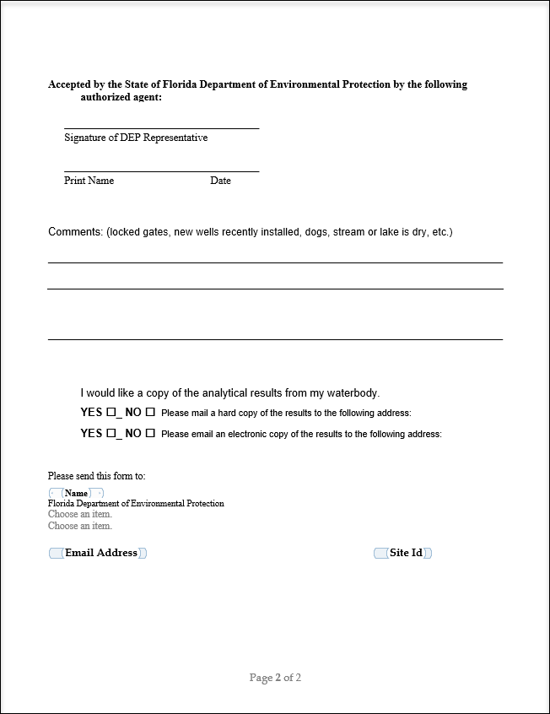

Figure 2. Example Laboratory Project and Sample Identification Label
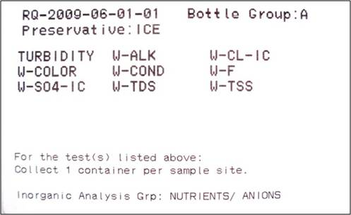
Figure 3. Barcoded Station Label - Field Sample, Option 1

Figure 4. Barcoded Station Label - Field Sample, Option 2

Figure 5. Barcoded Station Label - Field Duplicate, Option 1

Figure 6. Barcoded Station Label - Field Duplicate, Option 2

Figure 7. Field duplicate label on lab submittal form with comment

Figure 8. Field blank label on lab submittal form with comment

Figure 9. DEP Laboratory Chain of Custody
(Page 1 of 3.) This figure is provided as an example only.
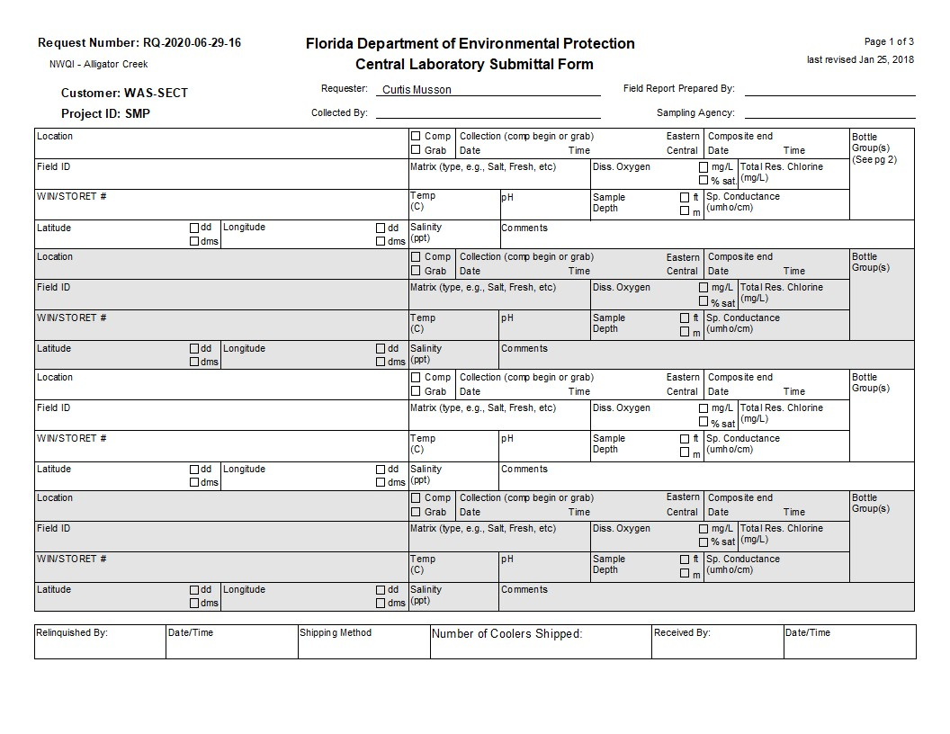
Figure 9. Continued (page 2 of 3).
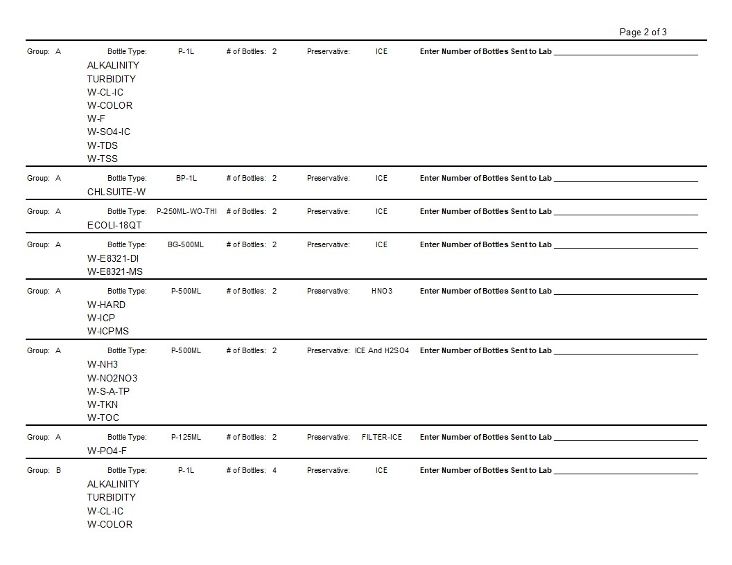

Figure 9. Continued (page 3 of 3).
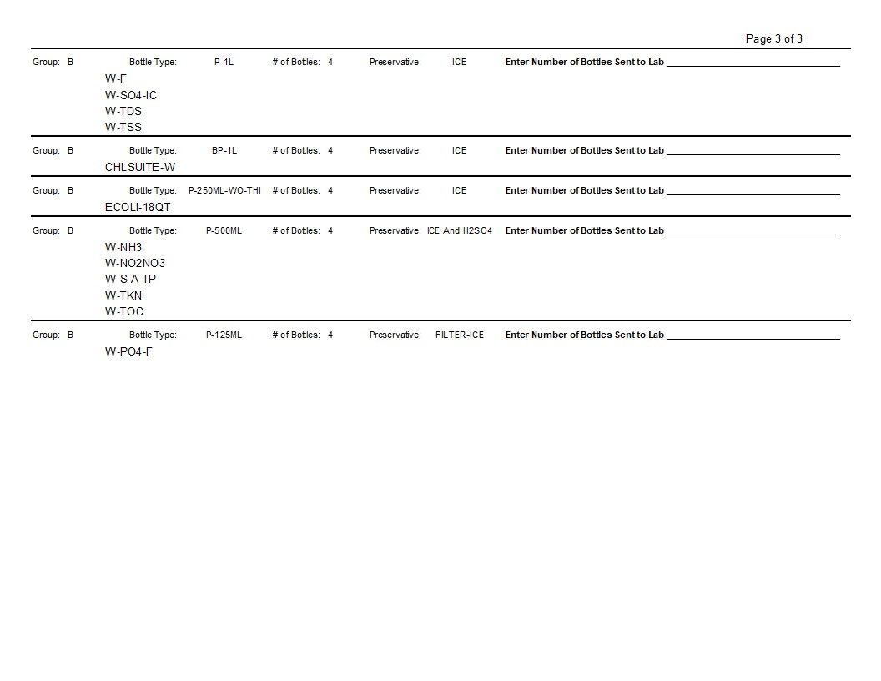

Figure 10. SMP Field Sheet - Field Sample
(Page 1 of 2.) This figure is provided as an example only.
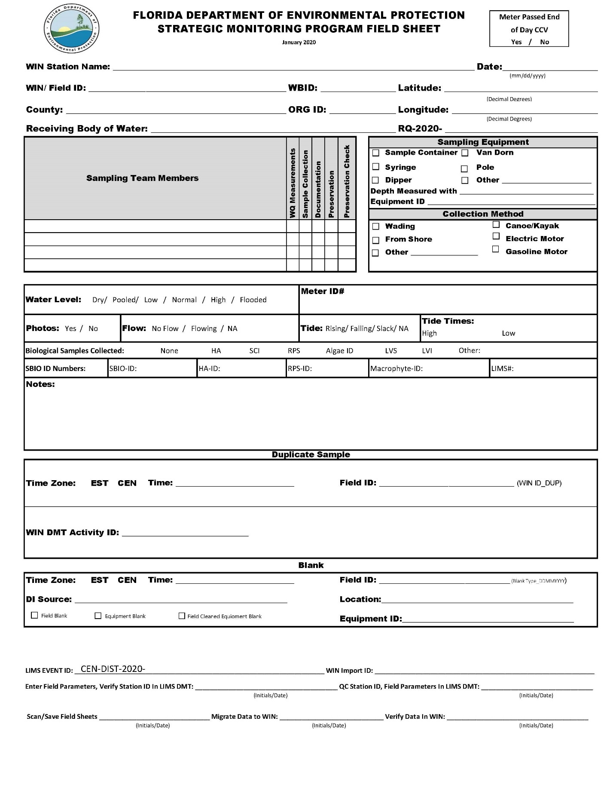
Figure 10. Continued (page 2 of 2).
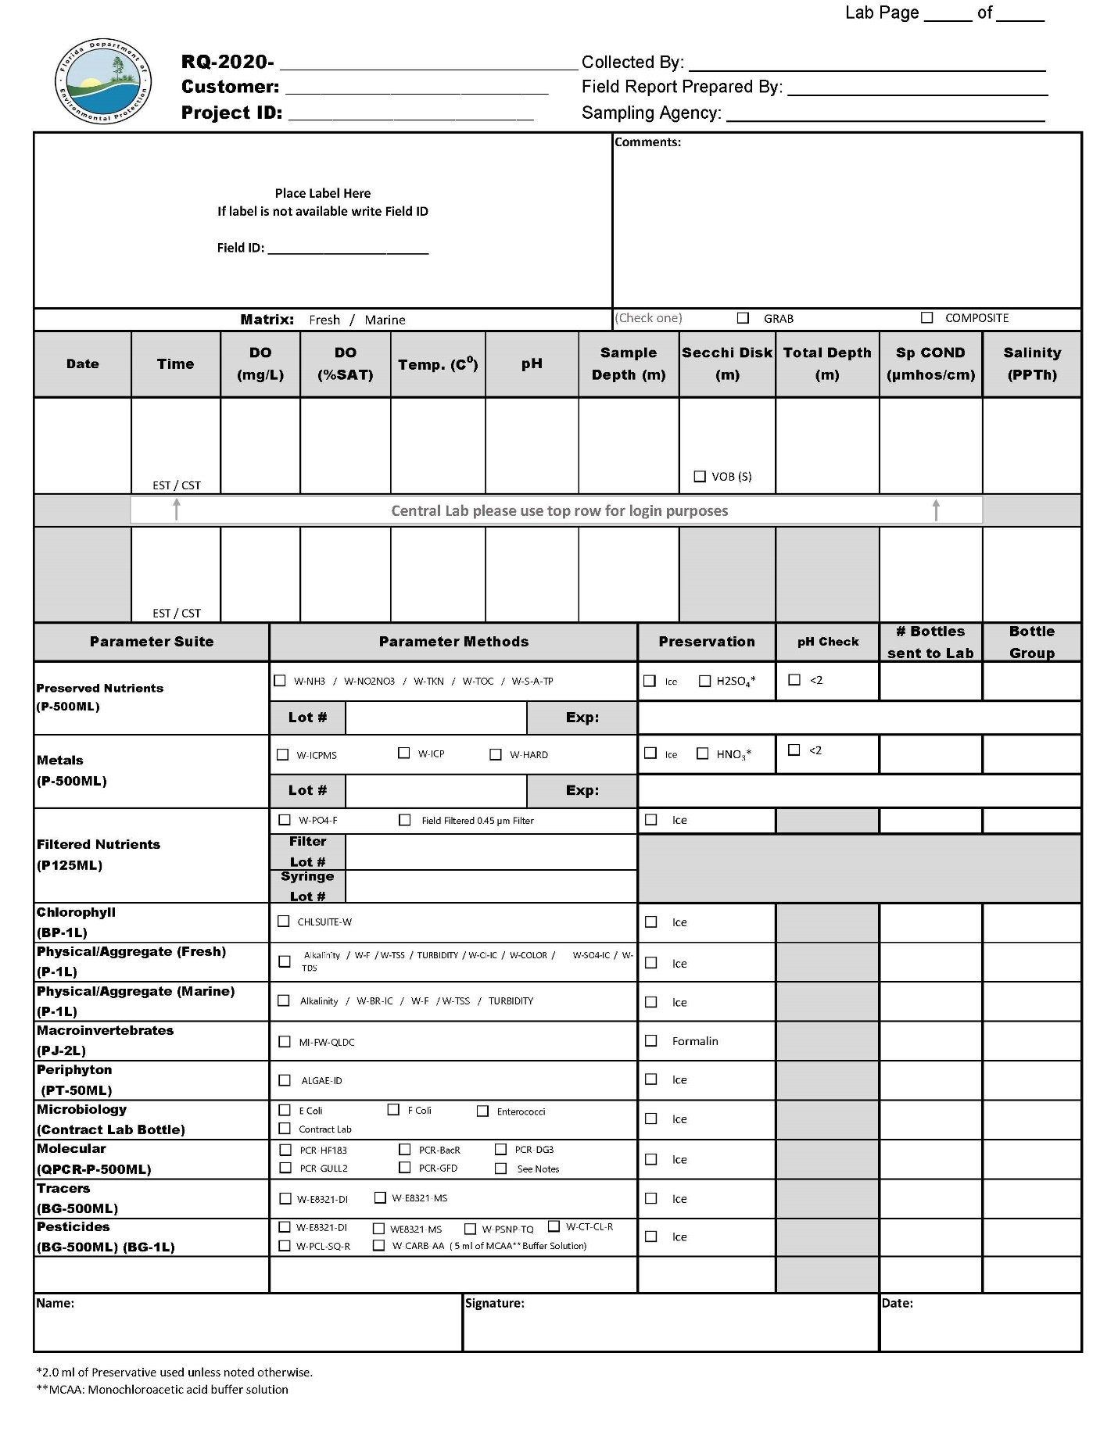

Figure 11. SMP Field Sheet - Field Duplicate
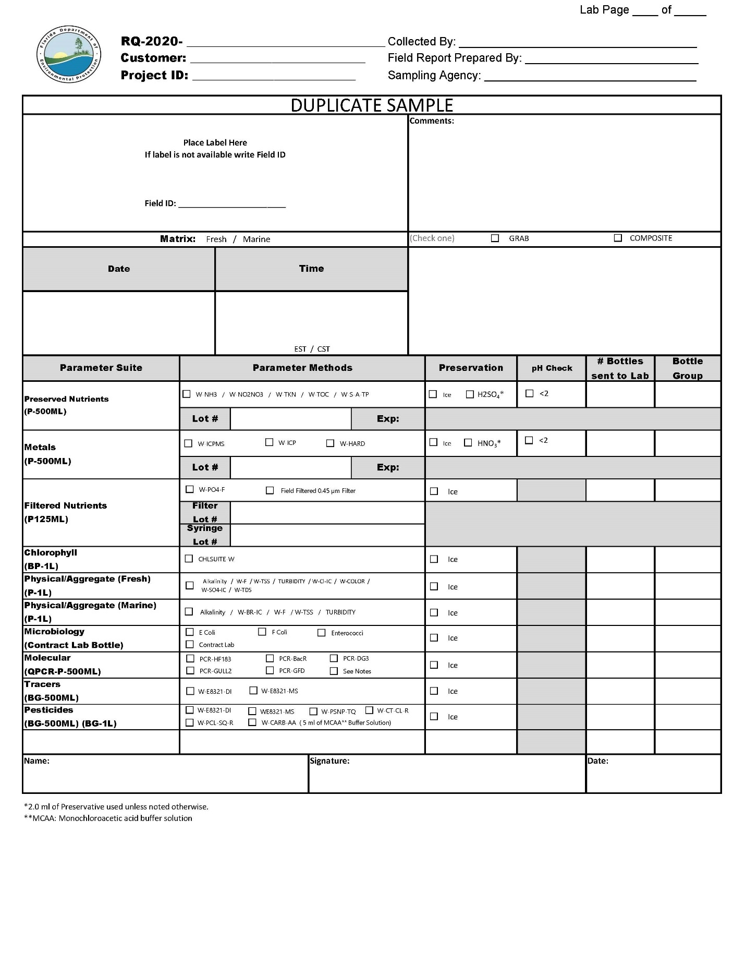

Figure 12. SMP Field Sheet - Quality Control Blank
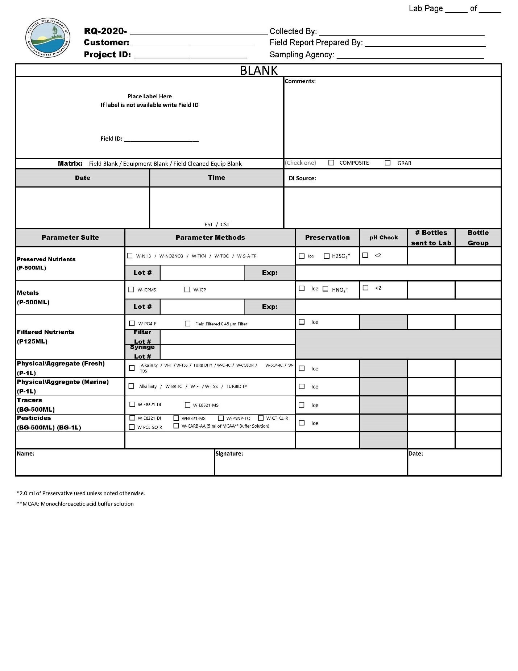

Figure 13. Required Bioassessment Documentation
Bioassessment | Stream WBID |  |  |  | Lake WBID
Bioassessment | RPS Field Sheet | LVS Field Sheet | HA Sketch  HA Score | Phys-Chem Form | LVI Data Sheet | Lake HA Field Sheet | Lake Observation Field Sheet
SCI | X | X | X | X
RPS | X | X | X | X
LVS | X | X | X | X
HA |  |  | X | X
PhysChem |  |  | X | X
LVI |  |  |  |  | X | X | X

Figure 14. Stream/River Habitat Sketch Field Sheet
This figure is provided as an example only. Please visit the Quality Assurance SOP and Forms web page to download the most recent version.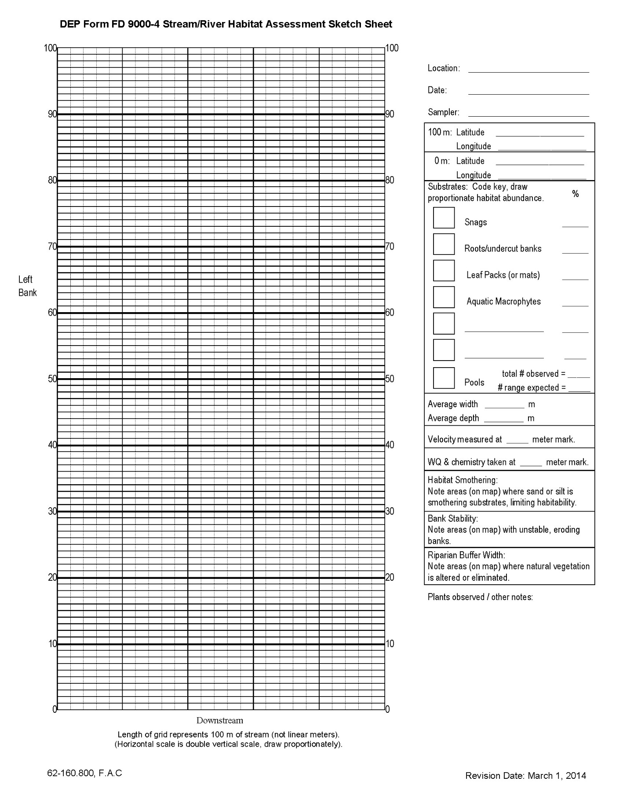
Figure 15. Stream/River Habitat Assessment Score Field Sheet
This figure is provided as an example only. Please visit the Quality Assurance SOP and Forms web page to download the most recent version.
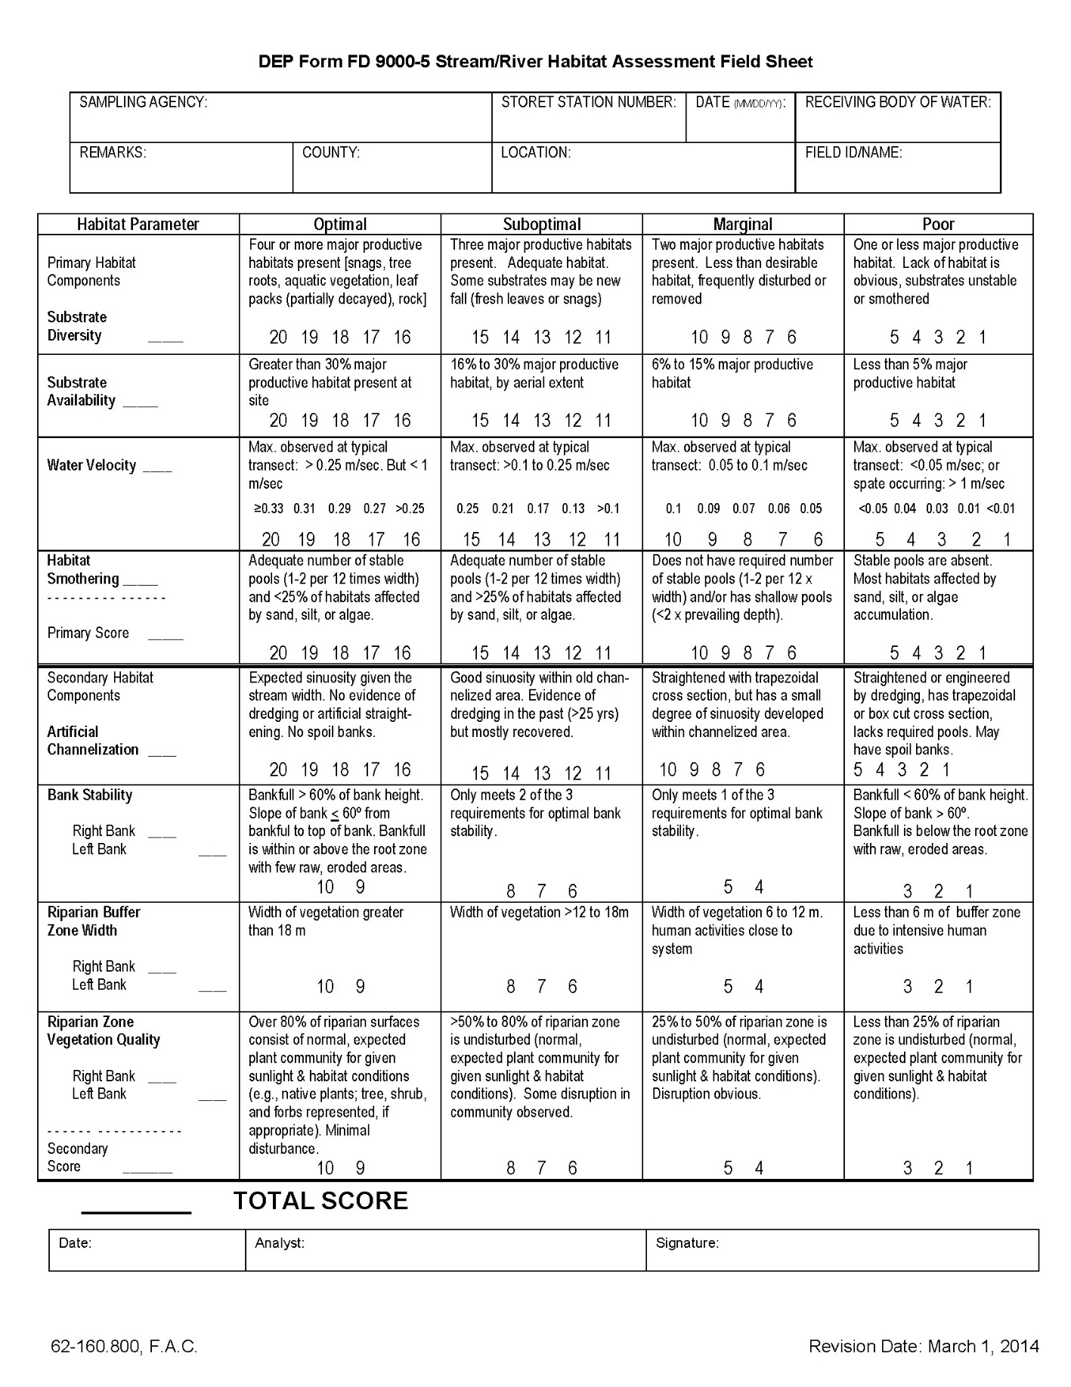
Figure 16. Rapid Periphyton Survey Field Sheet
This figure is provided as an example only. Please visit the Quality Assurance SOP and Forms web page to download the most recent version.
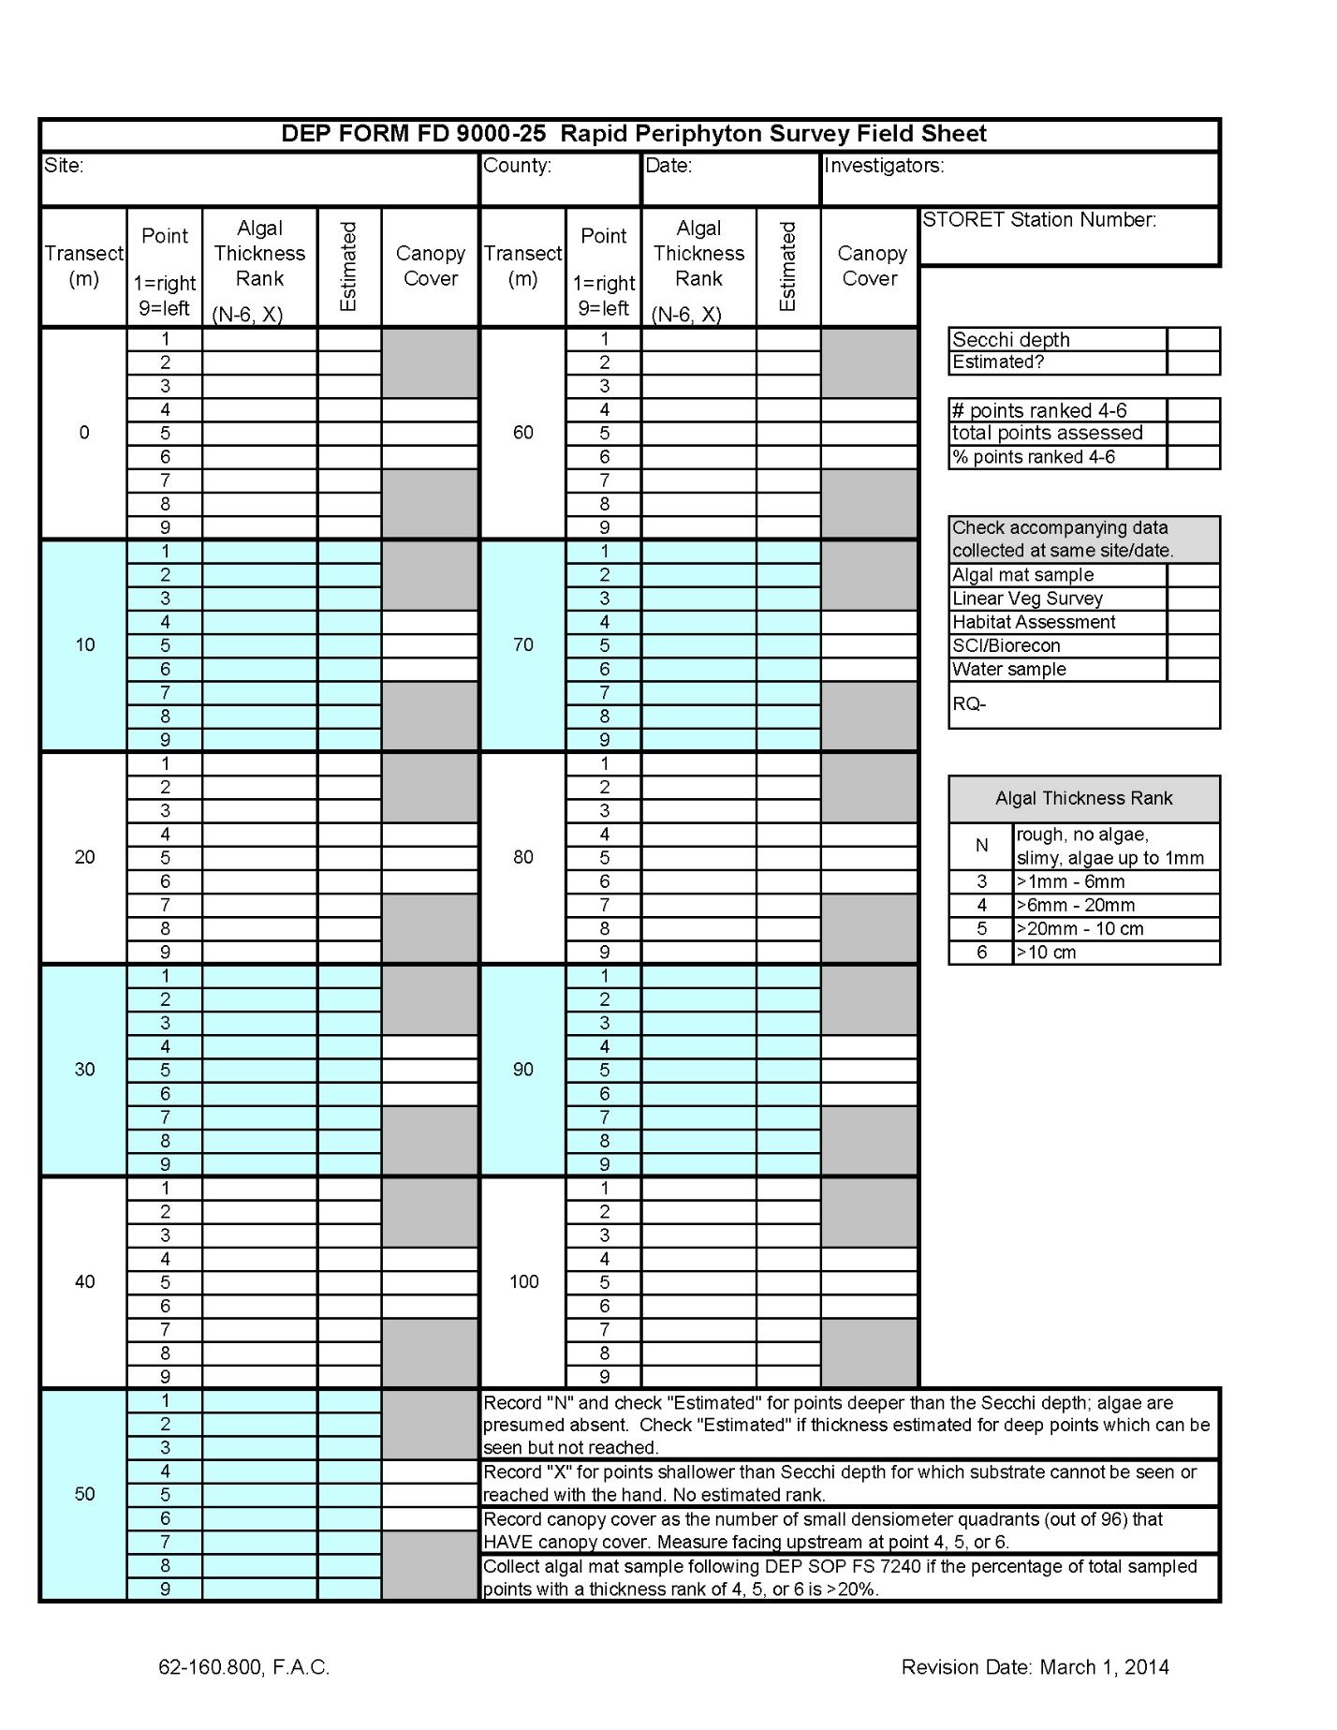

Figure 17. Linear Vegetation Survey Field Sheet
This figure is provided as an example only. Please visit the Quality Assurance SOP and Forms web page to download the most recent version.
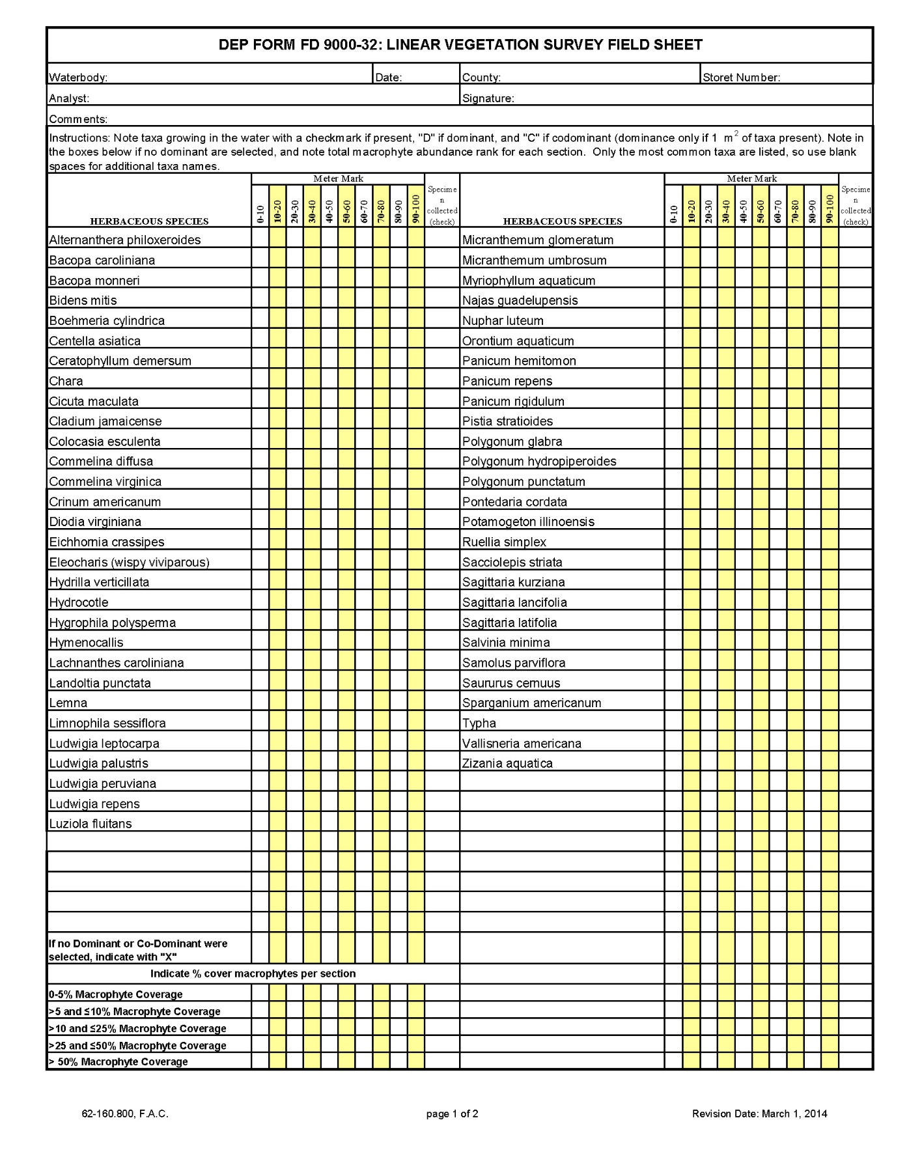

Figure 18. Physical Chemical Characteristic Field Sheet
This figure is provided as an example only. Please visit the Quality Assurance SOP and Forms web page to download the most recent version.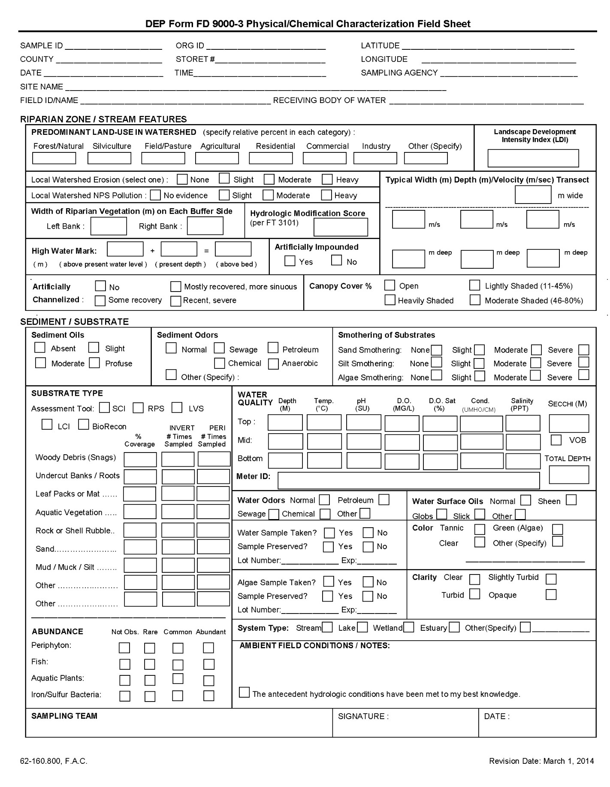
Figure 19. Lake Habitat Assessment Field Sheet
This figure is provided as an example only. Please visit the Quality Assurance SOP and Forms web page to download the most recent version.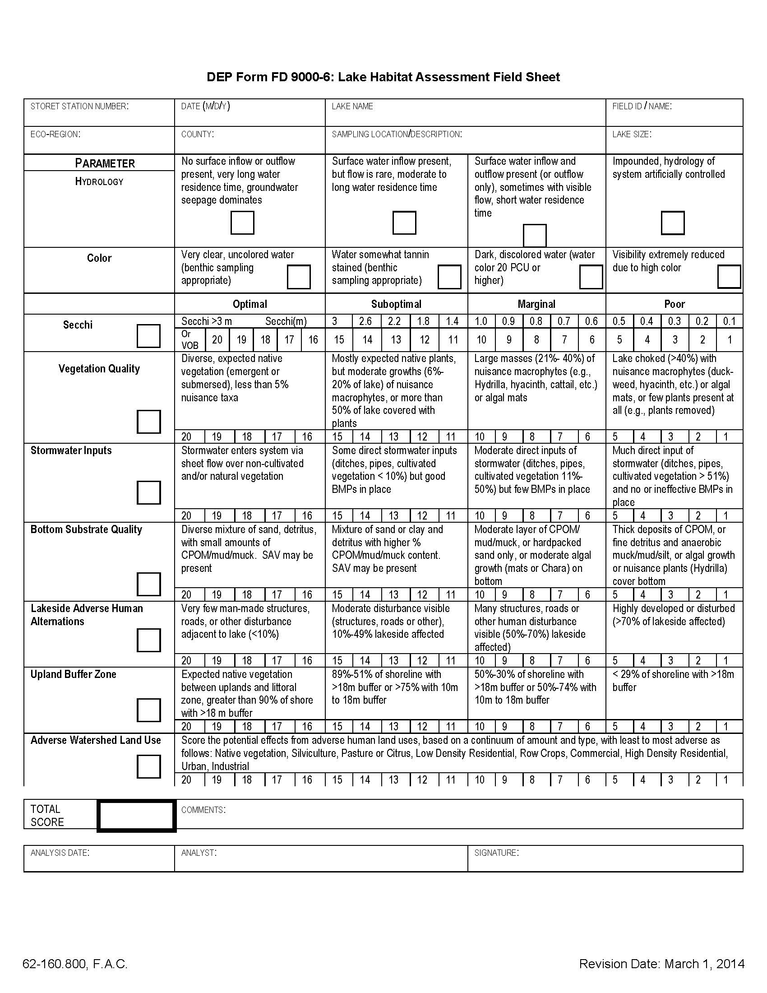
Figure 20. Lake Observation Field Sheet
This figure is provided as an example only. Please visit the Quality Assurance SOP and Forms web page to download the most recent version.
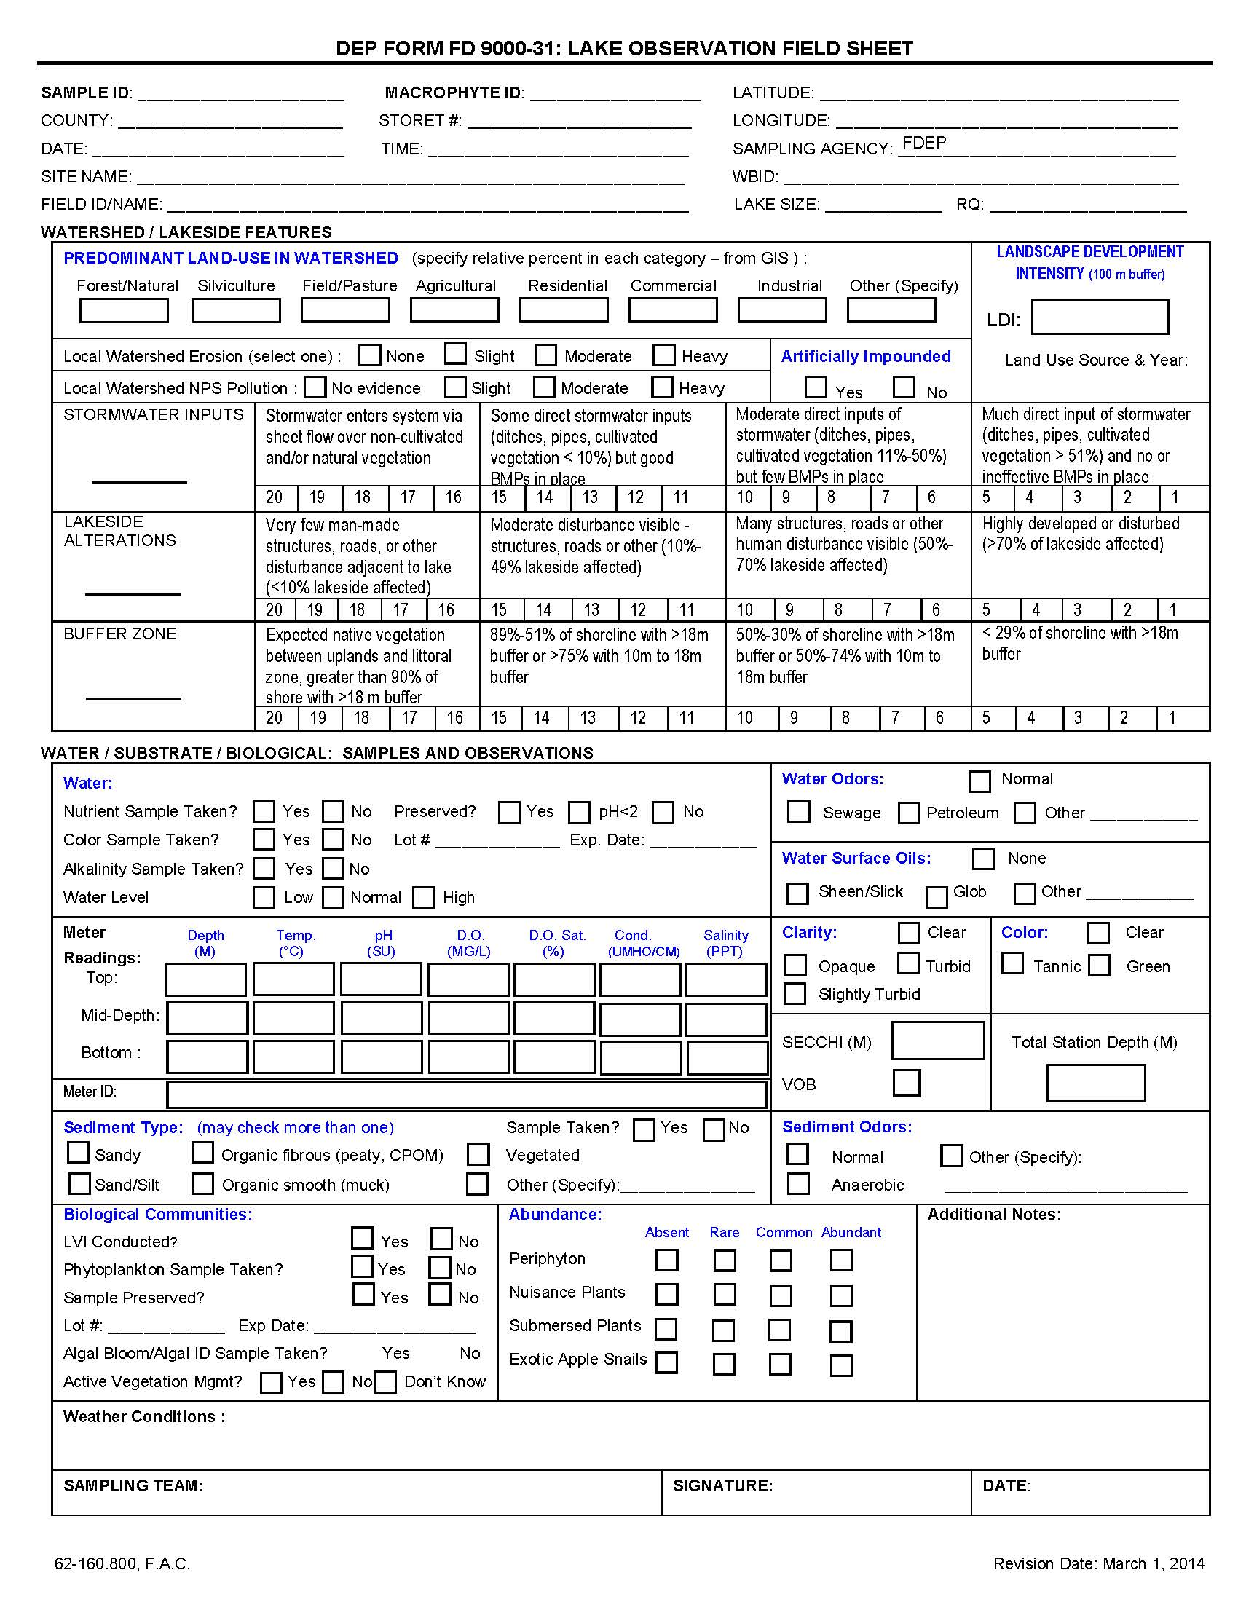
Figure 21. Lake Vegetation Index Field Sheet
(page 1 of 2.) This figure is provided as an example only. Please visit the Quality Assurance SOP and Forms web page to download the most recent version.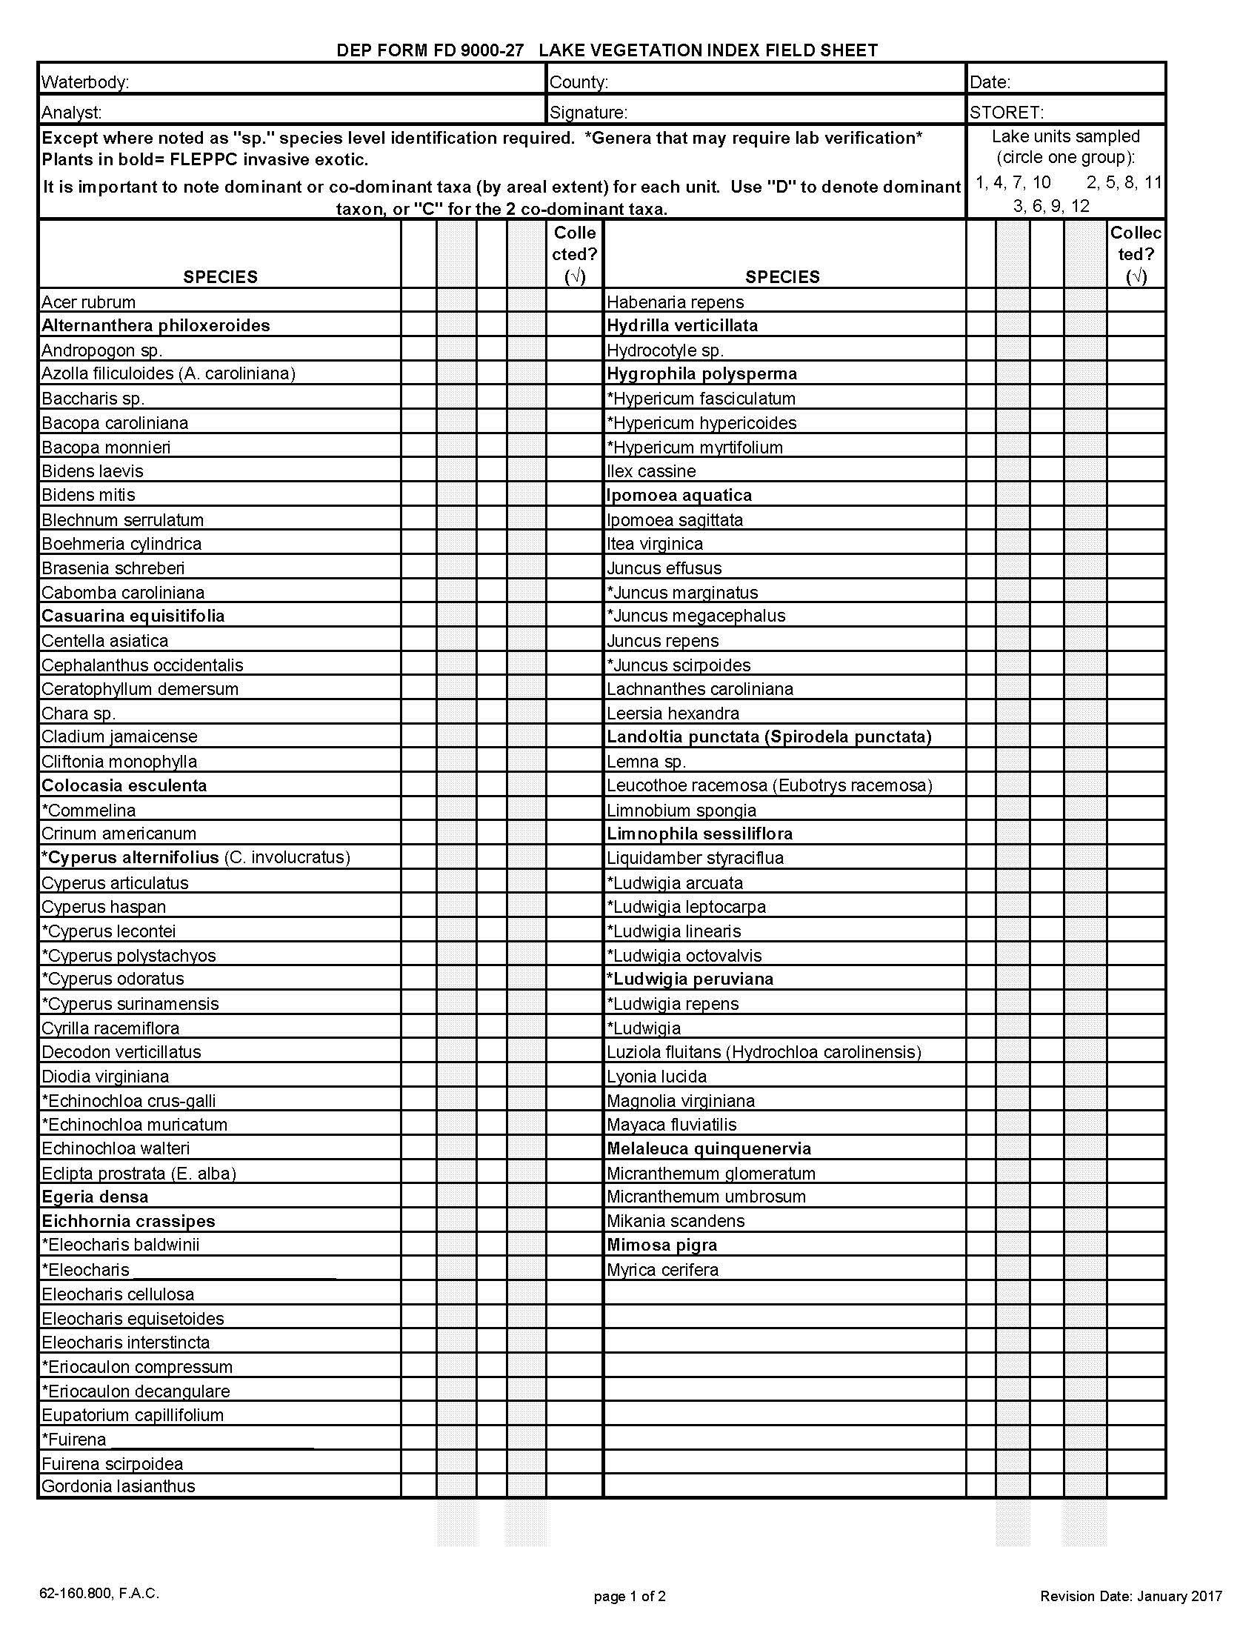
Figure 21. Continued (page 2 of 2).
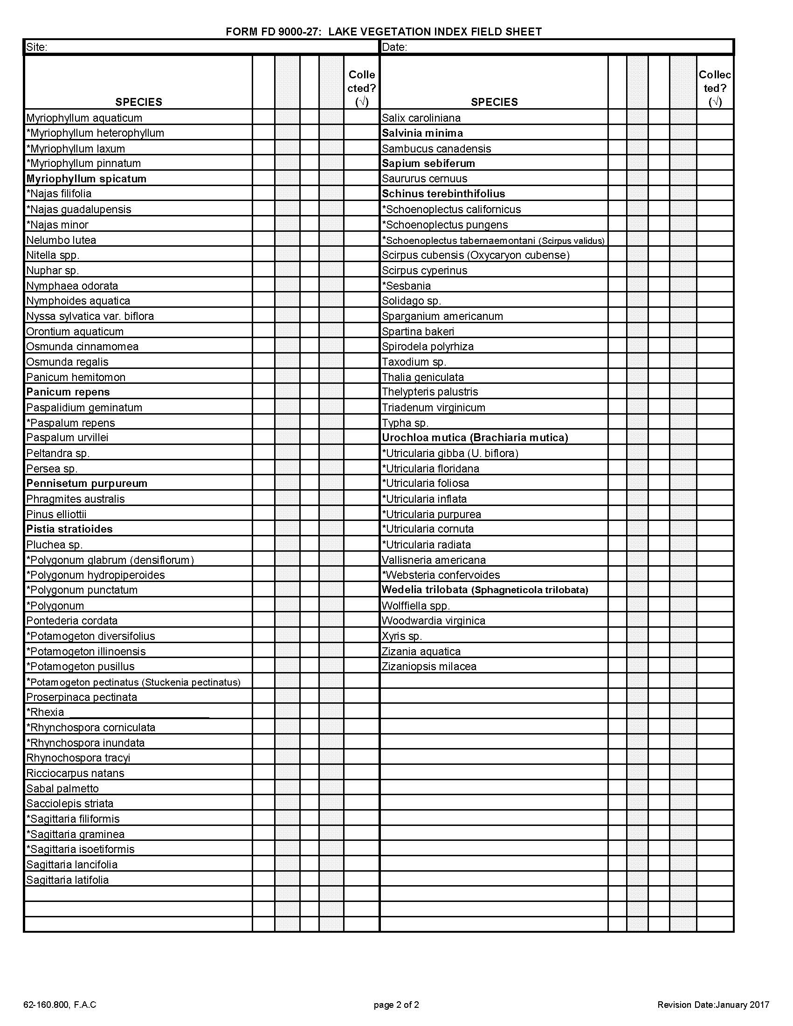

Figure 22. Sampling Equipment Check List
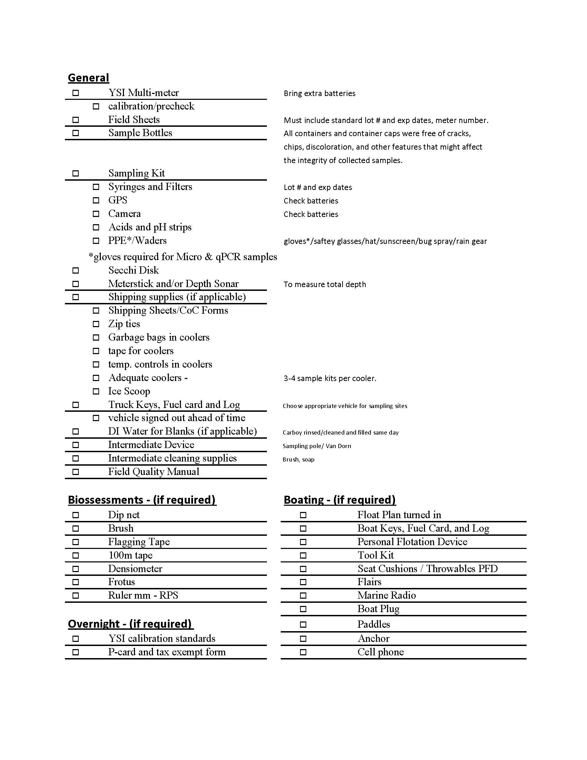

Figure 23. DEP Regulatory Districts and Contact Information
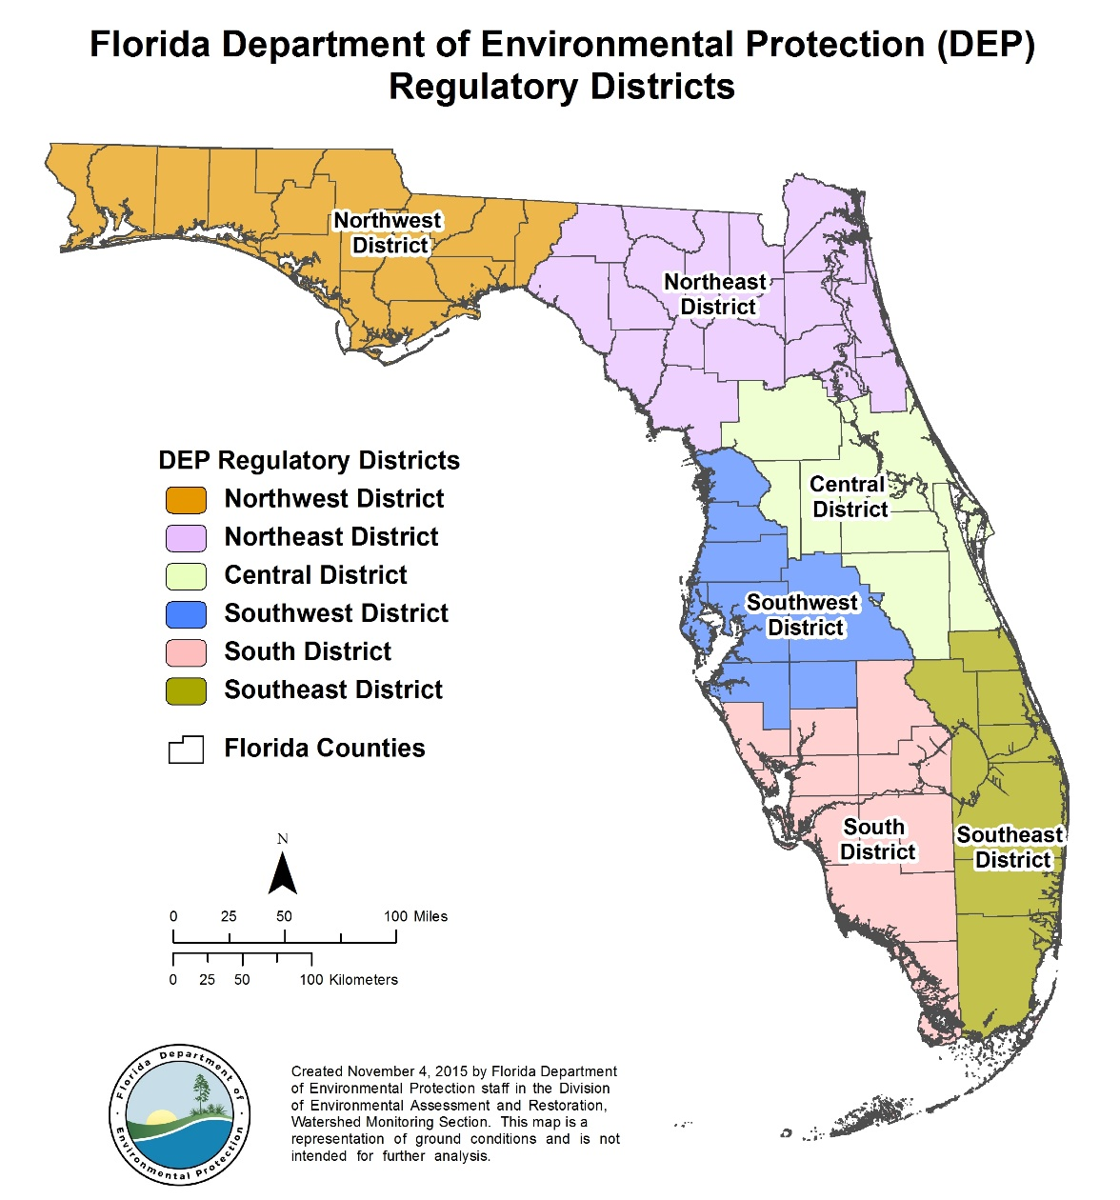

Figure 24. SMP ROC Regions
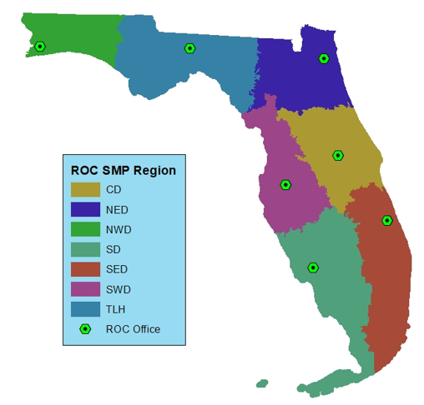

Figure 25. Basin Contacts
This figure is provided as an example only. Please visit the Quality Assurance SOP and Forms web page to download the most recent version
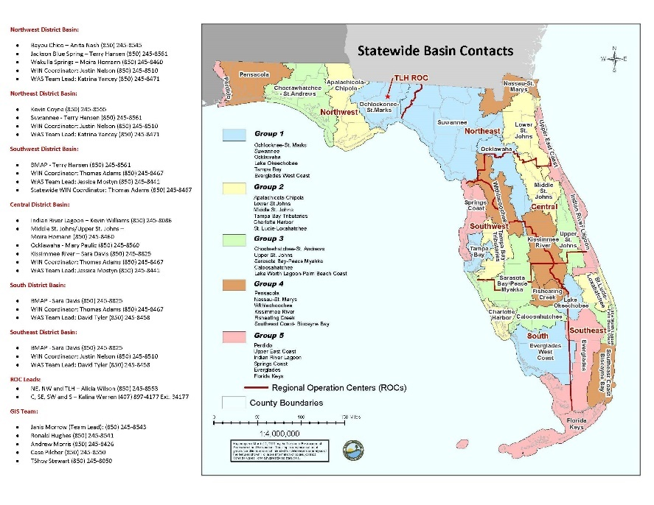

Figure 26. Example Cleaning Log
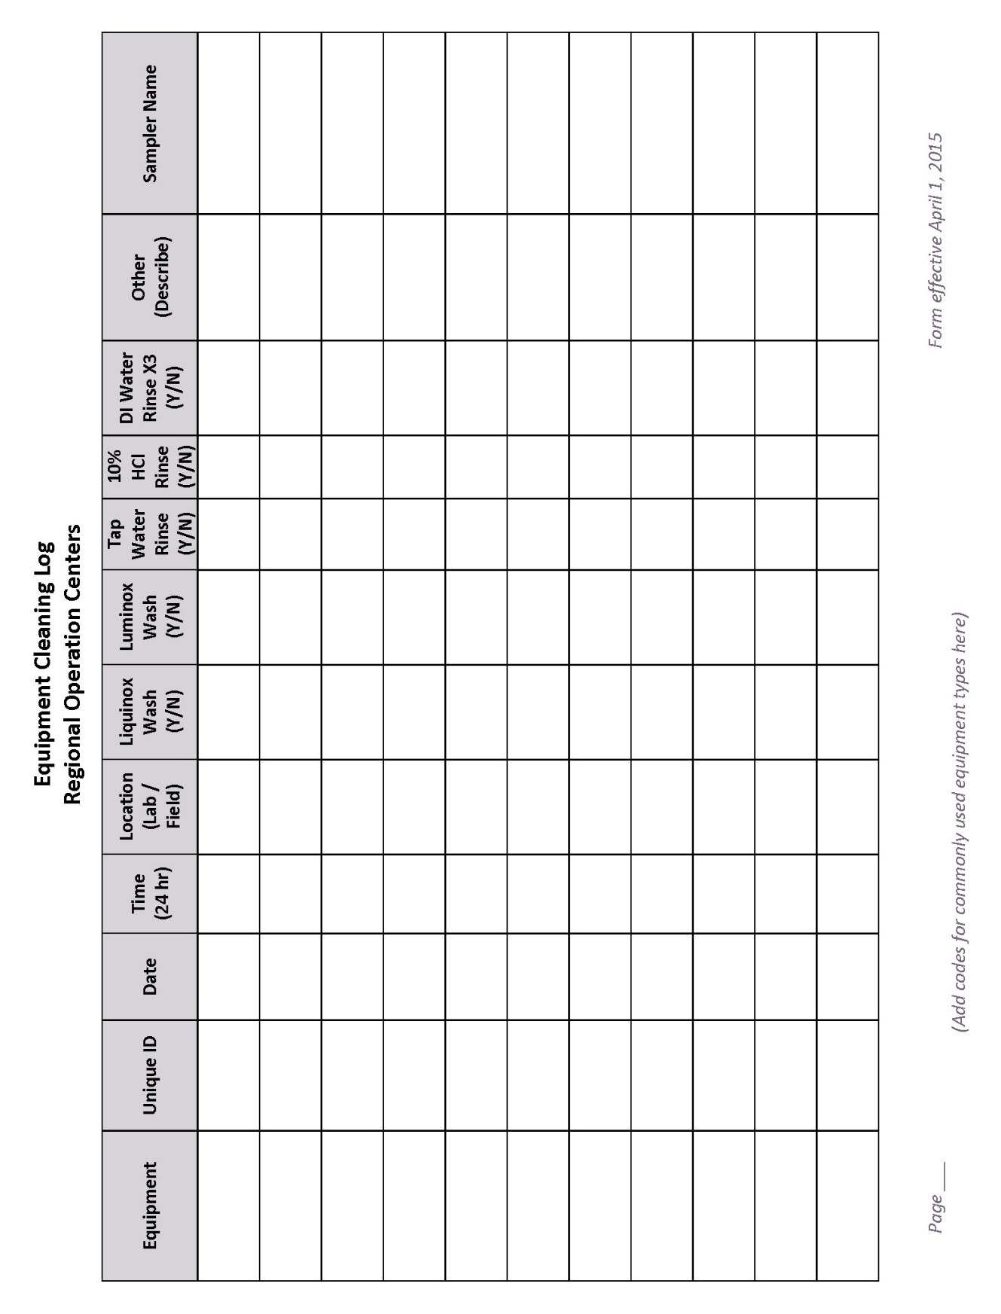

Figure 27. Example Standard Reagent Filter and Syringe Log
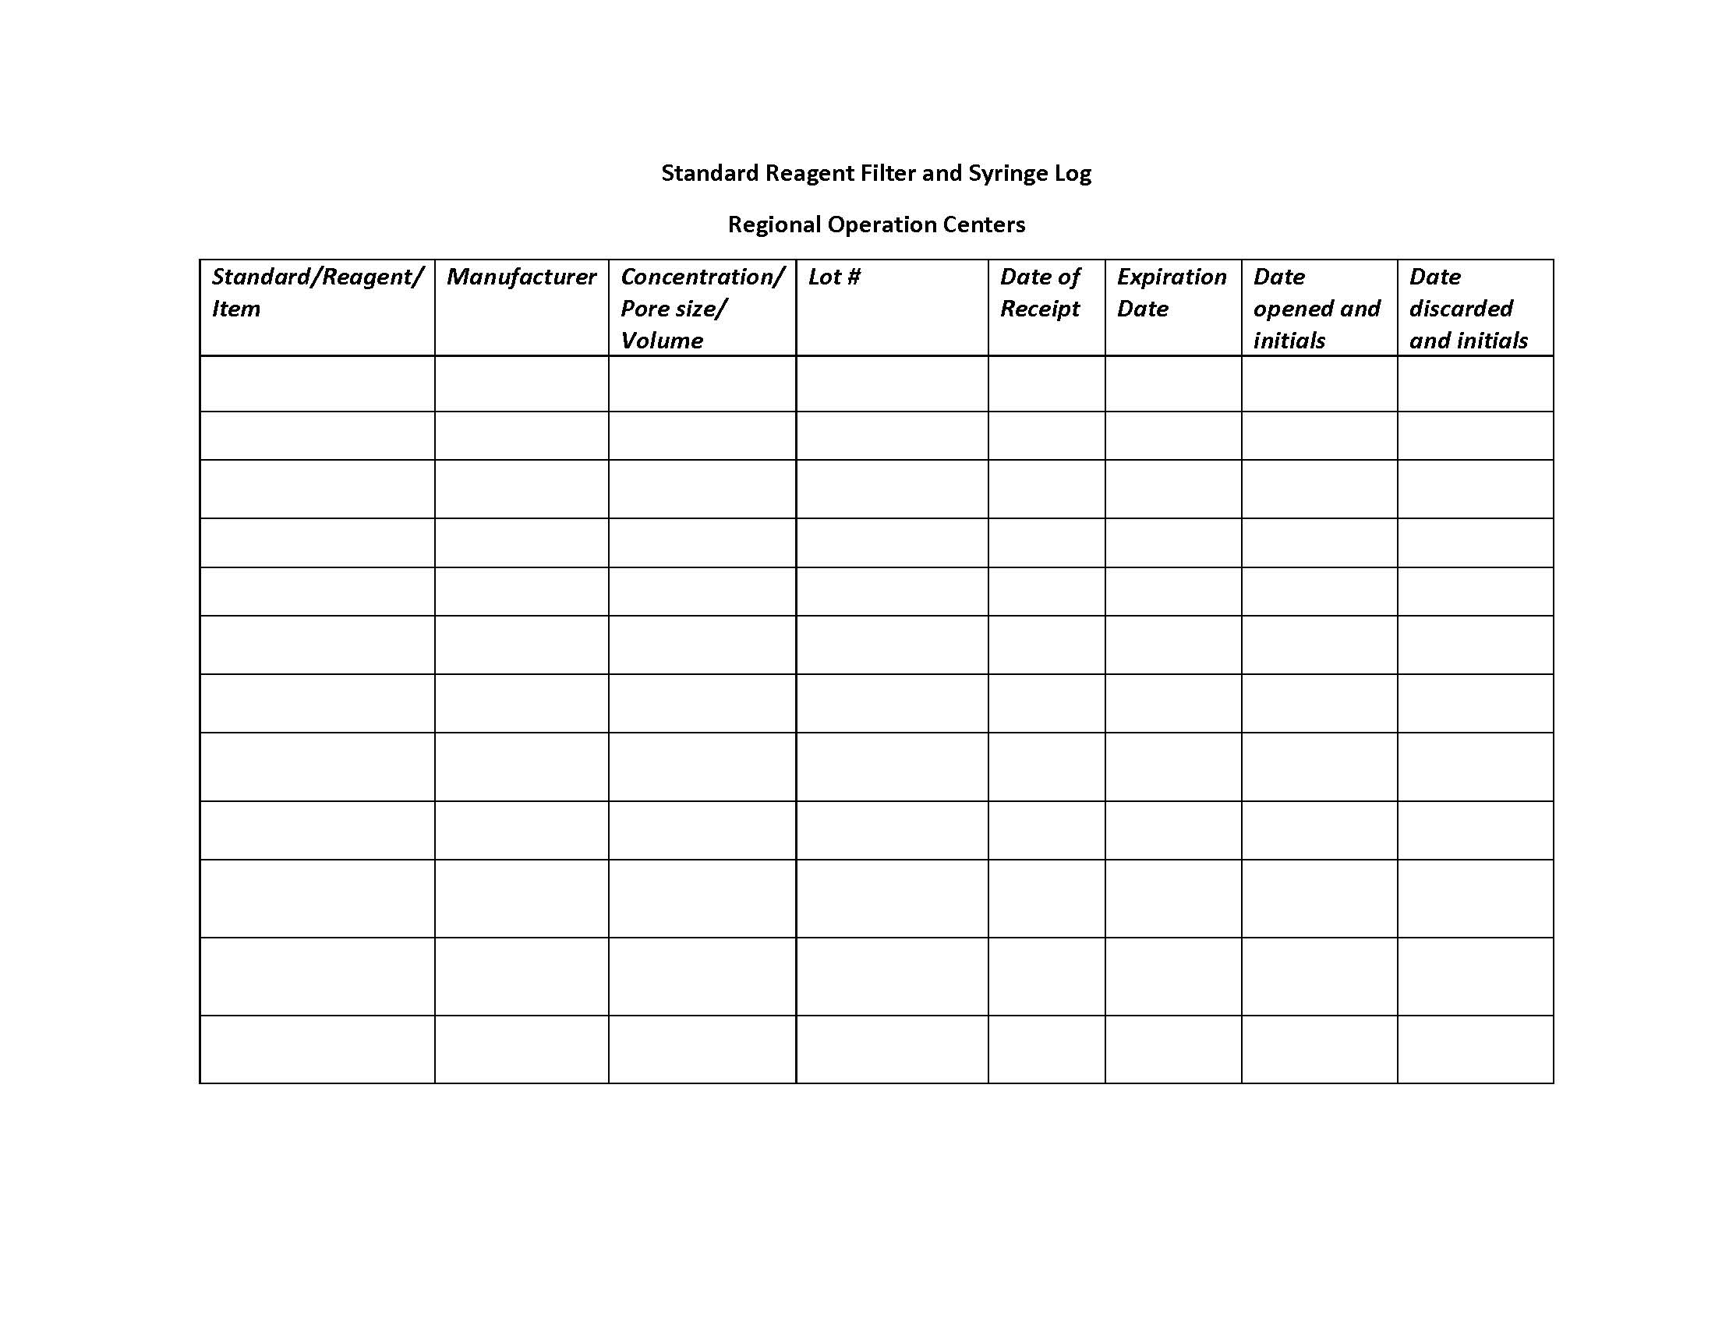

Figure 28. Calibration and Verification Log
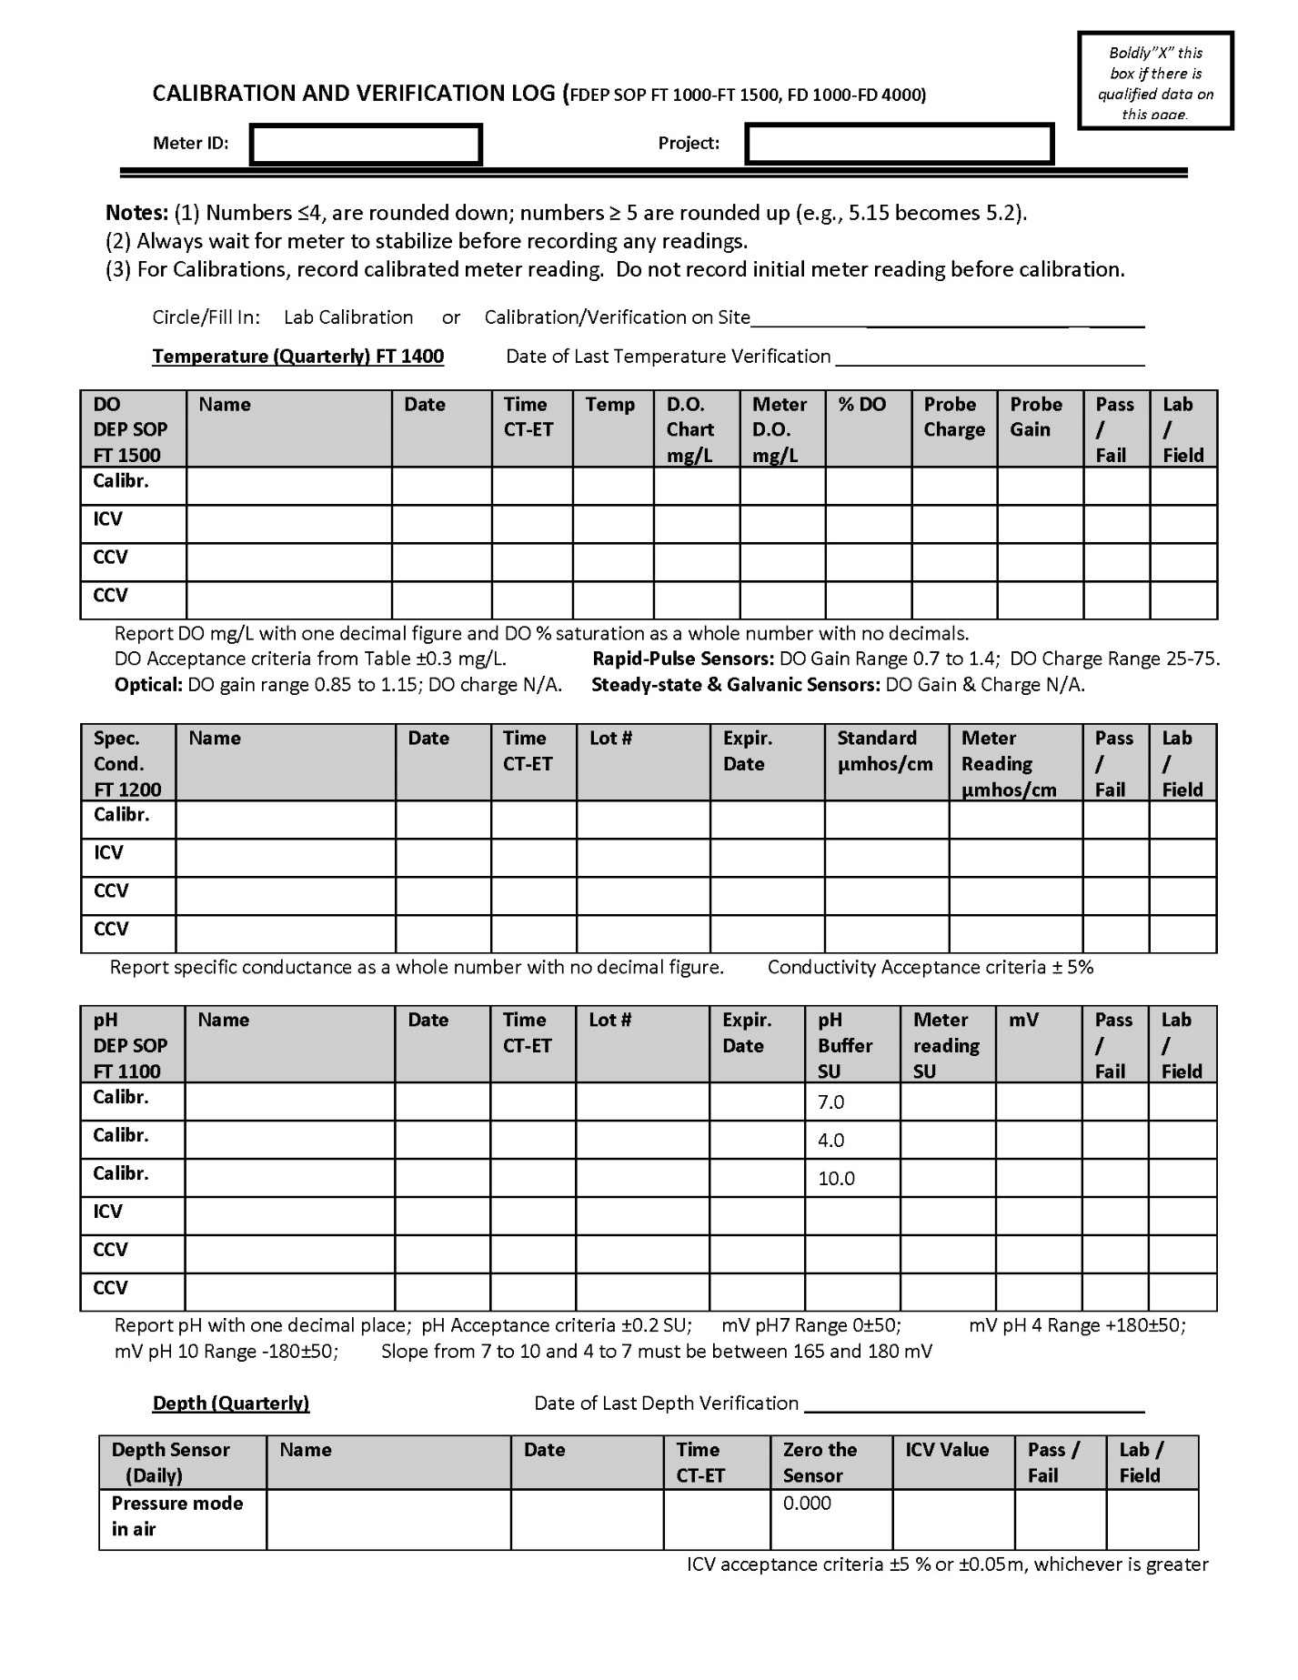

Figure 29. Example Equipment Maintenance Log
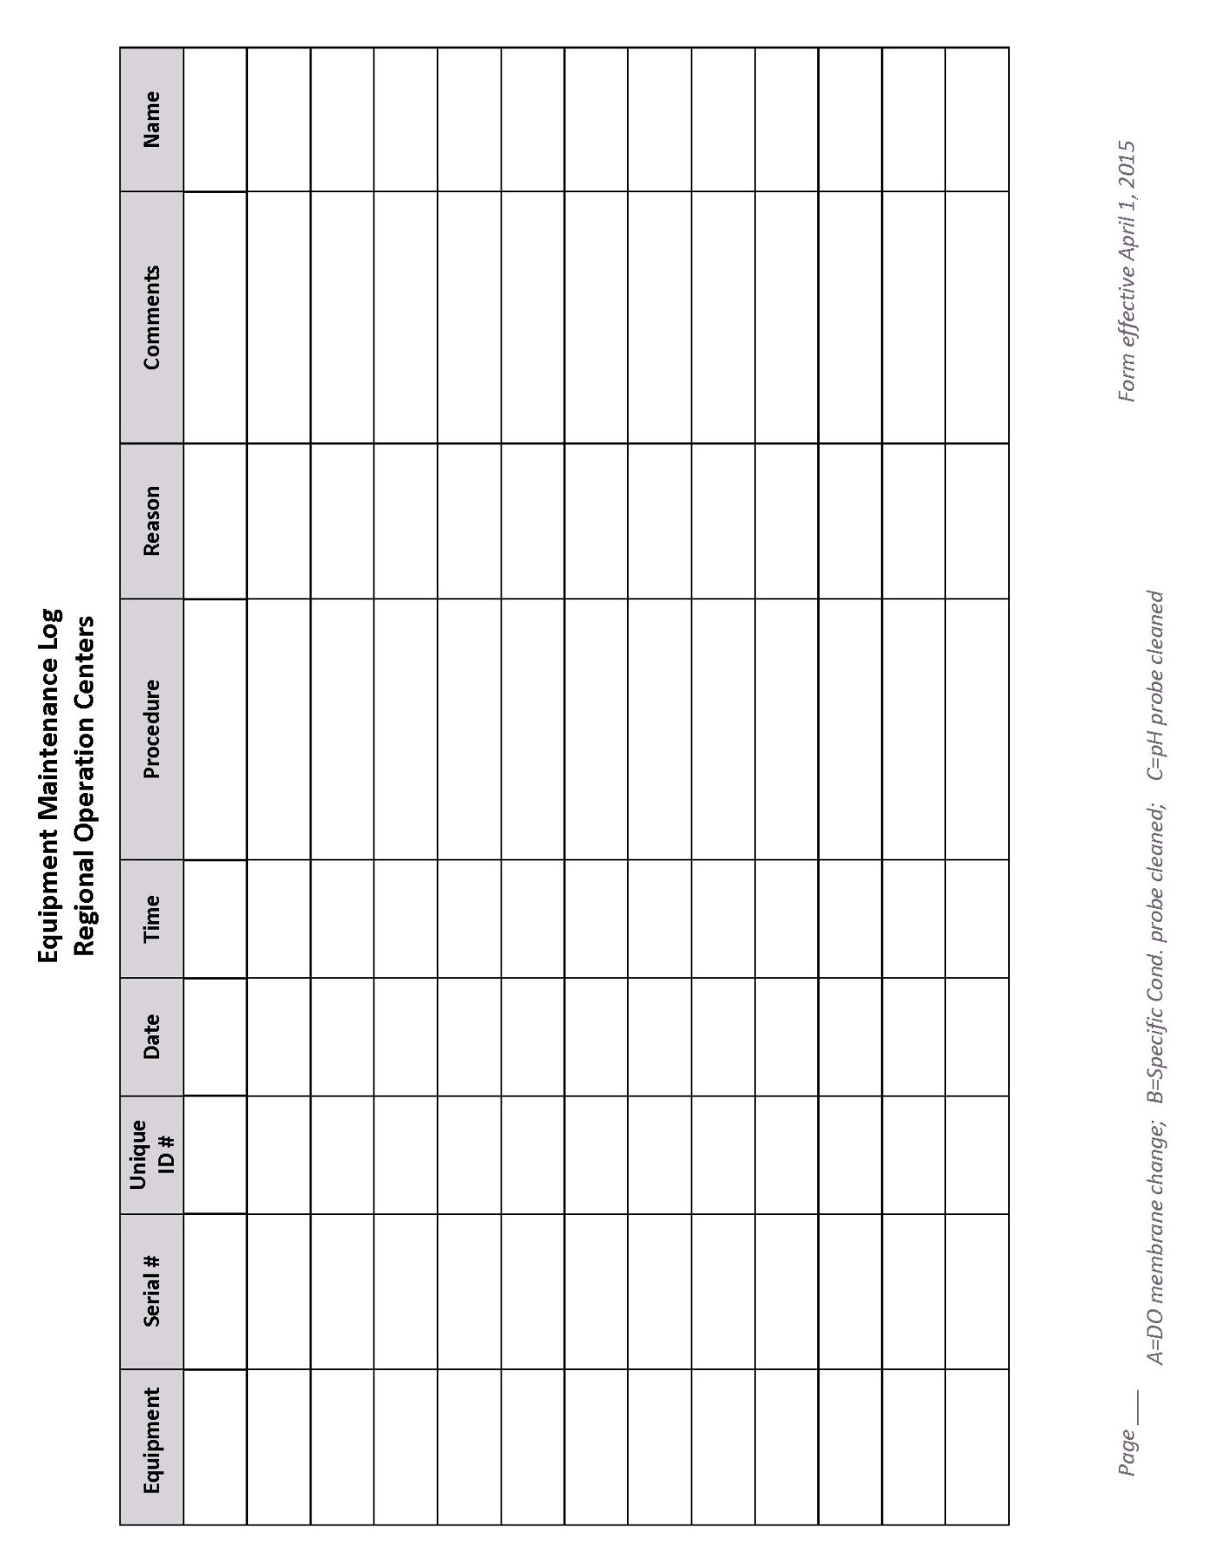

Figure 30. Surface Water Data Collection According to Total Water Depth
Total Water Depth | Primary (Surface) Measurement Depth | Bottom Measurement Depth | Total # Measurements | Sample Collection Depth
< 0.1 m | None | None | 0 | None
≥ 0.1 m and < 0.6 m | Mid-depth | None | 1 | Mid-depth
≥ 0.6 m and < 1.5 m | 0.3 m below surface | None | 1 | 0.3 m below surface
≥ 1.5 m | 0.3 m below surface | 0.5 m above bottom | 2 | 0.3 m below  surface

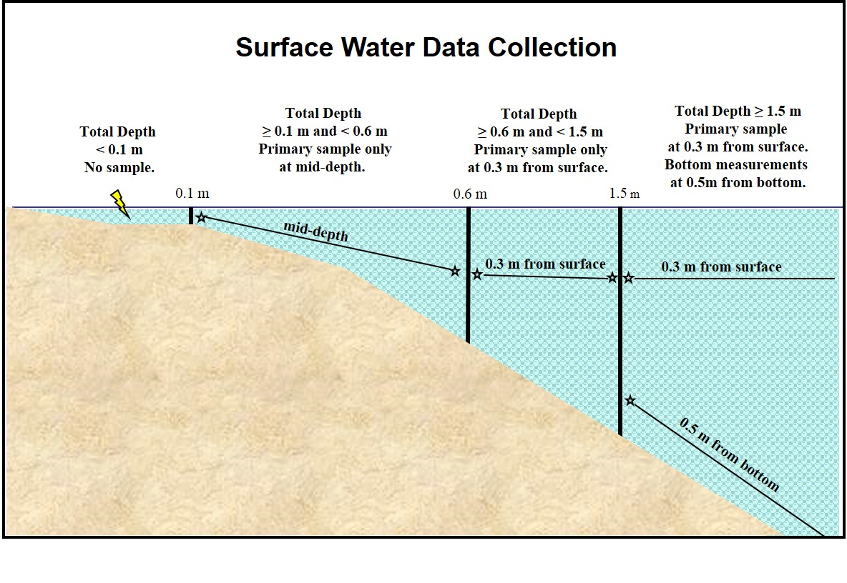

Figure 31. Example Laboratory Production and Container Numbers Label

Figure 32. Quality Assurance, Precision and Accuracy
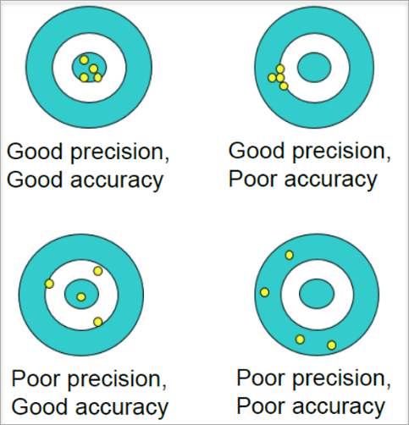

Figure 33. Blank Result Review flow Chart
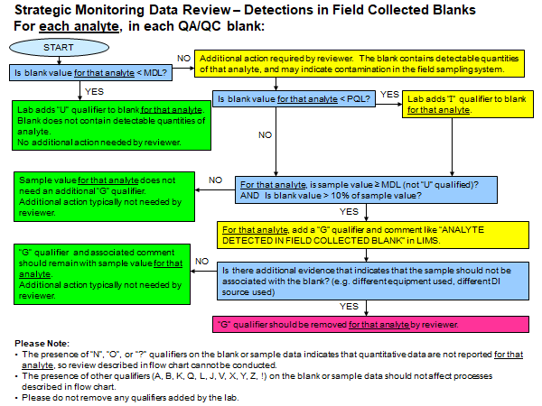

Figure 34. Relative Percent Difference Formula
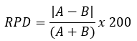

Figure 35. SCI Preservation

Figure 36. Quarterly Temperature Verification Log Page 1 of 2
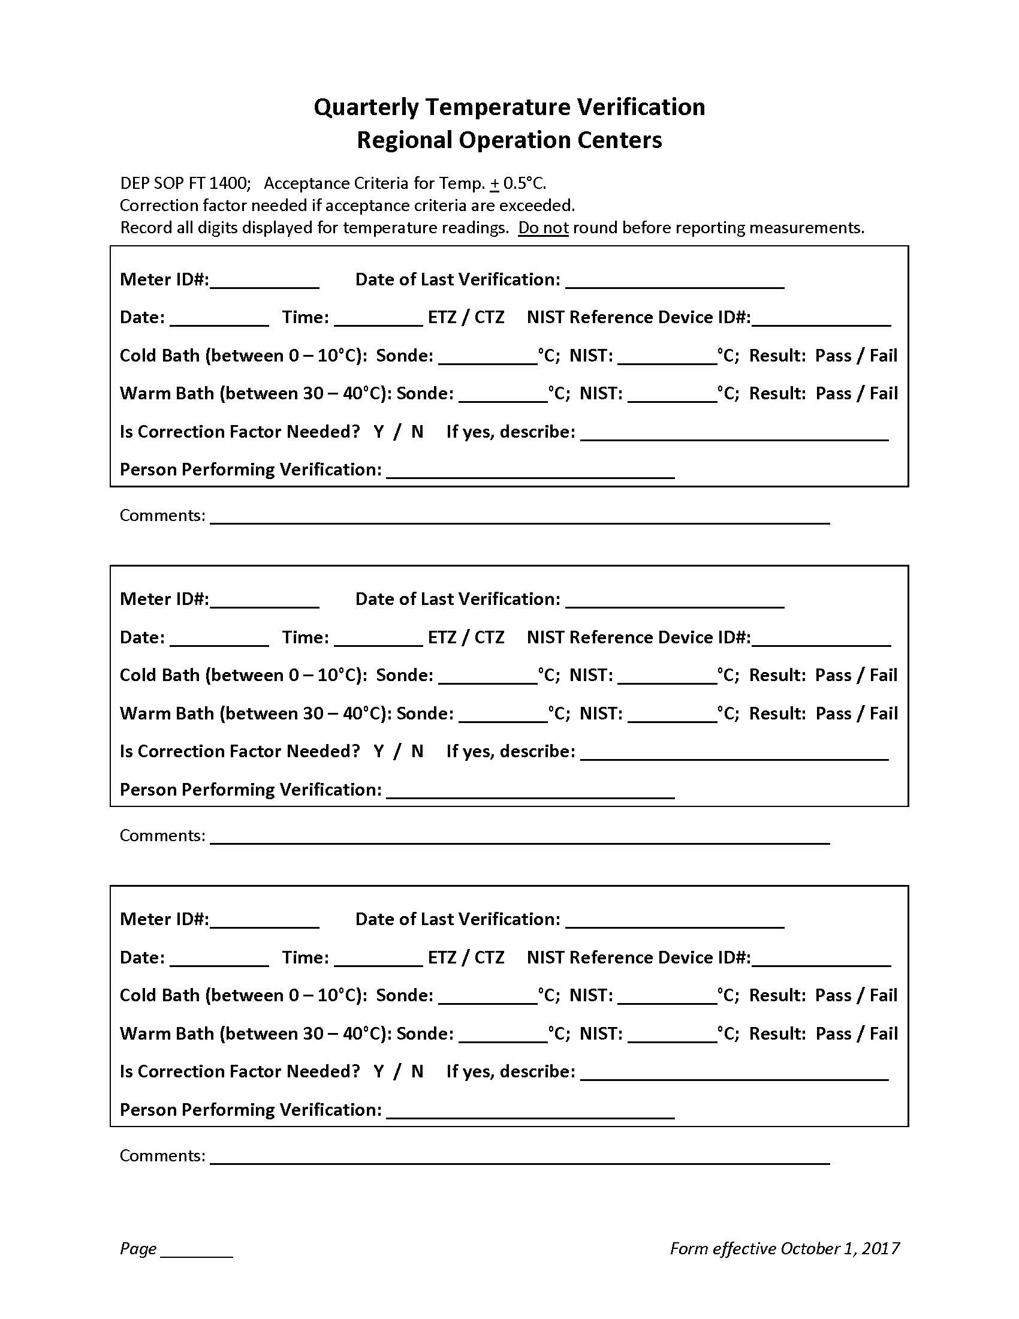

Figure 37. Quarterly Temperature Verification Log Page 2 of 2

Figure 38. Depth Verification Log Page 1 of 2
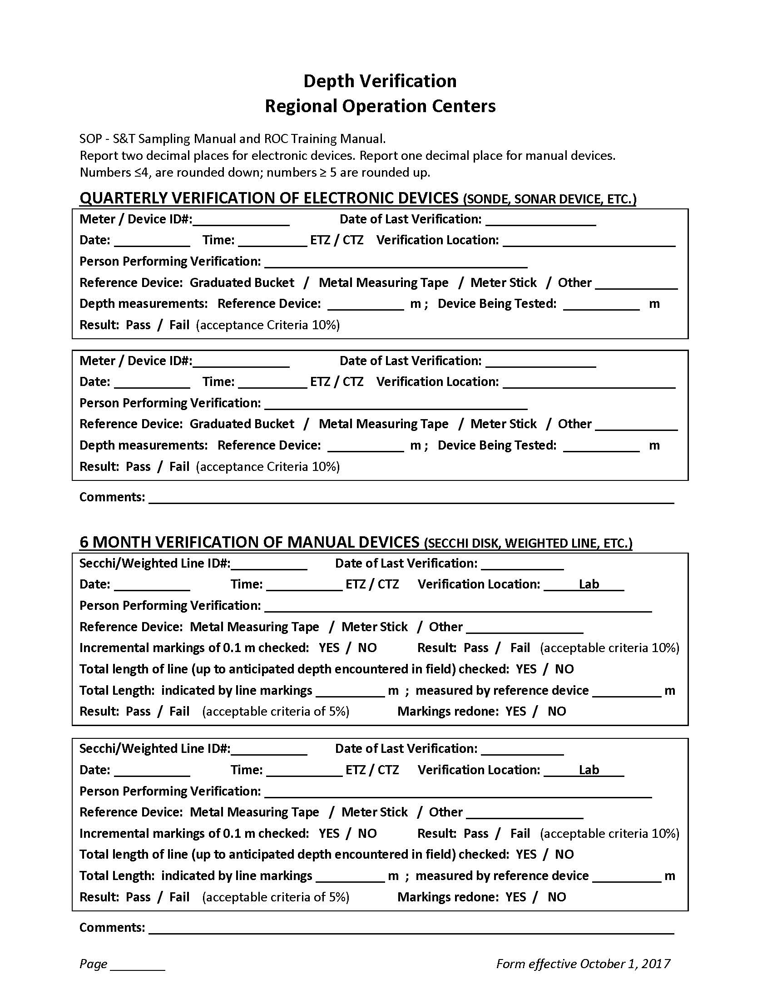

Figure 39. Depth Verification Log Page 2 of 2

Figure 40. Required Bioassessment Documentation
Bioassessment | Stream WBID |  |  |  | Lake WBID
Bioassessment | RPS Field Sheet | LVS Field Sheet | HA Sketch  HA Score | PhysChem Form | LVI Data Sheet | Lake HA Field Sheet | Lake Observation Field Sheet
SCI | X | X | X | X
RPS | X | X | X | X
LVS | X | X | X | X
HA |  |  | X | X
PhysChem |  |  | X | X
LVI |  |  |  |  | X | X | X

Figure 41. SCI Site Evaluation Form (Page 1 of 4)
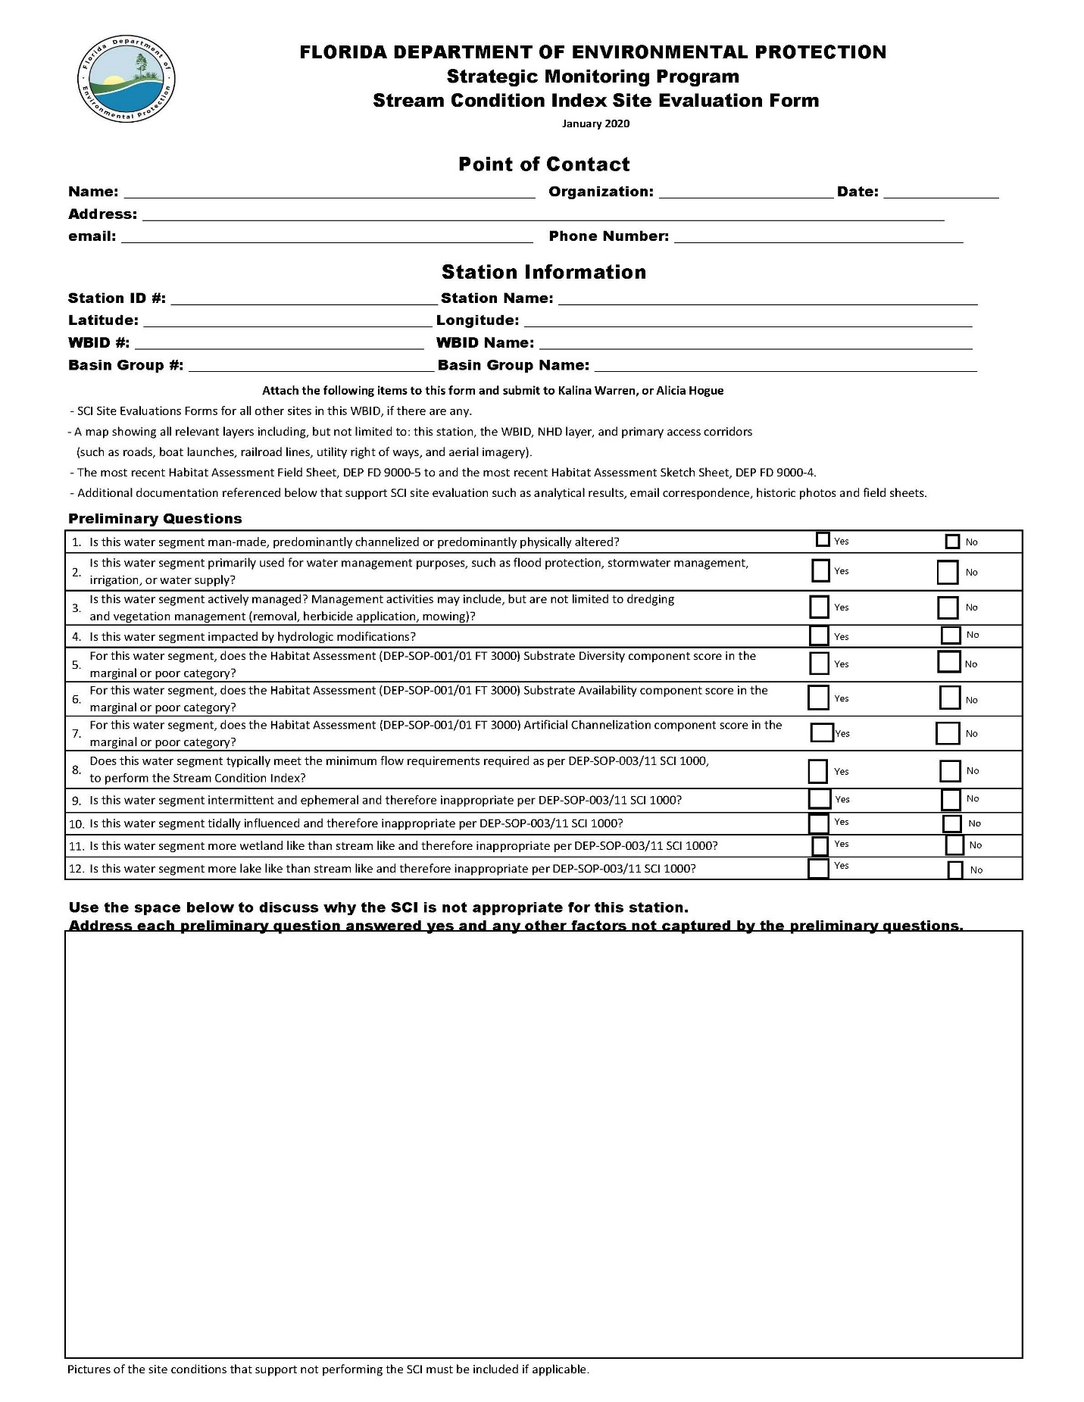

Figure 42. SCI Site Evaluation Form (Page 2 of 4)
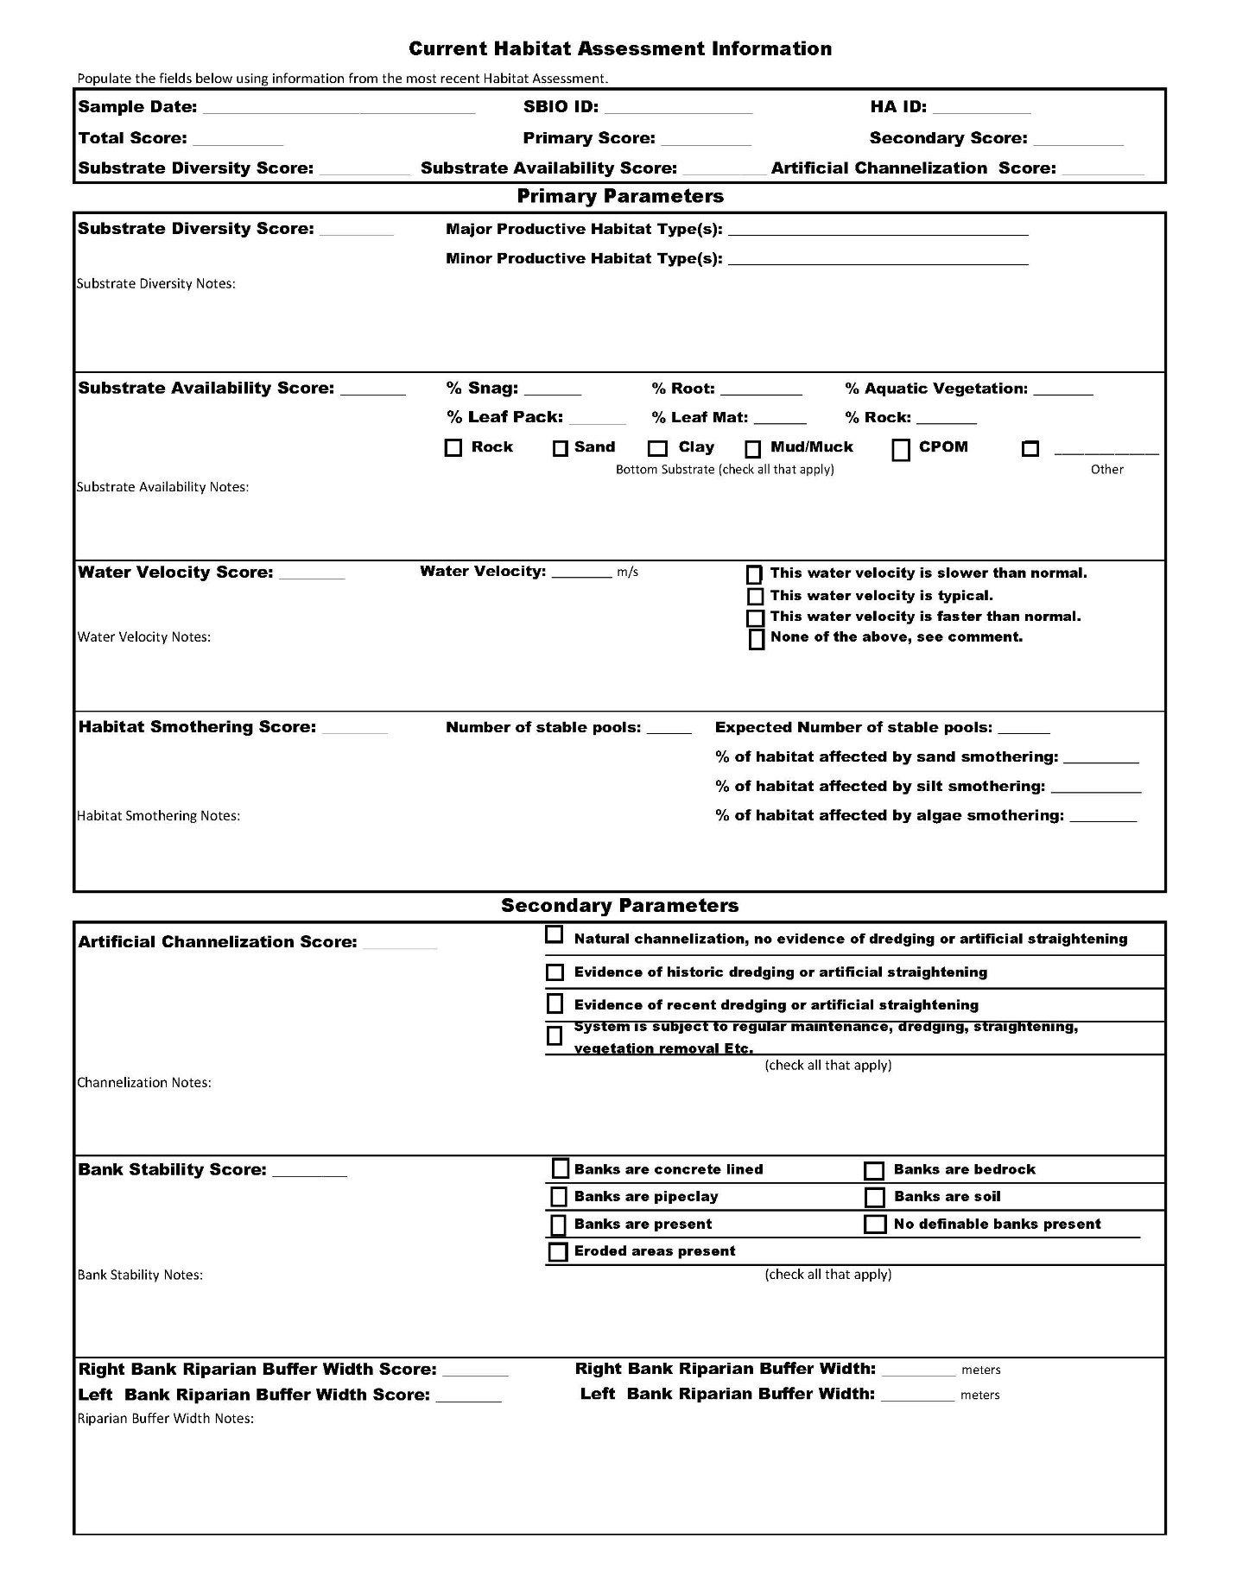

Figure 43. SCI Site Evaluation Form (Page 3 of 4)
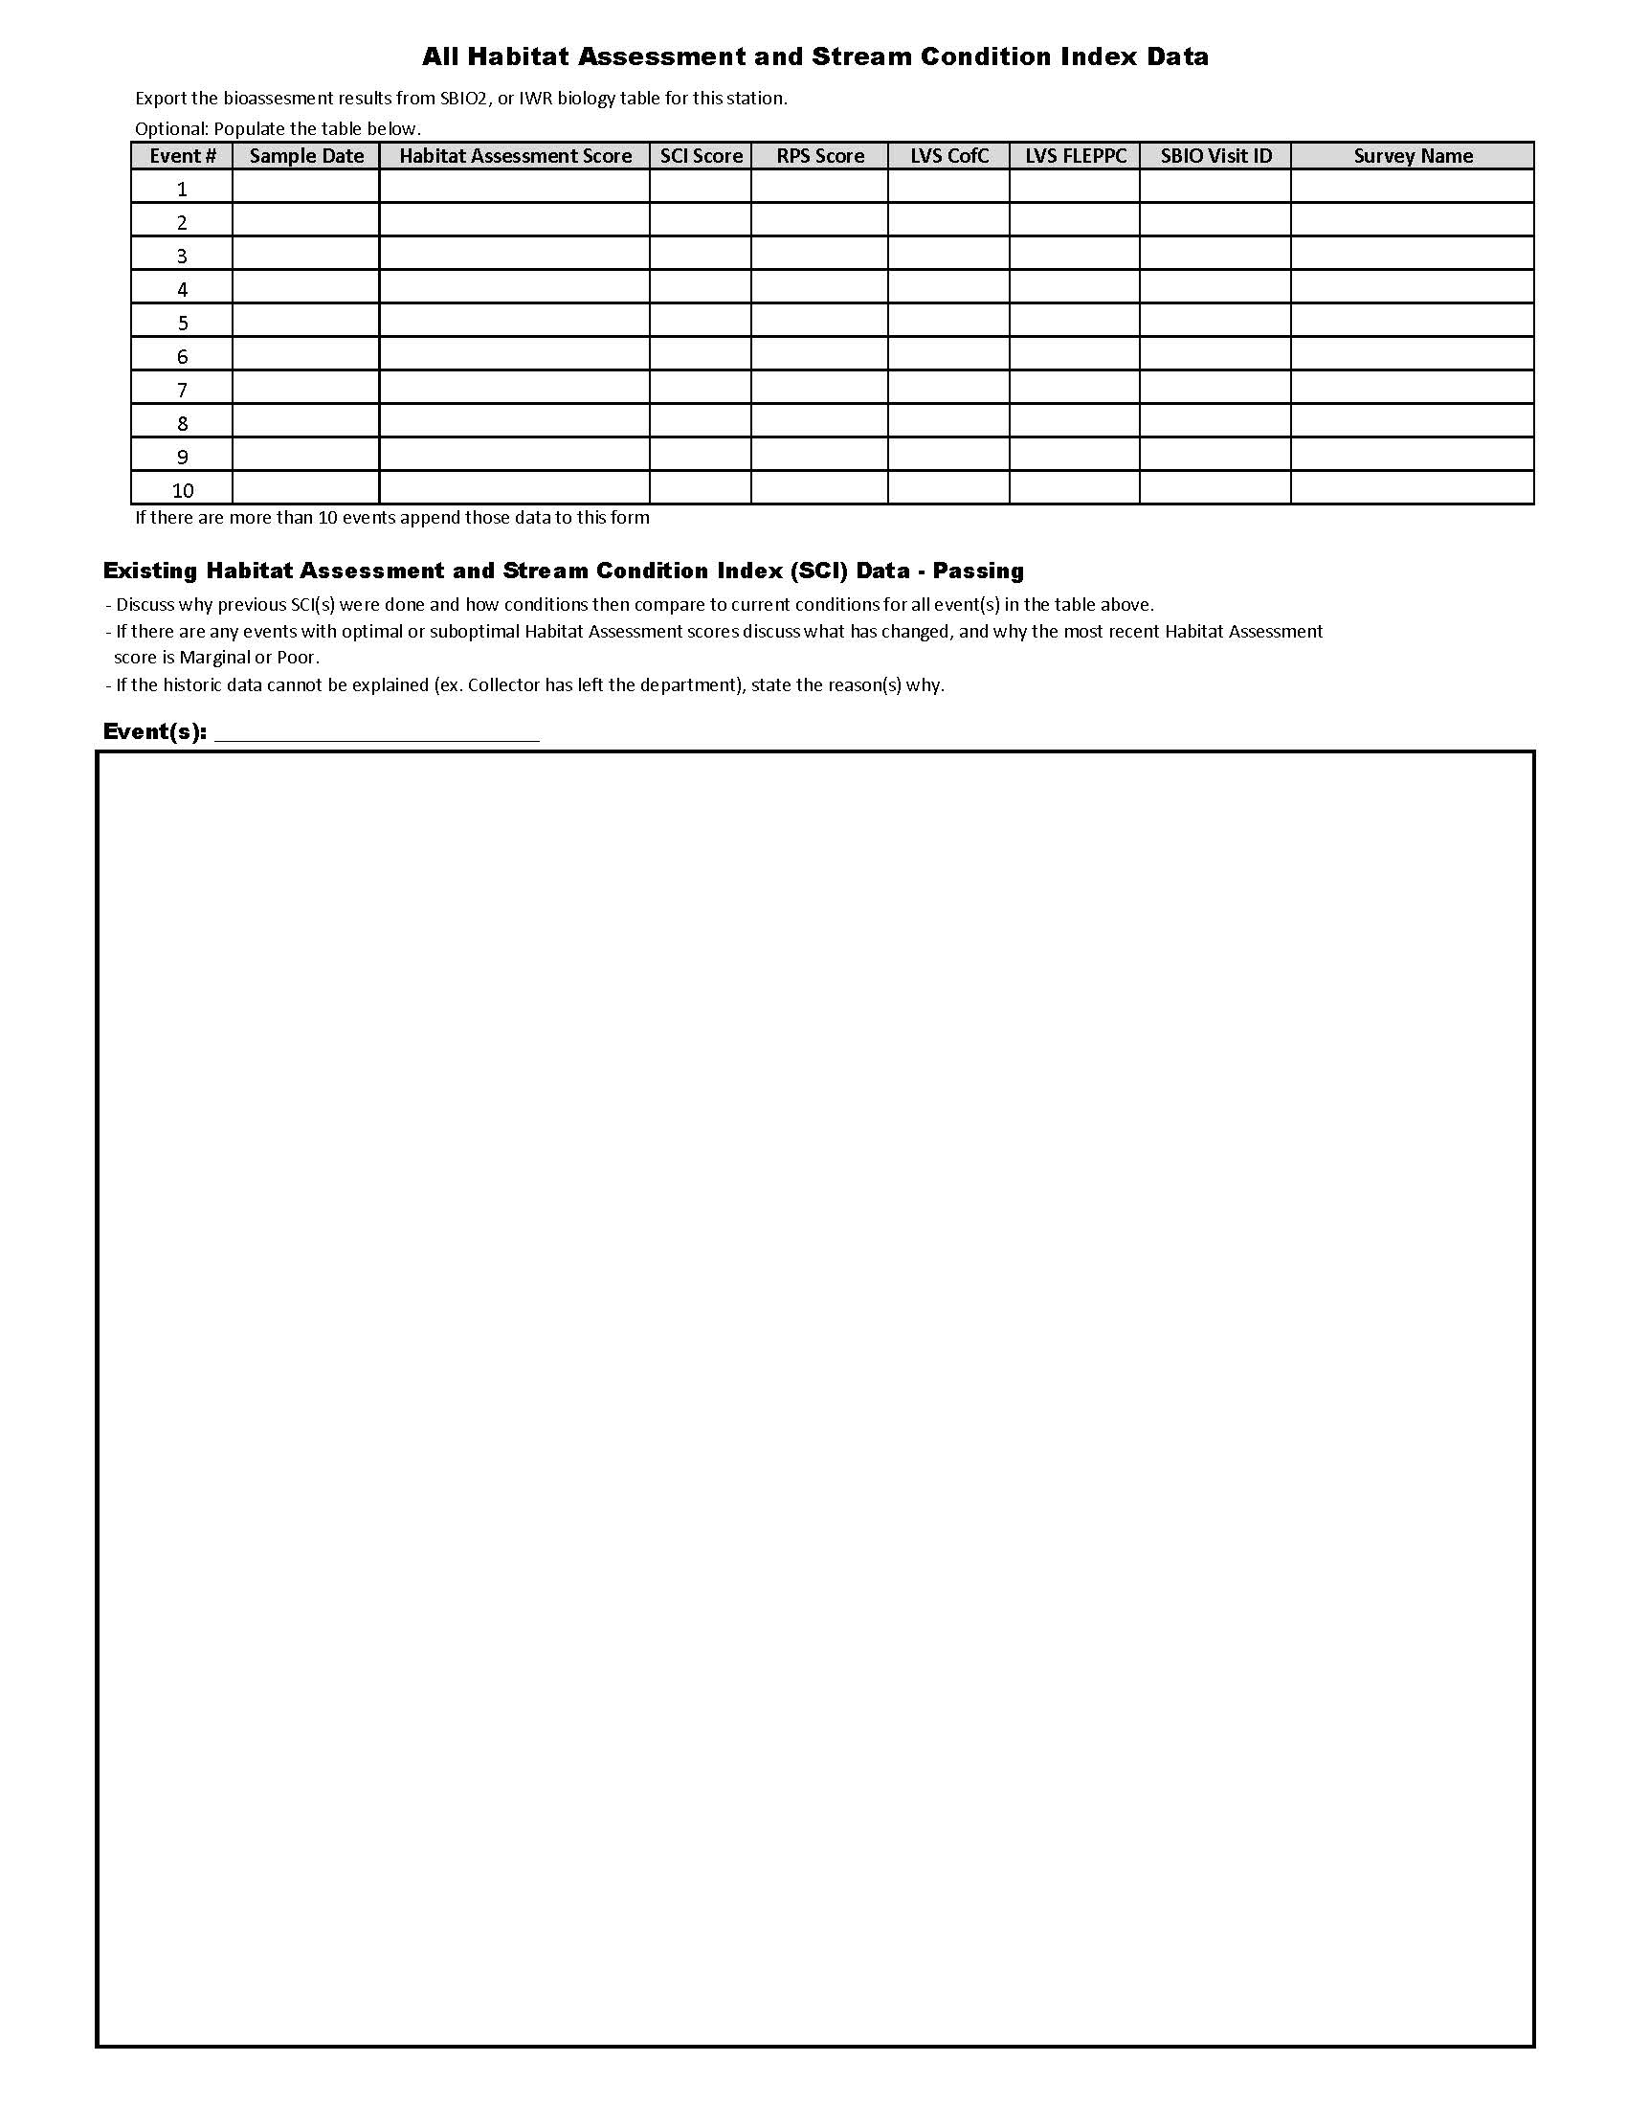

Figure 44. SCI Site Evaluation Form (Page 4 of 4)
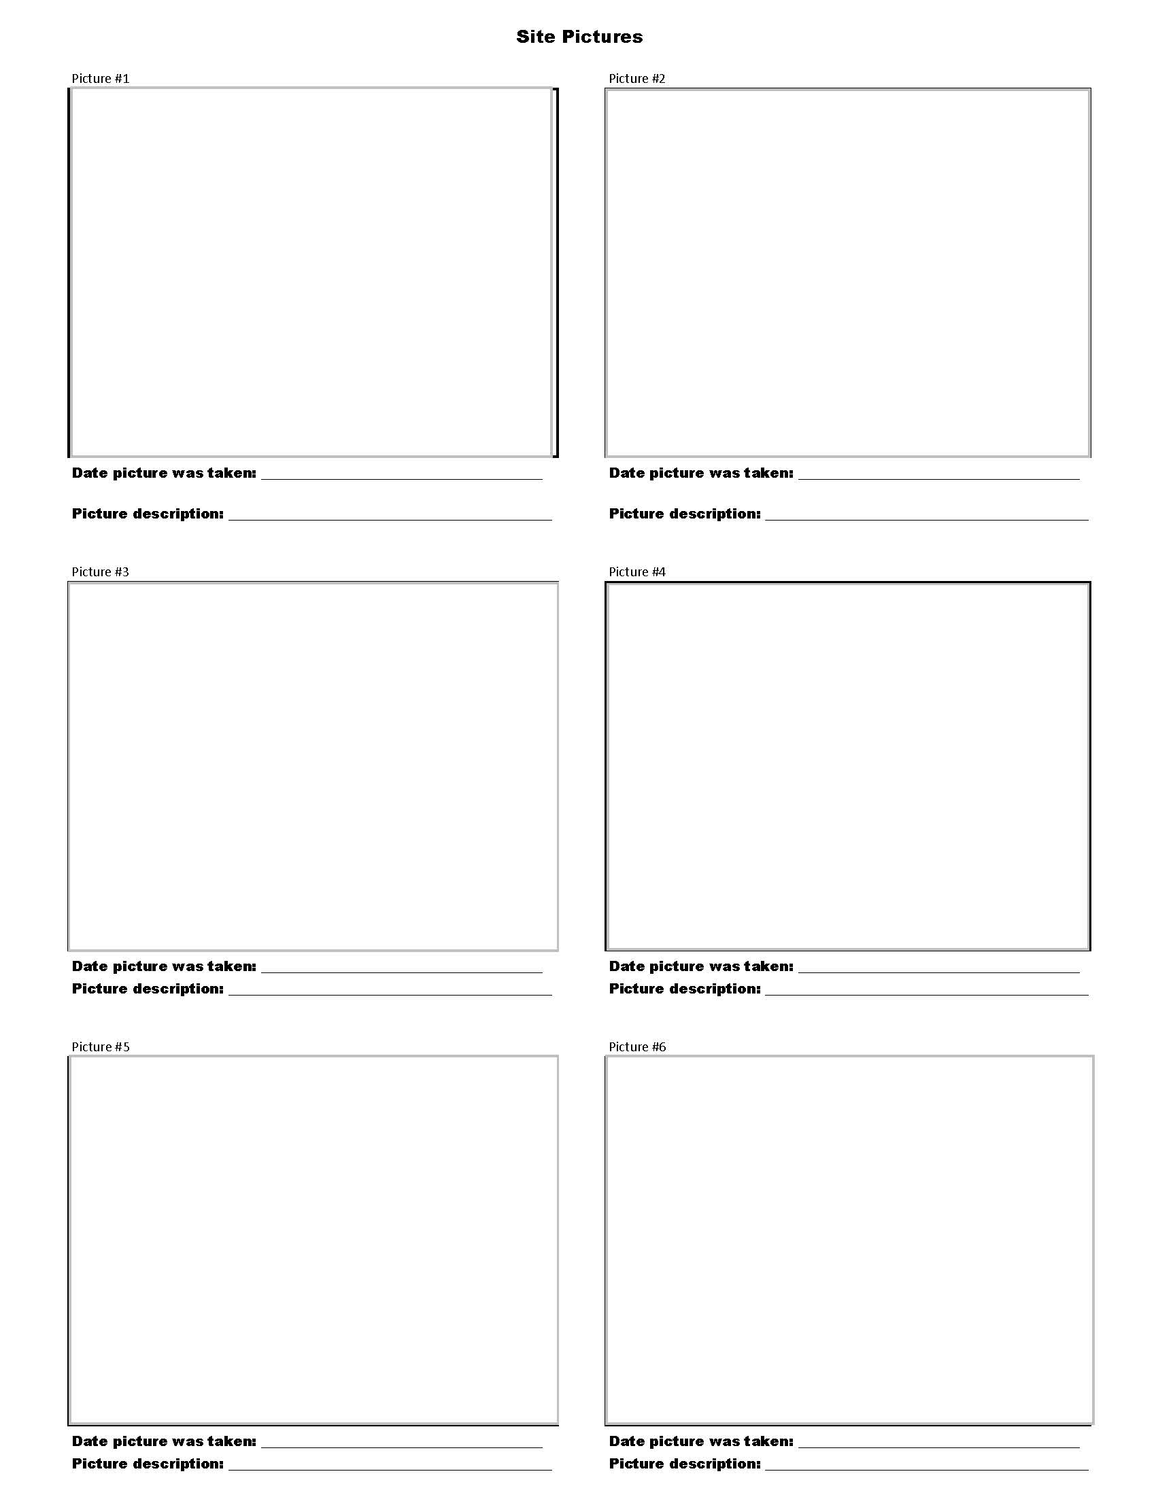

Figure 45. RPS Conceptual Layout
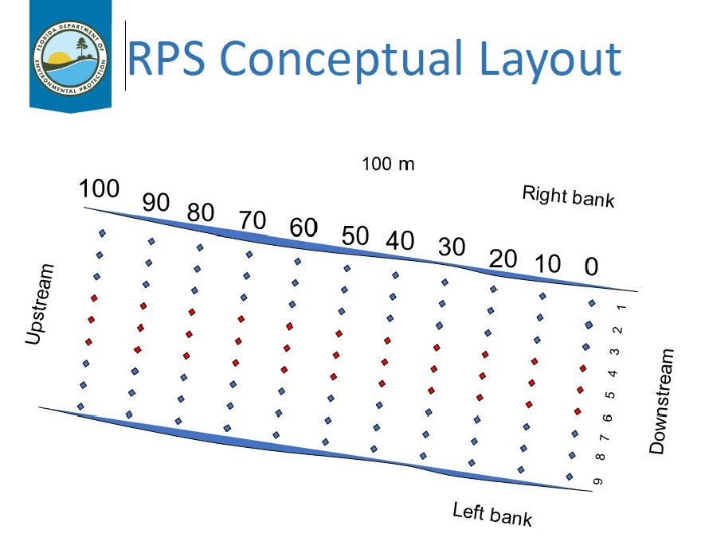

Figure 46. Plant-ID Label
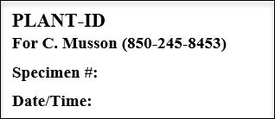

Figure 47. Lake Vegetation Index Quadrants

Figure 48. Lake Vegetation Index Sampling Section
Figure 49. Lake Vegetation Index Regions

Figure 50. Continuous Monitoring Sond Deployment
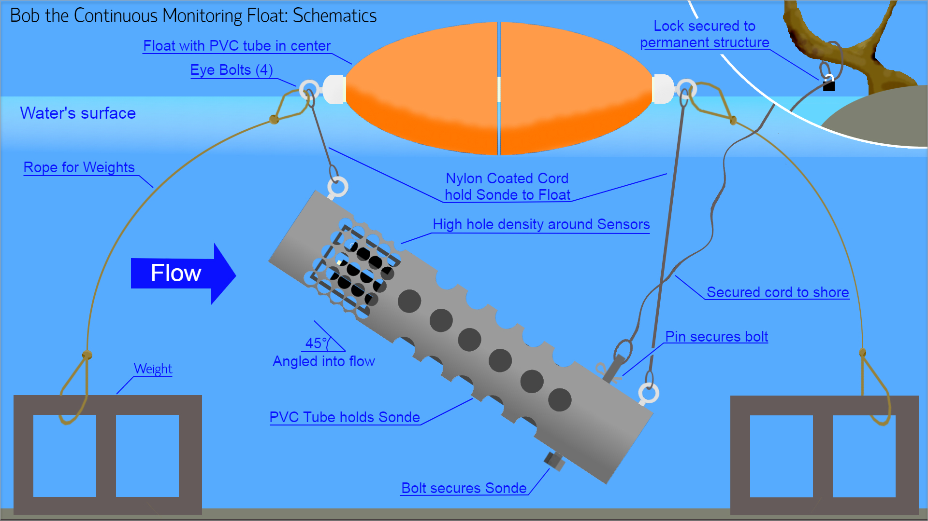

Figure 51. Continuous Monitoring Field Sheet
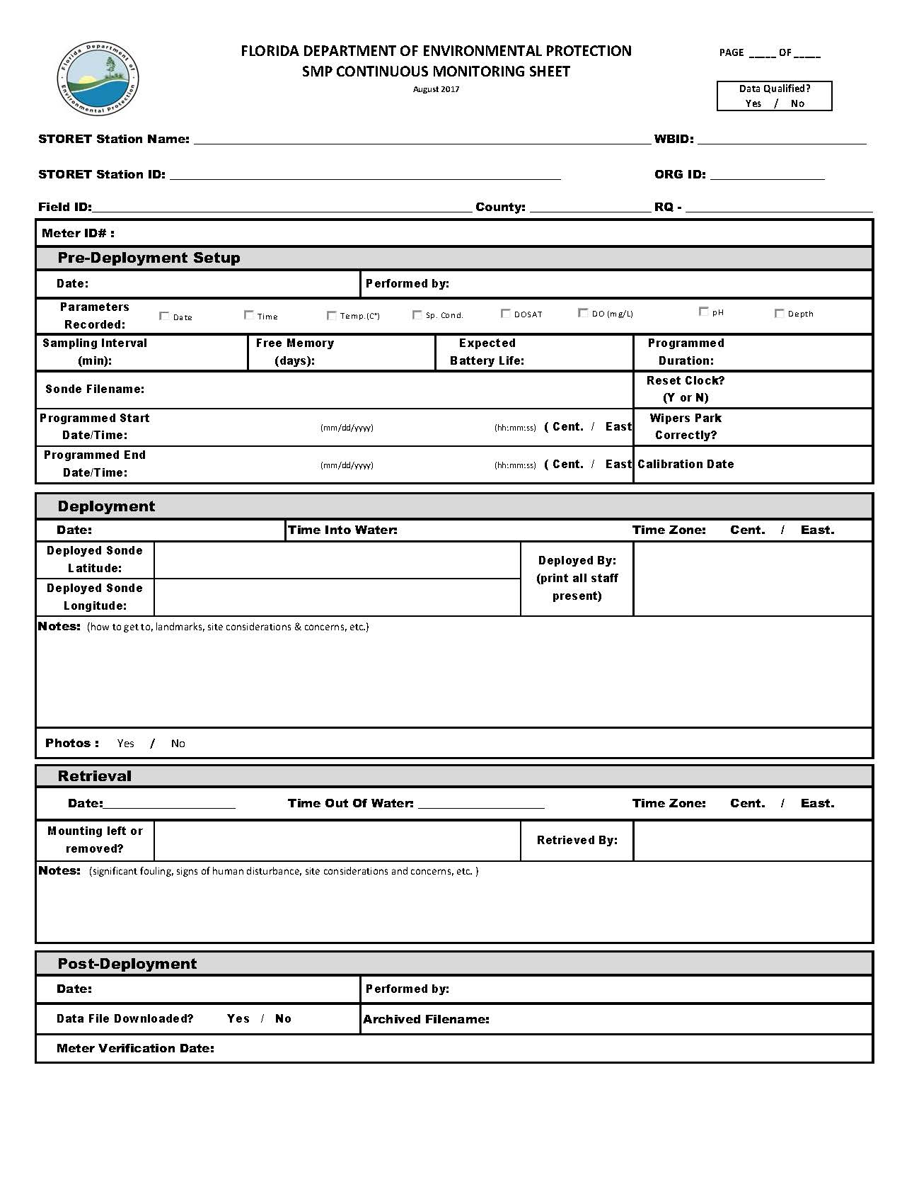

Figure 52. DMT Field Blank example

Figure 53. DMT Duplicate example

Figure 54. SMP Folder Hierarchy Guidance (Page 1 of 2)
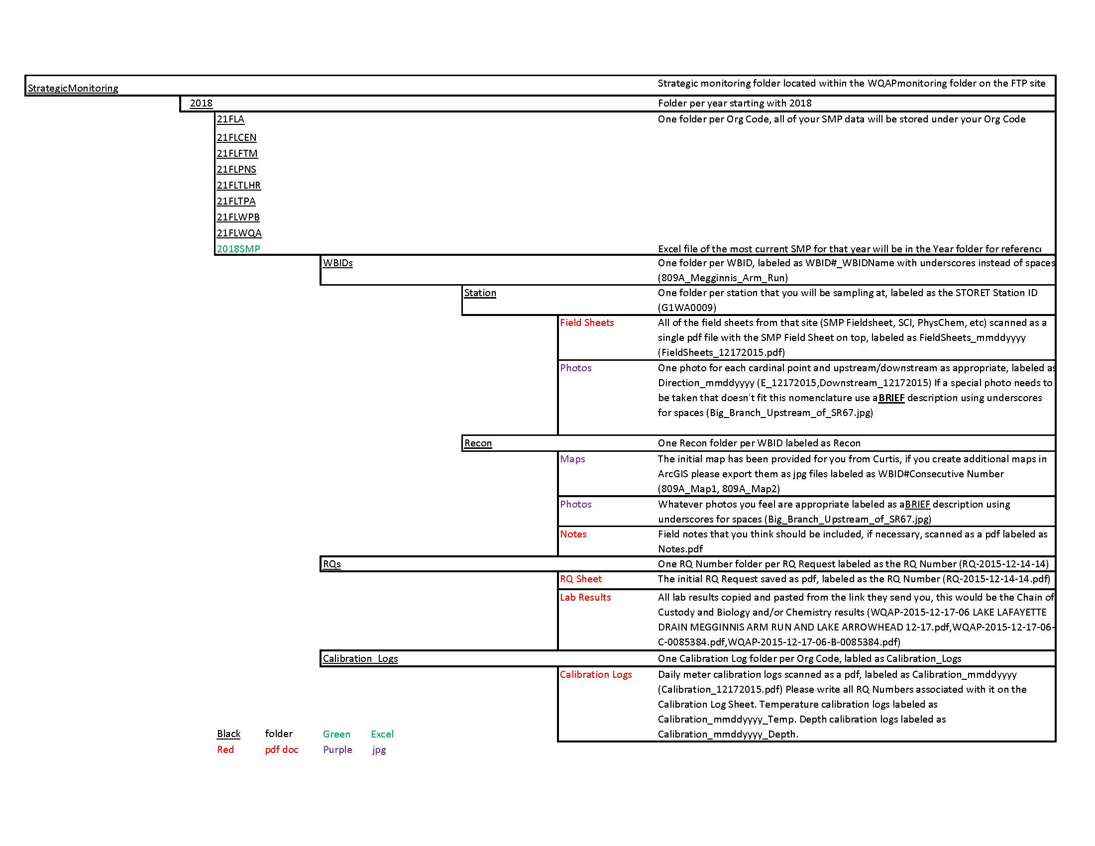
Figure 54. SMP Folder Hierarchy Guidance (Page 2 of 2)
