Integrated Water Quality Assessment for Florida:
2010 305(b) Report
and 303(d) List Update

APPENDICES

September 2010
Florida Department of Environmental Protection
Division of Environmental Assessment and Restoration
Tallahassee, Florida
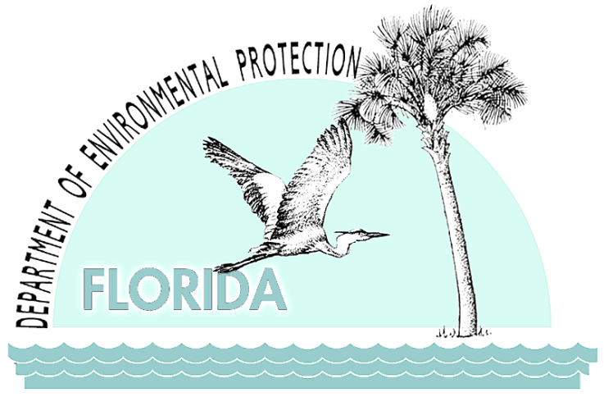

Florida Department of Environmental Protection
Division of Water Resource Management
Bureau of Watershed Management
2600 Blair Stone Road
Tallahassee, Florida 32399-2400
www2.dep.state.fl.us/water/

Table of Contents

APPENDIX A: Maps and Tables with 2004–08 Status Network Surfacae Water Assessment Results for Large Lakes, Small Lakes, Rivers, and Streams 1
APPENDIX B: Discussion of Status Network Surface Water Indicators for Rivers, Streams, and Lakes, and Ground Water Indicators for Confined and Unconfined Aquifers 50
Surface Water Indicators for Rivers, Streams, and Lakes 50
Fecal Coliform Bacteria 50
Dissolved Oxygen 50
Un-ionized Ammonia 51
Chlorophyll a 51
Trophic State Index 51
Ground Water Indicators 52
Total Coliform Bacteria 52
Fecal Coliform Bacteria 53
Arsenic 53
Cadmium 53
Chromium 54
Fluoride 54
Lead 54
Nitrate-Nitrite 54
Sodium 55
APPENDIX C: Maps and Tables with 2004–08 Probabilistic Ground Water Assessment Results for Confined Aquifers and Unconfined Aquifers 56
APPENDIX D. Impaired Surface Waters Rule Methodology for Evaluating Impairment for the Basin Assessments 111
Aquatic Life Based Attainment 111
Exceedances of Numeric Water Quality Criteria 111
Exceedances of Nutrient Thresholds 112
Exceedances of Biological Thresholds 113
Lake Condition Index 114
Stream Condition Index 114
BioReconnaissance 115
Biological Integrity Standard 115
Evaluation of Toxicity Data 115
Primary Contact and Recreation Attainment 116
Fish and Shellfish Consumption Attainment 116
Drinking Water Attainment and Protection of Human Health 116
Appendix E: Impaired Lakes in Florida, Group 1–5 Basins 117

List of Tables

Table A.1. Percentage of Rivers Meeting Threshold Value for DO Calculated Using Probabilistic Monitoring Design 3
Table A.2. Percentage of Rivers Meeting Threshold Value for Fecal Coliform Calculated Using Probabilistic Monitoring Design 6
Table A.3. Percentage of Rivers Meeting Threshold Value for Un-ionized Ammonia Calculated Using Probabilistic Monitoring Design 9
Table A.4. Percentage of Rivers Meeting Threshold Value for Chlorophyll a Calculated Using Probabilistic Monitoring Design 12
Table A.5. Percentage of Streams Meeting Threshold Value for DO Calculated Using Probabilistic Monitoring Design 15
Table A.6. Percentage of Streams Meeting Threshold Value for Fecal Coliform Calculated Using Probabilistic Monitoring Design 18
Table A.7. Percentage of Streams Meeting Threshold Value for Un-ionized Ammonia Calculated Using Probabilistic Monitoring Design 21
Table A.8. Percentage of Streams Meeting Threshold Value for Chlorophyll a Calculated Using Probabilistic Monitoring Design 24
Table A.9. Percentage of Large Lakes Meeting Threshold Value for DO Calculated Using Probabilistic Monitoring Design 27
Table A.10. Percentage of Large Lakes Meeting Threshold Value for Fecal Coliform Calculated Using Probabilistic Monitoring Design 30
Table A.11. Percentage of Large Lakes Meeting Threshold Value for Un-ionized Ammonia Calculated Using Probabilistic Monitoring Design 33
Table A.12. Percentage of Large Lakes Meeting Threshold Value for TSI Calculated Using Probabilistic Monitoring Design 36
Table A.13. Percentage of Small Lakes Meeting Threshold Value for DO Calculated Using Probabilistic Monitoring Design 39
Table A.14. Percentage of Small Lakes Meeting Threshold Value for Fecal Coliform Calculated Using Probabilistic Monitoring Design 42
Table A.15. Percentage of Small Lakes Meeting Threshold Value for Un-ionized Ammonia Calculated Using Probabilistic Monitoring Design 45
Table A.16. Percentage of Small Lakes Meeting Threshold Value for TSI Calculated Using Probabilistic Monitoring Design 48
Table B.1. Status Monitoring Network Water Quality Standards for Surface Water 50
Table B.2. Status Monitoring Network Water Quality Standards for Ground Water 52
Table C.1. Status Monitoring Network Water Quality Criteria/Thresholds for Ground Water 56
Table C.1. Percentage of Confined Aquifers Meeting Threshold Value for Arsenic Calculated Using Probabilistic Monitoring Design 58
Table C.2. Percentage of Confined Aquifers Meeting Threshold Value for Cadmium Calculated Using Probabilistic Monitoring Design 61
Table C.3. Percentage of Confined Aquifers Meeting Threshold Value for Chromium Calculated Using Probabilistic Monitoring Design 64
Table C.4. Percentage of Confined Aquifers Meeting Threshold Value for Fluoride Calculated Using Probabilistic Monitoring Design 67
Table C.5. Percentage of Confined Aquifers Meeting Threshold Value for Lead Calculated Using Probabilistic Monitoring Design 70
Table C.6. Percentage of Confined Aquifers Meeting Threshold Value for Nitrate + Nitrite Calculated Using Probabilistic Monitoring Design 73
Table C.7. Percentage of Confined Aquifers Meeting Threshold Value for Sodium Calculated Using Probabilistic Monitoring Design 76
Table C.8. Percentage of Confined Aquifers Meeting Threshold Value for Fecal Coliform Calculated Using Probabilistic Monitoring Design 79
Table C.9. Percentage of Confined Aquifers Meeting Threshold Value for Total Coliform Calculated Using Probabilistic Monitoring Design 82
Table C.10. Percentage of Unconfined Aquifers Meeting Threshold Value for Arsenic Calculated Using Probabilistic Monitoring Design 85
Table C.11. Percentage of Unconfined Aquifers Meeting Threshold Value for Cadmium Calculated Using Probabilistic Monitoring Design 88
Table C.12. Percentage of Unconfined Aquifers Meeting Threshold Value for Chromium Calculated Using Probabilistic Monitoring Design 91
Table C.13. Percentage of Unconfined Aquifers Meeting Threshold Value for Fluoride Calculated Using Probabilistic Monitoring Design 94
Table C.14. Percentage of Unconfined Aquifers Meeting Threshold Value for Lead Calculated Using Probabilistic Monitoring Design 97
Table C.15. Percentage of Unconfined Aquifers Meeting Threshold Value for Nitrate + Nitrite Calculated Using Probabilistic Monitoring Design 100
Table C.16. Percentage of Unconfined Aquifers Meeting Threshold Value for Sodium Calculated Using Probabilistic Monitoring Design 103
Table C.17. Percentage of Unconfined Aquifers Meeting Threshold Value for Fecal Coliform Calculated Using Probabilistic Monitoring Design 106
Table C.18. Percentage of Unconfined Aquifers Meeting Threshold Value for Total Coliform Calculated Using Probabilistic Monitoring Design 109
Table D.1. SCI Metrics for the Northeast, Panhandle, and Peninsula Regions of Florida 114
Table D.2. BioRecon Metrics for the Northeast, Panhandle, and Peninsula Regions of Florida 115
Table D.3. BioRecon Sample Size and Index Range 115

List of Figures

Figure A.1. Summary of DO Assessment for Rivers 2
Figure A.2. Summary of Fecal Coliform Assessment for Rivers 5
Figure A.3. Summary of Un-ionized Ammonia Assessment for Rivers 8
Figure A.4. Summary of Chlorophyll a Assessment for Rivers 11
Figure A.5. Summary of DO Assessment for Streams 14
Figure A.6. Summary of Fecal Coliform Assessment for Streams 17
Figure A.7. Summary of Un-ionized Ammonia Assessment for Streams 20
Figure A.8. Summary of Chlorophyll a Assessment for Streams 23
Figure A.9. Summary of DO Assessment for Large Lakes 26
Figure A.10. Summary of Fecal Coliform Assessment for Large Lakes 29
Figure A.11. Summary of Un-ionized Ammonia Assessment for Large Lakes 32
Figure A.12. Summary of TSI Assessment for Large Lakes 35
Figure A.13. Summary of DO Assessment for Small Lakes 38
Figure A.14. Summary of Fecal Coliform Assessment for Small Lakes 41
Figure A.15. Summary of Un-ionized Ammonia Assessment for Small Lakes 44
Figure A.16. Summary of TSI Assessment for Small Lakes 47
Figure C.1. Summary of Arsenic Assessment for Confined Aquifers 57
Figure C.2. Summary of Cadmium Assessment for Confined Aquifers 60
Figure C.3. Summary of Chromium Assessment for Confined Aquifers 63
Figure C.4. Summary of Fluoride Assessment for Confined Aquifers 66
Figure C.5. Summary of Lead Assessment for Confined Aquifers 69
Figure C.6. Summary of Nitrate + Nitrite Assessment for Confined Aquifers 72
Figure C.7. Summary of Sodium Assessment for Confined Aquifers 75
Figure C.8. Summary of Fecal Coliform Assessment for Confined Aquifers 78
Figure C.9. Summary of Total Coliform Assessment for Confined Aquifers 81
Figure C.10. Summary of Arsenic Assessment for Unconfined Aquifers 84
Figure C.11. Summary of Cadmium Assessment for Unconfined Aquifers 87
Figure C.12. Summary of Chromium Assessment for Unconfined Aquifers 90
Figure C.13. Summary of Fluoride Assessment for Unconfined Aquifers 93
Figure C.14. Summary of Lead Assessment for Unconfined Aquifers 96
Figure C.15. Summary of Nitrate + Nitrite Assessment for Unconfined Aquifers 99
Figure C.16. Summary of Sodium Assessment for Unconfined Aquifers 102
Figure C.17. Summary of Fecal Coliform Assessment for Unconfined Aquifers 105
Figure C.18. Summary of Total Coliform Assessment for Unconfined Aquifers 108

APPENDIX A: Maps and Tables with 2004–08 Status Network Surface Water Assessment Results for Large Lakes, Small Lakes, Rivers, and Streams

The Status Network design focuses on the following four surface water resource types:
- Rivers are major rivers of the state;
- Streams are the remaining streams;
- Large Lakes are 25 acres or greater; and
- Small Lakes are 2.5 to less than 25 acres in size.

Status Network indicators include the following:
- Rivers and Streams:
- DO
- Fecal coliform
- Un-ionized ammonia (calculated)
- Chlorophyll a

- Large and Small Lakes:
- DO
- Fecal coliform
- Un-ionized ammonia (calculated)
- TSI

The threshold criteria for these indicators are as follows:
- DO: 5.0 mg/L or above.
- Fecal coliform: less than or equal to 400 counts/100mL.
- Un-ionized ammonia: less than 0.02 mg/L.
- Chlorophyll a: less than or equal to 20 μg/L.
- TSI: For samples with color less than or equal to 40 PCUs, the threshold is less than or equal to 40. For samples with color greater than 40 PCUs, the threshold is less than or equal to 60.

The light blue portion of each individual pie chart is the portion that meets the threshold for each indicator.
Note: Appendix B provides additional information on whether the thresholds listed in the tables in this appendix are water quality standards or screening levels.

Figure A.1. Summary of DO Assessment for Rivers

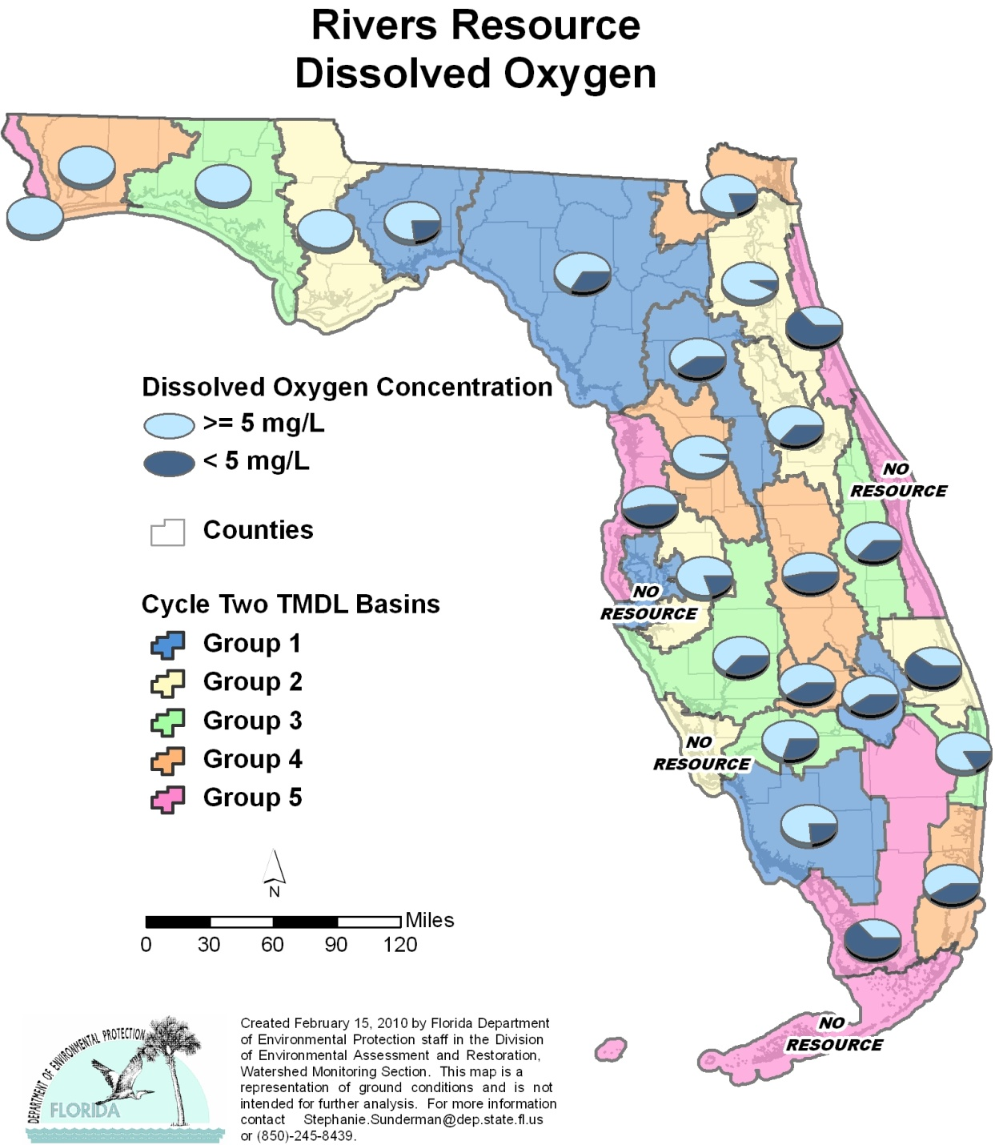

Table A.1. Percentage of Rivers Meeting Threshold Value for DO Calculated Using Probabilistic Monitoring Design
Status Network Designated Use: Recreation and Aquatic Life Units: Miles

This is a 10-column table. Column 1 lists the basin, Column 2 lists the target population, Column 3 lists the sampleable miles, Column 4 lists the dry miles, Column 5 lists the inaccessible miles, Column 6 lists the number of samples, Column 7 lists the percent meeting threshold, Column 8 lists the 95% confidence bounds, Column 9 lists the percent not meeting threshold, and Column 10 lists the assessment period.

¹ No large rivers in basin
² N/A = Not applicable
Basin | Target Population | Sampleable | Dry | Inaccessible | Number of Samples | % Meeting Threshold | 95% Confidence Bounds  (% Meeting Threshold) | % Not Meeting Threshold | Assessment Period
NWFWMD1  Ochlockonee–St. Marks | 143 | 116 | 0 | 27 | 30 | 76.7 | 65.4-87.9 | 23.3 | Aug–Oct 2004
SFWMD1  Everglades–West Coast | 255 | 207 | 0 | 48 | 30 | 76.7 | 62.6-90.7 | 23.3 | May–June 2004
SFWMD6  Lake Okeechobee | 23 | 14 | 0 | 9 | 30 | 60.0 | 47.8-72.2 | 40.0 | May–June 2004
SJRWMD1  Ocklawaha | 62 | 54 | 0 | 8 | 30 | 60.00 | 47.8-72.2 | 40.0 | May–June 2004
SRWMD1  Suwannee | 333 | 294 | 20 | 19 | 30 | 66.7 | 53.5-79.8 | 33.3 | Aug–Sept 2004
SWFWMD1  Tampa Bay¹ | 0 | 0 | 0 | 0 | 0 | N/A² | N/A² | N/A² | N/A²
NWFWMD2  Apalachicola–Chipola | 184 | 178 | 0 | 6 | 30 | 100.0 | 100.0 | 0.0 | Aug-Sept 2005
SFWMD2  St Lucie–Loxahatchee | 128 | 128 | 0 | 0 | 30 | 40.0 | 29.4-50.6 | 60.0 | May-July 2005
SFWMD7  Charlotte Harbor¹ | 0 | 0 | 0 | 0 | 0 | N/A² | N/A² | N/A² | N/A²
SJRWMD2  Lower St. Johns | 130 | 95 | 6 | 29 | 30 | 93.3 | 85.6-100.0 | 6.7 | May-June 2005
SJRWMD6  Middle St. Johns | 124 | 95 | 0 | 29 | 30 | 63.3 | 52.0-74.7 | 36.7 | May-July 2005
SWFWMD2  Tampa Bay Tributaries | 127 | 69 | 0 | 58 | 30 | 80.0 | 68.3-91.7 | 20.0 | May-Dec 2005
NWFWMD3  Choctawhatchee–  St. Andrews | 169 | 127 | 17 | 25 | 30 | 100.0 | 100.0 | 0.0 | Aug-Oct 2006
SFWMD3  Caloosahatchee | 44 | 44 | 0 | 0 | 30 | 70.0 | 65.0-75.0 | 30.0 | May-June 2006
SFWMD8  Lake Worth Lagoon–  Palm Beach Coast | 87 | 87 | 0 | 0 | 30 | 83.3 | 71.5-95.2 | 16.7 | May 2006
SJRWMD3  Upper St. Johns | 62 | 62 | 0 | 0 | 30 | 63.3 | 50.2-76.5 | 36.7 | May-June 2006
SWFWMD3  Sarasota Bay–Peace–Myakka | 136 | 95 | 0 | 41 | 30 | 63.3 | 52.1-74.6 | 36.7 | June-July 2006
NWFWMD4  Pensacola | 243 | 235 | 0 | 8 | 30 | 100.0 | 100.0 | 0.0 | Aug-Sept 2007
SFWMD4  Fisheating Creek | 105 | 58 | 0 | 47 | 27 | 59.3 | 48.4-70.1 | 40.7 | July 2007
SFWMD9  Kissimmee River | 177 | 82 | 8 | 87 | 30 | 53.3 | 39.0-67.7 | 46.7 | May-July 2007
SFWMD10  Southeast Coast–  Biscayne Bay | 179 | 179 | 0 | 0 | 27 | 59.3 | 45.0-73.5 | 40.7 | May-July 2007
SJRWMD4  Nassau–St. Marys | 116 | 53 | 0 | 63 | 30 | 80.0 | 69.5-90.5 | 20.0 | May-June 2007
SWFWMD4  Withlacoochee | 88 | 42 | 23 | 23 | 30 | 96.7 | 91.1-100.0 | 3.3 | March-May 2007
NWFWMD5  Perdido | 22 | 19 | 0 | 3 | 30 | 100.0 | 100.0 | 0.0 | Aug-Sept 2008
SFWMD5  Everglades | 313 | 313 | 0 | 0 | 30 | 36.7 | 24.3-49.0 | 63.3 | May-July 2008
SFWMD11  Florida Keys¹ | 0 | 0 | 0 | 0 | 0 | N/A² | N/A² | N/A² | N/A²
SJRWMD5  Indian River Lagoon¹ | 0 | 0 | 0 | 0 | 0 | N/A² | N/A² | N/A² | N/A²
SJRWMD7  Upper East Coast | 12 | 4 | 5 | 3 | 30 | 36.7 | 27.0-46.4 | 63.3 | May-June 2008
SWFWMD5  Springs Coast | 20 | 14 | 5 | 1 | 30 | 53.3 | 39.2-67.4 | 46.7 | June-July 2008
Summary of All Basins | 3,282 | 2,664 | 84 | 534 | 744 | 71.8 | 69.1-74.5 | 28.2 | 2004–08

Figure A.2. Summary of Fecal Coliform Assessment for Rivers

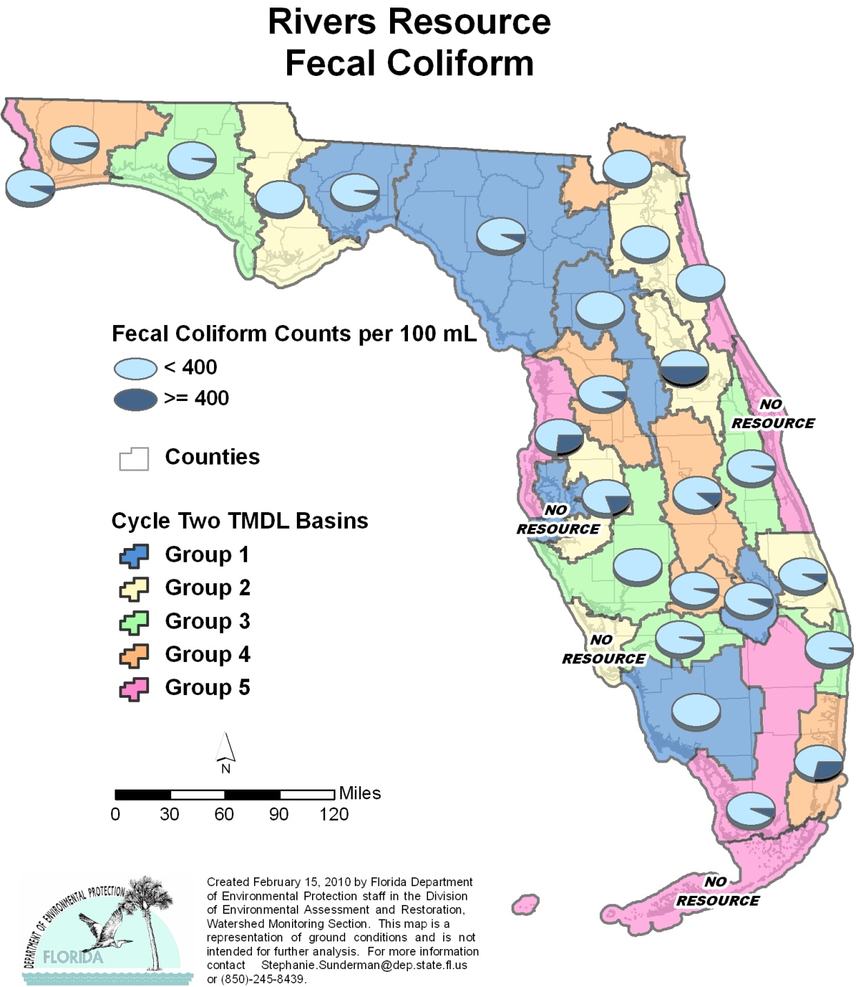

Table A.2. Percentage of Rivers Meeting Threshold Value for Fecal Coliform Calculated Using Probabilistic Monitoring Design
Status Network Designated Use: Recreation and Aquatic Life Units: Miles

This is a 10-column table. Column 1 lists the basin, Column 2 lists the target population, Column 3 lists the sampleable miles, Column 4 lists the dry miles, Column 5 lists the inaccessible miles, Column 6 lists the number of samples, Column 7 lists the percent meeting threshold, Column 8 lists the 95% confidence bounds, Column 9 lists the percent not meeting threshold, and Column 10 lists the assessment period.

¹ No large rivers in basin
² N/A = Not applicable
Basin | Target Population | Sampleable | Dry | Inaccessible | Number of Samples | % Meeting Threshold | 95% Confidence Bounds  (% Meeting Threshold) | % Not Meeting Threshold | Assessment Period
NWFWMD1  Ochlockonee–St. Marks | 143 | 116 | 0 | 27 | 30 | 96.7 | 91.1-100.0 | 3.3 | Aug–Oct 2004
SFWMD1  Everglades–West Coast | 255 | 207 | 0 | 48 | 30 | 100.0 | 100.0 | 0.0 | May–June 2004
SFWMD6  Lake Okeechobee | 23 | 14 | 0 | 9 | 30 | 93.3 | 86.4-100.0 | 6.7 | May–June 2004
SJRWMD1  Ocklawaha | 62 | 54 | 0 | 8 | 28 | 100.0 | 100.0 | 0.0 | May–June 2004
SRWMD1  Suwannee | 333 | 294 | 20 | 19 | 29 | 93.1 | 85.2-100.0 | 6.9 | Aug–Sept 2004
SWFWMD1  Tampa Bay¹ | 0 | 0 | 0 | 0 | 0 | N/A² | N/A² | N/A² | N/A²
NWFWMD2  Apalachicola–Chipola | 184 | 178 | 0 | 6 | 30 | 100.0 | 100.0 | 0.0 | Aug-Sept 2005
SFWMD2  St Lucie–Loxahatchee | 128 | 128 | 0 | 0 | 28 | 92.9 | 84.4-100.0 | 7.1 | May-July 2005
SFWMD7  Charlotte Harbor¹ | 0 | 0 | 0 | 0 | 0 | N/A² | N/A² | N/A² | N/A²
SJRWMD2  Lower St. Johns | 130 | 95 | 6 | 29 | 26 | 100.0 | 100.0 | 0.0 | May-June 2005
SJRWMD6  Middle St. Johns | 124 | 95 | 0 | 29 | 14 | 50.0 | 27.0-73.0 | 50.0 | May-July 2005
SWFWMD2  Tampa Bay Tributaries | 127 | 69 | 0 | 58 | 30 | 80.0 | 70.0-90.0 | 20.0 | May-Dec 2005
NWFWMD3  Choctawhatchee–  St. Andrews | 169 | 127 | 17 | 25 | 30 | 96.7 | 90.8-100.0 | 3.3 | Aug-Oct 2006
SFWMD3  Caloosahatchee | 44 | 44 | 0 | 0 | 30 | 96.7 | 91.3-100.0 | 3.3 | May-June 2006
SFWMD8  Lake Worth Lagoon–  Palm Beach Coast | 87 | 87 | 0 | 0 | 30 | 96.7 | 91.3-100.0 | 3.3 | May 2006
SJRWMD3  Upper St. Johns | 62 | 62 | 0 | 0 | 29 | 96.6 | 90.9-100.0 | 3.4 | May-June 2006
SWFWMD3  Sarasota Bay–Peace–Myakka | 136 | 95 | 0 | 41 | 2 | 100.0 | 100.0 | 0.0 | June-July 2006
NWFWMD4  Pensacola | 243 | 235 | 0 | 8 | 30 | 96.7 | 91.0-100.0 | 3.3 | Aug-Sept 2007
SFWMD4  Fisheating Creek | 105 | 58 | 0 | 47 | 27 | 96.3 | 90.0-100.0 | 3.7 | July 2007
SFWMD9  Kissimmee River | 177 | 82 | 8 | 87 | 27 | 88.9 | 79.7-98.1 | 11.1 | May-July 2007
SFWMD10  Southeast Coast–  Biscayne Bay | 179 | 179 | 0 | 0 | 28 | 71.4 | 59.2-83.7 | 28.6 | May-July 2007
SJRWMD4  Nassau–St. Marys | 116 | 53 | 0 | 63 | 28 | 100.0 | 100.0 | 0.0 | May-June 2007
SWFWMD4  Withlacoochee | 88 | 42 | 23 | 23 | 30 | 93.3 | 85.6-100.0 | 6.7 | May-July 2007
NWFWMD5  Perdido | 22 | 19 | 0 | 3 | 30 | 93.3 | 87.5-99.1 | 6.7 | Aug-Sept 2008
SFWMD5  Everglades | 313 | 313 | 0 | 0 | 30 | 93.3 | 86.4-100.0 | 6.7 | May-July 2008
SFWMD11  Florida Keys¹ | 0 | 0 | 0 | 0 | 0 | N/A² | N/A² | N/A² | N/A²
SJRWMD5  Indian River Lagoon¹ | 0 | 0 | 0 | 0 | 0 | N/A² | N/A² | N/A² | N/A²
SJRWMD7  Upper East Coast | 12 | 4 | 5 | 3 | 30 | 100.0 | 100.0 | 0.0 | May-June 2008
SWFWMD5  Springs Coast | 20 | 14 | 5 | 1 | 30 | 73.3 | 63.0-83.7 | 26.7 | June-July 2008
Summary of All Basins | 3,282 | 2,664 | 84 | 534 | 686 | 89.2 | 87.5-90.8 | 10.8 | 2004–08

Figure A.3. Summary of Un-ionized Ammonia Assessment for Rivers

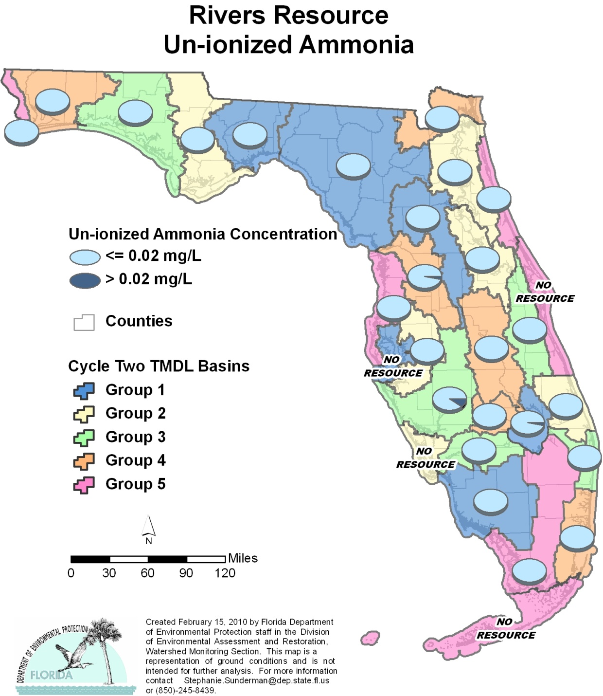

Table A.3. Percentage of Rivers Meeting Threshold Value for Un-ionized Ammonia Calculated Using Probabilistic Monitoring Design
Status Network Designated Use: Recreation and Aquatic Life Units: Miles

This is a 10-column table. Column 1 lists the basin, Column 2 lists the target population, Column 3 lists the sampleable miles, Column 4 lists the dry miles, Column 5 lists the inaccessible miles, Column 6 lists the number of samples, Column 7 lists the percent meeting threshold, Column 8 lists the 95% confidence bounds, Column 9 lists the percent not meeting threshold, and Column 10 lists the assessment period.

¹ No large rivers in basin
² N/A = Not applicable
Basin | Target Population | Sampleable | Dry | Inaccessible | Number of Samples | % Meeting Threshold | 95% Confidence Bounds  (% Meeting Threshold) | % Not Meeting Threshold | Assessment Period
NWFWMD1  Ochlockonee–St. Marks | 143 | 116 | 0 | 27 | 30 | 100.0 | 100.0 | 0.0 | Aug–Oct 2004
SFWMD1  Everglades–West Coast | 255 | 207 | 0 | 48 | 30 | 100.0 | 100.0 | 0.0 | May–June 2004
SFWMD6  Lake Okeechobee | 23 | 14 | 0 | 9 | 30 | 96.7 | 91.0-100.0 | 3.3 | May–June 2004
SJRWMD1  Ocklawaha | 62 | 54 | 0 | 8 | 30 | 100.0 | 100.0 | 0.0 | May–June 2004
SRWMD1  Suwannee | 333 | 294 | 20 | 19 | 30 | 100.0 | 100.0 | 0.0 | Aug–Sept 2004
SWFWMD1  Tampa Bay¹ | 0 | 0 | 0 | 0 | 0 | N/A² | N/A² | N/A² | N/A²
NWFWMD2  Apalachicola–Chipola | 184 | 178 | 0 | 6 | 30 | 100.0 | 100.0 | 0.0 | Aug-Sept 2005
SFWMD2  St Lucie–Loxahatchee | 128 | 128 | 0 | 0 | 30 | 100.0 | 100.0 | 0.0 | May-July 2005
SFWMD7  Charlotte Harbor¹ | 0 | 0 | 0 | 0 | 0 | N/A² | N/A² | N/A² | N/A²
SJRWMD2  Lower St. Johns | 130 | 95 | 6 | 29 | 30 | 100.0 | 100.0 | 0.0 | May-June 2005
SJRWMD6  Middle St. Johns | 124 | 95 | 0 | 29 | 30 | 100.0 | 100.0 | 0.0 | May-July 2005
SWFWMD2  Tampa Bay Tributaries | 127 | 69 | 0 | 58 | 30 | 100.0 | 100.0 | 0.0 | May-Dec 2005
NWFWMD3  Choctawhatchee–  St. Andrews | 169 | 127 | 17 | 25 | 30 | 100.0 | 100.0 | 0.0 | Aug-Oct 2006
SFWMD3  Caloosahatchee | 44 | 44 | 0 | 0 | 30 | 100.0 | 100.0 | 0.0 | May-June 2006
SFWMD8  Lake Worth Lagoon–  Palm Beach Coast | 87 | 87 | 0 | 0 | 30 | 100.0 | 100.0 | 0.0 | May 2006
SJRWMD3  Upper St. Johns | 62 | 62 | 0 | 0 | 30 | 100.0 | 100.0 | 0.0 | May-June 2006
SWFWMD3  Sarasota Bay–Peace–Myakka | 136 | 95 | 0 | 41 | 30 | 90.0 | 82.7-97.3 | 10.0 | June-July 2006
NWFWMD4  Pensacola | 243 | 235 | 0 | 8 | 30 | 100.0 | 100.0 | 0.0 | Aug-Sept 2007
SFWMD4  Fisheating Creek | 105 | 58 | 0 | 47 | 27 | 100.0 | 100.0 | 0.0 | July 2007
SFWMD9  Kissimmee River | 177 | 82 | 8 | 87 | 30 | 100.0 | 100.0 | 0.0 | May-July 2007
SFWMD10  Southeast Coast–  Biscayne Bay | 179 | 179 | 0 | 0 | 29 | 100.0 | 100.0 | 0.0 | May-July 2007
SJRWMD4  Nassau–St. Marys | 116 | 53 | 0 | 63 | 30 | 100.0 | 100.0 | 0.0 | May-June 2007
SWFWMD4  Withlacoochee | 88 | 42 | 23 | 23 | 30 | 96.7 | 91.1-100.0 | 3.3 | May-July 2007
NWFWMD5  Perdido | 22 | 19 | 0 | 3 | 30 | 100.0 | 100.0 | 0.0 | Aug-Sept 2008
SFWMD5  Everglades | 313 | 313 | 0 | 0 | 30 | 100.0 | 100.0 | 0.0 | May-July 2008
SFWMD11  Florida Keys¹ | 0 | 0 | 0 | 0 | 0 | N/A² | N/A² | N/A² | N/A²
SJRWMD5  Indian River Lagoon¹ | 0 | 0 | 0 | 0 | 0 | N/A² | N/A² | N/A² | N/A²
SJRWMD7  Upper East Coast | 12 | 4 | 5 | 3 | 30 | 100.0 | 100.0 | 0.0 | May-June 2008
SWFWMD5  Springs Coast | 20 | 14 | 5 | 1 | 30 | 100.0 | 100.0 | 0.0 | June-July 2008
Summary of All Basins | 3,282 | 2,664 | 84 | 534 | 746 | 99.4 | 99.1–99.8 | 0.6 | 2004–08

Figure A.4. Summary of Chlorophyll a Assessment for Rivers

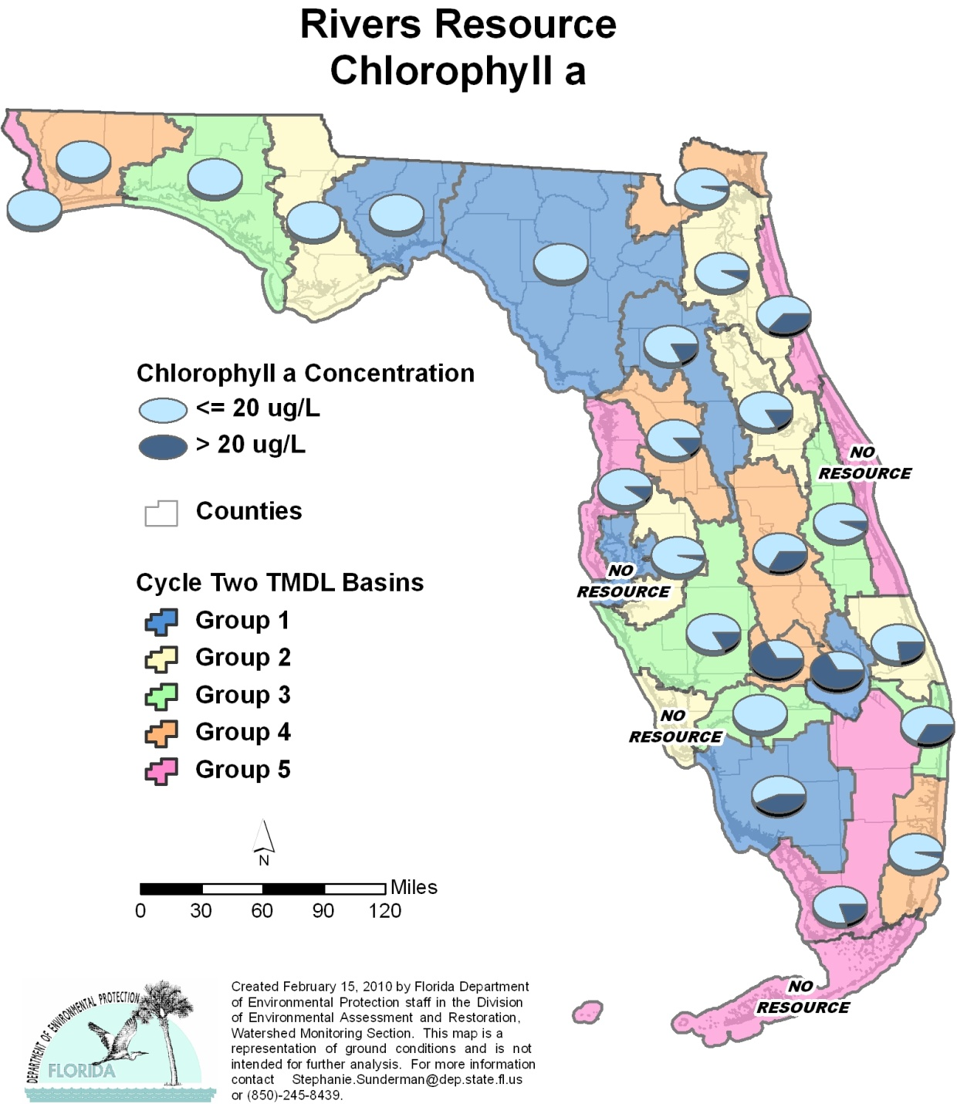

Table A.4. Percentage of Rivers Meeting Threshold Value for Chlorophyll a Calculated Using Probabilistic Monitoring Design
Status Network Designated Use: Recreation and Aquatic Life Units: Miles

This is a 10-column table. Column 1 lists the basin, Column 2 lists the target population, Column 3 lists the sampleable miles, Column 4 lists the dry miles, Column 5 lists the inaccessible miles, Column 6 lists the number of samples, Column 7 lists the percent meeting threshold, Column 8 lists the 95% confidence bounds, Column 9 lists the percent not meeting threshold, and Column 10 lists the assessment period.

¹ No large rivers in basin
² N/A = Not applicable
Basin | Target Population | Sampleable | Dry | Inaccessible | Number of Samples | % Meeting Threshold | 95% Confidence Bounds  (% Meeting Threshold) | % Not Meeting Threshold | Assessment Period
NWFWMD1  Ochlockonee–St. Marks | 143 | 116 | 0 | 27 | 30 | 100.0 | 100.0 | 0.0 | Aug–Oct 2004
SFWMD1  Everglades–West Coast | 255 | 207 | 0 | 48 | 30 | 56.7 | 42.6 - 70.8 | 43.3 | May–June 2004
SFWMD6  Lake Okeechobee | 23 | 14 | 0 | 9 | 30 | 33.3 | 23.6 - 43.1 | 66.7 | May–June 2004
SJRWMD1  Ocklawaha | 62 | 54 | 0 | 8 | 29 | 82.6 | 72.5 – 93.0 | 17.4 | May–June 2004
SRWMD1  Suwannee | 333 | 294 | 20 | 19 | 30 | 100.0 | 100.0 | 0.0 | Aug–Sept 2004
SWFWMD1  Tampa Bay¹ | 0 | 0 | 0 | 0 | 0 | N/A² | N/A² | N/A² | N/A²
NWFWMD2  Apalachicola–Chipola | 184 | 178 | 0 | 6 | 30 | 100.0 | 100.0 | 0.0 | Aug-Sept 2005
SFWMD2  St Lucie–Loxahatchee | 128 | 128 | 0 | 0 | 30 | 76.7 | 63.7-89.7 | 23.3 | May-July 2005
SFWMD7  Charlotte Harbor¹ | 0 | 0 | 0 | 0 | 0 | N/A² | N/A² | N/A² | N/A²
SJRWMD2  Lower St. Johns | 130 | 95 | 6 | 29 | 29 | 93.1 | 84.7-100.0 | 6.9 | May-June 2005
SJRWMD6  Middle St. Johns | 124 | 95 | 0 | 29 | 30 | 83.3 | 73.3-93.4 | 16.7 | May-July 2005
SWFWMD2  Tampa Bay Tributaries | 127 | 69 | 0 | 58 | 30 | 96.7 | 91.0-100.0 | 3.3 | May-Dec 2005
NWFWMD3  Choctawhatchee–  St. Andrews | 169 | 127 | 17 | 25 | 30 | 100.0 | 100.0 | 0.0 | Aug-Oct 2006
SFWMD3  Caloosahatchee | 44 | 44 | 0 | 0 | 30 | 100.0 | 100.0 | 0.0 | May-June 2006
SFWMD8  Lake Worth Lagoon–  Palm Beach Coast | 87 | 87 | 0 | 0 | 30 | 66.7 | 54.3-79.0 | 33.3 | May 2006
SJRWMD3  Upper St. Johns | 62 | 62 | 0 | 0 | 30 | 93.3 | 85.7-100.0 | 6.7 | May-June 2006
SWFWMD3  Sarasota Bay–Peace–Myakka | 136 | 95 | 0 | 41 | 30 | 83.3 | 74.1-92.6 | 16.7 | June-July 2006
NWFWMD4  Pensacola | 243 | 235 | 0 | 8 | 30 | 100.0 | 100.0 | 0.0 | Aug-Sept 2007
SFWMD4  Fisheating Creek | 105 | 58 | 0 | 47 | 27 | 33.3 | 24.2-42.5 | 66.7 | July 2007
SFWMD9  Kissimmee River | 177 | 82 | 8 | 87 | 27 | 66.7 | 52.1-81.3 | 33.3 | May-July 2007
SFWMD10  Southeast Coast–  Biscayne Bay | 179 | 179 | 0 | 0 | 29 | 96.0 | 89.6-100.0 | 4.0 | May-July 2007
SJRWMD4  Nassau–St. Marys | 116 | 53 | 0 | 63 | 29 | 96.6 | 91.0-100.0 | 3.4 | May-June 2007
SWFWMD4  Withlacoochee | 88 | 42 | 23 | 23 | 30 | 86.7 | 82.3-91.1 | 13.3 | March-May 2007
NWFWMD5  Perdido | 22 | 19 | 0 | 3 | 30 | 100.0 | 100.0 | 0.0 | Aug-Sept 2008
SFWMD5  Everglades | 313 | 313 | 0 | 0 | 30 | 80.0 | 70.9-89.1 | 20.0 | May-July 2008
SFWMD11  Florida Keys¹ | 0 | 0 | 0 | 0 | 0 | N/A² | N/A² | N/A² | N/A²
SJRWMD5  Indian River Lagoon¹ | 0 | 0 | 0 | 0 | 0 | N/A² | N/A² | N/A² | N/A²
SJRWMD7  Upper East Coast | 12 | 4 | 5 | 3 | 30 | 63.3 | 49.2-77.4 | 36.7 | May-June 2008
SWFWMD5  Springs Coast | 20 | 14 | 5 | 1 | 30 | 90.0 | 81.0-99.0 | 10.0 | June-July 2008
Summary of All Basins | 3,282 | 2,664 | 84 | 534 | 740 | 85.6 | 83.6-87.5 | 14.4 | 2004–08

Figure A.5. Summary of DO Assessment for Streams

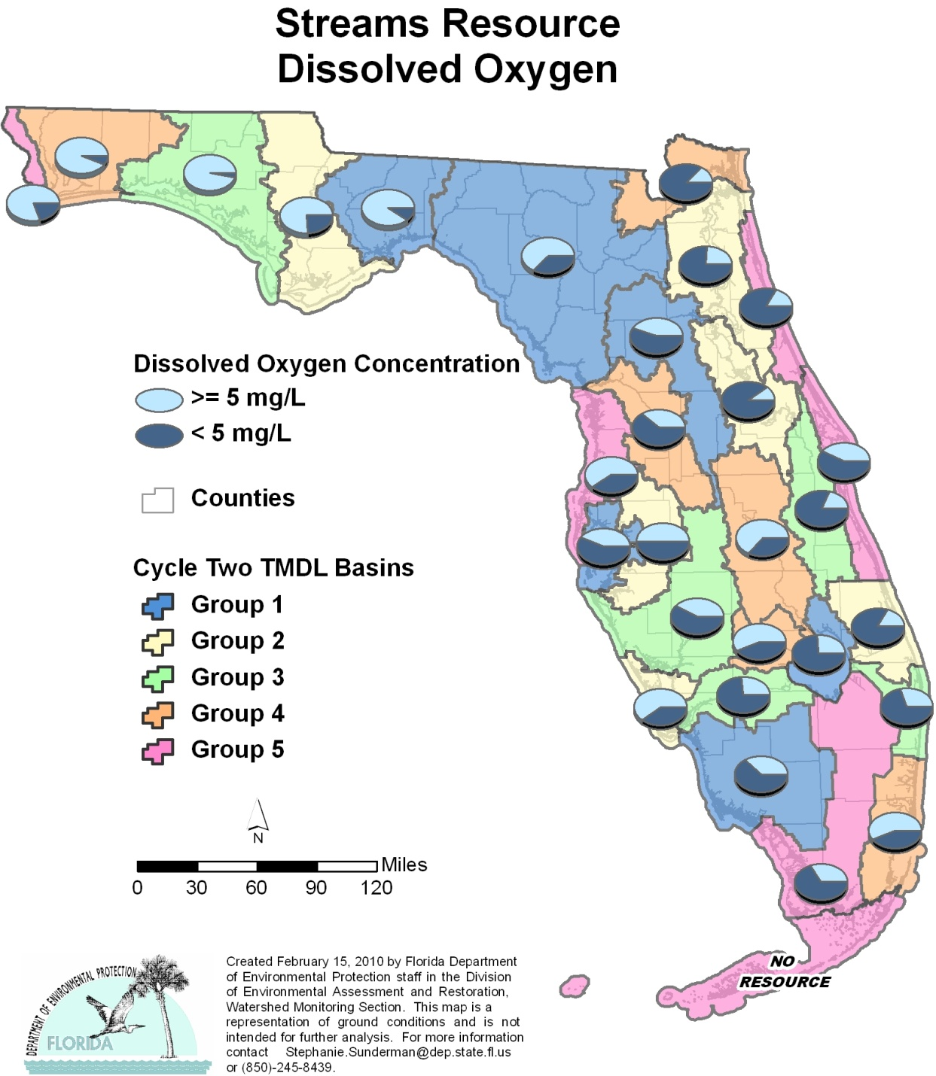

Table A.5. Percentage of Streams Meeting Threshold Value for DO Calculated Using Probabilistic Monitoring Design
Status Network Designated Use: Recreation and Aquatic Life Units: Miles

This is a 10-column table. Column 1 lists the basin, Column 2 lists the target population, Column 3 lists the sampleable miles, Column 4 lists the dry miles, Column 5 lists the inaccessible miles, Column 6 lists the number of samples, Column 7 lists the percent meeting threshold, Column 8 lists the 95% confidence bounds, Column 9 lists the percent not meeting threshold, and Column 10 lists the assessment period.

¹ No small streams in basin
² N/A = Not applicable
Basin | Target Population | Sampleable | Dry | Inaccessible | Number of Samples | % Meeting Threshold | 95% Confidence Bounds  (% Meeting Threshold) | % Not Meeting Threshold | Assessment Period
NWFWMD1  Ochlockonee–St. Marks | 1,267 | 535 | 482 | 250 | 30 | 90.0 | 80.3-99.7 | 10.0 | April-June 2004
SFWMD1  Everglades–West Coast | 902 | 173 | 77 | 652 | 8 | 37.5 | 11.0-89.0 | 62.5 | Oct 2004
SFWMD6  Lake Okeechobee | 648 | 490 | 70 | 88 | 27 | 25.9 | 11.4-40.5 | 74.1 | Oct 2004
SJRWMD1  Ocklawaha | 320 | 125 | 35 | 160 | 27 | 44.4 | 28.4-60.5 | 55.6 | Aug-Dec 2004
SRWMD1  Suwannee | 1,794 | 233 | 686 | 875 | 19 | 63.2 | 46.2-80.1 | 36.8 | April-June 2004
SWFWMD1  Tampa Bay | 212 | 116 | 12 | 84 | 30 | 43.3 | 27.3-59.4 | 56.7 | Aug-Sept 2004
NWFWMD2  Apalachicola–Chipola | 1,353 | 643 | 133 | 577 | 29 | 75.9 | 64.0-87.7 | 24.1 | May-June 2005
SFWMD2  St Lucie–Loxahatchee | 3,984 | 1,784 | 178 | 2,022 | 29 | 17.2 | 6.4-28.1 | 82.8 | Aug-Oct 2005
SFWMD7  Charlotte Harbor | 108 | 87 | 6 | 15 | 28 | 60.7 | 45.9-75.5 | 39.3 | Aug-Oct 2005
SJRWMD2  Lower St. Johns | 1,597 | 622 | 249 | 726 | 29 | 24.1 | 11.9-36.4 | 75.9 | Aug-Oct 2005
SJRWMD6  Middle St. Johns | 615 | 303 | 40 | 272 | 29 | 10.3 | 0.3-20.4 | 89.7 | Aug-Oct 2005
SWFWMD2  Tampa Bay Tributaries | 931 | 405 | 94 | 432 | 30 | 50.0 | 34.3-65.7 | 50.0 | Aug-Sept 2005
NWFWMD3  Choctawhatchee–  St. Andrews | 2,142 | 918 | 704 | 520 | 30 | 96.7 | 91.2-100.0 | 3.3 | April-June 2006
SFWMD3  Caloosahatchee | 1,585 | 754 | 76 | 755 | 30 | 26.7 | 13.5-39.8 | 73.3 | Aug-Sept 2006
SFWMD8  Lake Worth Lagoon–  Palm Beach Coast | 695 | 579 | 0 | 116 | 30 | 30.0 | 15.9-44.1 | 70.0 | Aug 2006
SJRWMD3  Upper St. Johns | 2,578 | 600 | 240 | 1,738 | 26 | 19.2 | 5.2-33.2 | 81.8 | Aug-Sept 2006
SWFWMD3  Sarasota Bay–Peace–Myakka | 2,880 | 640 | 320 | 1,920 | 30 | 41.7 | 26.1-57.4 | 58.3 | Aug-Oct 2006
NWFWMD4  Pensacola | 1,703 | 1,135 | 341 | 227 | 30 | 93.3 | 85.6-100.0 | 6.7 | April-June 2007
SFWMD4  Fisheating Creek | 1,123 | 290 | 252 | 581 | 30 | 56.7 | 40.8-72.5 | 43.3 | Sept-Oct 2007
SFWMD9  Kissimmee River | 2,323 | 1,096 | 526 | 701 | 25 | 64.0 | 48.0-80.0 | 36.0 | Oct-Nov 2007
SFWMD10  Southeast Coast–  Biscayne Bay | 662 | 567 | 0 | 95 | 30 | 56.7 | 43.7-69.7 | 43.3 | Sept-Oct 2007
SJRWMD4  Nassau–St. Marys | 605 | 123 | 45 | 437 | 30 | 13.3 | 2.6-24.1 | 86.7 | Aug-Oct 2007
SWFWMD4  Withlacoochee | 422 | 56 | 321 | 45 | 21 | 38.1 | 21.9-54.3 | 61.9 | Aug-Oct 2007
NWFWMD5  Perdido | 223 | 93 | 62 | 68 | 30 | 80.0 | 67.0-93.0 | 20.0 | April-June 2008
SFWMD5  Everglades | 3,258 | 1,086 | 36 | 2,136 | 30 | 33.3 | 18.1-48.5 | 66.7 | Aug-Oct 2008
SFWMD11  Florida Keys¹ | 0 | 0 | 0 | 0 | 0 | N/A² | N/A² | N/A² | N/A²
SJRWMD5  Indian River Lagoon | 166 | 83 | 52 | 31 | 19 | 42.1 | 21.9-62.3 | 57.9 | Sept-Oct 2008
SJRWMD7  Upper East Coast | 144 | 58 | 16 | 70 | 29 | 17.2 | 5.5-29.0 | 82.8 | Aug-Sept 2008
SWFWMD5  Springs Coast | 150 | 58 | 37 | 55 | 30 | 60.0 | 46.4-73.6 | 40.0 | Sept-Oct 2008
Summary of All Basins | 34,390 | 13,652 | 5,090 | 15,648 | 765 | 45.6 | 42.0-49.2 | 54.4 | 2004–08

Figure A.6. Summary of Fecal Coliform Assessment for Streams

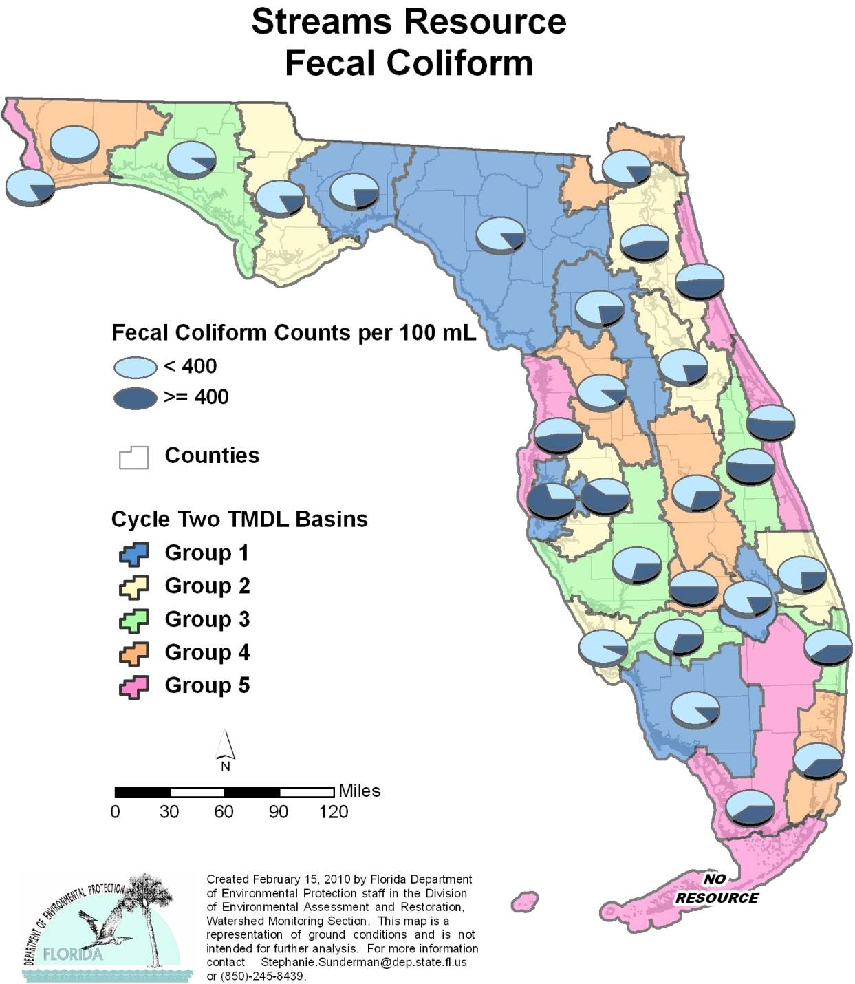

Table A.6. Percentage of Streams Meeting Threshold Value for Fecal Coliform Calculated Using Probabilistic Monitoring Design
Status Network Designated Use: Recreation and Aquatic Life Units: Miles

This is a 10-column table. Column 1 lists the basin, Column 2 lists the target population, Column 3 lists the sampleable miles, Column 4 lists the dry miles, Column 5 lists the inaccessible miles, Column 6 lists the number of samples, Column 7 lists the percent meeting threshold, Column 8 lists the 95% confidence bounds, Column 9 lists the percent not meeting threshold, and Column 10 lists the assessment period.

¹ No small streams in basin
² N/A = Not applicable
Basin | Target Population | Sampleable | Dry | Inaccessible | Number of Samples | % Meeting Threshold | 95% Confidence Bounds  (% Meeting Threshold) | % Not Meeting Threshold | Assessment Period
NWFWMD1  Ochlockonee–St. Marks | 1,267 | 535 | 482 | 250 | 30 | 76.7 | 63.2-90.1 | 23.3 | April-June 2004
SFWMD1  Everglades–West Coast | 902 | 173 | 77 | 652 | 8 | 87.5 | 66.3-100.0 | 12.5 | Oct 2004
SFWMD6  Lake Okeechobee | 648 | 490 | 70 | 88 | 26 | 80.8 | 66.7-94.8 | 19.2 | Oct 2004
SJRWMD1  Ocklawaha | 320 | 125 | 35 | 160 | 27 | 77.8 | 65.3-90.2 | 22.2 | Aug-Dec 2004
SRWMD1  Suwannee | 1,794 | 233 | 686 | 875 | 21 | 85.7 | 71.9-99.5 | 14.3 | April-June 2004
SWFWMD1  Tampa Bay | 212 | 116 | 12 | 84 | 30 | 30.0 | 16.5-43.5 | 70.0 | Aug-Sept 2004
NWFWMD2  Apalachicola–Chipola | 1,353 | 643 | 133 | 577 | 29 | 82.8 | 71.2-94.3 | 17.2 | May-June 2005
SFWMD2  St Lucie–Loxahatchee | 3,984 | 1,784 | 178 | 2,022 | 29 | 75.9 | 62.8-88.9 | 24.1 | Aug-Oct 2005
SFWMD7  Charlotte Harbor | 108 | 87 | 6 | 15 | 28 | 92.9 | 84.3-100.0 | 7.1 | Aug-Oct 2005
SJRWMD2  Lower St. Johns | 1,597 | 622 | 249 | 726 | 29 | 55.2 | 38.5-71.9 | 44.8 | Aug-Oct 2005
SJRWMD6  Middle St. Johns | 615 | 303 | 40 | 272 | 29 | 79.3 | 66.6-92.1 | 20.7 | Aug-Oct 2005
SWFWMD2  Tampa Bay Tributaries | 931 | 405 | 94 | 432 | 30 | 40.0 | 24.5-55.5 | 60.0 | Aug-Sept 2005
NWFWMD3  Choctawhatchee–  St. Andrews | 2,142 | 918 | 704 | 520 | 30 | 90.0 | 81.5-98.5 | 10.0 | April-June 2006
SFWMD3  Caloosahatchee | 1,585 | 754 | 76 | 755 | 30 | 70.0 | 56.5-83.5 | 30.0 | Aug-Sept 2006
SFWMD8  Lake Worth Lagoon–  Palm Beach Coast | 695 | 579 | 0 | 116 | 30 | 60.0 | 43.5-76.5 | 40.0 | Aug 2006
SJRWMD3  Upper St. Johns | 2,578 | 600 | 240 | 1,738 | 29 | 48.3 | 33.5-63.0 | 51.7 | Aug-Sept 2006
SWFWMD3  Sarasota Bay–Peace–Myakka | 2,880 | 640 | 320 | 1,920 | 30 | 70.9 | 56.7-85.0 | 29.1 | Aug-Oct 2006
NWFWMD4  Pensacola | 1,703 | 1,135 | 341 | 227 | 24 | 100.0 | 100.0 | 0.0 | April-June 2007
SFWMD4  Fisheating Creek | 1,123 | 290 | 252 | 581 | 30 | 50.0 | 36.7-63.2 | 50.0 | Sept-Oct 2007
SFWMD9  Kissimmee River | 2,323 | 1,096 | 526 | 701 | 25 | 70.8 | 55.6-86.0 | 29.2 | Oct-Nov 2007
SFWMD10  Southeast Coast–  Biscayne Bay | 662 | 567 | 0 | 95 | 30 | 63.0 | 47.0-79.0 | 37.0 | Sept-Oct 2007
SJRWMD4  Nassau–St. Marys | 605 | 123 | 45 | 437 | 30 | 83.3 | 73.0-93.6 | 16.7 | Aug-Oct 2007
SWFWMD4  Withlacoochee | 422 | 56 | 321 | 45 | 21 | 88.9 | 77.2-100.0 | 11.1 | Aug-Oct 2007
NWFWMD5  Perdido | 223 | 93 | 62 | 68 | 30 | 83.3 | 71.5-95.2 | 16.7 | April-June 2008
SFWMD5  Everglades | 3,258 | 1,086 | 36 | 2,136 | 30 | 60.0 | 45.4-74.6 | 40.0 | Aug-Oct 2008
SFWMD11  Florida Keys¹ | 0 | 0 | 0 | 0 | 0 | N/A² | N/A² | N/A² | N/A²
SJRWMD5  Indian River Lagoon | 166 | 83 | 52 | 31 | 19 | 47.4 | 29.9-64.8 | 52.6 | Sept-Oct 2008
SJRWMD7  Upper East Coast | 144 | 58 | 16 | 70 | 29 | 51.7 | 36.0-67.4 | 48.3 | Aug-Sept 2008
SWFWMD5  Springs Coast | 150 | 58 | 37 | 55 | 30 | 53.3 | 43.5-63.1 | 46.7 | Sept-Oct 2008
Summary of All Basins | 34,390 | 13,652 | 5,090 | 15,648 | 763 | 71.6 | 68.2-75.0 | 28.4 | 2004–08

Figure A.7. Summary of Un-ionized Ammonia Assessment for Streams

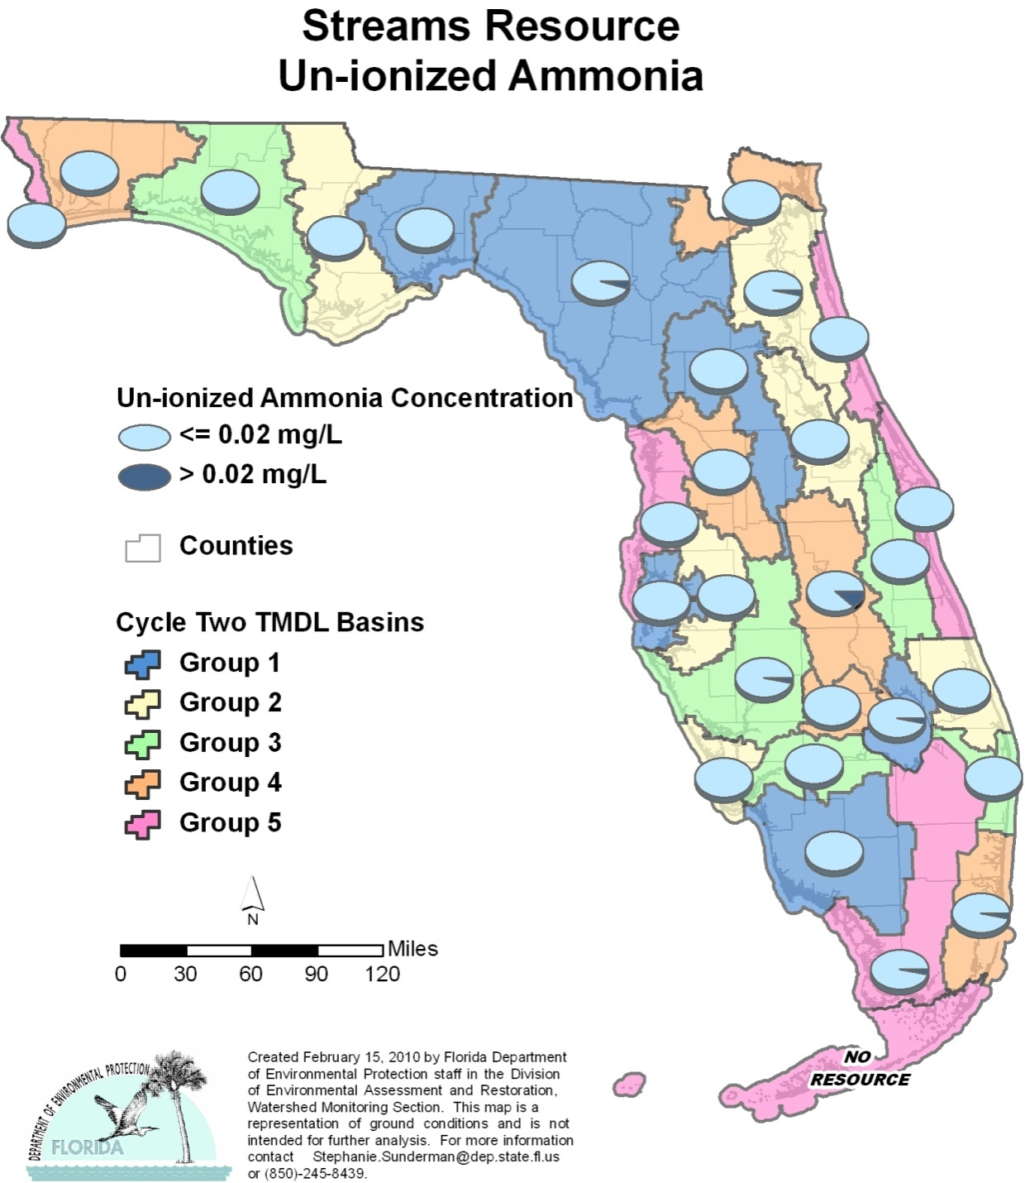

Table A.7. Percentage of Streams Meeting Threshold Value for Un-ionized Ammonia Calculated Using Probabilistic Monitoring Design
Status Network Designated Use: Recreation and Aquatic Life Units: Miles

This is a 10-column table. Column 1 lists the basin, Column 2 lists the target population, Column 3 lists the sampleable miles, Column 4 lists the dry miles, Column 5 lists the inaccessible miles, Column 6 lists the number of samples, Column 7 lists the percent meeting threshold, Column 8 lists the 95% confidence bounds, Column 9 lists the percent not meeting threshold, and Column 10 lists the assessment period.

¹ No small streams in basin
² N/A = Not applicable
Basin | Target Population | Sampleable | Dry | Inaccessible | Number of Samples | % Meeting Threshold | 95% Confidence Bounds  (%Meeting Threshold) | % Not Meeting Threshold | Assessment Period
NWFWMD1  Ochlockonee–St. Marks | 1,267 | 535 | 482 | 250 | 30 | 100.0 | 100.0 | 0.0 | April-June 2004
SFWMD1  Everglades–West Coast | 902 | 173 | 77 | 652 | 8 | 100.0 | 100.0 | 0.0 | Oct 2004
SFWMD6  Lake Okeechobee | 648 | 490 | 70 | 88 | 28 | 96.4 | 90.2-100.0 | 3.6 | Oct 2004
SJRWMD1  Ocklawaha | 320 | 125 | 35 | 160 | 29 | 100.0 | 100.0 | 0.0 | Aug-Dec 2004
SRWMD1  Suwannee | 1,794 | 233 | 686 | 875 | 21 | 95.2 | 86.8-100.0 | 4.8 | April-June 2004
SWFWMD1  Tampa Bay | 212 | 116 | 12 | 84 | 30 | 100.0 | 100.0 | 0.0 | Aug-Sept 2004
NWFWMD2  Apalachicola–Chipola | 1,353 | 643 | 133 | 577 | 29 | 100.0 | 100.0 | 0.0 | May-June 2005
SFWMD2  St Lucie–Loxahatchee | 3,984 | 1,784 | 178 | 2,022 | 30 | 100.0 | 100.0 | 0.0 | Aug-Oct 2005
SFWMD7  Charlotte Harbor | 108 | 87 | 6 | 15 | 30 | 100.0 | 100.0 | 0.0 | Aug-Oct 2005
SJRWMD2  Lower St. Johns | 1,597 | 622 | 249 | 726 | 30 | 96.7 | 90.8-100.0 | 3.3 | Aug-Oct 2005
SJRWMD6  Middle St. Johns | 615 | 303 | 40 | 272 | 30 | 100.0 | 100.0 | 0.0 | Aug-Oct 2005
SWFWMD2  Tampa Bay Tributaries | 931 | 405 | 94 | 432 | 28 | 100.0 | 100.0 | 0.0 | Aug-Sept 2005
NWFWMD3  Choctawhatchee–  St. Andrews | 2,142 | 918 | 704 | 520 | 30 | 100.0 | 100.0 | 0.0 | April-June 2006
SFWMD3  Caloosahatchee | 1,585 | 754 | 76 | 755 | 30 | 100.0 | 100.0 | 0.0 | Aug-Sept 2006
SFWMD8  Lake Worth Lagoon–  Palm Beach Coast | 695 | 579 | 0 | 116 | 30 | 100.0 | 100.0 | 0.0 | Aug 2006
SJRWMD3  Upper St. Johns | 2,578 | 600 | 240 | 1,738 | 30 | 100.0 | 100.0 | 0.0 | Aug-Sept 2006
SWFWMD3  Sarasota Bay–Peace–Myakka | 2,880 | 640 | 320 | 1,920 | 30 | 96.5 | 90.5-100.0 | 3.5 | Aug-Oct 2006
NWFWMD4  Pensacola | 1,703 | 1,135 | 341 | 227 | 2 | 100.0 | 100.0 | 0.0 | April-June 2007
SFWMD4  Fisheating Creek | 1,123 | 290 | 252 | 581 | 30 | 100.0 | 100.0 | 0.0 | Sept-Oct 2007
SFWMD9  Kissimmee River | 2,323 | 1,096 | 526 | 701 | 25 | 88.0 | 78.3-97.7 | 12.0 | Oct-Nov 2007
SFWMD10  Southeast Coast–  Biscayne Bay | 662 | 567 | 0 | 95 | 30 | 96.7 | 91.2-100.0 | 3.3 | Sept-Oct 2007
SJRWMD4  Nassau–St. Marys | 605 | 123 | 45 | 437 | 30 | 100.0 | 100.0 | 0.0 | Aug-Oct 2007
SWFWMD4  Withlacoochee | 422 | 56 | 321 | 45 | 21 | 100.0 | 100.0 | 0.0 | Aug-Oct 2007
NWFWMD5  Perdido | 223 | 93 | 62 | 68 | 30 | 100.0 | 100.0 | 0.0 | April-June 2008
SFWMD5  Everglades | 3,258 | 1,086 | 36 | 2,136 | 30 | 96.7 | 90.8-100.0 | 3.3 | Aug-Oct 2008
SFWMD11  Florida Keys¹ | 0 | 0 | 0 | 0 | 0 | N/A² | N/A² | N/A² | N/A²
SJRWMD5  Indian River Lagoon | 166 | 83 | 52 | 31 | 19 | 100.0 | 100.0 | 0.0 | Sept-Oct 2008
SJRWMD7  Upper East Coast | 144 | 58 | 16 | 70 | 30 | 100.0 | 100.0 | 0.0 | Aug-Sept 2008
SWFWMD5  Springs Coast | 150 | 58 | 37 | 55 | 30 | 100.0 | 100.0 | 0.0 | Sept-Oct 2008
Summary of All Basins | 34,390 | 13,652 | 5,090 | 15,648 | 750 | 98.4 | 97.4-99.3 | 1.6 | 2004–08

Figure A.8. Summary of Chlorophyll a Assessment for Streams

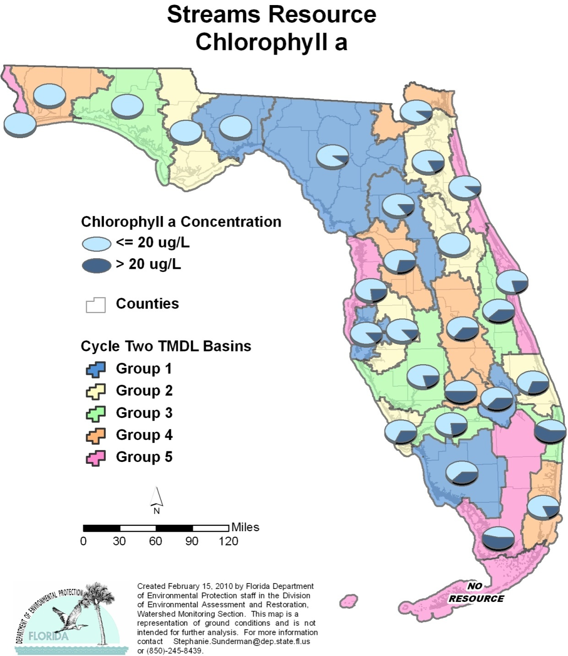

Table A.8. Percentage of Streams Meeting Threshold Value for Chlorophyll a Calculated Using Probabilistic Monitoring Design
Status Network Designated Use: Recreation and Aquatic Life Units: Miles

This is a 10-column table. Column 1 lists the basin, Column 2 lists the target population, Column 3 lists the sampleable miles, Column 4 lists the dry miles, Column 5 lists the inaccessible miles, Column 6 lists the number of samples, Column 7 lists the percent meeting threshold, Column 8 lists the 95% confidence bounds, Column 9 lists the percent not meeting threshold, and Column 10 lists the assessment period.

¹ No small streams in basin
² N/A = Not applicable
Basin | Target Population | Sampleable | Dry | Inaccessible | Number of Samples | % Meeting Threshold | 95% Confidence Bounds  (% Meeting Threshold) | % Not Meeting Threshold | Assessment Period
NWFWMD1  Ochlockonee–St. Marks | 1,267 | 535 | 482 | 250 | 30 | 100.0 | 100.0 | 0.0 | April-June 2004
SFWMD1  Everglades–West Coast | 902 | 173 | 77 | 652 | 8 | 62.5 | 31.7-93.3 | 37.5 | Oct 2004
SFWMD6  Lake Okeechobee | 648 | 490 | 70 | 88 | 27 | 63.0 | 46.3-79.6 | 37.0 | Oct 2004
SJRWMD1  Ocklawaha | 320 | 125 | 35 | 160 | 27 | 85.2 | 76.4-94.0 | 14.8 | Aug-Dec 2004
SRWMD1  Suwannee | 1,794 | 233 | 686 | 875 | 21 | 90.5 | 79.5-100.0 | 9.5 | April-June 2004
SWFWMD1  Tampa Bay | 212 | 116 | 12 | 84 | 30 | 86.7 | 76.0-97.3 | 13.3 | Aug-Sept 2004
NWFWMD2  Apalachicola–Chipola | 1,353 | 643 | 133 | 577 | 29 | 100.0 | 100.0 | 0.0 | May-June 2005
SFWMD2  St Lucie–Loxahatchee | 3,984 | 1,784 | 178 | 2,022 | 29 | 69.0 | 54.5-83.4 | 31.0 | Aug-Oct 2005
SFWMD7  Charlotte Harbor | 108 | 87 | 6 | 15 | 28 | 67.9 | 53.5-82.2 | 32.1 | Aug-Oct 2005
SJRWMD2  Lower St. Johns | 1,597 | 622 | 249 | 726 | 29 | 82.8 | 71.7-93.8 | 17.2 | Aug-Oct 2005
SJRWMD6  Middle St. Johns | 615 | 303 | 40 | 272 | 29 | 100.0 | 100.0 | 0.0 | Aug-Oct 2005
SWFWMD2  Tampa Bay Tributaries | 931 | 405 | 94 | 432 | 30 | 86.7 | 76.0-97.3 | 13.3 | Aug-Sept 2005
NWFWMD3  Choctawhatchee–  St. Andrews | 2,142 | 918 | 704 | 520 | 30 | 100.0 | 100.0 | 0.0 | April-June 2006
SFWMD3  Caloosahatchee | 1,585 | 754 | 76 | 755 | 30 | 76.7 | 64.3-89.1 | 23.3 | Aug-Sept 2006
SFWMD8  Lake Worth Lagoon–  Palm Beach Coast | 695 | 579 | 0 | 116 | 30 | 43.3 | 27.4-59.3 | 56.7 | Aug 2006
SJRWMD3  Upper St. Johns | 2,578 | 600 | 240 | 1,738 | 29 | 62.1 | 47.0-77.1 | 37.9 | Aug-Sept 2006
SWFWMD3  Sarasota Bay–Peace–Myakka | 2,880 | 640 | 320 | 1,920 | 30 | 79.1 | 65.9-92.3 | 20.9 | Aug-Oct 2006
NWFWMD4  Pensacola | 1,703 | 1,135 | 341 | 227 | 24 | 100.0 | 100.0 | 0.0 | April-June 2007
SFWMD4  Fisheating Creek | 1,123 | 290 | 252 | 581 | 30 | 50.0 | 35.1-64.9 | 50.0 | Sept-Oct 2007
SFWMD9  Kissimmee River | 2,323 | 1,096 | 526 | 701 | 25 | 64.0 | 46.6-81.4 | 36.0 | Oct-Nov 2007
SFWMD10  Southeast Coast–  Biscayne Bay | 662 | 567 | 0 | 95 | 27 | 81.5 | 69.8-93.1 | 18.5 | Sept-Oct 2007
SJRWMD4  Nassau–St. Marys | 605 | 123 | 45 | 437 | 30 | 90.0 | 81.4-98.6 | 10.0 | Aug-Oct 2007
SWFWMD4  Withlacoochee | 422 | 56 | 321 | 45 | 21 | 71.4 | 53.9-89.0 | 28.6 | Aug-Oct 2007
NWFWMD5  Perdido | 223 | 93 | 62 | 68 | 30 | 100.0 | 100.0 | 0.0 | April-June 2008
SFWMD5  Everglades | 3,258 | 1,086 | 36 | 2,136 | 30 | 46.7 | 33.0-60.3 | 53.3 | Aug-Oct 2008
SFWMD11  Florida Keys¹ | 0 | 0 | 0 | 0 | 0 | N/A² | N/A² | N/A² | N/A²
SJRWMD5  Indian River Lagoon | 166 | 83 | 52 | 31 | 19 | 78.9 | 63.9-93.9 | 21.1 | Sept-Oct 2008
SJRWMD7  Upper East Coast | 144 | 58 | 16 | 70 | 29 | 90.0 | 80.0-99.4 | 10.0 | Aug-Sept 2008
SWFWMD5  Springs Coast | 150 | 58 | 37 | 55 | 30 | 76.7 | 62.7-90.6 | 23.3 | Sept-Oct 2008
Summary of All Basins | 34,390 | 13,652 | 5,090 | 15,648 | 761 | 75.2 | 71.5-78.9 | 24.8 | 2004–008

Figure A.9. Summary of DO Assessment for Large Lakes

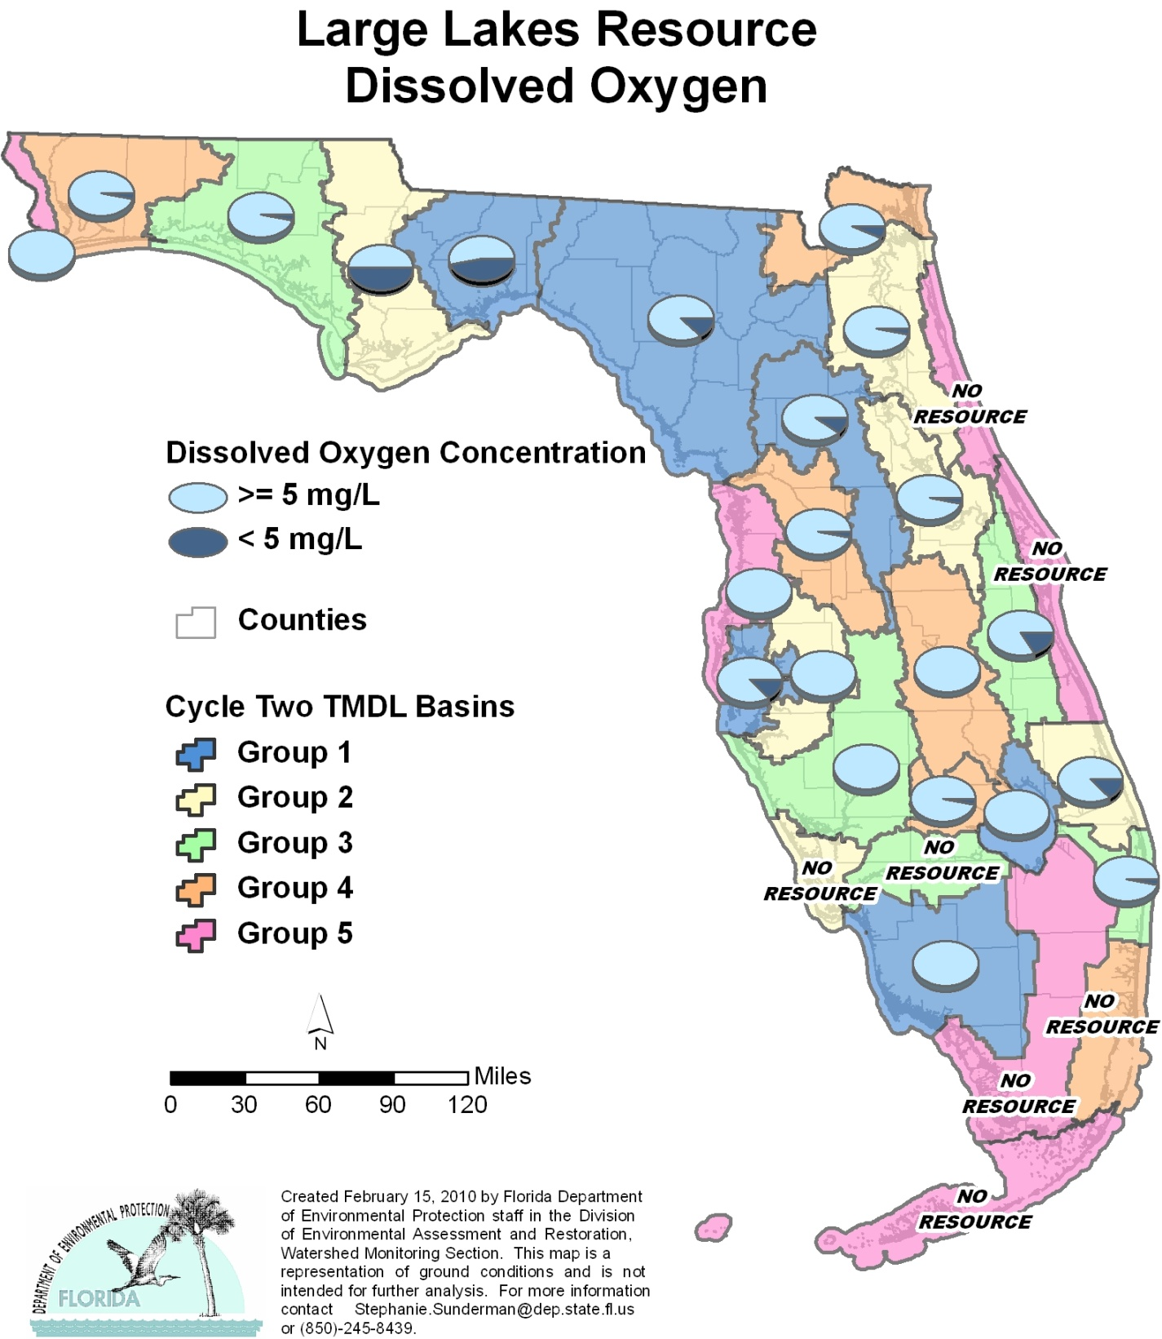

Table A.9. Percentage of Large Lakes Meeting Threshold Value for DO Calculated Using Probabilistic Monitoring Design
Status Network Designated Use: Recreation and Aquatic Life Units: Acres

This is a 10-column table. Column 1 lists the basin, Column 2 lists the target population, Column 3 lists the sampleable acres, Column 4 lists the dry miles, Column 5 lists the inaccessible acres, Column 6 lists the number of samples, Column 7 lists the percent meeting threshold, Column 8 lists the 95% confidence bounds, Column 9 lists the percent not meeting threshold, and Column 10 lists the assessment period.

¹ No large lakes in basin
² N/A = Not applicable
Basin | Target Population | Sampleable | Dry | Inaccessible | Number of Samples | % Meeting Threshold | 95% Confidence Bounds  (% Meeting Threshold) | % Not Meeting Threshold | Assessment Period
NWFWMD1  Ochlockonee–St. Marks | 30,107 | 17,042 | 1,704 | 11,361 | 30 | 53.3 | 42.2-64.4 | 46.7 | June-Aug 2004
SFWMD1  Everglades–West Coast | 1,524 | 1,426 | 0 | 98 | 29 | 100.0 | 100.0 | 0.0 | Oct-Dec 2004
SFWMD6  Lake Okeechobee | 340,652 | 234,933 | 0 | 105,719 | 23 | 100.0 | 100.0 | 0.0 | Nov-Dec 2004
SJRWMD1  Ocklawaha | 142,923 | 119,103 | 0 | 23,820 | 30 | 90.0 | 81.2-98.8 | 10.0 | Oct-Dec 2004
SRWMD1  Suwannee | 24,566 | 14,932 | 4,335 | 5,299 | 31 | 87.1 | 78.0-96.2 | 12.9 | July 2004
SWFWMD1  Tampa Bay | 6,191 | 6,191 | 0 | 0 | 30 | 86.7 | 78.3-95.0 | 13.3 | Oct-Nov 2004
NWFWMD2  Apalachicola–Chipola | 15,723 | 13,873 | 0 | 1,850 | 30 | 50.0 | 37.9-62.1 | 50.0 | July 2005
SFWMD2  St Lucie–Loxahatchee | 626 | 470 | 0 | 156 | 30 | 86.7 | 76.4-97.0 | 13.3 | Nov-Dec 2005
SFWMD7  Charlotte Harbor | 10 | 0 | 0 | 10 | 0 | N/A² | N/A² | N/A² | N/A²
SJRWMD2  Lower St. Johns | 37,417 | 30,338 | 0 | 7,079 | 30 | 96.7 | 91.3-100.0 | 3.3 | Oct-Dec 2005
SJRWMD6  Middle St. Johns | 116,082 | 94,121 | 6,275 | 15,686 | 30 | 96.7 | 91.1-100.0 | 3.3 | Nov-Dec 2005
SWFWMD2  Tampa Bay Tributaries | 6,473 | 4,979 | 0 | 1,494 | 30 | 100.0 | 100.0 | 0.0 | Oct-Nov 2005
NWFWMD3  Choctawhatchee–  St. Andrews | 14,871 | 8,747 | 5,832 | 292 | 30 | 96.7 | 91.2-100.0 | 3.3 | Jun-Aug 2006
SFWMD3  Caloosahatchee | 203 | 0 | 0 | 203 | 0 | N/A² | N/A² | N/A² | N/A²
SFWMD8  Lake Worth Lagoon–  Palm Beach Coast | 1,490 | 1,490 | 0 | 0 | 30 | 96.7 | 91.4-100.0 | 3.3 | Oct-Nov 2006
SJRWMD3  Upper St. Johns | 20,908 | 16,952 | 565 | 3,391 | 30 | 83.3 | 73.8-92.9 | 16.7 | Oct-Nov 2006
SWFWMD3  Sarasota Bay–Peace–Myakka | 36,927 | 31,652 | 0 | 5,275 | 30 | 100.0 | 100.0 | 0.0 | Nov-Dec 2006
NWFWMD4  Pensacola | 1,688 | 1,298 | 216 | 174 | 30 | 96.7 | 91.3-100.0 | 3.3 | June-July 2007
SFWMD4  Fisheating Creek | 419 | 185 | 0 | 234 | 30 | 96.7 | 91.3-100.0 | 3.3 | Nov-Dec 2007
SFWMD9  Kissimmee River | 192,758 | 192,758 | 0 | 0 | 27 | 100.0 | 100.0 | 0.0 | Nov-Dec 2007
SFWMD10  Southeast Coast–  Biscayne Bay¹ | 0 | 0 | 0 | 0 | 0 | N/A² | N/A² | N/A² | Nov-Dec 2007
SJRWMD4  Nassau–St. Marys | 2,874 | 2,874 | 0 | 0 | 30 | 93.3 | 85.4-100.0 | 6.7 | Oct 2007
SWFWMD4  Withlacoochee | 38,016 | 17,022 | 2,837 | 18,157 | 30 | 96.7 | 91.2-100.0 | 3.3 | Nov-Dec 2007
NWFWMD5  Perdido | 69 | 69 | 0 | 0 | 8 | 100.0 | 100.0 | 0.0 | June 2008
SFWMD5  Everglades¹ | 0 | 0 | 0 | 0 | 0 | N/A² | N/A² | N/A² | N/A²
SFWMD11  Florida Keys¹ | 0 | 0 | 0 | 0 | 0 | N/A² | N/A² | N/A² | N/A²
SJRWMD5  Indian River Lagoon | 90 | 0 | 90 | 0 | 0 | N/A² | N/A² | N/A² | N/A²
SJRWMD7  Upper East Coast | 288 | 0 | 288 | 0 | 0 | N/A² | N/A² | N/A² | N/A²
SWFWMD5  Springs Coast | 6,004 | 1,396 | 4,421 | 187 | 30 | 100.0 | 100.0 | 0.0 | Nov-Dec 2008
Summary of All Basins | 1,038,899 | 811,851 | 26,563 | 200,485 | 628 | 95.0 | 93.4-96.7 | 5.0 | 2004–08

Figure A.10. Summary of Fecal Coliform Assessment for Large Lakes

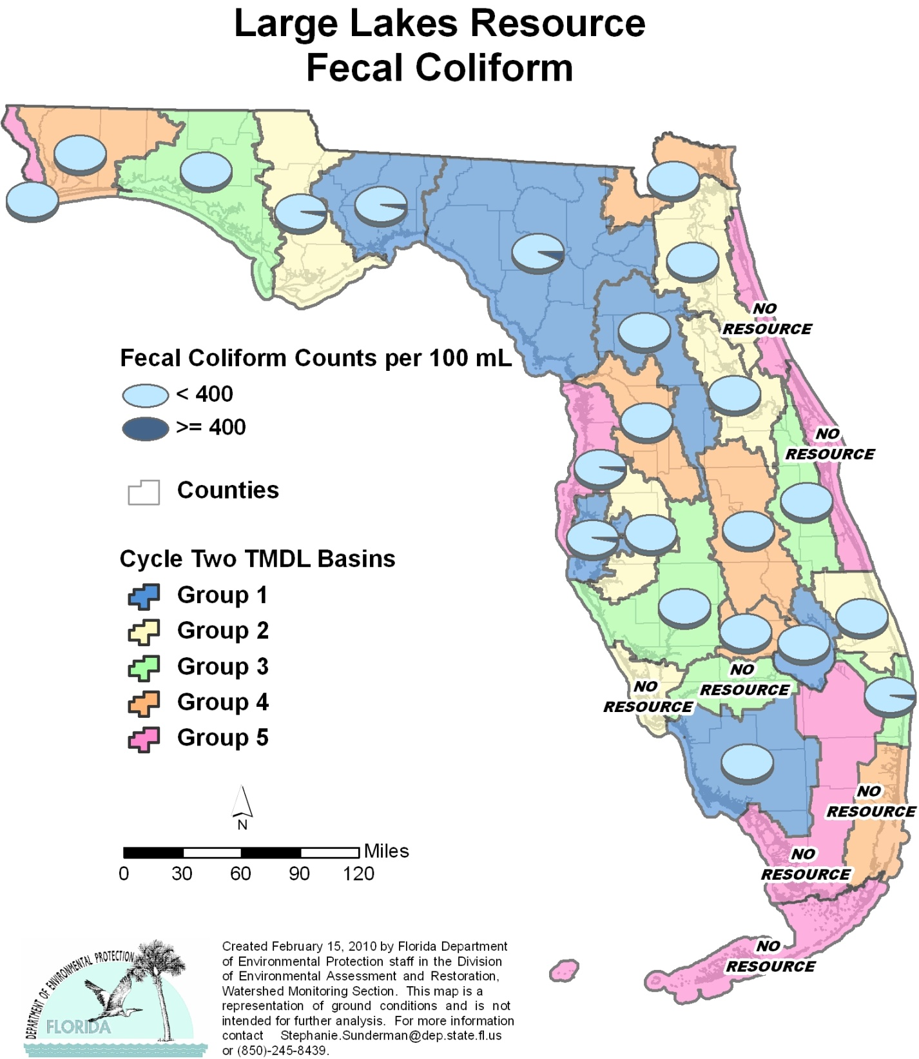

Table A.10. Percentage of Large Lakes Meeting Threshold Value for Fecal Coliform Calculated Using Probabilistic Monitoring Design
Status Network Designated Use: Recreation and Aquatic Life Units: Acres

This is a 10-column table. Column 1 lists the basin, Column 2 lists the target population, Column 3 lists the sampleable acres, Column 4 lists the dry miles, Column 5 lists the inaccessible acres, Column 6 lists the number of samples, Column 7 lists the percent meeting threshold, Column 8 lists the 95% confidence bounds, Column 9 lists the percent not meeting threshold, and Column 10 lists the assessment period.

¹ No large lakes in basin
² N/A = Not applicable
Basin | Target Population | Sampleable | Dry | Inaccessible | Number of Samples | % Meeting Threshold | 95% Confidence Bounds  (% Meeting Threshold) | % Not Meeting Threshold | Assessment Period
NWFWMD1  Ochlockonee–St. Marks | 30,107 | 17,042 | 1,704 | 11,361 | 30 | 96.7 | 91.0-100.0 | 3.3 | June-Aug 2004
SFWMD1  Everglades–West Coast | 1,524 | 1,426 | 0 | 98 | 29 | 100.0 | 100.0 | 0.0 | Oct-Dec 2004
SFWMD6  Lake Okeechobee | 340,652 | 234,933 | 0 | 105,719 | 17 | 100.0 | 100.0 | 0.0 | Nov-Dec 2004
SJRWMD1  Ocklawaha | 142,923 | 119,103 | 0 | 23,820 | 29 | 100.0 | 100.0 | 0.0 | Oct-Dec 2004
SRWMD1  Suwannee | 24,566 | 14,932 | 4,335 | 5,299 | 31 | 93.5 | 86.0-100.0 | 6.5 | July 2004
SWFWMD1  Tampa Bay | 6,191 | 6,191 | 0 | 0 | 30 | 96.7 | 91.0-100.0 | 3.3 | Oct-Nov 2004
NWFWMD2  Apalachicola–Chipola | 15,723 | 13,873 | 0 | 1,850 | 30 | 96.7 | 91.0-100.0 | 3.3 | July 2005
SFWMD2  St Lucie–Loxahatchee | 626 | 470 | 0 | 156 | 28 | 100.0 | 100.0 | 0.0 | Nov-Dec 2005
SFWMD7  Charlotte Harbor | 10 | 0 | 0 | 10 | 0 | N/A² | N/A² | N/A² | N/A²
SJRWMD2  Lower St. Johns | 37,417 | 30,338 | 0 | 7,079 | 29 | 100.0 | 100.0 | 0.0 | Oct-Dec 2005
SJRWMD6  Middle St. Johns | 116,082 | 94,121 | 6,275 | 15,686 | 27 | 100.0 | 100.0 | 0.0 | Nov-Dec 2005
SWFWMD2  Tampa Bay Tributaries | 6,473 | 4,979 | 0 | 1,494 | 30 | 100.0 | 100.0 | 0.0 | Oct-Nov 2005
NWFWMD3  Choctawhatchee–  St. Andrews | 14,871 | 8,747 | 5,832 | 292 | 30 | 100.0 | 100.0 | 0.0 | Jun-Aug 2006
SFWMD3  Caloosahatchee | 203 | 0 | 0 | 203 | 0 | N/A² | N/A² | N/A² | N/A²
SFWMD8  Lake Worth Lagoon–  Palm Beach Coast | 1,490 | 1,490 | 0 | 0 | 29 | 96.6 | 90.9-100.0 | 3.4 | Oct-Nov 2006
SJRWMD3  Upper St. Johns | 20,908 | 16,952 | 565 | 3,391 | 30 | 100.0 | 100.0 | 0.0 | Oct-Nov 2006
SWFWMD3  Sarasota Bay–Peace–Myakka | 36,927 | 31,652 | 0 | 5,275 | 30 | 100.0 | 100.0 | 0.0 | Nov-Dec 2006
NWFWMD4  Pensacola | 1,688 | 1,298 | 216 | 174 | 30 | 100.0 | 100.0 | 0.0 | June-July 2007
SFWMD4  Fisheating Creek | 419 | 185 | 0 | 234 | 30 | 100.0 | 100.0 | 0.0 | Nov-Dec 2007
SFWMD9  Kissimmee River | 192,758 | 192,758 | 0 | 0 | 29 | 100.0 | 100.0 | 0.0 | Nov-Dec 2007
SFWMD10  Southeast Coast–  Biscayne Bay¹ | 0 | 0 | 0 | 0 | 0 | N/A² | N/A² | N/A² | Nov-Dec 2007
SJRWMD4  Nassau-St. Marys | 2,874 | 2,874 | 0 | 0 | 30 | 100.0 | 100.0 | 0.0 | Oct 2007
SWFWMD4  Withlacoochee | 38,016 | 17,022 | 2,837 | 18,157 | 30 | 100.0 | 100.0 | 0.0 | Nov-Dec 2007
NWFWMD5  Perdido | 69 | 69 | 0 | 0 | 8 | 100.0 | 100.0 | 0.0 | June 2008
SFWMD5  Everglades¹ | 0 | 0 | 0 | 0 | 0 | N/A² | N/A² | N/A² | N/A²
SFWMD11  Florida Keys¹ | 0 | 0 | 0 | 0 | 0 | N/A² | N/A² | N/A² | N/A²
SJRWMD5  Indian River Lagoon | 90 | 0 | 90 | 0 | 0 | N/A² | N/A² | N/A² | N/A²
SJRWMD7  Upper East Coast | 288 | 0 | 288 | 0 | 0 | N/A² | N/A² | N/A² | N/A²
SWFWMD5  Springs Coast | 6,004 | 1,396 | 4,421 | 187 | 30 | 96.7 | 91.0-100.0 | 3.3 | Nov-Dec 2008
Summary of All Basins | 1,038,899 | 811,851 | 26,563 | 200,485 | 616 | 99.7 | 99.5-99.9 | 0.3 | 2004–08

Figure A.11. Summary of Un-ionized Ammonia Assessment for Large Lakes

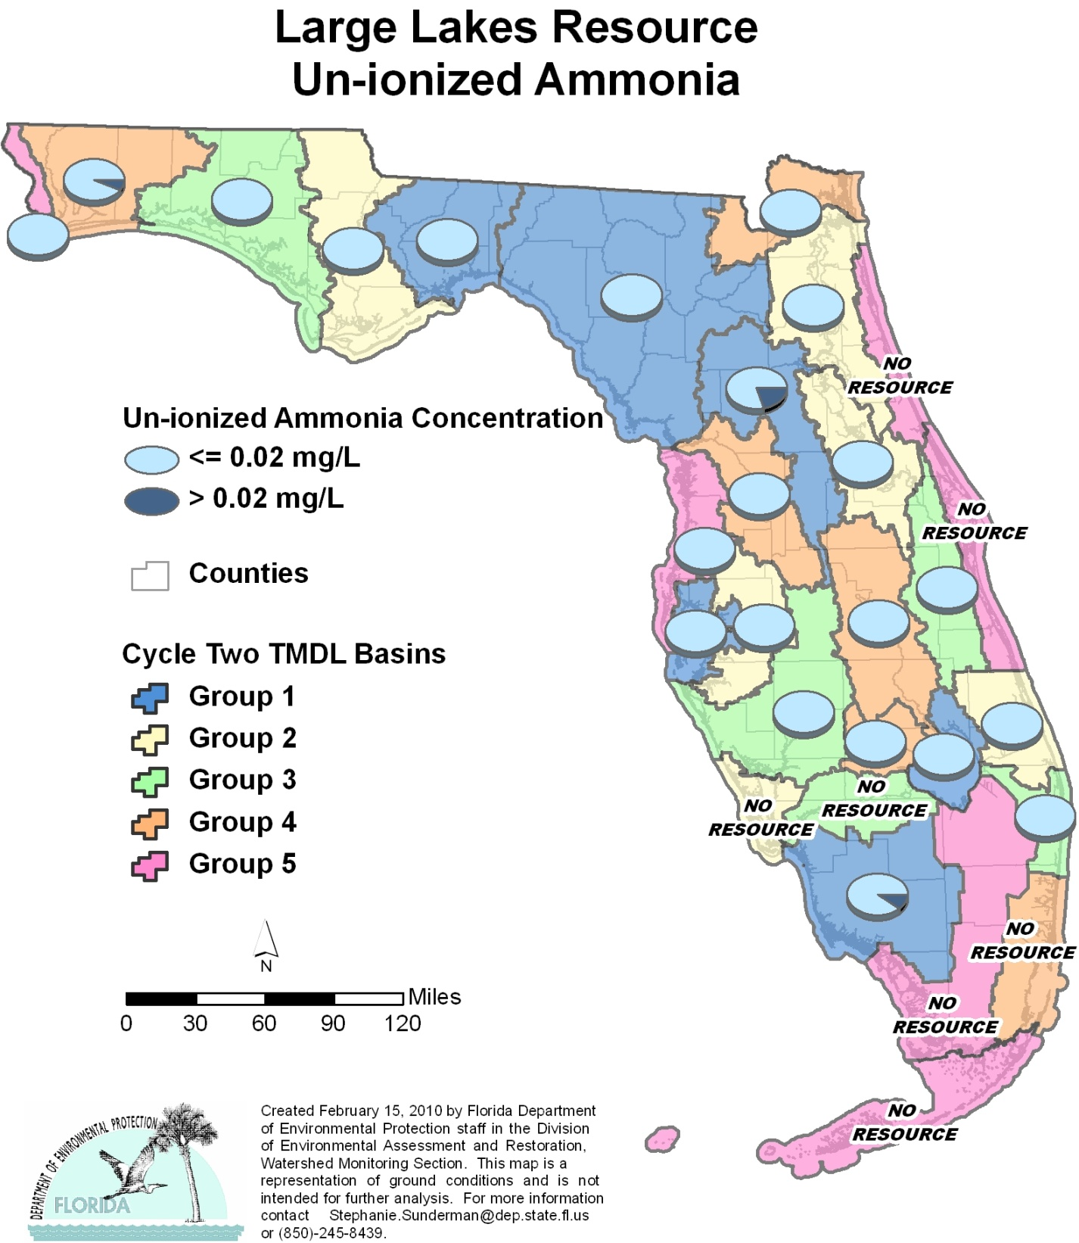

Table A.11. Percentage of Large Lakes Meeting Threshold Value for Un-ionized Ammonia Calculated Using Probabilistic Monitoring Design
Status Network Designated Use: Recreation and Aquatic Life Units: Acres

This is a 10-column table. Column 1 lists the basin, Column 2 lists the target population, Column 3 lists the sampleable acres, Column 4 lists the dry miles, Column 5 lists the inaccessible acres, Column 6 lists the number of samples, Column 7 lists the percent meeting threshold, Column 8 lists the 95% confidence bounds, Column 9 lists the percent not meeting threshold, and Column 10 lists the assessment period.
¹ No large lakes in basin
² N/A = Not applicable
Basin | Target Population | Sampleable | Dry | Inaccessible | Number of Samples | % Meeting Threshold | 95% Confidence Bounds  (% Meeting Threshold) | % Not Meeting Threshold | Assessment Period
NWFWMD1  Ochlockonee–St. Marks | 30,107 | 17,042 | 1,704 | 11,361 | 30 | 100.0 | 100.0 | 0.0 | June-Aug 2004
SFWMD1  Everglades–West Coast | 1,524 | 1,426 | 0 | 98 | 29 | 89.7 | 79.9-99.4 | 10.3 | Oct-Dec 2004
SFWMD6  Lake Okeechobee | 340,652 | 234,933 | 0 | 105,719 | 19 | 100.0 | 100.0 | 0.0 | Nov-Dec 2004
SJRWMD1  Ocklawaha | 142,923 | 119,103 | 0 | 23,820 | 30 | 80.0 | 71.4-88.6 | 20.0 | Oct-Dec 2004
SRWMD1  Suwannee | 24,566 | 14,932 | 4,335 | 5,299 | 31 | 100.0 | 100.0 | 0.0 | July 2004
SWFWMD1  Tampa Bay | 6,191 | 6,191 | 0 | 0 | 30 | 100.0 | 100.0 | 0.0 | Oct-Nov 2004
NWFWMD2  Apalachicola–Chipola | 15,723 | 13,873 | 0 | 1,850 | 30 | 100.0 | 100.0 | 0.0 | July 2005
SFWMD2  St Lucie–Loxahatchee | 626 | 470 | 0 | 156 | 29 | 100.0 | 100.0 | 0.0 | Nov-Dec 2005
SFWMD7  Charlotte Harbor | 10 | 0 | 0 | 10 | 0 | N/A² | N/A² | N/A² | N/A²
SJRWMD2  Lower St. Johns | 37,417 | 30,338 | 0 | 7,079 | 30 | 100.0 | 100.0 | 0.0 | Oct-Dec 2005
SJRWMD6  Middle St. Johns | 116,082 | 94,121 | 6,275 | 15,686 | 30 | 100.0 | 100.0 | 0.0 | Nov-Dec 2005
SWFWMD2  Tampa Bay Tributaries | 6,473 | 4,979 | 0 | 1,494 | 30 | 100.0 | 100.0 | 0.0 | Oct-Nov 2005
NWFWMD3  Choctawhatchee–  St. Andrews | 14,871 | 8,747 | 5,832 | 292 | 30 | 100.0 | 100.0 | 0.0 | Jun-Aug 2006
SFWMD3  Caloosahatchee | 203 | 0 | 0 | 203 | 0 | N/A² | N/A² | N/A² | N/A²
SFWMD8  Lake Worth Lagoon–  Palm Beach Coast | 1,490 | 1,490 | 0 | 0 | 30 | 100.0 | 100.0 | 0.0 | Oct-Nov 2006
SJRWMD3  Upper St. Johns | 20,908 | 16,952 | 565 | 3,391 | 30 | 100.0 | 100.0 | 0.0 | Oct-Nov 2006
SWFWMD3  Sarasota Bay–Peace–Myakka | 36,927 | 31,652 | 0 | 5,275 | 30 | 100.0 | 100.0 | 0.0 | Nov-Dec 2006
NWFWMD4  Pensacola | 1,688 | 1,298 | 216 | 174 | 30 | 93.3 | 87.3-99.3 | 6.7 | June-July 2007
SFWMD4  Fisheating Creek | 419 | 185 | 0 | 234 | 30 | 100.0 | 100.0 | 0.0 | Nov-Dec 2007
SFWMD9  Kissimmee River | 192,758 | 192,758 | 0 | 0 | 30 | 100.0 | 100.0 | 0.0 | Nov-Dec 2007
SFWMD10  Southeast Coast–  Biscayne Bay¹ | 0 | 0 | 0 | 0 | 0 | N/A² | N/A² | N/A² | Nov-Dec 2007
SJRWMD4  Nassau-St. Marys | 2,874 | 2,874 | 0 | 0 | 30 | 100.0 | 100.0 | 0.0 | Oct 2007
SWFWMD4  Withlacoochee | 38,016 | 17,022 | 2,837 | 18,157 | 30 | 100.0 | 100.0 | 0.0 | Nov-Dec 2007
NWFWMD5  Perdido | 69 | 69 | 0 | 0 | 8 | 100.0 | 100.0 | 0.0 | June 2008
SFWMD5  Everglades¹ | 0 | 0 | 0 | 0 | 0 | N/A² | N/A² | N/A² | N/A²
SFWMD11  Florida Keys¹ | 0 | 0 | 0 | 0 | 0 | N/A² | N/A² | N/A² | N/A²
SJRWMD5  Indian River Lagoon | 90 | 0 | 90 | 0 | 0 | N/A² | N/A² | N/A² | N/A²
SJRWMD7  Upper East Coast | 288 | 0 | 288 | 0 | 0 | N/A² | N/A² | N/A² | N/A²
SWFWMD5  Springs Coast | 6,004 | 1,396 | 4,421 | 187 | 30 | 100.0 | 100.0 | 0.0 | Nov-Dec 2008
Summary of All Basins | 1,038,899 | 811,851 | 26,563 | 200,485 | 626 | 96.6 | 95.2-98.1 | 3.4 | 2004–08

Figure A.12. Summary of TSI Assessment for Large Lakes

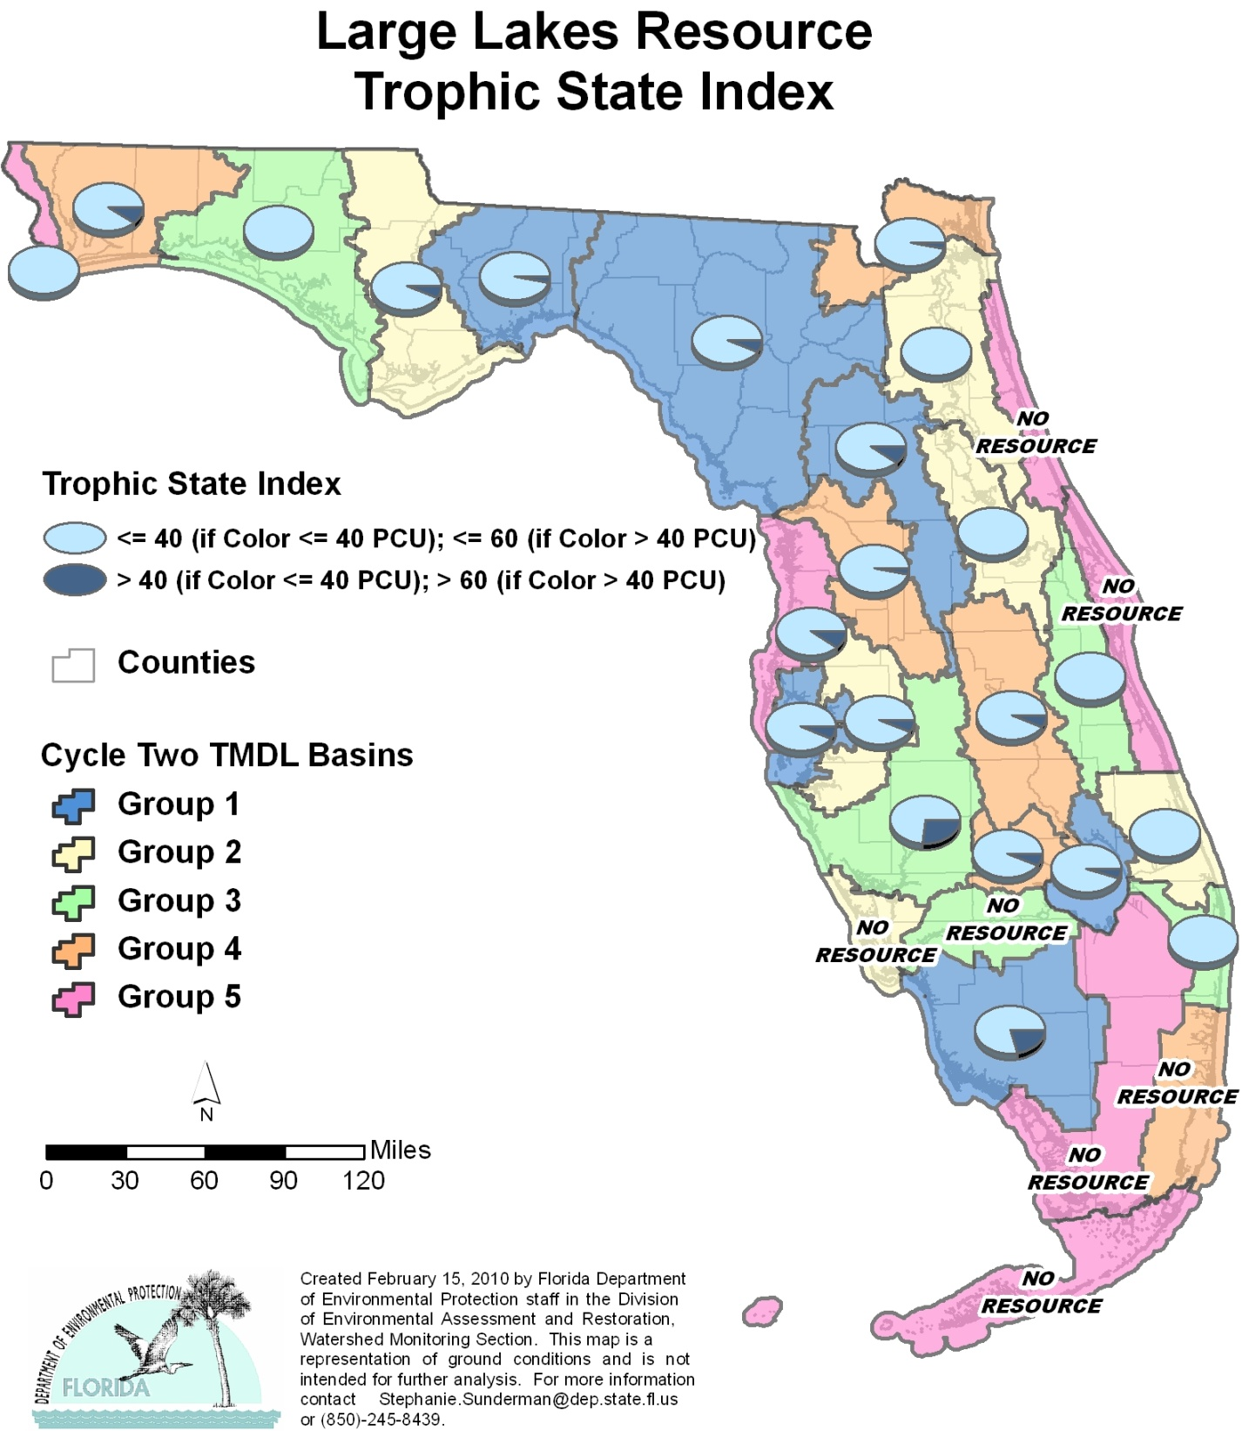

Table A.12. Percentage of Large Lakes Meeting Threshold Value for TSI Calculated Using Probabilistic Monitoring Design
Status Network Designated Use: Recreation and Aquatic Life Units: Acres

This is a 10-column table. Column 1 lists the basin, Column 2 lists the target population, Column 3 lists the sampleable acres, Column 4 lists the dry miles, Column 5 lists the inaccessible acres, Column 6 lists the number of samples, Column 7 lists the percent meeting threshold, Column 8 lists the 95% confidence bounds, Column 9 lists the percent not meeting threshold, and Column 10 lists the assessment period.

¹ No large lakes in basin
² N/A = Not applicable
Basin | Target Population | Sampleable | Dry | Inaccessible | Number of Samples | % Meeting Threshold | 95% Confidence Bounds  (% Meeting Threshold) | % Not Meeting Threshold | Assessment Period
NWFWMD1  Ochlockonee–St. Marks | 30,107 | 17,042 | 1,704 | 11,361 | 30 | 96.7 | 90.9-100.0 | 3.3 | June-Aug 2004
SFWMD1  Everglades–West Coast | 1,524 | 1,426 | 0 | 98 | 29 | 79.3 | 66.8-91.8 | 20.7 | Oct-Dec 2004
SFWMD6  Lake Okeechobee | 340,652 | 234,933 | 0 | 105,719 | 19 | 94.7 | 86.1-100.0 | 5.3 | Nov-Dec 2004
SJRWMD1  Ocklawaha | 142,923 | 119,103 | 0 | 23,820 | 30 | 90.0 | 80.7-99.3 | 10.0 | Oct-Dec 2004
SRWMD1  Suwannee | 24,566 | 14,932 | 4,335 | 5,299 | 31 | 93.5 | 86.1-100.0 | 6.5 | July 2004
SWFWMD1  Tampa Bay | 6,191 | 6,191 | 0 | 0 | 30 | 93.3 | 87.7-98.9 | 6.7 | Oct-Nov 2004
NWFWMD2  Apalachicola–Chipola | 15,723 | 13,873 | 0 | 1,850 | 30 | 93.3 | 85.5-100.0 | 6.7 | July 2005
SFWMD2  St Lucie–Loxahatchee | 626 | 470 | 0 | 156 | 30 | 100.0 | 100.0 | 0.0 | Nov-Dec 2005
SFWMD7  Charlotte Harbor | 10 | 0 | 0 | 10 | 0 | N/A² | N/A² | N/A² | N/A²
SJRWMD2  Lower St. Johns | 37,417 | 30,338 | 0 | 7,079 | 30 | 100.0 | 100.0 | 0.0 | Oct-Dec 2005
SJRWMD6  Middle St. Johns | 116,082 | 94,121 | 6,275 | 15,686 | 30 | 100.0 | 100.0 | 0.0 | Nov-Dec 2005
SWFWMD2  Tampa Bay Tributaries | 6,473 | 4,979 | 0 | 1,494 | 30 | 93.3 | 87.4-99.3 | 6.7 | Oct-Nov 2005
NWFWMD3  Choctawhatchee–  St. Andrews | 14,871 | 8,747 | 5,832 | 292 | 30 | 100.0 | 100.0 | 0.0 | Jun-Aug 2006
SFWMD3  Caloosahatchee | 203 | 0 | 0 | 203 | 0 | N/A² | N/A² | N/A² | N/A²
SFWMD8  Lake Worth Lagoon–  Palm Beach Coast | 1,490 | 1,490 | 0 | 0 | 30 | 100.0 | 100.0 | 0.0 | Oct-Nov 2006
SJRWMD3  Upper St. Johns | 20,908 | 16,952 | 565 | 3,391 | 30 | 100.0 | 100.0 | 0.0 | Oct-Nov 2006
SWFWMD3  Sarasota Bay–Peace–Myakka | 36,927 | 31,652 | 0 | 5,275 | 30 | 73.3 | 60.3-86.3 | 26.7 | Nov-Dec 2006
NWFWMD4  Pensacola | 1,688 | 1,298 | 216 | 174 | 30 | 90.0 | 81.5-98.5 | 10.0 | June-July 2007
SFWMD4  Fisheating Creek | 419 | 185 | 0 | 234 | 30 | 93.3 | 86.8-99.8 | 6.7 | Nov-Dec 2007
SFWMD9  Kissimmee River | 192,758 | 192,758 | 0 | 0 | 30 | 93.3 | 85.6-100.0 | 6.7 | Nov-Dec 2007
SFWMD10  Southeast Coast–  Biscayne Bay¹ | 0 | 0 | 0 | 0 | 0 | N/A² | N/A² | N/A² | Nov-Dec 2007
SJRWMD4  Nassau–St. Marys | 2,874 | 2,874 | 0 | 0 | 30 | 96.7 | 90.8-100.0 | 3.3 | Oct 2007
SWFWMD4  Withlacoochee | 38,016 | 17,022 | 2,837 | 18,157 | 30 | 96.7 | 90.8-100.0 | 3.3 | Nov-Dec 2007
NWFWMD5  Perdido | 69 | 69 | 0 | 0 | 8 | 100.0 | 100.0 | 0.0 | June 2008
SFWMD5  Everglades¹ | 0 | 0 | 0 | 0 | 0 | N/A² | N/A² | N/A² | N/A²
SFWMD11  Florida Keys¹ | 0 | 0 | 0 | 0 | 0 | N/A² | N/A² | N/A² | N/A²
SJRWMD5  Indian River Lagoon | 90 | 0 | 90 | 0 | 0 | N/A² | N/A² | N/A² | N/A²
SJRWMD7  Upper East Coast | 288 | 0 | 288 | 0 | 0 | N/A² | N/A² | N/A² | N/A²
SWFWMD5  Springs Coast | 6,004 | 1,396 | 4,421 | 187 | 30 | 90.0 | 80.7-99.3 | 10.0 | Nov-Dec 2008
Summary of All Basins | 1,038,899 | 811,851 | 26,563 | 200,485 | 6327 | 94.0 | 90.75-97.6 | 6.0 | 2004–08

Figure A.13. Summary of DO Assessment for Small Lakes

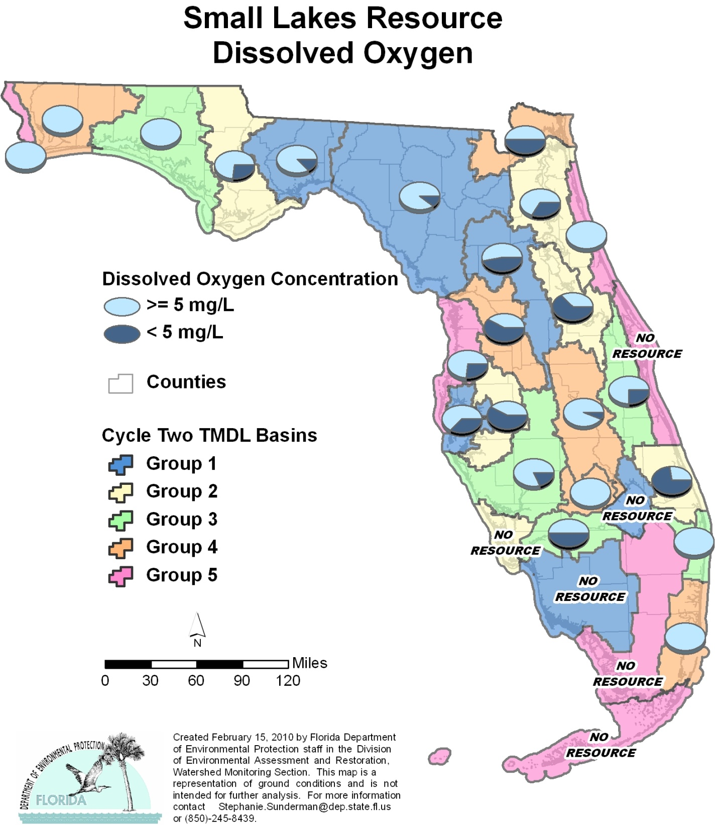

Table A.13. Percentage of Small Lakes Meeting Threshold Value for DO Calculated Using Probabilistic Monitoring Design
Status Network Designated Use: Recreation and Aquatic Life Units: Lakes

This is a 10-column table. Column 1 lists the basin, Column 2 lists the target population, Column 3 lists the sampleable lakes, Column 4 lists the dry miles, Column 5 lists the inaccessible lakes, Column 6 lists the number of samples, Column 7 lists the percent meeting threshold, Column 8 lists the 95% confidence bounds, Column 9 lists the percent not meeting threshold, and Column 10 lists the assessment period.

¹ No small lakes in basin
² N/A = Not applicable
Basin | Target Population | Sampleable | Dry | Inaccessible | Number of Samples | % Meeting Threshold | 95% Confidence Bounds  (% Meeting Threshold) | % Not Meeting Threshold | Assessment Period
NWFWMD1  Ochlockonee–St. Marks | 301 | 161 | 32 | 108 | 30 | 86.7 | 77.6-95.8 | 13.3 | March-April 2004
SFWMD1  Everglades–West Coast | 3 | 0 | 3 | 0 | 0 | N/A² | N/A² | N/A² | N/A²
SFWMD6  Lake Okeechobee¹ | 0 | 0 | 0 | 0 | 0 | N/A² | N/A² | N/A² | N/A²
SJRWMD1  Ocklawaha | 552 | 224 | 75 | 253 | 30 | 53.3 | 37.1-69.6 | 46.7 | July-Sept 2004
SRWMD1  Suwannee | 994 | 215 | 382 | 397 | 27 | 88.9 | 78.6-99.2 | 11.1 | March-April 2004
SWFWMD1  Tampa Bay | 216 | 175 | 6 | 35 | 30 | 63.3 | 49.3-77.4 | 36.7 | July-Aug 2004
NWFWMD2  Apalachicola–Chipola | 353 | 76 | 76 | 201 | 30 | 73.3 | 61.2-85.4 | 26.7 | March-May 2005
SFWMD2  St Lucie–Loxahatchee | 18 | 11 | 0 | 7 | 11 | 27.3 | 2.2-52.4 | 72.7 | July-Aug 2005
SFWMD7  Charlotte Harbor | 19 | 0 | 6 | 13 | 0 | N/A² | N/A² | N/A² | N/A²
SJRWMD2  Lower St. Johns | 180 | 84 | 6 | 90 | 30 | 66.7 | 52.8-80.5 | 33.3 | July 2005
SJRWMD6  Middle St. Johns | 499 | 272 | 9 | 218 | 30 | 36.7 | 22.0-51.3 | 63.3 | July-Aug 2005
SWFWMD2  Tampa Bay Tributaries | 248 | 105 | 24 | 119 | 31 | 41.9 | 27.5-56.4 | 58.1 | July-Aug 2005
NWFWMD3  Choctawhatchee–  St. Andrews | 298 | 142 | 19 | 137 | 30 | 100.0 | 100.0 | 0.0 | March-May 2006
SFWMD3  Caloosahatchee | 44 | 6 | 0 | 38 | 4 | 50.0 | 2.0-98.0 | 50.0 | July 2006
SFWMD8  Lake Worth Lagoon–  Palm Beach Coast | 13 | 10 | 0 | 3 | 10 | 100.0 | 100.0 | 0.0 | July 2006
SJRWMD3  Upper St. Johns | 105 | 16 | 12 | 77 | 4 | 75.0 | 33.4-100.0 | 25.0 | July-Sept 2006
SWFWMD3  Sarasota Bay–Peace–Myakka | 252 | 115 | 9 | 128 | 27 | 81.5 | 68.0-95.0 | 18.5 | Aug-Sept 2006
NWFWMD4  Pensacola | 245 | 119 | 63 | 63 | 30 | 100.0 | 100.0 | 0.0 | April-May 2007
SFWMD4  Fisheating Creek | 19 | 6 | 0 | 13 | 6 | 100.0 | 100.0 | 0.0 | Aug 2007
SFWMD9  Kissimmee River | 260 | 145 | 58 | 57 | 30 | 93.3 | 85.6-100.0 | 6.7 | July-Aug 2007
SFWMD10  Southeast Coast–  Biscayne Bay | 16 | 14 | 0 | 2 | 7 | 100.0 | 100.0 | 0.0 | July 2007
SJRWMD4  Nassau–St. Marys | 3 | 2 | 0 | 1 | 2 | 50.0 | 0.0-100.0 | 50.0 | July 2007
SWFWMD4  Withlacoochee | 788 | 115 | 563 | 110 | 24 | 41.7 | 24.6-58.8 | 58.3 | Aug-Sept 2007
NWFWMD5  Perdido | 13 | 10 | 0 | 3 | 10 | 100.0 | 100.0 | 0.0 | March 2008
SFWMD5  Everglades¹ | 0 | 0 | 0 | 0 | 0 | N/A² | N/A² | N/A² | N/A²
SFWMD11  Florida Keys¹ | 0 | 0 | 0 | 0 | 0 | N/A² | N/A² | N/A² | N/A²
SJRWMD5  Indian River Lagoon | 32 | 1 | 26 | 5 | 0 | N/A² | N/A² | N/A² | July 2008
SJRWMD7  Upper East Coast | 7 | 2 | 2 | 3 | 2 | 100.0 | 100.0 | 0.0 | July 2008
SWFWMD5  Springs Coast | 404 | 121 | 145 | 138 | 30 | 73.3 | 58.9-87.7 | 26.7 | July-Sept 2008
Summary of All Basins | 5,882 | 2,147 | 1,516 | 2,219 | 465 | 71.2 | 66.7-75.6 | 28.8 | 2004–08

Figure A.14. Summary of Fecal Coliform Assessment for Small Lakes

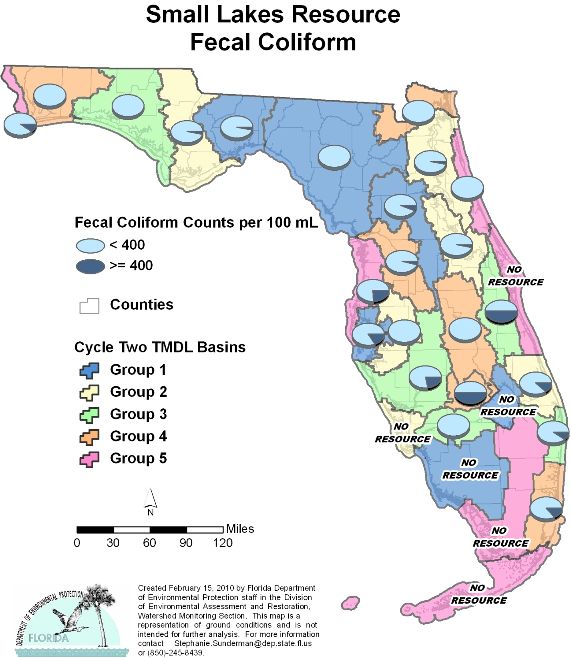

Table A.14. Percentage of Small Lakes Meeting Threshold Value for Fecal Coliform Calculated Using Probabilistic Monitoring Design
Status Network Designated Use: Recreation and Aquatic Life Units: Lakes

This is a 10-column table. Column 1 lists the basin, Column 2 lists the target population, Column 3 lists the sampleable lakes, Column 4 lists the dry miles, Column 5 lists the inaccessible lakes, Column 6 lists the number of samples, Column 7 lists the percent meeting threshold, Column 8 lists the 95% confidence bounds, Column 9 lists the percent not meeting threshold, and Column 10 lists the assessment period.

¹ No small lakes in basin
² N/A = Not applicable
Basin | Target Population | Sampleable | Dry | Inaccessible | Number of Samples | % Meeting Threshold | 95% Confidence Bounds  (% Meeting Threshold ) | % Not Meeting Threshold | Assessment Period
NWFWMD1  Ochlockonee–St. Marks | 301 | 161 | 32 | 108 | 30 | 96.7 | 91.2-100.0 | 3.3 | March-April 2004
SFWMD1  Everglades–West Coast | 3 | 0 | 3 | 0 | 0 | N/A² | N/A² | N/A² | N/A²
SFWMD6  Lake Okeechobee¹ | 0 | 0 | 0 | 0 | 0 | N/A² | N/A² | N/A² | N/A²
SJRWMD1  Ocklawaha | 552 | 224 | 75 | 253 | 30 | 93.3 | 87.8-98.8 | 6.7 | July-Sept 2004
SRWMD1  Suwannee | 994 | 215 | 382 | 397 | 25 | 100.0 | 100.0 | 0.0 | March-April 2004
SWFWMD1  Tampa Bay | 216 | 175 | 6 | 35 | 30 | 83.3 | 72.8-93.9 | 16.7 | July-Aug 2004
NWFWMD2  Apalachicola–Chipola | 353 | 76 | 76 | 201 | 30 | 96.7 | 91.0-100.0 | 3.3 | March-May 2005
SFWMD2  St Lucie–Loxahatchee | 18 | 11 | 0 | 7 | 8 | 87.5 | 67.2-100.0 | 12.5 | July-Aug 2005
SFWMD7  Charlotte Harbor | 19 | 0 | 6 | 13 | 0 | N/A² | N/A² | N/A² | July-Aug 2005
SJRWMD2  Lower St. Johns | 180 | 84 | 6 | 90 | 30 | 96.7 | 91.0-100.0 | 3.3 | July 2005
SJRWMD6  Middle St. Johns | 499 | 272 | 9 | 218 | 30 | 96.7 | 91.0-100.0 | 3.3 | July-Aug 2005
SWFWMD2  Tampa Bay Tributaries | 248 | 105 | 24 | 119 | 30 | 100.0 | 100.0 | 0.0 | July-Aug 2005
NWFWMD3  Choctawhatchee-  St. Andrews | 298 | 142 | 19 | 137 | 30 | 100.0 | 100.0 | 0.0 | March-May 2006
SFWMD3  Caloosahatchee | 44 | 6 | 0 | 38 | 4 | 100.0 | 100.0 | 0.0 | July 2006
SFWMD8  Lake Worth Lagoon–  Palm Beach Coast | 13 | 10 | 0 | 3 | 10 | 90.0 | 73.7-100.0 | 10.0 | July 2006
SJRWMD3  Upper St. Johns | 105 | 16 | 12 | 77 | 2 | 50.0 | 0.0-100.0 | 50.0 | July-Sept 2006
SWFWMD3  Sarasota Bay–Peace–Myakka | 252 | 115 | 9 | 128 | 27 | 77.8 | 64.7-90.8 | 22.2 | Aug-Sept 2006
NWFWMD4  Pensacola | 245 | 119 | 63 | 63 | 30 | 100.0 | 100.0 | 0.0 | April-May 2007
SFWMD4  Fisheating Creek | 19 | 6 | 0 | 13 | 6 | 50.0 | 10.8-89.2 | 50.0 | Aug 2007
SFWMD9  Kissimmee River | 260 | 145 | 58 | 57 | 30 | 100.0 | 100.0 | 0.0 | July-Aug 2007
SFWMD10  Southeast Coast–  Biscayne Bay | 16 | 14 | 0 | 2 | 7 | 85.7 | 62.0-100.0 | 14.3 | July 2007
SJRWMD4  Nassau–St. Marys | 3 | 2 | 0 | 1 | 2 | 100.0 | 100.0 | 0.0 | July 2007
SWFWMD4  Withlacoochee | 788 | 115 | 563 | 110 | 24 | 95.8 | 88.8-100.0 | 4.2 | Aug-Sept 2007
NWFWMD5  Perdido | 13 | 10 | 0 | 3 | 10 | 90.0 | 73.8-100.0 | 10.0 | March 2008
SFWMD5  Everglades¹ | 0 | 0 | 0 | 0 | 0 | N/A² | N/A² | N/A² | N/A²
SFWMD11  Florida Keys¹ | 0 | 0 | 0 | 0 | 0 | N/A² | N/A² | N/A² | N/A²
SJRWMD5  Indian River Lagoon | 32 | 1 | 26 | 5 | 0 | N/A² | N/A² | N/A² | July 2008
SJRWMD7  Upper East Coast | 7 | 2 | 2 | 3 | 2 | 100.0 | 100.0 | 0.0 | July 2008
SWFWMD5  Springs Coast | 404 | 121 | 145 | 138 | 29 | 75.9 | 62.5-89.2 | 24.1 | July-Sept 2008
Summary of All Basins | 5882 | 2147 | 1516 | 2219 | 456 | 90.9 | 84.1-97.7 | 9.1 | 2004–08

Figure A.15. Summary of Un-ionized Ammonia Assessment for Small Lakes

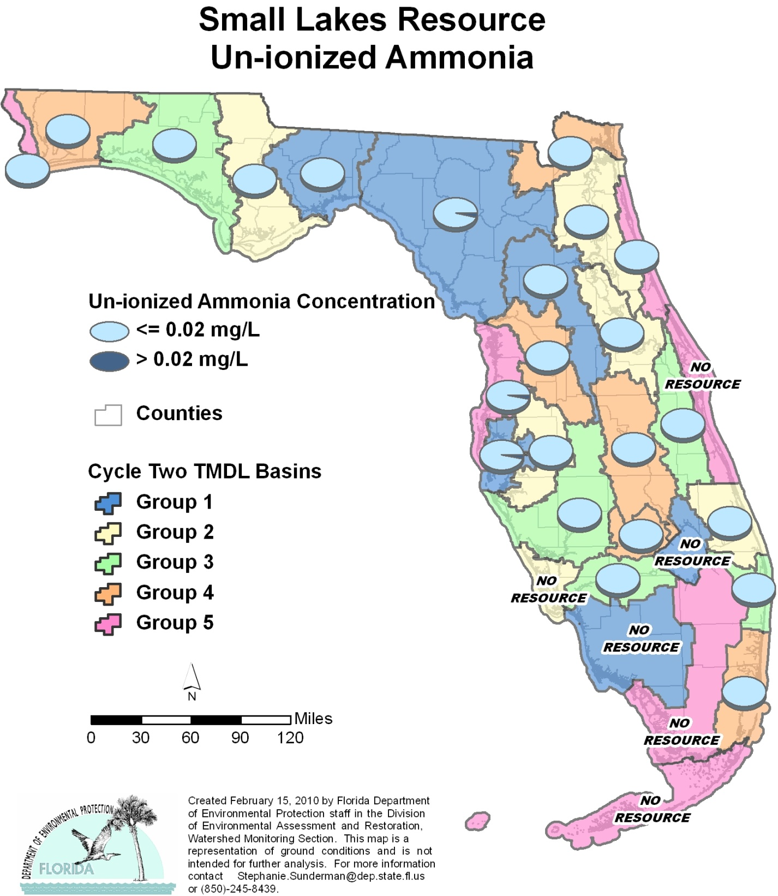

Table A.15. Percentage of Small Lakes Meeting Threshold Value for Un-ionized Ammonia Calculated Using Probabilistic Monitoring Design
Status Network Designated Use: Recreation and Aquatic Life Units: Lakes

This is a 10-column table. Column 1 lists the basin, Column 2 lists the target population, Column 3 lists the sampleable lakes, Column 4 lists the dry miles, Column 5 lists the inaccessible lakes, Column 6 lists the number of samples, Column 7 lists the percent meeting threshold, Column 8 lists the 95% confidence bounds, Column 9 lists the percent not meeting threshold, and Column 10 lists the assessment period.

¹ No small lakes in basin
² N/A = Not applicable
Basin | Target Population | Sampleable | Dry | Inaccessible | Number of Samples | % Meeting Threshold | 95% Confidence Bounds  (% Meeting Threshold) | % Not Meeting Threshold | Assessment Period
NWFWMD1  Ochlockonee–St. Marks | 301 | 161 | 32 | 108 | 30 | 100.0 | 100.0 | 0.0 | March-April 2004
SFWMD1  Everglades–West Coast | 3 | 0 | 3 | 0 | 0 | N/A² | N/A² | N/A² | N/A²
SFWMD6  Lake Okeechobee¹ | 0 | 0 | 0 | 0 | 0 | N/A² | N/A² | N/A² | N/A²
SJRWMD1  Ocklawaha | 552 | 224 | 75 | 253 | 30 | 100.0 | 100.0 | 0.0 | July-Sept 2004
SRWMD1  Suwannee | 994 | 215 | 382 | 397 | 27 | 96.3 | 90.3-100.0 | 3.7 | March-April 2004
SWFWMD1  Tampa Bay | 216 | 175 | 6 | 35 | 30 | 96.7 | 90.9-100.0 | 3.3 | July-Aug 2004
NWFWMD2  Apalachicola–Chipola | 353 | 76 | 76 | 201 | 30 | 100.0 | 100.0 | 0.0 | March-May 2005
SFWMD2  St Lucie–Loxahatchee | 18 | 11 | 0 | 7 | 11 | 100.0 | 100.0 | 0.0 | July-Aug 2005
SFWMD7  Charlotte Harbor | 19 | 0 | 6 | 13 | 0 | N/A² | N/A² | N/A² | N/A²
SJRWMD2  Lower St. Johns | 180 | 84 | 6 | 90 | 30 | 100.0 | 100.0 | 0.0 | July 2005
SJRWMD6  Middle St. Johns | 499 | 272 | 9 | 218 | 30 | 100.0 | 100.0 | 0.0 | July-Aug 2005
SWFWMD2  Tampa Bay Tributaries | 248 | 105 | 24 | 119 | 31 | 100.0 | 100.0 | 0.0 | July-Aug 2005
NWFWMD3  Choctawhatchee–  St. Andrews | 298 | 142 | 19 | 137 | 30 | 100.0 | 100.0 | 0.0 | March-May 2006
SFWMD3  Caloosahatchee | 44 | 6 | 0 | 38 | 4 | 100.0 | 100.0 | 0.0 | July 2006
SFWMD8  Lake Worth Lagoon-  Palm Beach Coast | 13 | 10 | 0 | 3 | 10 | 100.0 | 100.0 | 0.0 | July 2006
SJRWMD3  Upper St. Johns | 105 | 16 | 12 | 77 | 4 | 100.0 | 100.0 | 0.0 | July-Sept 2006
SWFWMD3  Sarasota Bay–Peace–Myakka | 252 | 115 | 9 | 128 | 27 | 100.0 | 100.0 | 0.0 | Aug-Sept 2006
NWFWMD4  Pensacola | 245 | 119 | 63 | 63 | 29 | 100.0 | 100.0 | 0.0 | April-May 2007
SFWMD4  Fisheating Creek | 19 | 6 | 0 | 13 | 6 | 100.0 | 100.0 | 0.0 | Aug 2007
SFWMD9  Kissimmee River | 260 | 145 | 58 | 57 | 30 | 100.0 | 100.0 | 0.0 | July-Aug 2007
SFWMD10  Southeast Coast–  Biscayne Bay | 16 | 14 | 0 | 2 | 7 | 100.0 | 100.0 | 0.0 | July 2007
SJRWMD4  Nassau–St. Marys | 3 | 2 | 0 | 1 | 2 | 100.0 | 100.0 | 0.0 | July 2007
SWFWMD4  Withlacoochee | 788 | 115 | 563 | 110 | 24 | 100.0 | 100.0 | 0.0 | Aug-Sept 2007
NWFWMD5  Perdido | 13 | 10 | 0 | 3 | 10 | 100.0 | 100.0 | 0.0 | March 2008
SFWMD5  Everglades¹ | 0 | 0 | 0 | 0 | 0 | N/A² | N/A² | N/A² | N/A²
SFWMD11  Florida Keys¹ | 0 | 0 | 0 | 0 | 0 | N/A² | N/A² | N/A² | N/A²
SJRWMD5  Indian River Lagoon | 32 | 1 | 26 | 5 | 0 | N/A² | N/A² | N/A² | July 2008
SJRWMD7  Upper East Coast | 7 | 2 | 2 | 3 | 2 | 100.0 | 100.0 | 0.0 | July 2008
SWFWMD5  Springs Coast | 404 | 121 | 145 | 138 | 30 | 96.7 | 91.3-100.0 | 3.3 | July-Sept 2008
Summary of All Basins | 5,882 | 2,147 | 1,516 | 2,219 | 464 | 99.3 | 98.5-100.0 | 0.7 | 2004–08

Figure A.16. Summary of TSI Assessment for Small Lakes

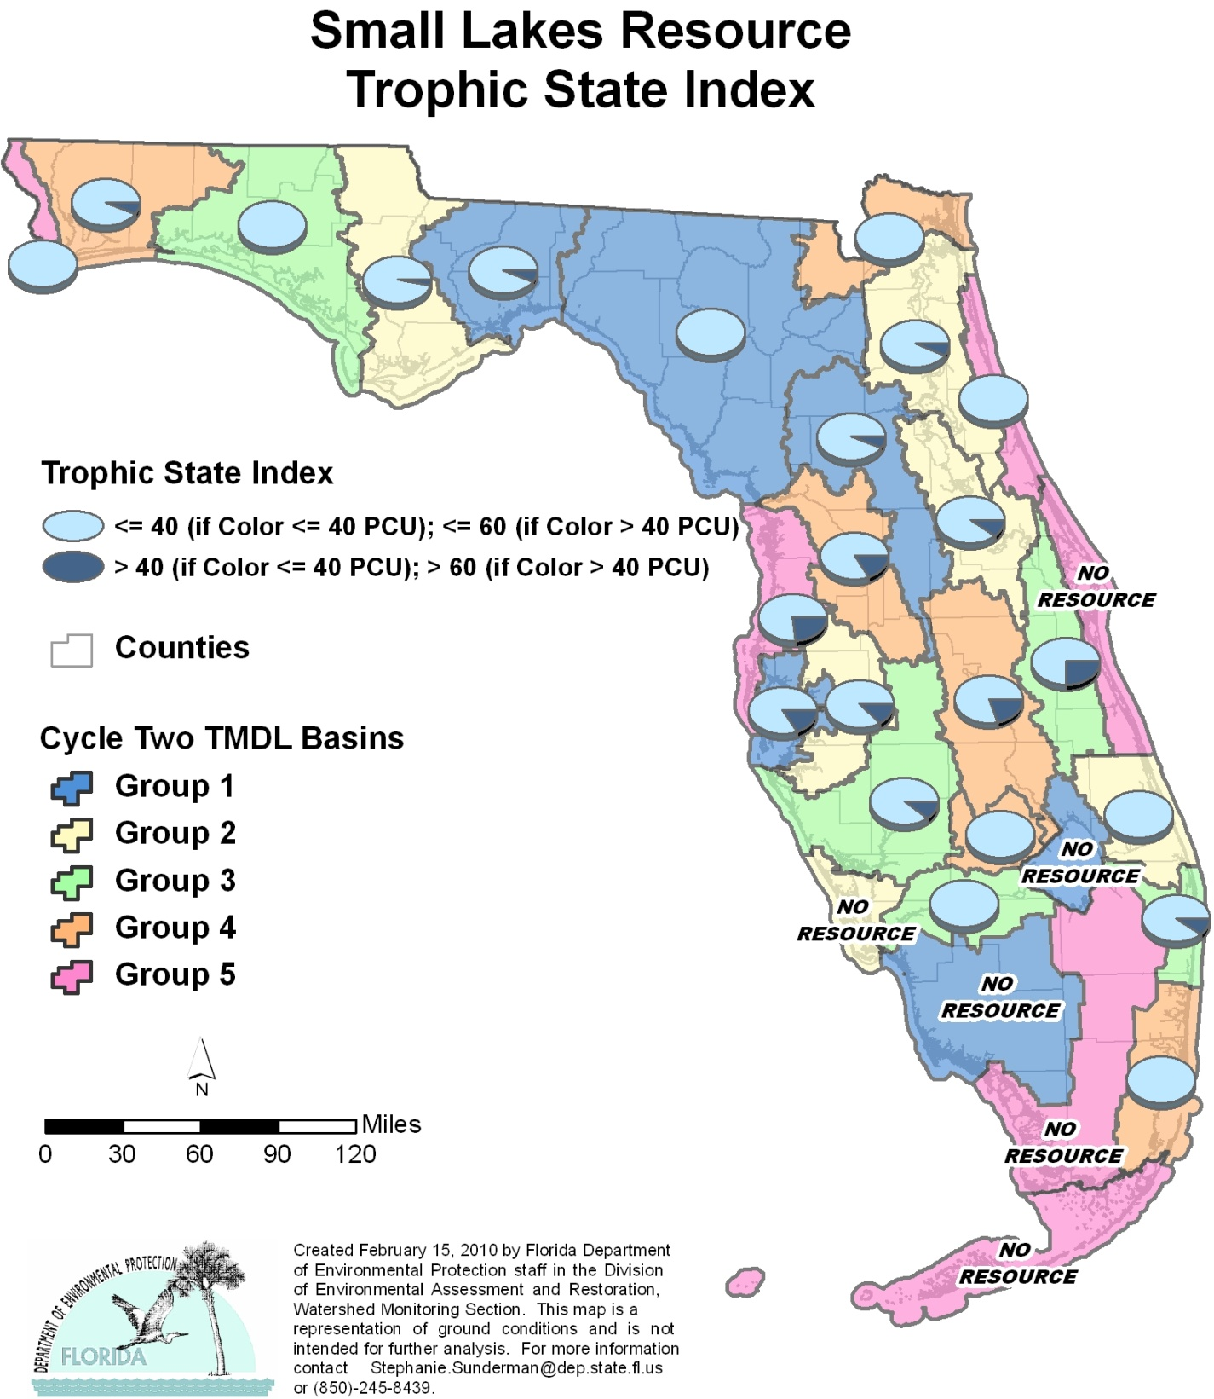

Table A.16. Percentage of Small Lakes Meeting Threshold Value for TSI Calculated Using Probabilistic Monitoring Design
Status Network Designated Use: Recreation and Aquatic Life Units: Lakes

This is a 10-column table. Column 1 lists the basin, Column 2 lists the target population, Column 3 lists the sampleable lakes, Column 4 lists the dry miles, Column 5 lists the inaccessible lakes, Column 6 lists the number of samples, Column 7 lists the percent meeting threshold, Column 8 lists the 95% confidence bounds, Column 9 lists the percent not meeting threshold, and Column 10 lists the assessment period.

¹ No small lakes in basin
² N/A = Not applicable
Basin | Target Population | Sampleable | Dry | Inaccessible | Number of Samples | % Meeting Threshold | 95% Confidence Bounds  (% Meeting Threshold) | % Not Meeting Threshold | Assessment Period
NWFWMD1  Ochlockonee–St. Marks | 301 | 161 | 32 | 108 | 30 | 93.3 | 85.7-100.0 | 6.7 | March-April 2004
SFWMD1  Everglades–West Coast | 3 | 0 | 3 | 0 | 0 | N/A² | N/A² | N/A² | N/A²
SFWMD6  Lake Okeechobee¹ | 0 | 0 | 0 | 0 | 0 | N/A² | N/A² | N/A² | N/A²
SJRWMD1  Ocklawaha | 552 | 224 | 75 | 253 | 30 | 93.3 | 85.6-100.0 | 6.7 | July-Sept 2004
SRWMD1  Suwannee | 994 | 215 | 382 | 397 | 27 | 100.0 | 100.0 | 0.0 | March-April 2004
SWFWMD1  Tampa Bay | 216 | 175 | 6 | 35 | 30 | 83.3 | 73.2-93.5 | 16.7 | July-Aug 2004
NWFWMD2  Apalachicola–Chipola | 353 | 76 | 76 | 201 | 30 | 96.7 | 91.0-100.0 | 3.3 | March-May 2005
SFWMD2  St Lucie–Loxahatchee | 18 | 11 | 0 | 7 | 11 | 100.0 | 100.0 | 0.0 | July-Aug 2005
SFWMD7  Charlotte Harbor | 19 | 0 | 6 | 13 | 0 | N/A² | N/A² | N/A² | N/A²
SJRWMD2  Lower St. Johns | 180 | 84 | 6 | 90 | 30 | 93.3 | 85.3-100.0 | 6.7 | July 2005
SJRWMD6  Middle St. Johns | 499 | 272 | 9 | 218 | 30 | 90.0 | 80.1-99.9 | 10.0 | July-Aug 2005
SWFWMD2  Tampa Bay Tributaries | 248 | 105 | 24 | 119 | 31 | 87.1 | 77.9-96.3 | 12.9 | July-Aug 2005
NWFWMD3  Choctawhatchee–  St. Andrews | 298 | 142 | 19 | 137 | 30 | 100.0 | 100.0 | 0.0 | March-May 2006
SFWMD3  Caloosahatchee | 44 | 6 | 0 | 38 | 4 | 100.0 | 100.0 | 0.0 | July 2006
SFWMD8  Lake Worth Lagoon–  Palm Beach Coast | 13 | 10 | 0 | 3 | 10 | 90.0 | 72.7-100.0 | 10.0 | July 2006
SJRWMD3  Upper St. Johns | 105 | 16 | 12 | 77 | 4 | 75.0 | 33.1-100.0 | 25.0 | July-Sept 2006
SWFWMD3  Sarasota Bay–Peace–Myakka | 252 | 115 | 9 | 128 | 27 | 88.9 | 78.4-99.4 | 11.1 | Aug-Sept 2006
NWFWMD4  Pensacola | 245 | 119 | 63 | 63 | 30 | 93.3 | 85.4-100.0 | 6.7 | April-May 2007
SFWMD4  Fisheating Creek | 19 | 6 | 0 | 13 | 6 | 100.0 | 100.0 | 0.0 | Aug 2007
SFWMD9  Kissimmee River | 260 | 145 | 58 | 57 | 30 | 80.0 | 68.7-91.3 | 20.0 | July-Aug 2007
SFWMD10  Southeast Coast–  Biscayne Bay | 16 | 14 | 0 | 2 | 7 | 100.0 | 100.0 | 0.0 | July 2007
SJRWMD4  Nassau–St. Marys | 3 | 2 | 0 | 1 | 2 | 100.0 | 100.0 | 0.0 | July 2007
SWFWMD4  Withlacoochee | 788 | 115 | 563 | 110 | 24 | 83.3 | 70.6-96.1 | 16.7 | Aug-Sept 2007
NWFWMD5  Perdido | 13 | 10 | 0 | 3 | 10 | 100.0 | 100.0 | 0.0 | March 2008
SFWMD5  Everglades¹ | 0 | 0 | 0 | 0 | 0 | N/A² | N/A² | N/A² | N/A²
SFWMD11  Florida Keys¹ | 0 | 0 | 0 | 0 | 0 | N/A² | N/A² | N/A² | N/A²
SJRWMD5  Indian River Lagoon | 32 | 1 | 26 | 5 | 0 | N/A² | N/A² | N/A² | July 2008
SJRWMD7  Upper East Coast | 7 | 2 | 2 | 3 | 2 | 100.0 | 100.0 | 0.0 | July 2008
SWFWMD5  Springs Coast | 404 | 121 | 145 | 138 | 30 | 76.7 | 63.4-89.9 | 23.3 | July-Sept 2008
Summary of All Basins | 5,882 | 2,147 | 1,516 | 2,219 | 465 | 90.3 | 86.8-93.8 | 9.7 | 2004–08

APPENDIX B: Discussion of Status Network Surface Water Indicators for Rivers, Streams, and Lakes, and Ground Water Indicators for Confined and Unconfined Aquifers

Surface Water Indicators for Rivers, Streams, and Lakes
Table B.1 contains the list of surface water analytes, with the associated criterion for each analyte.

Table B.1. Status Monitoring Network Water Quality Standards for Surface Water

This is a three-column table. Column 1 lists the indicator, Column 2 lists the criterion/threshold, and Column 3 lists the designated use.

Indicators | Criterion/Threshold¹ | Designated Use
Fecal Coliform Bacteria | < 400 counts/100mL | Recreation
DO | ≥ 5 mg/L | Aquatic Life
Un-ionized Ammonia | ≤ 0.02 mg/L | Aquatic Life
Chlorophyll a | ≤ 20 μg/L | Aquatic Life
TSI | Color ≤ 40 PCUs, then TSI ≤ 40  Color > 40 PCUs, then TSI ≤ 60 | Aquatic Life
¹ mL – milliliters; mg/L – milligrams per liter; μg/L – micrograms per liter; PCUs – platinum cobalt units

Fecal Coliform Bacteria
The threshold for fecal coliform bacteria is 400 colonies per 100 mL of water. Additionally, twice that number (800), as cited in Rule 62-302, F.A.C., indicates a highly contaminated result, and is used for regulatory purposes. The presence of these bacteria can indicate the contamination of a waterway or well and the possible presence of other pathogenic organisms.
Fecal coliform bacteria can enter water through the discharge of waste from mammals and birds, agricultural and stormwater runoff, and untreated human sewage. Septic tanks for individual homes can become overloaded during the rainy season and allow untreated human wastes to flow into drainage ditches and nearby waters. Agricultural practices that fail to contain animal wastes during the rainy season, as well as spreading manure and fertilizer on fields during rainy periods, and allowing livestock access to streams can all contribute fecal coliform contamination.

Dissolved Oxygen
The state criterion for DO is greater than or equal to 5 mg/L. DO is a measure of water quality indicating free oxygen dissolved in water. Oxygen is measured in its dissolved form. If more oxygen is consumed than is produced, DO levels decline and some sensitive aquatic animals may move away, weaken, or die. Levels vary with water temperature; therefore, cold water holds more oxygen than warm water.
Surface water gains oxygen from the atmosphere and plants as a result of photosynthesis. Running water contains more oxygen than still water because of its flow. Respiration by aquatic animals, decomposition, and various chemical reactions consume oxygen.
Wastewater from sewage treatment plants often contains organic materials that are decomposed by microorganisms, which use oxygen in the process. Other sources of oxygen-consuming waste include stormwater runoff from farmland or urban streets, feedlots, and failing septic systems. Ground water is naturally low in DO. Surface water contact with ground water seepage or upwelling can cause a natural lowering of DO levels.

Un-ionized Ammonia
The threshold for un-ionized ammonia is ≤0.02 mg/L as ammonia and is calculated using temperature, salinity, ammonia, and pH. This criterion applies to predominantly fresh waters in Florida. In water, ammonia occurs in two forms, which together are called total ammonia nitrogen, or TAN. Chemically, these two forms are represented as NH₄⁺ and NH₃. NH₄⁺ is called ionized ammonia because it has a positive electrical charge, and NH₃ is called un-ionized ammonia as it has no charge. Un-ionized ammonia (abbreviated as UIA), is the form that is toxic to fish and invertebrates. Water temperature and pH affect the form of ammonia that is predominant at any given time in an aquatic system.

Chlorophyll a
The threshold for chlorophyll a is ≤ 20 μg/L. This threshold is applied to the rivers and streams resources in the Status Monitoring Network. This is not a criterion under Rule 62-302, F.A.C.; rather, it is listed as a measure to identify impairment in surface waters in Section 62-303.351, F.A.C., which describes the assessment of nutrients in streams. Chlorophyll is the pigment that allows plants—including algae—to convert sunlight into organic compounds during the process of photosynthesis. Chlorophyll a is the predominant type found in algae and cyanobacteria (blue-green algae), and its abundance is a measurable indicator of the amount of algae present in a surface waterbody.
Excessive quantities of chlorophyll a can indicate the presence of algal blooms. These usually consist of species undesirable for fish and other predators to consume. Unconsumed algae sink to the bottom and decay, using up the oxygen required by other plants and benthic organisms to survive. The presence of too many nutrients, such as nitrogen and phosphorus, can stimulate algal blooms and reduce water clarity.
Chlorophyll a also plays a direct role in reducing the amount of light available to plants in shallow-water habitats. Like their terrestrial cousins, these plants need sunlight to grow. As chlorophyll a levels increase, the amount of sunlight reaching underwater plants declines.

Trophic State Index
TSI and chlorophyll a are the primary measures used to assess nutrient impairment in waterbodies. TSI is measured using chlorophyll, nitrogen, and phosphorus concentrations. There are two thresholds for TSI that are based on the color of a lake. Dark-water lakes with a mean color greater than 40 PCUs are impaired when their annual mean TSI exceeds 60. Clear and low-color lakes with a mean color less than or equal to 40 PCUs are impaired when their annual mean TSI exceeds 40. A 10-unit increase or decrease in the index represents a doubling or halving, respectively, of the number of algal cells present
Note: Both chlorophyll a and TSI are not standards, but thresholds used to estimate the condition of state waters. These thresholds are used in the analysis of Status Monitoring Network data based on single samples in a basin during a predetermined index period. The analysis and representation of these data are not intended to infer the verification of impairment in these waters, as defined in Rule 62-303, F.A.C.

Ground Water Indicators
Analytes with primary drinking water standards have been added to measure the condition of Florida’s aquifers. Table B.2 contains the list of ground water analytes with the associated criterion for each analyte. Primary standards mean that the criterion for an analyte is based on human health effects.
Key indicator contaminants for ground water (e.g., chloride, nitrate, metals, and bacteria) serve to assess its general suitability for drinking water purposes. Aquifer samples collected for the Status Monitoring Network between 1999 and 2003 (Cycle 1) were filtered to mitigate well construction factors, and the analytes were measured as dissolved constituents. Aquifer samples collected for the Status Monitoring Network between 2004 and 2009 (Cycle 2) were not filtered and were analyzed as total constituents. These samples represent more closely the conditions of water as it comes directly from the aquifer. Additionally, standards are measured using unfiltered water, and so unfiltered samples allow consistency with standards.

Table B.2. Status Monitoring Network Water Quality Standards for Ground Water

This is a three-column table. Column 1 lists the indicator, Column 2 lists the criterion/threshold, and Column 3 lists the designated use.

1 The MDL for fecal coliform, per FDEP SOP MB-X, is 2 counts/100mL.
Indicators | Criterion/Threshold | Designated Use
Arsenic | ≤ 10 μg/L | Potable Water (drinking water)
Cadmium | ≤ 5 μg/L | Potable Water (drinking water)
Chromium | ≤ 100 μg/L | Potable Water (drinking water)
Lead | ≤ 15 μg/L | Potable Water (drinking water)
Nitrate–Nitrite | ≤ 10 mg/L | Potable Water (drinking water)
Sodium | ≤ 160 mg/L | Potable Water (drinking water)
Fluoride | ≤ 4 mg/L | Potable Water (drinking water)
Total Coliform Bacteria  (counts/100mL) | ≤ 4 (sample maximum) | Potable Water (drinking water)
Fecal Coliform Bacteria  (counts/100mL) | < 2 (sample maximum)1 | Potable Water (drinking water)

Total Coliform Bacteria
The EPA has determined that the presence of total coliform is a possible health concern. Total coliform bacteria are common in the environment and are generally not harmful themselves. The presence of these bacteria in drinking water, however, is a result of a problem with water treatment or the pipes that distribute the water, and indicates that the water may be contaminated with organisms that can cause disease.
The EPA and the state have set an enforceable drinking water standard for total coliform of 4 counts per 100 mL to reduce the risk of adverse health effects. Drinking water that meets this standard is usually not associated with a health risk from disease-causing bacteria and should be considered safe.

Fecal Coliform Bacteria
The EPA has determined that the presence of fecal coliform bacteria is a possible health concern because they are usually associated with sewage or animal wastes. Their presence in drinking water generally results from a problem with water treatment or pipes that distribute the water, and indicates that the water may be contaminated with organisms that can cause disease. In addition, ground water can become contaminated with fecal coliform from surface water interactions in karst (limestone) terrains, such as those found in Florida.
The EPA and the state have set an enforceable drinking water standard for fecal coliform to reduce the risk of adverse health effects. Under this standard, all drinking water samples must be free of fecal coliform bacteria. The FDEP Bureau of Laboratories has a Minimum Detection Limit (MDL) per sample of 2/100mL, and so the presence of any detectable fecal coliform is considered an exceedance. Drinking water that meets this standard is associated with little or no health risk, and should be considered safe.

Arsenic
Arsenic, a naturally occurring element, is widely distributed in the earth’s crust. Two main categories are found, inorganic and organic arsenic. Inorganic arsenic compounds are mainly used to preserve wood. Organic arsenic compounds, found in animals and plants, occur when arsenic combines with carbon and hydrogen. Organic arsenic compounds are used as pesticides.
Many arsenic compounds can dissolve in water, and can be transported into ground water. Arsenic can affect human health. Several studies have shown that inorganic arsenic can increase the risk of lung, skin, bladder, liver, kidney, and prostate cancers. The World Health Organization (WHO), the U.S. Department of Health and Human Services (DHHS), and the EPA have determined that inorganic arsenic is a human carcinogen. For this reason, the EPA and FDEP have set an enforceable drinking water standard of 10 parts per billion (ppb) for arsenic.
Organic arsenic compounds are less toxic than inorganic arsenic compounds. However, exposure to high levels of some organic arsenic compounds may cause similar effects to those of inorganic arsenic.

Cadmium
The EPA and FDEP set the drinking water standard for cadmium at 5 ppb to protect against the risk of adverse health effects. Cadmium, a naturally occurring heavy metal whose chemical properties are similar to those of zinc, does not occur uncombined in nature. A byproduct of smelting and refining zinc and lead ores, it is used for its anticorrosive properties in the electroplating of steel, in its sulfide form in the manufacture of paint pigments, and in the manufacture of batteries and other electrical components. Cadmium also occurs as a byproduct in many chemical fertilizers that are produced from phosphate ores. Cadmium enters the ambient air primarily from local smelting operations, it enters soil from local mining operations and from chemical fertilizers, and it enters water from fertilizer runoff and/or industrial wastewater.
This inorganic metal is a contaminant in the metals used to galvanize pipe. It generally enters water by the corrosion of galvanized pipes or by improper waste disposal. Drinking water that meets the EPA standard is associated with little to none of this risk and is considered safe with respect to cadmium.

Chromium
This inorganic metal, which occurs naturally in the ground, is often used in the electroplating of metals. It generally enters water from runoff from old mining operations and improper waste disposal from plating operations. Some humans exposed to high levels of chromium have suffered liver and kidney damage, dermatitis, and respiratory problems. The EPA has set the drinking water standard for chromium at 100 ppb to protect against the risk of adverse health effects. Drinking water that meets the EPA standard is associated with little to none of this risk and is considered safe with respect to chromium.

Fluoride
EPA regulations require that fluoride, which occurs naturally in some water supplies, not exceed a concentration of 4.0 mg/L in drinking water. Extended exposure to drinking water levels above 4.0 mg/L may result in crippling skeletal fluorosis, a serious bone disorder.
State regulations require notification of the public when monitoring indicates that the fluoride in a drinking water system exceeds 2.0 mg/L. This is intended to alert families about dental problems that might affect children under 9 years of age. Fluoride in children's drinking water at levels of approximately 1 mg/L reduces the number of dental cavities. However, some children exposed to levels of fluoride greater than about 2.0 mg/L may develop dental fluorosis. In its moderate and severe forms, this is a brown staining and/or pitting of the permanent teeth.
Because dental fluorosis occurs only when developing teeth (before they erupt from the gums) are exposed to elevated fluoride levels, households without children are not expected to be affected by this level of fluoride. Families with children under the age of nine are encouraged to seek other sources of drinking water for their children to avoid the possibility of staining and pitting.

Lead
The EPA and FDEP set the drinking water standard for lead at 15 ppb to protect against the risk of adverse health effects. Lead toxicity affects the nervous system, blood, kidney, heart, and reproductive system. Infants and young children whose nervous and circulatory systems are not fully developed are more susceptible to the adverse health effects from lead exposure. Irreversible learning difficulties, mental retardation, and delayed neurological and physical development can occur from long-term exposure to even low levels of lead.
Materials that contain lead have frequently been used in the construction of water supply distribution systems, and in plumbing systems in private homes and other buildings. The most commonly found materials include service lines, pipes, brass and bronze fixtures, and solders and fluxes. Lead in these materials can contaminate drinking water as a result of the corrosion that takes place when water comes into contact with those materials.

Nitrate-Nitrite
The EPA has set the drinking water standard at 10 ppm for nitrate to protect against the risk of adverse effects. Excessive levels of nitrate in drinking water have caused serious illness and sometimes death in infants less than 6 months of age. Nitrate is used in fertilizer and is found in sewage and wastes from human and/or farm animals; it generally enters drinking water from these activities.
The EPA has also set a drinking water standard for nitrite at 1 part per million (ppm). To allow for the fact that the toxicity of nitrate and nitrite are additive, the EPA has established a standard for the sum of nitrate and nitrite at 10 ppm. Drinking water that meets the EPA standard is associated with little to none of this risk and is considered safe with respect to nitrate.

Sodium
The EPA has set the drinking water standard for sodium (salt) at 160 ppm to protect individuals who are susceptible to sodium-sensitive hypertension or diseases that cause difficulty in regulating body fluid volume. Sodium is monitored so that individuals on sodium-restricted diets may take the sodium in their water into account. Sodium naturally occurs in food and drinking water. Food is the common source of sodium. Drinking water contributes only a small fraction (less than 10%) of an individual’s overall sodium intake.

APPENDIX C: Maps and Tables with 2004–08 Probabilistic Ground Water Assessment Results for Confined Aquifers and Unconfined Aquifers

The Status Network design focuses on the following two ground water resource types:
- Confined Aquifers
- Unconfined Aquifers

This appendix contains information on the following indicators for Confined and Unconfined Aquifers for the Status Network:
- Arsenic
- Cadmium
- Chromium
- Fluoride
- Lead
- Nitrate + nitrite
- Sodium
- Fecal coliform
- Total coliform

Table C.1 lists the threshold criteria for these ground water analytes, with the associated criterion for each analyte.

Table C.1. Status Monitoring Network Water Quality Criteria/Thresholds for Ground Water

This is a two-column table. Column 1 lists the indicator, and Column 2 lists the criterion/threshold.

Note: Appendix B provides additional information on whether the thresholds listed in the tables in this appendix are water quality standards or screening levels.
Indicator | Criterion/Threshold¹
Arsenic | ≤ 10 μg/L
Cadmium | ≤ 5 μg/L
Chromium | ≤ 100 μg/L
Lead | ≤ 15 μg/L
Nitrate–Nitrite | ≤ 10 mg/L
Sodium | ≤ 160 mg/L
Fluoride | ≤ 4 mg/L
Fecal Coliform Bacteria  (counts/100mL) | ≤ 2 (sample maximum)
Total Coliform Bacteria  (counts/100mL) | ≤ 4 (sample maximum)

Figure C.1. Summary of Arsenic Assessment for Confined Aquifers

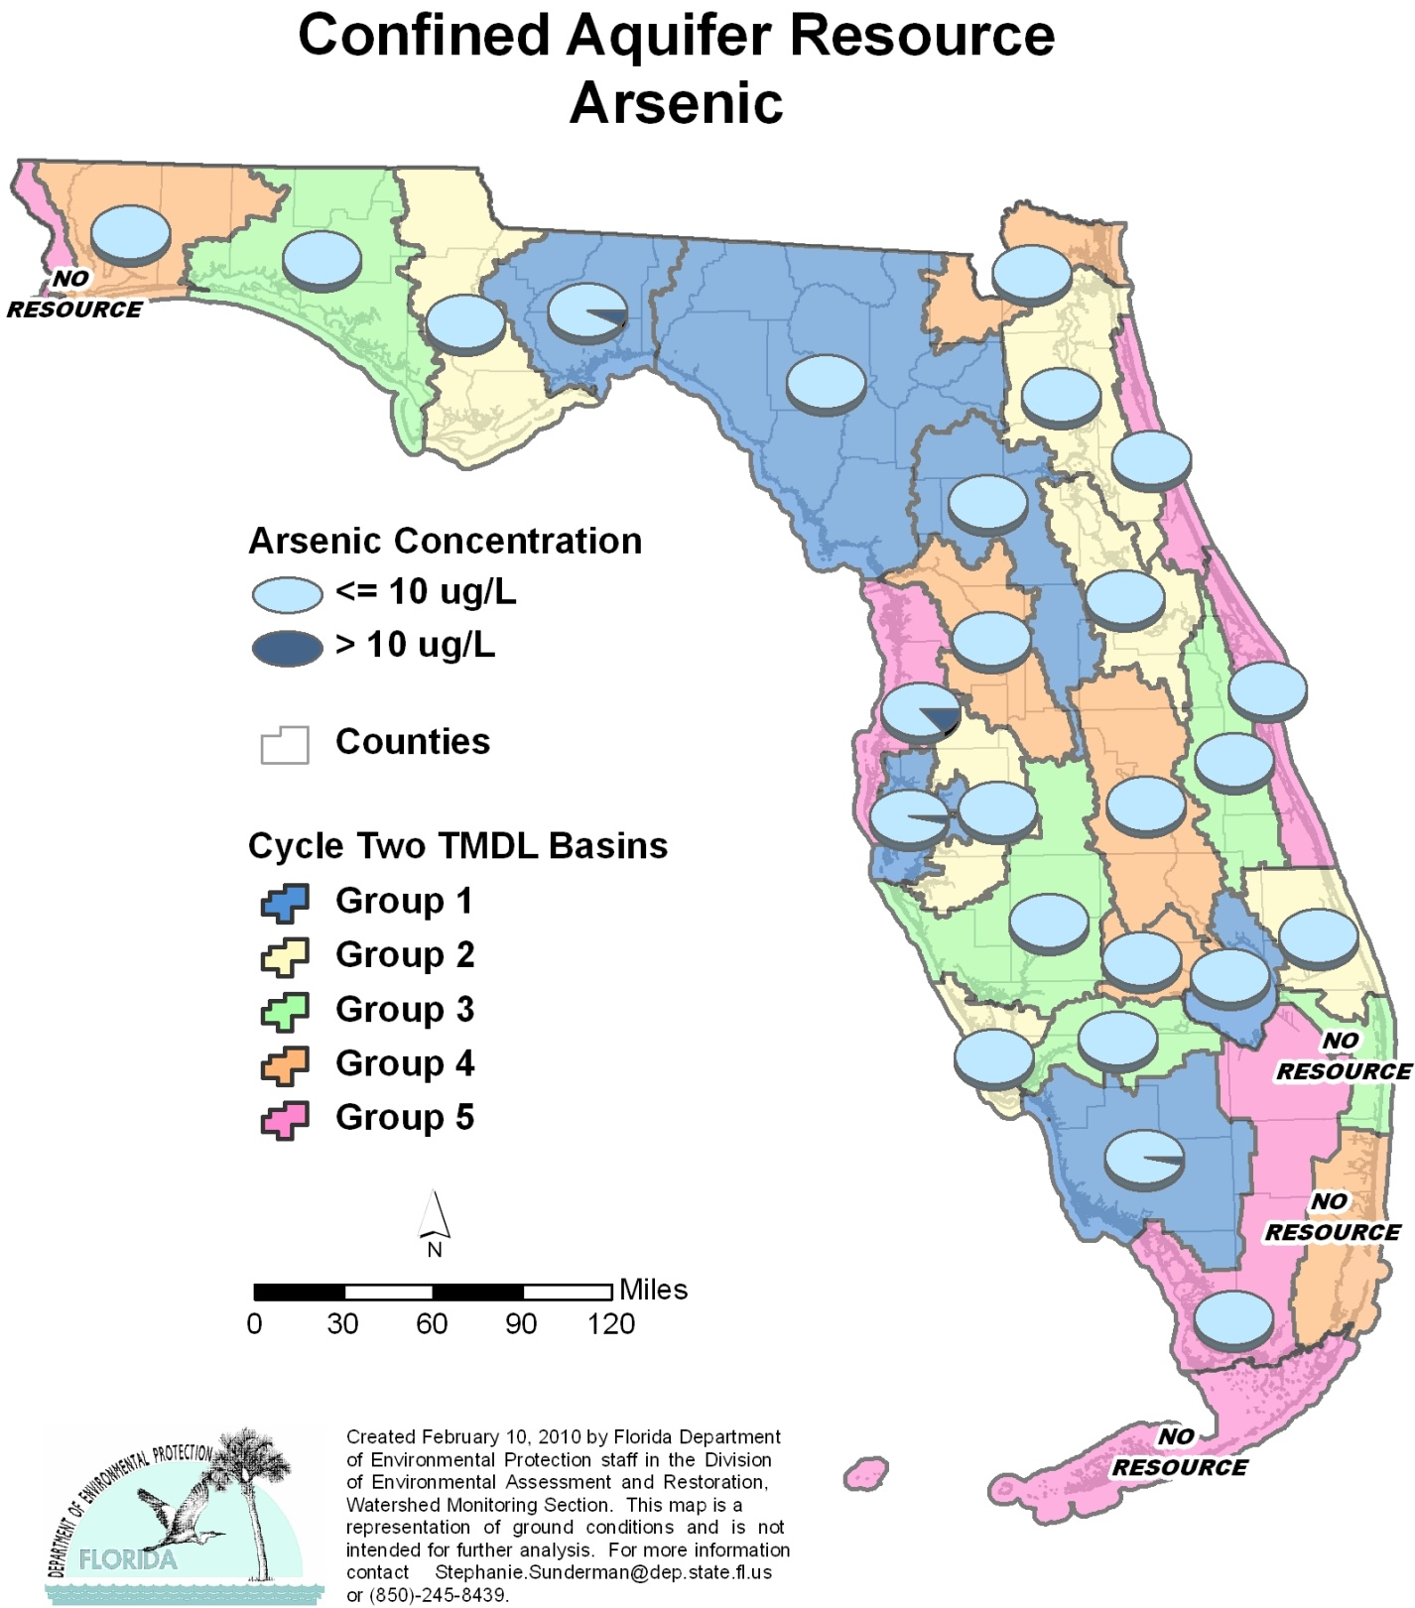

Table C.1. Percentage of Confined Aquifers Meeting Threshold Value for Arsenic Calculated Using Probabilistic Monitoring Design
Status Network Designated Use: Primary Drinking Water Standards Units: Number of wells in list frame

This is a nine-column table. Column 1 lists the basin, Column 2 lists the target population, Column 3 lists the number of sampleable wells, Column 4 lists the number of inaccessible wells, Column 5 lists the number of samples, Column 6 lists the percent meeting threshold, Column 7 lists the 95% confidence bounds, Column 8 lists the percent not meeting threshold, and Column 9 lists the assessment period.

¹ No confined aquifer wells in basin
² N/A = Not applicable
Basin | Target Population | Sampleable | Inaccessible | Number of Samples | % Meeting Threshold | 95% Confidence Bounds  (% Meeting Threshold) | % Not Meeting Threshold | Assessment Period
NWFWMD1  Ochlockonee–St. Marks | 1,600 | 1,024 | 576 | 30 | 92.9 | 84.5-100.0 | 7.1 | Jan-Mar 2004
SFWMD1  Everglades–West Coast | 80 | 63 | 17 | 30 | 96.5 | 90.7-100.0 | 3.5 | Jan-Mar 2004
SFWMD6  Lake Okeechobee | 8 | 4 | 4 | 4 | 100.0 | 100.0 | 0.0 | Jan-Mar 2004
SJRWMD1  Ocklawaha | 167 | 116 | 51 | 30 | 100.0 | 100.0 | 0.0 | Jan-Mar 2004
SRWMD1  Suwannee | 376 | 260 | 116 | 30 | 100.0 | 100.0 | 0.0 | Jan-Mar 2004
SWFWMD1  Tampa Bay | 113 | 72 | 41 | 30 | 96.9 | 91.8-100.0 | 3.1 | Jan-Mar 2004
NWFWMD2  Apalachicola–Chipola | 194 | 89 | 105 | 30 | 100.0 | 100.0 | 0.0 | Jan-Feb 2005
SFWMD2  St Lucie–Loxahatchee | 12 | 9 | 3 | 9 | 100.0 | 100.0 | 0.0 | Jan-Feb 2005
SFWMD7  Charlotte Harbor | 54 | 33 | 21 | 30 | 100.0 | 100.0 | 0.0 | Feb-Mar 2005
SJRWMD2  Lower St. Johns | 259 | 161 | 98 | 21 | 100.0 | 100.0 | 0.0 | Jan-Mar 2005
SJRWMD6  Middle St. Johns | 304 | 188 | 116 | 30 | 100.0 | 100.0 | 0.0 | Jan-Mar 2005
SWFWMD2  Tampa Bay Tributaries | 172 | 57 | 115 | 19 | 100.0 | 100.0 | 0.0 | Jan-Feb 2005
NWFWMD3  Choctawhatchee–  St. Andrews | 1,823 | 820 | 1,003 | 30 | 100.0 | 100.0 | 0.0 | Jan-Feb 2006
SFWMD3  Caloosahatchee | 57 | 43 | 14 | 30 | 100.0 | 100.0 | 0.0 | Jan-Feb 2006
SFWMD8  Lake Worth Lagoon–  Palm Beach Coast¹ | 0 | 0 | 0 | 0 | N/A² | N/A² | N/A² | N/A²
SJRWMD3  Upper St. Johns | 54 | 31 | 23 | 28 | 100.0 | 100.0 | 0.0 | Jan-Feb 2006
SWFWMD3  Sarasota Bay–Peace–Myakka | 460 | 179 | 281 | 30 | 100.0 | 100.0 | 0.0 | Jan-Mar 2006
NWFWMD4  Pensacola | 149 | 75 | 74 | 30 | 100.0 | 100.0 | 0.0 | Jan-Feb 2007
SFWMD4  Fisheating Creek | 15 | 6 | 9 | 6 | 100.0 | 100.0 | 0.0 | Jan-Feb 2007
SFWMD9  Kissimmee River | 131 | 56 | 75 | 29 | 100.0 | 100.0 | 0.0 | Jan-Mar 2007
SFWMD10  Southeast Coast–  Biscayne Bay | 2 | 0 | 2 | 0 | N/A² | N/A² | N/A² | N/A²
SJRWMD4  Nassau–St. Marys | 78 | 28 | 50 | 28 | 100.0 | 100.0 | 0.0 | Jan-Mar 2007
SWFWMD4  Withlacoochee | 48 | 23 | 25 | 23 | 100.0 | 100.0 | 0.0 | Feb-Mar 2007
NWFWMD5  Perdido | 1 | 0 | 1 | 0 | N/A² | N/A² | N/A² | N/A²
SFWMD5  Everglades | 4 | 4 | 0 | 4 | 100.0 | 100.0 | 0.0 | Feb 2008
SFWMD11  Florida Keys¹ | 0 | 0 | 0 | 0 | N/A² | N/A² | N/A² | N/A²
SJRWMD5  Indian River Lagoon | 45 | 21 | 24 | 21 | 100.0 | 100.0 | 0.0 | Jan-Mar 2008
SJRWMD7  Upper East Coast | 62 | 26 | 36 | 26 | 100.0 | 100.0 | 0.0 | Feb-Mar 2008
SWFWMD5  Springs Coast | 87 | 51 | 36 | 30 | 86.7 | 77.2-96.2 | 13.3 | Jan-Mar 2008
Summary of All Basins | 6,355 | 3,439 | 2,916 | 608 | 98.5 | 96.9-100.0 | 1.5 | 2004–08

Figure C.2. Summary of Cadmium Assessment for Confined Aquifers

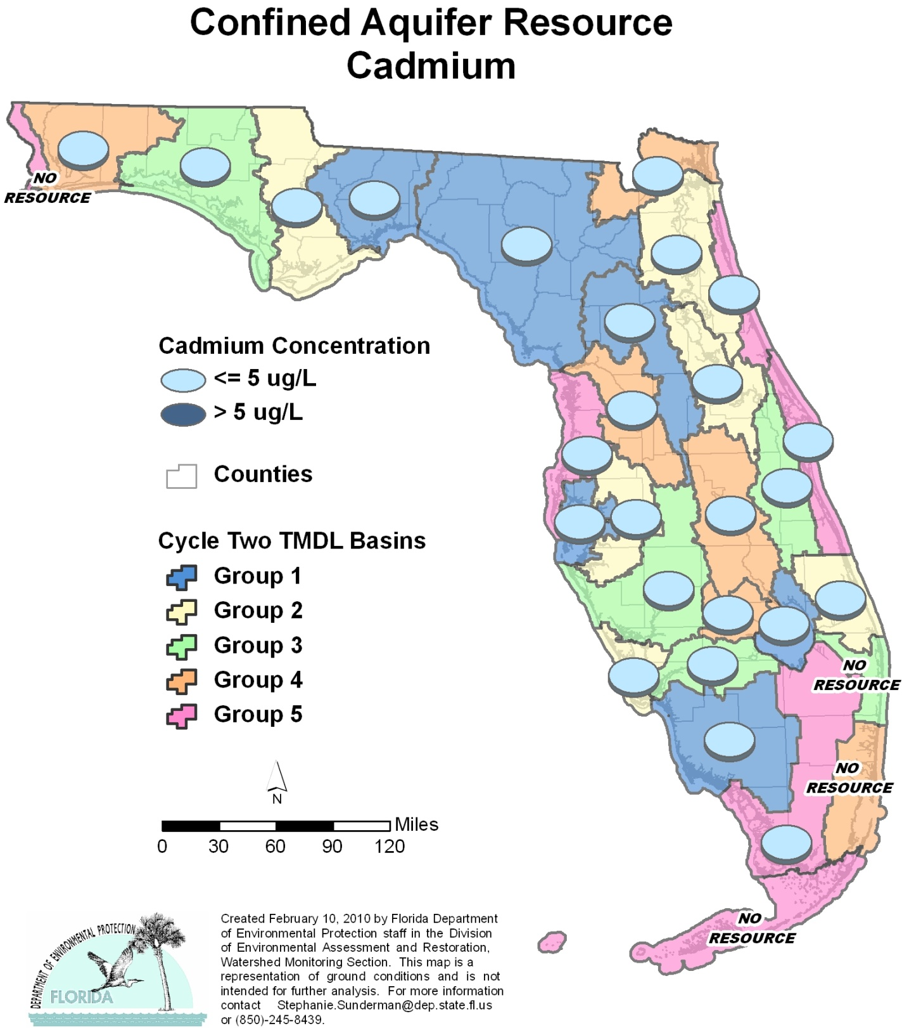

Table C.2. Percentage of Confined Aquifers Meeting Threshold Value for Cadmium Calculated Using Probabilistic Monitoring Design
Status Network Designated Use: Primary Drinking Water Standards Units: Number of wells in list frame

This is a nine-column table. Column 1 lists the basin, Column 2 lists the target population, Column 3 lists the number of sampleable wells, Column 4 lists the number of inaccessible wells, Column 5 lists the number of samples, Column 6 lists the percent meeting threshold, Column 7 lists the 95% confidence bounds, Column 8 lists the percent not meeting threshold, and Column 9 lists the assessment period.

¹ No confined aquifer wells in basin
² N/A = Not applicable
Basin | Target Population | Sampleable | Inaccessible | Number of Samples | % Meeting Threshold | 95% Confidence Bounds  (% Meeting Threshold) | % Not Meeting Threshold | Assessment Period
NWFWMD1  Ochlockonee–St. Marks | 1,600 | 1,024 | 576 | 30 | 100.0 | 100.0 | 0.0 | Jan-Mar 2004
SFWMD1  Everglades–West Coast | 80 | 63 | 17 | 30 | 100.0 | 100.0 | 0.0 | Jan-Mar 2004
SFWMD6  Lake Okeechobee | 8 | 4 | 4 | 4 | 100.0 | 100.0 | 0.0 | Jan-Mar 2004
SJRWMD1  Ocklawaha | 167 | 116 | 51 | 30 | 100.0 | 100.0 | 0.0 | Jan-Mar 2004
SRWMD1  Suwannee | 376 | 260 | 116 | 30 | 100.0 | 100.0 | 0.0 | Jan-Mar 2004
SWFWMD1  Tampa Bay | 113 | 72 | 41 | 30 | 100.0 | 100.0 | 0.0 | Jan-Mar 2004
NWFWMD2  Apalachicola–Chipola | 194 | 89 | 105 | 30 | 100.0 | 100.0 | 0.0 | Jan-Feb 2005
SFWMD2  St Lucie–Loxahatchee | 12 | 9 | 3 | 9 | 100.0 | 100.0 | 0.0 | Jan-Feb 2005
SFWMD7  Charlotte Harbor | 54 | 33 | 21 | 30 | 100.0 | 100.0 | 0.0 | Feb-Mar 2005
SJRWMD2  Lower St. Johns | 259 | 161 | 98 | 30 | 100.0 | 100.0 | 0.0 | Jan-Mar 2005
SJRWMD6  Middle St. Johns | 304 | 188 | 116 | 30 | 100.0 | 100.0 | 0.0 | Jan-Mar 2005
SWFWMD2  Tampa Bay Tributaries | 172 | 57 | 115 | 30 | 100.0 | 100.0 | 0.0 | Jan-Feb 2005
NWFWMD3  Choctawhatchee-  St. Andrews | 1,823 | 820 | 1,003 | 30 | 100.0 | 100.0 | 0.0 | Jan-Feb 2006
SFWMD3  Caloosahatchee | 57 | 43 | 14 | 30 | 100.0 | 100.0 | 0.0 | Jan-Feb 2006
SFWMD8  Lake Worth Lagoon–  Palm Beach Coast¹ | 0 | 0 | 0 | 0 | N/A² | N/A² | N/A² | N/A²
SJRWMD3  Upper St. Johns | 54 | 31 | 23 | 28 | 100.0 | 100.0 | 0.0 | Jan-Feb 2006
SWFWMD3  Sarasota Bay–Peace–Myakka | 460 | 179 | 281 | 30 | 100.0 | 100.0 | 0.0 | Jan-Mar 2006
NWFWMD4  Pensacola | 149 | 75 | 74 | 30 | 100.0 | 100.0 | 0.0 | Jan-Feb 2007
SFWMD4  Fisheating Creek | 15 | 6 | 9 | 6 | 100.0 | 100.0 | 0.0 | Jan-Feb 2007
SFWMD9  Kissimmee River | 131 | 56 | 75 | 29 | 100.0 | 100.0 | 0.0 | Jan-Mar 2007
SFWMD10  Southeast Coast–  Biscayne Bay | 2 | 0 | 2 | 0 | N/A² | N/A² | N/A² | N/A²
SJRWMD4  Nassau–St. Marys | 78 | 28 | 50 | 28 | 100.0 | 100.0 | 0.0 | Jan-Mar 2007
SWFWMD4  Withlacoochee | 48 | 23 | 25 | 23 | 100.0 | 100.0 | 0.0 | Feb-Mar 2007
NWFWMD5  Perdido | 1 | 0 | 1 | 0 | N/A² | N/A² | N/A² | N/A²
SFWMD5  Everglades | 4 | 4 | 0 | 4 | 100.0 | 100.0 | 0.0 | Feb 2008
SFWMD11  Florida Keys¹ | 0 | 0 | 0 | 0 | N/A² | N/A² | N/A² | N/A²
SJRWMD5  Indian River Lagoon | 45 | 21 | 24 | 21 | 100.0 | 100.0 | 0.0 | Jan-Mar 2008
SJRWMD7  Upper East Coast | 62 | 26 | 36 | 26 | 100.0 | 100.0 | 0.0 | Feb-Mar 2008
SWFWMD5  Springs Coast | 87 | 51 | 36 | 30 | 100.0 | 100.0 | 0.0 | Jan-Mar 2008
Summary of All Basins | 6,355 | 3,439 | 2,916 | 628 | 100.0 | 100.0 | 0.0 | 2004–08

Figure C.3. Summary of Chromium Assessment for Confined Aquifers

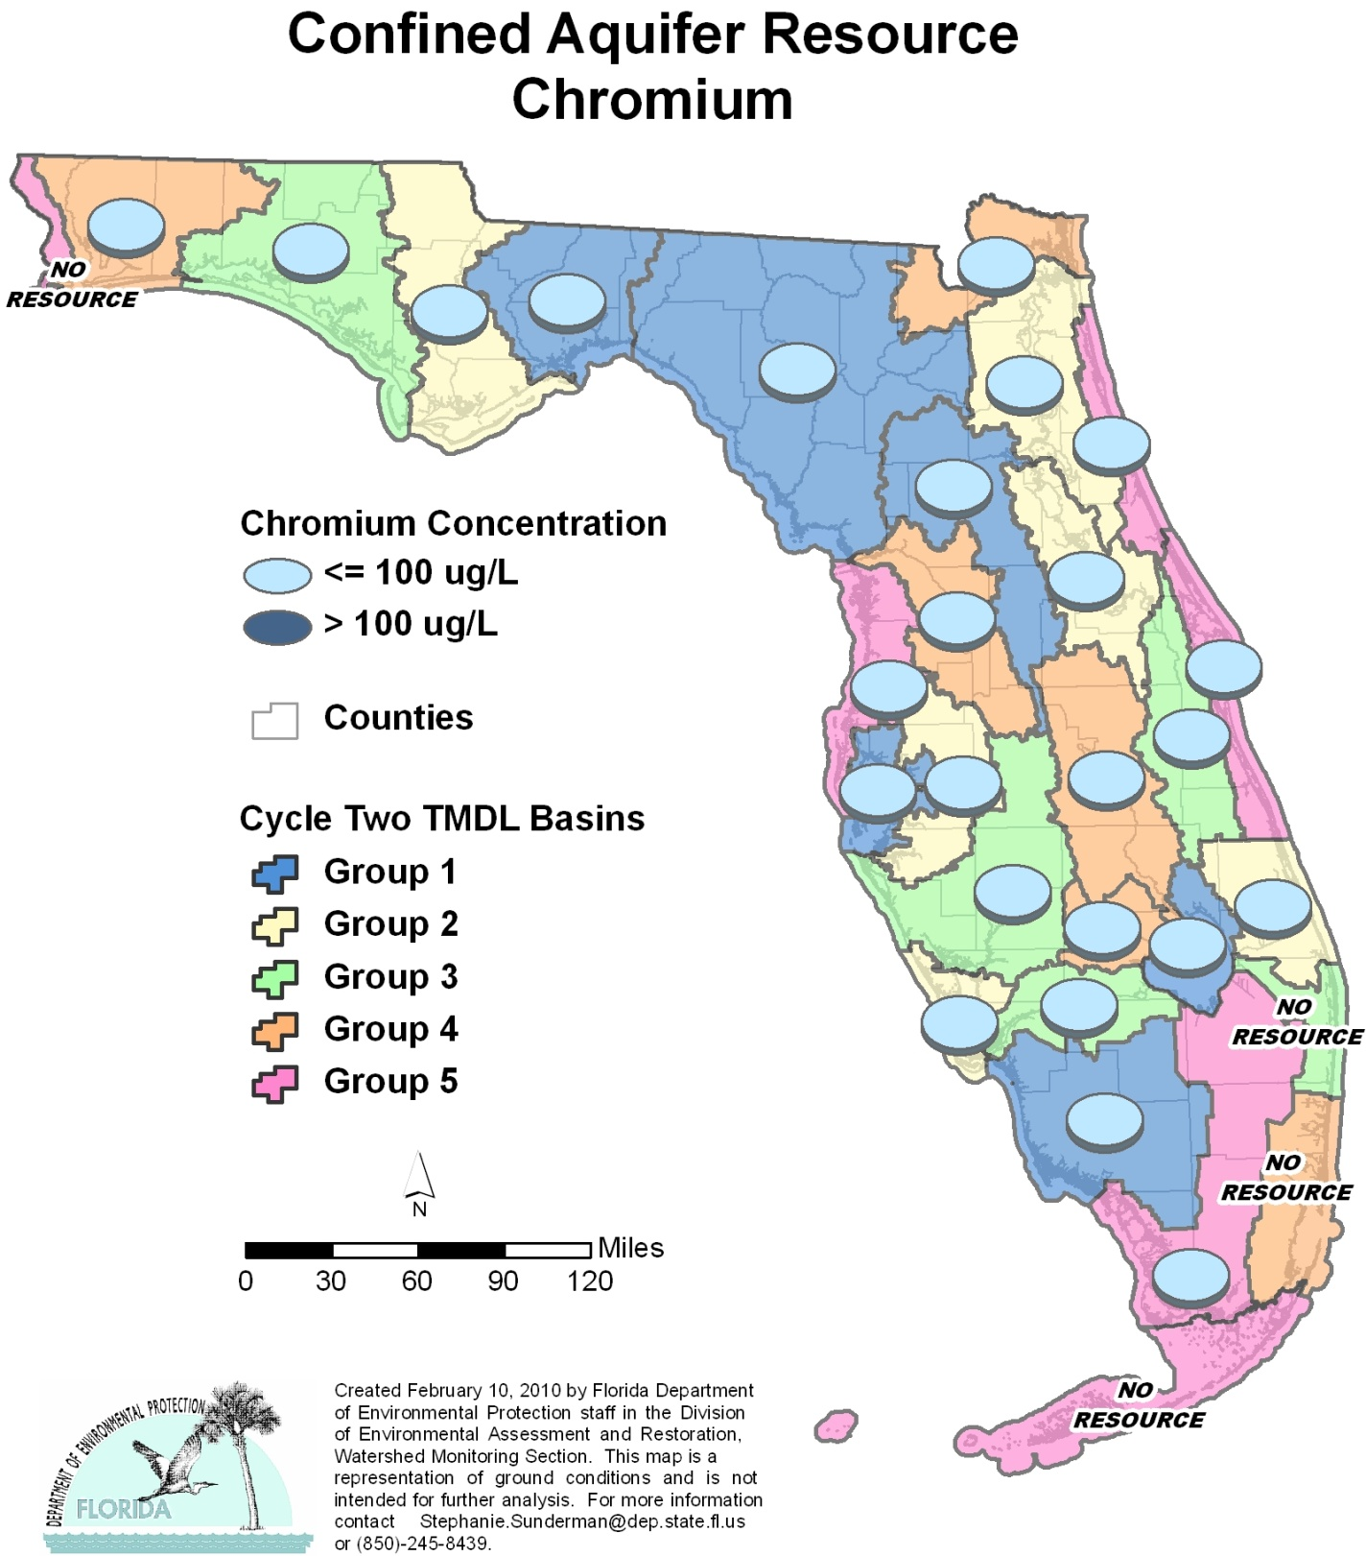

Table C.3. Percentage of Confined Aquifers Meeting Threshold Value for Chromium Calculated Using Probabilistic Monitoring Design
Status Network Designated Use: Primary Drinking Water Standards Units: Number of wells in list frame

This is a nine-column table. Column 1 lists the basin, Column 2 lists the target population, Column 3 lists the number of sampleable wells, Column 4 lists the number of inaccessible wells, Column 5 lists the number of samples, Column 6 lists the percent meeting threshold, Column 7 lists the 95% confidence bounds, Column 8 lists the percent not meeting threshold, and Column 9 lists the assessment period.

¹ No confined aquifer wells in basin
² N/A = Not applicable
Basin | Target Population | Sampleable | Inaccessible | Number of Samples | % Meeting Threshold | 95% Confidence Bounds  (% Meeting Threshold) | % Not Meeting Threshold | Assessment Period
NWFWMD1  Ochlockonee–St. Marks | 1,600 | 1,024 | 576 | 30 | 100.0 | 100.0 | 0.0 | Jan-Mar 2004
SFWMD1  Everglades–West Coast | 80 | 63 | 17 | 30 | 100.0 | 100.0 | 0.0 | Jan-Mar 2004
SFWMD6  Lake Okeechobee | 8 | 4 | 4 | 4 | 100.0 | 100.0 | 0.0 | Jan-Mar 2004
SJRWMD1  Ocklawaha | 167 | 116 | 51 | 30 | 100.0 | 100.0 | 0.0 | Jan-Mar 2004
SRWMD1  Suwannee | 376 | 260 | 116 | 30 | 100.0 | 100.0 | 0.0 | Jan-Mar 2004
SWFWMD1  Tampa Bay | 113 | 72 | 41 | 30 | 100.0 | 100.0 | 0.0 | Jan-Mar 2004
NWFWMD2  Apalachicola–Chipola | 194 | 89 | 105 | 30 | 100.0 | 100.0 | 0.0 | Jan-Feb 2005
SFWMD2  St Lucie–Loxahatchee | 12 | 9 | 3 | 9 | 100.0 | 100.0 | 0.0 | Jan-Feb 2005
SFWMD7  Charlotte Harbor | 54 | 33 | 21 | 30 | 100.0 | 100.0 | 0.0 | Feb-Mar 2005
SJRWMD2  Lower St. Johns | 259 | 161 | 98 | 30 | 100.0 | 100.0 | 0.0 | Jan-Mar 2005
SJRWMD6  Middle St. Johns | 304 | 188 | 116 | 30 | 100.0 | 100.0 | 0.0 | Jan-Mar 2005
SWFWMD2  Tampa Bay Tributaries | 172 | 57 | 115 | 30 | 100.0 | 100.0 | 0.0 | Jan-Feb 2005
NWFWMD3  Choctawhatchee–  St. Andrews | 1,823 | 820 | 1,003 | 30 | 100.0 | 100.0 | 0.0 | Jan-Feb 2006
SFWMD3  Caloosahatchee | 57 | 43 | 14 | 30 | 100.0 | 100.0 | 0.0 | Jan-Feb 2006
SFWMD8  Lake Worth Lagoon-  Palm Beach Coast¹ | 0 | 0 | 0 | 0 | N/A² | N/A² | N/A² | N/A²
SJRWMD3  Upper St. Johns | 54 | 31 | 23 | 28 | 100.0 | 100.0 | 0.0 | Jan-Feb 2006
SWFWMD3  Sarasota Bay–Peace–Myakka | 460 | 179 | 281 | 30 | 100.0 | 100.0 | 0.0 | Jan-Mar 2006
NWFWMD4  Pensacola | 149 | 75 | 74 | 30 | 100.0 | 100.0 | 0.0 | Jan-Feb 2007
SFWMD4  Fisheating Creek | 15 | 6 | 9 | 6 | 100.0 | 100.0 | 0.0 | Jan-Feb 2007
SFWMD9  Kissimmee River | 131 | 56 | 75 | 29 | 100.0 | 100.0 | 0.0 | Jan-Mar 2007
SFWMD10  Southeast Coast–  Biscayne Bay | 2 | 0 | 2 | 0 | N/A² | N/A² | N/A² | N/A²
SJRWMD4  Nassau–St. Marys | 78 | 28 | 50 | 28 | 100.0 | 100.0 | 0.0 | Jan-Mar 2007
SWFWMD4  Withlacoochee | 48 | 23 | 25 | 23 | 100.0 | 100.0 | 0.0 | Feb-Mar 2007
NWFWMD5  Perdido | 1 | 0 | 1 | 0 | N/A² | N/A² | N/A² | N/A²
SFWMD5  Everglades | 4 | 4 | 0 | 4 | 100.0 | 100.0 | 0.0 | Feb 2008
SFWMD11  Florida Keys¹ | 0 | 0 | 0 | 0 | N/A² | N/A² | N/A² | N/A²
SJRWMD5  Indian River Lagoon | 45 | 21 | 24 | 21 | 100.0 | 100.0 | 0.0 | Jan-Mar 2008
SJRWMD7  Upper East Coast | 62 | 26 | 36 | 26 | 100.0 | 100.0 | 0.0 | Feb-Mar 2008
SWFWMD5  Springs Coast | 87 | 51 | 36 | 30 | 100.0 | 100.0 | 0.0 | Jan-Mar 2008
Summary of All Basins | 6,355 | 3,439 | 2,916 | 628 | 100.0 | 100.0 | 0.0 | 2004–08

Figure C.4. Summary of Fluoride Assessment for Confined Aquifers

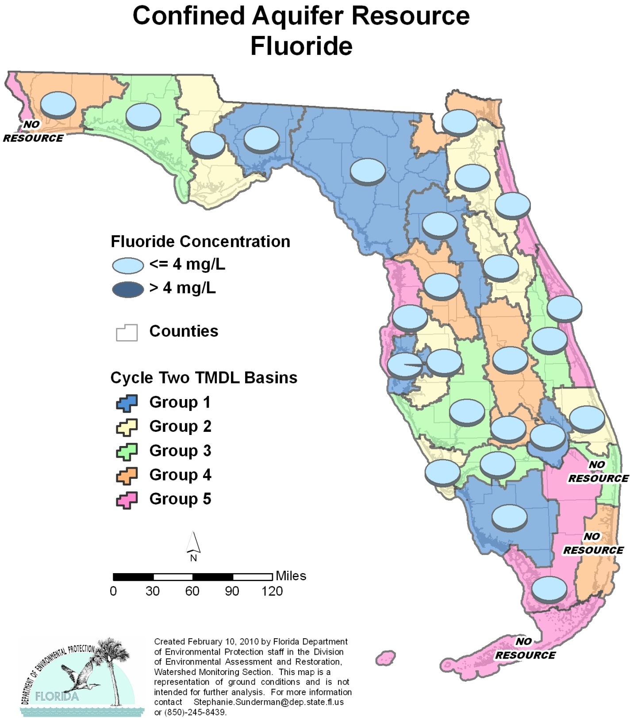

Table C.4. Percentage of Confined Aquifers Meeting Threshold Value for Fluoride Calculated Using Probabilistic Monitoring Design
Status Network Designated Use: Primary Drinking Water Standards Units: Number of wells in list frame

This is a nine-column table. Column 1 lists the basin, Column 2 lists the target population, Column 3 lists the number of sampleable wells, Column 4 lists the number of inaccessible wells, Column 5 lists the number of samples, Column 6 lists the percent meeting threshold, Column 7 lists the 95% confidence bounds, Column 8 lists the percent not meeting threshold, and Column 9 lists the assessment period.

¹ No confined aquifer wells in basin
² N/A = Not applicable
Basin | Target Population | Sampleable | Inaccessible | Number of Samples | % Meeting Threshold | 95% Confidence Bounds  (% Meeting Threshold) | % Not Meeting Threshold | Assessment Period
NWFWMD1  Ochlockonee–St. Marks | 1,600 | 1,024 | 576 | 30 | 100.0 | 100.0 | 0.0 | Jan-Mar 2004
SFWMD1  Everglades–West Coast | 80 | 63 | 17 | 30 | 100.0 | 100.0 | 0.0 | Jan-Mar 2004
SFWMD6  Lake Okeechobee | 8 | 4 | 4 | 4 | 100.0 | 100.0 | 0.0 | Jan-Mar 2004
SJRWMD1  Ocklawaha | 167 | 116 | 51 | 30 | 100.0 | 100.0 | 0.0 | Jan-Mar 2004
SRWMD1  Suwannee | 376 | 260 | 116 | 30 | 100.0 | 100.0 | 0.0 | Jan-Mar 2004
SWFWMD1  Tampa Bay | 113 | 72 | 41 | 30 | 97.6 | 93.6-100.0 | 2.4 | Jan-Mar 2004
NWFWMD2  Apalachicola–Chipola | 194 | 89 | 105 | 30 | 100.0 | 100.0 | 0.0 | Jan-Feb 2005
SFWMD2  St Lucie–Loxahatchee | 12 | 9 | 3 | 9 | 100.0 | 100.0 | 0.0 | Jan-Feb 2005
SFWMD7  Charlotte Harbor | 54 | 33 | 21 | 29 | 100.0 | 100.0 | 0.0 | Feb-Mar 2005
SJRWMD2  Lower St. Johns | 259 | 161 | 98 | 30 | 100.0 | 100.0 | 0.0 | Jan-Mar 2005
SJRWMD6  Middle St. Johns | 304 | 188 | 116 | 30 | 100.0 | 100.0 | 0.0 | Jan-Mar 2005
SWFWMD2  Tampa Bay Tributaries | 172 | 57 | 115 | 30 | 100.0 | 100.0 | 0.0 | Jan-Feb 2005
NWFWMD3  Choctawhatchee–  St. Andrews | 1,823 | 820 | 1,003 | 30 | 100.0 | 100.0 | 0.0 | Jan-Feb 2006
SFWMD3  Caloosahatchee | 57 | 43 | 14 | 30 | 100.0 | 100.0 | 0.0 | Jan-Feb 2006
SFWMD8  Lake Worth Lagoon–  Palm Beach Coast¹ | 0 | 0 | 0 | 0 | N/A² | N/A² | N/A² | N/A²
SJRWMD3  Upper St. Johns | 54 | 31 | 23 | 28 | 100.0 | 100.0 | 0.0 | Jan-Feb 2006
SWFWMD3  Sarasota Bay–Peace–Myakka | 460 | 179 | 281 | 30 | 100.0 | 100.0 | 0.0 | Jan-Mar 2006
NWFWMD4  Pensacola | 149 | 75 | 74 | 30 | 100.0 | 100.0 | 0.0 | Jan-Feb 2007
SFWMD4  Fisheating Creek | 15 | 6 | 9 | 6 | 100.0 | 100.0 | 0.0 | Jan-Feb 2007
SFWMD9  Kissimmee River | 131 | 56 | 75 | 29 | 100.0 | 100.0 | 0.0 | Jan-Mar 2007
SFWMD10  Southeast Coast–  Biscayne Bay | 2 | 0 | 2 | 0 | N/A² | N/A² | N/A² | N/A²
SJRWMD4  Nassau–St. Marys | 78 | 28 | 50 | 28 | 100.0 | 100.0 | 0.0 | Jan-Mar 2007
SWFWMD4  Withlacoochee | 48 | 23 | 25 | 23 | 100.0 | 100.0 | 0.0 | Feb-Mar 2007
NWFWMD5  Perdido | 1 | 0 | 1 | 0 | N/A² | N/A² | N/A² | N/A²
SFWMD5  Everglades | 4 | 4 | 0 | 4 | 100.0 | 100.0 | 0.0 | Feb 2008
SFWMD11  Florida Keys¹ | 0 | 0 | 0 | 0 | N/A² | N/A² | N/A² | N/A²
SJRWMD5  Indian River Lagoon | 45 | 21 | 24 | 21 | 100.0 | 100.0 | 0.0 | Jan-Mar 2008
SJRWMD7  Upper East Coast | 62 | 26 | 36 | 26 | 100.0 | 100.0 | 0.0 | Feb-Mar 2008
SWFWMD5  Springs Coast | 87 | 51 | 36 | 30 | 100.0 | 100.0 | 0.0 | Jan-Mar 2008
Summary of All Basins | 6,355 | 3,439 | 2,916 | 627 | 99.97 | 99.9-100.0 | 0.03 | 2004–08

Figure C.5. Summary of Lead Assessment for Confined Aquifers

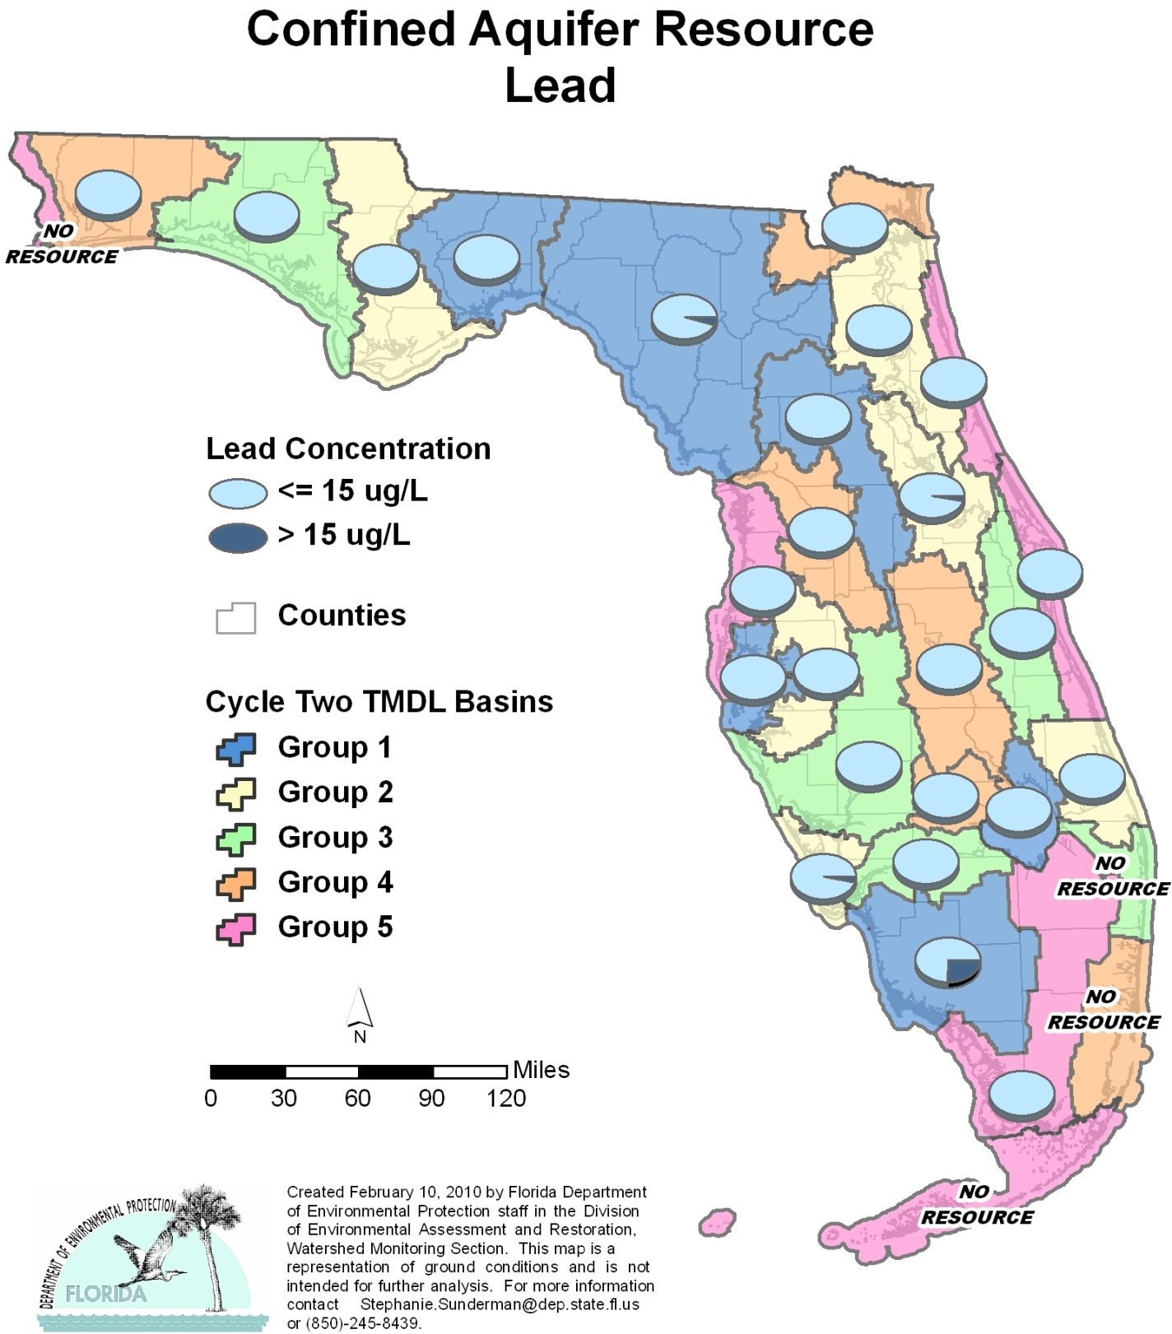

Table C.5. Percentage of Confined Aquifers Meeting Threshold Value for Lead Calculated Using Probabilistic Monitoring Design
Status Network Designated Use: Primary Drinking Water Standards Units: Number of wells in list frame

This is a nine-column table. Column 1 lists the basin, Column 2 lists the target population, Column 3 lists the number of sampleable wells, Column 4 lists the number of inaccessible wells, Column 5 lists the number of samples, Column 6 lists the percent meeting threshold, Column 7 lists the 95% confidence bounds, Column 8 lists the percent not meeting threshold, and Column 9 lists the assessment period.

1 No confined aquifer wells in basin
2 N/A = Not applicable
Basin | Target Population | Sampleable | Inaccessible | Number of Samples | % Meeting Threshold | 95% Confidence Bounds  (% Meeting Threshold) | % Not Meeting Threshold | Assessment Period
NWFWMD1  Ochlockonee–St. Marks | 1,600 | 1,024 | 576 | 30 | 100.0 | 100.0 | 0.0 | Jan-Mar 2004
SFWMD1  Everglades–West Coast | 80 | 63 | 17 | 30 | 74.5 | 61.8-87.3 | 25.45 | Jan-Mar 2004
SFWMD6  Lake Okeechobee | 8 | 4 | 4 | 4 | 100.0 | 100.0 | 0.0 | Jan-Mar 2004
SJRWMD1  Ocklawaha | 167 | 116 | 51 | 30 | 100.0 | 100.0 | 0.0 | Jan-Mar 2004
SRWMD1  Suwannee | 376 | 260 | 116 | 30 | 95.1 | 86.7-100.0 | 4.9 | Jan-Mar 2004
SWFWMD1  Tampa Bay | 113 | 72 | 41 | 24 | 100.0 | 100.0 | 0.0 | Jan-Mar 2004
NWFWMD2  Apalachicola–Chipola | 194 | 89 | 105 | 30 | 100.0 | 100.0 | 0.0 | Jan-Feb 2005
SFWMD2  St Lucie–Loxahatchee | 12 | 9 | 3 | 9 | 100.0 | 100.0 | 0.0 | Jan-Feb 2005
SFWMD7  Charlotte Harbor | 54 | 33 | 21 | 30 | 96.7 | 91.4-100.0 | 3.3 | Feb-Mar 2005
SJRWMD2  Lower St. Johns | 259 | 161 | 98 | 30 | 100.0 | 100.0 | 0.0 | Jan-Mar 2005
SJRWMD6  Middle St. Johns | 304 | 188 | 116 | 30 | 97.0 | 91.9-100.0 | 2.8 | Jan-Mar 2005
SWFWMD2  Tampa Bay Tributaries | 172 | 57 | 115 | 26 | 100.0 | 100.0 | 0.0 | Jan-Feb 2005
NWFWMD3  Choctawhatchee–  St. Andrews | 1,823 | 820 | 1,003 | 30 | 100.0 | 100.0 | 0.0 | Jan-Feb 2006
SFWMD3  Caloosahatchee | 57 | 43 | 14 | 30 | 100.0 | 100.0 | 0.0 | Jan-Feb 2006
SFWMD8  Lake Worth Lagoon–  Palm Beach Coast¹ | 0 | 0 | 0 | 0 | N/A² | N/A² | N/A² | N/A²
SJRWMD3  Upper St. Johns | 54 | 31 | 23 | 28 | 100.0 | 100.0 | 0.0 | Jan-Feb 2006
SWFWMD3  Sarasota Bay–Peace–Myakka | 460 | 179 | 281 | 30 | 100.0 | 100.0 | 0.0 | Jan-Mar 2006
NWFWMD4  Pensacola | 149 | 75 | 74 | 30 | 100.0 | 100.0 | 0.0 | Jan-Feb 2007
SFWMD4  Fisheating Creek | 15 | 6 | 9 | 6 | 100.0 | 100.0 | 0.0 | Jan-Feb 2007
SFWMD9  Kissimmee River | 131 | 56 | 75 | 29 | 100.0 | 100.0 | 0.0 | Jan-Mar 2007
SFWMD10  Southeast Coast–  Biscayne Bay | 2 | 0 | 2 | 0 | N/A² | N/A² | N/A² | N/A²
SJRWMD4  Nassau–St. Marys | 78 | 28 | 50 | 28 | 100.0 | 100.0 | 0.0 | Jan-Mar 2007
SWFWMD4  Withlacoochee | 48 | 23 | 25 | 22 | 100.0 | 100.0 | 0.0 | Feb-Mar 2007
NWFWMD5  Perdido | 1 | 0 | 1 | 0 | N/A² | N/A² | N/A² | N/A²
SFWMD5  Everglades | 4 | 4 | 0 | 4 | 100.0 | 100.0 | 0.0 | Feb 2008
SFWMD11  Florida Keys¹ | 0 | 0 | 0 | 0 | N/A² | N/A² | N/A² | N/A²
SJRWMD5  Indian River Lagoon | 45 | 21 | 24 | 21 | 100.0 | 100.0 | 0.0 | Jan-Mar 2008
SJRWMD7  Upper East Coast | 62 | 26 | 36 | 26 | 100.0 | 100.0 | 0.0 | Feb-Mar 2008
SWFWMD5  Springs Coast | 87 | 51 | 36 | 30 | 100.0 | 100.0 | 0.0 | Jan-Mar 2008
Summary of All Basins | 6,355 | 3,439 | 2,916 | 615 | 99.4 | 99.0-99.8 | 0.6 | 2004–08

Figure C.6. Summary of Nitrate + Nitrite Assessment for Confined Aquifers

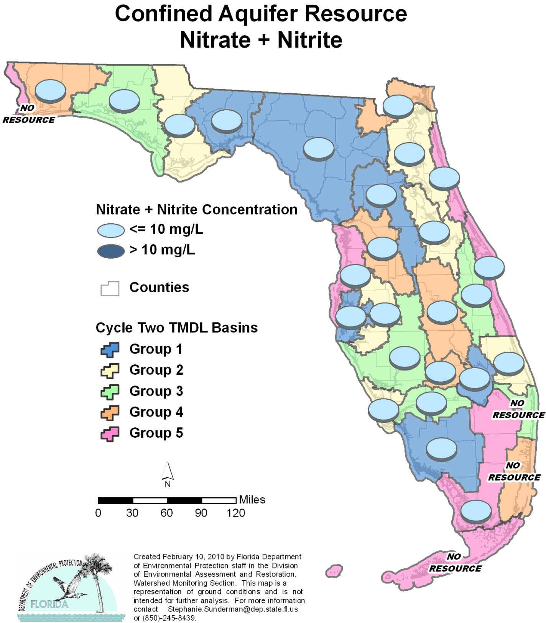

Table C.6. Percentage of Confined Aquifers Meeting Threshold Value for Nitrate + Nitrite Calculated Using Probabilistic Monitoring Design
Status Network Designated Use: Primary Drinking Water Standards Units: Number of wells in list frame

This is a nine-column table. Column 1 lists the basin, Column 2 lists the target population, Column 3 lists the number of sampleable wells, Column 4 lists the number of inaccessible wells, Column 5 lists the number of samples, Column 6 lists the percent meeting threshold, Column 7 lists the 95% confidence bounds, Column 8 lists the percent not meeting threshold, and Column 9 lists the assessment period.
¹ No confined aquifer wells in basin
² N/A = Not applicable
Basin | Target Population | Sampleable | Inaccessible | Number of Samples | % Meeting Threshold | 95% Confidence Bounds  (% Meeting Threshold) | % Not Meeting Threshold | Assessment Period
NWFWMD1  Ochlockonee–St. Marks | 1,600 | 1,024 | 576 | 21 | 100.0 | 100.0 | 0.0 | Jan-Mar 2004
SFWMD1  Everglades–West Coast | 80 | 63 | 17 | 30 | 100.0 | 100.0 | 0.0 | Jan-Mar 2004
SFWMD6  Lake Okeechobee | 8 | 4 | 4 | 4 | 100.0 | 100.0 | 0.0 | Jan-Mar 2004
SJRWMD1  Ocklawaha | 167 | 116 | 51 | 30 | 100.0 | 100.0 | 0.0 | Jan-Mar 2004
SRWMD1  Suwannee | 376 | 260 | 116 | 30 | 100.0 | 100.0 | 0.0 | Jan-Mar 2004
SWFWMD1  Tampa Bay | 113 | 72 | 41 | 29 | 100.0 | 100.0 | 0.0 | Jan-Mar 2004
NWFWMD2  Apalachicola–Chipola | 194 | 89 | 105 | 30 | 100.0 | 100.0 | 0.0 | Jan-Feb 2005
SFWMD2  St Lucie–Loxahatchee | 12 | 9 | 3 | 9 | 100.0 | 100.0 | 0.0 | Jan-Feb 2005
SFWMD7  Charlotte Harbor | 54 | 33 | 21 | 29 | 100.0 | 100.0 | 0.0 | Feb-Mar 2005
SJRWMD2  Lower St. Johns | 259 | 161 | 98 | 30 | 100.0 | 100.0 | 0.0 | Jan-Mar 2005
SJRWMD6  Middle St. Johns | 304 | 188 | 116 | 30 | 100.0 | 100.0 | 0.0 | Jan-Mar 2005
SWFWMD2  Tampa Bay Tributaries | 172 | 57 | 115 | 28 | 100.0 | 100.0 | 0.0 | Jan-Feb 2005
NWFWMD3  Choctawhatchee–  St. Andrews | 1,823 | 820 | 1,003 | 30 | 100.0 | 100.0 | 0.0 | Jan-Feb 2006
SFWMD3  Caloosahatchee | 57 | 43 | 14 | 30 | 100.0 | 100.0 | 0.0 | Jan-Feb 2006
SFWMD8  Lake Worth Lagoon–  Palm Beach Coast¹ | 0 | 0 | 0 | 0 | N/A² | N/A² | N/A² | N/A²
SJRWMD3  Upper St. Johns | 54 | 31 | 23 | 28 | 100.0 | 100.0 | 0.0 | Jan-Feb 2006
SWFWMD3  Sarasota Bay–Peace–Myakka | 460 | 179 | 281 | 30 | 100.0 | 100.0 | 0.0 | Jan-Mar 2006
NWFWMD4  Pensacola | 149 | 75 | 74 | 30 | 100.0 | 100.0 | 0.0 | Jan-Feb 2007
SFWMD4  Fisheating Creek | 15 | 6 | 9 | 6 | 100.0 | 100.0 | 0.0 | Jan-Feb 2007
SFWMD9  Kissimmee River | 131 | 56 | 75 | 27 | 100.0 | 100.0 | 0.0 | Jan-Mar 2007
SFWMD10  Southeast Coast–  Biscayne Bay | 2 | 0 | 2 | 0 | N/A² | N/A² | N/A² | N/A²
SJRWMD4  Nassau–St. Marys | 78 | 28 | 50 | 28 | 100.0 | 100.0 | 0.0 | Jan-Mar 2007
SWFWMD4  Withlacoochee | 48 | 23 | 25 | 23 | 100.0 | 100.0 | 0.0 | Feb-Mar 2007
NWFWMD5  Perdido | 1 | 0 | 1 | 0 | N/A² | N/A² | N/A² | N/A²
SFWMD5  Everglades | 4 | 4 | 0 | 4 | 100.0 | 100.0 | 0.0 | Feb 2008
SFWMD11  Florida Keys¹ | 0 | 0 | 0 | 0 | N/A² | N/A² | N/A² | N/A²
SJRWMD5  Indian River Lagoon | 45 | 21 | 24 | 17 | 100.0 | 100.0 | 0.0 | Jan-Mar 2008
SJRWMD7  Upper East Coast | 62 | 26 | 36 | 26 | 100.0 | 100.0 | 0.0 | Feb-Mar 2008
SWFWMD5  Springs Coast | 87 | 51 | 36 | 30 | 100.0 | 100.0 | 0.0 | Jan-Mar 2008
Summary of All Basins | 6,355 | 3,439 | 2,916 | 609 | 100.0 | 100.0 | 0.0 | 2004–08

Figure C.7. Summary of Sodium Assessment for Confined Aquifers

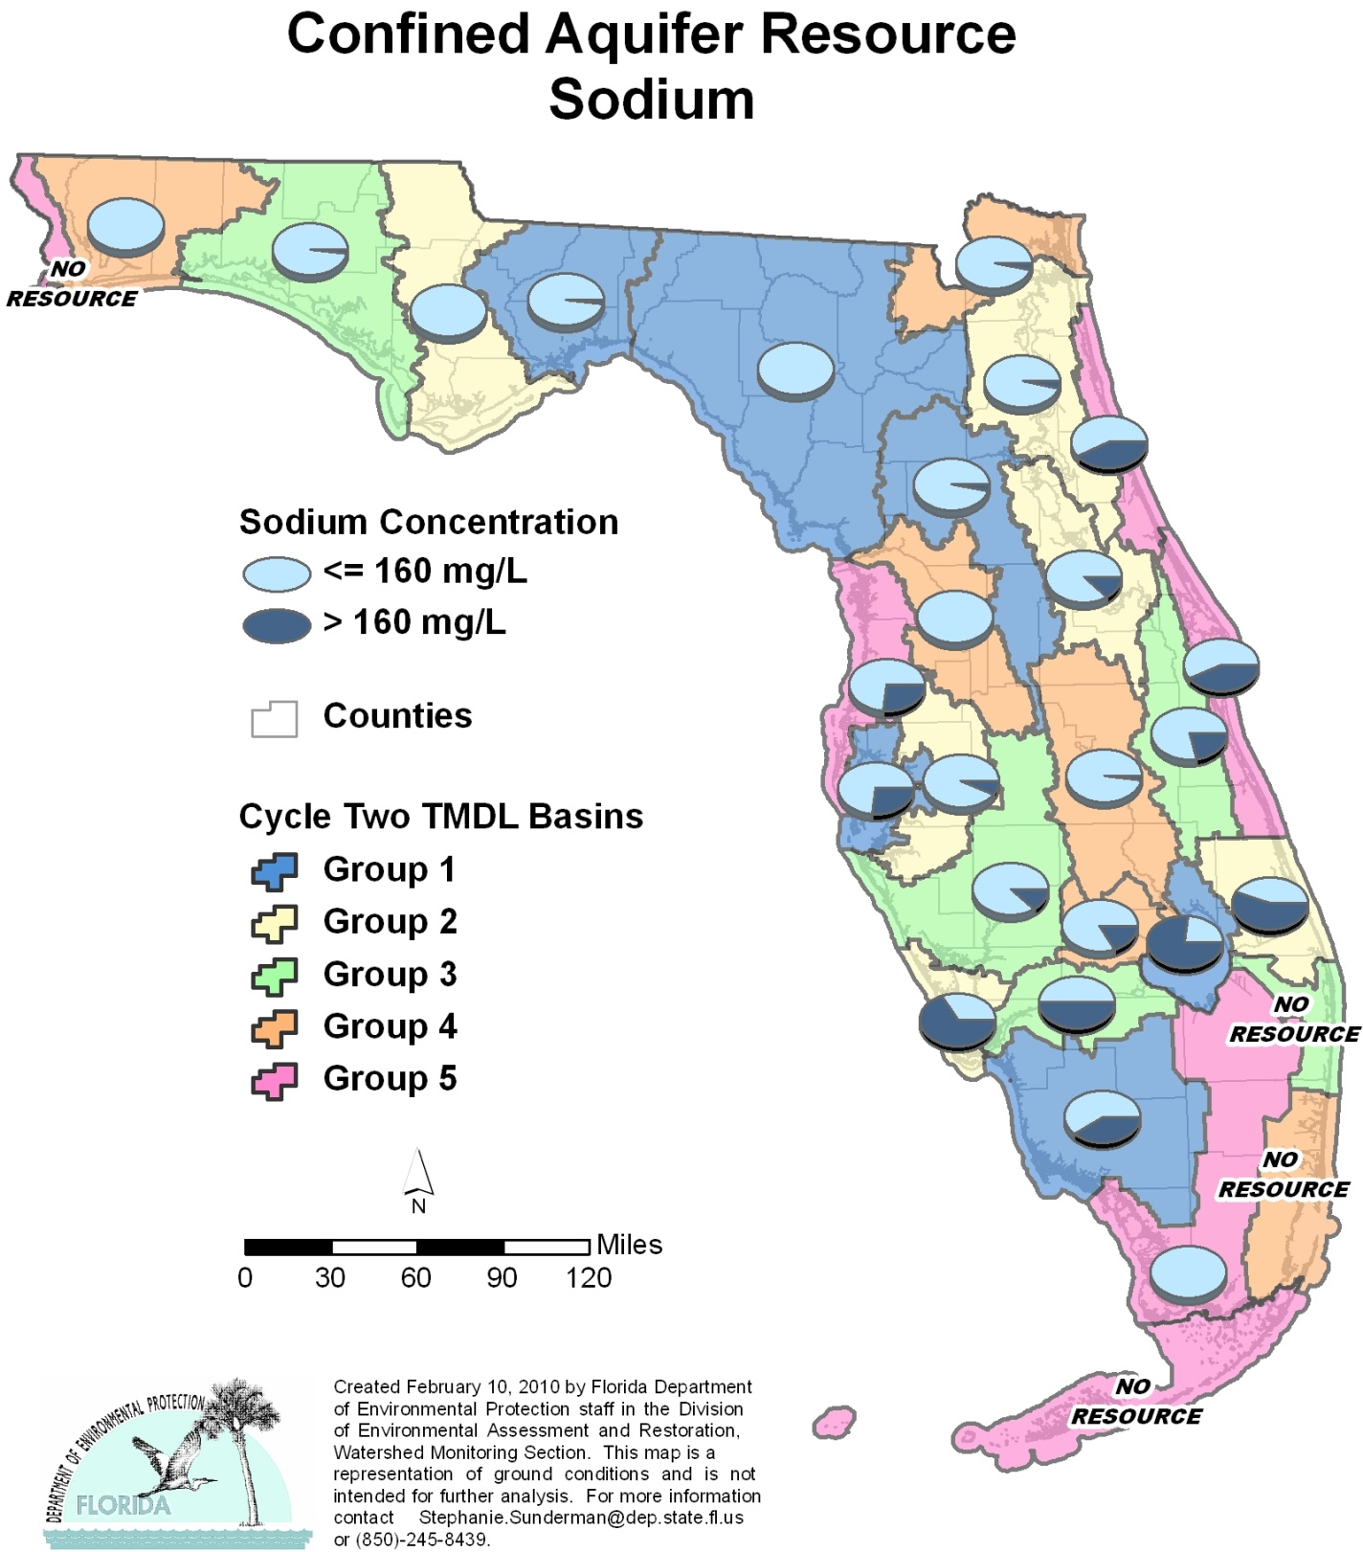

Table C.7. Percentage of Confined Aquifers Meeting Threshold Value for Sodium Calculated Using Probabilistic Monitoring Design
Status Network Designated Use: Primary Drinking Water Standards Units: Number of wells in list frame

This is a nine-column table. Column 1 lists the basin, Column 2 lists the target population, Column 3 lists the number of sampleable wells, Column 4 lists the number of inaccessible wells, Column 5 lists the number of samples, Column 6 lists the percent meeting threshold, Column 7 lists the 95% confidence bounds, Column 8 lists the percent not meeting threshold, and Column 9 lists the assessment period.

¹ No confined aquifer wells in basin
² N/A = Not applicable
Basin | Target Population | Sampleable | Inaccessible | Number of Samples | % Meeting Threshold | 95% Confidence Bounds  (% Meeting Threshold) | % Not Meeting Threshold | Assessment Period
NWFWMD1  Ochlockonee–St. Marks | 1,600 | 1,024 | 576 | 30 | 97.9 | 94.3-100.0 | 2.1 | Jan-Mar 2004
SFWMD1  Everglades–West Coast | 80 | 63 | 17 | 30 | 59.5 | 43.0-76.0 | 40.5 | Jan-Mar 2004
SFWMD6  Lake Okeechobee | 8 | 4 | 4 | 4 | 23.3 | 0.0-62.1 | 76.7 | Jan-Mar 2004
SJRWMD1  Ocklawaha | 167 | 116 | 51 | 30 | 96.9 | 91.7-100.0 | 3.1 | Jan-Mar 2004
SRWMD1  Suwannee | 376 | 260 | 116 | 30 | 100.0 | 100.0 | 0.0 | Jan-Mar 2004
SWFWMD1  Tampa Bay | 113 | 72 | 41 | 30 | 72.8 | 59.3-86.3 | 27.2 | Jan-Mar 2004
NWFWMD2  Apalachicola–Chipola | 194 | 89 | 105 | 30 | 100.0 | 100.0 | 0.0 | Jan-Feb 2005
SFWMD2  St Lucie–Loxahatchee | 12 | 9 | 3 | 9 | 44.4 | 20.3-68.6 | 55.6 | Jan-Feb 2005
SFWMD7  Charlotte Harbor | 54 | 33 | 21 | 30 | 33.3 | 22.0-44.7 | 66.7 | Feb-Mar 2005
SJRWMD2  Lower St. Johns | 259 | 161 | 98 | 30 | 96.4 | 90.3-100.0 | 3.6 | Jan-Mar 2005
SJRWMD6  Middle St. Johns | 304 | 188 | 116 | 30 | 87.3 | 78.1-96.6 | 12.7 | Jan-Mar 2005
SWFWMD2  Tampa Bay Tributaries | 172 | 57 | 115 | 30 | 93.2 | 86.9-99.5 | 6.8 | Jan-Feb 2005
NWFWMD3  Choctawhatchee–  St. Andrews | 1,823 | 820 | 1,003 | 30 | 97.6 | 93.5-100.0 | 2.4 | Jan-Feb 2006
SFWMD3  Caloosahatchee | 57 | 43 | 14 | 30 | 50.0 | 35.6-64.4 | 50.0 | Jan-Feb 2006
SFWMD8  Lake Worth Lagoon–  Palm Beach Coast¹ | 0 | 0 | 0 | 0 | N/A² | N/A² | N/A² | N/A²
SJRWMD3  Upper St. Johns | 54 | 31 | 23 | 28 | 78.6 | 71.4-85.8 | 21.4 | Jan-Feb 2006
SWFWMD3  Sarasota Bay–Peace–Myakka | 460 | 179 | 281 | 30 | 87.9 | 79.7-96.0 | 12.1 | Jan-Mar 2006
NWFWMD4  Pensacola | 149 | 75 | 74 | 30 | 100.0 | 100.0 | 0.0 | Jan-Feb 2007
SFWMD4  Fisheating Creek | 15 | 6 | 9 | 6 | 83.3 | 57.0-100.0 | 16.7 | Jan-Feb 2007
SFWMD9  Kissimmee River | 131 | 56 | 75 | 29 | 97.9 | 94.4-100.0 | 2.1 | Jan-Mar 2007
SFWMD10  Southeast Coast–  Biscayne Bay | 2 | 0 | 2 | 0 | N/A² | N/A² | N/A² | N/A²
SJRWMD4  Nassau–St. Marys | 78 | 28 | 50 | 28 | 96.4 | 90.6-100.0 | 3.6 | Jan-Mar 2007
SWFWMD4  Withlacoochee | 48 | 23 | 25 | 23 | 100.0 | 100.0 | 0.0 | Feb-Mar 2007
NWFWMD5  Perdido | 1 | 0 | 1 | 0 | N/A² | N/A² | N/A² | N/A²
SFWMD5  Everglades | 4 | 4 | 0 | 4 | 100.0 | 100.0 | 0.0 | Feb 2008
SFWMD11  Florida Keys¹ | 0 | 0 | 0 | 0 | N/A² | N/A² | N/A² | N/A²
SJRWMD5  Indian River Lagoon | 45 | 21 | 24 | 21 | 57.1 | 42.0-72.3 | 42.9 | Jan-Mar 2008
SJRWMD7  Upper East Coast | 62 | 26 | 36 | 26 | 57.7 | 47.0-68.4 | 42.3 | Feb-Mar 2008
SWFWMD5  Springs Coast | 87 | 51 | 36 | 30 | 73.3 | 59.9-86.7 | 26.7 | Jan-Mar 2008
Summary of All Basins | 6,355 | 3,439 | 2,916 | 628 | 94.9 | 93.7-96.2 | 5.1 | 2004–08

Figure C.8. Summary of Fecal Coliform Assessment for Confined Aquifers

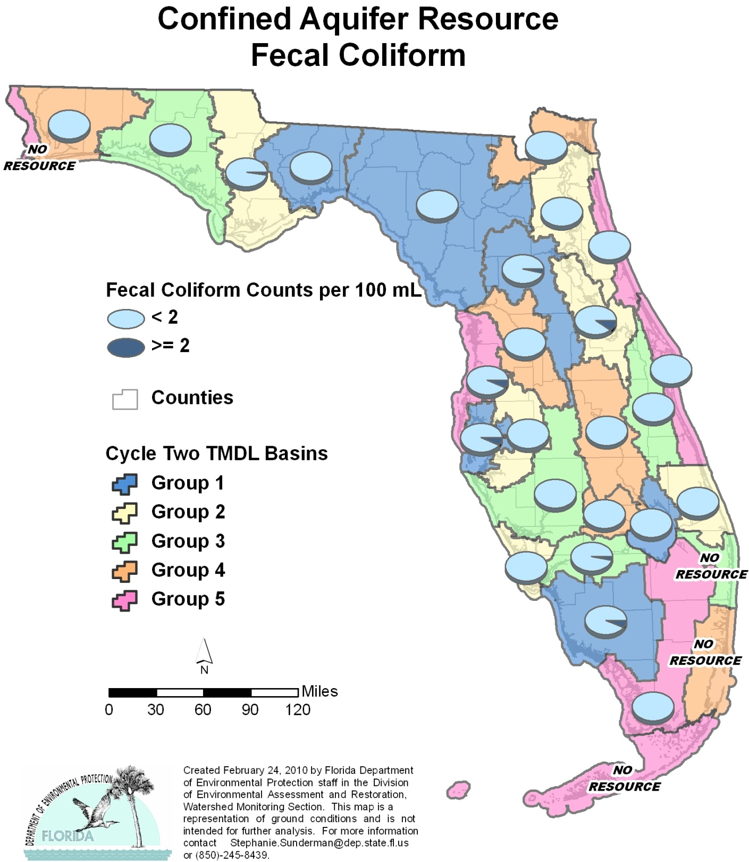

Table C.8. Percentage of Confined Aquifers Meeting Threshold Value for Fecal Coliform Calculated Using Probabilistic Monitoring Design
Status Network Designated Use: Primary Drinking Water Standards Units: Number of wells in list frame

This is a nine-column table. Column 1 lists the basin, Column 2 lists the target population, Column 3 lists the number of sampleable wells, Column 4 lists the number of inaccessible wells, Column 5 lists the number of samples, Column 6 lists the percent meeting threshold, Column 7 lists the 95% confidence bounds, Column 8 lists the percent not meeting threshold, and Column 9 lists the assessment period.
¹ No confined aquifer wells in basin
² N/A = Not applicable
Basin | Target Population | Sampleable | Inaccessible | Number of Samples | % Meeting Threshold | 95% Confidence Bounds  (% Meeting Threshold) | % Not Meeting Threshold | Assessment Period
NWFWMD1  Ochlockonee–St. Marks | 1,600 | 1,024 | 576 | 30 | 100.0 | 100.0 | 0.0 | Jan-Mar 2004
SFWMD1  Everglades–West Coast | 80 | 63 | 17 | 30 | 93.0 | 84.5-100.0 | 7.0 | Jan-Mar 2004
SFWMD6  Lake Okeechobee | 8 | 4 | 4 | 4 | 100.0 | 100.0 | 0.0 | Jan-Mar 2004
SJRWMD1  Ocklawaha | 167 | 116 | 51 | 30 | 96.5 | 90.7-100.0 | 3.5 | Jan-Mar 2004
SRWMD1  Suwannee | 376 | 260 | 116 | 30 | 100.0 | 100.0 | 0.0 | Jan-Mar 2004
SWFWMD1  Tampa Bay | 113 | 72 | 41 | 30 | 92.9 | 84.6-100.0 | 7.1 | Jan-Mar 2004
NWFWMD2  Apalachicola–Chipola | 194 | 89 | 105 | 29 | 97.8 | 94.2-100.0 | 2.2 | Jan-Feb 2005
SFWMD2  St Lucie–Loxahatchee | 12 | 9 | 3 | 9 | 100.0 | 100.0 | 0.0 | Jan-Feb 2005
SFWMD7  Charlotte Harbor | 54 | 33 | 21 | 30 | 100.0 | 100.0 | 0.0 | Feb-Mar 2005
SJRWMD2  Lower St. Johns | 259 | 161 | 98 | 30 | 100.0 | 100.0 | 0.0 | Jan-Mar 2005
SJRWMD6  Middle St. Johns | 304 | 188 | 116 | 30 | 89.4 | 77.2-100.0 | 10.3 | Jan-Mar 2005
SWFWMD2  Tampa Bay Tributaries | 172 | 57 | 115 | 26 | 100.0 | 100.0 | 0.0 | Jan-Feb 2005
NWFWMD3  Choctawhatchee–  St. Andrews | 1,823 | 820 | 1,003 | 30 | 100.0 | 100.0 | 0.0 | Jan-Feb 2006
SFWMD3  Caloosahatchee | 57 | 43 | 14 | 30 | 96.7 | 91.4-100.0 | 3.3 | Jan-Feb 2006
SFWMD8  Lake Worth Lagoon–  Palm Beach Coast¹ | 0 | 0 | 0 | 0 | N/A² | N/A² | N/A² | N/A²
SJRWMD3  Upper St. Johns | 54 | 31 | 23 | 28 | 100.0 | 100.0 | 0.0 | Jan-Feb 2006
SWFWMD3  Sarasota Bay–Peace–Myakka | 460 | 179 | 281 | 30 | 100.0 | 100.0 | 0.0 | Jan-Mar 2006
NWFWMD4  Pensacola | 149 | 75 | 74 | 30 | 100.0 | 100.0 | 0.0 | Jan-Feb 2007
SFWMD4  Fisheating Creek | 15 | 6 | 9 | 6 | 100.0 | 100.0 | 0.0 | Jan-Feb 2007
SFWMD9  Kissimmee River | 131 | 56 | 75 | 28 | 100.0 | 100.0 | 0.0 | Jan-Mar 2007
SFWMD10  Southeast Coast–  Biscayne Bay | 2 | 0 | 2 | 0 | N/A² | N/A² | N/A² | N/A²
SJRWMD4  Nassau–St. Marys | 78 | 28 | 50 | 28 | 100.0 | 100.0 | 0.0 | Jan-Mar 2007
SWFWMD4  Withlacoochee | 48 | 23 | 25 | 23 | 100.0 | 100.0 | 0.0 | Feb-Mar 2007
NWFWMD5  Perdido | 1 | 0 | 1 | 0 | N/A² | N/A² | N/A² | N/A²
SFWMD5  Everglades | 4 | 4 | 0 | 4 | 100.0 | 100.0 | 0.0 | Feb 2008
SFWMD11  Florida Keys¹ | 0 | 0 | 0 | 0 | N/A² | N/A² | N/A² | N/A²
SJRWMD5  Indian River Lagoon | 45 | 21 | 24 | 21 | 100.0 | 100.0 | 0.0 | Jan-Mar 2008
SJRWMD7  Upper East Coast | 62 | 26 | 36 | 26 | 100.0 | 100.0 | 0.0 | Feb-Mar 2008
SWFWMD5  Springs Coast | 87 | 51 | 36 | 30 | 93.3 | 87.0-99.7 | 6.7 | Jan-Mar 2008
Summary of All Basins | 6,355 | 3,439 | 2,916 | 622 | 98.7 | 97.5-99.8 | 1.3 | 2004–08

Figure C.9. Summary of Total Coliform Assessment for Confined Aquifers

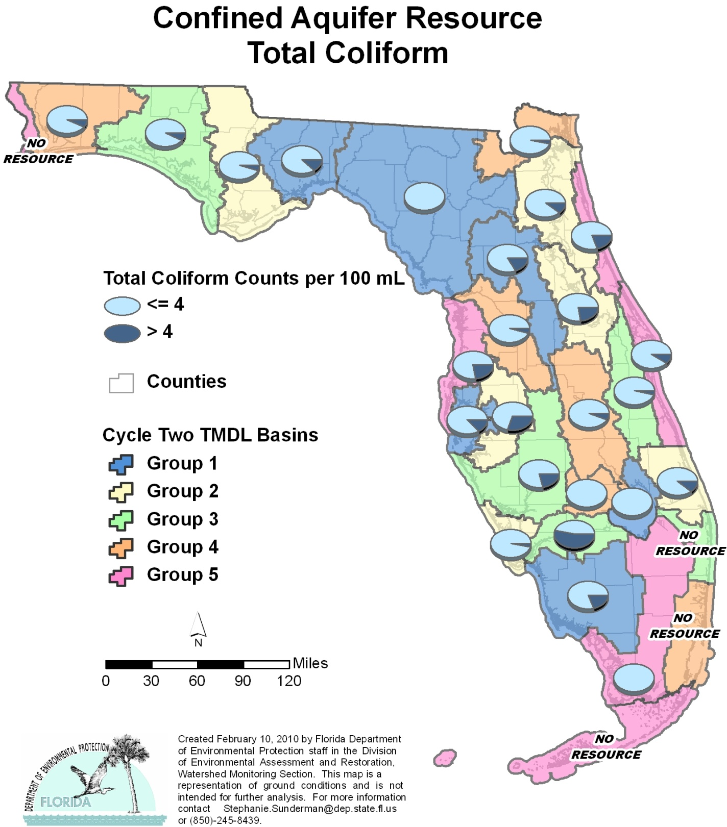

Table C.9. Percentage of Confined Aquifers Meeting Threshold Value for Total Coliform Calculated Using Probabilistic Monitoring Design
Status Network Designated Use: Primary Drinking Water Standards Units: Number of wells in list frame

This is a nine-column table. Column 1 lists the basin, Column 2 lists the target population, Column 3 lists the number of sampleable wells, Column 4 lists the number of inaccessible wells, Column 5 lists the number of samples, Column 6 lists the percent meeting threshold, Column 7 lists the 95% confidence bounds, Column 8 lists the percent not meeting threshold, and Column 9 lists the assessment period.
¹ No confined aquifer wells in basin
² N/A = Not applicable
Basin | Target Population | Sampleable | Inaccessible | Number of Samples | % Meeting Threshold | 95% Confidence Bounds  (% Meeting Threshold) | % Not Meeting Threshold | Assessment Period
NWFWMD1  Ochlockonee–St. Marks | 1,600 | 1,024 | 576 | 30 | 87.4 | 72.2-100.0 | 12.6 | Jan-Mar 2004
SFWMD1  Everglades–West Coast | 80 | 63 | 17 | 28 | 80.8 | 68.7-92.9 | 19.2 | Jan-Mar 2004
SFWMD6  Lake Okeechobee | 8 | 4 | 4 | 4 | 100.0 | 100.0 | 0.0 | Jan-Mar 2004
SJRWMD1  Ocklawaha | 167 | 116 | 51 | 30 | 83.2 | 71.9-94.5 | 16.8 | Jan-Mar 2004
SRWMD1  Suwannee | 376 | 260 | 116 | 30 | 100.0 | 100.0 | 0.0 | Jan-Mar 2004
SWFWMD1  Tampa Bay | 113 | 72 | 41 | 30 | 86.6 | 75.1-98.0 | 13.4 | Jan-Mar 2004
NWFWMD2  Apalachicola–Chipola | 194 | 89 | 105 | 29 | 94.9 | 86.0-100.0 | 5.1 | Jan-Feb 2005
SFWMD2  St Lucie–Loxahatchee | 12 | 9 | 3 | 9 | 88.9 | 70.0-100.0 | 11.1 | Jan-Feb 2005
SFWMD7  Charlotte Harbor | 54 | 33 | 21 | 30 | 96.7 | 90.8-100.0 | 3.3 | Feb-Mar 2005
SJRWMD2  Lower St. Johns | 259 | 161 | 98 | 27 | 89.6 | 78.9-100.0 | 10.6 | Jan-Mar 2005
SJRWMD6  Middle St. Johns | 304 | 188 | 116 | 30 | 77.3 | 61.8-92.8 | 22.7 | Jan-Mar 2005
SWFWMD2  Tampa Bay Tributaries | 172 | 57 | 115 | 27 | 69.6 | 54.2-84.9 | 30.4 | Jan-Feb 2005
NWFWMD3  Choctawhatchee–  St. Andrews | 1,823 | 820 | 1,003 | 30 | 92.3 | 83.1-100.0 | 7.7 | Jan-Feb 2006
SFWMD3  Caloosahatchee | 57 | 43 | 14 | 30 | 46.7 | 32.9-60.5 | 53.3 | Jan-Feb 2006
SFWMD8  Lake Worth Lagoon–  Palm Beach Coast¹ | 0 | 0 | 0 | 0 | N/A² | N/A² | N/A² | N/A²
SJRWMD3  Upper St. Johns | 54 | 31 | 23 | 28 | 96.4 | 90.6-100.0 | 3.6 | Jan-Feb 2006
SWFWMD3  Sarasota Bay–Peace–Myakka | 460 | 179 | 281 | 30 | 78.9 | 65.9-91.9 | 21.1 | Jan-Mar 2006
NWFWMD4  Pensacola | 149 | 75 | 74 | 30 | 92.9 | 84.3-100.0 | 7.1 | Jan-Feb 2007
SFWMD4  Fisheating Creek | 15 | 6 | 9 | 6 | 100.0 | 100.0 | 0.0 | Jan-Feb 2007
SFWMD9  Kissimmee River | 131 | 56 | 75 | 28 | 94.0 | 86.6-100.0 | 6.0 | Jan-Mar 2007
SFWMD10  Southeast Coast–  Biscayne Bay | 2 | 0 | 2 | 0 | N/A² | N/A² | N/A² | N/A²
SJRWMD4  Nassau–St. Marys | 78 | 28 | 50 | 28 | 96.4 | 90.0-100.0 | 3.6 | Jan-Mar 2007
SWFWMD4  Withlacoochee | 48 | 23 | 25 | 23 | 95.6 | 88.1-100.0 | 4.4 | Feb-Mar 2007
NWFWMD5  Perdido | 1 | 0 | 1 | 0 | N/A² | N/A² | N/A² | N/A²
SFWMD5  Everglades | 4 | 4 | 0 | 4 | 100.0 | 100.0 | 0.0 | Feb 2008
SFWMD11  Florida Keys¹ | 0 | 0 | 0 | 0 | N/A² | N/A² | N/A² | N/A²
SJRWMD5  Indian River Lagoon | 45 | 21 | 24 | 21 | 90.5 | 79.2-100.0 | 9.5 | Jan-Mar 2008
SJRWMD7  Upper East Coast | 62 | 26 | 36 | 26 | 80.8 | 68.6-92.9 | 19.2 | Feb-Mar 2008
SWFWMD5  Springs Coast | 87 | 51 | 36 | 18 | 77.8 | 61.9-93.6 | 22.2 | Jan-Mar 2008
Summary of All Basins | 6,355 | 3,439 | 2,916 | 606 | 90.0 | 85.6-94.4 | 10.0 | 2004–08

Figure C.10. Summary of Arsenic Assessment for Unconfined Aquifers

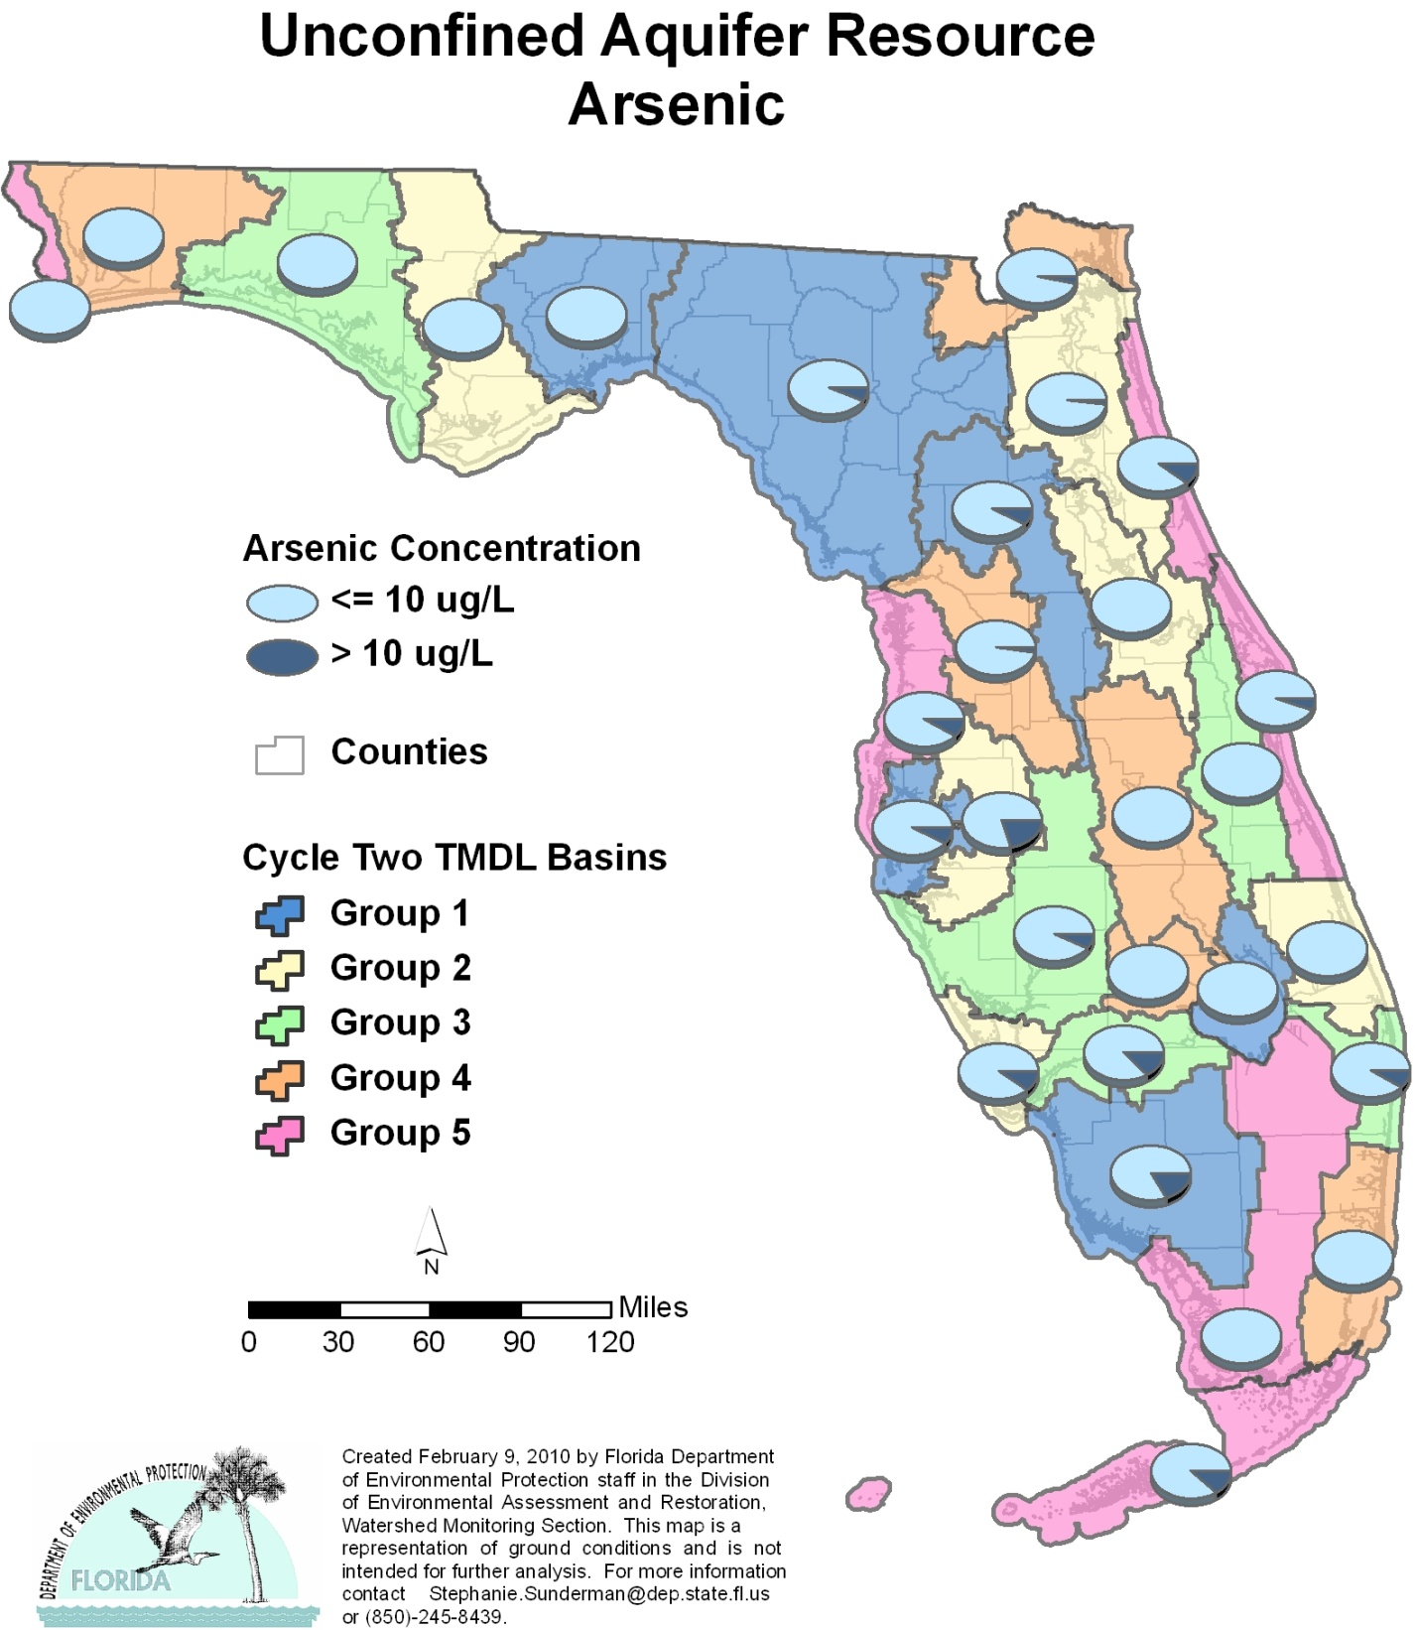

Table C.10. Percentage of Unconfined Aquifers Meeting Threshold Value for Arsenic Calculated Using Probabilistic Monitoring Design
Status Network Designated Use: Primary Drinking Water Standards Units: Number of wells in list frame

This is a nine-column table. Column 1 lists the basin, Column 2 lists the target population, Column 3 lists the number of sampleable wells, Column 4 lists the number of inaccessible wells, Column 5 lists the number of samples, Column 6 lists the percent meeting threshold, Column 7 lists the 95% confidence bounds, Column 8 lists the percent not meeting threshold, and Column 9 lists the assessment period.

¹ No confined aquifer wells in basin
² N/A = Not applicable
Basin | Target Population | Sampleable | Inaccessible | Number of Samples | % Meeting Threshold | 95% Confidence Bounds  (% Meeting Threshold) | % Not Meeting Threshold | Assessment Period
NWFWMD1  Ochlockonee–St. Marks | 542 | 303 | 239 | 30 | 100.0 | 100.0 | 0.0 | June-July 2004
SFWMD1  Everglades–West Coast | 240 | 133 | 107 | 30 | 82.8 | 65.2-100.0 | 17.2 | April-May 2004
SFWMD6  Lake Okeechobee | 103 | 74 | 29 | 30 | 100.0 | 100.0 | 0.0 | April-May 2004
SJRWMD1  Ocklawaha | 273 | 115 | 158 | 30 | 92.1 | 82.8-100.0 | 7.9 | April-May 2004
SRWMD1  Suwannee | 560 | 198 | 362 | 29 | 93.3 | 86.2-100.0 | 6.7 | June-July 2004
SWFWMD1  Tampa Bay | 125 | 92 | 33 | 30 | 92.2 | 83.5-100.0 | 7.8 | April-May 2004
NWFWMD2  Apalachicola–Chipola | 74 | 44 | 30 | 30 | 100.0 | 100.0 | 0.0 | Aug 2005
SFWMD2  St Lucie–Loxahatchee | 339 | 217 | 122 | 30 | 100.0 | 100.0 | 0.0 | April-May 2005
SFWMD7  Charlotte Harbor | 52 | 42 | 10 | 29 | 89.7 | 80.0-99.3 | 10.3 | April-May 2005
SJRWMD2  Lower St. Johns | 177 | 133 | 44 | 30 | 98.1 | 94.9-100.0 | 1.9 | April-June 2005
SJRWMD6  Middle St. Johns | 293 | 173 | 120 | 30 | 100.0 | 100.0 | 0.0 | April-June 2005
SWFWMD2  Tampa Bay Tributaries | 74 | 34 | 40 | 30 | 79.6 | 62.1-97.0 | 20.4 | April-May 2005
NWFWMD3  Choctawhatchee–  St. Andrews | 455 | 264 | 191 | 30 | 100.0 | 100.0 | 0.0 | June-Aug 2006
SFWMD3  Caloosahatchee | 102 | 60 | 42 | 30 | 86.7 | 77.3-96.0 | 13.3 | April-May 2006
SFWMD8  Lake Worth Lagoon–  Palm Beach Coast | 343 | 106 | 237 | 30 | 90.7 | 82.3-99.1 | 9.3 | April-May 2006
SJRWMD3  Upper St. Johns | 121 | 31 | 90 | 29 | 96.3 | 90.3-100.0 | 3.7 | April-June 2006
SWFWMD3  Sarasota Bay–Peace–Myakka | 279 | 95 | 184 | 30 | 92.9 | 84.5-100.0 | 7.1 | April-June 2006
NWFWMD4  Pensacola | 1,015 | 508 | 507 | 30 | 100.0 | 100.0 | 0.0 | June-Aug 2007
SFWMD4  Fisheating Creek | 34 | 13 | 21 | 13 | 100.0 | 100.0 | 0.0 | April-May 2007
SFWMD9  Kissimmee River | 406 | 57 | 349 | 25 | 100.0 | 100.0 | 0.0 | May-June 2007
SFWMD10  Southeast Coast–  Biscayne Bay | 590 | 171 | 419 | 30 | 100.0 | 100.0 | 0.0 | April-June 2007
SJRWMD4  Nassau–St. Marys | 68 | 34 | 34 | 29 | 96.6 | 90.6-100.0 | 3.4 | April-May 2007
SWFWMD4  Withlacoochee | 304 | 100 | 204 | 30 | 97.7 | 93.8-100.0 | 2.3 | April-June 2007
NWFWMD5  Perdido | 629 | 262 | 367 | 30 | 100.0 | 100.0 | 0.0 | June-Aug 2008
SFWMD5  Everglades | 212 | 56 | 156 | 30 | 100.0 | 100.0 | 0.0 | April-June 2008
SFWMD11  Florida Keys | 15 | 8 | 7 | 8 | 87.5 | 67.6-100.0 | 12.5 | May-June 2008
SJRWMD5  Indian River Lagoon | 264 | 152 | 112 | 30 | 94.5 | 87.5-100.0 | 5.5 | April-June 2008
SJRWMD7  Upper East Coast | 117 | 50 | 67 | 29 | 100.0 | 100.0 | 0.0 | April-June 2008
SWFWMD5  Springs Coast | 397 | 173 | 224 | 30 | 91.4 | 83.6-99.3 | 8.6 | April-May 2008
Summary of All Basins | 8,203 | 3,698 | 4,505 | 821 | 96.9 | 95.9-97.9 | 3.1 | 2004–08

Figure C.11. Summary of Cadmium Assessment for Unconfined Aquifers

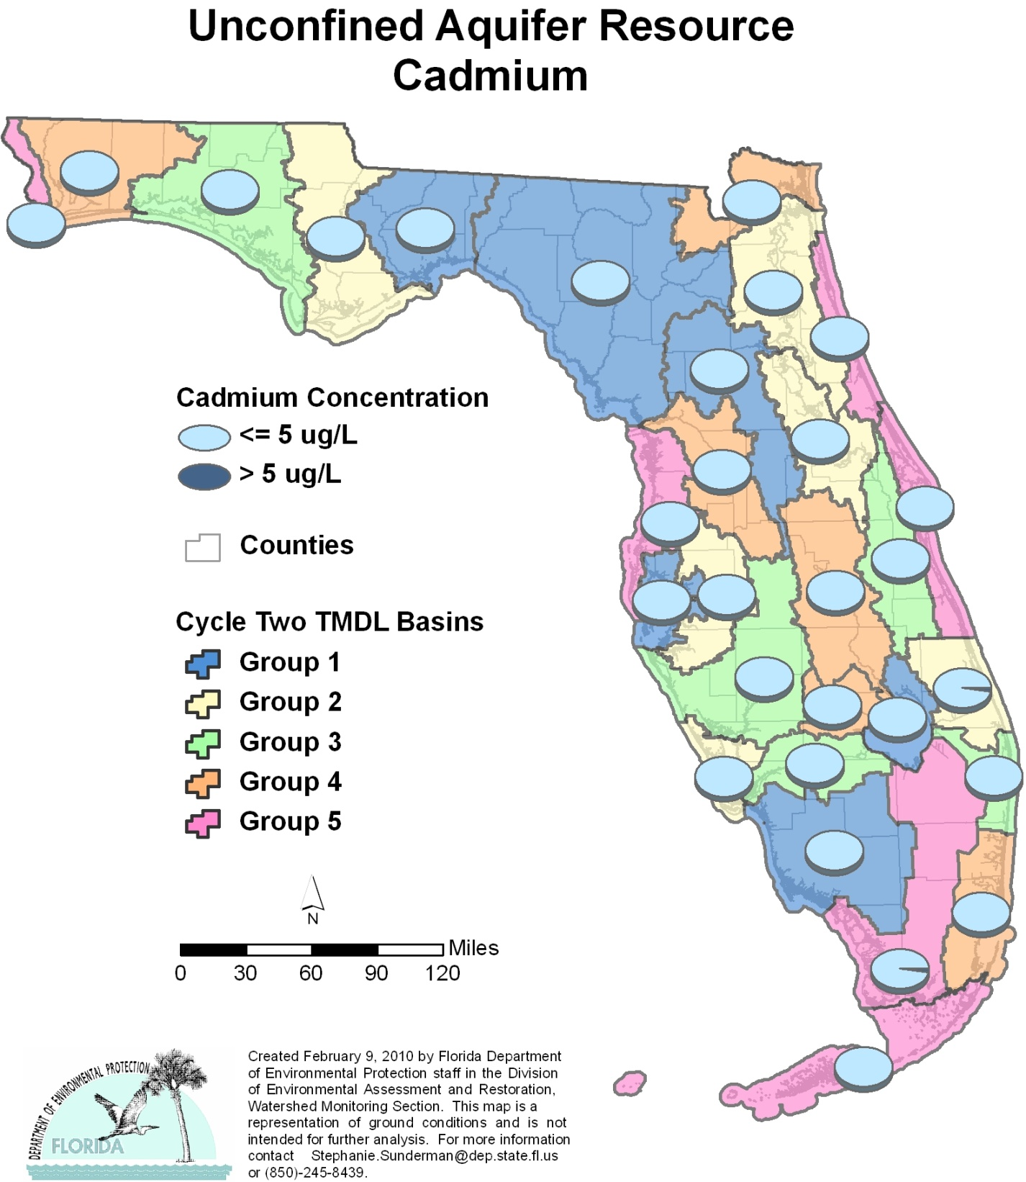

Table C.11. Percentage of Unconfined Aquifers Meeting Threshold Value for Cadmium Calculated Using Probabilistic Monitoring Design
Status Network Designated Use: Primary Drinking Water Standards Units: Number of wells in list frame

This is a nine-column table. Column 1 lists the basin, Column 2 lists the target population, Column 3 lists the number of sampleable wells, Column 4 lists the number of inaccessible wells, Column 5 lists the number of samples, Column 6 lists the percent meeting threshold, Column 7 lists the 95% confidence bounds, Column 8 lists the percent not meeting threshold, and Column 9 lists the assessment period.
¹ No confined aquifer wells in basin
² N/A = Not applicable
Basin | Target Population | Sampleable | Inaccessible | Number of Samples | % Meeting Threshold | 95% Confidence Bounds  (% Meeting Threshold) | % Not Meeting Threshold | Assessment Period
NWFWMD1  Ochlockonee–St. Marks | 542 | 303 | 239 | 30 | 100.0 | 100.0 | 0.0 | June-July 2004
SFWMD1  Everglades–West Coast | 240 | 133 | 107 | 30 | 100.0 | 100.0 | 0.0 | April-May 2004
SFWMD6  Lake Okeechobee | 103 | 74 | 29 | 30 | 100.0 | 100.0 | 0.0 | April-May 2004
SJRWMD1  Ocklawaha | 273 | 115 | 158 | 30 | 100.0 | 100.0 | 0.0 | April-May 2004
SRWMD1  Suwannee | 560 | 198 | 362 | 29 | 100.0 | 100.0 | 0.0 | June-July 2004
SWFWMD1  Tampa Bay | 125 | 92 | 33 | 30 | 100.0 | 100.0 | 0.0 | April-May 2004
NWFWMD2  Apalachicola–Chipola | 74 | 44 | 30 | 30 | 100.0 | 100.0 | 0.0 | Aug 2005
SFWMD2  St Lucie–Loxahatchee | 339 | 217 | 122 | 30 | 97.8 | 94.0-100.0 | 2.2 | April-May 2005
SFWMD7  Charlotte Harbor | 52 | 42 | 10 | 29 | 100.0 | 100.0 | 0.0 | April-May 2005
SJRWMD2  Lower St. Johns | 177 | 133 | 44 | 30 | 100.0 | 100.0 | 0.0 | April-June 2005
SJRWMD6  Middle St. Johns | 293 | 173 | 120 | 30 | 100.0 | 100.0 | 0.0 | April-June 2005
SWFWMD2  Tampa Bay Tributaries | 74 | 34 | 40 | 30 | 100.0 | 100.0 | 0.0 | April-May 2005
NWFWMD3  Choctawhatchee–  St. Andrews | 455 | 264 | 191 | 30 | 100.0 | 100.0 | 0.0 | June-Aug 2006
SFWMD3  Caloosahatchee | 102 | 60 | 42 | 30 | 100.0 | 100.0 | 0.0 | April-May 2006
SFWMD8  Lake Worth Lagoon–  Palm Beach Coast | 343 | 106 | 237 | 30 | 100.0 | 100.0 | 0.0 | April-May 2006
SJRWMD3  Upper St. Johns | 121 | 31 | 90 | 29 | 100.0 | 100.0 | 0.0 | April.-June 2006
SWFWMD3  Sarasota Bay–Peace–Myakka | 279 | 95 | 184 | 30 | 100.0 | 100.0 | 0.0 | April-June 2006
NWFWMD4  Pensacola | 1,015 | 508 | 507 | 30 | 100.0 | 100.0 | 0.0 | June-Aug 2007
SFWMD4  Fisheating Creek | 34 | 13 | 21 | 13 | 100.0 | 100.0 | 0.0 | April-May 2007
SFWMD9  Kissimmee River | 406 | 57 | 349 | 12 | 100.0 | 100.0 | 0.0 | May-June 2007
SFWMD10  Southeast Coast–  Biscayne Bay | 590 | 171 | 419 | 30 | 100.0 | 100.0 | 0.0 | April-June 2007
SJRWMD4  Nassau–St. Marys | 68 | 34 | 34 | 29 | 100.0 | 100.0 | 0.0 | April-May 2007
SWFWMD4  Withlacoochee | 304 | 100 | 204 | 30 | 100.0 | 100.0 | 0.0 | April-June 2007
NWFWMD5  Perdido | 629 | 262 | 367 | 30 | 100.0 | 100.0 | 0.0 | June-Aug 2008
SFWMD5  Everglades | 212 | 56 | 156 | 30 | 97.8 | 94.0-100.0 | 2.2 | April-June 2008
SFWMD11  Florida Keys | 15 | 8 | 7 | 8 | 100.0 | 100.0 | 0.0 | May-June 2008
SJRWMD5  Indian River Lagoon | 264 | 152 | 112 | 30 | 100.0 | 100.0 | 0.0 | April-June 2008
SJRWMD7  Upper East Coast | 117 | 50 | 67 | 29 | 100.0 | 100.0 | 0.0 | April-June 2008
SWFWMD5  Springs Coast | 397 | 173 | 224 | 30 | 100.0 | 100.0 | 0.0 | April-May 2008
Summary of All Basins | 8,203 | 3,698 | 4,505 | 808 | 99.9 | 99.7-100.0 | 0.1 | 2004–08

Figure C.12. Summary of Chromium Assessment for Unconfined Aquifers

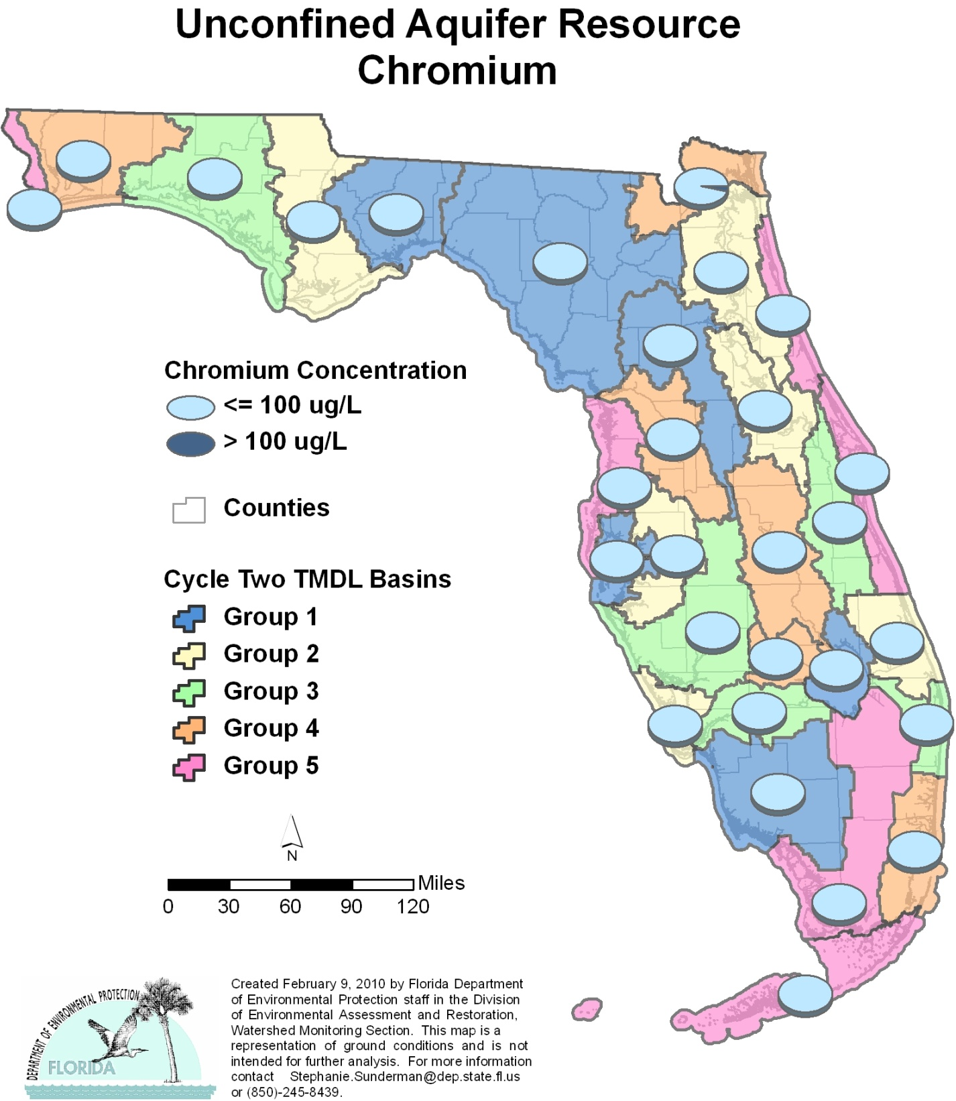

Table C.12. Percentage of Unconfined Aquifers Meeting Threshold Value for Chromium Calculated Using Probabilistic Monitoring Design
Status Network Designated Use: Primary Drinking Water Standards Units: Number of wells in list frame

This is a nine-column table. Column 1 lists the basin, Column 2 lists the target population, Column 3 lists the number of sampleable wells, Column 4 lists the number of inaccessible wells, Column 5 lists the number of samples, Column 6 lists the percent meeting threshold, Column 7 lists the 95% confidence bounds, Column 8 lists the percent not meeting threshold, and Column 9 lists the assessment period.
¹ No confined aquifer wells in basin
² N/A = Not applicable
Basin | Target Population | Sampleable | Inaccessible | Number of Samples | % Meeting Threshold | 95% Confidence Bounds  (% Meeting Threshold) | % Not Meeting Threshold | Assessment Period
NWFWMD1  Ochlockonee–St. Marks | 542 | 303 | 239 | 30 | 100.0 | 100.0 | 0.0 | June-July 2004
SFWMD1  Everglades–West Coast | 240 | 133 | 107 | 30 | 100.0 | 100.0 | 0.0 | April-May 2004
SFWMD6  Lake Okeechobee | 103 | 74 | 29 | 30 | 100.0 | 100.0 | 0.0 | April-May 2004
SJRWMD1  Ocklawaha | 273 | 115 | 158 | 30 | 100.0 | 100.0 | 0.0 | April-May 2004
SRWMD1  Suwannee | 560 | 198 | 362 | 29 | 100.0 | 100.0 | 0.0 | June-July 2004
SWFWMD1  Tampa Bay | 125 | 92 | 33 | 30 | 100.0 | 100.0 | 0.0 | April-May 2004
NWFWMD2  Apalachicola–Chipola | 74 | 44 | 30 | 30 | 100.0 | 100.0 | 0.0 | Aug 2005
SFWMD2  St Lucie–Loxahatchee | 339 | 217 | 122 | 30 | 100.0 | 100.0 | 0.0 | April-May 2005
SFWMD7  Charlotte Harbor | 52 | 42 | 10 | 29 | 100.0 | 100.0 | 0.0 | April-May 2005
SJRWMD2  Lower St. Johns | 177 | 133 | 44 | 30 | 100.0 | 100.0 | 0.0 | April-June 2005
SJRWMD6  Middle St. Johns | 293 | 173 | 120 | 30 | 100.0 | 100.0 | 0.0 | April-June 2005
SWFWMD2  Tampa Bay Tributaries | 74 | 34 | 40 | 30 | 100.0 | 100.0 | 0.0 | April-May 2005
NWFWMD3  Choctawhatchee–  St. Andrews | 455 | 264 | 191 | 11 | 100.0 | 100.0 | 0.0 | June-Aug 2006
SFWMD3  Caloosahatchee | 102 | 60 | 42 | 30 | 100.0 | 100.0 | 0.0 | April-May 2006
SFWMD8  Lake Worth Lagoon–  Palm Beach Coast | 343 | 106 | 237 | 30 | 100.0 | 100.0 | 0.0 | April-May 2006
SJRWMD3  Upper St. Johns | 121 | 31 | 90 | 29 | 100.0 | 100.0 | 0.0 | April-June 2006
SWFWMD3  Sarasota Bay–Peace–Myakka | 279 | 95 | 184 | 30 | 100.0 | 100.0 | 0.0 | April-June 2006
NWFWMD4  Pensacola | 1,015 | 508 | 507 | 30 | 100.0 | 100.0 | 0.0 | June-Aug 2007
SFWMD4  Fisheating Creek | 34 | 13 | 21 | 13 | 100.0 | 100.0 | 0.0 | April-May 2007
SFWMD9  Kissimmee River | 406 | 57 | 349 | 6 | 100.0 | 100.0 | 0.0 | May-June 2007
SFWMD10  Southeast Coast–  Biscayne Bay | 590 | 171 | 419 | 30 | 100.0 | 100.0 | 0.0 | April-June 2007
SJRWMD4  Nassau–St. Marys | 68 | 34 | 34 | 29 | 96.6 | 90.9-100.0 | 3.4 | April-May 2007
SWFWMD4  Withlacoochee | 304 | 100 | 204 | 30 | 100.0 | 100.0 | 0.0 | April-June 2007
NWFWMD5  Perdido | 629 | 262 | 367 | 30 | 100.0 | 100.0 | 0.0 | June-Aug 2008
SFWMD5  Everglades | 212 | 56 | 156 | 30 | 100.0 | 100.0 | 0.0 | April-June 2008
SFWMD11  Florida Keys | 15 | 8 | 7 | 8 | 100.0 | 100.0 | 0.0 | May-June 2008
SJRWMD5  Indian River Lagoon | 264 | 152 | 112 | 30 | 100.0 | 100.0 | 0.0 | April-June 2008
SJRWMD7  Upper East Coast | 117 | 50 | 67 | 29 | 100.0 | 100.0 | 0.0 | April-June 2008
SWFWMD5  Springs Coast | 397 | 173 | 224 | 30 | 100.0 | 100.0 | 0.0 | April-May 2008
Summary of All Basins | 8,203 | 3,698 | 4,505 | 783 | 99.98 | 99.9-100.0 | 0.02 | 2004–08

Figure C.13. Summary of Fluoride Assessment for Unconfined Aquifers

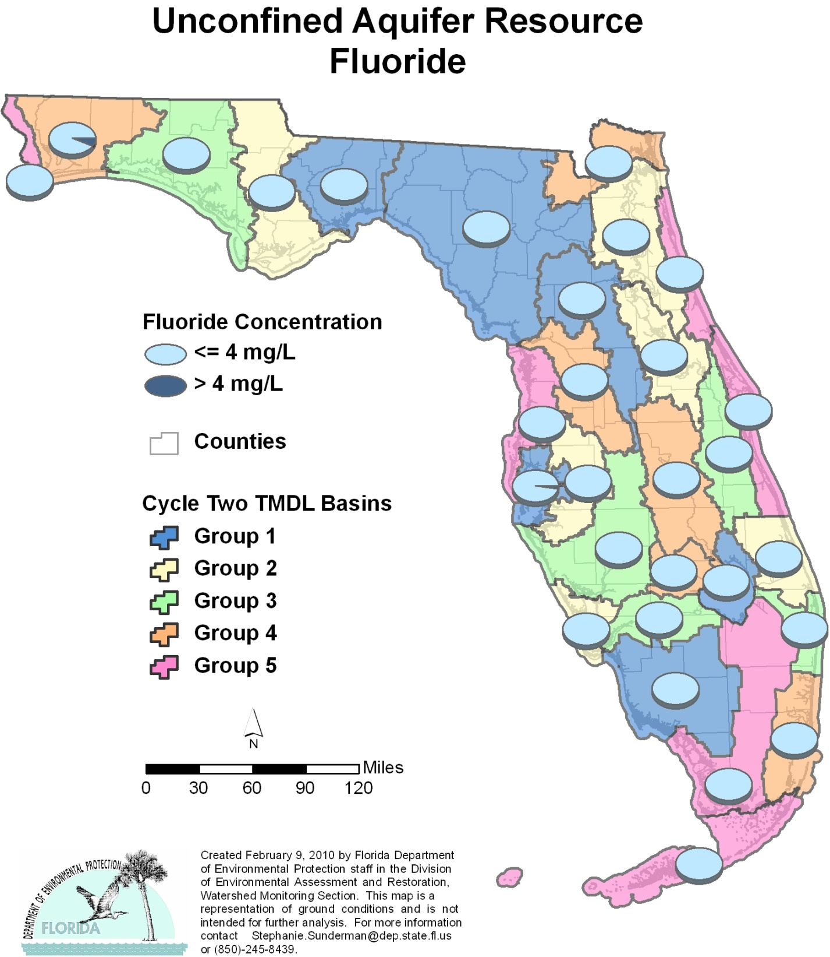

Table C.13. Percentage of Unconfined Aquifers Meeting Threshold Value for Fluoride Calculated Using Probabilistic Monitoring Design
Status Network Designated Use: Primary Drinking Water Standards Units: Number of wells in list frame

This is a nine-column table. Column 1 lists the basin, Column 2 lists the target population, Column 3 lists the number of sampleable wells, Column 4 lists the number of inaccessible wells, Column 5 lists the number of samples, Column 6 lists the percent meeting threshold, Column 7 lists the 95% confidence bounds, Column 8 lists the percent not meeting threshold, and Column 9 lists the assessment period.

¹ No confined aquifer wells in basin
² N/A = Not applicable
Basin | Target Population | Sampleable | Inaccessible | Number of Samples | % Meeting Threshold | 95% Confidence Bounds  (% Meeting Threshold) | % Not Meeting Threshold | Assessment Period
NWFWMD1  Ochlockonee–St. Marks | 542 | 303 | 239 | 30 | 100.0 | 100.0 | 0.0 | June-July 2004
SFWMD1  Everglades–West Coast | 240 | 133 | 107 | 30 | 100.0 | 100.0 | 0.0 | April-May 2004
SFWMD6  Lake Okeechobee | 103 | 74 | 29 | 30 | 100.0 | 100.0 | 0.0 | April-May 2004
SJRWMD1  Ocklawaha | 273 | 115 | 158 | 30 | 100.0 | 100.0 | 0.0 | April-May 2004
SRWMD1  Suwannee | 560 | 198 | 362 | 30 | 100.0 | 100.0 | 0.0 | June-July 2004
SWFWMD1  Tampa Bay | 125 | 92 | 33 | 30 | 97.6 | 93.6-100.0 | 2.4 | April-May 2004
NWFWMD2  Apalachicola–Chipola | 74 | 44 | 30 | 30 | 100.0 | 100.0 | 0.0 | Aug 2005
SFWMD2  St Lucie–Loxahatchee | 339 | 217 | 122 | 30 | 100.0 | 100.0 | 0.0 | April-May 2005
SFWMD7  Charlotte Harbor | 52 | 42 | 10 | 29 | 100.0 | 100.0 | 0.0 | April-May 2005
SJRWMD2  Lower St. Johns | 177 | 133 | 44 | 30 | 100.0 | 100.0 | 0.0 | April-June 2005
SJRWMD6  Middle St. Johns | 293 | 173 | 120 | 30 | 100.0 | 100.0 | 0.0 | April-June 2005
SWFWMD2  Tampa Bay Tributaries | 74 | 34 | 40 | 30 | 100.0 | 100.0 | 0.0 | April-May 2005
NWFWMD3  Choctawhatchee–  St. Andrews | 455 | 264 | 191 | 30 | 100.0 | 100.0 | 0.0 | June-Aug 2006
SFWMD3  Caloosahatchee | 102 | 60 | 42 | 30 | 100.0 | 100.0 | 0.0 | April-May 2006
SFWMD8  Lake Worth Lagoon–  Palm Beach Coast | 343 | 106 | 237 | 30 | 100.0 | 100.0 | 0.0 | April-May 2006
SJRWMD3  Upper St. Johns | 121 | 31 | 90 | 29 | 100.0 | 100.0 | 0.0 | April-June 2006
SWFWMD3  Sarasota Bay–Peace–Myakka | 279 | 95 | 184 | 30 | 100.0 | 100.0 | 0.0 | April-June 2006
NWFWMD4  Pensacola | 1,015 | 508 | 507 | 30 | 93.6 | 82.8-100.0 | 6.4 | June-Aug 2007
SFWMD4  Fisheating Creek | 34 | 13 | 21 | 13 | 100.0 | 100.0 | 0.0 | April-May 2007
SFWMD9  Kissimmee River | 406 | 57 | 349 | 25 | 100.0 | 100.0 | 0.0 | May-June 2007
SFWMD10  Southeast Coast–  Biscayne Bay | 590 | 171 | 419 | 30 | 100.0 | 100.0 | 0.0 | April-June 2007
SJRWMD4  Nassau–St. Marys | 68 | 34 | 34 | 29 | 100.0 | 100.0 | 0.0 | April-May 2007
SWFWMD4  Withlacoochee | 304 | 100 | 204 | 30 | 100.0 | 100.0 | 0.0 | April-June 2007
NWFWMD5  Perdido | 629 | 262 | 367 | 30 | 100.0 | 100.0 | 0.0 | June-Aug 2008
SFWMD5  Everglades | 212 | 56 | 156 | 30 | 100.0 | 100.0 | 0.0 | April-June 2008
SFWMD11  Florida Keys | 15 | 8 | 7 | 8 | 100.0 | 100.0 | 0.0 | May-June 2008
SJRWMD5  Indian River Lagoon | 264 | 152 | 112 | 30 | 100.0 | 100.0 | 0.0 | April-June 2008
SJRWMD7  Upper East Coast | 117 | 50 | 67 | 29 | 100.0 | 100.0 | 0.0 | April-June 2008
SWFWMD5  Springs Coast | 397 | 173 | 224 | 30 | 100.0 | 100.0 | 0.0 | April-May 2008
Summary of All Basins | 8,203 | 3,698 | 4,505 | 822 | 99.3 | 98.2-100.0 | 0.7 | 2004–08

Figure C.14. Summary of Lead Assessment for Unconfined Aquifers

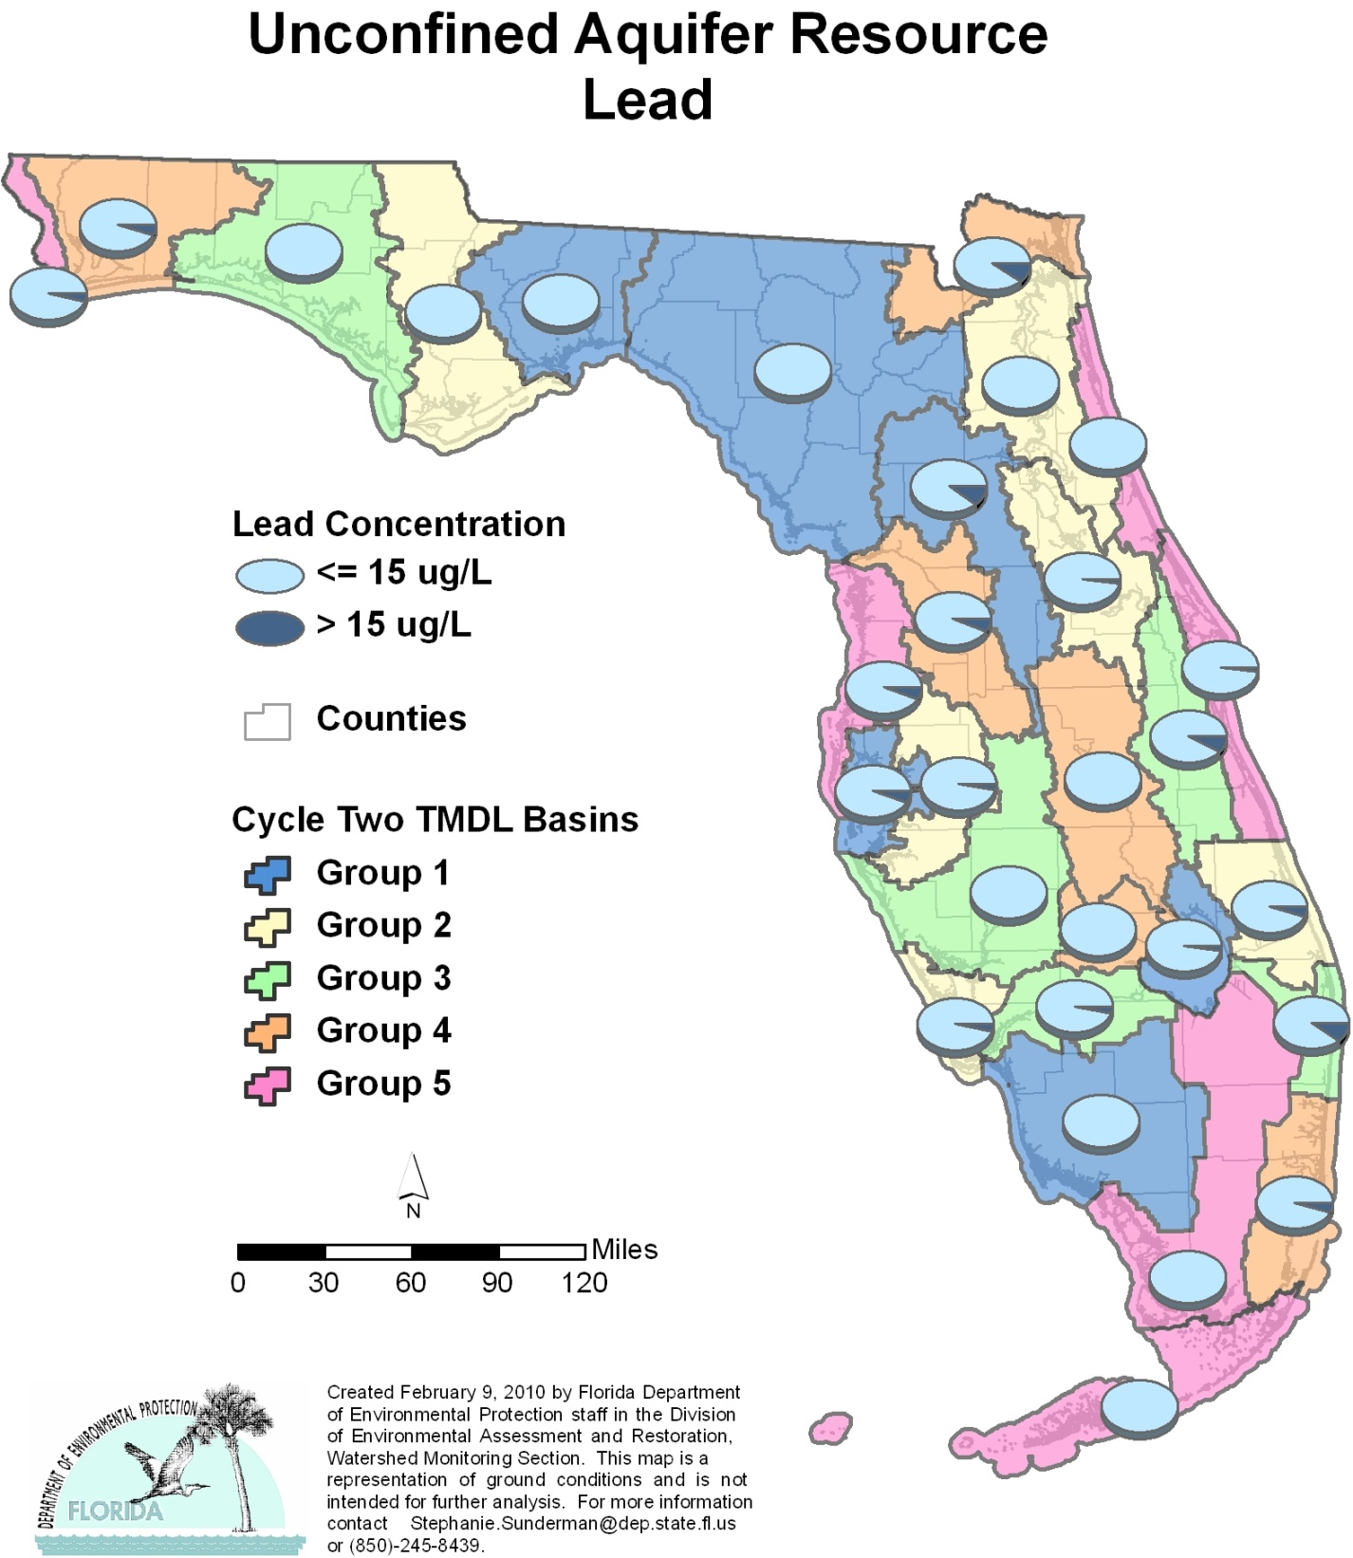

Table C.14. Percentage of Unconfined Aquifers Meeting Threshold Value for Lead Calculated Using Probabilistic Monitoring Design
Status Network Designated Use: Primary Drinking Water Standards Units: Number of wells in list frame

This is a nine-column table. Column 1 lists the basin, Column 2 lists the target population, Column 3 lists the number of sampleable wells, Column 4 lists the number of inaccessible wells, Column 5 lists the number of samples, Column 6 lists the percent meeting threshold, Column 7 lists the 95% confidence bounds, Column 8 lists the percent not meeting threshold, and Column 9 lists the assessment period.

¹ No confined aquifer wells in basin
² N/A = Not applicable
Basin | Target Population | Sampleable | Inaccessible | Number of Samples | % Meeting Threshold | 95% Confidence Bounds  (% Meeting Threshold) | % Not Meeting Threshold | Assessment Period
NWFWMD1  Ochlockonee–St. Marks | 542 | 303 | 239 | 30 | 100.0 | 100.0 | 0.0 | June-July 2004
SFWMD1  Everglades–West Coast | 240 | 133 | 107 | 30 | 100.0 | 100.0 | 0.0 | April-May 2004
SFWMD6  Lake Okeechobee | 103 | 74 | 29 | 30 | 97.4 | 92.9-100.0 | 2.6 | April-May 2004
SJRWMD1  Ocklawaha | 273 | 115 | 158 | 27 | 89.1 | 75.9-100.0 | 10.9 | April-May 2004
SRWMD1  Suwannee | 560 | 198 | 362 | 29 | 100.0 | 100.0 | 0.0 | June-July 2004
SWFWMD1  Tampa Bay | 125 | 92 | 33 | 30 | 94.0 | 86.4-100.0 | 6.0 | April-May 2004
NWFWMD2  Apalachicola–Chipola | 74 | 44 | 30 | 30 | 100.0 | 100.0 | 0.0 | Aug 2005
SFWMD2  St Lucie–Loxahatchee | 339 | 217 | 122 | 30 | 95.1 | 89.5-100.0 | 4.9 | April-May 2005
SFWMD7  Charlotte Harbor | 52 | 42 | 10 | 26 | 96.2 | 90.0-100.0 | 3.8 | April-May 2005
SJRWMD2  Lower St. Johns | 177 | 133 | 44 | 30 | 100.0 | 100.0 | 0.0 | April-June 2005
SJRWMD6  Middle St. Johns | 293 | 173 | 120 | 30 | 97.8 | 94.1-100.0 | 2.2 | April-June 2005
SWFWMD2  Tampa Bay Tributaries | 74 | 34 | 40 | 30 | 97.3 | 92.9-100.0 | 2.7 | April-May 2005
NWFWMD3  Choctawhatchee–  St. Andrews | 455 | 264 | 191 | 30 | 100.0 | 100.0 | 0.0 | June-Aug 2006
SFWMD3  Caloosahatchee | 102 | 60 | 42 | 30 | 96.7 | 91.1-100.0 | 3.3 | April-May 2006
SFWMD8  Lake Worth Lagoon–  Palm Beach Coast | 343 | 106 | 237 | 30 | 89.8 | 81.1-98.6 | 10.2 | April-May 2006
SJRWMD3  Upper St. Johns | 121 | 31 | 90 | 29 | 91.8 | 82.1-100.0 | 8.2 | April-June 2006
SWFWMD3  Sarasota Bay–Peace–Myakka | 279 | 95 | 184 | 30 | 100.0 | 100.0 | 0.0 | April-June 2006
NWFWMD4  Pensacola | 1,015 | 508 | 507 | 30 | 94.8 | 86.4-100.0 | 5.2 | June-Aug 2007
SFWMD4  Fisheating Creek | 34 | 13 | 21 | 8 | 100.0 | 100.0 | 0.0 | April-May 2007
SFWMD9  Kissimmee River | 406 | 57 | 349 | 25 | 100.0 | 100.0 | 0.0 | May-June 2007
SFWMD10  Southeast Coast–  Biscayne Bay | 590 | 171 | 419 | 30 | 95.2 | 87.9-100.0 | 4.8 | April-June 2007
SJRWMD4  Nassau–St. Marys | 68 | 34 | 34 | 20 | 90.0 | 78.3-100.0 | 10.0 | April-May 2007
SWFWMD4  Withlacoochee | 304 | 100 | 204 | 30 | 93.3 | 85.7-100.0 | 6.7 | April-June 2007
NWFWMD5  Perdido | 629 | 262 | 367 | 30 | 96.2 | 89.5-100.0 | 3.8 | June-Aug 2008
SFWMD5  Everglades | 212 | 56 | 156 | 15 | 100.0 | 100.0 | 0.0 | April-June 2008
SFWMD11  Florida Keys | 15 | 8 | 7 | 8 | 100.0 | 100.0 | 0.0 | May-June 2008
SJRWMD5  Indian River Lagoon | 264 | 152 | 112 | 30 | 98.0 | 94.8-100.0 | 2.0 | April-June 2008
SJRWMD7  Upper East Coast | 117 | 50 | 67 | 29 | 100.0 | 100.0 | 0.0 | April-June 2008
SWFWMD5  Springs Coast | 397 | 173 | 224 | 30 | 93.9 | 86.5-100.0 | 6.1 | April-May 2008
Summary of All Basins | 8,203 | 3,698 | 4,505 | 786 | 97.5 | 96.3-98.7 | 2.5 | 2004–08

Figure C.15. Summary of Nitrate + Nitrite Assessment for Unconfined Aquifers

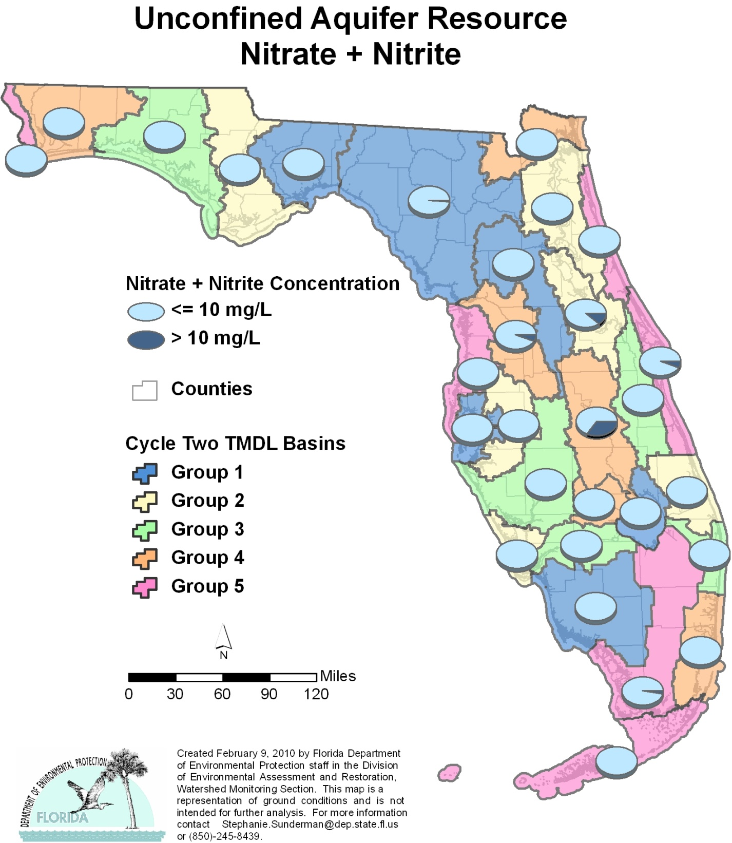

Table C.15. Percentage of Unconfined Aquifers Meeting Threshold Value for Nitrate + Nitrite Calculated Using Probabilistic Monitoring Design
Status Network Designated Use: Primary Drinking Water Standards Units: Number of wells in list frame

This is a nine-column table. Column 1 lists the basin, Column 2 lists the target population, Column 3 lists the number of sampleable wells, Column 4 lists the number of inaccessible wells, Column 5 lists the number of samples, Column 6 lists the percent meeting threshold, Column 7 lists the 95% confidence bounds, Column 8 lists the percent not meeting threshold, and Column 9 lists the assessment period.

¹ No confined aquifer wells in basin
² N/A = Not applicable
Basin | Target Population | Sampleable | Inaccessible | Number of Samples | % Meeting Threshold | 95% Confidence Bounds  (% Meeting Threshold) | % Not Meeting Threshold | Assessment Period
NWFWMD1  Ochlockonee–St. Marks | 542 | 303 | 239 | 30 | 100.0 | 100.0 | 0.0 | June-July 2004
SFWMD1  Everglades–West Coast | 240 | 133 | 107 | 30 | 100.0 | 100.0 | 0.0 | April-May 2004
SFWMD6  Lake Okeechobee | 103 | 74 | 29 | 30 | 100.0 | 100.0 | 0.0 | April-May 2004
SJRWMD1  Ocklawaha | 273 | 115 | 158 | 30 | 100.0 | 100.0 | 0.0 | April-May 2004
SRWMD1  Suwannee | 560 | 198 | 362 | 30 | 98.4 | 95.7-100.0 | 1.6 | June-July 2004
SWFWMD1  Tampa Bay | 125 | 92 | 33 | 30 | 100.0 | 100.0 | 0.0 | April-May 2004
NWFWMD2  Apalachicola–Chipola | 74 | 44 | 30 | 30 | 100.0 | 100.0 | 0.0 | Aug 2005
SFWMD2  St Lucie–Loxahatchee | 339 | 217 | 122 | 30 | 100.0 | 100.0 | 0.0 | April-May 2005
SFWMD7  Charlotte Harbor | 52 | 42 | 10 | 29 | 100.0 | 100.0 | 0.0 | April-May 2005
SJRWMD2  Lower St. Johns | 177 | 133 | 44 | 30 | 100.0 | 100.0 | 0.0 | April-June 2005
SJRWMD6  Middle St. Johns | 293 | 173 | 120 | 30 | 88.3 | 75.4-100.0 | 11.7 | April-June 2005
SWFWMD2  Tampa Bay Tributaries | 74 | 34 | 40 | 30 | 100.0 | 100.0 | 0.0 | April-May 2005
NWFWMD3  Choctawhatchee–  St. Andrews | 455 | 264 | 191 | 30 | 100.0 | 100.0 | 0.0 | June-Aug 2006
SFWMD3  Caloosahatchee | 102 | 60 | 42 | 28 | 100.0 | 100.0 | 0.0 | April-May 2006
SFWMD8  Lake Worth Lagoon–  Palm Beach Coast | 343 | 106 | 237 | 27 | 100.0 | 100.0 | 0.0 | April-May 2006
SJRWMD3  Upper St. Johns | 121 | 31 | 90 | 25 | 100.0 | 100.0 | 0.0 | April-June 2006
SWFWMD3  Sarasota Bay–Peace–Myakka | 279 | 95 | 184 | 29 | 100.0 | 100.0 | 0.0 | April-June 2006
NWFWMD4  Pensacola | 1,015 | 508 | 507 | 30 | 100.0 | 100.0 | 0.0 | June-Aug 2007
SFWMD4  Fisheating Creek | 34 | 13 | 21 | 6 | 100.0 | 100.0 | 0.0 | April-May 2007
SFWMD9  Kissimmee River | 406 | 57 | 349 | 19 | 65.2 | 46.4-84.0 | 34.8 | May-June 2007
SFWMD10  Southeast Coast–  Biscayne Bay | 590 | 171 | 419 | 30 | 100.0 | 100.0 | 0.0 | April-June 2007
SJRWMD4  Nassau–St. Marys | 68 | 34 | 34 | 14 | 100.0 | 100.0 | 0.0 | April-May 2007
SWFWMD4  Withlacoochee | 304 | 100 | 204 | 23 | 92.0 | 81.9-100.0 | 5.7 | April-June 2007
NWFWMD5  Perdido | 629 | 262 | 367 | 28 | 100.0 | 100.0 | 0.0 | June-Aug 2008
SFWMD5  Everglades | 212 | 56 | 156 | 30 | 97.4 | 92.8-100.0 | 2.6 | April-June 2008
SFWMD11  Florida Keys | 15 | 8 | 7 | 8 | 100.0 | 100.0 | 0.0 | May-June 2008
SJRWMD5  Indian River Lagoon | 264 | 152 | 112 | 30 | 94.0 | 86.0-100.0 | 6.0 | April-June 2008
SJRWMD7  Upper East Coast | 117 | 50 | 67 | 24 | 100.0 | 100.0 | 0.0 | April-June 2008
SWFWMD5  Springs Coast | 397 | 173 | 224 | 26 | 100.0 | 100.0 | 0.0 | April-May 2008
Summary of All Basins | 8,203 | 3,698 | 4,505 | 766 | 97.7 | 96.8-98.7 | 2.3 | 2004–08

Figure C.16. Summary of Sodium Assessment for Unconfined Aquifers

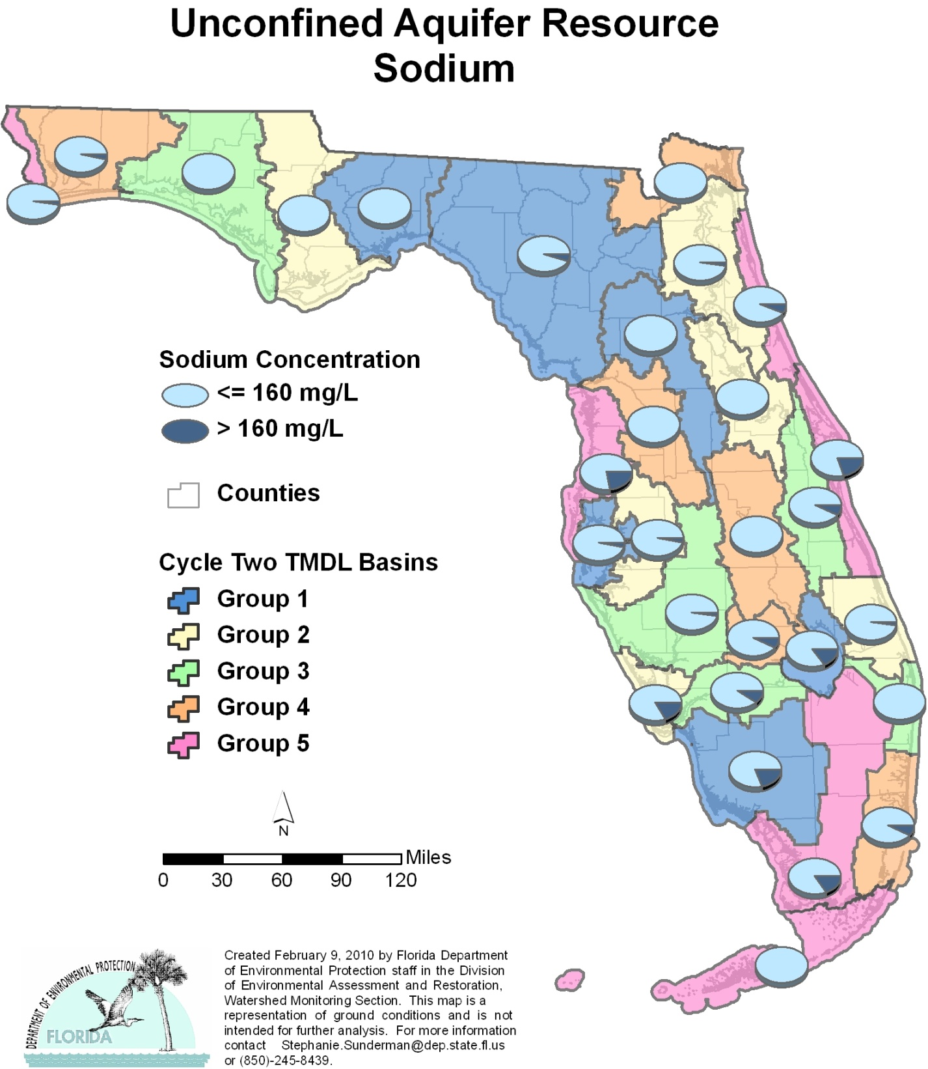

Table C.16. Percentage of Unconfined Aquifers Meeting Threshold Value for Sodium Calculated Using Probabilistic Monitoring Design
Status Network Designated Use: Primary Drinking Water Standards Units: Number of wells in list frame

This is a nine-column table. Column 1 lists the basin, Column 2 lists the target population, Column 3 lists the number of sampleable wells, Column 4 lists the number of inaccessible wells, Column 5 lists the number of samples, Column 6 lists the percent meeting threshold, Column 7 lists the 95% confidence bounds, Column 8 lists the percent not meeting threshold, and Column 9 lists the assessment period.

¹ No confined aquifer wells in basin
² N/A = Not applicable
Basin | Target Population | Sampleable | Inaccessible | Number of Samples | % Meeting Threshold | 95% Confidence Bounds  (% Meeting Threshold) | % Not Meeting Threshold | Assessment Period
NWFWMD1  Ochlockonee–St. Marks | 542 | 303 | 239 | 30 | 100.0 | 100.0 | 0.0 | June-July 2004
SFWMD1  Everglades–West Coast | 240 | 133 | 107 | 30 | 80.2 | 61.9-98.4 | 19.8 | April-May 2004
SFWMD6  Lake Okeechobee | 103 | 74 | 29 | 30 | 84.7 | 72.8-96.6 | 15.3 | April-May 2004
SJRWMD1  Ocklawaha | 273 | 115 | 158 | 30 | 100.0 | 100.0 | 0.0 | April-May 2004
SRWMD1  Suwannee | 560 | 198 | 362 | 30 | 94.6 | 88.9-100.0 | 5.4 | June-July 2004
SWFWMD1  Tampa Bay | 125 | 92 | 33 | 30 | 96.9 | 91.9-100.0 | 3.1 | April-May 2004
NWFWMD2  Apalachicola–Chipola | 74 | 44 | 30 | 30 | 100.0 | 100.0 | 0.0 | Aug 2005
SFWMD2  St Lucie–Loxahatchee | 339 | 217 | 122 | 30 | 97.8 | 94.1-100.0 | 2.2 | April-May 2005
SFWMD7  Charlotte Harbor | 52 | 42 | 10 | 29 | 82.8 | 71.4-94.1 | 17.2 | April-May 2005
SJRWMD2  Lower St. Johns | 177 | 133 | 44 | 30 | 86.1 | 65.4-100.0 | 13.9 | April-June 2005
SJRWMD6  Middle St. Johns | 293 | 173 | 120 | 30 | 100.0 | 100.0 | 0.0 | April-June 2005
SWFWMD2  Tampa Bay Tributaries | 74 | 34 | 40 | 30 | 96.8 | 91.3-100.0 | 3.2 | April-May 2005
NWFWMD3  Choctawhatchee–  St. Andrews | 455 | 264 | 191 | 30 | 100.0 | 100.0 | 0.0 | June-Aug 2006
SFWMD3  Caloosahatchee | 102 | 60 | 42 | 30 | 90.0 | 81.3-98.7 | 10.0 | April-May 2006
SFWMD8  Lake Worth Lagoon–  Palm Beach Coast | 343 | 106 | 237 | 30 | 100.0 | 100.0 | 0.0 | April-May 2006
SJRWMD3  Upper St. Johns | 121 | 31 | 90 | 29 | 92.7 | 84.7-100.0 | 7.3 | April-June 2006
SWFWMD3  Sarasota Bay–Peace–Myakka | 279 | 95 | 184 | 30 | 97.3 | 92.8-100.0 | 2.7 | April-June 2006
NWFWMD4  Pensacola | 1,015 | 508 | 507 | 30 | 96.5 | 90.9-100.0 | 3.5 | June-Aug 2007
SFWMD4  Fisheating Creek | 34 | 13 | 21 | 13 | 92.3 | 79.9-100.0 | 7.7 | April-May 2007
SFWMD9  Kissimmee River | 406 | 57 | 349 | 25 | 100.0 | 100.0 | 0.0 | May-June 2007
SFWMD10  Southeast Coast–  Biscayne Bay | 590 | 171 | 419 | 30 | 92.3 | 82.9-100.0 | 7.7 | April-June 2007
SJRWMD4  Nassau–St. Marys | 68 | 34 | 34 | 29 | 100.0 | 100.0 | 0.0 | April-May 2007
SWFWMD4  Withlacoochee | 304 | 100 | 204 | 30 | 100.0 | 100.0 | 0.0 | April-June 2007
NWFWMD5  Perdido | 629 | 262 | 367 | 30 | 97.7 | 93.9-100.0 | 2.3 | June-Aug 2008
SFWMD5  Everglades | 212 | 56 | 156 | 30 | 84.2 | 76.9-91.6 | 15.8 | April-June 2008
SFWMD11  Florida Keys | 15 | 8 | 7 | 8 | 100.0 | 100.0 | 0.0 | May-June 2008
SJRWMD5  Indian River Lagoon | 264 | 152 | 112 | 30 | 80.2 | 66.6-93.7 | 19.8 | April-June 2008
SJRWMD7  Upper East Coast | 117 | 50 | 67 | 29 | 93.1 | 84.9-100.0 | 6.9 | April-June 2008
SWFWMD5  Springs Coast | 397 | 173 | 224 | 30 | 77.8 | 63.6-92.1 | 22.2 | April-May 2008
Summary of All Basins | 8,203 | 3,698 | 4,505 | 822 | 95.7 | 94.5-96.9 | 4.3 | 2004–08

Figure C.17. Summary of Fecal Coliform Assessment for Unconfined Aquifers

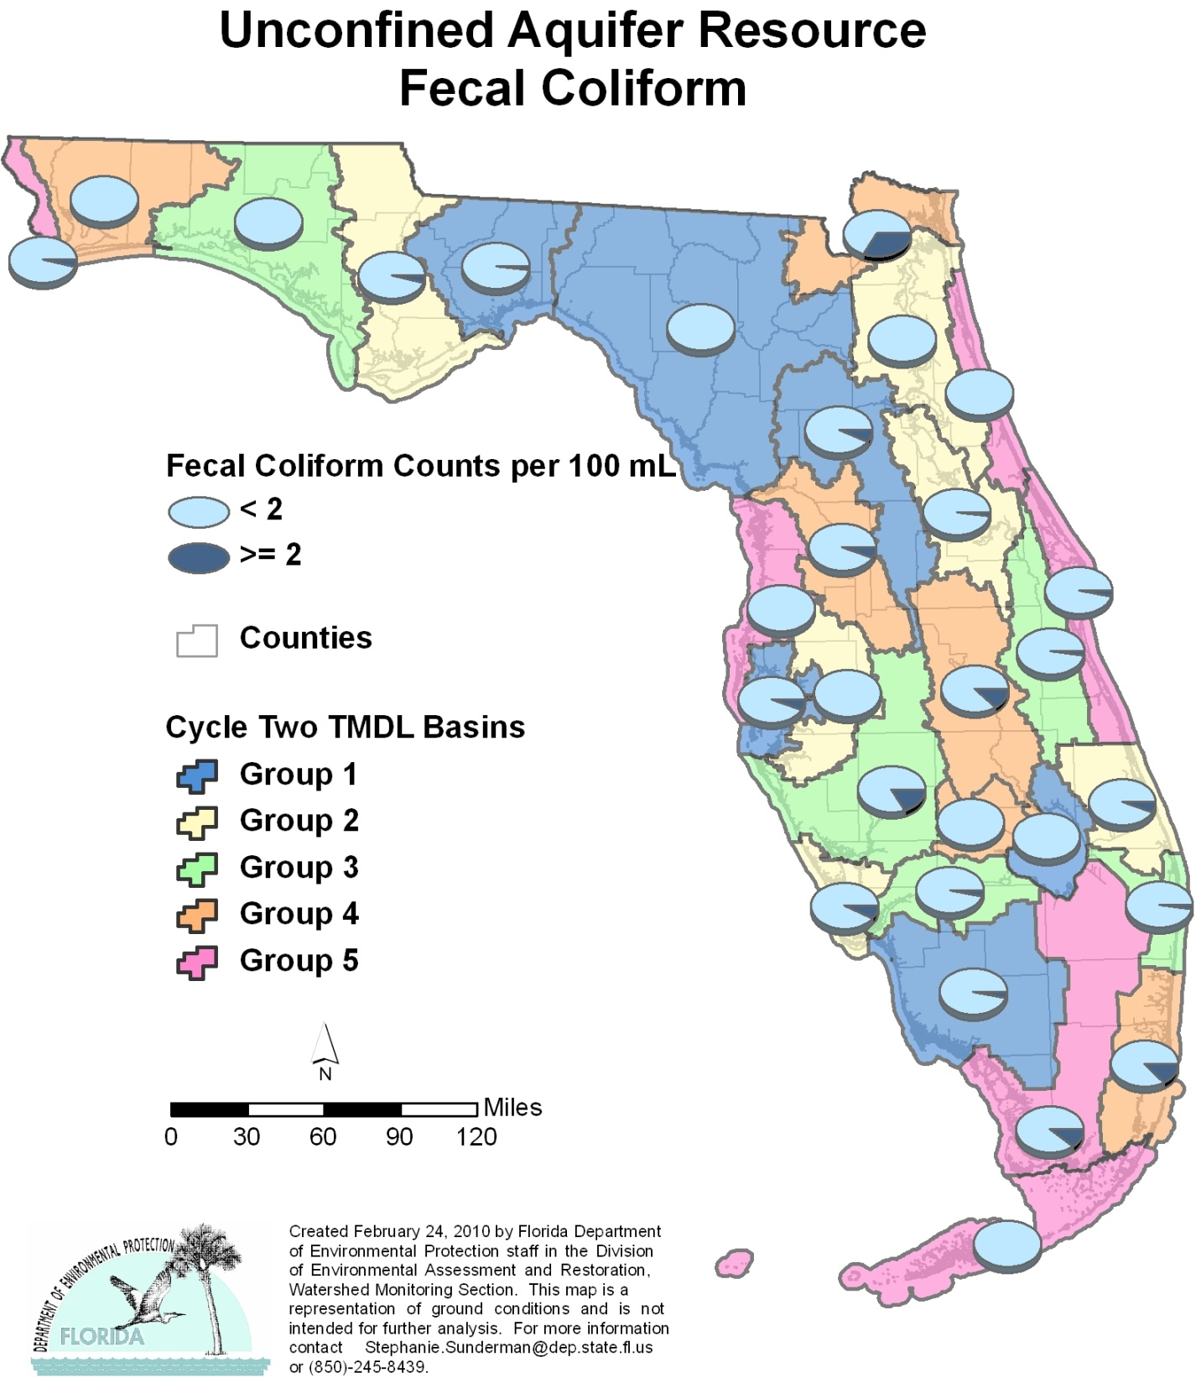

Table C.17. Percentage of Unconfined Aquifers Meeting Threshold Value for Fecal Coliform Calculated Using Probabilistic Monitoring Design
Status Network Designated Use: Primary Drinking Water Standards Units: Number of wells in list frame

This is a nine-column table. Column 1 lists the basin, Column 2 lists the target population, Column 3 lists the number of sampleable wells, Column 4 lists the number of inaccessible wells, Column 5 lists the number of samples, Column 6 lists the percent meeting threshold, Column 7 lists the 95% confidence bounds, Column 8 lists the percent not meeting threshold, and Column 9 lists the assessment period.
¹ No confined aquifer wells in basin
² N/A = Not applicable
Basin | Target Population | Sampleable | Inaccessible | Number of Samples | % Meeting Threshold | 95% Confidence Bounds  (% Meeting Threshold) | % Not Meeting Threshold | Assessment Period
NWFWMD1  Ochlockonee–St. Marks | 542 | 303 | 239 | 30 | 98.0 | 95.1-100.0 | 2.0 | June-July 2004
SFWMD1  Everglades–West Coast | 240 | 133 | 107 | 30 | 96.5 | 90.6-100.0 | 3.5 | April-May 2004
SFWMD6  Lake Okeechobee | 103 | 74 | 29 | 30 | 100.0 | 100.0 | 0.0 | April-May 2004
SJRWMD1  Ocklawaha | 273 | 115 | 158 | 30 | 93.2 | 83.3-100.0 | 6.8 | April-May 2004
SRWMD1  Suwannee | 560 | 198 | 362 | 29 | 100.0 | 100.0 | 0.0 | June-July 2004
SWFWMD1  Tampa Bay | 125 | 92 | 33 | 30 | 94.3 | 84.9-100.0 | 5.7 | April-May 2004
NWFWMD2  Apalachicola–Chipola | 74 | 44 | 30 | 30 | 95.7 | 88.1-100.0 | 4.3 | Aug 2005
SFWMD2  St Lucie–Loxahatchee | 339 | 217 | 122 | 25 | 94.0 | 84.2-100.0 | 6.0 | April-May 2005
SFWMD7  Charlotte Harbor | 52 | 42 | 10 | 28 | 92.9 | 84.9-100.0 | 7.1 | April-May 2005
SJRWMD2  Lower St. Johns | 177 | 133 | 44 | 30 | 96.1 | 90.2-100.0 | 3.9 | April-June 2005
SJRWMD6  Middle St. Johns | 293 | 173 | 120 | 30 | 97.8 | 94.1-100.0 | 2.2 | April-June 2005
SWFWMD2  Tampa Bay Tributaries | 74 | 34 | 40 | 29 | 100.0 | 100.0 | 0.0 | April-May 2005
NWFWMD3  Choctawhatchee–  St. Andrews | 455 | 264 | 191 | 30 | 100.0 | 100.0 | 0.0 | June-Aug 2006
SFWMD3  Caloosahatchee | 102 | 60 | 42 | 29 | 96.6 | 90.8-100.0 | 3.4 | April-May 2006
SFWMD8  Lake Worth Lagoon–  Palm Beach Coast | 343 | 106 | 237 | 30 | 97.5 | 93.0-100.0 | 2.5 | April-May 2006
SJRWMD3  Upper St. Johns | 121 | 31 | 90 | 29 | 97.5 | 93.2-100.0 | 2.5 | April-June 2006
SWFWMD3  Sarasota Bay–Peace–Myakka | 279 | 95 | 184 | 30 | 82.9 | 71.7-94.1 | 17.1 | April-June 2006
NWFWMD4  Pensacola | 1,015 | 508 | 507 | 30 | 100.0 | 100.0 | 0.0 | June-Aug 2007
SFWMD4  Fisheating Creek | 34 | 13 | 21 | 13 | 100.0 | 100.0 | 0.0 | April-May 2007
SFWMD9  Kissimmee River | 406 | 57 | 349 | 25 | 87.3 | 74.8-99.8 | 12.7 | May-June 2007
SFWMD10  Southeast Coast–  Biscayne Bay | 590 | 171 | 419 | 30 | 86.9 | 76.1-97.6 | 13.1 | April-June 2007
SJRWMD4  Nassau–St. Marys | 68 | 34 | 34 | 28 | 92.9 | 84.5-100.0 | 7.1 | April-May 2007
SWFWMD4  Withlacoochee | 304 | 100 | 204 | 31 | 94.3 | 87.1-100.0 | 5.7 | April-June 2007
NWFWMD5  Perdido | 629 | 262 | 367 | 30 | 96.2 | 89.9-100.0 | 3.8 | June-Aug 2008
SFWMD5  Everglades | 212 | 56 | 156 | 30 | 89.0 | 80.5-97.6 | 11.0 | April-June 2008
SFWMD11  Florida Keys | 15 | 8 | 7 | 8 | 100.0 | 100.0 | 0.0 | May-June 2008
SJRWMD5  Indian River Lagoon | 264 | 152 | 112 | 30 | 96.5 | 90.4-100.0 | 3.5 | April-June 2008
SJRWMD7  Upper East Coast | 117 | 50 | 67 | 29 | 100.0 | 100.0 | 0.0 | April-June 2008
SWFWMD5  Springs Coast | 397 | 173 | 224 | 30 | 100.0 | 100.0 | 0.0 | April-May 2008
Summary of All Basins | 8,203 | 3,698 | 4,505 | 813 | 96.2 | 94.2-98.2 | 3.8 | 2004–08

Figure C.18. Summary of Total Coliform Assessment for Unconfined Aquifers

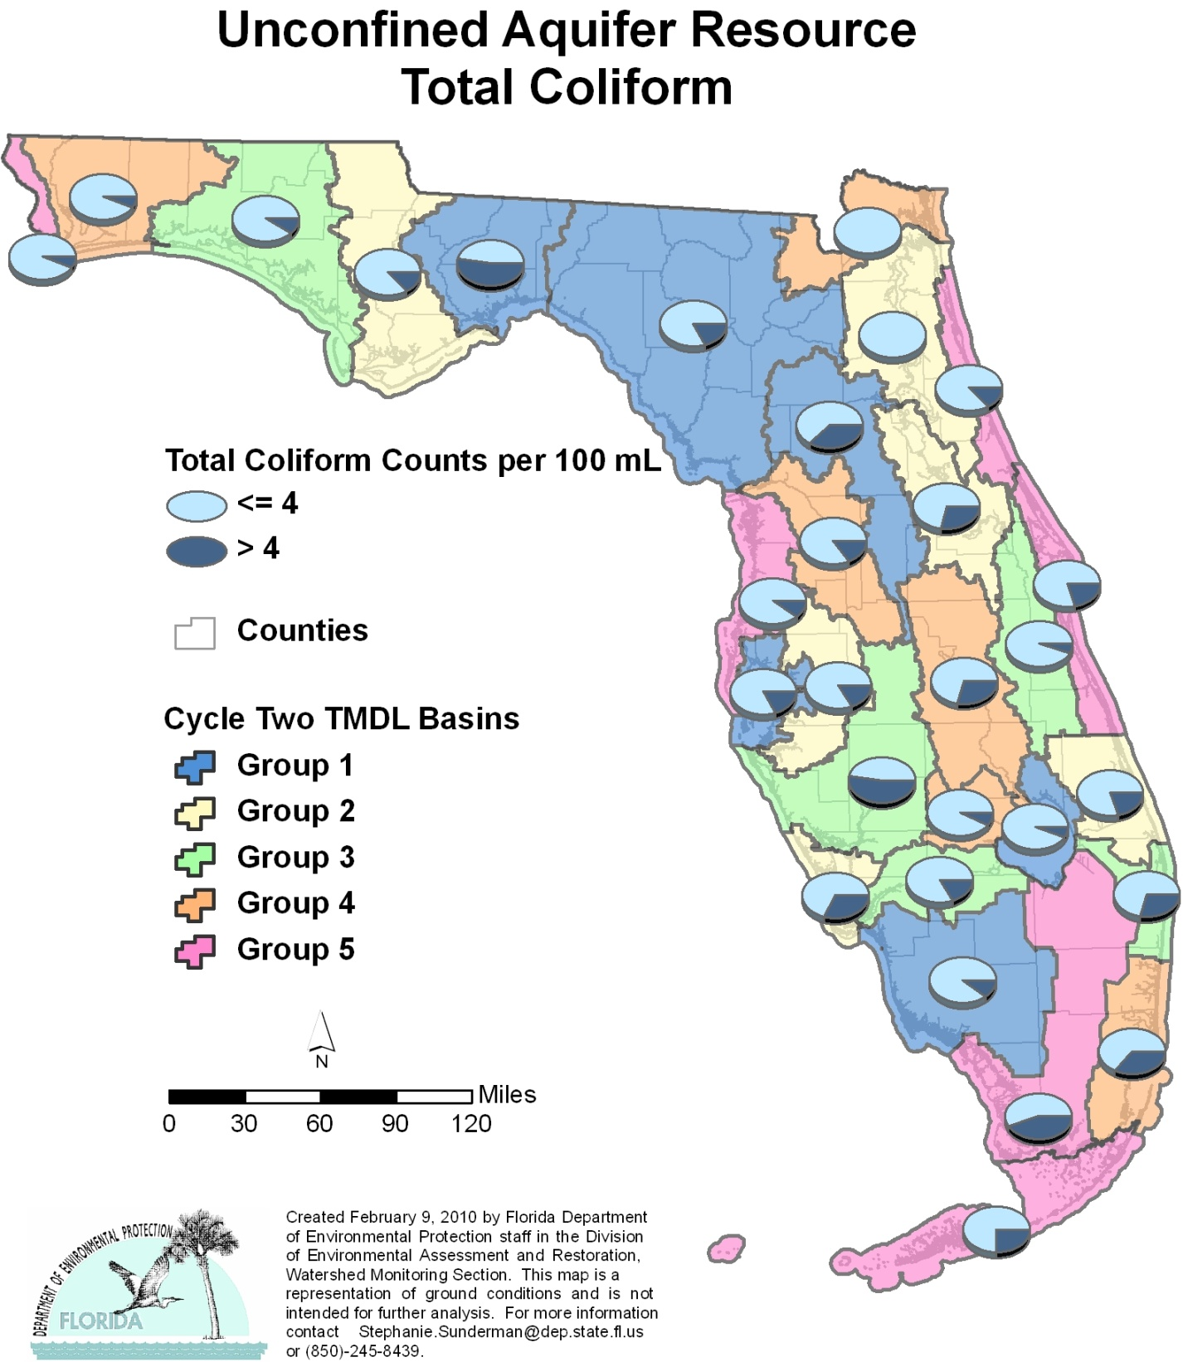

Table C.18. Percentage of Unconfined Aquifers Meeting Threshold Value for Total Coliform Calculated Using Probabilistic Monitoring Design
Status Network Designated Use: Primary Drinking Water Standards Units: Number of wells in list frame

This is a nine-column table. Column 1 lists the basin, Column 2 lists the target population, Column 3 lists the number of sampleable wells, Column 4 lists the number of inaccessible wells, Column 5 lists the number of samples, Column 6 lists the percent meeting threshold, Column 7 lists the 95% confidence bounds, Column 8 lists the percent not meeting threshold, and Column 9 lists the assessment period.
¹ No confined aquifer wells in basin
² N/A = Not applicable
Basin | Target Population | Sampleable | Inaccessible | Number of Samples | % Meeting Threshold | 95% Confidence Bounds  (% Meeting Threshold) | % Not Meeting Threshold | Assessment Period
NWFWMD1  Ochlockonee–St. Marks | 542 | 303 | 239 | 30 | 55.1 | 28.5-81.7 | 44.9 | June-July 2004
SFWMD1  Everglades–West Coast | 240 | 133 | 107 | 30 | 89.8 | 82.4-97.2 | 10.2 | April-May 2004
SFWMD6  Lake Okeechobee | 103 | 74 | 29 | 30 | 94.7 | 88.4-100.0 | 5.3 | April-May 2004
SJRWMD1  Ocklawaha | 273 | 115 | 158 | 30 | 69.3 | 52.6-86.0 | 30.7 | April-May 2004
SRWMD1  Suwannee | 560 | 198 | 362 | 28 | 82.1 | 66.2-98.1 | 17.9 | June-July 2004
SWFWMD1  Tampa Bay | 125 | 92 | 33 | 30 | 83.3 | 71.7-94.9 | 16.7 | April-May 2004
NWFWMD2  Apalachicola–Chipola | 74 | 44 | 30 | 30 | 89.6 | 76.8-100.0 | 10.4 | Aug 2005
SFWMD2  St Lucie–Loxahatchee | 339 | 217 | 122 | 25 | 82.5 | 67.6-97.4 | 17.5 | April-May 2005
SFWMD7  Charlotte Harbor | 52 | 42 | 10 | 26 | 73.1 | 59.6-86.5 | 26.9 | April-May 2005
SJRWMD2  Lower St. Johns | 177 | 133 | 44 | 21 | 100.0 | 100.0 | 0.0 | April-June 2005
SJRWMD6  Middle St. Johns | 293 | 173 | 120 | 30 | 74.3 | 58.5-90.0 | 25.7 | April-June 2005
SWFWMD2  Tampa Bay Tributaries | 74 | 34 | 40 | 29 | 86.2 | 76.4-96.1 | 13.8 | April-May 2005
NWFWMD3  Choctawhatchee–  St. Andrews | 455 | 264 | 191 | 30 | 92.9 | 85.7-100.0 | 7.1 | June-Aug 2006
SFWMD3  Caloosahatchee | 102 | 60 | 42 | 27 | 85.2 | 75.8-94.6 | 14.8 | April-May 2006
SFWMD8  Lake Worth Lagoon–  Palm Beach Coast | 343 | 106 | 237 | 30 | 72.2 | 58.8-85.7 | 27.8 | April-May 2006
SJRWMD3  Upper St. Johns | 121 | 31 | 90 | 29 | 95.0 | 89.7-100.0 | 5.0 | April-June 2006
SWFWMD3  Sarasota Bay–Peace–Myakka | 279 | 95 | 184 | 30 | 55.2 | 39.8-70.6 | 44.8 | April-June 2006
NWFWMD4  Pensacola | 1,015 | 508 | 507 | 30 | 93.8 | 85.6-100.0 | 6.2 | June-Aug 2007
SFWMD4  Fisheating Creek | 34 | 13 | 21 | 13 | 92.3 | 78.4-100.0 | 7.7 | April-May 2007
SFWMD9  Kissimmee River | 406 | 57 | 349 | 25 | 70.6 | 54.1-87.0 | 29.4 | May-June 2007
SFWMD10  Southeast Coast–  Biscayne Bay | 590 | 171 | 419 | 30 | 64.4 | 47.9-81.0 | 35.6 | April-June 2007
SJRWMD4  Nassau–St. Marys | 68 | 34 | 34 | 3 | 100.0 | 100.0 | 0.0 | April-May 2007
SWFWMD4  Withlacoochee | 304 | 100 | 204 | 31 | 84.9 | 75.3-94.4 | 15.1 | April-June 2007
NWFWMD5  Perdido | 629 | 262 | 367 | 30 | 93.6 | 83.2-100.0 | 6.4 | June-Aug 2008
SFWMD5  Everglades | 212 | 56 | 156 | 30 | 55.9 | 38.0-73.9 | 44.1 | April-June 2008
SFWMD11  Florida Keys | 15 | 8 | 7 | 8 | 75.0 | 47.0-100.0 | 25.0 | May-June 2008
SJRWMD5  Indian River Lagoon | 264 | 152 | 112 | 30 | 79.9 | 65.0-94.9 | 20.1 | April-June 2008
SJRWMD7  Upper East Coast | 117 | 50 | 67 | 29 | 86.2 | 76.4-96.0 | 13.8 | April-June 2008
SWFWMD5  Springs Coast | 397 | 173 | 224 | 30 | 89.7 | 79.3-100.0 | 10.3 | April-May 2008
Summary of All Basins | 8,203 | 3,698 | 4,505 | 774 | 82.6 | 78.8-86.5 | 17.4 | 2004–08

APPENDIX D. Impaired Surface Waters Rule Methodology for Evaluating Impairment for the Basin Assessments
To determine the status of surface water quality in individual WBIDs in Florida, three categories of data—chemistry data, biological data, and fish consumption advisories—are evaluated using the IWR methodology to determine potential impairments for four designated use attainment categories: aquatic life, primary contact and recreation, fish and shellfish consumption, drinking water use, and protection of human health.

Aquatic Life Based Attainment
The IWR follows the principle of independent applicability. A waterbody is listed for potential impairment of aquatic life use support based on exceedances of any one of four types of water quality indicators (numeric water quality criteria, nutrient thresholds, biological thresholds, and toxicity data).

Exceedances of Numeric Water Quality Criteria
The water quality data from STORET used in evaluating impairment were also used in making attainment determinations. The assessment of impairment included only ambient surface water quality stations. Water quality information from point sources or wells was excluded. Data that were determined to be of insufficient quality for TMDL data quality objectives were also excluded from the Verified List assessment. Monitoring stations were classified as one of five waterbody types—spring, stream, lake, estuary, or blackwater—based on specific criteria. The assessments included the following parameters:
Metals Arsenic, aluminum, cadmium, chromium VI, chromium III, copper, iron, lead, mercury, nickel, selenium, silver, thallium, and zinc
Nutrients Chlorophyll a for streams and estuaries, and TSI (chlorophyll a, total nitrogen, and total phosphorus) for lakes
Conventionals DO, fecal coliform, pH, unionized ammonia

The requirements for placing waters on the Planning List of potentially impaired waters included a minimum of 10 temporally independent samples from the 10-year period of record shown in Tables 13a and 13b (in Chapter 3), unless there were 3 exceedances of water quality or 1 exceedance of an acute toxicity criterion in a 3-year period. The screening methodology for the Verified List of impaired waters requires at least 20 samples from the last 7.5 years preceding the Planning List assessment. An exceedance, meaning that water quality criteria or standards are not met, is recorded any time the criterion is exceeded by any amount. An exceedance for DO, however, means that a waterbody does not meet the DO criterion, rather than an actual exceedance of the criterion.
To determine if a water should be placed on the Planning List for each parameter, the chemical data were analyzed using a computer program written to assess the data, based on criteria established in the IWR, with two exceptions. First, un-ionized ammonia data were not analyzed by the program, but rather with an Excel spreadsheet. Second, because the full complexity of the pH criterion could not be programmed, the incomplete listings for pH were not included, but were further examined while additional data were collected during Phase 2 of the watershed management cycle. Data analysis and statistical summaries of waterbody identification numbers (WBIDs), waterbody types, and parameters obtained from the STORET Database were conducted using Access, SAS statistical software, and ArcView GIS applications
The data for metals and conventional parameters were compared with the state surface water quality criteria in Section 62-302.530, F.A.C. (IWR). The rule contains a table of sample numbers versus exceedances. A waterbody was placed on the Planning List if there was at least 80% confidence that the actual criteria exceedance rate was greater than or equal to 10%. To be placed on the Verified List, at least a 90% confidence rate was required.

Exceedances of Nutrient Thresholds
The state currently has a narrative nutrient criterion instead of a numeric value for nutrient thresholds. The narrative criterion states, “In no case shall nutrient concentrations of a body of water be altered so as to cause an imbalance in natural populations of aquatic flora or fauna.” The IWR provides an interpretation of the narrative nutrient criterion. In general, the TSI and the annual mean chlorophyll a values are the primary means for assessing whether a waterbody should be assessed further for nutrient impairment.
The rule also considers other information that might indicate an imbalance in flora or fauna due to nutrient enrichment, such as algal blooms, excessive macrophyte growth, a decrease in the distribution (either in density or aerial coverage) of seagrasses or other submerged aquatic vegetation, changes in algal species richness, and excessive diel oxygen swings.
Potential nutrient impairment was evaluated by calculating annual mean chlorophyll a values for estuaries and streams and the TSI for lakes. For lakes, the TSI was calculated using chlorophyll a, total phosphorus, and total nitrogen measurements. Direct evidence of imbalances of flora and fauna in waterbodies was also considered in the evaluation of nutrient impairments.
In estuarine areas, a waterbody was considered nutrient enriched if the annual mean chlorophyll a values were greater than 11 μg/L, or if annual mean chlorophyll a values increased by more than 50% over historical values for at least 2 consecutive years. For streams, a waterbody was considered nutrient enriched if the annual mean chlorophyll a values were greater than 20 μg/L, or if the annual mean increased by more than 50% over historical values for at least 2 consecutive years.
A lake with a mean color greater than 40 PCUs was considered nutrient enriched if the annual mean TSI exceeded 60. A lake with a mean color less than or equal to 40 PCUs was considered nutrient enriched if the annual mean TSI exceeded 40. In addition, a lake was considered nutrient enriched if there was a statistically significant increase in TSI over the last 5-year period, or if TSI measurements were 10 units higher than historical values.

Exceedances of Biological Thresholds
Bioassessments were carried out for streams, lakes, canals, and rivers using the IWR as guidance and following FDEP’s standard operating procedures, which provide definitions and specific methods for the generation and analysis of bioassessment data. These are referenced in the individual bioassessment data tables contained in the Water Quality Status Reports (available at http://www.dep.state.fl.us/water/basin411/default.htm). The purpose behind using a bioassessment methodology in surface water characterizations is that biological components of the environment manifest long-term water quality conditions and thus provide a better indication of a waterbody’s true health than discrete chemical or physical measurements alone. Biological communities also respond to factors other than water quality, such as habitat disruption and hydrologic disturbances. Therefore, to use bioassessment data to list a waterbody, FDEP must reasonably demonstrate the pollutant responsible for the observed degradation. Recent recalibrations of the SCI and the BioRecon method involved the use of the Human Disturbance Gradient (HDG). The HDG ranked sites based on independent assessments of habitat quality, the degree of hydrologic disturbance, water quality, and human land use intensity. Biological measures (metrics) associated with minimally affected waters in a given region were used to set ecoregional expectations.
A metric is a precise measure of biological community structure or function that responds in a predictable manner to human disturbance. Metrics (e.g., number of long-lived taxa, number of sensitive taxa, % filter feeders, % clingers) were calculated and aggregated into a dimensionless, multimetric index. Indices have advantages over individual metrics in that they can integrate several nonredundant metrics into a single score that reflects a wider range of biological variables. In Florida, multimetric bioassessment indices have been developed for vascular plants (aquatic trees, shrubs, and herbaceous macrophytes) and benthic macroinvertebrates (animals without a backbone, such as aquatic insects, crayfish, snails, and mussels). Efforts to create multimetric indices for periphyton (attached algae) and phytoplankton (drifting algae) are currently under way.
Only macroinvertebrate data from ambient sites in state surface waters were used in the bioassessments analyzed for the Planning and Verified Lists. The data included sites designated as test and background sites for NPDES fifth-year inspections, but excluded data from effluent outfalls from discharging facilities, or data from monitoring sites not clearly established to collect ambient water quality data. Because site-specific habitat and physicochemical assessment information (e.g., % suitable macroinvertebrate habitat, water velocities, extent of sand or silt smothering, and riparian [or streamside] buffer zone widths) was not available at the time of reporting, it was not included. However, this information is important for identifying the stressors responsible for a failed bioassessment and will be included in future reporting. Waterbodies that are adversely affected only by pollution (e.g., a lack of habitat or hydrologic disruption) but not a pollutant (a water quality exceedance) are not placed on the Verified List.
The data used to develop the Planning and Verified Lists were obtained from FDEP’s Biological Database (SBIO) and the EPA’s STORET Water Quality Database, where it could be substantiated that the data were generated in compliance with the bioassessment standard operating procedures referenced in the IWR (Section 62-303.330, F.A.C.). The data from these databases were used without regard to the randomness of sample site selection.

Lake Condition Index
The scoring of the individual metrics of the Lake Condition Index (LCI), except % Diptera, was performed according to the following formula:
100(B/A) where A = the 95 percentile of the reference population and B = observed value.

For % Diptera, the following formula was used:
100 (100-B)/(100-A) where A = the 95 percentile of the reference population and B = observed value.

An average LCI score was calculated by averaging the scores of the 6 metrics in the method: total number of taxa; total number of taxa belonging to the orders Ephemeroptera, Odonata, and Trichoptera (EOT taxa); % EOT taxa; Shannon-Wiener Diversity Index score; Hulbert Index score; and % Dipteran individuals. LCI calculations were only provided for noncolored lakes
(< 20 PCUs). As macroinvertebrate-based indices have not been shown to assess colored lakes in Florida accurately (> 20 PCUs), they have been excluded from bioassessments. A poor or very poor rating based on the average score constituted a failed bioassessment, based on the IWR.

Stream Condition Index
A total SCI score was calculated by averaging the scores of the 10 metrics in the method: total number of taxa; total number of taxa belonging to the order Ephemeroptera, total taxa of the order Trichoptera, % filter feeders, % long-lived taxa, clinger taxa, % dominant taxa, % taxa in the Tanytarsini, % sensitive taxa, and % very tolerant taxa (see Table D.1 for calculations). A poor or very poor rating based on the total score constituted a failed bioassessment, based on the IWR. The Basin Status Reports contain definitions and specific methods for the generation and analysis of bioassessment data.

Table D.1. SCI Metrics for the Northeast, Panhandle, and Peninsula Regions of Florida

This is a four-column table. Column 1 lists the SCI metric, Column 2 lists the calculation for northeast Florida, Column 3 lists the calculation for the Panhandle region, and Column 4 lists the calculation for the Peninsula region.

SCI Metric | Northeast | Panhandle | Peninsula
Total taxa | 10 * (X–16)/26 | 10 * (X–16)/33 | 10 * (X–16)/25
Ephemeroptera taxa | 10 * X /3.5 | 10 * X /6 | 10 * X /5
Trichoptera taxa | 10 * X /6.5 | 10 * X /7 | 10 * X /7
% filterer | 10 * (X–1)/41 | 10 * (X–1)/44 | 10 * (X–1)/39
Long-lived taxa | 10 * X /3 | 10 * X /5 | 10 * X /4
Clinger taxa | 10 * X /9 | 10 * X /15.5 | 10 * X /8
% dominance | 10 – ( 10 * [ ( X–10)/44 ] ) | 10 – ( 10 * [ ( X–10)/33 ] ) | 10 – ( 10 * [ ( X–10)/44 ] )
% Tanytarsini | 10 * [ ln( X + 1) /3.3] | 10 * [ ln( X + 1) /3.3] | 10 * [ ln( X + 1) /3.3]
Sensitive taxa | 10 * X /11 | 10 * X /19 | 10 * X /9
% Very tolerant | 10 – (10 * [ ln( X + 1)/4.4 ] ) | 10 – (10 * [ ln( X + 1)/3.6 ] ) | 10 – (10 * [ ln( X + 1)/4.1 ] )

BioReconnaissance
To establish an impairment rating based on BioRecon data, the six metrics as calculated in Table D.2 were used.

Table D.2. BioRecon Metrics for the Northeast, Panhandle, and Peninsula Regions of Florida

This is a four-column table. Column 1 lists the BioRecon metric, Column 2 lists the calculation for northeast Florida, Column 3 lists the calculation for the Panhandle region, and Column 4 lists the calculation for the Peninsula region.

BioRecon Metric | Northeast | Panhandle | Peninsula
Total taxa | (X–14)/23 | (X–16)/33 | (X–11)/25
Ephemeroptera taxa | X /3.5 | X /12 | X /5
Trichoptera taxa | X /6.5 | X /7 | X /7
Long–lived taxa | X /6 | X /10 | X /7
Clinger taxa | X /7 | X /15.5 | X /8
Sensitive taxa | X /11 | X /19 | X /9

A poor score, based on two BioRecon failures, warrants inclusion on the Verified List (Table D.3).

Table D.3. BioRecon Sample Size and Index Range

This is a two-column table. Column 1 lists the BioRecon sample size and score, and Column 2 lists the index range.

BioRecon | Index Range
1 sample: Pass | (6–10)
1 sample: Fail | (0–6)
2 samples: Good | (7–10)
2 samples: Fair | (4–7)
2 samples: Poor | (0–4)

Biological Integrity Standard
Quantitative data, generated through the use of Hester-Dendy artificial substrate samplers, were used to calculate Shannon-Wiener Diversity Index scores for paired background and test sites, as specified in the Biological Integrity Standard of Subsection 62-302.530(11), F.A.C. One failure of the standard meant that a waterbody segment was listed as potentially impaired.

Evaluation of Toxicity Data
Although the IWR describes the use of toxicity data for the assessment of aquatic life-based attainment, no ambient toxicity data were available for assessment and this metric was not used.

Primary Contact and Recreation Attainment
For Class I, II, or III waters, a waterbody was potentially impaired if the following criteria were met:
The waterbody segment did not meet the applicable water quality criteria for bacteriological quality,
The waterbody segment included a bathing area that was closed by a local health department or county government for more than 1 week or more than once during a calendar year based on bacteriological data,
The waterbody segment included a bathing area for which a local health department or county government issued closures, advisories, or warnings totaling 21 days or more during a calendar year based on bacteriological data, or
The waterbody segment included a bathing area that was closed or had advisories or warnings for more than 12 weeks during a calendar year based on previous bacteriological data or on derived relationships between bacteria levels and rainfall or flow.

Fish and Shellfish Consumption Attainment
For Class I, II, or III waters, a waterbody was potentially impaired if it did not meet the applicable Class II water quality criteria for bacteriological quality, or if a fish consumption advisory had been issued. Fish consumption advisories were based on FDOH’s “limited consumption” or “no consumption” advisories for surface waters because of high levels of mercury in fish tissue. In addition, for Class II waters, waterbody segments that had been approved for shellfish harvesting but were downgraded to a more restrictive classification were listed as potentially impaired.

Drinking Water Attainment and Protection of Human Health
For Class I waters, a waterbody was potentially impaired if it did not meet the applicable Class I water quality criteria.

Appendix E: Impaired Lakes in Florida,
Group 1–5 Basins

This is a five-column table. Column 1 lists each impaired lake, Column 2 lists the WBID number, Column 3 lists the parameter causing impairment, Column 4 lists the basin group, and Column 5 lists the basin group name.

Note: The most up-to-date list of verified waters, by basin group, is available at http://www.dep.state.fl.us/water/tmdl/.
Lake | WBID | Parameter Causing Impairment | Basin Group | Basin Group Name
Alachua Sink | 2720A | Fecal Coliform | Group 1 | Ocklawaha
Alford Arm | 647 | DO | Group 1 | Ochlockonee–St. Marks
Alligator Lake | 1574A | DO | Group 1 | Tampa Bay
Alligator Lake | 3176 | Fish | Group 4 | Kissimmee River
Alligator Lake | 3516A | DO | Group 1 | Suwannee
Alligator Lake | 3516A | TSI | Group 1 | Suwannee
Alligator Lake | Alligator Lake | Alligator Lake | Alligator Lake | Alligator Lake
Asher Lake | 3004O | TSI | Group 2 | Middle St. Johns
Banana Lake | 1549B | TSI | Group 3 | Sarasota Bay–Peace–Myakka
Bear Gulley Lake | 3009 | TSI | Group 2 | Middle St. Johns
Bear Lake | 3004A | Fish | Group 2 | Middle St. Johns
Bear Lake | 3004A | TSI | Group 2 | Middle St. Johns
Bellows Lake | 1579A | TSI | Group 1 | Tampa Bay
Bevens Arm | 2718B | Historic TSI | Group 1 | Ocklawaha
Bevens Arm | 2718B | TSI | Group 1 | Ocklawaha
Bevens Arm | 2718B | Turbidity | Group 1 | Ocklawaha
Big Redfish Lake | 959I | DO | Group 3 | Choctawhatchee–St. Andrew
Blue Cypress Lake | 2893V | Fish | Group 3 | Upper St. Johns
Blue Cypress Lake | 2893V | TSI Trend | Group 3 | Upper St. Johns
Boyd Lake | 2917 | Fish | Group 2 | Middle St. Johns
Brick Lake | 3177A | Fish | Group 4 | Kissimmee River
Broken Arrow Lake | 2953A | Historic TSI | Group 2 | Middle St. Johns
Buck Lake | 1493E | TSI | Group 1 | Tampa Bay
Buck Lake | 2966A | Fish | Group 3 | Upper St. Johns
Buck Lake | 2991B | TSI | Group 2 | Middle St. Johns
Calm Lake | 1473Y | Historic TSI | Group 1 | Tampa Bay
Camp Creek Lake | 1027A | DO | Group 3 | Choctawhatchee–St. Andrew
Cane Lake | 3169J | TSI | Group 4 | Kissimmee River
Cascade Lake | 878D | DO | Group 1 | Ochlockonee–St. Marks
Clark Lake | 1971 | TSI | Group 3 | Sarasota Bay–Peace–Myakka
Clear Lake | 3169G | TSI | Group 4 | Kissimmee River
Clear Lake | 3245C2 | TSI | Group 3 | Lake Worth Lagoon–Palm Beach Coast
Cowpen Lake | 2723A | Fish | Group 1 | Ocklawaha
Crescent Lake | 1474V | TSI | Group 1 | Tampa Bay
Crescent Lake | 1700A | DO | Group 1 | Tampa Bay
Crescent Lake | 2606B | Fish | Group 2 | Lower St. Johns
Crescent Lake | 2606B | TSI | Group 2 | Lower St. Johns
Crystal Lake | 1497A | TSI | Group 3 | Sarasota Bay–Peace–Myakka
Cub Lake | 3004P | TSI | Group 2 | Middle St. Johns
Cue Lake | 2575 | Fish | Group 2 | Lower St. Johns
Davis Lake | 2593A | DO | Group 2 | Lower St. Johns
Dead Lake | 2615A | Fish | Group 2 | Lower St. Johns
Dead Lake | 51A | Fish | Group 2 | Apalachicola–Chipola
Deer Lake | 1521P | TSI | Group 3 | Sarasota Bay–Peace–Myakka
Deerpoint Lake | 553A | Fish | Group 3 | Choctawhatchee–St. Andrew
Doctors Lake | 2389 | TSI | Group 2 | Lower St. Johns
Double Pond | 210A | Fish | Group 3 | Choctawhatchee–St. Andrew
Draper Lake | 959D | DO | Group 3 | Choctawhatchee–St. Andrew
Eagle Lake | 1623M | TSI | Group 3 | Sarasota Bay–Peace–Myakka
Eagle Run | 2308 | DO | Group 2 | Lower St. Johns
Eagle Run | 2308 | Fecal Coliform | Group 2 | Lower St. Johns
East Lake Tohopekaliga | 3172 | Fish | Group 4 | Kissimmee River
Eastern Lake | 1037 | DO | Group 3 | Choctawhatchee–St. Andrew
Ella Lake | 2797A | DO | Group 1 | Ocklawaha
Ella Lake | 2797A | Fish | Group 1 | Ocklawaha
Fairy Lake | 2994C | TSI | Group 2 | Middle St. Johns
Fox Lake | 3008A | DO | Group 3 | Upper St. Johns
Fox Lake | 3008A | Fish | Group 3 | Upper St. Johns
Fruitwood Lake | 2994Y | Historic TSI | Group 2 | Middle St. Johns
Fruitwood Lake | 2994Y | TSI | Group 2 | Middle St. Johns
Fuller Lake | 959G | DO | Group 3 | Choctawhatchee–St. Andrew
Georges Lake | 2541 | Fish | Group 2 | Lower St. Johns
Georges Lake | 2541 | Historic TSI | Group 2 | Lower St. Johns
Georges Lake | 2541 | TSI Trend | Group 2 | Lower St. Johns
Grassy Lake | 1623M1 | TSI | Group 3 | Sarasota Bay–Peace–Myakka
Hampton Lake | 3635A | Fish | Group 1 | Suwannee
Hillsborough Reservoir | 1443E1 | DO | Group 2 | Tampa Bay Tributaries
Hillsborough Reservoir | 1443E1 | Fish | Group 2 | Tampa Bay Tributaries
Hillsborough Reservoir | 1443E1 | TSI | Group 2 | Tampa Bay Tributaries
Hollingsworth Lake | 1549X | TSI | Group 3 | Sarasota Bay–Peace–Myakka
Holly Lake | 2803A | DO | Group 1 | Ocklawaha
Holly Lake | 2803A | Fish | Group 1 | Ocklawaha
Horseshoe Lake | 2991D | DO | Group 2 | Middle St. Johns
Howell Lake | 2997B | Historic TSI | Group 2 | Middle St. Johns
Howell Lake | 2997B | TSI | Group 2 | Middle St. Johns
Huckleberry Lake | 1893 | TSI | Group 4 | Kissimmee River
Island Lake | 2994D | TSI | Group 2 | Middle St. Johns
Johns Lake | 2873C | Fish | Group 1 | Ocklawaha
Johns Lake | 2873C | Historic TSI | Group 1 | Ocklawaha
Johns Lake | 2873C | TSI | Group 1 | Ocklawaha
King Lake–Open Water | 1451G | TSI | Group 2 | Tampa Bay Tributaries
Kingsley Lake | 2476B | DO | Group 2 | Lower St. Johns
Kingsley Lake | 2476B | Historic TSI | Group 2 | Lower St. Johns
Kingsley Lake | 2476B | TSI Trend | Group 2 | Lower St. Johns
Konomac Lake Reservoir | 2954 | Fish | Group 2 | Middle St. Johns
Lake Adair | 2997R | TSI | Group 2 | Middle St. Johns
Lake Alfred | 1488D | TSI | Group 3 | Sarasota Bay–Peace–Myakka
Lake Altho | 3605H | Fish | Group 1 | Suwannee
Lake Ann | 2997B1 | TSI Trend | Group 2 | Middle St. Johns
Lake Ann | 2997B1 | TSI | Group 2 | Middle St. Johns
Lake Annie | 1539C | TSI | Group 3 | Sarasota Bay–Peace–Myakka
Lake Arbuckle | 1685A | Fish | Group 4 | Kissimmee River
Lake Arianna (North) | 1501B | TSI | Group 3 | Sarasota Bay–Peace–Myakka
Lake Ashby | 2925A | Fish | Group 2 | Middle St. Johns
Lake Ashby | 2925A | TSI Trend | Group 2 | Middle St. Johns
Lake Barton | 3023E | TSI | Group 2 | Middle St. Johns
Lake Blue | 1521Q | TSI | Group 3 | Sarasota Bay–Peace–Myakka
Lake Bonny | 1497E | TSI | Group 3 | Sarasota Bay–Peace–Myakka
Lake Broward | 2617A | Fish | Group 2 | Lower St. Johns
Lake Bryant | 2782C | Fish | Group 1 | Ocklawaha
Lake Bryant | 2782C | TSI | Group 1 | Ocklawaha
Lake Buckeye | 1488S | TSI | Group 3 | Sarasota Bay–Peace–Myakka
Lake Buffum | 1677C | Fish | Group 3 | Sarasota Bay–Peace–Myakka
Lake Burkett | 3009C | TSI | Group 2 | Middle St. Johns
Lake Butler | 3170Q | Fish | Group 4 | Kissimmee River
Lake Butler | 3170Q | Historic TSI | Group 4 | Kissimmee River
Lake Catherine | 3169P | DO | Group 4 | Kissimmee River
Lake Catherine | 3169P | TSI | Group 4 | Kissimmee River
Lake Chautauqua | 1603D | DO | Group 1 | Tampa Bay
Lake Cherry | 2839D | DO | Group 1 | Ocklawaha
Lake Cherry | 2839D | Fish | Group 1 | Ocklawaha
Lake Cherry | 2839D | Historic TSI | Group 1 | Ocklawaha
Lake Cherry | 3322A | Fish | Group 1 | Suwannee
Lake Clarke | 3245B | Fecal Coliform | Group 3 | Lake Worth Lagoon–  Palm Beach Coast
Lake Clinch | 1706 | Fish | Group 4 | Kissimmee River
Lake Cone at Seminole | 28932 | Fish | Group 3 | Upper St. Johns
Lake Confusion | 15003 | TSI | Group 3 | Sarasota Bay–Peace–Myakka
Lake Conine | 1488U | TSI | Group 3 | Sarasota Bay–Peace–Myakka
Lake Copeland | 3168M | TSI | Group 4 | Kissimmee River
Lake Crosby | 3593A | Fish | Group 1 | Suwannee
Lake Cypress | 3180A | Fish | Group 4 | Kissimmee River
Lake Cypress | 3180A | TSI | Group 4 | Kissimmee River
Lake Daisy | 1539R | TSI | Group 3 | Sarasota Bay–Peace–Myakka
Lake Daniel | 3004E | TSI | Group 2 | Middle St. Johns
Lake Daugharty | 2671A | Fish | Group 2 | Lower St. Johns
Lake Davenport | 1436A | DO | Group 4 | Kissimmee River
Lake Dead Lady | 1474W | TSI | Group 1 | Tampa Bay
Lake Delancey | 2894 | Fish | Group 2 | Middle St. Johns
Lake Denham | 2832A | DO | Group 1 | Ocklawaha
Lake Denham | 2832A | TSI | Group 1 | Ocklawaha
Lake Dexter | 1539P | Fish | Group 3 | Sarasota Bay–Peace–Myakka
Lake Dexter | 2921C | Fish | Group 2 | Middle St. Johns
Lake Dias | 2667A | TSI | Group 2 | Lower St. Johns
Lake Disston | 2630B | Fish | Group 2 | Lower St. Johns
Lake Disston | 2630B | Lead | Group 2 | Lower St. Johns
Lake Dorr | 2929C | Fish | Group 2 | Middle St. Johns
Lake Dot | 2997Q | Fecal Coliform | Group 2 | Middle St. Johns
Lake Dot | 2997Q | Historic TSI | Group 2 | Middle St. Johns
Lake Dot | 2997Q | TSI | Group 2 | Middle St. Johns
Lake Eaton | 2771A | DO | Group 1 | Ocklawaha
Lake Eaton | 2771A | Fish | Group 1 | Ocklawaha
Lake Echo | 1488Z | TSI | Group 3 | Sarasota Bay–Peace–Myakka
Lake Effie | 1617A | DO | Group 3 | Sarasota Bay–Peace–Myakka
Lake Elbert | 1548 | TSI | Group 3 | Sarasota Bay–Peace–Myakka
Lake Eloise | 1521B | TSI | Group 3 | Sarasota Bay–Peace–Myakka
Lake Emporia | 2912A | Historic TSI | Group 2 | Middle St. Johns
Lake Emporia | 2912A | TSI | Group 2 | Middle St. Johns
Lake Erie | 971A | DO | Group 1 | Ochlockonee–St. Marks
Lake Estelle | 2997K | TSI | Group 2 | Middle St. Johns
Lake Eustis | 2817B | DO | Group 1 | Ocklawaha
Lake Eva | 15101 | TSI | Group 3 | Sarasota Bay–Peace–Myakka
Lake Fairview | 3004B | TSI | Group 2 | Middle St. Johns
Lake Fairview | 3004N | TSI | Group 2 | Middle St. Johns
Lake Formosa | 2997M | TSI | Group 2 | Middle St. Johns
Lake Frederica | 3036 | Fish | Group 2 | Middle St. Johns
Lake Gandy | 3004J | Historic TSI | Group 2 | Middle St. Johns
Lake Gandy | 3004J | TSI | Group 2 | Middle St. Johns
Lake Gear | 3023D | TSI | Group 2 | Middle St. Johns
Lake Geneva | 2509 | Historic TSI | Group 2 | Lower St. Johns
Lake Geneva | 2509 | Lead | Group 2 | Lower St. Johns
Lake George | 2893A | Fish | Group 2 | Middle St. Johns
Lake George | 2893A | TSI | Group 2 | Middle St. Johns
Lake George | 3009E | Historic TSI | Group 2 | Middle St. Johns
Lake Georgia | 3009E | TSI | Group 2 | Middle St. Johns
Lake Gibson | 1497D | TSI | Group 3 | Sarasota Bay–Peace–Myakka
Lake Haines | 1488C | TSI | Group 3 | Sarasota Bay–Peace–Myakka
Lake Hall | 689B | DO | Group 1 | Ochlockonee–St. Marks
Lake Hamilton | 15041 | Fish | Group 3 | Sarasota Bay–Peace–Myakka
Lake Hancock | 1392B | DO | Group 5 | Springs Coast
Lake Hancock | 1623L | DO | Group 3 | Sarasota Bay–Peace–Myakka
Lake Hancock | 1623L | TSI | Group 3 | Sarasota Bay–Peace–Myakka
Lake Harney | 2964A | DO | Group 2 | Middle St. Johns
Lake Harney | 2964A | Fish | Group 2 | Middle St. Johns
Lake Harney | 2964A | TSI | Group 2 | Middle St. Johns
Lake Harriet | 3000A | DO | Group 2 | Middle St. Johns
Lake Harriet | 3000A | Fecal Coliform | Group 2 | Middle St. Johns
Lake Hart | 3171 | Fish | Group 4 | Kissimmee River
Lake Hatchineha | 1472B | Fish | Group 4 | Kissimmee River
Lake Hayes | 2999A | TSI | Group 2 | Middle St. Johns
Lake Helen Blazes | 2893Q | Fish | Group 3 | Upper St. Johns
Lake Hiawassa | 878C | DO | Group 1 | Ochlockonee–St. Marks
Lake Hiawassee | 3002J | TSI | Group 2 | Middle St. Johns
Lake Hiawatha | 2839B | DO | Group 1 | Ocklawaha
Lake Hicpochee | 3237C | DO | Group 3 | Caloosahatchee
Lake Hicpochee | 3237C | DO | Group 3 | Caloosahatchee
Lake Holden | 3168H | TSI | Group 4 | Kissimmee River
Lake Ida | 3262A | TSI | Group 3 | Lake Worth Lagoon–  Palm Beach Coast
Lake in the Woods | 29977 | TSI | Group 2 | Middle St. Johns
Lake Istokpoga | 1856B | Historic TSI | Group 4 | Kissimmee River
Lake Istokpoga | 1856B | TSI | Group 4 | Kissimmee River
Lake Jackson  (Osceola County) | 3183G | DO | Group 4 | Kissimmee River
Lake Jackson  (Osceola County) | 3183G | TSI | Group 4 | Kissimmee River
Lake Joanna | 2821B | Historic TSI | Group 1 | Ocklawaha
Lake Josephine | 1860B | Fish | Group 4 | Kissimmee River
Lake Josephine | 1860B | TSI | Group 4 | Kissimmee River
Lake Juanita | 1473W | Historic TSI | Group 1 | Tampa Bay
Lake June in Winter | 1938A | Fish | Group 4 | Kissimmee River
Lake Juniper | 283 | Fish | Group 3 | Choctawhatchee–St. Andrew
Lake Kerr | 2899B | Fish | Group 2 | Middle St. Johns
Lake Kerr | 2899B | TSI Trend | Group 2 | Middle St. Johns
Lake Killarney | 2997X | TSI | Group 2 | Middle St. Johns
Lake Killarney | 647C | DO | Group 1 | Ochlockonee–St. Marks
Lake Kissimmee | 3183B | Fish | Group 4 | Kissimmee River
Lake Kissimmee | 3183B | TSI | Group 4 | Kissimmee River
Lake Lafayette  (Lower Segment) | 756C | DO | Group 1 | Ochlockonee–St. Marks
Lake Lafayette  (Lower Segment) | 756C | TSI | Group 1 | Ochlockonee–St. Marks
Lake Lafayette  (Upper Segment) | 756A | DO | Group 1 | Ochlockonee–St. Marks
Lake Lafayette (Upper Segment) | 756A | Fecal Coliform | Group 1 | Ochlockonee–St. Marks
Lake Lena | 1501 | TSI | Group 3 | Sarasota Bay–Peace–Myakka
Lake Lorna Doone | 3169H | TSI | Group 4 | Kissimmee River
Lake Louisa | 2839M | DO | Group 1 | Ocklawaha
Lake Louisa | 2839M | Fish | Group 1 | Ocklawaha
Lake Lucien | 3011C | Fish | Group 2 | Middle St. Johns
Lake Madelene | 1516B | TSI | Group 1 | Tampa Bay
Lake Maggiore | 1731A | DO | Group 1 | Tampa Bay
Lake Maggiore | 1731A | TSI | Group 1 | Tampa Bay
Lake Maggiore | 1731A | Unionized Ammonia | Group 1 | Tampa Bay
Lake Manatee Reservoir | 1807B | DO | Group 2 | Tampa Bay Tributaries
Lake Manatee Reservoir | 1807B | Fecal Coliform | Group 2 | Tampa Bay Tributaries
Lake Manatee Reservoir | 1807B | TSI | Group 2 | Tampa Bay Tributaries
Lake Mann | 3169I | TSI | Group 4 | Kissimmee River
Lake Margaret | 2892 | Fish | Group 2 | Middle St. Johns
Lake Marian | 3184 | TSI | Group 4 | Kissimmee River
Lake Marianna | 1521L | TSI | Group 3 | Sarasota Bay–Peace–Myakka
Lake Marion | 3731A | DO | Group 1 | Suwannee
Lake Martha | 1488P | TSI | Group 3 | Sarasota Bay–Peace–Myakka
Lake Mary Jane | 3171A | Fish | Group 4 | Kissimmee River
Lake Mary Jane | 3171A | Lead | Group 4 | Kissimmee River
Lake Maude | 1488Q | TSI | Group 3 | Sarasota Bay–Peace–Myakka
Lake Mcleod | 1588A | TSI | Group 3 | Sarasota Bay–Peace–Myakka
Lake Menzie | 1539Z | TSI | Group 3 | Sarasota Bay–Peace–Myakka
Lake Miccosukee | 791N | DO | Group 1 | Ochlockonee–St. Marks
Lake Miccosukee | 791N | TSI | Group 1 | Ochlockonee–St. Marks
Lake Minnehaha | 2839N | DO | Group 1 | Ocklawaha
Lake Minnehaha | 2839N | Fish | Group 1 | Ocklawaha
Lake Minneola | 2839A | Fish | Group 1 | Ocklawaha
Lake Molly | 2680A | TSI | Group 2 | Lower St. Johns
Lake Monroe | 2893D | DO | Group 2 | Middle St. Johns
Lake Monroe | 2893D | Fish | Group 2 | Middle St. Johns
Lake Monroe | 2893D | TSI | Group 2 | Middle St. Johns
Lake Munson | 807C | DO | Group 1 | Ochlockonee–St. Marks
Lake Munson | 807C | TSI | Group 1 | Ochlockonee–St. Marks
Lake Munson | 807C | Turbidity | Group 1 | Ochlockonee–St. Marks
Lake Myakka Lower Segment) | 1981 | Fish | Group 3 | Sarasota Bay–Peace–Myakka
Lake Myakka (Upper Segment) | 1981C | Fish | Group 3 | Sarasota Bay–Peace–Myakka
Lake Myakka (Upper Segment) | 1981C | TSI | Group 3 | Sarasota Bay–Peace–Myakka
Lake Myrtle | 2986B | DO | Group 2 | Middle St. Johns
Lake Mystic | 926A1 | Fish | Group 2 | Apalachicola–Chipola
Lake Nash | 1450B | Fish | Group 5 | Springs Coast
Lake Ned | 1539Q | TSI | Group 3 | Sarasota Bay–Peace–Myakka
Lake Norris | 2929B | Fish | Group 2 | Middle St. Johns
Lake Ocklawaha | 2740B | Fish | Group 1 | Ocklawaha
Lake Octahatchee | 3321A | Fish | Group 1 | Suwannee
Lake Okeechobee | 3212A | Iron | Group 1 | Lake Okeechobee
Lake Okeechobee | 3212A | Fish | Group 1 | Lake Okeechobee
Lake Okeechobee | 3212B | Fish | Group 1 | Lake Okeechobee
Lake Okeechobee | 3212C | Iron | Group 1 | Lake Okeechobee
Lake Okeechobee | 3212C | Fish | Group 1 | Lake Okeechobee
Lake Okeechobee | 3212D | Iron | Group 1 | Lake Okeechobee
Lake Okeechobee | 3212D | Fish | Group 1 | Lake Okeechobee
Lake Okeechobee | 3212D | pH | Group 1 | Lake Okeechobee
Lake Okeechobee | 3212E | Alkalinity | Group 1 | Lake Okeechobee
Lake Okeechobee | 3212E | Iron | Group 1 | Lake Okeechobee
Lake Okeechobee | 3212E | Fish | Group 1 | Lake Okeechobee
Lake Okeechobee | 3212F | Iron | Group 1 | Lake Okeechobee
Lake Okeechobee | 3212F | Fish | Group 1 | Lake Okeechobee
Lake Okeechobee | 3212F | pH | Group 1 | Lake Okeechobee
Lake Okeechobee | 3212G | Fish | Group 1 | Lake Okeechobee
Lake Okeechobee | 3212H | Iron | Group 1 | Lake Okeechobee
Lake Okeechobee | 3212H | Fish | Group 1 | Lake Okeechobee
Lake Okeechobee | 3212H | pH | Group 1 | Lake Okeechobee
Lake Okeechobee | 3212I | Fish | Group 1 | Lake Okeechobee
Lake Okeechobee | 3212I | pH | Group 1 | Lake Okeechobee
Lake Olive | 3168N | TSI | Group 4 | Kissimmee River
Lake Osborne | 3256A | DO | Group 3 | Lake Worth Lagoon–  Palm Beach Coast
Lake Overstreet | 689A | DO | Group 1 | Ochlockonee–St. Marks
Lake Panasoffkee | 1351B | DO | Group 4 | Withlacoochee
Lake Panasoffkee | 1351B | Historic TSI | Group 4 | Withlacoochee
Lake Panasoffkee | 1351B | TSI | Group 4 | Withlacoochee
Lake Pansy | 1488Y | TSI | Group 3 | Sarasota Bay–Peace–Myakka
Lake Park | 2997U | TSI | Group 2 | Middle St. Johns
Lake Parker | 1497B | TSI | Group 3 | Sarasota Bay–Peace–Myakka
Lake Pearl | 3000 | TSI | Group 2 | Middle St. Johns
Lake Piney Z | 756B | DO | Group 1 | Ochlockonee–St. Marks
Lake Piney Z | 756B | TSI | Group 1 | Ochlockonee–St. Marks
Lake Placid | 1938C | Fish | Group 4 | Kissimmee River
Lake Poinsett | 2893K | DO | Group 3 | Upper St. Johns
Lake Poinsett | 2893K | Fish | Group 3 | Upper St. Johns
Lake Poinsett | 2893K | Historic TSI | Group 3 | Upper St. Johns
Lake Powell | 1055A | DO | Group 3 | Choctawhatchee–St. Andrew
Lake Reinheimer | 1478H | TSI | Group 1 | Tampa Bay
Lake Rochelle | 1488B | TSI | Group 3 | Sarasota Bay–Peace–Myakka
Lake Ross | 2543F | Lead | Group 2 | Lower St. Johns
Lake Ross | 2543F | TSI | Group 2 | Lower St. Johns
Lake Rowena | 2997J | TSI | Group 2 | Middle St. Johns
Lake Russell | 3170B | Fish | Group 4 | Kissimmee River
Lake Sampson | 3598D | Fish | Group 1 | Suwannee
Lake Sarah | 3004F | TSI | Group 2 | Middle St. Johns
Lake Sebring | 1842 | Fish | Group 4 | Kissimmee River
Lake Seminole | 60 | TSI | Group 2 | Apalachicola–Chipola
Lake Shadow | 3011B | TSI | Group 2 | Middle St. Johns
Lake Sheelar | 2528B | DO | Group 2 | Lower St. Johns
Lake Sheelar | 2528B | Historic TSI | Group 2 | Lower St. Johns
Lake Silver | 1488G | TSI | Group 3 | Sarasota Bay–Peace–Myakka
Lake Smart | 1488A | TSI | Group 3 | Sarasota Bay–Peace–Myakka
Lake Spring | 2997S | TSI | Group 2 | Middle St. Johns
Lake Stahl | 1549B1 | DO | Group 3 | Sarasota Bay–Peace–Myakka
Lake Stahl | 1549B1 | TSI | Group 3 | Sarasota Bay–Peace–Myakka
Lake Sue | 2997I | TSI | Group 2 | Middle St. Johns
Lake Susannah | 3023C | TSI Trend | Group 2 | Middle St. Johns
Lake Swoope | 1488V | TSI | Group 3 | Sarasota Bay–Peace–Myakka
Lake Sybella | 29975 | TSI | Group 2 | Middle St. Johns
Lake Sylvan | 2961 | Fish | Group 2 | Middle St. Johns
Lake Talquin | 1297C | DO | Group 1 | Ochlockonee–St. Marks
Lake Talquin | 1297C | Fish | Group 1 | Ochlockonee–St. Marks
Lake Talquin | 1297C | TSI | Group 1 | Ochlockonee–St. Marks
Lake Talquin | 1297D | DO | Group 1 | Ochlockonee–St. Marks
Lake Talquin | 1297D | Fish | Group 1 | Ochlockonee–St. Marks
Lake Talquin | 1297D | TSI | Group 1 | Ochlockonee–St. Marks
Lake Tarpon | 1486A | DO | Group 1 | Tampa Bay
Lake Tarpon | 1486A | Historic TSI | Group 1 | Tampa Bay
Lake Tenoroc | 1497C | TSI | Group 3 | Sarasota Bay–Peace–Myakka
Lake Thonotosassa | 1522B | DO | Group 2 | Tampa Bay Tributaries
Lake Thonotosassa | 1522B | Historic TSI | Group 2 | Tampa Bay Tributaries
Lake Thonotosassa | 1522B | TSI | Group 2 | Tampa Bay Tributaries
Lake Thonotosassa | 1522B | Unionized Ammonia | Group 2 | Tampa Bay Tributaries
Lake Tohopekaliga | 3173A | Fish | Group 4 | Kissimmee River
Lake Tony | 2994Y1 | TSI | Group 2 | Middle St. Johns
Lake Tracy | 14921 | TSI | Group 3 | Sarasota Bay–Peace–Myakka
Lake Trafford | 3259W | DO | Group 1 | Everglades West Coast
Lake Trafford | 3259W | TSI | Group 1 | Everglades West Coast
Lake Trafford | 3259W | Unionized Ammonia | Group 1 | Everglades West Coast
Lake Underhille | 3168G | TSI | Group 4 | Kissimmee River
Lake Washington | 2893O | DO | Group 3 | Upper St. Johns
Lake Washington | 2893O | Fish | Group 3 | Upper St. Johns
Lake Washington | 2893O | Historic TSI | Group 3 | Upper St. Johns
Lake Weeks | 971B | DO | Group 1 | Ochlockonee–St. Marks
Lake Weir | 2790A | TSI | Group 1 | Ocklawaha
Lake Wekiva (Orlando) | 3004K | TSI | Group 2 | Middle St. Johns
Lake Weston | 3011A | TSI | Group 2 | Middle St. Johns
Lake Wilson | 2839C | DO | Group 1 | Ocklawaha
Lake Winder | 2893Y | DO | Group 3 | Upper St. Johns
Lake Winder | 2893Y | Fish | Group 3 | Upper St. Johns
Lake Winder | 2893Y | TSI | Group 3 | Upper St. Johns
Lake Winnemissett | 2931 | Historic TSI | Group 2 | Middle St. Johns
Lake Winnemissett | 2931 | TSI Trend | Group 2 | Middle St. Johns
Lake Winona | 2659A | Historic TSI | Group 2 | Lower St. Johns
Lake Winona | 2659A | TSI Trend | Group 2 | Lower St. Johns
Lake Wire | 1537 | Lead | Group 2 | Tampa Bay Tributaries
Lake Wire | 1537 | TSI | Group 2 | Tampa Bay Tributaries
Lake Woodruff | 2921 | Fish | Group 2 | Middle St. Johns
Leftover Lake Ivanhoe | 29971 | TSI | Group 2 | Middle St. Johns
Lily Lake | 2509H | Lead | Group 2 | Lower St. Johns
Linden Lake | 2956A1 | DO | Group 2 | Middle St. Johns
Little Hickory Bay | 3259Z | Fish | Group 1 | Everglades West Coast
Little Lake Hamilton | 15001 | TSI | Group 3 | Sarasota Bay–Peace–Myakka
Little Lake Howell | 2994X | TSI | Group 2 | Middle St. Johns
Little Lake Wilson | 1463M | Fecal Coliform | Group 1 | Tampa Bay
Little Lake Wilson | 1463M | TSI | Group 1 | Tampa Bay
Little Redfish Lake | 959J | DO | Group 3 | Choctawhatchee–St. Andrew
Livingston Lake | 1730B | Fish | Group 4 | Kissimmee River
Lochloosa Lake | 2738A | Historic TSI | Group 1 | Ocklawaha
Lochloosa Lake | 2738A | TSI | Group 1 | Ocklawaha
Low Lake | 3496A | DO | Group 1 | Suwannee
Merritts Mill Pond | 180A | Chlorophyll | Group 2 | Apalachicola–Chipola
Mill Dam Lake | 2779A | Fish | Group 1 | Ocklawaha
Moccasin Creek | 1530A | DO | Group 1 | Tampa Bay
Moccasin Creek | 1530A | Fecal Coliform | Group 1 | Tampa Bay
Moccasin Creek | 1530A | TSI | Group 1 | Tampa Bay
Moore Lake | 889A | DO | Group 1 | Ochlockonee–St. Marks
Moore Lake | 889A | Fish | Group 1 | Ochlockonee–St. Marks
Morris Lake | 959 | DO | Group 3 | Choctawhatchee–St. Andrew
Mound Lake | 1473X | Historic TSI | Group 1 | Tampa Bay
Mud Lake | 1467 | TSI | Group 4 | Withlacoochee
Mud Lake | 2893J | Fish | Group 2 | Middle St. Johns
Mullet Lake | 2893H | Fish | Group 2 | Middle St. Johns
Newnans Lake | 2705B | DO | Group 1 | Ocklawaha
Ocean Pond | 2339 | Fish | Group 4 | Nassau–St. Marys
Ocheesee Pond | 344 | DO | Group 2 | Apalachicola–Chipola
Orange Lake | 2749A | DO | Group 1 | Ocklawaha
Orange Lake Reach | 2749 | DO | Group 1 | Ocklawaha
Park Lake | 2997O | TSI | Group 2 | Middle St. Johns
Parker Creek | 1141A | DO | Group 3 | Choctawhatchee–St. Andrew
Peacock Lake | 3438A | DO | Group 1 | Suwannee
Persimmon Lake | 1938E | TSI | Group 4 | Kissimmee River
Pine Lake | 3245C4 | DO | Group 3 | Lake Worth Lagoon–  Palm Beach Coast
Pine Lake | 3245C4 | Fecal Coliform | Group 3 | Lake Worth Lagoon–  Palm Beach Coast
Pine Lake | 3245C4 | TSI | Group 3 | Lake Worth Lagoon–  Palm Beach Coast
Pineloch | 3168I | TSI | Group 4 | Kissimmee River
Puzzle Lake | 2964B | DO | Group 3 | Upper St. Johns
Puzzle Lake | 2964B | Fish | Group 3 | Upper St. Johns
Red Bug Lake | 2994E | TSI | Group 2 | Middle St. Johns
Red Lake | 3171C | Copper | Group 4 | Kissimmee River
Rock Lake | 3169Q | TSI | Group 4 | Kissimmee River
Ruth Lake | 2964C | Fish | Group 3 | Upper St. Johns
Ruth Lake | 2964C | TSI | Group 3 | Upper St. Johns
Sand Hammock Pond | 61A | Fish | Group 3 | Choctawhatchee–St. Andrew
Sand Lake | 2956E | TSI | Group 2 | Middle St. Johns
Santa Fe Lake | 3605G | DO | Group 1 | Suwannee
Santa Fe Lake | 3605G | Fish | Group 1 | Suwannee
Savannas | 3194C | Copper | Group 2 | St. Lucie–Loxahatchee
Savannas | 3194C | DO | Group 2 | St. Lucie–Loxahatchee
Sawgrass Lake | 28931 | DO | Group 3 | Upper St. Johns
Sawgrass Lake | 28931 | Fish | Group 3 | Upper St. Johns
Sawgrass Lake | 28931 | Historic TSI | Group 3 | Upper St. Johns
Sawgrass Lake | 28931 | TSI | Group 3 | Upper St. Johns
Saxon Lake | 1451W | TSI | Group 2 | Tampa Bay Tributaries
Sears Lake | 1501W | TSI | Group 3 | Sarasota Bay–Peace–Myakka
Shell Creek Reservoir (Hamilton Reservoir) | 2041B | DO | Group 3 | Sarasota Bay–Peace–Myakka
Silver Lake | 2825A | TSI | Group 1 | Ocklawaha
Smith Lake | 2785A | Fish | Group 1 | Ocklawaha
South Grasshopper Lake | 2916B | Fish | Group 2 | Middle St. Johns
South Lake | 3008B | Fish | Group 3 | Upper St. Johns
St. Johns River above Black Creek | 2213I | Silver | Group 2 | Lower St. Johns
St. Johns River above Black Creek | 2213I | Fish | Group 2 | Lower St. Johns
St. Johns River above Doctors Lake | 2213G | Fish | Group 2 | Lower St. Johns
St. Johns River above Doctors Lake | 2213G | Thallium | Group 2 | Lower St. Johns
St. Johns River above Federal Point | 2213L | DO | Group 2 | Lower St. Johns
St. Johns River above Federal Point | 2213L | Fish | Group 2 | Lower St. Johns
St. Johns River above Julington Creek | 2213H | Fish | Group 2 | Lower St. Johns
St. Johns River above Palmo Creek | 2213J | Fish | Group 2 | Lower St. Johns
St. Johns River above Tocoi | 2213K | Fish | Group 2 | Lower St. Johns
Sunset Lake | 1496A | TSI | Group 1 | Tampa Bay
Tallavanna Lake | 540A | TSI | Group 1 | Ochlockonee–St. Marks
Thompson Pond | 272 | TSI | Group 2 | Apalachicola–Chipola
Trout Lake | 2819A | DO | Group 1 | Ocklawaha
Watermelon Pond | 3703A | DO | Group 1 | Suwannee
Western Lake | 1009A | DO | Group 3 | Choctawhatchee–St. Andrew
Wildcat Lake | 2905C | Fish | Group 2 | Middle St. Johns

