Integrated Water Quality Assessment for Florida:
2010 305(b) Report
and 303(d) List Update

September 2010
Florida Department of Environmental Protection
Division of Environmental Assessment and Restoration
Tallahassee, Florida
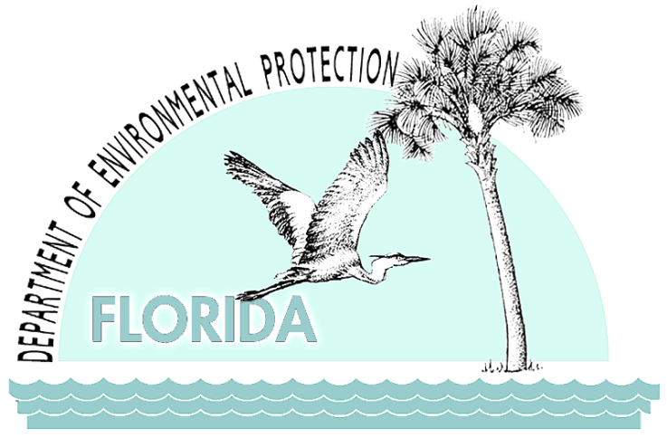

Florida Department of Environmental Protection
Division of Water Resource Management
Bureau of Watershed Management
2600 Blair Stone Road
Tallahassee, Florida 32399-2400
www2.dep.state.fl.us/water/

ACKNOWLEDGMENTS

This document was prepared by staff in the following bureaus of the Division of Environmental Assessment and Restoration, within the Florida Department of Environmental Protection:

- Bureau of Assessment and Restoration Support:
- Standards and Assessment Section
- Watershed Assessment Section
- Watershed Monitoring Section

- Bureau of Watershed Restoration:
- Ground Water Management Section
- Nonpoint Source Management Section
- Springs Initiative
- Watershed Evaluation and TMDL Section
- Watershed Planning and Coordination Section

- Bureau of Laboratories:
- Biology Section

Many thanks to staff at the Florida Fish and Wildlife Conservation Commission for their valuable help in updating the section on cyanobacteria in Chapter 3.

Table of Contents

List of Acronyms and Abbreviations xii
Executive Summary xvi
Chapter 1: Introduction 1
Purpose 1
Federal Assessment and Reporting Requirements 1
Integrating the Federal Requirements into Florida’s Watershed Management Approach 3
Chapter 2: Background Information 5
Overview 5
Population 7
Climate 7
Surface Water and Ground Water Resources 10
Streams and Rivers 10
Lakes 11
Estuaries and Coastal Waters 12
Wetlands 12
Aquifers and Springs 13
Hydrogeology 13
Surface Water 13
Ground Water 14
Surface Water–Ground Water Interactions 15
Chapter 3: Public Health Issues and Emerging STATE Concerns and Initiatives 17
Public Health Issues 17
Drinking Water 17
Healthy Beaches Program 18
Bacterial and Mercury Contamination 19
Harmful Algal Blooms 19
Emerging Concerns and Initiatives 23
Chapter 4: Florida’s Approach to Monitoring Surface Water and Ground Water 29
Background 29
Florida’s Integrated Water Resources Monitoring Program 33
Element 1: Monitoring Objectives 35
Element 2: Monitoring Strategy 35
Element 5: Quality Assurance 36
Element 6: Data Management 37
Element 9: Program Evaluation 37
Element 10: General Support and Infrastructure Planning 38
Evolving Approaches to Monitoring 38
Chapter 5. Design for the Status and Trend Networks 39
Background 39
Status Network Monitoring 40
Water Resource Types 40
Geographic Design and Site Selection 41
Sampling and Frequency 42
Status Network Core and Supplemental Indicators 42
Status Monitoring Network Design Changes 45
Future Design and Reporting 46
Trend Network 48
Surface Water Trend Network 50
Ground Water Trend Network 50
Trend Network Core and Supplemental Indicators 50
Data Evaluation 53
Chapter 6: Results of the Status and trend NeTWORK Assessments for 2004–08 54
Summary of Status Network Surface Water Results 54
Introduction 54
Rivers, Streams, Large Lakes, and Small Lakes 57
Sediment Quality Evaluation 70
Summary of Status Network Ground Water Results 76
Summary of Status Network Cycle 1 versus Cycle 2 Results 86
Summary of Surface and Ground Water Trend Network Results 87
Surface Water Trends 87
Ground Water Trends 97
Chapter 7. Introduction to Strategic Monitoring and assessment 116
Approach to the Comprehensive Assessment: Sections 305(b) and 303(d) 116
Determining Attainment of Designated Use(s) 119
How Data Are Identified and Evaluated 120
The Impaired Surface Waters Rule 120
Sources of Data 121
Quality Assurance/Quality Control Criteria 123
Criteria for Evaluating Outside Data 123
Rationales for Not Using Existing Data 123
How Data Are Used To Make Attainment Determinations 124
Public Participation Process 124
Chapter 8: Results of the Assessments Of Use Support 125
Surface Waters Assessed 125
Summary of Causes of Impairment 127
303(d) List of Verified Impaired Waters 129
Delisting 129
Biology 133
Special Focus: Lakes 133
Lake Trends 133
Approaches to Controlling Lake Pollution and Lake Water Quality 133
Publicly Owned Lakes with Impaired Uses 134
Drinking Water 134
Overlap of Source Water Areas and Impaired Surface Waters 135
Sediment Contamination 136
Freshwater Sediments 136
Estuarine and Marine Sediments 136
Chapter 9: Introduction to Ground Water Monitoring 139
Summary of Ground Water Monitoring Programs 139
FDEP-maintained Ground Water and Springs Monitoring Programs 140
Potable Water Monitoring by FDOH/FDEP Water Supply Restoration Program 140
Public Water System Monitoring 141
Monitoring of Discharges to Ground Water 142
Chapter 10: Results of the Ground Water Assessments 143
Overall Ground Water Quality 143
Ground Water Quality Issues and Contaminants of Concern, Including Public Health Issues 145
Volatile Organic Compounds 146
Synthetic Organic Chemicals/Pesticides 150
Nitrate 151
Primary Metals 151
Saline Water 152
Radionuclides 153
Trihalomethanes 153
Bacteria (Coliform) 153
Summary of Ground Water Contaminant Sources 154
Petroleum Facilities 154
Drycleaning Solvent Facilities 154
Federal and State Waste Cleanup and Monitoring Sites 155
Nonpoint Sources 155
Ground Water–Surface Water Interaction 155
Setting and Pathways 155
Ground Water Influence on Impaired Surface Waters 156
Springs and Spring-related Issues 156
Phosphorus 158
Chapter 11: Water Protection and Restoration Programs 161
Florida’s Water Resource Management Programs 161
Overview of Surface Water Monitoring Programs 162
Watershed-based Monitoring and Reporting 162
Overview of Surface Water Protection Programs 163
Water Quality Standards Program 163
Watershed Assessment Program 164
Public Participation 171
Surface Water Improvement and Management Program 171
Point Source Control Program 172
Nonpoint Source Management Program 174
Coordination with Other State, Tribal, and Local Agencies 177
Costs and Benefits of Implementing Florida’s Surface Water Protection Programs to Meet the Clean Water Act’s Objectives 180
Wetlands Program 183
Results of Florida’s Surface Water Protection Programs 190
References 191

List of Tables

Table 2.1. Florida Atlas 6
Table 4.1a. FDEP's Tier I Monitoring Programs 34
Table 4.1b. FDEP's Tier I and Tier II Blended Monitoring Programs 34
Table 4.1c. FDEP's Tier II Monitoring Programs 34
Table 4.1d. FDEP's Tier III Monitoring Programs 34
Table 5.1. Basin Groups for Implementing the 2004–08 Statewide Assessment 40
Table 5.2a. Status Network Core and Supplemental Indicators for Field Measurements 43
Table 5.2b. Status Network Core and Supplemental Indicators for Biological and Microbiological Indicators 44
Table 5.2c. Status Network Core and Supplemental Indicators for Organic and Nutrient Indicators 44
Table 5.2d. Status Network Core and Supplemental Indicators for Major Ion Indicators 44
Table 5.2e. Status Network Core and Supplemental Indicators for Metal Indicators 44
Table 5.2f. Status Network Core and Supplemental Indicators for Physical Property Indicators 45
Table 5.3a. Status Network Organic and Nutrient Indicators for Sediment Analysis in Lakes 45
Table 5.3b. Status Network Metal Indicators for Sediment Analysis in Lakes 45
Table 5.3c. Status Network Organic Indicators for Sediment Analysis in Lakes 45
Table 5.4a. Trend Network Field Measurement Indicators 48
Table 5.4b. Trend Network Biological and Microbiological Indicators 48
Table 5.4c. Trend Network Organic and Nutrient Indicators 49
Table 5.4d. Trend Network Major Ion Indicators 49
Table 5.4e. Trend Network Metal Indicators 49
Table 5.4f. Trend Network Physical Property Indicators 50
Table 6.1. Summary of Surface Water Resources Assessed by the Status Network’s Probabilistic Monitoring, 2004–08 54
Table 6.2a. Status Network Physical/Other Indicators/Index for Aquatic Life Use with Water Quality Criteria/Thresholds 55
Table 6.2b. Status Network Microbiological Indicators/Index for Recreation Use with Water Quality Criteria/Thresholds 55
Table 6.2c. FDEP Freshwater Lake Sediment Contaminant Thresholds for Metals 56
Table 6.2d. FDEP Freshwater Lake Sediment Contaminant Thresholds for Organic Contaminants 56
Table 6.3a. Legend for Terms Used in Tables 6.3b through 6.3e 57
Table 6.3b. Statewide Percentage of Rivers Meeting Threshold Values for Indicators Calculated Using Probabilistic Monitoring Design 60
Table 6.3c. Statewide Percentage of Streams Meeting Threshold Values for Indicators Calculated Using Probabilistic Monitoring Design 63
Table 6.3d. Statewide Percentage of Large Lakes Meeting Threshold Values for Indicators Calculated Using Probabilistic Monitoring Design 66
Table 6.3e. Statewide Percentage of Small Lakes Meeting Threshold Values for Indicators Calculated Using Probabilistic Monitoring Design 69
Table 6.4a. Statewide Percentage of Large Lakes Meeting Sediment Contaminant Threshold Values 73
Table 6.4b. Statewide Percentage of Small Lakes Meeting Sediment Contaminant Threshold Values 75
Table 6.5. Status Network Physical/Other Indicators/Index for Potable Water Supply for Ground Water with Water Quality Criteria/Thresholds 76
Table 6.6a. Legend for Terms Used in Tables 6.6b and 6.6c 77
Table 6.6b. Statewide Percentage of Confined Aquifers Meeting Threshold Values for Indicators Calculated Using Probabilistic Monitoring Design 80
Table 6.6c. Statewide Percentage of Unconfined Aquifers Meeting Threshold Values for Indicators Calculated Using Probabilistic Monitoring Design 84
Table 6.7a. Percentage of Combined Rivers and Streams Resource Meeting Threshold Values for Statewide Assessment for Cycles 1 and 2 86
Table 6.7b. Percentage of Small Lakes Resource Meeting Threshold Values for Statewide Assessment for Cycles 1 and 2 87
Table 6.7c. Percentage of Large Lakes Resource Meeting Threshold Values for Statewide Assessment for Cycles 1 and 2 87
Table 6.8a. Trends for Specified Analytes for Surface Water Trend Network Stations that Are Associated with a USGS Gauging Station and Adjusted for River Flow 88
Table 6.8b. Trends for Specified Analytes for Surface Water Stations from the Trend Network and not Adjusted for River Flow 89
Table 6.9a. Legend for the Acronyms and Abbreviations Used in Tables 6.9b and 6.9c 97
Table 6.9b. Trends for Specified Analytes for Stations in the Ground Water Trend Monitoring Network, Confined Aquifers 98
Table 6.9c. Trends for Specified Analytes for Stations in the Ground Water Trend Monitoring Network, Unconfined Aquifers 99
Table 7.1. Categories for Waterbodies or Waterbody Segments in the 2010 Integrated Report 117
Table 7.2. Basin Groups for Implementing the Watershed Management Cycle, by FDEP District Office 119
Table 7.3. Basin Rotation Schedule for TMDL Development and Implementation 119
Table 7.4. Designated Use Attainment Categories for Surface Waters in Florida 120
Table 7.5. Data Used in Developing the Planning and Verified Lists for the Basin Rotation Cycles 123
Table 8.1. Waters Assessed for the Statewide Basin Assessments, by Waterbody Type 126
Table 8.2. Size of Surface Waters Assigned to Each EPA Integrated Report Category 126
Table 8.3a. Miles of Rivers/Streams Impaired by Cause 127
Table 8.3b. Acres of Lakes Impaired by Cause 128
Table 8.3c. Square Miles of Estuaries Impaired by Cause 128
Table 8.3d. Square Miles of Coastal Waters Impaired by Cause 129
Table 8.4. Numbers of Measurements and Impairment Status for the BioRecon and SCI, 1992–October 2009 133
Table 8.5. Total Miles of Rivers/Streams and Acres of Lakes/Reservoirs Designated for Drinking Water Use 134
Table 8.6. Miles of Rivers/Streams and Acres of Lakes/Reservoirs Designated for Drinking Water Use that Are Assigned to Each of the EPA’s Five Reporting Categories 135
Table 8.7. Summary of Impaired River/Stream Miles and Lake/Reservoir Acres Overlapping Source Water Areas of Community Water Systems 136
Table 9.1a. Summary of Ground Water Monitoring Programs and Data Sources: FDEP-Maintained Monitoring Networks 139
Table 9.1b. Summary of Ground Water Monitoring Programs and Data Sources: Programs that Include Potable Ground Water Sampling: FDEP-Maintained Monitoring Networks 140
Table 10.1. Summary of Percent Ground Water Samples Achieving Primary Ground Water Standards for Selected Analytes by Basin 144
Table 10.2a. Summary of Recent Exceedances of Primary Ground Water Standards in Samples from Private Wells and Ground Water–Based Public Water Systems 148
Table 10.2b. Summary of Recent Exceedances of Primary Ground Water Standards in Samples from Private Wells and Ground Water–Based Public Water Systems 149
Table 10.3. Median Concentrations of Ground Water–Surface Water Constituents in Unconfined Aquifers (2000–2007/2008-2009) 157
Table 11.1. Status of Ongoing BMAP Efforts 169
Table 11.2. Primary Coordination Mechanisms for Managing State, Regional, and Local Water Resources 177
Table 11.3. Results of the 2004 Clean Watersheds Needs Survey for Florida 181
Table 11.4. Historical Estimates of Wetlands in Florida, 1780–1980 183
Table 11.5. Open Mitigation Banks in Florida¹ 188
Table 11.6. Acreage of Affected Wetlands Regulated by FDEP and the Water Management Districts (2004–09) 189

List of Figures

Figure 2.1. Florida’s Population Distribution, 2000 8
Figure 2.2. Florida’s Average Annual Rainfall, 1971–2000 9
Figure 2.3. Springs of Florida 14
Figure 2.4. Florida’s Hydrologic Divide 16
Figure 5.1. Status Network Sampling Periods for the Florida Panhandle and Florida Peninsula 42
Figure 5.2. Status Monitoring Network Reporting Units 47
Figure 5.3. Surface Water Trend Network Sites 51
Figure 5.4. Ground Water Trend Network Sites 52
Figure 6.1. Statewide River Sample Locations by Basin 58
Figure 6.2. Statewide Summary of River Results 59
Figure 6.3. Statewide Stream Sample Locations by Basin 61
Figure 6.4. Statewide Summary of Stream Results 62
Figure 6.5. Statewide Large Lake Sample Locations by Basin 64
Figure 6.6. Statewide Summary of Large Lake Results 65
Figure 6.7. Statewide Small Lake Sample Locations by Basin 67
Figure 6.8. Statewide Summary of Small Lake Results 68
Figure 6.9. Statewide Summary of Large Lake Sediment Results 72
Figure 6.10. Statewide Summary of Small Lake Sediment Results 74
Figure 6.11. Statewide Confined Aquifer Well Locations by Basin 78
Figure 6.12. Statewide Summary of Confined Aquifer Results 79
Figure 6.13. Statewide Unconfined Aquifer Well Locations by Basin 82
Figure 6.14. Statewide Summary of Unconfined Aquifer Results 83
Figure 6.15. Surface Water Trends for Nitrate + Nitrite, 1999–2008 90
Figure 6.16. Surface Water Trends for TKN, 1999–2008 91
Figure 6.17. Surface Water Trends for TP, 1999–2008 92
Figure 6.18. Surface Water Trends for TOC, 1999–2008 93
Figure 6.19. Surface Water Trends for Chlorophyll a, 1999–2008 94
Figure 6.20. Surface Water Trends for Fecal Coliform Bacteria, 1999–2008 95
Figure 6.21. Surface Water Trends for DO, 1999–2008 96
Figure 6.22. Ground Water Trends for Temperature, 1999–2008 100
Figure 6.23. Ground Water Trends for Specific Conductance, 1999–2008 101
Figure 6.24. Ground Water Trends for pH, 1999–2008 102
Figure 6.25. Ground Water Trends for Depth to Water, 1999–2008 103
Figure 6.26. Ground Water Trends for Total Dissolved Solids, 1999–2008 104
Figure 6.27. Ground Water Trends for Nitrate + Nitrite, 1999–2008 105
Figure 6.28. Ground Water Trends for Phosphorus, 1999–2008 106
Figure 6.29. Ground Water Trends for Potassium, 1999–2008 107
Figure 6.30. Ground Water Trends for Sulfate, 1999–2008 108
Figure 6.31. Ground Water Trends for Sodium, 1999–2008 109
Figure 6.32. Ground Water Trends for Chloride, 1999–2008 110
Figure 6.33. Ground Water Trends for Calcium, 1999–2008 111
Figure 6.34. Ground Water Trends for Magnesium, 1999–2008 112
Figure 6.35. Ground Water Trends for Alkalinity, 1999–2008 113
Figure 6.36. Ground Water Trends for Total Coliform, 1999–2008 114
Figure 6.37. Ground Water Trends for Fecal Coliform, 1999–2008 115
Figure 7.1. Period of Record Assessment Flow Chart 122
Figure 8.1. Decision Tree for Delisting Based on Chlorophyll a or TSI 130
Figure 8.2. Results of Florida’s Surface Water Quality Assessment for all Parameters (Excluding Mercury) 131
Figure 8.3. Results of Florida’s Surface Water Quality Assessment for Mercury 132
Figure 10.1. Numbers of Primary MCL Exceedances in Samples from Public Water Systems and Private Wells for the Recent 2-Year Period 147
Figure 10.2. Median Concentrations of Nitrate + Nitrite in FDEP’s Spring Network (2001–06) 159
Figure 10.3. Median Orthophosphate Concentrations in the Spring Network, 2001–06 160
Figure 11.1. Agencies Responsible for Water Resource Coordination and Management in Florida 179

List of Acronyms and Abbreviations
μg Microgram
μg/L Micrograms per Liter
μS MicroSiemen
μS/cm MicroSiemens per Centimeter
ALK Alkalinity
As Arsenic
ASR Aquifer Storage and Recovery
ATAC Allocation Technical Advisory Committee
BGD Billion Gallons per Day
BioRecon BioReconnaissance
BMAP Basin Management Action Plan
BMP Best Management Practice
BOD Biological Oxygen Demand
BRACE Bay Regional Atmospheric Chemistry Experiment
Ca Calcium
CaCO3 Calcium Carbonate
CAMA Coastal and Aquatic Managed Areas
CARL Conservation and Recreation Lands
CBI Compliance Biomonitoring Inspection
CBIR Community Budget Initiative Request
CCMP Comprehensive Conservation and Management Plan
CCUA Clay County Utility Authority
CEI Compliance Evaluation Inspection
CERCLA Comprehensive Environmental Response Compensation and Liability Act
CERP Comprehensive Everglades Restoration Plan
cfs Cubic Feet per Second
Chl-a Chlorophyll a
Cl Chloride
cm Centimeter
CSI Compliance Sampling Inspection
CSO Combined Sewer Overflow
CWA Clean Water Act
CWNS Clean Watersheds Needs Survey
CWSRF Clean Water State Revolving Fund
DEP Department of Environmental Protection
DMR Discharge Monitoring Report
DO Dissolved Oxygen
DSCP Drycleaning Solvent Cleanup Program
DWMP District Water Management Plan
EDB Ethylene Dibromide
ELRA Environmental Litigation Reform Act
EMAP Environmental Monitoring and Assessment Program
EPA U.S. Environmental Protection Agency
ERP Environmental Resource Permit
ESOC Emerging Substances of Concern
F.A.C. Florida Administrative Code
FC Fecal Coliform
FDACS Florida Department of Agriculture and Consumer Services
FDCA Florida Department of Community Affairs
FDEP Florida Department of Environmental Protection
FDER Florida Department of Environmental Regulation
FDOH Florida Department of Health
FDOT Florida Department of Transportation
FGS Florida Geological Survey
FL STORET Florida Storage and Retrieval (database)
FMRI Florida Marine Research Institute
F.S. Florida Statutes
FWC Florida Fish and Wildlife Conservation Commission
FWCI Florida Wetland Condition Index
FWRA Florida Watershed Restoration Act
FWRI Fish and Wildlife Research Institute
FWVSS Foodborne, Waterborne, and Vectorborne Disease Surveillance System
FY Fiscal year
FYI Fifth Year Inspection
GIS Geographic Information System
GRTS Generalized Random Tessellation Stratified
GWTV Ground Water Temporal Variability
HAB Harmful Algal Bloom
HABSOS Harmful Algal Bloom Observing System
HUC Hydrologic Unit Code
IBI Impact Bioassessment
IMAP Inshore Marine Monitoring and Assessment Program
IMC International Minerals and Chemicals Corporation
ISD Insufficient Data
IWR Impaired Surface Waters Rule
IWRM Integrated Water Resources Monitoring
K Potassium
kg Kilogram
L Liter
LVI Lake Vegetation Index
MCL Maximum Contaminant Level
mg Milligram
Mg Magnesium
MGD Million Gallons per Day
mg/L Milligrams per Liter
mL Milliliter
MML Mote Marine Laboratory
MS4 Municipal Separate Storm Sewer System
MSSW Management and Storage of Surface Water
NO_{X} Nitrate + Nitrite
N Nitrogen
Na Sodium
NEEPP Northern Everglades and Estuaries Protection Program
NELAC National Environmental Laboratory Accreditation Conference
NEP National Estuary Program
NHD National Hydrography Dataset
NOAA National Oceanic and Atmospheric Administration
NOI Notice of Intent
NOV Notice of Violation
NPDES National Pollutant Discharge Elimination System
NPL National Priorities List
NRDC Natural Resources Defense Council
NSP Neurotoxic Shellfish Poisoning
NSTP National Status and Trends Program
NWFWMD Northwest Florida Water Management District
OAWP Office of Agricultural Water Policy
OFW Outstanding Florida Water
P Phosphorus
P-2000 Preservation 2000
PAHs Polynuclear Aromatic Hydrocarbons
PAI Performance Audit Inspection
Pb Lead
PBS&J Post, Buckley, Schuh, and Jernigan, Incorporated
PCBs Polychlorinated Biphenyls
PCE Tetrachloroethylene
PCU Platinum Cobalt Unit
PEC Probable Effects Concentration
PLRG Pollutant Load Reduction Goal
ppb Parts per Billion
ppt Parts per Thousand
psu Practical Salinity Unit
PWS Public Water System
PWS ID# Public Water System Identification Number
QA Quality Assurance
QA/QC Quality Assurance/Quality Control
rNHD re-leveled National Hydrography Dataset
SO₄ Sulfate
SB Senate Bill
SC Specific Conductance
SCI Stream Condition Index
SFWMD South Florida Water Management District
SJRWMD St. Johns River Water Management District
SK Seasonal Kendall
SOCs Synthetic Organic Chemicals
SOP Standard Operating Procedure
SOR Save Our Rivers
SRF State Revolving Fund
SRWMD Suwannee River Water Management District
SSACs Site-Specific Alternative Criteria
STA Stormwater Treatment Area
STAG State and Tribal Assistance Grant
STCM Storage Tank Contamination Monitoring
STORET Storage and Retrieval
SWAPP Source Water Assessment and Protection Program
SWFWMD Southwest Florida Water Management District
SWIM Surface Water Improvement and Management
TAC Technical Advisory Committee
TC Total Coliform
TCE Trichloroethylene
TDS Total Dissolved Solids
TEC Threshold Effects Concentration
Th-232 Thorium-232
THMs Trihalomethanes
TKN Total Kjeldahl Nitrogen
TMDL Total Maximum Daily Load
TN Total Nitrogen
TOC Total Organic Carbon
TP Total Phosphorus
TSI Trophic State Index
TSS Total Suspended Solids
TV Temporal Variability
U-238 Uranium-238
UF University of Florida
UF-IFAS University of Florida Institute of Food and Agricultural Sciences
UIC Underground Injection Control
UMAM Uniform Mitigation Assessment Method
U.S.C. U.S. Code
USGS U.S. Geological Survey
VISA Very Intense Study Area
VOCs Volatile Organic Compounds
WBID Waterbody Identification Number
WHO World Health Organization
WL Water Level
WQBELs Water Quality–Based Effluent Limitations
WQI Water Quality Inspection
WSRP Water Supply Restoration Program
WWTF Wastewater Treatment Facility
XSI Toxic Sampling Inspection

Executive Summary

Purpose and Contents
This report, which is called the state’s Integrated Report because it addresses the reporting requirements of Sections 305(b) and 303(d) of the federal Clean Water Act (CWA), provides an overview of Florida’s surface water and ground water quality. Section 305(b) requires each state to report to the U.S. Environmental Protection Agency (EPA) on the condition of its surface waters, and Section 303(d) requires each state to report on its impaired waterbodies (those not meeting water quality standards). Using the information from all the states, the EPA provides Congress with a national inventory of water quality conditions and also develops priorities for future federal actions to protect and restore aquatic resources.

In preparing this report, the Florida Department of Environmental Protection (FDEP) assessed a wide variety of available water quality data, including data from FDEP’s Ambient Monitoring Networks (the “Status” and “Trend” monitoring networks), Total Maximum Daily Load (TMDL) Program data that are stored in the Florida Storage and Retrieval (STORET) database and used to identify impaired waters, and Ground Water Program data.

Statewide Status and Trend Monitoring Program for Surface and Ground Water

The Status Monitoring Network uses an EPA-designed probabilistic monitoring network to estimate the water quality of 100% of the sampleable fresh waters in the state with known confidence. This report presents both a statewide summary (Chapter 6) and basin-level summaries (see Appendices A and C) of a 5-year cycle (2004–08). The state’s surface and ground water resources are predominantly in good condition based on the indicators assessed. Streams are the sole water resource to have multiple indicators— chlorophyll a, fecal coliform, and dissolved oxygen (DO)—fall below 80% attainment, but many state streams naturally do not meet the applicable DO and fecal coliform criteria. Regional results provide a more focused estimate of the water quality condition in watersheds, and regional attainment differences may result from different land uses, alterations of the resource, geology, or other natural conditions.
An analysis of data from the Trend Monitoring Network, which consists of 76 surface water stations (e.g., rivers and streams) and 47 ground water wells located throughout Florida, did not identify any general surface water trends (when present, they were indicator specific) but identified some ground water trends that imply changes in water sources, water levels, or matrix interactions. The ground water wells show positive trends for saltwater encroachment indicators (calcium, sodium, chloride, and potassium) and for rock-matrix indicators (calcium, magnesium, potassium, and alkalinity) with an associated decrease in pH. These ground water results corroborate those presented in FDEP’s Florida Geological Survey Special Bulletin No. 69 (Copeland, 2009) and are considered the primary concern for the state’s ground waters.

Summary of Water Quality Standards Attainment for Assessed Rivers/Streams, Lakes, Estuaries, and Coastal Waters

For the determination of use support, FDEP assessed 23,922 miles of rivers and streams, 1,471,139 acres of lakes, 2,661 square miles of estuaries, and 6,699 square miles of coastal
waters using the methodology in the Impaired Surface Waters Rule (Chapter 62-303, Florida Administrative Code [F.A.C.]) for the identification of impaired waters. The table below lists the assessment results for the different waterbody types (rivers/streams, lakes, estuaries, and coastal waters).

Size of Surface Waters Assigned to Each EPA Integrated Report Category
This is a 10-column table. Column 1 lists the waterbody type, Columns 2 through 6 list the number of each waterbody type in Categories 2 through 5, respectively, Column 7 lists the number with no data, Column 8 lists the number with insufficient data, Column 9 lists the number of total waters assessed, and Column 10 lists the total number in the state.

Note: There are no waters in EPA Category 1 (attaining all designated uses) because FDEP does not sample for all criteria. Category 2 comprises waters attaining all the criteria that were sampled for.

* The EPA’s Integrated Report categories are as follows:
1—Attains all designated uses;
2—Attains some designated uses;
3a—No data and information are available to determine if any designated use is attained;
3b—Some data and information are available, but they are insufficient for determining if any designated use is attained;
3c—Meets Planning List criteria and is potentially impaired for one or more designated uses;
3d—Meets Verified List criteria and is potentially impaired for one or more designated uses;
4a—Impaired for one or more designated uses and the TMDL is complete;
4b—Impaired for one or more designated uses, but no TMDL is required because an existing or proposed pollutant control mechanism provides reasonable assurance that the water will attain standards in the future;
4c—Impaired for one or more designated uses but no TMDL is required because the impairment is not caused by a pollutant;
4d—No causative pollutant has been identified;
4e—Impaired, but recently completed or ongoing restoration activities should restore the designated uses of the waterbody; and
5—Water quality standards are not attained and a TMDL is required.
Waterbody  Type | Category 2* | Categories 3c and 3d (Planning List)* | Categories 4a, 4b, 4c* | Categories 4d, 4e* | Category 5* | No Data (Category 3a)* | Insufficient Data (Category 3b)* | Total Waters Assessed for at Least 1 Parameter | Total in State
Rivers/  Streams  (miles) | 919 | 2,354 | 658 | 2,193 | 7,796 | 7,695 | 2,308 | 13,919 | 23,922
Lakes  (acres) | 59,227 | 58,540 | 84,908 | 9,380 | 991,576 | 177,693 | 89,814 | 1,203,632 | 1,471,139
Estuaries  (square miles) | 23 | 58 | 0 | 0 | 2,573 | 184 | 4 | 2,473 | 2,661
Coastal  Waters  (square miles) | 0 | 0 | 0 | 0 | 6,699 | 0 | 0 | 6,699 | 6,699

Ground Water Protection Program

Available ground water monitoring program data were assessed to determine the overall quality of ground water relative to several categories of primary ground water Maximum Contaminant Levels (MCLs). The results, which are summarized in Table 10.1 in Chapter 10, indicate that bacteria (as total coliform) and salinity (as sodium) were the analyte groups with the highest percentage of exceedances of the MCLs. The Everglades, Everglades West Coast, Ochlockonee–St. Marks, and Southeast Coast–Biscayne Bay Basins have the highest number of wells exceeding the MCL for total coliform. However, coliform bacteria can commonly reflect conditions in the well rather than the aquifer when associated with well construction or inadequate maintenance issues, and so these results should be scrutinized. The statewide assessment shows that data from the past 2 years were similar to the 2000–07 median in the number of samples achieving the MCL (84% compared with 81%). Table 10.1 shows the basins with the highest number of wells achieving the MCL.

Conclusion

Since the passage of the CWA, FDEP has made tremendous progress statewide in identifying and addressing surface and ground water contamination. However, much more work remains to be done, especially in the face of Florida’s continued rapid population growth.

In cooperation with other agencies and stakeholders, FDEP continues to implement numerous programs and activities to continue its goal of protecting, managing, and restoring the state’s surface water quality, aquatic habitats, and aquatic life, as well as potable water supplies (see Chapter 11). It has also identified a number of ongoing and emerging issues of concern (see Chapter 3); FDEP’s current initiatives to address these issues include the following:

- The development of numeric criteria to address nutrient impairment of surface waters, caused by a variety of sources, including septic tanks, higher fertilizer use, and increased number of residential landscapes accompanying the state’s growing population.
- An update of the state’s Stormwater Rule to further reduce nutrient contamination in urban stormwater.
- The continued development and implementation of best management practices (BMPs) to further reduce contamination from agricultural runoff.
- Continued monitoring and investigation of increased nitrate concentrations in springs that cause the overgrowth of aquatic plants—including blue-green algae, which can produce toxins that affect humans and wildlife.
- Scientific studies to quantify the reductions needed to address the mercury impairment of surface waters statewide.
- The creation of a multiagency, statewide working group to address increased saltwater intrusion and encroachment into freshwater supplies.
- An ongoing study to identify the best locations for potable water wells that will minimize the potential for arsenic contamination, which is a problem in a number of areas in the state.
- The development of strategies for effectively addressing Emerging Substances of Concern (ESOC), which are man-made chemicals in many consumer goods such as pharmaceuticals and personal care products that have been found in water, soils, and the air.
- The study of potential impacts on the state’s aquatic resources linked to the increased acidification of the nation’s coastal waters.
- The revision of fecal coliform criteria and methods to assess human health issues at beaches and shellfish-harvesting areas more rapidly and accurately.
- The revision of DO criteria to more clearly define “natural conditions” and to better understand the natural variability of DO and nutrient levels in freshwater aquatic systems statewide.

Chapter 1: Introduction

Purpose

Contents

- Chapter 1 provides background information on the federal assessment and reporting requirements and how they are integrated into Florida’s watershed management approach.
- Chapter 2 contains background information on the state’s population, surface water and ground water resources, climate, and hydrogeology.
- Chapter 3 summarizes ongoing public health issues and emerging state concerns and initiatives.
- Chapter 4 discusses Florida’s general approach to monitoring surface water and ground water.
- Chapter 5 describes the statewide Status and Trend Monitoring Networks. These surface and ground water ambient monitoring programs allow estimates of the percentage of waters statewide that meet/do not meet water quality thresholds for their designated uses, or track changes in water quality over time.
- Chapter 6 summarizes the results of the Status Monitoring Network from 2004 through 2008, as well as long-term trends in surface and ground water quality.
- Chapter 7 describes the Strategic Monitoring design.
- Chapter 8 summarizes the significant surface water quality findings for Strategic Monitoring and the attainment of designated uses for rivers and streams, lakes, estuaries, and coastal waters.
- Chapter 9 discusses the state’s ground water monitoring programs.
- Chapter 10 presents significant ground water quality findings, summarizes ground water contaminant sources, and characterizes ground water–surface water interactions. Evaluating ground water resources is particularly important because 90% of the state’s drinking water supplies come from ground water.
- Chapter 11 describes Florida’s water resource management program to monitor and protect surface water resources.
- The Appendices, which are in a separate document, provide background information and supporting data.
This report provides an overview of Florida’s surface water and ground water quality as of 2010. Referred to as the Integrated Report because it fulfills the reporting requirements under Sections 305(b) and 303(d) of the federal Clean Water Act (CWA), the report must be submitted to the U.S. Environmental Protection Agency (EPA) every two years.

Federal Assessment and Reporting Requirements
Section 305(b) of the CWA requires states and other jurisdictions to submit biennial water quality reports to the EPA. These reports, referred to as 305(b) reports, describe surface water and ground water quality and trends, the extent to which waters are attaining their designated uses (such as drinking water, recreation, and shellfish harvesting), and major impacts to surface water and ground water. Under Section 303(d) of the CWA, states are also required to identify waters that are not attaining their designated uses, submit to the EPA a list of these impaired waters (referred to as the 303(d) list), and develop total maximum daily loads (TMDLs) for them.

A TMDL represents the maximum amount of a given pollutant that a waterbody can assimilate and still meet its designated uses.

Water quality monitoring and data analysis are the foundation of water resource management decisions. The EPA and its state partners have worked together to develop an integrated 305(b) and 303(d) assessment approach to address water quality monitoring strategies, data quality and data quantity needs, and data interpretation methodologies. This 2010 Integrated Report continues the consolidation and alignment of the 305(b) and 303(d) assessment and reporting requirements. It also includes Section 314 reporting on the status and trends of significant publicly owned lakes.

The Integrated Report allows states to document whether water quality standards are being attained, documents the availability of data and information for each waterbody segment, identifies trends in water quality conditions, and provides information to managers in setting priorities for future actions to protect and restore the health of Florida’s aquatic resources. This comprehensive approach to assessment enhances Florida’s ability to track important programmatic and environmental goals of the CWA and, ideally, speeds up the pace of achieving these goals.

Florida’s integrated approach to monitoring and assessment consists of three tiers: statewide ambient monitoring networks for status and trends, strategic monitoring for verification of impairment and identification of causative pollutants, and specialized, site-specific studies.

The Status component of the ambient monitoring program is a probabilistic assessment that is used to develop statistical estimates of water quality across the entire state, based on a stratified random sample design. The use of probability assessments produces an unbiased picture of water quality conditions statewide and provides a cost-effective benchmark of the success of Florida’s water quality programs. The results can also provide information on whether it would be useful to target certain waters for further assessment, or if limited resources for water quality assessment can be used more effectively in other ways. FDEP also implements a Trend Monitoring Network consisting of 76 surface water and 47 ground water stations. Trend analyses for surface and ground water resources are used to examine changes in water quality over time. Florida’s statewide Status and Trend monitoring networks enable FDEP to satisfy some of the reporting requirements for Sections 106 and 305(b) of the CWA.

A variety of basin- and waterbody-specific assessments are conducted as part of the second tier monitoring or Strategic Monitoring. The primary focus of strategic monitoring is to collect sufficient data to verify whether waters that have limited data indicating they are potentially impaired are in fact impaired, and to the extent possible, determine the causative pollutant for waters listed for dissolved oxygen (DO) or bioassessment failures. However, FDEP also conducts other types of strategic monitoring to better evaluate specific water resources (springs, for example).

Site-specific monitoring (Tier III) includes intensive surveys for TMDLs, monitoring for the development of water quality standards and site-specific alternative criteria (SSACs), and fifth-year inspections for permit renewals for facilities that discharge to surface waters. Special monitoring programs will address other program-specific needs, such as monitoring to develop predictive models, including the mercury TMDL being developed for Florida. Ground water arsenic studies address natural vs. anthropogenic sources of arsenic in aquifers, and restoration efforts are measured by project-specific studies.

All readily available ambient water quality data, regardless of the monitoring tier, are considered part of the 303(d) assessment for the determination of impaired waters, and each result is placed into one of five assessment categories, based on available data. According to the EPA, this approach allows the states to document the attainment of applicable water quality standards and develop monitoring strategies that effectively respond to the needs identified in the assessment, while ensuring that the attainment status of each water quality standard applicable to a particular waterbody segment is addressed. The five broad categories are as follows:

Category 1: All designated uses are supported; no use is threatened.
Category 2: Available data and/or information indicate that some, but not all, of the designated uses are supported.
Category 3: There are insufficient available data and/or information to make a use support determination.
Category 4: Available data and/or information indicate that at least one designated use is not being supported or is threatened, but a TMDL is not needed.
Category 5: Available data and/or information indicate that at least one designated use is not being supported or is threatened, and a TMDL is needed.

In addition to using these broad categories, the EPA allows states to develop and use individual subcategories to fit unique or specialized sets of circumstances. These subcategories (see Chapter 7) must be consistent with the purpose of the more general category and be approved by the EPA during its review of each state’s methodology for developing lists of impaired waters.

Integrating the Federal Requirements into Florida’s Watershed Management Approach
For the 2010 305(b) report, FDEP has continued to move towards a comprehensive assessment by integrating the federal assessment and reporting requirements into its watershed management approach. Federal requirements state that the following information should be provided:

- The extent to which the water quality of the state’s waters provides for the protection and propagation of a balanced population of shellfish, fish, and wildlife and allows for recreational activities in and on the water.
- An estimate of the extent to which CWA control programs have improved or will improve water quality, and recommendations for future actions.
- An estimate of the environmental, economic, and social costs and benefits needed to achieve CWA objectives and an estimate of the date for such achievements.
- A description of the nature and extent of nonpoint source pollution and recommendations needed to control each category of nonpoint sources.
- An assessment of the water quality of all publicly owned lakes, including lake trends, pollution control measures, and publicly owned lakes with impaired uses.

The 1999 Florida Watershed Restoration Act (FWRA) directed FDEP to implement a comprehensive, integrated watershed approach for evaluating and managing cumulative impacts to the state’s waters. The act clarified the TMDL Program and directed FDEP to develop an assessment methodology that allows for the consideration of whether water quality standards are being exceeded based on credible data, studies, and reports. Those waters determined to not meet water quality standards should then be included on the state’s 303(d) list of impaired waters, or those waters needing a TMDL, and the appropriate TMDLs should be developed (see Chapter 11 for more information). These objectives are carried out through coordination with the water management districts, Florida Department of Agriculture and Consumer Services (FDACS), Soil and Water Conservation Districts, environmental groups, regulated parties, and local stakeholders during all phases of the TMDL process.

The implementation of the watershed management approach was initiated in 2000. Florida’s 52 basins were divided into 29 groups that are distributed among FDEP’s 6 districts. There are 5 basins each in the Northwest, Central, Southwest, South, and Southeast Districts, and 4 basins in the Northeast District. One basin is assessed in each district every year. Using a rotating basin management cycle, which ensures that each basin is assessed every 5 years, FDEP and local stakeholders assess individual basins, identify impaired waters requiring the development of TMDLs, and develop Basin Management Action Plans (BMAPs) (see Chapter 11 for more information) and Reasonable Assurance Plans to restore water quality.

The assessment, consisting of multiple phases, has been completed in all of the state’s basins (the Group 1–5 basins) once. As part of its watershed management approach, FDEP developed Verified Lists of impaired waters for the Group 1–5 basins in 2002, 2003, 2004, 2005, and 2006, respectively. Cycle 2 of the rotating basin approach was initiated in 2007 with Verified Lists of impaired waters for the Group 1, Group 2, and Group 3 basins completed through 2009. Assessments and list development for Groups 4 and 5 will take place in 2010 and 2011. As required by Subsection 403.067(4), Florida Statutes (F.S.), the lists were adopted by Secretarial Order. The resulting Verified Lists of impaired waters and waters to be delisted in those basins amend the 1998 303(d) list of impaired Florida waters maintained by the EPA. FDEP intends to submit annual amendments to its 303(d) list as part of the watershed management approach.

The Status and Trend Monitoring results are a component of the CWA 106 monitoring work plan for FDEP. The results of these monitoring programs are reported internally through basin assessments, published by the Watershed Monitoring Section on FDEP’s Watershed Monitoring website. The years 2004 through 2008 follow the TMDL rotating basin design, and from 2009 to the present, the monitoring has shifted to an annual estimate of condition.

An additional requirement for CWA Section 106 is the submittal of the FDEP monitoring strategy, which addresses the suite of monitoring programs in this document, using the EPA’s March 2003 Elements of a State Water Monitoring and Assessment Program guidance. As part of the report, changes to the design document for the FDEP Watershed Monitoring program is updated as any changes to the design of the monitoring program or strategy occur.

Chapter 2: Background Information

Overview
Florida's 65,758 square miles support abundant, diverse natural resources. Some of these resources—such as the Everglades—are found nowhere else. Florida also contains the only coral reef in the continental United States. The state has 11,761 square miles of surface water (ranking third in the country in total water area) and large supplies of fresh water in its underground aquifers. Florida depends on water resources in many ways—for example, for its $26.4 billion fishing and $57 billion tourism industries (Florida Fish and Wildlife Conservation Commission [FWC] website, 2010; American Safety Council website, 2010).

The pressures of population growth and its accompanying development are impacting the state’s freshwater, ground water, and saltwater resources. Although the state ranks 22nd in the country in total area, it currently ranks fourth in population, and that population continues to grow. Most Floridians live in coastal areas where less fresh water is available, and about three-fourths of new Florida residents choose coastal locations for their new homes. As development continues, different users vie for water resources. Major challenges include maintaining overall water quality and supplies, protecting public health, satisfying competing and rapidly increasing demands for finite quantities of fresh water, minimizing damage to future water reserves, and ensuring healthy populations of fish and wildlife.

In addition, climate change, and its effects on water quality, must be considered in water resource management. Predicted impacts to Florida are increased air and water temperatures, increased variability in precipitation regimes, sea level rise, and salt water intrusion. In, 2007, Governor Charlie Crist established the Governor’s Action Team on Energy and Climate Change. This group was assigned the task of establishing a comprehensive Florida Energy and Climate Action Plan to achieve reductions in greenhouse gases.

Despite the fact that water is plentiful in many areas, water quantity and quality are critical issues. In 1950, Florida’s population of 2.8 million used about 2.9 billion gallons per day (BGD) of fresh ground water and surface water. In 1995, that number had risen to 7.2 BGD, and consumption is projected to rise to 9.3 BGD by 2020. Surface water and ground water quality has been impacted by industrial, residential, and agricultural land uses in areas throughout the state. While many point sources of pollution such as sewage treatment plant discharges have been eliminated, pollutant loading from widespread, diffuse nonpoint sources such as urban development and agriculture remains a challenge.

This chapter provides background information about Florida’s population, water resources, climate, and physical features. Table 2.1 summarizes basic information on the state and its surface water resources.

Table 2.1. Florida Atlas
This is a two-column table. Column 1 lists individual statistics for the state, and Column 2 lists the numbers for Florida associated with those statistics.

Statistic | Number
2008 estimated population (U.S. Census Bureau) | 18,328,340 people
Ranking by population among 50 states | 4th largest
% change, April 1, 2000, to July 1, 2008 | + 14.9%
Surface area | 65,758 square miles
Ranking by land area among 50 states | 22nd in size
Total water area | 11,761 square miles
Ranking by total water area among 50 states | 3rd largest
Number of U.S. Geological Survey (USGS) hydrologic units (i.e., watersheds with hydrologic unit codes, or HUCs) | 52
Total number of rivers and streams | More than 1,700
Total number of river and stream miles | 78,170 miles
Total river miles bordering other states | 191 miles
Chattahoochee River | 26 miles
Perdido River | 65 miles
St. Marys River | 100 miles
Longest river (entirely in Florida) | St. Johns River (273 miles)
Largest discharge | Apalachicola River (average of  24,768 cubic feet per second [cfs])
Total number of ditch and canal miles | 49,540 miles
Number of lakes, reservoirs, and ponds | 7,712 (area greater than or equal to 10 acres)
Area of lakes, reservoirs, and ponds | 1,618,368 acres
Area of largest lake | Lake Okeechobee (435,840 acres)
Area of estuaries and bays | 4,460 square miles
Area of coastal waters | 6,758 square miles
Area of freshwater and tidal wetlands | 17,830 square miles
Prominent wetland systems | Everglades and Big Cypress Swamp, Green Swamp, Okefenokee Swamp, Big Bend coastal marshes, St. Johns River marshes
Area of islands greater than 10 acres | 1,314 square miles
Number of known springs | More than 700
Combined spring outflow | 8 billion gallons per day
Largest spring | Wakulla Springs (average discharge  of 252 million gallons per day [MGD])
Number of first-order magnitude springs  (flows greater than 64.6 MGD) | 33

Sources: Copeland et al., 2009; Florida Trend, 2009; FWC website, 2010d; U.S. Census Bureau, 2010c; American Safety Council website, 2010, USGS, 2010.

Population
According to the U.S. Census Bureau, Florida’s population in 2008 was 18,328,340 (U.S. Census Bureau website, 2010c). Population growth has slowed during the current economic downturn, and is expected to reach only 1.57% in 2011–12. However, Florida is still projected to become the third most populated state sometime before 2014, behind California and Texas (Florida Trend, 2009). Within the next two decades, the state’s total population is expected to increase by 9.4 million people. Florida is also expected to gain 1.9 million people through international migration between 1995 and 2025, the third largest net gain in the country (U.S. Census Bureau website, 2010a–c).

As the baby-boom generation (those born between 1946 and 1964) reaches retirement age, the number of residents aged 65 and over will accelerate rapidly in all states. In Florida, the proportion of people over 65 was 17.4% as of 2008, and this number is projected to grow to 19.5% in 2015 (U.S. Census Bureau, 2010d).

The state has a number of large, expanding population centers, including southeastern Florida (Dade, Broward, and Palm Beach Counties), Jacksonville, Tampa–St. Petersburg, southwest Florida (from Sarasota to Naples), and Orlando (Figure 2.1). In contrast, other relatively large areas of Florida are sparsely populated.

Climate
The state’s climate ranges from a transitional zone between temperate and subtropical in the north and northwest, to tropical in the Keys. Summers are long, with periods of very warm, humid air. Maximum temperatures average about 90° F., although temperatures of 100° F. or greater can occur in some areas. Winters are generally mild, except when cold fronts move across the state. Frosts and freezes are possible, but typically temperatures do not remain low during the day, and cold weather usually lasts no more than two or three days at a time.

Rainfall across the state varies with location and season. On average, more than 60 inches per year falls in the far northwest and southeast, while the Keys receive about 40 inches annually (Figure 2.2). The heaviest rainfall occurs in northwestern Florida and in a strip 10 to 15 miles inland along the southeast coast. Variability in rainfall, both spatially and temporally, can contribute to local water shortages. Historically, Florida has had periods of high rainfall along with periods of low rainfall (e.g., drought). Based on data dating back to 1932, 2006 and 2007 were the driest back-to-back calendar years Florida has experienced.

Except for the northwestern part of the state, most of Florida has a rainy season and a relatively long dry season. In the peninsula, half the average annual rainfall usually falls between June and September. In northwestern Florida, a secondary rainy season occurs in late winter to early spring. The lowest rainfall for most of the state occurs in fall (October and November) and spring (April and May). The varying patterns of rainfall create differences in the timing of high and low discharges from surface waters.

Figure 2.1. Florida’s Population Distribution, 2000

Figure 2.2. Florida’s Average Annual Rainfall, 1971–2000

An approximate diagonal line drawn from the mouth of the St. Johns River at the Atlantic Ocean to the boundary of Levy and Dixie Counties on the Gulf of Mexico depicts a climatic river basin divide. North and northwest of the divide, streams have high discharges in spring and late winter (March and April) and low discharges in the fall and early winter (October and November). A second low-water period occurs from May to June. South of the climatic divide, high stream discharges occur in September and October, and low discharges occur from May to June.

Surface Water and Ground Water Resources
Florida has 78,170 miles of streams and rivers and 49,540 miles of ditches and canals. It has more than 7,700 lakes greater than 10 acres in size, with a total surface area of 1,618,368 acres. The state also has 4,460 square miles of estuaries and a coastline ranking second in length only to Alaska. A line running from the northeast corner of the state to Key West and back up to the northwest corner along the Gulf Coast would extend 1,300 miles. If the distance around barrier islands and estuaries were included, the line would stretch 9,888 miles.

Streams and Rivers
The state has more than 1,700 streams and rivers. Differences in climate, hydrogeology, and location all affect their water quality. The longest river entirely in the state is the St. Johns, which flows north as a recognizable stream about 273 miles from the St. Johns Marsh in northern St. Lucie County, to its mouth at Jacksonville. The river drains a land area equal to about one-sixth of Florida's surface. The Apalachicola River, in the Florida Panhandle, has the largest discharge flow, averaging almost 25,000 cubic feet per second. Its basin, draining over 19,000 square miles, extends to north Georgia’s southern Appalachian Mountains. In the Panhandle, spring discharges give rise to rivers, where the ground water base flow comprises 80% of the rivers’ flow.

The state has several types of natural river systems, including blackwater streams, spring runs, and estuarine or tidal streams, and these systems can be perennial or intermittent. Most of Florida’s rivers exhibit characteristics of more than one type of river system, either at different places along their length or at different times of the year. The links between surface water and ground water can also affect natural systems. For example, the Suwannee River, which originates in the Okefenokee Swamp as a blackwater stream, becomes spring fed south of Ellaville. During periods of high flow, it carries sand and sediments, behaving like a true alluvial stream (sediment carrying). During low flow, however, the river’s base flow comes from multiple springs, including several first-magnitude springs. These variations in flow affect the downstream stretches of the river and the receiving estuary. Ground water in the region has elevated nitrate concentrations that can affect animals and plants downstream (Suwannee River Water Management District website, 2010).

In north and northwest Florida, many rivers are alluvial. The Choctawhatchee, Apalachicola, and Escambia Rivers best represent this type of river. Common features include a well-developed floodplain, levees, terraces, oxbows, and remnant channels (sloughs) that parallel the active riverbed. Typically, because flows fluctuate more than with other types of rivers, habitats are more diverse.

There are many blackwater streams and rivers in Florida. Blackwater rivers usually have acidic, highly colored, slowly moving waters containing few sediments. These systems typically drain acidic flatwoods or swamps. The upper Suwannee River and north New River are examples of this type of river system.

Many major river systems that originate as springs are found in central and north Florida, the Big Bend area of the Gulf Coast, and the southern portion of the Tallahassee Hills. Chemically, these rivers are clear, alkaline, and well buffered. They have little temperature variation, relatively constant flows, and little sediment. Their clear water encourages the growth of submerged plants that provide habitat for diverse animal species. Many spring-fed rivers flow directly into estuaries, and the constant temperatures offer protection from temperature extremes to a number of species, including estuarine fish such as spotted seatrout and red drum, as well as marine mammals, such as manatees.

Major dams have been built on the Apalachicola, Ocklawaha, Ochlockonee, Hillsborough, and Withlacoochee (Citrus County) Rivers. The most extreme alterations were damming the Ocklawaha to create the Cross-Florida Barge Canal and channelizing the Kissimmee River. The hydrology of the southern third of Florida's peninsula has been significantly altered, and few naturally flowing streams and rivers remain. Most fresh waterbodies in south Florida are canals.

Several efforts are under way to restore some of the alterations, thus restoring natural flows and function to waterbodies. Significant work on the Kissimmee River since the 1990s has successfully restored flow in portions of the historical river channel, leading to improved habitat, fisheries, and water quality. Additional information on the Kissimmee restoration is available on the South Florida Water Management District Kissimmee River website.

Lakes
Florida's lakes provide important habitats for plant and animal species and are a valuable recreational resource. The state has more than 7,700 lakes, which occupy close to 6% of its surface area. The largest, Lake Okeechobee (covering 435,840 acres), is the ninth largest lake in surface area in the United States and the second largest freshwater lake wholly within the conterminous United States (Fernald and Purdum, 1998). Most of the state’s lakes are shallow, averaging 7 to 20 feet deep, although many sinkhole lakes and parts of other lakes can be much deeper.

Florida’s lakes are physically, chemically, and biologically diverse. Many lakes are spring-fed; others are seepage lakes fed by ground water, and still others are depression lakes fed by surface water sources. Florida lakes are classified according to water pH, water color, and the ecoregion of the lake basin. FDEP identified 47 different lake regions as part of its Lake Bioassessment/Regionalization Initiative.

Within each lake region, the lakes have similar geology, soils, chemistry, hydrology, and biology, and lakes in one region may differ significantly from those in another region. For example, most lakes in the New Hope Ridge/Greenhead Slope lake region in northwestern Florida (in Washington, Bay, Calhoun, and Jackson Counties) tend to have lower total nitrogen (TN), lower total phosphorus (TP), lower chlorophyll concentrations, and higher clarity compared with other Florida lakes. In comparison, lakes in the Lakeland/Bone Valley Upland lake region in central Florida (in Polk and Hillsborough Counties) tend to have higher TN, higher TP, higher chlorophyll concentrations, and lower clarity. Additional information on Florida lake regions and the ecology of Florida’s lakes is available from the LakeWatch website and the EPA Ecoregions of Florida website.

Estuaries and Coastal Waters
With nearly 10,000 coastal miles, Florida is second only to Alaska in amount of coastline. The state’s west coast alone contains almost 22% of the Gulf Coast estuarine acreage in the United States. Florida's estuaries are some of the nation's most diverse and productive. They include embayments, low- and high-energy tidal salt marshes, lagoons or sounds behind barrier islands, mangrove swamps, coral reefs, oyster bars, and tidal segments of large river mouths. Florida has more Estuaries of National Significance (Tampa Bay, Sarasota Bay, Charlotte Harbor, and Indian River Lagoon), designated by EPA, than any other state in the nation.

The Atlantic coast of Florida from the mouth of the St. Marys River to Biscayne Bay is a high-energy shoreline bordered by long stretches of barrier islands, behind which lie highly saline lagoons. This 350-mile stretch of coast contains only 18 river mouths and inlets. Biscayne Bay spans the transition from high- to low-energy shorelines.

At the southern end of the state lie Florida Bay and the Ten Thousand Islands, both of which are dominated by mangrove islands fronting expansive freshwater marshes on the mainland. Many tidal creeks and natural passes connect the islands and marshes. Historically, the area’s fresh water came mainly from sheet flow across the Everglades.

Florida's west coast has low relief, and the continental shelf extends seaward for many miles. Unlike the east coast, numerous rivers, creeks, and springs contribute to estuarine habitats. Generally, the west coast’s estuaries are well-mixed systems with broad variations in salinity. They often lie behind low-energy barrier islands or at the mouths of rivers that discharge into salt marshes or mangrove-fringed bays. The Big Bend coast from the Anclote Keys north to Apalachee Bay is low-energy marsh shoreline. While it does not conform to the classical definition of an estuary, its flora and fauna are typically estuarine. Many freshwater rivers and streams feeding the shoreline here are either spring runs or receive significant quantities of spring water. The Florida Panhandle from Apalachee Bay west to Pensacola Bay comprises high-energy barrier islands, with sand beaches fronting the Gulf of Mexico.

Major coastal and estuarine habitats vary from northern to southern Florida. Salt marshes dominate from Apalachicola Bay to Tampa Bay and from the Indian River Lagoon north to the Georgia state line. The estuaries west of Apalachicola Bay have few salt marshes. Mangrove swamps dominate the southern Florida coast. There are about 6,000 coral reefs between the city of Stuart on the Atlantic Coast south and west to the Dry Tortugas, while seagrasses are most abundant from Tarpon Springs to Charlotte Harbor and from Florida Bay to Biscayne Bay.

Wetlands
Because of its low elevation and peninsular nature, Florida has many varied types of wetlands, including estuarine Spartina and mangrove marshes, as well as freshwater sawgrass marshes, cypress swamps, and floodplain marshes. Wetlands comprise almost one-third of the state. The following are the largest and most important in the state:

The Everglades and the adjacent Big Cypress Swamp. Including the Water Conservation Areas (diked portions of the original Everglades system) and excluding the developed coastal ridge, this system extends from about 20 miles south of Lake Okeechobee to Florida Bay.
The Green Swamp in the state’s central plateau.
The Big Bend coast from the St. Marks River to the (South) Withlacoochee River.
Vast expanses of Spartina marsh between the Nassau and St. Mary’s Rivers.
The system of the St. Johns River marshes. Before alteration by humans, all but the northernmost one-fifth of the river basin was an extensive freshwater system of swamps, marshes and lakes (Kushlan, 1990). Even today, half of the length of the St. Johns River is actually marsh, and in many respects it functions like a northern-flowing Everglades.
The headwaters and floodplains of many rivers throughout the state, especially the Apalachicola, Suwannee, St. Johns, Ocklawaha, Kissimmee, and Peace Rivers.

In the past, many wetlands were drained (for agriculture and urban development), and numerous rivers were channelized for navigation. The modifications were most intense in south Florida, where, beginning in the 1920s, canals and levees were built to control flooding and drain wetlands. These modifications resulted in the loss of much of the original Everglades wetlands from Lake Okeechobee south. The Everglades restoration is under way to improve water quality. There are preliminary successes; however, restoration is a long-term effort involving many agencies working to revitalize the heavily altered system.

Aquifers and Springs
Florida lies atop a vast underground aquifer system that provides potable water to most of the state’s population. Ground water naturally discharges into streams, lakes, wetlands, coastal waters, and springs. Florida has more than 700 known springs (Figure 2.3), which discharge about 8 billion gallons of water per day (BGD); the state may contain the largest concentration of freshwater springs on Earth. The largest spring by discharge is Wakulla Springs, with an average discharge of 252 million gallons per day (MGD). Florida also contains 33 of the 78 first-magnitude springs (defined as springs that discharge on average at least 64.6 MGD) in the United States. Several river systems in the state originate as spring discharges.

Archaeological evidence indicates that humans have been attracted to Florida’s life-giving springs for thousands of years. Fourteen of Florida’s state parks named for springs attract millions of visitors each year, and private spring attractions and parks are a multimillion-dollar tourist industry.

Hydrogeology

Surface Water
Most of Florida is relatively flat. The highest elevations in the Panhandle are 345 feet near Lakewood (in Walton County) and 323 feet at Alford (in Washington County). At 312 feet, Sugarloaf Mountain (in Lake County) has the highest elevation in the peninsula (americasroof.com website, 2010). The longest river, the St. Johns on Florida’s east coast, only falls about a tenth of a foot per mile from the headwaters to the mouth. Surface drainage and topographic relief are greatest in the streams and rivers entering north and northwest Florida from Alabama and Georgia. Most of these streams are alluvial, or sediment carrying. As the land flattens farther south, surface drainage becomes less distinct, and the rivers and streams are typically slower moving, noneroding, and nonalluvial.

Many of Florida’s rivers have their headwaters in wetlands. In its natural setting, the Green Swamp in central Florida is the headwater for five major river systems: Withlacoochee (South), Ocklawaha, Peace, Kissimmee, and Hillsborough. In north Florida, the Suwannee and St. Marys Rivers originate in the Okefenokee Swamp. Throughout the state, smaller streams often disappear into wetlands and later re-emerge as channeled flows.

Figure 2.3. Springs of Florida

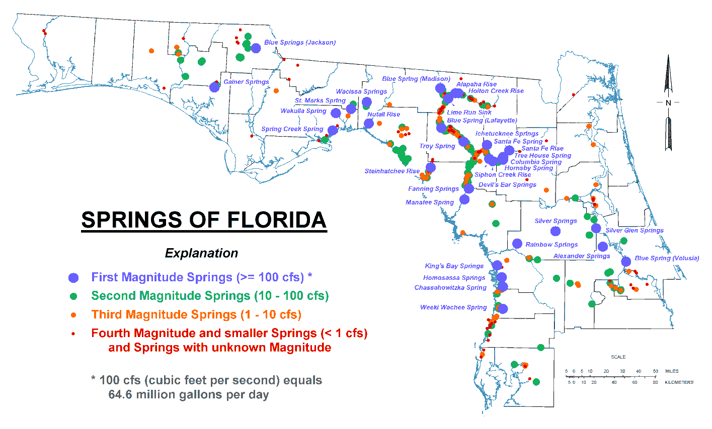

Ground Water
Florida is in the Coastal Plain physiographic province, which is blanketed by surficial sands and underlain by a thick sequence of bedded limestone and dolomite. Together the surficial sands, limestone, and dolomites form an enormous ground water reservoir that provides proportionally larger quantities of ground water than in any other state.

These sources of high-quality, potable ground water underlying virtually all of Florida supported average withdrawals of more than 6,873 MGD in 2005 (Marella, 2009). This remarkable resource supplies more than 90% of the drinking water for more than 18 million residents. In addition, ground water resources supply over 50% of all water needs, including agricultural, industrial, mining, and electric power generation.

Florida primarily relies on the following four aquifer systems as drinking water sources:

- The Floridan aquifer system, one of the most productive sources of ground water in the United States, extends across all of Florida, southern Georgia, and adjoining parts of Alabama and South Carolina. Many public water systems—including Jacksonville, Orlando, Clearwater, St. Petersburg, and Tallahassee—tap into the Floridan. It is also a major supplier of water for industrial, irrigation, and rural use. This aquifer provides 60% (4,124 MGD) of Florida’s potable water supplies.
- Unnamed surficial and intermediate aquifers, which are present over much of the state, are used when the deeper aquifers contain nonpotable water. They supply water needs for about 10% of the population, especially in rural locations. These aquifers provide 20% (1,375 MGD) of the state’s potable water supplies.
- In southeast Florida, the Biscayne aquifer supplies virtually all the water needs for over 4 million residents in densely populated Dade, Broward, Palm Beach and Monroe Counties. This aquifer provides 18% (1237 MGD) of Florida’s potable water supplies. The EPA has designated the Biscayne Aquifer as a sole source drinking water aquifer.
- The sand and gravel aquifer, the major source of water supply in the western part of the Florida Panhandle, provides 2% (137 MGD) of Florida’s potable water.

Surface Water–Ground Water Interactions
Florida’s low relief, coupled with its geologic history, has created unique hydrogeologic features. Large areas are characterized by karst topography, which forms when ground water dissolves limestone. Landforms in these areas include streams that disappear underground, springs and seeps where ground water rises to the surface, sinkholes, and caves. Surface water commonly drains underground and later reappears, sometimes in a completely different surface water basin from where it entered the ground. For example, drainage from a large karst area in Marion County provides water for Silver Springs, which discharges to the Ocklawaha River and then to the St. Johns River and the Atlantic Ocean. Karst areas in western Marion County provide water for Rainbow Springs, which discharges to the Withlacoochee River and then to the Gulf of Mexico.

Florida's sandy soils, high average rainfall, shallow water table, and porous karst terrain promote close and extensive interactions between ground water and surface water. By the same mechanisms, surface waters recharge underground aquifers. The fact that Florida contains more than one-third of the first-magnitude springs in the United States is an indication of significant ground water and surface water interchange. Most lakes and streams receive some ground water, but in a significant number of watersheds, ground water inflow contributes to the base flow for streams. In the Springs Coast region of western Florida, for example, ground water provides 70% to 80% of the flow in spring runs.

A hydrologic divide interrupts the movement of Florida’s ground water and surface water (Figure 2.4). The divide is represented by an approximate line extending from near Cedar Key on the Gulf Coast to New Smyrna Beach on the Atlantic Coast. Except for the St. Johns and Ocklawaha Rivers, little, if any, surface water or ground water moves across this barrier. Most major rivers north of the line receive part of their discharges from outside Florida, in addition to rain. South of the divide, rain is the sole fresh water source. Hydrologically, the half of Florida lying south of the divide is isolated. About 75% of the state’s population lives in this area in peninsular Florida.

Figure 2.4. Florida’s Hydrologic Divide

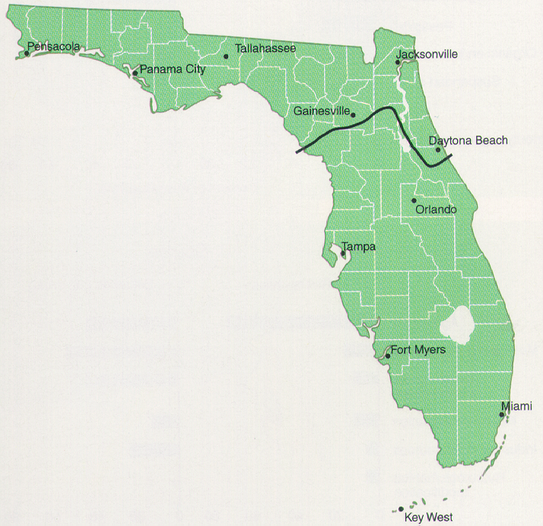

Source: Fernald and Purdum, 1998

Chapter 3: Public Health Issues and Emerging STATE Concerns and Initiatives

This chapter describes the major water quality-related public health issues and emerging concerns facing the state. It is important to note that Florida has well-established programs, including the permitting and Total Maximum Daily Load (TMDL) programs, that address these issues, and that Florida has made great progress in reducing pollutant discharges to state waters and restoring impaired waters. Chapter 11 describes these programs in detail, as well as specific initiatives designed to address emerging concerns. Specific examples of the progress that Florida has made towards reducing nutrient pollution in the Indian River Lagoon, Lake Apopka, Sarasota Bay, and Tampa Bay are available on the EPA Watershed Improvement Summaries website.

Public Health Issues

Drinking Water
FDEP has the primary role of regulating public water systems in Florida, under Chapter 403, Part IV, F.S., and by delegation of the federal program from the EPA. The section entitled Overview of Ground Water Protection Programs in Chapter 11 describes FDEP’s ongoing efforts to protect drinking water supplies.

A public water system is one that provides water to 25 or more people for at least 60 days each year or serves 15 or more service connections. These public water systems may be publicly or privately owned and operated. Additional information is available on the FDEP Drinking Water Program website.

The Florida Department of Health (FDOH) and the county health departments regulate very small water systems that provide water for public consumption, but that do not fall under the definition of public water systems. Additional information is available on the FDOH Bureau of Water Programs website. The water management districts regulate the construction of water wells, both public and private, and the quantities of water that may be extracted.

Arsenic has been found in potable water wells and monitoring wells in Florida. Regions with high exceedance levels include the Springs Coast, Lower St. Johns, Ocklawaha, Suwannee, Withlacoochee, and Tampa Bay Tributaries Basins. The source of arsenic in ground water may be naturally occurring, anthropogenic, or released into ground water because of human activities. Throughout Florida, arsenic is a naturally occurring, stable element associated with pyrite compounds, as well as with powellite compounds in some limestone formations in which ground water occurs. Potential anthropogenic sources include arsenic-based pesticides applied to cotton fields, citrus groves, golf courses, and cattle-dipping vats (which were used until the 1960s). Higher numbers of reported exceedances can be considered an artifact of the change in the EPA arsenic standard for ground water, which was reduced from 50 to 10 micrograms per liter (μg/L) in 2001, and was fully implemented in 2006.

Recent studies indicate that human disturbance that introduces water or oxygen into arsenic-bearing limestone can lead to the release of soluble arsenic from the rock matrix. Activities such as mining, well drilling, Aquifer Storage and Recovery (ASR) projects, (Arthur et al., 2002; Price and Pichler, 2006), or overpumping have all been shown to release previously stable arsenic into ground water. In addition, drought can lower the water table, allowing oxygen to permeate and leach arsenic compounds from sediments.

Healthy Beaches Program
As part of Florida’s Healthy Beaches Program, FDOH monitors the state’s coastal beaches for elevated levels of bacteria. In August 2000, the beach water sampling program was extended to all 34 of Florida's coastal counties through state legislation (Senate Bill [SB] 1412 and House Bill 2145) and funding. With additional funding from the EPA in 2002, the program was expanded to include weekly sampling for fecal coliform and enterococci bacteria at 304 beach locations throughout Florida.

In a healthy environment, an array of bacteria is normally found in the soil, on plants, on and in ourselves, our pets and other animals, and in water. When concentrations of bacteria are too high, they can present problems themselves, or they can be an indicator of other organisms that can cause problems to humans. The two bacteria types that normally inhabit the intestinal tract of humans and animals and are used as indicators of fecal pollution are fecal coliform and enterococci.

The presence of elevated levels of these bacteria in water is an indication of possible pollution that may come from stormwater runoff, pets, wildlife, or human sewage. While not necessarily pathogenic, their presence in high concentrations in recreational waters indicates that pathogens may be present. If waste pathogens are present and they are ingested while swimming, or if they enter the skin through a cut or sore, the bacteria may cause illness. The most commonly reported ailments are gastrointestinal distress and skin rashes. The rationale for selecting these two bacteria for analysis and the implications of the sampling results are described in more detail on the FDOH Florida Healthy Beaches Program website.

If a sampling event leads to a "poor" bacterial indicator result in a single sample, then the county health department immediately collects a resample or, if a resample cannot be taken, immediately issues an advisory. If a resample confirms the high result, an advisory is then issued, signs are posted parallel to the sample point, FDOH posts the results on its website, and the news media are notified.

If the total number of calendar days in a year that FDOH issues a swimming advisory exceeds 21 days for a given beach, FDEP places the waterbody on its list of potentially impaired waters (the Planning List), so that the bacteriological contamination can be verified and its sources identified and addressed.

The most recent sampling results and information on beach closures are available on the FDOH Florida Healthy Beaches Program website. Also available on the website is a program overview with the sampling history (1998 - 2000) of the original counties included in the program and the counties that were added.

Bacterial and Mercury Contamination
Assessment results indicate that several human health-related designated uses are not always maintained in Florida’s surface waters. Specifically, primary contact and recreation use support and shellfish harvesting use support are sometimes limited by the presence of bacteria in the water column, and fish consumption use support is commonly limited by the presence of mercury in fish tissue for a number of species in many waters across the state.

It is important to note, however, that these impairments are not based on documented impacts on public health. Florida has extensive monitoring programs that issue beach advisories, shellfish bed closures, and fish consumption advisories when ambient samples reach predetermined thresholds. These thresholds are conservatively designed to protect public health against the potential effects of exposure to bacteria (in water and shellfish) and mercury (in fish tissue).

The FDEP South Florida Mercury Science Program website provides information on the mercury issue and links to other useful websites dealing with mercury. Information on the latest fish consumption advisories is available on the FDOH Fish Consumption Advisory website. Information on shellfish bed closures is available on the FDACS Shellfish Harvesting website. Recent sampling results and information on beach closures are available on the FDOH Florida Healthy Beaches Program website.

Harmful Algal Blooms
Because of their potential public health threat, Florida closely tracks harmful algal blooms (HABs) in fresh waters as well as estuarine and marine waters. Typically caused by excess nutrients, these blooms may produce toxins that can harm humans through exposure to contaminated shellfish, fish, dermal contact, and even the inhalation of aerosols. They can also affect plant and animal communities. Additional information on HABs is available on the FDOH Aquatic Toxins Program website. Any illnesses caused by exposure to harmful algae can be reported to FDOH’s toll-free Aquatic Toxins Hotline (1-888-232-8635).

Freshwater HABs
The occurrence of cyanobacteria (or blue-green algae) blooms has received increased attention in recent years because of their potential to produce toxins that can harm humans, livestock, domestic animals, fish, and wildlife. Blooms of cyanobacteria are frequently associated with elevated nutrient concentrations, slow-moving water, and warm temperatures; however, significant blooms can occur almost any time of year due to Florida’s subtropical climate.

Cyanotoxins are chemicals naturally produced by some species of cyanobacteria that can damage the liver (hepatotoxins), nervous system (neurotoxins), and skin (dermatotoxins) of humans and other animals. Several cyanotoxins, namely microcystins and the lyngbyatoxins, are potential tumor promoters. Three classes of cyanotoxins (anatoxin-a, microcystin-LR, and cylindrospermopsin) are on the 2009 EPA Contaminant Candidate 3 List. The EPA uses this list to prioritize research and criteria development.

Potentially toxigenic cyanobacteria have at times been found statewide in river and stream systems, as well as lakes and estuaries. The results of the Cyanobacteria Survey Project (1999–2001), managed by the Harmful Algal Bloom Task Force at the FWC’s Fish and Wildlife Research Institute (FWRI), indicated that the taxa Microcystis aeruginosa, Anabaena spp., and Cylindrospermopsis raciborskii were the dominant species, while species with the genera Aphanizomenon, Planktothrix, Oscillatoria, and Lyngbya were also observed statewide but not as frequently. Cyanotoxins (microcystins, saxitoxin, cylindrospermopsins, and anatoxin) were also found statewide.

Measured concentrations of microcystins have been reported in some post-processed finished water from drinking water facilities in Florida. Over a period of about 9 months, the 2000 Cyanobacteria Survey Project focused on water treatment plants that produced drinking water from surface waters. On 6 occasions, microcystin levels (hepatotoxins) in finished samples were above the World Health Organization’s (WHO) suggested guideline level of 1 to 10 μg/L for drinking water. However, this level has a safety factor of 1,000 and is based on long-term exposure. Further, the sample deviation at these low concentrations raised the issue of quality assurance, particularly considering the use of new analytical procedures and the lack of laboratory certification. The results of a 2007 study by the FDEP Bureau of Laboratories indicated that there is as much as an order of magnitude difference in reported values between laboratories using different analytical methods.

Florida has not established any water quality standards for cyanotoxins. The WHO’s threshold is used as an indicator of potential adverse effects in potable drinking water. There are no established limits for fish tissue concentrations or recreational exposure. The FWC does not discourage people from eating fish from cyanobacteria bloom waters so long as the fish are active and appear healthy on the fishing line. FDOH recommends that people do not drink, recreate, or irrigate with water that is experiencing a cyanobacteria bloom.

Research by the FDEP Bureau of Laboratories on Microcystis aeruginosa bloom samples from Lake Munson in Leon County, Florida, indicates that even nontoxin-producing blooms can contain strains of M. aeruginosa that possess the gene for toxin production. This suggests that, for reasons yet unknown, nontoxin-producing blooms can become toxin-producing blooms under the right environmental conditions. This finding supports the FDOH guidance to stay out of bloom waters regardless of the toxin concentrations that may have been reported, as conditions and toxin concentrations can change rapidly.

Several drinking water facilities in Florida monitor for cyanotoxins. Reports from the WHO and other researchers around the world indicate that conventional treatment processes are effective at eliminating the algae and the toxin, so long as treatment media (e.g., activated carbon) in the systems are maintained. The taste, odor, and color associated with the bloom provide a clear indication of its presence and initiate the use of additional treatment. While these treatment techniques are used to control the taste, odor, and color of the water, they are also very effective at removing or degrading the toxins.

FDOH and FDEP have collaborated to create a new Cyanobacteria Bloom Module in the FDOH Foodborne, Waterborne, and Vectorborne Disease Surveillance System (FWVSS) database. The module allows each potential responding agency (e.g., FDOH and local county health units, FDEP, FWC, the water management districts, and FDACS) to enter a new case identification number for a cyanobacteria bloom. This system can send email notifications to the cyanobacteria bloom contacts in each agency whenever a new bloom is reported or a significant update is made to an existing case. The use of the new tool should help improve state agencies’ response to cyanobacteria blooms.

Estuarine and Marine HABS
With more than 50 marine and estuarine HAB species present, these species have the potential to affect public health, cause economic losses, affect living resources, disturb ecosystems, and generate water quality problems. Any highly concentrated bloom can reduce water quality, because decomposing and respiring cells contribute to the reduction (hypoxia) or absence of oxygen (anoxia), the production of nitrogenous byproducts, or the formation of toxic sulfides. Declining water quality can lead to animal mortality or chronic diseases, species avoidance of an area, and reduced feeding. Such sublethal, chronic effects on habitats can have far-reaching impacts on animal and plant communities.

Within the Gulf of Mexico, the National Oceanic and Atmospheric Administration (NOAA) Harmful Algal Bloom Operational Forecast System website provides information on the location, extent, and potential for the development or movement of HABs. The Gulf of Mexico Alliance, a partnership between Alabama, Florida, Louisiana, Mississippi, and Texas, is working to increase regional collaboration to enhance the Gulf’s ecological and economic health. Reducing the effects of HABs is one of its water quality priorities.

Red Tide
While most blooms of the dinoflagellate Karenia brevis occur on the west coast of Florida, red tides occasionally are entrained by the Gulf Stream and move to the east coast. Florida’s red tides have contributed to significant economic losses, causing declines in economically valued fisheries resources and impacting businesses that depend on local tourism. Historically, K. brevis red tides producing brevetoxins, which disrupt normal neurological processes, have caused the most significant problems. They have led to threats to the public from Neurotoxic Shellfish Poisoning (NSP) or from aerosolized toxins, annually caused the deaths of thousands of fish, and severely impacted endangered marine mammals, turtles, and birds. Fish kills caused by K. brevis were first documented in 1844, but the cause was not identified until the 1946–47 red tide outbreak.

Although human shellfish poisonings have been known in Florida since the 1880s, the connection with filter-feeding shellfish, toxicity, and K. brevis red tides was not identified until the 1960s. Over the past 40 years, human cases of NSP in Florida have only occurred when shellﬁsh were harvested illegally from state-regulated closed shellﬁsh beds or unapproved areas. There have been no human fatalities. People can suffer respiratory irritation and other pulmonary effects when brevetoxins become aerosolized through the disruption of K. brevis cells by breaking waves, surf, or onshore winds.

Although red tide blooms are natural events that start offshore, there is an ongoing scientific debate on whether land-based human influences affect the longevity and persistence of red tides once they come close to shore.

The existing red tide database suffers from a number of inconsistencies, including the presence of data collected for different purposes (experiments vs. monitoring), different sampling efforts over the years, and differences in collection and analysis techniques. Because of these issues, the FWC contracted with biostatisticians at the University of Florida (UF) to analyze the red tide data for long-term trends to determine what valid statistical conclusions could be drawn. UF concluded that the nature of the data prevented any valid statistical interpretation concerning trends and human influences on K. brevis blooms. A summary of the UF analysis is available on the FWC-FWRI website.

Current available data from the past 10 years suggest that K. brevis blooms may utilize a multitude of nutrient sources, which vary in significance depending on along-shore and offshore locations (Vargo et al., 2008). The data suggest that no single nutrient source (including terrestrially derived nutrients) is sufficient to support these blooms, and that while K. brevis can utilize these nearshore sources, the salinity restriction on K. brevis survival, which does not occur at salinity levels less than 24 parts per thousand (ppt), argues against a direct quantifiable link to land-based sources of nutrients. While data linking nutrient loading with K. brevis occurrence do not currently exist, the FWC’s FWRI is currently conducting research on this issue.

FWC–FWRI also monitors state waters for K. brevis red tides in cooperation with other state regulatory agencies, such as FDACS, FDOH, and FDEP; a volunteer network of boaters, charter boat captains, ﬁshermen, citizens; and Mote Marine Laboratory (MML). All analyses involve on-site testing, onboard testing, or onshore laboratory testing. Results are posted weekly on the FWC–FWRI website, and include data from a variety of sources. A toll-free number (1-866-300-9399) is also available to access current Florida red tide monitoring information.

To protect public health during bloom events, FDACS’ Division of Aquaculture closes shellﬁsh areas to harvesting when K. brevis cell counts are above 5,000 cells per liter. They are reopened when test results provided by FWC–FWRI are acceptable. The FDACS Shellfish Harvesting website lists current shellﬁsh area closures. This protocol is in compliance with Florida’s Marine Biotoxin Control Plan (FDACS, 2007).

The Harmful Algal Blooms Observing System (HABSOS) website is a web-based tool developed by a regional coalition of U.S. and Mexican federal and state agencies, as well as international researchers, to collect and disseminate information on K. brevis.

Other HAB Species
One of the most important HAB species in Florida other than K. brevis is the saxitoxin- producing dinoflagellate Pyrodinium bahamense var. bahamense. As a tropical species, it has seldom been observed at bloom levels north of Tampa Bay on the west coast and the Indian River Lagoon on the east coast, where the blooms are generally limited to May through October (Phlips et al., 2006). Pyrodinium can form intense blooms, which have been linked to the bioaccumulation of the neurotoxin in shellfish and fish (Landsberg et al., 2006). While these blooms raise serious concerns about impacts on the ecology of effected ecosystems and human health, the blooms have been occurring naturally at levels toxic to nearshore Florida fishes and seabirds for 25 million years (Emslie et al., 1996).

In Florida, Pyrodinium is most prevalent in flow-restricted lagoons and bays with long water residence times and salinities between 10 and 30 practical salinity units (psu). The latter conditions competitively favor Pyrodinium because of its slow growth rates and euryhaline character (Phlips et al., 2006). Blooms also appear to be accentuated during periods of elevated rainfall and nutrient loads to lagoons (Phlips et al., 2010a), suggesting a link between coastal eutrophication and the intensity and frequency of blooms. However, discharges of naturally tannic waters from wetlands during high rainfall events can also produce favorable conditions for this organism. These observations also point to the potential role of future climate trends in defining the dynamics of HAB species in Florida (Phlips et al., 2010a).

A number of other bloom-forming marine species have potentially harmful impacts in Florida; these can be roughly subdivided into two categories: toxin-producing species and taxa that form blooms associated with other important problems, such as low oxygen concentrations, physical damage to organisms, or general loss of habitat. Potential toxin-producing planktonic marine HAB species include the diatom group Pseudo-nitzschia spp., the dinoflagellates Alexandrium monilatum, Takayama pulchella, Karenia mikimotoi, K. selliformis, Karlodinium veneﬁcum, Prorocentrum minimum, P. rhathymum, and Cochliodinium polykrikoides, and the microflagellates Prymnesium spp., Chrysochromulina spp., and Chattonella sp. (Landsberg, 2002). Many of these species are associated with fish or shellfish kills in various ecosystems around the world (Landsberg, 2002).

Although all of these species have been observed at bloom levels in Florida (Phlips et al., 2010b), considerable uncertainty remains over the relative toxicity of the specific strains encountered in Florida. Certain species of benthic algae also produce toxins that can impact human health, such as the ciguatoxin-producing dinoflagellate Gamberdiscus toxicus, implicated in ciguatera incidents in south Florida (Landsberg, 2002).

The list of HAB species linked to hypoxia or other density-related issues (e.g., allelopathy, physical damage to gills of fish) is very long, including almost any species that reaches exceptionally high biomass. Examples include the widespread bloom-forming planktonic dinoflagellate Akashiwo sanguinea, in the Indian River Lagoon and the St. Lucie Estuary, and the cyanobacterium Synechococcus in Florida Bay (Phlips et al., 1999; Phlips et al., 2010b). Many ﬁsh kills, particularly those occurring in the early morning hours, are due to low DO levels in the water associated with algal blooms and are not necessarily the result of toxins. During the day, the photosynthetic activity of phytoplankton and other aquatic plants produces oxygen. At night, plants use oxygen, and this can decrease the levels of DO in restricted systems.

Another important issue associated with HABs is the loss or alteration of overall habitat quality. Prolonged and intense coastal eutrophication can result in the domination by a select few species, resulting in loss of diversity and alteration of food web structure and function. For example, during major Pyrodinium blooms, over 80% to 90% of total phytoplankton biomass is attributable to this toxic species (Phlips et al., 2006). Similar domination by single species occurs in benthic ecosystems, where massive blooms of green and red macroalgae have periodically over-run some shallow habitats of the Florida coast (Lapointe et al., 2007).

The FWC responds to discolored water, ﬁsh kills, and other mortality or disease events to determine whether the cause is environmental or human related. A statewide ﬁsh kill hotline
(1-800-636-0511) has been in operation for 15 years. The FWC ﬁsh kill database contains information on ﬁsh kills in Florida reported to the FWC from 1972 to the present. New ﬁsh kill reports can also be submitted through the website.

Emerging Concerns and Initiatives
FDEP has identified a variety of emerging state concerns related to water quality and is addressing these through the following special projects and initiatives:

- Nutrient Impairment. Significant progress has been made in reducing nutrient loads to state waters (see Chapter 11, which summarizes TMDL and BMAP activities that address nutrient loading to impaired waters and describes the permitting programs that have reduced nutrient loading from point sources and from new development). However, nutrient loading and the resulting HABs continue to be an issue. While the occurrence of blue-green algae is natural and has occurred throughout history, algal blooms caused by organic sources such as septic tanks, and nutrient loading from fertilizer use, together with a growing population and the resulting increase in residential landscapes, are an ongoing concern.
The state has collected and assessed large amounts of data related to nutrients. FDEP convened a Numeric Nutrient Criteria Technical Advisory Committee (Nutrient TAC) that has met 23 times since 2003. FDEP began rulemaking for the establishment of numeric nutrient criteria in lakes and streams in 2009, but suspended its rulemaking efforts when the EPA signed a Settlement Agreement that included a detailed schedule for the EPA to promulgate nutrient criteria, and provided its data to the EPA, which published proposed criteria in January 2010. Under the EPA's schedule, numeric nutrient criteria will be promulgated for lakes and flowing waters no later than October 2010. It will propose numeric nutrient criteria for south Florida canals and Florida's estuarine and coastal waters, as well as additional flowing waters criteria designed to protect downstream estuaries (termed “Downstream Protection Values”) in November 2011, with final promulgation no later than August 2012.
Additional information is available on the FDEP Numeric Nutrient Criteria Development website. The University of Florida Institute of Food and Agricultural Sciences (UF-IFAS) document, A Guide to EPA’s Proposed Numeric Nutrient Water Quality Criteria for Florida, provides summary information.
- Update of the State’s Stormwater Rule. Since the Stormwater Rule is currently based on a minimum treatment level of 80% average annual load reduction, urban stormwater remains a particular concern. In October 2007, FDEP’s Secretary and the Executive Directors of the state's five water management districts directed FDEP and district staff to develop a statewide stormwater treatment rule based on a performance standard requiring the lesser of an 85% nutrient load reduction, or postdevelopment stormwater nutrient loads that do not exceed predevelopment nutrient loads, where predevelopment land use is the natural vegetative community.
A Technical Advisory Committee (TAC) was established to provide input to FDEP and water management district staff on the draft Applicant’s Handbook and rule. The TAC met in 2008 and 2009. A revised draft rule and Stormwater Quality Applicant’s Handbook were published in February 2010, followed by a number of public workshops. Rule adoption will occur sometime between July 1, 2010, and June 30, 2011. Additional information is available on the FDEP Statewide Stormwater Treatment Rule Development website.
- Increasing Algal Growth in Springs. Water quality has declined in most springs since the 1970s; in particular, levels of nitrate (a nutrient) and blue-green algal growth in springs have increased. Recognizing the need to assess the status of blue-green algae not just in springs but all waters, in 1998 the Florida Legislature approved funding for the FWC’s Harmful Algal Bloom Task Force. This task force was initiated to address potential concerns regarding microalgae—including blue-green algae—through monitoring and investigation. The state continues to monitor blue-green algae closely and is taking long-term measures to reduce nutrient loading and improve water quality. FDOH’s Aquatic Toxins Program, in coordination with FDEP, has derived and implemented several tools to help identify and assess blue-green algae blooms.
- Mercury in Fish Tissue. In many coastal and inland waters, excessive concentrations of mercury in the tissue of some fish species limit the attainment of designated use. To address this issue, FDEP initiated the development of a statewide TMDL for mercury in 2008 that is scheduled to be completed by September 2012. The project consists of gathering and assessing a complex suite of data (on mercury emission, deposition, and aquatic cycling) and conducting modeling to quantify the needed mercury reductions in order to address mercury-related impairment in surface waters. Elements of the proposed statewide mercury TMDL study include the following:
- Collecting comprehensive, highly temporally resolved measurements of wet and dry mercury deposition at four locations, along with a suite of tracers that may be used to link deposition with sources. These sampling areas are referred to as “Supersites.”
- Identifying all significant sources of mercury, whether fixed or mobile, in Florida (an emissions inventory).
- Developing an empirical, probabilistic aquatic-cycling model to better understand how waterbody geochemistry affects mercury deposition with biomagnification in fish.
- Conducting atmospheric modeling (both dispersion and receptor models) to quantify Florida mercury sources versus those sources outside Florida that must be controlled to satisfy the TMDL.

- Saltwater Encroachment. In 2010, FDEP’s Florida Geological Survey (FGS), in concert with the Watershed Monitoring Section, completed Phase 2 of a springs and ground water quality assessment (using data collected from 2005 to 2009). The assessment interpreted data from the entire period of study (both phases covered 1991 to 2009) in context with climatic response, anthropogenic effects, and the development of predictive tools. Data indicate that freshwater ground water supplies are being affected by saltwater intrusion and encroachment. Induced saline-water upwelling and inland encroachment are becoming a significant environmental challenge, considering that the state needs plentiful, good-quality water for drinking, agricultural and industrial use, and the maintenance of natural communities.
To address water supply issues, the FGS has proposed the creation of a new multiagency working group to better align local, state and federal monitoring efforts, and to coordinate with the Florida Water Resources Monitoring Council. The objectives of the group would be to organize and initiate the multiagency statewide working group needed to address the issue of saltwater encroachment. There is further interest in developing and using “report card(s)” to increase public awareness and to keep elected officials and media engaged, in order to encourage the continued funding of relevant long-term programs, projects, and initiatives.
- Arsenic in Ground Water. Over the last two decades, high levels of arsenic, which can adversely affect human health, have been found in potable water wells and monitoring wells in Florida. Regions with high exceedance levels include the Springs Coast, Lower St. Johns, Ocklawaha, Suwannee, Withlacoochee, and Tampa Bay Tributaries Basins. The arsenic may be naturally occurring, anthropogenic, or released into ground water because of human activities. Recent reductions in the ground water arsenic criterion from 50 to 10 μg/L have increased the number of wells that may require remediation, such as the installation of filters.
To address the issue of arsenic contamination in ground water, FDEP’s Ground Water and Watershed Monitoring sections, the FGS, and the Southwest Florida Water Management District have initiated a focused five-year arsenic study in four counties in southwest Florida. The study, now in its third year, will evaluate the effect of land use, aquifer lithology, and water levels, or the interaction of all three, on arsenic levels in ground water and develop a predictive model to help identify the best locations for potable water wells with low arsenic-leaching potential.
- Emerging Substances of Concern. In December 2008, an FDEP workgroup released a report on strategies to effectively address a wide variety of potential contaminants in surface water and ground water. These contaminants, which are commonly referred to as Emerging Substances of Concern (ESOC), include global organic contaminants, endocrine-modulating chemicals, nanoparticles, and biological metabolites. Recent improvements in laboratory analytical methods have enabled the identification of these substances, which likely have been present in waters for decades. ESOC are particularly challenging for regulatory agencies because of their sheer numbers (there are about 14 million commercially available compounds in the United States) and because environmental risk cannot currently be meaningfully assessed for the vast majority of them.
The report identified several potential strategies for addressing ESOC, including the following:
- Preventing pollution through stakeholder education;
- Assessing ESOC data quality to better understand the magnitude of ESOC concentrations in the environment, given the incorrect reporting of ESOC levels by some key researchers;
- Asking the EPA for specific ESOC monitoring projects; and
- Improving coordination with federal agencies.

While the report describes all of the strategies, the workgroup concluded that preventing ESOC from entering the environment is the most effective control strategy, and FDEP’s initial efforts to address ESOC have focused on public education. Additional information and the workgroup report are available on the FDEP Watershed Management website.
- Ocean Acidification. Some recent studies have indicated a declining trend in pH in ocean waters on a global scale. Florida has many aquatic species that are sensitive to shifts in pH, and site-specific studies in Florida are needed. As part of a much larger statewide initiative to investigate global warming, FDEP has initiated activities to study potential impacts on the state’s aquatic resources of declining pH concentrations in the nation’s coastal waters. At this time, it is not known if this is an issue in Florida waters, but work continues in an effort to answer that question. FDEP’s Office of Coastal and Aquatic Managed Areas (CAMA) is coordinating the collection of carbon dioxide data in the vicinity of coral reefs. It will likely take several years of data collection before any trends are observed.
- Revision of Fecal Coliform Criteria. Based on beach advisories and shellfish bed closures, concentrations of bacteria above water quality standards in the water column sometimes limit primary contact and recreational use, as well as shellfish harvesting use support. However, these advisories or closures may not accurately identify the true risk to human health due to the limitations of the criteria used to assess these uses. Current methods for evaluating whether recreational and shellfish-harvesting areas meet water quality criteria are based on the culture of fecal bacteria used as indicators; these evaluations require more than 24 hours to perform and are not source specific, making them impractical for management decision making.
The EPA is currently revising recreational water quality criteria based on more rapid molecular methods; however, these methods have a number of disadvantages, as follows:
- They will still not be source specific;
- They will still not be rapid enough for beach managers to use for same day beach notifications;
- They will result in even greater numbers of waters being listed as impaired;
- They will be significantly more expensive; and
- They will result in questionable gains in human health protection.

FDEP is funding research to validate human-associated microbial source tracking tools to better distinguish when elevated fecal indicator levels are associated with human sources of fecal contamination, and not natural sources such as wildlife, in order to prioritize restoration efforts in areas with the greatest probable risk to human health.
- Revision of DO Criterion. Florida’s DO criterion currently requires that DO “shall not be less than 5.0 mg/L in Class I and III fresh waters. Additionally, normal daily and seasonal fluctuations above this level shall be maintained” (Subsection 62-302.530[31], Florida Administrative Code [F.A.C.]). Florida’s fresh waters are exposed to temperatures ranging from temperate to tropical, and many originate in low-oxygen environments, such as swamps and aquifers. These sources are naturally low in DO and have daily and seasonal fluctuations where DO falls below 5.0 mg/L. Since these levels result from natural conditions and native flora and fauna have adapted to this variability, they generally do not impact a waterbody’s designated use. Furthermore, Subsection 62-302.300(15), F.A.C., states that “the Department shall not strive to abate natural conditions”; therefore, FDEP is seeking to characterize natural conditions and identify causes of naturally low DO levels to more clearly define “natural conditions.”
To better understand the natural variability of DO and nutrient levels in freshwater aquatic systems around the state, FDEP conducted a major DO study in 2005–06. Approximately 350 sites in 6 different waterbody types were monitored quarterly. Data were collected on water quality, water chemistry, and biology. Data collected to date suggest that DO regimes naturally vary among different types of freshwater systems, and that revisions to the current DO criteria are warranted. However, FDEP is currently collecting additional data to better delineate those systems, characterize the respective DO regimes, and produce DO criteria that more accurately reflect reasonable expectations for those systems. Using this approach to refine Florida’s DO criterion will allow FDEP to determine when DO has been altered below these natural conditions and focus its TMDL development and restoration efforts on abating the causes of those alterations. FDEP is also considering revising the DO criteria for marine waters.

Chapter 4: Florida’s Approach to Monitoring Surface Water and Ground Water

Background
FDEP‘s approach to comprehensive surface water monitoring is designed to meet the monitoring-related requirements of the federal CWA, as well as Florida’s statutory and regulatory monitoring requirements. Broadly stated, these requirements are as follows:

Determine water quality standards attainment and identify impaired waters,
Identify the causes and sources of water quality impairments,
Establish, review, and revise water quality standards,
Support the implementation of water management programs,
Establish special monitoring for unique resources, and
Support the evaluation of program effectiveness.

FDEP continues to carry out extensive statewide monitoring in order to meet these federal and state requirements. However, other governmental entities at federal, state, regional, and local levels, as well as volunteer and private organizations, carry out monitoring. The bulk of the data used in this report comes from approximately 79 data providers across the state who conduct ambient monitoring of water chemistry, collect biological data, and sample sediments. In most cases, these data are initially loaded into the FL(orida) STOrage and RETrieval (STORET) database (FL STORET), and annually uploaded to the EPA national STORET database. FDEP evaluates these data to establish whether they meet quality assurance requirements of Chapter 62-160, F.A.C., and whether the data can be used to determine the health of the state’s ambient waters. Some qualifiers are placed on these data. For example, by law Florida LakeWatch data can be used only for nonregulatory proceedings and cannot be used for regulatory or enforcement activities. Chapter 5 provides additional details on these qualifiers.

Each governmental agency and volunteer or private organization has its own monitoring objectives, strategy, design, and indicators, as well as procedures for quality assurance, data management, data analysis and assessment, and reporting. However, any data derived by these organizations are beyond the scope of this report. The various federal, state, regional, and local agencies and organizations, including FDEP, that carry out water quality monitoring statewide, are as follows:

Federal Monitoring Agencies/Organizations

- Apalachicola National Estuarine Research Reserve
- Avon Park Air Force Range
- Charlotte Harbor National Estuary Program
- Eglin Air Force Base
- Guana Tolomato Matanzas National Estuarine Research Reserve
- Indian River Lagoon National Estuary Program
- National Oceanic and Atmospheric Administration
- Rookery Bay National Estuarine Research Reserve
- Sarasota Bay National Estuary Program
- Tampa Bay National Estuary Program
- U.S. Army Corps of Engineers
- U.S. Environmental Protection Agency
- U.S. Geological Survey

Out of State Monitoring Agencies/Organizations

- Georgia Department of Natural Resources

Florida Monitoring Agencies/Organizations

- Charlotte Harbor Aquatic/Buffer Preserves
- Estero Bay Aquatic Preserve
- Florida Department of Agriculture and Consumer Services
- Florida Department of Environmental Protection
- Florida Department of Health
- Florida Fish and Wildlife Conservation Commission
- Florida Marine Research Institute

Regional Monitoring Agencies/Organizations

- Choctawhatchee Basin Alliance
- Loxahatchee River District
- Peace River Manasota Regional Water Authority (PBS&J)
- Pensacola Bay Nutrient Study (Gulf Breeze)
- Northwest Florida Water Management District (NWFWMD)
- South Florida Water Management District (SFWMD)
- Southwest Florida Water Management District (SWFWMD)
- Southwest Florida Water Management District (Coast Project)
- St. Johns River Water Management District (SJRWMD)
- Suwannee River Water Management District (SRWMD)

Local Monitoring Agencies/Organizations

- Alachua County
- Bay County
- Broward County Environmental Monitoring Division
- Charlotte County Storm Water
- City of Cape Coral
- City of Jacksonville
- City of Lakeland
- City of Lynn Haven
- City of Key West
- City of Maitland
- City of Naples
- City of Orlando
- City of Panama City Beach
- City of Port St. Joe Project (Gulf Breeze)
- City of Port St. Joe Wastewater Treatment Plant
- City of Port St. Lucie
- City of Punta Gorda Utilities
- City of Sanibel
- City of Tallahassee
- City of Tampa
- City of West Palm Beach
- Collier County Pollution Control
- Dade County Environmental Resource Management
- East County Water Control District
- Escambia County Utility Association
- Hillsborough County
- Lake County Water Resource Management
- Lee County Environmental Laboratories
- Lee County Hyacinth Control District
- Manatee County Environmental Management
- McGlynn Laboratories and Leon County
- Okaloosa County Environmental Council
- Orange County Environmental Protection Division
- Palm Beach County Environmental Resource Management
- Pinellas County Department of Environmental Management
- Polk County Natural Resources Division
- Reedy Creek Improvement District Environmental Services
- Sarasota County Environmental Services
- Seminole County Public Works Roads/Stormwater
- Seminole Improvement District
- St. Johns County
- Volusia County Environmental Health Lab

Volunteer/Private Monitoring Agencies/Organizations

- Baskerville Donovan, Inc.
- Baywatch
- Biological Research Associates
- Bream Fisherman's Association
- Conservancy of Southwest Florida
- Environmental Research and Design, Inc
- Florida Center for Community Design + Research
- Florida LakeWatch (identification of potentially impaired waters only)
- Gulf Power Company
- IMC Agrico/Phosphates
- Janicki Environmental
- The Nature Conservancy of the Florida Keys
- Palm Coast Community Service Corp.
- Sanibel Captiva Conservation Foundation
- Southeast Environmental Research Center

Florida’s Integrated Water Resources Monitoring Program
As discussed earlier, water resource monitoring in Florida is conducted by FDEP, the water management districts, local governments, and other entities. Over the past decade, FDEP has worked closely with these monitoring entities to establish an Integrated Water Resources Monitoring (IWRM) Program that integrates surface water and ground water monitoring. Since it is fiscally and logistically prohibitive to sample every segment of river or stream, every acre of lake, or each individual monitoring well in the state annually, the IWRM also integrates three tiers of monitoring—statewide ambient monitoring networks that allow statistical inferences to be made about all waters in the state (Tier 1); strategic monitoring for verification of impairment and identification of causative pollutants (Tier 2); and specialized, site-specific monitoring (Tier 3) (Tables 4.1a through 4.1d). These three tiers are composed of several core monitoring programs in FDEP’s Division of Water Resource Management and Division of Environmental Assessment and Restoration. These tiers are not to be viewed as a prioritization structure; they simply reflect different categorical objectives.

The IWRM approach is consistent with the 2003 EPA guidance document, Elements of a State Water Monitoring and Assessment Program. In 2004, FDEP prepared and submitted a report on these elements for the different monitoring programs. The report, Elements of Florida’s Water Monitoring and Assessment Program, addresses the following 10 elements:

- Monitoring objectives;
- Monitoring strategy;
- Monitoring design;
- Indicators;
- Quality assurance;
- Data management;
- Data analysis and assessment;
- Reporting;
- Programmatic evaluation; and
- General support and infrastructure planning.

This section broadly discusses Elements 1 (monitoring objectives), 2 (monitoring strategy), 5 (quality assurance), 6 (data management), 9 (programmatic evaluation), and 10 (general support and infrastructure planning). The methodology and assessment sections of this chapter address Elements 3 (monitoring design), 4 (indicators), 7 (data analysis and assessment), and 8 (reporting).

Table 4.1a. FDEP's Tier I Monitoring Programs
This is a three-column table. Column 1 lists the program, Column 2 summarizes its activities, and Column 3 lists the resources addressed.
Program | Summary | Resources Addressed
Status Network | Consists of a probabilistic monitoring design to estimate water quality across the entire state based on a representative subsample of water resource types. | Large lakes, small lakes, rivers, streams, confined aquifers, and unconfined aquifers
Trend Network | Comprises a fixed station design to examine changes in water quality and flow over time throughout the state. | Rivers, streams, confined aquifers, and unconfined aquifers

Table 4.1b. FDEP's Tier I and Tier II Blended Monitoring Programs
This is a three-column table. Column 1 lists the program, Column 2 summarizes its activities, and Column 3 lists the resources addressed.
Program | Summary | Resources Addressed
Springs Initiative | Consists of a fixed station network of freshwater springs intended to enhance the understanding of Florida’s springs, stop the degradation and loss of spring flow, and restore springs to their former health. | First-magnitude springs, second-magnitude springs, subaquatic conduits, river rises, and coastal submarine springs

Table 4.1c. FDEP's Tier II Monitoring Programs
This is a three-column table. Column 1 lists the program, Column 2 summarizes its activities, and Column 3 lists the resources addressed.
Program | Summary | Resources Addressed
Strategic Monitoring Program | Addresses questions in specific basins and stream segments that are associated with determinations of waterbody impairment for the TMDL Program. | All surface waters based on the schedule in the watershed management cycle

Table 4.1d. FDEP's Tier III Monitoring Programs
This is a three-column table. Column 1 lists each program, Column 2 summarizes its activities, and Column 3 lists the resources addressed.
Program | Summary | Resources Addressed
Intensive Surveys for TMDLs | Provides detailed, time-limited investigations of the conditions of specific surface water resources that are identified as impaired. | Specific surface water resources identified as impaired
Water Quality Standards Development | Develops, evaluates, and revises new and existing surface water quality standards. Carries out monitoring to determine concentrations to protect aquatic life and human health. | Surface water and ground water
Site-Specific Alternative Criteria | Develops moderating provisions unique to a waterbody that does not meet particular water quality criteria, due to natural background conditions or human-induced conditions that cannot be controlled or abated. | Surface waterbodies to which particular ambient water quality criteria may not be applicable
Fifth-Year Inspections | Achieves and maintains compliance through sound environmental monitoring and permitting practices. | Surface waters that receive point source discharges

Element 1: Monitoring Objectives
The goal of FDEP’s monitoring activities is to determine the overall quality of the state’s surface and ground water, how they are changing over time, and the effectiveness of water resource management, protection, and restoration programs. Monitoring activities collectively address the following broad objectives:

Identify and document the condition of Florida’s water resources, spatially and temporally, with a known certainty;
Collect data on important chemical, physical, and biological parameters to characterize waterbodies based on thresholds in Chapters 62-302;
Collect data from impaired waters that will be used to evaluate changes over time in response to restoration activities;
Establish a database with known data quality objectives and quality assurance for the purpose of determining a basin’s long-term ecological health and establishing water quality standards;
Provide reliable data to managers, legislators, agencies, and the public, and aid in management decision making.

Element 2: Monitoring Strategy
Under FDEP’s IWRM approach, there are three tiers of monitoring, ranging from the general to the specific, designed to fill data gaps or support specific regulatory needs. Each of FDEP’s core monitoring programs has a detailed monitoring design, a list of core and supplemental water quality indicators, and specific procedures for quality assurance, data management, data analysis and assessment, reporting, and programmatic evaluation. FDEP relies on both chemical and biological sampling in its monitoring programs, and also conducts the bulk of the biological sampling that is carried out statewide. Tables 4.1a through 4.1d briefly describe FDEP’s approach and the water resources addressed for each FDEP monitoring program.

Based on the goals and objectives of each individual core monitoring program, sample locations are selected, monitoring parameters and sampling frequencies are determined, and sample collection and analysis are coordinated among FDEP’s districts and cooperating federal, state, and county agencies. This close coordination with other monitoring entities around the state is essential to prevent duplication and to maximize the number of waterbodies that are monitored on a regular basis.

FDEP’s three tiers of monitoring are as follows:

- Tier I consists of FDEP’s statewide surface water and ground water Status and Trend Networks. The Status Network employed a rotating-basin, probabilistic monitoring design to estimate water quality statewide during 2004–08, based on a representative subsample of water resource types. The Trend Network uses a fixed station design to examine changes in water quality and flow over time in selected river and stream sites throughout the state. The objective of these networks is to provide scientifically defensible information on the important chemical, physical, and biological characteristics of surface waters and major aquifer systems of Florida. Both networks are designed to measure condition using a variety of threshold values, including water quality standards, water quality indices, and other appropriate ecological indicators.
- Tier II includes the Strategic Monitoring Program, which is designed to address questions in specific basins and stream segments that are associated with determinations of waterbody impairment for the TMDL Program. In addition, this tier includes the Springs Initiative, which encompasses all of the extensive monitoring activities begun in 1999 to address the needs of Florida’s freshwater spring systems.
- Tier III addresses questions that are site-specific or regulatory in nature. Examples of Tier III monitoring activities include monitoring to determine whether moderating provisions such as site-specific alternative criteria (SSACs) should apply to certain waters, monitoring tied to regulatory permits issued by FDEP, monitoring to establish TMDLs (intensive surveys), and monitoring associated with evaluating the effectiveness of BMPs. Tier III also includes monitoring activities for the development of water quality standards.

Element 5: Quality Assurance
Because water quality monitoring is carried out by many agencies and groups statewide, FDEP has a centralized quality assurance (QA) program to ensure that data are properly and consistently collected. A Quality Assurance Officer coordinates and oversees data quality activities for each program. However, QA is the responsibility of everyone associated with sampling, monitoring, and data analysis. In September 2009, the FDEP Secretary approved a program directive, DEP 972, which further outlines this distributed responsibility, including each employee’s obligation to ensure that decisions are based upon defensible scientific information. Additionally, in support of the QA directive (DEP 972), all organizational units have been asked to update existing quality assurance manuals and plans, or for some groups, to create new quality plans describing internal QA procedures and criteria applied to all scientific data generation, review and use.

Training classes, which are conducted by FDEP staff, focus on program-specific sampling requirements. Any updates or changes to an individual program’s monitoring protocols are communicated through project management meetings, statewide meetings, and an Internet website.

The accuracy of field measurements is assessed through internal FDEP programs. Staff also monitor the on-site sampling environment, sampling equipment decontamination, sample container cleaning, the suitability of sample preservatives and analyte-free water, and sample transport and storage conditions, to control the impact that these activities may have on sample integrity and representativeness.

For each monitoring program, field staff are instructed to follow a comprehensive set of Standard Operating Procedures (DEP SOPs) for sample collection and field testing (e.g., field meter measurements). These are incorporated by reference in Chapter 62-160, F.A.C., Quality Assurance, and are specified in the FDEP document, Standard Operating Procedures for Field Activities (DEP-SOP-001/01, March 31, 2008). Other mandatory quality assurance requirements detailed in Chapter 62-160, F.A.C., are also followed.

Water quality samples are sent to FDEP’s Central Laboratory for analysis for the majority of programs; however, some external and overflow laboratories are also used. FDEP laboratories have SOPs for handling and analyzing samples, reporting applicable precision, accuracy and method detection limits, and for reporting data. Laboratory certification is maintained as required by Section 62-160.300, F.A.C. The Quality Assurance Rule, Chapter 62-160, F.A.C. (current effective date of 12/3/08) requires all entities submitting data to FDEP be certified by the National Environmental Laboratory Accreditation Conference (NELAC) through FDOH. The certification process requires the laboratory to develop a comprehensive quality manual for internal operations, analyze performance testing samples twice a year and undergo periodic systems audits conducted by FDOH inspectors. In addition, other mandatory QA requirements specified at 62-160, F.A.C. are followed. Contracted overflow labs are held to identical quality assurance requirements via detailed contract QA language.

The sampling and testing performance of field teams is evaluated by auditors from FDEP’s QA program, which is administered by the Standards and Assessment Section. Staff from other organizational units who have been trained as auditors also conduct these evaluations. The criteria for field performance are those specified by Chapter 62-160, F.A.C., the FDEP SOPs, internal quality manuals or plans, and where applicable, contractual requirements.

The quality of laboratory data and its usability for specific applications is also evaluated by auditors from FDEP’s QA program and other organizational units. The criteria for laboratory data usability are those specified by Chapter 62-160, F.A.C., the FDOH certification rule, Chapter 64E-1, F.A.C., the NELAC standards, which are incorporated by reference in Chapter 64E-1, F.A.C., data quality objectives specified in FDEP internal quality manuals or plans, other applicable FDEP program rules, and, where applicable, contractual requirements. In addition, a document describing the data evaluation process (Process for Assessing Data Usability, DEP-EA-001/07, March 31, 2008) is incorporated by reference into Chapter 62-160, F.A.C.

Various checklists have been developed to ensure the application of consistent and systematic procedures for auditing field and laboratory data.

Element 6: Data Management
The smooth and timely flow of water quality data from sample collectors and analytical agencies to data analysts is a high priority. FDEP’s Bureau of Assessment and Restoration Support and Bureau of Watershed Restoration house or oversee the majority of the surface and ground water resource monitoring programs described in this report. There are program-specific data management requirements; however, these bureaus serve as the principal warehouses for monitoring data. Assisted by cooperating federal, state, and county agencies, sample locations are selected, monitoring parameters and frequencies determined, and sample collection and analysis coordinated to meet data quality objectives.

Element 9: Program Evaluation
FDEP, in consultation with the EPA, reviews each monitoring program to determine how well the program serves its water quality decision needs for all state waters. EPA and FDEP QA audits are used in evaluating each program to determine how well each of the EPA’s recommended elements is addressed and how to incorporate needed changes and additions into future monitoring cycles. Additionally, DEP 972 (QA Directive) outlines FDEP’s distributed responsibility for ensuring that FDEP programs and organizational units meet established data quality objectives.

Element 10: General Support and Infrastructure Planning
The EPA’s general support and infrastructure planning element is encompassed by a number of activities. FDEP’s Central Laboratory provides laboratory support for all the core monitoring programs. Staff from all programs provide substantial support for planning and refining field logistics, and also provide data management, review, analysis and reporting. The results are often used to pursue and implement management actions to address areas of concern via differing program mechanisms.

Evolving Approaches to Monitoring
Florida continues to develop new approaches to monitoring. FDEP has developed a number of biological indices to characterize the condition of surface waters and has adopted these indices for use in water resource assessments at all three tiers of monitoring. FDEP currently uses the following indicators to measure the biological health of surface waters:

FDEP uses a macroinvertebrate-based index, BioReconnaissance (BioRecon), as a rapid assessment tool. The BioRecon is a 6-metric index ranging from 0 to 10. If a site scores less than 6 on the index, it is recommended for a further, more intensive study using the Stream Condition Index (SCI) method.
The SCI is a carefully calibrated macroinvertebrate index for use in flowing streams, and is used as a definitive measure of biological health for impairment. Data generated on the species composition and abundance of organisms in a stream are used to calculate 10 biological metrics (e.g., sensitive taxa, filter feeders, clingers, very tolerant taxa, Ephemeroptera and Trichoptera taxa). Points are assigned for each metric, based on regionally calibrated criteria.
Florida conducts, the Lake Vegetation Index (LVI), sampling to evaluate lake health based on plant community (macrophyte) composition. Using transects and a visual survey, the results can be compiled for a rapid assessment of lake condition.
A Wetland Condition Index, using vegetation, macroinvertebrates, and algae, has been developed for some freshwater wetland systems (forested wetlands and depressional wetlands; a pilot study for strands and floodplains was completed in 2005). This tool is being used to refine FDEP’s rapid wetland assessment methodology for permitting/mitigation and to assess the effectiveness of wetland restoration projects.
Florida has developed geochemical- and biology-based tools to measure the quality of sediments in marine and freshwater systems. For the 2010 Integrated Report, sediments were collected from a statistical sampling of lakes in the state as part of the Status Network. The resulting sediment chemistry results were first evaluated with a geochemical tool that identifies anthropogenic metals pollution and distinguishes it from naturally occurring sediment metals concentrations. Next, a biology-based sediment quality tool was used to estimate the levels of potentially toxic contaminants in sediments.

Chapter 5. Design for the Status and Trend Networks

Background
The 2002 EPA Integrated Report guidance on the requirements for water quality assessment, listing, and reporting under Sections 303(d) and 305(b) of the CWA states that “. . . a probabilistic monitoring design applied over large areas, such as a state or territory, is an excellent approach to producing, with known confidence, a ‘snapshot’ or statistical representation of the extent of waters that may or may not be impaired. A probabilistic monitoring design can assist a state or territory in determining monitoring priorities and in targeting monitoring activities” (EPA, November 19, 2001). Beginning in 2000, the Status Monitoring Network (Status Network), based on this probabilistic design, provided an unbiased, cost-effective subsampling of these resources. Florida adopted this approach so that the condition of the state’s surface and ground water resources could be estimated with a known statistical confidence. Data produced by the Status Network complements traditional CWA 305(b) and 303(d) reporting.

In addition, FDEP has designed a Trend Monitoring Network (Trend Network) to monitor changes in water quality in rivers, streams, and aquifers (via wells) over time. To achieve this goal, sites at fixed locations are sampled monthly or quarterly. The Trend Network complements the Status Network by providing spatial and temporal information about resources and potential changes from anthropogenic or natural influences, including extreme events (i.e., droughts and hurricanes).

The following resources are monitored in the Status and/or Trend Networks:

- Rivers and streams (including canals): Rivers, streams, and canals that are sampled include linear waterbodies with perennial flow that are waters of the state (Chapter 403, F.S.) or flow into waters of the state.
- Lakes (Status Network only): Lakes include natural bodies of standing water and reservoirs that are waters of the state and are designated as lakes on the USGS re-leveled National Hydrography Dataset (rNHD). The lakes population does not include many types of artificially created waterbodies, or streams/rivers impounded for agricultural use or private water supply.
- Ground water (confined and unconfined aquifers): The term ground water, as used here, refers to those portions of Florida’s aquifers that have the potential for supplying potable water or affecting the quality of currently potable water. However, this does not include ground water that lies directly within or beneath a permitted facility’s zone of discharge or water influenced by deep well injection (Class I and II wells).

Neither the Status Network nor the Trend Network is currently intended to monitor estuaries, springs, wetlands, or marine waters. Other sections within FDEP regulate and monitor these resources.

Status Network Monitoring
Stratified, random sampling (probabilistic) networks, such as the Status Network, sample predefined geographic subunits (basins) that together comprise the whole state. The resulting data can address questions at statewide and specific basin scales.

The state is divided into 29 basins as the foundation for the basin assessments (Table 5.1). During the five-year cycle of the Status Network (January 2004 through December 2008), all basins were sampled in a predetermined sequence, using the five-year rotation design adopted by FDEP’s Watershed Management Program. The basins were sampled in order; however, sampling was conducted one to two years prior to the basin assessments to allow the Status Network data to be available for these assessments.

Table 5.1. Basin Groups for Implementing the 2004–08 Statewide Assessment
This is a six-column table. Column 1 lists the FDEP districts and Columns 2 through 5 list the Group 1 through 5 basins, respectively.

- = Empty cell/no basin sampled
FDEP District | Group 1  Basins  (2004) | Group 2  Basins  (2005) | Group 3  Basins  (2006) | Group 4  Basins  (2007) | Group 5  Basins  (2008)
Northwest | Ochlockonee–  St. Marks | Apalachicola–Chipola | Choctawhatchee– St. Andrew | Pensacola | Perdido
Northeast | Suwannee | Lower St. Johns | - | Nassau–St. Marys | Upper East Coast
Central | Ocklawaha | Middle St. Johns | Upper St. Johns | Kissimmee River | Indian River Lagoon
Southwest | Tampa Bay | Tampa Bay Tributaries | Sarasota Bay–Peace–Myakka | Withlacoochee | Springs Coast
South | Everglades West  Coast | Charlotte Harbor | Caloosahatchee | Fisheating Creek | Florida Keys
Southeast | Lake Okeechobee | St. Lucie–Loxahatchee | Lake Worth Lagoon–  Palm Beach Coast | Southeast Coast–Biscayne Bay | Everglades

The Status Network uses the Generalized Random Tessellation Stratified (GRTS) sampling design, supported by the EPA’s Environmental Monitoring and Assessment Program (EMAP), to select sampling sites. Geographic stratification breaks the state into basins, from which the sample sites are chosen from a target population (list frame) using simple random selection. GRTS design ensures that the sites are representative of the target resources and that their selection is not biased.

FDEP made adjustments to the GRTS sample design due to the unequal distribution of water resources. For example, there are few lakes in the southern portion of the state, which is dominated by wetlands and canals. Other factors, such as periods of drought or denials of access from large landowners, can limit the list of possible sites to sample. Target resource lists are continually updated via field staff comments.

Water Resource Types
The parent populations for the Status Network are all statewide surface and ground waters. The following water resources are the target populations:

- Surface Water—Florida’s surface waters are diverse and challenging to categorize. Surface waters are divided into two groups: flowing (lotic) or still (lentic). The lotic group consists of rivers, streams, springs, and canals. In Florida, the lentic group consists of many types of natural lakes, including sand hill lakes, sinkhole lakes, oxbow lakes, and established reservoirs. These range in size from less than an acre to over 500,000 acres. Artificial waterbodies, such as stormwater retention ponds, impoundments used for agriculture, golf course ponds, or other man-made water features that are not waters of the state are common but are not part of the target population, and are removed from the resource list frame.
- Rivers, Streams, and Canals—Flowing surface waters that are waters of the state are divided into rivers or streams based on size, as recommended by FDEP and water management district staff. Large rivers are initially identified, and the remaining, smaller flowing surface waters are classified as streams. Rivers and streams that are mostly or entirely channelized are deemed canals and are still considered part of the target population. Segments of rivers and streams that are impounded are not included in this resource.
- Large and Small Lakes—Lakes are subdivided into two populations: (1) small lakes between 2.5 and 25 acres; and (2) large lakes over 25 acres. The differentiation on the basis of size is intended to accommodate different sampling strategies and allows better representation of the resource types. If all lakes were in one category, the size of large lakes would skew site selection and cause small lakes to be under-represented.

- Ground Water—Ground water resources are subdivided into two target populations for the purposes of sampling and resource characterization: (1) unconfined aquifers and (2) confined aquifers. Unconfined aquifers are near the land surface and can be readily affected by human activities. The confined aquifer target population includes aquifers that are below a confining unit and are heavily used as a source of water. Individual wells are selected from an annually updated list provided to FDEP by the water management districts. The ground water target population is chosen to represent ambient ground water conditions, avoiding wells in areas of known contamination and saltwater intrusion. Only upgradient wells from FDEP-permitted facilities, such as regulated landfill or wastewater treatment plants, are included on the list and considered for sampling. The target population also includes public supply wells because pumping typically removes high volumes of water.

Geographic Design and Site Selection
Location information for the state’s water resources resides in a Geographic Information System (GIS) database. Spatial representations of the targeted water resources are sent in a GIS file with associated information (metadata) to the EPA in Corvallis, Oregon, for site selections. Thirty random primary sites and a 5-time oversample (alternate sites), for a total of 180 possible sites, are selected from each water resource type in each basin, resulting in 1,080 potential sample sites statewide. The alternate sites are required due to the high probability of sampling problems, such as landowner denials of access, dry resources, and other challenges associated with random versus fixed station sampling designs.

Sampling and Frequency
The annual goal of the Status Network is to collect 30 samples from each water resource type in the basin, for a total of 180 samples statewide. Figure 5.1 represents the sampling scheme used from 2004 to 2008. Each water resource type was sampled over a two-month period, with a third “overflow” month available if needed. The state is divided into two sections, Panhandle and Peninsula, and sample collection is scheduled when water quality indicators are expected to show the greatest response or the least variability.

Figure 5.1. Status Network Sampling Periods for the Florida Panhandle and Florida Peninsula

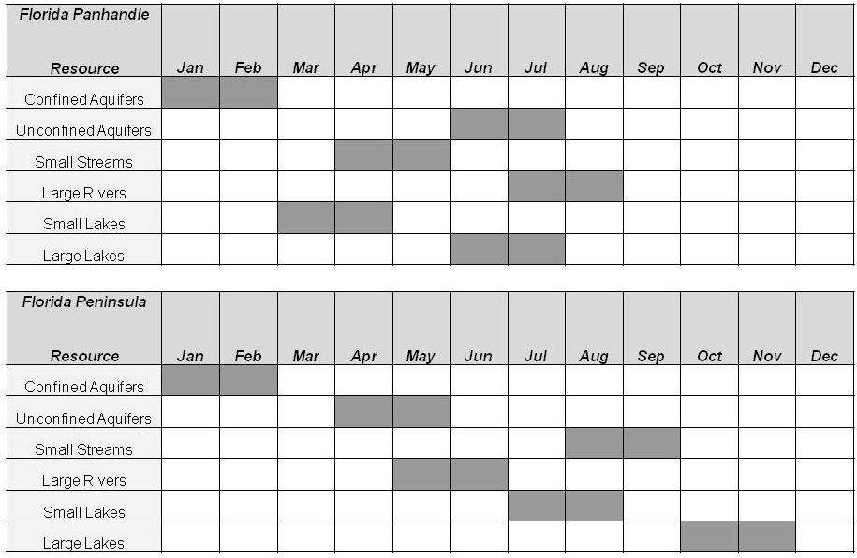

Status Network Core and Supplemental Indicators
While most water quality monitoring has historically focused on chemistry, FDEP’s Status and Trend Networks expand this scope to include biological and physical indicators. Together, the chemical, physical, and biological indicators provide scientific information about the condition of the state’s water resources and whether they meet their designated uses based on state and EPA guidance. Core indicators provide information about the chemical, physical, and biological status of surface and ground water, including suitability for human and aquatic uses. These data can be used to gage condition based on water quality standards or guidance. Supplemental indicators provide additional information and aid in screening for potential pollutants of concern. Certain biological indicators are collected only in rivers, streams, and lakes (i.e., chlorophyll a).

These core and supplemental indicators are often chosen to support special projects or used to develop water quality criteria. Some indicators are combined to form indices that evaluate waterbody condition—for example, the Trophic State Index (TSI) uses TN, TP, and chlorophyll a values to provide a broader understanding of a waterbody’s status. Selected indicators, such as chloride, nitrate, and bacteria, serve to assess the suitability of ground water for drinking water purposes. Likewise, the indicator lists for surface water resources are selected to detect threats to water quality, such as nutrient enrichment, which can lead to eutrophication and habitat loss. The Status Network has supported the development of biological indices to evaluate waterbody condition in Florida, and includes sampling for both the Stream Condition Index [SCI] and the Lake Vegetation Index [LVI]).

In addition to the suite of water quality indicators (Tables 5.2a through 5.2f), sediment chemistry is a useful supplemental indicator of an aquatic system’s ecological health (Tables 5.3a through 5.3c). Florida has developed geochemical and biological-based tools to assess sediment quality. The interpretation of sediment metals data is not straightforward because metals occur naturally in Florida sediment. Thus, depending on the source region, Florida sediment metal concentrations range by two orders of magnitude. FDEP uses the guidance outlined in An Interpretative Tool for the Assessment of Metal Enrichment in Florida Freshwater Sediment (Carvalho and Schropp et al., 2003), which estimates contamination through the use of a statistical normalizing technique. Additionally, FDEP follows the guidance outlined in Development and Evaluation of Numerical Sediment Quality Assessment Guidelines for Florida Inland Waters (MacDonald Environmental Sciences Ltd. and USGS, 2003), a biology-based tool that estimates the effects of potentially toxic contaminants in lake sediments.

Table 5.2a. Status Network Core and Supplemental Indicators for Field Measurements

Note: For Tables 5.2a through 5.2f, all samples are unfiltered unless stated. All methods, unless otherwise stated, are based on EPA 600, Methods for Chemical Analysis of Water and Wastes.

This is a three-column table. Column 1 lists the indicator, Column 2 lists the analytical method numbers, and Column 3 lists the sampled resource(s).

Field Measurement Indicator | Analysis Method | Sampled Resource(s)
pH | Method 150.1 | Lakes, Streams/Rivers, Aquifers
Temperature | Method 170.1 | Lakes, Streams/Rivers, Aquifers
Specific Conductance | Method 120.1 | Lakes, Streams/Rivers, Aquifers
DO | Method 360.1 | Lakes, Streams/Rivers, Aquifers
Turbidity | DEP-SOP-001/01 FT 1600 | Aquifers
Secchi Depth | Welch (1948); EPA 620/R-97/001 | Lakes, Streams/Rivers
Total Depth | Manual/electronic measuring device | Lakes, Streams/Rivers
Sample Depth | Manual/electronic measuring device | Lakes, Streams/Rivers
Micro Land Use | Sampling manual (01/09), Section 4 | Aquifers
Depth to Water | Steel tape and/or chalk | Aquifers

Table 5.2b. Status Network Core and Supplemental Indicators for Biological and Microbiological Indicators
This is a three-column table. Column 1 lists the indicator, Column 2 lists the analytical method numbers, and Column 3 lists the sampled resource(s).

¹ Dropped in 2005
² 2004–2007 SM 9230C
Biological/Microbiological Indicator | Analysis Method | Sampled Resource(s)
Chlorophyll a | SM 10200 H (modified) | Lakes, Streams/Rivers
Biological Community (SCI) | SM 10500 C (modified) | Streams/Rivers
Algal Growth Potential¹ | Method 9-78-018 (modified) | Small Lakes
Phytoplankton | SM 10200 F.1; 10200 F.2 | Lakes
Habitat Assessment | DEP-SOP-001/01 FT 3000 | Streams/Rivers
LVI | DEP-SOP-001/01 FS 7220 | Small Lakes
Total Coliform | SM 9222B | Aquifers
Fecal Coliform | SM 9222D | Lakes, Streams/Rivers, Aquifers
Enterococci | EPA 1600² | Lakes, Streams/Rivers

Table 5.2c. Status Network Core and Supplemental Indicators for Organic and Nutrient Indicators

This is a three-column table. Column 1 lists the indicator, Column 2 lists the analytical method numbers, and Column 3 lists the sampled resource(s).
Organic/Nutrient Indicator | Analysis Method | Sampled Resource(s)
Nitrate + Nitrite | Method 353.2 | Lakes, Streams/Rivers, Aquifers
Ammonia | Method 350.1 | Lakes, Streams/Rivers, Aquifers
Total Kjeldahl Nitrogen (TKN) | Method 351.2 | Lakes, Streams/Rivers, Aquifers
Phosphorus | Method 365.1/365.4 | Lakes, Streams/Rivers, Aquifers

Table 5.2d. Status Network Core and Supplemental Indicators for Major Ion Indicators

This is a three-column table. Column 1 lists the indicator, Column 2 lists the analytical method numbers, and Column 3 lists the sampled resource(s).
Major Ion Indicator | Analysis Method | Sampled Resource(s)
Chloride | Method 300 | Aquifers
Sulfate | Method 300 | Aquifers
Fluoride | Method 340.2 | Aquifers
Calcium | Method 200.7 | Aquifers
Magnesium | Method 200.7 | Aquifers
Sodium | Method 200.7 | Aquifers

Table 5.2e. Status Network Core and Supplemental Indicators for Metal Indicators

This is a three-column table. Column 1 lists the indicator, Column 2 lists the analytical method numbers, and Column 3 lists the sampled resource(s).
Metal Indicator | Analysis Method | Sampled Resource(s)
Aluminum, Arsenic, Calcium, Cadmium, Chromium, Copper, Iron, Lead, Magnesium, Manganese, Sodium, Zinc | Method 200.7/200.8 | Aquifers

Table 5.2f. Status Network Core and Supplemental Indicators for Physical Property Indicators
This is a three-column table. Column 1 lists the indicator, Column 2 lists the analytical method numbers, and Column 3 lists the sampled resource(s).

¹ Added in 2006
Physical Property Indicator | Analysis Method | Sampled Resource(s)
Alkalinity | Method 310.1 | Aquifers
Turbidity (Lab) | Method 180.1 | Lakes, Streams/Rivers, Aquifers
Specific Conductance (Lab)¹ | Method 120.1 | Lakes, Streams/Rivers, Aquifers
Color | Method 110.2 | Lakes, Streams/Rivers, Aquifers
Total Dissolved Solids | Method 160.2 | Aquifers

Table 5.3a. Status Network Organic and Nutrient Indicators for Sediment Analysis in Lakes

Note: For Tables 5.3a through 5.3c, all methods, unless otherwise stated, are based on EPA 600, Methods for Chemical Analysis of Water and Wastes.

This is a two-column table. Column 1 lists the indicators and Column 2 lists the analytical method numbers.
Sediment Organic/Nutrient Indicator | Analysis Method
Total Organic Carbon (TOC) | In-house based on 415.1
TP | Method 365.4
TKN | Method 351.2

Table 5.3b. Status Network Metal Indicators for Sediment Analysis in Lakes
This is a two-column table. Column 1 lists the indicators and Column 2 lists the analytical method numbers.
Sediment Metal Indicator | Analysis Method
Aluminum, Arsenic, Cadmium, Chromium, Copper, Iron, Lead, Nickel, Silver, Zinc | Method 6010B/6020
Mercury | DEP-SOP-001/01 Hg-008-3 (based on EPA 7471)

Table 5.3c. Status Network Organic Indicators for Sediment Analysis in Lakes

This is a two-column table. Column 1 lists the indicators and Column 2 lists the analytical method numbers.
Sediment Organic Indicator | Analysis Method
Polychlorinated Biphenyls (PCBs) | EPA 8080 (modified)
Polynuclear Aromatic Hydrocarbons (PAHs) | EPA 8270
Organochlorine Pesticides | EPA 8081A (modified)

Status Monitoring Network Design Changes
Starting in 2009, the Status Network was changed to an annual assessment of statewide water resource condition (Monitoring Strategy Design Document). For this assessment, the state is divided into six zones or reporting units (Figure 5.2). As in the previous cycle of sampling reported in this document, the design is based on four surface water resources (rivers, streams, large lakes, and small lakes) and two ground water resources (confined and unconfined aquifers).

The Status Network design has been changed in scope, but is still based on collecting a statistically valid number of samples for all resources to make an annual estimate of the condition of the state’s water resources. Sixty sites for each surface water resource type are distributed throughout the state (10 in each of the 6 zones), and 120 sites for each ground water resource type are distributed throughout the state (20 in each zone). Overall, fewer samples will be collected to make the statewide estimate; however, statewide condition will be assessed and can be reported on annually, rather than every 5 years. Based on these sample sizes, the 95% confidence interval for the estimate of statewide condition is ±12% for surface water and ± 9% for ground water.

Another significant design change is that surface water samples will be collected twice a year at each site. This will address questions about whether surface waters may be influenced by seasonality and changes in condition due to rainfall/drought events, and whether a five-year monitoring design with single sampling periods might misrepresent overall water quality conditions. These questions about variation in surface water quality will be answered based on the results of the initial and repeat sampling, and by collecting waters in different seasons statewide. The results from these two events will be evaluated to determine if the response compared with the thresholds is significant enough to warrant the second sample.

The results from earlier ground water analyses have clearly indicated that there are no seasonal trends in ground water quality. Therefore, no repeat sample will be collected for ground water resources.

A long-term benefit to the annual approach for both surface and ground water is the ability to examine trends in water quality over time. The annual approach, coupled with the existing Trend Network monthly sampling (discussed in the next section), will provide a more comprehensive picture of changes in water quality.

Future Design and Reporting
The statewide annual assessments from the Status Network will be available for the 2012 Integrated Report cycle. The results from both the Status and Trend Networks will continue to provide data on chemical, physical, and biological indicators to managers, other programs, and data users to complement their programs. Revisions to the design are anticipated as agency or other program needs change, and will be reported through the modification of the Monitoring Strategy Design Document submitted to the EPA.

Figure 5.2. Status Monitoring Network Reporting Units
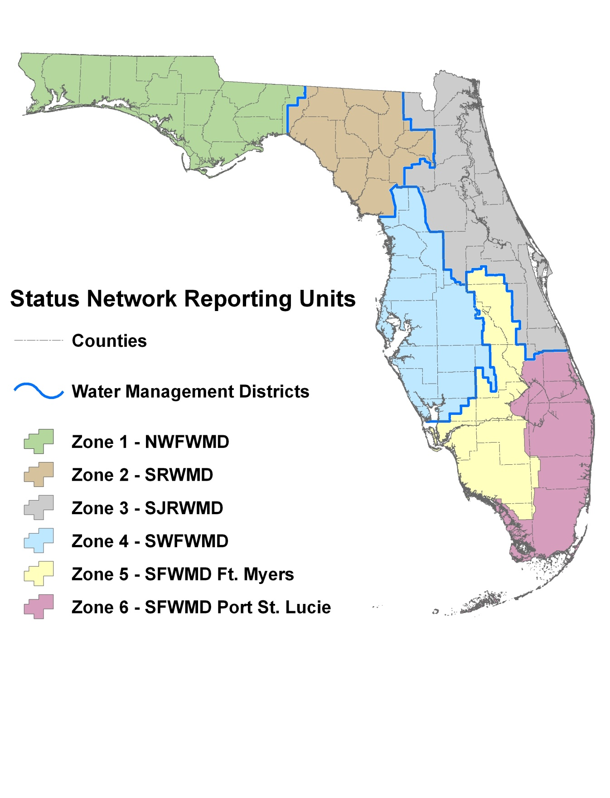

Trend Network
The Trend Network is designed to determine if there are changes over time in the State’s major rivers and aquifers based on selected indicators (Tables 5.4a through 5.4f) at fixed sites. To complete a statistically valid trend analysis, any periodicity implicit in the data must be identified by collecting a sufficient number of samples at regular intervals. For example, variability in data over seasons (seasonality) has to be shown for many surface water constituents; therefore, an effort should be made to collect at least one sample in each season, four per year at a minimum. However, surface waters are much more likely to be influenced by seasonal changes than ground water and, to prevent any aliasing to the data, sampling should be conducted monthly.

Trend Network data provide a temporal reference on a regional scale for the Status Network. To facilitate the comparison of Trend Network results with those of the Status Network, FDEP separates the Trend Network into surface water (rivers and streams) and ground water (confined and unconfined aquifers) resources.

Table 5.4a. Trend Network Field Measurement Indicators

Note: For Tables 5.4a through 5.4f, all methods, unless otherwise stated, are based on EPA 600, Methods for Chemical Analysis of Water and Wastes.

This is a four-column table. Column 1 lists the indicator, Column 2 lists the analytical method number, Column 3 lists the sampling regime for surface waters, and Column 4 lists the sampling regime for ground waters.

X = Other sample or measurement; N/A = Not applicable
Field Measurement Indicator | Analysis Method | Surface Water | Ground Water
pH | Method 150.1 | X | X
Temperature | Method 170.1 | X | X
Specific Conductance/Salinity | Method 120.1 | X | X
Dissolved Oxygen | Method 360.1 | X | X
Turbidity | DEP-SOP-001/01 FT 1600 | N/A | X
Secchi Depth | Welch (1948); EPA 620/R-97/001 | X | N/A
Total Depth | Manual/electronic measuring device | X | N/A
Sample Depth | Manual/electronic measuring device | X | N/A
Depth to Water | Steel tape and/or chalk | N/A | X

Table 5.4b. Trend Network Biological and Microbiological Indicators

This is a four-column table. Column 1 lists the indicator, Column 2 lists the analytical method number, Column 3 lists the sampling regime for surface waters, and Column 4 lists the sampling regime for ground waters.

¹ 2004–07 SM 9230C
T = Total sample (unfiltered sample); X = Other sample or measurement; N/A = Not applicable
² Collected once a year per site
Biological/Microbiological Indicator | Analysis Method | Surface Water | Ground Water
Chlorophyll a | SM 10200 H (modified) | T | N/A
Biological Community (SCI) | SM 10500 C (modified) | X^{1,2} | N/A
Habitat Assessment | DEP-SOP-001/01 FT 3000 | X² | N/A
Total Coliform | SM 9222B | N/A | T
Fecal Coliform | SM 9222D | T | T
Enterococci | EPA 1600¹ | T | N/A

Table 5.4c. Trend Network Organic and Nutrient Indicators
This is a four-column table. Column 1 lists the indicator, Column 2 lists the analytical method number, Column 3 lists the sampling regime for surface waters, and Column 4 lists the sampling regime for ground waters.

¹ Collected once a year per site
² Total analysis added annually in 2008
³ Dropped in 2008
T = Total sample (unfiltered sample); D = Dissolved sample (filtered sample)
Organic/Nutrient Indicator | Analysis Method | Surface Water | Ground Water
TOC | Method 415.1 | T | T
Nitrate + Nitrite | Method 353.2 | T | D/T^{1,2}
Ammonia | Method 350.1 | T | D/T^{1,2}
TKN | Method 351.2 | T | D/T^{1,2}
Phosphorus | Method 365.1/365.4 | T | D/T^{1,2}
Orthophosphate | Method 365.1 | D³ | D

Table 5.4d. Trend Network Major Ion Indicators
This is a four-column table. Column 1 lists the indicator, Column 2 lists the analytical method number, Column 3 lists the sampling regime for surface waters, and Column 4 lists the sampling regime for ground waters.

¹ Collected once a year per site
² Total analysis added annually in 2008
T = Total sample (unfiltered sample); D = Dissolved sample (filtered sample); N/A = Not applicable
Major Ion Indicator | Analysis Method | Surface Water | Ground Water
Chloride | Method 300 | T | D/T^{1,2}
Sulfate | Method 300 | T | D/T^{1,2}
Fluoride | Method 340.2 | T | D/T^{1,2}
Calcium | Method 200.7 | T | D/T¹
Magnesium | Method 200.7 | T | D/T¹
Sodium | Method 200.7 | T | D/T¹
Potassium | Method 200.7 | T | D/T^{1,2}

Table 5.4e. Trend Network Metal Indicators
This is a four-column table. Column 1 lists the indicator, Column 2 lists the analytical method number, Column 3 lists the sampling regime for surface waters, and Column 4 lists the sampling regime for ground waters.

¹ Collected once a year per site
² Total analysis added annually in 2008
T = Total sample (unfiltered sample)
Metal Indicator | Analysis Method | Surface Water | Ground Water
Aluminum, Arsenic, Calcium, Cadmium, Chromium, Copper, Iron, Lead, Magnesium, Manganese, Sodium, Zinc | Method 200.7/200.8 | T^{1,2} | T¹

Table 5.4f. Trend Network Physical Property Indicators
This is a four-column table. Column 1 lists the indicator, Column 2 lists the analytical method number, Column 3 lists the sampling regime for surface waters, and Column 4 lists the sampling regime for ground waters.

¹ Collected once a year per site
² Total analysis added annually in 2008
T = Total sample (unfiltered sample); D = Dissolved sample (filtered sample)
Physical Property Indicator | Analysis Method | Surface Water | Ground Water
Alkalinity | Method 310.1 | T | D/T^{1,2}
Turbidity (Lab) | Method 180.1 | T | T
Specific Conductance (Lab) | Method 120.1 | T | D/T^{1,2}
Color | Method 100.2 | T | T
Total Suspended Solids | Method 160.1 | T | T
Total Dissolved Solids | Method 160.2 | T | T

Surface Water Trend Network
The Surface Water Trend Network consists of 76 fixed sites that are sampled monthly (Figure 5.3). Most of these sites are located on the nontidal portions of rivers at or near USGS gauging stations, often at the lower end of a watershed. The sites enable FDEP to obtain biology, chemistry, and loading data at a point that integrates land use activities. Some Surface Water Trend Network sites are also located at or near the Florida boundary with Alabama and Georgia. These are used to obtain chemistry and loading data for rivers or streams entering Florida. Data from Surface Water Trend sites are used to evaluate temporal variability in Florida’s surface water resources and determine indicator trends. They are not designed to monitor point sources of pollution, since these sites are located away from known outfalls or other regulated sources.

Ground Water Trend Network
The Ground Water Trend Network consists of 47 fixed sites (Figure 5.4) that are used to obtain chemistry and field data in confined and unconfined aquifers. These data are used to quantify temporal variability in ground water resources. Water samples are collected quarterly at all wells in the Ground Water Trend Network. Field analytes are measured monthly at the unconfined aquifer sites. A land use form, completed at all sites annually, aids in determining potential sources of contamination for ground water resources.

Trend Network Core and Supplemental Indicators
For data comparability, many of the same indicators are included in both the Status and Trend Network indicator lists. To maintain the historical aspect of the data, changes to the indicator list are minimized but not restricted.

Figure 5.3. Surface Water Trend Network Sites
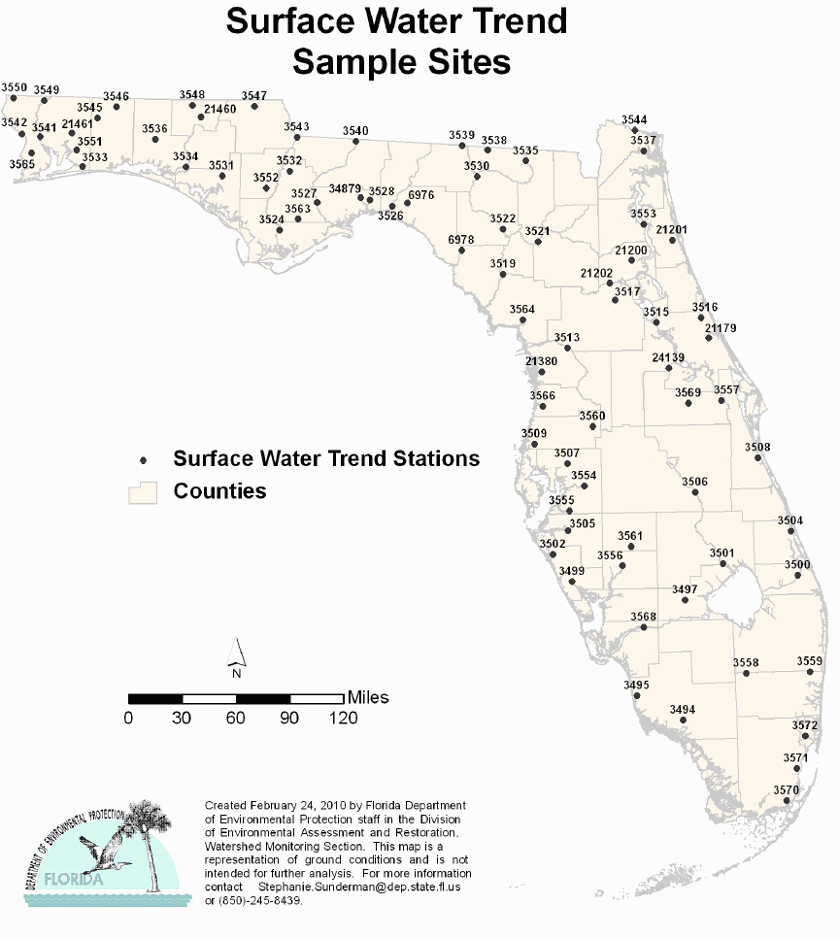
Figure 5.4. Ground Water Trend Network Sites

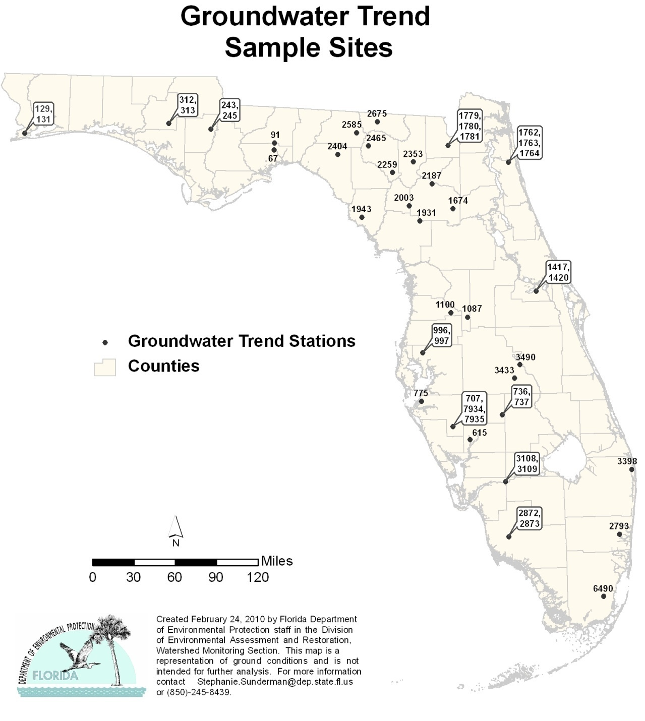

Data Evaluation
Prior to data analyses for Status and Trend reporting, all data were checked to ensure the accuracy of the results. Data from the Status Network that were qualified with an F, O, V, or Y were excluded before any analysis was conducted. All remaining data were used.

In the Trend Network, several stations—3 surface water and 3 ground water—were either recently added to the network or do not have enough data, for a variety of reasons, to conduct a Seasonal Kendall (SK) analysis. The SK analysis requires a reasonable amount of data—2 seasons and 12 data points—to reduce the influence of season during data analysis. It is a nonparametric test that is easy to compute, even in the presence of missing values or censored values, and is insensitive to outliers.

The statewide assessments provide a broad overview of the results obtained by the Status Network, while basinwide results may depict areas of concern for specific indicators. Statewide assessments can hide or minimize the impact an indicator may have at the basin level. In an effort to provide all the results beyond the statewide assessments, Appendices A and C contain tables presenting the results for each basin and maps to visually depict those results.

Not all resources occur in every basin—for example, there are no river resources in the Tampa Bay, Charlotte Harbor, Florida Keys, and Indian River Lagoon Basins. When no samples are collected, basin-specific results (Appendices A and C) are not reported. When significantly fewer than 30 samples per resource per basin are collected, the results are reported with an error estimate associated with the threshold value. All samples collected are included in the statewide assessment.

Chapter 6: Results of the Status and trend NeTWORK Assessments for 2004–08

Summary of Status Network Surface Water Results

Introduction
The probabilistic approach discussed in Chapter 5 was used to sample and report on the condition of surface water resources from the entire state. Two levels of assessment were conducted: first, basin assessments (Appendix A), and second, a statewide assessment, which is summarized here.

Four surface water resources were assessed: rivers, streams, large lakes, and small lakes. Table 6.1 summarizes the miles of rivers and streams, and acres and numbers of large and small lakes, for the waters assessed. Approximately 30 samples were collected from each resource for the 29 basins throughout the state.

Table 6.1. Summary of Surface Water Resources Assessed by the Status Network’s Probabilistic Monitoring, 2004–08
This is a two-column table. Column 1 lists the waterbody type and Column 2 lists the miles of rivers and streams, and acres and numbers of large and small lakes.

Note: The estimates in the table do not include coastal or estuarine waters. These calculations are from the 1:100,000 releveled rNHD.
Waterbody Type | Assessed
Rivers | 3,282 miles
Streams | 34,390 miles
Large Lakes | 1,038,899 acres
Small Lakes | 5,882 lakes

The indicators selected for surface water reporting include fecal coliform, DO, un-ionized ammonia, chlorophyll a (rivers and streams), and TSI (lakes). Tables 6.2a through 6.2d summarize the indicators and their threshold values. Appendix B discusses the reasoning behind the use of these indicators. Tables 5.2a through 5.2f and 5.3a through 5.3c contain the complete list of indicators used in the Status Monitoring Network.

The main source for these indicators is Chapter 62-302, F.A.C., which contains the surface water quality standards for Florida. The water quality criteria and thresholds are derived from the following:

- Section 62-302.530, F.A.C., Criteria for Surface Water Classifications;
- Chapter 62-550, F.A.C., Drinking Water Standards;
- Chapter 62-303, F.A.C., Identification of Impaired Surface Waters; and
- Section 62-520.420, F.A.C., Standards for Class G-I and Class G-II Ground Water.

It is important to note that the diversity of Florida’s aquatic ecosystems also means there is large natural variation in some water quality parameters. For example, surface waters that are dominated by ground water inflows or flows from wetland areas will have lower DO levels. Therefore, some Florida aquatic systems naturally exhibit DO levels less than the state’s standard of 5.0 mg/L.

Table 6.2a. Status Network Physical/Other Indicators/Index for Aquatic Life Use with Water Quality Criteria/Thresholds
This is a two-column table. Column 1 lists the indicators and Column 2 lists the water quality criteria/thresholds.

¹ Both TSI and chlorophyll a are not criteria, but thresholds used to estimate the impairment of state waters. These thresholds are used in the analysis of Status Monitoring Network data, based on single samples. The analysis and representation of these data are not intended to infer the verification of impairment, as defined in Chapter 62-303, F.A.C.
Physical/Other Indicators/  Indexfor Aquatic Life Use  (Surface Water) | Criterion/Threshold
DO | ≥ 5 mg/L
Un-ionized Ammonia | ≤ 0.02 mg/L
Fluoride | ≤10 mg/L
Specific Conductance | ≤1,275 or 50% above background
Chlorophyll a¹ | ≤ 20 µg/L
TSI¹ | Color ≤ 40 PCUs, then TSI ≤ 40  Color > 40 PCUs, then TSI ≤ 60

Table 6.2b. Status Network Microbiological Indicators/Index for Recreation Use with Water Quality Criteria/Thresholds
This is a two-column table. Column 1 lists the indicators and Column 2 lists the water quality criteria/thresholds.

Microbiological Indicator/  Index for Recreation Use  (Surface Water) | Criterion/Threshold
Fecal Coliform Bacteria | < 400 colonies/100mL

Table 6.2c. FDEP Freshwater Lake Sediment Contaminant Thresholds for Metals
This is a three-column table. Column 1 lists the metals, Column 2 lists the threshold effects concentration, and Column 3 lists the probable effects concentration.

Metal | Threshold Effects Concentration  (mg/kg) | Probable Effects Concentration  (mg/kg)
Arsenic | 9.8 | 33
Cadmium | 1.00 | 5
Chromium | 43.4 | 111
Copper | 32 | 149
Lead | 36 | 128
Mercury | 0.18 | 1.06
Nickel | 23 | 48
Zinc | 121 | 459
Silver | 1 | 2.2

Table 6.2d. FDEP Freshwater Lake Sediment Contaminant Thresholds for Organic Contaminants
This is a three-column table. Column 1 lists the organic contaminants, Column 2 lists the threshold effects concentration, and Column 3 lists the probable effects concentration.

Organic Contaminant | Threshold Effects Concentration  (µg/kg) | Probable Effects Concentration  (µg/kg)
Anthracene | 57 | 845
Fluorene | 77 | 536
Naphthalene | 176 | 561
Phenanthrene | 204 | 1,170
Benz[a]anthracene | 108 | 1,050
Benzo(a)pyrene | 150 | 1,450
Chrysene | 166 | 1,290
Fluoranthene | 423 | 2,230
Pyrene | 195 | 1,520
Total Polynuclear Aromatic Hydrocarbons (PAHs) | 1,610 | 22,800
Chlordane | 3.2 | 17.6
Dieldrin | 1.9 | 61.8
DDD | 4.9 | 28.0
DDE | 3.2 | 31.3
DDT | 4.2 | 62.9
Endrin | 2.2 | 207
Lindane | 2.4 | 5.0
Total Polychlorinated Biphenyls (PCBs) | 60 | 676

Rivers, Streams, Large Lakes, and Small Lakes
The following pages present the surface water Status Network results for rivers, streams, large lakes, and small lakes. For each resource, there is a map showing the sample site locations (Figures 6.1, 6.3, 6.5, and 6.7), a figure with a summary of the statewide results (Figures 6.2, 6.4, 6.6, and 6.8), and a table of the statewide results for each indicator for a particular resource (Tables 6.3b through 6.3e), followed by a discussion. Table 6.3a contains the legend for the terms used in the statewide summary tables.

The rotating basin component of the Status Network design allows for individual basin reports to be completed. Basin-specific reports are available on the FDEP Watershed Monitoring website. Additionally, basin results for the four resource types are reported as maps and in tabular form in Appendix A.

Table 6.3a. Legend for Terms Used in Tables 6.3b through 6.3e
This is a two-column table. Column 1 lists the terms used and Column 2 explains each term.

Term | Explanation
Analyte | Indicators chosen to base assessment of the condition of waters of the state.
Target Population | Estimate of actual extent of resource from which threshold results were calculated. Excludes % of resource that was determined to not fit definition of resource.
Sampleable | Estimate of extent of resource that staff would have been able to sample during index period.
Inaccessible | Estimate of extent of resource that was inaccessible due to safety concerns and owner denials.
Dry | Estimate of extent of resource that was dry during the index period and therefore could not be sampled.
Number of Samples | Number of samples used for statistical analysis after qualified data and resource exclusions are eliminated from the data pool.
% Meeting Threshold | % estimate of resource that meets a specific indicator’s criterion/threshold value.
95% Confidence Bounds  (% Meeting Threshold) | Upper and lower bounds for 95% confidence of % meeting a specific indicator’s criterion/threshold value.
% Not Meeting Threshold | % of estimate of extent of resource that does not meet a specific indicator’s criterion/threshold value.
Assessment Period | Duration of probabilistic survey sampling event.

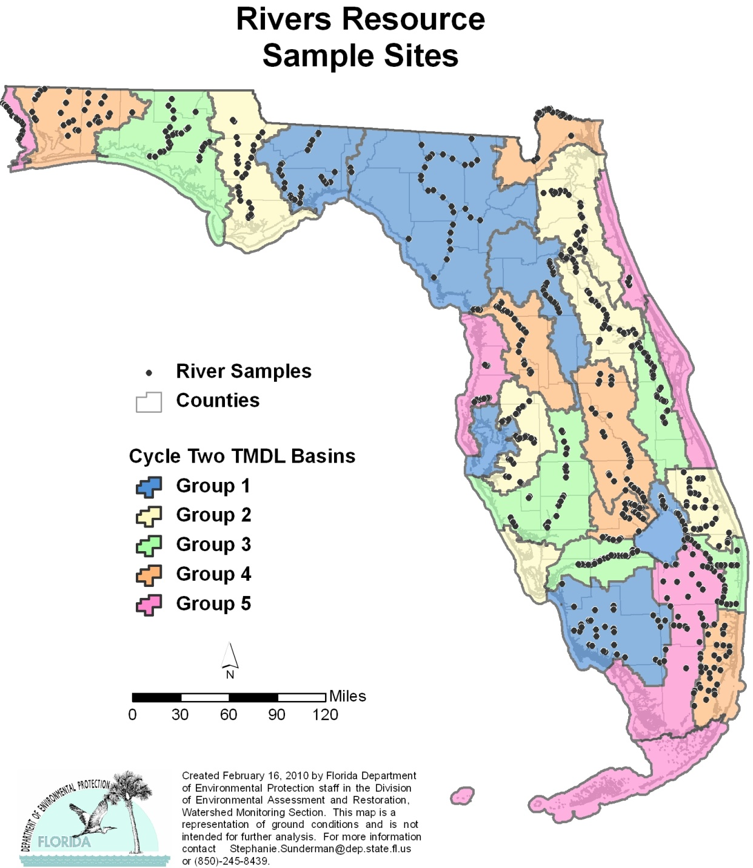
Figure 6.1. Statewide River Sample Locations by Basin

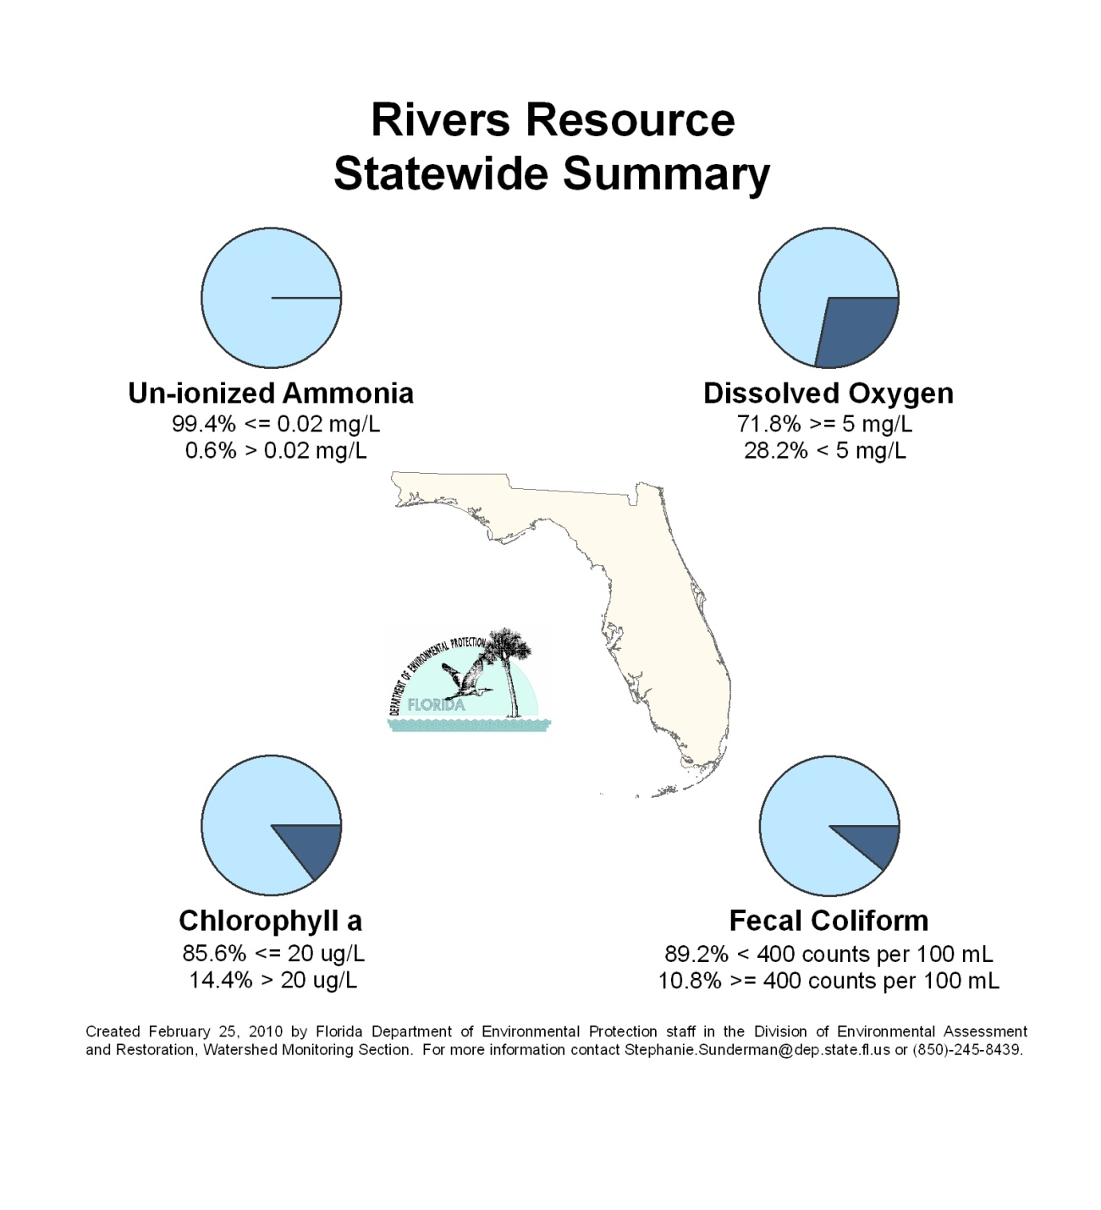
Figure 6.2. Statewide Summary of River Results

Table 6.3b. Statewide Percentage of Rivers Meeting Threshold Values for Indicators Calculated Using Probabilistic Monitoring Design
Status Network Designated Use: Recreation and Aquatic Life Units: Miles
This is a 10-column table. Column 1 lists the analyte, Column 2 lists the target population, Column 3 lists the sampleable miles, Column 4 lists the dry miles, Column 5 lists the inaccessible miles, Column 6 lists the number of samples, Column 7 lists the percent meeting the threshold, Column 8 lists the 95% confidence bounds, Column 9 lists the percent not meeting the threshold, and Column 10 lists the assessment period.

¹ Miles
² Estimated number of miles
Analyte | Target Population¹ | Sampleable² | Dry² | Inaccessible² | Number of Samples | % Meeting Threshold | 95%  Confidence Bounds  (% Meeting Threshold) | % Not Meeting Threshold | Assessment Period
Chlorophyll a | 3,282 | 2,664 | 84 | 534 | 740 | 85.6 | 83.6-87.5 | 14.4 | 2004-08
Un-ionized Ammonia | 3,282 | 2,664 | 84 | 534 | 746 | 99.4 | 99.1–99.8 | 0.6 | 2004-08
Fecal Coliform | 3,282 | 2,664 | 84 | 534 | 686 | 89.2 | 87.5-90.8 | 10.8 | 2004-08
DO | 3,282 | 2,664 | 84 | 534 | 744 | 71.8 | 69.1-74.5 | 28.2 | 2004-08

Highlights: Rivers
- No river resources in the Tampa Bay, Charlotte Harbor, Everglades, Florida Keys, and Indian River Lagoon Basins fit the definition of the target population.
- Statewide, 85.6% of the target population’s river miles were below the chlorophyll a indicator (< 20 μg/L) criteria. The threshold for chlorophyll a was met for 80%, or greater, of each basin’s river mileage for all but 5 basins. The Lake Okeechobee Basin had the lowest percentage of meeting the threshold; this may be attributable to the fact that the vast majority of river miles were canals.
- Statewide, 99.4% of the target population’s river miles were below the un-ionized ammonia (≤ 0.02 mg/L) criteria. The threshold for un-ionized ammonia was met for 95%, or greater, of all of the basins’ river mileage.
- Statewide, 89.2% of the target population’s river miles were below the fecal coliform (< 400 colonies/100mL) criteria. The threshold for fecal coliform was met for 80%, or greater, of each basin’s river mileage for all but 3 basins: Middle St. Johns (50.0%), Southeast Coast–Biscayne Bay (71.4%), and Springs Coast (73.3%).
- Statewide, 71.8% of the target population’s river miles were above the DO (≥ 5 mg/L) criteria. Only 8 of the 24 basins met the DO threshold for 80% of their river resource. Input of color and organic carbon from wetlands, stream geomorphology, respiration, and decomposition are factors that lower DO.

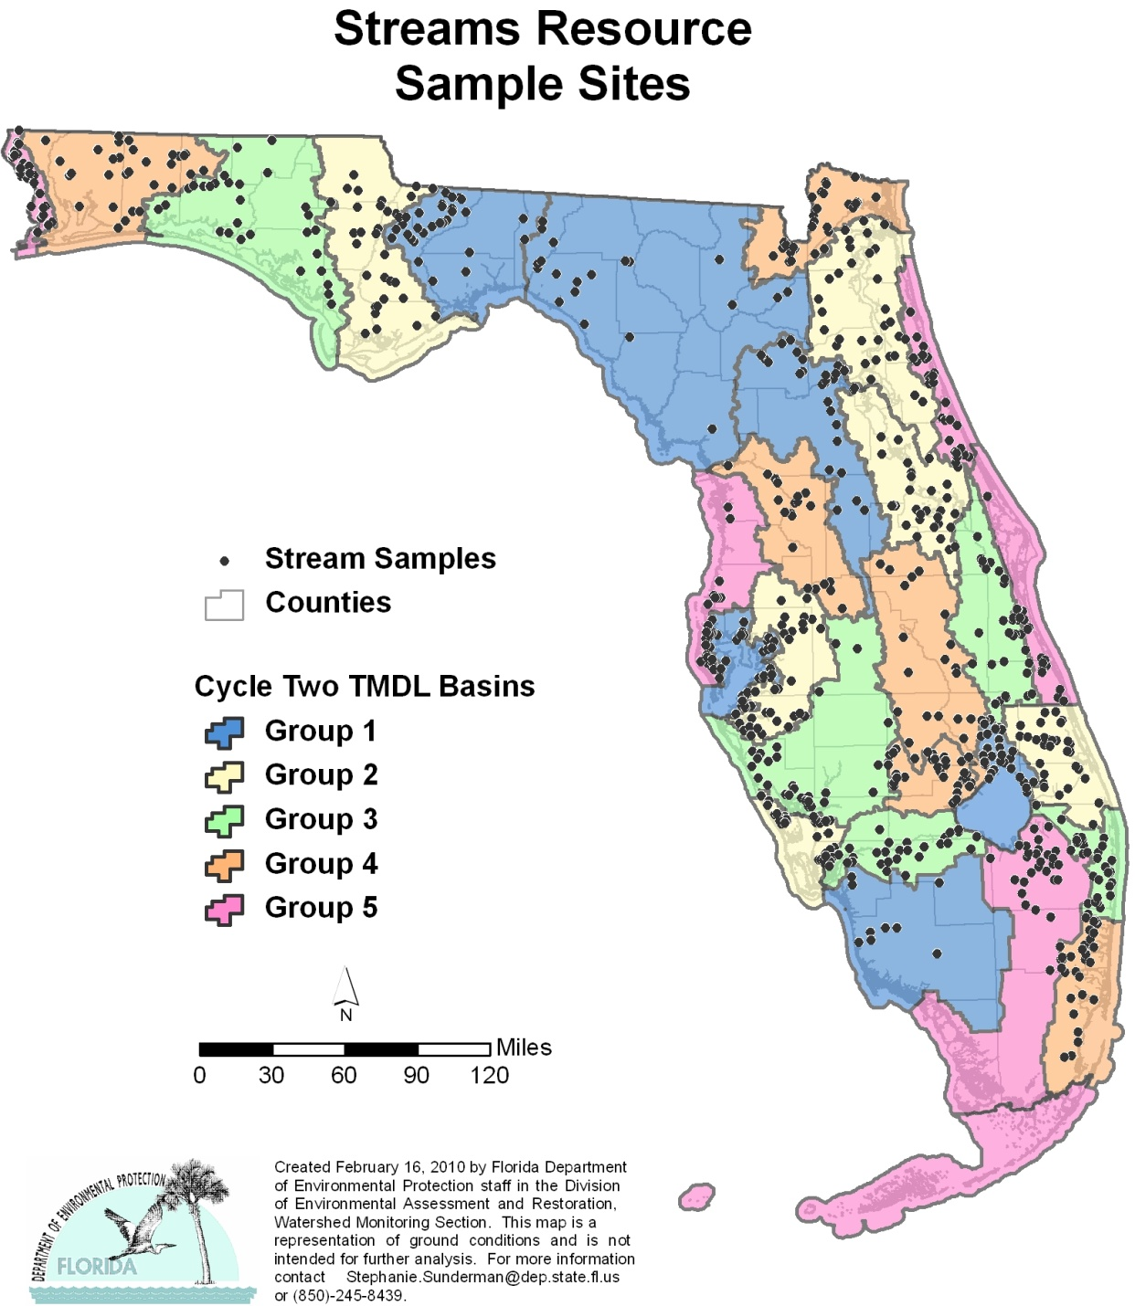
Figure 6.3. Statewide Stream Sample Locations by Basin

Figure 6.4. Statewide Summary of Stream Results
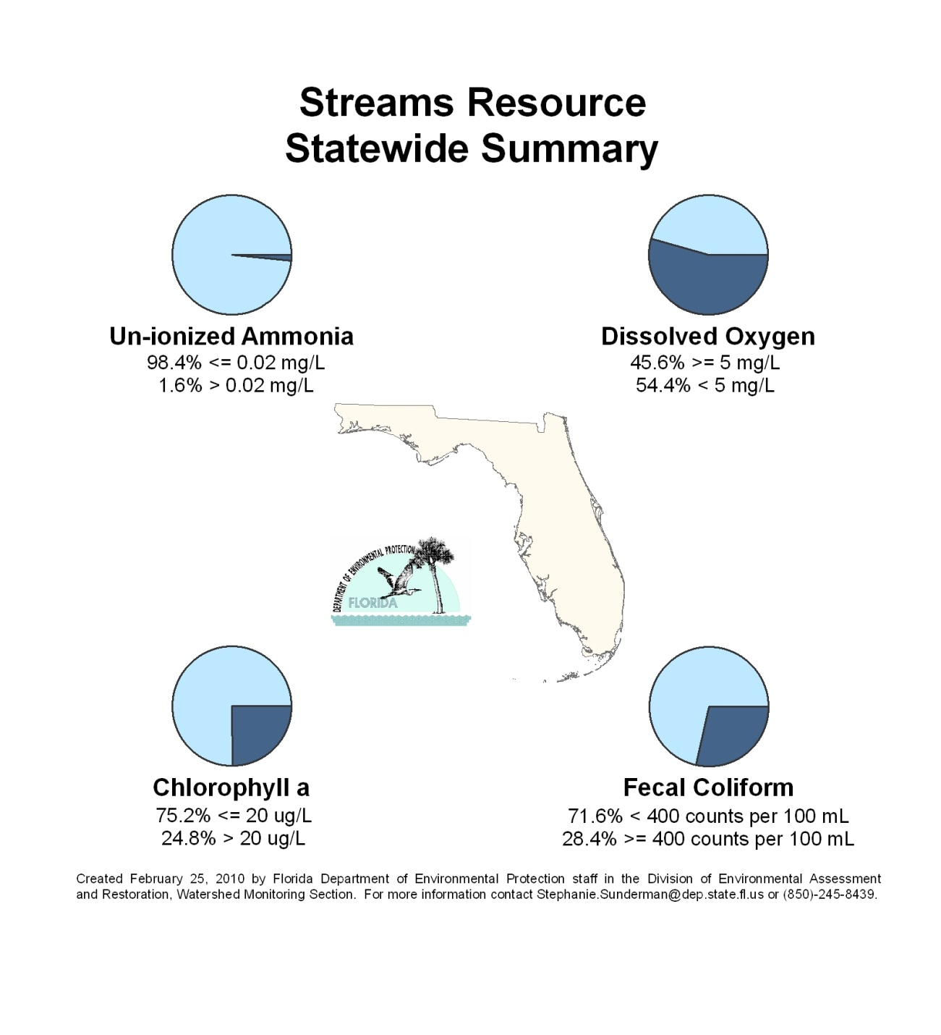

Table 6.3c. Statewide Percentage of Streams Meeting Threshold Values for Indicators Calculated Using Probabilistic Monitoring Design
Status Network Designated Use: Recreation and Aquatic Life Units: Miles
This is a 10-column table. Column 1 lists the analyte, Column 2 lists the target population, Column 3 lists the sampleable miles, Column 4 lists the dry miles, Column 5 lists the inaccessible miles, Column 6 lists the number of samples, Column 7 lists the percent meeting the threshold, Column 8 lists the 95% confidence bounds, Column 9 lists the percent not meeting the threshold, and Column 10 lists the assessment period.

¹ Miles
² Estimated number of miles
Analyte | Target Population¹ | Sampleable² | Dry² | Inaccessible² | Number of Samples | % Meeting Threshold | 95%  Confidence Bounds  (% Meeting Threshold) | % Not Meeting Threshold | Assessment Period
Chlorophyll a | 34,390 | 13,652 | 5,090 | 15,648 | 761 | 75.2 | 71.5-78.9 | 24.8 | 2004-08
Un-ionized Ammonia | 34,390 | 13,652 | 5,090 | 15,648 | 750 | 98.4 | 97.4-99.3 | 1.6 | 2004-08
Fecal Coliform | 34,390 | 13,652 | 5,090 | 15,648 | 763 | 71.6 | 68.2-75.0 | 28.4 | 2004-08
DO | 34,390 | 13,652 | 5,090 | 15,648 | 765 | 45.6 | 42.0-49.2 | 54.4 | 2004-08

Highlights: Streams
- No stream resources in the Florida Keys fit the definition of the target population.
- Statewide, 75.2% of the target population’s stream miles were below the chlorophyll a indicator (< 20 μg/L) criteria. The threshold for chlorophyll a was met for 80%, or greater, of each basin’s stream mileage for all but 12 basins. The Everglades Basin had the lowest percentage of meeting the threshold; this may be attributable to the fact that the vast majority of the target population stream miles in the basin were canals.
- Statewide, 98.4% of the target population’s stream miles were below the un-ionized ammonia (≤ 0.02 mg/L) criteria. The threshold for un-ionized ammonia was met for 95%, or greater, of all of the basins’ stream mileage.
- Statewide, 71.6% of the target population’s stream miles were below the fecal coliform (< 400 colonies/100mL) criteria. The threshold for fecal coliform was met for 80%, or greater, of each basin’s stream mileage for only 10 basins. Basins not meeting the threshold for fecal coliform for less than 50% of the basin’s stream miles include Tampa Bay (30.0%), Upper St. Johns (48.3%). and the Indian River Lagoon (47.5%).
- Statewide, 45.6% of the target population’s stream miles were above the DO (≥ 5 mg/L) criteria. Only 4 of the 28 basins met the DO threshold for 80% of their stream resource. Input of color and organic carbon from wetlands, stream geomorphology, respiration, and decomposition are factors that lower DO. FDEP is currently evaluating a revision to the DO criterion to more accurately account for natural low DO throughout the state.

Figure 6.5. Statewide Large Lake Sample Locations by Basin

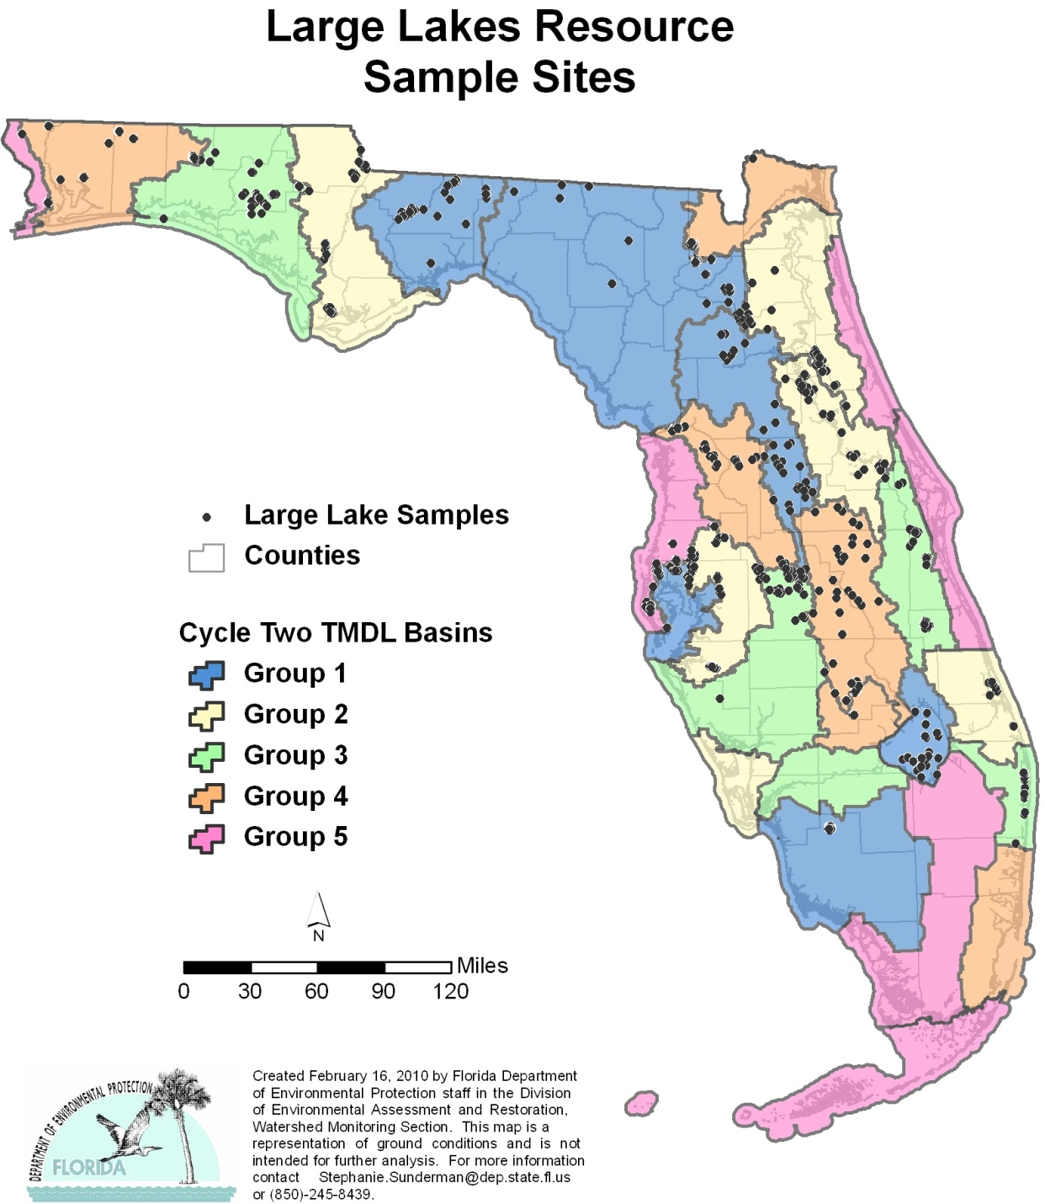
Figure 6.6. Statewide Summary of Large Lake Results

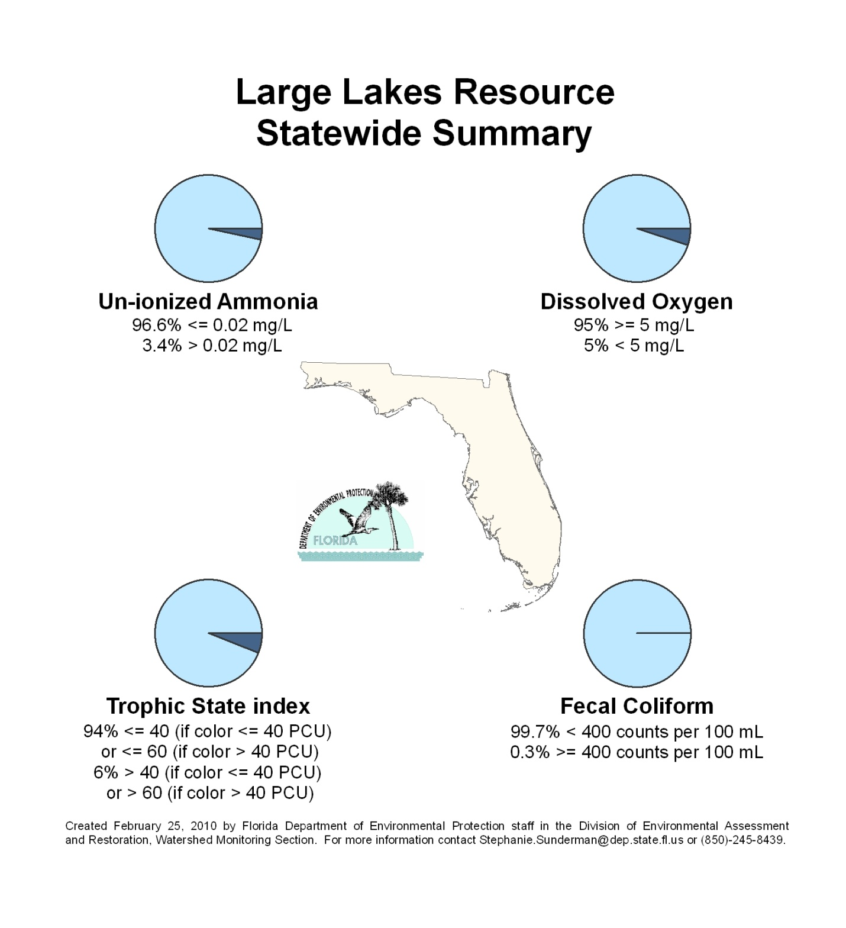

Table 6.3d. Statewide Percentage of Large Lakes Meeting Threshold Values for Indicators Calculated Using Probabilistic Monitoring Design
Status Network Designated Use: Recreation and Aquatic Life Units: Acres
This is a 10-column table. Column 1 lists the analyte, Column 2 lists the target population, Column 3 lists the sampleable miles, Column 4 lists the dry miles, Column 5 lists the inaccessible miles, Column 6 lists the number of samples, Column 7 lists the percent meeting the threshold, Column 8 lists the 95% confidence bounds, Column 9 lists the percent not meeting the threshold, and Column 10 lists the assessment period.

¹ Acres
² Estimated number of acres
Analyte | Target Population¹ | Sampleable² | Dry² | Inaccessible² | Number of Samples | % Meeting Threshold | 95%  Confidence Bounds  (% Meeting Threshold) | % Not Meeting Threshold | Assessment Period
TSI | 1,038,899 | 811,851 | 26,563 | 200,485 | 627 | 94.0 | 90.75-97.6 | 6.0 | 2004-08
Un-ionized Ammonia | 1,038,899 | 811,851 | 26,563 | 200,485 | 626 | 96.6 | 95.2-98.1 | 3.4 | 2004-08
Fecal Coliform | 1,038,899 | 811,851 | 26,563 | 200,485 | 616 | 99.7 | 99.5-99.9 | 0.3 | 2004-08
DO | 1,038,899 | 811,851 | 26,563 | 200,485 | 628 | 95.0 | 93.4-96.7 | 5.0 | 2004-08

Highlights: Large Lakes
- No large lake resources in the Charlotte Harbor, Caloosahatchee, Southeast Coast–Biscayne Bay, Everglades, Florida Keys, Indian River Lagoon, and Upper East Coast Basins fit the definition of the target population.
- Statewide, 94% of the target population’s lake acres were below the TSI indicator (Color ≤ 40 PCUs, then TSI ≤ 40; Color > 40 PCUs, then TSI ≤ 60) criteria. This threshold for TSI was met for 90%, or greater, of each basin’s lake acreage with two exceptions: the Everglades West Coast (79.3%) and Sarasota Bay–Peace–Myakka (73.3%) Basins.
- Statewide, 96.6% of the target population’s lake acres were below the un-ionized ammonia (≤ 0.02 mg/L) criteria. This threshold for un-ionized ammonia was met for 90%, or greater, of each basin’s lake acreage with two exceptions: the Everglades West Coast (89.7%) and the Ocklawaha (80.0%) Basins.
- Statewide, 99.7% of the target population’s lake acres were below the fecal coliform (< 400 colonies/100mL) criteria. This threshold for fecal coliform was met for 90%, or greater, in all basins.
- Statewide, 95% of the target population’s lake acres were above the DO (≥ 5 mg/L) criteria. This threshold for DO was met for 80%, or greater, of each basin’s lake acreage, except for the Ochlockonee–St. Marks (53.3%) and Apalachicola–Chipola (50.0%) Basins. Input of color and organic carbon from wetlands, respiration by aquatic animals, decomposition, and various chemical reactions lower DO.

Figure 6.7. Statewide Small Lake Sample Locations by Basin

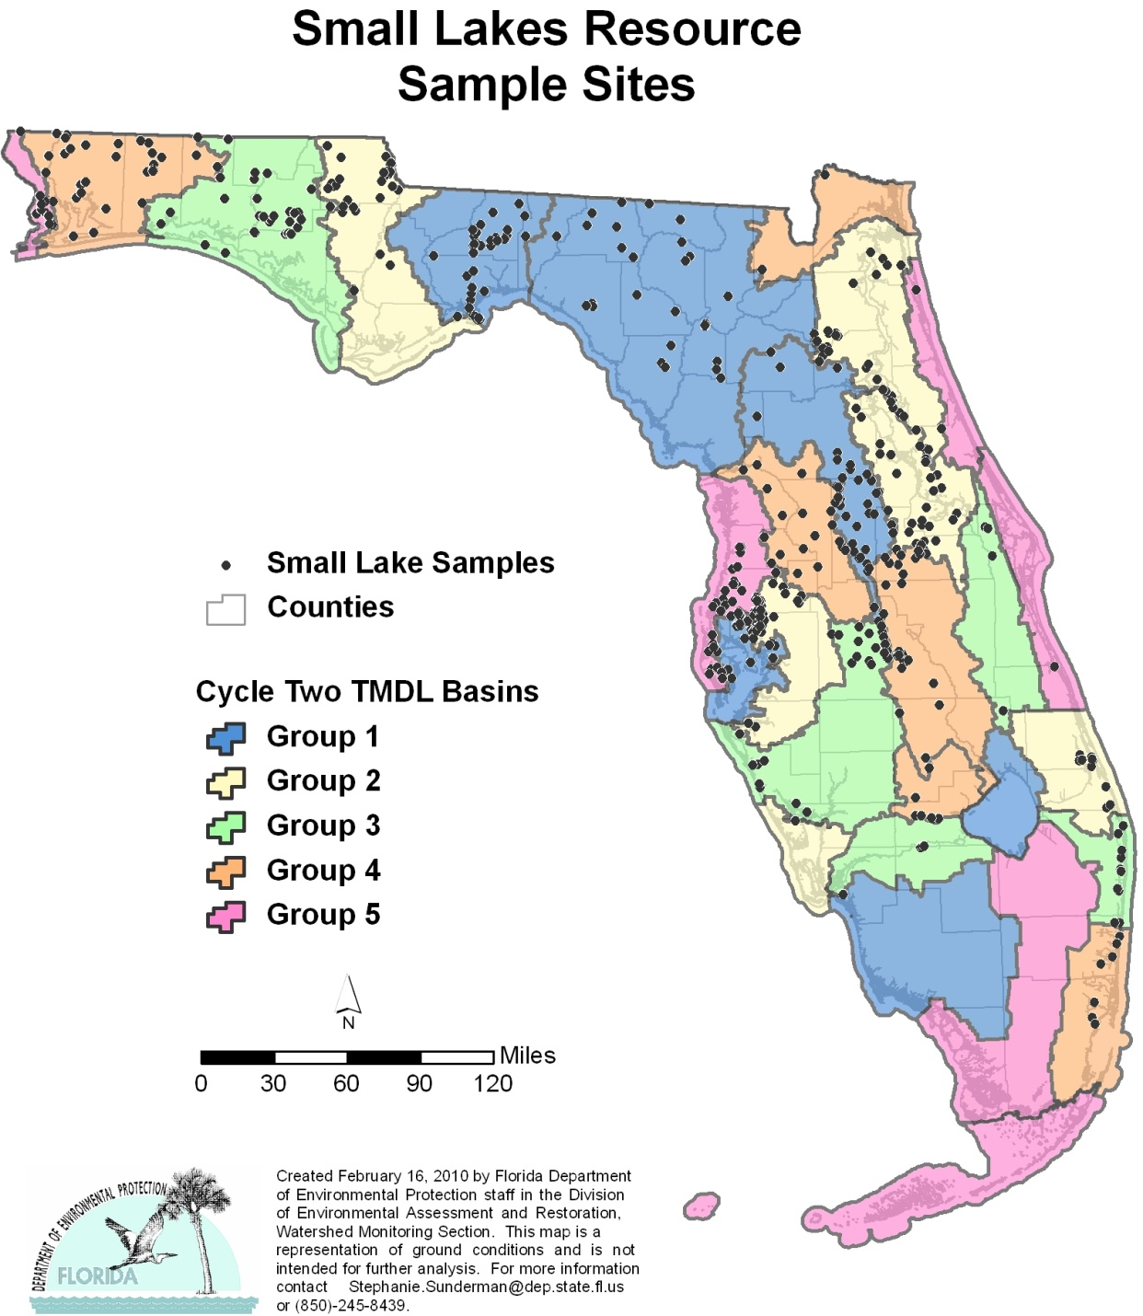

Figure 6.8. Statewide Summary of Small Lake Results

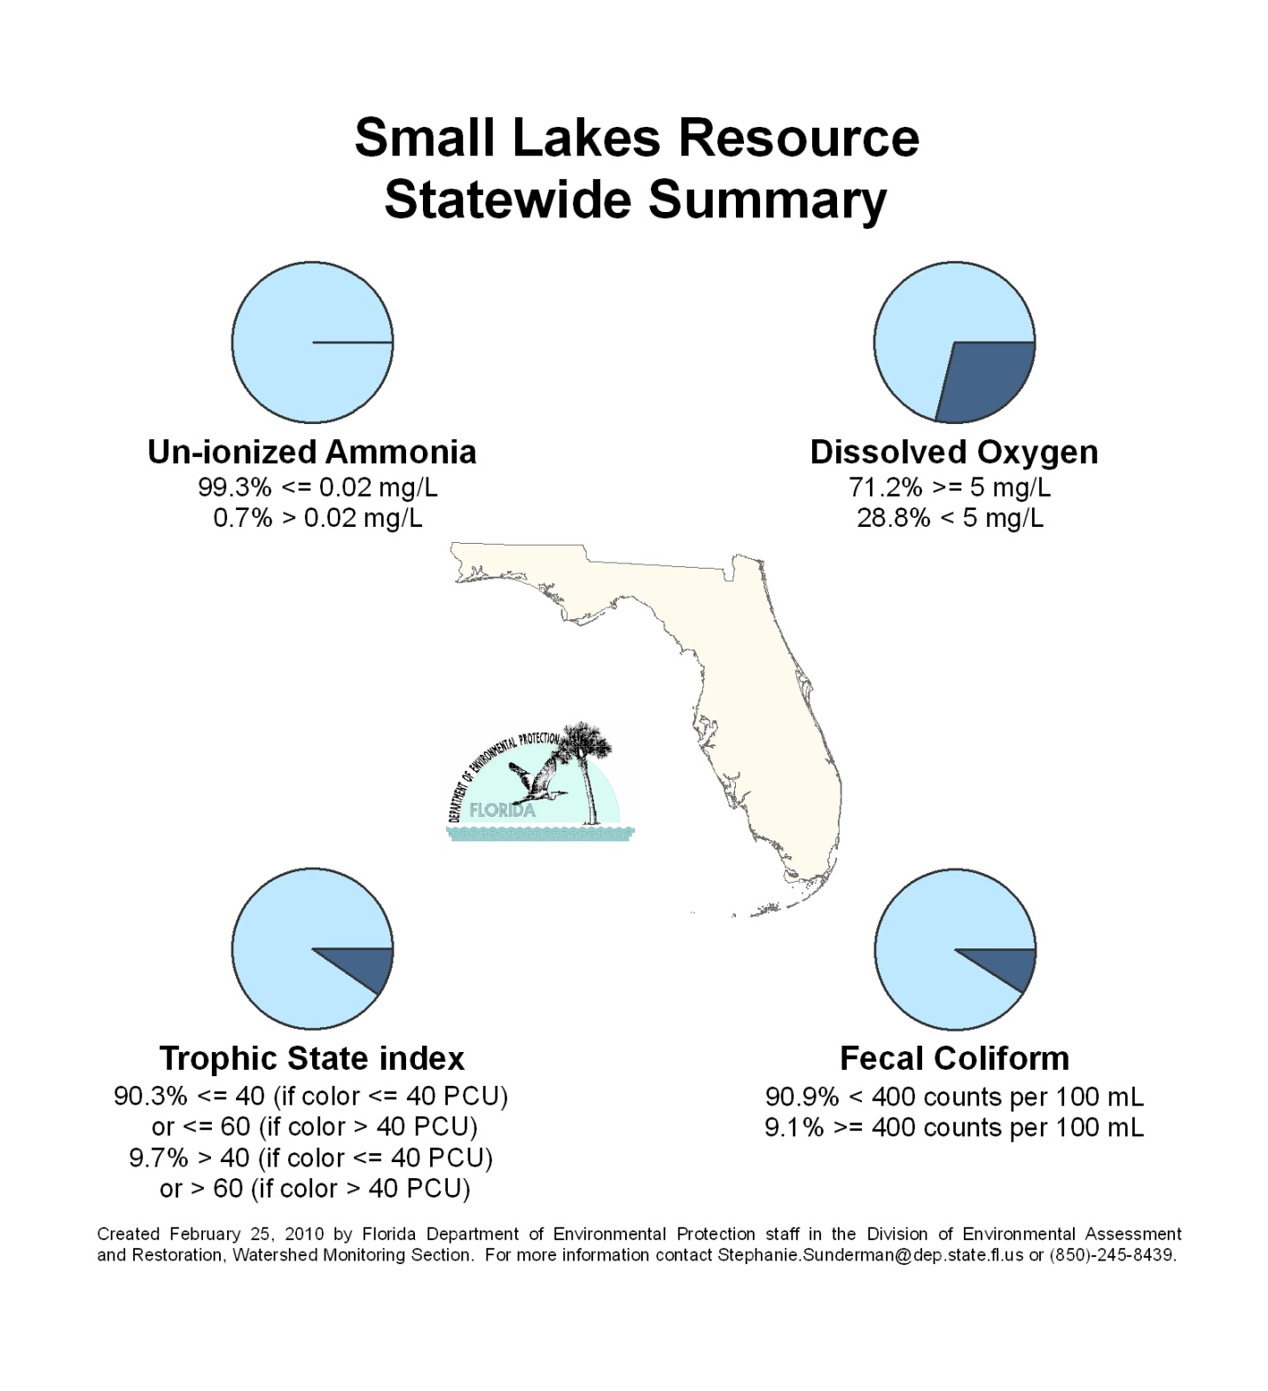

Table 6.3e. Statewide Percentage of Small Lakes Meeting Threshold Values for Indicators Calculated Using Probabilistic Monitoring Design
Status Network Designated Use: Recreation and Aquatic Life Units: Lakes
This is a 10-column table. Column 1 lists the analyte, Column 2 lists the target population, Column 3 lists the sampleable miles, Column 4 lists the dry miles, Column 5 lists the inaccessible miles, Column 6 lists the number of samples, Column 7 lists the percent meeting the threshold, Column 8 lists the 95% confidence bounds, Column 9 lists the percent not meeting the threshold, and Column 10 lists the assessment period.

¹ Lakes
² Estimated number of lakes
Analyte | Target Population¹ | Sampleable² | Dry² | Inaccessible² | Number of Samples | % Meeting Threshold | 95%  Confidence Bounds  (% Meeting Threshold) | % Not Meeting Threshold | Assessment Period
TSI | 5,882 | 2,147 | 1,516 | 2,219 | 465 | 90.3 | 86.8-93.8 | 9.7 | 2004-08
Un-ionized Ammonia | 5,882 | 2,147 | 1,516 | 2,219 | 464 | 99.3 | 98.5-100.0 | 0.7 | 2004-08
Fecal Coliform | 5,882 | 2,147 | 1,516 | 2,219 | 456 | 90.9 | 84.1-97.7 | 9.1 | 2004-08
DO | 5,882 | 2,147 | 1,516 | 2,219 | 465 | 71.2 | 66.7-75.6 | 28.8 | 2004-08

Highlights: Small Lakes
- No small lake resources in the Everglades West Coast, Lake Okeechobee, Charlotte Harbor, Everglades, Florida Keys, and Indian River Lagoon Basins fit the definition of the target population.
- Statewide, 90.3% of the target population’s individual lakes were below the TSI indicator (Color ≤ 40 PCUs, then TSI ≤ 40; Color > 40 PCUs, then TSI ≤ 60) criteria. This threshold for TSI was met for 80%, or greater, of each basin’s individual lakes with 2 exceptions: the Upper St. Johns (75.0%) and Springs Coast (76.7%) Basins.
- Statewide, 99.3% of the target population’s individual lakes were below the un-ionized ammonia (≤ 0.02 mg/L) criteria. This threshold for un-ionized ammonia was met for 95%, or greater, of each basin’s individual lakes.
- Statewide, 90.9% of the target population’s individual lakes were below the fecal coliform (< 400 colonies/100mL) criteria. This threshold for fecal coliform was met for 80%, or greater, of each basin’s individual lakes with 4 exceptions: the Upper St. Johns (50.0%), Sarasota Bay–Peace–Myakka (77.8%), Fisheating Creek (50.0%), and Springs Coast (75.9%) Basins.
- Statewide, 71.2% of the target population’s individual lakes were above the DO (≥ 5 mg/L) criteria. Only 8 of the 23 basins met the DO threshold for 80% of each basin’s individual small lakes. Input of color and organic carbon from wetlands, stream geomorphology, respiration, and decomposition are factors that lower DO.

Sediment Quality Evaluation

Background
In healthy aquatic environments, sediments provide critical habitat for many organisms. Sediments also function as both a sink and a source of contamination and nutrients, as they accumulate both over time from upland discharges, decomposition of organic (aquatic vegetation, algal species, etc.) material and atmospheric deposition. This accumulation can potentially affect the biological community. Knowledge of existing sediment quality is important for environmental managers in evaluating restoration and dredging projects, and to complement traditional water resource monitoring. Periodic water quality monitoring cannot fully evaluate aquatic ecosystems, as it is not usually designed to assess the cumulative impact of contaminants.

Before the 1980s, little was known about the abundance of metals or organics in sediments, especially the natural metals concentrations that differ in clay-rich north Florida sediments and carbonate-rich south Florida sediments. Unlike many water column constituents, Florida has no standards (criteria) for sediment, and no statutory authority to establish criteria. Therefore, it is important to use scientifically defensible thresholds to estimate the condition of sediments and determine the ecological significance of these thresholds.

The interpretation of marine and freshwater sediment metals data, which can vary by two orders of magnitude, is not straightforward because metallic elements are natural sediment constituents. To interpret sediment metals data, FDEP released two publications: A Guide to the Interpretation of Metals Concentrations in Estuarine Sediments (Schropp and Windom, 1988) and Development of an Interpretive Tool for the Assessment of Metal Enrichment in Florida Freshwater Sediment (Carvalho and Schropp et al., 2003). These documents use statistical normalization techniques to determine background concentrations of metals in sediments.

Additional information was needed to determine whether metals and organic contaminants were associated with biological effects in the benthic environment. During the 1990s, several state and federal agencies evaluated concentration-based sediment guidelines used in evaluating biological effects from sediment contaminants. These agencies employed several approaches, including a weight-of-evidence statistical strategy to derive guidelines from studies containing paired sediment chemistry and associated biological responses. To provide guidance in the interpretation of sediment contaminant data relating to biological impacts, FDEP published the following documents: Approach to the Assessment of Sediment Quality in Florida Coastal Waters (MacDonald, 1994) and Development and Evaluation of Numerical Sediment Quality Assessment Guidelines for Florida Inland Waters (MacDonald Environmental Sciences Ltd. and USGS, 2003). Additional information is available on the FDEP Sediment Guidelines website.

Rather than traditional pass/fail criteria, the approach uses two guidelines for each contaminant: a lower guideline referred to as the Threshold Effects Concentration (TEC) and a higher guideline, the Probable Effects Concentration (PEC). A value below the TEC indicates a low probability of harm occurring to sediment-dwelling organisms. Conversely, values above the PEC have a high probability of causing biological harm. .

The Status Network monitors several surface water resources. Since lakes integrate runoff and other discharges within watersheds, small and large lakes were selected as the most appropriate resources to evaluate the occurrence of both metal and organic constituents in sediments. Rivers and streams also can be depositional areas; however, sediments would likely be carried to downstream receiving waters because of stream flow and the subsequent transport of contaminants. Both the geochemical-based metals tool and the biological effects guidance values applicable to freshwater environments are used to evaluate results.

Small and Large Lakes
A total of 1,086 samples were collected from the state’s 2 lake resources: 459 from small lakes and 627 from large lakes. Statewide results for each lake resource are reported below. Samples were analyzed for major elements (aluminum and iron), a suite of trace metals, nutrients, and a suite of organic contaminants (Tables 5.3a through 5.3c). To ensure accurate metals data, samples were prepared for chemical analysis using EPA Method 3051 (total digestion) rather than with the EPA’s 200.2 method (referred to as the total recoverable method).

FDEP staff applied the sediment assessment tools to the lake datasets. The sediment metal concentrations were compared with the FDEP freshwater biologically based sediment guidelines (MacDonald, 1994) (Tables 6.2c and 6.2d). When the concentration exceeded either guideline, the metal concentration was evaluated. If the concentration was within the naturally occurring range, the sediment sample was reclassified as “not elevated.” Results can be found in Figures 6.9 and 6.10, along with Tables 6.4a and 6.4b. Tables 6.4a and 6.4b have two rows for each metal. The first row contains the uncorrected metals results, while the second row, with the heading “Corrected Metals,” contains the results after applying the metals normalization analysis.

This evaluation illustrates that the number of metal exceedances was lower than expected if concentration had been the only measure used to determine bioeffects. This is true especially for certain metals such as arsenic, cadmium, and chromium. Many sites that appear to be impacted in fact exhibit expected sediment metal concentrations. Using the bioeffect guidelines, the metals copper, lead, and zinc produce the most exceedances. Arsenic, cadmium, chromium, and silver rarely exceed guidelines. Not surprisingly, sediment metals are highest in lakes in urbanized areas, with the highest number of samples having elevated metals in the Tampa Bay and southeast Florida regions.

The evaluation of organic contaminants in the state’s lake sediments is straightforward, as normalization is not used to interpret organic contaminant concentrations. Pesticides and polynuclear aromatic hydrocarbons (PAHs) were the most frequently detected organic contaminants, reported in 34% of all samples. Polychlorinated biphenyls (PCBs) were detected in just 4 lake stations, or fewer than 1% of the total samples. When the organic contaminant concentration in a sample exceeded either guideline (TEC or PEC), this exceedance was recorded. Regions of the state that had the highest organic contaminant exceedances were the agricultural Ocklawaha River region (for DDT and derivatives), and the urbanized Tampa Bay region (for chlordane, a formerly widely used termiticide). Chlordane, a legacy organochlorine pesticide banned in 1988, is still found in many Florida lakes affected by urban stormwater. This widespread occurrence is a reminder that much work remains to protect state waters from pulses of untreated stormwater.

Figure 6.9. Statewide Summary of Large Lake Sediment Results

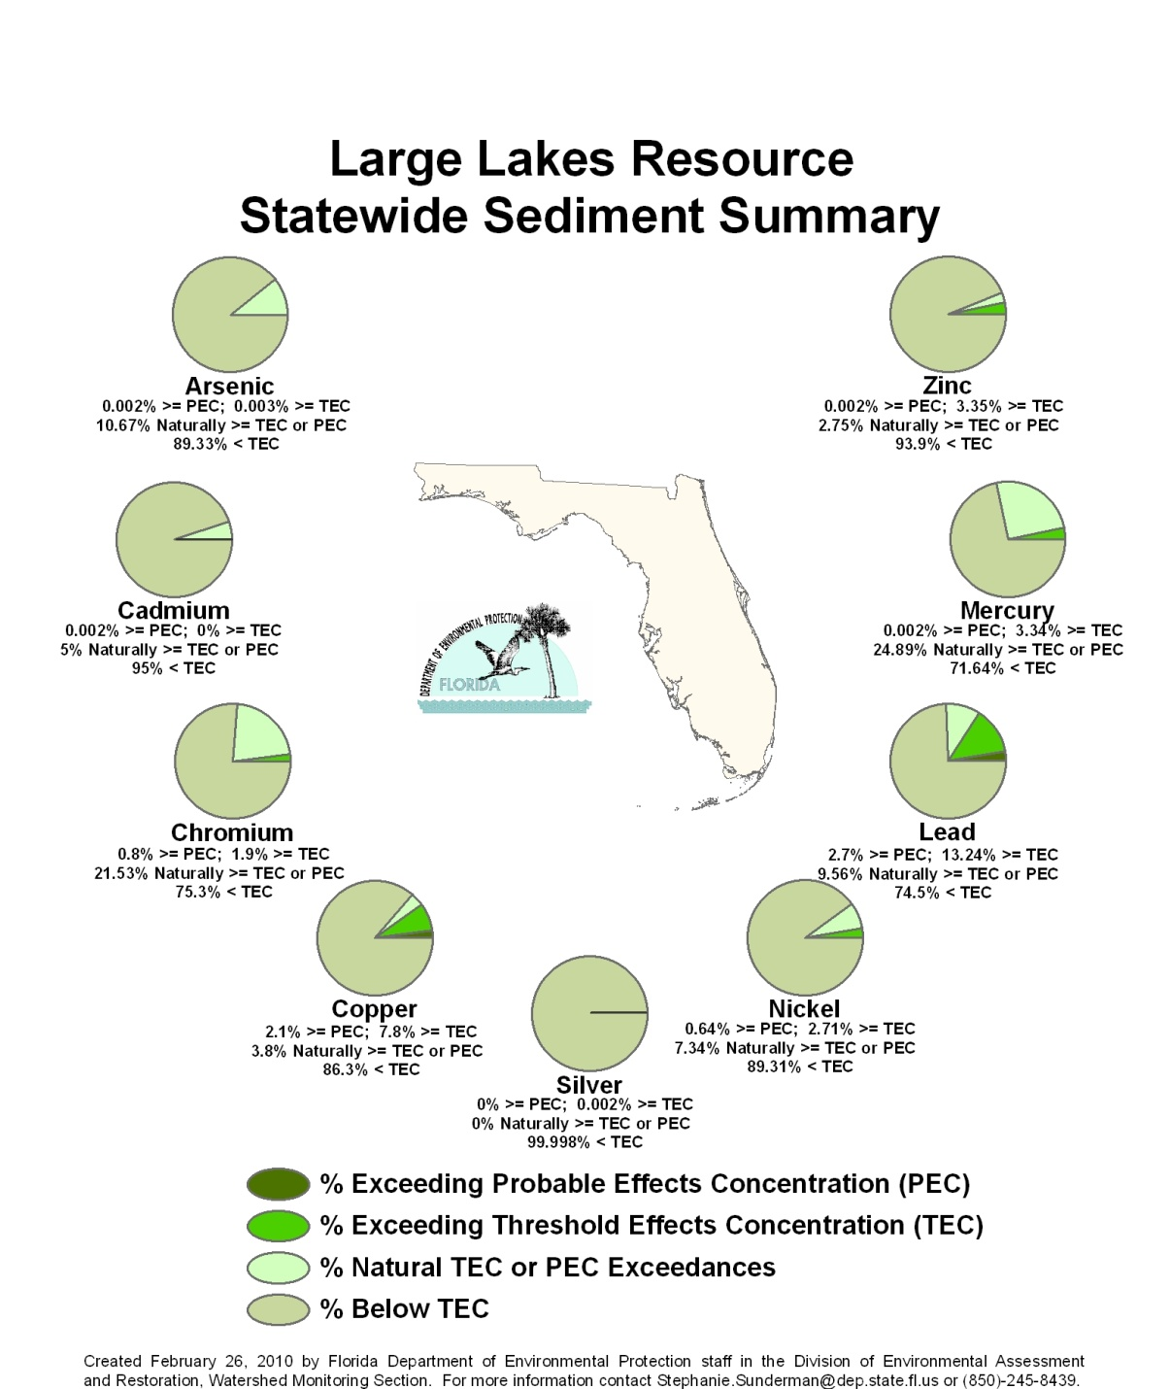

Table 6.4a. Statewide Percentage of Large Lakes Meeting Sediment Contaminant Threshold Values
This is a six-column table. Column 1 lists the metal (uncorrected and corrected), Column 2 lists the percent meeting the TEC threshold, Column 3 lists the percent not meeting the TEC threshold, Column 4 lists the percent not meeting the PEC threshold, Column 5 lists the percent of stations greater than the TEC that include naturally occurring metal concentrations, and Column 6 lists the percent of stations greater than the PEC that include naturally occurring metal concentrations.
na = Not applicable
Metal | % Meeting TEC Threshold | % Not Meeting TEC Threshold | % Not Meeting PEC Threshold | % of Stations >TEC Due to Natural Metal Concentrations | % of Stations >PEC Due to Natural Metal Concentrations
Arsenic Uncorrected | 89.3 | 10.7 | 0.002 | na | na
Arsenic Corrected | 89.33 | 0.003 | 0.002 | 10.67 | na
Cadmium Uncorrected | 94 | 5 | 1 | na | na
Cadmium Corrected | 95 | na | 0.002 | 5 | na
Chromium Uncorrected | 75.3 | 23.4 | 1.3 | na | na
Chromium Corrected | 75.3 | 1.9 | 0.8 | 21.53 | 0.47
Copper Uncorrected | 86.3 | 11.6 | 2.1 | na | na
Copper Corrected | 86.3 | 7.8 | 2.1 | 3.8 | na
Silver Uncorrected | 99.998 | 0.002 | na | na | na
Silver Corrected | 99.998 | 0.002 | na | na | na
Nickel Uncorrected | 89.31 | 10.05 | 0.64 | na | na
Nickel Corrected | 89.31 | 2.71 | 0.64 | 7.34 | na
Lead Uncorrected | 74.5 | 22.8 | 2.7 | na | na
Lead  Corrected | 74.5 | 13.24 | 2.7 | 9.56 | na
Mercury Uncorrected | 71.61 | 28.38 | 0.002 | na | na
Mercury Corrected | 71.61 | 3.34 | 0.002 | 24.89 | na
Zinc Uncorrected | 93.9 | 6.1 | 0.002 | na | na
Zinc  Corrected | 93.9 | 3.35 | 0.002 | 2.75 | na

Figure 6.10. Statewide Summary of Small Lake Sediment Results

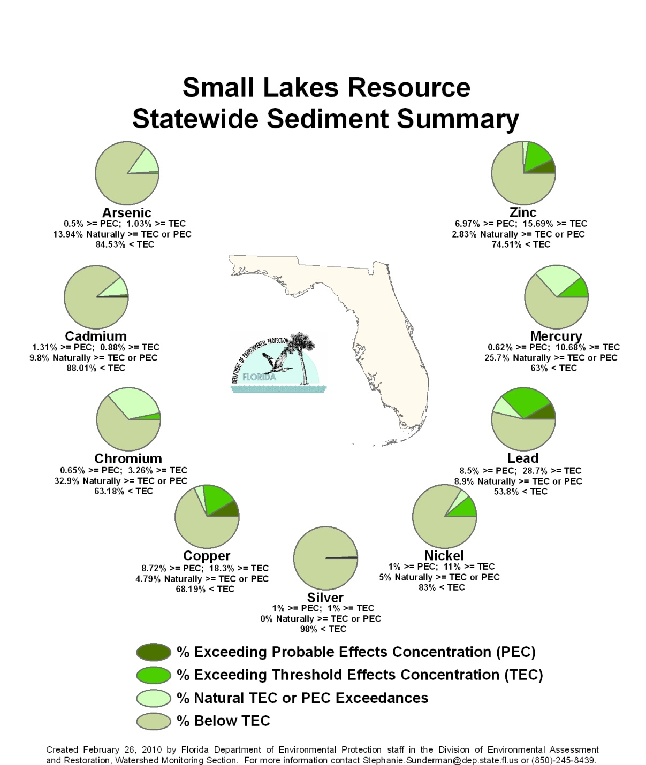

Table 6.4b. Statewide Percentage of Small Lakes Meeting Sediment Contaminant Threshold Values
This is a six-column table. Column 1 lists metal (uncorrected and corrected), Column 2 lists the percent meeting the TEC threshold, Column 3 lists the percent not meeting the TEC threshold, Column 4 lists the percent not meeting the PEC threshold, Column 5 lists the percent of stations greater than the TEC that include naturally occurring metal concentrations, and Column 6 lists the percent of stations greater than the PEC that include naturally occurring metal concentrations.
na = Not applicable
Metal | % Meeting TEC Threshold | % Not Meeting TEC Threshold | % Not Meeting PEC Threshold | % of Stations >TEC Due to Natural Metal Concentrations | % of Stations >PEC Due to Natural Metal Concentrations
Arsenic Uncorrected | 84.5 | 15 | 0.50 | na | na
Arsenic  Corrected | 84.53 | 1.03 | 0.5 | 13.94 | na
Cadmium Uncorrected | 88.01 | 10.68 | 1.31 | na | na
Cadmium Corrected | 88.01 | 0.88 | 1.31 | 9.8 | na
Chromium Uncorrected | 63.18 | 33.99 | 2.83 | na | na
Chromium Corrected | 63.18 | 3.26 | 0.65 | 32.9 | 2.19
Copper Uncorrected | 68.19 | 23.09 | 8.72 | na | na
Copper  Corrected | 68.19 | 18.3 | 8.72 | 4.79 | na
Silver Uncorrected | 98 | 1 | 1 | na | na
Silver  Corrected | 98 | 1 | 1 | na | na
Nickel Uncorrected | 83 | 16 | 1 | na | na
Nickel  Corrected | 83 | 11 | 1 | 5 | na
Lead  Uncorrected | 53.8 | 37.7 | 8.5 | na | na
Lead  Corrected | 53.8 | 28.7 | 8.5 | 8.9 | na
Mercury Uncorrected | 63 | 36 | 1 | na | na
Mercury Corrected | 63 | 10.68 | 0.62 | 25.7 | na
Zinc  Uncorrected | 74 | 19 | 7 | na | na
Zinc  Corrected | 74.51 | 15.69 | 6.97 | 2.83 | na

Summary of Status Network Ground Water Results
FDEP’s Watershed Monitoring Section has monitored ground water quality since 1986 in both confined and unconfined aquifers. The current Status Network ground water monitoring program uses a probabilistic monitoring design to estimate confined and unconfined aquifer water quality across the state. This estimate is, by necessity, based on a subsampling of wells representing both the confined and unconfined aquifers. The wells used in this evaluation include private, public, monitoring, and agricultural irrigation wells. Figures 6.11 and 6.13 depict the random wells that were sampled for confined and unconfined aquifers, respectively.

The assessment period for Cycle 2 discussed in this report is January 2004 through December 2008. Table 6.5 describes the ground water indicators used in the analysis and lists primary drinking water standards (thresholds). Some of the more important analytes include total coliform, nitrate-nitrite, trace metals such as arsenic and lead, and sodium (salinity), all of which are threats to drinking water quality.

Table 6.5. Status Network Physical/Other Indicators/Index for Potable Water Supply for Ground Water with Water Quality Criteria/Thresholds
This is a two-column table. Column 1 lists the indicator and Column 2 lists the water quality criteria/threshold for that indicator.

Primary Indicator/Index  for Potable Water Supply  (Ground Water) | Criterion/Threshold
Fluoride | ≤4 mg/L
Arsenic | ≤10 µg/L
Cadmium | ≤5 µg/L
Chromium | ≤100 µg/L
Lead | ≤15 µg/L
Nitrate-Nitrite | ≤10 mg/L
Sodium | ≤160 mg/L
Total Coliform Bacteria (#/100mL)  Fecal Coliform (#/100mL) | ≤4  <2

For each Status Network ground water resource (confined aquifers and unconfined aquifers), there is a map showing the sample site locations (Figures 6.11 and 6.13), a figure summarizing the statewide results (Figures 6.12 and 6.14), and a table containing the statewide results for each indicator for a particular resource (Tables 6.6b and 6.6c), followed by a discussion of the highlights. Table 6.6a contains a legend for the terms used in Tables 6.6b and 6.6c.

The rotating basin component of the Status Network design allows for individual basin reports to be completed. Basin-specific reports are available on the FDEP Watershed Monitoring website. Additionally, Appendix C shows the results for all 29 basins for both resource types on maps and in tabular form, with an explanation of the terms used in the assessment and the water quality targets.

Tables 6.6b and 6.6c provide an estimate of the quality of Florida’s confined and unconfined aquifers by listing the percentage of samples that meet a potable water threshold. Along with the percentage of wells meeting (% meeting) their specific thresholds, the 95% confidence bounds indicate that the percentage that meets threshold values accurately depicts the overall statewide well population.

Table 6.6a. Legend for Terms Used in Tables 6.6b and 6.6c
This is a two-column table. Column 1 lists the terms and Column 2 provides an explanation.

Term | Explanation
Analyte | Indicators chosen to base assessment of the condition of waters of the state.
Target Population | Number of wells from which inferences are based. Excludes % of resource that was determined to not fit definition of resource.
Sampleable | Estimate of the number of wells that staff are able to sample during index period.
Inaccessible | Estimate of the number of wells that are inaccessible due to safety concerns and owner denials.
Number of Samples | Number of samples used for statistical analysis after qualified data and resource exclusions are eliminated from the data pool.
% Meeting Threshold | % estimate of resource extent that meets a specific indicator’s criterion/threshold value.
95% Confidence Bounds  (% Meeting Threshold) | Upper and lower bounds for 95% confidence of % meeting a specific indicator’s criterion/threshold value.
% Not Meeting Threshold | % of estimate of extent of resource that does not meet a specific indicator’s criterion/threshold value.
Assessment Period | Duration of probabilistic survey’s sampling event.

Figure 6.11. Statewide Confined Aquifer Well Locations by Basin

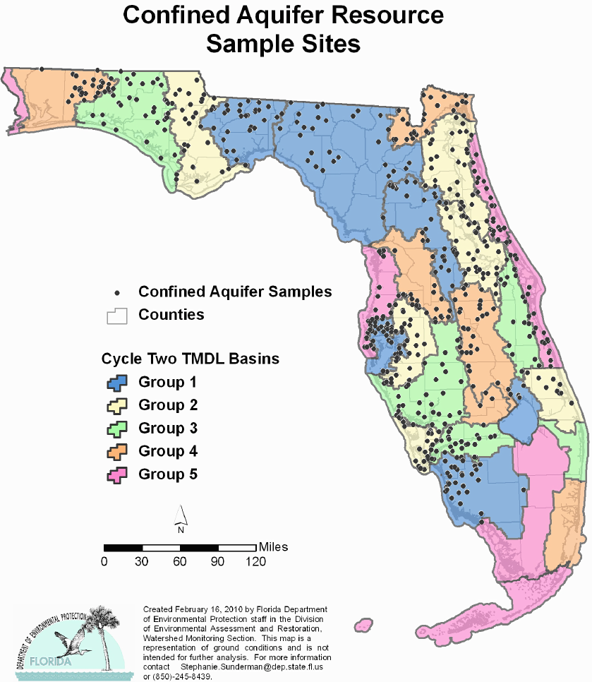

Figure 6.12. Statewide Summary of Confined Aquifer Results

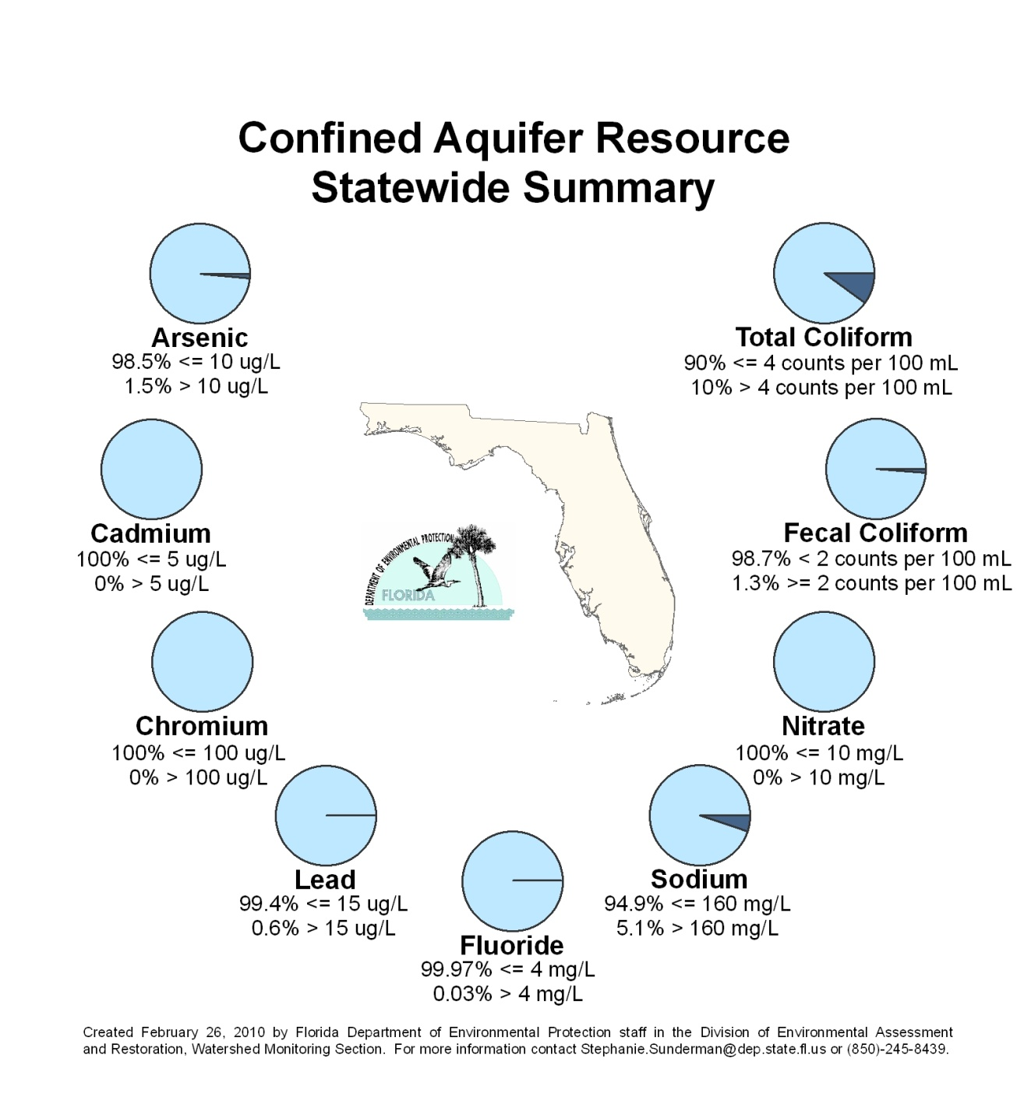

Table 6.6b. Statewide Percentage of Confined Aquifers Meeting Threshold Values for Indicators Calculated Using Probabilistic Monitoring Design
Status Network Designated Use: Primary Drinking Water Standards Units: Number of wells in list frame
This is a nine-column table. Column 1 lists the analyte, Column 2 lists the target population, Column 3 lists the sampleable number of wells, Column 4 lists the inaccessible wells, Column 5 lists the number of samples, Column 6 lists the percent meeting the threshold, Column 7 lists the 95% confidence bounds, Column 8 lists the percent not meeting the threshold, and Column 9 lists the assessment period.

¹ Wells in list frame
² Estimated number of wells
Analyte | Target Population¹ | Sampleable² | Inaccessible² | Number of Samples | % Meeting | 95%  Confidence Bounds  (% Meeting) | % Not Meeting | Assessment Period
Arsenic | 6,355 | 3,439 | 2,916 | 608 | 98.5 | 96.9-100.0 | 1.5 | 2004-08
Cadmium | 6,355 | 3,439 | 2,916 | 628 | 100.0 | 100.0 | 0.0 | 2004-08
Chromium | 6,355 | 3,439 | 2,916 | 628 | 100.0 | 100.0 | 0.0 | 2004-08
Lead | 6,355 | 3,439 | 2,916 | 615 | 99.4 | 99.0-99.8 | 0.6 | 2004-08
Nitrate-Nitrite | 6,355 | 3,439 | 2,916 | 609 | 100.0 | 100.0 | 0.0 | 2004-08
Sodium | 6,355 | 3,439 | 2,916 | 628 | 94.9 | 93.7-96.2 | 5.1 | 2004-08
Fluoride | 6,355 | 3,439 | 2,916 | 627 | 100.0 | 99.9-100.0 | 0.0 | 2004-08
Fecal Coliform | 6,355 | 3,439 | 2,916 | 622 | 98.7 | 97.5-99.8 | 1.3 | 2004-2008
Total Coliform | 6,355 | 3,439 | 2,916 | 606 | 90.0 | 85.6-94.4 | 10.0 | 2004-08

Highlights: Confined Aquifers
- No confined aquifer wells in the Lake Worth Lagoon–Palm Beach Coast and Florida Keys Basins fit the definition of the target population.
- Statewide, total coliform, fecal coliform, sodium, arsenic, and lead do not fully meet their target thresholds.
- 10% of the state’s sampled wells exceeded the potable water threshold for total coliform (≤4 colonies/100mL). Of the 29 basins (Appendix C), Caloosahatchee and Tampa Bay Tributaries had the highest exceedance rates, at 53.3% and 30.4%, respectively, for total coliform. In addition, 1.3% of the state’s wells exceeded the threshold for fecal coliform (<2 colonies/100mL). Wells in the Middle St. Johns and Tampa Bay Basins had the highest exceedance levels of fecal coliform at 10.3% and 7.1%, respectively. The detection of coliform in a confined well may be an indicator of aquifer contamination or may indicate problems with well construction or maintenance.
- Statewide, 5% of the sampled wells exceeded the ground water threshold for sodium (≤160 mg/L), an ion used to track saltwater encroachment. The highest percentages of confined aquifer wells that exceeded sodium thresholds were in the St Lucie–Loxahatchee (66.7%) and Charlotte Harbor (50.0%) Basins. Some of these aquifers may be naturally elevated in sodium; other aquifers are susceptible to the upconing of mineralized ground water from deeper aquifers or to saltwater intrusion resulting from overpumping.
- Overall, 1.5% of sampled wells exceeded the state threshold for arsenic (≤10 µg/L), and 0.6% exceeded the state threshold for lead, both of which are monitored to protect human health. The Springs Coast has the highest number of arsenic exceedances at 13.3%. As a result, this basin and the adjacent Tampa Bay Tributaries Basin are the focus of a current investigation and modeling effort to determine naturally occurring versus anthropogenically elevated arsenic concentrations. Recent studies (Arthur, Dabous, and Cowart, 2002; Jones and Pichler, 2007) have indicated that arsenic may be released by exposing arsenic-bearing aquifer rock to air or water, thus contributing to elevated arsenic. The Everglades–West Coast Basin had the highest exceedance rate for lead (25.5%), potentially attributable to well casing material or lead weights lost during water-level determinations.

Figure 6.13. Statewide Unconfined Aquifer Well Locations by Basin

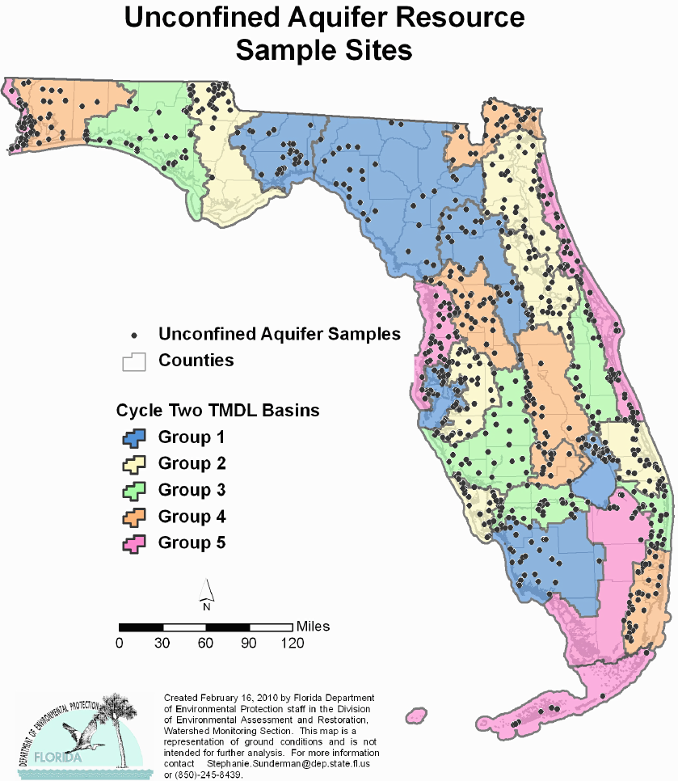

Figure 6.14. Statewide Summary of Unconfined Aquifer Results

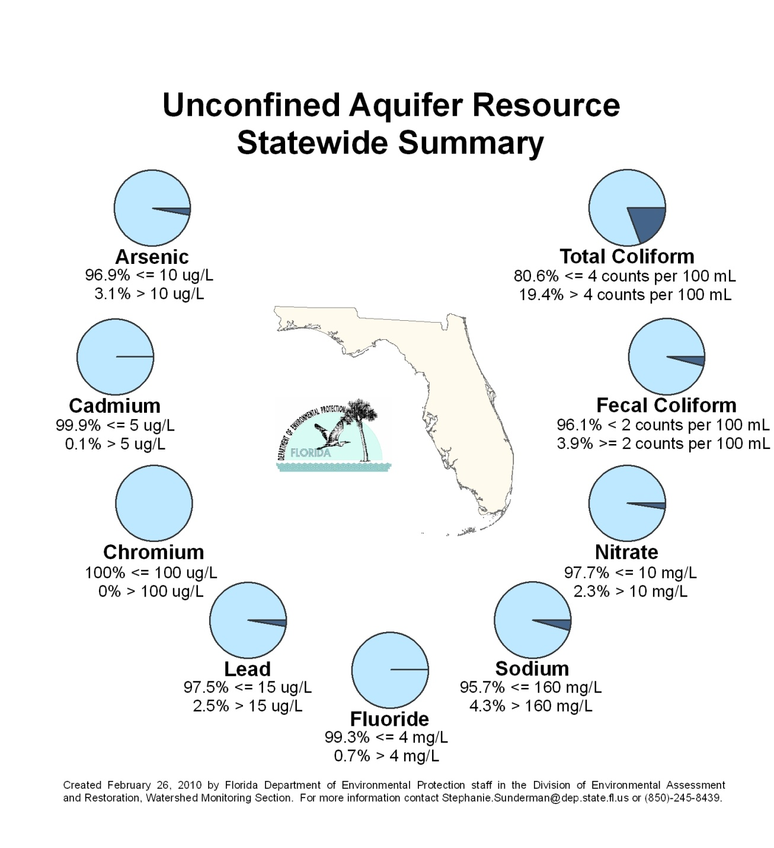

Table 6.6c. Statewide Percentage of Unconfined Aquifers Meeting Threshold Values for Indicators Calculated Using Probabilistic Monitoring Design
Status Network Designated Use: Primary Drinking Water Standards Units: Number of wells in list frame
This is a nine-column table. Column 1 lists the analyte, Column 2 lists the target population, Column 3 lists the sampleable number of wells, Column 4 lists the inaccessible wells, Column 5 lists the number of samples, Column 6 lists the percent meeting the threshold, Column 7 lists the 95% confidence bounds, Column 8 lists the percent not meeting the threshold, and Column 9 lists the assessment period.

¹ Wells in list frame
² Estimated number of wells
Analyte | Target Population¹ | Sampleable² | Inaccessible² | Number of Samples | % Meeting | 95%  Confidence Bounds  (% Meeting) | % Not Meeting | Assessment Period
Arsenic | 8,203 | 3,698 | 4,505 | 821 | 96.9 | 95.9-97.9 | 3.1 | 2004-08
Cadmium | 8,203 | 3,698 | 4,505 | 808 | 99.9 | 99.7-100.0 | 0.1 | 2004-08
Chromium | 8,203 | 3,698 | 4,505 | 783 | 100.0 | 99.9-100.0 | 0.0 | 2004-08
Lead | 8,203 | 3,698 | 4,505 | 822 | 97.5 | 96.3-98.7 | 2.5 | 2004-08
Nitrate-Nitrite | 8,203 | 3,698 | 4,505 | 786 | 97.7 | 96.8-98.7 | 2.3 | 2004-08
Sodium | 8,203 | 3,698 | 4,505 | 766 | 95.7 | 84.5-96.9 | 4.3 | 2004-08
Fluoride | 8,203 | 3,698 | 4,505 | 822 | 99.3 | 94.5-100.0 | 0.7 | 2004-08
Fecal Coliform | 8,203 | 3,698 | 4,505 | 813 | 96.2 | 94.2-98.2 | 3.8 | 2004-08
Total Coliform | 8,203 | 3,698 | 4,505 | 774 | 82.6 | 78.8-86.5 | 17.4 | 2004-08

Highlights: Unconfined Aquifers
- Unconfined (shallow) aquifers are often more susceptible to anthropogenic influences or changing hydrologic conditions. More unconfined aquifer wells exceeded their target thresholds than did wells in the confined aquifers.
- Of sampled wells in Florida, 19.4% did not meet the potable water threshold for total coliform (≤4 colonies/100mL). Unconfined aquifer wells in the Sarasota Bay–Peace–Myakka and Ochlockonee–St. Marks Basins had the highest exceedance rates for total coliform, at 52.6% and 52.5%, respectively.
- Statewide, fecal coliform levels (<2 colonies/100mL) exceeded the potable water threshold in 3.9% of wells sampled. The highest exceedance rates were found in the Sarasota Bay–Peace–Myakka (17.1%) and Southeast Coast–Biscayne Bay (13.1%) Basins. As in confined wells, coliform detection in an unconfined well can indicate problems with well construction or maintenance, and can also indicate contamination from surface water or stormwater runoff.
- Statewide, 4.3% of the wells sampled exceeded the state threshold for sodium (≤160 mg/L). Wells in the Springs Coast, Everglades–West Coast, and Indian River Lagoon Basins, all of which are coastal basins, had the highest exceedance rates for sodium, at 22.2%, 19.8%, and 19.8%, respectively. In unconfined aquifers, sodium levels above the state threshold can be indicative of the upconing of mineralized ground water from deeper aquifers, or saltwater intrusion resulting from overpumping or drought.
- Statewide, 3.1% of sampled wells in unconfined aquifers exceeded the state threshold for arsenic (≤10 µg/L). Wells in the Tampa Bay Tributaries and Everglades–West Coast Basins had the highest exceedance rates, at 20.4% and 17.2%, respectively. The source of arsenic in unconfined aquifers may be local geology or pesticides used in groves, golf courses, and cattle-dipping vats.
- In Florida, 2.5% of the unconfined wells sampled exceeded the state threshold for lead. The Lake Worth Lagoon–Palm Beach Coast and Ocklawaha Basins had the highest exceedance rates, at 10.9% and 10.2%, respectively. Lead levels (≤15 µg/L) above the state threshold can be indicative of contamination from land use practices. Another source of lead may be aging plumbing fixtures associated with wells.
- Statewide, 0.1% of the wells sampled exceeded the state threshold for cadmium. Wells in the St. Lucie–Loxahatchee River and Everglades Basins had the highest exceedance rates, both at 2.2%.
- The state threshold for nitrate-nitrite (≤10 mg/L) was exceeded in 2.3% of Florida wells sampled. The Kissimmee River and Middle St. Johns Basins had the highest exceedance rates, at 34.8% and 11.7%, respectively. Elevated nitrate detections reflect the presence of nutrient sources such as fertilizers, animal waste, or domestic wastewater.
- Statewide, 0.7% of the wells sampled exceeded the state threshold for fluoride (≤4 mg/L). The Pensacola Basin had the highest exceedance rate, at 6.4%, which may result from the influence of nearby marine areas.

Summary of Status Network Cycle 1 versus Cycle 2 Results
Between 2000 and 2008, the Status Network monitoring program completed two statewide assessments of surface and ground water resources: Cycle 1 (2000–03); and Cycle 2 (2004–08). This section compares the results for Cycles 1 and 2, where possible. Some resources could not be compared between cycles. Data from ground water resources from Cycle 1 were not analyzed and reported in the same manner as in Cycle 2, and therefore could not be compared.

Sampling of river and stream resources was comparable between the two cycles of statewide assessment for selected analytes. During Cycle 1, rivers and streams could not be differentiated by stream order, and so resources were combined for analysis and reporting in the 2006 305(b) report. For purposes of comparison with the Cycle 1 resource, Cycle 2 rivers and streams were combined and analyzed as one.

The two cycles had very similar results for the listed analytes (Table 6.7a). Reductions in the percentage of resources meeting thresholds in Cycle 2 could represent an artifact from the different coverages used to determine resource extent. In Cycle 1, the Watershed Monitoring Section used the 100K RF3 coverage; in Cycle 2, it adopted the National Hydrography Dataset (NHD) 100K coverage. Fewer Cycle 2 rivers and streams met the thresholds for specific indicators.

Table 6.7a. Percentage of Combined Rivers and Streams Resource Meeting Threshold Values for Statewide Assessment for Cycles 1 and 2
Status Network Designated Use: Recreation and Aquatic Life Units: Miles

This is a five-column table. Column 1 lists the analytes, Column 2 lists the Cycle 1 target population, Column 3 lists the Cycle 2 target population, Column 4 lists the percent meeting the threshold in Cycle 1, and Column 5 lists the percent meeting the threshold in Cycle 2.

Analyte | Cycle 1  Target Population | Cycle 2  Target Population | Cycle 1  % Meeting Threshold | Cycle 2  % Meeting Threshold)
Chlorophyll a | 32,929 | 37,733 | 80.2 | 75.4
Fecal Coliform | 32,929 | 37,733 | 73.8 | 72.3
DO | 32,929 | 37,733 | 50.1 | 46.8

The lakes resources, both large and small, were redefined from Cycle 1 to Cycle 2; however, TSI, fecal coliform, and DO results were suitable for comparison and are shown in Tables 6.7b and 6.7c for small and large lakes, respectively.

The results for small lakes were similar between Cycles 1 and 2 (Table 6.7b), although half of the target population from Cycle 1 small lakes was excluded in Cycle 2. Those lakes that were excluded were considered to be artificial, such as borrow pits or man-made lakes on golf courses. The results for fecal coliform and DO were very similar. The percentage of small lakes meeting the TSI threshold increased by nearly 10% from Cycle 1 to Cycle 2 and may reflect the removal of artificial lakes that should not have been sampled for biological indicators.

Table 6.7b. Percentage of Small Lakes Resource Meeting Threshold Values for Statewide Assessment for Cycles 1 and 2
Status Network Designated Use: Recreation and Aquatic Life Units: Lakes

This is a five-column table. Column 1 lists the analytes, Column 2 lists the Cycle 1 target population, Column 3 lists the Cycle 2 target population, Column 4 lists the percent meeting the threshold in Cycle 1, and Column 5 lists the percent meeting the threshold in Cycle 2.

Analyte | Cycle 1  Target Population | Cycle 2  Target Population | Cycle 1  % Meeting Threshold | Cycle 2  % Meeting Threshold
TSI | 10,630 | 5,882 | 81.7 | 90.3
Fecal Coliform | 10,630 | 5,882 | 90.9 | 90.9
DO | 10,630 | 5,882 | 75.1 | 71.2

The analyte results for large lakes were similar between Cycles 1 and 2 (Table 6.7c). In contrast to small lakes, very few large lakes were removed from the target population from Cycle 1 to Cycle 2; those that were may have been phosphate industry holding ponds. Overall results were similar to those found in the small lakes. DO and fecal coliform were very similar between Cycles 1 and 2. A 16% increase in large lakes meeting their TSI threshold may be an artifact of the removal of impacted lakes that should not have been sampled.

Table 6.7c. Percentage of Large Lakes Resource Meeting Threshold Values for Statewide Assessment for Cycles 1 and 2
Status Network Designated Use: Recreation and Aquatic Life Units: Acres

This is a five-column table. Column 1 lists the analytes, Column 2 lists the Cycle 1 target population, Column 3 lists the Cycle 2 target population, Column 4 lists the percent meeting the threshold in Cycle 1, and Column 5 lists the percent meeting the threshold in Cycle 2.

Analyte | Cycle 1  Target Population | Cycle 2  Target Population | Cycle 1  % Meeting Threshold | Cycle 2  % Meeting Threshold
TSI | 1,075,200 | 1,038,899 | 78.2 | 94.0
Fecal Coliform | 1,075,200 | 1,038,899 | 96.5 | 99.7
DO | 1,075,200 | 1,038,899 | 93.6 | 95.0

Summary of Surface and Ground Water Trend Network Results

Surface Water Trends
The flow rate of rivers can be thought of as cyclical and can complicate data analysis unless taken into consideration. Where available, flow rates from associated USGS gauging stations were collected at the same time as surface water samples. The surface water quality data were then adjusted for flow and deseasonalized, before the data were analyzed. Since ground water flows very slowly, there is little to no cyclicity to the data. Therefore, no adjustment to the ground water data was necessary prior to performing any analysis.

Forty-one surface water stations were adjusted for flow, while the remaining 35 stations were not flow adjusted. Tables 6.8a and 6.8b present the results of the trend analyses, and Figures 6.15 through 6.21 show the results graphically for each indicator.

Table 6.8a. Trends for Specified Analytes for Surface Water Trend Network Stations that Are Associated with a USGS Gauging Station and Adjusted for River Flow
This is a nine-column table. Column 1 lists the station, Column 2 lists the river, and Columns 3 through 9 list the analytes.

Positive trends are indicated with a plus sign (+), negative trends are indicated with a minus sign (-), and no trends are indicated by zero (o).
Station | River | Nitrate + Nitrite | TKN | TP | TOC | Chlorophyll a | Fecal Coliform | DO
3494 | Barron River | o | o | o | o | o | o | o
3558 | Miami Canal | o | o | o | o | o | o | o
3572 | Miami River | o | - | o | o | o | o | +
3500 | St. Lucie Canal | o | o | o | o | o | o | +
3519 | Suwannee River | o | o | o | o | o | o | o
3538 | Alapaha River | o | o | o | o | o | o | o
3524 | Apalachicola River | o | o | o | o | + | o | +
3527 | Ochlockonee River | o | o | o | o | o | o | +
3528 | St. Marks River | o | o | o | o | o | o | +
3531 | Econfina Creek | + | + | o | o | o | o | +
3532 | Telogia Creek | - | o | o | o | o | o | +
3534 | Choctawhatchee River | o | o | o | o | + | o | +
3565 | Elevenmile Creek | - | o | o | o | o | o | -
3541 | Escambia River | o | o | o | o | + | o | o
3542 | Perdido River | - | + | + | + | o | o | o
3543 | Apalachicola River | o | o | o | o | + | o | o
3545 | Blackwater River | o | o | o | o | o | + | +
3549 | Escambia River | o | o | o | o | + | o | +
3571 | Black Creek Canal | + | o | o | o | o | o | o
3559 | Hillsboro Canal | o | o | o | o | o | o | o
3568 | Caloosahatchee River | o | o | o | o | o | o | +
3497 | Fisheating Creek | o | + | o | + | o | o | o
3501 | Kissimmee River | o | o | o | o | o | o | o
3569 | Little Econlockhatchee River | o | o | o | o | o | + | -
3557 | St. Johns River | o | o | o | o | o | o | o
3515 | St. Johns River | o | o | o | o | - | o | o
3517 | Ocklawaha River | o | o | o | o | o | o | o
3564 | Waccasassa River | o | o | o | o | o | o | +
3521 | Santa Fe River | o | + | + | + | o | o | -
3522 | Suwannee River | o | o | o | o | + | + | o
3530 | Suwannee River | + | o | o | o | + | o | o
3535 | Suwannee River | + | o | o | + | o | o | o
3539 | Withlacoochee River | o | o | o | o | + | o | o
3556 | Peace River | o | + | + | o | + | o | o
3561 | Charlie Creek | o | + | + | o | o | o | o
3555 | Little Manatee River | o | + | o | + | o | o | o
3554 | Alafia River | o | + | - | o | o | o | o
3509 | Anclote River | - | o | - | o | - | + | o
3560 | Withlacoochee River | o | o | o | o | o | o | o
3566 | Weeki Wachee River | + | + | o | o | - | o | -
3513 | Withlacoochee River | + | o | o | o | o | o | o

Table 6.8b. Trends for Specified Analytes for Surface Water Stations from the Trend Network and not Adjusted for River Flow
This is a nine-column table. Column 1 lists the station, Column 2 lists the river, and Columns 3 through 9 list the analytes.

Positive trends are indicated with a plus sign (+), negative trends are indicated with a minus sign (-), and no trends are indicated by zero (o).
Station | River | Nitrate + Nitrite | TKN | TP | TOC | Chlorophyll a | Fecal Coliform | DO
3516 | Tomoka River | o | o | + | o | - | o | o
3553 | St. Johns River | o | o | o | - | o | o | +
3544 | St. Marys River | - | o | o | o | - | o | o
6978 | Steinhatchee River | o | o | o | o | - | o | o
3526 | Aucilla River | o | o | o | o | - | o | o
6976 | Econfina River | o | + | o | o | - | o | o
21380 | Homosassa Spring Run | + | + | o | o | - | + | o
3499 | Myakka River | o | + | o | o | + | o | o
3502 | Phillippe Creek | o | o | o | - | o | o | -
3505 | Manatee River | + | + | o | o | o | + | o
3507 | Hillsborough River | o | o | o | o | o | o | o
21460 | Wrights Creek | o | o | o | o | - | + | o
21461 | Big Coldwater Creek | o | o | - | o | - | + | o
3563 | New River | o | o | o | o | o | o | +
3552 | Chipola River | o | o | - | o | - | o | +
3533 | East Bay River | - | o | - | o | - | o | +
3551 | Yellow River | o | + | o | o | o | o | +
3540 | Ochlockonee River | o | o | - | o | + | o | +
3536 | Alaqua Creek | o | + | - | + | - | o | +
3546 | Yellow River | o | o | o | o | - | o | +
3547 | Cowarts Creek | o | o | o | o | - | - | +
3548 | Choctawhatchee River | o | o | o | o | o | o | +
3550 | Brushy Creek | - | + | o | + | - | o | o
3570 | Aerojet Canal | + | + | - | o | o | + | +
3495 | Golden Gate Canal | o | + | o | - | + | o | +
3504 | C-25 | o | + | o | o | + | o | o
3506 | Lake Kissimmee | o | o | o | - | + | o | -
21179 | Spruce Creek | o | o | o | o | o | o | o
21200 | Rice Creek | + | o | - | o | - | o | o
21201 | Moultrie Creek | o | o | o | o | - | o | -
21202 | Orange Creek | + | - | o | o | - | + | o
3508 | Indian River Lagoon | o | o | - | - | o | o | o
3537 | Nassau River | o | + | o | o | o | o | o

Figure 6.15. Surface Water Trends for Nitrate + Nitrite, 1999–2008

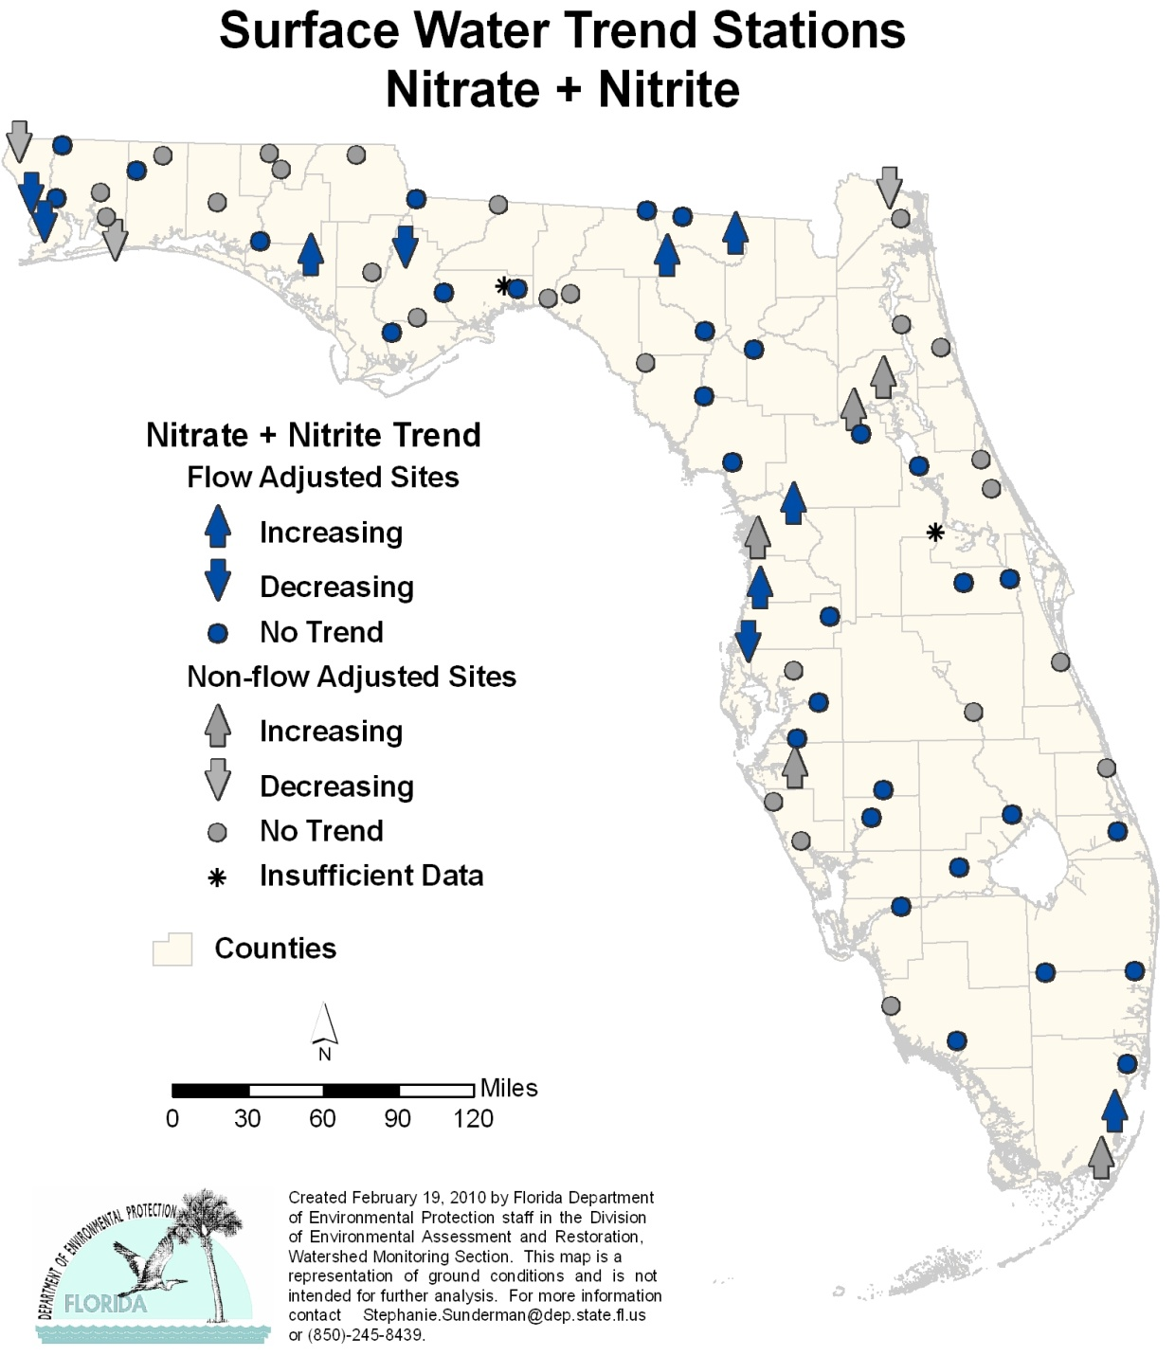
Highlights

- There were 7 stations with decreasing trends and 11 stations with increasing trends for nitrate-nitrite around the state. The far western Panhandle had 4 of the decreasing trend stations, while the remaining stations were located throughout the rest of the state. Trends in nitrate-nitrite may indicate changes in anthropogenic input.
Figure 6.16. Surface Water Trends for TKN, 1999–2008

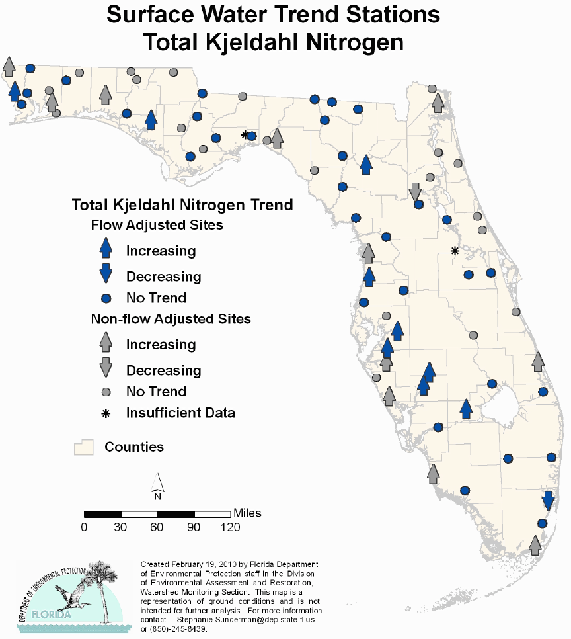

Highlights

- TKN had 20 stations with increasing trends and only 2 stations had decreasing trends. TKN is ammonia plus organic nitrogen.

Figure 6.17. Surface Water Trends for TP, 1999–2008

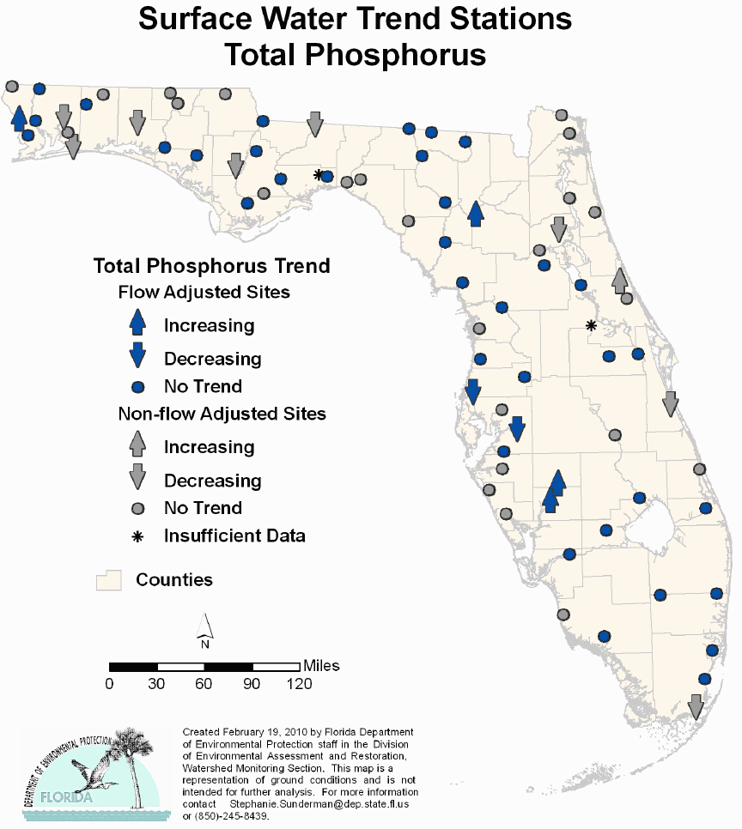

Highlights

- TP had 5 stations with increasing trends and 9 stations with decreasing trends across the state. There was no pattern for either the increasing or decreasing trends. Phosphorus is found naturally in ground water in many areas of the state.

Figure 6.18. Surface Water Trends for TOC, 1999–2008
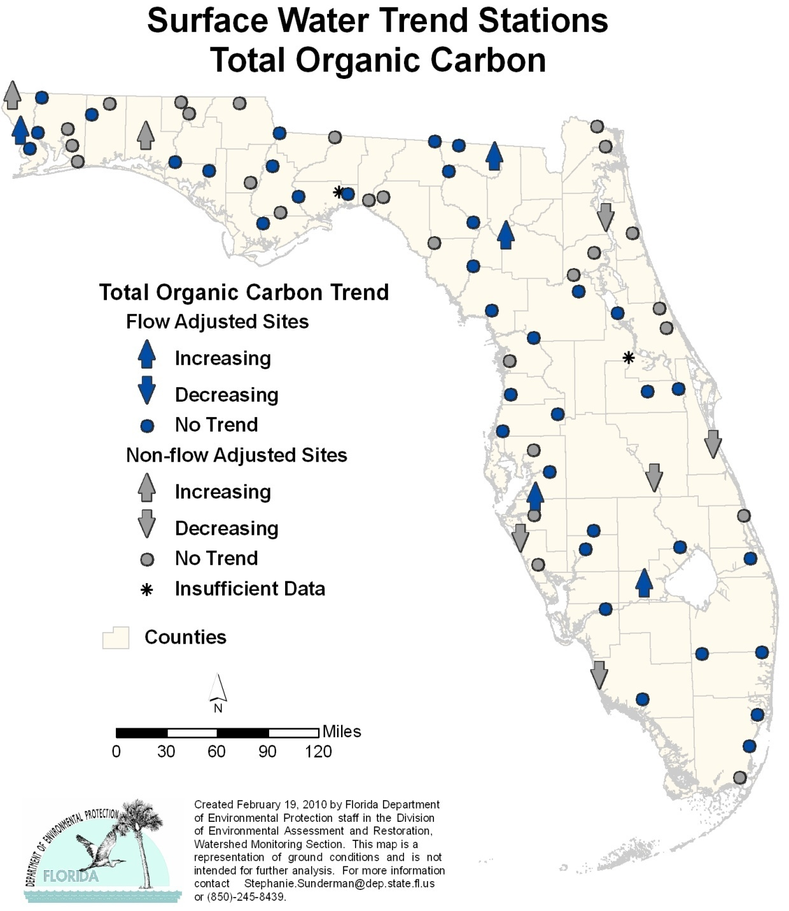

Highlights

- There were 7 stations with increasing trends and 5 stations with decreasing trends for TOC across the state. The increasing stations were predominantly located in the Panhandle region, while the decreasing stations were in the Peninsula.

Figure 6.19. Surface Water Trends for Chlorophyll a, 1999–2008
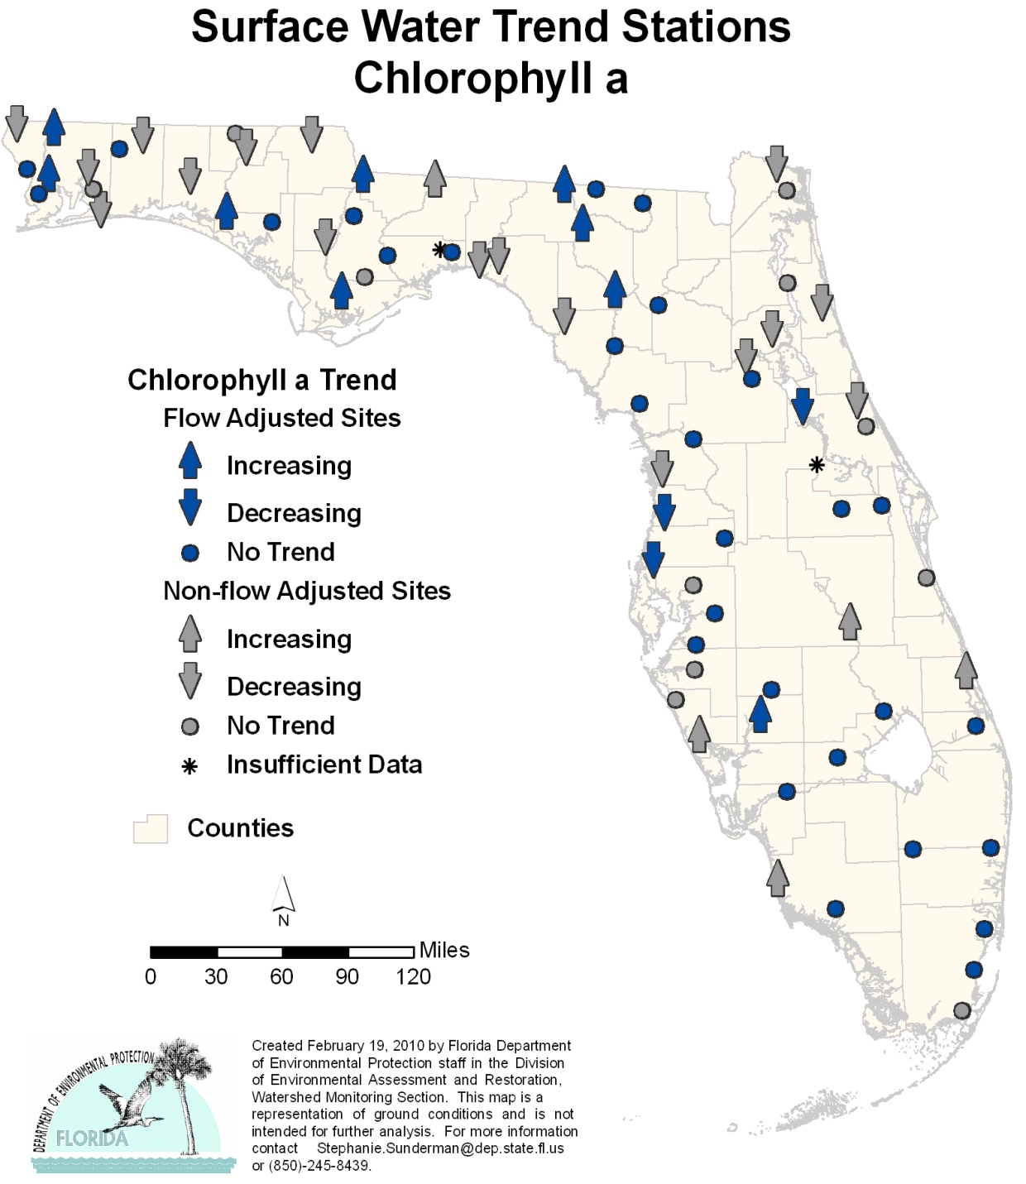

Highlights

- The trends for chlorophyll a were mixed, with 20 stations having a decreasing trend and 14 stations an increasing trend, with no apparent pattern around the state. Chlorophyll a is a photosynthetic pigment and may be used as a surrogate indicator of changes in plant biomass related to nutrients.

Figure 6.20. Surface Water Trends for Fecal Coliform Bacteria, 1999–2008
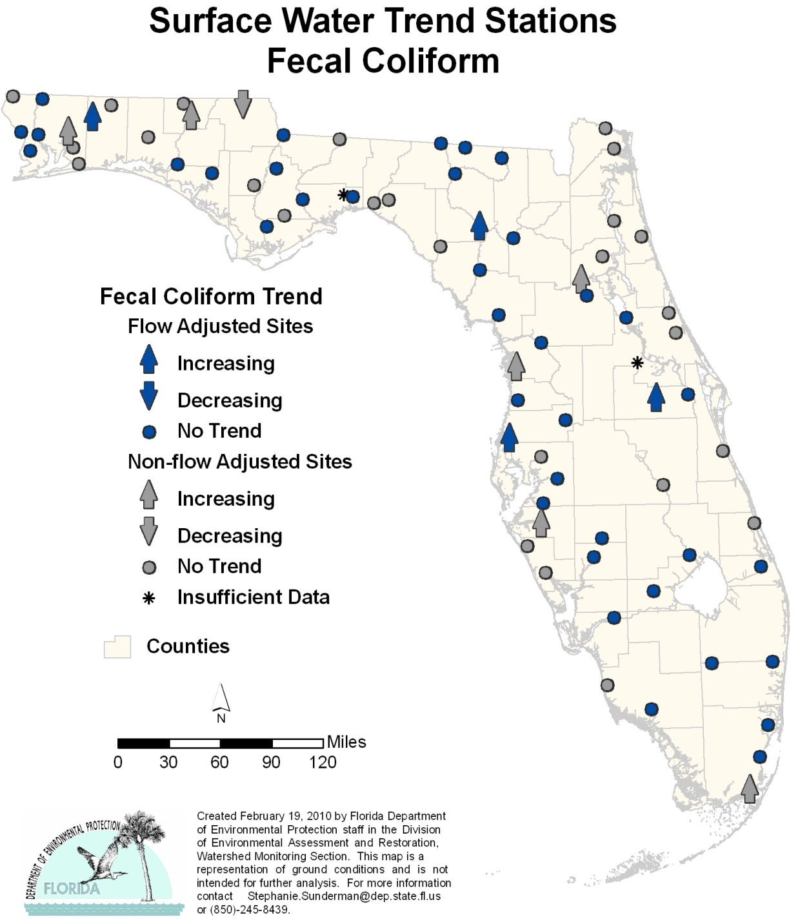

Highlights

- Ten stations had increasing trends for fecal coliform bacteria. There was one station with a decreasing trend, located at the Florida–Georgia border. Increased levels of fecal coliform in surface waters can indicate inadequate treatment of domestic wastewater, sewer line spills, or failing septic tanks; however, there are also many natural sources of coliform, and the EPA no longer supports the use of fecal coliform as an indicator organism.

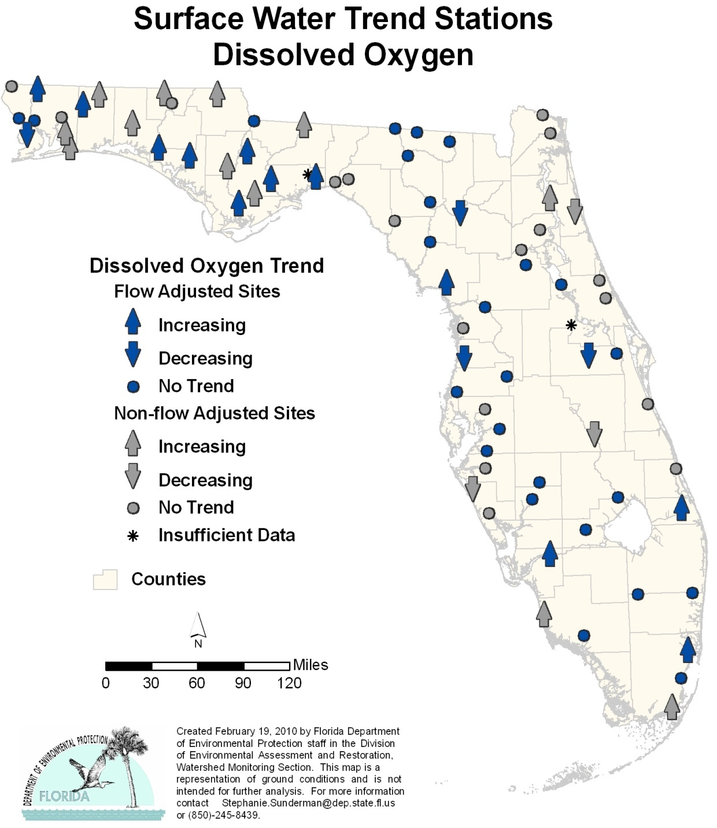
Figure 6.21. Surface Water Trends for DO, 1999–2008

Highlights

- Six stations had decreasing trends for DO (overall DO value decreasing), and 24 stations had increasing trends. There was no pattern to the trends, but more stations with increasing trends were located in the Panhandle.

Ground Water Trends
Forty-six of the 47 ground water stations (wells) had a complete set of field and analytical data. Twenty-two of the wells tap confined aquifers, while 25 tap unconfined aquifers. Tables 6.9b and 6.9c present the results of the trend analyses, and Figures 6.22 through 6.37 show the results graphically for each analyte. Table 6.9a contains the legend for the acronyms and abbreviations used in Tables 6.9b and 6.9c.

Table 6.9a. Legend for the Acronyms and Abbreviations Used in Tables 6.9b and 6.9c
This is a two-column table. Column 1 lists the acronym or abbreviation, and Column 2 spells out the acronym.

Acronym/Abbreviation | Indicator
Temp | Temperature (°C)
SC | Specific Conductance, Field
pH | pH, Field
WL | Depth to Water (from measuring point)
TDS | Total Dissolved Solids (TDS measured)
NO_{X} | Nitrate + Nitrite, Dissolved (as N)
P | Phosphorus, Dissolved (as P)
K | Potassium, Dissolved
SO₄ | Sulfate, Dissolved
Na | Sodium, Dissolved
Cl | Chloride, Dissolved
Ca | Calcium, Dissolved
Mg | Magnesium, Dissolved
ALK | Alkalinity, Dissolved (as calcium carbonate [CaCO3])
TC | Coliform, Total (MF method)
FC | Coliform, Fecal (MF method)

Table 6.9b. Trends for Specified Analytes for Stations in the Ground Water Trend Monitoring Network, Confined Aquifers
This is a 17-column table. Column 1 lists the stations and Columns 2 through 17 list the individual analytes.

Note: A positive trend is indicated with a plus sign (+), a negative trend is indicated with a minus sign (-), no trend is indicated by a zero (o), and insufficient data to determine a trend is indicated by (ISD).
Station | Temp | SC | pH | WL | TDS | NO_{X} | P | K | SO₄ | Na | Cl | Ca | Mg | ALK | TC | FC
243 | 0 | 0 | - | 0 | 0 | 0 | 0 | 0 | 0 | + | 0 | 0 | + | + | 0 | 0
312 | 0 | + | - | 0 | 0 | 0 | + | 0 | 0 | 0 | 0 | + | 0 | + | 0 | 0
615 | - | 0 | - | ISD | 0 | 0 | 0 | + | 0 | + | + | 0 | 0 | 0 | 0 | 0
707 | 0 | 0 | - | 0 | 0 | 0 | 0 | 0 | + | 0 | + | 0 | + | 0 | 0 | 0
737 | 0 | + | - | 0 | 0 | 0 | 0 | + | 0 | + | + | 0 | + | 0 | 0 | 0
775 | + | - | - | + | 0 | 0 | 0 | 0 | 0 | 0 | 0 | 0 | 0 | 0 | 0 | 0
997 | - | 0 | - | 0 | 0 | 0 | 0 | 0 | 0 | 0 | 0 | 0 | + | 0 | 0 | 0
1420 | + | 0 | 0 | 0 | 0 | 0 | 0 | 0 | 0 | 0 | 0 | 0 | 0 | 0 | 0 | 0
1674 | 0 | - | - | 0 | 0 | 0 | 0 | 0 | + | 0 | + | 0 | 0 | - | 0 | 0
1762 | 0 | 0 | 0 | 0 | 0 | 0 | 0 | + | 0 | 0 | + | 0 | 0 | 0 | 0 | 0
1763 | 0 | 0 | 0 | 0 | 0 | 0 | 0 | + | + | 0 | + | + | + | 0 | 0 | 0
1779 | 0 | 0 | 0 | 0 | 0 | 0 | 0 | 0 | 0 | 0 | 0 | 0 | 0 | 0 | 0 | 0
1780 | 0 | 0 | 0 | - | 0 | 0 | 0 | 0 | 0 | 0 | 0 | 0 | 0 | 0 | + | +
2187 | 0 | - | 0 | + | ISD | ISD | ISD | ISD | ISD | ISD | ISD | ISD | ISD | ISD | ISD | ISD
2353 | 0 | + | 0 | - | 0 | 0 | 0 | 0 | 0 | 0 | 0 | 0 | 0 | + | + | +
2404 | + | 0 | 0 | 0 | - | 0 | 0 | 0 | 0 | 0 | + | 0 | 0 | 0 | 0 | 0
2585 | + | + | 0 | 0 | 0 | 0 | 0 | 0 | 0 | + | + | 0 | 0 | 0 | 0 | 0
2675 | 0 | + | 0 | 0 | 0 | 0 | 0 | 0 | 0 | 0 | 0 | 0 | 0 | 0 | 0 | 0
2873 | 0 | 0 | 0 | 0 | - | 0 | - | 0 | 0 | 0 | - | 0 | 0 | 0 | 0 | +
3108 | + | 0 | 0 | 0 | 0 | 0 | 0 | 0 | 0 | 0 | 0 | 0 | 0 | 0 | 0 | 0
3433 | 0 | 0 | 0 | ISD | 0 | 0 | 0 | 0 | 0 | 0 | 0 | 0 | 0 | + | 0 | 0
7935 | 0 | 0 | - | 0 | 0 | 0 | 0 | 0 | 0 | + | + | + | 0 | 0 | 0 | 0

Table 6.9c. Trends for Specified Analytes for Stations in the Ground Water Trend Monitoring Network, Unconfined Aquifers
This is a 17-column table. Column 1 lists the stations and Columns 2 through 17 list the analytes.

Note: A positive trend is indicated with a plus sign (+), a negative trend is indicated with a minus sign (-), no trend is indicated by zero (o), and insufficient data to determine a trend is indicated by (ISD).
Station | Temp | SC | pH | WL | TDS | NO_{X} | P | K | SO₄ | Na | Cl | Ca | Mg | ALK | TC | FC
67 | - | 0 | 0 | ISD | 0 | - | 0 | 0 | 0 | 0 | + | 0 | 0 | 0 | 0 | 0
91 | 0 | 0 | 0 | 0 | 0 | 0 | + | + | - | + | 0 | 0 | 0 | 0 | 0 | 0
129 | 0 | 0 | 0 | - | 0 | 0 | 0 | 0 | 0 | 0 | 0 | 0 | 0 | 0 | 0 | 0
131 | 0 | + | - | - | 0 | 0 | 0 | + | + | + | + | + | + | - | 0 | 0
245 | 0 | + | 0 | 0 | 0 | 0 | 0 | + | 0 | + | + | 0 | + | 0 | + | +
313 | 0 | + | 0 | 0 | 0 | 0 | 0 | + | 0 | 0 | 0 | + | + | 0 | 0 | 0
736 | 0 | 0 | 0 | 0 | 0 | 0 | 0 | 0 | 0 | + | 0 | 0 | 0 | 0 | 0 | 0
996 | - | 0 | 0 | 0 | 0 | + | - | 0 | - | - | 0 | 0 | 0 | 0 | + | +
1087 | - | 0 | - | 0 | 0 | 0 | 0 | 0 | 0 | 0 | 0 | + | + | 0 | 0 | 0
1100 | 0 | + | - | 0 | + | 0 | 0 | - | 0 | 0 | 0 | + | + | + | 0 | 0
1417 | + | + | - | 0 | + | + | 0 | + | - | + | 0 | + | + | + | 0 | 0
1764 | 0 | + | 0 | 0 | 0 | 0 | 0 | 0 | - | 0 | 0 | 0 | 0 | + | 0 | 0
1781 | 0 | - | - | - | 0 | + | - | 0 | 0 | + | + | 0 | 0 | 0 | 0 | 0
1931 | + | + | 0 | 0 | + | 0 | 0 | + | + | 0 | 0 | + | 0 | + | + | 0
1943 | - | 0 | 0 | 0 | - | 0 | 0 | + | - | - | 0 | 0 | 0 | 0 | 0 | 0
2003 | 0 | 0 | 0 | 0 | 0 | 0 | + | 0 | 0 | 0 | 0 | 0 | + | 0 | + | +
2259 | 0 | + | 0 | 0 | 0 | 0 | 0 | 0 | + | 0 | 0 | 0 | + | 0 | + | 0
2465 | + | + | 0 | - | 0 | - | 0 | 0 | 0 | - | - | 0 | 0 | + | 0 | 0
2793 | - | + | 0 | 0 | 0 | + | 0 | 0 | - | 0 | + | 0 | 0 | 0 | 0 | 0
2872 | + | - | 0 | 0 | - | 0 | 0 | 0 | 0 | 0 | + | 0 | 0 | 0 | 0 | 0
3109 | - | + | + | + | 0 | 0 | 0 | + | + | + | + | + | + | - | 0 | 0
3398 | 0 | + | + | + | 0 | 0 | 0 | 0 | - | 0 | 0 | 0 | + | + | 0 | 0
3490 | + | - | 0 | 0 | 0 | 0 | - | 0 | 0 | - | - | 0 | - | + | 0 | 0
6490 | + | - | 0 | 0 | 0 | 0 | - | 0 | 0 | - | - | 0 | - | + | 0 | 0
7934 | + | - | 0 | 0 | 0 | 0 | 0 | 0 | 0 | - | - | 0 | 0 | 0 | 0 | 0

Figure 6.22. Ground Water Trends for Temperature, 1999–2008

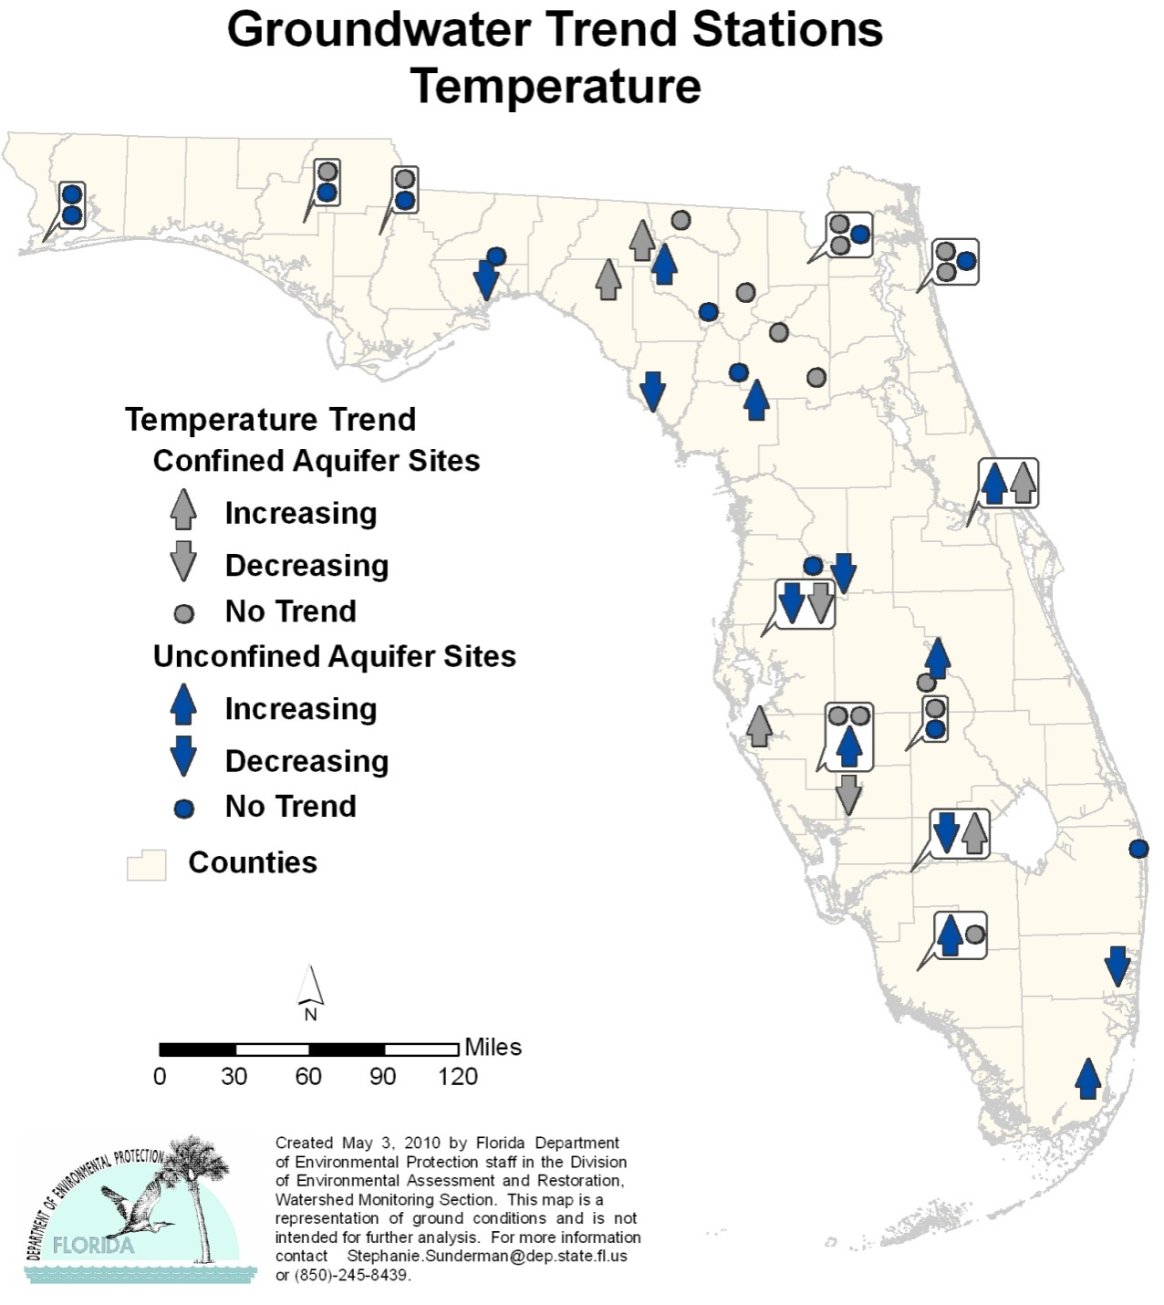

Highlights:

- The trend analysis for the confined aquifer wells reported 5 stations with an increasing trend and 2 stations with a decreasing trend for temperature (Temp).
- There were 7 stations with increasing trends in the unconfined aquifer wells and 6 stations with a decreasing trend.

Figure 6.23. Ground Water Trends for Specific Conductance, 1999–2008

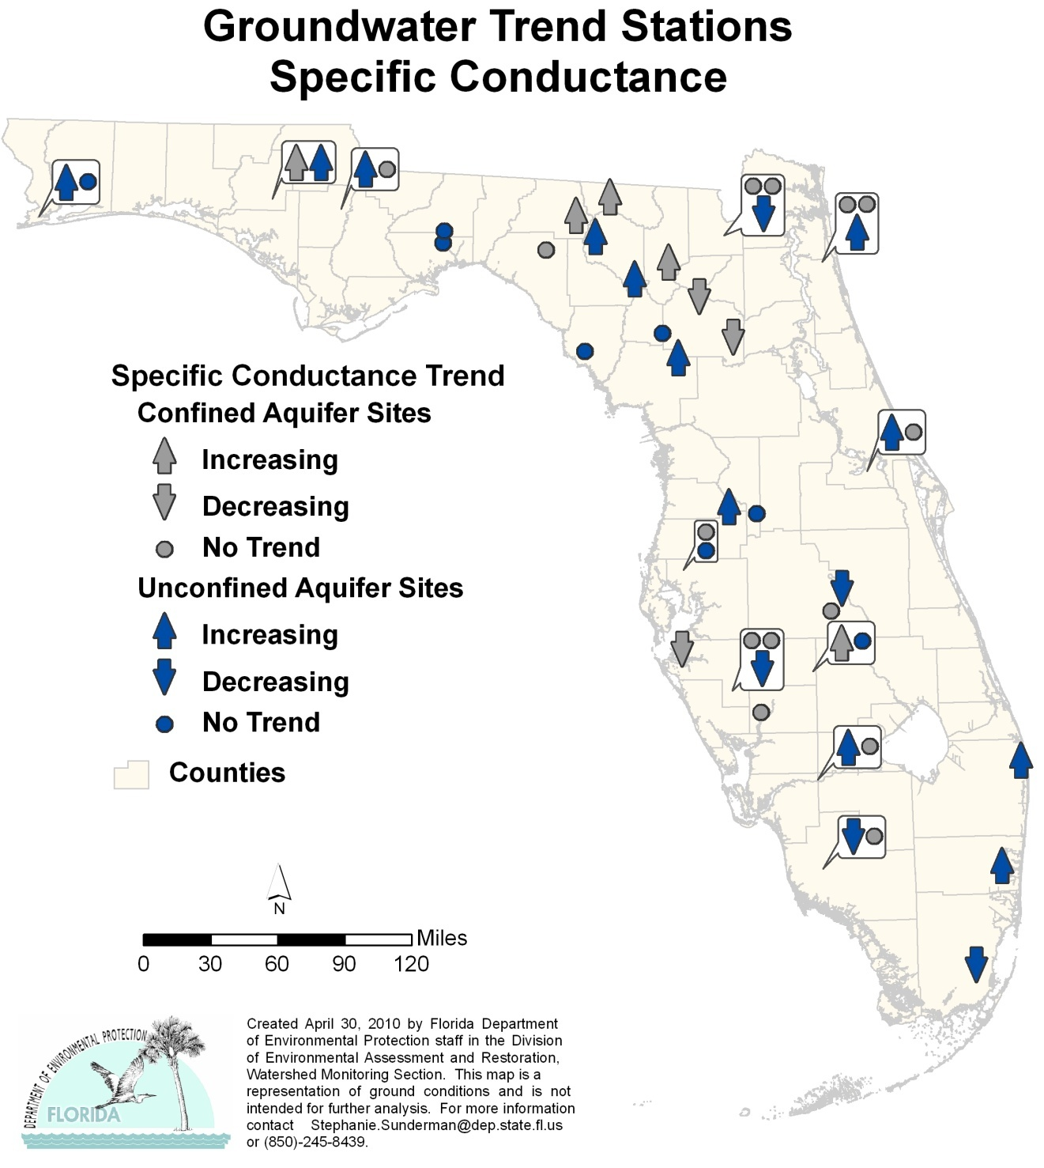

Highlights:

- The trend analysis for the confined aquifer wells reported 5 stations with an increasing trend and 3 stations with a decreasing trend for specific conductance (SC).
- There were 12 stations with increasing trends in the unconfined aquifer wells and 6 stations with a decreasing trend.

Figure 6.24. Ground Water Trends for pH, 1999–2008

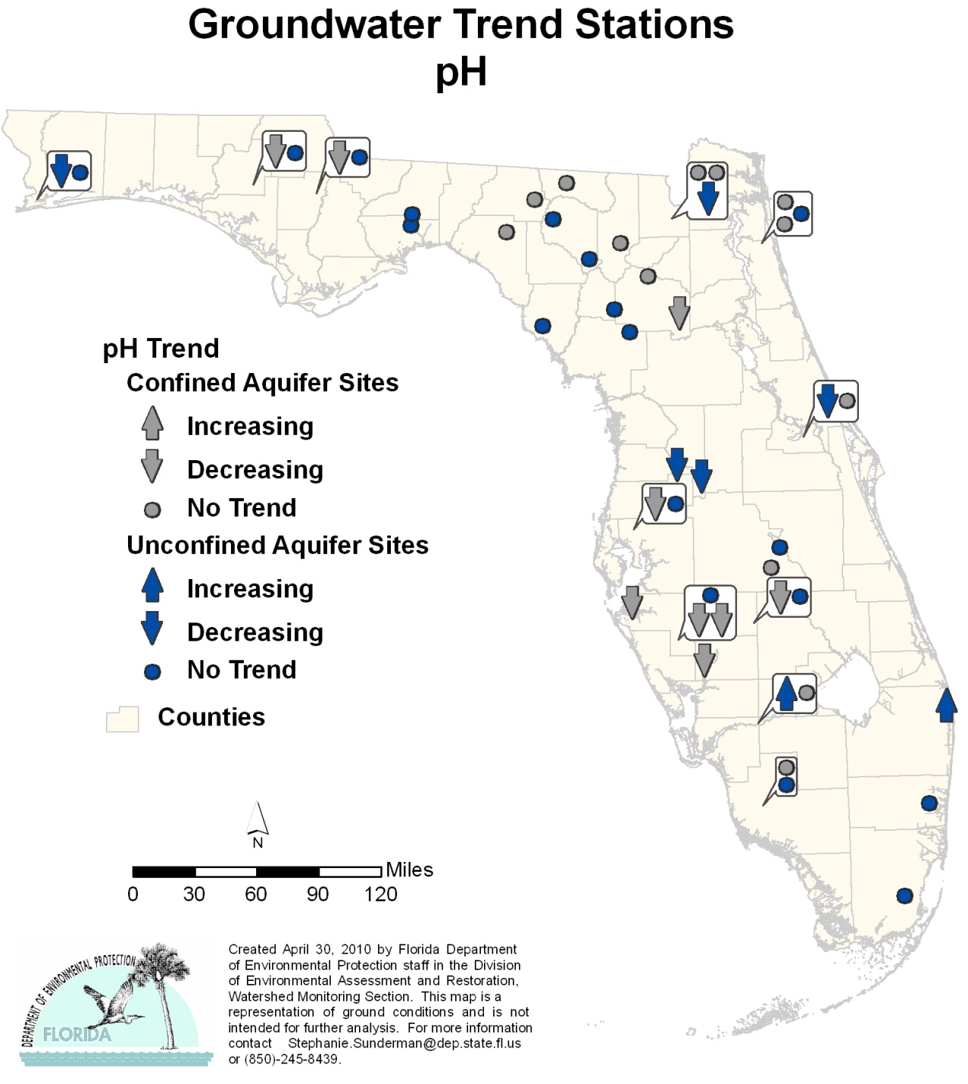

Highlights:

- The trend analysis for the confined aquifer wells reported none of the stations with an increasing trend and 9 stations with a decreasing trend for pH.
- There were 2 stations with increasing trends in the unconfined aquifer wells and 5 stations with a decreasing trend.

Figure 6.25. Ground Water Trends for Depth to Water, 1999–2008

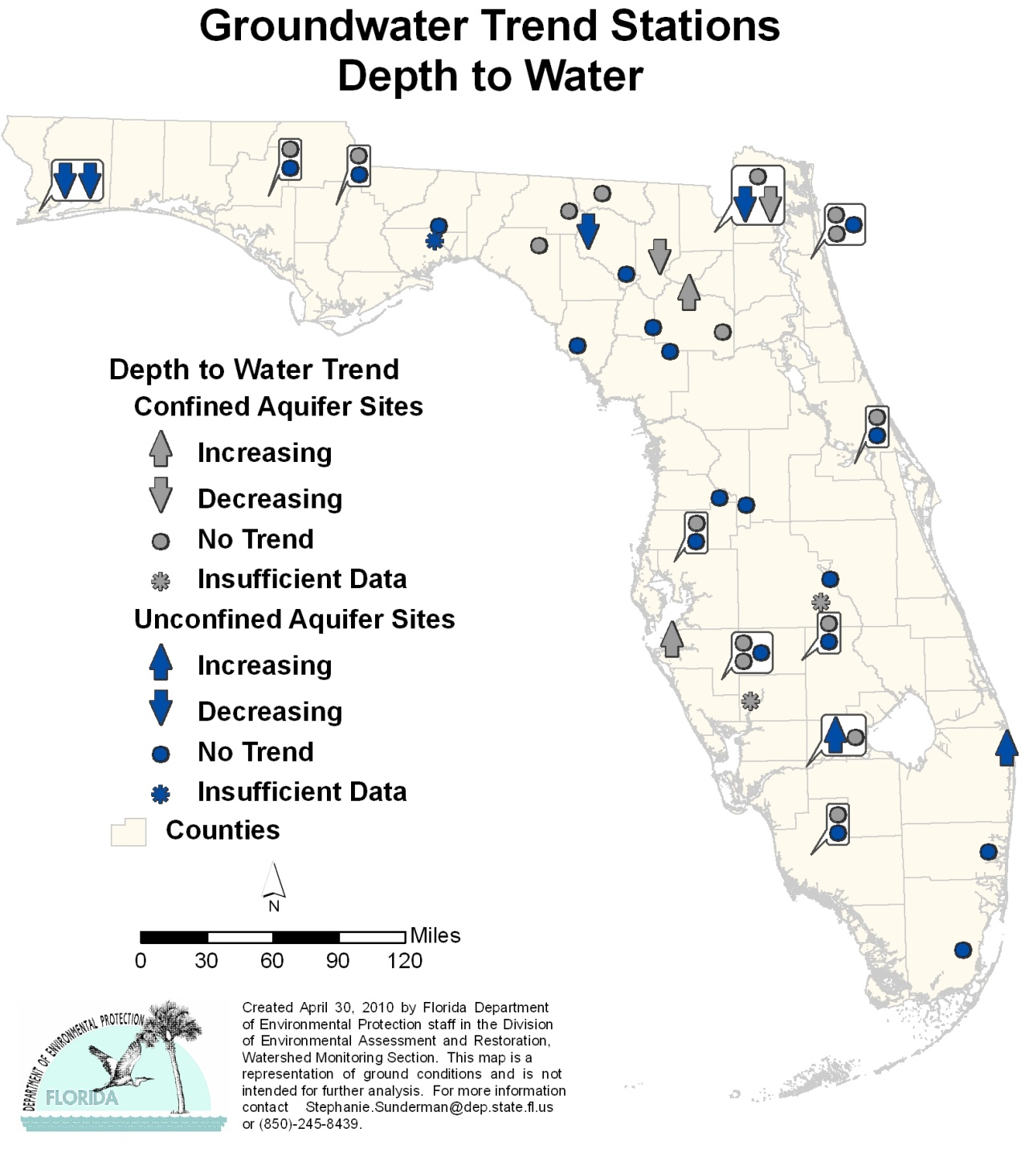

Highlights:

- The trend analysis for the confined aquifer wells reported 2 stations with an increasing trend and 2 stations with a decreasing trend for depth to water (water level [WL]). Two stations did not have enough data to determine if a trend exists (ISD). An increasing trend indicates the water level in the well is decreasing; a decreasing trend indicates the water level in the well is increasing.
- There were 2 stations with an increasing trend in the unconfined aquifer wells and 4 stations with a decreasing trend. One station did not have enough data to determine if a trend exists.
Figure 6.26. Ground Water Trends for Total Dissolved Solids, 1999–2008

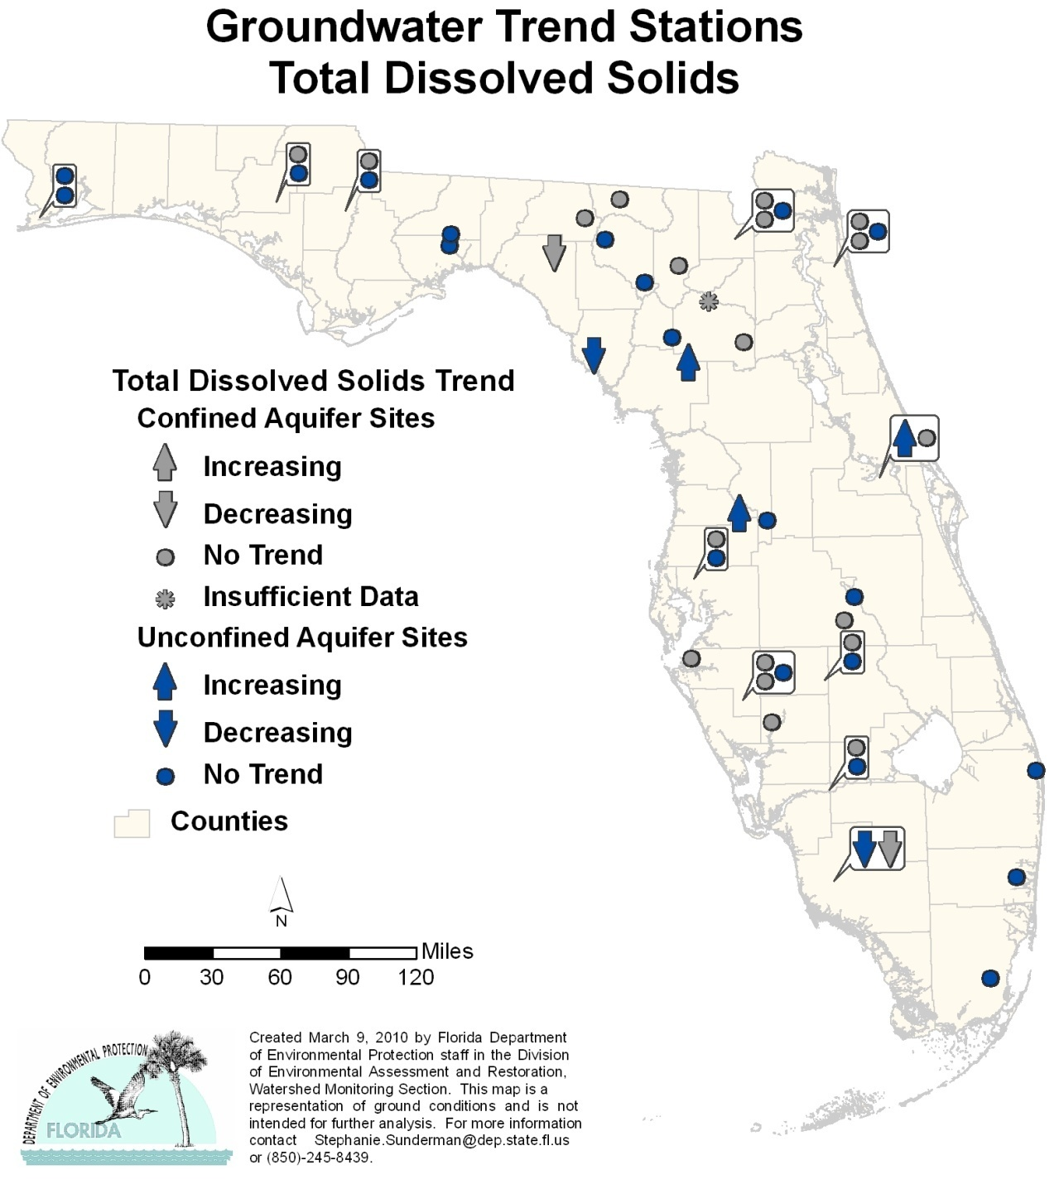

Highlights:

- The trend analysis for the confined aquifer wells reported none of the stations with an increasing trend and 2 stations with a decreasing trend for total dissolved solids (TDS).
- There were 3 stations with an increasing trend in the unconfined aquifer wells and 2 stations with a decreasing trend.

Figure 6.27. Ground Water Trends for Nitrate + Nitrite, 1999–2008

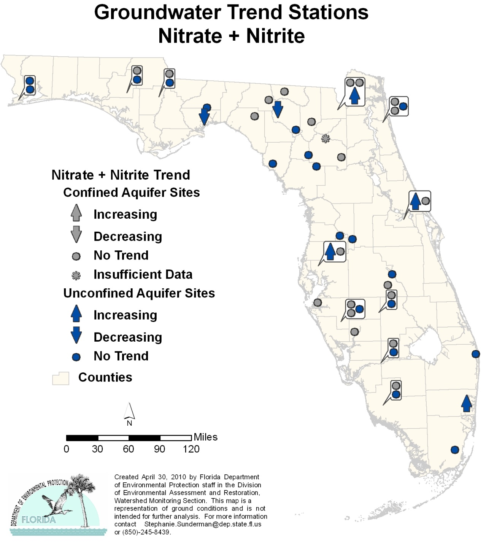

Highlights:

- The trend analysis for the confined aquifer wells reported none of the stations with an increasing or decreasing trend for nitrate + nitrite (NO_{X}).
- There were 4 stations with an increasing trend in the unconfined aquifer wells and 2 stations with a decreasing trend.

Figure 6.28. Ground Water Trends for Phosphorus, 1999–2008

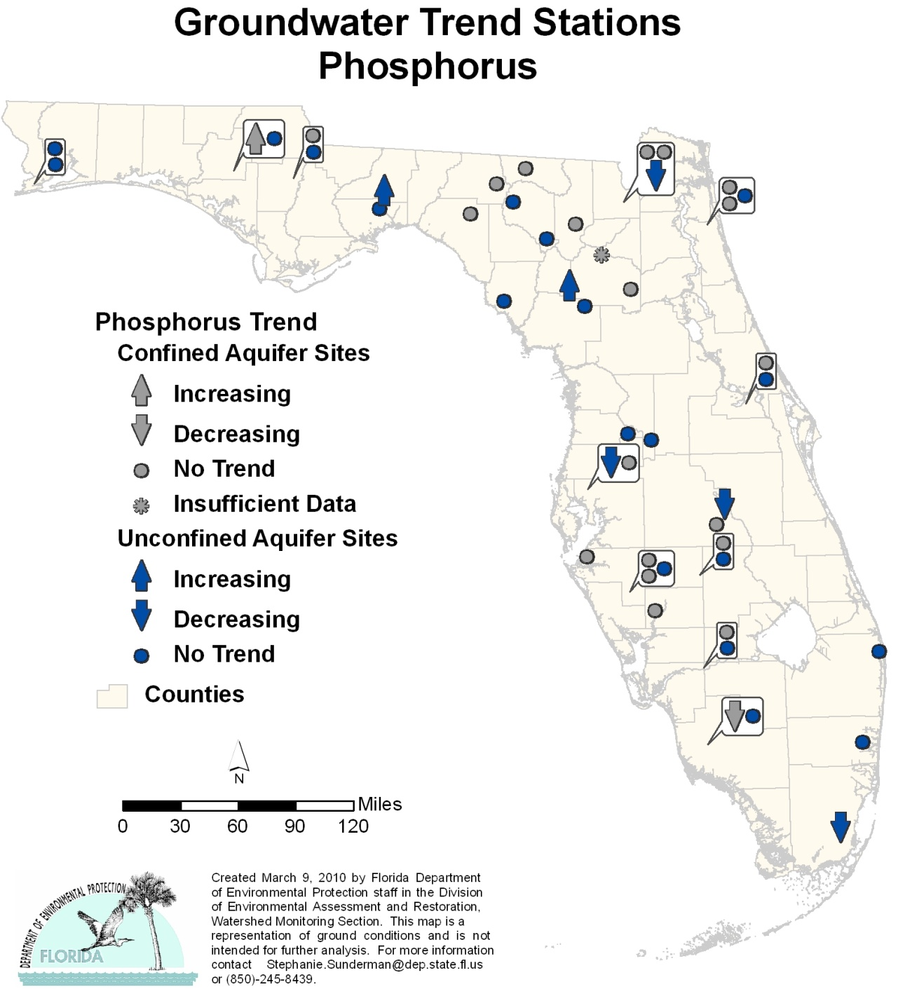

Highlights:

- The trend analysis for the confined aquifer wells reported 1 station with an increasing trend and 1 station with a decreasing trend for phosphorus (P).
- There were 2 stations with an increasing trend in the unconfined aquifer wells and 4 stations with a decreasing trend.

Figure 6.29. Ground Water Trends for Potassium, 1999–2008

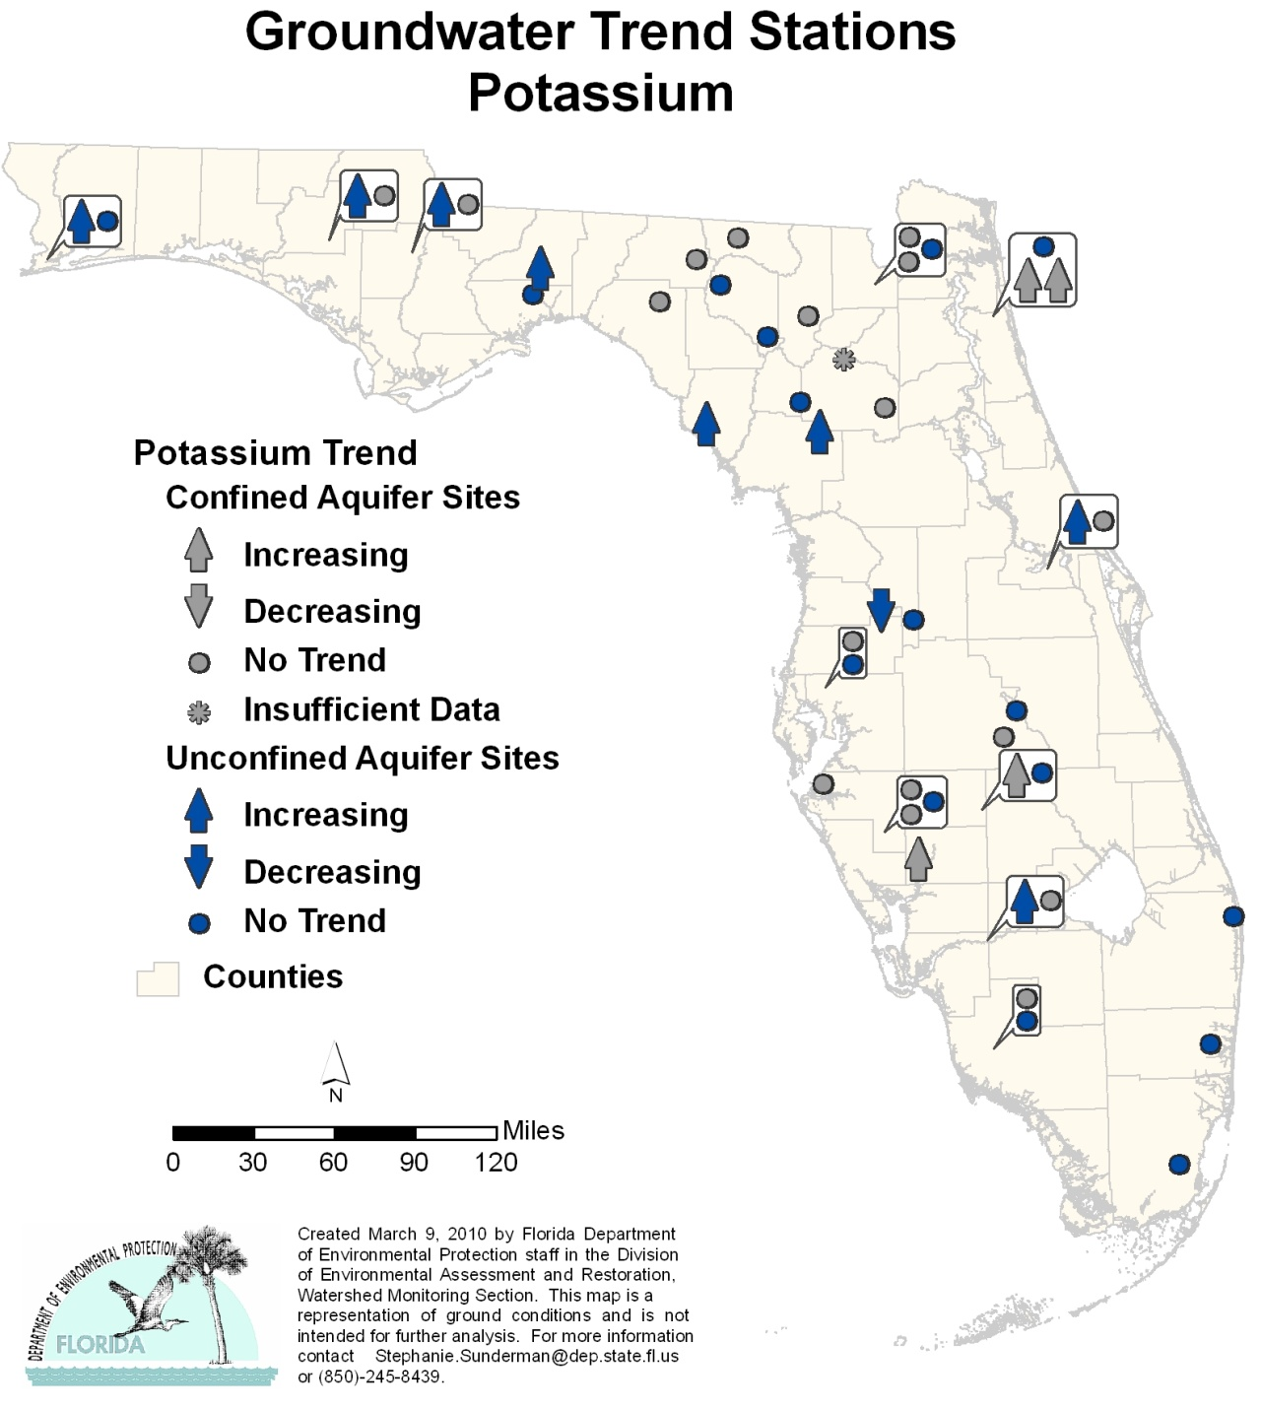

Highlights:

- The trend analysis for the confined aquifer wells reported 8 stations with increasing trends and 1 station with a decreasing trend for potassium (K).
- There were 4 stations with an increasing trend in the unconfined aquifer wells, and no stations had a decreasing trend.

Figure 6.30. Ground Water Trends for Sulfate, 1999–2008

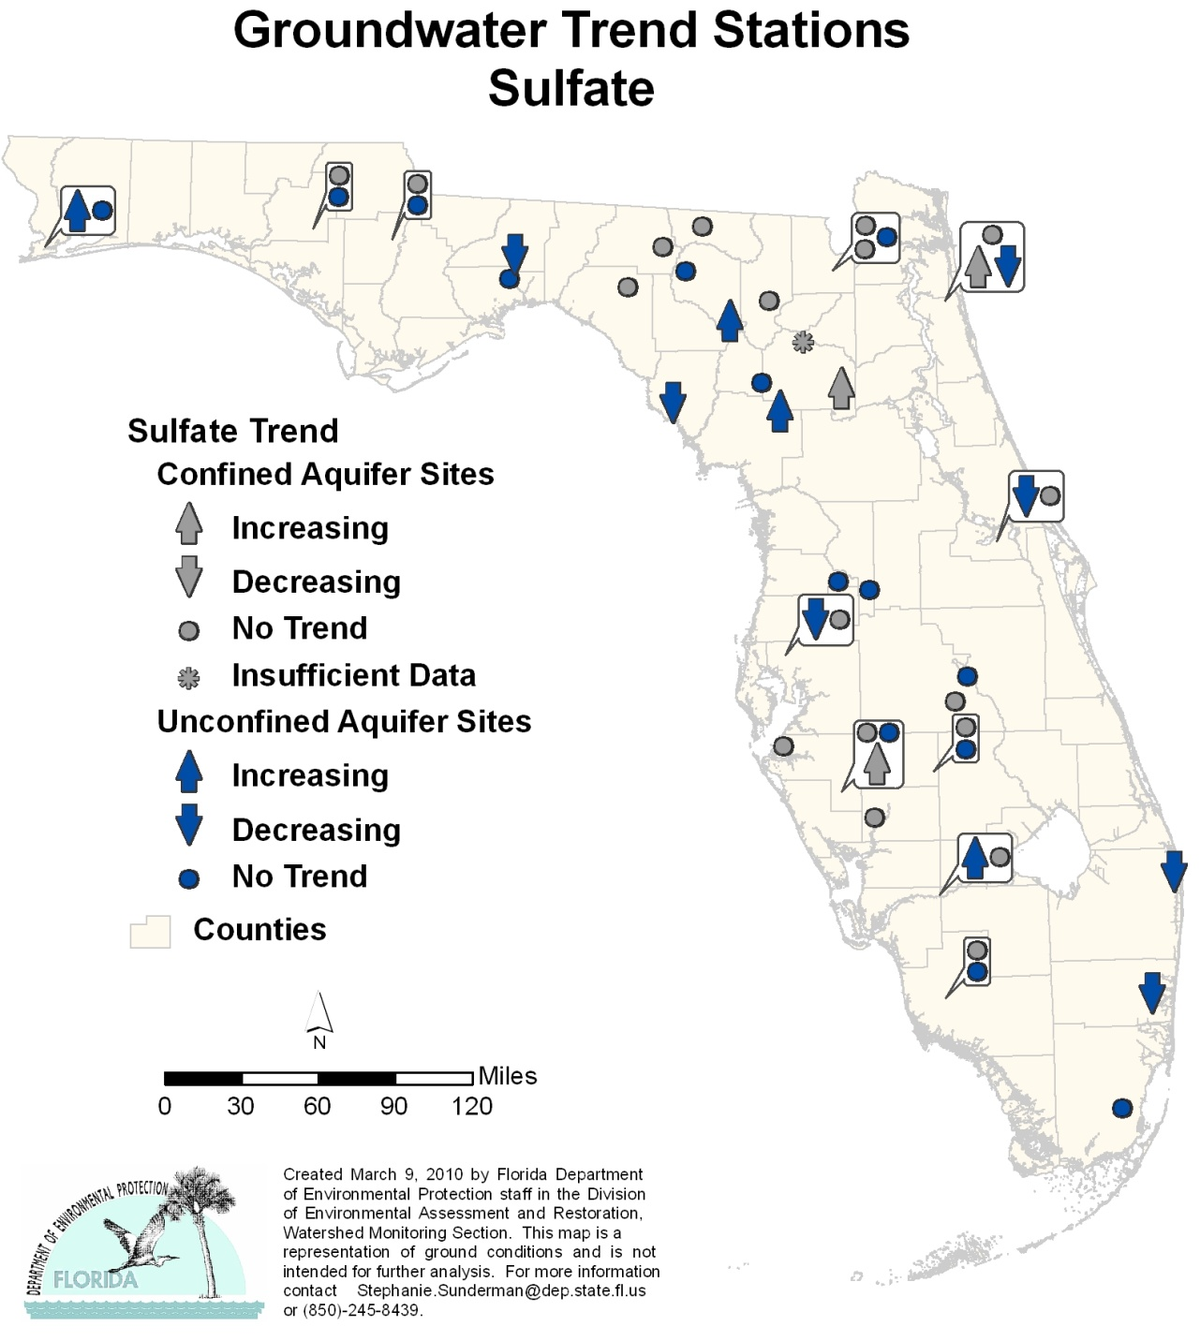

Highlights:

- The trend analysis for the confined aquifer wells reported 3 stations with an increasing trend and none of the stations with a decreasing trend for sulfate (SO₄).
- There were 4 stations with an increasing trend in the unconfined aquifer wells and 7 stations with a decreasing trend.

Figure 6.31. Ground Water Trends for Sodium, 1999–2008

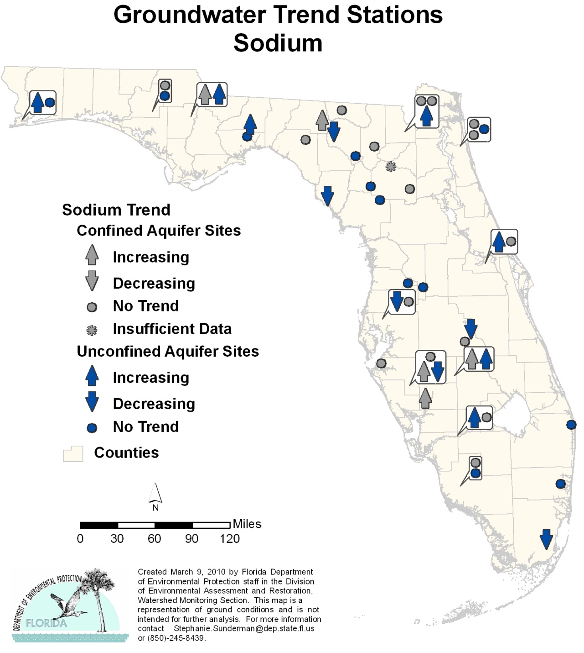

Highlights:

- The trend analysis for the confined aquifer wells reported 5 stations with an increasing trend and none of the stations with a decreasing trend for sodium (Na).
- There were 7 stations with an increasing trend in the unconfined aquifer wells and 6 stations with a decreasing trend.

Figure 6.32. Ground Water Trends for Chloride, 1999–2008

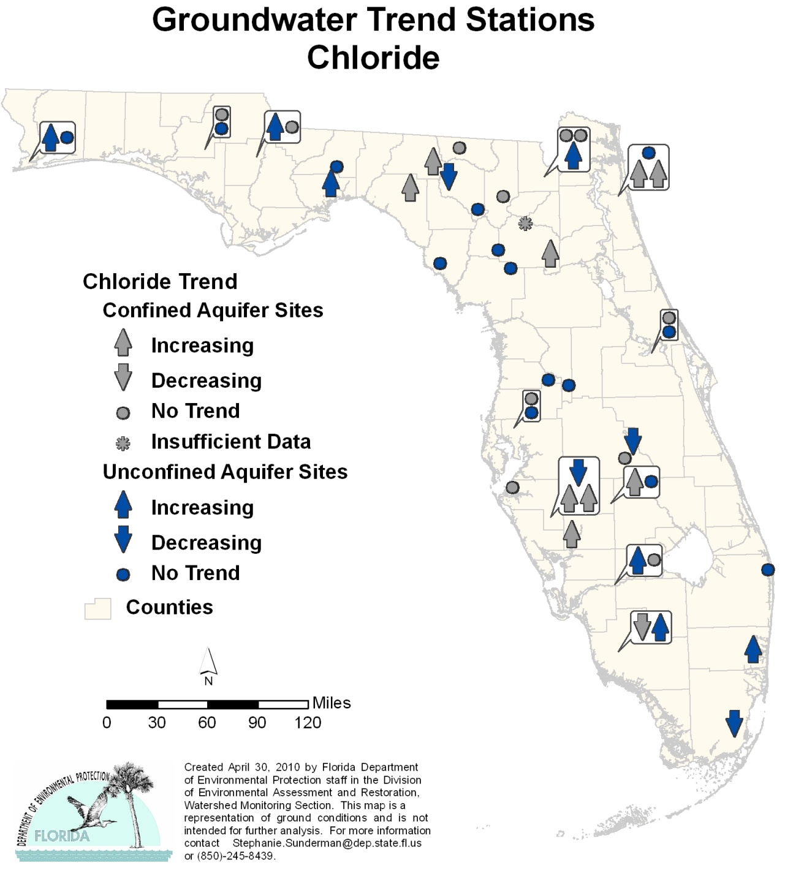

Highlights:

- The trend analysis for the confined aquifer wells reported 9 stations with an increasing trend and 1 station with a decreasing trend for chloride (Cl).
- There were 7 stations with an increasing trend in the unconfined aquifer wells and 4 stations with a decreasing trend.

Figure 6.33. Ground Water Trends for Calcium, 1999–2008

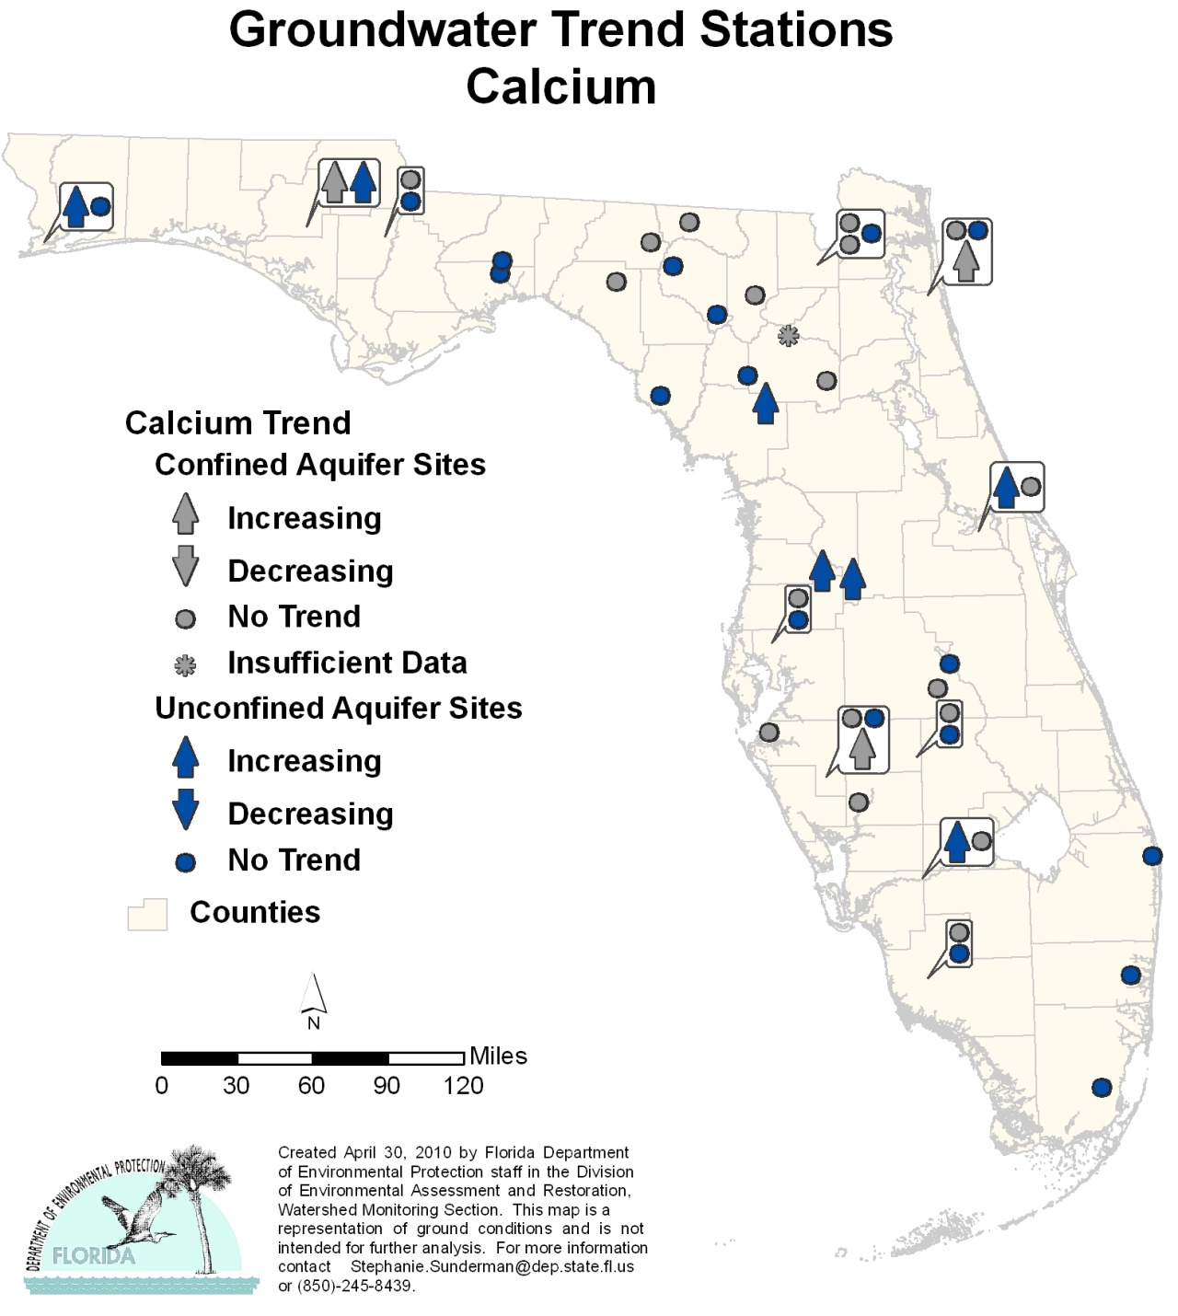

Highlights:

- The trend analysis for the confined aquifer wells reported 3 stations with an increasing trend and none of the stations with a decreasing trend for calcium (Ca).
- There were 7 stations with an increasing trend in the unconfined aquifer wells and none of the stations with a decreasing trend.

Figure 6.34. Ground Water Trends for Magnesium, 1999–2008

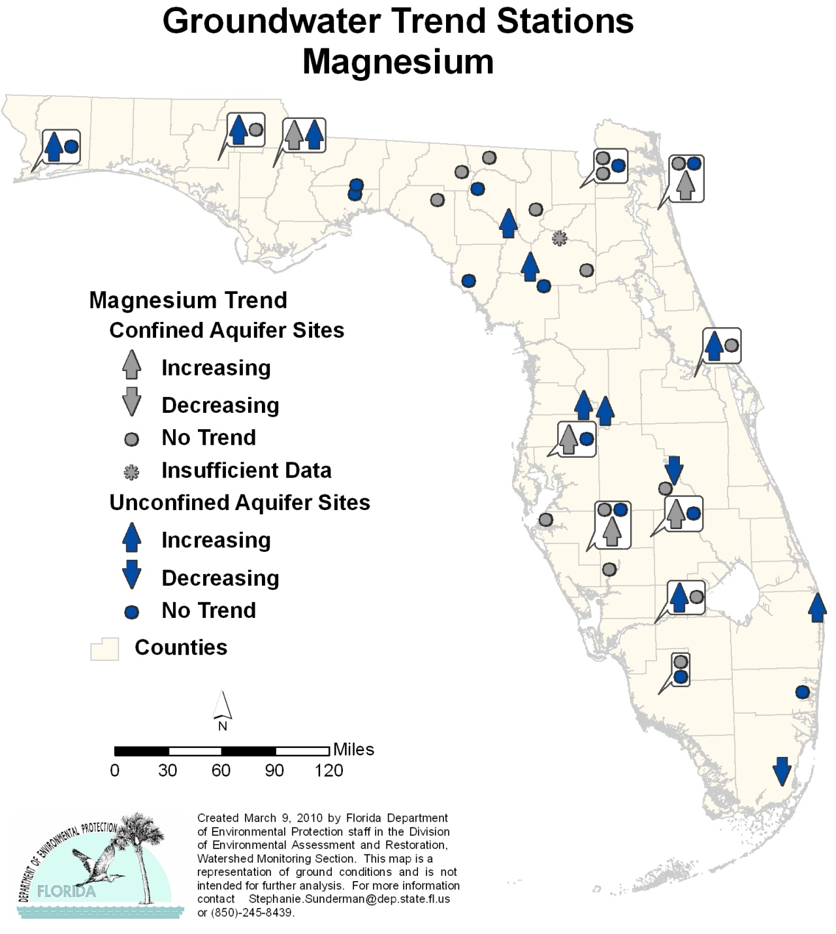

Highlights:

- The trend analysis for the confined aquifer wells reported 5 stations with an increasing trend and no stations with a decreasing trend for magnesium (Mg).
- There were 10 stations with an increasing trend in the unconfined aquifer wells and 2 stations with a decreasing trend.

Figure 6.35. Ground Water Trends for Alkalinity, 1999–2008

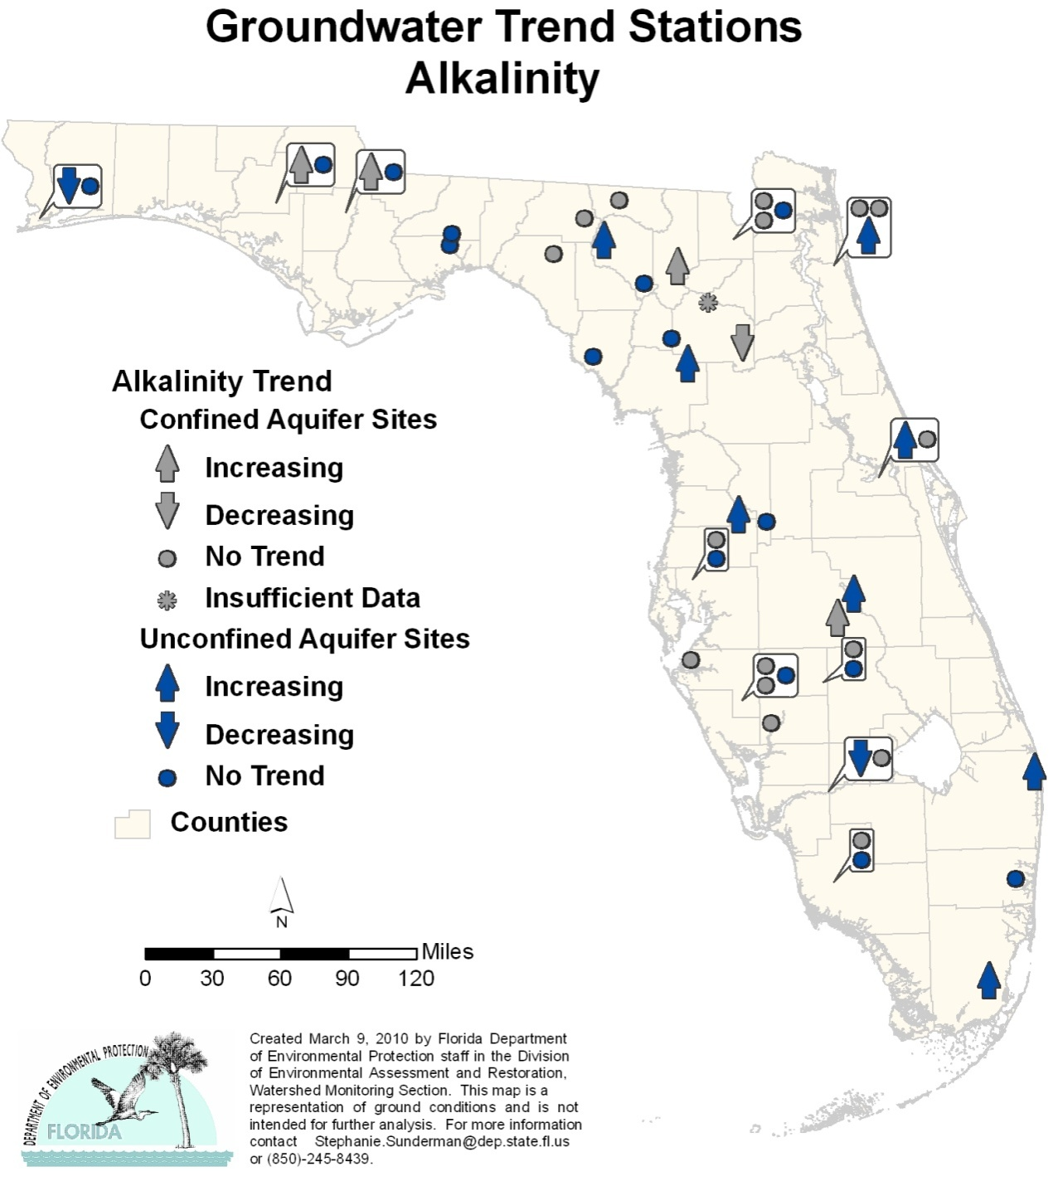

Highlights:

- The trend analysis for the confined aquifer wells reported 4 stations with an increasing trend and 1 station with a decreasing trend for alkalinity (ALK).
- There were 8 stations with an increasing trend in the unconfined aquifer wells and 2 stations with a decreasing trend.

Figure 6.36. Ground Water Trends for Total Coliform, 1999–2008

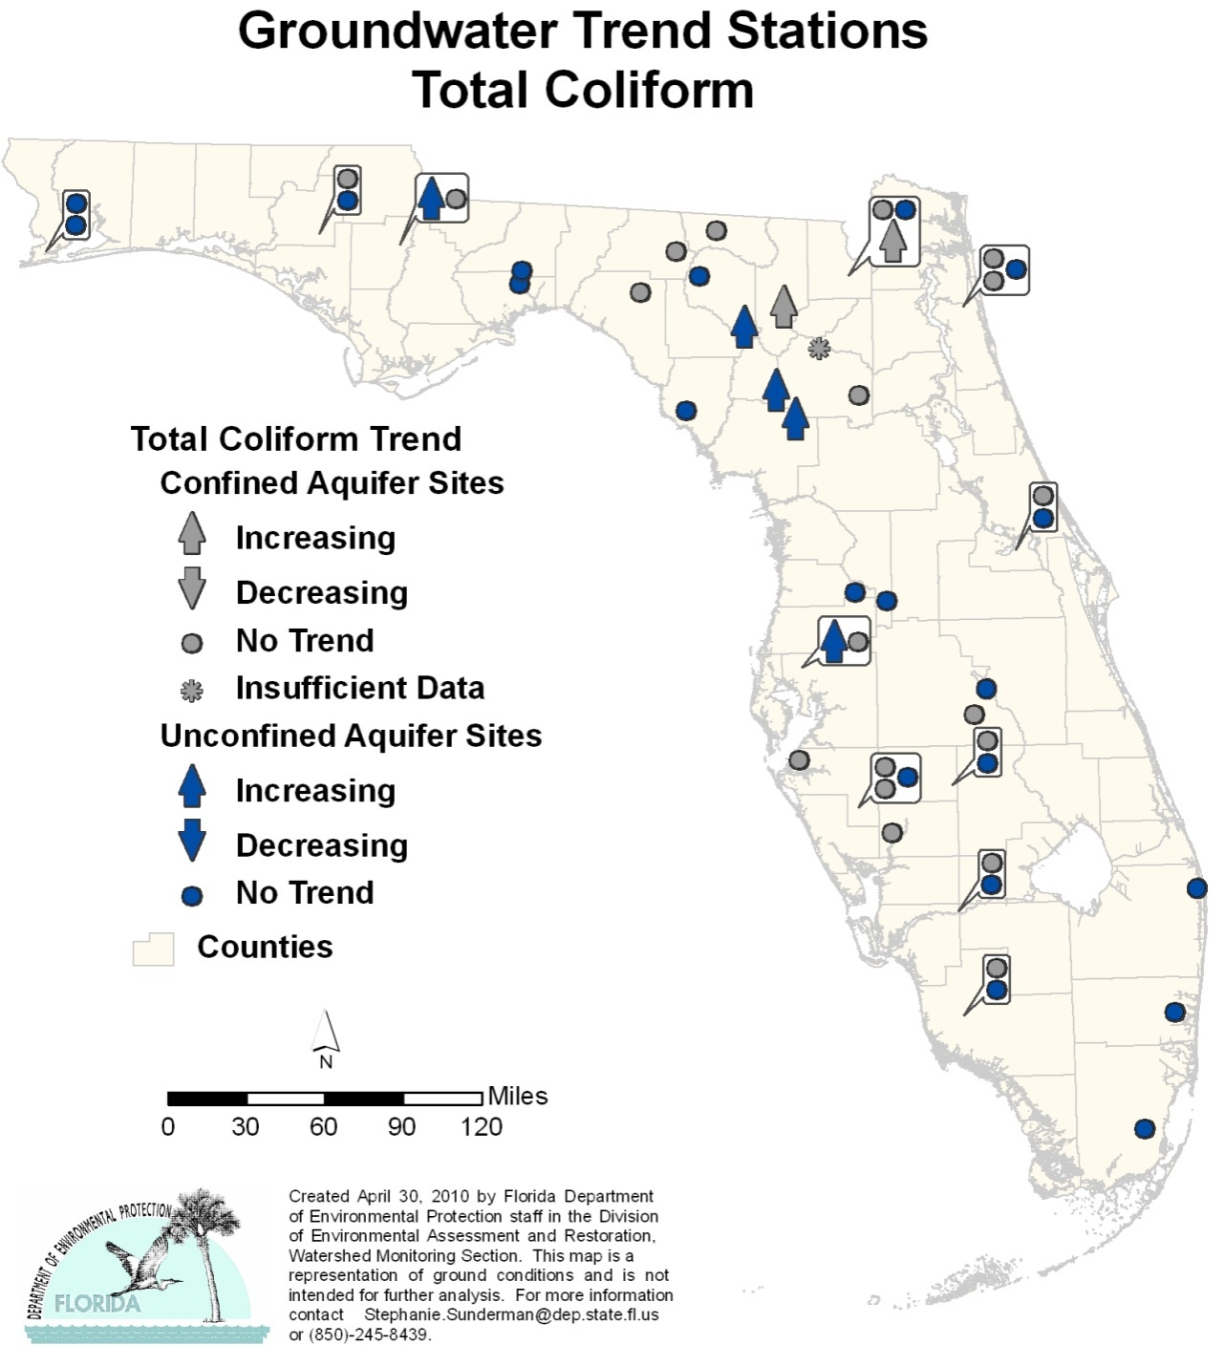

Highlights:

- The trend analysis for the confined aquifer wells reported 2 stations with an increasing trend and none of the stations with a decreasing trend for total coliform (TC).
- There were 5 stations with an increasing trend in the unconfined aquifer wells and none of the stations with a decreasing trend.

Figure 6.37. Ground Water Trends for Fecal Coliform, 1999–2008

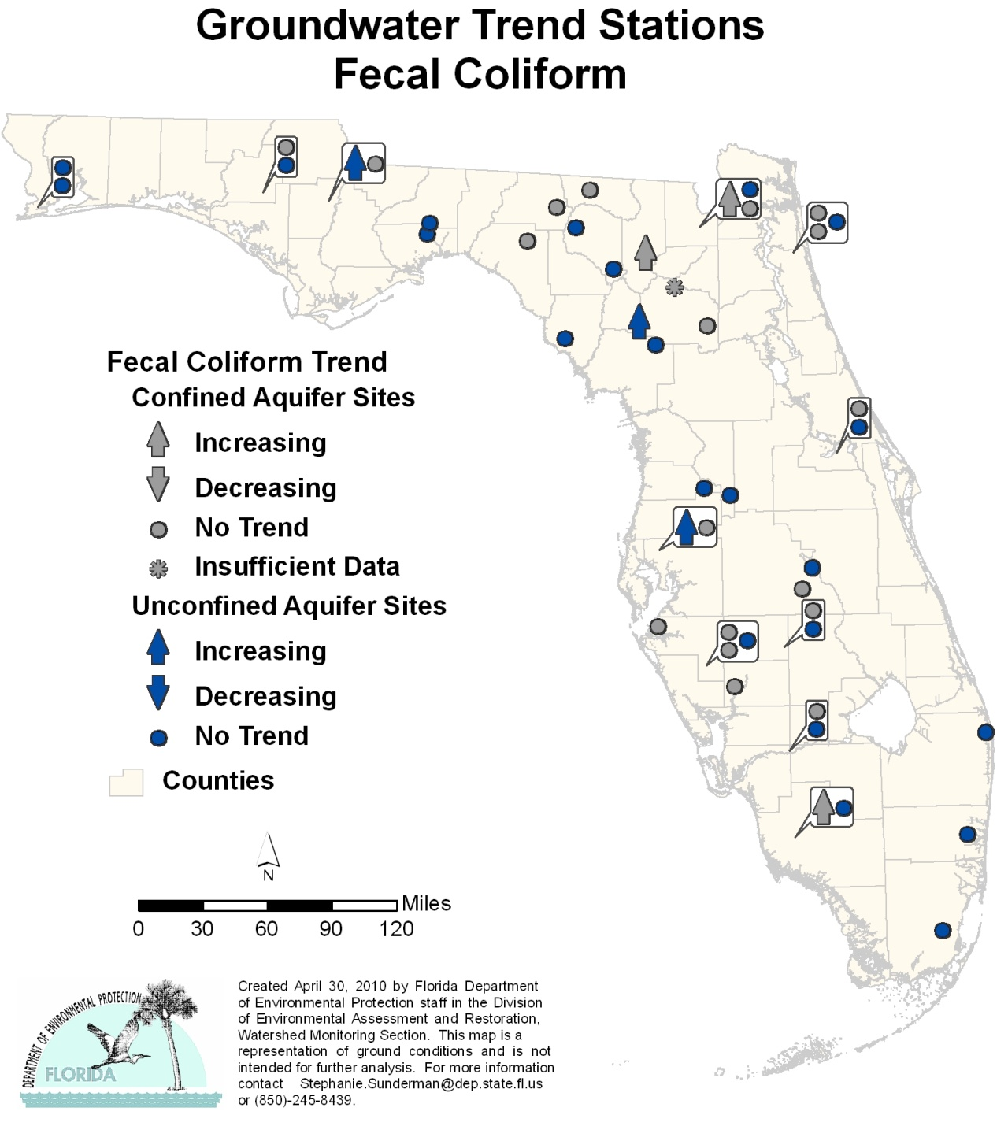

Highlights:

- The trend analysis for the confined aquifer wells reported 3 stations with an increasing trend and none of the stations with a decreasing trend for fecal coliform (FC).
- There were 3 stations with an increasing trend in the unconfined aquifer wells and none of the stations with a decreasing trend.

Chapter 7. Introduction to Strategic Monitoring and assessment

Approach to the Comprehensive Assessment: Sections 305(b) and 303(d)
The EPA has requested that the states merge their reporting requirements under the CWA for Section 305(b) surface water quality reports and Section 303(d) lists of impaired waters into an Integrated Water Quality Monitoring and Assessment Report (Wayland, 2001). Following the EPA’s guidance, FDEP delineated waterbodies or waterbody segments in each basin, assessed them for impairment based on individual parameters, and then placed each assessment into one of five major assessment categories and subcategories. These categories provide information on a waterbody’s status based on water quality, sufficiency of data, and the need for TMDL development (Table 7.1).

The EPA allows states to develop individual subcategories to fit a unique or specialized set of circumstances. These subcategories must be consistent with the purpose of the more general category and must be approved by the EPA during its review of each state’s methodology for developing lists of impaired waters. In addition, EPA requires that states describe the categories and subcategories it applies to the public. In Florida, these procedures are clearly presented during the development of each year’s group of impaired waters lists.

The primary purpose of the assessments for the Watershed Assessment Program and TMDL Program is to determine if waterbodies or waterbody segments should be placed on the Verified List of impaired waterbodies. The listings are made in accordance with evaluation thresholds and data sufficiency and data quality requirements in the IWR (Chapter 62-303, F.A.C.). The results of the assessment are used to identify waters in each basin for which TMDLs will be developed.

Determining impairment in individual waterbodies takes place in two phases. First, in each river basin FDEP evaluates the existing water quality data, using the methodology prescribed in the IWR, to determine whether waters are potentially impaired. Waters found to be potentially impaired are included on a Planning List for further assessment under Subsections 403.067(2) and (3), F.S. As required by Subsection 403.067(2), F.S., the Planning List is included as part of the master list, but it is not used to administer or implement any regulatory program and is submitted to the EPA for informational purposes only.

The second step is to assess waters on the Planning List under Subsection 403.067(3), F.S., as part of FDEP’s watershed management approach. FDEP carries out additional data gathering and strategic monitoring, focusing on these potentially impaired waters, and determines—using the methodology in the IWR—if a waterbody is, in fact, impaired and if the impairment is caused by pollutant discharges.

Table 7.1. Categories for Waterbodies or Waterbody Segments in the 2010 Integrated Report
This is a three-column table. Column 1 lists the waterbody categories, Column 2 provides a description, and Column 3 provides comments.

Note: The descriptions in this table are consistent with the EPA’s integrated assessment categories. In the Basin Status Reports for Groups 1 through 3 and in the Water Quality Assessment Reports for Groups 1 through 2 that were previously produced, Categories 4b and 4c were reversed. That is, the description of Category 4b was previously listed as Category 4c, and the description of Category 4c was listed as Category 4b.

Waterbodies that are verified impaired due to specified pollutants, and therefore require a TMDL, are listed under Category 5 in the Integrated Report; waterbodies with water quality impairments due to other causes, or unknown causes, are listed under Category 4c. Although TMDLs are not established for Category 4c waterbodies, these waterbodies still may be addressed through a watershed management program (for example, the Kissimmee River restoration).

¹ For purposes of the TMDL Program, pollutants are chemical and biological constituents, introduced by humans into a waterbody, that may result in pollution (water quality impairment). There are other causes of pollution, such as the physical alteration of a waterbody (for example, canals, dams, and ditches). However, TMDLs are established only for impairments caused by pollutants (a TMDL quantifies how much of a given pollutant a waterbody can receive and still meet its designated uses).

Category | Description | Comments
1 | Attaining all designated uses | If use attainment is verified for a waterbody or segment that was previously listed as impaired, FDEP will propose that it be delisted.
2 | Attaining some designated uses and insufficient or no information or data are present to determine if remaining uses are attained | If attainment is verified for some designated uses of a waterbody or segment, FDEP will propose partial delisting for the uses attained. Future monitoring will be recommended to determine if remaining uses are attained.
3a | No data and information are present to determine if any designated use is attained | Future monitoring will be recommended to determine if designated uses are attained.
3b | Some data and information are present but not enough to determine if any designated use is attained | Future monitoring will be recommended to gather sufficient information and data to determine if designated uses are attained.
3c | Enough data and information are present to determine that one or more designated uses may not be attained according to the Planning List methodology | A waterbody or segment is potentially impaired for one or more designated uses. These waters will be prioritized for future monitoring to verify use attainment or impaired status.
3d | Enough data and information are present to determine that one or more designated uses are not attained according to the Verified List methodology | A waterbody or segment exceeds Verified List evaluation criteria and may be listed as impaired at the end of Phase 2 of the watershed management cycle. However, the data have not yet been fully evaluated and the waters have not been formally verified as impaired. Further monitoring and analysis may be necessary.  NOTE: This category is applicable only to the Status Report. Waters that pass the Verified List criteria at this stage of the process are placed in Category 5.
4a | Impaired for one or more designated uses but does not require TMDL development because a TMDL has already been completed | After the EPA approves a TMDL for the impaired waterbody or segment, it will be included in a BMAP to reduce pollutant loading toward attainment of designated use(s).
4b | Impaired for one or more designated uses but does not require TMDL development because the water will attain water quality standards due to existing or proposed measures | Pollutant control mechanisms designed to attain applicable water quality standards within a reasonable time frame are either proposed or in place.
4c | Impaired for one or more criteria or designated uses but does not require TMDL development because impairment is not caused by a pollutant | This category includes waterbodies or segments that are impaired because of naturally occurring conditions or pollution. This typically applies to impairments tied to low DO or elevated iron concentrations. The impairment is not caused by specific pollutants, but is believed to be natural or caused by pollution.¹
4d | No causative pollutant has been identified | The waterbody does not meet its applicable criteria, but no causative pollutant has been identified. This typically applies to low DO or failed biological assessments. All available biological data, TN, TP, and biological oxygen demand (BOD) data, and land use have been assessed.
4e | Impaired, but recently completed or ongoing restoration activities should restore the designated uses of the waterbody | Restoration activities for this waterbody have been completed or are ongoing, such that once the activities are completed or the waterbody has had a chance to stabilize, FDEP believes it will meet its designated uses.
5 | One or more designated uses is not attained and a TMDL is required | Waterbodies or segments in this category are impaired for one or more designated uses by a pollutant or pollutants. Waters in this category are included on the basin-specific Verified List adopted by FDEP’s Secretary as Florida’s impaired waters list and submitted to the EPA as Florida’s 303(d) list of impaired waters at the end of Phase 2.

A Verified List of impaired waters is produced based on the results of this updated evaluation. The thresholds and data requirements for the Verified List are generally more stringent than those for the Planning List.

The Verified List is adopted by Secretarial Order in accordance with the FWRA. Once adopted, the list is submitted to the EPA for approval as an update to the state’s Section 303(d) list of impaired waters. FDEP is required to develop TMDLs for waters on the Verified List under Subsection 403.067(4), F.S. A watershed management plan (called a Basin Management Action Plan, or BMAP) to reduce the amount of pollutants that cause impairments may also be produced and implemented.

To implement the watershed cycle, the state’s river basins have been divided into five groups within each of FDEP’s six districts statewide, and each district assesses one basin each year. Table 7.2 shows the basin groups for implementing the cycle in FDEP’s districts. Table 7.3, which lists the basin rotation schedule for TMDL development and implementation, shows that it will take nine years to complete one full cycle of the state. Over time, the 1998 303(d) listing, as well as the listings for preceding cycles (Cycle 1, Cycle 2, etc.), are all taken into account in the subsequent cycle and result in an integrated assessment that includes consideration of the assessment in each cycle as well as an assessment of the entire period of record. This results in a conservative approach to keeping problem waters on the list.

The watershed management cycle is an iterative, or repeated, process. One of its key components is that the effectiveness of management activities (TMDL implementation) will be monitored in successive cycles. Monitoring conducted in Phase 2 of subsequent cycles will be targeted at evaluating whether water quality objectives are being met and whether individual waters are no longer impaired. FDEP also will track the implementation of scheduled restoration activities, whether required or voluntary, to ensure continued progress towards meeting the TMDLs.

Table 7.2. Basin Groups for Implementing the Watershed Management Cycle,
by FDEP District Office
This is a six-column table. Column 1 lists the FDEP districts, and Columns 2 through 5 list the Group 1 through 5 basins, respectively.

- = Empty cell/no basin sampled
FDEP District | Group 1  Basins  (2004) | Group 2  Basins  (2005) | Group 3  Basins  (2006) | Group 4  Basins  (2007) | Group 5  Basins  (2008)
Northwest | Ochlockonee–  St. Marks | Apalachicola–Chipola | Choctawhatchee– St. Andrew | Pensacola | Perdido
Northeast | Suwannee | Lower St. Johns | - | Nassau–St. Marys | Upper East Coast
Central | Ocklawaha | Middle St. Johns | Upper St. Johns | Kissimmee River | Indian River Lagoon
Southwest | Tampa Bay | Tampa Bay Tributaries | Sarasota Bay–Peace–Myakka | Withlacoochee | Springs Coast
South | Everglades West  Coast | Charlotte Harbor | Caloosahatchee | Fisheating Creek | Florida Keys
Southeast | Lake Okeechobee | St. Lucie–Loxahatchee | Lake Worth Lagoon–  Palm Beach Coast | Southeast Coast–Biscayne Bay | Everglades

Table 7.3. Basin Rotation Schedule for TMDL Development and Implementation
This is an 11-column table. Column 1 lists the basin group, and Columns 2 through 11 list the phase of the basin cycle for Years 1 through 10, respectively.

Note: The projected years for Phases 3, 4, and 5 may change due to accelerated local activities, length of plan development, legal challenges, etc.
- = Empty cell/no data
* Projected years for Phases 3, 4, and 5 may change due to accelerated local activities, length of plan development, legal challenges, etc.
** First five-year cycle = High-priority waters
⁺ Second five-year cycle = Medium-priority waters
Basin Group | Year 00/01 | Year 01/02 | Year 02/03* | Year 03*/04* | Year 04*/05* | Year 05*/06 | Year 06/07 | Year 07/08 | Year 08/09 | Year 09/10
Group 1 | Phase 1** | Phase 2** | Phase 3** | Phase 4** | Phase 5** | Phase 1⁺ | Phase 2⁺ | Phase 3⁺ | Phase 4⁺ | Phase 5⁺
Group 2 | - | Phase 1** | Phase 2** | Phase 3** | Phase 4** | Phase 5** | Phase 1⁺ | Phase 2⁺ | Phase 3⁺ | Phase 4⁺
Group 3 | - | - | Phase 1** | Phase 2** | Phase 3** | Phase 4** | Phase 5** | Phase 1⁺ | Phase 2⁺ | Phase 3⁺
Group 4 | - | - | - | Phase 1** | Phase 2** | Phase 3** | Phase 4** | Phase 5** | Phase 1⁺ | Phase 2⁺
Group 5 | - | - | - | - | Phase 1** | Phase 2** | Phase 3** | Phase 4** | Phase 5** | Phase 1⁺

Determining Attainment of Designated Use(s)
The designated uses of a given waterbody are established using the surface water quality classification system described in the section on Florida’s Water Quality Standards Program in Chapter 11. Specific water quality criteria, expressed as numeric or narrative limits for specific parameters, describe the water quality necessary to maintain each of these uses for surface water and ground water.

It is important to note, however, that the EPA uses slightly different terminology in its description of designated uses. Because FDEP is required to provide use attainment status for both the state’s 305(b) report and the state’s 303(d) list of impaired waters, FDEP uses EPA terminology when assessing waters for use attainment. The water quality evaluations and decision processes for listing impaired waters that are defined in Florida’s IWR are based on the following designated use attainment categories:

- Aquatic Life Use Support–Based Attainment
- Primary Contact and Recreation Attainment
- Fish and Shellfish Consumption Attainment
- Drinking Water Use Attainment
- Protection of Human Health

Table 7.4 summarizes the designated uses assigned to Florida’s various surface water classifications.

Table 7.4. Designated Use Attainment Categories for Surface Waters in Florida
This is a two-column table. Column 1 lists the designated use attainment category used in the IWR evaluation, and Column 2 lists the applicable Florida surface water classification.

Designated Use Attainment Category Used in IWR Evaluation | Applicable Florida  Surface Water Classification
Aquatic Life Use Support-Based Attainment | Class I, II, and III
Primary Contact and Recreation Attainment | Class I, II, and III
Fish and Shellfish Consumption Attainment | Class II
Drinking Water Use Attainment | Class I
Protection of Human Health | Class I, II, and III

How Data Are Identified and Evaluated

The Impaired Surface Waters Rule
To identify impaired waters in each of the state’s river basins, FDEP evaluates water quality data using the science-based methodology in the IWR (Chapter 62-303, F.A.C.). The rule establishes specific criteria and thresholds for impairment, in addition to data sufficiency and data quality requirements. The methodology described in the rule is based on a statistical approach (called the binomial method) designed to provide greater confidence that the outcome of the water quality assessment is correct.

In 2006, and again in 2007, the IWR was amended to address EPA’s comments following federal legal challenges that arose following its original adoption in 2001. After the state rulemaking process was completed, the revised IWR was submitted to the EPA on September 14, 2007, as a change to Florida Water Quality Standards. On February 19, 2008, the EPA sent a letter of approval to FDEP acknowledging that the IWR was an approved change to the Water Quality Standards. The current IWR is available on the FDEP website.

As part of the watershed management approach, for each river basin in the state FDEP follows the methodology in Section 62-303.300, F.A.C., to develop a Planning List of potentially impaired waters to be assessed under Subsections 403.067(2) and (3), F.S. The methodology for developing the Planning List includes an evaluation of aquatic life use support, primary contact and recreational use support, fish and shellfish consumption use support, drinking water use support, and protection of human health. Only in limited circumstances can data older than 10 years be used to evaluate water quality criteria exceedances for the Planning List. As required by Subsection 403.067(2), F.S., the Planning List will not be used to administer or implement any regulatory program, and is submitted to the EPA for informational purposes only.

After further assessment, using the methodology in Part III, Section 62-303.400, F.A.C., FDEP determines if waters on the Planning List are, in fact, impaired and if the impairment is caused by pollutant discharges. These waters are placed on a Verified List. The threshold and data requirements for the Verified List are generally more stringent than those for the Planning List. Other than those instances identified in the IWR, data older than 7.5 years, or from the period of record, are generally not used to verify impairment. If a decision can be made using available, recent data, then FDEP uses those data. However, when a decision cannot be made, then FDEP considers older data if it is available. Considerations include whether the data were analyzed at FDEP’s own lab, what quality assurance procedures were used in collecting the data, and whether metadata are available. The flow chart in Figure 7.1 demonstrates how older data are considered and assessments are carried out. The Verified List is adopted by Secretarial Order and forwarded to the EPA for approval as Florida’s Section 303(d) list of impaired waters. FDEP develops TMDLs for these waters under Subsection 403.067(4), F.S.

Sources of Data
FDEP’s assessment of water quality for each basin statewide includes an analysis of quantitative data from a variety of sources, many of which are readily available to the public. These sources include the EPA’s Legacy and modernized STORET databases, USGS, FDEP, FDOH, the water management districts, local governments, and volunteer monitoring groups.

Historically, FDEP carried out statewide water quality assessments using data available in the EPA’s Legacy STORET database; Legacy STORET makes up approximately 40% of the statewide data used in the IWR assessment. The Legacy STORET dataset is a repository of data collected and uploaded by numerous organizations through 1999. The Legacy STORET database can be accessed on the FDEP STORET website.

In 2000, the EPA created a modernized version of STORET that included new features designed to address data quality assurance/quality control concerns (see the new EPA STORET website). However, because of software difficulties associated with the batch uploading of data to modernized STORET, FDEP has decided to build a local version of STORET with much easier data-loading capabilities. Modernized STORET currently houses about 50% of the statewide IWR database.

Approximately 30% of the data used in the IWR assessment is provided by individual organizations that for various reasons, such as time constraints or resource limitations, are not able to enter their data into the national database. The organizations providing the largest datasets include the South Florida, Southwest Florida, and St. Johns River Water Management Districts; USGS; and UF LakeWatch volunteer monitoring group. Several of these databases are readily available to the public via the Internet: the South Florida Water Management District website, Southwest Florida Water Management District website, USGS website, and LakeWatch website.

FDEP created the IWR database in 2002 to evaluate data in accordance with the IWR methodology for every basin in the state, based on the appropriate data “window.” Table 7.5 shows the periods of record for the Verified and Planning Lists for the five basin groups for the first and second basin rotation cycles.

Figure 7.1. Period of Record Assessment Flow Chart

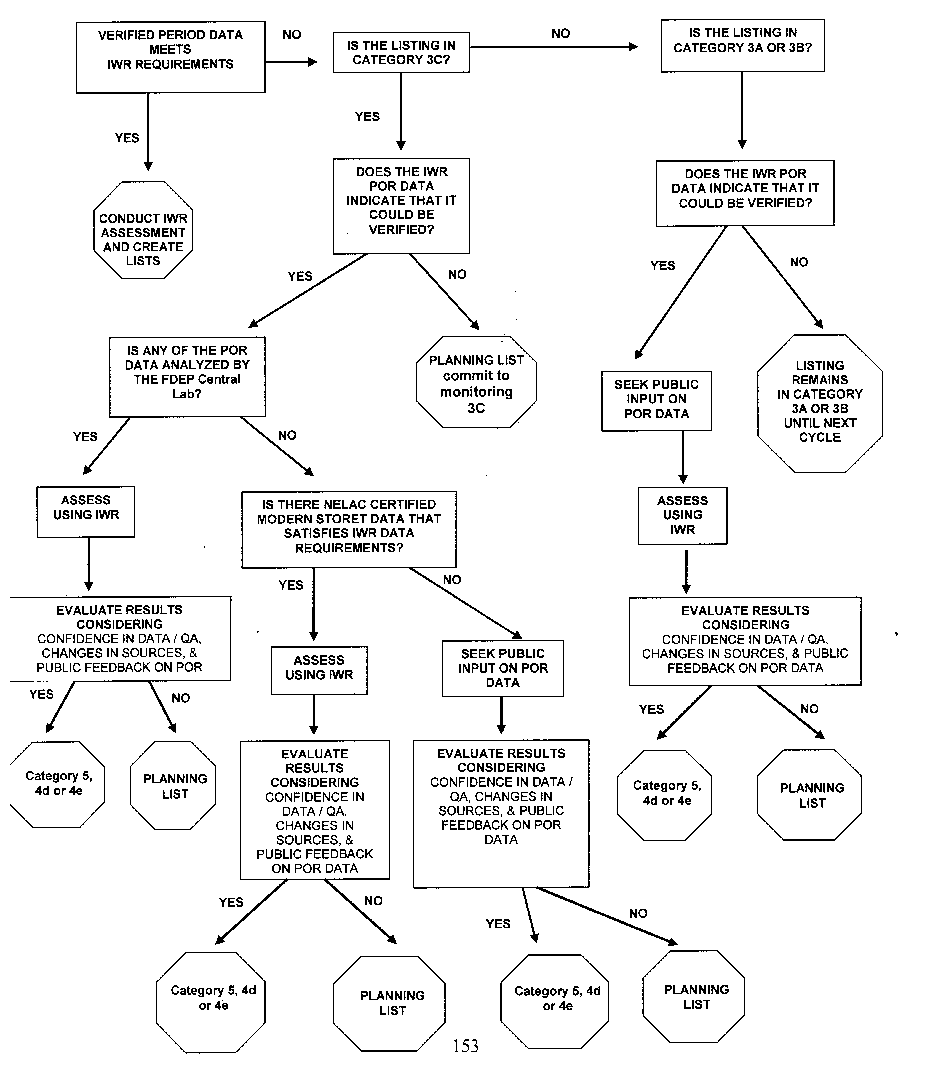

Table 7.5. Data Used in Developing the Planning and Verified Lists for the Basin Rotation Cycles
This is a four-column table. Column 1 lists the cycle rotation, Column 2 lists the basin group, Column 3 lists the planning period, and Column 4 lists the verified period.

Note: Typically, a 10-year data record is used for the development of the Planning Lists, and a 7.5-year record is used for the Verified Lists.
Cycle Rotation | Basin Group | Planning Period | Verified Period
1 | 1 | 1989–1998 | 1/1/1995–6/30/2002
1 | 2 | 1991–2000 | 1/1/1996–6/30/2003
1 | 3 | 1992–2001 | 1/1/1997–6/30/2004
1 | 4 | 1993–2002 | 1/1/1998–6/30/2005
1 | 5 | 1994–2003 | 1/1/1999–6/30/2006
2 | 1 | 1995–2004 | 1/1/2000–6/30/2007
2 | 2 | 1996–2005 | 1/1/2001–6/30/2008
2 | 3 | 1997–2006 | 1/1/2002–6/30/2009
2 | 4 | 1998–2007 | 1/1/2003–6/30/2010
2 | 5 | 1999–2008 | 1/1/2004–6/30/2011
3 | 1 | 1995–2004 | 1/1/2005–6/30/2012
3 | 2 | 1996–2005 | 1/1/2006–6/30/2013
3 | 3 | 1997–2006 | 1/1/2007–6/30/2014
3 | 4 | 1998–2007 | 1/1/2008–6/30/2015
3 | 5 | 1999–2008 | 1/1/2009–6/30/2016

Quality Assurance/Quality Control Criteria
The IWR addresses quality assurance/quality control (QA/QC) concerns by requiring all data to meet QA rule requirements (Chapter 62-160, F.A.C.), including NELAC certification and the use of established SOPs.

Criteria for Evaluating Outside Data
Occasionally, in closely evaluating data for a particular waterbody, FDEP may find systematic errors from a data provider. These errors may include the accidental shifting of decimals for a parameter such as iron (e.g., reporting 1,000 mg/L, rather than 1 mg/L). When systematic errors are found, those data are excluded from the analysis, and FDEP works with the provider to correct the errors. Upon correction, the data are used in the assessment.

The Florida Legislature has specifically prohibited the use of data from the volunteer monitoring group LakeWatch in any regulatory proceeding. However, LakeWatch data can be used in developing the Planning List of potentially impaired waters, evaluating pollutant loading to lakes, and modeling lake function for FDEP’s TMDL Program. The data can also be used to document long-term water quality trends and provide general background information, but they cannot be used to verify impairment, nor can they be used in support of enforcement actions.

Rationales for Not Using Existing Data
FDEP uses all water quality data that are provided through STORET, as long as it is ambient in nature (e.g., it does not use data for water coming out of a discharge pipe or within approved mixing zones). It may restrict the use of an agency’s data if consistent errors have been found (only the water quality parameters that have problems are restricted). FDEP also may restrict an agency’s data if it has failed QA/QC inspections. Data gathered during periods that are not representative of the general health of the waterbody (e.g., during or immediately after a hurricane that can be tied to a short-term event, such as a spill) are flagged for further evaluation before being added to the IWR database.

How Data Are Used To Make Attainment Determinations
Once the data are screened and validated, they are evaluated to determine whether individual segments with waterbody identification numbers (WBIDs) are attaining their designated uses. Different analytical approaches, such as statistical analyses, are used to infer conditions from all valid data. Appendix D provides a detailed description of the IWR methodology.

Public Participation Process
FDEP works with a variety of stakeholders in the assessment and TMDL processes. It also solicits and encourages public participation in a number of ways. It maintains an extensive distribution list; hosts both the Watershed Assessment Program website and TMDL Program website; publishes notices of meetings, workshops, and public hearings in the Florida Administrative Weekly, on the website, and in local newspapers; makes available to the public (via the website, mail, or email) the basin-specific draft Verified Lists of waters that meet the requirements of the IWR; holds public meetings on developing and adopting the Verified Lists of impaired waters and TMDLs; and requests and responds to public comments.

Citizens are given the opportunity to comment on the draft lists and TMDLs in person and/or in writing. As part of the review process, public workshops are advertised and held in each basin to help explain the process for developing the Verified List or TMDL, exchange information, and encourage public involvement. If additional information or data is provided prior to or during the public comment period, FDEP considers it before submitting the proposed list to the Secretary and EPA.

Chapter 8: Results of the Assessments Of Use Support

Surface Waters Assessed
For assessment purposes, FDEP has divided the state into water assessment polygons with a unique waterbody identification (WBID) number for each watershed or stream reach. There are 6,378 waterbodies, each of which are characterized by waterbody type (rivers/streams, lakes, estuaries, or coastal waters) and comprise hydrologically unique segments of rivers and streams, lakes, and estuaries with relatively similar water quality. Typically, the river and stream segments are about 5 miles long (generally bounded by headwaters, river mouths, or major intersecting streams); the estuary segments are about 5 square miles in size (often bounded by bridges); and lake segments comprise approximately 60 acres each (usually entire lakes, but if a lake is very large or has distinct areas of water quality, it may be subdivided).

The assessed waters include those waters for which enough information is available to determine whether they attain their designated use (Category 2 under the EPA’s integrated assessment) or do not attain their designated use (EPA Categories 4a, 4b, 4c, 4d, 4e, and 5) (see Chapter 7 for a description of the categories). Table 8.1 lists the number and size of waters assessed for each waterbody type, and Table 8.2 lists the number of surface waters assigned to each of the EPA reporting categories.

For the determination of use support in this report, FDEP assessed 13,919 miles of rivers and streams, 1,203,632 acres of lakes, 2,473 square miles of estuaries, and 6,699 square miles of coastal waters using the IWR methodology for the identification of impaired waters. (Note: The total estimated miles for estuaries decreased by 30% this year due to improved GIS techniques to calculate mileages and corrections to the WBID system; the corrections included removing land drainage areas from some incorrect estuarine WBIDs and only including the water area, resulting in a reduction of the estimates of total estuarine water area for Florida). The WBID system uses NHD mileages and acreages for lakes, estuaries, and streams; however, only those waters that are of significant size and perennial (not dry during the year) are used. The EPA has historically identified 52,000 miles of streams in Florida, but these estimates include ditches that may not hold water during the year.

It should be noted that the assessment results for lakes are highly affected by the assessment results for one impaired lake, Lake Okeechobee, which is by far the largest lake in the state. All estuaries and coastal waters have been assessed for mercury, and consumption advisories have been issued for a number of fish species because of excessive concentrations of mercury in fish tissue.

Table 8.1. Waters Assessed for the Statewide Basin Assessments, by Waterbody Type
This is a three-column table. Column 1 lists the waterbody type, Column 2 lists the number of waterbody segments, and Column 3 lists the miles, acres, or square miles assessed.

Note: Scale is 1:24,000.
Source: NHD
Waterbody Type | Number of Waterbody Segments | Assessed
Rivers/Streams | 3,996 | 13,919 miles
Lakes | 1,324 | 1,203,632 acres
Estuaries | 579 | 2,473 square miles
Coastal Waters | 154 | 6,699 square miles

Table 8.2. Size of Surface Waters Assigned to Each EPA Integrated Report Category
This is a 10-column table. Column 1 lists the waterbody type, Columns 2 through 6 list the number of each waterbody type in Categories 2 through 5, respectively, Column 7 lists the number with no data, Column 8 lists the number with insufficient data, Column 9 lists the number of total waters assessed, and Column 10 lists the total number in the state.

Note: There are no waters in EPA Category 1 (attaining all designated uses) because FDEP does not sample for all uses. Category 2 comprises waters attaining all the uses that are sampled for.

* The EPA’s Integrated Report categories are as follows:
1—Attains all designated uses;
2—Attains some designated uses;
3a—No data and information are available to determine if any designated use is attained;
3b—Some data and information are available, but they are insufficient for determining if any designated use is attained;
3c—Meets Planning List criteria and is potentially impaired for one or more designated uses;
3d—Meets Verified List criteria and is potentially impaired for one or more designated uses;
4a—Impaired for one or more designated uses and the TMDL is complete;
4b—Impaired for one or more designated uses, but no TMDL is required because an existing or proposed pollutant control mechanism provides reasonable assurance that the water will attain standards in the future;
4c—Impaired for one or more designated uses but no TMDL is required because the impairment is not caused by a pollutant;
4d—No causative pollutant has been identified;
4e—Impaired, but recently completed or ongoing restoration activities should restore the designated uses of the waterbody; and
5—Water quality standards are not attained and a TMDL is required.
Waterbody Type | Category 2* | Categories 3c and 3d (Planning List)* | Categories 4a, 4b, 4c* | Categories 4d, 4e* | Category 5* | No Data (Category 3a)* | Insufficient Data (Category 3b)* | Total Waters Assessed for at Least 1 Parameter | Total in State
Rivers/  Streams  (miles) | 919 | 2,354 | 658 | 2,193 | 7,796 | 7,695 | 2,308 | 13,919 | 23,922
Lakes  (acres) | 59,227 | 58,540 | 84,908 | 9,380 | 991,576 | 177,693 | 89,814 | 1,203,632 | 1,471,139
Estuaries  (square miles) | 23 | 58 | 0 | 0 | 2,573 | 184 | 4 | 2,473 | 2,661
Coastal  Waters  (square miles) | 0 | 0 | 0 | 0 | 6,699 | 0 | 0 | 6,699 | 6,699

Summary of Causes of Impairment
Tables 8.3a through 8.3d summarize the size of waters impaired by various causes for each waterbody type. The principal causes of impairment are as follows:

Out of 1,589 river/stream segments assessed: DO, fecal coliform, fish advisories for mercury, and chlorophyll a.
Out of 429 lake segments assessed: nutrients (TSI), fish advisories for mercury, and DO.
Out of 970 estuarine segments assessed: fish advisories for mercury, DO, nutrients (chlorophyll a), and fecal coliform.
Out of 196 coastal segments assessed: fish advisories for mercury and DO.

Table 8.3a. Miles of Rivers/Streams Impaired by Cause
This is a three-column table. Column 1 lists the parameter, Column 2 lists the number of waterbodies, and Column 3 lists the miles impaired.

Parameter | Number of Waterbodies | Miles Impaired
DO | 642 | 6,976
Fecal Coliform | 324 | 2,729
Mercury in Fish | 236 | 3,057
Chlorophyll a | 173 | 1,317
Historical Chlorophyll a | 49 | 601
Biology | 25 | 254
Iron | 20 | 528
Specific Conductance | 16 | 174
Lead | 13 | 128
Alkalinity | 12 | 216
Bacteria in Shellfish | 11 | 152
Turbidity | 10 | 64
Un-ionized Ammonia | 7 | 57
Dissolved Solids | 2 | 6
Silver | 1 | 6

Table 8.3b. Acres of Lakes Impaired by Cause
This is a three-column table. Column 1 lists the parameter, Column 2 lists the number of waterbodies, and Column 3 lists the acres impaired.

Parameter | Number of Waterbodies | Acres Impaired
TSI | 154 | 304,879
Mercury in Fish | 111 | 813,002
DO | 89 | 183,147
Historical TSI | 29 | 59,950
Fecal coliform | 10 | 9,548
Trend TSI | 9 | 13,328
Iron | 6 | 335,336
Lead | 6 | 4,892
Un-ionized Ammonia | 3 | 23,794
Copper | 2 | 12,293
Turbidity | 2 | 402
Silver | 1 | 7,428
Alkalinity | 1 | 76,741
Chlorophyll a | 1 | 278
Thallium | 1 | 3,761

Table 8.3c. Square Miles of Estuaries Impaired by Cause
This is a three-column table. Column 1 lists the parameter, Column 2 lists the number of waterbodies, and Column 3 lists the square miles impaired.

Parameter | Number of Waterbodies | Square Miles Impaired
Mercury in Fish | 495 | 2,683
DO | 129 | 432
Chlorophyll a | 99 | 470
Fecal Coliform | 97 | 472
Bacteria in Shellfish | 71 | 846
Copper | 22 | 100
Historical Chlorophyll a | 21 | 99
Iron | 17 | 98
Lead | 4 | 7
Nickel | 3 | 40
Arsenic | 2 | 8
Turbidity | 1 | 1

Table 8.3d. Square Miles of Coastal Waters Impaired by Cause
This is a three-column table. Column 1 lists the parameter, Column 2 lists the number of waterbodies, and Column 3 lists the square miles impaired.

Parameter | Number of Waterbodies | Square Miles Impaired
Mercury in Fish | 158 | 6,830
DO | 17 | 294
Copper | 9 | 93
Bacteria in Shellfish | 6 | 403
Beach Advisories | 2 | 0
Fecal Coliform | 3 | 430
Chlorophyll a | 1 | 102

303(d) List of Verified Impaired Waters
The 1998 303(d) list and the adopted 303(d) lists (Verified Lists) for 2002, 2003, 2004, 2005, 2006, and 2007 (Basin Groups 1–5, respectively) and the Cycle 2 results for Groups 1 through 3 are available on FDEP’s Watershed Assessment Program website.

The website also contains information on the adopted lists of waters to be delisted (i.e., removed) from the 1998 303(d) list and/or a previously adopted Verified List for the Group 1 through 5 basins. If use attainment is verified for a waterbody or segment that was previously listed as impaired, FDEP can propose that it be delisted. If attainment is verified for some designated uses of a waterbody or segment, FDEP will propose partial delisting for the uses attained. Future monitoring will be recommended to determine if the remaining uses are attained. Waters may also be delisted for other reasons, such as sufficient data to assess potential impairment, flaws in the original analysis, or impairment due to natural causes (such as low DO).

Delisting
FDEP may propose that a previously listed water segment be delisted for a variety of reasons (e.g., waters may be delisted if it is determined that the original listing was in error, or if it can be demonstrated that water quality criteria are currently being met for a waterbody or segment/analyte combination that was previously included on either the 1998 303[d] list, or on the state’s Verified List of impaired waters). The flow chart in Figure 8.1 shows an example of the decision process for delisting.

For those analytes where the assessment decisions are based on exceedances of numeric water quality criteria, the conditions for delisting are specified in the IWR; however, delisting decisions for nutrients are not as straightforward. The EPA has provided guidance that a waterbody previously verified as impaired for nutrients based on chlorophyll a or the TSI can be delisted, but remains in Category 3b unless and until site-specific information that demonstrates attainment of the designated use is included in the assessment. Site-specific information can include, but is not limited to, measures of biological response such as the SCI and macrophyte or algal surveys. This decision also depends on the status of the DO assessment. If a waterbody meets the delisting thresholds in the IWR for nutrients based on chlorophyll a or TSI, but is verified as impaired for DO, and either TN or TP is the causative pollutant, then the waterbody cannot be delisted unless site-specific information supports aquatic life use. Figure 8.1 shows the decision process for delisting under these circumstances.

Figure 8.2 shows the statewide assessment results for all parameters, excluding mercury. The figure illustrates the fact that most surface water quality problems are found in highly urbanized central and south Florida. Problems are evident around the densely populated, major urban centers, including Jacksonville, Orlando, Tampa, Pensacola, Cape Kennedy, and the southeastern Florida coast. Basins with intense agricultural and industrial use are also associated with poor water quality. Water quality in the northwest and west-central sections of the state is generally better than in other areas.

Figure 8.3 summarizes the assessment results for mercury. As noted earlier, consumption advisories have been issued for a number of fish species in many Florida waters. FDEP is developing statewide TMDLs for both fresh waters and marine waters that are impaired for mercury; the TMDLs are due by September 2012.

Figure 8.1. Decision Tree for Delisting Based on Chlorophyll a (Chl-a) or TSI
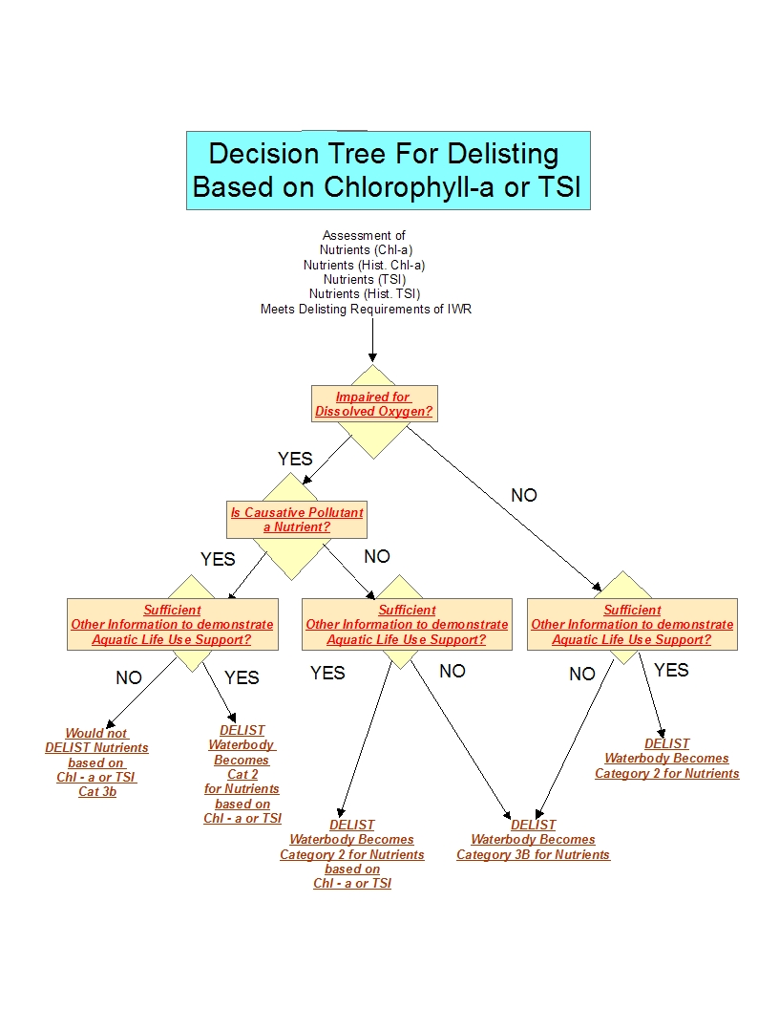
Figure 8.2. Results of Florida’s Surface Water Quality Assessment
for all Parameters (Excluding Mercury)

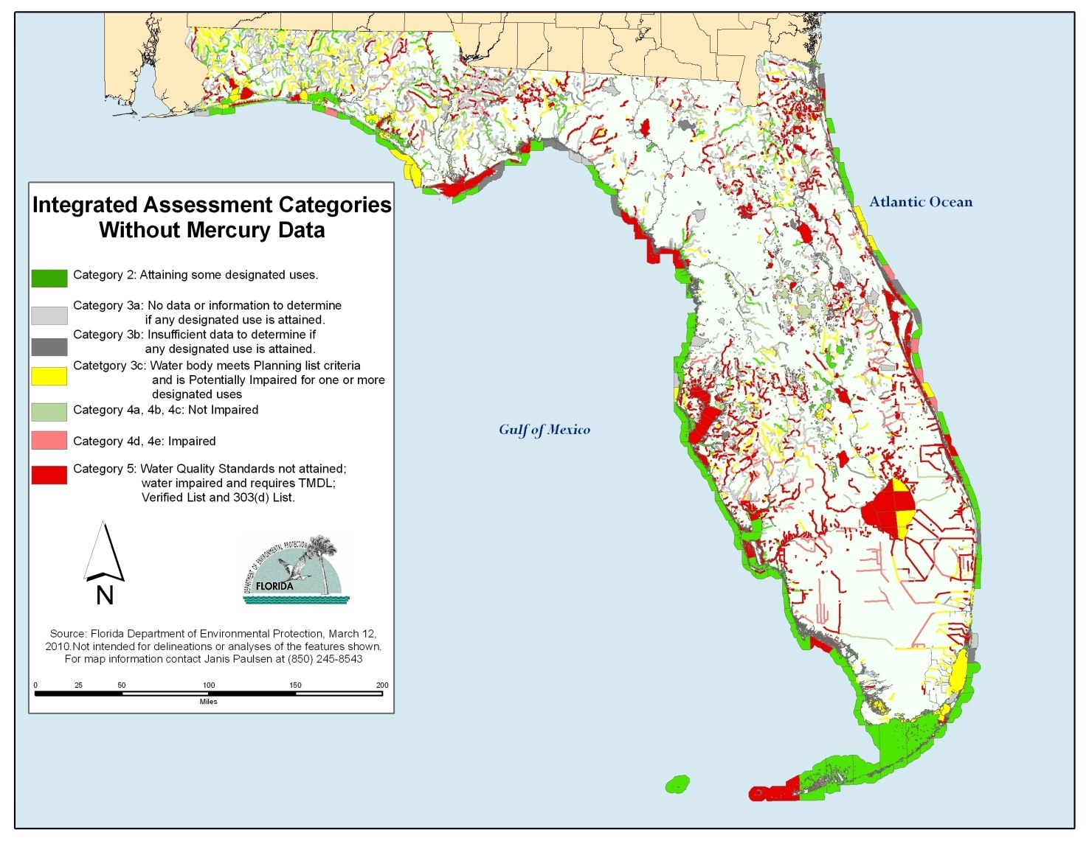

Figure 8.3. Results of Florida’s Surface Water Quality Assessment for Mercury

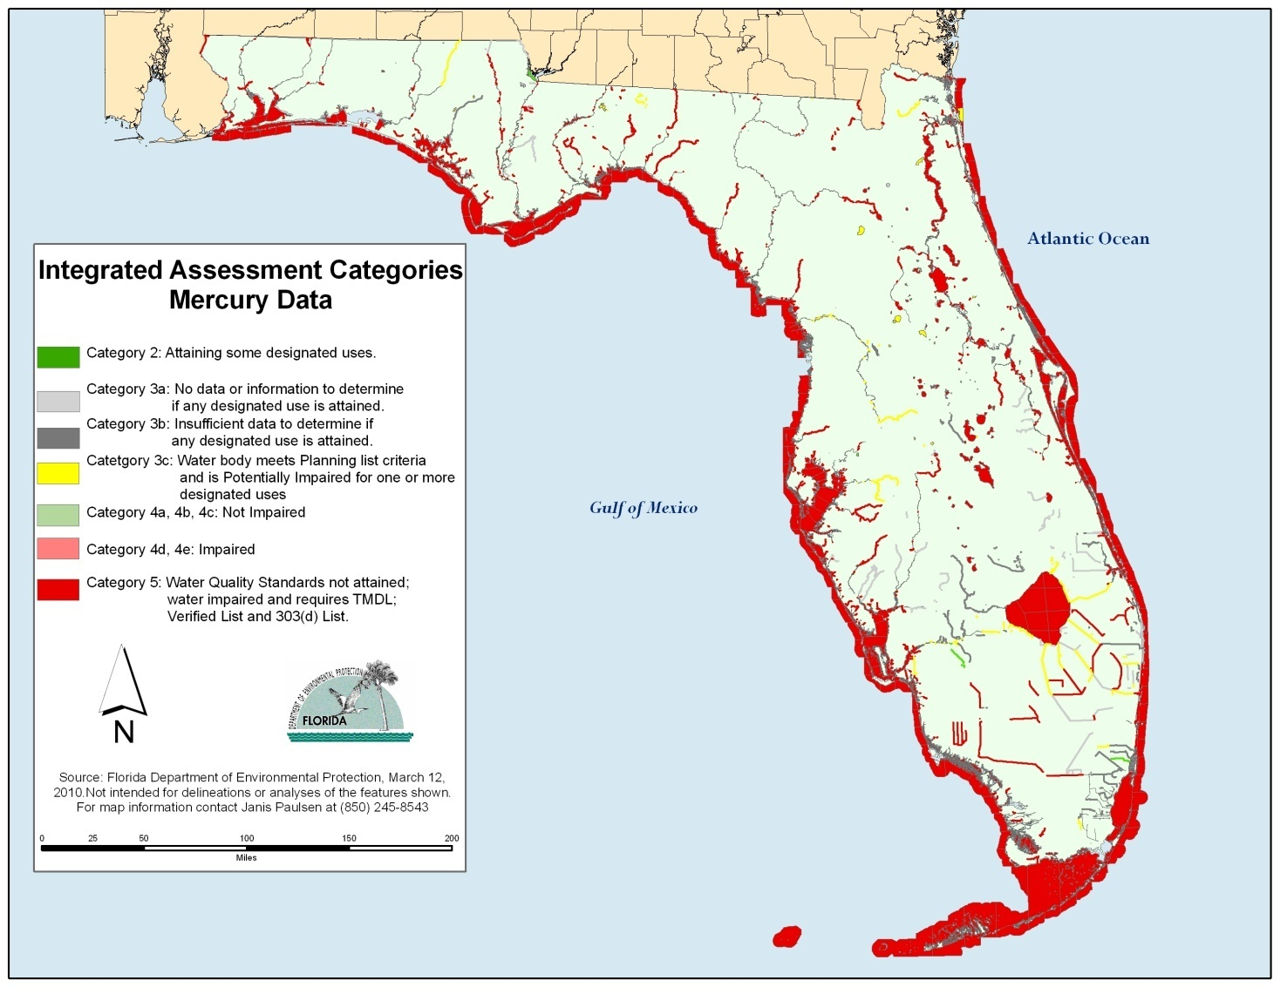

Biology
The IWR relies heavily on stream biological data for the assessment of impairment status. Since 1992, FDEP has processed 1,273 BioRecon and 2,968 SCI samples. Over this period, BioRecons statewide showed a 39% failure rate, and 21% of the SCIs failed. Table 8.4 shows the numbers of measurements and impairment status for the BioRecon and SCI from 1992 to October 2009.

Table 8.4. Numbers of Measurements and Impairment Status
for the BioRecon and SCI, 1992–October 2009
This is a four-column table. Column 1 lists the biological assessment, Column 2 lists the result, Column 3 lists the impairment status, and Column 4 lists the number of measurements

Biological Assessment | Result | Impairment Status | Number of Measurements
BioRecon | Pass | Not impaired | 443
BioRecon | Suspect | Not impaired | 331
BioRecon | Fail | Impaired | 449
SCI | Pass Excellent | Not impaired | 2,348
SCI | Fail | Impaired | 612

Special Focus: Lakes
Lakes are a particular focus of the EPA’s Integrated Report guidance. This section addresses CWA Section 314 reporting requirements, providing information on lake trends, approaches to controlling lake pollution and lake water quality, and publicly owned lakes with impaired uses. Table 8.2 includes a summary of the lake acres assigned to each EPA Integrated Report category, and Table 8.3b provides information on the acres of lakes impaired by various causes.

Lake Trends
Trends in Florida lakes between 1999 and 2008 were analyzed, and there were sufficient data for trend analysis for 369 lakes. Of these 369 lakes, 52 were improving, 260 were stable, and 57 were degrading. For 966 lakes, trends were unknown.

Trend analysis was accomplished using quarterly waterbody medians of nitrogen, phosphorus and chlorophyll a from 1999 through 2008. Only waterbodies with at least 10 years of data were used in the Spearman rank-order nonparametric correlation (correlations had to be significant at the 95% confidence level).

Approaches to Controlling Lake Pollution and Lake Water Quality
The TMDL assessment process described in Chapter 7 provides an approach to controlling the point and nonpoint source pollution entering Florida’s lakes and restoring lake water quality. In particular, the BMAPs developed for impaired waterbodies describe specific management activities and BMPs for reducing pollution. Each BMAP also provides interim and final targets for evaluating water quality improvements, a mechanism for tracking the implementation of management actions, procedures for monitoring and reporting on progress, data management and QA/QC procedures, a description of methods used to evaluate progress towards goals, a strategy and schedule for periodically reporting results to the public, and procedures to determine whether additional corrective actions are needed and whether plan components need to be revised.

Publicly Owned Lakes with Impaired Uses
Florida has a number of publicly owned lakes that are known to be impaired. These include lakes that do not meet applicable water quality standards or that require the implementation of control programs to maintain compliance with applicable standards. Appendix E lists alphabetically the impaired lakes in the state, the parameter causing impairment, the basin group, and the river basin within which each lake is located.

Drinking Water
Surface waters supply only about 13% of Florida's drinking water. Of 5,634 public drinking water systems statewide, 18 obtain their water from surface water. An additional 53 systems wholly or partially purchase water from these 18 systems. Because it is expensive to operate a surface water system (given that filtration and advanced disinfection are costly), most are large.

While earlier sections of this chapter discussed impaired waters by waterbody type, this section provides assessment results for waterbodies designated as Class I, potable water supply. To determine the attainment of water quality standards, the data for all Class I rivers/streams and lakes in the state were assessed against all criteria associated with those waters, not just those designated to potable water supply. Class I waters must also protect general human health, aquatic life, and allow for the protection of fish and wildlife, and recreational uses. In fact, the criteria not being attained in Class I waters are those that support Class III uses, not necessarily those uses associated with providing safe drinking water. Table 8.5 lists the total miles of rivers/streams and acres of lakes/reservoirs designated for drinking water use, and Table 8.6 lists the miles of rivers/streams and acres of lakes/reservoirs designated for drinking water use that are assigned to each of the EPA’s five reporting categories. Note that Lake Okeechobee is a Class I waterbody, and it comprises 435,840 acres of the total 490,356 lake acres that are currently impaired.

Table 8.5. Total Miles of Rivers/Streams and Acres of Lakes/Reservoirs Designated for Drinking Water Use
This is a three-column table. Column 1 lists the waterbody type, Column 2 lists the number of waterbodies in the state designated for drinking water use, and Column 3 lists the stream miles and lake acres with that designation.

Waterbody Type | Number | Total in State
Streams | 90 | 556 miles
Lakes | 24 | 501,170 acres

Table 8.6. Miles of Rivers/Streams and Acres of Lakes/Reservoirs Designated for Drinking Water Use that Are Assigned to Each of the EPA’s Five Reporting Categories
This is a five-column table. Column 1 lists the waterbody type, Column 2 lists the number of waterbodies, Column 3 lists the stream miles and lake acres, Column 4 lists the EPA category, and Column 5 lists the assessment status.

¹ The EPA’s Integrated Report categories are as follows:
1 = Attains all designated uses;
2 = Attains some designated uses;
3a = No data and information are available to determine if any designated use is attained;
3b = Some data and information are available, but they are insufficient for determining if any designated use is attained;
3c = Meets Planning List criteria and is potentially impaired for one or more designated uses;
3d = Meets Verified List criteria and is potentially impaired for one or more designated uses;
4a = Impaired for one or more designated uses and the TMDL is complete;
4b = Impaired for one or more designated uses, but no TMDL is required because an existing or proposed pollutant control mechanism provides reasonable assurance that the water will attain standards in the future;
4c = Impaired for one or more designated uses but no TMDL is required because the impairment is not caused by a pollutant; and
5 = Water quality standards are not attained and a TMDL is required.
Waterbody Type | Number of Waterbodies | Stream Miles  and Lake Acres | EPA Category¹ | Assessment Status
Rivers/Streams | 3 | 39 | 2 | Meets use
Rivers/Streams | 17 | 69 | 3a | No data
Rivers/Streams | 11 | 32 | 3b | Insufficient data
Rivers/Streams | 13 | 72 | 3c | Planning List
Rivers/Streams | 44 | 346 | 5 | Verified List
Lakes | 2 | 640 | 2 | Meets use
Lakes | 1 | 3,952 | 3a | No data
Lakes | 0 | 0 | 3c | Planning List
Lakes | 20 | 490,356 | 5 | Verified List

Overlap of Source Water Areas and Impaired Surface Waters
Verified Lists of impaired surface waters have been adopted for the Group 1–5 basins. Source water areas were modeled based on a 3-day travel time to the intake within surface waters and their 100-year floodplains. Streams were added to the source water coverage from USGS quadrangles, with a 3-meter buffer around each one. The overlap of surface waters that do not attain all criteria and these source water areas were determined using the source water coverage, the lists of impaired surface waters, the areas of Florida’s lakes and reservoirs, and the 1:24,000-scale NHD for streams. Table 8.7 lists the impaired river/stream miles and acres of lakes/reservoirs overlapping the source water areas of community water systems.

Table 8.7. Summary of Impaired River/Stream Miles and Lake/Reservoir Acres Overlapping Source Water Areas of Community Water Systems
This is a three-column table. Column 1 lists the surface water type, Column 2 lists the length or area of impaired waters overlapping source water areas in Groups 1–5, and Column 3 lists the percent of total length or area in Groups 1–5.

Note: The analysis is based on adopted lists of impaired surface waters for the Group 1–5 basins. Parameter of interest was fecal coliform.
Surface Water Type | Length or Area of Impaired Surface Waters Overlapping Source Water Areas in Basin Groups 1–5 | % of Total Length or Area in Basin Groups 1–5
Streams/Rivers | 584 miles | 1.15%
Lakes/Reservoirs | 1,478 acres | 0.094%

Sediment Contamination

Freshwater Sediments
In 2004, FDEP, in conjunction with two water management districts (Northwest Florida and St. Johns River), surveyed sediments from both large and small lakes in the 6 Group 1 basins. A total of 284 lake sediment samples were collected after the collection of the water samples. FDEP’s Central Laboratory analyzed these samples for metals, nutrients, and organic contaminants. Metals analyzed included arsenic, cadmium, chromium, copper, lead, nickel, mercury, silver, and zinc; organic contaminants included polynuclear hydrocarbons (PAHs), polychlorinated biphenyls (PCBs), and organochlorine pesticides (for example, DDT and its breakdown products). FDEP’s Monitoring Section then applied the sediment quality assessment tools to the resulting dataset.

Using the two guidelines in the 2003 guidelines document, the metals copper, lead, and zinc produce the most exceedances of both the lower and higher guidelines. Arsenic, cadmium, chromium, and mercury rarely exceed the higher guideline but do commonly exceed the lower guideline. Not surprisingly, sediment metals were highest in lakes in urbanized areas, with the highest number of samples that show elevated metals collected in the Tampa Bay region.

In the 284 samples, there were 41 detections of an organic contaminant; however, some sediment samples had detections of more than 1 individual organic contaminant. No PCB compounds were detected, and only 7 samples had detectable amounts of PAHs. However, the persistent organochlorine pesticides DDT (along with its breakdown products, DDD and DDE) and chlordane were detected at 20 stations. The two Group 1 basins with the most exceedances of the higher organic contaminant guideline were the Ocklawaha Basin, which is heavily agricultural, and the urban Tampa Bay Basin. Chlordane, a now-banned but formerly widely used termiticide, was detected in 7 lake sediment samples, all in the Tampa Bay Basin.

Estuarine and Marine Sediments
From several perspectives—economic, social, demographic, and particularly ecological—Florida’s inshore marine resources are one of the state's most valuable assets. But the state’s geologic and hydrologic features make its coastal surface waters and sediments relatively vulnerable to contamination. Sediment contamination is particularly important to water quality, because sediments and surface water interact extensively. Although Florida currently has no criteria for heavy metals or toxic organic contaminants in estuarine sediments, FDEP does have sediment guidelines to assess current conditions, to identify contaminated areas, and to provide background information for project managers. Guidance concentrations for most sediment contaminants are available for both fresh and estuarine/marine waters.

Starting in the 1980s, Florida Department of Environmental Regulation (FDER) staff began carrying out a number of surveys to assess sediment contamination. From 1983 to 1984, sediments were collected as part of the Deepwater Ports Project from sites near dense population centers and close to commercial channels and ship berths. A second survey, from 1985 to 1991, assessed sites where contamination was expected because of flows from tributaries and local land use practices. A third survey examined sites in relatively remote or unimpacted areas. The assembled data provided FDER staff with much needed sediment chemistry information. For example, they were used to determine the natural background concentrations of certain metals in Florida coastal sediments, including arsenic, cadmium, chromium, copper, mercury, lead, and zinc. This effort culminated in the release of the document, A Guide to Interpretation of Metal Concentrations in Estuarine Sediments (Schropp and Windom, 1988), which employed statistical normalization techniques to determine background concentrations of metals in sediments

In the early 1990s, the sediment research staff at the former FDER, now called FDEP, took this dataset (over 700 sites), and combined it with data from 42 sites collected by NOAA’s National Status and Trends Program (NSTP) and 33 sites in the St. Johns River collected by Mote Marine Laboratory (MML), a marine research facility in Sarasota. This enlarged dataset was later incorporated into a statewide Sediment Atlas that contained information collected from nearly 800 sites, and displayed metals contamination data as well as data for five classes of organic contaminants: chlorinated hydrocarbons (pesticides), polycyclic aromatic hydrocarbons (PAHs), polychlorinated biphenyls, phenolic hydrocarbons, and aliphatic hydrocarbons. The purpose of the Atlas was to document the locations of contaminated sediments throughout the state’s coastal waters.

In the Atlas, estuarine sediment metal contamination above background levels was most often seen for cadmium, mercury, lead, and zinc. PAHs were found in about 70% of the samples tested for organic chemicals. Of this group, fluoranthene and pyrene were found in more than 50% of the samples. Not surprisingly, more contaminants were found in urban watersheds than in rural or undeveloped watersheds.

As mentioned in Chapter 6 for the Watershed Monitoring Section’s freshwater sediment evaluation project, guidelines were developed to assess sediment contaminants in estuarine and marine sediments as well. The document Approach to the Assessment of Sediment Quality in Florida Coastal Waters (MacDonald Environmental Sciences Ltd., 1994) is still the source of FDEP’s contaminated sediment guidance in 2010. Although the guidelines are a valuable tool, they must be used with other tools and assessment procedures. The sediment guidelines do not replace dredging disposal criteria or formal procedures, nor are they meant to be sediment quality criteria or numeric attainment levels for cleaning up Superfund sites.

Although FDEP no longer carries out regular estuarine and marine sediment monitoring, the FWC’s Florida Marine Research Institute (FMRI) conducted a series of coastal and estuarine sediment chemistry surveys from 2000 through 2004, and prepared a series of annual reports that outlined its results and activities. The program, named the Florida Inshore Marine Monitoring and Assessment Program (IMAP), was a collaborative project between the EPA and FMRI. IMAP was designed to assess the ecological condition of Florida’s inshore waters using a set of ecological indicators combined with water and sediment chemistry results. IMAP began full-scale field sampling in the summer of 2000, and ended the work in 2004. The results of these efforts are available on the FMRI website.

Some Florida county governments also have active coastal sediment monitoring programs, or did in the recent past. Dade (Miami) and Hillsborough County governments both have engaged in extensive sediment monitoring efforts to assess the status of their coastal waters. The St. Johns River Water Management District has also conducted extensive sediment sampling up and down the St. Johns River, from the estuary mouth and back upstream.

Chapter 9: Introduction to Ground Water Monitoring

Summary of Ground Water Monitoring Programs
The quality of ground water is of foremost concern in Florida, because ground water is so heavily used as a potable water source and because ground water inputs into surface water systems are so important. Over the years, ground water quality monitoring has been incorporated into several programs. The programs pertinent to this report are discussed below and summarized in Tables 9.1a and 9.1b.

Table 9.1a. Summary of Ground Water Monitoring Programs and Data Sources:
FDEP-Maintained Monitoring Networks
This is a three-column table. Column 1 lists the monitoring network or program, Column 2 lists the period over which it has operated, and Column 3 provides a description.

Monitoring Network or Program | Period | Description
Status Network | 1999–2003  2004-2008 | The statewide rotating basin, probabilistic sampling network was based on sampling 60 wells from several basins per year. The 1999–2003 cycle (Cycle 1) completed a statewide survey in 4 years. During 2004–08, the state adopted the TMDL 29-basin design (Cycle 2), completing the statewide survey in 5 years. These sample locations were randomly selected from a list frame of wells, with samples collected from 30 unconfined and 30 confined aquifers in each 5 to 6 reporting units. This report presents the results from Cycle 2.
Status Network | 2009–ongoing | This statewide probabilistic sampling network samples 240 wells annually. Sample locations are randomly selected from a list frame of wells, with samples collected from 20 unconfined and 20 confined aquifers in each of 6 reporting units. The data used to characterize water quality on a statewide scale, and the parameters monitored, correspond with those targeted in surface water evaluations.
Background Network and  Temporal Variability (TV) Subnetwork | 1985–1999 | A statewide network of 1,600 water wells and monitoring wells used to spatially monitor general background water quality of local aquifers (surficial, intermediate, and Floridan). On average, each well was sampled once every 3 years for an extensive list of analytes. TV network wells are sampled monthly to quarterly.
Ground Water Temporal Variability (GWTV) Subnetwork | 1999–ongoing | The current network consists of 46 wells statewide. It is designed to help correlate Status Network results with seasonal hydrologic variations, and estimate the temporal variance of analytes.
Very Intense Study Area (VISA) Network | 1989–1999 | The network monitored the effects of land uses on ground water quality in 23 selected areas of the state. Individual VISAs consisted of approximately 20 wells sampled 3 times over an 11-year period. Sampling was carried out for a targeted list of analytes.
Springs Monitoring Network | 2001–2010 | Fifty-eight samples were collected quarterly from 23 first-magnitude and 9 second-magnitude spring clusters. The basic analyte list is identical to that used for the Status Network.

Table 9.1b. Summary of Ground Water Monitoring Programs and Data Sources: Programs that Include Potable Ground Water Sampling:
FDEP-Maintained Monitoring Networks
This is a three-column table. Column 1 lists the monitoring network or program, Column 2 lists the period over which it has operated, and Column 3 provides a description.

Monitoring Network or Program | Period | Description
Public Water System (PWS)  Monitoring | Ongoing | Under Chapter 62-550, F.A.C., all public water systems are required to monitor and report water quality at regular intervals within their Compliance Cycle. Ground water is the primary source of potable water in the state.
FDOH/FDEP Water Supply Restoration Program (WSRP)–Private Well Sampling Program | Ongoing | This consists of private well data collected in investigations of potential ground water contamination, maintained in an FDEP WSRP database. The parameter list is variable, depending on the contaminants of concern.
Monitoring of discharges  to ground water | Ongoing | Under Chapter 62-522, F.A.C., facilities discharging to ground water are required to implement a ground water monitoring plan and report those results to FDEP.

FDEP-maintained Ground Water and Springs Monitoring Programs
FDEP established a ground water quality monitoring network in 1984, under the authority and direction of the 1983 Water Quality Assurance Act. From 1984 to1999, the Background Network was maintained to establish the background and baseline ground water quality of major aquifer systems in Florida. In 1999, FDEP initiated a probabilistic sampling Status Network to assess ground water and surface water quality on a basin-wide scale. This sampling has been integrated into the agency’s watershed management approach. Since the Status Network’s inception, three statewide samplings have been completed.

Monitoring results for the Ground Water Temporal Variability Network (GWTV), which also began in 1999, are used to assess seasonal and long-term variability in ground water quality. Other, historical monitoring efforts include the Background Network, the VISA Network, and FDOH’s Private Water Well Quality Survey. Additional information on all these monitoring networks is available on the FDEP Watershed Monitoring website.

This report includes the Status Network monitoring data in the dataset used to evaluate overall ground water quality and ground water parameters of particular concern that may influence receiving surface waters.

FDEP established a springs monitoring network as part of the Florida Springs Initiative. Beginning in 2000, this initially included quarterly monitoring at each of the state’s first-magnitude springs but has since expanded to include important second-magnitude springs as well. In this report, Springs Initiative monitoring data are evaluated to identify spring water quality with respect to nutrients.

Potable Water Monitoring by FDOH/FDEP Water Supply Restoration Program
Contaminated drinking water wells are identified through the sampling efforts of the local county public health units, supported by FDEP funding. To optimize resources, wells are sampled in areas of known or suspected contamination, such as agricultural areas, areas of known off-site contamination near regulated facilities, landfills, or near underground storage tanks.

The FDOH Petroleum Surveillance Program concentrates its efforts in areas suspected to have petroleum-related contamination and targets drinking water wells near known storage tanks for sampling.

The Drinking Water Toxics Program looks for contamination related to the use of pesticides and fertilizers, and contamination from solvents and metals. The program is a cooperative effort between FDOH, the county public health units, and FDEP. FDEP funds the program through a contract with FDOH, and FDOH directs the sampling effort by local public health units.

In this report, the FDEP Water Supply Restoration Program (WSRP) database maintained by FDEP was used in the evaluation of the ground water contaminants of concern identified in private drinking water wells. The database currently has water quality records for approximately 40,000 private wells. A caveat to their use in this evaluation is that these wells are not evenly distributed because they were sampled in areas of known or suspected contamination. Thus, the number of exceedances in a particular basin can be misleading because the results may depend on well density and distribution in relationship to a given problem area.

Public Water System Monitoring
Approximately 5,600 public water systems (PWSs) in Florida rely on ground water. These are served by over 10,000 wells. Chapter 62-550, F.A.C., sets the drinking water standards, the monitoring requirements and treatment techniques to be met by PWSs, and that testing must be conducted by FDOH certified laboratories. The ultimate concern of the PWS supervision program is the quality of water when the water reaches consumers, but PWS monitoring involves the direct sampling of wells in some instances. Water quality results include samples from various entry points into the water system and points in the distribution system, include treated water, and for some parameters may include composite samples. Not all samples included in the data are used to determine compliance with 62-550.

The monitoring framework for PWSs is a nine-year compliance cycle containing specific monitoring requirements for individual parameter groups and specific actions based on the detection of parameters above action limits or maximum contaminant levels (MCLs). Water quality data in the PWS database are reported by the public water system identification number (PWS ID#). While individual sample results collected for this report may exceed an action level or MCL, that exceedance does not necessarily translate directly into a violation of water delivered to the consumer because of the compositing or blending of water mentioned above, or because averaging with subsequent samples was below the action level or MCL. Additional information is available on the FDEP Drinking Water Program website.

Water quality data in the PWS database were used in the evaluation of regional and statewide contaminants of concern. These data can either represent one individual well or a composite sample from multiple wells that comprise a system. Generally, the most densely populated areas of the state have public supply systems with multiple wells, while less populated areas may rely on only one well. Each public supply well was assigned to a basin or, in the case of a system, the basin that represents the majority of those wells. In the analysis of contaminants of concern, the number of MCL exceedances is not weighted, and thus each exceedance may represent one individual well or a composite of many wells in a system. Drinking water standards, monitoring requirements, and the frequency of sampling for public water supply wells are based on Chapter 62-550, F.A.C.

Monitoring of Discharges to Ground Water
FDEP implements a comprehensive ground water quality protection program that regulates discharges to ground water. The program establishes ground water quality standards and classifications and permitting criteria. Several FDEP rules contain construction and operation requirements, minimum setbacks, and ground water monitoring criteria.

Most permitted discharges to ground water are required to submit and implement a ground water monitoring plan showing the location of the proposed upgradient and downgradient monitoring wells, construction details, and a ground water sampling and analysis protocol. At a minimum, these plans require three monitoring wells: a background well, an intermediate well, and a compliance well. These wells are generally sampled quarterly by the permittee, and the analysis is submitted to FDEP to ensure compliance with Florida’s ground water standards.

Chapter 10: Results of the Ground Water Assessments

Overall Ground Water Quality
A combination of data from all agencies in Florida with ground water monitoring programs was used to evaluate the overall quality of ground water based on several categories of primary ground water MCLs. The data were sorted into analyte groups, and an “indicator” analyte was selected to determine ground water quality for wells in each of the basins. The groups used in this evaluation include metals, bacteria, nitrate, and saline water, which represent some of the most common threats to drinking water noted by the EPA in national surveys. Organics and radionuclides were not included in the Status Network parameter list but are addressed in a later section. It should be noted that the ground water evaluation used a larger set of data from more monitoring stations than were available in the probabilistic network used for the Status and Trends reporting in Chapter 5. This evaluation also provided information by basin rather than statewide as was done with the assessments reported in Chapter 5.

The wells used in this statewide evaluation of overall ground water quality consist of a mixture of drinking water, irrigation, production, and monitoring wells that are used by FDEP, the water management districts, and the USGS for monitoring ground water quality. There is no single database from which these come, nor is there a singular monitoring objective under which the sampling occurred. These data indicate general basin-scale or statewide conditions and do not represent local conditions. They generally represent ambient ground water quality, although a small number of wells are used for targeted monitoring. It is assumed for the purposes of this analysis that the water quality in these wells provides a generalized representation of overall ground water conditions.

Table 10.1 presents the results of this evaluation, with the results provided by individual basin and combined for statewide statistics. The results in the table are further broken down to show the results from the past two years and prior data back to 2000. Older (pre-2000) data may include nonrepresentative artifacts from sample collection and analysis, and so these are not included in the assessment.

In the statewide dataset, bacteria (as total coliform) and salinity (as sodium) were the analyte groups with the fewest wells that were found to meet their designated uses.

Coliform bacteria can commonly reflect conditions in the well rather than the aquifer when associated with well construction or inadequate maintenance issues, and so these results should also be scrutinized. They are discussed in greater detail in the next section on contaminants of concern. The statewide assessment shows that data from the past 2 years were similar to the 2000–07 median in the number of samples achieving the MCL (84% compared with 81%). Table 10.1 shows the basins with the highest number of wells achieving the ground water standards. The Everglades, Everglades West Coast, Ochlockonee–St. Marks, and Southeast Coast–Biscayne Bay Basins have the highest number of wells exceeding the MCL for total coliform.

Table 10.1. Summary of Percent Ground Water Samples Achieving Primary Ground Water Standards for Selected Analytes by Basin
This is a seven-column table. Column 1 lists the basins, Column 2 lists the most frequent metal (arsenic or lead) over the MCL in 2000–07 and 2008–09, and Columns 3 through 5 list the results for arsenic, lead, total coliform, nitrate + nitrite (as N), and total sodium, respectively, in 2000–07 and 2008–09.

Notes: Data are from a combination of sources, including FDEP’s Status Network, the water management districts, and USGS. For some basins, datasets are limited. Values for basins with 5 or fewer samples are indicated by shading and an asterisk.
¹ Metals assessments were conducted for arsenic (As) and lead (Pb), the two primary metals most commonly exceeding their MCL.
N/A = Not available
Basin | Metals  (Most Frequent Metal exceeding MCL  2000–07 / 2008–09 | Arsenic¹  2000–07 / 2008–09 | Lead¹  2000–07 / 2008–09 | Coliform, Total  2000–07 / 2008–09 | Nitrate + Nitrite  (as N)  2000–07 / 2008–09 | Sodium, Total  2000–07 / 2008–09
Apalachicola–Chipola | 100% - 100% | 100% - 100% | 100% - 100% | 92% - 100% | 100% - 100% | 100% - 100%
Caloosahatchee | 82% - 100% (As) | 82% - 100% | 100% - 100% | 75% - 83% | 100% - 100% | 39% -75 %
Charlotte Harbor | 95% - 100% (As) | 95% - 100% | 97% - 100% | 84% - 100% | 100% - 100% | 37% - 0%*
Choctawhatchee–  St. Andrew | 100% - 100% | 100% - 100% | 100% - 100% | 87% - 90% | 100% - 100% | 99% - 100%
Everglades | 100% - 100% | 100% - 100% | 100% - 100% | N/A - 63% | 100% - 98% | 55% - 76%
Everglades West Coast | 88% - 96% (Pb) | 94% - 88% | 88% - 96% | 72% - 68% | 100% - 100% | 28% - 64%
Fisheating Creek | 100% - N/A | 100% - N/A | 100% - N/A | 97% - N/A | 53% - 61% | 89% - N/A
Florida Keys | N/A - 88% (As) | N/A - 88% | N/A - 100% | N/A - 75% | 100% - 100% | 0%* - 0%
Indian River Lagoon | 100% - 96% (As) | 100% - 96% | 100% - 98% | 100% - 85% | 100% - 98% | 60% - 47%
Kissimmee River | 100% - 88% (Pb) | 100% - 100% | 100% - 88% | 90% - 97% | 52% - 54% | 99% - 95%
Lake Okeechobee | 97% - 100% (Pb) | 100% - 100% | 97% - 100% | 100% - 100% | 99% - 100% | 67% - 40%*
Lake Worth Lagoon–  Palm Beach Coast | 91% - 100% (Pb) | 96% - 100% | 91% - 100% | 74% - 88% | 100% - 100% | 47% - 100%*
Lower St. Johns | 100% - 100% | 100% - 100% | 100% - 100% | 76% - 83% | 100% - 100% | 89% - 82%
Middle St. Johns | 97% - 100% (Pb) | 100% - 100% | 97% - 100% | 79% - 84% | 97% - 100% | 72% - 75%
Nassau–St. Marys | 98% - 100% (Pb) | 99% - 100% | 98% - 100% | 87% - 86% | 100% - 100% | 97% - 94%
Ochlockonee–St. Marks | 97% - 100% (As) | 97% - 100% | 100% - 100% | 66% - 68% | 99% - 81% | 99% - 100%
Ocklawaha | 96% - 100% (Pb) | 97% - 100% | 96% - 100% | 79% - 91% | 99% - 100% | 98% - 99%
Pensacola | 99% - 100% (Pb) | 100% - 100% | 99% - 100% | 93% - 100% | 100% - 100% | 99% - 100%
Perdido | N/A - 97% (Pb) | N/A - 100% | N/A - 97% | N/A - 97% | 100% - 100% | N/A - 97%
Sarasota Bay–Peace–Myakka | 97% - 100% (As) | 97% - 100% | 100% - 100% | 73% - 93% | 89% - 88% | 94% - 100%
Southeast Coast–Biscayne Bay | 98% - 100% (Pb) | 100% - 100% | 98% - 100% | 71% - 68% | 100% - 100% | 44% - 85%
Springs Coast | N/A - 89% (As) | N/A - 89% | N/A - 97% | N/A - 84% | 99% - 100% | N/A - 73%
St. Lucie–Loxahatchee | 95% - 100% (Pb) | 100% - 100% | 95% - 100% | 64% - 100% | 100% - 100% | 24% - 0%*
Suwannee | 99% - 99% (As) | 99% - 99% | 99% - 100% | 83% - 80% | 99% - 99% | 99% - 99%
Tampa Bay | 91% - 100% (As) | 91% - 100% | 94% - 100% | 80% - 100% | 99% - 100% | 88% - 100%
Tampa Bay Tributaries | 93% - 100% (As) | 93% - 100% | 98% - 100% | 77% - 67% | 98% - 100% | 95% - 75%*
Upper East Coast | 60% - 100% (Pb) | 80%* - 100% | 60%* - 100% | 0%* - 79% | 100% - 100% | 67% - 63%
Upper St. Johns | 96% - 100% (Pb) | 98% - 100% | 96% - 100% | 95% - 50% | 100% - 83% | 44% - 43%
Withlacoochee | 98% - 100% (Pb) | 99% - 100% | 98% - 100% | 82% - 92% | 99% - 100% | 100% - 100%
STATEWIDE SUMMARY | 99% - 99% (Pb) | 99% - 99% | 99% - 99% | 81% - 84% | 94% - 94% | 85% - 82%

Sodium can be used as an indicator of saline ground water influence on freshwater aquifers. The issues with salt water can be related to increased ground water usage that creates the upconing of mineralized ground water from deeper aquifers or seawater intrusion if wells are located in coastal areas. Saline water (as sodium) may be a concern in approximately 15% of the state, based on statewide statistics. The statewide assessment shows that data from the past 2 years were similar to the 2000–07 median in the number of samples achieving the MCL (82% in comparison to 85%). Table 10.1 shows the basins with the highest number of wells achieving the MCL for sodium. Coastal basins were found to have the lowest percentage of wells meeting the MCL, with Caloosahatchee, Charlotte Harbor, Everglades West Coast, and St. Lucie–Loxahatchee having the highest number of wells exceeding the MCL for sodium.

One or more metals exceeding a primary ground water MCL occurred in only about 1% of the samples, with the most prevalent metals exceedances for lead and arsenic. Lead levels are sometimes related to well casing or plumbing material, but arsenic is most frequently associated with a contaminant source or natural condition in the aquifer when it is found at concentrations above its MCL.

Nitrate - nitrogen is a conservative contaminant, and concentrations are not typically biased by well materials or sampling technique. The compound nitrite - nitrogen is seldom detected in ground water and, if present, occurs in only minute concentrations. Therefore, when concentrations of nitrate + nitrite - nitrogen are reported together, as they are in Table 10.1, it can be safely assumed that the value represents the nitrate concentration. Elevated nitrate levels reflect the presence of nutrient sources such as fertilizers, animal waste, or domestic wastewater. According to the statewide assessment, nitrate above the MCL is a concern in 6% of the wells sampled. Table 10.1 lists the basins with the highest number of wells achieving the MCL for nitrate. Basins with the lowest percentage of wells meeting the MCL for nitrate included Fisheating Creek and Kissimmee River.

This generalized analysis shows that overall ground water quality in the state is good, when considering these parameters. However, this analysis indicates that there are some ground water quality issues in the state, and, depending on the contaminant, they can occur on a localized or regional scale. The following section describes the contaminants of concern in Florida and their observed occurrences in potable ground water.

Ground Water Quality Issues and Contaminants of Concern, Including Public Health Issues
As discussed in the analysis of ambient data, the overall quality of ground water in Florida is good. However, there are ground water quality issues in specific areas. Private well sampling data and public water system data (which include both treated and raw water samples) were used to develop a summary of the categories of parameters that were most frequently found at levels exceeding primary ground water MCLs in potable water aquifers. Data were obtained for a two-year period of record spanning November 2007 through November 2009. The MCL exceedances during this period help shape some of the more current issues and contaminants of concern for potable ground water resources. The reporting of these exceedances in wells and water systems is not meant to imply that well owners or public water customers are consuming contaminated ground water. Alternative sources or treatment systems are provided to private well owners, and water from public water systems is most often treated but sometimes blended to reduce contaminants to safe levels.

Figure 10.1 provides a statewide summary of findings by contaminant category. Tables 10.2a and 10.2b summarize contaminant categories in each of the state’s 29 major basins, showing the total number of MCL exceedances reported over time and the numbers of exceedances found in the most recent 2-year period. These categories include volatile organic compounds (VOCs), pesticides/synthetic organic chemicals (SOCs), nitrate, primary metals, salinity (as measured by sodium concentrations), and radionuclides. The specific contaminants included in this evaluation have potable ground water MCLs. Although not included in the summary table, trihalomethanes and bacteria are significant contaminants affecting water supplies, and they are also discussed in this section.

Volatile Organic Compounds
Volatile organics can be highly mobile and persistent in ground water, and incidences of ground water contamination by VOCs are widespread. Table 10.2a includes a summary of the numbers of water systems or private wells for which samples contained above-MCL levels of VOCs that have primary drinking water MCLs. The highest numbers of public water systems that have historically had above-MCL VOC levels were in the Ocklawaha, Middle St. Johns, and Tampa Bay Tributaries Basins; however, there have been few to no additions to these totals over the past two years. Historically, the highest numbers of MCL exceedances in private wells were in the Lower St. Johns, Middle St. Johns, Sarasota–Peace–Myakka and Tampa Bay Tributaries Basins. Of these, the highest number of MCL exceedances over the past two years was in the Middle St. Johns Basin (33 wells), followed by the Lower St. Johns and Southeast Coast–Biscayne Bay Basins (10 each).

Benzene has historically been the compound that most frequently exceeded MCLs in each of the two sets of water quality data, followed by trichloroethylene (TCE) and tetrachloroethylene (PCE). Other compounds with primary MCLs that were exceeded included vinyl chloride, dichloromethane, 1,1-dichloroethylene, 1,2-dichloroethane, and carbon tetrachloride (in PWS systems only). Based on the last two years of data, the highest number of exceedances in private wells was for vinyl chloride and the highest number of exceedances in public water systems was for 1,1-dichloroethylene.

Figure 10.1. Numbers of Primary MCL Exceedances in Samples from Public Water Systems and Private Wells for the Recent 2-Year Period

Table 10.2a. Summary of Recent Exceedances of Primary Ground Water Standards in Samples from Private Wells and Ground Water–Based Public Water Systems
This is a seven-column table. Column 1 lists the basin/aquifer. Columns 2 and 3 list the number of public water systems and private wells, respectively, exceeding primary standards for VOCs since the 2008 report. Columns 4 and 5 list the number of public/private exceedances, respectively, for pesticides/SOCs over the same period; and Columns 6 and 7 list the number of public/private exceedances, respectively, for nitrate.

¹ Public water systems or private wells with samples that exceeded primary MCLs for VOCs, excluding trihalomethanes and ethylene dibromide.
² Public water systems or private wells with samples that exceeded primary MCLs for pesticides (also known as SOCs).
³ Public systems or private wells with samples that exceeded MCLs for nitrate or nitrate + nitrite.
⁴ PWS data not restricted to wells only. Some parameter results are for other entry points into a system or composite samples. Data are from systems that operate their own wells. While individual sample results collected for this report may exceed an action level or MCL, that exceedance does not necessarily translate directly into a violation of water delivered to the consumer (1) because of the compositing or blending of water mentioned above, or (2) because averaging with subsequent samples was below the action level or MCL.
⁵ Private well sampling under the WSRP is targeted sampling conducted in areas of suspected contamination, and the parameters analyzed are specific to contaminants of concern.
- = Empty cell/no data
- | Contaminant Categories and Number of Wells or Water Systems with Samples that Have Exceeded Primary Standards  (period of record November 2007–November 2009)
Basin—Aquifer | VOCs¹ in Public Water Systems⁴ | VOCs¹ in Private Wells (WSRP)⁵ | Pesticides/  SOCs² in Public Water Systems⁴ | Pesticides/  SOCs² in Private Wells (WSRP)⁵ | Nitrate³ in Public Water Systems⁴ | Nitrate³ in Private Wells (WSRP)⁵
Apalachicola–Chipola—Floridan Aquifer | 0 | 0 | 1 | 6 | 0 | 10
Caloosahatchee—Surficial Aquifer | 0 | 0 | 0 | 0 | 3 | 0
Charlotte Harbor—Floridan Aquifer (SW) | 0 | 8 | 0 | 0 | 0 | 0
Choctawhatchee–St. Andrew—Floridan Aquifer | 0 | 0 | 0 | 0 | 0 | 0
Everglades—Surficial Aquifer (SW) | 0 | 0 | 0 | 0 | 0 | 0
Everglades West Coast—Surficial Aquifer | 0 | 1 | 0 | 0 | 0 | 0
Fisheating Creek—Surficial Aquifer | 0 | 0 | 0 | 0 | 0 | 4
Florida Keys—None | 0 | 0 | 0 | 0 | 0 | 0
Indian River Lagoon—Floridan and Surficial Aquifers | 0 | 7 | 0 | 0 | 1 | 0
Kissimmee River—Floridan, Intermediate, and Surficial Aquifers | 0 | 0 | 3 | 13 | 0 | 104
Lake Okeechobee—Surficial Aquifer (SW) | 0 | 0 | 0 | 0 | 1 | 0
Lake Worth Lagoon–Palm Beach Coast—Surficial Aquifer | 2 | 0 | 0 | 0 | 0 | 0
Lower St. Johns—Floridan Aquifer | 0 | 10 | 1 | 1 | 0 | 7
Middle St. Johns—Floridan Aquifer | 2 | 33 | 1 | 0 | 2 | 19
Nassau–St. Marys—Floridan Aquifer | 0 | 0 | 0 | 0 | 0 | 0
Ochlockonee–St. Marks—Floridan Aquifer | 1 | 0 | 1 | 0 | 1 | 0
Ocklawaha—Floridan Aquifer | 2 | 0 | 1 | 11 | 1 | 50
Pensacola—Sand-and-Gravel Aquifer | 1 | 0 | 2 | 3 | 1 | 0
Perdido—Sand-and-Gravel Aquifer | 0 | 0 | 0 | 0 | 1 | 0
Sarasota Bay–Peace–Myakka—Floridan and Surficial Aquifers | 0 | 1 | 0 | 3 | 0 | 73
Southeast Coast–Biscayne Bay---Biscayne Aquifer | 1 | 10 | 0 | 1 | 5 | 4
Springs Coast—Floridan Aquifer | 0 | 0 | 1 | 0 | 2 | 4
St. Lucie–Loxahatchee—Surficial Aquifer | 2 | 7 | 0 | 0 | 0 | 0
Suwannee—Floridan Aquifer | 0 | 1 | 0 | 2 | 2 | 15
Tampa Bay—Floridan Aquifer | 0 | 8 | 0 | 0 | 0 | 5
Tampa Bay Tributaries—Floridan Aquifer | 1 | 1 | 2 | 0 | 9 | 16
Upper East Coast—Floridan Aquifer and Surficial Aquifer | 0 | 1 | 0 | 0 | 0 | 0
Upper St. Johns—Floridan Aquifer and Surficial Aquifer | 1 | 1 | 0 | 0 | 0 | 0
Withlacoochee—Floridan Aquifer | 0 | 0 | 0 | 0 | 0 | 11
STATEWIDE SUMMARY—All Results | 13 | 89 | 13 | 40 | 29 | 322

Table 10.2b. Summary of Recent Exceedances of Primary Ground Water Standards in Samples from Private Wells and Ground Water–Based Public Water Systems
This is a seven-column table. Column 1 lists the basin/aquifer. Columns 2 and 3 list the number of public water systems and private wells, respectively, exceeding primary standards for primary metals since the 2008 report. Columns 4 and 5 list the number of public/private exceedances, respectively, for saline water over the same period; and Columns 6 and 7 list the number of public/private exceedances, respectively, for radionuclides.

¹ Public water systems or private wells with samples that exceeded MCLs for primary metals.
² Public water systems or private wells with samples that exceeded MCL for sodium, an indicator of salinity.
³ Public water systems or private wells with samples that exceeded MCL for radionuclides, measured as Radium-226, Radium-228, gross Alpha, and/or gross Beta.
⁴ PWS data not restricted to wells only. Some parameter results are for other entry points into a system or composite samples. Data are from systems that operate their own wells. While individual sample results collected for this report may exceed an action level or MCL, that exceedance does not necessarily translate directly into a violation of water delivered to the consumer (1) because of the compositing or blending of water mentioned above, or (2) because averaging with subsequent samples was below the action level or MCL.
⁵ Private well sampling under the WSRP is targeted sampling conducted in areas of suspected contamination, and the parameters analyzed are specific to contaminants of concern.
- = Empty cell/no data
- | Contaminant Categories and Number of Wells or Water Systems with Samples that Have Exceeded Primary Standards  (period of record November 2007–November 2009)
Basin—Aquifer | Primary Metals¹ in Public Water Systems⁴ | Primary Metals¹ in Private Wells (WSRP) ⁵ | Saline Water² in Public Water Systems⁴ | Saline Water² in Private Wells (WSRP) ⁵ | Radionuclides³ in Public Water Systems ⁴ | Radionuclides³ in Private Wells (WSRP) ⁵
Apalachicola–Chipola—Floridan Aquifer | 0 | 3 | 0 | 0 | 0 | -
Caloosahatchee—Surficial Aquifer | 1 | 0 | 0 | 0 | 1 | -
Charlotte Harbor—Floridan Aquifer | 0 | 6 | 2 | - | 1 | -
Choctawhatchee–St. Andrew—Floridan Aquifer | 1 | 2 | 0 | 0 | 0 | -
Everglades—Surficial Aquifer | 0 | 0 | 3 | - | 1 | -
Everglades West Coast—Surficial Aquifer | 2 | 1 | 3 | 0 | 1 | -
Fisheating Creek—Surficial Aquifer | 0 | 0 | 0 | - | 0 | -
Florida Keys—None | 0 | 0 | 0 | - | 0 | -
Indian River Lagoon—Floridan and Surficial Aquifers | 1 | 1 | 3 | - | 2 | -
Kissimmee River—Floridan, Intermediate, and Surficial Aquifers | 1 | 1 | 0 | 0 | 4 | -
Lake Okeechobee—Surficial Aquifer | 0 | 0 | 1 | - | 0 | -
Lake Worth Lagoon–Palm Beach Coast—Surficial Aquifer | 1 | 0 | 1 | 0 | 3 | -
Lower St. Johns—Floridan Aquifer | 1 | 12 | 1 | 2 | 0 | -
Middle St. Johns—Floridan Aquifer | 2 | 6 | 0 | 0 | 1 | -
Nassau–St. Marys—Floridan Aquifer | 1 | 1 | 1 | - | 1 | -
Ochlockonee–St. Marks—Floridan Aquifer | 1 | 3 | 0 | 0 | 0 | -
Ocklawaha—Floridan Aquifer | 4 | 27 | 2 | 0 | 0 | -
Pensacola—Sand-and-Gravel Aquifer | 1 | 3 | 2 | 1 | 5 | -
Perdido—Sand-and-Gravel Aquifer | 0 | 1 | 0 | - | 1 | -
Sarasota Bay–Peace–Myakka—Floridan and Surficial Aquifers | 0 | 7 | 3 | 1 | 8 | -
Southeast Coast–Biscayne Bay–Biscayne Aquifer | 3 | 4 | 5 | 0 | 3 | -
Springs Coast—Floridan Aquifer | 5 | 125 | 1 | 0 | 1 | -
St. Lucie–Loxahatchee—Surficial Aquifer | 1 | 0 | 3 | 0 | 0 | -
Suwannee—Floridan Aquifer | 3 | 153 | 1 | 0 | 1 | -
Tampa Bay—Floridan Aquifer | 0 | 5 | 0 | 0 | 4 | -
Tampa Bay Tributaries—Floridan Aquifer | 13 | 101 | 2 | 0 | 9 | -
Upper East Coast—Floridan Aquifer and Surficial Aquifer | 0 | 0 | 1 | - | 0 | -
Upper St. Johns—Floridan Aquifer and Surficial Aquifer | 0 | 4 | 3 | - | 1 | -
Withlacoochee—Floridan Aquifer | 0 | 253 | 0 | 0 | 1 | -
STATEWIDE SUMMARY—All Results | 42 | 792 | 38 | 4 | 49 | -

Synthetic Organic Chemicals/Pesticides
For SOCs used as pesticides, the highest number of historical MCL exceedances in samples from public water systems occurred in the Ocklawaha, Sarasota Bay–Peace–Myakka, and Withlacoochee Basins. However, over the past 2 years, there were very few exceedances of pesticide MCLs in public water systems, with the highest number (3) occurring in the Kissimmee Basin. In private wells, the highest number historically occurred in the Kissimmee, Apalachicola, and Ocklawaha Basins, with the highest numbers over the past 2 years occurring in the Kissimmee (13) and Ocklawaha (11) Basins.

The detections of agrichemicals in private wells can provide meaningful information on the presence/absence of these substances and give an indication of an aquifer’s vulnerability to pesticide use. The number of private well exceedances can sometimes be related to the density of homesteads (unregulated rural growth versus dense rural residential developments) and their proximity to agricultural land uses or lawn/turf care practices. Table 10.2a shows the distribution of MCL exceedances in samples reported for the recent two-year period.

The pesticides that historically occurred in public water systems at above-MCL concentrations were mainly found in the mid- to late-1980s and have since been banned from use. Lindane, toxaphene, and methoxychlor were the pesticides most commonly found at above-MCL concentrations in the 1980s but have not appeared in the PWS database at above-MCL levels since the early 1990s. These compounds, plus heptachlor, endothall, and malathion, were mainly found in the basins where agricultural land uses are or were prevalent. Dieldrin, another older compound, was also found in private drinking water wells. Dieldrin and metolachlor were the pesticides responsible for the few recent exceedances of pesticide MCLs in public water systems.

Ethylene dibromide (EDB), a nematocide used heavily in the 1980s on citrus and other croplands, was found to be highly mobile and a threat to potable ground water supplies. In response to FDEP’s identification of this as an issue, FDOH conducted a comprehensive EDB sampling program in areas where it was suspected to have been applied. In 16 basins, this revealed numerous private drinking water wells that were contaminated by the compound, prompting the formal delineation of ground water contamination areas. EDB was also found in public water systems throughout the state.

In the late 1980s, the use of EDB was banned. New MCL exceedances for EDB seldom occur; however, some private drinking water wells have continued to yield samples with detectable concentrations of EDB decades after its use was discontinued. The most recent PWS systems with levels of EDB above its MCL (in the late 1990s) were reported in the Tampa Bay Tributaries Basin of southwest Florida, which includes a significant agricultural area. Over the past 2 years, EDB has remained the most common pesticide with above-MCL concentrations in private wells.

More recently, applied pesticides such as bromacil and alachlor were detected at levels exceeding their health advisory limits in private drinking water wells. Bromacil has a ground water guidance concentration, and alachlor has a primary MCL. Elevated detections of bromacil were found (mainly in the 1990s) in the citrus-growing area of central Florida, which includes parts of the Kissimmee, Tampa Bay Tributaries, Middle St. Johns, and Ocklawaha Basins. In the 1990s, both compounds were found (along with dieldrin) at elevated levels in numerous wells in an agricultural area of Jackson County in the Apalachicola–Chipola Basin. FDACS has since required modifications to the application of bromacil to prohibit its application from citrus areas with vulnerable soils and high leaching potential. Alachlor is now listed as a restricted use pesticide.

Nitrate
Elevated nitrate concentrations in ground water have been associated with inorganic fertilizers, animal waste and domestic wastewater and residuals. Nitrate (also reported as nitrate + nitrite) above the MCL of 10 mg/L has historically been found at concentrations above the MCL in over 150 public water systems, with the Tampa Bay Tributaries Basin having by far the highest number. Over the past 2 years, samples from 29 systems using ground water have had MCL exceedances for nitrate. Historically, most of the private wells with nitrate above the MCL were found in the Kissimmee Basin, followed by the Ocklawaha and Sarasota Bay–Peace–Myakka Basins. Elevated concentrations of nitrate remain a problem with private wells, with 322 wells having exceedances over the recent 2-year period. These are all summarized in Table 10.2a.

Nitrate contamination of potable ground water remains a significant issue in some areas of Florida. The basins with the highest number of MCL exceedances in water systems and wells include large citrus-growing areas or areas where citrus was previously grown on top of vulnerable aquifers. The area of the Kissimmee Basin with the highest number of above-MCL concentrations of nitrate in private wells is the Ridge Citrus Area, located along the basin’s western edge. In the early 1990s, FDACS began implementing a BMP program for growers in the Ridge Citrus Area to use fertilizers more efficiently and reduce nitrate concentrations in ground water. It is hoped that this program will eventually help to reduce the number of nitrate exceedances in wells in this area.

Primary Metals
Metals with primary drinking water MCLs include arsenic, barium, beryllium, cadmium, chromium, lead, mercury, nickel, and selenium. Table 10.2b summarizes the exceedances of MCLs for primary metals during the recent 2-year period.

Approximately 1,000 of the 5,600 currently active public water systems have reported samples containing one or more primary metals exceeding an MCL, which may be misleading since elevated metals in public water systems are often due to the materials containing and conveying the water, rather than actual concentrations in ground water. Metal well casings, piping, storage tanks, and plumbing fixtures, in addition to sampling techniques, often cause bias in the analysis of ground water samples for metals. Lead and cadmium have historically been found most frequently at above-MCL concentrations in samples from public water systems, and both metals are very frequently associated with impurities in water distribution and storage systems. Galvanized coatings on metal surfaces, paint, and lead solder are documented sources of metals contamination in water systems.

However, arsenic has more recently arisen as an issue. The Tampa Bay Tributaries and Ocklawaha Basins have historically had the highest number of water systems reporting samples with above-MCL levels, primarily for lead and cadmium. In the past 2 years, there have been 42 exceedances for metals in samples from public water systems that withdraw ground water, mainly for lead and arsenic.

In samples from private drinking water wells, the metals most frequently exceeding MCLs are arsenic and lead, and there has been a significant increase in the number of samples with arsenic exceedances over the past 2 years. The basins with the highest total number of exceedances for the recent 2-year period are Withlacoochee (385 wells), Suwannee (229), Tampa Bay Tributaries (203), and Springs Coast (179). Lead, again, may be an artifact of well materials, piping, or plumbing fixtures, but arsenic is not typically associated with any of these. The resampling of private water wells usually reveals that there is no actual ground water problem with lead.

However, arsenic concentrations are more frequently reflective of the actual ground water concentration. The high number of recent arsenic exceedances can be explained by a greater focus on sampling for arsenic as a contaminant since the MCL was lowered from 50 to 10 μg/L in 2004. The results suggest that there may be a regional pattern of elevated arsenic in private wells in the southwestern part of the state and in the Suwannee Basin that may be related to a natural abundance of arsenic in the geologic material in those regions.

The arsenic in ground water may be naturally occurring, of anthropogenic origin, or released into ground water because of human activities. Throughout Florida, arsenic is a naturally occurring, stable element associated with pyrite compounds, as well as with powellite compounds in some limestone formations in which ground water occurs. Potential anthropogenic sources include arsenic-based pesticides applied to cotton fields, citrus groves, golf courses, and cattle-dipping vats (which were used until the 1960s).

Recent studies indicate that human disturbance that introduces water or oxygen into arsenic-bearing limestone can lead to the release of soluble arsenic from the rock matrix. Activities such as mining, well drilling, Aquifer Storage and Recovery (ASR), or overpumping have all been shown to release previously stable arsenic into ground water. In addition, drought can lower the water table, allowing oxygen to permeate and leach arsenic compounds from sediments.

To address this critical issue, FDEP’s Watershed Monitoring Section, the Florida Geological Survey, and the Southwest Florida Water Management District began a focused five-year arsenic study in 2008 in a four-county area of southwest Florida when funding becomes available. This initiative, designed to evaluate the effect of land use, aquifer lithology, and water levels, or the interaction of all three on arsenic levels in ground water, has been partially completed, and is seeking funding for study completion. The primary goal of this study is to develop a predictive model to preclude placing potable water wells in areas with high arsenic-leaching potential.

Saline Water
The intrusion of saline water has been a well-documented concern in some coastal areas of the state where a wedge of salt water migrates laterally inshore as pumping from supply wells increases. However, recent data indicate that these are not currently the areas with the most issues for wells used for potable supply. In other areas that lie farther inland, the upconing of brackish water from deeper zones seems to be more of an issue. In this assessment, an exceedance of the MCL for sodium was used as an indicator of possible saline water intrusion or upconing. Table 10.2b summarizes these results.

Historically, elevated sodium concentrations were found in samples from public water systems in the Tampa Bay Tributaries, Middle St. Johns, and Ocklawaha Basins. Public drinking water supplies in the three basins with the highest number of sodium exceedances are in high-growth areas of the state where consumptive use is beginning to exceed aquifer capacity. In these basins, overpumping has resulted in upconing from deeper zones in the Floridan aquifer that are saline. The increase in population in many of these areas is creating stress on potable ground water supplies, and water resource managers and public water utilities have begun to look for alternative supplies to continue providing potable water to their customers.

Although private wells are not frequently sampled for sodium, historical data show that private well samples in the Lower St. Johns, Middle St. Johns, and Sarasota Bay–Peace–Myakka (11 wells) Basins have exceeded the MCL for sodium. Data from the recent 2-year period do not indicate any sharp increase in numbers of sodium MCL exceedances for either public water systems or private wells (although, with limited data). Over the past 2 years, there have been 38 systems with samples from public water systems and 4 private wells with exceedances for sodium.

Radionuclides
In Florida, most elevated radionuclide levels are due to natural conditions, but these conditions may still result in MCL exceedances and a potential health concern. Radionuclides occur naturally as trace elements in rocks and soils as a consequence of the radioactive decay of uranium-238 (U-238) and thorium-232 (Th-232). Elevated radionuclide levels occur most commonly from phosphate that is prevalent in Miocene-age clay deposits present throughout much of the state. Radionuclides measured in ground water include gross Alpha, gross Beta, radium 226, and radium 228. Gross Alpha is the most commonly measured parameter. Table 10.2b summarizes radionuclide MCL exceedances in water from public water systems. There have been no samples collected from private wells for radionuclides in the past 2 years.

Historically, public water systems in the west-central area of the state have most frequently had MCL exceedances for radionuclides. The Sarasota Bay–Peace–Myakka, Tampa Bay Tributaries, and Kissimmee Basins have historically had the most radionuclide issues. These basins include one of the three largest phosphate-mining areas in the world which encompasses large areas of Manatee, Sarasota, Polk, and Hillsborough Counties. FDOH infrequently samples private wells for radionuclides, and there are no private well data from the recent two-year period. Historically, based on limited data, the highest number of MCL exceedances in private wells was in the Tampa Bay Tributaries Basin.

Trihalomethanes
Chlorination is a disinfection treatment practiced by public water systems to kill potentially harmful bacteria. Unlike a number of states, Florida requires public water systems to provide disinfection. Trihalomethanes (THMs) are an unfortunate byproduct of chlorinating source water that contains organic matter. Chloroform, dibromochloromethane, bromodichloromethane, and bromoform are the most common THMs found in treated water. Basins with public water systems experiencing the most issues with THMs over the recent 2-year period (based on primary MCL exceedances for “total THMs”) include Middle St. Johns, Kissimmee River, Lower St. Johns and Sarasota–Peace–Myakka. Some public water systems are using alternative disinfection methods (such as the use of chloramine) to reduce or eliminate the creation of THMs.

Bacteria (Coliform)
Bacteria are not typically a concern to public water systems, because the water is disinfected before distribution. However, the bacterial contamination of private wells is an ongoing issue that is being addressed by FDOH. Unfortunately, the number of bacterial exceedances in private drinking water wells is poorly documented and not maintained in a central database. Of all water quality issues evaluated, bacterial contamination, as indicated by elevated total coliform counts, is one of the most prevalent issues in ground water samples collected from monitoring wells (Table 10.1).

However, the significance of these findings must still be determined. High bacterial counts may be caused by improper well construction, poor hygiene at the wellhead, animal waste or septic tank issues and/or flooding, and the surface water infiltration of a water system. These considerations highlight the fact that individual well assessments are necessary, and that in many cases, bacterial contamination is localized and may not be an issue outside of the individual wells themselves.

Summary of Ground Water Contaminant Sources
The EPA’s 2004 Florida Source Water Assessment identified the top five potential sources of contamination in Florida. These are (1) underground storage tanks (not leaking), (2) gasoline service stations (including historical gas stations), (3) municipal sanitary waste treatment and disposal (commercial, domestic, and industrial waste), (4) known contamination sites/plumes (equivalent to FDEP’s delineated areas), and (5) drycleaning facilities. Several of these have commonly been the focus of waste cleanup and monitoring activities in Florida.

However, there are also instances where ground water has been degraded as the result of nonpoint activities. This section discusses the most significant ground water degradation sources, based on waste cleanup, monitoring, and restoration actions taken by FDEP and other agencies concerned with ground water quality.

Petroleum Facilities
FDEP’s Storage Tank Contamination Monitoring (STCM) database contains information on all storage tank facilities registered with FDEP and tracked for active storage tanks, storage tank history, or petroleum cleanup activity. Currently, the STCM database lists approximately 63,500 registered petroleum storage tanks, and it shows that approximately 14,800 storage tank facilities have documented ground water contamination by petroleum constituents. Petroleum sites and petroleum problems are concentrated in the most populated areas of the state, as well as along major transportation corridors. The main petroleum constituents found in ground water are benzene, toluene, ethylbenzene, xylenes, and methyl tert-butyl ether. Contaminants at older petroleum sites may also contain lead and EDB.

Florida’s Petroleum Cleanup Program encompasses the technical oversight, management, and administrative activities necessary to prioritize, assess, and clean up sites contaminated by the discharges of petroleum and petroleum products from stationary petroleum storage systems. These include sites determined to be eligible for state-funded cleanup using preapproved contractors designated by the property owner or responsible party and state lead contractors under direct contract with FDEP, as well as nonprogram or voluntary cleanup sites funded by responsible parties.

Drycleaning Solvent Facilities
Approximately 1,400 drycleaning facilities (mainly retail) have signed up for eligibility for contaminant cleanup under FDEP’s Drycleaning Solvent Cleanup Program (DSCP) due to evidence of contamination. Of those, approximately 190 are actively being assessed and may be under remedial action. Drycleaning solvent constituents (PCE, TCE, dichloroethenes, and vinyl chloride) are among the most mobile and persistent contaminants in the environment.

The Florida Legislature established a state-funded program, administered by FDEP, to clean up properties that are contaminated as a result of the operations of a drycleaning facility or wholesale supply facility (Chapter 376, F.S.). The drycleaning industry sponsored the statute to address environmental, economic, and liability issues resulting from drycleaning solvent contamination. The program limits the liability of the owner, operator, and real property owner of drycleaning or wholesale supply facilities for cleaning up drycleaning solvent contamination, if the parties meet the eligibility conditions stated in the law.

Federal and State Waste Cleanup and Monitoring Sites
The Federal Superfund Program (authorized under the Comprehensive Environmental Response Compensation and Liability Act [CERCLA]) and Florida’s Hazardous Waste Site Cleanup Program were developed to provide mechanisms for addressing contamination on uncontrolled or abandoned hazardous waste sites. In the state, there are currently 50 Superfund sites on the National Priorities List (NPL) and 72 sites on Florida’s Hazardous Waste Cleanup Program list. Many of these sites have documented ground water contamination.

Nonpoint Sources
Degraded ground water quality is sometimes not associated with a single contaminant source but instead may be related to multiple sources or land use practices in an area. In many cases, the cumulative effect of human activities through leaching from nonpoint sources of pollution, such as septic tanks or fertilizer applications, creates ground water quality problems. In many urban areas of the state, ground water (including sinkholes and permitted injection wells) receives untreated stormwater runoff from urban areas and roadways. Ground water is particularly vulnerable in karst (limestone) areas, where these discharges have a direct, unfiltered pathway to the drinking water resource. In other areas, wastewater applications, septic tank leachate, right-of-way maintenance, and residential landscaping fertilization can degrade ground water quality and cause potential problems in karst areas where springs discharge. Additionally, the leaching of fertilizers and pesticides from agricultural lands has had a significant impact on ground water quality.

Unfortunately, the potable ground water resource in some areas dominated by agricultural activities is often susceptible to direct impacts by fertilizer and agrichemical use. The Ridge citrus area in central Florida provides an example of an area with known nitrate impacts to ground water. Ridge citrus growers are now addressing nonpoint impacts through the Agricultural Nonpoint Source Program, using voluntary fertilizer management practices as a primary BMP. This work is serving as a model for the implementation of BMPs to protect ground water from contamination caused by the use of fertilizers and pesticides on urban lands. These more-refined BMP programs should reduce the nutrient contamination of ground water.

Ground Water–Surface Water Interaction

Setting and Pathways
The free exchange between ground water and surface water in Florida cannot be overemphasized. As mentioned previously, spring-fed stream systems can depend almost entirely on ground water discharge. Canals can also contain mostly ground water. Other streams and lakes may receive over half of their total inflows via ground water seepage, and natural estuaries rely on ground water seepage as a significant source of fresh water. In areas where the Floridan aquifer system is near the surface, and in southern parts of the state where porous limestone is present near the surface, conduit systems in the limestone material efficiently deliver ground water to streams and canals at high rates. In other areas of the state, ground water discharge occurs as seepage from the surficial aquifer system.

Ground Water Influence on Impaired Surface Waters
Nutrients, DO, and iron are the parameters of greatest concern identified in basin-scale evaluations of ground water influence on impaired or potentially impaired surface waters. Table 10.3 summarizes the median concentrations of these parameters in unconfined aquifers of the state’s 29 major basins. The table also compares these ground water medians with the statewide medians for surface water types.

Relatively low concentrations of nitrate and phosphorus can create nutrient imbalances in surface water and contribute to impairments. Nitrate in ground water is associated with anthropogenic sources such as atmospheric deposition, fertilizers, animal waste, and human wastewater. Elevated nitrogen concentrations are of particular concern to fragile surface water systems such as spring runs. As discussed previously, phosphorus occurs naturally throughout the state, and its natural occurrence in ground water is attributed to ground water contact with mineral phosphate in the aquifer material. It can also be derived from organic material such as peat or from phosphatic shell beds. The more common anthropogenic sources of phosphorus include fertilizers, animal waste, and domestic wastewater/residuals.

Low DO is a normal characteristic of ground water. Depressed DO in springs, spring runs, spring-fed rivers, and many drainage canals is often primarily or entirely attributable to ground water inflows. In instances where ground water contributions to surface waterbodies are high, low DO is a typical consequence.

Iron is another ground water constituent that occurs naturally due to the leaching of ferric iron from iron-rich clay soils and sediment. Iron in the environment also has an affinity for organic materials. Streams that are high in iron concentration typically have a high to moderate ground water component, low DO, and high dissolved organic carbon content.

Specific conductance is also sometimes an indicator of ground water discharge to surface waters. In some basins, the specific conductance of ground water discharging to surface water (quite often springs) is higher than 1,275 microSiemens per centimeter (μS/cm), which may reflect an exceedance of the specific conductance criterion for fresh surface waters (the criterion is stated as 50% above background or 1,275 μS/cm, whichever is higher).

Springs and Spring-related Issues
Nutrient over enrichment causes the impairment of many surface waters, including springs. The two major nutrients that are monitored are nitrogen and phosphorus, which are essential nutrients to plant life, including algae. For aquatic vegetation and algae to grow, both nutrients have to be present. In fact, one can be present in excess but if the other is not present, the overgrowth of vegetation or algae is not likely to occur. Historically, many spring systems have had sufficient phosphorus to cause an overabundance of plant growth, but this was limited by very low concentrations of nitrogen.

Table 10.3. Median Concentrations of Ground Water–Surface Water Constituents in Unconfined Aquifers (2000–2007/2008-2009)

The first value in each column represents a period of record 2000-2007 defined as January 1, 2000 to October 31, 2007; the second value in each column represents a period of record 2008-2009 defined as November 1, 2007 to December 31, 2009.

This is a six-column table. Column 1 lists the individual basins. Column 2 lists the median concentrations for nitrate + nitrite (as N), Column 3 for phosphorus, Column 4 for DO, Column 5 for iron, and Column 6 for specific conductance.

Notes: Ground water data provided from multiple sources, all representing unconfined aquifers that have the potential to interact with surface water.
¹ Values that are concentrations higher (or in the case of DO, lower) than median values for streams, lakes, or estuaries in Florida (per Hand, 2004) are indicated by shading and an asterisk.
² Values that are higher (or in the case of DO, lower) than one or more surface water quality standard per Rule 62-302, F.A.C., are indicated by boldface type and a double asterisk.
N/A = Data not available
Basin | Nitrate + Nitrite (as N) (mg/L) | Phosphorus  (mg/L) | DO  (mg/L) | Iron  (μg/L) | Specific Conductance (μS/cm)
Apalachicola–Chipola | 1.6 ** / 1.1 ** | 0.015 / 0.011 | 6.2 / 6.5 | 16 / 30 | 200 / 200
Caloosahatchee | 0.004 / 0.008 | 0.043 * / 0.062 * | 0.40 ** / 0.76 ** | 1,260 ** / 1,460 ** | 675 * / 835 *
Charlotte Harbor | 0.008 / N/A | 0.044 * / N/A | 0.54 **/ N/A | 846 ** / N/A | 874 * / N/A
Choctawhatchee–St. Andrew | 0.08 * / 0.79 ** | 0.008 / 0.020 | 4.3 / 6.2 | 64 / 30 | 68 / 215
Everglades | 0.004 / 0.005 | 0.025 / 0.024 | 0.24 ** / 1.4 ** | 2,550 ** / 30 | 1,161 * / 1,285*
Everglades West Coast | 0.004 / 0.035 * | 0.053 * / 0.036 * | 0.38 ** / 0.64 ** | 740 ** / 1,260 ** | 596 * / 574 *
Fisheating Creek | 10.5 ** / 10.2 ** | 0.021 / N/A | 4.3 * / 6.1 | 158 / N/A | 306 / 375
Florida Keys | 0.017 / 0.005 | N/A / 0.018 | 0.19 ** / 2.8 ** | N/A / 90 | 2,314 */14,957*
Indian River Lagoon | 0.008 / 0.014 | 0.86 * / 0.19 * | 0.76 ** / 0.75 ** | 1,100 ** / 430.5 ** | 481 * / 1,380 *
Kissimmee River | 11.0 ** / 12.3 ** | 0.025 / 0.210 * | 6.3 / 7.0 | 200.7 ** / 710 ** | 344 / 310
Lake Okeechobee | 0.004 / 0.04 * | 0.26 * / N/A | 0.3 ** / 0.2 ** | 569 ** / N/A | 616 * / 704 *
Lake Worth Lagoon–Palm Beach Coast | 0.004 / 0.008 | 0.063 * / 0.250 * | 0.25 ** / 0.32 ** | 102.5 / 41.5 | 493 * / 497 *
Lower St. Johns | 0.06 * / 0.04 * | 0.047 * / 0.035 * | 0.36 ** / 0.18 ** | 458 ** / 1441 ** | 185 / 219
Middle St. Johns | 0.016 / 0.020 | 0.04 * / 0.38 * | 0.48 ** / 0.29 ** | 1,100 ** / 934 * | 336 / 170
Nassau–St. Marys | 0.009 / 0.020 | 0.065 * / 0.033 * | 0.92 ** / 1.3 ** | 248 / 30 | 106 / 100
Ochlockonee–St. Marks | 0.086 * / 0.450 ** | 0.021 / 0.028 | 2.8 ** / 1.3 ** | 179 / 30 | 183 / 333
Ocklawaha | 0.038 * / 1.50 ** | 0.077 * / 0.160 * | 6.7 / 7.1 | 127 / 43.5 | 168 / 168
Pensacola | 0.02 / 0.01 | 0.004 / 0.011 | 0.34 ** / 0.19 ** | 87 / 860 ** | 50 / 67.5
Perdido | 0.82 ** / 0.35 * | N/A / 0.004 | 6.48 / 6.03 | N/A / 30 | 31.5 / 42
Sarasota Bay–Peace–Myakka | 0.020 / 0.011 | 0.2 * / N/A | 0.50 ** / 0.91 ** | 1,425 ** / N/A | 347 / 305
Southeast Coast–Biscayne Bay | 0.015 / 0.050 * | 0.016 / 0.017 | 0.46 ** / 0.84 ** | 578 ** / 440 ** | 1,190 * / 1,070*
Springs Coast | 0.009 / 0.020 | 0.020 / 0.078 * | 0.98 ** / 1.02 ** | N/A / 1,230 ** | 655 * / 650 *
St. Lucie–Loxahatchee | 0.02 / 0.04 * | 0.086 * / N/A | 0.19 ** / 0.20 ** | 1,100 ** / N/A | 747 * / 745 *
Suwannee | 0.03 * / 0.29 * | 0.082 * / 0.033 * | 4.09 ** / 4.6 ** | 454.5 ** / 111.5 | 373 / 412 *
Tampa Bay | 0.029 * / 0.080 * | 0.025 / 0.110 * | 0.52 ** / 1.8 ** | 389 ** / 260 | 120 / 58
Tampa Bay Tributaries | 0.010 / 0.003 | 0.050 * / 0.064 * | 0.5 ** / 1.1 ** | 881 ** / N/A | 416 * / 417 *
Upper East Coast | 0.020 / 0.012 | 1.1 * / 0.26 * | 0.32 ** / 0.54 ** | 55 / 820 ** | 467 * / 739 *
Upper St. Johns | 0.004 / 0.025 * | 0.250 * / 0.059 * | 0.63 ** / 1.0 ** | 805.5 ** / 382.5 ** | 559 * / 1,830 *
Withlacoochee | 0.02 / 0.04 * | 0.12 * / 0.45 * | 0.85 ** / 1.3 ** | 756 ** / 1582 ** | 418 * / 515 *
STATEWIDE MEDIAN | 0.032 * / 0.040 * | 0.060 * / 0.047 * | 0.72 ** / 0.92 ** | 207 / 150 | 605 * / 570 *

Historically, nitrogen was only a minor constituent of spring water, and typical nitrate concentrations in Florida were less than 0.2 mg/L until the early 1970s. However, due to the use of fertilizers and wastewater applications (both human and animal manure), nitrate concentrations greater than 1 mg/L can now be found in many springs. Data from the springs monitoring network indicate that elevated nitrate (expressed as nitrate + nitrite – total) is a widespread problem (Figure 10.2), and with sufficient phosphorus in the water column, seemingly low nitrate concentrations can actually cause a significant shift in the balance of spring ecological communities, leading to the degradation of biological systems due to the increased growth of algae and sometimes aquatic plants.

Research into the relationship of nutrients to algal growth in springs has led FDEP to propose a “clear stream” surface water criterion of 0.35 mg/L, which is applicable for springs. The median nitrate + nitrite concentration for all springs in the network was 0.65 mg/L, nearly twice as high as the proposed criterion. Based on the proposed criterion, about two-thirds (almost 74%) of the network springs have median nitrate + nitrite concentrations high enough to promote algal growth problems. Jackson Blue, Fanning, Apopka, and Lithia Major Springs are among the most nitrate-laden springs in the network, with nitrate + nitrite concentrations approaching 3 mg/L or higher. Of these, Fanning Spring has the highest nitrate + nitrite concentration. It is noteworthy that these three springs are located in areas that include agricultural and/or former agricultural areas undergoing urbanization.

Based on data from multiple sources, currently only a small number of springs in the state exhibit nitrate concentrations close to background conditions. The concentrations of nitrate + nitrite in these springs may be primarily due to atmospheric deposition, since they are mostly located in remote settings such as national forests or away from land uses considered as nitrogen sources. Some springs previously considered as background springs have had increases in their nitrate concentrations to the point that they are no longer considered as such. This may be due to increased atmospheric deposition or other factors.

Phosphorus
Phosphorus is measured as both TP and orthophosphate by the spring monitoring program. TP consists of organic and inorganic fractions. The soluble inorganic form of phosphorus is orthophosphate. There is very little organic phosphorus in ground water, and, with few exceptions only inorganic (orthophosphate) is found in springs. Orthophosphate is also the natural form of phosphorus found in geologic material and the form of phosphorus found in conventional fertilizers. Throughout much of Florida, the Miocene-age Hawthorn Group comprises a massive geologic unit that is naturally rich in phosphorus. This material lies on top of the porous and permeable limestone in which spring systems occur, and it can provide a continuing source of phosphorus to ground water.

The natural abundance of phosphorus varies across the state, and as a result background ground water concentrations vary. Table 10.3 summarizes the median phosphorus concentrations in ground water of the nine basins that have springs.

Springs in the Suwannee and Middle St. Johns River Basins have the highest orthophosphate concentrations, with many springs in these basins having phosphorus concentrations significantly higher than the median value of 0.03 mg/L in FDEP’s network (Figure 10.3). The springs in the network with the highest orthophosphate concentrations are Wekiwa, Rock, Hornsby, Volusia Blue, Fanning, Lithia Springs Major, Ichetucknee Group, DeLeon, Alexander, Lafayette, and Big Springs. In contrast, springs in the Choctawhatchee–St. Andrew Basin, have low concentrations of phosphorus.

Figure 10.2. Median Concentrations of Nitrate + Nitrite in FDEP’s Spring Network (2001–06)
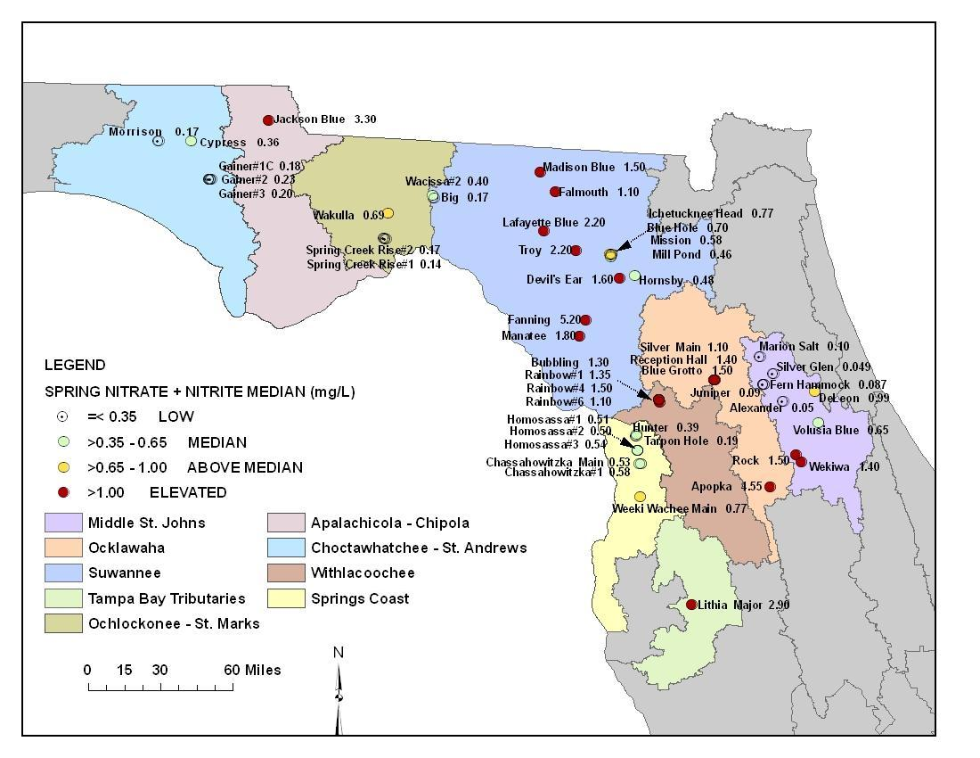

Figure 10.3. Median Orthophosphate Concentrations in the Spring Network, 2001–06
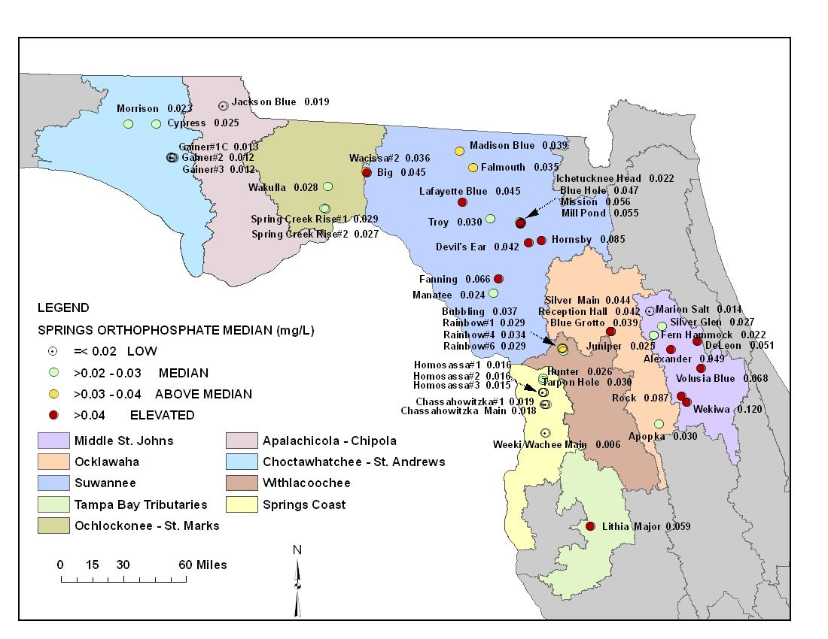

Chapter 11: Water Protection and Restoration Programs

Maintaining overall water quality and supplies, protecting potable water supplies, satisfying competing and rapidly increasing demands for finite quantities of fresh water, minimizing damage to future water reserves, addressing habitat loss and associated aquatic life use, and ensuring healthy populations of fish and wildlife are major objectives of water resource management and protection. To meet these objectives, many different programs and agencies throughout the state, including FDEP, address activities and problems that affect surface water and ground water quality and quantity. In cooperation with other agencies and stakeholders, FDEP has also initiated a number of programs and activities, which are discussed in this chapter, to expand the scientific understanding of Florida’s water resources and improve the protection, management, and restoration of surface water and ground water.

Florida’s Water Resource Management Programs
In 1972, the Florida Legislature, recognizing the importance of the state’s water resources, passed the Florida Water Resources Act, 373, F.S., and the Florida Air and Water Pollution Control Act, Chapter 403, F.S. Many goals and policies in the State Comprehensive Plan, Chapter 187, F.S., also address water resources and natural systems protection.

In addition to the FDEP district offices around the state, Florida is unique in that there are also five regional water management districts broadly established along natural watershed boundaries:

- Northwest Florida;
- St. Johns River;
- Southwest Florida;
- South Florida; and
- Suwannee River.

The statute gives FDEP “general supervisory authority” over the districts and the authority to exercise any power authorized to be exercised by the districts. FDEP exercises its general supervisory authority through several means, including reviewing and approving district rules, carrying out coordinated planning, and providing program, policy, and rule guidance through the Water Resource Implementation Rule (Chapter 62-40, F.A.C.).

This approach combines state-level oversight with regional decision making. It facilitates appropriate statewide consistency in the application of Florida water law, while maintaining regional flexibility where necessary to accommodate the wide-ranging climatic, geological, and environmental conditions that affect the state’s water resources.

The water management activities of FDEP and the water management districts are divided into the following four areas of responsibility:

- Water Supply: Promoting the availability of sufficient water for all existing and future reasonable and beneficial uses and natural systems.
- Flood Protection and Floodplain Management: Preventing or minimizing damage from floods, and protecting and enhancing the natural system values of floodplains.
- Water Quality Management: Improving, protecting, and maintaining the quality of surface and ground water.
- Natural System Management: Preserving, protecting, and restoring natural systems.

These responsibilities are carried out through a variety of activities, including planning, watershed management, assessment through application of water quality standards, the management of nonpoint source pollution, wastewater facilities permitting, ambient water quality monitoring, ground water protection, educational programs, and land management.

Overview of Surface Water Monitoring Programs

Watershed-based Monitoring and Reporting
Different types of monitoring, ranging from the general to the specific, are needed to answer questions about water quality at varying scales. Questions may pertain to larger national, statewide, or regional/local conditions; whether trends exist in water quality over time; or whether there are problems in individual surface or ground waters. Other monitoring may include gathering project-specific information to develop standards or to fill data gaps if there is a need to address specific regulatory problems. To that end, FDEP has developed diverse monitoring programs to resolve questions in response to these needs.

FDEP has embraced a tiered monitoring approach and is reporting the results of statewide ambient monitoring networks (Tier I; Chapter 5 and Chapter 6), strategic monitoring for verification of impairment and identification of causative pollutants, (Tier II; Chapter 7 and Chapter 8,) and specialized, site-specific monitoring (Tier III). Tier I consists of FDEP’s statewide surface water Status Monitoring (probabilistic) and Trend Monitoring Networks, TMDL basin- and waterbody-specific monitoring, and site-specific monitoring for special projects and regulatory needs, such as statewide DO and nutrient criteria monitoring.

The Tier I Status Network used a rotating basin, probabilistic monitoring design to estimate water quality across the entire state during 2004–08, based on a representative subsample of water resource types. These estimates are based on a variety of threshold values, including water quality standards, water quality indices, and other appropriate ecological indicators. The Trend Network uses a fixed station design to examine changes in water quality over time in select river and stream sites throughout the state.

Strategic monitoring (Tier II) includes monitoring designed to address data gaps in order to verify impairment in potentially impaired waterbodies and monitoring in response to citizen concerns and environmental emergencies. The Springs Initiative monitoring is another example, and encompasses all of the extensive monitoring activities begun in 1999 to address the needs of Florida’s freshwater spring systems, a fragile and unique resource type that is at risk.

Tier III monitoring addresses questions that are regulatory in nature, or that support specific program needs and quality objectives. Examples include monitoring to determine whether moderating provisions such as SSACs should apply to certain waters, monitoring tied to regulatory permits issued by FDEP (including fifth-year inspections of wastewater facilities under the National Pollutant Discharge Elimination System (NPDES) Program, intensive surveys for the development of TMDLs, monitoring to evaluate the effectiveness of best management practices (BMPs), and, monitoring to establish or revise state water quality standards.

Each of FDEP’s core monitoring programs has a monitoring design, a list of core and supplemental water quality indicators, and specific procedures for quality assurance, data management, data analysis and assessment, reporting, and programmatic evaluation. FDEP relies on both chemical and biological sampling in all of its monitoring programs and conducts the bulk of the biological sampling statewide. The remainder of this report contains information about the programs, their objectives, and the results of each of their efforts.

Overview of Surface Water Protection Programs

Water Quality Standards Program
Florida’s surface water quality standards are described in Chapter 62-302, F.A.C. The components of this system, which are described below, include water quality classifications; water quality criteria; an anti-degradation policy; and moderating provisions.

Water Quality Classifications
Florida’s Water Quality Standards Program, the foundation of the state’s program of water quality management, designates the “present and future most beneficial uses” of the waters of the state (Subsection 403.061[10], F.S.). Florida’s surface water is protected for five designated use classifications, as follows:

Class I Potable water supplies
Class II Shellfish propagation or harvesting
Class III Recreation, propagation, and maintenance of a healthy, well-balanced population of fish and wildlife
Class IV Agricultural water supplies (large agricultural lands, located mainly around Lake Okeechobee)
Class V Navigation, utility, and industrial use (there are no state waters currently in this class)

Class I waters generally have the most stringent water quality criteria and Class V the least. However, Class I, II, and III surface waters share water quality criteria established to protect recreation and the propagation and maintenance of a healthy, well-balanced population of fish and wildlife. All waters of the state are considered to be Class III, except for those specifically identified in Section 62-302.600, F.A.C. All waters of the state are required to meet the “Minimum Criteria for Surface Waters,” as identified in Section 62-302.500, F.A.C.

FDEP has proposed the establishment of a Class III subclassification (Class III Limited) for some wholly artificial and altered waters, in acknowledgment that many of these waters have physical or habitat limitations that preclude support of the same type of aquatic ecosystem as a natural stream or lake. Chapter 7 discusses the relationship between the state and the EPA’s designated use classifications.

Water Quality Criteria
Water quality criteria, expressed as numeric or narrative limits for specific parameters, describe the water quality necessary to maintain designated uses (such as fishing, swimming, and drinking water) for surface water and ground water. These criteria are presented in Chapter 62-302, F.A.C., and specifically in Section 62-302.530, F.A.C.

Anti-degradation Policy
The Florida Anti-degradation Policy (Sections 62-302.300 and 62-4.242, F.A.C.) recognizes that pollution that causes or contributes to new violations of water quality standards or to the continuation of existing violations is harmful to the waters of the state. Under this policy, the permitting of new or previously unpermitted existing discharges is prohibited where the discharge is expected to reduce the quality of a receiving water below the classification established for it. Any lowering of water quality caused by a new or expanded discharge to surface waters must be in the public interest (that is, the benefits of the discharge to public health, safety, and welfare must outweigh any adverse impacts on fish and wildlife or recreation). Further, the permittee must demonstrate that other disposal alternatives (for example, reuse) or pollution prevention are not economically and technologically reasonable alternatives to the surface water discharge.

Moderating Provisions
Florida’s water quality standards include a variety of moderating provisions (provided in Subsection 62-302.300(10) and Chapters 62-4 and 62-6, F.A.C., and described in Sections 62-302.300, 62-4.244, 62-302.800, 62-4.243, F.A.C., and Sections 403.201 and 373.414, F.S.) include mixing zones, zones of discharge, SSACs, exemptions, and variances. These provisions are intended to moderate the applicability of water quality standards where it has been determined that, under certain special circumstances, the social, economic, and environmental costs of such applicability outweigh the benefits.

Watershed Assessment Program
The primary tasks of the Watershed Assessment Program include coordinating strategic monitoring; implementing Chapter 62-303, F.A.C., also known as the Impaired Surface Waters Rule (IWR); ensuring the completion of the biannual Integrated Report; and submitting annual updates of Florida’s 303(d) list to the EPA . Section 303(d) of the federal CWA requires States to submit to the EPA lists of surface waters that do not meet applicable water quality standards (i.e., their designated uses or water quality criteria) and establish TMDLs for each of these waters on a schedule. Pollution limits are then allocated to each pollutant source in an individual river basin. A waterbody that does not meet its designated use is defined as impaired.

Florida Watershed Restoration Act
The 1999 FWRA (Section 403.067, F.S.) clarified FDEP’s statutory authority to establish TMDLs, required FDEP to develop a scientifically sound methodology for identifying impaired waters, specified that FDEP could develop TMDLs only for waters identified as impaired using this new methodology, and directed FDEP to establish an Allocation Technical Advisory Committee (ATAC) to assure the equitable allocation of load reductions when implementing TMDLs.

Another significant component of the FWRA was the requirement for FDEP and FDACS to adopt, by rule, BMPs to reduce urban and agricultural nonpoint sources of pollution. As Florida already has an urban stormwater regulatory program, this new authority was particularly important in strengthening Florida’s agricultural nonpoint source management program. This section of the law requires FDACS to adopt, by rule, BMPs to reduce agricultural nonpoint source pollution, and for FDEP to verify the effectiveness of the BMPs in reducing pollutant loads.

Once FDACS adopts the BMPs, landowners must submit a Notice of Intent (NOI) to FDACS, specifying the BMPs that will be applied on specific land parcels and the schedule for BMP implementation. The landowners also must maintain records, such as fertilizer use, and allow FDACS staff to inspect the BMPs. By submitting a NOI, the landowners become eligible for state and federal cost-share funding to implement BMPs and receive a presumption of compliance that they are meeting water quality standards. The BMP rules and the associated BMP manuals that have been adopted are available from FDAC’s Office of Agricultural Water Policy website.

The FWRA identifies BMAPs as the primary mechanism for implementing TMDLs to restore water quality. BMAPs are developed cooperatively with local stakeholders over an 18- to 24-month period following TMDL development. The strategies developed in each BMAP are implemented in NPDES permits for wastewater facilities and municipal separate storm sewer system (MS4) permits.

The 2005 Florida Legislature’s amendments to the FWRA focused on the development and adoption of BMAPs as an appropriate method for implementing TMDLs. The Legislature also established a long-term funding source that provided $20 million per year for urban stormwater retrofitting projects to reduce pollutant loadings to impaired waters; however, that level of funding has not been consistently provided. Additionally, the 2005 amendments provide FDEP with the ability to take enforcement action against nonpoint sources that do not implement the BMPs that they agreed to implement in the BMAP.

Impaired Surface Waters Rule
Waterbodies are assessed and TMDLs are developed and implemented using the methodology in Florida’s IWR (Chapter 62-303, F.A.C.). This is a science-based methodology for evaluating water quality data in order to identify impaired waters, and establishes specific criteria for impairment based on chemical parameters, the interpretation of narrative nutrient criteria, biological impairment, fish consumption advisories, and ecological impairment. The IWR also establishes thresholds for data sufficiency and data quality, including the minimum sample size required and the number of exceedances of the applicable water quality standard for a given sample size that identify a waterbody as impaired. The number of exceedances is based on a statistical approach designed to provide greater confidence that the outcome of the water quality assessment is correct. Waters that are identified as impaired through the IWR are prioritized for TMDL development and implementation.

In 2006, and again in 2007, the IWR was amended to address legal challenges that arose following the original adoption in 2001. After the state rulemaking process was completed, the revised IWR was submitted to the EPA on September 14, 2007, as a change to water quality standards. On February 19, 2008, the EPA sent a letter of approval to FDEP acknowledging that the IWR was an approved change to water quality standards.

Watershed Management Approach
FDEP's statewide tactic to water resource management, called the watershed management approach, is the framework for developing and implementing the provisions of Section 303(d) of the CWA, including the development of TMDLs, as required by federal and state laws.

Watershed management is a comprehensive approach to managing water resources on the basis of hydrologic units—which are natural boundaries such as river basins—rather than arbitrary political or regulatory boundaries. It does not focus on individual causes of pollution. Instead, each basin is assessed as an entire functioning system, and aquatic resources are evaluated from a basin-wide perspective that considers the cumulative effects of human activities.

On a simple level, Florida’s watershed management approach provides a mechanism to focus resources on specific units (river or estuary basins), rather than trying to work on all state waters at one time. An important feature is the involvement of all the stakeholders who have an interest in an individual basin (including federal, state, regional, tribal, and local governments and individual citizens), in a cooperative effort to define, prioritize, and resolve water quality problems. Existing programs are coordinated to manage basin resources without duplicated effort. The watershed management approach is not new, nor does it compete with or replace existing programs. Rather than relying on single solutions to water resource issues, it is intended to improve the health of surface water and ground water resources by strengthening coordination among such activities as monitoring, stormwater management, wastewater treatment, wetland restoration, land acquisition, and public involvement.

Florida’s watershed management approach involves a multiple-phase, five-year, rotating basin cycle. During Phase 1, a Planning List of potentially impaired waters is prepared in a collaborative process with stakeholders. During this phase, FDEP works closely with local monitoring staff to determine when and where additional monitoring is needed to verify the impairments. This culminates in the preparation of a Strategic Monitoring Plan that is implemented the following year, during Phase 2 of the cycle.

The key product of Phase 2 is the Verified List of impaired waters. These lists are developed through applying the water quality standards in Chapter 62-302 F.A.C., as well as the methodologies provided in Chapter 62-303, F.A.C. There are generally draft lists developed which are provided to stakeholders for comment. Lists are finalized based on public comment and any additional information received throughout the process.

During Phase 3 of the cycle, watershed and waterbody modeling are carried out to develop TMDLs for impaired waters and the preliminary allocations to point and nonpoint sources. Typically, a Basin Working Group is formalized during this phase and begins the process of developing the BMAP that will guide TMDL implementation activities. FDEP works closely with the Basin Working Group and other watershed stakeholders to ensure that they understand and support the approaches being undertaken to develop the TMDL. To date, FDEP has adopted a total of 234 TMDLs. Of those 234, 138 were developed for DO and/or nutrients, 92 were developed for bacteria, and 4 are for other parameters such as un-ionized ammonia. These TMDLs represent areas in all basin groups and cover many of the largest watersheds within the state (e.g., St. Johns River, St. Lucie Estuary). Many more TMDLs have been drafted or are in various stages of development.

During Phase 4 of the cycle, the basin working group and other stakeholders—especially representatives of local governments, including local elected officials—develop the BMAP. This process typically takes about two years and culminates in the adoption of the BMAP by FDEP’s Secretary.

Both the BMAP and the Verified List of impaired waters are adopted by Secretarial Order, while all TMDLs are adopted by rule. Like all official agency actions, these adoptions are subject to state administrative procedures set forth in Chapter 120, F.S. Once a BMAP, Verified List, or TMDL is adopted, a notice is published in the Florida Administrative Weekly and any affected party has the opportunity to request an administrative hearing to challenge the adoption.

Florida continues to develop an integrated database of assessment information that reflects whether water quality standards are being attained. The Verified Lists of impaired waters, lists of waters to be delisted, Basin Status and Water Quality Assessment Reports, BMAPs, TMDL reports, and other information are available on the FDEP Watershed Assessment Program website.

BMAP Development Activities to Date
To date seven BMAPs have been fully adopted and are under implementation in the following basins: Upper Ocklawaha, Orange Creek, Long Branch, Lower St. Johns River Mainstem, Lower St. Johns River Tributaries, Hillsborough River and Lake Jesup. An eighth BMAP for additional Lower St. Johns River Tributaries is expected to be adopted shortly. BMAP development activities are currently under way and in various stages of completion in an additional eight basins around the state: the Upper Peace River and Winter Haven Chain of Lakes, Wekiva, Suwannee, Bayou Chico, Indian River Lagoon Mainstem, Caloosahatchee, Everglades West Coast, St. Lucie, and Wakulla/Lake Munson. Table 11.1 describes the current status of these ongoing BMAP efforts. In addition to these BMAPs, local governments and water management districts are concurrently carrying out restoration activities in many other waterbodies statewide.

BMAPs are Florida’s primary mechanism for implementing TMDLs adopted through Chapter 403.067, F.S. They are developed in collaboration with groups of stakeholders, including other state agencies, water management districts, county and municipal governments, and other local stakeholders. BMAPs are then adopted by FDEP Secretarial Order. The goals of the BMAP are to reach consensus on the scientific foundation of the TMDL, determine detailed allocations as appropriate, and reach agreement on how the required load reductions will be accomplished. A BMAP includes defined water quality restoration goals, refined source identification, detailed allocations by entity where appropriate, load reduction projects, a monitoring plan, and local commitments. Implementation projects may include structural and nonstructural BMPs, education and outreach activities, additional research and studies, changes to programs and permits, and changes to local ordinances and policies.

The Lower St. Johns River Mainstem BMAP provides an excellent example of both the extent of the efforts required to address TMDL requirements and move forward in carrying them out. The TMDL required a reduction of 1,076,403 kilograms per year (kg/yr) TN in the marine portion of the river. Through 2009, the responsible entities have achieved reductions of 543,525 kg/yr. In the freshwater section, the TMDL required reductions of 1,543,989 kg/yr of TN and 99.285 kg/yr of TP. Through 2009, the entities have achieved reductions of 134,289 kg/yr of TN and 37,403 kg/yr of TP.

During 2009, three wastewater treatment facility (WWTF) projects in the freshwater section were completed, with a total reduction of 26,045 kg/yr of TN and 3,451 kg/yr of TP. While no WWTF projects were completed in the marine section this past year, FDEP issued the majority of the aggregate and individual facility permits to initiate the reductions needed from wastewater point sources discharging to the marine portion of the river. During 2009, 3 MS4 projects were completed in the freshwater section, for a total reduction of 111.5 kg/yr of TN and 189.6 kg/yr of TP. The reductions in TP that were accomplished this year, in combination with the completed projects in the BMAP, have achieved the TP reductions required for the MS4s in the freshwater section. An additional 10 MS4 projects were completed in the marine section, for a reduction of 3,685 kg/yr of TN.

Progress was also made towards addressing nutrient loads from nonpoint sources. In the freshwater section, 6 non-MS4 projects were completed this year, yielding 1,763 kg/yr of TN and 769.2 kg/yr of TP reductions. There were also 3 non-MS4 projects completed in the marine section, for 993 kg/yr of TN reduction. FDACS continued to sign up growers under the vegetable and agronomic crop BMP manual. The sod and cow/calf manuals were adopted this year, and FDACS held workshops to inform producers about the manuals and to begin the enrollment process. To date, no producers have opted to monitor water quality instead of implementing BMPs. In addition, the St. Johns River Water Management District is currently assessing the most cost-effective means of meeting the remainder of the agricultural allocation through improved BMPs, land buffers, and regional treatment.

BMAP monitoring plan efforts have started in the freshwater section, marine section, and tributaries. The river transect sampling in the freshwater section occurred on schedule from April through October. The two new continuous DO monitoring stations were added in the marine section. The entities have started the ambient water quality sampling in the tributaries, and the Clay County Utility Authority (CCUA) has initiated high-flow sampling. FDEP and the St. Johns River Water Management District also prepared a detailed monitoring plan to support the BMAP that describes the processes for collecting and submitting data.

The Lake Jesup BMAP, adopted in May 2010, includes commitments for projects to reduce TP by 10,167.5 pounds per year (lbs/yr) over the next 5 years (approximately 54% of the total reduction required by the TMDL, which will be fully met within 15 years). Many projects have already been completed demonstrating the commitment of local stakeholders to the restoration of their local waterbodies.

Information on FDEP’s BMAP activities can be found on FDEP’s Watershed Management website.

Table 11.1. Status of Ongoing BMAP Efforts
This is a four-column table. Column 1 lists the basin, Column 2 lists the status of BMAP development, Column 3 lists the impairment(s) addressed by the BMAP, and Column 4 lists comments.

Basin | Status | Impairment(s) Addressed by BMAP | Comments
Lower St. Johns Tributaries | BMAP II near adoption | Fecal Coliform | BMAP II, implementing TMDLs for 15 WBIDs, has been completed. The BMAP was endorsed by the Basin Working Group; presented at a public meeting on June 9, 2010; and is currently running through the FDEP adoption process, with Secretarial adoption anticipated in August 2010.
Suwannee | Individual stakeholder discussions ongoing | Nutrients/DO | BMAP efforts in this basin started in November 2008. Monthly BMAP stakeholder meetings were conducted through May 2010. The next stage of contacting basin stakeholders (counties, cities, and agricultural interests) is ongoing. The BMAP effort is focusing initially on the Santa Fe sub-basin. The Suwannee River BMAP will lag by approximately 6 to 9 months.
Bayou Chico | Next technical meeting anticipated in fall 2010 | Fecal Coliform | This group of stakeholders has been active in restoring the basin for many years, and BMAP progress is going smoothly. Five BMAP and/or technical meetings have been held to date. A draft BMAP is being developed based on information provided by stakeholders, and while additional information may be necessary to fill in the data and information gaps for the draft, it appears that the BMAP will remain on schedule for adoption by the end of 2010 (barring any delays as a result of the Gulf oil spill, which has most stakeholders’ attention at this time). The next step is completion of the draft BMAP for distribution, review, and comments.
Wekiva | Next Basin Working Group meeting expected in fall 2010 | Nutrients/DO | BMAP efforts began in March 2009, and the most recent Basin Working Group Meeting was held on March 18, 2010. Technical work continues in the interim. Current BMAP activities include building common understanding of sources, developing the allocation/sufficiency of effort approach, and compiling a list of preliminary projects. The BMAP will be sensitive to local concerns connected to other Wekiva Protection Area activities.
Upper Peace (Hancock Chain, Winter Haven Chain, and Upper Peace Creek) | BMAP activities on hold pending resolution of issues related to effectiveness of management options and completion of local watershed master plan | Nutrients,  Fecal Coliform | A technical review of the TMDLs and lake processes has led to questions about the effectiveness of management options attempting to meet TMDLs. A comprehensive watershed master plan is being developed for the City of Winter Haven and Southwest Florida Water Management District, and needs further consideration before moving forward with a BMAP for the southern Winter Haven Chain of Lakes. The consultant's interim plan is being developed and will be reviewed, but the final plan is not expected until late 2010. In addition, FDEP will develop any Upper Peace River TMDL implementation plans concurrently with the Southern Chain of Lakes BMAP development (anticipated at the end of 2010). Coordination efforts with the City of Winter Haven, Polk County, and other stakeholders continues, and a meeting is planned to discuss local watershed plans and the interim reports that may affect implementation strategies at the end of August,2010. Further BMAP efforts for other waterbodies in the basin are on hold pending the resolution of issues related to the effectiveness of management options.
Indian River Lagoon | Continuing rotating meetings among sub-basins | Nutrients/DO | The Indian River Lagoon Mainstem Basin has been divided into three sub-basins (Banana River, North, and Central) for BMAP development. Banana River sub-basin allocations are complete, project information collection is under way (projected completion by fall 2010), and a draft BMAP is anticipated in winter 2010. Nutrient TMDLs for tributaries to the North and Central sub-basins are anticipated in fall 2010, with allocations for those sub-basin BMAPs anticipated by winter 2010. The Monitoring Plan discussions are under way, with primary and secondary objectives being developed in coordination with local stakeholders.
St. Lucie | Next technical meeting planned fall 2010 | Nutrients/BOD | BMAP activities were started in July 2009. The last BMAP technical meeting was held in March 2010, and one-on-one stakeholder meetings with cities/counties were held in December 2009. An evaluation continues of the Northern Everglades and Estuaries Protection Program (NEEPP) Regional Watershed Protection Plan applicability and implementation/allocation approach document. FDEP staff are reviewing the applicability of different models for detailed allocations, and gathering information on land use and agricultural and MS4 jurisdictional areas. Meetings are anticipated with various Special Districts, along with continued coordination with local municipalities, to move to the next step of detailed allocations and project tables. Stakeholder technical meetings are expected to continue in fall 2010.
Lake Munson/  Munson Slough | BMAP kickoff anticipated in fall 2010 | Nutrients/DO/  Fecal Coliform | FDEP staff are following local concerns and news related to the final adoption of the Lake Munson/Munson Slough and Wakulla River TMDLs (workshop held on May 28, 2010). BMAP development is currently on hold pending the final adoption of the draft TMDLs, the selection of the Wakulla Springs facilitator, and subsequent meetings of the Wakulla Springs Working Group; these activities should help to define the next steps and BMAP development for the entire Wakulla springshed.
Everglades West Coast | Next technical meeting to be held fall 2010 | Multiple | Basic Watershed Management Modeling to determine current loading was completed, and details were presented to stakeholders at the last technical meeting in February 2010. One-on-one meetings were held with stakeholders to discuss current loading calculation process and projects eligible for BMAP credit. FDEP staff are currently evaluating the list of nutrient reduction projects implemented since the TMDL verified period and calculating BMP efficiencies for the projects submitted. Staff are awaiting results from a nutrient source tracking and ground water input study conducted in June 2010. BMAP stakeholder technical meetings are expected to continue in fall 2010.
Caloosahatchee | Next technical meeting to be held fall 2010 | Nutrients | The last BMAP technical meeting was held in February 2010. The current loading calculation process and potential allocation approaches were discussed. One-on-one meetings were held with several stakeholders to address concerns and discuss the types of projects that would receive credit in the BMAP. Staff are currently evaluating the list of nutrient reduction projects implemented since the TMDL verified period and working on calculating BMP efficiencies for projects submitted. They are finalizing current loading calculations and draft potential allocation approach calculations. BMAP stakeholder technical meetings are expected to continue in fall 2010.

Public Participation
The success of Florida’s water resource management program, especially its watershed management approach/TMDL Program, depends heavily on input from local stakeholders in each watershed. This process is highly collaborative, and FDEP staff closely coordinate and communicate with stakeholders in all phases of the five-year, rotating basin cycle.

FDEP works with a variety of stakeholders in developing a draft Verified List of impaired waters for each basin. The draft lists are placed on the FDEP Watershed Assessment Program website and are also sent by request to interested parties via mail or email. As part of the review process, public workshops are advertised and held in each basin to help explain the process for developing the Verified Lists, exchange information, and encourage public involvement. The workshops are noticed in the Florida Administrative Weekly and on the website. Stakeholders are given the opportunity to comment on the draft lists in person at public workshops and/or through email and letters. If additional information or data are provided during the public comment period or before, FDEP typically creates a revised draft Verified List for further review and comment before submitting the final proposed list to the Secretary for adoption and then to the EPA.

All public meetings are recorded, and specific comments are noted in written meeting summaries. Significant comments typically receive a written response. All written comments received and FDEP’s responses are kept in a permanent file maintained by FDEP. These are included in an Appendix to each Water Quality Assessment Report. The reports are available on the FDEP Watershed Management website.

Surface Water Improvement and Management Program
In 1987, the Florida Legislature passed the Surface Water Improvement and Management (SWIM) Act, Sections 373.451 through 373.4595, F.S. The act directed the state to develop management and restoration plans for preserving or restoring priority waterbodies. The legislation designated 6 SWIM waterbodies: Lake Apopka, Tampa Bay, Indian River Lagoon, Biscayne Bay, Lower St. Johns River, and Lake Okeechobee. Currently, 29 waterbodies are on the priority list. Additional information and the list of priority waterbodies are available on the FDEP SWIM Program website.

The SWIM Program addresses a waterbody’s needs as a system of connected resources, rather than isolated wetlands or waterbodies. Its goals are protecting water quality and natural systems, creating governmental and other partnerships, and managing watersheds. While FDEP oversees the program, the water management districts are responsible for its implementation—including developing lists of additional high-priority waterbodies and waterbody plans (outlined under Chapter 62-43, F.A.C.). The districts also provide matching funds for state revenues. In a collaborative effort, other federal and state agencies, local governments, and the private sector provide funds or in-kind services.

SWIM plans must contain the following:

- A description of the waterbody;
- A list of governmental agencies with jurisdiction;
- A description of land uses;
- A list of point and nonpoint source discharges;
- Restoration strategies;
- Research or feasibility studies needed to support restoration strategies;
- A restoration schedule;
- An estimate of costs; and
- Plans for interagency coordination and environmental education.

Pollutant Load Reduction Goals
A pollutant load reduction goal (PLRG) is an estimated reduction in stormwater pollutant loadings needed to preserve or restore designated uses in SWIM waterbodies that receive stormwater. Ultimately, water quality in a receiving water should meet state water quality standards, and PLRGs provide benchmarks toward which specific strategies can be directed. Interim PLRGs are best-judgment estimates of the pollution reductions from specific corrective actions. Final PLRGs are goals needed to maintain water quality standards.

The Water Resource Implementation Rule (Chapter 62-40, F.A.C.) requires the water management districts to establish PLRGs for SWIM priority waters and other waterbodies, and include them as part of a SWIM plan, other watershed management plan, or district-wide or basin-specific rules.

Point Source Control Program
Florida's well-established wastewater facility regulatory program was revised in 1995 when the EPA authorized FDEP to administer a partial NPDES Program, and then expanded again in 2000 when the EPA authorized FDEP to administer the NPDES stormwater program. While the federal program only regulates discharges to surface waters, the state wastewater program issues permits for facilities that discharge to either surface water or ground water. Of about 4,500 wastewater facilities in Florida, approximately 500 are permitted to discharge to state surface waters under individual permits. While an additional 500 facilities discharge to surface water under general (called generic) permit authorization (and many others discharge stormwater to surface water under the NPDES Stormwater Program), most wastewater facilities in Florida discharge indirectly to ground water via land application or reuse.

An important component of Florida’s wastewater management is the encouragement and promotion of reuse. Florida leads the nation in reuse. In fact, the current reuse capacity (2008 data) represents about 64% of the total permitted domestic wastewater treatment capacity in Florida.

FDEP's six district offices handle most of the permitting process, with the Tallahassee office overseeing the program, conducting rulemaking, providing technical assistance, managing the state and federal wastewater databases that are the repositories of all program data, and coordinating with the EPA. The Tallahassee office also oversees the administrative relief mechanisms for applicants that are allowed under Florida law, as well as permits for steam electric–generating power plants that discharge to waters of the state, and the implementation of the pretreatment component of the NPDES Program. Wastewater permits, issued for up to five years, set effluent limits and monitoring requirements to provide reasonable assurance that water quality criteria will be met. A permit may allow a mixing zone when there is enough dilution to ensure that a waterbody's designated use will not be affected. In other special cases, a variance allows certain water quality standards to be exceeded temporarily. Facilities that cannot comply with new requirements may be issued or reissued a permit containing the effluent limitations to be met and an administrative order setting out the steps required to achieve compliance. This procedure applies only to facilities complying with an existing permit, and is not used in lieu of enforcement when a permittee is out of compliance with an existing permit or operating without a required permit.

All facilities must meet, at a minimum, the appropriate technology-based effluent limitations. In many cases, water quality–based effluent limitations (WQBELs) may also be necessary. Two types of WQBELs are used (as defined in Chapter 62-650, F.A.C.). Level I WQBELs are generally based on more simplified evaluations for streams and for permit renewals. To determine Level II WQBELs, which are typically calculated for more complicated situations, a waterbody is generally sampled intensively, and computer models are used to predict its response to a facility’s discharge.

Permit Compliance
The primary objective of FDEP’s Wastewater Program is to protect the quality of Florida's surface water and ground water by ensuring that permitted wastewater facilities meet the conditions of their permits and to quickly identify unpermitted pollution sources and those facilities that do not meet water quality standards or specific permit conditions. To provide proper oversight of the wastewater facilities in the state, FDEP’s Wastewater Compliance Evaluation Section developed a compliance inspection strategy based on its five-year permitting cycle (permits are issued for five years).

For NPDES-permitted facilities, the goal is to conduct an annual inspection with at least a Compliance Evaluation Inspection (CEI) and to conduct a Performance Audit Inspection (PAI) immediately following permit renewal. When an NPDES-permitted facility is approximately one year away from submitting a permit renewal application, a much more comprehensive inspection, or Fifth Year Inspection (FYI), is scheduled. The FYI consists of an overview of the facilities operation, but also includes an in-depth sampling plan consisting of a Compliance Sampling Inspection (CSI), Toxic Sampling Inspection (XSI), Compliance Biomonitoring Inspection (CBI), Impact Bioassessment (IBI), and Water Quality Inspection (WQI). The results of these inspections help to determine if current permit limits are adequate to protect the quality of the receiving waters. Land application facilities are also inspected annually as resources allow; however, they are not subject to the same sampling intensity as the surface water dischargers.

District compliance and enforcement staff make every effort to work with permittees to resolve minor problems before beginning a formal enforcement action. During an inspection, it is the inspector’s responsibility to determine if a facility is in compliance with its permit limits and compliance schedules. This is accomplished by verifying the accuracy of facility records and reports, plant operation and maintenance requirements, effluent quality data (Discharge Monitoring Reports, or DMRs), and the general reliability of the facility’s self-monitoring program.

Enforcement
FDEP’s Wastewater Program uses the Office of General Council’s Enforcement Manual as a guide for developing specific types of enforcement actions such as Consent Orders and Notices of Violations. However, in order to provide guidance on specific wastewater issues related directly to the Wastewater Program, the Wastewater Program Enforcement Response Guide was developed to aid inspectors in determining the proper course for corrective actions. The guide also provides consistency in addressing enforcement actions specifically related to wastewater issues.

When formal enforcement is necessary, staff attempt to negotiate a consent order, which is a type of administrative order in which civil penalties (such as fines) and corrective actions for noncompliance can be assessed. Consent orders also establish step-by-step schedules for complying with permit conditions and Florida law.

In 2001, the Florida Legislature enacted the Environmental Litigation Reform Act (ELRA) to provide a fair, consistent, and expedient method for determining appropriate penalty amounts for violations. If a settlement cannot be reached through the consent order process, FDEP has the authority to issue a Notice of Violation (NOV) to collect penalties (up to $10,000), as specified in ELRA. The NOV can also be used when only corrective actions are needed and no penalties are being sought. When a serious violation endangers human health or welfare, or the environment, FDEP issues a complaint for injunctive relief or takes other legal action, including an immediate final order for corrective action.

Nonpoint Source Management Program
The importance of minimizing nonpoint source pollution, especially from new development, was recognized in Florida in the late 1970s when the state’s growth rate increased greatly. Over the past 25 years, Florida has implemented one of the most comprehensive and effective nonpoint source management programs in the country. The Nonpoint Source Management Program includes a mixture of regulatory, nonregulatory, land acquisition, public education, and finance assistance components, which are discussed below.

Stormwater Rule
The cornerstone of Florida’s nonpoint source program is the state Stormwater Rule. Florida was the first state in the country to establish a statewide Stormwater Permitting Program that requires the treatment of stormwater from all new development. The state’s first Stormwater Rule was adopted in 1979, with a more comprehensive rule going into effect in February 1982. New developments, except for single-family dwellings, and modifications to existing discharges must obtain stormwater permits. Projects must include a stormwater management system that provides flood control and BMPs such as retention, detention, or wetland filtration to reduce stormwater pollutants. The Stormwater Rule, a technology-based rule, establishes design criteria for various stormwater treatment BMPs to obtain the minimum level of treatment established in the state’s Water Resource Implementation Rule (Chapter 62-40, F.A.C.). Specifically, these BMPs are designed to remove at least 80% of the total suspended solids (TSS) pollutant loading. For Outstanding Florida Waters (OFWs), some other sensitive waters (such as shellfish-harvesting areas), and waters that are below standards, BMPs must be designed to remove 95% of the TSS loading.

A 1989 stormwater law directed FDEP to establish statewide goals for treatment and to oversee the implementation of stormwater regulatory programs, which were also delegated to the water management districts. Delegation allows minor design adjustments for Florida’s diverse landscape. In 1993, the Florida Legislature modified portions of Chapters 373 and 403, F.S., to streamline permitting. The Wetlands Resource Permit and the Management and Storage of Surface Water (MSSW) Permit were unified into a single Environmental Resource Permit (ERP) to provide for flood control, stormwater treatment, and wetlands protection, and to increase statewide consistency in minimizing the impacts of new land uses. This permit program was implemented across the state, except in the area served by the Northwest Florida Water Management District. In 2006, the Legislature authorized the creation of an ERP Program in northwest Florida, and the program was adopted and implemented there in early 2010.

Wetlands Protection and Permitting
A second important nonpoint source regulatory program is the state’s wetlands protection law and permitting program. This program has been instrumental in minimizing the loss of wetlands, especially isolated wetlands. Details about this program can be found in later in this chapter, in the section on the Wetlands Program.

Best Management Practices
As discussed earlier in this chapter (in the section on the Watershed Assessment Program), the FWRA requires FDACS’ Office of Agricultural Water Policy (OAWP) to develop and adopt, by rule, BMPs to reduce agricultural nonpoint source pollution. FDEP is charged with monitoring the effectiveness of the BMPs. To date, FDACS has developed and/or adopted BMP manuals for Ridge citrus, Indian River citrus, leatherleaf ferns, silviculture, cow/calf operations, Peace River citrus, vegetable and agronomic crops, container-grown plants, forage grass, tri-county agriculture, south Florida nurseries, and Gulf citrus. The BMP rules and the associated BMP manuals that have been adopted are available on the FDACS Office of Agricultural Water Policy website.

This nonregulatory program provides agricultural producers with incentives to implement BMPs. Participation in the program opens the door for state and federal cost-share dollars to implement BMPs, and it provides the landowner with a presumption of compliance that water quality standards are being met. To participate, landowners must submit a NOI to FDACS, specifying the lands to be covered, the BMPs to be implemented, the BMP implementation schedule, and the annual tracking requirements such as fertilizer use.

Land Acquisition
Land acquisition is one of the most important components of Florida’s Nonpoint Source Management Program. The state’s first environmental land acquisition program was enacted by the Legislature in 1972 (the Environmentally Endangered Lands Act). In 1981, the Save our Coasts and Save our Rivers Programs were enacted to expand land acquisition. In 1989, recognizing the importance of accelerating land acquisition, given the state’s rapid population growth, the Preservation 2000 program was enacted. This decade-long program provided $300 million annually for land acquisition. In 1999, Preservation 2000 was extended for another decade by the enactment of the Florida Forever Program, which continued the $300 million annual commitment for another decade. These programs have led to the acquisition of over 1 million acres of sensitive lands.

Growth Management
The state’s growth management program, implemented by the Florida Department of Community Affairs (FDCA) and the state’s local governments, is another key component of Florida’s Nonpoint Source Management Program. The 1985 State Comprehensive Plan and the Local Government Comprehensive Planning and Land Development Regulation Act require local governments to establish blueprints for future growth (local comprehensive plans) and to adopt local land development regulations to minimize the adverse social, economic, and environmental impacts of growth.

Public Education
Public education on “pointless personal pollution” is the final component of Florida’s Nonpoint Source Management Program. Over the past 20 years, a wide variety of educational materials, many of which can be customized for local areas, have been developed and distributed. Nearly all of these materials are now available electronically and can be downloaded either from the FDEP website or from the University of Central Florida Stormwater Management Academy website. Given the state’s rapid growth rate, and the number of people arriving from out of state, these educational materials are important in teaching residents how they contribute to nonpoint source pollution and how they can be part of the solution to pointless personal pollution.

Nature and Extent of Nonpoint Source Pollution
Florida has made significant progress towards addressing elevated nutrients, but nutrient impairment is still an ongoing challenge, as evidenced by eutrophic conditions in some state surface waters and Florida’s increased nitrates in ground water. Nutrient impairment remains a concern due to higher fertilizer use by the state’s intensive agricultural industry and continued population growth, both of which increase wastewater and nonpoint source nutrient loads. The cumulative impacts of nonpoint source pollution, also called “pointless personal pollution,” continue to be an issue. The state’s Stormwater Rule is currently based on a minimum treatment level of 80% average annual load reduction.

It is important to remember that many activities resulting in nonpoint source pollution often are not regulated and that public education, cultural change, and personal stewardship are also essential in protecting Florida’s water resources. A simple example is controlling pet wastes, which can add nutrients and fecal bacteria to the landscape that are washed off with each rain storm. Picking up and properly disposing of pet waste is essential to preventing this source of “pointless personal pollution.”

FDEP’s comprehensive Nonpoint Source Management Program, in collaboration with the TMDL Program (which is being implemented through the watershed management approach), provides the institutional, technical, and financial framework to address these issues.

Coordination with Other State, Tribal, and Local Agencies
Florida’s surface water protection programs all emphasize the need for interagency coordination in achieving statewide water management goals. Table 11.2 lists the primary state, local, and regional coordination mechanisms for managing water resources. Figure 11.1 shows the agencies responsible for water resource management and coordination in Florida, and lists their principal activities.

Table 11.2. Primary Coordination Mechanisms for Managing State,
Regional, and Local Water Resources
This is a two-column table. Column 1 lists the function/entity, and Column 2 lists the primary coordination mechanisms.

Function/Entity | Primary Mechanisms
General supervision over water management districts (policies, plans, and programs)  (FDEP) | a. Water Resources Coordinating Commission  b. Meetings of the water management districts’ executive directors  c. Water Resource Implementation Rule (Chapter 62-40, F.A.C.)  d. Florida Water Plan/District Water Management Plan (DWMP) work group  e. Issue-specific work groups (policy and rule development)  f. Reuse Coordinating Committee  g. Memoranda of understanding (delegation of programs and authorities)  h. Permit streamlining, mitigation banking  i. FDEP review of water management district rules and budgets, auditing
Statewide watershed management approach (FDEP) | a. Implementation of rotating basin watershed management cycle for assessing the state’s river basins  b. Process for verifying impaired waterbodies in each basin  c. Development of total maximum daily loads (TMDLs) for verified impaired waters  d. Adaptive management
State Comprehensive Plan  (Governor’s Office) | Overall coordination by Governor’s Office
State Land Development Plan  (Florida Department of Community Affairs [FDCA]) | Interagency Planning Committees
Florida Transportation Plan  (Florida Department of Transportation [FDOT]) | Interagency plan review process
Strategic regional policy plans  (Regional Planning Councils) | a. Florida Water Plan/DWMP work group  b. Plan review process (Subsection 186.507[2], F.S., and Chapter 27E-5, F.A.C.)
Agricultural interests  (FDACS) | Agricultural Water Policy Committee
Local comprehensive plans  (FDCA) | Plan review process  (Chapter 9J-5, F.A.C.)
Water supply planning, wastewater management, stormwater management, solid waste management  (Local governments) | FDEP and water management district programs for technical and financial assistance
Reuse of reclaimed water  (FDEP, water management districts, FDCA, FDOT, Public Service Commission) | Reuse Coordinating Committee
U.S. Army Corps of Engineers | a. Public works program  b. State clearinghouse review process  c. Quarterly meetings between FDEP and the Corps  d. Joint FDEP/Corps permit application process (CWA, Section 404)  e. Memoranda of understanding  f. Potential delegation of Section 404 permitting to FDEP
U.S. Environmental Protection Agency | a. U. S. Environmental Protection Agency (EPA)/FDEP yearly work plans and grants  b. EPA technical assistance and special projects  c. Delegation of EPA/CWA programs to FDEP  d. National Estuary Program annual work plans and grants
National Oceanic and Atmospheric Administration | a. Grants  b. Cooperative agreements and special projects
U.S. Geological Survey | a. Contracts for technical services and data  b. Cooperative agreements
U.S. Department of Agriculture Natural Resources Conservation Service (formerly Soil Conservation Service) | Contracts for technical services and data
U.S. Forest Service | Ecosystem Management teams
U.S. Fish and Wildlife Service | a. Acquisition programs  b. Ecosystem Management teams  c. Special projects
National Park Service | a. Acquisition programs  b. Ecosystem Management teams
Alabama and Georgia | a. Memorandum of Agreement for Apalachicola–Chattahoochee–Flint/Alabama–Coosa–Tallapoosa Rivers Comprehensive Study  b. Suwannee River Coordinating Committee  c. St. Marys River Management Committee  d. Florida–Alabama Water Resources Coordinating Council

Figure 11.1. Agencies Responsible for Water Resource Coordination and Management in Florida

Recommended Nonpoint Source Programs
FDEP is currently developing a revised statewide stormwater treatment rule that will increase the minimum level of treatment of nutrients from stormwater discharges. It is also working with the development community and local governments to promote low-impact development and practices such as green roofs, pervious pavements, and stormwater harvesting.

Another major focus has been reducing potential nutrient impacts from the fertilization of urban landscapes. This is being implemented through the Florida Yards and Neighborhoods Program, the Green Industries BMP Training and Certification Program, the development of a Florida-Friendly Model Landscape Ordinance, and a change in Florida’s fertilizer labeling rules such that only “Florida-friendly fertilizers” with low or no phosphorus and slow-release nitrogen are sold in Florida.

Costs and Benefits of Implementing Florida’s Surface Water Protection Programs to Meet the Clean Water Act’s Objectives
The EPA, in partnership with the states, conducts the Clean Watersheds Needs Survey (CWNS) to identify and document the cost of projects needed to address water quality and public health in all 50 states, the District of Columbia, and the U.S.-held territories. The CWNS includes detailed estimates of the capital costs eligible for funding under the Clean Water State Revolving Fund (CWSRF) Program established by the 1987 Amendments to the CWA—that is, CWSRF-eligible costs. The CWNS includes publicly owned municipal wastewater collection and treatment facilities, facilities for the control of combined sewer overflows (CSOs), activities designed to control stormwater runoff, activities designed to control nonpoint source pollution, and activities associated with implementing approved Comprehensive Conservation and Management Plans (CCMPs) under the National Estuary Program (NEP) established by Section 320 of the CWA.

Key elements of the survey are as follows:

Facilities must be publicly owned and operated,
Costs represent capital needs (operating and maintenance costs are not represented), and
Costs must be documented.

Historically, the costs have been interpreted as representing 20-year design needs, but since the 1996 survey, costs have been documented by planning and design documents representing horizons of 10 years or less.

The survey is conducted every four years, and the results are published in the Clean Watersheds Needs Survey Report to Congress. While the 2008 survey results are not available, the 2004 survey results are available on the EPA Clean Watershed Needs Survey website. Table 11.3 summarizes the most recent survey results for Florida.

These needs are being addressed by several funding mechanisms, most notably the CWA State Revolving Fund (SRF) Program; direct congressional appropriations through the State and Tribal Assistance Grant (STAG) Program; state appropriations through the Community Budget Initiative Request (CBIR) Program; the Comprehensive Everglades Restoration Plan (CERP) (a joint 50/50 program funded by Florida and the EPA); Section 319 nonpoint source grants; TMDL Water Quality Restoration Grants; and local county, municipal, and water management district programs.

Dedicated Funding
Dedicated funding for nonpoint source management programs is crucial to their success. In 1986, legislation was passed that authorized local governments to implement stormwater utility fees to provide funding for stormwater treatment and infrastructure. Today, over 140 of Florida’s local governments have implemented a stormwater utility fee, with the average fee for a single-family homeowner of $3.50. These dedicated local stormwater funds open the door for cost-sharing from FDEP and the water management districts for stormwater retrofitting projects.

In 1994 the Legislature adopted the Nitrate Bill, which imposed a small fee on nitrogen fertilizers. These funds are used to fund research to develop BMPs to reduce the leaching of nitrogen into ground water, especially from agricultural producers. In 2004, the Nitrate Bill was expanded to add a fee for phosphorus fertilizers and also to address the eutrophication of surface waters.

In 1997, legislation expanded the scope of the State Revolving Loan Fund Program to provide funding for stormwater retrofitting projects and for agricultural BMP implementation. With the passage of the FWRA in 1999, FDEP and FDACS were authorized to receive documentary stamp funding for the research and demonstration of urban and agricultural BMPs. Funding has varied from $2.8 million to $9.2 million per year.

Finally, as discussed earlier, in 2005 the Legislature established a new funding source that will provide FDEP with about $2 million per year for the TMDL Water Quality Restoration Grant Program, allowing FDEP to partner with local governments on urban stormwater retrofitting projects.

Table 11.3. Results of the 2004 Clean Watersheds Needs Survey for Florida
This is a two-column table. Column 1 lists the category of need, and Column 2 lists the dollar amount needed.

Category of Need | Needs ($000)
Category I – Secondary Treatment | $ 33,611
Category II – Advanced Treatment | $ 4,595,918
Category III-A – Inflow/Infiltration Correction | $ 310,526
Category III-B – Major Sewer Rehabilitation | $ 960,088
Category IV-A – New Collector Sewers | $ 1,752,257
Category IV-B – New Transmission Facilities | $ 1,392,458
Category V – Combined Sewer Overflow Correction | 0
Category VI – MS4 Permitted Stormwater Management | $ 2,182,750
Category VII – Nonpoint Source BMPs | $ 9,285,007
Category VIII – Confined Animals Point Source | 0
Category IX – Mining Point Source | 0
Category X – Recycled Reclaimed Water Distribution | $ 1,672,115
Category XI – Estuary Management | $ 63,073
Florida’s Total Needs | $22,247,803

Clean Water State Revolving Fund Program
The CWSRF Program provides low-interest loans for water pollution control activities and facilities. Water pollution sources are divided into point sources (typically domestic and industrial wastewater discharges) and nonpoint sources (generally related to leaching or runoff associated with rainfall events from various land uses). Since the program began in 1989, FDEP has made over $2 billion in loans. The program revolves in perpetuity, using state and federal appropriations, loan repayments, investment earnings, and bond proceeds.

This program evolved from the federal Construction Grants Program as a result of the 1988 amendments to the CWA. Between 1958 and 1988, almost $2 billion was disbursed from the Construction Grants Program to help municipalities meet the enforceable requirements of the CWA, particularly applicable NPDES permit requirements. Only a few federal construction grants were awarded after 1988, with the last grant awarded in 1994 to Marathon.

Projects eligible for CWSRF loans include wastewater management facilities, reclaimed wastewater reuse facilities, stormwater management facilities, widely accepted pollution control practices (sometimes called BMPs) associated with agricultural stormwater runoff pollution control activities, brownfields associated with the contamination of ground water or surface water, and estuary protection activities and facilities.

For the SRF Program, a total of $2.43 billion has been disbursed to date from funds awarded to the following sources:

- Wastewater: $2,766,361,590
- Stormwater: $105,901,550
- Nonpoint sources: $5,353,699

Section 319(h) Grant Funds
FDEP’s Nonpoint Source Management Section administers grant money it receives from the EPA through Section 319(h) of the federal CWA. These grant funds can be used to implement projects or programs that will help to reduce nonpoint sources of pollution. Projects or programs are targeted toward the state's nonpoint source priority watersheds, which are the verified impaired waters on the 303(d) list, the state's SWIM watersheds, and NEP waters. All projects must include at least a 40% nonfederal match.

Examples of fundable projects include the demonstration and evaluation of BMPs, nonpoint pollution reduction in priority watersheds, ground water protection from nonpoint sources, and public education programs on nonpoint source management. Section 319 funding from fiscal year (FY) 1988 through FY 2007 totaled $117 million. Approximately 70% of these funds have been used to partner with local governments and water management districts on urban stormwater retrofitting projects to reduce stormwater pollutant loadings to priority waterbodies such as the Indian River Lagoon and Tampa Bay.

TMDL Water Quality Restoration Grants
With the passage of the 1999 FWRA, FDEP and FDACS also began receiving funds generated by documentary stamps to conduct urban BMP research or to reduce nonpoint source pollution discharged to impaired waterbodies. The funding amount has varied from $1 million to $9.2 million per year, with the agencies receiving a total of $52 million since the program began. Since 1999, FDEP has also received additional funds for the TMDL Program from the Florida Legislature both for program operations and for TMDL Water Quality Grants to reduce pollutant loads from urban stormwater discharges. In 2005, the Legislature enacted Senate Bill (SB) 444, creating a new funding source for the TMDL Program that provides $20 million annually to FDEP, with 7.5% going to FDACS.

In 2008, FDEP adopted Chapter 62-305, F.A.C. (TMDL Water Quality Grants), to set forth the procedures for administering these grant funds. Since the program began, FDEP has issued over $48 million in TMDL grants to local governments and water management districts. These grants require at least a 50% match from grant recipients. In addition, FDEP has issued over $11 million in contracts for urban BMP research, with the results of these projects being integrated into the revised statewide stormwater treatment rule, which is currently under development. Unfortunately, the 2009 economic crisis led the Legislature to eliminate this funding source; however, some limited funding was provided for the 2010–11 fiscal year.

Wetlands Program

Wetlands Inventory and Wetlands Protection
This section provides an inventory of the major wetlands and historical coverage of wetlands in the state, the development of wetlands water quality standards, and management and protection efforts for wetlands and other surface waters. Due to a lack of sufficient funding and resources, Florida does not have a program to comprehensively monitor the areal extent (gains or losses of wetland acreage) or health (water quality and functions) of wetlands on a statewide basis. Some monitoring is required in the process of reviewing and granting permits for dredging and filling in wetlands and other surface waters, particularly when the permit authorizes mitigation for work in wetlands or other surface waters, and for activities that discharge wastewater to wetlands.

Historical Wetlands Coverage in Florida
Although information on the historical extent of Florida’s wetlands is limited, one researcher estimates that the state lost as many as 46% of its original wetlands between the 1780s and the 1980s. Table 11.4 contains estimates of Florida’s historical wetlands at a number of different points in time.

Table 11.4. Historical Estimates of Wetlands in Florida, 1780–1980
This is a three-column table. Column 1 lists the period for the estimate, Column 2 lists the wetlands acreage during that period, and Column 3 lists the information source.

Period | Wetlands Acreage | Source
circa 1780 | approx. 200,000,000 | unknown
mid-1950s | 12,779,000 | Hefner, 1986
mid-1970s | 11,334,000 | Hefner, 1986
mid-1970s | 11,298,600 | Frayer and Hefner, 1991
1979–80 | 11,854,822 | Tiner, 1984
circa 1980 | 11,038,300 | Dahl, 1990

What is notable about the table above is that the rate of wetland loss has significantly slowed since the mid-1970s, corresponding to when federal and state dredge-and-fill regulatory programs were enacted. There is no single, current, comprehensive way to estimate the wetland acreage in Florida. The state developed its own wetland delineation methodology, which has been adopted as Chapter 62-340, F.A.C. This methodology, used by all state and local agencies throughout the state, requires field-based, site-specific determinations on a case-by-case basis—including an assessment of on-site soils, hydrology, and vegetation. As such, wetland estimates using the Florida methodology cannot be determined based on aerial surveys or mapping. The U.S. Fish and Wildlife Service have estimated wetlands coverage nationwide, including Florida, using the National Wetlands Inventory, and many of the estimates in the table are based on that inventory. However, wetlands mapped in the inventory have not been ground-truthed and maps produced using the inventory do not directly correspond to either the state methodology or the wetland mapping methodology used by the U.S. Army Corps of Engineers.

Development of Wetlands Water Quality Standards
Florida does not have separate water quality standards for wetlands. Wetlands are considered surface waters of the state, although water quality standards do not apply to wetlands that are wholly owned by one person other than the state, except with respect to discharges offsite and into ground water. Wetlands in which water quality standards apply are subject to the same water quality standards as other surface waters, including the same five functional classifications described earlier and the state's anti-degradation rules (as set out in Sections 62-302.300 and 62-4.242, F.A.C.). Most wetlands, like most surface waters in Florida, are designated as Class III Waters, except where a wetland is part of the landward extent of another waterbody that is classified otherwise (as Class I, II, IV, or V waters), in which case the water quality standards that apply to the wetland are the same as the waterbody with which the wetlands are associated.

Florida’s rules already contain qualitative and quantitative biological criteria—for example, substances shall not be present in concentrations that will result in a dominance of nuisance species, and there is a maximum allowable degradation of biological integrity. The state has developed procedures for assessing biological communities in streams and lakes, defining relevant ecoregions, and identifying relatively pristine reference sites. Florida has also developed and implemented the toughest standards for phosphate loading in the country (for the Everglades (10 parts per billion [ppb]). Lake Apopka (in central Florida), a lake that had been long degraded by agricultural runoff and wastewater discharges, and its associated wetlands also has a special standard of 55 ppb for TP.

Wetlands Management and Protection
Florida implements an independent state regulatory permitting program that operates in addition to the federal dredge-and-fill permitting program. Under the authority of Part IV, Chapter 373, F.S., the state’s regulatory permit program, known as the ERP Program, governs the construction, alteration, operation, maintenance, abandonment or removal of any surface water management system (including stormwater management systems), dam, impoundment, reservoir, appurtenant work or works, including dredging or filling in wetlands and other surface waters, and for the maintenance and operation of existing agricultural surface water management systems or the construction of new agricultural surface water management systems dredging and filling. A separate regulatory program under Sections 403.9321 through 403.9333, F.S., governs the trimming and alteration of mangroves, which consist of tropical to subtropical wetland swamp vegetation growing within tidal environments, primarily in south Florida.

As discussed below, Florida’s ERP Program is implemented jointly by FDEP and the five water management districts, as well as by one delegated local government. As such, there are some differences in how the program is implemented statewide. Rules regulating impacts to wetlands and other surface waters have been adopted by FDEP and each of the water management districts. These include Chapter 62-312, F.A.C., which covers the Florida Panhandle, and Chapters 62-330, 62-340, 62-341, 62-343, 62-346, 40A-4, 40B-4, 40B-400, 40C-4, 40C-40, 40C-41, 40C-400, 40D-4, 40D-40, 40D-400, 40E-4, 40E-40, 40E-41, and 40E-400, F.A.C. A requirement for issuing a permit is that the activity must not be contrary to the public interest, or, if located in OFWs, the activity must be clearly in the public interest.

In peninsular Florida (encompassing the geographic territory of four water management districts, beginning south and east of mid-Jefferson County):
- The ERP Program regulates virtually all alterations to the landscape, including all tidal and freshwater wetlands and other surface waters (including isolated wetlands) and uplands. The ERP addresses dredging and filling in wetlands and other surface waters, as well as stormwater runoff quality (i.e., stormwater treatment) and quantity (i.e., stormwater attenuation and flooding of other properties), including that resulting from alterations of uplands. The program regulates everything from the construction of single-family residences in wetlands, to convenience stores in uplands, to dredging and filling for any purpose in wetlands and other surface waters (including maintenance dredging), to the construction of roads located in uplands and wetlands, to agricultural alterations that impede or divert the flow of surface waters. Issuance of the ERP also constitutes a water quality certification or waiver under Section 401 of the CWA, 33 U.S.C. 1341. In addition, the issuance of an ERP in coastal counties constitutes a finding of consistency under the Florida Coastal Zone Management Program under Section 307 (Coastal Zone Management Act). The ERP Program is implemented jointly by FDEP, four water management districts, and one (as of 2009) delegated local government (Broward County), in accordance with operating agreements that identify the respective divisions of responsibilities.
In the Panhandle (encompassing the geographic territory of the Northwest Florida Water Management District, west of and including mid-Jefferson County):
- A Wetland Resource Permit Program under Chapter 62-312, F.A.C, regulates dredging and filling in all tidal and freshwater wetlands and other surface waters that are connected (by one or more natural or artificial waters) to other bays, bayous, streams, rivers, lakes, estuaries, or the Gulf of Mexico. It does not regulate dredging or filling in isolated wetlands. The issuance of a Wetland Resource Permit also constitutes a water quality certification or waiver under Section 401 of the CWA, 33 U.S.C. 1341, and a finding of consistency under the Florida Coastal Zone Management Program under Section 307 (Coastal Zone Management Act). This program is implemented solely by FDEP.
- A separate stormwater permit program under Chapter 62-346, F.A.C., regulates construction and land alterations (typically in uplands) that collect, convey, channel, hold, inhibit, or divert the movement of stormwater and that discharge into surface waters. This rule addresses the quality and quantity (i.e., flooding) of water. It became effective on October 1, 2007, replacing Chapter 62-25, F.A.C., which only regulated the quality, not the quantity of stormwater. Chapter 62-346, F.A.C., is implemented jointly by FDEP and the Northwest Florida Water Management District in accordance with an activity-based division of responsibilities (for additional information, see the Northwest Florida Water Management District brochure, Environmental Resource Permitting in Florida’s Panhandle). FDEP is the process of rulemaking under the authority of Section 373.4145(1), F.S., to expand Chapter 62-346, F.A.C., to also regulate management and storage of surface waters in the same manner as they are regulated in peninsular Florida. Once adopted, Chapter 62-346, F.A.C., will also regulate dredging and filling in wetlands and other surface waters, including isolated wetlands, which will effectively replace the need for a separate wetland resource permit under Chapter 62-312, F.A.C.
- An agricultural and dam safety program implemented by the Northwest Florida Water Management District under Chapters 40A-44 and 40A-4, F.A.C., respectively. This includes regulating the management, storage, and drainage of surface waters associated with agricultural and forestry projects. The program has jurisdiction over impacts to isolated wetlands in agricultural lands, and the issuance of this permit constitutes water quality certification under Section 401 of the CWA, 33 U.S.C. 1341. The dam safety program regulates the construction, alteration, or abandonment of dams or levees used in nonagricultural settings.

In addition to the regulatory permit programs described above, activities that are located on submerged lands owned by the state (otherwise called sovereign submerged lands) also require a proprietary authorization for such use under Chapter 253, F.S., and Chapter 18-21, F.A.C. Such lands generally extend waterward from the mean high water line (of tidal waters) or the ordinary high water line (of fresh waters) both inland and out to the state’s territorial limit (approximately 3 miles into the Atlantic Ocean, and 10 miles into the Gulf of Mexico).

If such lands are located in certain designated Aquatic Preserves, the authorization also must meet the requirements of Chapter 258, F.S., and Chapter 18-18, F.A.C. (in the Biscayne Bay Aquatic Preserve), and Chapter 18-20, F.A.C. (in all the other aquatic preserves). Such authorization considers issues such as riparian rights, impacts to submerged land resources, and the preemption of other uses of the water by the public. Authorizations typically are in the form of consents of use, easements, and leases. This program is implemented jointly by FDEP and four of the state’s five water management districts, in accordance with the same operating agreement that governs the ERP Program. The program is structured so that applicants who do not qualify at the time of the permit application for both the regulatory permit and the proprietary authorization cannot receive either a permit or an authorization.

Although each FDEP and water management district office has its own enforcement officers, the public reports many violations. Public education occurs through several state pamphlets and documents, technical and regulatory workshops, and newspaper coverage. The press has done a good job of reporting on wetlands issues.

As discussed above, Florida uses its own methodology (Chapter 62-340, F.A.C.), rather than the federal methodology, to delineate the boundaries of wetlands and other surface waters. This approach, designed specifically for Florida wetland communities, determines the landward extent of wetlands and other surface waters. It applies to both isolated and contiguous wetlands, with some exceptions in northwest Florida, and must be used by all local, state, and regional governments.

Numerous programs are working to restore both freshwater and estuarine wetlands—most notably the Everglades system. Over 60,000 acres of filtration marshes, known as stormwater treatment areas, or STAs, are being built to reduce the phosphorus in agricultural runoff entering the Everglades.

Land acquisition is crucial to wetlands preservation. The state has bought thousands of acres of wetlands and other environmentally sensitive lands since 1963, mainly through the Florida Forever and Conservation and Recreation Lands (CARL) Programs, administered by FDEP, and the Save Our Rivers (SOR) Program, administered by the water management districts. Both are funded primarily by the documentary stamp tax on the transfer of property. Additional funding comes from the Preservation 2000 (P-2000) Trust Fund. In addition to outright land purchases, the state and water management districts can enter into agreements where the owner retains use of the property with certain restrictions such as conservation easements, the purchase of development rights, leasebacks, and sale with reserved life estates.

Florida’s five water management districts regulate agriculture and silviculture under Part IV, Chapter 373, F.S. Permit applicants must show that they will not harm wetlands (including isolated wetlands) of five acres or larger. FDACS also has developed and advises the districts on agricultural and silvicultural BMPs in hardwood forested wetlands. In addition, the districts administer permits for surface water and ground water withdrawals (consumptive use permitting) under Part II, Chapter 373, F.S.

Mitigation, which is often used to offset otherwise unpermittable wetlands impacts, may include the restoration, enhancement, creation, or preservation of wetlands, other surface waters, or uplands. Before 2004, the recommended ranges of ratios for offsetting wetland impacts through mitigation generally ranged from 1.5:1 to 4:1 for created or restored marshes, 2:1 to 5:1 for created or restored swamps, 4:1 to 20:1 for wetlands enhancement, 10:1 to 60:1 for wetlands preservation, and 3:1 to 20:1 for uplands preservation.

In 2004, FDEP, in consultation with the water management districts, adopted a statewide Uniform Mitigation Assessment Method (UMAM) in Chapter 62-345, F.A.C. All state, regional, and local agencies in the state use UMAM to determine the amount of mitigation required to offset impacts to wetlands and other surface waters. As of August 2005, the U.S. Army Corps of Engineers, Jacksonville District, also began using this method. It is used to determine the amount of functional loss caused by a proposed project, and the amount of “lift” need to offset that loss of function.

FDEP and the water management districts adopted rules governing mitigation banks in 1994 (Chapter 62-342, F.A.C.). A mitigation bank is a large area set aside for enhancement, restoration, and preservation. Mitigation credits are the increase in ecological value from restoring, creating, enhancing, or preserving wetlands. Permit applicants can use mitigation credits to offset damage to wetlands functions. Table 11.5 lists all open mitigation banks in the state and the agency administering each of them.

Table 11.5. Open Mitigation Banks in Florida¹
This is a six-column table. Column 1 lists the bank name, Column 2 the administrative agency, Column 3 the acreage, Column 4 the potential credits, Column 5 the credits released, and Column 6 the credits used.

¹ Current data were updated December 2008.
² SFWMD = South Florida Water Management District
SJRWMD – St. Johns River Water Management District
SWFWMD = Southwest Florida Water Management District
- = Empty cell/no data
Bank Name | Administrative Agency² | Acres | Potential Credits | Credits Released | Credits  Used
Bear Point | FDEP | 317.00 | 49.80 | 45.00 | 3.9
Breakfast Point | FDEP | 4,637.00 | 1,051.66 | 151.50 | 29.50
Corkscrew | FDEP | 635.00 | 351.80 | 144.73 | 18.70
Devils Swamp | FDEP | 3,049.20 | 526.80 | 208.20 | 1.57
FMB | FDEP | 1,582.00 | 847.50 | 847.50 | 799.90
FPL/EMB I | FDEP | 4,125.00 | 424.50 | 382.00 | 270.27
FPL/EMB II | FDEP | 9,026.00 | 1,769.53 | 547.27 | 139.35
Garcon | FDEP | 337.00 | 172.39 | 77.40 | 16.10
Graham | FDEP | 66.00 | 32.50 | 29.25 | 5.50
Lox | FDEP | 1,264.00 | 641.60 | 385.00 | 319.80
LPI | FDEP | 1,264.00 | 807.00 | 330.60 | 199.18
NOKUSE | FDEP | 2220.00 | 248.50 | - | -
San Pedro | FDEP | 6,748.00 | 1,083.00 | 282.10 | 10.77
Sand Hill Lakes | FDEP | 2,155.00 | 298.40 | 148 | 69.96
Wekiva River | FDEP | 1,643.00 | 258.24 | 97.53 | 26.51
Big Cypress | SFWMD | 1,280.00 | 1,001.78 | 641.19 | 246.23
Bluefield | SFWMD | 2,695.00 | 1,240.00 | 686.00 | 331.00
Panther | SFWMD | 2,788.00 | 934.64 | 880.85 | 851.63
Reedy Creek | SFWMD | 2,993.00 | 627 | 590.13 | 416.00
RG Reserve | SFWMD | 638.00 | 32.48 | 10.00 | 2.55
Treasure Coast | SFWMD | 2,545.14 | 1,033.43 | - | -
Barberville | SJRWMD | 366 | 84.30 | 58.30 | 57.42
Blackwater | SJRWMD | 347.00 | 152.13 | 15.31 | 2.01
Brick Road | SJRWMD | 2945.00 | 451.41 | - | -
CGW | SJRWMD | 150.00 | 66.20 | 54.60 | 42.70
Colbert | SJRWMD | 2,604.00 | 718.80 | 560.30 | 515.90
East Central | SJRWMD | 1,061.00 | 286.30 | 286.30 | 286.04
Farmton | SJRWMD | 23,992.00 | 4,585.00 | 783.20 | 720.87
Lake Louisa | SJRWMD | 1,007.00 | 297.90 | 246.00 | 245.90
Lake Monroe | SJRWMD | 603.00 | 199.90 | 130.00 | 114.58
Loblolly | SJRWMD | 6,247.00 | 2,031.80 | 1074.51 | 1008.50
Longleaf | SJRWMD | 3,021.00 | 808.30 | 444.58 | 169.13
Mary A | SJRWMD | 2,069.00 | 1,252.80 | 707.29 | 394.92
NE Florida | SJRWMD | 779.00 | 407.30 | 393.90 | 376.98
Port Orange | SJRWMD | 5,719.00 | 1,176.30 | 237.90 | 112.10
Sundew | SJRWMD | 2,107.00 | 698.30 | 192.01 | 129.85
Thomas Creek | SJRWMD | 594.00 | 72.48 | 20.91 | -
TM-Econ | SJRWMD | 5,199.00 | 1,568.60 | 879.46 | 538.94
Toso | SJRWMD | 1,312.00 | 185.00 | 185.00 | 152.90
Tupelo | SJRWMD | 1,524.80 | 459.70 | 258.76 | 209.37
Boran | SWFWMD | 237.00 | 108.59 | 108.59 | 100.70
Hammock Lakes | SWFWMD | 819.00 | 58.04 | - | -
Myakka | SWFWMD | 380.00 | 224.60 | 38.20 | 12.09
Tampa Bay | SWFWMD | 161.200 | 111.55 | - | -
Upper Coastal | SWFWMD | 149.00 | 47.62 | - | -
Wetlandsbank | SFWMD | 420.00 | 370.00 | 367.37 | 367.37
Split Oak | SFWMD | 1,049.00 | 206.50 | 88.80 | 88.80

Integrity of Wetlands Resources
The acreage of wetlands that have been authorized to be dredged, filled, created, improved, and preserved as a result of ERP and wetland resource permits issued by FDEP and the water management districts from 2004 to 2009 is shown in Table 11.6.

Table 11.6. Acreage of Affected Wetlands Regulated by FDEP and the Water Management Districts (2004–09)
This is a five-column table. Column 1 lists the agency, Column 2 lists the wetlands acreage permanently lost, Column 3 lists the acreage created, Column 4 lists the acreage preserved, and Column 5 lists the acreage improved.

¹ FDEP data coverage is from October 2004 to September 2009.
² Data do not represent impacts from nonregulated or unpermitted activities.
³ Wetlands that have been destroyed.
⁴ Wetlands created where none existed.
⁵ Wetlands having additional protective devices placed on them (i.e., conservation easements).
⁶ Poor or lesser quality jurisdictional wetlands that have been enhanced through various activities (i.e., improved hydrology;
removal of exotics, re-establishment of native flora).
Agency | Wetlands Acreage Permanently Lost³ | Wetlands Acreage Created⁴ | Wetlands Acreage Preserved⁵ | Wetlands Acreage Improved⁶
FDEP¹ | 996.77 | 146.52 | 2,409.60 | 2,563.09
Northwest Florida Water Management District | 100.94 | 105.34 | 1,847.54 | 66.93
Southwest Florida Water Management District | 2,971.50 | 3,638.19 | 14,061.54 | 4,148.72
St. Johns River Water Management District | 8,305.69 | 762.01 | 48,593.66 | 6,317.77
South Florida Water Management District | 9,776.05 | 4,735.26 | 22,404.55 | 13,517.66
Suwannee River Water Management District | 36.71 | 25.26 | 276.34 | 235.08
Totals² | 22,187.66 | 9,412.58 | 89,593.23 | 26,849.25

Results of Florida’s Surface Water Protection Programs
Despite the increase in Florida’s population over the past 35 years, from 6.8 million to more than 18 million, the state’s surface water management programs have been successful in preventing and minimizing pollution from new sources, especially from new nonpoint sources of pollution, and in reducing existing pollutant loadings, especially from point sources of pollution. This has been accomplished by implementing new technologies, requiring better treatment of wastewater discharges, eliminating many surface water discharges, and treating stormwater.

References

Abbott, J.P., L.J. Flewelling, and J.H. Landsberg. 2009. Saxitoxin monitoring of three species of Florida puffer ﬁsh. Harmful Algae 8: 343–348.
Abbott, G.M., J.H. Landsberg, A.R. Reich, K.A. Steidinger, S. Ketchen, and C. Blackmore. 2009. Resource guide for public health response to harmful algal blooms in Florida. Florida Fish and Wildlife Conservation Commission, Fish and Wildlife Research Institute, Technical Report TR-14. Available: http://research.myfwc.com/engine/download_
redirection_process.asp?file=TR_14screen.pdf&objid=20125&dltype=article.
American Public Health Association. 1995. Standard methods for the examination of water and wastewater resources. 19th Edition. Baltimore, MD: United Book Press.
American Safety Council website. 2010. Florida quickfacts. Available: http://www.
stateofflorida.com/Portal/DesktopDefault.aspx?tabid=95.
Americasroof.com website. 2010. Available: http://www.americasroof.com/highest/fl.shtml.
Arthur, J.A., A.A. Dabous, and J.B. Cowart. 2002. Mobilization of arsenic and other trace elements during aquifer storage and recovery, southwest Florida. U.S. Geological Survey Open File Report 02–89. USGS Artificial Recharge Workshop Proceedings. Available: http://water.usgs.gov/ogw/pubs/ofr0289/jda_mobilization.htm.
Azanza, R. V., and F.J.R.M. Taylor. 2001. Are Pyrodinium blooms in the Southeast Asianregion recurring and spreading? A view at the end of the millennium. Ambio 30: 356–364.
Backer, L.C. 2009. Impacts of Florida red tides on coastal communities. Harmful Algae 8: 618–622.
Backer, L.C., L.E. Fleming, A.D. Rowan, and D.G. Baden. 2003. Epidemiology, public health and human illnesses associated with harmful marine algae. In: G.M. Hallegraeff, D.M. Anderson, and A.D. Cembella (Eds.), Manual on harmful marine microalgae (Paris, France: Intergovernmental Oceanographic Commission of UNESCO, pp. 723–750).
Bay Regional Atmospheric Chemistry Experiment (BRACE) website. Available: http://hsc.usf.
edu/publichealth/EOH/BRACE/.
Blair, J.A., and R. Jones. Updated January 15, 2008. Consumer Fertilizer Task Force: Final report to the 2008 Florida Legislature. Tallahassee, FL: Florida State University, Florida Conflict Resolution Consortium. Available: http://consensus.fsu.edu/fertilizer-task-force/pdfs2/Fertilizer_Task_Force_Final_Report11408-3.pdf.
Bodager, D. 2002. Outbreak of saxitoxin illness following consumption of Florida pufferﬁsh. Florida Journal of Environmental Health 179: 9–13.
Brown, M.T., K.C. Reiss, M.J. Cohen, J.M. Evans, P.W. Inglett, K.S. Inglett, K.R. Reddy, T.K. Frazer, C.A. Jacoby, E.J. Phlips, R.L. Knight, S.K. Notestein, R.G. Hamann, and K.A. McKee. April 28, 2008. Summary and synthesis of the available literature on the effects of nutrients on spring organisms and systems. Gainesville, FL: University of Florida Water Institute. Available: http://www.dep.state.fl.us/springs/reports/files/UF_SpringsNutrients_
Report.pdf.
Burns, J. 2008. Toxic cyanobacteria in Florida waters. Adv. Exp. Med. Biol. 619: 127–137.
Burns, J., C. Williams, and A. Chapman. 2002. Cyanobacteria and their toxins in Florida surface waters. In: D. Johnson and R.D. Harbison (Eds.), Proceedings of health effects of exposure to cyanobacteria toxins: State of the science (August 13–14, 2002, Sarasota, FL, pp. 16–21).
Carvalho, A., W. Schropp, G.M. Sloane, T.P. Biernacki, and T.L. Seal. 2003. Development of an interpretive tool for assessment of metal enrichment in Florida freshwater sediment. Jacksonville, FL: Taylor Engineering and Florida Department of Environmental Protection. Prepared for the Florida Department of Environmental Protection. Available: http://www.dep.state.fl.us/water/monitoring/docs/seds/FFW_Metals_Report_Final.pdf.
Chapman, A.D., and C.L. Schelske. 1997. Recent appearance of Cylindrospermopsis (Cyanobacteria) in five hypereutrophic Florida lakes. J. Phycology 33: 191–195.
Comprehensive Everglades Restoration Plan website. 2010. Available: http://www.
evergladesplan.org/index.aspx.
Conover, W.J. 1999. Practical nonparametric statistics. New York: Wiley.
Copeland, R., N.A. Doran, A.J. White, and S.B. Upchurch. 2009. Regional and statewide trends in Florida’s spring and well groundwater quality. Florida Geological Survey Bulletin No. 69. Tallahassee, FL. Available: http://ufdcweb1.uflib.ufl.edu/ufdc/
?b=UF00095137&v=00001.
Crabbe, N. February 28, 2008. Drought just tip of water problems. Gainesville Sun.
Dahl, T.E. 1990. Wetlands—Losses in the United States, 1780s to 1980s. U.S. Fish and Wildlife Service Report to Congress. St. Petersburg, FL: National Wetlands Inventory. Available: http://www.fws.gov/wetlands/_documents/gSandT/NationalReports/
WetlandsLossesUS1780sto1980s.pdf.
———. 2005. Florida's wetlands: An update on status and trends, 1985 to 1996. Washington, DC: U.S .Department of the Interior, Fish and Wildlife Service. Available: http://www.
fws.gov/wetlands/_documents/gSandT/StateRegionalReports/FloridasWetlandsUpdateStatusTrends1985to1996.pdf.
Emslie, S.D., W.D. Allmon, F.J. Rich, J.H. Wrenn, and S. D. Defrance. 1996. Integrated taphonomy of an avian death assemblage in marine sediments from the late Pliocene of Florida. Palaeogeogr. Palaeocl. 124, 107–136.
Fernald, E.A., and E.D. Purdum (Eds.). 1998. Water resources atlas of Florida. Tallahassee, FL: Florida State University, Institute of Science and Public Affairs.
Fleming, L.E., D.G. Baden, J.A. Bean, R. Weisman, and D.G. Blythe. 1998. Marine seafood toxin diseases: Issues in epidemiology and community outreach. In: Environmental health resources for community outreach and education: Marine science (Miami, FL: National Institute of Environmental Health Sciences, Marine and Freshwater Biomedical Sciences Center). Available: http://iodeweb1.vliz.be/odin/bitstream/1834/758/1/Lora%20E5.pdf.
Flewelling, L.J., J.P. Naar, J.P. Abbott, D.G. Baden, N.B. Barros, G.D. Bossart, M.-Y.C. Bottein, D.G. Hammond, E.M. Haubold, C.A. Heil, M.S. Henry, H.M. Jacocks, T.A. Leighfield, R.H. Pierce, T.D. Pitchford, S.A. Rommel, P.S. Scott, K.A. Steidinger, E.W. Truby, F.M. Van Dolah, and J.H. Landsberg. 2005. Brevitoxicosis: Red tides and marine mammal mortalities. Nature 435 (7043), 755–756.
Florida Administrative Code. August 8, 2007. Section 5E-1.003. Labels or tags. Available: https://www.flrules.org/gateway/ChapterHome.asp?Chapter=5E-1.
Florida Department of Agriculture and Consumer Services. Revised November 29, 2007. Contingency plan for the control of shellﬁsh potentially contaminated by marine biotoxin. Tallahassee, FL.
———. 2006. Shellfish harvesting website. Division of Aquaculture. Available: http://www.floridaaquaculture.com/SEAS/SEAS_intro.htm.
———. 2006. Red tide website. Available: http://www.floridaaquaculture.com/
RedTide/RedTideInfo.htm.
———. Revised November 29, 2007. Contingency plan for the control of shellﬁsh potentially contaminated by marine biotoxin. Tallahassee, FL.
———. 2010. Office of Agricultural Water Policy website. Available: http://www.
floridaagwaterpolicy.com/.
Florida Department of Environmental Protection. 1994. Florida coastal sediments contaminants atlas. Available: http://publicfiles.dep.state.fl.us/FGS/FGS_Publications/
FGS%20Library%20Documents/FLCoastSedContamAtlas.pdf.
———. 2010. 1:24,000 High-Resolution, National Hydrography Dataset.
———. 2000. Integrated water quality assessment for Florida: 2000 305(b) report and 303(d) list update. Tallahassee, FL: Bureau of Watershed Management. Available: http://www.dep.state.fl.us/water/docs/2004_Integrated_Report.pdf.
———. 2000–06. Basin status reports and water quality assessment reports. Available: http://www.dep.state.fl.us/water/tmdl/stat_rep.htm.
———. February 2001. A report to the Governor and the Legislature on the allocation of Total Maximum Daily Loads in Florida. Tallahassee, FL: Bureau of Watershed Management.
———. May 1, 2001. Impaired surface waters rule (draft–adopted version). Available: http://www.dep.state.fl.us/water/tmdl/docs/AmendedIWR.pdf.
———. January 2003. Interpretative tool for the assessment of metal enrichment in Florida freshwater sediment. Available: http://www.dep.state.fl.us/water/monitoring/fwseds.htm.
———. 2004. Integrated water quality assessment for Florida: 2004 305(b) report and 303(d) list update. Tallahassee, FL: Bureau of Watershed Management. Available: http://www.dep.state.fl.us/water/docs/2004_Integrated_Report.pdf.
———. February 1, 2004. Standard operating procedures for field activities website.
FDEP-SOP-001/01. Available: http://www.dep.state.fl.us/labs/qa/qadocument.htm.
———. December 22, 2004 (revised March 30, 2005). Elements of Florida’s water monitoring and assessment program. Tallahassee, FL: Division of Water Resource Management, Bureau of Watershed Management. Available: http://www.dep.state.fl.us/
water/monitoring/docs/MonitoringStrategy_106.pdf.
———. 2006a. South Florida Mercury Science Program website. Available: http://www.dep.state.fl.us/labs/mercury/index.htm.
———. 2006b. Criteria for surface water quality classifications website. Available: http://www.dep.state.fl.us/water/wqssp/classes.htm.
———. 2006c. Florida’s springs: Protecting native gems. Available: www.floridasprings.org.
———. 2006d. Drinking Water Program website. Available: http://www.dep.state.fl.us/
water/drinkingwater/index.htm.
———. 2006e. STORET Program website. Available: http://www.dep.state.fl.us/water/
storet/index.htm.
———. May 2, 2006. Integrated water quality assessment for Florida: 2006 305(b) report and 303(d) list update. Tallahassee, FL: Bureau of Watershed Management. Available: http://www.dep.state.fl.us/water/docs/2006_Integrated_Report.pdf.
———. December 2006. Canal recharge: A report to the Legislature and Governor. Preliminary draft report. Division of Water Resource Management in consultation with the South Florida Water Management District. Available: http://www.dep.state.fl.us/water/wqssp/docs/CanalRechargeReport.pdf.
———. September 2007. Plan for development of a statewide total maximum daily load for mercury (mercury TMDL). Tallahassee, FL: Division of Water Resource Management and Division of Air Resource Management, Bureau of Laboratories. Available: http://dep.state.fl.us/water/tmdl/docs/tmdls/merc-tmdl-plan-draft.pdf.
———. October 2008. Integrated water quality assessment for Florida: 2009 305(b) report and 303(d) list update. Tallahassee, FL: Bureau of Watershed Management. Available: http://www.dep.state.fl.us/water/docs/2008_Integrated_Report.pdf.
———. December 3, 2008. Standard operating procedures for field activities website. Available: http://www.dep.state.fl.us/labs/qa/sops.htm.
———. 2010a. Blue-green algae website. Available: http://www.dep.state.fl.us/water/
bgalgae/index.htm.
———. 2010b. Bureau of Petroleum Storage Systems website. Available: http://www.dep.
state.fl.us/waste/categories/pss/default.htm.
———. 2010c. Delineation Program website. Available: http://www.dep.state.fl.us/water/
groundwater/delineate.htm.
———. 2010d. Drinking Water Program website. Available: http://www.dep.state.fl.us/water/
drinkingwater/.
———. 2010e. Drinking Water Toxics Program website. Available: http://www.doh.state.fl.us/
Environment/water/index.html#Drinking2.
———. 2010f. Drinking Water Program website. Available: http://www.dep.state.fl.us/water/
drinkingwater/index.htm.
———. 2010g. Emerging substances of concern fact sheet. Available: http://www.dep.state.
fl.us/water/esoc.htm.
———. 2010h. Florida’s springs: Protecting nature’s gems. Available: http://www.
floridasprings.org/.
———. 2010i. Florida’s surface water quality standards: Refining designated uses and classifications. Assessment and Restoration Support. Available: http://www.dep.state.
fl.us/secretary/designateduse.htm.
———. 2010j. Interpretative tool spreadsheet for assessment of metal enrichment in Florida freshwater sediment. Available: http://www.dep.state.fl.us/WATER/monitoring/fwseds.htm.
———. 2010k. Nonpoint Source Management Program website. Available: http://www.dep.
state.fl.us/water/nonpoint/.
———. 2010l. Numeric nutrient criteria development website. Available: http://www.dep.state.
fl.us/water/wqssp/nutrients/index.htm.
———. 2010m. Sediment guidelines website. Available: http://www.dep.state.fl.us/water/
monitoring/sediments.htm.
———. 2010n. Source Water Assessment and Protection Program website. Available: http://www.dep.state.fl.us/swapp/.
———. 2010o. Statewide stormwater treatment rule development website. Available: http://www.dep.state.fl.us/Water/wetlands/erp/rules/stormwater/index.htm.
———. 2010p. STORET website. Available: http://www.dep.state.fl.us/water/storet/index.htm.
———. 2010q. TMDL Program website. Available: http://www.dep.state.fl.us/water/tmdl/
index.htm.
———. 2010r. Underground Injection Control Program website. Available: http://www.dep.
state.fl.us/water/uic/.
———. 2010s. Water Supply Restoration Program website. Available: http://www.dep.
state.fl.us/water/wff/wsupply/.
———. 2010t. Watershed Assessment Program website. Available: http://www.dep.
state.fl.us/water/watersheds/assessment/index.htm.
———. 2010u. Watershed monitoring basin reports. Available: http://www.dep.state.
fl.us/water/monitoring/basins.htm.
———. 2010v. Wellhead Protection Program website. Available: http://www.dep.state.
fl.us/water/groundwater/wellhead.htm.
Florida Department of Health. 2010a. Aquatic Toxins Program website. Available: http://www.doh.state.fl.us/Environment/medicine/aquatic/index.html.
———. 2010b. Beach closures website. Available: http://esetappsdoh.doh.state.fl.us/
irm00beachwater/default.aspx.
———. 2010c. Beach water sampling results website. Healthy Beaches Program. Available: http://esetappsdoh.doh.state.fl.us/irm00beachwater/default.aspx.
———. 2010d. Program history website. Healthy Beaches Program. Available: http://esetappsdoh.doh.state.fl.us/irm00beachwater/history/hisintro.htm.
———. 2010e. Fish consumption advisories website. Available: http://www.doh.state.
fl.us/environment/community/fishconsumptionadvisories/index.html.
———. 2010f. Healthy Beaches Program website. Available: http://esetappsdoh.doh.state.
fl.us/irm00beachwater/terms.htm.
———. 2010g. Petroleum Surveillance Program (Super Act) website. Available: http://www.doh.state.fl.us/Environment/water/petroleum/saindex.html.
———. 2010h. Small water systems website. Bureau of Water Programs. Available: http://www.doh.state.fl.us/environment/water/index.html.
Florida Fish and Wildlife Conservation Commission, Fish and Wildlife Research Institute website. 2010a. Available: http://research.myfwc.com/.
———. 2010b. Fish kills website. Available: http://research.myfwc.com/fishkill/.
———. 2010c. Harmful Algal Bloom Task Force website. Available: http://research.myfwc.
com/features/category_main.asp?id=2343.
———. 2010d. The economic impact of saltwater fishing in Florida. Available: http://myfwc.com/conservation/Conservation_ValueofConservation_EconSaltwaterImpact.htm.
Florida LakeWatch. October 1999. A beginner’s guide to water management: The ABCs. Gainesville, FL: University of Florida, Department of Fisheries and Aquatic Sciences, Institute of Food and Agricultural Sciences. Available: http://lakewatch.ifas.ufl.edu/
circpdffolder/ABCsInt.pdf.
Florida Springs Task Force. November 2000. Florida’s springs: Strategies for protection and restoration. Available: http://www.dep.state.fl.us/springs/reports/files/
SpringsTaskForceReport.pdf.
Florida Trend. 2009. 2009 Economic yearbook: Bad case of the blues. Available: http://www.floridatrend.com/article.asp?aID=50744.
Fore, L.S., R. Frydenborg, D. Miller, T. Frick, D. Whiting, J. Espy, and L. Wolfe. March 2007. Development and testing of biomonitoring tools for macroinvertebrates in Florida streams (Stream Condition Index and BioRecon: Final report. Prepared for the Florida Department of Environmental Protection by Statistical Design, Inc., Seattle, WA. Available: http://publicfiles.dep.state.fl.us/dear/labs/sas/sopdoc/sci_final.pdf.
Frayer, W.E., and J.M. Hefner. 1991. Florida wetlands status and trends, 1970s to 1980s. Atlanta, GA: U.S. Fish and Wildlife Service, Southeast Region. Available: http://www.fws.gov/wetlands/_documents/gSandT/StateRegionalReports/FloridaWetlandsStatusTrends1970sto1980s.pdf.
Fujiki, H., M. Suganuma, H. Surguri, S. Yoshizawa, K. Takagi, M. Nakayasu, M. Ojika, K. Yamada, T. Yasumoto, R.E. Moore, and T. Sugimura, T. 1990. New tumor promoters from marine natural products. In: S. Hall and G. Strichartz (Eds.), Marine toxins: Origin, structure and molecular pharmacology (Washington, DC: American Chemical Society, pp. 232–240).
Gabriel, M.C., D.M. Axelrad, T. Lange, and T. Dirk. 2010. Mercury and sulfur monitoring: Research and environmental assessment in south Florida. In: 2010 South Florida environmental report, Volume I, Chapter 3B (West Palm Beach, FL: South Florida Water Management District). Available: https://my.sfwmd.gov/portal/page/portal/
pg_grp_sfwmd_sfer/portlet_sfer/tab2236037/2010%20report/v1/chapters/v1_ch3B.pdf.
Gao, X. 2007. TMDL report: Nutrient TMDLs for the Wekiva River (WBIDs 2956, 2956A, and 2956C) and Rock Springs Run (WBID 2967), Draft 11/15/07. Tallahassee, FL: Florida Department of Environmental Protection, Watershed Assessment Section. Available: http://www.dep.state.fl.us/water/tmdl/docs/tmdls/final/gp2/Wekiva_MainStem04182008.pdf.
Gerritsen, J., B. Jessup, E. Leppo, and J. White. July 2000. Development of Lake Condition Indexes (LCI) for Florida. Prepared for the Florida Department of Environmental Protection by Tetra Tech, Inc., Owings Mills, MD. Available: http://publicfiles.dep.state.fl.us/
dear/labs/sas/sopdoc/lci_final.pdf.
Gilbert, R.O. 1987. Statistical methods for environmental pollution monitoring. New York, NY: Van Nostrand.
Gulf of Mexico Alliance website. 2010. Available: http://gulfofmexicoalliance.org/.
Hand, J. October 2004. Typical water quality values for Florida’s lakes, streams, and estuaries. Draft. Tallahassee, FL: Florida Department of Environmental Protection, Bureau of Watershed Management.
Harrington, D., G. Maddox, and R. Hicks. 2008. Florida Springs Initiative monitoring network report 2008. Tallahassee, FL: Florida Department of Environmental Protection, Division of Environmental Assessment and Restoration. Available: http://publicfiles.dep.state.
fl.us/DEAR/BMAP/Wekiva/Reports&ReferenceDocuments/FDEP2008SpringsReport/2008FDEPSpringsDataReport_final.pdf.
Hefner, J.M. 1986. Wetlands of Florida 1950s to 1970s. In: E.D. Estevez, J. Miller, J. Morris, and R. Hamman (Eds.), Proceedings of the conference: Managing cumulative effects in Florida wetlands (Madison, WI: Omnipress). New College Environmental Studies Program, Publication No. 37.
Heil, C.A., and K.A. Steidinger. 2009. Monitoring, management, and mitigation of Karenia blooms in the eastern Gulf of Mexico. Harmful Algae 8: 611–617.
Heil, D. 2009. Karenia brevis monitoring, management, and mitigation for Florida molluscan shellﬁsh harvesting areas. Harmful Algae 8(4): 608–610.
Jones, G.W, and T. Pichler. 2007. The relationship between pyrite stability and arsenic Mobility during aquifer storage and recovery in southwest central Florida. Environmental Science and Technology v. 41-3, pp. 723–730.
Kirkpatrick, B., L.E. Fleming, L.C. Backer, J.A. Bean, R. Tamer, G. Kirkpatrick, T. Kane, A. Wanner, D. Dalpra, A. Reich, and D.G. Baden. 2006. Environmental exposures to Florida red tides: Effects on emergency room respiratory diagnoses admissions. Harmful Algae 5: 526–533.
Kirkpatrick, B., L. Fleming, D. SquicciarinI, L. Backer, R. Clark, W. Abraham, J. Benson, Y.S. Cheng, D. Johnson, R. Pierce, J. Zaias, J.D. Bossart, and D.G. Baden. 2004. Literature review of Florida red tide: Implications for human health. Harmful Algae 3: 99–115.
Kushlan, J.A. 1990. Freshwater marshes. In: R.L. Myers and J.J. Ewel (Eds.), Ecosystems of Florida (Orlando, FL: University of Central Florida Press).
Landsberg, J.H. 2002. The effects of harmful algal blooms on aquatic organisms. Reviews in Fisheries Science 10: 113–390.
Landsberg, J.H., S. Hall, J.N. Johannessen, K.D. White, S.M. Conrad, and J.P. Abbott et al. 2006. Saxitoxin puffer fish poisoning in the United States, with the first report of Pyrodinium bahamense as the putative toxin source. Environ. Health Persp. 114: 1502–1507.
Lane, C.R., M.T. Brown, M. Murray-Hudson, and M.B. Vivas. September 2003. The Wetland Condition Index (WCI): Biological indicators of Wetland condition for isolated depressional herbaceous wetlands in Florida. Report submitted to the Florida Department of Environmental Protection under Contract #WM-683. Gainesville, FL: University of Florida, H.T. Odum Center for Wetlands. Available: http://publicfiles.dep.state.fl.us/dear/labs/
sas/library/docs/wet_herb.pdf.
Lapointe, B. E., and B.J. Bedford. 2007. Drift rhodophyte blooms emerge in Lee County, Florida, USA: Evidence of escalating coastal eutrophication. Harmful Algae 6:421–437.
Long, E.R., and L.G. Morgan. 1990. The potential for biological effects of sediment-sorbed contaminants tested in the National Status and Trends Program. National Oceanic and Atmospheric Administration Technical Memorandum NOS OMA 52. Seattle, WA: National Oceanic and Atmospheric Administration.
MacDonald, D.D. 1994. Approach to the assessment of sediment quality in Florida coastal waters. MacDonald Environmental Sciences Ltd. Prepared for the Florida Department of Environmental Protection. Available: http://www.dep.state.fl.us/waste/quick_topics/
publications/documents/sediment/volume2.pdf.
MacDonald Environmental Sciences Ltd. and U.S. Geological Survey. 2003. Development and evaluation of numerical sediment quality assessment guidelines for Florida inland waters. Available: http://www.dep.state.fl.us/water/monitoring/docs/seds/SQAGs_for_
Florida_Inland_Waters_01_03.PDF.
Marella, R.L. 2009. Water withdrawals, use, and trends in Florida, 2005. U.S. Geological Survey Scientific Investigations Report 2009-5125. Available: http://pubs.usgs.gov/
sir/2009/5125/.
National Oceanic and Atmospheric Administration. 2010. Harmful Algal Bloom Operational Forecast System website. Available: http://tidesandcurrents.noaa.gov/hab/.
Natural Resources Defense Council. April 2007. Florida’s coastal and ocean future: A blueprint for economic and environmental leadership. Florida Ocean and Coastal Coalition. Issue Paper. Available: http://www.nrdc.org/water/oceans/florida/flfuture.pdf.
Netstate.com website. 2010. The state of Florida. Available: http://www.netstate.com/
states/intro/fl_intro.htm.
Northwest Florida Water Management District. September 19, 2007. Environmental resource permitting in Florida’s Panhandle. Brochure. District Publication Number PIC 07-01. Available: http://www.dep.state.fl.us/water/wetlands/docs/erp/nwerp_brochure.pdf.
Obreza, T., M. Clark, B. Boman, T. Borisova, and M. Cohen, et al. A guide to EPA’s proposed numeric nutrient water quality criteria for Florida. SL316. Gainesville, FL: University of Florida Institute of Food and Agricultural Sciences. Available: http://edis.ifas.
ufl.edu/pdffiles/SS/SS52800.pdf.
Ollis, S., and G. Redfield. 2010. Introduction. In: 2010 South Florida environmental report, Volume I, Chapter 1 (West Palm Beach, FL: South Florida Water Management District). Available: https://my.sfwmd.gov/portal/page/portal/pg_grp_sfwmd_sfer/
portlet_sfer/tab2236037/2010%20report/v1/chapters/v1_ch1.pdf.
Phlips, E. J., S. Badylak, and T.L. Lynch. 1999. Blooms of the picoplanktonic Cyanobacterium Synechococcus in Florida Bay. Limnol. Oceanogr. 44:1166–1175.
Phlips, E. J., S. Badylak, E.L. Bledsoe, and M. Cichra. 2006. Factors influencing the distribution and abundance of Pyrodinium bahamense in coastal ecosystems of Florida. Mar. Ecol. Progr. Ser. 322:99–115.
Phlips, E. J., S. Badylak, M. Christman, and M. Lasi. 2010a. Climatic trends and temporal patterns of phytoplankton composition, abundance and succession in the Indian River Lagoon, Florida, USA. Estuaries and Coasts 33:498–513.
Phlips, E. J., S. Badylak, M. Christman, J. Wolney, J. Garland, and L. Hall et al. 2010b. Scales of variability of harmful algae blooms in the Indian River, Florida, USA. Harmful Algae, accepted for publication.
Phlips, E.J., E. Bledsoe, M. Cichra, S. Badylak, and J.Frost. 2002. The distribution of potentially toxic cyanobacteria in Florida. In: D. Johnson and R.D. Harbison (Eds.), Proceedings of health effects of exposure to cyanobacteria toxins: State of the science, August 13–14, 2002, Sarasota, FL, pp. 22–29. Available: http://www.doh.state.fl.us/environment/community/ aquatic/pdfs/Cyanobacteria_200208.pdf.
Poli, M.A., S.M. Musser, R.W. Dickey, P. Eilers, and S. Hall. 2000. Neurotoxic shellﬁsh poisoning and brevetoxin metabolites: A case study from Florida. Toxicon 38: 981–993.
Price, R. E. and T. Pichler. 2006. Abundance and mineralogical association of arsenic in the Suwannee Limestone (Florida): implications for arsenic release during water-rock interaction. Invited paper for special issue of Chemical Geology 228 (1-3), 44–56.
Reiss, K.C., and M.T. Brown. June 2005a. The Florida Wetland Condition Index (FWCI): Developing biological indicators for isolated depressional forested wetlands. Report submitted to the Florida Department of Environmental Protection under Contract #WM-683. Gainesville, FL: University of Florida, Howard T. Odum Center for Wetlands. Available: http://publicfiles.dep.state.fl.us/dear/labs/sas/library/docs/wet_depf.pdf.
———. June 2005b. Pilot study—The Florida Wetland Condition Index (FWCI): Preliminary development of biological indicators for forested strand and floodplain wetlands. Report submitted to the Florida Department of Environmental Protection under Contract #WM-683. Gainesville, FL: University of Florida, Howard T. Odum Center for Wetlands. Available: http://publicfiles.dep.state.fl.us/dear/labs/sas/library/docs/wet_stfp.pdf.
Sato, K., A. Kitahara, K. Satoh, T. Ichikawa, M. Tatematsu, and N. Ito. 1984. The placental form of glutathione S-transferase as a new marker protein for preneoplasia in rat chemical carcinogenesis. Gann 75: 199–202.
Schropp, S., and H. Windom. 1988. A guide to the interpretation of metals concentrations in estuarine sediments. Tallassee, FL: Florida Department of Environmental Regulation, Coastal Zone Management Section. Available: http://www.dep.state.fl.us/WATER/
monitoring/docs/seds/estuarine.pdf.
Scott, T.M., G.H. Means, R.P. Meegan, R.C. Means, S.B. Upchurch, R.E. Copeland, J. Jones, T. Roberts, and A. Willet. 2004. Springs of Florida. Florida Geological Survey. Bulletin 66. Available: http://www.dep.state.fl.us/geology/geologictopics/springs/bulletin66.htm.
Seal, T., F. Calder, G. Sloane, S. Schropp, and H. Windom. 1994. Florida coastal sediment contaminants atlas: A summary of coastal sediment quality surveys. Florida Department of Environmental Protection. Available: http://publicfiles.dep.state.fl.us/FGS/
FGS_Publications/FGS%20Library%20Documents/FLCoastSedContamAtlas.pdf.
South Florida Water Management District website. 2010a. Available: http://www.sfwmd.
gov/portal/page/portal/sfwmdmain/home%20page.
———. 2010b. About Everglades website. Available: https://my.sfwmd.gov/portal/page/
portal/pg_grp_sfwmd_watershed/subtabs_evergladesflbay_home/tab1834093/flbayalgalbloom.pdf.
Steidinger, K.A., P. Carlson, D. Baden, C. Rodriguez, and J. Seagle. 1998. Neurotoxic shellﬁsh poisoning due to toxin retention in the clam Chione cancellata. In: B. Reguera, J. Blanco, M.L. Fernández, and T. Wyatt (Eds.), Harmful algae (Paris, France: Xunta de Galicia and Intergovernmental Oceanographic Commission of UNESCO, pp. 457–458).
Steidinger, K.A., J.H. Landsberg, C.R. Tomas, and J.W. Burns. 1999. Harmful algal blooms in Florida. Unpublished technical report submitted to the Florida Harmful Algal Bloom Task Force. St. Petersburg, FL: Florida Fish and Wildlife Conservation Commission, Fish and Wildlife Research Institute. Available: http://research.myfwc.com/features/
view_article.asp?id=26925.
Steidinger, K.A., J.H. Landsberg, E.W. Truby, and B.S. Roberts. 1998. First report of Gymnodinium pulchellum Larsen 1994 (Dinophyceae) in North America and associated fish kills in the Indian River, Florida. J. Phycology 34: 431–437.
Stevenson, R.J, A. Pinowska, A. Albertin, and J.O. Sickman. 2007. Ecological condition of alga and nutrients in Florida springs: The synthesis report. Michigan State University, Department of Zoology, FDEP Contract WM858. Available: http://publicfiles.dep.
state.fl.us/dear/labs/sas/library/docs/springs/synthesisreport.pdf.
Suwannee River Water Management District website. 2010. Nitrate information. Available: http://www.srwmd.state.fl.us/index.aspx?NID=151.
Tiner, R.W., Jr. 1984. Wetlands of the United States: Current status and recent trends. Washington, DC: U.S. Fish and Wildlife Service, National Wetlands Inventory.
University of Central Florida. 2010. Stormwater Management Academy website. Available: http://www.stormwater.ucf.edu/.
University of Florida Institute of Food and Agricultural Sciences. February 2010. A guide to EPA’s proposed numeric nutrient water quality criteria for Florida. SL316. Gainesville, FL: Soil and Water Science Department, Florida Cooperative Extension Service. Available: http://edis.ifas.ufl.edu/pdffiles/SS/SS52800.pdf.
———. 2010. LakeWatch website. Available: http://lakewatch.ifas.ufl.edu/.
University of South Florida. 2010. Bay Regional Atmospheric Chemistry Experiment website. Available: http://hsc.usf.edu/publichealth/EOH/BRACE/.
U.S. Census Bureau website. 2010a. Quickfacts. Available: http://quickfacts.census.gov/
qfd/states/12000.html.
———. 2010b. State resident population—Projections: 2010 to 2030. Available: http://www.census.gov/compendia/statab/2010/tables/10s0014.pdf.
———. 2010c. Resident population by age and state: 2008. Available: http://www.census.gov/compendia/statab/2010/tables/10s0016.pdf.
———. 2010d. Resident population by age and state—Projections: 2010 and 2015. Available: http://www.census.gov/compendia/statab/2010/tables/10s0018.pdf.
U.S. Environmental Protection Agency. November 19, 2001. 2002 Integrated water quality monitoring and assessment report guidance. Memorandum. Available: http://www.epa.gov/owow/TMDL/2002wqma.html.
———. March 2003. Elements of a state water monitoring and assessment program. Washington, DC: Office of Wetlands, Oceans and Watersheds. EPA 841-B-03-003. Available: http://www.epa.gov/owow/monitoring/elements/.
———. July 29, 2005. Guidance for 2004 assessment, listing, and reporting requirements under Sections 303(d) and 305 (b) of the Clean Water Act. Watershed Branch, Office of Wetlands, Oceans and Watersheds.
———. 2006a. Ecoregions of Florida website. Available: http://www.epa.gov/wed/pages/
ecoregions/fl_eco.htm.
———. 2006b. Region 4: Total maximum daily loads in Florida website. Available: http://www.epa.gov/region4/water/tmdl/florida/.
———. 2006c. National STORET Program website. http://www.epa.gov/storet/.
———. 2008. Clean watersheds needs survey 2004: Report to Congress. Available: http://www.epa.gov/cwns/2004rtc/cwns2004rtc.pdf.
———. 2009. Contaminant Candidate 3 list. Available: http://www.epa.gov/ogwdw000/ccl/ccl3.html#chemical.
———. January 14, 2009. Letter to Michael Sole, FDEP Secretary, from Benjamin Grumbles, Assistant Administrator. Washington, DC: Office of Water.
———. 2010a. Clean Watersheds Needs Survey website. Available: http://www.epa.gov/cwns/.
———. 2010b. STORET/WQX website. Available: http://www.epa.gov/storet/.
U.S. Fish and Wildlife Service, National Wetlands Inventory, Branch of Resource and Mapping Support. 2010. Wetlands Status and Trends website. Available: http://www.fws.gov/
wetlands/StatusAndTrends/.
U.S. Geological Survey. 2006. Water resources of the United States website. Available: http://water.usgs.gov/.
———. 2008. Historical water use by category, 1970–2000. Available: http://fl.water.usgs.
gov/WaterUse/Historical_Tables_Miscellaneous/florida-historical-category.1970-2000.htm.
U.S. Geological Survey and Florida Water Science Center Environmental Data Server website. 2010. Available: http://www.envirobase.usgs.gov/.
Vogel, M. April 2006. Economic yearbook 2006: Good migrations. Florida Trend. Available: http://www.floridatrend.com/article.asp?id=5795.
Water Quality Association. 2006. Water quality glossary: pH. Available: http://www.wqa.
org/glossary.cfm?gl=1146.
Watkins, S.M., A. Reich, L.E. Fleming, and R. Hammond. 2008. Neurotoxic shellﬁsh poisoning. Marine Drugs 6: 431–455.
Wayland, R.H. November 19, 2001. 2002 Integrated water quality monitoring and assessment report guidance. Memorandum. Washington, DC: U.S. Environmental Protection Agency. Available: http://www.epa.gov/owow/tmdl/2002wqma.html.
Wekell, J.C., J. Hurst, and K.A. Lefebvre. 2004. The origin of the regulatory limits for PSP and ASP toxins in shellﬁsh. J. Shellﬁsh Res. 23: 927–930.
Welch, P.S. 1948. Limnological methods. New York, NY: John Wiley and Sons, Inc.
Williams, C.D., M.T. Aubel, A.D. Chapman, and P.E. D’Aiuto. 2007. Identification of cyanobacterial toxins in Florida’s freshwater systems. Lake and Reservoir Management 23: 144–152.
Williams, C.D., J. Burns, A. Chapman, M. Pawlowicz, and W. Carmichael. 2006. Assessment of cyanotoxins in Florida’s surface waters and associated drinking water resources. Final report to the St. Johns River Water Management District, Palatka, FL. Available: http://www.greenwaterlab.com/newsite/articles/Assessment%20of%20Cyanotoxins%202001.pdf.

Much of the information in this section was abstracted from Abbott et al., 2009. Other sources are listed in the References section at the end of this report.
At the federal level, Section 305(b) of the 1972 CWA (Federal Water Pollution Control Act, 33 U.S. Code 1251–1375, as amended) directs each state to (1) prepare and submit a report every two years that includes a description of water quality of all of its navigable surface waters to the EPA, and (2) analyze the extent to which navigable waters provide for the protection and propagation of a balanced population of shellfish, fish, and wildlife. Section 303(d) of the CWA requires states to submit to the EPA lists of surface waters that are impaired (i.e., that do not meet their designated uses, such as drinking water, recreation, and shellfish harvesting, as defined by applicable water quality standards). TMDLs must be developed for each of these impaired waters on a schedule. Also, Section 106 (e)(1) of the CWA directs the EPA to determine whether states meet the prerequisites for monitoring their aquatic resources. Monitoring is required under Florida law through a series of rules that govern FDEP’s regulatory activities. The 1997 Water Quality Assurance Act (Section 403.063, F.S.) directs FDEP to establish and maintain a ground water quality monitoring network designed to detect or predict contamination of the state’s ground water resources. In addition, Section 62-40.540, F.A.C., Florida’s Water Policy, states that FDEP “. . . shall coordinate district, state agency, and local government water quality monitoring activities in order to improve data quality and reduce costs.”
Metadata consist of information about other data, including when and how the data were collected, by whom, and how they were formatted.
The qualifiers are as follows: - The F value qualifier indicates that the reported value failed to meet the established field quality control criteria for either precision or accuracy, or the sample matrix interfered with the ability to make an accurate field determination, or the value is questionable because of improper field sampling protocols. - Data qualified with an O indicate that the site was sampled but a chemical analysis was lost or not performed. - The V value qualifier indicates that the analyte was detected in both the sample and any of the associated blanks at similar concentrations. - Data with the Y value qualifier indicate the laboratory analysis is from an unpreserved or improperly preserved sample, and therefore the data may not be accurate.
Category 4c consists of waters that do not attain use because of natural causes, and thus a TMDL is not required.
The numbers in Table 8.1 are different from those in Table 6.1 because the WBID system is used to generate results for Table 8.1, and only specific waters that are deemed to be the mainstream waters in the state are used in the WBID system. Very small, unsampled waters are generally not included. Although both mileage estimates come from the most recent NHD coverages, Table 6.1 uses all the available NHD mileages.
The expanded database is summarized in the Florida Coastal Sediment Contaminants Atlas (FDEP, 1994).
Wetlands owned entirely by one person other than the state are not considered waters of the state; this would include isolated wetlands owned entirely by one permit (Section 403.031[13], F.S.).
Section 373.461(3)(a), F.S., and Section 11.7 of the St. Johns River Water Management District Applicant’s Handbook: Management and Storage of Surface Waters.
Although this last designation, created in 1989, applies to Everglades and Biscayne National Parks, it has not been confirmed by the Florida Legislature.

