Introduction of High Risk Harmful Algal Blooms to the Gulf of Mexico via Ships’ Ballast Water

Robin Brinkmeyer, Ph.D.
Texas A&M University at Galveston
Dept. of Marine Sciences

Scope of Work

GOMA Task— Compile information to identify high-risk HAB introduction and transfer mechanisms and identify areas already known to be high risk or hotspots.

For this task, we will specifically examine ships’ ballast water as a transfer mechanism for HABs.

Introduction— Increased transportation of ships’ ballast water from port to port has attributed to an increase in the number of harmful algal blooms (HABs) occurring
globally over the last several decades (Anderson, 2009). The combination of larger
ballast tanks, accelerated international commerce, and shorter transit times
contribute to the increasing rate of successful HAB invasions in coastal bays and estuaries (Cohen and Carlton, 1998). Already in the early 1900’s ships ballast water was suspected as a vector for a bloom of an Asian species of Odontella sinensis (Biddulphia) in the North Sea. More recently, Burkholder and colleagues (2007) reported on the presence of 100 phytoplankton species (23 potentially harmful) in 62 ballast tank samples collected from U.S. Navy ships docking at the west and east coasts of the U.S.

Preliminary data—We have been analyzing ships’ ballast water uptake and discharge records for the Port of Houston. In 2010, 9,488,177 metric tons of ‘domestic’ and 11,605,291 metric tons of ‘foreign’ ships’ ballast water were discharged into Port of Houston waters (figs 1 and 2) (Morris and Brinkmeyer, in prep). These data were obtained from National Ballast Information Clearinghouse (NCBI) database (http://invasions.si.edu) maintained by the Smithsonian Institute and the U.S. Coast Guard. For every U.S. port, the NCBI receives ballast uptake and discharge information that includes ship name, IMO call number, last port visited, number of ballast tanks, latitude/longitude of ballast water uptake, exchange, and discharge plus the volumes, method of ballast water management, and notes on exceptions (i.e. justification to forego BWE). The forms are submitted to the database via internet or fax. Ballast water ‘source’ is delineated by the U.S. Coast Guard using the Exclusive Economic Zone (EEZ; between 3 and 200 nautical miles (nm) offshore—note for Texas and western Florida it is between 9 and 200 nm). Ballast water is either ‘overseas’ i.e. taken on at foreign ports or in blue water outside of the U.S. EEZ or ‘coastwise’ if taken up within the EEZ. During our review of 2010 Ballast Reporting records for the Port of Houston, we found several ships that utilize ambiguities in the U.S. federal regulations. The definition of ‘overseas’ and ‘coastwise’ in the regulations is obviously interpreted rather loosely by some ships. To paraphrase ‘33 CFR 151.2036’ of the U.S. Code of Federal Regulations, “ballast water taken up in U.S. ports or within the EEZ or within 200 nm is classified as coastwise“. This means that ballast water taken up at ports in the U.S. Virgin Islands, Puerto Rico, or any other U.S. territory, regardless of geographic location, ocean, etc., can be discharged at ports in the contiguous U.S. without implementing ballast water exchange (BWE) in open water. The rationale for BWE in open water is to flush out fresh water organisms, typical of ports, and take up salt water so that the freshwater organisms that remain cannot survive. More interesting, from a biologist’s perspective, is our finding that ships taking up ballast water at ports in the Bahamas and most of the Pan-American ports (e.g. Mexico, Central and South America-Southern Gulf of Mexico, Pacific or Caribbean) also do not undergo BWE if they sail within the 200 nm boundary and then cite the 33 CFR 151.2036 to justify discharge of ‘foreign’ water at U.S. ports.

The regulations for discharge of ballast water from domestic sources are also interpreted loosely. For example, ships taking on ballast water at ports along the upper East Coast remain within the EEZ en route to the Gulf of Mexico and then discharge their ballast without undergoing any type of ballast water management like BWE. According to the U.S. Coast Guard, all waters within 200 nm of the U.S. coast are the ‘same geographic’ ocean. BWE often requires several days and can be hazardous for ships due to potential listing (tilting). The cost of fuel and the time delay for BWE, are the greatest motivation for ships to find creative ways to use loose definitions of the CFRs to classify their ballast water as the ‘same geographic water’. Inclement weather and rough seas are also an accepted justification to forego BWE.

The opening of the newly widened Panama Canal in 2014 is expected to more than quadruple imports from Asia to the Port of Houston. The Port of Houston is currently constructing additional deep draft terminals to accommodate the 12,000 to 14,000 TEU (20 ft container) ‘Post-Panamax’ mega-sized container ships. In anticipation of these new markets, large chain stores such as Walmart are building their own terminals at the Port of Houston Bayport complex (portofhouston.org). Ports in other Gulf States are making similar preparations.

Based upon the screening of ships ballast water reporting data for just one year, it is obvious that there is much to learn and understand about the activities of the shipping industry in the Gulf of Mexico.

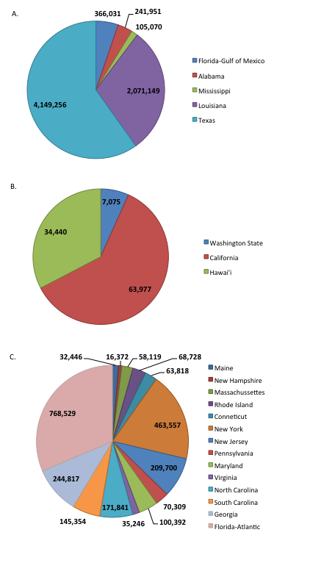 | Figure 1. Ships’ ballast water (metric tons) discharged at the Port of Houston in 2010 from U.S. ports (Data are combined per ocean and state).  a) Gulf of Mexico States; b) Pacific Ocean States;  c) Atlantic Ocean States.

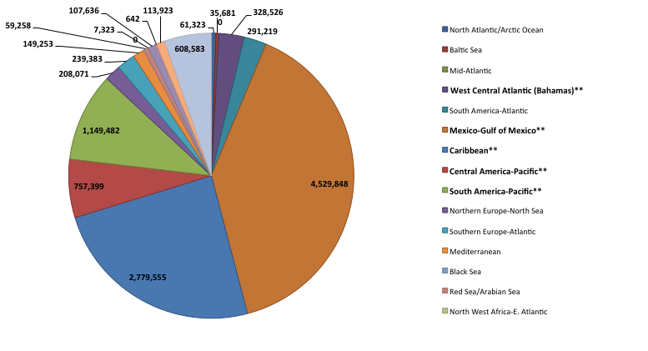

Figure 2. Foreign water sources of ships’ ballast water (metric tons) discharged at the Port of Houston in 2010. Double asterisks next to ocean names in the legend indicate frequent lack of BWE by ships with the justification that these and U.S. waters are geographically the same.

References—
Anderson, D.M. (2009) Approaches to monitoring, control and management of
harmful algal blooms (HABs). Ocean & Coastal Management. 52:342-347.

Burkholder, J.M., Hallegraeff, G. M., Melia, G., Cohen, A., Bowers, H. A., Oldach,
D. W., Parrow, M. W., Sullivan, M. J., Zimba, P. V., Allen, E. H., Kinder,
C. A. and Mallin, M. A. (2007) Phytoplankton and bacterial assemblages in
ballast water of U.S. military ships as a function of port of origin, voyage
time, and ocean exchange practices Harmful Algae 6(4):486-518.

Cohen, A.N. and Carlton, J.T. (1998) Accelerating Invasion Rate in a Highly
Invaded Estuary. Science. 279:55-558.

Ostenfeld, C.H., (1908). On the immigration of Biddulphia sinensis Grev. and its
occurence in the North Sea during 1903–1907.Meddelelser fra Kommissionen
for Havundersogelser. Plankton 1 (6), 1–25.

Time line and objectives—
Project Period:
Four months

Objectives

Month 1: 1) Compilation of available ballast management records from January 1, 2008 to present for ships entering and leaving the major ports in the Gulf of Mexico, (data would include relevant info such as ship type, recent ports of call, volume and source(s) of ballast water discharged at GOM ports, or exchange in GOM waters).

Month 2: 2) Literature review of risk analyses studies for HAB species introduction by ballast water from ballasting/de-ballasting practices.

Month 3: 3) The identification of potential ‘high risk’ areas or 'hot-spots' in the Gulf of Mexico based on information gathered for objectives 1 and 2. These could be ports, ballast water exchange zones, or lightering areas.

Deliverable—A written report that presents the results of objectives 1-3.

