NORTHWEST DISTRICT • OCHLOCKONEE/ST. MARKS BASIN
LAKE TALQUIN PLANNING UNIT

DRAFT TMDL Report Attachment 1

Lake Talquin Nutrient and DO TMDLs
Data Summary, Data,
Figures, and Tables

Douglas Gilbert

Water Quality Evaluation and TMDL Program
Division of Environmental Assessment and Restoration
Florida Department of Environmental Protection

July 19 2016

2600 Blair Stone Road
Mail Station 3575
Tallahassee, FL 32399-2400



Acknowledgments
This analysis could not have been accomplished without significant contributions from staff in the Florida Department of Environmental Protection’s GIS and Northwest District Office. Modeling support was provided by Tim Wool, Glynn Fernandez, Amanda Powel, and Craig Hesterlee with the U.S. Environmental Protection Agency (EPA) Region 4.
Editorial assistance was provided by Xueqing Gao.
Map production assistance was provided by Ronald Hughes.
For additional information on the watershed management approach and impaired waters in the Ochlockonee/St. Marks Basin, contact:
Moria Homann, Environmental Consultant
Florida Department of Environmental Protection
Bureau of Watershed Restoration
Watershed Planning and Coordination Section
2600 Blair Stone Road, Mail Station 3565
Tallahassee, FL 32399-2400
Email: Moria.Homann@dep.state.fl.us
Phone: (850) 245–8460
Fax: (850) 245–8434

Access to all data used in the development of this report can be obtained by contacting:
Douglas Gilbert, Environmental Manager
Florida Department of Environmental Protection
Water Quality and TMDL Program
Watershed Evaluation and TMDL Section
2600 Blair Stone Road, Mail Station 3555
Tallahassee, FL 32399-2400
Email: douglas.gilbert@dep.state.fl.us
Phone: (850) 245–8450;
Fax: (850) 245–8536

Contents
B.1 Lake Talquin Watershed 25
B.2 Rainfall 29
B.2 Rainfall Tallahassee Regional Airport 1980 - 2013 29
B.3 River Flows 33
B.4 Water Quality Data 45
B.4A. Ochlockonee River Above Lake Talquin WBID 1297E 45
B.4B Little Attapulgus Creek and Attapulgus River 71
B.4C Little River WBID 424 83
B.4D. Richlander Creek WBID 680 Drains to Lake Talquin 108
B.4E Rocky Comfort WBID 1304 Drains to Lake Talquin 127
B.4F. Bear Creek WBID 757 Drains to Lake Talquin 146
B.4G. Ocklawaha Creek WBID 811 Drains to Lake Talquin 165
B.4H Hammock Creek WBID 879 Drains to Lake Talquin 184
B.4I Freeman Creek WBID 954 Drains to Lake Talquin 205
B.4J Harvey Creek WBID 921 Drains to Lake Talquin 225
B.4K. Polk Creek WBID 896 Drains to Lake Talquin 244
B.4L. Upper Lake Talquin WBID 1297D 262
B.4M. Lower Lake Talquin WBID 1297C 288
B.4N. Ochlockonee River Outlet WBID 1297B (Below Lake Talquin) 314
B.5 Summary of Water Quality Data 339
B.6 Summary of Landuse Data 361

List of Tables
Table B.1.1. Lake Talquin Subbasin Area and Data Review 27
Table B.1.2. Lake Talquin Watershed Area Florida and Georgia 28
Table B.2.1. Annual Rainfall Tallahassee Regional Airport 31
Table B.2.2. Monthly Rainfall Tallahassee Regional Airport 32
Table B.3.1. Flow Summaries 44
Table B.3.2. Flow and Load Estimates 44
Table B.4A.1. Ochlockonee River WBID 1297E Water Quality Stations 65
Table B.4A.2. Ochlockonee River WBID 1297E Long-Term Geomean Alkalinity and Color 67
Table B.4A.3. Ochlockonee River WBID 1297E DO Percent Saturation vs. 67% Criterion 67
Table B.4A.4. Ochlockonee River WBID 1297E Annual Geomean TN, TP, TN/TP Ratio, and CChla 68
Table B.4A.5. Ochlockonee River WBID 1297E Water Quality Data Summary All Data 70
Table B.4A.6. Ochlockonee River WBID 1297E Water Quality Data Summary Verified Period Plus (2005 – 2013) 70
Table B.4B.1. Little Attapulgus and Attapulgus Stations 2013 79
Table B.4B.2. Little Attapulgus and Attapulgus Alkalinity 2013 79
Table B.4B.3. Little Attapulgus and Attapulgus True Color 2013 79
Table B.4B.4. Little Attapulgus and Attapulgus TN 2013 80
Table B.4B.5. Little Attapulgus and Attapulgus NH4-N 2013 80
Table B.4B.6. Little Attapulgus and Attapulgus NO23-N 2013 80
Table B.4B.7. Little Attapulgus and Attapulgus Organic-N 2013 81
Table B.4B.8. Little Attapulgus and Attapulgus TP 2013 81
Table B.4B.9. Little Attapulgus and Attapulgus PO4-P 2013 81
Table B.4B.10. Little Attapulgus and Attapulgus CChla 2013 81
Table B.4B.11. Little Attapulgus and Attapulgus BOD5 2013 82
Table B.4C.1. Little River WBID 424 IWR Stations 103
Table B.4C.2. Little River WBID 424 Long-Term Geomean Alkalinity and Color 104
Table B.4C.3. Little River WBID 424 DO Percent Saturation vs. 67% Criterion 104
Table B.4C.4. Little River WBID 424 Annual Geomean TN, TP, TN/TP Ratio, and CChla 105
Table B.4C.5. Little River WBID 424 Water Quality Data Summary All Data 107
Table B.4C.6. Little River WBID 424 Water Quality Data Summary Verified Period Plus (2005 – 2013) 107
Table B.4D.1. Richlander Creek WBID 680 IWR Stations 124
Table B.4D.2. Richlander Creek WBID 680 Long-Term Geomean Alkalinity and Color 124
Table B.4D.3. Richlander Creek WBID 680 DO Percent Saturation vs. 67% Criterion 124
Table B.4D.4. Richlander Creek WBID 680 Annual Geomean TN, TP, TN/TP Ratio, and CChla 125
Table B.4D.5. Richlander Creek WBID 680 Water Quality Data Summary All Data 126
Table B.4D.6. Richlander Creek WBID 680 Water Quality Data Summary Verified Period Plus (2005 – 2013) 126
Table B.4E.1. Rocky Comfort Creek WBID 1304 IWR Stations 143
Table B.4E.2. Rocky Comfort Creek WBID 1304 Long-Term Geomean Alkalinity and Color 143
Table B.4E.3. Rocky Comfort Creek WBID 1304 DO Percent Saturation vs. 67% Criterion 143
Table B.4E.4. Rocky Comfort Creek WBID 1304 Annual Geomean TN, TP, TN/TP Ratio, and CChla 144
Table B.4E.5. Rocky Comfort Creek WBID 1304 Water Quality Data Summary All Data 145
Table B.4E.6. Rocky Comfort Creek WBID 1304 Water Quality Data Summary Verified Period Plus (2005 – 2013) 145
Table B.4F.1. Bear Creek WBID 757 IWR Stations 162
Table B.4F.2. Bear Creek WBID 757 Long-Term Geomean Alkalinity and Color 162
Table B.4F.3. Bear Creek WBID 757 DO Percent Saturation vs. 67% Criterion 162
Table B.4F.4. Bear Creek WBID 757 Annual Geomean TN, TP, TN/TP Ratio, and CChla 163
Table B.4F.5. Bear Creek WBID 757 Water Quality Data Summary All Data 164
Table B.4F.6. Bear Creek WBID 757 Water Quality Data Summary Verified Period Plus (2005 – 2013) 164
Table B.4G.1. Ocklawaha Creek WBID 811 IWR Stations 181
Table B.4G.2. Ocklawaha Creek WBID 811 Long-Term Geomean Alkalinity and Color 181
Table B.4G.3. Ocklawaha Creek WBID 811 DO Percent Saturation vs. 67% Criterion 181
Table B.4G.4. Ocklawaha Creek WBID 811 Annual Geomean TN, TP, TN/TP Ratio, and CChla 182
Table B.4G.5. Ocklawaha Creek WBID 811 Water Quality Data Summary All Data 183
Table B.4G.6. Ocklawaha Creek WBID 811 Water Quality Data Summary Verified Period Plus (2005 – 2013) 183
Table B.4H.1. Hammock Creek WBID 879 IWR Stations 202
Table B.4H.2. Hammock Creek WBID 879 Long-Term Geomean Alkalinity and Color 202
Table B.4H.3. Hammock Creek WBID 879 DO Percent Saturation vs. 67% Criterion 202
Table B.4H.4. Hammock Creek WBID 879 Annual Geomean TN, TP, TN/TP Ratio, and CChla 203
Table B.4H.5. Hammock Creek WBID 879 Water Quality Data Summary All Data 204
Table B.4H.6. Hammock Creek WBID 879 Water Quality Data Summary Verified Period Plus (2005 – 2013) 204
Table B.4I.1. Freeman Creek WBID 954 IWR Stations 222
Table B.4I.2. Freeman Creek WBID 954 Long-Term Geomean Alkalinity and Color 222
Table B.4I.3. Freeman Creek WBID 954 DO Percent Saturation vs. 67% Criterion 222
Table B.4I.4. Freeman Creek WBID 954 Annual Geomean TN, TP, TN/TP Ratio, and CChla 223
Table B.4I.5. Freeman Creek WBID 954 Water Quality Data Summary All Data 224
Table B.4I.6. Freeman Creek WBID 954 Water Quality Data Summary Verified Period (2005 – 2012) 224
Table B.4J.1. Harvey Creek WBID 921 IWR Stations 241
Table B.4J.2. Harvey Creek WBID 921 Long-Term Geomean Alkalinity and Color 241
Table B.4J.3. Harvey Creek WBID 921 DO Percent Saturation vs. 67% Criterion 241
Table B.4J.4. Harvey Creek WBID 921 Annual Geomean TN, TP, TN/TP Ratio, and CChla 242
Table B.4J.5. Harvey Creek WBID 921 Water Quality Data Summary All Data 243
Table B.4J.6. Harvey Creek WBID 921 Water Quality Data Summary Verified Period (2005 – 2012) 243
Table B.4K.1. Polk Creek WBID 896 IWR Stations 259
Table B.4K.2. Polk Creek WBID 896 Long-Term Geomean Alkalinity and Color 259
Table B.4K.3. Polk Creek WBID 896 DO Percent Saturation vs. 67% Criterion 259
Table B.4K.4. Polk Creek WBID 896 Annual Geomean TN, TP, TN/TP Ratio, and CChla 260
Table B.4K.5. Polk Creek WBID 896 Water Quality Data Summary All Data 261
Table B.4K.6. Polk Creek WBID 896 Water Quality Data Summary Verified Period (2005 – 2012) 261
Table B.4L.1. Lake Talquin WBIDs 1297D IWR Stations 284
Table B.4L.2. Lake Talquin Upper WBID 1297D Long-Term Geomean Alkalinity and Color 285
Table B.4L.3. Lake Talquin Upper WBID 1297D DO Percent Saturation vs. 67% Criterion 285
Table B.4L.4. Lake Talquin Upper WBID 1297D Annual Geomean TN, TP, TN/TP Ratio, and CChla 286
Table B.4L.5. Lake Talquin Upper WBID 1297D Water Quality Data Summary All Data 287
Table B.4L.6. Lake Talquin Upper WBID 1297D Water Quality Data Summary Verified Period Plus (2005 – 2013) 287
Table B.4M.1. Lake Talquin WBIDs 1297C IWR Stations 310
Table B.4M.2. Lake Talquin Lower WBID 1297C Long-Term Geomean Alkalinity and Color 311
Table B.4M.3. Lake Talquin Lower WBID 1297C DO Percent Saturation vs. 67% Criterion 311
Table B.4M.4. Lake Talquin Lower WBID 1297C Annual Geomean TN, TP, TN/TP Ratio, and CChla 312
Table B.4M.5. Lake Talquin Lower WBID 1297C Water Quality Data Summary All Data 313
Table B.4M.6. Lake Talquin Lower WBID 1297C Water Quality Data Summary Verified Period Plus (2005 – 2013) 313
Table B.4N.1. Ochlockonee River WBID 1297B Outlet IWR Stations 334
Table B.4N.2. Ochlockonee River WBID 1297B Outlet Long-Term Geomean Alkalinity and Color 334
Table B.4N.3. Ochlockonee River WBID 1297B Outlet DO Percent Saturation vs. 67% Criterion 335
Table B.4N.4. Ochlockonee River WBID 1297B Outlet Annual Geomean TN, TP, TN/TP Ratio, and CChla 336
Table B.4N.5. Ochlockonee River WBID 1297B Outlet Water Quality Data Summary All Data 338
Table B.4N.6. Ochlockonee River WBID 1297B Outlet Water Quality Data Summary Verified Period (2005 – 2011) 338
Table B.5.1. TN Tributaries Cumulative Frequency vs Lake Thresholds (2000 – Current) 347
Table B.5.2. TN Tributaries vs Lake Cumulative Frequency vs Lake Thresholds (2000 – Current) 347
Table B.5.3. TP Tributaries Cumulative Frequency vs Lake Thresholds (2000 – Current) 350
Table B.5.4. TP Tributaries vs Lake Cumulative Frequency vs Lake Thresholds (2000 – Current) 351
Table B.6.1. Classification of Land Use Categories in the Lake Talquin Watershed, 2006 362
Table B.6.2. Classification of Land Use Categories in the Ochlockonee River above Lake Talquin Watershed, 2006 364
Table B.6.3. Classification of Land Use Categories in the Hunter Creek Watershed, 2006 366
Table B.6.4. Classification of Land Use Categories in the Double Branch Watershed, 2006 368
Table B.6.5. Classification of Land Use Categories in the Mule Creek Watershed, 2006 370
Table B.6.6. Classification of Land Use Categories in the Pole Creek Watershed, 2006 372
Table B.6.7. Classification of Land Use Categories in the Attapulgus Creek Watershed, 2006 374
Table B.6.8. Classification of Land Use Categories in the Little Attapulgus Creek Watershed, 2006 376
Table B.6.9. Classification of Land Use Categories in the Swamp Creek Watershed, 2006 378
Table B.6.10. Classification of Land Use Categories in the Salem Creek Watershed, 2006 380
Table B.6.11. Classification of Land Use Categories in the Willacoochee Creek Watershed, 2006 382
Table B.6.12. Classification of Land Use Categories in the Quincy Creek Watershed, 2006 384
Table B.6.13. Classification of Land Use Categories in the Hurricane Creek Watershed, 2006 386
Table B.6.14. Classification of Land Use Categories in the Monroe Creek Watershed, 2006 388
Table B.6.15. Classification of Land Use Categories in the Richlander Creek Watershed, 2006 390
Table B.6.16. Classification of Land Use Categories in the Little River Area, 2006 392
Table B.6.17. Classification of Land Use Categories in the Rocky Comfort Creek Watershed, 2006 394
Table B.6.18. Classification of Land Use Categories in the Bear Creek Watershed, 2006 396
Table B.6.19. Classification of Land Use Categories in the McIntosh Branch Watershed, 2006 398
Table B.6.20. Classification of Land Use Categories in the Ocklawaha Creek Watershed, 2006 400
Table B.6.21. Classification of Land Use Categories in the Cuban Branch Watershed, 2006 402
Table B.6.22. Classification of Land Use Categories in the Hammock Creek Watershed, 2006 404
Table B.6.23. Classification of Land Use Categories in the Freeman Creek Watershed, 2006 406
Table B.6.24. Classification of Land Use Categories in the Harvey Creek Watershed, 2006 408
Table B.6.25. Classification of Land Use Categories in the Polk Creek Watershed, 2006 410
Table B.6.26. Classification of Land Use Categories in the Lake Talquin Runoff Area Draining Directly to Lake Talquin, 2006 412

List of Figures
Figure B.1.1. Location of the Lake Talquin Watershed in the Ochlockonee/St. Marks Basin 25
Figure B.1.2. Lake Talquin Watershed Subbasins 26
Figure B.2.1 Daily Rainfall 1980 – 2013 Tallahassee Regional Airport 29
Figure B.2.2 Daily Rainfall 2000 – 2013 Tallahassee Regional Airport 30
Figure B.2.3 Annual Average Rainfall 1980 – 2012 Tallahassee Regional Airport 30
Figure B.2.4 Monthly Average Rainfall Tallahassee Regional Airport 31
Figure B.3.1. Ochlockonee River Daily Flow Above Lake Talquin 1926 - 2013 33
Figure B.3.2. Ochlockonee River Daily Flow Above Lake Talquin 1998 - 2013 34
Figure B.3.3. Ochlockonee River Monthly Flow Above Lake Talquin 1998 - 2013 34
Figure B.3.4. Little River Daily Flow into Lake Talquin 1998 - 2013 35
Figure B.3.5. Little River Monthly Flow into Lake Talquin 1998 - 2013 35
Figure B.3.6. Little and Ochlockonee River Monthly Flow into Lake Talquin 1998 - 2013 36
Figure B.3.7. Little and Ochlockonee River Annual Flow into Lake Talquin 1985 - 2013 36
Figure B.3.8. Ochlockonee River Daily Flow out of Lake Talquin 1998 - 2013 37
Figure B.3.9. Ochlockonee River Monthly Flow out of Lake Talquin 1998 - 2013 37
Figure B.3.10. Ochlockonee River Annual Flow out of Lake Talquin 1998 - 2013 38
Figure B.3.11. Little and Ochlockonee River Annual Flow In and Ochlockonee River Flow out of Lake Talquin 1985 - 2013 38
Figure B.3.12. Little and Ochlockonee River Monthly Flow In and Ochlockonee River Flow out of Lake Talquin 1985 - 2013 39
Figure B.3.13. Richlander Creek Measured Flow (cfs) 1975 – 2013 39
Figure B.3.14. Richlander Creek Monthly Average Flow (cfs) 1975 – 2013 40
Figure B.3.15. Rocky Comfort Creek Measured Flow (cfs) 1975 – 2013 40
Figure B.3.16. Rocky Comfort Creek Monthly Average Flow (cfs) 1956 – 2013 41
Figure B.3.17. Bear Creek Measured Flow (cfs) 1975 – 2013 41
Figure B.3.18. Bear Creek Monthly Average Flow (cfs) 1975 – 2013 42
Figure B.3.19. Ocklawaha Creek Measured Flow (cfs) 1974 – 2013 42
Figure B.3.20. Ocklawaha Creek Monthly Average Flow (cfs) 1974 – 2013 43
Figure B.4A.1. Ochlockonee River WBIDs 1297E and 1297F Station Locations 47
Figure B.4A.2. Ochlockonee River WBID 1297E Daily Average Temperature 1957 - 2013 48
Figure B.4A.3. Ochlockonee River WBID 1297E Monthly Temperature 1957 - 2013 48
Figure B.4A.4. Ochlockonee River WBID 1297E Daily Average Alkalinity 1957- 2013 49
Figure B.4A.5. Ochlockonee River WBID 1297E Monthly Average Alkalinity 1957- 2013 49
Figure B.4A.6. Ochlockonee River WBID 1297E Daily Average True Color 1957- 2013 50
Figure B.4A.7. Ochlockonee River WBID 1297E Monthly Average True Color 1957- 2013 50
Figure B.4A.8. Ochlockonee River WBID 1297E Daily pH 1957- 2013 51
Figure B.4A.9. Ochlockonee River WBID 1297E Daily Average TN1971- 2013 51
Figure B.4A.10. Ochlockonee River WBID 1297E Daily Average TN 2005- 2013 52
Figure B.4A.11. Ochlockonee River WBID 1297E TN Annual Geomean 1972- 2013 52
Figure B.4A.12. Ochlockonee River WBID 1297E Monthly Average TN 1972- 2013 53
Figure B.4A.13. Ochlockonee River WBID 1297E Daily Average Ammonia-N 1971- 2013 53
Figure B.4A.14. Ochlockonee River WBID 1297E Daily Average Ammonia-N 2005- 2013 54
Figure B.4A.15. Ochlockonee River WBID 1297E Daily Average Nitrate/Nitrite-N 1973- 2013 54
Figure B.4A.16. Ochlockonee River WBID 1297E Daily Average Nitrate/Nitrite-N2005- 2013 55
Figure B.4A.17. Ochlockonee River WBID 1297E Daily Average Organic-N 1976- 2000 55
Figure B.4A.18. Ochlockonee River WBID 1297E Daily Average TP 1968 - 2013 56
Figure B.4A.19. Ochlockonee River WBID 1297E Daily Average TP 2005 - 2013 56
Figure B.4A.20. Ochlockonee River WBID 1297E Annual Geomean TP 1972 - 2013 57
Figure B.4A.21. Ochlockonee River WBID 1297E Monthly Average TP 1968 - 2013 57
Figure B.4A.22. Ochlockonee River WBID 1297E Daily Average Orthophosphate-P 1966 - 2013 58
Figure B.4A.23. Ochlockonee River WBID 1297E Daily Average Orthophosphate-P 2005 - 2013 58
Figure B.4A.24. Ochlockonee River WBID 1297E Daily Average CChla 1988 - 2013 59
Figure B.4A.25. Ochlockonee River WBID 1297E Daily Average CChla 2005 - 2013 59
Figure B.4A.26. Ochlockonee River WBID 1297E Annual Geomean CChla 1988 - 2013 60
Figure B.4A.27. Ochlockonee River WBID 1297E Monthly Average CChla 1988 - 2013 60
Figure B.4A.28. Ochlockonee River WBID 1297E Daily Average BOD5 1965 - 2013 61
Figure B.4A.29. Ochlockonee River WBID 1297E Daily Average BOD5 2005 - 2013 61
Figure B.4A.30. Ochlockonee River WBID 1297E Monthly Average BOD5 1965 - 2013 62
Figure B.4A.31. Ochlockonee River WBID 1297E Daily Average DO 1964 - 2013 62
Figure B.4A.32. Ochlockonee River WBID 1297E Monthly Average DO 1964 - 2013 63
Figure B.4A.33. Ochlockonee River WBID 1297E Daily Average DO Percent Saturation 1964 - 2013 63
Figure B.4A.34. Ochlockonee River WBID 1297E Daily Average DO Percent Saturation 2005 - 2013 64
Figure B.4A.35. Ochlockonee River WBID 1297E Monthly Average DO Percent Saturation 1964 - 2013 64
Figure B.4B.1 Little Attapulgus and Attapulgus 2013 Study Sites and BASF facility 72
Figure B.4B.2. Little Attapulgus and Attapulgus Alkalinity 2013 73
Figure B.4B.3. Little Attapulgus and Attapulgus True Color 2013 73
Figure B.4B.4. Little Attapulgus and Attapulgus TN 2013 74
Figure B.4B.5. Little Attapulgus and Attapulgus Ammonia-N 2013 74
Figure B.4B.6. Little Attapulgus and Attapulgus Nitrate/Nitrite-N 2013 75
Figure B.4B.7. Little Attapulgus and Attapulgus Organic-N 2013 75
Figure B.4B.8. Little Attapulgus and Attapulgus TP 2013 76
Figure B.4B.9. Little Attapulgus and Attapulgus Orthophosphate-P 2013 76
Figure B.4B.10. Little Attapulgus and Attapulgus Flow 2013 77
Figure B.4B.11. Little Attapulgus and Attapulgus CChla 2013 77
Figure B.4B.12. Little Attapulgus and Attapulgus BOD5 2013 78
Figure B.4C.1. Little River WBID 424 IWR Station Locations 85
Figure B.4C.2. Little River WBID 424 Daily Temperature 1962 - 2013 86
Figure B.4C.3. Little River WBID 424 Monthly Temperature 1962 - 2013 86
Figure B.4C.4. Little River WBID 424 Daily Average Alkalinity 1965- 2013 87
Figure B.4C.5. Little River WBID 424 Monthly Average Alkalinity 1965- 2013 87
Figure B.4C.6. Little River WBID 424 Daily Average True Color 1962- 2013 88
Figure B.4C.7. Little River WBID 424 Monthly Average True Color 1962- 2013 88
Figure B.4C.8. Little River WBID 424 Daily pH 1962- 2013 89
Figure B.4C.9. Little River WBID 424 Daily Average TN1973- 2013 89
Figure B.4C.10. Little River WBID 424 Daily Average TN 2005- 2013 90
Figure B.4C.11. Little River WBID 424 TN Annual Geomean 1973- 2013 90
Figure B.4C.12. Little River WBID 424 Monthly Average TN 1973- 2013 91
Figure B.4C.13. Little River WBID 424 Daily Average Ammonia-N 1971- 2013 91
Figure B.4C.14. Little River WBID 424 Daily Average Ammonia-N 2005- 2013 92
Figure B.4C.15. Little River WBID 424 Daily Average Nitrate/Nitrite-N1973- 2013 92
Figure B.4C.16. Little River WBID 424 Daily Average Nitrate/Nitrite-N2005- 2013 93
Figure B.4C.17. Little River WBID 424 Daily Average Organic-N 1970- 1990 93
Figure B.4C.18. Little River WBID 424 Daily Average TP 1968 - 2013 94
Figure B.4C.19. Little River WBID 424 Daily Average TP 2005 - 2013 94
Figure B.4C.20. Little River WBID 424 Annual Geomean TP 1972 - 2013 95
Figure B.4C.21. Little River WBID 424 Monthly Average TP 1968 - 2013 95
Figure B.4C.22. Little River WBID 424 Daily Average Orthophosphate-P 1966 - 2013 96
Figure B.4C.23. Little River WBID 424 Daily Average Orthophosphate-P 2005 - 2013 96
Figure B.4C.24. Little River WBID 424 Daily Average CChla 1988 - 2013 97
Figure B.4C.25. Little River WBID 424 Daily Average CChla 2005 - 2013 97
Figure B.4C.26. Little River WBID 424 Annual Geomean CChla 1992 - 2013 98
Figure B.4C.27. Little River WBID 424 Monthly Average CChla 1988 - 2013 98
Figure B.4C.28. Little River WBID 424 Daily Average BOD5 1965 - 2013 99
Figure B.4C.29. Little River WBID 424 Daily Average BOD5 2005 - 2013 99
Figure B.4C.30. Little River WBID 424 Monthly Average BOD5 1965 - 2013 100
Figure B.4C.31. Little River WBID 424 Daily Average DO 1962 - 2013 100
Figure B.4C.32. Little River WBID 424 Monthly Average DO 1962 - 2013 101
Figure B.4C.33. Little River WBID 424 Daily Average DO Percent Saturation 1962 - 2013 101
Figure B.4C.34 Little River WBID 424 Daily Average DO Percent Saturation 2005 - 2013 102
Figure B.4C.35. Little River WBID 424 Monthly Average DO Percent Saturation 1962 - 2013 102
Figure B.4D.1. Richlander Creek WBID 680 IWR Stations 110
Figure B.4D.2. Richlander Creek WBID 680 Monthly Temperature 1975 - 2013 111
Figure B.4D.3. Richlander Creek WBID 680 Daily Average Alkalinity 2013 111
Figure B.4D.4. Richlander Creek WBID 680 Monthly Average Alkalinity 2013 112
Figure B.4D.5. Richlander Creek WBID 680 Daily Average True Color 2000- 2013 112
Figure B.4D.6. Richlander Creek WBID 680 Monthly Average True Color 2000- 2013 113
Figure B.4D.7. Richlander Creek WBID 680 Daily pH 1975- 2013 113
Figure B.4D.8. Richlander Creek WBID 680 Daily Average TN1975- 2013 114
Figure B.4D.9. Richlander Creek WBID 680 Daily Average TN 2005- 2013 114
Figure B.4D.10. Richlander Creek WBID 680 TN Annual Geomean 2013 115
Figure B.4D.11. Richlander Creek WBID 680 Monthly Average TN 1975- 2013 115
Figure B.4D.12. Richlander Creek WBID 680 Daily Average Ammonia-N 1975- 2013 116
Figure B.4D.13. Richlander Creek WBID 680 Daily Average Nitrate/Nitrite-N1975- 2013 116
Figure B.4D.14. Richlander Creek WBID 680 Daily Average TP 1975 - 2013 117
Figure B.4D.15. Richlander Creek WBID 680 Daily Average TP 2005 - 2013 117
Figure B.4D.16. Richlander Creek WBID 680 Annual Geomean TP 2013 118
Figure B.4D.17. Richlander Creek WBID 680 Monthly Average TP 1975 - 2013 118
Figure B.4D.18. Richlander Creek WBID 680 Daily Average Orthophosphate-P 1975 - 2013 119
Figure B.4D.19. Richlander Creek WBID 680 Daily Average CChla 2000 - 2013 119
Figure B.4D.20. Richlander Creek WBID 680 Annual Geomean CChla 2013 120
Figure B.4D.21. Richlander Creek WBID 680 Monthly Average CChla 2000 - 2013 120
Figure B.4D.22. Richlander Creek WBID 680 Daily Average BOD5 2013 121
Figure B.4D.23. Richlander Creek WBID 680 Monthly Average BOD5 2013 121
Figure B.4D.24. Richlander Creek WBID 680 Daily Average DO 1975 - 2013 122
Figure B.4D.25. Richlander Creek WBID 680 Monthly Average DO 1975 - 2013 122
Figure B.4D.26. Richlander Creek WBID 680 Daily Average DO Percent Saturation 2000 - 2013 123
Figure B.4D.27. Richlander Creek WBID 680 Monthly Average DO Percent Saturation 2000 - 2013 123
Figure B.4E.1. Rocky Comfort Creek WBID 1304 IWR Stations 129
Figure B.4E.2. Rocky Comfort Creek WBID 1304 Monthly Temperature 1956 - 2013 130
Figure B.4E.3. Rocky Comfort Creek WBID 1304 Daily Average Alkalinity 1956 - 2013 130
Figure B.4E.4. Rocky Comfort Creek WBID 1304 Monthly Average Alkalinity 1956 - 2013 131
Figure B.4E.5. Rocky Comfort Creek WBID 1304Daily Average True Color 1956- 2013 131
Figure B.4E.6. Rocky Comfort Creek WBID 1304Monthly Average True Color 1956- 2013 132
Figure B.4E.7. Rocky Comfort Creek WBID 1304 Daily pH 1956- 2013 132
Figure B.4E.8. Rocky Comfort Creek WBID 1304Daily Average TN1975- 2013 133
Figure B.4E.9. Rocky Comfort Creek WBID 1304Daily Average TN 2005- 2013 133
Figure B.4E.10. Rocky Comfort Creek WBID 1304 TN Annual Geomean 2013 134
Figure B.4E.11. Rocky Comfort Creek WBID 1304Monthly Average TN 1975- 2013 134
Figure B.4E.12. Rocky Comfort Creek WBID 1304 Daily Average Ammonia-N 1975- 2013 135
Figure B.4E.13. Rocky Comfort Creek WBID 1304 Daily Average Nitrate/Nitrite-N1975- 2013 135
Figure B.4E.14. Rocky Comfort Creek WBID 1304 Daily Average TP 1968 - 2013 136
Figure B.4E.15. Rocky Comfort Creek WBID 1304 Daily Average TP 2005 - 2013 136
Figure B.4E.16 Rocky Comfort Creek WBID 1304 Annual Geomean TP 2013 137
Figure B.4E.17. Rocky Comfort Creek WBID 1304 Monthly Average TP 1968 - 2013 137
Figure B.4E.18. Rocky Comfort Creek WBID 1304 Daily Average Orthophosphate-P 1966 - 2013 138
Figure B.4E.19. Rocky Comfort Creek WBID 1304 Daily Average CChla 2000 - 2013 138
Figure B.4E.20. Rocky Comfort Creek WBID 1304 Annual Geomean CChla 2013 139
Figure B.4E.21. Rocky Comfort Creek WBID 1304 Monthly Average CChla 2000 - 2013 139
Figure B.4E.22. Rocky Comfort Creek WBID 1304 Daily Average BOD5 2013 140
Figure B.4E.23. Rocky Comfort Creek WBID 1304 Monthly Average BOD5 2013 140
Figure B.4E.24. Rocky Comfort Creek WBID 1304 Daily Average DO 1967 - 2013 141
Figure B.4E.25. Rocky Comfort Creek WBID 1304 Monthly Average DO 1967 - 2013 141
Figure B.4E.26. Rocky Comfort Creek WBID 1304 Daily Average DO Percent Saturation 1967 - 2013 142
Figure B.4E.27. Rocky Comfort Creek WBID 1304 Monthly Average DO Percent Saturation 1967 - 2013 142
Figure B.4F.1. Bear Creek WBID 757 IWR Stations 148
Figure B.4F.2. Bear Creek WBID 757 Monthly Temperature 1975 - 2013 149
Figure B.4F.3. Bear Creek WBID 757 Daily Average Alkalinity 1992 2013 149
Figure B.4F.4. Bear Creek WBID 757 Monthly Average Alkalinity 1992 - 2013 150
Figure B.4F.5. Bear Creek WBID 757 Daily Average True Color 1992- 2013 150
Figure B.4F.6. Bear Creek WBID 757 Monthly Average True Color 1992- 2013 151
Figure B.4F.7. Bear Creek WBID 757 Daily pH 1975- 2013 151
Figure B.4F.8. Bear Creek WBID 757 Daily Average TN1973- 2013 152
Figure B.4F.9. Bear Creek WBID 757 Daily Average TN 2005- 2013 152
Figure B.4F.10. Bear Creek WBID 757 TN Annual Geomean 1973 -2013 153
Figure B.4F.11. Bear Creek WBID 757 Monthly Average TN 1973- 2013 153
Figure B.4F.12. Bear Creek WBID 757 Daily Average Ammonia-N 1971- 2013 154
Figure B.4F.13. Bear Creek WBID 757 Daily Average Nitrate/Nitrite-N1973- 2013 154
Figure B.4F.14. Bear Creek WBID 757 Daily Average TP 1973 - 2013 155
Figure B.4F.15. Bear Creek WBID 757 Daily Average TP 2005 - 2013 155
Figure B.4F.16. Bear Creek WBID 757 Annual Geomean TP 1973 2013 156
Figure B.4F.17. Bear Creek WBID 757 Monthly Average TP 1973 - 2013 156
Figure B.4F.18. Bear Creek WBID 757 Daily Average Orthophosphate-P 1973 - 2013 157
Figure B.4F.19. Bear Creek WBID 757 Daily Average CChla 2000 - 2013 157
Figure B.4F.20. Bear Creek WBID 757 Annual Geomean CChla 2006 2013 158
Figure B.4F.21. Bear Creek WBID 757 Monthly Average CChla 2000 - 2013 158
Figure B.4F.22. Bear Creek WBID 757 Daily Average BOD5 2006 2013 159
Figure B.4F.23. Bear Creek WBID 757 Monthly Average BOD5 2006 2013 159
Figure B.4F.24. Bear Creek WBID 757 Daily Average DO 1975 - 2013 160
Figure B.4F.25. Bear Creek WBID 757 Monthly Average DO 1975 - 2013 160
Figure B.4F.26. Bear Creek WBID 757 Daily Average DO Percent Saturation 1979 - 2013 161
Figure B.4F.27. Bear Creek WBID 757 Monthly Average DO Percent Saturation 1979 - 2013 161
Figure B.4G.1. Ocklawaha Creek WBID 811 IWR Stations 167
Figure B.4G.2. Ocklawaha Creek WBID 811 Monthly Temperature 1974 - 2013 168
Figure B.4G.3. Ocklawaha Creek WBID 811 Daily Average Alkalinity 1974 - 2013 168
Figure B.4G.4. Ocklawaha Creek WBID 811 Monthly Average Alkalinity 1974 - 2013 169
Figure B.4G.5. Ocklawaha Creek WBID 811 Daily Average True Color 1974 - 2013 169
Figure B.4G.6. Ocklawaha Creek WBID 811 Monthly Average True Color 1974 - 2013 170
Figure B.4G.7. Ocklawaha Creek WBID 811 Daily pH 1974 - 2013 170
Figure B.4G.8. Ocklawaha Creek WBID 811 Daily Average TN1973 - 2013 171
Figure B.4G.9. Ocklawaha Creek WBID 811 Daily Average TN 2005- 2013 171
Figure B.4G.10. Ocklawaha Creek WBID 811 TN Annual Geomean 1973 - 2013 172
Figure B.4G.11. Ocklawaha Creek WBID 811 Monthly Average TN 1973 - 2013 172
Figure B.4G.12. Ocklawaha Creek WBID 811 Daily Average Ammonia-N 1971 - 2013 173
Figure B.4G.13. Ocklawaha Creek WBID 811 Daily Average Nitrate/Nitrite-N1973 - 2013 173
Figure B.4G.14. Ocklawaha Creek WBID 811 Daily Average TP 1973 - 2013 174
Figure B.4G.15. Ocklawaha Creek WBID 811 Daily Average TP 2005 - 2013 174
Figure B.4G.16. Ocklawaha Creek WBID 811 Annual Geomean TP 1973 - 2013 175
Figure B.4G.17. Ocklawaha Creek WBID 811 Monthly Average TP 1973 - 2013 175
Figure B.4G.18. Ocklawaha Creek WBID 811 Daily Average Orthophosphate-P 1973 - 2013 176
Figure B.4G.19. Ocklawaha Creek WBID 811 Daily Average CChla 2004 - 2013 176
Figure B.4G.20. Ocklawaha Creek WBID 811 Annual Geomean CChla 2004 - 2013 177
Figure B.4G.21. Ocklawaha Creek WBID 811 Monthly Average CChla 2004 - 2013 177
Figure B.4G.22. Ocklawaha Creek WBID 811 Daily Average BOD5 2006 - 2013 178
Figure B.4G.23. Ocklawaha Creek WBID 811 Monthly Average BOD5 2006 - 2013 178
Figure B.4G.24. Ocklawaha Creek WBID 811 Daily Average DO 1974 - 2013 179
Figure B.4G.25. Ocklawaha Creek WBID 811 Monthly Average DO 1974 - 2013 179
Figure B.4G.26. Ocklawaha Creek WBID 811 Daily Average DO Percent Saturation 1975 - 2013 180
Figure B.4G.27. Ocklawaha Creek WBID 811 Monthly Average DO Percent Saturation 1975 - 2013 180
Figure B.4H.1. Hammock Creek WBID 879 IWR Stations 186
Figure B.4H.2. Hammock Creek WBID 879 Monthly Temperature 1974 - 2013 187
Figure B.4H.3. Hammock Creek WBID 879 Daily Average Alkalinity 1974 - 2013 187
Figure B.4H.4. Hammock Creek WBID 879 Monthly Average Alkalinity 1974 - 2013 188
Figure B.4H.5. Hammock Creek WBID 879 Daily Average True Color 1974 - 2013 188
Figure B.4H.6. Hammock Creek WBID 879 Monthly Average True Color 1974 - 2013 189
Figure B.4H.7. Hammock Creek WBID 879 Daily pH 1974 - 2013 189
Figure B.4H.8. Hammock Creek WBID 879 Daily Average TN1973 - 2013 190
Figure B.4H.9. Hammock Creek WBID 879 TN Annual Geomean 1973 - 2013 190
Figure B.4H.10. Hammock Creek WBID 879 Monthly Average TN 1973 - 2013 191
Figure B.4H.11. Hammock Creek WBID 879 Daily Average Ammonia-N 1971 - 2013 191
Figure B.4H.12. Hammock Creek WBID 879 Daily Average Nitrate/Nitrite-N1973 - 2013 192
Figure B.4H.13. Hammock Creek WBID 879 Daily Average TP 1973 - 2013 192
Figure B.4H.14. Hammock Creek WBID 879 Annual Geomean TP 1973 - 2013 193
Figure B.4H.15. Hammock Creek WBID 879 Monthly Average TP 1973 - 2013 193
Figure B.4H.16. Hammock Creek WBID 879 Daily Average Orthophosphate-P 1973 - 2013 194
Figure B.4H.17. Hammock Creek WBID 879 Daily Average CChla 2004 - 2013 194
Figure B.4H.18. Hammock Creek WBID 879 Annual Geomean CChla 2004 - 2013 195
Figure B.4H.19. Hammock Creek WBID 879 Monthly Average CChla 2004 - 2013 195
Figure B.4H.20. Hammock Creek WBID 879 Daily Average BOD5 2006 - 2013 196
Figure B.4H.21. Hammock Creek WBID 879 Monthly Average BOD5 2006 - 2013 196
Figure B.4H.22. Hammock Creek WBID 879 Daily Average DO 1974 - 2013 197
Figure B.4H.23. Hammock Creek WBID 879 Monthly Average DO 1974 - 2013 197
Figure B.4H.24. Hammock Creek WBID 879 Daily Average DO Percent Saturation 1975 - 2013 198
Figure B.4H.25. Hammock Creek WBID 879 Monthly Average DO Percent Saturation 1975 - 2013 198
Figure B.4H.26. Hammock Creek Station with low DO 199
Figure B.4H.27. Hammock Creek Station Location below Bridge 200
Figure B.4H.28. Hammock Creek Station Looking Downstream into Lake Talquin DO 200
Figure B.4H.29. Hammock Creek Station Upstream of Bridge 201
Figure B.4I.1. Freeman Creek WBID 954 Water Quality Stations 207
Figure B.4I.2. Freeman Creek WBID 954 Monthly Temperature 1989 - 2012 208
Figure B.4I.3. Freeman Creek WBID 954 Daily Average Alkalinity 2006 - 2012 208
Figure B.4I.4. Freeman Creek WBID 954 Monthly Average Alkalinity 2006 - 2012 209
Figure B.4I.5. Freeman Creek WBID 954 Daily Average True Color 2006- 2012 209
Figure B.4I.6. Freeman Creek WBID 954 Monthly Average True Color 2006 - 2012 210
Figure B.4I.7. Freeman Creek WBID 954 Daily pH 1989- 2012 210
Figure B.4I.8. Freeman Creek WBID 954 Daily Average TN1989- 2012 211
Figure B.4I.9. Freeman Creek WBID 954 Daily Average TN 2005- 2012 211
Figure B.4I.10. Freeman Creek WBID 954 TN Annual Geomean 2005 - 2012 212
Figure B.4I.11. Freeman Creek WBID 954 Monthly Average TN 1989- 2012 212
Figure B.4I.12. Freeman Creek WBID 954 Daily Average Ammonia-N 1989- 2012 213
Figure B.4I.13. Freeman Creek WBID 954 Daily Average Ammonia-N 2005 2013 213
Figure B.4I.14. Freeman Creek WBID 954 Daily Average Nitrate/Nitrite-N 2000 - 2012 214
Figure B.4I.15. Freeman Creek WBID 954 Daily Average TP 1989 - 2012 214
Figure B.4I.16. Freeman Creek WBID 954 Daily Average TP 2005 - 2012 215
Figure B.4I.17. Freeman Creek WBID 954 Annual Geomean TP 2005 - 2013 215
Figure B.4I.18. Freeman Creek WBID 954 Monthly Average TP 1989 - 2012 216
Figure B.4I.19. Freeman Creek WBID 954 Daily Average Orthophosphate-P 1989 - 2012 216
Figure B.4I.20. Freeman Creek WBID 954 Daily Average Orthophosphate-P 2005 - 2012 217
Figure B.4I.21. Freeman Creek WBID 954 Daily Average CChla 1989 - 2012 217
Figure B.4I.22. Freeman Creek WBID 954 Annual Geomean CChla 2005 - 2013 218
Figure B.4I.23. Freeman Creek WBID 954 Monthly Average CChla 1989 - 2012 218
Figure B.4I.24. Freeman Creek WBID 954 Daily Average BOD5 2006 - 2012 219
Figure B.4I.25. Freeman Creek WBID 954 Monthly Average BOD5 2006 - 2012 219
Figure B.4I.26. Freeman Creek WBID 954 Daily Average DO 1989 - 2012 220
Figure B.4I.27. Freeman Creek WBID 954 Monthly Average DO 1989 - 2012 220
Figure B.4I.28. Freeman Creek WBID 954 Daily Average DO Percent Saturation 1989 - 2012 221
Figure B.4I.29. Freeman Creek WBID 954 Monthly Average DO Percent Saturation 1989 - 2012 221
Figure B.4J.1. Harvey Creek WBID 921 IWR Stations 227
Figure B.4J.2. Harvey Creek WBID 921 Monthly Temperature 1992 - 2011 228
Figure B.4J.3. Harvey Creek WBID 921 Daily Average Alkalinity 1992 - 2011 228
Figure B.4J.4. Harvey Creek WBID 921 Monthly Average Alkalinity 1992 - 2011 229
Figure B.4J.5. Harvey Creek WBID 921 Daily Average True Color 1992 - 2013 229
Figure B.4J.6. Harvey Creek WBID 921 Monthly Average True Color 1992 - 2013 230
Figure B.4J.7. Harvey Creek WBID 921 Daily pH 1992- 2011 230
Figure B.4J.8. Harvey Creek WBID 921 Daily Average TN1992- 2011 231
Figure B.4J.9. Harvey Creek WBID 921 Daily Average TN 2005- 2012 231
Figure B.4J.10. Harvey Creek WBID 921 TN Annual Geomean 2006 - 2013 232
Figure B.4J.11. Harvey Creek WBID 921 Monthly Average TN 1992- 2011 232
Figure B.4J.12. Harvey Creek WBID 921 Daily Average Ammonia-N 1992- 2011 233
Figure B.4J.13. Harvey Creek WBID 921 Daily Average Nitrate/Nitrite-N1992- 2011 233
Figure B.4J.14. Harvey Creek WBID 921 Daily Average TP 1992 - 2011 234
Figure B.4J.15. Harvey Creek WBID 921 Daily Average TP 2005 - 2012 234
Figure B.4J.16. Harvey Creek WBID 921 Annual Geomean TP 2006 - 2011 235
Figure B.4J.17. Harvey Creek WBID 921 Monthly Average TP 1992 - 2011 235
Figure B.4J.18. Harvey Creek WBID 921 Daily Average Orthophosphate-P 2006 - 2011 236
Figure B.4J.19. Harvey Creek WBID 921 Daily Average CChla 2006 - 2011 236
Figure B.4J.20. Harvey Creek WBID 921 Annual Geomean CChla 2006 - 2013 237
Figure B.4J.21. Harvey Creek WBID 921 Monthly Average CChla 2006 - 2011 237
Figure B.4J.22. Harvey Creek WBID 921 Daily Average BOD5 2006 - 2013 238
Figure B.4J.23. Harvey Creek WBID 921 Monthly Average BOD5 2006 - 2013 238
Figure B.4J.24. Harvey Creek WBID 921 Daily Average DO 1992 - 2011 239
Figure B.4J.25. Harvey Creek WBID 921 Monthly Average DO 1992 - 2011 239
Figure B.4J.26. Harvey Creek WBID 921 Daily Average DO Percent Saturation 1992 - 2011 240
Figure B.4J.27. Harvey Creek WBID 921 Monthly Average DO Percent Saturation 1992 - 2011 240
Figure B.4K.1. Polk Creek WBID 896 IWR Stations 246
Figure B.4K.2. Polk Creek WBID 896 Monthly Temperature 2002 - 2011 247
Figure B.4K.3. Polk Creek WBID 896 Daily Average Alkalinity 2006 - 2011 247
Figure B.4K.4. Polk Creek WBID 896 Monthly Average Alkalinity 2006 - 2011 248
Figure B.4K.5. Polk Creek WBID 896 Daily Average True Color 2006- 2011 248
Figure B.4K.6. Polk Creek WBID 896 Monthly Average True Color 2006- 2011 249
Figure B.4K.7. Polk Creek WBID 896 Daily pH 2002- 2011 249
Figure B.4K.8. Polk Creek WBID 896 Daily Average TN2006 - 2011 250
Figure B.4K.9. Polk Creek WBID 896 TN Annual Geomean 2005 - 2011 250
Figure B.4K.10. Polk Creek WBID 896 Monthly Average TN 2005 - 2011 251
Figure B.4K.11. Polk Creek WBID 896 Daily Average Ammonia-N 2006 - 2011 251
Figure B.4K.12. Polk Creek WBID 896 Daily Average Nitrate/Nitrite-N 2006 - 2011 252
Figure B.4K.13. Polk Creek WBID 896 Daily Average TP 2006 - 2011 252
Figure B.4K.14. Polk Creek WBID 896 Annual Geomean TP 2006 - 2011 253
Figure B.4K.15. Polk Creek WBID 896 Monthly Average TP 2006 - 2011 253
Figure B.4K.16. Polk Creek WBID 896 Daily Average Orthophosphate-P 2006 - 2011 254
Figure B.4K.17. Polk Creek WBID 896 Daily Average CChla 2005 - 2011 254
Figure B.4K.18. Polk Creek WBID 896 Annual Geomean CChla 2006 - 2011 255
Figure B.4K.19. Polk Creek WBID 896 Monthly Average CChla 2006 - 2011 255
Figure B.4K.20. Polk Creek WBID 896 Daily Average BOD5 2006 - 2011 256
Figure B.4K.21. Polk Creek WBID 896 Monthly Average BOD5 2006 - 2011 256
Figure B.4K.22. Polk Creek WBID 896 Daily Average DO 2002 - 2011 257
Figure B.4K.23. Polk Creek WBID 896 Monthly Average DO 2002 - 2011 257
Figure B.4K.24. Polk Creek WBID 896 Daily Average DO Percent Saturation 2002 - 2011 258
Figure B.4K.25. Polk Creek WBID 896 Monthly Average DO Percent Saturation 2002 - 2011 258
Figure B.4L.1. Lake Talquin WBIDs 1297D and 1297C IWR Stations 265
Figure B.4L.2. Lake Talquin Upper WBID 1297D Daily Temperature 1965 - 2013 266
Figure B.4L.3. Lake Talquin Upper WBID 1297D Monthly Temperature 1973 - 2013 266
Figure B.4L.4. Lake Talquin Upper WBID 1297D Temperature vs. Depth1973 - 2013 267
Figure B.4L.5. Lake Talquin Upper WBID 1297D Daily Average Alkalinity 1965- 2013 267
Figure B.4L.6. Lake Talquin Upper WBID 1297D Monthly Average Alkalinity 1965- 2013 268
Figure B.4L.7. Lake Talquin Upper WBID 1297D Daily Average True Color 1996- 2013 268
Figure B.4L.8. Lake Talquin Upper WBID 1297D Monthly Average True Color 1996- 2013 269
Figure B.4L.9. Lake Talquin Upper WBID 1297D Daily pH 1965- 2013 269
Figure B.4L.10. Lake Talquin Upper WBID 1297D Daily Average TN1973- 2013 270
Figure B.4L.11. Lake Talquin Upper WBID 1297D Daily Average TN 2005- 2013 270
Figure B.4L.12. Lake Talquin Upper WBID 1297D TN Annual Geomean 2000- 2013 271
Figure B.4L.13. Lake Talquin Upper WBID 1297D Monthly Average TN 1973- 2013 271
Figure B.4L.14. Lake Talquin Upper WBID 1297D Daily Average Ammonia-N 1973- 2013 272
Figure B.4L.15. Lake Talquin Upper WBID 1297D Daily Average Ammonia-N 2005- 2013 272
Figure B.4L.16. Lake Talquin Upper WBID 1297D Daily Average Nitrate/Nitrite-N1973- 2013 273
Figure B.4L.17. Lake Talquin Upper WBID 1297D Daily Average Nitrate/Nitrite-N2005- 2013 273
Figure B.4L.18. Lake Talquin Upper WBID 1297D Daily Average Organic-N 1973- 2012 274
Figure B.4L.19. Lake Talquin Upper WBID 1297D Daily Average TP 1973 - 2013 274
Figure B.4L.20. Lake Talquin Upper WBID 1297D Daily Average TP 2005 - 2013 275
Figure B.4L.21. Lake Talquin Upper WBID 1297D Annual Geomean TP 2000 - 2013 275
Figure B.4L.22. Lake Talquin Upper WBID 1297D Monthly Average TP 1973 - 2013 276
Figure B.4L.23. Lake Talquin Upper WBID 1297D Daily Average Orthophosphate-P 1973 - 2013 276
Figure B.4L.24. Lake Talquin Upper WBID 1297D Daily Average Orthophosphate-P 2005 - 2013 277
Figure B.4L.25. Lake Talquin Upper WBID 1297D Daily Average CChla 1989 - 2013 277
Figure B.4L.26. Lake Talquin Upper WBID 1297D Daily Average CChla 2005 - 2013 278
Figure B.4L.27. Lake Talquin Upper WBID 1297D Annual Geomean CChla 2003 - 2013 278
Figure B.4L.28. Lake Talquin Upper WBID 1297D Monthly Average CChla 1989 - 2013 279
Figure B.4L.29. Lake Talquin Upper WBID 1297D Daily Average BOD5 1965 - 2013 279
Figure B.4L.30. Lake Talquin Upper WBID 1297D Daily Average BOD5 2003 - 2013 280
Figure B.4L.31. Lake Talquin Upper WBID 1297D Monthly Average BOD5 1965 - 2013 280
Figure B.4L.32. Lake Talquin Upper WBID 1297D Daily Average DO 1965 - 2013 281
Figure B.4L.33. Lake Talquin Upper WBID 1297D Monthly Average DO 1965 - 2013 281
Figure B.4L.34. Lake Talquin Upper WBID 1297D Daily Average DO Percent Saturation 1965 - 2013 282
Figure B.4L.35. Lake Talquin Upper WBID 1297D Daily Average DO Percent Saturation 2005 - 2013 282
Figure B.4L.36. Lake Talquin Upper WBID 1297D Monthly Average DO Percent Saturation 1965 - 2013 283
Figure B.4M.1. Lake Talquin WBIDs 1297D and 1297C IWR Stations 291
Figure B.4M.2. Lake Talquin Lower WBID 1297C Daily Temperature 1965 - 2013 292
Figure B.4M.3. Lake Talquin Lower WBID 1297C Monthly Temperature 1973 - 2013 292
Figure B.4M.4. Lake Talquin Lower WBID 1297C Monthly Temperature 1965 - 2013 293
Figure B.4M.5. Lake Talquin Lower WBID 1297C Daily Average Alkalinity 1965- 2013 293
Figure B.4M.6. Lake Talquin Lower WBID 1297C Monthly Average Alkalinity 1965- 2013 294
Figure B.4M.7. Lake Talquin Lower WBID 1297C Daily Average True Color 1965- 2013 294
Figure B.4M.8. Lake Talquin Lower WBID 1297C Monthly Average True Color 1965- 2013 295
Figure B.4M.9. Lake Talquin Lower WBID 1297C Daily pH 1965- 2013 295
Figure B.4M.10. Lake Talquin Lower WBID 1297C Daily Average TN1967- 2013 296
Figure B.4M.11. Lake Talquin Lower WBID 1297C Daily Average TN 2005- 2013 296
Figure B.4M.12. Lake Talquin Lower WBID 1297C TN Annual Geomean 1999- 2013 297
Figure B.4M.13. Lake Talquin Lower WBID 1297C Monthly Average TN 1967- 2013 297
Figure B.4M.14. Lake Talquin Lower WBID 1297C Daily Average Ammonia-N 1967- 2013 298
Figure B.4M.15. Lake Talquin Lower WBID 1297C Daily Average Ammonia-N 2005- 2013 298
Figure B.4M.16. Lake Talquin Lower WBID 1297C Daily Average Nitrate/Nitrite-N1973- 2013 299
Figure B.4M.17. Lake Talquin Lower WBID 1297C Daily Average Nitrate/Nitrite-N2005- 2013 299
Figure B.4M.18. Lake Talquin Lower WBID 1297C Daily Average Organic-N 1967- 2012 300
Figure B.4M.19. Lake Talquin Lower WBID 1297C Daily Average TP 1967 - 2013 300
Figure B.4M.20. Lake Talquin Lower WBID 1297C Daily Average TP 2005 - 2013 301
Figure B.4M.21. Lake Talquin Lower WBID 1297C Annual Geomean TP 1999 - 2013 301
Figure B.4M.22. Lake Talquin Lower WBID 1297C Monthly Average TP 1967 - 2013 302
Figure B.4M.23. Lake Talquin Lower WBID 1297C Daily Average Orthophosphate-P 1965 - 2013 302
Figure B.4M.24. Lake Talquin Lower WBID 1297C Daily Average Orthophosphate-P 2005 - 2013 303
Figure B.4M.25. Lake Talquin Lower WBID 1297C Daily Average CChla 1989 - 2013 303
Figure B.4M.26. Lake Talquin Lower WBID 1297C Daily Average CChla 2005 - 2013 304
Figure B.4M.27. Lake Talquin Lower WBID 1297C Annual Geomean CChla 2003 - 2013 304
Figure B.4M.28. Lake Talquin Lower WBID 1297C Monthly Average CChla 1989 - 2013 305
Figure B.4M.29. Lake Talquin Lower WBID 1297C Daily Average BOD5 1965 - 2013 305
Figure B.4M.30. Lake Talquin Lower WBID 1297C Daily Average BOD5 2005 - 2013 306
Figure B.4M.31. Lake Talquin Lower WBID 1297C Monthly Average BOD5 1965 - 2013 306
Figure B.4M.32. Lake Talquin Lower WBID 1297C Daily Average DO 1965 - 2013 307
Figure B.4M.33. Lake Talquin Lower WBID 1297C Monthly Average DO 1965 - 2013 307
Figure B.4M.34. Lake Talquin Lower WBID 1297C Daily Average DO Percent Saturation 1971 - 2013 308
Figure B.4M.35. Lake Talquin Lower WBID 1297C Daily Average DO Percent Saturation 2005 - 2013 308
Figure B.4M.36. Lake Talquin Lower WBID 1297C Monthly Average DO Percent Saturation 1965 - 2013 309
Figure B.4N.1. Ochlockonee River Below Lake Talquin WBID 1297B IWR Stations 316
Figure B.4N.2. Ochlockonee River WBID 1297B Outlet Daily Temperature 1964 - 2011 317
Figure B.4N.3. Ochlockonee River WBID 1297B Outlet Monthly Temperature 1964 - 2011 317
Figure B.4N.4. Ochlockonee River WBID 1297B Outlet Daily Average Alkalinity 1965- 2011 318
Figure B.4N.5. Ochlockonee River WBID 1297B Outlet Monthly Average Alkalinity 1965- 2011 318
Figure B.4N.6. Ochlockonee River WBID 1297B Outlet Daily Average True Color 1964- 2011 319
Figure B.4N.7. Ochlockonee River WBID 1297B Outlet Monthly Average True Color 1964- 2011 319
Figure B.4N.8. Ochlockonee River WBID 1297B Outlet Daily pH 1964- 2011 320
Figure B.4N.9. Ochlockonee River WBID 1297B Outlet Daily Average TN1970- 2011 320
Figure B.4N.10. Ochlockonee River WBID 1297B Outlet Daily Average TN 2005- 2011 321
Figure B.4N.11. Ochlockonee River WBID 1297B Outlet TN Annual Geomean 1973- 2011 321
Figure B.4N.12. Ochlockonee River WBID 1297B Outlet Monthly Average TN 1970- 2011 322
Figure B.4N.13. Ochlockonee River WBID 1297B Outlet Daily Average Ammonia-N 1970- 2011 322
Figure B.4N.14. Ochlockonee River WBID 1297B Outlet Daily Average Ammonia-N 2005- 2011 323
Figure B.4N.15. Ochlockonee River WBID 1297B Outlet Daily Average Nitrate/Nitrite-N1970- 2011 323
Figure B.4N.16. Ochlockonee River WBID 1297B Outlet Daily Average Nitrate/Nitrite-N2005- 2011 324
Figure B.4N.17. Ochlockonee River WBID 1297B Outlet Daily Average Organic-N 1970- 2006 324
Figure B.4N.18. Ochlockonee River WBID 1297B Outlet Daily Average TP 1968 - 2011 325
Figure B.4N.19. Ochlockonee River WBID 1297B Outlet Daily Average TP 2005 - 2011 325
Figure B.4N.20. Ochlockonee River WBID 1297B Outlet Annual Geomean TP 1972 - 2011 326
Figure B.4N.21. Ochlockonee River WBID 1297B Outlet Monthly Average TP 1968 - 2011 326
Figure B.4N.22. Ochlockonee River WBID 1297B Outlet Daily Average Orthophosphate-P 1966 - 2011 327
Figure B.4N.23. Ochlockonee River WBID 1297B Outlet Daily Average Orthophosphate-P 2005 - 2011 327
Figure B.4N.24. Ochlockonee River WBID 1297B Outlet Daily Average CChla 1980 - 2011 328
Figure B.4N.25. Ochlockonee River WBID 1297B Outlet Daily Average CChla 2005 - 2011 328
Figure B.4N.26. Ochlockonee River WBID 1297B Outlet Annual Geomean CChla 2003 - 2011 329
Figure B.4N.27. Ochlockonee River WBID 1297B Outlet Monthly Average CChla 1980 - 2011 329
Figure B.4N.28. Ochlockonee River WBID 1297B Outlet Daily Average BOD5 1965 - 2011 330
Figure B.4N.29. Ochlockonee River WBID 1297B Outlet Daily Average BOD5 2005 - 2011 330
Figure B.4N.30. Ochlockonee River WBID 1297B Outlet Monthly Average BOD5 1965 - 2011 331
Figure B.4N.31. Ochlockonee River WBID 1297B Outlet Daily Average DO 1965 - 2011 331
Figure B.4N.32. Ochlockonee River WBID 1297B Outlet Monthly Average DO 1965 - 2011 332
Figure B.4N.33. Ochlockonee River WBID 1297B Outlet Daily Average DO Percent Saturation 1964 - 2011 332
Figure B.4N.34. Ochlockonee River WBID 1297B Outlet Daily Average DO Percent Saturation 2005 - 2011 333
Figure B.4N35. Ochlockonee River WBID 1297B Outlet Monthly Average DO Percent Saturation 1964 - 2011 333
Figure B.5.1. Little and Ochlockonee River WBIDs Monthly Average Color 339
Figure B.5.2. Lake Talquin Upper and Lower WBIDs Monthly Average Color 340
Figure B.5.3. Little/Ochlockonee Rivers and Lake Talquin Upper and Lower WBIDs Monthly Average Color 340
Figure B.5.4. Little and Ochlockonee River WBIDs Monthly Average Alkalinity 341
Figure B.5.5. Lake Talquin Upper and Lower WBIDs Monthly Average Alkalinity 342
Figure B.5.6. Little/Ochlockonee Rivers and Lake Talquin Upper and Lower WBIDs Monthly Average Alkalinity 342
Figure B.5.7. Little and Ochlockonee River WBIDs Monthly Average TN 343
Figure B.5.8. Lake Talquin Upper and Lower WBIDs Monthly Average TN 344
Figure B.5.9. Little/Ochlockonee Rivers and Lake Talquin Upper and Lower WBIDs Monthly Average TN 344
Figure B.5.10. TN Streams/Rivers All Data 2000 On Cumulative Frequency vs Lake Thresholds 345
Figure B.5.11. TN Streams/Rivers All Data 2000 On Cumulative Frequency vs Lake Thresholds (censored at 4.0 mg/L) 345
Figure B.5.12. TN Lake All Data 2000 On Cumulative Frequency vs Lake Thresholds 346
Figure B.5.13. TN Lake All Data 2000 On Cumulative Frequency vs Lake Thresholds (censored at 3.0 mg/L) 346
Figure B.5.14. Little and Ochlockonee River WBIDs Monthly Average TP 348
Figure B.5.15. Lake Talquin Upper and Lower WBIDs Monthly Average TP 348
Figure B.5.16. Little/Ochlockonee Rivers and Lake Talquin Upper and Lower WBIDs Monthly Average TP 349
Figure B.5.17. TP Streams/Rivers All Data 2000 On Cumulative Frequency vs Lake Thresholds 349
Figure B.5.18. TP Streams/Rivers All Data 2000 On Cumulative Frequency vs Lake Thresholds (censored at 0.2 mg/L) 350
Figure B.5.19. TP Lake All Data 2000 On Cumulative Frequency vs Lake Thresholds 350
Figure B.5.20. Little and Ochlockonee Rivers and Lake Talquin Monthly Average TN/TP Ratio 352
Figure B.5.21. Little and Ochlockonee River WBIDs Monthly Average CChla 353
Figure B.5.22. Lake Talquin Upper and Lower WBIDs Monthly Average CChla 354
Figure B.5.23. Little/Ochlockonee Rivers and Lake Talquin Upper and Lower WBIDs Monthly Average CChla 354
Figure B.5.24. Little and Ochlockonee River WBIDs Monthly Average BOD5 355
Figure B.5.25. Lake Talquin Upper and Lower WBIDs Monthly Average BOD5 356
Figure B.5.26. Little/Ochlockonee Rivers and Lake Talquin Upper and Lower WBIDs Monthly Average BOD5 356
Figure B.5.27. Little and Ochlockonee River WBIDs Monthly Average DO 357
Figure B.5.28. Lake Talquin Upper and Lower WBIDs Monthly Average DO 358
Figure B.5.29. Little/Ochlockonee Rivers and Lake Talquin Upper and Lower WBIDs Monthly Average DO 358
Figure B.5.30. Little and Ochlockonee River WBIDs Monthly Average DOSAT 359
Figure B.5.31. Lake Talquin Upper and Lower WBIDs Monthly Average DOSAT (upper 2 meters) 360
Figure B.5.32. Little/Ochlockonee Rivers and Lake Talquin Upper and Lower WBIDs Monthly Average DOSAT 360
Figure B.6.1. Principal Land Uses in the Lake Talquin Watershed, 2006 361
Figure B.6.2. Principal Land Uses in the Ochlockonee River Watershed above Lake Talquin, 2006 363
Figure B.6.3. Principal Land Uses in the Hunter Creek Watershed, 2006 365
Figure B.6.4. Principal Land Uses in the Double Branch Watershed, 2006 367
Figure B.6.5. Principal Land Uses in the Mule Creek Watershed, 2006 369
Figure B.6.6. Principal Land Uses in the Pole Branch Watershed, 2006 371
Figure B.6.7. Principal Land Uses in the Attapulgus Creek Watershed, 2006 373
Figure B.6.8. Principal Land Uses in the Little Attapulgus Creek Watershed, 2006 375
Figure B.6.9. Principal Land Uses in the Swamp Creek Watershed, 2006 377
Figure B.6.10. Principal Land Uses in the Salem Creek Watershed, 2006 379
Figure B.6.11. Principal Land Uses in the Willacoochee Creek Watershed, 2006 381
Figure B.6.12. Principal Land Uses in the Quincy Creek Watershed, 2006 383
Figure B.6.13. Principal Land Uses in the Hurricane Creek Watershed, 2006 385
Figure B.6.14. Principal Land Uses in the Monroe Creek Watershed, 2006 387
Figure B.6.15. Principal Land Uses in the Richlander Creek Watershed, 2006 389
Figure B.6.16. Principal Land Uses in the Little River Watershed, 2006 391
Figure B.6.17. Principal Land Uses in the Rocky Comfort Creek Watershed, 2006 393
Figure B.6.18. Principal Land Uses in the Bear Creek Watershed, 2006 395
Figure B.6.19. Principal Land Uses in the McIntosh Branch Watershed, 2006 397
Figure B.6.20. Principal Land Uses in the Ocklawaha Creek Watershed, 2006 399
Figure B.6.21. Principal Land Uses in the Cuban Branch Watershed, 2006 401
Figure B.6.22. Principal Land Uses in the Hammock Creek Watershed, 2006 403
Figure B.6.23. Principal Land Uses in the Freeman Creek Watershed, 2006 405
Figure B.6.24. Principal Land Uses in the Harvey Creek Watershed, 2006 407
Figure B.6.25. Principal Land Uses in the Polk Creek Watershed, 2006 409
Figure B.6.26. Principal Land Uses in the Lake Talquin Runoff Area to Lake Talquin, 2006 411

B.1 Lake Talquin Watershed

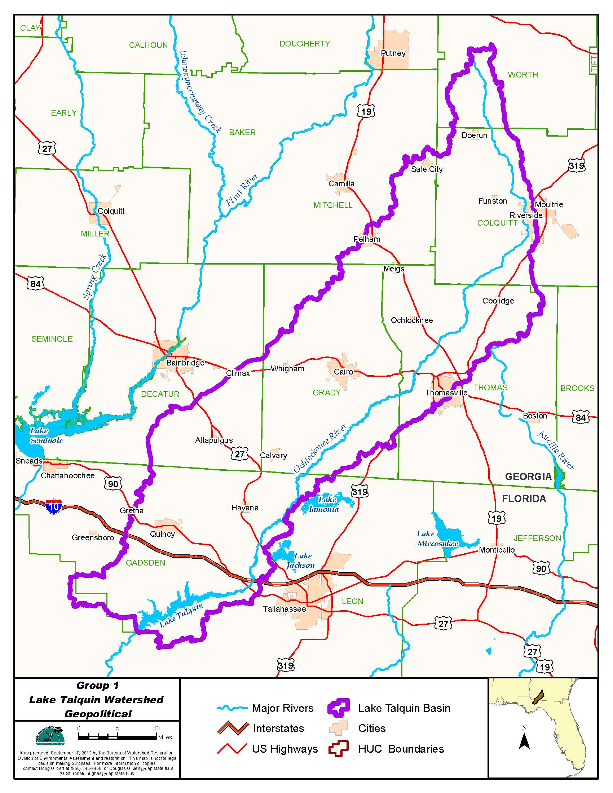

Figure B.1.1. Location of the Lake Talquin Watershed in the Ochlockonee/St. Marks Basin

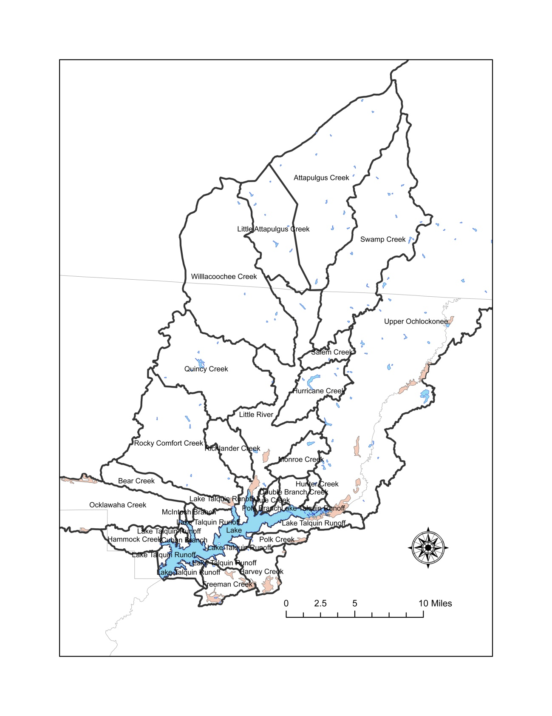
Figure B.1.2. Lake Talquin Watershed Subbasins

Table B.1.1. Lake Talquin Subbasin Area and Data Review
- equals empty cell no data

Lake Talquin Watershed Subbasin | WBID | Inlet to Lake Talquin | Assessed | Acres | SqMile | Percent of Watershed
Upper Ochlockonee | 1297E | Y | Y | 690204.8 | 1078.4 | 69.3
Hunter Creek | 787 | Y | ND | 1590.9 | 2.5 | 0.2
Double Branch Creek | 798 | Y | ND | 2678.7 | 4.2 | 0.3
Mule Creek | 804 | Y | ND | 1271.6 | 2.0 | 0.1
Pole Branch | 831 | Y | ND | 504.1 | 0.8 | 0.1
Little River | 424 | Y | Y | 24357.4 | 38.1 | 2.4
Attapulgus Creek (to the Little River) | Georgia | N | 2013 Study | 41089.1 | 64.2 | 4.1
Little Attapulgus Creek (to Attapulgus) | Georgia | N | 2013 Study | 15957.7 | 24.9 | 1.6
Swamp Creek (to Little River) | 427 | N | N | 36558.6 | 57.1 | 3.7
Salem Creek (to Little River) | 480 | N | N | 3537.0 | 5.5 | 0.4
Willacoochee Creek (to Little River) | 410 | N | N | 41591.6 | 65.0 | 4.2
Quincy Creek (to Little River) | (1303 and 1303a) | N | N | 25110.5 | 39.2 | 2.5
Hurricane Creek (to Little River) | 540 | N | N | 8208.5 | 12.8 | 0.8
Monroe Creek (to Little River) | 711 | N | N | 5204.2 | 8.1 | 0.5
Richlander Creek | 680 | Y | Y | 5801.6 | 9.1 | 0.6
Rocky Comfort Creek | 1304 | Y | Y | 27760.2 | 43.4 | 2.8
Bear Creek | 757 | Y | Y | 7582.7 | 11.9 | 0.8
Bear Creek Outlet | (part of 757) | Y | Y | 18301.3 | 28.6 | 1.8
McIntosh Branch (between Bear and Ocklawaha) | 849 | Y | ND | 490.8 | 0.8 | 0.0
Cuban Branch | (part of 1297C) | Y | ND | 689.6 | 1.1 | 0.1
Ocklawaha Creek | 811 | Y | Y | 19884.1 | 31.1 | 2.0
Hammock Creek | 879 | Y | Y | 4466.9 | 7.0 | 0.4
Freeman Creek | 954 | Y | Y | 4970.8 | 7.8 | 0.5
Harvey Creek | 921 | Y | Y | 5297.4 | 8.3 | 0.5
Polk Creek | 896 | Y | Y | 2806.4 | 4.4 | 0.3
Total Watershed | - | - | - | 995,916.6 | 1,556.2 | 100.0
Lake Talquin | 1297C and 1297D | N | Y | 8189.3 | 12.8 | -
Ochlockonee River below Lake Talquin | 1297B | N | Y | - | - | -

Table B.1.2. Lake Talquin Watershed Area Florida and Georgia
- equals empty cell no data

Watershed | Sq miles | Percent
Total area | 1556.2 | 100.0
Florida | 418.7 | 26.9
Georgia | 1137.5 | 73.1
- | - | -
Ochlockonee River | 1078.4 | 69.3
Little River | 315.0 | 20.2
All Other | 162.7 | 10.5

B.2 Rainfall
The annual average rainfall during 1980 – 2012 was 58.7 inches. From 2006 through 2012 (modeled period), years within an inch of the long-term average were considered as average years and include 2009 (58.1), 2010 (58.6), and 2012 (59.3). Dry years would be years with annual average rainfall less than 57.7 inches and includes 2006 (49.4), 2007 (44.5), and 2011 (34.8). The year 2011, with only 34.8 inches of rainfall, was the driest year during the period examined (1980 - 2012. Wet years would be years with greater than 59.7 inches of rainfall and includes 2008 (60.4). The period 2006 through 2012 included one wet year, three dry years, and three average years (Figure B.2.3, Table B.2.1).

From the data in Figure B.2.4, it can be seen that each year starts with increasing rainfall through March, followed by a drier period in April and May (among the driest months of the year). The months of June, July, and August are the wettest months.

B.2 Rainfall Tallahassee Regional Airport 1980 - 2013

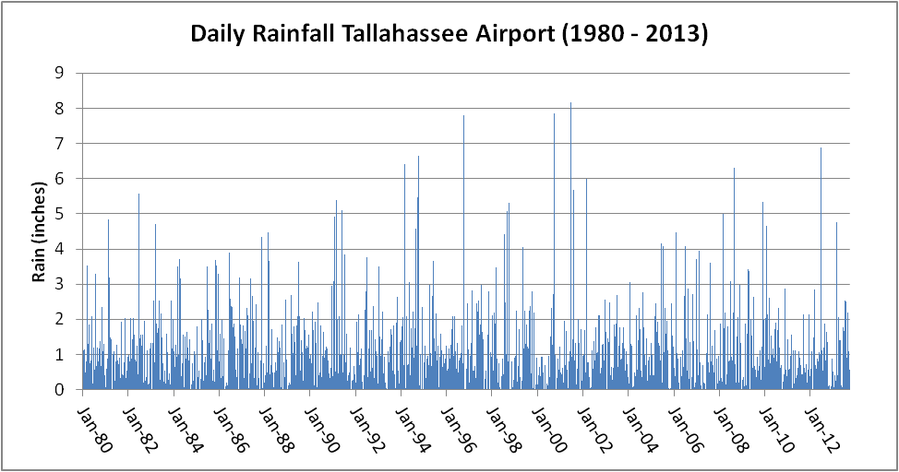

Figure B.2.1 Daily Rainfall 1980 – 2013 Tallahassee Regional Airport

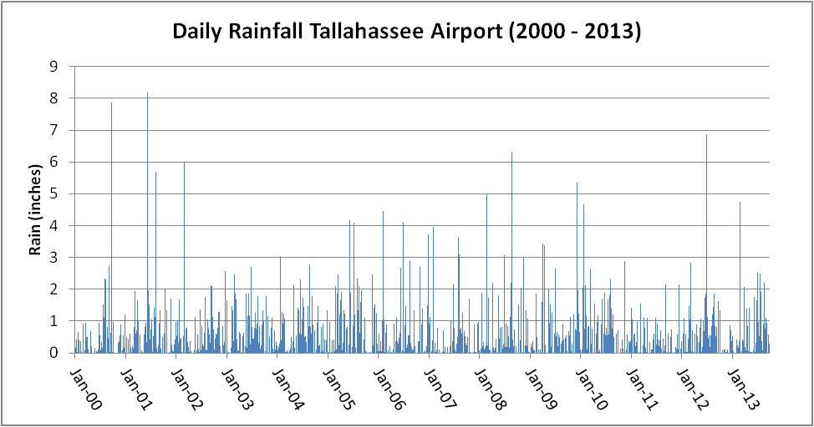

Figure B.2.2 Daily Rainfall 2000 – 2013 Tallahassee Regional Airport

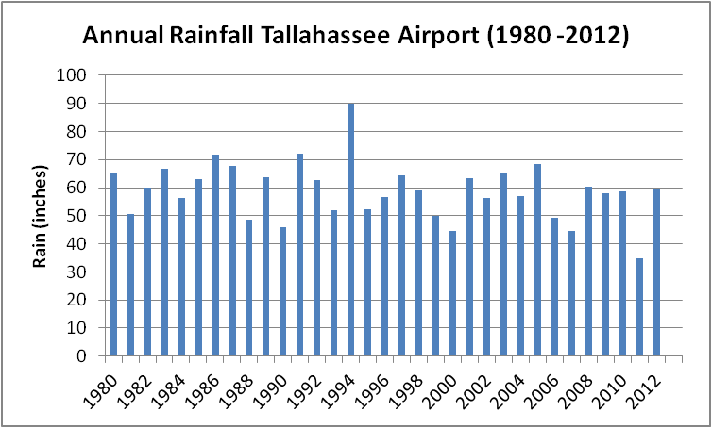

Figure B.2.3 Annual Average Rainfall 1980 – 2012 Tallahassee Regional Airport

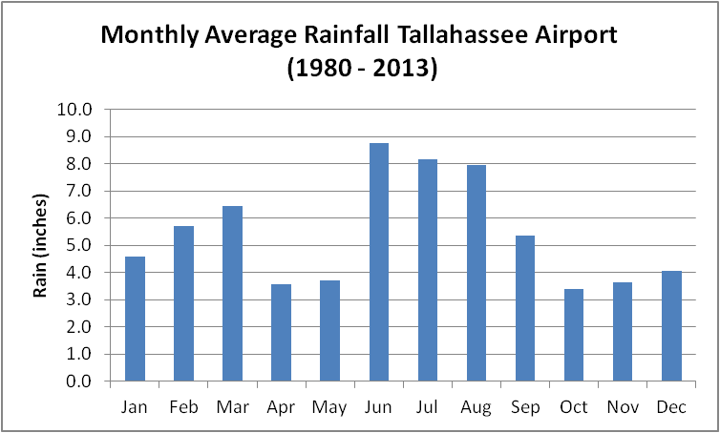

Figure B.2.4 Monthly Average Rainfall Tallahassee Regional Airport

Table B.2.1. Annual Rainfall Tallahassee Regional Airport

Year | Rain (inches)
1980 | 65.1
1981 | 50.7
1982 | 60.1
1983 | 66.9
1984 | 56.2
1985 | 62.9
1986 | 71.8
1987 | 67.8
1988 | 48.5
1989 | 63.6
1990 | 45.7
1991 | 72.3
1992 | 62.8
1993 | 52.0
1994 | 89.9
1995 | 52.4
1996 | 56.7
1997 | 64.3
1998 | 58.9
1999 | 50.1
2000 | 44.5
2001 | 63.5
2002 | 56.4
2003 | 65.3
2004 | 56.9
2005 | 68.3
2006 | 49.4
2007 | 44.5
2008 | 60.4
2009 | 58.1
2010 | 58.6
2011 | 34.8
2012 | 59.3
Average | 58.7

Table B.2.2. Monthly Rainfall Tallahassee Regional Airport

Month | Rain (inches)
Jan | 4.6
Feb | 5.7
Mar | 6.5
Apr | 3.6
May | 3.7
Jun | 8.8
Jul | 8.2
Aug | 8.0
Sep | 5.4
Oct | 3.4
Nov | 3.6
Dec | 4.1

B.3 River Flows

Below are all of the tables and figures for the daily average measured flows at Ochlocknee River above Lake Talquin (Hwy 27, near Havana, FL, USGS gage 02329000), Little River just above Lake Talquin (Hwy 268, near Midway, FL, USGS gage 02329600), Ochlockonee River below Lake Talquin (just below Hwy 20, near Bloxam, FL., USGS gage 02330000), and spot flow measurements on Richlander Creek (State RD. 65B), Rocky Comfort Creek (State Rd. 65B), Bear Creek (Hwy 267), and Ocklawaha Creek (Hwy 267).

From the data in Figure B.3.7 and Table B.3.1, it can be seen that the Ochlockonee River average flow of 766.7 cfs is slightly greater than 3 times the average flow of 254.5 cfs for the Little River and that while there are ~ 13 small streams flowing into the lake, the two main rivers make up 84.7 percent of the outflow from the lake (Figure B.3.11 and Table B.3.1. The monthly average flow in Figure B.3.12, shows that the highest flows occur from January through April with a large drop in flow during May, corresponding to the drop in rainfall during April and May, slightly increasing through August and then declining through the fall lagging a bit with monthly rainfall (Figure B.2.4). There are 13 small streams that discharge directly to Lake Talquin, of these four have had flows measured sporadically between 1956 and 2013. As can be seen on Figures B.3.11 through B.3.20 and Table B.3.1. these data indicate that the flows from these small streams may make up only 6.6% of the outflow from the lake and that Ocklawaha Creek with an average flow of 49 cfs makes up about 60% of the flow from these streams.

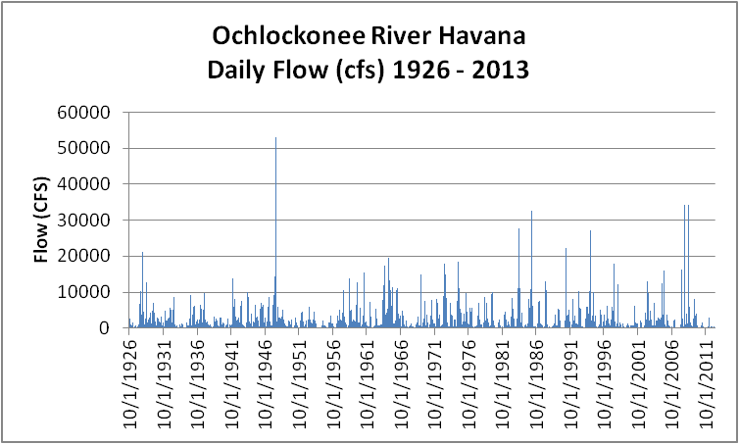
Figure B.3.1. Ochlockonee River Daily Flow Above Lake Talquin 1926 - 2013

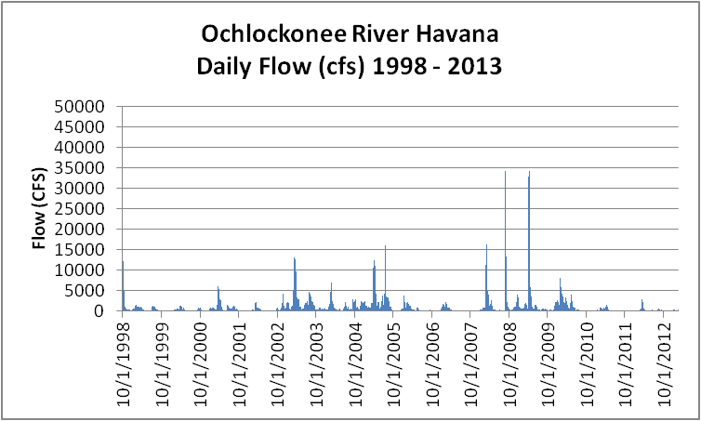

Figure B.3.2. Ochlockonee River Daily Flow Above Lake Talquin 1998 - 2013

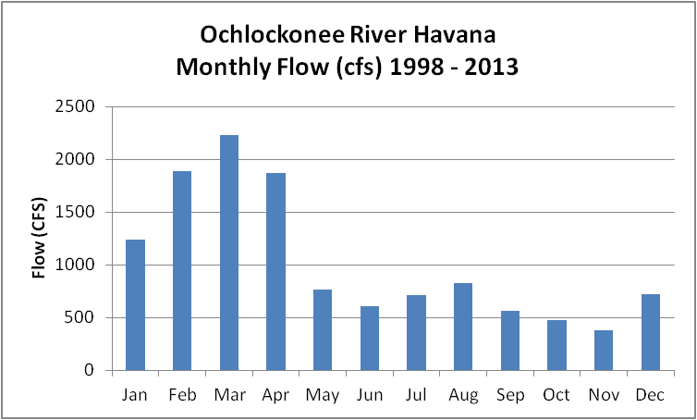

Figure B.3.3. Ochlockonee River Monthly Flow Above Lake Talquin 1998 - 2013

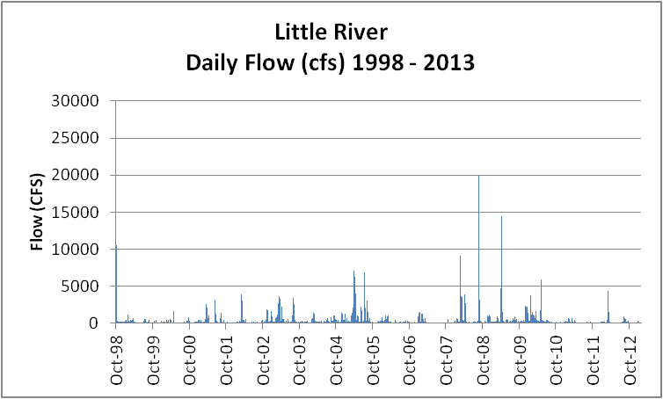

Figure B.3.4. Little River Daily Flow into Lake Talquin 1998 - 2013

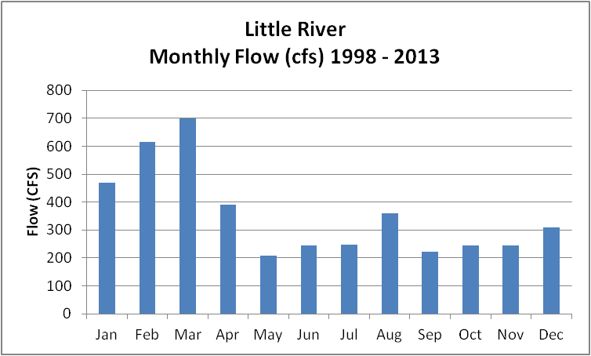
Figure B.3.5. Little River Monthly Flow into Lake Talquin 1998 - 2013

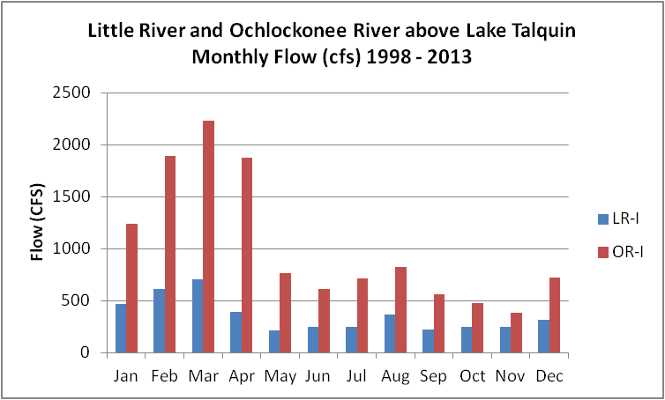

Figure B.3.6. Little and Ochlockonee River Monthly Flow into Lake Talquin 1998 - 2013

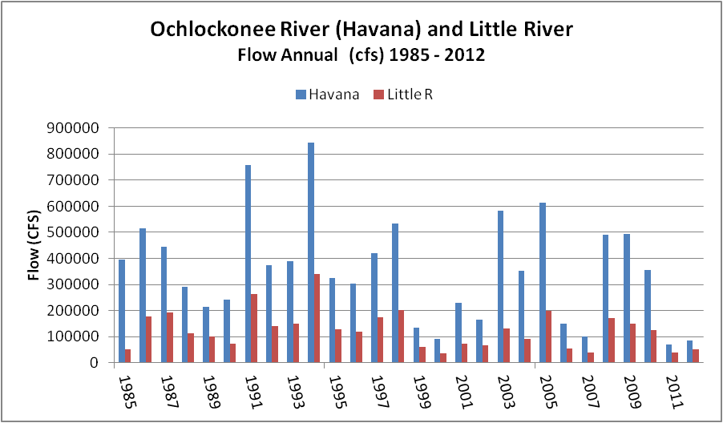

Figure B.3.7. Little and Ochlockonee River Annual Flow into Lake Talquin 1985 - 2013

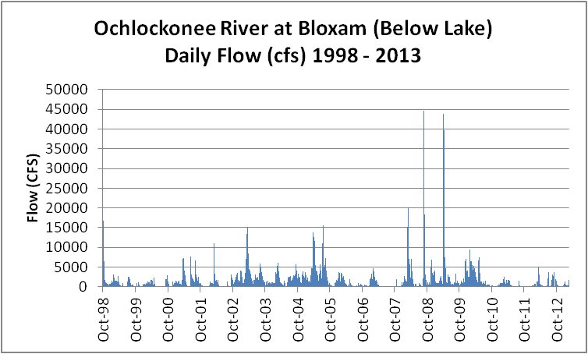

Figure B.3.8. Ochlockonee River Daily Flow out of Lake Talquin 1998 - 2013

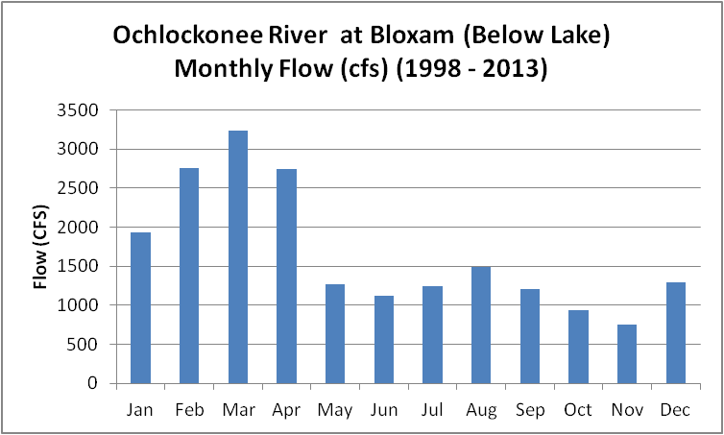

Figure B.3.9. Ochlockonee River Monthly Flow out of Lake Talquin 1998 - 2013

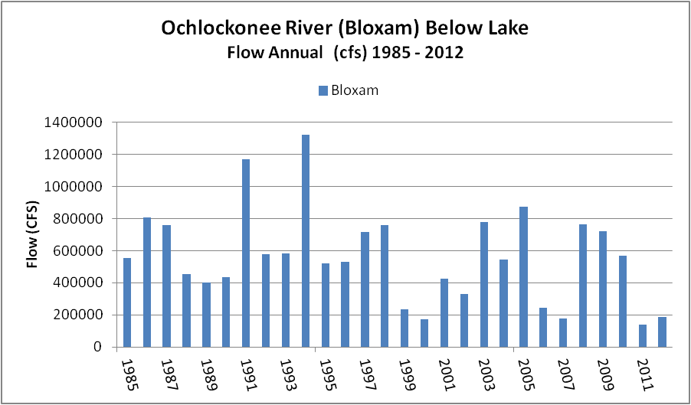

Figure B.3.10. Ochlockonee River Annual Flow out of Lake Talquin 1998 - 2013

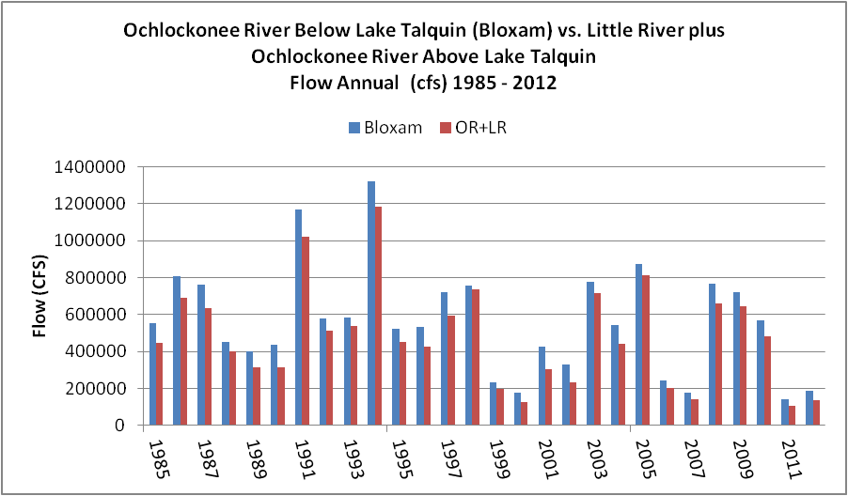

Figure B.3.11. Little and Ochlockonee River Annual Flow In and Ochlockonee River Flow out of Lake Talquin 1985 - 2013

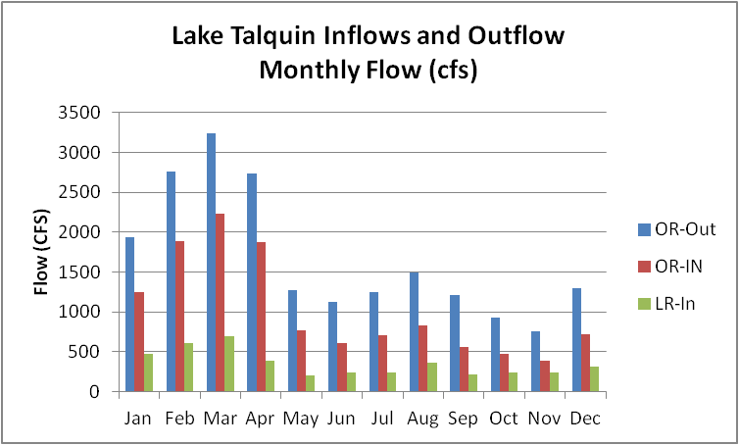

Figure B.3.12. Little and Ochlockonee River Monthly Flow In and Ochlockonee River Flow out of Lake Talquin 1985 - 2013

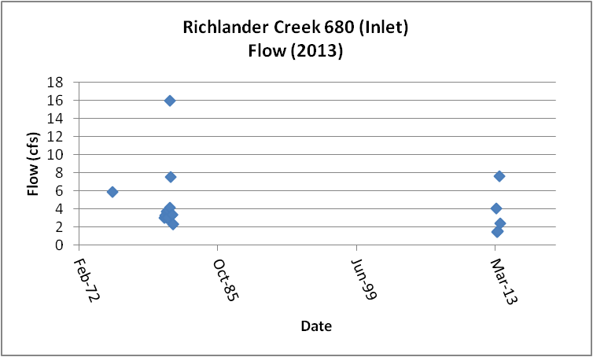

Figure B.3.13. Richlander Creek Measured Flow (cfs) 1975 – 2013

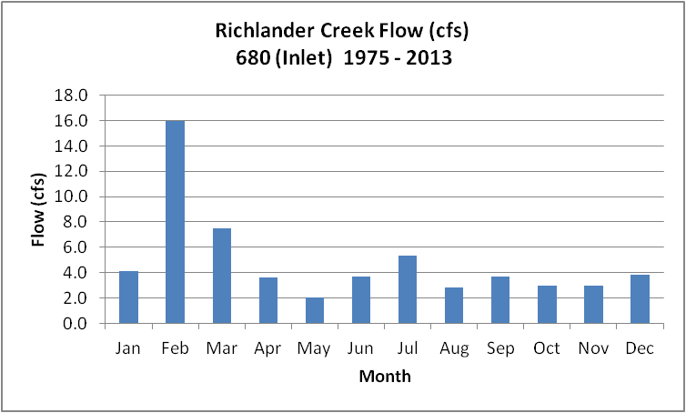

Figure B.3.14. Richlander Creek Monthly Average Flow (cfs) 1975 – 2013

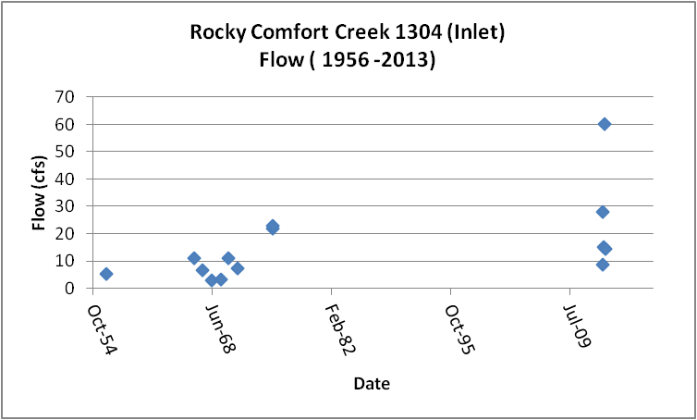
Figure B.3.15. Rocky Comfort Creek Measured Flow (cfs) 1975 – 2013

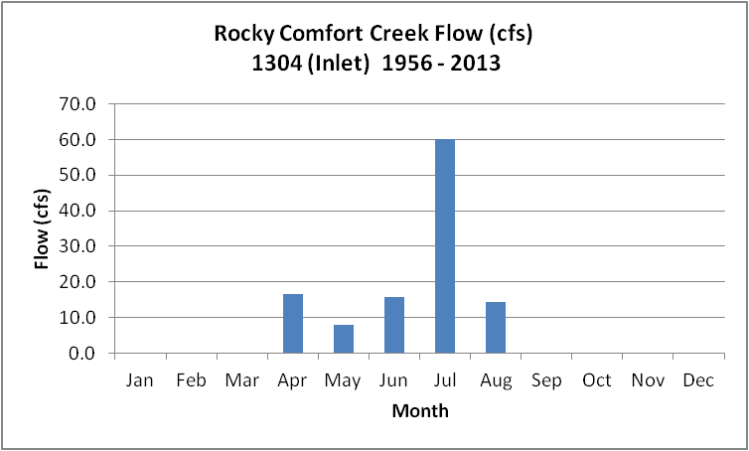
Figure B.3.16. Rocky Comfort Creek Monthly Average Flow (cfs) 1956 – 2013

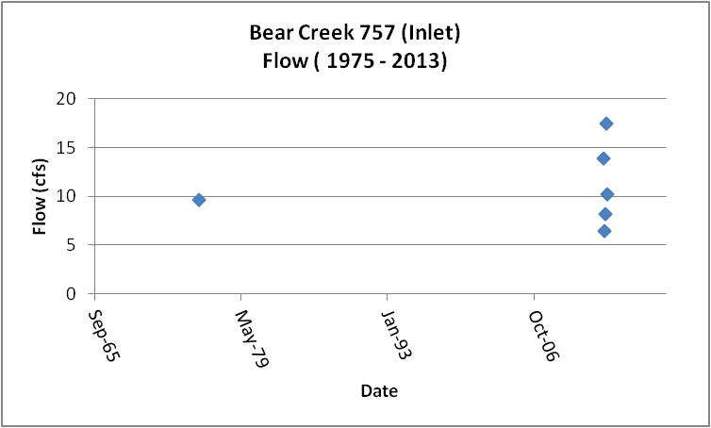
Figure B.3.17. Bear Creek Measured Flow (cfs) 1975 – 2013

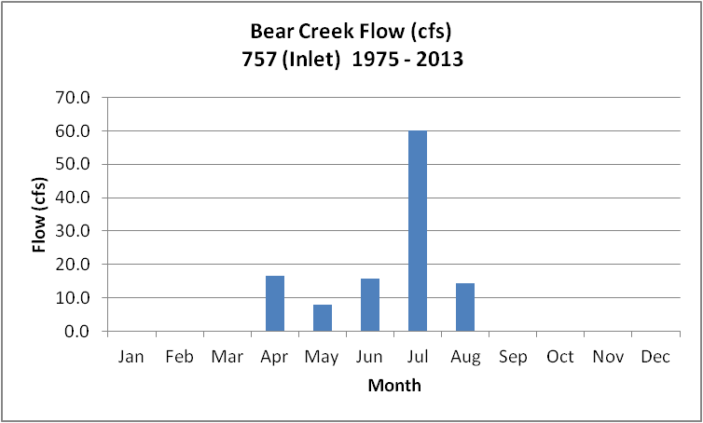
Figure B.3.18. Bear Creek Monthly Average Flow (cfs) 1975 – 2013

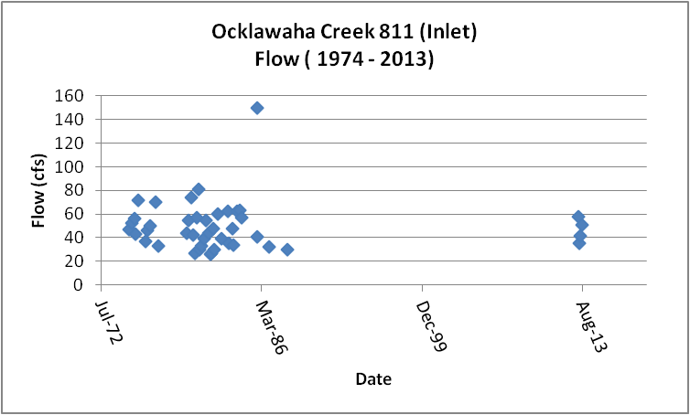
Figure B.3.19. Ocklawaha Creek Measured Flow (cfs) 1974 – 2013

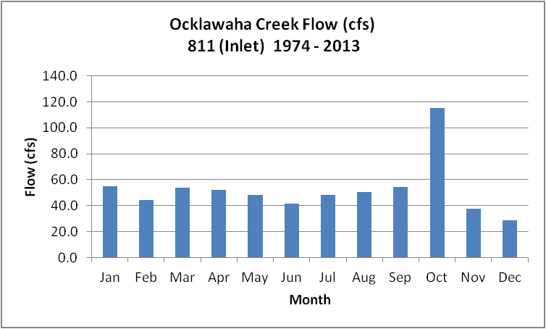
Figure B.3.20. Ocklawaha Creek Monthly Average Flow (cfs) 1974 – 2013

Table B.3.1. Flow Summaries
- equals empty cell no data
Category | unit | Ochlockonee River at Concord | Ochlockonee River at Havana | Little River | Ochlockonee + Little River | Richlander | Rocky Comfort | Bear | Ocklawaha | Ochlockonee River at Bloxam
- | - | 10/1/1998-2/1/2013 | 10/1/1998-2/1/2013 | 10/1/1998-2/1/2013 | 10/1/1998-2/1/2013 | 1975 -2013 (20 results) | 1956 -2013 (14 results) | 1975 -2013 (6 results) | 1974 -2013 (43 results) | 10/1/1998-2/1/2013
Min | cfs | 6.8 | 9.4 | 4.3 | - | 1.5 | 3.0 | 6.5 | 26.0 | 39.0
Max | cfs | 44,500.0 | 34,300.0 | 20,000.0 | - | 16.0 | 60.1 | 17.5 | 150.0 | 44,600.0
Median | cfs | 248.0 | 290.0 | 116.0 | 406.0 | 3.4 | 11.0 | 9.9 | 46.0 | 559.0
Mean | cfs | 770.3 | 766.7 | 254.5 | 1,021.2 | 4.3 | 15.6 | 11.0 | 49.2 | 1,205.6
10th | cfs | 39.0 | 49.0 | 24.0 | 73.0 | 2.2 | 3.9 | 7.3 | 30.0 | 101.9
75th | cfs | 789.0 | 791.0 | 232.0 | 1,023.0 | 4.0 | 20.3 | 13.0 | 57.0 | 1,430.0
90th | cfs | 1,750.0 | 1,820.0 | 434.7 | 2,254.7 | 7.5 | 26.4 | 15.7 | 68.6 | 2,860.0
Count | - | 5250 | 5250 | 5234 | - | 20 | 14 | 6 | 43 | 5250

Table B.3.2. Flow and Load Estimates
- equals empty cell no data

Basin | Flow (mean) | Flow Percent- | TN-GM | TN | TN | TP-GM | TP | TP
- | cfs | Percent | (mg/L) | (lbs/day) | Percent Load | (mg/L) | (lbs/day) | Percent Load
OR-I | 797.7 | 66.2 | 1.05 | 4517.7 | 59.6 | 0.107 | 460.4 | 69.5
LR-I | 282.7 | 23.4 | 1.8 | 2744.7 | 36.2 | 0.102 | 155.5 | 23.5
Tribs-G | 80.1 | 6.6 | 0.54 | 233.3 | 3.1 | 0.097 | 41.9 | 6.3
Tribs-L* | 45.1 | 3.7 | 0.37 | 90.0 | 1.2 | 0.018 | 4.4 | 0.7
Total | 1205.6 | 100 | - | 7585.7 | 100 | - | 662.2 | 100
OR-O | 1205.6 | - | - | 4812.0 | - | - | 357.7 | -

B.4 Water Quality Data
Summary data is presented for subbasins draining directly to Lake Talquin, starting with WBID 1297E, the Ochlockonee River above Lake Talquin (OR-I) and proceeding in a counter clockwise direction around the lake following the order in Table B.1.1. Figure B.1.2 shows the location of each subbasin in Table B.1.1. Several streams are not described, as there is no data in IWR Run 47 for these watersheds. These include, Hunter Creek (WBID 787), Double Branch Creek (WBID 798), Mule Creek (WBID 804), Pole Branch (WBID 831), McIntosh Branch (WBID 849), and Cuban Branch (stations are in Lake Talquin WBID 1297C).

B.4A. Ochlockonee River Above Lake Talquin WBID 1297E
This WBID is not impaired for DO or nutrients.
Table B.4A.1, lists the 46 stations that have been sampled in the Upper Ochlockonee River (WBID 1297E) watershed. Figure B.4A.1 depicts the station locations.
Tables B.4A.5 and B.4A.6 and Figures B.4A.4 and B.4A.5, provide the results for alkalinity. These data show that the Ochlockonee River above Lake Talquin has a period of record (POR) geomean (GM) alkalinity of 16.7 mg/L. The data indicate that the alkalinity for the period (2005 – 2013) is elevated over the POR (GM 29.0 mg/L vs. 16.7 mg/L). The seasonal pattern indicates that the alkalinity is lowest in the first three months of the year (~10.0 mg/L) and gradually increases through the year to high in November of 30.0 mg/L. This pattern for alkalinity is inversely related to river flow (highest in first three months of the year Figure B.3.12).
Tables B.4A.5 and B.4A.6 and Figures B.4A.6 and B.4A.7, provide the results for true color. These data show that the Ochlockonee River above Lake Talquin has a POR GM color of 62.5 PCU. The data indicate that the GM color for the period (2005 – 2013) of 61.7 PCU is similar to the POR color. The seasonal pattern indicates that the color is highest in the first half of the year (~80.0 PCU) with an average color for July of over 100 PCU, then decreasing through the fall and early winter. This pattern for color appears to be weakly related to river flow (highest color in first half of year when flows are higher and lower in the second half of the year Figure B.3.12).
Tables B.4A.5 and B.4A.6 and Figures B.4A.9 through B.4A.12, provide the results for TN. These data show that the Ochlockonee River above Lake Talquin has a POR GM TN of 0.92 mg/L. The data (Figure B.4A.11) indicate that the recent (2005 – 2013) TN GM of 1.05 mg/L is slightly greater than the TN GM for the POR and the new threshold AGM concentration for TN in the Panhandle East nutrient Watershed Region of 1.03 mg/L. The data also indicate that the overall trend is for declining AGM TN concentrations. This trend is driven by the relatively higher AGM concentrations that occurred from 1980 through 1990. The seasonal pattern indicates that the TN concentration increases from January through April, declines through July, increases through October and the declines to January. This pattern for TN, high in April and October is not clearly related to rainfall and flow (Figures B.2.4 and B.3.12).
Tables B.4A.5 and B.4A.6 and Figures B.4A.13 and B.4A.14, provide the results for NH4-N. These data show that the Ochlockonee River above Lake Talquin has a POR GM NH4-N of 0.061 mg/L. The data indicate that the recent (2005 – 2013) NH4-N GM of 0.036 mg/L is about half of the POR concentration and that the overall trend is for declining concentrations. This trend is driven by the relatively higher concentrations that occurred up until ~1996.
Tables B.4A.5 and B.4A.6 and Figures B.4A.15 and B.4A.16, provide the results for NO23-N. These data show that the Ochlockonee River above Lake Talquin has a POR GM NO23-N of 0.316 mg/L. The data indicate that the recent (2005 – 2013) NO23-N GM of 0.329 mg/L is about the same as the POR concentration and that there does not appear to be a trend for this constituent.
Tables B.4A.5 and B.4A.6 and Figures B.4A.18 through B.4A.21, provide the results for TP. These data show that the Ochlockonee River above Lake Talquin has a POR GM TP of 0.158 mg/L. The data (Figure B.4A.20) indicate that the recent (2005 – 2013) TP GM of 0.107 mg/L is slightly less than the TP GM for the POR and the new threshold AGM concentration for TP of 0.18 mg/L. The data also indicate that the overall trend is for declining AGM TP concentrations. This trend is driven by the relatively higher AGM concentrations that occurred from 1972 through 1990. The seasonal pattern indicates that the TP concentration decrease slightly from January through March, are slightly higher from April through August and highest during the fall and early winter. This pattern for TP is not clearly related to rainfall or flow (Figures B.2.4 and B.3.12).
Tables B.4A.5 and B.4A.6 and Figures B.4A.22 and B.4A.23, provide the results for PO4-P. These data show that the Ochlockonee River above Lake Talquin has a POR GM PO4-P of 0.12 mg/L. The data indicate that the recent (2005 – 2013) PO4-P GM of 0.046 mg/L is less than half of the POR concentration and that the overall trend is for declining concentrations. This trend is driven by the relatively higher concentrations that occurred up until ~1996.
Tables B.4A.5 and B.4A.6 and Figures B.4A.24 through B.4A.27, provide the results for CChla. These data show that the Ochlockonee River above Lake Talquin has a POR GM CChla of 2.2 ug/L. The data (Figure B.4A.26) indicate that the recent (2005 – 2013) CChla GM of 2.5 ug/L is not significantly different from the CChla GM for the POR and significantly less than the new threshold AGM concentration for CChla of 20.0 ug/L. The data also indicate that the overall trend is for increasing AGM CChla concentrations. This trend is driven by the relatively higher AGM concentration of ~10.0 ug/L that occurred in 2011. The seasonal pattern indicates that the CChla concentrations peak in May decrease significantly in June, increasing through August, then are reduced in September and October, increased during November and back down in December. This pattern may be influenced by varying detection limits over time and by data provider. The pattern in CChla appears partially related to rainfall and flow (Figures B.2.4 and B.3.12), with increasing flow/rain corresponding, in general, to periods of decreasing CChla concentrations.
Tables B.4A.5 and B.4A.6 and Figures B.4A.28 through B.4A.30, provide the results for BOD5. These data show that the Ochlockonee River above Lake Talquin has a POR GM BOD5 of 1.3 mg/L. The data indicate that the recent (2005 – 2013) BOD5 GM of 1.9 mg/L is not significantly different than the POR concentration. Variable detection limits over time may be having an influence on the data. There is no apparent overall trend.
Tables B.4A.5 and B.4A.6 and Figures B.4A.31 and B.4A.32, provide the results for DO. These data show that the Ochlockonee River above Lake Talquin has a POR GM DO of 6.2 mg/L. The data indicate that the recent (2005 – 2013) DO GM of 6.6 mg/L is not significantly different than the POR concentration. There is no apparent overall trend in time. Seasonal data indicate that the monthly average DO is always over 5.0 mg/L (Figure B.4A.32).
Tables B.4A.5 and B.4A.6 and Figures B.4A.33 through B.4A.35, provide the results for percent DO saturation. These data show that the Ochlockonee River above Lake Talquin has a POR GM DOSAT of 71.9 percent. The data indicate that the recent (2005 – 2013) DOSAT GM of 74.9 percent is slightly higher than the GM for the POR. The data do not appear to have a long-term trend. The data presented in Figure B.4A.33 indicates that there are sufficient results below the new 67% saturation DO criterion to warrant further investigation. The seasonal pattern indicates that the DOSAT is lowest in April and highest in June and November.

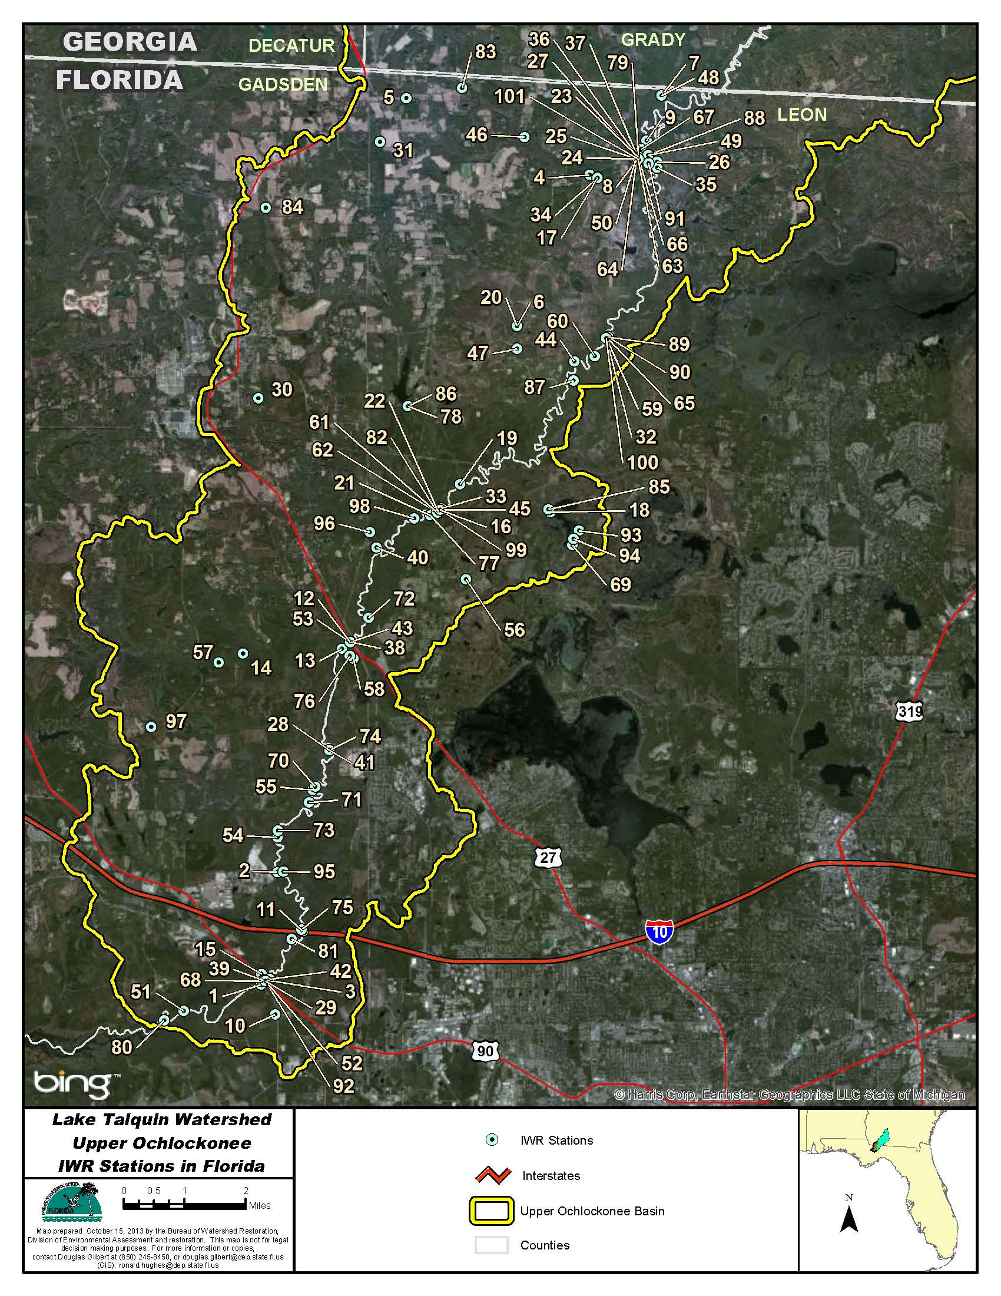
Figure B.4A.1. Ochlockonee River WBIDs 1297E and 1297F Station Locations

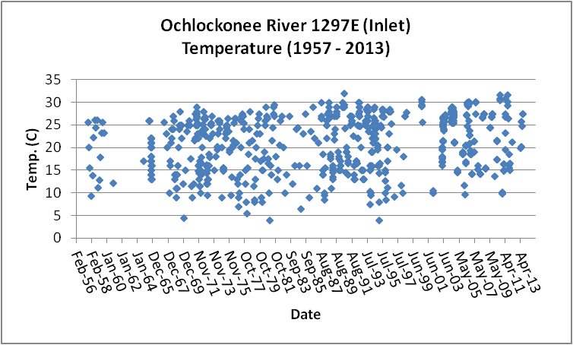
Figure B.4A.2. Ochlockonee River WBID 1297E Daily Average Temperature 1957 - 2013
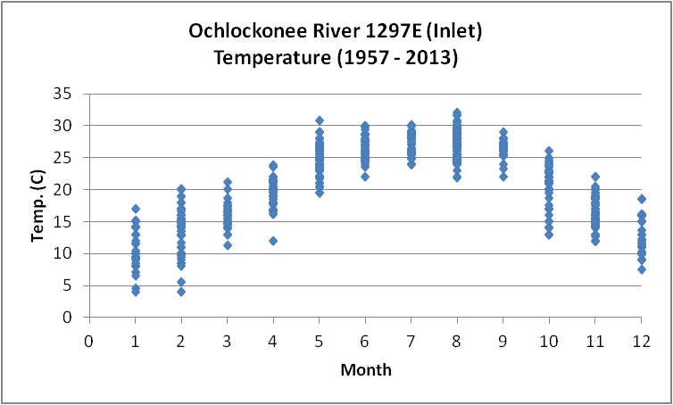
Figure B.4A.3. Ochlockonee River WBID 1297E Monthly Temperature 1957 - 2013

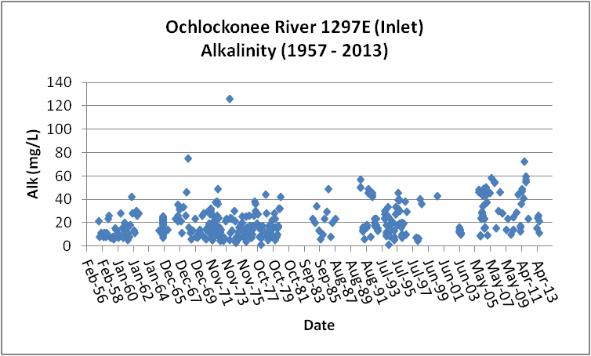
Figure B.4A.4. Ochlockonee River WBID 1297E Daily Average Alkalinity 1957- 2013

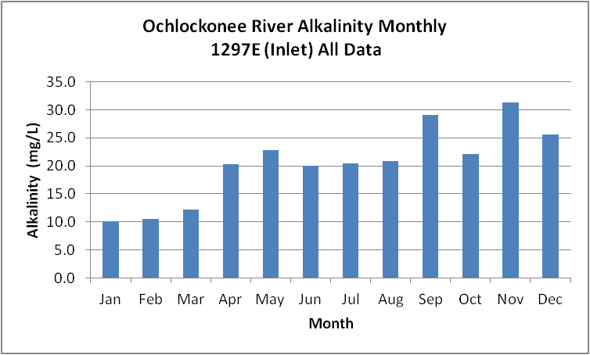
Figure B.4A.5. Ochlockonee River WBID 1297E Monthly Average Alkalinity 1957- 2013

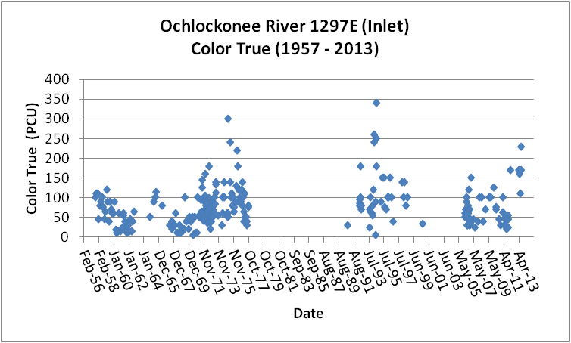
Figure B.4A.6. Ochlockonee River WBID 1297E Daily Average True Color 1957- 2013

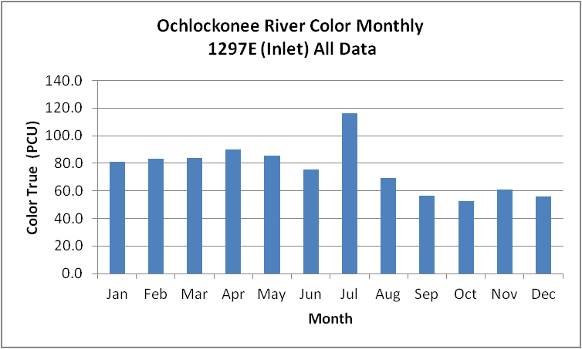
Figure B.4A.7. Ochlockonee River WBID 1297E Monthly Average True Color 1957- 2013

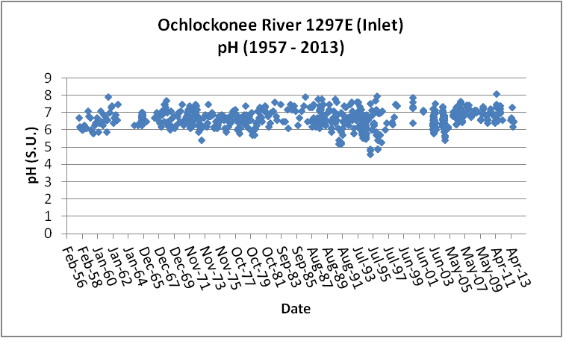
Figure B.4A.8. Ochlockonee River WBID 1297E Daily pH 1957- 2013

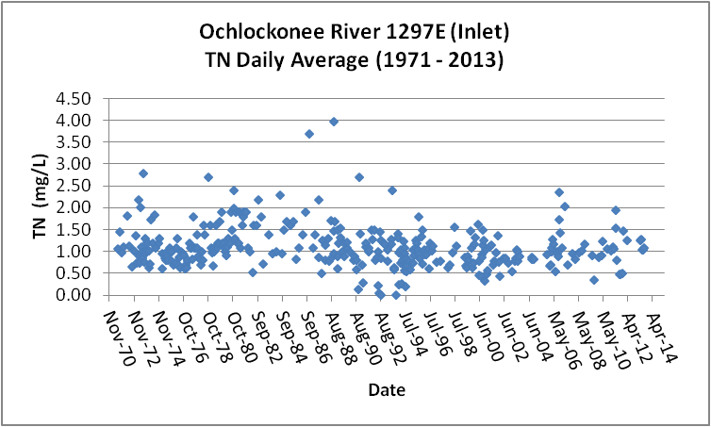
Figure B.4A.9. Ochlockonee River WBID 1297E Daily Average TN1971- 2013

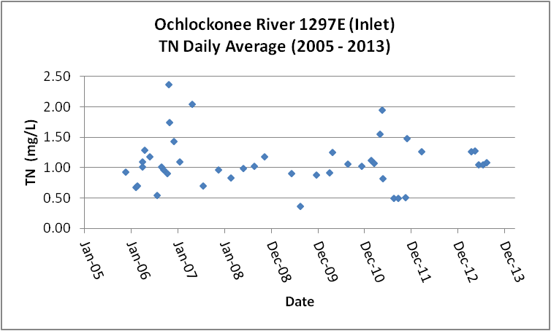
Figure B.4A.10. Ochlockonee River WBID 1297E Daily Average TN 2005- 2013

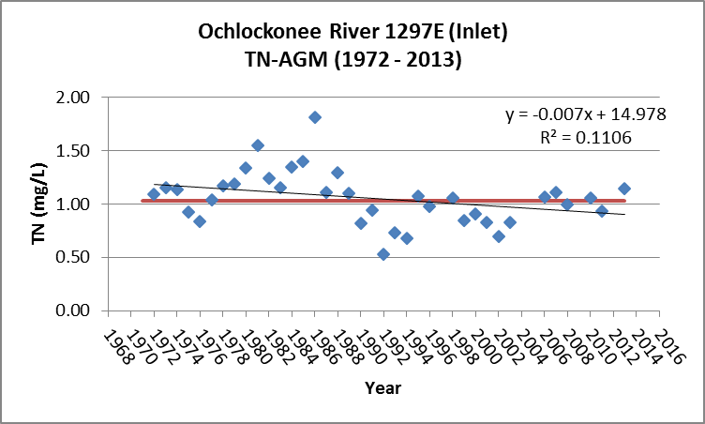
Figure B.4A.11. Ochlockonee River WBID 1297E TN Annual Geomean 1972- 2013

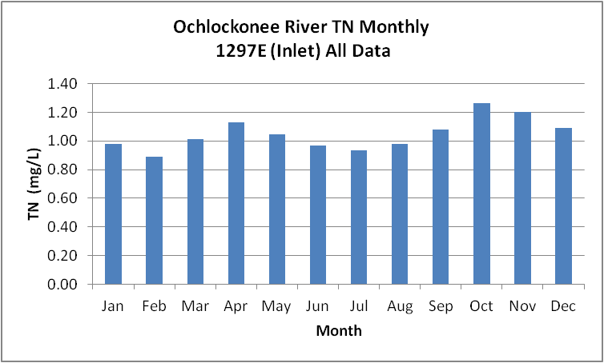
Figure B.4A.12. Ochlockonee River WBID 1297E Monthly Average TN 1972- 2013

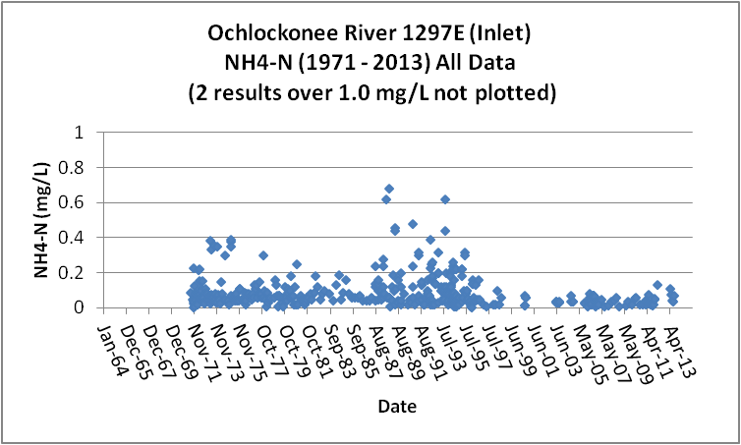
Figure B.4A.13. Ochlockonee River WBID 1297E Daily Average Ammonia-N 1971- 2013

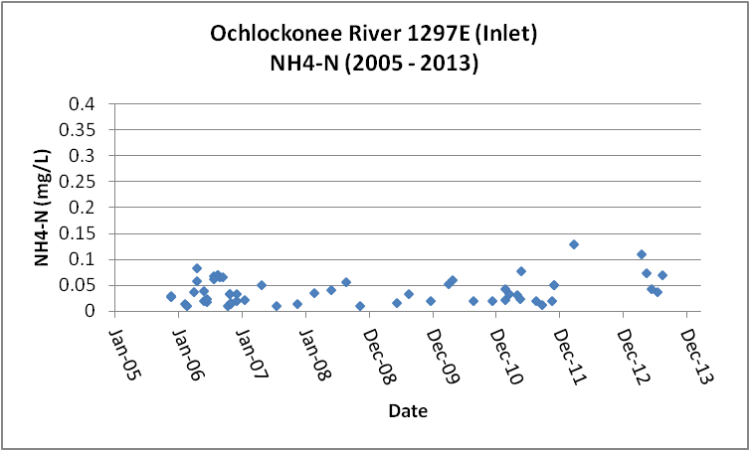
Figure B.4A.14. Ochlockonee River WBID 1297E Daily Average Ammonia-N 2005- 2013

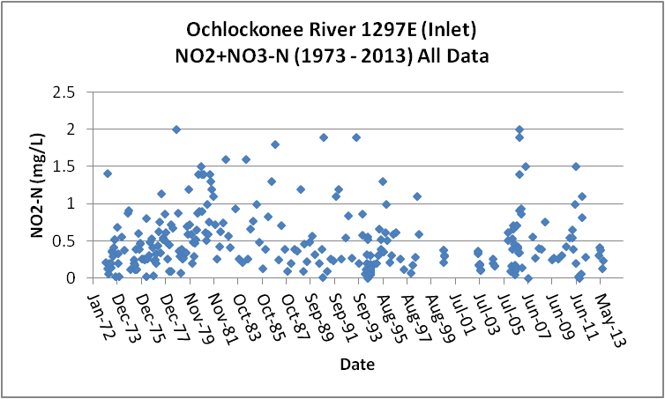
Figure B.4A.15. Ochlockonee River WBID 1297E Daily Average Nitrate/Nitrite-N 1973- 2013

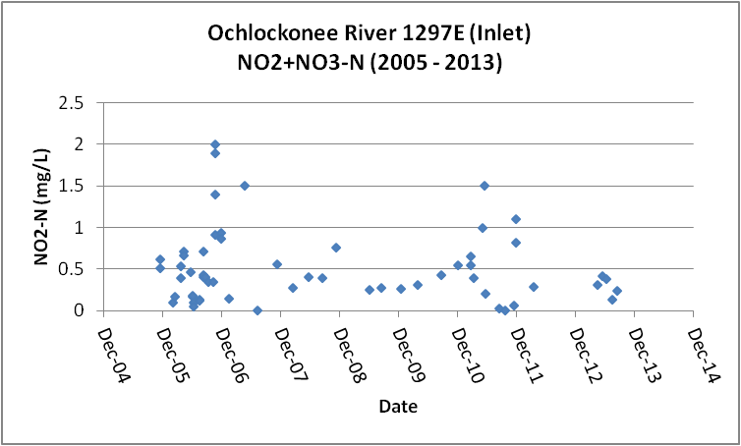
Figure B.4A.16. Ochlockonee River WBID 1297E Daily Average Nitrate/Nitrite-N2005- 2013

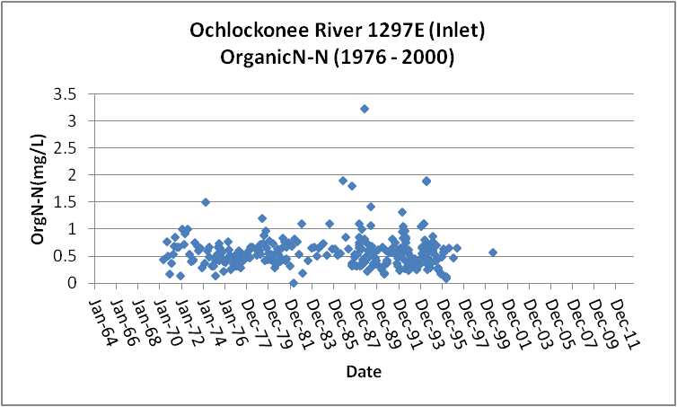
Figure B.4A.17. Ochlockonee River WBID 1297E Daily Average Organic-N 1976- 2000

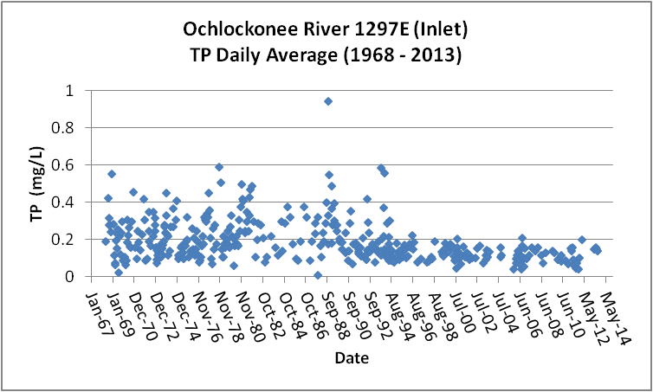
Figure B.4A.18. Ochlockonee River WBID 1297E Daily Average TP 1968 - 2013

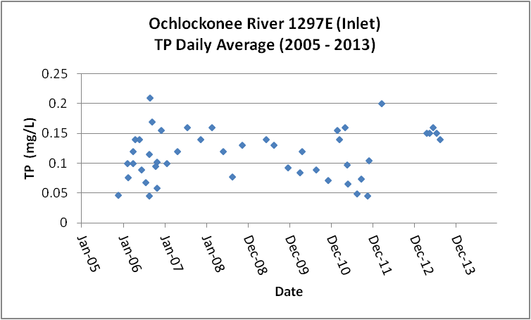
Figure B.4A.19. Ochlockonee River WBID 1297E Daily Average TP 2005 - 2013

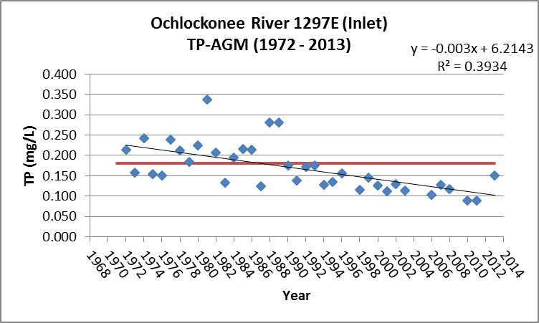
Figure B.4A.20. Ochlockonee River WBID 1297E Annual Geomean TP 1972 - 2013

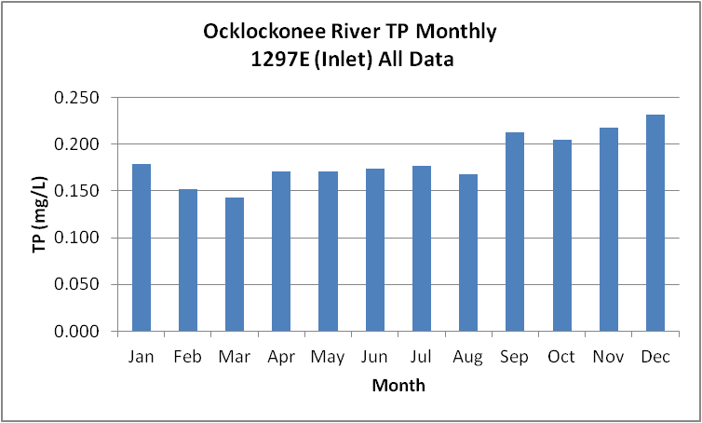
Figure B.4A.21. Ochlockonee River WBID 1297E Monthly Average TP 1968 - 2013

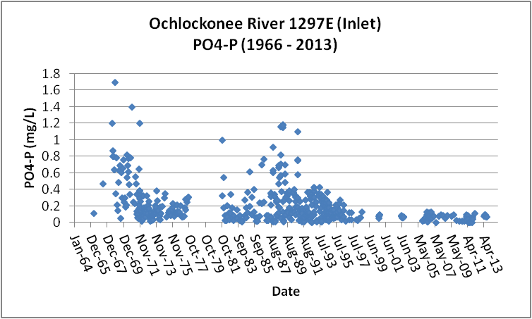
Figure B.4A.22. Ochlockonee River WBID 1297E Daily Average Orthophosphate-P 1966 - 2013

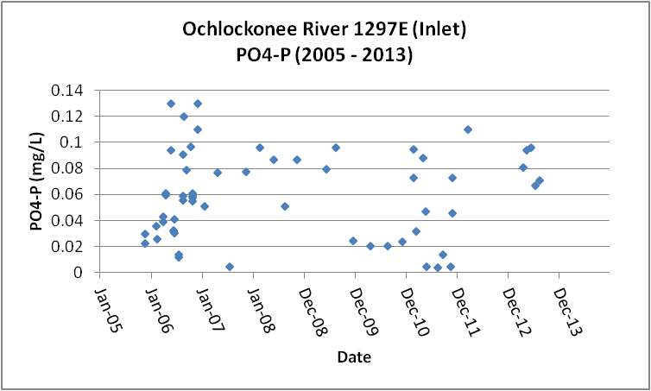
Figure B.4A.23. Ochlockonee River WBID 1297E Daily Average Orthophosphate-P 2005 - 2013

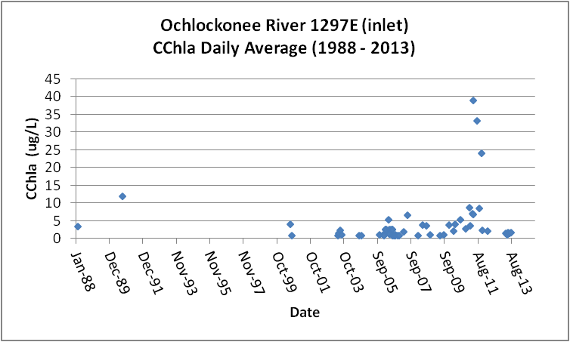
Figure B.4A.24. Ochlockonee River WBID 1297E Daily Average CChla 1988 - 2013

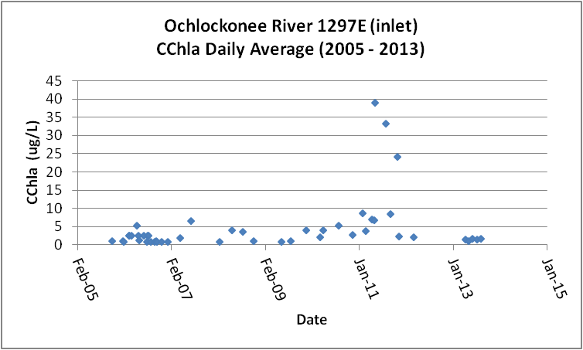
Figure B.4A.25. Ochlockonee River WBID 1297E Daily Average CChla 2005 - 2013

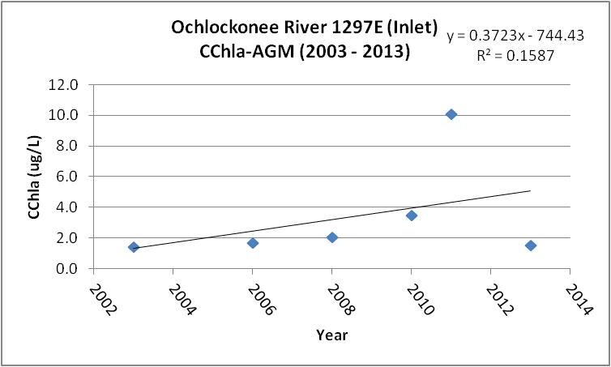
Figure B.4A.26. Ochlockonee River WBID 1297E Annual Geomean CChla 1988 - 2013

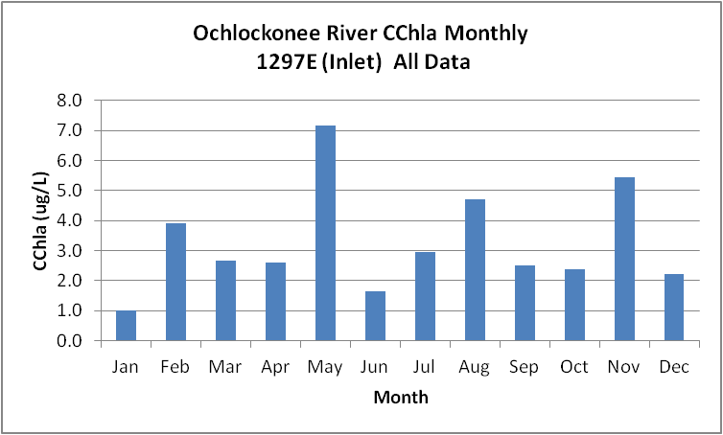
Figure B.4A.27. Ochlockonee River WBID 1297E Monthly Average CChla 1988 - 2013

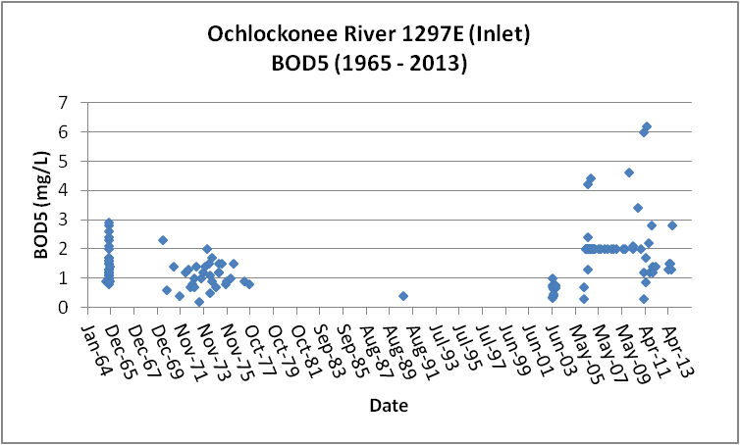
Figure B.4A.28. Ochlockonee River WBID 1297E Daily Average BOD5 1965 - 2013

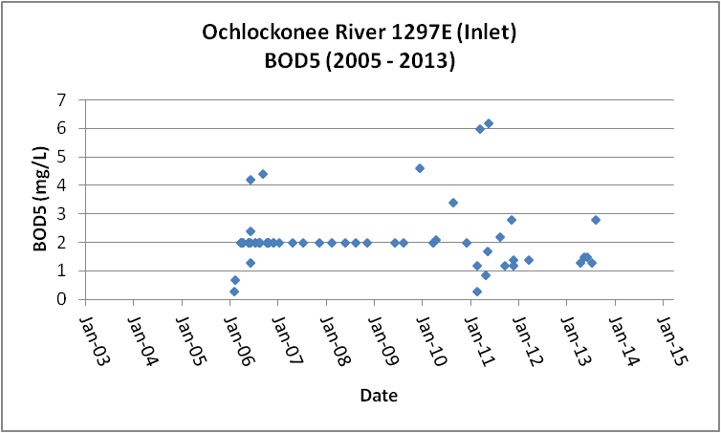
Figure B.4A.29. Ochlockonee River WBID 1297E Daily Average BOD5 2005 - 2013

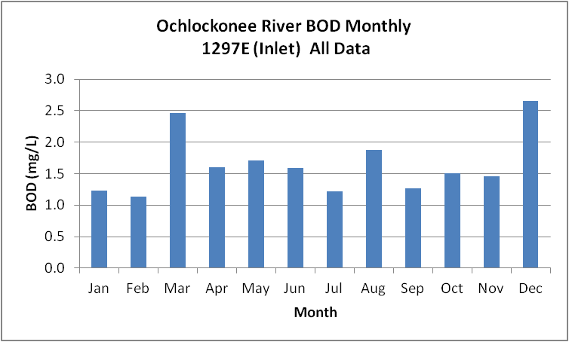
Figure B.4A.30. Ochlockonee River WBID 1297E Monthly Average BOD5 1965 - 2013

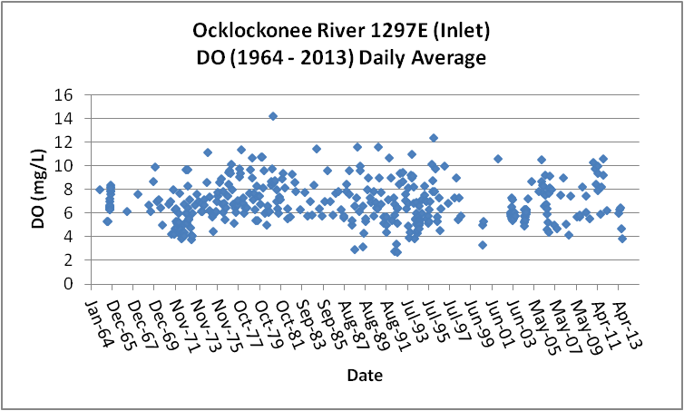
Figure B.4A.31. Ochlockonee River WBID 1297E Daily Average DO 1964 - 2013

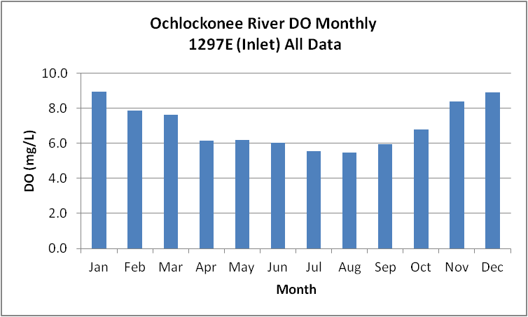
Figure B.4A.32. Ochlockonee River WBID 1297E Monthly Average DO 1964 - 2013

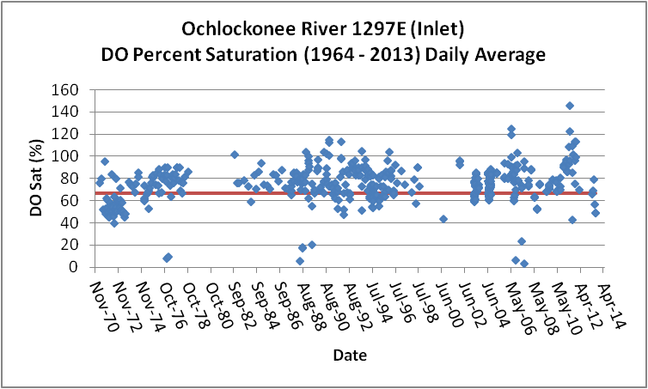
Figure B.4A.33. Ochlockonee River WBID 1297E Daily Average DO Percent Saturation 1964 - 2013

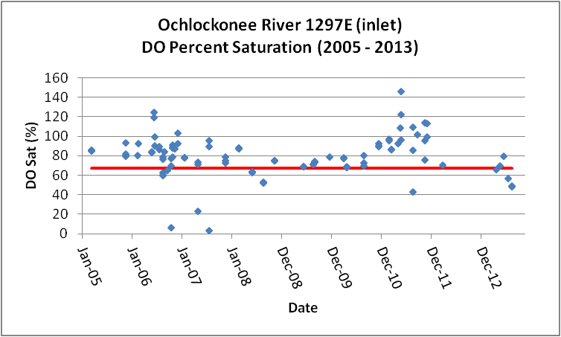
Figure B.4A.34. Ochlockonee River WBID 1297E Daily Average DO Percent Saturation 2005 - 2013

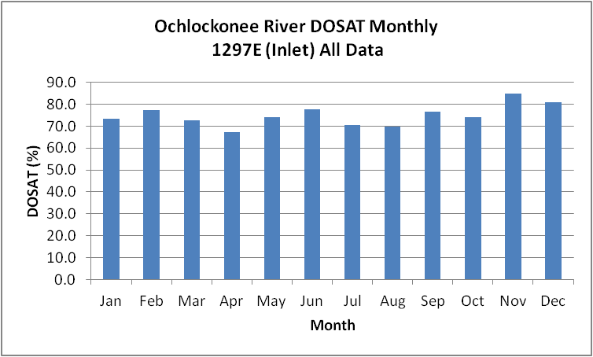
Figure B.4A.35. Ochlockonee River WBID 1297E Monthly Average DO Percent Saturation 1964 - 2013

Table B.4A.1. Ochlockonee River WBID 1297E Water Quality Stations
WBID | Station Number | Station Name | Begin Date | End Date
1297E | 21FLA 22020004 | OCHLOCKONEE R US 90 | 1964 | 1990
1297E | 21FLGW 8623 | NWA-HS-1003 OCHLOCKONEE RIVER | 2000 | 2000
1297E | 112WRD 02329252 | OCHLOCKONEE RIVER AT OCHLOCKONEE, FLA. | 1975 | 1975
1297E | 21FLPNS 22020077 | Three Pole Ck W of SR260, .31 mi S of US90 | 1995 | 1996
1297E | 21FLKWATLEO-OC-RIVER-3 | Leon-Ochlockonee River-3-3 | 1999 | 2003
1297E | 21FLGW S468 | OCHLOCKONEE R. NR HAVANA | 1997 | 1998
1297E | 21FLGW 22865 | NW1-LR-2024 OCHLOCKONEE RIVER | 2004 | 2004
1297E | 11EPALES1239E1 | OCHLOCKONEE RIVER | 1973 | 1974
1297E | 21FLWQA 303507108421337 | Ochlockonee River at SR 157 | 2002 | 2002
1297E | 21FLGFWFGFCNW0282 | OCHOLCKONEE RIVER NO. NEK. C-T ZONE ON PLOT | 1988 | 1989
1297E | 21FLBRA 1297E-C | 1297E - Ochlockonee River - 300m dwnstr of SR-153 | 2006 | 2006
1297E | 21FLA 22020013 | OCHLOCKONEE R OLD IRON BR FLA 15 | 1974 | 1975
1297E | 21FLPNS W0131 | Ochlockonee River At Tower Road (also 21FLFWF) | 0 | 0
1297E | 21FLLEONLCOC3047384407 | Ochlockonee River @ 90 | 2006 | 2010
1297E | 21FLBRA 1297E-B | 1297E - Ochlockonee River - At SR-153 | 2006 | 2006
1297E | 21FLWQA 303314308423028 | Ochlockonee River at US 27 | 2002 | 2002
1297E | 21FLMCGLTO1-90 | Ochlockonee River north of Lake Talquin off the Hi | 2000 | 2000
1297E | 21FLGFWFGFCNW0131 | OCHLOCKONEE RIVER AT TOWER ROAD | 1987 | 1996
1297E | 21FLBRA 1297E-A | 1297E - Ochlockonee River - 120m upstream or US 90 | 2006 | 2006
1297E | 112WRD 02329000 | OCHLOCKONEE RIVER NR HAVANA, FLA. | 1957 | 1997
1297E | 21FLMCGLT03 | Ochlockonee River @ Old Banbridge Road - lat/long | 1992 | 1994
1297E | 21FLGW 22845 | NW1-LR-2008 OCHLOCKONEE RIVER | 2004 | 2004
1297E | 21FLPNS 302824108424258 | Ochlockonee River @ US90 (also 21FLWQA) | 0 | 0
1297E | 21FLNWFD303314084230301 | OCHLOCKONEE RIVER @ US27 | 1995 | 1996
1297E | 21FLKWATLEO-OC-RIVER-2 | Leon-Ochlockonee River-2-2 | 1999 | 2003
1297E | 21FLGFWFGFCNW0283 | OCHLOCKONEE RIVER ORMA C-T ZONE ON PLOT | 1988 | 1989
1297E | 21FLGFWF03120003-LJ-05 | Lake Jackson Station 5 | 1996 | 1999
1297E | 1113S050645045 | OCHLOCKONEE R U S 27 N W TALLAHA | 1965 | 1965
1297E | 21FLGFWFGFCNW0132 | OCHLOCKONEE RIVER AT OLD BAINBRIDGE ROAD | 1987 | 1996
1297E | 21FLGFWF03120003-OR-03 | Ochlockonee River Station 3 | 1996 | 1996
1297E | 21FLNWFD302824084242801 | Ochlockonee River @ US 90 | 1993 | 1994
1297E | 21FLKWATLEO-OC-RIVER-1 | Leon-Ochlockonee River-1-1 | 1999 | 2003
1297E | 21FLGW 8643 | NWA-HS-1040 OCHLOCKONEE RIVER | 2000 | 2000
1297E | 21FLGW 22866 | NW1-LR-2039 OCHLOCKONEE RIVER | 2004 | 2004
1297E | 21FLGW 22843 | NW1-LR-2005 OCHLOCKONEE RIVER | 2004 | 2004
1297E | 21FLGFWF03120003-OR-02 | Ochlockonee River Station 2 | 1996 | 1996
1297E | 21FLBRA 1297E-D | 1297E - Ochlockonee River - at I-10 | 2006 | 2006
1297E | 21FLA 22020014 | OCHLOCKONEE R AT US 27 | 1974 | 1975
1297E | 21FLPNS 1297E-D | Ochlockonee River 1297-E-D | 2006 | 2006
1297E | 21FLA 22020032 | LAKE TALQUIN MOUTH OCHLOCKONEE R | 1974 | 1974
1297E | 1113S050644895 | OCHLOCKONEE R HWY 10 TALLAHASSEE | 1965 | 1965
1297E | 21FLPNS GFCNW0132 | Ochlockonee River at Old Bainbridge Rd | 1999 | 1999
1297E | 21FLWQA 302824108424258 | Ochlockonee River at US 90 | 2002 | 2006
1297E | 21FLGW 8636 | NWA-HS-1028 OCHLOCKONEE RIVER | 2000 | 2000
1297E | 1113S050645050 | OCHLOCKONEE R HWY 263 N W TALLAH | 1965 | 1965
1297E | 21FLPNS T03 | Ochlockonee River @ Old Banbridge Road - L(also 21FMCGL) | 0 | 0
1297F | 21FLNWFDS230 | Bryants Mill Creek above Ocklocknee | 1992 | 1992
1297F | 21FLMCGLT05 | Ochlockonee River @ Highway 12 - lat/long estimate | 1992 | 1994
1297F | 21FLBRA 1297F-D | 1297F - Ochlockonee River - 500m upstrm of Bridge SR 12 | 2007 | 2007
1297F | 21FLWQA 304008908418183 | Ochlockonee River at SR 12 | 2002 | 2006
1297F | 21FLMCGLT01 | Ochlockonee River, state road 12 | 1992 | 2006
1297F | 21FLGFWF03120003-OR-05 | Ochlockonee River Station 5 | 1996 | 1996
1297F | 21FLA 22020011 | OCHLOCKONEE R E CONCORD FLA 12 | 1965 | 1980
1297F | 112WRD 02328500 | OCHLOCKONEE RIVER NR CONCORD FLA | 1975 | 1977
1297F | 21FLGW 38479 | Z1-LR-4001 OCHLOCKONEE RIVER | 2010 | 2010
1297F | 1113S050645090 | OCHLOCKONEE R HWY 12 N TALLAHASS | 1965 | 1965
1297F | 21FLPNS 22020011 | OCHLOCKONEE R E CONCORD FLA 12 | 2001 | 2001
1297F | 21FLGW S296 | OCHLOCKONEE R. SR12 | 1997 | 1998
1297F | 21FLWQA 303714608419216 | Ochlockonee River at Colonel Lester's dock | 0 | 0
1297F | 21FLNWFD304102084175601 | Bryants Mill Cr. ab Ochlockonee | 1992 | 1992
1297F | 21FLNWFD304011084180901 | Ochlockonee Riv ab Bryants Mill Cr. | 1992 | 1992
1297F | 21FLGFWFGFCNW0133 | OCHLOCKONEE RIVER AT HIGHWAY 12 | 1987 | 1996
1297F | 21FLGW 39370 | Z1-LR-4001R OCHLOCKONEE RIVER | 0 | 0
1297F | 21FLGW 22864 | NW1-LR-2014 OCHLOCKONEE RIVER | 2004 | 2004
1297F | 21FLNWFD304008084181901 | Ochlockonee River @ C.R. 12 | 1992 | 1996
1297F | 21FLLEONLCOC3066984305 | Ochlockonee River @ Fairbanks Fairy | 2006 | 2010
1297F | 21FLGW 37909 | Z1-LR-3001R OCHLOCKONEE RIVER | 2009 | 2009
1297F | 21FLGW 3540 | OCHLOCKONEE RIVER AT S.R. 12 | 2007 | 2010
1297F | 21FLBRA 1297F-C | 1298F - - 250m upstrm bridge SR 12 | 2007 | 2007
1297F | 21FLGW 3540 | OCHLOCKONEE RIVER AT S.R. 12 | 2007 | 2010
1297F | 21FLGW 22863 | NW1-LR-2011 OCHLOCKONEE RIVER | 2004 | 2004
1297F | 21FLNWFDS229 | Ochlocknee River Above Bryants Mill | 1992 | 1992
1297F | 21FLGW 37499 | Z1-LR-3001 OCHLOCKONEE RIVER | 2009 | 2009
1297F | 21FLGW 37499 | Z1-LR-3001 OCHLOCKONEE RIVER | 2009 | 2009
1297F | 21FLBRA 1297F-B | 1297F - Ochlockonee River - 300m dwnstr of Fairbanks Ferry R | 2006 | 2007
1297F | 21FLGW 38479 | Z1-LR-4001 OCHLOCKONEE RIVER | 2010 | 2010
1297F | 21FLBRA 1297F-A | 1297F - Ochlockonee River - At Fairbanks Ferry Rd | 2006 | 2007

Table B.4A.2. Ochlockonee River WBID 1297E Long-Term Geomean Alkalinity and Color

WBID | Constituent | POR | Geomean
1297E | Alkalinity (mg/L) | 1957 - 2013 | 16.7
1297E | Color-True (PCU) | 1957 - 2013 | 62.5

Table B.4A.3. Ochlockonee River WBID 1297E DO Percent Saturation vs. 67% Criterion
- equals empty cell no data

Year | Category | Result
1964 - 2013 | Count | 587
- | Number P | 394
- | Number F | 193
- | Percent (%) F | 32.9
- | - | -
2005-2013 | Count | 105
- | Number P | 83
- | Number F | 22
- | Percent F | 21.0

Table B.4A.4. Ochlockonee River WBID 1297E Annual Geomean TN, TP, TN/TP Ratio, and CChla
- equals empty cell no data
Year | TN (mg/L) | TP (mg/L) | TN/TP | CChla (ug/L)
- | AGM | AGM | Ratio | AGM
1971 | - | 0.207 | - | -
1972 | 1.09 | 0.214 | 5.1 | -
1973 | 1.15 | 0.158 | 7.3 | -
1974 | 1.14 | 0.243 | 4.7 | -
1975 | 0.92 | 0.155 | 6.0 | -
1976 | 0.83 | 0.150 | 5.5 | -
1977 | 1.04 | 0.239 | 4.4 | -
1978 | 1.17 | 0.212 | 5.5 | -
1979 | 1.19 | 0.184 | 6.5 | -
1980 | 1.34 | 0.224 | 6.0 | -
1981 | 1.55 | 0.337 | 4.6 | -
1982 | 1.24 | 0.206 | 6.0 | -
1983 | 1.15 | 0.133 | 8.7 | -
1984 | 1.35 | 0.196 | 6.9 | -
1985 | 1.40 | 0.216 | 6.5 | -
1986 | 1.81 | 0.214 | 8.5 | -
1987 | 1.11 | 0.124 | 8.9 | -
1988 | 1.30 | 0.280 | 4.6 | -
1989 | 1.10 | 0.281 | 3.9 | -
1990 | 0.82 | 0.176 | 4.7 | -
1991 | 0.94 | 0.139 | 6.8 | -
1992 | 0.53 | 0.172 | 3.1 | -
1993 | 0.73 | 0.176 | 4.2 | -
1994 | 0.68 | 0.127 | 5.3 | -
1995 | 1.08 | 0.135 | 8.0 | -
1996 | 0.98 | 0.157 | 6.2 | -
1997 | - | - | - | -
1998 | 1.06 | 0.115 | 9.2 | -
1999 | 0.84 | 0.146 | 5.8 | -
2000 | 0.90 | 0.125 | 7.2 | -
2001 | 0.83 | 0.112 | 7.4 | -
2002 | 0.70 | 0.130 | 5.4 | -
2003 | 0.83 | 0.114 | 7.3 | 1.4
2004 | - | - | - | -
2005 | - | - | - | -
2006 | 1.07 | 0.104 | 10.3 | 1.7
2007 | 1.11 | 0.128 | 8.7 | -
2008 | 1.00 | 0.118 | 8.5 | 2.0
2009 | - | - | - | -
2010 | 1.06 | 0.089 | 11.8 | 3.5
2011 | 0.94 | 0.090 | 10.4 | 10.1
2012 | - | - | - | -
2013 | 1.14 | 0.150 | 7.6 | 1.5

Table B.4A.5. Ochlockonee River WBID 1297E Water Quality Data Summary All Data
- equals empty cell no data
Constituent | Units | POR | Count | Min | Max | Median | Mean | Geomean
Temperature | C | 1957 - 2013 | 743 | 4.0 | 32.0 | 23.3 | 21.6 | 20.6
Alkalinity | mg/L | 1957 - 2013 | 392 | 1.0 | 126.0 | 16.3 | 20.7 | 16.7
pH | S.U. | 1957 - 2013 | 748 | 4.6 | 8.1 | 6.6 | - | -
Color | PCU | 1957 - 2013 | 256 | 5.0 | 340.0 | 67.0 | 77.2 | 62.5
TN | mg/L | 1971 - 2013 | 534 | 0.02 | 4.01 | 0.99 | 1.04 | 0.920
NH4-N | mg/L | 1971 - 2013 | 448 | 0.001 | 2.78 | 0.06 | 0.10 | 0.061
NO23 | mg/L | 1973 - 2013 | 293 | 0.004 | 2.00 | 0.35 | 0.47 | 0.316
OrgN | mg/L | 1976 - 2000 | 321 | 0.01 | 3.24 | 0.55 | 0.58 | 0.517
TP | mg/L | 1968 - 2013 | 602 | 0.004 | 0.945 | 0.150 | 0.181 | 0.158
PO4-P | mg/L | 1968 - 2013 | 558 | 0.004 | 1.700 | 0.120 | 0.198 | 0.120
CChla | ug/L | 1988 - 2013 | 82 | 1.0 | 39.1 | 1.8 | 3.7 | 2.2
BOD5 | mg/L | 1965 - 2013 | 137 | 0.2 | 6.2 | 1.4 | 1.6 | 1.3
DO | mg/L | 1964 - 2013 | 687 | 0.1 | 14.2 | 6.5 | 6.6 | 6.2
%DOSat | % | 1964 - 2013 | 587 | 3.5 | 146.3 | 74.1 | 74.3 | 71.9

Table B.4A.6. Ochlockonee River WBID 1297E Water Quality Data Summary Verified Period Plus (2005 – 2013)
- equals empty cell no data
Constituent | Units | Verified Period+ | Count | Min | Max | Median | Mean | Geomean
Temperature | C | 2005 - 2013 | 109 | 9.7 | 31.6 | 21.3 | 21.9 | 21.0
Alkalinity | mg/L | 2005 - 2013 | 61 | 8.3 | 72.0 | 30.0 | 33.3 | 29.0
pH | S.U. | 2005 - 2013 | 109 | 6.1 | 8.1 | 6.9 | - | -
Color | PCU | 2005 - 2013 | 53 | 21.0 | 230.0 | 60.0 | 73.2 | 61.7
TN | mg/L | 2005 - 2013 | 53 | 0.36 | 2.44 | 1.05 | 1.13 | 1.05
NH4-N | mg/L | 2005 - 2013 | 58 | 0.01 | 1.50 | 0.03 | 0.07 | 0.036
NO23 | mg/L | 2005 - 2013 | 58 | 0.004 | 2.00 | 0.40 | 0.51 | 0.329
OrgN | mg/L | 2005 - 2013 | - | - | - | - | - | -
TP | mg/L | 2005 - 2013 | 57 | 0.040 | 0.210 | 0.120 | 0.115 | 0.107
PO4-P | mg/L | 2005 - 2013 | 59 | 0.004 | 0.130 | 0.059 | 0.059 | 0.046
CChla | ug/L | 2005 - 2013 | 59 | 1.0 | 39.1 | 2.6 | 4.3 | 2.5
BOD5 | mg/L | 2005 - 2013 | 58 | 0.3 | 6.2 | 2.0 | 2.1 | 1.9
DO | mg/L | 2005 - 2013 | 109 | 0.3 | 11.4 | 7.5 | 7.1 | 6.6
%DOSat | % | 2005 - 2013 | 105 | 3.5 | 146.3 | 79.0 | 79.6 | 74.9

B.4B Little Attapulgus Creek and Attapulgus River

Figures B.4B.1. through B.4B.12. and Tables B.4B.1. through B.4B.11 depict the station locations and data for this area. Table B4B.1, lists the 3 stations that were sampled in the Little Attapulgus Creek and Attapulgus Creek during the 2013 Study.
Station TQNS03 is located on Little Attapulgus Creek just west of Attapulgus Ga, off Faceville-Attapulgus Rd, upstream of the BASF facility. Station TQNS04 is on Little Attapulgus Creek off Hwy 241, just downstream of the BASF facility. Station TQNS02 is located off Hwy 159 on Attapulgus Creek, below the confluence with the Little Attapulgus Creek (Figure B.4B.1).
Data for alkalinity indicate a doubling in concentration below the BASF facility from a GM of 12.0 mg/L upstream to 24.0 mg/L downstream (Figure B.4B.2).
Data for dissolved versus total nitrogen (GM of sample events) indicates that 97% of the total nitrogen is dissolved. The data show that downstream of the facility the GM NH4-N is 124 times the upstream concentration, NO23-N is 43 times, and Org-N 2 times. Overall the TN downstream is increased 28 times the upstream concentration (Figure B.4B.4).
The TP (Figure B.4B.8) and PO4-P (Figure B.4B.9) GM downstream concentrations are about twice the upstream values.

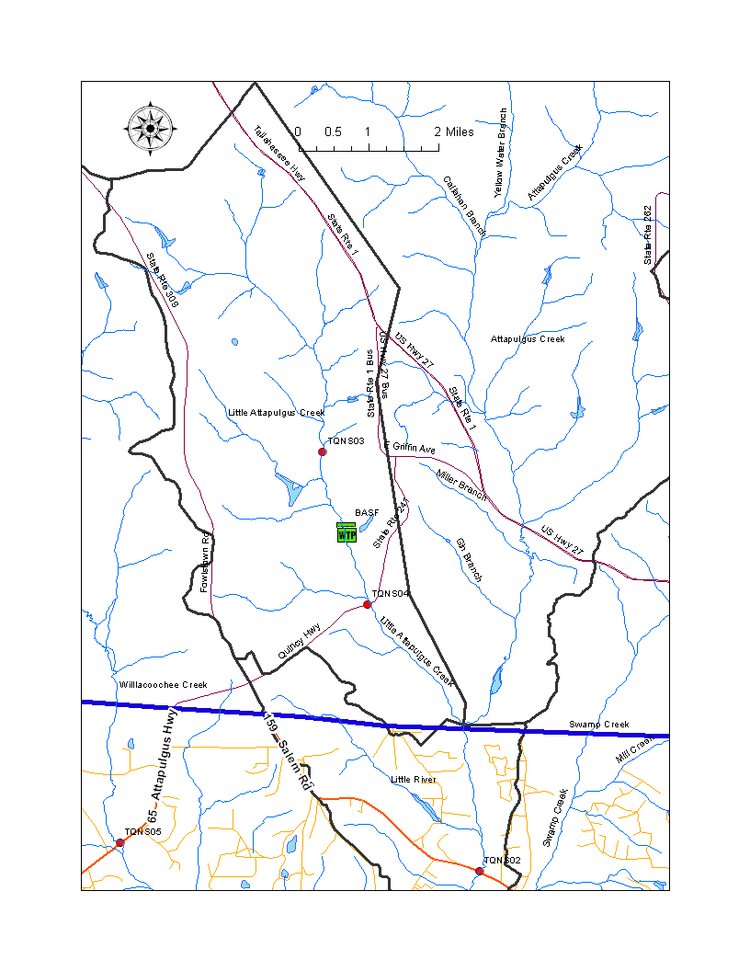
Figure B.4B.1 Little Attapulgus and Attapulgus 2013 Study Sites and BASF facility

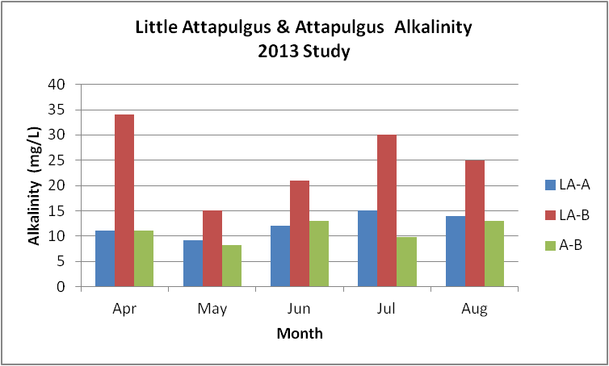
Figure B.4B.2. Little Attapulgus and Attapulgus Alkalinity 2013

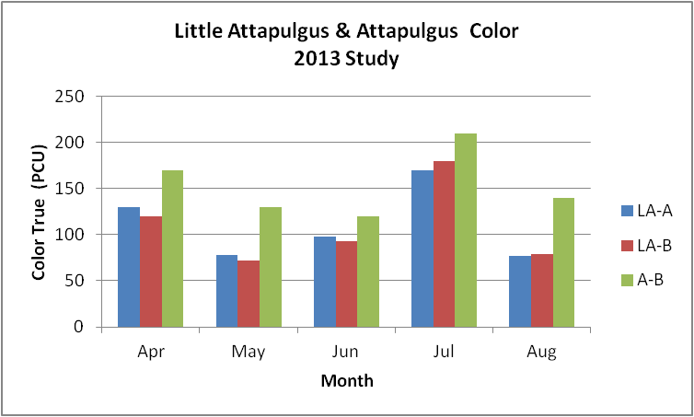
Figure B.4B.3. Little Attapulgus and Attapulgus True Color 2013

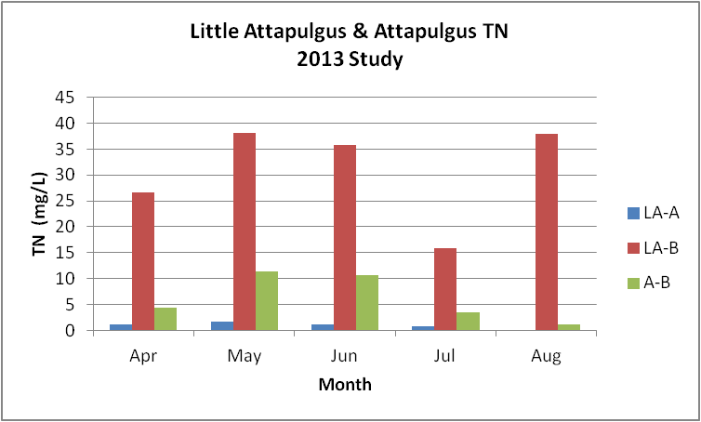
Figure B.4B.4. Little Attapulgus and Attapulgus TN 2013

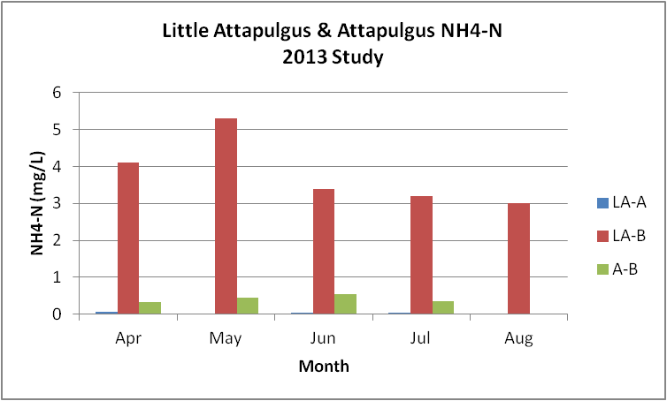
Figure B.4B.5. Little Attapulgus and Attapulgus Ammonia-N 2013

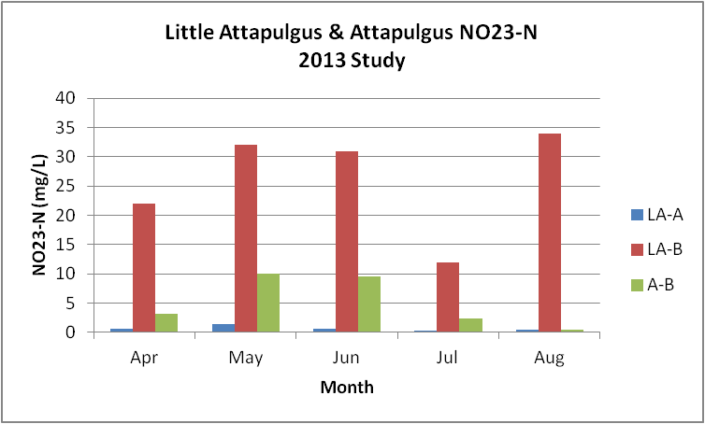
Figure B.4B.6. Little Attapulgus and Attapulgus Nitrate/Nitrite-N 2013

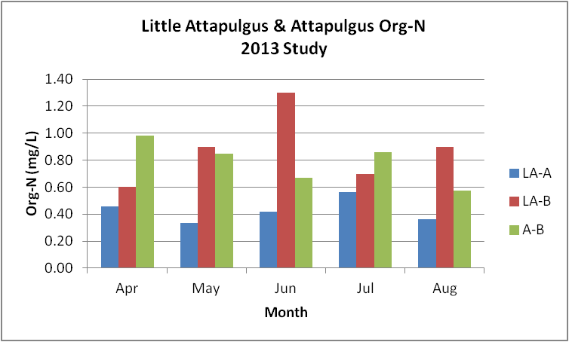
Figure B.4B.7. Little Attapulgus and Attapulgus Organic-N 2013

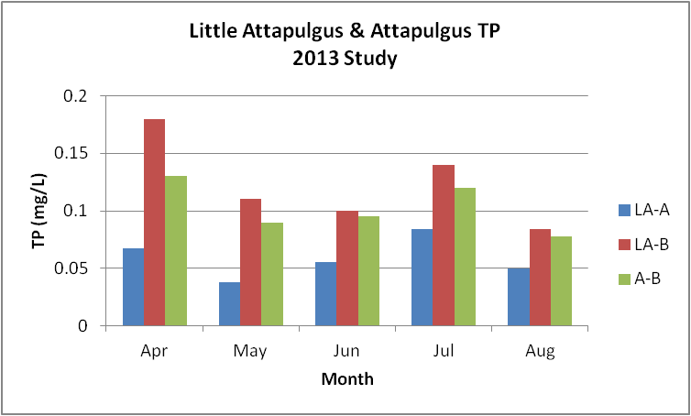
Figure B.4B.8. Little Attapulgus and Attapulgus TP 2013

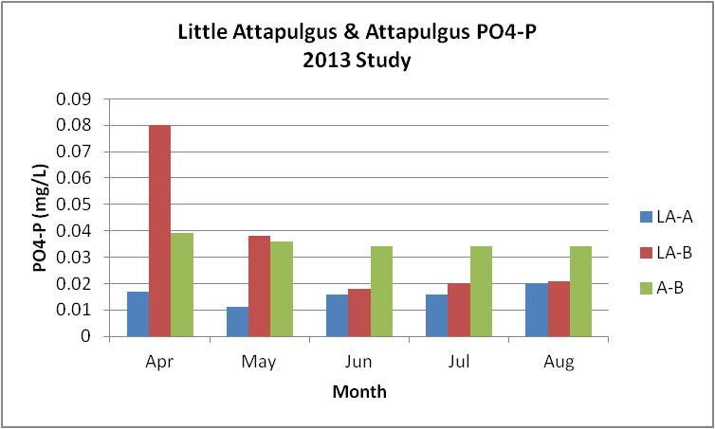
Figure B.4B.9. Little Attapulgus and Attapulgus Orthophosphate-P 2013

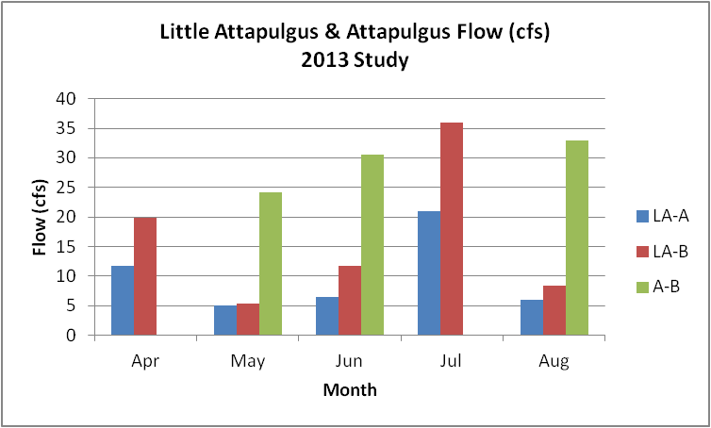
Figure B.4B.10. Little Attapulgus and Attapulgus Flow 2013

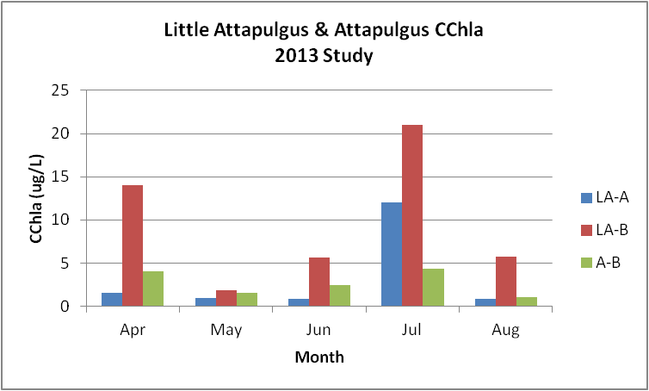
Figure B.4B.11. Little Attapulgus and Attapulgus CChla 2013

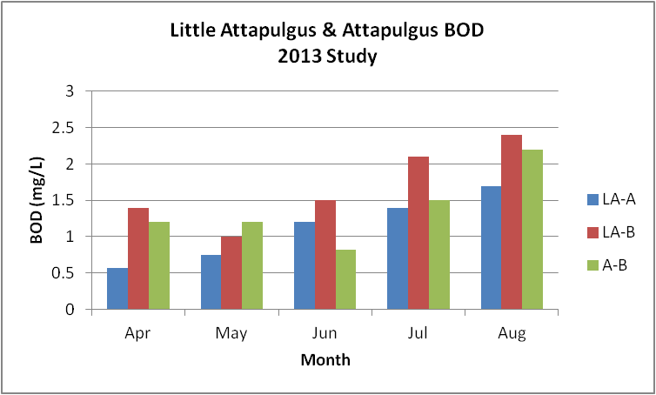
Figure B.4B.12. Little Attapulgus and Attapulgus BOD5 2013

Table B.4B.1. Little Attapulgus and Attapulgus Stations 2013

WBID | Station Number | Station Name | Begin Date | End Date
424 | 21FLWQA303946008427477 | ATTAPULGUS RIVER ON HWY 159 (SALEM ROAD) | 2013 | 2013
GA_A_BASF | 21FLWQA304459608430046 | LITTLE ATTAPULGUS RIVER ABOVE BASF ON 309 FACEVILLE ATTAPULGUS RD | 2013 | 2013
GA_A_BASF | 21FLWQA304305808429256 | LITTLE ATTAPULGUS RIVER BELOW BASF ON HWY 241 | 2013 | 2013

Table B.4B.2. Little Attapulgus and Attapulgus Alkalinity 2013
- equals empty cell no data
- | - | LA-Above | LA-Below | Attapulgus
Alkalinity | Min | 9.1 | 15.0 | 8.2
- | Max | 15.0 | 34.0 | 13.0
- | Median | 12.0 | 25.0 | 11.0
- | Mean | 12.2 | 25.0 | 11.0
- | Geomean | 12.0 | 24.0 | 10.8
- | Count | 5 | 5 | 5

Table B.4B.3. Little Attapulgus and Attapulgus True Color 2013
- equals empty cell no data
- | - | LA-Above | LA-Below | Attapulgus
Color | Min | 77.0 | 72.0 | 120.0
- | Max | 170.0 | 180.0 | 210.0
- | Median | 98.0 | 93.0 | 140.0
- | Mean | 110.6 | 108.8 | 154.0
- | Geomean | 105.4 | 102.7 | 150.8
- | Count | 5 | 5 | 5

Table B.4B.4. Little Attapulgus and Attapulgus TN 2013
- equals empty cell no data
- | - | LA-Above | LA-Below | Attapulgus
TN | Min | 0.79 | 15.90 | 1.08
- | Max | 1.76 | 38.20 | 11.30
- | Median | 1.10 | 35.70 | 4.40
- | Mean | 1.13 | 30.88 | 6.20
- | Geomean | 1.08 | 29.39 | 4.58
- | Count | 5 | 5 | 5

Table B.4B.5. Little Attapulgus and Attapulgus NH4-N 2013
- equals empty cell no data
- | - | LA-Above | LA-Below | Attapulgus
NH4-N | Min | 0.02 | 3.00 | 0.02
- | Max | 0.05 | 5.30 | 0.53
- | Median | 0.03 | 3.40 | 0.34
- | Mean | 0.04 | 3.80 | 0.33
- | Geomean | 0.03 | 3.72 | 0.21
- | Count | 5 | 5 | 5

Table B.4B.6. Little Attapulgus and Attapulgus NO23-N 2013
- equals empty cell no data
- | - | LA-Above | LA-Below | Attapulgus
NO23-N | Min | 0.23 | 12.00 | 0.49
- | Max | 1.40 | 34.00 | 10.00
- | Median | 0.64 | 31.00 | 3.10
- | Mean | 0.67 | 26.20 | 5.08
- | Geomean | 0.56 | 24.54 | 3.19
- | Count | 5 | 5 | 5

Table B.4B.7. Little Attapulgus and Attapulgus Organic-N 2013
- equals empty cell no data
Constituent | Category | LA-Above | LA-Below | Attapulgus
Org-N (mg/L) | Min | 0.33 | 0.60 | 0.57
- | Max | 0.57 | 1.30 | 0.98
- | Median | 0.42 | 0.90 | 0.85
- | Mean | 0.43 | 0.88 | 0.79
- | Geomean | 0.42 | 0.85 | 0.77

Table B.4B.8. Little Attapulgus and Attapulgus TP 2013
- equals empty cell no data
Constituent | Category | LA-Above | LA-Below | Attapulgus
TP (mg/L) | Min | 0.038 | 0.084 | 0.078
- | Max | 0.084 | 0.180 | 0.130
- | Median | 0.055 | 0.110 | 0.095
- | Mean | 0.059 | 0.123 | 0.103
- | Geomean | 0.057 | 0.118 | 0.101

Table B.4B.9. Little Attapulgus and Attapulgus PO4-P 2013
- equals empty cell no data
Constituent | Category | LA-Above | LA-Below | Attapulgus
PO4-P (mg/L) | Min | 0.011 | 0.018 | 0.034
- | Max | 0.020 | 0.080 | 0.039
- | Median | 0.016 | 0.021 | 0.034
- | Mean | 0.016 | 0.035 | 0.035
- | Geomean | 0.016 | 0.030 | 0.035

Table B.4B.10. Little Attapulgus and Attapulgus CChla 2013
- equals empty cell no data
Constituent | Category | LA-Above | LA-Below | Attapulgus
CChla (ug/L) | Min | 0.8 | 1.9 | 1.1
- | Max | 12.0 | 21.0 | 4.4
- | Median | 1.0 | 5.7 | 2.5
- | Mean | 3.3 | 9.6 | 2.7
- | Geomean | 1.7 | 7.1 | 2.4

Table B.4B.11. Little Attapulgus and Attapulgus BOD5 2013
- equals empty cell no data
Constituent | Category | LA-Above | LA-Below | Attapulgus
BOD5 (mg/L) | Min | 0.6 | 1.0 | 0.8
- | Max | 1.7 | 2.4 | 2.2
- | Median | 1.2 | 1.5 | 1.2
- | Mean | 1.1 | 1.7 | 1.4
- | Geomean | 1.0 | 1.6 | 1.3

B.4C Little River WBID 424
This WBID is not impaired for DO or nutrients.
Table B.4C.1, lists the 39 stations that have been sampled in the Little River WBID 424. Figure B.4C.1 depicts the station locations.
Tables B.4C.5 and B.4C.6 and Figures B.4C.4 and B.4C.5, provide the results for alkalinity. These data show that the Little River above Lake Talquin has a POR GM alkalinity of 13.7 mg/L. The data indicate that the alkalinity for the period (2005 – 2013) is elevated over the POR (GM 20.8 mg/L vs. 13.7 mg/L). The seasonal pattern indicates that the alkalinity is lowest in the first two months of the year (~10.0 mg/L) with a maximum in March (~25 mg/L) and then varying with 7 mg/L the rest of the year. This pattern for alkalinity is not clearly related to river flow or rainfall (Figures B.3.12 and B.2.4). Data collection in 2013 indicates that the BASF facility on the Little Attapulgus maybe increasing the alkalinity in that creek and that this may have an effect on the seasonal pattern.
Tables B.4C.5 and B.4C.6 and Figures B.4C.6 and B.4C.7, provide the results for true color. These data show that the Little River above Lake Talquin has a POR GM color of 63.1 PCU, very similar to the Ochlockonee River above Lake Talquin (62.5 PCU). The data indicate that the GM color for the period (2005 – 2013) of 76.4 PCU is slightly greater than the POR color. The seasonal pattern indicates that the color is high in January and decreases as monthly flow increases through March. Color goes up in April to the January levels and then declines through June. Color is highest in July and August when flows are low and at the lowest levels through the fall and early winter when flows are low. This pattern for color appears to be weakly related to river flow (Figure B.3.12).

Tables B.4C.5 and B.4C.6 and Figures B.4C.9 through B.4C.12, provide the results for TN. These data show that the Little River above Lake Talquin has a POR GM TN of 1.75 mg/L. The data (Figure B.4C.11) indicate that the recent (2005 – 2013) TN GM of 1.80 mg/L is similar to the POR TN GM for the POR and greater than the new threshold AGM concentration for TN of 1.03 mg/L. The data also indicate that the there is no overall trend for AGM TN concentrations. This is in direct contrast to the Ochlockonee River above the lake which shows a declining trend. The seasonal pattern indicates that the TN concentration increases from January through April, declines through June, progressively increases through November and then declines in December. This pattern for TN is similar to the Ochlockonee River above the lake and not clearly related to flow or rainfall (Figures B.3.12 and B.2.4).
Tables B.4C.5 and B.4C.6 and Figures B.4C.13 and B.4C.14, provide the results for NH4-N. These data show that the Little River above Lake Talquin has a POR GM NH4-N of 0.07 mg/L, slightly greater than the Ochlockonee River (0.061 mg/L). The data indicate that the recent (2005 – 2013) NH4-N GM of 0.057 mg/L is less than the POR concentration. There is no clear trend for NH4-N concentrations.
Tables B.4C.5 and B.4C.6 and Figures B.4C.15 and B.4C.16, provide the results for NO23-N. These data show that the Little River above Lake Talquin has a POR GM NO23-N of 0.91 mg/L, significantly greater than the 0.316 mg/L value for the Ochlockonee River above the lake. The data indicate that the recent (2005 – 2013) NO23-N GM of 0.904 mg/L is about the same as the POR concentration. There does not appear to be a trend for this constituent.
Tables B.4C.5 and B.4C.6 and Figures B.4C.18 through B.4C.21, provide the results for TP. These data show that the Little River above Lake Talquin has a POR GM TP of 0.125 mg/L, slightly less than the value for the Ochlockonee River above the lake (0.158 mg/L). The data indicate that the recent (2005 – 2013) TP GM of 0.102 mg/L is slightly less than the TP GM for the POR and the new threshold AGM concentration for TP of 0.18 mg/L. The data also indicate that the overall trend is a slight reduction in the AGM TP concentrations over time (Figure B.4C.20). This trend is driven by the relatively higher AGM concentrations that occurred from 1972 through 1973. The seasonal pattern indicates that the TP concentration are greatest in January, stay fairly consistent through July, increase in August and then gradual decline through the rest of the year. This pattern for TP is not clearly related to flow or rainfall (Figures B.3.12 and B.2.4).
Tables B.4C.5 and B.4C.6 and Figures B.4C.22 and B.4C.23, provide the results for PO4-P. These data show that the Little River above Lake Talquin has a POR GM PO4-P of 0.061 mg/L, about half of the POR value for the Ochlockonee River above the lake (0.12 mg/L). The data indicate that the recent (2005 – 2013) PO4-P GM of 0.038 mg/L is also less than the value of 0.046 mg/L for the Ochlockonee River and is reduced over the POR concentration and that the overall trend is for declining concentrations. This trend is driven by the relatively higher concentrations in the 1970’s.
Tables B.4C.5 and B.4C.6 and Figures B.4C.24 through B.4C.27, provide the results for CChla. These data show that the Little River above Lake Talquin has a POR GM CChla of 2.2 ug/L (same as the Ochlockonee River). The data indicate that the recent (2005 – 2013) CChla GM of 1.8 ug/L is not significantly different from the CChla GM for the POR and significantly less than the 20.0 ug/L new threshold AGM concentration for CChla. The data also indicate that the overall trend is for decreasing AGM CChla concentrations (Figure B.4C.26). This trend is driven by the relatively higher AGM concentration in 1992, reductions in detection limits over time, and the large number of less than detect results. The seasonal pattern indicates that the CChla concentrations are above the detection limits during the middle of the growing season, peaking in July and mostly less than detection during the remaining months of the year. This pattern may be influenced by varying detection limits over time. The pattern in CChla does not appear to be related to flow or rainfall (Figures B.3.12 and B.2.4).
Tables B.4C.5 and B.4C.6 and Figures B.4C.28 through B.4C.30, provide the results for BOD5. These data show that the Little River above Lake Talquin has a POR GM BOD5 of 1.3 mg/L (same as the Ochlockonee River). The data indicate that the recent (2005 – 2013) BOD5 GM of 1.0 mg/L is not significantly different than the POR concentration. Variable detection limits over time may be having an influence on the data. The BOD5 concentrations have come down over time, but this could be due changes in detection limits between data collected in the 1970’s and more recent results.
Tables B.4C.5 and B.4C.6 and Figures B.4C.31 and B.4C.32, provide the results for DO. These data show that the Little River above Lake Talquin has a POR GM DO of 7.4 mg/L. The data indicate that the recent (2005 – 2013) DO GM of 7.8 mg/L is not significantly different than the POR concentration. The DO concentrations may have increased slightly since the 1970’s. Seasonal data indicate that the monthly average DO is never less than 6.0 mg/L (Figure B.4C.32).
Tables B.4C.5 and B.4C.6 and Figures B.4C.33 through B.4C.35, provide the results for percent DO saturation. These data show that the Little River above Lake Talquin has a POR GM DOSAT of 77.2 percent. The data indicate that the recent (2005 – 2013) DOSAT GM of 87.2 percent is slightly higher than the GM for the POR. The data presented in Figure B.4C.34 indicates that there are is not an issue with the new 67% saturation DO criterion. The data do not appear to have a long-term trend (Figure B.4C.33). The seasonal pattern indicates that the DOSAT is lowest in June and October and highest in November.
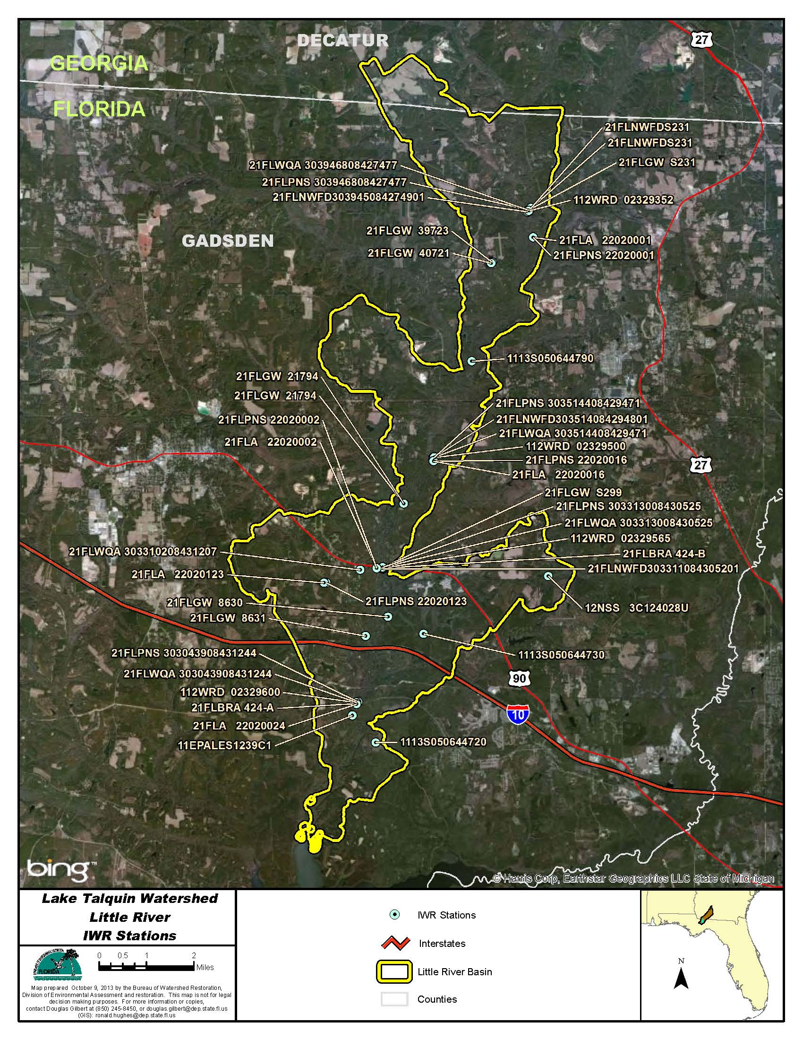
Figure B.4C.1. Little River WBID 424 IWR Station Locations

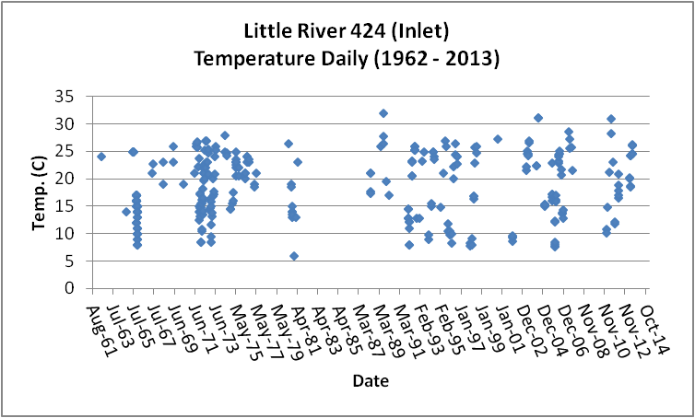
Figure B.4C.2. Little River WBID 424 Daily Temperature 1962 - 2013

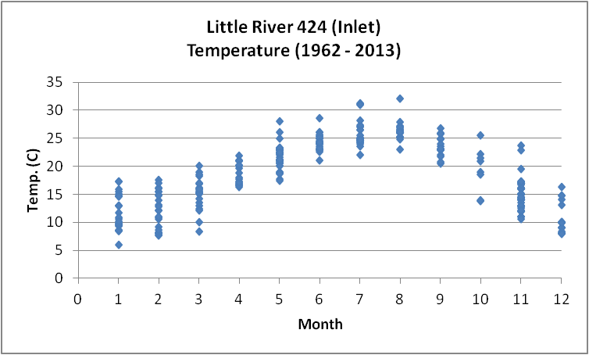
Figure B.4C.3. Little River WBID 424 Monthly Temperature 1962 - 2013

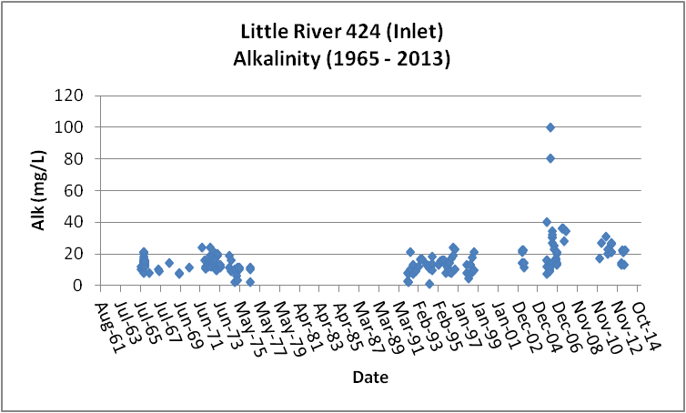
Figure B.4C.4. Little River WBID 424 Daily Average Alkalinity 1965- 2013

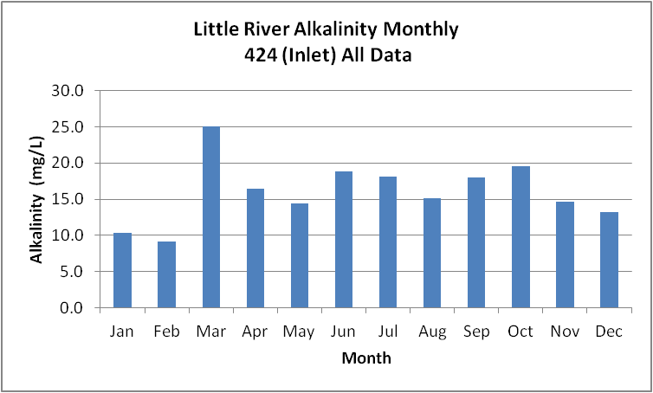
Figure B.4C.5. Little River WBID 424 Monthly Average Alkalinity 1965- 2013

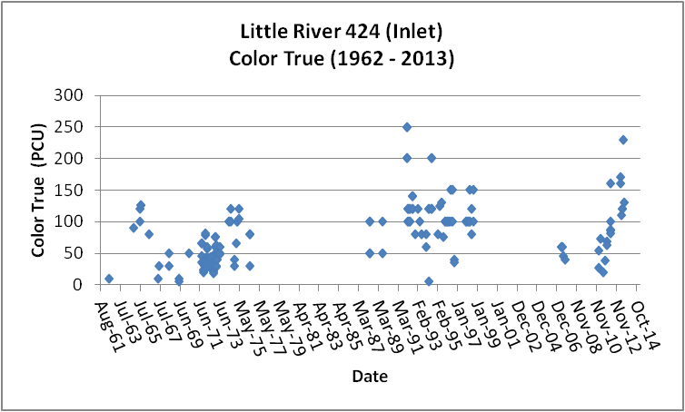
Figure B.4C.6. Little River WBID 424 Daily Average True Color 1962- 2013

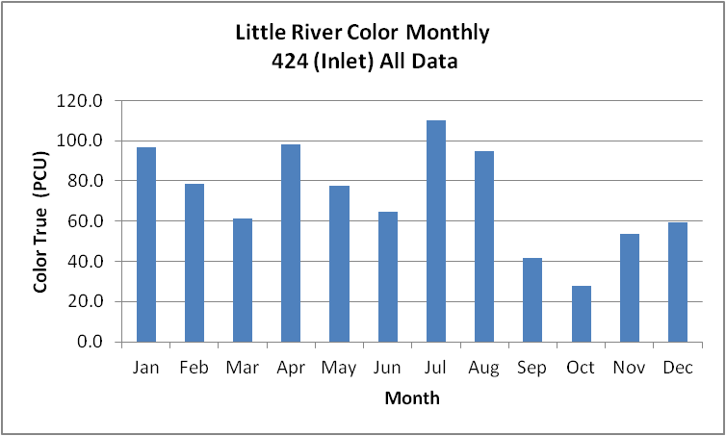
Figure B.4C.7. Little River WBID 424 Monthly Average True Color 1962- 2013

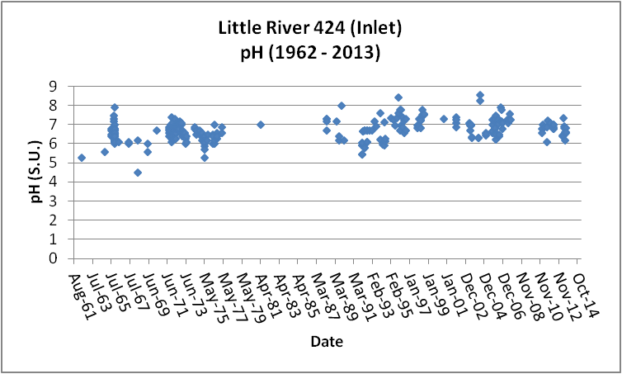
Figure B.4C.8. Little River WBID 424 Daily pH 1962- 2013

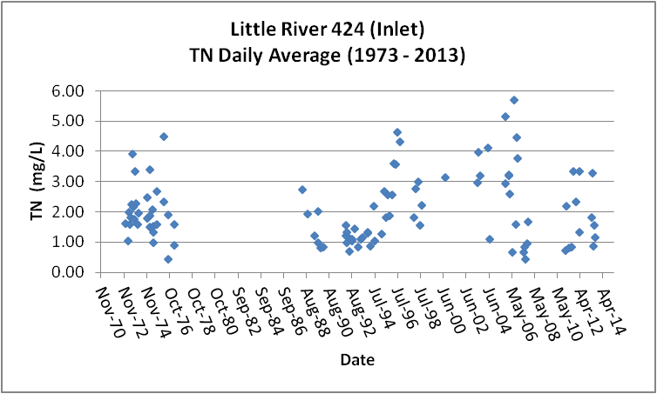
Figure B.4C.9. Little River WBID 424 Daily Average TN1973- 2013

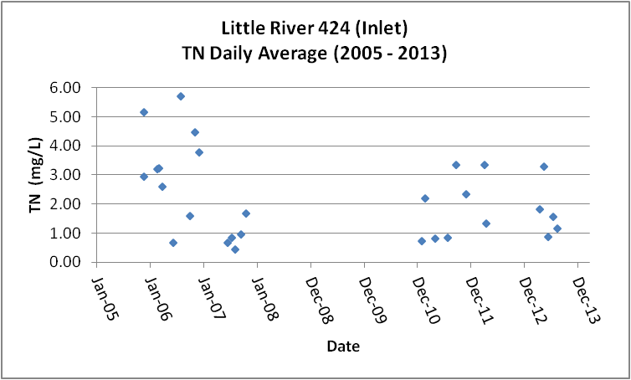
Figure B.4C.10. Little River WBID 424 Daily Average TN 2005- 2013

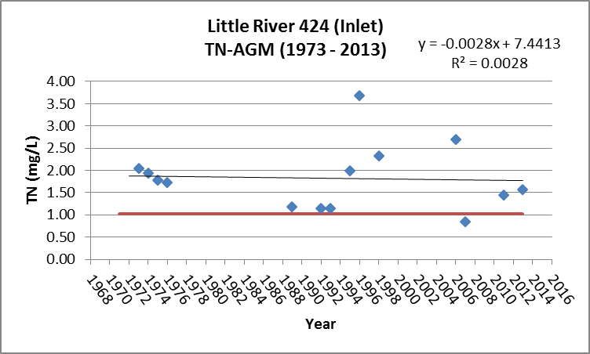
Figure B.4C.11. Little River WBID 424 TN Annual Geomean 1973- 2013

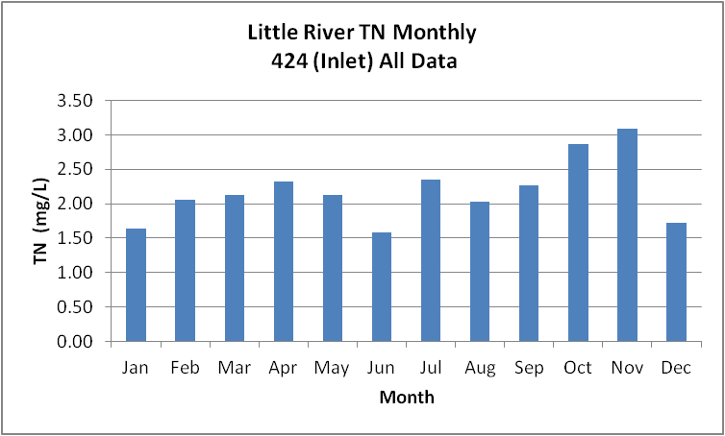
Figure B.4C.12. Little River WBID 424 Monthly Average TN 1973- 2013

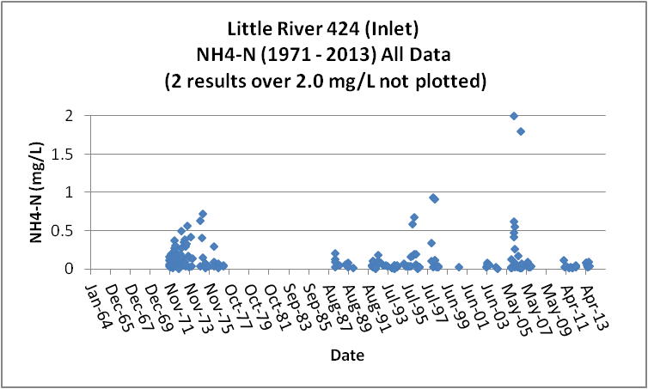
Figure B.4C.13. Little River WBID 424 Daily Average Ammonia-N 1971- 2013

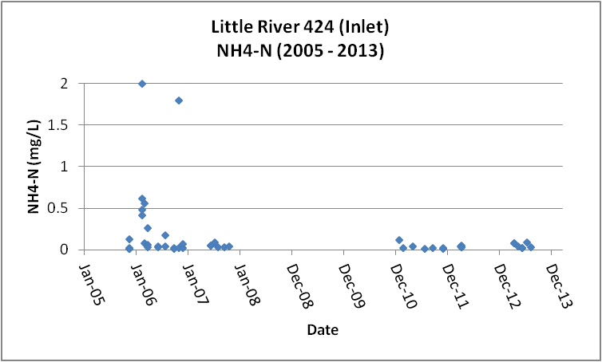
Figure B.4C.14. Little River WBID 424 Daily Average Ammonia-N 2005- 2013

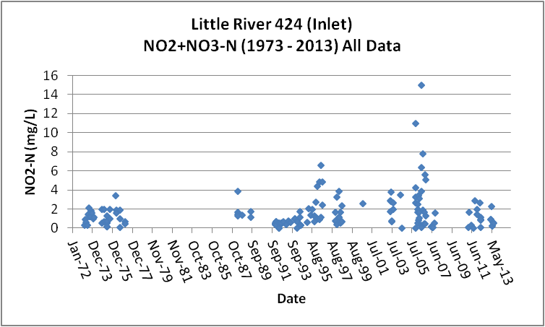
Figure B.4C.15. Little River WBID 424 Daily Average Nitrate/Nitrite-N1973- 2013

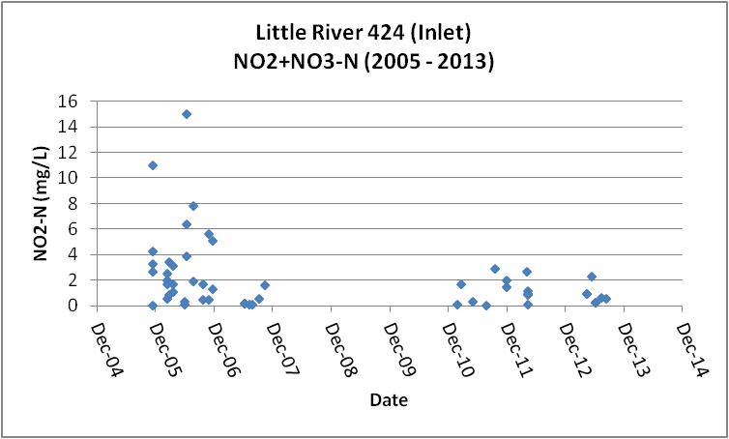
Figure B.4C.16. Little River WBID 424 Daily Average Nitrate/Nitrite-N2005- 2013

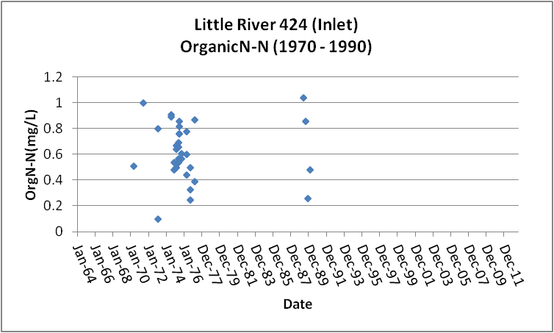
Figure B.4C.17. Little River WBID 424 Daily Average Organic-N 1970- 1990

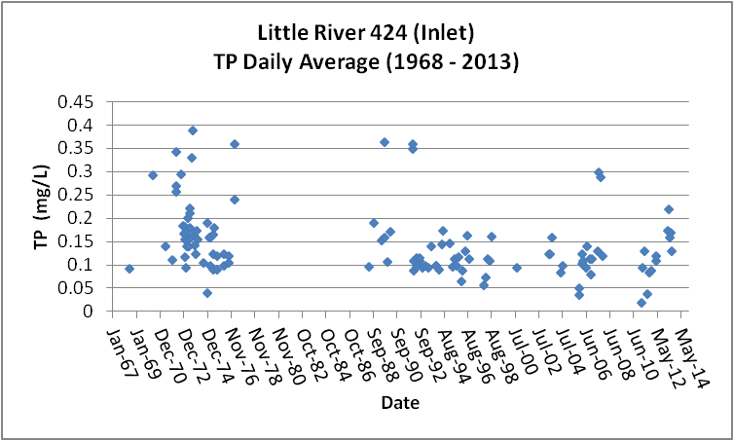
Figure B.4C.18. Little River WBID 424 Daily Average TP 1968 - 2013

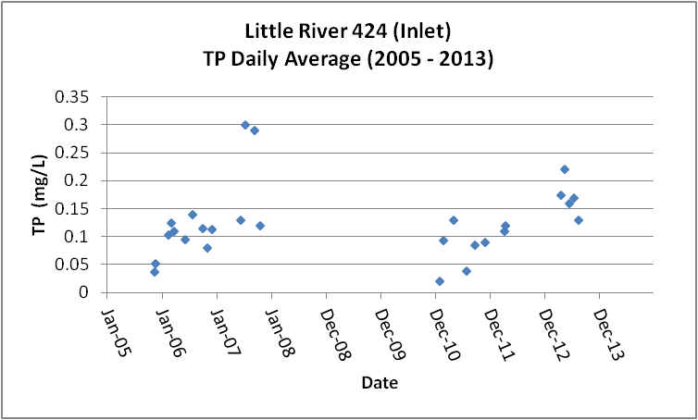
Figure B.4C.19. Little River WBID 424 Daily Average TP 2005 - 2013

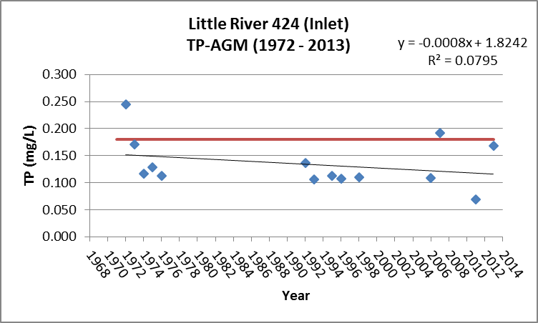
Figure B.4C.20. Little River WBID 424 Annual Geomean TP 1972 - 2013

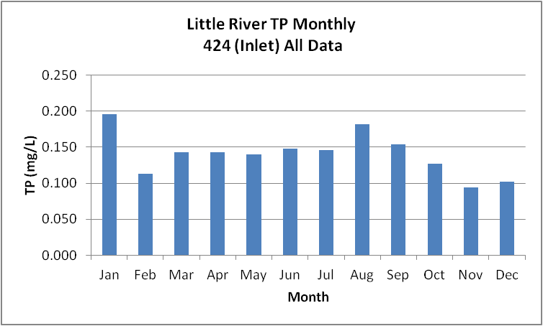
Figure B.4C.21. Little River WBID 424 Monthly Average TP 1968 - 2013

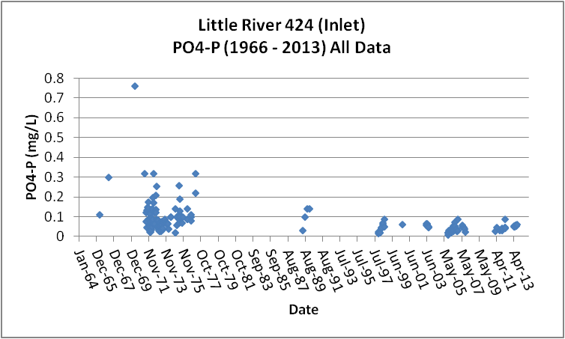
Figure B.4C.22. Little River WBID 424 Daily Average Orthophosphate-P 1966 - 2013

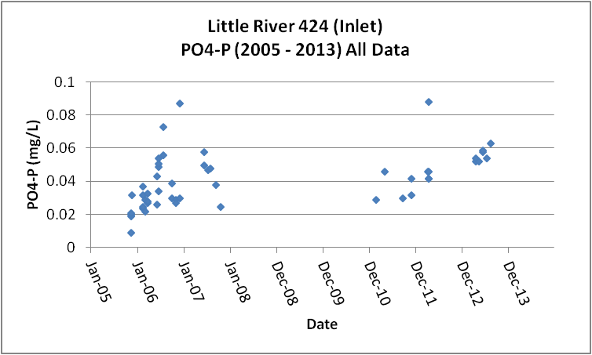
Figure B.4C.23. Little River WBID 424 Daily Average Orthophosphate-P 2005 - 2013

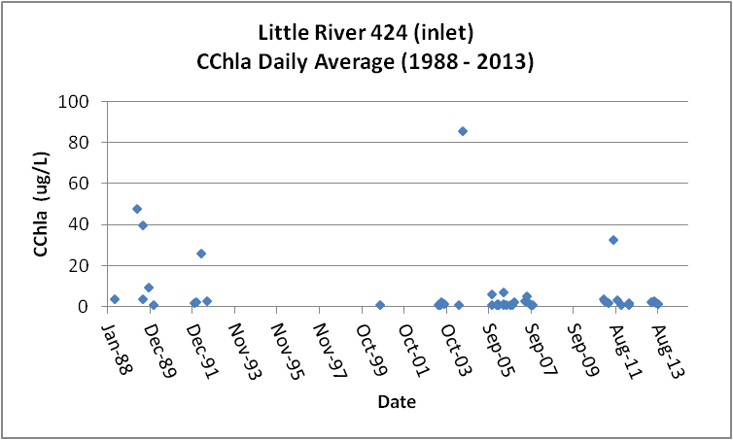
Figure B.4C.24. Little River WBID 424 Daily Average CChla 1988 - 2013

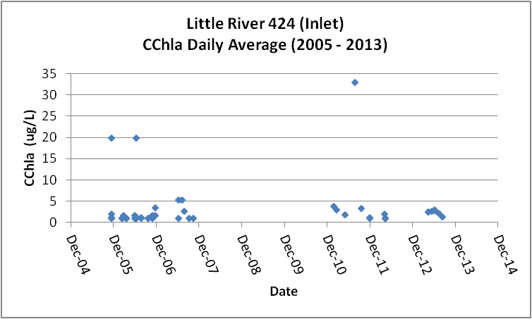
Figure B.4C.25. Little River WBID 424 Daily Average CChla 2005 - 2013

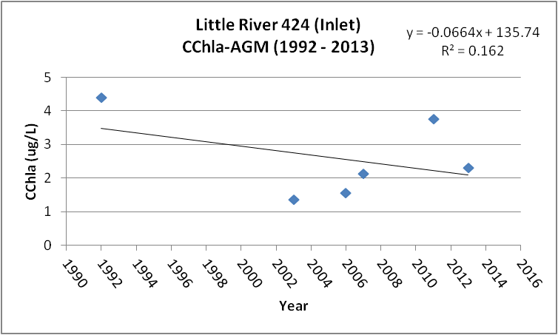
Figure B.4C.26. Little River WBID 424 Annual Geomean CChla 1992 - 2013

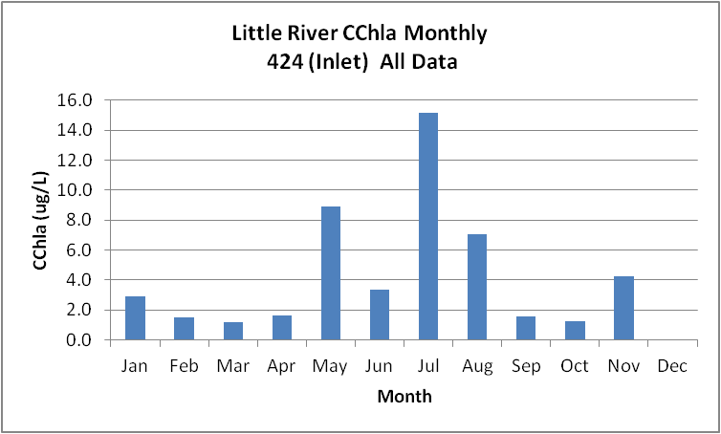
Figure B.4C.27. Little River WBID 424 Monthly Average CChla 1988 - 2013

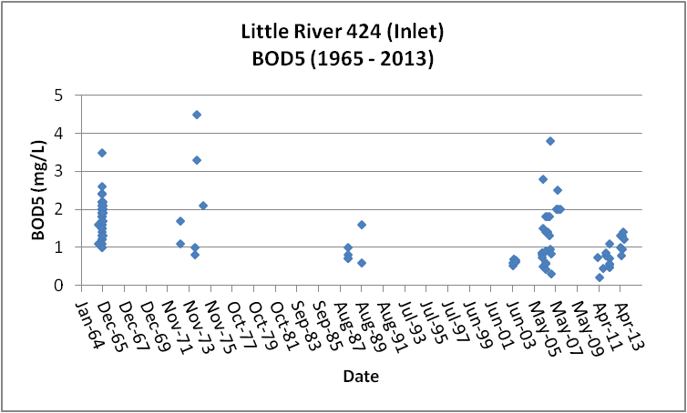
Figure B.4C.28. Little River WBID 424 Daily Average BOD5 1965 - 2013

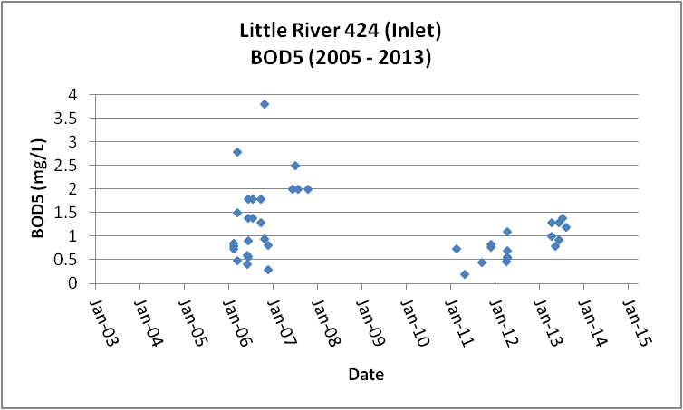
Figure B.4C.29. Little River WBID 424 Daily Average BOD5 2005 - 2013

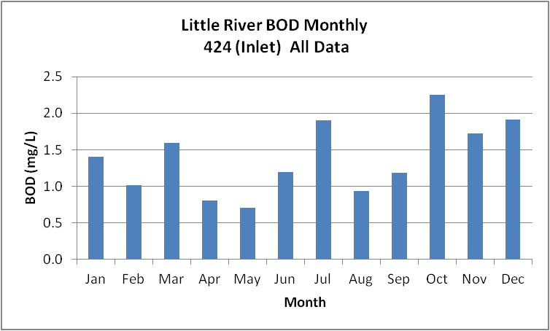
Figure B.4C.30. Little River WBID 424 Monthly Average BOD5 1965 - 2013

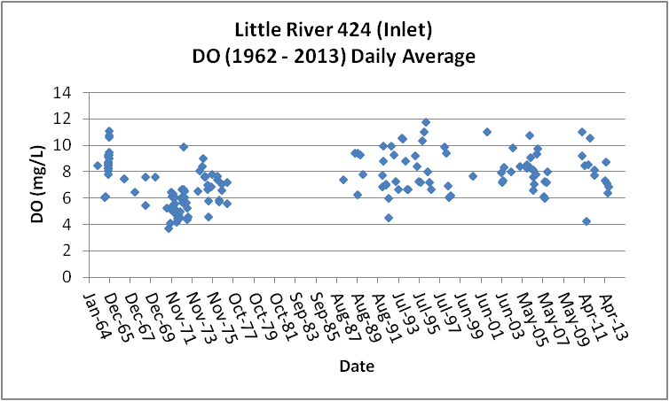
Figure B.4C.31. Little River WBID 424 Daily Average DO 1962 - 2013

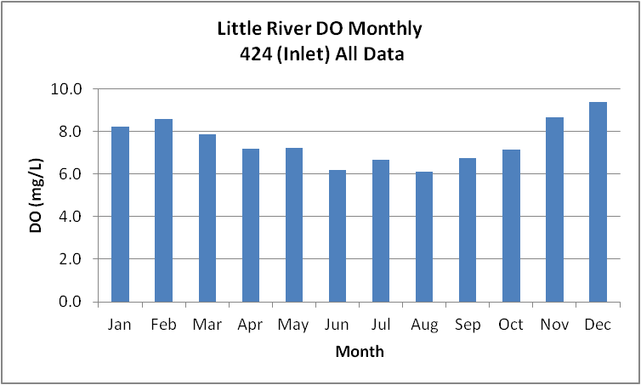
Figure B.4C.32. Little River WBID 424 Monthly Average DO 1962 - 2013

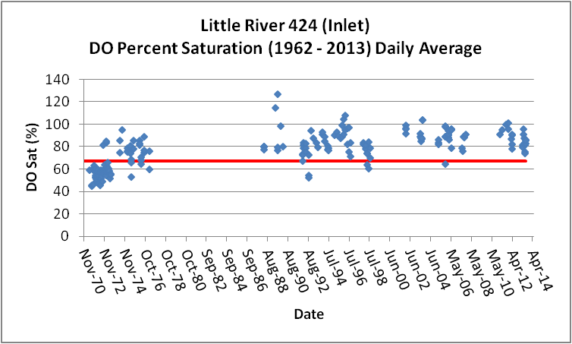
Figure B.4C.33. Little River WBID 424 Daily Average DO Percent Saturation 1962 - 2013

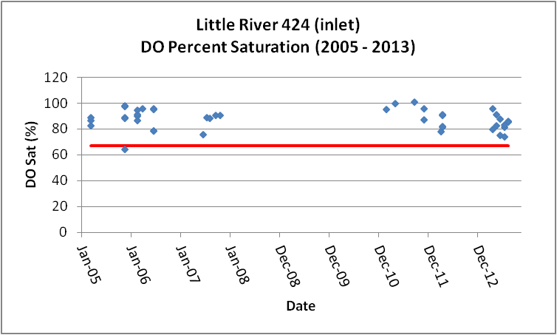
Figure B.4C.34 Little River WBID 424 Daily Average DO Percent Saturation 2005 - 2013

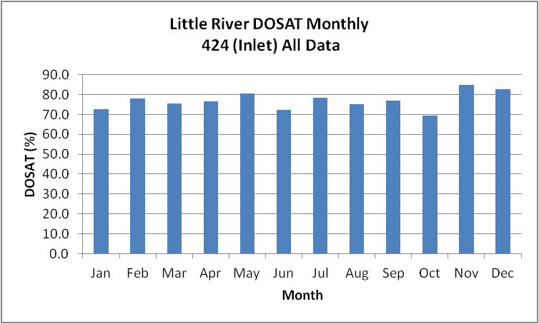
Figure B.4C.35. Little River WBID 424 Monthly Average DO Percent Saturation 1962 - 2013

Table B.4C.1. Little River WBID 424 IWR Stations
WBID | Station Number | Station Name | Begin Date | End Date
424 | 21FLPNS 22020002 | LITTLE R US HWY 90 | 1999 | 1999
424 | 21FLBRA 424-A | 424 - Little River - far dwnstrm from bridge on SR 268 | 2007 | 2007
424 | 21FLGW 8630 | NWA-HS-1016 LITTLE RIVER | 2000 | 2000
424 | 1113S050644790 | ATTAPULGUS CR HWY 159 NE QUINCY | 1965 | 1965
424 | 112WRD 02329500 | LITTLE RIVER NR QUINCY, FLA. | 1966 | 1981
424 | 21FLWQA 303043908431244 | Little River at SR 268 | 2002 | 2006
424 | 21FLNWFD303311084305201 | Little River @ U.S. 90 | 1992 | 1996
424 | 21FLGW S299 | LITTLE RIVER @ US 90 | 1997 | 1998
424 | 21FLGW 8631 | NWA-HS-1018 G CREEK | 2000 | 2000
424 | 11EPALES1239C1 | LITTLE RIVER | 1973 | 1974
424 | 21FLPNS 303514408429471 | Little River At SR 12 (also 21FLWQA) | 0 | 0
424 | 21FLPNS 303313008430525 | Little River At US 90 (also 21FLWQA) | 0 | 0
424 | 21FLGW 21794 | NW1-SS-2041 LITTLE RIVER | 2004 | 2004
424 | 112WRD 02329565 | LITTLE RIVER NR LITTMAN, FLA. | 1975 | 1981
424 | 1113S050644730 | LITTLE R US 90 HWY 10 SE QUINCY | 1965 | 1965
424 | 21FLWQA 303946808427477 | Attapulgus Creek at SR 159 | 2002 | 2006
424 | 21FLPNS 22020001 | ATTAPULGUS CR FLA 159 NW JAMISON | 1996 | 1996
424 | 21FLNWFDS231 | Attapulgus Cr. at 159 ab Willacoochee Cr. | 2008 | 2008
424 | 1113S050644720 | LITTLE R HWY 268 SE QUINCY | 1965 | 1965
424 | 21FLPNS 303043908431244 | Little River at SR 268 | 2006 | 2006
424 | 21FLBRA 424-B | 424 - Little River - Bridge on Highway 90 | 2007 | 2007
424 | 21FLNWFD303945084274901 | Attapulgus Cr. @ 159 ab Willacoochee Cr. | 1992 | 1996
424 | 21FLGW S231 | ATTAPULGUS CR 159 | 1997 | 1998
424 | 21FLWQA 303310208431207 | Trib at Rentz Road 0.25 miles South of US 90 | 0 | 0
424 | 112WRD 02329600 | LITTLE RIVER NR MIDWAY, FLA. | 1967 | 1981
424 | 21FLGW 39723 | Z1-SL-5007 UNNAMED SMALL LAKE | 0 | 0
424 | 21FLA 22020016 | LITTLE R AT BR ON FLA 12 | 1973 | 1989
424 | 21FLGW 21794 | NW1-SS-2041 LITTLE RIVER | 2004 | 2004
424 | 21FLA 22020024 | LITTLE R SR 268 | 1965 | 1988
424 | 21FLPNS 303946808427477 | Attapulgus Creek at SR 159 | 2006 | 2006
424 | 21FLNWFDS231 | Attapulgus Cr. at 159 ab Willacoochee Cr. | 2008 | 2008
424 | 21FLNWFD303514084294801 | Little River @ SR 12 | 1993 | 1994
424 | 21FLWQA 303313008430525 | Little River at US 90 | 2002 | 2006
424 | 21FLA 22020002 | LITTLE R US HWY 90 | 1962 | 1989
424 | 21FLWQA 303514408429471 | Little River at SR 12 | 2002 | 2006
424 | 21FLPNS 22020016 | LITTLE R AT BR ON FLA 12 | 1996 | 1996
424 | 21FLGW 40721 | Z1-SL-5007R UNNAMED SMALL LAKE | 0 | 0
424 | 21FLA 22020001 | ATTAPULGUS CR FLA 159 NW JAMISON | 1965 | 1988
424 | 112WRD 02329352 | ATTAPULGUS CREEK AT JAMIESON, FLA | 1974 | 1981

Table B.4C.2. Little River WBID 424 Long-Term Geomean Alkalinity and Color
WBID | Constituent | POR | Geomean
424 | Alkalinity (mg/L) | 1965 - 2013 | 13.7
424 | Color-True (PCU) | 1962 - 2013 | 63.1

Table B.4C.3. Little River WBID 424 DO Percent Saturation vs. 67% Criterion
- equals empty cell no data
Year | Category | Result
1962 - 2013 | Count | 266
- | Number P | 194
- | Number F | 67
- | Percent F | 25.2
- | - | -
2005 - 2013 | Count | 44
- | Number P | 43
- | Number F | 1
- | Percent F | 2.3

Table B.4C.4. Little River WBID 424 Annual Geomean TN, TP, TN/TP Ratio, and CChla
- equals empty cell no data
Year | TN (mg/L) | TP (mg/L) | TN/TP | CChla (ug/L)
- | AGM | AGM | Ratio | AGM
1971 | - | - | - | -
1972 | - | 0.245 | - | -
1973 | 2.04 | 0.170 | 12.0 | -
1974 | 1.95 | 0.117 | 16.7 | -
1975 | 1.78 | 0.128 | 13.9 | -
1976 | 1.73 | 0.112 | 15.5 | -
1977 | - | - | - | -
1978 | - | - | - | -
1979 | - | - | - | -
1980 | - | - | - | -
1981 | - | - | - | -
1982 | - | - | - | -
1983 | - | - | - | -
1984 | - | - | - | -
1985 | - | - | - | -
1986 | - | - | - | -
1987 | - | - | - | -
1988 | - | - | - | -
1989 | 1.19 | - | - | -
1990 | - | - | - | -
1991 | - | - | - | -
1992 | 1.15 | 0.136 | 8.4 | 4.4
1993 | 1.14 | 0.106 | 10.8 | -
1994 | - | - | - | -
1995 | 1.98 | 0.113 | 17.5 | -
1996 | 3.68 | 0.107 | 34.3 | -
1997 | - | - | - | -
1998 | 2.32 | 0.111 | 21.0 | -
1999 | - | - | - | -
2000 | - | - | - | -
2001 | - | - | - | -
2002 | - | - | - | -
2003 | - | - | - | 1.4
2004 | - | - | - | -
2005 | - | - | - | -
2006 | 2.70 | 0.109 | 24.8 | 1.6
2007 | 0.84 | 0.192 | 4.4 | 2.1
2008 | - | - | - | -
2009 | - | - | - | -
2010 | - | - | - | -
2011 | 1.44 | 0.069 | 20.7 | 3.8
2012 | - | - | - | -
2013 | 1.57 | 0.169 | 9.3 | 2.3

Table B.4C.5. Little River WBID 424 Water Quality Data Summary All Data
- equals empty cell no data
Constituent | Units | POR | Count | Min | Max | Median | Mean | Geomean
Temperature | C | 1962 - 2013 | 319 | 6.0 | 32.0 | 17.3 | 18.4 | 17.4
Alkalinity | mg/L | 1962 - 2013 | 219 | 1.0 | 100.0 | 14.0 | 15.6 | 13.7
pH | S.U. | 1962 - 2013 | 301 | 4.5 | 8.6 | 6.7 | - | -
Color | PCU | 1962 - 2013 | 175 | 5.0 | 250.0 | 73.0 | 77.9 | 63.1
TN | mg/L | 1973 - 2013 | 162 | 0.07 | 11.69 | 1.69 | 2.18 | 1.75
NH4-N | mg/L | 1971 - 2013 | 218 | 0.001 | 8.97 | 0.06 | 0.19 | 0.07
NO23 | mg/L | 1973 - 2013 | 160 | 0.004 | 15.00 | 1.02 | 1.62 | 0.91
OrgN | mg/L | 1970 - 1990 | 33 | 0.10 | 1.04 | 0.61 | 0.63 | 0.58
TP | mg/L | 1968 - 2013 | 184 | 0.020 | 0.560 | 0.120 | 0.141 | 0.125
PO4-P | mg/L | 1966 - 2013 | 173 | 0.009 | 0.760 | 0.058 | 0.079 | 0.061
CChla | ug/L | 1988 - 2013 | 78 | 1.0 | 86.0 | 1.6 | 5.4 | 2.2
BOD5 | mg/L | 1965 - 2013 | 118 | 0.2 | 4.5 | 1.5 | 1.5 | 1.3
DO | mg/L | 1962 - 2013 | 299 | 0.5 | 12.2 | 7.6 | 7.6 | 7.4
%DOSat | % | 1962 - 2013 | 266 | 44.8 | 127.0 | 82.0 | 78.7 | 77.2

Table B.4C.6. Little River WBID 424 Water Quality Data Summary Verified Period Plus (2005 – 2013)
- equals empty cell no data
Constituent | Units | Verified Period+ | Count | Min | Max | Median | Mean | Geomean
Temperature | C | 2005 - 2013 | 60 | 7.6 | 31.0 | 18.7 | 19.1 | 18.1
Alkalinity | mg/L | 2005 - 2013 | 50 | 7.0 | 100.0 | 21.0 | 24.0 | 20.8
pH | S.U. | 2005 - 2013 | 60 | 6.1 | 7.9 | 6.9 | - | -
Color | PCU | 2005 - 2013 | 24 | 19.0 | 230.0 | 77.5 | 90.0 | 76.4
TN | mg/L | 2005 - 2013 | 49 | 0.39 | 11.69 | 1.75 | 2.47 | 1.80
NH4-N | mg/L | 2005 - 2013 | 49 | 0.01 | 2.00 | 0.04 | 0.17 | 0.057
NO23 | mg/L | 2005 - 2013 | 52 | 0.004 | 15.00 | 1.25 | 2.14 | 0.904
OrgN | mg/L | - | - | - | - | - | - | -
TP | mg/L | 2005 - 2013 | 46 | 0.020 | 0.300 | 0.110 | 0.116 | 0.102
PO4-P | mg/L | 2005 - 2013 | 51 | 0.009 | 0.088 | 0.039 | 0.041 | 0.038
CChla | ug/L | 2005 - 2013 | 53 | 1.0 | 33.0 | 1.3 | 3.0 | 1.8
BOD5 | mg/L | 2005 - 2013 | 43 | 0.2 | 3.8 | 0.9 | 1.2 | 1.0
DO | mg/L | 2005 - 2013 | 62 | 0.5 | 11.2 | 8.2 | 8.2 | 7.8
%DOSat | % | 2005 - 2013 | 44 | 64.7 | 101.3 | 88.6 | 87.5 | 87.2

B.4D. Richlander Creek WBID 680 Drains to Lake Talquin
This WBID is not impaired for DO or nutrients.
Table B.4D.1, lists the 5 stations that have been sampled in Richlander Creek WBID 680. Figure B.4D.1 depicts the station locations. For most constituents there are less than 10 results over the POR.
Tables B.4D.5 and B.4D.6 and Figures B.4D.4 and B.4D.5, provide the results for alkalinity. These data show that Richlander Creek has a POR GM alkalinity of 18.5 mg/L. It should be noted that all of the alkalinity data is from 2013. There is insufficient data to determine accurate long-term or seasonal patterns.
Tables B.4D.5 and B.4D.6 and Figures B.4D.6 and B.4D.7, provide the results for true color. These data show that Richlander Creek has a POR GM color of 97.2 PCU, higher than the color for either the Little or Ochlockonee Rivers. The data indicate that the GM color for the period (2005 – 2013) of 96.1 PCU is similar to the POR color. There is insufficient data to determine accurate long-term or seasonal patterns.
Tables B.4D.5 and B.4D.6 and Figures B.4D.8 through B.4D.11, provide the results for TN. These data show that Richlander Creek has a POR GM TN of 0.86 mg/L. The data indicate that the recent (2005 – 2013) TN GM of 0.71 mg/L is reduced over the POR TN GM for the POR and less than the new 1.03 mg/L threshold AGM concentration for TN (Figure B.4D.10). There is insufficient data to determine accurate long-term or seasonal patterns.

Tables B.4D.5 and B.4D.6 and Figure B.4D.12 provide the results for NH4-N. These data show that Richlander Creek has a POR GM NH4-N of 0.05 mg/L. The data indicate that the recent (2005 – 2013) NH4-N GM of 0.03 mg/L is less than the POR concentration. There is insufficient data to determine accurate long-term or seasonal patterns.
Tables B.4D.5 and B.4D.6 and Figure B.4D.13 provide the results for NO23-N. These data show that Richlander Creek has a POR GM NO23-N of 0.23 mg/L, significantly less than either the Little or Ochlockonee Rivers. The data indicate that the recent (2005 – 2013) NO23-N GM of 0.26 mg/L is about the same as the POR concentration. There is insufficient data to determine accurate long-term or seasonal patterns
Tables B.4D.5 and B.4D.6 and Figures B.4D.14 through B.4D.17, provide the results for TP. These data show that Richlander Creek has a POR GM TP of 0.109 mg/L. The data indicate that the recent (2005 – 2013) TP GM of 0.11 mg/L is the same as the TP GM for the POR and less than the 0.18 mg/L threshold AGM concentration for TP. There is insufficient data to determine accurate long-term or seasonal patterns.
Tables B.4D.5 and B.4D.6 and Figure B.4D.18 provide the results for PO4-P. These data show that Richlander Creek has a POR GM PO4-P of 0.034 mg/L. The data indicate that the recent (2005 – 2013) PO4-P GM of 0.037 mg/L is similar to the POR concentration. There is insufficient data to accurate determine long-term or seasonal patterns.
Tables B.4D.5 and B.4D.6 and Figures B.4D.19 through B.4D.21, provide the results for CChla. These data show that Richlander Creek has a POR GM CChla of 1.4 ug/L. The data indicate that the recent (2005 – 2013) CChla GM of 1.5 ug/L is not significantly different from the CChla GM for the POR and significantly less than the new 20.0 ug/L threshold AGM concentration for CChla. The data set has a large number of less than detect results. There is insufficient data to determine accurate long-term or seasonal patterns.
Tables B.4D.5 and B.4D.6 and Figures B.4D.22 and B.4D.23, provide the results for BOD5. These data show that Richlander Creek has a POR GM BOD5 of 0.8 mg/L. All of the results are from 2013. There is insufficient data to determine accurate long-term or seasonal patterns.
Tables B.4D.5 and B.4D.6 and Figures B.4D.24 and B.4D.25, provide the results for DO. These data show that Richlander Creek has a POR GM DO of 8.0 mg/L. The data indicate that the recent (2005 – 2013) DO GM of 9.2 mg/L is greater than the POR concentration. The monthly average DO is never less than 6.0 mg/L (Figure B.4D.25). There is insufficient data to determine accurate long-term or seasonal patterns.
Tables B.4D.5 and B.4D.6 and Figures B.4D.26 and B.4D.27, provide the results for percent DO saturation. These data show that that Richlander Creek has a POR GM DOSAT of 98.7 percent. The data indicate that the recent (2005 – 2013) DOSAT GM of 105.0 percent is slightly higher than the GM for the POR. The data presented in Figure B.4D.26 indicates that there is not an issue with low DO under the new 67% saturation criterion. There is insufficient data to determine accurate long-term or seasonal patterns.

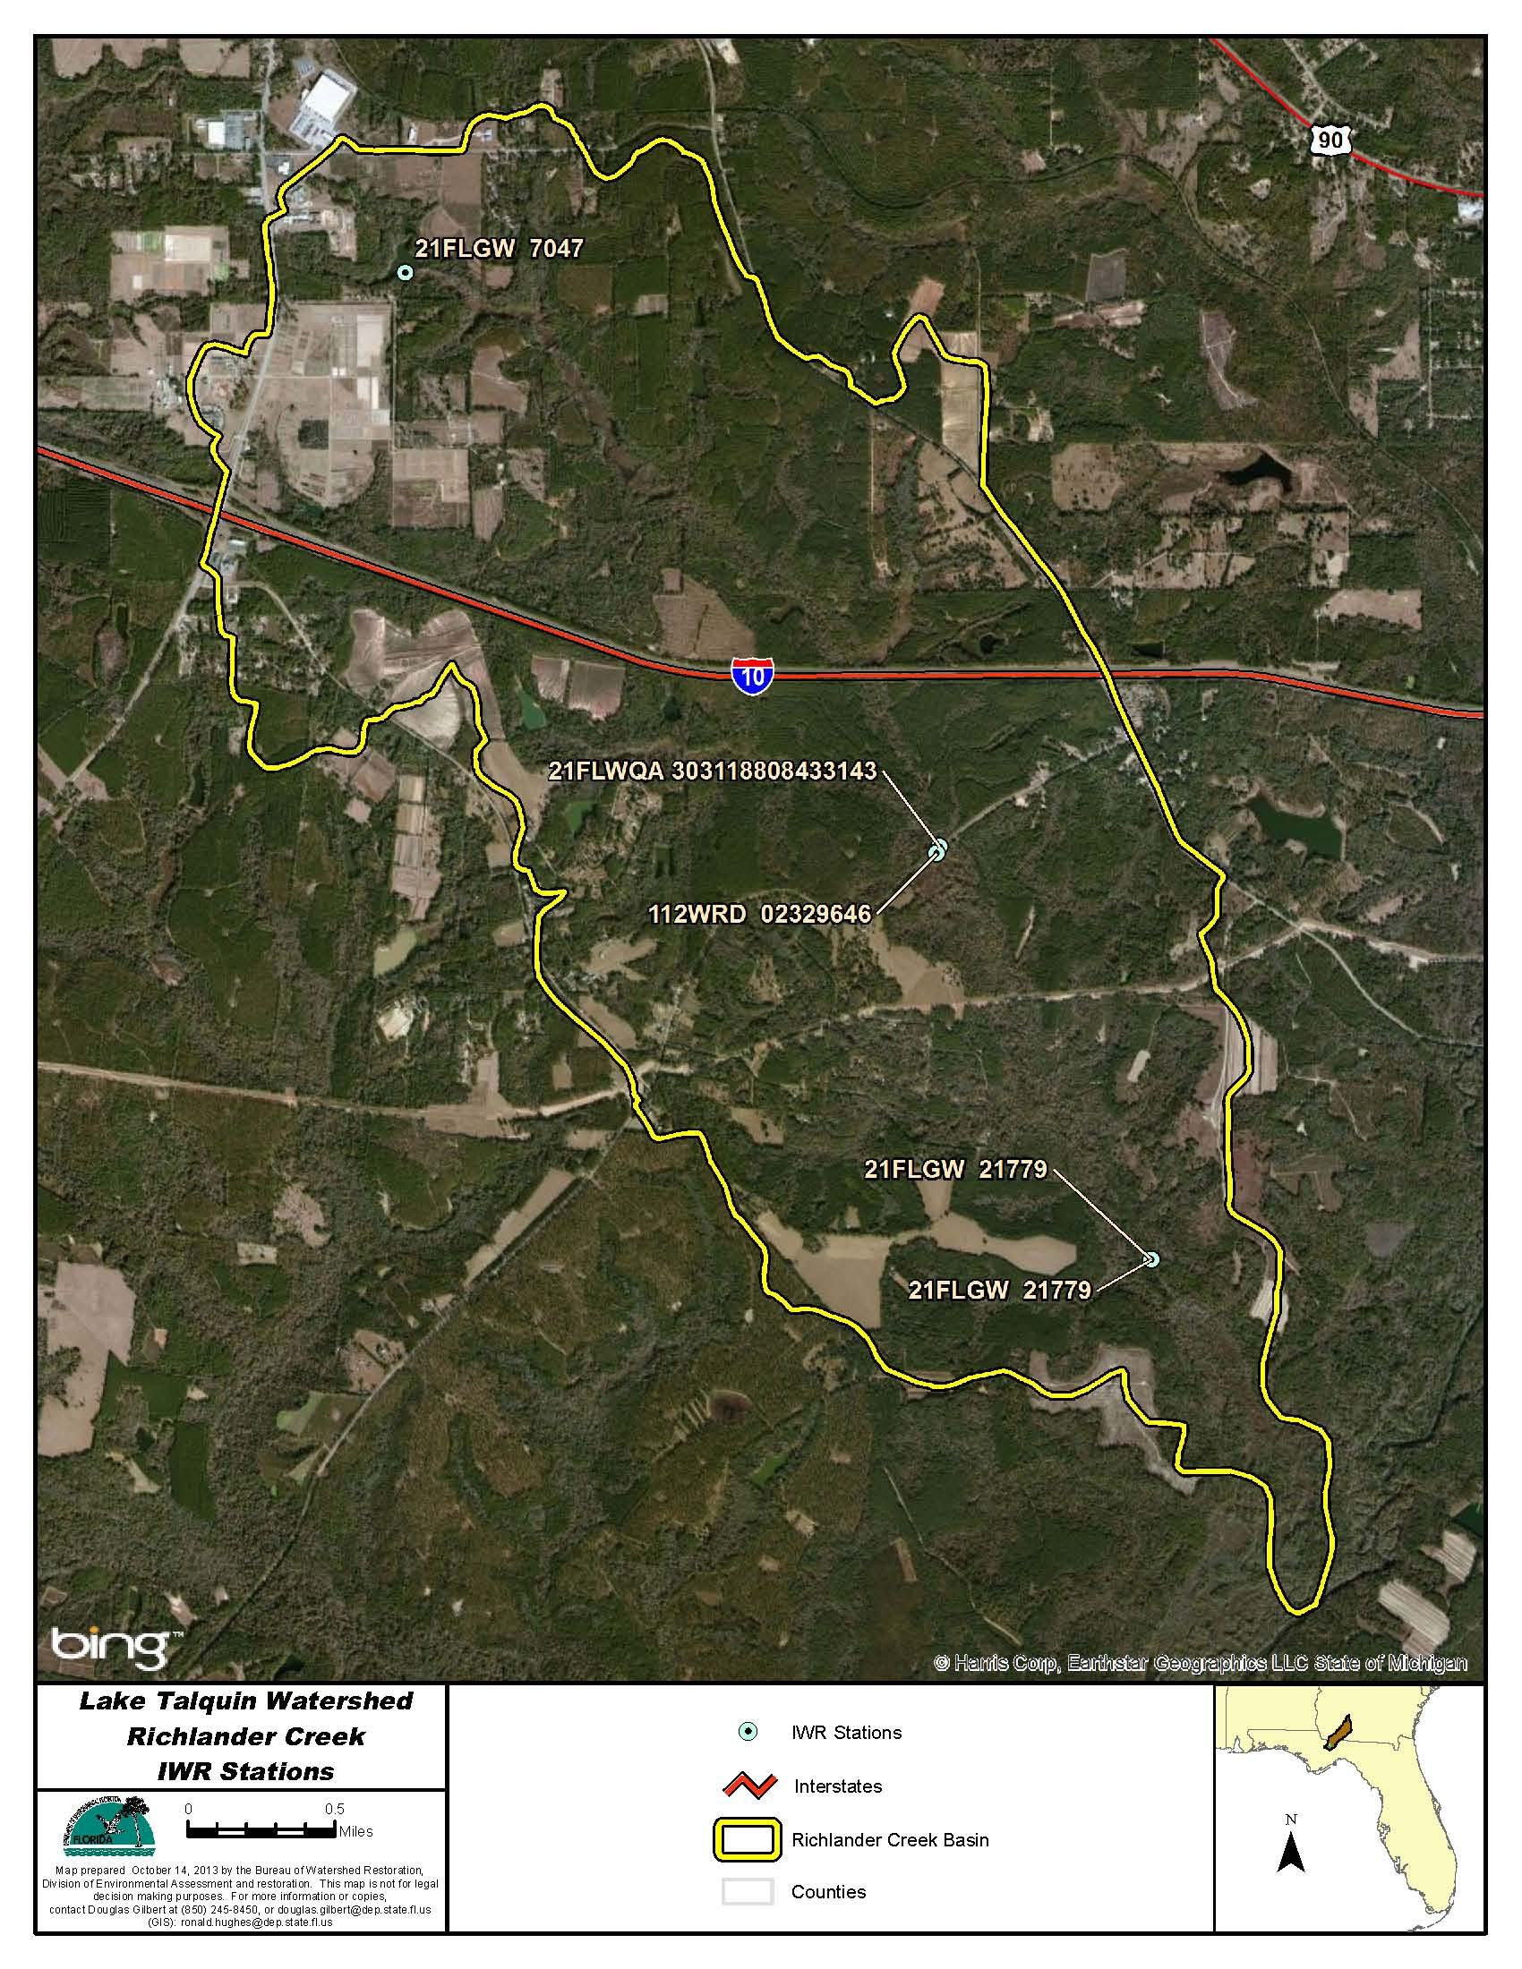
Figure B.4D.1. Richlander Creek WBID 680 IWR Stations

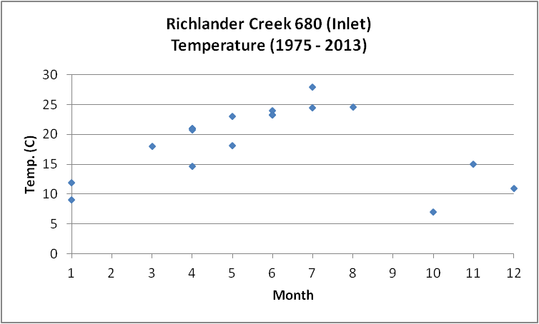
Figure B.4D.2. Richlander Creek WBID 680 Monthly Temperature 1975 - 2013

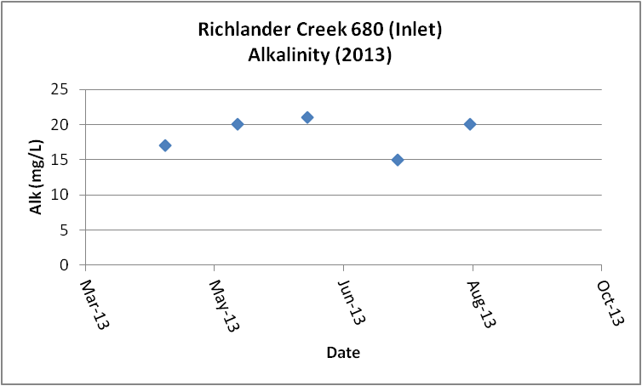
Figure B.4D.3. Richlander Creek WBID 680 Daily Average Alkalinity 2013

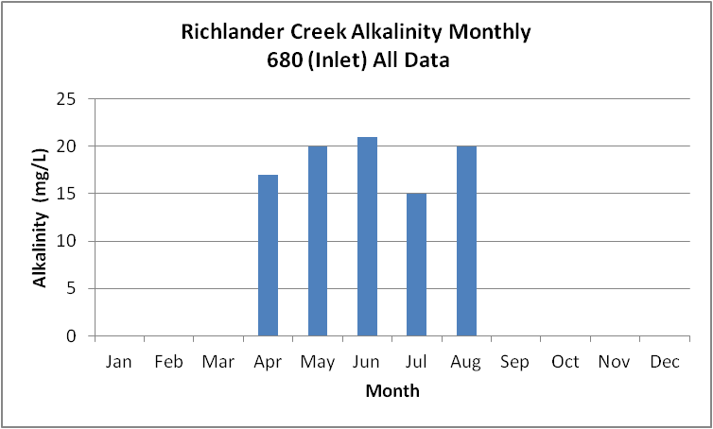
Figure B.4D.4. Richlander Creek WBID 680 Monthly Average Alkalinity 2013

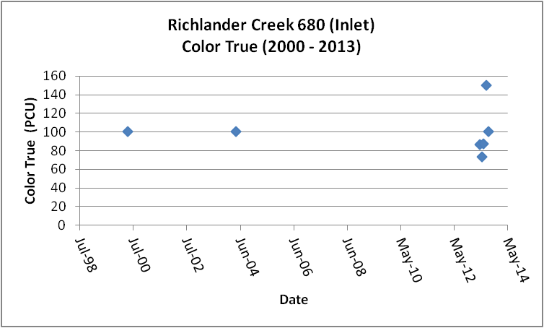
Figure B.4D.5. Richlander Creek WBID 680 Daily Average True Color 2000- 2013

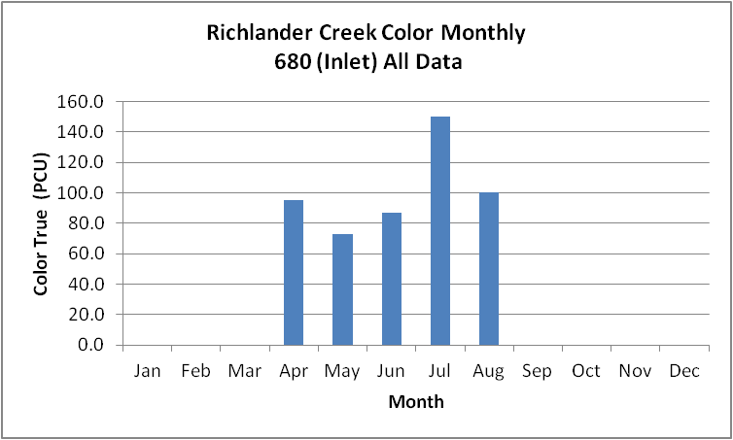
Figure B.4D.6. Richlander Creek WBID 680 Monthly Average True Color 2000- 2013

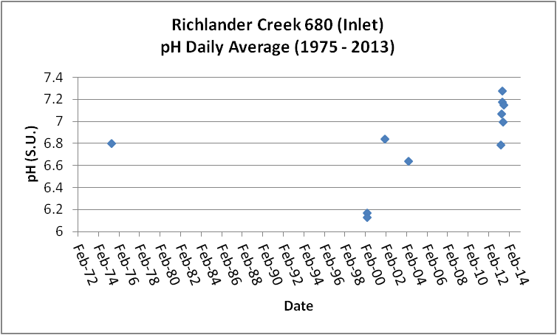
Figure B.4D.7. Richlander Creek WBID 680 Daily pH 1975- 2013

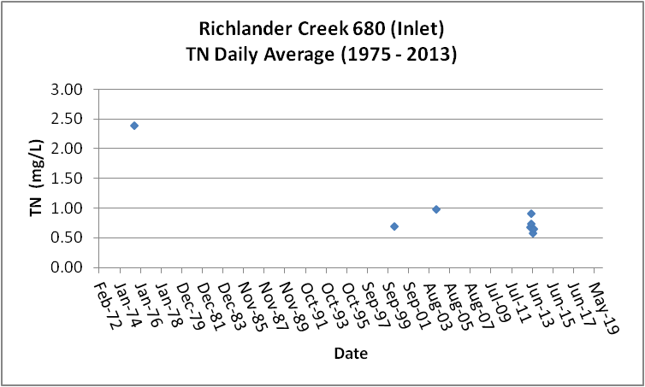
Figure B.4D.8. Richlander Creek WBID 680 Daily Average TN1975- 2013

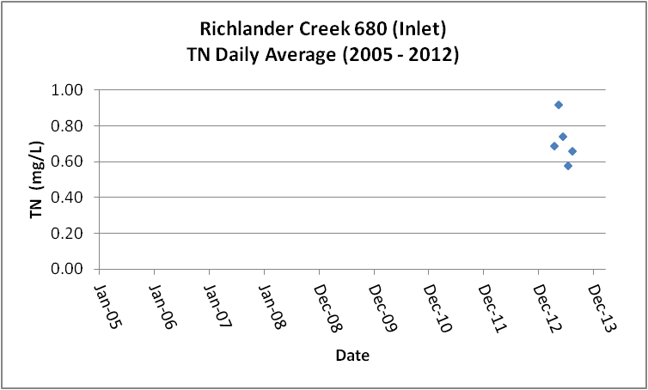
Figure B.4D.9. Richlander Creek WBID 680 Daily Average TN 2005- 2013

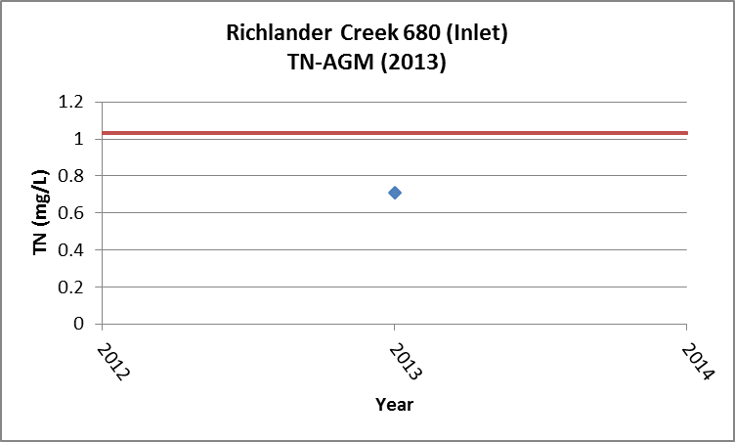
Figure B.4D.10. Richlander Creek WBID 680 TN Annual Geomean 2013

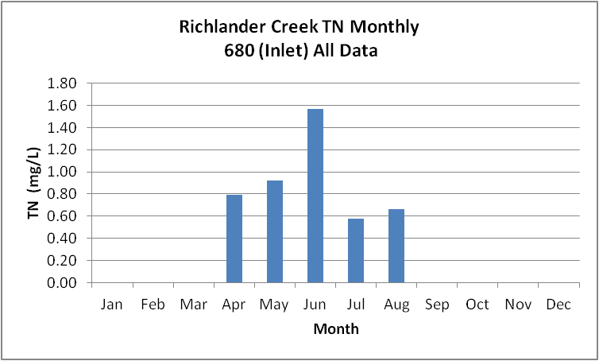
Figure B.4D.11. Richlander Creek WBID 680 Monthly Average TN 1975- 2013

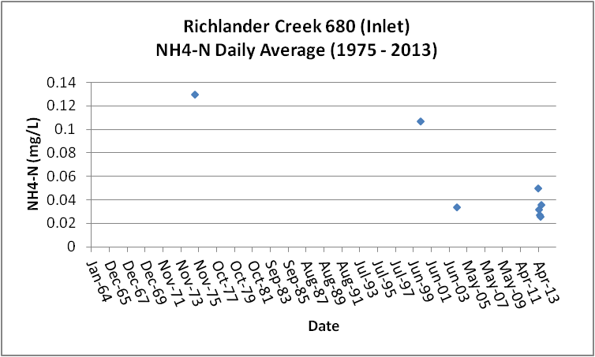
Figure B.4D.12. Richlander Creek WBID 680 Daily Average Ammonia-N 1975- 2013

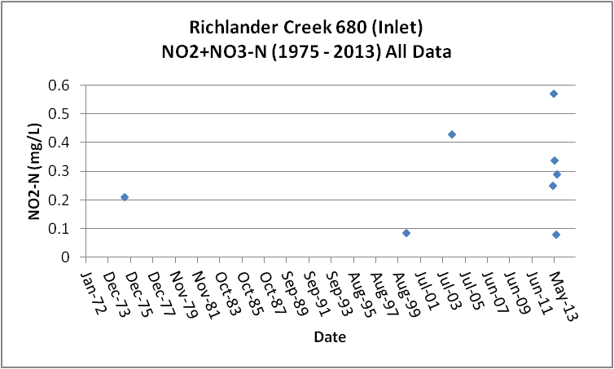
Figure B.4D.13. Richlander Creek WBID 680 Daily Average Nitrate/Nitrite-N1975- 2013

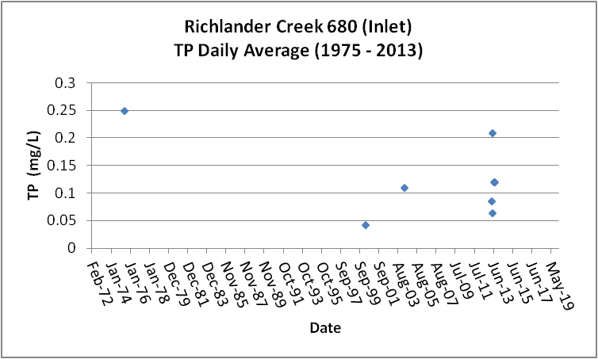
Figure B.4D.14. Richlander Creek WBID 680 Daily Average TP 1975 - 2013

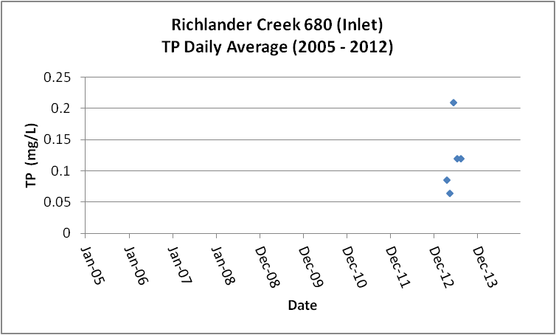
Figure B.4D.15. Richlander Creek WBID 680 Daily Average TP 2005 - 2013

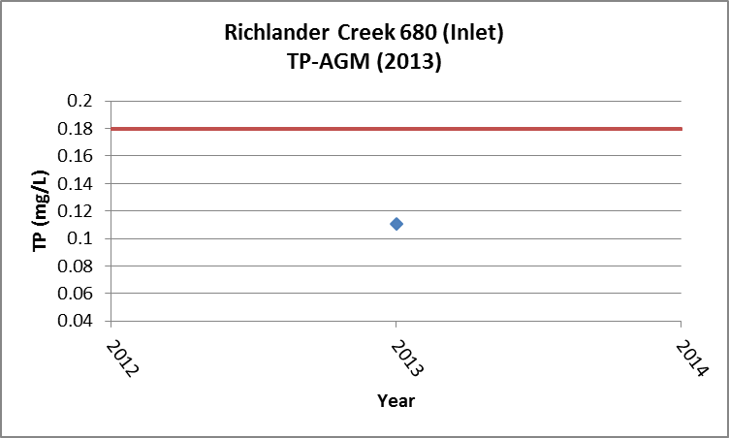
Figure B.4D.16. Richlander Creek WBID 680 Annual Geomean TP 2013

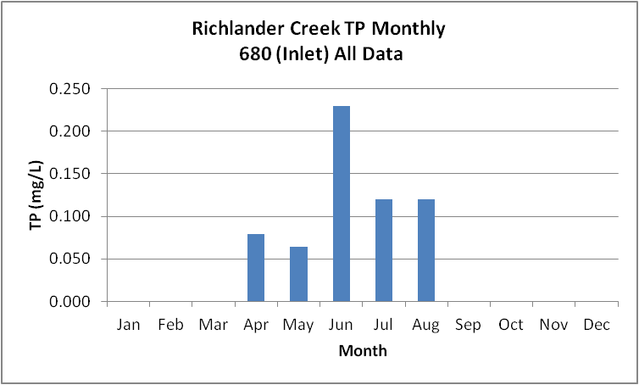
Figure B.4D.17. Richlander Creek WBID 680 Monthly Average TP 1975 - 2013

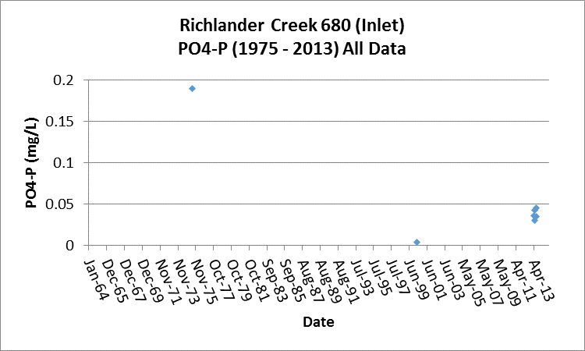

Figure B.4D.18. Richlander Creek WBID 680 Daily Average Orthophosphate-P 1975 - 2013

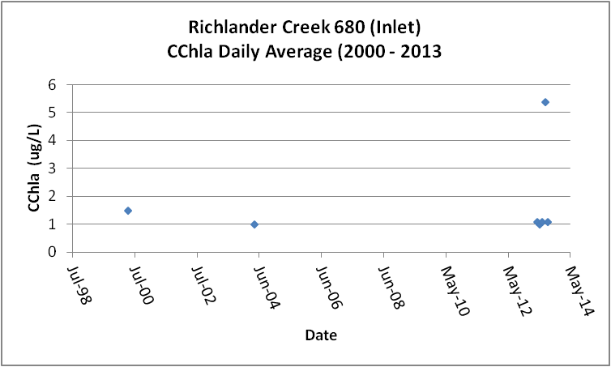
Figure B.4D.19. Richlander Creek WBID 680 Daily Average CChla 2000 - 2013

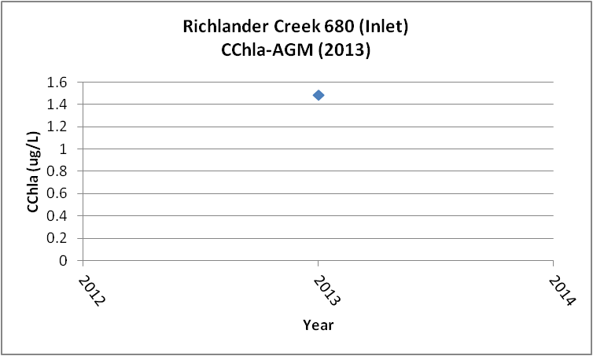
Figure B.4D.20. Richlander Creek WBID 680 Annual Geomean CChla 2013

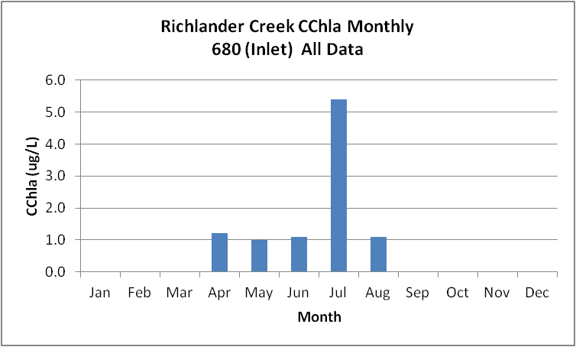
Figure B.4D.21. Richlander Creek WBID 680 Monthly Average CChla 2000 - 2013

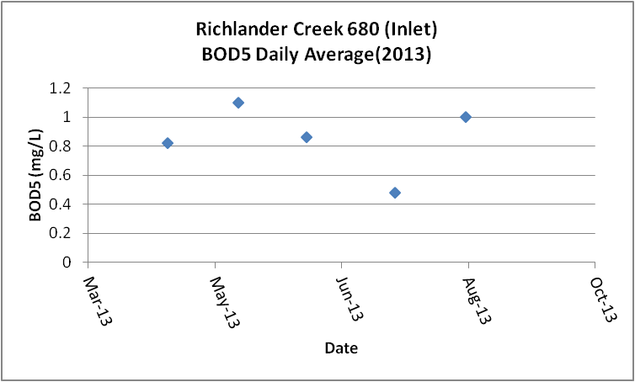
Figure B.4D.22. Richlander Creek WBID 680 Daily Average BOD5 2013

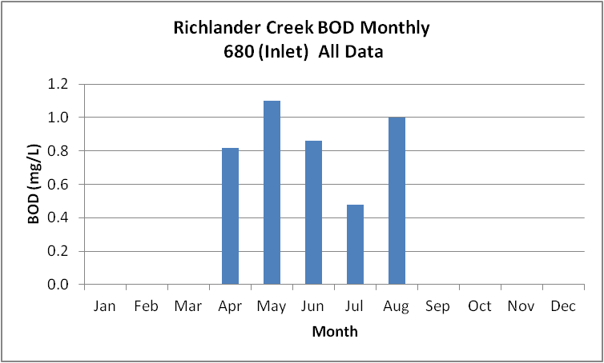
Figure B.4D.23. Richlander Creek WBID 680 Monthly Average BOD5 2013

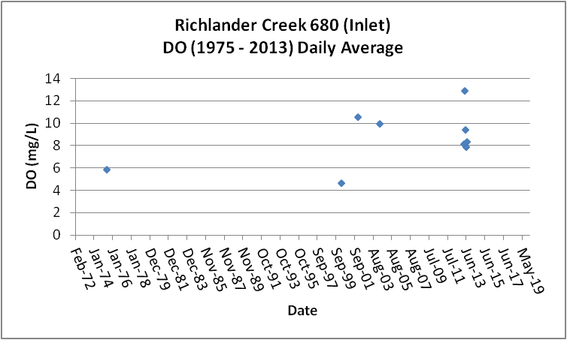
Figure B.4D.24. Richlander Creek WBID 680 Daily Average DO 1975 - 2013

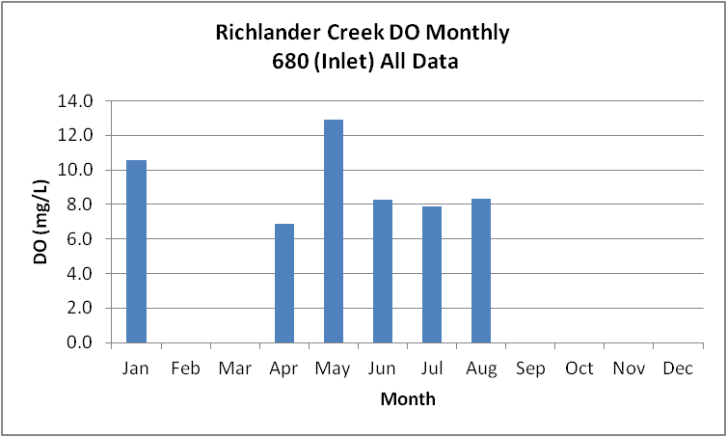
Figure B.4D.25. Richlander Creek WBID 680 Monthly Average DO 1975 - 2013

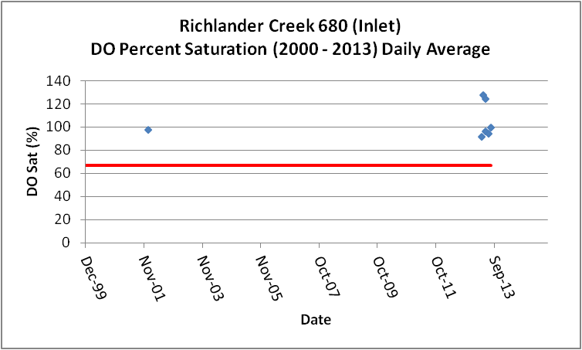
Figure B.4D.26. Richlander Creek WBID 680 Daily Average DO Percent Saturation 2000 - 2013

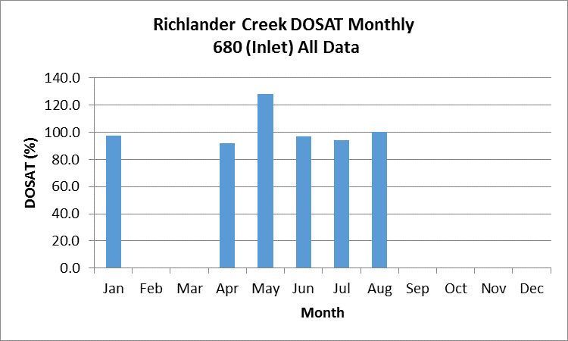
Figure B.4D.27. Richlander Creek WBID 680 Monthly Average DO Percent Saturation 2000 - 2013

Table B.4D.1. Richlander Creek WBID 680 IWR Stations
WBID | Station Number | Station Name | Begin Date | End Date
680 | 21FLGW 21779 | NW1-SS-2002 RICHLANDER CREEK | 2004 | 2004
680 | 21FLGW 21779 | NW1-SS-2002 RICHLANDER CREEK | 2004 | 2004
680 | 21FLGW 7047 | NWA-SL-1008 UNNAMED FARMPOND | 2000 | 2000
680 | 21FLWQA 303118808433143 | Richlander Creek at SR 65B | 2002 | 2002
680 | 112WRD 02329646 | RICHLANDER CREEK NR QUINCY FLA | 1975 | 1981

Table B.4D.2. Richlander Creek WBID 680 Long-Term Geomean Alkalinity and Color
WBID | Constituent | POR | Geomean
680 | Alkalinity (mg/L) | 2013 | 18.5
680 | Color-True (PCU) | 2000 - 2013 | 97.2

Table B.4D.3. Richlander Creek WBID 680 DO Percent Saturation vs. 67% Criterion
Year | Category | Result
1975 - 2013 | Count | 8
- | Number P | 7
- | Number F | 1
- | Percent F | 12.5
- | - | -
2005-2013 | Count | 6
- | Number P | 6
- | Number F | 0
- | Percent F | 0.0

Table B.4D.4. Richlander Creek WBID 680 Annual Geomean TN, TP, TN/TP Ratio, and CChla
Year | TN | TP | TN/TP | CChla
- | AGM | AGM | Ratio | AGM
2013 | 0.71 | 0.110 | 6.4 | 1.5

Table B.4D.5. Richlander Creek WBID 680 Water Quality Data Summary All Data
Constituent | Units | POR | Count | Min | Max | Median | Mean | Geomean
Temperature | C | 1975 - 2013 | 18 | 7.0 | 28.0 | 20.9 | 18.8 | 17.7
Alkalinity | mg/L | 2013 | 5 | 15.0 | 21.0 | 20.0 | 18.6 | 18.5
pH | S.U. | 1975 - 2013 | 11 | 6.1 | 7.3 | 6.8 | NA | NA
Color | PCU | 2000 - 2013 | 7 | 73.0 | 150.0 | 100.0 | 99.4 | 97.2
TN | mg/L | 1975 - 2013 | 8 | 0.58 | 2.40 | 0.72 | 0.96 | 0.86
NH4-N | mg/L | 1975 - 2013 | 8 | 0.026 | 0.13 | 0.04 | 0.06 | 0.05
NO23 | mg/L | 1975 - 2013 | 8 | 0.080 | 0.57 | 0.27 | 0.28 | 0.23
OrgN | mg/L | 1975 | 1 | 2.10 | 2.10 | 2.10 | 2.10 | 2.10
TP | mg/L | 1975 - 2013 | 8 | 0.043 | 0.250 | 0.115 | 0.125 | 0.109
PO4-P | mg/L | 1975 - 2013 | 7 | 0.004 | 0.190 | 0.036 | 0.055 | 0.034
CChla | ug/L | 2000 - 2013 | 7 | 1.0 | 5.4 | 1.1 | 1.7 | 1.4
BOD5 | mg/L | 2013 | 5 | 0.5 | 1.1 | 0.9 | 0.9 | 0.8
DO | mg/L | 1975 - 2013 | 11 | 4.6 | 12.9 | 8.2 | 8.4 | 8.0
%DOSat | % | 1975 - 2013 | 8 | 69.0 | 128.2 | 97.1 | 100.3 | 98.7

Table B.4D.6. Richlander Creek WBID 680 Water Quality Data Summary Verified Period Plus (2005 – 2013)
Constituent | Units | Verified Period + | Count | Min | Max | Median | Mean | Geomean
Temperature | C | 2005 - 2013 | 6 | 18.2 | 24.7 | 23.3 | 22.5 | 22.4
Alkalinity | mg/L | 2005 - 2013 | 5 | 15.0 | 21.0 | 20.0 | 18.6 | 18.5
pH | S.U. | 2005 - 2013 | 6 | 6.8 | 7.3 | 7.1 | NA | NA
Color | PCU | 2005 - 2013 | 5 | 73.0 | 150.0 | 87.0 | 99.2 | 96.1
TN | mg/L | 2005 - 2013 | 5 | 0.58 | 0.92 | 0.69 | 0.72 | 0.71
NH4-N | mg/L | 2005 - 2013 | 5 | 0.026 | 0.05 | 0.03 | 0.03 | 0.03
NO23 | mg/L | 2005 - 2013 | 5 | 0.080 | 0.57 | 0.29 | 0.31 | 0.26
OrgN | mg/L | - | - | - | - | - | - | -
TP | mg/L | 2005 - 2013 | 5 | 0.064 | 0.210 | 0.120 | 0.120 | 0.110
PO4-P | mg/L | 2005 - 2013 | 5 | 0.030 | 0.045 | 0.036 | 0.038 | 0.037
CChla | ug/L | 2005 - 2013 | 5 | 1.0 | 5.4 | 1.1 | 1.9 | 1.5
BOD5 | mg/L | 2005 - 2013 | 5 | 0.5 | 1.1 | 0.9 | 0.9 | 0.8
DO | mg/L | 2005 - 2013 | 6 | 7.9 | 12.9 | 8.3 | 9.4 | 9.2
%DOSat | % | 2005 - 2013 | 6 | 91.7 | 128.2 | 98.4 | 106.0 | 105.0

B.4E Rocky Comfort WBID 1304 Drains to Lake Talquin
This WBID is not impaired for DO or nutrients.
Table B.4E.1, lists the 8 stations that have been sampled in Rocky Comfort Creek WBID 1304. Figure B.4E.1 depicts the station locations. For most constituents there are less than 25 results over the POR. About half the data is from 1950 – 1970’s and the rest was collected after 2000.
Tables B.4E.5 and B.4E.6 and Figures B.4E.3 and B.4E.4, provide the results for alkalinity. These data show that Rocky Comfort Creek has a POR GM alkalinity of 14.1 mg/L. The data indicate that the GM for the period (2005 – 2013) of 22.4 is similar to the POR concentration. There is insufficient data to determine accurate long-term or seasonal patterns.
Tables B.4E.5 and B.4E.6 and Figures B.4E.6 and B.4E.7, provide the results for true color. These data show that Rocky Comfort Creek has a POR GM color of 64.3 PCU. The data indicate that the GM color for the period (2005 – 2013) of 83.7 PCU is higher than the POR color. There is insufficient data to determine accurate long-term or seasonal patterns.
Tables B.4E.5 and B.4E.6 and Figures B.4E.8 through B.4E.11, provide the results for TN. These data show that Rocky Comfort Creek has a POR GM TN of 0.75 mg/L. The data indicate that the recent (2005 – 2013) TN GM of 0.78 mg/L is similar to the POR TN GM for the POR and less than the new 1.03 mg/L threshold AGM concentration for TN (Figure B.4E.10). There is insufficient data to determine accurate long-term or seasonal patterns.
Tables B.4E.5 and B.4E.6 and Figure B.4E.12 provide the results for NH4-N. These data show that Rocky Comfort Creek has a POR GM NH4-N of 0.03 mg/L, less than either the Little or Ochlockonee Rivers. The data indicate that the recent (2005 – 2013) NH4-N GM of 0.02 mg/L is less than the POR concentration. There is insufficient data to determine accurate long-term or seasonal patterns.
Tables B.4E.5 and B.4E.6 and Figure B.4E.13 provide the results for NO23-N. These data show that Rocky Comfort Creek has a POR GM NO23-N of 0.08 mg/L, significantly less than either the Little or Ochlockonee Rivers. The data indicate that the recent (2005 – 2013) NO23-N GM of 0.06 mg/L is slightly less than the POR concentration, indicating a slight reduction since the 1970’s. There is insufficient data to determine accurate long-term or seasonal patterns
Tables B.4E.5 and B.4E.6 and Figures B.4E.14 through B.4E.17, provide the results for TP. These data show that Rocky Comfort Creek has a POR GM TP of 0.136 mg/L. The data indicate that the recent (2005 – 2013) TP GM of 0.177 mg/L is slightly greater than the TP GM for the POR and very close to the new 0.18 mg/L threshold AGM concentration for TP. The only year with sufficient data to calculate an AGM is 2013 (0.256 mg/L) and the result is greater than the new threshold AGM concentration for TP (Figure B.4E.16). There is insufficient data to determine accurate long-term or seasonal patterns.
Tables B.4E.5 and B.4E.6 and Figure B.4E.18 provide the results for PO4-P. These data show that Rocky Comfort Creek has a POR GM PO4-P of 0.093 mg/L. The data indicate that the recent (2005 – 2013) PO4-P GM of 0.082 mg/L is similar to the POR concentration. These concentrations are about twice as high as the Little and Ochlockonee Rivers as well as the adjacent Richlander Creek. There is insufficient data to determine accurate long-term or seasonal patterns.
Tables B.4E.5 and B.4E.6 and Figures B.4E.19 through B.4E.21, provide the results for CChla. These data show that Rocky Comfort Creek has a POR GM CChla of 3.8 ug/L. The data indicate that the recent (2005 – 2013) CChla GM of 5.7 ug/L is slightly greater than the CChla GM for the POR and significantly less than the new 20.0 ug/L threshold AGM concentration for CChla (Figure B.4E.20). These data indicate an increase in CChla concentrations over time. The CChla, while low, is elevated over the Little and Ochlockonee Rivers as well as the adjacent Richlander Creek. This pattern is also similar to the PO4-P results. The data set has a large number of less than detection results. There is insufficient data to determine accurate long-term or seasonal patterns.
Tables B.4E.5 and B.4E.6 and Figures B.4E.22 and B.4E.23, provide the results for BOD5. These data show that Rocky Comfort Creek has a POR GM BOD5 of 1.1 mg/L. All of the results are from 2013. There is insufficient data to determine accurate long-term or seasonal patterns.
Tables B.4E.5 and B.4E.6 and Figures B.4E.24 and B.4E.25, provide the results for DO. These data show that Rocky Comfort Creek has a POR GM DO of 5.8 mg/L. The data indicate that the recent (2005 – 2013) DO GM of 4.3 mg/L is less than the POR concentration and less than the old criterion of 5.0 mg/L. The monthly average DO drops below 4.0 mg/L for April (Figure B.4E.25). There is insufficient data to determine accurate long-term or seasonal patterns.
Tables B.4E.5 and B.4E.6 and Figures B.4E.26 and B.4E.27, provide the results for percent DO saturation. These data show that Rocky Comfort Creek has a POR GM DOSAT of 86.3 percent. The data indicate that the recent (2005 – 2013) DOSAT GM of 93.5 percent is slightly higher than the GM for the POR. The data presented in Figure B.4E.26 do not indicate an issue with the new 67% saturation DO criterion. There is insufficient data to determine accurate long-term or seasonal patterns.

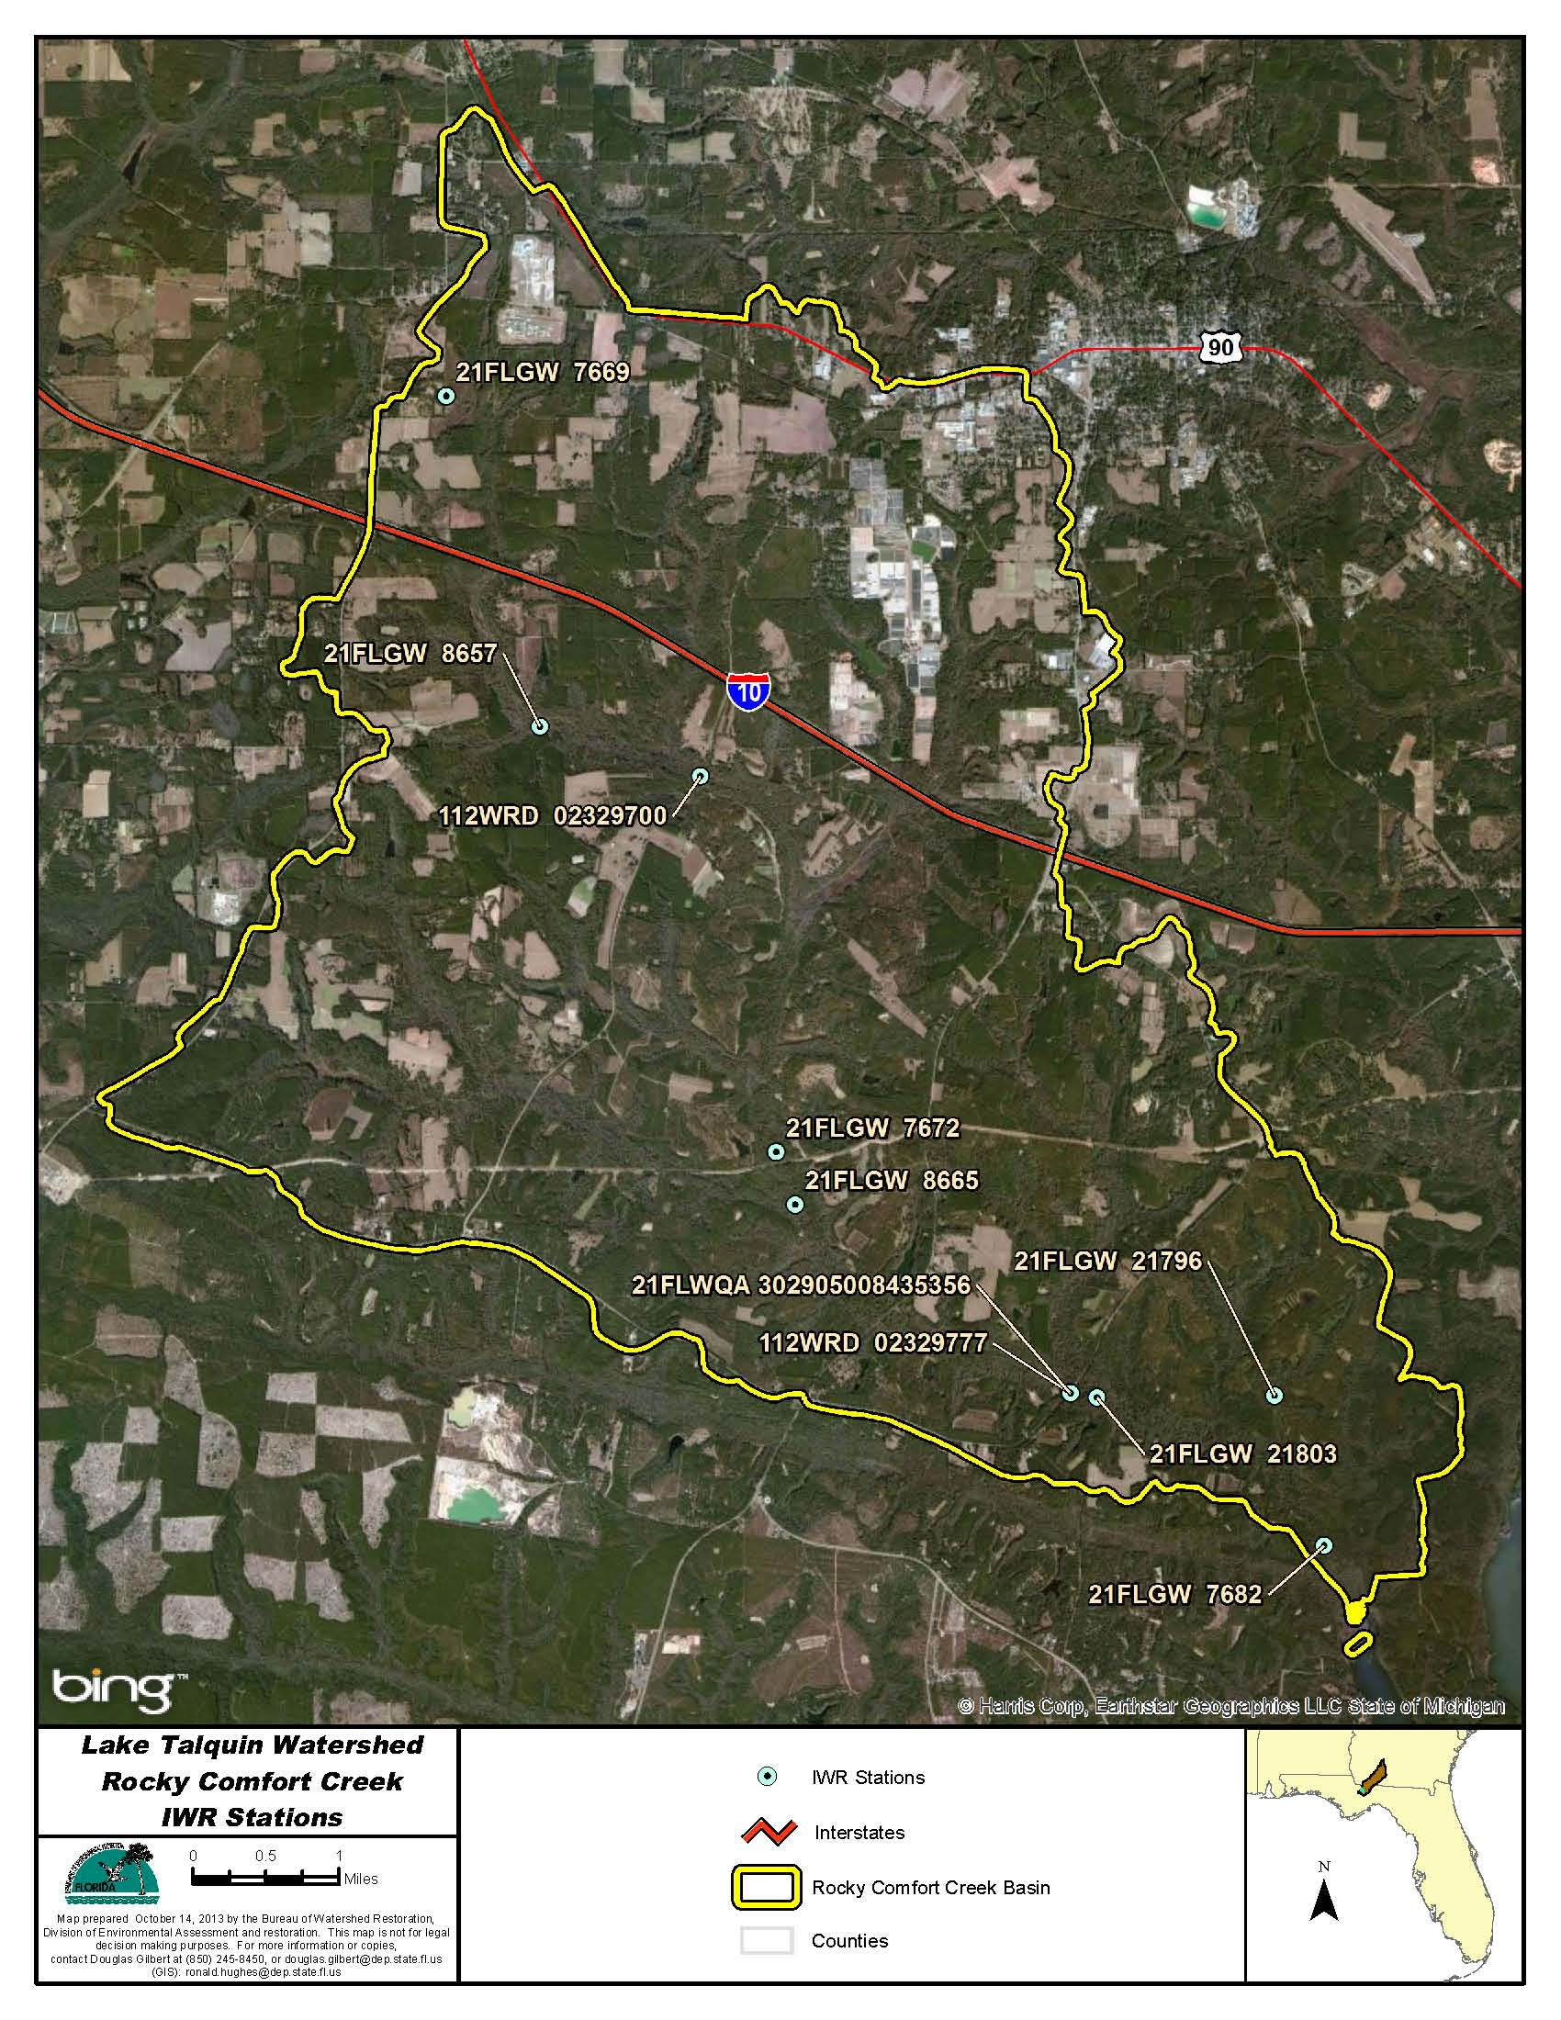
Figure B.4E.1. Rocky Comfort Creek WBID 1304 IWR Stations

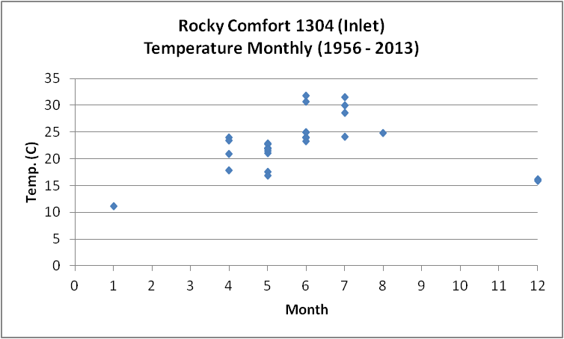
Figure B.4E.2. Rocky Comfort Creek WBID 1304 Monthly Temperature 1956 - 2013

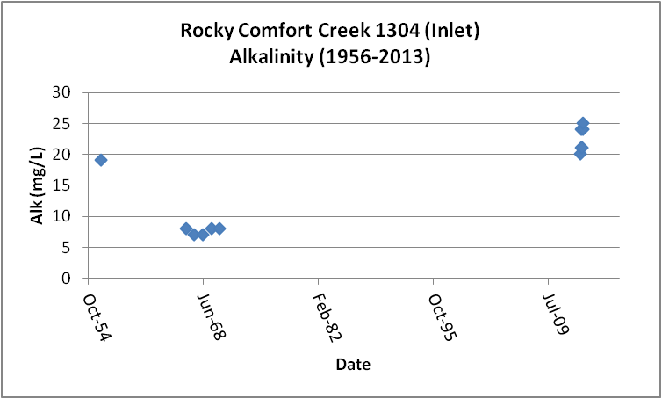
Figure B.4E.3. Rocky Comfort Creek WBID 1304 Daily Average Alkalinity 1956 - 2013

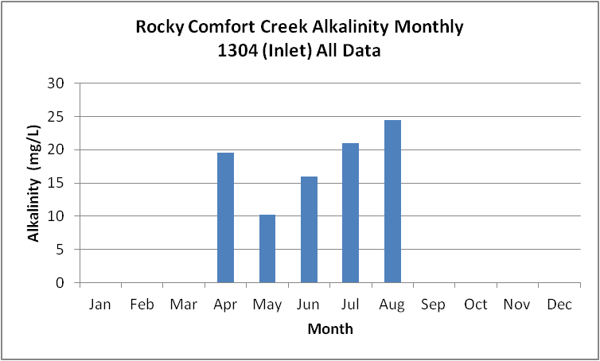
Figure B.4E.4. Rocky Comfort Creek WBID 1304 Monthly Average Alkalinity 1956 - 2013

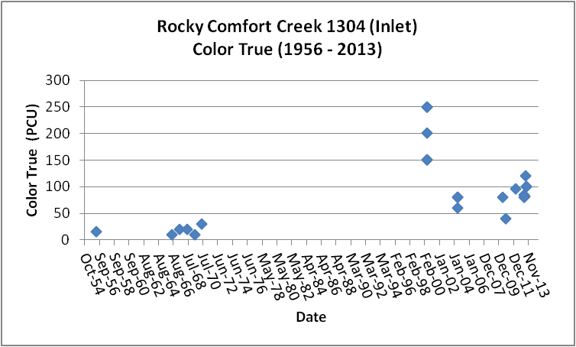
Figure B.4E.5. Rocky Comfort Creek WBID 1304Daily Average True Color 1956- 2013

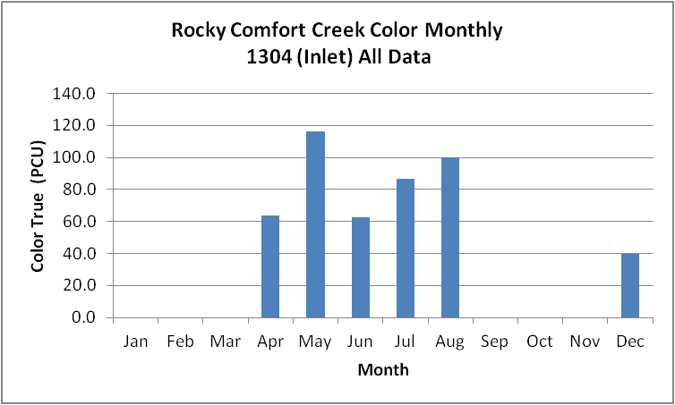
Figure B.4E.6. Rocky Comfort Creek WBID 1304Monthly Average True Color 1956- 2013

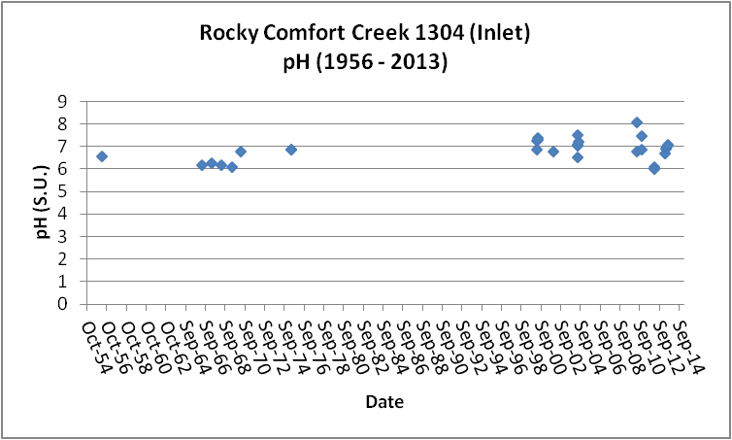
Figure B.4E.7. Rocky Comfort Creek WBID 1304 Daily pH 1956- 2013

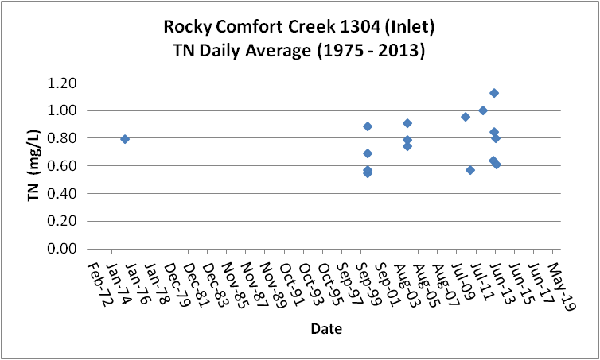
Figure B.4E.8. Rocky Comfort Creek WBID 1304Daily Average TN1975- 2013

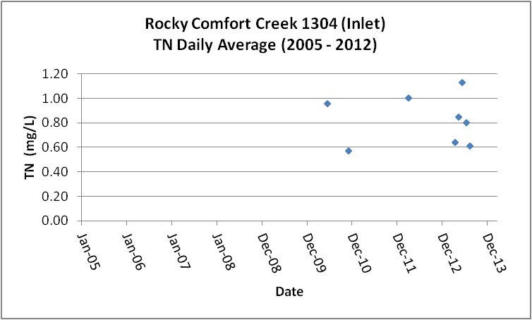
Figure B.4E.9. Rocky Comfort Creek WBID 1304Daily Average TN 2005- 2013

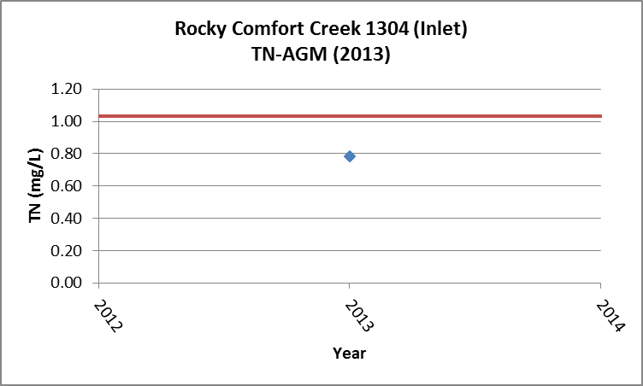
Figure B.4E.10. Rocky Comfort Creek WBID 1304 TN Annual Geomean 2013

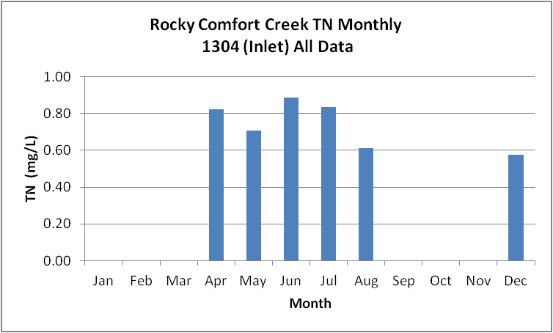
Figure B.4E.11. Rocky Comfort Creek WBID 1304Monthly Average TN 1975- 2013

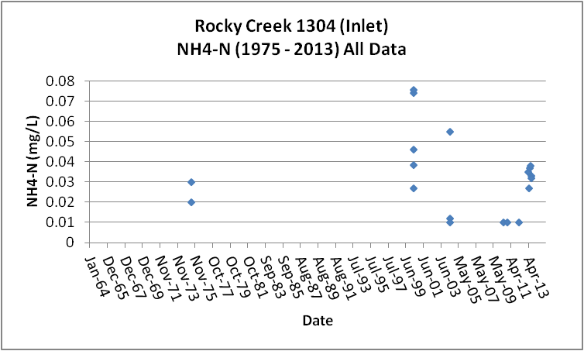
Figure B.4E.12. Rocky Comfort Creek WBID 1304 Daily Average Ammonia-N 1975- 2013

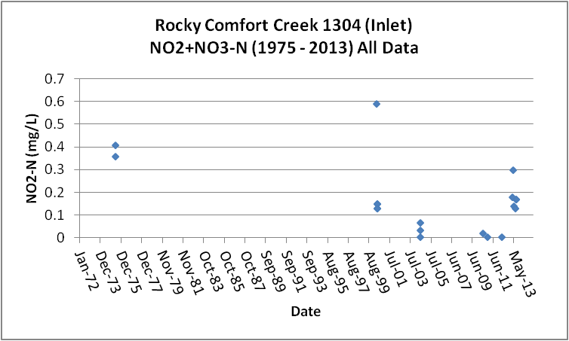
Figure B.4E.13. Rocky Comfort Creek WBID 1304 Daily Average Nitrate/Nitrite-N1975- 2013

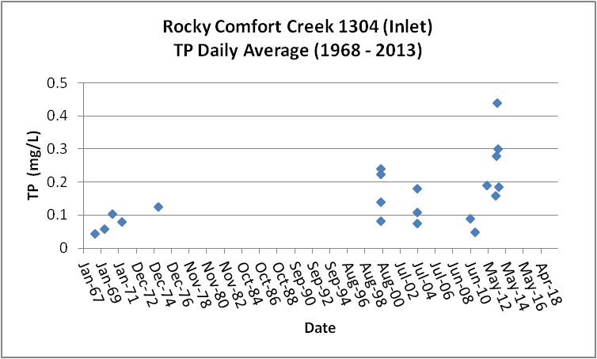
Figure B.4E.14. Rocky Comfort Creek WBID 1304 Daily Average TP 1968 - 2013

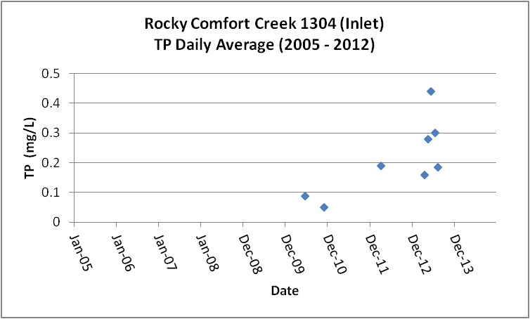
Figure B.4E.15. Rocky Comfort Creek WBID 1304 Daily Average TP 2005 - 2013

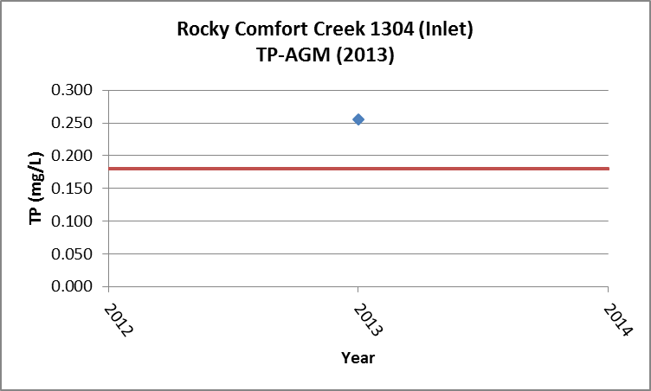
Figure B.4E.16 Rocky Comfort Creek WBID 1304 Annual Geomean TP 2013

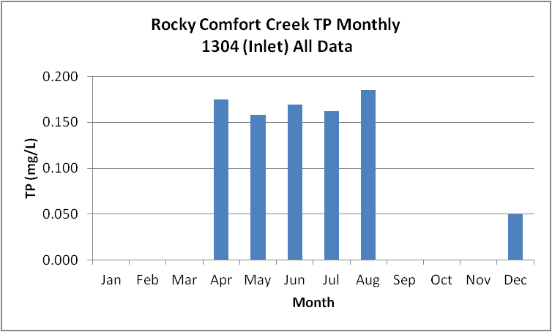
Figure B.4E.17. Rocky Comfort Creek WBID 1304 Monthly Average TP 1968 - 2013

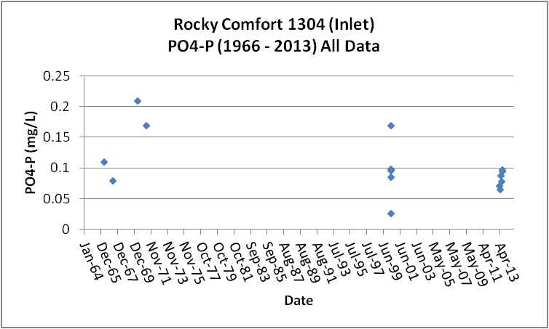
Figure B.4E.18. Rocky Comfort Creek WBID 1304 Daily Average Orthophosphate-P 1966 - 2013

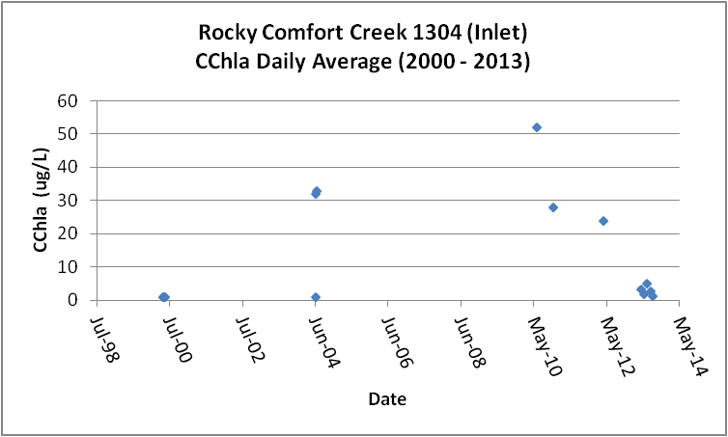
Figure B.4E.19. Rocky Comfort Creek WBID 1304 Daily Average CChla 2000 - 2013

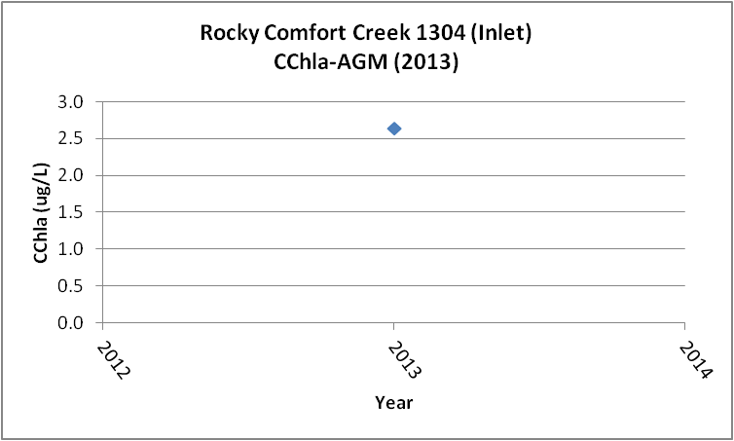
Figure B.4E.20. Rocky Comfort Creek WBID 1304 Annual Geomean CChla 2013

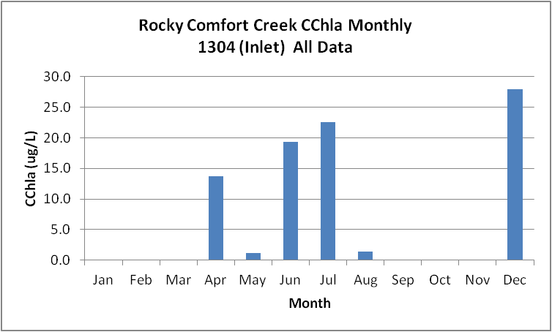
Figure B.4E.21. Rocky Comfort Creek WBID 1304 Monthly Average CChla 2000 - 2013

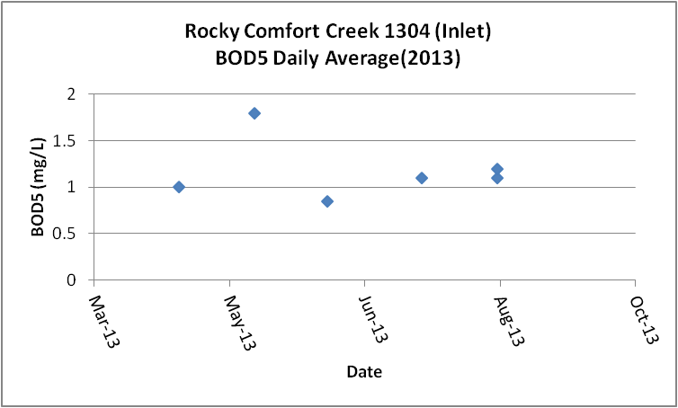
Figure B.4E.22. Rocky Comfort Creek WBID 1304 Daily Average BOD5 2013

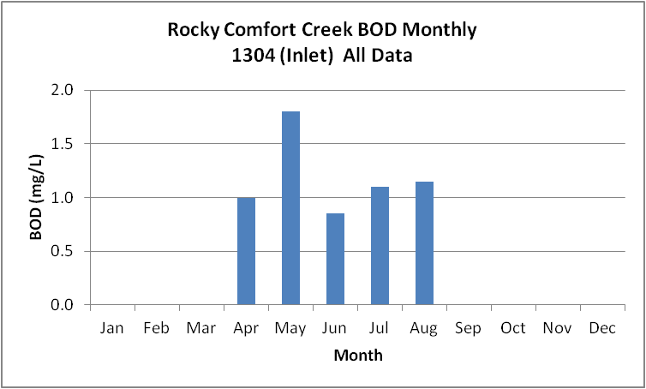
Figure B.4E.23. Rocky Comfort Creek WBID 1304 Monthly Average BOD5 2013

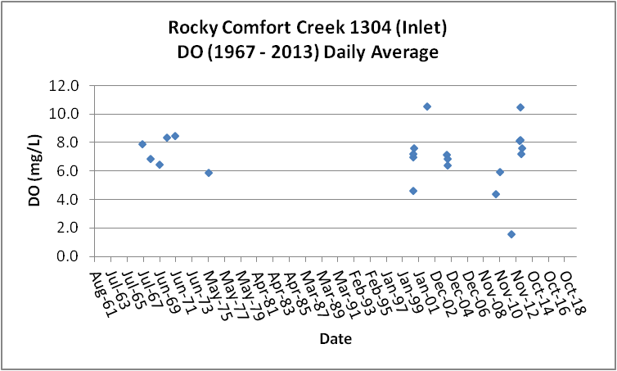
Figure B.4E.24. Rocky Comfort Creek WBID 1304 Daily Average DO 1967 - 2013

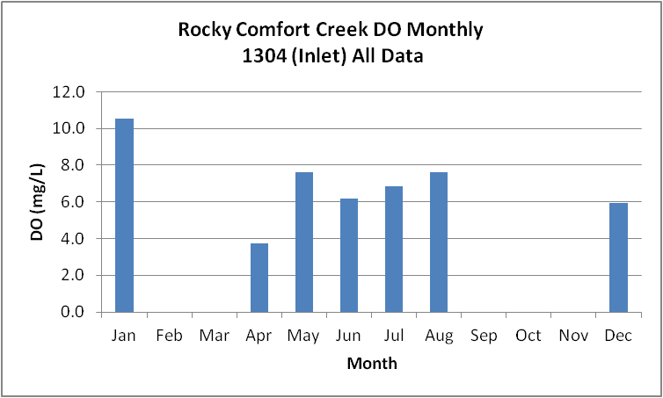
Figure B.4E.25. Rocky Comfort Creek WBID 1304 Monthly Average DO 1967 - 2013

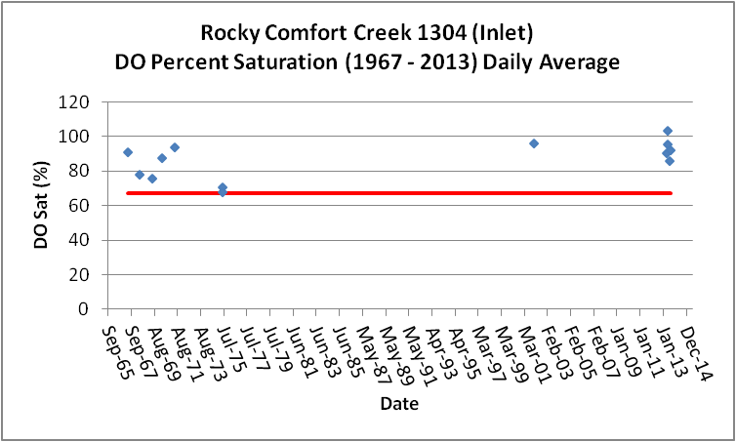
Figure B.4E.26. Rocky Comfort Creek WBID 1304 Daily Average DO Percent Saturation 1967 - 2013

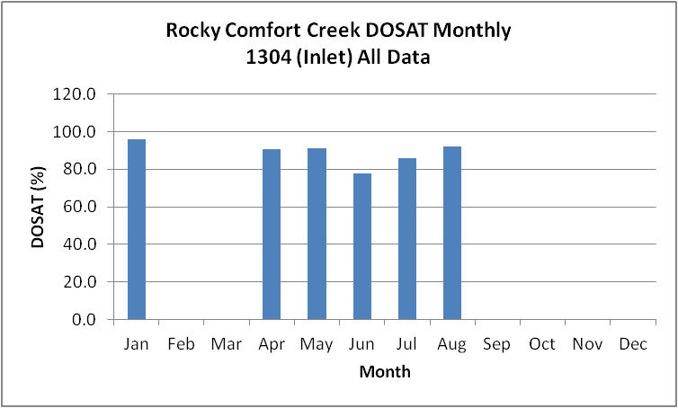
Figure B.4E.27. Rocky Comfort Creek WBID 1304 Monthly Average DO Percent Saturation 1967 - 2013

Table B.4E.1. Rocky Comfort Creek WBID 1304 IWR Stations
WBID | Station Number | Station Name | Begin Date | End Date
1304 | 21FLWQA 302905008435356 | Rocky Comfort Creek at SR 65B | 2002 | 2002
1304 | 112WRD 02329700 | ROCKY COMFORT CREEK NR QUINCY, FLA. | 1956 | 1975
1304 | 112WRD 02329777 | ROCKY COMFORT CREEK NR WETUMPKA, FLA. | 1975 | 1975
1304 | 21FLGW 7669 | NWA-LS-1018 UNNAMED STREAM | 2000 | 2000
1304 | 21FLGW 7672 | NWA-LS-1024 ROCKY COMFORT CREEK | 2000 | 2000
1304 | 21FLGW 21803 | NW1-SS-2065 ROCKY COMFORT CREEK | 2004 | 2004
1304 | 21FLGW 7682 | NWA-LS-1041 ROCKY COMFORT CREEK | 2000 | 2000
1304 | 21FLGW 8657 | NWA-LS-1046 ROCKY COMFORT CREEK | 2000 | 2000

Table B.4E.2. Rocky Comfort Creek WBID 1304 Long-Term Geomean Alkalinity and Color
WBID | Constituent | POR | Geomean
1304 | Alkalinity (mg/L) | 1956 - 2013 | 14.1
1304 | Color-True (PCU) | 1956 - 2013 | 64.3

Table B.4E.3. Rocky Comfort Creek WBID 1304 DO Percent Saturation vs. 67% Criterion
Year | Category | Result
1967 - 2013 | Count | 12
- | Number P | 11
- | Number F | 1
- | Percent F | 8.3
- | - | -
2005-2013 | Count | 5
- | Number P | 5
- | Number F | 0
- | Percent F | 0.0

Table B.4E.4. Rocky Comfort Creek WBID 1304 Annual Geomean TN, TP, TN/TP Ratio, and CChla
Year | TN | TP | TN/TP | CChla
- | AGM | AGM | Ratio | AGM
2013 | 0.79 | 0.256 | 3.1 | 2.6

Table B.4E.5. Rocky Comfort Creek WBID 1304 Water Quality Data Summary All Data
Constituent | Units | POR | Count | Min | Max | Median | Mean | Geomean
Temperature | C | 1956 - 2013 | 29 | 11.1 | 31.8 | 23.3 | 22.9 | 22.4
Alkalinity | mg/L | 1956 - 2013 | 12 | 7.0 | 25.0 | 19.5 | 16.0 | 14.1
pH | S.U. | 1956 - 2013 | 29 | 6.0 | 8.1 | 6.9 | NA | NA
Color | PCU | 1956 - 2013 | 23 | 10.0 | 250.0 | 80.0 | 91.6 | 64.3
TN | mg/L | 1975 - 2013 | 19 | 0.55 | 1.13 | 0.75 | 0.77 | 0.75
NH4-N | mg/L | 1975 - 2013 | 19 | 0.010 | 0.08 | 0.03 | 0.03 | 0.03
NO23 | mg/L | 1975 - 2013 | 19 | 0.004 | 0.59 | 0.14 | 0.17 | 0.08
OrgN | mg/L | 1970 - 1975 | 4 | 0.36 | 0.45 | 0.39 | 0.40 | 0.40
TP | mg/L | 1968 - 2013 | 23 | 0.046 | 0.440 | 0.140 | 0.161 | 0.136
PO4-P | mg/L | 1966 - 2013 | 15 | 0.026 | 0.210 | 0.095 | 0.103 | 0.093
CChla | ug/L | 2000 - 2013 | 17 | 1.0 | 52.0 | 1.9 | 11.2 | 3.8
BOD5 | mg/L | 2013 | 6 | 0.9 | 1.8 | 1.1 | 1.2 | 1.1
DO | mg/L | 1967 - 2013 | 28 | 0.8 | 10.6 | 7.2 | 6.7 | 5.8
%DOSat | % | 1967 - 2013 | 13 | 68.0 | 103.8 | 90.8 | 87.0 | 86.3

Table B.4E.6. Rocky Comfort Creek WBID 1304 Water Quality Data Summary Verified Period Plus (2005 – 2013)
Constituent | Units | Verified Period + | Count | Min | Max | Median | Mean | Geomean
Temperature | C | 2005 - 2013 | 11 | 15.9 | 31.8 | 23.4 | 22.9 | 22.3
Alkalinity | mg/L | 2005 - 2013 | 6 | 20.0 | 25.0 | 22.5 | 22.5 | 22.4
pH | S.U. | 2005 - 2013 | 11 | 6.0 | 8.1 | 6.9 | NA | NA
Color | PCU | 2005 - 2013 | 9 | 40.0 | 120.0 | 84.0 | 86.8 | 83.7
TN | mg/L | 2005 - 2013 | 9 | 0.57 | 1.13 | 0.80 | 0.80 | 0.78
NH4-N | mg/L | 2005 - 2013 | 9 | 0.010 | 0.04 | 0.03 | 0.03 | 0.02
NO23 | mg/L | 2005 - 2013 | 9 | 0.004 | 0.30 | 0.14 | 0.12 | 0.06
OrgN | mg/L | - | - | - | - | - | - | -
TP | mg/L | 2005 - 2013 | 9 | 0.050 | 0.440 | 0.190 | 0.209 | 0.177
PO4-P | mg/L | 2005 - 2013 | 6 | 0.066 | 0.097 | 0.084 | 0.083 | 0.082
CChla | ug/L | 2005 - 2013 | 9 | 1.4 | 52.0 | 3.4 | 13.3 | 5.7
BOD5 | mg/L | 2005 - 2013 | 6 | 0.9 | 1.8 | 1.1 | 1.2 | 1.1
DO | mg/L | 2005 - 2013 | 11 | 0.8 | 10.5 | 7.6 | 6.0 | 4.3
%DOSat | % | 2005 - 2013 | 5 | 85.9 | 103.8 | 92.0 | 93.7 | 93.5

B.4F. Bear Creek WBID 757 Drains to Lake Talquin
This WBID is not impaired for DO or nutrients.
Table B.4F.1, lists the 13 stations that have been sampled in Bear Creek WBID 757. Figure B.4F.1 depicts the station locations. About one third of the data was collected between 1973 and 1990.
Tables B.4F.5 and B.4F.6 and Figures B.4F.3 and B.4F.4, provide the results for alkalinity. These data show that Bear Creek has a POR GM alkalinity of 2.4 mg/L. The data indicate that the GM for the period (2005 – 2013) of 2.3 mg/L is similar to the POR concentration. There is insufficient data to determine accurate long-term or seasonal patterns.
Tables B.4F.5 and B.4F.6 and Figures B.4F.5 and B.4F.6, provide the results for true color. These data show that Bear Creek has a POR GM color of 54.6 PCU. The data indicate that the GM color for the period (2005 – 2013) of 46.0 PCU is less than the POR color. There is insufficient data to determine accurate long-term or seasonal patterns.
Tables B.4F.5 and B.4F.6 and Figures B.4F.8 through B.4F.11, provide the results for TN. These data show that Bear Creek has a POR GM TN of 0.42 mg/L. The data indicate that the recent (2005 – 2013) TN GM of 0.36 mg/L is slightly less than the POR TN GM for the POR and less than the new 1.03 mg/L threshold AGM concentration for TN (Figure B.4F.10). There is insufficient data to determine accurate long-term or seasonal patterns.
Tables B.4F.5 and B.4E.6 and Figure B.4F.12 provide the results for NH4-N. These data show that Bear Creek has a POR GM NH4-N of 0.03 mg/L, less than either the Little or Ochlockonee Rivers. The data indicate that the recent (2005 – 2013) NH4-N GM of 0.02 mg/L is less than the POR concentration. There is insufficient data to determine accurate long-term or seasonal patterns.
Tables B.4F.5 and B.4F.6 and Figure B.4F.13 provide the results for NO23-N. These data show that Bear Creek has a POR GM NO23-N of 0.03 mg/L, significantly less than either the Little or Ochlockonee Rivers. The data indicate that the recent (2005 – 2013) NO23-N GM of 0.04 mg/L is slightly greater than the POR concentration, indicating a slight increase since the 1970’s. There is insufficient data to determine accurate long-term or seasonal patterns
Tables B.4F.5 and B.4F.6 and Figures B.4F.14 through B.4F.17, provide the results for TP. These data show that Bear Creek has a POR GM TP of 0.080 mg/L. The data indicate that the recent (2005 – 2013) TP GM of 0.081 mg/L is not different from the TP GM for the POR and significantly less than the 0.18 mg/L new threshold AGM concentration for TP (Figure B.4F.16). There is insufficient data to determine accurate long-term or seasonal patterns.
Tables B.4F.5 and B.4F.6 and Figure B.4F.18 provide the results for PO4-P. These data show that Bear Creek has a POR GM PO4-P of 0.045 mg/L. The data indicate that the recent (2005 – 2013) PO4-P GM of 0.045 mg/L is the same as the POR concentration. These concentrations are similar to the Little and Ochlockonee Rivers as well as the adjacent Richlander Creek. There is insufficient data to determine accurate long-term or seasonal patterns.
Tables B.4F.5 and B.4F.6 and Figures B.4F.19 through B.4F.21, provide the results for CChla. These data show that Bear Creek has a POR GM CChla of 2.1 ug/L. The data indicate that the recent (2005 – 2013) CChla GM of 2.3 ug/L is similar to the CChla GM for the POR and significantly less than the new 20.0 ug/L threshold AGM concentration for CChla (Figure B.4F.20). The data set has a large number of less than detection results. There is insufficient data to determine accurate long-term or seasonal patterns.
Tables B.4F.5 and B.4F.6 and Figures B.4F.22 and B.4F.23, provide the results for BOD5. These data show that Bear Creek has a POR GM BOD5 of 1.6 mg/L as well as 1.6 mg/L for the period 2005 – 2013). There is insufficient data to determine accurate long-term or seasonal patterns.
Tables B.4F.5 and B.4F.6 and Figures B.4F.24 and B.4F.25, provide the results for DO. These data show that Bear Creek has a POR GM DO of 7.7 mg/L. The data indicate that the recent (2005 – 2013) DO GM of 8.2 mg/L is slightly greater than the POR concentration and the old criterion of 5.0 mg/L. The monthly average DO never drops below 5.0 mg/L (Figure B.4F.25). There is insufficient data to determine accurate long-term or seasonal patterns.

Tables B.4F.5 and B.4F.6 and Figures B.4F.26 and B.4F.27, provide the results for percent DO saturation. These data show that Bear Creek has a POR GM DOSAT of 94.1 percent. The data indicate that the recent (2005 – 2013) DOSAT GM of 96 percent is slightly higher than the GM for the POR. The data presented in Figure B.4F.26 do not indicate an issue with the new DO percent saturation criterion. There is insufficient data to determine accurate long-term or seasonal patterns.

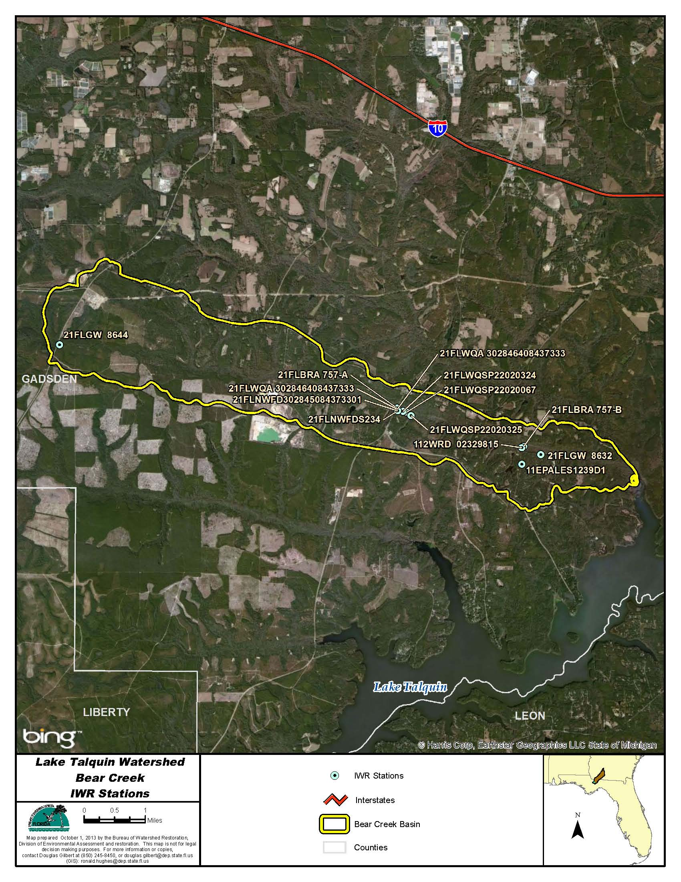
Figure B.4F.1. Bear Creek WBID 757 IWR Stations

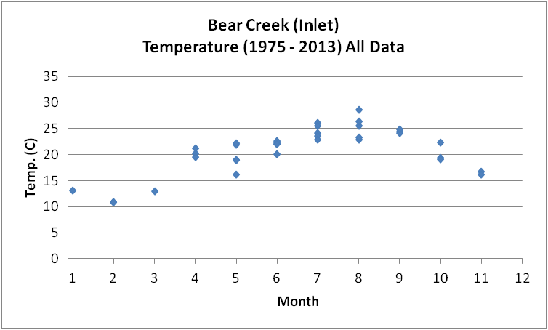
Figure B.4F.2. Bear Creek WBID 757 Monthly Temperature 1975 - 2013

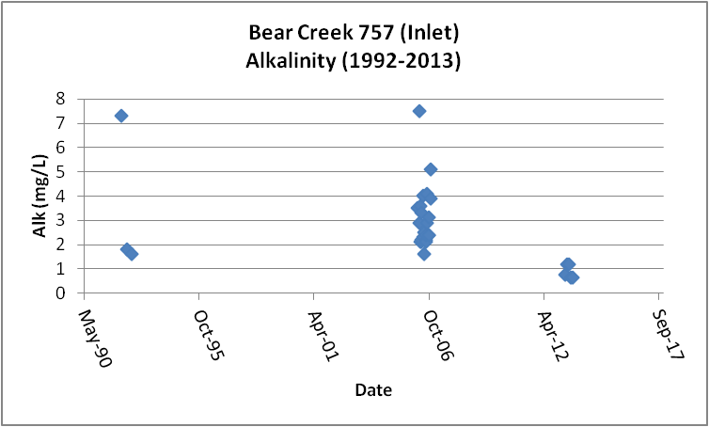
Figure B.4F.3. Bear Creek WBID 757 Daily Average Alkalinity 1992 2013

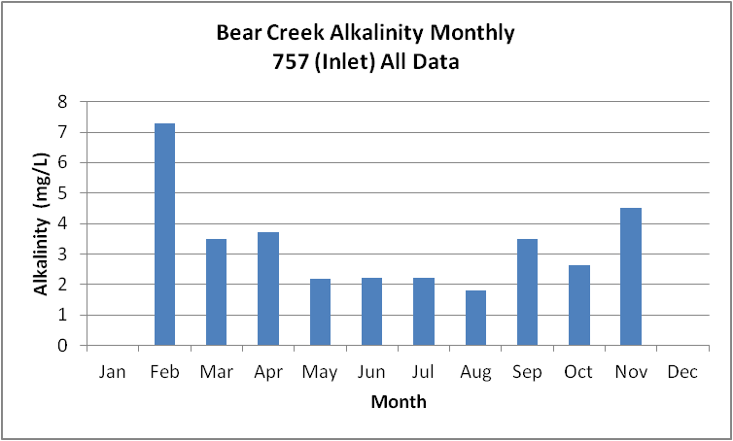
Figure B.4F.4. Bear Creek WBID 757 Monthly Average Alkalinity 1992 - 2013

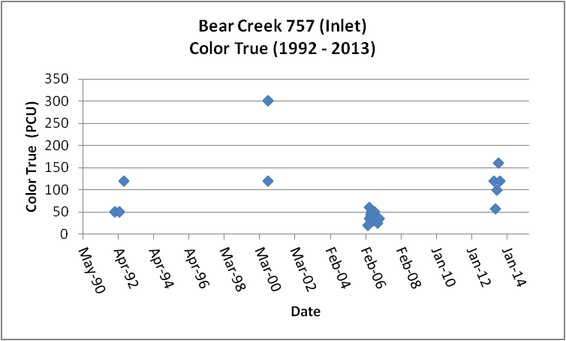
Figure B.4F.5. Bear Creek WBID 757 Daily Average True Color 1992- 2013

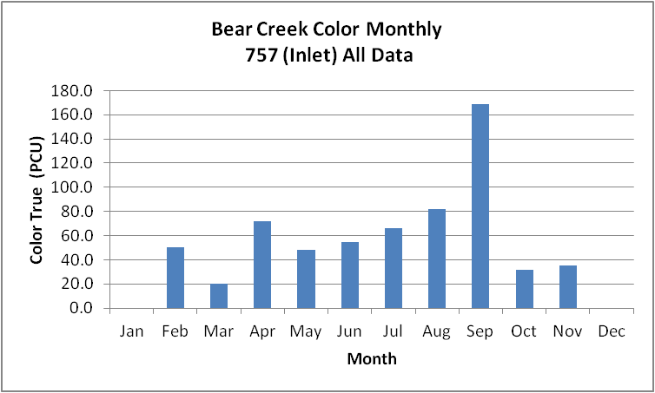
Figure B.4F.6. Bear Creek WBID 757 Monthly Average True Color 1992- 2013

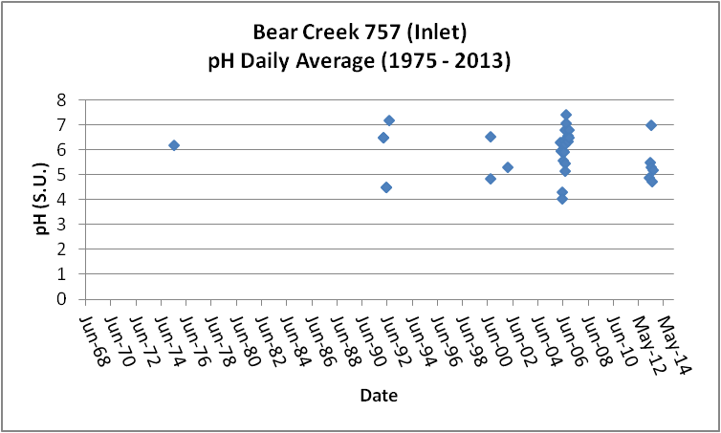
Figure B.4F.7. Bear Creek WBID 757 Daily pH 1975- 2013

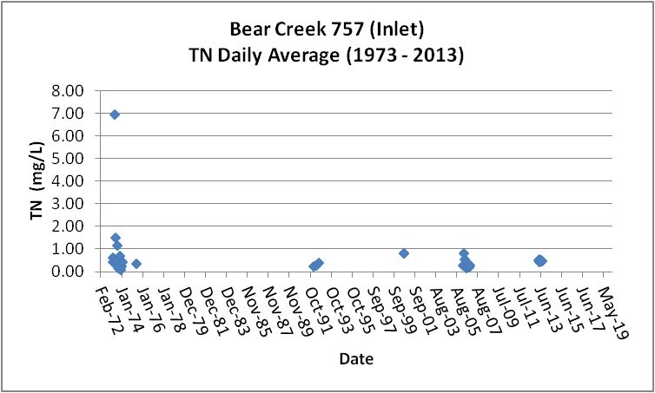
Figure B.4F.8. Bear Creek WBID 757 Daily Average TN1973- 2013

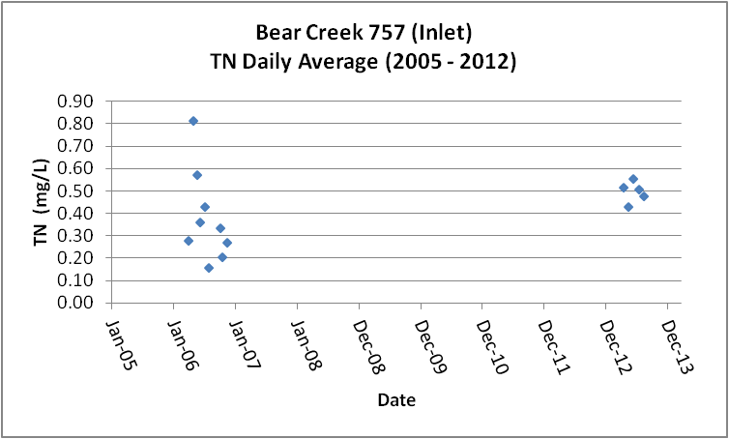
Figure B.4F.9. Bear Creek WBID 757 Daily Average TN 2005- 2013

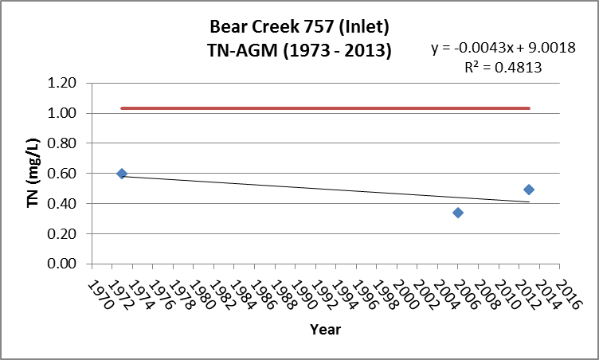
Figure B.4F.10. Bear Creek WBID 757 TN Annual Geomean 1973 -2013

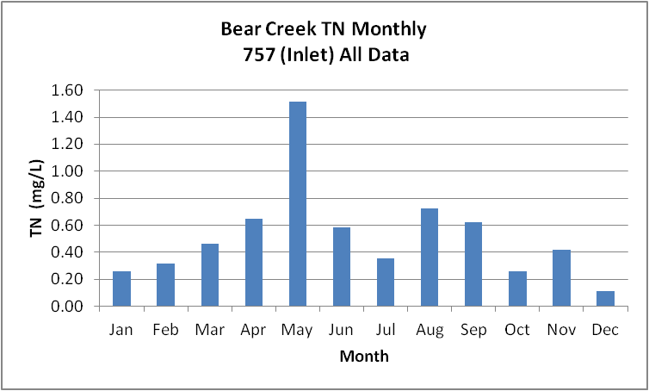
Figure B.4F.11. Bear Creek WBID 757 Monthly Average TN 1973- 2013

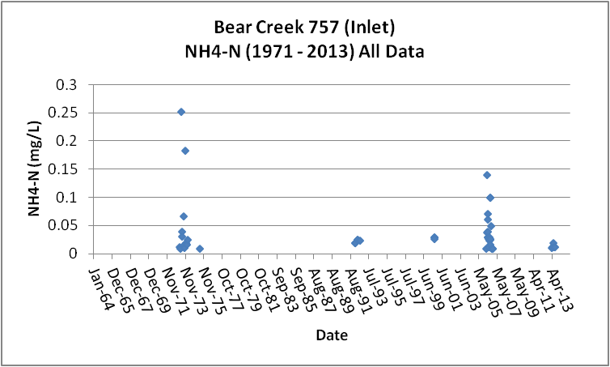
Figure B.4F.12. Bear Creek WBID 757 Daily Average Ammonia-N 1971- 2013

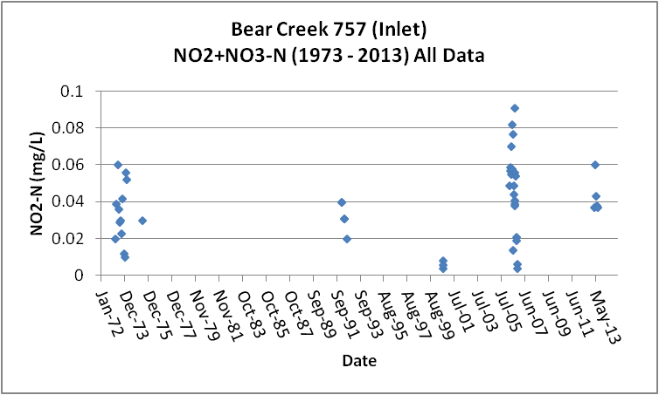
Figure B.4F.13. Bear Creek WBID 757 Daily Average Nitrate/Nitrite-N1973- 2013

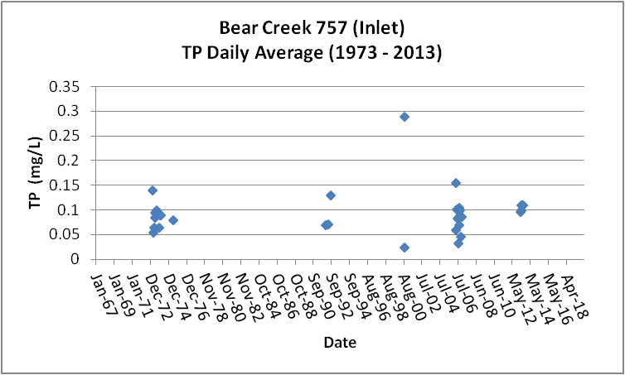
Figure B.4F.14. Bear Creek WBID 757 Daily Average TP 1973 - 2013

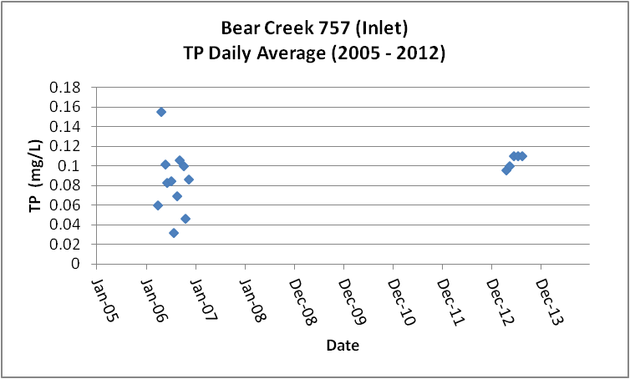
Figure B.4F.15. Bear Creek WBID 757 Daily Average TP 2005 - 2013

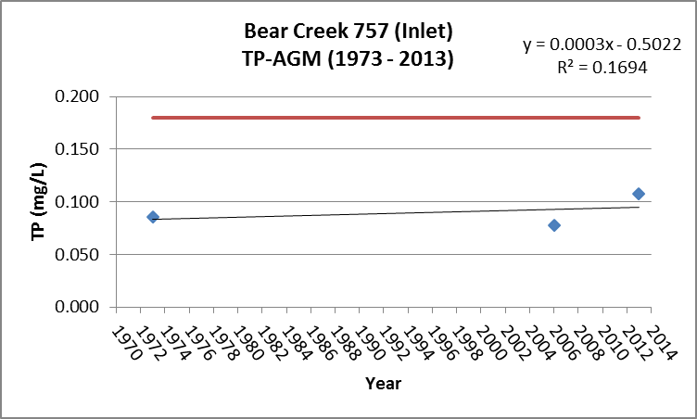
Figure B.4F.16. Bear Creek WBID 757 Annual Geomean TP 1973 2013

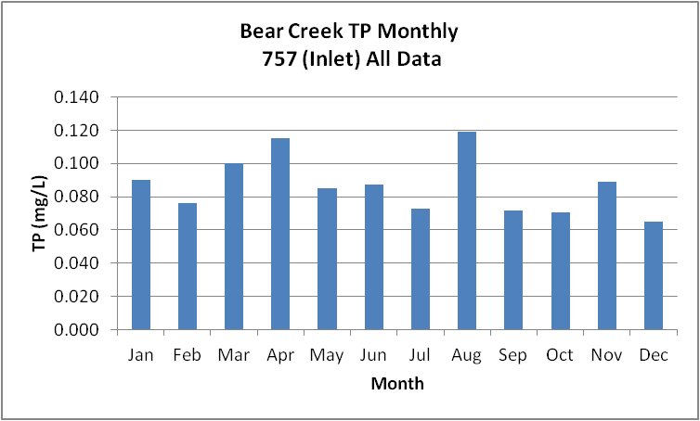
Figure B.4F.17. Bear Creek WBID 757 Monthly Average TP 1973 - 2013

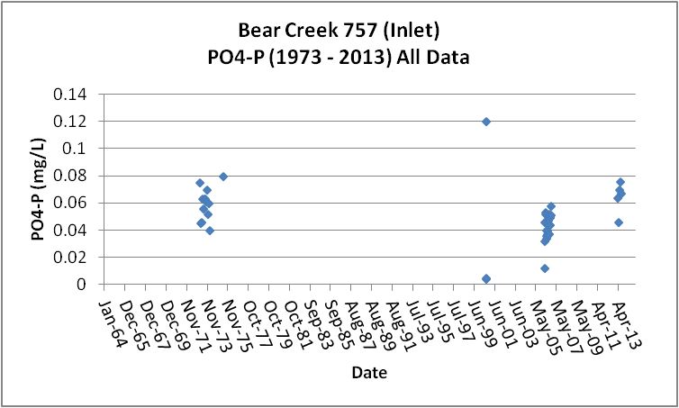
Figure B.4F.18. Bear Creek WBID 757 Daily Average Orthophosphate-P 1973 - 2013

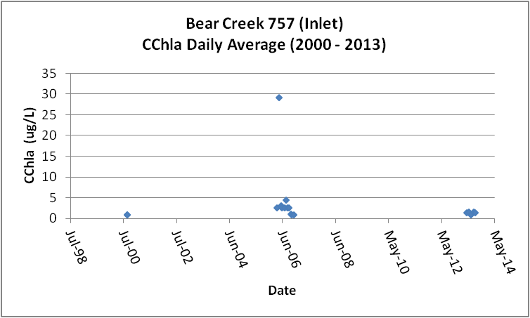
Figure B.4F.19. Bear Creek WBID 757 Daily Average CChla 2000 - 2013

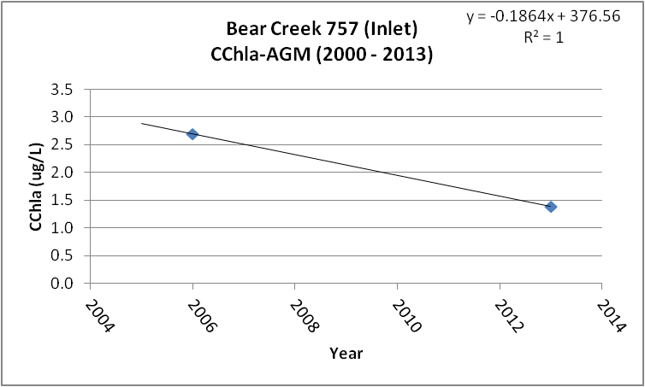
Figure B.4F.20. Bear Creek WBID 757 Annual Geomean CChla 2006 2013

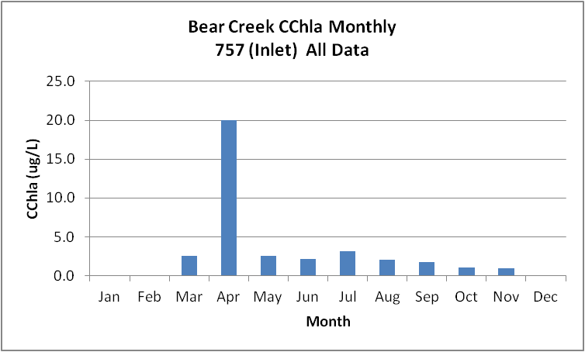
Figure B.4F.21. Bear Creek WBID 757 Monthly Average CChla 2000 - 2013

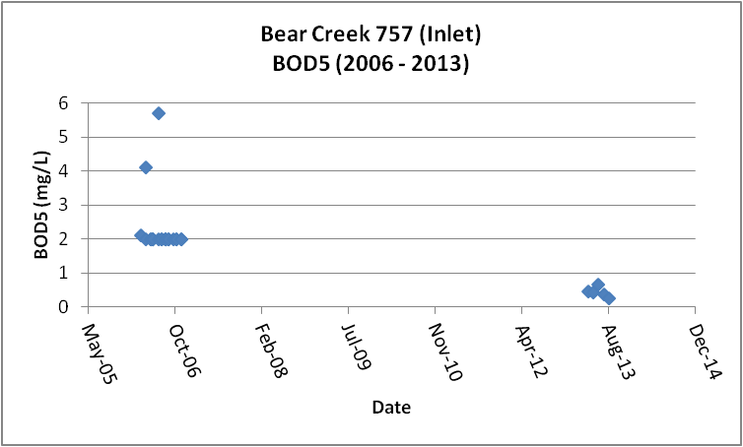
Figure B.4F.22. Bear Creek WBID 757 Daily Average BOD5 2006 2013

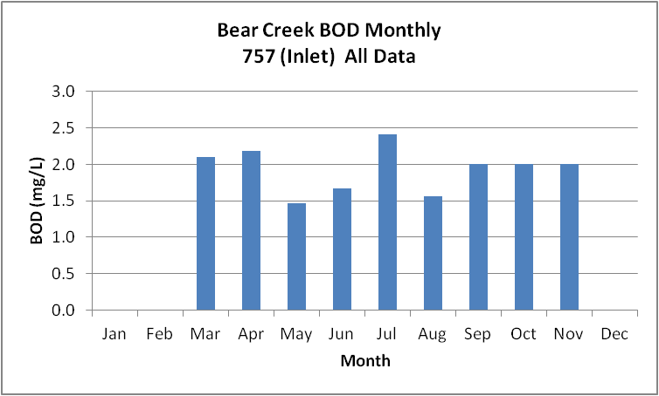
Figure B.4F.23. Bear Creek WBID 757 Monthly Average BOD5 2006 2013

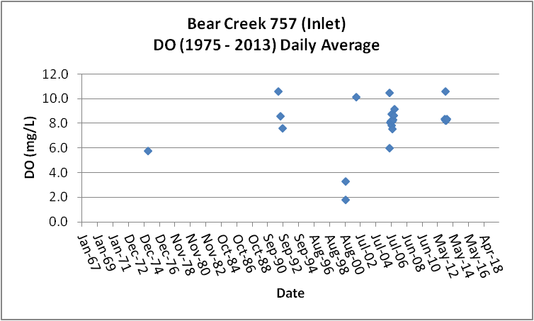
Figure B.4F.24. Bear Creek WBID 757 Daily Average DO 1975 - 2013

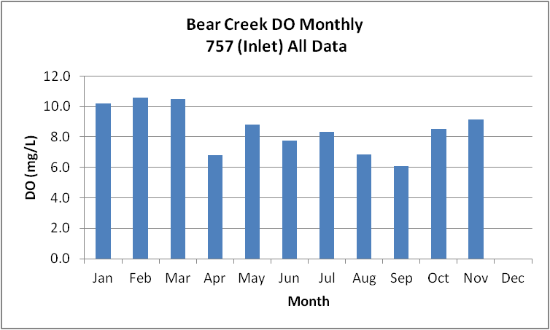
Figure B.4F.25. Bear Creek WBID 757 Monthly Average DO 1975 - 2013

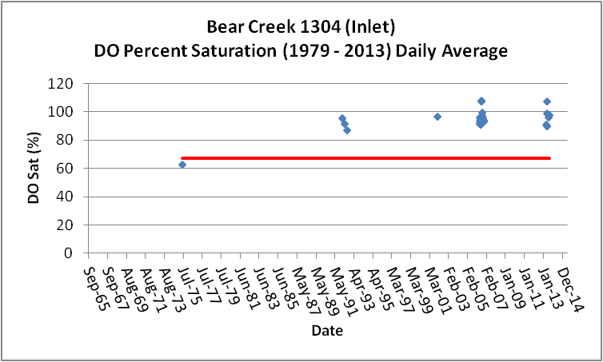
Figure B.4F.26. Bear Creek WBID 757 Daily Average DO Percent Saturation 1979 - 2013

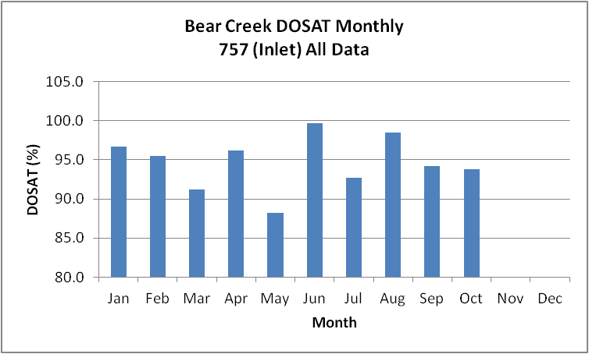
Figure B.4F.27. Bear Creek WBID 757 Monthly Average DO Percent Saturation 1979 - 2013

Table B.4F.1. Bear Creek WBID 757 IWR Stations
WBID | Station Number | Station Name | Begin Date | End Date
757 | 21FLWQA 302846408437333 | Bear Creek at SR 267 | 2003 | 2003
757 | 11EPALES1239D1 | BEAR CREEK | 1973 | 1974
757 | 21FLGW 8632 | NWA-HS-1023 BEAR CREEK (GADSDEN CO) | 2000 | 2000
757 | 21FLWQA 302846408437333 | Bear Creek at SR 267 | 2003 | 2003
757 | 21FLBRA 757-B | 757 - Bear Creek - at Bear Creek Rd | 2006 | 2006
757 | 21FLWQSP22020067 | Hester-dendy method study - Bear Creek - Bottom HD | 2009 | 2009
757 | 21FLBRA 757-A | 757 - Bear Creek - At SR-267 | 2006 | 2006
757 | 112WRD 02329815 | BEAR CREEK NR WETUMPKA, FLA. | 1975 | 1975
757 | 21FLNWFD302845084373301 | Bear Cr. ab Rocky Comfort @ 267 | 1992 | 1992
757 | 21FLGW 8644 | NWA-HS-1041 BEAR CREEK (GADSDEN CO) | 2000 | 2000
757 | 21FLWQSP22020324 | Bear Creek Site 1 | 2009 | 2009
757 | 21FLNWFDS234 | Bear Creek | 1992 | 1992
757 | 21FLWQSP22020325 | Bear Creek Site 3 | 2009 | 2009

Table B.4F.2. Bear Creek WBID 757 Long-Term Geomean Alkalinity and Color
WBID | Constituent | POR | Geomean
757 | Alkalinity (mg/L) | 1992 - 2013 | 2.4
757 | Color-True (PCU) | 1992 - 2013 | 54.6

Table B.4F.3. Bear Creek WBID 757 DO Percent Saturation vs. 67% Criterion
Year | Category | Results
1975 - 2013 | Count | 28
- | Number P | 27
- | Number F | 1
- | Percent F | 3.6
- | - | -
2005 - 2013 | Count | 23
- | Number P | 23
- | Number F | 0
- | Percent F | 0.0

Table B.4F.4. Bear Creek WBID 757 Annual Geomean TN, TP, TN/TP Ratio, and CChla
Year | TN | TP | TN/TP | CChla
- | AGM | AGM | Ratio | AGM
1973 | 0.60 | 0.086 | 7.0 | -
2006 | 0.34 | 0.078 | 4.4 | 2.7
2013 | 0.50 | 0.107 | 4.6 | 1.4

Table B.4F.5. Bear Creek WBID 757 Water Quality Data Summary All Data
Constituent | Units | POR | Count | Min | Max | Median | Mean | Geomean
Temperature | C | 1975 - 2013 | 35 | 10.9 | 28.6 | 22.0 | 20.9 | 20.4
Alkalinity | mg/L | 1992 - 2013 | 30 | 0.7 | 7.5 | 2.4 | 2.8 | 2.4
pH | S.U. | 1975 - 2013 | 35 | 4.1 | 7.4 | 6.0 | NA | NA
Color | PCU | 1992 - 2013 | 35 | 20.0 | 300.0 | 45.0 | 70.2 | 54.6
TN | mg/L | 1973 - 2013 | 43 | 0.11 | 6.96 | 0.39 | 0.62 | 0.42
NH4-N | mg/L | 1973 - 2013 | 48 | 0.009 | 0.25 | 0.03 | 0.04 | 0.03
NO23 | mg/L | 1973 - 2013 | 48 | 0.004 | 0.09 | 0.04 | 0.04 | 0.03
OrgN | mg/L | - | - | - | - | - | - | -
TP | mg/L | 1973 - 2013 | 48 | 0.023 | 0.290 | 0.084 | 0.089 | 0.080
PO4-P | mg/L | 1973 - 2013 | 43 | 0.004 | 0.120 | 0.050 | 0.051 | 0.045
CChla | ug/L | 2000 - 2013 | 30 | 1.0 | 56.0 | 2.6 | 3.9 | 2.1
BOD5 | mg/L | 2006 - 2013 | 27 | 0.3 | 5.7 | 2.0 | 1.9 | 1.6
DO | mg/L | 1975 - 2013 | 35 | 1.8 | 10.6 | 8.4 | 8.1 | 7.7
%DOSat | % | 1979 - 2013 | 28 | 63.0 | 108.3 | 94.1 | 94.5 | 94.1

Table B.4F.6. Bear Creek WBID 757 Water Quality Data Summary Verified Period Plus (2005 – 2013)
Constituent | Units | Verified Period + | Count | Min | Max | Median | Mean | Geomean
Temperature | C | 2005 - 2013 | 26 | 12.9 | 26.4 | 22.2 | 21.6 | 21.3
Alkalinity | mg/L | 2005 - 2013 | 27 | 0.7 | 7.5 | 2.4 | 2.7 | 2.3
pH | S.U. | 2005 - 2013 | 26 | 4.1 | 7.4 | 6.0 | NA | NA
Color | PCU | 2005 - 2013 | 27 | 20.0 | 160.0 | 40.0 | 52.5 | 46.0
TN | mg/L | 2005 - 2013 | 22 | 0.12 | 1.26 | 0.37 | 0.41 | 0.37
NH4-N | mg/L | 2005 - 2013 | 27 | 0.010 | 0.14 | 0.03 | 0.03 | 0.02
NO23 | mg/L | 2005 - 2013 | 27 | 0.004 | 0.09 | 0.05 | 0.05 | 0.04
OrgN | mg/L | - | - | - | - | - | - | -
TP | mg/L | 2005 - 2013 | 27 | 0.031 | 0.220 | 0.083 | 0.088 | 0.081
PO4-P | mg/L | 2005 - 2013 | 27 | 0.012 | 0.076 | 0.047 | 0.047 | 0.045
CChla | ug/L | 2005 - 2013 | 27 | 1.0 | 56.0 | 2.6 | 4.2 | 2.3
BOD5 | mg/L | 2005 - 2013 | 27 | 0.3 | 5.7 | 2.0 | 1.9 | 1.6
DO | mg/L | 2005 - 2013 | 26 | 3.5 | 10.6 | 8.4 | 8.3 | 8.2
%DOSat | % | 2005 - 2013 | 23 | 89.9 | 108.3 | 94.1 | 96.2 | 96.0

B.4G. Ocklawaha Creek WBID 811 Drains to Lake Talquin
This WBID is not impaired for DO or nutrients.
Table B.4G.1, lists the 11 stations that have been sampled in Bear Creek WBID 757. Figure B.4G.1 depicts the station locations.
Tables B.4G.5 and B.4G.6 and Figures B.4G.3 and B.4G.4, provide the results for alkalinity. These data show that Ocklawaha Creek has a POR GM alkalinity of 1.3 mg/L. The data indicate that the GM for the period (2005 – 2013) of 1.3 mg/L is the same as the POR concentration. The limited data indicate higher alkalinity in the summer (up to 6 mg/L). There is insufficient data to determine accurate long-term or seasonal patterns.
Tables B.4G.5 and B.4G.6 and Figures B.4G.5 and B.4G.6, provide the results for true color. These data show that Ocklawaha Creek has a POR GM color of 64.5 PCU. The data indicate that the GM color for the period (2005 – 2013) of 52.7 PCU is slightly lower than the POR color. There is insufficient data to determine accurate long-term or seasonal patterns.
Tables B.4G.5 and B.4G.6 and Figures B.4G.8 through B.4G.11, provide the results for TN. These data show that Ocklawaha Creek has a POR GM TN of 0.37 mg/L. The data indicate that the recent (2005 – 2013) TN GM of 0.30 mg/L is similar to the POR TN GM for the POR and significantly less than the 1.03 mg/L new threshold AGM concentration for TN (Figure B.4G.10). There were two years during the 1970’s and two years during the recent period (2005 – 2013) with sufficient data to calculate AGM concentrations. These results show that the TN concentrations have not changed significantly over time. The limited data indicate higher concentrations of TN during May and June (~1.0 mg/L) with concentrations less than 0.4 mg/L for much of the remaining months. There is insufficient data to determine accurate long-term or accurate seasonal patterns.
Tables B.4G.5 and B.4E.6 and Figure B.4G.12 provide the results for NH4-N. These data show that Ocklawaha Creek has a POR GM NH4-N of 0.02 mg/L, less than either the Little or Ocklawaha Rivers. The data indicate that the recent (2005 – 2013) NH4-N GM of 0.01 mg/L is less than the POR concentration. There is insufficient data to determine accurate long-term or seasonal patterns.
Tables B.4G.5 and B.4G.6 and Figure B.4G.13 provide the results for NO23-N. These data show that Ocklawaha Creek has a POR GM NO23-N of 0.02 mg/L, significantly less than either the Little or Ochlockonee Rivers. The data indicate that the recent (2005 – 2013) NO23-N GM of 0.02 mg/L is the same as the POR concentration. There is insufficient data to determine accurate long-term or seasonal patterns
Tables B.4G.5 and B.4G.6 and Figures B.4G.14 through B.4G.17, provide the results for TP. These data show that Ocklawaha Creek has a POR GM TP of 0.016 mg/L. The data indicate that the recent (2005 – 2013) TP GM of 0.019 mg/L is slightly greater than the TP GM for the POR and significantly less than the new 0.18 mg/L threshold AGM concentration for TP. There were two years during the 1970’s and two years during the recent period (2005 – 2013) with sufficient data to calculate AGM concentrations. These results show that the TP concentrations have not changed significantly over time (Figure B.4G.16). Similar to TN, the highest concentrations of TP occur during May and June. There is insufficient data to determine accurate long-term or seasonal patterns.
Tables B.4G.5 and B.4G.6 and Figure B.4G.18 provide the results for PO4-P. These data show that Ocklawaha Creek has a POR GM PO4-P of 0.008 mg/L. The data indicate that the recent (2005 – 2013) PO4-P GM of 0.005 mg/L is less than the POR concentration. There is insufficient data to determine accurate long-term or seasonal patterns.
Tables B.4G.5 and B.4G.6 and Figures B.4G.19 through B.4G.21, provide the results for CChla. These data show that Ocklawaha Creek has a POR GM CChla of 2.2 ug/L. The data indicate that the recent (2005 – 2013) CChla GM of 1.9 ug/L is similar to the CChla GM for the POR and significantly less than the new 20.0 ug/L threshold AGM concentration for CChla (Figure B.4G.20). The data set has a large number of less than detection results. There is insufficient data to determine accurate long-term or seasonal patterns.
Tables B.4G.5 and B.4G.6 and Figures B.4G.22 and B.4G.23, provide the results for BOD5. These data show that Ocklawaha Creek has a POR GM BOD5 of 1.5 mg/L. All of the results are from the period 2006 - 2013. There is insufficient data to determine accurate long-term or seasonal patterns.
Tables B.4G.5 and B.4G.6 and Figures B.4G.24 and B.4G.25, provide the results for DO. These data show that Ocklawaha Creek has a POR GM DO of 8.2 mg/L. The data indicate that the recent (2005 – 2013) DO GM of 8.4 mg/L is equivalent to the POR concentration. The monthly average DO never drops below 6.0 mg/L (Figure B.4G.25). There is insufficient data to determine accurate long-term or seasonal patterns.
Tables B.4G.5 and B.4G.6 and Figures B.4G.26 and B.4G.27, provide the results for percent DO saturation. These data show that Ocklawaha Creek has a POR GM DOSAT of 91.5 percent. The data indicate that the recent (2005 – 2013) DOSAT GM of 95.0 percent is the same as the GM for the POR. The data presented in Figure B.4G.26 do not indicate an issue with the new DO percent saturation criterion. There is insufficient data to determine accurate long-term or seasonal patterns.

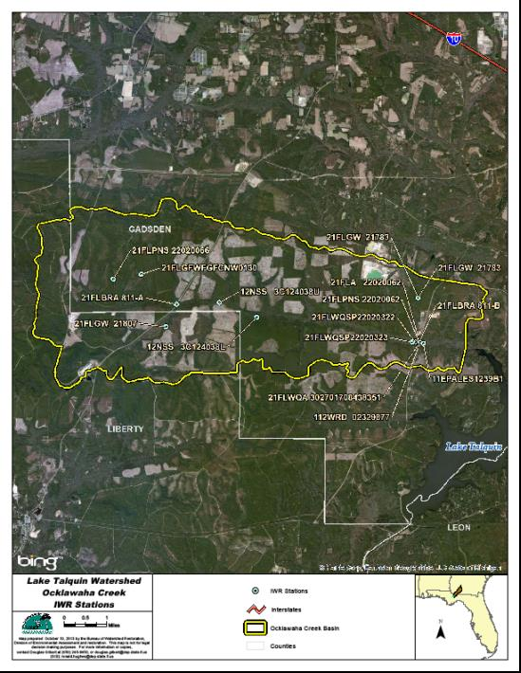
Figure B.4G.1. Ocklawaha Creek WBID 811 IWR Stations

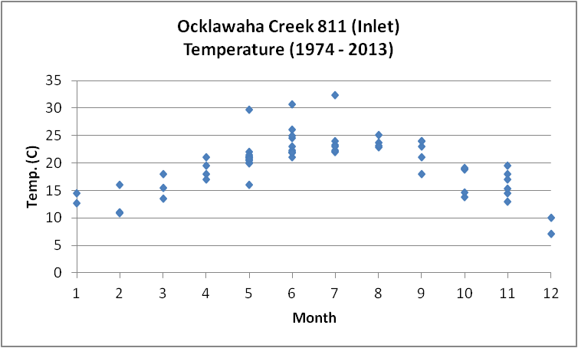
Figure B.4G.2. Ocklawaha Creek WBID 811 Monthly Temperature 1974 - 2013

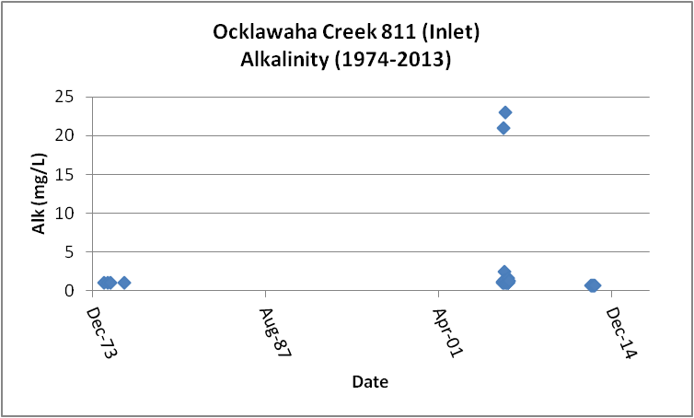
Figure B.4G.3. Ocklawaha Creek WBID 811 Daily Average Alkalinity 1974 - 2013

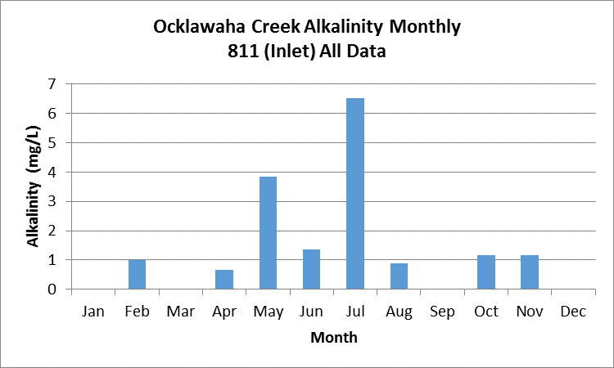
Figure B.4G.4. Ocklawaha Creek WBID 811 Monthly Average Alkalinity 1974 - 2013

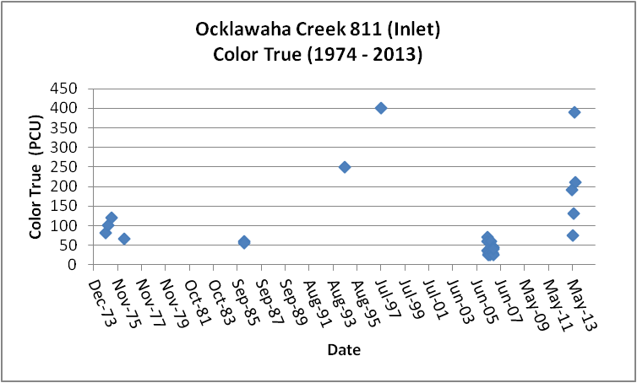
Figure B.4G.5. Ocklawaha Creek WBID 811 Daily Average True Color 1974 - 2013

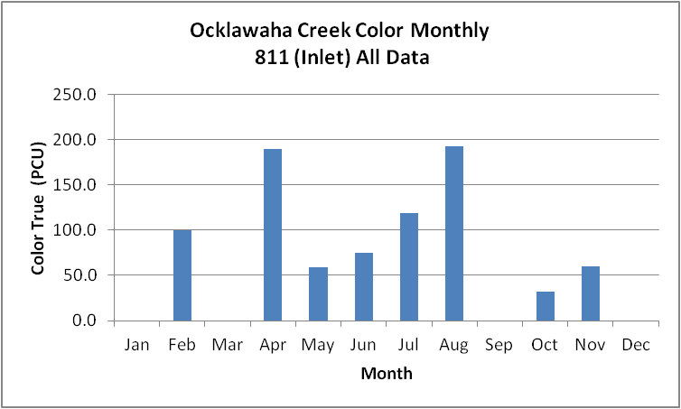
Figure B.4G.6. Ocklawaha Creek WBID 811 Monthly Average True Color 1974 - 2013

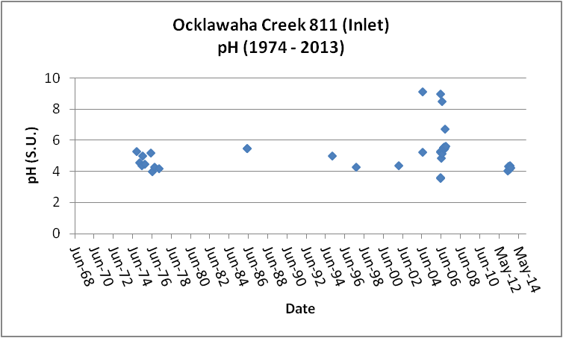
Figure B.4G.7. Ocklawaha Creek WBID 811 Daily pH 1974 - 2013

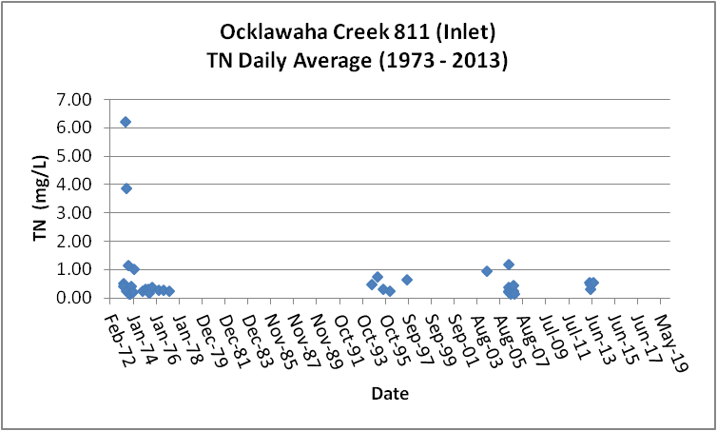
Figure B.4G.8. Ocklawaha Creek WBID 811 Daily Average TN1973 - 2013

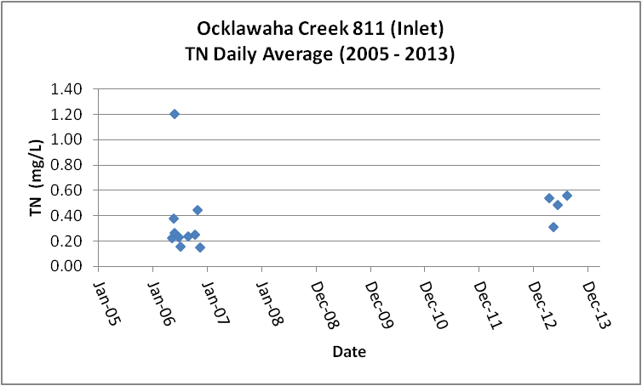
Figure B.4G.9. Ocklawaha Creek WBID 811 Daily Average TN 2005- 2013

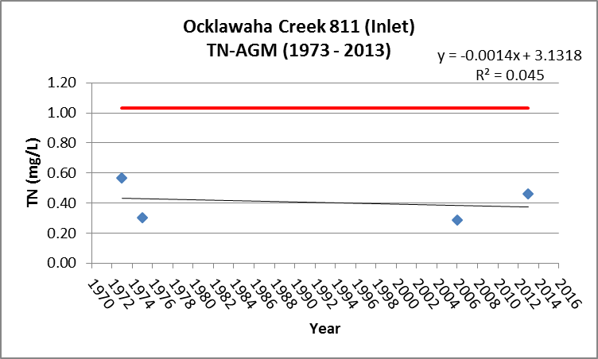
Figure B.4G.10. Ocklawaha Creek WBID 811 TN Annual Geomean 1973 - 2013

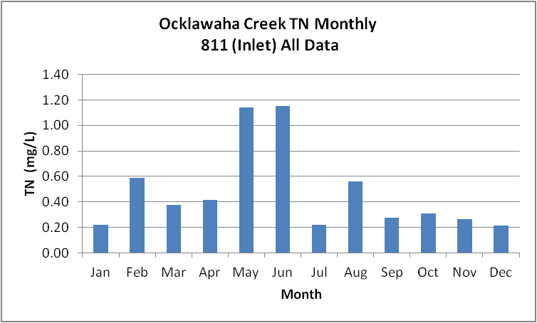
Figure B.4G.11. Ocklawaha Creek WBID 811 Monthly Average TN 1973 - 2013

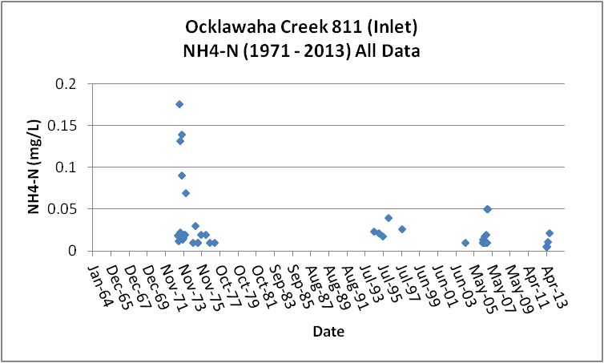
Figure B.4G.12. Ocklawaha Creek WBID 811 Daily Average Ammonia-N 1971 - 2013

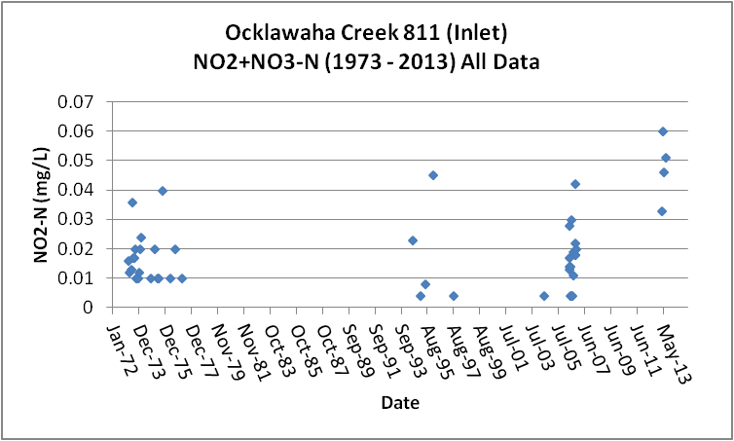
Figure B.4G.13. Ocklawaha Creek WBID 811 Daily Average Nitrate/Nitrite-N1973 - 2013

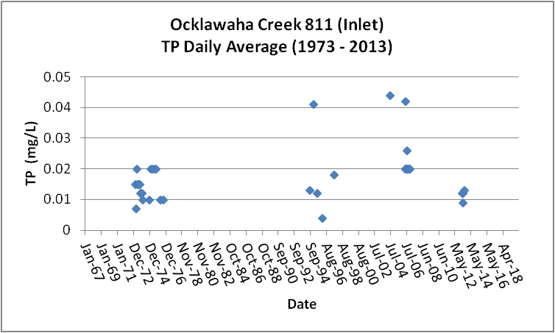
Figure B.4G.14. Ocklawaha Creek WBID 811 Daily Average TP 1973 - 2013

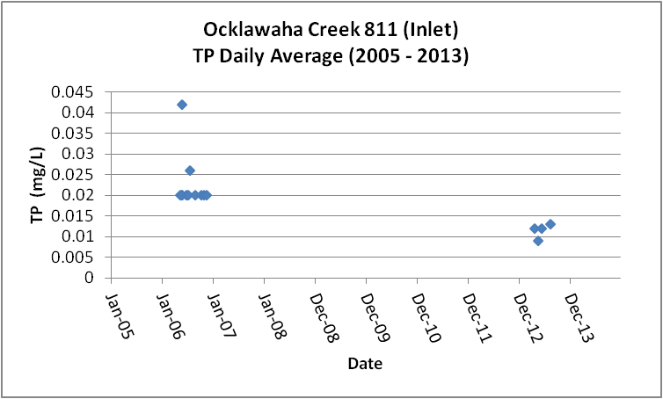
Figure B.4G.15. Ocklawaha Creek WBID 811 Daily Average TP 2005 - 2013

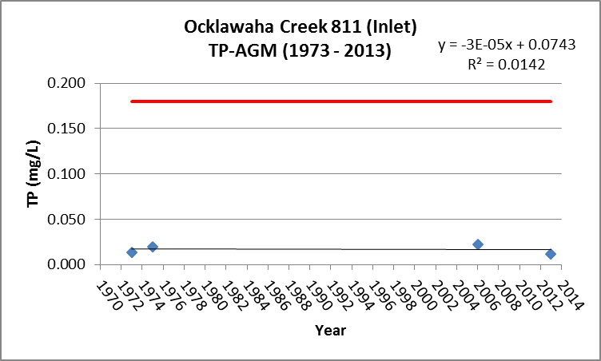
Figure B.4G.16. Ocklawaha Creek WBID 811 Annual Geomean TP 1973 - 2013

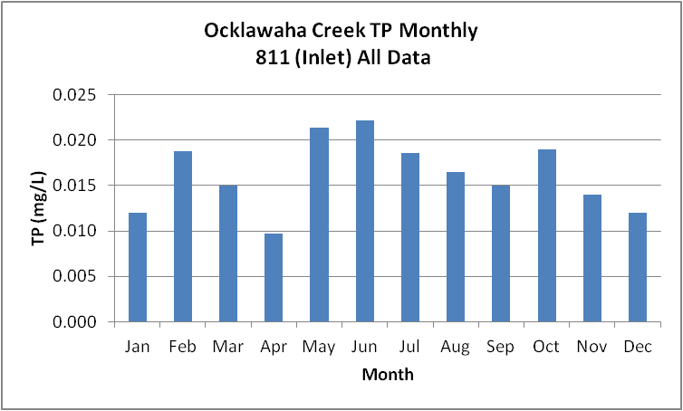
Figure B.4G.17. Ocklawaha Creek WBID 811 Monthly Average TP 1973 - 2013

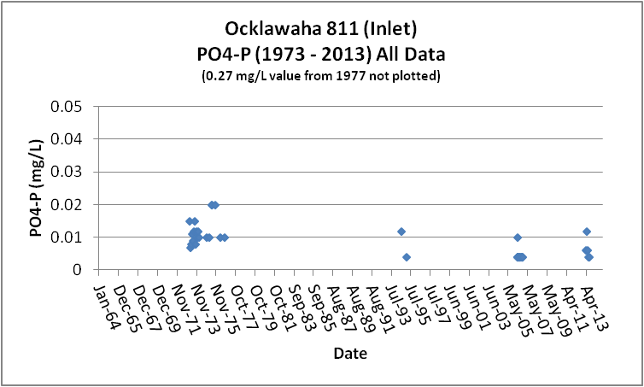
Figure B.4G.18. Ocklawaha Creek WBID 811 Daily Average Orthophosphate-P 1973 - 2013

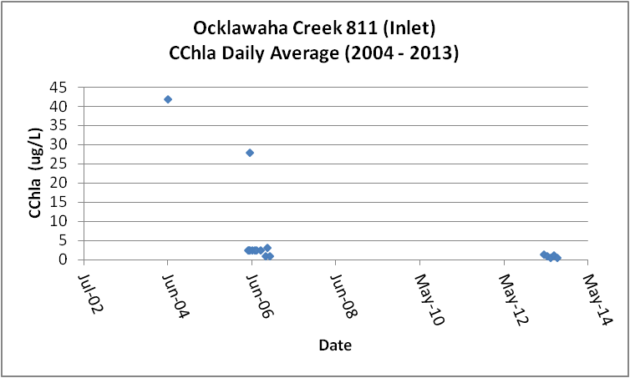
Figure B.4G.19. Ocklawaha Creek WBID 811 Daily Average CChla 2004 - 2013

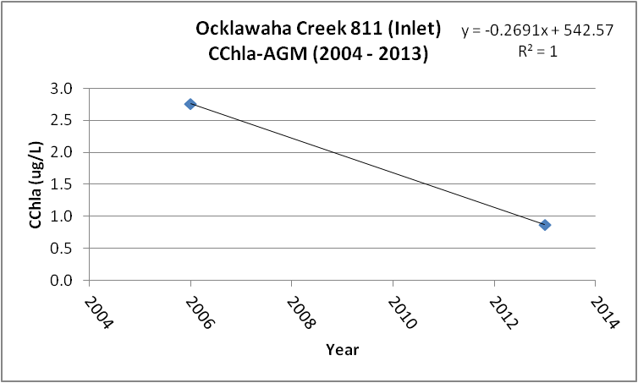
Figure B.4G.20. Ocklawaha Creek WBID 811 Annual Geomean CChla 2004 - 2013

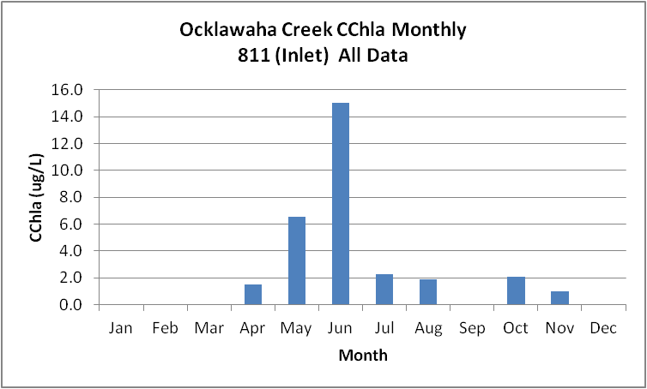
Figure B.4G.21. Ocklawaha Creek WBID 811 Monthly Average CChla 2004 - 2013

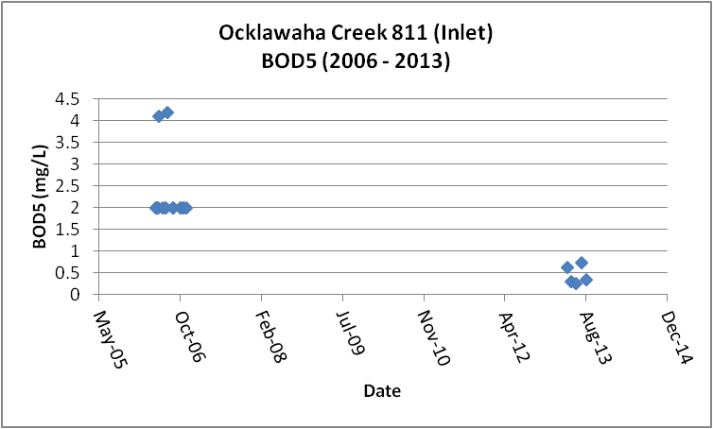
Figure B.4G.22. Ocklawaha Creek WBID 811 Daily Average BOD5 2006 - 2013

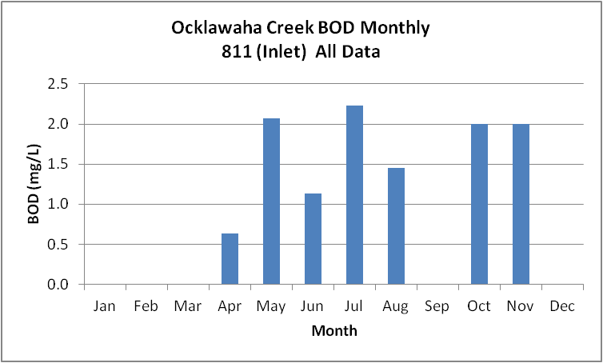
Figure B.4G.23. Ocklawaha Creek WBID 811 Monthly Average BOD5 2006 - 2013

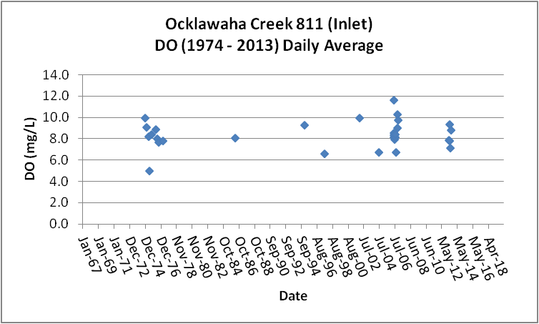
Figure B.4G.24. Ocklawaha Creek WBID 811 Daily Average DO 1974 - 2013

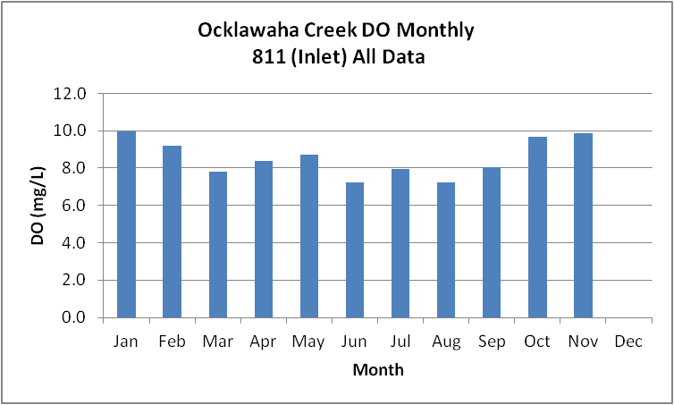
Figure B.4G.25. Ocklawaha Creek WBID 811 Monthly Average DO 1974 - 2013

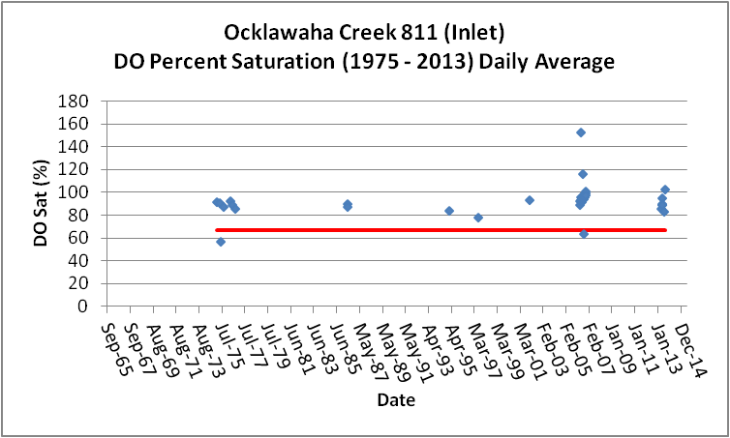
Figure B.4G.26. Ocklawaha Creek WBID 811 Daily Average DO Percent Saturation 1975 - 2013

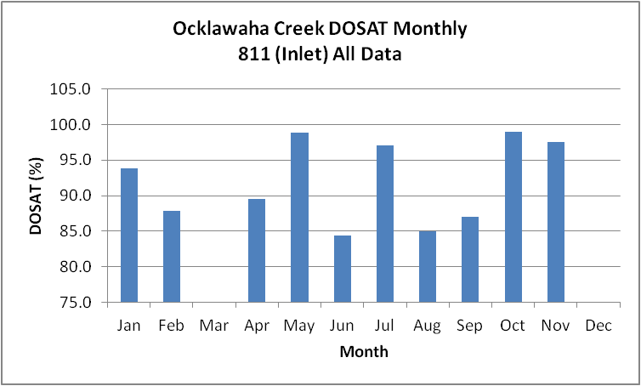
Figure B.4G.27. Ocklawaha Creek WBID 811 Monthly Average DO Percent Saturation 1975 - 2013

Table B.4G.1. Ocklawaha Creek WBID 811 IWR Stations
WBID | Station Number | Station Name | Begin Date | End Date
811 | 21FLBRA 811-A | 811 - Ocklawaha Creek - at SR-65 | 2006 | 2006
811 | 21FLPNS 22020062 | Ocklawaha Ck, SR 267, S of Quincy | 1994 | 2009
811 | 12NSS 3C124038U | OCKLAWAHA CREEK | 1986 | 1986
811 | 21FLWQSP22020322 | Ocklawaha Site 2 | 2009 | 2009
811 | 112WRD 02329877 | OCKLAWAHA CREEK NR WETUMPKA, FLA. | 1974 | 1988
811 | 21FLWQSP22020323 | Ocklawaha Site 3 | 2009 | 2009
811 | 21FLBRA 811-B | 811 - Ocklawaha Creek - At SR-267 | 2006 | 2006
811 | 21FLA 22020062 | OKLAWAHA CR. S.R.267 S.OF QUINCY ECOREG.65H | 1994 | 1997
811 | 12NSS 3C124038L | OCKLAWAHA CREEK | 1986 | 1986
811 | 21FLWQA 302701708438351 | Ocklawaha Creek at SR 267 | 2002 | 2002
811 | 11EPALES1239B1 | OCKLAWAHA CREEK | 1973 | 1974

Table B.4G.2. Ocklawaha Creek WBID 811 Long-Term Geomean Alkalinity and Color
WBID | Constituent | POR | Geomean
811 | Alkalinity (mg/L) | 1974 - 2013 | 1.3
811 | Color-True (PCU) | 1974 - 2013 | 64.5

Table B.4G.3. Ocklawaha Creek WBID 811 DO Percent Saturation vs. 67% Criterion
Year | Category | Result
1975 - 2013 | Count | 35
- | Number P | 33
- | Number F | 2
- | Percent F | 5.7
- | - | -
2005-2013 | Count | 23
- | Number P | 22
- | Number F | 1
- | Percent F | 4.3

Table B.4G.4. Ocklawaha Creek WBID 811 Annual Geomean TN, TP, TN/TP Ratio, and CChla
Year | TN | TP | TN/TP | CChla
- | AGM | AGM | Ratio | AGM
1973 | 0.57 | 0.014 | 41.5 | -
1975 | 0.30 | 0.020 | 15.2 | -
2006 | 0.29 | 0.022 | 13.2 | 2.8
2013 | 0.46 | 0.011 | 40.6 | 0.9

Table B.4G.5. Ocklawaha Creek WBID 811 Water Quality Data Summary All Data
Constituent | Units | POR | Count | Min | Max | Median | Mean | Geomean
Temperature | C | 1975 - 2013 | 66 | 7.0 | 32.4 | 21.0 | 19.8 | 19.1
Alkalinity | mg/L | 1992 - 2013 | 25 | 0.7 | 23.0 | 1.0 | 2.7 | 1.3
pH | S.U. | 1975 - 2013 | 39 | 3.6 | 9.1 | 5.0 | NA | NA
Color | PCU | 1992 - 2013 | 29 | 25.0 | 400.0 | 60.0 | 94.5 | 64.5
TN | mg/L | 1973 - 2013 | 45 | 0.11 | 6.21 | 0.29 | 0.60 | 0.37
NH4-N | mg/L | 1973 - 2013 | 46 | 0.005 | 0.18 | 0.02 | 0.03 | 0.02
NO23 | mg/L | 1973 - 2013 | 46 | 0.004 | 0.06 | 0.02 | 0.02 | 0.02
OrgN | mg/L | - | - | - | - | - | - | -
TP | mg/L | 1973 - 2013 | 45 | 0.004 | 0.044 | 0.020 | 0.018 | 0.016
PO4-P | mg/L | 1973 - 2013 | 43 | 0.004 | 0.270 | 0.008 | 0.014 | 0.008
CChla | ug/L | 2000 - 2013 | 22 | 0.6 | 42.0 | 2.6 | 5.0 | 2.2
BOD5 | mg/L | 2006 - 2013 | 21 | 0.3 | 4.2 | 2.0 | 1.8 | 1.5
DO | mg/L | 1975 - 2013 | 39 | 3.8 | 11.6 | 8.3 | 8.3 | 8.2
%DOSat | % | 1979 - 2013 | 35 | 57.0 | 152.9 | 92.0 | 92.6 | 91.5

Table B.4G.6. Ocklawaha Creek WBID 811 Water Quality Data Summary Verified Period Plus (2005 – 2013)
Constituent | Units | Verified Period + | Count | Min | Max | Median | Mean | Geomean
Temperature | C | 2005 - 2013 | 23 | 13.7 | 32.4 | 21.9 | 21.3 | 20.9
Alkalinity | mg/L | 2005 - 2013 | 21 | 0.7 | 23.0 | 1.0 | 3.1 | 1.3
pH | S.U. | 2005 - 2013 | 23 | 3.6 | 9.0 | 5.2 | NA | NA
Color | PCU | 2005 - 2013 | 21 | 25.0 | 390.0 | 40.0 | 76.7 | 52.7
TN | mg/L | 2005 - 2013 | 19 | 0.11 | 1.20 | 0.27 | 0.36 | 0.30
NH4-N | mg/L | 2005 - 2013 | 20 | 0.005 | 0.05 | 0.01 | 0.02 | 0.01
NO23 | mg/L | 2005 - 2013 | 20 | 0.004 | 0.06 | 0.02 | 0.02 | 0.02
OrgN | mg/L | - | - | - | - | - | - | -
TP | mg/L | 2005 - 2013 | 20 | 0.009 | 0.042 | 0.020 | 0.020 | 0.019
PO4-P | mg/L | 2005 - 2013 | 21 | 0.004 | 0.012 | 0.004 | 0.005 | 0.005
CChla | ug/L | 2005 - 2013 | 21 | 0.6 | 28.0 | 2.6 | 3.2 | 1.9
BOD5 | mg/L | 2005 - 2013 | 21 | 0.3 | 4.2 | 2.0 | 1.8 | 1.5
DO | mg/L | 2005 - 2013 | 23 | 5.5 | 11.6 | 8.3 | 8.5 | 8.4
%DOSat | % | 2005 - 2013 | 23 | 63.4 | 152.9 | 94.7 | 96.1 | 95.0

B.4H Hammock Creek WBID 879 Drains to Lake Talquin
This WBID is impaired for low DO linked to BOD.
The DO impairment for Hammock Creek is based on low DO measured at station 21FLBRA-879-A (Figures B.4H.1 and B.4H.26). As can be seen in Figures B.4H.27 through B.4H.29, this station is located in the interface between the creek and the lake within a delta that has been forming since the lake was created in the 1920’s. The area around the bridge is scoured out and the permanent pool within the delta (lake backwater effect) is not representative of a stream or a lake. The FDEP is proposing to delist this impairment due to a flaw in the analysis (inappropriate station location). The location of the primary station in the WBID is representative of the water quality in an area experiencing backwater effects from the lake as the stream drains into the delta, the data is presented below.

Table B.4H.1, lists the 3 stations that have been sampled in Hammock Creek WBID 879. Figure B.4H.1 depicts the station locations.
Tables B.4H.5 and B.4H.6 and Figures B.4H.3 and B.4H.4, provide the results for alkalinity. All of the data is from 2006. These data show that Hammock Creek has a POR GM alkalinity of 16.6 mg/L. The limited data indicate that alkalinity varies seasonally, with higher alkalinity between June and October (over 20 mg/L). There is insufficient data to determine accurate long-term or seasonal patterns.

Tables B.4H.5 and B.4H.6 and Figures B.4H.5 and B.4H.6, provide the results for true color. All of the data is from 2006. These data show that Hammock Creek has a POR GM color of 38.1 PCU. The limited data show that color and alkalinity vary inversely to each other and that alkalinity appears to vary directly with rainfall. The lowest color occurs in July, the month with the second highest rainfall. There is insufficient data to determine accurate long-term or seasonal patterns.
Tables B.4H.5 and B.4H.6 and Figures B.4H.8 through B.4H.10, provide the results for TN. All but two of the results come from 2006. These data show that Hammock Creek has a POR GM TN of 0.75 mg/L (Figure B.4H.9), slightly less than the 1.03 mg/L new AGM threshold. The limited data indicate higher concentrations of TN in May through September (~ 0.80 mg/L) with concentrations gradually declining through December (0.5 mg/L). There is insufficient data to determine accurate long-term or accurate seasonal patterns.
Tables B.4H.5 and B.4H.6 and Figure B.4H.11 provide the results for NH4-N. All but two of the results come from 2006. These data show that Hammock Creek has a POR GM NH4-N of 0.02 mg/L. There is insufficient data to determine accurate long-term or seasonal patterns.
Tables B.4H.5 and B.4H.6 and Figure B.4H.12 provide the results for NO23-N. All but two of the results come from 2006. These data show that Hammock Creek has a POR GM NO23-N of 0.02 mg/L. The data indicate that the recent (2005 – 2013) NO23-N GM of 0.02 mg/L is the same as the POR concentration. There is insufficient data to determine long-term or seasonal patterns
Tables B.4H.5 and B.4H.6 and Figures B.4H.13 through B.4H.15, provide the results for TP. All but one of the results comes from 2006. These data show that Hammock Creek has a POR GM TP of 0.031 mg/L. The data indicate that the recent (2005 – 2013) TP GM of 0.032 mg/L is equivalent to the POR value and significantly less than the new threshold AGM concentration for TP for streams of 0.18 mg/L (Figure B.4H.14). Similar to TN, the highest concentrations of TP occur during May through August. There is insufficient data to determine accurate long-term or seasonal patterns.
Tables B.4H.5 and B.4H.6 and Figure B.4H.16 provide the results for PO4-P. All but one of the results comes from 2006. These data show that Hammock Creek has a POR GM PO4-P of 0.005 mg/L. There is insufficient data to determine accurate long-term or seasonal patterns.
Tables B.4H.5 and B.4H.6 and Figures B.4H.17 through B.4H.19, provide the results for CChla. All but two of the results come from 2006. These data show that Hammock Creek has a POR GM CChla of 3.2 ug/L. These data indicate that the POR GM concentration is significantly less than the new threshold AGM concentration for CChla (Figure B.4H.18). The data set has a large number of less than detection results, with varying detection limits. There is insufficient data to determine accurate long-term or seasonal patterns.

Tables B.4H.5 and B.4H.6 and Figures B.4H.20 and B.4H.21, provide the results for BOD5. All of the results come from 2006. These data show that Hammock Creek has a POR GM BOD5 of 3.4 mg/L. These limited data indicate highest during the months May through September (~ 4.0 to 9.9 mg/L) and less than detection in the remaining months. There is insufficient data to determine accurate long-term or seasonal patterns.
Tables B.4H.5 and B.4H.6 and Figures B.4H.22 and B.4H.23, provide the results for DO. All but four of the results come from 2006. These data show that Hammock Creek has a POR GM DO of 6.0 mg/L. The monthly average DO drops below 5.0 mg/L in August and October (Figure B.4H.23). There is insufficient data to determine accurate long-term or seasonal patterns.
Tables B.4H.5 and B.4H.6 and Figures B.4H.24 and B.4H.25, provide the results for percent DO saturation. All but one of the results comes from 2006. These data show that Hammock Creek has a POR GM DOSAT of 71.1 percent. The data presented in Figure B.4H.24 indicate a potential issue with the new DO percent saturation criterion. However, as noted above the location of the station with low percent saturations may not be representative of a stream or a lake. There is insufficient data to determine accurate long-term or seasonal patterns.

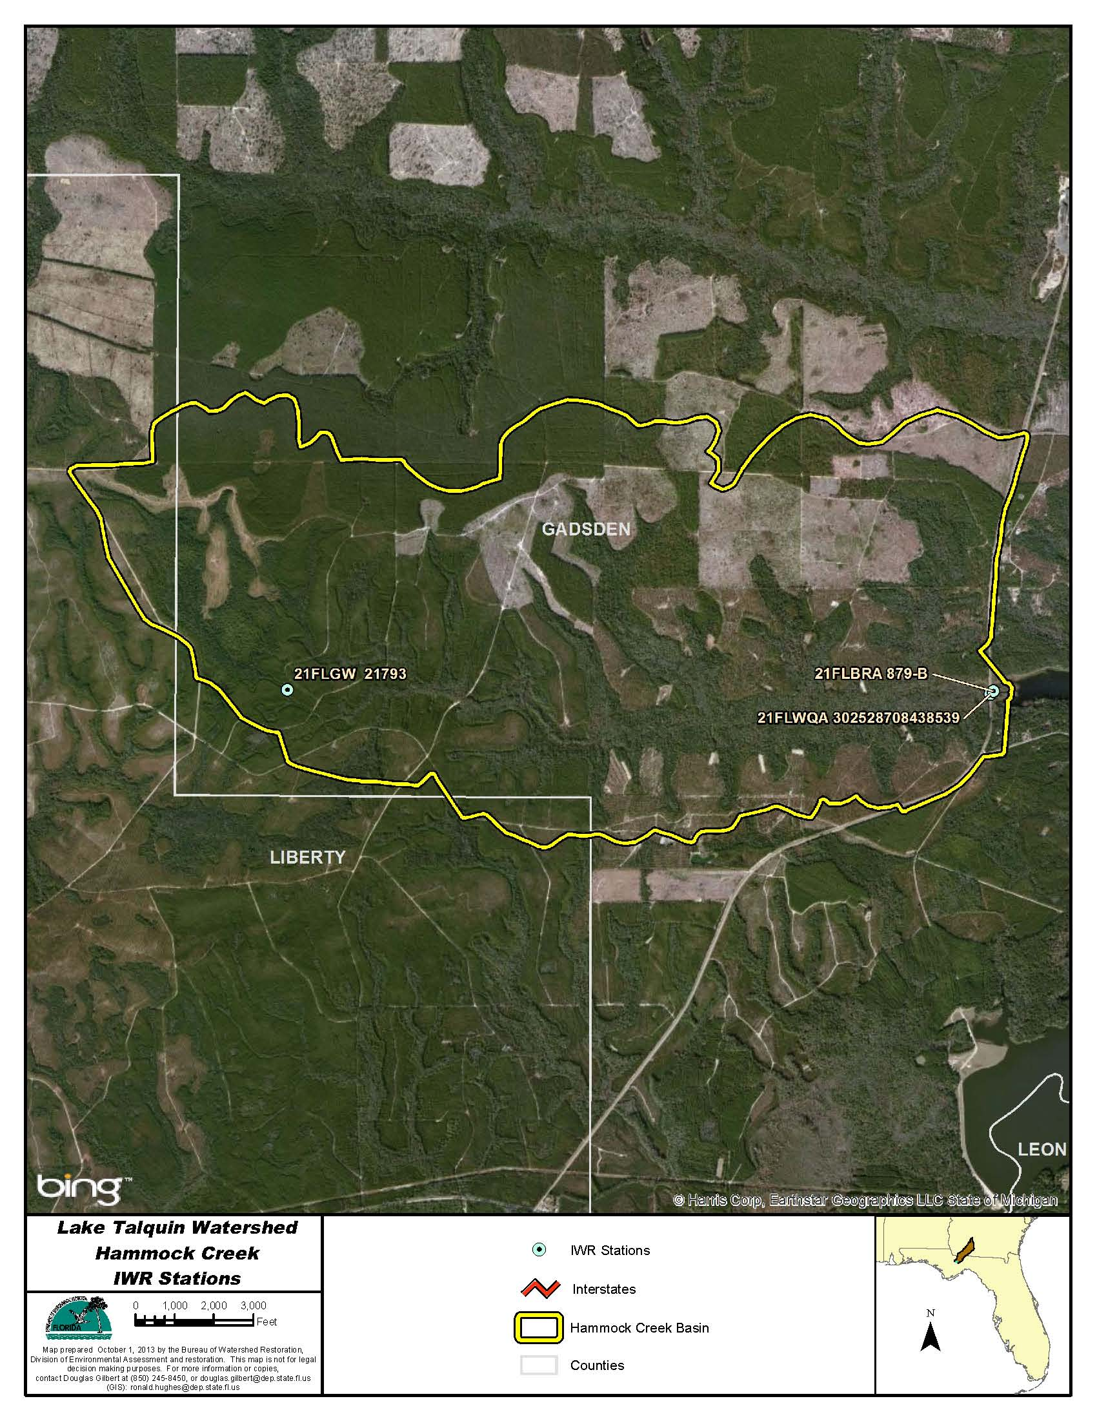
Figure B.4H.1. Hammock Creek WBID 879 IWR Stations

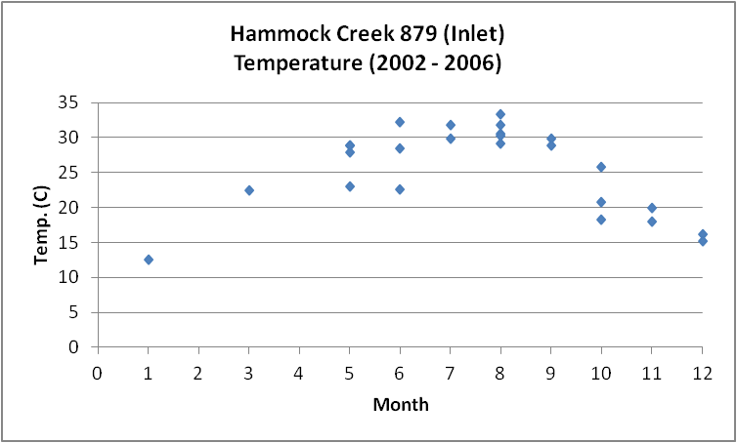
Figure B.4H.2. Hammock Creek WBID 879 Monthly Temperature 1974 - 2013

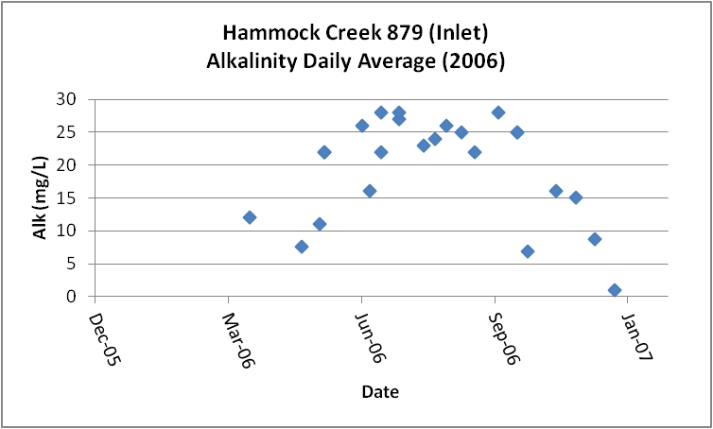
Figure B.4H.3. Hammock Creek WBID 879 Daily Average Alkalinity 1974 - 2013

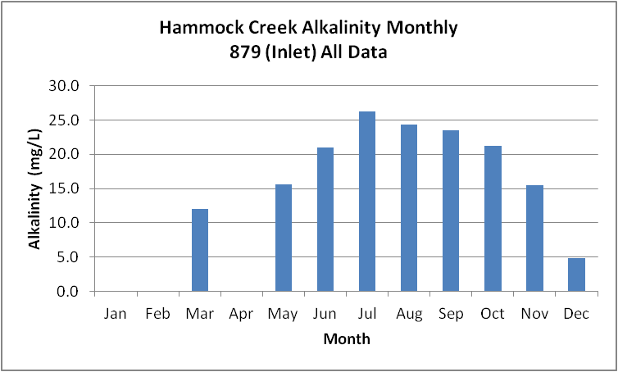
Figure B.4H.4. Hammock Creek WBID 879 Monthly Average Alkalinity 1974 - 2013

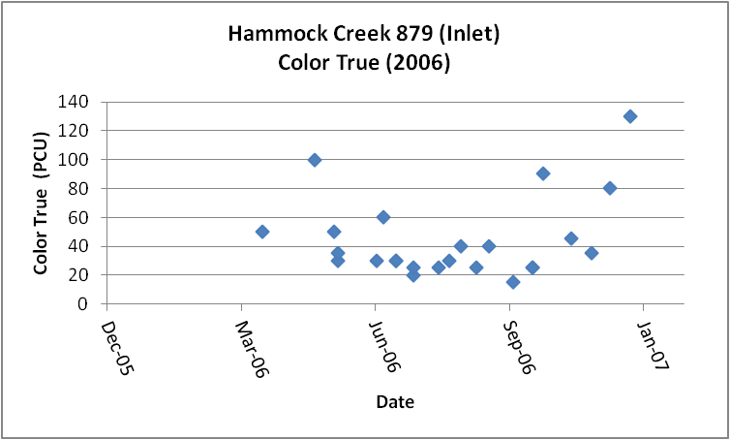
Figure B.4H.5. Hammock Creek WBID 879 Daily Average True Color 1974 - 2013

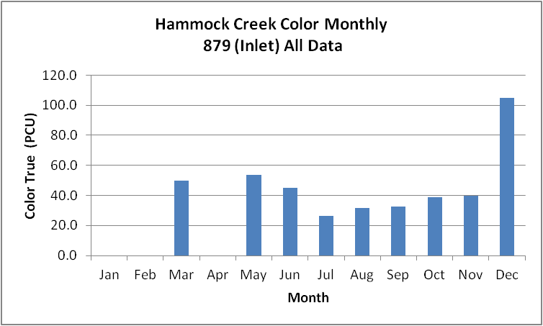
Figure B.4H.6. Hammock Creek WBID 879 Monthly Average True Color 1974 - 2013

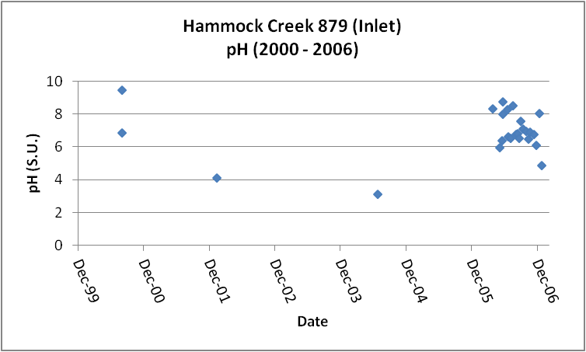
Figure B.4H.7. Hammock Creek WBID 879 Daily pH 1974 - 2013

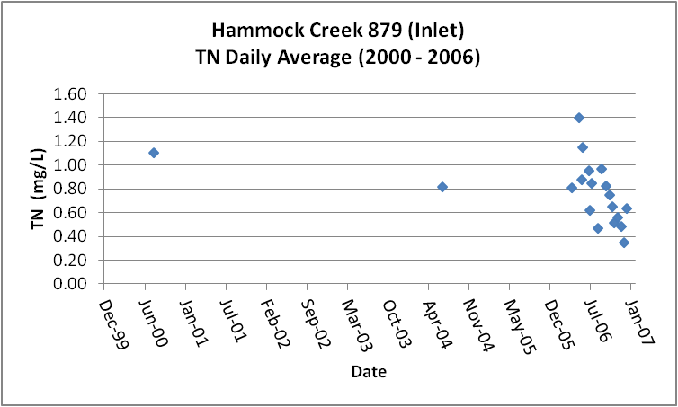
Figure B.4H.8. Hammock Creek WBID 879 Daily Average TN1973 - 2013

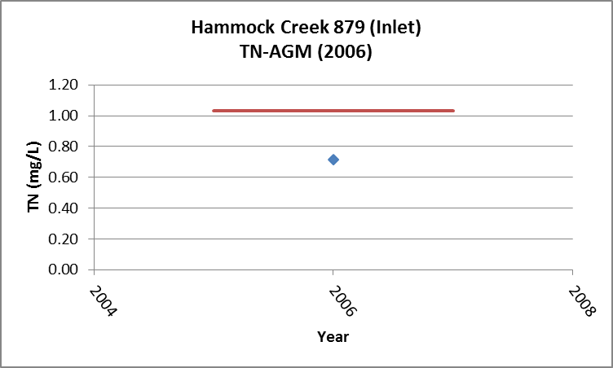

Figure B.4H.9. Hammock Creek WBID 879 TN Annual Geomean 1973 - 2013

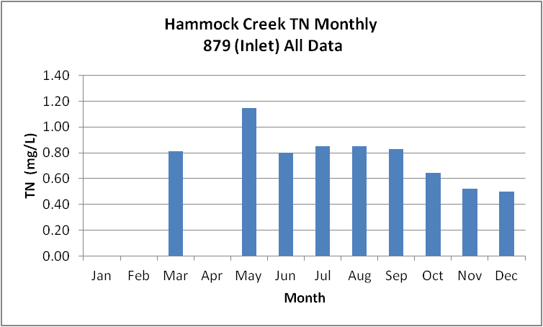
Figure B.4H.10. Hammock Creek WBID 879 Monthly Average TN 1973 - 2013

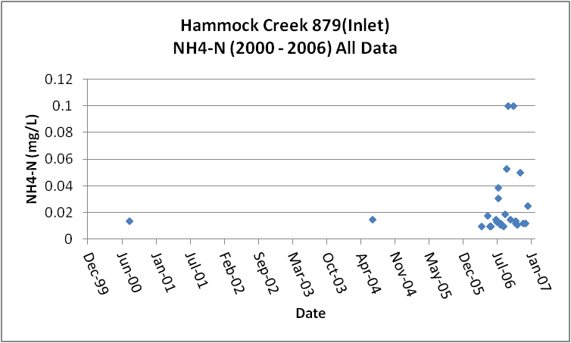
Figure B.4H.11. Hammock Creek WBID 879 Daily Average Ammonia-N 1971 - 2013

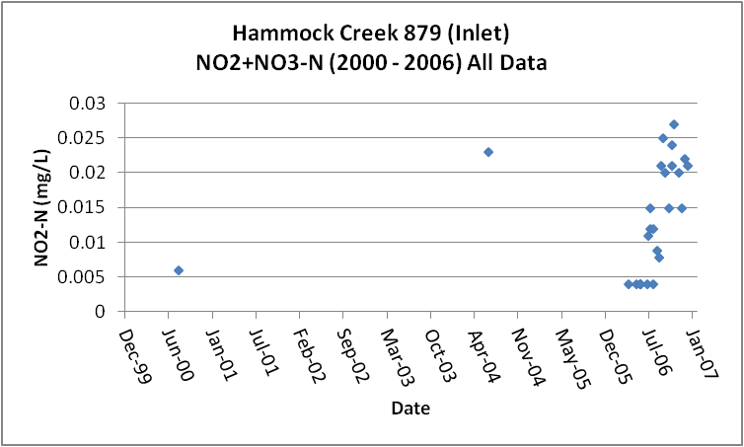
Figure B.4H.12. Hammock Creek WBID 879 Daily Average Nitrate/Nitrite-N1973 - 2013

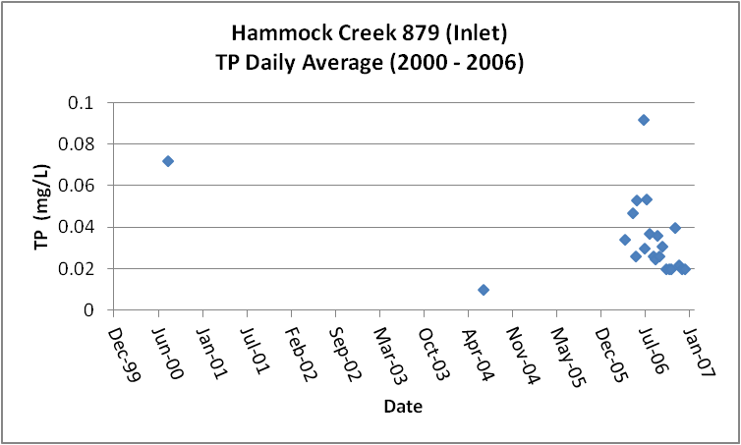
Figure B.4H.13. Hammock Creek WBID 879 Daily Average TP 1973 - 2013

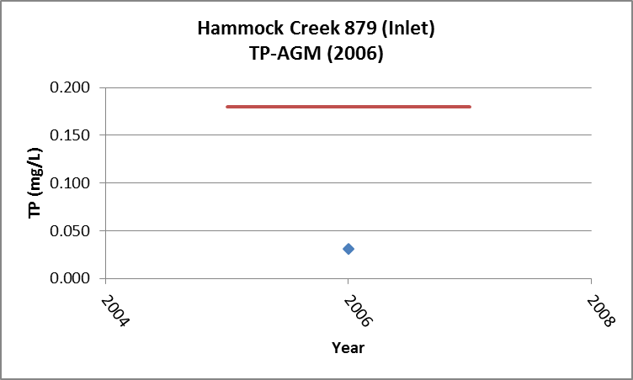

Figure B.4H.14. Hammock Creek WBID 879 Annual Geomean TP 1973 - 2013

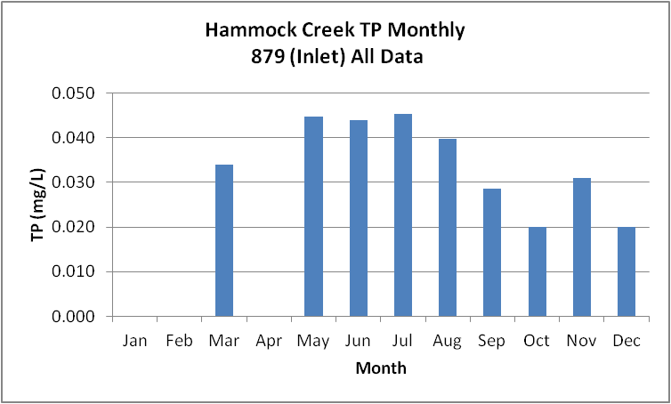
Figure B.4H.15. Hammock Creek WBID 879 Monthly Average TP 1973 - 2013

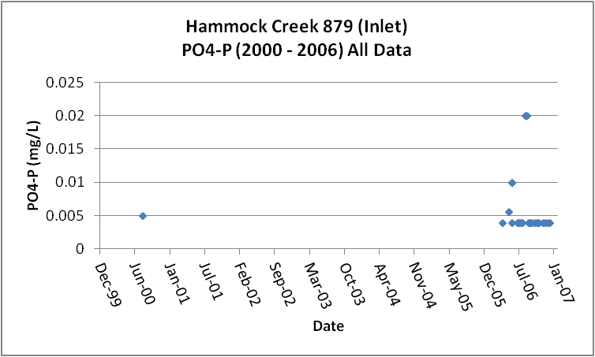
Figure B.4H.16. Hammock Creek WBID 879 Daily Average Orthophosphate-P 1973 - 2013

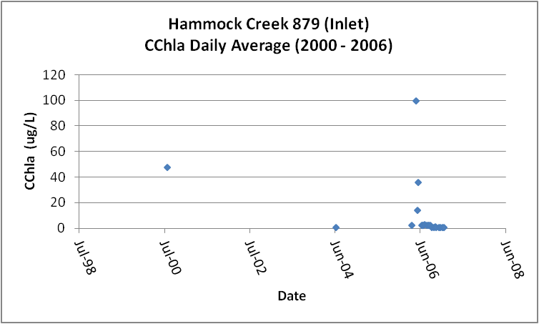
Figure B.4H.17. Hammock Creek WBID 879 Daily Average CChla 2004 - 2013

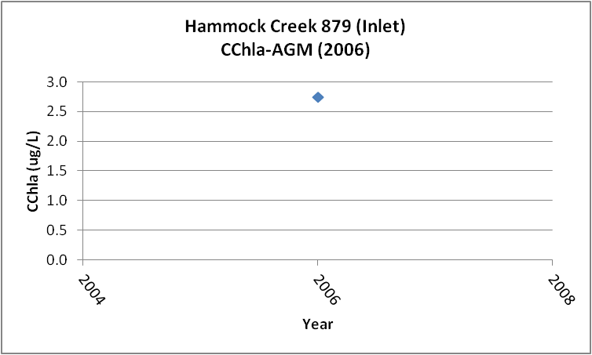
Figure B.4H.18. Hammock Creek WBID 879 Annual Geomean CChla 2004 - 2013

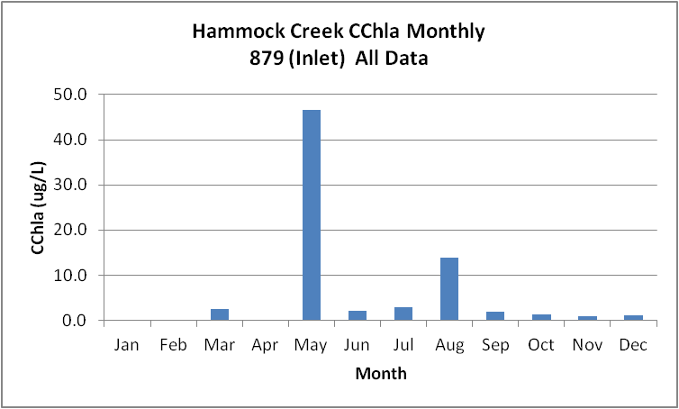
Figure B.4H.19. Hammock Creek WBID 879 Monthly Average CChla 2004 - 2013

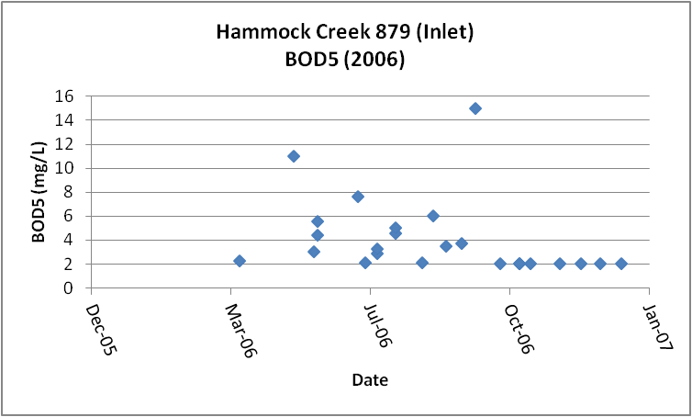
Figure B.4H.20. Hammock Creek WBID 879 Daily Average BOD5 2006 - 2013

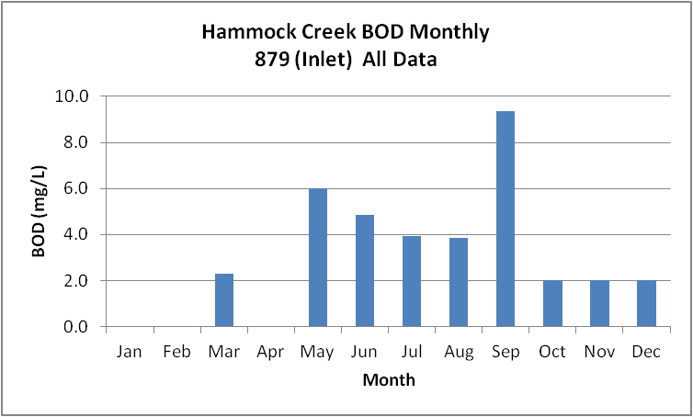
Figure B.4H.21. Hammock Creek WBID 879 Monthly Average BOD5 2006 - 2013

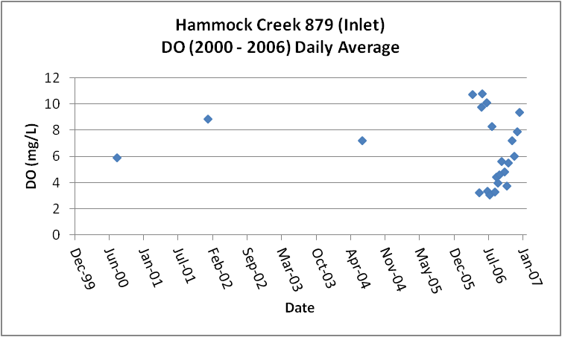
Figure B.4H.22. Hammock Creek WBID 879 Daily Average DO 1974 - 2013

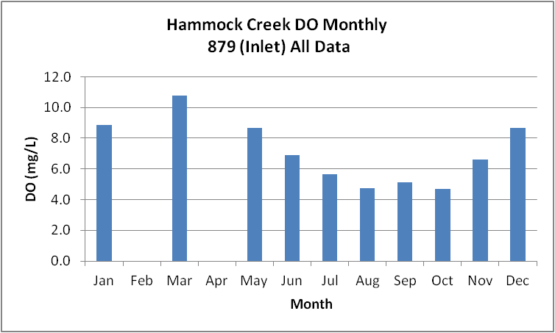
Figure B.4H.23. Hammock Creek WBID 879 Monthly Average DO 1974 - 2013

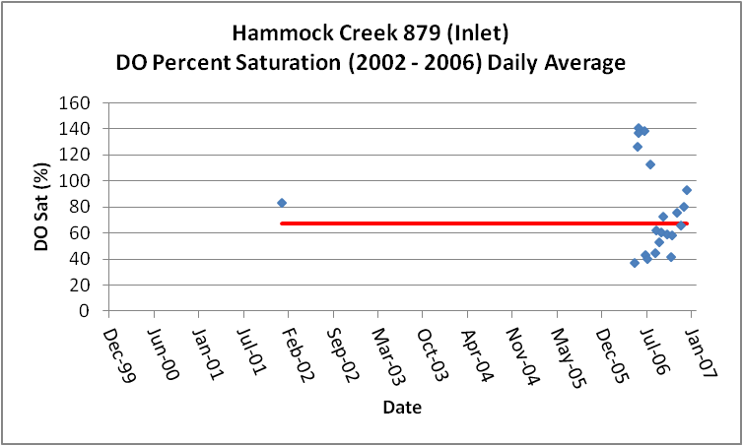
Figure B.4H.24. Hammock Creek WBID 879 Daily Average DO Percent Saturation 1975 - 2013

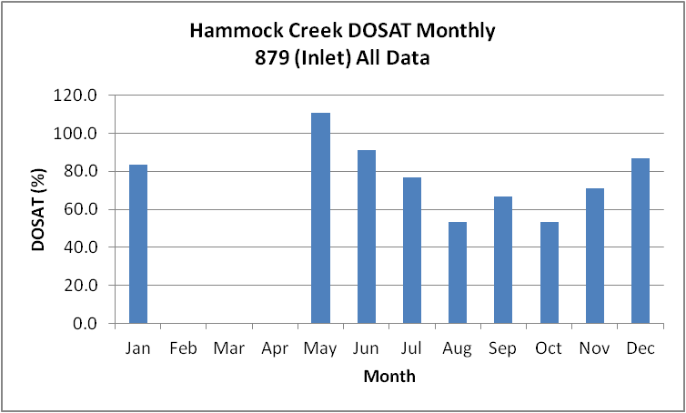
Figure B.4H.25. Hammock Creek WBID 879 Monthly Average DO Percent Saturation 1975 - 2013

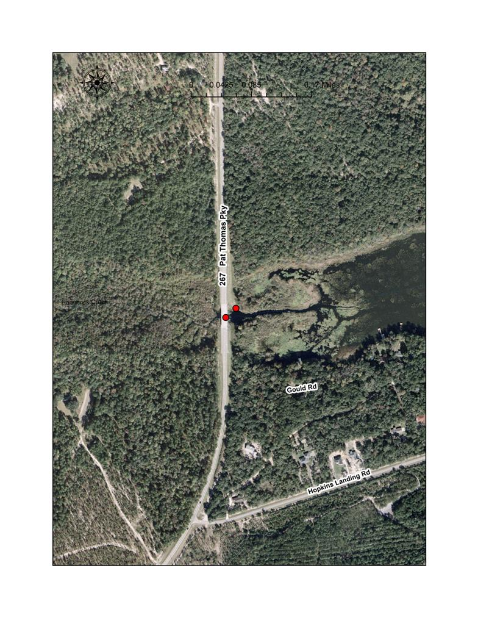

Figure B.4H.26. Hammock Creek Station with low DO

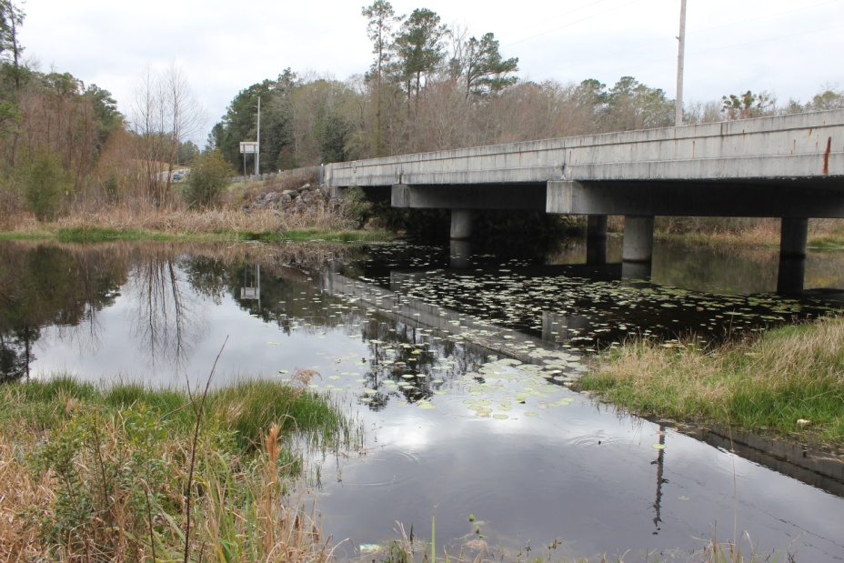

Figure B.4H.27. Hammock Creek Station Location below Bridge

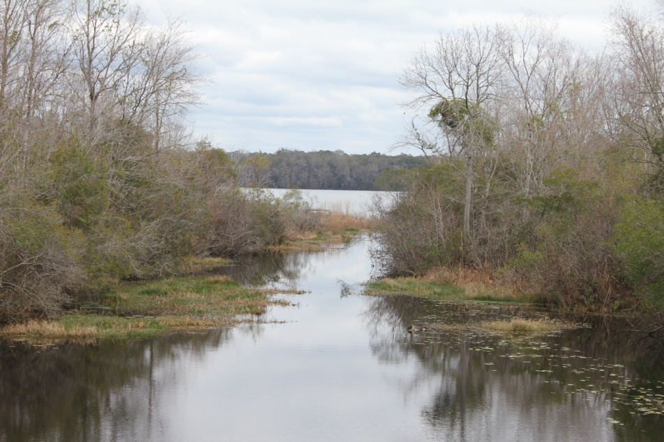

Figure B.4H.28. Hammock Creek Station Looking Downstream into Lake Talquin DO

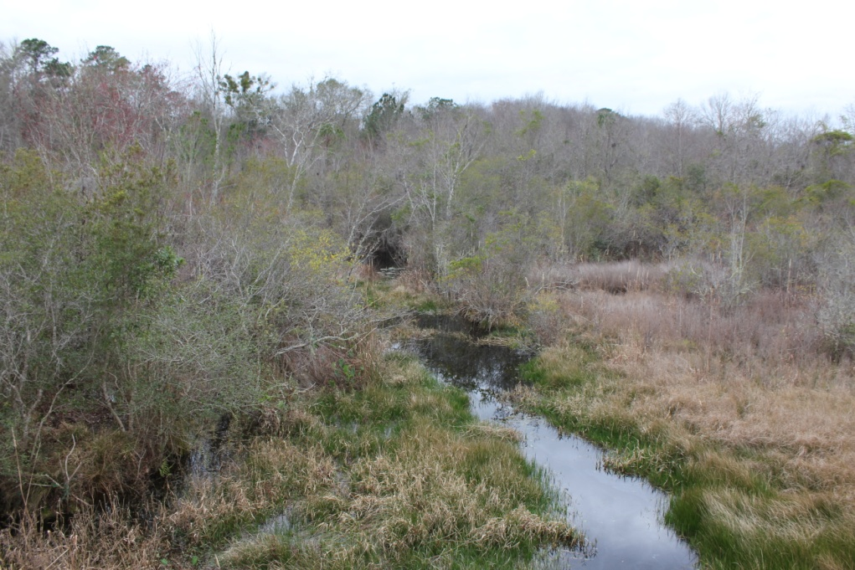

Figure B.4H.29. Hammock Creek Station Upstream of Bridge

Table B.4H.1. Hammock Creek WBID 879 IWR Stations
WBID | Station Number | Station Name | Begin Date | End Date
879 | 21FLGW 21793 | NW1-SS-2040 HAMMOCK CREEK | 2004 | 2004
879 | 21FLWQA 302528708438539 | Hammock Creek at SR 267 | 2002 | 2002
879 | 21FLBRA 879-B | 879 - Hammock Creek - at SR 267 | 2006 | 2006

Table B.4H.2. Hammock Creek WBID 879 Long-Term Geomean Alkalinity and Color
WBID | Constituent | POR | Geomean
879 | Alkalinity | 2002 - 2006 | 16.6
879 | Color-True | 2006 | 38.1

Table B.4H.3. Hammock Creek WBID 879 DO Percent Saturation vs. 67% Criterion
Year | Category | Result
2002 - 2006 | Count | 21
 | Number P | 10
 | Number F | 11
 | Percent F | 52.4
2005-2013 | Count | 20
 | Number P | 9
 | Number F | 11
 | Percent F | 55.0

Table B.4H.4. Hammock Creek WBID 879 Annual Geomean TN, TP, TN/TP Ratio, and CChla
Year | TN | TP | TN/TP | CChla
- | AGM | AGM | Ratio | AGM
2006 | 0.72 | 0.031 | 23.2 | 2.8

Table B.4H.5. Hammock Creek WBID 879 Water Quality Data Summary All Data
Constituent | Units | POR | Count | Min | Max | Median | Mean | Geomean
Temperature | C | 2000/2006 | 25 | 12.5 | 33.3 | 28.4 | 25.4 | 24.6
Alkalinity | mg/L | 2006 | 24 | 1.0 | 28.0 | 22.0 | 19.5 | 16.6
pH | S.U. | 2000/2006 | 25 | 3.2 | 9.5 | 6.8 | 6.9 | NA
Color | PCU | 2006 | 24 | 15.0 | 130.0 | 32.5 | 44.4 | 38.1
TN | mg/L | 2000/2006 | 22 | 0.35 | 1.40 | 0.82 | 0.80 | 0.75
NH4-N | mg/L | 2000/2006 | 26 | 0.010 | 0.10 | 0.01 | 0.02 | 0.02
NO23 | mg/L | 2000/2006 | 26 | 0.004 | 0.03 | 0.01 | 0.01 | 0.01
OrgN | mg/L
TP | mg/L | 2000/2006 | 26 | 0.010 | 0.092 | 0.028 | 0.036 | 0.031
PO4-P | mg/L | 2000/2006 | 25 | 0.004 | 0.020 | 0.004 | 0.006 | 0.005
CChla | ug/L | 2000/2006 | 26 | 1.0 | 100.0 | 2.6 | 10.6 | 3.2
BOD5 | mg/L | 2006 | 24 | 2.0 | 15.0 | 3.0 | 4.1 | 3.4
DO | mg/L | 2000/2006 | 25 | 2.9 | 11.1 | 6.0 | 6.6 | 6.0
%DOSat | % | 2002/2006 | 21 | 37.6 | 141.0 | 66.0 | 77.7 | 71.1

Table B.4H.6. Hammock Creek WBID 879 Water Quality Data Summary Verified Period Plus (2005 – 2013)
Constituent | Units | Verified Period + | Count | Min | Max | Median | Mean | Geomean
Temperature | C | VP (2005 - 2013) | 21 | 15.2 | 33.3 | 28.4 | 25.7 | 25.0
Alkalinity | mg/L | VP (2005 - 2013) | 24 | 1.0 | 28.0 | 22.0 | 19.5 | 16.6
pH | S.U. | VP (2005 - 2013) | 25 | 3.2 | 9.5 | 6.8 | NA | NA
Color | PCU | VP (2005 - 2013) | 24 | 15.0 | 130.0 | 32.5 | 44.4 | 38.1
TN | mg/L | VP (2005 - 2013) | 20 | 0.35 | 1.40 | 0.79 | 0.78 | 0.74
NH4-N | mg/L | VP (2005 - 2013) | 24 | 0.010 | 0.10 | 0.01 | 0.03 | 0.02
NO23 | mg/L | VP (2005 - 2013) | 24 | 0.004 | 0.03 | 0.01 | 0.01 | 0.01
OrgN | mg/L
TP | mg/L | VP (2005 - 2013) | 24 | 0.020 | 0.092 | 0.028 | 0.035 | 0.032
PO4-P | mg/L | VP (2005 - 2013) | 24 | 0.004 | 0.020 | 0.004 | 0.006 | 0.005
CChla | ug/L | VP (2005 - 2013) | 24 | 1.0 | 100.0 | 2.6 | 9.4 | 3.0
BOD5 | mg/L | VP (2005 - 2013) | 24 | 2.0 | 15.0 | 3.0 | 4.1 | 3.4
DO | mg/L | VP (2005 - 2013) | 21 | 3.1 | 11.1 | 5.6 | 6.5 | 5.9
%DOSat | % | VP (2005 - 2013) | 20 | 37.6 | 141.0 | 64.1 | 77.4 | 70.5

B.4I Freeman Creek WBID 954 Drains to Lake Talquin
This WBID is not impaired for DO or nutrients.
Table B.4I.1, lists the 7 stations that have been sampled in Freeman Creek WBID 954. Figure B.4I.1 depicts the station locations.
Tables B.4I.5 and B.4I.6 and Figures B.4I.3 and B.4I.4, provide the results for alkalinity. These data show that Freeman Creek has a POR GM alkalinity of 2.4 mg/L. All data were collected between 2006 and 2012. The limited data indicate higher monthly average alkalinity in the summer (up to 10 mg/L). There is insufficient data to determine accurate long-term or seasonal patterns.
Tables B.4I.5 and B.4I.6 and Figures B.4I.5 and B.4I.6, provide the results for true color. These data show that Freeman Creek has a POR GM color of 81.6 PCU. All data were collected between 2006 and 2012. There is insufficient data to determine accurate long-term or seasonal patterns.
Tables B.4I.5 and B.4I.6 and Figures B.4I.8 through B.4I.11, provide the results for TN. These data show that Freeman Creek has a POR GM TN of 0.46 mg/L. The data indicate that the recent (2005 – 2013) TN GM of 0.39 mg/L is similar to the POR TN GM for the POR and significantly less than the new 1.03 mg/L threshold AGM concentration for TN (Figure B.4I.10). There were four years during 2007 - 2011 with sufficient data to calculate AGM concentrations. These results show that the TN concentrations may be increasing over time. There is insufficient data to determine accurate long-term or seasonal patterns.
Tables B.4I.5 and B.4I.6 and Figure B.4I.12 provide the results for NH4-N. These data show that Freeman Creek has a POR GM NH4-N of 0.03 mg/L, less than either the Little or Ocklawaha Rivers. The data indicate that the recent (2005 – 2013) NH4-N GM of 0.02 mg/L is less than the POR concentration. There is insufficient data to determine accurate long-term or seasonal patterns.
Tables B.4I.5 and B.4I.6 and Figure B.4I.13 provide the results for NO23-N. These data show that Freeman Creek has a POR GM NO23-N of 0.01 mg/L, significantly less than either the Little or Ochlockonee Rivers. The data indicate that the recent (2005 – 2013) NO23-N GM of 0.01 mg/L is the same as the POR concentration. There is insufficient data to determine accurate long-term or seasonal patterns
Tables B.4I5 and B.4I.6 and Figures B.4I.14 through B.4I.17, provide the results for TP. These data show that Freeman Creek has a POR GM TP of 0.016 mg/L. The data indicate that the recent (2005 – 2013) TP GM of 0.01 mg/L is less than the TP GM for the POR and significantly less than the new 0.18 mg/L threshold AGM concentration for TP. There were four years during 2007 - 2011 with sufficient data to calculate AGM concentrations. These results show that the TP concentrations may be increasing over time (Figure B.4I.17). There is insufficient data to determine accurate long-term or seasonal patterns.

Tables B.4.I5 and B.4I.6 and Figure B.4I.18 provide the results for PO4-P. These data show that Freeman Creek has a POR GM PO4-P of 0.007 mg/L. The data indicate that the recent (2005 – 2013) PO4-P GM of 0.005 mg/L is less than the POR concentration. There is insufficient data to determine accurate long-term or seasonal patterns.
Tables B.4I.5 and B.4I.6 and Figures B.4I.19 through B.4I.21, provide the results for CChla. These data show that Freeman Creek has a POR GM CChla of 2.3 ug/L. The data indicate that the recent (2005 – 2013) CChla GM of 1.4 ug/L is similar to the CChla GM for the POR and significantly less than the new threshold AGM concentration for CChla (Figure B.4I.22). The data set has a large number of less than detection results. There is insufficient data to determine accurate long-term or seasonal patterns.
Tables B.4.I5 and B.4I.6 and Figures B.4I.22 and B.4I.23, provide the results for BOD5. These data show that Freeman Creek has a POR GM BOD5 of 1.5 mg/L. All of the results are from the period 2006 - 2013. There is insufficient data to determine accurate long-term or seasonal patterns.
Tables B.4.I5 and B.4I.6 and Figures B.4I.24 and B.4I.25, provide the results for DO. These data show that Freeman Creek has a POR GM DO of 6.5 mg/L. The data indicate that the recent (2005 – 2013) DO GM of 6.7 mg/L is equivalent to the POR concentration. The monthly average DO drops to ~ 4.0 in July and August (Figure B.4I.27). There is insufficient data to determine accurate long-term or seasonal patterns.
Tables B.4.I5 and B.4I.6 and Figures B.4I.26 and B.4I.27, provide the results for percent DO saturation. These data show that Freeman Creek has a POR GM DOSAT of 65.9 percent. The data indicate that the recent (2005 – 2013) DOSAT GM of 62.0 percent, slightly lower than the GM for the POR. The data presented in Figure B.4I.28 indicate a potential issue with the new DO 67 percent saturation criterion. There is insufficient data to determine accurate long-term or seasonal patterns.

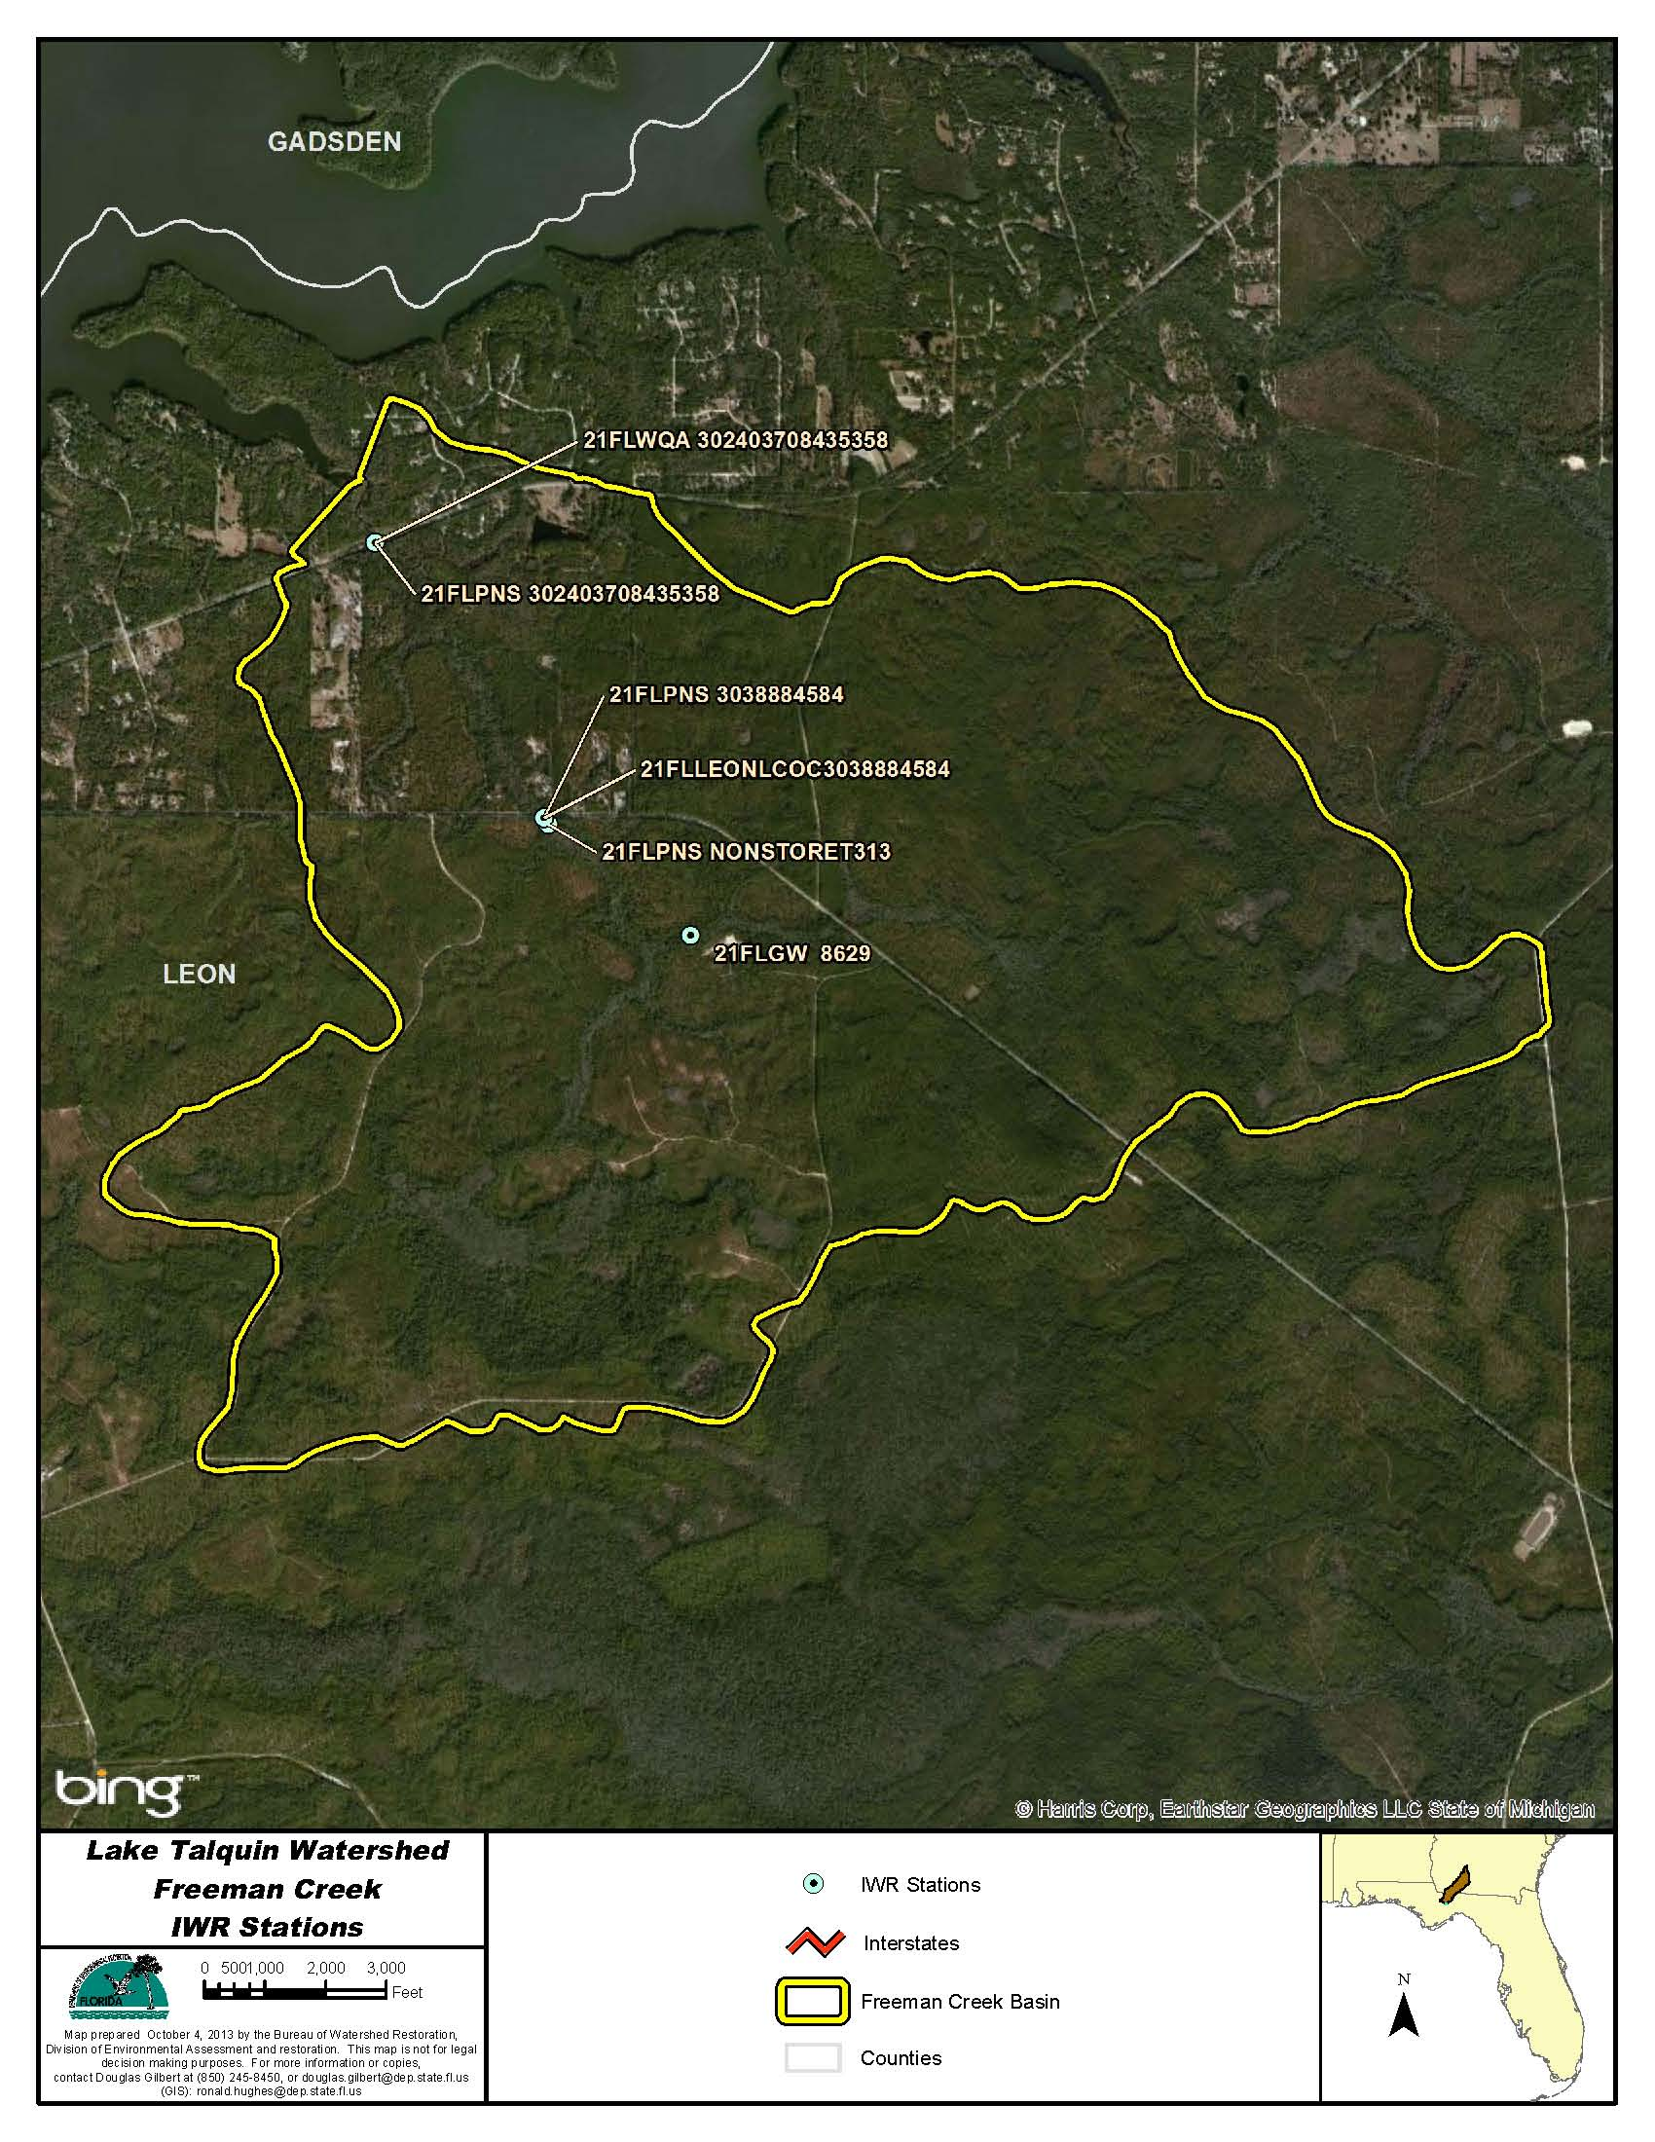
Figure B.4I.1. Freeman Creek WBID 954 Water Quality Stations

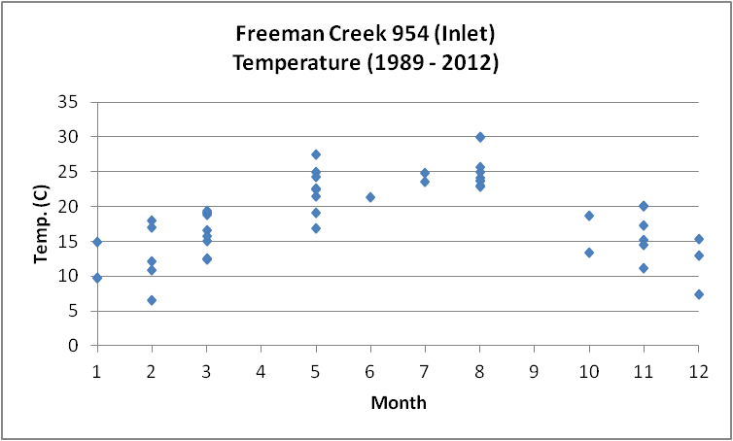
Figure B.4I.2. Freeman Creek WBID 954 Monthly Temperature 1989 - 2012

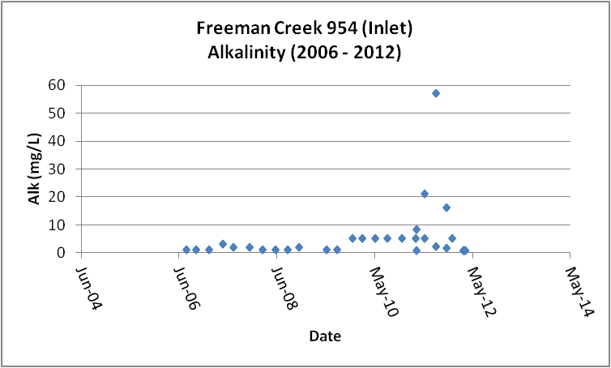
Figure B.4I.3. Freeman Creek WBID 954 Daily Average Alkalinity 2006 - 2012

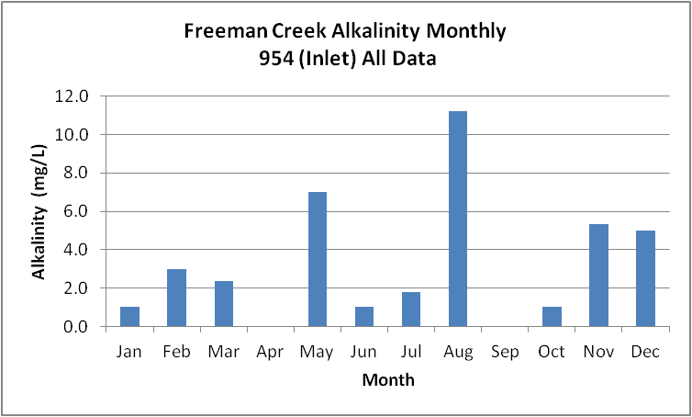
Figure B.4I.4. Freeman Creek WBID 954 Monthly Average Alkalinity 2006 - 2012

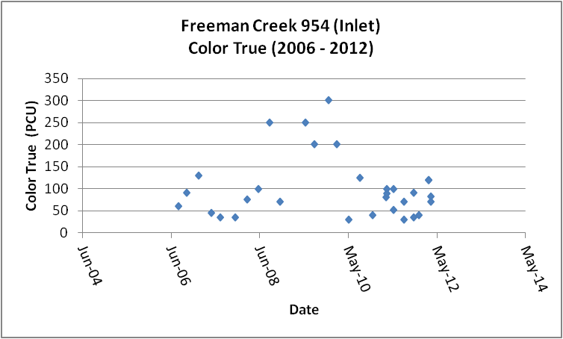
Figure B.4I.5. Freeman Creek WBID 954 Daily Average True Color 2006- 2012

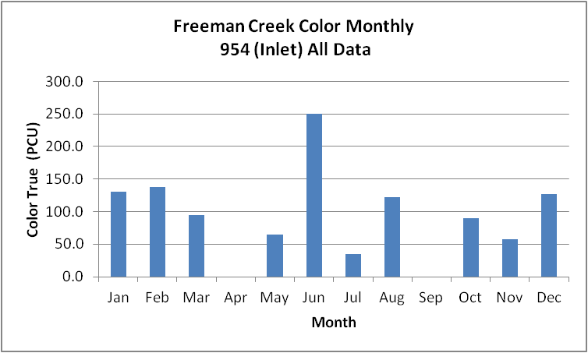
Figure B.4I.6. Freeman Creek WBID 954 Monthly Average True Color 2006 - 2012

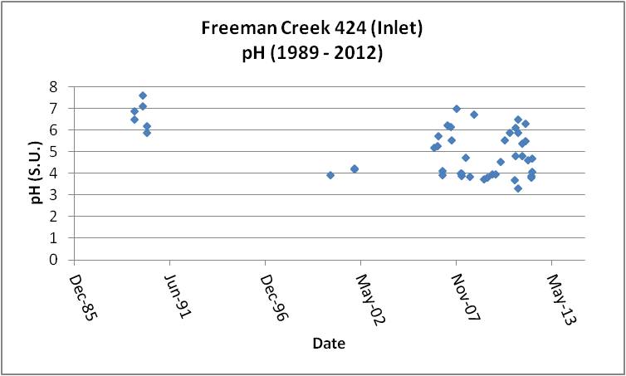
Figure B.4I.7. Freeman Creek WBID 954 Daily pH 1989- 2012

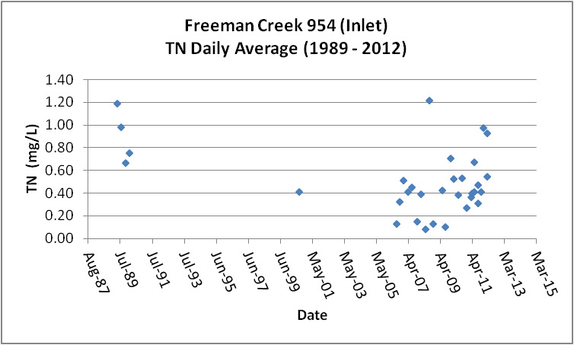
Figure B.4I.8. Freeman Creek WBID 954 Daily Average TN1989- 2012

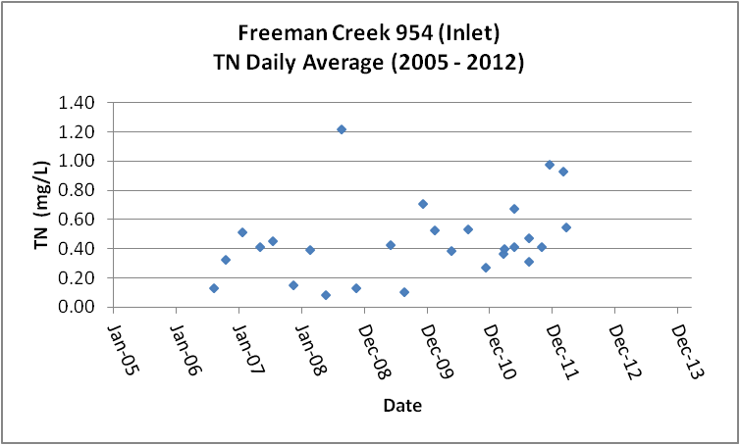
Figure B.4I.9. Freeman Creek WBID 954 Daily Average TN 2005- 2012

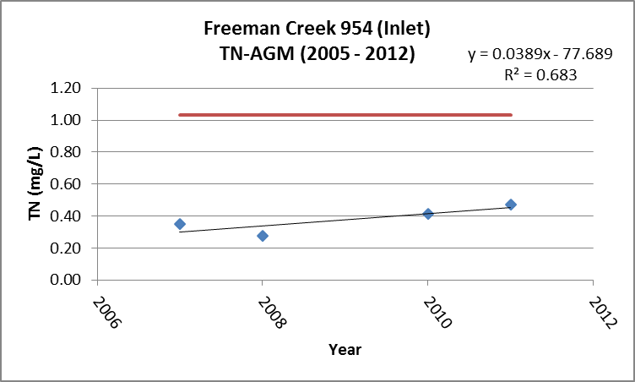
Figure B.4I.10. Freeman Creek WBID 954 TN Annual Geomean 2005 - 2012

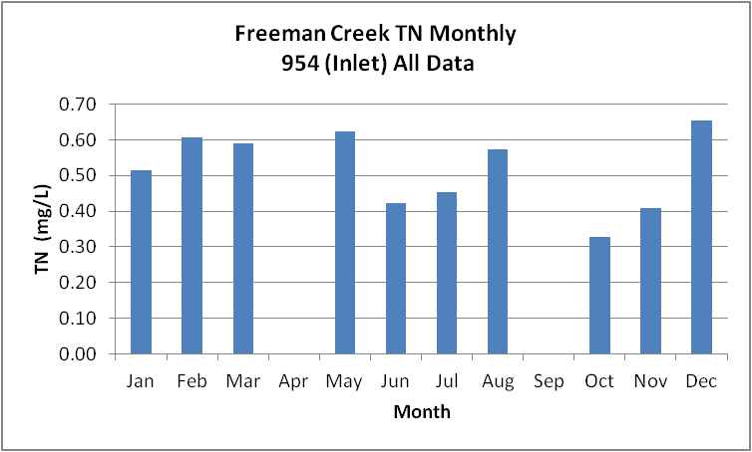
Figure B.4I.11. Freeman Creek WBID 954 Monthly Average TN 1989- 2012

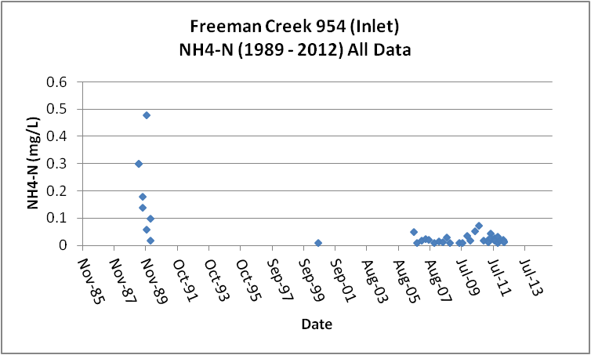
Figure B.4I.12. Freeman Creek WBID 954 Daily Average Ammonia-N 1989- 2012

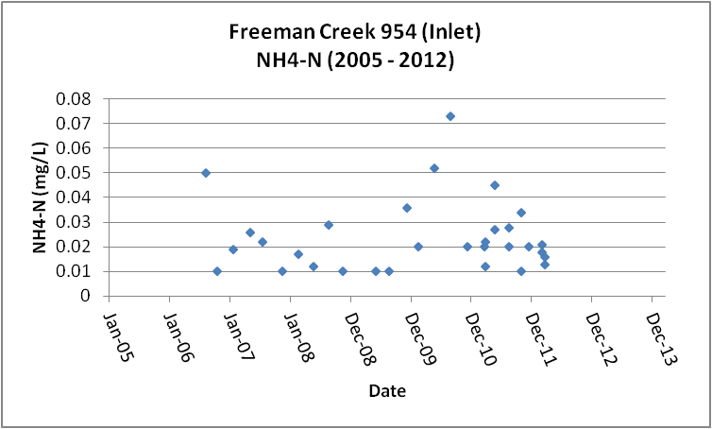
Figure B.4I.13. Freeman Creek WBID 954 Daily Average Ammonia-N 2005 2013

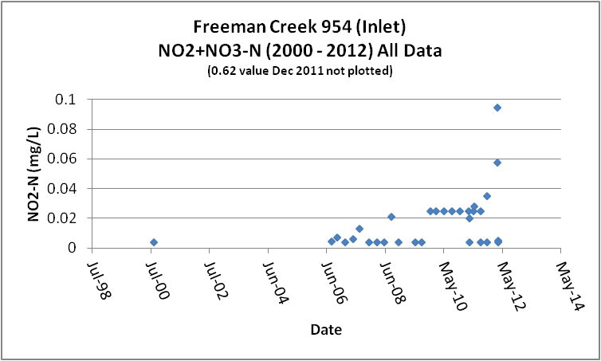
Figure B.4I.14. Freeman Creek WBID 954 Daily Average Nitrate/Nitrite-N 2000 - 2012

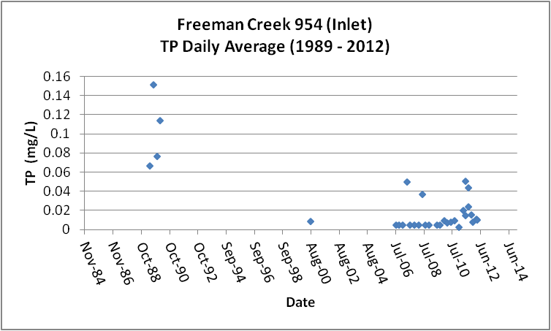
Figure B.4I.15. Freeman Creek WBID 954 Daily Average TP 1989 - 2012

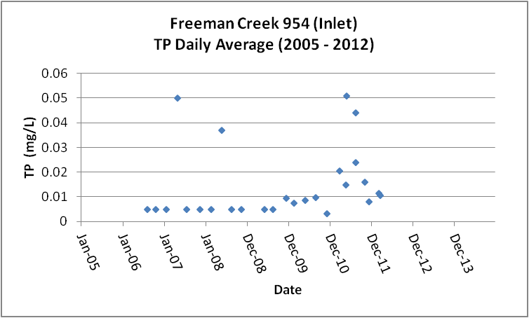
Figure B.4I.16. Freeman Creek WBID 954 Daily Average TP 2005 - 2012

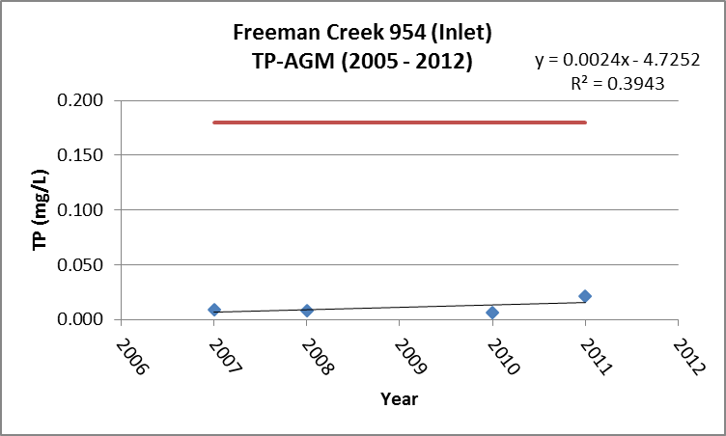
Figure B.4I.17. Freeman Creek WBID 954 Annual Geomean TP 2005 - 2013

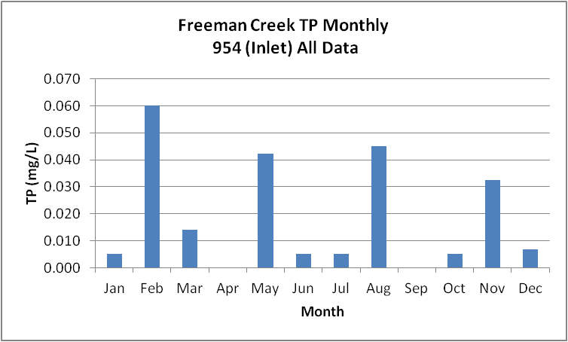
Figure B.4I.18. Freeman Creek WBID 954 Monthly Average TP 1989 - 2012

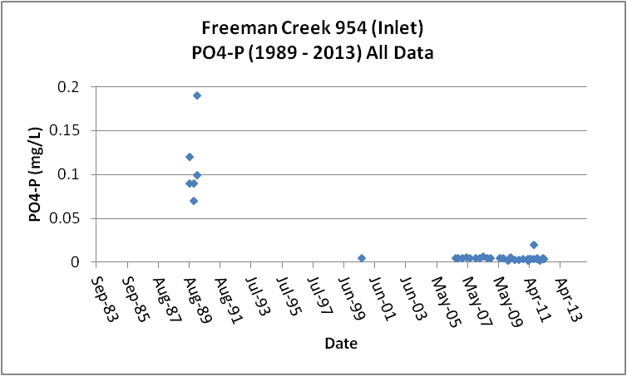
Figure B.4I.19. Freeman Creek WBID 954 Daily Average Orthophosphate-P 1989 - 2012

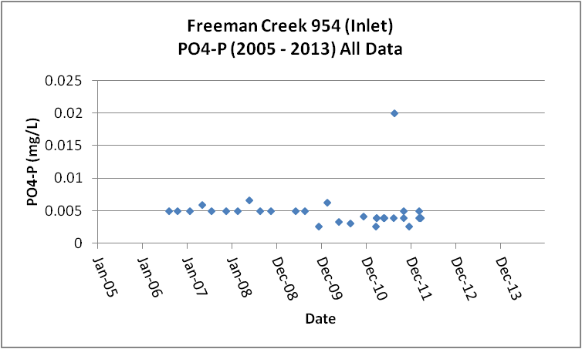
Figure B.4I.20. Freeman Creek WBID 954 Daily Average Orthophosphate-P 2005 - 2012

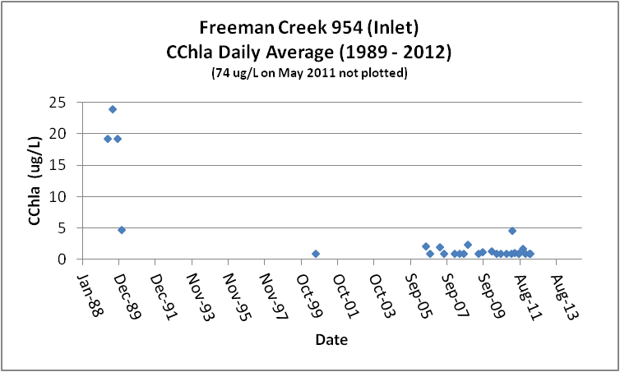
Figure B.4I.21. Freeman Creek WBID 954 Daily Average CChla 1989 - 2012

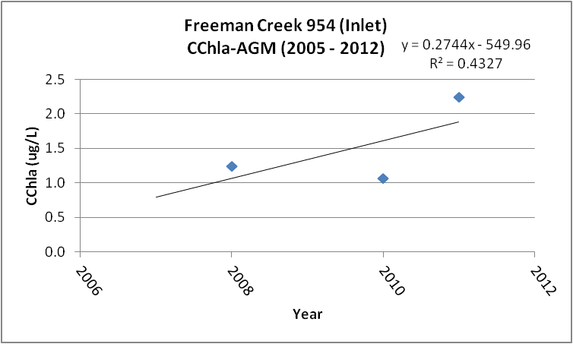
Figure B.4I.22. Freeman Creek WBID 954 Annual Geomean CChla 2005 - 2013

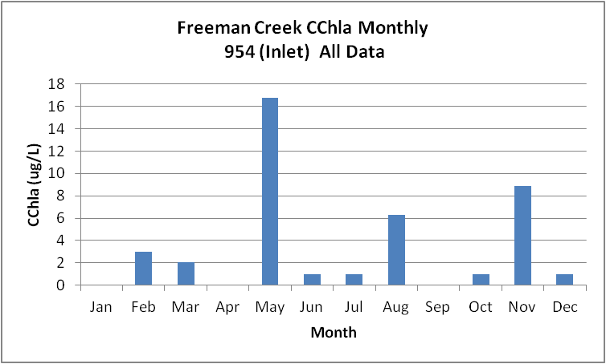
Figure B.4I.23. Freeman Creek WBID 954 Monthly Average CChla 1989 - 2012

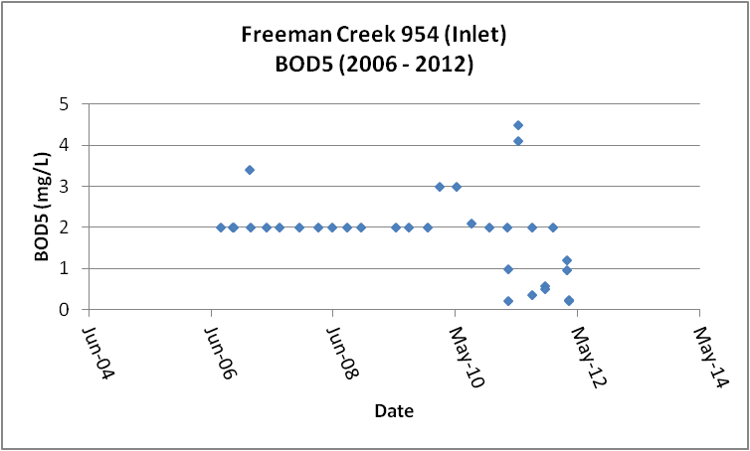
Figure B.4I.24. Freeman Creek WBID 954 Daily Average BOD5 2006 - 2012

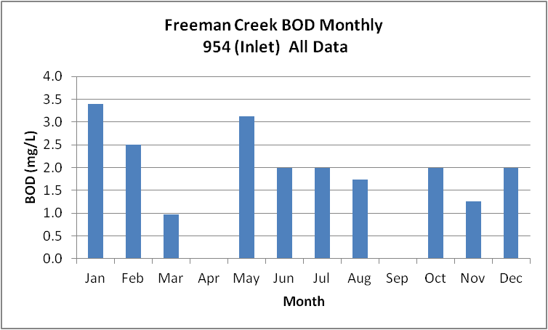
Figure B.4I.25. Freeman Creek WBID 954 Monthly Average BOD5 2006 - 2012

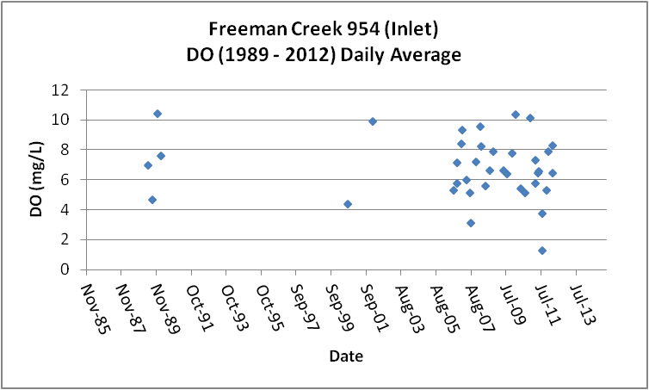
Figure B.4I.26. Freeman Creek WBID 954 Daily Average DO 1989 - 2012

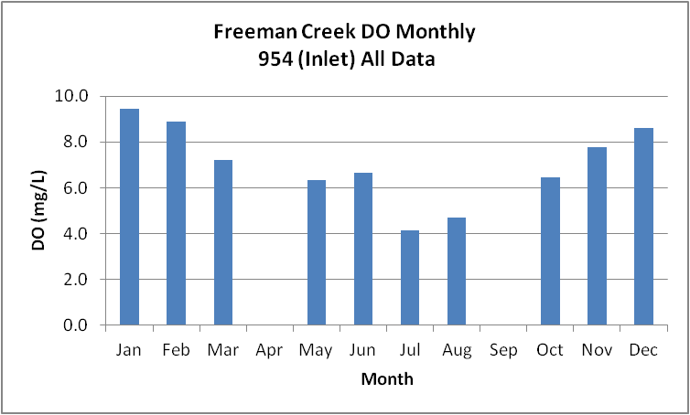
Figure B.4I.27. Freeman Creek WBID 954 Monthly Average DO 1989 - 2012

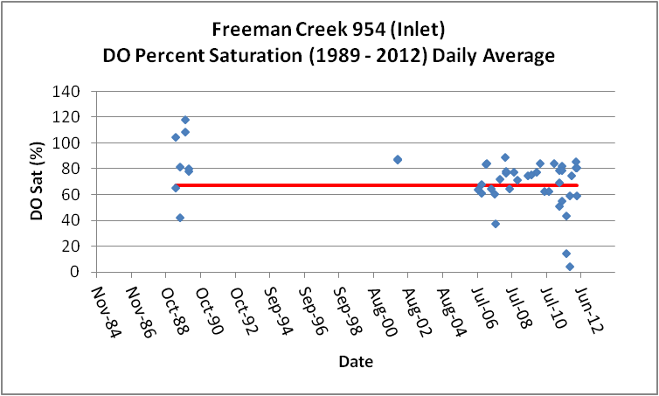
Figure B.4I.28. Freeman Creek WBID 954 Daily Average DO Percent Saturation 1989 - 2012

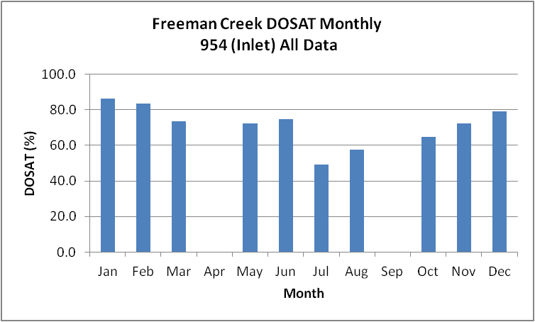
Figure B.4I.29. Freeman Creek WBID 954 Monthly Average DO Percent Saturation 1989 - 2012

Table B.4I.1. Freeman Creek WBID 954 IWR Stations
WBID | Station Number | Station Name | Begin Date | End Date
954 | 21FLGW 8629 | NWA-HS-1015 FREEMAN CREEK | 2000 | 2000
954 | 21FLLEONLCOC3038884584 | Freeman Creek @ 267 | 2011 | 2011
954 | 21FLPNS NONSTORET313 | Freeman Creek at SR 267 | 1998 | 1998
954 | 21FLWQA 302403708435358 | Freeman Creek at SR 20 | 2002 | 2002
954 | 21FLPNS 3038884584 | Freeman Creek @ 267 (also 21FLLEON) | 0 | 0
954 | 21FLPNS 302403708435358 | Freeman Creek At SR 20 (also 21FLWQA) | 0 | 0
954 | 21FLLEONLCOC3038884584 | Freeman Creek @ 267 | 2011 | 2011

Table B.4I.2. Freeman Creek WBID 954 Long-Term Geomean Alkalinity and Color
WBID | Constituent | POR | Geomean
954 | Alkalinity (mg/L) | 2006-2012 | 2.4
954 | Color-True (PCU) | 2006-2013 | 81.6

Table B.4I.3. Freeman Creek WBID 954 DO Percent Saturation vs. 67% Criterion
Year | Category | Result
1989 - 2012 | Count | 47
- | Number P | 30
- | Number F | 17
- | Percent F | 36.2
- | - | -
2005-2012 | Count | 37
- | Number P | 22
- | Number F | 15
- | Percent F | 40.5

Table B.4I.4. Freeman Creek WBID 954 Annual Geomean TN, TP, TN/TP Ratio, and CChla
Year | TN | TP | TN/TP | CChla
- | AGM | AGM | Ratio | AGM
2007 | 0.35 | 0.009 | 39.3 | -
2008 | 0.27 | 0.008 | 33.2 | 1.2
2009 | - | - | - | -
2010 | 0.42 | 0.007 | 62.8 | 1.1
2011 | 0.47 | 0.021 | 22.0 | 2.2

Table B.4I.5. Freeman Creek WBID 954 Water Quality Data Summary All Data
Constituent | Units | POR | Count | Min | Max | Median | Mean | Geomean
Temperature | C | 1989 - 2012 | 48 | 6.5 | 30.0 | 19.0 | 18.5 | 17.5
Alkalinity | mg/L | 2006 - 2012 | 31 | 0.7 | 57.1 | 1.8 | 5.4 | 2.4
pH | S.U. | 1989 - 2012 | 46 | 3.3 | 7.6 | 4.8 | NA | NA
Color | PCU | 2006 - 2012 | 31 | 30.0 | 300.0 | 83.0 | 100.4 | 81.6
TN | mg/L | 1989 - 2012 | 40 | 0.09 | 1.25 | 0.48 | 0.56 | 0.46
NH4-N | mg/L | 1989 - 2012 | 40 | 0.010 | 0.48 | 0.02 | 0.06 | 0.03
NO23 | mg/L | 2000 - 2012 | 32 | 0.004 | 0.62 | 0.01 | 0.04 | 0.01
OrgN | mg/L | 1989 - 1990 | 8 | 0.34 | 0.90 | 0.56 | 0.61 | 0.56
TP | mg/L | 1989 - 2012 | 39 | 0.003 | 0.156 | 0.010 | 0.032 | 0.016
PO4-P | mg/L | 1989 - 2012 | 38 | 0.003 | 0.190 | 0.005 | 0.022 | 0.007
CChla | ug/L | 1989 - 2012 | 37 | 1.0 | 74.0 | 1.0 | 6.7 | 2.3
BOD5 | mg/L | 2006 - 2012 | 33 | 0.2 | 4.5 | 2.0 | 1.9 | 1.5
DO | mg/L | 1989 - 2012 | 48 | 1.3 | 10.9 | 6.9 | 6.9 | 6.5
%DOSat | % | 1989 - 2012 | 45 | 4.6 | 118.5 | 75.5 | 71.4 | 65.9

Table B.4I.6. Freeman Creek WBID 954 Water Quality Data Summary Verified Period (2005 – 2012)
Constituent | Units | Verified Period | Count | Min | Max | Median | Mean | Geomean
Temperature | C | 2005 - 2012 | 37 | 6.5 | 25.6 | 18.7 | 17.8 | 17.0
Alkalinity | mg/L | 2005 - 2012 | 31 | 0.7 | 57.1 | 1.8 | 5.4 | 2.4
pH | S.U. | 2005 - 2012 | 36 | 3.3 | 7.0 | 4.7 | NA | NA
Color | PCU | 2005 - 2012 | 31 | 30.0 | 300.0 | 83.0 | 100.4 | 81.6
TN | mg/L | 2005 - 2012 | 31 | 0.09 | 1.22 | 0.42 | 0.47 | 0.39
NH4-N | mg/L | 2005 - 2012 | 31 | 0.010 | 0.07 | 0.02 | 0.02 | 0.02
NO23 | mg/L | 2005 - 2012 | 31 | 0.004 | 0.62 | 0.01 | 0.04 | 0.01
OrgN | mg/L | - | - | - | - | - | - | -
TP | mg/L | 2005 - 2012 | 30 | 0.003 | 0.051 | 0.009 | 0.014 | 0.010
PO4-P | mg/L | 2005 - 2012 | 31 | 0.003 | 0.020 | 0.005 | 0.005 | 0.005
CChla | ug/L | 2005 - 2012 | 28 | 1.0 | 74.0 | 1.0 | 4.1 | 1.4
BOD5 | mg/L | 2005 - 2012 | 33 | 0.2 | 4.5 | 2.0 | 1.9 | 1.5
DO | mg/L | 2005 - 2012 | 37 | 1.3 | 10.4 | 7.1 | 7.0 | 6.7
%DOSat | % | 2005 - 2012 | 37 | 4.6 | 89.2 | 74.9 | 68.4 | 62.0

B.4J Harvey Creek WBID 921 Drains to Lake Talquin
This WBID is not impaired for DO or nutrients.
Table B.4J.1, lists the 9 stations that have been sampled in Harvey Creek WBID 921. Figure B.4J.1 depicts the station locations.
Tables B.4J.5 and B.4J.6 and Figures B.4J.3 and B.4J.4, provide the results for alkalinity. These data show that Harvey Creek has a POR GM alkalinity of 3.9 mg/L. All data were collected between 2006 and 2012. There is insufficient data to determine accurate long-term or seasonal patterns.
Tables B.4J.5 and B.4J.6 and Figures B.4J.5 and B.4J.6, provide the results for true color. These data show that Harvey Creek has a POR GM color of 28.7 PCU. All data were collected between 2006 and 2012. The data indicate that Harvey Creek has the lowest color of any of the tributaries to Lake Talquin. There is insufficient data to determine accurate long-term or seasonal patterns.
Tables B.4J.5 and B.4J.6 and Figures B.4J.8 through B.4J.11, provide the results for TN. These data show that Harvey Creek has a POR GM TN of 0.26 mg/L. The data indicate that the recent (2005 – 2013) TN GM of 0.25 mg/L is equivalent to the POR TN GM for the POR and significantly less than the new 1.03 mg/L threshold AGM concentration for TN (Figure B.4J.10). There were five years during 2006 - 2011 with sufficient data to calculate AGM concentrations. These results show that the TN concentrations may be increasing over time. The limited data indicate highest concentrations of TN during June (~0.8 mg/L) with concentrations less than 0.4 mg/L for much of the remaining months. There is insufficient data to determine accurate long-term or seasonal patterns.
Tables B.4J.5 and B.4J.6 and Figure B.4J.12 provide the results for NH4-N. These data show that Harvey Creek has a POR GM NH4-N of 0.02 mg/L. The data indicate that the recent (2005 – 2013) NH4-N GM of 0.02 mg/L is the same as the POR concentration. There is insufficient data to determine accurate long-term or seasonal patterns.
Tables B.4J.5 and B.4J.6 and Figure B.4J.13 provide the results for NO23-N. These data show that Harvey Creek has a POR GM NO23-N of 0.02 mg/L. The data indicate that the recent (2005 – 2013) NO23-N GM of 0.02 mg/L is the same as the POR concentration. There is insufficient data to determine accurate long-term or seasonal patterns
Tables B.4J.5 and B.4J.6 and Figures B.4J.14 through B.4J.17, provide the results for TP. These data show that Harvey Creek has a POR GM TP of 0.012 mg/L. The data indicate that the recent (2005 – 2013) TP GM of 0.011 mg/L is equivalent to the TP GM for the POR and significantly less than the new 0.18 mg/L threshold AGM concentration for TP. There were four years between 2006 and 2011 with sufficient data to calculate AGM concentrations. These results indicate that TP concentrations have decreased over time (Figure B.4J.16). There is insufficient data to determine accurate long-term or seasonal patterns.
Tables B.4J.5 and B.4J.6 and Figure B.4J.18 provide the results for PO4-P. These data show that Harvey Creek has a POR GM PO4-P of 0.005 mg/L. The data indicate that the recent (2005 – 2013) PO4-P GM of 0.005 mg/L is equivalent to the POR concentration. There is insufficient data to determine accurate long-term or seasonal patterns.
Tables B.4J.5 and B.4J.6 and Figures B.4J.19 through B.4J.21, provide the results for CChla. These data show that Harvey Creek has a POR GM CChla of 1.5 ug/L. The data indicate that the recent (2005 – 2013) CChla GM of 1.5 ug/L is the same as the CChla GM for the POR and significantly less than the new threshold AGM concentration for CChla (Figure B.4J.20). The data set has a large number of less than detection results. There is insufficient data to determine accurate long-term or seasonal patterns.
Tables B.4J.5 and B.4J.6 and Figures B.4J.22 and B.4J.23, provide the results for BOD5. These data show that Harvey Creek has a POR GM BOD5 of 2.4 mg/L. All of the results are from the period 2006 - 2013. There is insufficient data to determine accurate long-term or seasonal patterns.
Tables B.4J.5 and B.4J.6 and Figures B.4J.24 and B.4J.25, provide the results for DO. These data show that Harvey Creek has a POR GM DO of 8.7 mg/L. The data indicate that the recent (2005 – 2013) DO GM of 8.8 mg/L is equivalent to the POR concentration. The monthly average DO never drops below 7.0 mg/L (Figure B.4J.25). There is insufficient data to determine accurate long-term or seasonal patterns.

Tables B.4J.5 and B.4J.6 and Figures B.4J.26 and B.4J.27, provide the results for percent DO saturation. These data show that Harvey Creek has a POR GM DOSAT of 92.1 percent. The data indicate that the recent (2005 – 2013) DOSAT GM of 93.1 percent is similar to the GM for the POR. The data presented in Figure B.4J.26 do not indicate an issue with the new DO percent saturation criterion. There is insufficient data to determine accurate long-term or seasonal patterns.

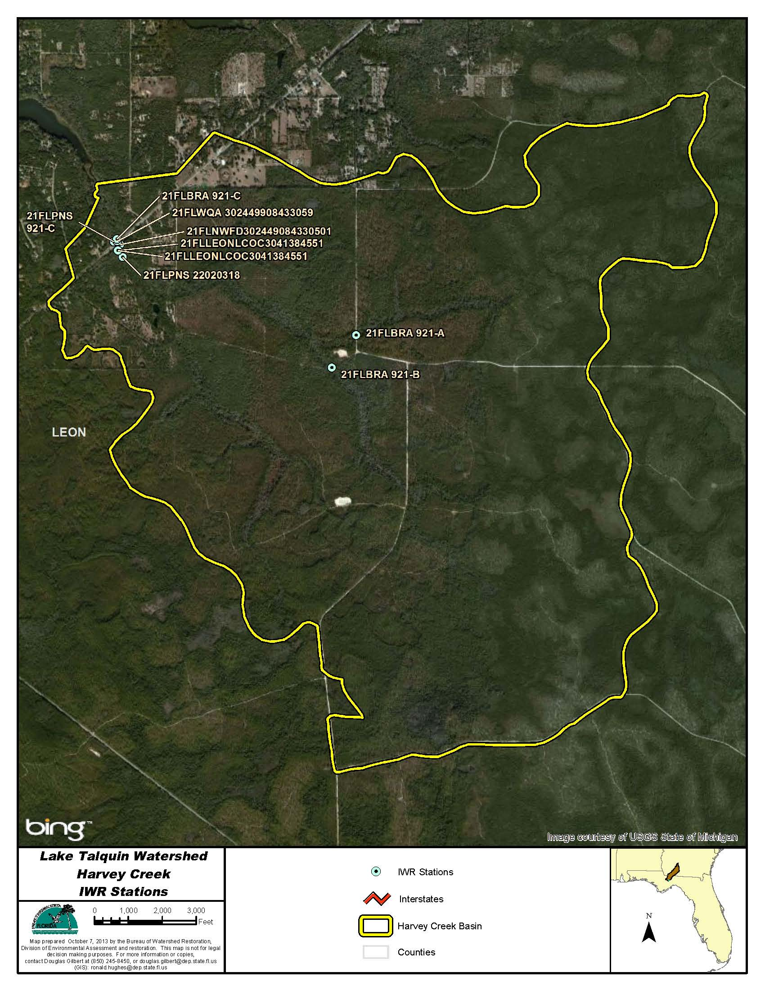
Figure B.4J.1. Harvey Creek WBID 921 IWR Stations

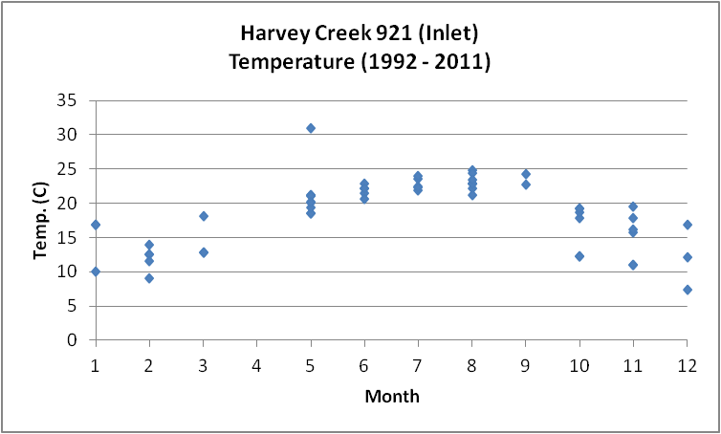
Figure B.4J.2. Harvey Creek WBID 921 Monthly Temperature 1992 - 2011

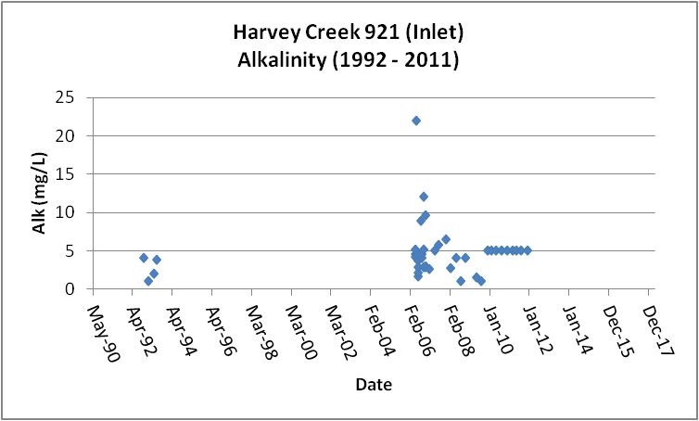
Figure B.4J.3. Harvey Creek WBID 921 Daily Average Alkalinity 1992 - 2011

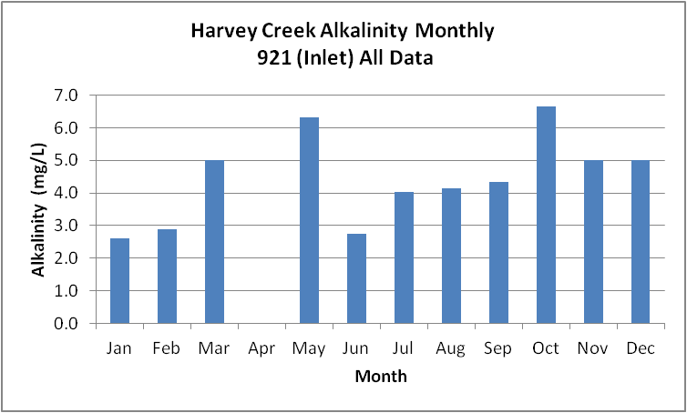
Figure B.4J.4. Harvey Creek WBID 921 Monthly Average Alkalinity 1992 - 2011

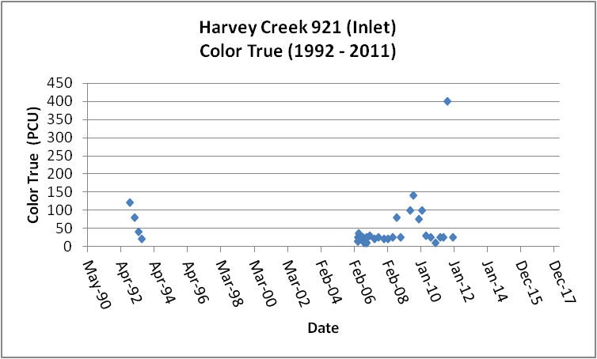
Figure B.4J.5. Harvey Creek WBID 921 Daily Average True Color 1992 - 2013

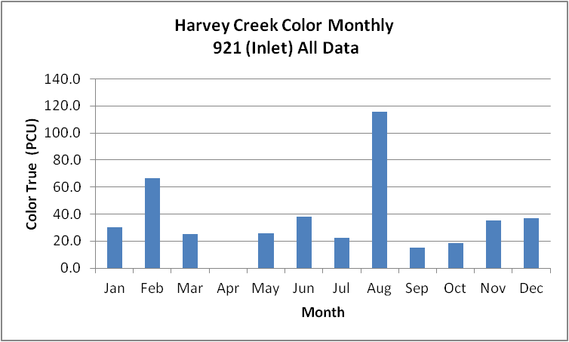
Figure B.4J.6. Harvey Creek WBID 921 Monthly Average True Color 1992 - 2013

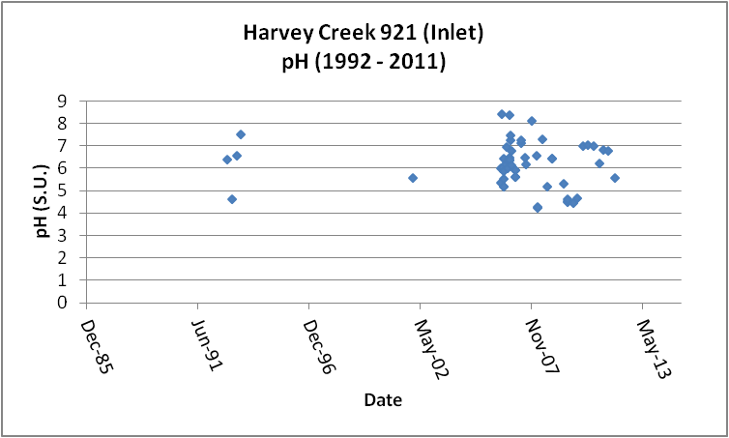
Figure B.4J.7. Harvey Creek WBID 921 Daily pH 1992- 2011

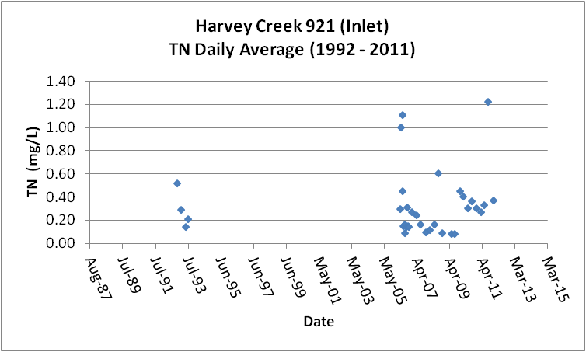
Figure B.4J.8. Harvey Creek WBID 921 Daily Average TN1992- 2011

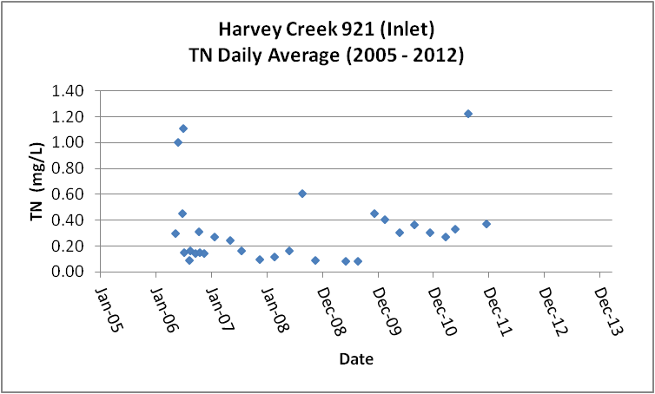
Figure B.4J.9. Harvey Creek WBID 921 Daily Average TN 2005- 2012

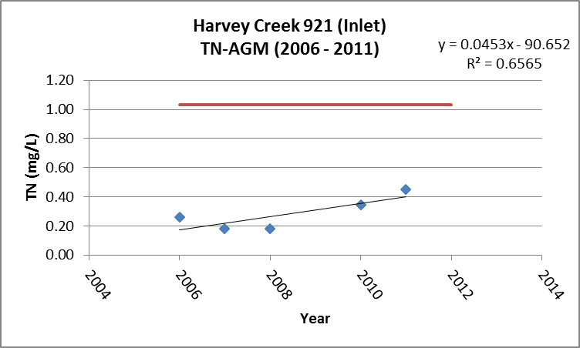
Figure B.4J.10. Harvey Creek WBID 921 TN Annual Geomean 2006 - 2013

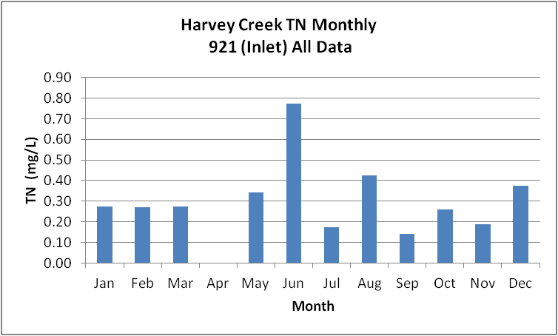
Figure B.4J.11. Harvey Creek WBID 921 Monthly Average TN 1992- 2011

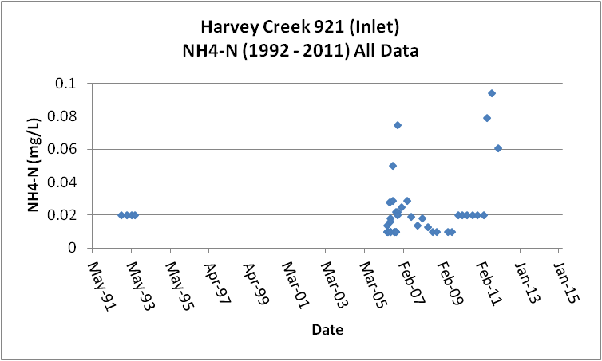
Figure B.4J.12. Harvey Creek WBID 921 Daily Average Ammonia-N 1992- 2011

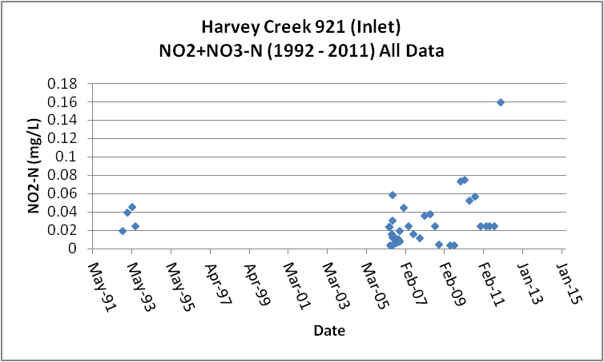
Figure B.4J.13. Harvey Creek WBID 921 Daily Average Nitrate/Nitrite-N1992- 2011

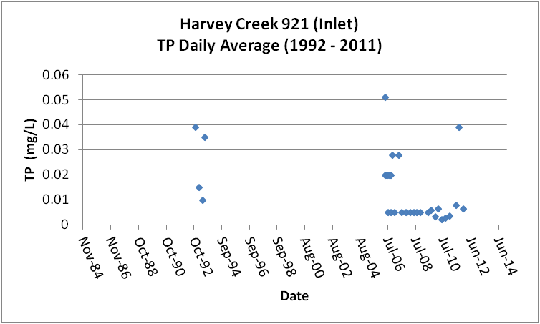
Figure B.4J.14. Harvey Creek WBID 921 Daily Average TP 1992 - 2011

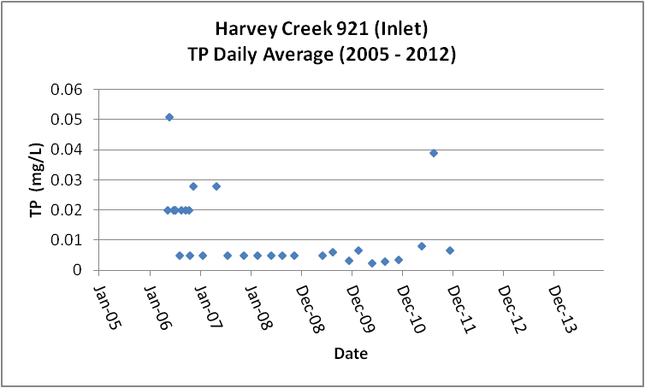
Figure B.4J.15. Harvey Creek WBID 921 Daily Average TP 2005 - 2012

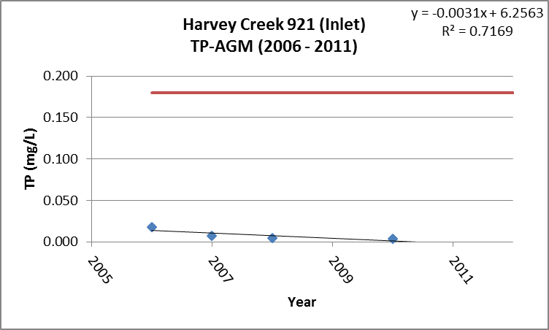
Figure B.4J.16. Harvey Creek WBID 921 Annual Geomean TP 2006 - 2011

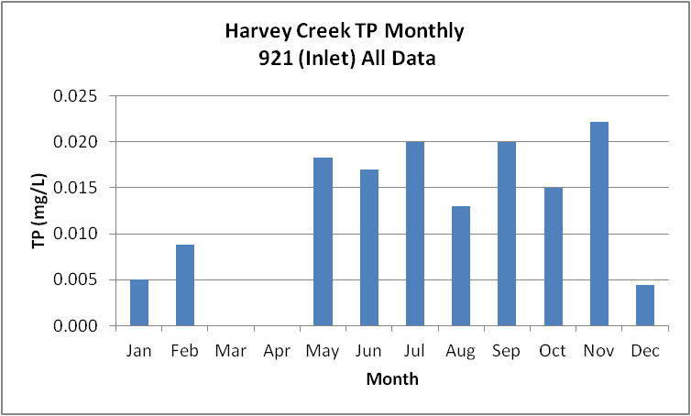
Figure B.4J.17. Harvey Creek WBID 921 Monthly Average TP 1992 - 2011

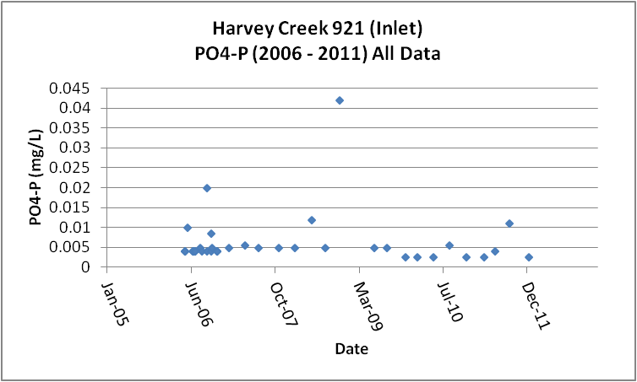
Figure B.4J.18. Harvey Creek WBID 921 Daily Average Orthophosphate-P 2006 - 2011

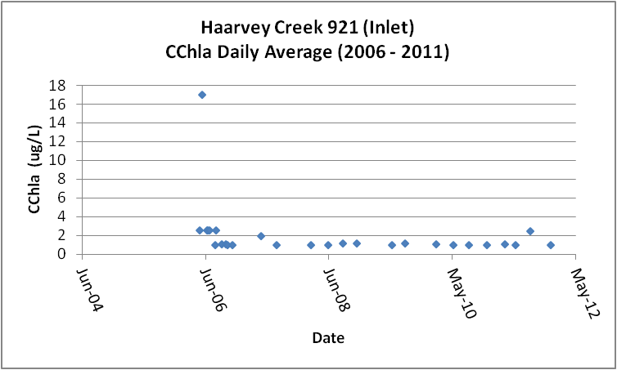
Figure B.4J.19. Harvey Creek WBID 921 Daily Average CChla 2006 - 2011

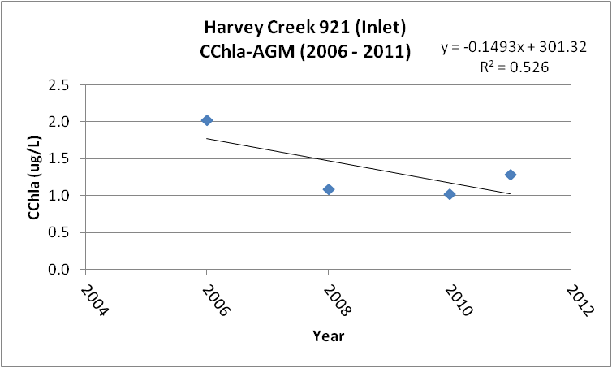
Figure B.4J.20. Harvey Creek WBID 921 Annual Geomean CChla 2006 - 2013

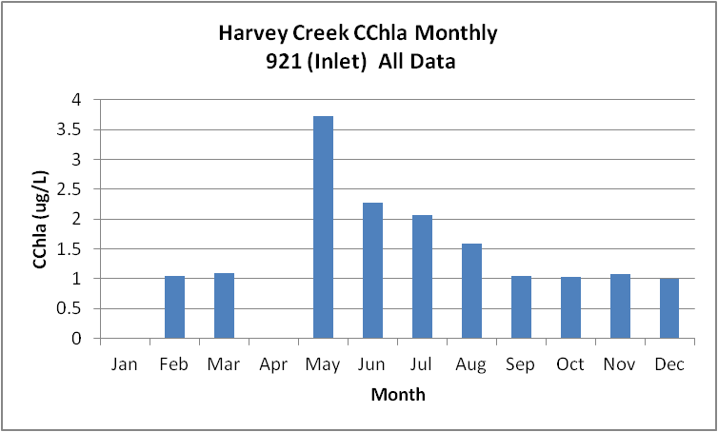
Figure B.4J.21. Harvey Creek WBID 921 Monthly Average CChla 2006 - 2011

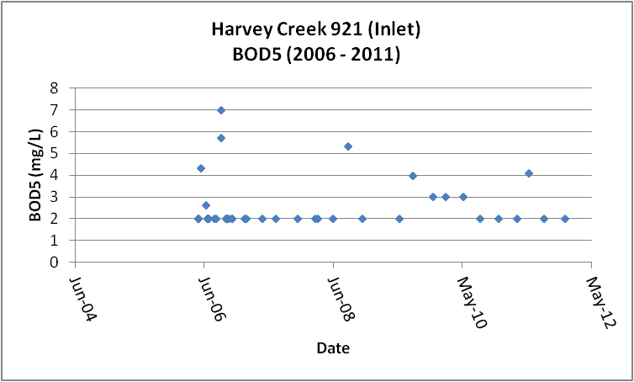
Figure B.4J.22. Harvey Creek WBID 921 Daily Average BOD5 2006 - 2013

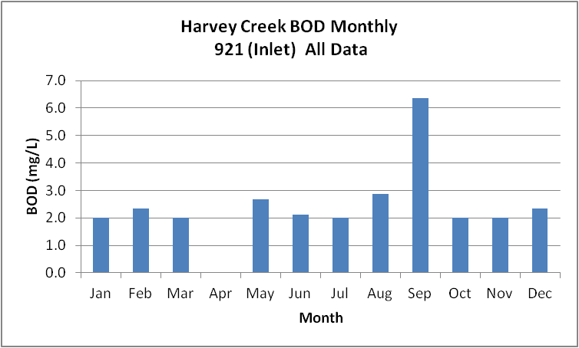
Figure B.4J.23. Harvey Creek WBID 921 Monthly Average BOD5 2006 - 2013

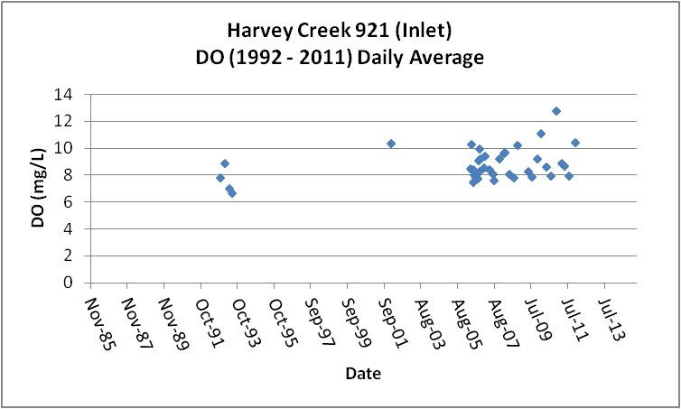
Figure B.4J.24. Harvey Creek WBID 921 Daily Average DO 1992 - 2011

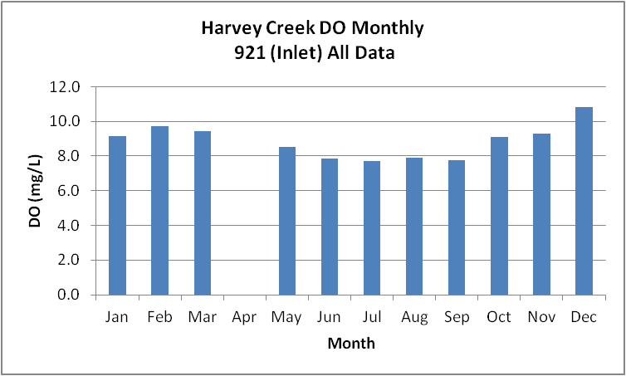
Figure B.4J.25. Harvey Creek WBID 921 Monthly Average DO 1992 - 2011

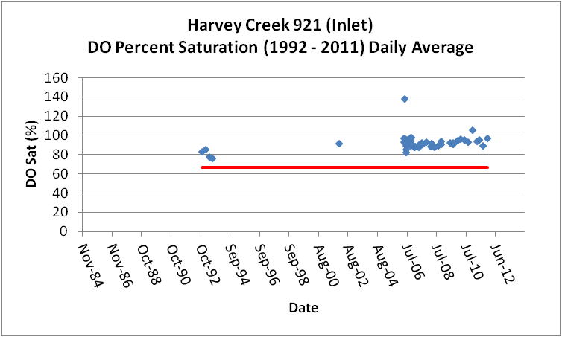
Figure B.4J.26. Harvey Creek WBID 921 Daily Average DO Percent Saturation 1992 - 2011

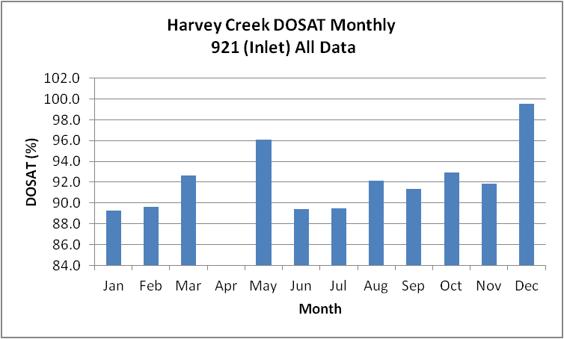
Figure B.4J.27. Harvey Creek WBID 921 Monthly Average DO Percent Saturation 1992 - 2011

Table B.4J.1. Harvey Creek WBID 921 IWR Stations
WBID | Station Number | Station Name | Begin Date | End Date
921 | 21FLPNS 921-C | Harvey Creek 921-C | 2006 | 2006
921 | 21FLNWFD302449084330501 | Harvey Creek @ Hwy. 20 | 1992 | 1993
921 | 21FLBRA 921-A | 921 - Harvey Creek - at Joe Thomas Rd | 2006 | 2006
921 | 21FLLEONLCOC3041384551 | Harvey Creek @ 20 | 2010 | 2010
921 | 21FLPNS 22020318 | Harvey crk- Hwy 20 | 1998 | 1999
921 | 21FLLEONLCOC3041384551 | Harvey Creek @ 20 | 2010 | 2010
921 | 21FLWQA 302449908433059 | Harvey Creek at SR 20 | 2002 | 2002
921 | 21FLBRA 921-C | 921 - Harvey Creek - at SR 20 | 2006 | 2006
921 | 21FLBRA 921-B | 921 - Harvey Creek - at Joe Thomas Rd II | 2006 | 2006

Table B.4J.2. Harvey Creek WBID 921 Long-Term Geomean Alkalinity and Color
WBID | Constituent | POR | Geomean
954 | Alkalinity (mg/L) | 1992 - 2011 | 3.9
954 | Color-True (PCU) | 1992 - 2011 | 28.7

Table B.4J.3. Harvey Creek WBID 921 DO Percent Saturation vs. 67% Criterion
Year | Category | Result
1989 - 2012 | Count | 55
- | Number P | 55
- | Number F | 0
- | Percent F | 0.0
- | - | -
2005 - 2012 | Count | 50
- | Number P | 50
- | Number F | 0
- | Percent F | 0.0

Table B.4J.4. Harvey Creek WBID 921 Annual Geomean TN, TP, TN/TP Ratio, and CChla
Year | TN | TP | TN/TP | CChla
- | AGM | AGM | Ratio | AGM
2006 | 0.26 | 0.017 | 14.8 | 2.0
2007 | 0.18 | 0.008 | 23.5 | -
2008 | 0.18 | 0.005 | 36.1 | 1.1
2009 | - | - | - | -
2010 | 0.34 | 0.003 | 98.4 | 1.0
2011 | 0.45 | - | - | 1.3

Table B.4J.5. Harvey Creek WBID 921 Water Quality Data Summary All Data
Constituent | Units | POR | Count | Min | Max | Median | Mean | Geomean
Temperature | C | 1989 - 2012 | 55 | 7.3 | 31.0 | 19.4 | 18.5 | 17.8
Alkalinity | mg/L | 2006 - 2012 | 43 | 1.0 | 22.0 | 4.2 | 4.7 | 3.9
pH | S.U. | 1989 - 2012 | 55 | 4.3 | 8.4 | 6.3 | N A | NA
Color | PCU | 2006 - 2012 | 43 | 10.0 | 400.0 | 25.0 | 43.4 | 28.7
TN | mg/L | 1989 - 2012 | 43 | 0.09 | 1.33 | 0.25 | 0.35 | 0.26
NH4-N | mg/L | 1989 - 2012 | 43 | 0.010 | 0.09 | 0.02 | 0.02 | 0.02
NO23 | mg/L | 2000 - 2012 | 43 | 0.004 | 0.16 | 0.02 | 0.03 | 0.02
OrgN | mg/L | - | - | - | - | - | - | -
TP | mg/L | 1989 - 2012 | 42 | 0.002 | 0.051 | 0.020 | 0.016 | 0.012
PO4-P | mg/L | 1989 - 2012 | 39 | 0.003 | 0.042 | 0.004 | 0.006 | 0.005
CChla | ug/L | 1989 - 2012 | 36 | 1.0 | 17.0 | 1.1 | 2.0 | 1.5
BOD5 | mg/L | 2006 - 2012 | 42 | 2.0 | 7.0 | 2.0 | 2.5 | 2.4
DO | mg/L | 1989 - 2012 | 55 | 6.7 | 12.8 | 8.5 | 8.7 | 8.7
%DOSat | % | 1989 - 2012 | 55 | 76.1 | 138.4 | 91.8 | 92.4 | 92.1

Table B.4J.6. Harvey Creek WBID 921 Water Quality Data Summary Verified Period (2005 – 2012)
Constituent | Units | Verified Period | Count | Min | Max | Median | Mean | Geomean
Temperature | C | 2005 - 2012 | 50 | 7.3 | 31.0 | 19.3 | 18.7 | 17.9
Alkalinity | mg/L | 2005 - 2012 | 39 | 1.0 | 22.0 | 4.6 | 4.9 | 4.1
pH | S.U. | 2005 - 2012 | 50 | 4.3 | 8.4 | 6.2 | NA | NA
Color | PCU | 2005 - 2012 | 39 | 10.0 | 400.0 | 25.0 | 41.2 | 27.0
TN | mg/L | 2005 - 2012 | 39 | 0.09 | 1.33 | 0.25 | 0.35 | 0.25
NH4-N | mg/L | 2005 - 2012 | 39 | 0.010 | 0.09 | 0.02 | 0.02 | 0.02
NO23 | mg/L | 2005 - 2012 | 39 | 0.004 | 0.16 | 0.02 | 0.03 | 0.02
OrgN | mg/L | - | - | - | - | - | - | -
TP | mg/L | 2005 - 2012 | 38 | 0.002 | 0.051 | 0.020 | 0.015 | 0.011
PO4-P | mg/L | 2005 - 2012 | 39 | 0.003 | 0.042 | 0.004 | 0.006 | 0.005
CChla | ug/L | 2005 - 2012 | 36 | 1.0 | 17.0 | 1.1 | 2.0 | 1.5
BOD5 | mg/L | 2005 - 2012 | 42 | 2.0 | 7.0 | 2.0 | 2.5 | 2.4
DO | mg/L | 2005 - 2012 | 51 | 7.2 | 12.8 | 8.5 | 8.8 | 8.8
%DOSat | % | 2005 - 2012 | 50 | 82.6 | 138.4 | 92.5 | 93.3 | 93.1

B.4K. Polk Creek WBID 896 Drains to Lake Talquin
This WBID is not impaired for DO or nutrients.
Table B.4K.1, lists the 6 stations that have been sampled in Polk Creek WBID 896. Figure B.4K.1 depicts the station locations.
Tables B.4K.5 and B.4K.6 and Figures B.4K.3 and B.4K.4, provide the results for alkalinity. These data show that Polk Creek has a POR GM alkalinity of 4.6 mg/L. All of the data is from the period 2006 – 2011. The limited data indicate higher alkalinity in the summer (up to 16 mg/L). There is insufficient data to determine accurate long-term or seasonal patterns.
Tables B.4K.5 and B.4K.6 and Figures B.4K.5 and B.4K.6, provide the results for true color. These data show that Polk Creek has a POR GM color of 87.2 PCU. All of the data is from the period 2006 – 2011. There is insufficient data to determine accurate long-term or seasonal patterns.
Tables B.4K.5 and B.4K.6 and Figures B.4K.8 through B.4K.11, provide the results for TN. These data show that Polk Creek has a POR GM TN of 0.46 mg/L. All of the data is from the period 2006 – 2011. There were four years during the period 2006 - 2011 with sufficient data to calculate AGM concentrations (Figure B.4K.9). These results show that the TN concentrations have not changed significantly over time and remain below the 1.03 mg/L TN AGM threshold concentration. The limited data indicate higher concentrations of TN during May and June (~0.65 mg/L) with concentrations less than 0.5 mg/L for much of the remaining months. There is insufficient data to determine accurate long-term or seasonal patterns.
Tables B.4K.5 and B.4K.6 and Figure B.4K.12 provide the results for NH4-N. These data show that Polk Creek has a POR GM NH4-N of 0.02 mg/L. All of the data is from the period 2006 – 2011. There is insufficient data to determine accurate long-term or seasonal patterns.
Tables B.4K.5 and B.4K.6 and Figure B.4K.13 provide the results for NO23-N. These data show that Polk Creek has a POR GM NO23-N of 0.02 mg/L. All of the data is from the period 2006 – 2011. There is insufficient data to determine accurate long-term or seasonal patterns
Tables B.4K.5 and B.4K.6 and Figures B.4K.14 through B.4K.17, provide the results for TP. These data show that Polk Creek has a POR GM TP of 0.033 mg/L. All of the data is from the period 2006 – 2011. There were four years during the period 2006 - 2011 with sufficient data to calculate AGM concentrations. These results show that the TP concentrations maybe increasing over time (Figure B14), but remain below the new 0.18 mg/L AGM threshold concentration. Similar to TN, the highest concentrations of TP occur during May and June. There is insufficient data to determine accurate long-term or seasonal patterns.
Tables B.4K.5 and B.4K.6 and Figure B.4K.18 provide the results for PO4-P. These data show that Polk Creek has a POR GM PO4-P of 0.023 mg/L. All of the data is from the period 2006 – 2011. The PO4-P concentration appears elevated relative to the TP concentration. There is insufficient data to determine accurate long-term or seasonal patterns.
Tables B.4K.5 and B.4K.6 and Figures B.4K.19 through B.4K.21, provide the results for CChla. These data show that Polk Creek has a POR GM CChla of 1.6 ug/L. All of the data is from the period 2006 – 2011. There were three years between 2006 and 2011 with sufficient data to calculate AGM concentrations. These AGM concentrations are significantly less than the new threshold AGM concentration for CChla (Figure B.4K.18). The data set has a large number of less than detection results. There is insufficient data to determine accurate long-term or seasonal patterns.
Tables B.4K.5 and B.4K.6 and Figures B.4K.22 and B.4K.23, provide the results for BOD5. These data show that Polk Creek has a POR GM BOD5 of 2.3 mg/L. All of the results are from the period 2006 - 2011. There is insufficient data to determine accurate long-term or seasonal patterns.
Tables B.4K.5 and B.4K.6 and Figures B.4K.24 and B.4K.25, provide the results for DO. These data show that Polk Creek has a POR GM DO of 8.7 mg/L. The data indicate that the recent (2005 – 2013) DO GM of 8.6 mg/L is equivalent to the POR concentration. The monthly average DO never drops below 6.0 mg/L (Figure B.4K.23). There is insufficient data to determine accurate long-term or seasonal patterns.

Tables B.4K.5 and B.4K.6 and Figures B.4K.26 and B.4K.27, provide the results for percent DO saturation. These data show that Polk Creek has a POR GM DOSAT of 96.0 percent. The data indicate that the recent (2005 – 2013) DOSAT GM is the same as the GM for the POR. The data presented in Figure B.4K.24 do not indicate an issue with the new DO percent saturation criterion. There is insufficient data to determine accurate long-term or seasonal patterns.

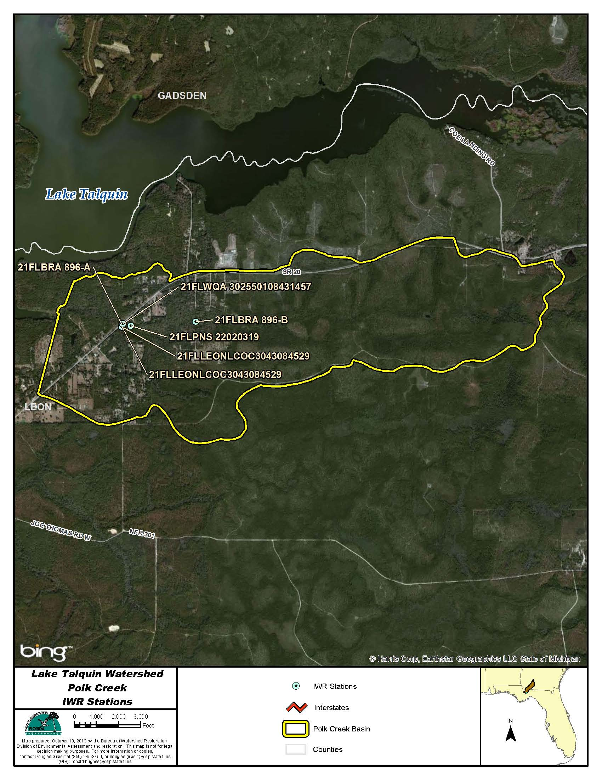
Figure B.4K.1. Polk Creek WBID 896 IWR Stations

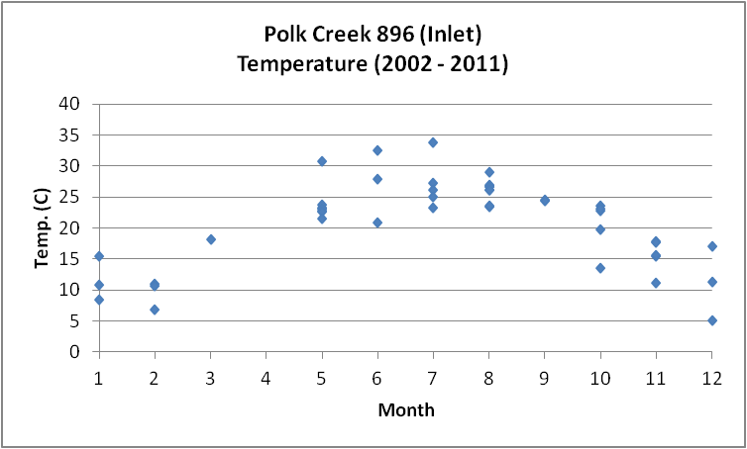
Figure B.4K.2. Polk Creek WBID 896 Monthly Temperature 2002 - 2011

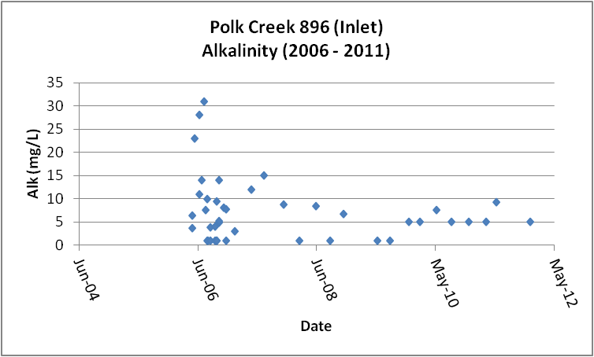
Figure B.4K.3. Polk Creek WBID 896 Daily Average Alkalinity 2006 - 2011

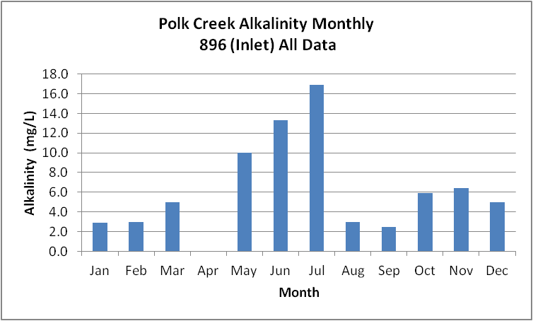
Figure B.4K.4. Polk Creek WBID 896 Monthly Average Alkalinity 2006 - 2011

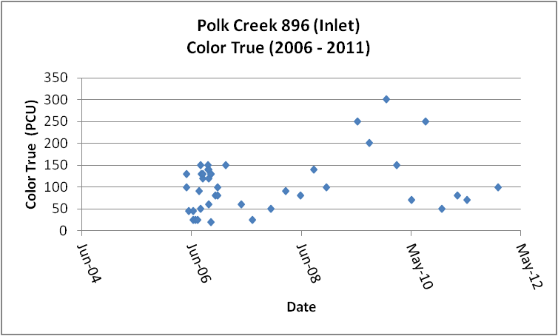
Figure B.4K.5. Polk Creek WBID 896 Daily Average True Color 2006- 2011

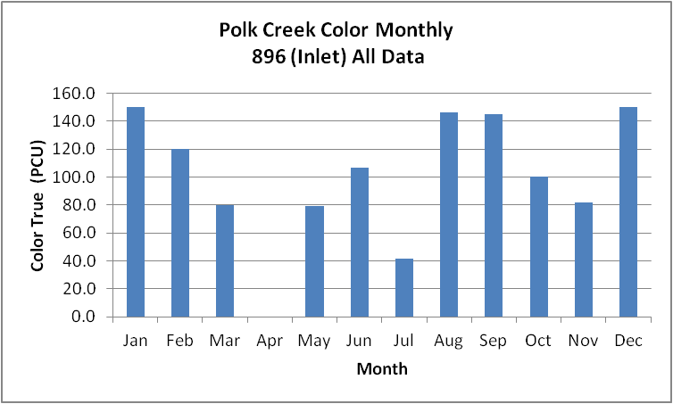
Figure B.4K.6. Polk Creek WBID 896 Monthly Average True Color 2006- 2011

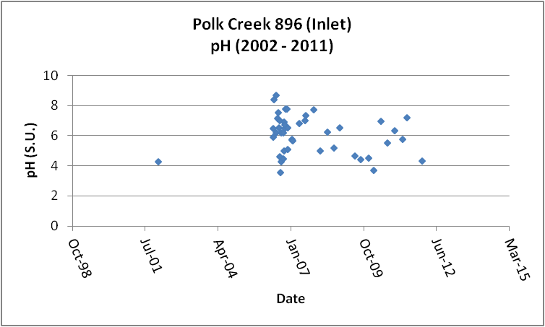
Figure B.4K.7. Polk Creek WBID 896 Daily pH 2002- 2011

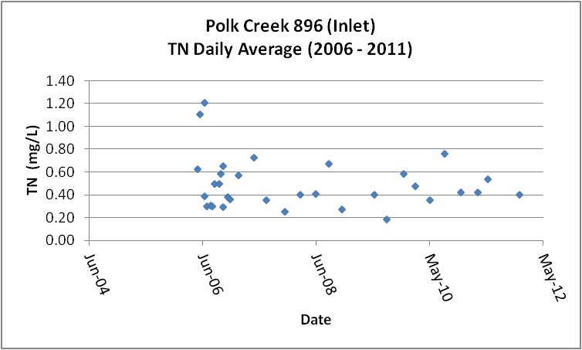
Figure B.4K.8. Polk Creek WBID 896 Daily Average TN2006 - 2011

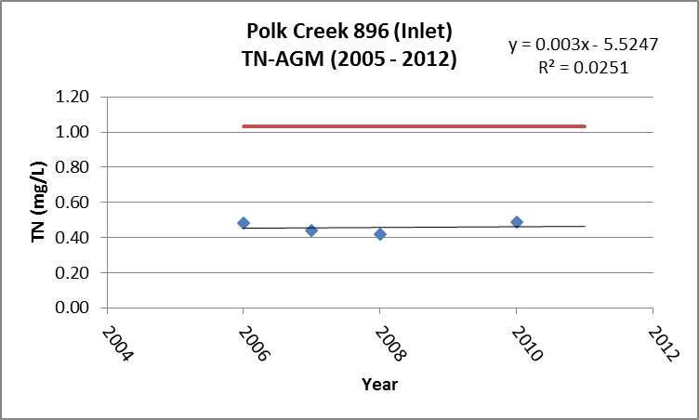
Figure B.4K.9. Polk Creek WBID 896 TN Annual Geomean 2005 - 2011

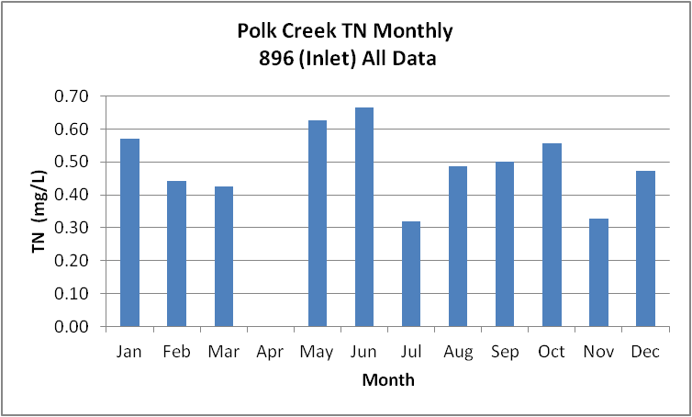
Figure B.4K.10. Polk Creek WBID 896 Monthly Average TN 2005 - 2011

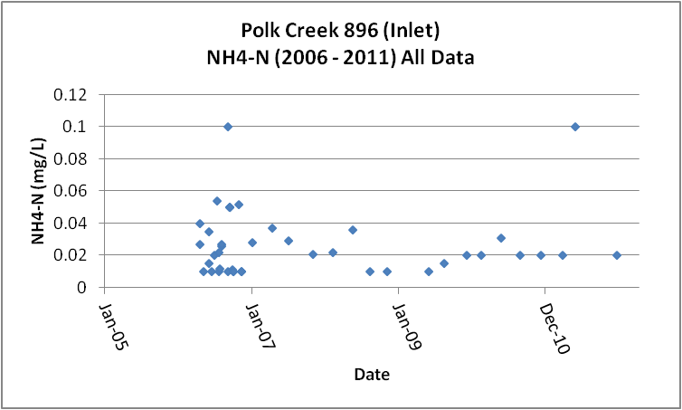
Figure B.4K.11. Polk Creek WBID 896 Daily Average Ammonia-N 2006 - 2011

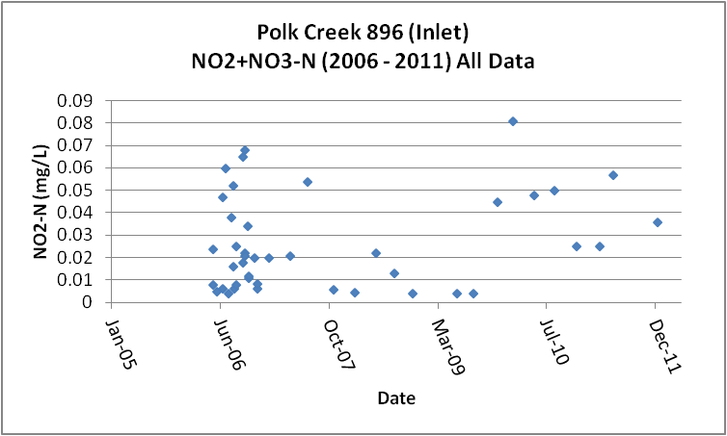
Figure B.4K.12. Polk Creek WBID 896 Daily Average Nitrate/Nitrite-N 2006 - 2011

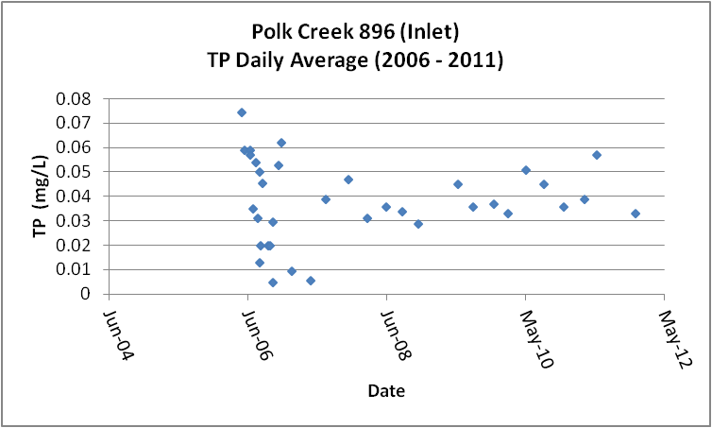
Figure B.4K.13. Polk Creek WBID 896 Daily Average TP 2006 - 2011

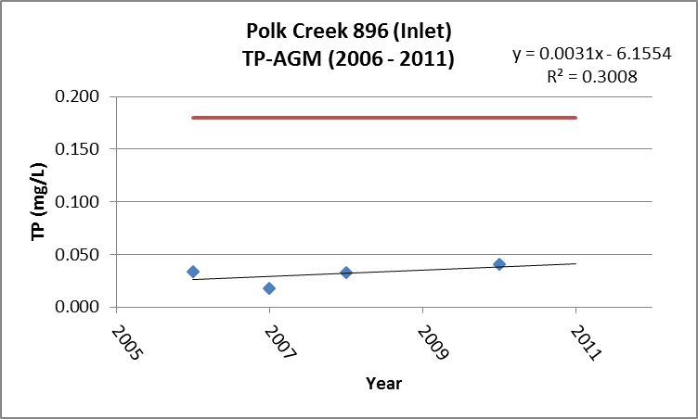
Figure B.4K.14. Polk Creek WBID 896 Annual Geomean TP 2006 - 2011

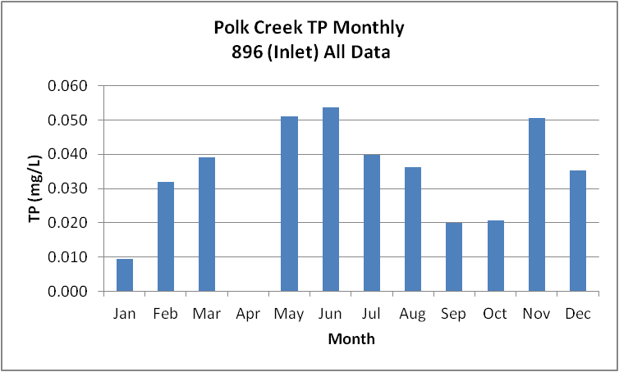
Figure B.4K.15. Polk Creek WBID 896 Monthly Average TP 2006 - 2011

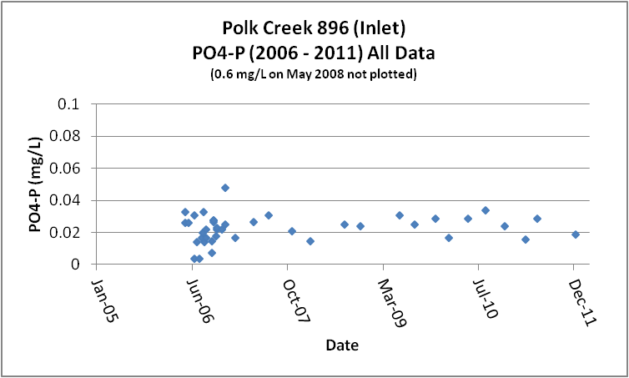
Figure B.4K.16. Polk Creek WBID 896 Daily Average Orthophosphate-P 2006 - 2011

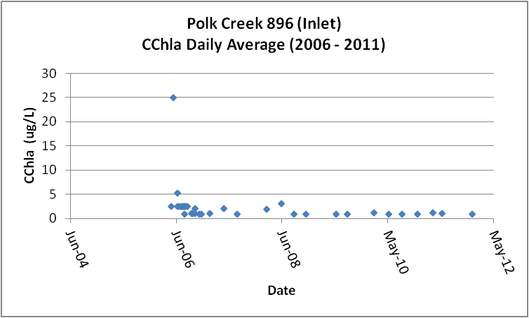
Figure B.4K.17. Polk Creek WBID 896 Daily Average CChla 2005 - 2011

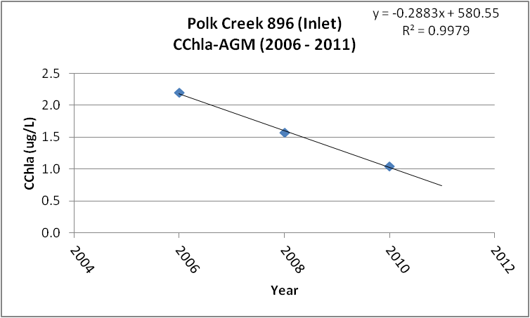
Figure B.4K.18. Polk Creek WBID 896 Annual Geomean CChla 2006 - 2011

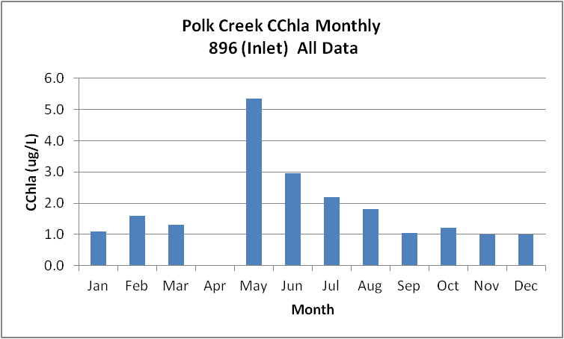
Figure B.4K.19. Polk Creek WBID 896 Monthly Average CChla 2006 - 2011

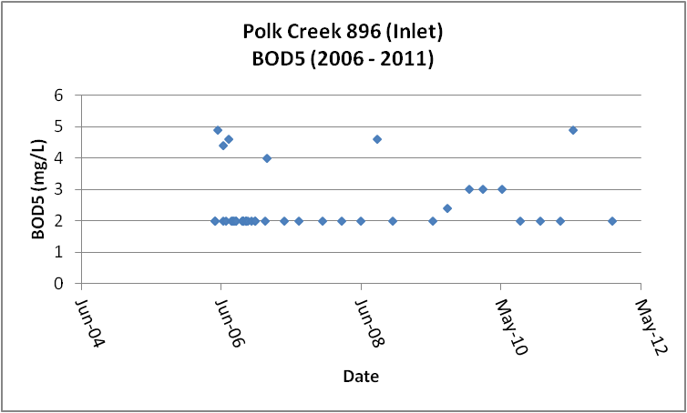
Figure B.4K.20. Polk Creek WBID 896 Daily Average BOD5 2006 - 2011

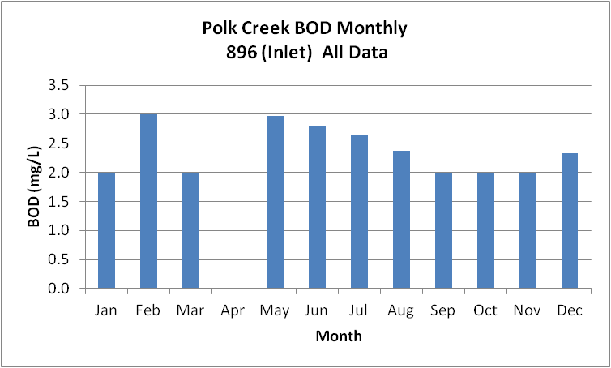
Figure B.4K.21. Polk Creek WBID 896 Monthly Average BOD5 2006 - 2011

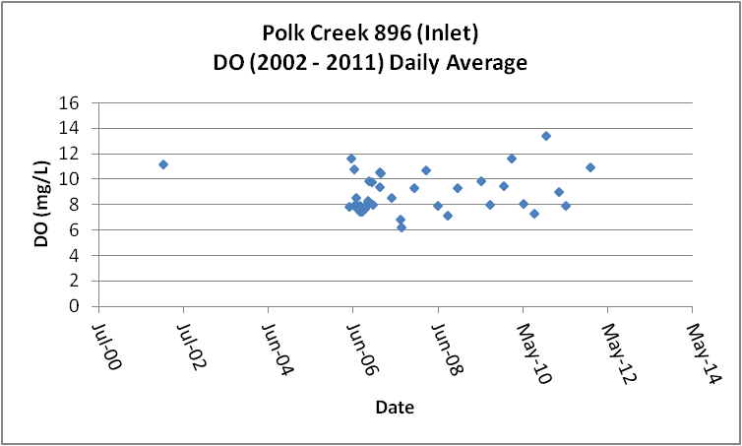
Figure B.4K.22. Polk Creek WBID 896 Daily Average DO 2002 - 2011

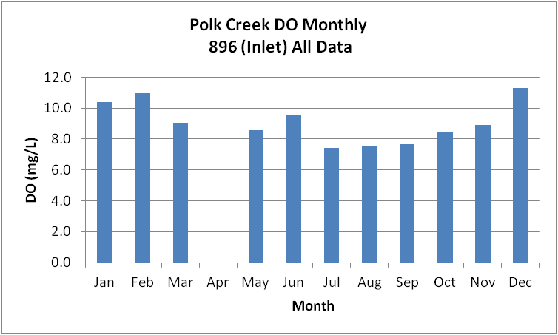
Figure B.4K.23. Polk Creek WBID 896 Monthly Average DO 2002 - 2011

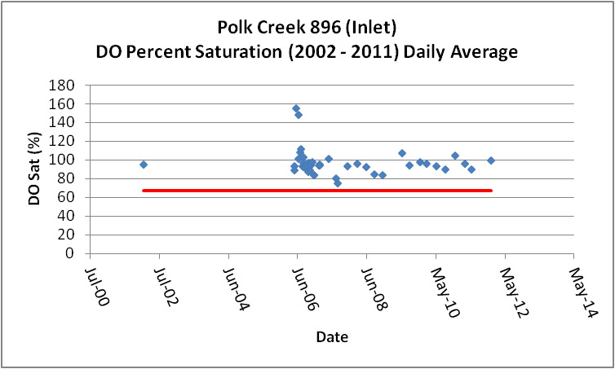
Figure B.4K.24. Polk Creek WBID 896 Daily Average DO Percent Saturation 2002 - 2011

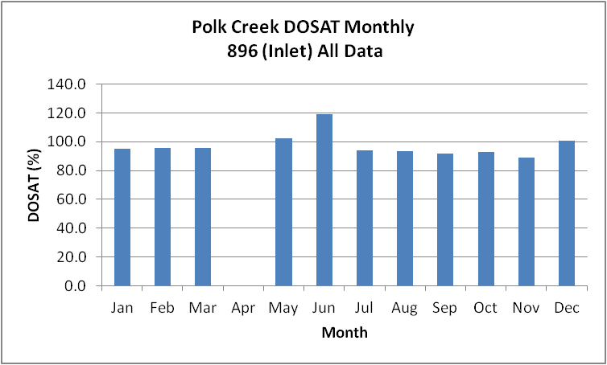
Figure B.4K.25. Polk Creek WBID 896 Monthly Average DO Percent Saturation 2002 - 2011

Table B.4K.1. Polk Creek WBID 896 IWR Stations
WBID | Station Number | Station Name | Begin Date | End Date
896 | 21FLPNS 22020319 | Polk Creek-below hywy 20 | 1998 | 1998
896 | 21FLBRA 896-A | 896 - Polk Creek - at highway 20 | 2006 | 2006
896 | 21FLLEONLCOC3043084529 | Polk Creek @ 20 | 2010 | 2010
896 | 21FLLEONLCOC3043084529 | Polk Creek @ 20 | 2010 | 2010
896 | 21FLBRA 896-B | 896 - Polk Creek - at Sir Richard Rd. | 2006 | 2006
896 | 21FLWQA 302550108431457 | Polk Creek at SR 20 | 2002 | 2002

Table B.4K.2. Polk Creek WBID 896 Long-Term Geomean Alkalinity and Color
WBID | Constituent | POR | Geomean
896 | Alkalinity (mg/L) | 2006 - 2011 | 4.6
896 | Color-True (PCU) | 2006 - 2011 | 87.2

Table B.4K.3. Polk Creek WBID 896 DO Percent Saturation vs. 67% Criterion
Year | Category | Result
2002 - 2011 | Count | 45
- | Number P | 45
- | Number F | 0
- | Percent F | 0.0
- | - | -
2005 - 2012 | Count | 44
- | Number P | 44
- | Number F | 0
- | Percent F | 0.0

Table B.4K.4. Polk Creek WBID 896 Annual Geomean TN, TP, TN/TP Ratio, and CChla
Year | TN | TP | TN/TP | CChla
- | AGM | AGM | Ratio | AGM
2006 | 0.48 | 0.034 | 14.2 | 2.2
2007 | 0.44 | 0.018 | 24.7 | -
2008 | 0.42 | 0.032 | 12.9 | 1.6
2009 | - | - | - | -
2010 | 0.49 | 0.041 | 12.0 | 1.0

Table B.4K.5. Polk Creek WBID 896 Water Quality Data Summary All Data
Constituent | Units | POR | Count | Min | Max | Median | Mean | Geomean
Temperature | C | 2002 - 2011 | 45 | 5.0 | 33.8 | 23.0 | 20.8 | 19.3
Alkalinity | mg/L | 2006 - 2011 | 42 | 1.0 | 31.0 | 5.0 | 7.2 | 4.6
pH | S.U. | 2002 - 2011 | 45 | 3.6 | 8.7 | 6.2 | NA | NA
Color | PCU | 2006 - 2011 | 42 | 20.0 | 300.0 | 100.0 | 105.5 | 87.2
TN | mg/L | 2006 - 2011 | 39 | 0.18 | 1.21 | 0.43 | 0.50 | 0.46
NH4-N | mg/L | 2006 - 2011 | 42 | 0.010 | 0.10 | 0.02 | 0.03 | 0.02
NO23 | mg/L | 2006 - 2011 | 42 | 0.004 | 0.08 | 0.02 | 0.03 | 0.02
OrgN | mg/L | - | - | - | - | - | - | -
TP | mg/L | 2006 - 2011 | 42 | 0.005 | 0.099 | 0.036 | 0.038 | 0.033
PO4-P | mg/L | 2006 - 2011 | 42 | 0.004 | 0.600 | 0.024 | 0.037 | 0.023
CChla | ug/L | 2006 - 2011 | 40 | 1.0 | 25.0 | 1.1 | 2.3 | 1.6
BOD5 | mg/L | 2006 - 2011 | 44 | 2.0 | 4.9 | 2.0 | 2.4 | 2.3
DO | mg/L | 2002 - 2011 | 45 | 6.3 | 13.4 | 8.1 | 8.8 | 8.7
%DOSat | % | 2002 - 2011 | 45 | 75.5 | 155.8 | 94.6 | 96.8 | 96.0

Table B.4K.6. Polk Creek WBID 896 Water Quality Data Summary Verified Period (2005 – 2012)
Constituent | Units | Verified Period | Count | Min | Max | Median | Mean | Geomean
Temperature | C | 2005 - 2011 | 44 | 5.0 | 33.8 | 23.0 | 21.1 | 19.7
Alkalinity | mg/L | 2005 - 2011 | 42 | 1.0 | 31.0 | 5.0 | 7.2 | 4.6
pH | S.U. | 2005 - 2011 | 44 | 3.6 | 8.7 | 6.2 | NA | NA
Color | PCU | 2005 - 2011 | 42 | 20.0 | 300.0 | 100.0 | 105.5 | 87.2
TN | mg/L | 2005 - 2011 | 39 | 0.18 | 1.21 | 0.43 | 0.50 | 0.46
NH4-N | mg/L | 2005 - 2011 | 42 | 0.010 | 0.10 | 0.02 | 0.03 | 0.02
NO23 | mg/L | 2005 - 2011 | 42 | 0.004 | 0.08 | 0.02 | 0.03 | 0.02
OrgN | mg/L | - | - | - | - | - | - | -
TP | mg/L | 2005 - 2011 | 42 | 0.005 | 0.099 | 0.036 | 0.038 | 0.033
PO4-P | mg/L | 2005 - 2011 | 42 | 0.004 | 0.600 | 0.024 | 0.037 | 0.023
CChla | ug/L | 2005 - 2011 | 40 | 1.0 | 25.0 | 1.1 | 2.3 | 1.6
BOD5 | mg/L | 2005 - 2011 | 44 | 2.0 | 4.9 | 2.0 | 2.4 | 2.3
DO | mg/L | 2005 - 2011 | 44 | 6.3 | 13.4 | 8.1 | 8.7 | 8.6
%DOSat | % | 2005 - 2011 | 44 | 75.5 | 155.8 | 94.5 | 96.9 | 96.0

B.4L. Upper Lake Talquin WBID 1297D
This WBID is verified impaired for nutrients due to elevated TSI (Chapter 2 of TMDL Report). Florida has newly adopted criteria for dissolved oxygen, total nitrogen, total phosphorous, and chlorophyll a (Chapter 3 of TMDL Report). The Department has not formally assessed the data for the Lake Talquin watershed under the new criteria. However, based on preliminary analysis, it is highly likely that Lake Talquin, currently listed as verified impaired for DO and nutrients will still be listed as verified impaired under the new criteria. Based on extensive analysis of data from lakes in Florida the Department has concluded that the health of lakes is best related to the area in the state in which the lake exists, the long-term color and alkalinity of the lake, and the level of nutrients and CChla present in the lake and maintaining an appropriate level of dissolved oxygen as compared to the percent saturation criterion for DO (Chapter 3 of TMDL Report). These data are best assessed as the long-term geomean (GM) for color and alkalinity and as the annual geomean for TN, TP, and CChla. As such, the presentation of data for the lake will use POR GMs for color and alkalinity and AGMs for nutrients and CChla. Lake Talquin is in the Panhandle East Nutrient Watershed Region (for streams/rivers). The numeric nutrient thresholds contained in Rule 62-302. 531, FAC, for lakes vary depending on color, alkalinity, CChla data sufficiency (for calculating AGM concentrations), and the CChla AGM concentration. The POR GM alkalinity and color for this segment of the lake is 16.8 mg/L and 62.3 PCU. This characterizes this section of the lake as high color, in which case the alkalinity does not impact the threshold concentrations for nutrients and CChla. The threshold for CChla is an AGM greater than 20 ug/L, TP AGM can range between 0.05 mg/L and 0.16 mg/L and TN AGM between 1.27 mg/L and 2.23 mg/L depending on the CChla AGM concentration (Chapter 3 of TMDL Report).

In some graphs for AGM TN, TP and CChla and daily average percent DOSAT (for lakes the DO data is from the upper two meters of the water column) lines are presented that represent the new thresholds. The Department notes that the data presented on these graphs has not been processed in accordance with all of the requirements of the new regulations in rule 62-303, F.A.C. As a result, a determination of compliance with the new criteria cannot be made from these data.
Table B.4L.1, lists the 32 stations that have been sampled in Lake Talquin Upper (WBID 1297D). Figure B.4L.1 depicts the station locations.
Tables B.4L.5 and B.4L.6 and Figures B.4L.5 and B.4L.6, provide the results for alkalinity. These data show that Lake Talquin Upper has a POR geomean (GM) alkalinity of 16.8 mg/L. The data indicate that the alkalinity for the period (2005 – 2013) is similar to the POR (GM 16.8 mg/L vs. 16.5 mg/L). The seasonal pattern indicates that the alkalinity is lowest in the first three months of the year (~ 12 mg/L), as flow into the lake and rainfall increase and gradually increases through August to just over 20 mg/L, (corresponding somewhat to changes in incoming flow) and then remaining around 18 – 19 mg/L for the rest of the year. This pattern for alkalinity is inversely related to river flow (flow highest in first three months of the year Figure B.3.12) and alkalinity at the lowest.
Tables B.4L.5 and B.4L.6 and Figures B.4L.7 and B.4L.8, provide the results for true color. These data show that Upper Lake Talquin has a POR GM color of 62.3 PCU, equivalent to the incoming color of the Ochlockonee River of 62.5 and the Little River (63.1). The data indicate that the GM color for the period (2005 – 2013) of 52.8 PCU is reduced relative to the POR color. The combined mean flow of Ochlockonee and Little Rivers for the period 1998 – 2013 of 1,021 cfs is slightly less than the flow of 1,080 cfs for the period 2005 – 2013, although the annual average rainfall was 2.3 inches greater for the earlier period (56.5 vs. 54.2 inches). The seasonal pattern indicates that the color appears more closely related to changes in incoming river flow (increasing with increased flow and decreasing with decreased flow) more so than local rainfall (Figures B.3.12 and B.2.4).
Tables B.4L.5 and B.4L.6 and Figures B.4L.10 through B.4L.13, provide the results for TN. These data show that Lake Talquin Upper has a POR GM TN of 0.62 mg/L. The data (Figure B.4L.12) indicate that the recent (2005 – 2013) TN GM of 0.68 mg/L is similar to the TN GM for the POR and less than the new default (1.27 mg/L) threshold AGM concentration for TN. The data also indicate that the overall trend appears to be for increasing AGM TN concentrations. The seasonal pattern indicates that the TN concentration generally increase slightly from January through July, then decreasing through the end of the year. This pattern for TN is not clearly related to flow or rainfall (Figures B.3.12 and B.2.4).
Tables B.4L.5 and B.4L.6 and Figures B.4L.14 and B.4L.15, provide the results for NH4-N. These data show that Lake Talquin Upper has a POR GM NH4-N of 0.055 mg/L. The data indicate that the recent (2005 – 2013) NH4-N GM of 0.033 mg/L is measurably less than the POR concentration and that the overall trend may be masked by the number of results reported as less than detection.
Tables B.4L.5 and B.4L.6 and Figures B.4L.16 and B.4L.17, provide the results for NO23-N. These data show that Lake Talquin Upper has a POR GM NO23-N of 0.063 mg/L. The data indicate that the recent (2005 – 2013) NO23-N GM of 0.038 mg/L is reduced over the POR concentration and that there does not appear to be a trend for this constituent.

Tables B.4L.5 and B.4L.6 and Figures B.4L.19 through B.4L.22, provide the results for TP. These data show that Lake Talquin Upper has a POR GM TP of 0.045 mg/L. The data (Figure B.4L.21) indicate that the recent (2005 – 2013) TP GM of 0.056 mg/L is measurably greater than the TP GM for the POR and slightly greater than the new 0.05 mg/L threshold AGM concentration for TP. The data also indicate that the overall trend is for increasing AGM TP concentrations. The seasonal pattern is similar to TN, with TP concentration generally increasing through July and then decreasing slightly through the rest of the year. This pattern for TP is not clearly related to flow or rainfall (Figures B.3.12 and B.2.4).
Tables B.4L.5 and B.4L.6 and Figures B.4L.22 and B.4L.23, provide the results for PO4-P. These data show that the Lake Talquin Upper has a POR GM PO4-P of 0.020 mg/L. The data indicate that the recent (2005 – 2013) PO4-P GM of 0.013 mg/L is about half of the POR concentration and that the overall trend may be masked by the number of results reported as less than detection.
Tables B.4L.5 and B.4L.6 and Figures B.4L.25 through B.4L.28, provide the results for CChla. These data show that Lake Talquin Upper has a POR GM CChla of 5.7 ug/L. The data (Figure B.4L.27) indicate that the recent (2005 – 2013) CChla GM of 5.2 ug/L is similar to the CChla GM for the POR and less than the new threshold AGM concentration for CChla. The data also indicate that the overall trend is for increasing AGM CChla concentrations. The seasonal pattern indicates that the CChla concentrations peak in June decrease significantly in July, than increasing through August, and slowly reducing concentrations for the remaining months of the year. The pattern in CChla may be influenced by heavy rainfall in June through August, bringing in lower CChla concentrations from the rivers, diluting the lake, and reducing the residence time of the lake (Figures B.3.12 and B.2.4).
Tables B.4L.5 and B.4L.6 and Figures B.4L.29 through B.4L.31, provide the results for BOD5. These data show that Lake Talquin Upper has a POR GM BOD5 of 1.7 mg/L. The data indicate that the recent (2005 – 2013) BOD5 GM of 1.8 mg/L is not significantly different than the POR concentration. Variable detection limits over time may be having an influence on the data. There is no apparent overall trend.
Tables B.4L.5 and B.4L.6 and Figures B.4L.32 and B.4L.33, provide the results for DO. These data show that Lake Talquin Upper has a POR GM DO of 6.1 mg/L. The data indicate that the recent (2005 – 2013) DO GM of 6.4 mg/L is similar to the POR concentration. There is no apparent overall trend in time. Seasonal data indicate that the monthly average DO reaches a minimum of 5.0 mg/L during August and is greater than this for the remaining months of the year (Figure B.4L.33).
Tables B.4L.5 and B.4L.6 and Figures B.4L.34 through B.4L.36, provide the results for percent DO saturation. These data show that Lake Talquin Upper has a POR GM DOSAT of 69.3 percent. The data indicate that the recent (2005 – 2013) DOSAT GM of 69.1 percent is similar to the GM for the POR. The data do not appear to have a long-term trend. The data presented in Figure B.4L.34 indicates that there are sufficient results below the new DO criterion to warrant further investigation. The seasonal pattern indicates that the DOSAT is lowest in August.

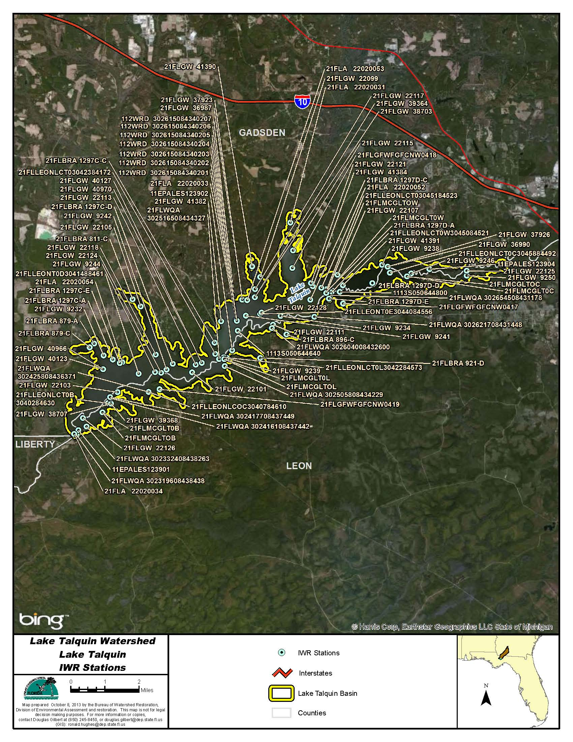
Figure B.4L.1. Lake Talquin WBIDs 1297D and 1297C IWR Stations

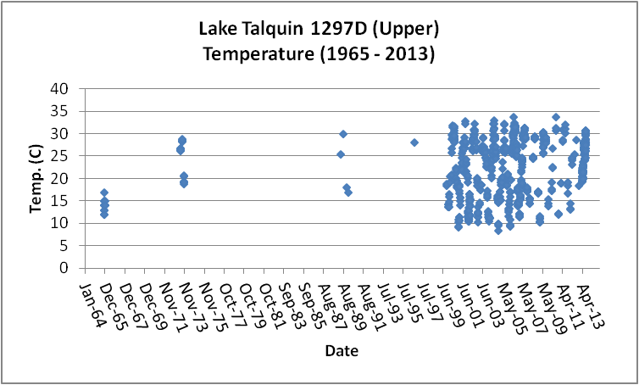
Figure B.4L.2. Lake Talquin Upper WBID 1297D Daily Temperature 1965 - 2013

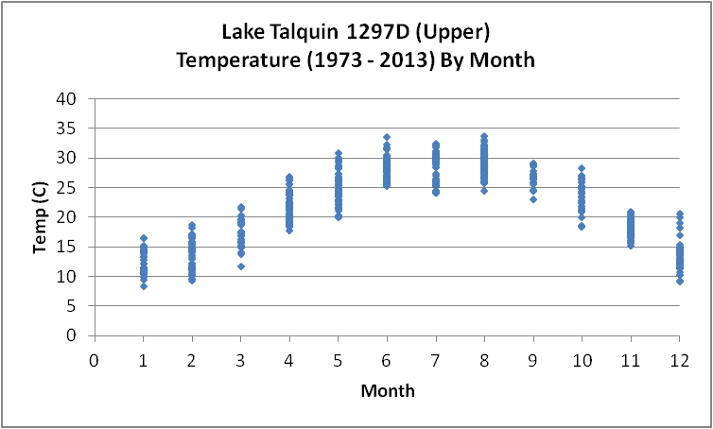
Figure B.4L.3. Lake Talquin Upper WBID 1297D Monthly Temperature 1973 - 2013

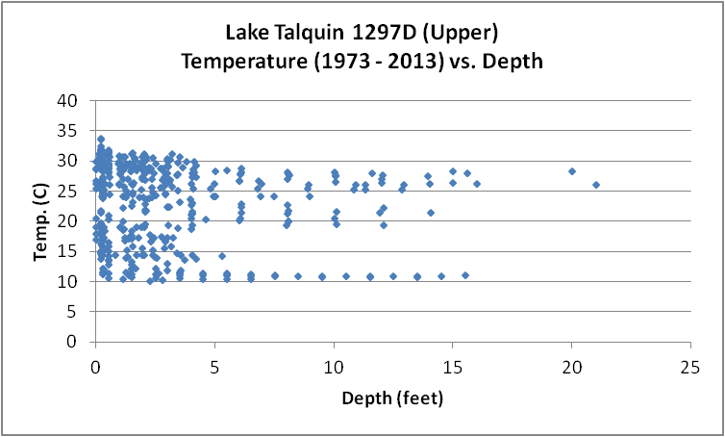
Figure B.4L.4. Lake Talquin Upper WBID 1297D Temperature vs. Depth1973 - 2013

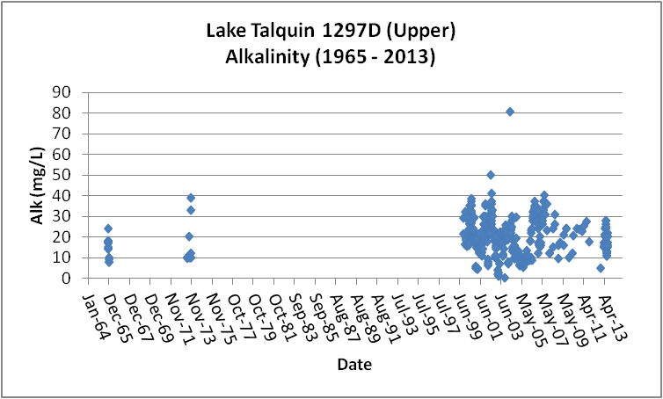
Figure B.4L.5. Lake Talquin Upper WBID 1297D Daily Average Alkalinity 1965- 2013

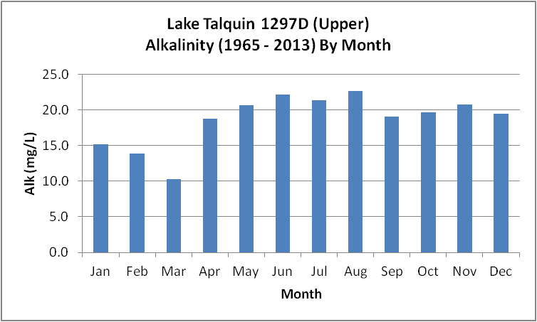
Figure B.4L.6. Lake Talquin Upper WBID 1297D Monthly Average Alkalinity 1965- 2013

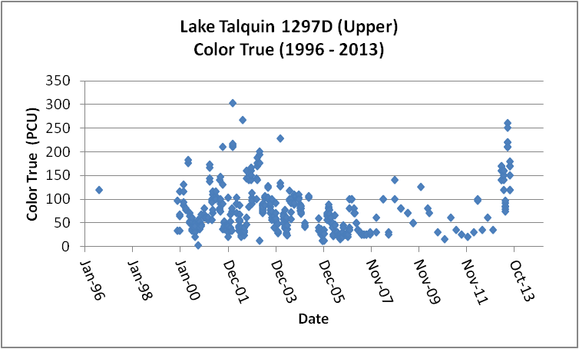
Figure B.4L.7. Lake Talquin Upper WBID 1297D Daily Average True Color 1996- 2013

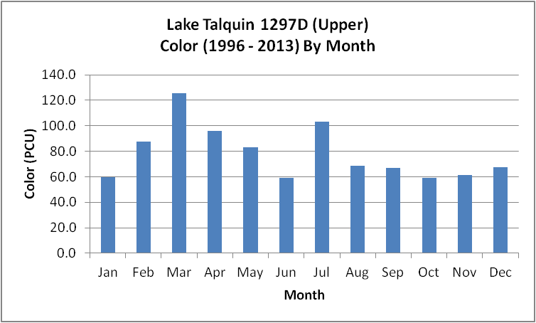
Figure B.4L.8. Lake Talquin Upper WBID 1297D Monthly Average True Color 1996- 2013

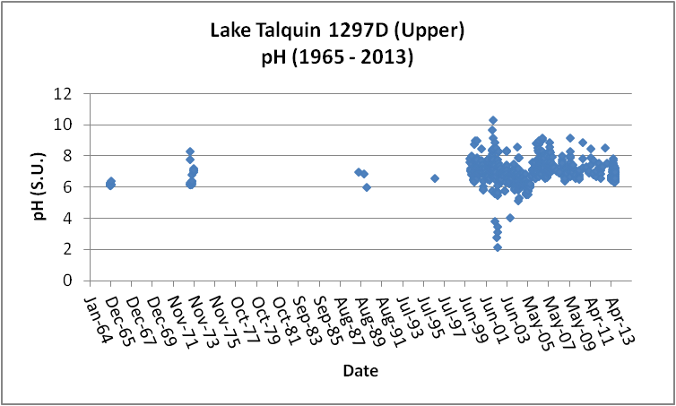
Figure B.4L.9. Lake Talquin Upper WBID 1297D Daily pH 1965- 2013

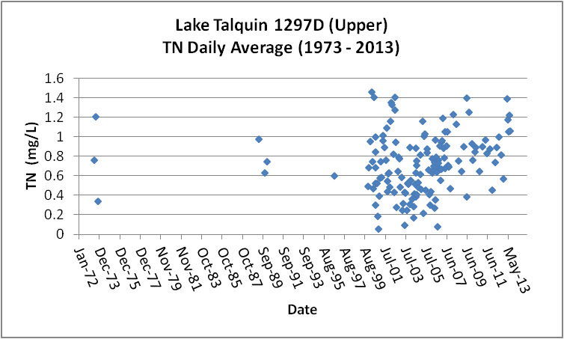
Figure B.4L.10. Lake Talquin Upper WBID 1297D Daily Average TN1973- 2013

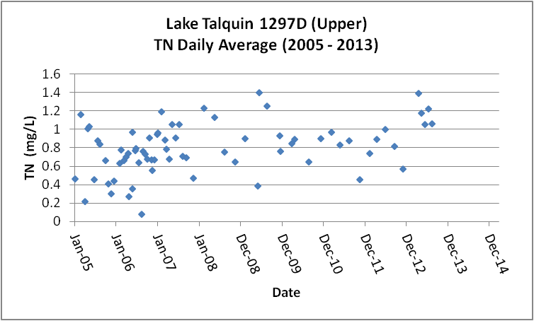
Figure B.4L.11. Lake Talquin Upper WBID 1297D Daily Average TN 2005- 2013

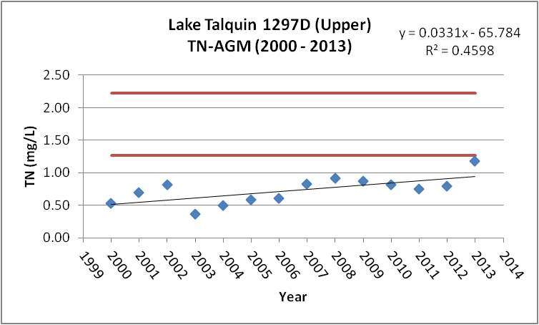
Figure B.4L.12. Lake Talquin Upper WBID 1297D TN Annual Geomean 2000- 2013

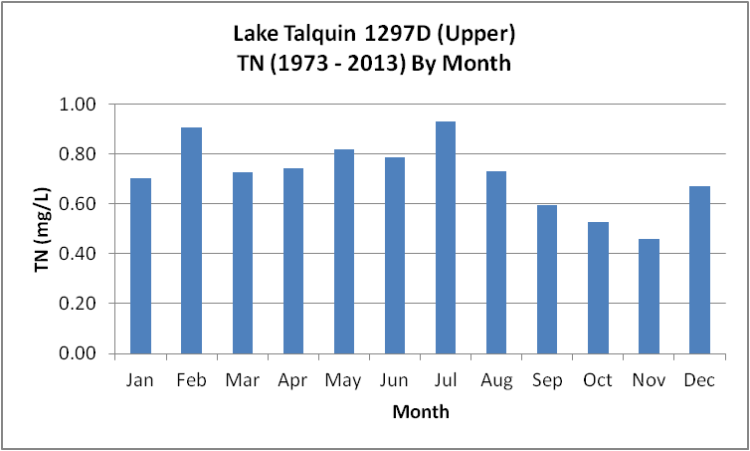
Figure B.4L.13. Lake Talquin Upper WBID 1297D Monthly Average TN 1973- 2013

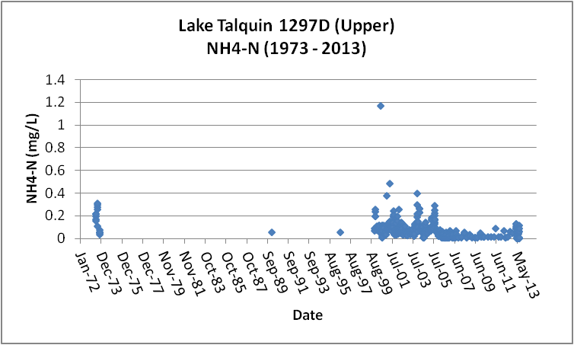
Figure B.4L.14. Lake Talquin Upper WBID 1297D Daily Average Ammonia-N 1973- 2013

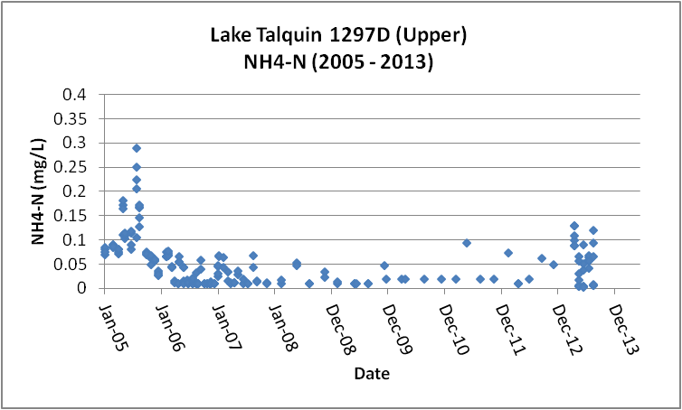
Figure B.4L.15. Lake Talquin Upper WBID 1297D Daily Average Ammonia-N 2005- 2013

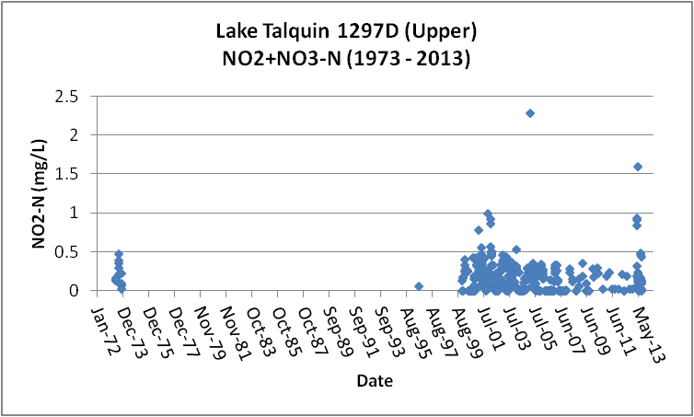
Figure B.4L.16. Lake Talquin Upper WBID 1297D Daily Average Nitrate/Nitrite-N1973- 2013

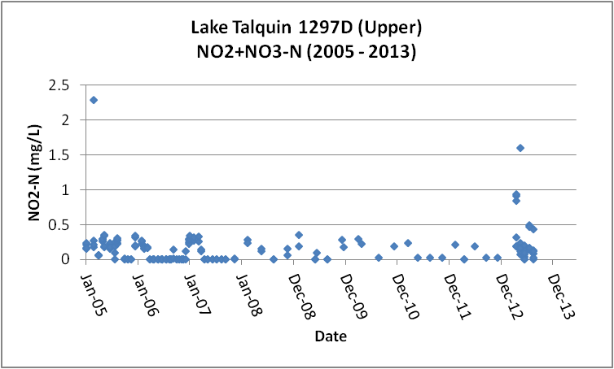
Figure B.4L.17. Lake Talquin Upper WBID 1297D Daily Average Nitrate/Nitrite-N2005- 2013

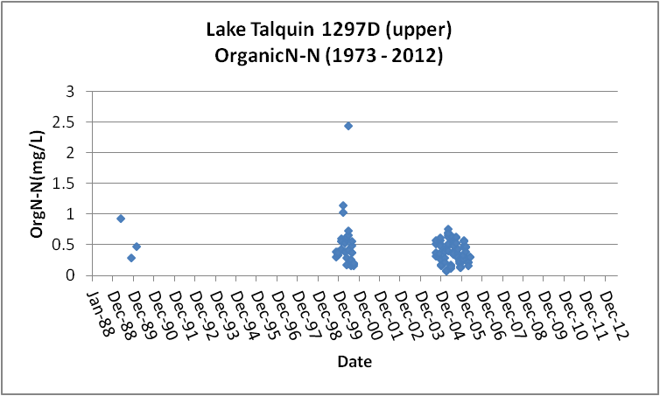
Figure B.4L.18. Lake Talquin Upper WBID 1297D Daily Average Organic-N 1973- 2012

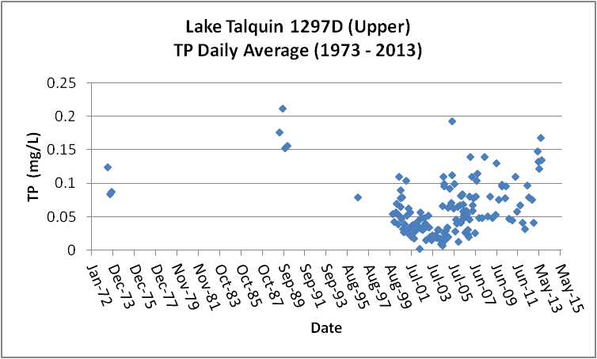
Figure B.4L.19. Lake Talquin Upper WBID 1297D Daily Average TP 1973 - 2013

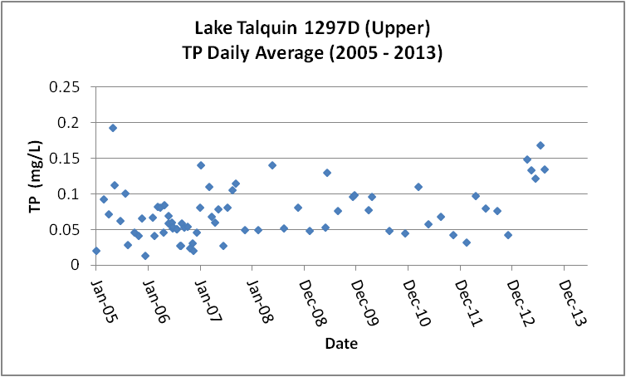
Figure B.4L.20. Lake Talquin Upper WBID 1297D Daily Average TP 2005 - 2013

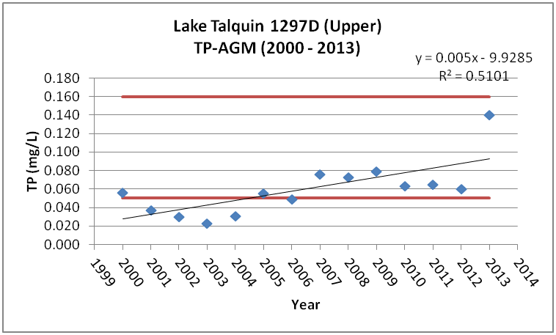
Figure B.4L.21. Lake Talquin Upper WBID 1297D Annual Geomean TP 2000 - 2013

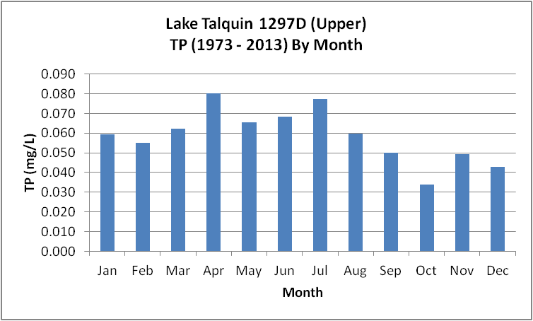
Figure B.4L.22. Lake Talquin Upper WBID 1297D Monthly Average TP 1973 - 2013

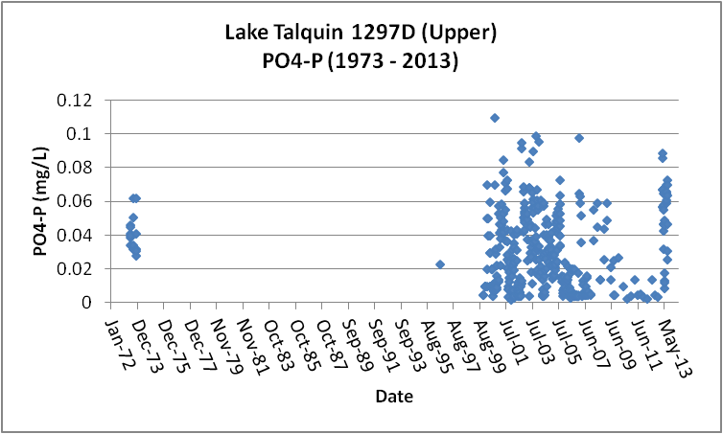
Figure B.4L.23. Lake Talquin Upper WBID 1297D Daily Average Orthophosphate-P 1973 - 2013

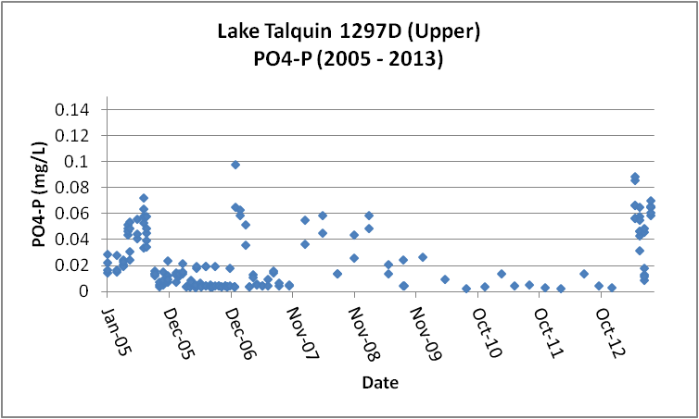
Figure B.4L.24. Lake Talquin Upper WBID 1297D Daily Average Orthophosphate-P 2005 - 2013

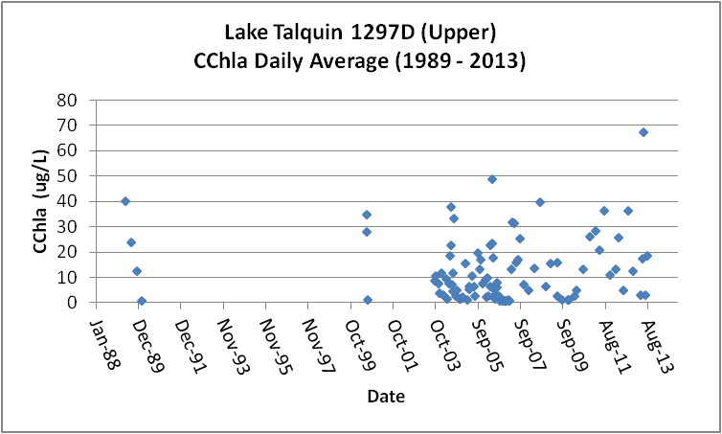
Figure B.4L.25. Lake Talquin Upper WBID 1297D Daily Average CChla 1989 - 2013

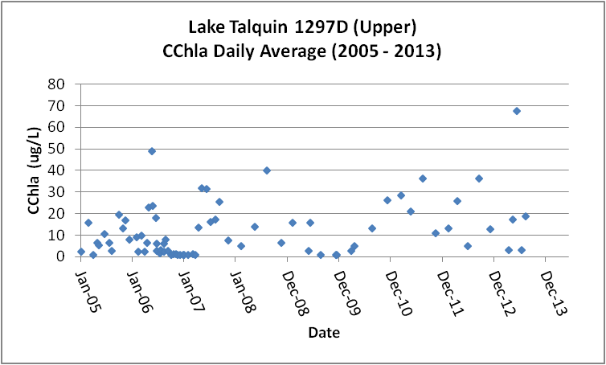
Figure B.4L.26. Lake Talquin Upper WBID 1297D Daily Average CChla 2005 - 2013

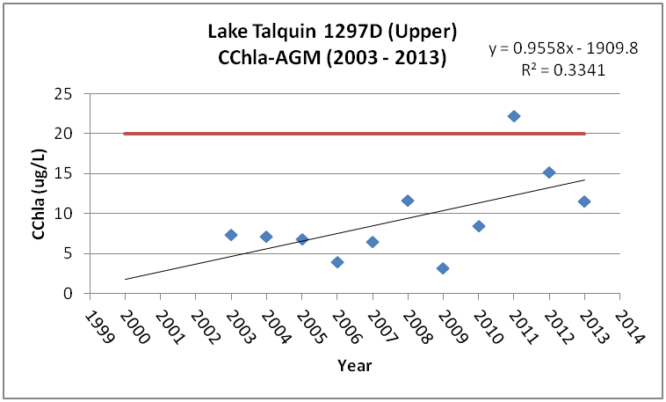
Figure B.4L.27. Lake Talquin Upper WBID 1297D Annual Geomean CChla 2003 - 2013

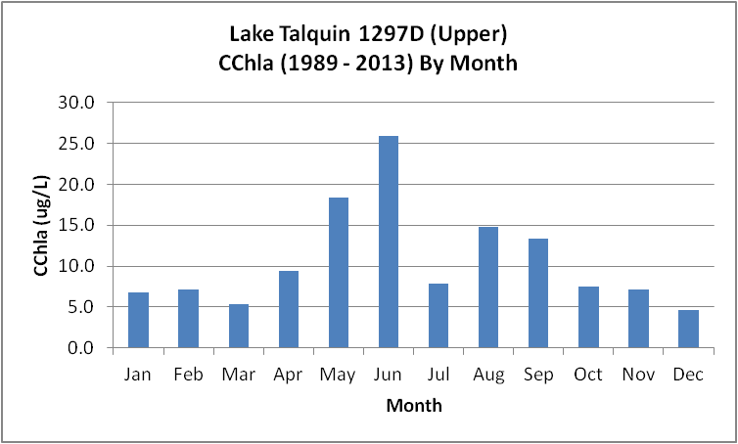
Figure B.4L.28. Lake Talquin Upper WBID 1297D Monthly Average CChla 1989 - 2013

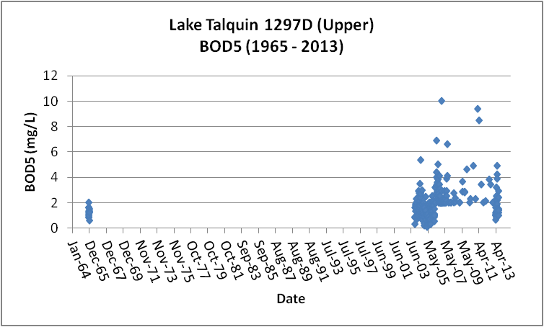
Figure B.4L.29. Lake Talquin Upper WBID 1297D Daily Average BOD5 1965 - 2013

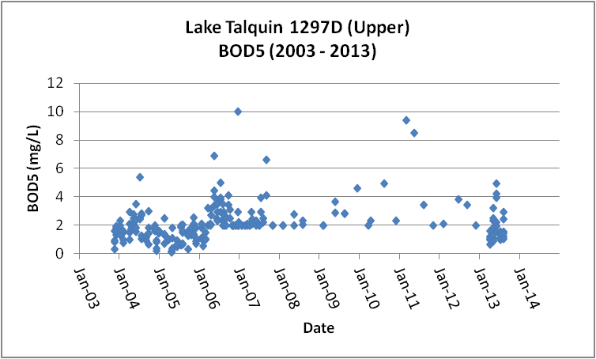
Figure B.4L.30. Lake Talquin Upper WBID 1297D Daily Average BOD5 2003 - 2013

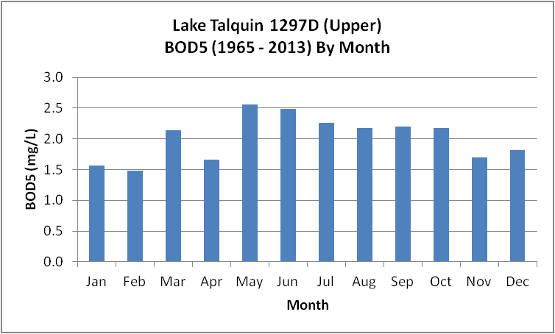
Figure B.4L.31. Lake Talquin Upper WBID 1297D Monthly Average BOD5 1965 - 2013

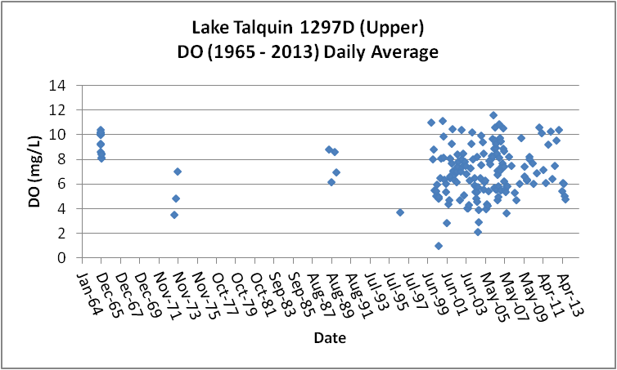
Figure B.4L.32. Lake Talquin Upper WBID 1297D Daily Average DO 1965 - 2013

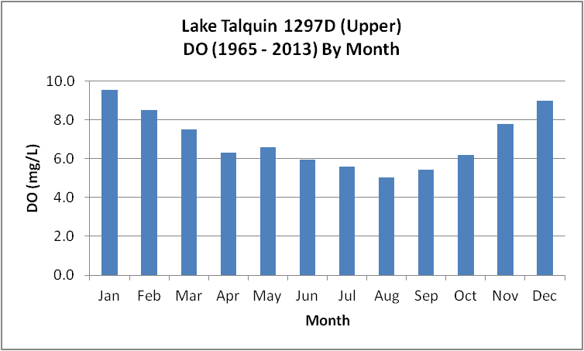
Figure B.4L.33. Lake Talquin Upper WBID 1297D Monthly Average DO 1965 - 2013

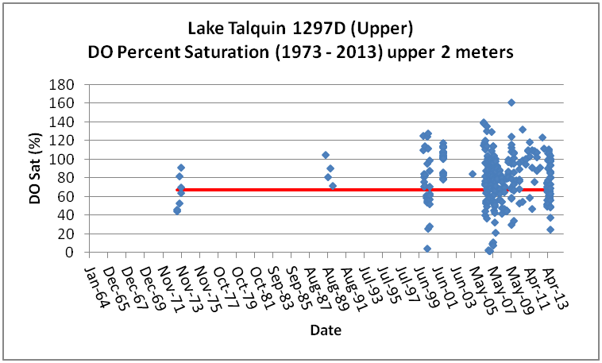
Figure B.4L.34. Lake Talquin Upper WBID 1297D Daily Average DO Percent Saturation 1965 - 2013

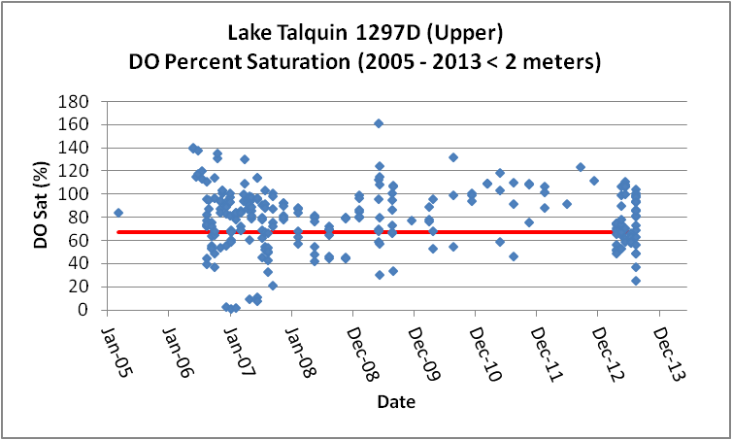
Figure B.4L.35. Lake Talquin Upper WBID 1297D Daily Average DO Percent Saturation 2005 - 2013

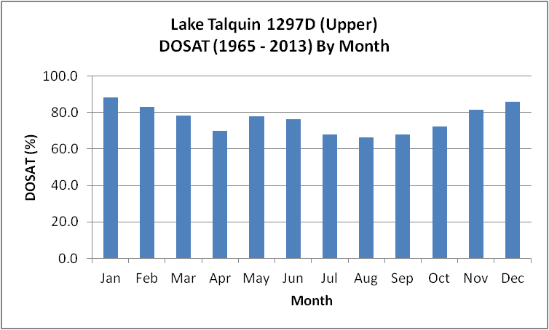
Figure B.4L.36. Lake Talquin Upper WBID 1297D Monthly Average DO Percent Saturation 1965 - 2013

Table B.4L.1. Lake Talquin WBIDs 1297D IWR Stations
WBID | Station Number | Station Name | Begin Date | End Date
1297D | 21FLGW 9234 | NWA-LL-1004 LAKE TALQUIN | 2000 | 2000
1297D | 21FLGW 22111 | NW1-LL-2022 LAKE TALQUIN | 2004 | 2004
1297D | 21FLMCGLTOC | T0C: Coes Boat Landing. Take boat to channel, 4 m | 2000 | 2000
1297D | 21FLLEONLCT0W3045084521 | Talquin 3 | 2006 | 2007
1297D | 21FLGW 9250 | NWA-LL-1030 LAKE TALQUIN | 2000 | 2000
1297D | 21FLGW 37926 | Z1-LL-3014R J T BUDD POND | 2009 | 2009
1297D | 21FLLEONLCT0C3045884492 | Talquin 4 | 2006 | 2009
1297D | 21FLGW 9246 | NWA-LL-1047 LAKE TALQUIN | 2000 | 2000
1297D | 21FLGW 9238 | NWA-LL-1010 LAKE TALQUIN | 2000 | 2000
1297D | 21FLBRA 1297D-A | 1297D - Lake Talquin - William's Landing | 2006 | 2007
1297D | 11EPALES123904 | LAKE TALQUIN | 1973 | 1973
1297D | 21FLLEONLCT03045184523 | Lake Talquin near Williams Landing | 2009 | 2010
1297D | 21FLGFWFGFCNW0417 | LAKE TALQUIN MIDLAKE BTW WILLIAMS AND HIGH BLUFF | 1989 | 1990
1297D | 21FLLEONT0E3044084556 | Lake Talquin Central | 2007 | 2009
1297D | 21FLGW 41391 | Z1-LL-6028 LAKE TALQUIN | 0 | 0
1297D | 21FLGW 22125 | NW1-LL-2049 LAKE TALQUIN | 2004 | 2004
1297D | 1113S050644800 | LAKE TELQUIN WILLIAMS LANDING | 1965 | 1966
1297D | 21FLMCGLT0W | Lake Talquin, Williams Landing, middle of lake | 1999 | 2006
1297D | 21FLGW 22107 | NW1-LL-2016 LAKE TALQUIN | 2004 | 2004
1297D | 21FLBRA 1297D-D | 1297D - Lake Talquin - 2km ENE of Williams landing | 2006 | 2006
1297D | 21FLA 22020052 | LAKE TALQUIN NE OF WILLIAMS LANDING | 1996 | 1996
1297D | 21FLWQA 302654508431178 | Lake Talquin at Williams Landing | 2002 | 2002
1297D | 21FLMCGLTOW | T0W: Williams Landing. Take boat to channel, 4 m d | 2000 | 2000
1297D | 21FLGW 36990 | Z1-LL-3014 J T BUDD POND | 2009 | 2009
1297D | 21FLBRA 1297D-E | 1297D - Lake Talquin - inlet W of William's Landing | 2006 | 2006
1297D | 21FLBRA 1297D-C | 1297D - Lake Talquin - W sect of WBID boundary | 2006 | 2007
1297D | 21FLA 22020053 | LAKE TALQUIN NEAR NORTH SHORE IN MIDDLE LOBE | 1996 | 1996
1297D | 21FLWQA 302621708431448 | Lake Talquin at Vause Landing | 2002 | 2002
1297D | 21FLMCGLT0C | Lake Talquin, Coes Landing, middle of lake | 1999 | 2006
1297D | 21FLGW 41384 | Z1-LL-6012 LAKE TALQUIN | 0 | 0
1297D | 21FLGW 22128 | NW1-LL-2054 LAKE TALQUIN | 2004 | 2004
1297D | 21FLGW 22121 | NW1-LL-2043 LAKE TALQUIN | 2004 | 2004

Table B.4L.2. Lake Talquin Upper WBID 1297D Long-Term Geomean Alkalinity and Color
WBID | Constituent | POR | Geomean
1297D | Alkalinity (mg/L) | 1965 - 2013 | 16.8
1297D | Color-True (PCU) | 1996 - 2013 | 62.3

Table B.4L.3. Lake Talquin Upper WBID 1297D DO Percent Saturation vs. 67% Criterion
Year | Category | Result (*)
1965 - 2012 | Count | 274
- | Number P | 207
- | Number F | 67
- | Percent F | 24.5
- | - | -
2005 - 2012 | Count | 210
- | Number P | 160
- | Number F | 50
- | Percent F | 23.8

(*) Result based only on upper 2 meters of water column

Table B.4L.4. Lake Talquin Upper WBID 1297D Annual Geomean TN, TP, TN/TP Ratio, and CChla
Year | TN | TP | TN/TP | CChla
- | AGM | AGM | Ratio | AGM
2000 | 0.53 | 0.056 | 9.5 | -
2001 | 0.70 | 0.038 | 18.5 | -
2002 | 0.81 | 0.030 | 27.0 | -
2003 | 0.37 | 0.023 | 16.0 | 7.4
2004 | 0.50 | 0.031 | 16.1 | 7.1
2005 | 0.58 | 0.056 | 10.4 | 6.8
2006 | 0.61 | 0.049 | 12.2 | 4.0
2007 | 0.83 | 0.076 | 10.9 | 6.5
2008 | 0.91 | 0.073 | 12.5 | 11.6
2009 | 0.87 | 0.079 | 11.0 | 3.1
2010 | 0.81 | 0.063 | 12.8 | 8.4
2011 | 0.75 | 0.065 | 11.5 | 22.2
2012 | 0.79 | 0.060 | 13.1 | 15.2
2013 | 1.18 | 0.140 | 8.4 | 11.6

Table B.4L.5. Lake Talquin Upper WBID 1297D Water Quality Data Summary All Data
Constituent | Units | POR | Count | Min | Max | Median | Mean | Geomean
Temperature | C | 1965 - 2013 | 716 | 8.3 | 33.7 | 24.2 | 22.2 | 21.0
Alkalinity | mg/L | 1965 - 2013 | 402 | 0.2 | 80.5 | 18.8 | 19.4 | 16.7
pH | S.U. | 1965 - 2013 | 713 | 2.2 | 10.3 | 7.0 | NA | NA
Color | PCU | 1996 - 2013 | 381 | 2.5 | 303.3 | 66.7 | 77.4 | 62.3
TN | mg/L | 1973 - 2013 | 444 | 0.04 | 3.62 | 0.68 | 0.72 | 0.62
NH4-N | mg/L | 1973 - 2013 | 441 | 0.003 | 1.17 | 0.06 | 0.08 | 0.055
NO23 | mg/L | 1973 - 2013 | 431 | 0.001 | 2.29 | 0.13 | 0.17 | 0.063
OrgN | mg/L | 1989 - 2006 | 114 | 0.081 | 2.440 | 0.378 | 0.417 | 0.355
TP | mg/L | 1973 - 2013 | 447 | 0.002 | 0.239 | 0.049 | 0.059 | 0.045
PO4-P | mg/L | 1973 - 2013 | 428 | 0.002 | 0.110 | 0.024 | 0.029 | 0.020
CChla | ug/L | 1989 - 2013 | 263 | 0.7 | 170.0 | 5.7 | 11.5 | 5.7
BOD5 | mg/L | 1965 - 2013 | 255 | 0.1 | 10.0 | 2.0 | 2.0 | 1.7
DO | mg/L | 1965 - 2013 | 713 | 0.1 | 12.5 | 7.0 | 6.8 | 6.1
%DOSat | % | 1965 - 2013 | 656 | 0.8 | 161.4 | 78.4 | 76.3 | 69.3

Table B.4L.6. Lake Talquin Upper WBID 1297D Water Quality Data Summary Verified Period Plus (2005 – 2013)
Constituent | Units | Verified Period+ | Count | Min | Max | Median | Mean | Geomean
Temperature | C | 2005 - 2013 | 404 | 8.3 | 33.7 | 25.2 | 23.4 | 21.5
Alkalinity | mg/L | 2005 - 2013 | 164 | 5.0 | 40.0 | 17.0 | 19.2 | 16.5
pH | S.U. | 2005 - 2013 | 402 | 5.5 | 9.2 | 7.0 | NA | NA
Color | PCU | 2005 - 2013 | 159 | 11.3 | 260.0 | 50.0 | 69.5 | 52.8
TN | mg/L | 2005 - 2013 | 183 | 0.08 | 2.77 | 0.82 | 0.82 | 0.68
NH4-N | mg/L | 2005 - 2013 | 190 | 0.003 | 0.29 | 0.04 | 0.05 | 0.033
NO23 | mg/L | 2005 - 2013 | 183 | 0.004 | 2.29 | 0.12 | 0.16 | 0.038
OrgN | mg/L | 2005 - 2013 | 65 | 0.081 | 0.759 | 0.355 | 0.364 | 0.316
TP | mg/L | 2005 - 2013 | 188 | 0.004 | 0.215 | 0.073 | 0.080 | 0.056
PO4-P | mg/L | 2005 - 2013 | 181 | 0.003 | 0.098 | 0.015 | 0.025 | 0.013
CChla | ug/L | 2005 - 2013 | 188 | 0.7 | 170.0 | 5.8 | 12.1 | 5.2
BOD5 | mg/L | 2005 - 2013 | 187 | 0.1 | 10.0 | 2.0 | 2.2 | 1.8
DO | mg/L | 2005 - 2013 | 405 | 0.2 | 12.4 | 6.8 | 6.6 | 6.4
%DOSat | % | 2005 - 2013 | 380 | 1.6 | 161.4 | 77.2 | 75.6 | 69.1

B.4M. Lower Lake Talquin WBID 1297C
This WBID is verified impaired for nutrients due to elevated TSI and low DO (Chapter 2). Florida has newly adopted criteria for dissolved oxygen, total nitrogen, total phosphorous, and chlorophyll a (Chapter 3). The Department has not formally assessed the data for the Lake Talquin watershed under the new criteria. However, based on preliminary analysis, it is highly likely that Lake Talquin, verified impaired for DO or nutrients will still be verified impaired under the new criteria. Based on extensive analysis of data from lakes in Florida the Department has concluded that the health of lakes is best related to the area in the state in which the lake exists, the long-term color and alkalinity of the lake, and the level of nutrients and CChla present in the lake and maintaining an appropriate level of dissolved oxygen as compared to the percent saturation criterion for DO (Chapter 3 of TMDL Report). These data are best assessed as the long-term geomean (GM) for color and alkalinity and as the annual geomean for TN, TP, and CChla. As such, the presentation of data for the lake will use POR GMs for color and alkalinity and AGMs for nutrients and CChla. The numeric nutrient thresholds contained in Rule 62-302. 531, FAC, for lakes vary depending on color, alkalinity, CChla data sufficiency (for calculating AGM concentrations), and the CChla AGM concentration. The POR GM alkalinity and color for this segment of the lake is 14.0 mg/L and 53.2 PCU. This characterizes this section of the lake as high color, in which case the alkalinity does not impact the threshold concentrations for nutrients and CChla. The threshold for CChla is an AGM greater than 20 ug/L, TP AGM can range between 0.05 mg/L and 0.16 mg/L and TN AGM between 1.27 mg/L and 2.23 mg/L depending on the CChla AGM concentration (Chapter 3 of TMDL Report).
In some graphs for AGM TN, TP and CChla and daily average percent DOSAT (for lakes the data is from the upper two meters of the water column) lines are presented that represent the new thresholds. The Department notes that the data presented on these graphs has not been processed in accordance with all of the requirements of the new regulations in rule 62-303, F.A.C. As a result, a determination of compliance with the new criteria cannot be made from these data.
Table B.4M.1, lists the 32 stations that have been sampled in Lake Talquin Lower (WBID 1297C). Figure B.4M.1 depicts the station locations.
Tables B.4M.5 and B.4M.6 and Figures B.4M.5 and B.4M.6, provide the results for alkalinity. These data show that Lake Talquin Lower has a POR GM alkalinity of 14.0 mg/L. The data indicate that the alkalinity for the period (2005 – 2013) is similar to the POR GM 14.0 mg/L vs. 14.5 mg/L). The seasonal pattern indicates that the alkalinity is lowest in the first three months of the year (~ 12 mg/L), as flow into the lake and rainfall increase and gradually increases through August to just over 20 mg/L, (corresponding somewhat to changes in incoming flow) and then decreasing slightly for the rest of the year. This pattern for alkalinity appears to be inversely related to river flow (flow highest in first three months of the year Figure B.3.12) and alkalinity at the lowest.
Tables B.4M.5 and B.4M.6 and Figures B.4M.7 and B.4M.8, provide the results for true color. These data show that Lake Talquin Lower has a POR GM color of 53.2 PCU, lower than the Upper area of the lake and the incoming color of the Ochlockonee River of 62.5 and the Little River (63.1). The data indicate that the GM color for the period (2005 – 2013) of 47.7 PCU is reduced relative to the POR color. The combined mean flow of Ochlockonee and Little Rivers for the period 1998 – 2013 of 1,021 cfs is slightly less than the flow of 1,080 cfs for the period 2005 – 2013, although the annual average rainfall was 2.3 inches greater for the earlier period (56.5 vs. 54.2 inches). The seasonal pattern indicates that the color appears more closely related to changes in incoming river flow (increasing with increased flow and decreasing with decreased flow) more so than local rainfall (Figures B.3.12 and B.2.4).
Tables B.4M.5 and B.4M.6 and Figures B.4M.10 through B.4M.13, provide the results for TN. These data show that Lake Talquin Lower has a POR GM TN of 0.67 mg/L. The data (Figure B.4M.12) indicate that the recent (2005 – 2013) TN GM of 0.80 mg/L is greater than the TN GM for the POR and less than the new default (1.27 mg/L) threshold AGM concentration for TN. The data also indicate that the overall trend appears to be for increasing AGM TN concentrations. The seasonal pattern indicates that the TN concentration generally increase slightly from January through July, then decreasing through the end of the year. This pattern for TN is not clearly related to flow or rainfall (Figures B.3.12 and B.2.4).
Tables B.4M.5 and B.4M.6 and Figures B.4M.14 and B.4M.15, provide the results for NH4-N. These data show that Lake Talquin Lower has a POR GM NH4-N of 0.055 mg/L. The data indicate that the recent (2005 – 2013) NH4-N GM of 0.034 mg/L is measurably less than the POR concentration and that the overall trend may be masked by the number of results reported as less than detection.

Tables B.4M.5 and B.4M.6 and Figures B.4M.16 and B.4M.17, provide the results for NO23-N. These data show that Lake Talquin Lower has a POR GM NO23-N of 0.033 mg/L. The data indicate that the recent (2005 – 2013) NO23-N GM of 0.031 mg/L is equivalent to the POR concentration and that there does not appear to be a trend for this constituent.
Tables B.4M.5 and B.4M.6 and Figures B.4M.19 through B.4M.22, provide the results for TP. These data show that Lake Talquin Lower has a POR GM TP of 0.043 mg/L. The data (Figure B.4M.21) indicate that the recent (2005 – 2013) TP GM of 0.054 mg/L is measurably greater than the TP GM for the POR and slightly greater than the new threshold AGM concentration for TP. The data also indicate that the overall trend is for increasing AGM TP concentrations. The seasonal pattern is similar to TN, with TP concentration generally increasing through June and then generally decreasing slightly through the rest of the year. This pattern for TP is not clearly related to flow or rainfall (Figures B.3.12 and B.2.4).
Tables B.4M.5 and B.4M.6 and Figures B.4M.22 and B.4M.23, provide the results for PO4-P. These data show that the Lake Talquin Lower has a POR GM PO4-P of 0.013 mg/L. The data indicate that the recent (2005 – 2013) PO4-P GM of 0.009 mg/L is less than the POR concentration and that the overall trend may be masked by the number of results reported as less than detection.
Tables B.4M.5 and B.4M.6 and Figures B.4M.25 through B.4M.28, provide the results for CChla. These data show that Lake Talquin Lower has a POR GM CChla of 10.2 ug/L, about twice as high as the Upper area of the lake. The data (Figure B.4M.27) indicate that the recent (2005 – 2013) CChla GM of 9.2 ug/L is similar to the CChla GM for the POR and less than the new threshold AGM concentration for CChla. The data also indicate that the overall trend is for increasing AGM CChla concentrations. The seasonal pattern indicates that the CChla concentrations peak in June decrease significantly in July, then increasing through August, and slowly reducing concentrations for the remaining months of the year. The pattern in CChla may be influenced by heavy rainfall in June through August, bringing in lower CChla concentrations from the rivers, diluting the lake, and reducing the residence time of the lake (Figure B.2.4).
Tables B.4M.5 and B.4M.6 and Figures B.4M.29 through B.4M.31, provide the results for BOD5. These data show that Lake Talquin Lower has a POR GM BOD5 of 1.8 mg/L. The data indicate that the recent (2005 – 2013) BOD5 GM of 2.0 mg/L is similar to the POR concentration. Variable detection limits over time may be having an influence on the data. There is no apparent overall trend.
Tables B.4M.5 and B.4M.6 and Figures B.4M.32 and B.4M.33, provide the results for DO. These data show that Lake Talquin Lower has a POR GM DO of 6.1 mg/L. The data indicate that the recent (2005 – 2013) DO GM of 6.4 mg/L is similar to the POR concentration. There is no apparent overall trend in time. Seasonal data indicate that the monthly average DO reaches a minimum of 5.0 mg/L during August and is greater than this for the remaining months of the year (Figure B.4M.33).
Tables B.4M.5 and B.4M.6 and Figures B.4M.34 through B.4M.36, provide the results for percent DO saturation. These data show that Lake Talquin Lower has a POR GM DOSAT of 69.3 percent. The data indicate that the recent (2005 – 2013) DOSAT GM of 69.1 percent is similar to the GM for the POR. The data do not appear to have a long-term trend. The data presented in Figure B.4M.34 indicates that there are sufficient results below the new DO criterion to warrant further investigation. The seasonal pattern indicates that the DOSAT is lowest in August.

Figure B.4M.1. Lake Talquin WBIDs 1297D and 1297C IWR Stations

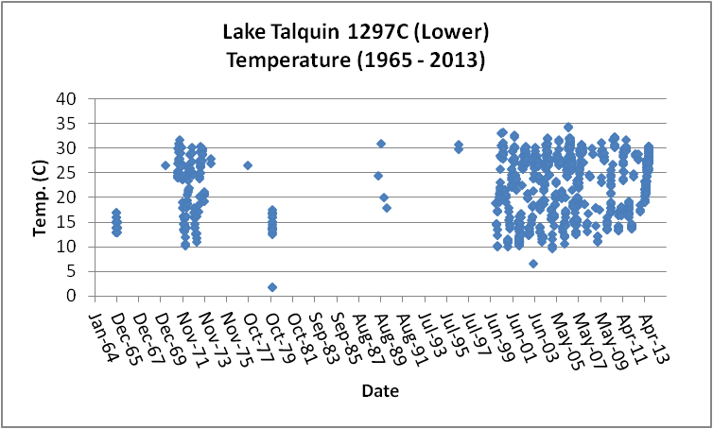
Figure B.4M.2. Lake Talquin Lower WBID 1297C Daily Temperature 1965 - 2013

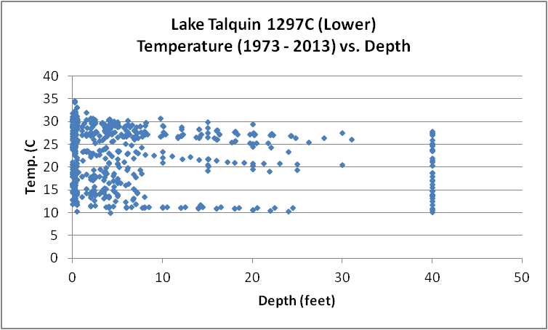
Figure B.4M.3. Lake Talquin Lower WBID 1297C Monthly Temperature 1973 - 2013

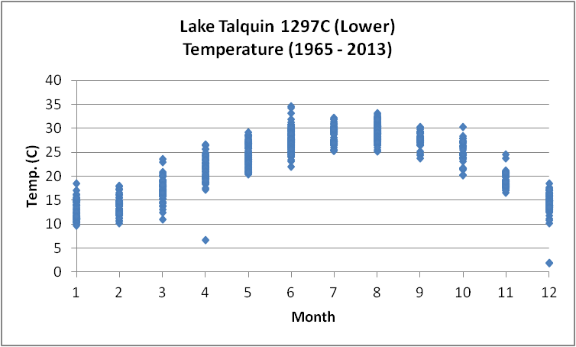
Figure B.4M.4. Lake Talquin Lower WBID 1297C Monthly Temperature 1965 - 2013

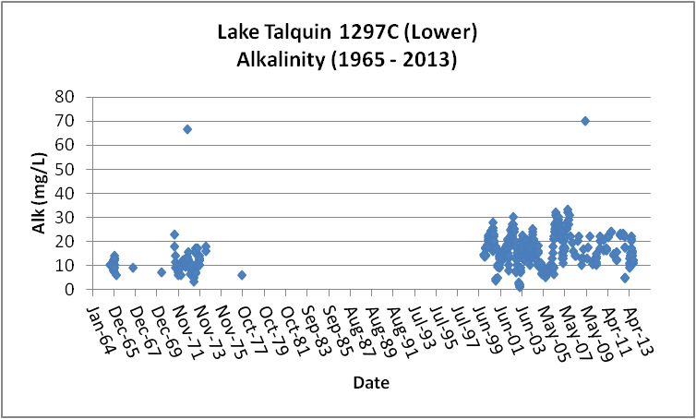
Figure B.4M.5. Lake Talquin Lower WBID 1297C Daily Average Alkalinity 1965- 2013

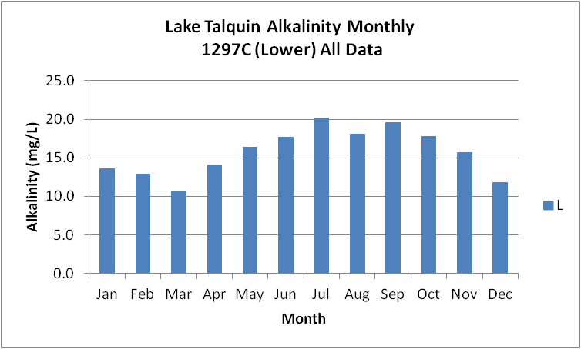
Figure B.4M.6. Lake Talquin Lower WBID 1297C Monthly Average Alkalinity 1965- 2013

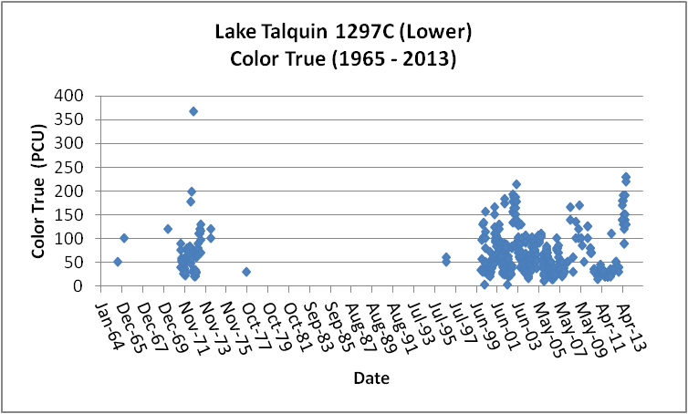
Figure B.4M.7. Lake Talquin Lower WBID 1297C Daily Average True Color 1965- 2013

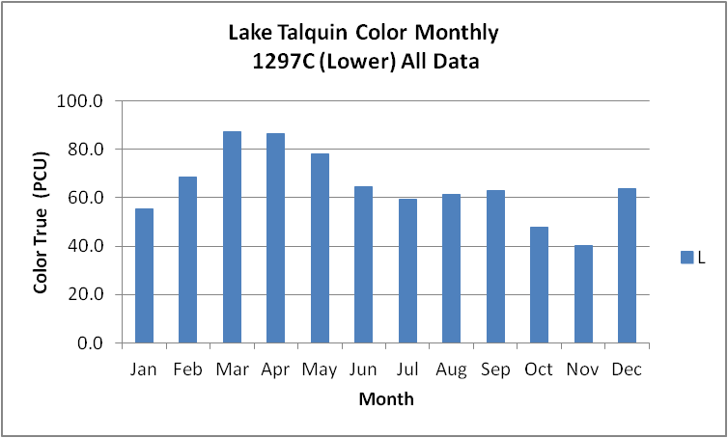
Figure B.4M.8. Lake Talquin Lower WBID 1297C Monthly Average True Color 1965- 2013

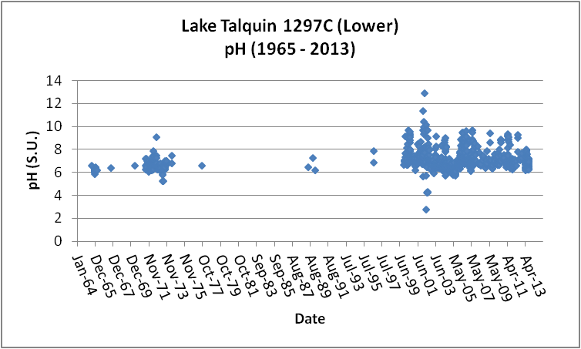
Figure B.4M.9. Lake Talquin Lower WBID 1297C Daily pH 1965- 2013

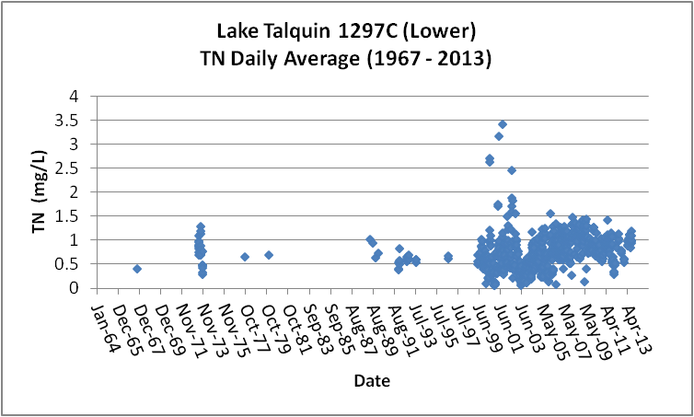
Figure B.4M.10. Lake Talquin Lower WBID 1297C Daily Average TN1967- 2013

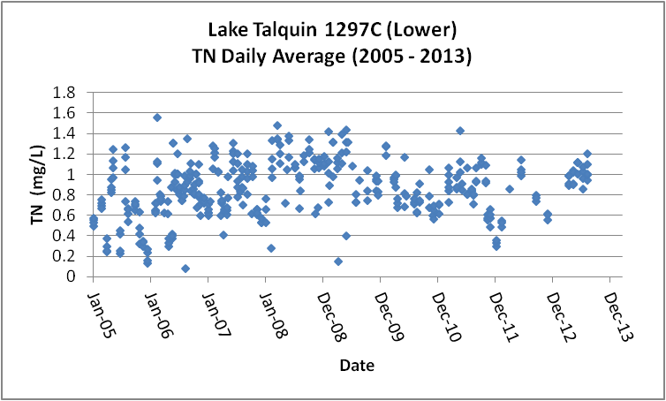
Figure B.4M.11. Lake Talquin Lower WBID 1297C Daily Average TN 2005- 2013

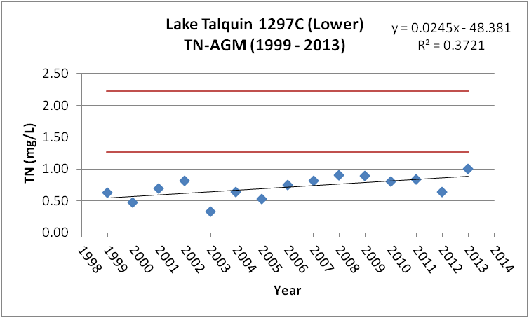
Figure B.4M.12. Lake Talquin Lower WBID 1297C TN Annual Geomean 1999- 2013

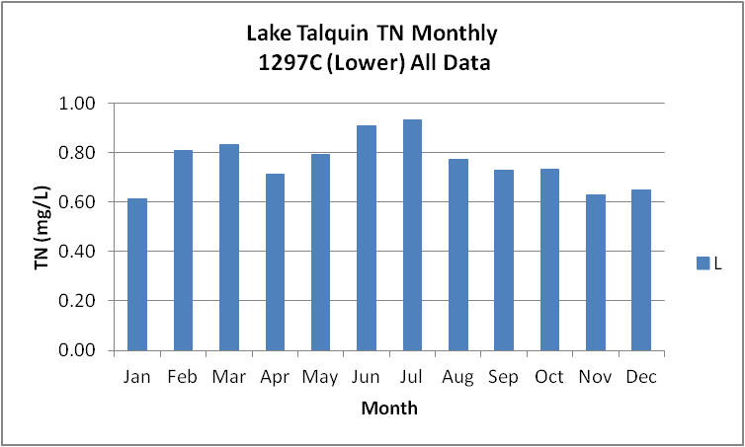
Figure B.4M.13. Lake Talquin Lower WBID 1297C Monthly Average TN 1967- 2013

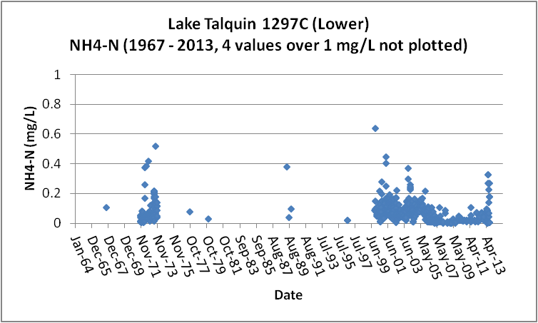
Figure B.4M.14. Lake Talquin Lower WBID 1297C Daily Average Ammonia-N 1967- 2013

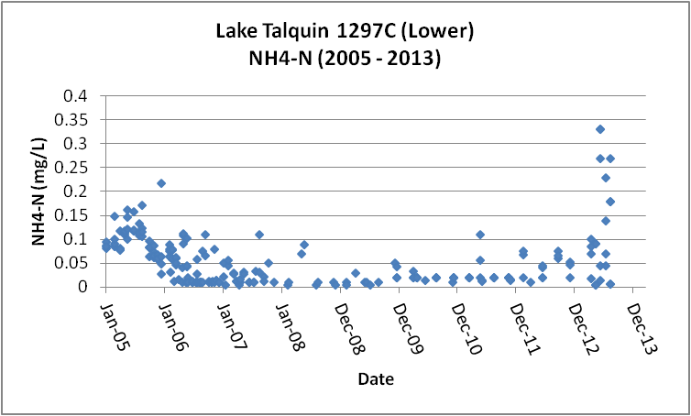
Figure B.4M.15. Lake Talquin Lower WBID 1297C Daily Average Ammonia-N 2005- 2013

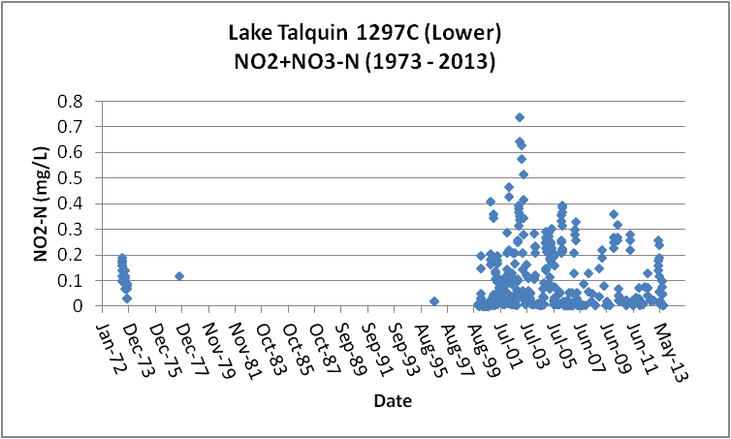
Figure B.4M.16. Lake Talquin Lower WBID 1297C Daily Average Nitrate/Nitrite-N1973- 2013

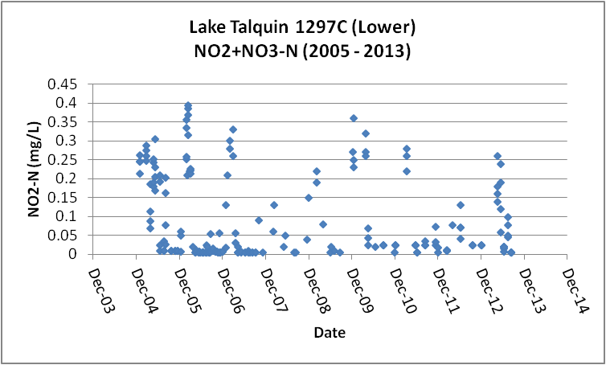
Figure B.4M.17. Lake Talquin Lower WBID 1297C Daily Average Nitrate/Nitrite-N2005- 2013

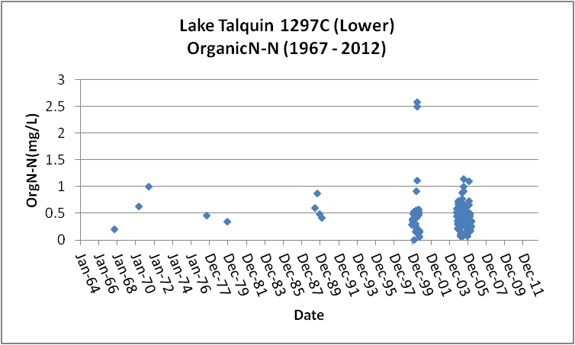
Figure B.4M.18. Lake Talquin Lower WBID 1297C Daily Average Organic-N 1967- 2012

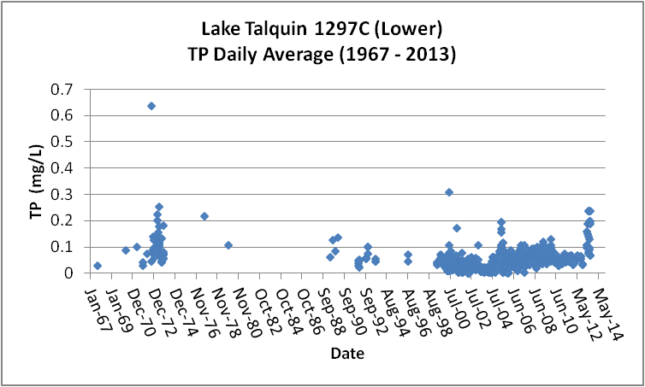
Figure B.4M.19. Lake Talquin Lower WBID 1297C Daily Average TP 1967 - 2013

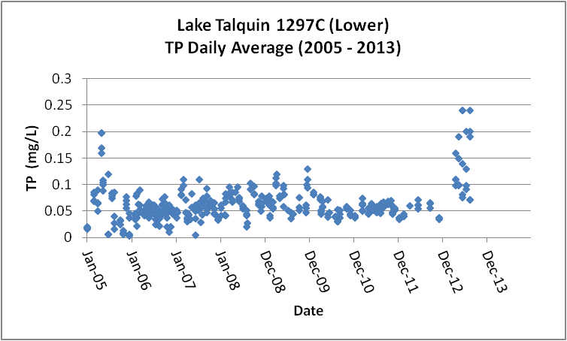
Figure B.4M.20. Lake Talquin Lower WBID 1297C Daily Average TP 2005 - 2013

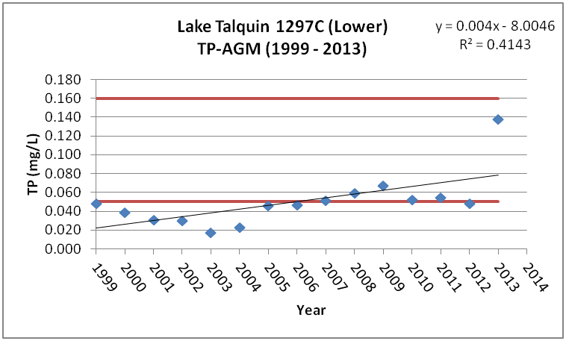
Figure B.4M.21. Lake Talquin Lower WBID 1297C Annual Geomean TP 1999 - 2013

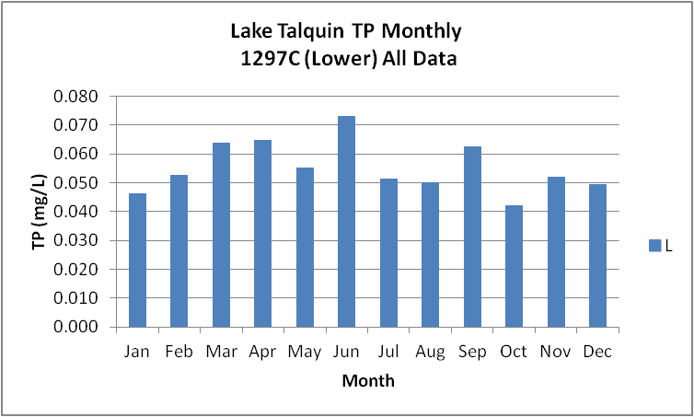
Figure B.4M.22. Lake Talquin Lower WBID 1297C Monthly Average TP 1967 - 2013

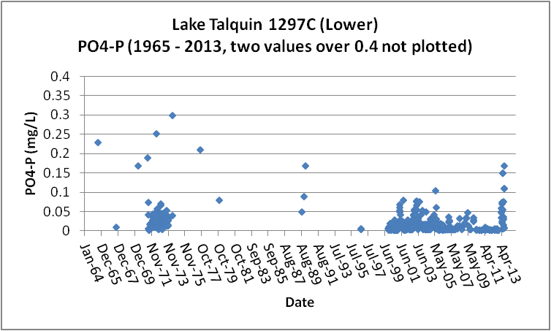
Figure B.4M.23. Lake Talquin Lower WBID 1297C Daily Average Orthophosphate-P 1965 - 2013

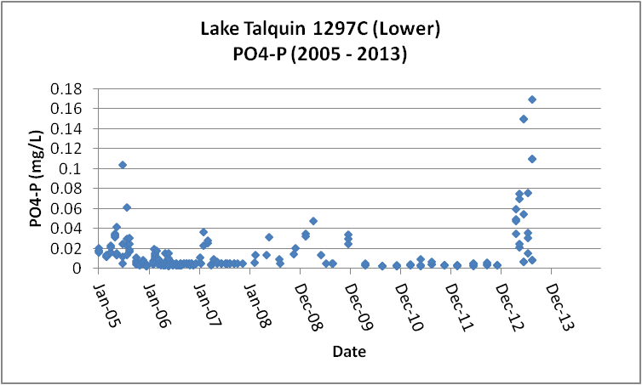
Figure B.4M.24. Lake Talquin Lower WBID 1297C Daily Average Orthophosphate-P 2005 - 2013

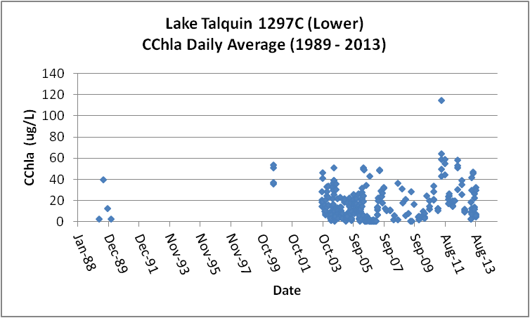
Figure B.4M.25. Lake Talquin Lower WBID 1297C Daily Average CChla 1989 - 2013

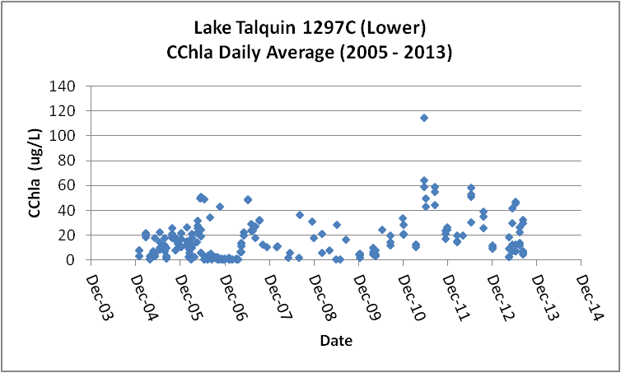
Figure B.4M.26. Lake Talquin Lower WBID 1297C Daily Average CChla 2005 - 2013

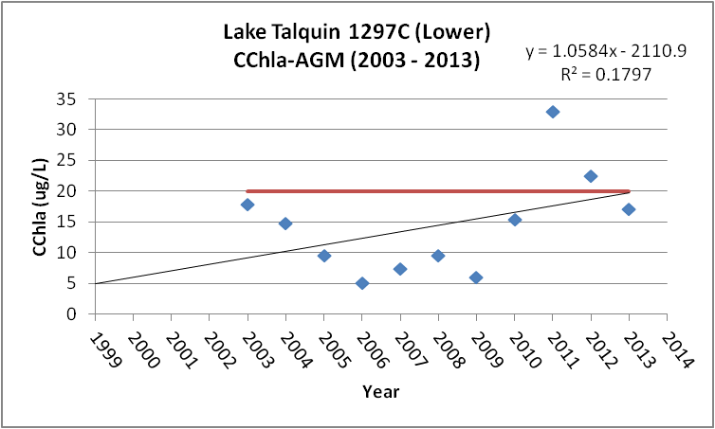
Figure B.4M.27. Lake Talquin Lower WBID 1297C Annual Geomean CChla 2003 - 2013

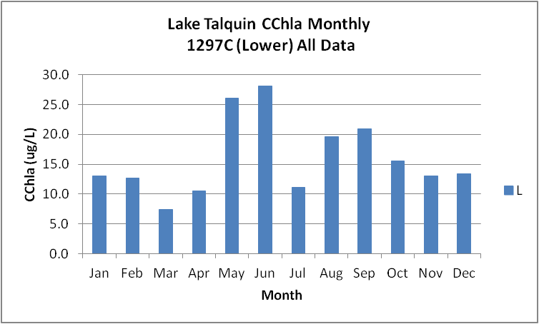
Figure B.4M.28. Lake Talquin Lower WBID 1297C Monthly Average CChla 1989 - 2013

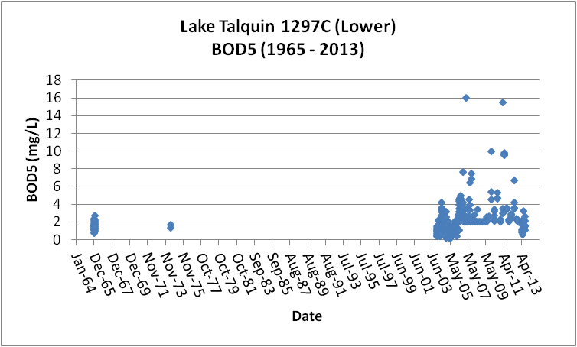
Figure B.4M.29. Lake Talquin Lower WBID 1297C Daily Average BOD5 1965 - 2013

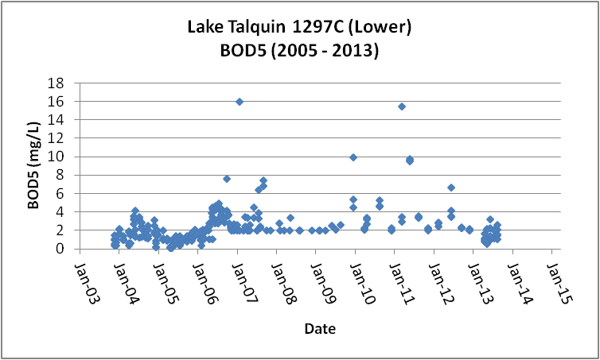
Figure B.4M.30. Lake Talquin Lower WBID 1297C Daily Average BOD5 2005 - 2013

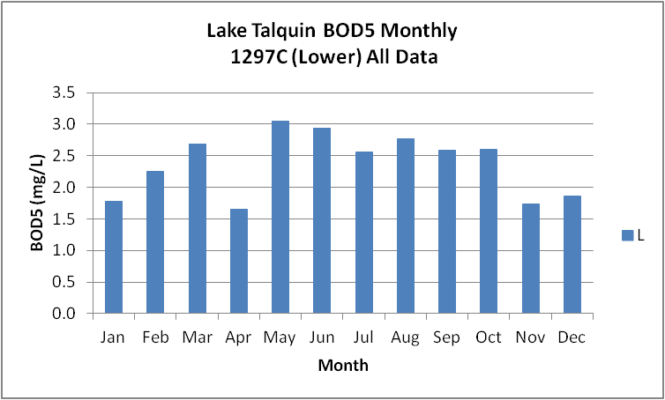
Figure B.4M.31. Lake Talquin Lower WBID 1297C Monthly Average BOD5 1965 - 2013

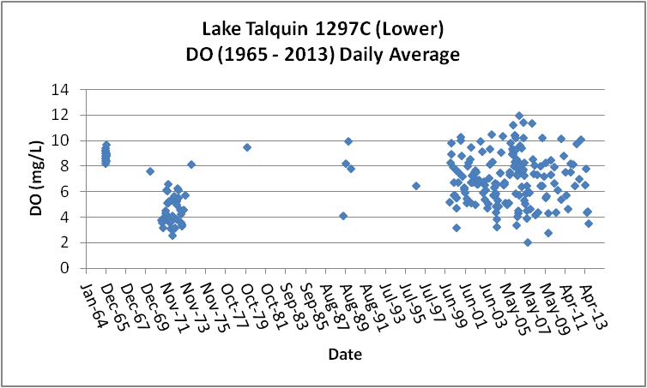
Figure B.4M.32. Lake Talquin Lower WBID 1297C Daily Average DO 1965 - 2013

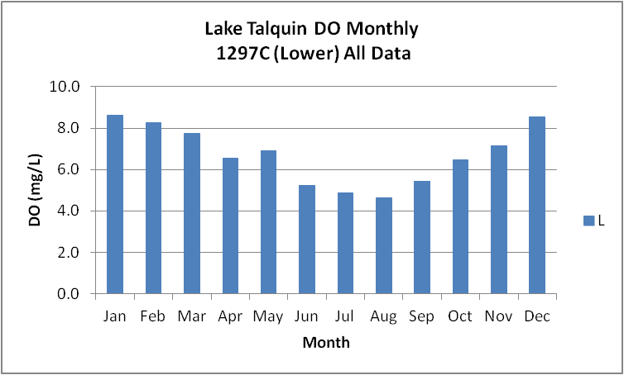
Figure B.4M.33. Lake Talquin Lower WBID 1297C Monthly Average DO 1965 - 2013

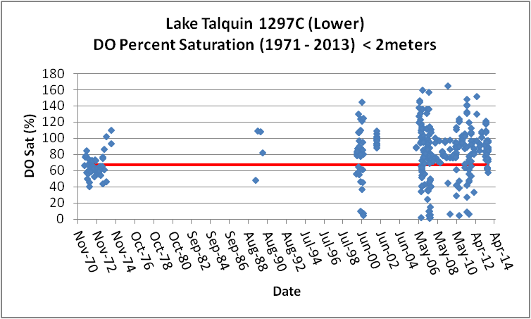
Figure B.4M.34. Lake Talquin Lower WBID 1297C Daily Average DO Percent Saturation 1971 - 2013

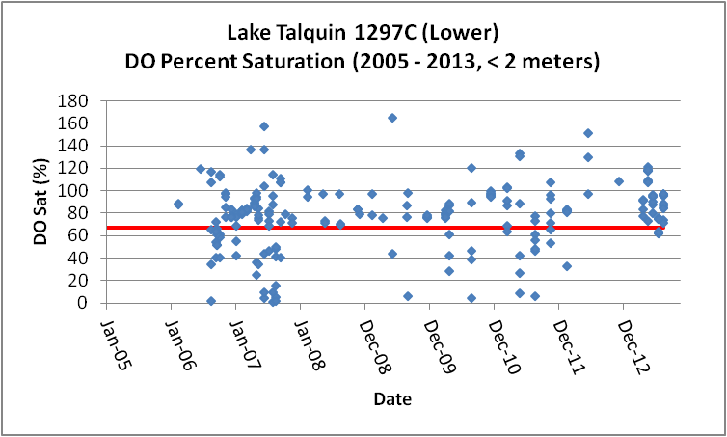
Figure B.4M.35. Lake Talquin Lower WBID 1297C Daily Average DO Percent Saturation 2005 - 2013

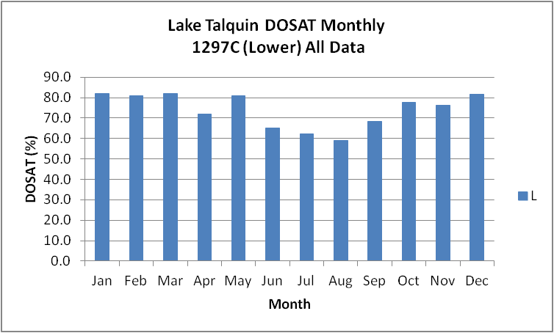
Figure B.4M.36. Lake Talquin Lower WBID 1297C Monthly Average DO Percent Saturation 1965 - 2013

Table B.4M.1. Lake Talquin WBIDs 1297C IWR Stations
WBID | Station Number | Station Name | Begin Date | End Date
1297C | 21FLLEONLCT0B3040284630 | Talquin 1 | 2006 | 2007
1297C | 21FLLEONLCT03042384172 | Lake Talquin near Luther Hall Landing | 2009 | 2010
1297C | 21FLGW 9242 | NWA-LL-1015 LAKE TALQUIN | 2000 | 2000
1297C | 21FLGW 9239 | NWA-LL-1012 LAKE TALQUIN | 2000 | 2000
1297C | 21FLGW 39368 | Z1-LL-4009R J T BUDD POND | 0 | 0
1297C | 21FLGW 38707 | Z1-LL-4009 J T BUDD POND | 2010 | 2010
1297C | 21FLGW 22124 | NW1-LL-2048 LAKE TALQUIN | 2004 | 2004
1297C | 21FLGW 22103 | NW1-LL-2011 LAKE TALQUIN | 2004 | 2004
1297C | 112WRD 302615084340203 | LAKE TALQUIN AT 1 MI SW OF CENTER | 1979 | 1979
1297C | 21FLGW 37923 | Z1-LL-3010R J T BUDD POND | 2009 | 2009
1297C | 21FLWQA 302416108437442 | Lake Talquin at Blounts Landing | 2002 | 2002
1297C | 21FLBRA 1297C-A | 1297C - Lake Talquin - Cook's Landing | 2006 | 2006
1297C | 112WRD 302615084340201 | LAKE TALQUIN AT 4.5 MI WSW OF CENTER | 1979 | 1979
1297C | 21FLMCGLTOB | T0B: Lake Talquin at Blount Rd/Lanier Landing. Tak | 2000 | 2000
1297C | 21FLMCGLT0L | Lake Talquin, Lewis Hall Landing, middle of lake | 1999 | 2006
1297C | 21FLLEONLCOC3040784610 | Lake Talquin (Ben Stoutamire Boat Landing) | 2005 | 2010
1297C | 112WRD 302615084340205 | LAKE TALQUIN AT 2 MI ENE OF CENTER | 1979 | 1979
1297C | 21FLGW 9241 | NWA-LL-1014 LAKE TALQUIN | 2000 | 2000
1297C | 21FLWQA 302332408438263 | Lake Talquin at LEW at dock .25 MI UPS dam | 0 | 0
1297C | 21FLWQA 302319608438438 | Ochlockonee River at dam | 2002 | 2002
1297C | 21FLGW 22113 | NW1-LL-2026 LAKE TALQUIN | 2004 | 2004
1297C | 21FLGW 22101 | NW1-LL-2008 LAKE TALQUIN | 2004 | 2004
1297C | 21FLA 22020054 | LAKE TALQUIN NEAR WHIPPOORWILL MARINA | 1996 | 1996
1297C | 21FLGW 36987 | Z1-LL-3010 J T BUDD POND | 2009 | 2009
1297C | 21FLWQA 302505808434229 | Lake Talquin at Halls Landing | 2002 | 2002
1297C | 21FLWQA 302417708437449 | OCHLOCKONEE RIVER (LAKE TALQUIN) NR BLOUNTS LANDING FROM BO | 0 | 0
1297C | 21FLLEONLCT0L3042284573 | Talquin 2 | 2006 | 2007
1297C | 21FLGW 40127 | Z1-LL-5009 J T BUDD POND | 0 | 0
1297C | 21FLGW 22118 | NW1-LL-2038 LAKE TALQUIN | 2004 | 2004
1297C | 21FLA 22020033 | LAKE TALQUIN MIDDLE OF | 1974 | 1974
1297C | 11EPALES123901 | LAKE TALQUIN | 1973 | 1973
1297C | 112WRD 302615084340202 | LAKE TALQUIN AT 3.5 MI WSW OF CENTER | 1979 | 1979
1297C | 21FLWQA 302516508434327 | Lake Talquin near Halls Landing | 0 | 0
1297C | 21FLWQA 302425808436371 | Lake Talquin at Ben Stoutmire Landing | 2002 | 2002
1297C | 21FLGW 40970 | Z1-LL-5009R LAKE TALQUIN | 0 | 0
1297C | 21FLGW 40966 | Z1-LL-5005R LAKE TALQUIN | 0 | 0
1297C | 21FLA 22020034 | LAKE TALQUIN DAM SITE | 1971 | 1974
1297C | 1113S050644640 | OCHLOCKONEE R AT L TELQUIN DAM | 1965 | 1966
1297C | 21FLMCGLTOL | T0L: Lake Talquin at Luther Hall Landing. Take boa | 2000 | 2000
1297C | 21FLGW 41382 | Z1-LL-6008 LAKE TALQUIN | 0 | 0
1297C | 21FLGW 40123 | Z1-LL-5005 J T BUDD POND | 0 | 0
1297C | 112WRD 302615084340204 | LAKE TALQUIN (AT CENTER) | 1979 | 1979
1297C | 21FLMCGLT0B | Lake Talquin, Southern end, middle of lake | 1999 | 2006
1297C | 21FLLEONT0D3041488461 | Lake Talquin West | 2007 | 2010
1297C | 21FLGW 9244 | NWA-LL-1025 LAKE TALQUIN | 2000 | 2000
1297C | 21FLGW 22126 | NW1-LL-2051 LAKE TALQUIN | 2004 | 2004
1297C | 21FLBRA 1297C-E | 1297C - Lake Talquin - 350m E of Cook's Landing | 2006 | 2006
1297C | 21FLBRA 1297C-D | 1297C - Lake Talquin - W-central section | 2006 | 2007
1297C | 21FLBRA 1297C-C | 1297C - Lake Talquin - Central Section | 2006 | 2007
1297C | 112WRD 302615084340207 | LAKE TALQUIN AT 6 MI ENE OF CENTER | 1979 | 1979
1297C | 112WRD 302615084340206 | LAKE TALQUIN AT 4.5 MI ENE OF CENTER | 1979 | 1979

Table B.4M.2. Lake Talquin Lower WBID 1297C Long-Term Geomean Alkalinity and Color
WBID | Constituent | POR | Geomean
1297C | Alkalinity (mg/L) | 1965 - 2013 | 14.0
1297C | Color-True (PCU) | 1996 - 2013 | 53.2

Table B.4M.3. Lake Talquin Lower WBID 1297C DO Percent Saturation vs. 67% Criterion
Year | Category | Result (*)
1971 - 2013 | Count | 367
 | Number P | 274
 | Number F | 93
 | Percent F | 25.3
2005-2013 | Count | 274
 | Number P | 203
 | Number F | 71
 | Percent F | 25.9

(*) Result based only on data from upper 2 meters of water column.

Table B.4M.4. Lake Talquin Lower WBID 1297C Annual Geomean TN, TP, TN/TP Ratio, and CChla
Year | TN | TP | TN/TP | CChla
- | AGM | AGM | Ratio | AGM
1972 | - | 0.127 | - | -
1973 | - | 0.116 | - | -
1999 | 0.63 | 0.048 | 13.1 | -
2000 | 0.48 | 0.039 | 12.4 | -
2001 | 0.69 | 0.031 | 22.4 | -
2002 | 0.81 | 0.030 | 26.9 | -
2003 | 0.33 | 0.018 | 18.8 | 17.8
2004 | 0.64 | 0.023 | 28.1 | 14.9
2005 | 0.53 | 0.046 | 11.7 | 9.6
2006 | 0.75 | 0.047 | 16.0 | 5.1
2007 | 0.81 | 0.052 | 15.8 | 7.5
2008 | 0.91 | 0.059 | 15.3 | 9.6
2009 | 0.89 | 0.067 | 13.3 | 5.9
2010 | 0.81 | 0.052 | 15.5 | 15.4
2011 | 0.83 | 0.055 | 15.2 | 33.0
2012 | 0.64 | 0.048 | 13.3 | 22.5
2013 | 1.01 | 0.138 | 7.3 | 17.1

Table B.4M.5. Lake Talquin Lower WBID 1297C Water Quality Data Summary All Data
Constituent | Units | POR | Count | Min | Max | Median | Mean | Geomean
Temperature | C | 1965 - 2013 | 952 | 1.8 | 34.5 | 23.2 | 22.0 | 20.9
Alkalinity | mg/L | 1965 - 2013 | 519 | 1.0 | 70.0 | 14.5 | 15.6 | 14.0
pH | S.U. | 1965 - 2013 | 915 | 2.8 | 12.9 | 6.9 | NA | NA
Color | PCU | 1996 - 2013 | 502 | 3.3 | 368.0 | 55.0 | 65.4 | 53.2
TN | mg/L | 1973 - 2013 | 699 | 0.07 | 3.43 | 0.73 | 0.76 | 0.67
NH4-N | mg/L | 1973 - 2013 | 558 | 0.004 | 3.64 | 0.06 | 0.09 | 0.055
NO23 | mg/L | 1973 - 2013 | 451 | 0.001 | 0.74 | 0.03 | 0.09 | 0.033
OrgN | mg/L | 1989 - 2006 | 124 | 0.010 | 2.580 | 0.405 | 0.458 | 0.359
TP | mg/L | 1973 - 2013 | 724 | 0.002 | 0.638 | 0.049 | 0.055 | 0.043
PO4-P | mg/L | 1973 - 2013 | 539 | 0.002 | 1.069 | 0.011 | 0.025 | 0.013
CChla | ug/L | 1989 - 2013 | 294 | 1.0 | 115.0 | 12.5 | 16.7 | 10.2
BOD5 | mg/L | 1965 - 2013 | 296 | 0.1 | 16.0 | 2.0 | 2.3 | 1.8
DO | mg/L | 1965 - 2013 | 934 | 0.0 | 12.8 | 7.2 | 6.6 | 5.2
%DOSat | % | 1965 - 2013 | 367 | 1.6 | 165.4 | 82.6 | 81.7 | 58.5

Table B.4M.6. Lake Talquin Lower WBID 1297C Water Quality Data Summary Verified Period Plus (2005 – 2013)
Constituent | Units | Verified Period+ | Count | Min | Max | Median | Mean | Geomean
Temperature | C | 2005 - 2013 | 484 | 9.6 | 34.5 | 24.5 | 23.2 | 22.4
Alkalinity | mg/L | 2005 - 2013 | 196 | 5.0 | 70.0 | 15.0 | 16.6 | 14.5
pH | S.U. | 2005 - 2013 | 484 | 5.7 | 9.7 | 6.9 | NA | NA
Color | PCU | 2005 - 2013 | 186 | 11.3 | 230.0 | 47.5 | 62.0 | 47.7
TN | mg/L | 2005 - 2013 | 369 | 0.08 | 1.56 | 0.86 | 0.86 | 0.80
NH4-N | mg/L | 2005 - 2013 | 214 | 0.004 | 0.33 | 0.04 | 0.06 | 0.034
NO23 | mg/L | 2005 - 2013 | 205 | 0.004 | 0.39 | 0.03 | 0.09 | 0.031
OrgN | mg/L | 2005 - 2013 | 60 | 0.010 | 2.580 | 0.459 | 0.508 | 0.389
TP | mg/L | 2005 - 2013 | 373 | 0.003 | 0.240 | 0.056 | 0.062 | 0.054
PO4-P | mg/L | 2005 - 2013 | 199 | 0.003 | 0.170 | 0.006 | 0.016 | 0.009
CChla | ug/L | 2005 - 2013 | 216 | 1.0 | 115.0 | 11.9 | 16.1 | 9.2
BOD5 | mg/L | 2005 - 2013 | 210 | 0.1 | 16.0 | 2.0 | 2.6 | 2.0
DO | mg/L | 2005 - 2013 | 485 | 0.0 | 12.8 | 7.1 | 6.5 | 4.9
%DOSat | % | 2005 - 2013 | 274 | 1.6 | 165.4 | 82.3 | 78.9 | 58.1

B.4N. Ochlockonee River Outlet WBID 1297B (Below Lake Talquin)
This WBID is not impaired for nutrients or low DO
Table B.4N.1, lists the 21 stations that have been sampled in the Ochlockonee River below Lake Talquin (WBID 1297B). Figure B.4N.1 depicts the station locations.
Tables B.4N.5 and B.4N.6 and Figures B.4N.4 and B.4N.5, provide the results for alkalinity. These data show that the Ochlockonee River below Lake Talquin has a POR GM alkalinity of 13.6 mg/L. The data indicate that the alkalinity for the period (2005 – 2013) of 15.8 mg/L is slightly less than the POR. The seasonal pattern indicates that the alkalinity is lowest in the first three months of the year (~ 10 mg/L), as flow into the lake and rainfall increase and gradually increases through the fall and early winter to over 20 mg/L. This pattern for alkalinity appears to be inversely related to river flow (flow highest in first three months of the year Figure B.3.12) and alkalinity at the lowest.
Tables B.4N.5 and B.4N.6 and Figures B.4N.6 and B.4N.7, provide the results for true color. These data show that the Ochlockonee River below Lake Talquin has a POR GM color of 57.7 PCU, lower than the Upper area of the lake and the incoming color of the Ochlockonee River of 62.5 and the Little River (63.1). The data indicate that the GM color for the period (2005 – 2013) of 42.7 PCU is reduced relative to the POR color. The combined mean flow of Ochlockonee and Little Rivers for the period 1998 – 2013 of 1,021 cfs is slightly less than the flow of 1,080 cfs for the period 2005 – 2013, although the annual average rainfall was 2.3 inches greater for the earlier period (56.5 vs. 54.2 inches). The seasonal pattern indicates that the color is highest during January through July and reduced during the drier periods in the late summer, fall, and early winter.
Tables B.4N.5 and B.4N.6 and Figures B.4N.9 through B.4N.12, provide the results for TN. These data show that the Ochlockonee River below Lake Talquin has a POR GM TN of 0.62 mg/L. The data (Figure B.4N.11) indicate that the recent (2005 – 2013) TN GM of 0.74 mg/L is greater than the TN GM for the POR and less than new 1.03 mg/L threshold AGM concentration for TN. The data indicate a slight decrease in AGM TN concentrations over values measured in the 1970’s. The seasonal pattern indicates that the TN concentration generally increase slightly from January through April, then decreasing through July, increasing through October and then decreasing through the end of the year. This pattern for TN is not clearly related to flow or rainfall (Figures B.3.12 and B.2.4).
Tables B.4N.5 and B.4N.6 and Figures B.4N.13 and B.4N.14, provide the results for NH4-N. These data show that the Ochlockonee River below Lake Talquin has a POR GM NH4-N of 0.093 mg/L. The data indicate that the recent (2005 – 2013) NH4-N GM of 0.088 mg/L is similar to the POR concentration. The overall trend may be masked by the number of results reported as less than detection.
Tables B.4N.5 and B.4N.6 and Figures B.4N.15 and B.4N.16, provide the results for NO23-N. These data show that the Ochlockonee River below Lake Talquin has a POR GM NO23-N of 0.066 mg/L. The data indicate that the recent (2005 – 2013) NO23-N GM of 0.069 mg/L is equivalent to the POR concentration and that there does not appear to be a trend for this constituent.
Tables B.4N.5 and B.4N.6 and Figures B.4N.18 through B.4N.21, provide the results for TP. These data show that the Ochlockonee River below Lake Talquin has a POR GM TP of 0.052 mg/L. The data (Figure B.4N.20) indicate that the recent (2005 – 2013) TP GM of 0.055 mg/L is similar to the TP GM for the POR and less than the new 0.18 mg/L threshold AGM concentration for TP. The data also indicate that the overall trend may be for decreasing AGM TP concentrations. The seasonal pattern has TP concentrations lowest during January through March, slightly higher but steady through August, and then at the highest during September through December. This pattern for TP is not clearly related to flow or rainfall (Figures B.3.12 and B.2.4).
Tables B.4N.5 and B.4N.6 and Figures B.4N.22 and B.4N.23, provide the results for PO4-P. These data show that the Ochlockonee River below Lake Talquin has a POR GM PO4-P of 0.017 mg/L. The data indicate that the recent (2005 – 2013) PO4-P GM of 0.010 mg/L is less than the POR concentration and that the overall trend may be masked by the number of results reported as less than detection.
Tables B.4N.5 and B.4N.6 and Figures B.4N.24 through B.4N.27, provide the results for CChla. These data show that the Ochlockonee River below Lake Talquin has a POR GM CChla of 5.1 ug/L. The data (Figure B.4N.26) indicate that the recent (2005 – 2013) CChla GM of 4.2 ug/L is slightly less than the CChla GM for the POR and less than the new threshold AGM concentration for CChla. The data also indicate that the overall trend may be for increasing AGM CChla concentrations. This trend may be related to the increasing trend for CChla in the lake. The seasonal pattern indicates that the CChla concentrations peak in May decrease significantly in June, then increasing through August, and slowly reducing concentrations through October, a third peak in November and decreasing through December. The pattern in CChla may be influenced by heavy rainfall in June through August, bringing in lower CChla concentrations from the lake (Figure B.2.4).
Tables B.4N.5 and B.4N.6 and Figures B.4N.28 through B.4N.30, provide the results for BOD5. These data show that the Ochlockonee River below Lake Talquin has a POR GM BOD5 of 1.3 mg/L. The data indicate that the recent (2005 – 2013) BOD5 GM of 1.8 mg/L is similar to the POR concentration. Variable detection limits over time may be having an influence on the data. There is no apparent overall trend.
Tables B.4N.5 and B.4N.6 and Figures B.4N.31 and B.4N.32, provide the results for DO. These data show that the Ochlockonee River below Lake Talquin has a POR GM DO of 6.4 mg/L. The data indicate that the recent (2005 – 2013) DO GM of 6.9 mg/L is similar to the POR concentration. There is no apparent overall trend in time. Seasonal data indicate that the monthly average DO reaches a minimum of during July and August of 5.5 mg/L (Figure B.4N.32).
Tables B.4N.5 and B.4N.6 and Figures B.4N.33 through B.4N.35, provide the results for percent DO saturation. These data show that the Ochlockonee River below Lake Talquin has a POR GM DOSAT of 72.9 percent. The data indicate that the recent (2005 – 2013) DOSAT GM of 76.9 percent is similar to the GM for the POR. The data do not appear to have a long-term trend. The data presented in Figure B.4N.33 indicates that there are sufficient results below the new DO criterion to warrant further investigation. The seasonal pattern indicates that the DOSAT is lowest in April.

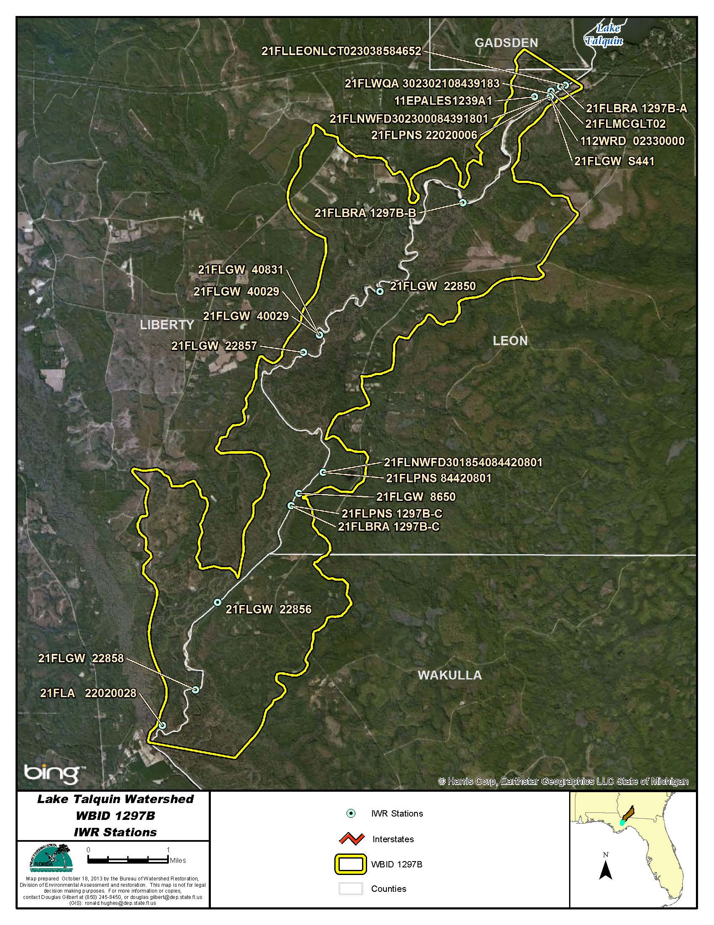
Figure B.4N.1. Ochlockonee River Below Lake Talquin WBID 1297B IWR Stations

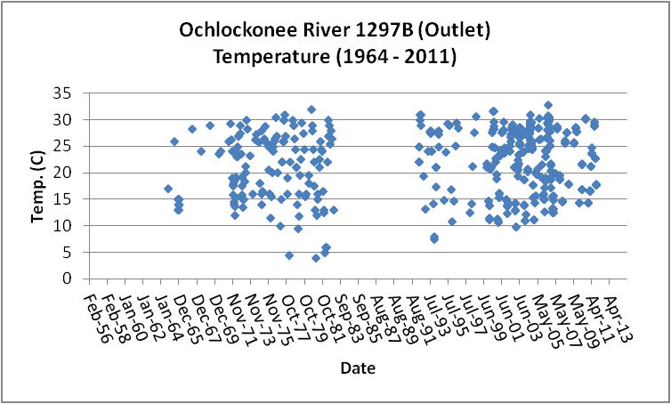
Figure B.4N.2. Ochlockonee River WBID 1297B Outlet Daily Temperature 1964 - 2011

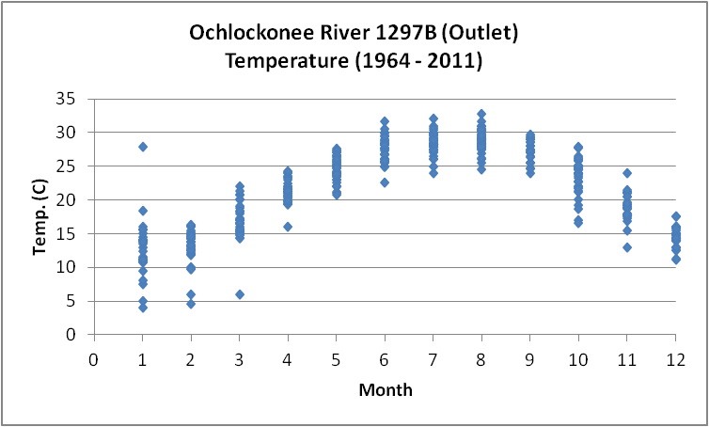
Figure B.4N.3. Ochlockonee River WBID 1297B Outlet Monthly Temperature 1964 - 2011

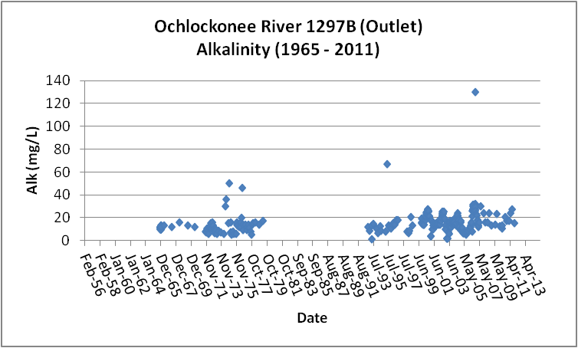
Figure B.4N.4. Ochlockonee River WBID 1297B Outlet Daily Average Alkalinity 1965- 2011

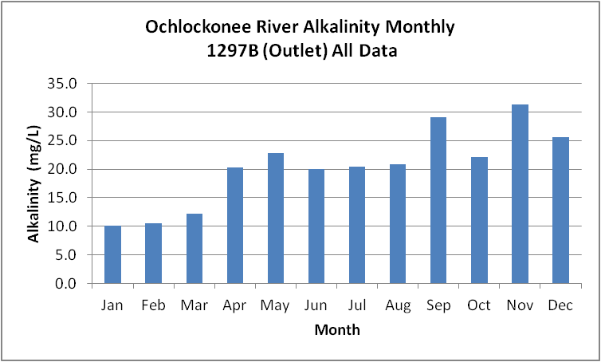
Figure B.4N.5. Ochlockonee River WBID 1297B Outlet Monthly Average Alkalinity 1965- 2011

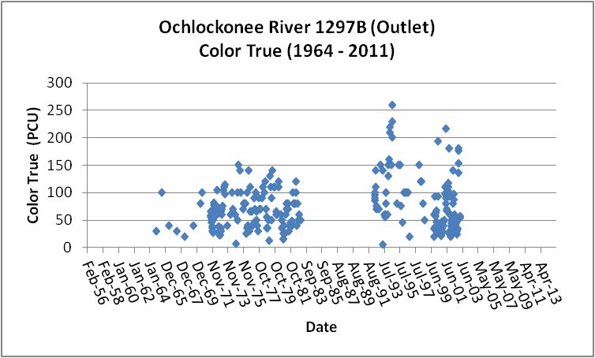
Figure B.4N.6. Ochlockonee River WBID 1297B Outlet Daily Average True Color 1964- 2011

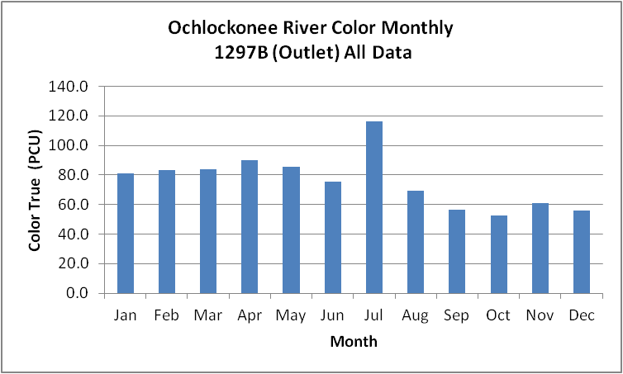
Figure B.4N.7. Ochlockonee River WBID 1297B Outlet Monthly Average True Color 1964- 2011

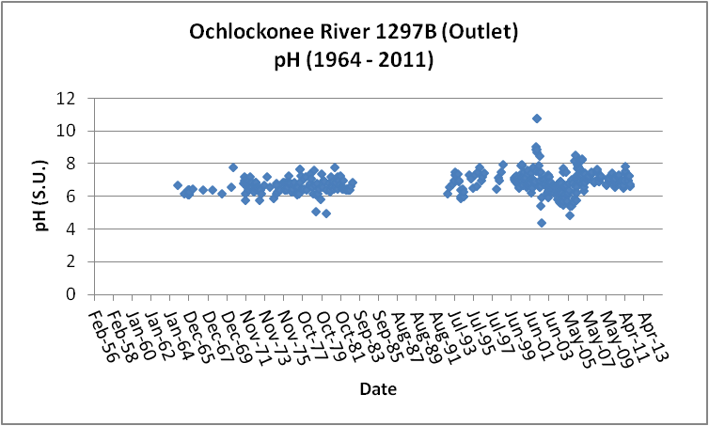
Figure B.4N.8. Ochlockonee River WBID 1297B Outlet Daily pH 1964- 2011

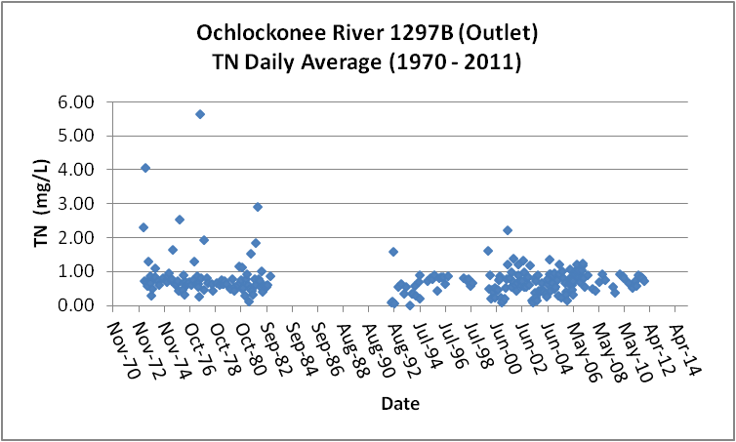
Figure B.4N.9. Ochlockonee River WBID 1297B Outlet Daily Average TN1970- 2011

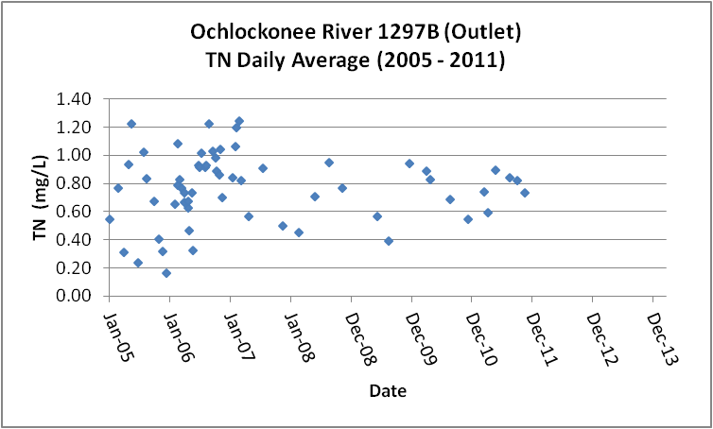
Figure B.4N.10. Ochlockonee River WBID 1297B Outlet Daily Average TN 2005- 2011

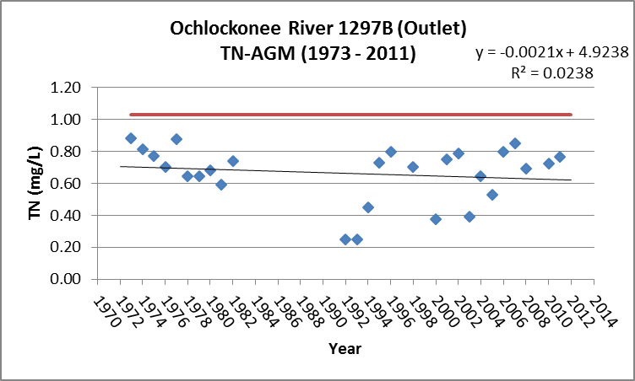
Figure B.4N.11. Ochlockonee River WBID 1297B Outlet TN Annual Geomean 1973- 2011

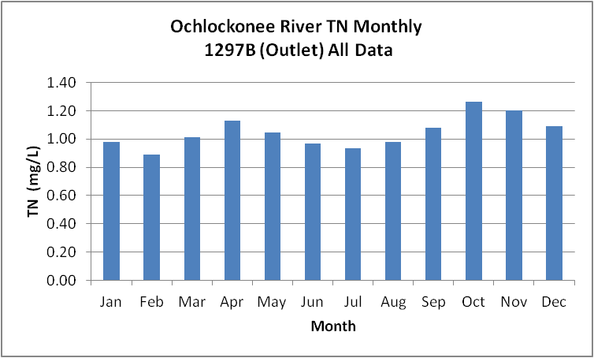
Figure B.4N.12. Ochlockonee River WBID 1297B Outlet Monthly Average TN 1970- 2011

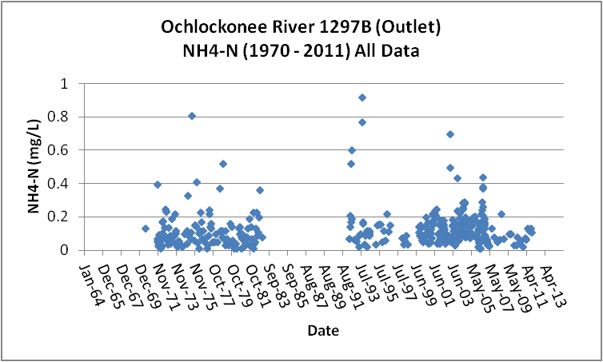
Figure B.4N.13. Ochlockonee River WBID 1297B Outlet Daily Average Ammonia-N 1970- 2011

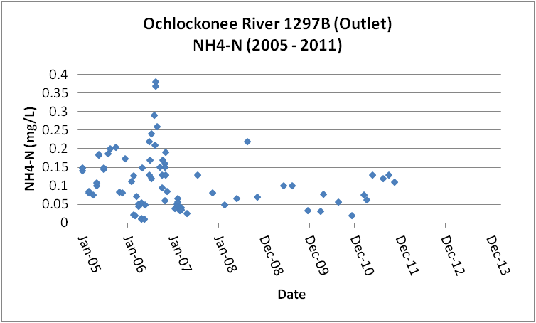
Figure B.4N.14. Ochlockonee River WBID 1297B Outlet Daily Average Ammonia-N 2005- 2011

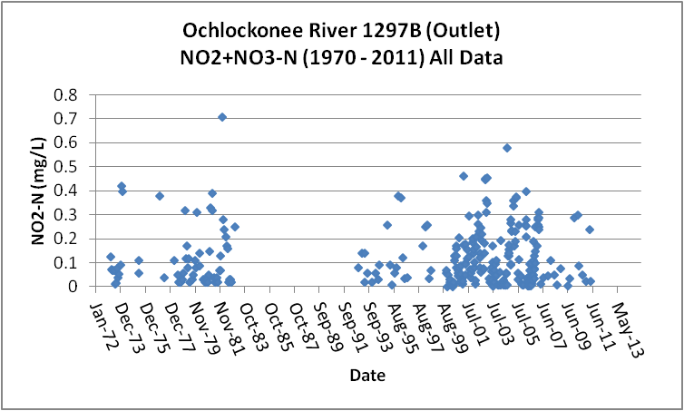
Figure B.4N.15. Ochlockonee River WBID 1297B Outlet Daily Average Nitrate/Nitrite-N1970- 2011

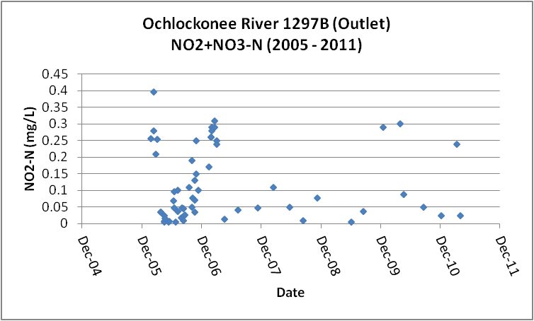
Figure B.4N.16. Ochlockonee River WBID 1297B Outlet Daily Average Nitrate/Nitrite-N2005- 2011

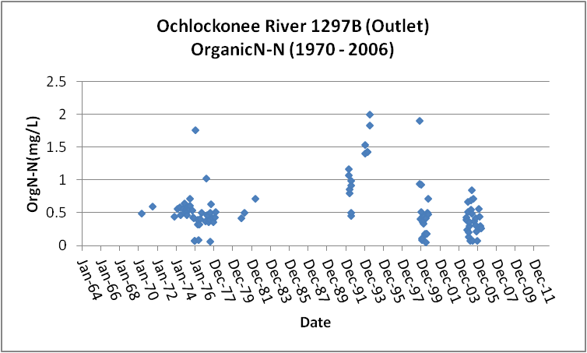
Figure B.4N.17. Ochlockonee River WBID 1297B Outlet Daily Average Organic-N 1970- 2006

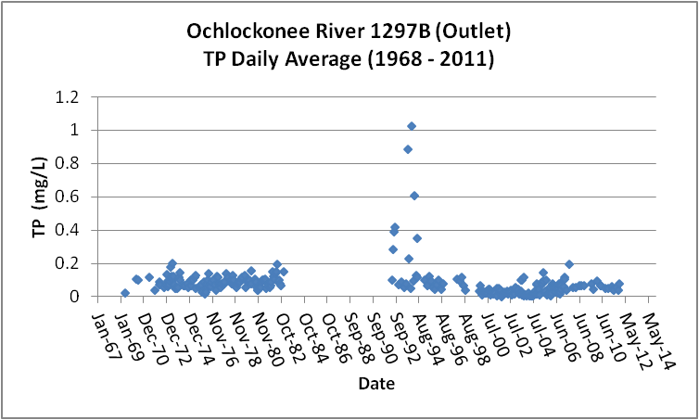
Figure B.4N.18. Ochlockonee River WBID 1297B Outlet Daily Average TP 1968 - 2011

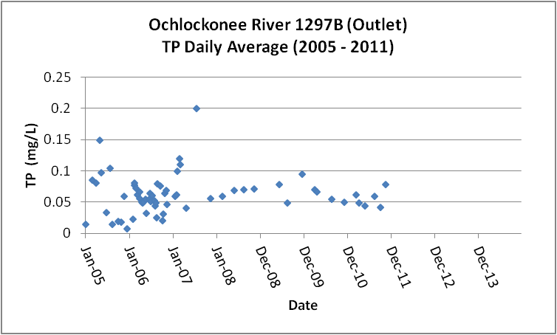
Figure B.4N.19. Ochlockonee River WBID 1297B Outlet Daily Average TP 2005 - 2011

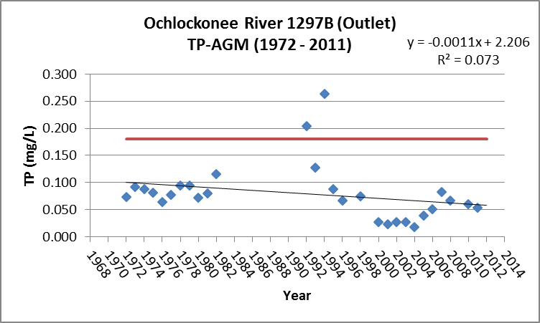
Figure B.4N.20. Ochlockonee River WBID 1297B Outlet Annual Geomean TP 1972 - 2011

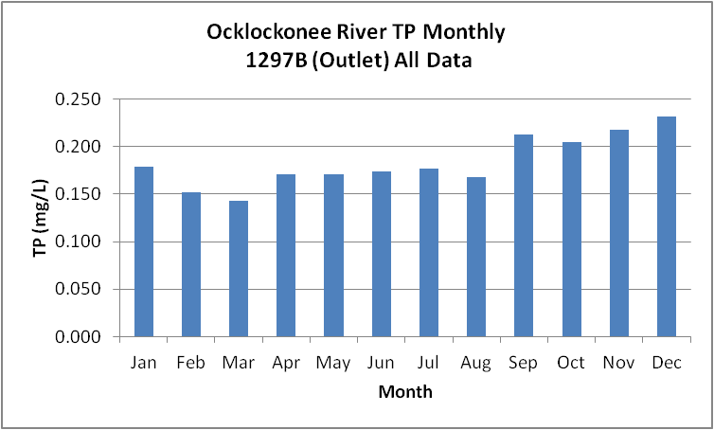
Figure B.4N.21. Ochlockonee River WBID 1297B Outlet Monthly Average TP 1968 - 2011

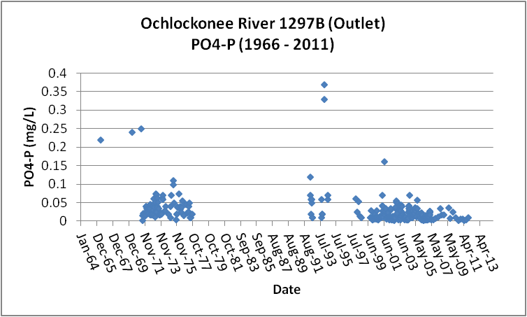
Figure B.4N.22. Ochlockonee River WBID 1297B Outlet Daily Average Orthophosphate-P 1966 - 2011

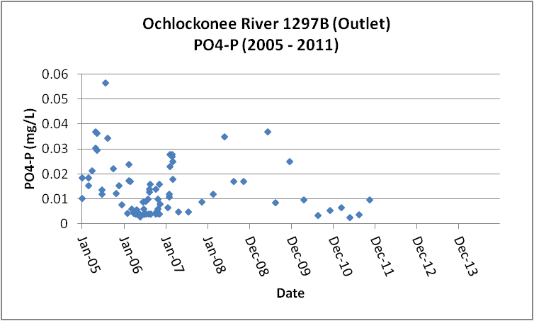
Figure B.4N.23. Ochlockonee River WBID 1297B Outlet Daily Average Orthophosphate-P 2005 - 2011

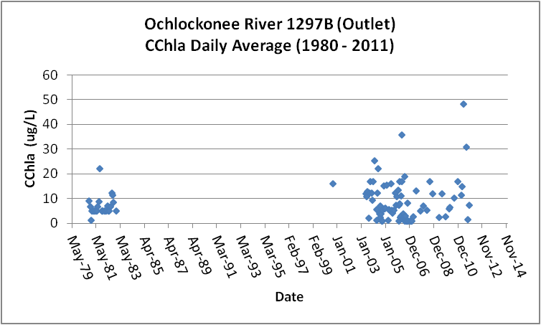
Figure B.4N.24. Ochlockonee River WBID 1297B Outlet Daily Average CChla 1980 - 2011

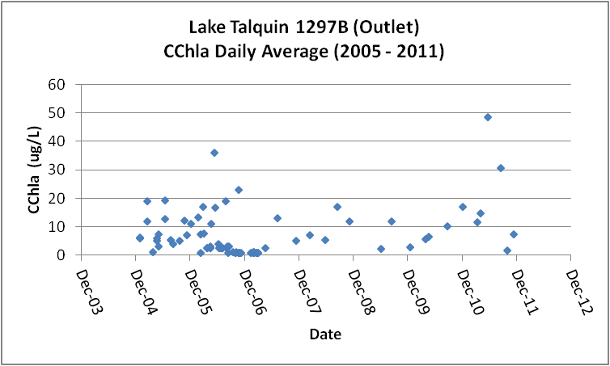
Figure B.4N.25. Ochlockonee River WBID 1297B Outlet Daily Average CChla 2005 - 2011

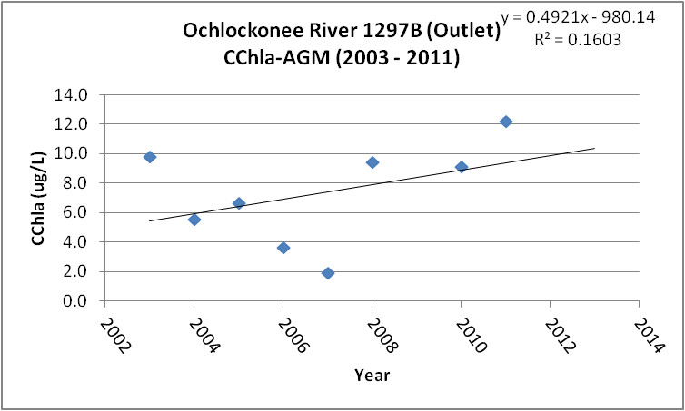
Figure B.4N.26. Ochlockonee River WBID 1297B Outlet Annual Geomean CChla 2003 - 2011

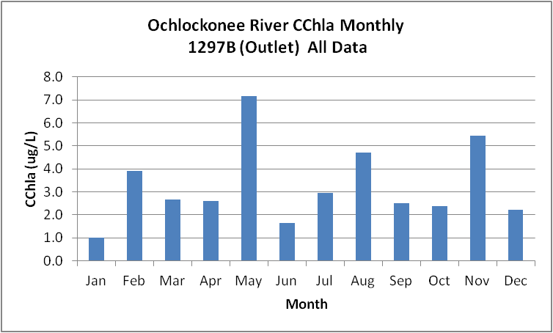
Figure B.4N.27. Ochlockonee River WBID 1297B Outlet Monthly Average CChla 1980 - 2011

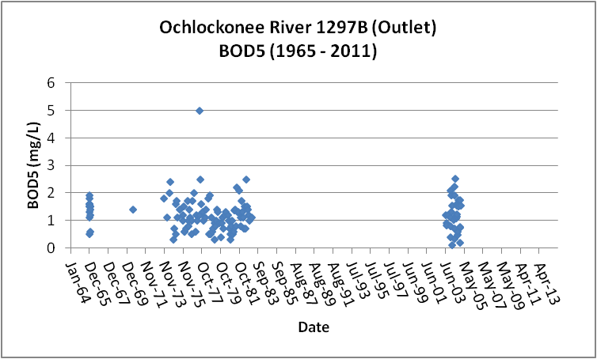
Figure B.4N.28. Ochlockonee River WBID 1297B Outlet Daily Average BOD5 1965 - 2011

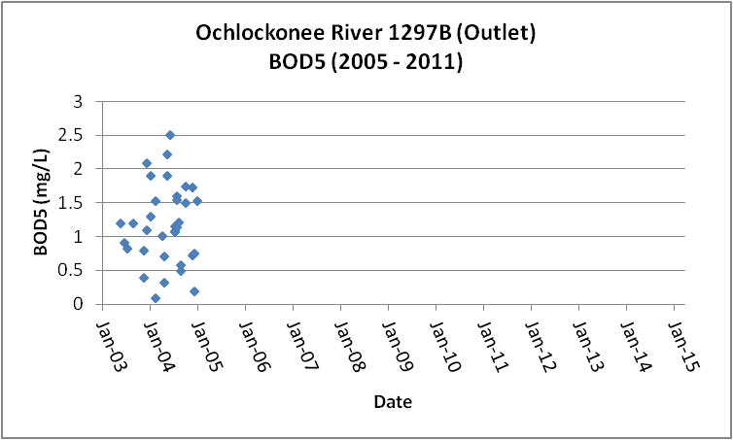
Figure B.4N.29. Ochlockonee River WBID 1297B Outlet Daily Average BOD5 2005 - 2011

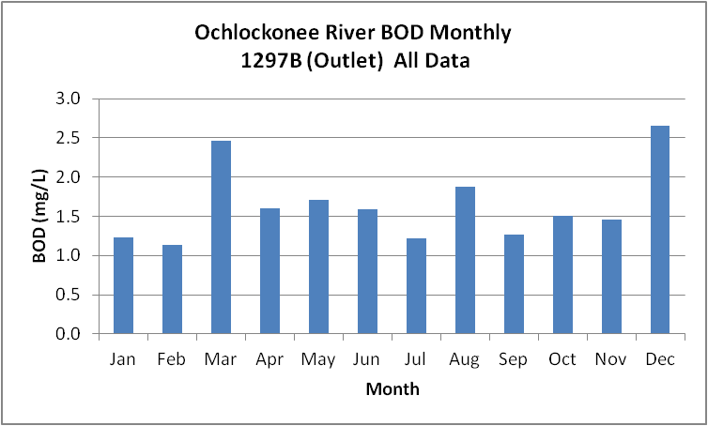
Figure B.4N.30. Ochlockonee River WBID 1297B Outlet Monthly Average BOD5 1965 - 2011

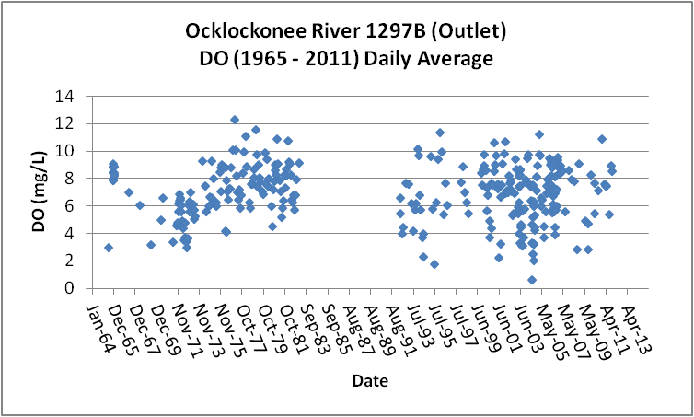
Figure B.4N.31. Ochlockonee River WBID 1297B Outlet Daily Average DO 1965 - 2011

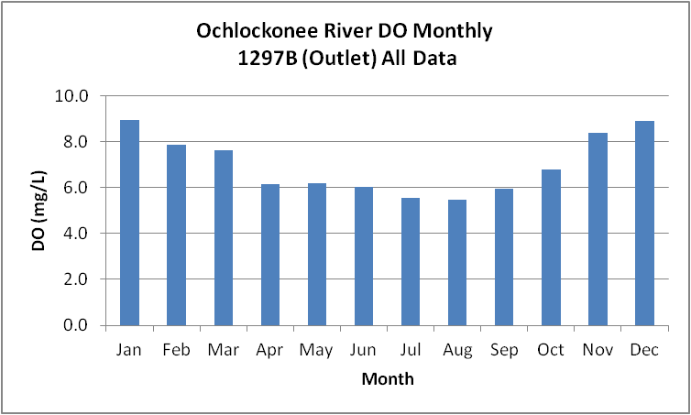
Figure B.4N.32. Ochlockonee River WBID 1297B Outlet Monthly Average DO 1965 - 2011

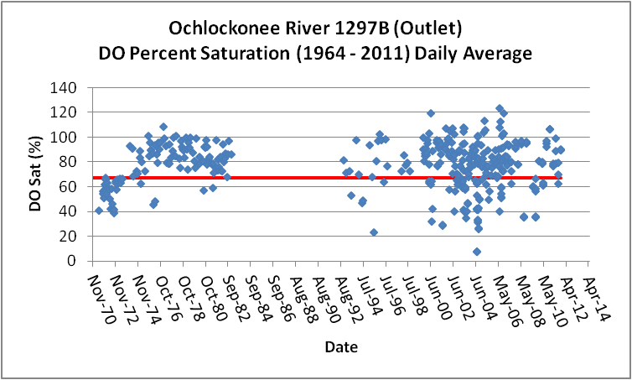
Figure B.4N.33. Ochlockonee River WBID 1297B Outlet Daily Average DO Percent Saturation 1964 - 2011

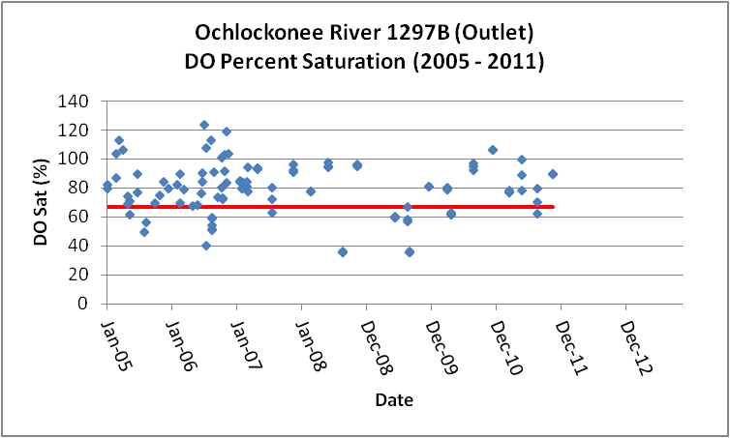
Figure B.4N.34. Ochlockonee River WBID 1297B Outlet Daily Average DO Percent Saturation 2005 - 2011

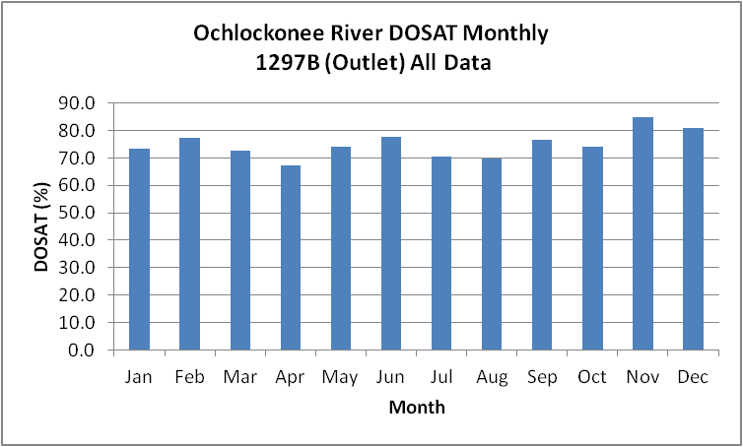
Figure B.4N35. Ochlockonee River WBID 1297B Outlet Monthly Average DO Percent Saturation 1964 - 2011

Table B.4N.1. Ochlockonee River WBID 1297B Outlet IWR Stations
WBID | Station Number | Station Name | Begin Date | End Date
1297B | 112WRD 02330000 | OCHLOCKONEE RIVER NR BLOXHAM, FLA. | 0 | 0
1297B | 11EPALES1239A1 | OCHLOCKONEE RIVER | 0 | 0
1297B | 21FLBRA 1297B-A | 1297B - Ochlockonee River - at SR-20 | 2006 | 2007
1297B | 21FLBRA 1297B-B | 1297B - Ochlockonee River - at FR-390 | 2006 | 2007
1297B | 21FLBRA 1297B-C | 1297B - Ochlockonee River - unnamed dirt rd S of Sweetwater | 2006 | 2006
1297B | 21FLGW 22850 | NW1-LR-2009 OCHLOCKONEE RIVER | 2004 | 2004
1297B | 21FLGW 22856 | NW1-LR-2036 OCHLOCKONEE RIVER | 2004 | 2004
1297B | 21FLGW 22857 | NW1-LR-2018 OCHLOCKONEE RIVER | 2004 | 2004
1297B | 21FLGW 22858 | NW1-LR-2029 OCHLOCKONEE RIVER | 2004 | 2004
1297B | 21FLGW 40029 | Z1-LR-5006 OCHLOCKONEE RIVER | 2011 | 2011
1297B | 21FLGW 40831 | Z1-LR-5006R OCHLOCKONEE RIVER | 2011 | 2011
1297B | 21FLGW 8650 | NWA-HS-1052 OCHLOCKONEE RIVER | 2000 | 2000
1297B | 21FLGW S441 | OCHLOCKONEE RIVER @ HWY 20 | 0 | 0
1297B | 21FLLEONLCT023038584652 | Ochlockonee River South of 20 | 2006 | 2011
1297B | 21FLMCGLT02 | Ochlockonee River, south of Lake Talquin | 2000 | 2006
1297B | 21FLNWFD301854084420801 | Ochlockonee River above Telogia Cr. | 0 | 0
1297B | 21FLNWFD302300084391801 | Ochlockonee River @ SR 20 | 0 | 0
1297B | 21FLPNS 1297B-C | Ochlockonee River | 0 | 0
1297B | 21FLPNS 22020006 | OCHLOCKONEE R AT FLA 20 | 0 | 0
1297B | 21FLPNS 84420801 | Ochlocknee Rv. TMDL | 0 | 0
1297B | 21FLWQA 302302108439183 | Ochlockonee River at SR 20 | 2002 | 2006

Table B.4N.2. Ochlockonee River WBID 1297B Outlet Long-Term Geomean Alkalinity and Color
WBID | Constituent | POR | Geomean
1297B | Alkalinity (mg/L) | 1965 - 2011 | 13.6
1297B | Color-True (PCU) | 1964 - 2011 | 57.7

Table B.4N.3. Ochlockonee River WBID 1297B Outlet DO Percent Saturation vs. 67% Criterion
Year | Category | Result
1964 - 2013 | Count | 416
- | Number P | 301
- | Number F | 115
- | Percent F | 27.6
- | - | -
2005 - 2013 | Count | 115
- | Number P | 90
- | Number F | 25
- | Percent F | 21.7

Table B.4N.4. Ochlockonee River WBID 1297B Outlet Annual Geomean TN, TP, TN/TP Ratio, and CChla
Year | TN (mg/L) | TP (mg/L) | TN/TP | CChla (ug/L)
- | AGM | AGM | Ratio | AGM
1971 | - | 0.207 | - | -
1972 | 1.09 | 0.214 | 5.1 | -
1973 | 1.15 | 0.158 | 7.3 | -
1974 | 1.14 | 0.243 | 4.7 | -
1975 | 0.92 | 0.155 | 6.0 | -
1976 | 0.83 | 0.150 | 5.5 | -
1977 | 1.04 | 0.239 | 4.4 | -
1978 | 1.17 | 0.212 | 5.5 | -
1979 | 1.19 | 0.184 | 6.5 | -
1980 | 1.34 | 0.224 | 6.0 | -
1981 | 1.55 | 0.337 | 4.6 | -
1982 | 1.24 | 0.206 | 6.0 | -
1983 | 1.15 | 0.133 | 8.7 | -
1984 | 1.35 | 0.196 | 6.9 | -
1985 | 1.40 | 0.216 | 6.5 | -
1986 | 1.81 | 0.214 | 8.5 | -
1987 | 1.11 | 0.124 | 8.9 | -
1988 | 1.30 | 0.280 | 4.6 | -
1989 | 1.10 | 0.281 | 3.9 | -
1990 | 0.82 | 0.176 | 4.7 | -
1991 | 0.94 | 0.139 | 6.8 | -
1992 | 0.53 | 0.172 | 3.1 | -
1993 | 0.73 | 0.176 | 4.2 | -
1994 | 0.68 | 0.127 | 5.3 | -
1995 | 1.08 | 0.135 | 8.0 | -
1996 | 0.98 | 0.157 | 6.2 | -
1997 | - | - | - | -
1998 | 1.06 | 0.115 | 9.2 | -
1999 | 0.84 | 0.146 | 5.8 | -
2000 | 0.90 | 0.125 | 7.2 | -
2001 | 0.83 | 0.112 | 7.4 | -
2002 | 0.70 | 0.130 | 5.4 | -
2003 | 0.83 | 0.114 | 7.3 | 1.4
2004 | - | - | - | -
2005 | - | - | - | -
2006 | 1.07 | 0.104 | 10.3 | 1.7
2007 | 1.11 | 0.128 | 8.7 | -
2008 | 1.00 | 0.118 | 8.5 | 2.0
2009 | - | - | - | -
2010 | 1.06 | 0.089 | 11.8 | 3.5
2011 | 0.94 | 0.090 | 10.4 | 10.1
2012 | - | - | - | -
2013 | 1.14 | 0.150 | 7.6 | 1.5

Table B.4N.5. Ochlockonee River WBID 1297B Outlet Water Quality Data Summary All Data
Constituent | Units | POR | Count | Min | Max | Median | Mean | Geomean
Temperature | C | 1964 - 2011 | 473 | 4.0 | 32.8 | 23.4 | 21.9 | 20.8
Alkalinity | mg/L | 1964 - 2011 | 300 | 1.0 | 130.0 | 14.0 | 15.7 | 13.6
pH | S.U. | 1964 - 2011 | 472 | 4.4 | 10.8 | 6.8 | NA | NA
Color | PCU | 1964 - 2011 | 370 | 5.0 | 260.0 | 60.0 | 68.7 | 57.7
TN | mg/L | 1970 - 2011 | 344 | 0.02 | 5.65 | 0.68 | 0.75 | 0.62
NH4-N | mg/L | 1970 - 2011 | 389 | 0.01 | 0.92 | 0.10 | 0.12 | 0.093
NO23 | mg/L | 1970 - 2011 | 297 | 0.003 | 0.71 | 0.07 | 0.12 | 0.066
OrgN | mg/L | 1970 - 2006 | 107 | 0.050 | 2.000 | 0.462 | 0.552 | 0.433
TP | mg/L | 1968 - 2011 | 374 | 0.002 | 1.070 | 0.060 | 0.082 | 0.052
PO4-P | mg/L | 1966 - 2011 | 300 | 0.002 | 0.370 | 0.017 | 0.028 | 0.017
CChla | ug/L | 1980 - 2011 | 149 | 1.0 | 48.5 | 5.3 | 7.8 | 5.1
BOD5 | mg/L | 1964 - 2011 | 213 | 0.1 | 6.6 | 1.4 | 1.6 | 1.3
DO | mg/L | 1964 - 2011 | 473 | 0.2 | 12.3 | 7.1 | 6.9 | 6.4
%DOSat | % | 1964 - 2011 | 414 | 7.7 | 123.7 | 79.7 | 76.4 | 72.9

Table B.4N.6. Ochlockonee River WBID 1297B Outlet Water Quality Data Summary Verified Period (2005 – 2011)
Constituent | Units | Verified Period | Count | Min | Max | Median | Mean | Geomean
Temperature | C | 2005 - 2011 | 124 | 11.1 | 32.8 | 21.6 | 22.0 | 21.2
Alkalinity | mg/L | 2005 - 2011 | 78 | 5.3 | 130.0 | 15.6 | 19.0 | 15.8
pH | S.U. | 2005 - 2011 | 127 | 4.9 | 8.6 | 7.1 | NA | NA
Color | PCU | 2005 - 2011 | 72 | 15.0 | 100.0 | 42.5 | 50.1 | 42.7
TN | mg/L | 2005 - 2011 | 77 | 0.17 | 1.49 | 0.82 | 0.79 | 0.74
NH4-N | mg/L | 2005 - 2011 | 80 | 0.01 | 0.44 | 0.10 | 0.12 | 0.088
NO23 | mg/L | 2005 - 2011 | 81 | 0.004 | 0.40 | 0.08 | 0.13 | 0.069
OrgN | mg/L | 2005 - 2011 | 21 | 0.081 | 0.846 | 0.314 | 0.370 | 0.302
TP | mg/L | 2005 - 2011 | 81 | 0.008 | 0.200 | 0.060 | 0.064 | 0.055
PO4-P | mg/L | 2005 - 2011 | 76 | 0.003 | 0.057 | 0.010 | 0.014 | 0.010
CChla | ug/L | 2005 - 2011 | 81 | 1.0 | 48.5 | 4.0 | 7.3 | 4.2
BOD5 | mg/L | 2005 - 2011 | 77 | 0.1 | 6.6 | 2.0 | 2.2 | 1.8
DO | mg/L | 2005 - 2011 | 127 | 2.8 | 11.2 | 7.6 | 7.2 | 6.9
%DOSat | % | 2005 - 2011 | 115 | 35.5 | 123.7 | 79.7 | 79.1 | 76.9

B.5 Summary of Water Quality Data
The figures below are based on the monthly average results and are presented in the following order for each figure. The Little River (LR-I), Ochlockonee River above Lake Talquin (OR-I), Upper Lake Talquin (LT-U), Lower Lake Talquin (LT-L), and the Ochlockonee River below Lake Talquin (OR-O).
Color:
The monthly average color concentration (Figure B.5.1) in the Little River appears more variable than the color in the Ochlockonee River, although both peak in July (corresponding to the month with greatest rainfall) and reach their lowest level during fall and early winter when rainfall is at the minimum. Except for June, the color in the Upper area of the lake (Figure B.5.2) is always greater than in the Lower area of the lake and peaks in March, corresponding to the month with the highest inflows from the rivers. Similar to the rivers, the lake color is at its minimum during fall and winter. The color of the Ochlockonee River below the lake (Figure B.5.3) more closely follows the pattern in the Lower area lake than the upstream river as it flows into Lake Talquin. The results for the POR color indicate that both major rivers and the Upper area of Lake Talquin have equivalent long-term color concentrations (62.3 PCU – 63.1 PCU), while the Lower area of the lake has a POR color concentration of 53.2 and the Ochlockonee River below the lake is 57.3 PCU.

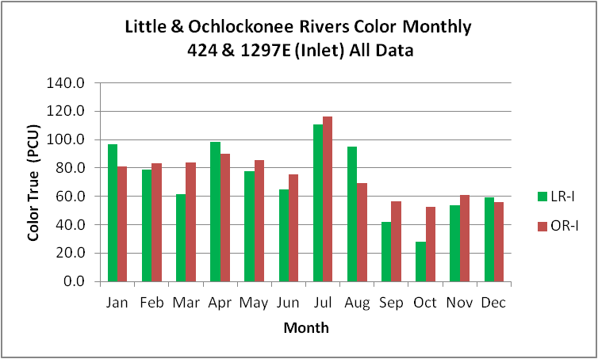
Figure B.5.1. Little and Ochlockonee River WBIDs Monthly Average Color

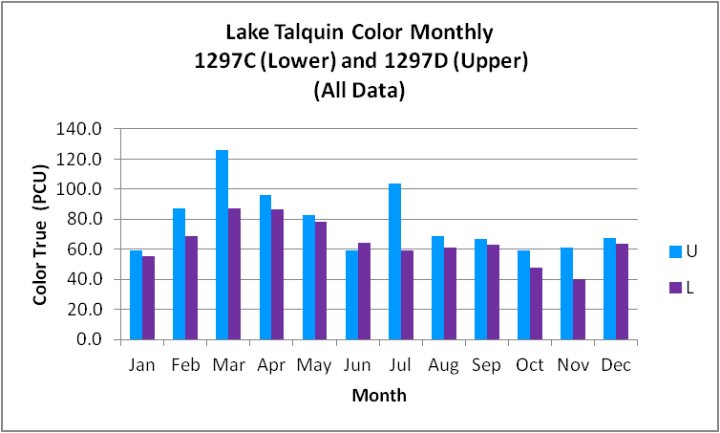
Figure B.5.2. Lake Talquin Upper and Lower WBIDs Monthly Average Color

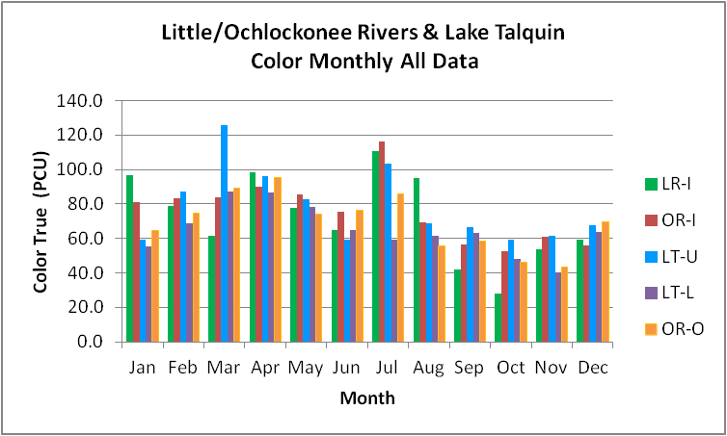
Figure B.5.3. Little/Ochlockonee Rivers and Lake Talquin Upper and Lower WBIDs Monthly Average Color

Alkalinity:

The alkalinity monthly concentration (Figure B.5.4) in the Ochlockonee River appears more variable than in the Little River, although the general patterns are similar with increasing concentrations between January and April, more stable concentrations through August, and higher concentrations during fall, decreasing during the winter months to the lowest levels (January). For most months of the year, the alkalinity in the Upper area of the lake (Figure B.5.5) is always greater than in the Lower area of the lake and peaking in the middle of the summer in both areas of the lake, then generally increasing in the Upper area and decreasing in the Lower portion of the lake. The alkalinity of the Ochlockonee River below the lake (Figure B.5.6) more closely follows the pattern in the Lower area of the lake than the upstream rivers as they flow into Lake Talquin. The results for the POR alkalinity indicate that both the Ochlockonee River above the lake and the Upper area of the lake have equivalent POR alkalinity concentrations (16.7 mg/L) while the Little River above the lake, the Lower area of the lake and the Ochlockonee River below the lake have equivalent POR concentrations (13.6 mg/L – 14.0 mg/L).

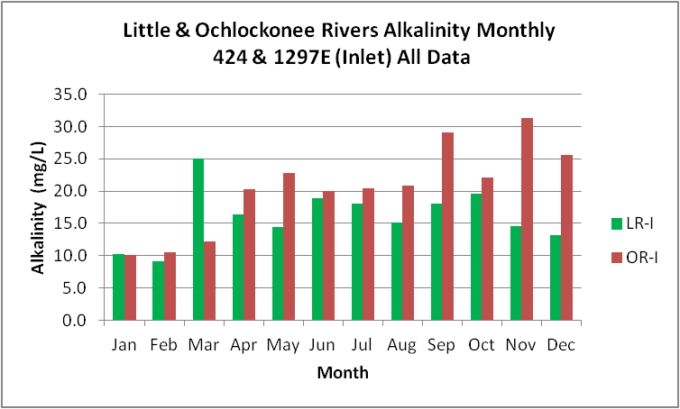
Figure B.5.4. Little and Ochlockonee River WBIDs Monthly Average Alkalinity

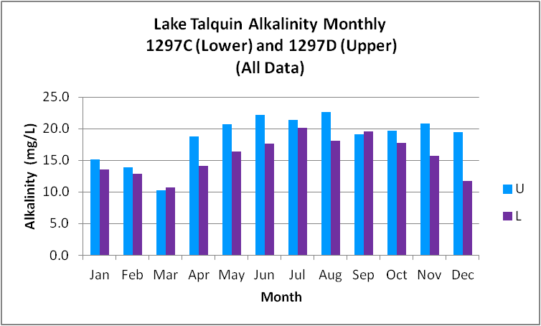
Figure B.5.5. Lake Talquin Upper and Lower WBIDs Monthly Average Alkalinity

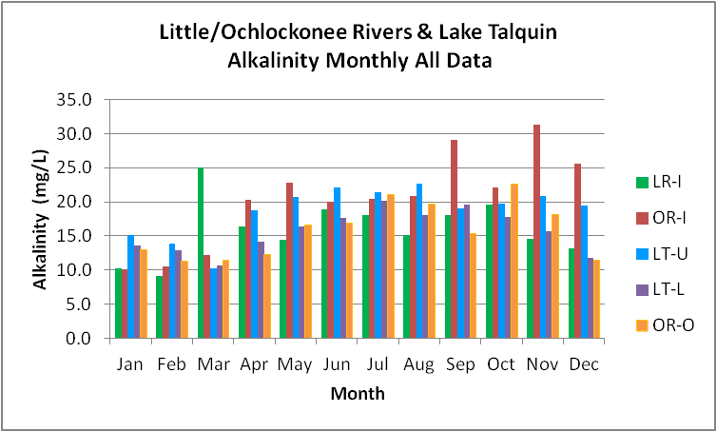
Figure B.5.6. Little/Ochlockonee Rivers and Lake Talquin Upper and Lower WBIDs Monthly Average Alkalinity

TN:

The TN monthly average concentration (Figure B.5.7) in the Ochlockonee River above the lake is often less than half the concentration in the Little River above the lake and appears to have the same general pattern with increasing concentrations between January and April, corresponding with increased flow in the rivers, lower concentrations in late summer, increasing through October/November, and then decreasing in December. In both areas of the lake (Figure B.5.8), concentrations are generally less than in the incoming Ochlockonee and Little Rivers. For most months of the year, the TN in the Upper area of the lake is greater than in the Lower area of the lake and declines from January through March, then increases to maximum levels in late summer. It appears that TN concentrations in the Upper lake hold steady during the fall and early winter while concentrations in the lower lake gradually decline. The TN concentrations of the Ochlockonee River below the lake (Figure B.5.9) are always less than the monthly average concentrations of the two main incoming rivers and less than the in-lake concentrations during April through July. The concentrations below the lake more closely follow the pattern in the Lower lake than the upstream rivers as they flow into Lake Talquin. The results for TN during the period 2005 – 2013 indicate that both major rivers have GM concentrations (OR-I 1.05 mg/L and LR-I 1.80 mg/L) well above the concentrations in the lake (LT-U 0.68 mg/L and LT-L 0.80 mg/L). The TN GM concentration in the OR-O below the lake of 0.74 mg/L is just above the concentration in Upper area of the lake and just below the concentration in the Lower area of the lake that discharges to the OR-O. In combination with the other data, this appears to indicate that the lake is retaining a large fraction of the nitrogen from incoming sources.

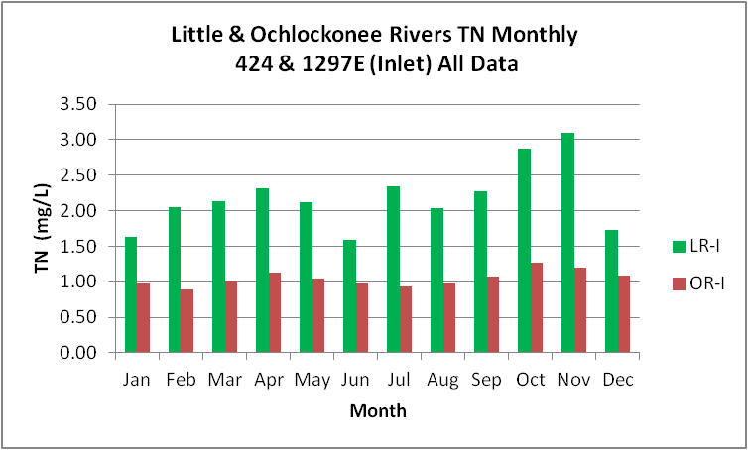
Figure B.5.7. Little and Ochlockonee River WBIDs Monthly Average TN

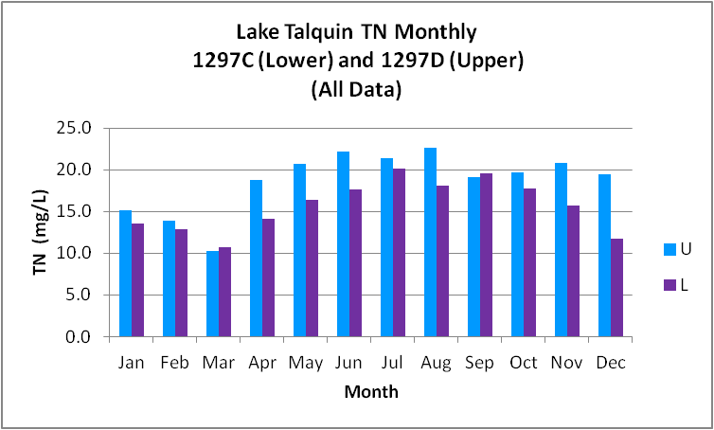
Figure B.5.8. Lake Talquin Upper and Lower WBIDs Monthly Average TN

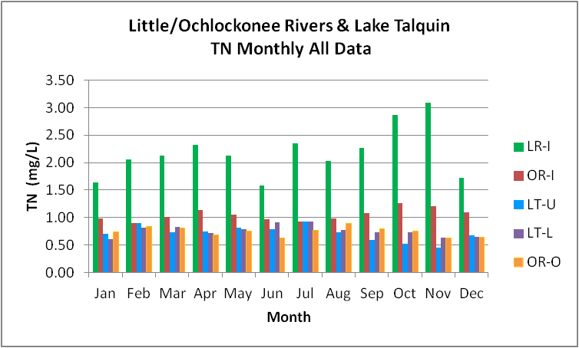
Figure B.5.9. Little/Ochlockonee Rivers and Lake Talquin Upper and Lower WBIDs Monthly Average TN

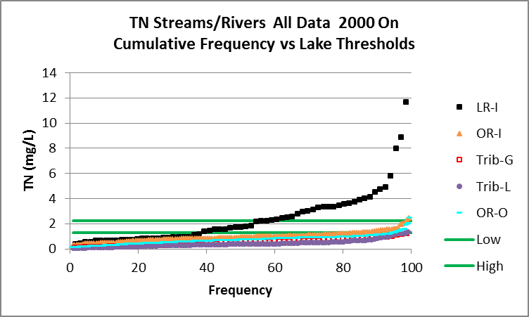

Figure B.5.10. TN Streams/Rivers All Data 2000 On Cumulative Frequency vs Lake Thresholds

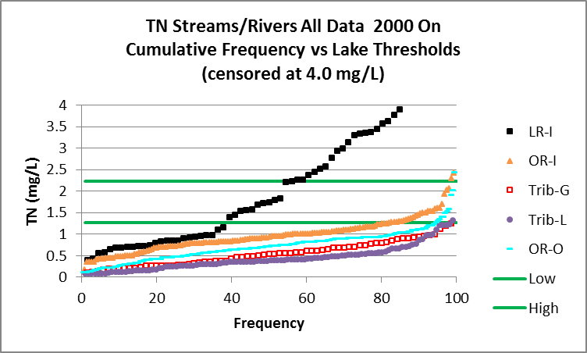

Figure B.5.11. TN Streams/Rivers All Data 2000 On Cumulative Frequency vs Lake Thresholds (censored at 4.0 mg/L)

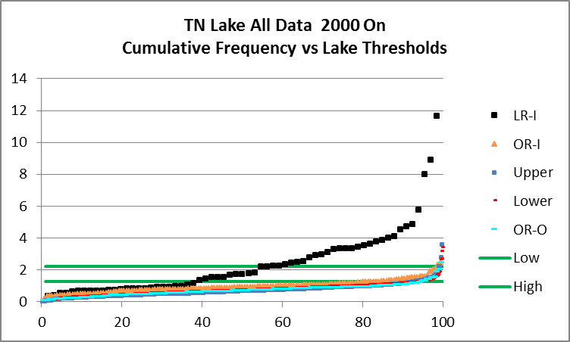

Figure B.5.12. TN Lake All Data 2000 On Cumulative Frequency vs Lake Thresholds

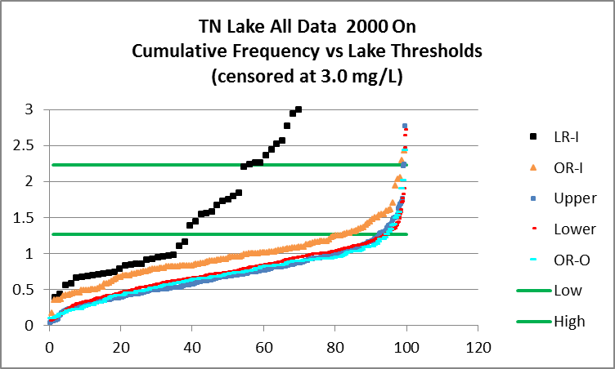

Figure B.5.13. TN Lake All Data 2000 On Cumulative Frequency vs Lake Thresholds (censored at 3.0 mg/L)

Table B.5.1. TN Tributaries Cumulative Frequency vs Lake Thresholds (2000 – Current)

 | TN | TN-Low | TN-High
Tribs | %<1.27 | %>1.27 | %>2.23
OR-I | 83.0 | 17.0 | 1.3
LR-I | 31.0 | 69.0 | 50.0
Tribs-G | 100.0 | 0.0 | 0.0
Tribs-L | 98.5 | 1.5 | 0.0
OR-O | 94.0 | 6.0 | 0.9

Table B.5.2. TN Tributaries vs Lake Cumulative Frequency vs Lake Thresholds (2000 – Current)

 | TN | TN-Low | TN-High
Lake | %<1.27 | %>1.27 | %>2.23
OR-I | 83.0 | 17.0 | 1.3
LR-I | 31.0 | 69.0 | 50.0
Upper | 92.4 | 7.6 | 0.8
Lower | 87.5 | 12.5 | 0.9
OR-O | 94.0 | 6.0 | 0.9

TP:

The TP monthly concentration (Figure B.5.14) in the Ochlockonee River is often greater than the concentration in the Little River and appears to have a different seasonal pattern. Both rivers show fairly steady concentrations from April through August. From August through December concentrations in the Little River decline while concentrations in the Ochlockonee river above the lake appear to either hold steady or increase slightly. It should be noted that at the same time TP concentrations in the Little River are declining (August – November) TN concentrations are increasing. Whereas the TN and TP patterns in the Ochlockonee River above the lake are similar. For seven months of the year (March and June – November) the TP in the Upper area of the lake (Figure B.5.15) is less than in the Lower area of the lake. In both areas, concentrations peak in July and generally decline through November. The TP concentrations of the Ochlockonee River below the lake (Figure B.5.16) are always less than the concentrations of the incoming rivers. The seasonal pattern in the river shows four peak concentration periods, January, April, July, and September. The results for TP during the period 2005 – 2013 indicate that both major rivers have equivalent GM concentrations (OR-I 0.107 mg/L and LR-I 0.102 mg/L) of TP that are well above the concentrations in the lake (LT-U 0.056 mg/L and LT-L 0.054 mg/L). The data indicate that both the Upper and Lower areas of the lake have equivalent GM TP concentrations that are equivalent to the GM concentration in the OR-O below the lake of 0.055 mg/L.

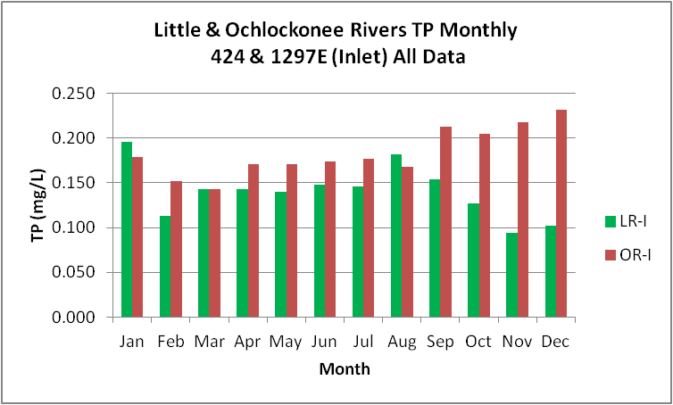
Figure B.5.14. Little and Ochlockonee River WBIDs Monthly Average TP

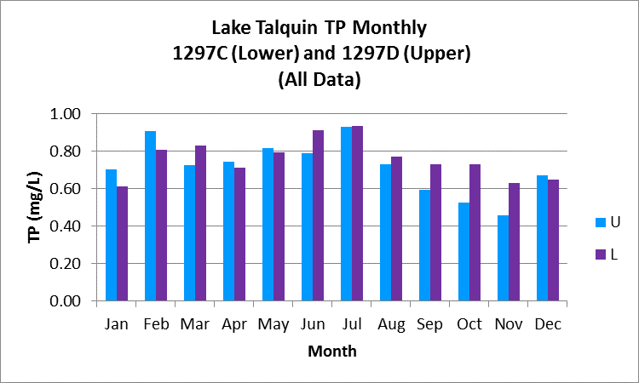
Figure B.5.15. Lake Talquin Upper and Lower WBIDs Monthly Average TP

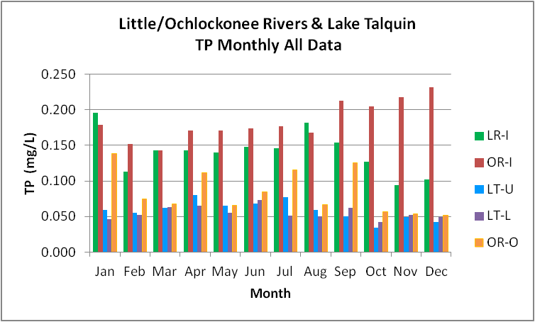
Figure B.5.16. Little/Ochlockonee Rivers and Lake Talquin Upper and Lower WBIDs Monthly Average TP
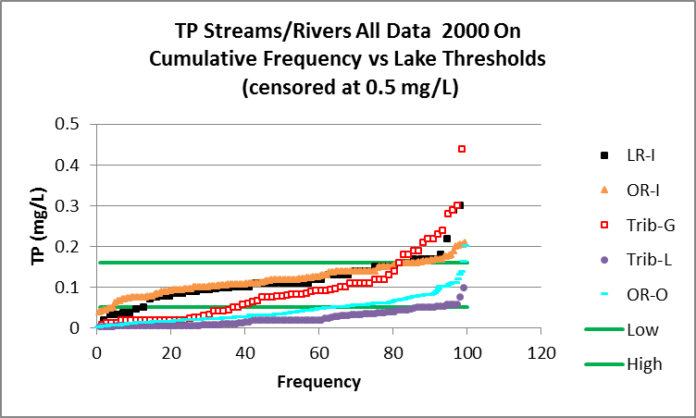

Figure B.5.17. TP Streams/Rivers All Data 2000 On Cumulative Frequency vs Lake Thresholds

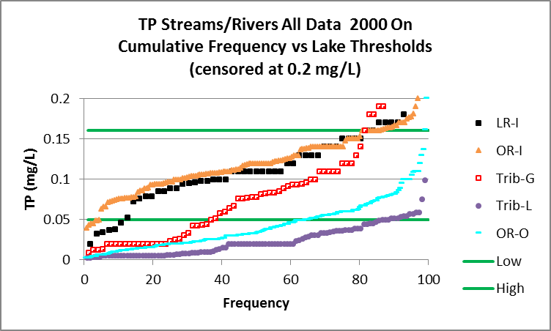

Figure B.5.18. TP Streams/Rivers All Data 2000 On Cumulative Frequency vs Lake Thresholds (censored at 0.2 mg/L)

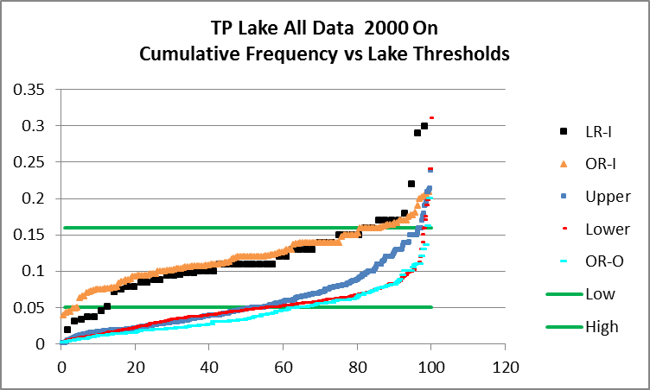

Figure B.5.19. TP Lake All Data 2000 On Cumulative Frequency vs Lake Thresholds

Table B.5.3. TP Tributaries Cumulative Frequency vs Lake Thresholds (2000 – Current)

 | TP | TP-Low | TP-High
Tribs | %<0.05 | %>0.05 | %>0.16
OR-I | 4.5 | 95.5 | 14.0
LR-I | 12.0 | 88.0 | 14.0
Tribs-G | 38.0 | 62.0 | 18.0
Tribs-L | 89.0 | 11.0 | 0.0
OR-O | 65.5 | 34.5 | 1.2

Table B.5.4. TP Tributaries vs Lake Cumulative Frequency vs Lake Thresholds (2000 – Current)
 | TP | TP-Low | TP-High
Lake | %<0.05 | %>0.05 | %>0.16
OR-I | 4.5 | 95.5 | 14.0
LR-I | 12.0 | 88.0 | 14.0
Upper | 53.3 | 46.7 | 2.5
Lower | 56.7 | 43.2 | 1.9
OR-O | 65.5 | 34.5 | 1.2

TN to TP Ratio:

TN to TP ratios (Figure B.5.20) indicates that the OR-I has a 2000 – 2013 annual average ratio of 8.5 indicating nitrogen limitation. The LR-I TN/TP average annual ratio of 14.8 for this period indicate co-limitation and is a reflection of the higher concentrations of nitrogen in the Little River over the Ochlockonee River. Data for the lake indicate that except for 2000 and 2013, the TN/TP ratio in the Upper area of the lakes is greater than 10 and generally lower than the TN/TP ratio in the Lower area of the lake, reflecting the influence of the OR-I. The data indicate that the lake becomes progressively more co-limited as you move from the Upper (13.6) area of the lake towards the dam (16.6). The TN/TP ratio of the river below the lake is 18.3. Results from averaging the monthly average GM TN and TP concentrations indicate that the OR-I (5.8), Richlander Creek (8.3), Rocky Comfort Creek (5.7), Bear Creek (5.9), and the OR-O (9.8) all tend to be N-Limited. Both the Upper (12.5) and Lower (14.0) areas of the lake, the LR-I (16.5), Polk Creek (18.4), Ocklawaha Creek (28.4), and Hammock creek tend to be Co-limited. Both Freeman Creek (53.1) and Harvey Creek (30.9) tend to be P-limited.

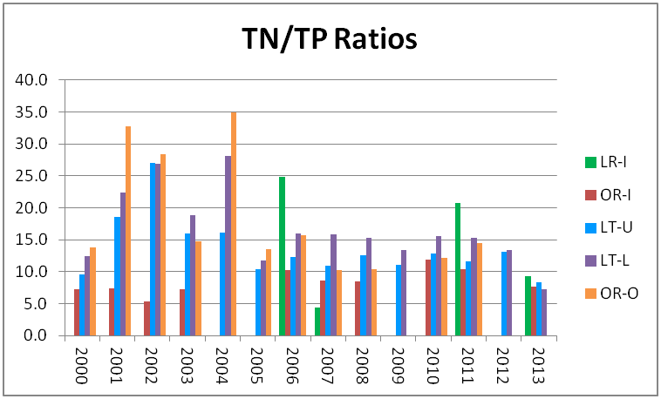
Figure B.5.20. Little and Ochlockonee Rivers and Lake Talquin Monthly Average TN/TP Ratio

CChla:

The CChla monthly concentration (Figure B.5.21) in the Ochlockonee River is greater than the concentration in the Little River during February through April and September through November and appears to have a similar seasonal pattern. Both rivers show higher concentrations during May, July, September, and November. The rivers exhibit fairly low concentrations from January through April, September, October, and December. The monthly average CChla concentration in the lake (Figure B.5.22) is always greater in the Lower area, averaging 4.9 ug/L higher. Both areas of the lake have peak concentrations in May and June with a large decrease in July. The average of the May and June monthly concentrations for the lake is 24.6 ug/L and for July it is 9.5 ug/L, a 61% reduction from the May-June average. This large reduction in July may be related to the large increase in rainfall (58%) that occurs in between May (average 3.7 inches) and June (average 8.8 inches). The data indicate that the increase in rainfall results in reduced CChla in the inflowing rivers, direct dilution of the lake, and a reduced residence time for the lake during this portion of the growing season. CChla monthly average concentrations in the lake rebound in August and September to about 17.2 ug/L and then gradually decline. The monthly average CChla in the Ochlockonee River below the lake (Figure B.5.23) is always less than the concentration in the lake with a maximum difference of 17.7 ug/L in July (9.3 ug/L and 27.0 ug/L, respectively). The results for CChla during the period 2005 – 2013 indicate that both major rivers have lower CChla GM concentrations than the lake. The data for the lake indicate the Lower area is more productive than the Upper area and the CChla in the river below the lake are about double the concentrations in the two upstream main rivers.

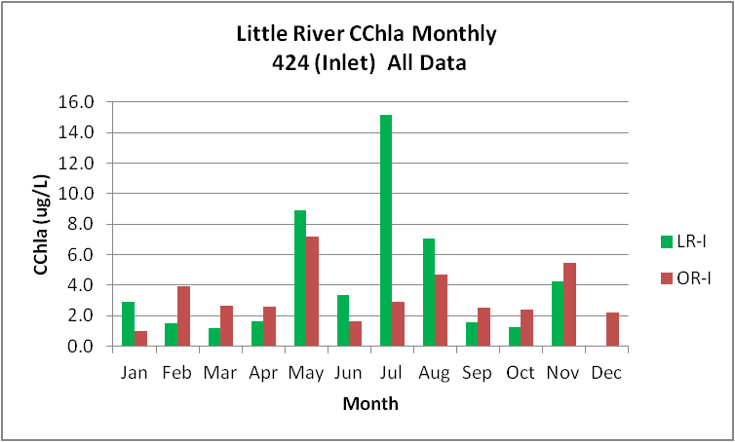
Figure B.5.21. Little and Ochlockonee River WBIDs Monthly Average CChla

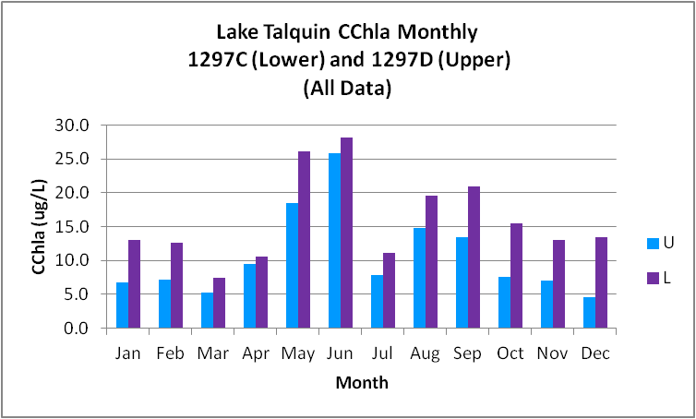
Figure B.5.22. Lake Talquin Upper and Lower WBIDs Monthly Average CChla

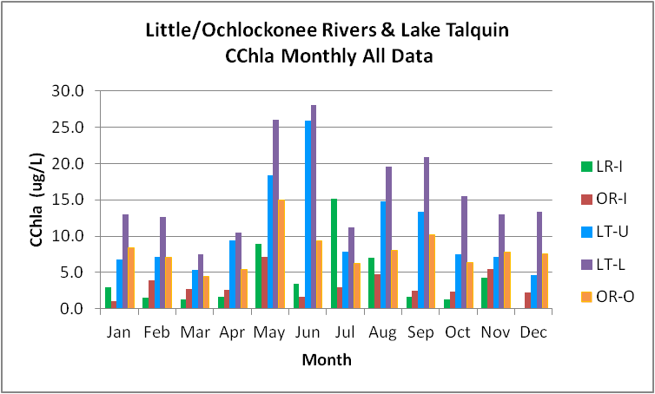
Figure B.5.23. Little/Ochlockonee Rivers and Lake Talquin Upper and Lower WBIDs Monthly Average CChla

BOD5:

The BOD5 monthly concentration (Figure B.5.24) in the Ochlockonee and Little Rivers follow a similar seasonal pattern from October through April with opposite trends from May through September. The monthly average BOD5 concentration in the lake (Figure B.5.25) is always greater in the Lower area, averaging 0.3 mg/L higher. Both areas of the lake have peak concentrations in May and June. The results for BOD5 during the period 2005 – 2013 indicate that both major rivers have lower BOD5 concentrations than the lake.

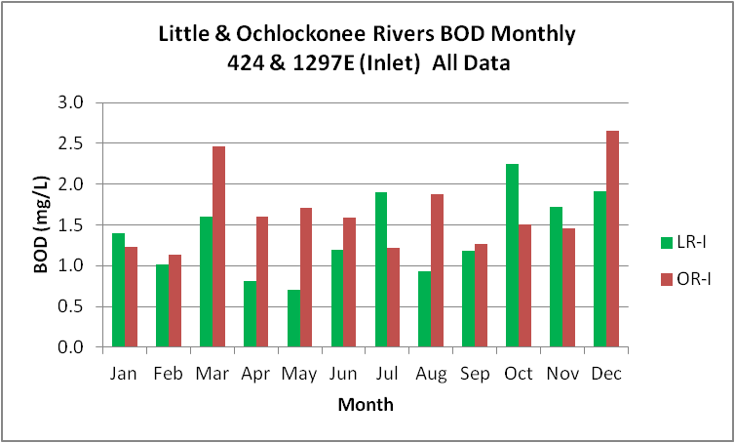
Figure B.5.24. Little and Ochlockonee River WBIDs Monthly Average BOD5

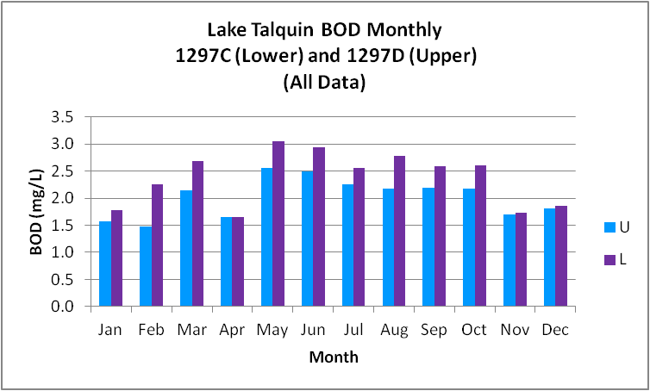
Figure B.5.25. Lake Talquin Upper and Lower WBIDs Monthly Average BOD5

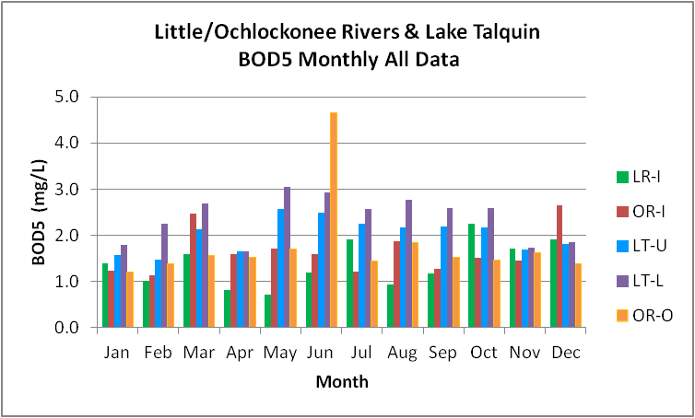
Figure B.5.26. Little/Ochlockonee Rivers and Lake Talquin Upper and Lower WBIDs Monthly Average BOD5

Dissolved Oxygen:

The DO monthly concentration (Figure B.5.27) in the Ochlockonee River is less than the concentration in the Little River for all months except January and appears to have a similar seasonal pattern. Both rivers have lower concentrations during April through August. The monthly average DO concentration in the lake (Figure B.5.28) is slightly greater in the Lower area during March, April May, and October. Both areas of the lake have the lowest DO concentrations in August. The monthly average DO in the Ochlockonee River below the lake (Figure B.5.29) follows the seasonal pattern in the lake. The results for DO during the period 2005 – 2013 indicate that both major rivers have DO average concentrations greater than the lake, as does the Ochlockonee River below the lake.

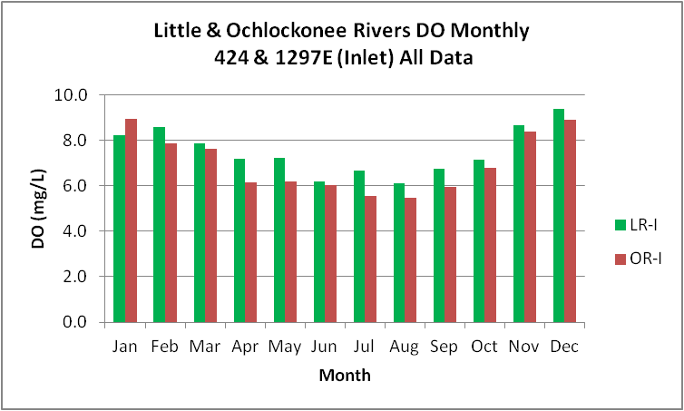
Figure B.5.27. Little and Ochlockonee River WBIDs Monthly Average DO

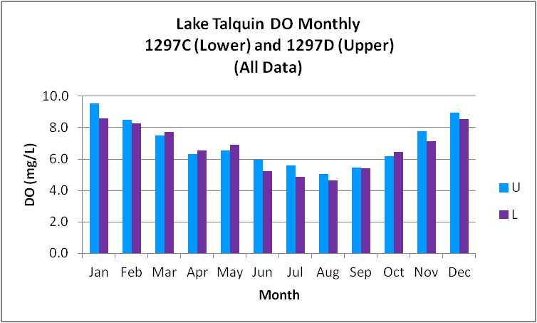
Figure B.5.28. Lake Talquin Upper and Lower WBIDs Monthly Average DO

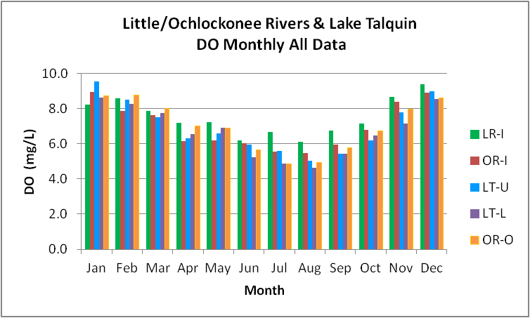
Figure B.5.29. Little/Ochlockonee Rivers and Lake Talquin Upper and Lower WBIDs Monthly Average DO

Dissolved Oxygen Percent Saturation:

The DO percent saturation (DO%S) monthly concentration (Figure B.5.30) in the Ochlockonee River is similar or slightly less than the average in the Little River except during June and October and appears to have a similar seasonal pattern. Both rivers show higher levels during November and December. The monthly average values in the lake (Figure B.5.31) are similar and follow the same seasonal pattern. The monthly average DO%S values in the Ochlockonee River below the lake (Figure B.5.32) are greater than the values in the lake during the summer (June, July, August, and September) and similar or less during other months of the year. The results for the period 2005 – 2013 indicate that both major rivers have higher values than the lake. The data for the lake indicate the Lower area is more productive (higher DO%S) than the Upper area.

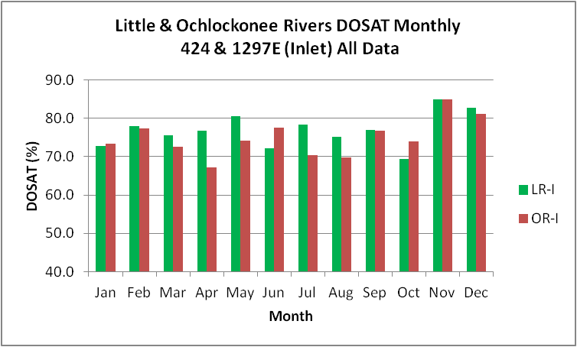
Figure B.5.30. Little and Ochlockonee River WBIDs Monthly Average DOSAT

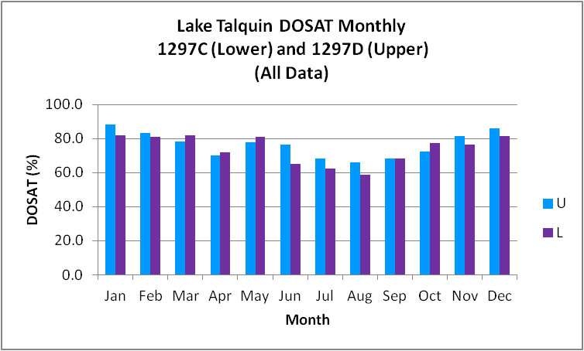
Figure B.5.31. Lake Talquin Upper and Lower WBIDs Monthly Average DOSAT (upper 2 meters)

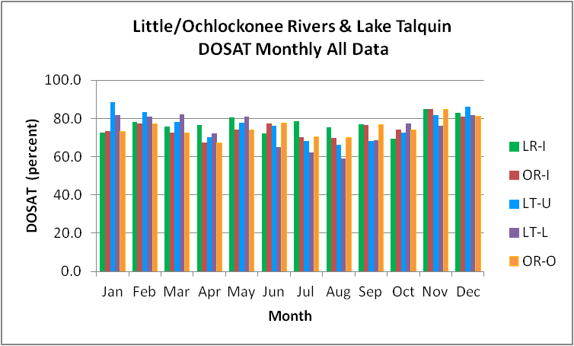
Figure B.5.32. Little/Ochlockonee Rivers and Lake Talquin Upper and Lower WBIDs Monthly Average DOSAT

B.6 Summary of Landuse Data

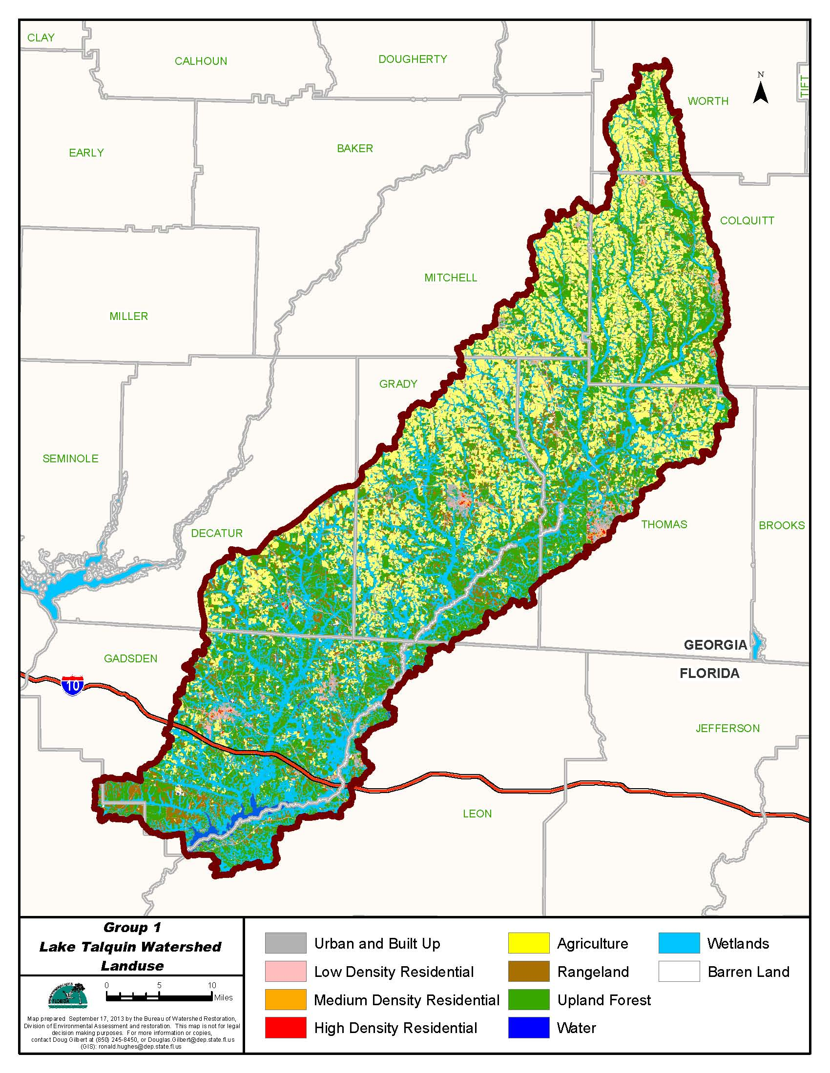

Figure B.6.1. Principal Land Uses in the Lake Talquin Watershed, 2006

Table B.6.1. Classification of Land Use Categories in the Lake Talquin Watershed, 2006
- = Empty cell/no data
LU Code | Landuse | Acres | Square Miles | Percentage
11 | Water | 13,629.2 | 21.3 | 1.4
21 | Urban Built up | 47,743.3 | 74.6 | 4.8
22 | Low Density Residential | 14,205.0 | 22.2 | 1.4
23 | Medium Density Residential | 2,442.1 | 3.8 | 0.2
24 | High Density Residential | 1,200.1 | 1.9 | 0.1
31 | Barren Land | 1,662.6 | 2.6 | 0.2
41 | Upland Forest | 307,305.2 | 480.2 | 30.6
52 | Rangeland | 78,766.2 | 123.1 | 7.8
81 | Agriculture | 280,674.7 | 438.6 | 28.0
90 | Wetlands | 256,402.3 | 400.6 | 25.5
TOTAL | Watershed | 1,004,030.6 | 1,568.8 | 100.0

Ochlockonee River above Lake Talquin

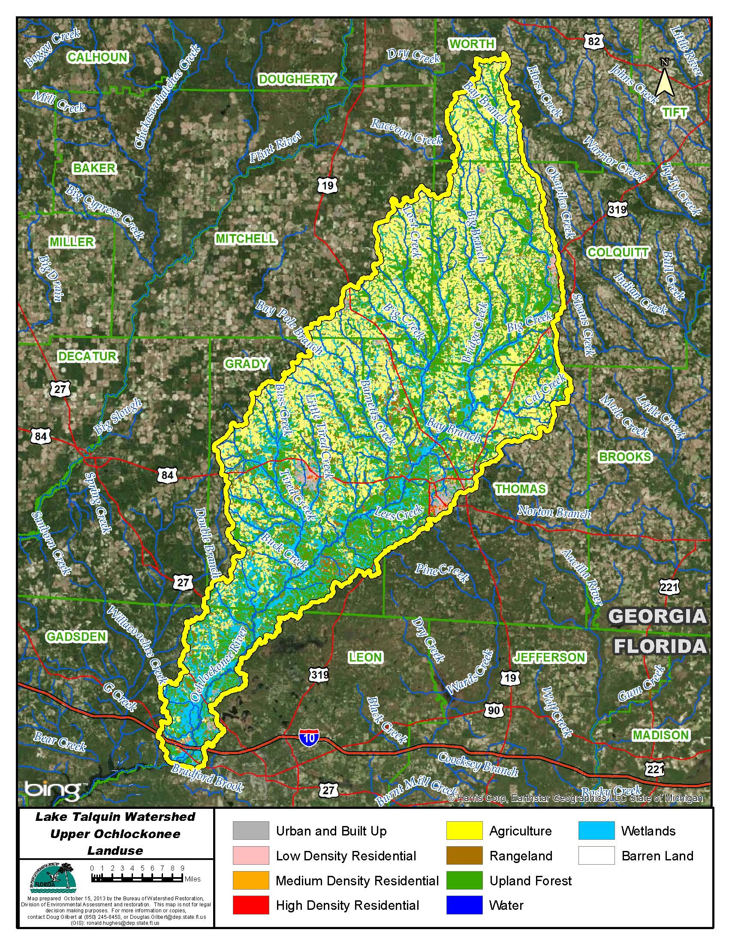

Figure B.6.2. Principal Land Uses in the Ochlockonee River Watershed above Lake Talquin, 2006

Table B.6.2. Classification of Land Use Categories in the Ochlockonee River above Lake Talquin Watershed, 2006

LU Code | Landuse | Acres | Square Miles | Percentage
11 | Water | 5,234.3 | 8.2 | 0.8
21 | Urban Built up | 33,994.0 | 53.1 | 4.9
22 | Low Density Res | 10,597.5 | 16.6 | 1.5
23 | Medium Density Res | 1,871.4 | 2.9 | 0.3
24 | High Density Res | 929.2 | 1.5 | 0.1
31 | Barren Land | 872.0 | 1.4 | 0.1
41 | Upland Forest | 201,640.8 | 315.1 | 29.2
52 | Rangeland | 49,878.1 | 77.9 | 7.2
81 | Agriculture | 231,796.5 | 362.2 | 33.6
90 | Wetlands | 153,385.1 | 239.7 | 22.2
Total | Watershed | 690,198.9 | 1,078.4 | 100.0

Hunter Creek

Hunter Creek drains directly to Lake Talquin between the Ochlockonee River and Little River.

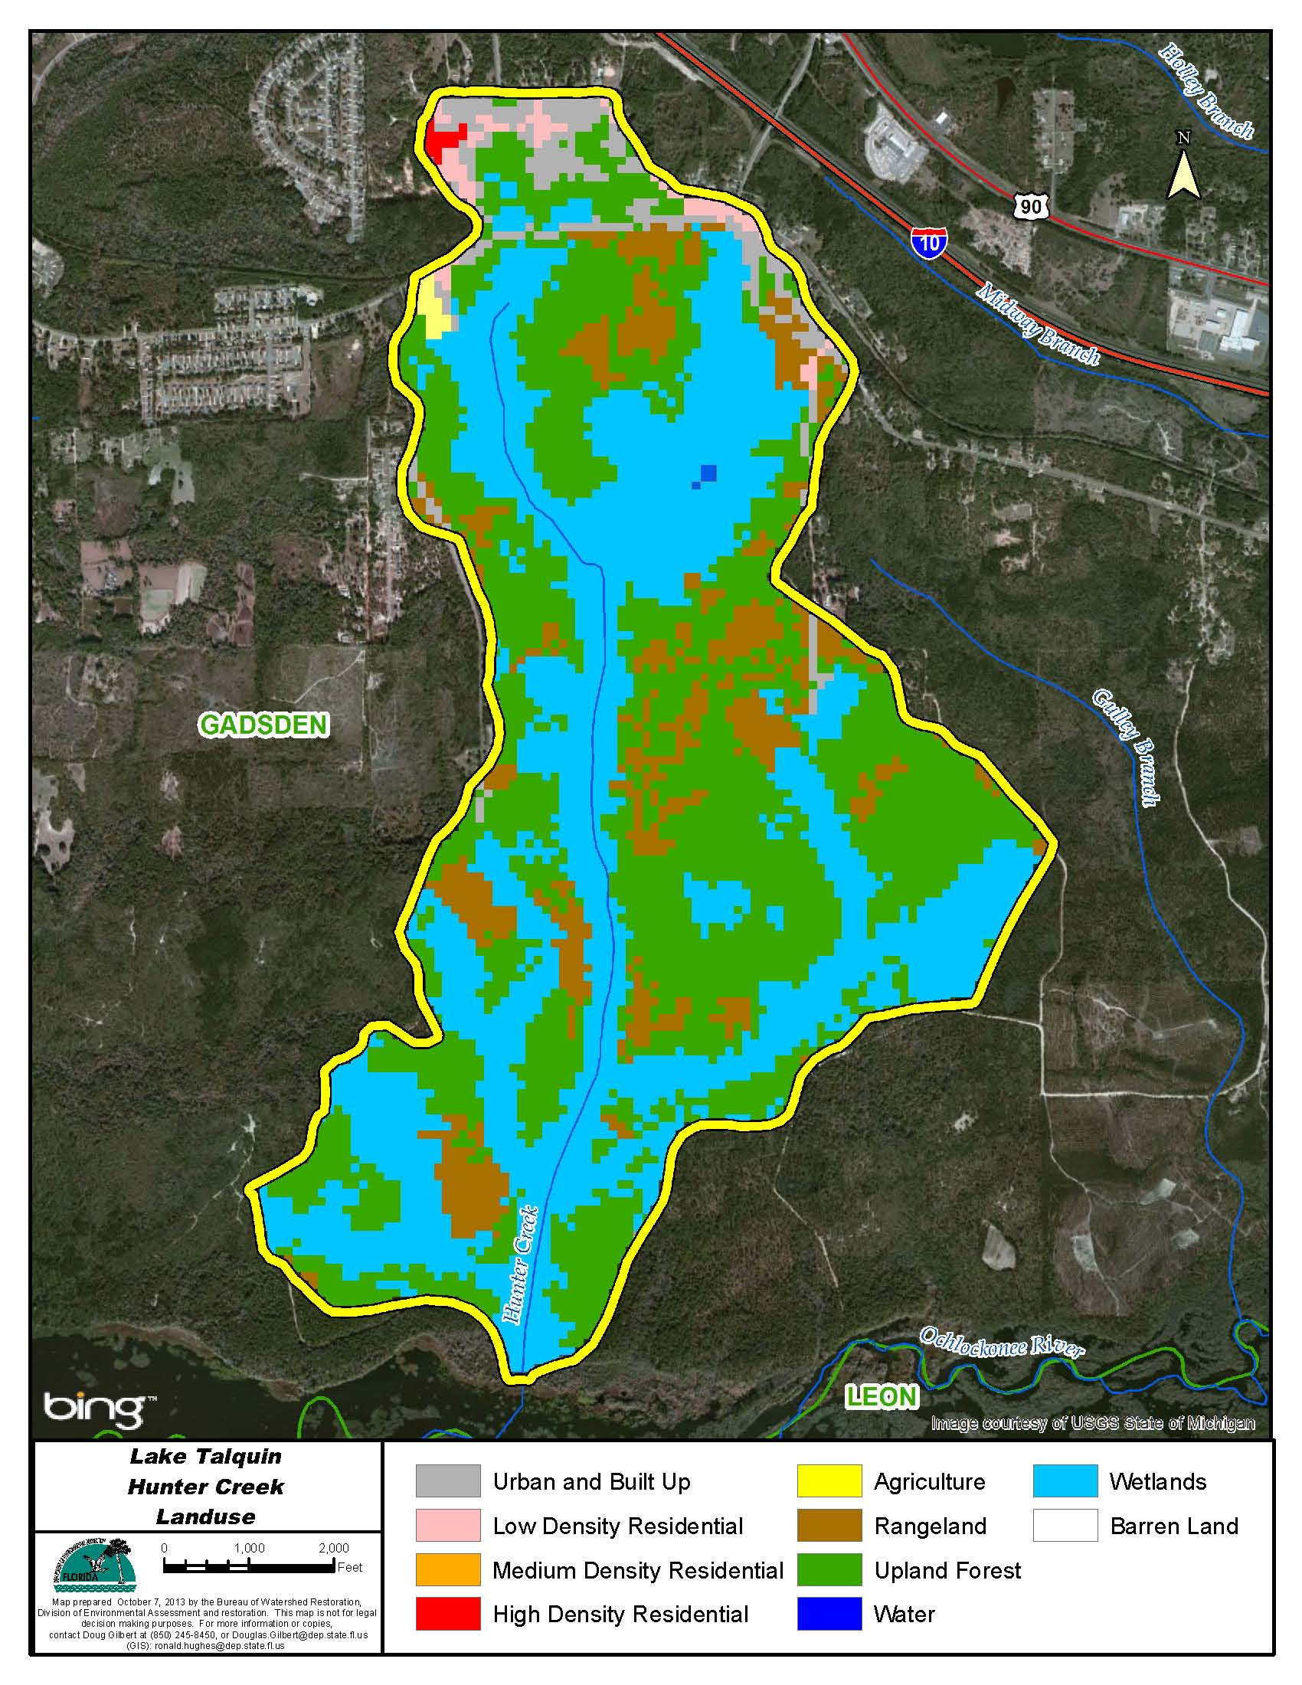

Figure B.6.3. Principal Land Uses in the Hunter Creek Watershed, 2006

Table B.6.3. Classification of Land Use Categories in the Hunter Creek Watershed, 2006
LU Code | Landuse | Acres | Square Miles | Percentage
11 | Water | 1.1 | 0.0 | 0.1
21 | Urban Built up | 59.6 | 0.1 | 3.7
22 | Low Density Res | 18.0 | 0.0 | 1.1
24 | High Density Res | 3.3 | 0.0 | 0.2
41 | Upland Forest | 679.9 | 1.1 | 42.8
52 | Rangeland | 173.5 | 0.3 | 10.9
81 | Agriculture | 4.4 | 0.0 | 0.3
90 | Wetlands | 649.6 | 1.0 | 40.9
Total | Watershed | 1,589.4 | 2.5 | 100.0

Double Branch

Double Branch drains directly to Lake Talquin between the Ochlockonee River and Little River.

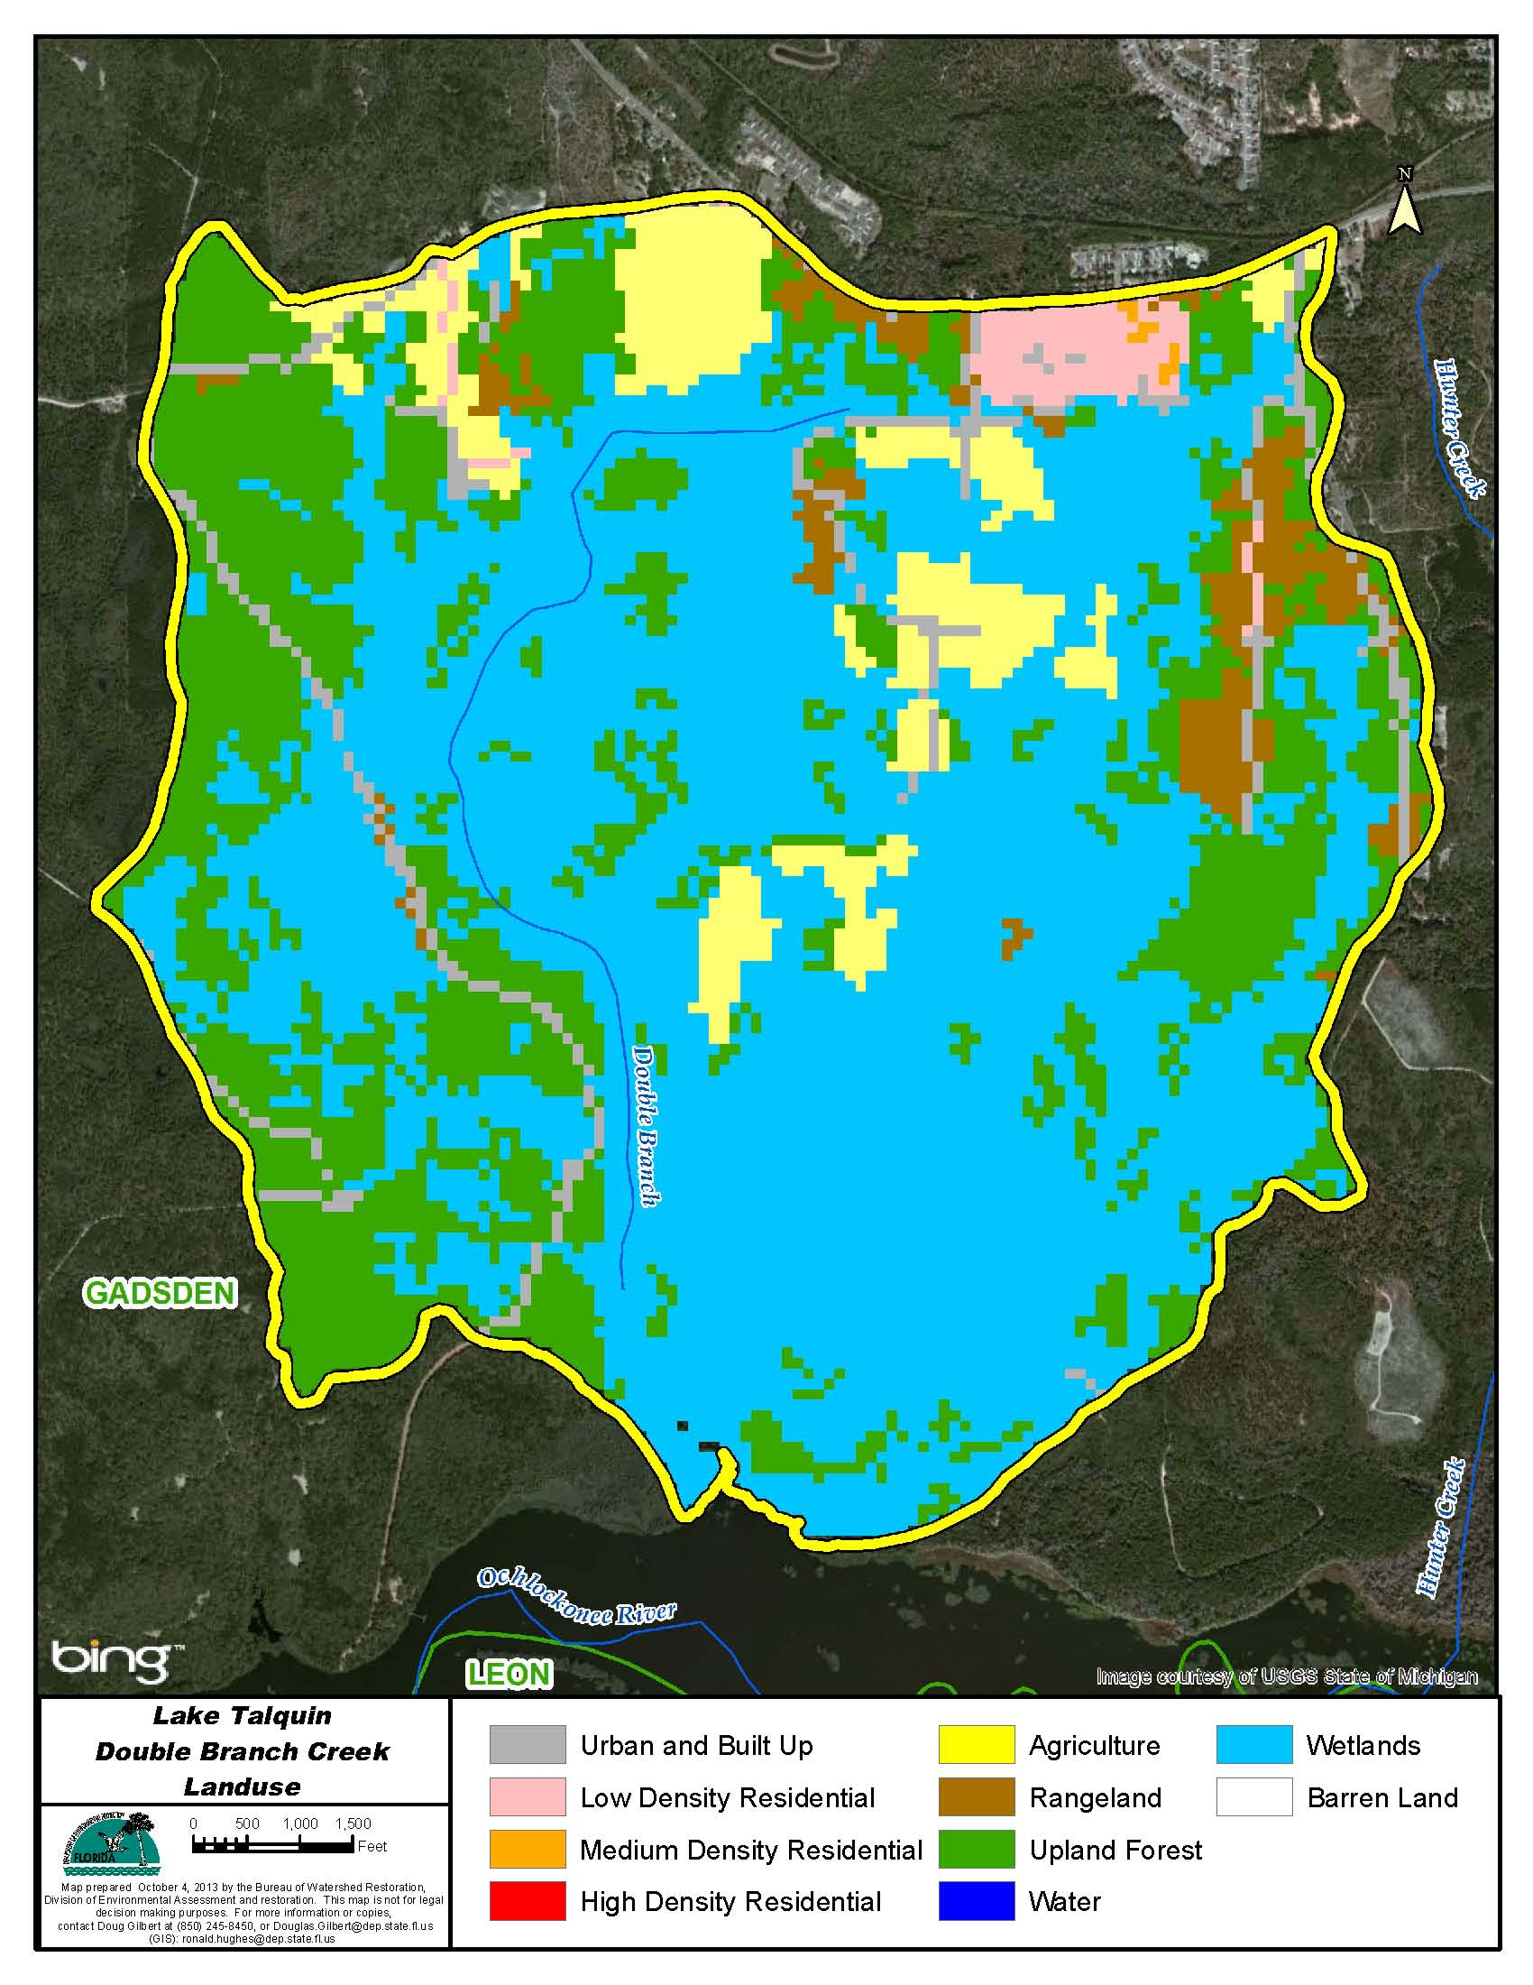

Figure B.6.4. Principal Land Uses in the Double Branch Watershed, 2006

Table B.6.4. Classification of Land Use Categories in the Double Branch Watershed, 2006

LU Code | Landuse | Acres | Square Miles | Percentage
21 | Urban Built up | 87.0 | 0.1 | 3.2
22 | Low Density Res | 42.5 | 0.1 | 1.6
23 | Medium Density Res | 2.7 | 0.0 | 0.1
41 | Upland Forest | 724.8 | 1.1 | 27.1
52 | Rangeland | 91.4 | 0.1 | 3.4
81 | Agriculture | 184.8 | 0.3 | 6.9
90 | Wetlands | 1,545.9 | 2.4 | 57.7
Total | Watershed | 2,679.0 | 4.2 | 100.0

Mule Creek

Mule Creek drains directly to Lake Talquin between the Ochlockonee and Little Rivers.

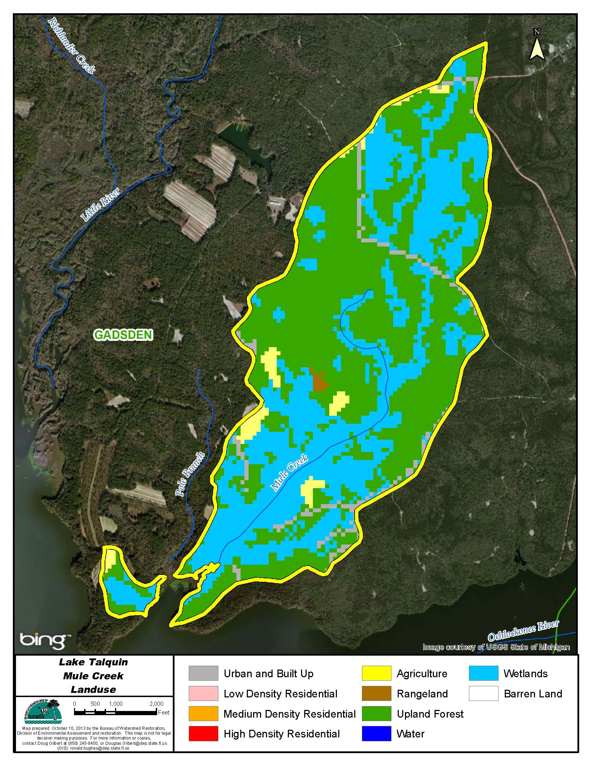

Figure B.6.5. Principal Land Uses in the Mule Creek Watershed, 2006

Table B.6.5. Classification of Land Use Categories in the Mule Creek Watershed, 2006

LU Code | Landuse | Acres | Square Miles | Percentage
21 | Urban Built up | 42.7 | 0.1 | 3.4
41 | Upland Forest | 691.4 | 1.1 | 54.3
52 | Rangeland | 3.3 | 0.0 | 0.3
82 | Agriculture | 36.3 | 0.1 | 2.8
90 | Wetlands | 498.6 | 0.8 | 39.2
Total | Watershed | 1,272.3 | 2.0 | 100.0

No OSTDs in Mule Creek

Pole Creek

Pole Creek drains directly to Lake Talquin between the Ochlockonee and Little Rivers.

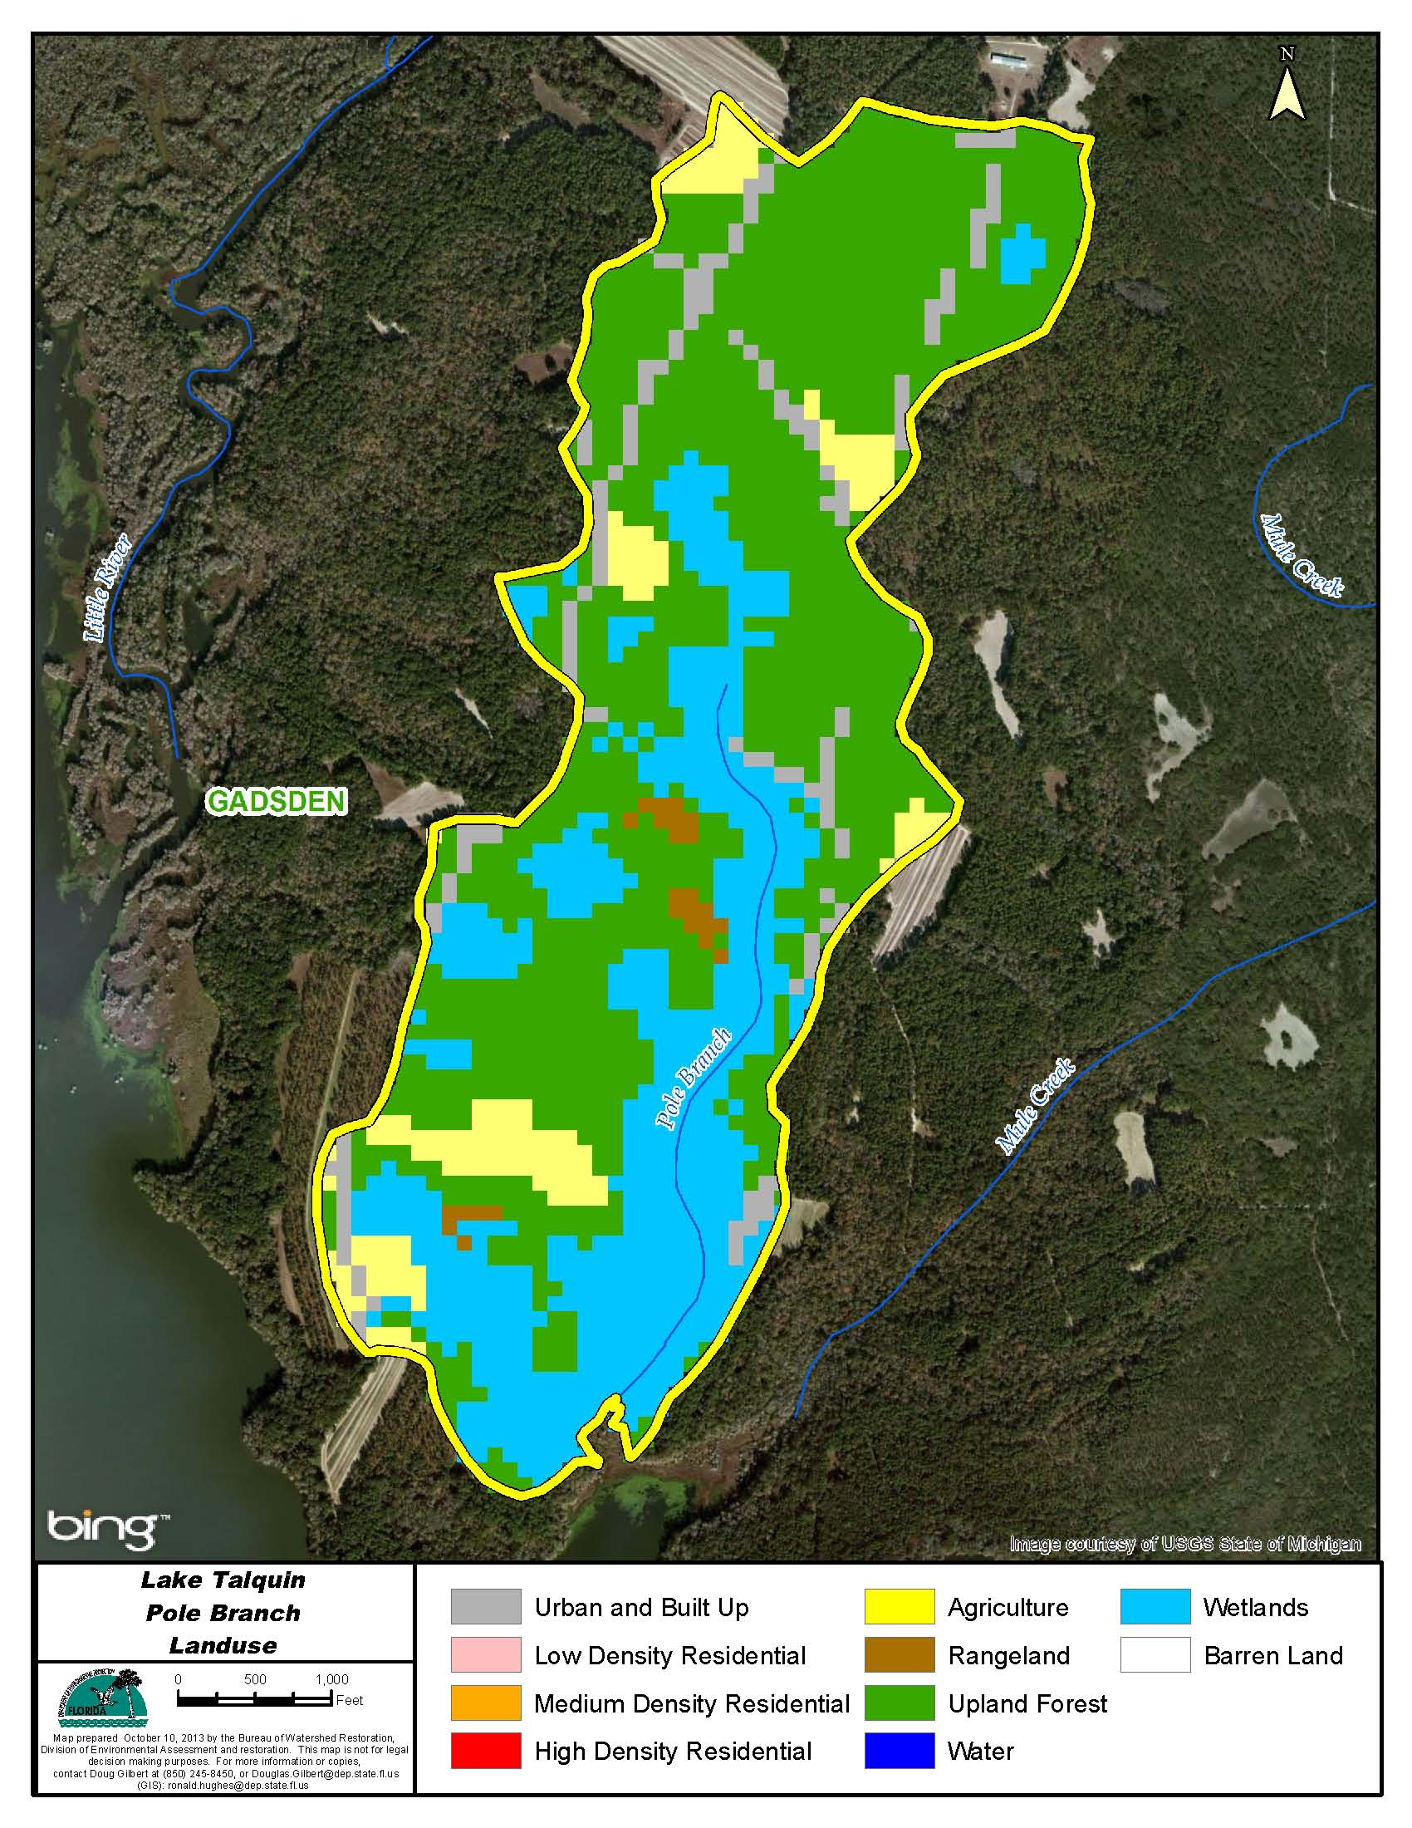

Figure B.6.6. Principal Land Uses in the Pole Branch Watershed, 2006

Table B.6.6. Classification of Land Use Categories in the Pole Creek Watershed, 2006

LU Code | Landuse | Acres | Square Miles | Percentage
21 | Urban Built up | 33.6 | 0.1 | 6.7
41 | Upland Forest | 281.6 | 0.4 | 55.8
52 | Rangeland | 5.8 | 0.0 | 1.1
82 | Agriculture | 37.1 | 0.1 | 7.4
90 | Wetlands | 146.8 | 0.2 | 29.1
Total | Watershed | 504.8 | 0.8 | 100.0

No OSTDs in Pole Creek watershed

Little River Above Lake Talquin:

The Little River has it’s origin just below where Attapulgus Creek joins with Salem Creek. The creeks that either make up or drain to the Little River are presented from upstream to downstream.
Attapulgus Creek

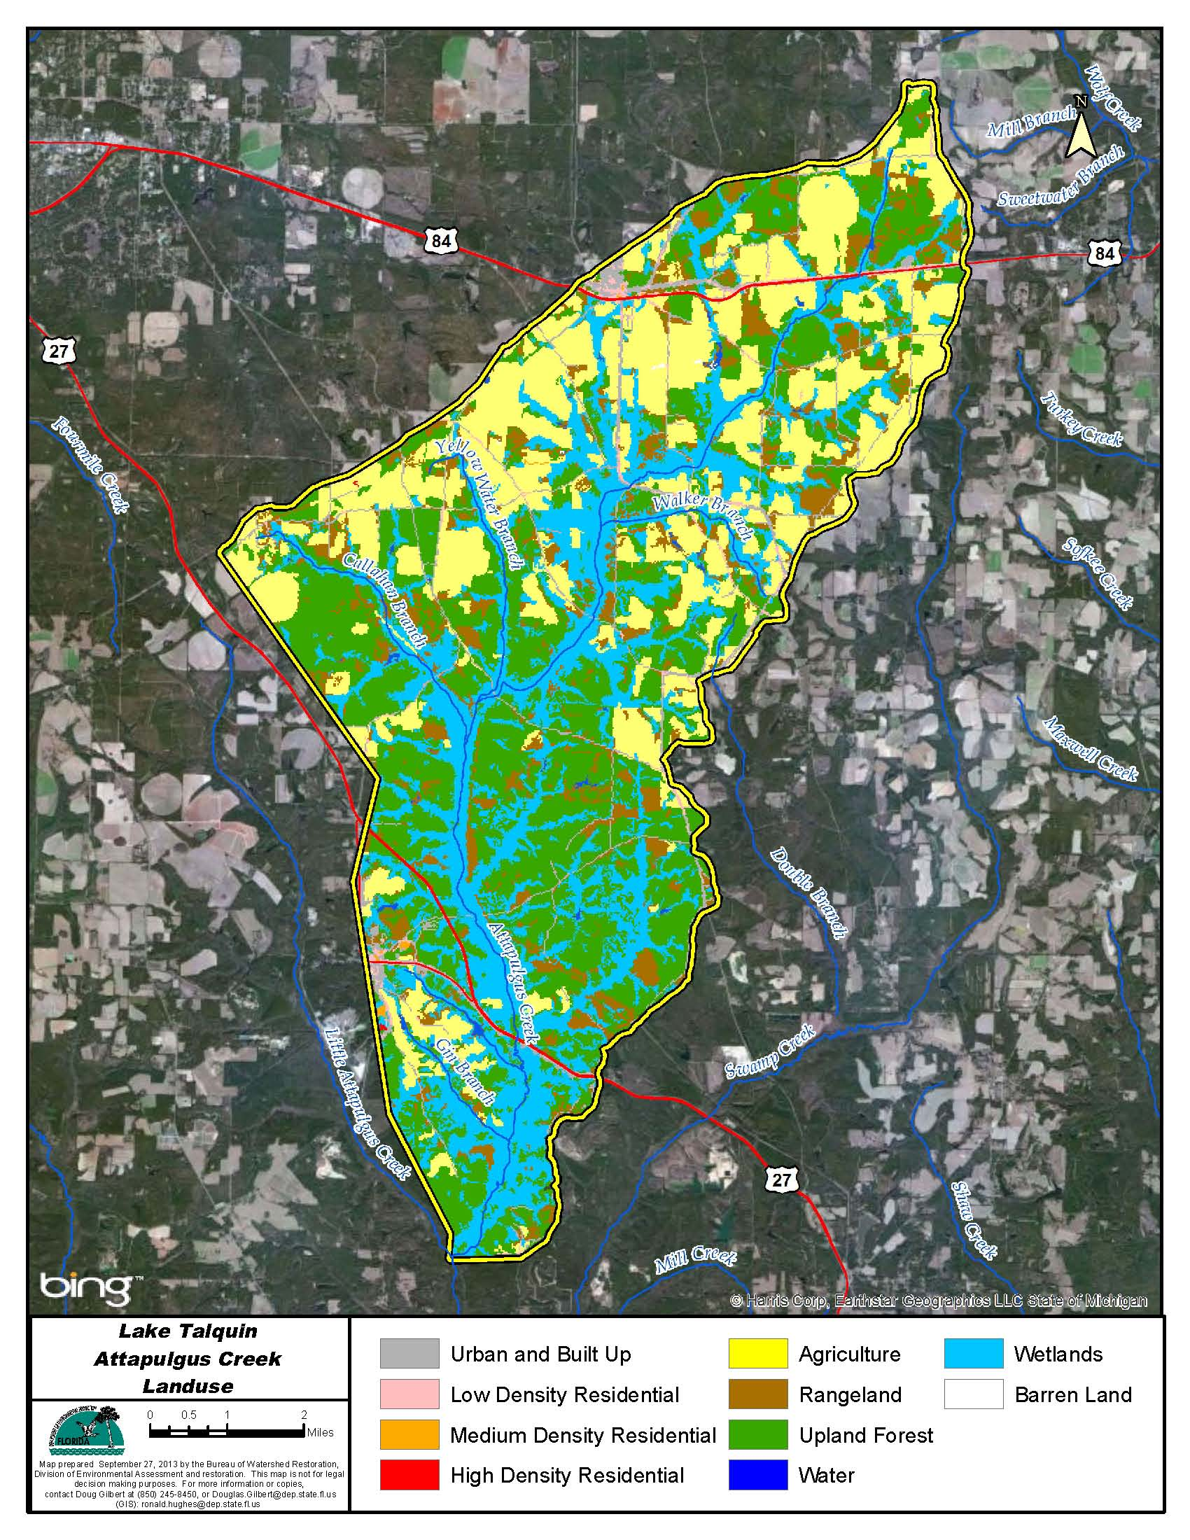

Figure B.6.7. Principal Land Uses in the Attapulgus Creek Watershed, 2006

Table B.6.7. Classification of Land Use Categories in the Attapulgus Creek Watershed, 2006
LU Code | Landuse | Acres | Square Miles | Percentage
11 | Water | 170.8 | 0.3 | 0.4
21 | Urban Built up | 1,505.4 | 2.4 | 3.7
22 | Low Density Res | 478.1 | 0.7 | 1.2
23 | Medium Density Res | 38.3 | 0.1 | 0.1
24 | High Density Res | 5.6 | 0.0 | 0.0
31 | Barren Land | 12.7 | 0.0 | 0.0
41 | Upland Forest | 13,601.6 | 21.3 | 33.1
52 | Rangeland | 4,004.4 | 6.3 | 9.7
81 | Agriculture | 10,592.2 | 16.6 | 25.8
90 | Wetlands | 10,680.0 | 16.7 | 26.0
Total | Watershed | 41,089.1 | 64.2 | 100.0

Little Attapulgus Creek

Little Attapulgus Creek drains to Attapulgus Creek.
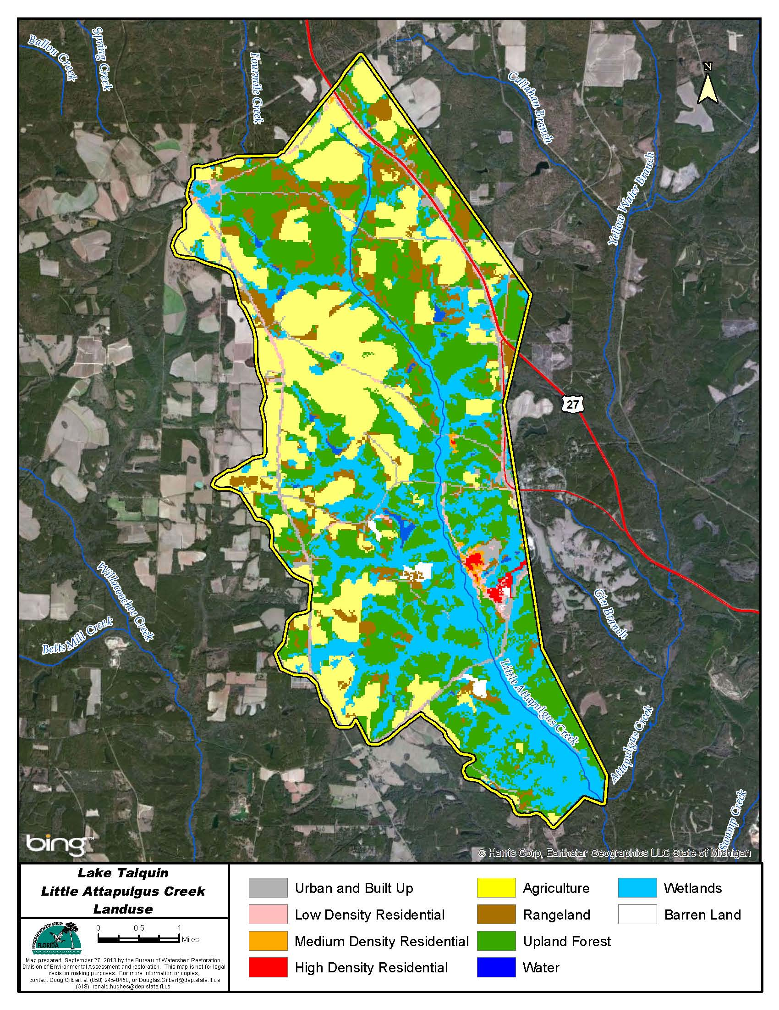

Figure B.6.8. Principal Land Uses in the Little Attapulgus Creek Watershed, 2006

Table B.6.8. Classification of Land Use Categories in the Little Attapulgus Creek Watershed, 2006

LU Code | Landuse | Acres | Square Miles | Percentage
11 | Water | 104.3 | 0.2 | 0.7
21 | Urban Built up | 698.8 | 1.1 | 4.4
22 | Low Density Res | 285.8 | 0.4 | 1.8
23 | Medium Density Res | 52.0 | 0.1 | 0.3
24 | High Density Res | 58.9 | 0.1 | 0.4
31 | Barren Land | 81.2 | 0.1 | 0.5
41 | Upland Forest | 5,243.2 | 8.2 | 32.9
52 | Rangeland | 1,404.0 | 2.2 | 8.8
81 | Agriculture | 4,113.2 | 6.4 | 25.8
90 | Wetlands | 3,919.0 | 6.1 | 24.6
Total | Watershed | 15,960.3 | 24.9 | 100.0

Swamp Creek

Swamp Creek drains to the Attapulgus Creek.
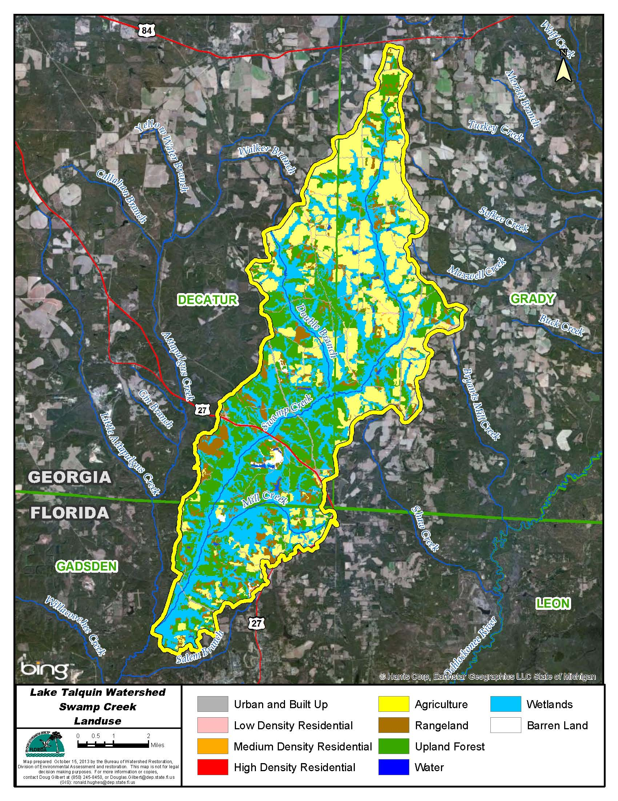

Figure B.6.9. Principal Land Uses in the Swamp Creek Watershed, 2006

Table B.6.9. Classification of Land Use Categories in the Swamp Creek Watershed, 2006
LU Code | Landuse | Acres | Square Miles | Percentage
11 | Water | 247.5 | 0.4 | 0.7
21 | Urban Built up | 1,308.6 | 2.0 | 3.6
22 | Low Density Res | 253.5 | 0.4 | 0.7
23 | Medium Density Res | 39.6 | 0.1 | 0.1
24 | High Density Res | 5.8 | 0.0 | 0.0
31 | Barren Land | 180.4 | 0.3 | 0.5
41 | Upland Forest | 10,066.4 | 15.7 | 27.5
52 | Rangeland | 2,783.5 | 4.3 | 7.6
81 | Agriculture | 10,131.8 | 15.8 | 27.7
90 | Wetlands | 11,539.8 | 18.0 | 31.6
Total | Watershed | 36,556.9 | 57.1 | 100.0

Salem Creek

Salem Creek drains to Attapulgus Creek in the area where Attapulgus Creek becomes the Little River.
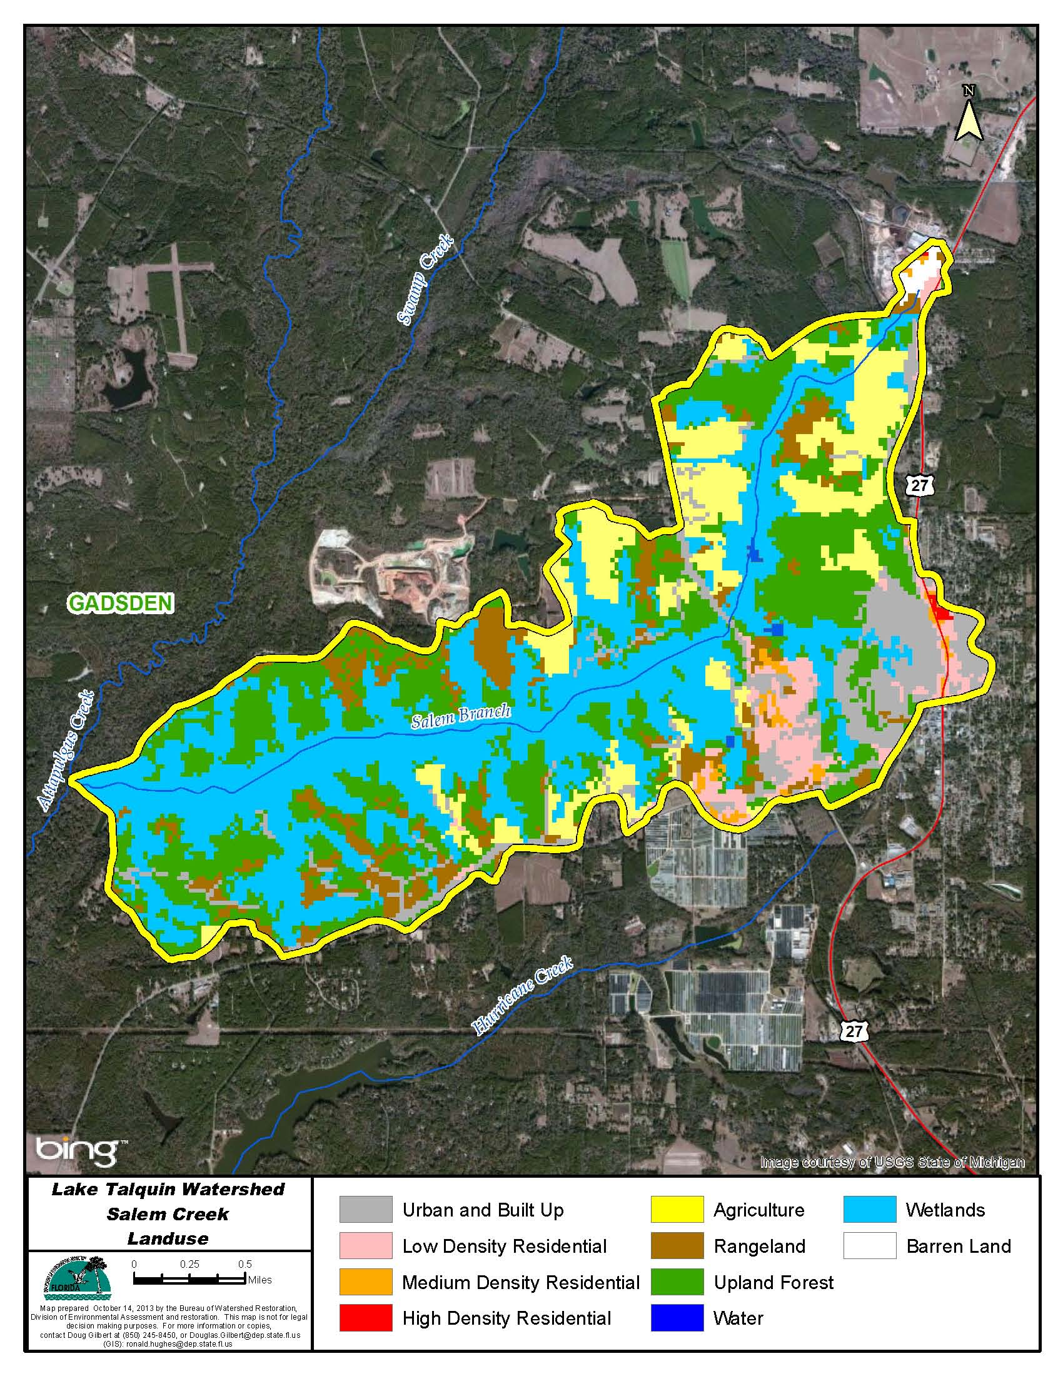

Figure B.6.10. Principal Land Uses in the Salem Creek Watershed, 2006

Table B.6.10. Classification of Land Use Categories in the Salem Creek Watershed, 2006

LU Code | Landuse | Acres | Square Miles | Percentage
11 | Water | 6.4 | 0.0 | 0.2
21 | Urban Built up | 340.9 | 0.5 | 9.6
22 | Low Density Res | 134.5 | 0.2 | 3.8
23 | Medium Density Res | 33.1 | 0.1 | 0.9
24 | High Density Res | 4.0 | 0.0 | 0.1
31 | Barren Land | 17.3 | 0.0 | 0.5
41 | Upland Forest | 999.2 | 1.6 | 28.2
52 | Rangeland | 315.6 | 0.5 | 8.9
81 | Agriculture | 453.2 | 0.7 | 12.8
90 | Wetlands | 1,234.3 | 1.9 | 34.9
Total | Watershed | 3,538.7 | 5.5 | 100.0

Willacoochee Creek

Willacoochee Creek drains to the Little River just below the confluence with Salem Creek.
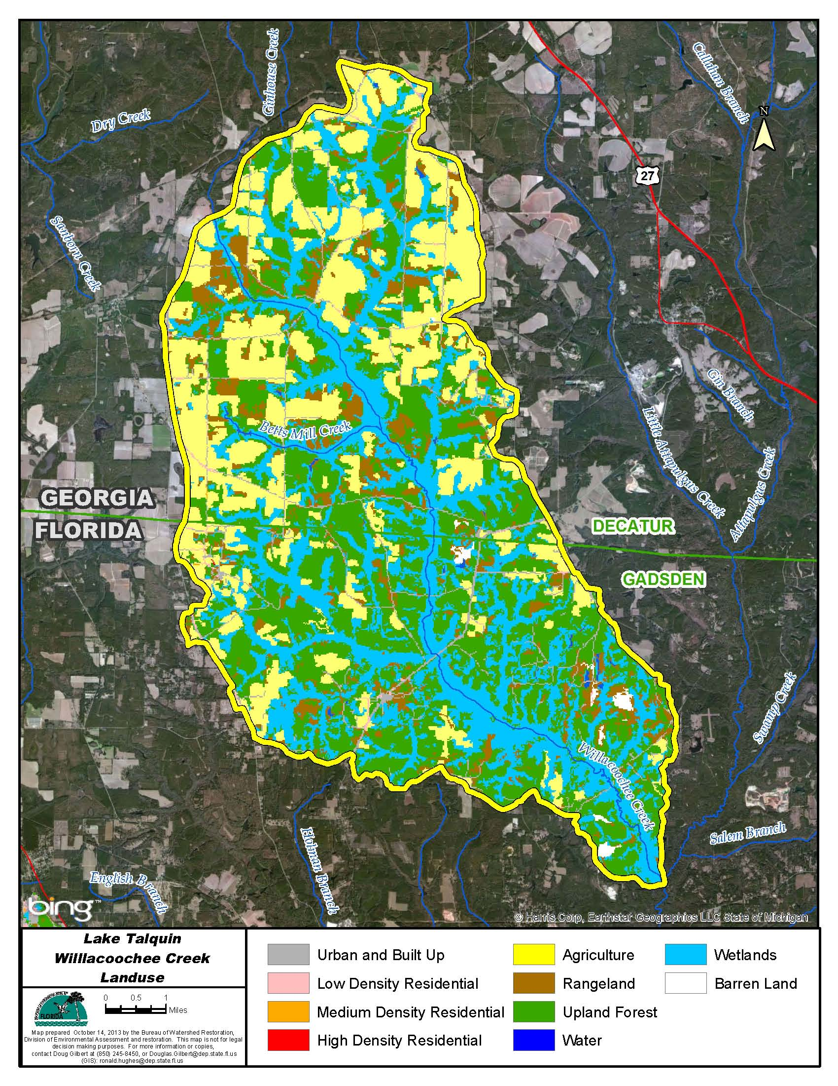

Figure B.6.11. Principal Land Uses in the Willacoochee Creek Watershed, 2006

Table B.6.11. Classification of Land Use Categories in the Willacoochee Creek Watershed, 2006

LU Code | Landuse | Acres | Square Miles | Percentage
11 | Water | 113.6 | 0.2 | 0.3
21 | Urban Built up | 1,331.3 | 2.1 | 3.2
22 | Low Density Res | 148.8 | 0.2 | 0.4
23 | Medium Density Res | 12.9 | 0.0 | 0.0
24 | High Density Res | 1.6 | 0.0 | 0.0
31 | Barren Land | 180.1 | 0.3 | 0.4
41 | Upland Forest | 14,472.1 | 22.6 | 34.8
52 | Rangeland | 3,531.2 | 5.5 | 8.5
81 | Agriculture | 10,044.0 | 15.7 | 24.2
90 | Wetlands | 11,754.0 | 18.4 | 28.3
Total | Watershed | 41,589.4 | 65.0 | 100.0

Quincy Creek

Quincy Creek drains to the Little River
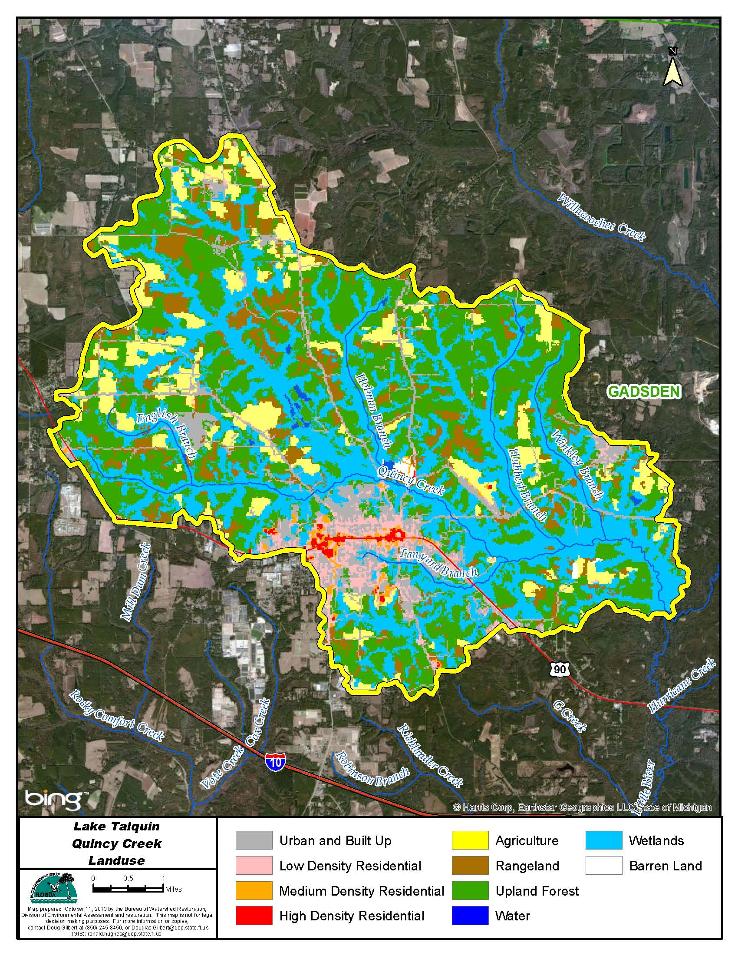

Figure B.6.12. Principal Land Uses in the Quincy Creek Watershed, 2006

Table B.6.12. Classification of Land Use Categories in the Quincy Creek Watershed, 2006

LU Code | Landuse | Acres | Square Miles | Percentage
11 | Water | 111.0 | 0.2 | 0.4
21 | Urban Built up | 2,264.0 | 3.5 | 9.0
22 | Low Density Res | 743.5 | 1.2 | 3.0
23 | Medium Density Res | 200.4 | 0.3 | 0.8
24 | High Density Res | 103.4 | 0.2 | 0.4
31 | Barren Land | 58.7 | 0.1 | 0.2
41 | Upland Forest | 8,775.0 | 13.7 | 34.9
52 | Rangeland | 2,351.8 | 3.7 | 9.4
81 | Agriculture | 2,456.1 | 3.8 | 9.8
90 | Wetlands | 8,045.5 | 12.6 | 32.0
Total | Watershed | 25,109.4 | 39.2 | 100.0

Hurricane Creek

Hurricane Creek drains to the Little River
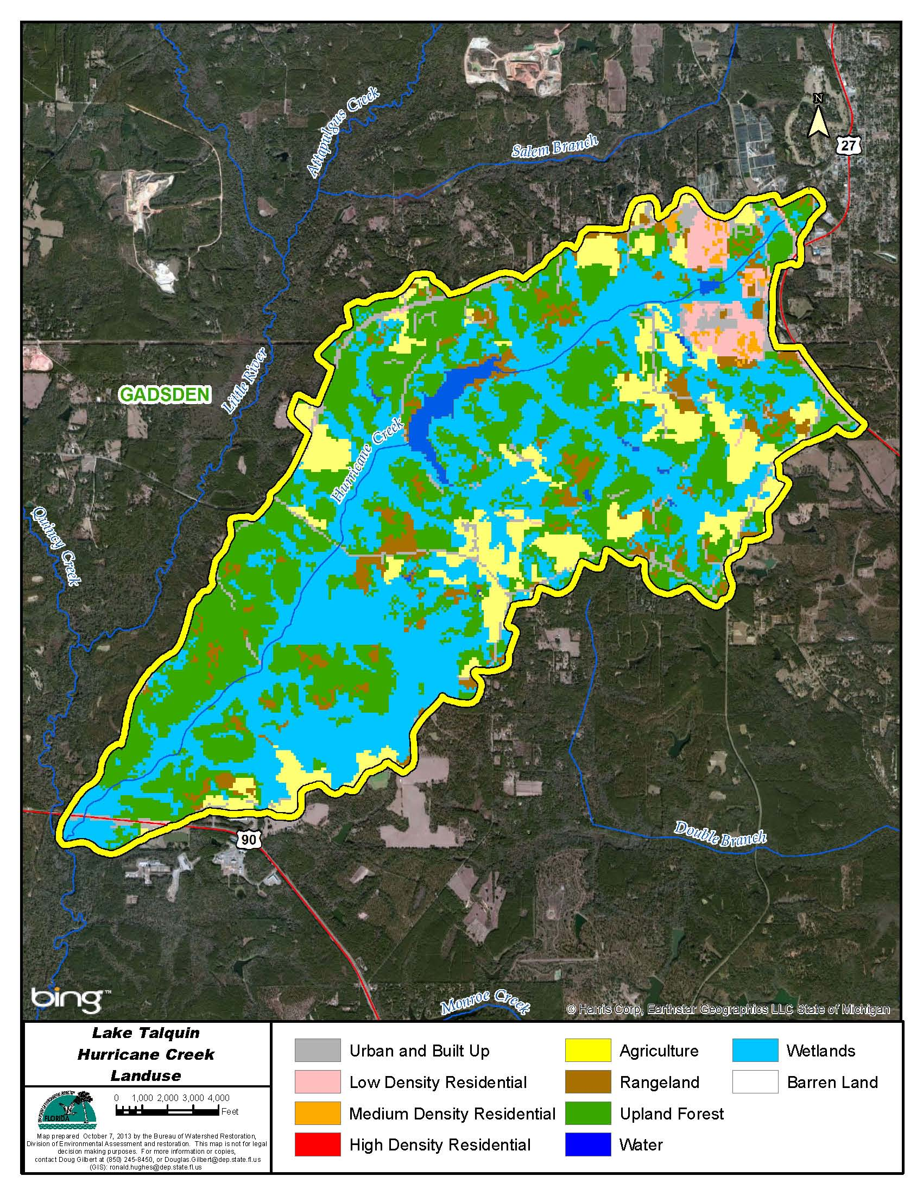

Figure B.6.13. Principal Land Uses in the Hurricane Creek Watershed, 2006

Table B.6.13. Classification of Land Use Categories in the Hurricane Creek Watershed, 2006

LU Code | Landuse | Acres | Square Miles | Percentage
11 | Water | 131.9 | 0.2 | 1.6
21 | Urban Built up | 365.2 | 0.6 | 4.4
22 | Low Density Res | 183.7 | 0.3 | 2.2
23 | Medium Density Res | 47.8 | 0.1 | 0.6
41 | Upland Forest | 2,894.5 | 4.5 | 35.3
52 | Rangeland | 475.7 | 0.7 | 5.8
81 | Agriculture | 928.3 | 1.5 | 11.3
90 | Wetlands | 3,180.5 | 5.0 | 38.8
Total | Watershed | 8,207.4 | 12.8 | 100.0

Monroe Creek

Monroe Creek drains to the Little River.
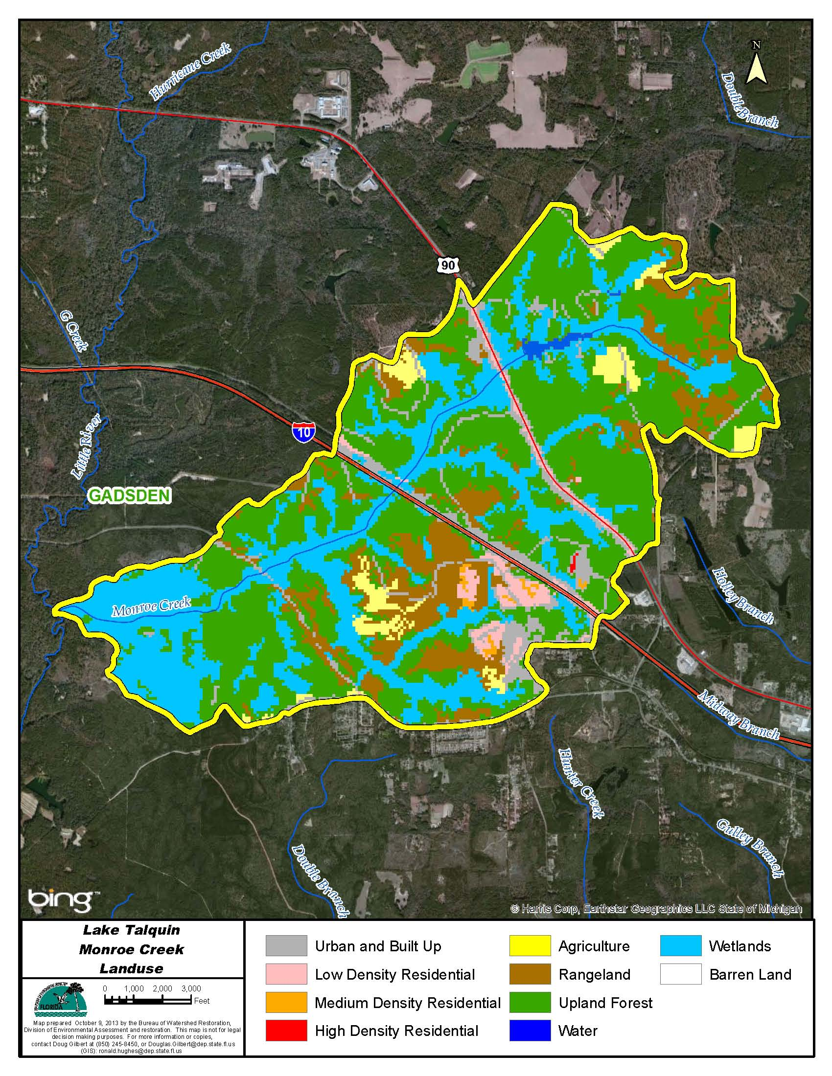

Figure B.6.14. Principal Land Uses in the Monroe Creek Watershed, 2006

Table B.6.14. Classification of Land Use Categories in the Monroe Creek Watershed, 2006

LU Code | Landuse | Acres | Square Miles | Percentage
11 | Water | 22.0 | 0.0 | 0.4
21 | Urban Built up | 399.9 | 0.6 | 7.7
22 | Low Density Res | 135.2 | 0.2 | 2.6
23 | Medium Density Res | 16.9 | 0.0 | 0.3
24 | High Density Res | 2.2 | 0.0 | 0.0
41 | Upland Forest | 2,391.8 | 3.7 | 45.9
52 | Rangeland | 659.2 | 1.0 | 12.7
81 | Agriculture | 168.6 | 0.3 | 3.2
90 | Wetlands | 1,411.3 | 2.2 | 27.1
Total | Watershed | 5,207.1 | 8.1 | 100.0

Richlander Creek

Richlander Creek

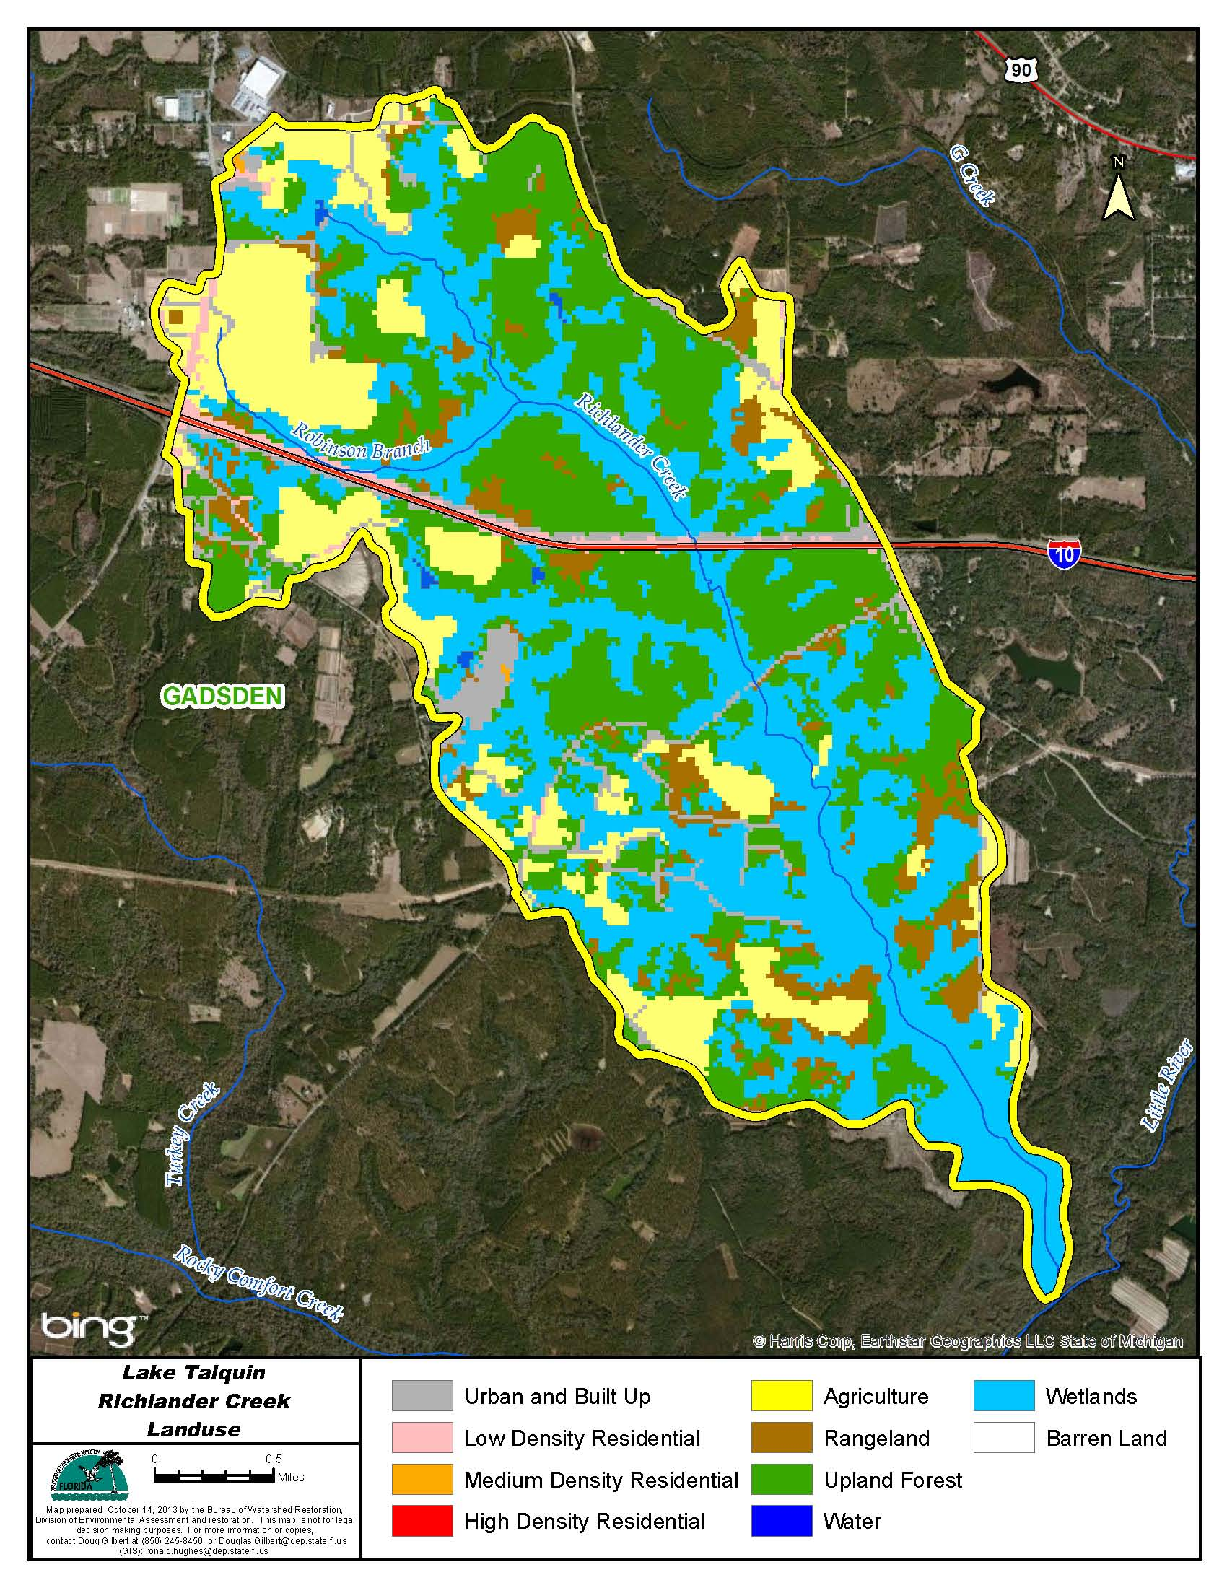

Figure B.6.15. Principal Land Uses in the Richlander Creek Watershed, 2006

Table B.6.15. Classification of Land Use Categories in the Richlander Creek Watershed, 2006

LU Code | Landuse | Acres | Square Miles | Percentage
11 | Water | 12.9 | 0.0 | 0.2
21 | Urban Built up | 329.1 | 0.5 | 5.7
22 | Low Density Res | 139.4 | 0.2 | 2.4
23 | Medium Density Res | 4.7 | 0.0 | 0.1
41 | Upland Forest | 1,861.4 | 2.9 | 32.1
52 | Rangeland | 421.0 | 0.7 | 7.3
81 | Agriculture | 914.7 | 1.4 | 15.8
90 | Wetlands | 2,119.0 | 3.3 | 36.5
Total | Watershed | 5,802.3 | 9.1 | 100.0

Little River Area

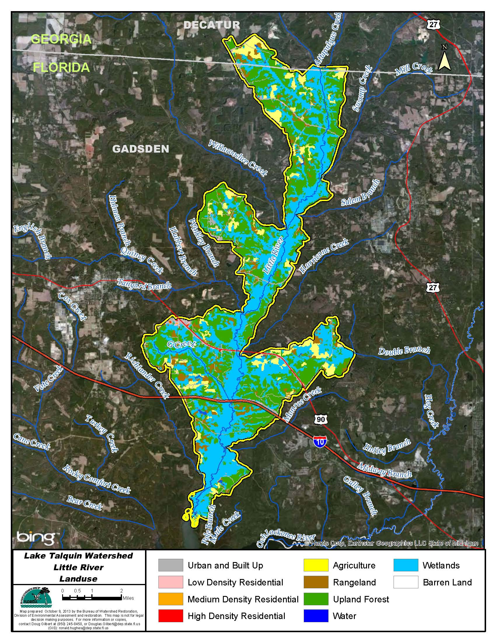

Figure B.6.16. Principal Land Uses in the Little River Watershed, 2006

Table B.6.16. Classification of Land Use Categories in the Little River Area, 2006

LU Code | Landuse | Acres | Square Miles | Percentage
11 | Water | 134.8 | 0.2 | 0.6
21 | Urban Built up | 1,017.2 | 1.6 | 4.2
22 | Low Density Res | 198.2 | 0.3 | 0.8
23 | Medium Density Res | 10.5 | 0.0 | 0.0
24 | High Density Res | 8.0 | 0.0 | 0.0
31 | Barren Land | 3.1 | 0.0 | 0.0
41 | Upland Forest | 9,227.1 | 14.4 | 37.9
52 | Rangeland | 1,394.2 | 2.2 | 5.7
81 | Agriculture | 1,837.0 | 2.9 | 7.5
90 | Wetlands | 10,527.0 | 16.4 | 43.2
Total | Watershed | 24,357.0 | 38.1 | 100.0

Rocky Comfort Creek

Rocky Comfort Creek drains directly to Lake Talquin.
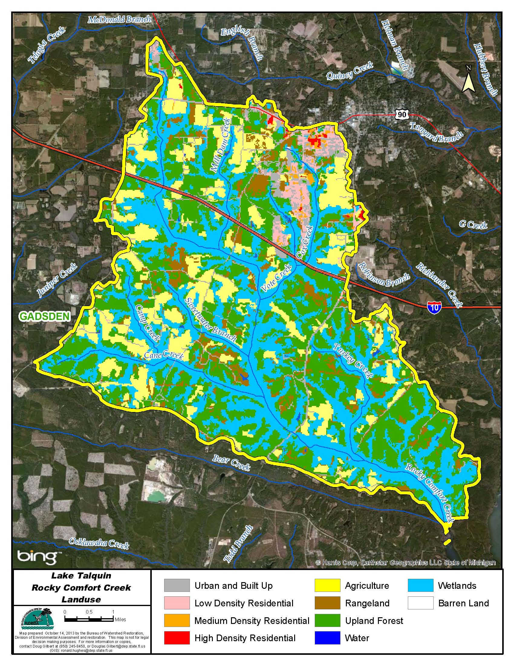

Figure B.6.17. Principal Land Uses in the Rocky Comfort Creek Watershed, 2006

Table B.6.17. Classification of Land Use Categories in the Rocky Comfort Creek Watershed, 2006

LU Code | Landuse | Acres | Square Miles | Percentage
11 | Water | 58.3 | 0.1 | 0.2
21 | Urban Built up | 1,631.9 | 2.5 | 5.9
22 | Low Density Res | 669.6 | 1.0 | 2.4
23 | Medium Density Res | 134.3 | 0.2 | 0.5
24 | High Density Res | 67.8 | 0.1 | 0.2
31 | Barren Land | 1.8 | 0.0 | 0.0
41 | Upland Forest | 9,393.3 | 14.7 | 33.8
52 | Rangeland | 1,854.5 | 2.9 | 6.7
81 | Agriculture | 4,528.4 | 7.1 | 16.3
90 | Wetlands | 9,416.6 | 14.7 | 33.9
Total | Watershed | 27,756.5 | 43.4 | 100.0

Bear Creek

Bear Creek drains directly to Lake Talquin.
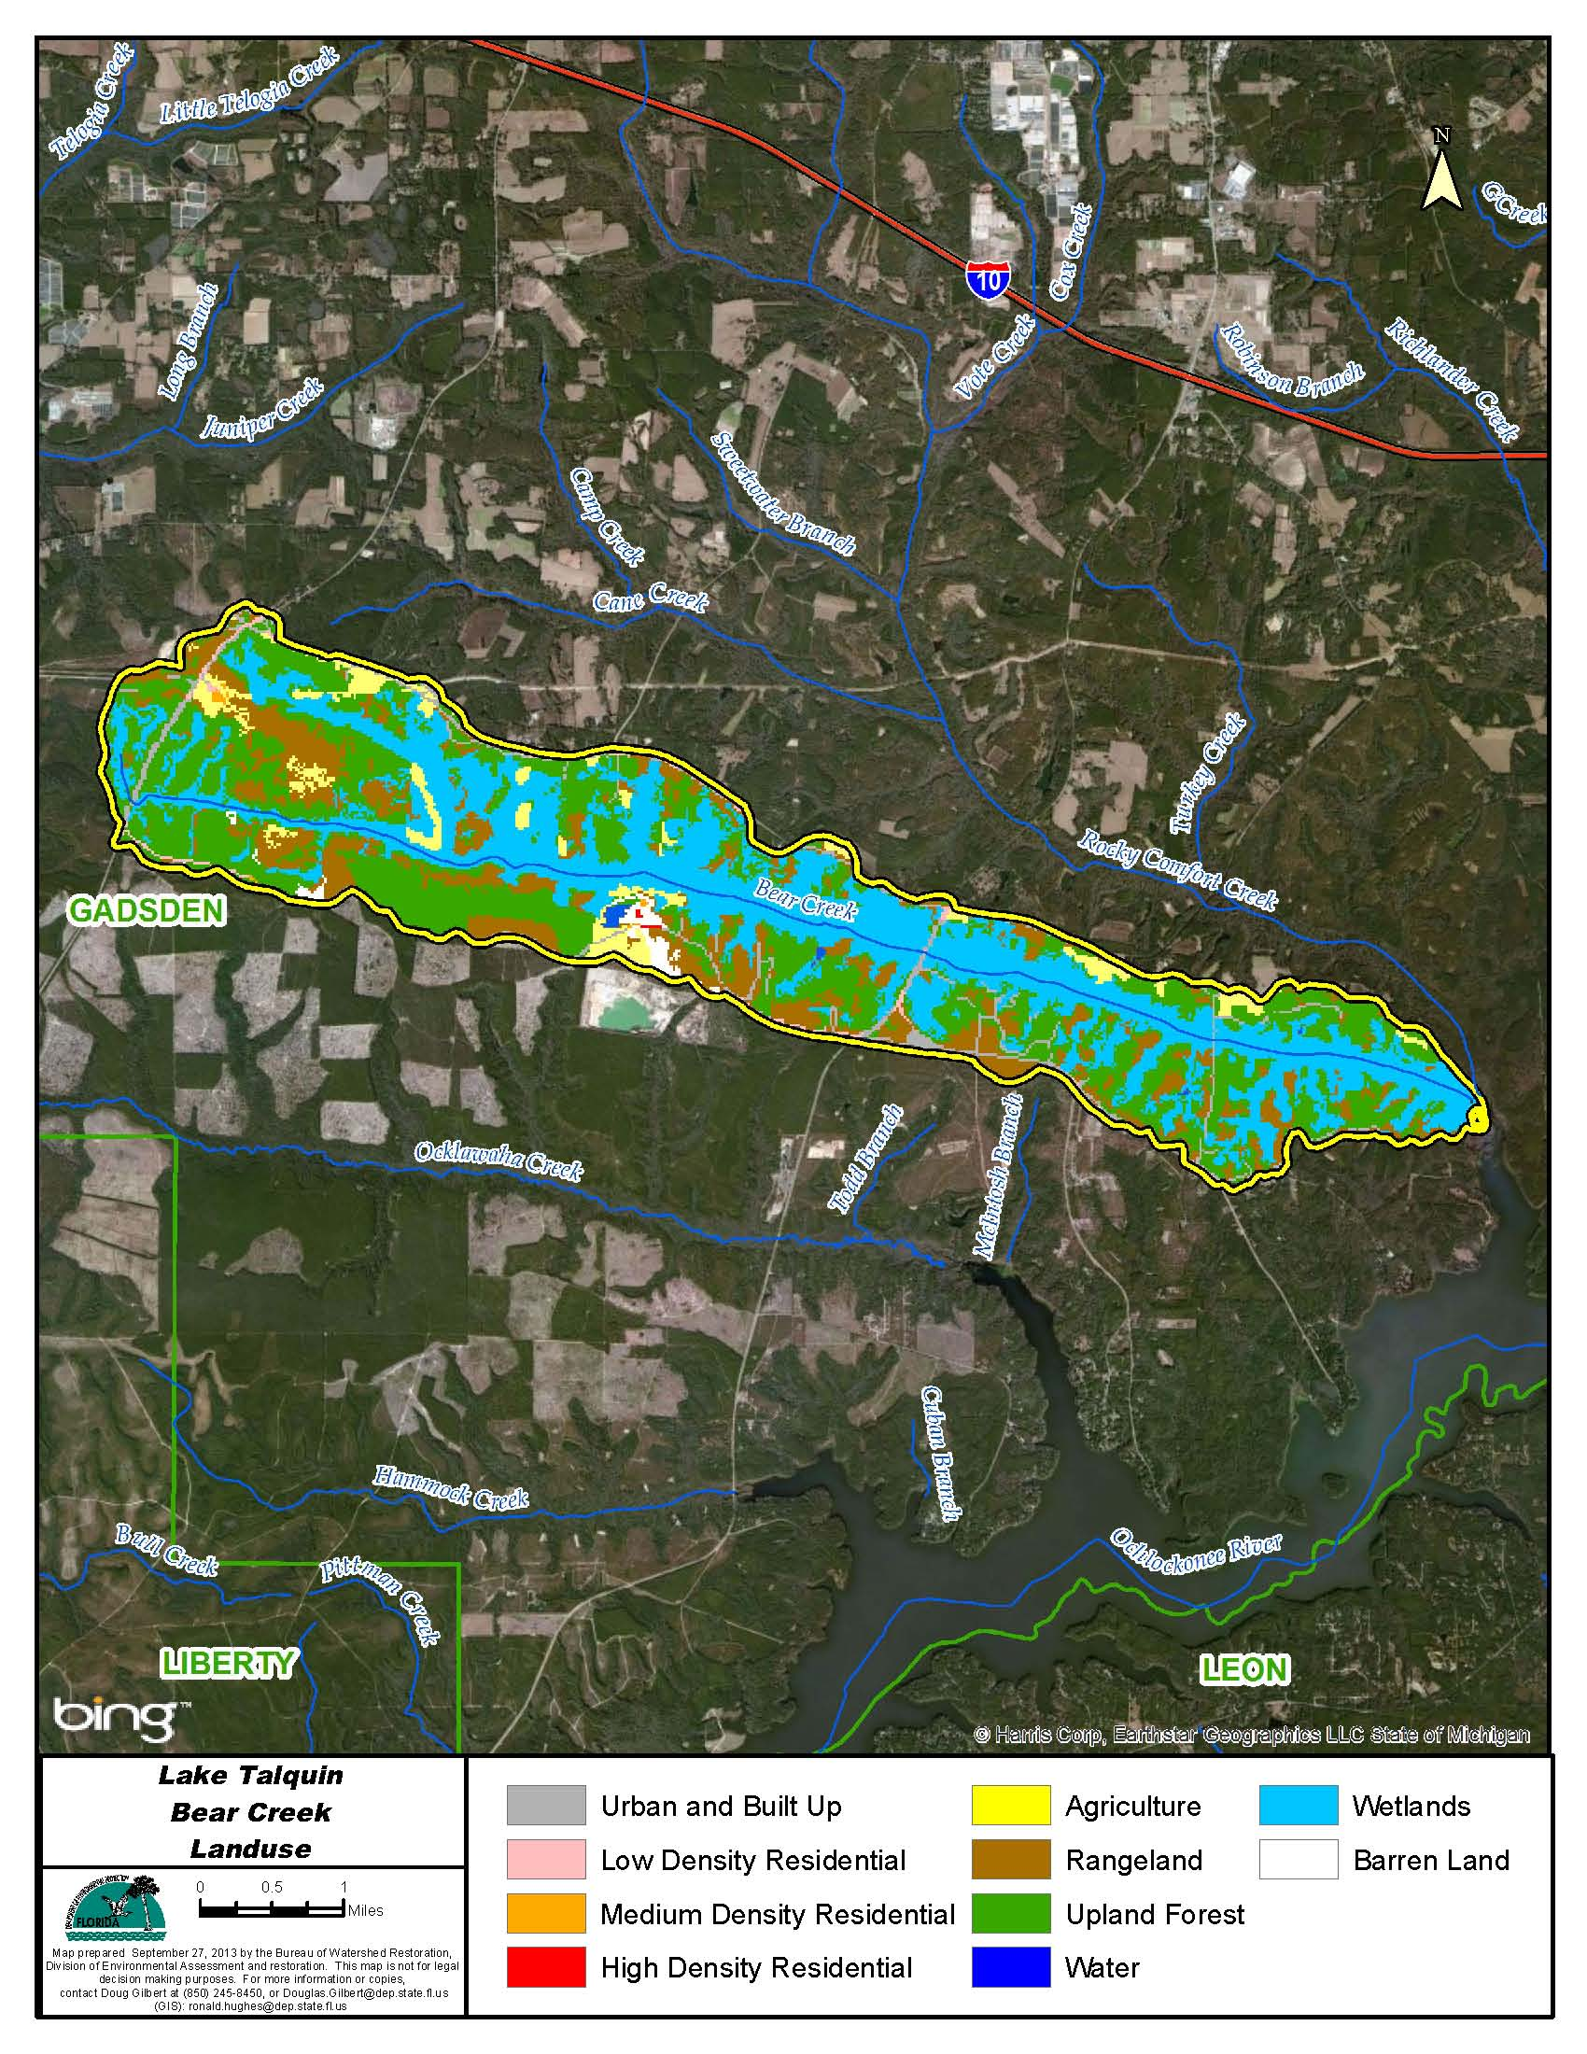

Figure B.6.18. Principal Land Uses in the Bear Creek Watershed, 2006

Table B.6.18. Classification of Land Use Categories in the Bear Creek Watershed, 2006

LU Code | Landuse | Acres | Square Miles | Percentage
11 | Water | 21.3 | 0.0 | 0.3
21 | Urban Built up | 233.5 | 0.4 | 3.1
22 | Low Density Res | 42.3 | 0.1 | 0.6
23 | Medium Density Res | 9.1 | 0.0 | 0.1
24 | High Density Res | 3.3 | 0.0 | 0.0
31 | Barren Land | 68.7 | 0.1 | 0.9
41 | Upland Forest | 2,719.0 | 4.2 | 35.9
52 | Rangeland | 1,279.9 | 2.0 | 16.9
81 | Agriculture | 332.0 | 0.5 | 4.4
90 | Wetlands | 2,875.1 | 4.5 | 37.9
Total | Watershed | 7,584.3 | 11.9 | 100.0

McIntosh Branch

McIntosh Branch drains directly to Lake Talquin.
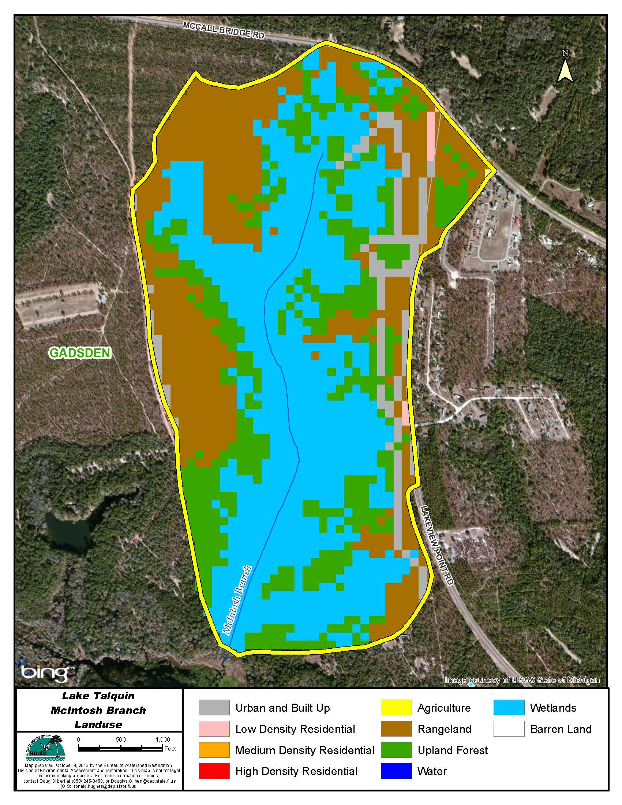

Figure B.6.19. Principal Land Uses in the McIntosh Branch Watershed, 2006

Table B.6.19. Classification of Land Use Categories in the McIntosh Branch Watershed, 2006

LU Code | Landuse | Acres | Square Miles | Percentage
21 | Urban Built up | 28.0 | 0.0 | 5.7
22 | Low Density Res | 2.2 | 0.0 | 0.5
41 | Upland Forest | 108.1 | 0.2 | 22.0
52 | Rangeland | 142.1 | 0.2 | 29.0
82 | Agriculture | 0.2 | 0.0 | 0.0
90 | Wetlands | 210.2 | 0.3 | 42.8
Total | Watershed | 490.8 | 0.8 | 100.0

No stations, no septic tanks

Ocklawaha Creek

Ocklawaha Creek drains directly to Lake Talquin.
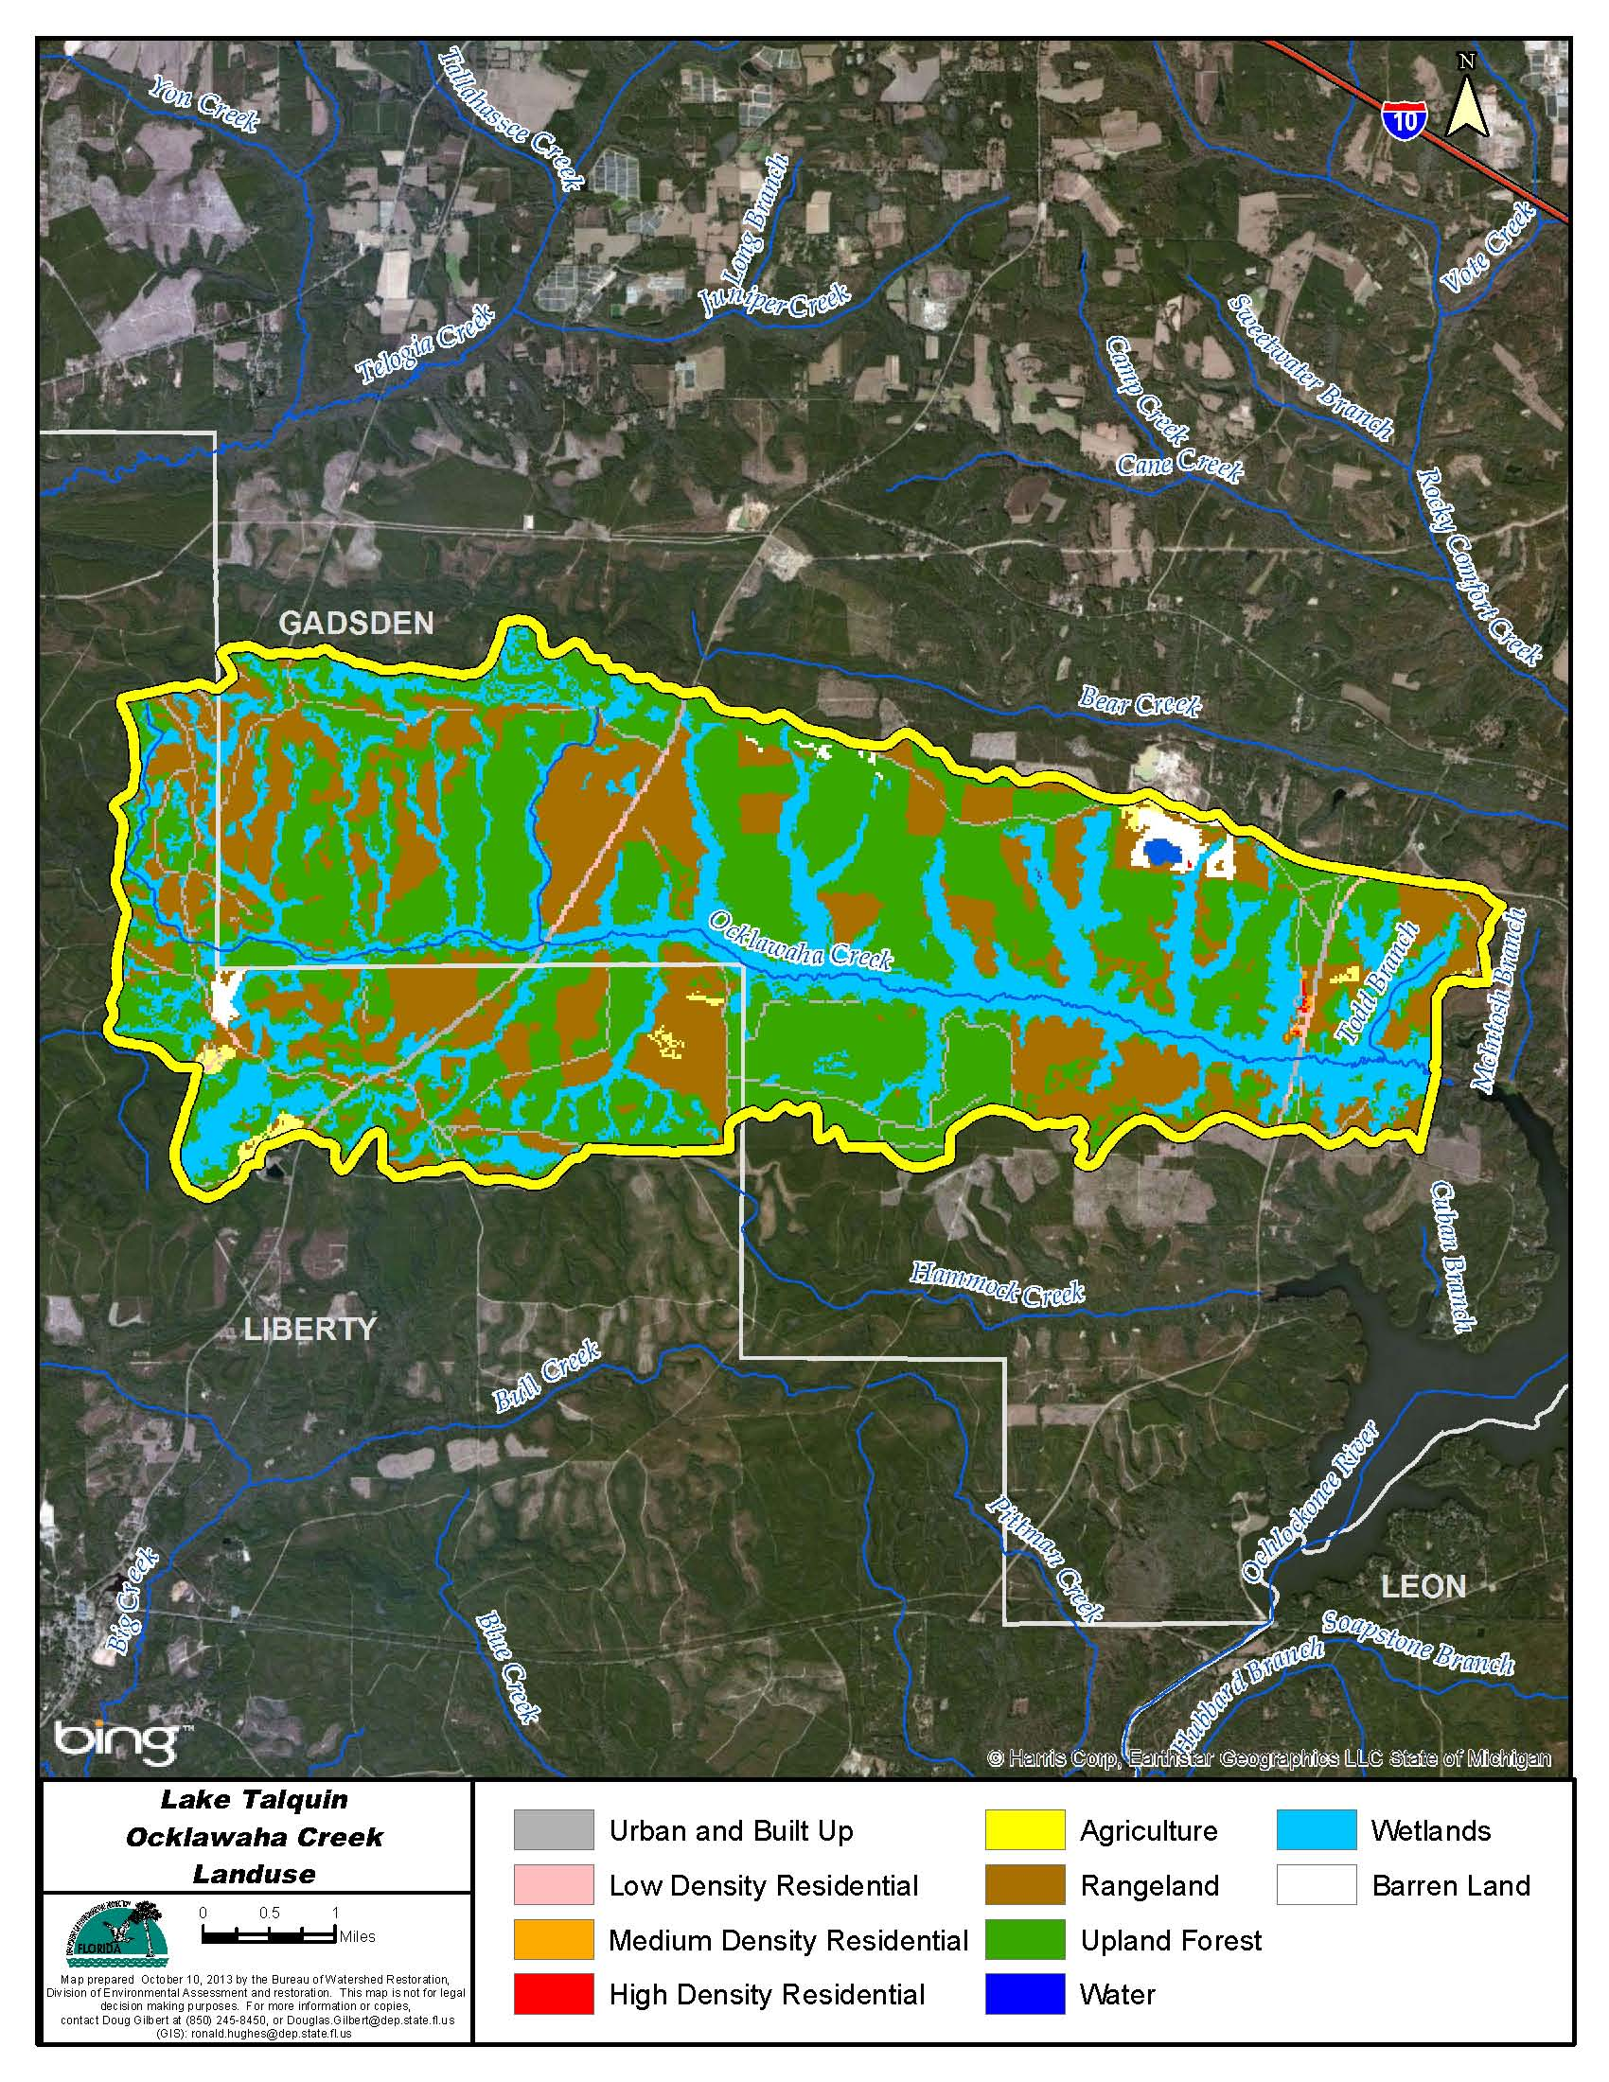

Figure B.6.20. Principal Land Uses in the Ocklawaha Creek Watershed, 2006

Table B.6.20. Classification of Land Use Categories in the Ocklawaha Creek Watershed, 2006

LU Code | Landuse | Acres | Square Miles | Percentage
11 | Water | 30.7 | 0.0 | 0.2
21 | Urban Built up | 533.1 | 0.8 | 2.7
22 | Low Density Res | 73.8 | 0.1 | 0.4
23 | Medium Density Res | 9.3 | 0.0 | 0.0
24 | High Density Res | 9.3 | 0.0 | 0.0
31 | Barren Land | 193.9 | 0.3 | 1.0
41 | Upland Forest | 8,622.4 | 13.5 | 43.4
52 | Rangeland | 5,505.8 | 8.6 | 27.7
82 | Agriculture | 133.2 | 0.2 | 0.7
90 | Wetlands | 4,773.7 | 7.5 | 24.0
Total | Watershed | 19,885.4 | 31.1 | 100.0

Cuban Branch

Cuban Branch drains directly to Lake Talquin.
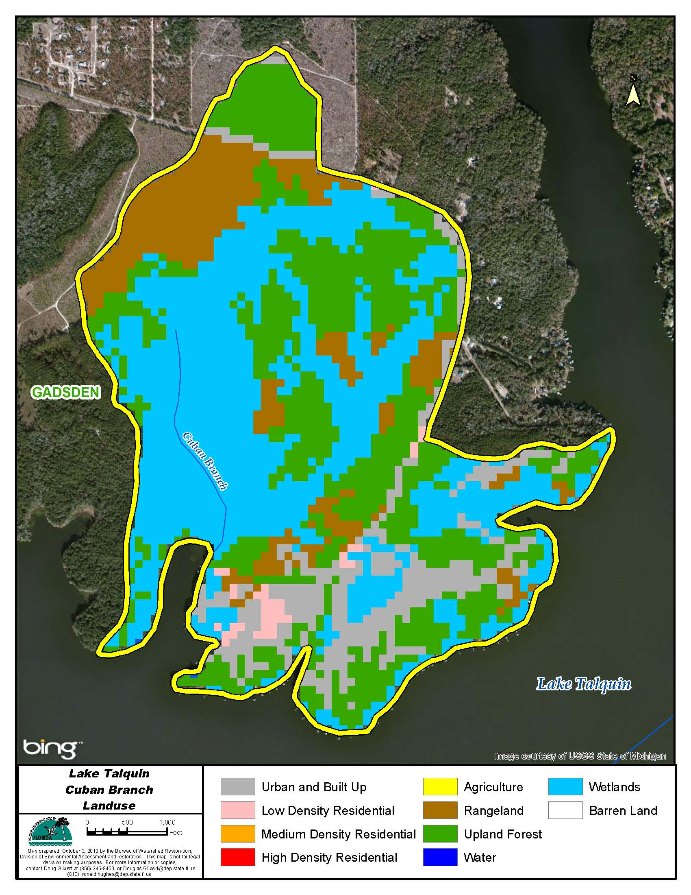

Figure B.6.21. Principal Land Uses in the Cuban Branch Watershed, 2006

Table B.6.21. Classification of Land Use Categories in the Cuban Branch Watershed, 2006

LU Code | Landuse | Acres | Square Miles | Percentage
11 | Water | 0.4 | 0.0 | 0.1
21 | Urban Built up | 80.3 | 0.1 | 11.6
22 | Low Density Res | 8.5 | 0.0 | 1.2
41 | Upland Forest | 227.3 | 0.4 | 33.0
52 | Rangeland | 92.5 | 0.1 | 13.4
90 | Wetlands | 280.4 | 0.4 | 40.7
Total | Watershed | 689.4 | 1.1 | 100.0

Hammock Creek

Hammock Creek drains directly to Lake Talquin.
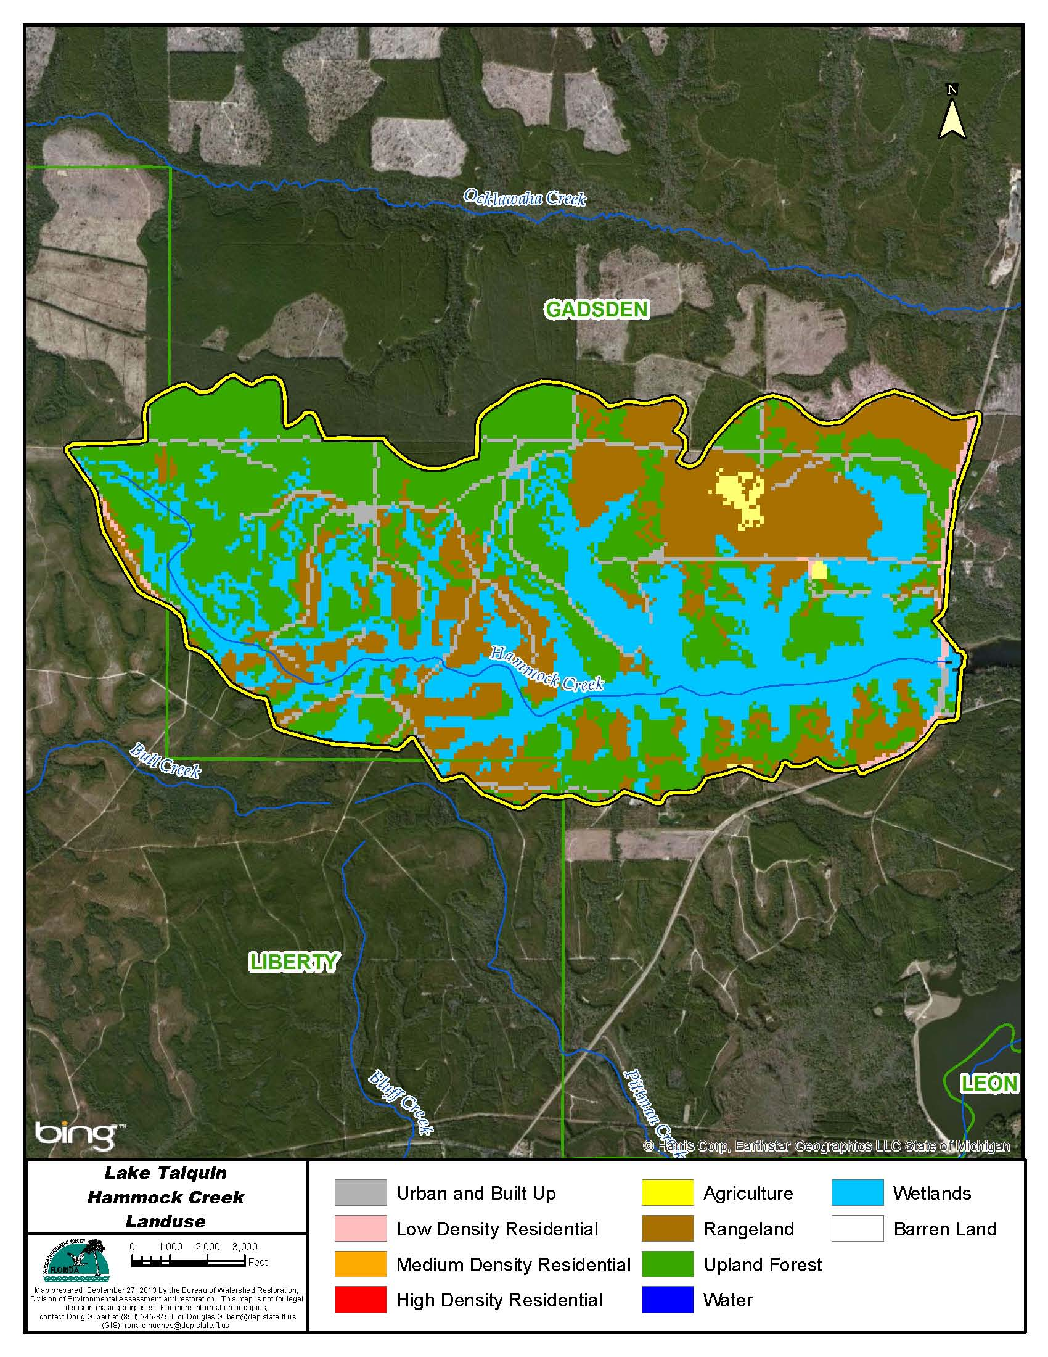

Figure B.6.22. Principal Land Uses in the Hammock Creek Watershed, 2006

Table B.6.22. Classification of Land Use Categories in the Hammock Creek Watershed, 2006

LU Code | Landuse | Acres | Square Miles | Percentage
21 | Urban Built up | 228.2 | 0.4 | 5.1
22 | Low Density Res | 32.0 | 0.1 | 0.7
42 | Upland Forest | 1,651.1 | 2.6 | 37.0
52 | Rangeland | 1,184.9 | 1.9 | 26.5
81 | Agriculture | 29.6 | 0.0 | 0.7
90 | Wetlands | 1,342.6 | 2.1 | 30.0
Total | Watershed | 4,468.3 | 7.0 | 100.0

Freeman Creek

Freeman Creek drains directly to Lake Talquin.
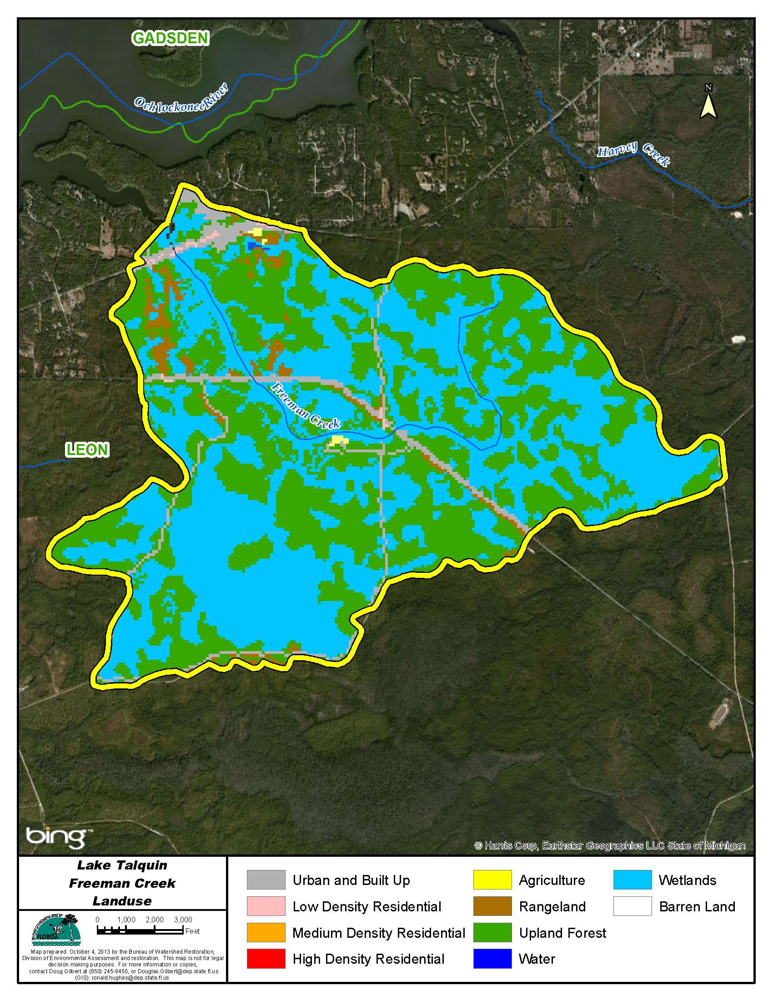

Figure B.6.23. Principal Land Uses in the Freeman Creek Watershed, 2006

Table B.6.23. Classification of Land Use Categories in the Freeman Creek Watershed, 2006

LU Code | Landuse | Acres | Square Miles | Percentage
11 | Water | 2.9 | 0.0 | 0.1
21 | Urban Built up | 198.8 | 0.3 | 4.0
22 | Low Density Res | 10.9 | 0.0 | 0.2
41 | Upland Forest | 2,181.9 | 3.4 | 43.9
52 | Rangeland | 118.5 | 0.2 | 2.4
81 | Agriculture | 6.9 | 0.0 | 0.1
90 | Wetlands | 2,448.1 | 3.8 | 49.3
Total | Watershed | 4,968.1 | 7.8 | 100.0

Harvey Creek

Harvey Creek drains directly to Lake Talquin.

Figure B.6.24. Principal Land Uses in the Harvey Creek Watershed, 2006

Table B.6.24. Classification of Land Use Categories in the Harvey Creek Watershed, 2006

LU Code | Landuse | Acres | Square Miles | Percentage
21 | Urban Built up | 184.8 | 0.3 | 3.5
22 | Low Density Res | 17.6 | 0.0 | 0.3
41 | Upland Forest | 2,178.3 | 3.4 | 41.1
52 | Rangeland | 188.6 | 0.3 | 3.6
81 | Agriculture | 42.0 | 0.1 | 0.8
90 | Wetlands | 2,687.9 | 4.2 | 50.7
Total | Watershed | 5,299.2 | 8.3 | 100.0

Polk Creek

Polk Creek drains directly to Lake Talquin.
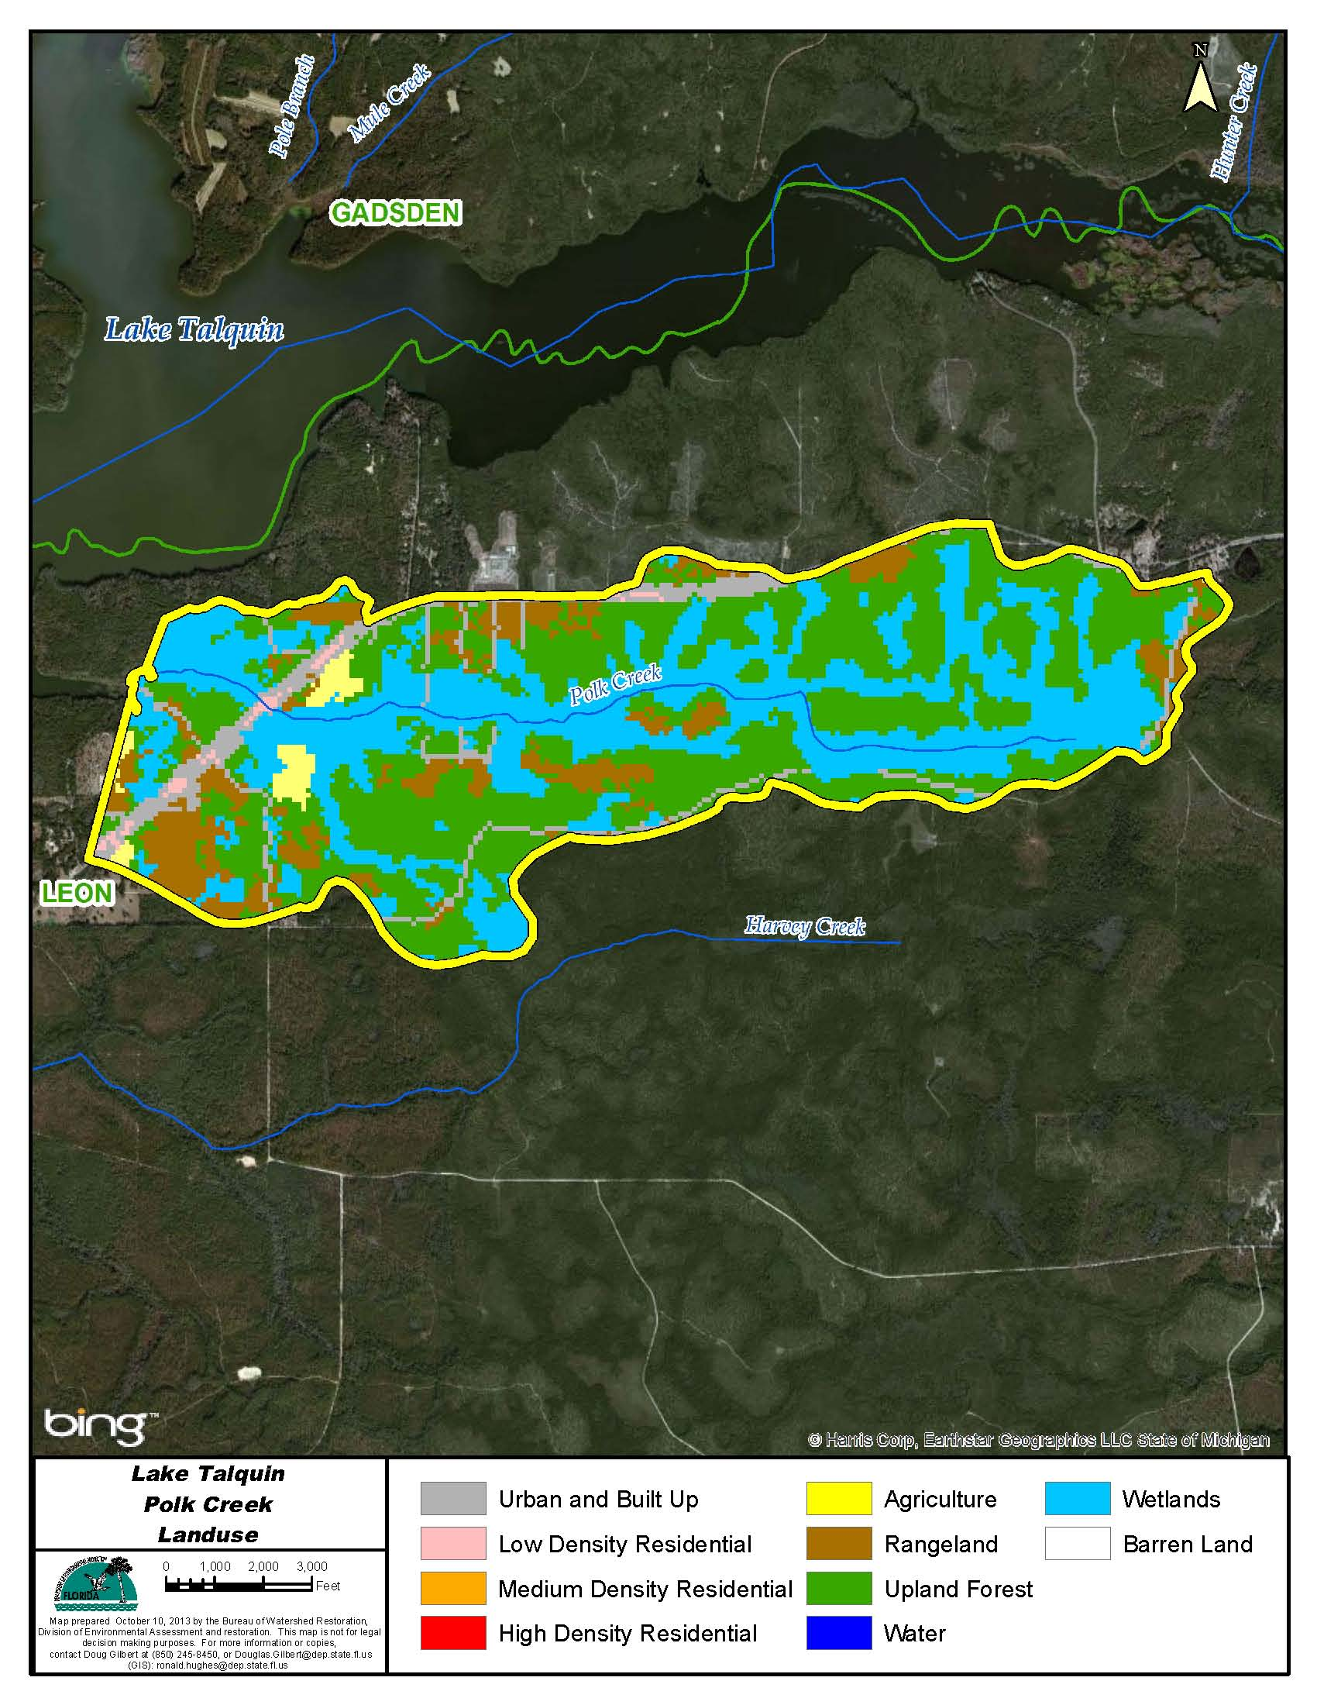

Figure B.6.25. Principal Land Uses in the Polk Creek Watershed, 2006

Table B.6.25. Classification of Land Use Categories in the Polk Creek Watershed, 2006

LU Code | Landuse | Acres | Square Miles | Percentage
21 | Urban Built up | 188.8 | 0.3 | 6.7
22 | Low Density Res | 18.0 | 0.0 | 0.6
41 | Upland Forest | 1,241.8 | 1.9 | 44.3
52 | Rangeland | 308.7 | 0.5 | 11.0
81 | Agriculture | 47.4 | 0.1 | 1.7
90 | Wetlands | 999.9 | 1.6 | 35.7
Total | Watershed | 2,804.6 | 4.4 | 100.0

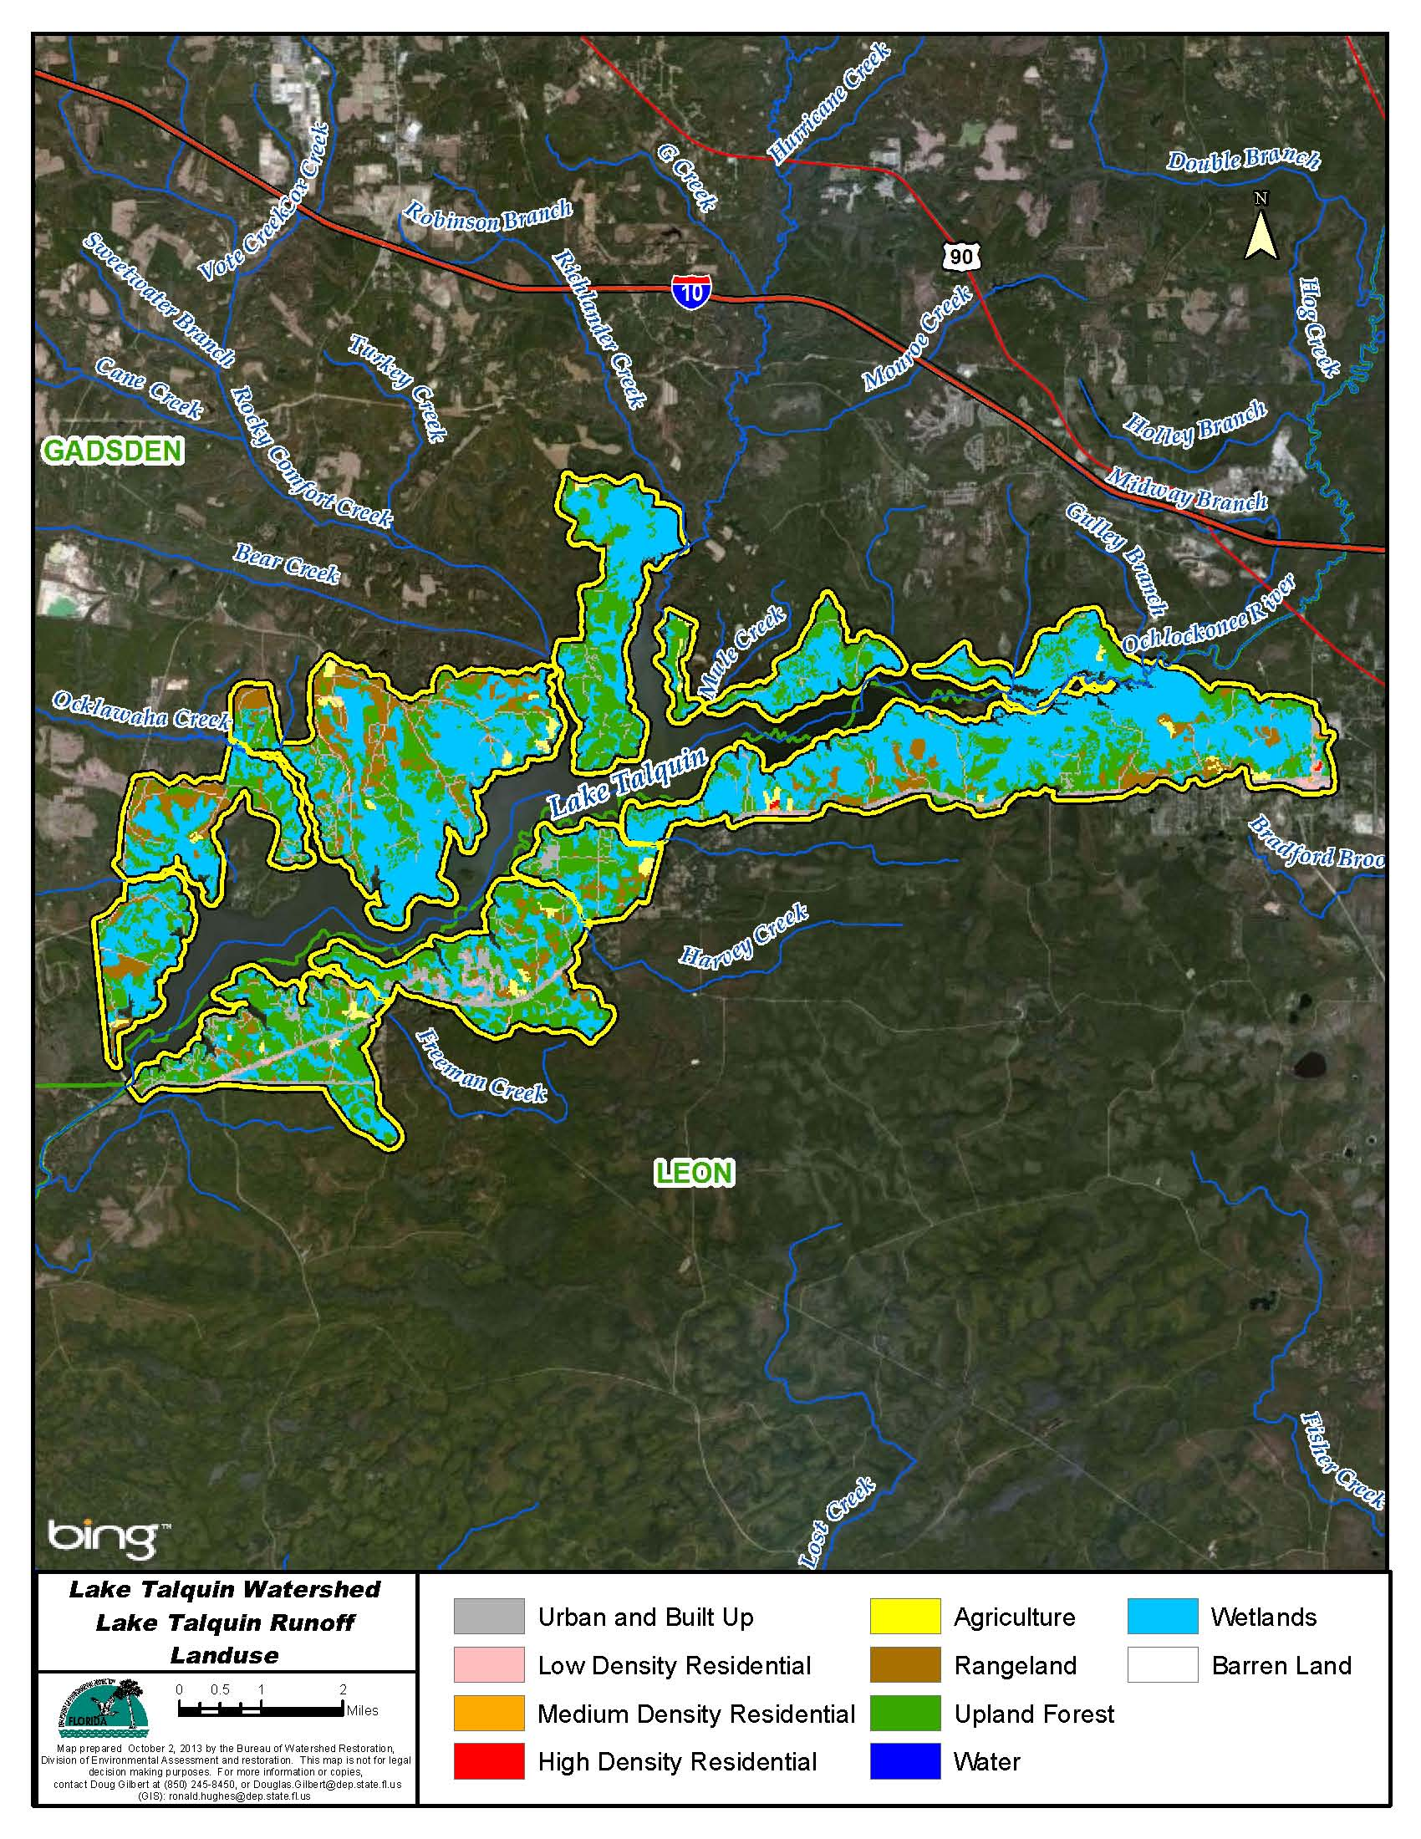

Figure B.6.26. Principal Land Uses in the Lake Talquin Runoff Area to Lake Talquin, 2006

Table B.6.26. Classification of Land Use Categories in the Lake Talquin Runoff Area Draining Directly to Lake Talquin, 2006

LU Code | Landuse | Acres | Square Miles | Percentage
11 | Water | 20.2 | 0.0 | 0.1
21 | Urban Built up | 1,347.7 | 2.1 | 7.4
22 | Low Density Res | 135.0 | 0.2 | 0.7
23 | Medium Density Res | 8.7 | 0.0 | 0.0
24 | High Density Res | 9.8 | 0.0 | 0.1
41 | Upland Forest | 6,076.2 | 9.5 | 33.2
52 | Rangeland | 1,684.6 | 2.6 | 9.2
81 | Agriculture | 280.2 | 0.4 | 1.5
90 | Wetlands | 8,735.9 | 13.6 | 47.7
Total | Watershed | 18,298.4 | 28.6 | 100.0


Florida Department of Environmental Protection
Division of Environmental Assessment and Restoration
Bureau of Watershed Restoration
2600 Blair Stone Road, Mail Station 3565
Tallahassee, FL 32399-2400

