NORTHWEST DISTRICT • OCHLOCKONEE–ST. MARKS BASIN

REVISED DRAFT

Lake Talquin (WBIDs 1297D and 1297C)
Nutrient TMDLs

and Documentation in Support of the Development of
Site-Specific Numeric Interpretations
of the Narrative Nutrient Criterion

Douglas Gilbert
Division of Environmental Assessment and Restoration
Florida Department of Environmental Protection

May 2017



2600 Blair Stone Road
Mail Station 3575
Tallahassee, FL 32399-2400

Acknowledgments
This analysis could not have been accomplished without significant contributions from staff in the Florida Department of Environmental Protection's Geographic Information System Section and Northwest District Office. Modeling support was provided by Tim Wool, Glynn Fernandez, Amy Howell, Craig Hesterlee, and Glenn Fernandez with the U.S. Environmental Protection Agency
Region 4.
Editorial assistance was provided by Erin Rasnake and Linda Lord.
Map production assistance was provided by Ronald Hughes.
For additional information on the watershed management approach and impaired waters in the Ochlockonee–St. Marks Basin, contact:
Kevin Coyne
Florida Department of Environmental Protection
Watershed Planning and Coordination Section
2600 Blair Stone Road, Mail Station 3565
Tallahassee, FL 32399-2400
Email: kevin.coyne@dep.state.fl.us
Phone: (850) 245–8555
Fax: (850) 245–8434

Access to all data used in the development of this report can be obtained by contacting:

Douglas Gilbert, Environmental Manager
Florida Department of Environmental Protection
Water Quality and TMDL Program
Watershed Evaluation and TMDL Section
2600 Blair Stone Road, Mail Station 3555
Tallahassee, FL 32399-2400
Email: douglas.gilbert@dep.state.fl.us
Phone: (850) 245–8450
Fax: (850) 245–8536

Contents
Acknowledgments 2
Chapter 1: INTRODUCTION 9
1.1 Purpose of Report 9
1.2 Identification of Waterbody 9
1.3 Background 13
Chapter 2: DESCRIPTION OF WATER QUALITY PROBLEM 14
2.1 Statutory Requirements and Rulemaking History 14
2.2 Information on Verified Impairment 14
2.3 Data Used in the Determination of the TMDL 17
Chapter 3. DESCRIPTION OF APPLICABLE WATER QUALITY STANDARDS AND TARGETS 18
3.1 Classification of the Waterbody and Criterion Applicable to the TMDL 18
3.2 Numeric Interpretation of the Narrative Nutrient Criterion for Lakes 18
3.3 Determination of Site-Specific Numeric Interpretation 20
Chapter 4: ASSESSMENT OF SOURCES 21
4.1 Types of Sources 21
4.2 Potential Sources of Nutrients in the Lake Talquin Watershed 21
Chapter 5: DETERMINATION OF ASSIMILATIVE CAPACITY 32
5.1 TMDL Development Process—Establishing Nutrient Targets 32
5.2 Calculation of Nutrient TMDLs and Applicable TN and TP Load–Based Criteria 43
5.3 Calculation of Wasteload Allocations 57
5.4 Critical Conditions/Seasonality 58
Chapter 6: DETERMINATION OF THE TMDL 59
6.1 Expression and Allocation of the TMDL 59
6.2 Load Allocation 60
6.3 Wasteload Allocation 61
6.4 Margin of Safety (MOS) 61
Chapter 7: TMDL IMPLEMENTATION 63
7.1 Basin Management Action Plans 63
References 65
Appendices 68
Appendix A: Background Information on Federal and State Stormwater Programs 68
Appendix B: Information in Support of Site-Specific Interpretations of the Narrative Nutrient Criterion 69
Attachments 73
Attachment 1: Surface Water Quality Results 73
Attachment 2: Modeling Calibration Report 73

List of Figures

Figure 1.1. Location of Lake Talquin WBIDs and streams and rivers draining to Lake Talquin 11
Figure 1.2. Location of the Lake Talquin watershed in the Ochlockonee–St. Marks Basin 12
Figure 2.1. Lake Talquin sampling stations 17
Figure 4.1. NPDES surface water discharge facilities in the Lake Talquin models 22
Figure 4.2. MS4 areas (yellow) in the Lake Talquin watershed (Florida) 24
Figure 4.3. Principal land uses in the Lake Talquin watershed, 2006 25
Figure 4.4. All OSTDS in the Lake Talquin watershed (Florida), 2010 29
Figure 4.5. OSTDS within 200 meters of a stream/river or lake in the Lake Talquin watershed (Florida), 2010 30
Figure 5.1. Chlorophyll a Assessment Zones (TMDL) 34
Figure 5.2. Example of excluded cells 34
Figure 5.3. Lake Talquin chlorophyll a daily average calibration, natural, and TMDL-WLA scenarios 45
Figure 5.4. Upper Zone chlorophyll a daily average calibration, natural, and TMDL-WLA scenarios 45
Figure 5.5. Middle Zone chlorophyll a daily average calibration, natural, and TMDL-WLA scenarios 46
Figure 5.6. Lower Zone chlorophyll a daily average calibration, natural, and TMDL-WLA scenarios 46
Figure 5.7. Little River Arm chlorophyll a daily average calibration, natural, and TMDL-WLA scenarios 47
Figure 5.8. Lake Talquin chlorophyll a daily AGM for calibration, natural, and TMDL-WLA scenarios 48
Figure 5.9. Upper Zone chlorophyll a Daily AGM for calibration, natural, and TMDL-WLA scenarios 49
Figure 5.10. Middle Zone chlorophyll a daily AGM for calibration, natural, and TMDL-WLA scenarios 49
Figure 5.11. Lower Zone chlorophyll a daily AGM for calibration, natural, and TMDL-WLA scenarios 50
Figure 5.12. Little River Arm chlorophyll a daily AGM for calibration, natural, and TMDL-WLA scenarios 50
Figure 5.13. Lake Talquin TP TMDL and TMDL-WLA 52
Figure 5.14. Lake Talquin TN TMDL and TMDL-WLA 54
Figure 5.15. Lake Talquin chlorophyll a TMDL and TMDL-WLA 56

List of Tables

Table 2.1. Verified impaired segments (nutrients and DO) in the Ochlockonee River Basin 15
Table 2.2. Assessment results for Upper Lake Talquin (WBID 1297D) 15
Table 2.3. Assessment results for Lower Lake Talquin (WBID 1297C) 15
Table 3.1. Chlorophyll a, TN, and TP criteria for Florida lakes (Subparagraph 62-302.531[2][b]1., F.A.C.) 19
Table 3.2. TMDL TN, TP, and chlorophyll a average AGM concentrations to attain the chlorophyll a target concentration 20
Table 4.1. NPDES point source surface water dischargers in the Lake Talquin models 23
Table 4.2. Classification of land use categories in the Lake Talquin watershed, 2006 26
Table 4.3. Summary of Quincy weighted mean annual wet deposition ammonium and nitrate concentrations 27
Table 4.4. All OSTDS in the Lake Talquin watershed (Florida), 2010 31
Table 4.5. OSTDS within 200 meters of a stream/river or lake in the Lake Talquin watershed (Florida), 2010 31
Table 5.1. Florida natural condition land use assignment 33
Table 5.2. Annual Average watershed loads for calibration, natural condition, anthropogenic, and percent reduction 36
Table 5.3. TN watershed scale factors, percent reductions and loads for calibration, natural condition, and anthropogenic scenarios 36
Table 5.4. TP watershed loads for calibration, natural conditions, and anthropogenic loads 37
Table 5.5. Lake Talquin TN AGM concentrations by area 38
Table 5.6. Little River Arm (LRA) TN AGM concentrations by year 38
Table 5.7. Upper Zone TN AGM concentrations by year 38
Table 5.8. Middle Zone TN AGM concentrations by year 39
Table 5.9. Lower TN AGM concentrations by year 39
Table 5.10. Lake Talquin TP AGM concentrations by area 39
Table 5.11. Little River Arm (LRA) TP AGM concentrations by year 40
Table 5.12. Upper Zone TP AGM concentrations by year 40
Table 5.13. Middle Zone TP AGM concentrations by year 40
Table 5.14. Lower Zone TP AGM concentrations by year 41
Table 5.15. Lake Talquin chlorophyll a AGM concentrations by area 41
Table 5.16. Little River Arm (LRA) chlorophyll a AGM concentrations by year 41
Table 5.17. Upper Zone chlorophyll a AGM by year 42
Table 5.18. Middle Zone chlorophyll a AGM by year 42
Table 5.19. Lower Zone chlorophyll a AGM by year 42
Table 5.22. Lake Talquin TN and TP, Calibration, TMDLC, and TMDL-WLA loads 43
Table 5.23. Lake Talquin TP TMDL Existing and TMDL-WLA by Area 51
Table 5.24. Lake Talquin TP TMDL-WLA by Area and Year 52
Table 5.25. Lake Talquin TN TMDL Current and TMDL-WLA by Area 53
Table 5.26. Lake Talquin TN TMDL-WLA by Area and Year 53
Table 5.27. Lake Talquin chlorophyll a TMDL Existing and TMDL-WLA by Area 55
Table 5.28. Lake Talquin chlorophyll a TMDL TMDL-WLA by Area and Year 55
Table 5.29. Quincy WLA TN and TP 57
Table 5.30. A.B. Hopkins WLA TN and TP 58
Table 6.1. TMDL components for nutrients in Lake Talquin (WBIDs 1297D and 1297C) 60
Table 6.2. TMDL components for nutrients at the Georgia – Florida State Line 60
Table B-1. Spatial extent of the numeric interpretation of the narrative nutrient criterion 69
Table B-2. Description of the numeric interpretation of the narrative nutrient criterion 70
Table B-3. Designated use, verified impairment, and approach to establish protective restoration targets 71
Table B-4. Documentation of the means to attain and maintain water quality standards for downstream waters 72
Table B-5. Documentation to demonstrate that administrative requirements are met 72

Websites

Florida Department of Environmental Protection

TMDL Program
Identification of Impaired Surface Waters Rule
Florida STORET Program
2014 Integrated Report
Criteria for Surface Water Quality Classifications
Surface Water Quality Standards

U.S. Environmental Protection Agency

Region 4: TMDLs in Florida
National STORET Program

Chapter 1: INTRODUCTION

1.1 Purpose of Report
This report presents the total maximum daily loads (TMDLs) developed to address the nutrient impairment of Lake Talquin, which is located in the Ochlockonee–St. Marks Basin. The nutrient TMDLs will constitute the site-specific numeric interpretation of the narrative nutrient criterion set forth in Paragraph 62-302.530(90)(b), Florida Administrative Code (F.A.C.), that will replace the otherwise applicable numeric nutrient criteria (NNC) in Subsection 62-302.531(2), F.A.C., for this particular water, pursuant to Paragraph 62-302.531(2)(a), F.A.C.. The lake was verified as impaired for nutrients and DO using the methodology in the Identification of Impaired Surface Waters Rule (IWR) (Chapter 62-303, F.A.C.), and was included on the Verified List of impaired waters for the Ochlockonee–St. Marks Basin that was adopted by Secretarial Order on March 19, 2009.
The TMDL process quantifies the amount of a pollutant that can be assimilated in a waterbody, identifies the sources of the pollutant, and provides water quality targets needed to achieve compliance with applicable water quality criteria based on the relationship between pollution sources and water quality in the receiving waterbody. The TMDLs establish the allowable loadings to Lake Talquin that would restore the waterbody so that it meets its applicable water quality criteria for nutrients.

1.2 Identification of Waterbody
For assessment purposes, the Florida Department of Environmental Protection (DEP) has divided the Ochlockonee–St. Marks Basin into water assessment polygons with a unique waterbody identification (WBID) number for each segment. Lake Talquin is divided into two WBIDs: 1297D and 1297C (Figure 1.1).

1.2.1 Lake Talquin (Upper), WBID 1297D
WBID 1297D (Upper) makes up the eastern section of the lake, exchanges water with WBID 1297C at their boundary, and includes 3,073.25 acres (38%) of the 8,087 acres (U.S. Geological Survey [USGS] National Hydrography Dataset [NHD]) of the open waters of Lake Talquin. This area receives drainage from the Ochlockonee and Little Rivers, Polk Creek, and numerous small tributaries in Leon County; and Bear, Rocky Comfort, Richlander, Mule, Double Branch, and Hunter Creeks in Gadsden County (Figure 1.1).

1.2.2 Lake Talquin (Lower), WBID 1297C
WBID 1297C (Lower) makes up the western section of the lake, including the outflow structure (Corn Hydroelectric Facility). The lower area of the lake includes 5,014.25 acres (62%) of the 8,087 acres of the open waters of Lake Talquin. This area exchanges water with WBID 1297C at their boundary and includes drainage from the Ocklawaha and Hammock Creeks in Gadsden County, Freeman and Harvey Creeks in Leon County, and numerous small tributaries (Figure 1.1).
The Lake Talquin watershed (Figure 1.2) covers 1,568.92 square miles, of which 73.3% (1,150.3 square miles) is located in Georgia, with the remaining 26.7% (418.7 square miles) in Florida. The Ochlockonee, Swamp, Attapulgus, and Willacoochee Rivers all form in Georgia and flow into Florida, forming the majority of the freshwater flow into Lake Talquin. Within just a few miles of entering Florida, in sequence, Attapulgus Creek, Swamp Creek, and Willacoochee Creek join, giving rise to the Little River, the second largest tributary to Lake Talquin.
The Ochlockonee River originates south of the town of Sylvester in Worth County, in southwest Georgia. It flows 206 miles before crossing into Florida, contributing the majority of the water for Lake Talquin (a long-term average flow of 1,530 cubic feet per second [cfs] of the 2,500 cfs leaving the lake) (61% of total outflow), eventually emptying into Ochlockonee Bay. In Florida, the river forms the western boundaries of Leon and Wakulla Counties and the eastern boundaries of Gadsden, Liberty, and Franklin Counties.
In Florida, the Ochlockonee and Little Rivers run 20 miles from the state line to Lake Talquin. Major centers of population in the Georgia portion of the watershed include Tifton, Moultrie, Thomasville, and Cairo. Major population centers in Florida include Gretna, Havana, and Quincy.
Additional information about the watershed hydrology and geology is available in the DEP Water Quality Assessment Report: Ochlockonee–St. Marks (2003) and the U.S. Environmental Protection Agency (EPA) Report on Lake Talquin, Gadsden and Leon Counties, Florida (1977).
Lake Talquin lies in the Quincy Hills division of the Tifton Uplands District. The Tifton Uplands region (locally known as the Tallahassee Hills) consists of clay-capped ridges that have been eroded and dissected by streams, with a relatively high potential for runoff (DEP 2001). The geology in the area is dominated by clayey sand and clayey limestone of the Hawthorn Formation. In the eastern Panhandle of north Florida, this type of clay is associated with the Torreya Formation of the Hawthorn Group (Scott 1988).
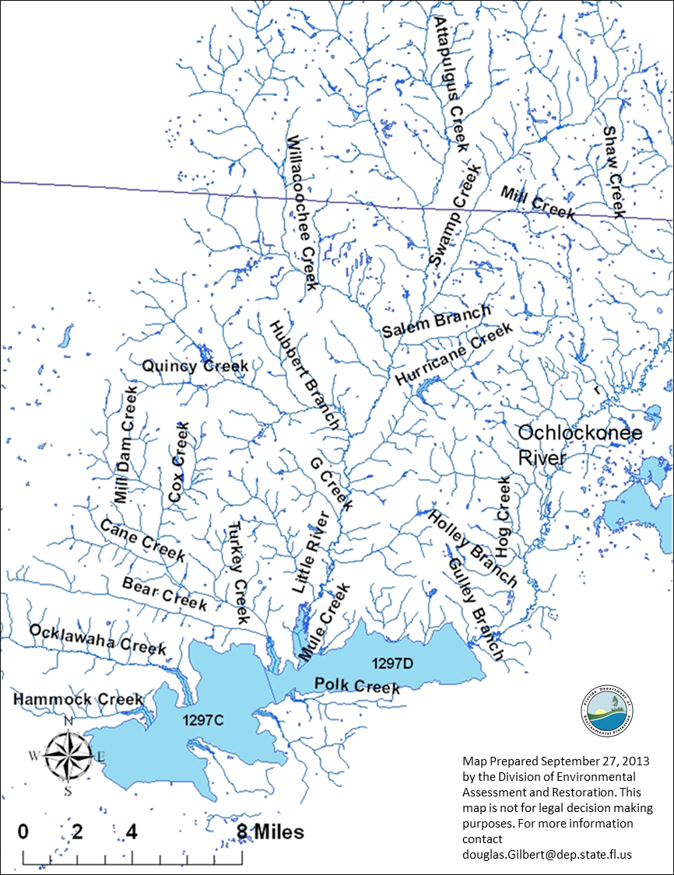
Figure 1.1. Location of Lake Talquin WBIDs and streams and rivers draining to Lake Talquin

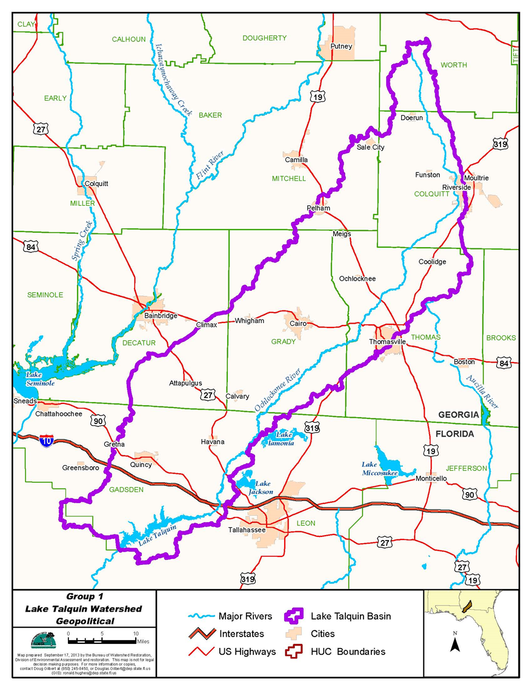

Figure 1.2. Location of the Lake Talquin watershed in the Ochlockonee–St. Marks Basin

1.3 Background
This report was developed as part of DEP's watershed management approach for restoring and protecting state waters and addressing TMDL Program requirements. The watershed approach, which is implemented using a cyclical management process that rotates through the state's 52 river basins over a five-year cycle, provides a framework for implementing the TMDL Program–related requirements of the 1972 federal Clean Water Act and the 1999 Florida Watershed Restoration Act (FWRA) (Chapter 99-223, Laws of Florida). Lake Talquin, located within the Ochlockonee River Basin is a Group 1 waterbody and next assessment cycle (4) will occur in 2018.
A TMDL represents the maximum amount of a given pollutant that a waterbody can assimilate and still meet water quality standards, including its applicable water quality criteria and its designated uses. TMDLs are developed for waterbodies that are verified as not meeting applicable water quality standards. They provide important water quality restoration goals that will guide restoration activities.
This TMDL report will be followed by the development and implementation of a restoration plan designed to reduce the amount of nutrients or causative pollutants that caused the verified impairment of Lake Talquin. These activities will depend heavily on the active participation of the Northwest Florida Water Management District (NWFMD), local governments, businesses, and other stakeholders. DEP will work with these organizations and individuals to undertake or continue reductions in the discharge of pollutants and achieve the established TMDLs for the impaired waterbody.

Chapter 2: DESCRIPTION OF WATER QUALITY PROBLEM

2.1 Statutory Requirements and Rulemaking History
Section 303(d) of the federal Clean Water Act requires states to submit to the EPA lists of surface waters that do not meet applicable water quality standards (impaired waters) and establish a TMDL for each pollutant causing the impairment of listed waters on a schedule. DEP has developed such lists, commonly referred to as 303(d) lists, since 1992. The FWRA (Section 403.067, F.S.) directed DEP to develop, and adopt by rule, a new science-based methodology to identify impaired waters.
The Environmental Regulation Commission adopted the new methodology as Chapter 62-303, F.A.C. (Identification of Impaired Surface Waters Rule, or IWR), in April 2001. The rule was amended in 2006, 2007, 2012, 2013, and 2015. The list of impaired waters in each basin, referred to as the Verified List, is also required by the FWRA (Subsection 403.067[4], F.S.); the state's 303(d) list is amended annually to include basin updates.

2.2 Information on Verified Impairment
DEP used the IWR to assess water quality impairments in the Ochlockonee–St. Marks Basin and verified the nutrient and DO impairments listed in Table 2.1 in accordance with the impairment thresholds and water quality criteria described in Chapter 3.
All raw data included in the report are available by contacting DEP's Watershed Evaluation and TMDL Section. Data from IWR Run 47 were processed by examining each result for appropriateness.
The remaining data provide the basis for preparing the figures and summary statistics. The summary statistics were calculated from these data in accordance with the newly adopted criteria for nutrients to determine the annual geometric mean (geomean, or AGM). Data used to make a determination of impairment in a waterbody must meet the stringent data quality and temporal and spatial processing requirements of the IWR. This may result in the exclusion of some data from the assessment process. Any data not included in the assessment are flagged in the IWR dataset. Subsequent to the presentation of the assessment results, all data meeting the general quality control requirements were incorporated into the impairment assessment.
The nutrient impairment in Lake Tallavana is being addressed in a separate TMDL. The Lake Talquin DO impairment was evaluated and will be addressed in a separate TMDL . The Hammock Creek DO impairment is proposed for delisting.

Table 2.1. Verified impaired segments (nutrients and DO) in the Ochlockonee River Basin
BOD = Biochemical oxygen demand
TSI = Trophic State Index
WBID | Waterbody Segment | Parameters Identified Using the IWR
879 | Hammock Creek | DO (BOD)
540A | Lake Tallavana | Nutrients (TSI)
1297D | Lake Talquin (Upper) | Nutrients (TSI)
1297C | Lake Talquin (Lower) | Nutrients (TSI)
1297C | Lake Talquin (Lower) | DO (BOD)

2.2.1 Summary of Verified Nutrient Impairments in Lake Talquin

2.2.1.1 Upper Lake Talquin (WBID 1297D) Impairments
Upper Lake Talquin was verified as impaired for nutrients (Table 2.1) based on an elevated TSI over the Cycle 2 verified period for the Group 1 basins (January 1, 2000–June 30, 2007). Table 2.2 provides the assessment results for TSI for the verified period.

Table 2.2. Assessment results for Upper Lake Talquin (WBID 1297D)
PCU = Platinum cobalt units
Year | Upper Lake Talquin  (WBID 1297D)  TSI | Color  (PCU)
2005 | 43.7 | >40
2006 | 41.8 | <40

These data indicate that Upper Lake Talquin exceeded the TSI impairment threshold for low-color lakes of 40 in 2006 and therefore met the conditions for being included on the Verified List of impaired waters.

2.2.1.2 Lower Lake Talquin (WBID 1297C) Impairments
The impairments in Lower Lake Talquin are based on data from the Cycle 2 verified period for the Group 1 basins (January 1, 2000–June 30, 2007), summarized in Table 2.3.

Table 2.3. Assessment results for Lower Lake Talquin (WBID 1297C)
Year | Lower Lake Talquin  (WBID 1297C)  TSI | Color  (PCU)
2005 | 45.6 | >40
2006 | 44.2 | <40

From these data it can be determined that Lower Lake Talquin exceeded the TSI impairment threshold for low color lakes of 40 in 2006 and therefore met the conditions for being included on the Verified List of impaired waters.
Florida adopted NNC for lakes, spring vents, and streams in 2011 that were subsequently approved by the EPA in 2012. Pursuant to Chapter 2013-71, Laws of Florida, the criteria went into effect on October 27, 2014. It is envisioned that these standards, in combination with the related bioassessment tools, will facilitate the assessment of designated use attainment for these waters and provide a better means to protect state waters from the adverse effects of nutrient over enrichment. The new lake NNC, set forth in Subparagraph 62-302.531(2)(b)1., F.A.C., are expressed as AGM values for chlorophyll a, TN, and TP, which are further described in Chapter 3.
Based on the extensive analysis of data from Florida lakes, DEP has concluded that lake health is best related to the area of the state where a lake is located, its long-term color and alkalinity, the level of nutrients and chlorophyll a present (Chapter 3). These data are best assessed as the long-term geomean (GM) for color and alkalinity and as the annual geomean for total nitrogen (TN), total phosphorus (TP), and chlorophyll a. As such, the presentation of data for the lake will use period of record (POR) GMs for color and alkalinity and AGMs for nutrients and chlorophyll a.
Lake Talquin is in the Panhandle East Nutrient Watershed Region (for streams/rivers). The numeric nutrient thresholds contained in Rule 62-302.531, F.A.C., for lakes vary depending on color, alkalinity, chlorophyll a data sufficiency (for calculating AGM concentrations), and chlorophyll a AGM concentration. The POR GM alkalinity and color for WBID 1297D is 16.8 mg/L and 62.3 PCU, respectively. The POR GM alkalinity and color for WBID 1297C is 14.0 mg/L and 53.2 PCU, respectively. This characterizes both WBIDs of the lake as high color, in which case alkalinity does not impact the threshold concentrations for nutrients and chlorophyll a. The threshold for chlorophyll a is an AGM greater than 20 micrograms per liter (µg/L), the TP AGM can range between 0.05 and 0.16 milligrams per liter (mg/L), and TN AGM can range between 1.27 and 2.23 mg/L, depending on the chlorophyll a AGM concentration (Chapter 3).
In Florida waterbodies, nitrogen and phosphorus are most often the limiting nutrients. A limiting nutrient is defined as the nutrient(s) that limits plant growth (both macrophytes and algae) when it is not available in sufficient quantities. In the past, management activities to control lake eutrophication focused on phosphorus reduction, as phosphorus was generally considered the limiting nutrient in freshwater systems. Recent studies, however, support the reduction of both nitrogen and phosphorus to control algal growth in aquatic systems (Conley et al. 2009; Paerl 2009; Paerl and Otten 2013). Furthermore, the analysis used in the development of the Florida lake NNC supports this idea, as statistically significant relationships were found between chlorophyll a values and both nitrogen and phosphorus concentrations (DEP 2012).

2.3 Data Used in the Determination of the TMDL
Attachment 1 (available on request) includes the complete set of text, tables, and figures summarizing and depicting the data for rainfall, flow, and water quality for all WBIDs in Lake Talquin and the Lake Talquin watershed in Florida.
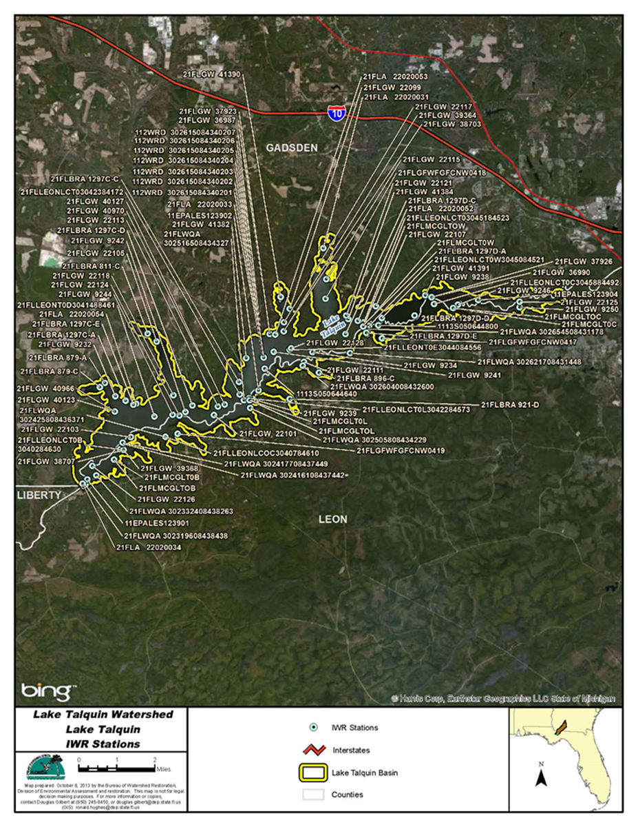
Figure 2.1. Lake Talquin sampling stations

Chapter 3. DESCRIPTION OF APPLICABLE WATER QUALITY STANDARDS AND TARGETS

3.1 Classification of the Waterbody and Criterion Applicable to the TMDL
Florida's surface waters are protected for six designated use classifications, as follows:
Class I Potable water supplies
Class II Shellfish propagation or harvesting
Class III Fish consumption; recreation, propagation and maintenance of a healthy, well-balanced population of fish and wildlife
Class III – Limited Fish consumption; recreation or limited recreation; and/or propagation and maintenance of a limited population of fish and wildlife
Class IV Agricultural water supplies
Class V Navigation, utility, and industrial use (there are no state waters currently in this class)

Lake Talquin (WBIDs 1297D and 1297C) is a Class III freshwater body, with a designated use of fish consumption, recreation, and propagation and maintenance of a healthy, well-balanced population of fish and wildlife. The Class III water quality criterion applicable to the verified impairments (nutrients) for these waters is Florida's nutrient criteria, contained in Rule 62-302.531, F.A.C., for TN, TP, and chlorophyll a and the criteria in Rule 62-302.533, F.A.C., for DO.
Based on a preliminary analysis, Lake Talquin, which was initially listed as verified impaired for nutrients based on TSI and DO, remains impaired for both nutrients and DO under the NNC.

3.2 Numeric Interpretation of the Narrative Nutrient Criterion for Lakes
The NNC for inland waters were adopted in Florida on December 8, 2011; were approved by the EPA on July 3, 2012; and have been in effect since October 27, 2014. The nutrient TMDLs in this report, upon adoption into Chapter 62-304, F.A.C., will constitute the site-specific numeric interpretations of the narrative nutrient criterion set forth in Paragraph 62-302.530(90)(b), F.A.C., that will supersede the otherwise applicable NNC in Subsection 62-302.531(2), F.A.C., for this particular waterbody.
The NNC rule language for lakes in Rule 62-302.531(2)(b)1., F.A.C., states:
For lakes, the applicable numeric interpretations of the narrative nutrient criterion in paragraph 62-302.530(90)(b), F.A.C., for chlorophyll a are shown in Table 3.1. The applicable interpretations for TN and TP will vary on an annual basis, depending on the availability of chlorophyll a data and the concentrations of nutrients and chlorophyll a in the lake, as described below. The applicable numeric interpretations for TN, TP, and chlorophyll a shall not be exceeded more than once in any consecutive three-year period.
a. If there are sufficient data to calculate the annual geometric mean chlorophyll a and the mean does not exceed the chlorophyll a value for the lake type in the table below, then the TN and TP numeric interpretations for that calendar year shall be the annual geometric means of lake TN and TP samples, subject to the minimum and maximum limits in the table below. [However, for lakes with color > 40 PCU in the West Central Nutrient Watershed Region, the maximum TP limit shall be the 0.49 mg/L TP streams threshold for the region]; or
b. If there are insufficient data to calculate the annual geometric mean chlorophyll a for a given year or the annual geometric mean chlorophyll a exceeds the values in the table below for the lake type, then the applicable numeric interpretations for TN and TP shall be the minimum values in the table below.
Based on the data retrieved from IWR Run 47, the long-term geometric mean color value for both WBIDs in Lake Talquin is greater than the 40 PCU value that distinguishes high-color lakes from clear lakes. This characterizes the lake as high color, in which case alkalinity does not impact the criteria for nutrients or chlorophyll a. Therefore, Lake Talquin is considered a high-color lake, and the applicable chlorophyll a target is an AGM greater than 20 µg/L, the TP AGM can range between 0.05 and 0.16 mg/L, and the TN AGM can range between 1.27 and 2.23 mg/L, depending on the chlorophyll a AGM concentration (Table 3.1).

Table 3.1. Chlorophyll a, TN, and TP criteria for Florida lakes (Subparagraph 62-302.531[2][b]1., F.A.C.)
¹ For lakes with color > 40 PCU in the West Central Nutrient Watershed Region, the maximum TP limit shall be the 0.49 mg/L TP streams threshold for the region.
CaCO₃ = Calcium carbonate
Long-Term Geometric Mean Lake Color and Alkalinity | AGM Chlorophyll a | Minimum Calculated AGM TP NNC | Minimum Calculated  AGM  TN NNC | Maximum Calculated  AGM  TP NNC | Maximum Calculated AGM  TN NNC
>40 PCU | 20 µg/L | 0.05 mg/L | 1.27 mg/L | 0.16 mg/L¹ | 2.23 mg/L
≤ 40 PCU and  > 20 mg/L CaCO₃ | 20 µg/L | 0.03 mg/L | 1.05 mg/L | 0.09 mg/L | 1.91 mg/L
≤ 40 PCU and  ≤ 20 mg/L CaCO₃ | 6 µg/L | 0.01 mg/L | 0.51 mg/L | 0.03 mg/L | 0.93 mg/L

To calculate an AGM for TN, TP, or chlorophyll a, there must be at least 4 temporally independent samples per year, with at least 1 sample taken between May 1 and September 30 and at least 1 sample taken during the other months of the calendar year. To be treated as temporally independent, samples must be taken at least 1 week apart.

3.3 Determination of Site-Specific Numeric Interpretation
The site-specific TN and TP targets for these TMDLs were established to achieve the generally applicable chlorophyll a criterion (20 µg/L) for high-color lakes. Based on several lines of evidence discussed in detail in the technical support document, Development of numeric nutrient criteria for Florida lakes, spring vents, and streams (DEP 2012), achieving a 20 µg/L chlorophyll a concentration as an AGM in this type of waterbody will prevent algal blooms and ensure that no harmful phytoplankton will impair the designated use. When this TMDL analysis was carried out, there was no site-specific information indicating that 20 µg/L is not protective of the designated use for this waterbody.
Using the modeling approach, as described in Chapter 5 of this report, the average zone-weighted AGM target TN and TP concentrations (Upper Zone, Middle Zone, and Lower Zone) to achieve the 20 µg/L chlorophyll a criterion (Table 3.2) ranged between 0.32 and 0.59 mg/L for TN and 0.014 and 0.051 mg/L for TP. Using the water quality model, DEP determined the nutrient loads that attain the target nutrient concentrations and chlorophyll a criterion. The nutrient loads (915,783 kg/yr TN and 76,585 kg/yr TP; Table 6.1) are based on the long-term (seven-year) average of the individual annual loads from the model not to be exceeded as a seven-year average. These nutrient loads are based on meeting an AGM chlorophyll a concentration of 20 µg/L in every year as a measure of conservatism. The nutrient loads are the site-specific numeric interpretations of the narrative nutrient criteria for Lake Talquin and the generally applicable chlorophyll a criterion of 20 µg/L as an AGM not to be exceeded more than once in any consecutive three-year period will continue to apply as the DEP has no reason to think that it is not protective of the lake. Chapter 5 provides a detailed discussion on how water quality models were used in establishing the target TN and TP concentrations and loads.

Table 3.2. TMDL TN, TP, and chlorophyll a average AGM concentrations to attain the chlorophyll a target concentration
Area | TN Minimum (mg/L) | TN Mean (mg/L) | TN Maximum (mg/L) | TP Minimum (mg/L) | TP Mean (mg/L) | TP Maximum (mg/L) | chlorophyll a Minimum (µg/L) | chlorophyll a Mean (µg/L) | chlorophyll a Maximum (µg/L)
Upper | 0.32 | 0.37 | 0.42 | 0.014 | 0.027 | 0.040 | 5.1 | 7.2 | 8.4
Middle | 0.47 | 0.52 | 0.59 | 0.034 | 0.040 | 0.046 | 13.9 | 14.8 | 16.5
Lower | 0.42 | 0.53 | 0.59 | 0.032 | 0.042 | 0.051 | 12.4 | 16.7 | 19.8
Lake Wide Average | 0.46 | 0.52 | 0.57 | 0.035 | 0.041 | 0.048 | 13.6 | 15.2 | 17.5

Appendix B summarizes the relevant TMDL information, including how the TMDL provides for the attainment and maintenance of water quality criteria in downstream waters (pursuant to Subsection 62-302.531[4], F.A.C.), to support using the TMDL nutrient loads as the site-specific numeric interpretations of the narrative nutrient criterion.

Chapter 4: ASSESSMENT OF SOURCES

4.1 Types of Sources
An important part of the TMDL analysis is the identification of pollutant source categories, source subcategories, or individual sources of pollutants in the impaired waterbody and the amount of pollutant loadings contributed by each of these sources. Sources are broadly classified as either "point sources" or "nonpoint sources." Historically, the term "point sources" has meant discharges to surface waters that typically have a continuous flow via a discernable, confined, and discrete conveyance, such as a pipe. Domestic and industrial wastewater treatment facilities (WWTFs) are examples of traditional point sources. In contrast, the term "nonpoint sources" was used to describe intermittent, rainfall-driven, diffuse sources of pollution associated with everyday human activities, including runoff from urban land uses, agriculture, silviculture, and mining; discharges from failing septic systems; and atmospheric deposition.
However, the 1987 amendments to the Clean Water Act redefined certain nonpoint sources of pollution as point sources subject to regulation under the EPA's National Pollutant Discharge Elimination System (NPDES) Program. These nonpoint sources included certain urban stormwater discharges, such as those from local government master drainage systems, construction sites over five acres, and a wide variety of industries (see Appendix A for background information on the federal and state stormwater programs).
To be consistent with Clean Water Act definitions, the term "point source" will be used to describe traditional point sources (such as domestic and industrial wastewater discharges) and stormwater systems requiring an NPDES stormwater permit when allocating pollutant load reductions required by a TMDL (see Section 6.1). However, the methodologies used to estimate nonpoint source loads do not distinguish between NPDES stormwater discharges and non-NPDES stormwater discharges, and as such, this source assessment section does not make any distinction between the two types of stormwater.

4.2 Potential Sources of Nutrients in the Lake Talquin Watershed

4.2.1 Point Sources

4.2.1.1 Wastewater Facilities
In Florida, currently only two WWTFs with the potential to impact Lake Talquin have NPDES permits allowing direct discharge to waters in the Lake Talquin watershed (Figure 4.1 and Table 4.1). These facilities, which are permitted through the NPDES Program in Florida, are the Arvah B. Hopkins power plant, located on Beaver Creek; and the Quincy domestic WWTP, located along Quincy Creek.
In Georgia, there are currently 8 NPDES surface water dischargers (6 domestic and 2 industrial facilities) (Figure 4.1 and Table 4.1) discharging to tributaries to Lake Talquin. These facilities are permitted by the state of Georgia.
All of the NPDES dischargers to surface water are taken into consideration in either the Loading Simulation Program in C++ (LSPC) model that delivers loadings to the Water Quality Analysis Simulation Program (WASP) models or input directly into the WASP models as a time series.

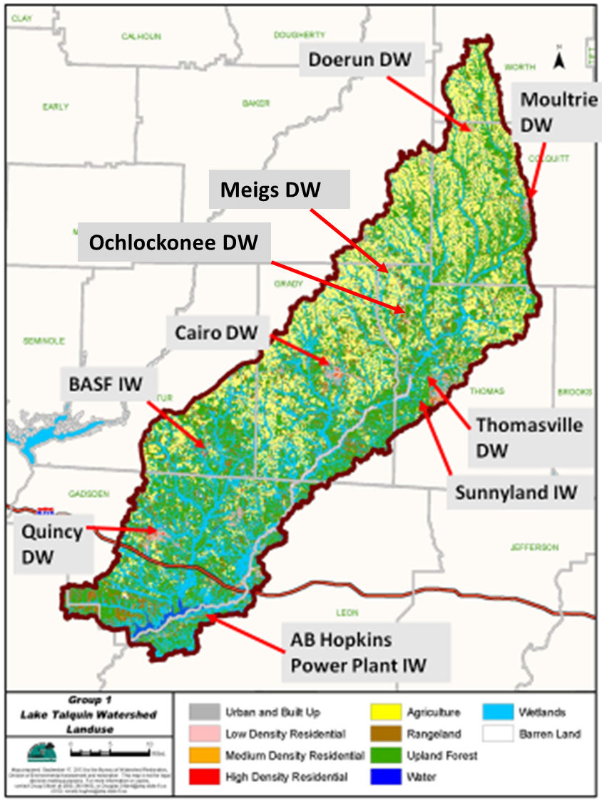
Figure 4.1. NPDES surface water discharge facilities in the Lake Talquin models

Table 4.1. NPDES point source surface water dischargers in the Lake Talquin models
IW = Industrial wastewater
DW = Domestic wastewater
PW = Power plant
WPCP = Water pollution control plant
Y = NPDES active permit
a = Average flow
mgd = Million gallons per day
Permit Number | Facility Name | Location | Facility Type | NPDES | Flow (mgd) | County
FL0025518 | Arvah B. Hopkins Power Plant | Beaver Creek | PW | Yes | 1.87 | Leon
FL0029033 | Quincy WWTP | Quincy Creek | DW | Yes | 1.5 | Gadsden
GA0024082 | City of Thomasville WPCP | Oquina Creek | DW | Yes | 6.5 | Thomas
GA0024660 | City of Moultrie WPCP | Ochlockonee River | DW | Yes | 4.0 | Colquitt
GA0025771 | City of Cairo WPCP | Parkers Mill Creek | DW | Yes | 3.5 | Grady
GA0001678 | BASF Attapulgus | Little Attapulgus Creek | IW | Yes | 2.19a | Decatur
GA0021717 | City of Doerun | Mill Creek | DW | Yes | 0.15 | Colquitt
GA001279 | Sunnyland (Genesis Project) | Tributary to Ochlockonee River | IW | Yes | 0.12a | Thomas
GA0048178 | City of Meigs | Oakey Creek tributary to Ochlockonee River | DW | Yes | 0.15 | Thomas
GA0046370 | Town of Ochlockonee | Pine Creek tributary to Ochlockonee River | DW | Yes | 0.05 | Thomas

4.2.1.2 Municipal Separate Storm Sewer Systems (MS4s)
MS4s may also discharge pollutants to waterbodies in response to storm events. To address stormwater discharges, the EPA developed the NPDES stormwater permitting program in two phases. Phase 1, promulgated in 1990, addresses large and medium-size MS4s located in incorporated areas and counties with populations of 100,000 or more. Phase 2 permitting began in 2003.
Regulated Phase II MS4s are defined in Rule 62-624.800, F.A.C., and typically cover urbanized areas serving jurisdictions with a population of at least 10,000 or discharging into Class I or Class II waters, or into OFWs. In the Lake Talquin watershed, the stormwater collection systems owned and operated by Leon County and the Florida Department of Transportation (FDOT) District 3 (NPDES MS4 Permit FLS000033) in Leon County are covered by a Phase I-C NPDES MS4 permit (Figure 4.2). This MS4 area (highlighted in yellow) is 66.8 square miles, or 16% of the 419 square miles of the watershed located in Florida.

4.2.2 Nonpoint Sources

4.2.2.1 Land Uses
Additional nutrient loadings to the impaired waters are generated from nonpoint sources in the watershed. Potential nonpoint sources are characterized by their pathway or delivery to the lake by runoff, groundwater, sediment nutrient release, and atmospheric deposition. Nonpoint sources can also be described by the type of land use where the sources are generated. Attachment 1 contains land use information for each Florida WBID for the Lake Talquin watershed.
The spatial distribution and acreage of different land use categories in Florida were identified using the 2006 National Land Cover Database (NLCD) land use coverage located at http://www.mrlc.gov/. As the majority of the watershed is outside of Florida, the NLCD was used to maintain consistency across state lines. Land use categories in each watershed were aggregated to the simplified Level 2 land use. They are depicted in Figure 4.3 and tabulated in Table 4.2.

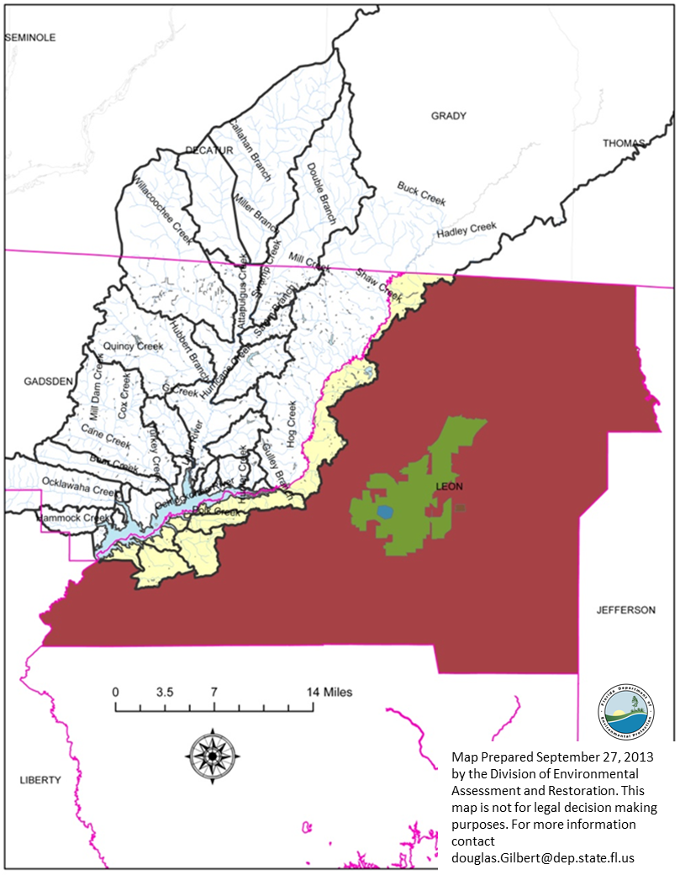
Figure 4.2. MS4 areas (yellow) in the Lake Talquin watershed (Florida)

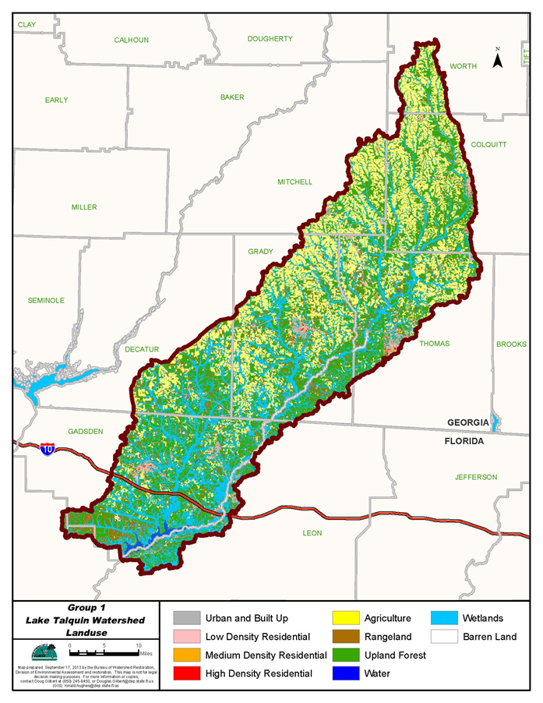
Figure 4.3. Principal land uses in the Lake Talquin watershed, 2006

Table 4.2. Classification of land use categories in the Lake Talquin watershed, 2006
Land Use Code | Land Use | Acres | Square Miles | %
11 | Water | 13,629.2 | 21.3 | 1.4%
21 | Urban Built Up | 47,743.3 | 74.6 | 4.8%
22 | Low Density Residential | 14,205.0 | 22.2 | 1.4%
23 | Medium Density Residential | 2,442.1 | 3.8 | 0.2%
24 | High Density Residential | 1,200.1 | 1.9 | 0.1%
31 | Barren Land | 1,662.6 | 2.6 | 0.2%
41 | Upland Forest | 307,305.2 | 480.2 | 30.6%
52 | Rangeland | 78,766.2 | 123.1 | 7.8%
81 | Agriculture | 280,674.7 | 438.6 | 28.0%
90 | Wetlands | 256,402.3 | 400.6 | 25.5%
TOTAL |  | 1,004,030.7 | 1,568.9 | 100.0%

4.2.2.2 Atmospheric Deposition
The National Atmospheric Deposition Program (NADP) National Trends Network (NTN) monitors precipitation chemistry at a network of 250 sites across the country. Ammonia and nitrate are among the constituents measured at these sites. The NADP Quincy (FL14) site, located in Gadsden County, has been operational since 1984. Precipitation-weighted mean annual concentrations for ammonium and nitrate from the Quincy NADP site were downloaded and used in the modeling (Table 4.3).

4.2.2.3 Other Potential Sources of Nutrient Loads in the Lake Talquin Watershed
Leon County Population
According to the U.S. Census Bureau, the population of Leon County in 2010 was 275,487. With an area of 666.85 square miles, the county has a population density of nearly 413 people per square mile. The Bureau reports that Leon County has 124,701 housing units (2011) and 109,508 households. For all of Leon County, the Bureau reported a housing density of 164 households (187 housing units) per square mile. This places Leon County at just over the average in housing densities in Florida of 133 households and 168 housing units per square mile (U.S. Census Bureau website 2013). The DEP notes that (based on information provided by Leon County) the area of Leon County MS4 within the watershed of Lake Talquin has a density of only 49.81 housing units and 116 people per square mile, significantly lower than the county wide average of 187 housing units and 413 people per square mile.
Gadsden County Population
According to the U.S. Census Bureau, the population of Gadsden County in 2010 was 46,389 and, with an area of 516.33 square miles, the county has a population density of nearly 90 people per square mile. The Bureau reports that Gadsden County has 19,561 housing units and 16,488 households. For all of Gadsden County, the Bureau reported a housing density of 31.9 households (37.9 housing units) per square mile. This places Gadsden County well below the average in housing densities in Florida of 133 households and 168 housing units per square mile (U.S. Census Bureau website 2014).

Table 4.3. Summary of Quincy weighted mean annual wet deposition ammonium and nitrate concentrations
Site ID | Year | NH₄  (mg/L) | NO₃  (mg/L)
FL14 | 1984 | 0.120 | 0.622
FL14 | 1985 | 0.073 | 0.410
FL14 | 1986 | 0.044 | 0.515
FL14 | 1987 | 0.077 | 0.549
FL14 | 1988 | 0.064 | 0.747
FL14 | 1989 | 0.144 | 0.636
FL14 | 1990 | 0.153 | 0.730
FL14 | 1991 | 0.068 | 0.538
FL14 | 1992 | 0.074 | 0.544
FL14 | 1993 | 0.114 | 0.711
FL14 | 1994 | 0.062 | 0.457
FL14 | 1995 | 0.166 | 0.614
FL14 | 1996 | 0.109 | 0.565
FL14 | 1997 | 0.091 | 0.630
FL14 | 1998 | 0.096 | 0.599
FL14 | 1999 | 0.095 | 0.690
FL14 | 2000 | 0.123 | 0.768
FL14 | 2001 | 0.101 | 0.611
FL14 | 2002 | 0.085 | 0.539
FL14 | 2003 | 0.113 | 0.628
FL14 | 2004 | 0.082 | 0.564
FL14 | 2005 | 0.110 | 0.551
FL14 | 2006 | 0.151 | 0.681
FL14 | 2007 | 0.110 | 0.557
FL14 | 2008 | 0.069 | 0.429
FL14 | 2009 | 0.132 | 0.451
FL14 | 2010 | 0.130 | 0.489
FL14 | 2011 | 0.148 | 0.495
FL14 | 2012 | 0.108 | 0.540
FL14 | 2013 | 0.107 | 0.480
FL14 | 2014 | 0.113 | 0.421

On-Site Sewage Treatment and Disposal Systems (OSTDS)
OSTDS, or septic tanks, are used to dispose of domestic waste at homes that are not on central sewer, often because providing central sewer is not available, cost-effective, or practical. When properly sited, designed, constructed, maintained, and operated, OSTDS provide a sanitary means of disposing of domestic waste. The nitrogen concentrations in effluent from OSTDS are considerably higher than those in effluent from typical domestic wastewater facilities, although the wastewater profile can vary from home to home. The physical setting of an OSTDS (soil and aquifer characteristics and proximity) is also a factor in the amount of nitrogen that it can leach to groundwater and springs (USGS 2010). The physical properties of an aquifer, such as thickness, sediment type (sand, silt, and clay), and location play a large part in determining whether contaminants from the land surface will reach groundwater (USGS 2010).
The number of OSTDS is based on information from the Florida Department of Health (FDOH) website (2010). The number of OSTDS in Georgia and their impact on the portion of the watershed in Florida are uncertain. The Lake Talquin watershed (in Florida) has 13,236 OSTDS (Figure 4.4 and Table 4.4), of which 4,723 are classified as existing, existing new, and new.
Table 4.5 summarizes the number of septic tanks in each category in the Lake Talquin watershed (in Florida) located within 200 meters of a stream/river or lake (Figure 4.5). Based on this information, there are 1,432 OSTDs in the watershed that are classified as existing, existing new, and new.
Septic tanks may also cause nutrient pollution when they are built too close to irrigation wells. Any well installed in the surficial aquifer system will cause a drawdown. If the septic tank system is built too close to the well (e.g., less than 75 feet), the septic tank discharge will be within the cone of influence of the well. As a result, septic tank effluent may enter the well, and once the polluted water is used to irrigate lawns, nitrogen pollution may reach the land surface and wash into surface waters through stormwater runoff. Loadings from septic tanks are implicitly considered during the modeling through parametrization and calibration (to ambient data) of the LSPC watershed model.
Sediment Nutrient Fluxes
The EPA Region 4 staff, using the lake model, conducted an investigation of the nutrient flux characteristics of Lake Talquin. The results of that investigation were presented at the July 27, 2016 public workshop. Based on that information the DEP and EPA determined that the existing parametrization of the model was sufficient.
Watershed Loading and Lake Talquin Model Calibration
EPA Region 4 staff took the lead in setting up and calibrating the models used to develop the TMDLs. The EPA modeling report is included as Attachment 2 (available on request). The report provides a description of the models, model setup, and model calibration.

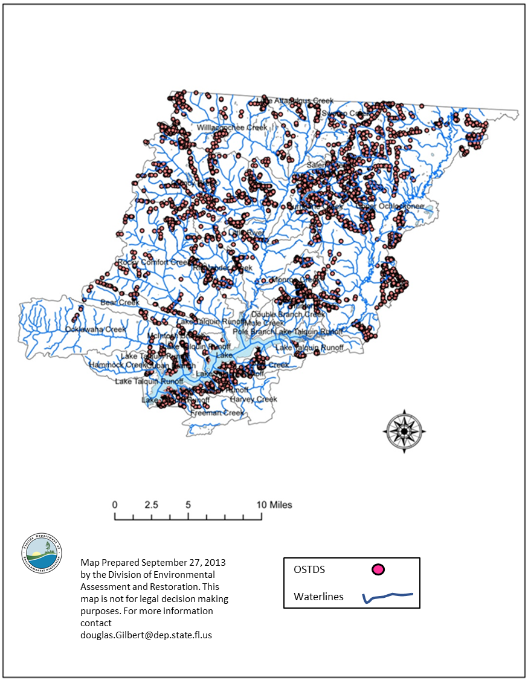

Figure 4.4. All OSTDS in the Lake Talquin watershed (Florida), 2010

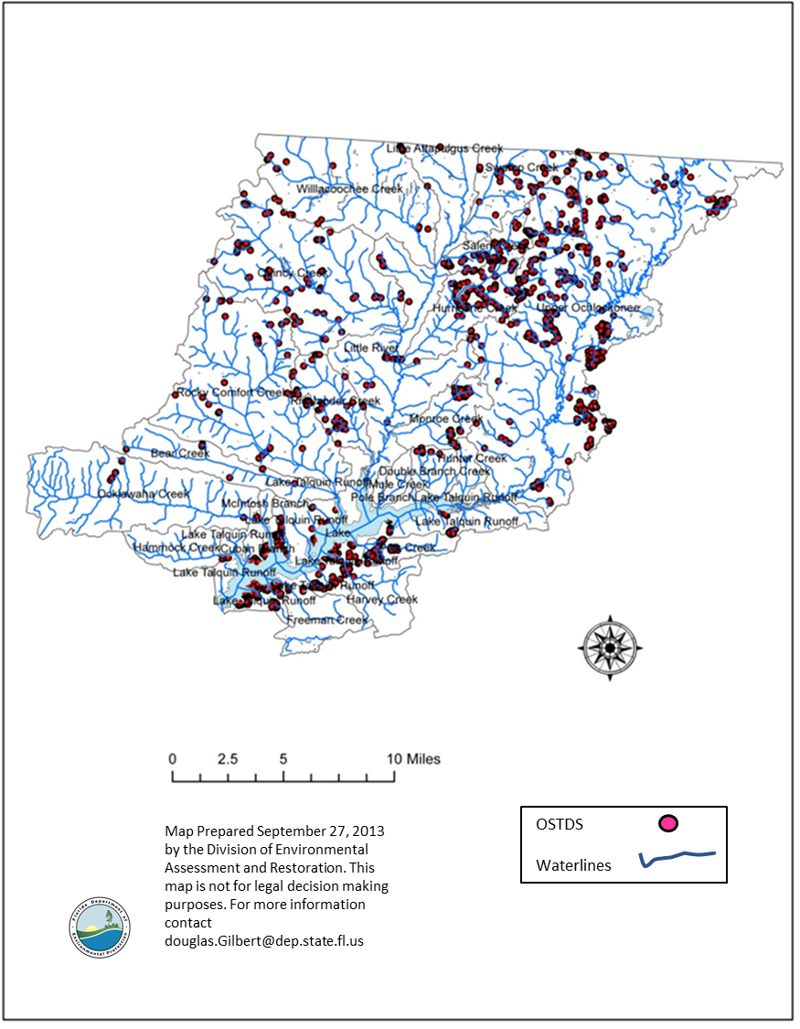
Figure 4.5. OSTDS within 200 meters of a stream/river or lake in the Lake Talquin watershed (Florida), 2010

Table 4.4. All OSTDS in the Lake Talquin watershed (Florida), 2010
County | OSTDS Type | Total
Gadsden | OSTDS Abandonment | 25
Gadsden | OSTDS Existing | 715
Gadsden | OSTDS Existing Modification | 153
Gadsden | OSTDS Existing New | 3
Gadsden | OSTDS Existing Repair | 1
Gadsden | OSTDS Holding Tank | 1
Gadsden | OSTDS New | 3,243
Gadsden | OSTDS Repair | 1,030
Total |  | 5,171

County | OSTDS Type | Total
Leon | OSTDS Abandonment | 12
Leon | OSTDS Existing | 237
Leon | OSTDS Existing Modification | 17
Leon | OSTDS Existing Repair | 1
Leon | OSTDS New | 525
Leon | OSTDS Repair | 655
Total |  | 1,447

Table 4.5. OSTDS within 200 meters of a stream/river or lake in the Lake Talquin watershed (Florida), 2010
County | OSTDS Type | Total
Gadsden | OSTDS Abandonment | 9
Gadsden | OSTDS Existing | 206
Gadsden | OSTDS Existing Modification | 38
Gadsden | OSTDS Existing New | 1
Gadsden | OSTDS Existing Repair | 1
Gadsden | OSTDS New | 838
Gadsden | OSTDS Repair | 368
Total |  | 1,461

County | OSTDS Type | Total
Leon | OSTDS Abandonment | 5
Leon | OSTDS Existing | 114
Leon | OSTDS Existing Modification | 10
Leon | OSTDS New | 273
Leon | OSTDS Repair | 338
Total |  | 740

Chapter 5: DETERMINATION OF ASSIMILATIVE CAPACITY

5.1 TMDL Development Process—Establishing Nutrient Targets
The EPA report HHHHHHHHHHH (EPA Modeling Report), documents the calibration for version 8 and the differences between version 6 and version 8. For this TMDL analysis, the version 8 calibrated model was used to develop a model–based prediction to estimate the in-lake nutrient concentrations and watershed nutrient loadings necessary to achieve an AGM chlorophyll a concentration no greater than 20 µg/L in any year of the modeled period. All modeling efforts have varying degrees of uncertainty that result from data limitations for calibration, assumptions made while parameterizing the models, and model imitations representing small spatial or temporal scales. The DEP is confident that the models used to develop these TMDLs, as calibrated, are suitable for the temporal and subbasin spatial scale used to develop the TMDLs.

5.1.1 Modeled Approach
Once the models were satisfactorily calibrated, DEP and the EPA provided the calibrated model to stakeholders and utilized the approach for developing the nutrient TMDLs presented at public workshops in July 2016 and July 2017. The approach is as follows:
- Use a long-term average AGM chlorophyll a of 20 µg/L as the target. The long-term average is calculated as the average of the volume-weighted AGM concentrations for each year of the model run (2006–12) in each of the zones described below.
- Use a model-simulated natural land use (background) condition to see if the chlorophyll a is greater than 20 µg/L. If it is, the AGM 20 µg/L target will not be pursued because DEP cannot abate the background conditions. Instead, DEP will use the 80th percentile of the model-simulated background condition to set the target.
- If the background condition is lower than the 20 µg/L criteria, DEP will use an AGM of 20 µg/L and the calibrated model to estimate the TMDL loads and site-specific TN and TP concentrations.
The background simulation was as follows:
- NRCS's SURRGO soil coverage was used in the analysis to evaluate the distribution of hydrologic soil groups in the Lake Talquin watershed and to convert existing human land into natural land.
- Land areas covered by A, A/D, B, and B/D soil types were converted to upland forest. Land areas covered by C, C/D, and D soil were converted to wetland areas (Table 5.1).
- Under the background condition, the discharge from all wastewater facilities was removed.

Table 5.1. Florida natural condition land use assignment
Land Use | Soil Group | Acres | % of Total
Forest | A | 93,693.3 | 24.5%
Forest | A/D | 76,225.9 | 20.0%
Forest | B | 111,513.2 | 29.2%
Forest | B/D | 47,984.4 | 12.6%
Wetland | C | 43,828.4 | 11.5%
Wetland | C/D | 7,816.1 | 2.0%
Wetland | D | 915.0 | 0.2%
SUM |  | 381,976.3 | 100.0%

After considering measured and predicted levels of chlorophyll a production, the physical characteristics of the lake, stakeholder input, and the March 2013 document Implementation of Florida’s Numeric Nutrient Criteria the DEP developed three assessment zones in the lake for use in developing the TMDLs. While historically no data were collected in the Little River Arm (LRA) that could be used as a part of model calibration, the model predicted that this area was one of the open water areas in the lake that had high levels of chlorophyll a that could persist for long periods. Other similar areas are located within the Upper and Lower Zones of the lake.
To address the shortfall, Leon County started collecting data in this part of the lake in 2013. The data collected support the predictions made by the model that this area of the lake is frequently one of the most productive areas of the lake. The three zones developed in response to stakeholder comments (Upper, Middle, and Lower) would be the focus of the TMDL development. The TMDL goal was to reduce nutrient inputs to the lake until the AGM chlorophyll a was below 20 µg/L for each year in each of the three assessment zones. The DEP will continue to work with stakeholders to develop monitoring plans that can be used to measure progress towards the restoration of Lake Talquin.
Figure 5.1 shows the location of the three assessment zones used to develop the TMDL (Upper, Middle, and Lower), and those cells that were excluded from the analysis. DEP decided not to include model cells in the development of the TMDL for several reasons. The loadings from the LSPC model that would naturally enter the lake as sheet flow were input to a single cell, resulting in a potential to over predict the level of chlorophyll a production in the first few cells around the LSPC loading point. In addition, as shown in Figure 5.2, several areas around the lake were more stream like than open waters of the lake and they were also removed from TMDL development. All tables and figures for the lake as a whole and for the three assessment zones have the cells marked as excluded removed from the calculations.

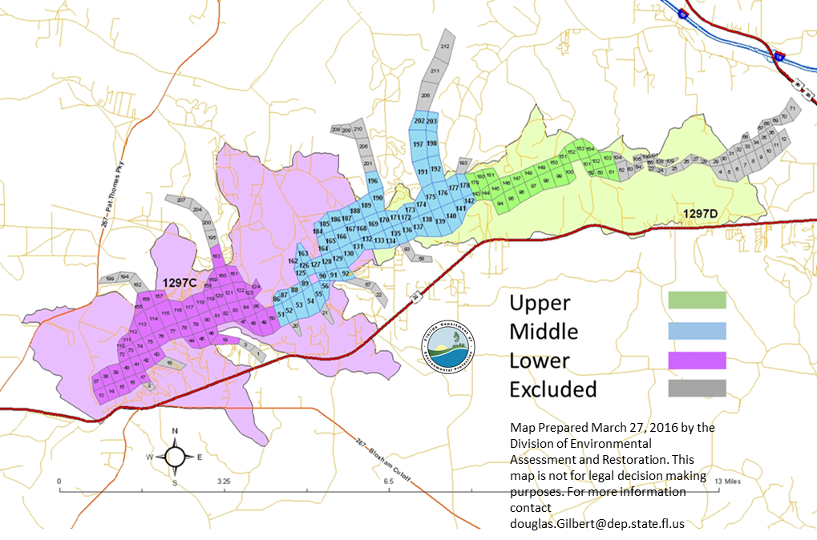
Figure 5.1. Chlorophyll a Assessment Zones (TMDL)
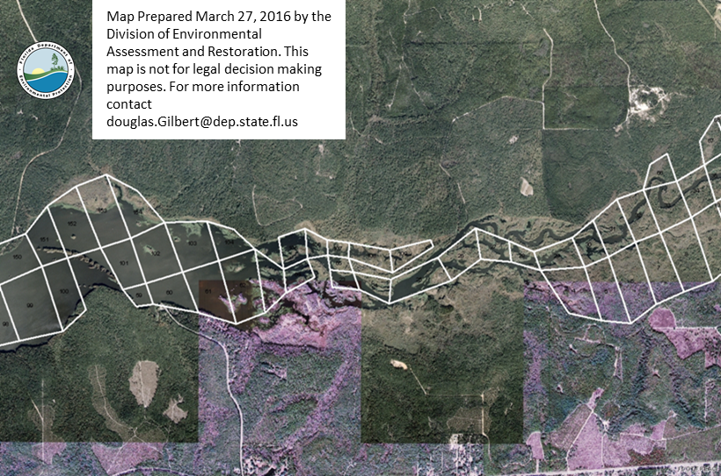
Figure 5.2. Example of excluded cells

5.1.1.1 Modeled Natural Background Condition
To ensure that the chlorophyll a concentration targets used in this TMDL will not abate the natural background condition for chlorophyll a, the LSPC model land uses were revised to simulate a natural land use background condition as described above.
Tables 5.5 through 5.18 summarize the in-lake TN, TP, and chlorophyll a AGM concentrations that resulted from the natural condition scenario. Based on these results, for the whole lake, the volume-weighted average AGM TN concentration is 0.51 mg/L, 0.023 mg/L for TP, and 9.3 µg/L for chlorophyll a.
Based on these results, no areas of the lake exceeded the AGM chlorophyll a target of 20 µg/L in any year. While informative, the natural land use scenario also resulted in different flow conditions from the calibrated model due in part to the loss of impervious land (by reassigning all anthropogenic land use types to only forest or wetland land use and removal of point sources). For the current natural condition run in the lake, the EFDC current condition flows were used. While this results in an increase in natural condition loads (based on higher flows in the current condition model) it provides a worst-case loading assessment for the natural condition chlorophyll a predictions.
To develop the TMDL, the previous 2016 TMDL (Version 6) percent reductions were used as a starting point. This was a 27.2 percent reduction in TN and a 32.9 percent reduction in TP. Reductions were made at all the terminal reaches (loading points) from the LSPC model and both the Little River and Ochlockonee River WASP model input locations. The reductions were made by reducing concentrations at the loading points and keeping the flows the same (current condition flows). The percent reductions were applied by calculating the ratio of the total TN and TP anthropogenic loads to the current condition total TN and TP loads (Table 5.2) and applying that ratio, as a scale factor (Tables 5.3 and 5.4), to each loading point to ensure that the anthropogenic loadings were reduced equally as a proportion of the total load at each location and to ensure that the basin specific reductions did not attempt to abate a natural condition.
In all text, tables and figures, TMDL-Current (TMDL-C) refers to a scenario where the percent reductions are applied to all terminal reaches (loading points) and the two Florida NPDES wastewater facilities are at current condition loads. TMDL-Waste Load Allocation (TMDL-WLA) is the TMDL-C scenario with the two Florida NPDES wastewater facilities at their respective waste load allocation loads (WLA).

Table 5.2. Annual Average watershed loads for calibration, natural condition, anthropogenic, and percent reduction

Nutrient | Calibration (kg/Yr) | Natural (kg/yr) | Anthropogenic (kg/Yr) | Anthropogenic (%) | Load Reduction (kg/Yr) | Percent Reduction Calibration Load (%) | TMDLC Load after reduction (kg/Yr) | Percent Reduction of Anthropogenic Load
TN | 1,246,069 | 764,562 | 481,507 | 38.6 | 336,227 | 27 | 909,841 | 70
TP | 109,175 | 42,475 | 66,700 | 61.1 | 35,919 | 33 | 73,127 | 54

Table 5.3. TN watershed scale factors, percent reductions and loads for calibration, natural condition, and anthropogenic scenarios
Basin Name | Model Basin Name | Scale Factor | Calibration TN (kg/Yr) | Natural TN (kg/yr) | Anthropogenic TN (kg/Yr) | Anthropogenic TN (%) | Load Reduction TN (kg/Yr) | Percent Reduction Calibration Load | TMDL-C Load after reduction TN (kg/Yr) | Percent Reduction of Anthropogenic Load
Ochlockonee River | Ochlockonee River | 0.7680 | 743,390.4 | 495,774.4 | 247,616.0 | 33.3 | 172,466.6 | 23.2 | 570,923.8 | 70
Little River | Little River | 0.5800 | 361,063.9 | 144,534.3 | 216,529.6 | 60.0 | 151,646.8 | 42.0 | 209,417.1 | 70
Runoff Little River Area | LSPC 60168 | 0.9888 | 3,192.0 | 3,141.0 | 51.0 | 1.6 | 35.8 | 1.1 | 3,156.3 | 70
Rock Comfort/Bear | LSPC 60114 | 0.7830 | 33,220.8 | 22,863.8 | 10,357.0 | 31.2 | 7,208.9 | 21.7 | 26,011.9 | 70
Ocklawaha | LSPC 60127 | 0.9000 | 16,718.0 | 14,342.3 | 2,375.6 | 14.2 | 1,671.8 | 10.0 | 15,046.2 | 70
Hammock | LSPC 60166 | 0.9130 | 6,550.2 | 5,739.6 | 810.5 | 12.4 | 569.9 | 8.7 | 5,980.3 | 70
Freeman | LSPC 60128 | 0.9485 | 12,025.4 | 11,142.0 | 883.4 | 7.3 | 619.3 | 5.2 | 11,406.1 | 70
Harvey | LSPC 60126 | 0.9666 | 25,192.9 | 23,985.8 | 1,207.2 | 4.8 | 841.4 | 3.3 | 24,351.5 | 70
Polk | LSPC 60169 | 0.9748 | 8,228.9 | 7,931.3 | 297.6 | 3.6 | 207.4 | 2.5 | 8,021.5 | 70
Runoff from Upper | LSPC 60125 | 0.9750 | 24,902.2 | 24,008.4 | 893.8 | 3.6 | 622.6 | 2.5 | 24,279.6 | 70
Runoff from Lower | LSPC 60167 | 0.9709 | 11,584.1 | 11,099.3 | 484.7 | 4.2 | 337.1 | 2.9 | 11,247.0 | 70

Table 5.4. TP watershed loads for calibration, natural conditions, and anthropogenic loads
Basin1 | Basin2 | Scale Factor | Calibration TP (kg/Yr) | Natural TP (kg/yr) | Anthropogenic TP (kg/Yr) | Anthropogenic TP (%) | Load Reduction TP (kg/Yr) | Percent Reduction Calibration Load | TMDL-C Load after reduction TP (kg/Yr) | Percent Reduction of Anthropogenic Load
Ochlockonee River | Ochlockonee River | 0.600 | 61,707.2 | 15,972.7 | 45,734.5 | 74.1 | 24,682.9 | 40.0 | 37,024.3 | 54
Little River | Little River | 0.725 | 32,758.5 | 16,172.8 | 16,585.7 | 50.6 | 9,008.6 | 27.5 | 23,749.9 | 54
Runoff Little River Area | LSPC 60168 | 0.974 | 206.7 | 196.8 | 9.9 | 4.8 | 5.4 | 2.6 | 201.4 | 54
Rock Comfort/Bear | LSPC 60114 | 0.735 | 5,249.1 | 2,661.9 | 2,587.2 | 49.3 | 1,391.0 | 26.5 | 3,858.1 | 54
Ocklawaha | LSPC 60127 | 0.853 | 2,099.6 | 1,522.9 | 576.7 | 27.5 | 308.6 | 14.7 | 1,790.9 | 54
Hammock | LSPC 60166 | 0.856 | 737.2 | 541.8 | 195.4 | 26.5 | 106.2 | 14.4 | 631.0 | 54
Freeman | LSPC 60128 | 0.894 | 987.0 | 792.2 | 194.9 | 19.7 | 104.6 | 10.6 | 882.4 | 54
Harvey | LSPC 60126 | 0.909 | 1,994.7 | 1,660.2 | 334.5 | 16.8 | 181.5 | 9.1 | 1,813.2 | 54
Polk | LSPC 60169 | 0.916 | 640.7 | 541.7 | 99.0 | 15.5 | 53.8 | 8.4 | 586.9 | 54
Runoff from Upper | LSPC 60125 | 0.932 | 1,929.4 | 1,685.5 | 244.0 | 12.6 | 131.2 | 6.8 | 1,798.2 | 54
Runoff from Lower | LSPC 60167 | 0.914 | 864.8 | 726.6 | 138.2 | 16.0 | 74.4 | 8.6 | 790.4 | 54

Table 5.5. Lake Talquin TN AGM concentrations by area
Lake Area | V8 Calibration TN (mg/L) | V8 Natural TN (mg/L) | V8 TMDL-C TN (mg/L) | V8 TMDL-WLA TN (mg/L)
Lake | 0.72 | 0.51 | 0.53 | 0.52
Upper | 0.46 | 0.47 | 0.38 | 0.37
Middle | 0.74 | 0.49 | 0.53 | 0.52
Lower | 0.72 | 0.53 | 0.54 | 0.53
Outlet | 0.71 | 0.52 | 0.53 | 0.52
LRiver Arm | 1.23 | 0.51 | 0.77 | 0.77

Table 5.6. Little River Arm (LRA) TN AGM concentrations by year
Year | V8 LRiver Arm Calibration TN (mg/L) | V8 LRiver Arm Natural TN (mg/L) | V8 LRiver Arm TMDL-C TN (mg/L) | V8 LRiver Arm TMDL-WLA TN (mg/L)
2006 | 1.20 | 0.50 | 0.75 | 0.75
2007 | 1.14 | 0.52 | 0.71 | 0.71
2008 | 1.10 | 0.50 | 0.68 | 0.68
2009 | 1.25 | 0.49 | 0.78 | 0.78
2010 | 1.07 | 0.49 | 0.67 | 0.66
2011 | 1.50 | 0.56 | 0.94 | 0.93
2012 | 1.36 | 0.50 | 0.85 | 0.84
Average | 1.23 | 0.51 | 0.77 | 0.76

Table 5.7. Upper Zone TN AGM concentrations by year
Year | V8 Upper Calibration TN (mg/L) | V8 Upper Natural TN (mg/L) | V8 Upper TMDL-C TN (mg/L) | V8 Upper TMDL-WLA TN (mg/L)
2006 | 0.45 | 0.45 | 0.36 | 0.36
2007 | 0.44 | 0.49 | 0.33 | 0.33
2008 | 0.51 | 0.45 | 0.42 | 0.41
2009 | 0.49 | 0.45 | 0.41 | 0.40
2010 | 0.44 | 0.45 | 0.36 | 0.36
2011 | 0.51 | 0.52 | 0.43 | 0.42
2012 | 0.36 | 0.45 | 0.35 | 0.32
Average | 0.46 | 0.47 | 0.38 | 0.37

Table 5.8. Middle Zone TN AGM concentrations by year
Year | V8 Middle Calibration TN (mg/L) | V8 Middle Natural TN (mg/L) | V8 Middle TMDL-C TN (mg/L) | V8 Middle TMDL-WLA TN (mg/L)
2006 | 0.67 | 0.45 | 0.48 | 0.47
2007 | 0.71 | 0.52 | 0.50 | 0.50
2008 | 0.74 | 0.50 | 0.53 | 0.53
2009 | 0.77 | 0.47 | 0.55 | 0.54
2010 | 0.66 | 0.46 | 0.47 | 0.47
2011 | 0.85 | 0.53 | 0.61 | 0.59
2012 | 0.78 | 0.49 | 0.57 | 0.55
Average | 0.74 | 0.49 | 0.53 | 0.52

Table 5.9. Lower TN AGM concentrations by year
Year | V8 Lower Calibration TN (mg/L) | V8 Lower Natural TN (mg/L) | V8 Lower TMDL-C TN (mg/L) | V8 Lower TMDL-WLA TN (mg/L)
2006 | 0.53 | 0.40 | 0.40 | 0.40
2007 | 0.74 | 0.57 | 0.54 | 0.54
2008 | 0.76 | 0.56 | 0.56 | 0.56
2009 | 0.73 | 0.53 | 0.55 | 0.54
2010 | 0.70 | 0.52 | 0.53 | 0.52
2011 | 0.79 | 0.54 | 0.58 | 0.57
2012 | 0.81 | 0.56 | 0.61 | 0.60
Average | 0.72 | 0.53 | 0.54 | 0.53

Table 5.10. Lake Talquin TP AGM concentrations by area
Lake Area | V8 Calibration TP (mg/L) | V8 Natural TP (mg/L) | V8 TMDL-C TP (mg/L) | V8 TMDL-WLA TP (mg/L)
Lake | 0.060 | 0.023 | 0.038 | 0.040
Upper | 0.049 | 0.007 | 0.025 | 0.027
Middle | 0.058 | 0.023 | 0.037 | 0.040
Lower | 0.061 | 0.026 | 0.040 | 0.042
Outlet | 0.061 | 0.026 | 0.040 | 0.042
LRiver Arm | 0.082 | 0.040 | 0.057 | 0.062

Table 5.11. Little River Arm (LRA) TP AGM concentrations by year

Year | V8 LRiver Arm Calibration TP (mg/L) | V8 LRiver Arm Natural TP (mg/L) | V8 LRiver Arm TMDL-C TP (mg/L) | V8 LRiver Arm TMDL-WLA TP (mg/L)
2006 | 0.082 | 0.040 | 0.057 | 0.061
2007 | 0.085 | 0.037 | 0.056 | 0.064
2008 | 0.090 | 0.045 | 0.063 | 0.067
2009 | 0.081 | 0.043 | 0.057 | 0.062
2010 | 0.086 | 0.043 | 0.059 | 0.064
2011 | 0.076 | 0.037 | 0.052 | 0.058
2012 | 0.074 | 0.035 | 0.051 | 0.057
Average | 0.082 | 0.040 | 0.056 | 0.062

Table 5.12. Upper Zone TP AGM concentrations by year
Year | V8 Upper Calibration TP (mg/L) | V8 Upper Natural TP (mg/L) | V8 Upper TMDL-C TP (mg/L) | V8 Upper TMDL-WLA TP (mg/L)
2006 | 0.047 | 0.007 | 0.024 | 0.026
2007 | 0.076 | 0.007 | 0.036 | 0.040
2008 | 0.052 | 0.011 | 0.028 | 0.030
2009 | 0.044 | 0.008 | 0.023 | 0.025
2010 | 0.050 | 0.008 | 0.026 | 0.028
2011 | 0.049 | 0.006 | 0.026 | 0.028
2012 | 0.026 | 0.005 | 0.013 | 0.014
Average | 0.049 | 0.007 | 0.025 | 0.027

Table 5.13. Middle Zone TP AGM concentrations by year
Year | V8 Middle Calibration TP (mg/L) | V8 Middle Natural TP (mg/L) | V8 Middle TMDL-C TP (mg/L) | V8 Middle TMDL-WLA TP (mg/L)
2006 | 0.055 | 0.022 | 0.035 | 0.037
2007 | 0.072 | 0.021 | 0.043 | 0.046
2008 | 0.068 | 0.027 | 0.043 | 0.045
2009 | 0.057 | 0.025 | 0.037 | 0.039
2010 | 0.058 | 0.025 | 0.038 | 0.040
2011 | 0.052 | 0.019 | 0.033 | 0.036
2012 | 0.047 | 0.020 | 0.031 | 0.034
Average | 0.058 | 0.023 | 0.037 | 0.040

Table 5.14. Lower Zone TP AGM concentrations by year
Year | V8 Lower Calibration TP (mg/L) | V8 Lower Natural TP (mg/L) | V8 Lower TMDL-C TP (mg/L) | V8 Lower TMDL-WLA TP (mg/L)
2006 | 0.045 | 0.020 | 0.031 | 0.032
2007 | 0.078 | 0.025 | 0.048 | 0.051
2008 | 0.073 | 0.031 | 0.048 | 0.050
2009 | 0.061 | 0.030 | 0.042 | 0.044
2010 | 0.064 | 0.030 | 0.044 | 0.045
2011 | 0.053 | 0.022 | 0.034 | 0.037
2012 | 0.050 | 0.023 | 0.034 | 0.036
Average | 0.061 | 0.026 | 0.040 | 0.042

Table 5.15. Lake Talquin chlorophyll a AGM concentrations by area
Lake Area | V8 Calibration chlorophyll a (µg/L) | V8 Natural chlorophyll a (µg /L) | V8 TMDL-C chlorophyll a (µg /L) | V8 TMDL-WLA chlorophyll a (µg /L)
Lake | 21.2 | 9.3 | 14.7 | 15.3
Upper | 10.0 | 2.6 | 7.0 | 7.2
Middle | 20.7 | 8.9 | 14.1 | 14.8
Lower | 23.1 | 10.7 | 16.2 | 16.7
Outlet | 22.7 | 10.7 | 16.0 | 16.5
LRiver Arm | 25.6 | 12.1 | 17.6 | 19.0

Table 5.16. Little River Arm (LRA) chlorophyll a AGM concentrations by year
Year | V8 LRiver Arm Calibration chlorophyll a (µg/L) | V8 LRiver Arm Natural chlorophyll a (µg/L) | V8 LRiver Arm TMDL-C chlorophyll a (µg/L) | V8 LRiver Arm TMDL-WLA chlorophyll a (µg/L)
2006 | 25.6 | 12.4 | 17.8 | 18.9
2007 | 27.4 | 12.3 | 18.1 | 19.8
2008 | 23.6 | 11.3 | 16.8 | 17.5
2009 | 23.5 | 12.2 | 16.5 | 17.6
2010 | 24.6 | 11.9 | 16.7 | 17.7
2011 | 27.9 | 12.6 | 19.0 | 21.3
2012 | 26.9 | 12.1 | 18.4 | 20.5
Average | 25.6 | 12.1 | 17.6 | 19.0

Table 5.17. Upper Zone chlorophyll a AGM by year
Year | V8 Upper Calibration chlorophyll a (µg/L) | V8 Upper Natural chlorophyll a (µg/L) | V8 Upper TMDL-C chlorophyll a (µg/L) | V8 Upper TMDL-WLA chlorophyll a (µg/L)
2006 | 10.2 | 2.5 | 7.2 | 7.4
2007 | 11.1 | 2.4 | 8.3 | 8.4
2008 | 9.7 | 3.4 | 7.2 | 7.4
2009 | 11.1 | 2.7 | 7.5 | 7.8
2010 | 9.4 | 2.8 | 6.9 | 7.1
2011 | 10.9 | 2.3 | 7.2 | 7.5
2012 | 7.9 | 2.0 | 4.7 | 5.1
Average | 10.0 | 2.6 | 7.0 | 7.2

Table 5.18. Middle Zone chlorophyll a AGM by year
Year | V8 Middle Calibration chlorophyll a (µg/L) | V8 Middle Natural chlorophyll a (µg/L) | V8 Middle TMDL-C chlorophyll a (µg/L) | V8 Middle TMDL-WLA chlorophyll a (µg/L)
2006 | 19.7 | 8.7 | 13.3 | 13.9
2007 | 23.3 | 8.7 | 15.8 | 16.5
2008 | 20.9 | 9.7 | 14.8 | 15.2
2009 | 20.2 | 9.6 | 13.9 | 14.5
2010 | 20.4 | 9.7 | 14.2 | 14.7
2011 | 21.1 | 7.9 | 13.7 | 14.7
2012 | 19.4 | 8.2 | 13.0 | 14.0
Average | 20.7 | 8.9 | 14.1 | 14.8

Table 5.19. Lower Zone chlorophyll a AGM by year
Year | V8 Lower Calibration chlorophyll a (µg/L) | V8 Lower Natural chlorophyll a (µg/L) | V8 Lower TMDL-C chlorophyll a (µg/L) | V8 Lower TMDL-WLA chlorophyll a (µg/L)
2006 | 17.6 | 8.2 | 12.1 | 12.4
2007 | 27.5 | 10.5 | 19.3 | 19.8
2008 | 25.5 | 12.6 | 18.4 | 18.8
2009 | 23.5 | 12.5 | 16.8 | 17.3
2010 | 24.7 | 12.6 | 17.8 | 18.2
2011 | 21.7 | 9.1 | 14.6 | 15.4
2012 | 21.0 | 9.7 | 14.4 | 15.3
Average | 23.1 | 10.7 | 16.2 | 16.7

Table 5.22. Lake Talquin TN and TP, Calibration, TMDLC, and TMDL-WLA loads
Basin Name | Model Basin Name | Calibration TN (kg/yr) | TMDL-C TN (kg/yr) | Calibration TP (kg/yr) | TMDL-C TP (kg/yr)
Ochlockonee River | Ochlockonee River | 743,390.4 | 570,923.8 | 61707.2 | 37024.3
Little River | Little River | 361,063.9 | 209,417.1 | 32758.5 | 23749.9
Runoff Little River Area | LSPC 60168 | 3,192.0 | 3,156.3 | 206.7 | 201.4
Rock Comfort/Bear | LSPC 60114 | 33,220.8 | 26,011.9 | 5249.1 | 3858.1
Ocklawaha | LSPC 60127 | 16,718.0 | 15,046.2 | 2099.6 | 1790.9
Hammock | LSPC 60166 | 6,550.2 | 5,980.3 | 737.2 | 631.0
Freeman | LSPC 60128 | 12,025.4 | 11,406.1 | 987.0 | 882.4
Harvey | LSPC 60126 | 25,192.9 | 24,351.5 | 1994.7 | 1813.2
Polk | LSPC 60169 | 8,228.9 | 8,021.5 | 640.7 | 586.9
Runoff from Upper | LSPC 60125 | 24,902.2 | 24,279.7 | 1929.4 | 1798.2
Runoff from Lower | LSPC 60167 | 11,584.1 | 11,247.0 | 864.8 | 790.4
Subtotal |  | 1,246,068.7 | 909,841.2 | 109175.0 | 73126.8
WLA |  |  | 5,942.0 |  | 3458.0
Total |  | 1,246,069 | 915,783 | 109,175 | 76,585

5.2 Calculation of Nutrient TMDLs and Applicable TN and TP Load–Based Criteria
To achieve the 20 µg/L AGM chlorophyll a target every year, the long-term mean TN and TP loads that achieve the chlorophyll a target were simulated using the lake WASP model. The current condition loads were reduced by 27 percent for TN and 33 percent for TP and the results show that the in-lake chlorophyll a AGM concentration of 20 µg/L was achieved every year in all three assessment zones.
Table 5.3 and Table 5.4 summarize the annual loads for each loading point under current, natural, and TMDL-C conditions for TN and TP, respectively. These two tables also contain the scale factors applied to the calibration concentrations to achieve the same percentage reduction in anthropogenic loads at each loading point to the lake and the percent reduction in total load that this represents. As an example, use Table 5.3 depicting TN loads from the Ochlockonee River Basin. A percent reduction in total calibration load is entered in the spreadsheet that would then calculate the ratio of total anthropogenic load to the reduction in total load. Once the percent reduction in total load that results in the change in anthropogenic load is determined, the process is repeated for each subbasin such that the same reduction in anthropogenic loading is achieved in all subbasins. From this, the percent reduction in total load would be used to calculate the scale factor that is then multiplied times the lake WASP model time series concentrations.
For example, using the Ochlochonee River TN, total calibration subbasin load of 743,390 kg/yr, times the percent reduction in calibration load of 0.232 (23.2%) equals a 172,467 kg/yr load reduction. Given the total anthropogenic subbasin load of 247,616 kg/yr and a load reduction of 172,467 kg/yr the percent of anthropogenic load ((load reduction/anthropogenic load)*100) is 70 percent. The scale factor is calculated as ((100-percent reduction in calibration load)/100). In this case, ((100-23.2)/100), or 0.768. The scale factor of 0.768 is then multiplied times the lake WASP model time series concentration for all nitrogen related constituents coming from the Ochlochonee River.
Figures 5.3 through 5.12 depict the response of chlorophyll a in the whole lake (minus the excluded cells), each zone, and the Little River Arm for the calibration, natural, and TMDL-WLA, load scenarios.

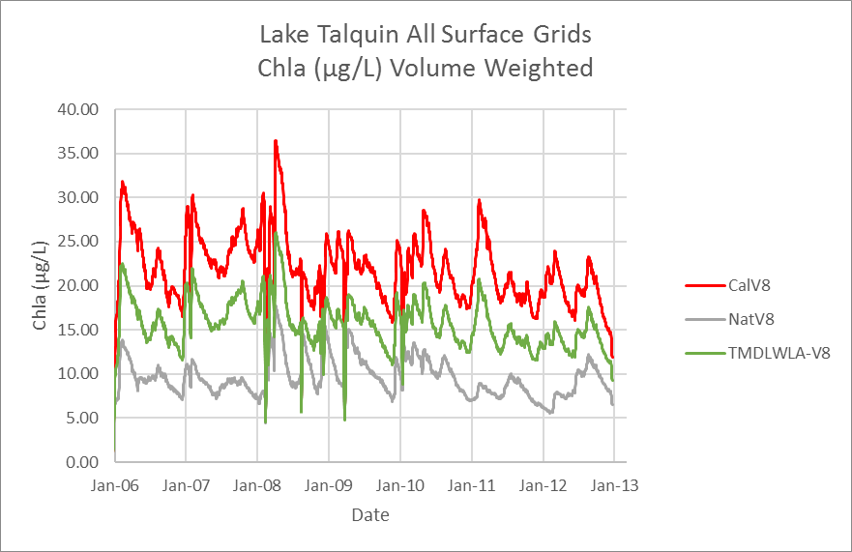
Figure 5.3. Lake Talquin chlorophyll a daily average calibration, natural, and TMDL-WLA scenarios
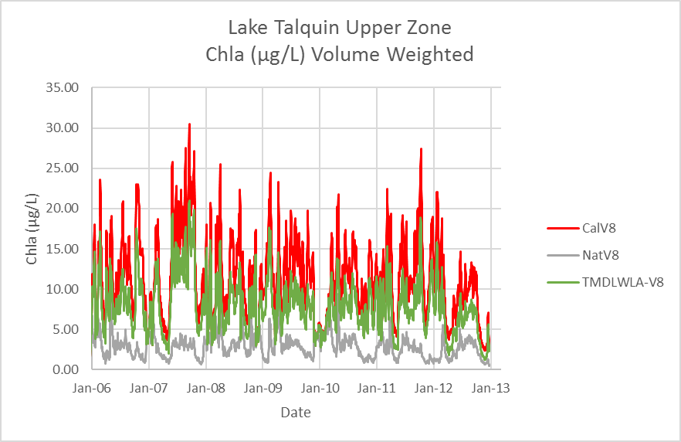
Figure 5.4. Upper Zone chlorophyll a daily average calibration, natural, and TMDL-WLA scenarios

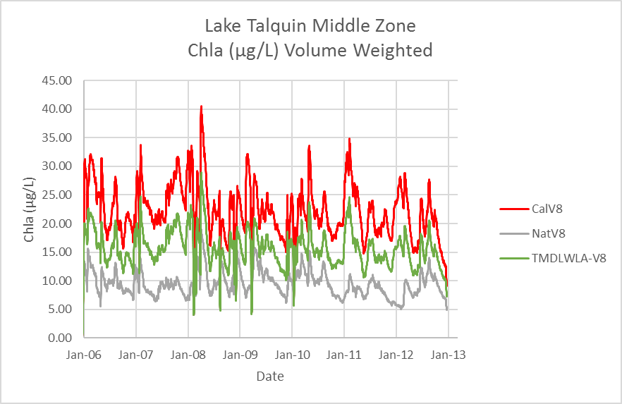

Figure 5.5. Middle Zone chlorophyll a daily average calibration, natural, and TMDL-WLA scenarios
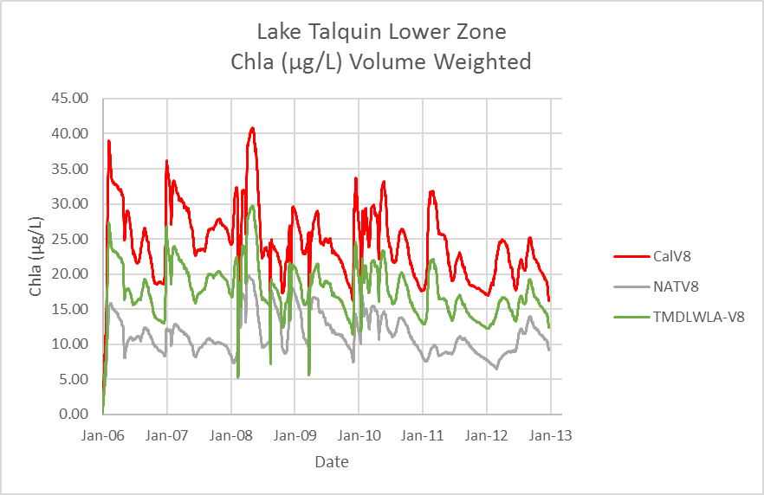

Figure 5.6. Lower Zone chlorophyll a daily average calibration, natural, and TMDL-WLA scenarios
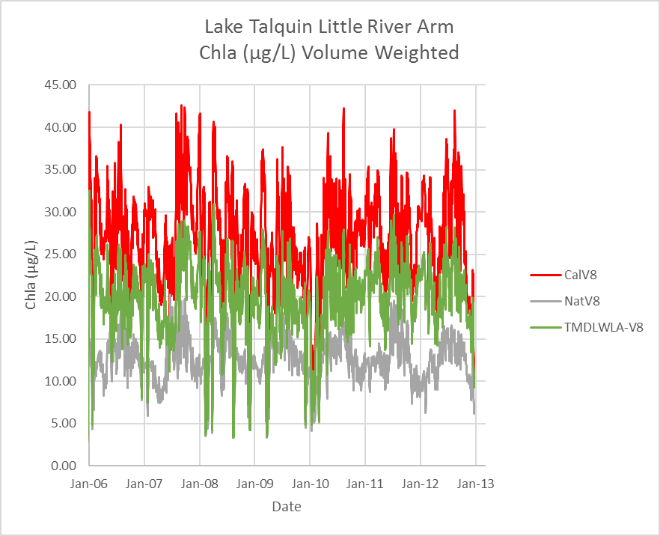

Figure 5.7. Little River Arm chlorophyll a daily average calibration, natural, and TMDL-WLA scenarios

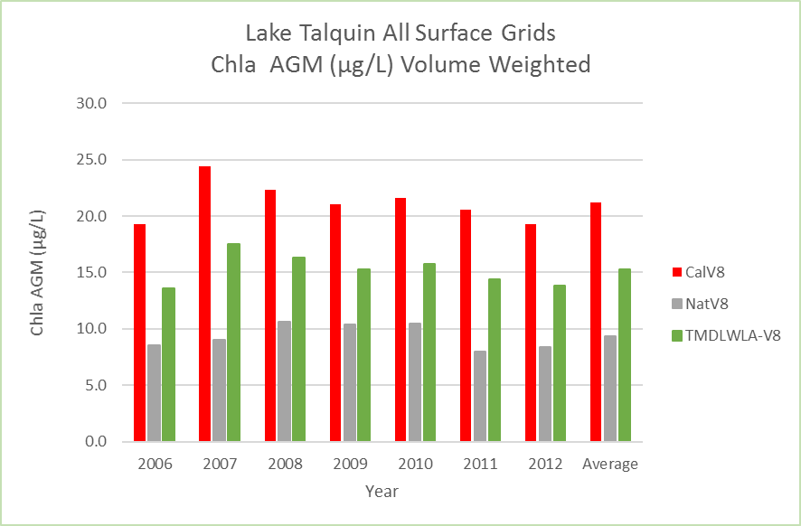

Figure 5.8. Lake Talquin chlorophyll a daily AGM for calibration, natural, and TMDL-WLA scenarios

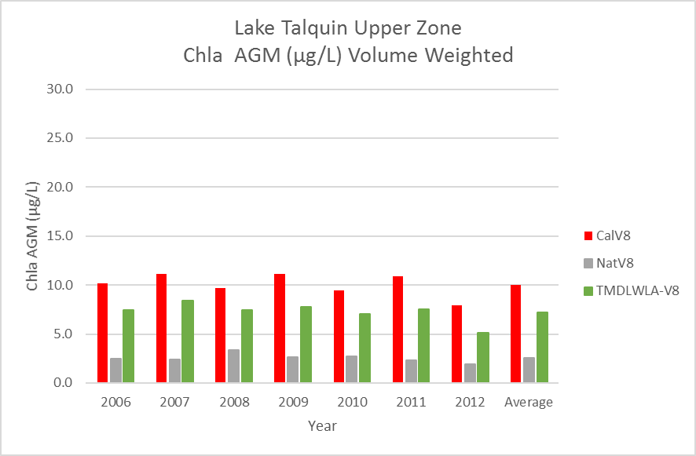

Figure 5.9. Upper Zone chlorophyll a Daily AGM for calibration, natural, and TMDL-WLA scenarios
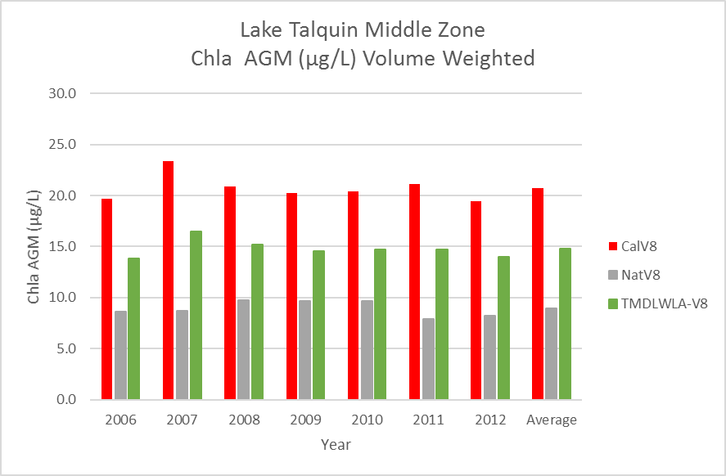
Figure 5.10. Middle Zone chlorophyll a daily AGM for calibration, natural, and TMDL-WLA scenarios

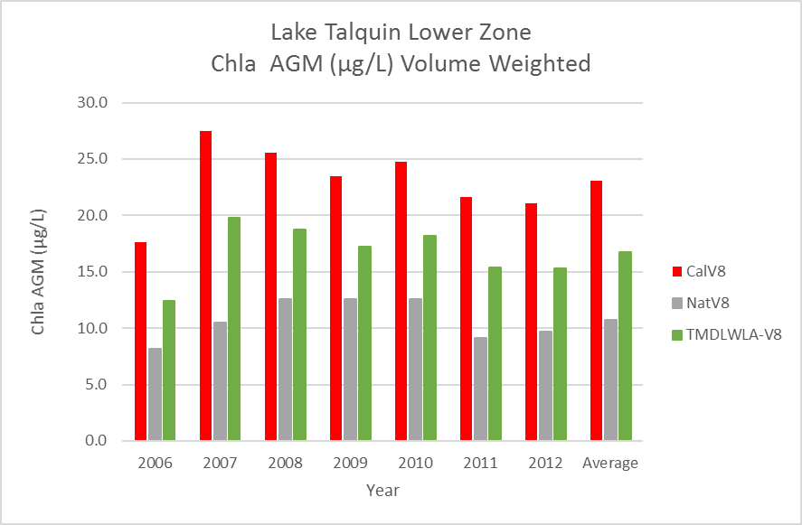
Figure 5.11. Lower Zone chlorophyll a daily AGM for calibration, natural, and TMDL-WLA scenarios
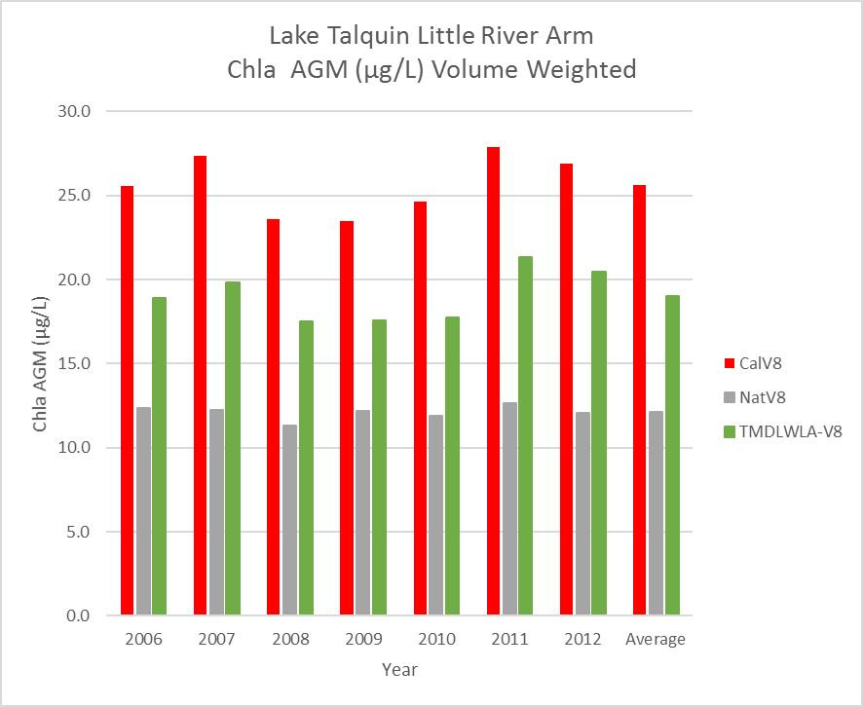

Figure 5.12. Little River Arm chlorophyll a daily AGM for calibration, natural, and TMDL-WLA scenarios

The TN TMDL-C long-term average watershed load (average of the annual accumulative loads) of 909,841 kg/yr represents a 70% reduction from the long-term average anthropogenic load, or a 27% reduction in the current total load. The TP TMDL long-term average load of 73,127 kg/yr represents a 54% reduction from the long-term average anthropogenic load, or a 33% reduction in the current total load.
Tables 5.3 and 5.4 also list the percent reduction in total load of TN and TP for each source basin discharging to the lake. These tables are not an allocation and are only intended to inform restoration efforts by readily identifying areas of the watershed that generate high levels of anthropogenic loadings and the relative percent reductions in TN and TP unique to each source area. One such area is the MS4 for Leon County and FDOT depicted on Figure 4.2. There are 14 LSPC subbasins located fully or in part within the Leon County MS4 area of the watershed. Of these 14 subbasins, nine are part of the Ochlockonee River WASP model and five drain directly to the lake. The loadings from three of these five stream subbasins (Freeman, Harvey, and Polk) can be characterized directly from model results in the two tables. Based on these results, the levels of reductions in these three subbasins range from a maximum of 5.2% for TN and 10.6% for TP, as compared to the watershed wide average of 27% for TN and 33% for TP. Additionally, DEP notes that due to circulation patterns in the lake, nutrient reductions in just the Little River or the Ochlockonee River may not result in the lake meeting the criteria for chlorophyll a in all areas in all years.
Once the TMDL watershed load reductions were established based on existing conditions and the wasteload allocations (WLAs) were determined (Section 5.4), the models were run with the TMDL percent reductions and the two NPDES wastewater facilities located in Florida at their respective WLA’s. As depicted in Figures 5.13 through 5.15 and Tables 5.23 through 5.28 there were only minor differences between TMDL-C for the existing condition and the TMDL with the NPDES facilities at their WLA levels (TMDL-WLA). The final TMDL and in-lake concentrations of TN and TP as expressed in Chapter 6 are based on the TMDL-WLA scenario. The lake-wide long-term average of the seven years (2006 -2012) of annual geomeans is 0.040 mg/L for TP and 0.52 mg/L for TN.

Table 5.23. Lake Talquin TP TMDL Existing and TMDL-WLA by Area
Lake Area | TMDLC-V8 TP (mg/L) | TMDLWLA-V8 TP (mg/L)
Lake | 0.038 | 0.040
Upper | 0.025 | 0.027
Middle | 0.037 | 0.040
Lower | 0.040 | 0.042

Table 5.24. Lake Talquin TP TMDL-WLA by Area and Year
Year | Lake TMDLWLA-V8 TP (mg/L) | Upper TMDLWLA-V8 TP (mg/L) | Middle TMDLWLA-V8 TP (mg/L) | Lower TMDLWLA-V8 TP (mg/L)
2006 | 0.036 | 0.026 | 0.037 | 0.032
2007 | 0.049 | 0.040 | 0.046 | 0.051
2008 | 0.047 | 0.030 | 0.045 | 0.050
2009 | 0.040 | 0.025 | 0.039 | 0.044
2010 | 0.042 | 0.028 | 0.040 | 0.045
2011 | 0.036 | 0.028 | 0.036 | 0.037
2012 | 0.034 | 0.014 | 0.034 | 0.036
Average | 0.041 | 0.027 | 0.040 | 0.042

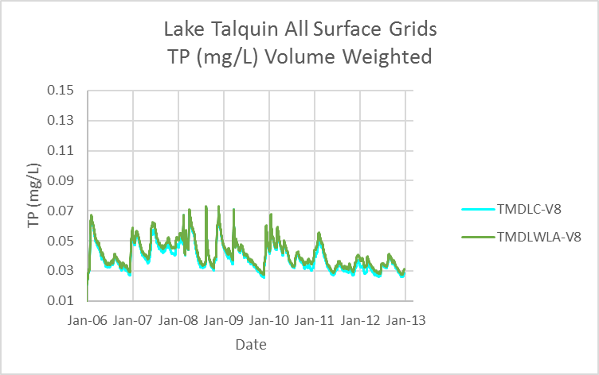

Figure 5.13. Lake Talquin TP TMDL and TMDL-WLA

Table 5.25. Lake Talquin TN TMDL Current and TMDL-WLA by Area

Lake Area | V8 TMDL-C TN (mg/L) | V8 TMDL-WLA TN (mg/L)
Lake | 0.53 | 0.52
Upper | 0.38 | 0.37
Middle | 0.53 | 0.52
Lower | 0.54 | 0.54

Table 5.26. Lake Talquin TN TMDL-WLA by Area and Year

Year | V8 Lake TMDL-WLA TN (mg/L) | V8 Upper TMDL-WLA TN (mg/L) | V8 Middle TMDL-WLA TN (mg/L) | V8 Lower TMDL-WLA TN (mg/L)
2006 | 0.46 | 0.37 | 0.49 | 0.42
2007 | 0.51 | 0.33 | 0.50 | 0.54
2008 | 0.54 | 0.41 | 0.53 | 0.56
2009 | 0.53 | 0.40 | 0.54 | 0.54
2010 | 0.49 | 0.36 | 0.47 | 0.52
2011 | 0.57 | 0.42 | 0.59 | 0.57
2012 | 0.55 | 0.32 | 0.55 | 0.59
Average | 0.52 | 0.37 | 0.52 | 0.53

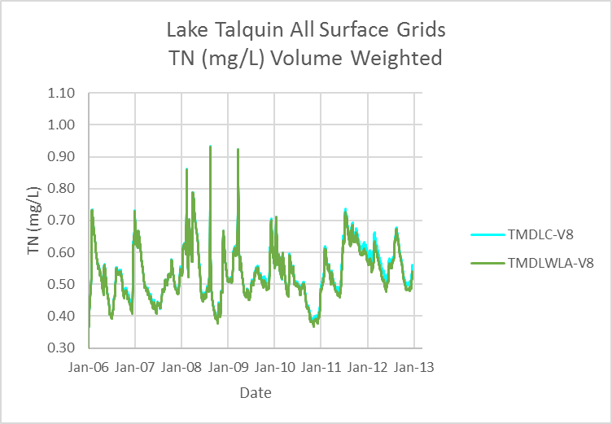
Figure 5.14. Lake Talquin TN TMDL and TMDL-WLA

Table 5.27. Lake Talquin chlorophyll a TMDL Existing and TMDL-WLA by Area
Lake Area | V8 TMDL-C chlorophyll a (µg/L) | V8 TMDL-WLA chlorophyll a (µg/L)
Lake | 14.7 | 15.3
Upper | 7.0 | 7.2
Middle | 14.1 | 14.8
Lower | 16.2 | 16.7

Table 5.28. Lake Talquin chlorophyll a TMDL TMDL-WLA by Area and Year
Year | V8 Lake TMDL-WLA chlorophyll a (µg/L) | V8 Upper TMDL-WLA chlorophyll a (µg/L) | V8 Middle TMDL-WLA chlorophyll a (µg/L) | V8 Lower TMDL-WLA chlorophyll a (µg/L)
2006 | 13.6 | 7.4 | 13.9 | 12.4
2007 | 17.5 | 8.4 | 16.5 | 19.8
2008 | 16.3 | 7.4 | 15.2 | 18.8
2009 | 15.3 | 7.8 | 14.5 | 17.3
2010 | 15.7 | 7.1 | 14.7 | 18.2
2011 | 14.4 | 7.5 | 14.7 | 15.4
2012 | 13.9 | 5.1 | 14.0 | 15.3
Average | 15.2 | 7.2 | 14.8 | 16.7

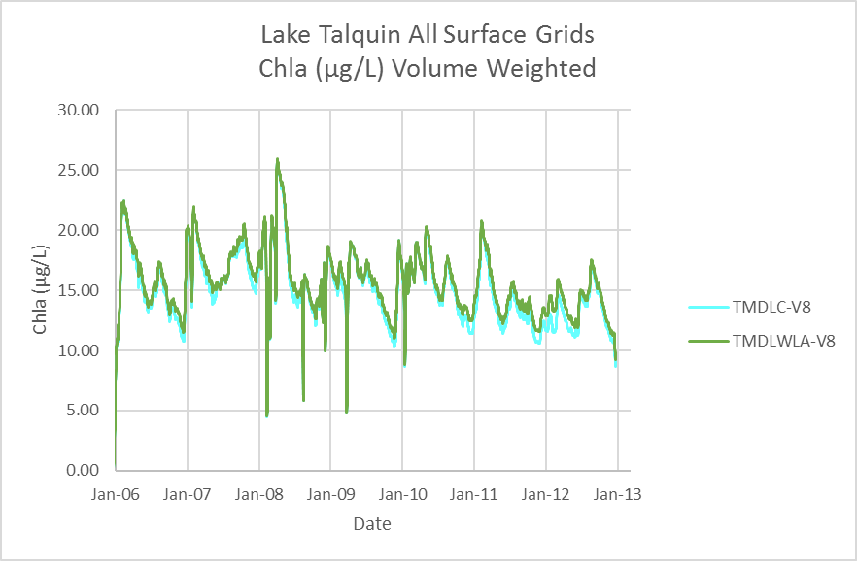

Figure 5.15. Lake Talquin chlorophyll a TMDL and TMDL-WLA

Based on the analysis of measured data and model results it is the recommendation of DEP that Lake Talquin be redelineated for assessment purposes from the existing two WBIDs to the three zones (Upper, Middle, and Lower) used to develop the nutrient chlorophyll a TMDL.

5.3 Calculation of Wasteload Allocations
Wasteload allocations (WLAs) for the two NPDES facilities in Florida were developed considering their current permit limits, the quality and frequency of their actual discharge, and the assimilative capacity of Lake Talquin. For the Quincy WWTF, discharge volume, TN, and TP concentration data were retrieved from the Discharge Monitoring Reports submitted to DEP. The permitted capacity (based on permit limits) and the 95th percentile of these data were used to calculate the long-term (2006–12) annual average WLA.

5.3.1 Quincy AWT (FL0029033)
Quincy is an advanced wastewater treatment (AWT) facility with nutrient concentrations of 3 mg/L for TN and 1 mg/L for TP. Based on past practices for calculating WLAs for AWT facilities, DEP allocated annual TN and TP loads equivalent to the 95th percentile of the discharged nutrient loads for the 2006 to 2012 period. The WLA for Quincy is a long-term (2006–12) average load of 1,271 kg/yr TP and 4.922 kg/yr TN (Table 5.29).

Table 5.29. Quincy WLA TN and TP
Quincy | Flow (mgd) | TP (mg/L) | TP (lbs/day) | TP  (lbs/yr) | TP  (kg/yr) | TN (mg/L) | TN (lbs/day) | TN  (lbs/yr) | TN  (kg/yr)
Permitted | 1.50 | 1.0 | 12.5 | 4,566 | 2,071 | 3.0 | 37.5 | 13,698 | 6,213
95th-WLA | 1.15 | 0.8 | 7.7 | 2,801 | 1,271 | 3.1 | 29.7 | 10,852 | 4,922

5.3.2 A.B. Hopkins Power Plant (FL0025518)
The A.B. Hopkins plant discharges to Beaver Creek. From the point of discharge, Beaver Creek runs two miles, passing through two large wetland areas, before reaching the ponded portion of the Ochlockonee River floodplain. This area of the floodplain is impacted by backwater effects from Lake Talquin, and the flow path through much of the floodplain is permanently flooded.
In the current modeling, the power plant discharge nutrient load is input directly into the Lake Talquin WASP model (Lake Segment 9) as a worst-case scenario. Data analysis from sampling of Beaver Creek indicates a high potential for some level of phosphorus assimilation in the creek before flow enters the ponded portion of the Ochlockonee River floodplain, where additional assimilation maybe occurring. The analysis of measured data from the effluent and Beaver Creek and modeling results indicate that the discharge has the potential to contribute to a small increase in phytoplankton growth in the impaired lake.
In this case, as in other similar cases, DEP is proposing to use the 95th percentiles of the existing flow and nutrient concentrations as the WLA. For this WLA, the City of Tallahassee provided the flow data, and DEP and the City provided the effluent nutrient concentration data. The WLA for A.B. Hopkins is a long-term (2006–12) average load of 2,187 kg/yr TP and 1,020 kg/yr TN (Table 5.30).

Table 5.30. A.B. Hopkins WLA TN and TP
A.B. Hopkins | Flow (mgd) | TP (mg/L) | TP (lbs/d) | TP  (lbs/yr) | TP  (kg/yr) | TN (mg/L) | TN  (lbs/d) | TN  (lbs/yr) | TN  (kg/yr)
Permitted | 2.70 | * | 19.8 | 7,233 | 3,281 | * | 9.2 | 3,370 | 1,529
95th-WLA | 1.80 | 0.88 | 13.2 | 4,822 | 2,187 | 0.4 | 6.2 | 2,248 | 1,020
* no permit limit; used 95th percentile concentration for calculation.

Based on a recent EPA memorandum (2006), daily loads of TN and TP from point sources should be calculated. In this TMDL analysis, daily WLAs for facilities that have whole-year daily discharge was calculated as annual loads divided by 365 days. It should be noted that the daily loads presented in this report are for informational purposes only. The implementation of these TMDLs and WLAs will be based on an annual time scale.

5.4 Critical Conditions/Seasonality
The estimated assimilative capacity is based on annual conditions, rather than critical/seasonal conditions, because (1) the methodology used to determine assimilative capacity does not lend itself very well to short-term assessments; (2) DEP is generally more concerned with the net change in overall primary productivity in the segment, which is better addressed on an annual basis; and (3) the methodology used to determine impairment is based on annual conditions (AGMs or arithmetic means).

Chapter 6: DETERMINATION OF THE TMDL

6.1 Expression and Allocation of the TMDL
The objective of a TMDL is to provide a basis for allocating acceptable loads among all of the known pollutant sources in a watershed so that appropriate control measures can be implemented and water quality standards achieved. A TMDL is expressed as the sum of all point source loads (wasteload allocations, or WLAs), nonpoint source loads (load allocations, or LAs), and an appropriate margin of safety (MOS), which takes into account any uncertainty concerning the relationship between effluent limitations and water quality:
TMDL = ∑  WLAs + ∑  LAs + MOS
As discussed earlier, the WLA is broken out into separate subcategories for wastewater discharges and stormwater discharges regulated under the NPDES Program:
TMDL ≅ ∑  WLAs_{wastewater} + ∑  WLAs_{NPDES Stormwater} + ∑  LAs + MOS
It should be noted that the various components of the revised TMDL equation may not sum up to the value of the TMDL because (1) the WLA for NPDES stormwater is typically based on the percent reduction needed for nonpoint sources and is also accounted for within the LA; and (2) TMDL components can be expressed in different terms (for example, the WLA for stormwater is typically expressed as a percent reduction, and the WLA for wastewater is typically expressed as mass per day).
WLAs for stormwater discharges are typically expressed as "percent reduction" because it is very difficult to quantify the loads from MS4s (given the numerous discharge points) and to distinguish loads from MS4s from other nonpoint sources (given the nature of stormwater transport). The permitting of stormwater discharges also differs from the permitting of most wastewater point sources. Because stormwater discharges cannot be centrally collected, monitored, and treated, they are not subject to the same types of effluent limitations as wastewater facilities, and instead are required to meet a performance standard of providing treatment to the "maximum extent practical" through the implementation of BMPs.
This approach is consistent with federal regulations (40 Code of Federal Regulations § 130.2[I]), which state that TMDLs can be expressed in terms of mass per time (e.g., pounds per day), toxicity, or other appropriate measure. The TMDLs for Lake Talquin are expressed as the long-term mean annual load of TN and TP the waterbody can assimilate and maintain the Class III narrative nutrient criterion, and the needed percent reductions from the existing condition to achieve the TMDL target (see Table 6.1). These TMDLs were based on long-term (7-year) averages of simulated data from 2006 to 2012. The restoration goal is to achieve the generally applicable chlorophyll a criterion of 20 µg/L as an AGM not to be exceeded more than once in any three consecutive year period in each of the three assessment zones.

Table 6.1. TMDL components for nutrients in Lake Talquin (WBIDs 1297D and 1297C)
Note: The required percent reductions listed in this table represent the reduction from all sources. The needed percent reduction for each individual watershed can be calculated based on the relative load contribution from each provided in Chapter 4 and Chapter 5.
(KG/YR*) = Sum of the TMDL nonpoint source load and the point source WLA loads for Quincy WWTF and A.B. Hopkins Power Plant. The TN and TP TMDLs are a long-term average (seven years) of annual loads not to be exceed as a seven-year average. The chlorophyll a criterion is the generally applicable criterion of 20 µg/L as an AGM not to be exceeded more than once in any consecutive three-year period.
(KG/YR**) = Sum of the WLA for Quincy WWTF and A.B. Hopkins Power Plant.
Parameter | TMDL (kg/yr*) | WLA Wastewater  (kg/yr**) | WLA NPDES Stormwater  (% reduction) | LA  (% reduction) | MOS
TN | 915,783 | 5,942 | 27% | 27% | Implicit
TP | 76,585 | 3,458 | 33% | 33% | Implicit

6.2 Load Allocation
Utilizing the TMDL-WLA scenario, the long-term average percent reductions from the existing loadings of 27% for TN and 33% for TP correspond to long-term (2006–12) average of the AGM concentrations for the lake of 0.52 mg/L for TN and 0.040 mg/L for TP, which result in meeting the target chlorophyll a concentration of 20 µg/L. It should be noted that the LA includes loading from stormwater discharges regulated by DEP and the water management districts that are not part of the NPDES stormwater program (see Appendix A).

6.2.1 State of Georgia
Based on the EPA Modeling Report for Lake Talquin (May 2017), the majority of the anthropogenic nutrient loadings to Lake Talquin originate in Georgia. Therefore, the nutrient water quality standards for Lake Talquin will not be attainable unless significant nutrient load reductions are achieved from anthropogenic sources in Georgia. The modeled expectations for load reductions from all anthropogenic sources in the state of Georgia necessary to achieve the Lake Talquin TMDL are set forth in Table 6.2, and are based on the basin specific watershed percent reductions for TN and TP (applied to the calibration loadings calculated at the state line for the Ochlocknee River and Little River from the EPA Modeling Report).

Table 6.2. TMDL components for nutrients at the Georgia – Florida State Line
Water Body Characteristics at the State Line | TN Calibration (kg/yr) | TN TMDL Percent Reduction (%) | TN TMDL Load Reduction (kg/yr) | TN TMDL Load Allocation (kg/yr) | TP Calibration (kg/yr) | TP TMDL Percent Reduction (%) | TP TMDL Load Reduction (kg/yr) | TP TMDL Load Allocation (kg/yr)
Little River | 265,219 | 42.0 | 111,392 | 153,827 | 19,729 | 27.5 | 5,426 | 14,304
Ochlockonee River | 690,500 | 23.2 | 160,196 | 530,304 | 61,823 | 40.0 | 24,729 | 37,094

The load reductions from Georgia may be modified at the state line between the Ochlockonee River and Little River basins, as long as 1) the aggregate load reductions into Florida are not lessened for TN and TP, and 2) there is an affirmative demonstration of reasonable assurance that any modification at the state line will still meet nutrient water quality criteria in downstream Florida waters.

6.3 Wasteload Allocation

6.3.1 NPDES Wastewater Discharges
Two NPDES-permitted wastewater facilities in the Lake Talquin watershed require WLAs. As described in Chapters 4 and 5, the Quincy AWT (FL0029033) facility WLA for TN is a long-term annual average (2006 - 2012) load of 4,922 kg/yr (13.5 kg/d) and 1,271 kg/yr (3.48 kg/d) for TP. The A.B. Hopkins Power Plant (FL0025518) WLA for TN is a long-term average (2006–12) load of 1,020 kg/yr (2.79 kg/d) and 2,187 kg/yr (5.99 kg/d) for TP.
Based on an EPA memorandum (2006), daily loads of TN and TP from point sources should be calculated. In this TMDL report, daily WLAs for facilities that have whole-year daily discharge was calculated as annual loads divided by 365 days. It should be noted that the daily loads presented in this report are for informational purposes only. The implementation of these TMDLs and WLAs will be based on an annual time scale.

6.3.2 NPDES Stormwater Discharges
In the Lake Talquin watershed, the stormwater collection systems owned and operated by Leon County and FDOT District 3 (NPDES MS4 Permit FLS000033) in Leon County are covered by a Phase I-C NPDES MS4 permit (Figure 4.2). This MS4 area (highlighted in yellow) is 66.8 square miles or 16% of the 419 square miles of the watershed located in Florida. The MS4 in Florida is 4.3% of the total watershed of 1,569 square miles. The percent reductions for Freeman Creek, Harvey Creek, and Polk Creek were calculated directly from model results (Table 5.21). Based on these results, the levels of reductions in these three subbasins range from a maximum of 5.2% for TN to 10.6% for TP, as compared to the watershed wide average of 27% for TN and 33% for TP.
It should be noted that any MS4 permittee is only responsible for reducing the anthropogenic loads associated with stormwater outfalls that it owns or otherwise has responsible control over, and it is not responsible for reducing other nonpoint source loads in its jurisdiction.

6.4 Margin of Safety (MOS)
The MOS can either be implicitly accounted for by choosing conservative assumptions about loading or water quality response, or explicitly accounted for during the allocation of loadings. Consistent with the recommendations of the Allocation Technical Advisory Committee (DEP 2001), an implicit MOS was used in the development of these TMDLs. The MOS is a required component of a TMDL and accounts for the uncertainty about the relationship between pollutant loads and the quality of the receiving waterbody (Clean Water Act, Section 303[d][1][c]). Considerable uncertainty is usually inherent in estimating nutrient loading from nonpoint sources, as well as predicting water quality response. The effectiveness of management activities (e.g., stormwater management plans) in reducing loading is also subject to uncertainty.
An implicit MOS was used because the TMDLs were based on the conservative decisions associated with a number of the modeling assumptions in determining assimilative capacity (i.e., loading and water quality response for Lake Talquin). The TMDLs were developed using water quality results from both high- and low-rainfall years. Based on rainfall data from 1980 – 2012, the average annual rainfall was 58.7 inches. Years with rainfall within one inch of the average were considered as average years [2009 (58.1), 2010 (58.6), and 2012 (59.3)]. Years with rainfall less than 57.7 were considered as dry years [2006 (49.4), 2007 (44.5), and 2011 (34.8)]. The year 2011 had the lowest annual average rainfall of any year in the period examined. Having three of the seven years modeled as dry years results in a conservative estimate as under dry conditions the lake will have the longest residence time. Years with rainfall averaging over 59.7 inches were considered as wet years [2008 (60.4)]. Additionally, as a measure of conservatism, the TMDL chlorophyll a target was established as an annual geomean not to be exceeded in any one year.

Chapter 7: TMDL IMPLEMENTATION

7.1 Basin Management Action Plans
Following the adoption of these TMDLs by rule, DEP will determine the best course of action regarding their implementation. Depending on the pollutant(s) causing the waterbody impairment and the significance of the waterbody, DEP will select the best course of action leading to the development of a plan to restore the waterbody. Often this will be accomplished cooperatively with stakeholders by creating a basin management action plan, referred to as the BMAP. BMAPs are the primary mechanism through which TMDLs are implemented in Florida (see Subsection 403.067[7], F.S.).
If DEP determines that a BMAP is needed to support the implementation of these TMDLs, a BMAP will be developed through a transparent, stakeholder-driven process intended to result in a plan that is cost-effective, is technically feasible, and meets the restoration needs of the applicable waterbodies. Once adopted by order of the DEP Secretary, BMAPs are enforceable through wastewater and municipal stormwater permits for point sources and through BMP implementation for nonpoint sources. Among other components, BMAPs typically include the following:
- Water quality goals (based directly on the TMDLs).
- Refined source identification.
- Load reduction requirements for stakeholders (quantitative detailed allocations, if technically feasible).
- A description of the load reduction activities to be undertaken, including structural projects, nonstructural BMPs, and public education and outreach.
- A description of further research, data collection, or source identification needed to achieve the TMDLs.
- Timetables for implementation.
- Implementation funding mechanisms.
- An evaluation of future increases in pollutant loading due to population growth.
- Implementation milestones, project tracking, water quality monitoring, and adaptive management procedures.
- Stakeholder statements of commitment (typically a local government resolution).

BMAPs are updated through annual meetings and may be officially revised every five years. Completed BMAPs in the state have improved communication and cooperation among local stakeholders and state agencies; improved internal communication within local governments; applied high-quality science and local information in managing water resources; clarified the obligations of wastewater point source, MS4, and non-MS4 stakeholders in TMDL implementation; enhanced transparency in DEP's decision making; and built strong relationships between DEP and local stakeholders that have benefited other program areas.

References
Association of Metropolitan Sewerage Agencies. 1994. Separate sanitary sewer overflows: What do we currently know? Washington, DC.
Bachmann, R.W. 1980. Prediction of total nitrogen in lakes and reservoirs. In: U.S. Environmental Protection Agency, Restoration of lakes and inland waters: International symposium on inland waters and lake restoration (Portland, ME: September 8-12, 1980, EPA 440/5-81-010, pp 320–24).
Carlson, R.E., and J. Simpson. 1996. A coordinator's guide to volunteer lake monitoring methods. North American Lake Management Society.
Chapra, S.C. 1997. Surface water-quality modeling McGraw-Hill Company Inc.
Conley, D.J., H.W. Paerl, R.W. Howarth, D.F. Boesch, S.P. Seitzinger, K.E. Havens,. C. Lancelot, and G.E. Likens. 2009. Controlling eutrophication: Nitrogen and phosphorus. Science 323: 1014–1015.
Di Toro, D.M. 2001. Sediment flux modeling. New York: Wiley-Interscience.
Di Toro, D.M., Paquin, P. R., Subburamu, K. and Gruber, D.A. 1990. Sediment oxygen demand model: methane and ammonia oxidation. J. Environ. Engr. ASCE, 116: 945-986.
Di Toro, D.M., and J. F. Fitzpatrick. 1993. Chesapeake Bay sediment flux model. Technical Report EL-93-2. Vicksburg, MS: U.S. Army Corps of Engineers, Waterways Experiment Station.
Di Toro, D.M., J. F. Fitzpatrick and T. R. Isleib. 1994. A model of manganese and iron fluxes from sediments. Contract Report W-94-1. Vicksburg, MS: U.S. Army Corps of Engineers, Waterways Experiment Station.
Florida Department of Environmental Protection. February 2001. A report to the Governor and the Legislature on the allocation of total maximum daily loads in Florida. Tallahassee, FL: Bureau of Watershed Management.
———. 2001. Basin status report: Ochlockonee–St. Marks. Tallahassee, FL: Division of Water Resource Management.
———. 2010. Lake Tallavana: Natural radon tracer survey using radionuclides to estimate ground water discharge in a fuller's earth north Florida lake. Tallahassee, FL: Ground Water Protection Section, Bureau of Watershed Restoration, Division of Environmental Assessment and Restoration.
———. 2012. Development of numeric nutrient criteria for Florida lakes, spring vents, and streams. Technical support document. Tallahassee, FL: Division of Environmental Assessment and Restoration, Standards and Assessment Section.
———. 2013. Chapter 62-302, Florida Administrative Code. Surface water quality standards. Tallahassee, FL: Division of Environmental Assessment and Restoration.
———. 2015. Chapter 62-303, Florida Administrative Code. Identification of impaired surface waters. Tallahassee, FL: Division of Environmental Assessment and Restoration.
Florida Department of Health. 2008. OSTDS statistics website.
Florida Watershed Restoration Act. Chapter 99-223, Laws of Florida.
Gregory, J. 2007. Lessons learned in nutrient criteria development in Virginia. Virginia Department of Environmental Quality.
Griffith, G.E., D.E. Canfield, Jr., C.H. Horsburgh, and J.M. Omernik. August 1997. Lake regions of Florida. EPA/R-97/127. U.S. Environmental Protection Agency.
Macindoe, J. 2006. Why establish nutrient criteria for Alabama lakes? Alabama Department of Environmental Management. Presentation to the Tallapoosa Watershed Conference.
Minnesota Pollution Control Agency. 1999. Effect of septic systems on ground water quality. Baxter, MN: Ground Water and Assessment Program.
Paerl, H.W. 2009. Controlling eutrophication along the freshwater—marine continuum: dual nutrient (N and P) reductions are essential. Estuaries and Coasts 32: 593. doi:10.1007/s12237-009-9158-8.
Paerl, H.W., and T.G. Otten. 2013. Harmful cyanobacterial blooms: Causes, consequences, and controls.
Rossman, L.A. 2004. Storm water management model, user's manual, Version 5.0. Cincinnati, OH: Water Supply and Water Resources Division, National Risk Management Research Laboratory.
Scott, T.M. 1988. The lithostratigraphy of the Hawthorn Group (Miocene) of Florida. Florida Geological Survey Bulletin No. 59.
Southeast Regional Climate Center website. 2010. Climate Information for Management and Operational Decisions (CLIMOD) system for the southeastern United States.
U.S. Census Bureau website. 2014.
U.S. Environmental Protection Agency. 1977. Report on Lake Talquin, Gadsden and Leon Counties, Florida, EPA Region IV. Working Paper No. 274. Corvallis Environmental Research Laboratory, Corvallis, OR, and Environmental Monitoring and Support Laboratory, Las Vegas, NV.
———. 1988. Storm water management model, Version 4. EPA\600\3-88/001a. Washington, DC.
———. 1997. Compendium of tools for watershed assessment and TMDL development. EPA-841-B-97-006. Washington, DC.
———. 2000. Nutrient criteria technical guidance manual: Lakes and reservoirs. EPA-822-B00-001. Washington, DC.
———. 2005. Storm water management model, user's manual Version 5.0. EPA/600/R-05\040. Washington, DC.
———. 2015. Modeling report: Lake Talquin – Including Ochlockonee River and Little River, nutrients.
U.S. Geological Survey. 2010. What is ground water?
Walker, W.W., Jr. 1987. Empirical methods for predicting eutrophication in impoundments. Report 4, Phase III: Application manual. Technical Report E-81-9. Vicksburg, MS: U.S. Army Corps of Engineers, Waterways Experiment Station.
———. 2004 (updated from 1996). Simplified procedures for eutrophication assessment and prediction. Instruction Report W–96–2. U.S. Army Corps of Engineers.
Wetzel, R.G. 1983. Limnology. Philadelphia, PA: Saunders College Publishing.
Whitmore, T. 2003. Water quality trends associated with algal changes in Florida lakes: Historic evidence for defining nutrient criteria conditions in EPA defined Florida lake regions.
Winter, T.C. 1981. Uncertainties in estimating the water balance of lakes. Water Resources Bulletin 17(1): 82–115.

Appendices

Appendix A: Background Information on Federal and State Stormwater Programs
In 1982, Florida became the first state in the country to implement statewide regulations to address the issue of nonpoint source pollution by requiring new development and redevelopment to treat stormwater before it is discharged. The Stormwater Rule, as authorized in Chapter 403, F.S., was established as a technology-based program that relies on the implementation of BMPs that are designed to achieve a specific level of treatment (i.e., performance standards) as set forth in Rule 62-40, F.A.C. In 1994, DEP's stormwater treatment requirements were integrated with the stormwater flood control requirements of the water management districts, along with wetland protection requirements, into the Environmental Resource Permit (ERP) regulations, as authorized under Part IV of Chapter 373, F.S.
Rule 62-40 also requires the state's water management districts to establish stormwater pollutant load reduction goals (PLRGs) and adopt them as part of a surface water improvement and management (SWIM) plan, other watershed plan, or rule. Stormwater PLRGs are a major component of the load allocation part of a TMDL. To date, stormwater PLRGs have been established for Tampa Bay, Lake Thonotosassa, the Winter Haven Chain of Lakes, the Everglades, Lake Okeechobee, and Lake Apopka.
In 1987, the U.S. Congress established Section 402(p) as part of the federal Clean Water Act Reauthorization. This section of the law amended the scope of the federal NPDES permitting program to designate certain stormwater discharges as "point sources" of pollution. The EPA promulgated regulations and began implementing the Phase I NPDES stormwater program in 1990 to address stormwater discharges associated with industrial activity, including 11 categories of industrial activity, construction activities disturbing 5 or more acres of land, and large and medium MS4s located in incorporated places and counties with populations of 100,000 or more.
However, because the master drainage systems of most local governments in Florida are physically interconnected, the EPA implemented Phase I of the MS4 permitting program on a countywide basis, which brought in all cities (incorporated areas), Chapter 298 special districts; community development districts, water control districts, and FDOT throughout the 15 counties meeting the population criteria. DEP received authorization to implement the NPDES Stormwater Program in October 2000. DEP's authority to administer the program is set forth in Section 403.0885, F.S.
The Phase II NPDES Stormwater Program, promulgated in1999, addresses additional sources, including small MS4s and small construction activities disturbing 1 and 5 acres, and urbanized areas serving a minimum resident population of at least 1,000 individuals. While these urban stormwater discharges are technically referred to as "point sources" for the purpose of regulation, they are still diffuse sources of pollution that cannot be easily collected and treated by a central treatment facility, as are other point sources of pollution such as domestic and industrial wastewater discharges. It should be noted that Phase I MS4 permits issued in Florida include a reopener clause that allows permit revisions to implement TMDLs when the implementation plan is formally adopted.

Appendix B: Information in Support of Site-Specific Interpretations of the Narrative Nutrient Criterion

Table B-1. Spatial extent of the numeric interpretation of the narrative nutrient criterion

Waterbody Location Information | Description of Waterbody Location Information
Waterbody name | Lake Talquin
Waterbody type(s) | Lake
Waterbody ID (WBID) | WBIDs 1297D and 1297C (see Figure 1.2)
Description | The Lake Talquin watershed covers 1,568.92 square miles, of which 73.3% (1,150.3 square miles) is located in Georgia and the remaining 26.7% (418.7 square miles) in Gadsden and Leon Counties in Florida. The surface area of the lake is 8,087 acres, and the watershed encompasses 1,004,031 acres. The average depth of the lake is 13.1 feet, with a maximum depth of 30 feet. The lake discharges into the Ochlockonee River, which discharges into Ochlockonee Bay and the Gulf of Mexico.
Specific location (latitude/ longitude or river miles) | The center of Lake Talquin is located at N: 30⁰ 26' 16.48"/ W: 84⁰ 33'47.88". The site-specific nutrient criteria apply as spatial averages for the lake, as defined by the three assessment zones in the TMDL report.
Map | Figure 1.2 shows the general location of Lake Talquin and its watershed, and Figure 4.3 shows land uses in the watershed. The predominant land use in the watershed is natural (upland forest, water, and wetland), making up 57.5% of the watershed area. Urban and residential land uses make up 6.7% of the watershed. Agricultural lands (including rangelands) occupy 35.8% of the land area.
Classification(s) | Class III freshwater
Basin name  (Hydrologic Unit Code [HUC] 8) | Ochlockonee River Basin (03120003)

Table B-2. Description of the numeric interpretation of the narrative nutrient criterion

Numeric Interpretation of  Narrative Nutrient Criterion | Parameter Information Related to Numeric Interpretation  of the Narrative Nutrient Criterion
NNC summary:  Default nutrient watershed region or lake classification (if applicable) and corresponding NNC | Lake Talquin is high color (> 40 PCU), in which case alkalinity does not impact the criteria for nutrients or chlorophyll a and the generally applicable NNC, which are expressed as AGM concentrations not to be exceeded more than once in any 3-year period, are chlorophyll a of 20 µg/L, TN of 1.27 to 2.23 mg/L, and TP of 0.05 to 0.16 mg/L.
Proposed TN, TP, chlorophyll a, and/or nitrate + nitrite concentrations (magnitude, duration, and frequency) | Numeric interpretations of the narrative nutrient criterion:  This TMDL is only modifying the default NNC for TN and TP. (The default NNC for chlorophyll a is not being changed, as the department has no evidence that the default criterion is not protective of the designated uses of the lake.) The TN and TP NNC are expressed as long-term loads. Specifically, the TN load of 915,783 kg/yr and TP load of 76,585 kg/yr, are both expressed as long-term averages of annual loads, not to be exceeded as a long term (seven year) average.  The TMDL condition for Lake Talquin will result in the default in-lake AGM Chla concentration of 20 µg/L being attained. The TMDL loads are considered the site-specific interpretation of the narrative criterion, and the generally applicable Chla criterion of 20 µg/L as an AGM not to be exceeded more than once in any consecutive three-year period will continue to apply as the department has no reason to think that it is not protective of the lake.
Period of record used to develop numeric interpretations of the narrative nutrient criterion\a for TN and TP | The criteria are based on the application of the LSPC watershed loading model, a WASP model for the Little River, a WASP model for the Ochlockonee River, all coupled to an EFDC and WASP model for Lake Talquin, that simulated water quality conditions for the period from 2006 to 2012. The primary datasets for this period include water quality data from the IWR Database (IWR Run 49), as well as rainfall and evapotranspiration data.
How the criteria developed are spatially and temporally representative of the waterbody or critical condition | The water quality results applied in the analysis spanned the 2006–12 period, which included both wet and dry years. The annual average rainfall for 2006 to 2012 was 52.2 inches/year; 2006, 2007, and 2011 were dry years; 2009, 2010, and 2012 were average years; and 2008 was a wet year.  Figure 2.1 shows the sampling stations in Lake Talquin.  The stations are located throughout the lake.  Water quality data for variables relevant to TMDL development are presented in Attachment 1 (available upon request).

Table B-3. Designated use, verified impairment, and approach to establish protective restoration targets

Designated Use Requirements | Information Related to Designated Use Requirements
History of assessment of  designated use support | Lake Talquin was verified as impaired for nutrients and low DO during the Group 1 Cycle 2 verified period assessment (January 1, 2000–June 30, 2007) due to excessive nutrients, because the TSI threshold of 40 and the DO criterion of 5.0 mg/L were exceeded using the methodology in the IWR (Chapter 62-303, F.A.C.). As a result, the lake was included on the Group 1 Cycle 2 Verified List of impaired waters for the Ochlockonee–St Marks River Basin that was adopted by Secretarial Order on May 19, 2009. The impairments were confirmed for the Group 1 Cycle 3 verified period assessment (January 1, 2005–June 30, 2012).  Based on an analysis of the data from 2006 to 2012 in IWR Database Run 49, the results indicate that Lake Talquin would not attain the generally applicable lake NNC for chlorophyll a, for high-color lakes, or for DO percent saturation and thus will remain assessed as impaired for nutrients and DO.
Basis for use support | The site-specific TN and TP targets for this waterbody were established to achieve the chlorophyll a criterion (20 µg/L) for high-color, high-alkalinity lakes. Based on several lines of evidence discussed in detail in the technical support document for the development of NNC (DEP 2012), achieving 20 µg/L chlorophyll a in this type of lake will prevent algal blooms and ensure there will be no harmful phytoplankton that will impair designated use. At the time of TMDL development, there was no site-specific information indicating that 20 µg/L is not protective of the designated use for this waterbody.
Approach used to develop criteria and how it protects uses | For the Lake Talquin nutrient TMDLs, DEP created loading-based criteria using a calibrated set of models to simulate loading from the Lake Talquin watershed, and this information was fed into the receiving water models WASP and EFDC. The long-term mean of these TN and TP loadings to achieve the 20 µg/L chlorophyll a criterion in every year were determined by incrementally lowering the TN and TP loads into the lake until the chlorophyll a target was achieved.
How the TMDL analysis will ensure that nutrient-related parameters are attained to demonstrate that the TMDLs will not negatively impact other water quality criteria. | The impact of nutrients on DO impairment was investigated using the Lake Talquin models, and there were only minor changes in the DO of the lake due to reductions in the nutrient load. Reducing nutrient loads entering the lake will not negatively impact other water quality parameters for the lake.

Table B-4. Documentation of the means to attain and maintain water quality standards for downstream waters
Downstream Waters Protection and Monitoring Requirements | Information Related to Downstream Waters Protection and Monitoring Requirements
Identification of downstream waters: List receiving waters and identify technical justification for concluding downstream waters are protected. | Lake Talquin discharges into the Ochlockonee River, which runs to Ochlockonee Bay, which empties to the Gulf of Mexico. The only downstream impairment is in the segment of the river immediately downstream of the lake for historical chlorophyll a. This historical chlorophyll a threshold no longer exists in rule. Any increases in chlorophyll a in the river below the lake will be reduced by the restoration of Lake Talquin.  The Lake Talquin TMDL should improve water quality in downstream waterbodies, which are not impaired for nutrients.
Summary of existing monitoring and assessment related to the implementation of Subsection 62-302.531(4), F.A.C., and trends tests in Chapter 62-303, F.A.C. | McGlynn Laboratories, Florida LakeWatch, and Leon County conduct routine monitoring of Lake Talquin. Future monitoring results from waters upstream and downstream of Lake Talquin, and from Lake Talquin itself, will be used to assess progress towards the restoration of the lake.

Table B-5. Documentation to demonstrate that administrative requirements are met
Administrative Requirements | Information for Administrative Requirements
Notice and comment notifications | DEP published a Notice of Development of Rulemaking on April 6, 2015, to initiate TMDL development for impaired waters in the Ochlockonee River Basin. A rule development public workshop for the TMDLs was held on July 27, 2016. Public comments were received for the TMDLs after that. DEP has prepared a responsiveness summary for these comments.
Hearing requirements and adoption format used; responsiveness summary | Following the publication of the Notice of Proposed Rule, DEP will provide a 21-day challenge period and a public hearing that will be noticed no less than 45 days prior.
Official submittal to EPA for review and General Counsel certification | If DEP does not receive a rule challenge, the certification package for the rule will be prepared by DEP's program attorney. DEP will prepare the TMDL and submittal package for the TMDLs to be considered a site-specific interpretation of the narrative nutrient criterion, and submit these documents to the EPA.

Attachments

Attachment 1: Surface Water Quality Results
Included as a separate document. Available on request.

Attachment 2: Modeling Calibration Report
Lake Talquin – Including Ochlockonee River and Little River
Model description, setup, and calibration
Included as a separate document. Available on request

