Modeling Report
Lake Talquin – Including Ochlockonee River and Little River Nutrients

May 16, 2017
Revision 8


Table of Contents
Modeling Report 1
Watershed Description 1
Modeling Approach 4
LSPC Watershed Model 4
WASP Water Quality Model 4
EFDC Hydrodynamic Model 5
Model Domains 6
Watershed Model Application 7
Watershed Delineation and Landuse 7
Meteorological Information 9
Hydraulic Calibration 11
Nutrient Loadings 13
Hydrodynamic Model Application 14
Distribution of EFDC Flow Correction 17
Hydrodynamic Model Calibration 18
Water Quality Model Application 23
Model Network 23
Water Quality Model Calibration 25
Station location 27
Little River/Ochlockonee River Water Quality Calibration 28
Water Temperature 28
Dissolved Oxygen 30
Chlorophyll a 41
Nitrogen 47
Phosphorus 66
Total Suspended Solids 74
Longitudinal Profile 78
Distribution Analysis 81
Little River Distribution Analysis 82
Ochlockonee River Distribution Analysis 84
Lake Talquin Distribution Analysis 86
Lake Talquin Load Analysis 89
Flows 90
Lake Talquin Nutrient Load Analysis 91
Point and Non-Point Source Analysis 92
State Loadings 92
Ochlockonee River Nutrient Contribution Analysis 96
Little River Nutrient Contribution Analysis 98
Point Sources Data Inputs 98
Ochlockonee River 99
Thomasville WPCP – Permit #GA0024082 101
Moultrie WPCP – Permit # GA0024660 102
Cairo WPCP – Permit # GA0025771 103
Doerun WPCP – Permit # GA0021717 103
Sunnyland (aka Genesis Project/Affinity) Permit # GA001279 103
Facilities Not Included in the Model 104
Little River 104
Quincy WPCP – Permit # FL0029033 107
BASF Attapulgus Plant – Permit # GA0001678 107
Natural Condition Scenarios 108
Ochlockonee River 108
Little River 111
Lake Talquin Modeling Scenarios 113
Comparison Version 6 & 8 116

Table of Figures
Figure 1 Location of the Lake Talquin Watershed 2
Figure 2 Lake Talquin Watershed Landuse Data 3
Figure 3 WASP 7.52 Advanced Eutrophication State Variables 5
Figure 4 LPSC Watersheds and WASP Segments 6
Figure 5 Lake Talquin Watershed Delineation 8
Figure 6 Hourly Rainfall Station 0088758 9
Figure 7 Meteorological Station Locations 11
Figure 8 Flow Calibration for Ochlockonee River USGS Gage 02329000 12
Figure 9 Flow Calibration for Ochlockonee River USGS Gage 02327500 12
Figure 10 Flow Calibration for Little River USGS Gage 02329600 13
Figure 11 Lake Talquin EFDC Grid 15
Figure 12 Lake Talquin Depth Profiles 16
Figure 13 Water Surface Elevation Calibration 17
Figure 14 EFDC Inflow Correction Flow Distribution 18
Figure 15 21FLLEONLCT0C3045884492: Talquin 4 for Water Temperature 19
Figure 16 21FLLEONLCT03045184523: Lake Talquin near Williams Landing for Water Temperature 19
Figure 17 21FLLEONLCT0W3045084521: Talquin 3 for Water Temperature 20
Figure 18 21FLLEONT0E3044084556: Lake Talquin Central for Water Temperature 20
Figure 19 21FLLEONLCT03042384172: Lake Talquin near Luther Hall Landing for Water Temperature 21
Figure 20 21FLLEONLCT0L3042284573: Talquin 2 for Water Temperature 21
Figure 21 21FLLEONT0D3041488461: Lake Talquin West for Water Temperature 22
Figure 22 21FLLEONLCOC3040784610: Lake Talquin (Ben Stoutamire Boat Landing) for Water Temperature 22
Figure 23 21FLLEONLCT0B3040284630: Talquin 1 for Water Temperature 23
Figure 24 WASP Model Segmentation for Little River 24
Figure 25 WASP Model Segmentation for Ochlockonee River 24
Figure 26 Little River WASP Water Quality Calibration Segments 26
Figure 27 Ochlockonee WASP Water Quality Calibration Segments 27
Figure 28 Lake Talquin Calibration Station Location 28
Figure 29 Water Temperature Calibration Attapulgus Creek at SR 159 29
Figure 30 Water Temperature Calibration Little River at SR 268 29
Figure 31 Water Temperature Calibration Ochlockonee River at SR 12 30
Figure 32 Water Temperature Calibration Ochlockonee River at Hadley Road 30
Figure 33 Dissolved Oxygen Calibration Attapulgus Creek at SR 159 31
Figure 34 Dissolved Oxygen Calibration Little River at SR 268 31
Figure 35 Dissolved Oxygen Calibration Ochlockonee River at SR 12 32
Figure 36 Dissolved Oxygen Calibration Ochlockonee River at Hadley Road 32
Figure 37 21FLLEONLCT0C3045884492: Talquin 4 for Dissolved Oxygen – Surface Layer 33
Figure 38 21FLLEONLCT0C3045884492: Talquin 4 for Dissolved Oxygen – Bottom Layer 33
Figure 39 21FLLEONLCT03045184523: Lake Talquin near Williams Landing for Dissolved Oxygen – Surface Layer 34
Figure 40 21FLLEONLCT03045184523: Lake Talquin near Williams Landing for Dissolved Oxygen – Bottom Layer 34
Figure 41 21FLLEONLCT0W3045084521: Talquin 3 for Dissolved Oxygen – Surface Layer 35
Figure 42 21FLLEONLCT0W3045084521: Talquin 3 for Dissolved Oxygen – Bottom Layer 35
Figure 43 21FLLEONT0E3044084556: Lake Talquin Central for Dissolved Oxygen – Surface Layer 36
Figure 44 21FLLEONT0E3044084556: Lake Talquin Central for Dissolved Oxygen – Bottom Layer 36
Figure 45 21FLLEONLCT03042384172: Lake Talquin near Luther Hall Landing for Dissolved Oxygen – Surface Layer 37
Figure 46 21FLLEONLCT03042384172: Lake Talquin near Luther Hall Landing for Dissolved Oxygen – Bottom Layer 37
Figure 47 21FLLEONLCT0L3042284573: Talquin 2 for Dissolved Oxygen – Surface Layer 38
Figure 48 21FLLEONLCT0L3042284573: Talquin 2 for Dissolved Oxygen – Bottom Layer 38
Figure 49 21FLLEONT0D3041488461: Lake Talquin West for Dissolved Oxygen – Surface Layer 39
Figure 50 21FLLEONT0D3041488461: Lake Talquin West for Dissolved Oxygen – Bottom Layer 39
Figure 51 21FLLEONLCOC3040784610: Lake Talquin (Ben Stoutamire Boat Landing) for Dissolved Oxygen – Surface Layer 40
Figure 52 21FLLEONLCOC3040784610: Lake Talquin (Ben Stoutamire Boat Landing) for Dissolved Oxygen – Bottom Layer 40
Figure 53 21FLLEONLCT0B3040284630: Talquin 1 for Dissolved Oxygen – Surface Layer 41
Figure 54 21FLLEONLCT0B3040284630: Talquin 1 for Dissolved Oxygen – Bottom Layer 41
Figure 55 Chlorophyll a Calibration Attapulgus Creek at SR 159 42
Figure 56 Chlorophyll a Calibration Little River at SR 268 42
Figure 57 21FLLEONLCT0C3045884492: Talquin 4 for Chlorophyll a 43
Figure 58 21FLLEONLCT03045184523: Lake Talquin near Williams Landing for Chlorophyll a 43
Figure 59 21FLLEONLCT0W3045084521: Talquin 3 for Chlorophyll a 44
Figure 60 21FLLEONT0E3044084556: Lake Talquin Central for Chlorophyll a 44
Figure 61 21FLLEONLCT03042384172: Lake Talquin near Luther Hall Landing for Chlorophyll a 45
Figure 62 21FLLEONLCT0L3042284573: Talquin 2 for Chlorophyll a 45
Figure 63 21FLLEONT0D3041488461: Lake Talquin West for Chlorophyll a 46
Figure 64 21FLLEONLCOC3040784610: Lake Talquin (Ben Stoutamire Boat Landing) for Chlorophyll a 46
Figure 65 21FLLEONLCT0B3040284630: Talquin 1 for Chlorophyll a 47
Figure 66 Total Nitrogen Calibration Attapulgus Creek at SR 159 47
Figure 67 Total Nitrogen Calibration Little River at SR 268 48
Figure 68 NH4 Calibration Attapulgus Creek at SR 159 48
Figure 69 NH4 Calibration Little River at SR 268 49
Figure 70 Nitrate/Nitrite Calibration Attapulgus Creek at SR 159 49
Figure 71 Nitrate/Nitrite Calibration Little River at SR 268 50
Figure 72 Total Nitrogen Calibration Ochlockonee River at SR 12 50
Figure 73 Total Nitrogen Calibration Ochlockonee River Near Hadley Road 51
Figure 74 Ammonia Calibration Ochlockonee River at SR 12 51
Figure 75 Ammonia Calibration Ochlockonee River Near Hadley Road 52
Figure 76 Nitrate Calibration Ochlockonee River at SR 12 52
Figure 77 Nitrate/Nitrite Calibration Ochlockonee River Near Hadley Road 53
Figure 78 21FLLEONLCT0C3045884492: Talquin 4 for Total Nitrogen 53
Figure 79 21FLLEONLCT03045184523: Lake Talquin near Williams Landing for Total Nitrogen 54
Figure 80 21FLLEONLCT0W3045084521: Talquin 3 for Total Nitrogen 54
Figure 81 21FLLEONT0E3044084556: Lake Talquin Central for Total Nitrogen 55
Figure 82 21FLLEONLCT03042384172: Lake Talquin near Luther Hall Landing for Total Nitrogen 55
Figure 83 21FLLEONLCT0L3042284573: Talquin 2 for Total Nitrogen 56
Figure 84 21FLLEONT0D3041488461: Lake Talquin West for Total Nitrogen 56
Figure 85 21FLLEONLCOC3040784610: Lake Talquin (Ben Stoutamire Boat Landing) for Total Nitrogen 57
Figure 86 21FLLEONLCT0B3040284630: Talquin 1 for Total Nitrogen 57
Figure 87 21FLLEONLCT0C3045884492: Talquin 4 for Ammonia 58
Figure 88 21FLLEONLCT03045184523: Lake Talquin near Williams Landing for Ammonia 58
Figure 89 21FLLEONLCT0W3045084521: Talquin 3 for Ammonia 59
Figure 90 21FLLEONT0E3044084556: Lake Talquin Central for Ammonia 59
Figure 91 21FLLEONLCT03042384172: Lake Talquin near Luther Hall Landing for Ammonia 60
Figure 92 21FLLEONLCT0L3042284573: Talquin 2 for Ammonia 60
Figure 93 21FLLEONT0D3041488461: Lake Talquin West for Ammonia 61
Figure 94 21FLLEONLCOC3040784610: Lake Talquin (Ben Stoutamire Boat Landing) for Ammonia 61
Figure 95 21FLLEONLCT0B3040284630: Talquin 1 for Ammonia 62
Figure 96 21FLLEONLCT0C3045884492: Talquin 4 for Nitrate 62
Figure 97 21FLLEONLCT03045184523: Lake Talquin near Williams Landing for Nitrate 63
Figure 98 21FLLEONLCT0W3045084521: Talquin 3 for Nitrate 63
Figure 99 21FLLEONT0E3044084556: Lake Talquin Central for Nitrate 64
Figure 100 21FLLEONLCT03042384172: Lake Talquin near Luther Hall Landing for Nitrate 64
Figure 101 21FLLEONLCT0L3042284573: Talquin 2 for Nitrate 65
Figure 102 21FLLEONT0D3041488461: Lake Talquin West for Nitrate 65
Figure 103 21FLLEONLCOC3040784610: Lake Talquin (Ben Stoutamire Boat Landing) for Nitrate 66
Figure 104 21FLLEONLCT0B3040284630: Talquin 1 for Nitrate 66
Figure 105 Total Phosphorus Calibration Little River @ SR268 67
Figure 106 Total Phosphorus Calibration Attapulgus Creek at SR 159 67
Figure 107 Ortho-Phosphate Calibration Little River @ SR268 68
Figure 108 Ortho-Phosphate Calibration Attapulgus Creek at SR 159 68
Figure 109 Total Phosphorus Calibration Ochlockonee River near Hadley Road 69
Figure 110 Orthophosphate Calibration Ochlockonee River near Hadley Road 69
Figure 111 21FLLEONLCT0C3045884492: Talquin 4 for Total Phosphorus 70
Figure 112 21FLLEONLCT03045184523: Lake Talquin near Williams Landing for Total Phosphorus 70
Figure 113 21FLLEONLCT0W3045084521: Talquin 3 for Total Phosphorus 71
Figure 114 21FLLEONT0E3044084556: Lake Talquin Central for Total Phosphorus 71
Figure 115 21FLLEONLCT03042384172: Lake Talquin near Luther Hall Landing for Total Phosphorus 72
Figure 116 21FLLEONLCT0L3042284573: Talquin 2 for Total Phosphorus 72
Figure 117 21FLLEONT0D3041488461: Lake Talquin West for Total Phosphorus 73
Figure 118 21FLLEONLCOC3040784610: Lake Talquin (Ben Stoutamire Boat Landing) for Total Phosphorus 73
Figure 119 21FLLEONLCT0B3040284630: Talquin 1 for Total Phosphorus 74
Figure 120 121 21FLLEONLCT0C3045884492: Talquin 4 for Total Suspended Solids 74
Figure 122 21FLLEONLCT03045184523: Lake Talquin near Williams Landing for Total Suspended Solids 75
Figure 123 21FLLEONLCT0W3045084521: Talquin 3 for Total Suspended Solids 75
Figure 124 125 21FLLEONT0E3044084556: Lake Talquin Central for Total Suspended Solids 76
Figure 126 127 21FLLEONLCT03042384172: Lake Talquin near Luther Hall Landing for Total Suspended Solids 76
Figure 128 129 21FLLEONLCT0L3042284573: Talquin 2 for Total 77
Figure 130 21FLLEONT0D3041488461: Lake Talquin West for Total Suspended Solids 77
Figure 131 21FLLEONLCOC3040784610: Lake Talquin (Ben Stoutamire Boat Landing) for Total Suspended Solids 78
Figure 132 21FLLEONLCT0B3040284630: Talquin 1 for Total Suspended Solids 78
Figure 133 Longitudinal Profile -- Chlorophyll a 79
Figure 134 Longitudinal Profile -- Dissolved Oxygen 79
Figure 135 Longitudinal Profile -- Total Nitrogen 80
Figure 136 Longitudinal Profile -- Total Phosphorus 80
Figure 137 Longitudinal Profile -- Ammonia 81
Figure 138 Longitudinal Profile -- Nitrate 81
Figure 139 Little River Chlorophyll a Distribution over Simulation Period 82
Figure 140 Little River Dissolved Oxygen Distribution over Simulation Period 82
Figure 141 Little River Total Nitrogen Distribution over Simulation Period 83
Figure 142 Little River Total Phosphorus Distribution over Simulation Period 83
Figure 143 Little River Water Temperature Distribution over Simulation Period 83
Figure 144 Ochlockonee River Chlorophyll a Distribution over Simulation Period 84
Figure 145 Ochlockonee River Dissolved Oxygen Distribution over Simulation Period 84
Figure 146 Ochlockonee River Total Nitrogen Distribution over Simulation Period 84
Figure 147 Ochlockonee River Total Phosphorus Distribution over Simulation Period 85
Figure 148 Ochlockonee River Water Temperature Distribution over Simulation Period 85
Figure 149 Lake Talquin Chlorphyll a Distribution over Simulation Period 86
Figure 150 Lake Talquin Dissolved Oxygen Bottom Distribution over Simulation Period 86
Figure 151 Lake Talquin Total Nitrogen Distribution over Simulation Period 87
Figure 152 Lake Talquin Total Phosphorus Distribution over Simulation Period 87
Figure 153 Lake Talquin Ammonia Distribution over Simulation Period 88
Figure 154 Lake Talquin Nitrate Distribution over Simulation Period 88
Figure 155 Lake Talquin Total Suspended Solids Distribution over Simulation Period 89
Figure 156 Lake Talquin Temperature Distribution over Simulation Period 89
Figure 157 Percent Land Area for Watershed by State 90
Figure 158 Annual Daily Average Flow at Lake Talquin Inlet 91
Figure 159 Total Nitrogen Loading to Lake Talquin from Ochlockonee and Little River 92
Figure 160 Total Phosphorus Loading to Lake Talquin from Ochlockonee and Little River 92
Figure 161 Annual Total Nitrogen Loads by State for Little River 93
Figure 162 Annual Total Phosphorus Loads by State for Little River 94
Figure 163 Annual Total Nitrogen Loads by State for Ochlockonee River 94
Figure 164 Annual Total Phosphorus Loads by State for Ochlockonee River 95
Figure 165 Percentage of Total Nitrogen Load to Lake Talquin by State 95
Figure 166 Percentage of Total Phosphorus Load to Lake Talquin by State 96
Figure 167 Ochlockonee River: Total Phosphorus vs. Flow 97
Figure 168 Ochlockonee River: Total Nitrogen vs. Flow 97
Figure 169 Location of Point Sources along the Ochlockonee River 99
Figure 170 Total Nitrogen Load from Point Sources in Ochlockonee River 100
Figure 171 Total Phosphorus Load from Point Sources in Ochlockonee River 100
Figure 172 BOD Load from Point Sources in Ochlockonee River 101
Figure 173 CHLAC Concentration Change Due to Point Sources in Ochlockonee River 101
Figure 174 – Little River Simulated NPDES Dischargers 105
Figure 175 Total Nitrogen Load from Point Sources in Little River (Daily Average) 106
Figure 176 Total Phosphorus Load from Point Sources in Little River 106
Figure 177 Ochlockonee River Predicted Flow: Current vs. Natural Conditions 109
Figure 178 Ochlockonee River Probability Plot for Flow: Current vs. Natural Conditions 109
Figure 179 Ochlockonee River Predicted Total Nitrogen: Current vs. Natural Conditions 109
Figure 180 Ochlockonee River Probability Plot for Total Nitrogen: Current vs. Natural Conditions 110
Figure 181 Ochlockonee River Predicted Total Phosphorus: Current vs. Natural Conditions 110
Figure 182 Ochlockonee River Probability Plot for Total Phosphorus: Current vs. Natural Conditions 110
Figure 183 Little River Predicted Flow: Current vs. Natural Conditions 111
Figure 184 Little River Probability Plot for Flow: Current vs. Natural Conditions 111
Figure 185 Little River Predicted Total Nitrogen: Current vs. Natural Conditions 112
Figure 186 Little River Probability Plot for Total Nitrogen: Current vs. Natural Conditions 112
Figure 187 Little River Predicted Total Phosphorus: Current vs. Natural Conditions 112
Figure 188 Little River Probability Plot for Total Phosphorus: Current vs. Natural Conditions 113
Figure 189 Calculated Annual Geometric Means for each scenario 116
Figure 190 Comparison of CBOD Time Series Version 6 vs. 8 117
Figure 191 Comparison of CBOD Probability Plot Version 6 vs. 8 118
Figure 192 Comparison of Chlorophyll a Time Series Version 6 vs. 8 119
Figure 193 Comparison of Chlorophyll a Probability Plot Version 6 vs. 8 120
Figure 194 Comparison of Ammonia Time Series Version 6 vs. 8 121
Figure 195 Comparison of Ammonia Probability Plot Version 6 vs. 8 122
Figure 196 Comparison of Nitrate Time Series Version 6 vs. 8 123
Figure 197 Comparison of Nitrate Probability Plot Version 6 vs. 8 124
Figure 198 Comparison of Total Nitrogen Time Series Version 6 vs. 8 125
Figure 199 Comparison of Total Nitrogen Probability Plot Version 6 vs. 8 126
Figure 200 Comparison of Total Phosphorus Time Series Version 6 vs. 8 127
Figure 201 Comparison of Total Phosphorus Probability Plot Version 6 vs. 8 128
Figure 202 Comparison of Total Suspended Solids Time Series Version 6 vs. 8 129
Figure 203 Comparison of Total Suspended Solids Probability Plot Version 6 vs. 8 130

Table of Tables
Table 1 Annual Rainfall for Simulation Period 10
Table 2 Event Mean Concentration (mg/l) for Landuse Classifications 13
Table 3 Inflow Correction Distribution 18
Table 4 Monitoring Stations used in Little River Water Quality Model Calibration 25
Table 5 Monitoring Stations used in Ochlockonee River Water Quality Model Calibration 26
Table 6 Monitoring Stations used in Lake Talquin Water Quality Model Calibration 27
Table 7 Annual Nutrient Loadings to Lake Talquin 91
Table 8 Total Phosphorus and Nitrogen Loading Analysis for Ochlockonee River 98
Table 9 Total Nitrogen Loading Analysis for Little River 98
Table 10 Thomasville DMR Data 102
Table 11 Moultrie DMR Data 102
Table 12 Cairo DMR Data 103
Table 13 Sunnyland DMR Data 104
Table 14 Quincy DMR Data 107
Table 15 BASF001 DMR 107
Table 16 BASF002 DMR 108
Table 17 Little River – Annual Loadings for Total Nitrogen and Total Phosphorus for each Scenario 113
Table 18 Ochlockonee River– Annual Loadings for Total Nitrogen and Total Phosphorus for each Scenario 113
Table 19 LSPC 60114 – Annual Loadings for Total Nitrogen and Total Phosphorus for each Scenario 114
Table 20 LSPC 60125 – Annual Loadings for Total Nitrogen and Total Phosphorus for each Scenario 114
Table 21 LSPC 60126 – Annual Loadings for Total Nitrogen and Total Phosphorus for each Scenario 114
Table 22 LSPC 60127 – Annual Loadings for Total Nitrogen and Total Phosphorus for each Scenario 114
Table 23 LSPC 60128 – Annual Loadings for Total Nitrogen and Total Phosphorus for each Scenario 114
Table 24 LSPC 60166 – Annual Loadings for Total Nitrogen and Total Phosphorus for each Scenario 115
Table 25 LSPC 60167 – Annual Loadings for Total Nitrogen and Total Phosphorus for each Scenario 115
Table 26 LSPC 60168 – Annual Loadings for Total Nitrogen and Total Phosphorus for each Scenario 115
Table 27 LSPC 60169 – Annual Loadings for Total Nitrogen and Total Phosphorus for each Scenario 115

Watershed Description
Lake Talquin is located west of Tallahassee, Florida approximately 15 miles south of the Florida-Georgia state line. The Lake Talquin Watershed encompasses over 1,700 square miles and includes portions of the following counties in Georgia: Worth, Mitchell, Colquitt, Decatur, Grady and Thomas, along with Gadsden and Leon Counties in Florida (Figure 1). Lake Talquin receives water from both the Little River and the Ochlockonee River. The following creeks drain to Little River: Quincy Creek, Willacoochee Creek, Attapulgus Creek, and Swamp Creek, along with several smaller and/or unnamed tributaries. The following creeks drain to Ochlockonee River: Turkey Creek, Lees Creek, Barnett’s Creek (both east and west branches), Lost Creek, Big Creek, Little Creek, and Bridge Creek, along with several smaller and/or unnamed tributaries. See Figure 2 for an aerial view of the delineated watershed.
Approximately 41% of the watershed is forested or clear-cut and 16% of the watershed is wetlands. Agricultural land uses (crop and pasture) comprise 33% with a greater percentage located in Georgia. About 6% of the watershed is urban land uses (Figure 3).
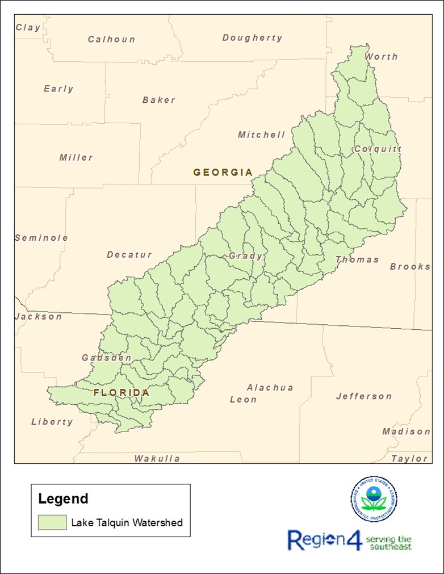
Figure 1 Location of the Lake Talquin Watershed
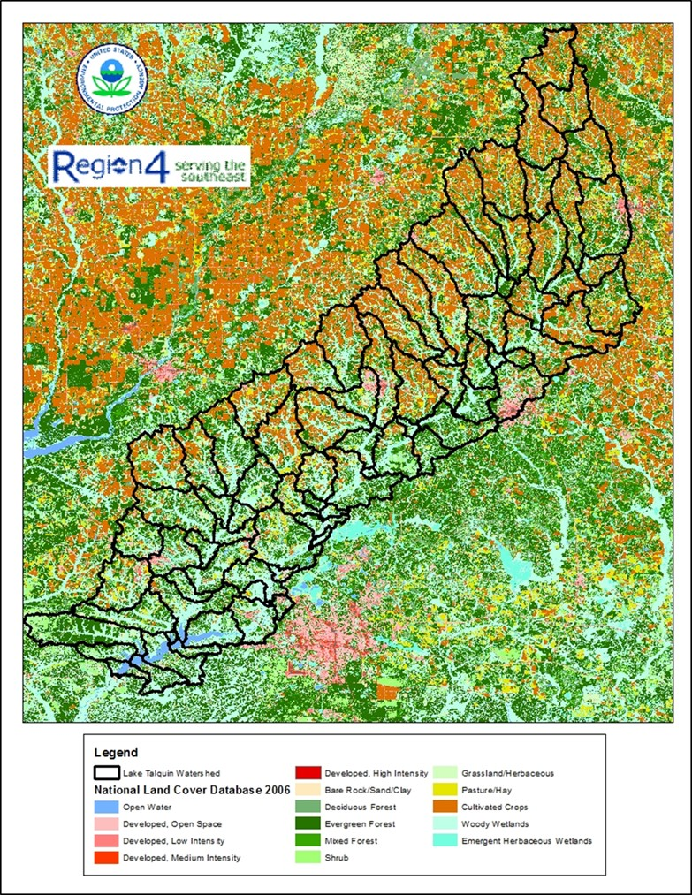
Figure 2 Lake Talquin Watershed Landuse Data

Modeling Approach
The modeling approach that was used for the development of the nutrient model for Lake Talquin (including Little River and Ochlockonee River) considers 17 years of meteorological and flow conditions. The selection of a longer term continuous simulation insures that average, wet and dry conditions are included in the model. The modeling approach uses a dynamic watershed model that predicts surface runoff of pollutants (nitrogen, phosphorus and BOD) and flow as function of landuse and meteorological information. The 17-year simulation of watershed loadings and flow are fed forward to a water quality model that predicts the impacts of the loadings and flow on water quality in the waterbody. The water quality model predicts: dissolved oxygen, nitrogen (ammonia, nitrate, and organic nitrogen), phosphorus (orthophosphate, organic phosphorus), chlorophyll a, biochemical oxygen demand as a function of loads and flows provided by the watershed model.

LSPC Watershed Model
The Loading Simulation Program C++ (LSPC) is the watershed model. LSPC is the Loading Simulation Program in C++, a watershed modeling system that includes streamlined Hydrologic Simulation Program Fortran (HSPF) algorithms for simulating hydrology, sediment, and general water quality on land as well as a simplified stream fate and transport model. LSPC is derived from the Mining Data Analysis System (MDAS), which was originally developed by EPA Region 3 (under contract with Tetra Tech) and has been widely used for TMDLs. In 2003, U.S. Environmental Protection Agency (EPA) Region 4 contracted with Tetra Tech to refine, streamline, and produce user documentation for the model for public distribution. LSPC was developed to serve as the primary watershed model for the EPA TMDL Modeling Toolbox.

WASP Water Quality Model
Water Quality Analysis Simulation Program (WASP 7.52) (USEPA, 2014) is a generalized framework for modeling contaminant fate and transport in surface waters. Its flexible, compartmental approach allows it to address problems in one, two, or three dimensions. It is designed to allow easy substitution of user-written routines into the program structure. WASP has been used to answer questions regarding biochemical oxygen demand, dissolved oxygen dynamics, nutrients and eutrophication, bacterial contamination, and organic chemical and heavy metal contamination. The Advanced Eutrophication Module of WASP was used for Lake Talquin. Figure 3 provides a schematic of the state variables considered by the module.
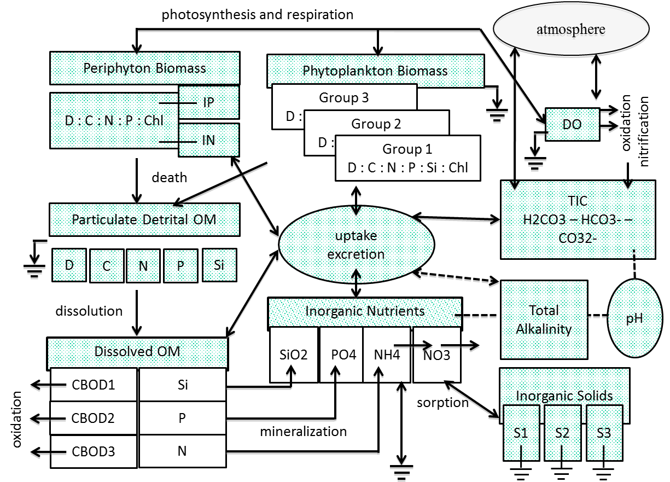
Figure 3 WASP 7.52 Advanced Eutrophication State Variables
The WASP model integrates the predicted flows and loads from the LSPC model to simulate water quality responses in: nitrogen, phosphorus, chlorophyll a and dissolved oxygen. Both LSPC and WASP will be calibrated to current conditions. For this application, WASP is the receiving water quality model for both Lake Talquin and its tributaries.

EFDC Hydrodynamic Model
The Environmental Fluid Dynamics Code (EFDC Hydro) is a state-of-the-art hydrodynamic model that can be used to simulate aquatic systems in one, two, and three dimensions. For this application, a three dimensional EFDC grid was developed for Lake Talquin to provide necessary hydrodynamic inputs to WASP, the advanced receiving water quality model. EFDC uses stretched or sigma vertical coordinates and Cartesian or curvilinear, orthogonal horizontal coordinates to represent the physical characteristics of a waterbody. It solves three-dimensional, vertically hydrostatic, free surface, turbulent averaged equations of motion for a variable-density fluid. Dynamically-coupled transport equations for turbulent kinetic energy, turbulent length scale, salinity and temperature are also solved.

Model Domains
Because of the size and complexity of the watershed and the TMDL/nutrient criteria decision that will be made a set of nested models where developed. Figure 4 depicts the model network for the five models. The green polygons define the areas that were simulated for the Ochlockonee River watershed. Results, both flows and loads are used by all the other models. The red line segments represent the WASP water quality model for the Ochlockonee River. This model incorporates the flows and loads from the watershed model plus the 5 NPDES dischargers for fate and transport to Lake Talquin. The pink line segments represent the WASP water quality model for the Attapulgus River (Georgia)/Little River (Florida). This model incorporates the flows and loads from the watershed model plus the 2 NPDES dischargers for fate and transport to Lake Talquin. The yellow grid represents the hydrodynamic and water quality model for Lake Talquin. The hydrodynamic and water quality model receives flows and loads from the mainstem river WASP models (Ochlockonee and Attapulgus/Little River) and the surrounding watershed model.
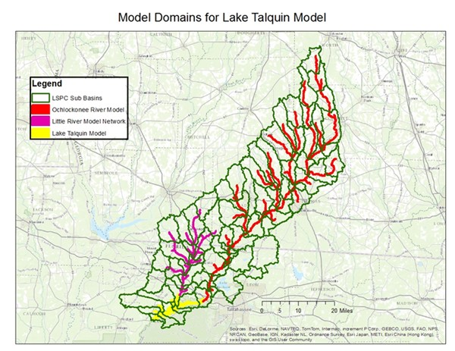
Figure 4 LPSC Watersheds and WASP Segments

Watershed Model Application
The watershed model was applied to the Lake Talquin watershed for the simulation period of 1996 through 2012. The 1996 year was used to equilibrate the initial conditions in the watershed model (soil moisture, buildup and washoff), from 1997 through 2012 was used to predict flows and loads under current conditions that will be passed onto the water quality model.

Watershed Delineation and Landuse
The upstream sections of the watershed that drain ultimately to Lake Talquin, including Little River and Ochlockonee River, were included in the LSPC watershed model. The watershed was delineated into 85 sub basins (Figure 5). Sixteen sub basins drained to the Little River, 57 sub basins drained to Ochlockonee River, and 12 sub basins drained directly to Lake Talquin (Figure 5). The LSPC model predicts flow and loads coming from each of these sub basins into Little River, Ochlockonee River, and eventually into Lake Talquin.
The initial model setup and parameterization for Lake Talquin watershed model was based on EPA’s LSPC model used for the purposes of nutrient criteria development and from the Apalachee basin model developed by Tetra-Tech for the State of Georgia (Tetra-Tech, 2011); the initial model was further refined and calibrated to all local data and gages that were available in the watershed.
The watershed model uses land use data as the basis for representing hydrology and nonpoint source loadings. The Georgia Land Use Trends (GLUT), FDEP Level III Florida Land Use, and the National Landuse Coverage Dataset (NLCD) were used to develop the watershed land use representations. The GLUT 2008 was used as the primary coverage in the Georgia portion of the watershed and FDEP and NLCD 2006 data was used complete the land use coverage in Florida where there was no GLUT 2008 data. The coverages utilized a variety of land use classes, and the FDEP coverages were grouped and reclassified into 18 land use categories: beaches/dune/mud, open water, utility swaths, developed open space, developed low intensity, developed medium intensity, developed high intensity, clear-cut/sparse, quarries/strip mines, deciduous forest, evergreen forest, mixed forest, golf courses, pasture, row crop, forested wetland, non-forested wetland (salt/brackish), and non-forested wetland (freshwater). The GLUT and NLCD datasets were then reclassified into the same land use categories. For the LSPC simulation, similar land use classes were grouped together into reduced into 15 modeling categories, i.e., deciduous forest, evergreen forest and mixed forest were grouped together into a unit named forest.
The LSPC model requires division of land uses in each sub-watershed into separate pervious and impervious land units. The GLUT impervious cover was intersected with the GLUT land use-land cover. Any impervious areas associated with utility swaths, developed open space, and developed low intensity, were grouped together and placed into a new category of low intensity developed impervious cover. Impervious areas associated with medium intensity development and high intensity development, were kept separate and placed into two categories of medium intensity developed impervious and high intensity developed impervious cover, respectively. Finally, any impervious area not already accounted for in the three developed impervious cover categories, were grouped together into a fourth catch all category for remaining impervious areas.
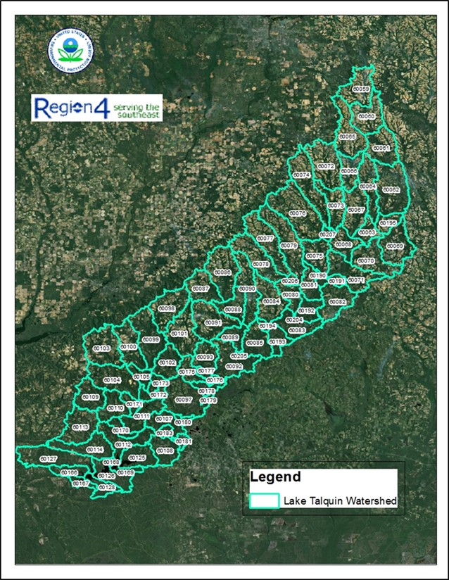
Figure 5 Lake Talquin Watershed Delineation

Meteorological Information
Non-point source loadings and hydrological conditions are dependent on weather conditions. Hourly data from weather stations within the boundaries of, or in close proximity to the sub-watersheds were applied to the watershed model. An ASCII file (*.air) was generated for each meteorological and precipitation station used for the hydrologic evaluations in LSPC. Each meteorological and precipitation station file contains atmospheric data used for modeling of the hydrologic processes. These data include precipitation, air temperature, dew point temperature, wind speed, cloud cover, evaporation, and solar radiation. These data are used directly, or calculated from the observed data.
Figure 6 depicts the hourly rainfall for the Tallahassee WSO AP (WBAN 088758) meteorological station. The period of record being simulated during this TMDL development contains average, wet and dry years.
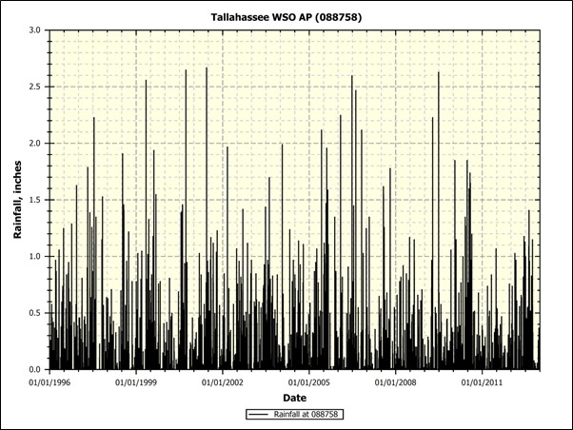
Figure 6 Hourly Rainfall Station 0088758
Table 1 provides the annual rainfall for each of the simulation years.

Table 1 Annual Rainfall for Simulation Period
Year | Quincy (in) | Tallahassee (in) | Bainbridge (in) | Camilla (in) | Moultrie (in) | Cairo (in) | Thomasville (in)
1996 | 56 | 53 | 54 | 50 | 49 | 55 | 54
1997 | 74 | 60 | 61 | 56 | 56 | 61 | 69
1998 | 37 | 55 | 57 | 55 | 53 | 51 | 60
1999 | 43 | 48 | 43 | 32 | 35 | 35 | 44
2000 | 45 | 44 | 40 | 41 | 46 | 40 | 55
2001 | 53 | 63 | 46 | 49 | 44 | 55 | 48
2002 | 63 | 55 | 57 | 53 | 59 | 53 | 59
2003 | 57 | 65 | 54 | 64 | 51 | 56 | 58
2004 | 80 | 56 | 51 | 51 | 58 | 57 | 58
2005 | 79 | 68 | 68 | 54 | 65 | 67 | 65
2006 | 46 | 50 | 36 | 47 | 38 | 46 | 45
2007 | 40 | 36 | 34 | 37 | 37 | 37 | 32
2008 | 66 | 51 | 69 | 62 | 53 | 60 | 63
2009 | 63 | 48 | 52 | 58 | 52 | 47 | 50
2010 | 51 | 59 | 43 | 43 | 39 | 44 | 46
2011 | 38 | 35 | 37 | 34 | 38 | 38 | 40
2012 | 45 | 56 | 48 | 35 | 40 | 42 | 44

Figure 7 provides the location of the meteorological stations used in the watershed model.
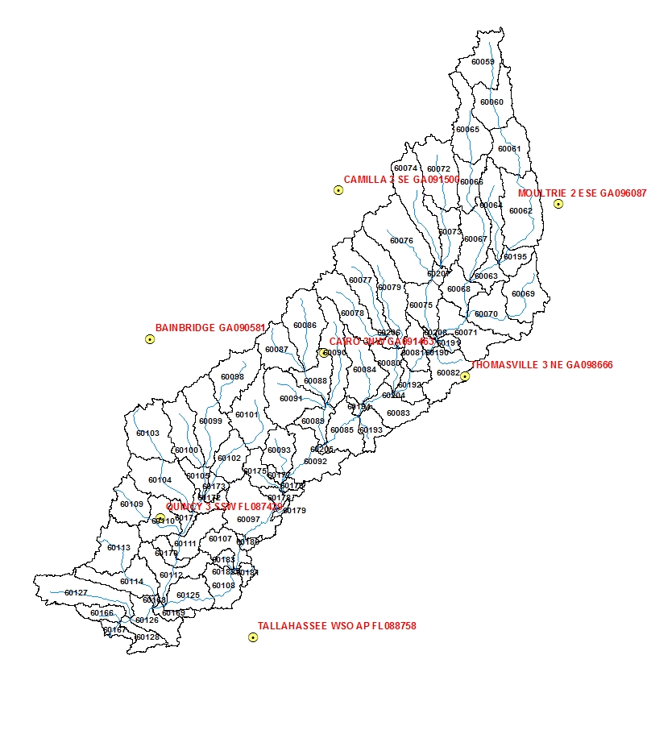
Figure 7 Meteorological Station Locations

Hydraulic Calibration
The watershed and water quality model were calibrated for flow by comparing the predicted flows to several USGS gages located within the watershed. Figure 8 through Figure 10 illustrate both a quantitative and qualitative comparison of the model flow predictions directly compared to measurements at the USGS gages.
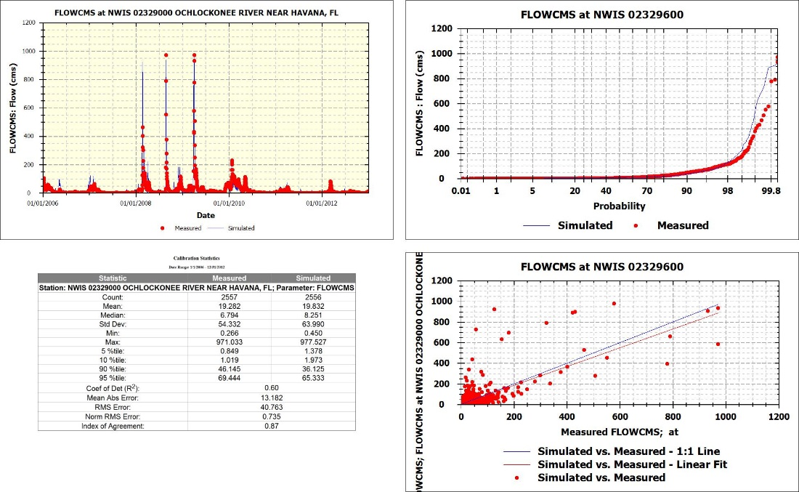
Figure 8 Flow Calibration for Ochlockonee River USGS Gage 02329000
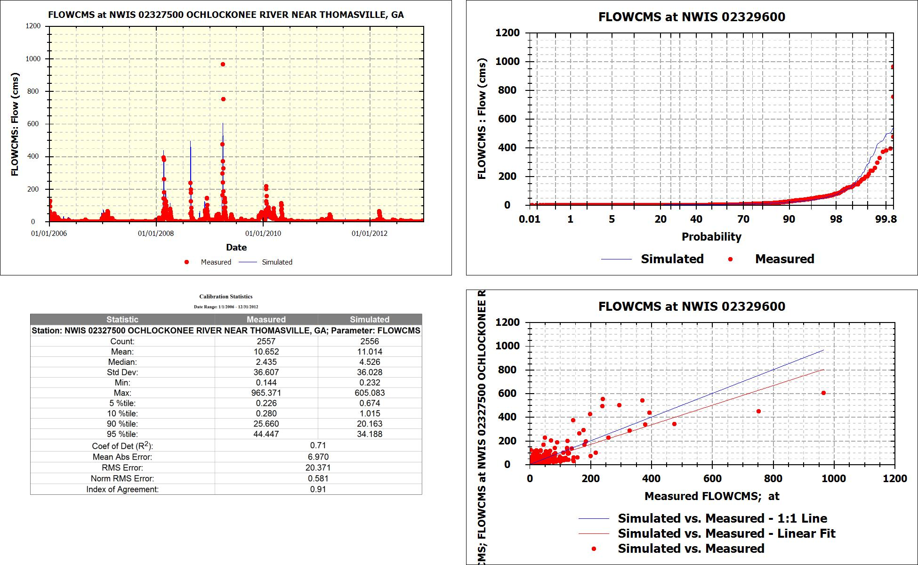
Figure 9 Flow Calibration for Ochlockonee River USGS Gage 02327500
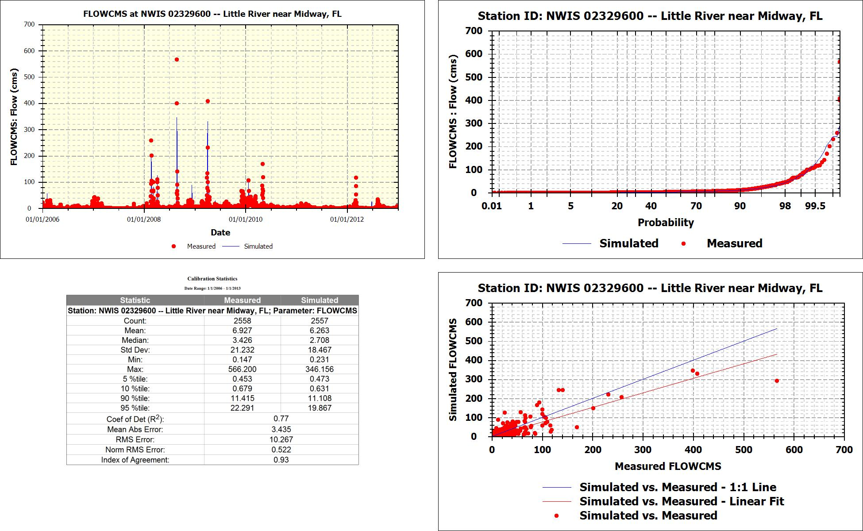
Figure 10 Flow Calibration for Little River USGS Gage 02329600

Nutrient Loadings
Watershed loadings were generated using event mean concentrations for total nitrogen, total phosphorus and BOD (Table 2Table 1). The initial EMC values were derived for each landuse type from a study by Harper and Baker (2007) and then calibrated to all data available for the watershed. Wetland EMCs were derived from the study of Reiss et.al (2009). The study summarizes the available literature on nutrient concentrations and hydrology for wetlands in Florida.
Table 2 Event Mean Concentration (mg/l) for Landuse Classifications
Landuse | TN (mg/L) | TP (mg/L) | BOD₅ (mg/L)
Beach | 2.07 | 0.41 | 1.93
Water | 1.50 | 0.10 | 1.93
LowIntDev-Pervious | 2.07 | 0.41 | 7.86
LowIntDev-Impervious | 1.18 | 0.19 | 7.60
MedIntDev-Pervious | 2.07 | 0.41 | 7.86
MedIntDev-Impervious | 2.07 | 0.41 | 7.86
HighIntDev-Pervious | 2.32 | 0.52 | 11.28
HighIntDev-Impervious | 2.40 | 0.35 | 11.30
Barren | 2.07 | 0.41 | 1.35
Forest | 1.15 | 0.11 | 1.35
Golf | 3.47 | 0.62 | 5.62
Pasture | 3.47 | 0.62 | 8.24
Crop | 2.65 | 0.85 | 5.62
WetLand | 2.88 | 0.68 | 1.93
All Other Impervious | 2.07 | 0.41 | 7.27
Harper H. H. and D. M. Baker, 2007. Evaluation of Current Stormwater Design Criteria within the State of Florida. Final Report submitted to Florida Department of Environmental Protection. Environmental Research & Design, Inc. Orlando, FL.
Reiss, K.C., Evans, J., and M. Brown, 2009. Summary of Available Literature on Nutrient Concentrations and Hydrology for Florida Isolated Wetlands. Final Report submitted to Florida Department of Environmental Protection, Tallahassee, FL.

Hydrodynamic Model Application
The Environmental Fluids Dynamic Code (EFDC) was applied to Lake Talquin to predict transport in the lake as a function of watershed flows and meteorological conditions. The Tallahassee Airport station was used to parameterize the meteorological conditions for the lake. The lake was divided up into 212 horizontal segments and consists of two layers (Figure 11).
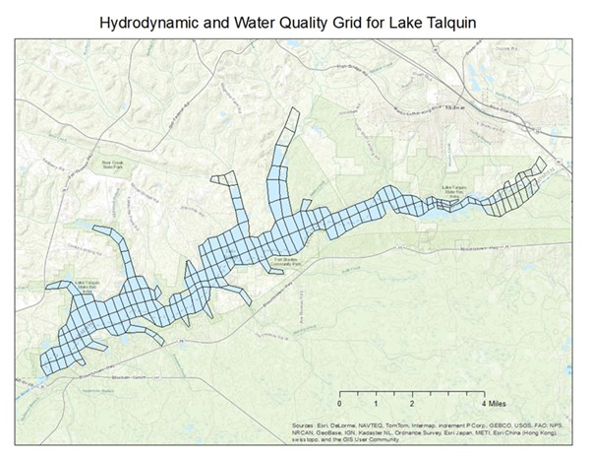
Figure 11 Lake Talquin EFDC Grid
Lake depths were estimated based upon a map that was developed by Gadsden and Leon County from 2007 (Figure 12). Depths were interpolated to the EFDC grid to account for change in depth in the lake.
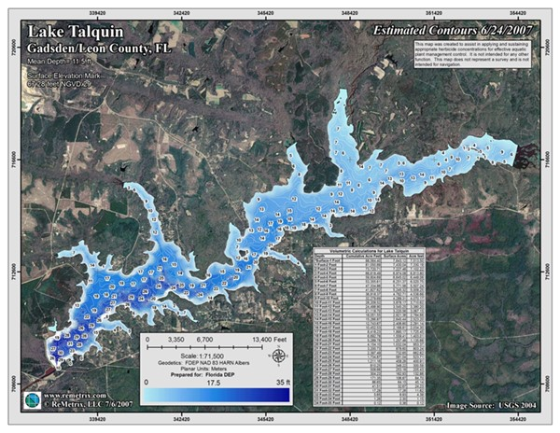
Figure 12 Lake Talquin Depth Profiles
Figure 13 illustrates the calibration of water surface elevation. While the watershed model was executed for 1997 through 2012, the hydrodynamic and water quality model for the lake was executed 2007 through 2012 because of the available water surface elevation data. This data is critical to determine whether the flows are well calibrated.
Figure 13 Water Surface Elevation Calibration

Distribution of EFDC Flow Correction
One of the calibration steps in applying EFDC to reservoirs is to adjust inflows and outflows to insure that the predict water surface elevation of the hydrodynamic model matches the measured water surface elevation. This insures that water mass balance is maintained throughout the simulation period. Because it is virtually impossible to define all inflows (tributary, groundwater, sheet flow) and all outflows (dam release, dam seepage, groundwater loss) EFDC includes a flow balancing utility that can adjust inflow/outflow to maintain the measured water surface elevation. The EFDC flow balancing utility has a limitation of only adding and removing flows at two points. Once the adjusted inflow and outflow time series has been estimated, the user must go back and apply the adjusted flows to all of the inflows and outflows. All of corrected outfall was added to the dam discharge time series in the EFDC QSER.INP file. The corrected inflow time series was distributed to all of the inflow time series in the EFDC QSER.INP file. Table 3 below provides the percentage of the inflow correction that would be added to each of the tributary time series.
The step described above was left out of previous versions of the hydrodynamic and water quality model (Version 6). The Section Comparison Version 6 & 8 towards the end of the document provides a graphical comparison between Version 6 of the water quality model to the current Version 7 where of the flow correction was distributed to all of the inflow points.
Table 3 Inflow Correction Distribution
Figure 14 illustrates where each of the inflows enter the model grid. Each of these pore points will have additional flow added using the calculated percentages when the EFDC flow correction utility needed to add flow to maintain the measured water surface elevation.
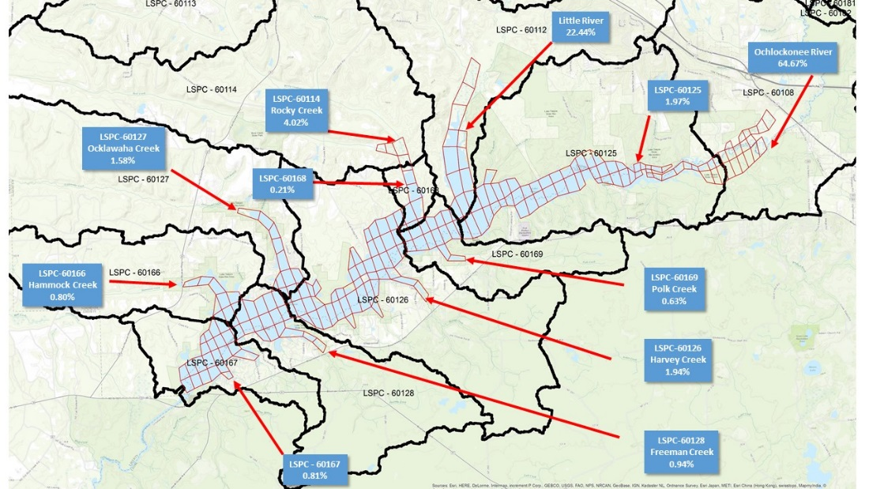
Figure 14 EFDC Inflow Correction Flow Distribution

Hydrodynamic Model Calibration
The following figures illustrate the temperature calibration for Lake Talquin. For all calibration plots for both the hydrodynamic and water quality model will use the same monitoring stations as depicted in Figure 28. For the lake model, all results shown are for the surface layer of the model. Figure 15 through Figure 23 provide a comparison of the model predicted temperature to the measured data.
Figure 15 21FLLEONLCT0C3045884492: Talquin 4 for Water Temperature

Figure 16 21FLLEONLCT03045184523: Lake Talquin near Williams Landing for Water Temperature
Figure 17 21FLLEONLCT0W3045084521: Talquin 3 for Water Temperature

Figure 18 21FLLEONT0E3044084556: Lake Talquin Central for Water Temperature
Figure 19 21FLLEONLCT03042384172: Lake Talquin near Luther Hall Landing for Water Temperature

Figure 20 21FLLEONLCT0L3042284573: Talquin 2 for Water Temperature
Figure 21 21FLLEONT0D3041488461: Lake Talquin West for Water Temperature

Figure 22 21FLLEONLCOC3040784610: Lake Talquin (Ben Stoutamire Boat Landing) for Water Temperature
Figure 23 21FLLEONLCT0B3040284630: Talquin 1 for Water Temperature

Water Quality Model Application
The WASP water quality model uses the kinematic wave equation to simulate flow and velocity in Lake Talquin’ s tributaries, and the advanced eutrophication module to predict dissolved oxygen and Chlorophyll-a responses to BOD, total nitrogen and total phosphorus loadings. The watershed tributary geometry was determined from NHDPlus coverages of the free flowing stream sections.

Model Network
The Lake Talquin WASP model is comprised of 3 separate WASP water quality models, Little River, Ochlockonee River, and Lake Talquin. The output parameters for both Little River and Ochlockonee River tributaries are loaded into the Lake Talquin WASP model. The model segmentation for both of the river models was done based upon the NHDPlus coverage taking into account travel time, pore points for the watershed model and IWR monitoring stations.
Figure 24 illustrates 132 water quality model segments that are simulated for the Little River. The 18 subwatershed LSPC model flows and loads enter the water quality model at 18 different WASP segments. Figure 24 illustrates the 183 water quality model segments that are simulated for the Ochlockonee River. The LSPC model flows and loads enter the water quality model at 55 separate WASP segments.
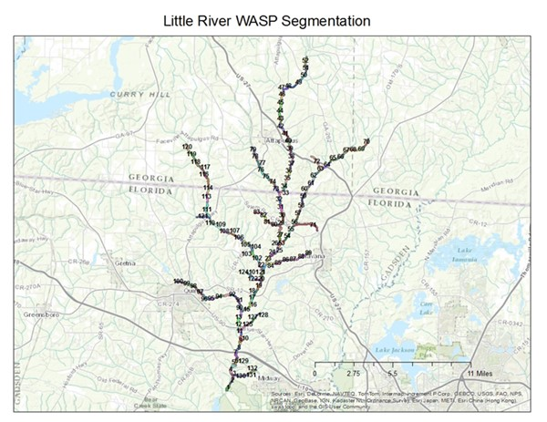
Figure 24 WASP Model Segmentation for Little River

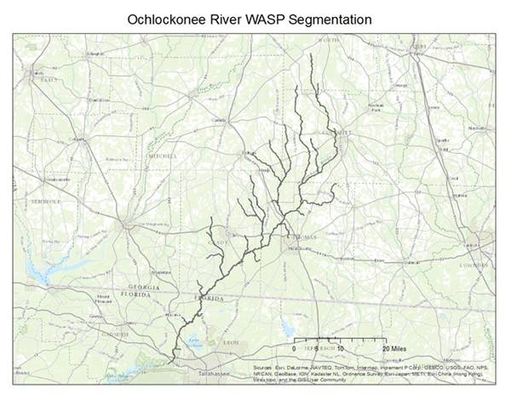
Figure 25 WASP Model Segmentation for Ochlockonee River
An EFDC grid was developed for Lake Talquin which consists of 212 horizontal cells with 2 layers. The model grid includes all the major and minor tributaries to the lake. EFDC and WASP are linked 1 to 1 in space. EFDC supplies updated hydrodynamic information to WASP every 60 EFDC time steps (Figure 11).

Water Quality Model Calibration
The water quality models were calibrated to available data. The fine tuning of the calibration of the models utilized the monitoring station(s) located at the lower end that contained the most monitoring data. For the lake calibration, all model results and measured data are representing the surface layer of the WASP model.
Table 4 - Table 6 list monitoring stations used to calibrate the three WASP models developed for Lake Talquin Watershed. All stations that had nutrient, BOD, dissolved oxygen and chlorophyll-a measurements were used in the calibration process. The stations highlighted in yellow provided the most critical monitoring data and were therefore provided the most influence to the water quality calibration.
Table 4 Monitoring Stations used in Little River Water Quality Model Calibration
WASP Segment | State | Station ID | Station Name
4 | FL | 21FLBRA 424-A | 424 - Little River - far dwnstrm from bridge on SR 268
4 | FL | 21FLPNS 303043908431244 | Little River at SR 268
29 | FL | 21FLPNS 303946808427477 | Attapulgus Creek at SR 159
29 | FL | 21FLWQA 303946808427477 | Attapulgus Creek at SR 159
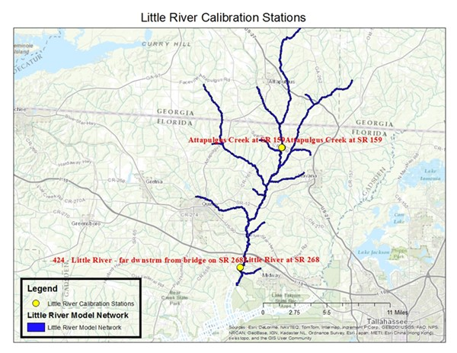
Figure 26 Little River WASP Water Quality Calibration Segments
Table 5 Monitoring Stations used in Ochlockonee River Water Quality Model Calibration
WASP Segment | State | Station ID | Station Name
25 | GA | 21GAEPD_WQX-1003010102 | Ochlockonee River @ Hadley Ferry Rd. nr Calvary, Ga.
25 | GA | USGS-02328200 | OCHLOCKONEE RIVER NEAR CALVARY, GA
20 | FL | 21FLGW 3540 | Ochlockonee river at SR 12

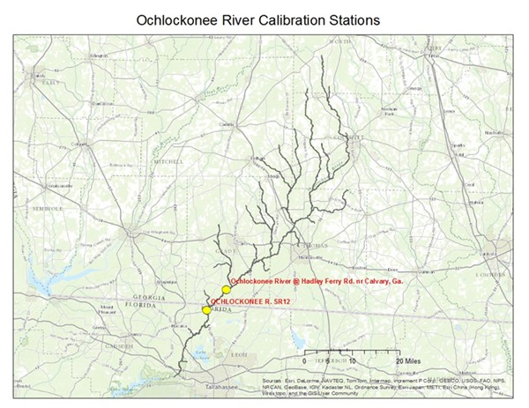
Figure 27 Ochlockonee WASP Water Quality Calibration Segments
Table 6 Monitoring Stations used in Lake Talquin Water Quality Model Calibration
Station | Station Name
21FLLEONLCOC3040784610 | Lake Talquin (Ben Stoutamire Boat Landing)
21FLLEONLCT03042384172 | Lake Talquin near Luther Hall Landing
21FLLEONLCT03045184523 | Lake Talquin near Williams Landing
21FLLEONLCT0B3040284630 | Talquin 1
21FLLEONLCT0C3045884492 | Talquin 4
21FLLEONLCT0L3042284573 | Talquin 2
21FLLEONLCT0W3045084521 | Talquin 3
21FLLEONT0D3041488461 | Lake Talquin West
21FLLEONT0E3044084556 | Lake Talquin Central

Station location
Figure 28 illustrates the location of the water quality stations that were used in the calibration. All of these stations are maintained by Leon County, FL. These stations were chosen because they represent the most complete and long term record of data for Lake Talquin.
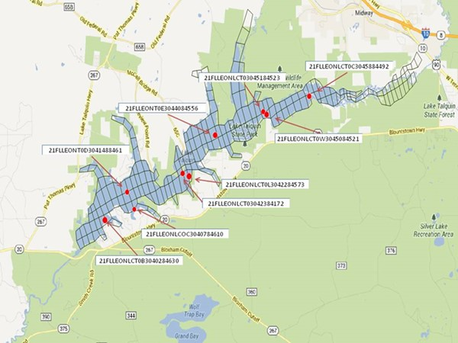
Figure 28 Lake Talquin Calibration Station Location

Little River/Ochlockonee River Water Quality Calibration
Both the Ochlockonee and Little River Models were calibrated against available ambient monitoring data. Stations with the most complete dataset were used. The model calibration focused on getting the loads to Lake Talquin correct.

Water Temperature
The riverine models were configured to simulation water temperature. This step was important because it provides daily water temperatures that are used to influence the degradation of BOD, kinetic transformation (mineralization, dissolution), and algal growth/death rates.
Figure 29 - illustrate both a quantitative and qualitative comparisons of simulated water temperature to direct field measurements.
Figure 29 Water Temperature Calibration Attapulgus Creek at SR 159

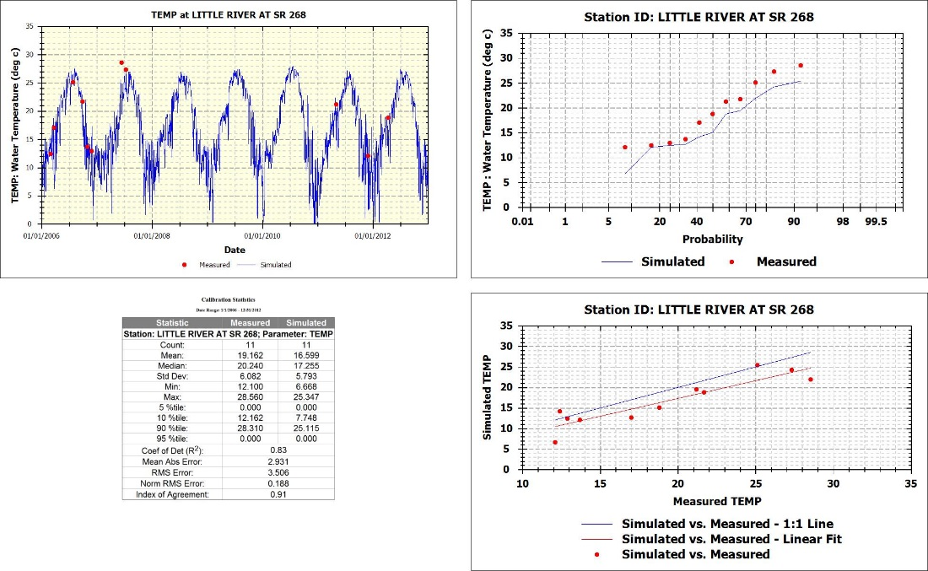
Figure 30 Water Temperature Calibration Little River at SR 268
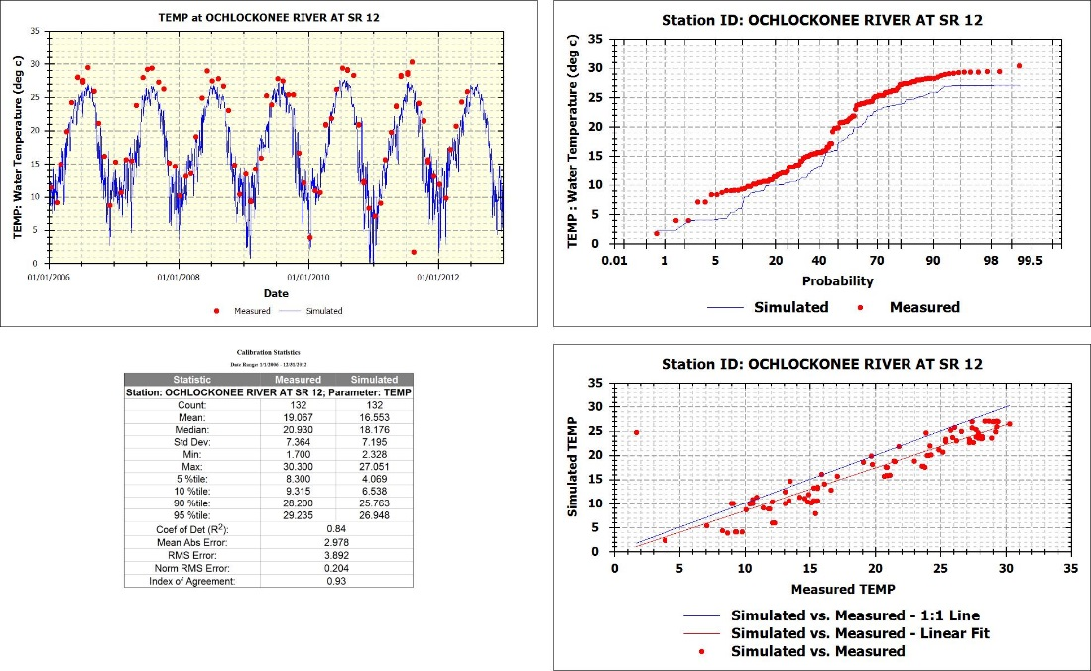
Figure 31 Water Temperature Calibration Ochlockonee River at SR 12

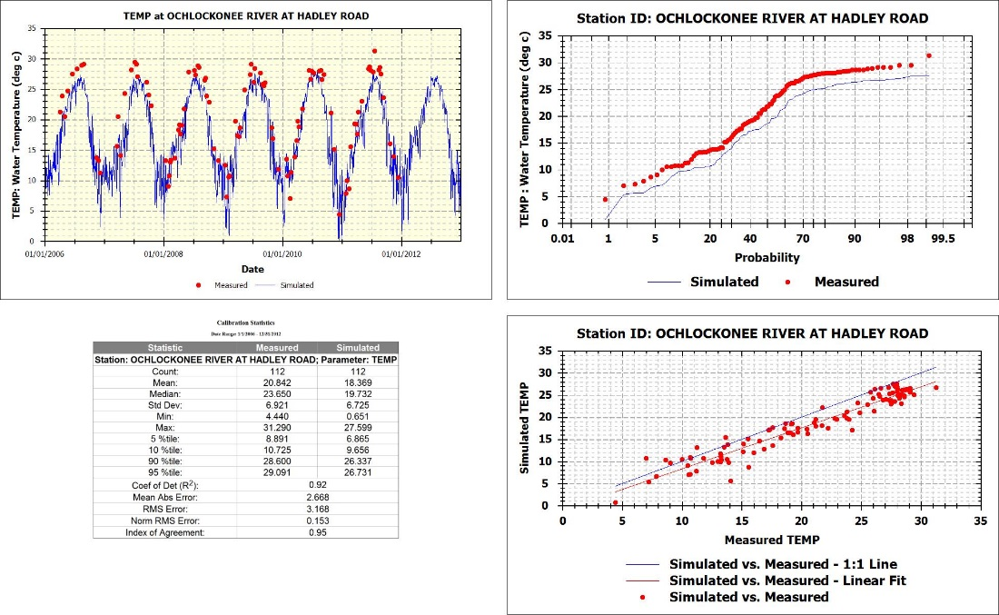
Figure 32 Water Temperature Calibration Ochlockonee River at Hadley Road

Dissolved Oxygen
Figure 33 through Figure 53 illustrates both a quantitative and qualitative comparison of the predicted dissolved oxygen concentrations compared to the direct measurements.
Figure 33 Dissolved Oxygen Calibration Attapulgus Creek at SR 159
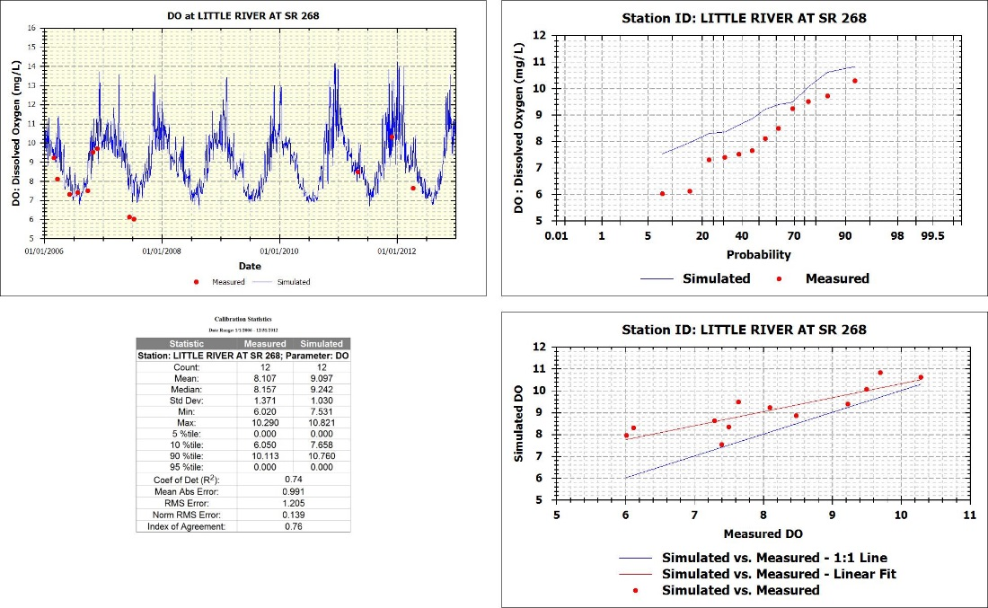
Figure 34 Dissolved Oxygen Calibration Little River at SR 268

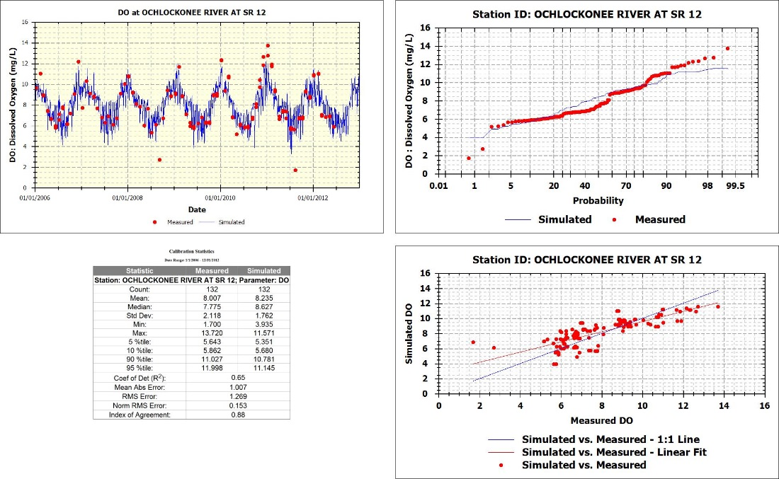
Figure 35 Dissolved Oxygen Calibration Ochlockonee River at SR 12

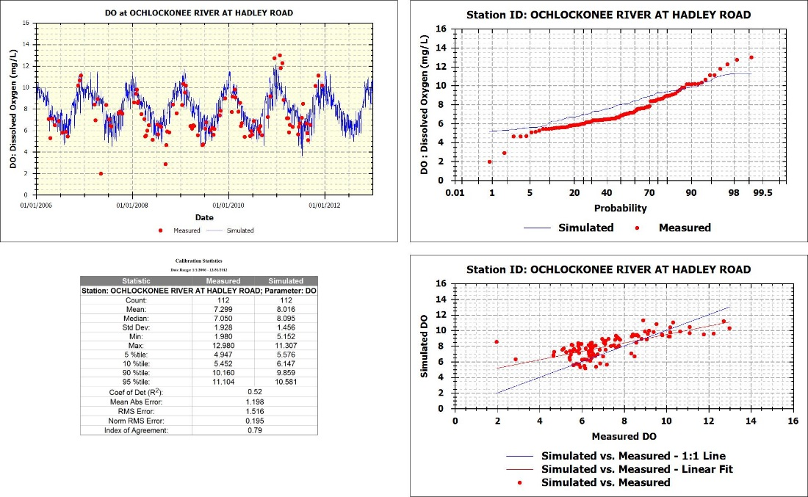
Figure 36 Dissolved Oxygen Calibration Ochlockonee River at Hadley Road

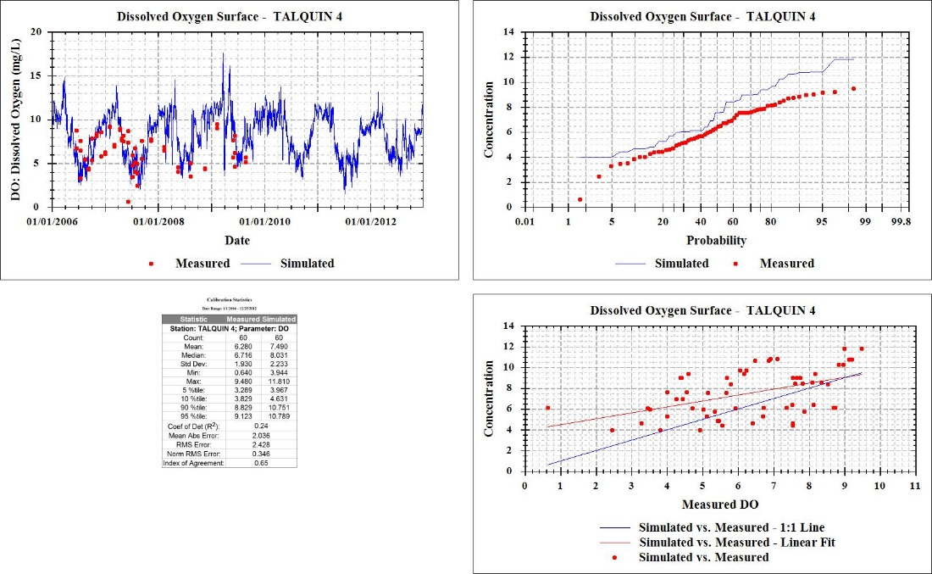
Figure 37 21FLLEONLCT0C3045884492: Talquin 4 for Dissolved Oxygen – Surface Layer
Figure 38 21FLLEONLCT0C3045884492: Talquin 4 for Dissolved Oxygen – Bottom Layer

Figure 39 21FLLEONLCT03045184523: Lake Talquin near Williams Landing for Dissolved Oxygen – Surface Layer
Figure 40 21FLLEONLCT03045184523: Lake Talquin near Williams Landing for Dissolved Oxygen – Bottom Layer

Figure 41 21FLLEONLCT0W3045084521: Talquin 3 for Dissolved Oxygen – Surface Layer

Figure 42 21FLLEONLCT0W3045084521: Talquin 3 for Dissolved Oxygen – Bottom Layer

Figure 43 21FLLEONT0E3044084556: Lake Talquin Central for Dissolved Oxygen – Surface Layer

Figure 44 21FLLEONT0E3044084556: Lake Talquin Central for Dissolved Oxygen – Bottom Layer

Figure 45 21FLLEONLCT03042384172: Lake Talquin near Luther Hall Landing for Dissolved Oxygen – Surface Layer
Figure 46 21FLLEONLCT03042384172: Lake Talquin near Luther Hall Landing for Dissolved Oxygen – Bottom Layer

Figure 47 21FLLEONLCT0L3042284573: Talquin 2 for Dissolved Oxygen – Surface Layer
Figure 48 21FLLEONLCT0L3042284573: Talquin 2 for Dissolved Oxygen – Bottom Layer

Figure 49 21FLLEONT0D3041488461: Lake Talquin West for Dissolved Oxygen – Surface Layer

Figure 50 21FLLEONT0D3041488461: Lake Talquin West for Dissolved Oxygen – Bottom Layer

Figure 51 21FLLEONLCOC3040784610: Lake Talquin (Ben Stoutamire Boat Landing) for Dissolved Oxygen – Surface Layer
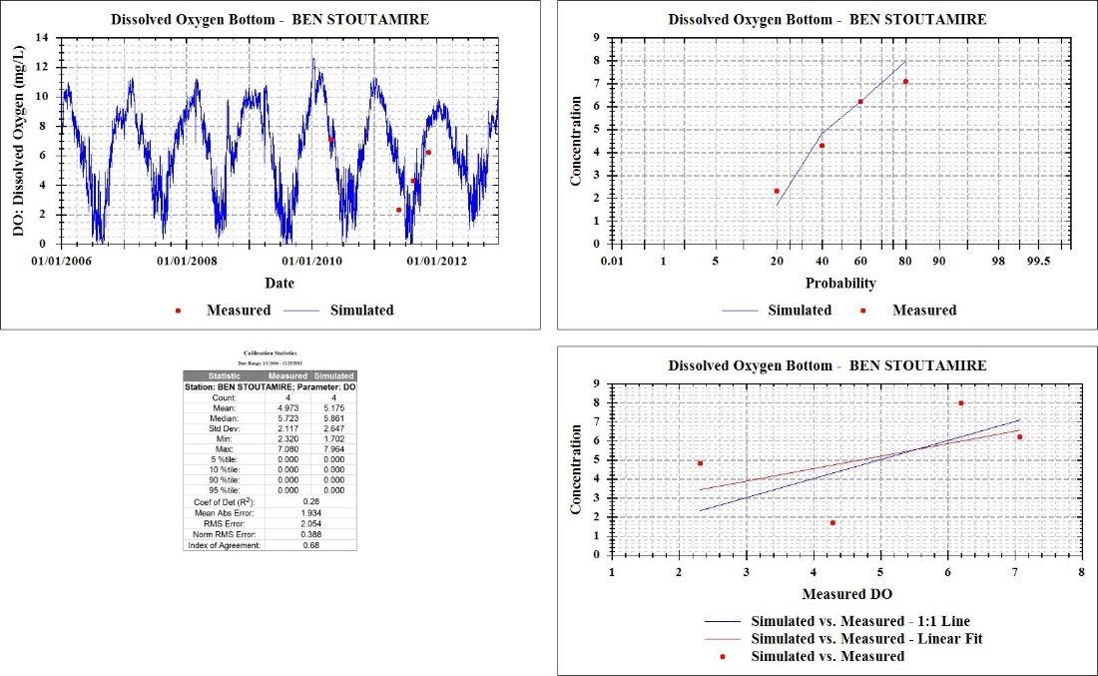
Figure 52 21FLLEONLCOC3040784610: Lake Talquin (Ben Stoutamire Boat Landing) for Dissolved Oxygen – Bottom Layer

Figure 53 21FLLEONLCT0B3040284630: Talquin 1 for Dissolved Oxygen – Surface Layer
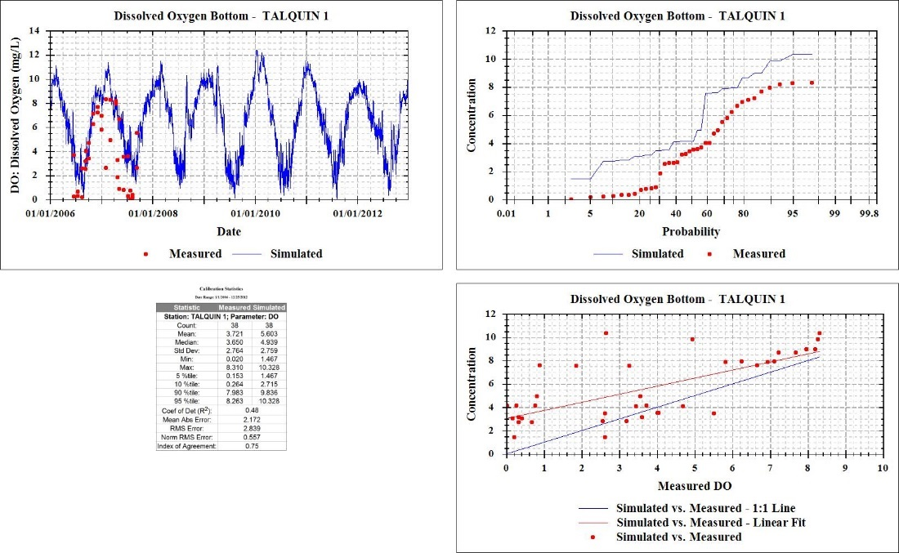
Figure 54 21FLLEONLCT0B3040284630: Talquin 1 for Dissolved Oxygen – Bottom Layer

Chlorophyll a
Figure 55 through Figure 65 illustrate a quantitative and qualitative comparison of the predicted chlorophyll-a concentrations to direct field measurements.
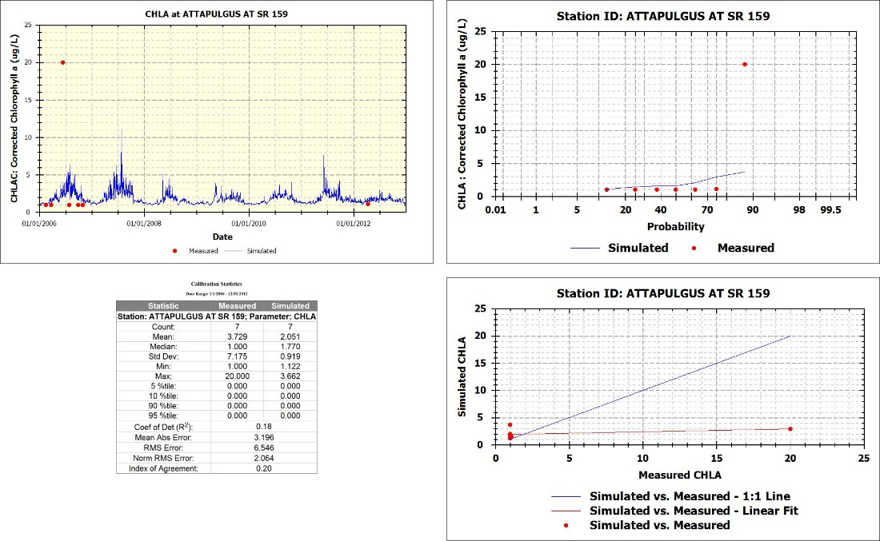
Figure 55 Chlorophyll a Calibration Attapulgus Creek at SR 159

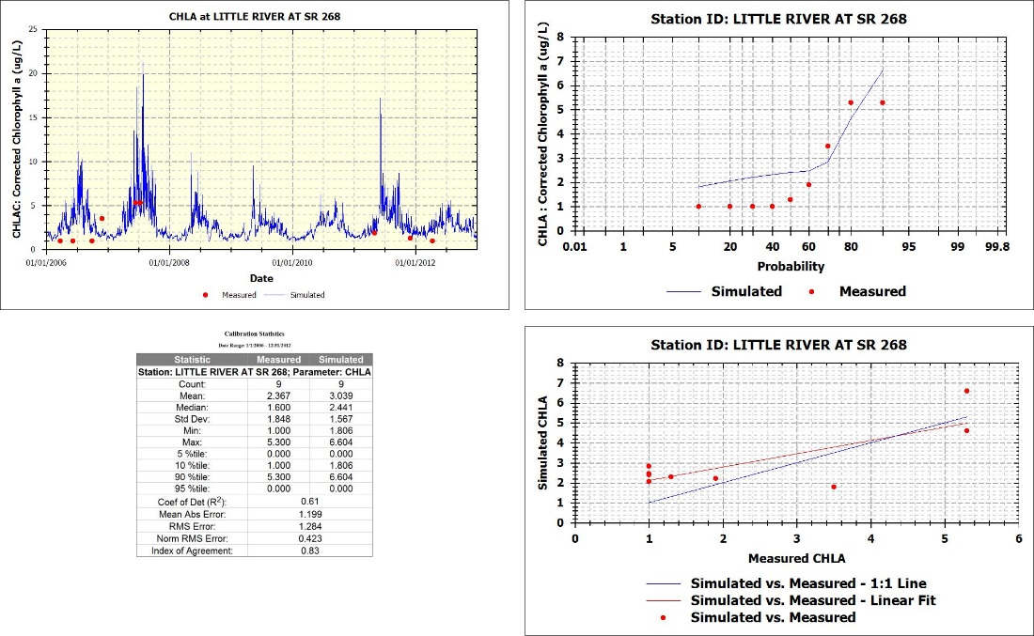
Figure 56 Chlorophyll a Calibration Little River at SR 268

Figure 57 21FLLEONLCT0C3045884492: Talquin 4 for Chlorophyll a

Figure 58 21FLLEONLCT03045184523: Lake Talquin near Williams Landing for Chlorophyll a
Figure 59 21FLLEONLCT0W3045084521: Talquin 3 for Chlorophyll a

Figure 60 21FLLEONT0E3044084556: Lake Talquin Central for Chlorophyll a
Figure 61 21FLLEONLCT03042384172: Lake Talquin near Luther Hall Landing for Chlorophyll a

Figure 62 21FLLEONLCT0L3042284573: Talquin 2 for Chlorophyll a
Figure 63 21FLLEONT0D3041488461: Lake Talquin West for Chlorophyll a

Figure 64 21FLLEONLCOC3040784610: Lake Talquin (Ben Stoutamire Boat Landing) for Chlorophyll a
Figure 65 21FLLEONLCT0B3040284630: Talquin 1 for Chlorophyll a

Nitrogen
Figure 66 through Figure 86 illustrate quantitative and qualitative comparisons of the model predictions for total nitrogen, NH_{4,} and NO₃O₂ to available direct field measurements.
Figure 66 Total Nitrogen Calibration Attapulgus Creek at SR 159

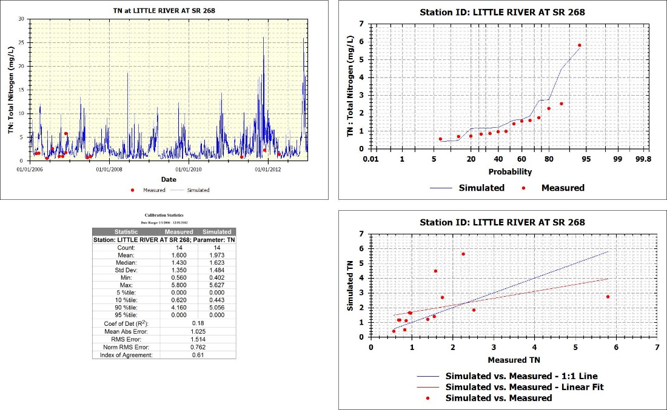
Figure 67 Total Nitrogen Calibration Little River at SR 268
Figure 68 NH4 Calibration Attapulgus Creek at SR 159

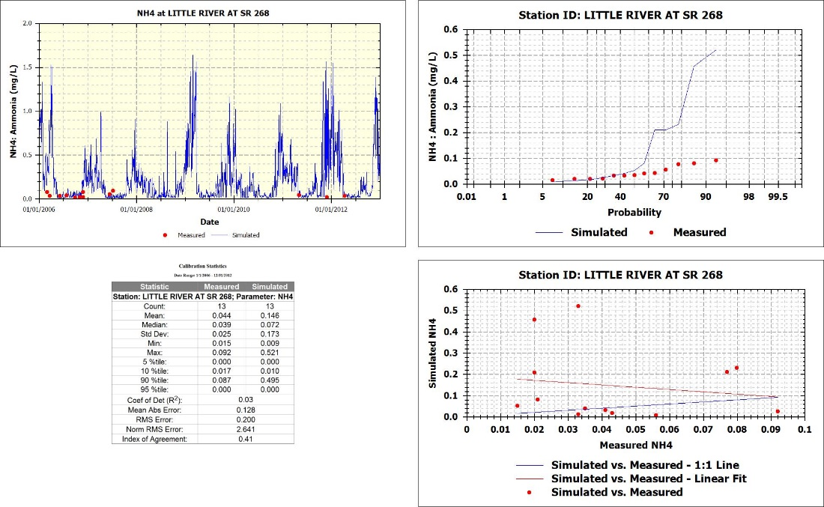
Figure 69 NH4 Calibration Little River at SR 268
Figure 70 Nitrate/Nitrite Calibration Attapulgus Creek at SR 159

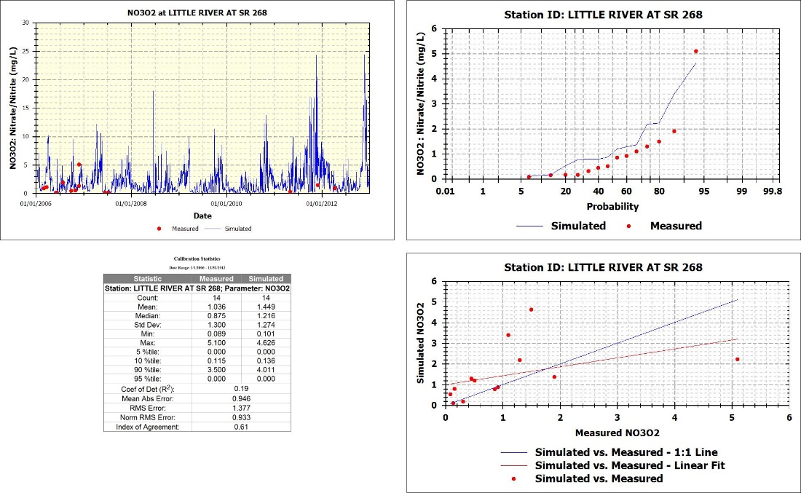
Figure 71 Nitrate/Nitrite Calibration Little River at SR 268
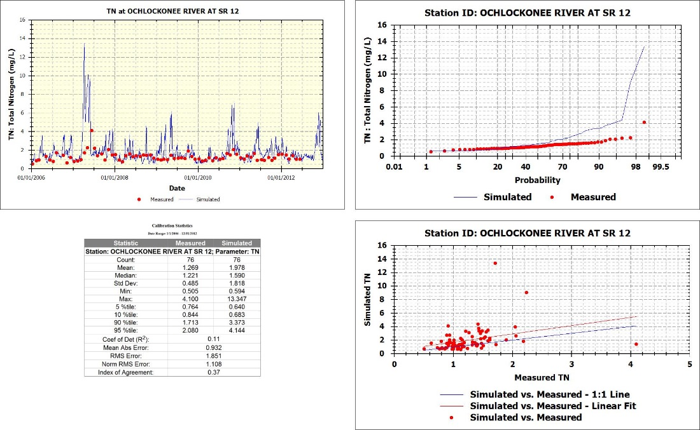
Figure 72 Total Nitrogen Calibration Ochlockonee River at SR 12

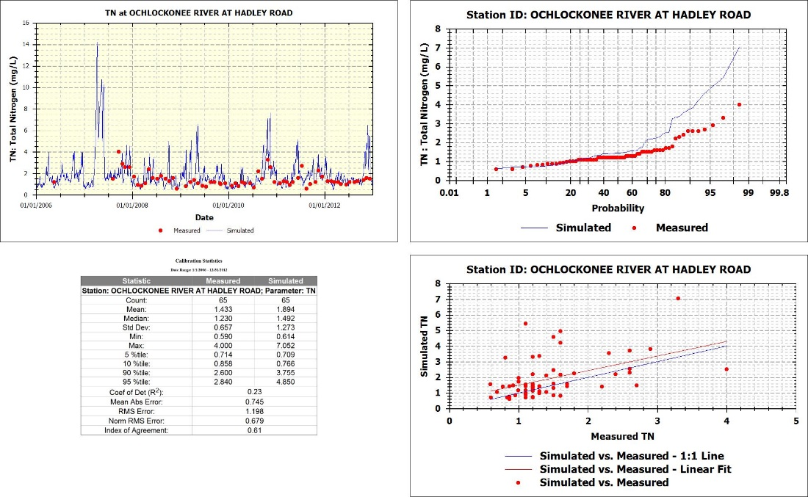
Figure 73 Total Nitrogen Calibration Ochlockonee River Near Hadley Road
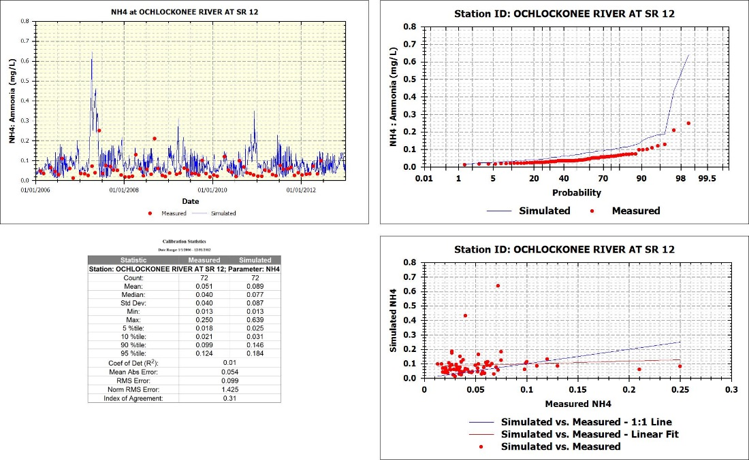
Figure 74 Ammonia Calibration Ochlockonee River at SR 12
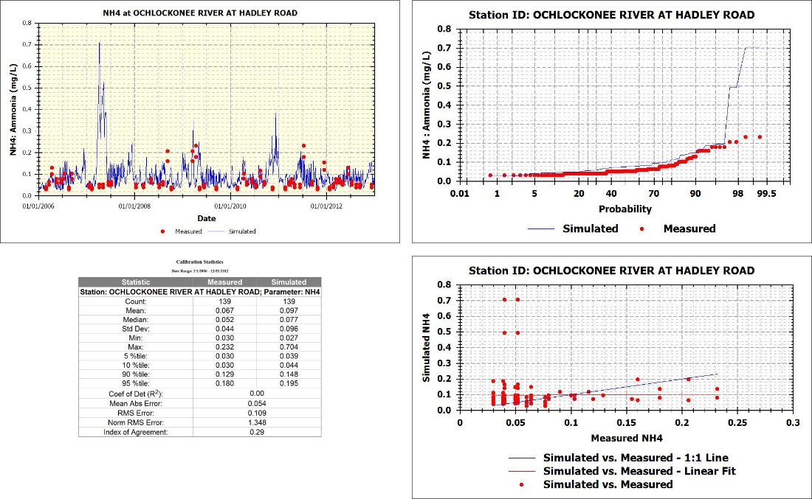
Figure 75 Ammonia Calibration Ochlockonee River Near Hadley Road
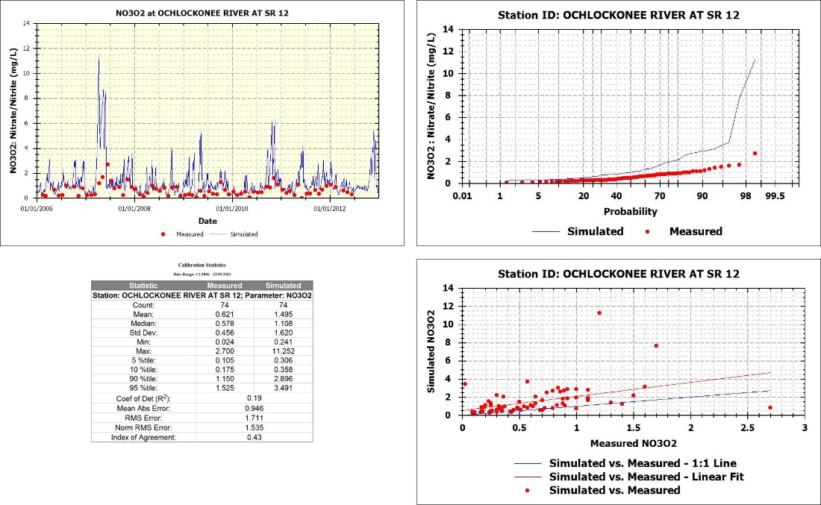
Figure 76 Nitrate Calibration Ochlockonee River at SR 12

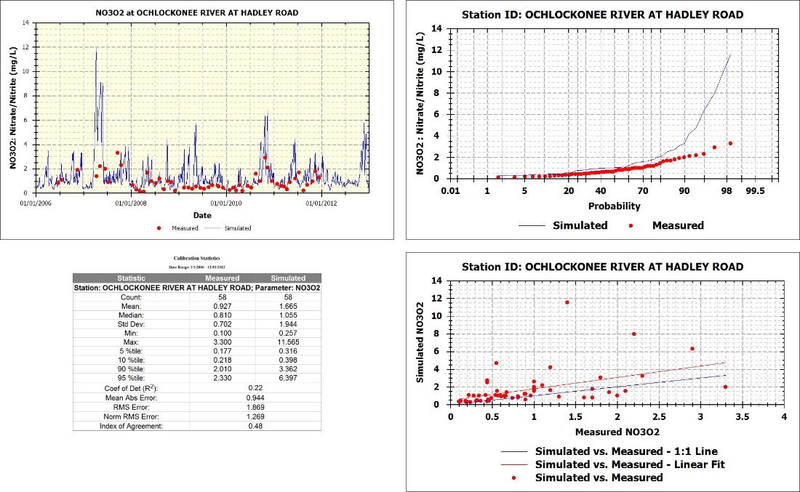
Figure 77 Nitrate/Nitrite Calibration Ochlockonee River Near Hadley Road

Figure 78 21FLLEONLCT0C3045884492: Talquin 4 for Total Nitrogen

Figure 79 21FLLEONLCT03045184523: Lake Talquin near Williams Landing for Total Nitrogen

Figure 80 21FLLEONLCT0W3045084521: Talquin 3 for Total Nitrogen

Figure 81 21FLLEONT0E3044084556: Lake Talquin Central for Total Nitrogen

Figure 82 21FLLEONLCT03042384172: Lake Talquin near Luther Hall Landing for Total Nitrogen

Figure 83 21FLLEONLCT0L3042284573: Talquin 2 for Total Nitrogen

Figure 84 21FLLEONT0D3041488461: Lake Talquin West for Total Nitrogen

Figure 85 21FLLEONLCOC3040784610: Lake Talquin (Ben Stoutamire Boat Landing) for Total Nitrogen

Figure 86 21FLLEONLCT0B3040284630: Talquin 1 for Total Nitrogen

Figure 87 21FLLEONLCT0C3045884492: Talquin 4 for Ammonia

Figure 88 21FLLEONLCT03045184523: Lake Talquin near Williams Landing for Ammonia

Figure 89 21FLLEONLCT0W3045084521: Talquin 3 for Ammonia

Figure 90 21FLLEONT0E3044084556: Lake Talquin Central for Ammonia

Figure 91 21FLLEONLCT03042384172: Lake Talquin near Luther Hall Landing for Ammonia

Figure 92 21FLLEONLCT0L3042284573: Talquin 2 for Ammonia

Figure 93 21FLLEONT0D3041488461: Lake Talquin West for Ammonia

Figure 94 21FLLEONLCOC3040784610: Lake Talquin (Ben Stoutamire Boat Landing) for Ammonia

Figure 95 21FLLEONLCT0B3040284630: Talquin 1 for Ammonia

Figure 96 21FLLEONLCT0C3045884492: Talquin 4 for Nitrate
Figure 97 21FLLEONLCT03045184523: Lake Talquin near Williams Landing for Nitrate

Figure 98 21FLLEONLCT0W3045084521: Talquin 3 for Nitrate
Figure 99 21FLLEONT0E3044084556: Lake Talquin Central for Nitrate

Figure 100 21FLLEONLCT03042384172: Lake Talquin near Luther Hall Landing for Nitrate

Figure 101 21FLLEONLCT0L3042284573: Talquin 2 for Nitrate

Figure 102 21FLLEONT0D3041488461: Lake Talquin West for Nitrate

Figure 103 21FLLEONLCOC3040784610: Lake Talquin (Ben Stoutamire Boat Landing) for Nitrate

Figure 104 21FLLEONLCT0B3040284630: Talquin 1 for Nitrate

Phosphorus
Figure 105 through Figure 119 illustrate quantitative and qualitative comparison of the model predictions for total phosphorus and ortho-phosphate to direct field measurements.
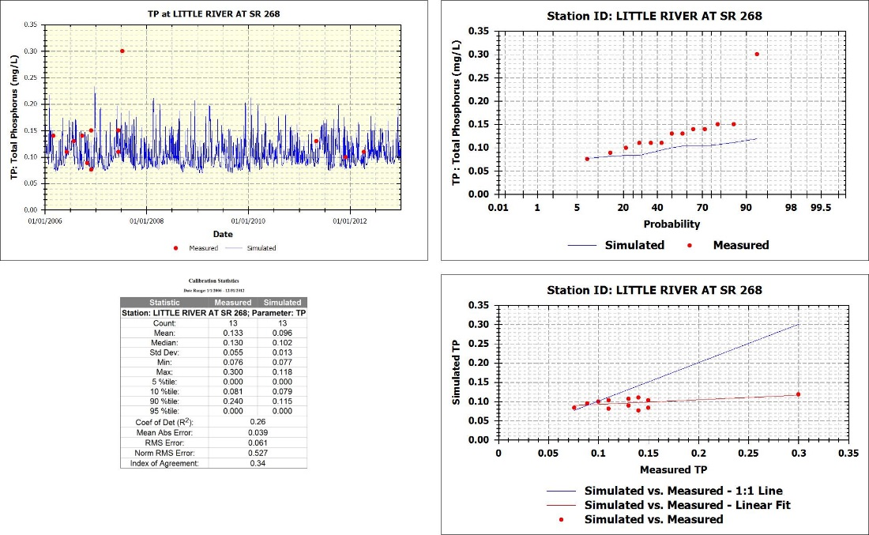
Figure 105 Total Phosphorus Calibration Little River @ SR268

Figure 106 Total Phosphorus Calibration Attapulgus Creek at SR 159

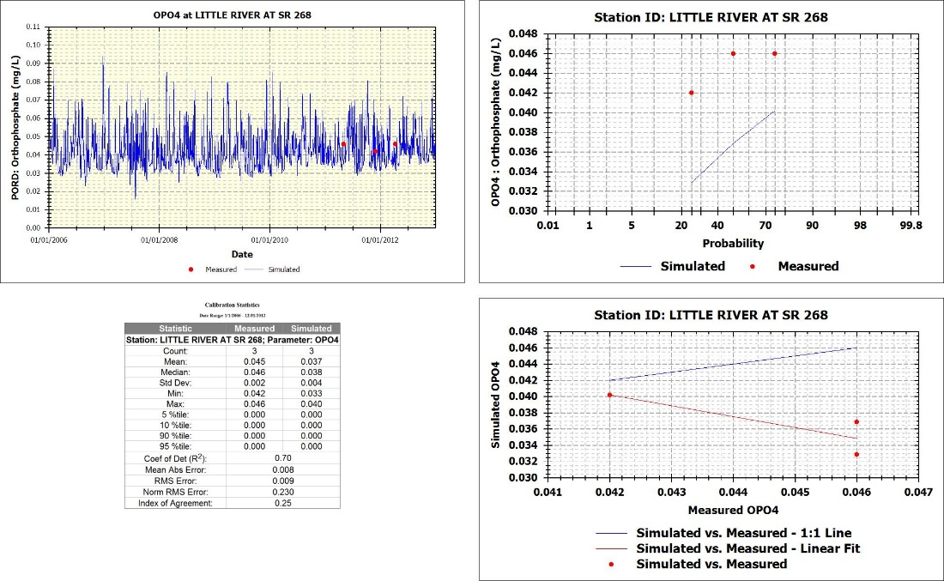
Figure 107 Ortho-Phosphate Calibration Little River @ SR268

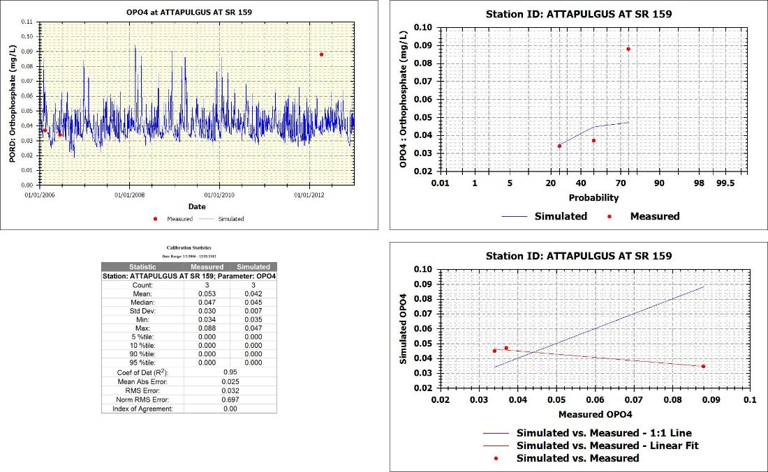
Figure 108 Ortho-Phosphate Calibration Attapulgus Creek at SR 159

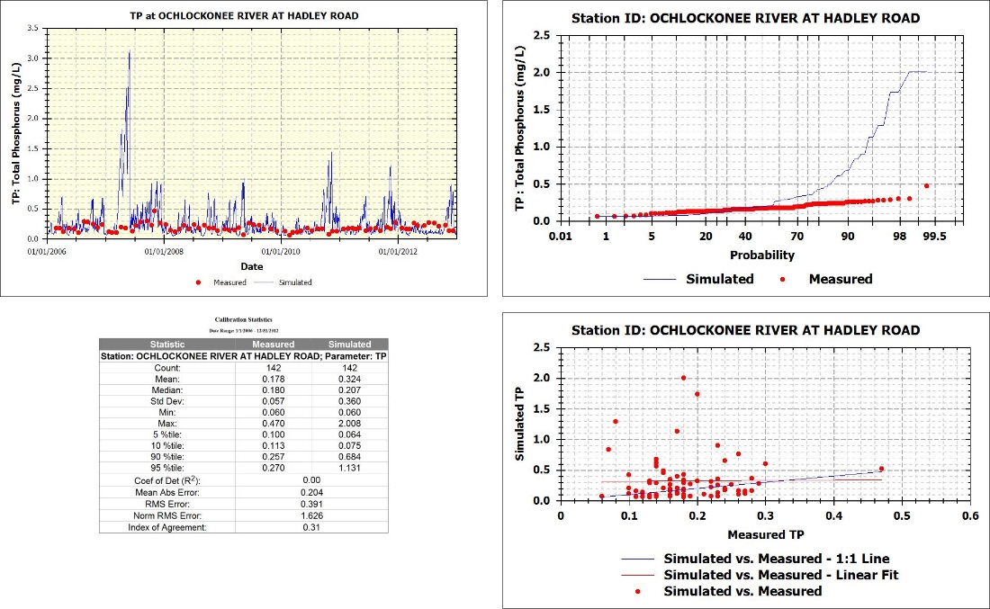
Figure 109 Total Phosphorus Calibration Ochlockonee River near Hadley Road

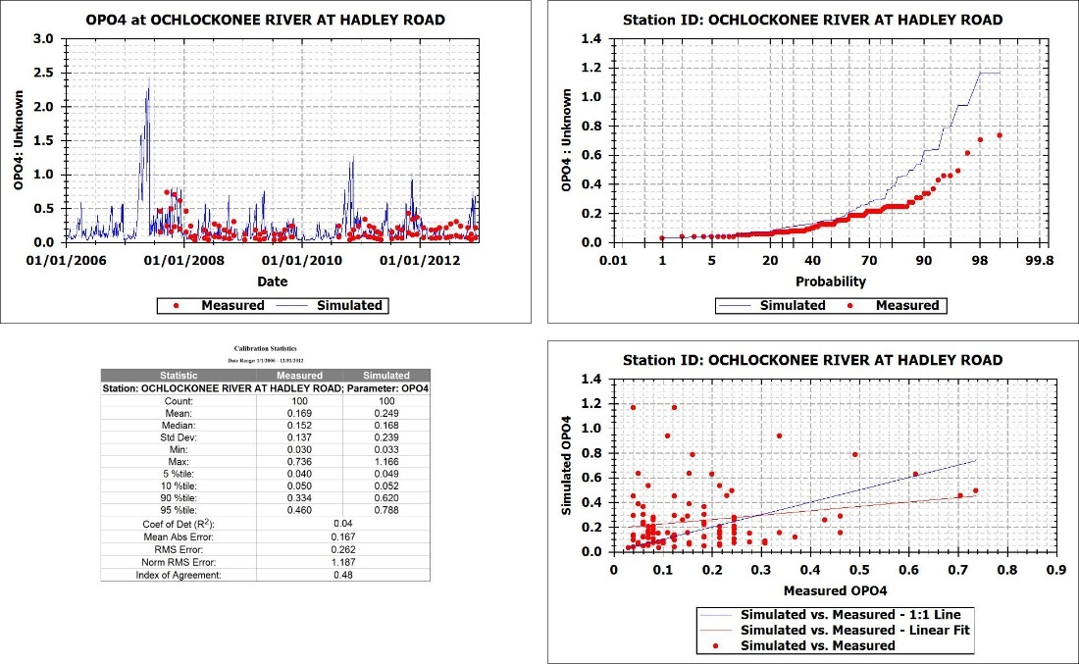
Figure 110 Orthophosphate Calibration Ochlockonee River near Hadley Road

Figure 111 21FLLEONLCT0C3045884492: Talquin 4 for Total Phosphorus

Figure 112 21FLLEONLCT03045184523: Lake Talquin near Williams Landing for Total Phosphorus

Figure 113 21FLLEONLCT0W3045084521: Talquin 3 for Total Phosphorus

Figure 114 21FLLEONT0E3044084556: Lake Talquin Central for Total Phosphorus
Figure 115 21FLLEONLCT03042384172: Lake Talquin near Luther Hall Landing for Total Phosphorus

Figure 116 21FLLEONLCT0L3042284573: Talquin 2 for Total Phosphorus

Figure 117 21FLLEONT0D3041488461: Lake Talquin West for Total Phosphorus

Figure 118 21FLLEONLCOC3040784610: Lake Talquin (Ben Stoutamire Boat Landing) for Total Phosphorus

Figure 119 21FLLEONLCT0B3040284630: Talquin 1 for Total Phosphorus

Total Suspended Solids
Figure 120 121 21FLLEONLCT0C3045884492: Talquin 4 for Total Suspended Solids

Figure 122 21FLLEONLCT03045184523: Lake Talquin near Williams Landing for Total Suspended Solids

Figure 123 21FLLEONLCT0W3045084521: Talquin 3 for Total Suspended Solids

Figure 124 125 21FLLEONT0E3044084556: Lake Talquin Central for Total Suspended Solids

Figure 126 127 21FLLEONLCT03042384172: Lake Talquin near Luther Hall Landing for Total Suspended Solids

Figure 128 129 21FLLEONLCT0L3042284573: Talquin 2 for Total

Figure 130 21FLLEONT0D3041488461: Lake Talquin West for Total Suspended Solids

Figure 131 21FLLEONLCOC3040784610: Lake Talquin (Ben Stoutamire Boat Landing) for Total Suspended Solids

Figure 132 21FLLEONLCT0B3040284630: Talquin 1 for Total Suspended Solids

Longitudinal Profile
Figure 133 through Figure 138 compare the annual average predicted concentrations with the annual average measured concentrations. This provides a good comparison of the nutrient dynamics and algal growth as the watershed loads moves through Lake Talquin.

Figure 133 Longitudinal Profile -- Chlorophyll a

Figure 134 Longitudinal Profile -- Dissolved Oxygen

Figure 135 Longitudinal Profile -- Total Nitrogen

Figure 136 Longitudinal Profile -- Total Phosphorus

Figure 137 Longitudinal Profile -- Ammonia

Figure 138 Longitudinal Profile -- Nitrate

Distribution Analysis
The distribution analysis illustrates the range and distribution of the model results over the simulation period using a box and whisker plot. The blue box provides the 75th and 25th quartile, the solid blue line in the box represents the median model prediction, the diamond represents the mean of the model prediction, the green circle represents the average of the observed data, red dots indicate the individual observed data points, the black dots represents the individual data points from the model prediction. These plots provide a good comparison of observed vs. predicted over the simulation period and are a good way to see any model biases. Distribution plots are provided for the two calibration stations in the Little River and Ochlockonee River and for all stations used in Lake Talquin.

Little River Distribution Analysis

Figure 139 Little River Chlorophyll a Distribution over Simulation Period

Figure 140 Little River Dissolved Oxygen Distribution over Simulation Period

Figure 141 Little River Total Nitrogen Distribution over Simulation Period

Figure 142 Little River Total Phosphorus Distribution over Simulation Period

Figure 143 Little River Water Temperature Distribution over Simulation Period

Ochlockonee River Distribution Analysis
Figure 144 Ochlockonee River Chlorophyll a Distribution over Simulation Period

Figure 145 Ochlockonee River Dissolved Oxygen Distribution over Simulation Period

Figure 146 Ochlockonee River Total Nitrogen Distribution over Simulation Period
Figure 147 Ochlockonee River Total Phosphorus Distribution over Simulation Period

Figure 148 Ochlockonee River Water Temperature Distribution over Simulation Period

Lake Talquin Distribution Analysis
Figure 149 Lake Talquin Chlorphyll a Distribution over Simulation Period
Figure 150 Lake Talquin Dissolved Oxygen Bottom Distribution over Simulation Period

Figure 151 Lake Talquin Total Nitrogen Distribution over Simulation Period
Figure 152 Lake Talquin Total Phosphorus Distribution over Simulation Period

Figure 153 Lake Talquin Ammonia Distribution over Simulation Period
Figure 154 Lake Talquin Nitrate Distribution over Simulation Period

Figure 155 Lake Talquin Total Suspended Solids Distribution over Simulation Period

Figure 156 Lake Talquin Temperature Distribution over Simulation Period

Lake Talquin Load Analysis
Using the predicted time series of flows and loads from the Ochlockonee and Little River water quality models a load analysis was conducted. Loads were calculated from daily flows and concentrations from the terminal model segments (inlets to the Lake model). Load analysis was conducted at the segments that correspond to the Georgia/Florida state line.
Figure 157 provides a comparison of the percentage of the watershed land area that is in each state. With 73% of the watershed area in Georgia it is expected that most of the loading to Lake Talquin will come from Georgia.

Figure 157 Percent Land Area for Watershed by State

Flows
Figure 158 illustrates the predicted annual average daily flows at the inlet of Lake Talquin from the Ochlockonee and Little Rivers. The figure shows the simulation period considers a wide range of hydraulic conditions. This simulation period provides a wide range of flow and loading conditions.

Figure 158 Annual Daily Average Flow at Lake Talquin Inlet

Lake Talquin Nutrient Load Analysis
The following provides an analysis of the nutrient loadings to Lake Talquin. The loadings were calculated using the predicted flows and concentrations predicted by the river water quality models. Therefore, these loads do account for nutrient cycling in the watershed. Table 7 provides the nutrient loads to Lake Talquin by year and river basin.
Table 7 Annual Nutrient Loadings to Lake Talquin
Figure 159 shows an analysis of the percentage of the total nitrogen load coming from the Ochlockonee and Little River basins.

Figure 159 Total Nitrogen Loading to Lake Talquin from Ochlockonee and Little River
Figure 160 shows an analysis of the percentage of the total phosphorus load coming from the Ochlockonee and Little River basins.

Figure 160 Total Phosphorus Loading to Lake Talquin from Ochlockonee and Little River

Point and Non-Point Source Analysis
Model simulations were conducted with and without the permitted discharges to determine their contribution to the nutrient loads to Lake Talquin. provides the annual loads of nutrients attributed to the point sources in each river basin.

State Loadings
A loading analysis was conducted to determine the amount of nutrient loads coming from both states in Lake Talquin. The State of Georgia’s nutrient loadings to Lake Talquin were calculate by using the simulated daily flows and concentrations corresponding to the segments at the Georgia/Florida Stateline. Florida’s nutrient contribution was calculated by taking the current loading to Lake Talquin minus the Georgia loadings at the Stateline.

 | Little River (kg/yr) |  |  |  | Ochlockonee River (kg/yr)
 | Total Nitrogen |  | Total Phosphorus |  | Total Nitrogen |  | Total Phosphorus
Year | FL | GA | FL | GA | FL | GA | FL | GA
2006 | 58552 | 234448 | 7614 | 15630 | 83359 | 485189 | 7595 | 44204
2007 | 51549 | 167265 | 6118 | 10555 | 70553 | 445789 | 7102 | 44873
2008 | 215814 | 408600 | 31572 | 40919 | 144586 | 1337811 | 11401 | 105490
2009 | 171901 | 329529 | 24666 | 24878 | 176481 | 964463 | 13387 | 73161
2010 | 85405 | 271769 | 11382 | 23528 | 95402 | 555647 | 8399 | 48918
2011 | 54736 | 197935 | 6535 | 8215 | 52110 | 406470 | 4445 | 34671
2012 | 32956 | 246990 | 3320 | 14380 | 54417 | 331459 | 3992 | 24313
Average | 95845 | 265219 | 13030 | 19729 | 96701 | 646690 | 8046 | 53662

Figure 161 and Figure 162 illustrate the annual total nutrient load by state for Little River over the simulation period.

Figure 161 Annual Total Nitrogen Loads by State for Little River
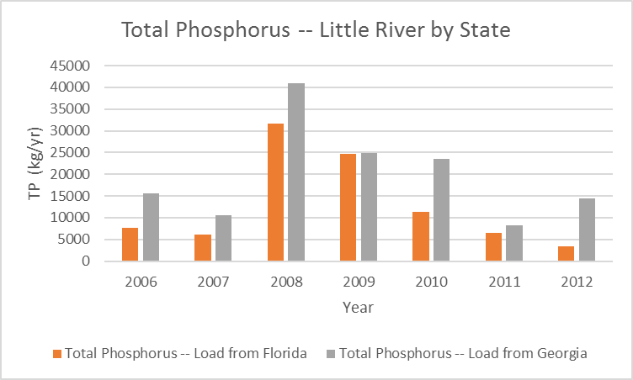
Figure 162 Annual Total Phosphorus Loads by State for Little River
Figure 163 and Figure 164 illustrate the annual total nutrient load by state for Ochlockonee River over the simulation period.

Figure 163 Annual Total Nitrogen Loads by State for Ochlockonee River

Figure 164 Annual Total Phosphorus Loads by State for Ochlockonee River
Figure 165 and Figure 166 illustrates the percentages of total nitrogen and total phosphorus coming from each state that enters Lake Talquin.

Figure 165 Percentage of Total Nitrogen Load to Lake Talquin by State

Figure 166 Percentage of Total Phosphorus Load to Lake Talquin by State

Ochlockonee River Nutrient Contribution Analysis
When reviewing the time series plots of the model predicted phosphorus concentration with the measured data it could be concluded that the models are over predicting the phosphorus load. Several analyses were conducted to determine when the model is over predicting phosphorous compared to the observed data as well as an annual loading analysis. Figure 167 and Figure 168 illustrates the predicted total phosphorus and concentrations versus flow. This figure shows that the over prediction of total phosphorus occurs during the lowest flow periods where the river is dominated by waste water treatment plants. Because the over predictions are at the very lowest flows the overall load to the lake is minimal.
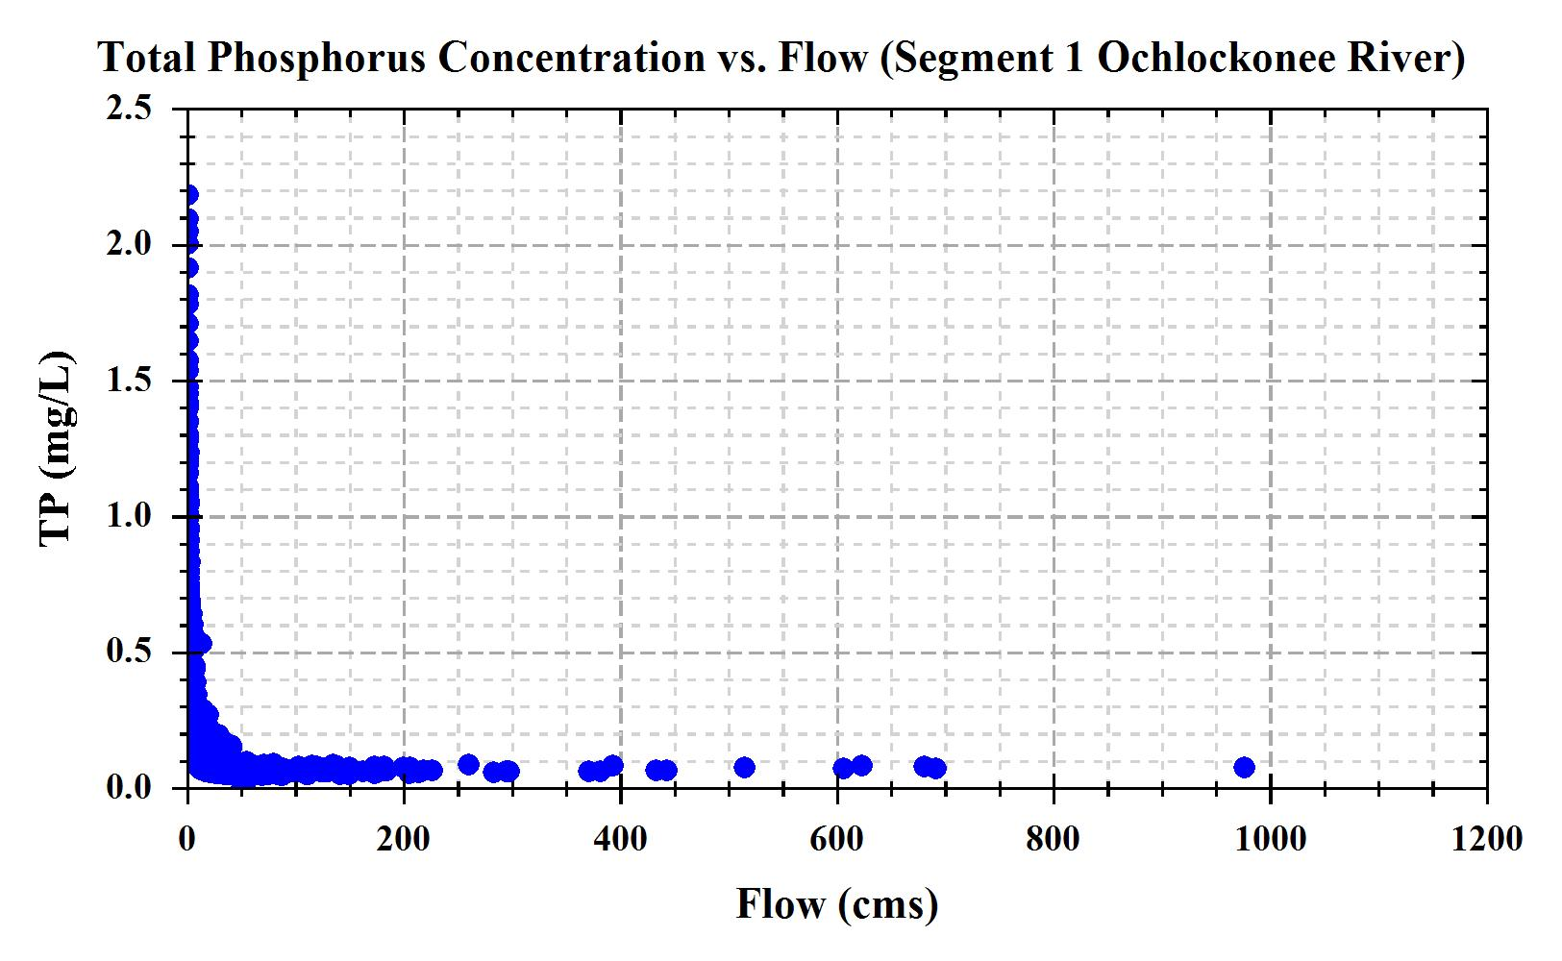
Figure 167 Ochlockonee River: Total Phosphorus vs. Flow
Figure 168 Ochlockonee River: Total Nitrogen vs. Flow
Table 8 compares the annual loads of nitrogen and phosphorus as calculated from the model predictions and using the USGS’s LOADEST method for the Ochlockonee River. USGS LOADSET uses paired observations of flow and total nitrogen/phosphorus concentrations and applies statistical methods to calculate annual loads. The analysis indicates that the models are under predicting (red values) total nutrient loads.
Table 8 Total Phosphorus and Nitrogen Loading Analysis for Ochlockonee River

Little River Nutrient Contribution Analysis
Table 9 compares the annual loads of nitrogen as calculated from the model predictions and using the USGS’s LOADEST method for the Little River. While there are limited measured total nitrogen values, the analysis shows the model is over predicting by approximately 16%. The results of the comparison are statistical the same at the 95 percentile.
Table 9 Total Nitrogen Loading Analysis for Little River

Point Sources Data Inputs
Point sources discharging into the Ochlockonee River and the Little River were input into the corresponding WASP model. Descriptions of the included point sources, the utilized data sources, and the methods used to calculate unavailable data are provided in the sections below. No significant point sources discharge directly to Lake Talquin or its immediate watersheds (those not simulated in the Ochlocknee and Little Rivers). The distributed models and model inputs include spreadsheets that were used to characterize the point sources.

Ochlockonee River
The Ochlockonee River WASP model includes four municipal wastewater treatment plants (WWTP) and one food processing facility as point sources for BOD, and TN. TP is also included for the WWTPs. All parameters associated with the point sources were added into the Ochlockonee River WASP model as concentration boundary inputs with separate surface flow functions. (Figure 169)
.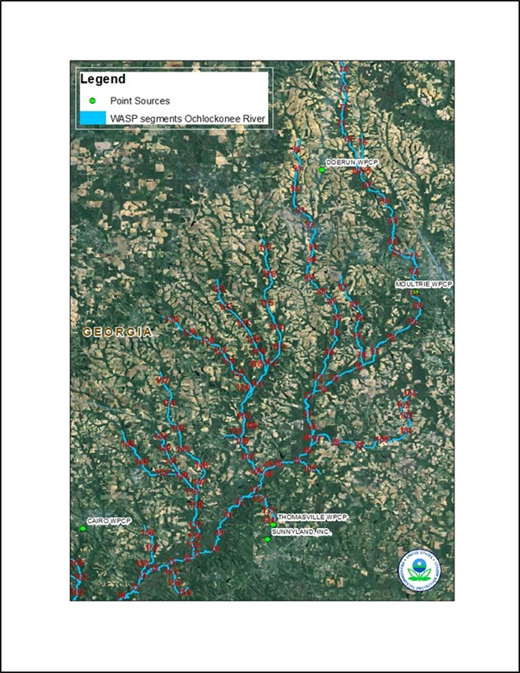
Figure 169 Location of Point Sources along the Ochlockonee River
The total annual loads, along with the Chlorophyll-a concentrations at the outflow of the Ochlockonee River WASP model, are depicted below in Figure 170- Figure 173.

Figure 170 Total Nitrogen Load from Point Sources in Ochlockonee River

Figure 171 Total Phosphorus Load from Point Sources in Ochlockonee River

Figure 172 BOD Load from Point Sources in Ochlockonee River

Figure 173 CHLAC Concentration Change Due to Point Sources in Ochlockonee River
The following paragraphs discuss each point source individually.

Thomasville WPCP – Permit #GA0024082
DMR data stored on PCS and ICIS was used for the BOD, flow, and ammonia monthly input values. However, no data was identified in PCS or ICIS for TP (PO₄ and Organic P) or NOx and Organic N (Table 10). All of these parameters are needed in order to run the WASP model. A review of EPA’s file for this facility located two permit applications and some limited TKN sampling data from 2012. This data was used to calculate an average ratio for Ammonia/TN, NOx/TN, and Organic N/TN. These ratios were used to calculate NOx and Organic N based on the Ammonia concentrations provided in DMR. Due to spikes in NOx concentrations when ammonia concentrations were high, a maximum TN target of 20.60 (the maximum of the two TN values presented in the permits applications) was added to the model. The average TP value was also calculated by using the permit applications. Due to no additional data available, a percentage allotment of 70% PO4 and 30% Organic P was assumed.
Table 10 Thomasville DMR Data
Parameter | # of Obs | Start Date | End Date | Mean | Min | Max
Ammonia | 192 | 1/1/1997 | 12/7/2012 | 0.338 | 0.010 | 2.000
Nitrate | 84 | 1/1/2006 | 12/7/2012 | 17.927 | 8.430 | 35.000
DON | 84 | 1/2/2006 | 12/7/2012 | 1.042 | 0.200 | 4.920
DIP | 84 | 1/2/2006 | 12/7/2012 | 1.902 | 1.000 | 7.000
DOP | 84 | 1/2/2006 | 12/7/2012 | 0.862 | 0.000 | 15.800
BOD | 192 | 1/1/1997 | 12/7/2012 | 5.424 | 2.000 | 17.500
DO | 127 | 6/30/2002 | 12/31/2012 | 6.554 | 5.200 | 7.600
Flow | 192 | 1/1/1997 | 12/7/2012 | 0.171 | 0.000 | 0.453

Moultrie WPCP – Permit # GA0024660
DMR data stored on PCS and ICIS was used for the BOD, flow, and ammonia monthly input values. However, no data was identified in PCS or ICIS for TP (PO₄ and Organic P) or NOx and Organic N (Table 11). All of these parameters are needed in order to run the WASP model. A review of EPA’s file for this facility located two permit applications. This data was used to calculate an average ratio for Ammonia/TN, NOx/TN, and Organic N/TN. These ratios were used to calculate NOx and Organic N based on the Ammonia concentrations provided in DMR. Due to spikes in NOx concentrations when ammonia concentrations were high, a maximum TN target of 22.7 (the maximum of the two TN values presented in the permits applications) was added to the model. The average TP value was also calculated by using the permit applications. Due to no additional data available, a percentage allotment of 70% PO4 and 30% Organic P was assumed.
Table 11 Moultrie DMR Data
Parameter | # of Obs | Start Date | End Date | Mean | Min | Max
Ammonia | 192 | 1/1/1997 | 12/7/2012 | 0.562 | 0.000 | 7.000
Nitrate | 84 | 1/2/2006 | 12/7/2012 | 16.660 | 1.560 | 26.500
DON | 84 | 1/2/2006 | 12/7/2012 | 9.200 | 0.000 | 68.000
DIP | 84 | 1/2/2006 | 12/7/2012 | 4.523 | 1.400 | 9.000
DOP | 84 | 1/2/2006 | 12/7/2012 | 0.351 | 0.000 | 1.500
BOD | 192 | 1/1/1997 | 12/7/2012 | 4.091 | 1.000 | 24.000
DO | 192 | 1/31/1997 | 12/31/2012 | 7.352 | 3.300 | 9.300
Flow | 192 | 1/1/1997 | 12/7/2012 | 0.133 | 0.068 | 0.296

Cairo WPCP – Permit # GA0025771
DMR data stored on PCS and ICIS was used for the BOD, flow, and ammonia monthly input values (Table 12). However, Cairo was not discharging to a stream during from 1998 until 2006. Cairo was operating under a land application permit at that time. For this model, a zero discharge (i.e. load) was assumed during those years. GAEPD provided the BOD, flow and ammonia monthly values for 2006. However, no data was identified in PCS or ICIS, or available from GAEPD, for NOx and Organic N. These parameters are needed in order to run the WASP model. A review of EPA’s file for this facility located a permit application. This data was used to calculate an average ratio for Ammonia/TN, NOx/TN, and Organic N/TN. GAEPD provided the TP and Ortho P data for the years 2006 through 2012. This data was used as the monthly input values for phosphorus. Since no data was available for 1997-98, the average TP value was used for those years.
Table 12 Cairo DMR Data
Parameter | # of Obs | Start Date | End Date | Mean | Min | Max
Ammonia | 99 | 1/1/1997 | 12/4/2012 | 0.900 | 0.000 | 4.710
Nitrate | 84 | 1/1/2006 | 12/4/2012 | 3.326 | 0.160 | 8.180
DON | 84 | 1/1/2006 | 12/4/2012 | 1.573 | 0.080 | 3.870
DIP | 84 | 1/1/2006 | 12/4/2012 | 0.185 | 0.000 | 0.990
DOP | 84 | 1/1/2006 | 12/4/2012 | 0.323 | 0.000 | 0.790
BOD | 99 | 1/1/1997 | 12/4/2012 | 5.500 | 0.000 | 12.000
DO | 72 | 1/31/2007 | 12/31/2012 | 7.358 | 6.000 | 10.000
Flow | 99 | 1/1/1997 | 12/4/2012 | 0.060 | 0.000 | 0.148

Doerun WPCP – Permit # GA0021717
This facility is a minor wastewater treatment plant and therefore, no DMR data was available. A review of EPA’s file for this facility located a permit application. The permit application contained sampling results for ammonia, NOx, TKN and phosphorus. Since this was the only data available it was used as the monthly data inputs in the WASP model. Additionally, the permit provided permit limits for BOD and flow. These limits were used in the model.

Sunnyland (aka Genesis Project/Affinity) Permit # GA001279
This facility is a frozen food plant. The DMR data stored on PCS and ICIS was used for the monthly BOD, flow and ammonia input values (Table 13). Several gaps in data were present on the in the databases. A search of the PCS website indicated that the gaps in data occurred whenever there was no discharge from the facility. Therefore, in the WASP model, whenever no flow was listed a zero flow and concentration was assumed for that time period. No data was found regarding phosphorus in PCS, ICIS or during a file review. Therefore, a phosphorus load was not added to the model for this point source.
Table 13 Sunnyland DMR Data
Parameter | # of Obs | Start Date | End Date | Mean | Min | Max
Ammonia | 192 | 1/1/1997 | 12/7/2012 | 0.147 | 0.000 | 8.500
Nitrate | 84 | 1/2/2006 | 12/7/2012 | 0.033 | 0.000 | 0.426
DON | 2 | 1/1/2006 | 12/31/2012 | 0.000 | 0.000 | 0.000
DIP | 84 | 1/2/2006 | 12/7/2012 | 0.471 | 0.000 | 5.900
DOP | 84 | 1/2/2006 | 12/7/2012 | 0.075 | 0.000 | 0.840
BOD | 192 | 1/1/1997 | 12/7/2012 | 3.300 | 0.000 | 115.500
DO | 124 | 9/30/2002 | 12/31/2012 | 1.031 | 0.000 | 10.800
Flow | 192 | 1/1/1997 | 12/7/2012 | 0.005 | 0.000 | 0.237

Facilities Not Included in the Model
The following permitted facilities were not included in this model:
- Pelham WPCP – Permit # GA0025518 – This facility was a minor wastewater treatment plant. According to GAEPD, the facility closed out their permit in the 1990s. Therefore, it was not included in the WASP model.

- W.B. Roddenbery Company – Permit # GA0001660 – According to the PCS data, this facility was first permitted in 1997. A review of the EPA’s files on this facility determined all production ceased on July 2002. Since the facility was only active for five years, TN and TP were not regulated by the permit, and it was only a minor permitted facility, it was not included in the WASP model.

- The remaining permits are for mining facilities (Permits # GA0047503, GA0047511, GA0047520, and GA0032409) and three of the four permits are no longer active. Additionally none of the mining permits have limits for TN or TP. For these reasons, the mining permits were not included in the WASP model.

Little River
The Little River model includes two significant point sources: Quincy WPCP and BASF Attapulgus Plant (Figure 174). Quincy is a major domestic wastewater treatment plant while BASF is a major industrial discharger.
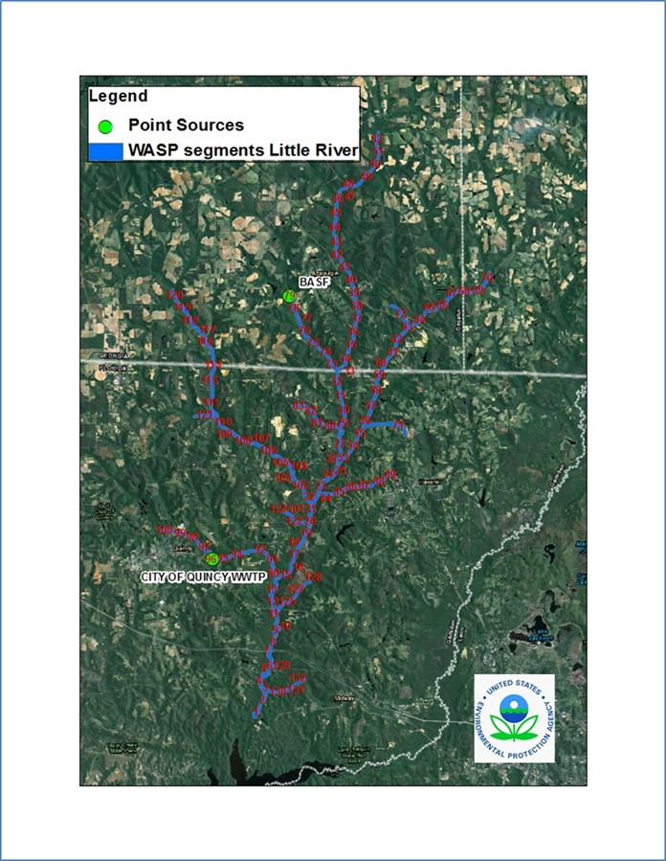
Figure 174 – Little River Simulated NPDES Dischargers
The total annual nutrient loads at the outflow of the Little River WASP model, are depicted below in Figure 175 and Figure 176.

Figure 175 Total Nitrogen Load from Point Sources in Little River (Daily Average)

Figure 176 Total Phosphorus Load from Point Sources in Little River
The following paragraphs discuss each point source.

Quincy WPCP – Permit # FL0029033
This facility discharges out of a single outfall (001)(Table 14). Monthly DMR data retrieved from ICIS and PCS are used to load effluent flows and pollutant concentrations for total nitrogen, total phosphorus and BOD5. Data for the period 1996 through 2012 are available. For individual nutrient speciation, limited PO4, TKN and NH3 data from the facility’s most recent permit application is used to estimate nutrient fractions. These values compare reasonably well with ambient and observed nutrient fractions such that the ambient speciation applied to LSPC output was also used for this facilitate for efficiency (3% NH3, 23% NO3NO2, 74% Org N, 40% PO4, 60% Org P). Reported monthly dissolved oxygen concentrations are put directly into the model. Stepwise interpolations are used in the model to emulate the DMR monthly values.
Table 14 Quincy DMR Data
Parameter | # of Obs | Start Date | End Date | Mean | Min | Max
Ammonia | 30 | 5/11/2006 | 8/27/2012 | 9.271 | 0.200 | 29.600
Nitrate | 30 | 5/11/2006 | 8/27/2012 | 37.507 | 0.800 | 180.000
DON | 2 | 1/1/2006 | 12/31/2012 | 0.000 | 0.000 | 0.000
DIP | 2 | 1/1/2006 | 12/31/2012 | 0.000 | 0.000 | 0.000
DOP | 2 | 1/1/2006 | 12/31/2012 | 0.000 | 0.000 | 0.000
BOD | 2 | 1/1/2006 | 12/31/2012 | 0.000 | 0.000 | 0.000
DO | 2 | 1/1/2006 | 12/31/2012 | 7.000 | 7.000 | 7.000
Flow | 2557 | 1/1/2006 | 12/31/2012 | 0.005 | 0.000 | 0.200

BASF Attapulgus Plant – Permit # GA0001678
The BASF facility maintains two permitted outfalls (001 and 002)(Table 15 & Table 16). Monthly DMR data was processed to parameterize the inputs to the model. A summary of the data is provided in the tables below for each of the outfalls.
Table 15 BASF001 DMR
Parameter | # of Obs | Start Date | End Date | Mean | Min | Max
Ammonia | 883 | 1/2/2006 | 12/31/2012 | 32.874 | 0.042 | 108.000
Nitrate | 885 | 1/2/2006 | 12/31/2012 | 170.194 | 3.820 | 408.000
DON | 2 | 1/1/2006 | 12/31/2012 | 0.000 | 0.000 | 0.000
DIP | 2 | 1/1/2006 | 12/31/2012 | 0.000 | 0.000 | 0.000
DOP | 2 | 1/1/2006 | 12/31/2012 | 0.000 | 0.000 | 0.000
BOD | 2 | 1/1/2006 | 12/31/2012 | 0.000 | 0.000 | 0.000
DO | 2 | 1/1/2006 | 12/31/2012 | 7.000 | 7.000 | 7.000
Flow | 2557 | 1/1/2006 | 12/31/2012 | 0.026 | 0.000 | 0.214

Table 16 BASF002 DMR
Parameter | # of Obs | Start Date | End Date | Mean | Min | Max
Ammonia | 30 | 5/11/2006 | 8/27/2012 | 9.271 | 0.200 | 29.600
Nitrate | 30 | 5/11/2006 | 8/27/2012 | 37.507 | 0.800 | 180.000
DON | 2 | 1/1/2006 | 12/31/2012 | 0.000 | 0.000 | 0.000
DIP | 2 | 1/1/2006 | 12/31/2012 | 0.000 | 0.000 | 0.000
DOP | 2 | 1/1/2006 | 12/31/2012 | 0.000 | 0.000 | 0.000
BOD | 2 | 1/1/2006 | 12/31/2012 | 0.000 | 0.000 | 0.000
DO | 2 | 1/1/2006 | 12/31/2012 | 7.000 | 7.000 | 7.000
Flow | 2557 | 1/1/2006 | 12/31/2012 | 0.005 | 0.000 | 0.200

Natural Condition Scenarios
Two sets of natural conditions scenarios were developed (FDEP and GAEPD) that used different methodologies for characterizing a non-anthropogenic Ochlockonee watershed. This methodology converted all anthropogenic landuses (developed, agriculture, etc.) to upland forest and wetlands. All point sources loads and flows were removed. The watershed model scenarios (FDEP & GAEPD) executed and fed forward into the calibrated Ochlockonee and Little River WASP models. The river models and the directly connected watershed model results were fed forward into the calibrated Lake Talquin WASP model. Because the two natural condition scenarios yield virtually the same result, the FDEP methodology is compared with the current condition.

Ochlockonee River
Figure 177 - Figure 183 illustrate the difference between the current conditions and the natural condition scenarios for flow, total nitrogen and total phosphorus for the Ochlockonee River.
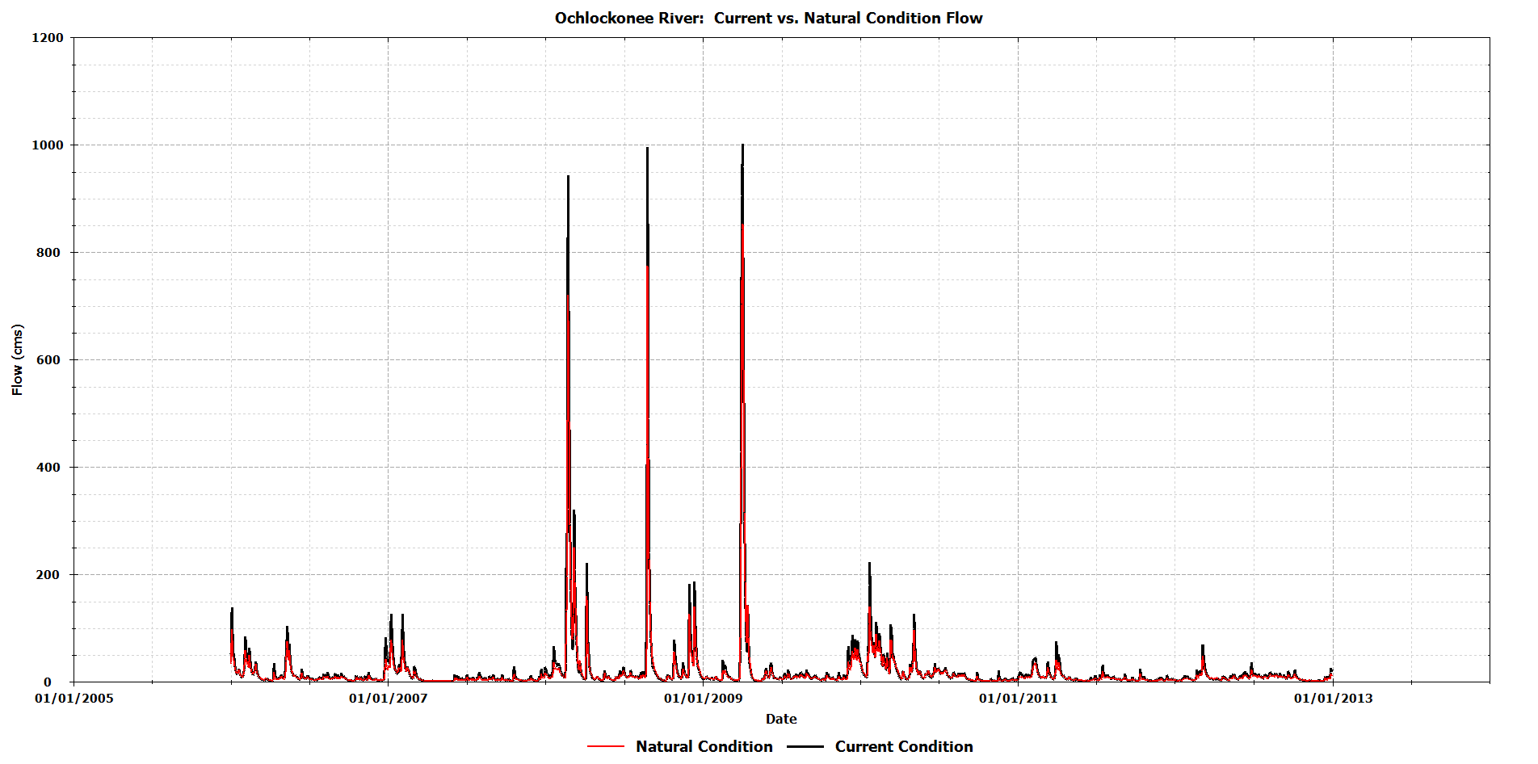
Figure 177 Ochlockonee River Predicted Flow: Current vs. Natural Conditions
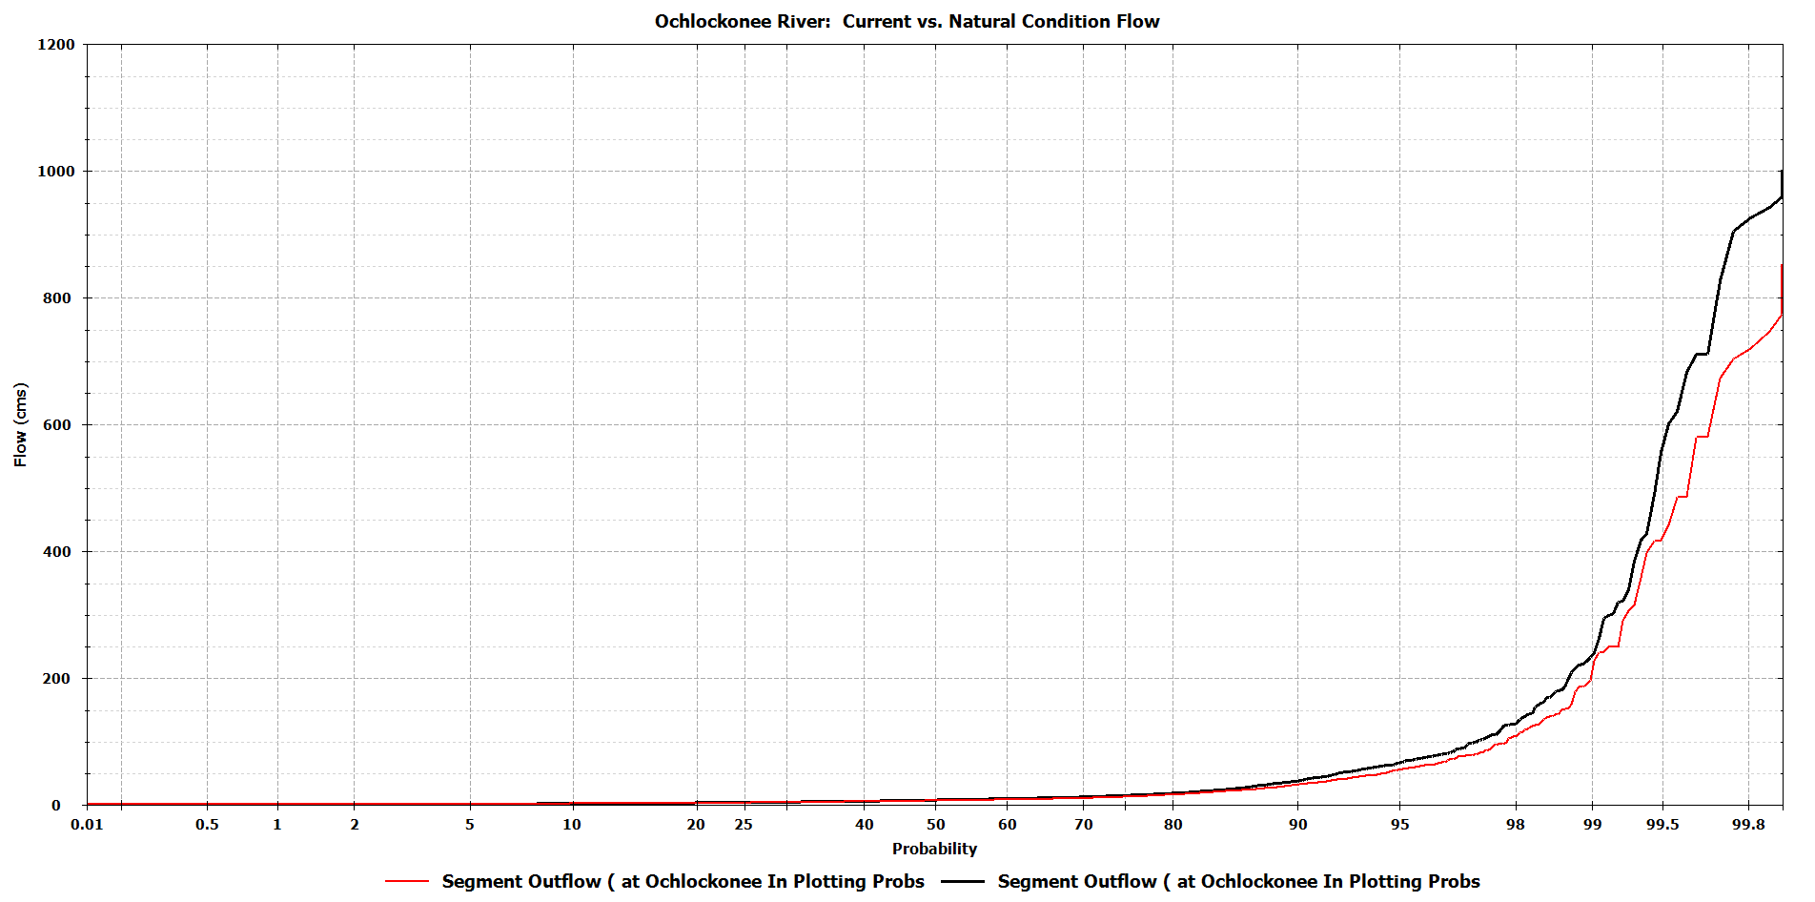
Figure 178 Ochlockonee River Probability Plot for Flow: Current vs. Natural Conditions
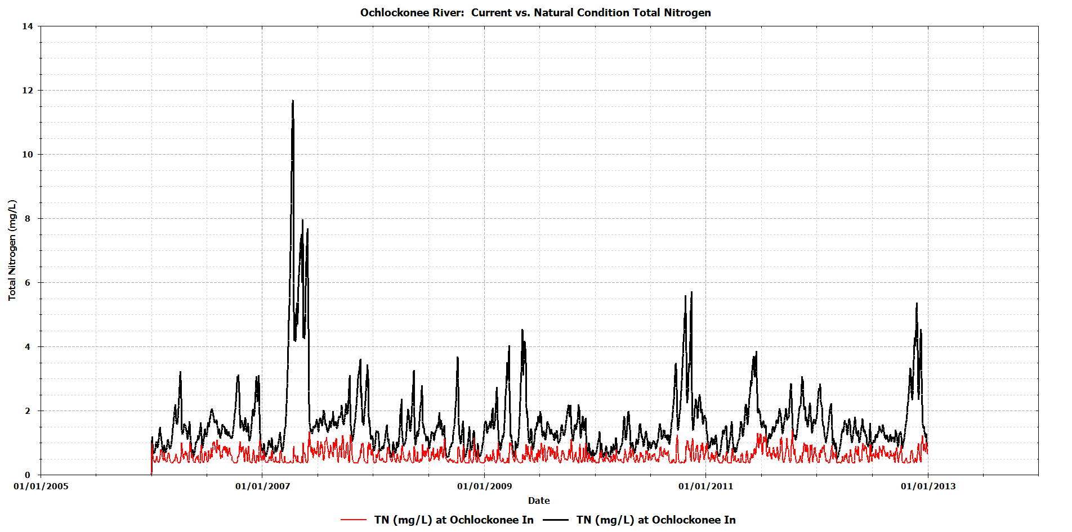
Figure 179 Ochlockonee River Predicted Total Nitrogen: Current vs. Natural Conditions
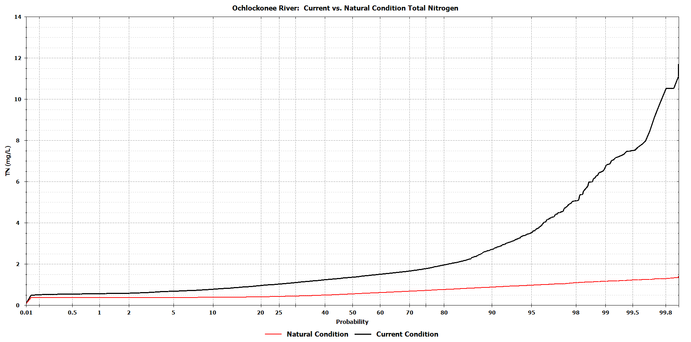
Figure 180 Ochlockonee River Probability Plot for Total Nitrogen: Current vs. Natural Conditions
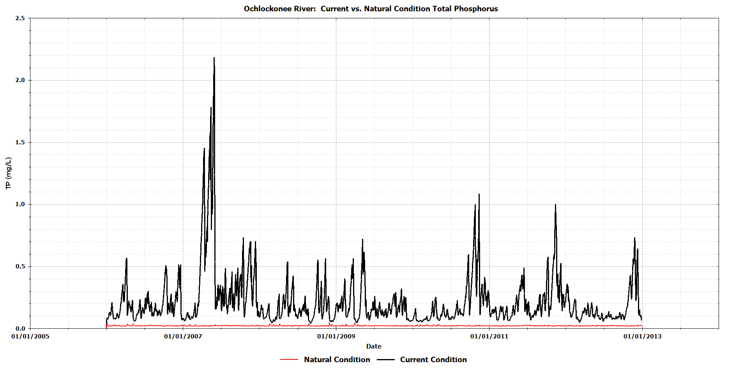
Figure 181 Ochlockonee River Predicted Total Phosphorus: Current vs. Natural Conditions
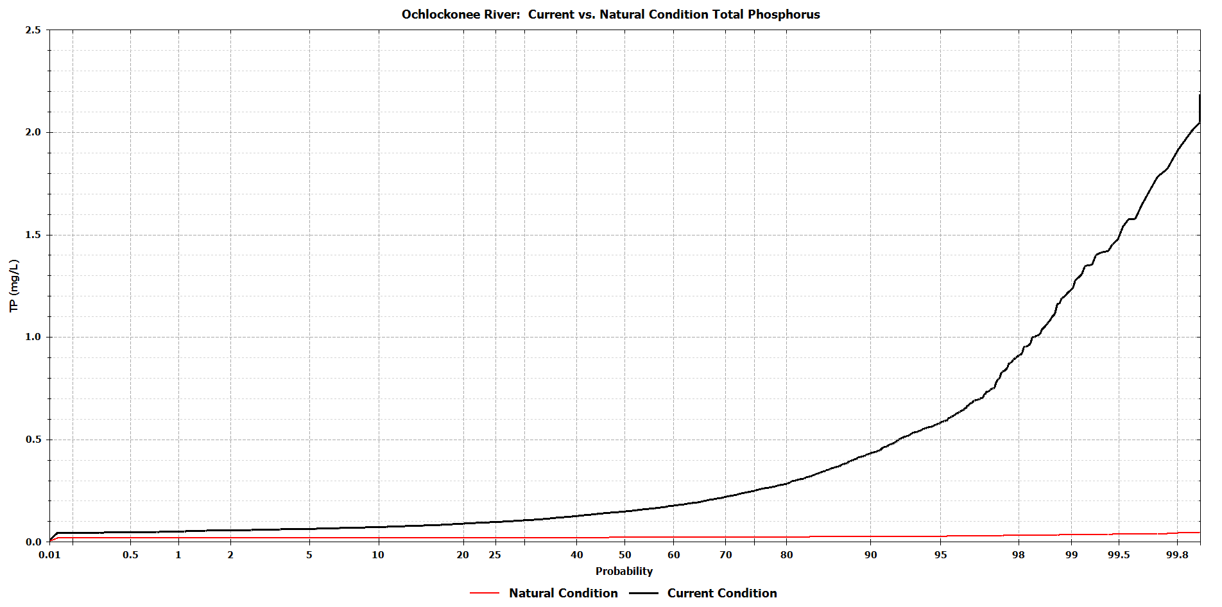
Figure 182 Ochlockonee River Probability Plot for Total Phosphorus: Current vs. Natural Conditions

Little River
Figure 183 - Figure 188 illustrate the difference between the current conditions and the natural condition scenarios for flow, total nitrogen and total phosphorus for the Little River.
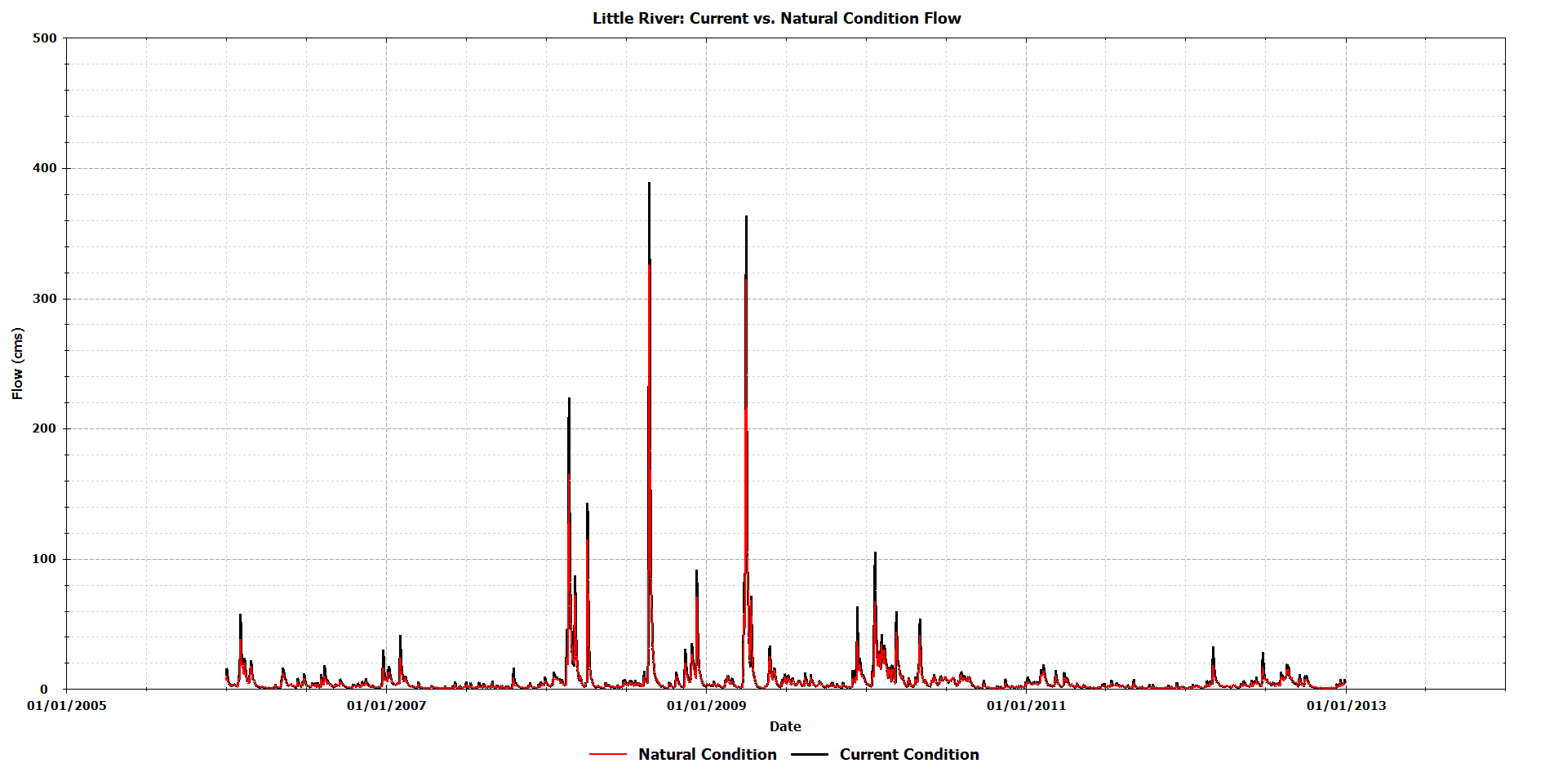
Figure 183 Little River Predicted Flow: Current vs. Natural Conditions
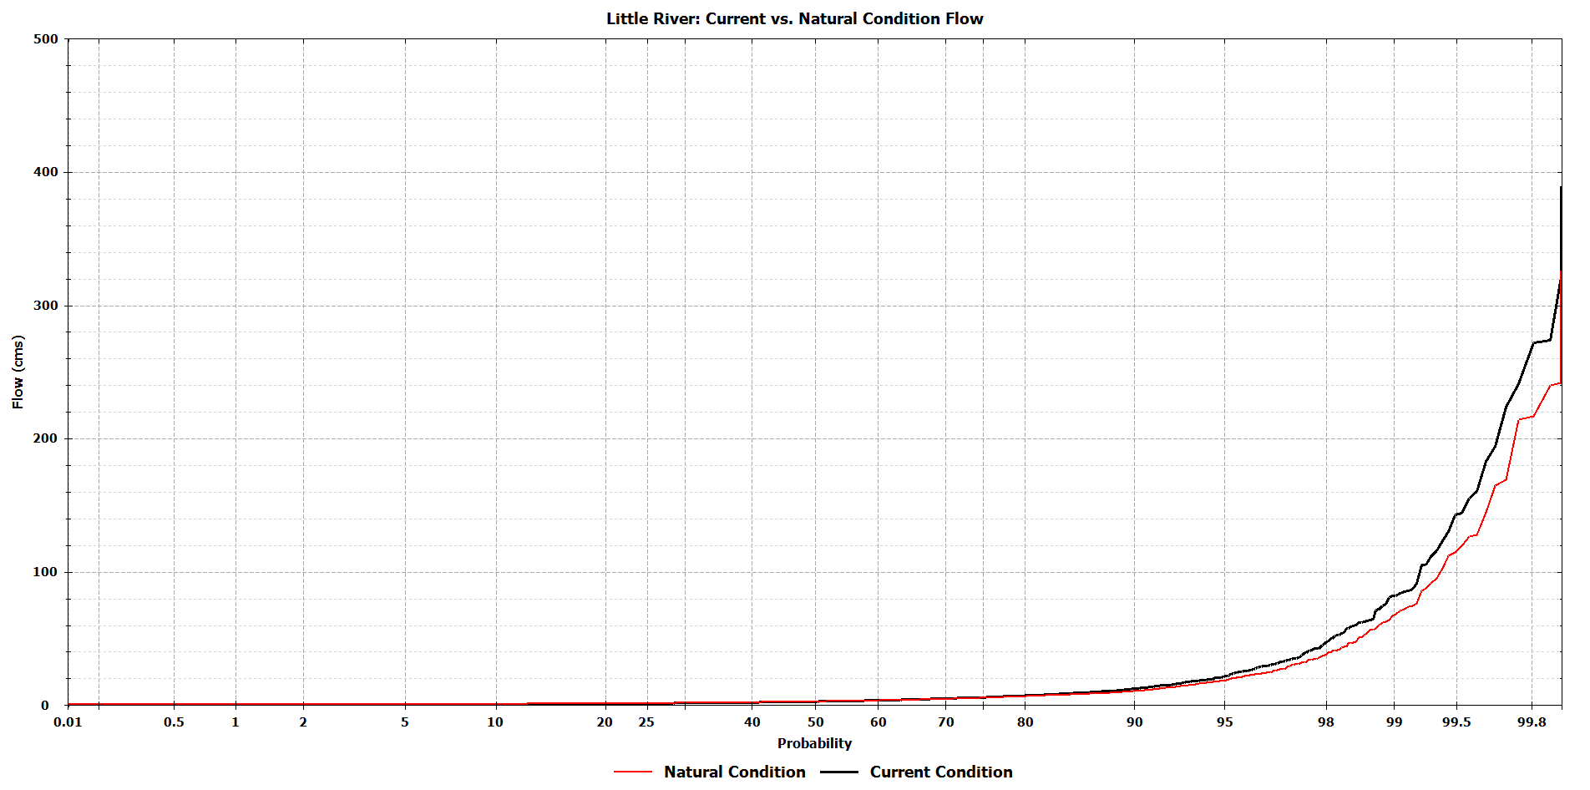
Figure 184 Little River Probability Plot for Flow: Current vs. Natural Conditions
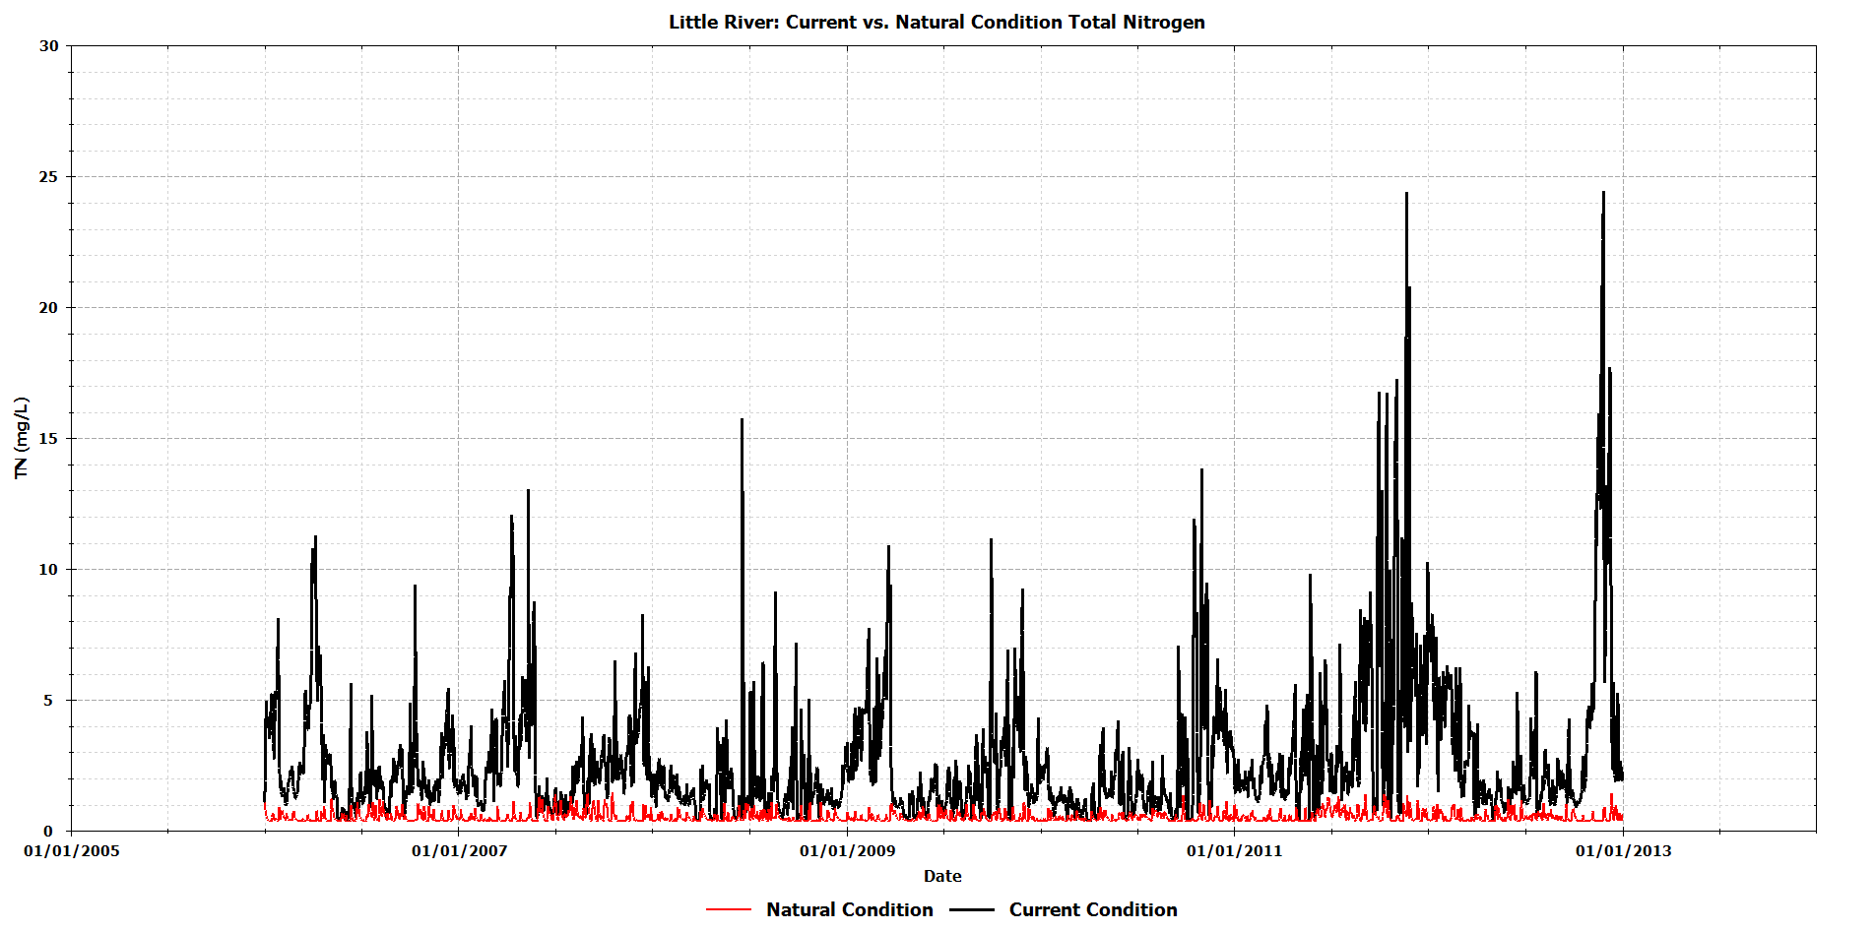
Figure 185 Little River Predicted Total Nitrogen: Current vs. Natural Conditions
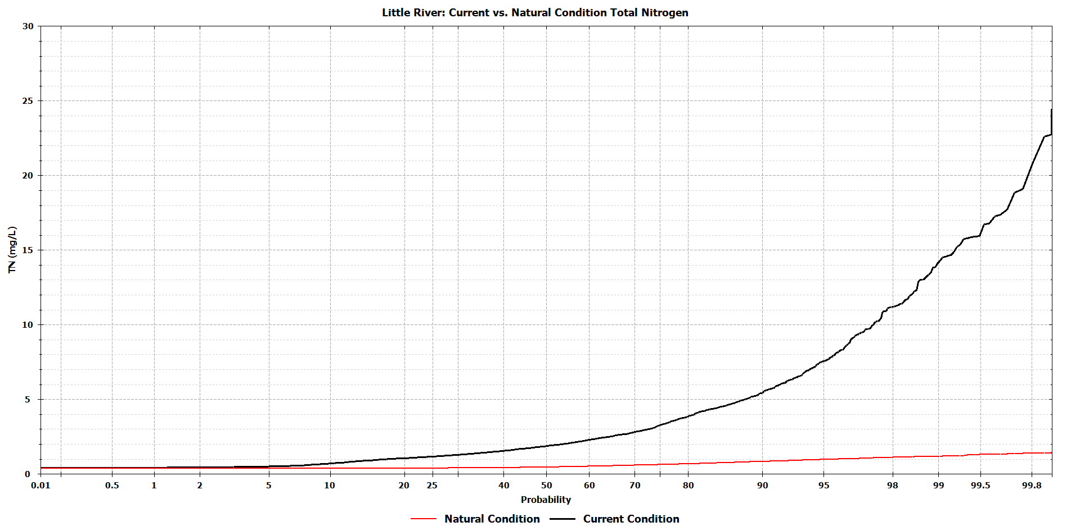
Figure 186 Little River Probability Plot for Total Nitrogen: Current vs. Natural Conditions
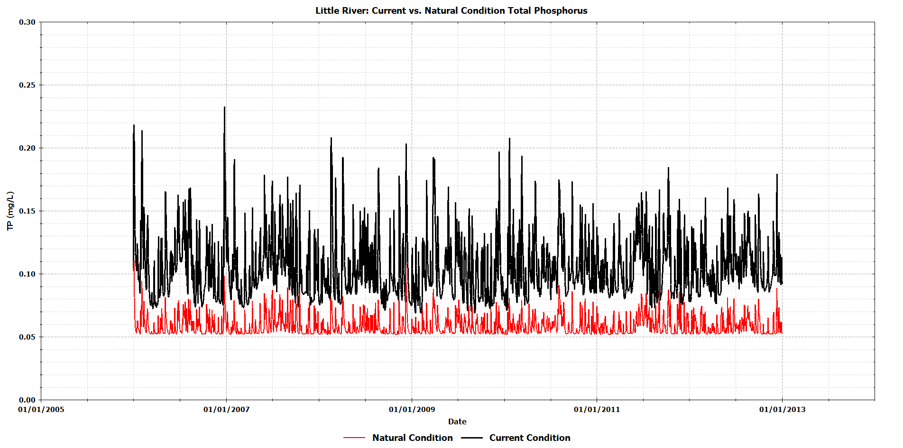
Figure 187 Little River Predicted Total Phosphorus: Current vs. Natural Conditions
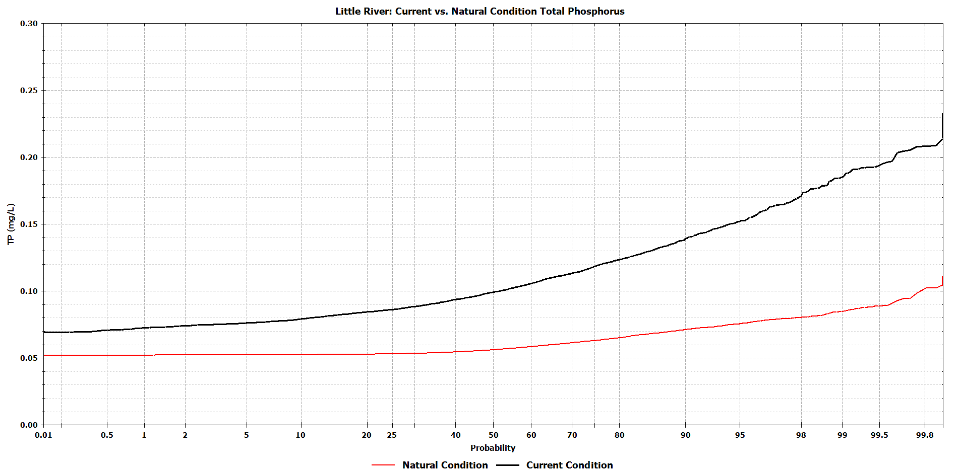
Figure 188 Little River Probability Plot for Total Phosphorus: Current vs. Natural Conditions

Lake Talquin Modeling Scenarios
The results of the natural conditions scenarios for Ochlockonee and Little River we processed forward into the calibrated Lake Talquin hydrodynamic and water quality. The EFDC model was executed using the new inflows from the scenarios. The calibrated Lake Talquin water quality model was executed using the new flows (from EFDC) and loads from (LSPC directly connected to the lake) and the WASP Ochlockonee and Little River WASP models.
The model results were processed for each of the 4 zones for the 7 years as described in the potential end point analysis.
Table 17 Little River – Annual Loadings for Total Nitrogen and Total Phosphorus for each Scenario
Table 18 Ochlockonee River– Annual Loadings for Total Nitrogen and Total Phosphorus for each Scenario

Table 19 LSPC 60114 – Annual Loadings for Total Nitrogen and Total Phosphorus for each Scenario
Table 20 LSPC 60125 – Annual Loadings for Total Nitrogen and Total Phosphorus for each Scenario
Table 21 LSPC 60126 – Annual Loadings for Total Nitrogen and Total Phosphorus for each Scenario
Table 22 LSPC 60127 – Annual Loadings for Total Nitrogen and Total Phosphorus for each Scenario
Table 23 LSPC 60128 – Annual Loadings for Total Nitrogen and Total Phosphorus for each Scenario

Table 24 LSPC 60166 – Annual Loadings for Total Nitrogen and Total Phosphorus for each Scenario
Table 25 LSPC 60167 – Annual Loadings for Total Nitrogen and Total Phosphorus for each Scenario
Table 26 LSPC 60168 – Annual Loadings for Total Nitrogen and Total Phosphorus for each Scenario
Table 27 LSPC 60169 – Annual Loadings for Total Nitrogen and Total Phosphorus for each Scenario

Figure 189 Calculated Annual Geometric Means for each scenario

Comparison Version 6 & 8
The following figures show a direct comparison between the Version 6 and Version 8 calibrated models at current conditions. The difference can be attributed to how the EFDC flow correction is applied to the water quality model as well patching to the LSPC rainfall files. Slight modifications were made to the model constants for Version 8, these changes were made because of changes in retention time (due to flow correction modification). Maximum algal growth rate was reduced from 3.0 to 2.5 per day. Organic nitrogen mineralization rates were increased to better match the inorganic nitrogen concentrations.
Figure 190 through Figure 203 provides a direct comparison of the predicted time series to CBOD, NH3, NO3, Chlorophyll a, Total Nitrogen, Total Phosphorus, Total Suspended Solids for the entire simulation period. Probability plot comparisons are made as well to show the difference in central tendency and the high and low percentiles.
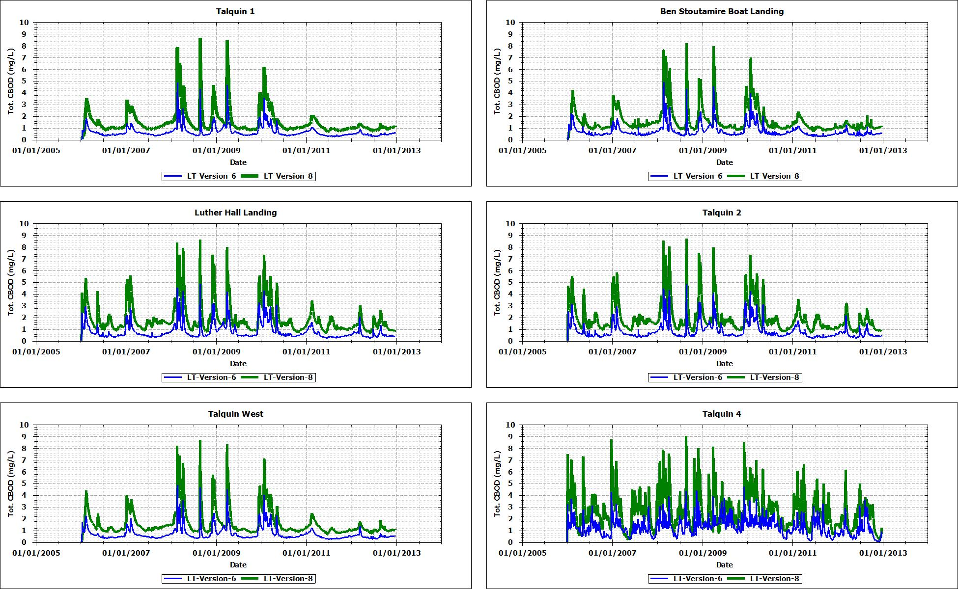
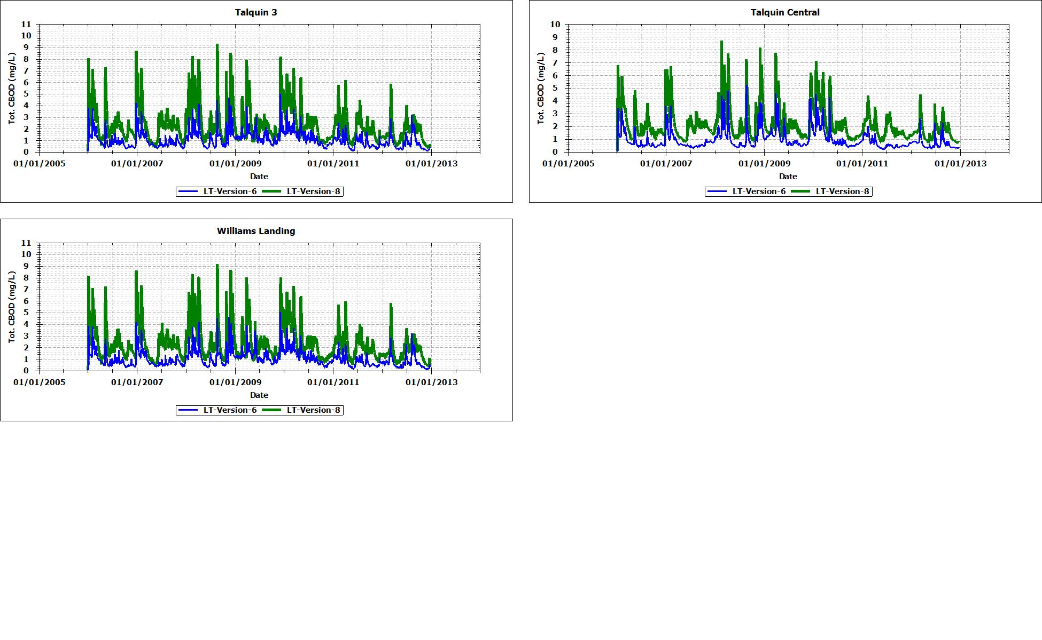
Figure 190 Comparison of CBOD Time Series Version 6 vs. 8

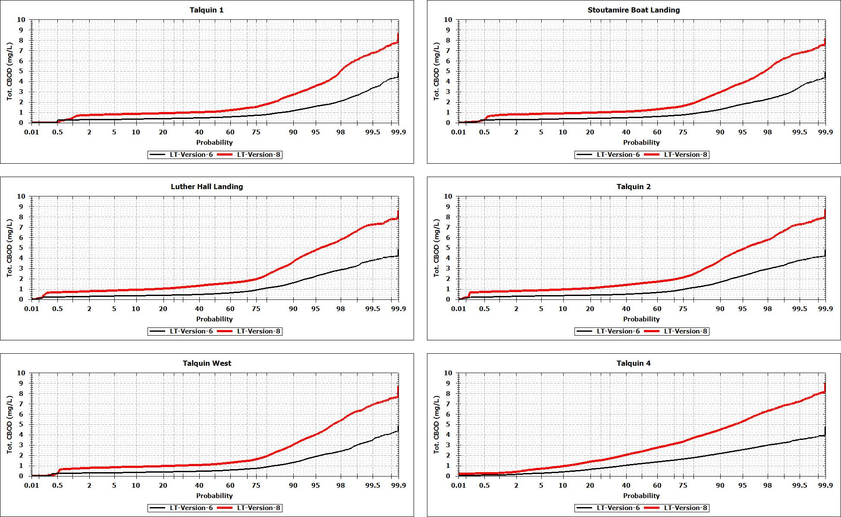
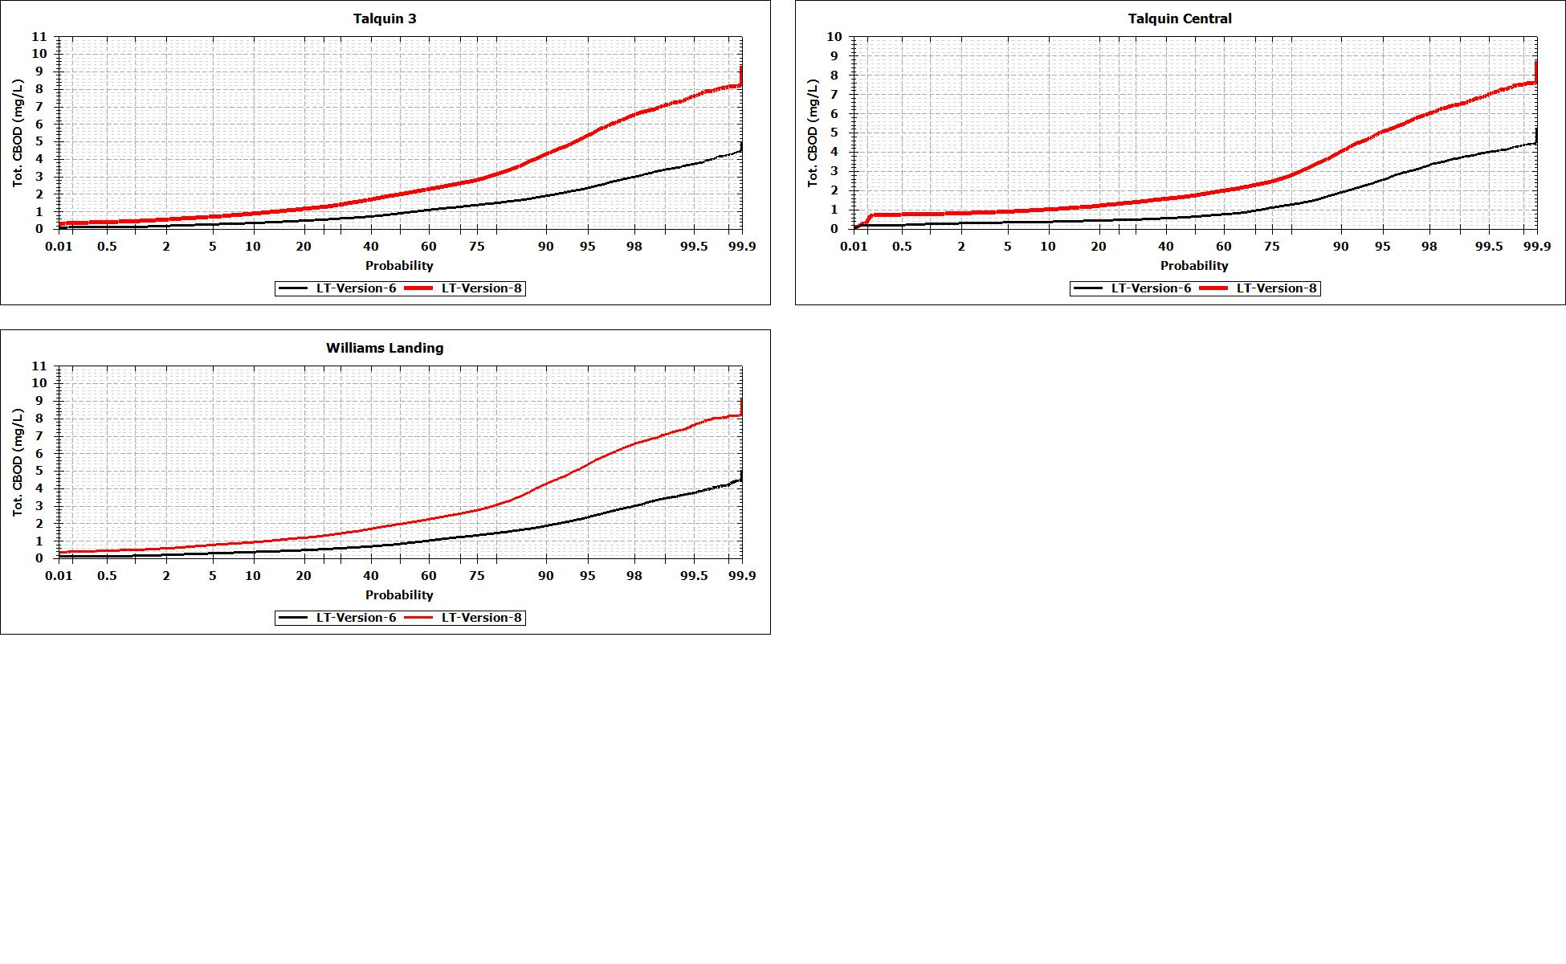
Figure 191 Comparison of CBOD Probability Plot Version 6 vs. 8

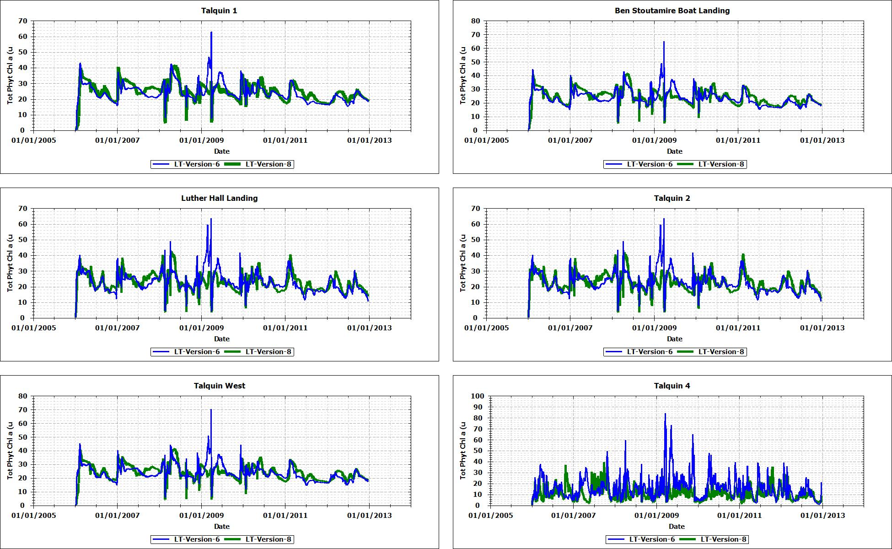
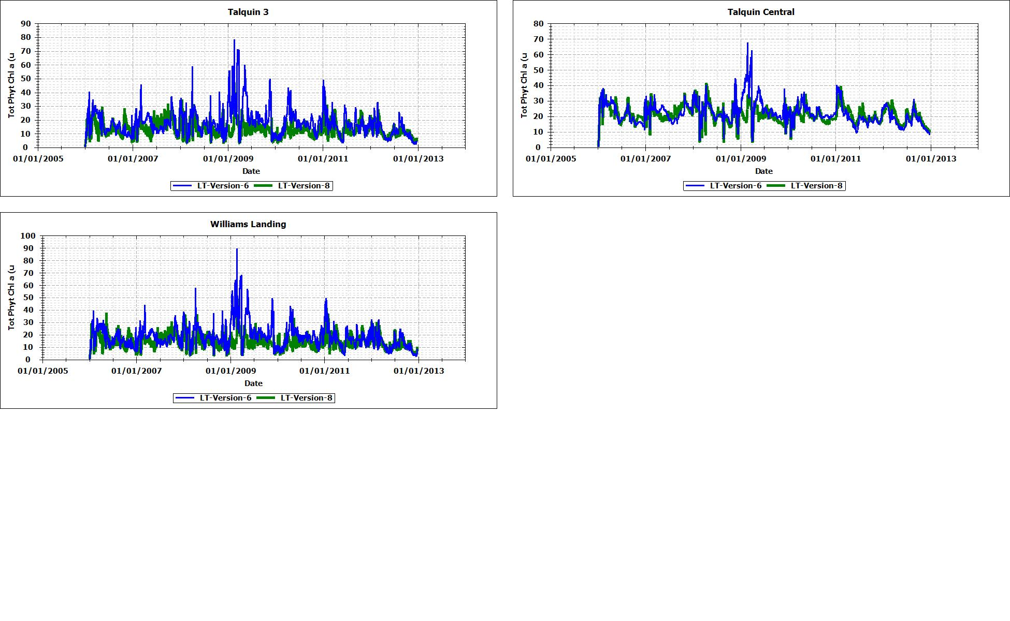
Figure 192 Comparison of Chlorophyll a Time Series Version 6 vs. 8

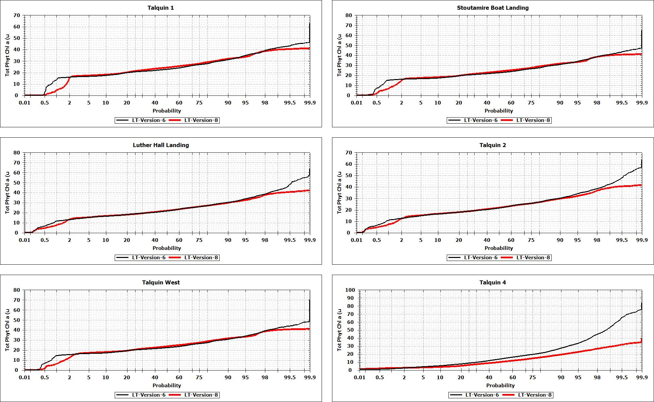
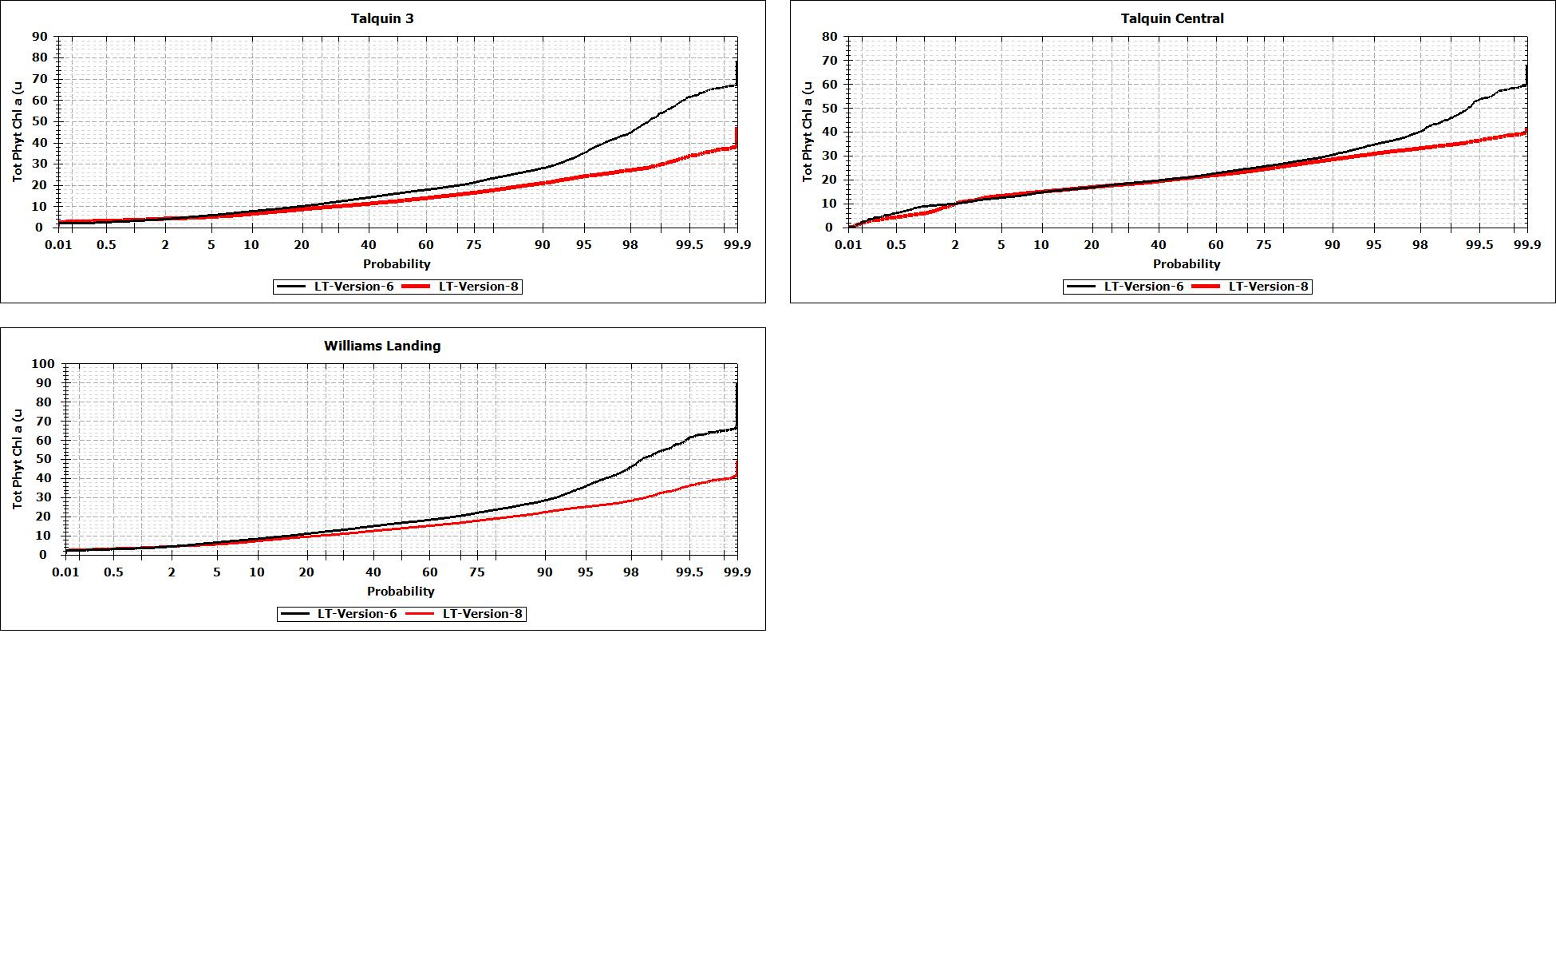
Figure 193 Comparison of Chlorophyll a Probability Plot Version 6 vs. 8

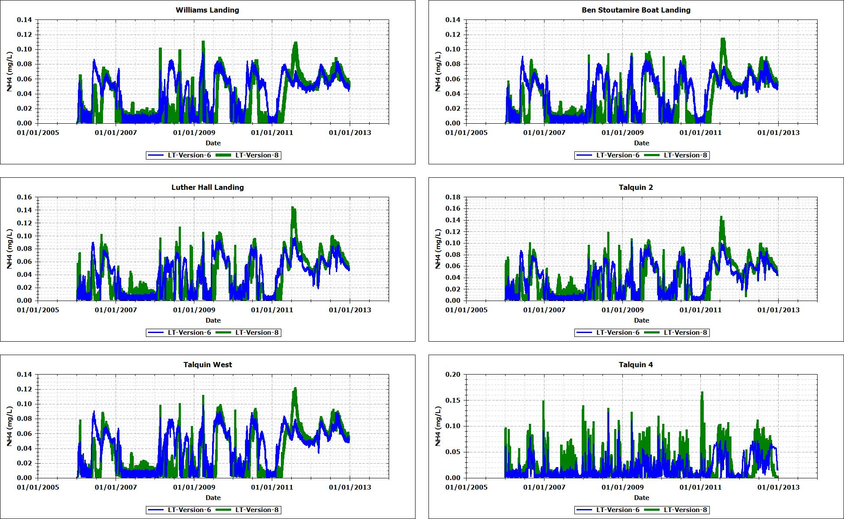
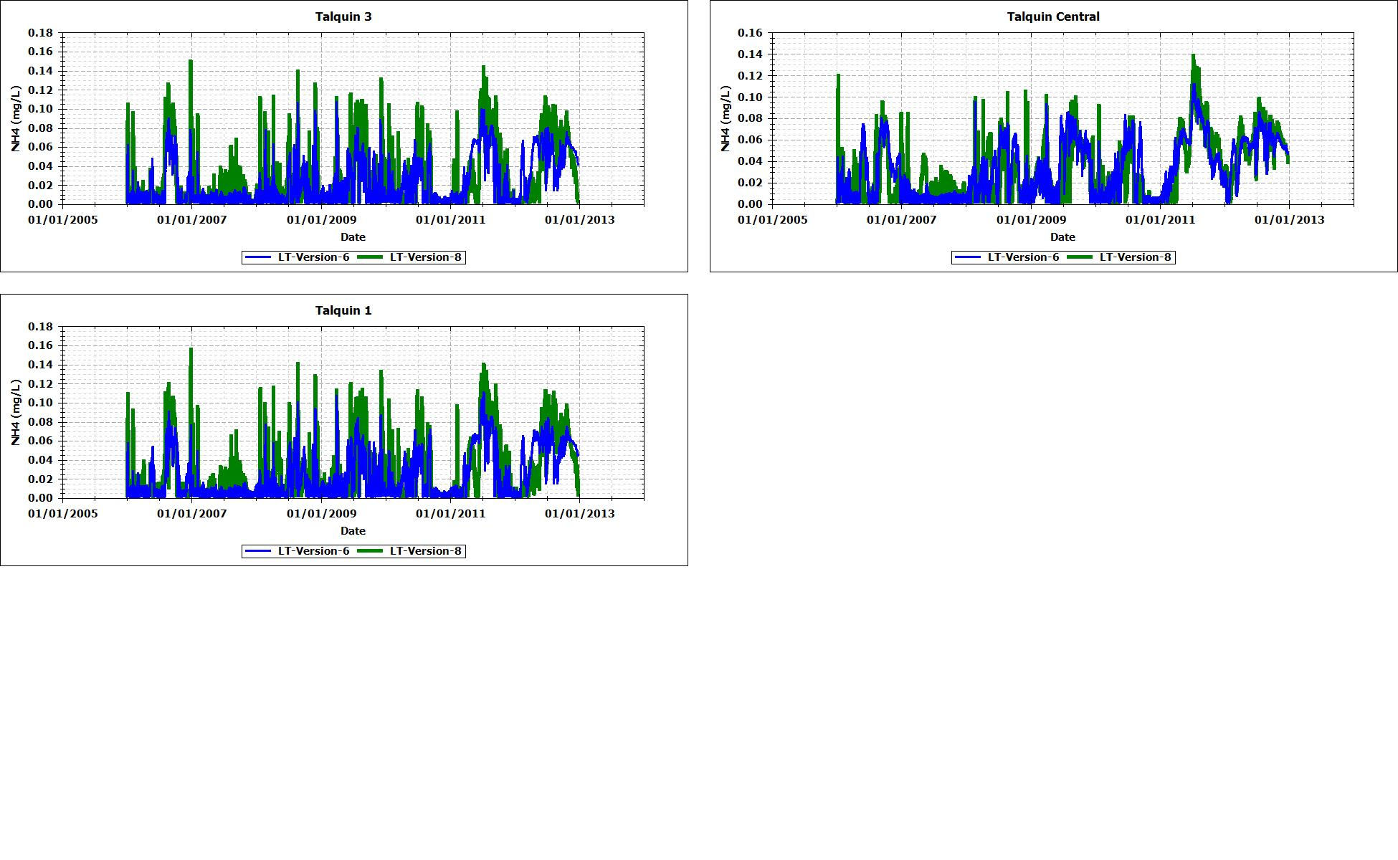
Figure 194 Comparison of Ammonia Time Series Version 6 vs. 8
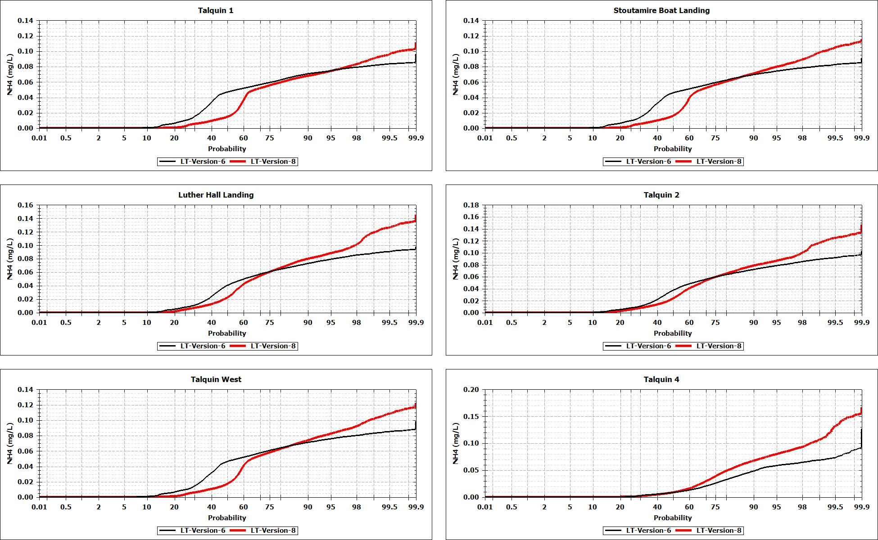
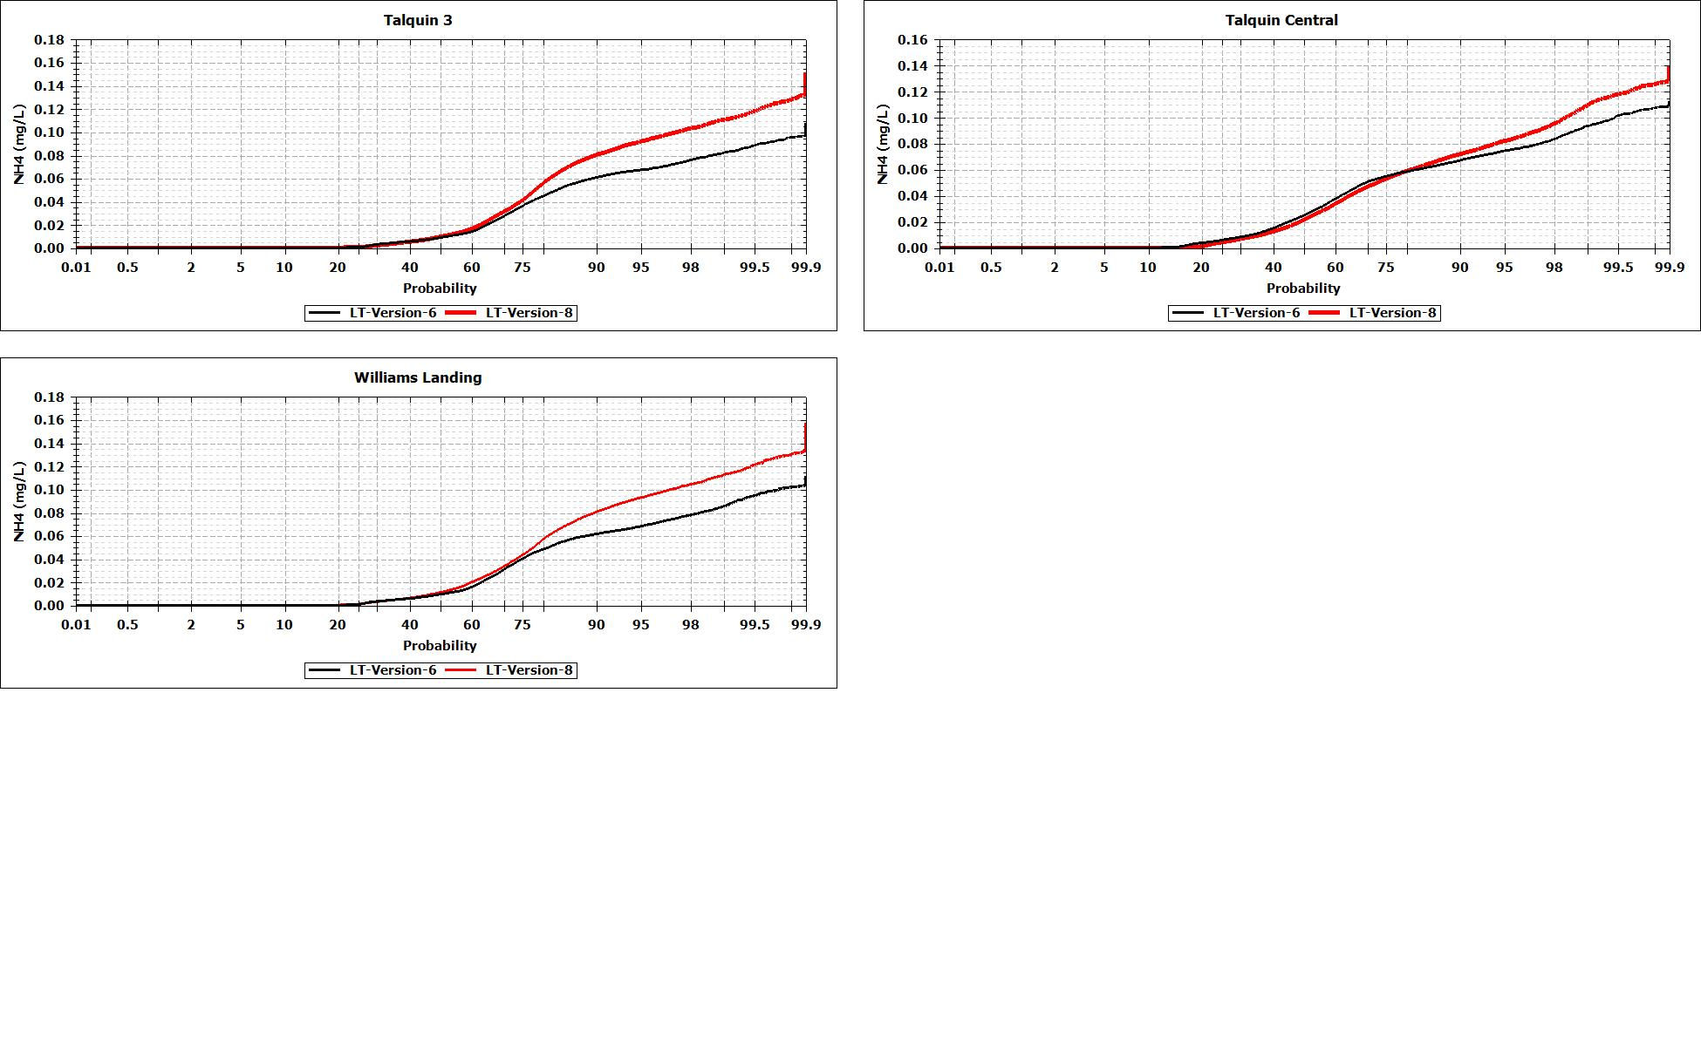
Figure 195 Comparison of Ammonia Probability Plot Version 6 vs. 8
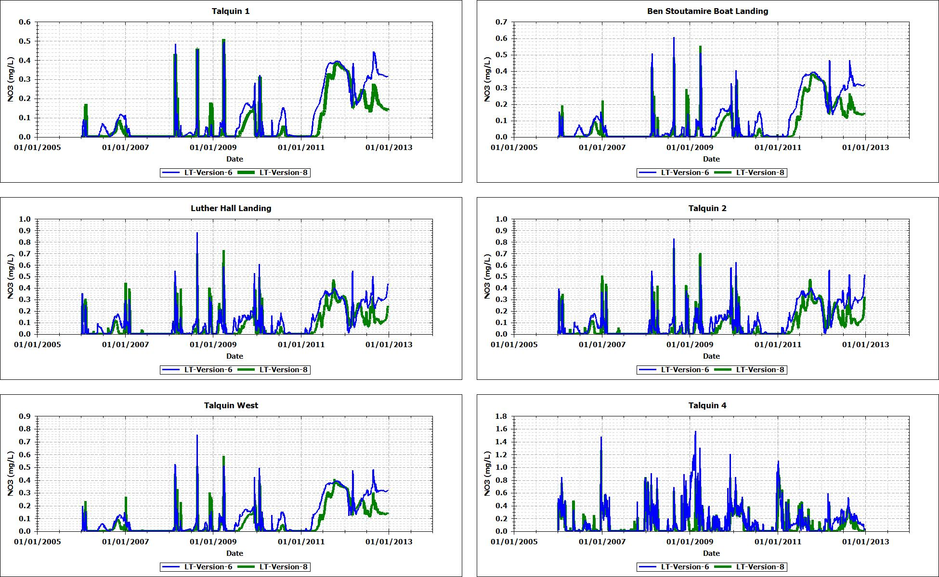
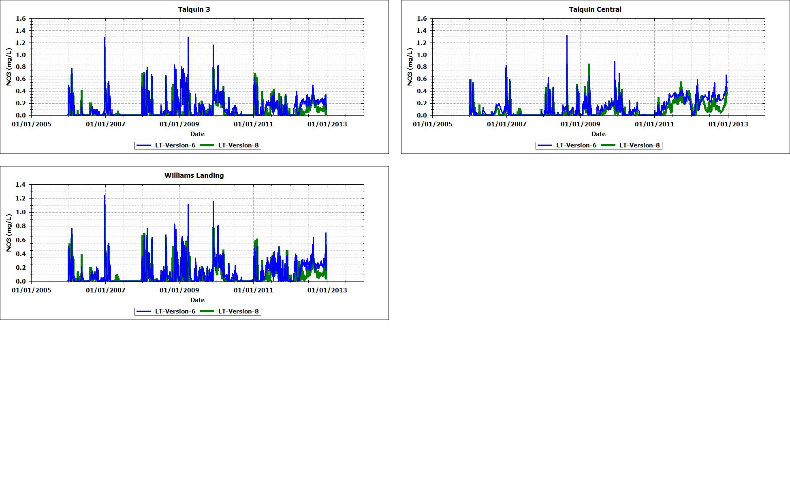
Figure 196 Comparison of Nitrate Time Series Version 6 vs. 8

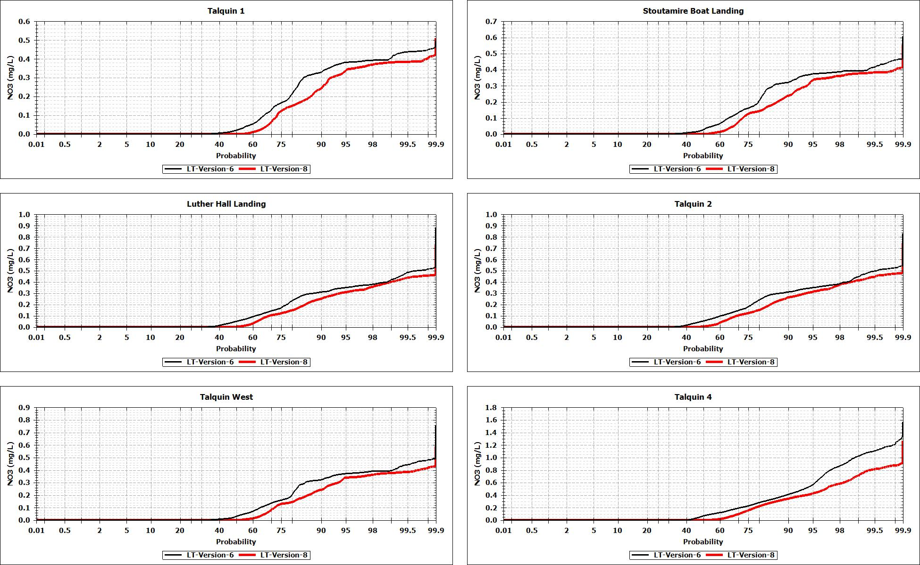
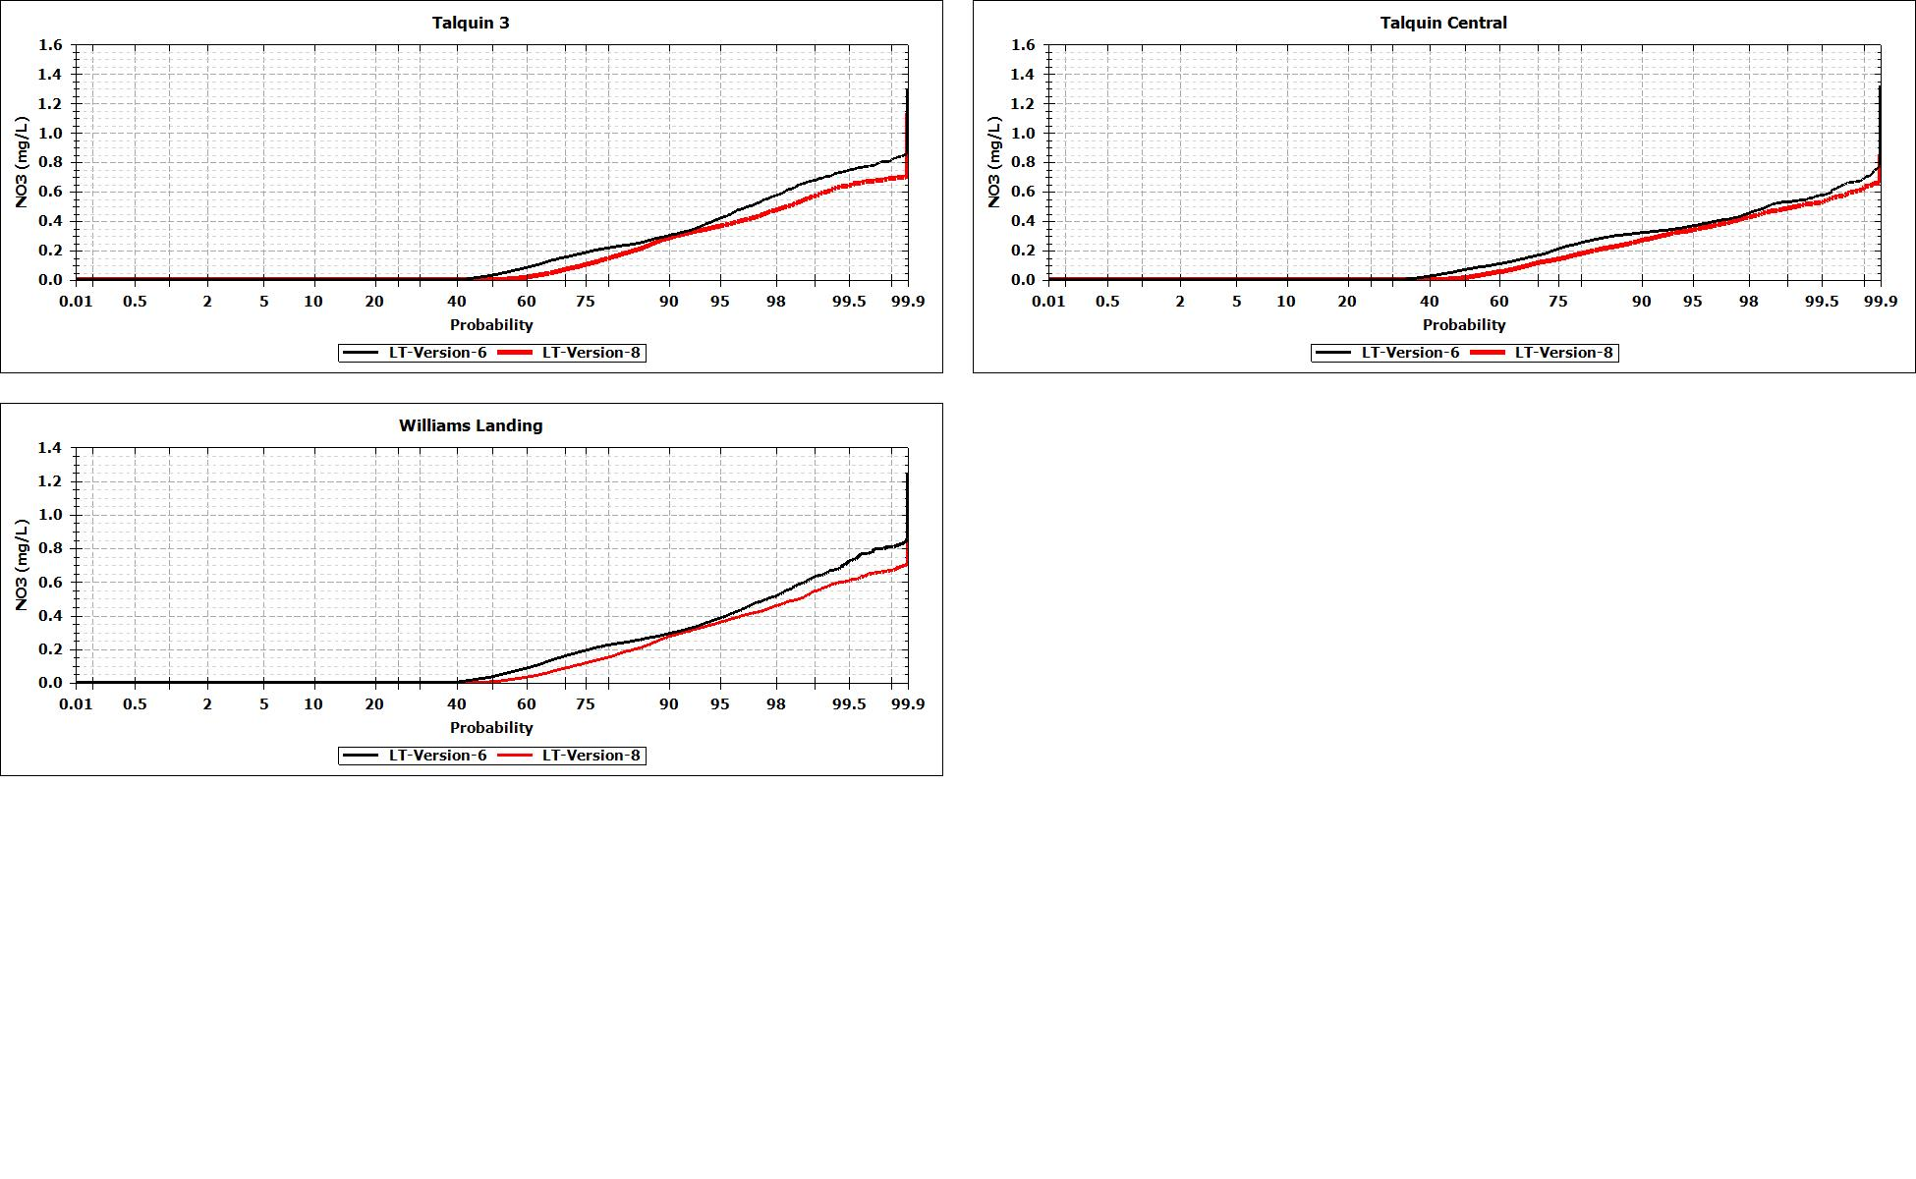
Figure 197 Comparison of Nitrate Probability Plot Version 6 vs. 8

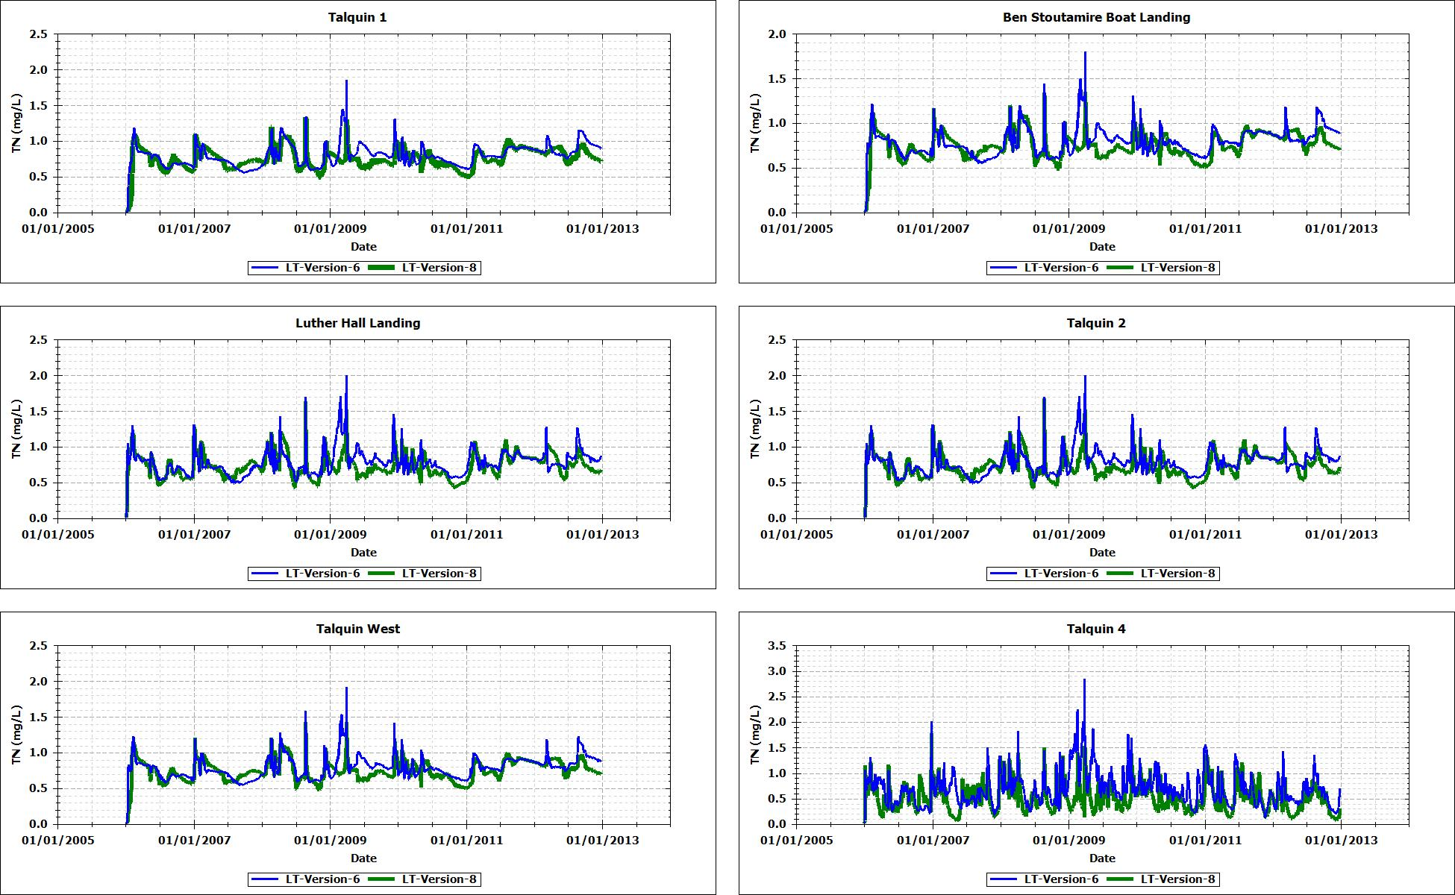
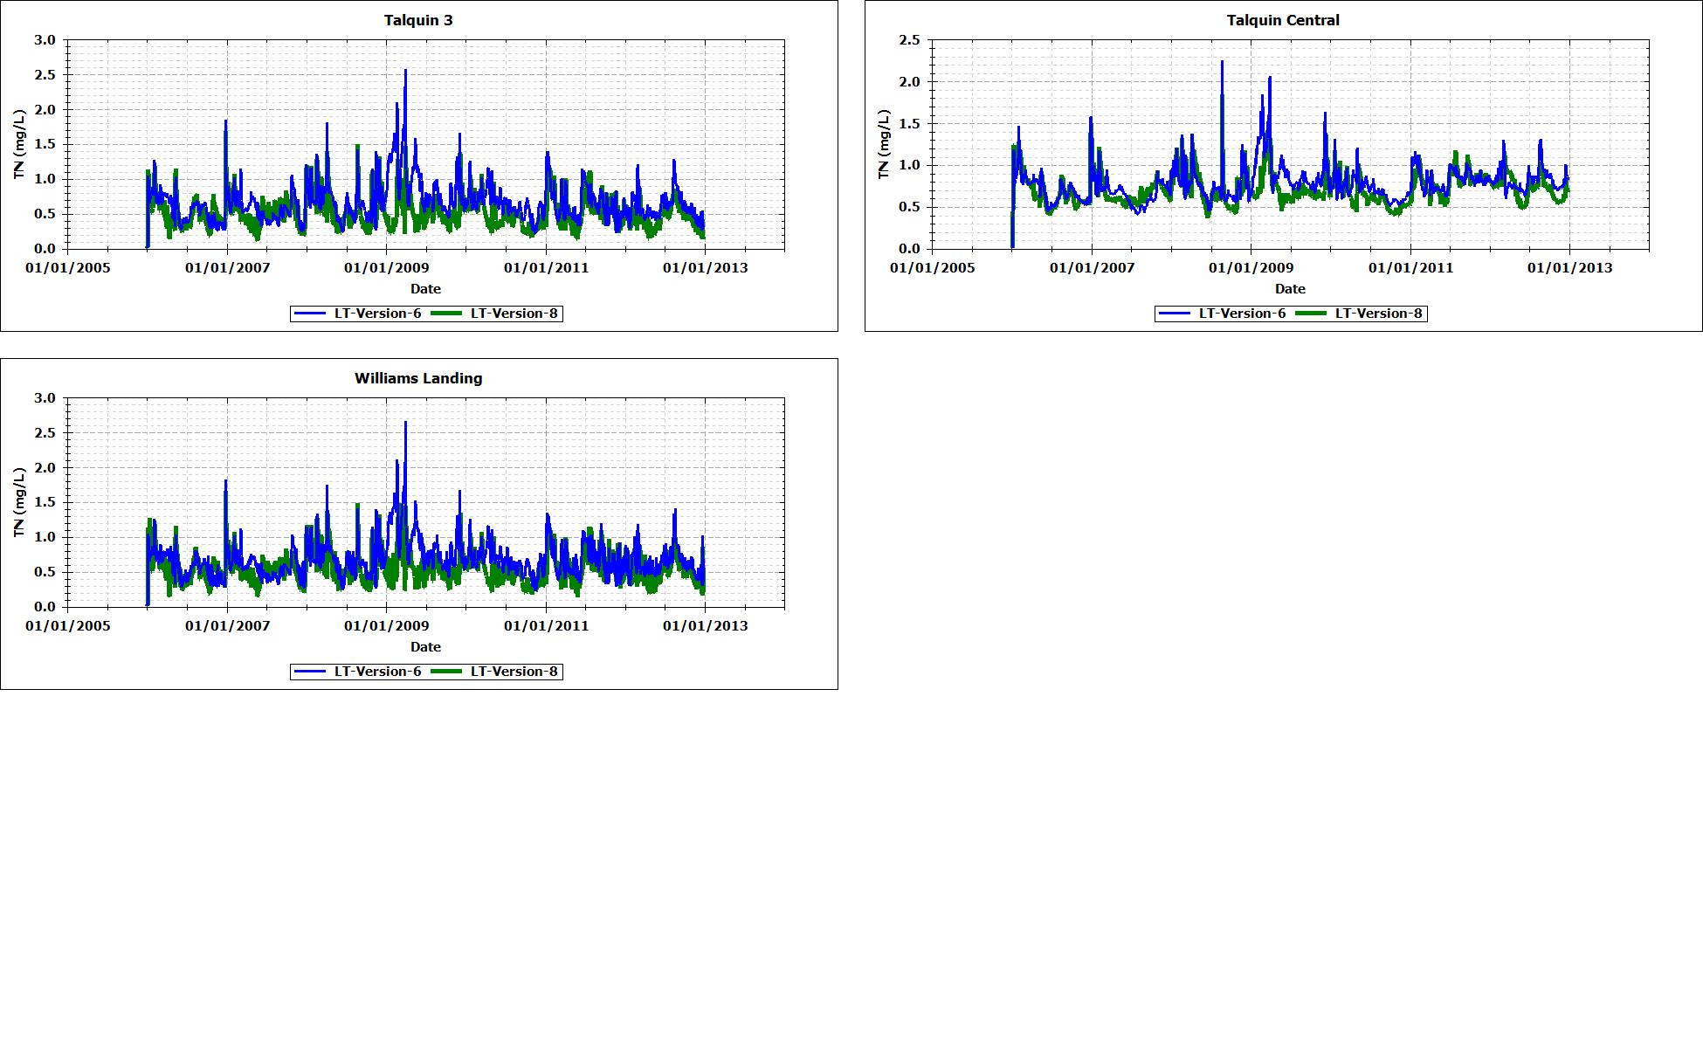
Figure 198 Comparison of Total Nitrogen Time Series Version 6 vs. 8

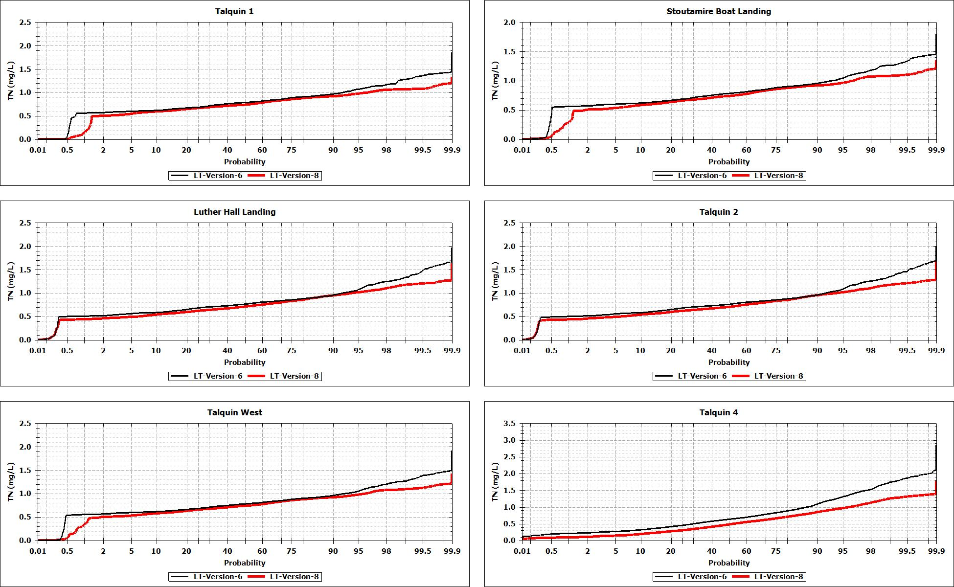
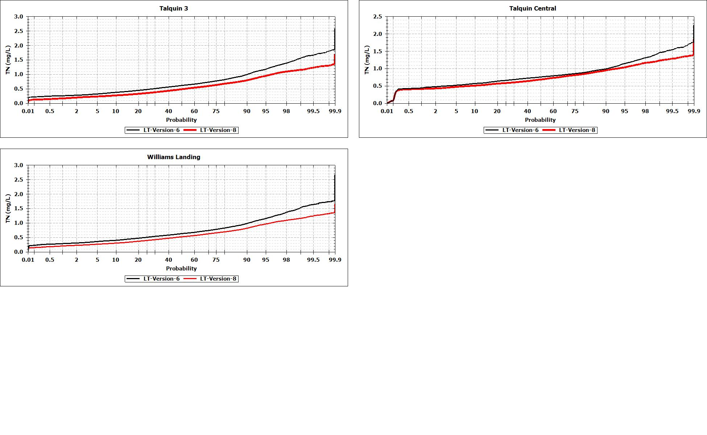
Figure 199 Comparison of Total Nitrogen Probability Plot Version 6 vs. 8

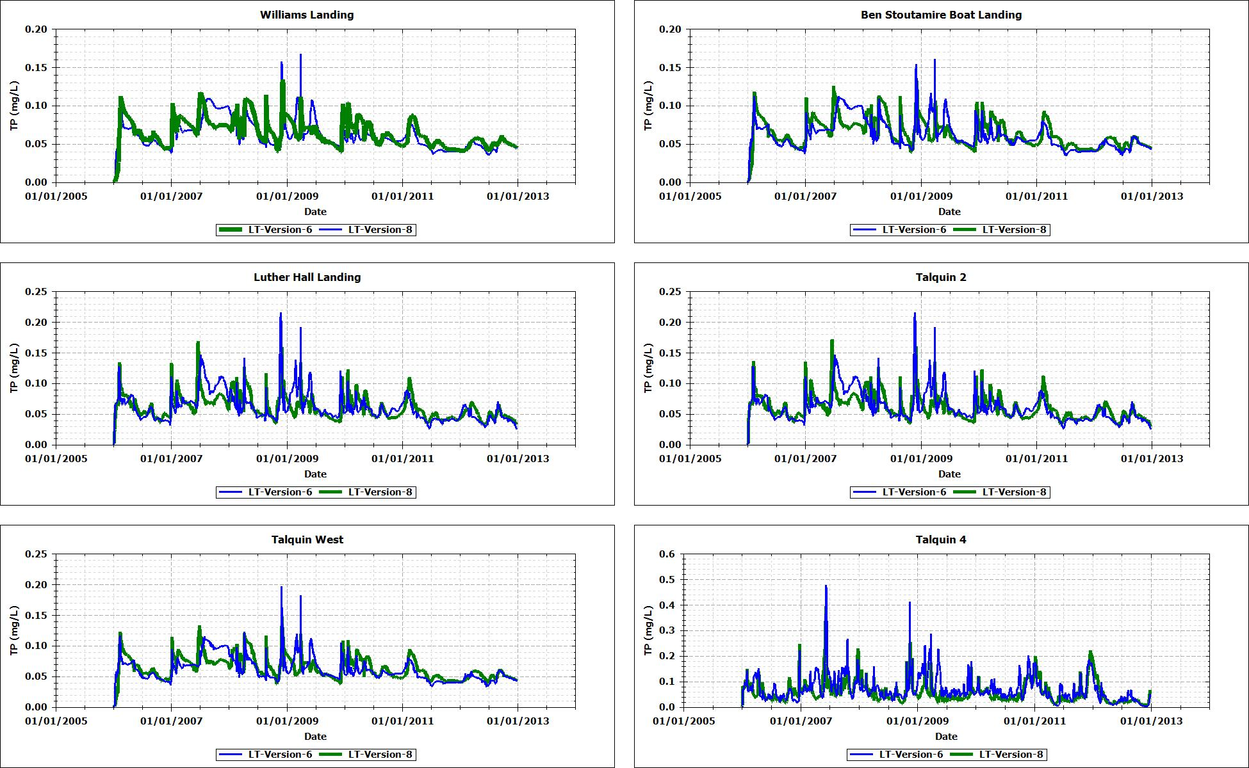
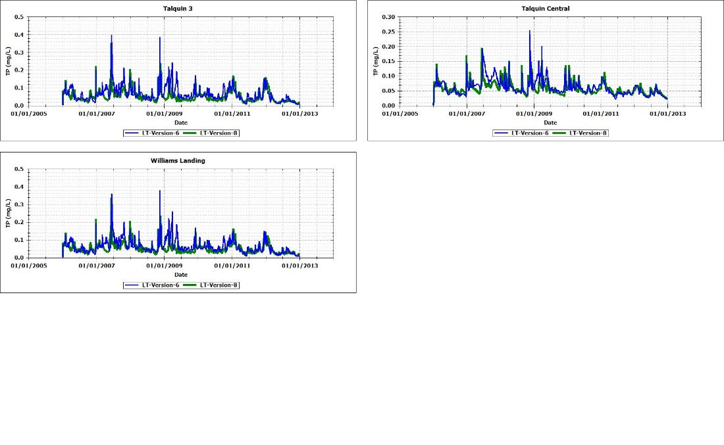
Figure 200 Comparison of Total Phosphorus Time Series Version 6 vs. 8

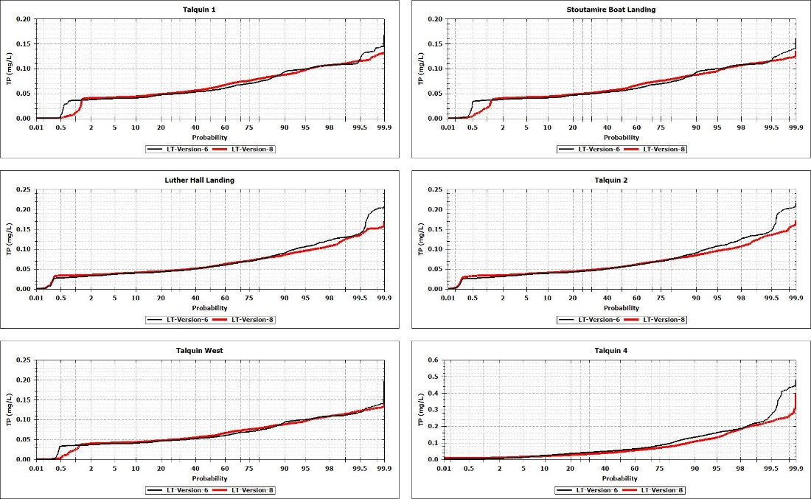
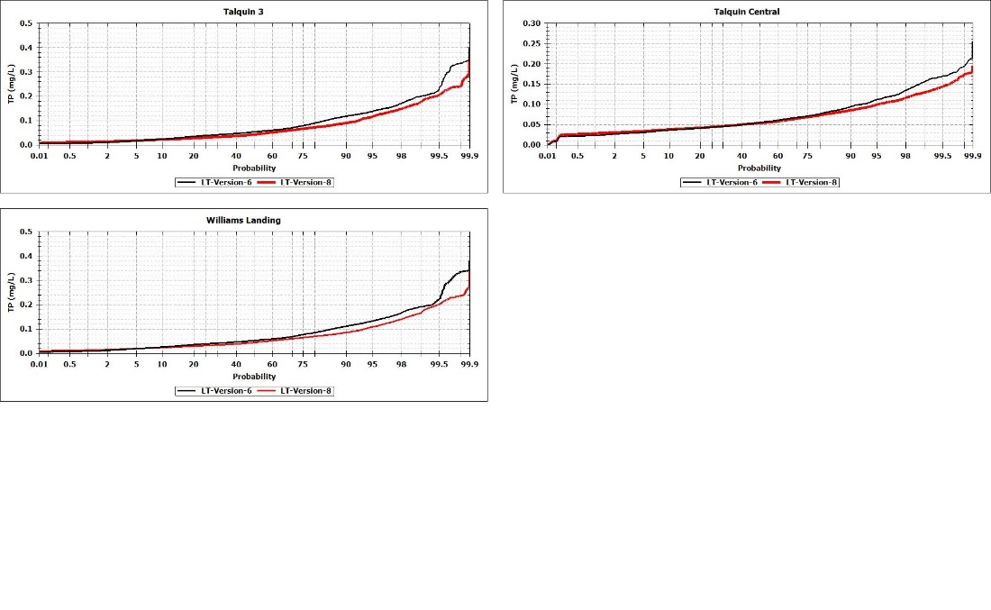
Figure 201 Comparison of Total Phosphorus Probability Plot Version 6 vs. 8
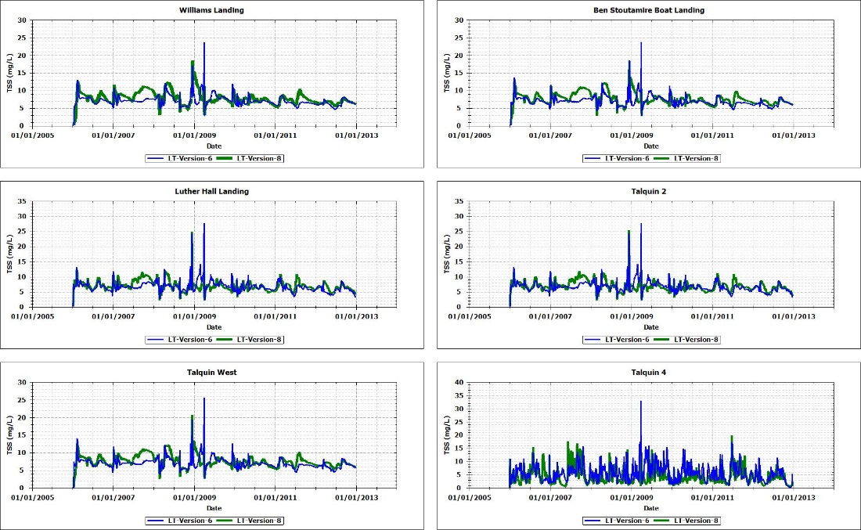
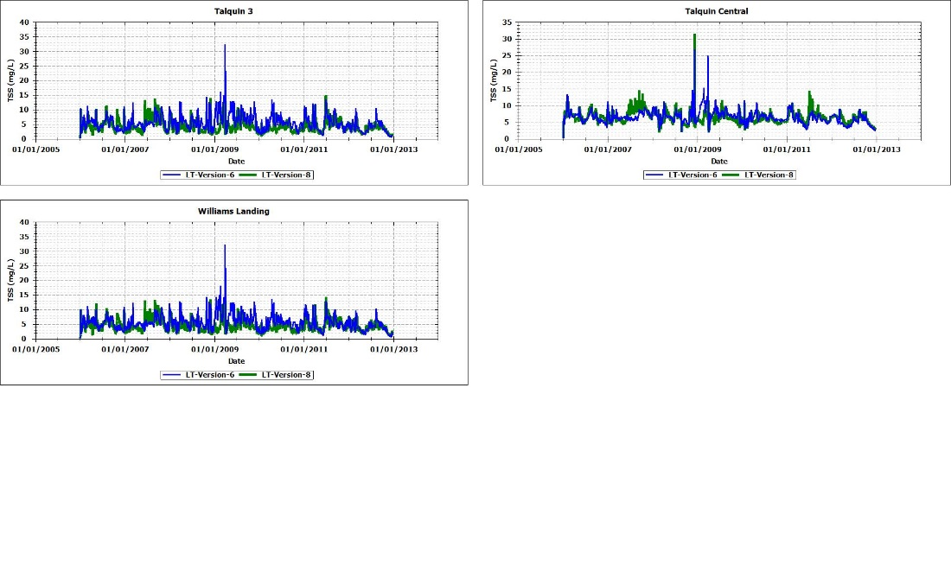
Figure 202 Comparison of Total Suspended Solids Time Series Version 6 vs. 8

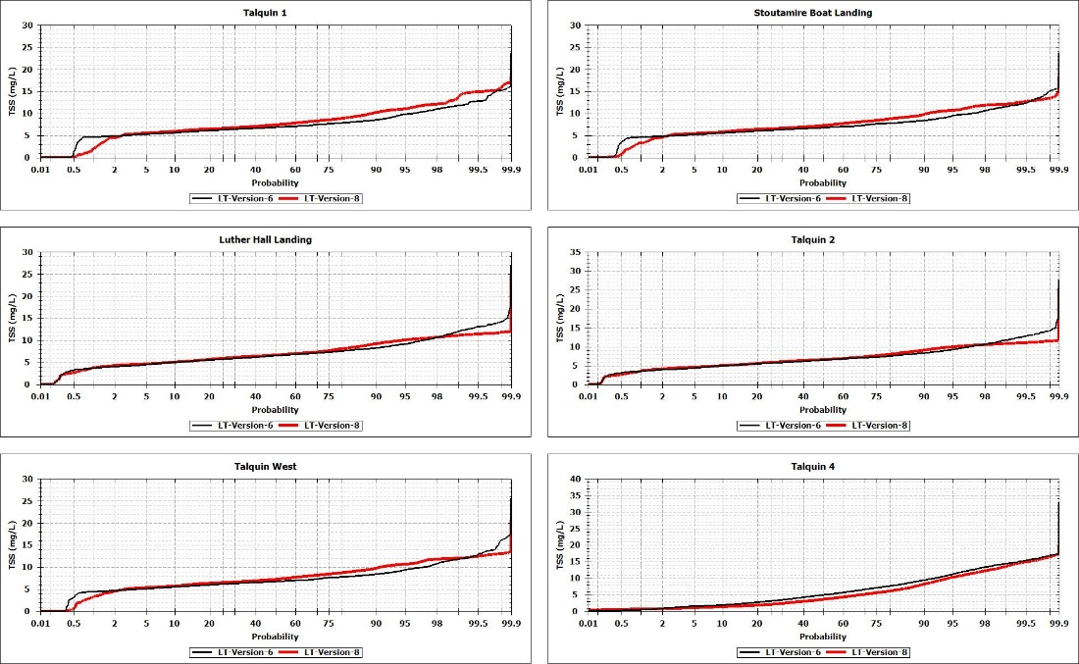
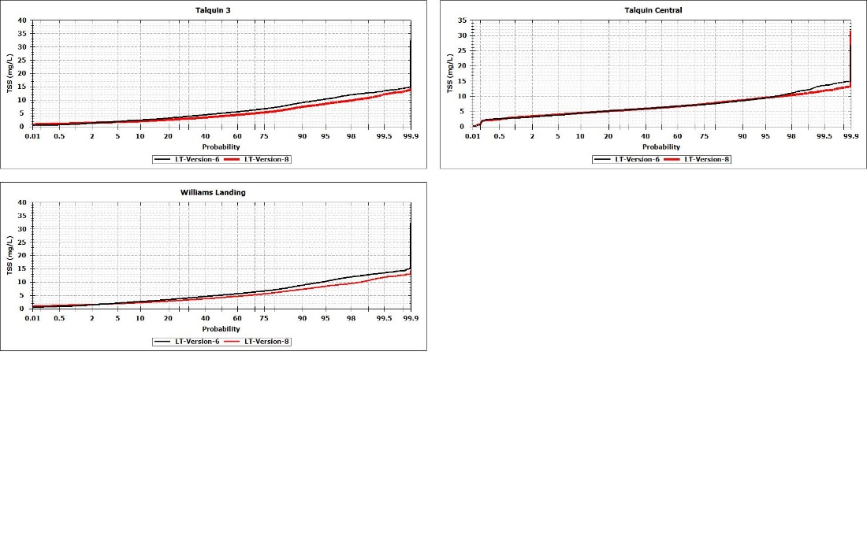
Figure 203 Comparison of Total Suspended Solids Probability Plot Version 6 vs. 8

