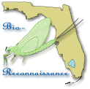
STREAM ECOSUMMARY
Yellow River below U.S. Highway 90
July 23, 2002
FDEP conducted BioRecon biological sampling at Yellow River below Highway 90 in Okaloosa County on July 23, 2002 (Figure 1). The river near this site, located 40 meters above Trammel Creek had been proposed for damming by local development interest. Reference data was needed by managers to consider the potential loss of stream resources. Much of the riparian wetlands along the Yellow River west of Crestview had been purchased by the Northwest Florida Water Management District (NWFWMD) for conservation purposes (Yellow River Water Management Area). The macroinvertebrate community and water quality data indicated that the Yellow River at this site exceeded expectations for a healthy, well-balanced stream. It had (as of May 2012) the highest BioRecon scores in Florida for Total taxa (81), tied the best scores in the state for Florida Index -clean water indicators (50), and second for EPT -mayflies, stoneflies, caddisflies (40).
Background
Although healthy, well-balanced stream and river communities may be maintained with some level of human activity, such activities may result in waterbody degradation. Human stressors may include increased inputs of nutrients, sediments, and/or pesticides from watershed runoff, adverse hydrologic alterations, undesirable removal of habitat or riparian buffer activities have resulted in the condition where a vegetation, and

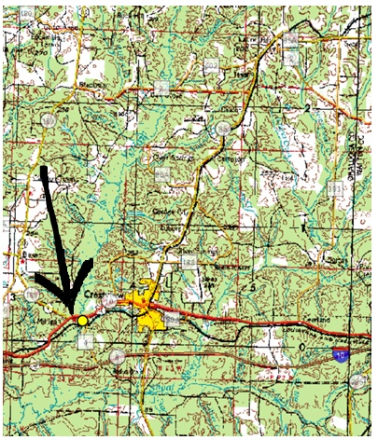 Figure 1. Location of the Yellow River below U.S. 90 in Okaloosa County.

introduction of nuisance (generally exotic) plants and animals. FDEP methods can evaluate if human particular waterbody has exceeded water quality criteria (Chapter 62-302, Florida Administrative Code), including whether adverse impacts to biological communities have
occurred. FDEP water quality standards are designed to protect designated uses of the waters of the state (e.g., recreation, aquatic life support), and exceedances of these standards is associated with interference with the designated use. The Biological Reconnaissance (BioRecon) assesses how closely the macroinvertebrate community (e.g., aquatic insects, clams, and crayfish) of a stream resembles the macroinvertebrate community of an undisturbed or “reference” condition. The stream and river habitat assessment evaluates the availability and quality of habitat for macroinvertebrates, and can help diagnose the cause of a low BioRecon score.

Methods

This stream was sampled on July 23, 2002 by the FDEP Northwest District Office. Surface water measurements were analyzed for dissolved oxygen, % dissolved oxygen saturation, water temperature, pH, specific conductance, and secchi depth following FDEP Standard Operating Procedures (SOPs, see http://www.dep.state.fl.us/water/sas/sop/index.htm for details). Sampling and analyses met FDEP quality assurance/ quality control standards (see http://www.dep.state.fl.us/water/sas/qa/index.htm)
The BioRecon was sampled per FDEP SOP FS7410 and calculated per FDEP BioRecon_1992 scoring. Biological Reconnaissance (BioRecon) is a rapid community based biological assessment of stream health using benthic macroinvertebrates sampled via four sweeps of a D-frame dip net, with organisms (excluding Oligochaeta, Chironomidae, and Acarina) identified to the lowest practical taxonomic level. The BioRecon_1992 is composed of three metrics, which decrease in response to human disturbance. These include Total # of taxa (24 threshold for impairment), Florida Index-clean water indicators (22 threshold for impairment), and EPT (17 threshold for impairment). The BioRecon rating categories were: Healthy (meeting 3 of 3 Biometrics); Suspect (2-3); and Impaired (0/1-3). The Stream and River Habitat Assessment was conducted per FDEP SOP FT 3100. The Habitat Assessment is a rapid field method in which a sampler scores eight in-stream and riparian components to estimate the influence of habitat factors on the resident aquatic organisms. Habitat Assessment scores range from 11-160 and overall habitat quality is assigned to one of four categories: Optimal (120-160 points), Suboptimal (80-119 points), Marginal (40-79 points), and Poor (11-39 points).
Site Information
This Panhandle bioassessment site (STORET station 33040004) is located two miles southeast of Crestview (N 30°44’ 56” W -86° 37’ 29.2”). The Yellow River at this location is a 4th to 5th order stream, draining the Southern Pine Plains and Hills ecoregion (65f). The Yellow River originates in southern Alabama, north of Andalusia and Opp and flows to Pensacola Bay via Blackwater and East Bays. The US Fish Wildlife Service has identified the Yellow River as spawning habitat for the gulf sturgeon. The substrate required is exposed limestone bedrock overlain with gravel and small cobble. The stream bed at this site consists of sand and some gravel (Figure 2).

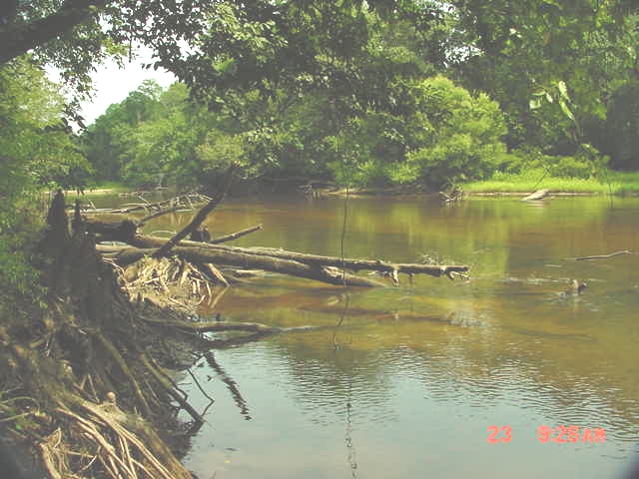 Figure 2. BioRecon Index site for Yellow River below U.S. 90 on July 23, 2002.
Results
Water Quality
The water quality samples complied with water quality criteria (Table 1). Specific conductance (68 µmhos/cm) and pH (6.7) reflects the affect of Karst lime rock geologic conditions of the Yellow River headwaters. The sand and gravel aquifer of the western most Florida Panhandle has a lower pH (~4-6 standard units) and specific conductance (15-50 μmhos/cm).

Table 1. Water quality results from July 23, 2002 at Yellow River below U.S. 90.
Analyte | Result | Remark | Applicable Class III Water Quality Criteria
Field Temperature (°C) | 27.2
Field pH (SU) | 6.7
Field Dissolved Oxygen (mg/L) | 7.1 |  | >5.0
Field Specific Conductance (µmhos/cm) | 68 |  | Not to exceed 50% of background or 1275 μmhos/cm
% Dissolved Oxygen Saturation | 88
Secchi depth (meters) | 2
Habitat Assessment
The stream and river habitat assessment scored 110, in the suboptimal range. Water velocity and all the secondary habitat components (Artificial Channelization, Bank Stability, Riparian Zone Buffer Width, & Riparian Zone Quality) rated Optimal. Substrate Diversity rated Marginal with only 2 productive habitats (woody material & roots). Substrate Availability and Habitat Smothering rated in the Poor Category because of 91% sand and 5% silt filling the streambed. No pools were in the sample reach. Gravel was detected buried beneath the sand and had 1% site coverage exposed by rapid stream velocity in riffles. Sediment sources include expanding development in Crestview, dam failures i.e. Davis Mill Creek, Murder Creek, & Silver Creek, row crops including cotton around Baker, and numerous dirt roads. Purchases of the Yellow River riparian zone by the NWFWMD had limited erosion from past silvicultural practices that clear-cut slope and wetland forests to plant pine plantations.
BioRecon Index
The BioRecon_1992 score for this site was 3 out of a possible 3 points. This passed all three 1992 biometric thresholds, which rated a “Healthy, “designation. The Total Taxa threshold of 24 was more than tripled to 81, the FI threshold of 22 was more than doubled to 50, and the EPT threshold of 17 was more than doubled to 40. The only collection of the rare mayfly Homoeoneuria dolani in the FDEP statewide biological database (SBIO) was collected in this sample. Other rare mayflies Baetisca escambiensis and Cercobrachys etowah were also collected here and listed in SBIO at only a few sites. Live native mussels Anodonta, Elliptio, and Fusconaria were collected and released. In addition five taxa of snail were collected and these mollusks along with the mussels reflect the influence of the limestone aquifer surfacing near the Alabama Stateline.
Periphyton
Attached algae were abundant on the stream substrates. The periphyton consisted of filamentous green and cyanobacteria (blue-green algae) with diatoms (Figure 3). Low flow conditions (~170 CFS) below the Seven-Day Ten-Year Low (~190 CFS) were measured by the USGS Milligan gage at Highway 90 on July 23, 2002. The Median Daily Streamflow based on 57 years of record was ~600 CFS. The low stream flow may increase nutrient concentrations that could stimulate algal growth by limiting dilution of local agricultural and urban nonpoint source runoff. Some growth of algae (typically diatoms) is expected in a fully functioning stream, but an over abundance of algae (especially filamentous algae) may reduce habitat quality (from smothering) and lead to excess organic matter production (and decomposition), which can harm fish and invertebrates.
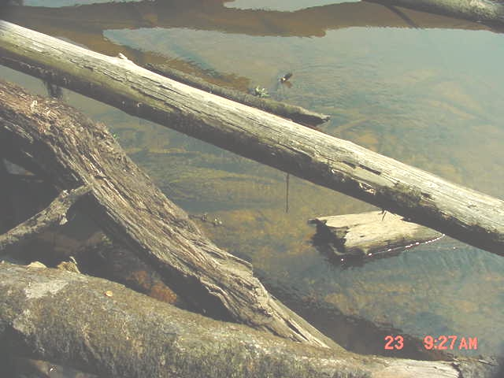 Figure 3. Attached algae on submerged woody material.

This Yellow River site had the highest BioRecon biometrics for Total Taxa in Florida (as of May 2012). It had similar scores to Alaqua Creek Forest Oak Road and Pond Creek Arcadia Mill for highest FI and EPT in Florida. Although the diversity was excellent, aquatic community’s productivity was low because of only a 3% available productive habitat. Fish (observed darters, chubsuckers, hogchokers, madtoms, shiners, and topminnows) were common in the limited areas of woody habitats. Many logs (potential fish food habitats) were buried under the sand reducing fish productivity. The habitat smothering was likely associated with historic erosion in the basin.

Thank you for your interest in conserving the water quality of Florida’s streams and rivers. Please feel free to contact us if you have any questions.
Contact and resources for more information
Donald H. Ray 850 595-0636 donald.ray@dep.state.fl.us
DEP biological assessment resources: http://www.dep.state.fl.us/water/bioassess/index.htm

