
STREAM ECOSUMMARY
Beaver Creek downstream of Arvah B. Hopkins Power Plant, Leon County
October 21, 2013, May 28, 2014, and July 3, 2014
Physical, chemical, and biological sampling was conducted at Beaver Creek, the receiving waters for Arvah B. Hopkins Power Plant, in Leon County through a collaborative effort by personnel from the Division of Environmental Assessment and Restoration (DEAR) including staff from the Central Laboratory in Tallahassee on October 21, 2013 and staff from the Aquatic Ecology and Quality Assurance Section on May 28, 2014 and July 3, 2014. The assessments addressed in this report were conducted to provide information for review of NPDES permit renewal applications associated with the Arvah B. Hopkins Generating Station, and to obtain biological and water quality information to assess if the stream is in compliance with numeric nutrient criteria (NNC) in Rule 62-302.531, F.A.C. Available water quality results indicate elevated total phosphorous levels in the stream may exceed nutrient thresholds for the region, however the overall floral and faunal community data indicates that the stream meets expectations for a healthy, well-balanced stream.

Background
Healthy, well-balanced stream and river communities may be maintained with some level of human activity, but excessive human disturbance may result in waterbody degradation. Human stressors may include increased inputs of nutrients, sediments, and/or other contaminants from watershed runoff, adverse hydrologic alterations, undesirable removal of habitat or riparian buffer vegetation, and introduction of nuisance (generally exotic) plants and animals. DEP evaluates if human activities have resulted in the condition where a particular waterbody has exceeded water quality criteria (Chapter 62-302, Florida Administrative Code), including whether adverse impacts to biological communities have occurred. DEP water quality standards are designed to protect designated uses of the waters of the state (e.g., recreation, aquatic life use support), and exceedances of these standards is associated with interference with the designated use. Additionally, DEP evaluates the health of floral (plants and algae) and faunal (animal) communities and conducts habitat assessments to diagnose potential physical impacts.

The Arvah B. Hopkins Generating Station is an electric generating facility owned and operated by the City of Tallahassee. The plant is located approximately four miles west of Tallahassee, on Geddie Road in Leon County, Florida. Since 1995, Beaver Creek has been sampled to provide biological assessment information for review of NPDES permit renewal applications associated the Arvah B. Hopkins Generation Station. This facility (NPDES # FL0025518) has a permitted 2.7 million gallons per day (MGD) discharge of industrial wastewater from natural-gas, steam electric power generation to Beaver Creek, Class III Fresh Waters. The discharge from the facility forms the headwaters of Beaver Creek, which then flows through the Talquin Wildlife Management Area and is a tributary of the Ochlockonee River, an Outstanding Florida Water (OFW). The distance traversed by Beaver Creek is approximately two miles from its headwaters located adjacent to the facility until its confluence with the Ochlockonee River. The point where the creek joins the Ocklockonee River is located just upstream (approximately one mile northeast) of Lake Talquin.
Methods
Water Quality

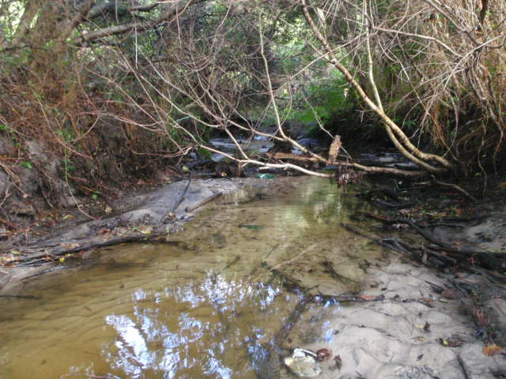
Surface water samples were collected at three downstream locations in Beaver Creek that include a Test Site (Figure 1) , a Downstream Site (Figure 2) located downstream of the Test Site, and an intermediate site referred to as the Beaver Dam Road Site located between the two. The Beaver Dam Road site has historically been used by the FDEP Central Laboratory to sample for copper and was established in association with a copper mixing zone in the NPDES permit.

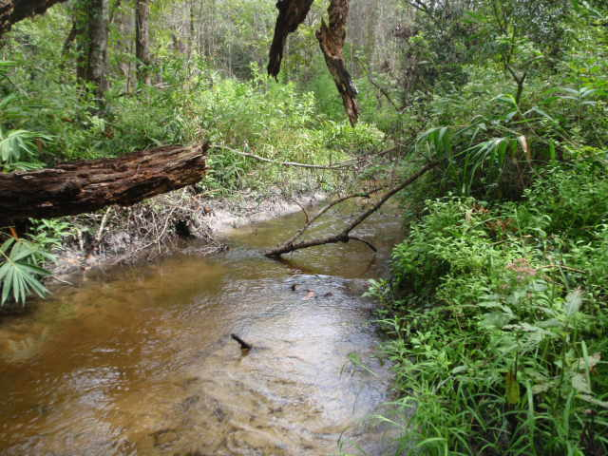
Figure 1. Test Site sampling location in Beaver Creek, October 21, 2013.

Figure 2. Downstream sampling location on Beaver Creek, October 21, 2013.

The Test Site is the closest to the facility and approximately 415 downstream of the point of discharge, the Beaver Dam Road site is approximately 960 m downstream of the point of discharge, and the furthest downstream site (Downstream Site) is located approximately 1,600 meters downstream of the point of discharge (Figure 3).

Surface water samples were collected from the Test, Beaver Dam Road, and Downstream sites on October 21, 2013, at the Test and Downstream sites on May 28, 2014, and at the Test site on July 3, 2014, for analysis of nutrients, chlorophyll a, alkalinity and color following DEP Standard Operating Procedures (SOPs, see
http://www.dep.state.fl.us/water/sas/sop/index.htm for details) and met the requirements of the FDEP Quality Assurance Rule, Chapter 62-160, F.A.C. (https://www.flrules.org/gateway/ChapterHome.asp?Chapter=62-160). The sampling conducted on October 21, 2013, was part of a 5th year inspection for purposes of evaluating the NPDES permit application and included a wider array of analytes associated with the effluent discharge than what is in this report. Full sample results for that inspection can be found in the March 2014 Biological Assessment of the Arvah B. Hopkins Generating Station (ftp://ftp.dep.state.fl.us/pub/labs/lds/reports/13881.pdf).

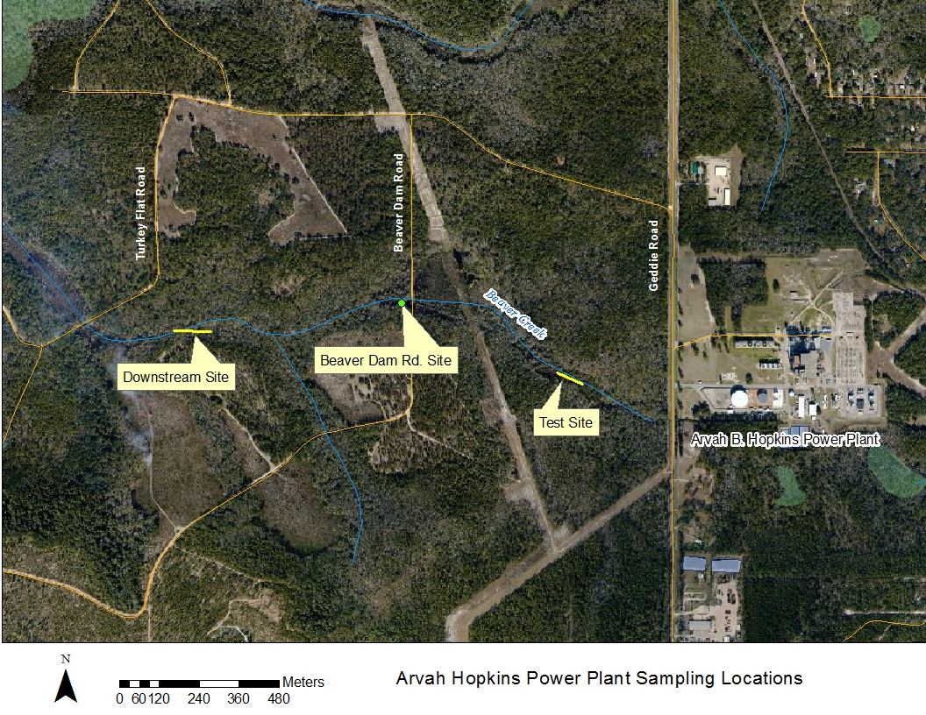
Figure 3. Location of Beaver Creek and Sampling Sites.

Chapter 62-302.531, F.A.C., provides that Numeric Nutrient Criteria are achieved in streams if:
Information on chlorophyll a levels, algal mats or blooms, nuisance macrophyte growth, and changes in algal species composition do not indicate an imbalance in flora or fauna; AND EITHER
The average score of at least two temporally independent Stream Condition Indices (SCIs) is 40 or higher, with neither of the two most recent SCI scores less than 35, OR
The Nutrient Thresholds (expressed as annual geometric means) are not exceeded more than once in a three year period.
The nutrient thresholds are found in Table 1. The sampling site is in the Panhandle East nutrient region. The floral and faunal measures are described below.
Table 1. Nutrient thresholds for Florida Nutrient Regions, expressed as Annual Geometric Means (based on a minimum of four samples per year), not to be exceeded more than once in a consecutive three year period.
Nutrient Region | Total Phosphorus Threshold | Total Nitrogen Threshold
Panhandle West | 0.06 mg/L | 0.67 mg/L
Panhandle East | 0.18 mg/L | 1.03 mg/L
North Central | 0.30 mg/L | 1.87 mg/L
Peninsula | 0.12 mg/L | 1.54 mg/L
West Central | 0.49 mg/L | 1.65 mg/L
South Florida | No numeric nutrient threshold. The narrative criterion in paragraph 62-302.530(47)(b), F.A.C., applies.

Dissolved Oxygen
Rule 62-302.533 (1), F.A.C., states that no more than 10 percent of the daily average percent dissolved oxygen (DO) saturation values shall be below 67 percent in the Panhandle bioregion, 38 percent in the Peninsula and Everglades bioregions, or 34 percent in the Northeast and Big Bend bioregions. Percent saturation takes into account factors such as temperature, atmospheric pressure, and salinity. The Beaver Creek site is located in the Big Bend bioregion.
The daily average freshwater DO criteria is preferentially assessed using daily average values calculated from full days of diel (collected over a 24 hour period) monitoring data. If diel monitoring data are not available (as was the case for this report), instantaneous samples are used to assess the DO criterion by comparing the instantaeous value with a time-of-day-specific translation of the daily average criterion. The equations to calculate the time-of-day-specific translation of the daily average criterion are cited in 62-303.420(9), F.A.C., and a spreadsheet calculator for this purpose is available at: http://www.dep.state.fl.us/water/wqssp/dissoxy.htm.

Habitat Assessment
The Stream and River Habitat Assessment was conducted at the Test Site on October 21, 2013 and July 3, 2014, and at the Downstream Site on October 21, 2013 and May 28 2014 per DEP SOP FT 3100. The Habitat Assessment is a rapid field method in which a sampler scores eight in-stream and riparian components to estimate the influence of habitat factors on the resident aquatic organisms. Habitat Assessment scores range from 11-160 and overall habitat quality is assigned to one of four categories: Optimal (120-160 points), Suboptimal (80-119 points), Marginal (40-79 points), and Poor (11-39 points).

Floral Assessment
Evaluations of stream flora include the Rapid Periphyton Survey (RPS, DEP SOP FS 7230), community composition information associated with dominant algal taxa (where applicable), Linear Vegetation Survey (LVS, DEP SOP 7320), and chlorophyll a. The RPS assesses the extent and thickness of algae in the stream reach, while the LVS assesses how closely the in-stream plant community resembles a minimally disturbed condition. Results are assessed as described beginning on page 8 of “Implementation of Florida’s Numeric Nutrient Standards,” dated April 2013, using evidentiary thresholds derived from a population of minimally disturbed reference sites. The RPS and LVS were conducted at the Test Site on October 21, 2013 and July 3, 2014, and at the Downstream Site on October 21, 2013 and May 28, 2014.

Faunal Assessment
The Stream Condition Index (SCI) assesses how closely the macroinvertebrate community (e.g., aquatic insects, clams, crayfish) of a stream resembles the macroinvertebrate community of an undisturbed or “reference” condition. The SCI was sampled at the Test Site on October 21, 2013 and July 3, 2014, and at the Downstream Site on May 28, 2014 and calculated per DEP SOP SCI 1000. For the SCI, ten measures of macroinvertebrate health are calculated and summed to yield a final score from 0-100. Average SCI scores ≥ 40 are considered “Healthy” (as long as neither of the latest two SCI scores were < 35) with scores ≥ 64 considered “Exceptional.”

Evaluation of Stream Exclusions for Applying Nutrient Criteria
When assessing a stream for compliance with numeric nutrient criteria (NNC) in Rule 62-302.531, F.A.C., it is important to note that several waterbody types are excluded from the stream definition in Rule 62-302.200(36), F.A.C. These include lake-like portions of rivers (where the lake NNC apply) and ditches/canals used for water management purposes, non-perennial streams, wetlands, and tidally fluctuating areas (where the narrative criterion, “no imbalances in natural populations of aquatic flora or fauna,” continues to apply). The NNC in Rule 62-302.531, F.A.C., were applicable to Beaver Creek.

Results
Water Quality
The water quality results are shown in Table 2. Based on results presented in this report, the total phosphorous levels in the stream may exceed the Panhandle East threshold (0.18 mg/L); however the thresholds represent annual geometric mean concentrations (based on minimum of four samples per year) not to be exceeded more than once in any three calendar year period, and are used in combination with floral and faunal information. Therefore even though the threshold appears to be exceeded during this reconnaissance level sampling, additional nutrient sampling may be needed to meet data sufficiency requirements to calculate and assess attainment of the water quality standard. It is likely that elevated total phosphorous levels being expressed in the stream are at least partially related to the effluent coming from cooling towers and groundwater used by the facility. All other applicable water quality criteria were met.

Most of the dissolved oxygen results obtained in the field and presented in Table 2 have been deemed unreliable due to post sampling documentation that shows the meters did not pass calibration verification criteria. There were no indications in the field that the existing DO regime was not fully supporting aquatic life uses.

Table 2. Water quality results from October 21, 2013, May 28, 2013 and July 3, 2014 at Test Site, Beaver Dam Road and Downstream Site on Bear Creek.
Analyte | Test Site October -21, 2013 | Test Site -May 28, 2014 | Test Site -July 3, 2014 | Beaver Dam Road – October 21, 2013 ** | Downstream Site- October 21, 2013 | Downstream Site- May 28, 2014 | Applicable Class III Water Quality Criteria
Field Temperature (°C) | 22.2 | 22.7 | 23.9 |  | 21.0 | 22.86
Field pH (SU) | 7.81 | 7.45 | 7.3 |  | 7.97 | N/A
Field Dissolved Oxygen (% saturation) | 106.4 J | 13.2 J | 105.9 |  | 103.8 J | 14.3 J | ≥34%
Field Specific Conductance (µmhos/cm) | 735 | 764 | 804 |  | 685 | 691 | 50% above background or 1275 µmhos/cm, whichever is greater
Alkalinity (mg CaCO₃/L) | 147 |  |  |  |  |  | Shall not be depressed below 20
Color (PCU) | 6 | 4.5 | 4.5 |  |  | 17
Total Phosphorus (mg/L) as P | 0.52 | 0.44 | 0.58 | 0.51 |  | 0.43 | ≤0.18 *
Nitrate+Nitrite (mg/L) as N | 0.049 | 0.072 | 0.05 | 0.048 |  | 0.064
Ammonia (mg/L) as N | 0.005 | 0.015 | 0.006 |  |  | 0.022
Total Kjeldahl Nitrogen (mg/L) as N | 0.22 | 0.23 | 0.23 | 0.25 |  | 0.29
Total Nitrogen (mg/L) as N | 0.27 | 0.30 | 0.28 | 0.30 |  | 0.35 | ≤1.03 *
J – Estimated value
* Annual geometric numeric nutrient threshold for Panhandle East Region (see Table 1), used in combination with information on flora and fauna.
** Sampler documentation and communication indicates the nutrients may have been collected at the Downstream Site, not the Beaver Dam Rd site. Further investigation suggests a Laboratory sample log-in error may have occurred. In either case, the sampling site is located downstream of the Test Site.

Habitat Assessment
The stream and river habitat assessment results are shown in Table 3. The scores ranged from 117 to 129 at the Test Site and from 120 to 129 at the Downstream Site, which is in the suboptimal to optimal range.

Substrate diversity and availability at the Test Site sampled on October 21, 2013 and July 3, 2014 varied from marginal to poor range with two to three major productive habitats consisting of roots/undercut banks and snags and leaf packs. Average water velocity was measured at an optimal level (0.33 m/s) during both sampling events. Fish and aquatic insects require sufficient water velocity to maintain various aspects of their life cycle. Habitat smothering was in the suboptimal range. Riparian buffer zone width and vegetation quality scored in the suboptimal to optimal range due to the relatively undisturbed forested plant community within the Talquin Wildlife Management Area.

The Downstream Site sampled on October 21, 2013 and May 28, 2014 had habitat assessment results similar to the Test Site and also scored overall in the suboptimal to optimal category. Water velocity was slightly lower at the Downstream Site on the July 3, 2014 sampling (0.29 m/s) which is not unexpected due variability in discharges from the Arvah Hopkins facility and increased distance from the discharge. A slight increase in stream sinuosity scores was noted further downstream and away from the facility and closer to the streams confluence with the Ocklockonee River. However, substrate diversity and availability scores were similar to the Test Site and were in the marginal to suboptimal range. Likewise, the riparian buffer width and vegetation quality scores were in the suboptimal to optimal category.

Table 3. Floral and faunal assessment results from October 21, 2013, May 28, 2013, and July 3, 2014 at the Test Site and Downstream Site on Bear Creek.
Floral/Faunal Metric | Evidentiary Threshold of No Imbalances | Test Site October -21, 2013 | Test Site -May 28, 2014 | Test Site -July 3, 2014 | Downstream Site- October 21, 2013 | Downstream Site- May 28, 2014
LVS C of C | Site average > 2.5 | < 2 m² * |  | < 2 m² * | < 2 m² * | < 2 m² *
LVS FLEPPC | Site average < 25% | 0 | 0 | 0 | 0 | 0
RPS (# of points rank 4-6) | < 25% rank 4-6 (algae > 6 mm thick) coverage.  If 20 to 25 % rank 4-6 coverage, evaluate algal species | 0 | 0 | 0 | 0 | 0
Chlorophyll a (corrected; µg/L) | < 3.2 ug/L. If 3.2 to 20 ug/L, site specific evaluation | 0.6 I | 0.85 I | 2.2 | 0.56 I | 0.81 I
SCI | Average > 40 | 40 | - | 45 | - | 50
Habitat Assessment |  | 129 | - | 117 | 129 | 120
*- Less than 2m² of macrophyte coverage present, therefore no C of C calculated.
I –The reported value is between the laboratory method detection limit and the laboratory practical quantitation limit.

Floral Assessment
The results of floral surveys are shown in Table 3. Because many streams naturally have very little or no vegetation, interpretation of LVS data requires that a minimum of two of square meters (2m²), of macrophyte coverage be present throughout the 100 meter reach. If there is < 2m² of vascular plant coverage present in a 100 m reach, there are no floral imbalances attributable to aquatic plants. Both the Test Site and Downstream Site had < 2m² of vascular plant coverage and therefore no floral imbalance is assumed. The lack of aquatic vascular plants observed in Beaver Creek is more likely attributable to the substantial shading from canopy cover and the stream morphology commonly found and expected in the natural systems throughout this region. Additionally, no occurrence of Florida Exotic Plant Council (FLEPPC) exotics were noted in the stream.

The Rapid Periphyton Survey (RPS) is used to quantify the extent and abundance of attached algae and is an effective tool to quantify abundance of nuisance or problematic algal growth. The Department compares RPS results from a stream to the RPS results compiled from the population of minimally disturbed and healthy sites that was sampled by the Department as part of the NNC development. RPS rank 4-6 coverage (Rank 4-6 represent algae lengths of > 6 mm) at these streams ranged from 0% to 66%, with a mean value of 6% and 90th percentile value of 25%. Therefore, if a stream exhibits a percent coverage of RPS ranks 4-6 of 25% or less in both samples, the RPS results indicate evidence of no imbalance of flora. If a stream segments exceeds an RPS 4-6 coverage of >25% during two consecutive, temporally independent samplings (at least 3 months apart), the Department considers this as evidence that the NNC is not achieved. No attached algae were observed on the substrates present during the RPS assessments conducted on October 21, 2013 and July 3, 2014 at the Test Site or the Downstream Site on October 21, 2013 and May 28, 2014. Therefore, Beaver Creek achieves the attached algae component of floral measures for the NNC.

If a stream exhibits annual geometric mean (AGM) chlorophyll a concentrations between the mean observed at minimally disturbed and healthy sites (2.0-2.1 µg/L) and the associated 90th percentile values (3.2-3.5 µg/L), this is an indication of no imbalance of flora. While the values in Table 3 represent individual sample results and not the AGM, these values are all less than 3.2 µg/L and suggest no imbalance in the floral communities as represented by chlorophyll- a.

Faunal Assessment (Stream Condition Index)
The SCI scores (Table 3) for the Test Site were 40 (October 21, 2013) and 45 (July 5, 2014). The SCI score for the Downstream Site (October 21, 2013) was 50. A balanced faunal community is achieved if the average score of at least two temporally independent SCIs, performed at representative locations and time, is 40 or higher, with neither of the two most recent SCI scores less than 35. The scores for Beaver Creek indicate the stream is meeting the threshold for a healthy balanced faunal community.

Conclusions
To evaluate whether a stream achieves the NNC, the investigator must calculate annual geometric mean total nitrogen (TN), total phosphorous (TP), and chlorophyll-a (minimum of four samples each), and collect a minimum of two samples of each of the following: RPS, LVS, HA, and SCI. Taken together, these data are used as multiple lines of evidence to decide whether a stream is healthy, with acceptable levels of nutrients.
The NNC in paragraph 62-302.530(47)(b), F.A.C., states that “in no case shall nutrient concentrations of a body of water be altered so as to cause an imbalance in natural populations of aquatic flora or fauna.” The method for numerically interpreting the NNC, on a site-specific basis, in provided in Rule 62-302.531, F.A.C.
Chapter 62-302.531, F.A.C., provides that Numeric Nutrient Criteria are achieved in streams if:
- Information on chlorophyll-a levels, algal mats or blooms, nuisance macrophyte growth, and changes in algal species composition do not indicate an imbalance in flora and fauna; AND EITHER
- The average score of at least two temporally independent SCIs performed at representative locations and times is 40 or higher, with neither of the two most recent SCI scores less than 35 (i.e., no faunal imbalances), OR
- The Nutrient Thresholds (expressed as annual geometric means) are not exceeded more than once in a three year period.
Beaver Creek downstream from the Arvah Hopkins facility passed the two temporally-independent samplings of SCI, RPS, and LVS. In addition, the chlorophyll-a values are within the range of reference site levels (below < 3.2 µg/L). The total phosphorous in Beaver Creek may likely exceed the Panhandle East threshold (0.18 mg/L) if there were enough samples to calculate a geometric mean; however there is not an observable expression of these elevated levels in the in-stream biological communities (via the SCI, RPS, LVS, and chlorophyll-a), thus the levels are considered to be in compliance with the NNC.
Thank you for your interest in maintaining the water quality of Florida’s aquatic resources. Please contact us if you have any questions.
Contact and resources for more information
Larry Olney
850-245-8504
larry.olney@dep.state.fl.us
DEP biological assessment resources: http://www.dep.state.fl.us/water/bioassess/index.htm

