Bioassessment Report Tracker
(BCReport)
Overview Document

Prepared by: | Jonathan Barnes
Date: | 07/02/2010
Last Modified: | 08/11/2010
Version: | 1.4

Table of Contents

REVISION HISTORY 2
DEFINITIONS 2
History 4
Purpose 4
Bioassessment Report Review Process: 4
System Interfaces 5
User / Customer Interfaces 5
Hardware Interfaces 6
Software Interfaces 6
FTP Server Settings: 6
Application Functional Diagram 7
Contact Information 8
Pending Tasks for Final Deliverables: 8
Important Support and Maintenance Information 8
• Single FTP Application File Storage Place 8
• SMTP E-mail Feature 8
• Modify Application Group Account Users: 9
• Modify Application FTP Folder Access 9
• Converter Mswrd632 Error 10

REVISION HISTORY

Date | Description | Version
07/02/2010 | Chiakwang Lin - DRAFT | 1.0
07/09/2010 | Chiakwang Lin - | 1.1
08/02/2010 | Finalized pending tasks and Maintenance Information | 1.2
08/02/2010 | Added FTP and SMTP Section in the Support and Maintenance Information Section. | 1.3
08/11/2010 | Jonathan Barnes - Added Troubleshooting information and Updates to user custom interface | 1.4

DEFINITIONS

Abbreviation or Acronym | Meaning
OTIS | Office of Technology and Information Services
DEAR | Division of Environmental Assessment & Restoration (DEAR)
SAS | Standard Assessment Section of DEAR
WITS | Water Information Technology Services

History
Ecosummary Management System (EMS)
The Ecosummary Management System (EMS) was conceived as a way of assisting DEP biologists in the creation, review, distribution, and management of Ecosummaries – short ecological reports on the results of field sampling, intended for a wide audience with a non-technical background. Each Ecosummary provides information on a sample that occurs at a single site or station, on a single date, and for a single purpose or program.
EMS is composed of three parts:
- The Ecosummary Wizard — a Visual Basic application that accepts input from authors, reviewers, and administrators of the system. It is the primary interface used to create, edit, review, and delete Ecosummaries. The Ecosummary Wizard saves the report data to the Ecosummary Database.
- The Ecosummary Database — an Oracle database that stores the text of the Ecosummary reports and their associated data.
- The Ecosummary Website — a collection of Microsoft Active Server Pages (ASP) documents that formats and organizes the display of Ecosummaries through retrieving data from the Ecosummary Database.

Purpose

Since EMS manages only the process for the Ecosummary reports, Bioassessment Report Tracker (BCReport) was created to also track other Bioassessment reports such as Basin Assessment, Biological Assessment, and Ecological Assessment reports.

The Bioassessment Report Tracker was partially worked on by Devan Cobb. The application has reached a point where she requires technical assistance to bring this to completion by WITS for statewide usage. The initial Service Request was named Bioassessment Tracker Upload.

This will result in the replacement of the EcoSummary Wizard VB application, database, as well as the associated web application. BCReport implements a limited business process flow, to migrate Bioassessment reports through the chain. It requires the coordination with Standard Assessment Section (SAS) and Biology Section staff for reviewing, approving, and posting the final/approved version of the Bioassessment reports. Additionally, WITS (and possibly OTIS) server staff are involved for the permissions to the server.

Bioassessment Report Review Process:
The production reports normally pass through the following stages through the BCReport application:
- Report Upload — Author submits the report from their local machine.
  - New Upload: This is the first-time report upload, done from the New Report page. BCReport copies the report file from author’s local machine to the FTP server for District Review.
  - Revision Upload: Reports that do not pass either the District Review or the SAS QAQC checks fall into this category. Author needs to revise the local copy and re-upload the report from the Revision Report Upload page. Once uploaded, BCReport replaces the existing server file with the revision report.
Upon confirmation of the upload, BCReport generates an e-mail notification to both the Report Author and the District Supervisor.

- District Review — the District supervisor review the new or revision uploaded reports within the supervised area.
  - District Approval — District approved reports are ready for QAQC checks by SAS reviewer. Once the supervisor confirms approval, BCReport generates and sends an e-mail notification to designated SAS contacts (Cc: Report Author).
  - District Return — the report that does not pass the District Review process needs further revision. Supervisor’s comment is required to explain the reason for denial. BCReport generates an e-mail notification to both Report Author and District Supervisor.

- QAQC Review — an assigned SAS review performs the Quality Assurance/Quality Control checks for the District approved reports.
  - SAS Approval — QAQC approved reports are ready to be posted to the Lab website. Once the SAS reviewer confirms approval, BCReport generates an e-mail notification to Joy Jackson (Cc: Report Author).
  - SAS Return — the report that does not pass the QAQC process needs further revision and re-upload. Comment from the SAS reviewer is required to explain the reason for denial. BCReport generates an e-mail notification to Report Author (Cc: SAS reviewer and District Supervisor).

- Posted — the assigned Report Publisher (currently Joy Jackson) posts the QAQC approved reports to the Lab website.
Once Report Publisher confirms posted, BCReport delete the reports from the temporary post folder, and then generates an e-mail notification to Report Author.

System Interfaces

- Application BCReport application resides on the Water’s Intranet web server along with Water’s legacy ASP applications. The application data is stored in the Access file bcreport.mdb, within the same application directory.
- FTP Server The Bioassessment report templates and the uploaded reports for review are temporary stored in the application directory on the FTP server. More details please see the Important Support and Maintenance Information Section.

User / Customer Interfaces

The production entry points to the ASP applications: http://water/bcreport/

Users can also access WWCVC on various platforms through the following URLs:

Development Root | Web Access | Description
\\WaterwebDev | http://WaterwebDev/bcreport/ | Development BCReport

Beta Root | Web Access | Description
\\WaterwebBeta | http://WaterwebBeta/bcreport | Beta BCReport

Production Root | Web Access | Description
WaterwebProd | http://water/bcreport/ | Production BCReport

Hardware Interfaces

- Dev – WaterwebDev
- Beta – WaterwebBeta
- Prod – WaterwebProd

Software Interfaces

The application source on various platforms can be accessed by mapping to the following drives (developers only):

Development Box | Map Drive | Description
\\waterwebdev\ | \\WaterwebDev\www$\bcreport | Development BCReport

Beta Box | Map Drive | Description
\\WaterwebBeta\ | \\WaterwebBeta\www$\bcreport | Beta BCReport

Production Box | Map Drive | Description
\\WaterwebProd\www$ | \\WaterwebProd\www$\bcreport | Production BCReport

FTP Server Settings:

- Physical storage of the report files: under \\publicfiles\PUBFDS\DEAR\status\bcreport
- See Important Support and Maintenance Information Section for FTP user access maintenance.

Sub  Folder | Map Drive | Description
Review | \\publicfiles\PUBFDS\DEAR\status\bcreport\review | Submitted reports for District Supervisor review
QAQC | \\publicfiles\PUBFDS\DEAR\status\bcreport\QAQC | District approved reports for QAQC checks
Post | \\publicfiles\PUBFDS\DEAR\status\bcreport\post | QAQC approved reports ready to be published
Template | \\publicfiles\PUBFDS\DEAR\status\bcreport\templates | Read-only Bioassessment report document templates

- Users access these FTP correspondent websites to read the reports or templates

Sub  Folder | FTP Public read-only website | Description
Review | http://publicfiles.dep.state.fl.us/DEAR/status/bcreport/review | List pending District review reports
QAQC | http://publicfiles.dep.state.fl.us/DEAR/status/bcreport/QAQC | List pending QAQC review reports
Post | http://publicfiles.dep.state.fl.us/DEAR/status/bcreport/post | List post candidate reports
Template | http://publicfiles.dep.state.fl.us/DEAR/status/bcreport/templates | List read-only report templates

Application Functional Diagram

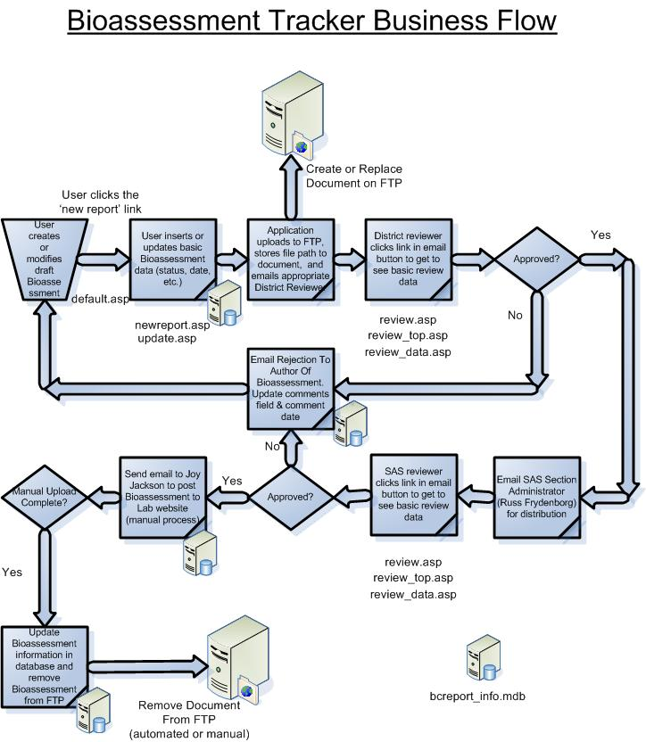

Contact Information

Executive Sponsor Heather Richie
Customer Contact Devan Cobb (will maintain source code after WITS delivery)
WITS Business Manager Jeffrey (Dan) Zimmerman

Application Developers (alphabetical order of first name):
Chia-Kwang Lin
Dongmei Zhao
Preethi Raghuramareddy

Pending Tasks for Final Deliverables:

- Beta Migration Setup – Modify e-mail recipients, table cleanup, ADMIN query & data, etc.
- Beta Testing – Coordinate with Customer. Resolve any issues that arise.
- Prod Migration Setup – Modify e-mail recipients, table cleanup, ADMIN query & data, etc.
- Prod Migration – Coordination with Customer.
- Close up Service Request.

Important Support and Maintenance Information

Single FTP Application File Storage Place
Currently there is only one bcReport application directory on the FTP server where the physical reports are stored. This directory and its sub-directories are shared throughout the DEV, Beta, and Prod platform. For the initial migration we can clean up the dummy files as well as the database dummy records, but this will become a problem after the application is migrate to the production. Staffs who maintain the application will have to find a way to distinguish the real report files versus the test ones if file transfer activities are triggered from different platforms.

Ideally we should have other strategies to keep test place for each platform independently. Until then, maintenance for the files on FTP directories must be carefully managed.

Global.asa The links to the application FTP directories are stored as Application variables in global.asa, in which also contains the database connections Session variables.

SMTP E-mail Feature
One reason the application has to be moved to the WaterwebDev for development was that the e-mail function did not work on the tlhdwfd server and no one seemed to know why. We do not know whether we will encounter the same problem when migrating to WaterwebBeta and WaterwebProd. If we do, then coordination with OTIS Service Desk is required.

Processing.asp Application e-mail functions are coded in processing.asp. In order to avoid flooding users with test e-mails during the development, the recipients of the e-mail notifications are sent to the developers as the newly added ADMIN group in the access database (bcreport.mdb). To setup the Beta and Prod environments, this file needs to be updated to enable e-mail sending to the correct recipients.

Modify Application Group Account Users:
The current users for the group accounts are listed in FTP_Group_Accounts.xlsx in the application Documentation folder.

Original OTIS Contact: Susan Miller
Future OTIS Contact: Service Desk

Current Group Accounts: bcReport
bcReport_template
bcReport_review
bcReport_QAQC
bcReport_post

Users can be added to or delete from the group list.

Modify Application FTP Folder Access
OTIS has created five group accounts and the folder shares granted to each.

The original request for group accounts was for setting up the application folder accessibilities based on application user roles (e.g. author, district reviewer, SAS reviewer, report publisher, and administrator). However, customer later agreed to standardize the report filename on the network. WITS then coded for application to centralize the FTP activities.

Users should access the report through the bcreport application instead of directly accessing the physical files from the network, but if they do, the server folder shares are still in effect.

The table below shows the current setup for the group user account and their share privileges.

Group Acct | FTP Directory | Folder Share
bcReport | \\publicfiles\PUBFDS\DEAR\status\bcreport | ADMIN to all bcreport & sub folders
bcreport_review | \\publicfiles\PUBFDS\DEAR\status\bcreport\review | Read
bcreport_QAQC | \\publicfiles\PUBFDS\DEAR\status\bcreport\QAQC | Read
bcreport_post | \\publicfiles\PUBFDS\DEAR\status\bcreport\post | Read
bcreport_templates | \\publicfiles\PUBFDS\DEAR\status\bcreport\templates  \\publicfiles\PUBFDS\DEAR\status\bcreport\review | Read  Read/Write

In the future if Customer decides to change the FTP folder settings. The responsible staff for maintaining the application can send request to OTIS Service Desk (see next sections)

Troubleshooting FTP:
OTIS email – 7/30/10 (Check communications folder for more details)

The DEP Service Desk requires more information for ticket number 2526. Please read the description below, and then contact the Service Desk by calling 850/245-7555 or by replying to this email message.
Description: I gave the iusr account permission to modify/write to the bcreport folder. Have someone test and see if this got it going. If it did you can close this one.
I don't know how the permissions were removed but make note that the floridadep\iusr_internetprod account needs modify permissions to the bcreport folder. Ideally it would be better to have the credentials passed via their code but that is something a developer would need to address...
DEP Service Desk
850/245-7555

Troubleshooting Database
Microsoft JET Database Engine error: Ensure that the bcreport.mdb is not opened on your desktop. The following permissions need to be added for the application to correctly write to the database file. Waterwebbeta\users must have modify and write functions. 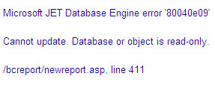
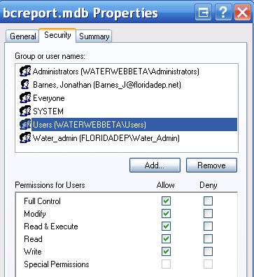

Converter Mswrd632 Error

This error shows from when bcreport application is trying to open certain file type (e.g. a docx file). Usually when you OK out the first appearance, it disappears from the current session.
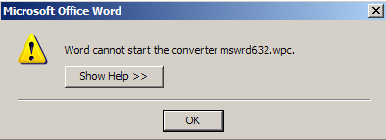

This error is caused by the security update for Windows XP, Windows 2000, and Windows Server 2003 on December 8, 2009. The website below provides the solution by editing the registry of local machine:
http://www.wincert.net/tips/microsoft-windows/windows-7/1786-word-cannot-start-the-converter-mswrd632wpc-error.html

Because of the fund constraints for the service request, we did not spend more time to do further research or test on the solution but ignoring it at this time.

