Bioassessment Report Tracker updates
Website: http://waterwebprod/bcreport/default.asp
Programming code: \\waterwebprod\www$\bcreport
FTP location for reports: \\publicfiles\PUBFDS\DEAR\status\bcreport

Generally the only things that need to be done with this application are keeping the people, templates, report examples updated and delete old versions of reports.
The drop-down lists for the Author and District found on http://waterwebprod/bcreport/newreport.asp as well as the addresses for the approval e-mails, are populated by tables in the Access database (bcreport) on the back end.

- To make updates to Authors and Supervisors go to the appropriate table in the database (bcreport.mdb)
  - “Users” table – contain Author information
    - update First Name, Last name, Author, E-mail, and District
  - “Supervisors” table – contains the Supervisor information
    - 1 supervisor per district
    - update E-mail, District, Name
  - Make sure your districts in the user table and the supervisor table match correctly
  - “QAQC” table – contains the people in Aquatic Ecology and Quality Assurance (AEQA) that review the reports after supervisor approval
    - update Name, E-mail, First and Last
  - “Info” table holds all the tracking information for the report – nothing to update
  - “Final_Approval” table contains the person that posts the reports to the web through the lab report upload system
    - update First Name, Last Name and E-mail
- If updates need to be made to the AEQA reviewers or the person posting through the lab page
  - These e-mails are hard coded in “processing.asp” and will need to be updated there (see below)
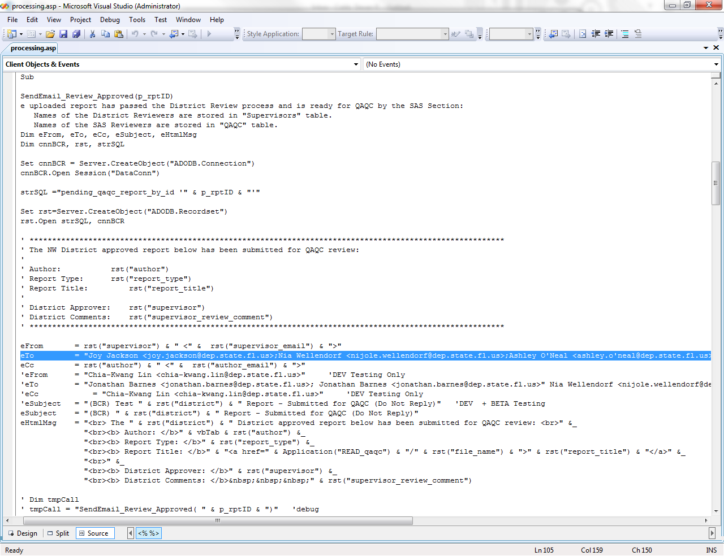
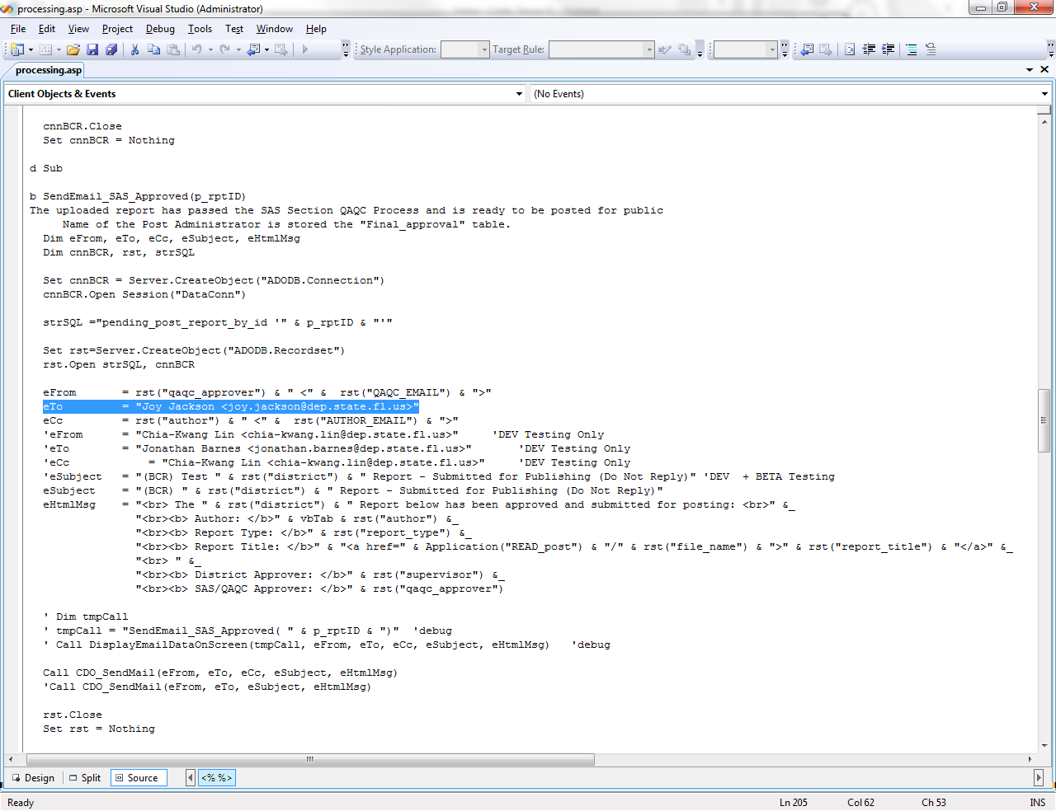
- To make updates to the report templates – the updated templates will come from AEQA.
  - Just put the updated report in the folder on the FTP site (yep! That’s it!) (\\publicfiles\PUBFDS\DEAR\status\bcreport\templates)
- To update the example reports:
  - Put the example report in pdf format in the report_examples subfolder (it’s in the same folder that the code is in).
  - Update the link information in newreport.asp
    - The blue is the link to the example report.
    - The black is what is seen on the webpage
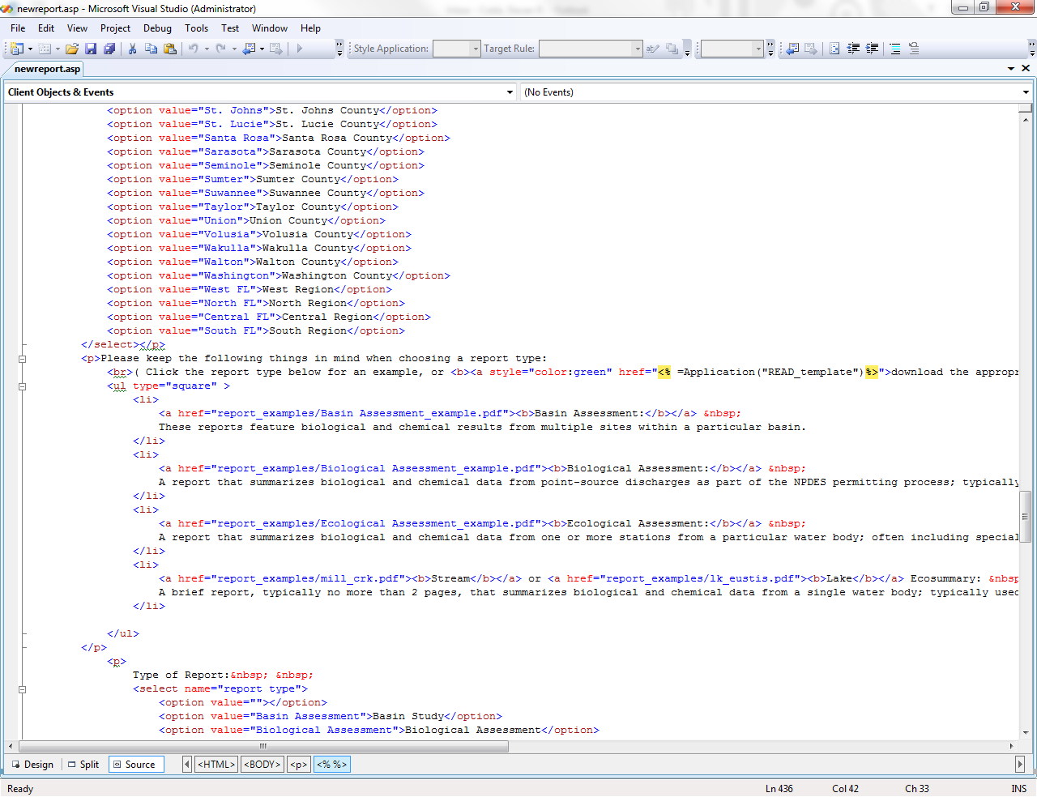

- To delete reports that have had corrected versions uploaded. (This request will come from the author of the report usually)
  - Go to the report status page (http://waterwebprod/bcreport/status.asp)
    - Hover over report that needs to be deleted
    - On the bottom of the screen a URL will appear - take note of the 3 digit number at the end of the URL. This is the report reference in the database and on the ftp site.
  - Go to the database (bcreport.mdb)
    - Delete the record of the report from the “Info” table that needs to be deleted – the number will match the 3 digit number at the end of the URL (this removes it from the status page.
  - Go to the ftp site
    - Open the appropriate folder (either “QAQC” or “Review” – this is determined by where it is located on the status page. If it has reached the “post” folder it already has supervisor and QA approval)
    - Delete the file with the 3 digit number that matches the URL id number.

- For contact updates and changes make sure you change all of the appropriate information (contacts.asp).
  - Name, section, e-mail and supervisor
  - In the screenshot below:
    - The green is commented out – the website ignores this text. In this case it was left in so I don’t have to retype the whole block of information, I’d just change the name, e-mail and double check the section and supervisor.
    - The black is what is seen on the webpage
    - The blue is the link to the e-mail address – when it is clicked from the webpage it will pop up an e-mail to send to the person
      - Make sure that both the blue e-mail address and the black e-mail address are updated and are the same (copy and paste errors are common on this page)
  - “tr” = row and “td”=cell in a table
