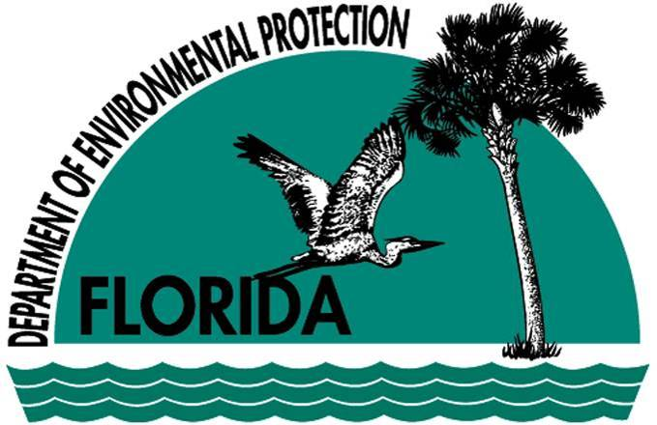

Biological Assessment of
Elevenmile Creek below
Klondike Landfill
Escambia County
FDEP File No. 0078440-004-SO
WACS ID No. 1690

Conducted July 1, 2013 and July 2, 2013

December 2013

Division of Environmental Assessment and
Restoration
Northwest District

Executive Summary

As requested by the Waste Management/Air Resources Cleanup Section, Department of Environmental Protection (DEP) staff from the Division of Environmental Assessment and
Restoration conducted water quality sampling and biological assessments of Elevenmile Creek on July 1, 2013 and July 2, 2013. The assessment locations are located above and below the Klondike Landfill which is located in Escambia County. The objectives of this study were to:
- Measure the existing water quality and biological health of Elevenmile Creek including a small tributary, “Klondike Branch” adjacent to and below the inactive cells of Klondike Landfill as compared to an upstream Control site; and
- Determine if disposal activities resulted in non-compliance with the biological integrity criterion as referenced in Rule 62-302.530 (10), Florida Administrative Code (F.A.C.).
The Klondike Landfill, which is no longer an active solid waste facility, was in operation from 1976-1982 and was classified as Class II (household and commercial solid waste). The post closure utilization of the facility is an outdoor archery range. Results from this study may be used to determine future permit revisions related to their continuing surface water and groundwater monitoring plan.
Three stream sites were sampled to assess the influence of the Klondike Landfill on water quality in Elevenmile Creek, one upstream and another downstream from the landfill. An additional site, “Klondike Branch” was selected as it was in close proximity to groundwater monitoring wells, utilized by the facility. The biological community was evaluated using the Stream Condition Index (SCI) at each location. Overall the biological community of Elevenmile Creek below the landfill was characterized as healthy, achieving a SCI score of Category 2 and therefore, is currently meeting expectations for a healthy well-balanced system. However, it should be noted that background conditions prior to disposal activities are not known for this system which would provide a true indication of anthropogenic impacts.
A review of ground water monitoring well data (sampled in 2012 by county personnel) revealed elevated levels of ammonia, iron, arsenic and total dissolved solids (TDS). Elevated iron levels were also measured in Elevenmile Creek (July 1, 2013) at the two assessment sites below the landfill. The iron levels at the Test Site and “Klondike Branch” measured 1,220 and 2,220 mg/L, respectively, exceeding the surface water quality criteria of 1,000 mg/L. All remaining metals analyses including arsenic were below their respective surface water quality standards (F.A.C. 62-302.530).
Total ammonia is normally very low in western Panhandle streams. Total ammonia was 2.5 times higher at the Test Site (0.28 mg/L) than the Control Site (0.11 mg/L) and 5.4 times higher than the Control at “Klondike Branch” (0.59 mg/L). All three locations including the Control site exceeded the State Numeric Nutrient Threshold of 0.67 mg/L for total nitrogen (TN) (Panhandle West), but note that the stream numeric nutrient criterion is achieved if the flora and fauna are healthy.
Introduction
This study was conducted to assess the influence of the Klondike Landfill on water quality and biological communities of Elevenmile Creek. Although healthy, well-balanced stream and river communities may be maintained with some level of human activity, such activities may result in waterbody degradation. Human stressors may include increased inputs of nutrients, sediments, metals and/or pesticides from watershed runoff, adverse hydrologic alterations, undesirable removal of habitat or riparian buffer vegetation, and introduction of nuisance (generally exotic) plants and animals. DEP has field methods to evaluate if human activities have resulted in the condition where a particular waterbody has exceeded water quality criteria of Chapter 62-302, F.A.C., including whether adverse impacts to biological communities have occurred. DEP water quality standards are designed to protect designated uses of the waters of the state (e.g., recreation, aquatic life support), and exceedances of these standards is associated with interference with the designated use. The SCI assesses how closely the macroinvertebrate community (e.g., aquatic insects, clams, and crayfish) of a stream resembles the macroinvertebrate community of an undisturbed or “reference” condition. The habitat assessment evaluates the availability and quality of habitat for macroinvertebrates, and can help diagnose the cause of a low SCI score.
Site Information and Sampling Locations
The landfill is located approximately 5 miles southeast of Beulah, 1 mile south of Highway 90, in Escambia County. Elevenmile Creek flows along the landfill’s western border and is located in the Gulf Coast Flatwoods, Southern Coastal Plains 75a Ecoregion (Figure 1). Elevenmile Creek is a fourth order stream at this location and for more than 70 years received pulp mill effluent until the end of 2012. Biological background conditions are not known prior to landfill activities or industrial pulp mill waste discharge; therefore a SCI Control site located 2 miles upstream was selected as a comparison to the SCI Test site (Figures 2 & 3). The Test Site is located below the southwestern property line on Elevenmile Creek and downstream from the permitted surface water location SW-2. An additional assessment site, “Klondike Branch,” is located below 3 active monitoring wells where elevated TDS, ammonia, iron and arsenic levels were measured in 2012; see Table 1 for site coordinates.

Methods
This site was assessed on July 1 and 2, 2013 by the DEP’s Northwest District Office. Surface water and biological samples were collected following DEP Standard Operating Procedures (SOPs, see http://www.dep.state.fl.us/water/sas/sop/sops.htm for details). Sampling and analyses met DEP quality assurance/ quality control standards (see http://www.dep.state.fl.us/water/sas/qa/index.htm). The SCI was conducted per DEP SOP FS7420 and calculated per DEP SOP LT7200. The SCI consists of collecting macroinvertebrates via 20 D-frame dip-net sweeps (0.5 m in length) in the most productive habitats in a 100 m reach of the stream. The organisms are sub-sampled, and identified to the lowest practical taxonomic level. The SCI is composed of ten metrics (Table 3), eight of which decrease in response to human disturbance, with two metrics (% very tolerant and % dominant) increasing in response to human disturbance. According to DEP SOP LT 7000, the SCI score ranges and categories are: (68-100) Exceptional; (35-67) Healthy; and (0-34) Impaired. EPA approved biological health assessment criteria state that a site is considered to meet designated uses if the average of the two most recent SCI scores is 40 or higher and neither of those scores is less than 35. The Stream and River Habitat Assessment was conducted per DEP SOP FT 3100. The Habitat Assessment is a rapid field method in which a sampler scores eight in-stream and riparian components to estimate the influence of habitat factors on the resident aquatic organisms. Habitat Assessment scores range from 11-160 and overall habitat quality is assigned to one of four categories: Optimal (120-160 points), Suboptimal (80-119 points), Marginal (40-79 points), and Poor (11-39 points).

Results and Discussion
Water Chemistry
Field measurements were within normal ranges of western Panhandle streams; however, conductivity was slightly elevated ranging from 57 µmhos/cm at the Control site to 74 µmhos/cm at the Test site. Turbidity measured at the Test Site was 1.2 NTU higher than the control and 7.5 NTU higher at “Klondike Branch” and therefore is within turbidity standards (≤29 NTU above natural background conditions). Iron levels were elevated in all three sampling locations including the Control site (840 μg/L) but exceeded water quality criteria of 1,000 μg/L at the Test site and “Klondike Branch.” All arsenic concentrations (0.46 - 0.82 μg/L) were low measuring between the method detection limit (MDL – 0.25 μg/L) and laboratory practical quantitation limit (PQL – 1.0 μg/L). Mercury levels were below the water quality criteria of 0.012 μg/L, ranging from 0.0024 μg/L at the Control site to 0.0052 μg/L and 0.0090 μg/L at the Test site and “Klondike Branch,” respectively. Unionized ammonia values were elevated at all locations but were below the Class III water quality criteria of 0.02 μg/L. Total nitrogen (TN), however exceeded the State Numeric Nutrient Threshold of 0.67 mg/L for TN (Panhandle West), See Table 2.

Habitat Assessment
The Habitat Assessment sites for all three locations were similar, scoring in the mid-suboptimal range. Five productive habitats may be present in Florida streams; snags or woody material, leaf pack, submersed roots, submersed aquatic vegetation and rocks. It is considered a major productive habitat when ≥ 2 m² is present and a minor habitat when ≤ 2 m² is present within the 100 m assessment site. A diversity of habitat is the key to a more diverse aquatic macroinvertebrate community. Two productive habitats were observed at the Test site (snags & leaf pack) and Control site (snags & roots) giving both sites a marginal score for substrate diversity. There were also two major habitats on “Klondike Branch”, snags and roots. Unstable banks can cause sand and silt smothering making habitat unavailable for aquatic insects and fish. Moderate to severe sand smothering was observed at the Control and Test sites resulting in a marginal score for substrate availability (Figure 4). Severe silt smothering was observed in “Klondike Branch” (Figure 5). In addition, bank stability for all three locations scored in the sub-optimal category. Water velocities scored in the optimal range at all three locations. Fish and sensitive aquatic insects require sufficient water velocity to maintain high dissolved oxygen concentrations. Riparian zone vegetation quality received a marginal rating as several exotic species were observed (Figure 6).
Stream Condition Index
The SCI score for all three locations on Elevenmile Creek was scored in the Healthy Category; see Appendix A for a brief explanation of these results. The Test site SCI (43A) scored 23% lower than that of the Control site SCI (56A). There was a 50% reduction of taxa collected at the Test site (27) than the Control site (48). In addition, only one species of mayfly was collected at the Test site compared to 5 species at the Control site. It should be noted that stoneflies, a sensitive taxa normally found in Panhandle streams, were absent from all three sampling sites. “Klondike Branch” scored similar to the control with a 55A (see Table 4).

Conclusions
Although total nitrogen samples exceeded the regional nutrient threshold, an imbalance of flora and fauna was not observed, indicating compliance with stream nutrient criteria. Aquatic plants totaled only 0.1% productive minor habitat at the Test site and 0.2% productive minor habitat at the Control site. It should be noted the aquatic plant community were partially composed of invasive exotic species, Colocasia esculenta (wild taro), Hygrophila polysperma (East Indian hygrophila) and Alternanthera philoxeroides (alligator weed), Figure 7. Although algae mats were observed on some snags and leaf packs, growth did not appear to be excessive at this location. Elevated iron concentrations also did not appear to have an impact to the aquatic benthic community.

Tables
Table 1: Sample Station Coordinates

Site | Latitude | Longitude
Control | 30˚ 29’ 54.8” | 087˚ 20’ 08.6”
Test | 30˚ 28’ 46.4” | 087˚ 20’ 48.3”
“Klondike Branch” | 30˚ 29’ 0.8” | 087˚ 20’ 44.3”

Table 2. Physical/Chemical Water Quality Values for Klondike Landfill Facility study sites collected July 01, and July 2, 2013. SCI score metric Panhandle West.

 | Control | Test | “Klondike Branch” | Applicable Class III Water Quality Criteria
SCI Score | 56A | 43A | 55A
Habitat Score | 92 | 95 | 101
Temperature Field (˚C) | 22.42 | 23.25 | 26.6
Specific Conductance Field (µmhos/cm) | 57 | 65 | 74 | Shall not be increased more than 50% above background or to 1275, whichever is greater.
Dissolved Oxygen Field (mg/L) | 7.59 | 6.96 | 6.89
Dissolved Oxygen Field (%) | 87.5 | 81.8 | 85.8 | No more than 10% of the daily average percent DO saturation values shall be below 67%
pH Field | 6.40 | 6.96 | 6.41
Turbidity [Nephelometric Turbidity Units (NTU)] | 3.5 A | 4.7 | 11 | ≤29 above natural background conditions
TDS (mg/L) | 41 | 48 | 48
TSS (mg/L) | 4 I | 6 | 11
Organic Carbon (mg C/L) | 2.7 | 3.2 | 3.5
Biochemical Oxygen Demand-5 Day (mg/L) | 0.99 I | 1.2 I | 1.0 I
Chlorophyll-a Corrected (μg/L) | 1.1 I | 1.8 I | 2.0 I
Total Phosphorus (mg/L) | 0.014 | 0.019 | 0.029 | * ≤ 0.06
Ortho-Phosphate (mg P/L) | 0.004 I | 0.010 I | 0.006 I
Nitrate+Nitrite (mg/L) | 0.58 | 0.53 | 0.52
Total Ammonia (mg/L) | 0.11 | 0.28 | 0.59
Total Kjeldahl Nitrogen (mg/L) | 0.28 | 0.46 | 0.80
Total Nitrogen (mg/L) | 0.97 | 1.27 | 1.91 | * ≤ 0.67
Un-ionized Ammonia  (mg/L as NH₃) | 0.000158 | 0.00155 | 0.001166 | ≤ 0.02
Sulfate  (mg SO4/L) | 2.4 A | 2.7 | 2.5
Chloride (mg Cl/L) | 7.0 A | 7.4 | 8.1
Fluoride (mg F/L) | 0.035 U | 0.035 U | 0.035 U
Color (PCU) | 31 A | 38 A | 41
Alkalinity (mg CaCO3/L) | 8.9 | 11 | 15
Calcium (mg/L) | 3.76 | 4.27 | 4.41
Iron (ug/L) | 840 | 1220 | 2220 | ≤ 1000
Magnesium (mg/L) | 1.26 | 1.38 | 1.56
Potassium (mg/L) | 0.65 | 0.82 I | 1.0 I
Sodium (mg/L) | 4.9 | 4.9 | 5.4
Zinc (mg/L) | 5.0 U | 5.0 U | 5.0 U
Arsenic (μg/L) | 0.46 I | 0.58 I | 0.82 I | ≤ 50
Cadmium (μg/L) | 0.050 U | 0.050 U | 0.050 U
Chromium (μg/L) | 0.30 U | 0.31 I | 0.57 I
Copper (μg/L) | 0.77 I | 1.71 | 0.67 I
Lead (μg/L) | 0.43 I | 0.94 | 0.52 I
Nickel (μg/L) | 0.85 I | 1.18 | 0.94 I
Silver (μg/L) | 0.025 U | 0.033 I | 0.25 U
Mercury (μg/L)  [EPA 1631E MDL 0.1ng/L] | 0.0024 | 0.0052 | 0.0090 | .012
Fecal Coliform (MF) CFU/100 ml | 149 | 136 | 96 | MPN or MF counts shall not exceed a monthly average of 200, nor exceed 400 in 10% of the samples, nor exceed 800 on any one day. Monthly averages shall be expressed as geometric means based on a minimum of 5 samples taken over a 30 day period.
* Panhandle West nutrient region. U – Analyzed for but not detected. A – Mean of two or more determinations. I – Reported value is between the laboratory method detection limit and the laboratory practical quantitation limit.
Values do not comply with Class III Fresh water quality standards, 62-302, F.A.C.

Table 3. Stream Condition Index metric score results, Elevenmile Creek above and below Klondike Landfill, July 1 and 2, 2013. Note: results are an average of 2 replicates except Ephemeroptera, Trichoptera taxa and Total Taxa.

Stream Condition Index Metric | Control Site | Test Site | “Klondike Branch”
Total taxa | 48 | 27 | 42
Ephemeroptera taxa | 5 | 1 | 5
Trichoptera taxa | 7 | 7 | 6
% Filterer | 26 | 29 | 38
Long-lived taxa | 1 | 0 | 1
Clinger taxa | 6 | 6 | 6
% Dominance | 26 | 27 | 34
% Tanytarsini | 6 | 1 | 4
Sensitive taxa | 7 | 6 | 7
% Very tolerant | 3 | 1 | 2

Figures
Figure 1. Map of study sight and sampling locations on Elevenmile Creek and Klondike Landfill in Escambia County.
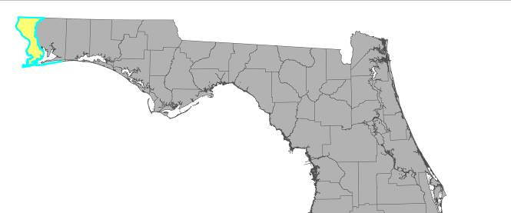
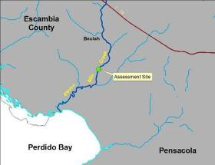
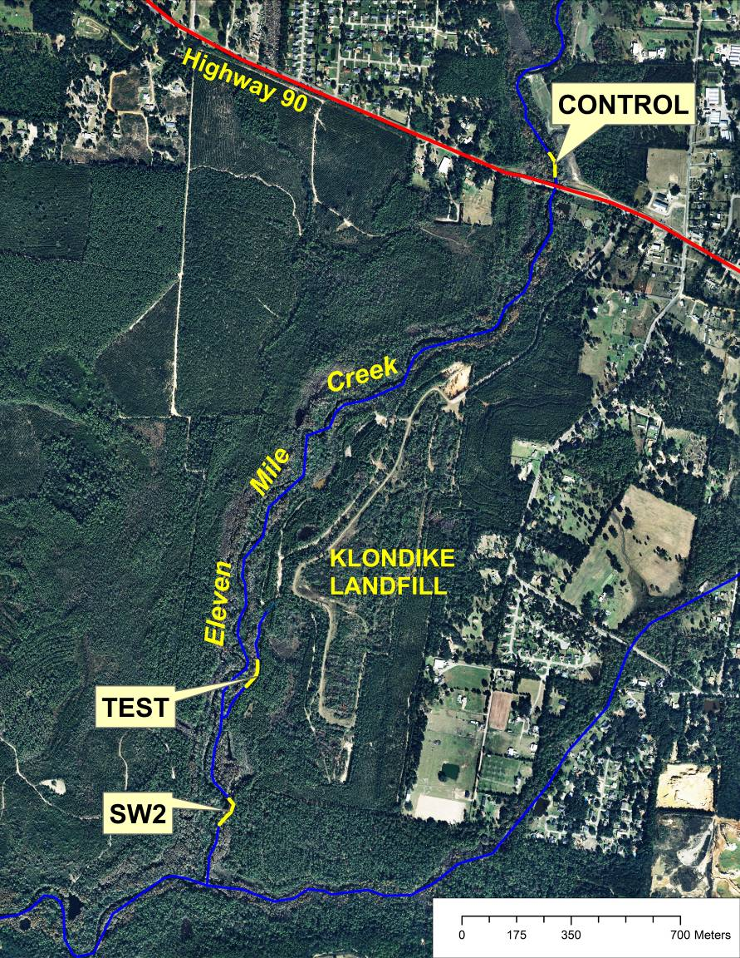
Figure 2. SCI location of Elevenmile Cr below Klondike Landfill (Test), July 1, 2013.
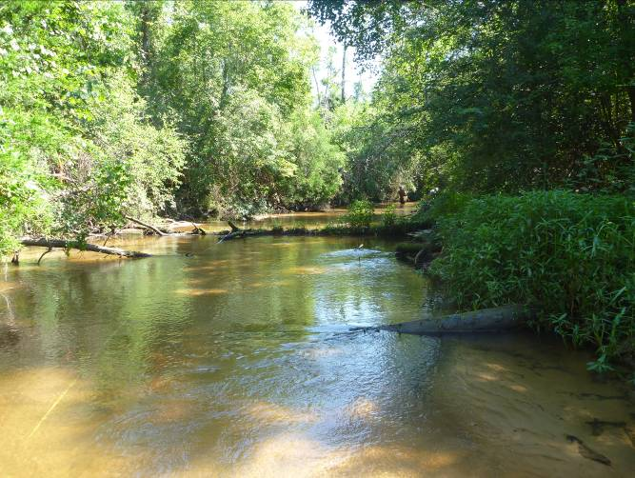
Figure 3. SCI location of Elevenmile Cr above Hwy. 90 (Control), July 2, 2013.
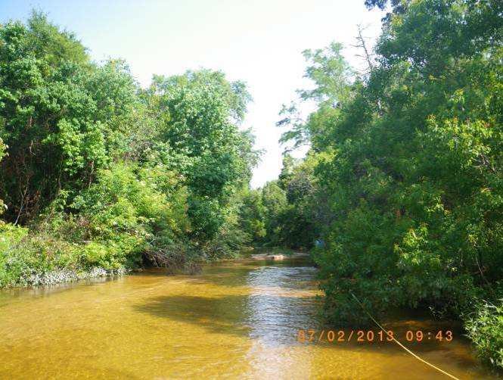
Figure 4. Elevenmile Creek SCI Test site July 1, 2013, showing partially buried log.
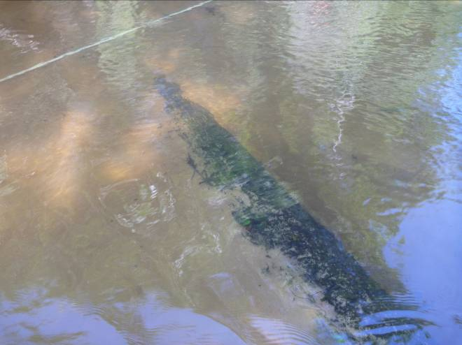
Smothered log

Figure 5. SCI location of “Klondike Branch” below monitoring wells, July 1, 2013. 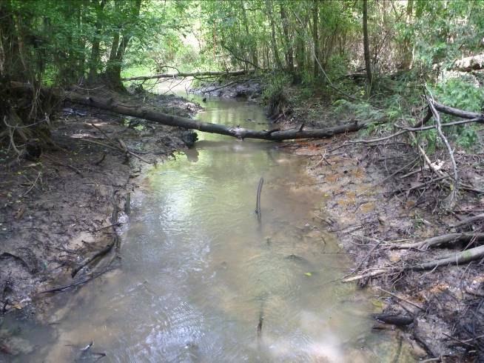
Figure 6. Groundwater iron leachate down gradient of Klondike landfill on “Klondike Branch”, July 1, 2013.
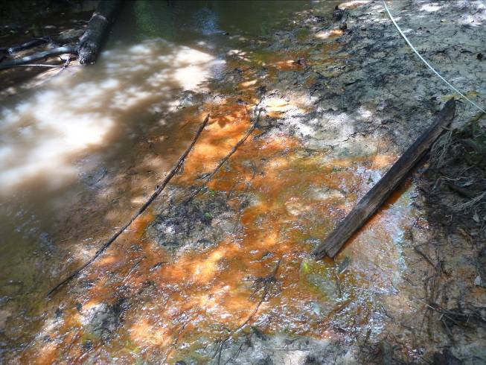
Figure 7. Wild taro (Colocasia esculenta) at the Control site, July 2, 2013.
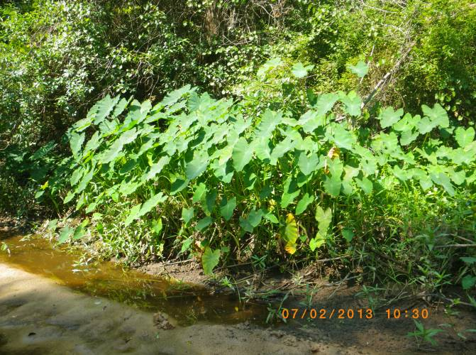

Literature Cited
Florida Department of Environmental Protection. Standards and Assessment Section Bureau of Assessment and Restoration Support DEP-SAS-003/1. 2011. Development of Aquatic Life Use Support Attainment Thresholds for Florida’s Stream Condition Index and Lake Vegetation Index
http://www.dep.state.fl.us/water/bioassess/docs/attainment-thresholds-sci-and-lvi.pdf

Appendix A
Table LT 7200-2 Determination of Biological Indices

SCI Score | SCI 2007 Category Name | Example Description
68–100 | Category 1  (“exceptional”) | Higher diversity of taxa than for Category 2, particularly for Ephemeroptera and Trichoptera; several more clinger and sensitive taxa than found in Category 2; high proportion for Tanytarsini; few individuals in the dominant taxon; very tolerant individuals make up a very small percentage of the assemblage.
48–67 | Category 2  (“healthy”) | Diverse assemblage with 30 different species found on average; several different taxa each of Ephemeroptera, Trichoptera, and long-lived and, on average, 5 unique clinger and 6 sensitive taxa routinely found; small increase in dominance by a single taxon relative to Category 1; very tolerant taxa represent a small percentage of individuals, but noticeably increased from Category 1.
35-47 | Category 2  (“healthy”) | Diverse assemblage with 30 different species found on average; several different taxa each of Ephemeroptera, Trichoptera, and long-lived and, on average, 5 unique clinger and 6 sensitive taxa routinely found; small increase in dominance by a single taxon relative to Category 1; very tolerant taxa represent a small percentage of individuals, but noticeably increased from Category 1.  Note: any score of 35 and above is not impaired using the current interpretation categories.
0–34 | Category 3  (“impaired”) | Notable loss of taxonomic diversity; Ephemeroptera, Trichoptera, long-lived, clinger, and sensitive taxa uncommon or rare; half the number of filterers than expected; assemblage dominated by a tolerant taxon; very tolerant individuals represent a large proportion of the individuals collected.

Appendix B
Macroinvertebrate Taxa List
Control
STORET station | 33010013
Sample date | 7/2/2013
BenID | 42619
Order | Taxon Name | Rep 1NCounted | Rep 2NCounted
Acariformes | Hygrobates | 0 | 1
Amphipoda | Hyalella azteca | 14 | 35
 | Crangonyx | 1 | 1
Bivalvia | Sphaeriidae(mollusca) | 7 | 2
Coleoptera | Stenelmis | 40 | 28
 | Dubiraphia vittata | 2 | 2
 | Microcylloepus pusillus | 1 | 0
 | Ancyronyx variegatus | 4 | 4
Diptera | Chironomidae | 1 | 1
 | Ablabesmyia hauberi | 0 | 1
 | Ablabesmyia mallochi | 3 | 1
 | Labrundinia | 2 | 0
 | Procladius | 0 | 3
 | Cricotopus bicinctus | 0 | 1
 | Cryptochironomus | 0 | 1
 | Dicrotendipes | 0 | 1
 | Paracladopelma | 1 | 0
 | Saetheria hirta | 0 | 1
 | Stenochironomus | 1 | 0
 | Tribelos jucundum | 2 | 2
 | Rheotanytarsus pellucidus | 0 | 1
 | Palpomyia/bezzia grp. | 0 | 1
 | Thienemannimyia grp. | 5 | 2
 | Dicrotendipes sp. a epler | 0 | 1
 | Polypedilum illinoense grp. | 0 | 1
 | Rheotanytarsus exiguus grp. | 5 | 6
 | Tanytarsus sp. c epler | 1 | 1
 | Cricotopus or orthocladius | 0 | 1
 | Tvetenia tshernovskii | 4 | 4
Ephemeroptera | Baetis intercalaris | 1 | 1
 | Caenis | 1 | 1
 | Acerpenna pygmaea | 1 | 6
 | Labiobaetis propinquus | 2 | 0
 | Pseudocentroptiloides usa | 0 | 1
Gastropoda | Planorbidae | 2 | 0
 | Physa | 0 | 2
Isopoda | Caecidotea | 0 | 2
Lepidoptera | Petrophila | 1 | 0
Odonata | Gomphus dilatatus | 0 | 1
 | Neurocordulia molesta | 1 | 0
 | Enallagma | 2 | 0
Oligochaeta | Tubificidae | 1 | 1
 | Eclipidrilus | 1 | 0
Platyhelminthes | Platyhelminthes | 1 | 2
Trichoptera | Chimarra | 0 | 1
 | Cheumatopsyche | 14 | 5
 | Hydropsyche mississippiensis | 16 | 13
 | Hydroptila | 0 | 1
 | Triaenodes | 0 | 1
 | Oecetis | 0 | 1
 | Nectopsyche candida | 3 | 2

Test
STORET station | 33010151
Sample date | 7/1/2013
BenID | 42649
Order | Taxon Name | Rep 1NCounted | Rep 2NCounted
Acariformes | Hygrobates | 2 | 0
Amphipoda | Amphipoda | 1 | 0
 | Hyalella azteca | 4 | 9
Coleoptera | Dineutus | 2 | 1
 | Scirtidae | 0 | 1
 | Elmidae | 21 | 21
 | Stenelmis | 20 | 23
 | Ancyronyx variegatus | 5 | 4
Diptera | Simulium | 3 | 2
 | Atrichopogon | 3 | 6
 | Ablabesmyia mallochi | 2 | 0
 | Pentaneura inconspicua | 1 | 1
 | Tribelos jucundum | 1 | 0
 | Hemerodromia | 2 | 3
 | Thienemannimyia grp. | 3 | 0
 | Rheotanytarsus exiguus grp. | 0 | 2
 | Cricotopus or orthocladius | 0 | 2
 | Tvetenia tshernovskii | 9 | 10
Ephemeroptera | Baetidae | 5 | 7
 | Acerpenna pygmaea | 6 | 3
Heteroptera | Mesovelia | 0 | 2
Odonata | Gomphidae | 1 | 1
 | Coenagrionidae | 6 | 1
Trichoptera | Trichoptera | 1 | 0
 | Chimarra | 0 | 2
 | Hydropsychidae | 2 | 0
 | Cheumatopsyche | 39 | 35
 | Hydropsyche | 1 | 0
 | Hydroptila | 7 | 6
 | Oecetis persimilis | 2 | 1
 | Oecetis georgia | 0 | 2
 | Nectopsyche | 5 | 4

“Klondike Branch”
STORET station | 33010152
Sample date | 7/1/2013
BenID | 42658
Order | Taxon Name | Rep 1NCounted | Rep 2NCounted
Acariformes | Hygrobates | 0 | 2
 | Acariformes | 0 | 1
Amphipoda | Amphipoda | 2 | 0
 | Hyalella azteca | 3 | 2
 | Crangonyx | 1 | 0
Bivalvia | Sphaeriidae(mollusca) | 0 | 1
Coleoptera | Dineutus | 2 | 5
 | Scirtidae | 2 | 0
 | Elmidae | 21 | 12
 | Stenelmis | 33 | 30
 | Dubiraphia vittata | 0 | 1
 | Ancyronyx variegatus | 1 | 0
Decapoda | Cambaridae | 1 | 0
Diptera | Simulium | 10 | 13
 | Atrichopogon | 1 | 0
 | Chironomidae | 2 | 1
 | Ablabesmyia mallochi | 0 | 1
 | Stenochironomus | 1 | 3
 | Tribelos jucundum | 5 | 1
 | Paratanytarsus | 0 | 1
 | Rheotanytarsus pellucidus | 2 | 1
 | Thienemannimyia grp. | 1 | 6
 | Polypedilum scalaenum grp. | 0 | 1
 | Polypedilum illinoense grp. | 1 | 2
 | Rheotanytarsus exiguus grp. | 5 | 2
 | Tvetenia tshernovskii | 3 | 3
Ephemeroptera | Baetidae | 2 | 1
 | Caenis | 0 | 1
 | Acerpenna pygmaea | 2 | 2
 | Labiobaetis propinquus | 0 | 1
 | Maccaffertium exiguum | 1 | 0
 | Maccaffertium smithae | 1 | 0
Isopoda | Caecidotea | 6 | 3
Nemertea | Prostoma | 0 | 1
Odonata | Boyeria vinosa | 0 | 1
 | Libellulidae | 0 | 1
 | Coenagrionidae | 0 | 1
 | Enallagma | 2 | 0
Oligochaeta | Tubificidae | 1 | 1
Platyhelminthes | Platyhelminthes | 0 | 1
Trichoptera | Chimarra | 1 | 1
 | Hydropsychidae | 0 | 3
 | Cheumatopsyche | 28 | 47
 | Oecetis georgia | 1 | 0
 | Nectopsyche exquisita | 3 | 4
 | Nectopsyche pavida | 0 | 1
 | Oecetis inconspicua cmplx. | 1 | 1

