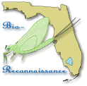
STREAM ECOSUMMARY
Coon Camp Branch, January 31, 2006
FDEP conducted biological monitoring at Coon Camp Branch in Okaloosa County on January 31, 2006 to assess closure of North River Road (Figure 1). This BioRecon monitoring documented stream restoration activities by the Blackwater River State Forest (BRSF) staff in their attempts to close a highly eroded logging road used for recreational off-road driving (Figures 1 and 2).
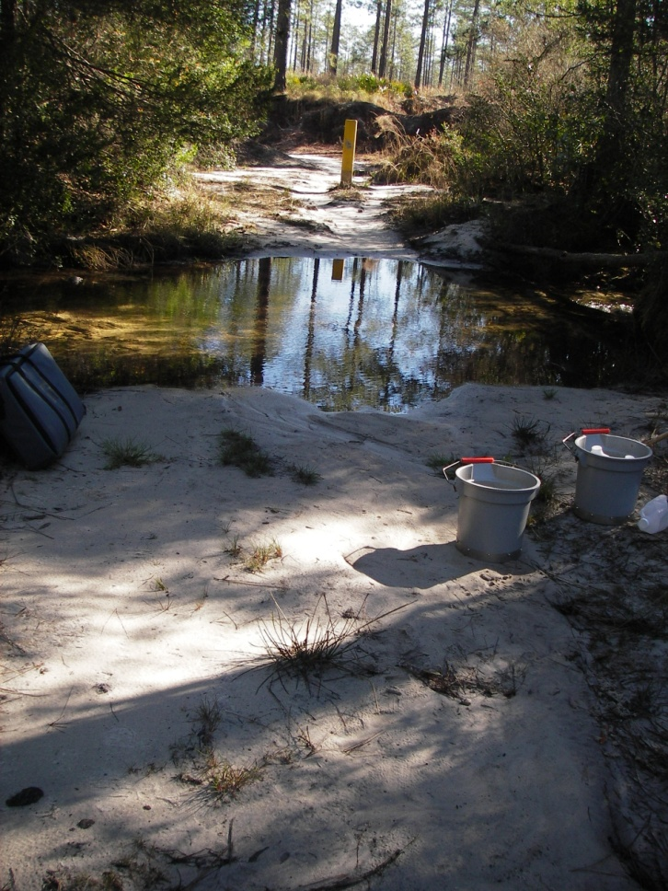

Figure 1. BioRecon Index site for Coon Camp Branch below North River Road on 01/31/2006.

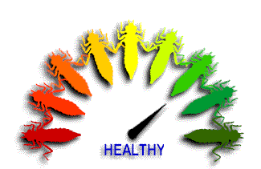
Overall, the macroinvertebrate community and water quality data indicated that the stream had improved after restoration activities and now met expectations for a healthy, well-balanced stream. A pre-road closure BioRecon was taken on August 5, 1999 did not meet standards for healthy well-balance fish and wildlife population, an Ecosummary report was written (for a copy of this and other Ecosummary reports contact Devan Cobb Devan.R.Cobb@dep.state.fl.us).
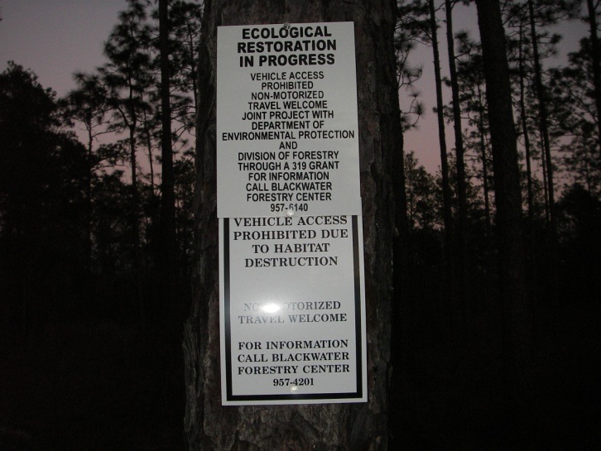Figure 2. North River Road Closure sign at Coon Camp Branch on 01/31/2006.
Background
Although healthy, well-balanced stream and river communities may be maintained with some level of human activity, such activities may result in waterbody degradation. Human stressors may include increased inputs of nutrients, sediments, and/or pesticides from watershed runoff, adverse hydrologic alterations, undesirable removal of habitat or riparian buffer vegetation, and introduction of nuisance (generally exotic) plants and animals. FDEP has methods to evaluate if human activities have resulted in the condition where a particular waterbody has exceeded water quality criteria (Chapter 62-302, Florida Administrative Code), including whether adverse impacts to biological communities have occurred. FDEP water quality standards are designed to protect designated uses of the waters of the state (e.g., recreation, aquatic life
support), and exceedances of these standards is associated with interference with the designated use. The Biological Reconnaissance (BioRecon) assesses how closely the macroinvertebrate community (e.g., aquatic insects, clams, and crayfish) of a stream resembles the macroinvertebrate community of an undisturbed or “reference” condition. The stream and river habitat assessment evaluates the availability and quality of habitat for macroinvertebrates, and can help diagnose the cause of a low BioRecon score.

Methods
This stream was sampled on 01/31/2006 by the FDEP Northwest District Office following FDEP Standard Operating Procedures (SOPs, see http://www.dep.state.fl.us/water/sas/sop/sops.htm for details). Sampling and analyses met FDEP quality assurance/ quality control standards (see http://www.dep.state.fl.us/water/sas/qa/index.htm)
The BioRecon was sampled per FDEP SOP FS7410 and calculated per FDEP BioRecon_2004 scoring (FDEP SOP version LT7100). BioRecon is a rapid community based biological assessment of stream health using benthic macroinvertebrates sampled via four sweeps of a D-frame dip net, with organisms (excluding worms, midges, and mites) identified to the lowest practical taxonomic level. The BioRecon_2004 is composed of six metrics, which decrease in response to human disturbance. These include Total # of Taxa, Ephemeroptera Taxa, Trichoptera Taxa, Long-Lived Taxa, Clinger Taxa, and Sensitive Taxa. The BioRecon rating categories were: “Pass” 6-10 score, “Fail” 0-5. The Stream and River Habitat Assessment was conducted per FDEP SOP FT 3100. The Habitat Assessment is a rapid field method in which a sampler scores eight in-stream and riparian components to estimate the influence of habitat factors on the resident aquatic organisms. Habitat Assessment scores range from 11-160 and overall habitat quality is assigned to one of four categories: Optimal (120-160 points), Suboptimal (80-119 points), Marginal (40-79 points), and Poor (11-39 points).
Site Information
Coon Camp Branch (STORET #33030105) at the bioassessment site (Figure 3) (N 30º 42' 8.8 " W -86º 51' 9.2") is a second order stream. It is a tributary to the Blackwater River, which is classified as Outstanding Florida Waters (OFW).under the State Water Quality Standards. The Blackwater River flows into Pensacola Bay via The Blackwater and East Bays. The Yellow River Marsh along Blackwater Bay is a State Aquatic Preserve and also listed as an OFW as is the Blackwater River State Park located about 1 mile downstream of Coon Camp Branch. The site is located about 11 miles northeast of Milton. Coon Camp Branch drains the southern pine plains and hills of subecoregion. 65f. A FDEP Section 319 grant to the Florida Division of Forestry funded closing and repairing roads to prevent sediment runoff from affecting streams in the BRSF watershed. http://water.epa.gov/polwaste/nps/success319/Section319III_FL.cfm#2. Completion of the restoration work was delayed from 1999 to 2006 by willful damage by locals and BRSF management changes. Previous attempts to do a post-restoration BioRecon had to be aborted because road barriers were destroyed and bypassed. The erosion-causing vehicle traffic across the streambed continued into the summer of 2005 (Figure 4). During January 31, 2006 it was observed that concrete posts were pulled out and berms destroyed on the western stream approach by four wheel drive vehicles. However, only the recent evidence of horse traffic was observed in the stream (Figure 5).
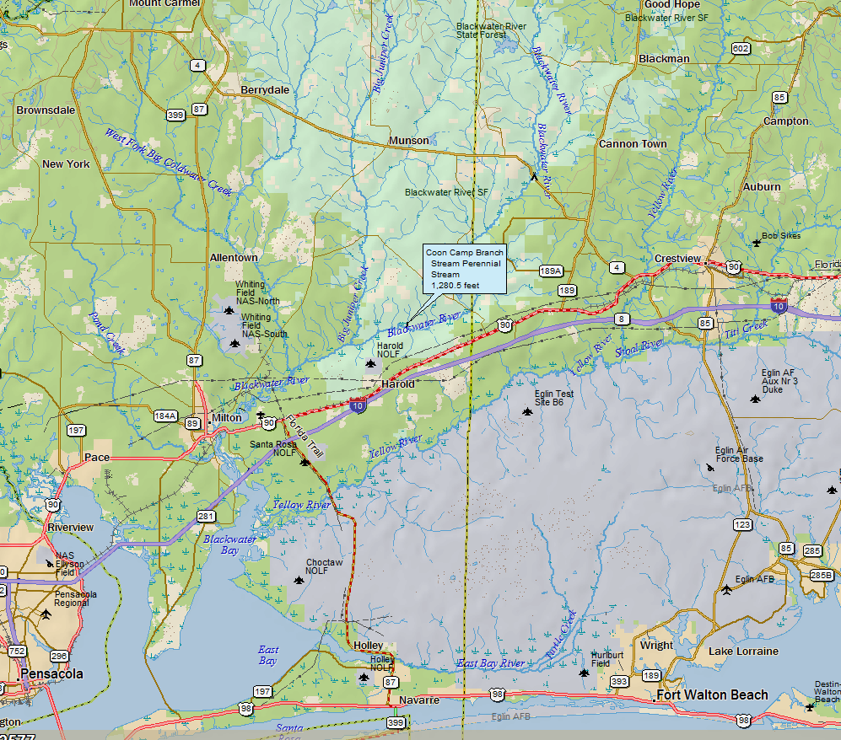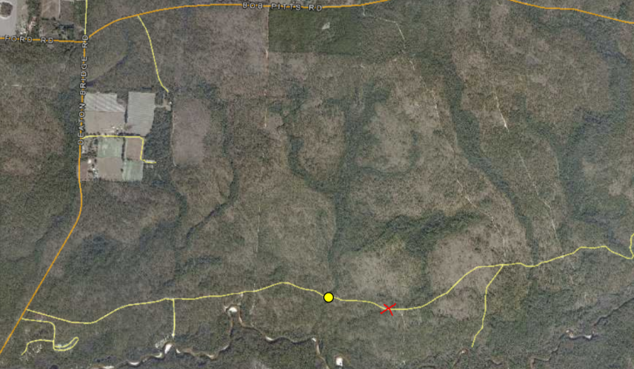Figure 3. BioRecon Location of Coon Camp Branch (yellow dot) Blackwater River State Forest (shaded blue on topography map) in Okaloosa County, aerial flight dates November 2006.
Florida Natural Area Inventory (FNAI) listed species of the area include the Diminutive Clubtail Gomphus westfalli, and Stonefly Leuctra cottaquilla found in the adjacent Wolftrap Branch. The FNAI listed Stonefly Perlinella zwicki, Zigzag Blackwater River Caddisfly Agarodes ziczac, Panhandle Lily Lilium iridollae, White-top Pitcherplant Sarracenia leucophylla, Spoon-leaved Sundew Drosera intermedia. Florida Flame Azalea Rhododendron austrinum Gopher Tortoise Gopherus polyphemus and Red-cockaded Woodpecker Picoides borealis are found in the local area. Pescador's Bottle-Cased Caddisfly Oxyethira pescadori, Peters' Caddisfly Cheumatopsyche Cheumatopsyche petersi, Floridian Finger-net Caddisfly Chimarra florida, Little-entrance Oxyethiran Microcaddisfly Oxyethira janella, Elerob's Microcaddisfly Oxyethira elerobi, and Mayfly Baetisca escambiensis were found at the Blackwater River State Park. All these FNAI listed species could be expected to be found in the Coon Camp Branch watershed. 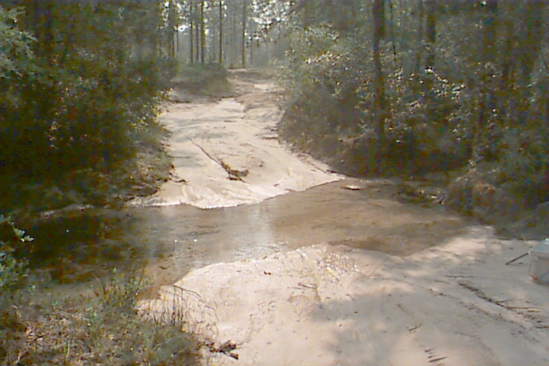 Figure 4. Coon Camp Branch un-stabilized road approach 07/05/2005 with clay fill material.
Results
Water Quality
The water quality parameter results were typical of sand and gravel Panhandle streams (Table 1). The relatively warm winter water temperature (15.23°C) reflected the influence of groundwater base flow conditions. The moderate pH (6.32 SU) and very low specific conductance (5 µmhos/cm) were typical of the quartz sand and gravel aquifer in the western Florida Panhandle. The percent dissolved oxygen saturation (88) at the slower flowing road crossing was slightly lower than the typical 90-100% found in fast flowing Panhandle streams. However, just below the crossing, an excellent thalweg stream velocity (0.6meters/ second) provided near maximum re-aeration. A small amount of oxygen demand was exerted by horse droppings and the fine organic particulate matter (FPOM) accumulated at the road crossing (Figure 5). The FPOM sediment source should disappear as vegetation grows over the denuded road surface approaches.

Table 1. Water quality results at Coon Camp Branch below North River Road on 01/31/2006.
Analyte | Result | Applicable Class III Water Quality Criteria
Field Temperature (°C) | 15.23
Field pH (SU) | 6.32
Field Dissolved Oxygen (mg/L) | 8.87 | >5.0
% Dissolved Oxygen Saturation | 88.2 | 67
Field Specific Conductance (µmhos/cm) | 5 | Not to exceed 50% of background or 1275 μmhos/cm

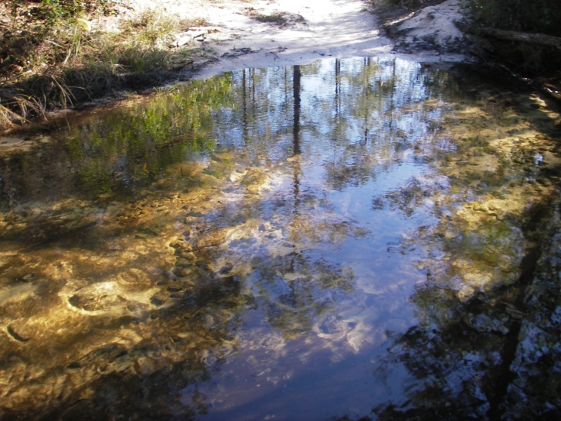
Figure 5.. Horseshoe prints and filamentous algae growing horse droppings at road crossing 01/31/2006.

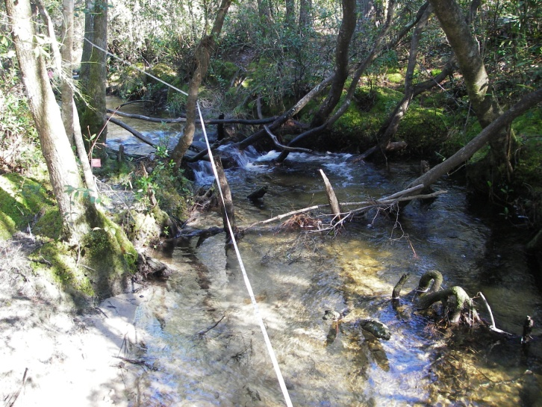Figure 6. Coon Camp Branch healthy riffle habitat 01/31/2006.
Habitat Assessment
The stream habitat assessment scored 128 in the optimal range (Figure 6). This was a significant improvement over the 73 marginal rating of the 1999 stream habitat score. Substrate Diversity (four productive habitats), Substrate Availability (60%), Water Velocity (0.6 meters/second), and Artificial Channelization, were optimal. Habitat Smothering (30%), Bank Stability, and Riparian Zone Vegetation Quality (remnant narrow Atlantic white cedar forest strip along the riparian zone) was suboptimal. The Riparian Buffer Zone Width was marginal (riparian zone burned, killing the Atlantic white cedar forest to within 4 meters of the stream. Note the orange colored clay road fill material brought in prior to 1999 for road maintenance (Figure 4) had washed down stream of the sample reach leaving natural white quartz sand in 2006 (Figures 1, 6, and 7).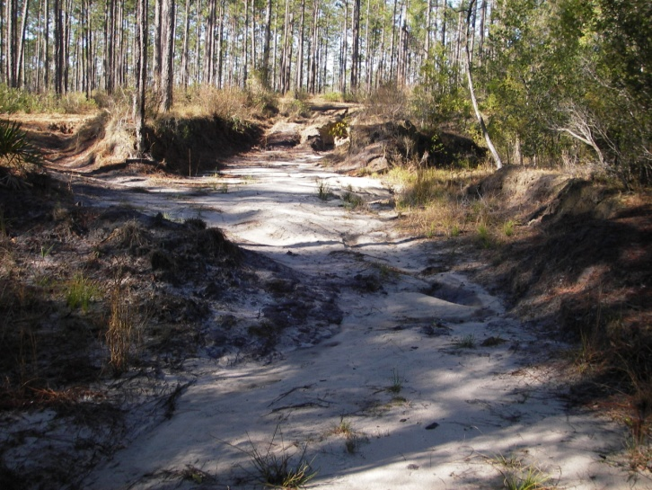 Figure 7. Coon Camp Branch un-stabilized road approach 01/31/2006.
A Coon Camp Branch tributary (Figure 3 red x mark) was clear-cut and channelized for logging road access to post-Hurricane Ivan salvage logging (Figure 8). The destroyed riparian zone and eroded channel contributed clay and organic matter turbidity along with sediments to Coon Camp Branch below the North River Road sample reach.

BioRecon Index
The 2006 BioRecon_2004 score for this site was 8 out of a possible 10 points compared with 2 of 10 in 1999. The 2006 BioRecon 2004 score resulted in a “Pass” designation compared to a “Suspect” in 1999. The main improvement in January 2006 was that macro-invertebrate (fish food) productivity almost doubled (164 Total Number of Individuals) after the road closure less than 6 months earlier compared to 1999 (85 Total Number of Individuals). The productivity increased because of habitat smothering decreased from 93% during 1999 in the sample reach below North River to 30% in 2006 about 6 months after final road closure. Available substrate increased from 7% in 1999 to 60% in 2006. In 1999 only topminnows were observed in the sample reach. Darters and shiners along with salamanders were commonly observed during the 2006 monitoring. The 2006 BioRecon biometrics showed improvement (Taxa 42, Sensitive Taxa 15, EPT 21) compared to the sampling conducted on 08/5/1999 (Taxa 31, Sensitive Taxa 12, EPT 15). A comparatively stable community structure was indicated during both samples. The EPT, mayflies (Ephemeroptera), stoneflies (Plecoptera), and caddisflies (Trichoptera) are the more sensitive orders of the stream community. The EPT made up 59% of the 2006 sample compared to 53% in 1999. The EPT normally comprise about 50% of the aquatic macroinvertebrate in the healthiest Panhandle streams. Stoneflies, the most sensitive to pollution had 3 species during both 2006 from 2000 samples.

Periphyton
The attached algal community in the stream consisted of mainly diatoms with heavy growth filamentous green algae only growing on horse droppings at the open area of the road crossing (Figure 5).
Some growth of algae (typically diatoms) is expected in a fully functioning stream, but an over abundance of algae (especially filamentous algae) may reduce habitat quality (from smothering) and lead to excess organic matter production (and decomposition), which can harm fish and invertebrates.
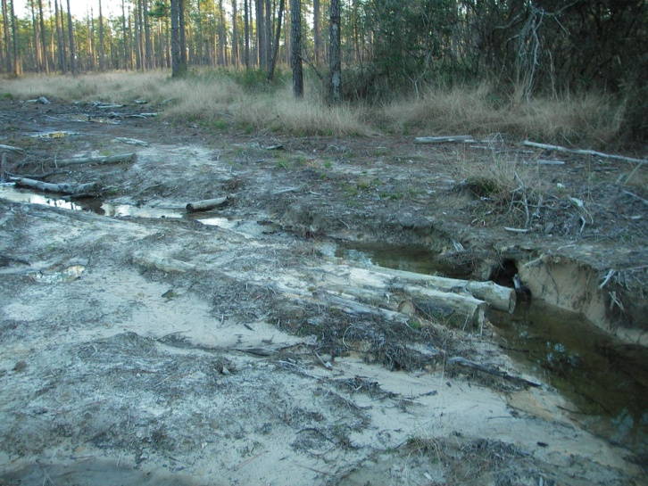Figure 8. Coon Camp Branch tributary clear cut and channelized for logging road access to post-Hurricane Ivan salvage logging 01/31/2006 (red dot in Figure 3).
Conclusions
The closing of the North River Road over Coon Camp Branch (Figure 1) was a positive benefit to the health of the stream biota. The stream macroinvertebrate productivity significantly improved after the dirt road sediment runoff that smothered habitats had been curtailed with the road closure. Turbidity and sediments in Coon Camp Branch were reduced after stopping the practice of dumping clay fill on the road crossing. Since the road had been effectively closed for only a few months prior to the bioassessment, continued improvement was expected as vegetation grows to cover the bare soil (Figures 1 and 7). Berms and log check dams installed on the closed road near the stream approach would have been effective in preventing erosion.

Best Management Practices for logging need to be followed to prevent scour and erosion caused by the forestry operation shown in Figure 8.

Thank you for your interest in maintaining the water quality of Florida’s streams and rivers. Please feel free to contact us if you have any questions.

Contact and resources for more information
Donald H. Ray 850 595-0636 donald.ray@dep.state.fl.us
or rick.abad@dep.state.fl.us
FDEP biological assessment resources: http://www.dep.state.fl.us/water/bioassess/index.htm

