
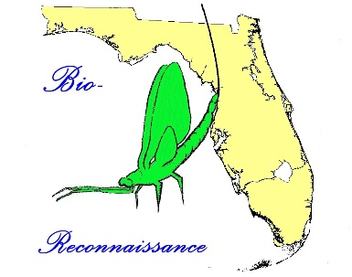
STREAM ECOSUMMARY
Dean Creek below Power Lines, WBID 683, Santa Rosa County
April 3, 2014

Biological monitoring was conducted at Dean Creek (east head) (STORET 33030179, [SBIO DEANCESTHD]) in Santa Rosa County on April 3, 2014 by Rick Abad of the DEP – Division of Environmental Assessment and Restoration (DEAR) Northwest Regional Office Center. This assessment was conducted in response to a request by Jackson Guard staff (Natural Resources Section – Forestry 96CEG/CEIEA) at Eglin Air Force Base. The purpose of the sampling was to document the stream health after restoration activities were completed and compare results to an assessment conducted before planned restoration activities. The Biorecon score improved to a 6 (“healthy”) out of a possible 10. The previous Biorecon conducted March 4, 2013, scored a 5 out of 10, indicating an increase of the aquatic insect diversity after the restoration efforts.

Background
Although healthy, well-balanced stream and river communities may be maintained with some level of human activity, such activities may result in waterbody degradation. Human stressors may include increased inputs of nutrients, sediments, and/or pesticides from watershed runoff, adverse hydrologic alterations, undesirable removal of habitat or riparian buffer vegetation, and introduction of nuisance (generally exotic) plants and animals. FDEP has methods to evaluate if human activities have resulted in the condition where a particular waterbody has exceeded water quality criteria (Chapter 62-302, Florida Administrative Code), including whether adverse impacts to biological communities have occurred. FDEP water quality standards are designed to protect designated uses of the waters of the state (e.g., recreation, aquatic life support), and exceedances of these standards is associated with interference with the designated use. The Biological Reconnaissance (Biorecon) assesses how closely the macroinvertebrate community (e.g., aquatic insects, clams, and crayfish) of a stream resembles the macroinvertebrate community of an undisturbed or “reference” condition. The stream and river habitat assessment evaluates the availability and quality of habitat for macroinvertebrates, and can help diagnose the cause of a low Biorecon score.

Methods
Water Quality
On April 3, 2014 Surface water field measurements were made following DEP Standard Operating Procedures (SOPs, see http://www.dep.state.fl.us/water/sas/sop/index.htm for details) and met the requirements of the FDEP Quality Assurance Rule, Chapter 62-160, F.A.C. (https://www.flrules.org/gateway/ChapterHome.asp?Chapter=62-160).

Biorecon
The BioRecon was sampled per FDEP SOP FS7410 and calculated per FDEP BioRecon_2008 scoring (FDEP SOP version LT7100). The entire 100m stretch was sampled which included the restored section. BioRecon is a rapid community based biological assessment of stream health using benthic macroinvertebrates sampled via four sweeps of a D-frame dip net, with organisms (excluding worms, midges, and mites) identified to the lowest practical taxonomic level. The BioRecon_2008 is composed of six metrics, which decrease in response to human disturbance. These include Total # of Taxa, Ephemeroptera Taxa, Trichoptera Taxa, Long-Lived Taxa, Clinger Taxa, and Sensitive Taxa. The BioRecon rating categories were: Category 1 “exceptional” [7-10] score, Category 2 “healthy” [4-7), Category 3 “impaired” [0-4). Square brackets indicate a value is included in the range; round brackets indicate a value is not included.

Habitat Assessment
The Stream and River Habitat Assessment was conducted per DEP SOP FT 3100. The Habitat Assessment is a rapid field method in which a sampler scores eight in-stream and riparian components to estimate the influence of habitat factors on the resident aquatic organisms. Habitat Assessment scores range from 11-160 and overall habitat quality is assigned to one of four categories: Optimal (120-160 points), Suboptimal (80-119 points), Marginal (40-79 points), and Poor (11-39 points).

Site Description
Dean Creek is a 4th order stream located in the Southern Coastal Plain and Gulf Coast Flatwoods (75a) in Santa Rosa County. The assessment site is located on Dean Creek’s eastern head (N30º 27’ 54.8”, W086º 53’ 19.7”) approximately 0.75 miles northeast of Holly and 1 mile east of Highway 87 on Eglin Air Force Base property. It is a slightly tannic sand/gravel 3rd order stream at this location. The 100m reach is surrounded mostly by a young forested floodplain composed mainly of black titi (Cliftonia monophylla) and wax myrtle (Myrica cerifera).
Site and Assessment History
This site was previously used as a ford crossing for off road vehicles. A report following the initial assessment (Stream Ecosummary - Dean Creek below Power Lines March 20, 2013) found severe sand smothering in the last 30m of the 100m assessment reach caused mostly by the crossing (see Figure 3). Additionally, this prior assessment concluded that the ford crossing contributed to sand smothering downstream from the power line easement. Despite the negative impacts, the macroinvertebrate community, on March 20, 2013, scored in the “Healthy” range based on the Biorecon methods (see Table 1). In 2007, an assessment conducted upstream from the power line crossing scored in the “Exceptional” range following the Stream Condition Index method or SCI (for more information see DEP SOP LT 7200 Stream Condition Index Determination http://publicfiles.dep.state.fl.us/dear/sas/sopdoc/2008sops/lt7000.pdf ). This 2007 SCI upstream from the ford crossing found a total of 16 species of Ephemeroptera and Trichoptera. In the 2013 Biorecon downstream from the ford crossing only 12 species of Ephemeroptera and Trichoptera were collected. This downward trend may indicate biological impacts from the ford crossing activities.

The restoration project which began in the summer of 2013 was completed in January 2014. Erosion controls were installed, the banks were stabilized and the stream channel realigned (see Figure 2).

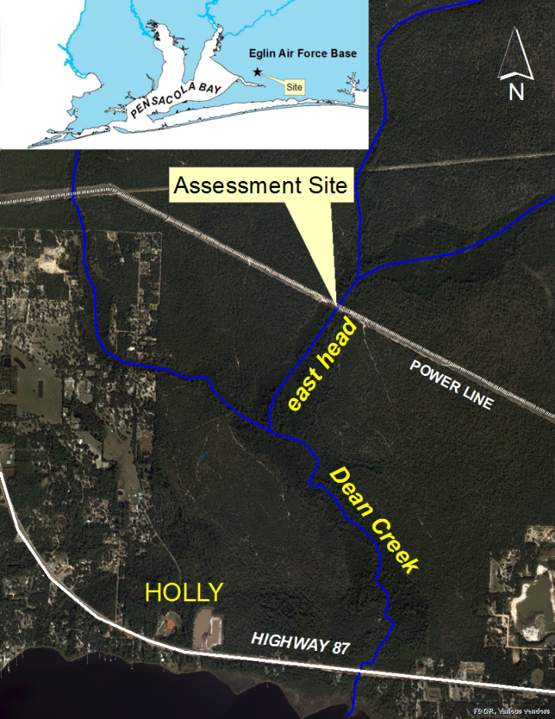
Figure 1. Location of the assessment site, Dean Creek (east head) in Santa Rosa County.

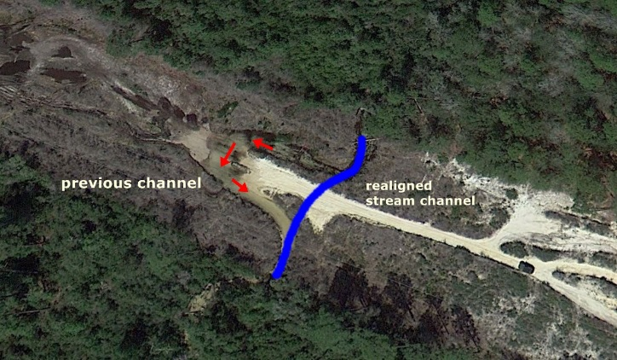
Figure 2. Aerial image (03/28/2013) depicting realigned stream channel and also the previous stream channel of Dean Creek (east head) under power lines in Santa Rosa County.

Results and Discussion
Water Quality
The water quality results are shown in Table 1. All field measurements were within acceptable levels and typical for clean sand/gravel streams found in the Florida Panhandle.

Table 1. Water quality results from April 3, 2014 at Dean Creek (east head).
Analyte | Result | Applicable Class III Water Quality Criteria
Field Temperature (°C) | 19.13
Field pH (SU) | 4.04
Field Dissolved Oxygen (% saturation) | 96.0 | Panhandle West: 67%;
Field Specific Conductance (µmhos/cm) | 27 | 50% above background or 1275 µmhos/cm, whichever is greater

Habitat Assessment
The stream and river habitat assessment scored in the optimal range of 121, a 14% increase from the 2013 Biorecon (99). Sand smothered habitat can reduce habitat availability for aquatic insects. There was a 10% increase of available habitat observed most of which was in the restored area under the power lines. Pools and riffles are stream characteristics that are necessary for transport of sediments downstream. Inadequate pools and riffles can indicate habitat smothering. Habitat smothering improved to the suboptimal range from marginal range. Coconut coir matting and planted vegetation were used to stabilize the banks at the restoration site (see Figure 5). Bank stability improved to a rating of optimal from suboptimal.

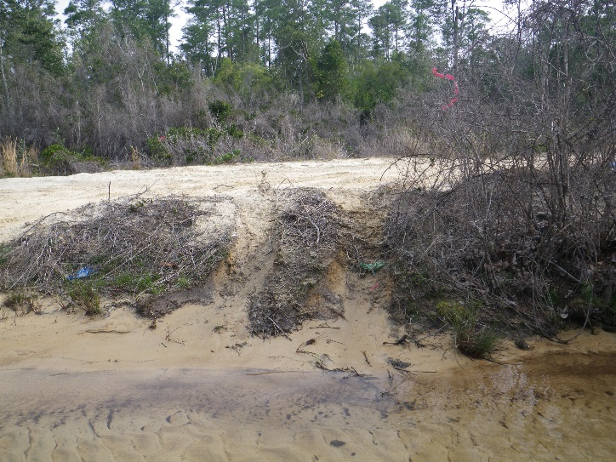
Figure 3. Dean Creek before restoration. North view of ford crossing at 75m mark on 3/20/2013.

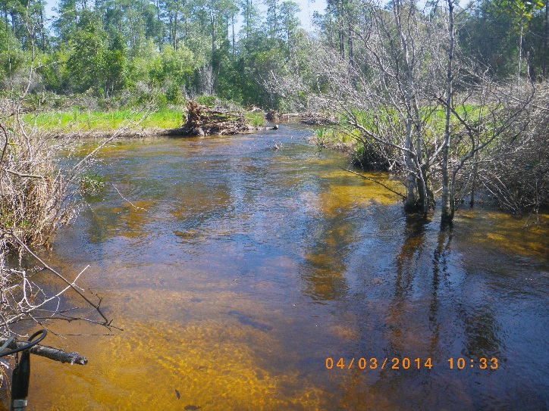
Figure 4. Dean Creek after restoration. North view ford crossing at 60 meter mark on April 3, 2014.

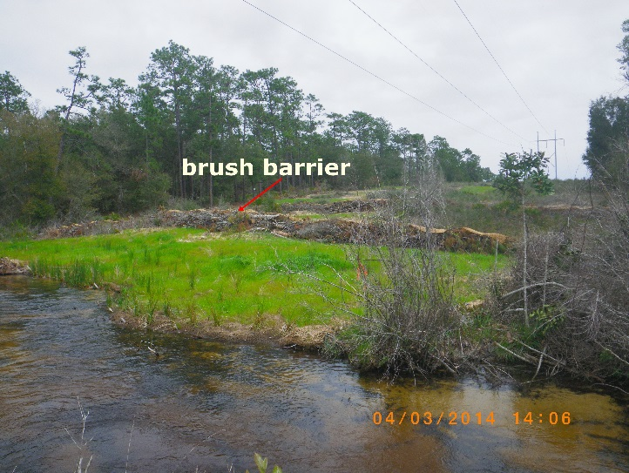
Figure 5. Dean Creek on April 3, 2014 showing restored banks and added brush barriers underneath power lines.

Stream Condition Index
The Biorecon for this site scored a 6 out of a possible 10 giving it a “healthy” rating. All but one metric improved from the previous Biorecon (see Table 2). Mayflies (Ephemeroptera) and caddisflies (Trichoptera) collected increased by 2 and 1, respectively. A rarely collected mayfly species, Habrophlebia vibrans (Pescador, et. al. 2004), was found during this assessment but not from the previous Biorecon in 2013. It was possibly collected in 2007 upstream from the power lines but only identified to family as Leptophlebiidae.

Table 2. Biorecon results from Dean Creek (east head) collected 4/3/2014 and 3/20/2013.
Metric | 4/3/2014 | 3/20/2013
Total taxa | 29 | 24
Ephemeroptera taxa | 6 | 4
Trichoptera taxa | 9 | 8
Long-lived taxa | 5 | 5
Clinger taxa | 12 | 11
Sensitive taxa | 13 | 9
BioRecon Score | 6 | 5

Conclusions
The ford-crossing was found to be the main cause of impairments below the power line easement. The initial assessment following the restoration project found an increase in the biological community and overall habitat assessment. The strategically placed “root wads” and pine logs in the stream provided bank stabilization and necessary cover for fish and aquatic insects. Although stream side tree plantings were not included in the restoration, eliminating road access, installing coconut matting and brush barriers should reduce sedimentation runoff and thus reduce sediment loading downstream (see Figure 7). Habitat smothering below the power line will continue to improve over time.
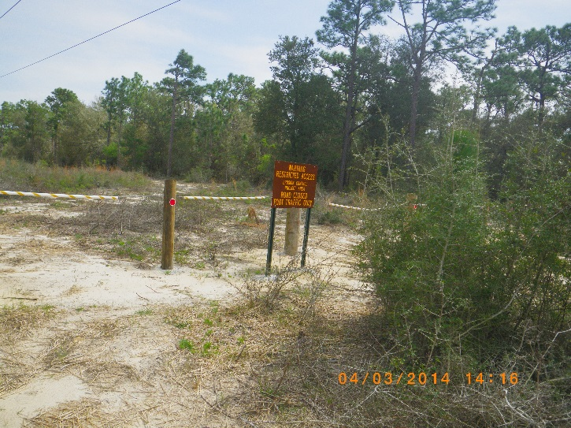
Figure 7. Road closure signs eliminating road access to Dean Creek.

Thank you for your interest in maintaining the water quality of Florida’s aquatic resources. Please contact us if you have any questions.
Contact and resources for more information
Rick Abad (850-595-0552)
rick.abad@dep.state.fl.us

DEP biological assessment resources: http://www.dep.state.fl.us/water/bioassess/index.htm

Pescador, Manual L., et. al. Guide to the Mayfly (Ephemeroptera) Nymphs of Florida. 2004.
http://www.dep.state.fl.us/labs/cgi-bin/sbio/keys.asp

