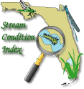
STREAM ECOSUMMARY
Gammons Branch below Shoal River I-10 Rest Area, March 29, 2012
FDEP conducted Stream Condition Index (SCI) biological and water quality sampling at Gammons Branch in Okaloosa County (Figure 1) on March 29, 2012 to assess attainment of designated uses. The stream was sampled at request by the Northwest Florida Water Management District (NWFWMD) for input on a possible land purchase. The Okaloosa Water and Sewer had plans for the NWFWMD to purchase land to build a dam across the creek for a 165-acre drinking water reservoir http://www.crestviewbulletin.com/news/water-8868-county-river.html http://www.crestview-bulletin.com/articles/reservoir-12673-water-river.html Overall, the data indicated that the stream surpassed expectations for a healthy, well-balanced stream.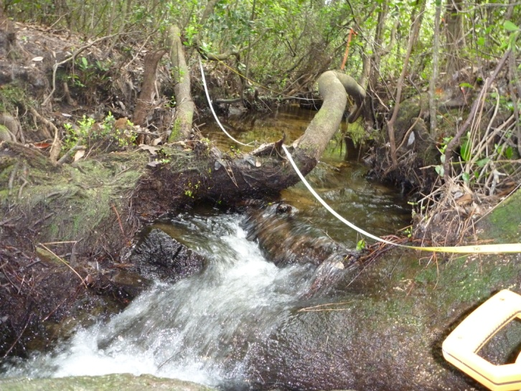Figure 1. Stream Condition Index site for Gammons Branch on 3/29/2012. Background
Although healthy, well-balanced stream and river communities may be maintained with some level of human activity, such activities may result in waterbody degradation. Human stressors may include increased inputs of nutrients, sediments, and/or pesticides from watershed runoff, adverse hydrologic alterations, undesirable removal of habitat or riparian buffer vegetation, and introduction of nuisance (generally exotic) plants and animals. DEP has methods to evaluate if human activities have resulted in the condition where a particular waterbody has exceeded water quality criteria (Chapter 62-302, Florida Administrative Code), including whether adverse impacts to biological communities have occurred. DEP water quality standards are designed to protect designated uses of the waters of the state (e.g., recreation, aquatic life support), and exceedances of these standards is associated with interference with the designated use. The Stream Condition Index (SCI) assesses how closely the macroinvertebrate community (e.g., aquatic insects, clams, crayfish) of a stream resembles the macroinvertebrate community of an undisturbed or “reference” condition. The stream and river habitat assessment evaluates the availability and
quality of habitat for macroinvertebrates, and can help diagnose the cause of a low SCI score.

Methods
This stream was sampled on March 29, 2012 by the DEP Northwest District Office. Surface water samples were collected following DEP Standard Operating Procedures (SOPs, see http://www.dep.state.fl.us/water/sas/qa/sops.htm for details). Sampling and analyses met FDEP quality assurance/ quality control standards (see http://www.dep.state.fl.us/water/sas/qa/index.htm)
The Stream Condition Index (SCI) was sampled per DEP SOP FS7420 and calculated per DEP SOP LT7200. The SCI consists of collecting macroinvertebrates via 20 D-frame dipnet sweeps (0.5 m in length) in the most productive habitats in a 100 m reach of stream. The organisms are sub-sampled, and identified to the lowest practical taxonomic level. The SCI is composed of ten metrics, eight of which decrease in response to human disturbance, with two metrics (% very tolerant and % dominant) increasing in response to human disturbance. According to DEP SOP LT 7000, the SCI score ranges and categories are: (68-111) Exceptional; (35-67) Healthy; and (0-34) Impaired. Proposed biological health assessment criteria state that a site is considered to meet designated uses if the average of the two most recent SCI scores is 40 or higher and neither of those scores is less than 35. The Stream and River Habitat Assessment was conducted per DEP SOP FT 3100. The Habitat Assessment is a rapid field method in which a sampler scores eight in-stream and riparian components to estimate the influence of habitat factors on the resident aquatic organisms. Habitat Assessment scores range from 11-160 and overall habitat quality is assigned to one of four categories: Optimal (120-160 points), Suboptimal (80-119 points), Marginal (40-79 points), and Poor (11-39 points).
Site Information
This site (Lat/Long N30.4297 W-86.3100) is located a mile east of Crestview in Okaloosa County (Figure 2). 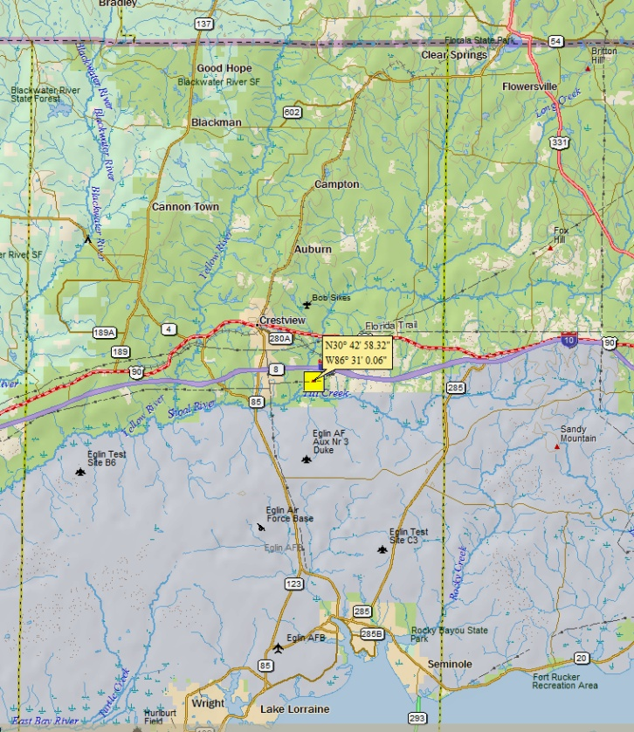 Figure 2. SCI sample location of Gammons Branch in Okaloosa County.
Gammons Branch is a third order stream at the sample site (STORET 33040215) draining the sand hills of ecoregion 65f. It receives runoff from I-10, rest area parking lots, vehicle track erosion and clearing for residential transmission line, clearing for major transmission line, dirt road erosion, culvert failure, and sand mine. Gammons Branch flows to the Shoal River which joins the Yellow River progressing through Blackwater and East Bay before reaching Pensacola Bay. Gammon Branch headwaters are formed by groundwater seeping out the bottom of numerous hillsides called steepheads. The seepage stream and slope are Florida Natural Area Inventory (FNAI) rated S2 = “Imperiled in Florida because of rarity (6 to 20 occurrences or less than 3000 individuals) or because of vulnerability to extinction due to some natural or man-made factor.” Species listed by FNAI found at this site include Kalmia latifolia, mountain laurel (Figure 3), Leuctra cottaquilla, Cottaquilla stonefly, Fallicambarus byersi, Lavender Burrowing Crayfish http://www.fnai.org/PDF/Element_tracking_summary_201206.pdf

Results
Water Quality
The water quality samples complied with all Class III water quality criteria (Table 1). Nutrients were low, typical of the sand and gravel aquifer of the Panhandle. The 95 percent dissolved oxygen saturation supports the 3 taxa of sensitive stoneflies collected in this SCI sample.
Table 1. Water quality results from 3/29/2012 at Gammons Branch.
Analyte | Result | Remark | Applicable Class III Water Quality Criteria
Field Temperature (°C) | 13.36
Field pH (SU) | 5.51
Field Dissolved Oxygen (mg/L) | 8.93 |  | >5.0
% Dissolved Oxygen Saturation | 95
Specific Conductance (µmhos/cm) | 27 |  | Not to exceed 50% of background or 1275 μmhos/cm
Turbidity | 2.1
Total Dissolved Solids (mg/l) | 20 | I
Total Suspended Solids (mg/l) | 2 | U
Alkalinity (mg CaCO₃/L) | 1.3 | I
Color (PCU) | 33
Chloride (mg/l) | 3.1
Fluoride | 0.035 | U
Calcium (mg/l) | 1.87
Magnesium (mg/l) | 0.47
Potassium (mg/l) | 0.33 | I
Sodium (mg/l) | 1.7 | I
Sulfate (mg/l) | 2.7
Chlorophyll a (µg/L)
Total Phosphorus (mg/L) | 0.004 | U | *0.06 mg/L
Nitrate+Nitrite (mg/L) | 0.29
Ammonia (mg/L) | 0.010 | U
Total Kejldahl Nitrogen (mg/L) | 0.12 | I
Total Nitrogen (mg/L) | 0.41 | I | *0.67 mg/L
Organic Carbon (mg/L | 2.6 | I
Zinc (mg/l) | 5.0 | U
I – Result was between the method detection limit (MDL) and the practical quantitation limit (PQL)
U – Compound was analyzed for but not detected
* Federally promulgated numeric nutrient criteria for Panhandle West nutrient region

Habitat Assessment
The stream habitat assessment score was 143 which is in the optimal range. Substrate Availability (34%), Water Velocity (0.3 meters/second), Artificial Channelization, Bank Stability Riparian Buffer Zone Width, and Riparian Zone Vegetation Quality rated Optimal. Habitat Smothering and Substrate Diversity scored Suboptimal.
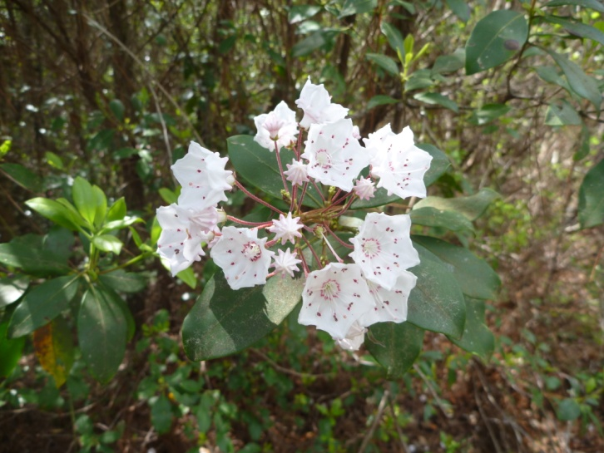 Figure 3. Mountain laurel Kalmia latifolia in bloom.

Stream Condition Index
The SCI score for this site was 75 out of a possible 111 points, corresponding with a “Exceptional" designation. The most sensitive aquatic insect orders of mayflies (Ephemeroptera), stoneflies (Plecoptera), and caddisflies (Trichoptera) (EPT) comprised 38% of the 288 organisms randomly sorted from the sample. A high percent of EPT is typical from the least-impacted panhandle streams. The EPT comprised 19 of the 50 taxa in the SCI sample (38%).

Periphyton
Attached algae in the stream were common and consisted of diatoms, some green algae, cyanobacteria (blue-green algae), and the red filamentous algae Batrachospermum, which grow in low nutrient conditions. Liverworts, mosses, and sponges, typical of clean streams were observed on substrates. Fish were rare with a few darters and shiners observed in addition to frogs, salamanders and turtles.
Some growth of algae (typically diatoms) is expected in a fully functioning stream, but an over abundance of algae (especially filamentous algae) may reduce habitat quality (from smothering) and lead to excess organic matter production (and decomposition), which can harm fish and invertebrates.
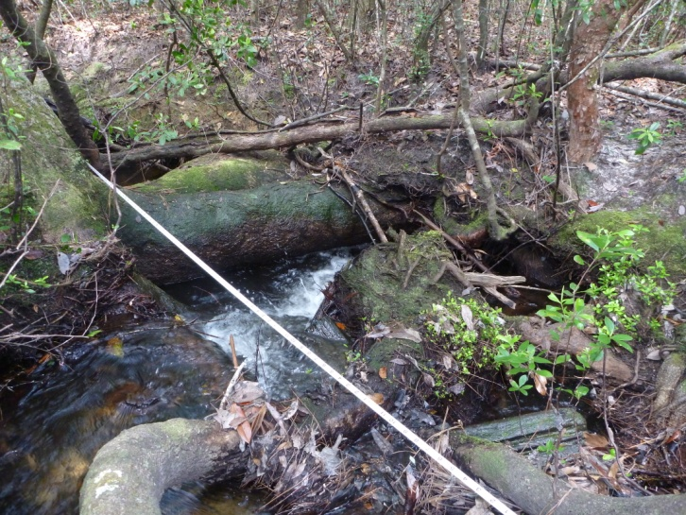 Figure 4. Algae, mosses, & liverworts.
Thank you for your interest in conserving the water quality of Florida’s streams and rivers. Please feel free to contact us if you have any questions.
Contact and resources for more information
Donald H. Ray 850 595-0636 donald.ray@dep.state.fl.us DEP biological assessment resources: http://www.dep.state.fl.us/water/bioassess/index.htm

