STREAM ECOSUMMARY
Mill Creek at NE 148th Terrace,
August 2, 2010
DEP conducted water quality and biological sampling at Mill Creek in Marion County on August 2, 2010. Mill Creek was sampled as part of the strategic monitoring plan for the Ocklawaha basin to verify potential biological impairments and also as part of a study to evaluate the effects of naturally low dissolved oxygen levels. Dissolved oxygen levels that naturally fall below 5.0 mg/L may still support a healthy stream ecosystem but are exceedaces of the water quality standards outlined in Chapter 62-302, Florida Administrative Code. Overall, the water quality and macroinvertebrate community data indicated that the stream met expectations for a healthy, well-balanced stream.
Background
Although healthy, well-balanced stream and river communities may be maintained even with some level of human disturbance, human activities may result in waterbody degradation. Human stressors may include increased inputs of nutrients, sediments, and/or pesticides from watershed runoff, adverse hydrologic alterations, undesirable removal of habitat or riparian buffer vegetation, and introduction of nuisance (generally exotic) plants and animals. DEP has methods to evaluate if human activities have resulted in the condition where a particular waterbody has exceeded water quality criteria (Chapter 62-302, Florida Administrative Code), including whether adverse impacts to biological communities have occurred. DEP water quality standards are designed to protect designated uses of the waters of the state (e.g., recreation, aquatic life support), and exceedances of these standards are associated with interference with the designated use. The Stream Condition Index (SCI) assesses how closely the macroinvertebrate community (e.g., aquatic insects, clams, crayfish) of a stream resembles the macroinvertebrate community of an undisturbed or “reference” condition. The Stream and River Habitat Assessment evaluates the availability and quality of habitat for macroinvertebrates, and can help diagnose the cause of a low SCI score.
Methods
This stream was sampled on August 2, 2010 by the DEP Central District Office. Surface water samples were collected for analysis of nutrients, chlorophyll-a, phaeophytin-a, color, turbidity, alkalinity, chloride and various metals; following DEP Standard Operating Procedures (SOPs, see http://www.dep.state.fl.us/water/sas/qa/sops.htm for details). Sampling and analyses met FDEP quality assurance/ quality control standards (see http://www.dep.state.fl.us/water/sas/qa/index.htm). A water quality duplicate sample and field blank were collected at the same time as the Mill Creek water quality samples. The Stream Condition Index (SCI) was sampled per DEP SOP FS7420 and calculated per DEP SOP LT7200. The SCI consists of collecting macroinvertebrates via 20 D-frame dipnet sweeps (0.5 m in length) in the most productive habitats in a 100 m reach of stream. The organisms are sub-sampled, and identified to the lowest practical taxonomic level. The SCI is composed of ten metrics, eight of which decrease in response to human disturbance, with two metrics (% very tolerant and % dominant) increasing in response to human disturbance. According to DEP SOP LT 7000, the SCI score ranges and categories are: (68-100) Exceptional; (35-67) Healthy; and (0-34) Impaired. As part of numeric nutrient criteria development, DEP and EPA have concluded that a balanced faunal community is achieved if the average score of at least two temporally independent SCIs, performed at representative locations and times, is 40 or higher, with neither of the two most recent SCI scores less than 35. An SCI duplicate sample was collected at the same time as this sample to verify the precision of collection method. The Stream and River Habitat Assessment was conducted per DEP SOP FT 3100. The Habitat Assessment is a rapid field method in which a sampler scores eight in-stream and riparian components to estimate the influence of habitat factors on the resident aquatic organisms. Habitat Assessment scores range from 11-160 and overall habitat quality is assigned to one of four categories: Optimal (120-160 points), Suboptimal (80-119 points), Marginal (40-79 points), and Poor (11-39 points).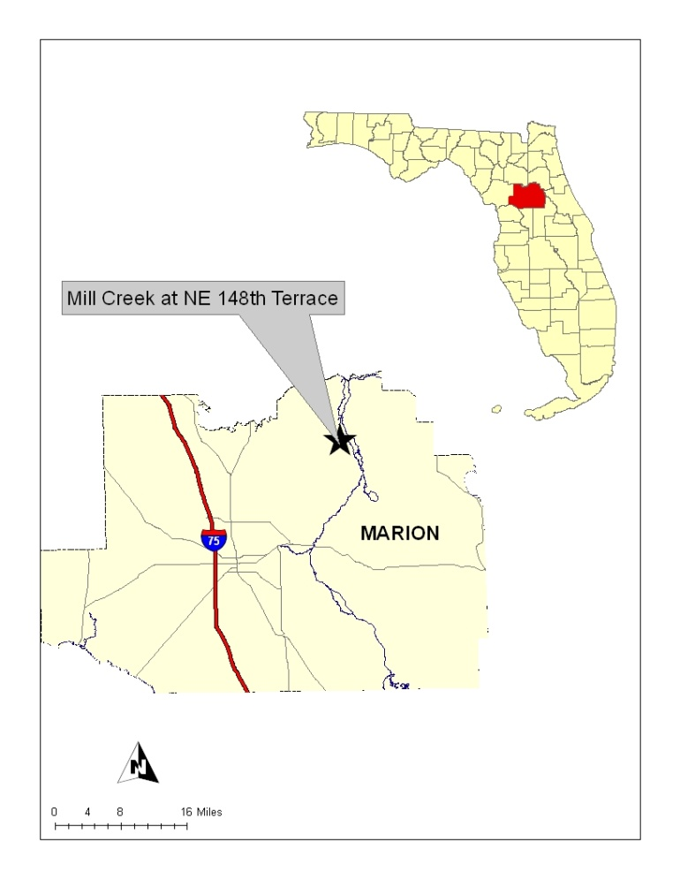
Figure 1. Location of Mill Creek at NE 148th Terrace in Marion County.
Site Information
This site on Mill Creek is located upstream of the NE 148th Terrace bridge. In this area, the average width of the stream was 4 meters and the average depth was 0.5 meters. The sample site had an average velocity of 0.17 m/s. The stream bottom consisted of sand, silt and muck. The shoreline plant community consisted of cypress, red maple, and elm trees along with buttonbush and royal fern. Due to the naturally tannic water, the aquatic plant community was sparse and consisted of small areas of spikerush. No exotic invasive plant species were identified during this assessment (www.FLEPPC.org).

A Habitat Assessment and SCI were conducted at Mill Creek at NE 148th Terrace on March 10, 2010, and scored “Optimal” (137) and “Healthy” (67) respectively. Other historical data for this site include an SCI collected in 1996, scoring “Excellent,” and BioRecons in 2003 and 2006, both scoring “Healthy.” The BioRecon is a screening tool for the SCI. It also uses macroinvertebrate community metrics to evaluate stream health (sampled per DEP SOP FS 7410 and calculated per DEP SOP LT7100).
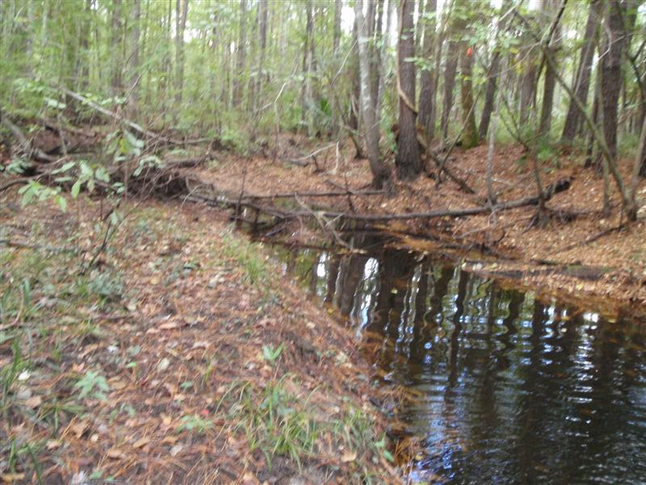
Figure 2. Stream Condition Index transect at Mill Creek
Results
Water Quality
The water quality samples collected on August 2, 2010, complied with applicable water quality criteria (Table 1) except for dissolved oxygen (DO), which was just below the surface water criteria of 5.0 mg/L outlined in Chapter 62-302, Florida Administrative Code. The total phosphorus (TP) values met the Federal Class III Water Quality Criteria limits while the total nitrogen (TN) values exceeded the newly established criteria (note that compliance with lake numeric nutrient criteria involves an annual geometric mean, and is not based on single samples). Based on the total Kjeldahl nitrogen (TKN) and ammonia results, elevated TN was due to the high concentration of naturally occurring, organic nitrogen. It should be noted that the nitrate+nitrite, TN, and copper values presented here are estimated values, and may not be accurate due to contamination of the field blank for the nitrite/nitrate and copper parameters.

Table 1. Water quality results from 8-2-2010 at Mill Creek.
Analyte | Result | Remark | Applicable Class III Water Quality Criteria
Field Temperature (°C) | 26.0
Field pH (SU) | 5.4
Field Dissolved Oxygen (mg/L) | 4.95 |  | > 5.0
Field Specific Conductance (µmhos/cm) | 71
Secchi Depth (m) | 0.2
Alkalinity (mg CaCO₃/L) | 3.9
Turbidity (NTU) | 2.1 | A
Total Dissolved Solids (mg/L) | 134
Total Suspended Solids (mg/L) | 4 | I
Chloride (mg/L) | 8.4
Fluoride (mg/L) | 0.056 | I
Sulfate (mg/L) | 0.26 | I
True Color (PCU) | 500 | A
Chlorophyll-a (µg/L) | 0.55 | U
Phaeophytin-a (µg/L) | 0.68 | I
Organic Carbon  (mg C/L) | 67
Total Phosphorus (mg/L) | 0.027 |  | ≤0.12*
Nitrate+Nitrite (mg/L) | 0.015 | J
Ammonia (mg/L) | 0.042
Total Kjeldahl Nitrogen (mg/L) | 1.8
Total Nitrogen (mg/L) | 1.8 | J | ≤1.54*
Calcium (mg/L) | 7.57
Iron (µg/L) | 2,570
Magnesium (mg/L) | 2.33
Hardness (mg/L) | 9.90
Potassium (mg/L) | 0.47 | I
Sodium (mg/L) | 5.8
Zinc (µg/L) | 5.7 | I | ≤37.0**
Arsenic (µg/L) | 1.03 |  | ≤50
Cadmium (µg/L) | 0.030 | U | ≤0.382**
Chromium (µg/L) | 1.7 |  | ≤27.7**
Copper (µg/L) | 0.88 | IJ | ≤2.85**
Lead (µg/L) | 0.76 | I | ≤0.545**
* F.A.C. Chapter 62-302 Surface Water Quality Standards - Draft
** Based on hardness < 25 mg/L
A - Value reported is the arithmetic mean (average) of two or more
determinations.
I- The reported value is between the laboratory method detection limit and the laboratory practical quantitation limit.
J – The analyte was found in the field blank.
U - Indicates that the compound was analyzed for but not detected.

A dissolved oxygen (DO) study was also performed at this site where continuous dissolved oxygen monitoring sondes were deployed for 5-day periods in March and August to monitor diurnal fluctuations in DO. In March, the DO levels ranged from 7.97 mg/L to 9.70 mg/L. In August, the levels ranged from 4.06 mg/L to 4.82 mg/L. In addition, three more water quality samples were collected throughout 2010 for the strategic monitoring plan, and DO values were 4.95 mg/L, 3.05 mg/L, and 5.07 mg/L. Two of the three measurements did not meet Chapter 62-302, F.A.C., limits of > 5.0 mg/L. The low DO readings were associated with periods of low stream flow and high water temperatures.

Habitat Assessment
The Stream and River Habitat Assessment score was 135, which is in the “Optimal” category. There were two productive macroinvertebrate habitats sampled: the fallen trees and roots originating from the stream banks. Less than 25% of the productive habitats were smothered with sand or silt. The stream had natural sinuosity, an adequate diversity of depths, and showed little evidence of physical alterations. The bank stability, riparian zone buffer width and vegetation quality components all scored in the optimal category indicating that upland disturbance is low in this watershed.

Stream Condition Index
The SCI scores for this site, including the duplicate sample, were 68 and 61 out of a possible 100 points, corresponding with “Exceptional” and “Healthy” designations. In these samples, many water quality sensitive macroinvertebrate groups were present, including mayflies, caddisflies, damselflies, dobsonflies, black flies, and aquatic beetles. The macroinvertebrates collected in these samples represent the expected macroinvertebrate diversity for a healthy stream community. Overall, the minimal human disturbance, “Exceptional” SCI scores and “Optimal” Habitat Assessment results show that Mill Creek met the expectations for a healthy, well-balanced stream and that it should not be listed for biological or DO impairment.

Thank you for your interest in maintaining the water quality of Florida’s streams and rivers. Please feel free to contact us if you have any questions.
Contact and resources for more information
Kalina Warren, 407-897-4177
Kalina.Warren@dep.state.fl.us

DEP biological assessment resources: http://www.dep.state.fl.us/water/bioassess/index.htm

