STREAM ECOSUMMARY
Mizners Branch at Falls Way Drive,
February 16, 2010
DEP conducted chemical and biological sampling at Mizners Branch in Volusia County on February 16, 2010. Mizners Branch was sampled as part of the strategic monitoring plan for the Upper East Coast basin to verify potential dissolved oxygen impairments. Overall, the macroinvertebrate community data indicated that the stream did not meet expectations for a healthy, well-balanced stream due to poor habitat availability and physical alterations to the stream. Water quality was acceptable, although the potential for stormwater inputs does exist.
Background
Although healthy, well balanced stream and river communities may be maintained even with some level of human disturbance, human activities may result in waterbody degradation. Human stressors may include increased inputs of nutrients, sediments, and/or pesticides from watershed runoff, adverse hydrologic alterations, undesirable removal of habitat or riparian buffer vegetation, and introduction of nuisance (generally exotic) plants and animals. DEP has methods to evaluate if human activities have resulted in the condition where a particular waterbody has exceeded water quality criteria (Chapter 62-302, Florida Administrative Code), including whether adverse impacts to biological communities have occurred. DEP water quality standards are designed to protect designated uses of the waters of the state (e.g., recreation, aquatic life support), and exceedances of these standards is associated with interference with the designated use. The Stream Condition Index (SCI) assesses how closely the macroinvertebrate community (e.g., aquatic insects, clams, crayfish) of a stream resembles the macroinvertebrate community of an undisturbed or “reference” condition. The Stream and River Habitat Assessment evaluates the availability and quality of habitat for macroinvertebrates, and can help diagnose the cause of a low SCI score.

Methods
This stream was sampled on February 16, 2010 by the DEP Central District Office. Surface water samples were collected for analysis of algal growth potential, biological oxygen demand, nutrients, chlorophyll a, phaeophytin-a, color, turbidity, alkalinity, sulfate and chloride; following DEP Standard Operating Procedures (SOPs, see http://www.dep.state.fl.us/water/sas/qa/sops.htm for details) and met FDEP quality assurance/ quality control standards (see http://www.dep.state.fl.us/water/sas/qa/index.htm)
The Stream Condition Index (SCI) was sampled per DEP SOP FS7420 and calculated per DEP SOP LT7200. The SCI consists of collecting macroinvertebrates via 20 D-frame dipnet sweeps (0.5 m in length) in the most productive habitats in a 100 m reach of stream. The organisms are sub-sampled, and identified to the lowest practical taxonomic level. The SCI is composed of ten metrics, eight of which decrease in response to human disturbance, with two metrics (% very tolerant and % dominant) increasing in response to human disturbance. According to DEP SOP LT 7000, the SCI score ranges and categories are: (68-100) Exceptional; (35-67) Healthy; and (0-34) Impaired. As part of numeric nutrient criteria development, EPA considered an SCI score of 40 or higher to fully meet the expectation of a healthy, well- balanced community. The Stream and River Habitat Assessment was conducted per DEP SOP FT 3100. The Habitat Assessment is a rapid field method in which a sampler scores eight in-stream and riparian components to estimate the influence of habitat factors on the resident aquatic organisms. Habitat Assessment scores range from 11-160 and overall habitat quality is assigned to one of four categories: Optimal (120-160 points), Suboptimal (80-119 points), Marginal (40-79 points), and Poor (11-39 points).
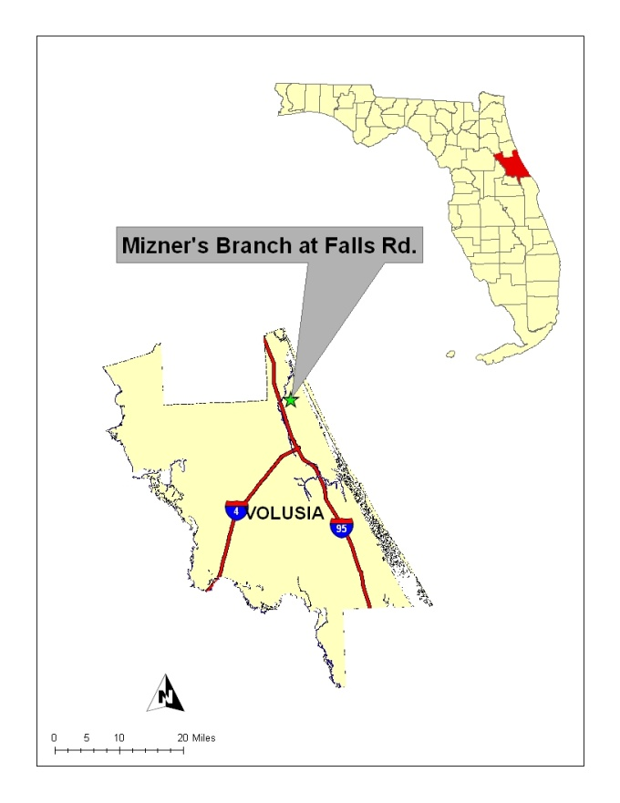
Figure 1: Location of Mizners Branch in Volusia County.

Site Information
Mizners Branch was sampled south of Falls Way Drive (see Figure 1). In this area, the average width of the stream was 3 meters and the average depth was 0.15 meters. The sample site had an average velocity of 0.20 m/s. The stream bottom consisted mostly of sand with some silt and muck. Periphyton was common throughout the stream reach. The shoreline plant community consisted of cabbage palm, laurel oak, red maple, and air potato. The aquatic plant community consisted of hydrilla, wild taro, duck potato, and springtape. The presence of three FLEPPC category 1 exotic invasive plant species, air potato, wild taro, and hydrilla, indicates that the native plant community has been altered (www.FLEPPC.org).
This was the first biological assessment on this portion of Mizners Branch. In 2000, Mizners Branch was sampled twice at S.R. 40 and scored in the “Excellent” and “Healthy” categories. Degraded habitat and poor water velocity at the S.R. 40 site led the Central District to choose the new site at Falls Way Drive as the appropriate site for the strategic monitoring samples.
Results
Water Quality
The water quality samples complied with applicable water quality criteria (Table 1). The dissolved oxygen level at the time of sampling was 8.7 mg/L, but due to a calibration issue, this is an estimated value. Dissolved oxygen samples from five other sampling events in 2010 indicate that Mizners Branch meets the Class III Water Quality Criteria of greater than or equal to 5 mg/L. The total nitrogen and total phosphorus values were below the Federal Class III Water Quality Criteria limits.

Table 1. Water quality results from 2-16-2010 at Mizners Branch.
Analyte | Result | Remark | Applicable Class III Water Quality Criteria
Field Temperature (°C) | 14.7 |  | N/A
Field pH (SU) | 7.7 |  | N/A
Field Dissolved Oxygen (mg/L) | 8.7 | J | > 5.0
Field Specific Conductance (µmhos/cm) | 392 |  | N/A
Secchi Depth | VOB |  | N/A
Algal Growth Potential (mg/L) | 30.5 |  | N/A
Alkalinity (mg CaCO₃/L) | 109 | A | N/A
Turbidity (NTU) | 2.2 |  | N/A
Chloride (mg/L) | 46 |  | N/A
Sulfate (mg/L) | 12 |  | N/A
Apparent Color (PCU) | 120 | A | N/A
Chlorophyll a (µg/L) | 1.8 |  | N/A
Phaeophytin-a (µg/L) | 0.58 | I | N/A
Biological Oxygen Demand (mg/L) | 0.41 | IJ | N/A
Total Phosphorus (mg/L) | 0.071 |  | 0.12*
Nitrate+Nitrite (mg/L) | 0.31 |  | N/A
Ammonia (mg/L) | 0.18 |  | N/A
Total Kejldahl Nitrogen (mg/L) | 0.97 |  | N/A
Total Nitrogen (mg/L) | 1.28 |  | 1.54*
* Federally promulgated numeric nutrient criteria for Peninsula nutrient region. EPA numeric nutrient criteria will not take effect until 03/2012.
VOB – The Secchi disk was visible at the bottom of the stream.
A - Value reported is the arithmetic mean (average) of two or more
determinations.
I- The reported value is between the laboratory method detection limit and the laboratory practical quantitation limit.
J - The field calibration verification did not meet calibration acceptance
criteria.

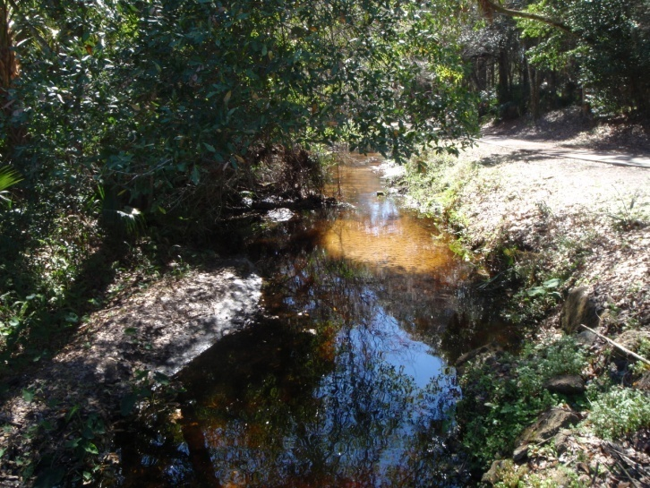
Figure 2. Location of 100 meter SCI transect on Mizners Branch on 2-16-2010.
Habitat Assessment
The Stream and River Habitat Assessment score was 88, which is in the low range of the suboptimal category. Of the three productive habitats sampled, the fallen trees and roots originating from the stream banks were the most productive macroinvertebrate habitats while the aquatic vegetation was less productive. The substrate availability component scored in the marginal category due to a low total percent habitat of 8.4% for the entire stream segment surveyed. The stream was ditch-like with spoil banks evident on either side. Bank stability was poor for the entire stream segment with obvious eroded areas. The riparian buffer zone width and vegetation quality components scored in the poor category for the right bank while the left bank scored in the optimal and sub-optimal categories, respectively. These scores reflect the fact that the right stream bank was maintained to the stream edge, an obvious source of disturbance to the native plant community and reduction in buffering capacity of the riparian zone (See Figure 2).

Stream Condition Index
The SCI score for this site was 21 out of a possible 100 points, corresponding with an "Impaired" designation. This site was chosen as the best representative habitat within the watershed to conduct both the Habitat Assessment and the Stream Condition Index. In this case, it appears that the poor habitat availability and artificial channelization at this site is limiting the macroinvertebrate community. Artificial channelization and disturbed riparian areas alter the structural characteristics of the stream and alters the expected macroinvertebrate diversity. The lack of optimal stream habitat shifts the macroinvertebrate community from healthy and diverse to an abundance of macroinvertebrates that can tolerate the disturbed conditions.

Follow up on Mizners Branch
A second and third Habitat Assessment were conducted on November 2, 2010 and February 17, 2011. The site scored in the marginal category for both assessments: 71 and 62, respectively. This provides more evidence that poor habitat was the reason why the stream did not meet expectation of a healthy well-balanced stream. Due to the poor habitat availability and physical stream alterations, a second SCI was not performed.

Thank you for your interest in maintaining the water quality of Florida’s streams and rivers. Please feel free to contact us if you have any questions.
Contact and resources for more information
Day M. Goldsmith, 407-894-7555 ext. 2221 Day.McClanahanGoldsmith@dep.state.fl.us
DEP biological assessment resources: http://www.dep.state.fl.us/water/bioassess/index.htm

