

STREAM ECOSUMMARY
Turkey Creek (Bolton) below Niceville Waste Water Treatment Plant Spray-field, July 21, 2008 & January 14, 2009
FDEP conducted biological and water quality sampling at Turkey Creek (Bolton) 600 meters below Niceville wastewater treatment plant (WWTP) sprayfields in Okaloosa County (Figure 1) on July 21, 2008 and January 14, 2009 for a SCI nutrient gradient study project. 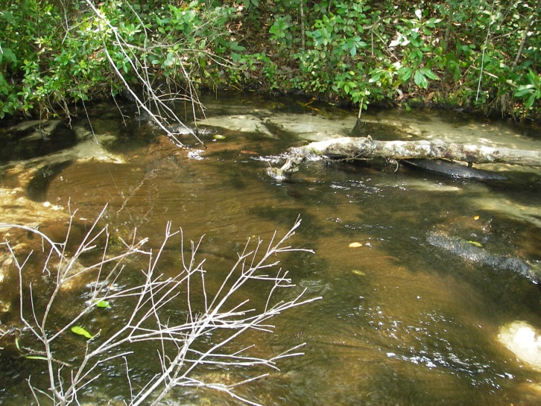 Figure 1. Turkey Creek (Bolton) below WWTP Sprayfield SCI site on July 21, 2008.
Since 1986, the Eglin AFB land managers at Jackson Guard had concerns that wastewater loading from the Niceville WWTP affected the Okaloosa Darter, a listed Federally Endangered Species. A 2000 Ecosummary was written on Turkey Creek (Bolton) below Rocky Bayou Drive 2,745 meters downstream of the sprayfields (for a copy contact Devan Cobb Devan.R.Cobb@dep.state.fl.us). The water quality data collected for the SCI samples on July 21, 2008 and January 14, 2009 indicated that the stream did not meet expectations for a healthy, well-balanced stream. The macroinvertebrate community SCI score rated a Category 2 with a 53 in July 2008 and a 56 January 2009.

Background
Although healthy, well-balanced stream and river communities may be maintained with some level of human activity, such activities may result in waterbody degradation. Human stressors may include increased inputs of nutrients, sediments, and/or pesticides from watershed runoff, adverse hydrologic alterations, undesirable removal of habitat or riparian buffer vegetation, and introduction of nuisance (generally exotic) plants and animals. FDEP has methods to evaluate if human activities have resulted in the condition where a particular waterbody has exceeded water quality criteria (Chapter 62-302, Florida Administrative Code), including whether adverse impacts to biological communities have occurred. FDEP water quality standards are designed to protect designated uses of the waters of the state (e.g., recreation, aquatic life support), and exceedances of these standards is associated with interference with the designated use. The Stream Condition Index (SCI) assesses how closely the macroinvertebrate community (e.g., aquatic insects, clams, crayfish) of a stream resembles the macroinvertebrate community of an undisturbed or “reference” condition. The stream and river habitat assessment evaluates the availability and
quality of habitat for macroinvertebrates, and can help diagnose the cause of a low SCI score.

Methods
This stream was sampled on July 21, 2008 and January 14, 2009 by the FDEP Northwest District Office. Surface water samples followed FDEP Standard Operating Procedures (SOPs, see http://www.dep.state.fl.us/water/sas/sop/sops.htm for details). Sampling and analyses met FDEP quality assurance/ quality control standards (see http://www.dep.state.fl.us/water/sas/qa/index.htm)
The Stream Condition Index (SCI) was sampled per FDEP SOP FS7420 and calculated per FDEP SOP LT7200. The SCI consists of collecting macroinvertebrates via 20 D-frame dipnet sweeps (0.5 m in length) in the most productive habitats in a 100 m reach of stream. The organisms are sub-sampled, and identified to the lowest practical taxonomic level. The SCI is composed of ten metrics, eight of which decrease in response to human disturbance, with two metrics (% very tolerant and % dominant) increasing in response to human disturbance. According to FDEP SOP LT 7000, the SCI score ranges and categories are: (68-111) Exceptional; (35-67) Healthy; and (0-34) Impaired. Proposed biological health assessment criteria state that a site is considered to meet designated uses if the average of the two most recent temporally independent SCI scores is 40 or higher and neither of those scores is less than 35. The Stream and River Habitat Assessment was conducted per FDEP SOP FT 3100. The Habitat Assessment is a rapid field method in which a sampler scores eight in-stream and riparian components to estimate the influence of habitat factors on the resident aquatic organisms. Habitat Assessment scores range from 11-160 and overall habitat quality is assigned to one of four categories: Optimal (120-160 points), Suboptimal (80-119 points), Marginal (40-79 points), and Poor (11-39 points).

Site Information
This site (STORET # 32010268) is located about 1 mile northeast of Niceville, east of College Boulevard in Okaloosa County (N30⁰ 32‘10“W-86⁰ 26‘00“) (Figure 2).
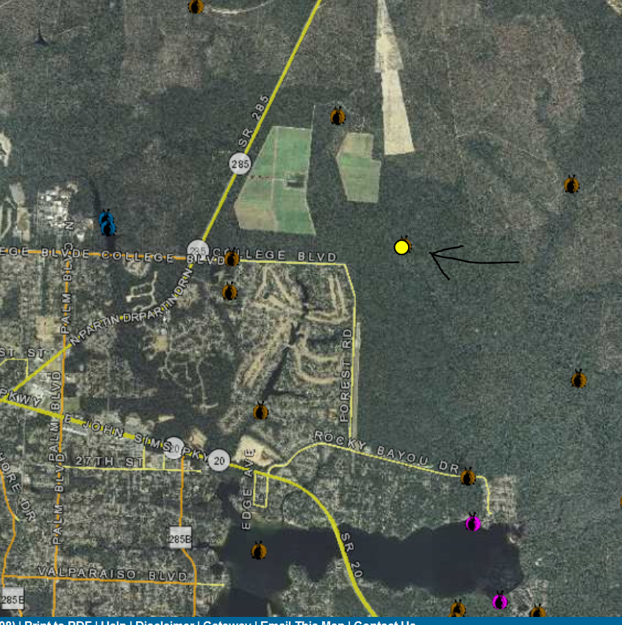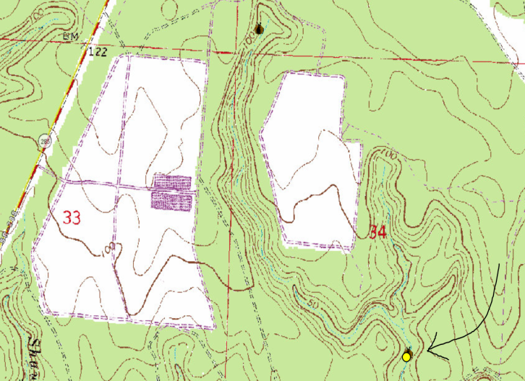 Figure 2. Location of Turkey Creek (Bolton) SCI site below Niceville WWTP sprayfield in Okaloosa County.
The wastewater sprayfield sites are adjacent to steephead streams on Eglin Air Force Base property (Figure 2). The permitted maximum wastewater load capacity for the sprayfields issued by FDEP for 2005 through 2010 was 3.0 million gallons per day (MGD) or 2.9 inches per week. The very deep sandy Lakeland soils of the area have 0 to 30% slopes that are excessively drained and rapidly permeable. The site is located in Ecoregion 75a Gulf Coast Flatwoods Southern Coastal Plain and the headwaters are located in Ecoregion 65f Southern Pine Plain and Hills Southeastern Plains. Turkey Creek flows into Rocky Bayou near the community of Bolton and then to Choctawhatchee Bay. Rocky Bayou State Park ranked second for bacteria contamination in Florida’s Healthy Beach monitoring program for 2012. There is another locally more recognized stream also named Turkey Creek in Niceville that flows into Boggy Bayou.
Results
Water Quality
The water quality samples did not comply with water quality criteria as total nitrogen was at 3.09 and 3.56 mg/L (Table 1). The background (STORET 32010063) total nitrogen concentration was 0.17 mg/L on May 27, 1987 and less than 0.13 mg/L on May 10, 1988 (Table 1) at 0.16 to 0.24 mile above the Niceville WWTP sprayfields in Turkey Creek (Bolton) (Figure 2). The total phosphorus concentration (0.036 & 0.037 mg/L) was higher than the background above the sprayfield (less than 0.01 mg/L for the May 1987 & 1988 samples). The Niceville WWTP sprayfield groundwater monitoring wells had nitrite-nitrate (NO2-NO3) concentrations above the State Water Standard of 10 mg/L in 6 well samples (10.5-14.6 mg/L) reported to the FDEP wastewater section during the period between the SCI sample dates (July 2008, October 2008, & February 2009). The sprayfield background well was reported at 0.01-0.1 mg/L NO2-NO3. The stream pH (6.46 & 7.38 SU) and specific conductance (136 &152 µmhos/cm) had increased over the background conditions above the sprayfield (pH 4.6 SU & specific conductance 21 µmhos/cm). The dissolved oxygen was super-saturated (116%) during the summer sample from an algal bloom stimulated by nutrients in the treated wastewater (Figures 1, 5a, 5b, & 6). The water quality results below the sprayfields were elevated above the western Florida Panhandle Sand and Gravel Aquifer System background concentrations. The Turkey Creek steephead spring water quality results (Table 1) were the background conditions for the local aquifer.

Table 1. Water quality results from Turkey Creek (Bolton) below WWTP Sprayfield SCI site on July 21, 2008 & January 14, 2009 and Turkey (Bolton) Creek steephead on May27, 1987 and May 10, 1988.
Analyte | Result  7/21/08 | Result 1/14/09 | Results steephead  5/27/1987 5/10/1988 | Applicable Class III Water Quality Criteria
Field Temperature (°C) | 22.11 | 14.3 | 20  21
Field pH (SU) | 6.46 | 7.38 | -  4.6 | Not to exceed 1 SU over background
Field Dissolved Oxygen (mg/L) | 10.17 | 9.83 | -  7.3 | >5.0
% Dissolved Oxygen Saturation | 116 | 95 | -  81
Specific Conductance (µmhos/cm) | 136 | 152 | -  21 | Not to exceed 50% of background or 1275 μmhos/cm
Turbidity | 0.75 | 1.2 | 5  1 | Not to exceed 29 over background
TSS (mg/l) | 7 | 6 I | 5K  5K
Color (PCU) | 15 | 10 | 20  5
Chlorophyll a (µg/L) | 0.75 I | 0.55U | 4K  4K
Total Phosphorus (mg/L) | 0.036 I | 0.037I | 0.01K  0.01K | *<0.06
Nitrate+Nitrite (mg/L) | 2.8 | 3.3 | 0.12  0.08
Ammonia (mg/L) | 0.010 U | 0.011I | 0.04  0.01K
Total Kejldahl Nitrogen (mg/L) | 0.29 | 0.26 | 0.05  0.05K
Total Nitrogen (mg/L) | 3.09 | 3.56 | 0.17  0.13K | *<0.67
Organic Carbon (mg/L | 1.3I | 1.5I | -  -
I – Result was between the method detection limit (MDL) and the practical quantitation limit (PQL)
K - Actual value is known to be less than value given.
U – Compound was analyzed for but not detected
* F.A.C. Chapter 62-302 Surface Water Quality Standards. Criteria are applicable to the annual geometric means. – DRAFT

Habitat Assessment
The stream habitat assessment scores were 101 and 107 in the suboptimal range. Water Velocity, Artificial Channelization, Bank Stability, and Riparian Zone Buffer Width and Riparian Vegetation Quality (winter only) rated optimal. Riparian Vegetation Quality (summer only) rated suboptimal. Substrate Diversity rated marginal. Substrate Availability and Habitat Smothering rated poor. A filamentous algal bloom smothered productive habitat as did sand and silt. Jackson Guard staff had reported on different occasions that the stream banks had eroded and the streambed had down-cut adjacent to and below the Niceville WWTP sprayfields (1987-2012) (Figure 3). Long Creek the adjacent watershed for comparison shows (Figure 4) the typical groundwater fed stable stream channel in the panhandle sand hill region.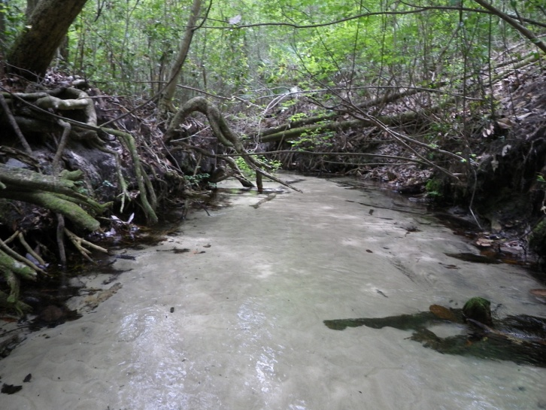Figure 3 Turkey (Bolton) Creek above the SCI site and adjacent to the Niceville WWTP sprayfields 12/26/2012 Note the deeply incised stream channel. (Photograph by Bill Tate USFWS).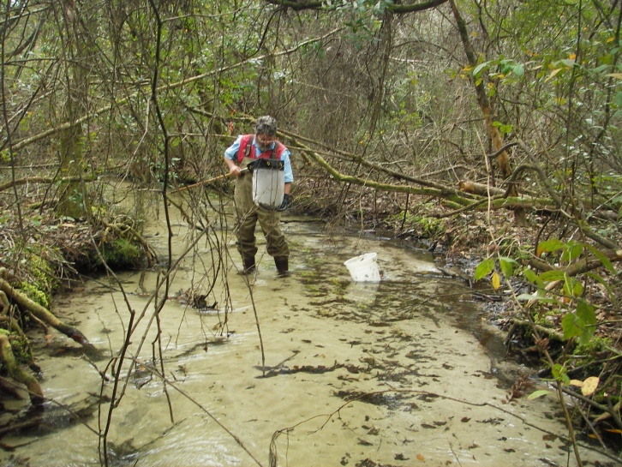 Figure 4 Long Creek Eglin Road 406 ~ 1 mile east-northeast of Turkey (Bolton) Creek SCI site February 12, 2008. Note lack of an incised stream channel.

The permitted volume (3 MGD) of wastewater imported from other Niceville area watersheds applied at 2.9 inches a week to the sprayfields appeared to have overloaded the stream channel. Average annual rainfall at the Niceville WWTP is 69.2 inches (1.33 inches per week). To accommodate the increased flow of the treated effluent to the watershed, the stream channel had incised and widened. The hydraulic overload had flowed down and through the 12 to 30% sandy slope of the sprayfields to erode sand and silt from the stream banks. Eroded sediments were deposited downstream forming sand/silt bars burying logs and sphagnum moss in the SCI sample reach. (Figure 1).

Stream Condition Index
The SCI scores for Turkey Creek (Bolton) site were 53 and 56 (summer & winter) corresponding with a Category 2 “Healthy," designation. The Eglin Reservation background streams score in the SCI Category 1 “Exceptional” designation (i.e. Alaqua Creek Forest Oak Road SCI 84 on 02/21/2006, Little Rocky Creek ER 477 SCI 73 on 10/28/2009, and Dean Creek above power lines SCI 81 on 03/26/2007).
The Turkey Creek (Bolton) benthic community’s dominant family was short-lived midges (Chironomidae) comprising 68% of the summer and 54% of the winter samples. The order Diptera comprised 71% and 64% of the organisms collected. Only 1 Long-Lived Taxa was collected in the summer and 2 in the winter sample. The longer life-cycle EPT, mayflies (Ephemeroptera), stoneflies (Plecoptera), and caddisflies (Trichoptera) made up only 11% (summer) and 21% (winter) of the SCI samples. The EPT are the more sensitive orders of the stream community. They normally comprise about 50% of the aquatic macroinvertebrate in the healthiest Panhandle streams (i.e. 54% EPT for Alaqua Creek Forest Oak Road on 02/21/2006, 46% Little Rocky Creek ER477, 61% Dean Creek above power lines on 03/26/2007). The stoneflies, the most sensitive to pollution were absent during the summer sampling. Only one stonefly taxon, Perlesta placida complex making up 3% of the sample was found during the winter. For comparison, Long Creek Eglin Road 406 about a mile to the east-northeast of the Turkey Creek Bolton site on 2/12/08, stoneflies comprised 22%, of the community (EPT 68% - mayflies 18% & caddisflies 28%). The dominant taxon (13%) was stonefly Acroneuria lycorias, one of the 3 stonefly taxa collected. A total of 12 Long-Lived Taxa were found. A summer (8/9/02) Jackson Guard sample at this same Long Creek site found 3 taxa of stoneflies making up 7% of the macroinvertebrate community( EPT 53%).
A summer algal bloom in Turkey Creek (Bolton) on 07//21/2008 created super-saturated dissolved oxygen concentrations (116%) through photosynthesis during sunlight hours. Conversely, respiration by the algal bloom and organic decomposition from the eutrophication consumes the dissolved oxygen after sundown. This causes the dissolved oxygen concentrations to fall below the requirements of sensitive taxa like the stoneflies. The wastewater input to Turkey Bolton Creek increased the pH (6.46 & 7.38 SU) from the background above the sprayfields (4.6 SU). The increase in pH enabled snails (Elimia & Hydrobiidae) to inhabit (6% of the benthic macroinvertebrate community in both summer & winter) this formally acid sand and gravel aquifer stream. The invasive Asiatic snail Melananoides tuberculatus was found at this site during an August 24, 2011 SCI sample (score 53) by a consultant for the Niceville wastewater treatment plant.

Periphyton
The summer attached algal community in the stream was dominated by green alga Ankisrodesmus falcatus (Figures 5a, 5b), an indicator of eutrophic conditions with pH higher than 7 SU. Cyano-bacteria (blue-green algae) and diatoms were also common. The winter attached algal community in the stream was dominated by filamentous red algae Compsopogon coeruleus (Figure 6) and diatoms. Compsopogon coeruleus is a tropical invasive alga from Southeast Asia. It was reported as an indicator of organic pollution in the Philippines and occurred in a lake receiving sewage water in India during the winter to early summer (December to April). Cyano-bacteria and green algae were also common. The algae blooms were fueled by the elevated total nitrogen concentrations (3.09 &3.56 mg/l), primarily nitrate-nitrite (2.8 & 3.3 mg/l) in the wastewater discharge to Turkey Creek (Bolton).
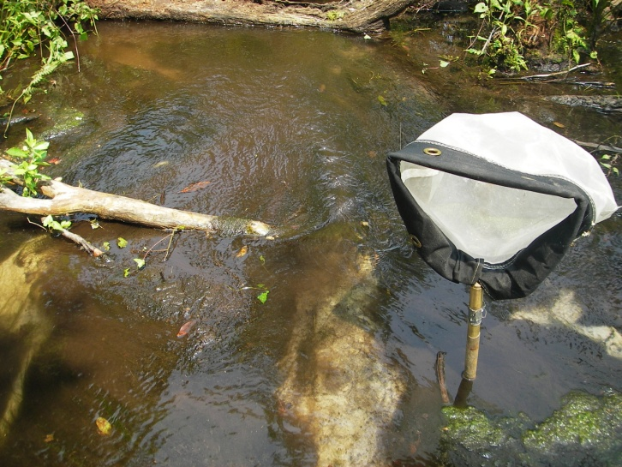

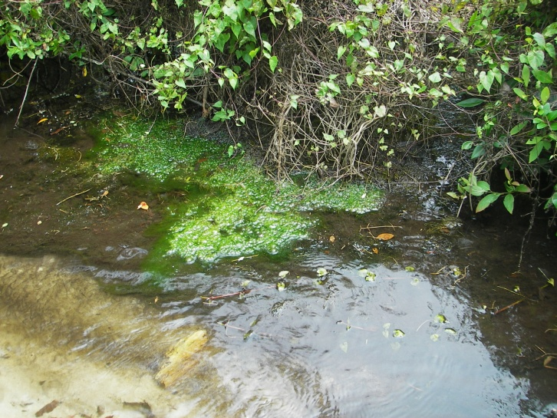 Figures 5a & 5b. Filamentous algae bloom at Turkey Creek (Bolton) below WWTP Sprayfield SCI site on July 21, 2008.
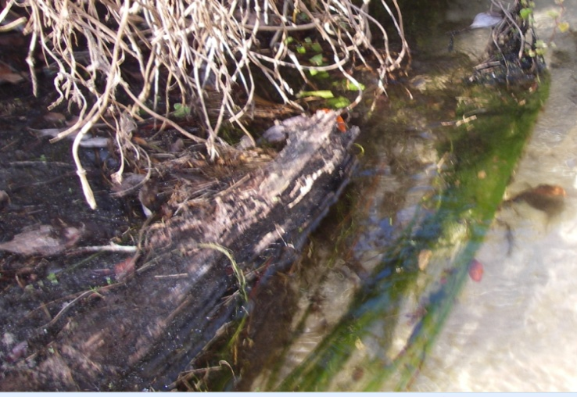
Figure 6. Filamentous algae bloom at Turkey Creek (Bolton) below WWTP Sprayfield SCI site on January 14, 2009.
Some growth of algae (typically diatoms) is expected in a fully functioning stream, but an over abundance of algae (especially filamentous algae) may reduce habitat quality (from smothering) and lead to excess organic matter production (and decomposition), which can harm fish and invertebrates.

Conclusions
The nutrient load affects during 2008-2009 indicated imbalances in flora with algal mats, blooms, and changes in algal species composition. The fauna composition had changed to one dominated by short-lived midges from the expected stream community with many long-lived sensitive taxa such as mayflies, stoneflies, and caddisflies. The introduced invasive Asian species had replaced some of the natural Florida fauna. To reduce nutrient loading to Rocky Bayou and alleviate concerns for the Okaloosa Darter, Advance Wastewater Treatment (AWT) for the Niceville WWTP was recommended in the 2000 Turkey (Bolton) Creek Ecosummary. A 2013 consent order permit revision was issued to upgrade the Niceville WWTP to AWT with a 3.0 mg/L total nitrogen annual average for the sprayfields. However, the 2013 permit will increase the sprayfields loading capacity to 3.65 MGD – 4.45 inches per week from the 2005 and 2010 permits– 3.0 MGD capacity - 2.9 inches per week. The Choctawhatchee Mid Bay Bridge bypass connection highway will cross the western sprayfield reducing the total size by 30%. The consent order construction deadline for the completion of the permitted upgrades to the Niceville WWTP and its compliance with the revised permit limits of January 14, 2013 had been extended to July 31, 2013. The deadline to achieve compliance with final ground water compliance monitoring well nitrate limits in the consent order permit by January 14. 2014 was extended to July 31, 2014.
Thank you for your interest in conserving the water quality of Florida’s streams and rivers.
Please feel free to contact us if you have any questions.
Contact and resources for more information
Donald H. Ray 850 595-0636 donald.ray@dep.state.fl.us DEP biological assessment resources: http://www.dep.state.fl.us/water/bioassess/index.htm

