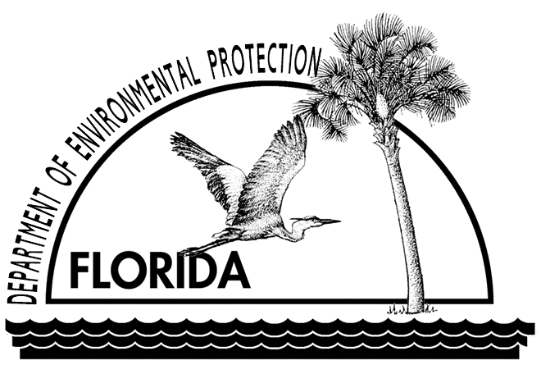
PITHLACHASCOTEE RIVER ECOSUMMARY
WBID 1409
Pasco County
STORET Station 28152268239035

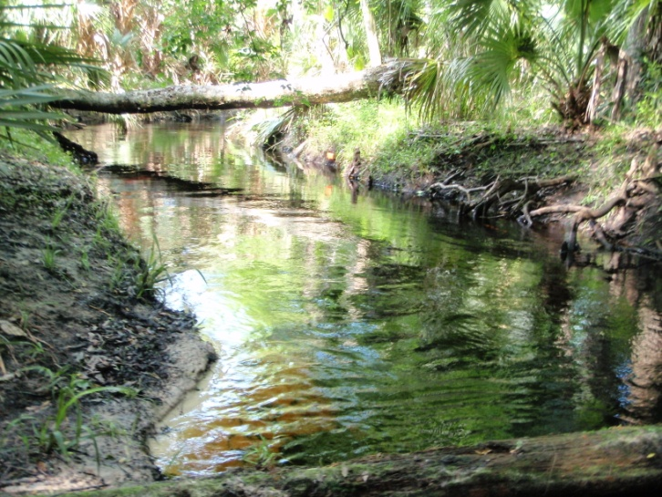
Figure 1. Photo of the Stream Condition Index transect at the Upper Pithlachascoee River.

The Florida Department of Environmental Protection (FDEP) conducted water quality and biological sampling six times at the Pithlachascotee River site (TP211PITH) in Pasco County from 2005 to 2011, with the objective of gaining further information on the biological health of the watershed as part of Florida's Watershed Assessment and TMDL programs. Overall, the water quality and macroinvertebrate community data indicated that the stream met expectations for a healthy, well-balanced stream.

- Background
The biological assessment method used was the Stream Condition Index (SCI), developed by FDEP to determine the ecological integrity of aquatic macroinvertebrate communities. The SCI evaluates how closely the macroinvertebrate community of a stream resembles that of an undisturbed or “reference” condition. The SCI is based on ten measurements of the aquatic macroinvertebrate community, eight of which decrease in response to human disturbance and two metrics (% very tolerant and % dominant) that increase with greater human disturbance. As described in DEP SOP LT 7000, the SCI score ranges and categories are: (68-100) Exceptional; (35-67) Healthy; and (0-34) Impaired. As part of numeric nutrient criteria development, an SCI score of 40 or higher, based on the two most recent samples, was determined to fully meet the expectation of a healthy, well-balanced community, with no single value below 35.
Each SCI includes assessment of stream habitat, conducted per DEP SOP FT 3100, and qualitative collection of periphyton (algae that is attached to in-stream substrates) collected per DEP SOP FS 7220. The stream and river habitat assessment evaluates the availability and quality of habitat for macroinvertebrates, and can help diagnose the cause of a low SCI score. The periphyton data identifies the kind of algae living in the stream. Some growth of algae (diatoms in particular) is normal in a fully functioning stream, but an over-abundance of algae (especially filamentous algae) may reduce habitat quality (by smothering) and result in the production of excess organic matter. The decomposition of surplus organic matter can reduce the oxygen content of the stream water, which can harm fish and invertebrates.
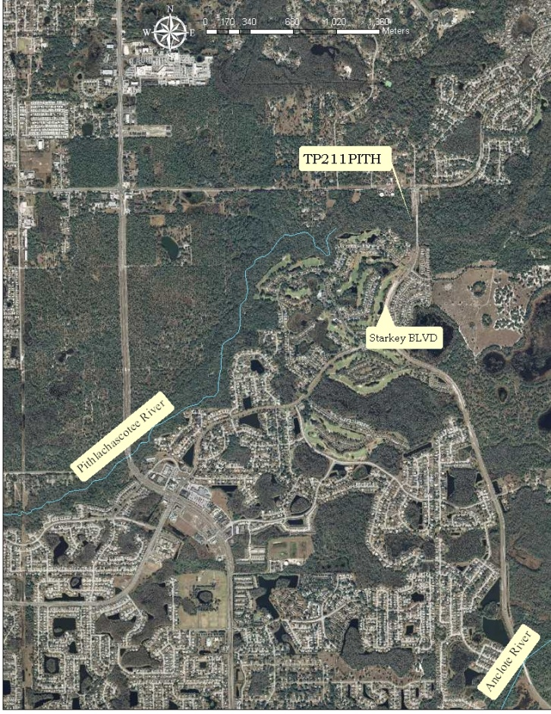
Figure 2. Map of the TP211PITH upstream of the Starkey Blvd Bridge east of New Port Richey.

- Watershed Characteristics

The Pithlachascotee River is a blackwater system. Blackwater systems are streams and rivers that originate in swamps and wetlands and become darkly-colored as organic material decays and leaches into the water. The Pithlachascotee is more than 20 miles long and originates northwest of the Starkey Wilderness Preserve in western Pasco County (Figure 2). The Preserve is owned by the Southwest Florida Water Management District and managed by Pasco County. The property serves as a natural buffer for the river and protects water quality by acting as a natural filter of surface water. The Preserve also functions as a recharge area for a regional well field operated by Tampa Bay Water that is an essential component of the multi-county water supply system that supplies drinking water to the greater Tampa Bay area. Along with the Anclote River, the locally nicknamed "Cotee" River crosses the Preserve and meanders southwest through heavily urbanized Pasco County, entering the Gulf of Mexico via Miller’s Bayou in New Port Richey.
- Methods

The site, TP211PITH, is located west of Land O’Lakes, north of Odessa just off of Starkey Blvd (Figure 2). The SCIs were collected on April 13, 2005; March 13, and October 15, 2008; October 29, 2009; April 20, 2010 and June 14, 2011. Each one was sampled by DEP Southwest (SW) District Office staff per DEP SOP FS7420 and calculated per DEP SOP LT7200. The SCI consists of collecting organisms via 20 D-frame dipnet sweeps (0.5 m in length) from the most productive habitats in a 100 m reach of stream. The organisms are sub-sampled, sorted, and identified to the lowest practical taxonomic level. Each SCI included habitat assessments per DEP SOP FT 3100 and physicochemical parameters measured with a YSI multiparameter instrument. Surface water was collected for chemical analysis on 10/15/08, 4/20/10 and 6/14/11.

Periphyton (attached algae) was collected on 3/13/08, 10/15/08 and 6/14/11 using DEP’s Qualitative Periphyton Method (DEP SOP FS 7220). A total of 10 sample aliquots are apportioned across available habitats (snags, roots, leaf packs, vegetation and rock, excluding sediments) in a 100 m stream reach. To perform the method, a seasoned substrate is chosen, and algae is removed from a 9 cm diameter area and placed into a wide-mouth jar that was been filled with 100 ml of site water. Water and algae are mixed and a 4 ml aliquot is removed and placed into a centrifuge tube. Nine additional aliquots are sampled in this manner for a final volume of 40 ml.

- Results

Habitat: The riparian zone was mostly natural and quite extensive, nearly 300 meters on the north side and more than 100 meters wide on the south side. The in-stream habitat in this section of the Pithlachascotee River was predominantly sandy bottom, typically with three habitats (snags, leaves and roots). The Habitat Assessment (HA) scores ranged from 120 to 135, consistently falling in the “Optimal” category (Table 1). The stream was always sampled when flowing steadily and water levels allowed accessibility to in-stream substrates.

Invertebrates: The results of the SCI are shown in Table 1. All scores were in the healthy Category 2 range, from 39 to 65. The variability in both the SCI and Habitat scores is natural and most likely related to hydrological conditions, which affects the availability and accessibility of habitat. Both prolonged low flow conditions and sudden high flow conditions (scouring) may naturally stress the benthic community.

Table 1. Stream Conditioning Index (SCI) scores obtained since 2005.
Sampling Date | Habitat Score | SCI Score | Designated Use
04/13/05 | 133 | 62 | Category2 Healthy
03/13/2008 | 135 | 56 | Category2 Healthy
10/15/2008 | 144 | 39 | Category2  Healthy
10/29/2009 | 134 | 64 | Category2 Healthy
04/20/2010 | 148 | 65 | Category 2  Healthy
06/14/2011 | 120 | 46 | Category 2  Healthy

Table 2. Physicochemical water quality measurements for all six sampling events.
Date | Temp (°C) | DO (mg/L) | pH (SU) | Conductivity (µmhos/cm) | Velo-city (m/sec)
04/13/2005 | 21.44 | 4.94 | 7.48 | 188 | 0.20
03/13/2008 | 17.37 | 5.00 | 7.22 | 274 | 0.25
10/15/2008 | 22.8 | 4.72 | 7.27 | 248 | 0.30
10/29/2009 | 23.77 | 4.28 | 7.04 | 240 | 0.20
04/20/2010 | 19.34 | 5.29 | 7.5 | 206 | 0.33
06/14/2011 | 25.04 | 3.32 | 7.69 | 375 | 0.14

Table 3. Analytical surface water quality results for 10/15/08, 4/20/10 and 6/14/11 sampling events
Analyte | Result  10/15/08 | Result  4/20/10 | Result  6/14/11 | Applicable Class III Water Quality Criteria (freshwater)
Alkalinity (mg CaCO₃/L) | ** | 65 | 166 | ≥20
Color (PCU) | 250 | 200 | 22 | -
Chlorophyll a (µg/L) | 1.8 | 0.55 | 4.5 | -
Total Phosphorus (mg/L) | 0.084 | 0.058 | 0.088 | *0.12 mg/L
Nitrate+Nitrite (mg/L) | 0.03 | 0.035 | 0.05 | -
Ammonia (mg/L) | 0.051 | 0.044 | 0.09 | -
Total Kejldahl Nitrogen (mg/L) | 2.5 | 1.5 | ** | -
Total Nitrogen (mg/L) | 2.53 | 1.535 | ** | *1.54 mg/L
* Federally promulgated numeric nutrient criteria for Peninsular nutrient region
** not analyzed

Water chemistry: Table 2 summarizes the metered measurements for all five sampling events. Table 3 lists the results for the chemical analytes for the three dates they were collected. All parameters fell within natural unimpaired levels for all sampling dates, except for Total nitrogen (TN) and dissolved oxygen (DO). Total nitrogen exceeded the proposed criteria of 1.54 mg/L due to elevated Total Kejldahl Nitrogen (TKN) on 10/15/08. The DO was below the current Class III Standard of 5.0 mg/l on 4/13/05, 10/15/18, 10/29/09 and 6/14/11. However, these values are not unusual for a stream that drains a swamp high in organic matter (TKN) and low in dissolved oxygen.

Algae: The periphyton results are shown in Table 4 and did not reveal any imbalance of the aquatic fauna in the stream. It was dominated by the diatoms, Achnanthes rupestoides and Navicula tripunctata. The most common non-diatom algae present were the unicellular, blue-green algae Chlorococcum and the blue-green filamentous algae Schizothrix calcicola.

Table 4. Periphyton data summaries for 3/13/08, 10/15/08 and 6/14/11.
Date | Diatom % | Blue-green % | Yellowgreen % | Dominant diatom | Most common non diatom algae
03/13/08 | 87.71 | 9.63 | 2.33 | Achnanthes rupestoides | Chlorococcum
10/15/08 | 40.74 | 56.23 | 2.36 | Achnanthes rupestoides | Schizothrix calcicola
06/14/11 | 60.93 | 36.43 | 1.36 | Navicula tripunctata | Schizothrix calcicola

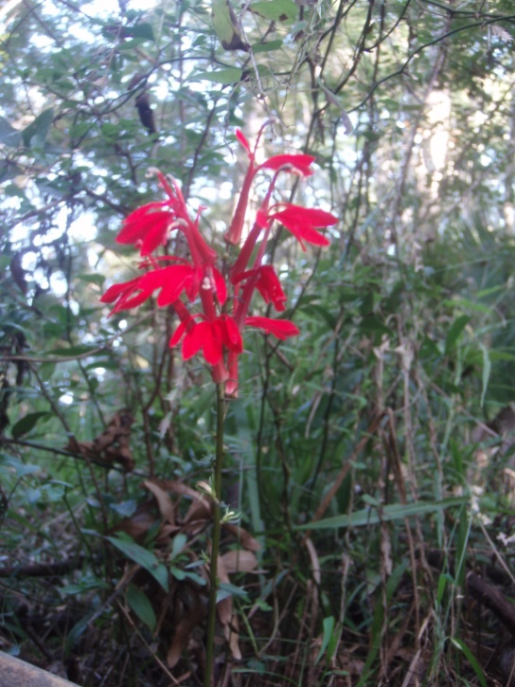
Figure 3. Cardinal Flower (Lobelia cardinalis L) at the sampling site.

One notable biological aspect of the Pithlachascotee River is the presence of the cardinal flower Lobelia cardinalis Linneaeus (Figure 3). The cardinal flower is a threatened native herbaceous plant whose stems and leaves have a purplish tint and whose flower is bright red. Ruby-throated hummingbirds are its primary pollinator, and butterflies are also attracted to it. Threatened is defined as species of plants native to the state that are in rapid decline in the number of plants within the state, but which have not so decreased in such number as to cause them to be endangered.(Atlas of Florida Vascular Plants)

- Significance

Despite the exceedance of the proposed total nitrogen criteria and the current dissolved oxygen standard, the biological sampling indicates that Upper Pithlachascotee River supports a healthy, well balanced macroinvertebrate community. The high organic matter and low oxygen levels reflect a stream draining swampland.

- References

All of the Florida Department of Environmental Protection (FDEP) Standard Operation Procedures (SOP) can be found on the Departments website:
http://www.dep.state.fl.us/labs/cgi-bin/sop/biosop.asp

Atlas of Florida Vascular Plants_ Institute for Systematic Botany
http://www.florida.plantatlas.usf.edu/Plant.aspx?id=3462

DEP-SOP-002/01 LT 7000 Determination of Biological Indices, 12/03/08
http://publicfiles.dep.state.fl.us/dear/sas/sopdoc/2008sops/lt7000.pdf

DEP-SOP-001/01 FT 3000 Aquatic Habitat Characterization http://publicfiles.dep.state.fl.us/dear/sas/sopdoc/2008sops/ft3000.pdf

Development and Testing of Biomonitoring Tools for Macroinvertebrates in Florida Streams Fore, L. 2004_ Final Report
http://publicfiles.dep.state.fl.us/dear/sas/sopdoc/sci_old.pdf

Stream Condition Index (SCI) Report. Fore, L. et al. 2007. Development and Testing of Biomonitoring Tools for Macroinvertebrates in Florida Streams.
http://publicfiles.dep.state.fl.us/dear/sas/sopdoc/sci_final.pdf

Watershed Excursion of the Springs Coast Southwest Florida Water Management District_ Pithlachascotee River
http://www.swfwmd.state.fl.us/education/interactive/springscoast/7.shtml

For more information, please contact Gitta Schmitt, Southwest District Office, 13051 N. Telecom Pkwy, Tampa, FL 33637. (813) 632-7600 x 490.
E-mail: Gitta.Schmitt@dep.state.fl.us

