Florida Beaches Statewide Habitat Conservation Plan

SUMMARY: In 2007, DEP initiated an effort to obtain an Incidental Take Permit (ITP) from the US Fish and Wildlife Service (USFWS) for impacts to listed species or their habitat that may occur because of activities permitted by the Coastal Construction Control Line (CCCL) Regulatory Program. DEP, in partnership with FWC, USFWS and other stakeholders (collectively known as the “working group”), is developing a statewide Habitat Conservation Plan (HCP), acclaimed as one of the nation’s largest and most comprehensive HCP efforts.

HCPs are planning documents used by non-federal entities as part of an application for an incidental take permit. The plan identifies the potential species impacted, potential threats, potential take, and sets the framework for minimizing and mitigating these impacts. It also details how the HCP will be implemented, administered and funded.

The USFWS is funding the development of the HCP through FWC from a grant program under Section 6 of the Endangered Species Act, and since 2007, the DEP has received approximately $4,711,178. The “working group” anticipates that the HCP will be completed in Phase 9, and once completed, the HCP will accompany an ITP application to the USFWS requesting a specified amount of take over the life of the permit, which is proposed as 25 years.
BACKGROUND: DEP agreed to initiate the development of the HCP after record storm seasons resulted in intensive shoreline erosion and an increase in emergency coastal armoring projects. Non-Government Organizations and the USFWS compiled data signifying how DEP regulated activities were resulting in the loss of listed species habitat. The data compelled then DEP Secretary Sole to initiate a statewide HCP for activities regulated under the CCCL Program before a third-party suit could be brought against the agency. Reasons for deciding to apply for ITP included:
- Unprecedented 2004 and 2005 hurricane seasons;
- Extensive coastal erosion and property damage;
- How to handle the aftermath and expedite reconstruction due to emergencies while protecting listed species; and
- To minimize and mitigate for the impacts that may be caused to listed species because of authorized CCCL activities.

The agency realized there would be other benefits from this endeavor, such as:
- Ensure compliance with the Endangered Species Act;
- Minimize risk from potential 3rd party lawsuits;
- Develop standard environmental protection measures (self-certification, BMPs, streamline permitting process);
- Remove uncertainty from the regulatory process; and
- Address impacts to listed species & their habitats comprehensively, rather than parcel by parcel.
USFWS recommended that a Steering Committee be formed to guide the development of this large-scale HCP. Accordingly, the DEP Secretary established the Florida Beaches HCP Steering Committee consisting of representatives from 9 stakeholder groups. The Steering Committee operates under the provisions set forth in its Charter established in 2009, convenes quarterly, and serves at the discretion of the DEP Secretary. The HCP plan area covers properties and activities seaward of coastal construction control lines.

STATUS:
HCP Chapters Completed, In Progress, Up-Coming
- Executive Summary
- Introduction (1)
- Biological Goals, Objectives &Benefits (2)
- Plan Preparation Process (3)
- Covered Activities (4)
- Covered Species with Accounts (5)
- Plan Area (6)
- Threats to Covered Species in Plan Area from CCCL Activities (7)
- Assessment of Anticipated Take (8)
- Alternatives Analysis (9)
- Minimization Measures (10)
- Mitigation Measures (11)
- Implementation Strategy, Plan Management, Funding &Schedule (12)
- Adaptive Management Plan (13)
- Changed/Unforeseen Circumstances (14)
- Compliance Monitoring &Reporting (15)

PHASE 9 (2017/2018): The working group will continue to work with Steering and Technical Committees under Task 1 to complete and peer review the remaining HCP chapters. Specifically, these include Chapters 11 (Mitigation Measures), 12 (Implementation Strategy, Plan Management, Funding, and Schedule), 13 (Adaptive Management Plan), and 15 (Compliance Monitoring and Reporting). Task 2 will focus on the technological aspects of the plan implementation. Existing DEP and FWC workflows will be analyzed and revised to be consistent with proposed implementation strategies. Under Task 3, the proposed legislative changes needed to fully implement the HCP will be vetted for approval to expand legislative authority. Task 4 will target outreach to stakeholders and will focus on establishing partnerships with local governments to address HCP implementation, as well as, integration of the Florida Beaches HCP with existing HCPs in the plan area.

HCP Work Plan (June 2017)
    - Execute grant and task orders
    - Complete unfinished chapters for submission in early 2018
    - Finalize take models (direct and indirect impacts)
    - Steering Committee vote on covered species edits (State vs. Federally Listed Species) approved May 24, 2017 Steering Committee Meeting
    - Additional review for minimization measures and conservation recommendations
    - Compile potential mitigation projects, calculating mitigation fees, ranking mitigation projects (habitat quality indices)

MORE HEAVY LIFTING NEEDED:
Implementation Strategy/Plan Management (Chapt. 12)
- Legislative changes needed for implementation
- Funding for gap between HCP application submittal and potential USFWS implementation grant when approved
- Implementation responsibilities (FDEP, FWC, local partners):
  - IT project for CCCL/HCP online permitting
  - CCCL/HCP permit fee collection
  - CCCL/HCP permit mitigation project and fund administration
- NEPA documentation
- Schedule
Adaptive Management (Chapter 13)
- Describes specific steps (alternative strategies) to be taken if monitoring data indicate that proposed minimization and mitigation measures are not achieving the biological objectives set forth in the FBHCP – seeking net conservation benefit to covered species
Compliance Monitoring and Reporting (Chapter 15)
- Compliance monitoring plan
- Reporting procedures
Outreach with local governments and stakeholders will increase and public meetings will be conducted

PROPOSED LEGISLATIVE CHANGES:
Add listed species not currently covered by CCCL in s. 161.053(4)(c)
- Conditional denial/acceptance of CCCL permit pending proof of individual ITP
Funding Mechanism 161 Part I
- Minimization Measures - 161.053(4)(c)
- Impact and mitigation measures – 161.053(4)(f)
Operational phase added to CCCL permits – 161 Part

LISTED ANIMAL SPECIES:

SHOREBIRDS AND SEABIRDS
Federal
• Piping plover (Charadrius melodus) – federally listed as endangered or threatened, depending on breeding population.
• Red knot (Calidris canutus rufa) - Current candidate for Federal listing.
State
• American oystercatcher (Haematopus palliatus) – Likely candidate for future Federal listing; species of special concern in Florida.
• Black skimmer (Rynchops niger) – Likely candidate for future Federal listing; species of special concern in Florida.
• Least tern (Sternula antillarum) – Likely candidate for future Federal listing; listed as threatened in Florida.
• Snowy plover (Charadrius alexandrinus tenuirostris) - Likely candidate for future Federal listing; listed as threatened in Florida.
• Wilson’s plover (Charadrius wilsonia) – Likely candidate for future Federal listing.

REPTILES
Federal
• Green sea turtle (Chelonia mydas) – federally listed as endangered.
• Hawksbill sea turtle (Eretmochelys imbricata) – federally listed as endangered.
• Kemp’s ridley sea turtle (Lepidochelys kempsii) – federally listed as endangered.
• Leatherback sea turtle (Dermochelys coriacea) – federally listed as endangered.
• Loggerhead sea turtle (Caretta caretta) – federally listed as endangered.
State
• Gopher tortoise (Gopherus polyphemus) – Current candidate for Federal listing; listed as threatened in Florida.

MAMMALS
Federal
• Anastasia Island beach mouse (Peromyscus polionotus phasma) – federally listed as threatened.
• Choctawhatchee beach mouse (Peromyscus polionotus allophrys) – federally listed as endangered.
• Perdido Key beach mouse (Peromyscus polionotus trissyllepsis) – federally listed as endangered.
• St. Andrew beach mouse (Peromyscus polionotus peninsularis) – federally listed as endangered.
• Southeastern beach mouse (Peromyscus polionotus niveiventris) – federally listed as threatened.
State
• Santa Rosa beach mouse (Peromyscus polionotus leucocephalus) – Likely candidate for future Federal listing.

LISTED PLANT SPECIES:
Federal
• Aboriginal prickly-apple (Harrisia aboriginum) federally listed as endangered.
• Beach jacquemontia (Jacquemontia reclinata) federally listed as endangered
• Garber’s spurge (Chamaesyce garberi) federally listed as threatened

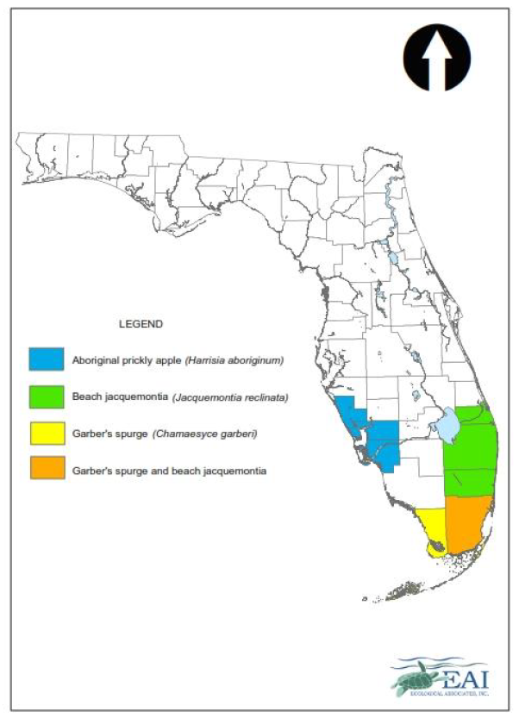

HCP PROPERTIES:

Vacant or open properties assessed in HCP 2012 Upland Development Summary Report.

Sample Map – Sarasota County

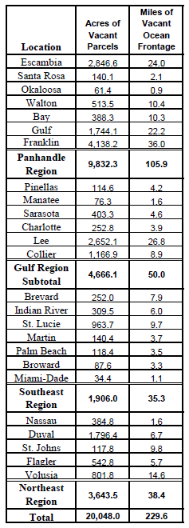
Summary of Potential Coastal Upland Development Area (2008 – 2010)

