Property Legal Descriptions http://dnr.wi.gov/forestry/Private/PLSSTut/legaldesc.htm
WHAT IS A LEGAL DESCRIPTION?
A legal description is used to describe the location of a parcel land in legal documents (for example, the deed to a piece of property). The Public Land Survey System (PLSS) is used in legal descriptions. It employs a grid system based on township, range and section numbers. Here's an example of a PLSS legal description:
N 1/2 SE 1/4, SW 1/4, S24, T32N, R18E
For details on what these numbers mean, go through the quick PLSS tutorial, given below.
You can find the township, range and section information on:
- A property tax bill or property deed.
- plat maps (available by contacting the county clerk or from mapping companies).
- USGS topographic maps (available by calling USGS at 1-800-872-6277)
- maps such as the ones in the Florida Atlas & Gazetteer, produced by DeLorme Mapping Company (available at many gas stations, bookstores and discount stores).
- County Highway Department maps.
- http://data.labins.org/imf3/LABINS2B/labins.jsp
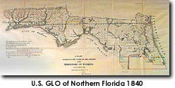
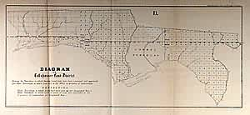
When the land was first surveyed in a state, it was divided into a grid, starting from the prime benchmark and meridian. Each grid cell represents approximately 36 square miles (the measurements were not always precise due to the instruments the surveyors were using, among other limitations). This grid system is known as the Public Land Survey System (PLSS). An example of a legal description using the PLSS is given below.
N 1/2 SE 1/4 SW 1/4, S24, T32N, R18E
- The descriptions are generally read from front to back. For example, the description above would be read "The north 1/2 of the southeast quarter of the southwest quarter of section 24, township 32 north, range 18 east."
- However, the easiest way to interpret descriptions is from back to front (or, right to left). To determine where the property is, we will break the description down into each of its elements, starting from the back and working our way to the front. We'll be starting with the most general labels and then move into the smallest, most specific labels.
RANGE - N 1/2 SE 1/4, SW 1/4, S24, T32N, R18E
Each cell in the grid is identified by a township and range number. The range number identifies how many cells the property is to the east or west of a starting point. The range identified in our example legal description, R18E, is highlighted in Figure 3.
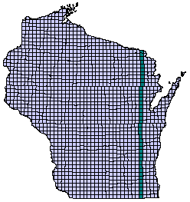
Figure 3: Range 18 East

TOWNSHIP - N 1/2 SE 1/4, SW 1/4, S24, T32N, R18E
The township number identifies how many cells the property is to north or south of a starting point. Only northern townships are possible in Wisconsin. The township identified in our example legal description, T32N, is highlighted in Figure 4.
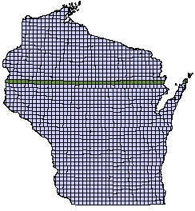
Figure 4: Township 32 North
SECTION - N 1/2 SE 1/4, SW 1/4, S24, T32N, R18E
Each 36-square-mile parcel identified by a township and range number is further divided into 36 sections, each section theoretically being 1 square mile, or 640 acres. The cells are numbered "boustrophedonically", or "as the cow plows", which means that the numbers wrap around in an "s" shape. Such a numbering system was easier for the surveyors to use when they were doing the original surveying. Our example refers to section 24, which is highlighted in red in Figure 5.
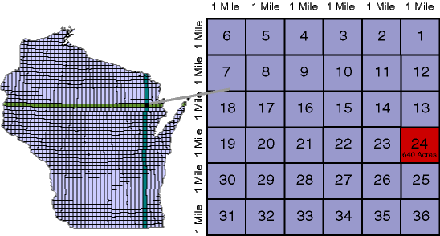
Figure 5: Section 24
QUARTER SECTION
Many parcels of land are smaller than an entire section. They sometimes are the size of a quarter section. Each section is divided into 4 quarters, each being 1/4 square miles, or 160 acres. Each of the quarter sections is labeled with a quadrant direction. In our example, the description is referring to the southwest quarter section of section 24, which is highlighted in yellow in Figure 6. Again, be sure to read the description from back to front so you know to which quarter section the description is referring.
N 1/2 SE 1/4, SW 1/4, S24, T32N, R18E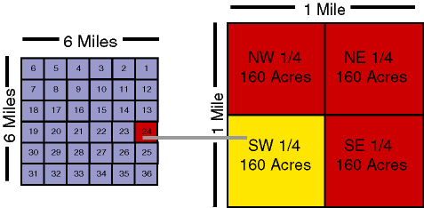 Figure 6: SW 1/4 Section of Section 24

QUARTER-QUARTER SECTION
Quarter sections can be further divided into 4 more parts (called the quarter-quarter section), each being 1320 feet in length (1/4 of a mile), which results in 1,742,400 square feet, or 40 acres. Our description tells us that we are looking for the SE quarter-quarter section. Because we already know from our last step that we are in the SW quarter section, we know to now locate the SE quarter-quarter section in the SW quarter, as shown in blue in Figure 7.
N 1/2 SE 1/4, SW 1/4, S24, T32N, R18E
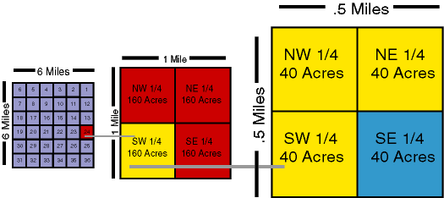
Figure 7: SE Quarter-Quarter Section

HALF QUARTER-QUARTER SECTION
Finally, we also have a reference to a half of a quarter-quarter section in our example. Halves can be used instead of, or in addition to, quarters to describe property location. In the case of our example legal description, the half quarter-quarter section is 20 acres (though if the legal description had read N 1/2, S24, T32N, R18E, the area of the half would have been 320 acres). Halves can be north, south, east or west. The north half of the southeast quarter-quarter section is highlighted in orange in Figure 8.
N 1/2 SE 1/4, SW 1/4, S24, T32N, R18E
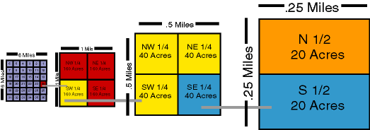
Figure 8: N 1/2 of the SE Quarter-Quarter Section
Figure 9 shows the location of the land we've been locating in context. You now know how to locate land using a PLSS description!
N 1/2 SE 1/4, SW 1/4, S24, T32N, R18E
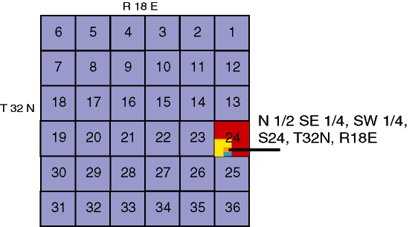
Figure 9: Location of N 1/2 SE 1/4, SW 1/4, S24, T32N, R18E

PLSS DOES NOT WORK WELL IN COASTAL AREAS!
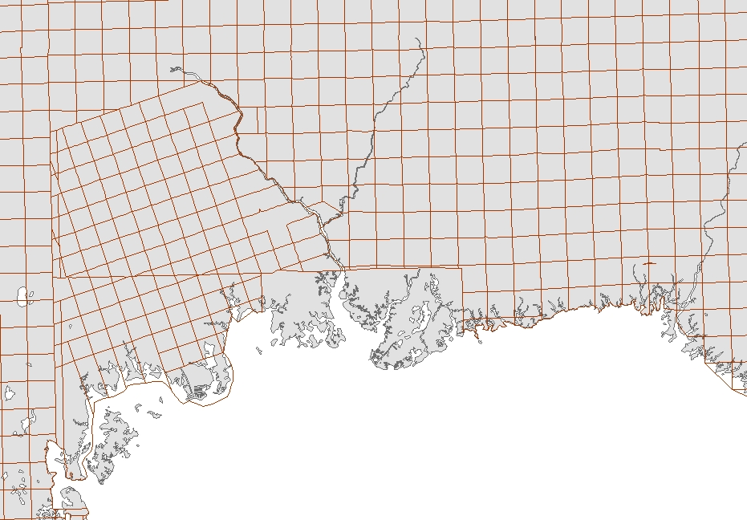
U.S. NATIONAL GRID
Florida’s unique geography of miles of coastlines, multiple river corridors, and large watersheds make the use of the common Township/Range/Section grid (PLSS) all but impossible except for a handful of inland counties. As the grid approaches wetlands, river corridors and the coast line, sections become irregular in shape and can be significantly larger than the typical square mile, which is too large to accommodate the needs of ground crews.
Adoption of a national grid system has been identified as ‘critical’ in a number of after action reports, investigations and studies dating as far back as Hurricane Andrew. In an effort to standardize maps in Florida for both emergency and other operations, the State Fire Marshal, as the coordinating agency for search and rescue under the State Comprehensive Emergency Management Plan, and the Division of Emergency Management are embarking on a program to adopt the US National Grid (USNG) as the standard in Florida. This project will ensure a uniform grid mapping system across cities and counties in Florida, and will match the system used by the National Guard, the US Coast Guard and the US military when they are deployed into our state.

Courtesy of the University of Florida's GeoPlan Center, USNG data for all of Florida is now available for download at the Florida Geographic Data Library.
Please visit http://www.fgdl.org, click on FGDL Metadata Explorer, enter "usng" under the keyword search, click Start Search, and select the grid size and appropriate UTM zone...
Reminder -- the UTM 16/17 junction runs down Jefferson county, so counties west are in UTM 16 and counties east are in UTM 17.

