Appendix M
Rainfall Criteria
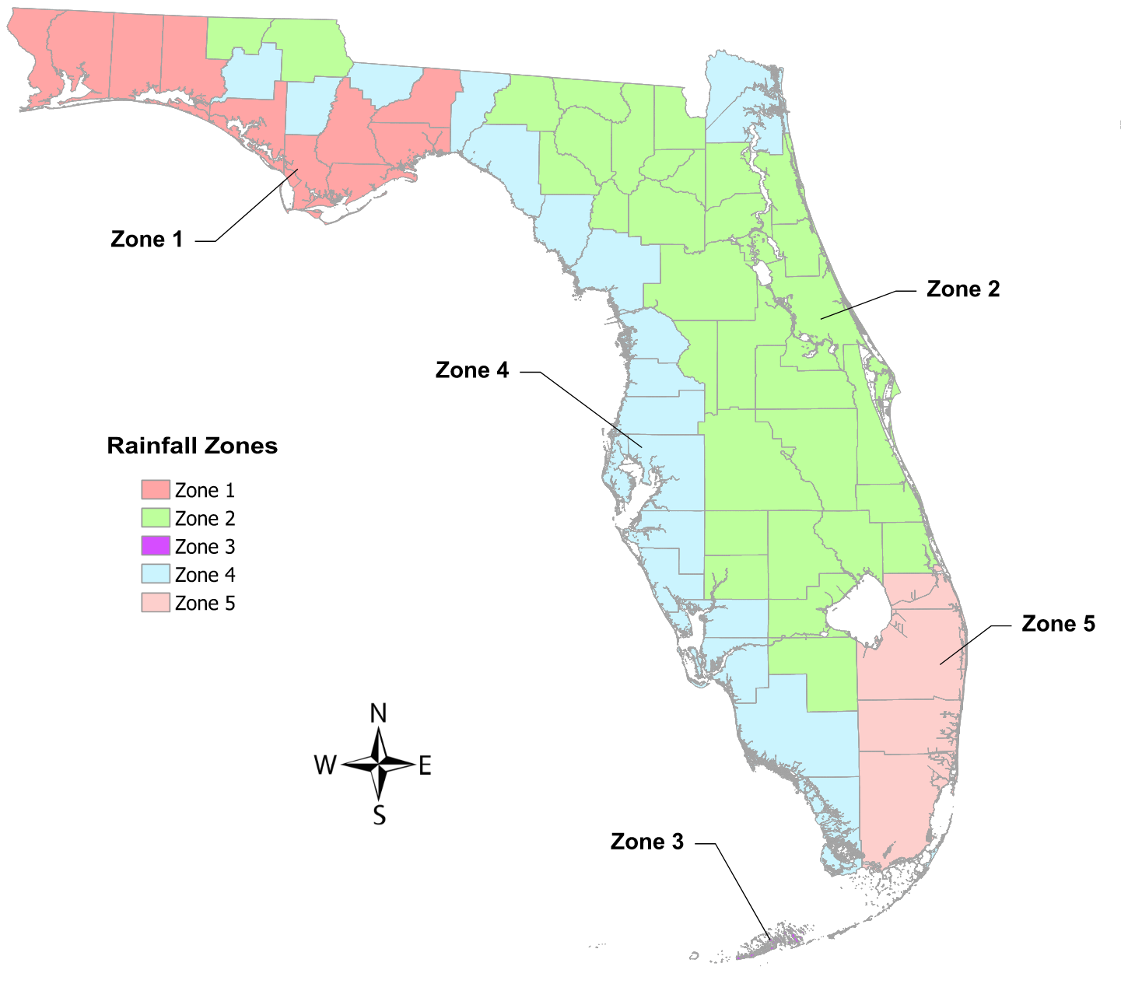
Figure 1: Designated Meteorological Regions (Zones) in Florida

Table 1: Counties Included in the Designated Meteorological Zones

ZONE 1
Bay
Escambia
Franklin
Gulf
Leon
Liberty
Okaloosa
Santa Rosa
Wakulla
Walton
ZONE 2
Alachua
Baker
Bradford
Brevard
Calhoun
Clay
Columbia
Desoto
Flagler
Gadsden
Gilchrist
Glades
Hamilton
Hardee
Hendry
Highlands
Holmes
Indian River
Jackson
Lafayette
Lake
Madison
Marion
Okeechobee
Orange
Osceola
Polk
Putnam
Seminole
St. Johns
St. Lucie
Sumter
Suwannee
Union
Volusia
ZONE 3
Monroe County -
Florida Keys from
Key Largo to Key
West

ZONE 4
Charlotte
Citrus
Collier
Dixie
Duval
Hernando
Hillsborough
Jefferson
Lee
Levy
Manatee
Mainland Monroe
Nassau
Pasco
Pinellas
Sarasota
Taylor
Washington
ZONE 5
Broward
Miami-Dade
Martin
Palm Beach

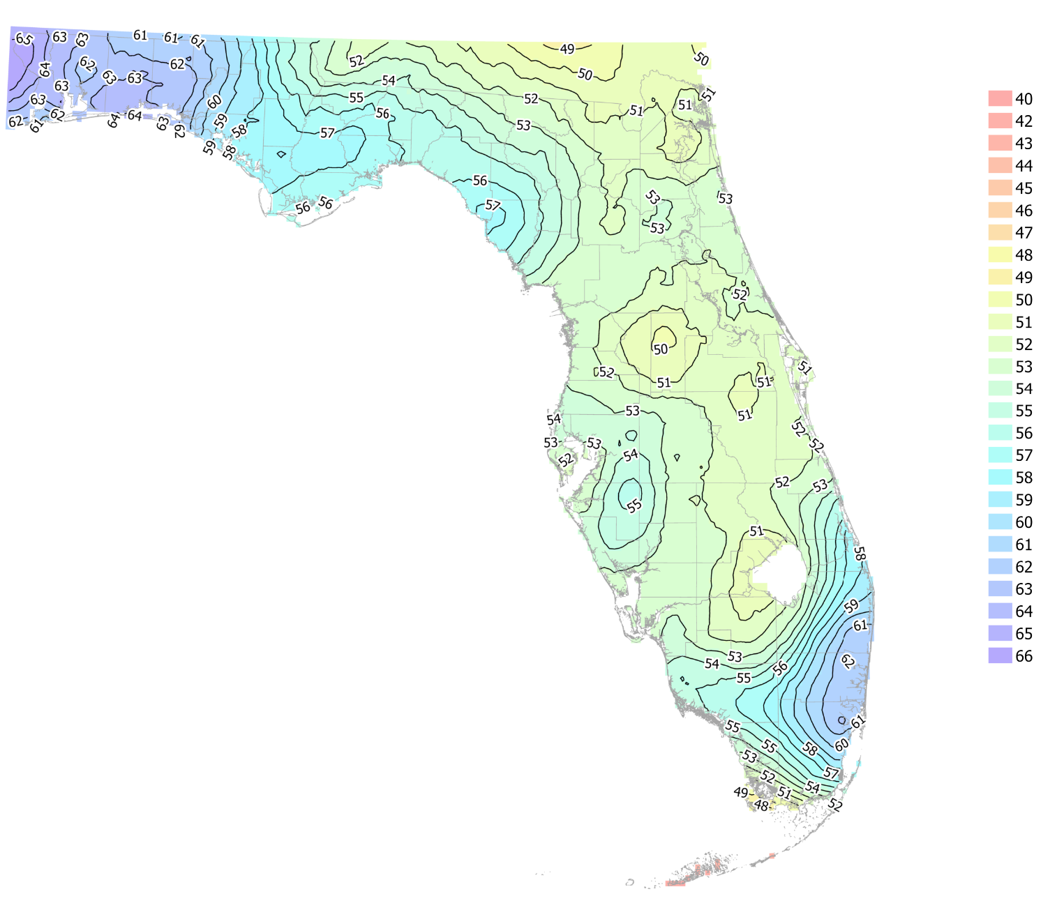
Figure 2: Average Annual Rainfall Isopleth Map for Florida

