2. The “Permittee” tab

Once you have selected either New Permit Builder Project or Open Permit Builder Project, entered the Facility ID and PA Sequence Number, and clicked Open, you will be directed to either the domestic or industrial Permittee tab screen illustrated below.

This screen will automatically be populated with information from WAFR about the permittee associated with your Permit Builder project. Consequently, in order to make any changes to this information, you will have to make them through WAFR.

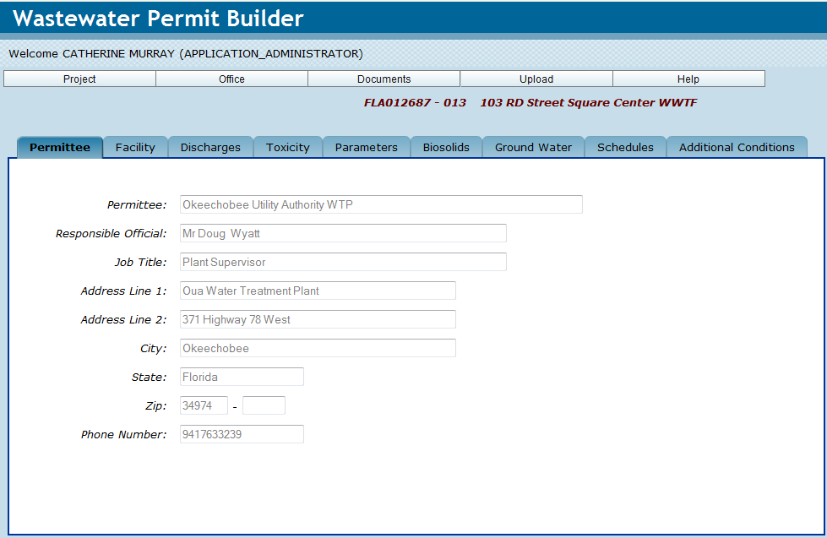
The domestic “Permittee” Tab.

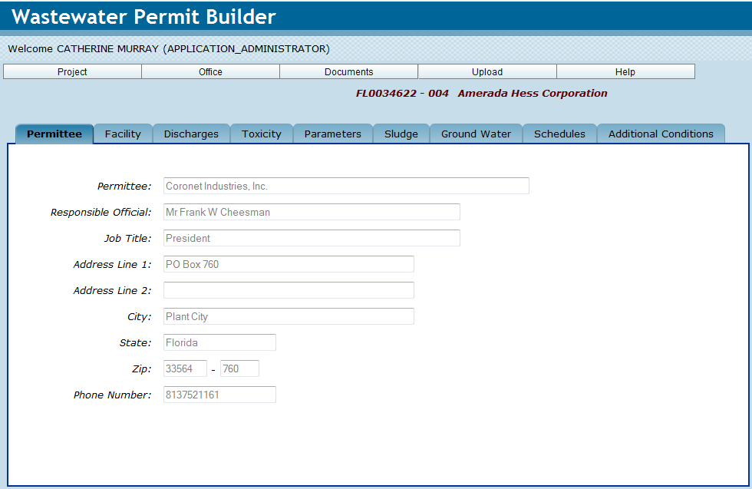
The industrial “Permittee” Tab.

PERMIT BUILDER TIP 2A
What does the gray lettering mean?
Information that has been extracted from WAFR will always appear in gray lettering. You will not be able to use the Reset button on the General sub-tab as this information can only be modified or deleted from WAFR.

CONGRATULATIONS!
YOU HAVE COMPLETED THE “PERMITTEE” TAB

See Chapter 1, Section 1.2.2.1 – The “Open Permit Builder Project” and the “New Permit Builder Project” windows.

