3. The “Facility” tab and its sub-tabs

Similarly, when you click on the Facility tab, you will access a screen automatically populated with information from WAFR about the facility.

For domestic wastewater projects, the Facility tab has five sub-tabs associated with it: General, Facility Characteristics, Permitted Capacity, Pretreatment, and CAR.

For industrial wastewater projects, the Facility tab has three sub-tabs associated with it: General, Facility Characteristics, and Permitted Capacity.

3.1. The “General” sub-tab

The General sub-tab, for both domestic and industrial projects, contains the name and location of the facility extracted from WAFR and will appear in gray lettering. In order to make changes to this information, you will have to make them through WAFR.

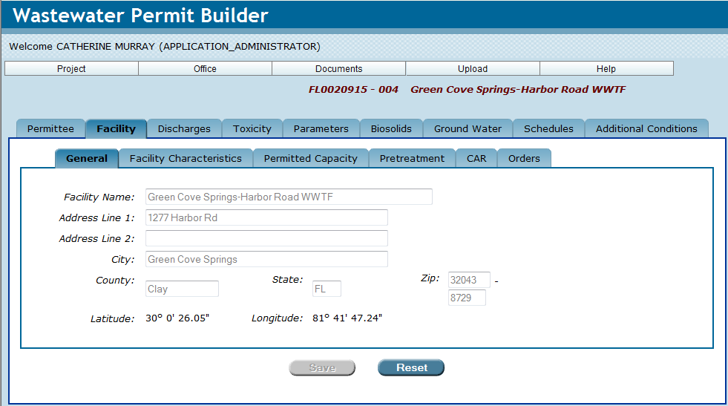

3.2. The “Facility Characteristics” sub-tab

In the Facility Characteristics sub-tab, Permit Builder requests that you input other information about the facility, some of which you should be able to extract from the facility’s permit application.

3.2.1. The “Facility Characteristics” sub-tab (Domestic Wastewater)

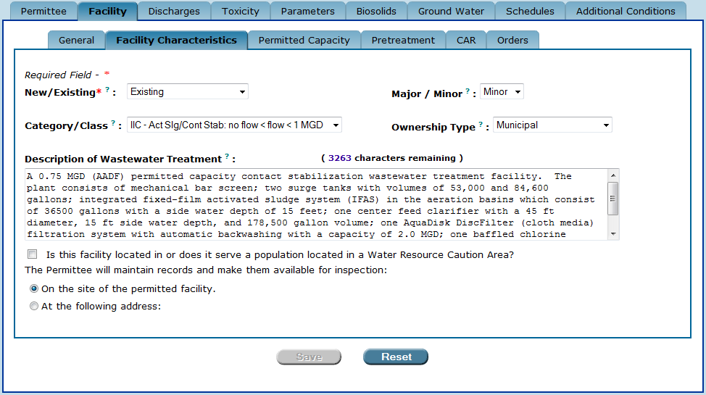
The domestic “Facility Characteristics” sub-tab.

3.2.1.1. The “New/Existing” drop-down box
The New/Existing drop-down box actually has three options:
- New – Select this option if the facility is a new facility and does not have a wastewater permit with the Department.
- Existing – Select this option if the facility is applying for renewal of a previously issued Department permit.
- Substantial Modification – Select this option if the facility is applying for a substantial revision to its current operating permit.

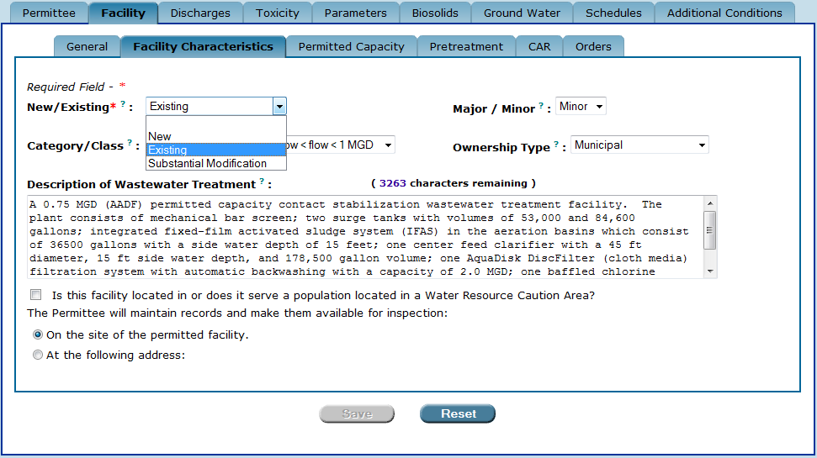

3.2.1.2. The “Major/Minor” drop-down box
The Major/Minor drop-down box appears when the facility is permitted to discharge to surface waters (i.e., the Facility ID begins with FL0). In this case, the permit writer has two options:
- Major – Select this option if the facility is a major discharger.
- Minor – Select this option if the facility is a minor discharger.

Generally, municipal or publicly owned wastewater treatment facilities with permitted surface water discharges greater than or equal to 1 MGD are major dischargers, and those with less than 1 MGD are minor. However, the major/minor rating for these facilities can also be affected if they are intermittent dischargers or employ reuse. If the facility has an authorized surface water discharge that is greater than 1 MGD on a long term average basis (e.g., annual or 3-month average), then it must be classified as a major. Intermittent dischargers should be classified based on their expected annual average discharge flow. Similarly, surface water dischargers that employ reuse should be rated based on the amount being discharged to surface waters, not the treatment capacity of the facility. Therefore, large municipal facilities (greater than 1 MGD including land application) are not considered majors unless their surface water discharges are permitted for or expected to average greater than 1 MGD.

 When determining the major/minor rating for non-municipal or privately owned domestic wastewater treatment facilities, the permit writer should refer to the EPA NPDES Permit Rating Work Sheet. The NPDES Permit Rating Work Sheet should be used to calculate a score for new facilities, and it should be used whenever an existing permit’s rating should be corrected or reconsidered during the permit renewal cycle.

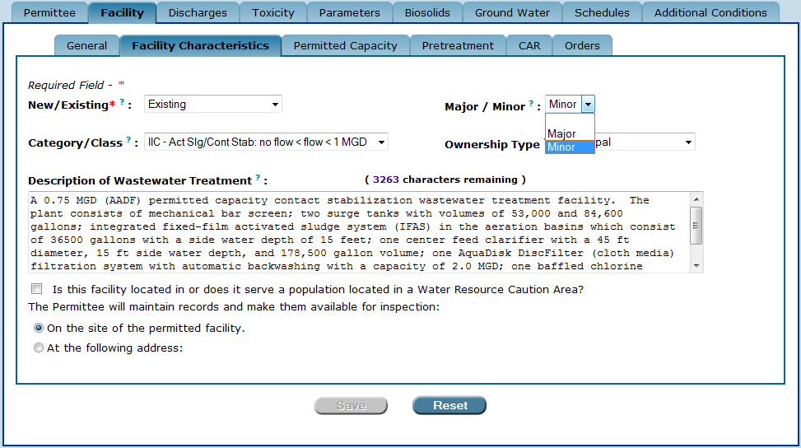

3.2.1.3. The “Category/Class” drop-down box
The Category/Class drop-down box has 14 options with respect to the treatment process category and capacity class of the facility. These categories and classes are defined in Rule 62-699.310, F.A.C.

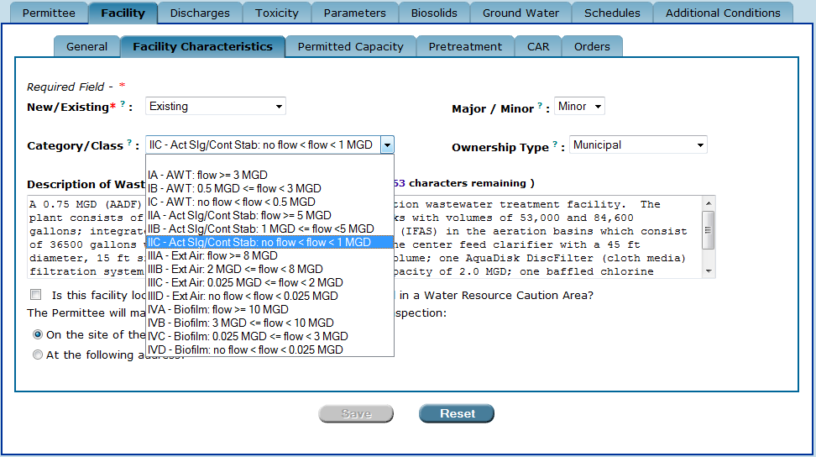

3.2.1.4. The “Ownership Type” drop-down box
The Ownership Type drop-down box has eight options from which you can choose. This information should be included in the facility’s permit application.

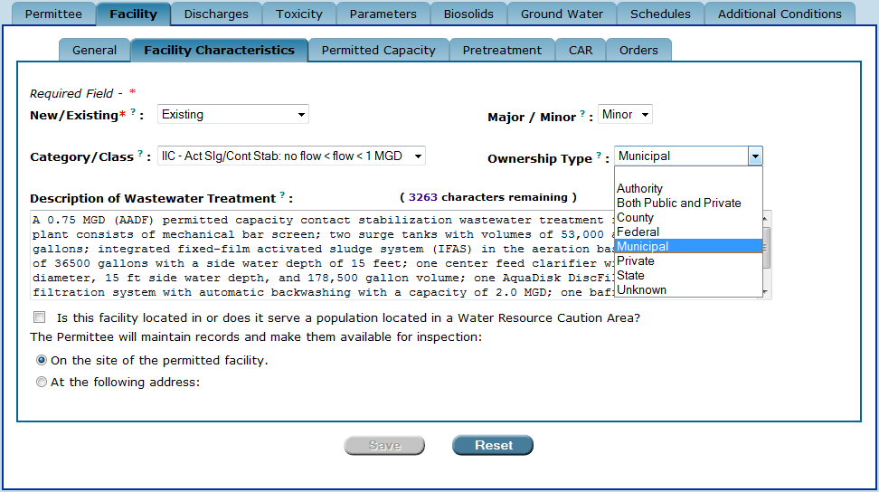

3.2.1.5. The “Description of Wastewater Treatment” field
In the Description of Wastewater Treatment field, type a description of the facility’s wastewater treatment processes.
NOTE: You may want to consult the facility’s current operating permit for the wastewater treatment description. However, be sure to check WAFR-PA for any permitted revisions or outstanding projects that may have been issued since the last operating permit issuance date to ensure that your entry reflects the most up-to-date description.

3.2.1.6. The “Water Resource Caution Area” check-box statement

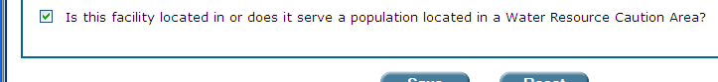

Click this check-box statement if the facility is located in, or serves a population located in a Water Resource Caution Area. When checked, a standard permit condition appears in the permit that states, “The permittee shall comply with all conditions and requirements for reuse contained in their consumptive use permit issued by the Water Management District, if such requirements are consistent with Department rules.”

3.2.2. The “Facility Characteristics” sub-tab (Industrial Wastewater)

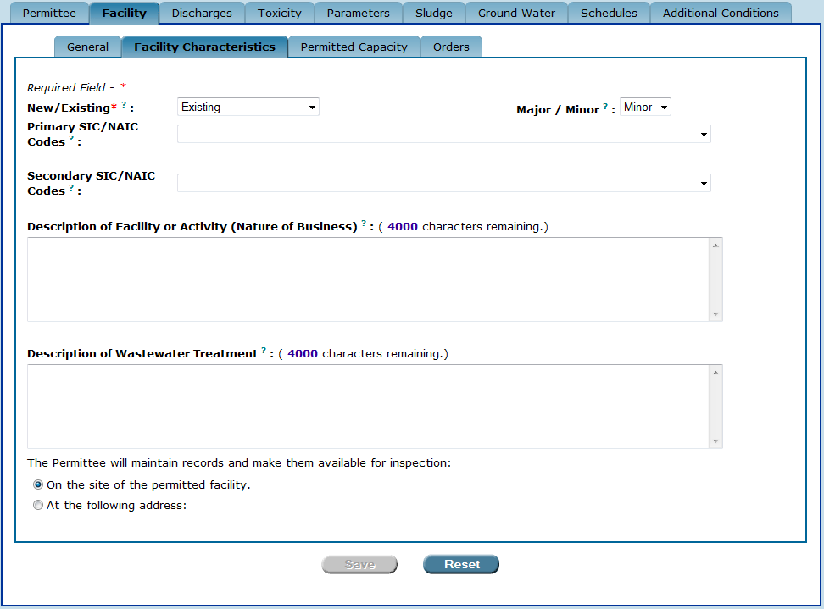
The industrial “Facility Characteristics” sub-tab.

3.2.2.1. The “New/Existing” drop-down box
Industrial and domestic projects both use the New/Existing drop-down box. For a description of this field, see Section 3.2.1.1.

3.2.2.2. The “Major/Minor” drop-down box
Industrial and domestic projects both use the Major/Minor drop-down box. For a description of this field, see Section 3.2.1.2.

3.2.2.3. The “Primary SIC/NAIC Codes” drop-down box
Select the primary Standard Industrial Classification (SIC)/North American Industry Classification System (NAICS) code for the facility from the Primary SIC/NAIC Codes drop-down box. This information should be included in the facility’s permit application.

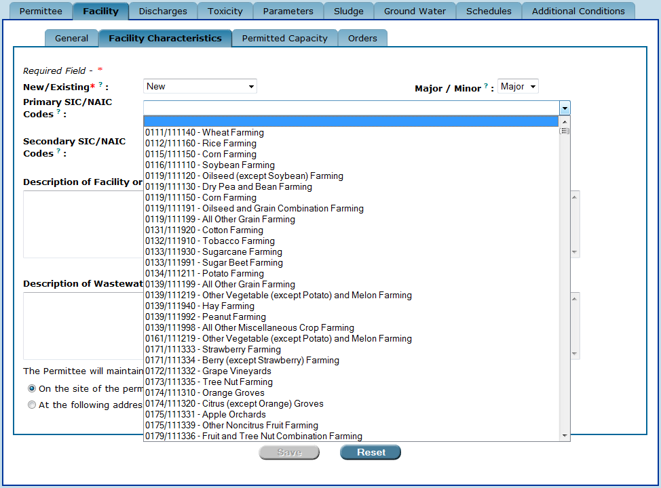

3.2.2.4. The “Secondary SIC/NAIC Codes” drop-down box
If necessary, select a secondary SIC/NAICS code for the facility from the Secondary SIC/NAIC Codes drop-down box.

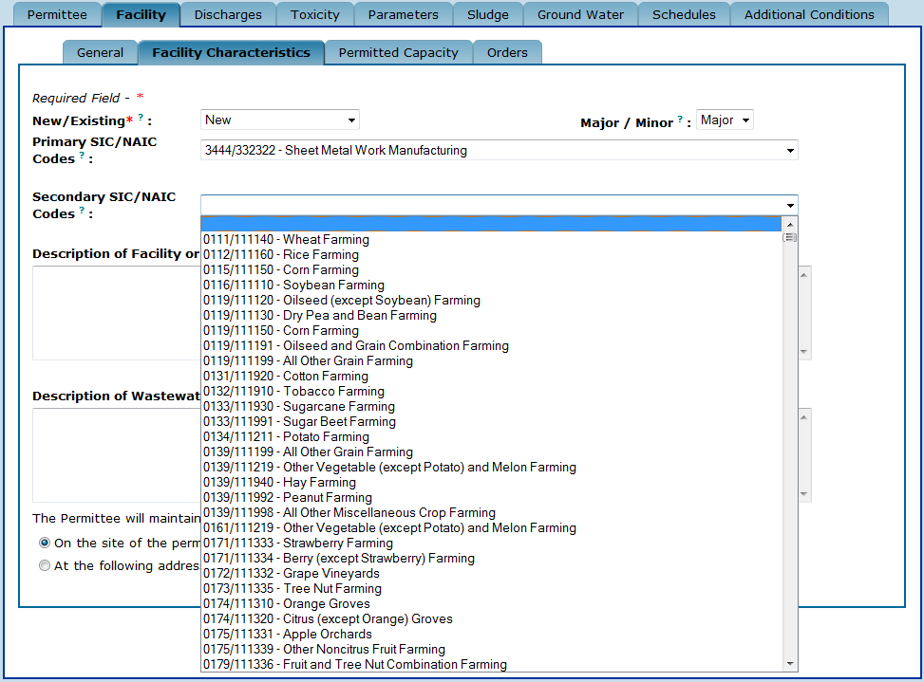

3.2.2.5. The “Description of Facility or Activity (Nature of Business)” field
In the Description of Facility of Activity (Nature of Business) field, type a description of the facility or the activity to be permitted. This information should be included in the facility’s permit application.

3.2.2.6. The “Description of Wastewater Treatment” field
Industrial and domestic projects both use the Description of Wastewater Treatment field. For a description of this field, see Section 3.2.1.4.

3.2.3. The “Save” and “Reset” buttons
Once you have completed your entries to the Facility Characteristics sub-tab, be sure to either:
Save ow
- Click to save your entries; or
Reset ow
- Click to clear all entries made to the Facility Characteristics sub-tab. This will restore all fields to any information entered before the last time this sub-tab was saved.

3.3. The “Permitted Capacity” sub-tab
The Permitted Capacity is the flow rate, in million gallons per day (MGD), that the facility will be allowed to operate by the Department permit. The Permitted Capacity sub-tab allows you to enter information about the facility’s:
- Existing permitted capacity – the capacity which the facility is currently permitted to operate.
- Proposed Increase in permitted capacity – the increased (or decreased) capacity which the facility will be permitted to operate. This field should be completed when the permitted capacity is being increased.
- Proposed Total – the sum of the Existing and Proposed Increase in permitted capacity. This value is automatically calculated by Permit Builder.
- Basis for Permitted Capacity – the statistical basis used to calculate the facility’s permitted capacity. For domestic wastewater projects, this drop-down box allows you to select one of three options, as illustrated below. The basis for permitted capacity defines how the permitted capacity is calculated as established in Rule 62-600.200, F.A.C.

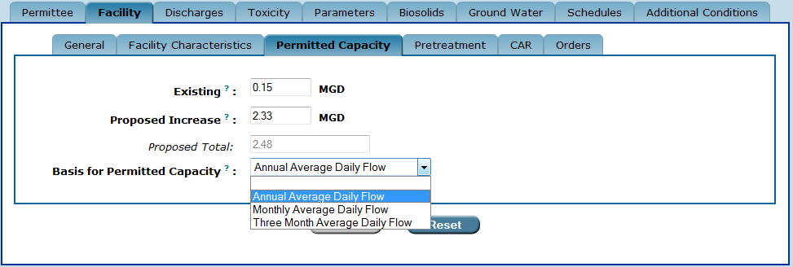
The domestic “Basis for Permitted Capacity” drop-down box options.

For industrial wastewater projects, this drop-down box allows you to select one of five options, as illustrated below.

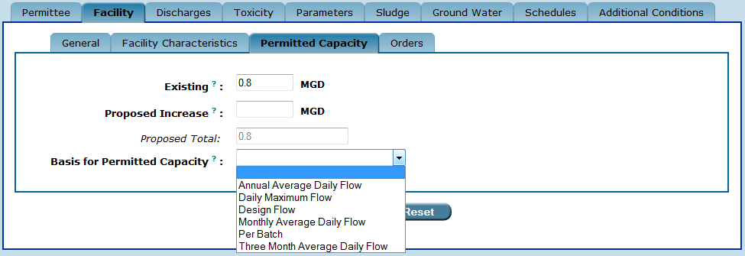
The industrial “Basis for Permitted Capacity” drop-down box options.

3.3.1. The “Save” and “Reset” buttons

Once you have completed your entries in the Permitted Capacity sub-tab, be sure to either:
Save ow
- Click to save your entries; or
Reset ow
- Click to clear all entries made to the Permitted Capacity sub-tab. This will restore all fields to any information entered before the last time this sub-tab was saved.

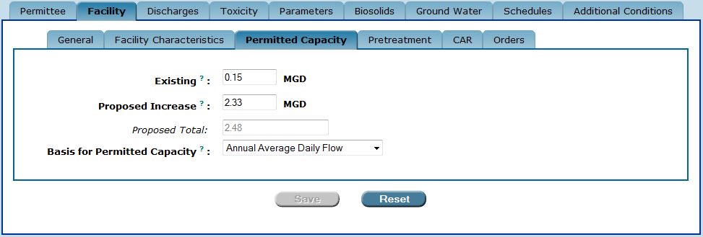

3.3.2. The “changes made that affect default parameters” reminder

When entering permitted capacity information for domestic wastewater projects, Permit Builder will display the following window if changes have made to either the Proposed Total (by way of entering a value in the Proposed Increase field) or to the Basis for Permitted Capacity field.

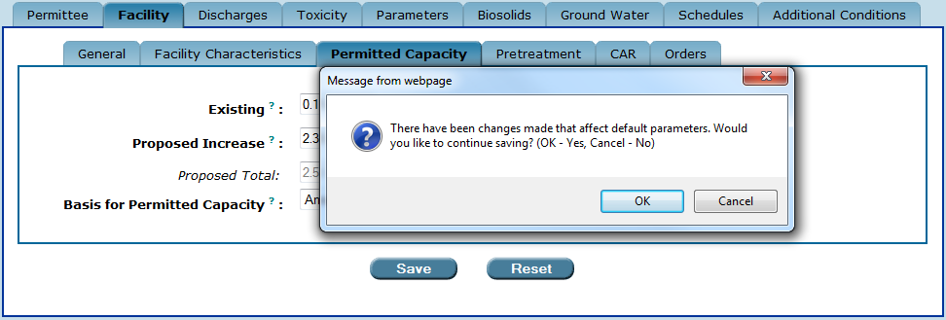
OK ow
If you are sure of your entries, click
Cancel ow
Otherwise, click and check with your supervisor.

3.4. The “Pretreatment” sub-tab

The Pretreatment sub-tab contains several radio-button statements for describing a facility’s pretreatment program status. The Pretreatment sub-tab is largely read-only and the permit writer is not able to edit the options that appear on this sub-tab. The Pretreatment sub-tab pulls information from the pretreatment fields in WAFR. To make changes to the information that appears on this sub-tab in Permit Builder, changes need to be made to the pretreatment fields in WAFR. The industrial pretreatment program staff in Tallahassee is primarily responsible for maintaining the pretreatment information in WAFR. For information about your facility’s pretreatment program requirements, contact the Department’s pretreatment program coordinator.

3.4.1. The “Facility is not required to have a pretreatment program” radio-button statement
IF the facility is not required to have a Pretreatment Program,
THEN the radio-button selected will be the statement:
- Facility is not required to have a pretreatment program.

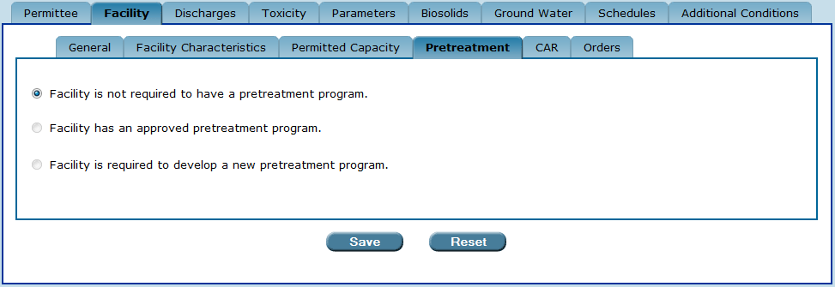
The “Pretreatment” sub-tab.

3.4.2 The “Facility has an approved pretreatment program” radio-button statement
IF the facility already has an approved Pretreatment Program,
THEN the radio-button selected will be the statement:
- Facility has an approved pretreatment program.

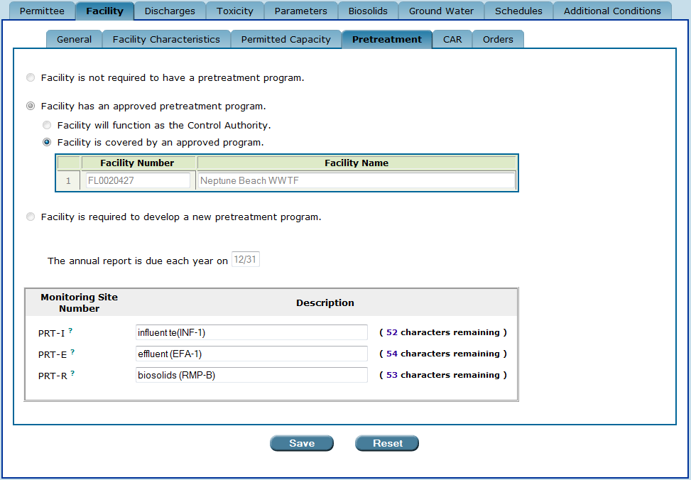

3.4.2.1. “Control Authority” versus “covered by an approved program”
Where the facility has an approved pretreatment program or is required to develop a new pretreatment program, two additional radio-buttons define whether the facility functions as the Control Authority, or is covered by an approved program.

For facilities covered by another facility’s pretreatment program, the permit will indicate that the pretreatment program requirements are included in the Control Authority’s permit. For facilities acting as the Control Authority, the permit will include all the pretreatment program requirement as well as reference any facilities covered by the Control Authority’s pretreatment program.

3.4.2.2. Pretreatment Program Annual Report due-date
For a facility that has an approved pretreatment program or is required to develop a new pretreatment program, Permit Builder adds a field to display the date the Pretreatment Program Annual Report is due each year. This information is also obtained by Permit Builder from WAFR.

3.4.2.3. Pretreatment monitoring sites
For a facility that has an approved pretreatment program or is required to develop a new pretreatment program, Permit Builder will also display the names and descriptions of the locations of the three pretreatment monitoring sites, which will appear in the Pretreatment Program Annual Report as well as the monthly Discharge Monitoring Reports (DMRs):
- PRT-I, the influent pretreatment monitoring site.
- PRT-E, the effluent pretreatment monitoring site.
- PRT-R, the biosolids (or residuals) monitoring site.

A pretreatment monitoring site may or may not be the same as another monitoring site within the facility.

If these sites exist in WAFR, the descriptions in WAFR will appear in the Monitoring Site table on the Pretreatment sub-tab. However, the permit writer is able to edit the existing WAFR descriptions for PRT-I, PRT-E, and PRT-R or create new ones if these sites do not exist in WAFR. The site descriptions edited or created in Permit Builder will be uploaded to WAFR when the permit writer uploads the project to WAFR

3.4.3. The “Facility is required to develop a new pretreatment program” radio-button statement
IF the facility is required to develop a new pretreatment program,
THEN the radio-button selected will be the statement:
- Facility is required to develop a new pretreatment program.

Again, whether the facility functions as the Control Authority or is covered by an approved program will also be indicated on the sub-tab based on information obtained from WAFR. See section 3.4.2.1.

For additional information on the date the Pretreatment Program Annual Report is due each year and the locations of the three pretreatment monitoring sites, see sections 3.4.2.2. and 3.4.2.3.

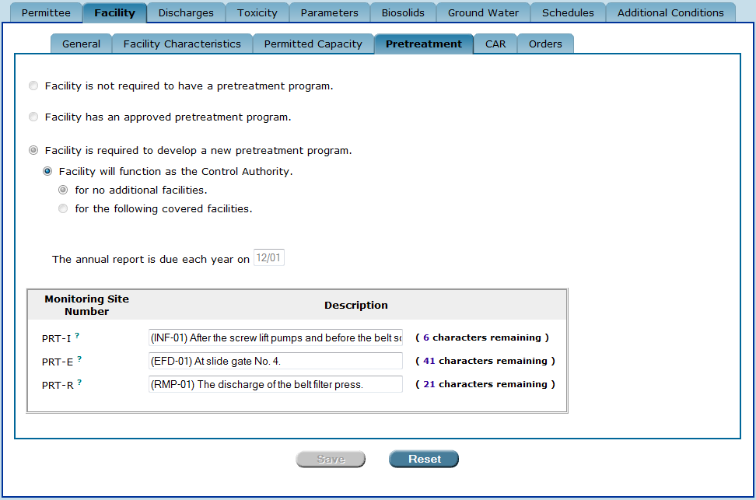

3.4.4. The “Save” and “Reset” buttons

Once you have finished the CAR sub-tab, be sure to either:.
Save ow
- Click to save your entries; or
Reset ow
- Click to clear all entries made to the CAR sub-tab. This will restore all fields to any information entered before the last time this sub-tab was saved.

3.5. The “CAR” sub-tab

A wastewater treatment facility is required to submit an initial Capacity Analysis Report, or CAR, when its three-month average daily flow (TMADF) for the most recent three consecutive months exceeds 50 percent of the permitted capacity of either its treatment plant, or its reuse and disposal system.

The CAR sub-tab contains three radio-button statements for describing a facility’s Capacity Analysis Report requirements.

3.5.1. The “Initial CAR has not been submitted” radio-button statement

If the facility’s TMADF has not yet reached 50 percent of the permitted capacity of either its treatment plant, or its reuse and disposal system, then the facility is not yet required to submit a CAR, and you should click on the radio-button statement:

- Initial CAR has not been submitted.

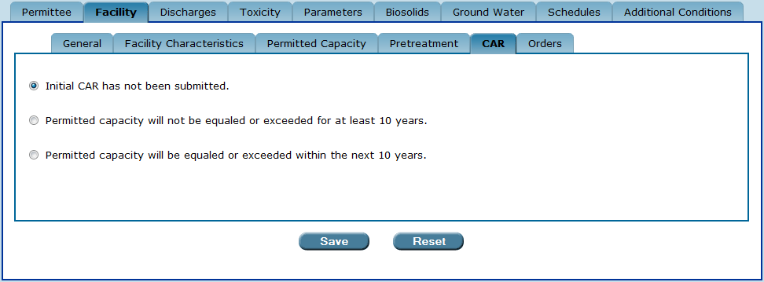
The “CAR” sub-tab.

3.5.2. The “Permitted capacity will not be equaled or exceeded for at least 10 years” radio-button statement

If the facility has submitted an initial or updated CAR indicating that the permitted capacity will not be equaled or exceeded for at least 10 years, then click the radio-button statement:

- Permitted capacity will not be equaled or exceeded for at least 10 years.

A facility in this situation is required to submit an updated CAR to the Department at five-year intervals or with each application for permit renewal.

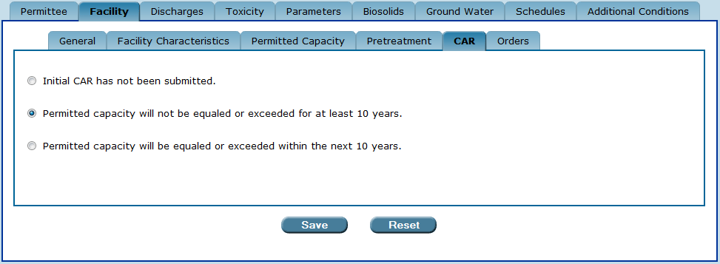

3.5.3. The “Permitted capacity will be equaled or exceeded within the next 10 years” radio-button statement

If the facility has submitted an initial or updated CAR indicating that the permitted capacity will be equaled or exceeded within 10 years, then click the radio-button statement:

- Permitted capacity will be equaled or exceeded within the next 10 years.

A facility in this situation is required to submit an updated CAR to the Department annually.

In the month and day drop-down boxes, select the month and day the CAR is due each year. This information should be provided in the facility’s application for permit renewal.

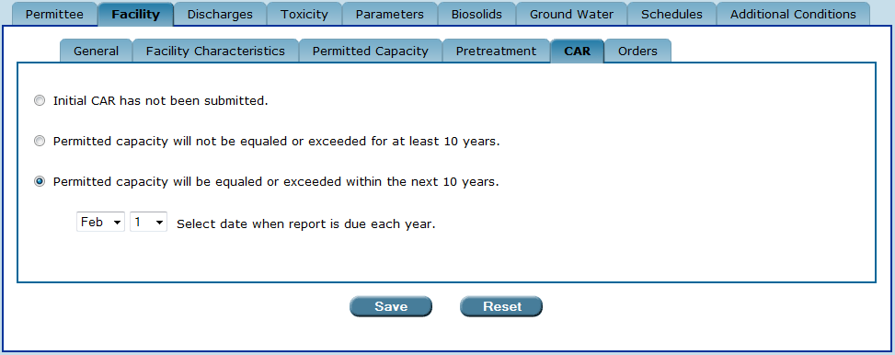

3.5.4. The “Save” and “Reset” buttons

Once you have finished with the CAR sub-tab, you will also be finished entering all required data corresponding to the Facility tab, and are ready to move on to the next Permit Builder tab.

Be sure to:
Save ow
- Click to save your entries to CAR sub-tab.
Reset ow
- Click to clear all entries made to the CAR sub-tab. This will restore all fields to any information entered before the last time this sub-tab was saved.

3.6. The “Orders” sub-tab

If a facility has an Administrative Order (AO) or a Consent Order (CO), that information is entered on the Orders sub-tab. From the Type of Order(s) pick-list, the permit writer selects Administrative (AO), Consent (CO), or both by pressing the Control button and clicking one or both types of order.

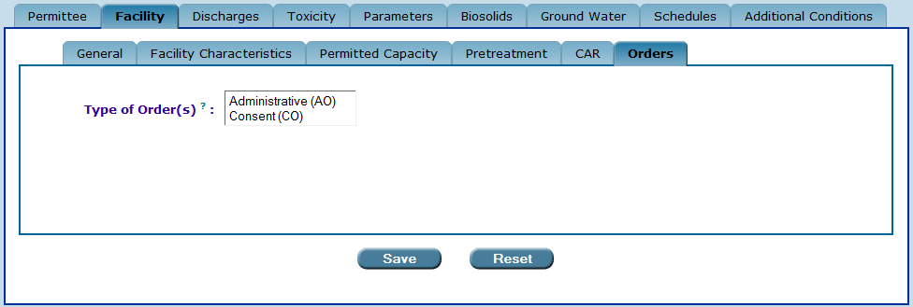
The “Order sub-tab”.

Once an order is selected, Permit Builder requests that you input information about the order: the order number, the effective or executed date, and a description of the purpose or intent of the order. Any order numbers created on this sub-tab will be included in the Final Limit or Order # drop-down box on the Parameter tab’s Limit and Statistical Basis pop-up window (see section 6.4 of the Permit Builder User Guide) and the Toxicity tab (see section 5.1 of the Permit Builder User Guide). In order to include interim limits associated with an order in your Permit Builder project, an order must be created and a file number provided on the Orders sub-tab.

If more than one order is needed for either type of order, press the Add Row button under the appropriate table and provide the file number, effective or executed date, and the purpose or intent.

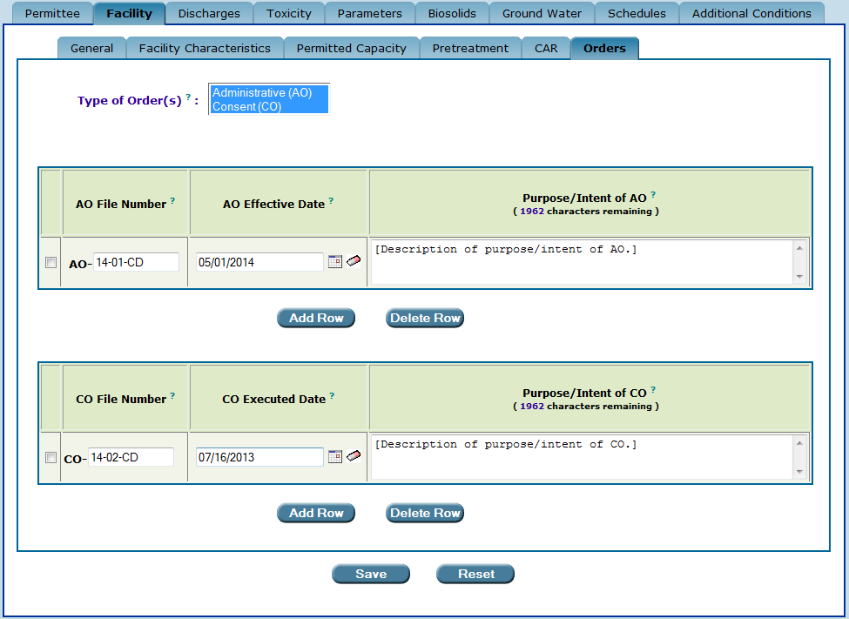
The “Orders sub-tab” with information about the order numbers, AO Effective Date, CO Executed Date, and the purpose of the orders provided by the permit writer.

If an Administrative Order is created on the Orders sub-tab, the AO will be referenced in the permit on the cover page and in the schedules section. If either an Adminstrative Order or a Consent Order is created on the Orders sub-tab, the order or orders will be referenced, including the purpose/intent, in the fact sheet or statement of basis.
CONGRATULATIONS!
YOU HAVE COMPLETED THE “FACILITY” TAB

See Rules 62-620.200(49) and (50), F.A.C., for detailed definitions of substantial modification and substantial revision.
A Water Resource Caution Area (WRCA) is an area that has critical water supply problems or is projected to have critical water supply problems within the next 20 years. Reuse of reclaimed water from domestic wastewater treatment facilities is typically required within a WRCA, as directed by Chapter 62-40, F.A.C. WRCAs are identified by Florida’s water management districts (WMDs), of which there are five statewide. If you are unsure as to whether or not the Permit Builder project you are working on is subject to WRCA requirements, ask your supervisor or check the DEP Reuse Program’s website. You may also contact the WMD and request a copy of its District Water Management Plan. This publication, usually available on-line, will contain detailed information on all WRCAs within the WMD’s jurisdiction.
That is, if changes have been made since the last time the permit writer clicked the Save button.
Some large municipalities have several wastewater treatment facilities under their jurisdiction, with one of the facilities designated as the Control Authority. For example, the City of Orlando has three wastewater treatment facilities – Iron Bridge Regional Water Reclamation Facility, Water Conserv I Water Reclamation Facility, and Water Conserv II Water Reclamation Facility. Iron Bridge functions as the pretreatment Control Authority over itself and the two other facilities, while Water Conserv I and II are covered by an approved program, namely, the Iron Bridge pretreatment program.
See Rule 62-600.405, F.A.C., Planning for Wastewater Facilities Expansion.

