4. The “Discharges” tab

The first task on the Discharges tab is to either create new or select existing Monitoring Groups for your Permit Builder project. A monitoring group identifies the type of effluent disposal system the facility employs after effluent has been treated to meet limitations established in the permit. The effluent is released to the environment to either:

- a surface water discharge outfall (monitoring group code “D”),
- an underground injection well (monitoring group code “U”),
- a land application site for reuse (monitoring group code “R”), or
- a land application site for disposal (monitoring group code “G”).

Additionally, one monitoring group is used to allow for the monitoring of specific internal waste streams before effluent is released to the environment. This monitoring group is known as:

- an internal outfall (monitoring group code “I”).

Section 4.1. describes how to select a monitoring group that has already been entered into Permit Builder.

Details for creating the five types of monitoring group sites are contained in the following sections of the Permit Builder User Guide.

- 4.2. Creating Monitoring Group Site “D” for discharge to a surface water body
- 4.3. Creating Monitoring Group Site “U” for discharge to an underground injection
control system
- 4.4. Creating Monitoring Group Site “R” for discharge to a land application site
(reuse) or Monitoring Group Site “G” for discharge to a land application site
(disposal)
- 4.5. Creating Monitoring Group Site “I” for sampling at an internal outfall

4.1. The “Discharge Points” screen – selecting a Monitoring Group already entered into Permit Builder

The screen shot below illustrates a project where the permit writer entered monitoring group information during a previous Permit Builder session. In this example, six monitoring groups are listed in the Monitoring Groups drop-down box.

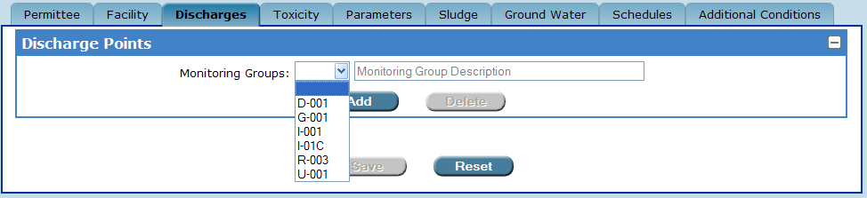

The “Monitoring Groups” drop-down box contains a list of monitoring groups
previously entered by the permit writer.

To select one of these monitoring groups, simply place the arrow cursor over your choice and click.

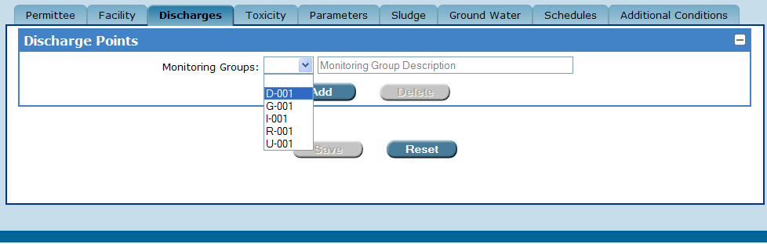

Selecting a Monitoring Group from the list.

Permit Builder will then display the following message:

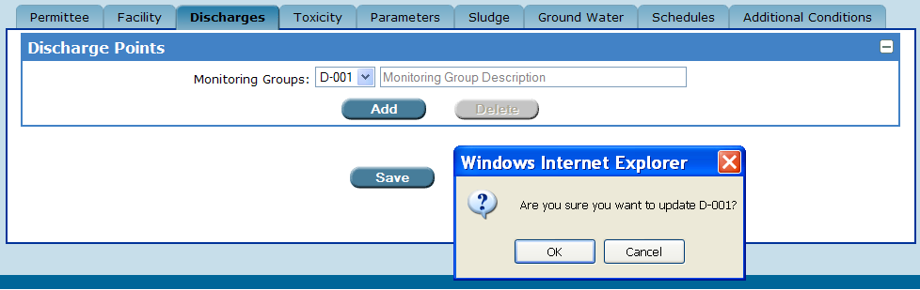

Click “OK” to select a Monitoring Group.
OK

To accept this choice, click .

Permit Builder will then populate the Discharge Points screen with the corresponding information previously entered about the monitoring group site. However, you will now be able to make certain changes to this information.

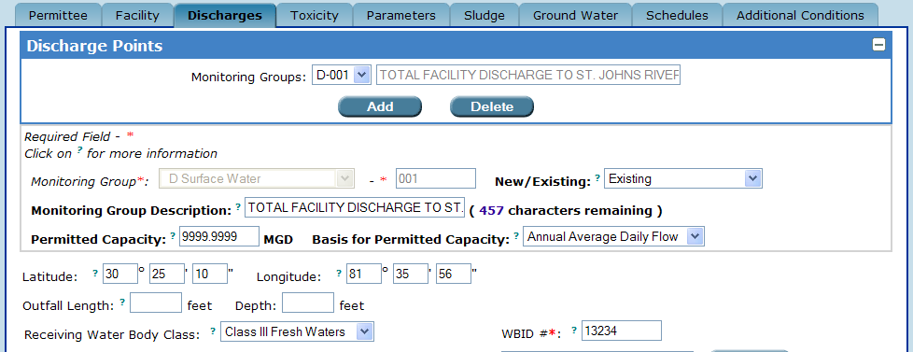

The “Discharge Points” screen is now populated with information about the selected monitoring group.

4.1.1. What if the “Monitoring Groups” drop-down box is empty?

If the Monitoring Groups drop-down box is narrow and empty when you click on it, as illustrated below, then no monitoring groups have been entered into Permit Builder for the facility. Proceed to Sections 4.2., 4.3., 4.4., and 4.5. for instructions on creating the five types of monitoring groups for your project.

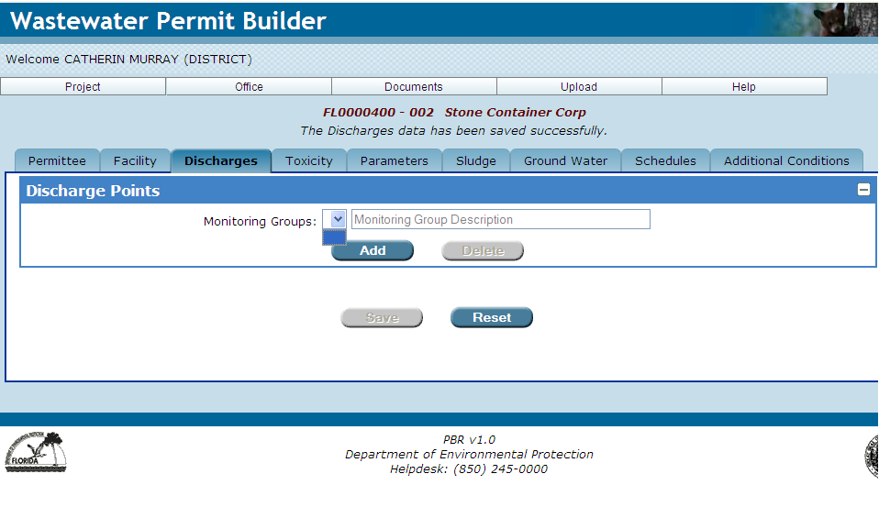

The “Monitoring Groups” drop-down box is empty.

4.2. Creating Monitoring Group Site “D” for discharge to a surface water body
Add
To create a “D” monitoring group, click on the Discharge Points screen.

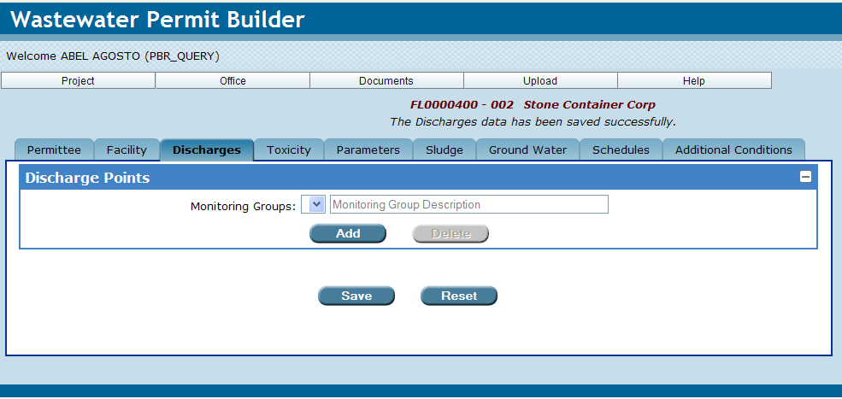

Permit Builder will display the Site Selection screen illustrated below, which contains two tables:

- The Create New Monitoring Group Site table where you can create new monitoring groups sites for your Permit Builder project, and

- The Select Existing WAFR Monitoring Group Site table where you can select existing monitoring groups previously associated with the facility through WAFR.

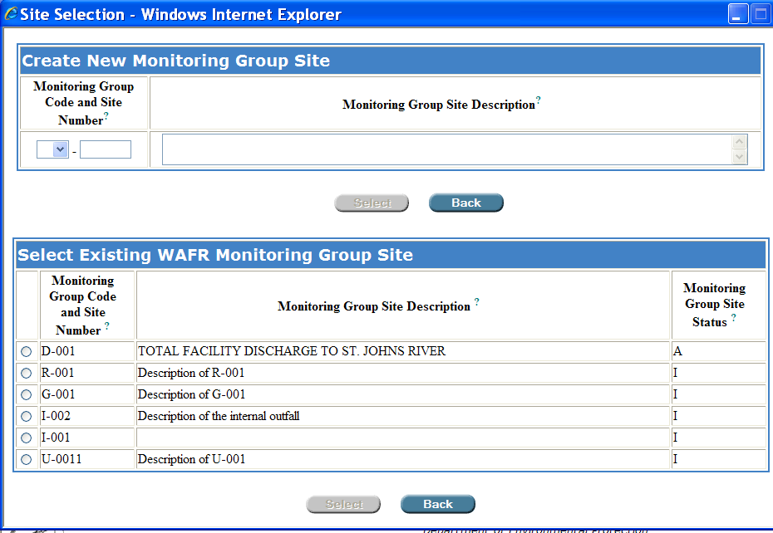

The “Site Selection” screen and its “Create New Monitoring Group Site”
and “Select Existing WAFR Monitoring Group Site” tables.

4.2.1. The “Create New Monitoring Group Site” table

To create a new monitoring group site “D” for discharge to a surface water body, follow Steps 1 – 4 below:

Step 1: Click the drop-down box located in the Create New Monitoring Group Site window, under Monitoring Group Code and Site Number, and select “D.”

Step 2: Type in the appropriate Site Number which is usually a three-digit number beginning with zero. This number should be unique to this surface water discharge monitoring group site.

Step 3: In the Monitoring Group Site Description field, type a brief description of the monitoring group site. This description will appear on the Discharge Monitoring Report (DMR).
Select
Step 4: Click to accept your entry and be directed back to the Discharge Points screen,
or
Back
Click to cancel your entries and be directed back to the Discharge Points screen.

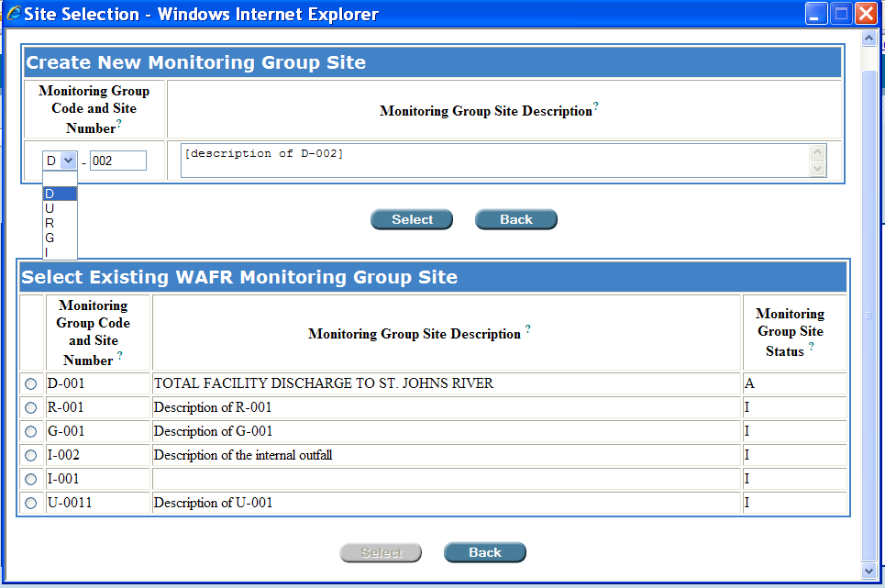
The permit writer has created monitoring group “D-002.”
After clicking “Select,” Permit Builder will return to the “Discharge Points” screen.

4.2.2. The “Select Existing WAFR Monitoring Group Site” table

To select an existing WAFR monitoring group site (if any sites are listed), do the following:

In the Select Existing WAFR Monitoring Group Site table, click the radio button and then click the corresponding button.
Select

Permit Builder will direct you back to the Discharge Points screen.

Back
NOTE: Click either of the buttons to cancel your entries and be directed back to the Discharge Points screen.

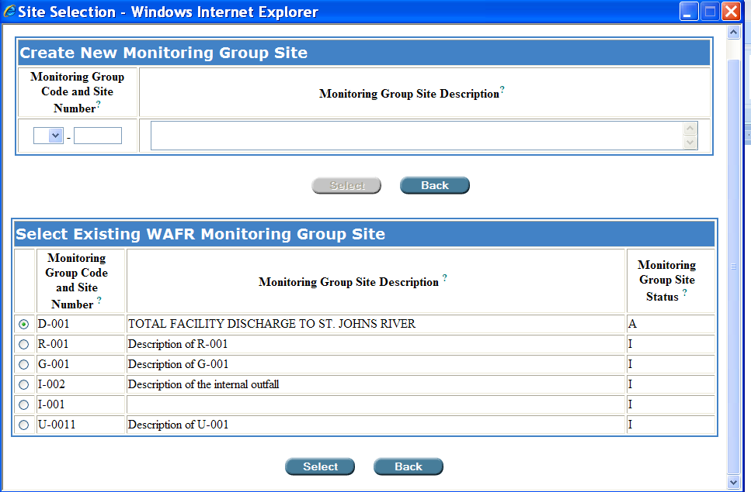
Click the radio button and then Select.

Selecting an existing WAFR monitoring group site, “D-001” in this example.

NOTE: If the Select Existing WAFR Monitoring Group Site table is empty, then no sites have been entered into WAFR for the facility. This may be the case for a new facility.

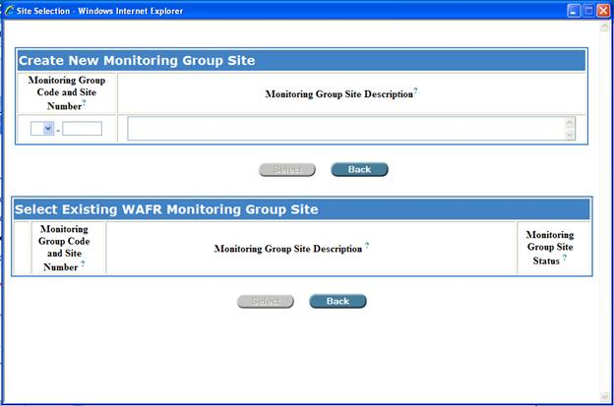

The “Select Existing WAFR Monitoring Group Site” table is empty.

Let’s pause a moment ….

You have now completed the initial steps in creating a Monitoring Group Site “D.”

Sections 4.2.3. – 4.2.5. address the remaining fields and check-box statements on the Discharge Points screen that you will need to fill out in order to complete creating a Monitoring Group Site “D” for your Permit Builder project.

4.2.3. Returning to the “Discharge Points” screen

Once you have been directed back to the Discharge Points screen, Permit Builder will now allow you to input more information about the surface water discharge monitoring group site you either created or selected from the Site Selection screen, D-001 in this example.

The Monitoring Group Description field will contain the description you typed into the similarly named field of the Create New Monitoring Group Site table. Permit Builder will allow you to edit this information from the Discharges Points screen.

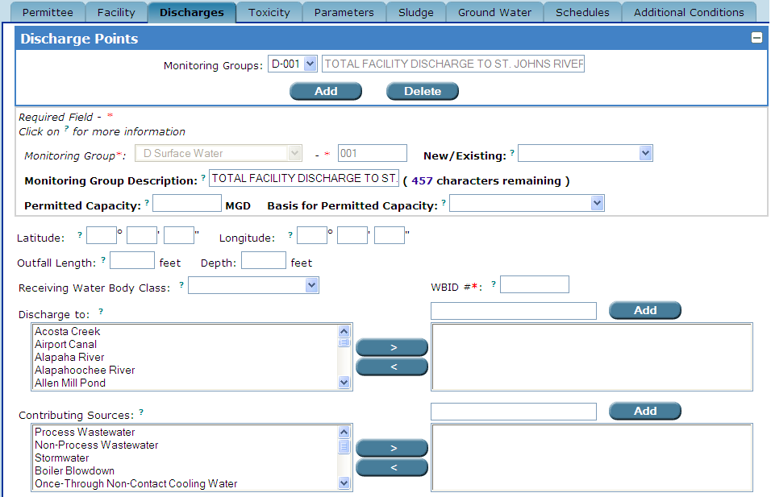
Permit Builder returns to the “Discharge Points” screen.
The “Monitoring Group Description” field which the permit writer may edit.

NOTE: Although you will be able to edit information on the Discharge Points screen in fields where text appears in black lettering, you will not be able to edit information where text appears in grey lettering.

Select the following information about the Monitoring Group site from the corresponding drop-down boxes, and fill-in the respective fields:

- New/Existing or Substantial Modification

- Select New if the Monitoring Group has not been previously permitted.
- Select Existing if the Monitoring Group has been previously permitted.
- Select Substantial Modification if the Monitoring Group is associated with the facility’s substantial modification, as defined in Rule 62-620.200(49), F.A.C.

- Permitted Capacity and Basis for Permitted Capacity

- Enter the permitted capacity (in million gallons per day, MGD).
- Select the basis used to calculate the permitted capacity which will be either

- Daily Maximum Flow,
- Monthly Average Daily Flow, or
- Annual Average Daily Flow

- Latitude and Longitude coordinates

- See Appendix A., Entering “Latitude” and “Longitude” coordinates.

- Outfall Length and Depth

- This information should be provided in the permit application and is a partial description of an outfall structure’s placement within a receiving surface water body.

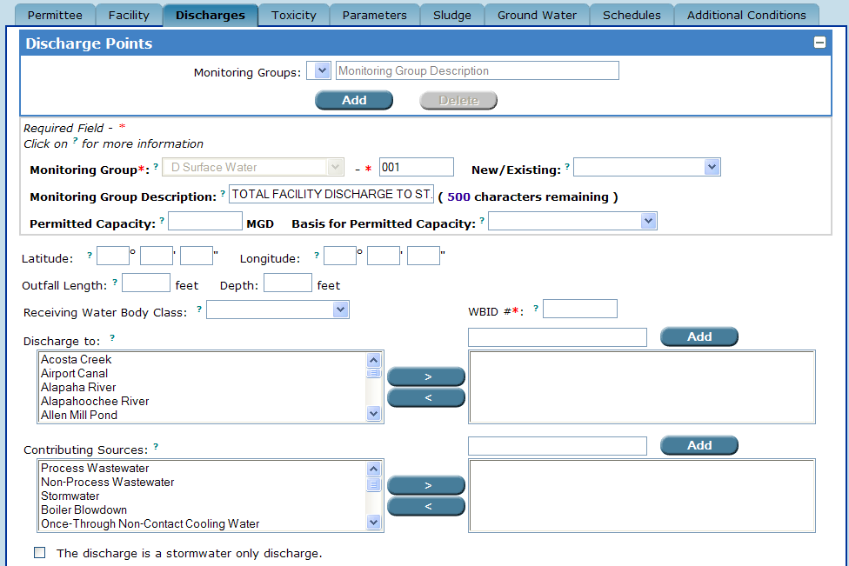
Entering information about monitoring group D-001 in the “New/Existing,” “Permitted Capacity,” “Basis for Permitted Capacity,” “Latitude,” “Longitude,” “Outfall Length,” and outfall “Depth” fields.

4.2.3.1. The “Receiving Water Body Class” field

You are now ready to select the Receiving Water Body Class for Monitoring Group D-001. This information should be provided in the permit application. However, as a permit writer, you should cross-check all submitted information with the facility’s current operating permit and with the information entered into WAFR.

The Receiving Water Body Class field has a drop-down box which lists all of the possible surface water body classes to which a receiving water body may belong and to which the Monitoring Group (D-001 in this example) is permitted to discharge.

Permit Builder offers the following five choices in the Receiving Water Body Class drop-down box:

- Class I Waters – Potable Water Supplies.
- Class II Waters – Shellfish Propagation and Harvesting.
- Class III Fresh Waters – Recreation, Propagation and Maintenance of a Healthy, Well-Balanced Population of Fish and Wildlife.
- Class III Marine Waters – Recreation, Propagation and Maintenance of a Healthy, Well-Balanced Population of Fish and Wildlife.
- Class IV Waters – Agricultural Water Supplies.

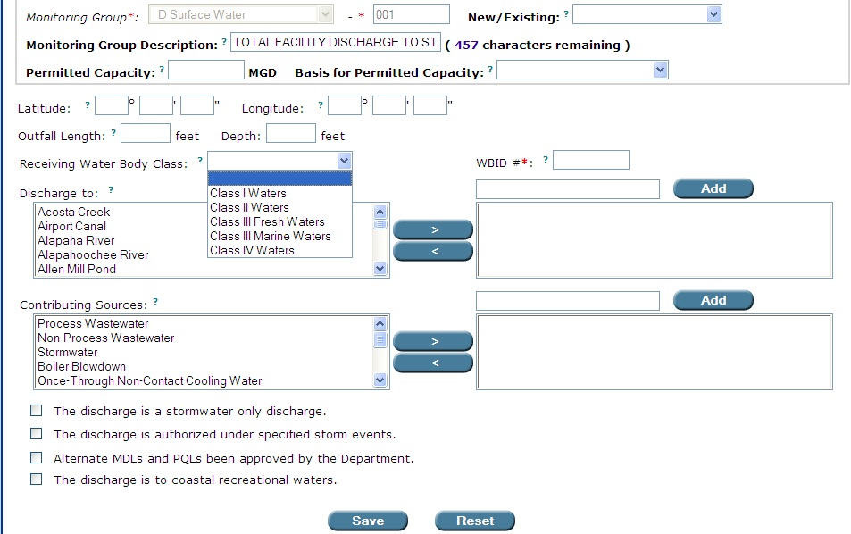

The “Receiving Water Body Class” drop-down box on the Discharge Points screen.

These classes of receiving water bodies, together with the list of classified waters in Florida, are identified in Rule 62-302.400, F.A.C., Classification of Surface Waters, Usage, Reclassification, Classified Waters.

Filling in the other information requested by Permit Builder on the Discharge Points screen - additional fields, drop-down boxes, and statements - enables you, the permit writer, to tell Permit Builder more about the particular aspects of the discharge.

4.2.3.2. The “Discharge to” field

The Discharge to field contains a list of all surface water bodies that may receive effluent discharges from wastewater facilities.
>
By highlighting any one of the water bodies listed and clicking you can create a list of receiving water bodies specific to the surface water discharge Monitoring Group (D-001 in this example).

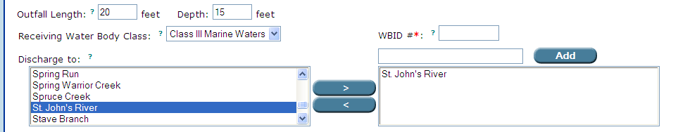

Selecting a receiving water body from the “Discharge to” list.

If the receiving water body is not on the list displayed in the Discharge to field, you may type in the name of the water body in the window located left of the “Add” button, and then click . This action will include your typed entry on the list of receiving water bodies specific to Monitoring Group D-001.
Add

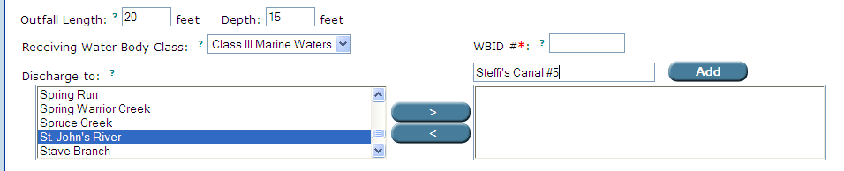

Adding a receiving water body that is not on the “Discharge to” list.

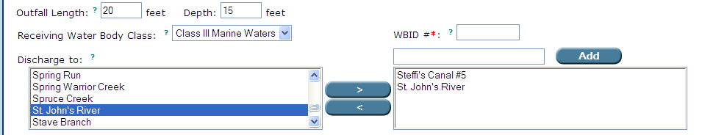

Selecting a receiving water body from the “Discharge to” list.

If you wish to remove an entry from the list of specific receiving water bodies for Monitoring Group D-001, highlight it and click .
<

4.2.3.3. The “WBID #” field

The WBID # field will contain the water body identification number of the water body receiving the Monitoring Group’s effluent discharge. The Department has assigned a unique water body identification number to each watershed or stream reach in Florida. You may wish to contact the Watershed Assessment Section or the Total Maximum Daily Load Development Section to verify that you have the receiving body’s correct WBID number to enter in the WBID # field. Alternatively, the Department’s web-based application TMDL Tracker may be used to determine the WBID of your receiving water body.

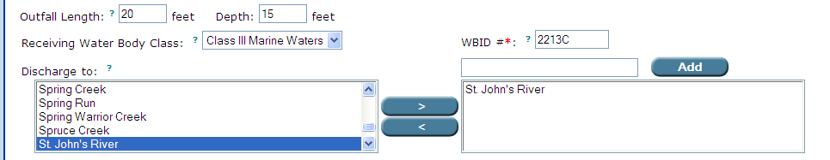
Entering the WBID number of a Monitoring Group’s receiving water body in the “WBID #” field.

If multiple receiving water bodies are listed for the Monitoring Group (e.g., Fishing Creek to Ortega River to St. Johns River), the WBID number of the Monitoring Group’s first receiving water body is the one entered in the WBID # field.

4.2.3.4. The “Contributing Sources” field

The Contributing Sources field contains a list of the most common waste streams contributing to the discharge of industrial wastewater facilities.
>
By highlighting any one of the sources listed and clicking you can create a list of contributing sources specific to the surface water discharge Monitoring Group (D-001 in this example).
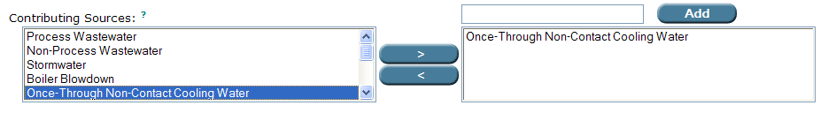
Selecting a source from the “Contributing Sources” list.

If the source is not on the list displayed in the Contributing Source field, you may type in the appropriate source in the window located left of the “Add” button, and then click . This action will include your typed entry on the list of contributing sources specific to Monitoring Group D-001.
Add

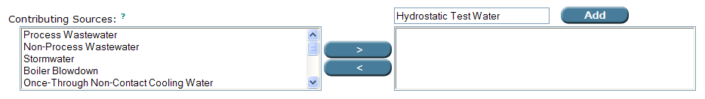

Adding a source that is not on the “Contributing Source” list.

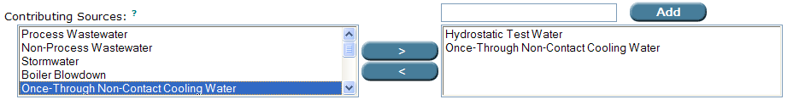
Selecting a source from the “Contributing Sources” list.

If you wish to remove an entry from the list of specific sources for Monitoring Group D-001, highlight it and click .
<

4.2.4. The various “check-box” statements on the “Discharges” tab, for “Monitoring Group D”

On the Discharges tab, Permit Builder will display various statements preceded by a check-box. For Monitoring Group D surface water discharges, these statements will appear in the lower half of the screen, beneath the Contributing Sources field.

By selecting one or more of these statements, you will be giving Permit Builder details about the facility’s surface water discharge. In return, Permit Builder will generate corresponding standard permit conditions in the text of the permit.

The screen shots below illustrate the general appearance of the Discharge Points screen for a Monitoring Group D, with its various check-box statements.

Each of these statements will be discussed in detail in the following Sections 4.2.4.1. through 4.2.4.4.

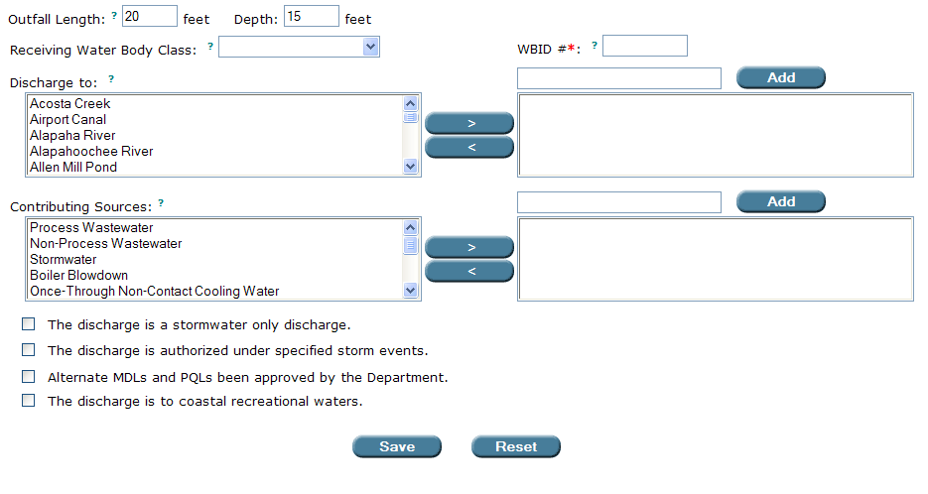

The various check-box statements Permit Builder will display.

4.2.4.1. The “stormwater only discharge” check-box statement

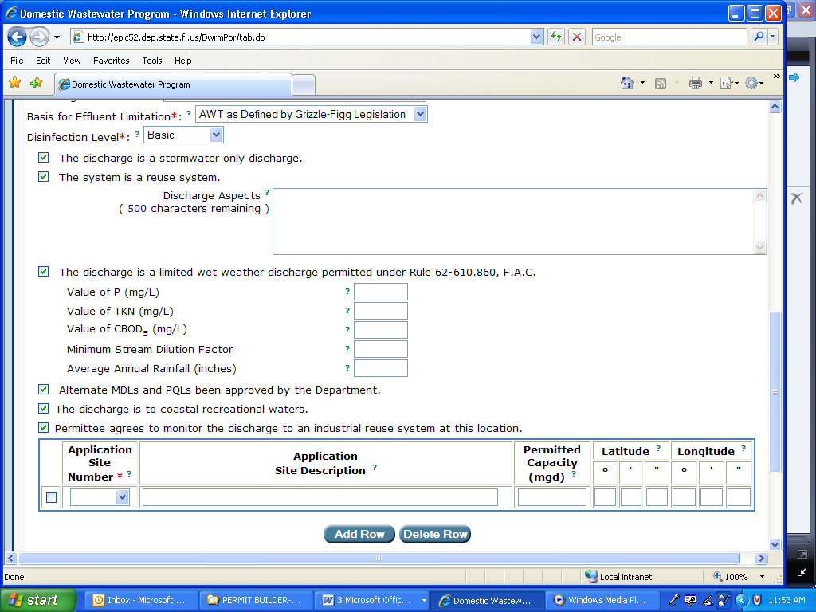

WHAT this check-box statement means:

By selecting this check-box statement, you are telling Permit Builder that the facility’s discharge from this particular Monitoring Group D, is a stormwater only discharge.

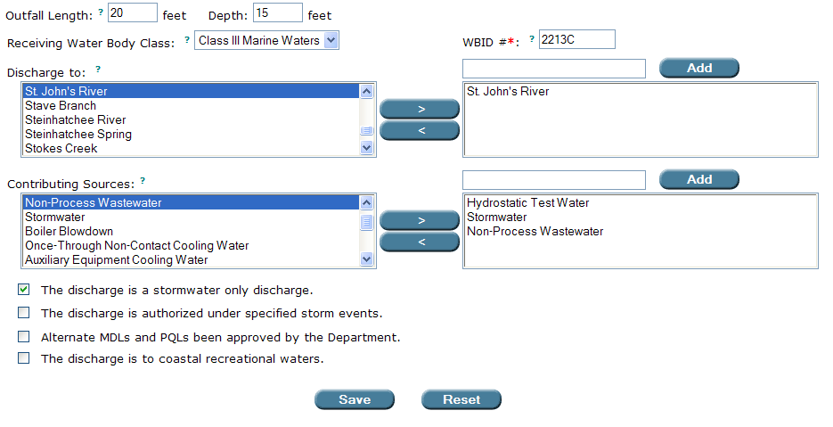

“The discharge is a stormwater only discharge” check-box statement.

4.2.5.2. The “authorized under specified storm events” check-box statement

WHAT this check-box statement means:

The facility is permitted to discharge at this particular Monitoring Group D only after a rainfall event exceeding the specified duration and frequency (e.g., 10-year, 24-hour storm event).

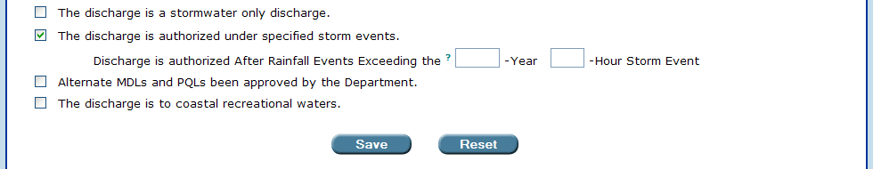

When the “authorized under specified storm events” check-box statement is selected,
Permit Builder will ask you to enter the return period and duration of the storm event.

4.2.5.3. The “MDLs / PQLs” check-box statement

WHAT this check-box statement means:

The facility has been approved by the Department to use alternate method detection limits (MDLs) and practical quantitation limits (PQLs) for routine laboratory analysis of its treated effluent.

4.2.5.4. “The discharge is to coastal recreational waters” check-box statement

WHAT this check-box statement means:

The facility is discharging its treated effluent to coastal recreation waters, which are marine coastal waters, including the mouth of coastal estuaries. Coastal recreation waters do not include inland waters or waters upstream from the mouth of a river or stream at its connection with the open sea. Facilities that discharge to this type of surface water are required to monitor for certain pathogens.

4.3. Creating Monitoring Group Site “U” for discharge to an underground injection control system
Add
To create a “U” monitoring group, click on the Discharge Points screen.

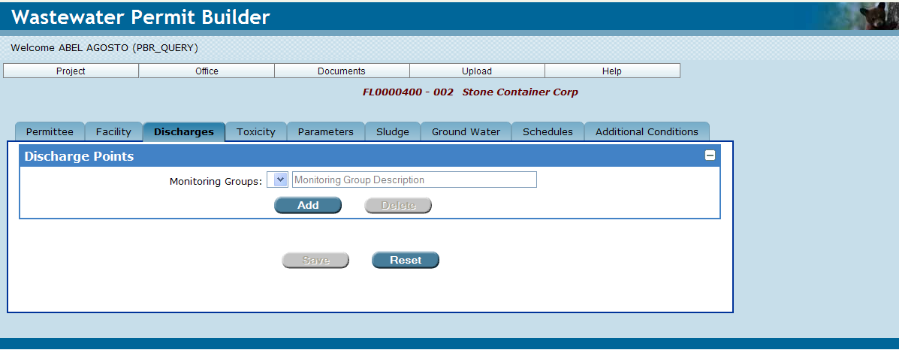

Permit Builder will display the Site Selection screen illustrated below, which contains two tables:
- The Create New Monitoring Group Site table where you can create new monitoring groups sites for your Permit Builder project, and
- The Select Existing WAFR Monitoring Group Site table where you can select existing monitoring groups previously associated with the facility through WAFR.

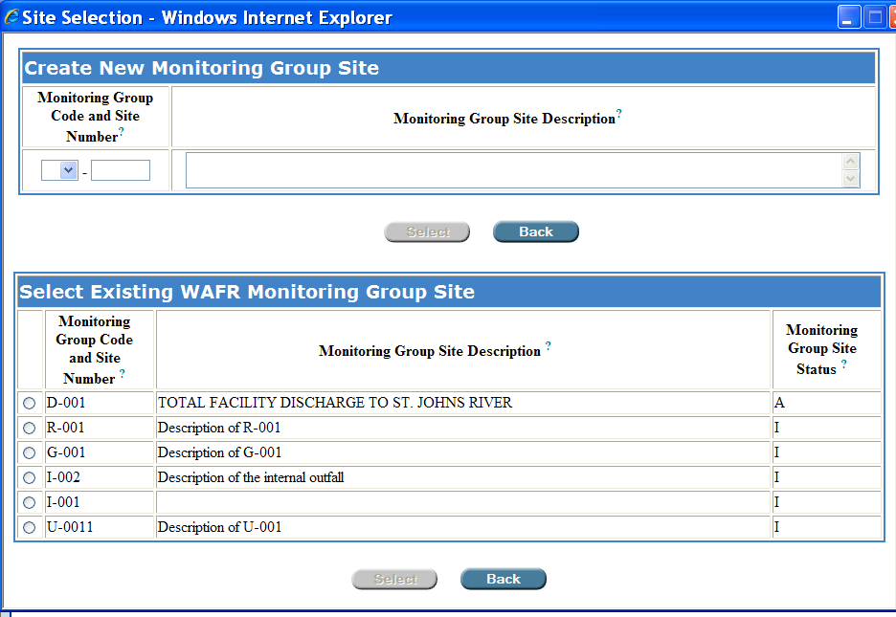

The “Site Selection” screen and its “Create New Monitoring Group Site”
and “Select Existing WAFR Monitoring Group Site” tables.

4.3.1. The “Create New Monitoring Group Site” table

To create a new monitoring group site “U” for a discharge to an underground injection control system, follow Steps 1 – 4 below:

Step 1: Click the drop-down box located in the Create New Monitoring Group Site window, under Monitoring Group Code and Site Number, and select “U.”

Step 2: Type in the appropriate Site Number which is usually a three-digit number beginning with zero. This number should be unique to this land application monitoring group site.

Step 3: In the Monitoring Group Site Description field, type a brief description of the monitoring group site. This description will appear on the Discharge Monitoring Report (DMR).
Select
Step 4: Click to accept your entry and be directed back to the Discharge Points screen, or
Back
Click to cancel your entries and be directed back to the Discharge Points screen.

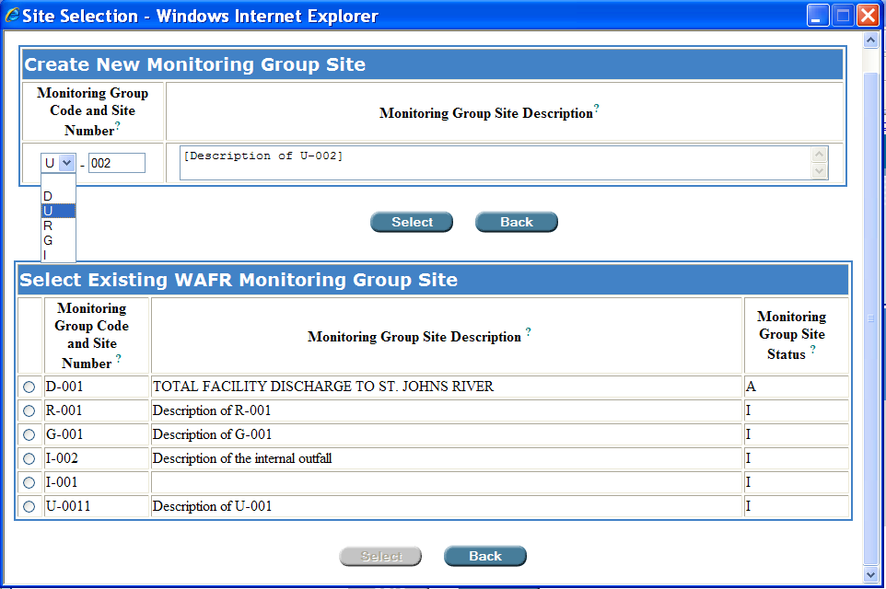
The permit writer has created monitoring group “U-002.”
After clicking “Select,” Permit Builder will return to the “Discharge Points” screen.

4.3.2. The “Select Existing WAFR Monitoring Group Site” tables

To select an existing WAFR monitoring group site (if any sites are listed), do the following:

In the Select Existing WAFR Monitoring Group Site table, click the radio button and then click the corresponding button. Permit Builder will direct you back to the Discharge Points screen.
Select

Back
NOTE: Click either of the buttons to cancel your entries and be directed back to the Discharge Points screen.

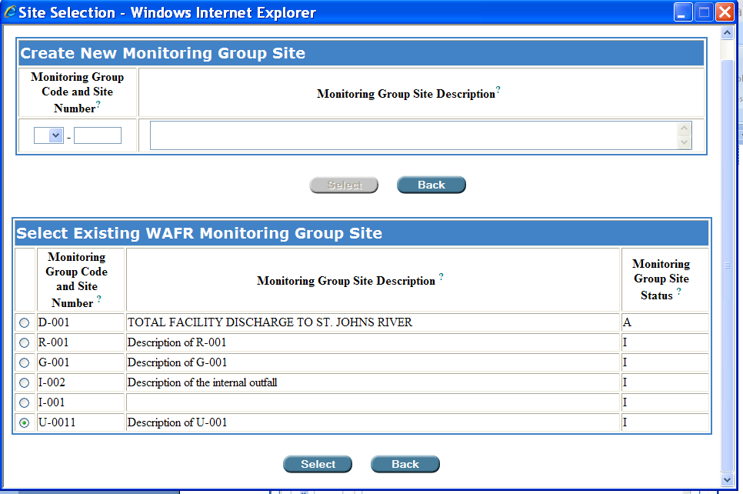
Click the radio button and then Select.

Selecting an existing WAFR monitoring group site, “U-0011” in this example.

NOTE: If the Select Existing WAFR Monitoring Group Site table is empty, then no sites have been entered into WAFR for the facility. This may be the case for a new facility.

The “Select Existing WAFR Monitoring Group Site” table is empty.

Let’s pause a moment ….

You have now completed the initial steps in creating a Monitoring Group Site “U.”

Section 4.3.3. addresses the remaining fields on the Discharge Points screen that you will need to fill out in order to complete creating a Monitoring Group Site “U” for your Permit Builder project.

4.3.3. Returning to the “Discharge Points” screen

Once you have been directed back to the Discharge Points screen, Permit Builder will now allow you to input more information about the underground injection control system monitoring group site you either created or selected from the Site Selection screen, U-002 in this example.

The Monitoring Group Description field will contain the description you typed into the similarly named field of the Create New Monitoring Group Site table. Permit Builder will allow you to edit this information from the Discharges Points screen.

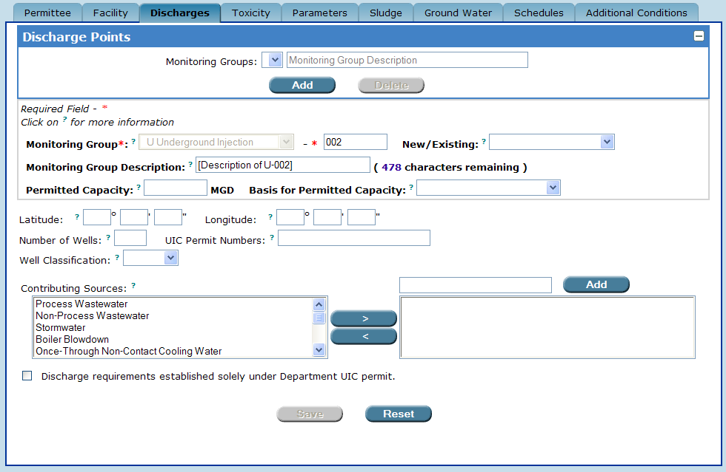
Permit Builder returns to the “Discharge Points” screen.
The “Monitoring Group Description” field which the permit writer may edit.

NOTE: Although you will be able to edit information on the Discharge Points screen in fields where text appears in black lettering, you will not be able to edit information where text appears in grey lettering.

Select the following information about the Monitoring Group site from the corresponding drop-down boxes, and fill-in the respective fields:

- New/Existing or Substantial Modification

- Select New if the Monitoring Group has not been previously permitted.
- Select Existing if the Monitoring Group has been previously permitted.
- Select Substantial Modification if the Monitoring Group is associated with the facility’s substantial modification, as defined in Rule 62-620.200(49), F.A.C.

- Permitted Capacity and Basis for Permitted Capacity

- Enter the permitted capacity (in million gallons per day, MGD).
- Select the basis used to calculate the permitted capacity which will be either

- Daily Maximum Flow,
- Monthly Average Daily Flow, or
- Annual Average Daily Flow

- Latitude and Longitude coordinates

- See Appendix A., Entering “Latitude” and “Longitude” coordinates.

- Number of Wells

- Enter the number of wells permitted for injection of wastewater.

- UIC Permit Numbers

- Enter the permit numbers issued by the Department’s UIC Program.

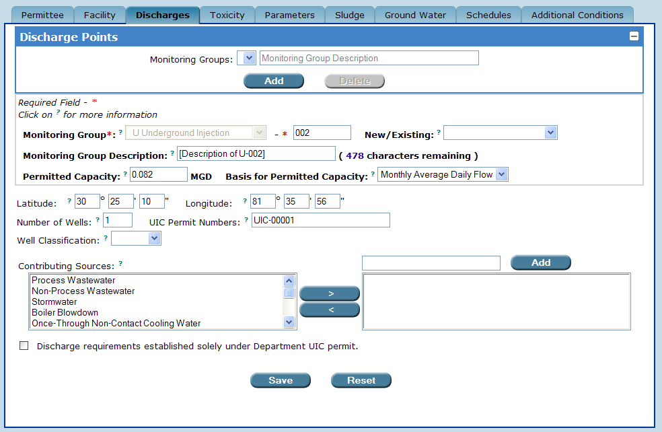
Entering information about monitoring group “U-002” in the “New/Existing,” “Permitted Capacity,” “Basis for Permitted Capacity,” “Latitude,” “Longitude,” “Number of Wells,” and
“UIC Permit Numbers” fields.

- Well Classification and Ground Water Class

Permit Builder allows you to select one of two classes of injection wells:

- Class I – Wells used to inject hazardous waste (new hazardous waste wells were banned in 1983), nonhazardous waste, or municipal waste below the lowermost underground sources of drinking water.

- Class I injection wells may only inject to Class G-IV ground water.

- Class V – Wells not included in the other well classes which generally inject nonhazardous fluid into or above an underground source of drinking water.

When selecting either Class I or Class V wells, Permit Builder will automatically display the Ground Water Class drop-down box.

Ground water classes are defined in Rule 62-520.410, F.A.C., as follows:

- Class F-I – Potable water use, ground water in a single source aquifer specifically located in northeast Flagler County, as specified in Rule 62-520.460, F.A.C., and which has a TDS content of less than 3,000 mg/L and was specifically reclassified as Class F-I by the ERC.

- Class G-I – Potable water use, ground water in single source aquifers which has a TDS content of less than 3,000 mg/L.

- Class G-II – Potable water use, ground water in aquifers which has a TDS content of less than 10,000 mg/L, unless otherwise classified by the ERC.

- Class G-III – Non-potable water use, ground water in unconfined aquifers which has a TDS content of 10,000 mg/L or greater; or which has a TDS content of 3,000 to 10,000 mg/L and either has been reclassified by the ERC as having no reasonable potential as a future source of drinking water, or has been designated by the Department as an exempted aquifer pursuant to Rule 62-528.300(3), F.A.C.

- Class G-IV – Non-potable water use, ground water in confined aquifers which has a total TDS content of 10,000 mg/L or greater.

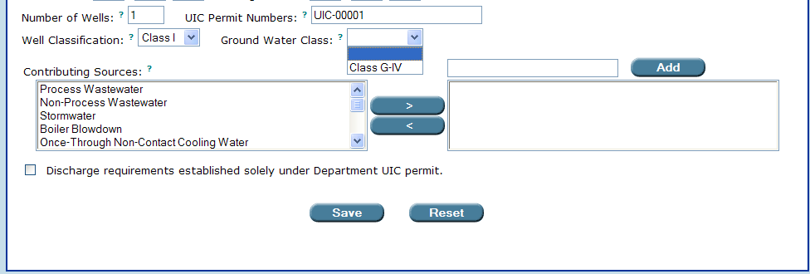

The “Ground Water Class” drop-down box when “Well Classification” is selected for “Class I.”

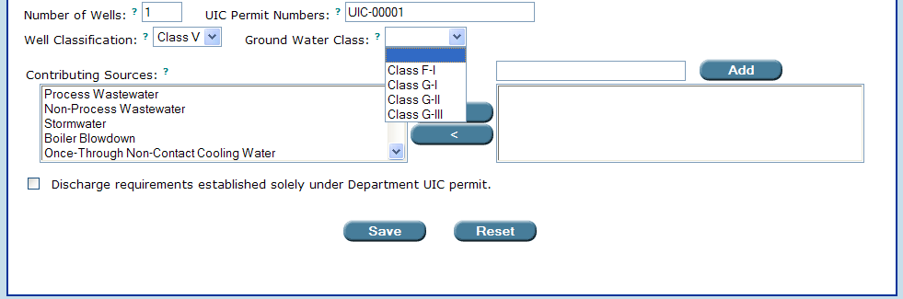

The “Ground Water Class” drop-down box when “Well Classification” is selected for “Class V”.

- Contributing Sources

  - Select the appropriate waste stream source that contributes to the effluent of the underground injection discharge Monitoring Group by highlighting the source from the Contributing Source field and clicking .
>

Selecting a source from the “Contributing Sources” list.

- If the source is not displayed in the Contributing Source field, you may type in the source name in the window located left of the “Add” button, and then click . This action will include your typed entry on the list of contributing sources specific to the underground injection Monitoring Group.
Add

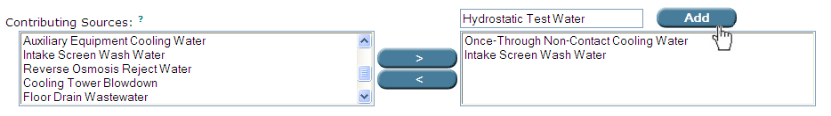
Adding a source that is not on the “Contributing Source” list.

  - If you wish to remove an entry from the list of specific sources for the underground injection Monitoring Group, highlight it and click ..
<

- Department UIC Permit check-box statement

  - If this statement is selected, Permit Builder will generate a single standard permit condition in the text of the permit indicating that the requirements for this underground injection Monitoring Group are established solely by the UIC permit(s) specified by the permit writer in the UIC Permit Numbers field described above.

4.4. Creating Monitoring Group Site “R” for discharge to a land application site (reuse) or a Monitoring Group Site “G” for discharge to a land application site (disposal)

Entering information for either a reuse or disposal land application system is identical. To create an “R” or a “G” monitoring group, click on the Discharge Points screen.
Add

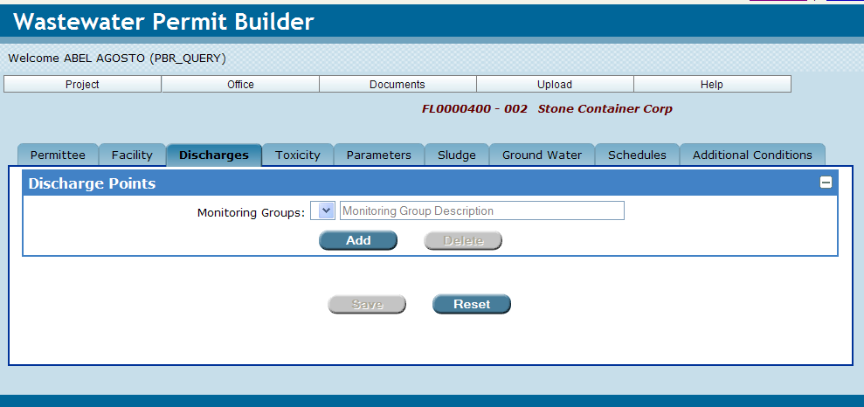

Permit Builder will display the Site Selection screen illustrated below, which contains two tables:

- The Create New Monitoring Group Site table where you can create new monitoring groups sites for your Permit Builder project, and

- The Select Existing WAFR Monitoring Group Site table where you can select existing monitoring groups previously associated with the facility through WAFR.

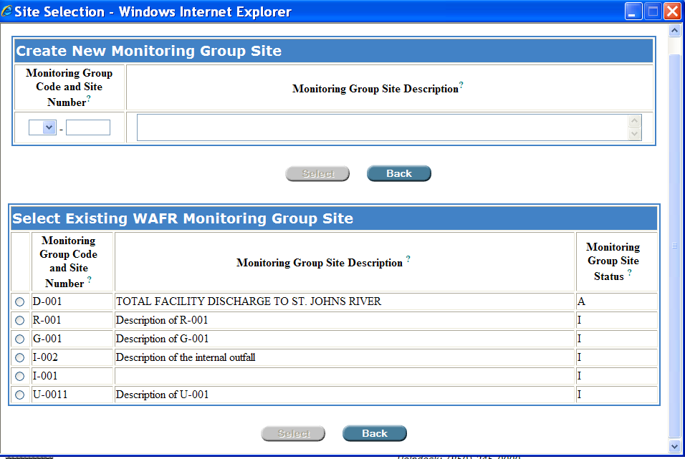

The “Site Selection” screen and its “Create New Monitoring Group Site”
and “Select Existing WAFR Monitoring Group Site” tables.

4.4.1. The “Create New Monitoring Group Site” table

Follow Steps 1 – 4 below to:

- Create a new monitoring group site “R” for a discharge to a land application site for the purpose of reusing industrial wastewater effluent for a beneficial purpose, or

- Create a new monitoring group site “G” for a discharge to a land application site for the purpose of disposing of industrial wastewater effluent rather than reusing it for a beneficial purpose.

Step 1: Click the drop-down box located in the Create New Monitoring Group Site window, under Monitoring Group Code and Site Number, and select “R” for land application (reuse) or “G” for land application (disposal).

Step 2: Type in the appropriate Site Number which is usually a three-digit number beginning with zero. This number should be unique to this land application monitoring group site.

Step 3: In the Monitoring Group Site Description field, type a brief description of the monitoring group site. This description will appear on the Discharge Monitoring Report (DMR).
Select
Step 4: Click to accept your entry and be directed back to the Discharge Points screen, or
Back
Click to cancel your entries and be directed back to the Discharge Points screen.

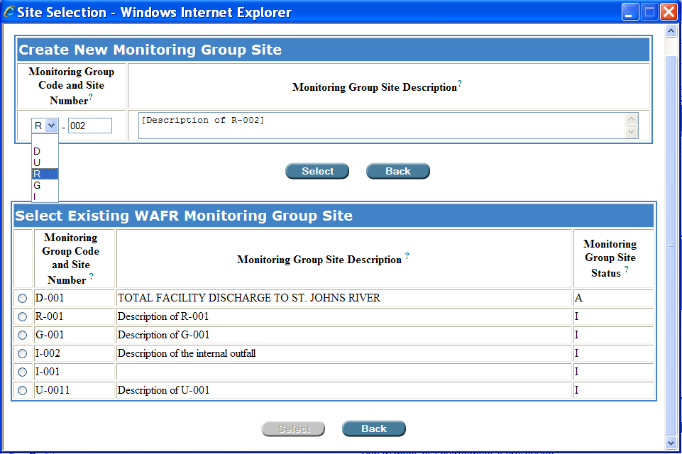
The permit writer has created monitoring group “R-002.”
After clicking “Select,” Permit Builder will return to the “Discharge Points” screen.

4.4.2. The “Select Existing WAFR Monitoring Group Site” table

To select an existing WAFR monitoring group site (if any sites are listed), do the following:

In the Select Existing WAFR Monitoring Group Site table, click the radio button and then click the corresponding button. Permit Builder will direct you back to the Discharge Points screen.
Select
Back
NOTE: Click either of the buttons to cancel your entries and be directed back to the Discharge Points screen.

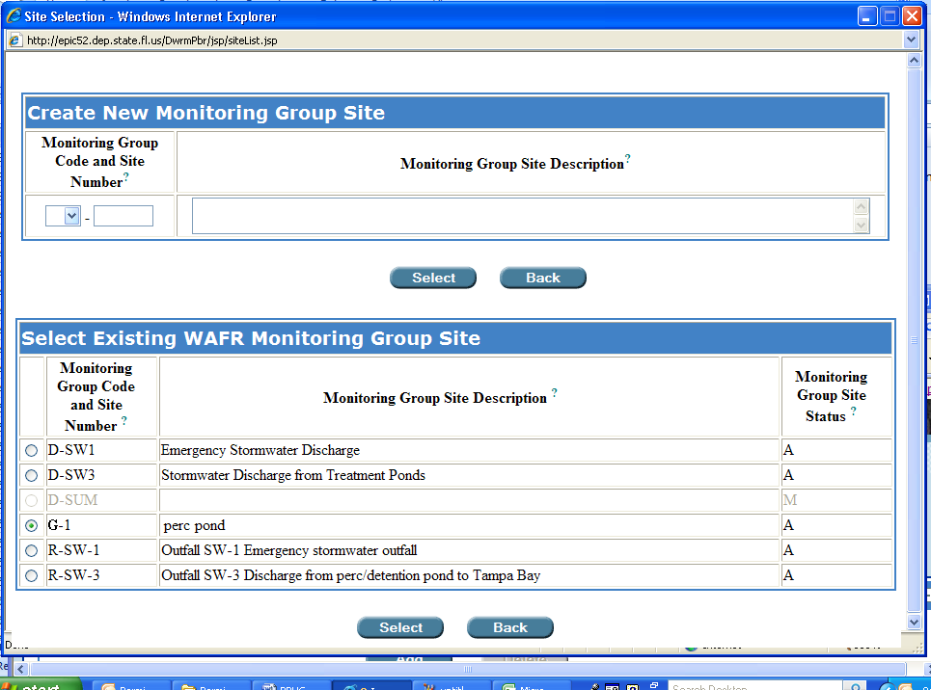
Click the radio button and then Select.

Selecting an existing WAFR monitoring group site, “G-1” in this example.

NOTE: If the Select Existing WAFR Monitoring Group Site table is empty, then no sites have been entered into WAFR for the facility. This may be the case for a new facility.

Let’s pause a moment ….
You have now completed the initial steps in creating a land application (reuse) Monitoring Group Site “R” or a land application (disposal) Monitoring Group Site “G.”
Once Permit Builder returns to the Discharge Points screen, you will have the option of creating any one of five types of land application systems for your project. Instructions on creating each of these systems are contained in Section 4.4.4.

4.4.3. Returning to the “Discharge Points” screen

Once you have been directed back to the Discharge Points screen, Permit Builder will now allow you to input more information about the land application monitoring group site you either created or selected from the Site Selection screen – R-001 in this example.

The Monitoring Group Description field will contain the description you typed into the similarly named field of the Create New Monitoring Group Site table. Permit Builder will allow you to edit this information from the Discharges Points screen.

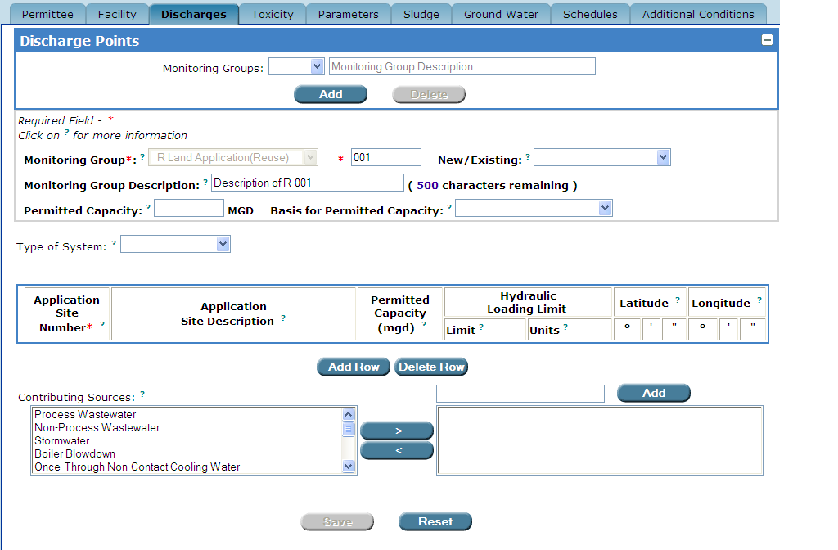
Permit Builder returns to the “Discharge Points” screen.
The “Monitoring Group Description” field which the permit writer may edit.

NOTE: Although you will be able to edit information on the Discharge Points screen in fields where text appears in black lettering, you will not be able to edit information where text appears in grey lettering.

Select the following information about the Monitoring Group site from the corresponding drop-down boxes, and fill-in the respective fields:

- New/Existing or Substantial Modification

- Select New if the Monitoring Group has not been previously permitted.
- Select Existing if the Monitoring Group has been previously permitted.
- Select Substantial Modification if the Monitoring Group is associated with the facility’s substantial modification, as defined in Rule 62-620.200(49), F.A.C.

- Permitted Capacity and Basis for Permitted Capacity

- Enter the permitted capacity (in million gallons per day, MGD).
- Select the basis used to calculate the permitted capacity which will be either

- Daily Maximum Flow,
- Monthly Average Daily Flow, or
- Annual Average Daily Flow.

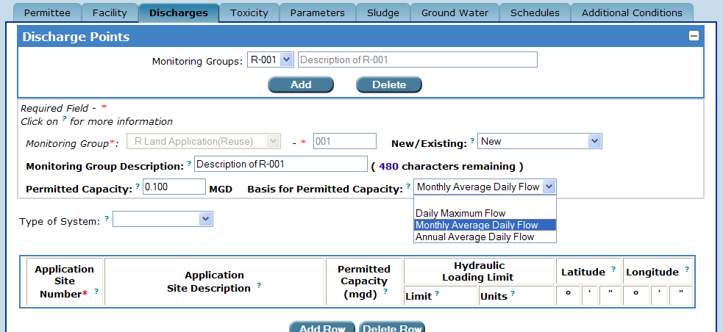
Selecting either “New,” “Existing,” or “Substantial Revision” in the “New/Existing” field, entering the permitted capacity in the “Permitted Capacity” field, and selecting the basis for permitted capacity from the “Basis for Permitted Capacity” drop-down box.

- Type of System

- Select reuse or disposal land application system from the drop-down box
- Sprayfield
- Drainfield
- Percolation Pond
- Infiltration Trench
- Evaporation Pond

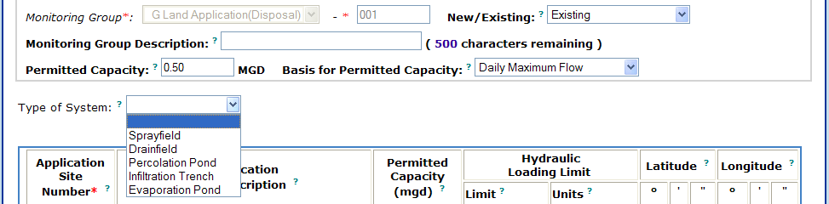
Selecting the “Type of System” from the drop-down box

Section 4.4.4 will help you create the specific types of land application sites for your Permit Builder project.

4.4.4. The land application system

From the Type of System drop-down box, select the type of land application system you would like to create:

- Sprayfield,
- Drainfield,
- Percolation Pond,
- Infiltration Trench, or
- Evaporation Pond.

Permit Builder will display:

- the Application Sites table,
- the Contributing Sources field, and
- the “optional land application requirement” check-box statements.

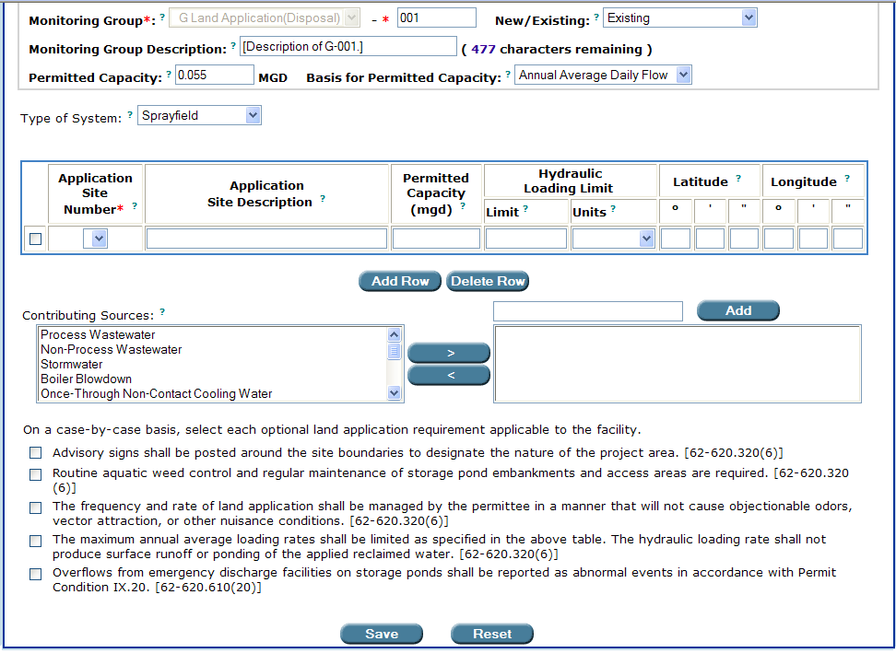
The Discharge Points screen when the Sprayfield option is selected
from the “Type of System” drop-down box.

First, look at the Application Site Number column in the Application Sites table.

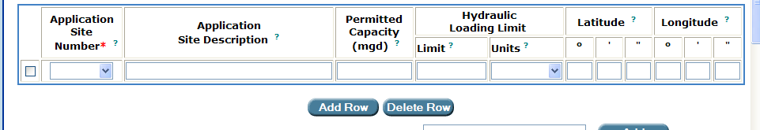

If the Application Site Number drop down box in the Application Sites table is narrow and empty when you click on it, then application sites have not yet been entered into Permit Builder for your project.

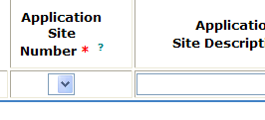 | 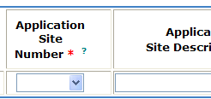 | 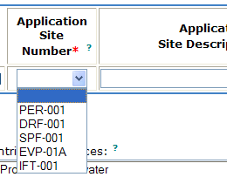
A narrow drop-down box indicates no application sites have been entered into the Permit Builder project. | A wide drop-down box indicates application sites have already been entered into the Permit Builder project. | Clicking on the drop-down box arrow brings up the list of application sites already entered into the Permit Builder project.

4.4.4.1. Creating a land application site

To create a land application site for your Permit Builder project, follow Steps 1 – 9 below.

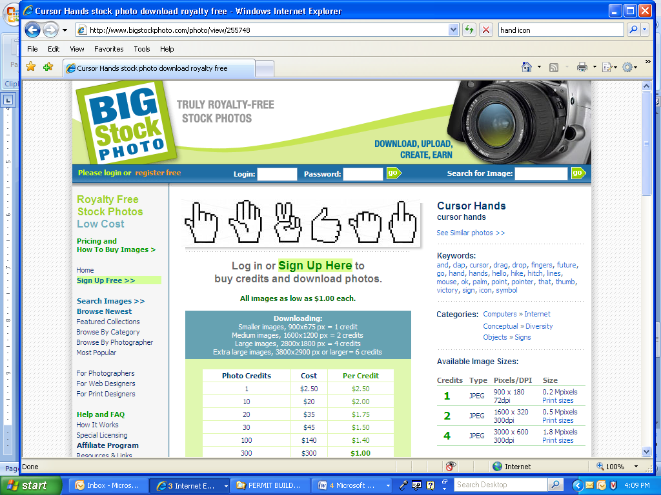
Step 1: Double-click anywhere in the Application Sites table where the hand-icon appears.

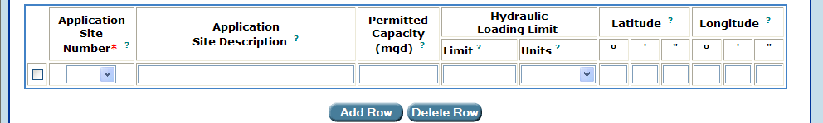

Permit Builder will then direct you to the Application Sites screen shown below.

Add Row
Step 2: From the Application Sites screen click .

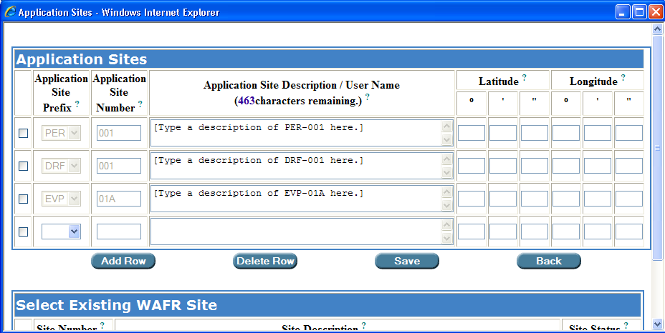
From the “Application Sites” table, click the “Add Row” button.
In this example, the permit writer had already entered three application sites to this project during previous Permit Builder sessions.

Step 3: Click on the Application Site Prefix drop-down box where you will see a list of five prefixes corresponding to five types of land application systems.
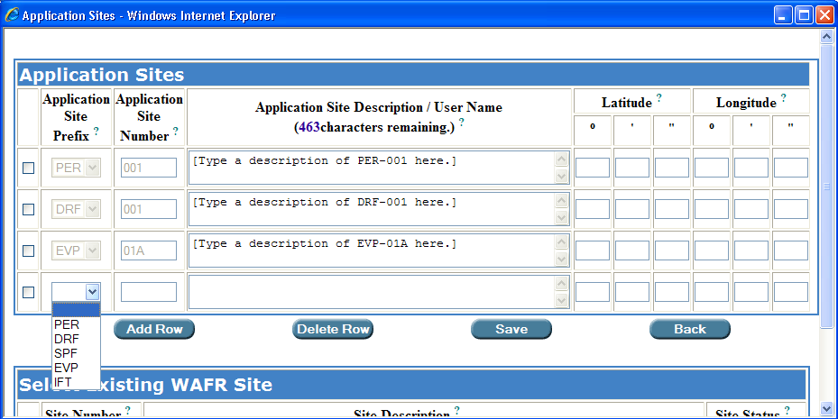

The Application Site Prefix drop-down box.

NOTE: A description of each prefix may be accessed by clicking on the blue question mark ? in the Application Site Prefix header box.

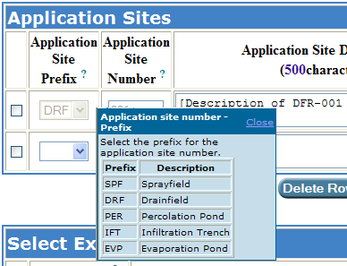
An information box for Application Site Prefix descriptions.

Step 4: Select the Application Site Prefix that is typical for the Type of System selected earlier on the Discharge Points screen.

- SPF – for Sprayfield,
- DRF – for Drainfield,
- PER – for Percolation Pond,
- IFT – for Infiltration Trench, or
- EVP – for Evaporation Pond.

In this example, the permit writer is selecting prefix SPF which is compatible with a sprayfield system.

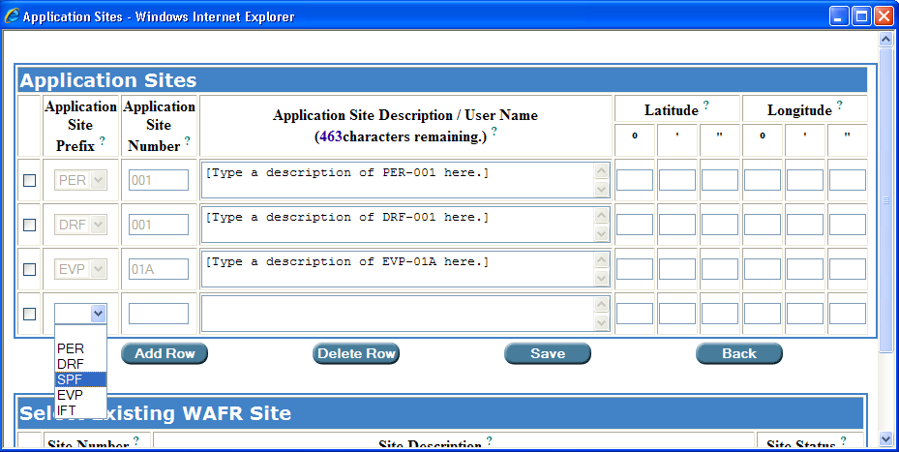

Select the Application Site Prefix that is typical of the Type of System.

Step 5: Enter the Application Site Number, Description, and the Latitude and Longitude coordinates for the newly created application site (SPF-002 in this example).

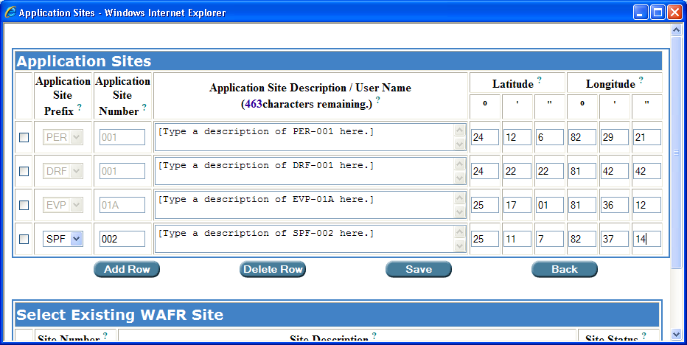

Entering the Application Site Number, Description, and Latitude and Longitude coordinates.

Save
Step 6: Click . Permit Builder will then return to Discharge Points screen where you will now see your latest application site entry listed in the Application Site Number drop-down box.

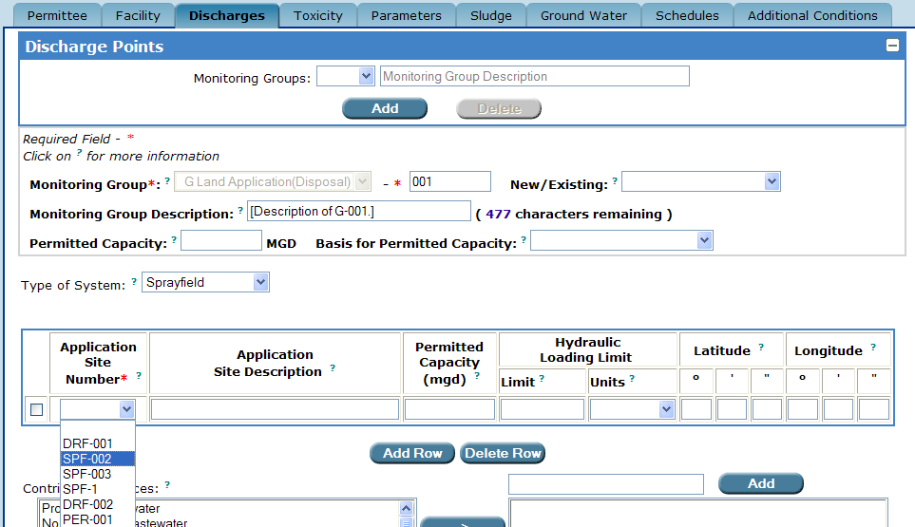

The Application Sites table now displays the permit writer’s latest entry (SPF-002 in this example).

Step 7: After selecting the application site from the Application Site Number drop-down box, Permit Builder will populate the table with the Application Site Description, and the Latitude and Longitude coordinates you entered from the Application Sites screen.

NOTE: This information is in grey lettering indicating that you will be unable to edit it from this screen. To edit you must return to the Application Sites table.

Step 8: Enter the Permitted Capacity and the Hydraulic Loading Limit, and select the Units from the drop-down box.

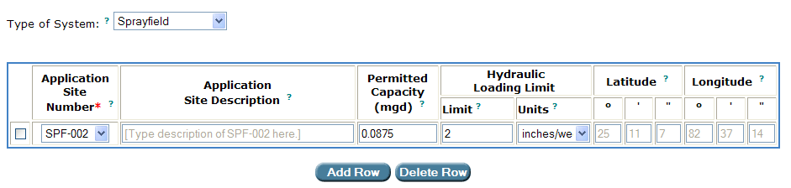

Entering Permitted Capacity and Hydraulic Loading Limit.

Step 9: To add another application site to the table, repeat Steps 1 – 8.

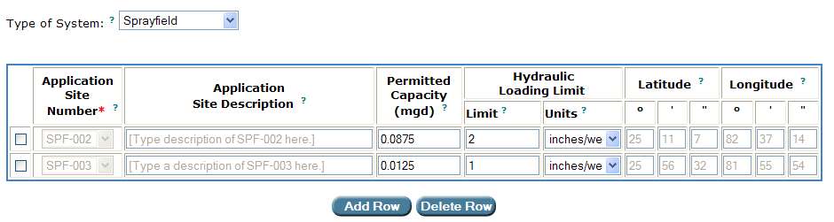

An application sites table with more than one application site.

4.4.4.2. SELECTING an Existing WAFR Site from the “Application Sites” screen

To Select an Existing WAFR Site, follow Steps 1 – 3 below.
Add Row
Step 1: Click located under the Application Sites table.

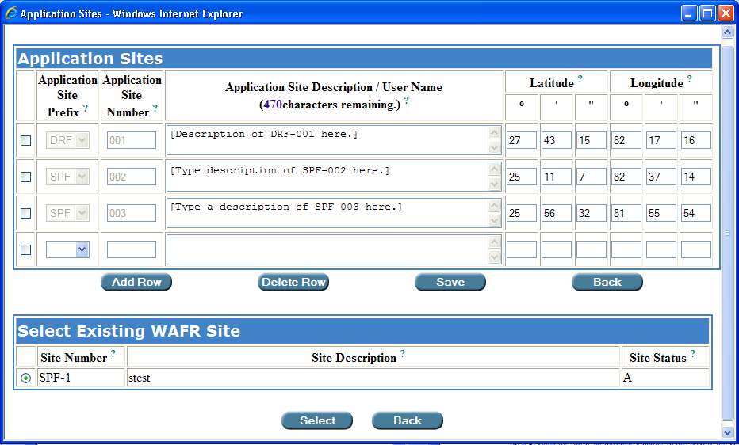

Step 2: Click the radio-button corresponding to the WAFR site you wish to select from the Select
Existing WAFR Site table, and then click .
Select

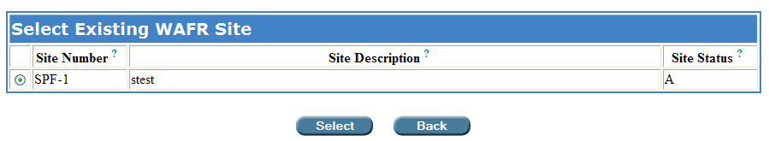

Permit Builder will then move the WAFR site you selected (SPF-1 in this example) to the Application Sites table.

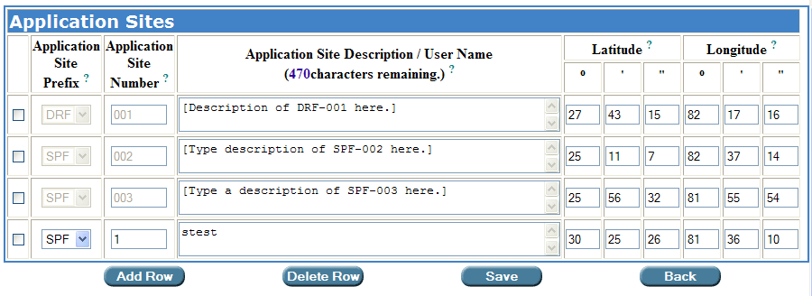

Save

Step 3: Click .

Permit Builder will then return to the Discharge Points screen where you can resume completing other entries about the land application site.

Back
NOTE: Clicking either of the buttons will return you to the Discharge Points screen but without adding any of the entries you may have made from the Application Sites screen.

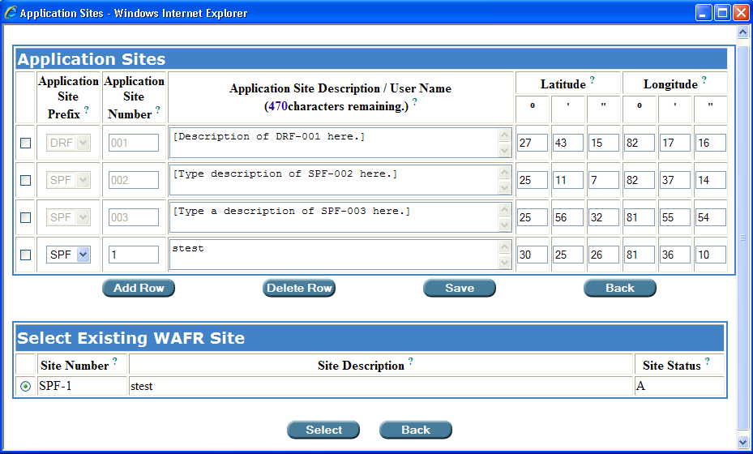

4.4.4.3. DELETING an application site from the Application Sites screen
Delete Row

To delete an application site, check the corresponding check-box and click .

NOTE: Although Permit Builder allows you to add and delete application sites, it will not allow you to add or delete existing WAFR sites. This can only be done through WAFR-PA.
If you should delete an application site that you added to the Application Sites table by moving it from the Select Existing WAFR Site table, the site will reappear in the Select Existing WAFR Site table.

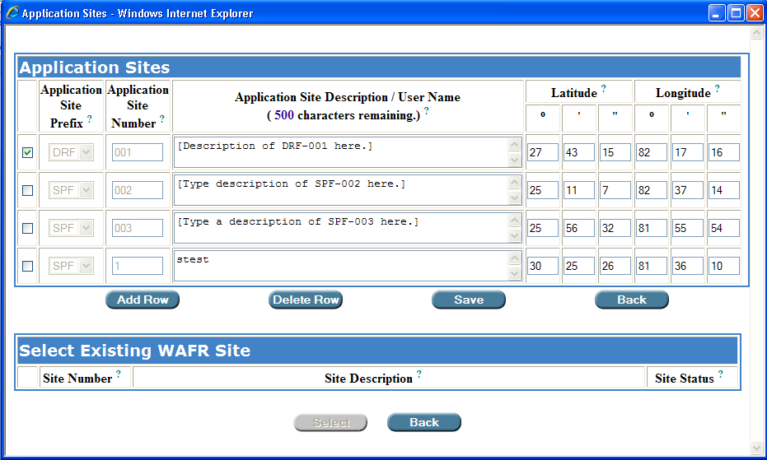

Deleting an application site from the Application Sites table.

4.4.4.4. Selecting a non-typical application site

If you choose an application site that is non-typical for the Type of System, Permit Builder will give you the following message:

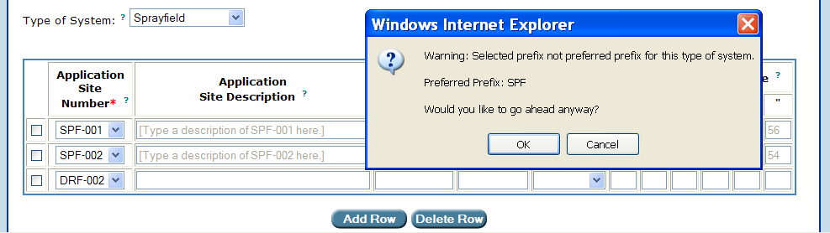

Although Permit Builder will allow you to select a non-typical land application system for a particular system type, always check the permittee’s application as well as your own entries to confirm that you want to continue with a non-typical land application system.

4.4.4.5. The “Contributing Sources” field

The Contributing Sources field contains a list of the most common waste streams contributing to the discharge of industrial wastewater facilities.
>
By highlighting any one of the sources listed and clicking you can create a list of contributing sources specific to the land application monitoring group.
Selecting a source from the “Contributing Sources” list.

If the source is not on the list displayed in the Contributing Source field, you may type in the appropriate source in the window located left of the “Add” button, and then click . This action will include your typed entry on the list of contributing sources specific to your land application monitoring group.
Add

Adding a source that is not on the “Contributing Source” list.

Selecting a source from the “Contributing Sources” list.

If you wish to remove an entry from the list of specific sources for Monitoring Group R-003, highlight it and click .
<

4.4.4.6. The various “optional land application requirement” check-box statements, for land application systems

On the Discharges tab, Permit Builder will display various statements preceded by a check-box. For land application systems, these statements will appear beneath the Contributing Sources field.

By selecting one or more of these statements, you will be giving Permit Builder details about the facility’s land application system. In return, Permit Builder will generate corresponding standard permit conditions in the text of the permit.

The screen shots below illustrate the general appearance of the Discharge Points screen for a Monitoring Group R or G, with its various check-box statements for different types of land application systems.

Each of these statements will be discussed in detail in the following Sections 4.4.4.6.1. through 4.4.4.6.7.

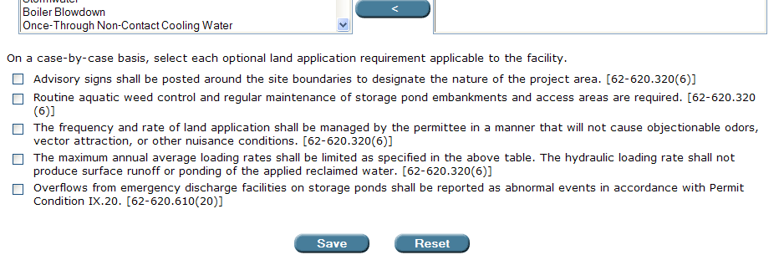

The various “optional land application requirement” check-box statements displayed when

“Type of System” is selected for “Sprayfield.”

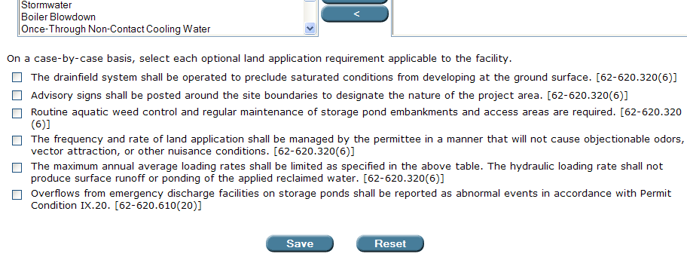

The various “optional land application requirement” check-box statements displayed when

“Type of System” is selected for “Drainfield.”

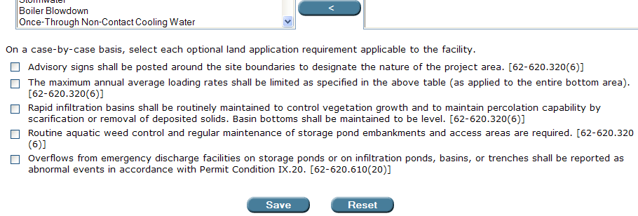

The various “optional land application requirement” check-box statements displayed when

“Type of System” is selected for “Percolation Pond” or “Infiltration Trench.”

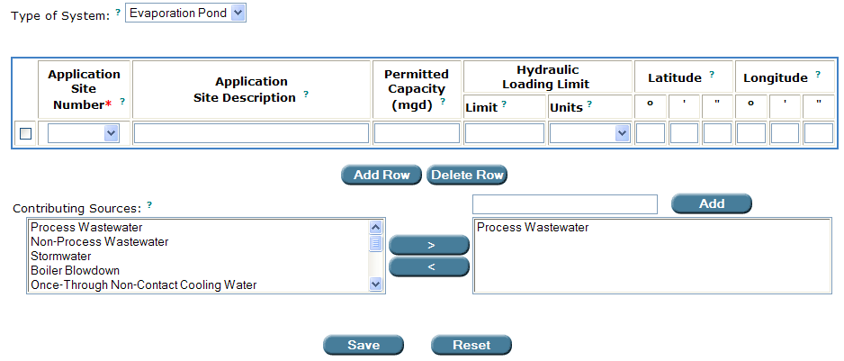

No check-box statements are displayed when “Type of System” is selected for “Evaporation Pond.”

When you select an optional land application requirement for a land application system in your Permit Builder project, Permit Builder adds the selected statement, and rule reference, as a permit condition in the Additional Land Application Requirements section of the permit.

4.4.4.6.1. The “advisory signs” check-box statement

WHAT this check-box statement means:

The wastewater facility is required to display signs designating the nature of the project area.

This optional land application requirement may be applicable to some Sprayfield, Drainfield, Percolation Pond, and Evaporation Trench land application systems.

4.4.4.6.2. The “weed control” check-box statement

WHAT this check-box statement means:

The wastewater facility is required to perform regular maintenance of the land application site and its access areas.

This optional land application requirement may be applicable to some Sprayfield, Drainfield, Percolation Pond, and Evaporation Trench land application systems.

4.4.4.6.3. The “frequency and rate of land application” check-box statement

WHAT this check-box statement means:

Land application of the facility’s wastewater will be carried out by the permittee so that nuisance conditions do not occur.

This optional land application requirement may be applicable to some Sprayfield and Drainfield land application systems.

4.4.4.6.4. The “maximum annual average loading rate” check-box statement

WHAT this check-box statement means:

The hydraulic loading rate you specified in the Application Sites table is the permitted hydraulic loading limit for the applicable land application system. The hydraulic loading rate employed at the facility must not produce surface runoff or ponding of the applied reclaimed water.

When selected, this requirement will appear in the permit in the following way:

The maximum annual average loading rate to the [Application Site Description] shall be limited to [Hydraulic Loading Limit] [Units]. The hydraulic loading rate shall not produce surface runoff or ponding of the applied reclaimed water. [62-620.320(6)]

This optional land application requirement may be applicable to some Sprayfield, Drainfield, Percolation Pond, and Evaporation Trench land application systems.

4.4.4.6.5. The “overflows from emergency discharge facilities” check-box statement

WHAT this check-box statement means:

The permittee is required to report emergency discharges to the Department in accordance with Permit Condition IX.20. and Rule 62-620.610(20), F.A.C.

This optional land application requirement may be applicable to some Sprayfield, Drainfield, Percolation Pond, and Evaporation Trench land application systems.

4.4.4.6.6. The “saturated conditions” check-box statement

WHAT this check-box statement means:

This statement requires the drainfield system to be operated in such a way that saturated conditions are prevented from developing.

This optional land application requirement may be applicable to some Drainfield land application systems.

4.4.4.6.7. The “rapid infiltration basins” check-box statement

WHAT this check-box statement means:

This statement requires that the rapid infiltration basins be managed so that percolation capability is maintained.

This optional land application requirement may be applicable to some Percolation Pond and Infiltration Trench land application systems.

Now that you have completed creating a land application system for your Permit Builder project,

Click to save your entries,
Save
or
Click to restore the Discharges tab to the entries last saved.
Reset

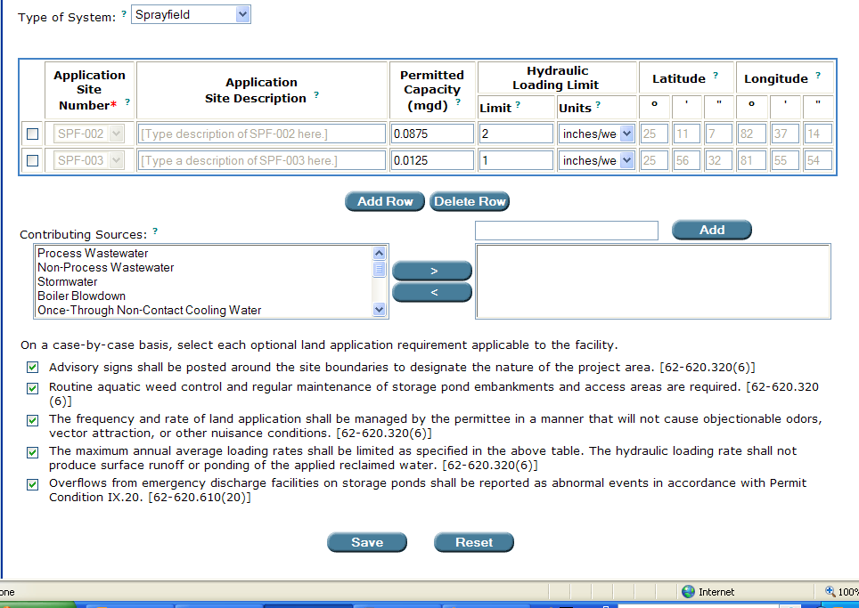

Don’t forget to SAVE!

4.5. Creating Monitoring Group Site “I” for sampling at an internal outfall
Add
To create an “I” monitoring group, click on the Discharge Points screen.

Permit Builder will display the Site Selection screen illustrated below, which contains two tables:

- The Create New Monitoring Group Site table where you can create new monitoring groups sites for your Permit Builder project, and

- The Select Existing WAFR Monitoring Group Site table where you can select existing monitoring groups previously associated with the facility through WAFR.

The “Site Selection” screen and its “Create New Monitoring Group Site”
and “Select Existing WAFR Monitoring Group Site” tables.

4.5.1. The “Create New Monitoring Group Site” table

To create a new monitoring group site “I” for an internal outfall, follow Steps 1 – 4 below.

Step 1: Click the drop-down box located in the Create New Monitoring Group Site window, under Monitoring Group Code and Site Number, and select “I.”

Step 2: Type in the appropriate Site Number which is usually a three-digit number beginning with zero. This number should be unique to this land application monitoring group site.

Step 3: In the Monitoring Group Site Description field, type a brief description of the monitoring group site. This description will appear on the Discharge Monitoring Report (DMR).
Select
Step 4: Click to accept your entry and be directed back to the Discharge Points screen, or
Back
Click to cancel your entries and be directed back to the Discharge Points screen.

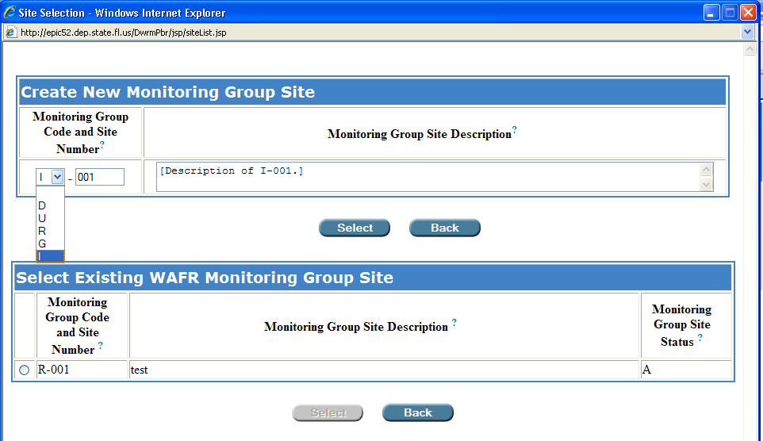
The permit writer has created monitoring group “I-001.”
After clicking “Select,” Permit Builder will return to the “Discharge Points” screen.

4.5.2. The “Select Existing WAFR Monitoring Group Site” table

To select an existing WAFR monitoring group site (if any sites are listed), do the following:

In the Select Existing WAFR Monitoring Group Site table, click the radio button and then click the corresponding button. Permit Builder will direct you back to the Discharge Points screen.
Select
Back
NOTE: Click either of the buttons to cancel your entries and be directed back to the Discharge Points screen.

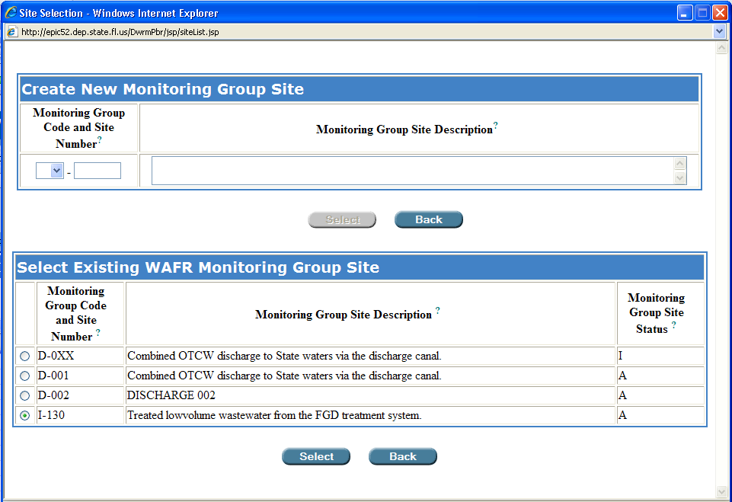
Click the radio button and then Select.

Selecting an existing WAFR monitoring group site, “I-130” in this example.

NOTE: If the Select Existing WAFR Monitoring Group Site table is empty, then no sites have been entered into WAFR for the facility. This may be the case for a new facility.

Let’s pause a moment ….
You have now completed the initial steps in creating a Monitoring Group Site “I.”

Sections 4.5.3. – 4.5.8. address the remaining fields on the Discharge Points screen that you will need to fill out in order to complete creating a Monitoring Group Site “I” for your Permit Builder project.

4.5.3. Returning to the “Discharge Points” screen

Once you have been directed back to the Discharge Points screen, Permit Builder will now allow you to input more information about the reuse land application monitoring group site you either created or selected from the Site Selection screen – I-001 in this example.

The Monitoring Group Description field will contain the description you typed into the similarly named field of the Create New Monitoring Group Site table. Permit Builder will allow you to edit this information from the Discharges Points screen.

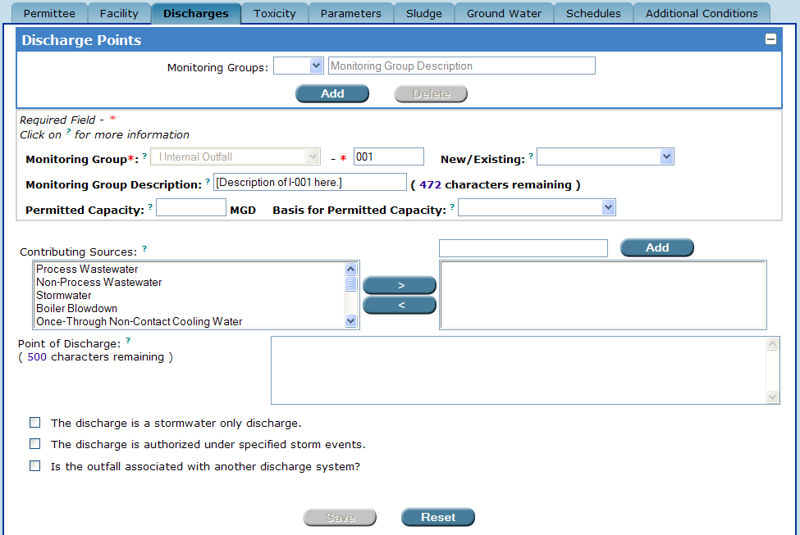
Permit Builder returns to the “Discharge Points” screen.
The “Monitoring Group Description” field which the permit writer may edit.

NOTE: Although you will be able to edit information on the Discharge Points screen in fields where text appears in black lettering, you will not be able to edit information where text appears in grey lettering.

Select the following information about the Monitoring Group site from the corresponding drop-down boxes, and fill-in the respective fields:

- New/Existing or Substantial Modification

- Select New if the Monitoring Group has not been previously permitted.
- Select Existing if the Monitoring Group has been previously permitted.
- Select Substantial Modification if the Monitoring Group is associated with the facility’s substantial modification, as defined in Rule 62-620.200(49), F.A.C.

- Permitted Capacity and Basis for Permitted Capacity

- Enter the permitted capacity (in million gallons per day, MGD).
- Select the basis used to calculate the permitted capacity which will be either

- Daily Maximum Flow,
- Monthly Average Daily Flow, or
- Annual Average Daily Flow

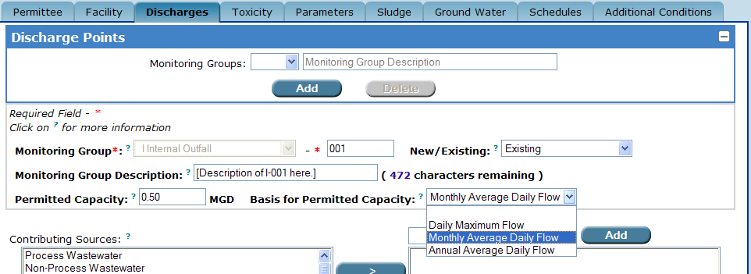
Selecting either “New,” “Existing,” or “Substantial Revision” in the “New/Existing” field, entering the permitted capacity in the “Permitted Capacity” field, and selecting the basis for permitted capacity from the “Basis for Permitted Capacity” drop-down box.

4.5.4. The “Contributing Sources” field

The Contributing Sources field contains a list of the most common waste streams contributing to the discharge of industrial wastewater facilities.
>
By highlighting any one of the sources listed and clicking you can create a list of contributing sources specific to the internal outfall Monitoring Group (I-001 in this example).

Selecting a source from the “Contributing Sources” list.

If the source is not on the list displayed in the Contributing Source field, you may type in the appropriate source in the window located left of the “Add” button, and then click . This action will include your typed entry on the list of contributing sources specific to Monitoring Group I-001.
Add

Adding a source that is not on the “Contributing Source” list.

Selecting a source from the “Contributing Sources” list.

If you wish to remove an entry from the list of specific sources for Monitoring Group I-001, highlight it and click .
<

4.5.5. The “Point of Discharge” field

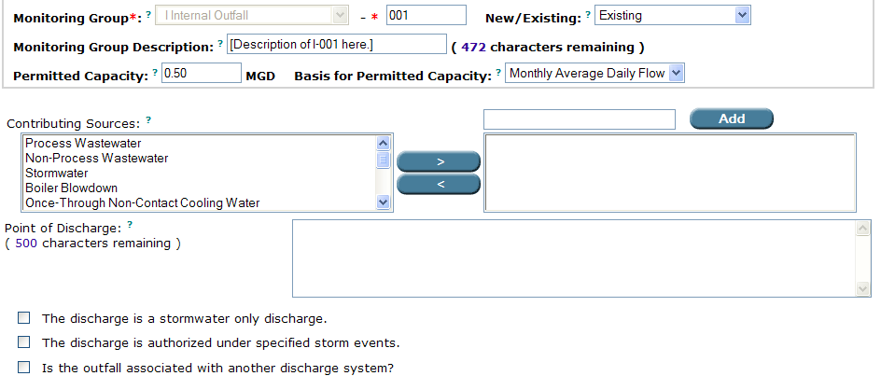
The “Point of Discharge” field.

Enter a description of the point of discharge for the internal outfall in the Point of Discharge field. The description of the location of the discharge you enter will be included in the text of the permit.

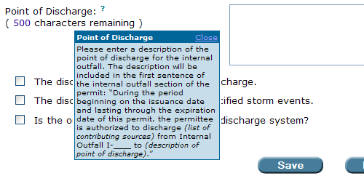
Clicking on the little blue question mark will display an information box about what to type in the “Point of Discharge” field and how that information will appear in the permit document.

4.5.6. The “stormwater only discharge” check-box statement

WHAT this check-box statement means:

By selecting this check-box statement, you are telling Permit Builder that the facility’s discharge from this particular Monitoring Group I, is a stormwater only discharge.

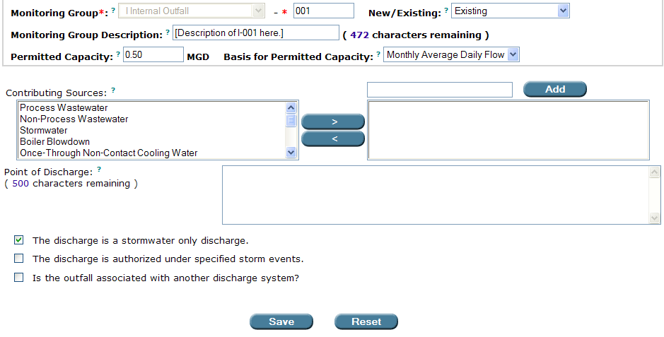
“The discharge is a stormwater only discharge” check-box statement.

When selecting the stormwater only discharge check-box, Permit Builder will display the following “Stormwater only discharge” notice:

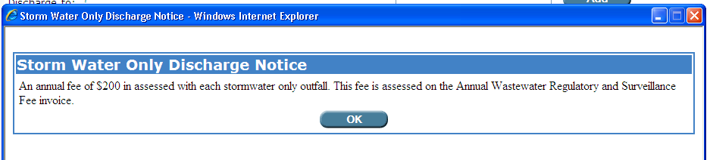
Permit Builder displays this notice if the permit writer checks the “discharge is a stormwater only discharge” check-box statement.

Clicking the OK button returns you to the Discharge Points screen.

4.5.7. The “authorized under specified storm events” check-box statement

WHAT this check-box statement means:

The facility is permitted to discharge at this particular Monitoring Group I only after a rainfall event exceeding the specified duration and frequency (e.g., 10-year, 24-hour storm event).

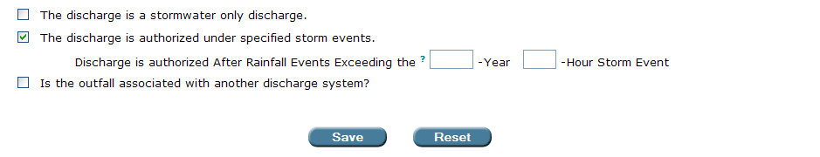

When the “authorized under specified storm events” check-box statement is selected,
Permit Builder will ask you to enter the return period and duration of the storm event.

4.5.8. The “outfall is associated with another discharge” check-box statement

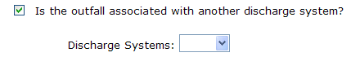

WHAT this check-box statement means:

When you select this statement, you are telling Permit Builder that the internal outfall is associated with a specific discharge. Permit Builder then asks you to select from the Discharge System drop-down box the Monitoring group number of the discharge system this internal outfall is associated with.

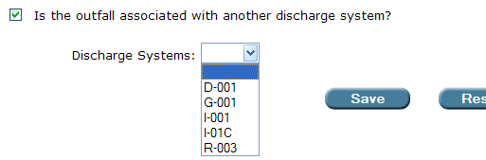
When selected, the “outfall is associated with another discharge system” check-box statement displays the “Discharge System” drop-down box.
The “Discharge Systems” drop-down box contains list of all Monitoring Groups
created by the permit writer.

CONGRATULATIONS!

YOU HAVE COMPLETED THE “DISCHARGES” TAB

The Select button will not become available until you enter both a Monitoring Group Code and Site Number.
The Monitoring Group code (D-001 in this example), should coincide with the “outfall site” or “discharge site” numbers or codes referred to in the permit application and/or in the permit text itself. These terms may be used interchangeably.
The list of surface water bodies displayed in the Discharge to field will be limited to those surface water bodies in your district.
A facility may request Department approval of alternative MDLs and PQLs for a water quality parameter which may have a permit limit not necessitating the use of a highly sensitive (i.e., a test with a very low detection limit), and expensive, laboratory test. A less sensitive, and less expensive, laboratory test may be adequate as long as the test’s detection limit for the water quality parameter under consideration is lower than the permit limit.
The terms “coastal recreational waters” and “coastal recreation waters” are used interchangeably.
The Select button will not become available until you enter both a Monitoring Group Code and Site Number.
Construction permits for underground injection control wells are issued independently by the Department’s Underground Injection Control (UIC) Program. UIC permit numbers should be provided by the applicant.
TDS = total dissolved solids.
ERC = Environmental Regulation Commission. The Florida ERC (also known as the Commission) is a non-salaried, seven-member board selected by the Governor, who represent agriculture, the development industry, local government, the environmental community, citizens, and members of the scientific and technical community. The ERC sets standards and rules that protect Floridians and the environment based on sound scientific and technical validity, economic impacts, and risks and benefits to the public and Florida’s natural resources. Most issues that go before the ERC relate to air pollution, water quality, and waste management.
The Select button will not become available until you enter both a Monitoring Group Code and Site Number.
See Appendix A. Entering “Latitude” and “Longitude” coordinates.
The Select button will not become available until you enter both a Monitoring Group Code and Site Number.

