5. The “Toxicity” tab

The “Toxicity” tab for domestic wastewater facilities.

The “Toxicity” tab for industrial wastewater facilities.

Whole Effluent Toxicity (WET) is a permit parameter designed to evaluate the toxicity of the entire effluent stream as opposed to just its individual pollutants. In accordance with Rule 62-620.620(3), F.A.C., “WET test(s)” or “toxicity testing” is required for the following wastewater facilities that discharge to surface waters:

- Major wastewater facilities;
- Minor domestic wastewater facilities either with a pretreatment program, or those required to develop a pretreatment program;
- Minor industrial wastewater facilities with a discharge that has the potential to result in aquatic toxicity; and
- Any wastewater facility, regardless of size, which has a prior history of effluent toxicity.

If your Permit Builder project includes a discharge to a surface water body and, therefore, has at least one “D” Monitoring Group designation, it will likely entail toxicity testing for those monitoring groups.

In the screen shot below, you will notice that the Monitoring Groups drop-down box on the Toxicity tab lists only the monitoring group associated with surface water discharge – D-001 in this example.

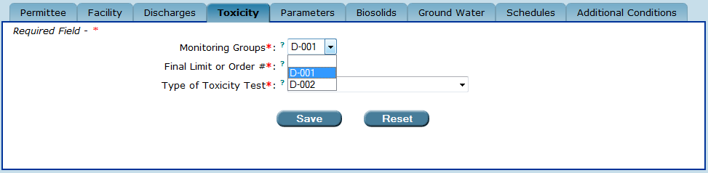
The “Toxicity” tab.
The “Monitoring Groups” drop-down box lists only the “D” monitoring groups associated with the project’s discharge to surface water.

5.1. The “Final Limit or Order #” drop-down box

Once you have selected the “D” Monitoring Group from the drop-down box, Permit Builder will display the Final Limit or Order # and the Type of Toxicity Test drop-down boxes. The Final Limit or Order # drop-down lists the options “Final” as well as any administrative and consent order numbers created by the permit writer on the Orders sub-tab under the Facility tab (see Chapter 3 of the Permit Builder User Guide for information on how to create an order).

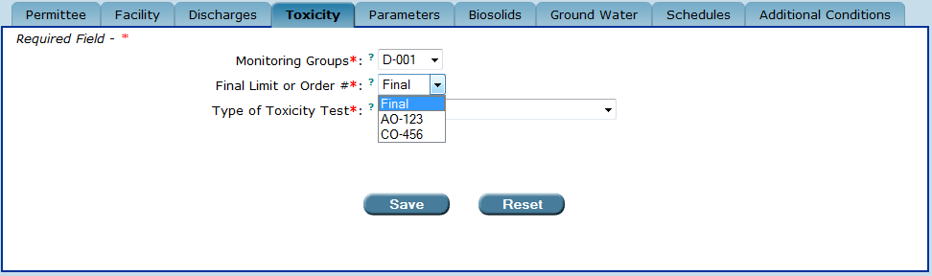
The “Final Limit or Order #” drop-down box options include “Final” as well as any CO or AO numbers created by the permit writer.

To include an interim limit toxicity requirement in your project, select the order number the interim limit is associated with. The date range over which an interim toxicity requirement is applicable is entered by the permit writer on the Parameters tab. For interim toxicity requirements, the permit writer may also indicate (on the Parameters tab) that the permit limit is a report only monitoring requirement.

5.2. The “Type of Toxicity Test” drop-down box

Once you have selected the “D” Monitoring Group from the drop-down box, Permit Builder will display the Type of Toxicity Test drop-down box which lists seven options, six of which correspond to the six kinds of WET tests.

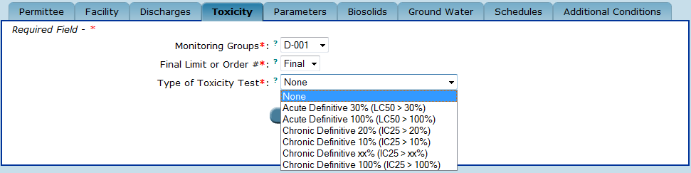
The “Type of Toxicity Test” drop-down box options.

These options are described in detail as follows:

- None
  - Select this option if your Permit Builder project does not fall within the criteria set forth in Rule 62-620.620(3), F.A.C.
- Acute Definitive 30% (LC50 > 30%)
  - This test applies to facilities that qualify for acute WET test relief under Rule 62-4.244(3)(b), F.A.C. These facilities employ at least a 100:1 dilution ratio in the receiving water. The discharge pipe is equipped with a high-rate diffuser such that the effluent concentration is 10% within a distance equal to 50 times the discharge length scale.
  - This test may also apply to facilities with open ocean discharges, but only if the permittee has provided data demonstrating that discharges meet chronic WET test limitations at a concentration consisting of 10% effluent. (See Rule 62-620.620(3)(d)2., F.A.C.)
- Acute Definitive 100% (LC50 > 100%)
  - This test is for intermittent dischargers who are unable to perform the chronic WET test due to the frequency or duration of the discharge.
  - Although facilities are not typically required to conduct both toxicity tests, the Department has the option of requiring a facility to conduct acute WET tests in addition to the chronic WET test if the facility has an LC50 less than the acute WET limit within 96 hours during the chronic WET test. The acute WET limit is found in Rule 62-4.241, F.A.C. This situation may occur when a facility has been granted a mixing zone for conducting chronic WET tests, and it is later determined through the examination of the chronic WET test results, that the 100% effluent concentration has greater than 50% mortality.

- Chronic Definitive 20% (IC25 > 20%)
  - This test applies to industrial wastewater facilities, and in particular, to drinking water treatment facilities with demineralization concentrate discharges that qualify for acute WET test relief under Rule 62-4.244(3)(d), F.A.C. If a large or small facility has at least a 4:1 dilution ratio in the receiving water within a distance of twice the natural water depth, the acute and chronic WET limit shall be met in a 20% effluent concentration, and a chronic WET test is performed. If the discharger is a large drinking water producer and has less than a 4:1 dilution ratio within a distance equal to twice the natural water depth, a Chronic Definitive xx% test applies. See Section 403.0882(2)(b), F.S., for a definition of small and large drinking water producer.
- Chronic Definitive 10% (IC25 > 10%)
  - This test applies to facilities with open ocean discharges permitted under Rule 62-4.244(3)(c), F.A.C. These facilities may opt to conduct the Acute Definitive 30% (LC50 > 30%) WET test if they satisfy the requirements set forth in Rule 62-620.620(3)(d)2., F.A.C.

- Chronic Definitive xx% (IC25 > xx%)
  - This test applies to facilities with a chronic toxicity mixing zone together with a chronic toxicity limit other than 20%.
- Chronic Definitive 100% (IC25 > 100%)
  - This test applies to facilities without a chronic toxicity mixing zone or acute toxicity relief as provided in Rule 62-4.244(3)(a) – (d), F.A.C.

5.3. The “Percent Effluent” field

This field appears only when the permit writer selects the Chronic Definitive xx% (IC25 > xx%) WET test in the Type of Toxicity Test drop-down box. Enter the effluent concentration (in percent) at the edge of the mixing zone. For example, if the effluent is diluted to a 3:1 ratio within the mixing zone, enter “25” since the effluent concentration at the edge of the mixing zone will be 25%, and the effluent WET limit will be IC25 > 25%.

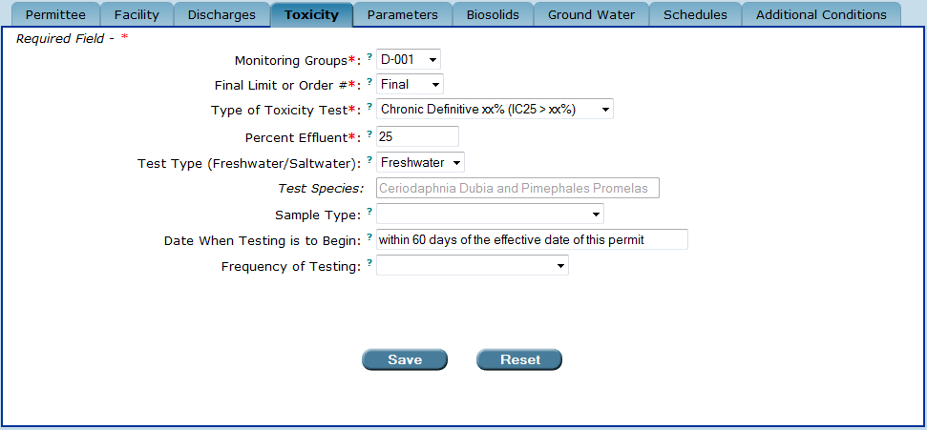
The “Percent Effluent” field.
Permit Builder displays this field only when the permit writer selects the
“Chronic Definitive xx% (IC25 > xx%)” option from the “Type of Toxicity Test” drop-down box.

5.4. The “Test Type (Freshwater/Saltwater)” drop-down box

The Test Type determines the species of aquatic organisms to be used in the facility’s WET test.

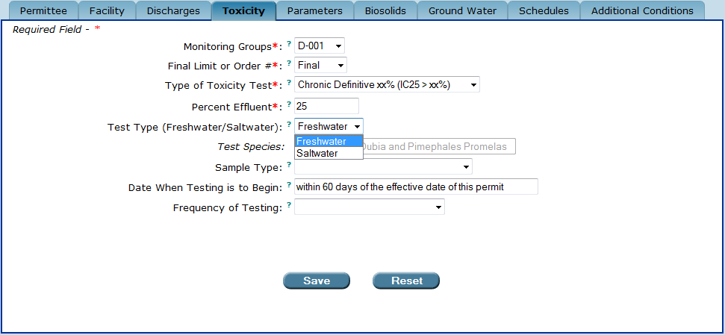
The “Test Type (Freshwater/Saltwater)” drop-down box.

5.4.1. Selecting the “Freshwater” option from the “Test Type (Freshwater/Saltwater)” drop-down box

- Select the Freshwater option if:
  - the facility discharges to predominantly fresh waters,
- Select the Freshwater option if:
  - the facility discharges to predominantly marine waters,
AND
  - the WET test limit is equal to 100% effluent,
AND
  - effluent salinity is less than 1.0 parts per thousand (salinity < 1.0 ppt).
- Select the Freshwater option if:
  - the facility discharges to predominantly marine waters,
AND
  - the WET test limit is less than 100% effluent,
AND
  - effluent salinity is less than 1.0 parts per thousand (salinity < 1.0 ppt) when diluted to the WET test limit using dilution water adjusted to the minimum salinity of the receiving water.

5.4.2. Selecting the “Saltwater” option from the “Test Type (Freshwater/Saltwater)” drop-down box

- Select the Saltwater option if:
  - the facility discharges to predominantly marine waters,
AND
  - the facility’s WET test limit is equal to 100% effluent,
AND
  - effluent salinity is greater than or equal to 1.0 parts per thousand (salinity > 1.0 ppt).
- Select the Saltwater option if:
  - the facility discharges to predominantly marine waters,
AND
  - the facility’s WET test limit is less than 100% effluent,
AND
  - effluent salinity is greater than or equal to 1.0 parts per thousand (salinity > 1.0 ppt) when diluted to the WET limit using dilution water adjusted to the minimum salinity of the receiving water.

5.5. The “Test Species” field

Once you have selected the Test Type (Freshwater/Saltwater) species of the facility’s WET test, Permit Builder will display the default species in the Test Species field. You will not be able to change this display, as indicated by the gray lettering.

The “Test Species” field and its default display.
The permit writer will not be able to change this entry as indicated by the gray lettering.

Requirements defining which Test Species are to be used for each of the various WET tests are established in Rule 62-620.620(3)(g) and (h), F.A.C., as follows:

- For Chronic Saltwater WET tests, the test species are
  - Americamysis (Mysidopsis) bahia, and
  - Menidia beryllina.
- For Chronic Freshwater WET tests, the test species are
  - Ceriodaphnia dubia, and
  - Pimephales promelas.
- For Acute Saltwater WET tests, the test species are
  - Americamysis (Mysidopsis) bahia, and
  - Menidia beryllina.
- For Acute Freshwater WET tests, the test species are
  - Ceriodaphnia dubia, and
  - Cyprinella leedsi.

5.6. The “Minimum Salinity of Receiving Water” field

The Minimum Salinity of Receiving Water field appears when the permit writer selects:

- Acute Definitive 30% (LC50 > 30%), and
- Saltwater

from their respective drop-down boxes.

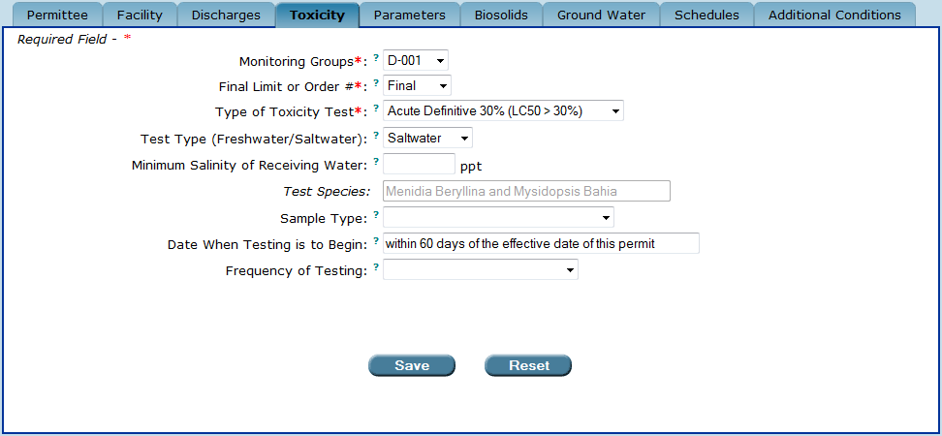
The “Minimum Salinity of Receiving Water” field.

This field applies to facilities that have been granted relief according to the mixing zone rule, 62-4.244(3)(b), F.A.C. This test may also apply to facilities with open ocean discharges, but only if the permittee has provided data demonstrating that discharges meet chronic WET test limitations at a concentration consisting of 10% effluent. In accordance with Rule 62-4.244(3)(c), F.A.C., the effluent is to be diluted to 30% using dilution water adjusted to the minimum salinity of the receiving water.

Rule 62-4.244(3)(b), F.A.C., does not specify the adjusted salinity for facilities that qualify for acute WET test relief. However, Rule 62-620.620(3)(h), F.A.C., states that determination of WET test species is based on the salinity of the effluent diluted to the WET test acute toxicity limit with control test water adjusted to the minimum salinity of the receiving water.

5.7. The “Sample Type” drop-down box

The Sample Type drop-down box displays either two or three options, depending on whether Acute or Chronic WET tests are selected from the Type of Toxicity Test drop-down box.

5.7.1. The “Sample Type” options for “Acute” WET tests

When selecting either

- Acute Definitive 30% (LC50 > 30%), or
- Acute Definitive 100% (LC50 > 100%),

from the Type of Toxicity Test drop-down box, Permit Builder will display the following two options in the Sample Type drop-down box:

- Four Separate Grab Samples
  - This default sample type is used when acute WET tests (either freshwater or saltwater) are required.
  - One WET test consists of four separate bioassays for each test species, for a total of eight bioassays per WET test.
  - Each grab sample is taken at 6-hour intervals over a 24-hour period to catch any peaks in toxicity and to account for daily variations in effluent quality.

- Single Grab Sample
  - This sample type is an option when acute WET tests (either freshwater or saltwater) are required and effluent composition, with respect to type and amount of any parameter, is known by the facility to be stable and is therefore, not expected to fluctuate over a 24-hour period.

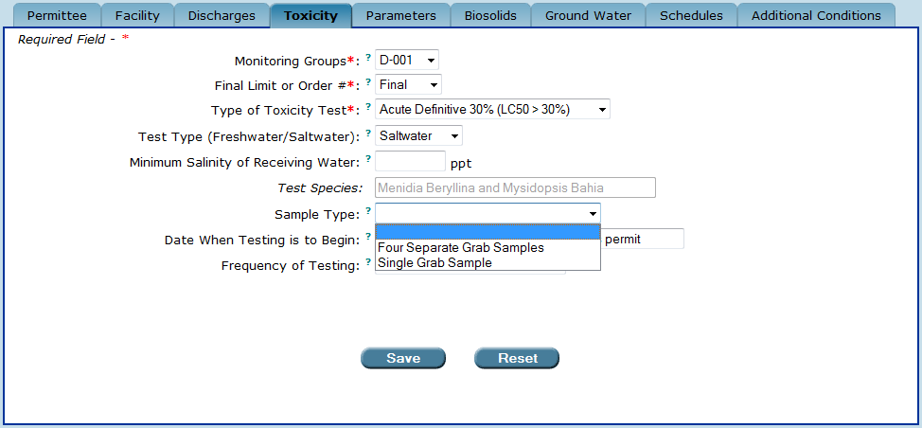
The “Sample Type” drop-down box when “Type of Toxicity Test” is selected
for one of the “Acute” WET test options.

5.7.2. The “Sample Type” options for “Chronic” WET tests

When selecting either

- Chronic Definitive 20% (IC50 > 20%),
- Chronic Definitive 10% (IC50 > 10%),
- Chronic Definitive xx% (IC50 > xx%), or
- Chronic Definitive 100% (IC50 > 100%),

from the Type of Toxicity Test drop-down box, Permit Builder will display the following three options in the Sample Type drop-down box:

- 24-hr Time Proportioned Composite
  - This sample type is used when:
    - Chronic WET tests (either freshwater or saltwater) are required;
    - Effluent flow is continuous;
    - Samples may be taken either manually or automatically; and
    - Composite samples are representative of the effluent discharged over the previous 24 hours.

- 24-hr Flow Proportioned Composite
  - This sample type is used when:
    - Chronic WET tests (either freshwater or saltwater) are required;
    - Effluent flow fluctuates over a 24-hour period;
    - Samples may be taken either manually or automatically; and
    - Composite samples are representative of the effluent discharged over the previous 24 hours.

- Single Grab Sample
  - This sample type is generally not recommended for chronic WET tests.
  - It is allowed only when a facility required to conduct chronic WET tests:
    - Is unable to collect composite samples; and
    - Effluent composition, with respect to type and amount of any parameter, is stable and not expected to fluctuate over a 24-hour period.

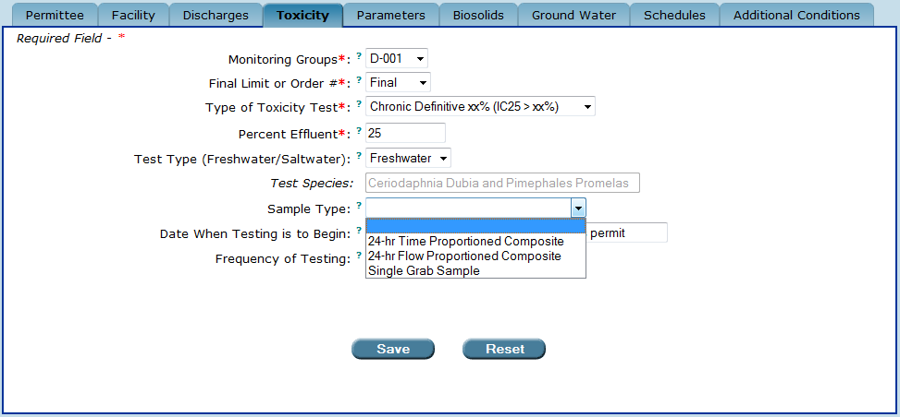
The “Sample Type” drop-down box when “Type of Toxicity Test” is selected
for one of the “Chronic” WET test options.

5.8. The “Date When Testing is to Begin” field

Permit Builder displays the default phrase “within 60 days of the effective date of this permit.” However, it is possible to make your own entry simply by clicking in the field and typing either a specific date, or another phrase.

In general, new permits require the first WET test to begin within 60 days of the permit effective date. Permit renewals will typically require the first WET test of the renewed permit cycle to occur at the regularly scheduled interval established in the previous permit.

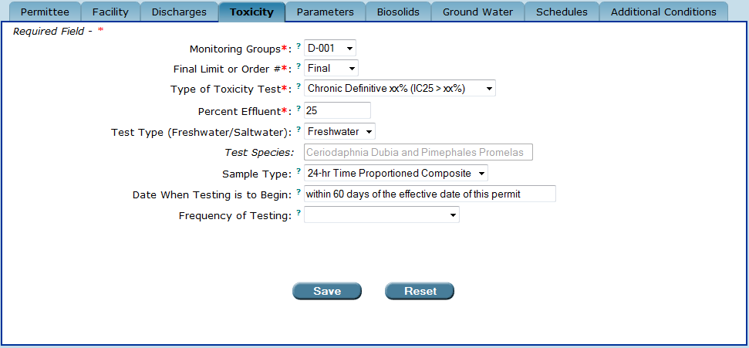
The “Date When Testing is to Begin” field.
Permit Builder will display the default phrase shown, but the permit writer may change it.

5.9. The “Frequency of Testing” drop-down box

The Frequency of Testing drop-down box displays three options which are appropriate for the following conditions:

- Quarterly
  - Quarterly testing is the default frequency specified in Rule 62-620.620(3)(g)1., F.A.C., as “routine” WET tests conducted at regularly scheduled intervals of once every three months, unless otherwise specified in the facility’s permit, or if the permittee is granted a reduction in monitoring frequency in accordance with Rule 62-620.620(3)(l), F.A.C.
  - Quarterly testing is the appropriate frequency for all new facilities required to conduct WET tests under Rule 62-620.620(3)(a), F.A.C.
  - Quarterly testing is the appropriate frequency for any facility that has changed from one type of WET test to another (e.g., from acute to chronic).
  - Quarterly testing is the appropriate frequency for any facility that has had two or more WET failures during the previous five-year permit cycle.
  - Quarterly testing is the appropriate frequency for any facility previously allowed to conduct WET tests semi-annually, that has had two or more WET test failures within the previous five-year permit cycle. The increase to quarterly testing would be in effect at the time of the facility’s next permit renewal.
- Semi-Annually, twice per year
  - Semi-annual testing is the appropriate frequency for facilities that have demonstrated compliance with WET test requirements for at least one year.
- Annually
  - Annual testing is the appropriate frequency for facilities that have a history of compliance with WET test requirements for at least five years.

NOTE: If a facility has been allowed to conduct WET tests annually and has either had one test failure within the previous five-year permit cycle, or it did not follow-up a failed WET test with additional testing, then frequency may be increased to either quarterly or semi-annually.

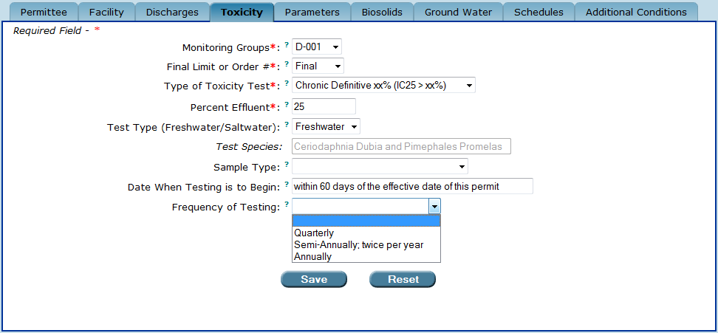
The “Frequency of Testing” drop-down box.

Additionally, please note that WET toxicity testing requirements appear on the most frequently reported DMR (generally monthly) of the surface water monitoring group requiring the testing. See Chapter 11 of the Permit Builder User Guide for additional information on drafting permit documents.

5.10. The “Save” and “Reset” buttons

Be sure to:
Save ow
- Click to save your entries to the Toxicity tab.
- Click to clear all entries made to the Toxicity tab. This will restore all fields to any information entered before the last time this tab was saved.
Reset ow

CONGRATULATIONS!
YOU HAVE COMPLETED THE “TOXICITY” TAB

Sections 3.2.1.2 and 3.2.2.2 provide information on how wastewater facilities are designated as major or minor.
The expression “LC50” is defined as the “lethal concentration to 50% of the test organisms.” The LC50 is the calculated percentage of effluent (at a specific location) at which 50% of the test organisms die within a specified test period. The lower the LC50 value, the greater the toxicity of the effluent. The expression “LC50 > 30%” implies that 50% of the test organisms will die, compared to the control, at an effluent concentration greater than 30% effluent.
The “discharge length scale” is equal to the square root of the area of the discharge pipe opening.
The expression “IC25” is defined as the “inhibition concentration to 25% of test organisms,” and is expressed as percent effluent. The IC25 is the calculated percentage of effluent (at a specific location) at which test organisms exhibit a 25% reduction in a non-quantal biological measurement such as reproduction or growth. (A quantal measurement is one in which there can be only two outcomes such as either “dead” or “alive,” or “all” or “none.”) The lower the IC25 value, the greater the toxicity of the effluent. The expression “IC25 > 20%” implies that a 25% change (i.e., decrease) in the test organism’s reproduction or growth, compared to the control, occurs at an effluent concentration greater than 20% effluent.
Common names for the test species are: - Opossum shrimp – Americamysis (Mysidopsis) bahia; - Inland silversides – Menidia beryllina; - Water flea – Ceriodaphnia dubia; - Fathead minnow – Pimephales promelas; and - Bannerfin shiner – Cyprinella leedsi.
In general, annual WET tests are suitable when a facility has an effluent discharge that is stable (i.e., parameter type and amount do not greatly fluctuate), and the facility is consistently in compliance with the limits established in the permit.

