6. The “Parameters” tab

The Parameters tab displays a parameters table for each monitoring group you enter into your Permit Builder project from the Discharges tab. Permit Builder gives you the ability to edit these tables, i.e., you may add or delete parameters, as well as change values in all columns.

For domestic wastewater facilities, default values are automatically entered into the columns for Parameter, Units, Max/Min, Limit, Statistical Basis, Frequency of Analysis, and Sample Type depending on the information entered in the Facility and Discharges tabs.

For industrial wastewater facilities, these values typically are not defaulted, and the permit writer must enter each separately.

The screen shot below illustrates default parameters for a rapid infiltration basin (RIB) system, associated with monitoring group “R-001.”

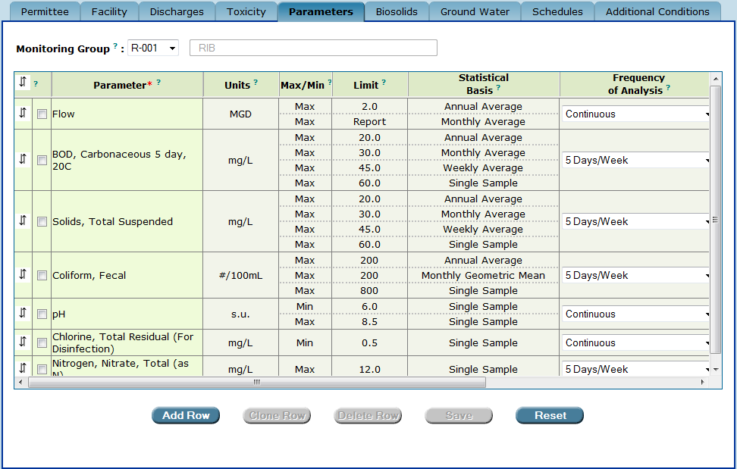
The “Parameters” tab displays a table with default parameters for a specific monitoring group.
In this example, monitoring group “R-001” is a “RIB” land application system.

If your Permit Builder project includes any monitoring group sites with the “D” prefix, indicating discharge to a surface water body, the Parameters tab will also contain the parameter “Whole Effluent Toxicity” based on the information you entered from the Toxicity tab.

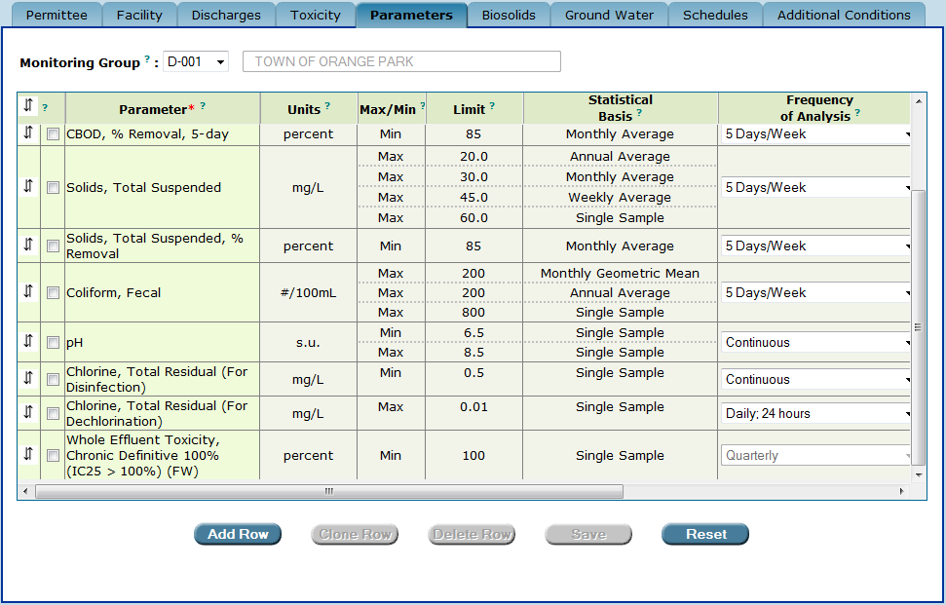
A parameters table for a monitoring group designated as a discharge to a surface water, “D-001”
The parameter “Whole Effluent Toxicity” is listed at the bottom of the table.

6.1. Adding, deleting, and editing parameters, and moving a parameter’s position within the parameters table

Permit Builder allows you to add, delete, or edit parameters from the parameter table by using the steps outlined under each section heading.

6.1.1. Adding parameters to the parameters table
Parameters may be added to the parameter table by clicking Add Row and selecting the parameter to be added from the list of the parameters available in Permit Builder. Parameters may also be added to the parameter table by cloning an existing parameter table row.
6.1.1.1. Adding parameters to the parameter table by clicking Add Row

To add a new parameter to the parameters table for a particular monitoring group, follow Steps 1 – 10 below.
Add Row
Step 1: Click

Permit Builder will add an empty row at the bottom of the table.
Step 2: Double-click in the empty parameter cell where the hand icon 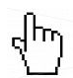 appears.

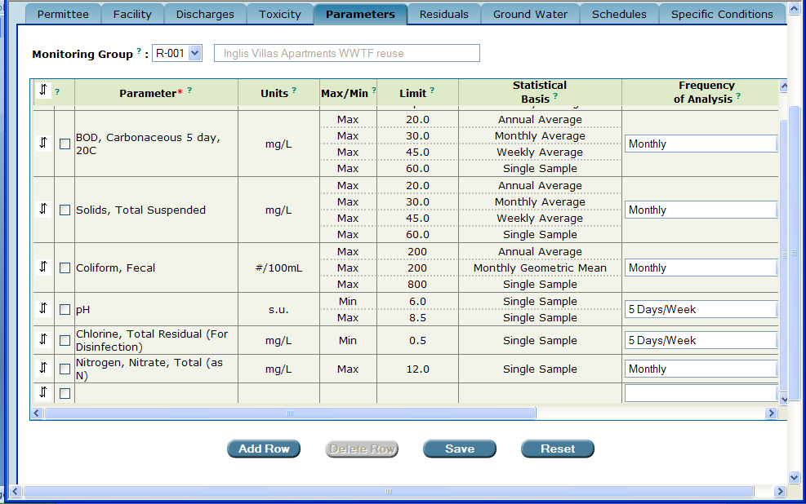
Click Add Row, and then double-click in the empty parameter cell.

Permit Builder will then display the Enter or Change Parameter screen illustrated below.

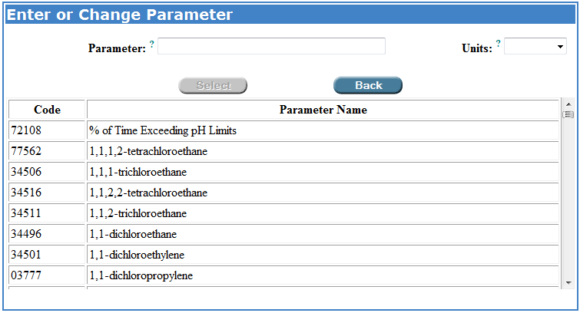
The “Enter or Change Parameter” screen.

Step 3: In the Parameter field, type the name or parameter code of the parameter you wish to add.

For example, after typing the word “arsenic,” Permit Builder then displays only those parameters with “arsenic” in the parameter name.

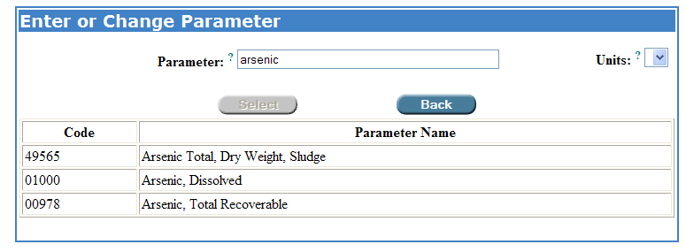
The permit writer has typed “arsenic” in the “Parameter” field. Permit Builder automatically displays only those parameters with “arsenic” in the parameter name.

Step 4: Click on the desired parameter to highlight it, and then click on the Units drop-down box arrow to select the appropriate units.

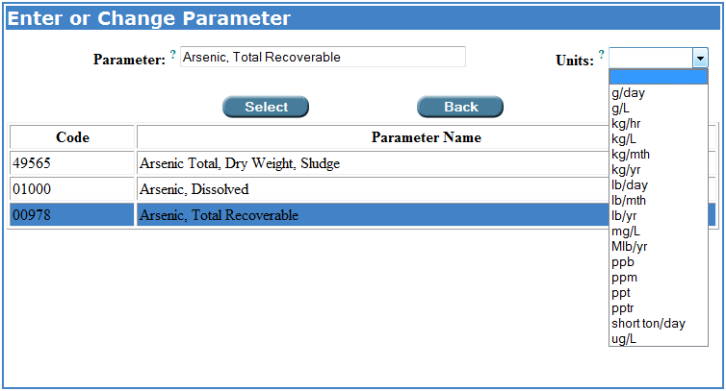

Select
Step 5: Click

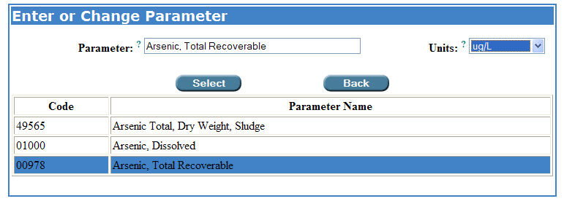

After clicking the Select button, Permit Builder will return to the Parameters tab where you will see your newly added parameter and accompanying units – “Arsenic, Total Recoverable” and “ug/L” in this example – at the bottom of the table.

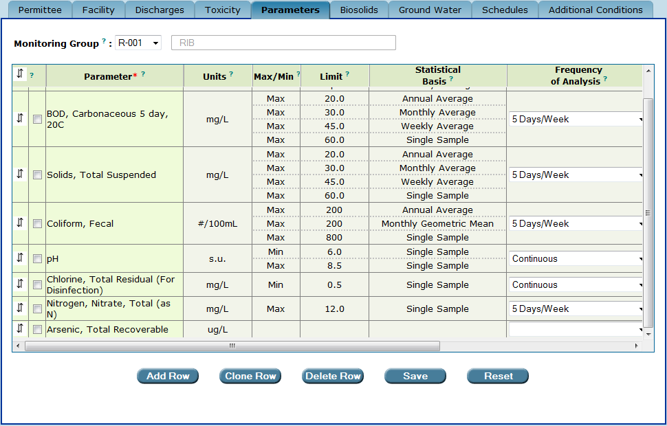
The parameter “Arsenic, Total Recoverable” has been added to the table.

Step 6: Double-click in either the Max/Min, Limit, or Statistical Basis cells to complete the information on the newly added parameter.

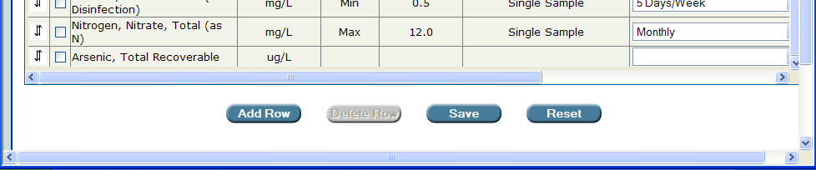

Permit Builder will display the Limit and Statistical Basis screen.

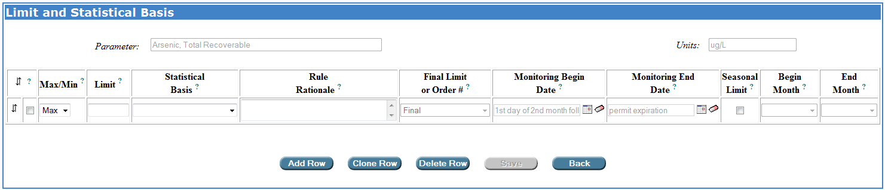
The “Limit and Statistical Basis” screen.

Step 7: Enter the following information pertaining to the newly added parameter:
- Max/Min – corresponds to whether the parameter limit or “Report” requirement is maximum or minimum.
- Limit – corresponds to the numerical value of the permit limit. Make sure this value is consistent with the units selected from the Enter or Change Parameter screen.
- Statistical Basis – corresponds to the averaging period or statistical time period that the permit limit is based on and that the permittee must report on the DMR.
- Rule Rationale – corresponds to the rule that is used to justify the permit limit.
- Seasonal Limit, Begin Month, and End Month – specify a particular time period or season, if appropriate, during which the parameter is limited and required to be monitored.
For the Statistical Basis, Rule Rationale, and Begin Month and End Month fields, click on the corresponding drop-down box arrows to display the lists of options.

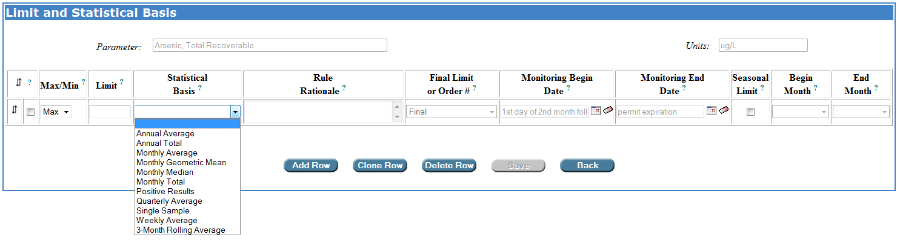

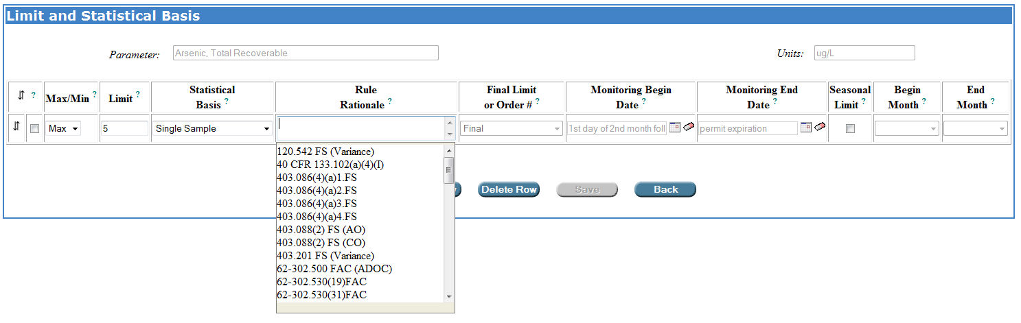

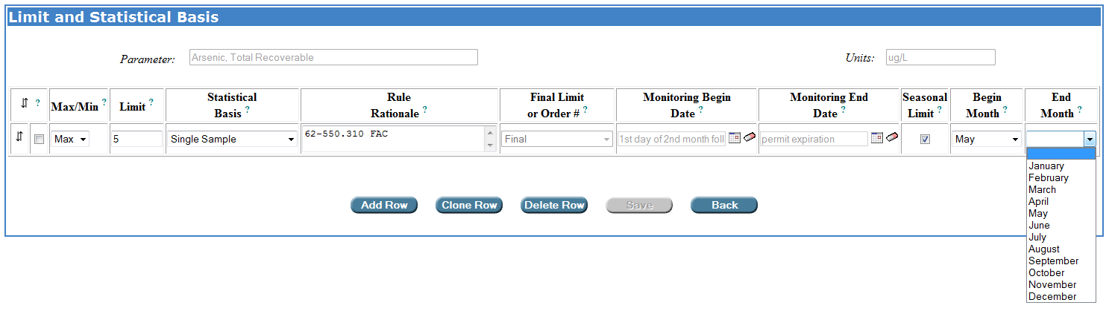

After the lists of options are displayed, click on the appropriate Statistical Basis, Rule Rational, and Begin Month and End Month for the corresponding parameter limit.

Save
Step 8: Click

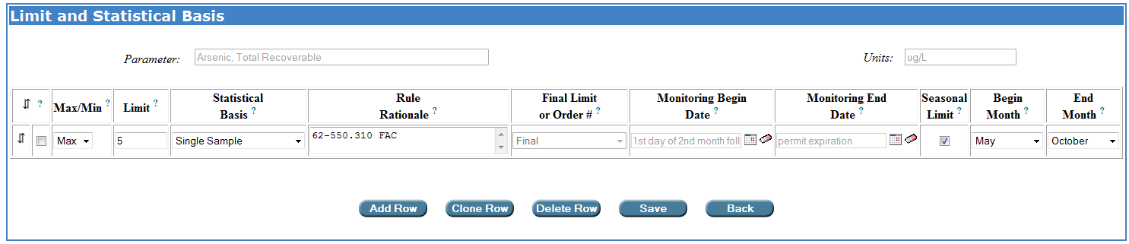

Permit Builder will then return to the table on the Parameters tab where you can now view the added parameter – “Arsenic, Total Recoverable” in this example – together with the Max/Min, Limit, and Statistical Basis entries you made from the Limit and Statistical Basis screen.

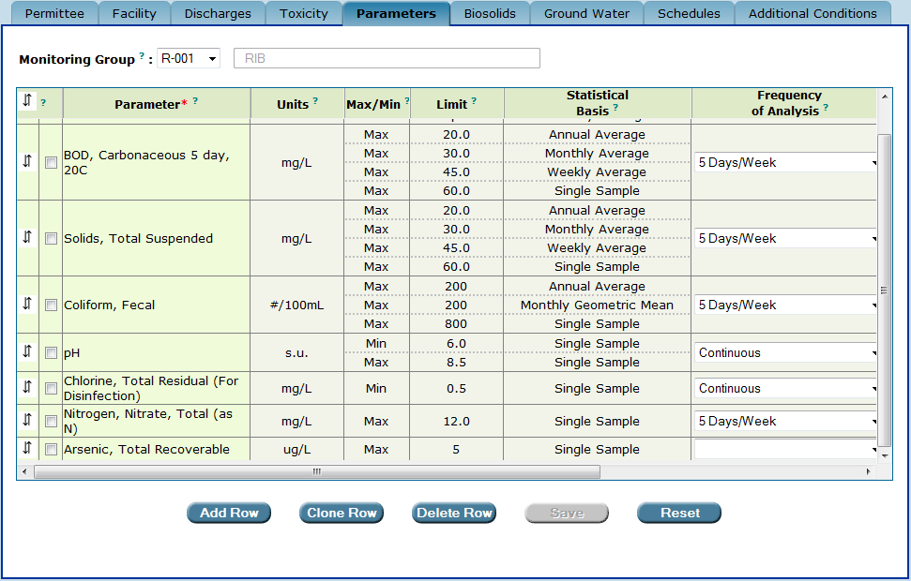
Permit Builder returns to the table on the “Parameters” tab where information entered from
the “Limit and Statistical Basis” screen is displayed.

Step 9: Scroll right so that the drop-down boxes for Frequency of Analysis, Sample Type, and Monitoring Site Number are in view for the added parameter, and then make the appropriate selections for your project.

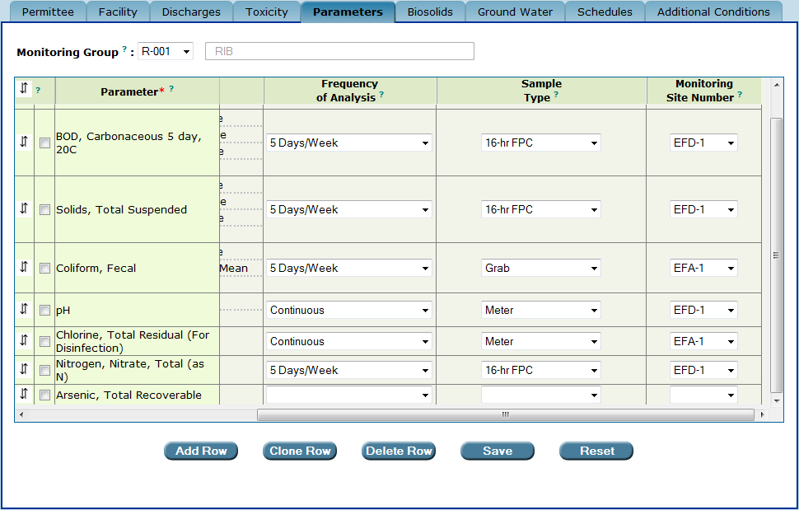
The permit writer has scrolled right to view the drop-down boxes for “Frequency of Analysis,” “Sample Type,” and “Monitoring Site Number” drop-down boxes for the added parameter.

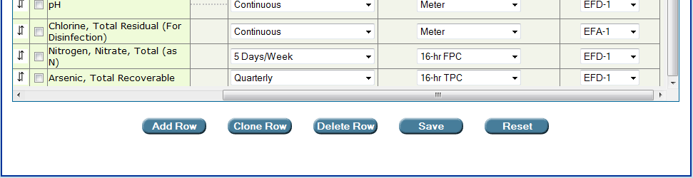
The permit writer has entered the corresponding information.

Step 10: Be sure to:
Save
- Click to save your entries to the Parameters tab.
Reset
- Click to clear recent entries made to the Parameters tab. This will restore all fields to information entered before the last time this tab was saved.

6.1.1.2. Adding parameters to the parameter table by cloning existing rows

To add a parameter to the parameters table for a particular monitoring group by cloning an existing parameter table row, click the check-box located to the left of the Parameter Name and then click . To add data such as Units, Max/Min, Limit, Statistical Basis, Frequency of Analysis, Sample Type, and Monitoring Site Number to the newly cloned row, see Section 6.1.1.1. To edit existing information in the cloned parameter row, see Section 6.3.1.
Clone Row

The ability to clone row is particularly useful when a parameter is monitored or limited at multiple monitoring sites, as is sometimes the case particularly within the industrial wastewater program. In these instances, a parameter row is cloned, and a monitoring site number is added or modified for each cloned row.

Parameters with conditional limits (e.g., Specific Conductance based on background), hardness-based metals, and Whole Effluent Toxicity may not be cloned.

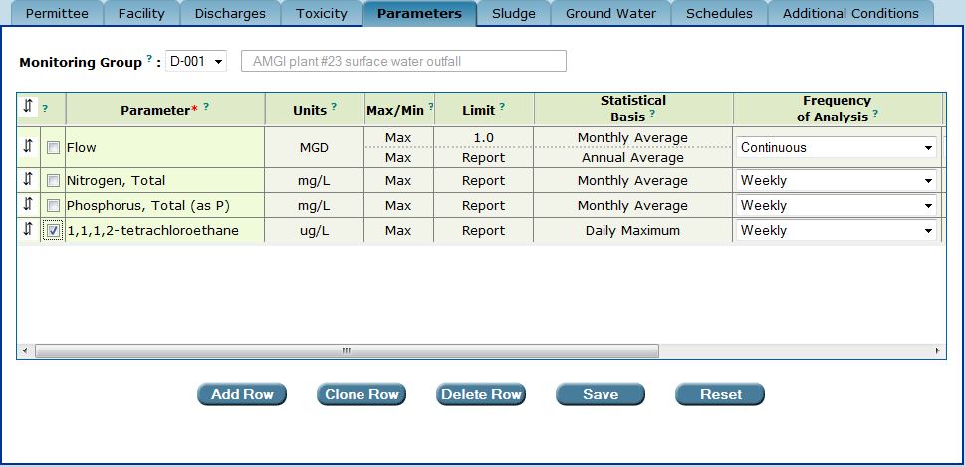
Click the checkbox to the left of the parameter, and then click Clone Row.

Permit Builder will then make a copy of the parameter row:
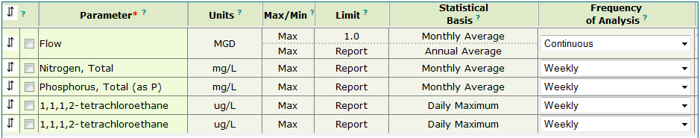

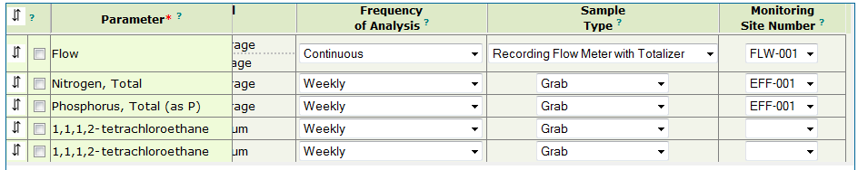
A cloned row is an exact copy of the original row. After cloning a parameter table row, you may add or edit information in the original and cloned rows.

Be sure to:
Save
- Click to save your entries to the Parameters tab.
Reset
- Click to clear recent entries made to the Parameters tab. This will restore all fields to information entered before the last time this tab was saved.

6.1.2. Deleting parameters from the parameters table

Permit Builder allows you to delete parameters from the the parameters table by simply clicking the check-box located to the left of the Parameter Name and then clicking .
Delete Row

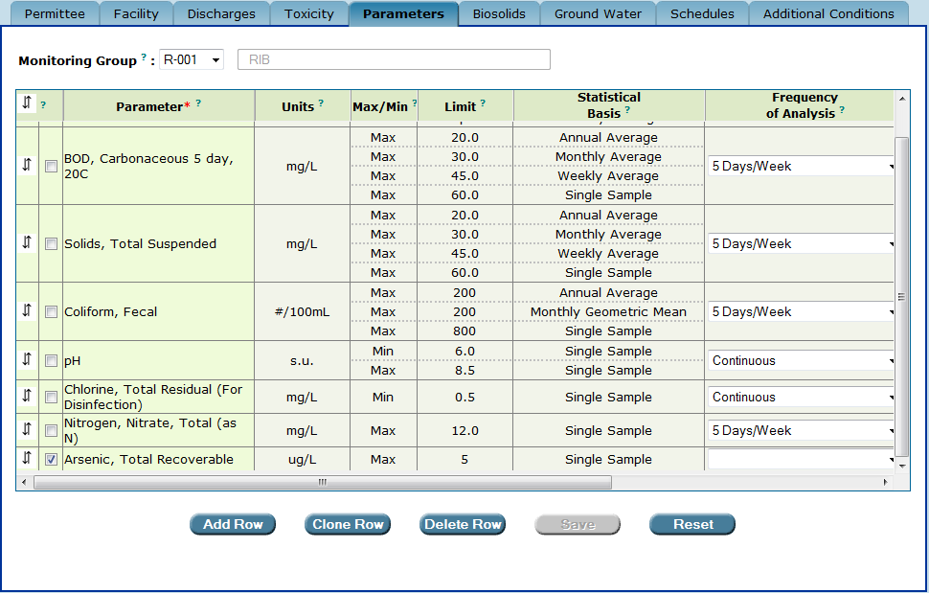
Deleting a parameter from the parameters table.

6.1.3. Editing parameters in the parameters table

Permit Builder allows you to edit the information for a particular parameter.

Editing a parameter’s “Units”

To edit a parameter’s Units, access the Enter or Change Parameter screen by double-clicking on either the parameter’s name cell or units cell.

Double-click either the parameter’s name cell or units cell
to access the “Enter or Change Parameter” screen.

Click on the Units drop-down box arrow and select the units you wish to use.

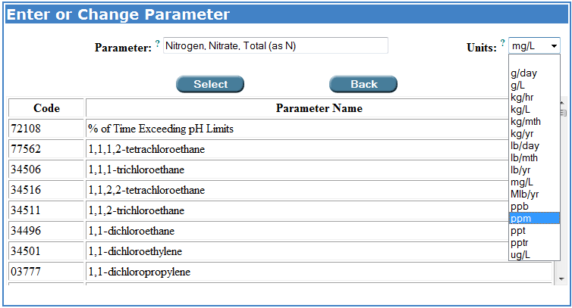
Select
Click to select your entry and return to the Parameters tab, or
Back
Click to cancel and return to the Parameters tab.

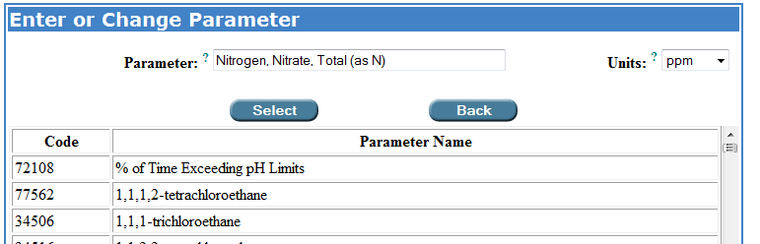

You will now see your edit displayed in the parameters table.

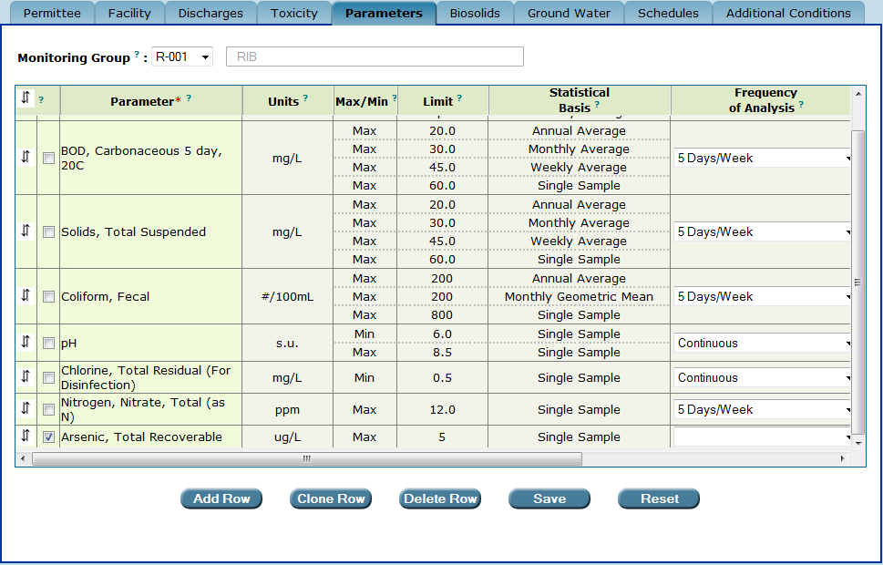
Upon returning to the parameters table, the permit writer can view the edit made to the “Units” for “Nitrogen, Nitrate, Total (as N).”

Editing a parameter’s “Max/Min,” “Limit,” or “Statistical Basis”

To edit a parameter’s Max/Min, Limit, or Statistical Basis, double-click any of the corresponding cells to access the Limit and Statistical Basis screen.

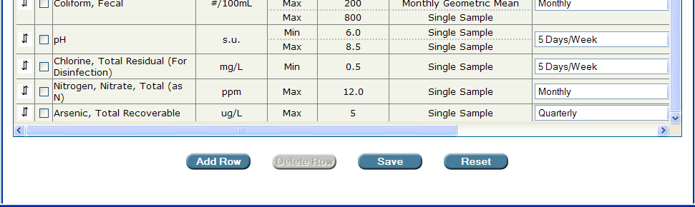
Double-click either the parameter’s “Max/Min,” “Limit,” or “Statistical Basis” cells to access the “Limit and Statistical Basis” screen.

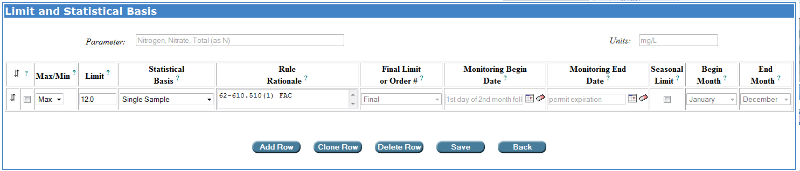
Save
Edit the information and click

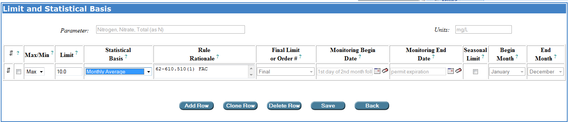
The permit writer has changed the “Limit” and the “Statistical Basis.”

Permit Builder will once again return to the Parameters tab where you will see the edits you made displayed in the parameters table.

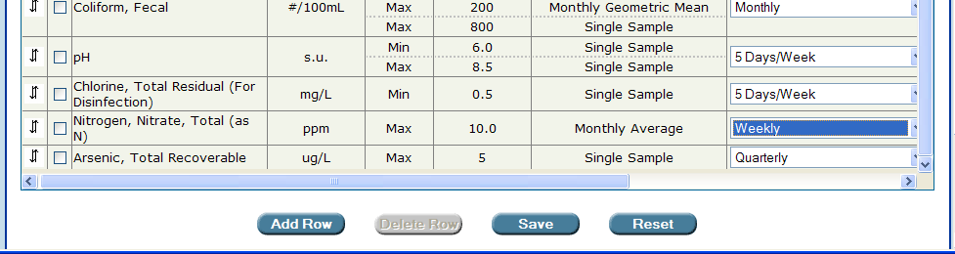
The permit writer can view edits made to the “Limit” and “Statistical Basis” cells, and has also changed the “Frequency of Analysis” from “Monthly” to “Weekly.”

6.1.4. Moving a parameter’s position within the parameters table

Permit Builder allows you to move a parameter’s location up or down within the table.

Step 1: Place your cursor over the down-and-up arrows  in the far left column of the parameter you wish to move, and click once to highlight the parameter row.

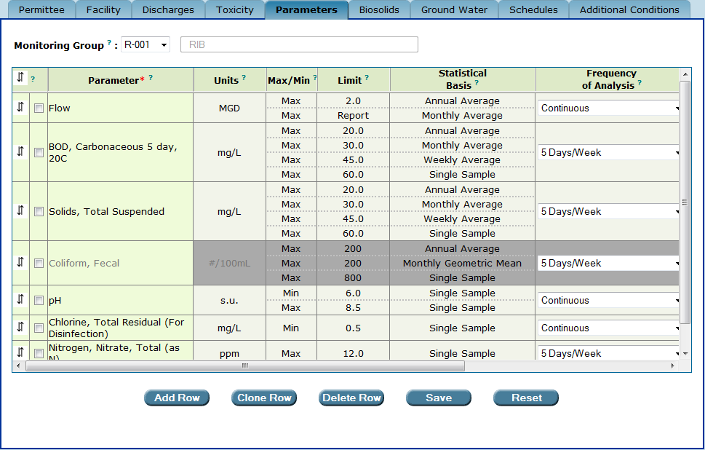
To move a parameter within the table, first high-light the parameter row by clicking
the “down-and-up arrows.”

Step 2: Click the down-and-up arrows  of the row above the row where you want to move the parameter. For example, to move “Coliform, Fecal” to the row below “Flow,” click on the down-and-up arrows  of the row for “Flow.”

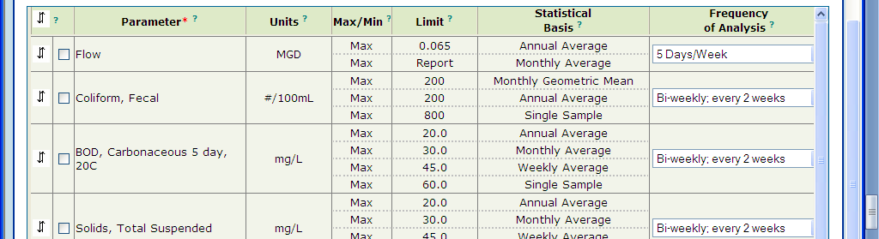
The parameter “Coliform, Fecal” has been moved below the parameter “Flow.”

6.1.5. Moving a parameter’s position to the top row of the parameters table

To move a parameter to the top row of the parameters table:

Step 1: Place your cursor over the down-and-up arrows  in the far left column of the parameter you wish to move and click once to highlight the parameter row.

To move a parameter to the top row of the table, first high-light the parameter row
by clicking on the “down-and-up arrows”.

Step 2: Click the down-and-up arrows  in the top left corner of the parameter table.

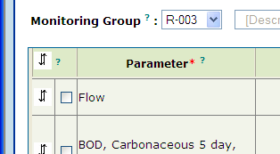

The “down-and-up arrows” at the top left-hand corner of the table.

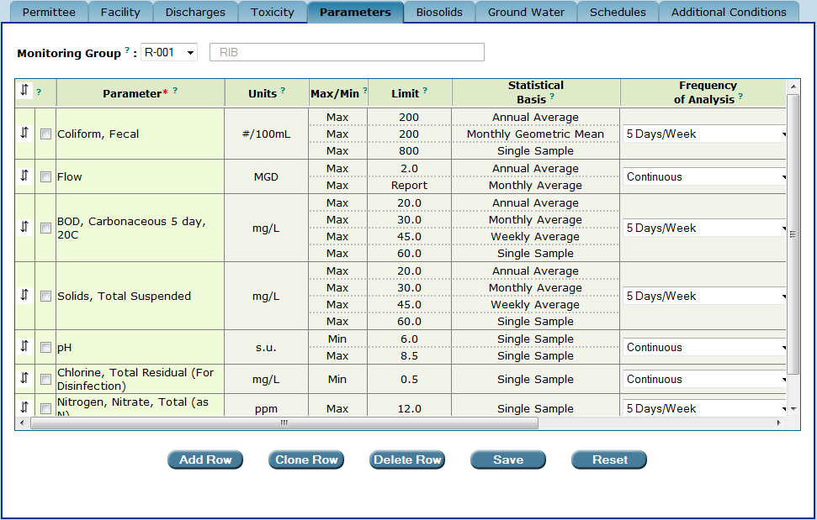
The parameter “Coliform, Fecal” has been moved to the top of the table.
Save
Be sure to click to save the moved parameter row.

6.2. The “Frequency of Analysis” and “Sample Type” columns

Permit Builder gives you the option of entering or changing the Frequency of Analysis and Sample Type columns by clicking on the corresponding drop-down box arrows to display the lists of options.

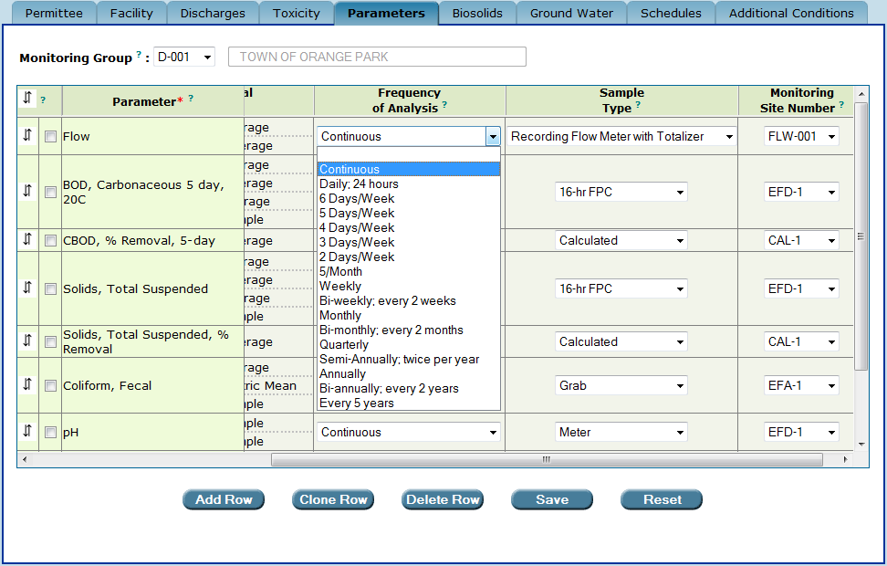
The “Frequency of Analysis” column and its list of options in the drop-down boxes.

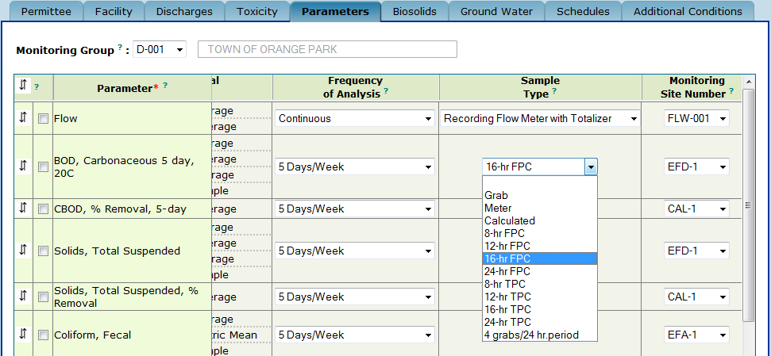
The “Sample Type” column and its list of options in the drop-down boxes. For the parameter “Flow”, the “Sample Type” drop-down box contains different options than for other parameters.

After the list of options is displayed, click on the appropriate Frequency of Analysis and Sample Type for the corresponding parameter.

6.3. The “Monitoring Site Number” column

A facility’s Monitoring Site is a physical location where samples are taken for analysis, such as the influent at the headworks or discharge from a chlorine contact chamber. It may also be a calculated value in the case of certain parameters such as certain flow measurements and percent capacity.

For each parameter in the table, you will need to select a Monitoring Site Number in the column located on the far right of the parameters table.

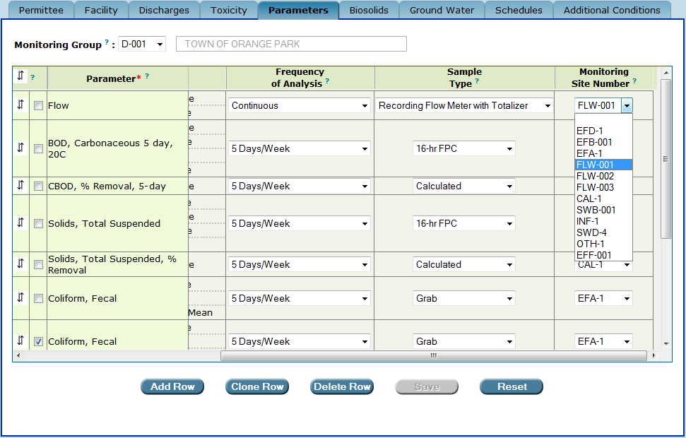

When you click on any of the Monitoring Site Number drop-down box arrows, Permit Builder will display a list of sites. If you do not see the desired sites listed, you will have to create them.
After the list of sites is displayed, click on the appropriate site for the corresponding parameter.

6.3.1. Creating new and modifying existing “Monitoring Site Numbers”

If the Monitoring Site Number drop-down box does not contain the appropriate monitoring site number for a particular parameter, you may create a site by following Steps 1 – 6 below:
Step 1: Double-click anywhere in the column heading using the hand icon

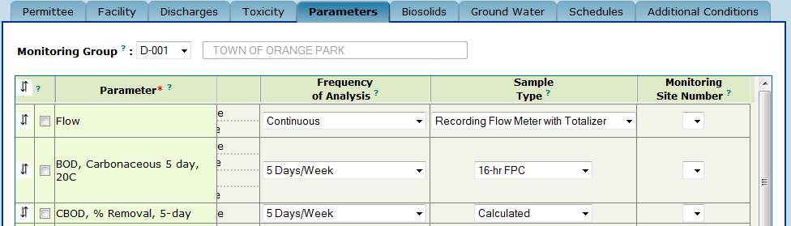
Double-click the “Monitoring Site Number” column heading to display
the “Add or Modify Monitoring Site Number” screen.

Permit Builder will then display the Add or Modify Monitoring Site Number screen where you will see any previously entered monitoring site numbers and site descriptions, as illustrated below.

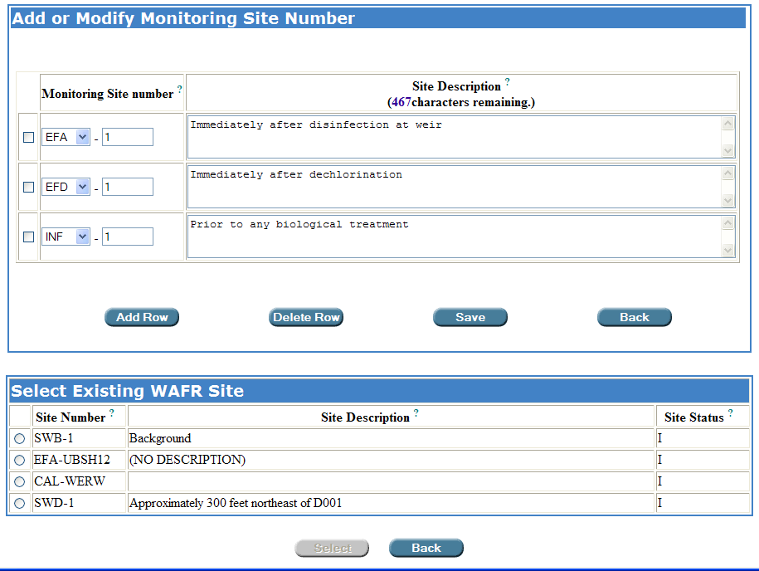
The “Add or Modify Monitoring Site Number” screen, where the permit writer
may add new, and modify existing Monitoring Site Numbers in the “Parameters” table.

Add Row ow
Step 2: Click to add a blank row to the bottom of the table.

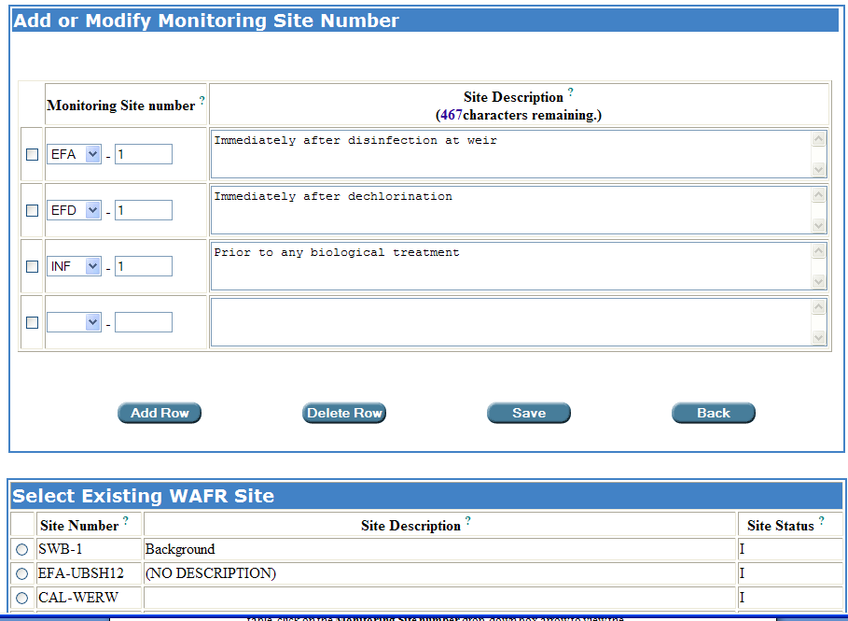

Step 3: To add a monitoring site that is not listed in the Select Existing WAFR Site table, click on the Monitoring Site number drop-down box arrow to view the list of 17 prefix options.

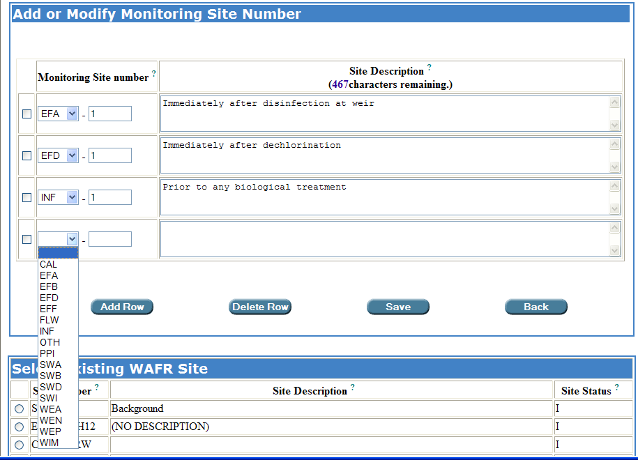

Step 4: From the Monitoring Site Number drop-down box list of prefix options, select the appropriate prefix, and type the number and a description of the monitoring site in the corresponding fields.

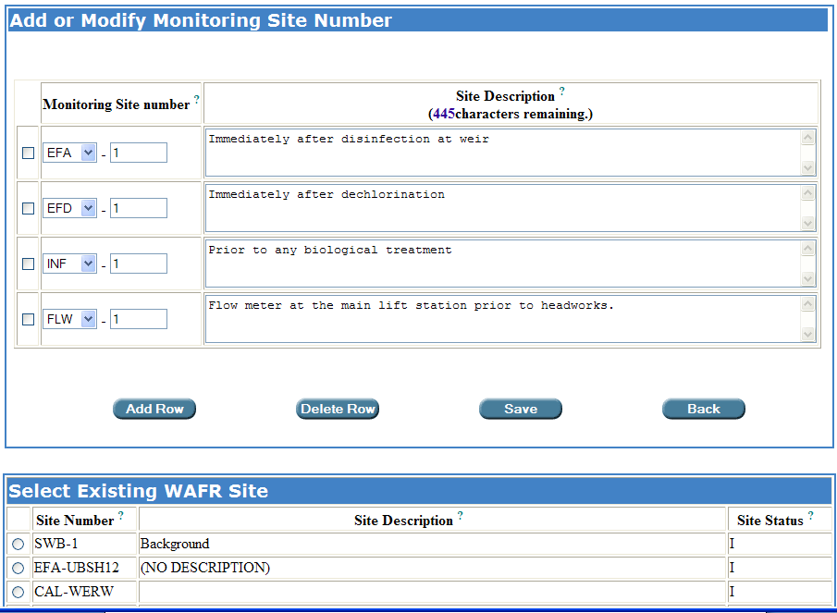
The permit writer has created a new monitoring site, “FLW-1” in this example.

Step 5: To add a monitoring site that is listed in the Select Existing WAFR Site table, click the radio button corresponding to the desired site, and then click
Select ow

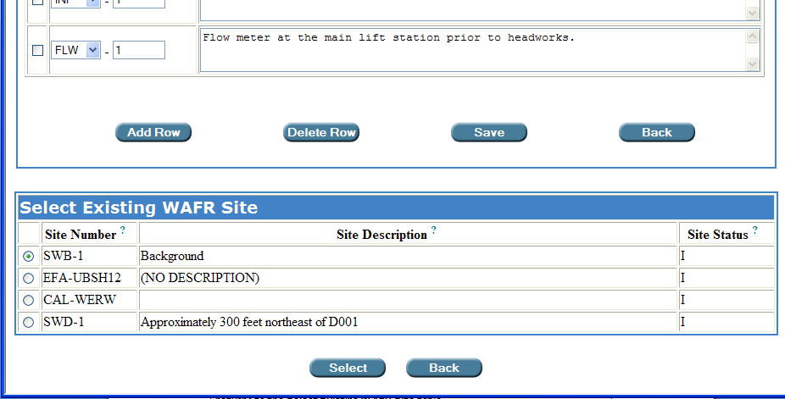

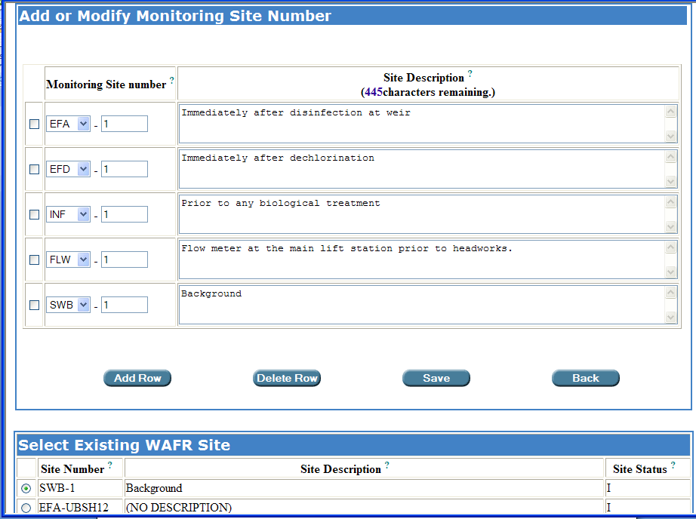
The permit writer has selected an existing WAFR site, “SWB-1” in this example.

NOTE: If you select a site from the Select Existing WAFR Site table and “Save,” the selected site will be added to the Add or Modify Monitoring Site Number table and deleted from the Select Existing WAFR Site table. Conversely, if you delete a row from the Add or Modify Monitoring Site Number table that was selected from the Select Existing WAFR Site table and “Save,” the site returns to the Select Existing WAFR Site table.

Save ow
Step 6: Click to save your entries and return to the Parameters tab; or
Click to cancel your entries, and return to the Parameters tab.
Back

Once you have completed Steps 1 – 4 and have returned to the parameters table, you will be able to select any of the Monitoring Site Numbers either previously created, newly created, or edited.

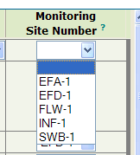
A “Monitoring Site Number” drop-down box in the table of the “Parameters” tab, displaying all previously created sites as well as the newly created “FLW-1” site and the existing WAFR site “SWB-1.

6.3.2. “Monitoring Site Number” prefixes

Permit Builder contains the following prefix options in the Monitoring Site Number drop-down box located in the Add or Modify Monitoring Site Number screen:

- CAL – Calculated value using values from other samples.
- DWM – Public (municipal) drinking water well. (IW only)
- DWP – Public drinking water well. (IW only)
- EFA – Sample point immediately after disinfection such as the discharge from a chlorine contact chamber.
- EFB – Sample point immediately before disinfection.
- EFD – Sample point immediately after dechlorination.
- EFF – Effluent sampling location, such as a tap, pipe, or valve, where many effluent parameters such as TSS and CBOD5 are sampled at the facility.
- FLW – Any site where flow is monitored.
- GYP – Gypstack from phosphate processing. (IW only)
- IMP – Any structure impounding/holding liquids. Usually lined with little percolation. (IW only)
- INA – Annulus of an injection well. (IW only)
- INF – Influent sampling site prior to the treatment train.
- INJ – Class I injection well. (IW only)
- INJ5 – Class V injection well. (IW only)
- INT – Intake from stream, lake or other SW body. (IW only)
- INW – Intake from ground water well. (IW only)
- LCS – Leachate collection system sample point. (IW only)
- OTH – Any other site.
- OUI – Internal outfall which limitations or monitoring conditions established prior to discharge into the main effluent stream downstream from the final. (IW only)
- OUTS – Surface water discharge point for stormwater only. (IW only)
- PER – A pond which allows infiltration water into the ground water. (IW only)
- PPI – Any location within a treatment plant where samples are taken, and not designated by any other monitoring site prefix.
- STM – Stormwater site. (IW only)
- SWA – Ambient surface water body sampling site representative of natural background conditions.
- SWB – Surface water sampling site within the receiving water body, not impacted by the facility’s effluent, and reflecting current water quality conditions.
- SWD – Surface water test site within the effluent zone of impact, in a unidirectional flow water body.
- SWI – Surface water test site within the effluent zone of impact, in either a lake or tidal region of an estuary.
- SWU – A surface water control site upstream of the effluent discharge in a unidirectional flow waterbody. (IW only)
- WEA – Monitoring location within a manmade or constructed wastewater wetland.
- WEN – Monitoring location within a natural wetland that is being used as a control site for a nearby wastewater wetland.
- WEP – Monitoring point for the effluent sheet flow exiting from a wastewater wetland system, to final receiving waters.
- WIM – Monitoring location within a natural wastewater wetland.

Don’t forget to either:
Save
- Click to save your edits to the Parameters tab, or
Reset
- Click to clear all edits made to the Parameters tab. This will restore all fields to any information entered before the last time this tab was saved.

6.4 Creating Interim Limits

To create interim limits for effluent and reclaimed water monitoring, an Administrative Order (AO) or a Consent Order (CO) must first be created on the Orders sub-tab under the Facility tab (see Chapter 3 of the Permit Builder User Guide for information on how to create an order). Once an order has been created in your Permit Builder project, the Limit Type column will be included in your parameter table. The Limit Type column will indicate whether each limit is a final limit or an interim limit.

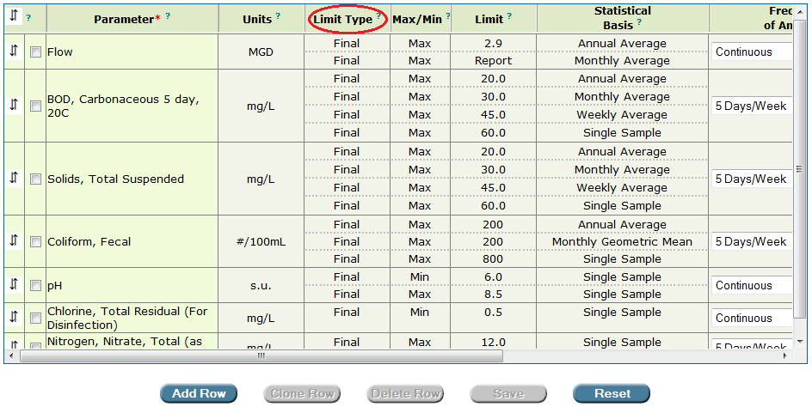
The “Limit Type” column is displayed in the parameter table when an order has been created by the permit writer for the Permit Builder project.

To create an interim limit, open the Limit and Statistical Basis pop-up window as described above (by double clicking on the Max/Min, Limit, or Statistical Basis field of a parameter). Select or enter the limit, statistical basis, and rule rational and indicate whether the limit is a maximum limit or a minimum limit. If the limit is an interim limit, select the order number with which the interim limit is associated from the Final Limit or Order # drop-down box (the order numbers will have been created by the permit writer on the Orders sub-tab under the Facility tab, see Chapter 3 of the Permit Builder User Guide). If the limit is a final limit, you will not need to make a selection form the Final Limit or Order # drop-down box since “Final” is the default option.

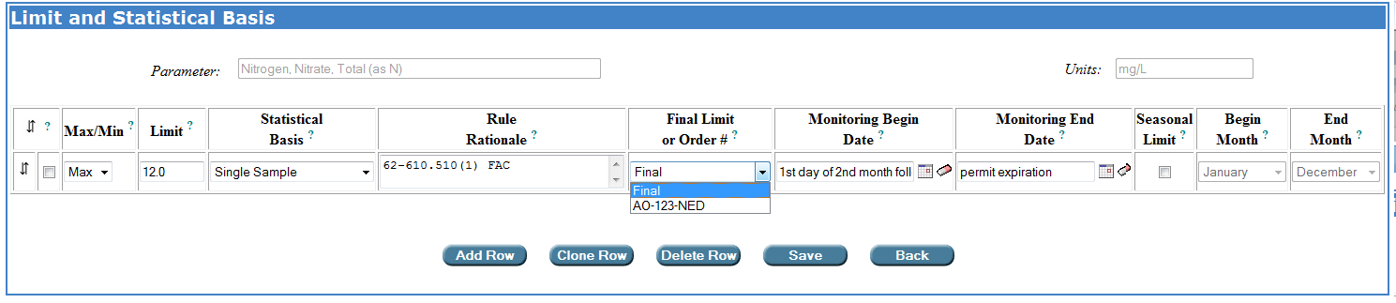

To indicate that a limit is an interim limit, select the order number of the Administrative Order or Consent Order that includes the interim limit from the “Final Limit or Order #” drop-down box on the “Limit and Statistical Basis” pop-up window. The order numbers populating the “Final Limit or Order #” drop-down box are created by the permit writer on the Orders sub-tab under the Facility tab.

The dates over which the interim and final limits apply are specified on the Limit and Statistical Basis pop-up window. When a project has not yet been issued in WAFR-PA, the Monitoring Begin Date field will initially be populated with the phrase, “1st day of the second month following the effective date of the permit” (i.e., the monitoring start date) for both interim and final limits. The Monitoring End Date will initially be populated with the phrase, “permit expiration” for both interim and final limits.

Calendar dates may be entered into the date fields or selected from a calendar after clicking on the calendar icon following each date field. Text may not be entered into the date fields. If the default text language (“1st day of the second month following the effective date of the permit” or “permit expiration”) is overwritten with a calendar date, the text language may be retrieved by selected a different option from the Final Limit or Order # drop-down box and then re-selecting the desired option.

The monitoring begin and end dates will be used in generating DMRs. For projects that have not yet been issued in WAFR-PA, Permit Builder has been programmed so that “1st day of the second month following the effective date of the permit” is the earliest monitoring date. Any calendar monitoring begin date will be assumed by Permit Builder to fall after the “1st day of the second month following the effective date of the permit.” That is, if the permit writer anticipates that a permit will be issued on May 23, 2015, so that the “1st day of the second month following the effective date of the permit” will be July 1, 2015. “1st day of the second month following the effective date of the permit” should still be used as the monitoring begin date for limits that are effective on the monitoring start date rather than 7/1/2015 (unless all “1st day of the second month following the effective date of the permit” monitoring begin dates, for all final and interim limits, are changed to 7/1/2015). If 7/1/2015 is used in place of some “1st day of the second month following the effective date of the permit” monitoring begin dates, Permit Builder will create a DMR with an effective range of “1st day of the second month following the effective date of the permit” through 6/30/2015.

Please note that the permit must have been issued in WAFR-PA before a Permit Builder project containing interim limits may be uploaded to WAFR.

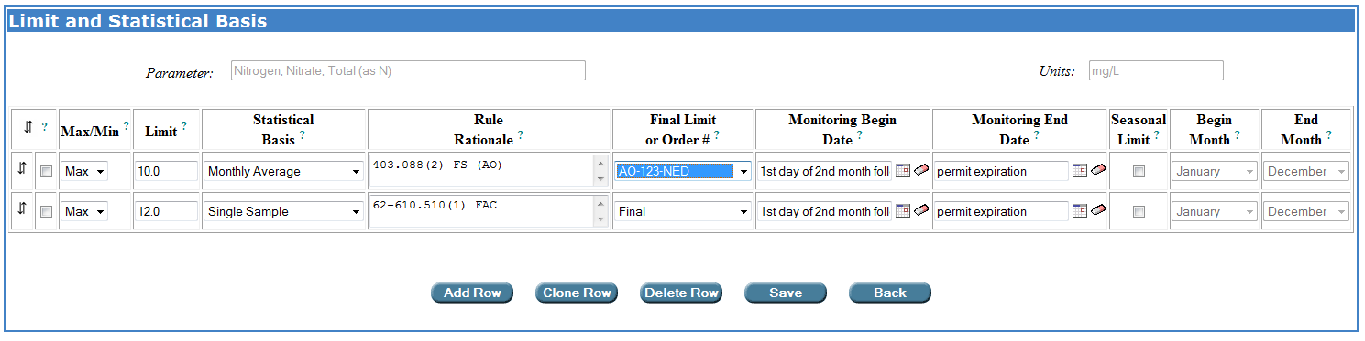
For projects that have not yet been issued in WAFR-PA, monitoring dates default to “1st day of the second month following the effective date of the permit” and “permit expiration.”

When a project has been issued in WAFR-PA, the Monitoring Begin Date field will initially be populated with the calendar date corresponding to the first day of the second month following the effective date of the permit (i.e., the monitoring start date) for final limits and interim limits associated with AOs. For interim limits associated with COs, the Monitoring Begin Date field will initially be populated with the calendar date corresponding to the first day of the month following the CO executed date specified by the permit writer on the Orders sub-tab under the Facility tab (see Chapter 3 of the Permit User Guide). For all interim and final limits, the Monitoring End Date will initially be populated with the calendar date corresponding to the date of permit expiration.

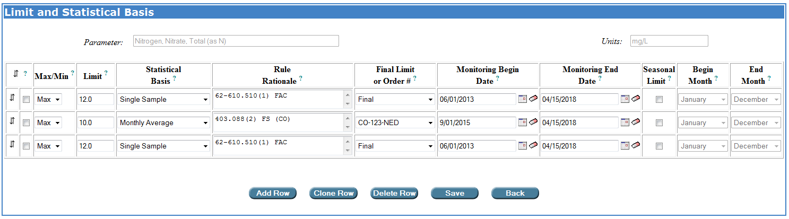
For projects that have been issued in WAFR-PA, monitoring begin dates for limits associated with Administrative Orders and final limits default to the calendar date corresponding to the first day of the second month following the effective date of the permit. Monitoring begin dates for limits associated with Consent Orders default to the calendar date of the first day of the month following the executed date entered by the permit writer on the Orders sub-tab under the Facility tab. Monitoring end dates for interim and final limits default to the calendar date corresponding to the permit expiration date.

For compatibility with EPA’s ICIS database and the Department’s eDMR system, monitoring dates need to begin on the first day of a month. Monitoring dates should end on the last day of a month or the permit expiration date. Additionally, there should not be any overlap or gaps in monitoring effective dates between interim and final limits. One limit should begin on the day following another limit’s end date. There are no checks in Permit Builder to ensure that appropriate interim and final effective date ranges have been included in the project. If the interim and final DMRs generated by Permit Builder for your project are not what you anticipated, check the monitoring begin and end dates for the parameters with interim and final limits to ensure that the correct dates have been entered.

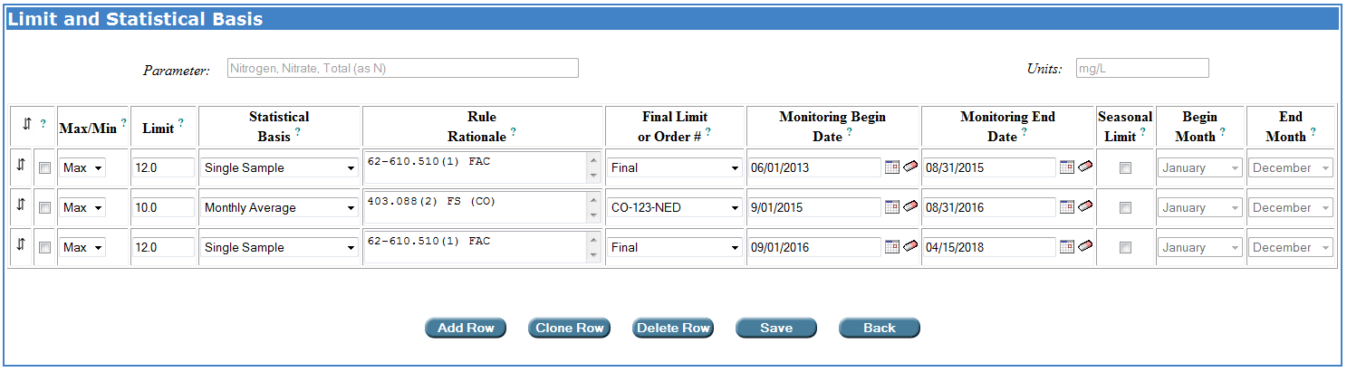
There should be no overlapping or gaps between interim and final limits. One limit should begin on the day following the end date of another limit.

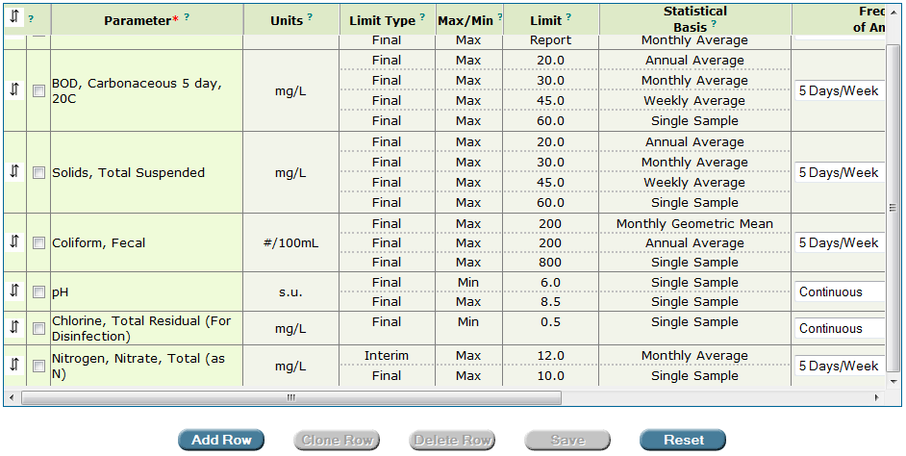
Interim limits have been added by the permit writer for “Nitrogen, Nitrate, Total (as N)”.

6.5. Navigating within the Parameter Table

When using the Frequency of Analysis, Sample Type, and Monitoring Site Number drop-downs menus in the parameter table, you can use the “Enter” key to move to the row below and the “Tab” key to move to the column to the right.

CONGRATULATIONS!
YOU HAVE COMPLETED THE “PARAMETERS” TAB

Before adding, deleting, or editing any parameters for a facility, always check the facility’s most recent file(s) which should contain the current operating permit and any permit modifications or revisions that may affect parameters and their limits. If in doubt, ask your supervisor.
Click the Back button to cancel your action and return to the Parameters tab.
This information should be contained in the permit application. However, be sure to check all documents in the facility’s current permit file, or ask your supervisor.
If the Monitoring Site Number drop-down box is empty, or does not contain appropriate site numbers, you will have to create them. See Section 6.3.1. Creating new, and modifying existing “Monitoring Site Numbers” above.
When Permit Builder generates the Discharge Monitoring Report (DMR) for the particular discharge, the parameters will appear in the same order as they appear in the parameters table in Permit Builder.
See Section 6.3.1. Creating new and modifying existing “Monitoring Site Numbers.”
See Section 6.3.2. “Monitoring Site Number” prefixes, for a description of each prefix.
Please remember that a Permit Builder project may be created only when the permit has not yet been issued in WAFR-PA. However, once a Permit Builder project has been created, the permit may be issued at any time. An existing Permit Builder project may be edited or uploaded to WAFR regardless of whether it has been issued. Please note, however, that the permit must have been issued in WAFR-PA before a Permit Builder project containing interim limits may be uploaded to WAFR.

