7A. The “Biosolids” tab

Permitting requirements for the beneficial use or disposal of wastewater treatment facility biosolids (also known as residuals or sludge) are established in Chapter 62-640, F.A.C., Biosolids.

When you are ready to begin entering biosolids data into your Permit Builder project, click the Biosolids tab which will take you to the screen illustrated below.

7A.1. The “General” sub-tab

The General sub-tab contains fields and check-box statements that provide Permit Builder with basic information about the facility’s method of handling its biosolids.

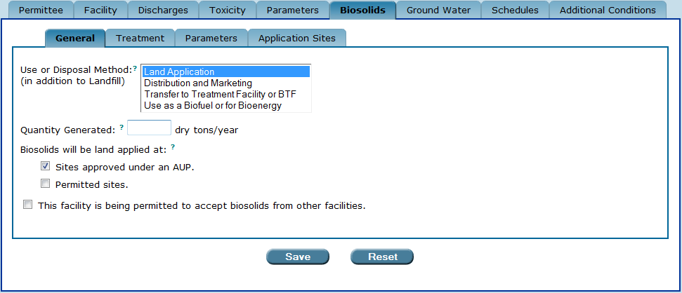
The Biosolids tab and its sub-tabs.

7A.1.1. The “Use or Disposal Method” field on the “General” sub-tab

The Use or Disposal Method field displays the following four options for biosolids use or disposal:
- Land Application. This method of biosolids use is practiced by facilities that treat their biosolids to Class A, Class AA, or Class B. These classes of treated biosolids may then be transported by a contracted hauler to an approved land application site where they are land-applied as fertilizer or soil amendment.
- Distribution and Marketing, as defined in Rule 62-640.200(16), F.A.C. This method of biosolids use is practiced by facilities that treat their biosolids to Class AA. The biosolids may then be sold or given away in either bulk or packaged form.
- Transfer to Treatment Facility or BTF. This method of biosolids disposal is used by facilities that send their untreated biosolids to either another wastewater treatment facility or a biosolids treatment facility (BTF) for treatment.
- Use as a Biofuel or for Bioenergy. This method of biosolids use is practiced by facilities that incinerate or use biosolids as a biofuel or for bioenergy by gasification. This option is intended for facilities where the energy equipment is part of the facility. If a waste-to-energy facility is to burn the biosolids, transfer would be the appropriate disposal method to select since the biosolids would be transferred to that facility.
Any use or disposal methods selected are in addition to Landfill, which refers to a solid waste landfill. This method of biosolids disposal is used by facilities that dispose of their biosolids in a landfill. A facility will frequently select this option together with another disposal method option since disposal to a landfill may be utilized as an alternative option.
Depending on the use or disposal method selected, a requirement to monitor the quantity of biosolids land applied, distributed and marketed inside Florida, distributed and marketed outside Florida, transferred, or used as a biofuel or for bioenergy is included on the DMR. Permit Builder always includes a requirement to monitor the quantity of biosolids landfilled on the DMR.

7A.1.1.1. Selecting more than one option in the “Use or Disposal Method” field

Permit Builder allows you to select more than one option from the Use or Disposal Method field by pressing and holding the control key (CTRL) while clicking an option.

See Scenario 6 in Section 7A.1.1.2. for an illustration.

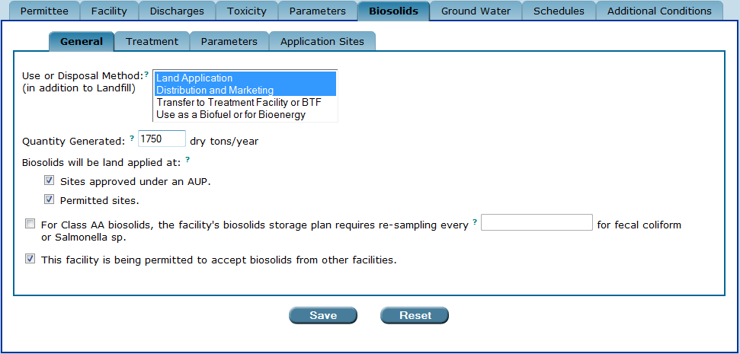
Selecting more than one option in the “Use or Disposal Method” field.

7A.1.1.2. The six “Use or Disposal Method” scenarios

Depending on which Use or Disposal Method you choose, Permit Builder will display additional fields and check-box statements for you to fill out.

The six possible Use or Disposal Method scenarios on the General sub-tab are detailed below.

“Use or Disposal Method” – SCENARIO 1

IF the Use or Disposal Method is selected for none of the options:

- Landfill will be the only permitted method

THEN Permit Builder will display the following:
- The “facility is being permitted to accept biosolids from other facilities” check-box statement. Select this check-box if this statement applies to your Permit Builder project. This will tell Permit Builder to generate certain special permit conditions in the body of the permit that outline record-keeping requirements and certain responsibilities the permittee will be required to assume. Additionally, Permit Builder will include a requirement to monitor the quantity of biosolids received by the facility from other facilities on the DMR.

NOTE: The Treatment and Application Sites sub-tabs are not accessible when Landfill is this only use or disposal method.

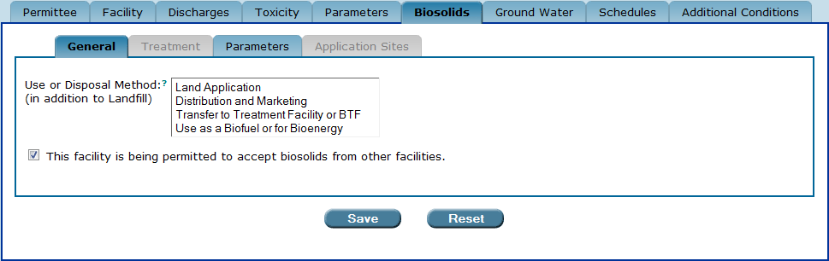
The “General” sub-tab when no options are selected for “Use or Disposal Method” and Landfill is the only use or disposal method.

“Use or Disposal Method” – SCENARIO 2

IF the Use or Disposal Method is selected for:

- Land Application

THEN Permit Builder will display the following:
- The Quantity Generated field. This information should be provided in the facility’s permit application. The quantity entered will determine the frequency of biosolids analysis required in the permit. Enter integers only. Do not use commas or decimal points.
- The “biosolids will be land applied at” check-box statements. Select the “sites approved at an AUP” check-box statement if this statement applies to your Permit Builder project. This will tell Permit Builder to generate special permit conditions in the permit that outline requirements for facilities applying biosolids at application sites currently permitted under chapter 62-640, F.A.C., as amended March 30, 1998, but not yet permitted under that chapter as amended August 29, 2010. Select the “permitted sites” check-box statement if this statement applies to your Permit Builder project. This will tell Permit Builder to generate special permit conditions in the permit that outline requirements for facilities applying biosolids at application sites that are permitted under chapter 62-640, F.A.C., as amended August 29, 2010.
- The “facility is being permitted to accept biosolids from other facilities” check-box statement. (See Scenario 1 above for an explanation of this check-box statement.)

NOTE: The Application Sites sub-tab is not accessible unless biosolids will be land applied at sites approved under an AUP and the “sites approved under an AUP” check-box statement is selected.

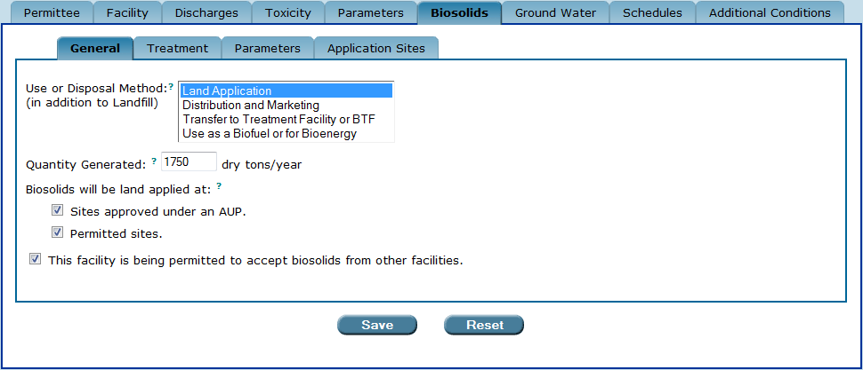
The “General” sub-tab when “Land Application” is selected for “Use or Disposal Method.”

“Use or Disposal Method” – SCENARIO 3

IF the Use or Disposal Method is selected for:

- Distribution and Marketing

THEN Permit Builder will display the following:
- The “fecal coliform or Salmonella sp. re-sampling” check-box statement and text field. Select this check-box if this statement applies to your Permit Builder project. Enter the Class AA re-sampling frequency specified in the facility’s Biosolids Storage Plan. This will tell Permit Builder to generate a special permit condition in the body of the permit that stipulates how frequently Class AA biosolid must be resampled when stored for more than 45 days.
- The “facility is being permitted to accept biosolids from other facilities” check-box statement. (See Scenario 1 above for an explanation of this check-box statement.)

NOTE: The Application Sites sub-tab is not accessible when this use or disposal method is selected.

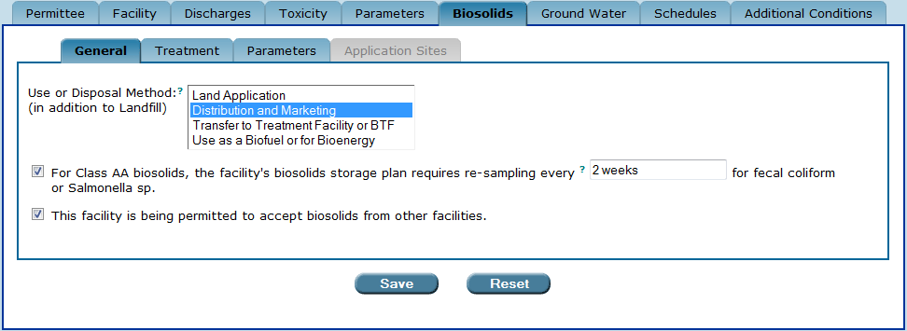
The “General” sub-tab when “Distribution and Marketing” is selected for “Use or Disposal Method.”

“Use or Disposal Method” - SCENARIO 4

IF the Use or Disposal Method is selected for:

- Transfer to Treatment Facility or BTF

THEN Permit Builder will display the following:
- The Treatment Facility Name field. This information should be provided in the facility’s permit application.
- The “facility is being permitted to accept biosolids from other facilities” check-box statement. (See Scenario 1 above for an explanation of this check-box statement.)

NOTE: The Treatment and Application Sites sub-tabs are not accessible when this use or disposal method is selected.

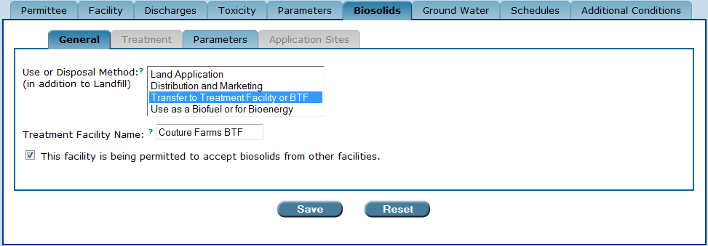
The “General” sub-tab when “Transfer to Treatment Facility or BTF” is selected for
“Use or Disposal Method.”

“Use or Disposal Method” – SCENARIO 5

IF the Use or Disposal Method is selected for:

- Use as a Biofuel or for Bioenergy

THEN Permit Builder will display the following:
- The “facility is being permitted to accept biosolids from other facilities” check-box statement. (See Scenario 1 above for an explanation of this check-box statement.)

NOTE: The Treatment and Application Sites sub-tabs are not accessible when this disposal method is selected.

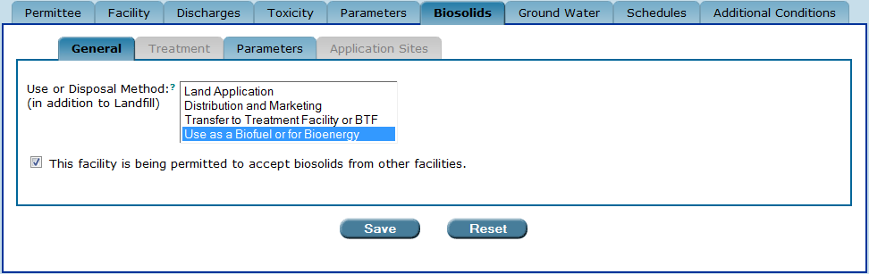
The “General” sub-tab when “Use as a Biofuel or for Bioenergy” is selected for “Use or Disposal Method.”

“Use or Disposal Method” – SCENARIO 6

IF the Use or Disposal Method is selected for:

- Multiple options. Permit Builder allows you to choose more than one use or disposal method in addition to Landfill by holding down the control key (CTRL) while clicking the option.

THEN Permit Builder will display the following:

- All corresponding fields and check-boxes (see Scenarios 1 – 5 above).

NOTE: Many domestic wastewater treatment facility permits list more than one biosolids use or disposal method, with the alternative option being Landfill.

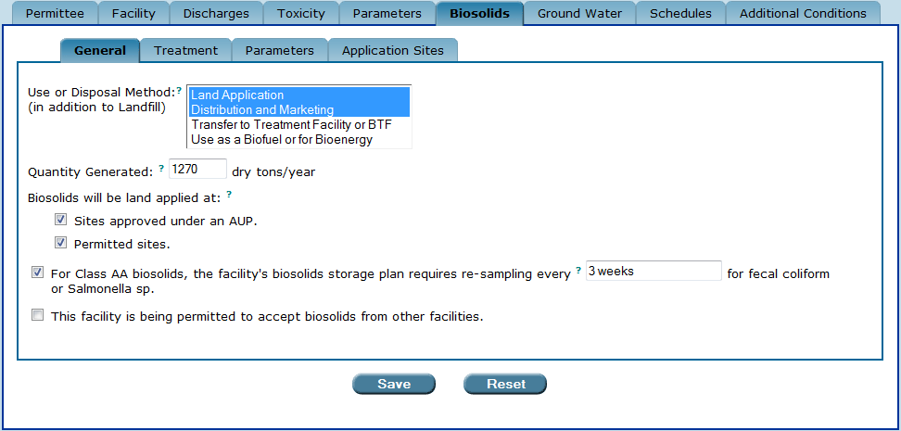

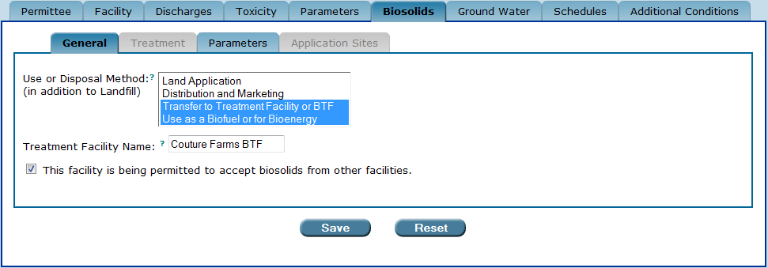
The “General” sub-tab when multiple options are selected for “Disposal Method.”

7A.1.2. The “Save” and “Reset” buttons

Once you have finished with the General sub-tab, be sure to either:
Click to save your entries to General sub-tab.
Save ow
Click to restore all fields to any information entered before the last time this sub-tab was saved.
Reset ow

7A.2. The “Treatment” sub-tab

The Treatment sub-tab is accessible when at least one of the following options is selected for the Use or Disposal Method field on the General sub-tab:

- Land Application, or
- Distribution and Marketing.

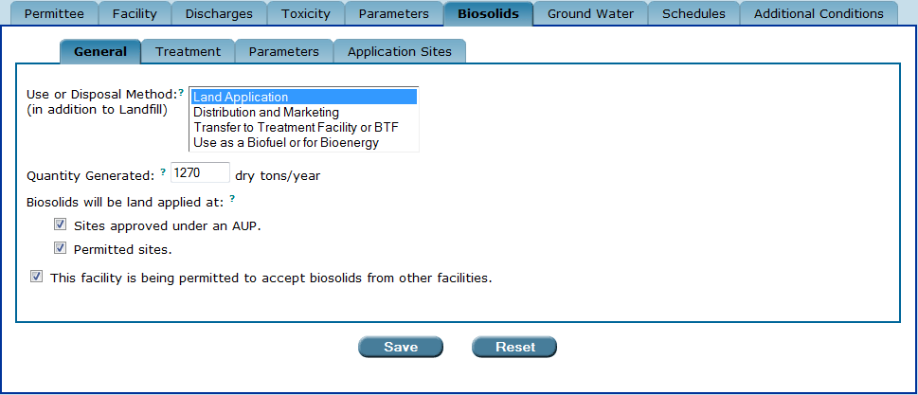
The Application Sites sub-tab is accessible only when the biosolids will be land applied at “sites approved under an AUP” check-box is selected.

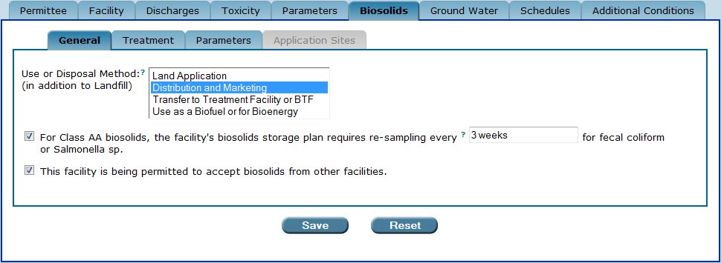
The Application Sites sub-tab is not accessible.
The “Treatment” sub-tab is accessible when at least one of the “Use or Disposal Method” options on the “General” sub-tab is selected for either “Land Application” or “Distribution and Marketing.”

7A.2.1. The “Biosolids Class” check-boxes on the “Treatment” sub-tab

The Biosolids Class check-boxes on the Treatment sub-tab indicate the class of biosolids a facility produces after treatment. The three biosolids classes are:

- Class A, as defined in Rule 62-640.200(9), F.A.C.,
- Class AA, as defined in Rule 62-640.200(10), F.A.C., and
- Class B, as defined in Rule 62-640.200(11), F.A.C.

Biosolids Class is a designation of the level of treatment the facility performs on its biosolids prior to beneficial use or disposal, and is specified in the permit application.

IF you select Land Application as one of the options in the Use or Disposal Method field,

THEN Biosolids Class may be Class A, Class AA, Class B, or all three.

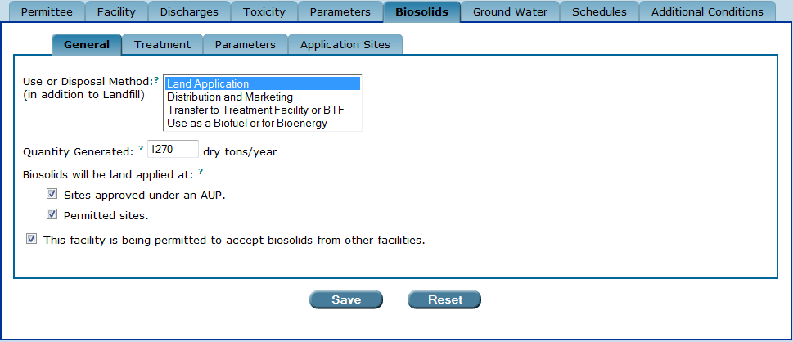

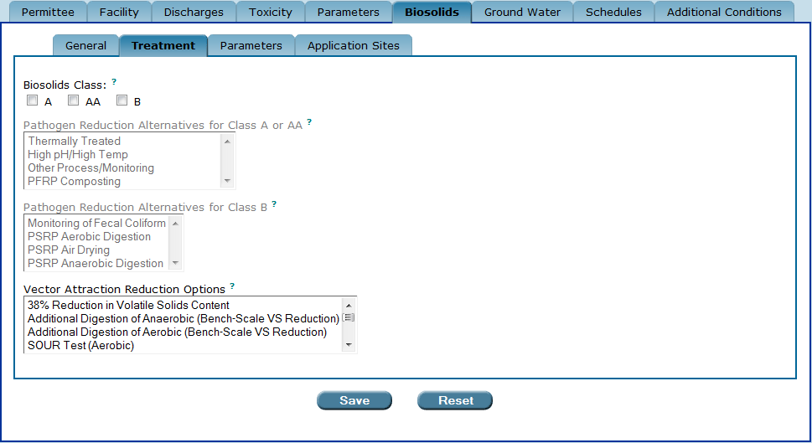
The “Use or Disposal Method” field on the “General” sub-tab is selected for “Land Application.”
The “Biosolids Class” on the “Treatment” sub-tab may be selected for “A”, “AA”, “B” or all three.

IF you select Distribution and Marketing as one of the options in the Use or Disposal Method field,

THEN Biosolids Class may only be Class AA.

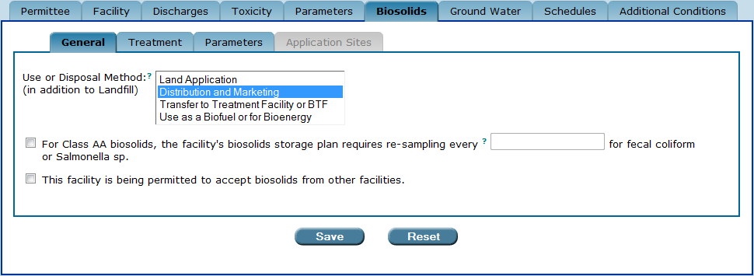

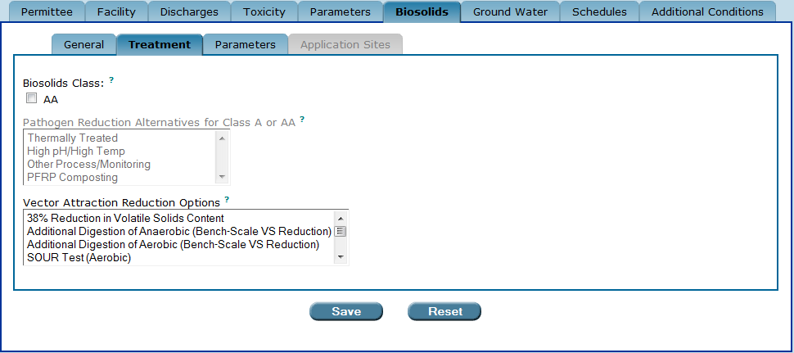
The “Use or Disposal Method” field on the “General” sub-tab is selected for “Distribution and Marketing.”
The “Biosolids Class” on the “Treatment” sub-tab may only be “AA.”

IF you select both Land Application and Distribution and Marketing in the Use or Disposal Method field,

THEN Biosolids Class may be Class A, Class AA, and/or Class B.

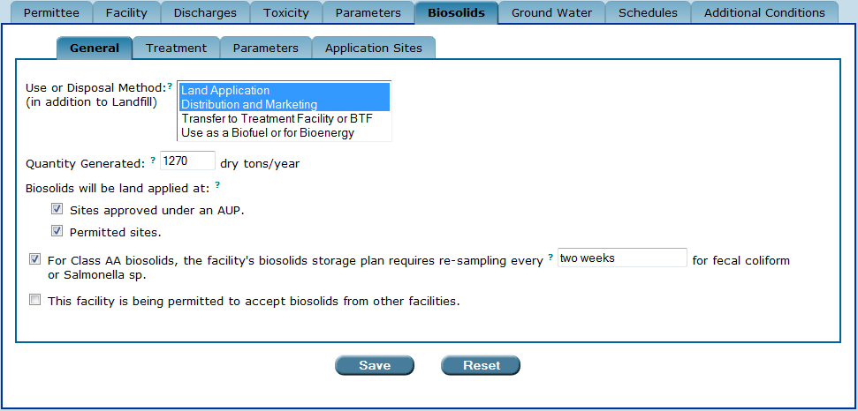

The “Use or Disposal Method” field on the “General” sub-tab is selected for both “Land Application” and “Distribution and Marketing.” The “Biosolids Class” on the “Treatment” sub-tab may be
either “A,” “AA,” “B,” or any combination of the three classes.

7A.2.2. The “Pathogen Reduction Alternatives” and the “Vector Attraction Reduction Options” fields on the “Treatment” sub-tab

On the Treatment sub-tab, Permit Builder will display two or three fields depending on which class of biosolids is selected, or if more than one class of biosolids is selected.

Each field lists the various biosolids treatment alternatives and options established and defined in 40 CFR 503.32 and 40 CFR 503.33. These requirements are incorporated by reference in Rule 62-640.600, F.A.C., Pathogen Reduction and Vector Attraction Reduction.

The primary purpose of all pathogen reduction alternatives is to reduce the number of pathogens present in the biosolids prior to their being either land applied or distributed and marketed as fertilizer.

The primary purpose of all vector attraction reduction options is to diminish within the biosolids, those characteristics that attract vectors, i.e., rodents, insects, and other organisms capable of transporting agents of infectious diseases.

7A.2.2.1. Pathogen reduction alternatives for Class A or Class AA biosolids

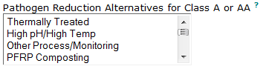

The Pathogen Reduction Alternatives for Class A or AA biosolids listed in the field are:

  - Thermally Treated
  - High pH/High Temp
  - Other Process/Monitoring
  - PFRP Composting
  - PFRP Heat Drying
  - PFRP Heat Treatment
  - PFRP Thermophilic Aerobic Digestion
  - PFRP Beta Ray Irradiation
  - PFRP Gamma Ray Irradiation
  - PFRP Pasteurization
  - Equivalent to PFRP

IF the last alternative is selected:

- Equivalent to PFRP

THEN Permit Builder will display the use of … field where you may enter a description of the equivalent process. (This field currently allows 200 characters.)

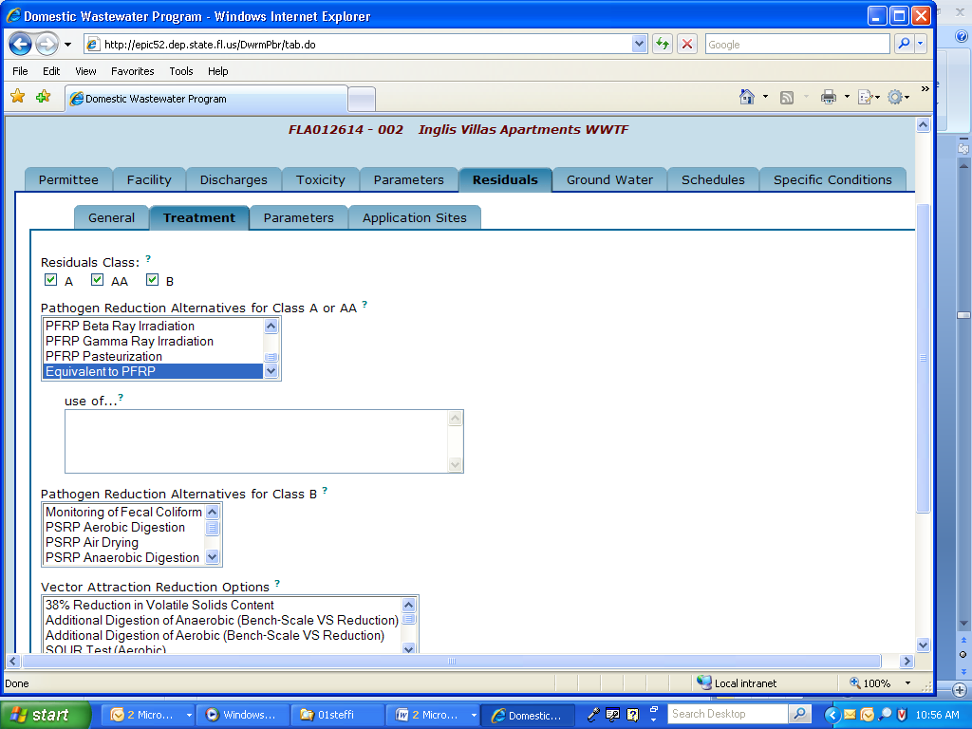

For information on what to enter into the use of … field, click ?

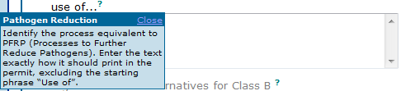

When any pathogen reduction alternative is selected, Permit Builder will display the enter the parameters to be monitored to demonstrate compliance with pathogen reduction requirements field where you may enter a description of the parameters to be monitored to demonstrate compliance with the selected pathogen reduction alternative(s). (This field currently allows 200 characters.)

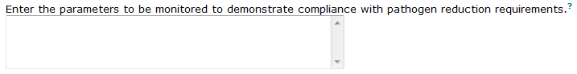

For information on what to enter into the parameters to be monitored to demonstrate compliance field, click ?

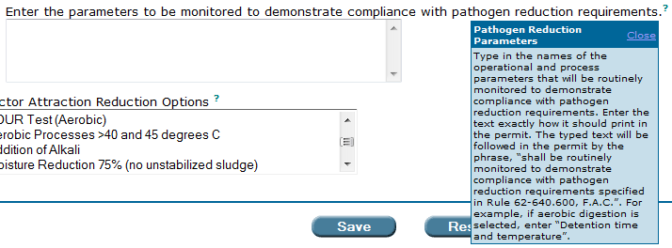

7A.2.2.2. Pathogen reduction alternatives for Class B biosolids

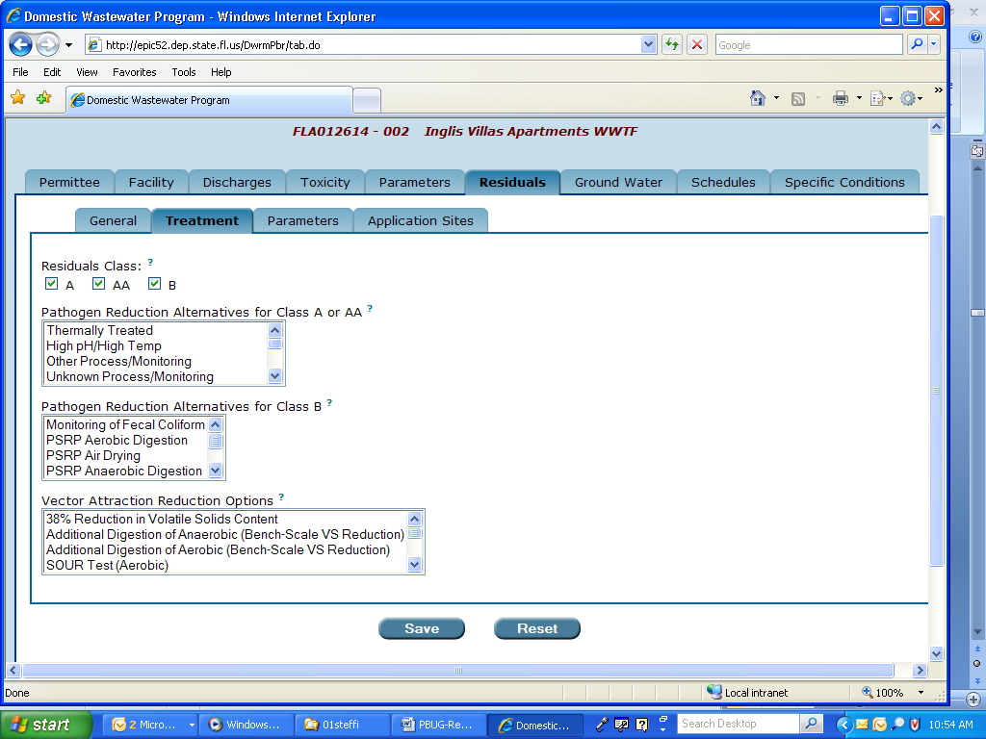

The Pathogen Reduction Alternatives for Class B biosolids listed in the field are:

  - Monitoring of Fecal Coliform
  - PSRP Aerobic Digestion
  - PSRP Air Drying
  - PSRP Anaerobic Digestion
  - PSRP Composting
  - PSRP Lime Stabilization
  - Equivalent to PSRP

IF the last alternative is selected:

- Equivalent to PSRP

THEN Permit Builder will display the use of … field where you may enter a description of the equivalent process. (This field currently allows 200 characters.)

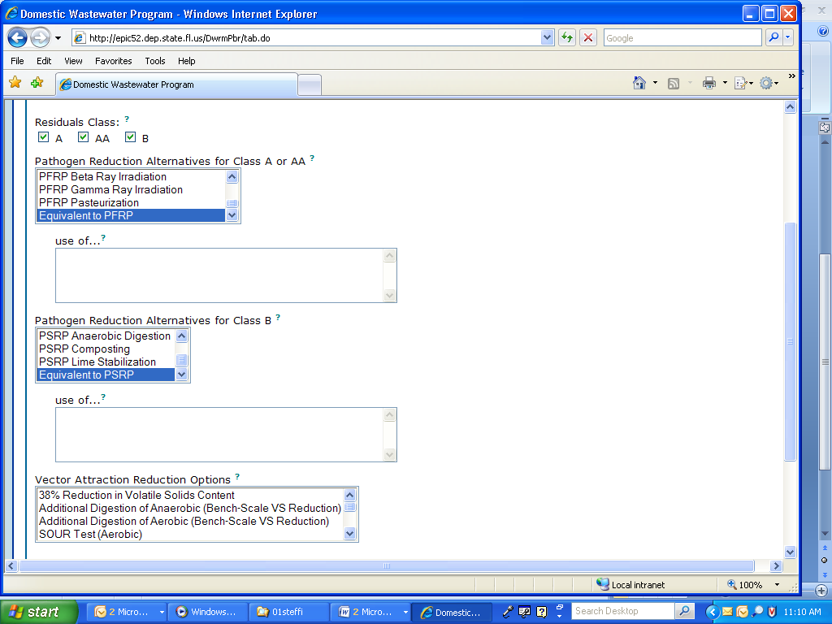

To access information on what to enter into the use of … field, click ?

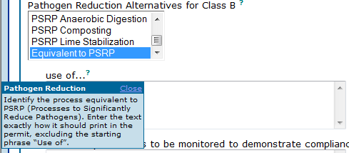

When any pathogen reduction alternative is selected, Permit Builder will display the enter the parameters to be monitored to demonstrate compliance with pathogen reduction requirements field where you may enter a description of the parameters to be monitored to demonstrate compliance with the selected pathogen reduction alternative(s). (This field currently allows 200 characters.)

For information on what to enter into the parameters to be monitored to demonstrate compliance field, click ?

7A.2.2.3. Vector attraction reduction options

The Vector Attraction Reduction Options apply to all classes of biosolids, and are listed in the field:

  - 38% Reduction in Volatile Solids Content
  - Additional Digestion of Anaerobic (Bench-Scale VS Reduction)
  - Additional Digestion of Aerobic (Bench-Scale VS Reduction)
  - SOUR Test (Aerobic)
  - Aerobic Processes > 40 and 45 degrees C
  - Addition of Alkali
  - Moisture Reduction 75% (no unstabilized sludge)
  - Moisture Reduction 90%
  - Injection
  - Incorporation

7A.2.3. Selecting more than one alternative or option from any field on the “Treatment” sub-tab

Permit Builder allows you to select more than one alternative or option from any of the fields by pressing and holding the control key (CTRL) while clicking an alternative or option.

Some domestic wastewater treatment facilities may list more than one pathogen reduction alternative and/or more than one vector attraction reduction option in their permit applications.

As long as the multiple selections are appropriate and relevant to the facility’s biosolids treatment processes, a facility may utilize more than one alternative or option. For example, a facility that incorporates lime stabilization would not be able to demonstrate vector attraction reduction by doing the SOUR test since the SOUR test is designed for biological treatment systems, and not for chemical treatment processes.

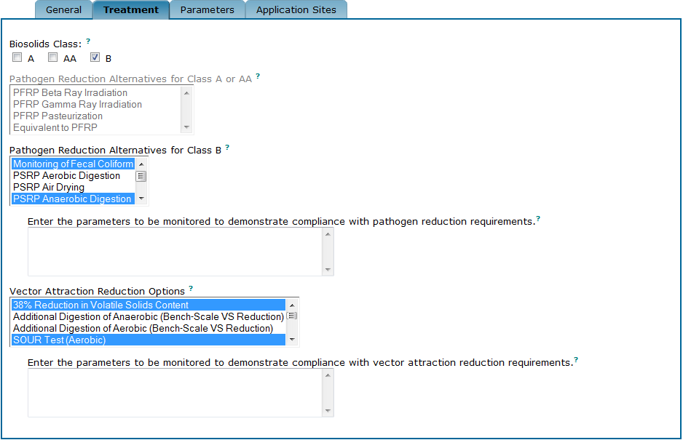
Select more than one treatment alternative or option by holding the CTRL key while clicking the selection.

7A.2.4. The five “Treatment” sub-tab scenarios

The five possible scenarios on the Treatment sub-tab are based on which class of biosolids has been selected for your Permit Builder project. Scenarios 4 and 5 illustrate what you will encounter within the Treatment sub-tab when more than one class of biosolids is selected.

“Treatment” sub-tab – SCENARIO 1

IF the Disposal Method field on the General sub-tab is selected for:

- Land Application

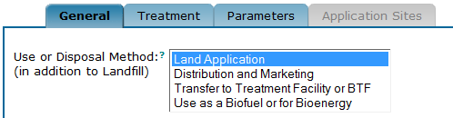

AND Biosolids Class on the Treatment sub-tab is selected for A,

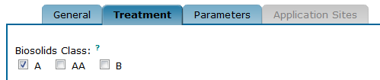

THEN Permit Builder will display three fields, where two are accessible:

- The Pathogen Reduction Alternatives for Class A or AA, and
- The Vector Attraction Reduction Options.

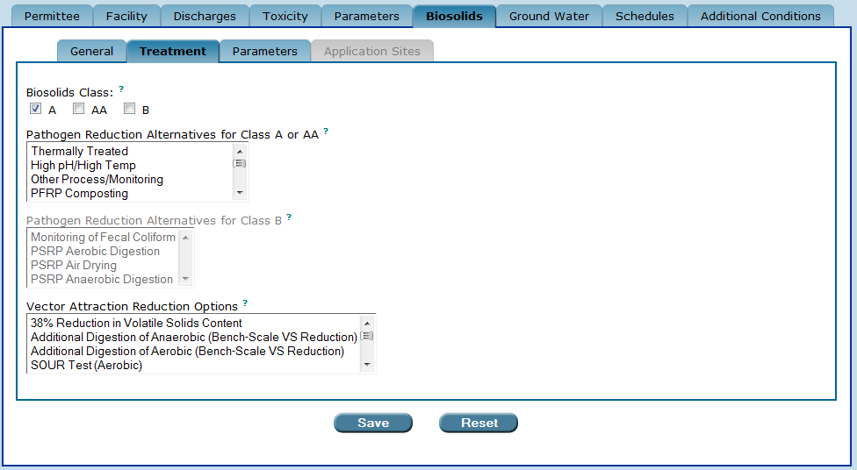
The “Treatment” sub-tab when the “Use or Disposal Method” field on the “General” sub-tab
is selected for “Land Application,” and “Biosolids Class” is selected for “A.”

“Treatment” sub-tab – SCENARIO 2

IF the Use or Disposal Method field on the General sub-tab is selected for:

- Land Application

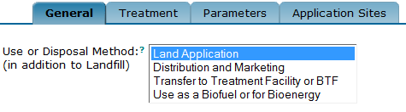

AND Biosolids Class on the Treatment sub-tab is selected for B,

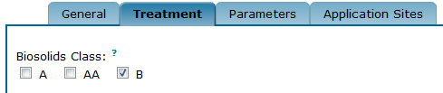

THEN Permit Builder will display three fields, where two are accessible:

- The Pathogen Reduction Alternatives for Class B, and
- The Vector Attraction Reduction Options.

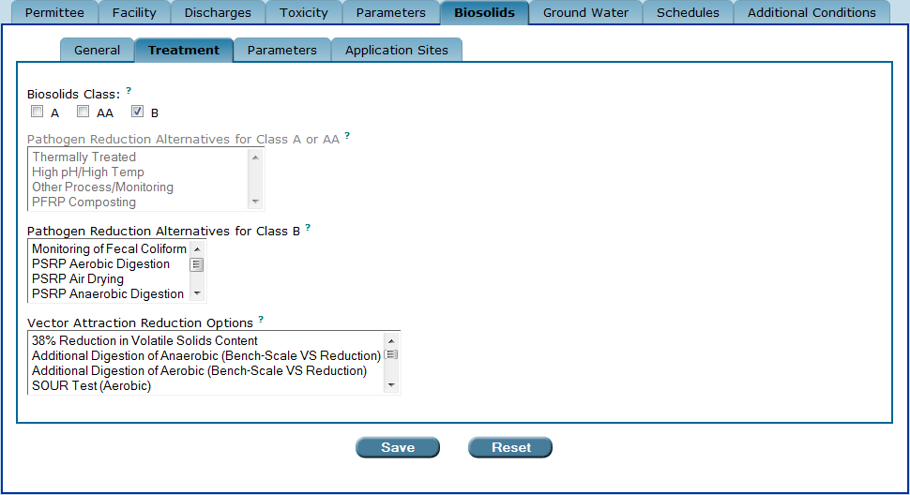
The “Treatment” sub-tab when the “Use or Disposal Method” field on the “General” sub-tab
is selected for “Land Application,” and “Biosolids Class” is selected for “B.”

“Treatment” sub-tab – SCENARIO 3

IF the Use or Disposal Method field on the General sub-tab is selected for:

- Distribution and Marketing

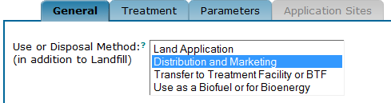

THEN Biosolids Class on the Treatment sub-tab may be only AA,

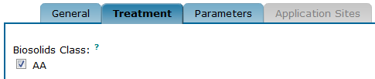

AND Permit Builder will display two fields, where both are accessible:

- The Pathogen Reduction Alternatives for Class A or AA, and
- The Vector Attraction Options.

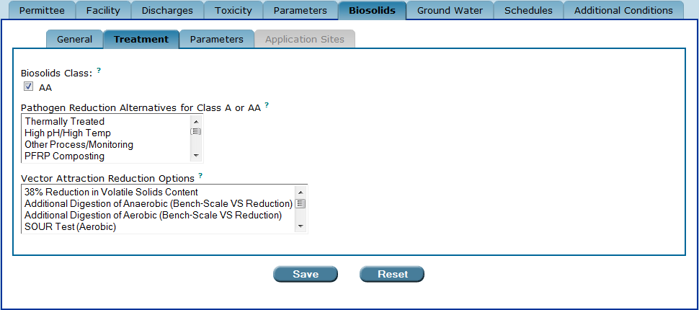
The “Treatment” sub-tab when the “Use or Disposal Method” field on the “General” sub-tab is selected for “Distribution and Marketing.” The “Biosolids Class” defaults to “AA.”

“Treatment” sub-tab – SCENARIO 4

A facility may carry out more than one biosolids treatment process and therefore, produce more than one class of biosolids.

IF the Use or Disposal Method field on the General sub-tab is selected for:

- Land Application

AND Biosoldis Class on the Treatment sub-tab is selected for A, AA, and B,

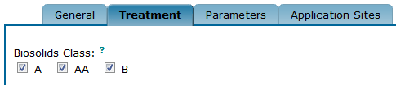

THEN Permit Builder will display three fields, where all are accessible:

- The Pathogen Reduction Alternatives for Class A or AA,
- The Pathogen Reduction Alternatives for Class B, and
- The Vector Attraction Reduction Options.

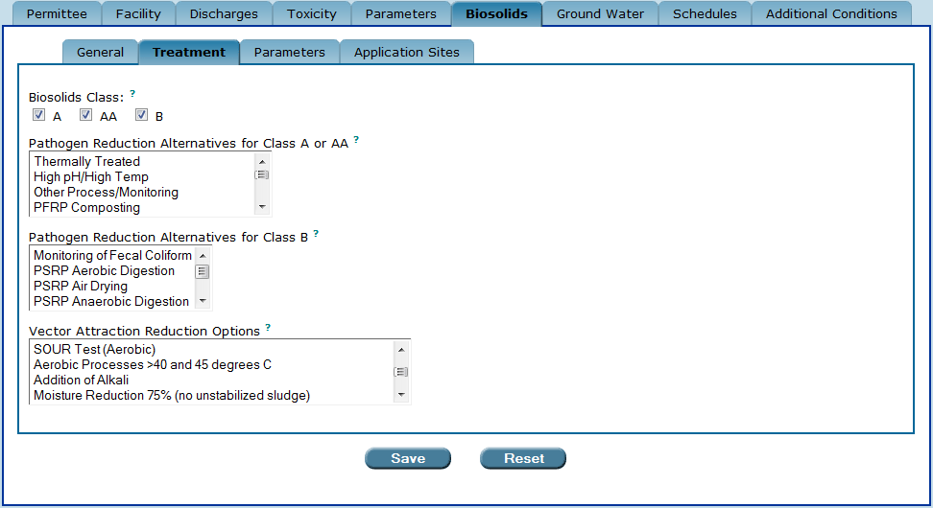
The “Treatment” sub-tab when the “Use or Disposal Method” field on the “General” sub-tab
is selected for “Land Application.” The permit writer has the option of choosing all biosolids classes.

“Treatment” sub-tab – SCENARIO 5

A facility may carry out more than one biosolids treatment process and therefore, produce more than one class of biosolids.

IF the Use or Disposal Method field on the General sub-tab is selected for:

- Land Application, and
- Distribution and Marketing

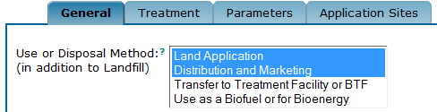

THEN Permit Builder will display three fields, where all are accessible:

- The Pathogen Reduction Alternatives for Class A or AA,
- The Pathogen Reduction Alternatives for Class B, and
- The Vector Attraction Reduction Options.

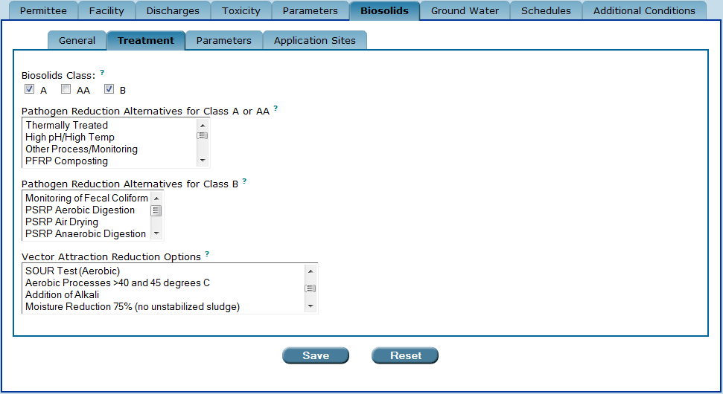
The “Treatment” sub-tab when the “Use or Disposal Method” field on the “General” sub-tab
is selected for “Land Application” and “Distribution and Marketing.”
The permit writer has the option of choosing multiple biosolids classes.

7A.3. The “Parameters” sub-tab

The Parameters sub-tab is accessible when any or no options are selected in the Use or Disposal Method field on the General sub-tab:

- Land Application,
- Distribution and Marketing,
- Transfer to Treatment Facility or BTF,
- Use as a Biofuel or for Bioenergy, or
- Landfill (i.e., no option is selected).

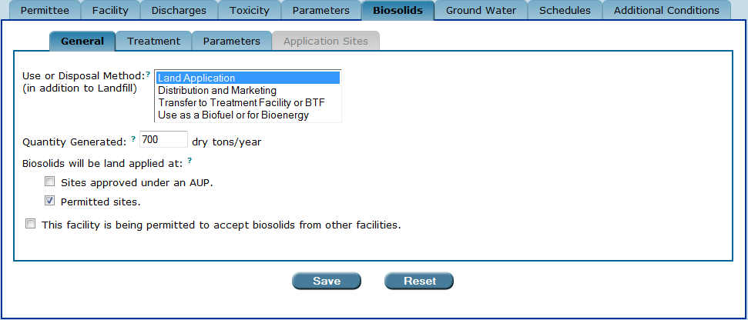
The Application Sites sub-tab is accessible only when the biosolids will be land applied at “sites approved under an AUP” check-box is selected.

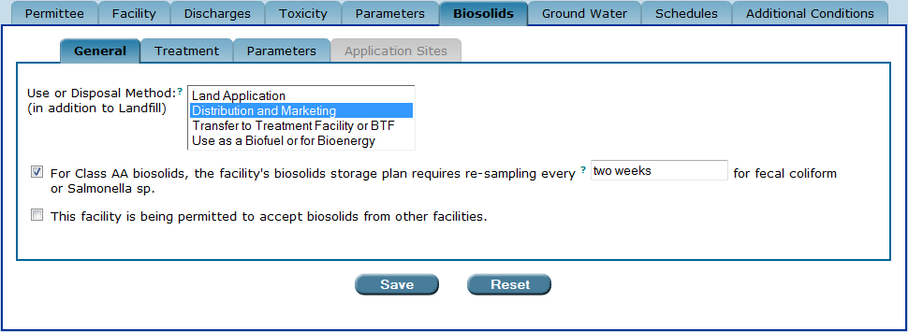
The Application Sites sub-tab is not accessible.

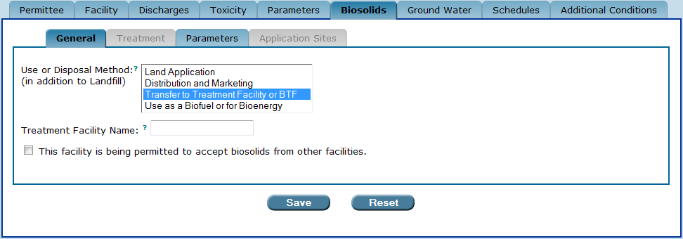
Neither the Treatment nor Application Sites sub-tabs are accessible.

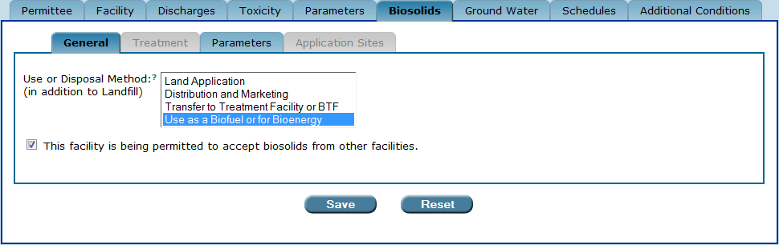
Neither the Treatment nor Application Sites sub-tabs are accessible.

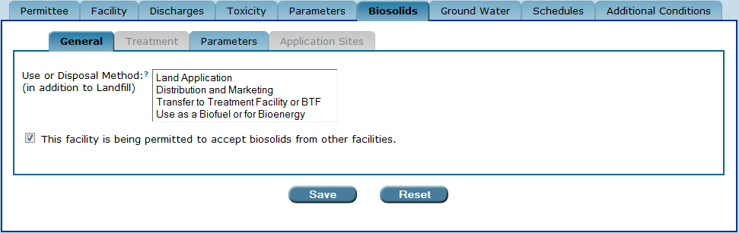
Neither the Treatment nor Application Sites sub-tabs are accessible.

The “Parameters” sub-tab is accessible when any selection is made from the “Use or Disposal Method” field in the “General” sub-tab – “Land Application,” “Distribution and Marketing,” “Transfer to Treatment Facility or BTF”, “Use as a Biofuel or for Bioenergy”, or Landfill (i.e., no selection is made from the “Use or Disposal Method” field).

In addition to conducting pathogen reduction and vector attraction reduction, a facility that produces either Class A, Class AA, and/or Class B biosolids is also required to monitor for certain nutrient, metals, and other parameters established in Chapter 62-640, F.A.C. Permit Builder will display a table of these parameters once you have selected the class or classes of biosolids from the Treatment sub-tab.

All facilities are required to monitor the quantities of biosolids received from source facilities, landfilled, incinerated, transferred to another facility, land applied, or distributed and marketed. Permit Builder will display a table of the biosolids quantities parameters once you have selected the use or disposal method or methods from the General sub-tab and indicated whether the facility is being permitted to receive biosolids from other facilities.

7A.3.1. The biosolids parameters table

Once you have selected the use or disposal method or methods from the General sub-tab and indicated whether the facility is being permitted to accept biosolids from other facilities, Permit Builder will display a biosolids quantities parameters table on the Parameters sub-tab, with a list of default biosolids quantities parameters (e.g., quantity of biosolids landfilled, quantity of biosolids land-applied, quantity of biosolids received from other facilities, etc.).

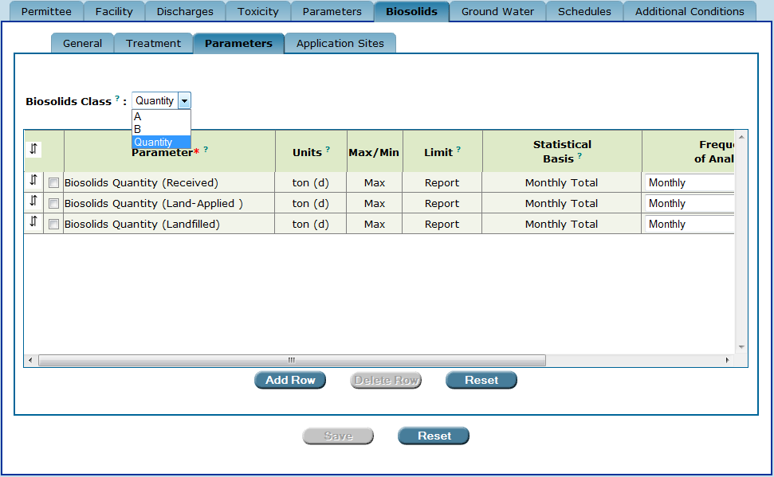
The “biosolids quantities parameters table.”

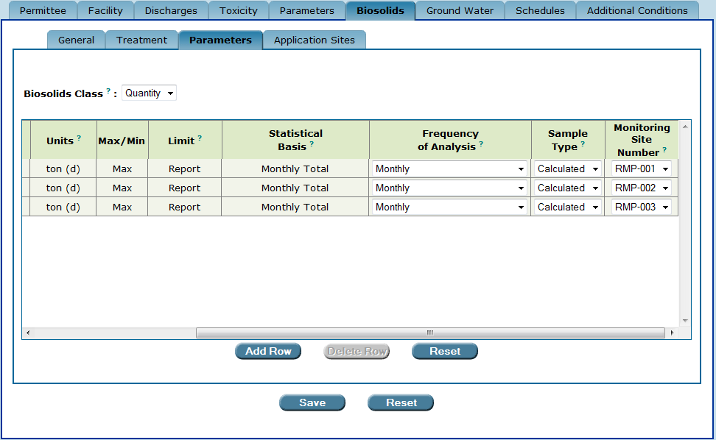
The “biosolids quantities parameters table” (continued).

If the use or disposal method includes land application or distribution and marketing, once you have selected a Biosolids Class from the Treatment sub-tab Permit Builder will also display a biosolids class parameters table on the Parameters sub-tab, with a list of default parameters, depending on which class (or classes) of biosolids have been selected.

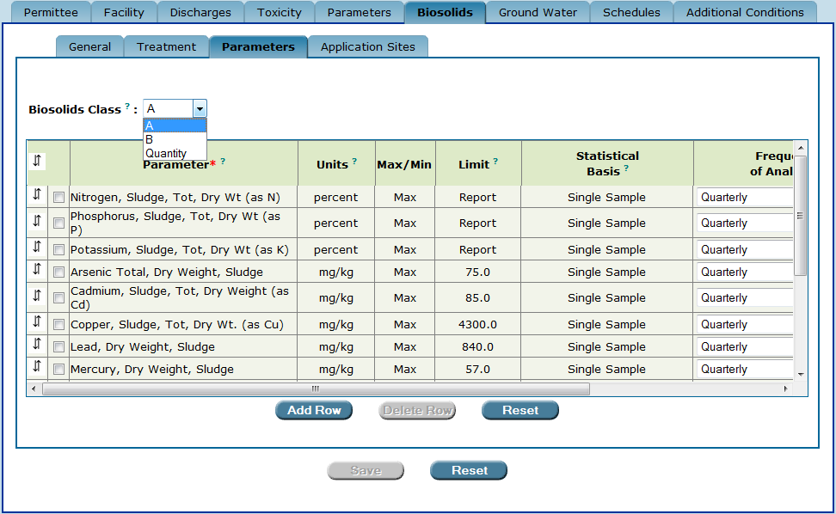
The “biosolids Class A parameters table.”
In this example, more than one Biosolids Class has been selected from the “Treatment” sub-tab.
Permit Builder will generate a parameters table for each Biosolids Class as well as the Biosolids Quantities parameters table.

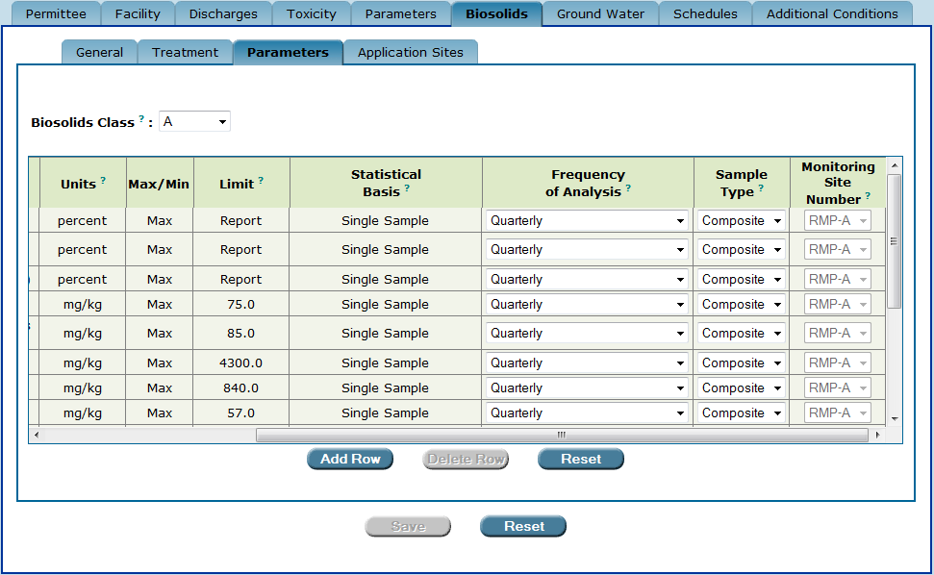
The “biosolids Class A parameters table” (continued).

The biosolids parameters tables contain the following column headings:
- Parameter – corresponds to the name of the substance (i.e., nutrient, metal, pathogen, or other chemical or physical constituent) that may be present in the facility’s biosolids or the quantity of biosolids that is to be limited or monitored.
- Units – corresponds to the units of measurement for a parameter limited in the facility’s permit or reported on its Discharge Monitoring Report (DMR).
- Max/Min – corresponds to whether the limit listed in the “Limit” column is a maximum or minimum allowable amount.
- Limit – corresponds to the allowable amount of a parameter in the facility’s biosolids. If the “Limit” column contains “Report,” then the facility need only report the maximum or minimum value of a parameter for a specific monitoring period.
- Statistical Basis – corresponds to the method of determining the amount of a parameter in a particular biosolids sample. For biosoldis analysis, the statistical basis will be:
  - Annual Average,
  - Single Sample,
  - Monthly Average,
  - Geometric Mean, or
  - Monthly Total.
- Frequency of Analysis – corresponds to the number of times, within a monitoring period, a facility is required to sample and analyze its biosolids for a specific parameter. Although the Frequency of Analysis column contains several options, frequency of analysis is generally determined by the class and amount of biosolids generated by the facility, based on the requirements established in Rule 62-640.650(3)(a)4.c., F.A.C.
For Class A and Class B biosolids, the frequency of analysis is generally:

  - Annually – or once per year, for facilities that generate
> 0 to < 160 dry tons per year of biosolids.
  - Quarterly – or once per quarter, for facilities that generate
> 160 to < 800 dry tons per year of biosolids.
  - Bi-monthly; Every 2 Months – or once per 60 days, for facilities that generate
> 800 to < 8,000 dry tons per year of biosolids.
  - Monthly – or once per month, for facilities that generate
> 8,000 dry tons per year of biosolids.

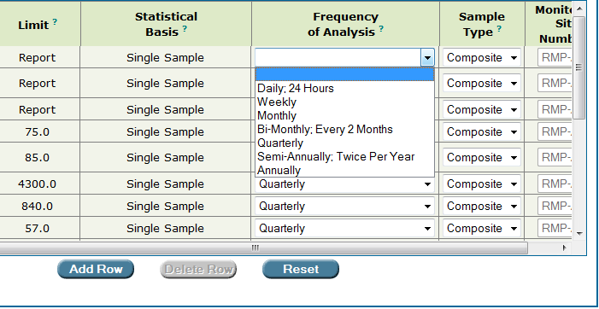
The “Frequency of Analysis” drop-down box.
Not all options listed apply to the monitoring of biosolids.

NOTE: For Class A or Class B biosolids, Permit Builder will automatically populate the Frequency of Analysis column with default values when the Quantity Generated field on the General sub-tab is filled in. For Class AA biosolids, the default frequency of analysis value is Monthly, regardless of quantity generated.

- Sample Type – corresponds to the type of sample collected for analysis of a parameter, where:
  - Grab refers to a single sample collected for a particular parameter. In accordance with Rule 62-640.650(3)(a)6., F.A.C., grab samples shall be used for pathogens and determinations of percent volatile solids.
  - Composite refers to a mixture of several single samples. In accordance with Rule 62-640.650(3)(a)6., F.A.C., composite samples shall be used for metals and nutrients.
  - Calculated refers to the calculation from total solids, flow measurement, truck weight, or other methods that is required to determine the quantities of biosolids that the facility landfills, land applies, distributes and markets, transfers to other facilities, incinerates, or receives from other facilities.

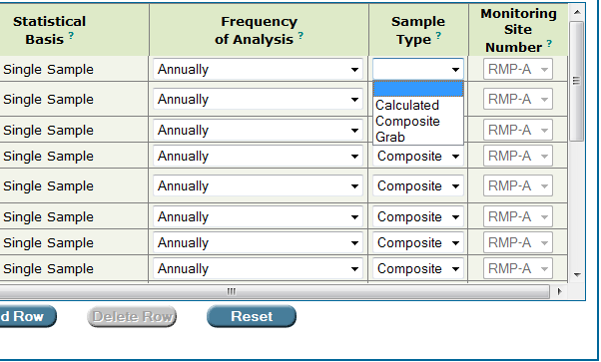
The “Sample Type” drop-down box.

- Monitoring Site Number – corresponds to the location of the biosolids monitoring site where:
  - RMP-A corresponds to the monitoring site location for Class A biosolids;
  - RMP-AA corresponds to the monitoring site location for Class AA biosolids; and
  - RMP-B corresponds to the monitoring site location for Class B biosolids.

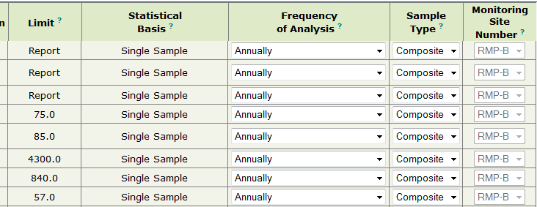
The “Monitoring Site Number” column has defaulted to “RMP-B,”
which is compatible with Class B biosolids.

Monitoring Site Numbers RMP-A, RMP-AA, and RMP-B appear automatically for each parameter in the Class A, AA, and B parameters tables, respectively. RMP Monitoring Site Numbers must be created by the permit writer for the biosolids quantities parameters in the biosolids quantities parameters table. RMP Monitoring Site Numbers may be created by following Steps 1 – 5 below:
Step 1: Double-click anywhere in the column heading using the hand icon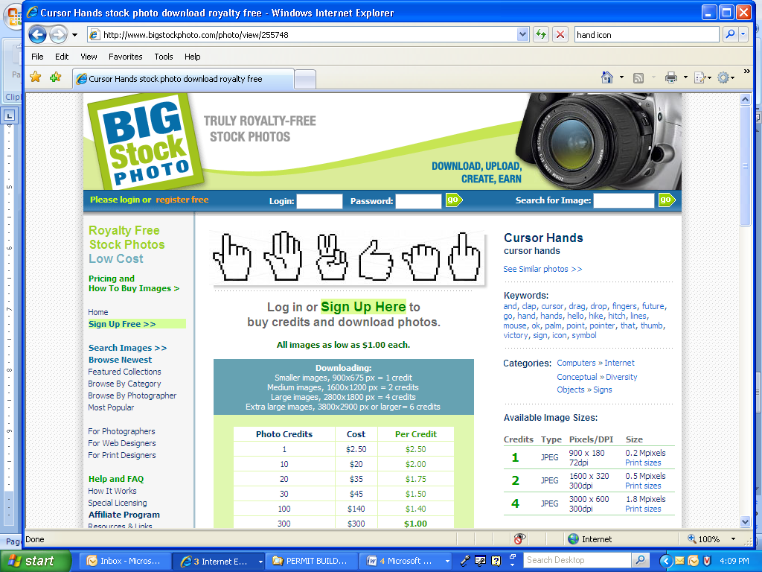

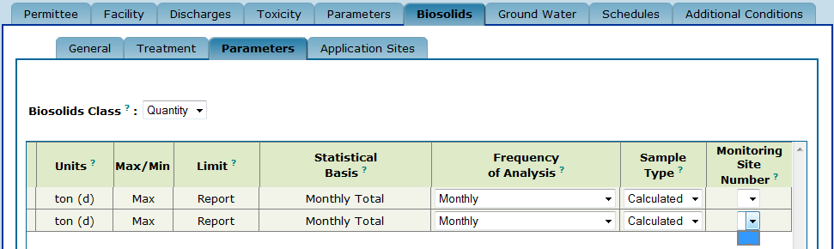
Double-click the “Monitoring Site Number” column heading to display
the “Add or Modify Monitoring Site Number” screen.
In this example, no Monitoring Site Numbers have been created on the biosolids quantities parameters table.

Permit Builder will then display the Select a Monitoring Site Number screen where you will see any previously created monitoring site numbers and site descriptions, as illustrated below.

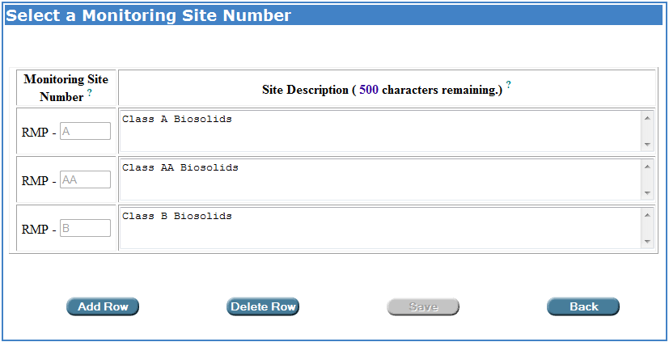
The “Select a Monitoring Site Number” screen, where the permit writer may add new, and modify existing Monitoring Site Numbers and Site Descriptions in the “Biosolids Parameters” tables. The “Select an Existing WAFR Site” table will not appear until the permit writer prepares to create a new RMP Monitoring Site Number by clicking on “Add Row.”

In the above example, monitoring sites RMP-A, RMP-AA, and RMP-B appear because the permit writer had checked the boxes corresponding to Class A, Class AA, and Class B biosolids on the Treatment sub-tab, illustrated below.

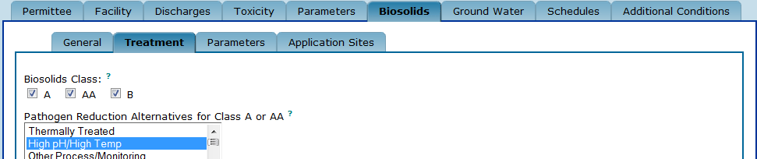

If your project includes a Biosolids Class A, AA, or B parameters table, RMP-A, RMP-AA, or RMP-B, as appropriate, will appear in the Select a Monitoring Site Number table. For the biosolids quantities parameters table, you must create an RMP Monitoring Site Number.

Step 2: To create an RMP Monitoring Site Number for the biosolids quantities parameters table, click to add a blank row to the bottom of the table.
Add Row ow

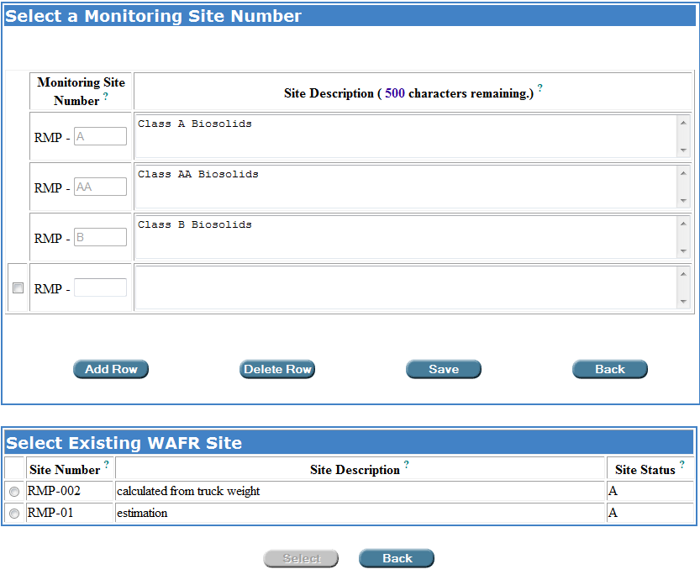
Click “Add Row” to create a new RMP Monitoring Site Number.
The “Select an Existing WAFR Site” table will appear once the permit writer clicks on “Add Row” to add a blank row at the bottom of the “Select a Monitoring Site Number” table.

Step 3: To add a monitoring site that is not listed in the Select Existing WAFR Site table, type the number and a description of the monitoring site in the corresponding fields.

A description of the facility’s biosolids monitoring site(s) should be provided in the permit application. It is the same as the biosolids sample collection point. The monitoring site/sample collection point is generally located after biosolids treatment and before either land application (for Classes A and B) or distribution and marketing (for Class AA).

For information on what to enter into the Site Description field of Monitoring Site Numbers created for biosolids quantities parameters, click ?

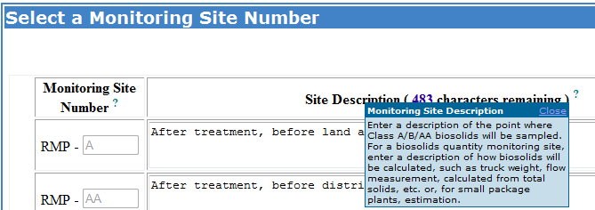

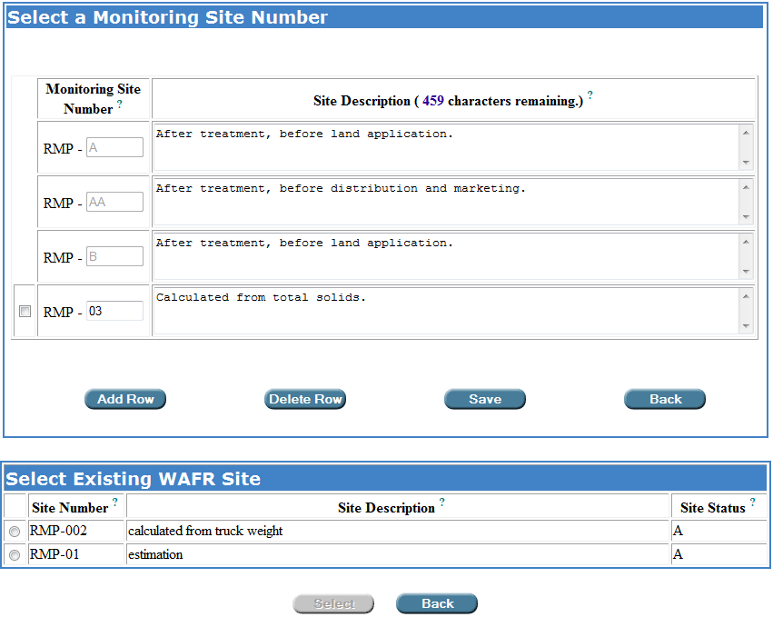
The permit writer has created a new monitoring site, “RMP-03” in this example.

Step 4: To add a monitoring site that is listed in the Select Existing WAFR Site table, add a blank row to the Select a New Monitoring Site Number table by clicking , click the radio button corresponding to the desired site, and then click .
Add Row ow
Select ow

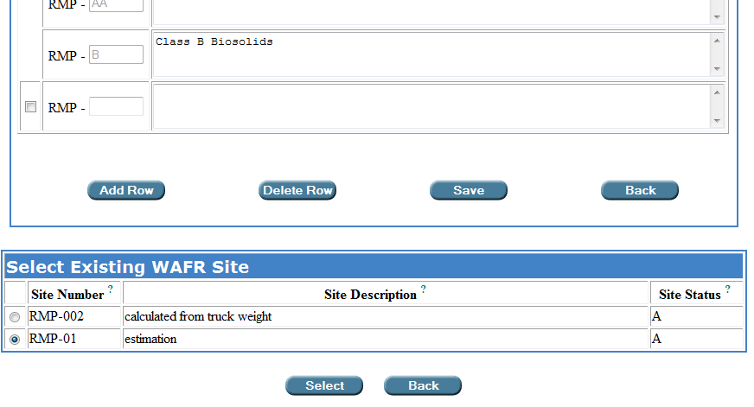

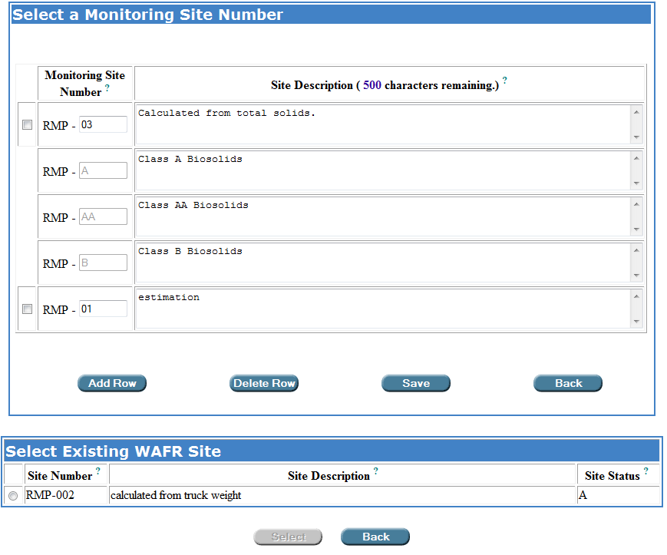
The permit writer has selected an existing WAFR site, “RMP-01” in this example.

NOTE: If you select a site from the Select Existing WAFR Site table and “Save,” the selected site will be added to the Select a Monitoring Site Number table and deleted from the Select Existing WAFR Site table. Conversely, if you delete a row from the Select a Monitoring Site Number table that was selected from the Select Existing WAFR Site table and “Save,” the site returns to the Select Existing WAFR Site table.

Save ow
Step 5: Click to save your entries and return to the Parameters sub-tab; or
Click to cancel your entries, and return to the Parameters sub-tab.
Back

Once you have completed Steps 1 – 5 and have returned to the biosolids parameters table, you will be able to select any of the created RMP Monitoring Site Numbers.

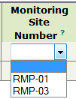
A “Monitoring Site Number” drop-down box in the biosolids parameters table of the “Parameters” sub-tab displaying created site “RMP-03” site and the existing WAFR site “RMP-01”.

7A.3.2. The default parameters for all biosolids classes

In accordance with Rule 62-640.650(3)(a)3., F.A.C., facilities that land apply or distribute and market biosolids are required to monitor for the 14 parameters listed below, together with their corresponding reporting units of measurement.

- Three nutrient parameters:
  - Total Nitrogen percent dry weight basis
  - Total Phosphorus percent dry weight basis
  - Total Potassium percent dry weight basis
- Nine metal parameters:
  - Arsenic mg/kg dry weight basis
  - Cadmium mg/kg dry weight basis
  - Copper mg/kg dry weight basis
  - Lead mg/kg dry weight basis
  - Mercury mg/kg dry weight basis
  - Molybdenum mg/kg dry weight basis
  - Nickel mg/kg dry weight basis
  - Selenium mg/kg dry weight basis
  - Zinc mg/kg dry weight basis
- Two physical property parameters:
  - pH standard units, s.u.
  - Total Solids percent

Facilities that produce Class A or Class AA biosolids are also required to monitor for one of the following pathogen parameters:

- Two pathogen parameters:
  - Fecal Coliform Most Probable Number per gram dry weight basis (MPN/g)
  - Salmonella Most Probable Number per 4 grams dry weight basis (MPN/4 g)

Facilities that produce Class A , Class AA, or Class B biosolids which are treated by alkaline addition are required to monitor the physical property parameter listed below. Treatment by alkaline addition includes meeting the:
- Class A pathogen reduction requirements in 40 CFR 503.32(a)(4) (Biosolids Treated in a High pH-High Temperature Process),
- Class B pathogen reduction requirements in 40 CFR 503.32(b)(3) (Use of Processes to Significantly Reduce Pathogens – Lime Stabilization), or
- Class A or Class B vector attraction reduction requirements in 40 CFR 503.33(b)(6) (Add alkaline materials to raise the pH under specified conditions).

- Physical property parameter:
  - Calcium Carbonate Equivalent % dry weight basis

Facilities achieving Class A pathogen reduction by meeting the pathogen reduction requirements in 40 CFR 503.32(a)(5), Biosolids Treated in Other Processes, are required to monitor for the following pathogen parameters:

- Pathogen parameters:
  - Enteric Viruses Plaque Forming Units per 4 gram dry weight basis (PFU/4 g)
  - Viable Helminth Ova Number per gram dry weight basis (#/g)

Facilities achieving Class B pathogen reduction by meeting the pathogen reduction requirements in 40 CFR 503.32(b)(2), Monitoring of Indicator Organisms, are required to monitor for the following pathogen parameter:

- Pathogen parameters:
  - Fecal Coliform Most Probable Number per gram dry weight basis (MPN/g) or Colony Forming Units per gram dry weight basis (CFU/g)

For parameters that have no numerical limit associated with them, Permit Builder will display the word Report in the Limit column. This indicates that the facility has a report only monitoring requirement for the parameter in question.

The “ceiling concentrations,” or maximum allowable amounts (based on a single sample statistical basis) of the nine metal parameters are established in Rule 62-640.700, F.A.C., and appear in the Limit column of the biosolids parameters table.

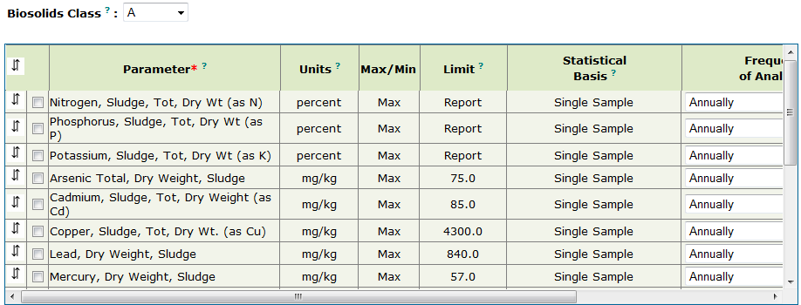
The biosolids parameters table for either Class A or Class B biosolids.
All parameter limits are based on a “Single Sample.”

Additionally, a facility producing Class AA biosolids shall also meet the monthly average concentrations for all metals (except molybdenum) established in Rule 62-640.700(5)(b), F.A.C.

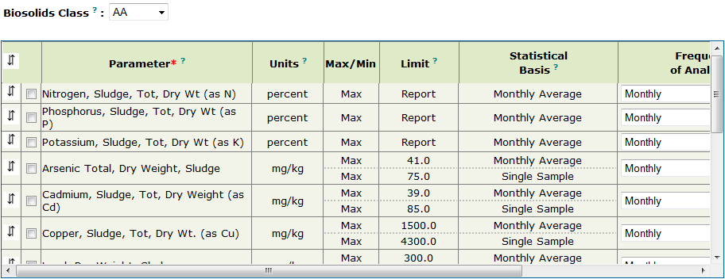
The biosolids parameters table for Class AA biosolids.
All metal parameters (except molybdenum) have “Single Sample”
as well as “Monthly Average” limits.

7A.3.3. Adding and deleting parameters, and editing parameter information in the biosolids parameters table

Permit Builder allows you to add, delete, and edit the default parameters and their corresponding information. However, always check with your supervisor before making changes to any default information for a facility.

7A.3.3.1. Adding a parameter to the biosolids parameters table

An example of a situation where you may want to add a parameter to the default set of parameters would be for a facility that produces Class B biosolids, but is required to monitor for dioxin. Since dioxin is not a default parameter for Class B biosolids, you will have to add it to the biosolids parameters table using the following steps:
Add Row ow
Step 1: Click located just below the table.

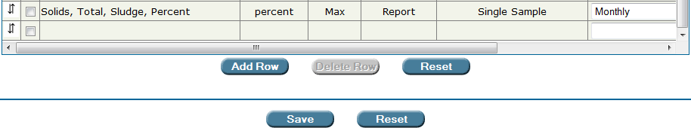
Double-click here.

Step 2: Double click in the empty parameter cell of the row you have just added. Permit Builder will display the Enter or Change Parameter screen illustrated below.

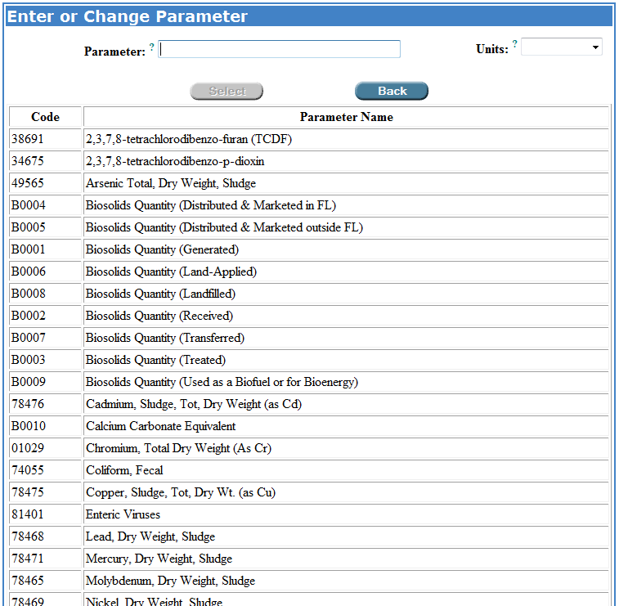
The “Enter or Change Parameter” screen.

Step 3: In the Enter or Change Parameter screen, click on the parameter you wish to add to the biosolids parameters table (2,3,7,8-tetrachlorodibenzo-p-dioxin in this example). Permit Builder will highlight it and display it in the Parameter field at the top of the screen.

Step 4: If the correct units corresponding to the parameter you have just selected are not displayed in the Units field, click on the Units drop-down box and select the appropriate units (ng/kg in this example).

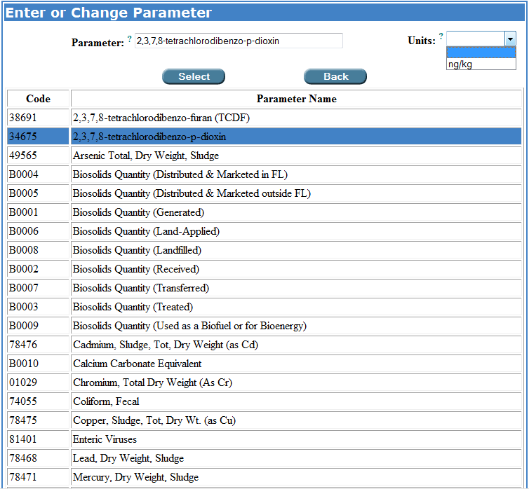
Selecting a parameter to add to the biosolids parameters table,
together with its appropriate units.

Select ow
Step 5: Click which is located at the bottom of the Enter or Change Parameter table. Permit Builder will close the Enter or Change Parameter table and return to the biosolids parameters table where you will now see the newly added parameter, “2,3,7,8-tetrachlorodibenzo-p-dioxin” with its associated units.
Back ow
Click to cancel your request to enter or change a parameter. Permit Builder will then return to the biosolids parameters table.

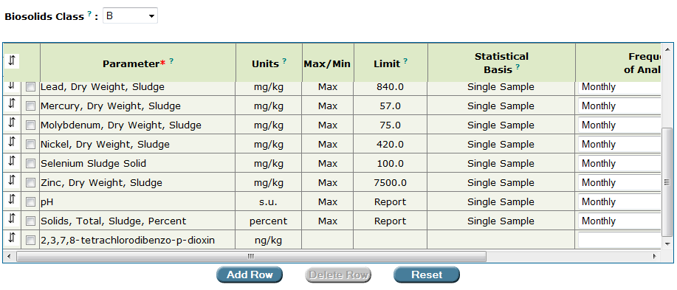
The parameter “2,3,7,8-tetrachlorodibenzo-p-dioxin” together with its units of “ng/kg” has been added
to a Class B biosolids parameters table.

Step 6: Access the Max/Min, Limit, and Statistical Basis columns by double clicking in any of their empty cells in the newly added parameter row (“2,3,7,8-tetrachlorodibenzo-p-dioxin” in this example).

Permit Builder will then display the Limit and Statistical Basis screen illustrated below.

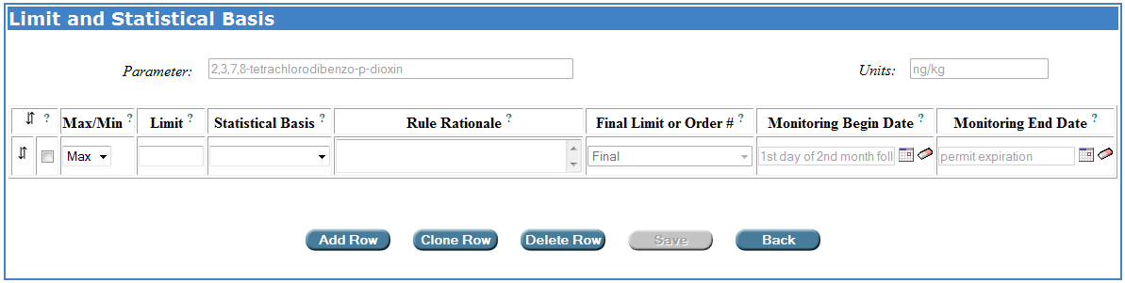
The “Limit and Statistical Basis” screen.

Step 7: Enter the appropriate information by typing in the numerical Limit and accessing the drop-down boxes for Max/Min, Statistical Basis, and Rule Rationale.

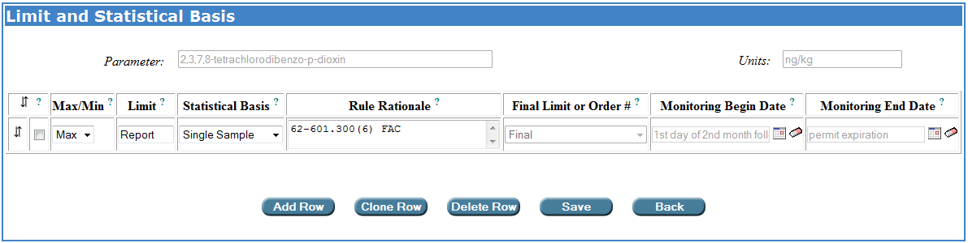
Entering information in the “Limit and Statistical Basis” screen.

Add Row ow
Step 8: To add another limit for the same parameter, click and complete the information.

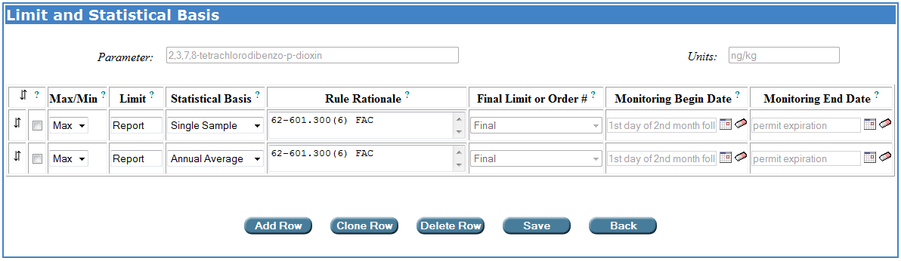
Adding another limit to a parameter.
In this example, the permit writer typed in “62-601.300(6)” under the rule citation in the “Rule Rationale” field to indicate that the limits have been included based on the permit writer’s best professional judgment.

Step 9: When you have completed your entries for the new parameter, click .
Save ow
Permit Builder will then return to the biosolids parameters table where you will now see your entries for the newly added parameter (“2,3,7,8-tetrachlorodibenzo-p-dioxin” in this example).

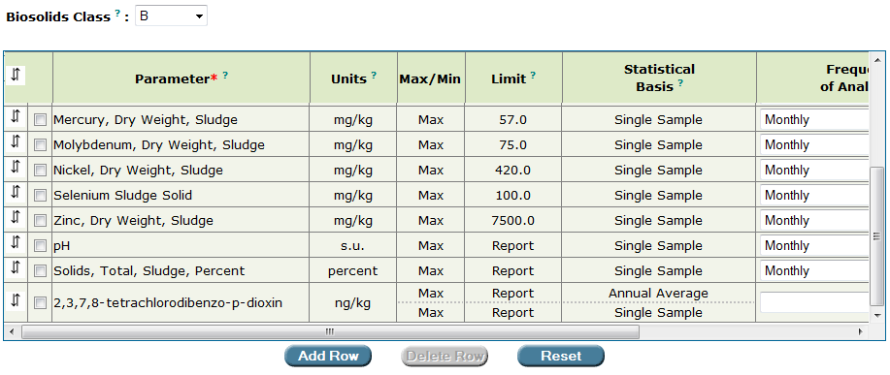
The new parameter “2,3,7,8-tetrachlorodibenzo-p-dioxin” with the two limits
associated with it has been added by the permit writer.

Step 10: Select Frequency of Analysis and Sample Type from the corresponding drop-down boxes and select the appropriate options, as illustrated below.

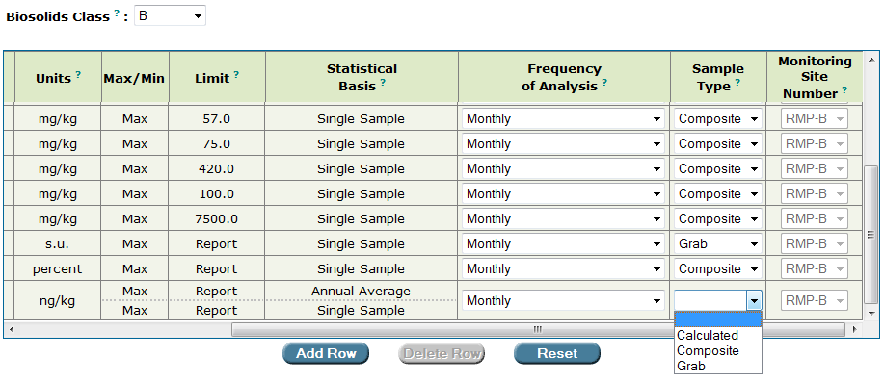

Step 11: Click to save your entries, or
Save ow
Reset ow
Click to restore the table to the entries last saved.

7A.3.3.2. Creating interim limits for biosolids monitoring

To create interim limits for biosolids monitoring, an Administrative Order (AO) or a Consent Order (CO) must first be created on the Orders sub-tab under the Facility tab (see Chapter 3 of the Permit Builder User Guide for information on how to create an order). Once an order has been created in your Permit Builder project, the Limit Type column will be included in your biosolids parameter table. The Limit Type column will indicate whether each limit is a final limit or an interim limit.

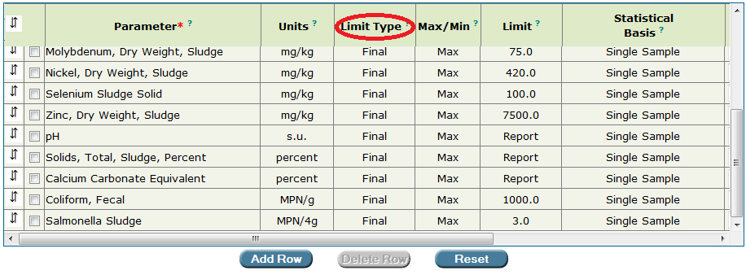
The “Limit Type” column is displayed in the biosolids parameter table when an order has been created by the permit writer for the Permit Builder project.

To create an interim limit, open the Limit and Statistical Basis pop-up window as described above (by double clicking on the Max/Min, Limit, or Statistical Basis fields of a parameter). Select or enter the limit, statistical basis, and rule rational and indicate whether the limit is a maximum limit or a minimum limit. If the limit is an interim limit, select the order number with which the interim limit is associated from the Final Limit or Order # drop-down box (the order numbers will have been created by the permit writer on the Orders sub-tab under the Facility tab, see Chapter 3 of the Permit Builder User Guide). If the limit is a final limit, you will not need to make a selection form the Final Limit or Order # drop-down box since “Final” is the default option.

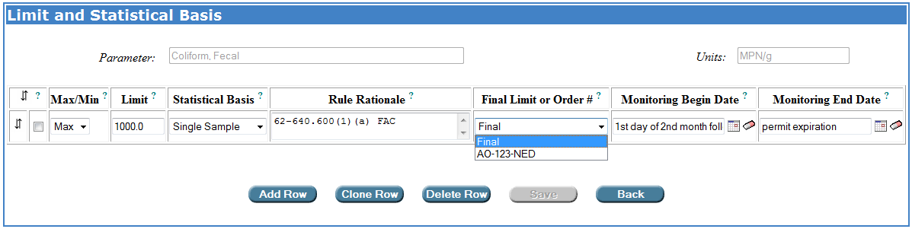

To indicate that a limit is an interim limit, select the order number of the Administrative Order or Consent Order that includes the interim limit from the “Final Limit or Order #” drop-down box on the “Limit and Statistical Basis” pop-up window. The order numbers populating the “Final Limit or Order #” drop-down box are created by the permit writer on the Orders sub-tab under the Facility tab.

The dates over which the interim and final limits apply are specified on the Limit and Statistical Basis pop-up window. When a project has not yet been issued in WAFR-PA, the Monitoring Begin Date field will initially be populated with the phrase, “1st day of the second month following the effective date of the permit” (i.e., the monitoring start date) for both interim and final limits. The Monitoring End Date will initially be populated with the phrase, “permit expiration” for both interim and final limits.

Calendar dates may be entered into the date fields or selected from a calendar after clicking on the calendar icon following each date field. Text may not be entered into the date fields. If the default text language (“1st day of the second month following the effective date of the permit” or “permit expiration”) is overwritten with a calendar date, the text language may be retrieved by selected a different option from the Final Limit or Order # drop-down box and then re-selecting the desired option.

The monitoring begin and end dates will be used in generating DMRs. For projects that have not yet been issued in WAFR-PA, Permit Builder has been programmed so that “1st day of the second month following the effective date of the permit” is the earliest monitoring date. Any calendar monitoring begin date will be assumed by Permit Builder to fall after the “1st day of the second month following the effective date of the permit.” That is, if the permit writer anticipates that a permit will be issued on May 23, 2015, so that the “1st day of the second month following the effective date of the permit” will be July 1, 2015. “1st day of the second month following the effective date of the permit” should still be used as the monitoring begin date for limits that are effective on the monitoring start date rather than 7/1/2015 (unless all “1st day of the second month following the effective date of the permit” monitoring begin dates, for all final and interim limits, are changed to 7/1/2015). If 7/1/2015 is used in place of some “1st day of the second month following the effective date of the permit” monitoring begin dates, Permit Builder will create a DMR with an effective range of “1st day of the second month following the effective date of the permit” through 6/30/2015.

Please note that the permit must have been issued in WAFR-PA before a Permit Builder project containing interim limits may be uploaded to WAFR.

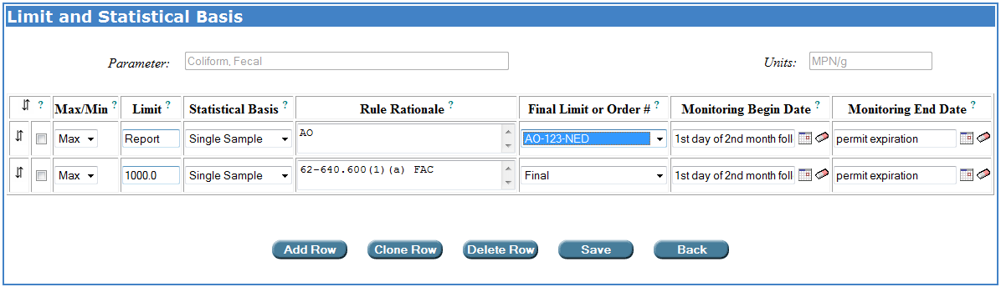
For projects that have not yet been issued in WAFR-PA, monitoring dates default to “1st day of the second month following the effective date of the permit” and “permit expiration.”

When a project has been issued in WAFR-PA, the Monitoring Begin Date field will initially be populated with the calendar date corresponding to the first day of the second month following the effective date of the permit (i.e., the monitoring start date) for final limits and interim limits associated with AOs. For interim limits associated with COs, the Monitoring Begin Date field will initially be populated with the calendar date corresponding to the first day of the month following the CO executed date specified by the permit writer on the Orders sub-tab under the Facility tab (see Chapter 3 of the Permit User Guide). For all interim and final limits, the Monitoring End Date will initially be populated with the calendar date corresponding to the date of permit expiration.

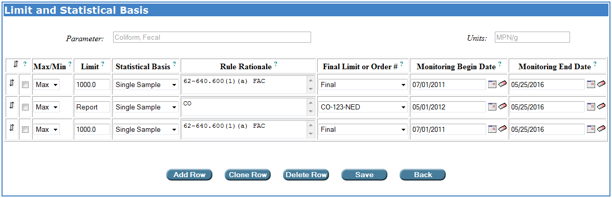
For projects that have been issued in WAFR-PA, monitoring begin dates for limits associated with Administrative Orders and final limits default to the calendar date corresponding to the first day of the second month following the effective date of the permit. Monitoring begin dates for limits associated with Consent Orders default to the calendar date of the first day of the month following the executed date entered by the permit writer on the Orders sub-tab under the Facility tab. Monitoring end dates for interim and final limits default to the calendar date corresponding to the permit expiration date.

For compatibility with EPA’s ICIS database and the Department’s eDMR system, monitoring dates need to begin on the first day of a month. Monitoring dates should end on the last day of a month or the permit expiration date. Additionally, there should not be any overlap or gaps in monitoring effective dates between interim and final limits. One limit should begin on the day following another limit’s end date. There are no checks in Permit Builder to ensure that appropriate interim and final effective date ranges have been included in the project. If the interim and final DMRs generated by Permit Builder for your project are not what you anticipated, check the monitoring begin and end dates for the parameters with interim and final limits to ensure that the correct dates have been entered.

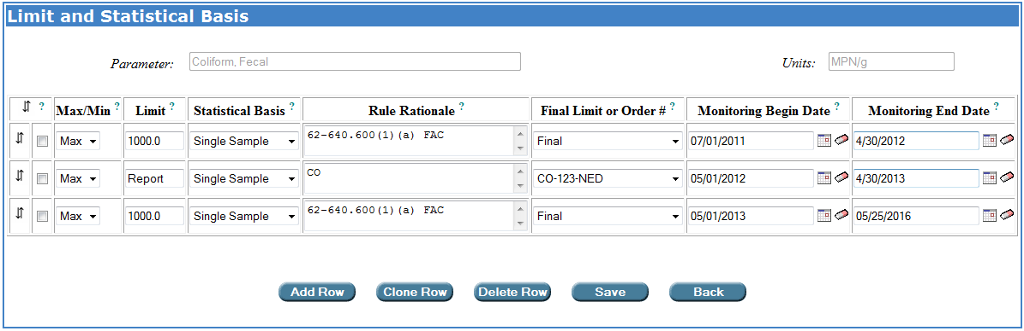
There should be no overlapping or gaps between interim and final limits. One limit should begin on the day following the end date of another limit.

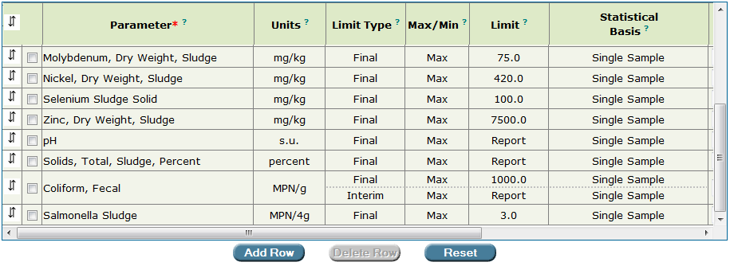
Interim limits have been added by the permit writer for “Coliform, Fecal”.

7A.3.3.3. Adding limits to the Limit and Statistical Basis pop-up window by cloning existing limits

To add a limit to the Limit and Statistical Basis pop-up window by cloning an existing limit row, click the check-box located to the left of the Max/Min field and then click . The ability to clone row is particularly useful when adding interim limits for a parameter.
Clone Row

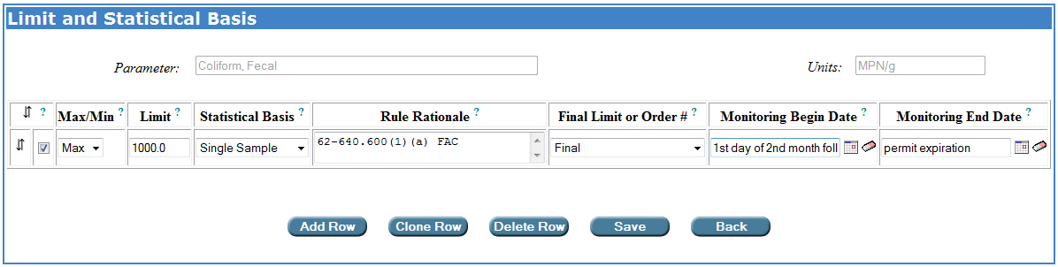
Click the checkbox to the left of the limit, and then click Clone Row.

Permit Builder will then make a copy of the parameter row:
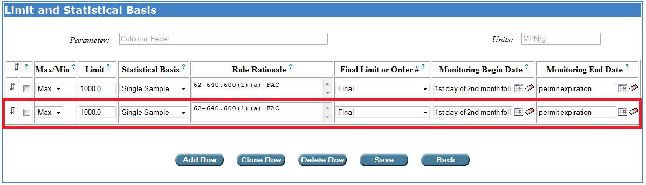

A cloned row is an exact copy of the original row. After cloning a limit row, you may add or edit information in the original and cloned rows.

Save
Be sure to click to save your entries to the Limit and Statistical Basis pop-up window.

7A.3.3.4. Deleting a parameter from the biosolids parameters table

To delete a parameter row, or several parameter rows at once, click the corresponding check-boxes on the left side of the biosolids parameters table, and then click .
Delete Row ow

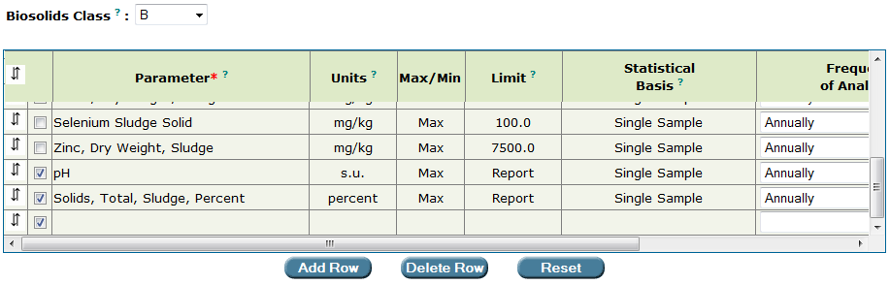
Deleting a row, or several rows at once, from the biosolids parameters table.
The permit writer has clicked on the corresponding check-boxes of the parameters to be deleted
and will then click the “Delete Row” button.

7A.3.3.5. Editing parameter information from the biosolids parameters table

Permit Builder allows you to edit the default parameters and their corresponding information. However, always check with your supervisor before making any changes to any default information.

By double-clicking anywhere in a parameters cell or its corresponding units cell, Permit Builder will display the Enter or Change Parameter screen.

In the example below, the permit writer double-clicked on the parameter cell for “Potassium.” Permit Builder then displays the Enter or Change Parameter screen with the parameter “Potassium” high-lighted within the parameters list. The highlighted parameter is also displayed at the top of the screen together with its corresponding Units.

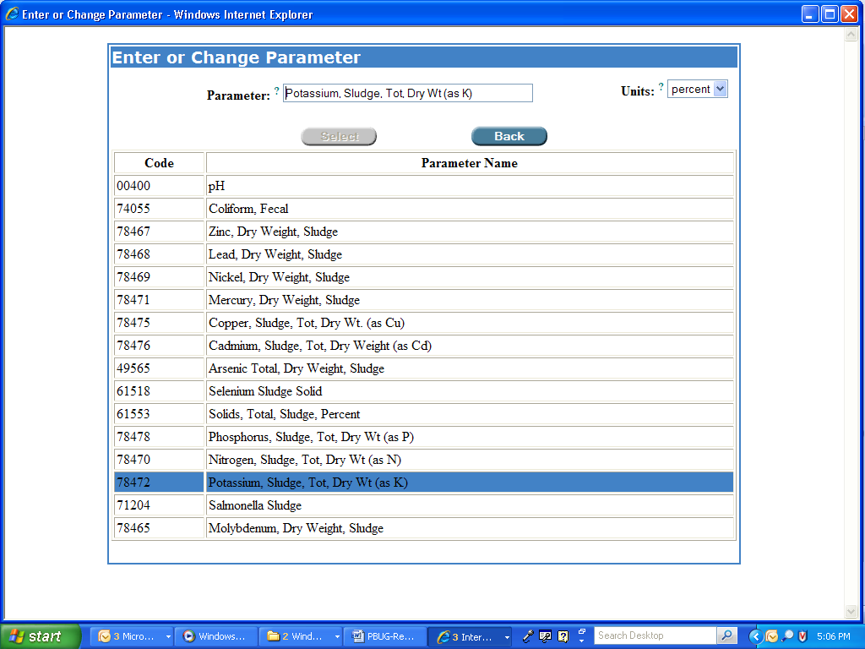
The “Enter or Change Parameter” screen.

From the Enter or Change Parameter screen, you may click on another parameter to replace the existing parameter, and you may also change the units of any parameter by accessing the Units drop-down box.

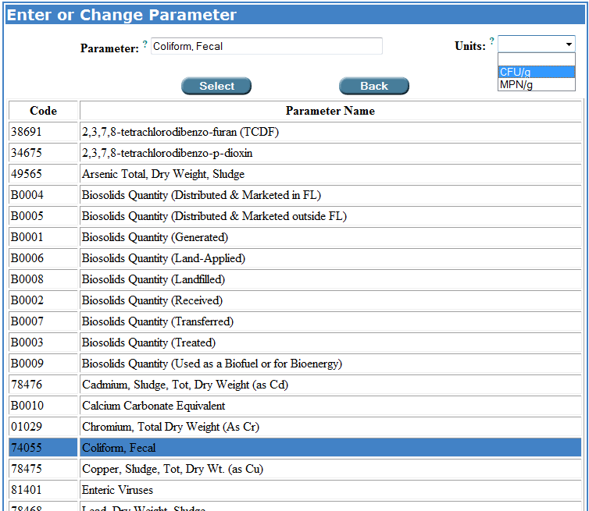
Selecting another parameter and changing the units.

Select ow
When you have finished editing the parameter, click which will insert your changes into the biosolids parameters table.

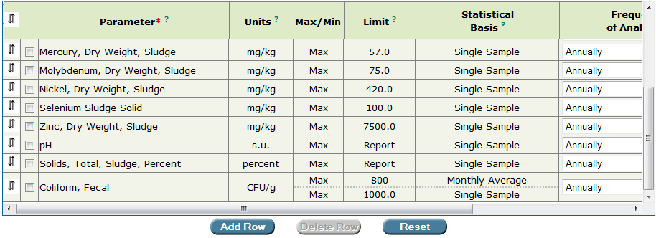
The units for the parameter “Coliform, Fecal” have been changed from MPN/g to CFU/g in the biosolids parameters table.

To edit the Max/Min, Limit, and Statistical Basis for the parameter you just edited, double-click on either of these cells in the row corresponding to the edited parameter to display the Limit and Statistical Basis screen, and make your changes. Be sure to click .
Save ow

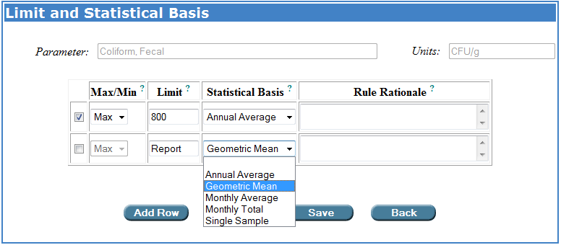

Permit Builder will then return to the biosolids parameters table where you may view your changes.

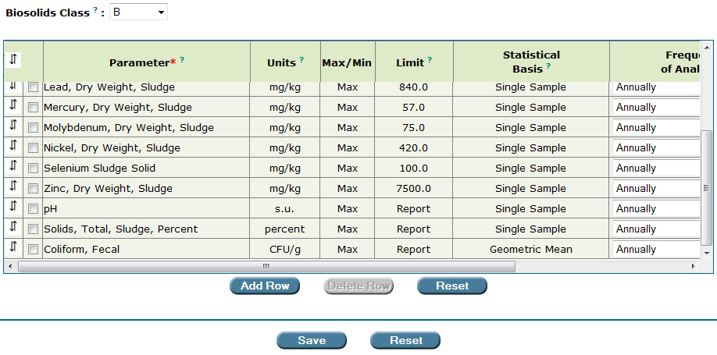
The permit writer has changed the units for “Coliform, Fecal” from “MPN/g” to “CFU/g”, and has also changed the “Limit” and “Statistical Basis” from “Single Sample” to “Geometric Mean.”

Reset ow
Save ow
Click to save your changes, or click located directly under the biosolids
parameters table to cancel your changes.

7A.3.3.6. Moving a parameter’s position within the biosolids parameters table

Permit Builder allows you to move a parameter’s location up or down within the table.

Step 1: Place your cursor over the down-and-up arrows  in the far left column of the parameter you wish to move, and click once to highlight the parameter row.

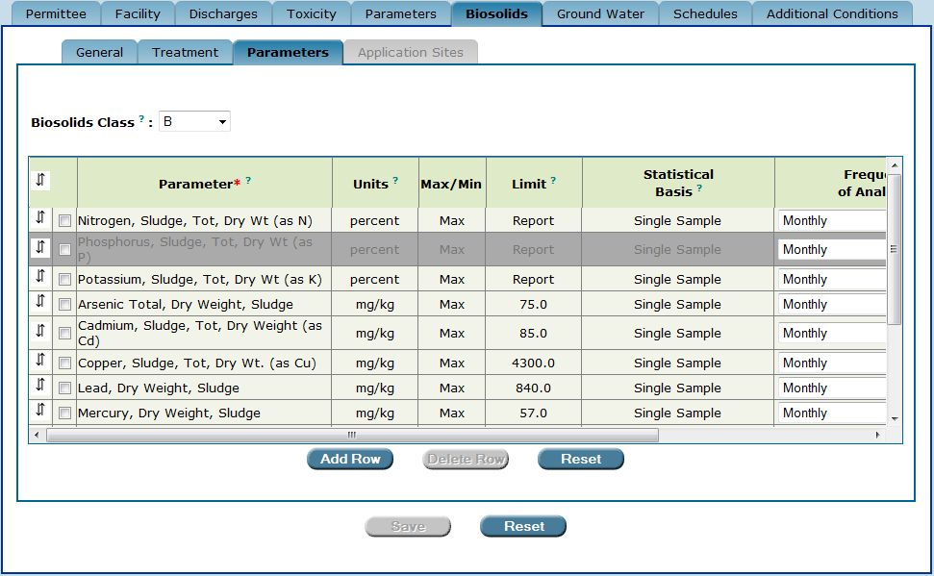
To move a parameter within the table, first high-light the parameter row by clicking
the “down-and-up arrows.”

Step 2: Click the down-and-up arrows  of the row above the row where you want to move the parameter. For example, to move “Phosphorus” to the row below “Lead,” click on the down-and-up arrows  of the row for “Lead.”

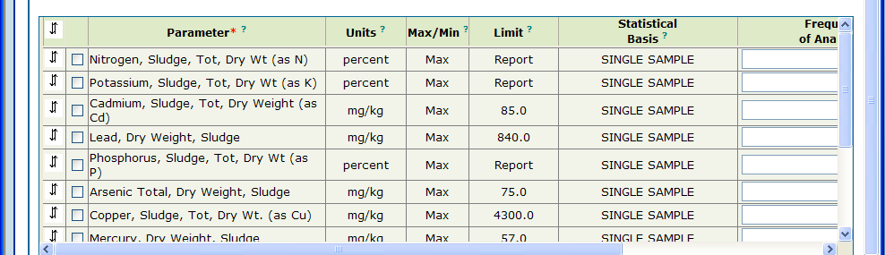
The parameter “Phosphorus” has been moved below the parameter “Lead.”

7A.3.3.7. Moving a parameter’s position to the top row of the biosolids parameters table

To move a parameter to the top row of the parameter table:

Step 1: Place your cursor over the down-and-up arrows  in the far left column of the parameter you wish to move and click once to highlight the parameter row.

To move a parameter to the top row of the table, first high-light the parameter row
by clicking on the “down-and-up arrows”.

Step 2: Click the down-and-up arrows  in the top left corner of the parameter table.
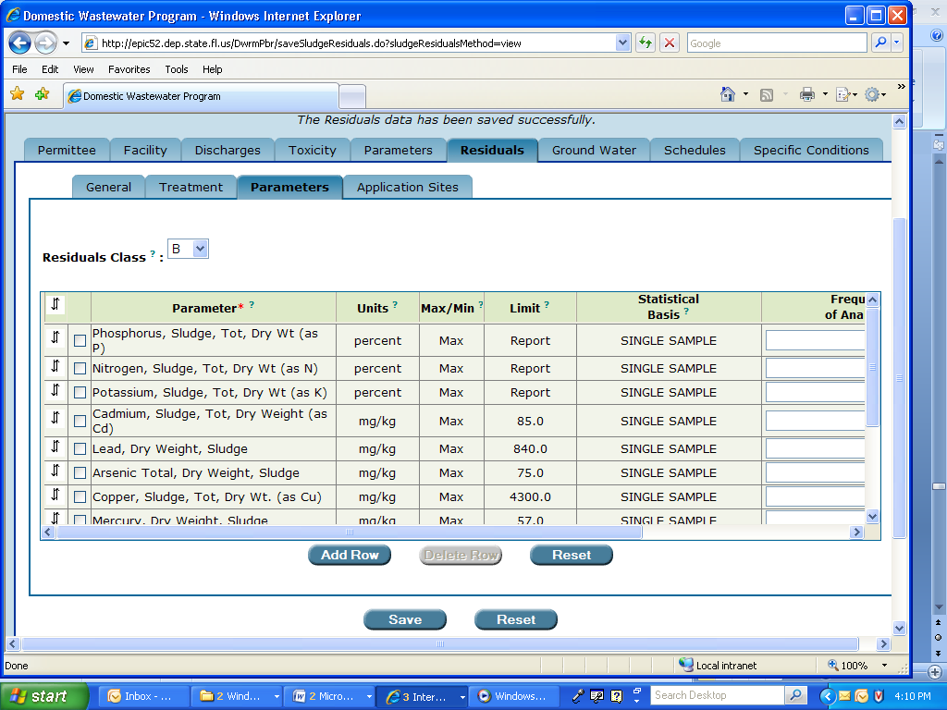
The “down-and-up arrows” at the top left-hand corner of the table.

The parameter “Phosphorus” has been moved to the top of the table.

7A.3.3.8. Adding additional parameter information to the biosolids parameters table

Permit Builder gives you the capability to include in your permit project additional information about a parameter that will be displayed in the permit document and the DMR once they have been generated.

By left-clicking ? in the Parameter heading, Permit Builder will display a text box (illustrated below), describing how to enter this additional information:

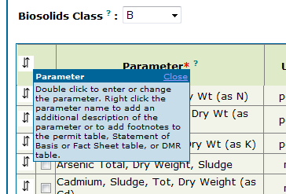

To begin entering additional information for a particular parameter, use the following steps:

Step 1: Right-click on the parameter name. In this example, the parameter Coliform, Fecal was previously added to the parameter table since it is not always a default parameter for Class B biosolids.

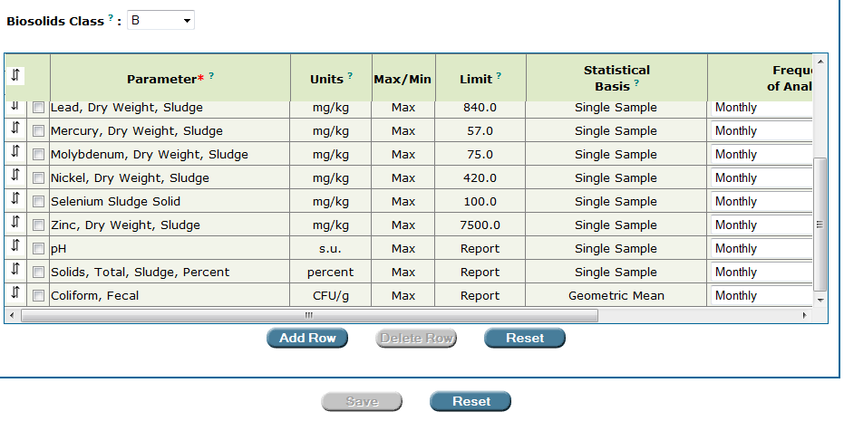
Editing parameter information.
Begin by right-clicking on the parameter name – “Coliform, Fecal” in this example.

Permit Builder will then display the Add to Parameter Description or Add a Footnote screen seen below.

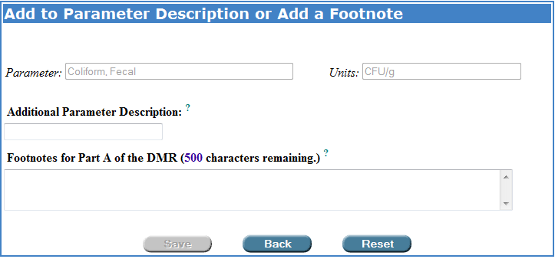
The “Add to Parameter Description or Add a Footnote” screen.

Step 2: Type in any appropriate information relating to the facility’s monitoring of the specific parameter being added or edited. This information will then appear in the permit text and DMR of your Permit Builder project once these documents have been generated.

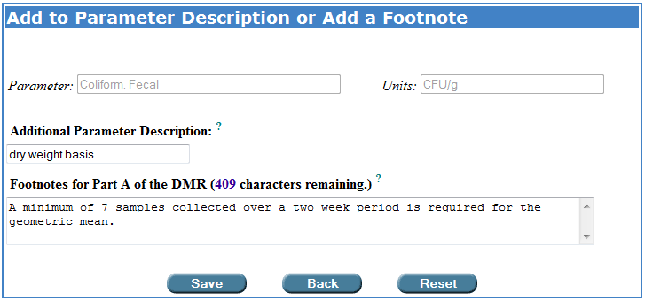
Typing text in the “Add to Parameter Description or Add a Footnote” screen fields. Permit Builder will incorporate this information into the permit documents.

Save ow
Step 3: Click to save your entries and return to the biosolids parameters table.
Back ow
Click to cancel and return to the biosolids parameters table.
Reset ow
Click to restore the table to the entries last saved.

7A.3.3.9. The two “Reset” buttons on the biosolids parameters table page

Once you have finished entering or changing all parameter information and Permit Builder has returned to the biosolids parameters table, you will notice the two Reset buttons – one located directly beneath the table next to the Delete Row button, and the other farther down next to the Save button.

Do not confuse the two “Reset” buttons!
Clicking the Reset button located directly under the parameter table next to the Delete Row button will restore the table to the entries last saved. Clicking the Reset button located next to the Save button will restore all changes made to the Biosolids tab and all its sub-tabs, to the information and settings last entered and saved by the permit writer.

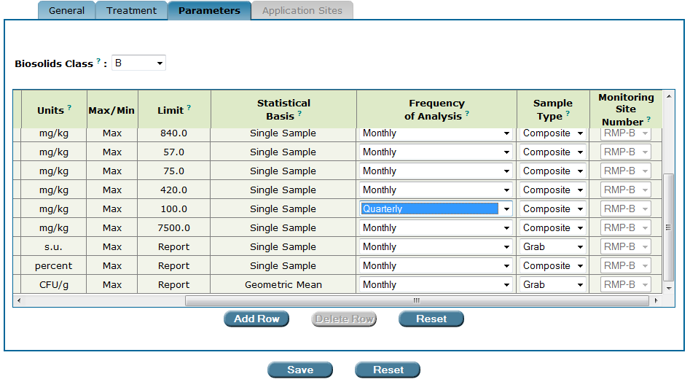
Click this Reset button to restore the table to the entries last saved.
Click this Reset button to restore all changes made to the Biosolids tab and its sub-tabs to the entries last saved.

7A.4. The “Application Sites” sub-tab

***Please note that since biosolids application sites were required to be permitted by January 1, 2013, the Application Sites sub-tab is no longer necessary and is slated to be removed from the Biosolids tab. To ensure that outdated standard permit conditions are not included in a permit, under the General sub-tab the permit writer should not indicate that biosolids will be land applied at sites approved under an AUP. At this time, biosolids in the process of being permitted to be land applied should be land applied at permitted sites.***

The Application Sites sub-tab is accessible when the Use or Disposal Method on the General sub-tab has been selected for Land Application and the permit writer indicates that the biosolids will be land applied at sites approved under an AUP.

While Permit Builder currently allows you to indicate that land application will occur at sites approved under an AUP and allows you to select those sites on the Application Sites sub-tab, by January 1, 2013, land application may occur only at sites permitted under Chapter 62-640, F.A.C., as amended on August 29, 2010, and all land application at unpermitted sites (i.e., sites approved under an AUP only) must cease.

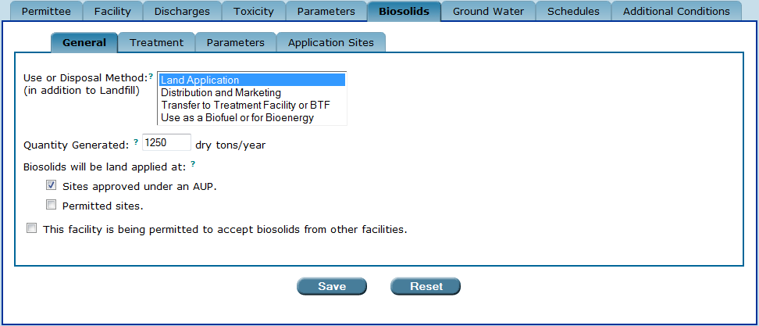
The “Application Sites” sub-tab is accessible when the “Use or Disposal Method” on the “General” sub-tab is selected for “Land Application” and the permit writer has indicated that the “biosolids will be land applied at sites approved under an AUP”.

Requirements for the land application of Class A, Class AA, and Class B biosolids are established in Rules 62-640.700and 62-640.800, F.A.C., as amended on August 29, 2010.

Once you have clicked on the Application Sites sub-tab, Permit Builder will display the application site table. For a new Permit Builder project, this table should be empty as illustrated below, indicating that you will need to add one or more biosolids application sites to your project.

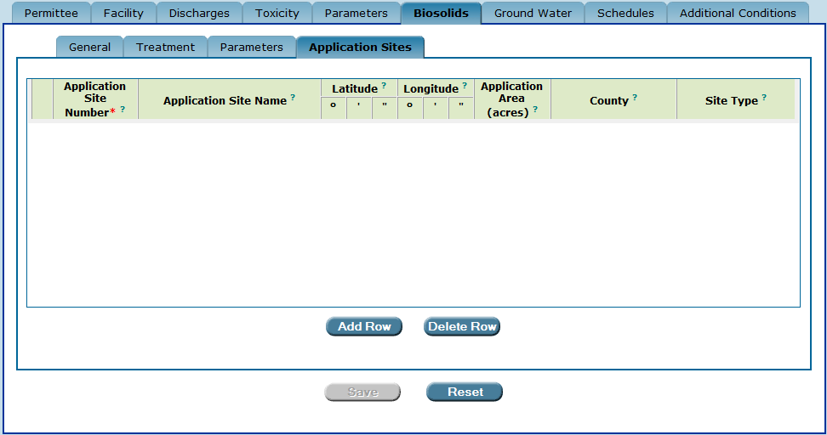
The application site table on “Application Sites” sub-tab. An empty table indicates that biosolids application sites have not yet been entered into the Permit Builder project.

7A.4.1. Adding biosolids application sites to your Permit Builder project

To add one or more biosolids application sites to your Permit Builder project, use the following steps:
Add Row ow
Step 1: Click located under the application site table.

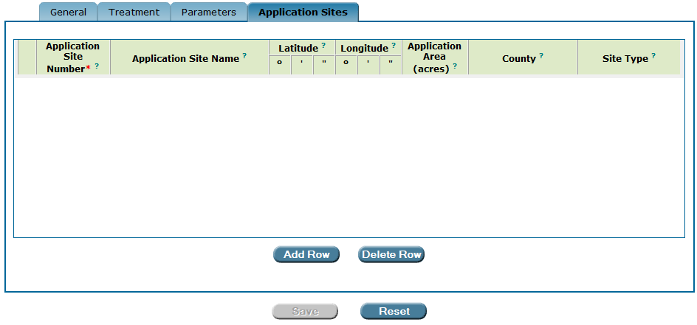

Permit Builder will then display the Biosolids Application Sites screen with contains a long list of permitted land application sites together with their associated information.

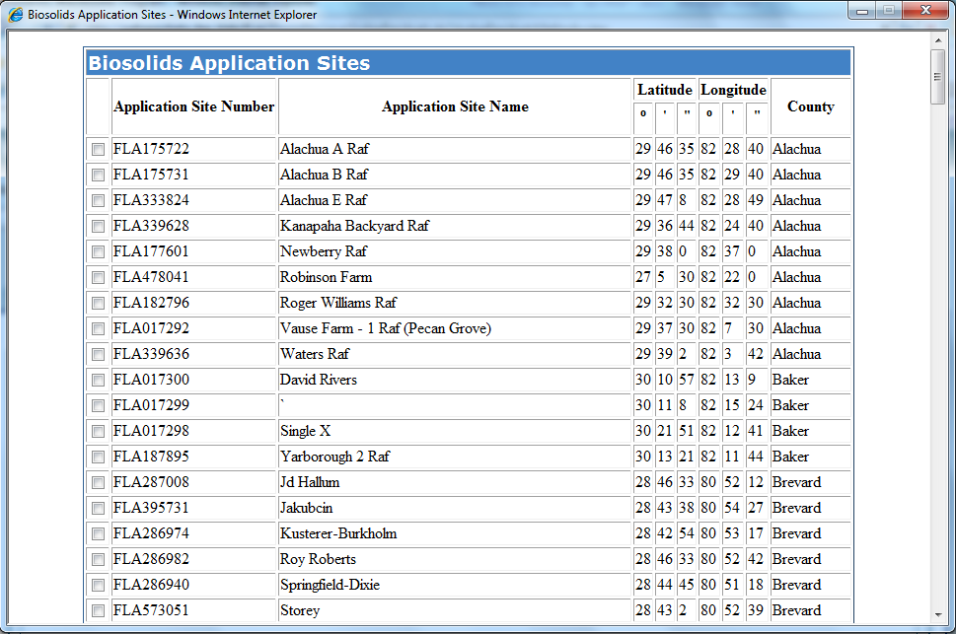
The “Biosolids Application Sites” screen with its long list of sites.

Step 2: Select one or more application sites from the list by clicking on their corresponding check-boxes. Application site information should be provided in the facility’s permit application and also in the facility’s Agricultural Use Plan (AUP).

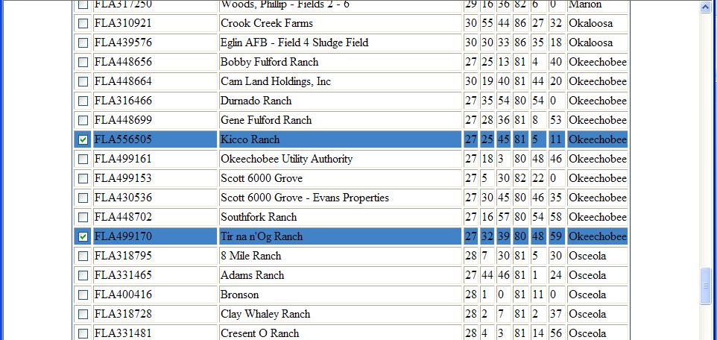

Select ow
Step 3: Click located at the bottom of the Biosolids Application Sites screen.

Back ow
Click to cancel your selections and close the Biosolids
Application Sites screen, returning to the Application Sites sub-tab.

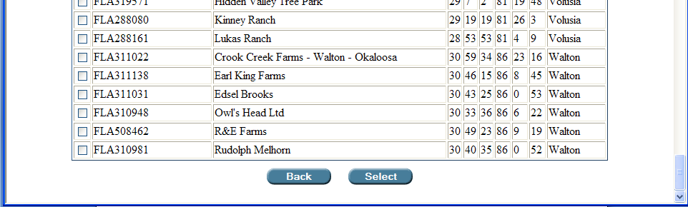

Step 4: You should now be viewing the Biosolids Application Sites screen with the sites you just selected displayed in the table.

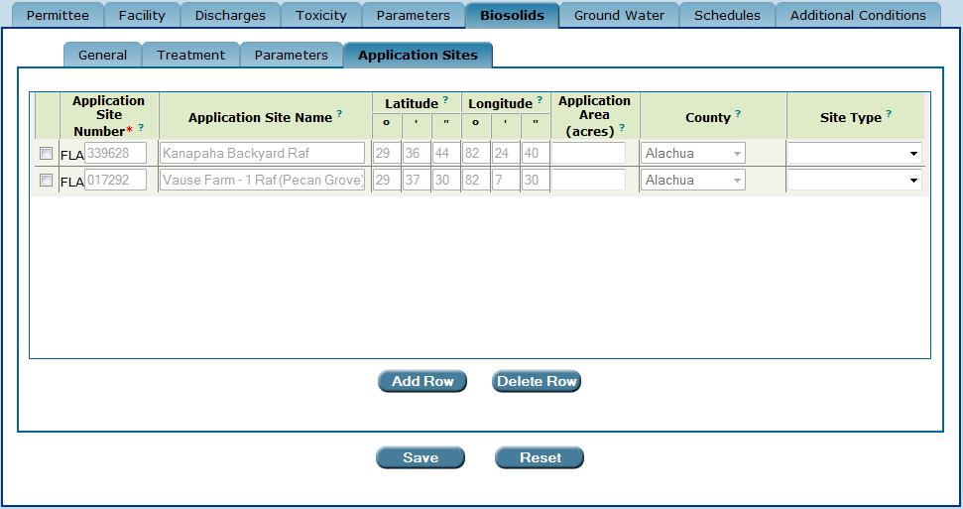
The “Application Sites” sub-tab now displays the sites the permit writer has selected.

Step 5: Enter the Application Area (in acres) and select the Site Type from the drop-down box. This information should be provided in the facility’s permit application and AUP.

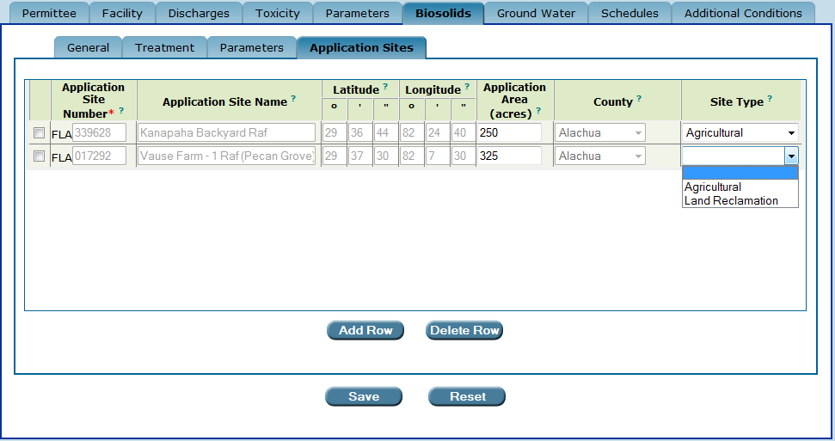

Save ow
Step 6: Click to save your entries.
Reset ow
Click to restore the table to the entries last saved.

7A.4.2. Deleting biosolids application sites from your Permit Builder project

To delete one or more application sites from the biosolids application site table, simply click on the
corresponding check-boxes and then click the button.
Delete Row ow

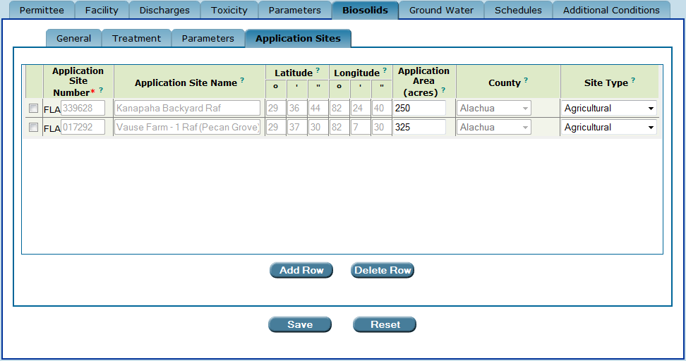
Deleting application sites from the biosolids application site table.

7A.5. The “Save” and “Reset” buttons

Once you have finished with the Application Sites sub-tab, you will also be finished entering all required data corresponding to the Biosolids tab, and are ready to move on to the next Permit Builder tab.

Be sure to:
Save ow
- Click to save your entries to Application Sites sub-tab.
Reset ow
- Click to clear all entries made to the Application Sites sub-tab. This will restore all fields to any information entered before the last time this sub-tab was saved.

CONGRATULATIONS!
YOU HAVE COMPLETED THE “BIOSOLIDS” TAB

Both Land Application and Distribution and Marketing are beneficial uses of biosolids. The only true disposal method is Landfill.
Definitions for the different classes of biosolids are contained in Rule 62-640.200, F.A.C.
In general, facilities that accept biosolids from other facilities are classified as biosolids treatment facilities (BTFs) and are permitted under requirements set forth in Rule 62-640.880, F.A.C. However, some permitted domestic wastewater treatment facilities may accept biosolids from other facilities. Although these facilities may not be required to obtain a separate permit as a BTF, the permit should include conditions that identify the permittee’s responsibilities associated with accepting biosolids.
Application sites are required to be permitted under chapter 62-640, F.A.C., as amended August 29, 2010, by January 1, 2013.
Pathogens are defined in Rule 62-640.200(31), F.A.C., as disease-causing organisms and include certain bacteria, protozoa, viruses, and viable helminths (parasitic worms) ova and any other organisms that cause disease.
This definition of vectors is given in Rule 62-640.200(48), F.A.C.
PFRP stands for Processes to Further Reduce Pathogens. The list of PFRPs may be found in Appendix B of 40 CFR 503, Pathogen Treatment Processes.
PSRP stands for Processes to Significantly Reduce Pathogens. The list of PSRPs may be found in Appendix B of 40 CFR 503, Pathogen Treatment Processes.
Injection is not an acceptable vector attraction reduction option for Class AA biosolids.
Incorporation is not an acceptable vector attraction reduction option for Class AA biosolids.
SOUR stands for Specific Oxygen Uptake Rate. The SOUR test can provide a quick measure of organic load and biodegradability in sludge.
The Parameters sub-tab located within the Biosolids tab addresses biosolids monitoring parameters and should not be confused with the Parameters tab which addresses wastewater effluent monitoring parameters.
All parameter information that appears in the biosolids quantities parameters table – either as default information or information that the permit writer edits, adds, or deletes – will appear in the permit and in the biosolids quantities Discharge Monitoring Report (DMR) Permit Builder will eventually generate for the permit project.
All parameter information that appears in the biosolids Class A, AA, or B parameters table – either as default information or information that the permit writer edits, adds, or deletes – will appear in the permit and in the biosolids DMR Permit Builder will eventually generate for the permit project.
Parameters that have “Report” in their Limit column are not limited to a specific numerical value. However, the facility is required to report numerical values of these parameters on its DMR. These values may then be used to calculate other values subject to a permitted limit such as a monthly or annual average.
“Monthly Average” for certain parameters will appear in the Statistical Basis column for Class AA biosolids only. “Geometric Mean” will appear for fecal coliform for Class B biosolids only. “Monthly Total” will appear for biosolids quantities parameters only.
Permit Builder will also allow you to type in any rule not present in the Rule Rationale drop-down box. Simply click anywhere in the field and begin typing. To select more than one rule rationale from the drop-down box, enter a comma after selecting the rationale.
Clicking the Back button will cancel any entries you made on the Limit and Statistical Basis screen by closing the screen and returning to the biosolids parameters table.
Please remember that a Permit Builder project may be created only when the permit has not yet been issued in WAFR-PA. However, once a Permit Builder project has been created, the permit may be issued at any time. An existing Permit Builder project may be edited or uploaded to WAFR regardless of whether it has been issued. Please note, however, that the permit must have been issued in WAFR-PA before a Permit Builder project containing interim limits may be uploaded to WAFR.
Although some facilities have customized lists of parameters for which they monitor, always check with your supervisor before deleting a parameter from any parameter table.
Do not confuse this Reset button with the reset button located next to the Save button which, when clicked, will restore all changes to the Biosolids tab and all its sub-tabs back to the information and settings last entered and saved by the permit writer.
When Permit Builder generates the Discharge Monitoring Report (DMR) for the facility’s biosolids, the parameters will appear in the same order as they appear in the parameter table in Permit Builder.
Until January 1, 2013, domestic wastewater facilities that directly land-apply their biosolids at land application sites that are not yet permitted under Chapter 62-640, F.A.C., as amended on August 29, 2010, are required to submit an Agricultural Use Plan (AUP) together with their permit applications. Requirements for AUPs are established in Rule 62-640.500, F.A.C, as amended on March 30, 1998.

