7B. The “Sludge” tab

Sludge generated by industrial wastewater treatment facilities is not currently regulated by the NPDES Program. Permitting requirements for the beneficial use or disposal of sludge are established in state law. Within the Department, both the Division of Water Resource Management and the Division of Waste Management share some responsibility for industrial sludge regulation under chapter 403, F.S., and chapters 62-620, 62-701, and 62-730, F.A.C. Generally, sludge permit requirements are developed on a case-by-case basis.

When you are ready to begin entering sludge data into your Permit Builder project, click the Sludge tab which will take you to the screen illustrated below.

7B.1. The “General” sub-tab

The General sub-tab contains fields and check-box statements that provide Permit Builder with basic information about the facility’s method of handling its sludge.

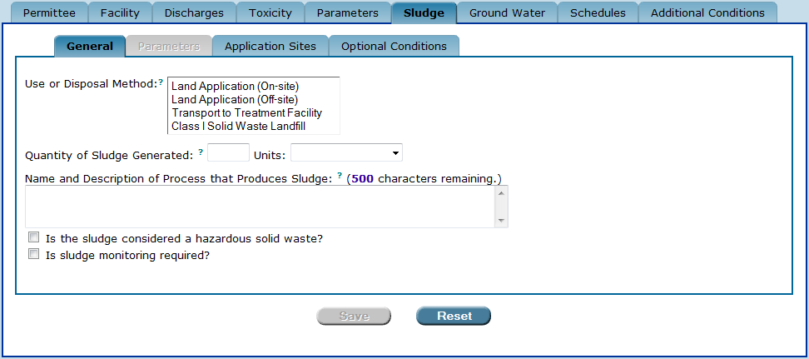
The “Sludge” tab and its sub-tabs.

7B.1.1. The “Disposal Method” field on the “General” sub-tab

The Disposal Method field displays the following four options for the sludge disposal:
- Land Application (On-site). Land application means spreading, spraying, or disking waste on the land for some beneficial purpose. Generally, management standards and monitoring requirements for on-site land application of non-hazardous sludge are addressed in the generating facility’s permit.
- Land Application (Off-site). Land application means spreading, spraying, or disking waste on the land for some beneficial purpose. Generally, when off-site land application does not require a separate permit, management standards and monitoring requirements for off-site land application, and off-site storage prior to application, of non-hazardous sludge are addressed in the generating facility’s permit.
- Transport to Treatment Facility. This method of sludge disposal is used by facilities that send their untreated or partially treated sludge to an off-site treatment facility. Facilities storing, transporting, and disposing of sludge characterized as hazardous waste must do so in accordance with the requirements of Chapter 62-730, F.A.C..
- Class I Solid Waste Landfill. This method of sludge disposal is used by facilities that dispose of their non-hazardous sludge in a landfill. A facility might select this option together with another disposal method option since disposal to a landfill may be utilized as an alternative option. Facilities disposing of their sludge in a solid waste landfill must do so in accordance with the requirements of Chapter 62-701, F.A.C.

7B.1.1.1. Selecting more than one option in the “Disposal Method” field

Permit Builder allows you to select more than one option from the Disposal Method field by pressing and holding the control key (CTRL) while clicking an option.

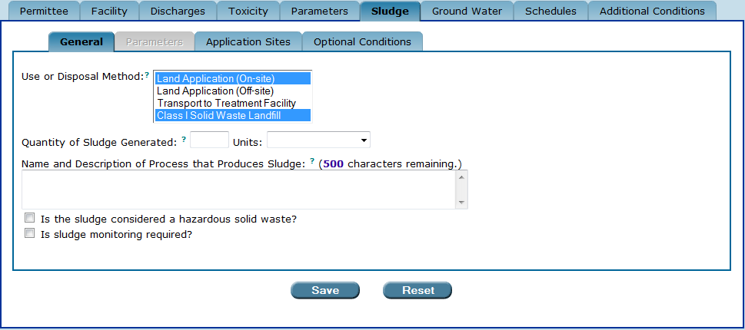
Selecting more than one option in the “Disposal Method” field.

7B.1.1.2. “Disposal Method” scenarios

Depending on which Disposal Method you choose, Permit Builder will display additional fields for you to fill out.

The possible Disposal Method scenarios on the General sub-tab are detailed below.

“Disposal Method” – SCENARIO 1

IF the Disposal Method is selected for:

- Land Application (On-site),
- Land Application (Off-site), or
- Class I Solid Waste Landfill

THEN Permit Builder will display the following:
- The Quantity of Sludge Generated field. This information should be provided in the facility’s permit application. Enter integers only. Do not use commas or decimal points.
- The Units drop-down box. Select the appropriate Units from the drop-down box that correspond to the Quantity of Sludge Generated. For the amount of sludge generated, the units will be:
  - Wet Tons/Day
  - Dry Tons/Day
  - Gpd
  - Wet Tons/Load
  - Dry Tons/Load
  - Wet Pounds/Load
  - Dry Pounds/Load
- The Name and Description of Process that Produces Sludge field. The description of the sludge producing processes entered in this field will appear in the fact sheet as follows: Based on the permit application, the facility produces (Quantity of Sludge Generated and Units) of industrial sludge from the (Name and Description of Process that Produces Sludge).
- The “Is the sludge considered a hazardous solid waste?” check-box statement. Select this check-box if the sludge generated by your facility is considered a hazardous solid waste. This will tell Permit Builder to generate certain special permit conditions in the body of the permit that outline certain responsibilities the permittee will be required to assume.
- The “Is sludge monitoring required?” check-box statement. Select this check-box if sludge monitoring is required in your Permit Builder project.

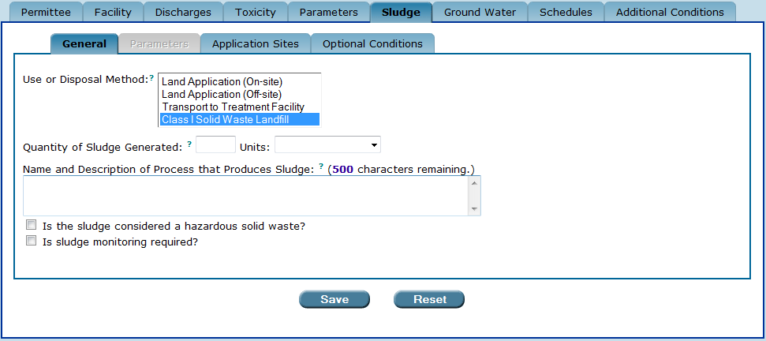
The “General” sub-tab when “Class I Solid Waste Landfill” is selected for
“Disposal Method.” The same fields and check-boxes also appear when “Land Application (On-site)”
or “Land Application (Off-site)” are selected.

“Disposal Method” – SCENARIO 2

IF the Disposal Method is selected for:

- Transport to Treatment Facility

THEN, in addition to the fields and check-boxes identified in Scenario 1 above, Permit Builder will display the following:
- The Treatment Facility Name field. Type in the name of the facility to where sludge will be transported.

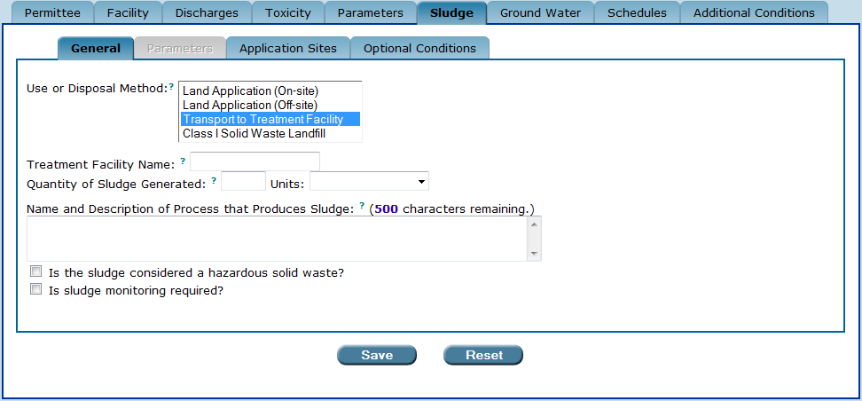
The “General” sub-tab when “Transport to Treatment Facility” is selected for “Disposal Method.”

“Disposal Method” – SCENARIO 3

IF the Disposal Method is selected for:

- Multiple options. Permit Builder allows you to choose more than one disposal method by holding down the control key (CTRL) while clicking the option.

THEN Permit Builder will display the following:

- All corresponding fields and check-boxes (see Scenarios 1 and 2 above).

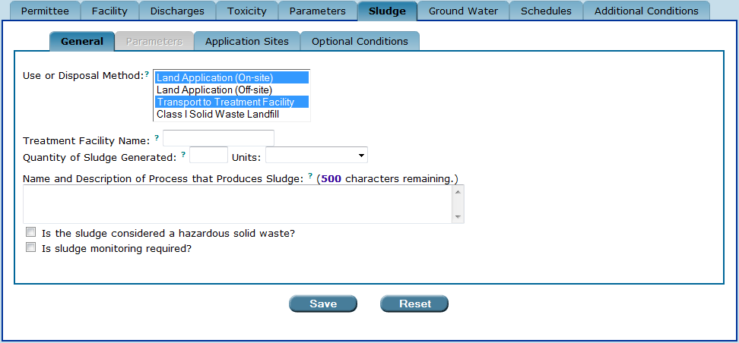
The “General” sub-tab when multiple options are selected for “Disposal Method.”
If “Transport to Treatment Facility” is one of the “Disposal Methods” selected, the “Treatment Facility Name” field will appear in addition to the other fields and check-boxes.

7B.1.2. The “Save” and “Reset” buttons

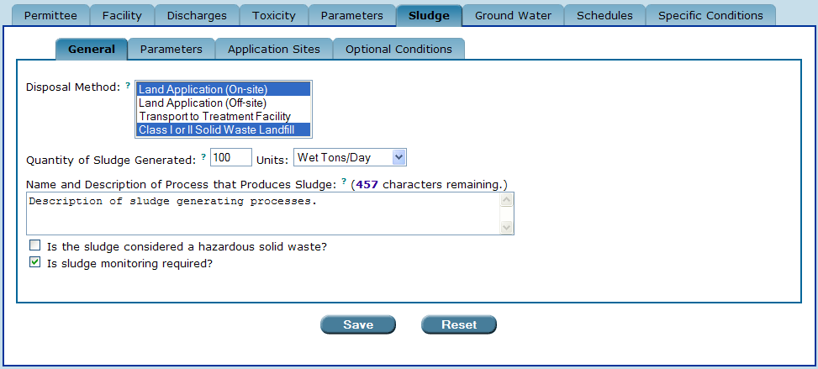

Once you have finished with the General sub-tab, be sure to either:
Save ow
- Click to save your entries to the General sub-tab.
- Click to restore all fields to any information entered before the last time this sub-tab was saved.
Reset ow

7B.2. The “Parameters” sub-tab

The Parameters sub-tab is accessible as long as the “Is sludge monitoring required?” check-box statement is selected on the General sub-tab:

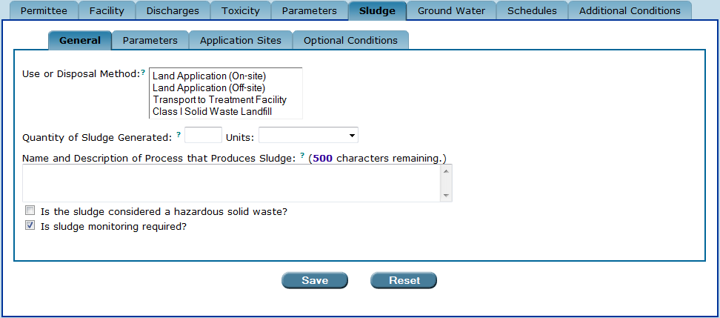
The “Parameters” sub-tab is accessible when the “Is sludge monitoring required?”
check-box statement has been selected in the “General” sub-tab.

7B.2.1. The sludge parameters table

Once you have selected the “Is sludge monitoring required?” check-box statement on the General sub-tab, Permit Builder will display an empty sludge parameters table on the Parameters sub-tab.

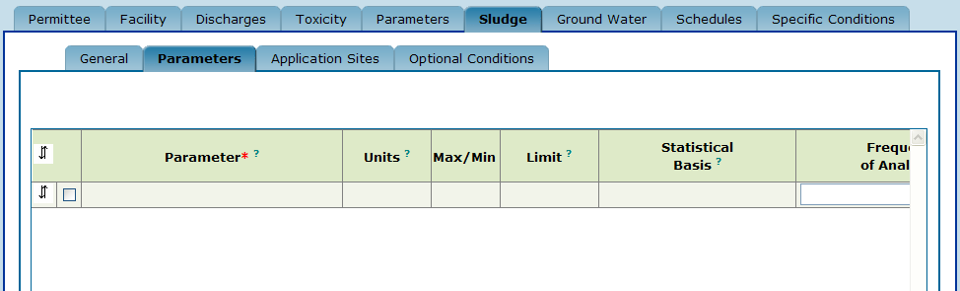
The “sludge parameters table.”
.

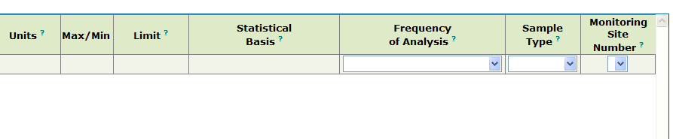
The “sludge parameters table” (continued).

The sludge parameters table contains the following column headings:
- Parameter – corresponds to the name of the substance (i.e., nutrient, metal, pathogen, or other chemical or physical constituent) to be limited or monitored, that may be present in the facility’s sludge.
- Units – corresponds to the units of measurement for a parameter limited in the facility’s permit or reported on its Discharge Monitoring Report (DMR).
- Max/Min – corresponds to whether the limit listed in the “Limit” column, is a maximum or minimum allowable amount.
- Limit – corresponds to the allowable amount of a parameter in the facility’s sludge. If the “Limit” column contains “Report,” then the facility need only report the maximum or minimum value of a parameter for a specific monitoring period.
- Statistical Basis – corresponds to the method of determining the amount of a parameter in a particular sludge sample. For sludge analysis, the statistical basis will be:
  - Annual Average,
  - Geometric Mean,
  - Monthly average,
  - Monthly Total, or
  - Single sample.
- Frequency of Analysis – corresponds to the number of times, within a monitoring period, a facility is required to sample and analyze its sludge for a specific parameter. For sludge analysis, the frequency of analysis will be:
  - Daily; 24 Hours – or once per 24 hours.
  - Weekly – or once per 7 days.
  - Monthly – or once per month.
  - Bi-monthly; Every 2 Months – or once per 60 days.
  - Quarterly – or once per quarter.
  - Semi-Annually; Twice Per Year – or once per 6 months.
  - Annually – or once per year.

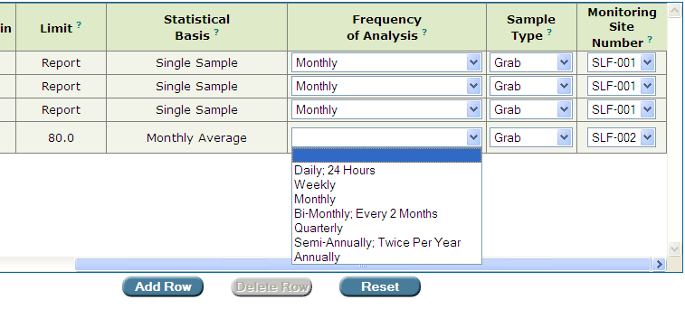
The “Frequency of Analysis” drop-down box.

- Sample Type – corresponds to the type of sample collected for analysis of a parameter, where:
  - Grab refers to a single sample collected for a particular parameter. Grab samples should be used for pathogens and determinations of percent volatile solids.
  - Composite refers to a mixture of several single samples. Composite samples should be used for metals.

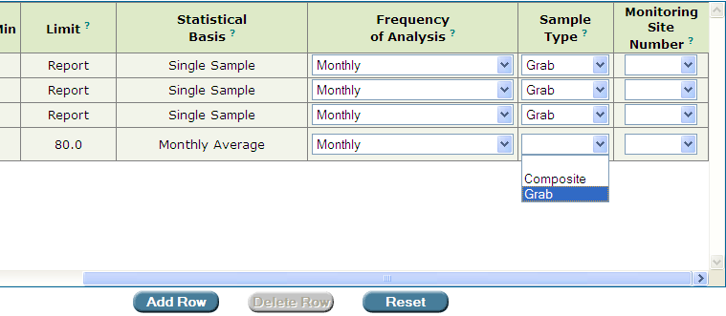
The “Sample Type” drop-down box.

- Monitoring Site Number – corresponds to the location of the sludge monitoring site.

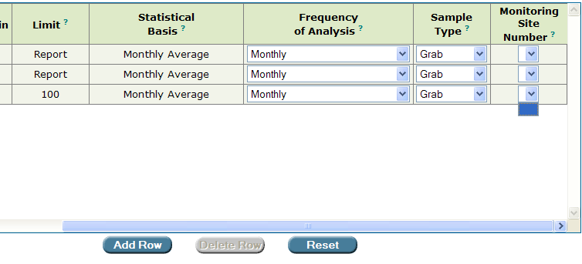
An empty “Monitoring Site Number” drop-down box.

7B.2.2. Adding and deleting parameters, and editing parameter information in the sludge parameters table

Permit Builder allows you to add, delete, and edit the sludge monitoring parameters and their corresponding information.

7B.2.2.1. Adding a parameter to the sludge parameters table

Add Row ow
Step 1: Click located just below the table, or proceed to Step 2 if the table already contains a blank row.

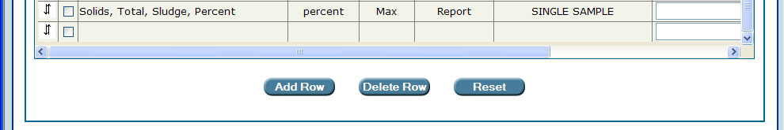

Step 2: Double click in the empty parameter cell of the blank row. Permit Builder will display the Enter or Change Parameter screen illustrated below.

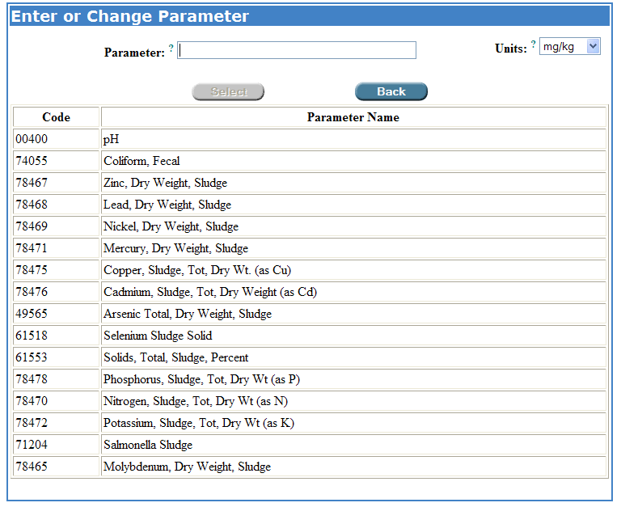
The “Enter or Change Parameter” screen.

Step 3: In the Enter or Change Parameter screen, click on the parameter you wish to add to the sludge parameters table (Coliform, Fecal in this example). Permit Builder will highlight it and display it in the Parameter field at the top of the screen.

Step 4: If the correct units corresponding to the parameter you have just selected are not displayed in the Units field, click on the Units drop-down box and select the appropriate units (MPN/g in this example).

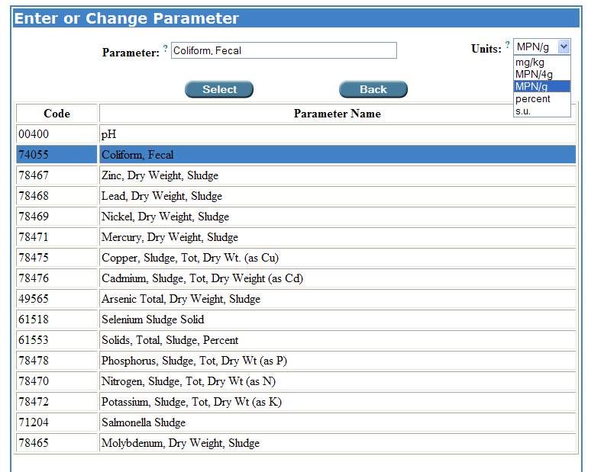
Selecting a parameter to add to the sludge parameters table,
together with its appropriate units.

Select ow
Step 5: Click which is located at the bottom of the Enter or Change Parameter table. Permit Builder will close the Enter or Change Parameter table and return to the sludge parameters table where you will now see the newly added parameter, “Fecal, Coliform” with its associated units.
Back ow
Click to cancel your request to enter or change a parameter. Permit Builder will then return to the sludge parameters table.

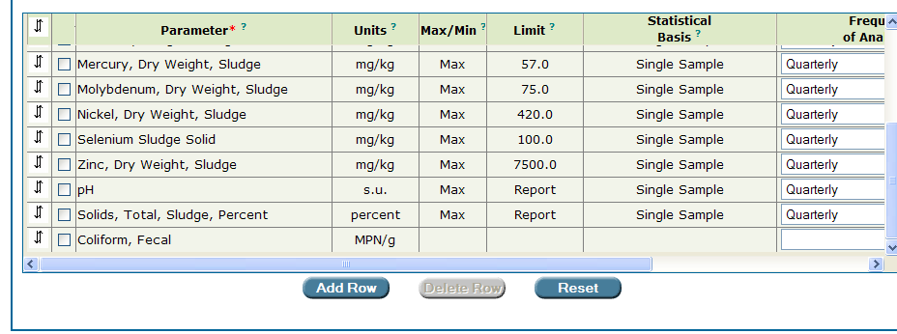
The parameter “Coliform, Fecal” together with its units of “MPN/g” has been added
to a sludge parameters table.

Step 6: Access the Max/Min, Limit, and Statistical Basis columns by double clicking in any of their empty cells in the newly added parameter row (“Coliform, Fecal” in this example).

Permit Builder will then display the Limit and Statistical Basis screen illustrated below.

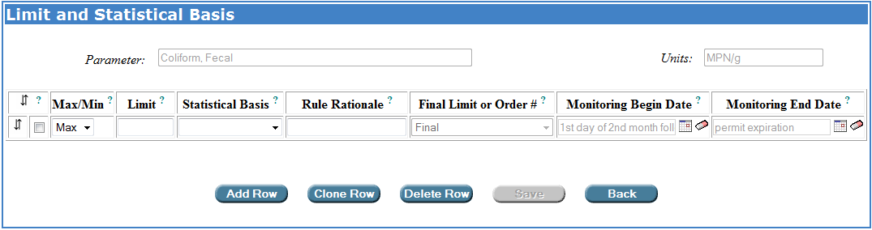
The “Limit and Statistical Basis” screen.

Step 7: Enter the appropriate information by typing in the numerical Limit and the Rule Rationale and accessing the drop-down menus for Max/Min and Statistical Basis.

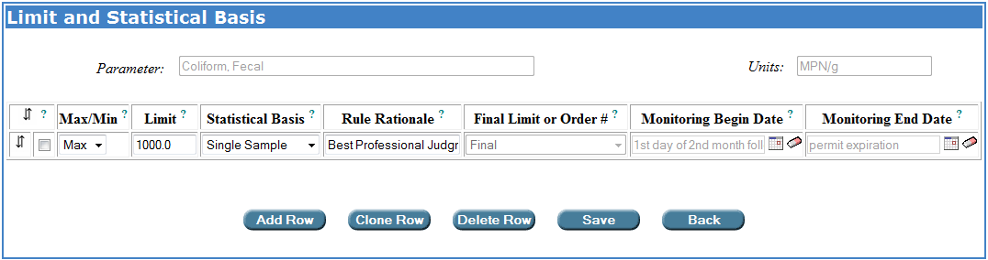
Entering information in the “Limit and Statistical Basis” screen.

Step 8: To add another limit for the same parameter, click and complete the information.
Add Row ow

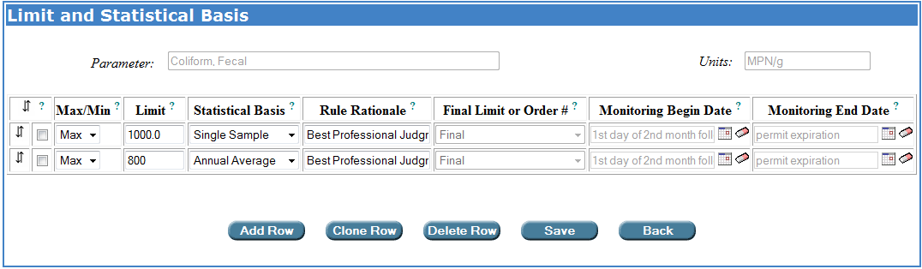
Adding another limit to a parameter.
In this example, the permit writer typed in “Best professional judgment
of the permit writer” in the “Rule Rationale” field.

Step 9: When you have completed your entries for the new parameter, click .
Save ow
Permit Builder will then return to the sludge parameters table where you will now see your entries for the newly added parameter (“Coliform, Fecal” in this example).

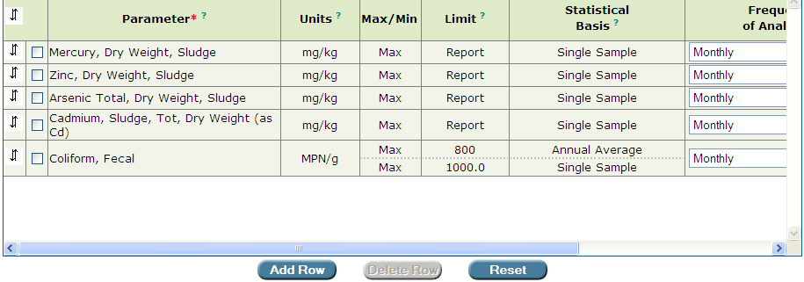
The new parameter “Coliform, Fecal” with the two limits associated with it
has been added by the permit writer.

Step 10: Select Frequency of Analysis, Sample Type, and Monitoring Site Number from the corresponding drop-down boxes and select the appropriate options, as illustrated below.

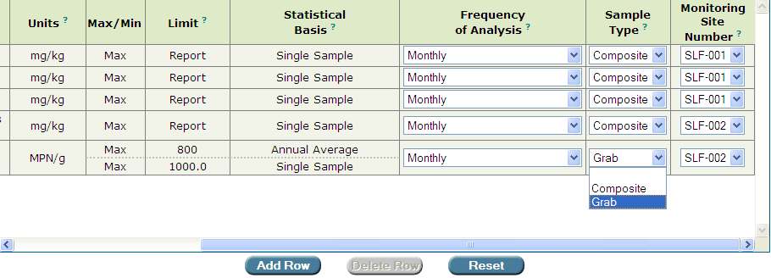

Reset ow
Save ow
Step 11: Click to save your entries, or Click to restore the table to the entries last saved.

7B.2.2.2. Creating interim limits for sludge monitoring

To create interim limits for sludge monitoring, an Administrative Order (AO) or a Consent Order (CO) must first be created on the Orders sub-tab under the Facility tab (see Chapter 3 of the Permit Builder User Guide for information on how to create an order). Once an order has been created in your Permit Builder project, the Limit Type column will be included in your sludge parameter table. The Limit Type column will indicate whether each limit is a final limit or an interim limit.

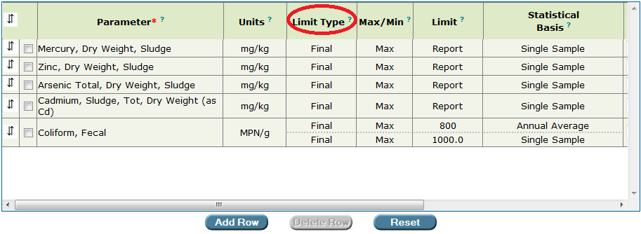
The “Limit Type” column is displayed in the sludge parameter table when an order has been created by the permit writer for the Permit Builder project.

To create an interim limit, open the Limit and Statistical Basis pop-up window as described above (by double clicking on the Max/Min, Limit, or Statistical Basis fields of a parameter). Select or enter the limit, statistical basis, and rule rational and indicate whether the limit is a maximum limit or a minimum limit. If the limit is an interim limit, select the order number with which the interim limit is associated from the Final Limit or Order # drop-down box (the order numbers will have created by the permit writer on the Orders sub-tab under the Facility tab, see Chapter 3 of the Permit Builder User Guide). If the limit is a final limit, you will not need to make a selection form the Final Limit or Order # drop-down box since “Final” is the default option.

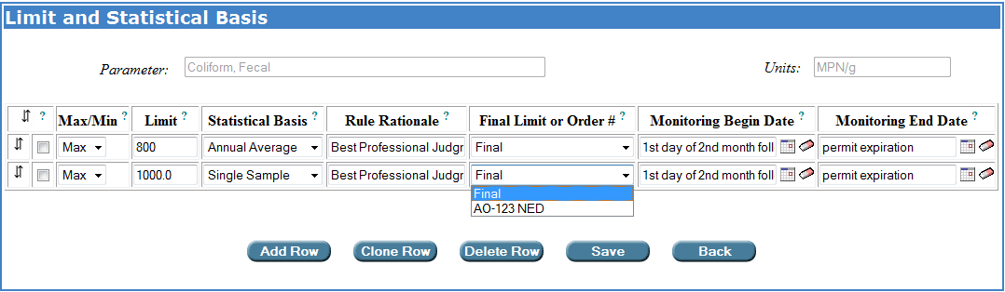

To indicate that a limit is an interim limit, select the order number of the Administrative Order or Consent Order that includes the interim limit from the “Final Limit or Order #” drop-down box on the “Limit and Statistical Basis” pop-up window. The order numbers populating the “Final Limit or Order #” drop-down box are created by the permit writer on the Orders sub-tab under the Facility tab.

The dates over which the interim and final limits apply are specified on the Limit and Statistical Basis pop-up window. When a project has not yet been issued in WAFR-PA, the Monitoring Begin Date field will initially be populated with the phrase, “1st day of the second month following the effective date of the permit” (i.e., the monitoring start date) for both interim and final limits. The Monitoring End Date will initially be populated with the phrase, “permit expiration” for both interim and final limits.

Calendar dates may be entered in to the date fields or selected from a calendar after clicking on the calendar icon following each date field. Text may not be entered into the date fields. If the default text language (“1st day of the second month following the effective date of the permit” or “permit expiration”) is overwritten with a calendar date, the text language may be retrieved by selected a different option from the Final Limit or Order # drop-down box and then re-selecting the desired option.

The monitoring begin and end dates will be used in generating DMRs. For projects that have not yet been issued in WAFR-PA, Permit Builder has been programmed so that “1st day of the second month following the effective date of the permit” is the earliest monitoring date. Any calendar monitoring begin date will be assumed by Permit Builder to fall after the “1st day of the second month following the effective date of the permit.” That is, if the permit writer anticipates that a permit will be issued on May 23, 2015, so that the “1st day of the second month following the effective date of the permit” will be July 1, 2015. “1st day of the second month following the effective date of the permit” should still be used as the monitoring begin date for limits that are effective on the monitoring start date rather than 7/1/2015 (unless all “1st day of the second month following the effective date of the permit” monitoring begin dates, for all final and interim limits, are changed to 7/1/2015). If 7/1/2015 is used in place of some “1st day of the second month following the effective date of the permit” monitoring begin dates, Permit Builder will create a DMR with an effective range of “1st day of the second month following the effective date of the permit” through 6/30/2015.

Please note that the permit must have been issued in WAFR-PA before a Permit Builder project containing interim limits may be uploaded to WAFR.

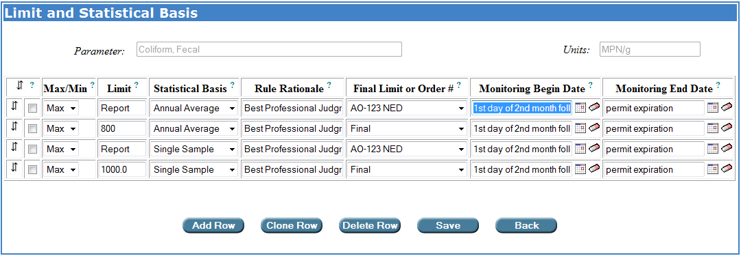
For projects that have not yet been issued in WAFR-PA, monitoring dates default to “1st day of the second month following the effective date of the permit” and “permit expiration.”

When a project has been issued in WAFR-PA, the Monitoring Begin Date field will initially be populated with the calendar date corresponding to the first day of the second month following the effective date of the permit (i.e., the monitoring start date) for final limits and interim limits associated with AOs. For interim limits associated with COs, the Monitoring Begin Date field will initially be populated with the calendar date corresponding to the first day of the month following the CO executed date specified by the permit writer on the Orders sub-tab under the Facility tab (see Chapter 3 of the Permit User Guide). For all interim and final limits, the Monitoring End Date will initially be populated with the calendar date corresponding to the date of permit expiration.

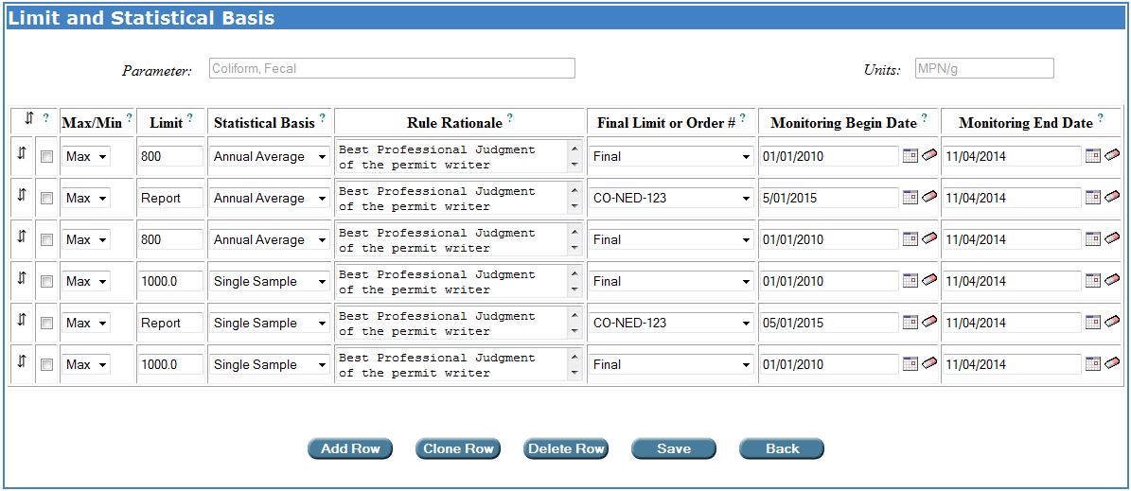
For projects that have been issued in WAFR-PA, monitoring begin dates for limits associated with Administrative Orders and final limits default to the calendar date corresponding to the first day of the second month following the effective date of the permit. Monitoring begin dates for limits associated with Consent Orders default to the calendar date of the first day of the month following the executed date entered by the permit writer on the Orders sub-tab under the Facility tab. Monitoring end dates for interim and final limits default to the calendar date corresponding to the permit expiration date.

For compatibility with EPA’s ICIS database and the Department’s eDMR system, monitoring dates need to begin on the first day of a month. Monitoring dates should end on the last day of a month or the permit expiration date. Additionally, there should not be any overlap or gaps in monitoring effective dates between interim and final limits. A one limit should begin on the day following another limits end date. There are no checks in Permit Builder to ensure that appropriate interim and final effective date ranges have been included in the project. If the interim and final DMRs generated by Permit Builder for your project are not what you anticipated, check the monitoring begin and end dates for the parameters with interim and final limits to ensure that the correct dates have been entered.

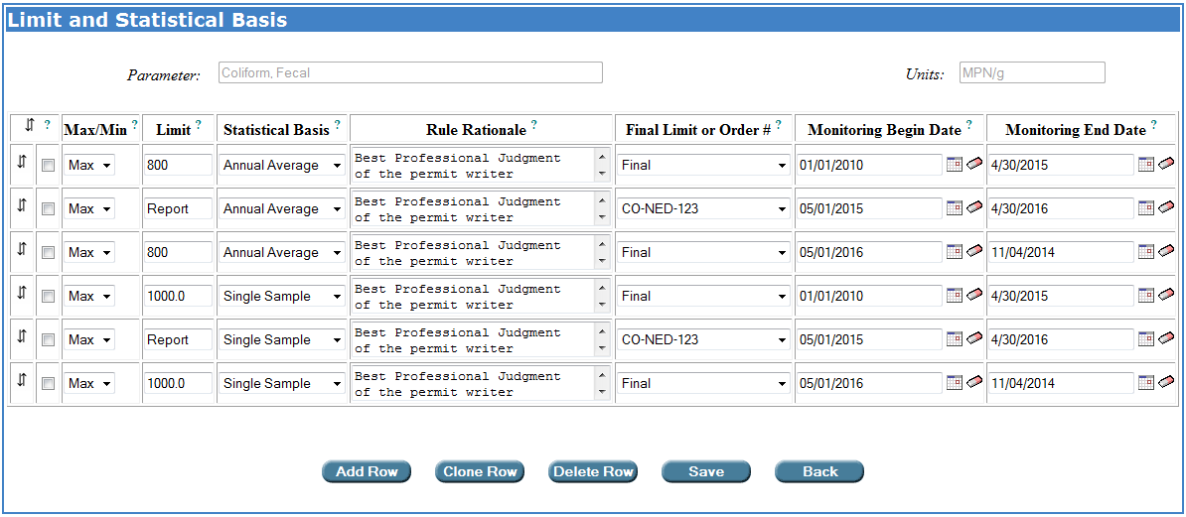
There should be no overlapping or gaps between interim and final limits. One limit should begin on the day following the end date of another limit.

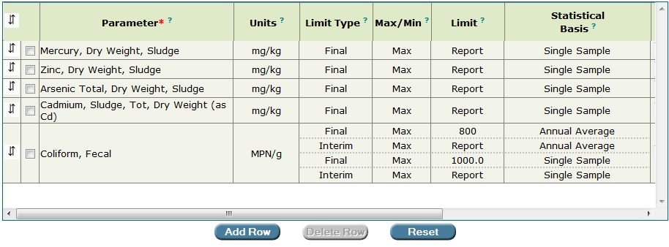
Interim limits have been added by the permit writer for “Coliform, Fecal”.

7B.2.2.3 Adding limits to the Limit and Statistical Basis pop-up window by cloning existing limits

To add a limit to the Limit and Statistical Basis pop-up window by cloning an existing limit row, click the check-box located to the left of the Max/Min field and then click . The ability to clone row is particularly useful when adding interim limits for a parameter.
Clone Row

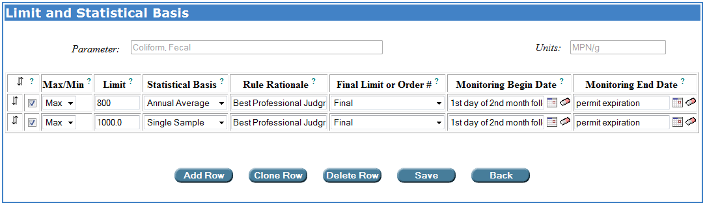
Click the checkbox to the left of the limit, and then click Clone Row.

Permit Builder will then make a copy of the parameter row:
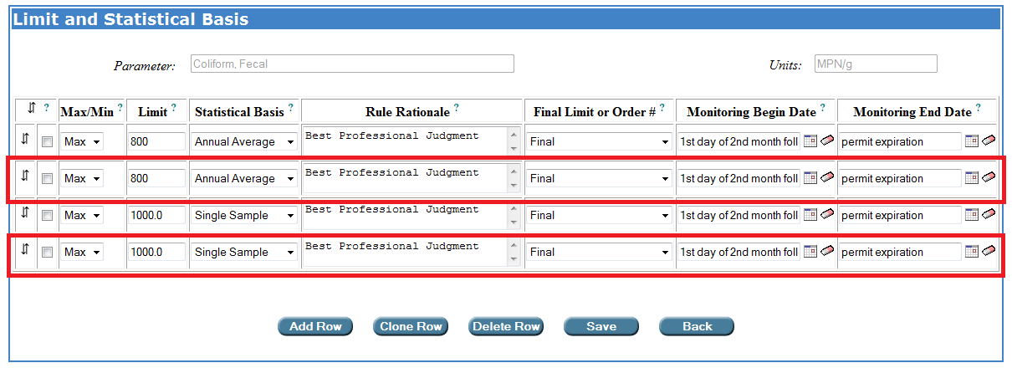

A cloned row is an exact copy of the original row. After cloning a limit row, you may add or edit information in the original and cloned rows.

Save
Be sure to click to save your entries to the Limit and Statistical Basis pop-up window.

7B.2.2.4. Creating sludge monitoring sites within the sludge parameters table

To create a sludge monitoring site for your Permit Builder project, double-click on the Monitoring Site Number heading in the sludge parameters table. This will open the Add or Modify Monitoring Site Number/Select Existing WAFR Site input screen, illustrated below.

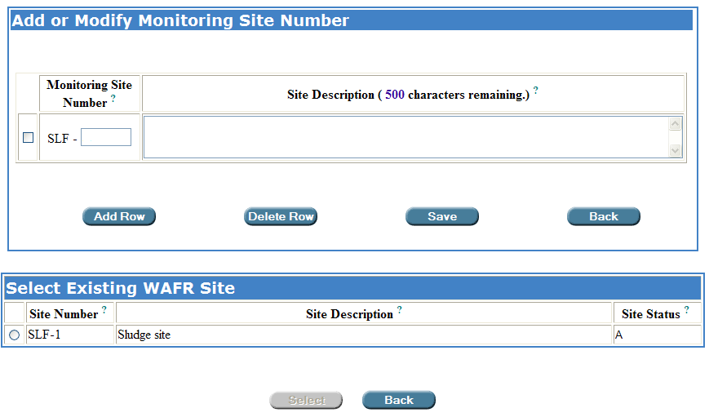
The “Add or Modify Monitoring Site Number/Select Existing WAFR Site” input screen is accessed by double-clicking on the “Monitoring Site Number” heading in the sludge parameters table.

7B.2.2.4.1. The “Select Existing WAFR Site” table

Be sure to check the Select Existing WAFR Site table, which may contain one or more sludge monitoring sites, before entering sludge monitoring site information in the Add or Modify Monitoring Site Number table, since the sludge monitoring site may already exist in WAFR.

(If the Select Existing WAFR Site table does not initially appear with the Add or Modify Monitoring Site Number table, click the Add Row button beneath the Add or Modify Monitoring Site Number table.)

If the Select Existing WAFR Site table contains any sludge monitoring sites that you wish to select, click on the corresponding radio button, and then click
Select

(You may select only one sludge monitoring site at a time.)

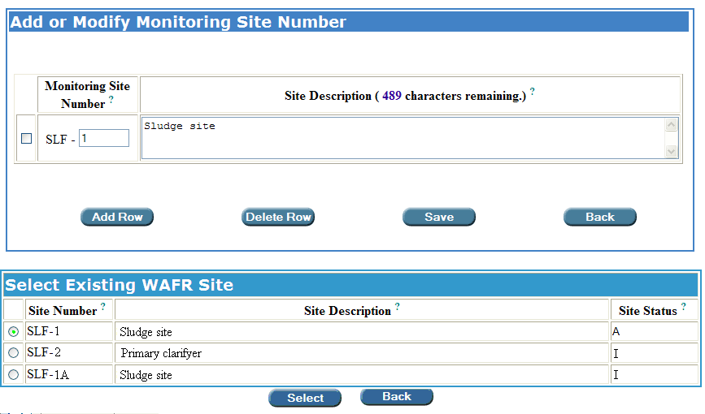
Selecting a sludge monitoring site from the “Select Existing WAFR Site” table.
Only one monitoring site at a time can be selected.

Permit Builder will then move the selected sludge monitoring site from the Select Existing WAFR Site table to the Add or Modify Monitoring Site Number table.

The permit writer selected “SLF-1” from the “Select Existing WAFR Site” table which is
now listed in the “Add or Modify Monitoring Site Number” table.

7B.2.2.4.2. The “Add or Modify Monitoring Site Number” table

Some facilities may not yet have any sludge monitoring sites associated with them through WAFR. In this case, the Select Existing WAFR Site table will be empty, as illustrated below.

You will then have to create sludge monitoring site information in the Add or Modify Monitoring Site Number table.

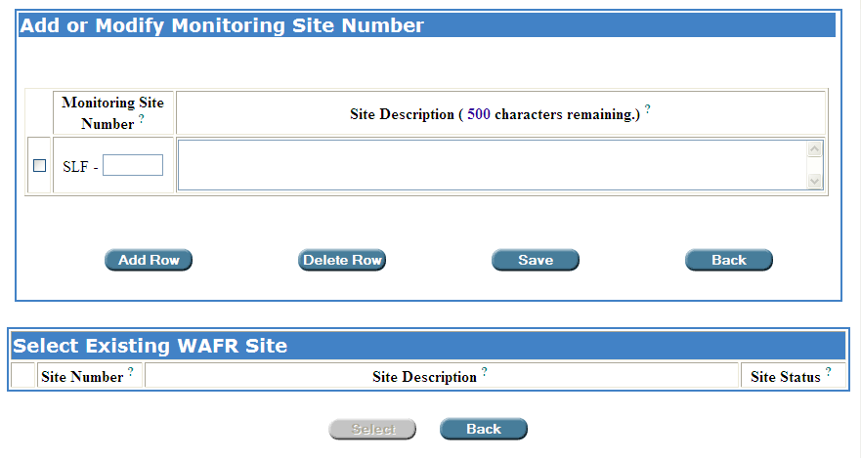
An example of a project with no sludge monitoring sites listed in the “Select Existing WAFR Site”
table. The permit writer will have to create all sludge monitoring sites.

Save ow
Fill in the Monitoring Site Number and the Site Description, click to save your entries, or to cancel your entries, and return to the sludge parameters table.
Back ow

Add Row ow
To create another sludge monitoring site, click located just below the table and complete the information. Be sure to uniquely name each monitoring site location.

A description of the facility’s sludge monitoring site(s) should be provided in the permit application.

NOTE: Each Monitoring Site Number should be unique. If not, Permit Builder will display the following message:

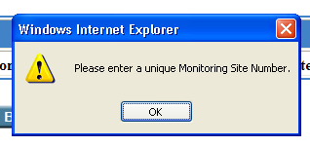

To delete a sludge monitoring site, or several sites at once, click the corresponding check-boxes on the left side of the Add or Modify Monitoring Site Number table, and then click
Delete Row ow

Once you have created the sludge monitoring site(s) on the Add or Modify Monitoring Site Number screen, these sites can be selected from the Monitoring Site Number drop-down box on the sludge parameters table.

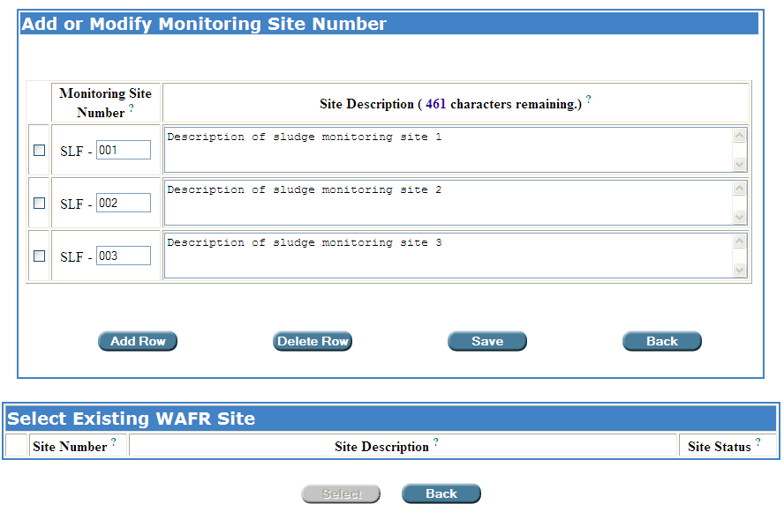
The permit writer has completed all sludge monitoring site information for the project.
Don’t forget to SAVE!

Save ow
Once you have finished adding and modifying sludge monitoring sites and clicked , Permit Builder will then return to the Parameters sub-tab.

From the sludge parameters table on the Parameters sub-tab, click on the Monitoring Site Number drop-down box.

You will now be able to view and select any of the sludge monitoring sites entered into your Permit Builder project. Select the Monitoring Site Number of the sludge monitoring site you wish to add.

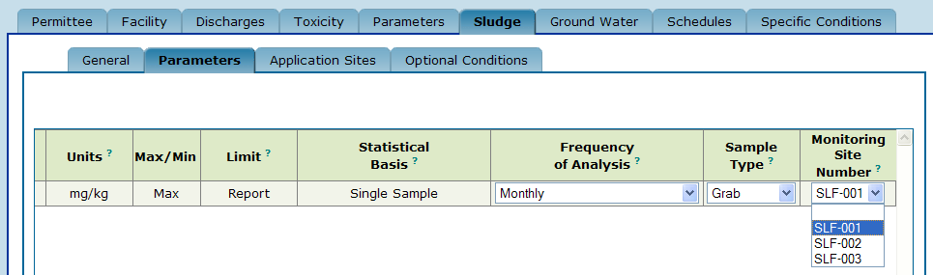
Returning to the “Parameters” sub-tab, the permit writer is now able to view a
list of the sludge monitoring sites for the project.

When sludge DMRs are generated, each sludge monitoring site number selected on the sludge parameter table will appear as its own DMR. For example, if a sludge parameter table includes parameters monitored at SLF-001, SLF-002, and SLF-003, parameters monitored at SLF-001 will appear on the monitoring group SLF-001 DMRs (monthly, quarterly, semi-annual, etc., as appropriate), parameters monitored at SLF-002 will appear on the monitoring group SLF-002 DMRs, and parameters monitored at SLF-003 will appear on the monitoring group SLF-003 DMRs. In this example, there will be at least three sludge DMRs.

7B.2.2.5. Deleting a parameter from the sludge parameters table

To delete a parameter row, or several parameter rows at once, click the corresponding check-boxes on the left side of the sludge parameters table, and then click
Delete Row ow

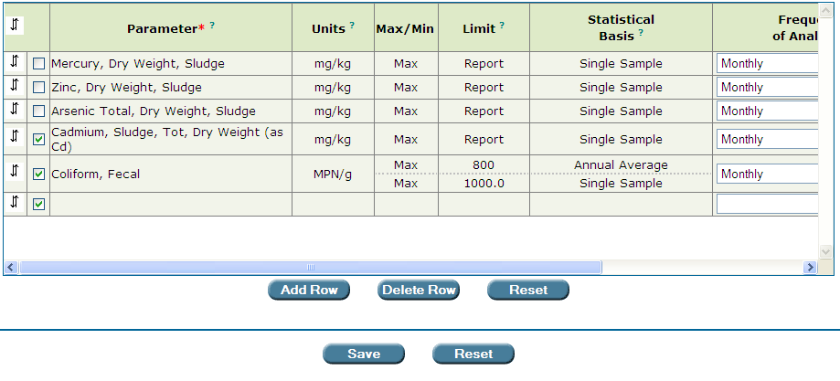
Deleting a row, or several rows at once, from the sludge parameters table.
The permit writer has clicked on the corresponding check-boxes of the parameters to be deleted
and will then click the “Delete Row” button.
7B.2.2.6. Editing parameter information from the sludge parameters table

By double-clicking anywhere in a parameter cell or its corresponding units cell, Permit Builder will display the Enter or Change Parameter screen.

In the example below, the permit writer double-clicked on the parameter cell for “Potassium.” Permit Builder then displays the Enter or Change Parameter screen with the parameter “Potassium” high-lighted within the parameters list. The highlighted parameter is also displayed at the top of the screen together with its corresponding Units.

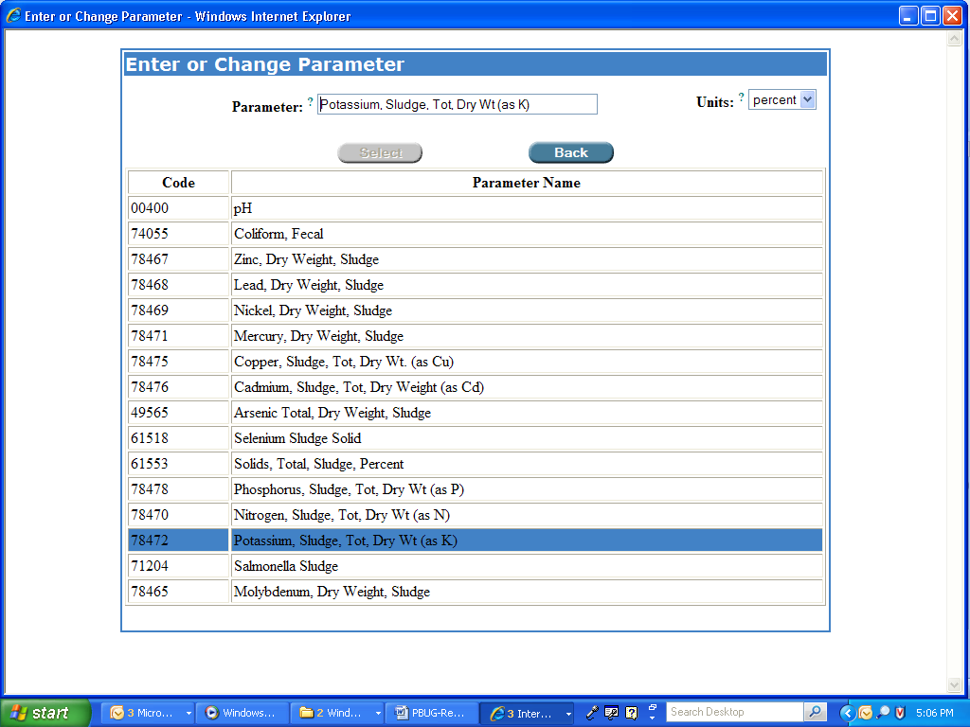
The “Enter or Change Parameter” screen.

From the Enter or Change Parameter screen, you may click on another parameter to replace the existing parameter, and you may also change the units of any parameter by accessing the Units drop-down box.

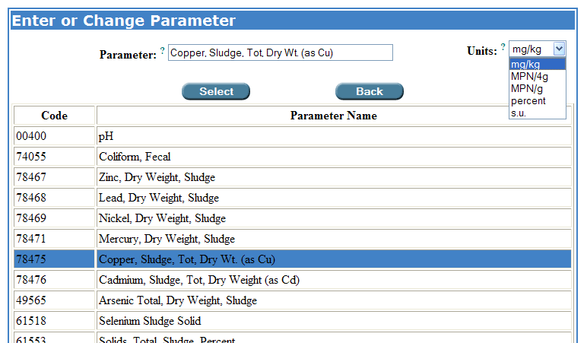
Selecting another parameter and changing the units.

Select ow
When you have finished editing the parameter, click which will insert your changes into the sludge parameters table.

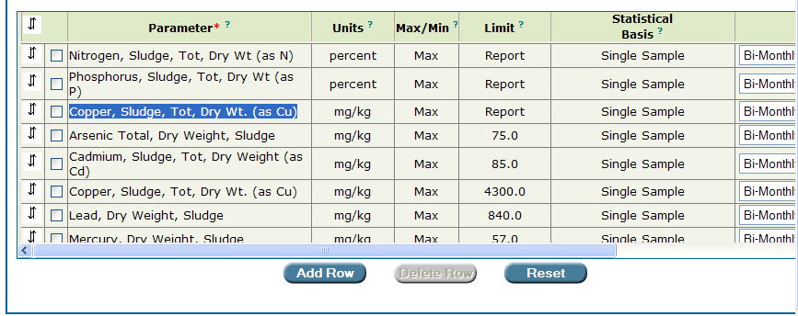
The parameter “Potassium” has been replaced by “Copper” in the sludge parameters table.

To edit the Max/Min, Limit, and/or Statistical Basis for the parameter you just edited, double-click on any of these cells in the row corresponding to the edited parameter to display the Limit and Statistical Basis screen, and make your changes.
Save ow
Be sure to click .

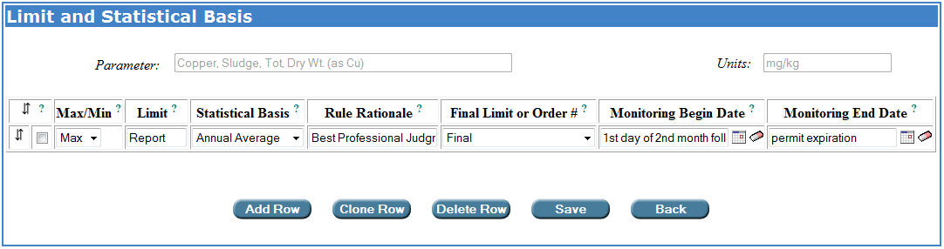

Permit Builder will then return to the sludge parameters table where you may view your changes.

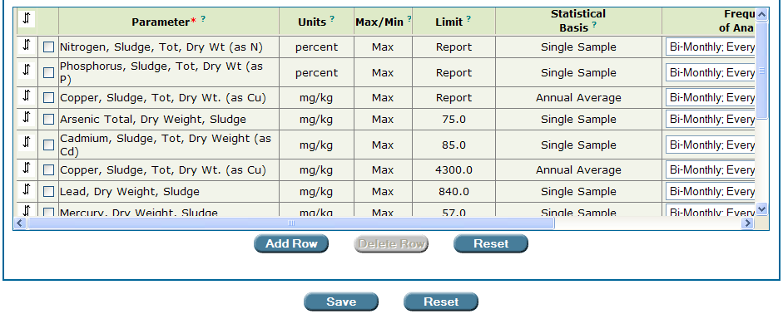
The permit writer has replaced “Potassium” with “Copper” in the third row of the table, and has also changed the “Statistical Basis” from “Single Sample” to “Annual Average.”

Save ow
Reset ow
Click to save your changes, or click located directly under the sludge
parameters table to cancel your changes.

7B.2.2.7. Moving a parameter’s position within the sludge parameters table

Permit Builder allows you to move a parameter’s location up or down within the table.

Step 1: Place your cursor over the up-and-down arrows  in the far left column of the parameter you wish to move, and click once to highlight the parameter row.

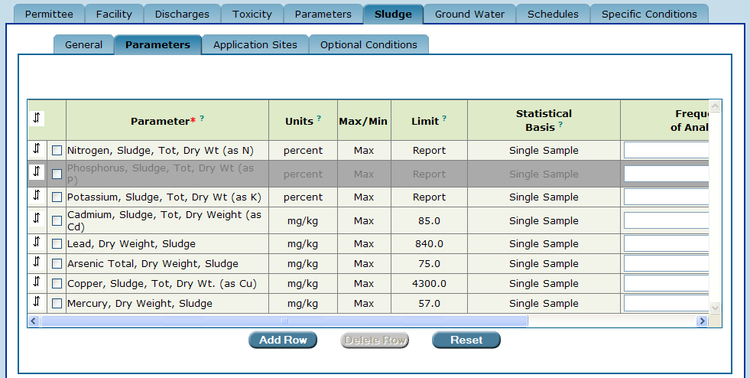
To move a parameter within the table, first high-light the parameter row by clicking on
the up-and-down arrows.

Step 2: Click the up-and-down arrows  of the row above the row where you want to move the parameter. For example, to move “Phosphorus” to the row below “Lead,” click on the up-and-down arrows  of the row for “Lead.”

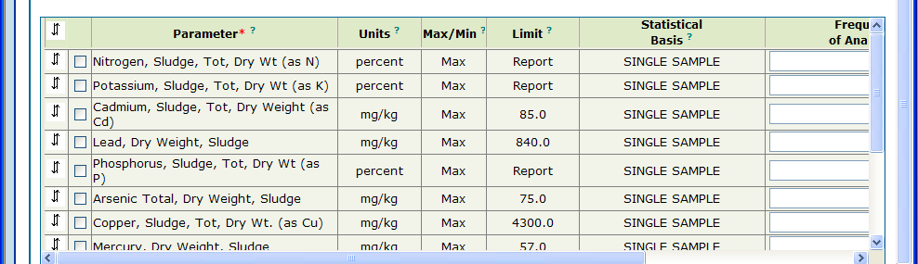
The parameter “Phosphorus” has been moved below the parameter “Lead.”

7B.2.2.8. Moving a parameter’s position to the top row of the sludge parameters table

To move a parameter to the top row of the parameter table:

Step 1: Place your cursor over the up-and-down arrows  in the far left column of the parameter you wish to move and click once to highlight the parameter row.

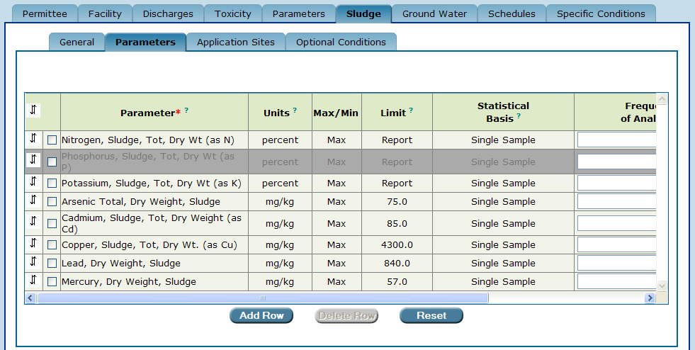
To move a parameter to the top row of the table, first high-light the parameter row
by clicking on the up-and-down arrows.

Step 2: Click up-and-down arrows  in the top left corner of the parameter table.
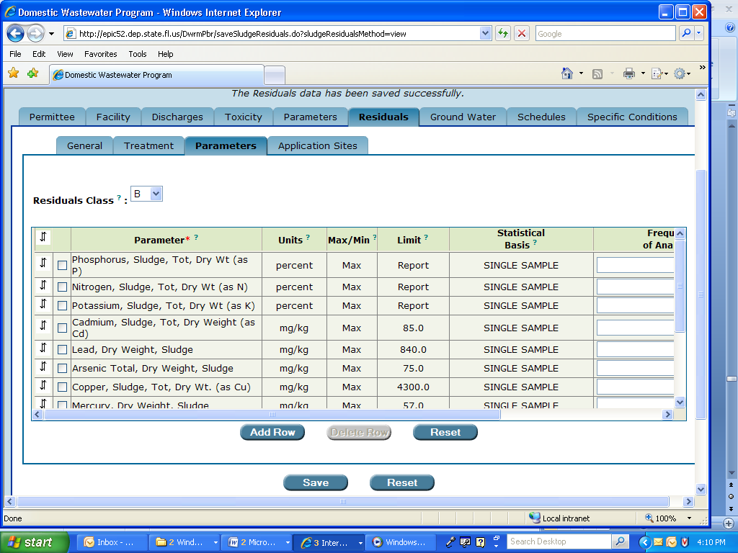
The “up-and-down arrows” at the top left-hand corner of the table.

The parameter “Phosphorus” has been moved to the top of the table.

7B.2.2.9. Adding additional parameter information to the sludge parameters table

Permit Builder gives you the capability to include in your permit project additional information about a parameter that will be displayed in the permit document and the DMR once they have been generated.

By left-clicking ? in the Parameter heading, Permit Builder will display a text box (illustrated below), describing how to enter this additional information:

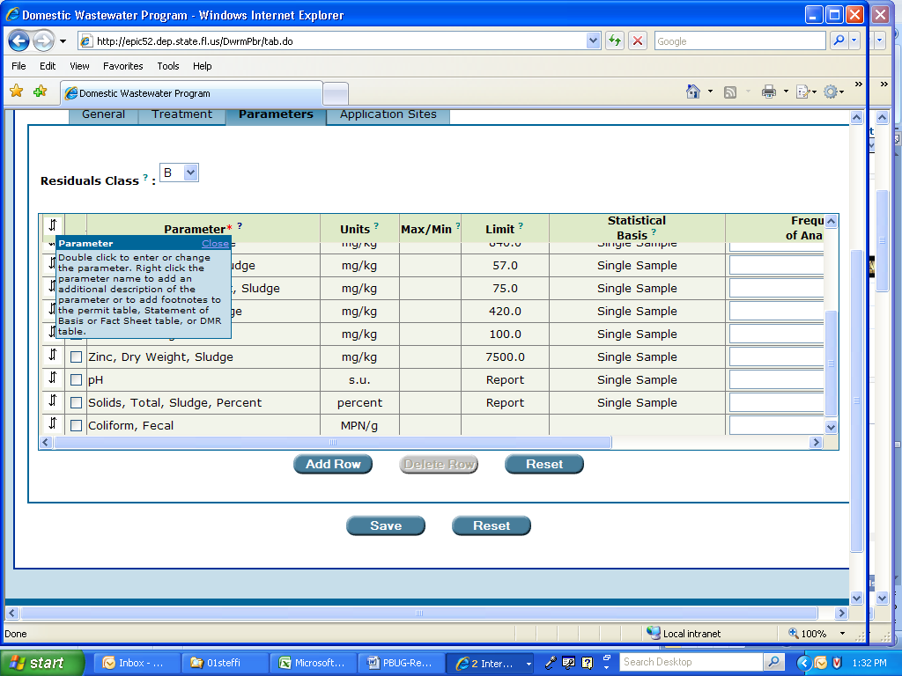

To begin entering additional information for a particular parameter, use the following steps:

Step 1: Right-click on the parameter name.

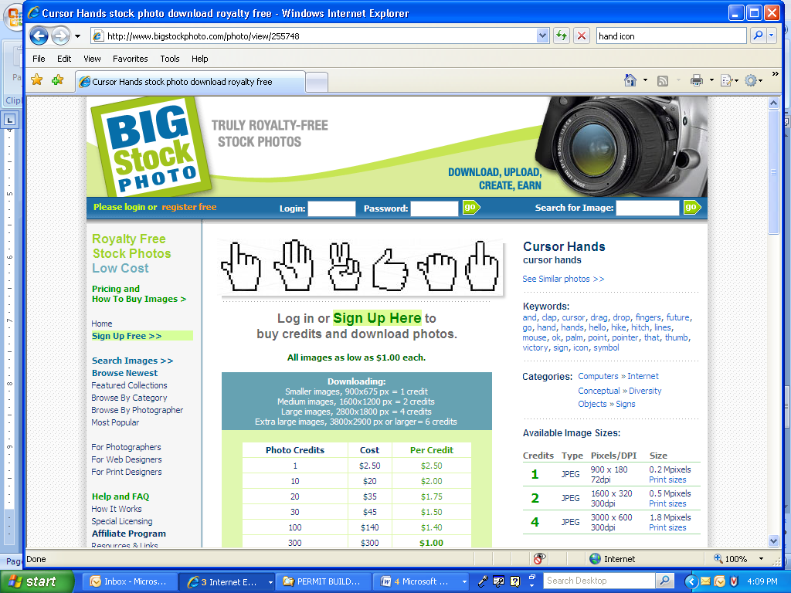
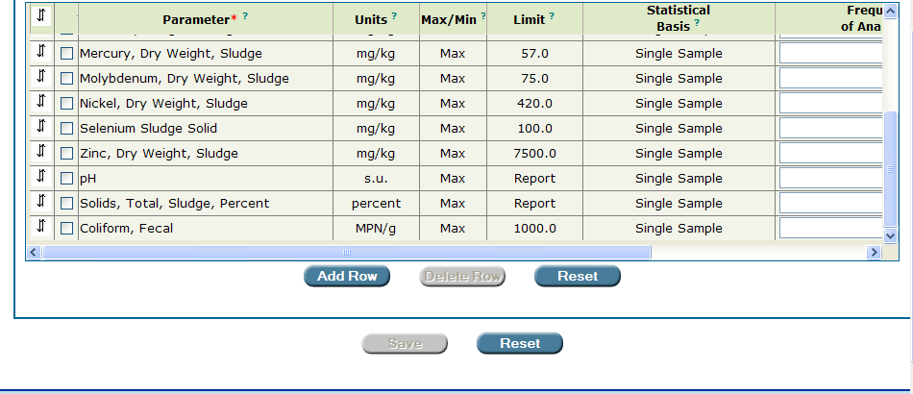
Editing parameter information.
Begin by right-clicking on the parameter name – “Coliform, Fecal” in this example.

Permit Builder will then display the Add to Parameter Description or Add a Footnote screen seen below.

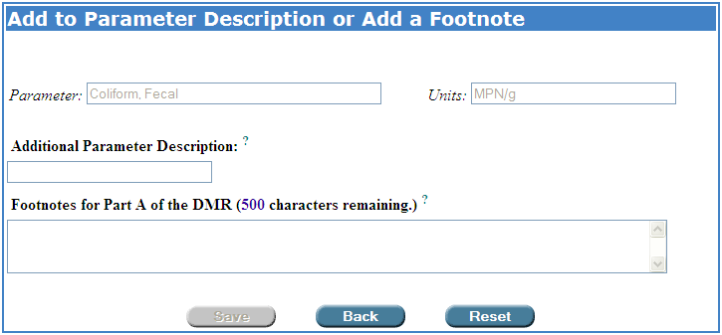
The “Add to Parameter Description or Add a Footnote” screen.

Step 2: Type in any appropriate information relating to the facility’s monitoring of the specific parameter being added or edited. This information will then appear in the permit text and DMR of your Permit Builder project once these documents have been generated.

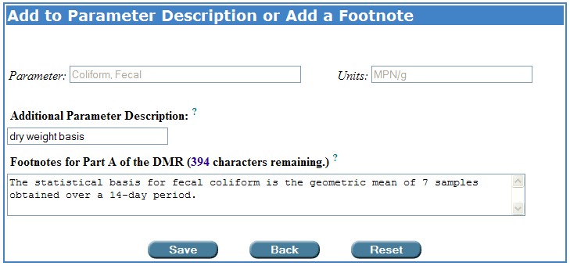
Typing text in the “Add to Parameter Description or Add a Footnote” screen fields.
Permit Builder will incorporate this information into the permit documents.

Save ow
Step 3: Click to save your entries and return to the sludge parameters table.
Back ow
Click to cancel and return to the sludge parameters table.
Reset ow
Click to restore the table to the entries last saved.

7B.2.2.10. The two “Reset” buttons on the sludge parameters table page

Once you have finished entering or changing all parameter information and Permit Builder has returned to the sludge parameters table, you will notice the two Reset buttons – one located directly beneath the table next to the Delete Row button, and the other farther down next to the Save button.

Do not confuse the two “Reset” buttons!
Clicking the Reset button located directly under the parameter table next to the Delete Row button will restore the table to the entries last saved. Clicking the Reset button located next to the Save button will restore all changes made to the Sludge tab and all its sub-tabs to the information and settings last entered and saved by the permit writer.

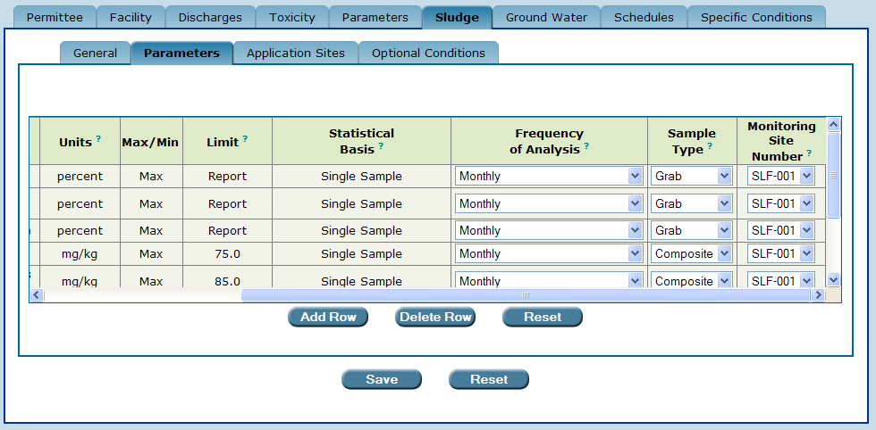
Click this Reset button to restore the table to the entries last saved.
Click this Reset button to restore all changes made to the Sludge tab and its sub-tabs to the entries last saved.

7B.3. The “Application Sites” sub-tab

Once you have clicked on the Application Sites sub-tab, Permit Builder will display the application site table. For a new Permit Builder project, this table should be empty as illustrated below, indicating that you will need to add one or more sludge application sites to your project.

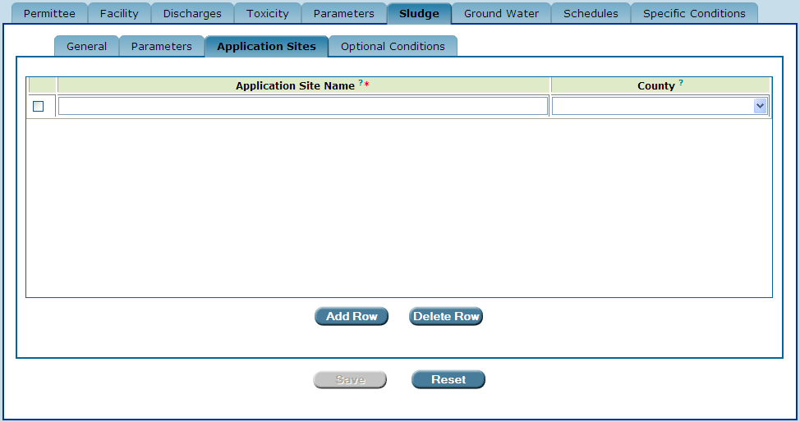
The application site table on the“Application Sites” sub-tab. An empty table indicates that sludge application sites have not yet been entered into the Permit Builder project.

7B.3.1. Adding sludge application sites to your Permit Builder project

To add one or more sludge land application sites to your Permit Builder project, use the following steps:

Step 1: Type in the name of the site where sludge will applied in the Application Site Name field and select the county in which the application site is located from the County drop-down box.. Application site information should be provided in the facility’s permit application.
Add Row ow
Step 2: To add another application site name, click located under the sludge application site table.

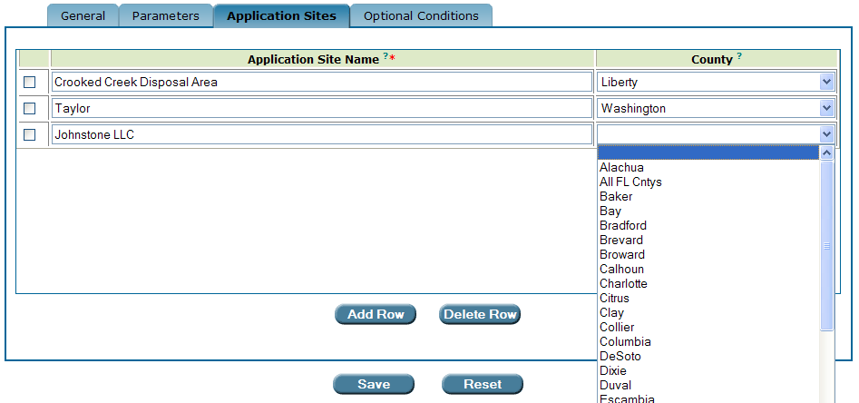
The “Application Sites” sub-tab now displays the sites the permit writer has entered

Reset ow
Save ow
Step 3: Click to save your entries, or to restore the table to the entries last saved.

7B.3.2. Deleting sludge application sites from your Permit Builder project

To delete one or more application sites from the sludge application site table, simply click on the
corresponding check-boxes and then click the button.
Delete Row ow

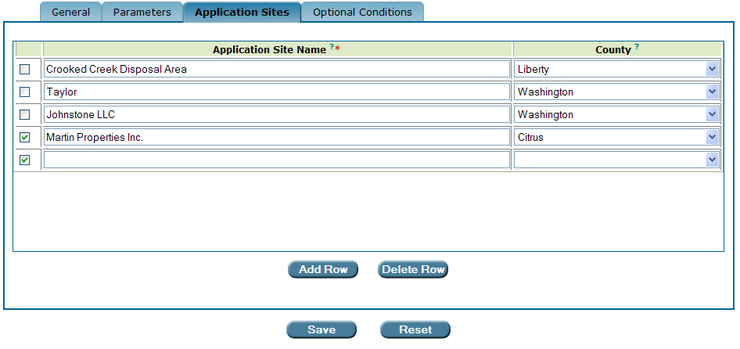
Deleting application sites from the sludge application site table.

7B.4. The “Optional Conditions” sub-tab

The permit conditions on the Optional Conditions sub-tab are generally applicable to facilities that land apply sludge.

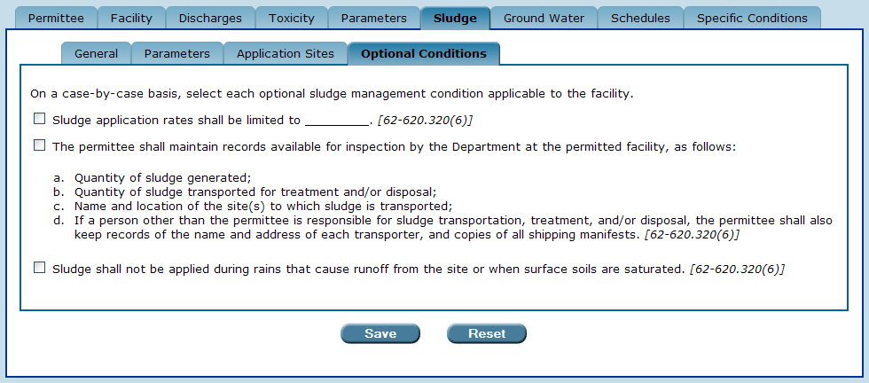
The “Optional Conditions” sub-tab

If any of these statements apply to your Permit Builder project, select the appropriate check-boxes. The selected statements will appear as permit conditions in the body of the permit.

When the “sludge application rates shall be limited to ________.” check-box statement is selected, a Sludge Application Rate field appears allowing you to type in the sludge application rate to which the facility will be limited.

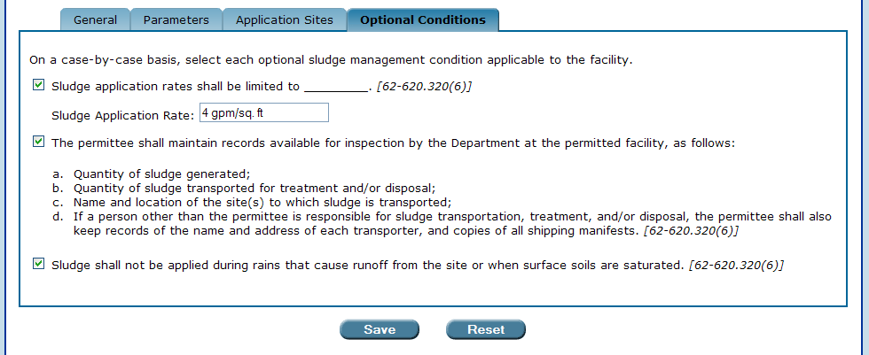
The “Sludge Application Rate” field appears when the “sludge application rates shall
be limited to _____.” checkbox statement is selected.

7B.5. The “Save” and “Reset” buttons

Once you have finished with the Optional Conditions sub-tab, you will also be finished entering all required data corresponding to the Sludge tab, and are ready to move on to the next Permit Builder tab.

Be sure to:
Save ow
- Click to save your entries to Optional Conditions sub-tab.
Reset ow
- Click to clear all entries made to the Optional Conditions sub-tab. This will restore all fields to any information entered before the last time this sub-tab was saved.

CONGRATULATIONS!
YOU HAVE COMPLETED THE “SLUDGE” TAB

See DEP program guidance memorandum OWM-01-02, Permitting of Solid Waste Disposal Areas Associated with Industrial Facilities, available at http://depnet/wrm/policy_manuals.htm. See also the Division of Waste Management’s rulemaking plans webpage at http://www.dep.state.fl.us/waste/categories/solid_waste/pages/IWDR.htm for information on the Division’s plans to develop specific requirements for the storage, disposal, and beneficial use of non-hazardous industrial wastes. Additionally, specific industries and facilities have sought and received exemptions from portions of chapter 62-701, F.A.C., that have allowed them to modify their sludge management requirements under that chapter (e.g., Florida Electric Power Coordinating Group, Inc., 1994, Evaluation of Solid Waste Management Practices and Requirements - Florida Electric Utility Industry, prepared by Woodward-Clyde Consultants, Tallahassee, Florida, July, and Florida Pulp & Paper Association, 1994, Request for Alternate Solid Waste Requirements for the Florida Pulp & Paper Industry, prepared by CH2MHILL, Gainesville, Florida, October).
Land Application is really a beneficial use of sludge. The only true disposal method for non-hazardous waste is Class I Solid Waste Landfill.
Facilities storing, transporting, and disposing of sludge characterized as hazardous waste must do so in accordance with the requirements of Chapter 62-730, F.A.C.
The Parameters sub-tab located within the Sludge tab addresses sludge monitoring parameters and should not be confused with the Parameters tab which addresses wastewater effluent monitoring parameters.
All parameter information that appears in the sludge parameters table will appear in the permit and in Part A of the Discharge Monitoring Report (DMR) Permit Builder will eventually generate for the permit project.
Parameters that have “Report” in their Limit column are not limited to a specific numerical value. However, the facility is required to report numerical values of these parameters on its DMR. These values may then be used to calculate other values subject to a permitted limit such as a monthly or annual average.
Clicking the Back button will cancel any entries you made on the Limit and Statistical Basis screen by closing the screen and returning to the sludge parameters table.
Please remember that a Permit Builder project may be created only when the permit has not yet been issued in WAFR-PA. However, once a Permit Builder project has been created, the permit may be issued at any time. An existing Permit Builder project may be edited or uploaded to WAFR regardless of whether it has been issued. Please note, however, that the permit must have been issued in WAFR-PA before a Permit Builder project containing interim limits may be uploaded to WAFR.
If the Select Existing WAFR Site table does not initially appear with the Add or Modify Monitoring Site Number table, click the Add Row button at the bottom of the Add or Modify Monitoring Site Number screen.
If you cannot view a list of sludge monitoring sites and the Monitoring Site Number drop-down box is still empty, then most likely you forgot to click the SAVE button after inputting sludge monitoring site information.
Do not confuse this Reset button with the reset button located next to the Save button which, when clicked, will restore all changes to the Sludge tab and all its sub-tabs back to the information and settings you last saved.
When Permit Builder generates the facility’s Discharge Monitoring Report (DMR), the parameters will appear in the same order as they appear in the parameter tables in Permit Builder.

