8. The “Ground Water” tab

The “Ground Water” tab for domestic wastewater facilities.

The “Ground Water” tab for industrial wastewater facilities.

Domestic and industrial facilities that dispose of their effluent through land application sites such as those discussed in Chapter 4, may be required to monitor ground water by means of the following types of wells:

- Background monitoring well (MWB) – an up-gradient monitoring well located as close as possible to the land application site without being affected by that site’s discharge, in order to determine the natural background quality of the ground water.
- Compliance monitoring well (MWC) – a down-gradient monitoring well located at the edge of the zone of discharge from the land application site.
- Intermediate monitoring well (MWI) – a down-gradient monitoring well located within the zone of discharge and designed to detect the chemical, physical, and microbiological characteristics of the discharge plume.
- Piezometer monitoring well (MWP) – a well used solely to monitor water-level elevation to aid in determining the direction of groundwater flow.

8.1. The “Monitoring Groups Associated with Groundwater Monitoring” screen

To first thing to do on the Ground Water tab is to associate a Monitoring Group with the ground water monitoring requirements that will be established in the facility’s permit.

In the example illustrated in the screen shot below, the Monitoring Group drop-down box is narrow and empty, indicating that the permit writer has not yet associated a monitoring group with the ground water tab for this particular Permit Builder project.

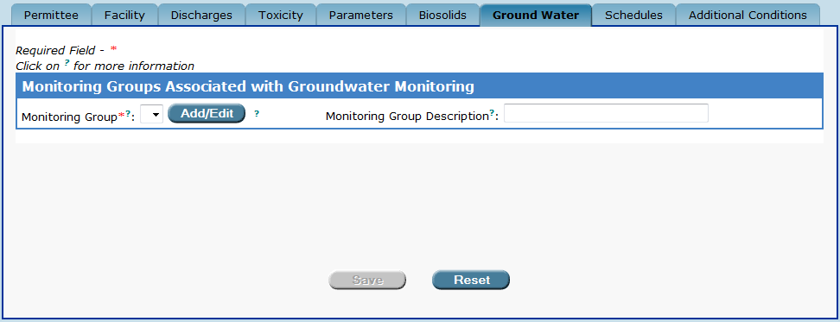
The “Ground Water” tab.
In this example, the “Monitoring Group” drop-down box is narrow and empty, indicating that the
permit writer has not yet associated a monitoring group with ground water monitoring.

To add a Monitoring Group or edit a Monitoring Group previously created in the Discharges tab:

Add/Edit
Step 1: Click the button located to the right of the Monitoring Group drop-down box.

Permit Builder will then display the Edit Monitoring Groups screen, illustrated below:

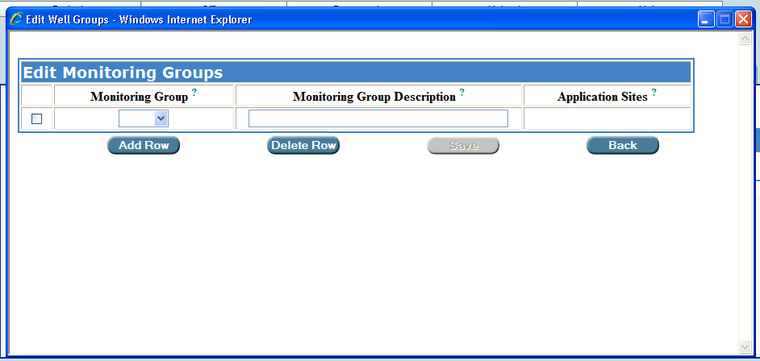
The “Edit Monitoring Groups” screen.

Step 2: Click the drop-down arrow under the Monitoring Group heading to display all monitoring groups available for ground water monitoring, previously created in the Discharges tab. Select a Monitoring Group by clicking on it.

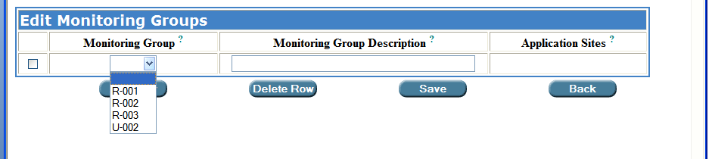

NOTE: If Permit Builder displays the message illustrated below after you selected a Monitoring Group from the drop-down list, you will have to return to the Discharges tab to input application site information for the particular Monitoring Group (R-002 in this example).

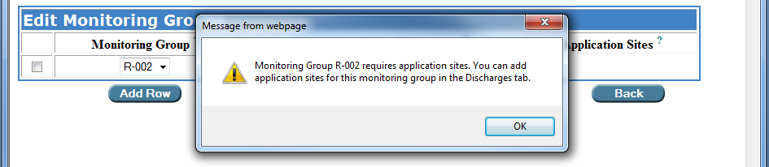
The permit writer has selected Monitoring Group R-002, but will have to return to the “Discharges” tab to input application site information for Monitoring Group R-002.

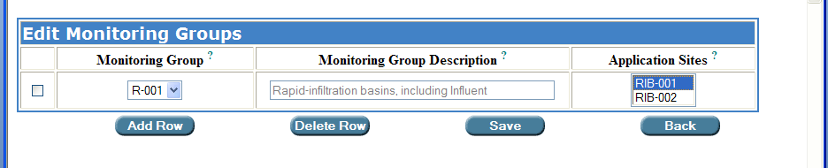
In this domestic wastewater example, the permit writer has selected Monitoring Group R-001 which has two rapid infiltration basin systems – RIB-001 and RIB-002 – already associated with it from the Discharges tab.

Step 3: If the Monitoring Group has more than one Application Site associated with it and ground water monitoring is required for more than one of the associated sites, select all appropriate sites by holding down the Control Key (CTRL) while clicking each site.

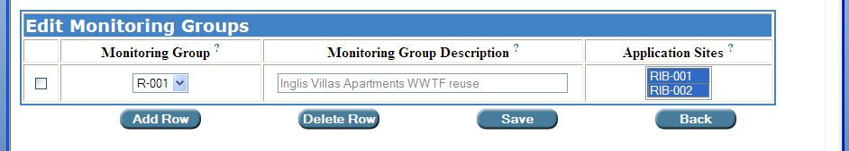
To select more than one site in the “Application Sites” field,
hold down the Control Key while clicking on each site.

To return to the Monitoring Groups Associated with Groundwater Monitoring screen, click
Save

Otherwise, continue to Step 4.

Step 4: If the facility has more than one Monitoring Group associated with a land application site, click and then select the other Monitoring Group (R-002 in this example).
Add Row

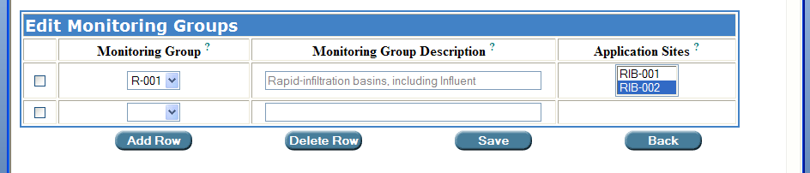

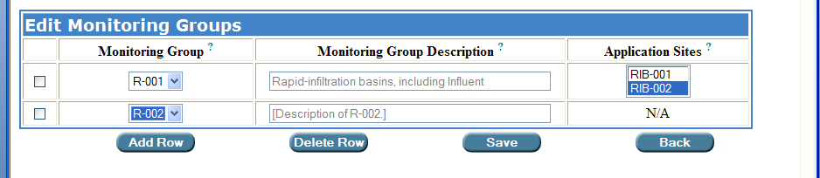
The permit writer has added another row and then selected Monitoring Group R-002, which in this example, is a Slow-Rate Public Access land application system. Note that the “Application Sites” column displays “N/A” for “Not Applicable,” since land application for R-002 is associated with golf course and residential irrigation system at a country club community.
Save
Step 5: Click

Permit Builder will then return to the Monitoring Groups Associated with Groundwater Monitoring screen where it will now display the Monitoring Groups associated with groundwater monitoring in the drop-down box.

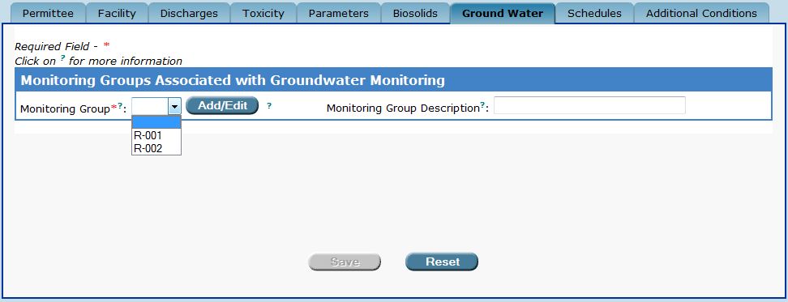

Step 6: Select a Monitoring Group and Application Site Number.

Permit Builder will then display a table with three sub-tabs:

- Monitoring Wells,
- Parameters, and
- Zone of Discharge.

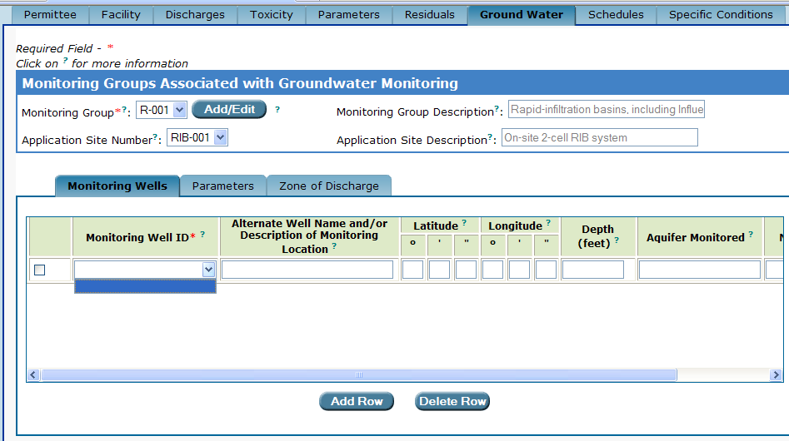
The permit writer has selected R-001 displayed in the “Monitoring Group” drop-down box.
Permit Builder then displays a table with three sub-tabs.

8.1.1. The “Monitoring Wells” sub-tab

The Monitoring Wells sub-tab contains a table, as illustrated in the screen-shot below. If the Monitoring Well ID drop-down box is empty, you will need to input monitoring well information in order to complete the Ground Water tab.

Double click anywhere in the heading row of the monitoring well table.

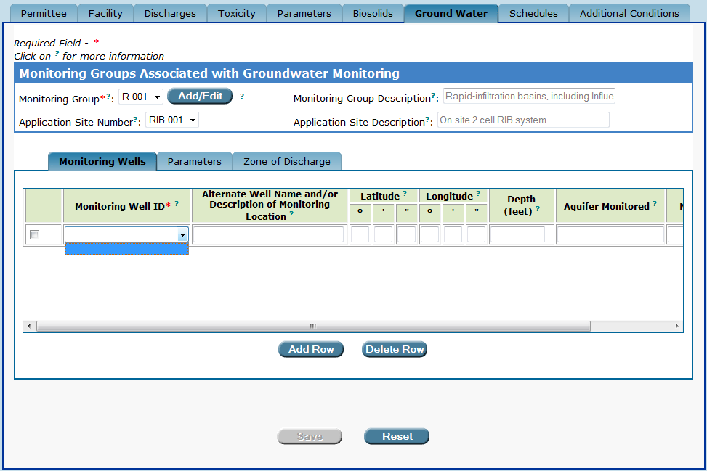
The “Monitoring Wells” sub-tab and table.
The permit writer has not yet inputted monitoring well information.

Permit Builder will direct you to the Monitoring Wells/Select Existing WAFR Site input screen illustrated below.

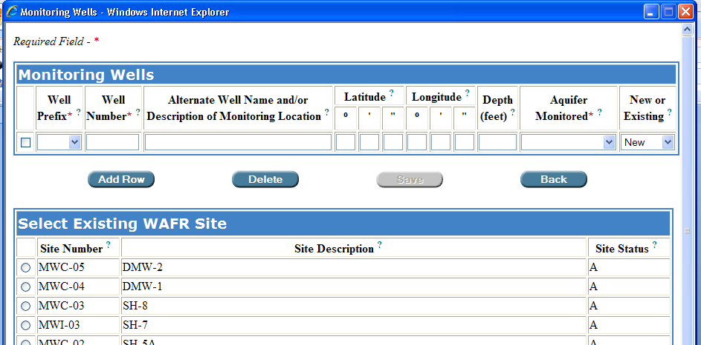
The “Monitoring Wells/Select Existing WAFR Site” input screen.

8.1.1.1. The “Select Existing WAFR Site” table

Be sure to check the Select Existing WAFR Site table which may contain one or more monitoring well sites, before entering monitoring well information in the Monitoring Well table, since the monitoring well site may already exist in WAFR.

If the Select Existing WAFR Site table contains any monitoring wells that are associated with a particular Monitoring Group, click on the corresponding radio button, and then click
Select

(You may select only one monitoring well at a time.)

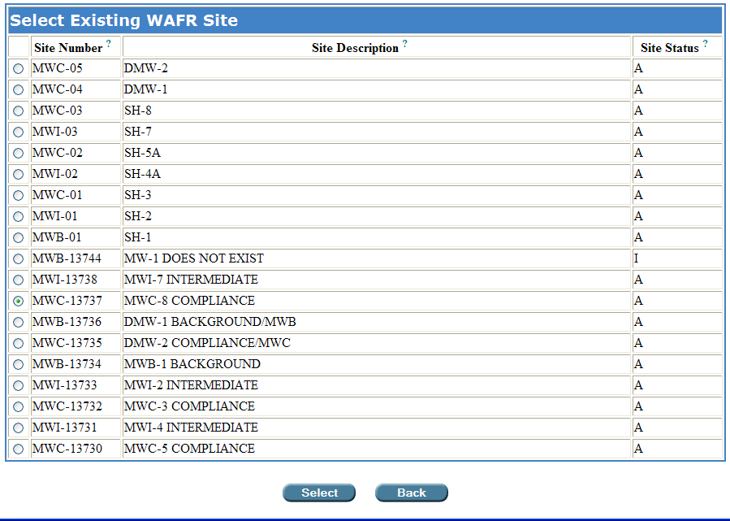
Selecting a monitoring well from the “Select Existing WAFR Site” table.
Only one well at a time can be selected.

Permit Builder will then move the selected monitoring well site from the Select Existing WAFR Site table to the Monitoring Well table, as shown below.

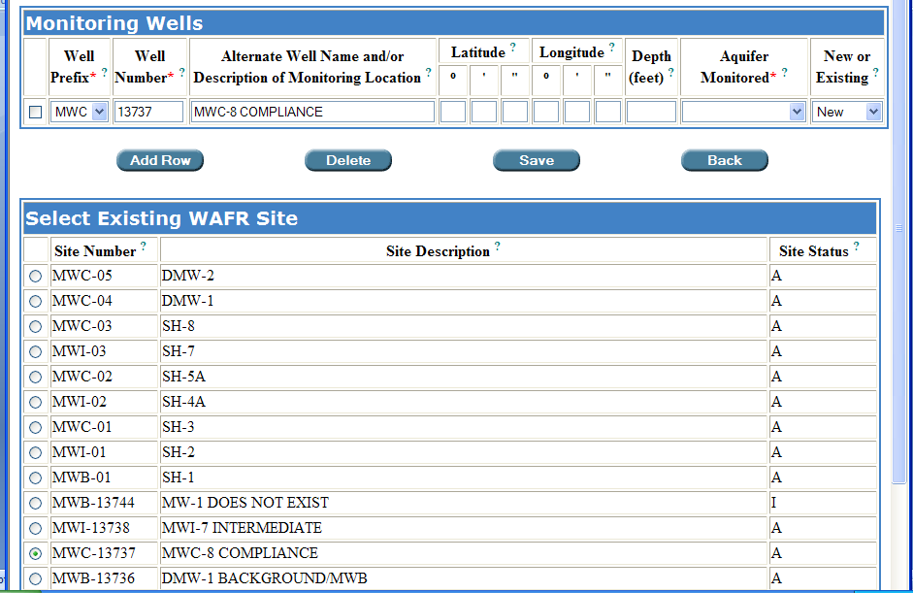
The permit writer selected “MWC-13737” from the “Select Existing WAFR Site”
which is now listed in the “Monitoring Wells” table.

8.1.1.2. The “Monitoring Wells” table

Some facilities may not yet have any monitoring well sites associated with them through WAFR. In this case, the Select Existing WAFR Site table will be empty, as illustrated below.

You will then have to create monitoring well site information in the Monitoring Wells table.

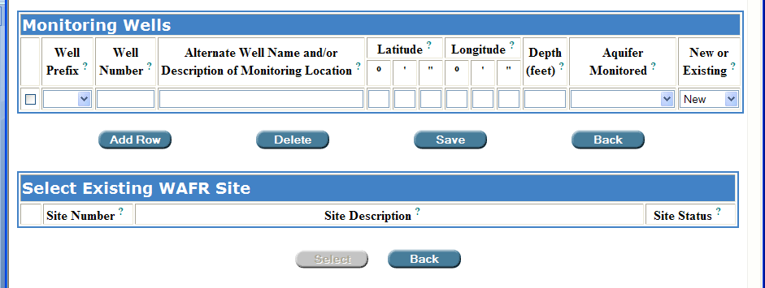
An example of a project with no monitoring well sites listed in the “Select Existing WAFR Site” table. The permit writer will have to create all monitoring well sites.

To create monitoring well site information in the Monitoring Wells table:

Step 1: From the Well Prefix drop-down box, select the appropriate prefix depending on which type of monitoring well(s) the facility uses for groundwater monitoring.

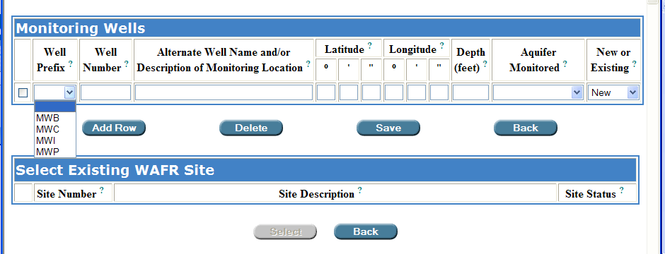
The “Well Prefix” drop-down box and its options.

NOTE: You may click on the ? next to any table heading to view more information. For Well Prefix, Permit Builder will display the following descriptions:

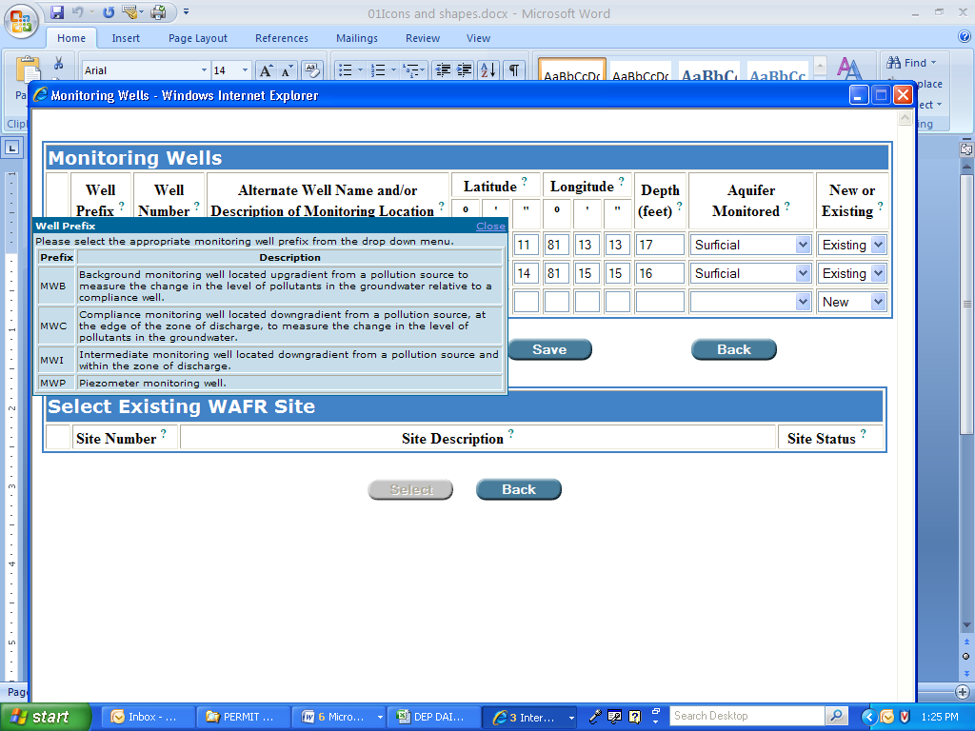

Step 2: Fill in the Well Number, Alternate Well Name and/or Description of Monitoring Location, Latitude and Longitude, and Depth (in feet) for each well.

Much of this information should be contained in the permit application and current operating permit.

NOTE: Each Well Prefix and Well Number combination should be unique. If not, Permit Builder will display the following message:

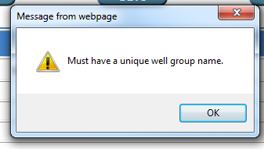

Step 3: From the Aquifer Monitored and New or Existing drop-down boxes, select the appropriate options from the corresponding lists.

Again, this information should be contained in the permit application and current operating permit.

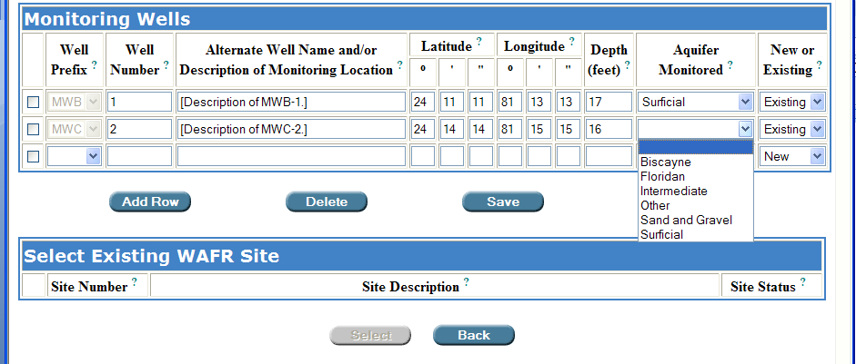
The “Aquifer Monitored” drop-down box and its list of options.

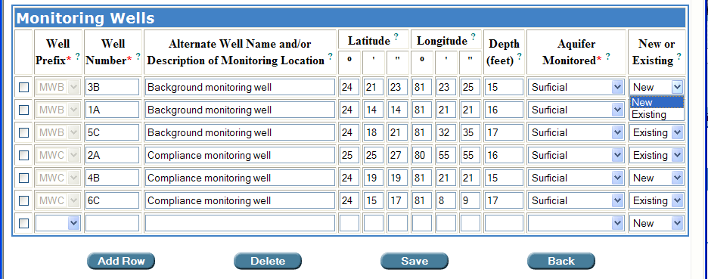
The “New or Existing” drop-down box

Step 4: Once you have completed all monitoring well information, click
Save

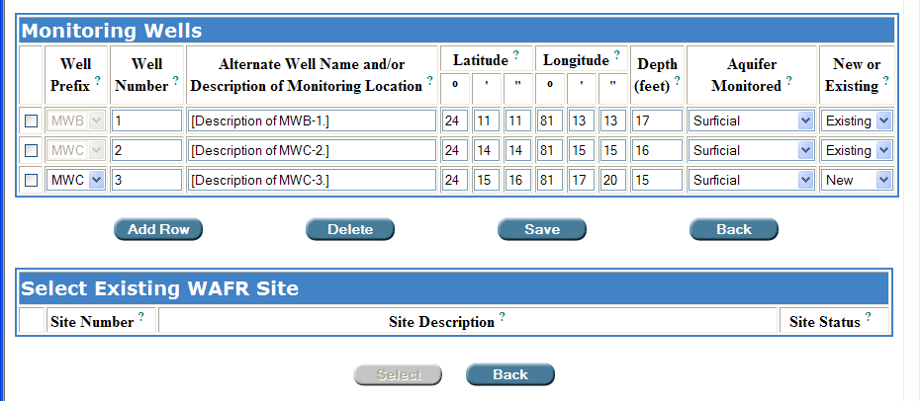

The permit writer has completed all monitoring well information for the project.
Don’t forget to SAVE!

Permit Builder will then return to Monitoring Wells sub-tab.

Step 5: From the table on the Monitoring Wells sub-tab, click on the Monitoring Well ID drop-down box.

You will now be able to view and select any or all of the monitoring wells entered into your Permit Builder project. Then select the Monitoring Well ID you wish to add.

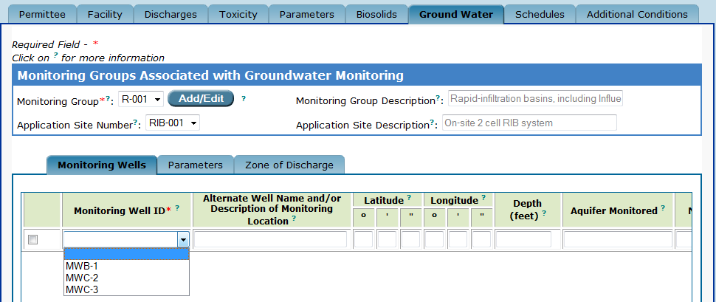

Returning to the “Monitoring Wells” sub-tab,
the permit writer is now able to view a list of the monitoring wells for the project.

Permit Builder will automatically populate the table with all of the information previously entered on the Monitoring Wells screen.
Add Row
Step 6: Click before adding another monitoring well to the table.

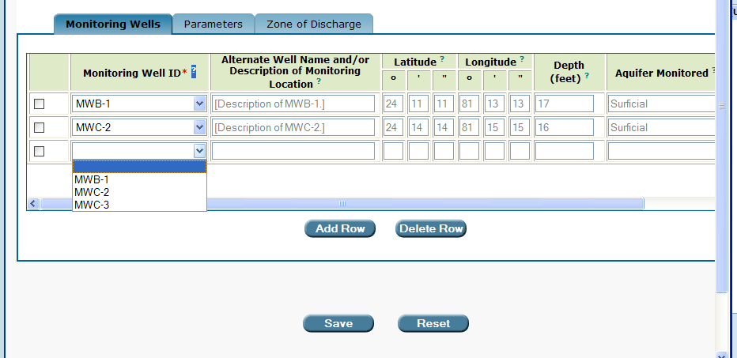

Save
Step 7: Once you have finished adding all monitoring wells to the table, click

NOTE: Clicking will restore the table to the entries last saved.
Reset

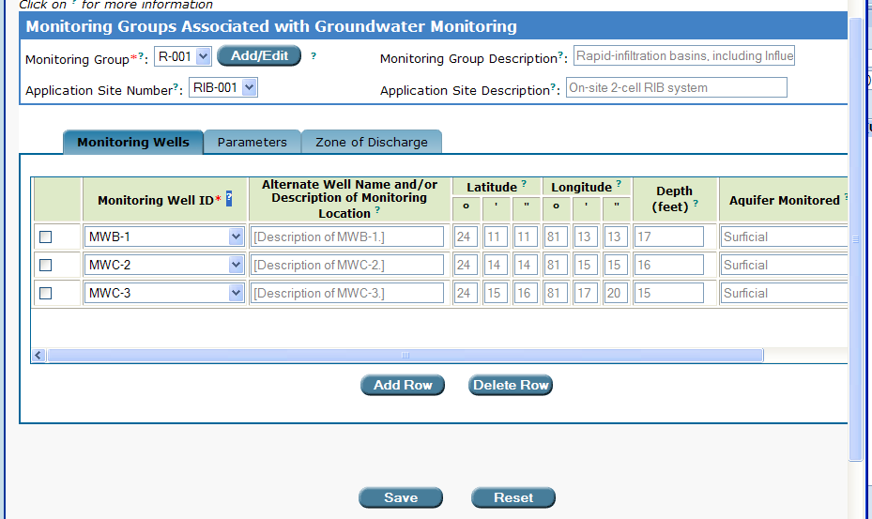
Don’t forget to SAVE!

8.1.2. The “Parameters” sub-tab

Domestic wastewater projects:

Once you have completed all ground water monitoring well information for your domestic wastewater project, Permit Builder will automatically create a table of default parameters. Each Parameter has its associated Units, Compliance Well Limit, monitoring Frequency, and Sample Type.

Click on the Parameters sub-tab to view monitoring well parameters.

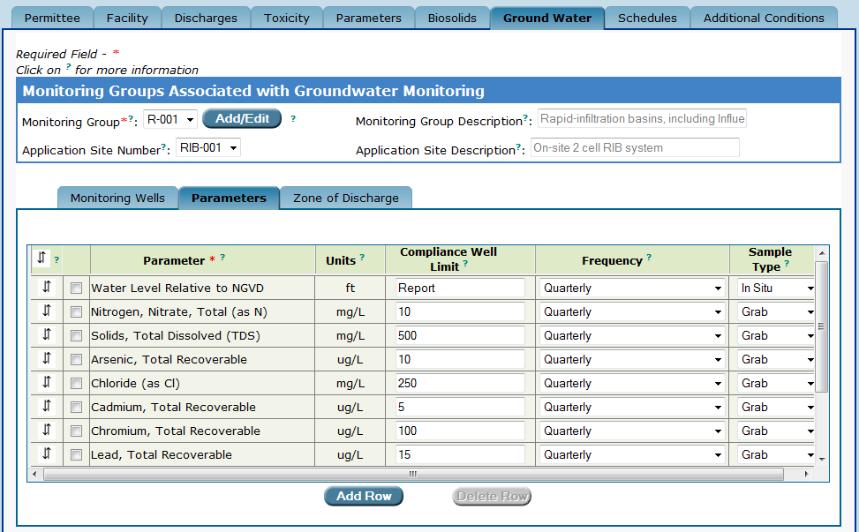
The “Parameters” sub-tab displays ground water monitoring well parameters
automatically created by Permit Builder for a domestic wastewater project.

Industrial wastewater projects:

For industrial wastewater projects, the Parameters sub-tab table will be empty until the permit writer adds a Parameter and its associated Units, Compliance Well Limit, monitoring Frequency, and Sample Type.

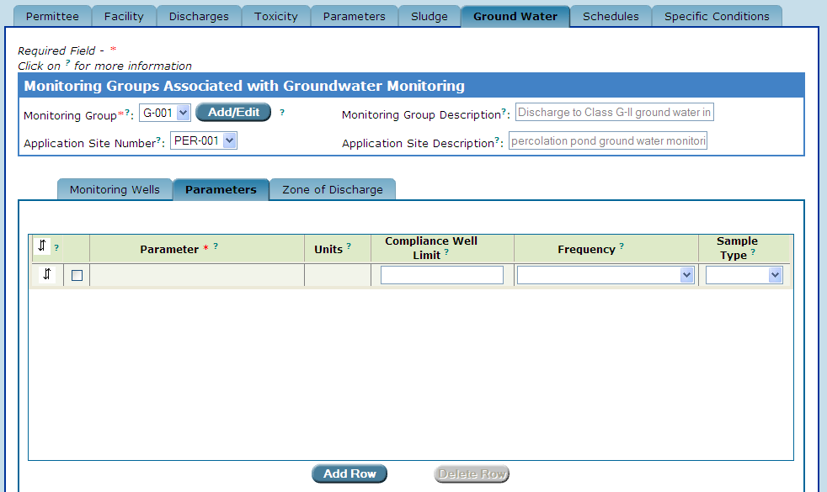
The “Parameters” sub-tab before the permit writer has input ground water
monitoring well parameters for an industrial wastewater project.

8.1.2.1. Adding and deleting parameters on the “Parameters” sub-tab

Permit Builder allows you to change the Parameters table by adding or deleting parameters from the default list.

Adding parameters:
Add Row
Step 1: Click , or proceed to Step 2 if the table already contains a blank row.
Step 2: Double-click anywhere in the blank row where the hand icon 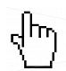appears. Permit Builder will then display the Enter or Change Parameter screen illustrated below.

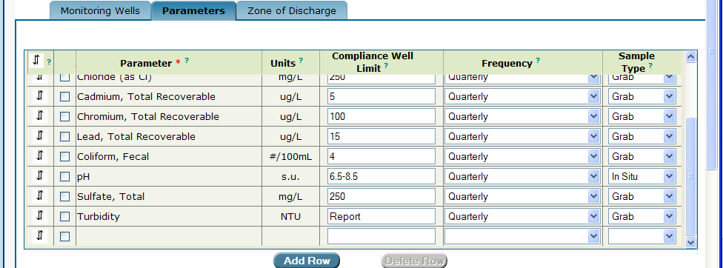
Adding a blank row to the “Parameters” sub-tab table.

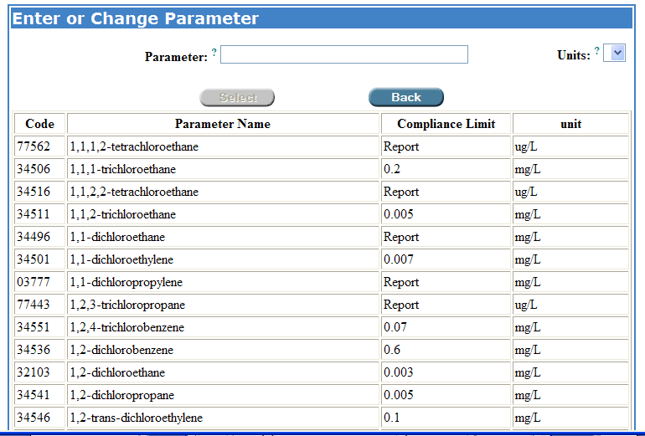
The “Enter or Change Parameter” screen.

Step 3: Scroll through the list of parameters and make your selection by clicking on the desired parameter row.
Step 4: Scrolling back to the top of the Enter or Change Parameter screen, you will notice that your parameter option has been entered in the Parameter field.

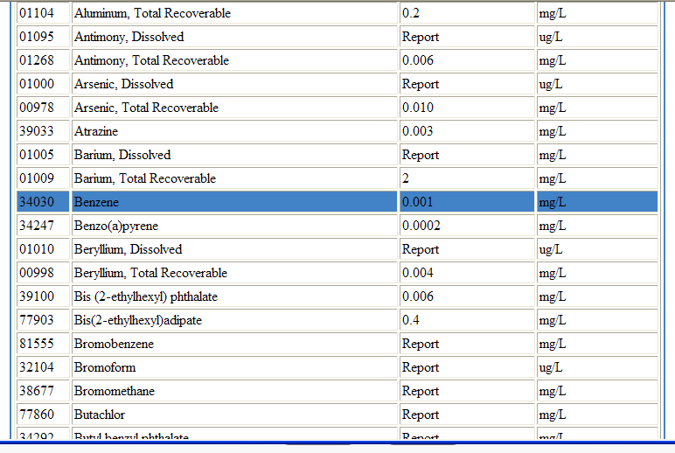
The permit writer has clicked on the parameter to be added.

Step 5: The correct units should be displayed in the Units drop-down box. If not, click on the Units drop-down box and select the correct units.

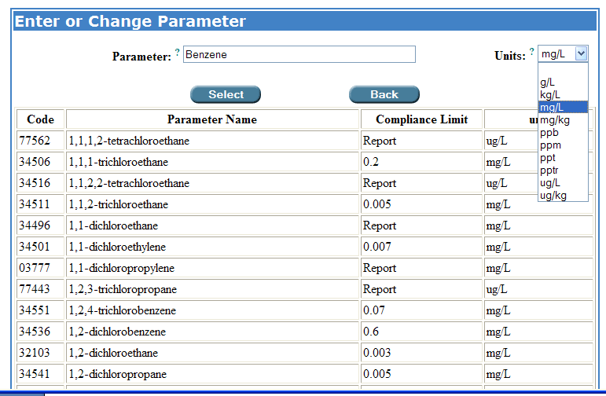
Changing units for the added parameter.

Step 6: Click to return to the Parameters sub-tab table where you will see the newly added parameter (Benzene in this example), together with its corresponding compliance limit and units.
Select
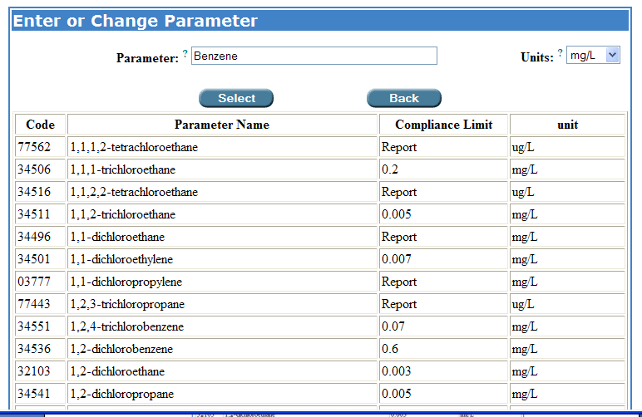

Step 7: Select the appropriate Frequency and Sample Type from the corresponding drop-down boxes.
Save
Step 8: Click to save your entry.

Reset
NOTE: Clicking will restore the table to the entries last saved.

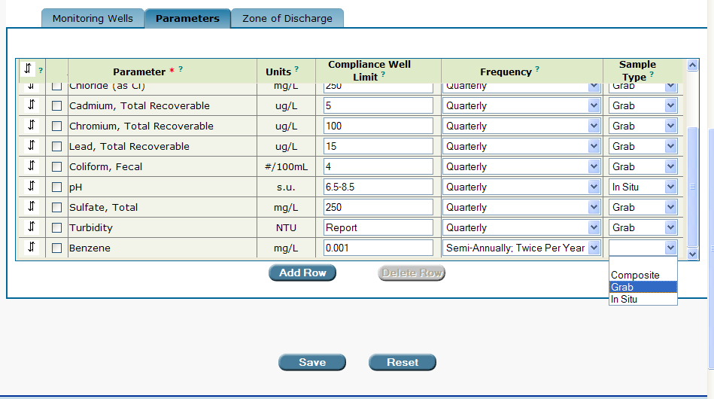
Don’t forget to SAVE!

Deleting parameters:

Step 1: Click the check boxes of the parameters you wish to delete from the table.
Delete Row
Step 2: Click .
Save
Step 3: Click to save your entry.

Reset
NOTE: Clicking will restore the table to the entries last saved.

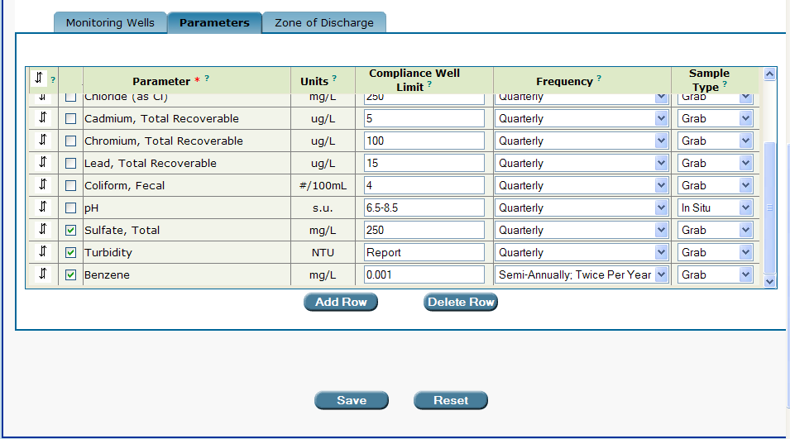
Deleting parameters from the “Parameters” sub-tab table.

8.1.3. The “Zone of Discharge” sub-tab

The Zone of Discharge sub-tab only appears for facilities with a land application system. The sub-tab contains several radio-button statements regarding the horizontal and vertical physical extents of the facility’s zone of discharge for its land application system(s). This information should be contained in the facility’s current operating permit and ground water monitoring plan.

Check the radio-button statements that correspond to your Permit Builder project.

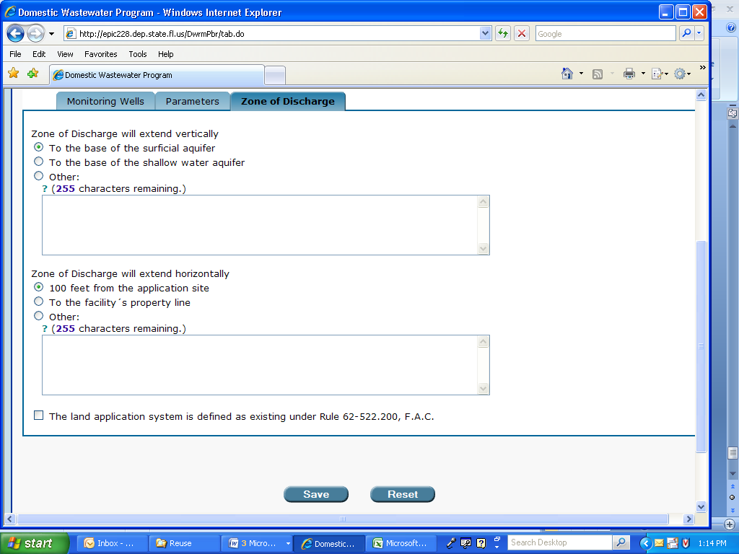

8.1.3.1. The “Rule 62-522.200” check-box statement

This statement should be checked if the facility’s land application system is defined as an “existing installation” under Rule 62-522.200, F.A.C.
Save
Don’t forget to !
CONGRATULATIONS!
YOU HAVE COMPLETED THE “GROUND WATER” TAB

Recall from Chapter 4 that a Monitoring Group identifies the type of effluent disposal system employed by the facility. Ground Water monitoring is typically associated with effluent disposal by land application, i.e., effluent disposal systems with the “R-” or “G-” designation and with underground injection well systems with the “U-” designation.
See Chapter 4, The “Discharges” Tab
Although this example makes use of rapid infiltration systems at a domestic wastewater system, the same process of adding and editing monitoring groups applies to industrial wastewater facilities with their monitoring groups and associated application sites - sprayfields (“SPF-”), drainfields (“DRF-”), percolation ponds (“PER-”), infiltration trenches (“IFT-”), and evaporation ponds (“EVP-”).
See Appendix A – Entering “Latitude” and “Longitude” coordinates.
If you cannot view a list of monitoring wells and the Monitoring Well ID drop-down box is still empty, then most likely you forgot to click the SAVE button after inputting monitoring well information. If this is the case, return to Step 1 under Section 8.1.1.2.
Before adding or deleting a default parameter, check current rule requirements, as well as with your supervisor.
Be sure to check the facility’s current operating permit before deleting (or adding) any parameters, or check with your supervisor.
This rule states: For the purposes of Chapters 62-520 and 62-522, F.A.C., “Existing installation” means any installation which had filed a complete application for a water discharge permit on or before January 1, 1983, or which submitted a ground water monitoring plan no later than six months after the date required for that type of installation as listed in Rule 62-528.700, F.A.C., (1983) and a plan was subsequently approved by the Department, or which was in fact an installation reasonably expected to release contaminants into the ground water on or before July 1, 1982, and operated consistently with statutes and rules relating to ground water discharge in effect at the time of the operation.

