11. Drafting and Uploading Permit Documents

Now that you have addressed all tabs in Permit Builder for your project, you are ready to draft the permit documents.
Documents ow
From the Tabs screen illustrated below, click to access the menu of documents.

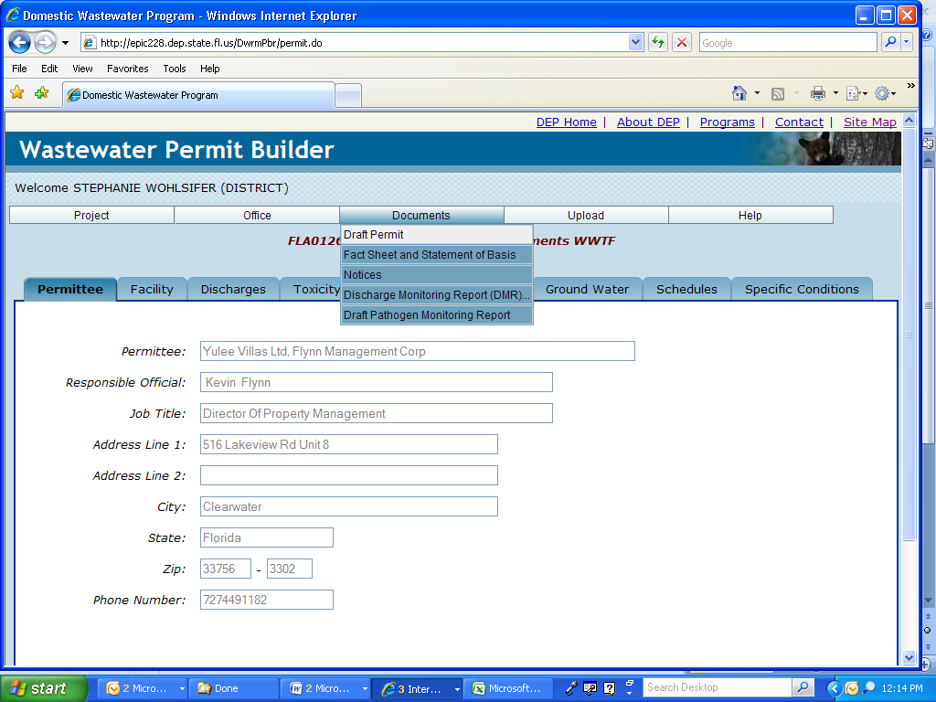
The “Tabs” screen and “Documents” menu.

11.1. Generating the “Draft Permit”

From the Documents menu, click Draft Permit.

Permit Builder will ask you to Please Wait… while it generates the permit.

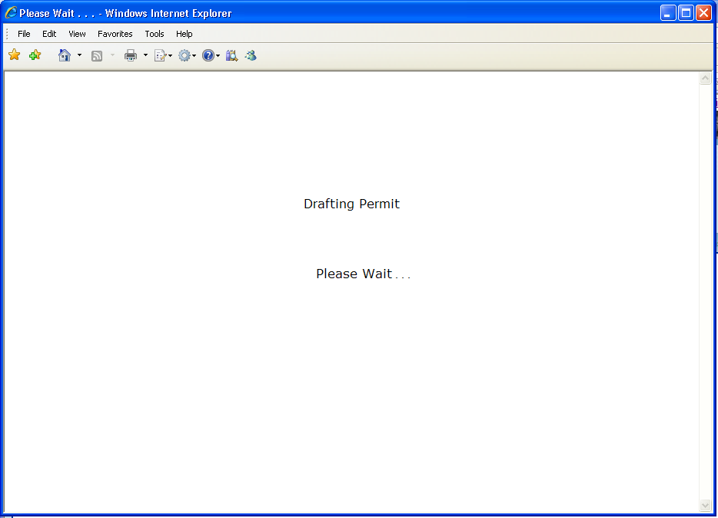

Permit Builder will then display the File Download window.
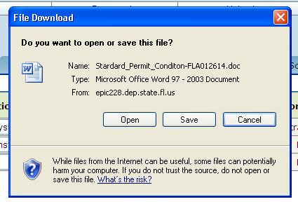
Permit Builder has assigned a default name to the document.

When clicking Permit Builder will display the Save As window with the default file name displayed in the in the File name field, where you can save draft permits at a location of your choice.
Save
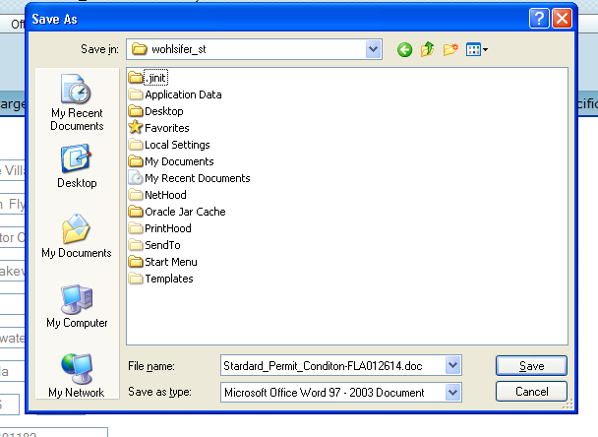

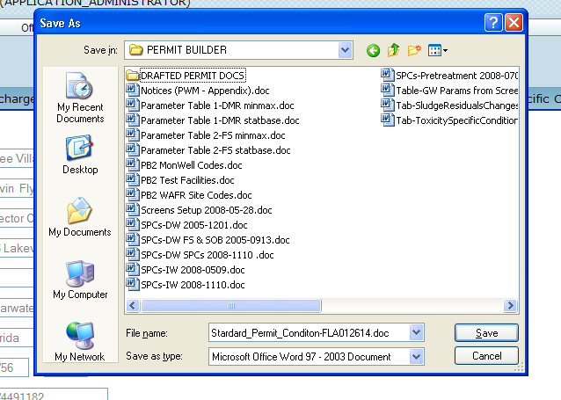
The permit writer has created a folder for saving draft permit documents generated by Permit Builder.

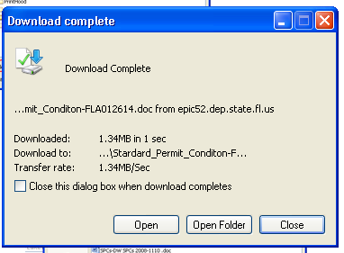
The “Download Complete” screen which should
appear after successfully saving the draft permit.

After clicking , Permit Builder will display the draft permit in Microsoft Word© where you can view it directly and then save if you haven’t already.
Open

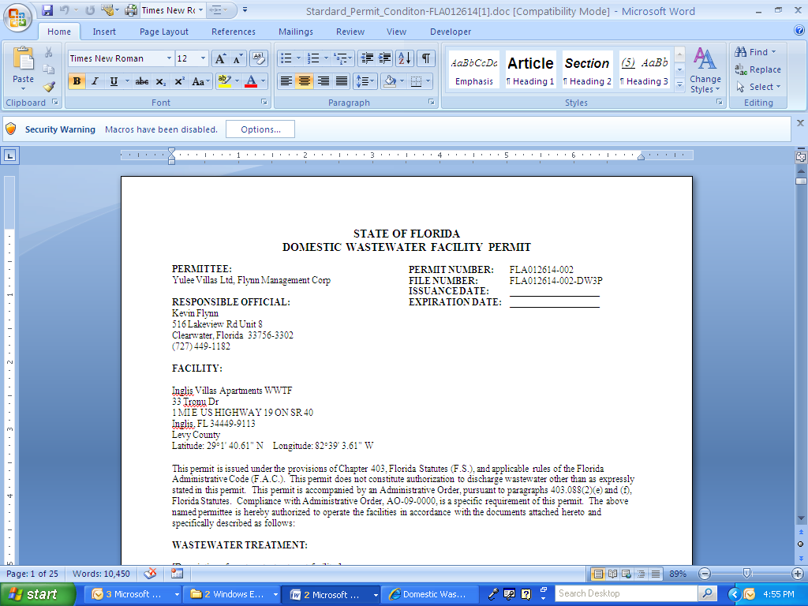
Permit Builder has drafted the permit in Microsoft Word©.

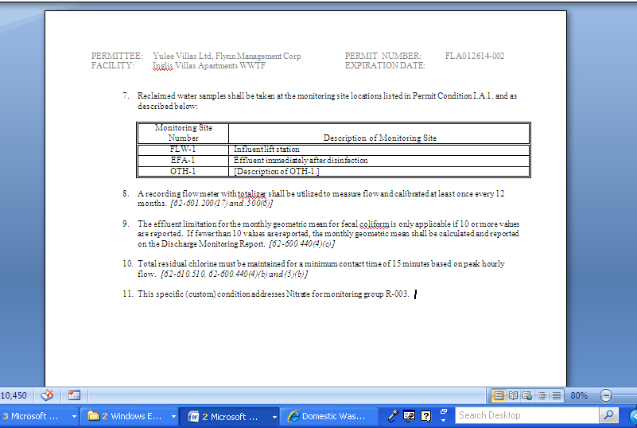
The specific (custom) condition added by the permit writer in the “Specific Conditions” tab
appears in the body of the permit.

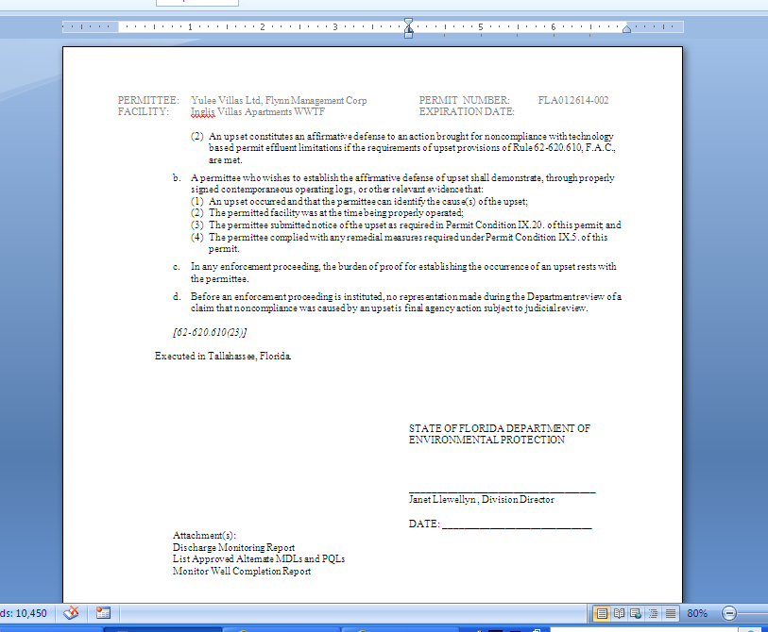
The last page of a drafted permit, showing the office of origin, the name of the authorized person, and a list of attachments.

11.1.1. Activating the “Macros Security Warning” message in MS Word©

In order for MS Word© to show the correct standard permit condition references in the parameters tables, you will have to enable Macros.

After you have opened your draft permit, check to see whether the Macros Security Warning message is displayed in a bar located above the document and below the toolbars.

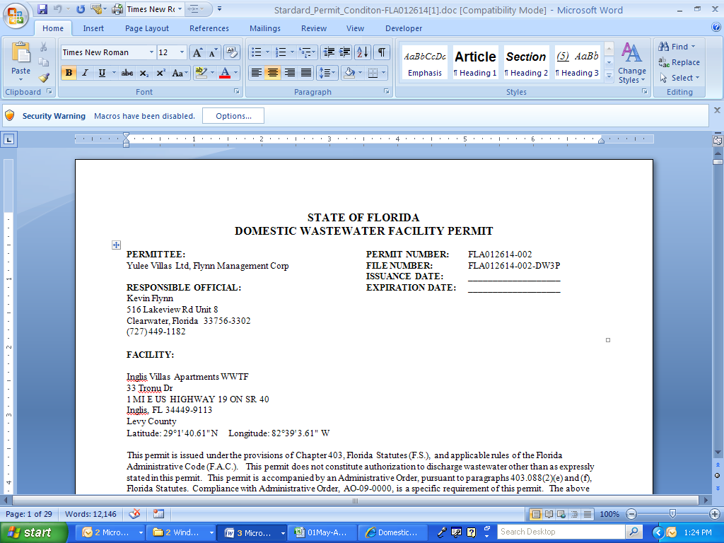
The “Macros Security Warning” message is displayed.

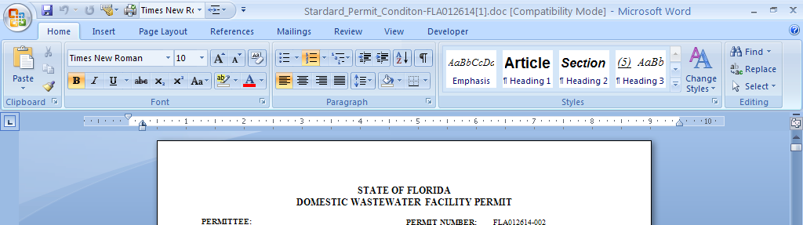
The “Macros Security Warning” message is not displayed.

If the Macros Security Warning message is displayed, skip to Section 11.1.2.

If the Macros Security Warning message is not displayed, follow Steps 1 – 6 below:

Step 1: Click the office button located at the top left-hand corner of your screen.

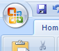

Word Options
Step 2: Click which will display the Word Options window illustrated below.

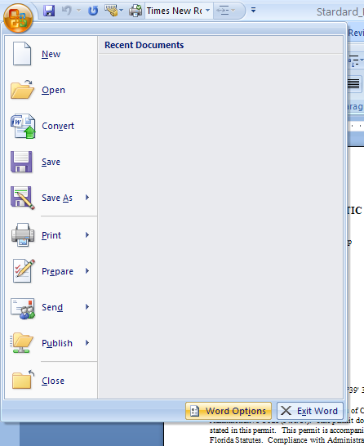

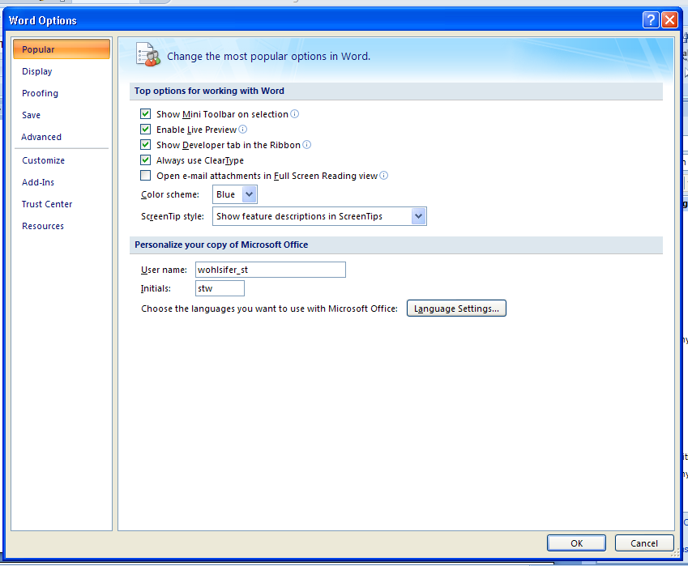
The “Word Options” window.

Trust Center
Step 3: In the Word Options window, click .

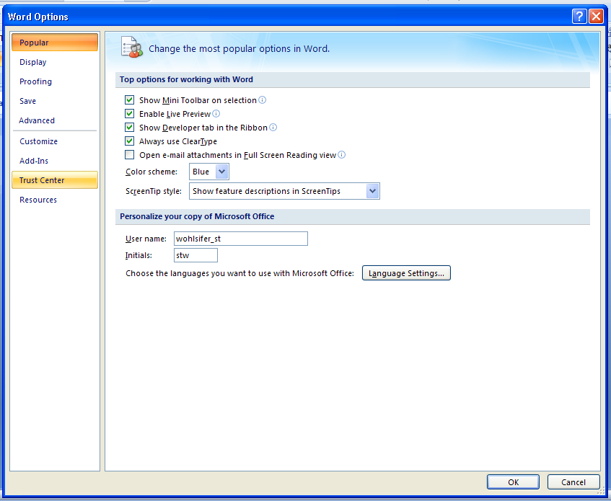
The permit writer is getting ready to click “Trust Center” in the “Word Options” window.

Trust Center Settings
Step 4: Click .

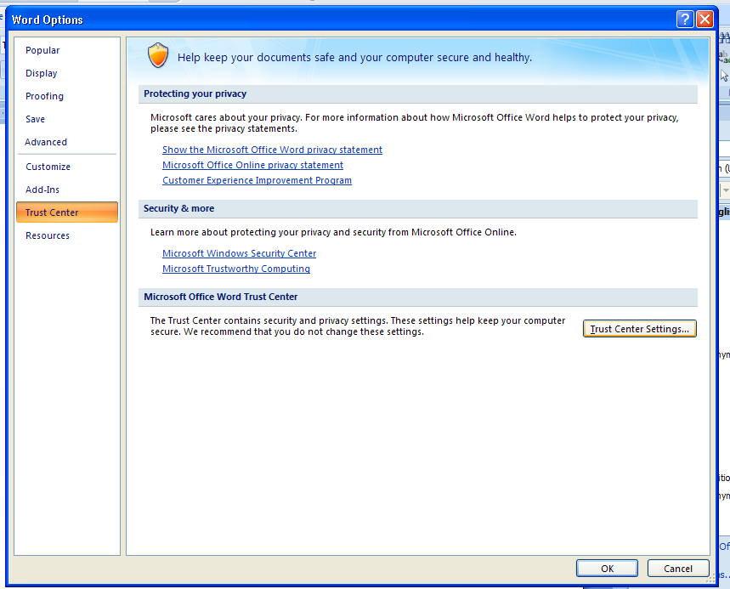

Macro Settings
Step 5: In the Trust Center window, click and then select the radio-button statement,

- Disable all macros with notification.

OK
Step 6: Click .

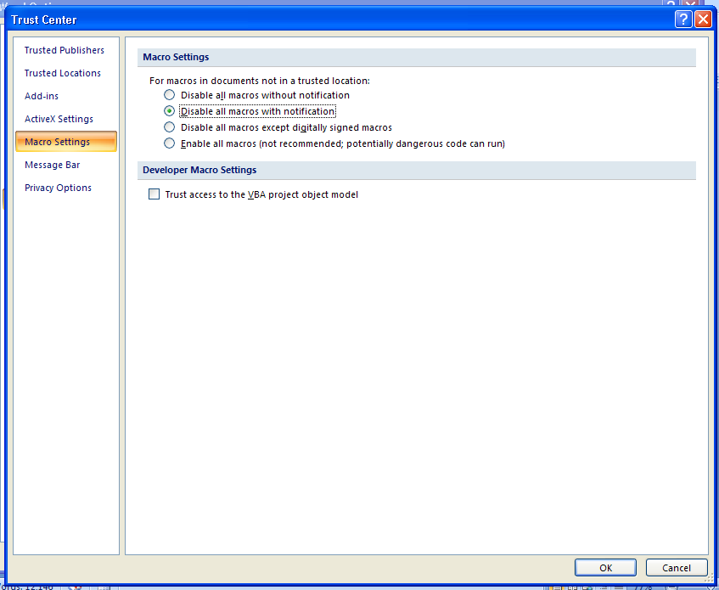

The Macros Security Warning message should now be displayed.

11.1.2. Enabling Macros

Once you have opened your draft permit document in MS Word©, you will notice the Macros Security Warning message located in the bar above the document and below the toolbars.

This message indicates that unless you enable Macros within the document file, the parameters tables within the draft permit will not reference the correct standard permit conditions when appropriate. For example, in the screen shot below, you will notice that all references to standard permit conditions in the “Notes” column of the parameters table are listed as “I.A.1.”

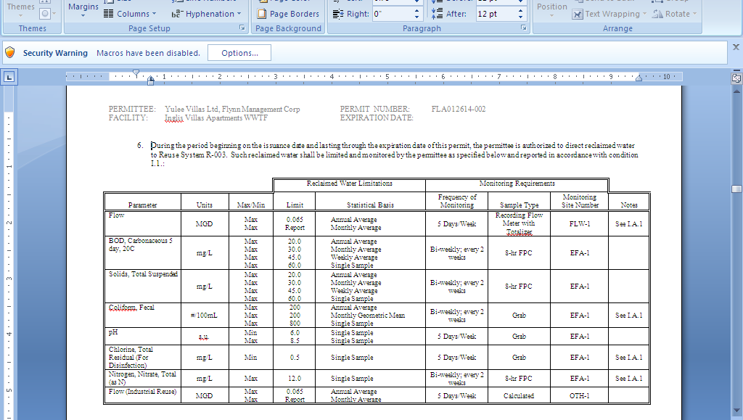
The permit writer has not yet enable Macros. Consequently, all standard permit conditions in the “Notes” column of the parameters tables are incorrectly listed as “I.A.1.”

Options …
To enable Macros, click .

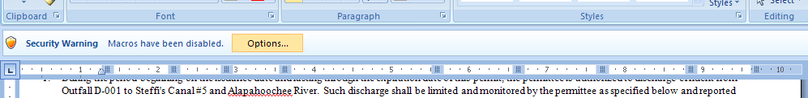

MS Office© will display Microsoft Office Security Options window shown below.
Select the radio button corresponding to the message, “Enable this content,” and click .
OK

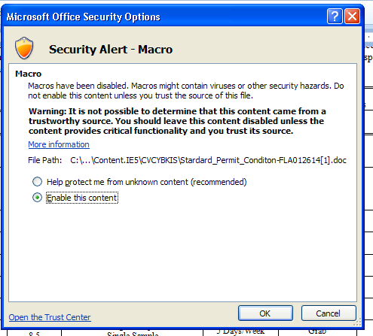

All parameters tables should now display references to the correct standard permit conditions in the “Notes columns.”

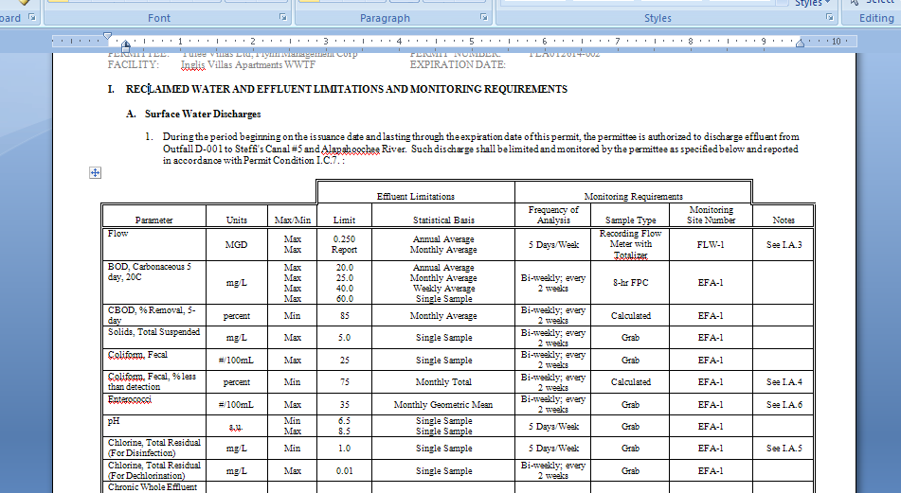
The permit writer has enabled Macros and the correct references to standard permit conditions are displayed in the parameters table. The security warning message is no longer displayed above the document.

11.1.3. Correcting the “page number reference” at the beginning of the draft permit

You will need to correct the page number reference at the beginning of the draft permit, located under the IN ACCORDANCE WITH heading.

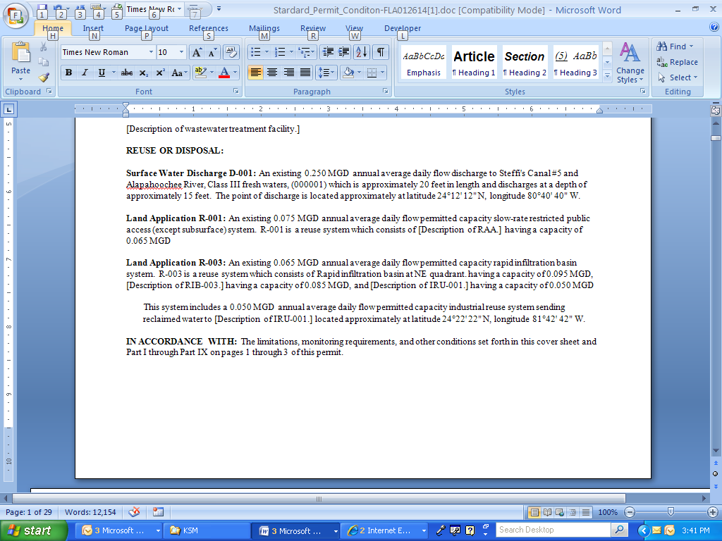

Simply highlight the incorrect page number – “3” in this example – and right-click. Then click on Update Field.

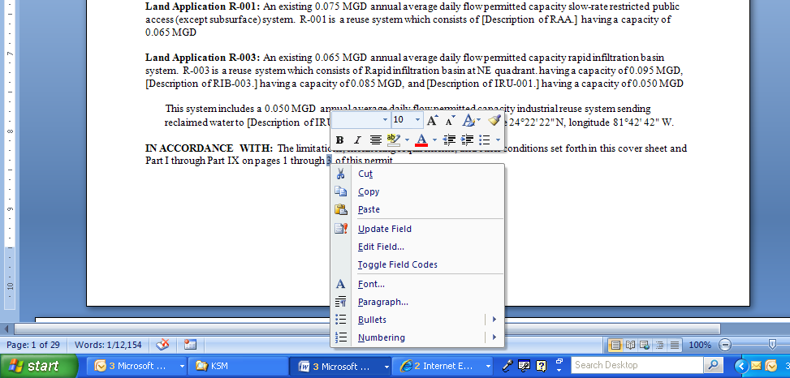

The correct page number will now be displayed.

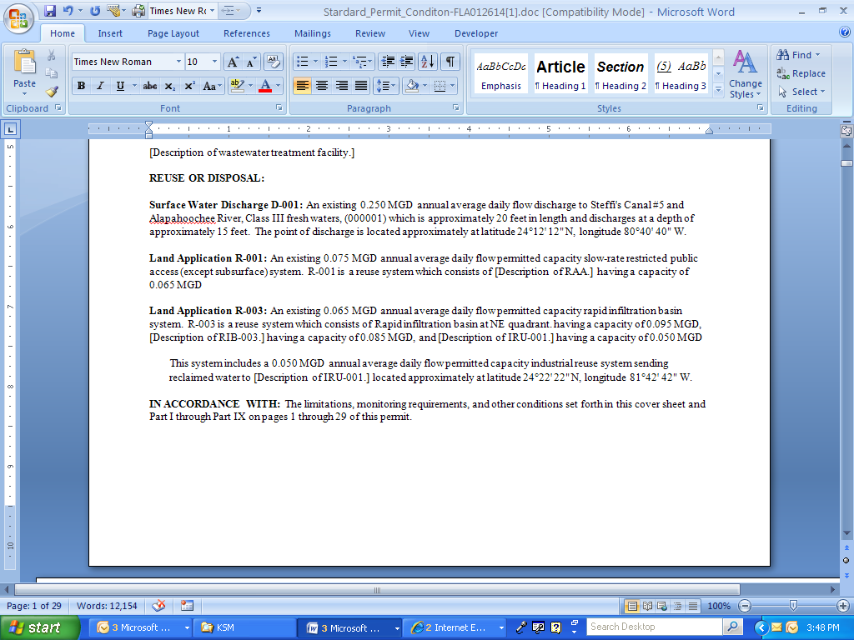
The permit writer has corrected the “page number reference.”

11.2. Generating the “Fact Sheet” or “Statement of Basis”

The Fact Sheet or Statement of Basis provides justification for inclusion of permit conditions in the permit plus any other information pertinent to the included conditions.

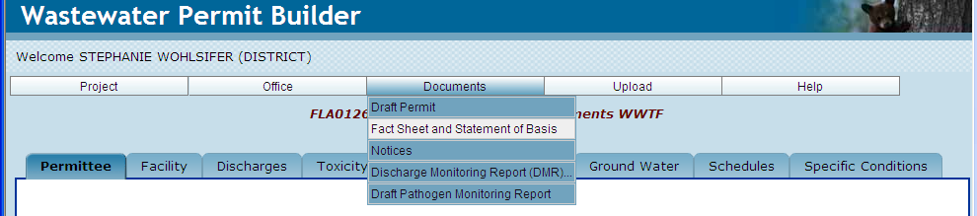

A Fact Sheet must accompany the following types of draft permits for discharges to surface waters:

- Draft permits for major facilities or activities, as designated by the US EPA;
- Draft permits that incorporate a variance or exemption;
- Draft permits for facilities or activities of wide-spread public interest, or that raise major issues, which may or may not have associated orders; and

The permit writer should also consider developing a fact sheet for any permit that requires complex calculations or special conditions, including such discharges to ground water.

A Statement of Basis is a simplified version of a fact sheet and is required for every draft permit for which a fact sheet is not prepared.

After clicking on the Fact Sheet and Statement of Basis sub-menu, Permit Builder will display a screen with five tabs, each of which is discussed in the following sections.

11.2.1. The “Discharges” tab

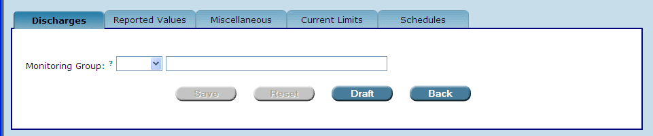

The Discharges tab allows you to select each of your Permit Builder project’s monitoring groups by clicking on the Monitoring Group drop-down box and making your selection.

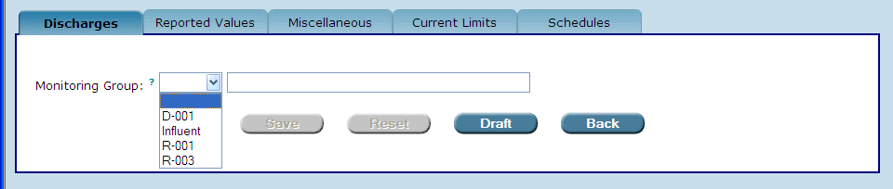
The “Monitoring Group” drop-down box lists all monitoring group entries previously made by the permit writer for the Permit Builder project.

11.2.1.1. Selecting a “D” monitoring group

If your Permit Builder project has a discharge to a surface water body and therefore has a monitoring group with a “D” designation, select it from the Monitoring Group drop-down box. Permit Builder will display the screen illustrated below.

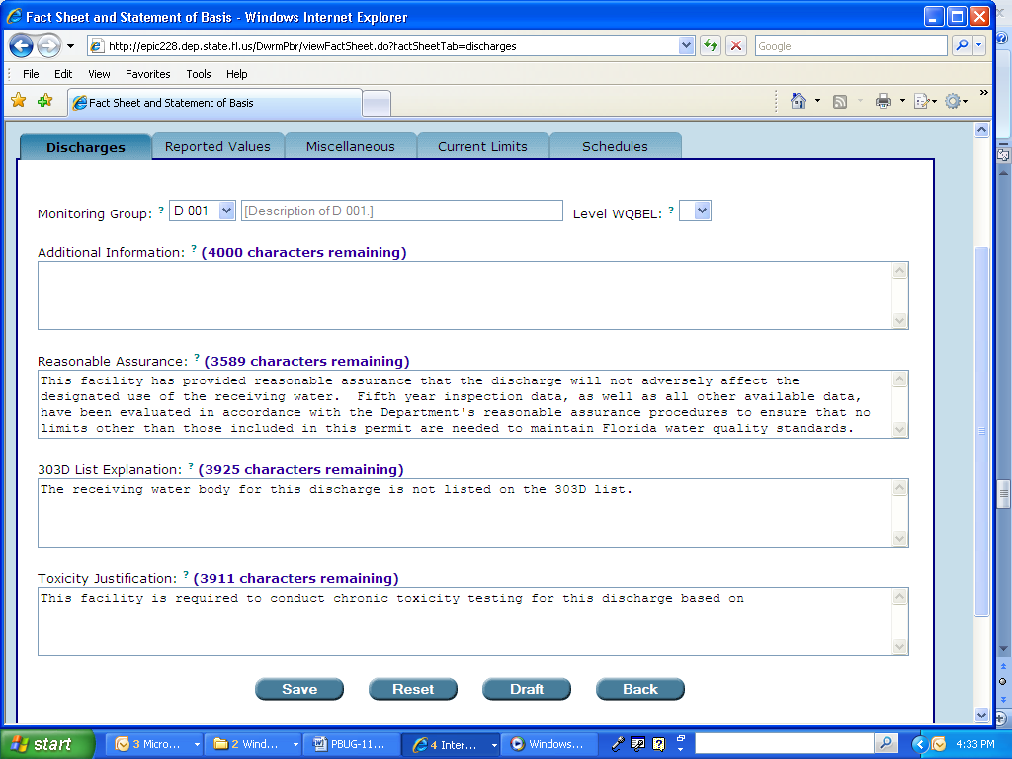
The permit writer has selected the “D-001” monitoring group.

11.2.1.1.1. The “Level WQBEL” drop-down box

This field applies only to monitoring groups with the “D” designation. A Water Quality-Based Effluent Limit (WQBEL) is an effluent limitation that may be more stringent than a technology-based effluent limit (TBEL). A WQBEL is implemented when the Department determines it necessary to ensure that water quality standards in a receiving water body will not be violated.

WQBEL studies involve a site-specific evaluation of a discharge and its effect on the receiving water body. This evaluation is made through the use of various scientific methodologies approved by the Department. Depending on the outcome of this evaluation, a WQBEL is then designed to protect the quality of the receiving water body by ensuring that water quality standards are met.

There are two methods or “processes” for determining the necessity of a WQBEL:

- The WQBEL Level I Process, as established in Rule 62-650.400, F.A.C., is typically applied to the renewal of existing permits or the issuance of new permits when data are sufficient to determine that the quality of the receiving water body currently meets standards and is expected to continue meeting standards with the discharge.

- The WQBEL Level II Process, established in Rule 62-650.500, F.A.C., is typically applied to new discharge permits and to permit renewals when existing water quality data is insufficient to evaluate expected water quality impacts, or when the available assimilative capacity of the receiving water body is being completely utilized, or might reasonably be expected to be completely utilized by the discharge, either by itself or in combination with other discharges to the receiving water body.

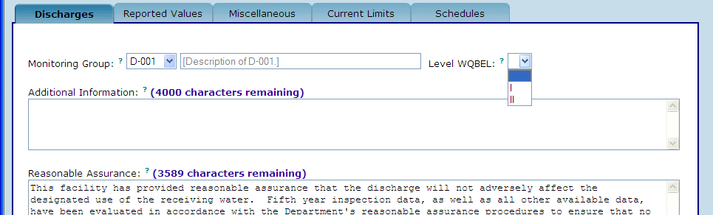
Selecting the “Level WQBEL” for monitoring group “D-001.”

11.2.1.2. Other fields on the “Discharges” tab for a “D” monitoring group

The Discharges tab for monitoring groups with the “D” designation also contains four fields, some of which have default language generated by Permit Builder. However, you will be able to edit all text contained in these fields.

The four fields are:

- The Additional Information field – for entering additional discussion, calculations, or other information needed to help fully explain the rationale for permit limits, monitoring requirements, and other permit conditions associated with the effluent limitations, including mixing zones.

- The Reasonable Assurance field – for adding or editing the default “reasonable assurance” statement as necessary to describe how reasonable assurance has been demonstrated such that the discharge will not violate water quality standards.

- The 303D List Explanation field – for adding or editing the default “303D list explanation.” For facilities that are listed on the 303D list, provide the name of each parameter of concern associated with the 303D listed receiving water body, including information regarding how the effluent limitations for the parameter of concern were established for the discharge. Also, provide the WBID number and any additional information pertaining to the implementation of the TMDL for the water body such as schedules for BMAP development and reopener clauses that may be included in the permit. For example permit language, see Section 13.4 for the Permit Writer’s Manual.

- The Toxicity Justification field – for adding or editing the default “toxicity justification.” Justification may include a summary of the toxicity data generated during the last permit cycle and the compliance status of the facility. If the facility has been granted a mixing zone for toxicity, include the dilution characteristics determined by the Watershed Assessment Section and based on that dilution, what the permit limit will be. Include any unique characteristics of the discharge which support the testing requirement. For example, if the discharge is intermittent, identify the anticipated days of discharge per event, the conditions under which a discharge will occur, and the time between discharge events.

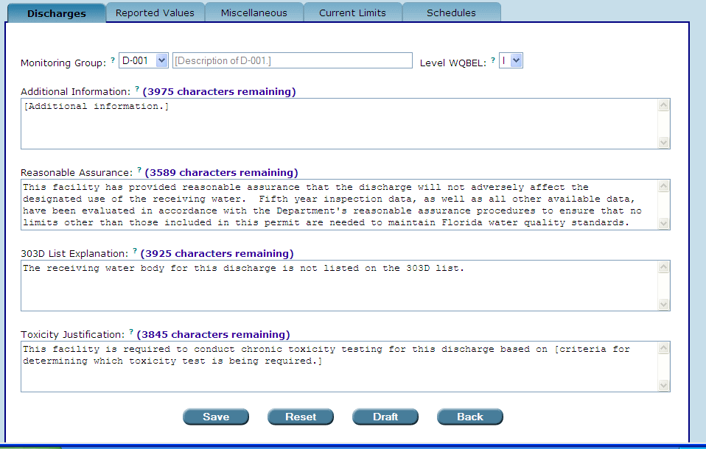
The permit writer has added text to the “Additional Information” and “Toxicity Justification” fields.

PERMIT BUILDER TIP 11A
The little blue question mark ?
Don’t forget you can always click the little blue question mark ? after each field name to display a text box that provides details about what information to enter.

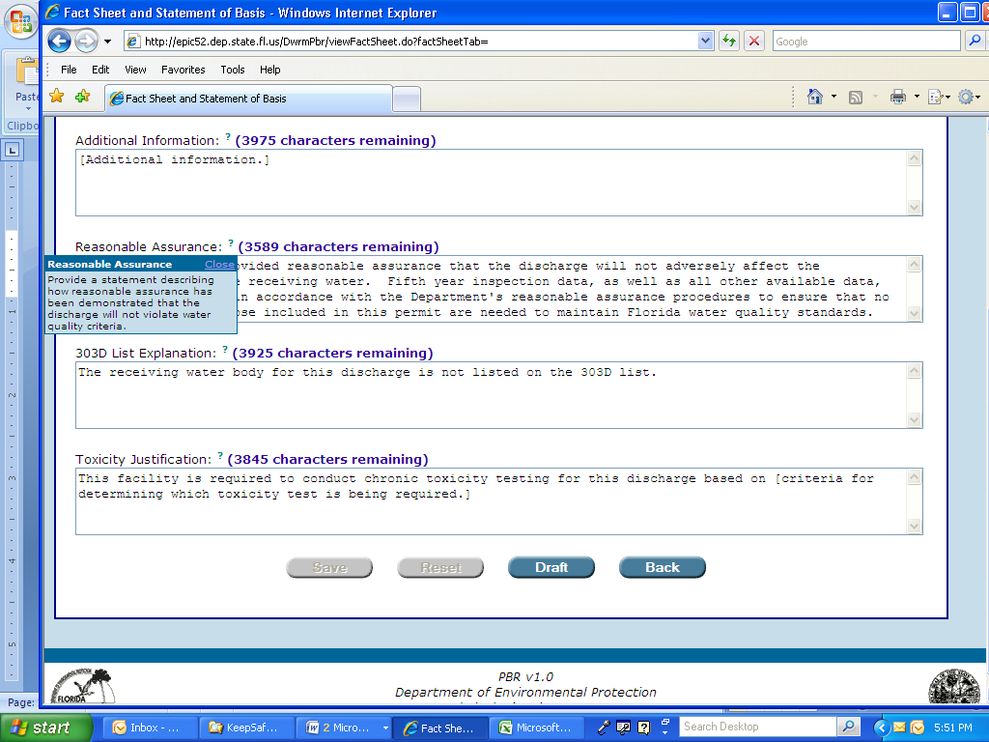
The permit writer has accessed the text box for the “Reasonable Assurance” field.

11.2.2. The “Reported Values” tab

The Reported Values tab applies only to monitoring groups with the “D” designation, and contains a table listing the same parameters you entered from the main Discharges tab for a particular monitoring group.

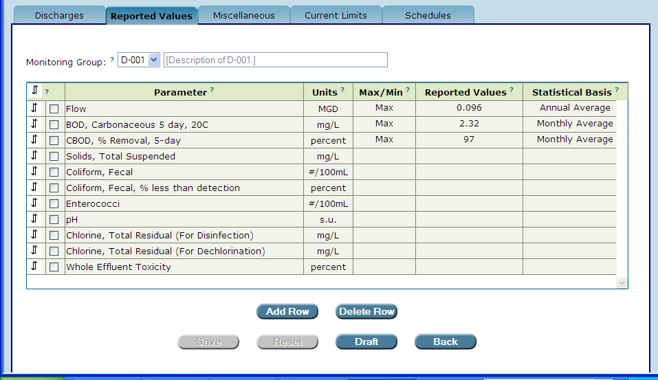
Click any empty cell for a particular parameter to access the Enter or Change Reported Values screen.
The “Reported Values” tab applies only to monitoring groups with the “D” designation.
The permit writer has begun entering data furnished by the permit application.

Values for the Max/Min, Reported Values, and Statistical Basis columns should be provided by the applicant in the permit application.

Enter this information in the table illustrated below by using the following steps:

Step 1: Double-click in any of the empty cells for a particular parameter. Permit Builder will then display the Enter or Change Reported Values screen.

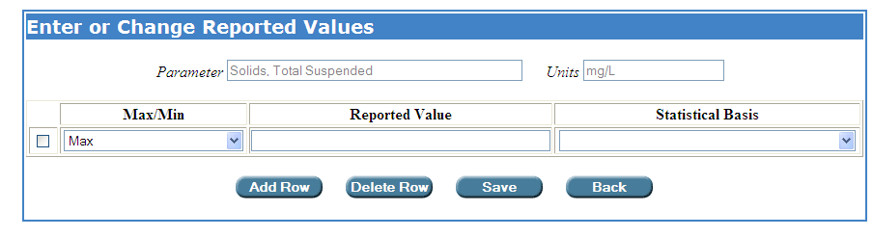
The permit writer clicked on one of the empty cells of the parameter, “Solids, Total Suspended.”

Add Row
Step 2: Enter the information provided in the application. Click to enter more than one reported value for the parameter (e.g., when the applicant reports parameter values for more than one statistical basis). Then enter each reported value and statistical basis.

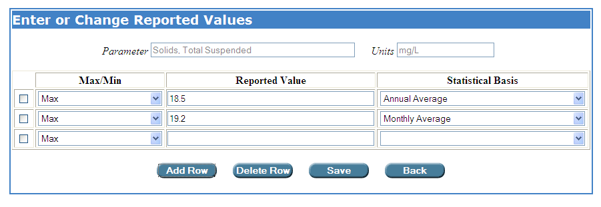
Save
Step 3: Click to save your entries and return to the Reported Values tab,

or
Back
Click to cancel your entries and return to the Reported Values tab.

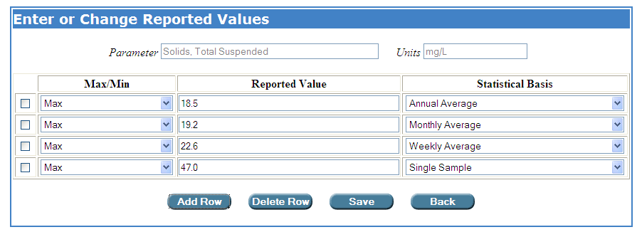

If you saved your entries, Permit Builder will now display them in the table on the Reported Values tab.

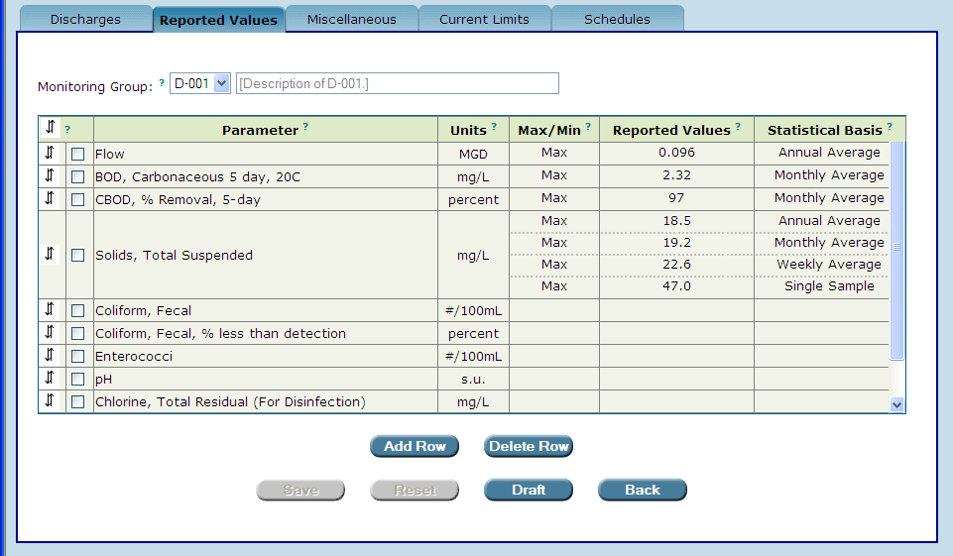
The permit writer has successfully entered and saved values in the “Reported Values” table.

Step 4: Repeat Steps 1 – 3 for all parameters.
Save
Step 5: Click to save your entries, or
Click to cancel your entries and restore the table to entries made before the last time this tab was saved.
Reset

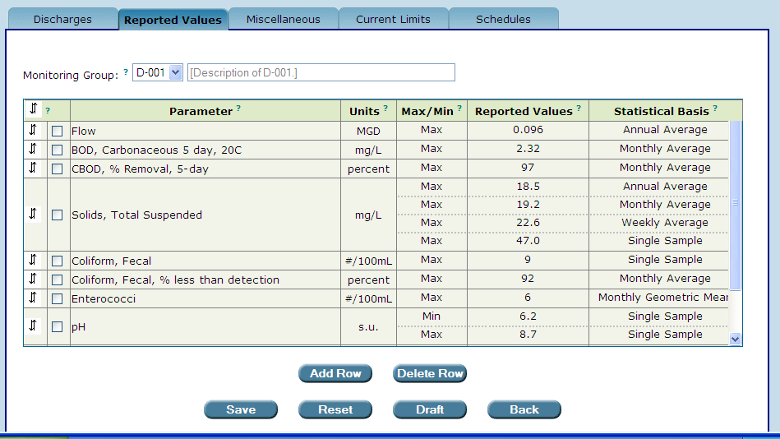

Back
NOTE: Clicking will return you to the Permittee tab.

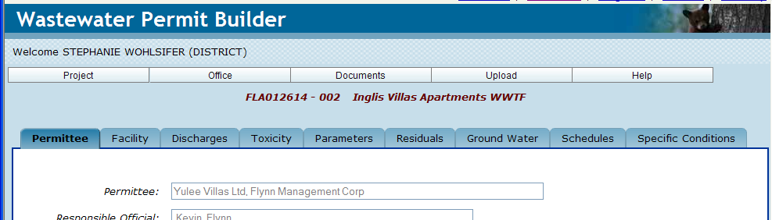

11.2.2.1. Adding, deleting, and editing parameters, and moving a parameter’s position within the table

As with all other parameter tables in Permit Builder, you will have the ability to add, delete, and edit parameters, as well as change the order in which they appear within the table.

See Chapter 6, Section 6.3. for details.

11.2.3. The “Miscellaneous” tab

The Miscellaneous tab contains fields with default information entered by Permit Builder based on your entries in the main tabs addressed in previous chapters. You may add, delete, or edit any of this information simply by clicking in the field.

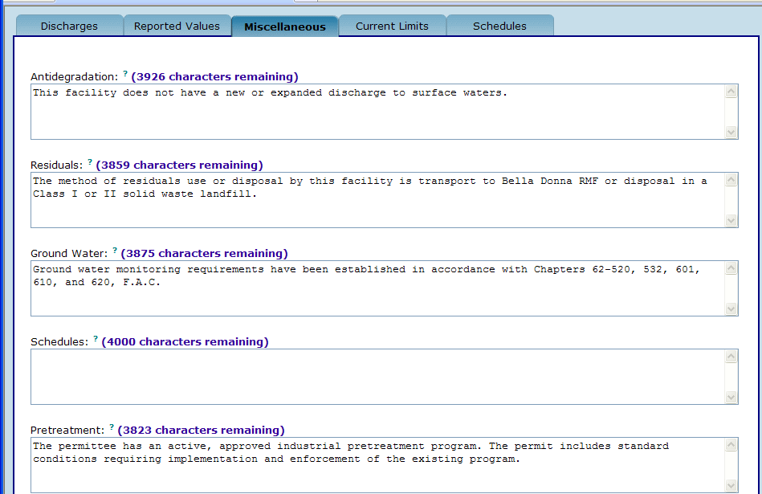
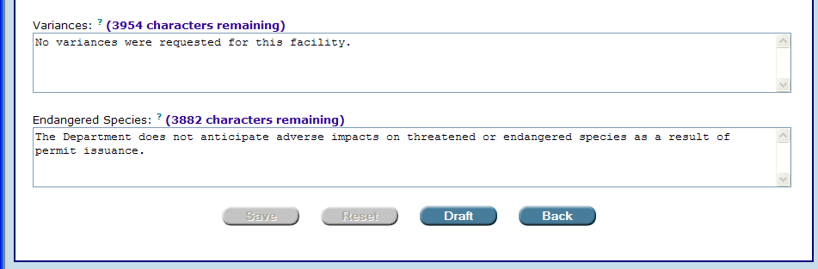
The “Miscellaneous” tab.
You will have to scroll down in order to view the entire screen.

11.2.4. The “Current Limits” tab

On the Current Limits tab, enter the Expiration Date of Current Permit by first clicking on the calendar icon.

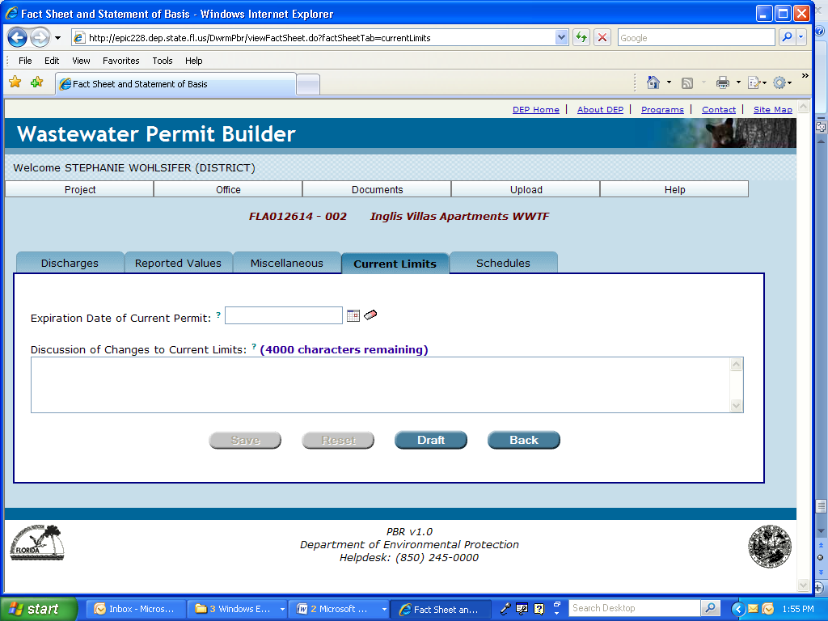

From the Select Date, Please window, use the inner set of arrows to scroll through the months of the current year, or use the outer set of arrows to scroll through past or future years. Then click on the appropriate day to enter the date.

Click the eraser icon to delete a date.

The calendar and eraser icons.

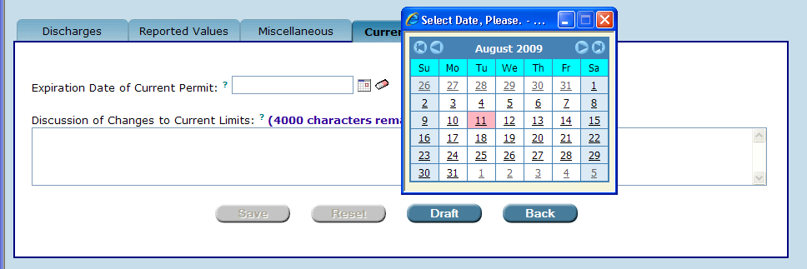
Access the “Select Date, Please” window by clicking the calendar icon.

In the Discussion of Changes to Current Limits field, provide a discussion of any changes to the effluent or reclaimed water limitations or monitoring requirements from the current permit. Be sure to include a justification for any reduction in monitoring requirements. Then click .
Save

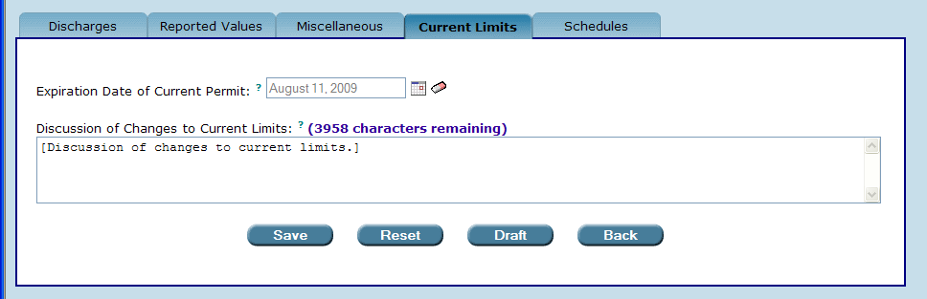

11.2.5. The “Schedules” tab

The Schedules tab allows you to enter all proposed dates relevant to issuance of the permit.

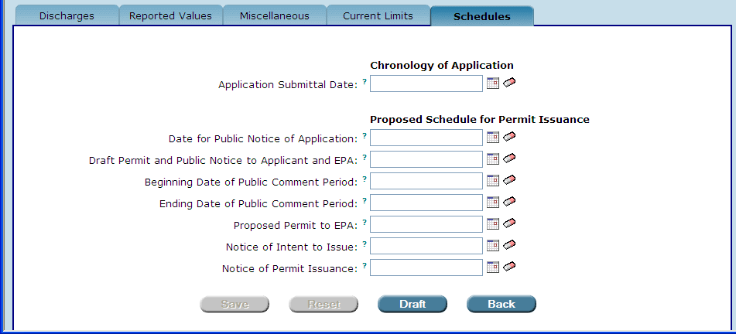

To enter dates, simply click on the calendar icons to the right of each field to access the Select Date, Please window, and select dates as described above in Section 11.2.4.

Click the eraser icon to delete a date.

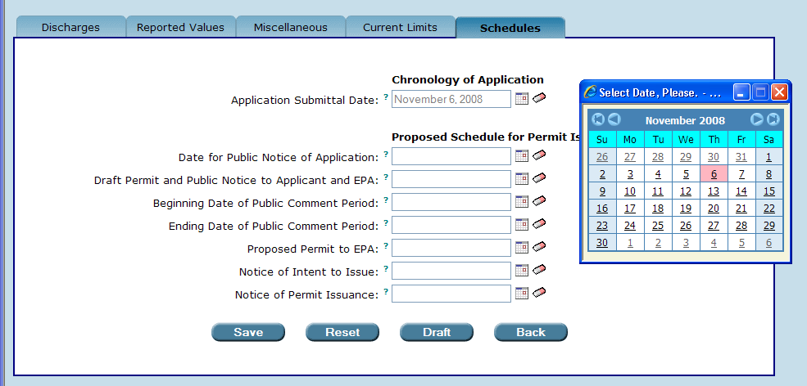

Landmark dates listed on the Schedules tab are described in detail below.

- Application Submittal Date – the date the permit application has been officially accepted by the Department. When a permit application is submitted to the Department and is accompanied by the application processing fee, it is stamped with the date of receipt, and marked with a notation that a fee in a specific amount was received. This date becomes “Day 1” of the 30-day application review period during which you are to determine that the submitted application is complete and that information provided is accurate.

- Date for Public Notice of Application – the anticipated date the applicant for a project that is reasonably expected to result in heightened public concern, or for a project where there is likelihood of a request for administrative proceedings, will be required to publish a notice of application. The notice of application is prepared by the Department and must be published by the applicant, one time only, within 14 days after a complete application is filed. The day the applicant receives the cover letter of the Notice of Application should be used to establish this 14-day period. NOTE: The Department should send the cover letter of the Notice of Application to the applicant within 30 days of receipt of the complete application to be consistent with the 30-day review period required by Rules 62-620.510(1) and (3), F.A.C. Rule 62-110.106(6), F.A.C.

- Draft Permit and Public Notice to Applicant and EPA – the anticipated date the Department will send the draft permit and public notice to the applicant and to the EPA Region 4 in Atlanta, Georgia. This applies only to facilities discharging to surface waters.

- Beginning Date of Public Comment Period – the anticipated commencement date of the public comment period.

- Ending Date of Public Comment Period – the last day of the public comment period. The ending date of the public comment period must be at least 30 days after public notice.

- Proposed Permit to EPA – the anticipated date the Department will submit the proposed final permit to the EPA Region 4 in Atlanta, Georgia.

- Notice of Intent to Issue – the anticipated date the Department provides the Notice of Intent to Issue Permit to the applicant.

- Notice of Permit Issuance – the anticipated date the Department will issue the Notice of Permit Issuance.

When you have finished entering all relevant dates,
Reset
Save
Click or click to restore fields to the entries last saved.

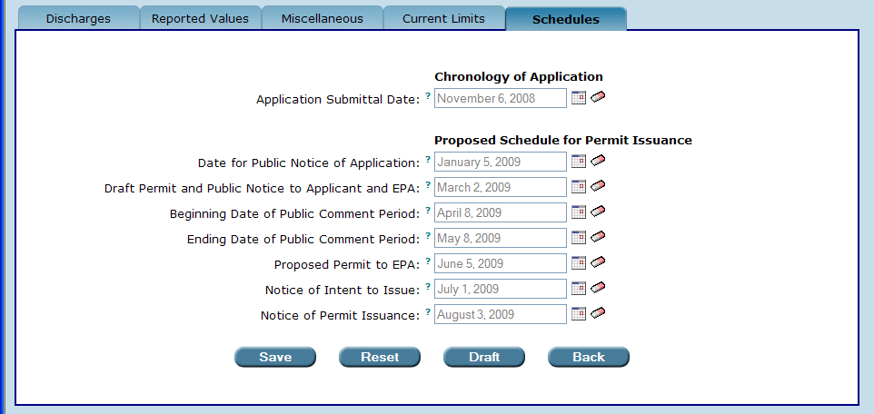
The permit writer has entered all proposed dates relevant to the issuance of the permit.

Draft
To draft the Fact Sheet or Statement of Basis, click .

Permit Builder will display the following message:

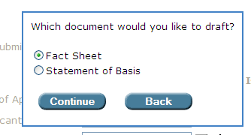
Continue
Click the radio button corresponding to the document you wish to draft and then click

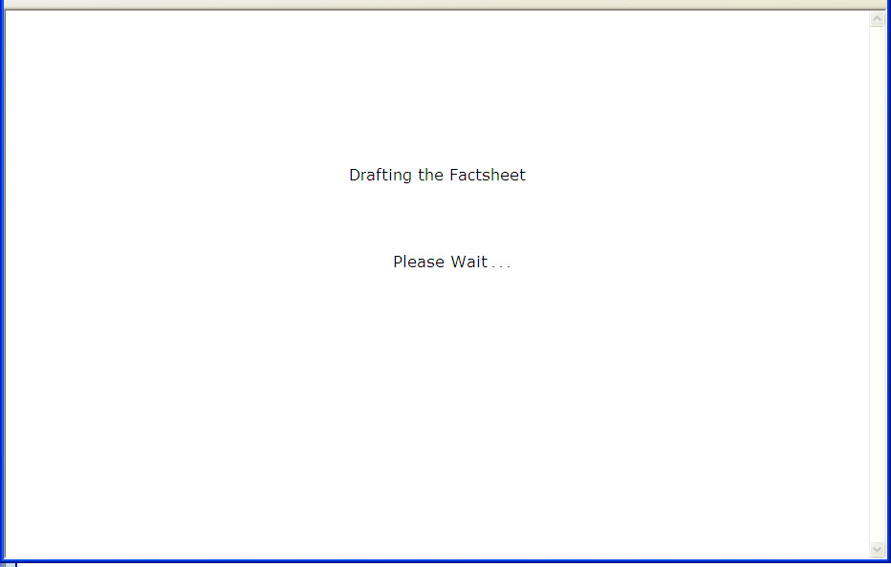

Permit Builder will then display the File Download window, similar to the one you encountered in Section 11.1.

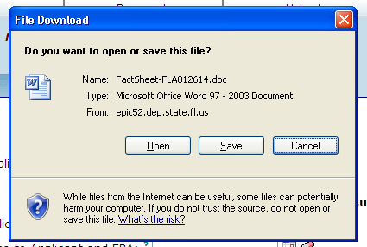

To Save or Open the Fact Sheet or Statement of Basis, proceed as you did in Section 11.1 when you generated the draft permit.

NOTE: Permit Builder populates all default language for the textboxes in the Fact Sheet and Statement of Basis tabs based on information the permit writer entered in the main permit tabs.

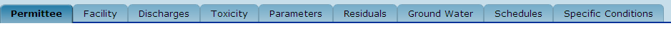
The main permit tabs.

The default language is based on the information that the permit writer entered immediately before the permit writer initially opened the Fact Sheet and Statement of Basis tabs. Changing information in the main permits tabs after the Fact Sheet and Statement of Basis tabs have been opened will not change the textbox language in the Fact Sheet and Statement of Basis tabs. In order to change the textbox language, the permit writer must make the changes manually (i.e. by typing the desired language directly into the textboxes.)

11.3. Generating “Notices”

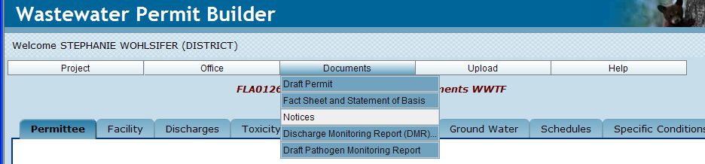

After clicking the Notices sub-menu, Permit Builder will display the Notices screen illustrated below, with the list of 21 notices.

You may select only one notice at a time by clicking the radio button corresponding to the notice you wish to generate. Permit Builder will display instructions on the use of each notice at the bottom left of the screen.
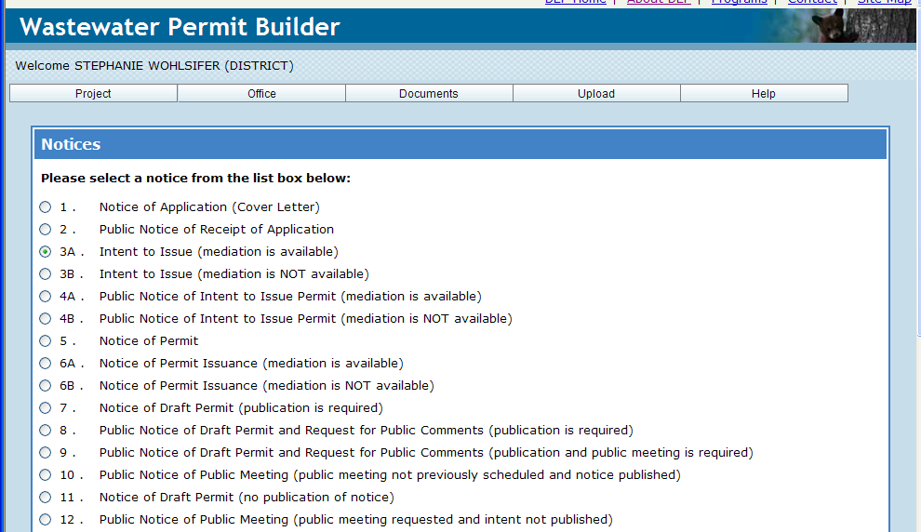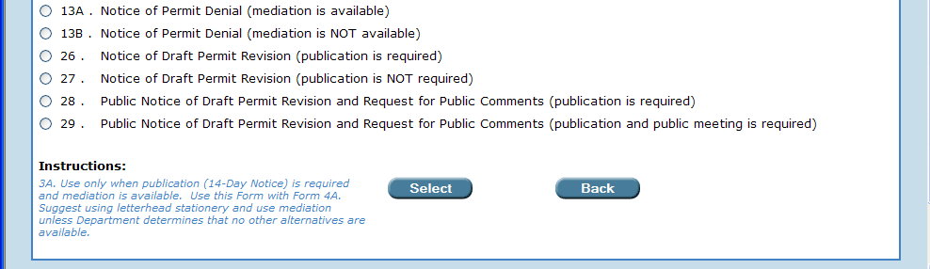
The “Notices” screen. You will have to scroll down in order to view the entire list of notices.
In this example, the permit writer has selected notice “3A.” by clicking the radio button. At the bottom left of the screen, Permit Builder displays instructions on using notice “3A.”

Back
NOTE: Clicking will return you to the Permittee tab.

Click to generate the notice. Permit Builder will ask you to Please Wait… while it generates the notice.
Select
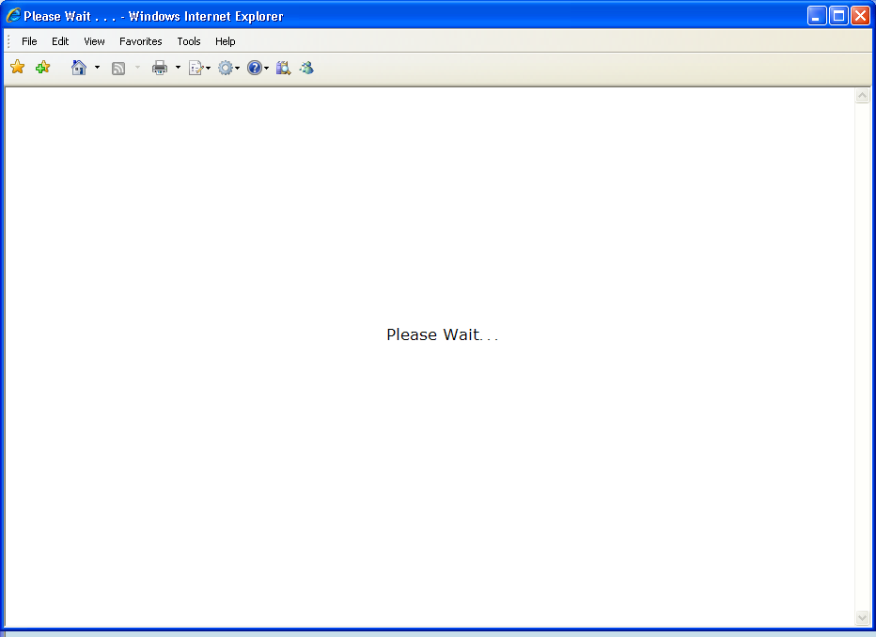

Permit Builder will then display the File Download window, requesting that you either
Open
or the notice, or your request and return to the Notices screen.
Cancel
Save

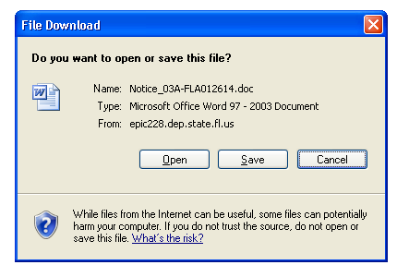
Permit Builder has assigned a default name to the document.

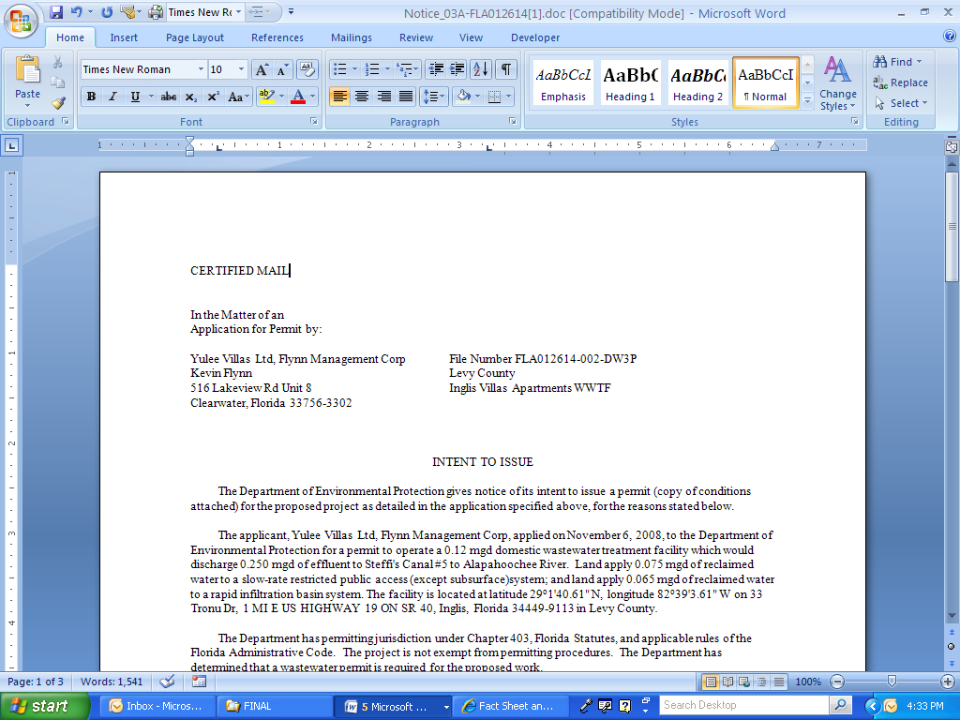
The permit writer clicked “Open” on the “File Download” window.
Permit Builder has displayed the notice in MS Word©.

11.4. Generating the “Discharge Monitoring Report (DMR)”

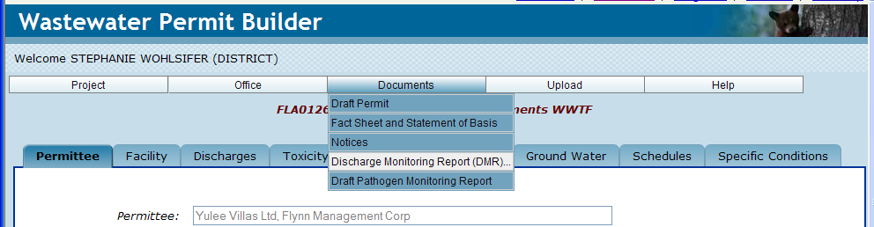

After clicking the Discharge Monitoring Report (DMR)… sub-menu, Permit Builder will display the Generate Discharge Monitoring Report(s) screen illustrated below.

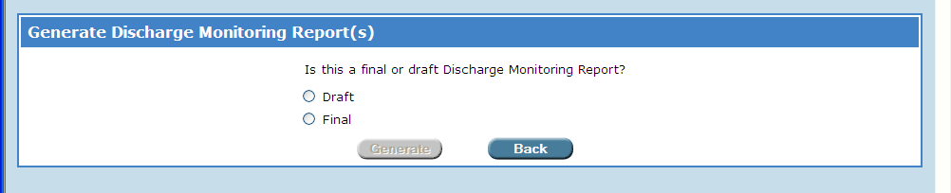

Whether you click the radio button for either Draft or Final, Permit Builder will display a list of options, as illustrated in the screen shot below.

Check all boxes corresponding to the options that apply to your Permit Builder project, and
Generate
Click to begin generating the DMRs, or
Back
Click to cancel and return to the Permittee tab.

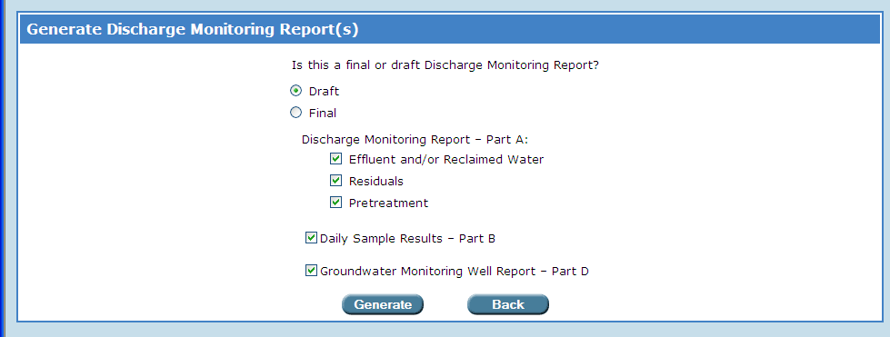
The permit writer is preparing to generate several “Draft” DMRs for a Permit Builder project.

After clicking the Generate button, Permit Builder will ask you to Please Wait… while it generates the DMRs. Depending on the number of DMRs to be generated, the wait time can be from several seconds to about one minute.

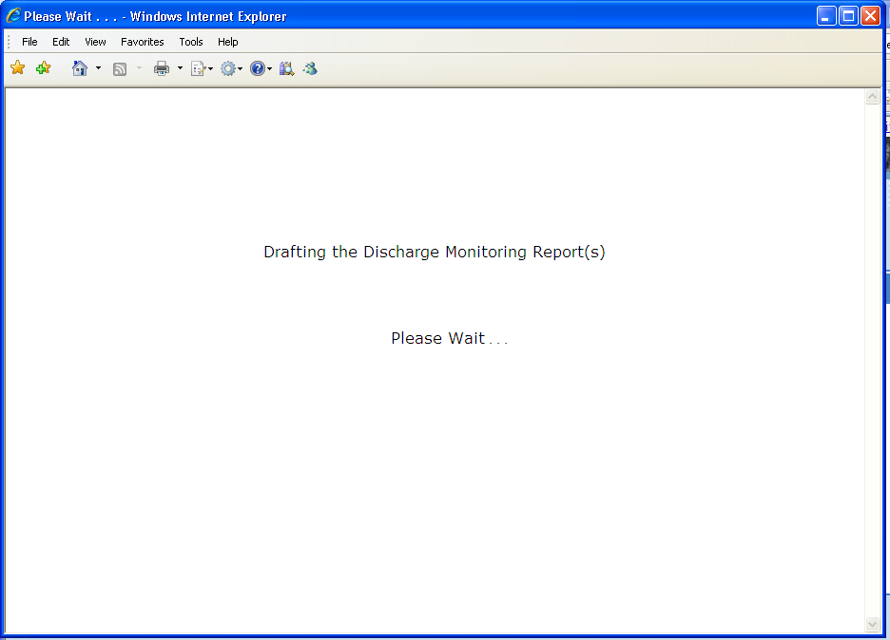

Permit Builder will then display the File Download window, requesting that you either
Open
or the notice, or your request and return to the Generate Discharge
Cancel
Save
Monitoring Report(s) screen.

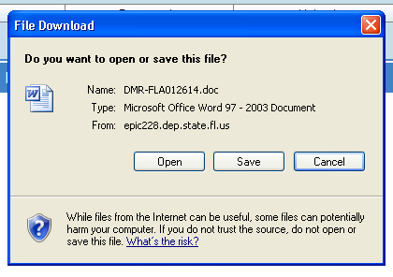
Permit Builder has assigned a default name to the document.

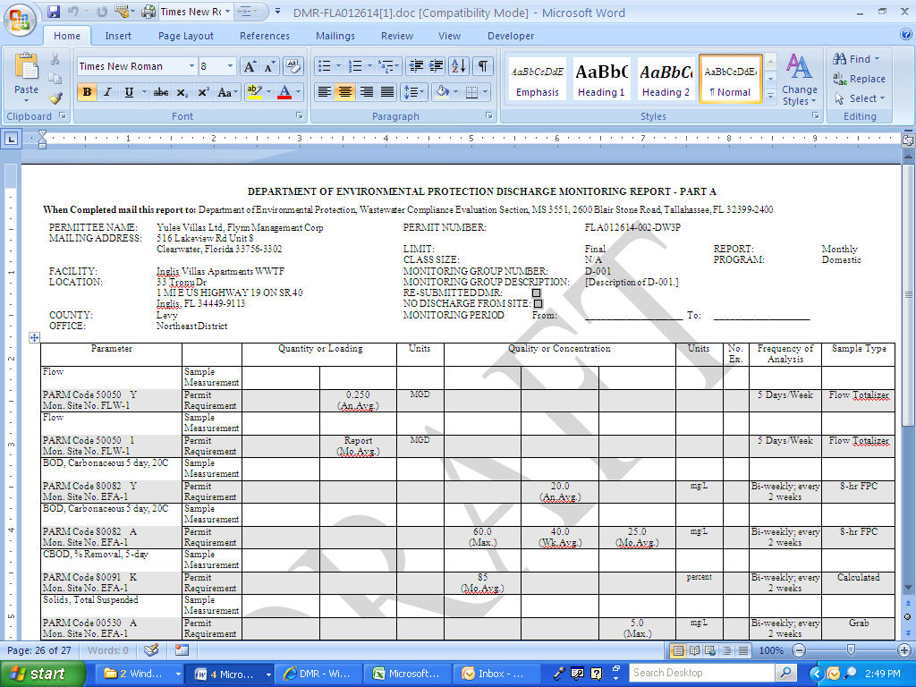
The permit writer clicked “Open” on the “File Download” window.
Permit Builder displays the first DMR (for monitoring group “D-001”) in MS Word©.

You can now scroll through the DMR document to view all DMRs you requested Permit Builder to generate for your project.

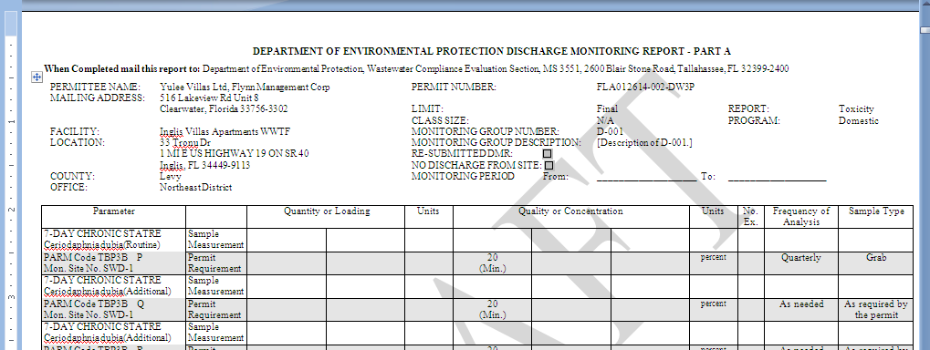
The toxicity DMR for monitoring group “D-001.”

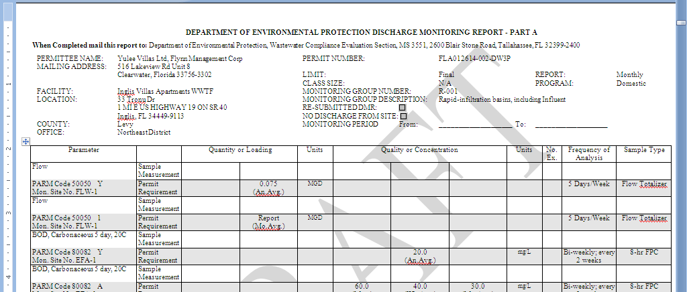
The reclaimed water DMR for the RIB system for monitoring group “R-001.”

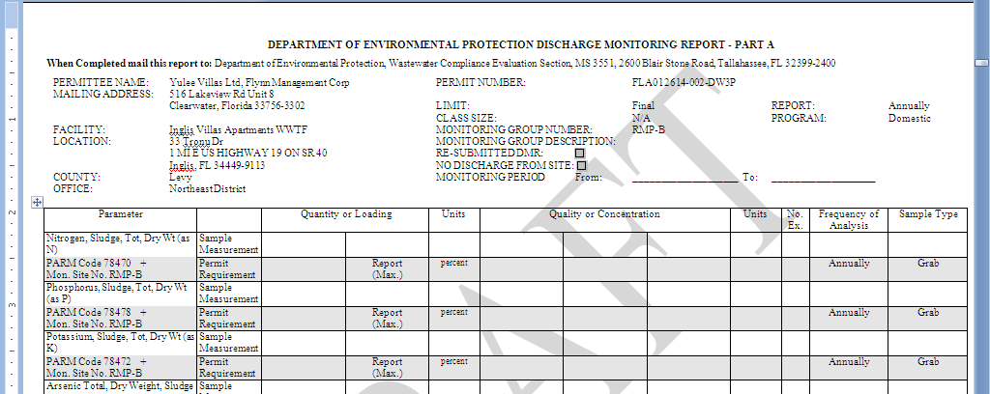
The residuals DMR for monitoring group “RMP-B.”

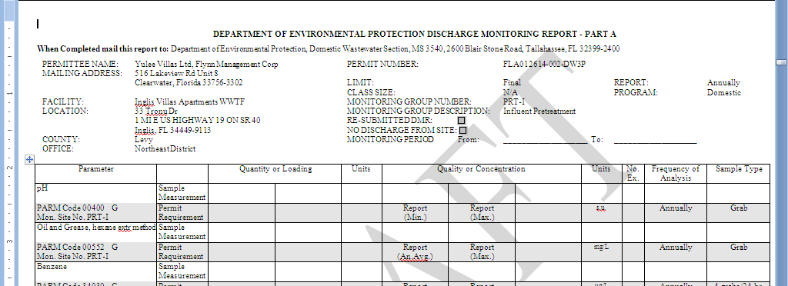
The pretreatment DMRs for monitoring groups “PRT-I,” “PRT-E,” and “PRT-R”.

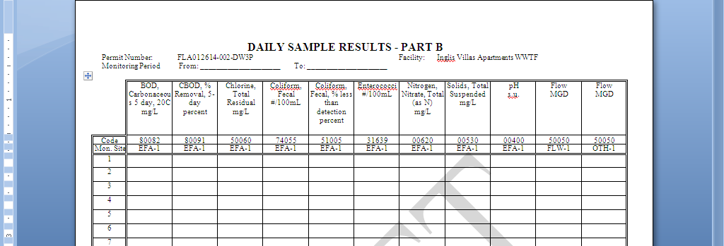
The “Daily Sample Results – Part B” DMR for monitoring group “R-001.”

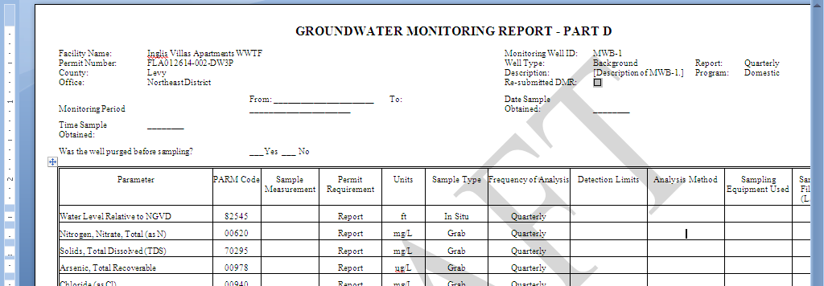
The “Groundwater Monitoring Report – Part D” DMR (for monitoring group “R-001”)

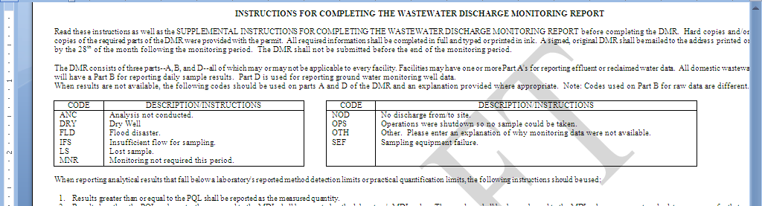
The “Instructions for Completing the Wastewater Discharge Monitoring Report.”

11.5. Generating the “Draft Pathogen Monitoring Report”

The Pathogen Monitoring Report (DEP Form 62-610.(4)(a)4.), for monitoring and reporting of Giardia and Cryptosporidium, is to be submitted by certain domestic wastewater treatment facilities in accordance with the requirements of Part III of Chapter 62-610, F.A.C., or as required by the permit.

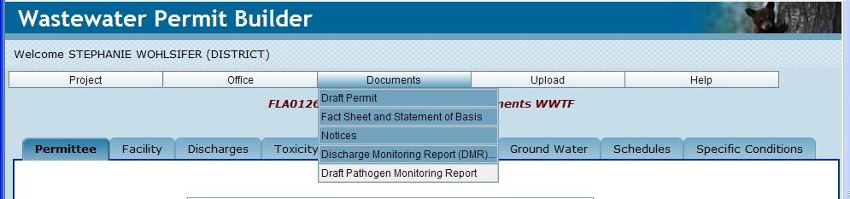

After clicking the Draft Pathogen Monitoring Report sub-menu, Permit Builder will ask you to Please Wait… while it generates the report form.

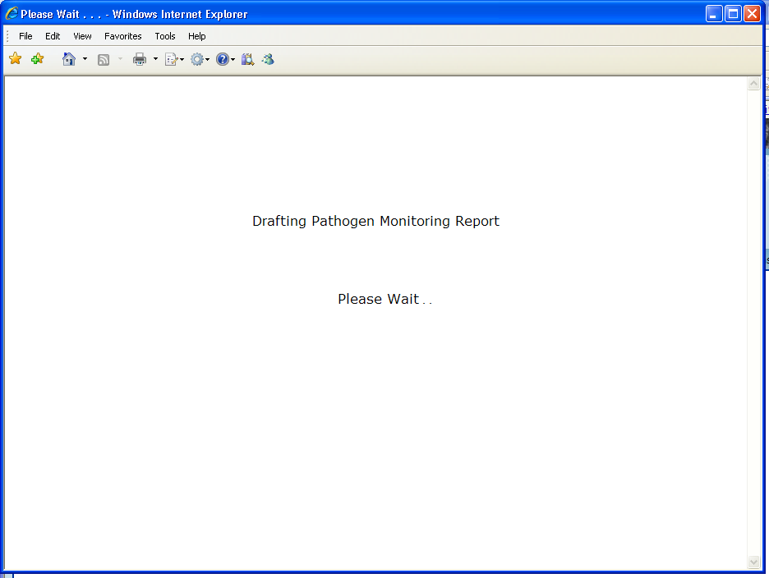

Permit Builder will then display the File Download window, requesting that you either
Open
or the notice, or your request and return to the Generate Discharge
Cancel
Save
Monitoring Report(s) screen.

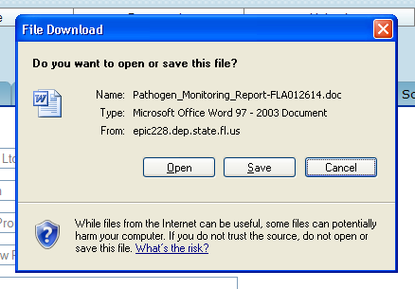
Permit Builder has assigned a default name to the document.

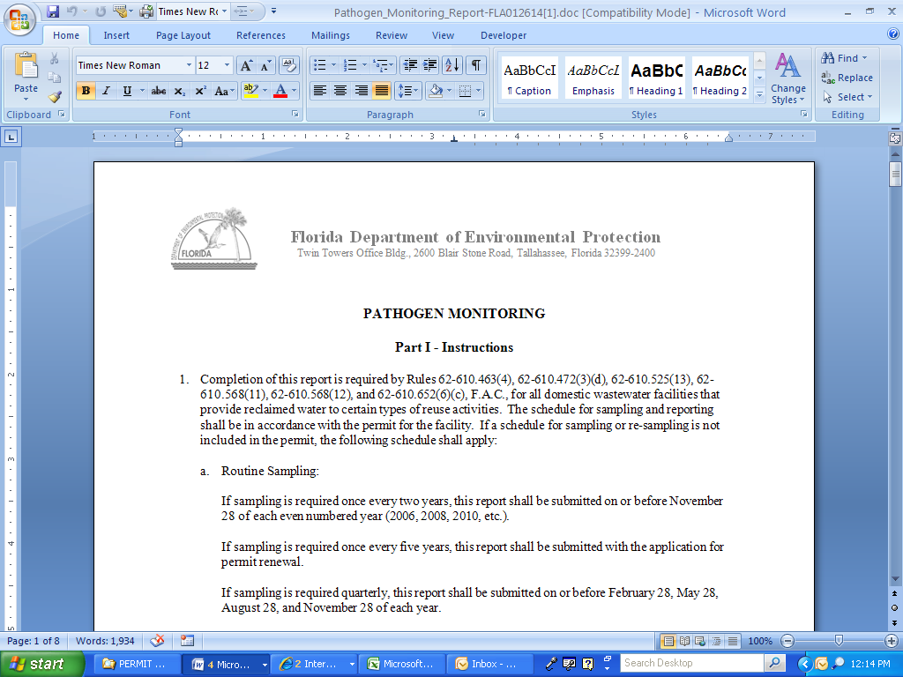
The permit writer clicked “Open” on the “File Download” window.
Permit Builder has displayed the Pathogen Monitoring Report in MS Word©.

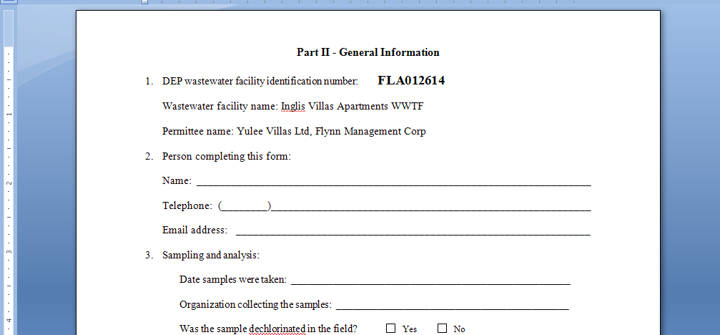
Permit Builder automatically enters the facility ID number, facility name, and permittee name in Part II of the “Pathogen Monitoring Report.”

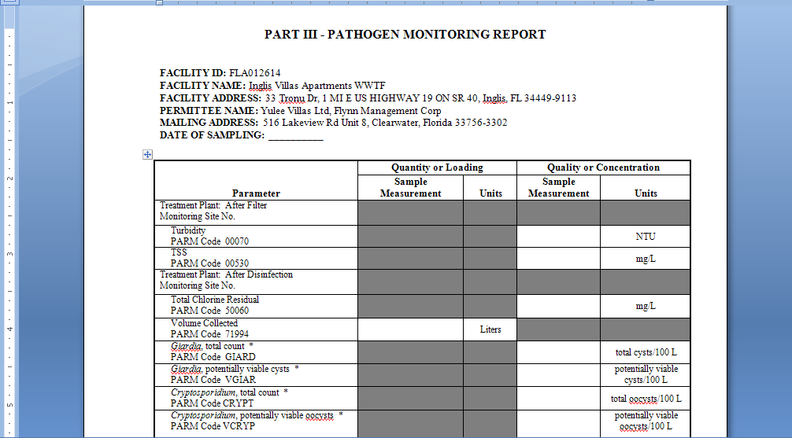
Permit Builder automatically enters the facility ID number, facility name, facility address, permittee name, and mailing address in Part III of the “Pathogen Monitoring Report.”

11.6. Printing Documents
Sometimes due to the way MS Word© is programmed you may experience problems with format changes in the documents that are generated after you save them. In order to prevent these problems, we recommend that you use the Convert option prior to saving. To Convert your documents,
- Click the Microsoft Office Button ,
- Click Convert, and then
- Save the document.

11.7. Uploading to WAFR using the “Upload” menu option

To upload your Permit Builder project to WAFR, click the Upload menu and then click Upload.

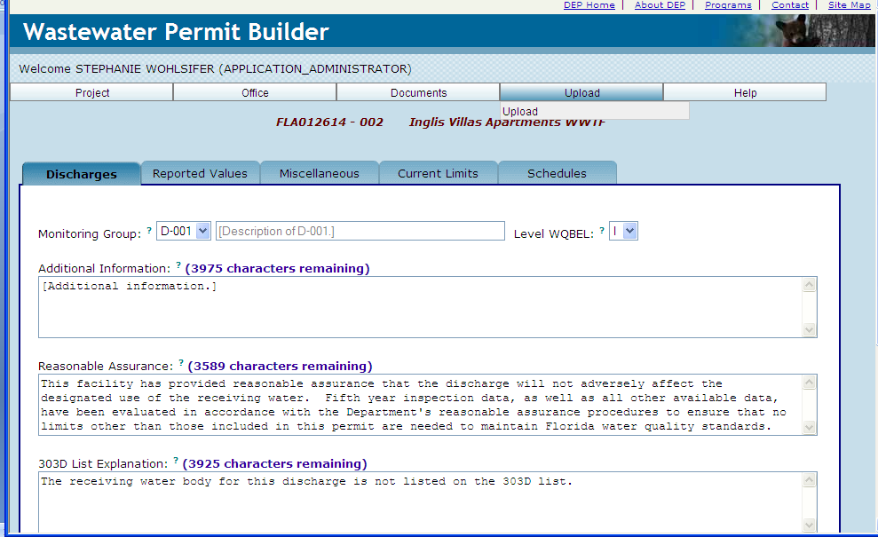

Permit Builder will display the following screen:

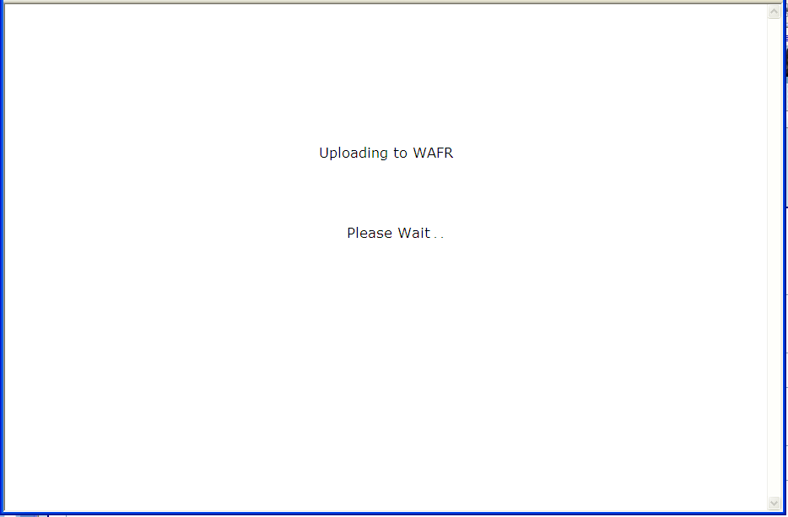

After a few moments, Permit Builder will then display the following message:

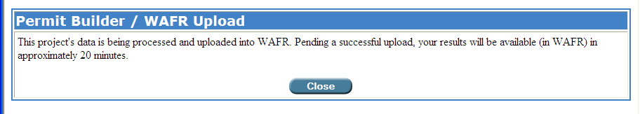

CONGRATULATIONS!
YOU HAVE COMPLETED DRAFTING ALL PERMIT DOCUMENTS

A Macro is an abbreviation for a set of program commands or instructions stored within a file.
If you do not see the Macros Security Warning message, see Section 11.1.1.
For details on the components of a Fact Sheet and a Statement of Basis, see Chapter 7 of the Wastewater Permit Writers Manual, September 15, 2008, which may be accessed from the following Intranet sites http://depnet/wrm/wfreg/domestic/default.htm or http://depnet/wrm/wfreg/industrial/default.htm.
TBELs and WQBELS are defined in Rules 62-600.420 and 62-600.430, F.A.C., respectively.
Guidelines for WQBEL Level I and Level II determinations are established in Chapter 62-650, F.A.C.
To fully understand the permitting process and your role as permit writer, consult the Wastewater Permit Writers Manual, which is accessible on-line at http://depnet/wrm/wfreg/domestic/default.htm or http://depnet/wrm/wfreg/industrial/default.htm.
See Section 11.1. above for details on opening or saving a document.
See Section 11.1. above for details on opening or saving a document.
See Section 11.1. above for details on opening or saving a document.

