A. Entering “Latitude” and “Longitude” coordinates

When entering coordinates for Latitude and Longitude in either the Discharge Points screen or in any of the Application Sites table, Permit Builder will prompt you with a message if the coordinates you enter are not within the proper ranges.

Coordinate ranges should be as follows:

- Latitude: 24 – 31 degrees, 00 – 59 minutes, 00 – 59 seconds.
- Longitude: 80 – 88 degrees, 00 – 59 minutes, 00 – 59 seconds.

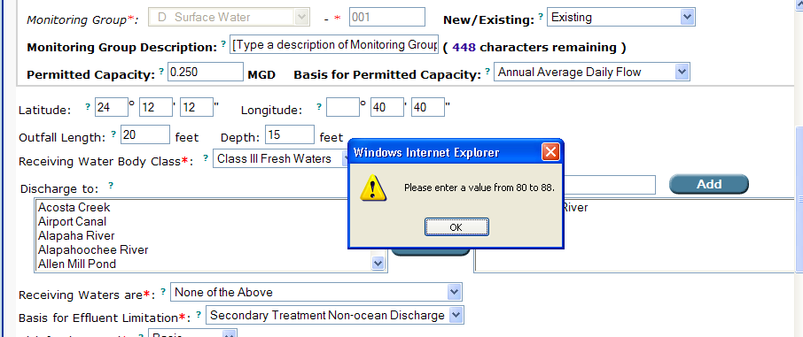
Latitude and Longitude coordinates fields on the Discharges Tab.

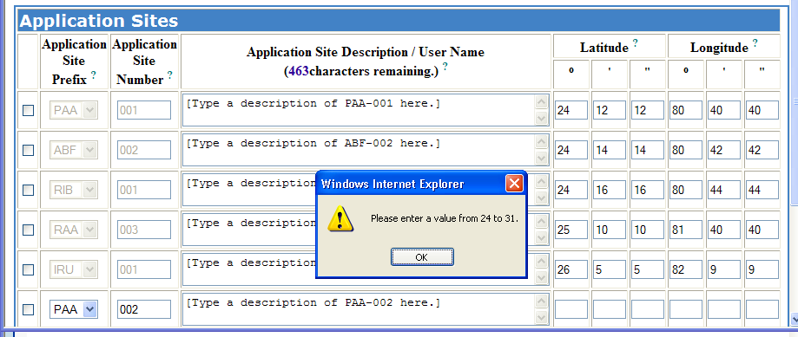
Latitude and Longitude coordinates fields in an Application Sites table.

Always check the coordinates submitted with the permit application for a facility, with the coordinates that have been entered into WAFR-PA. If they differ, choose the set of coordinates given in WAFR, as these coordinates have been verified.

