APPLICANT'S HANDBOOK:

MANAGEMENT AND STORAGE OF SURFACE WATERS

February 16, 2010
As Adopted for Use by the Department [Effective Date]

ST. JOHNS RIVER WATER MANAGEMENT DISTRICT
4049 Reid Street
Palatka, FL 32177-2529
(386) 329-4500

TABLE OF CONTENTS

PART I - POLICY AND PROCEDURES Page
1.0 Introduction
1.1 Policy. 1-1
1.2 Purpose 1-1
1.3 Organization 1-2
1.4 Applicable Statutes and Rules 1-2
1.5 Types of Rules 1-2

2.0 Definitions
2.0 Definitions 2-1

3.0 Activities Requiring a Permit
3.1 Date of Implementation 3-1
3.2 Permits Required 3-1
3.3 Thresholds 3-3
3.4 Exemptions 3-6
3.5 Conceptual Approval Permit 3-15

4.0 Application Preparation
4.1 Preapplication Conference 4-1
4.2 Forms and Instructions 4-1
4.3 Permit Processing Fee 4-2

5.0 Procedures for Processing Individual Permits
5.1 Procedures Required 5-1
5.2 Initial Receipt 5-1
5.3 Request for Additional Information 5-1
5.4 Staff Evaluation 5-2
5.5 Regulatory Meeting 5-4

6.0 Procedures for Processing Standard and Noticed General Environmental Resource Permits
6.1 Procedures Required 6-1
6.2 Standard 6-1
6.3 Initial Receipt of a Standard General Permit 6-2
6.4 Request for Additional Inform Permit 6-2
6.5 Staff Evaluation of Standard Permit 6-3
6.6 Noticed General Permits 6-4
6.7 Staff Evaluation of a Notice of Intent to Use a Noticed General Permit 6-5
6.8 Special Procedures for Certain Noticed General Permits 6-5

7.0 Permits
7.1 Operation Permits 7-1
7.2 Master Drainage Plans 7-3
7.3 Transfers 7-4
7.4 Related Permits 7-4
7.5 Duration 7-5
7.6 Enforcement and Inspection 7-5

PART II - CRITERIA FOR EVALUATION
8.0 Criteria for Evaluation
8.1 Purpose 8-1
8.2 Source of Criteria 8-1
8.3 Statutory Criteria 8-1

9.0 Conditions for Issuance of Permits
9.1 Section 40C-4.301, F.A.C., Conditions 9-1

10.0 Additional Conditions for Issuance of Permits
10.1 Section 40C-4.302, F.A.C., Conditions 10-1
10.2 Harm to the Water Resources and Objectives of the District Criteria 10-2
10.3 Peak Discharge 10-3
10.4 Volume 10-6
10.5 Storage and Conveyance 10-6
10.6 Low Flow and Base Flow Maintenance 10-9
10.7 Water Quality 10-10
10.8 Applicant Responsibility 10-10

11.0 Basin Criteria
11.1 Upper St. Johns River Hydrologic Basin 11-7
11.2 Ocklawaha River Hydrologic Basin 11-7
11.3 Wekiva River Hydrologic Basin and Wekiva Recharge Protection Basin 11-8
11.4 Econlockhatchee River Hydrologic Basin 11-14
11.5 Tomoka River and Spruce Creek Hydrologic 11-19
11.6 Sensitive Karst Areas Basin 11-25
11.7 Lake Apopka Drainage Basin 11-25

12.0 Environmental Considerations
12.1 Wetlands and Other Surface Waters 12-1
12.2 Environmental Criteria 12-2
12.3 Mitigation 12-23
12.4 Mitigation Banks 12-35
12.5 Formal Determination of the Landward Extent of Wetlands
and Other Surface Waters 12-58

PART III - METHODOLOGIES
13.0 Methodologies for Calculating Peak Discharge
13.1 Rainfall 13-1
13.2 Antecedent Moisture Conditions 13-1
13.3 Upper Soil Zone Storage 13-1
13.4 Surface Storage 13-1
13.5 Time of Concentration 13-1
13.6 Tailwater Conditions 13-2
13.7 Changes in Land Use 13-5
13.8 Runoff Estimation 13-5
13.9 Detention Basin Design 13-8
13.10 References for Section 13 13-11

14.0 Methodologies for Calculating Rainfall Data
14.1 24-Hour Storms 14-1
14.2 Four Day Storms 14-5
14.3 References for Section 14 14-12

15.0 Procedures for Determination of Floodplain Elevations and Floodway Encroachment Limits Using Normal Depth Analysis
15.1 Introduction 15-1
15.2 Data Required for Analysis 15-2
15.3 Manning's Equation 15-4
15.4 Procedures for the Determination of Flood Stage 15-4
15.5 Determination of Floodway Limits 15-6
15.6 References for Section 15 15-10

16.0 Design and Operation of Multi-Purpose Impoundments to Provide Low Flow Benefits
16.1 Determination of 5-Year 30-Day Low Flow 16-1
16.2 Design Guidelines 16-3
16.3 Operation of Impoundment to Provide Necessary Low Flow 16-3

17.0 Standards for Dams and Impoundments
17.1 Hazard Classification 17-1
17.2 Storage Capacity 17-1
17.3 Height 17-1
17.4 Probable Maximum Precipitation (PMP) 17-1
17.5 References for Section 17 17-2

18.0 Additional Basin Criteria
18.1 Soil Types Within Most Effective Recharge Area 18-1
18.2 Erosion and Sediment Control Principles 18-2
18.3 Erosion and Sediment Control Plan 18-3
18.4 References for Erosion and Sediment Control 18-4

PART IV - APPENDICES
Appendix A -- Chapters 40C-4, 40C-40, 40C-41, 40C-42, 40C-44, and 40C-400, F.A.C.
Appendix B -- Application Forms and Notice of Intent
Appendix C -- Chapter 373, F.S.
Appendix D -- Chapter 120, F.S.
Appendix E -- Sections 403.021, 403.812 - 403.8135, F.S.
Appendix F -- Chapter 40C-1, F.A.C., and Chapter 28-101 through 28-110, F.S., Uniform Rules of Procedure
Appendix G -- Chapter 62-340, F.A.C., Delineation of the Landward Extent of Wetlands and Surface Waters
Appendix H -- Agricultural Practices
Appendix I -- Criteria/Performance Criteria
Appendix J -- Sample Conditions Compliance Forms
Appendix K -- Hydrologic Basin Boundaries
Appendix L -- Chapter 40C-8, F.A.C., Minimum Flows and Levels
Appendix M -- Regional Watershed
Appendix N – Chapter 62-345, F.A.C., Uniform Mitigation Assessment Method

PART I
POLICY AND PROCEDURES

1.0 Introduction

1.1 Policy

In implementing the regulatory program authorized under part IV, chapter 373, F.S., and established by chapters 40C-4, 40C-40, 40C-41, 40C-42, 40C-44, and 62-341 40C-400,. F.A.C., a policy of the Department District is to assist those affected in understanding the program and in completing applications. The regulatory program under part IV, chapter 373, F.S., has three major components.

(a) Regulation of surface water management systems under chapters 40C-4, 40C-40, 40C-41, and 62-341 40C-400, F.A.C.;

(b) Regulation of stormwater management systems under chapter 40C-42, F.A.C.; and

(c) Regulation of agricultural surface water management systems under chapter 40C-44, F.A.C.

Three different Applicant's Handbooks have been developed by the District, corresponding to these three components.

1.2 Purpose

This Handbook provides applicants, potential applicants, and others who are interested, with information regarding the permitting program for the regulation of surface water management systems under chapters 40C-4, 40C-40, 40C-41, and 62-341 40C-400, F.A.C. Additionally, certain general information is provided regarding the District's regulatory programs under chapters 40C-42 and 40C-44, F.A.C.; however, more detailed discussions of these components of the District's regulatory program are found in the "Applicant's Handbook: Regulation of Stormwater Management Systems, chapter 40C-42, F.A.C." and the "Applicant's Handbook: Agricultural Surface Water Management Systems", respectively. In cases where conflicting or ambiguous interpretations of the information in this Handbook result in uncertainty, the final determination of appropriate procedures to be followed will be made by reference to chapters 120 and 373, F.S., and chapters 40C-1, 40C-4, 40C-40, 40C-41, 40C-42, 40C-44, and 62-341 40C-400, F.A.C.
1.3 Organization

This Handbook is divided into four parts which provide information regarding the programs, policy and procedures (Part I), criteria used in permit evaluation (Part II), methodologies which have been found to be useful in designing systems to meet the specified criteria (Part III), and supplemental materials such as relevant statutes and rules (Part IV).

If an applicant or potential applicant has any questions about these procedures or wishes to have Department District staff assistance in interpreting them or in completing an application, the applicant is encouraged to contact the nearest Department District office:

Florida Department of Environmental Protection  Northeast District  7825 Baymeadows Way, Suite B200  Jacksonville, Florida 32256-7577 | Florida Department of Environmental Protection  Central District  3319 Maguire Boulevard, Suite 232  Orlando, Florida 32803-3767
Florida Department of Environmental Protection
Southwest District
13051 N Telecom Parkway
Temple Terrace, FL 33637-0926

St. Johns River Water Management District
P.O. Box 1429 Palatka, Florida 32178-1429
(904) 329-4500

St. Johns River Water Management District
7775 Baymeadows Way, Suite 102 Jacksonville, Florida 32256
(904) 730-6270

St. Johns River Water Management District 618 East South Street, Suite 200 Orlando, Florida 32801
(407) 879-4300

St. Johns River Water Management District 305 East Drive Melbourne, Florida 32904
(407) 984-4940

1.4 Applicable Statutes and Rules

The permit application process is governed by chapters 373 and 120, F.S., and chapters 40C-1, 40C-4, 40C-40, 40C-41, 40C-42, 40C-44, and 62-341 40C-400, F.A.C. Copies of these statutes (abridged) and rules are included in this Handbook (Part IV) and should be consulted for a comprehensive understanding of the application process.

1.5 Types of Rules

The District has implemented six (6) sets of rules to regulate surface water management systems: chapter 40C-4, F.A.C., (Environmental Resource Permits: Surface Water Management Systems); chapter 40C-40, F.A.C., (Standard General Environmental Resource Permits); chapter 40C-41, F.A.C., (Environmental Resource Permits: Surface Water Management Basin Criteria); chapter 40C-42, F.A.C., (Environmental Resource Permits: Regulation of Stormwater Management Systems); chapter 40C-44, F.A.C., (Environment Resource Permits: Regulation of Agricultural Surface Water Management Systems); and 62-341 40C-400, F.A.C., (Noticed General Environmental Resource Permits).

1.5.1 Chapter 40C-4, F.A.C., provides for the regulation of surface water management systems which are above the thresholds explained in section 3.3 of this Handbook. The term "surface water management system" includes any stormwater management system, dam, impoundment, reservoir, appurtenant work, or works, or any combination thereof. The term also includes areas of dredging or filling, as those terms are defined in subsections 373.403(13) and 373.403(14), F.S. (See section 2.0 of this Handbook for definitions of these terms.) This chapter establishes procedures which are to be followed in obtaining a permit, and it lists the criteria which must be met in order to obtain a permit. Individual and conceptual approval environmental resource permits are issued pursuant to chapter 40C-4, F.A.C.

1.5.2 Chapter 40C-40, F.A.C., provides for a shortened permitting procedure for surface water management systems which are relatively small-scale (see section 3.3 of this Handbook for a description of thresholds) and which meet the criteria established in chapter 40C-4, F.A.C. These types of permits are known as "standard general environmental resource permits."

1.5.3 Chapter 40C-41, F.A.C., establishes criteria which must be met for systems within specified geographic areas of special concern. These criteria are in addition to the ones established in chapters 40C-4, 40C-40, and 40C-42, F.A.C., and are applicable to individual, standard general, and conceptual approval permits issued under chapters 40C-4, 40C-40, and 40C-42, F.A.C.

1.5.4 Chapter 40C-42, F.A.C., provides for the permitting of stormwater management systems for certain projects that fall below the thresholds explained in section 3.3 of this Handbook. Permits issued under chapter 40C-42, F.A.C., are known as either individual or standard general environmental resource stormwater permits. In addition, the rule contains standards and design and performance criteria for stormwater management systems that serve to provide reasonable assurance that systems meet the water quality standards and criteria in chapter 40C-4, F.A.C.

1.5.5 Chapter 40C-44, F.A.C., provides for the permitting of certain agricultural operations that are not required to obtain a permit under chapter 40C-4, F.A.C., and are not statutorily exempt. Permits issued under chapter 40C-44, F.A.C., are known as either individual or standard general environmental resource agricultural system permits. In addition, the rule contains standards and presumptive design and performance criteria for agricultural surface water management systems that serve to provide reasonable assurance that systems meet the water quality standards and criteria in chapter 40C-4, F.A.C.

1.5.6 Chapter 62-341 40C-400, F.A.C., provides for noticed general environmental resource permits for certain specified surface water management systems. A system which meets or exceeds the permitting thresholds in section 3.3 of this Handbook or chapters 40C-42 or 40C-44, F.A.C., and complies with all the requirements for a noticed general permit, is not required to obtain a permit under chapters 40C-4, 40C-40, 40C-42, or 40C-44, F.A.C.

2.0 Definitions

The following definitions are used by the Department District to clarify its intent in implementing its permitting programs pursuant to part IV, chapter 373, F.S. Many of these definitions are derived directly from chapter 373, F.S., and are reproduced here for the convenience of applicants.

(a) Abandon or Abandonment - Cessation of use and maintenance activities or responsibility for a system, or part of a system. (subsection 40C-4.021(1), F.A.C.).

(b) Alter - Means to extend a dam or works beyond maintenance in its original condition, including changes which may increase or diminish the flow or storage of surface water which may affect the safety of such dam or works (subsection 373.403(7), F.S.).

(c) Appurtenant Work - Any artificial improvements to a dam which might affect the safety of such dam or, when employed, might affect the holding capacity of such dam or of the reservoir or impoundment created by such dam (subsection 373.403(2), F.S.).

(d) Aquatic Preserve - Those areas designated in part II, chapter 258, F.S. (subsection 40C-4.021(4), F.A.C.).

(e) Artificial Structure(s) - Any object constructed or installed by man which has a water management effect, including, but without limitation thereof, dikes, levees, embankments, ditches, canals, conduits, channels, culverts, and pipes.

(f) Closed System - Any reservoir or works located entirely within agricultural lands owned or controlled by the user and which requires water only for the filling, replenishing, and maintaining the water level thereof (subsection 373.403(6), F.S.).

(g) Conceptual Approval Permit - A surface water management permit issued by the District, approving the concept of a master plan for a surface water management system, which is binding upon the District and the permittee (subsection 40C-4.021(6), F.A.C.).

(h) Construction - Any activity including land clearing, earth-moving or the erection of structures which will result in the creation of a system (subsection 40C-4.021(7), F.A.C.).

(i) Coral - Living stony coral and soft coral (subsection 62-341 40C-400.021(3), F.A.C.).

(j) Creation - The establishment of new wetlands or surface waters by conversion of other land forms.

(k) Dam - Any artificial or natural barrier, with appurtenant works, raised to obstruct or impound, or which does obstruct or impound, any of the surface waters of the state (subsection 373.403(1), F.S.).

(l) Direct Hydrologic Connection - A surface water connection which occurs on an average of 30 or more consecutive days per year. In the absence of reliable hydrologic records, a continuum of wetlands maybe used to establish a direct hydrologic connection.

(m) Discharge - To allow or cause water to flow.

(n) Drainage basin- A subdivision of a watershed (subsection 373.403(9), F.S.).

(o) Dredging - Excavation, by any means, in surface waters or wetlands, as delineated in subsection 373.421(1), F.S. Excavation also means the excavation, or creation, of a water body which is, or is to be, connected to surface waters or wetlands, as delineated in subsection 373.421(1), F.S., directly or via an excavated water body or series of water bodies (subsection 373.403(13), F.S.).

(p) Ecological value - The value of functions performed by uplands, wetlands and other surface waters to the abundance, diversity, and habitats of fish, wildlife, and listed species. These functions include, but are not limited to, providing cover and refuge; breeding, nesting, denning, and nursery areas; corridors for wildlife movement; food chain support; and natural water storage, natural flow attenuation, and water quality improvement, which enhances fish, wildlife and listed species utilization. (subsection 373.403(18), F.S.)

(q)(p) Endangered Species - Those animal species which are listed in Rule 68A-27.003 (as amended December 16, 2003) section 39-27.003, F.A.C., and those plant species which are listed as endangered in 50 Code of Federal Regulations 17.12 (as amended April 8, 2004), when such plants are found to be located in a wetland or other surface water.

(r)(q) Enhancement - Improving the ecological value of wetlands, other surface waters, or uplands that have been degraded in comparison to their historic condition.

(s)(r) Estuary - A semi-enclosed, naturally existing coastal body of water which has a free connection with the open sea and within which seawater is measurably diluted with fresh water derived from riverine systems (subsection 373.403(15), F.S.).

(t)(s) Existing nesting or denning - As used in subsection 12.2.7, this phrase refers to an upland site which is currently being used for nesting or denning, or is expected, based on reasonable scientific judgement, to be used for such purposes based on past nesting or denning at the site.

(u)(t) Filling- The deposition, by any means, of materials in surface waters or wetlands, as delineated in subsection 373.421(1), F.S. (subsection 373.403(14), F.S.).

(v)(u) Floodway - The permanent channel of a stream or other watercourse, plus any adjacent floodplain areas that must be kept free of any encroachment in order to discharge the 100 year flood without cumulatively increasing the water surface elevation more than a designated amount (not to exceed one foot except as otherwise established by the District or established by a Flood Insurance Rate Study conducted by the Federal Emergency Management Agency (FEMA) ).

NOTE: The one foot increase cited above is used in the determination of the floodway itself and is not meant to allow subsequent increase in the 100 year flood elevation, once the limits of the floodway have been so set. That is, in order to determine that portion of the floodplain which will be designated as the floodway, one begins at the outer limits of the floodplain and assumes full development inward, toward the river or stream channel, on both sides of the flood hazard area, until the point is reached where development will cause the 100 year flood elevation to rise by one foot. The area remaining between this boundary and the channel is the floodway, and because any further development here would necessarily increase the 100 year flood elevation by more than one foot, no such development can be permitted.

(w)(v) Hydrologically Sensitive Area - Wetlands and those geographical areas which are specifically designated as hydrologically sensitive areas by the Board because of the importance of the hydrology and hydraulics of the area in meeting the Legislative policy contained in section 373.016, F.S. (subsection 40C-4.021(15), F.A.C.).

(x)(w) Impervious - Land surfaces which do not allow, or minimally allow, the penetration of water; included as examples are building roofs, normal concrete and asphalt pavements, and some fine grained soils such as clays.

(y)(x) Impoundment - Any lake, reservoir, pond, or other containment of surface water occupying a bed or depression in the earth's surface and having a discernible shoreline (subsections 373.403(3) and 373.019(14), F.S.).

(aa)(y) Isolated Wetland - Any wetland without a direct hydrologic connection to a lake, stream, estuary, or marine water.
(z) THIS PARAGRAPH NOT ADOPTED FOR USE BY THE DEPARTMENT

(bb)(z) Lagoon- A naturally existing coastal zone depression which is below mean high water and which has permanent or ephemeral communications with the sea, but which is protected from the sea by some type of naturally existing barrier (subsection 373.403(16), F.S.).

(cc)(aa) Listed Species - Those animal species which are endangered, threatened or of special concern and are listed in Rules 68A-27.003 (as amended December 16, 2003), 68A-27.004 (as amended May 15, 2008), and 68A-27.005 (as amended November 8, 2007) sections 39-27.003, 39-27.004, and 39-27.005, F.A.C.; and those plant species listed in 50 Code of Federal Regulations 17.12 (as amended April 8, 2004), when such plants are found to be located in a wetland or other surface water (subsection 40C-4.021(2019), F.A.C.).

(dd)(bb) Littoral Zone - In reference to stormwater management systems, this phrase shall mean that portion of a wet detention pond which is designed to contain rooted aquatic plants.

(ee)(cc) Maintenance or Repairs - Means remedial work of a nature as may affect the safety of any dam, impoundment, reservoir, or appurtenant work or works, but excludes routine custodial maintenance (subsection 373.403(8), F.S.).

(ff)(dd) Mitigation - An action or series of actions to offset the adverse impacts that would otherwise cause a regulated activity to fail to meet the criteria set forth in sections 12.2 - 12.2.8.2. Mitigation usually consists of restoration, enhancement, creation, preservation, or a combination thereof.

(gg) THIS PARAGRAPH NOT ADOPTED FOR USE BY THE DEPARTMENT

(hh) THIS PARAGRAPH NOT ADOPTED FOR USE BY THE DEPARTMENT

(ii) THIS PARAGRAPH NOT ADOPTED FOR USE BY THE DEPARTMENT

(jj) THIS PARAGRAPH NOT ADOPTED FOR USE BY THE DEPARTMENT

(kk) THIS PARAGRAPH NOT ADOPTED FOR USE BY THE DEPARTMENT

(ll)(ee) Operate or Operation - To cause or to allow a system to function.

(mm)(ff) Other surface waters - Surface waters as described and delineated pursuant to section 62-340.600, F.A.C., as ratified by section 373.4211, F.S., other than wetlands (subsection 40C-42.021(21), F.A.C.).

(nn)(gg) Other Watercourses - Any canal, ditch, or other artificial watercourse in which water usually flows in a defined bed or channel. It is not essential that the flowing be uniform or uninterrupted (subsection 373.019(12), F.S.).

(oo)(hh) Permanent Pool - That portion of a wet detention pond which normally holds water (e.g., between the normal water level and the pond bottom).

(pp)(ii) Preservation - The protection of wetlands, other surface waters or uplands from adverse impacts by placing a conservation easement or other comparable land use restriction over the property or by donation of fee simple interest in the property.

(qq)(jj) Project Area - The area being modified or altered in conjunction with a proposed activity requiring a permit (subsection 40C-4.021(22)).

(rr) THIS PARAGRAPH NOT ADOPTED FOR USE BY THE DEPARTMENT

(ss)(kk) Regulated activity - The construction, alteration, operation, maintenance, abandonment or removal of a system regulated pursuant to part IV, chapter 373, F.S.

(tt)(ll) Remove or Removal - Cessation of use and maintenance activities for a system, or part of a system, accompanied by elimination of all or part of the system (subsection 40C-4.021(23), F.A.C.).

(uu)(mm) Reservoir - Any artificial or natural holding area which contains or will contain the water impounded by a dam (subsection 373.403(4), F.S.).

(vv)(nn) Restoration - Converting back to a historic condition those wetlands, surface waters, or uplands which currently exist as a land form which differs from the historic condition.

(ww)(oo) Seawall- A manmade wall or encroachment, except riprap, which is made to break the force of waves and to protect the shore from erosion (subsection 373.403(17), F.S.).

(xx)(pp) Stormwater management system- A system which is designed and constructed or implemented to control discharges which are necessitated by rainfall events, incorporating methods to collect, convey, store, absorb, inhibit, treat, use, or reuse water to prevent or reduce flooding, overdrainage, environmental degradation, and water pollution or otherwise affect the quantity and quality of discharges from the system (subsection 373.403(10), F.S.).

(yy)(qq) Stream - Any river, creek, slough, or natural watercourse in which water usually flows in a defined bed or channel. It is not essential that the flowing be uniform or uninterrupted. The fact that some part of the bed or channel shall have been dredged or improved does not prevent the watercourse from being a stream (subsection 373.019(11), F.S.).

(zz)(rr) Surface Water - Water upon the surface of the earth, whether contained in bounds created naturally or artificially or diffused. Water from natural springs shall be classified as surface water when it exits from the spring onto the earth's surface (subsection 373.019(10), F.S.).

(aaa)(ss) Surface Water Management System or System - A stormwater management system, dam, impoundment, reservoir, appurtenant work, or works, or any combination thereof. The terms "surface water management system" or "system" include areas of dredging or filling, as those terms are defined in subsections 373.403(13) and 373.403(14), F.S. (subsection 40C-4.021(26), F.A.C.).

(bbb)(tt) Threatened Species - Those animal species listed in Rule 68A-27.004 (as amended May 15, 2008) section 39-27.004, F.A.C., and those plant species which are listed as threatened in 50 Code of Federal Regulations 17.12 (as amended April 8, 2004) when such plants are found to be located in a wetland or other surface water.

(ccc)(uu) Total Land Area - Land holdings under common ownership which are contiguous or land holdings which are served by common surface water management facilities (subsection 40C-4.021(27), F.A.C.).

(ddd)(vv) Traversing Work - Any artificial structure or construction that is placed in or across a stream, or other watercourse, or an impoundment (subsection 40C-4.021(28), F.A.C.).

(eee)(ww) Watershed- The land area which contributes to the flow of water into a receiving body of water (subsection 373.403(12), F.S.).

(fff)(xx) Wetlands - Those areas that are inundated or saturated by surface or ground water at a frequency and a duration sufficient to support, and under normal circumstances do support, a prevalence of vegetation typically adapted for life in saturated soils. Soils present in wetlands generally are classified as hydric or alluvial, or possess characteristics that are associated with reducing soil conditions. The prevalent vegetation in wetlands generally consists of facultative or obligate hydrophytic macrophytes that are typically adapted to areas having soil conditions described above. These species, due to morphological, physiological, or reproductive adaptations, have the ability to grow, reproduce, or persist in aquatic environments or anaerobic soil conditions. Florida wetlands generally include swamps, marshes, bayheads, bogs, cypress domes and strands, sloughs, wet prairies, riverine swamps and marshes, hydric seepage slopes, tidal marshes, mangrove swamps and other similar areas. Florida wetlands generally do not include longleaf or slash pine flatwoods with an understory dominated by saw palmetto. (subsection 373.019(17), F.S.) The landward extent of wetlands is delineated pursuant to sections 62-340.100 through 62-340.550, F.A.C., as ratified by section 373.4211, F.S., (subsection 40C-4.021(30), F.A.C.)

(ggg)(yy) Wet Detention - means the collection and temporary storage of stormwater in a permanently wet impoundment in such a manner as to provide for treatment through physical, chemical, and biological processes with subsequent gradual release of the stormwater.

(hhh)(zz) Works - All artificial structures, including, but not limited to, canals, conduits, channels, culverts, pipes, and other construction that connects to, draws water from, drains water into, or is placed in or across the waters in the state (subsection 373.403(5), F.S.).

3.0 Activities Requiring a Permit

3.1 Date of Implementation

Chapters 40C-4, 40C-40, and 40C-41, F.A.C., became effective December 7, 1983.

3.1.1 Prior to December 7, 1983, rules authorized under part IV, chapter 373, F.S., were implemented in the Upper St. Johns River Basin and the Ocklawaha River Basin.

3.1.2 These previously implemented rules were established in chapter 40C-4, F.A.C., and were effective on January 31, 1977.

3.1.3 The rules adopted on December 7, 1983 supersede all previous rules.

3.1.4 The areas of the District in which the District had previously implemented rules authorized under part IV, chapter 373, F.S., are depicted in Figure 3.1-1.

3.1.5 The date of implementation is important in determining whether a permit is required. Section 40C-4.051, F.A.C., provides that certain systems are not required to be permitted until they are to be altered, removed or abandoned.

3.2 Permits Required

An individual or general permit must be obtained for any stormwater management system, dam, impoundment, reservoir, appurtenant work or works which exceed the thresholds listed in section 3.3 of this Handbook. Such permit is to be obtained as:

(a) Authorization to construct prior to the construction of a proposed system.

(b) Authorization to alter prior to the alteration of an existing system.

(c) Authorization to operate the entire system prior to the construction or operation of a proposed system or alteration of an existing system.

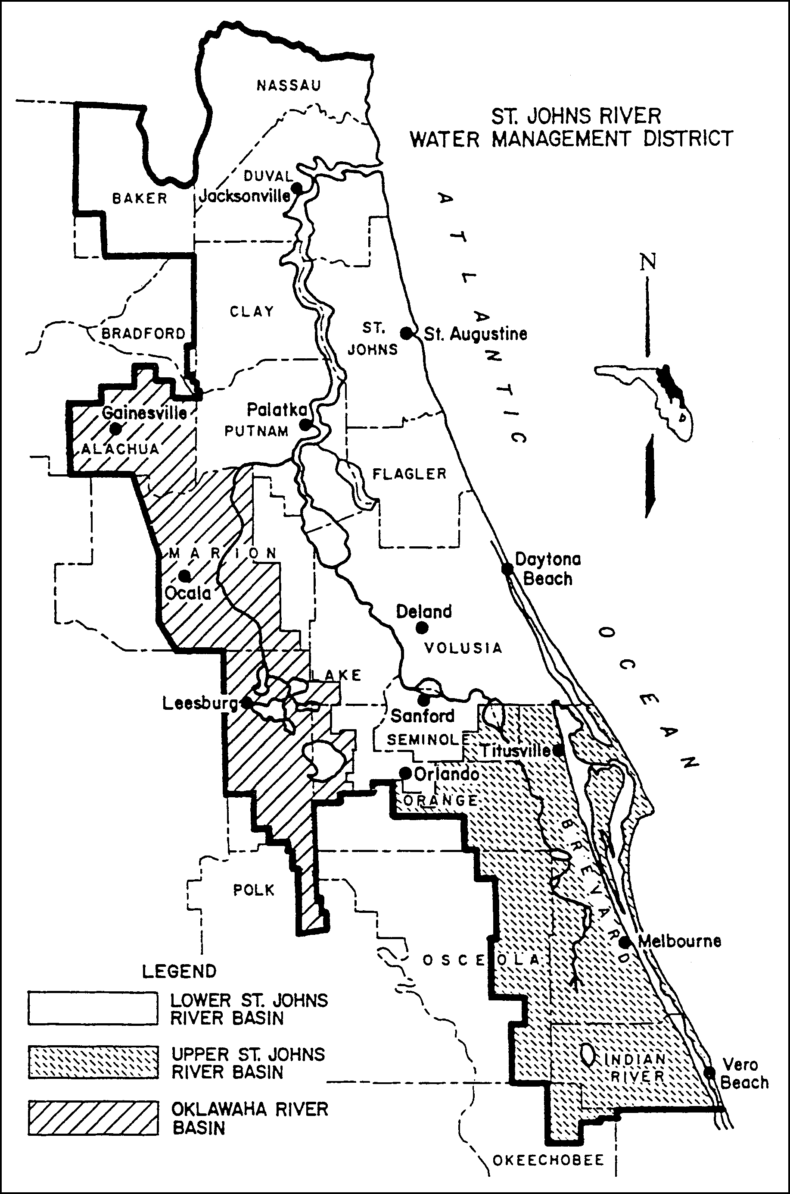
Figure 3.2-1 Areas within the District Having Differing Effective Dates for Implementation of Management and Storage of Surface Water Rules
(d) Authorization to maintain prior to the maintenance or repair of a proposed system, or alteration of an existing system, except for routine custodial maintenance.

(e) Authorization to abandon prior to the abandonment of an existing system.

(f) Authorization to remove prior to the removal of an existing system.

3.2.1 "Alter" is defined in subsection 373.403(7), F.S., to mean "to extend a dam or works beyond maintenance in its original condition, including changes which may increase or diminish the flow or storage of surface water which may affect the safety of such dam or works." The Department District interprets the phrase "beyond maintenance in its original condition" to include the following activities:

(a) Addition to works, appurtenant works, dams, reservoirs or impoundments to an existing system;

(b) Change of any part of an existing system to capacities or locations different from those originally constructed; or

(c) Addition of, or changes to, works, appurtenant works, dams, reservoirs, or impoundments to an existing system which will result in changes in the rate, volume, or timing of discharges from those authorized under the provisions of chapters 40C-4, 40C-40, or 40C-41, F.A.C.

Minor changes which are exempt by statute or rule do not constitute alterations.

3.2.2 A request for authorization to operate and maintain must be included in the application requesting authorization to construct or to alter.

3.2.3 The Department Board will not issue separate permits for parts of a system, except for a system which is to be constructed in phases.

3.2.4 If an application for authorization to alter, maintain, abandon, or remove an existing system or to operate and maintain a proposed alteration to an existing system is denied, such denial will not affect the applicant's right to the continued operation of his existing system.

3.3 Thresholds

3.3.1 A general or individual permit is required prior to the undertaking of any activity described in section 3.2 if such activity:

(a) is capable of impounding a volume of water of 40 or more acre-feet; or

(b) serves a project with a total land area equal to or exceeding 40 acres; or

(c) serves a project with a total land area equal to or exceeding ten acres, when any part of the project is located within the Wekiva River Hydrologic Basin north of State Road 436, or within the Econlockhatchee River Hydrologic Basin, within the Tomoka River Hydrologic Basin, or within the Spruce Creek Hydrologic Basin; or

(d) provides for the placement of 12 or more acres of impervious surface which constitutes 40 or more percent of the total land area; or

(e) provides for the placement of one half acre or more of impervious surface, when any of the impervious surface is located within the Wekiva River Hydrologic Basin north of State Road 436; or

(f) provides for the placement of two acres or more of impervious surface, when any of the impervious surface is located within the Econlockhatchee River Hydrologic Basin, within the Tomoka River Hydrologic Basin, or within the Spruce Creek Hydrologic Basin; or

(g) is wholly or partially located within the Wekiva River Hydrologic Basin's Riparian Habitat Protection Zone as described in Paragraph 40C-41.063(3)(e); or

(h) is wholly or partially located in, on, or over any wetland or other surface water.

3.3.2 A standard general environmental resource permit is issued for a specific class of surface water management systems which meet the criteria specified in chapters 40C-4, 40C-40, and 40C-41, F.A.C. (if applicable), and this Handbook, and which:

(a) are not capable of impounding more than 120 acre-feet; and

- serve projects of less than 100 acres total land area; and

(c) do not involve regulated activities, including dredging or filling, in, on, or over a total of one acre or more of wetlands and other surface waters. However, calculation of the one acre area shall not include:

1. Ditches that were constructed in uplands;

2. Any isolated wetland with a surface area of less than 0.5 acres.

An application to modify an individual, standard, or conceptual environmental resource permit or a mitigation bank permit or conceptual approval permit shall be processed as a standard environmental resource permit so long as the scope of the modification by itself does not exceed the limitations listed in paragraphs (a)-(c) above.

3.3.3 A noticed general environmental resource permit may be applied for under chapter 62-341 40C-400, F.A.C., for certain specified surface water management systems which meet the terms, conditions, limitations, and restrictions applicable to any of the following noticed general permits:

(a) General Permit for Construction, Alteration or Maintenance of Boat Ramps and Associated Accessory Docks (see Rule section 62-341 40C-400.417, F.A.C.).

(b) General Permit for Certain Piers and Associated Structures (see Rule section 62-341 40C-400.427, F.A.C.)

(c) General Permit for Installation of Riprap (see Rule section 62-341 40C-400.431, F.A.C.).

(d) General Permit for Installation of Fences (see Rule section 62-341 40C-400.437, F.A.C.).

(e) General Permit for the Construction or Maintenance of Culverted Driveway or Roadway Crossings and Bridges of Artificial Waterways (see Rule section 62-341 40C-400.439, F.A.C.).

(f) General Permit to the Florida Department of Transportation, Counties and Municipalities for Minor Bridge Alteration, Replacement, Maintenance and Operation (see section 62-341 40C-400.443, F.A.C.).

(g) General Permit to the Florida Department of Transportation, Counties and Municipalities for Minor Activities Within Existing Rights-of-Way or Easements (see Rule section 62-341 40C-400.447, F.A.C.).

(h) General Permit for Installation, Maintenance, Repair and Removal of Underground Cable, Conduit, or Pipeline (see Rule section 62-341 40C-400.453, F.A.C.).

(i) General Permit for the Construction of Aerial Pipeline, Cable, and Conduit Crossings of Certain Waters (see Rule section 62-341 40C-400.455, F.A.C.).

(j) General Permit for Subaqueous Utility Crossings of Artificial Waterways (see Rule section 62-341 40C-400.457, F.A.C.).

(k) General Permit for the Construction and Operation of Culverts and Associated Water Control Structures in Mosquito Control Impoundments by Governmental Mosquito Control Agencies (see Rule section 62-341 40C-400.463, F.A.C.).

(l) General Permit for Breaching Mosquito Control Impoundments by Governmental Mosquito Control Agencies (see Rule section 62-341 40C-400.467, F.A.C.).

(m) General Permit for Minor Activities (see Rule section 62-341 40C-400.475, F.A.C.).

(n) General Permit to the Department to Conduct Minor Activities (see Rule section 62-341 40C-400.483, F.A.C.).

(o) General Permit to the Department for Environmental Restoration and Enhancement (see Rule section 62-341 40C-400.485, F.A.C.).

(p) General Permit to the Department to Change Operating Schedules for Department Water Control Structures (see Rule section 62-341 40C-400.487, F.A.C.).

(q) General Permit for U.S. Forest Service for Minor Works Within National Forests (see Rule section 62-341 40C-400.495, F.A.C.).

(r) General Permit for Construction, Operation, Maintenance, Alteration, Abandonment or Removal of Minor Silvicultural Surface Water Management Systems (see Rule section 62-341 40C-400.500, F.A.C.).

3.3.4 Different thresholds may be implemented by the Department District for specific geographic areas. These different thresholds will be implemented through the rule adoption process.

3.4 Exemptions

3.4.1 Florida Statutes specifically exempt certain activities from the requirements of chapters 40C-4, 40C-40, 40C-41, and 62-341 40C-400, F.A.C., as well as other regulatory rules implementing part IV, chapter 373, F.S. These statutory exemptions are discussed below:

(a) Subsection 373.406(1), F.S., states that "Nothing herein, or in any rule, regulation, or order adopted pursuant hereto, shall be construed to affect the right of any natural person to capture, discharge, and use water for purposes permitted by law." Thus, the consumptive use of water for a domestic use does not by itself require an environmental resource permit under part IV, chapter 373, F.S. Such use may, however, require that a consumptive use permit be obtained. Refer to chapter 40C-2, F.A.C., for details.

(b) Subsection 373.406(2), F.S., states that "Nothing herein, or in any rule, regulation or order adopted pursuant hereto, shall be construed to affect the right of any person engaged in the occupation of agriculture, silviculture, floriculture, or horticulture to alter the topography of any tract of land for purposes consistent with the practice of such occupation. However, such alteration may not be for the sole or predominant purpose of impounding or obstructing surface waters."

In determining whether an exemption is available to a person engaged in the occupation of agriculture, silviculture, floriculture or horticulture, the following questions must be addressed:

1. Is the proposed topographic alteration consistent with the practice of agriculture, silviculture, floriculture or horticulture?

2. Is the proposed topographic alteration for the sole or predominant purpose of impounding or obstructing surface waters?

If the first question is answered affirmatively and the second is answered negatively, an exemption under subsection 373.406(2), F.S., is available. The exemption is construed as set forth in the Conference Committee Report on CS/CS/HB 1187, Journal of the House of Representatives, May 29, 1984, page 734 and Journal of the Senate, May 28, 1984, page 475.

The Department District presumes that the following activities are consistent with the practice of silviculture when they are undertaken to place property into silvicultural use or to perpetuate the maintenance of property in silvicultural use. The following activities are also presumed not to be for the sole or predominant purpose of impounding or obstructing surface waters:

1. normal site preparation for planting of the tree crop;

2. planting; and

3. harvesting.

If any activity is undertaken to place the property into a use other than silviculture (for example: harvesting which is designed to clear property in preparation for commercial, industrial or residential development rather than regeneration) the activity is not considered to be consistent with the practice of silviculture and will be subject to the permitting jurisdiction of the Department District. Examples of activities which are considered to be for the sole or predominant purpose of impounding or obstructing surface waters because they have the effect of more than incidentally trapping, obstructing or diverting surface water are activities which create canals, ditches, culverts, impoundments or fill roads.

In determining consistency with the practice of agriculture occupations, the Department District will refer to the following publication: "A Manual of Reference Management Practices for Agricultural Activities (November, 1978)" The following practices described in the manual are considered as having impoundment or obstruction of surface waters as a primary purpose:

1. Diversion, when such practice would cause diverted water to flow directly onto the property of another landowner

2. Floodwater Retarding Structure

3. Irrigation Pit or Regulating Reservoir

4. Pond

5. Structure for Water Control

6. Regulating Water in Drainage Systems

7. Pumping Plant for Water Control, when used for controlling water levels on land

Other practices which are described in the manual and which are constructed and operated in compliance with Soil Conservation Service standards and approved by the local Soil and Water Conservation District are presumed to be consistent with agricultural activities. Practices which are not described in the manual are presumed to be inconsistent with the practice of agriculture and a permit is required for the construction, alteration, operation, maintenance, removal, or abandonment of a system, subject to the thresholds. See Appendix H for a complete listing of agricultural practices described in the manual. A copy of the manual may be obtained by contacting the District headquarters.

(c) Subsection 373.406(3), F.S., states that "Nothing herein, or in any rule, regulation or order adopted pursuant hereto, shall be construed to be applicable to construction, operation, or maintenance of any agricultural closed system. However, Part II of this chapter (chapter 373) shall be applicable as to the taking and discharging of water for filling, replenishing, and maintaining the water level in any such agricultural closed system. This subsection shall not be construed to eliminate the necessity to meet generally accepted engineering practices for construction, operation, and maintenance of dams, dikes, or levees." A "closed system" is defined in subsection 373.403(6) as "any reservoir or works located entirely within agricultural lands owned or controlled by the user and which requires water only for the filling, replenishing, and maintaining the water level thereof," and a surface water management permit is not required for such systems.

(d) Subsection 403.813(1)(2), F.S., provides that no permit shall be required for certain activities. Refer to Appendix E for the complete text of subsection 403.813(1)(2), F.S.

(e) Exemptions for certain maintenance activities are provided in paragraphs 403.813(1)(2) (f) and (g), F.S., and are described in detail below. The exemption in 403.813(1)(2) (f), F.S. addresses the maintenance dredging of existing manmade canals and channels, which include navigation basins and ship’s berths; intake and discharge structures; and previously dredged portions of natural water bodies within recorded drainage rights-of-way or drainage easements. The exemption in 403.813(1)(2) (g), F.S., addresses the maintenance of existing insect control structures, dikes, and irrigation and drainage ditches. These exemptions have a number of limitations or conditions, which are further described below.

1. Routine custodial maintenance.

The maintenance exemptions in paragraphs 403.813(1)(2) (f) and (g), F.S., allow only routine custodial maintenance having no more than a minimal adverse environmental impact.

In order to be considered routine custodial maintenance that has no more than a minimal adverse impact on the environment, the maintenance must occur on a frequent enough basis to ensure that the system continues to function as originally designed. The Department District recognizes that a partial loss of function will occur over a period of time prior to routine custodial maintenance. However, should a system be allowed to deteriorate over a period of time to the extent that it no longer functions, then restoring the system to its original design is not exempt from the requirements to obtain a permit. A system is considered to no longer function when it no longer fulfills its originally intended purpose or the repairs needed to restore the system to original design are so extensive that they would cause more than a minimal adverse environmental impact. Examples of originally intended purposes of systems include:

a. dikes - preventing flooding to enable specific agricultural, urban or recreational land uses;

b. irrigation ditches - conveying water from a water source to a water use area;

c. drainage ditches - draining lands to enable specific agricultural, residential, commercial or recreational land use;

d. drainage ditches - draining lands to enable harvesting, site preparation, and regeneration of silvicultural lands during timber rotations;

e. canals - conveying water for flood control or draining lands to enable specific land uses or navigational uses; and

f. channels – specific navigational uses.

(This list of examples is provided to assist maintenance entities and is not all-inclusive)

The only instance when repair of a non-functioning system would be routine custodial maintenance is when the system has lost functionality due to a sudden event such as a large storm. In such a case the repair must be conducted as soon as practicable after the damage occurs, but in no case later than June 1 of the next calendar year. This serves to ensure a continuity of function during the wet season, which generally occurs between June and October in the District. If the June 1 deadline would result in a substantial hardship or would violate principles of fairness, the maintenance entity may seek a variance from the requirement pursuant to section 120.542, F.S.

The evaluation of environmental impacts will compare the environmental conditions prior to conducting the proposed maintenance activity with the expected environmental conditions that would result from the proposed maintenance activity. Environmental impacts that are considered to be more than minimal include: increasing or decreasing water levels in wetlands or other surface waters in a manner that adversely impacts fish and wildlife or their habitat as described in sections 12 through 12.2.8; increasing water levels off-site in a manner which causes flood damage as described in paragraph 40C-4.301(1)(a), (b), or (c ), F.A.C.; and causing a violation of state water quality standards in receiving waters, as described in paragraph 40C-4.301(1)(e), F.A.C.

2. Original design specifications/configurations.

a. Paragraph 403.813(1)(2)(f), F.S. requires that no more dredging is to be performed than is necessary to restore the canals, channels, intake and discharge structures and previously dredged portions of natural water bodies, to original design specifications or configurations. Paragraph 403.813(1)(2)(g), F.S. requires that no more dredging is to be performed than is necessary to restore the dike or irrigation or drainage ditch, to its original design specifications.

b. The entity claiming the maintenance exemption bears the burden of establishing that its activity qualifies for the exemption, including that the maintenance will not extend the system beyond its original design specifications or configuration. However, there is no requirement for the maintenance entity to provide advance notice to the Department District that they are planning on performing maintenance that qualifies for the exemptions in paragraphs 403.813(1)(2)(f) or (g), F.S., except for the 30 day notice required for the maintenance dredging of previously dredged portions of natural water bodies.

Maintenance entities are encouraged to notify the Department District of proposed maintenance and to discuss its planned scope and extent with the Department District. Maintenance entities may also request confirmation from the Department District that they qualify for an exemption. In the event that the planned activity does not qualify for an exemption, such consultation should help to avoid enforcement action by the Department District.

c. Direct evidence of original design can include: plans; historical aerial photographs; surveyed cross sections; soil boring reports, if such borings can distinguish between the original soils and the sediment deposited in a system; and other historical documents. Where such documentary evidence does not clearly establish the original design, eyewitness accounts may provide further evidence of the original design specifications or configuration. In addition, indirect evidence may be used. Indirect evidence is evidence from which the original design specifications or configuration can be scientifically deduced. Examples of such indirect evidence include historic information of land uses enabled by the system and the sizes and capacities of associated systems, such as culverts or weirs. If the maintenance entity can not establish the original design of a system, the maintenance exemptions in paragraphs 403.813(1)(2) (f) and (g), F.S., may not be used.

3. The following limitations, conditions, and definitions also apply to the exemption in paragraph 403.813(1)(2) (f), F.S., for maintenance dredging of existing: canals and channels, including navigation basins and ship’s berths; intake and discharge structures; and previously dredged portions of natural water bodies within recorded drainage rights-of-way or drainage easements:

a. spoil material must be deposited in a self-contained, upland spoil disposal site which will prevent the escape of spoil material into the waters of the state. For the purposes of the exemptions in paragraphs 403.813(1)(2)(f) and (g), F.S., a self-contained, upland disposal site is a disposal site located entirely in uplands which is designed to prevent the spoil material from reentering waters of the state as defined in subsection 403.031(13), F.S. Examples of self-contained upland spoil disposal sites include the following:

i. An upland area separated from waters of the state by a berm, such that the spoil material can not reenter waters of the state;

ii. In a system which has an outer berm or dike, placing the spoil on the inner banks of the dike where it could potentially reenter those interior canals which are not waters of the state, and where the spoil material is prevented from being discharged to waters of the state through the operation of a pump or other type of water control structure; and

iii. In a system involving a road with roadside ditches which are waters of the state, placing spoil in a “V” shaped notch in the center of the road such that it could not be discharged to waters of the state.

(This list of examples is provided to assist maintenance entities and is not all-inclusive)

Additionally, use of dredged materials to conduct exempt or permitted maintenance of a dike or road shall not be considered spoil disposal, so long as the dredged materials are only used to restore the dike or road to original design specifications and the dredged material is not deposited into waters of the state outside of the original dike or road cross section.

b. best management practices for erosion and sediment control must be used at the dredge site to prevent bank erosion and scouring and to prevent turbidity, dredged material, and toxic or deleterious substances from discharging into adjacent waters during maintenance dredging;

c. the maintenance dredging shall not cause significant impacts to previously undisturbed natural areas;

d. maintenance work must be conducted in accordance with paragraph 370.12(2)(d), F.S., which provides that, except as may be authorized by a valid state permit issued pursuant to paragraph 370.12(2)(c), F.S., or by the terms of a valid federal permit, the maintenance entity shall not at any time, by any means or in any manner intentionally or negligently:

i. annoy, molest, harass, or disturb or attempt to molest, harass, or disturb any manatee;

ii. injure or harm or attempt to injure or harm any manatee;

iii. capture or collect or attempt to capture or collect any manatee;

iv. pursue, hunt, wound, or kill or attempt to pursue, hunt, wound, or kill any manatee; or

v. possess, literally or constructively, any manatee or any part of any manatee.

e. for canals and previously dredged portions of natural water bodies, the exemption only applies to such systems constructed prior to April 3, 1970, or constructed on or after April 3, 1970, pursuant to all necessary state permits;

f. the exemption does not apply to the removal of any natural or manmade barrier separating a canal or canal system from adjacent waters;

g. maintenance dredging shall be limited to a depth of no more than 5 feet below mean low water for existing manmade canals or intake or discharge structures which have not been permitted for construction or maintenance dredging by the Board of Trustees of the Internal Improvement Trust Fund or the United States Army Corps of Engineers;

h. for maintenance dredging of a previously dredged portion of a natural water body, the maintenance entity must notify the Department District at least 30 days prior to dredging, and provide documentation of original design specifications or configurations where such exist;

i. the term “natural water bodies” as used in paragraph 403.813(1)(2)(f), F.S. means those surface water bodies extending waterward from the boundary established pursuant to the methodology in chapter 62-340, F.A.C., except for those waters that were created solely due to acts of man, such as borrow pits, ditches, canals, and artificial impoundments, located in areas that were uplands prior to construction.

4. The following limitations or conditions also apply to the exemption in paragraph 403.813(1)(2)(g), F.S., for the maintenance of existing insect control structures, dikes, and irrigation and drainage ditches:

a. spoil material must be deposited on a self-contained, upland spoil site which will prevent the escape of spoil material into waters of the state (see 3.4.1(e)3.a. above for further explanation of self-contained, upland spoil site);

b. for insect control structures, if the agency named in section 403.813(1)(3) (g), F.S., determines that the cost of spoil disposal is so excessive that it will inhibit proposed insect control, then existing spoil sites or dikes may be used upon notification to the Department of Environmental Protection or the District. In such cases, turbidity control devices shall be used when the receiving water body is a potable water supply, is designated as shellfish harvesting waters, or functions as a habitat for commercially or recreationally important shellfish or finfish.

3.4.2 In addition to the statutory exemptions, District rules also provide for the exemptions described in section 40C-4.051, F.A.C.

3.5 Conceptual Approval Permit

3.5.1 Because many water management systems are designed and constructed in phases, a procedure has been established which provides for Department District review and approval of master development plans. The intent of this procedure is to assure the permittee that the engineering concepts upon which he bases current and future design decisions are likely to meet District rule criteria at least in concept.

The application form for a conceptual approval permit has been adopted by reference in subsection 40C-4.900(1), F.A.C., and is contained in Appendix B of this Handbook.

3.5.2 For a system which is to be constructed in phases, in addition to the conceptual approval permit, a permit must be obtained for any one or combination of the following (if the total system, will meet or exceed the thresholds described in section 3.3):

(a) Authorization to construct and operate the initial phase, prior to the construction of the initial phase of a proposed system.

(b) Authorization to alter, prior to the construction of each succeeding phase of a system.

(c) Authorization to operate all constructed phases, at the time that the application is made for alteration.

3.5.3 The Department’s Governing Board's determination that the conceptual plans are consistent with chapter 373, F.S., and chapters 40C-4, 40C-40, and 40C-41, F.A.C., will provide the applicant with an assurance that the concepts upon which his designs are based can provide for systems which will not be harmful to the water resources of the District and will not be inconsistent with the overall objectives of the District.

3.5.4 The conceptual approval permit will be valid for twenty years provided that construction of the initial phase of the system must be permitted and construction undertaken within two years of the granting of the conceptual approval permit and provided that all phases of the system are designed and built in accordance with the terms of the conceptual approval permit, and that all required permits for subsequent phases are obtained. However, if the project approved by the conceptual approval permit is undergoing development-of-regional-impact review pursuant to section 380.06, F.S., and an administrative appeal of that review has been filed, the permittee may toll the two year time period for permitting and undertaking construction by notifying the Department District, in writing, that the development-of-regional-impact review has been appealed within two years of issuance of the conceptual permit, and notifying the Department District, in writing, of the final action resolving such administrative appeal. If proper notice is given as indicated above, the two year time period for permitting and undertaking construction shall be tolled from the date the administrative appeal of the development-of-regional-impact review is filed, to the date of final action resolving such administrative appeal.

3.5.5 Phases within a conceptually approved project shall be processed as standard permits provided:

(a) The proposed activity is consistent with the conceptual approval permit;

(b) The approved conceptual plan includes the location and acreage of wetlands onsite, an assessment of wetland impacts, and a conceptual mitigation plan (if required); and

(c) The approved conceptual plan includes the approximate size, location, and discharge points of the proposed stormwater management system.

4.0 THROUGH 6.8 — THESE SECTIONS NOT ADOPTED FOR USE BY THE DEPARTMENT

7.0 Permits

7.1 Operation Permits

All permits to construct, alter and maintain a surface water management system also include a permit to operate the system. An applicant must submit the information described in this section to specify the entity that will operate and maintain the system with the construction, alteration or maintenance permit application. The construction, alteration, or maintenance permit will be converted to the operation permit once the District determines the system or independent portion of a system has been constructed in compliance with the permit, and an appropriate entity has accepted responsibility for operation and maintenance of the system or independent portion of a system. The Department District will transfer the operation permit to an operation and maintenance entity upon request, pursuant to Rule section 62-343.110 40C-4.351, F.A.C., once all conditions for converting the construction, alteration, or maintenance permit have been met.

7.1.1 The following entities are acceptable for ensuring that a surface water management system will be operated and routine custodial maintenance will be performed in compliance with the requirements of chapters 40C-4, 40C-40, or 40C-42, F.A.C.:

(a) local governmental units including counties and municipalities, and Municipal Service Taxing Units,

(b) active water control districts created pursuant to chapter 298, F.S., drainage districts created by special act, special districts defined in chapter 189, Community Development District created pursuant to chapter 190, F.S., Special Assessment Districts created pursuant to chapter 170, F.S., or water management districts created pursuant to chapter 373, F.S.,

(c) state or federal agencies,

(d) duly constituted communication, water, sewer, stormwater, electrical or other public utilities,

(e) profit or non-profit corporations as indicated below, or

(f) property owners or developers provided:

1. the property owner or developer provides written proof, either by letter or resolution, that a governmental entity or an acceptable entity set forth in paragraphs 7.1.1(a) through (e) above will accept the operation and maintenance of the stormwater management system when construction of the system is completed;

2. the property owner or developer provides proof of bonding or other assurance of a similar nature in an amount sufficient to cover the costs of the operation and maintenance of the system for a period of 10 years;

3. The property owner or developer wholly owns the property, and intends to retain this ownership; or

4. The property owner or developer will retain ownership of the property and will lease or rent it to third parties.

If the property owner or developer is to serve as the operation and maintenance entity, the property owner or developer must provide a copy of legal documentation demonstrating that the property owner or developer will have the right to enter upon the property and maintain the system. Bonding or other financial assurances provided to other governmental entities is acceptable under paragraph 7.1.1(f)2. provided such bonding or other financial assurance covers the costs of operating and maintaining the system for a period of ten years in addition to the cost of any other activity the bond or other financial assurance secures.

If the proposed maintenance entity falls within paragraph (a), (b), (c), or (d) above, a letter of intent from such entity must be submitted to the Department District as part of the permit application, indicating the entity's intention to accept responsibility for operation and maintenance of the permitted system when construction of the system is complete. The letter of intent shall also specify any portions of the system that the governmental entity will operate and maintain.

The documentary assurances required under paragraph (f) above or section 7.1.2 below must be submitted to the Department District as a part of the permit application and approved by the staff before a recommendation for approval of the permit will be made.

7.1.2 Profit or non-profit corporations such as homeowners associations, property owners associations, condominium owners associations or master associations are acceptable operation and maintenance entities only if the corporation has the financial, legal, and administrative capability to provide for the long term operation and routine custodial maintenance of the surface water management system.

(a) If a homeowner, property owner, condominium or master association is proposed, the applicant must submit draft Articles of Incorporation, Declaration, Restrictive Covenants, Deed Restrictions or other organizational or operation documents, or draft amendments thereto, that affirmatively assign responsibility for the operation or routine custodial maintenance of the surface water management system. These documents must be submitted to the Department District as part of the permit application.

(b) The association must have sufficient powers reflected in its organizational or operational documents to:

1. operate and perform routine custodial maintenance of the surface water management system as exempted or permitted by the Department District,

2. establish rules and regulations,

3. assess members for the cost of operating and maintaining the system, and enforce the collection of such assessments,

4. contract for services to provide for operation and routine custodial maintenance (if the association contemplates employing a maintenance company), and

5. exist in perpetuity; the articles of incorporation must provide that if the association is dissolved, the system shall be transferred to and maintained by an entity described in paragraphs 7.1.1(a) through (e) prior to the association's dissolution.

    - If an operation and maintenance entity is proposed for a project which will be constructed in phases, and subsequent phases will utilize the same surface water management system as the initial phase or phases, the entity must have the ability to accept responsibility for the operation and routine custodial maintenance of the surface water management system for future phases of the project.

If the development scheme contemplates independent operation and maintenance entities for different phases, and the system is integrated throughout the project, the entities, either separately or collectively, must have the responsibility and authority to operate and perform routine custodial maintenance of the system for the entire project area. That authority must include cross easements for surface water management and the ability to enter and maintain the various works, should any sub-entity fail to maintain a portion of the system within the project area.

7.1.4 When the applicant intends to convey the property to multiple third parties, the applicant will be an approved operation and maintenance entity from the time construction begins until the system is dedicated to and accepted by an established legal entity as described in paragraphs 7.1.1(a) through (e), provided that the applicant provides adequate proof that such an entity (as described in subsection 7.1.1) will exist when construction of the system is complete, and of the future acceptance of the system by such entity.

7.2 Master Drainage Plans

7.2.1 An applicant may apply for and receive a standard or individual permit for its existing or proposed master drainage plan for a project area.

7.2.2 Such application will be processed in accordance with the procedures established for standard and individual permits.

7.2.3 After issuance of an individual permit for a master drainage plan, subsequent activities within the master drainage plan which are conducted in accordance with the requirements of 40C-40.302(1), F.A.C., and which would ordinarily require an individual permit, may be authorized under the provisions of a standard permit.

7.2.4 Subsequent activities which would ordinarily require an individual permit and which significantly differ from the approved master drainage plan will require an individual permit.

7.3 THIS SECTION NOT ADOPTED FOR USE BY THE DEPARTMENT

7.4 Related Permits

7.4.1 Application to construct, alter, or maintain a system must include application for any related permit required to operate a system.

7.4.2 The permit for operation and maintenance will be granted with a condition that the operation and maintenance permit becomes valid upon satisfactory completion of the permitted construction or alteration and compliance with all conditions of the permit.

7.4.3 Dewatering during construction may require a consumptive use permit. Please refer to Chapter 40C-2, F.A.C.

7.5 THROUGH 7.6.2 — THESE SECTIONS NOT ADOPTED FOR USE BY THE DEPARTMENT

PART II

CRITERIA FOR EVALUATION

8.0 Criteria for Evaluation

8.1 Purpose

The criteria which are explained in this part are those which have been approved by the Governing Board for use by District staff in evaluating environmental resource permit applications pursuant to chapters 40C-4, 40C-40, and 40C-41, F.A.C. The criteria are used in evaluating applications for individual, standard, and conceptual approval permits. The staff recommendation on permit approval for any permit will be based upon a determination of whether the system meets the criteria for evaluation.

8.2 Source of Criteria

The criteria for evaluation have been developed from guidelines established in Chapter 373, F.S. (Water Resources Act of 1972); Chapter 403, F.S., (Environmental Control); Chapter 62-40, F.A.C. (Water Resource Implementation Rule State Water Policy); and Governing Board policy as stated in Chapter 40C-4, F.A.C., (Environmental Resource Permits: Surface Water Management Systems), Chapter 40C-40, F.A.C., (Standard General Environmental Resource Permits), Chapter 40C-41, F.A.C., (Environmental Resource Permits: Surface Water Management Basin Criteria), Chapter 40C-42, F.A.C., (Environmental Resource Permits: Regulation of Stormwater Management Systems), Chapter 40C-44, F.A.C., (Environmental Resource Permits: Regulation of Agricultural Surface Water Management Systems), this Handbook, and through permitting decisions of the Governing Board,. cCopies of Chapter 373, F.S., (abridged), Chapters 40C-4, 40C-40, 40C-41, and 62-341 40C-400, F.A.C., are contained in the appendices in Part IV of this Handbook.

8.3 Statutory Criteria

8.3.1 In order to obtain a permit, an applicant must give reasonable assurance that:

(a) The construction or alteration of any stormwater management system, dam, impoundment, reservoir, appurtenant work or works will not be harmful to the water resources of the District.

(b) The operation or maintenance of any stormwater management system, dam, impoundment, reservoir, appurtenant work or works will not be inconsistent with the overall objectives of the District and will not be harmful to the water resources of the District.

(c) The abandonment or removal of any stormwater management system, dam, impoundment, reservoir, appurtenant work or works will not be inconsistent with the overall objectives of the District.

All conditions for permit issuance set forth in sections 9 and 10 are therefore based upon these two major standards established by the statute.

9.0 Conditions for Issuance of Permits

9.1 Section 40C-4.301, F.A.C., Conditions

9.1.1 In order to obtain an individual, standard general, or conceptual environmental resource permit, an applicant must provide reasonable assurance that the construction, alteration, operation, maintenance, removal, or abandonment of a surface water management system:

(a) Will not cause adverse water quantity impacts to receiving waters and adjacent lands;

(b) Will not cause adverse flooding to on-site or off-site property;

(c) Will not cause adverse impacts to existing surface water storage and conveyance capabilities;

(d) Will not adversely impact the value of functions provided to fish and wildlife and listed species by wetlands and other surface waters;

(e) Will not adversely affect the quality of receiving waters such that the water quality standards set forth in chapters 62-3, 62-4, 62-302, 62-520, 62-522 and 62-550, F.A.C., including any antidegradation provisions of sections 62-4.242 (1)(a) and (b), 62-4.242(2) and (3), and 62-302.300, F.A.C., and any special standards for Outstanding Florida Waters and Outstanding National Resource Waters set forth in sections 62-4.242(2) and (3), F.A.C., will be violated;

(f) Will not cause adverse secondary impacts to the water resources;

(g) Will not adversely impact the maintenance of surface or ground water levels or surface water flows established in Chapter 40C-8, F.A.C.;

(h) Will not cause adverse impacts to a work of the District established pursuant to section 373.086, F.S.;

(i) Will be capable, based on generally accepted engineering and scientific principles, of being performed and of functioning as proposed;

(j) Will be conducted by an entity with the financial, legal and administrative capability of ensuring that the activity will be undertaken in accordance with the terms and conditions of the permit, if issued; and

(k) Will comply with any applicable special basin or geographic area criteria established in chapter 40C-41, F.A.C.

9.1.2 If the applicant is unable to meet water quality standards because existing ambient water quality does not meet standards, the applicant must comply with the requirements set forth in subsection 12.2.4.5.

9.1.3 In evaluating the potential for flood damages to residences, public buildings, or public streets and roadways, the following criteria will be utilized:

(a) Any proposed streets and roadways must be flood-free as required by local government criteria; and

(b) The first floor of any proposed building used for residence or as a public facility, must be set at or above an elevation adopted by local ordinance or, where a local ordinance has not been adopted, at the 100 year flood elevation calculated by the Department District, or approved by the Department District based upon the determination of the applicant.

10.0 Additional Conditions for Issuance of Permits

10.1 Section 40C-4.302, F.A.C., Conditions

10.1.1 In addition to the conditions set forth in section 9, in order to obtain a standard general, individual, or conceptual approval permit an applicant must provide reasonable assurance that the construction, alteration, operation, maintenance, removal, and abandonment of a system:

(a) located in, on, or over wetlands or other surface waters will not be contrary to the public interest, or if such an activity significantly degrades or is within an Outstanding Florida Water, that the activity will be clearly in the public interest, as determined by balancing the following criteria as set forth in subsections 12.2.3 through 12.2.3.7:

1. Whether the activity will adversely affect the public health, safety, or welfare or the property of others;

2. Whether the activity will adversely affect the conservation of fish and wildlife, including endangered or threatened species, or their habitats;

3. Whether the activity will adversely affect navigation or the flow of water or cause harmful erosion or shoaling;

4. Whether the activity will adversely affect the fishing or recreational values or marine productivity in the vicinity of the activity;

5. Whether the activity will be of a temporary or permanent nature;

6. Whether the activity will adversely affect or will enhance significant historical and archaeological resources under the provisions of section 267.061, F.S.; and

7. The current condition and relative value of functions being performed by areas affected by the proposed activity.

(b) Will not cause unacceptable cumulative impacts upon wetlands and other surface waters as set forth in subsections 12.2.8 through 12.2.8.2.

(c) Located in, adjacent to or in close proximity to Class II waters or located in Class II waters or Class III waters classified by the Department as approved, restricted or conditionally restricted for shellfish harvesting pursuant to chapter 62R-7, F.A.C., will comply with the additional criteria in subsection 12.2.5 of the Applicant's Handbook adopted by reference in Chapter 62-113 section 40C-4.091, F.A.C.

(d) Which constitute vertical seawalls in estuaries or lagoons, will comply with the additional criteria provided in subsection 12.2.6 of the Applicant's Handbook.

10.1.2 When determining whether a permit applicant has provided reasonable assurances that District permitting standards will be met, the District shall take into consideration the applicant's violation of any Department rules adopted pursuant to sections 403.91 - 403.929, F.S., (1984 Supp.), as amended, which the Department District had the responsibility to enforce pursuant to delegation, or any District or Department rules adopted pursuant to part IV, chapter 373, F.S., relating to any other project or activity and efforts taken by the applicant to resolve these violations. The Department's delegation to the District to enforce Department rules is set forth in the Operating Agreement concerning Stormwater Discharge Regulation and Dredge and Fill Regulation, dated January 4, 1988; Operating Agreement concerning Management and Storage of Surface Waters Regulation and Wetland Resource Regulation between the St. Johns River Water Management District and Department of Environmental Regulation, dated August 28, 1992; and Operating Agreement Concerning Regulation under Part IV, Chapter 373, F.S., between St. Johns River Water Management District and Department of Environmental Protection dated August 25, 1994; Operating Agreement Concerning Regulation under Part IV, Chapter 373, F.S., and Aquaculture General Permits Under Section 403.814, F.S., between St. Johns River Water Management District and Department of Environmental Protection dated December 3, 1998; and Operating Agreement Concerning Regulation Under Part IV, Chapter 373, F.S., between St. Johns River Water Management District and Department of Environmental Protection dated July 1, 2007, all incorporated by reference in Chapter 62-113 Rule 40C-4.091, F.A.C. Revised 7/1/07.

10.2 Harm to the Water Resources and Objectives of the District Criteria

10.2.1 It is presumed that a system meets the standards listed in paragraphs 9.1.1(a) through (c) if the system meets the following criteria:

(a) The post-development peak rate of discharge must not exceed the pre-development peak rate of discharge for the storm event as prescribed in section 10.3.

(b) The post-development volume of direct runoff must not exceed the pre-development volume of direct runoff for systems as prescribed in subsections 10.4.2 and 10.4.3.

(c) Floodways and floodplains, and levels of flood flows or velocities of adjacent streams, impoundments or other watercourses must not be altered so as to adversely impact the off-site storage and conveyance capabilities of the water resource (see section 10.5).

(d) Flows of adjacent streams, impoundments or other watercourses must not be decreased so as to cause adverse impacts (see section 10.6).

10.2.2 Compliance with the following criteria shall constitute reasonable assurance that a proposed system meets the requirements of paragraphs 9.1.1 (d), (e), (f), (j), and (k) and 10.1.1 (a) through (d):

(a) State water quality standards must not be violated, as set forth in subsections 10.7 through 10.7.2 and 12.2.4 through 12.2.4.5.

(b) The applicant must establish financial responsibility and provide for an operation and maintenance entity, as set forth in subsections 10.8 through 10.8.3.

(c) The environmental criteria set forth in subsections 12.2 through 12.3.8, including mitigation and mitigation banking provisions, must be met.

(d) Applicable basin criteria set forth in section 11 and chapter 40C-41, F.A.C., must be met.

10.2.3 The applicant has two options for providing reasonable assurances that the standards referenced in subsection 10.2.1 are met. The applicant may make such demonstration through compliance with the criteria specified in subsection 10.2.1 or by use of alternative methods as may be appropriate for the specific system. If the applicant wishes to use alternative methods, he should contact the Department District to arrange for a preapplication conference to discuss the methods to be utilized in meeting the standards listed in subsection 10.2.1.

10.2.4 An abbreviated listing of criteria and related performance criteria is provided in Appendix I. This listing is provided solely as an aid to understanding the number of requirements for providing reasonable assurance that harm to the resource will not occur.

10.3 Peak Discharge

10.3.1 Criterion: The post-development peak rate of discharge must not exceed the pre-development peak rate of discharge.

10.3.2 Storm Frequency:

The peak discharge requirement shall be met for the 25 year frequency storm for all areas of the District except:

(a) For those systems which discharge directly into the St. Johns River north of Lake George, the man-made portions of the Intracoastal Waterway, the Intracoastal Waterway north of the Matanzas Inlet, or the Atlantic Ocean.

(b) Where separate basin criteria have been adopted (see section 11.0).

10.3.3 Storm Duration:

In determining rate of peak discharge, a 24-hour duration storm is to be used.

10.3.4 Aggregate Discharge:

Depending on the location and design of large systems where multiple off-site discharges are designed to occur, the District may allow the total post-development peak discharge not to exceed the pre-development peak discharge for the combined discharges rather than for each individual discharge. Such a consideration shall be made only if the combined discharges meet all other requirements of Chapter 40C-4, F.A.C., and discharge to the same receiving water body.

10.3.5 Methodologies:

Peak discharge computations should consider the duration, frequency, and intensity of rainfall, the antecedent moisture conditions, upper soil zone and surface storage, time of concentration, tailwater conditions, changes in land use or land cover, and any other changes in topographic and hydrologic characteristics. Large systems should be divided into subbasins according to artificial or natural drainage divides to allow for more accurate hydrologic simulations. Examples of accepted methodologies for computation of runoff are as follows:

(a) Soil Conservation Service Method (see U.S. Department of Agriculture, Soil Conservation Service "National Engineering Handbook, Section 4, Hydrology," TR-55 or TR-20 user’s manuals).

(b) Santa Barbara Urban Hydrograph Method.

(c) U.S. Army Corps of Engineers HEC-1 Computer Programs.

(d) Other hydrograph methods approved by the District.

See section 13 12.0 of this Handbook for additional information regarding accepted methodologies.

10.3.6 Rainfall Intensity:

In determining peak discharge rates, intensity of rainfall values shall be obtained through a statistical analysis of historical long term rainfall data or from sources or methods generally accepted as good engineering practice.

(a) Examples of acceptable sources include:

1. USDA Soil Conservation Service, "Rainfall Frequency Atlas of Alabama, Florida, Georgia, and South Carolina for Durations from 30 Minutes to 24 Hours and Return Periods from 1 to 100 Years" January 1978; Gainesville, Florida.

2. U.S. Weather Bureau Technical Paper No. 49.

3. U.S. Weather Bureau Technical Paper No. 40.

4. U.S. Department of Interior, Bureau of Reclamation, "Design of Small Dams", 2nd Edition.

(b) For a drainage basin greater than 10 square miles, the areal rainfall can be calculated from point rainfall using a method that has been well documented. The converting factor as described in U.S. Weather Bureau Technical Paper No. 49 may be used.

Additional information regarding determination of rainfall intensities and distributions is found in section 14 13.0 of this Handbook.

10.3.7 Design Techniques:

Various design techniques are available to the engineer to estimate approximate pre-development peak discharge rates for the system through a reduction in excess runoff. Acceptable design techniques include detention basins, the use of grassed waterways, and any other storage capability that the particular system may have. Where detention basins are designed for reducing post-development peak discharge, the outlet and regulation schedule should be designed to provide necessary design detention and retention storage within 14 days following any storm event.

10.3.8 Upper Soil Zone Storage and Surface Storage:

In most instances, the upper soil zone storage and surface storage capacities will have an effect on the pre-development and post-development peak discharges and should be considered in these computations. Any generally accepted and well documented method may be used to develop the upper soil zone storage and surface storage values.

(a) The soil zone storage at the beginning of a storm should be estimated by using reasonable and appropriate parameters to reflect drainage practices, average wet season water table elevation, the antecedent moisture condition (AMC II) (see section 13 12.1) and any underlying soil characteristics which would limit or prevent percolation of storm water into the entire soil column. In no case should the soil storage used in the computation exceed the difference between the maximum soil water capacity and the field capacity (i.e., gravitational water) for the soil columns above any impervious layer or seasonal ground water table.

(b) Surface storage, including that available in wetlands and low lying areas, shall be considered as depression storage. Depression storage shall be analyzed for its effect on peak discharge and the time of concentration. Depression storage can also be considered in post- development storage routing which would require development of stage-storage relationships; if depression storage is considered, then both pre-development and post-development storage routing must be considered.

10.4 Volume

10.4.1 Criterion: The post-development volume of direct runoff must not exceed the pre-development volume of direct runoff for systems as prescribed in subsections 10.4.2 and 10.4.3.

10.4.2 Systems discharging to land-locked lakes which are adjacent to properties of more than one ownership shall not cause an increase in the total pre-development flood stage. This can be accomplished through retention with percolation or, if the soil conditions are not sufficient for percolation, then through detention for a duration sufficient to mitigate adverse impacts on flood stages. In determining the volume of direct runoff, 96-hour duration storm is to be used.

10.4.3 Additional volume requirements are found in section 11.0 for those systems which are within areas for which separate basin criteria have been adopted pursuant to Chapter 40C-41, F.A.C.

10.5 Storage and Conveyance

10.5.1 Criterion: Floodways and floodplains, and levels of flood flows or velocities of adjacent streams, impoundments or other water courses must not be altered so as to adversely impact the off-site storage and conveyance capabilities of the water resource.

10.5.2 (a) A system may not cause a net reduction in flood storage within a 10 year floodplain except for structures elevated on pilings or traversing works. Traversing works, works or other structures shall cause no more than a one foot increase in the 100 year flood elevation immediately upstream and no more than one tenth of a foot increase in the 100 year flood elevation 500 feet upstream. A system will not cause a net reduction in flood storage within a 10 year floodplain if compensating storage is provided outside the 10 year floodplain.

(b) A system may not cause a reduction in the flood conveyance capabilities provided by a floodway except for structure elevated on pilings or traversing works. Such works, or other structures shall cause no more than a one foot increase in the 100 year flood elevation immediately upstream and no more than one tenth of a foot increase in the 100 year flood elevation 500 feet upstream.

(c) An applicant may only be permitted to contravene the requirements of (a) or (b) if the applicant gives reasonable assurance that were all other persons who could impact the surface water of any impoundment, stream, or other watercourse by floodplain encroachment to exceed (a) and (b) above to the same degree as the applicant proposes, the cumulative impacts would not contravene Subsection 40C-4.301(1) or Paragraph (2)(a), F.A.C., and that the singular impact would not contravene Subsection 40C-4.301(1) or Paragraph (2)(a), F.A.C.

10.5.3 Floodway and Floodplain Elevation Determination:

(a) The floodway and floodplain criteria contained in subsection 10.5.2 are applicable only to locations downstream of the point on a stream or watercourse where the drainage area is five square miles.

(b) The District has detailed information regarding floodplain and floodway elevations for many of the streams and water courses in its jurisdiction. The applicant is encouraged to consult with the District prior to making calculations. Other sources of information include the most recently published data from flood insurance rate studies or relevant engineering reports. If data are not available from the District, the flood insurance rate studies, or published reports, the applicant will be responsible for making determination of floodplain elevations or floodway limits using the procedure of "Normal Depth Analysis" (see section 15 14.0 of this Handbook), extrapolation of existing data, or any other acceptable technique.

10.5.4 Flow Velocity:

Good engineering practices shall be employed to minimize the flow velocity to avoid transport of soil particles and other suspended solids from one location and deposition in another location. Many different measures, structural or non- structural, may be used to reduce erosion from the bottom and side slopes of a conveyance system or around the control structures. However, velocity reduction measures and re- vegetation with naturally occurring species of the area should be considered before using other methods of bottom and side slope consolidation.

10.5.5 Stabilization of Side Slopes:

Stabilization of side slopes is necessary in order to prevent erosion due to flow velocity and runoff from the banks. Good engineering practices, taking into consideration soil characteristics, flow and drainage characteristics, shall be employed. Again, the retardation of overland runoff and soil stabilization using naturally occurring vegetation coverage shall be considered before paving, riprap, lining, energy dissipation and other structural measures are employed.

10.5.6 Dams greater than six feet in height or which have a storage capacity of greater than 15 acre-feet of water which could be released in the event of dam failure shall have a spillway system with a capacity to pass the flow resulting from the design storm indicated in Table 10.5.7-1, without overtopping the dam unless the applicant provides analyses to show that the design flood can be stored, passed through, or passed over the dam without failure occurring. See section 17 of this Handbook for additional information concerning hazard classification, stage capacity, height and probable maximum precipitation (PMP).

TABLE 10.5.7-1
Hazard  Classification | Storage Capacity  (acre-feet) | Height  (feet) | Design  Storm
A | > 15 | > 6 | 25-yr.
B | < 1000 | < 40 | 25-yr
 |  | 40-100 | 1/2 PMP
 |  | > 100 | PMP
 | 1000-50,000 | < 100 | 1/2 PMP
 |  | > 100 | PMP
 | 50,000 | > 6 | PMP
C | < 1000 | < 40 | 1/2 PMP
 |  | > 40 | PMP
 | > 1000 | > 6 | PMP

10.5.7 Dams greater than six feet in height or which have a storage capacity of greater than 15 acre-feet of water which could be released in the event of dam failure shall have a spillway system capable of removing from the reservoir at least 80% of the water detained in the reservoir above the principal spillway within ten days after passage of the design storm.

10.6 Low Flow and Base Flow Maintenance

10.6.1 Criterion: Flows of adjacent streams, impoundments or other water courses must not be decreased so as to cause adverse impacts.

10.6.2 Low Flow:

(a) Only systems with both of the following conditions meet the low flow performance criteria in (b) and (c).

1. Systems which impound water for purposes in addition to temporary detention storage. Water impounded longer than a 14 day bleed down period is considered conservation storage for benefits other than detention storage (i.e., recreation, irrigation, etc.).

2. Systems that impound a stream or other water course which, under pre-development conditions, discharged surface water off-site to receiving water during 5 year, 30-day drought frequency conditions.

(b) Any system meeting the conditions of (a) above shall be designed with an outlet structure to maintain a low flow discharge of available conservation storage. When the conservation storage is at the average dry season design stage, the low flow discharge should equal the average pre-development surface water discharge which occurred from the project site to receiving waters during the 5 year, 30-day drought. See section 16 15 for methods in determination of 5 year, 30-day low flow and design guidelines.

(c) The system shall be operated to provide a low flow discharge whenever water is impounded. However, discharge may be discontinued, if desired, during the wet season (considered as June through October) unless a water shortage condition is declared by the District. The actual discharge will vary according to the water stage in the impoundment. When conservation storage is at the average dry season design stage, the discharge will be the average 5 year, 30-day low flow. When storage is below the average dry season design stage, the discharge may be less than the average 5 year, 30- day low flow.

10.6.3 Base Flow

It is presumed that an adverse impact will result if the system causes the ground water table to be lowered: a) more than an average three feet lower over the project area than the average dry season low water table; or b) at any location, more than five feet lower than the average dry season low water table; or c) to a level that would decrease the flows or levels of surface water bodies below any minimum level or flow established by the Governing Board pursuant to section 373.042, F.S.

10.7 Water Quality

10.7.1 Criterion: State water quality standards must not be violated.

10.7.2 The District cannot by permit authorize degradation of water quality below the standards set forth in chapters 62-3 and 62-4, 62-302, 62-520, 62-522, and 62-550, F.A.C., including any antidegradation provisions of sections 62-4.242(1)(a) and (b), 62-4.242(2) and (3), and 62-302.300, F.A.C., and any special standards for Outstanding Florida Waters and Outstanding National Resource Waters set forth in sections 62-4.242(2) and (3), F.A.C. Furthermore, the District cannot authorize permits which modify the quantity of water discharged offsite if such discharge will cause adverse environmental or water quality impacts.

The quality of stormwater discharged to receiving water is presumed to meet the surface water standards in chapters 62-3, 62-4, and 62-302, F.A.C., and ground water standards in chapter 62-550, F.A.C., if the system requires a permit pursuant to chapter 40C-42, F.A.C., or chapter 40C-44, F.A.C., and is in compliance with such chapter; or the system has a valid agricultural discharge/industrial wastewater treatment facility operating permit under chapter 62-6, F.A.C.

When an activity which requires a permit pursuant to chapter 40C-4, F.A.C., also requires a permit pursuant to either chapters 40C-42 or 40C-44, F.A.C., the review for determining compliance with all relevant permitting requirements will be included as part of the environmental resource permit issued pursuant to chapter 40C-4, F.A.C., (i.e., for these projects a separate permit will not be required). For this reason, environmental resource permit applications for these systems must also include all information required by chapter 40C-42 or 40C-44, F.A.C., as appropriate. Further information and guidelines for design of water quality treatment practices (such as retention or wet detention) is available from the Department District upon request as part of chapters 40C-42 and 40C-44, F.A.C., and the permit application and supporting materials.

10.8 Applicant Responsibility

10.8.1 Criterion: The applicant must provide for an operation and maintenance entity and establish financial responsibility.

10.8.2 The applicant shall establish financial responsibility as required in subsections 12.3.7 through 12.3.7.9.

10.8.3 The applicant must provide for an operation and maintenance entity as required in subsections 7.1.1 through 7.1.4.

11.0 Basin Criteria

Chapter 40C-41, F.A.C., and this section establish additional criteria which are to be used in reviewing applications for permits in certain hydrologic basins. These basins are:

(a) Upper St. Johns River Hydrologic Basin

(b) Ocklawaha River Hydrologic Basin

(c) Wekiva River Hydrologic Basin
(d) Wekiva Recharge Protection Basin
(e)(d) Econlockhatchee River Hydrologic Basin

(f) Tomoka River Hydrologic Basin

(g) Spruce Creek Hydrologic Basin

(h)(e) Sensitive Karst Areas Basin

(i) Lake Apopka Hydrologic Basin

See Figure 11.0-1 for a description of the areas contained within the Upper St. Johns River Hydrologic Basin, the Ocklawaha River Hydrologic Basin, the Wekiva River Hydrologic Basin, and the Econlockhatchee River Hydrologic Basin, the Tomoka River Hydrologic Basin and the Spruce Creek Hydrologic Basin. See Figures 11.0-2, 11.0-3, and 11.0-4 for a description of the areas contained within the Sensitive Karst Areas Basin. See Figure 11.0-5 for a description of the areas contained within the Lake Apopka Hydrologic Basin. A legal description of the Hydrologic Basin boundaries is available in Appendix K.

Figure 11.0-1 Basin Criteria Map Upper St. Johns River Hydrologic Basin, Oklawaha River Hydrologic Basin, Wediva River Hydrologic Basin and Econlockhatchee River Hydrologic Basin

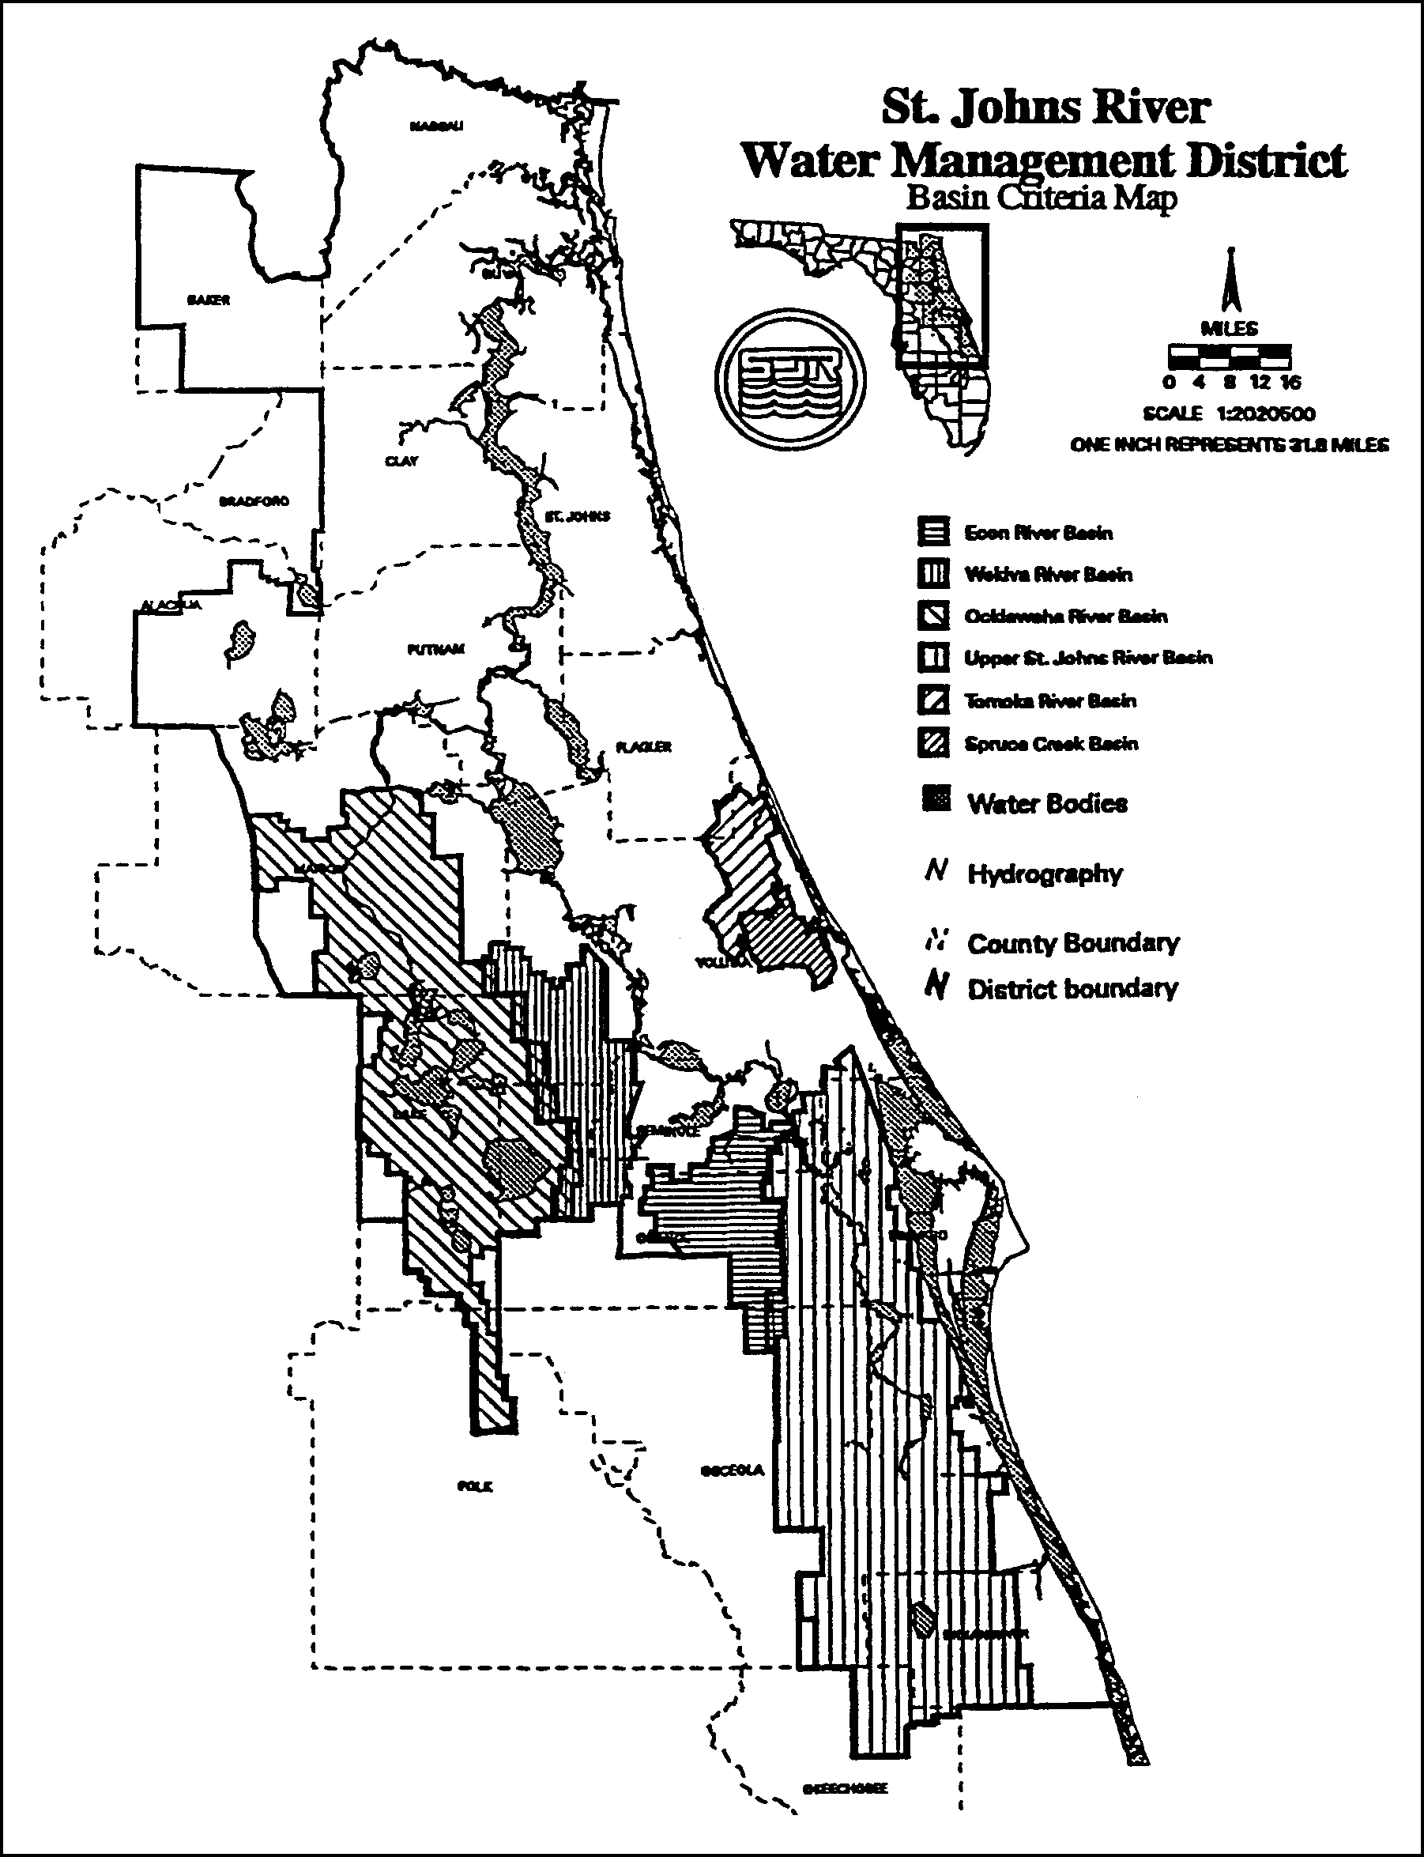

Figure 11.0-2 Sensitive Karst Areas in the St. Johns River Water Management District
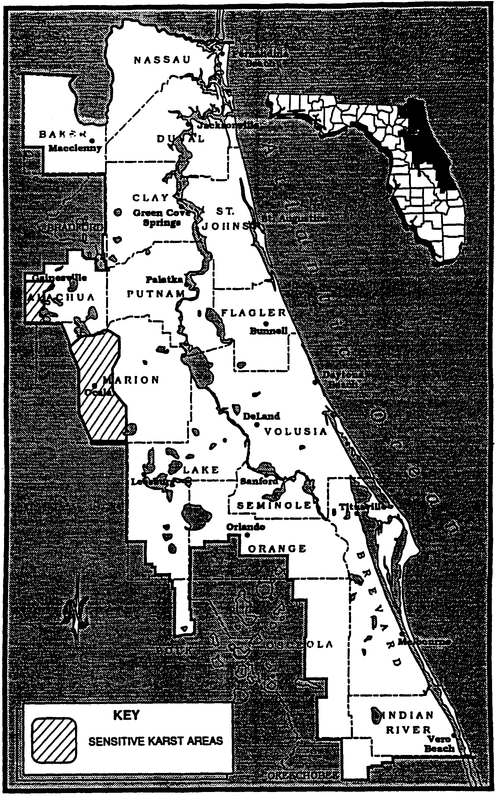
Figure 11.0-2 Sensitive Karst Areas in the St. Johns River Water Management District
Figure 11.0-3 Alachua County Karst Area
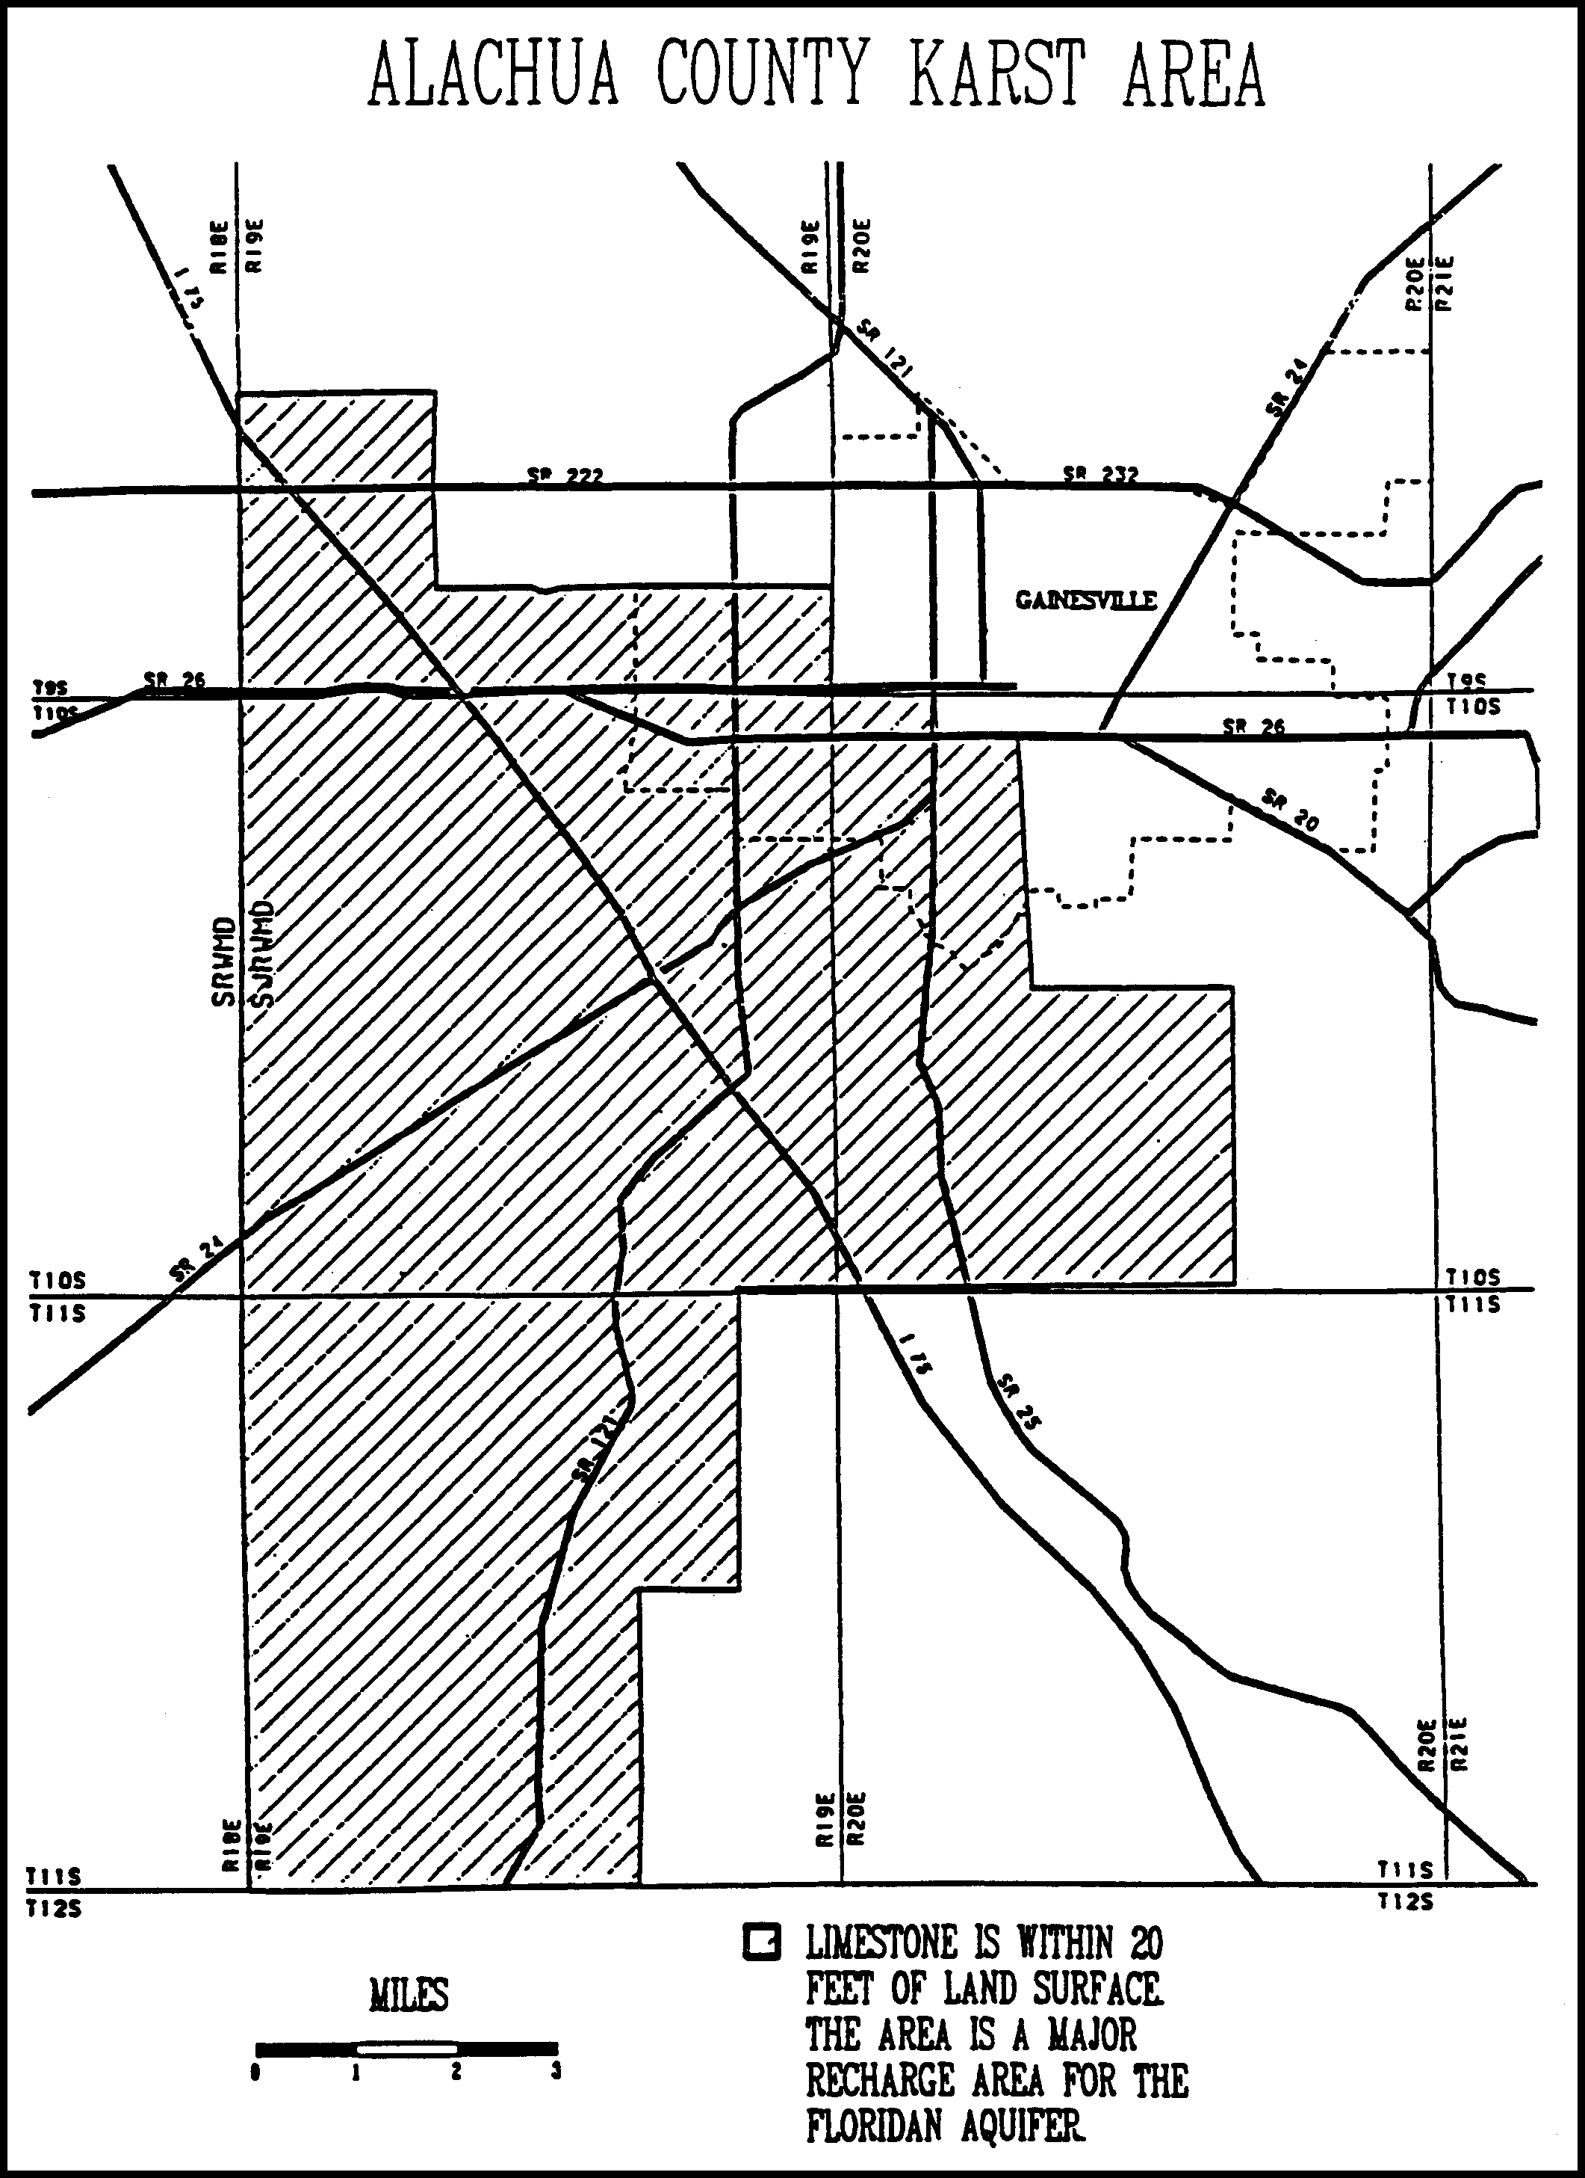
Figure 11.0-3 Alachua County Karst Area
Figure 11.0-4 Marion County Karst Area
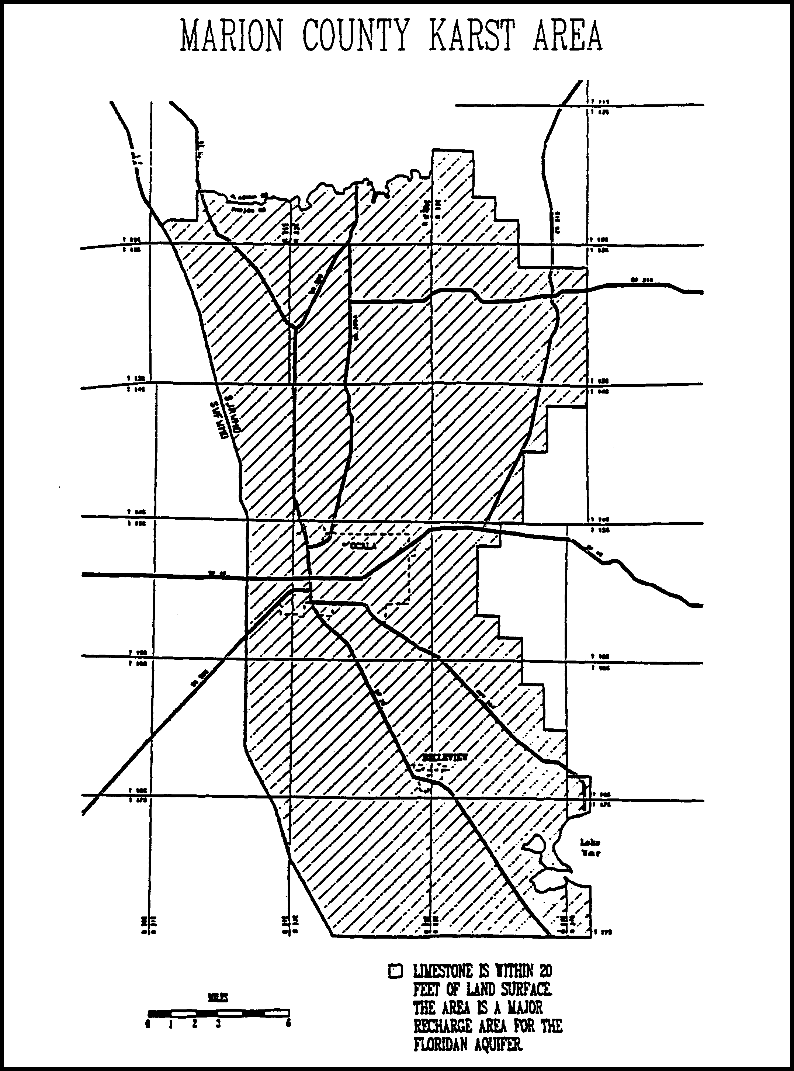
Figure 11.0-4 Marion County Karst Area
Figure 11.0-5 Lake Apopka Drainage Basin (New Map)

11.1 Upper St. Johns River Hydrologic Basin

In addition to the design criteria described in sections 9.0 and 10.0 above, systems in the Upper St. Johns River Basin must meet the following criteria:

11.1.1 Storm Frequency

The system shall meet applicable discharge criteria for 10 year and 25 year frequency storms. On-site storage and outlet capacity should be designed for the 25 year storm. Outlet capacity design should be checked and further refined, if necessary, for the 10 year storm. (See section 13.9 for detailed discussion of detention design.)

11.1.2 Runoff Volume

For systems utilizing pumped discharges, the post-development discharge volume during the four day period beginning the third day of the four day duration storm may not exceed the pre-development discharge during the same period.

11.1.3 Interbasin Diversion

(a) A system may not result in an increase in the amount of water being diverted from the Upper St. Johns River Hydrologic Basin into coastal receiving waters.

(b) It is an objective of the District to, where practical, curtail diversions of water from the Upper St. Johns River Hydrologic Basin into coastal receiving waters.

11.2 Ocklawaha River Hydrologic Basin

In addition to the design criteria described in sections 9.0 and 10.0 above, systems in the Ocklawaha River Hydrologic Basin must meet the following criteria:

11.2.1 Storm Frequency

The system shall meet applicable discharge criteria for 10 year and 25 year frequency storms. On-site storage and outlet capacity should be designed for the 25 year storm. Outlet capacity design should be checked and further refined, if necessary, for the 10 year storm. (See section 13.9 for detailed discussion of detention design.)

11.2.2 Runoff Volume

For systems utilizing pumped discharges, the post-development discharge volume during the four day period beginning the third day of the four day duration storm may not exceed the pre- development discharge during the same period.

11.3 Wekiva River Hydrologic Basin and Wekiva Recharge Protection Basin

In addition to the standards and design criteria described in sections 9.0 and 10.0 above, systems in the Wekiva River Hydrologic Basin or the Wekiva Recharge Protection Basin (which are both shown in Figure 11.3-2) must meet the following standards and criteria as described below:

11.3.1 Recharge Standard

Applicants required to obtain a permit pursuant to Chapters 40C-4, 40C-40, 40C-42, or 40C-44, F.A.C., for a surface water management system located within the Wekiva Recharge Protection Basin shall demonstrate that the system provides for retention storage of three inches of runoff from all impervious areas proposed to be constructed on soils defined as a Type “A” Soils as defined by the Natural Resources Conservation Service (NRCS) Soil Survey in the following NRCS publications: Soil Survey of Lake County Area, Florida (1975); Soil Survey of Orange County Area, Florida (1989); and Soil Survey of Seminole County Area, Florida (1990), which are hereby incorporated by reference For purposes of this rule, areas with Type “A” Soils shall be considered “Most Effective Recharge Areas.” The system shall be capable of infiltrating this storage volume through natural percolation into the surrounding soils within 72 hours. Off-site areas or regional systems may be utilized to satisfy this requirement. Projects or portions of projects in Most Effective Recharge Areas must retain three inches of runoff from the directly connected impervious area within the project area. As an alternative, applicants may instead demonstrate that the post-development recharge capacity is will be equal to or greater than the pre-development recharge capacity. Pre-development recharge shall be based upon the land uses in place as of 12-3-06. Applicants may utilize existing permitted municipal master stormwater systems, in lieu of onsite retention, to demonstrate that post-development recharge is equal to or greater than pre-development recharge. Also, applicants may submit additional geotechnical information to establish whether or not a site contains Type “A” soils. Most Effective Recharge Areas have been defined by the U.S. Geological Survey as areas which have 10-20 inches of recharge per year. Figure 11.3-2 shows the approximate location of Most Effective Recharge Areas in the Wekiva Basin. Most Effective Recharge Areas can be more accurately defined by soil types. The Soil Conservation Service has categorized soils according to hydrologic characteristics. Those soils determined by the SCS to be Type "A" Hydrologic Soil Group shall be considered to be Most Effective Recharge Areas.
Section 18.1 contains a list of Type "A" soils. This list will be used to determine whether a proposed project or portion of a project is in the Most Effective Recharge Area. Also, applicants may submit additional geotechnical information to establish whether or not a site contains Type "A" soils and is within the Most Effective Recharge Area.
Directly connected impervious areas are those impervious areas which are connected to the surface water management system by a drainage improvement such as a ditch, storm sewer, paved channel, or other man-made conveyance. Stormwater that is retained must be infiltrated into the soil or evaporated such that the storage volume is recovered within 14 days following a storm event.
11.3.2 Storage Standard

(a) Within the Wekiva River Hydrologic Basin, Aa system may not cause a net reduction in flood storage within the 100 year floodplain of a stream or other watercourse which has a drainage area upstream of more than one square mile and which has a direct hydrologic connection to the Wekiva or Little Wekiva Rivers or Black Water Creek.

Figure 11.3-2 Wekiva River Hydrologic Basin and Wekiva Recharge Protection Basin Most Effective Recharge Areas in the Wekiva Basin
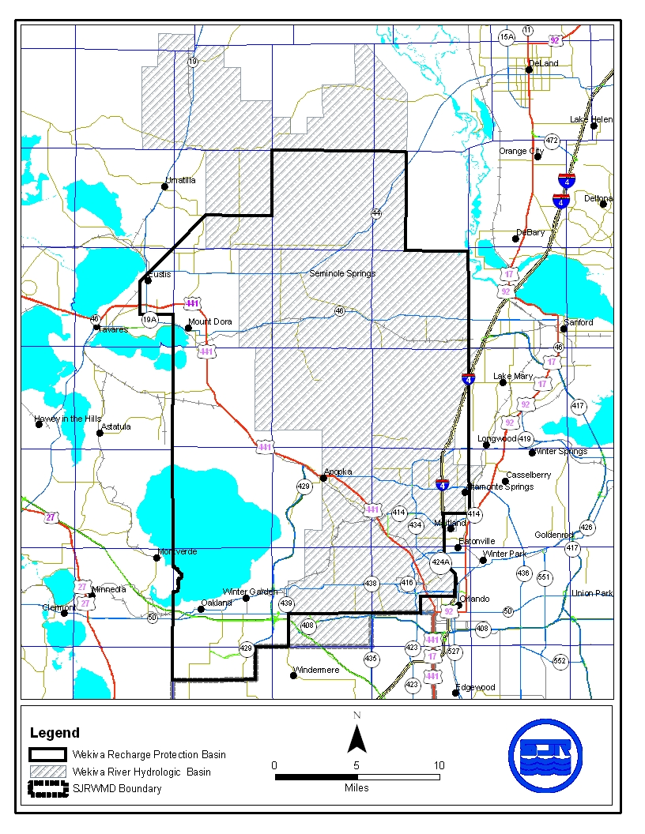
11.3.3 Standards for Erosion and Sediment Control and Water Quality

Construction and alteration of systems can result in erosion and downstream turbidity and sedimentation of waters. Erosion is the process by which the land surface is worn away by action of wind, water, and gravity. During construction and alteration, the potential for erosion increases dramatically. The result of erosion is discharges of turbid water and subsequent sedimentation (settling out) of soil particles in downstream receiving waters. Turbidity, suspended solids, and sedimentation result in adverse biological effects in aquatic and wetland environments, water quality degradation, and loss of flood storage and conveyance. The potential for erosion can be severe in the Wekiva River Hydrologic Basin as a result of steep slopes and erosive soils.

(a) Although erosion and sediment control measures are required throughout the St. Johns River Water Management District, the District has determined that the problems associated with erosion in the Wekiva River Hydrologic Basin are sufficiently serious to warrant requiring those applicants proposing certain systems to provide detailed plans when permit applications are submitted.

A Water Quality Protection Zone shall extend one half mile from the Wekiva River, Little Wekiva River north of State Road 436, Black Water Creek, Rock Springs Run, Seminole Creek, and Sulphur Run, and shall also extend one quarter mile from any wetland abutting an Outstanding Florida Water.

An erosion and sediment control plan must be submitted as part of the surface water management permit application for a surface water management system which:

1. Serves a project which is located wholly or partially within this zone; or

2. Serves a project with a total land area equal to or exceeding 120 acres.

The applicant proposing such a system must give reasonable assurance in the erosion and sediment control plan that during construction or alteration of the system (including revegetation and stabilization), erosion will be minimized and sediment will be retained on-site. The plan must be in conformance with the erosion and sediment control principles set forth in section 18.2, Applicant's Handbook: Management and Storage of Surface Waters, and must contain the information set forth in section 18.3, Applicant's Handbook: Management and Storage of Surface Waters.

(b) For a project which will be located wholly or partially within 100 feet of an Outstanding Florida Water or within 100 feet of any wetland abutting such a water, an applicant must provide reasonable assurance that the construction or alteration of the system will not cause sedimentation within these wetlands or waters and that filtration of runoff will occur prior to discharge into these wetlands and waters.

It is presumed that this standard will be met if, in addition to implementation of the plan required in paragraph (a), any one of the following criteria is met:

1. A minimum 100 foot width of undisturbed vegetation must be retained landward of the Outstanding Florida Water or the abutting wetland, whichever is more landward. During construction or alteration, runoff (including turbid discharges from dewatering activities) must be allowed to sheetflow across this undisturbed vegetation as the natural topography allows. Concentrated or channelized runoff from construction or alteration areas must be dispersed before flowing across this undisturbed vegetation. Construction or alteration of limited scope necessary for outfall structures may occur within this area of undisturbed vegetation.

2. Construction of the following perimeter controls at all outfall points to the Outstanding Florida Water or its abutting wetlands must be completed prior to the start of any construction or alteration of the remainder of the system:

a. Stormwater discharge facility meeting the requirements of Chapter 40C-42, F.A.C.;

b. Sedimentation trap or basin located immediately upstream of the stormwater discharge facility referred to above; and

c. Spreader swale to reduce the velocity of discharge from the stormwater facility to non-erosive rates before discharge to wetlands abutting the Outstanding Florida Water.

These perimeter controls must be maintained routinely and operated throughout construction or alteration of the entire system. A minimum 25 foot width of undisturbed vegetation must be retained landward of the Outstanding Florida Water or the abutting wetland, whichever is more landward. Construction or alteration of limited scope necessary for outfall structures may occur within this area of undisturbed vegetation.

3. During construction or alteration, no direct discharge to the Outstanding Florida Water or its abutting wetland may occur during the 10 year 24 hour storm event or due to discharge from dewatering activities. Any on-site storage required to satisfy this criteria must be available (recovered) within 14 days following the rainfall event. A minimum 25 foot width of undisturbed vegetation must be retained landward of the Outstanding Florida Water or the abutting wetland, whichever is more landward. Construction or alteration of limited scope necessary for outfall structures may occur within this area of undisturbed vegetation.

In determining whether construction or alteration is of "limited scope necessary", pursuant to any of the three presumptive criteria above, the District shall require that the area of disturbance be minimized and that the length of time between initial disturbance and stabilization of the area also be minimized.

11.3.4 Standard for Limiting Drawdown

Lowering the ground water table adjacent to wetlands can change the wetland hydroperiod such that the functions provided by the wetland are adversely affected.

Within the Wekiva River Hydrologic Basin aA Water Quantity Protection Zone shall extend 300 feet landward of the landward extent of Black Water Swamp and the wetlands abutting the Wekiva River, Little Wekiva River, Rock Springs Run, Black Water Creek, Sulphur Run, Seminole Creek, Lake Norris, and Lake Dorr. As part of providing reasonable assurance that the standard set forth in paragraph 40C-4.301(1)(d) is met, where any part of a system located within this zone will cause a drawdown, the applicant must provide reasonable assurance that construction, alteration, operation, or maintenance of the system will not cause ground water table drawdowns which would adversely affect the functions provided by the referenced wetlands.

The applicant shall provide an analysis which includes a determination of the magnitude and areal extent of any drawdowns, based on site specific hydrogeologic data collected by the applicant, as well as a description of the referenced wetlands, the functions provided by these wetlands, and the predicted impacts to these functions.

It is presumed that the part of this standard regarding drawdown effects will be met if the following criteria is met:

A ground water table drawdown must not occur within the Water Quantity Protection Zone.
11.3.5 Standard for Riparian Wildlife Habitat

Within the Wekiva River Hydrologic Basin, tThe wetlands abutting the Wekiva River, Little Wekiva River downstream of Maitland Boulevard, Rock Springs Run, Black Water Creek, Sulphur Run and Seminole Creek support an abundance and diversity of aquatic and wetland dependent wildlife. Uplands abutting these wetlands protect the wetlands from climatic extremes and also provide important habitat for some aquatic and wetland dependent species. Construction and alteration of surface water management systems within these wetlands and uplands can result in adverse changes in the habitat, abundance, and food sources of aquatic and wetland dependent species.

(a) The applicant must provide reasonable assurance that the construction or alteration of a system will not adversely affect the abundance, food sources, or habitat (including its use to satisfy nesting, breeding and resting needs) of aquatic or wetland dependent species provided by the following designated Riparian Habitat Protection Zone:

1. The wetlands abutting the Wekiva River, Little Wekiva River downstream of Maitland Boulevard, Rock Springs Run, Black Water Creek, Sulphur Run, or Seminole Creek;

2. The uplands which are within 50 feet landward of the landward extent of the wetlands above.

3. The uplands which are within 550 feet landward of the stream's edge as defined, for the purpose of this subsection, as the waterward extent of the forested wetlands abutting the Wekiva River, Little Wekiva River downstream of the northernmost crossing of the Little Wekiva River with S.R. 434, Rock Springs Run, Black Water Creek, Sulphur Run or Seminole Creek. In the absence of forested wetlands abutting these streams, the stream's edge shall be defined, for the purpose of this subsection, as the mean annual surface water elevation of the stream; however, if hydrologic records are unavailable, the landward extent of the herbaceous emergent wetland vegetation growing in these streams shall be considered to be the stream's edge.

(b) Any of the following activities within the Riparian Habitat Protection Zone is presumed to adversely affect the abundance, food sources, or habitat of aquatic or wetland dependent species provided by the zone: construction of buildings, golf courses, impoundments, roads, canals, ditches, swales, and any land clearing which results in the creation of any system. (Activities not listed above do not receive a presumption of no adverse effect.)

(c) The presumption in paragraph (b) shall not apply to any activity which promotes a more endemic state, where the land in the zone has been changed by man. An example of such an activity would be construction undertaken to return lands managed for agriculture or silviculture to a vegetative community that is more compatible with the endemic land cover.

11.3.6 Local Government Notification for Wekiva River Protection Area

The District shall not issue a conceptual approval, individual, or standard permit for a proposed surface water management system located wholly or partially within the Wekiva River Protection Area, as defined in Section 369.303(9), F.S., until the appropriate local government has provided written notification that the proposed activity is consistent with the local comprehensive plan and is in compliance with land development regulation in effect in the area where development will take place. The applicant proposing such a system must submit to the District form no. 40C-41.063(4), entitled "Local Government Notification", after it has been completed and executed by the local government. This form is hereby incorporated by reference and is available upon request from the St. Johns River Water Management District, 4049 Reid Street, Palatka, Florida 32177-2529. Permit applications for systems within the Wekiva River Protection Area shall be processed by the District staff pursuant to the time frames established in Section 120.60, F.S., and any District rule regarding permit processing, except that any agency action to approve or approve with conditions shall not occur until the Local Government Notification has been received by the District.

11.4 Econlockhatchee River Hydrologic Basin

In addition to the standards and design criteria described in sections 9.0 and 10.0 above, systems in the Econlockhatchee River Hydrologic Basin must meet the following standards and criteria:

11.4.1 Design Storm Criteria

Systems must meet the peak discharge requirement for the following 24 hour duration design storm events:

(a) Mean annual storm (2.3 year return period) with a total 24 hour rain fall depth of 4.5 inches.

(b) 25-year return period (applicable District-wide in subsection 10.3.2).

System outlet control structures can be designed to meet the control peak discharge rates for both design storms by use of a two-stage weir, v-notch weir, multiple orifices, or other similar structures.

11.4.2 Floodplain Storage Criteria

A system must not cause a net reduction in flood storage within the 100 year floodplain of the Econlockhatchee River or any of its tributaries, at a location with an upstream drainage area of 1 square mile or greater, except for structures elevated on pilings or traversing works that comply with conveyance requirements in subsection 10.5.2.

11.4.3 Stormwater Management Standard

(a) Construction of new stormwater management systems must be in accordance with the design and performance standards of chapter 40C-42, F.A.C. However, systems which serve drainage areas in excess of 10 acres can not use detention with filtration treatment as the sole stormwater treatment methodology. Additionally, when retention systems are not feasible due to limited percolation capacity, wet detention treatment or other treatment demonstrated to be equivalent to retention or wet detention, in accordance with chapter 40C-42, F.A.C., and Paragraph 11.4.3(b), must be used.

(b) Wet detention treatment systems:

(1) provide a treatment volume of one ince of runoff, or 2.5 inches of runoff from the impervious area, whichever is greater

(2) are designed so that outfall structures shal bleed down the required treatement volume such that one-half of this volume will be discharged within 60 to 72 hours following a storm event, but no more than one-half of this volume will be discharged within the first 60 hours.

(3) provide a permanent pool of water such that the volume between the control or bleed down elevation and the pond bottom results in an average residence time of at least 14 days during the wet season (June - October).

(4) provide a littoral zone to be designed as follows:

a. the littoral zone shall be gently sloped (6:1 or flatter). At least 30 percent of the wet detention system surface area shall consist of a littoral zone. The percentage of littoral zone is based on the ratio of vegetated littoral zone to surface area of the pond at the control elevation.

b. he treatment volume must not cause the pond level to rise more than 18 inches above the control elevation unless it is demonstrated that the littoral zone vegetation can survive at greater depths.

c. eighty percent coverage of the littoral zone by suitable aquatic plants is required within the first thirty-six months following completion of the system.

d. to meet the 80% coverage requirement, planting of the littoral zone is recommended. As an alternative, portions of the littoral zone may be established by placement of wetland top soils (at least a four inch depth) containing a seed source of desirable native plants. When utilizing this alternative, the littoral zone must be stabilized by mulching or other means and at least the portion of the littoral zone within 25 feet of the inlet and outlet structures must be planted.

(5) are designed so that the permanent pool does not exceed a maximum depth of 12 feet below the invert of the bleed down device unless the applicant affirmatively demonstrates that greater depths will not inhibit the physical, chemical and biological treatment processes or cause the resuspension of pollutants into the water column due to anaerobic conditions in the bottom sediments and water.

(6) are designed so the flow path through the pond has an average length to width ratio of at least 2:1. The alignment and location of inlets and outlets should be designed to maximize flow paths in the pond. If short flow paths are unavoidable, the effective flow path should be increased by adding diversion barriers such as islands, peninsula, or baffles to the pond. Inlet structures shall be designed to dissipate the energy of water entering the pond.

(7) are designed so that bleed down devices incorporating dimensions smaller than three inches minimum width or less than 20 degrees for "v" notches shall include a device to eliminate clogging. Examples of such devices include baffles, grates, and pipe elbows.

(8) are designed so that bleed down structure invert elevations are at or above the estimated post-development average water table elevation and above the anticipated post-development wet season tailwater elevation. If the structure is proposed to be set below the average water table elevation, ground water inflow must be considered in the drawdown calculations, calculation of average residence time, and estimated normal water level.

(9) provide for permanent maintenance easements or other acceptable legal instruments to allow for access to and maintenance of the system, including the pond, littoral zone, inlets, and outlets.

11.4.34 Riparian Wildlife Habitat Standard

The wetlands abutting the Econlockhatchee River and its tributaries support an abundance and diversity of aquatic and wetland dependent wildlife. Uplands abutting these wetlands protect the wetlands and provide important habitat for aquatic and wetland dependent species. Construction, alteration, operation, maintenance, removal or abandonment of surface water management systems within these wetlands and uplands can result in adverse changes in the habitat, diversity, abundance and food sources of aquatic and wetland dependent species. Implementation of these regulations should be done in a manner which encourages development of functional resource protection plans.

(a) The applicant must provide reasonable assurance that the construction, alteration, operation, maintenance, removal or abandonment of a system within the following designated Riparian Habitat Protection Zone will not adversely affect the abundance, diversity, food sources or habitat (including its use to satisfy nesting, breeding and resting needs) of aquatic or wetland dependent species:

1. The wetlands contiguous with the Econlockhatchee River and the following tributaries: Little Econlockhatchee River north of University Boulevard, Mills Creek, Silcox Branch (branch of Mills Creek), Mills Branch (branch of Mills Creek), Long Branch, Hart Branch, Cowpen Branch, Green Branch, Turkey Creek, Little Creek, and Fourmile Creek;

2. The uplands which are within 50 feet landward of the landward extent of the wetlands above; and

3. The uplands which are within 550 feet landward of the stream's edge as defined, for the purpose of this subsection, as the waterward extent of the forested wetlands abutting the Econlockhatchee River and the above named tributaries. In the absence of forested wetlands abutting these streams, the stream's edge shall be defined, for the purpose of this subsection, as the mean annual surface water elevation of the stream; however, if hydrologic records are unavailable, the landward extent of the herbaceous emergent wetland vegetation growing in these streams shall be considered to be the stream's edge.

4. The following portions of streams typically lack a defined water's edge, and subparagraph 3. shall not apply:

a. Mills Creek upstream of the intersection of the creek with the Fort Christmas Road in Section 2, Township 22 South, Range 32 East;

b. Long Branch upstream of the intersections of the creek with SR 520;

c. Hart Branch upstream of the intersection of the creek and the Old Railroad Grade in Section 18, Township 23 South, Range 32 East;

d. Cowpen Branch upstream of the southernmost bifurcation of the creek in Section 20, Township 23 South, Range 32 East;

e. Green Branch upstream of the intersection of the creek with the north-south section line between Section 29 and 30, Township 23 South, Range 32 East;

f. Turkey Creek including Turkey Creek Bay upstream of the intersection of the creek with the Weewahootee Road in Section 5, Township 24 South, Range 32 East;

g. Little Creek upstream of the intersection of the creek with the north-south section line between Sections 22 and 23, Township 24 South, Range 32 East;

h. Fourmile Creek including Bee Tree Swamp upstream of a point along the creek exactly halfway between section lines at the south end of Section 21 and the north end of Section 33 within Section 28, Township 24 South, Range 32 East; and

i. all of the Econlockhatchee River Swamp (a portion of the Econlockhatchee River).

(b) Any of the following activities within the Riparian Habitat Protection Zone are presumed to adversely affect the abundance, food sources, or habitat of aquatic or wetland dependent species provided by the zone: construction of buildings, golf courses, impoundments, roads, canals, ditches, swales, and any land clearing which results in the creation of any system. (activities not listed above do not receive a presumption of no adverse effect.)

(c) The presumption in paragraph (b) shall not apply to any activity which promotes a more endemic state, where the land in the zone has been changed by man. An example of such an activity would be construction undertaken to return lands managed for agriculture or silviculture to a vegetative community that is more compatible with endemic land cover.

(d) Applicants seeking to develop within the Riparian Habitat Protection Zone shall be given the opportunity to demonstrate that the particular development for which permitting is being sought will not have an adverse effect on the functions provided by the zone to aquatic or wetland dependent species. The functions provided by the zone are dependent on many factors. When assessing the value of the zone to aquatic and wetland dependent species, factors which the District will consider include: vegetative land cover, hydrologic regime, topography, soils, and land uses, existing within and adjacent to the zone; and range, habitat, and food source needs of aquatic and wetland dependent species, as well as sightings, tracks, or other such empirical evidence of use.

(e) The standard of paragraph 11.4.4(a) may be met by demonstrating that the overall merits of the proposed plan of development, including the preservation, creation or enhancement of viable wildlife habitat, provide a degree of resource protection to these types of fish and wildlife which offsets adverse effects that the system may have on the abundance, diversity, food sources, or habitat of aquatic or wetland dependent species provided by the zone. Mitigation plans will be considered on a case-by-case basis upon detailed site specific analyses. The goal of this analysis shall be the determination of the value of the proposed mitigation plan to aquatic and wetland dependent species with particular attention to threatened or endangered species. Mitigation plans should include: the information set forth in subsection 12.3.3 for the uplands and wetlands within the zone and within other areas to be preserved, created or enhanced as mitigation for impacts within the zone; as well as other pertinent information, including land use, and the proximity of the site to publicly owned land dedicated to conservation. Implementation of this section contemplates that the proximity of development to the river and tributaries named herein and activities permitted in the zone may vary from place to place in support of a functional resource protection plan. Furthermore, some reasonable use of the land within the protection zone can be allowed under subsection 11.4.4.

(f) Roads or other traversing works which cross the zone have the potential to fragment the zone and adversely affect the habitat value of the zone to aquatic and wetland dependent species. To minimize adverse effects to the zone, applicants for permits to construct traversing works in the zone must first demonstrate the need for the traversing works to provide for regional transportation, regional utility services, or reasonable property access, in addition to meeting the requirement of paragraph 11.4.4(a), above. Traversing works must also be designed to meet all requirements of the district rules related to water quality and quantity. Permittees responsible for traversing works shall be required to be responsible for maintaining the traversing works clean and free from trash and debris to the greatest extent practical.

11.4.45 Off-site Land Preservation as Mitigation in the Econlockhatchee River Hydrologic Basin.

Mitigation in the Econlockhatchee River Hydrologic Basin must offset any adverse impacts of the system to the functions provided by the Econlockhatchee River Riparian Habitat Protection Zone and wetlands outside this zone, to aquatic and wetland dependent species. Subsection 16.1.6 of this Handbook allows for consideration of innovative mitigation proposals. Mitigation within the Econlockhatchee River Hydrologic Basin may include the off-site preservation of lands. The lands proposed for preservation must be regionally significant or provide unique fish and wildlife habitat. For the purposes of this section the land to be preserved must be located entirely within the Econlockhatchee River Basin as designated in section 40C-41.023, F.A.C., and the applicant must propose to convey the land in fee simple to the St. Johns River Water Management District or a mutually acceptable designee. At the option of the District, a perpetual conservation easement or other acceptable legal instrument may be conveyed to the District or a mutually acceptable designee in accordance with section 704.06, F.S. All of the following requirements will apply to off-site land preservation proposals within the Econlockhatchee River Basin:

(a) Prior to proposing off-site land preservation, the applicant must demonstrate that alternatives for avoiding adverse impacts to the functions provided by the Riparian Habitat Protection Zone and wetlands outside the zone have been evaluated, and that to the maximum extent practicable, adverse impacts to these functions have been avoided.

(b) As a part of an off-site land preservation proposal, the applicant must demonstrate that the proposal meets the standard described in paragraph 11.4.34(a) by providing a functional analysis, as described in paragraph 11.4. 34 (b), of the proposed impacts within the Riparian Habitat Protection Zone and the benefits of the proposed preservation area. If adverse impacts occur to wetlands, then as part of an off-site land preservation proposal, the applicant must demonstrate that the proposal meets the criteria described in section 12.3 subsection 10.7.4.

(c) The range of appropriate ratios to be used to determine credit for preservation will depend upon the functional analysis of impacts and benefits. The suitability of this mitigation option, the specific ratios applicable, credits to be assigned, and the use of these credits will be determined on a case-by-case basis based on site specific information.
11.5 Tomoka River and Spruce Creek Hydrologic Basins

In addition to the standards and design criteria described in sections 8.0, 9.0, 10.0, above, and 12.0 below, systems within the Tomoka River Hydrologic Basin or the Spruce Creek Hydrologic Basin must meet the following standards and criteria:

11.5.1 Recharge Standard

Projects, or portions of projects, in the Most Effective Recharge Areas must retain three (3) inches of runoff from the directly connected impervious area within the Most Effective Recharge Area of the project area. As an alternative, applicants may demonstrate that the post-development recharge capacity will be equal to or greater than the pre-development recharge capacity.

Most Effective Recharge Areas, as used in this section, are areas which have 10-20 inches of recharge per year. Most Effective Recharge Areas can be more accurately defined by soils types. Those areas with Type “A” Hydrologic Soil Group shall be considered to be Most Effective Recharge Areas. Figures 11.5-1 and Figure 11.5-2 show the approximate location of the Most Effective Recharge Area in the Tomoka River and Spruce Creek Hydrologic Basins.

Section 18.1 contains a list of Type “A” soils for Flagler and Volusia counties. This list will be used to determine whether a proposed project, or portion of a project, is in the Most Effective Recharge Area. Also, applicants may submit additional geotechnical information to establish whether or not a site contains Type “A” soils and is within the Most Effective Recharge Area.

Directly connected impervious areas are those impervious areas, which are connected to the surface water management system by a drainage improvement, such as a ditch, storm sewer, paved channel, or other man-made conveyance. Stormwater that is retained must be infiltrated into the soil or evaporated such that the storage volume is recovered within 14 days following the storm event.

Figure 11.5-1 Tomoka River Soils Map
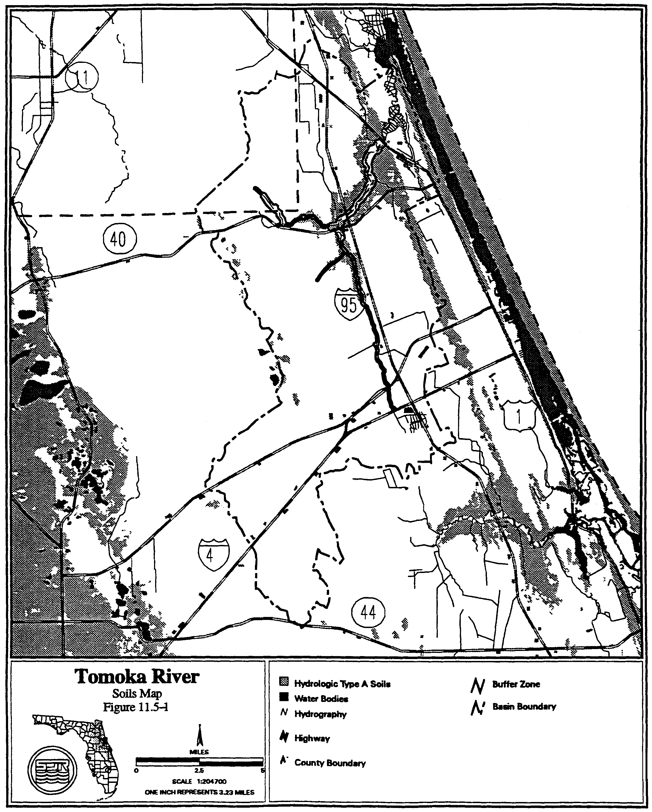
Figure 11.2-5 Spruce Creek Soils Map
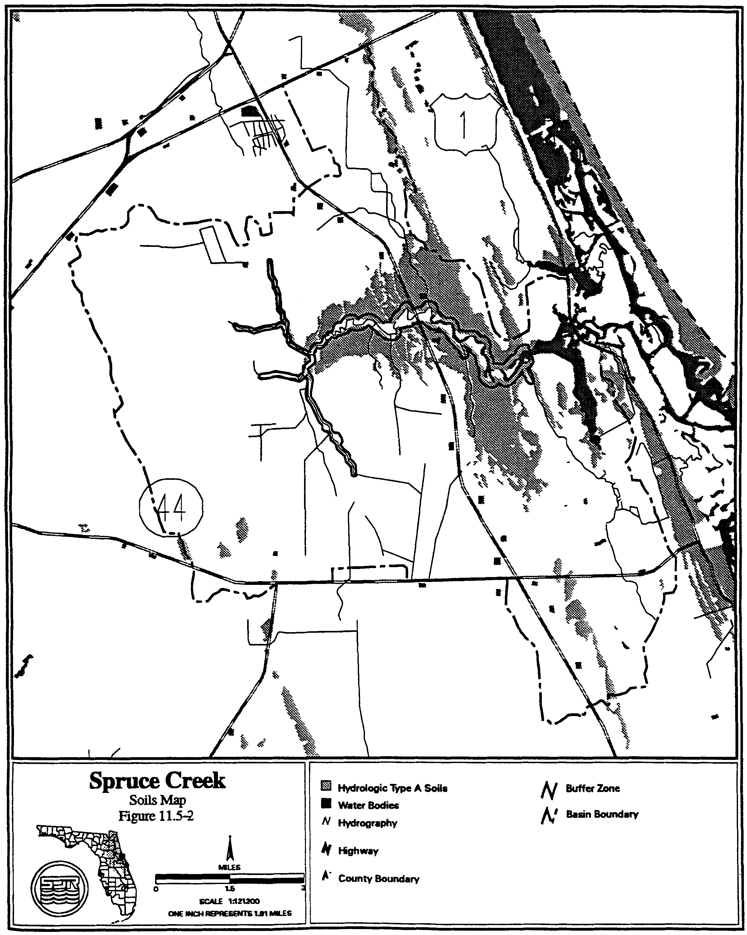

11.5.2 Floodplain Storage Criteria

Systems constructed in the 100 year floodplain have the potential to increase flood stages on adjacent property. A system must not cause a net reduction in flood storage within the 100 year floodplain of the Tomoka River or Spruce Creek or any of their tributaries except for structures elevated on pilings or traversing works that comply with conveyance requirements in subsection 10.5.2.

11.5.3 Stormwater Management Standard

Construction of new stormwater management systems must be in accordance with the design and performance standards of chapter 40C-42, F.A.C. However, systems which serve drainage areas in excess of 10 acres cannot use detention with filtration treatment as the sole stormwater treatment methodology. Additionally, when retention systems are not feasible due to limited percolation capacity, wet detention treatment or other treatment demonstrated to be equivalent to retention or wet detention, in accordance with chapter 40C-42, F.A.C., must be used.

11.5.4 Riparian Wildlife Habitat Standard

The wetlands abutting the Tomoka River and Spruce Creek and their tributaries support an abundance and diversity of aquatic and wetland dependent wildlife. Uplands abutting these wetlands protect the wetlands and provide important habitat for aquatic and wetland dependent species. Construction, alteration, operation, maintenance, removal or abandonment of surface water management systems within these wetlands and uplands can result in adverse changes in the habitat, diversity, abundance and food sources of aquatic and wetland dependent species. Implementation of these regulations should be done in a manner which encourages development of functional resource protection plans.

(a) The applicant must provide reasonable assurance that the construction, alteration, operation, maintenance, removal or abandonment of a system within the following designated Riparian Habitat Protection Zone will not adversely affect the abundance, diversity, food sources or habitat (including its use to satisfy nesting, breeding and resting needs) of aquatic or wetland dependent species:

1. The wetlands and uplands which are within 50 feet landward of the landward extent of the wetlands which abut Spruce Creek north of Pioneer Trail to the FEC railroad, and the Tomoka River north of I-4 to US 1 and the following tributaries:

a. Spruce Creek east of the western section line of Section 35, Township 16 South, Range 32 East, Volusia County, Florida.

b. Spruce Creek east of the power line easement in Section 27, Township 16 South, Range 32 East, Volusia County, Florida.

c. Spruce Creek west of SR 415 and south of the northern section line of Section 23, Township 16 South, Range 32 East, Volusia County, Florida.

d. The Little Tomoka River north of SR 40 in Volusia County and south of the western section line of Section 22, Range 31 East, Township 14 South, Flagler County.

e. Priest Branch east of the power line easement in Section 6, Township 15 South, Range 32 East, Volusia County, Florida.

2. The uplands which are within 550 feet landward of the stream's edge of the following portions of the streams. The stream’s edge is defined, for the purpose of this subsection, as the waterward extent of the wetlands abutting the stream:

a. Spruce Creek north of the southern section line of Section 25, Range 32 East, Township 16 South, Volusia County, Florida;

b. Tomoka River north of the confluence of the Tomoka River and Priest Branch; and

3. The uplands which are within 320 feet landward of the stream’s edge of the following stream. The stream’s edge is defined, for the purpose of this subsection, as the waterward extent of the wetlands abutting the stream:

a. Spruce Creek east of I-95 and west of the FEC railroad; and

4. The uplands that are within 275 feet landward of the edge of the following streams:

a. Spruce Creek south of the southern section line if Section 25, Range 32 East, Township 16 South, Volusia County, Florida;

b. Spruce Creek east of the western section line of Section 35, Township 16 South, Range 32 East, Volusia County, Florida.

c. Spruce Creek east of the power line easement in Section 27, Township 16 South, Range 32 East, Volusia County, Florida.

d. Spruce Creek west of SR 415 and south of the northern section line of Section 23, Township 16 South, Range 32 East, Volusia County, Florida.

e. The Tomoka River south of the confluence of the Tomoka River and Priest Branch in section 36, Range 31 East, Township 14 South, Volusia County, Florida;

f. The Little Tomoka River north of SR 40, Volusia County, and south of the western section line of Section 22, Range 31 East, Township 14 South, Flagler County, Florida.

g. Priest Branch east of the power line easement in Section 6, Township 15 South, Range 32 East, Volusia County, Florida.

(b) Any of the following activities within the Riparian Habitat Protection Zone are presumed to adversely affect the abundance, food sources, or habitat of aquatic or wetland dependent species provided by the Zone: construction of buildings, golf courses, impoundments, roads, canals, ditches, swales, and any land clearing which results in the creation of any system (activities not listed above do not receive a presumption of no adverse effect.)

(c) The presumption in paragraph (b) shall not apply to any activity which promotes a more endemic state, where the land in the Zone has been changed by man. An example of such an activity would be construction undertaken to return lands managed for agriculture or silviculture to a vegetative community that is more compatible with endemic land cover.

(d) The standard of subsection 11.5.4(a) may be met by demonstrating that the overall merits of the proposed plan of development, including mitigation as described in section 12.3, Applicant's Handbook: Management and Storage of Surface Waters, provide a degree of resource protection to these types of fish and wildlife which offsets adverse effects of the proposed system on the uplands and wetlands within the Zone. Some reasonable use of the land within the Protection zone can be allowed under subsection 11.5.4.

(e) Roads or other traversing works which cross the Zone have the potential to fragment the Zone and adversely affect the habitat value of the Zone to aquatic and wetland dependent species. To minimize adverse effects to the Zone, applicants for permits to construct traversing works in the Zone must first demonstrate the need for the traversing works to provide for regional transportation, regional utility services, or reasonable property access, in addition to meeting the requirement of subsection 11.5.4(a), above. Traversing works must also be designed to meet all requirements of the district rules related to water quality and quantity.

11.65 Sensitive Karst Areas Basin

In addition to the requirements for issuance and design and performance criteria described in chapter 40C-42, F.A.C., systems in the Sensitive Karst Areas Basin must meet the criteria in section 40C-41.063(7), F.A.C.

11.7 Lake Apopka Hydrologic Basin

(a) Pursuant to section 373.461(3)(a), F.S., the total phosphorus criterion for Lake Apopka is 55 parts per billion. To meet this total phosphorus criterion, the applicant must provide reasonable assurance of compliance with the following total phosphorus discharge limitations and comply with the relevant monitoring requirements in section 11.7(b) and relevant inspection requirements of section 11.7(c):

(1) Sites Within Lake Apopka Hydrologic Basin

Applicants required to obtain a permit pursuant to chapters 40C-4, 40C-40, 40C-42, or 40C-44, F.A.C., for a surface water management system located within the Lake Apopka Hydrologic Basin shall demonstrate: (i) that the system provides stormwater treatment equivalent to or greater than any of the applicable stormwater treatment options contained in Table 11.7-1 for the removal of total phosphorus; (ii) that the post-development total phosphorus load discharged from the project area will not exceed the pre-development total phosphorus load discharged from the project area; or (iii) that the system, under the soil moisture conditions described in section 10.3.8(a), will not discharge water to Lake Apopka or its tributaries for the 100-year, 24-hour storm event. Systems described under section 11.7(a)(1)iii shall be considered to discharge to a land-locked lake that must meet the criteria in sections 10.4.1 and 10.4.2. Any alteration of a system originally permitted pursuant to section 11.7(a)(1)iii which results in an increase in discharge of water to Lake Apopka or its tributaries shall be considered an interbasin diversion that must meet the criteria in sections 11.7(a)(2) and 11.7(b)(4).

(2) Interbasin Diversion of Water to Lake Apopka Hydrologic Basin

Applicants required to obtain a permit pursuant to chapters 40C-4, 40C-40, 40C-42, or 40C-44, F.A.C., for a surface water management system that will cause the importation of water from another hydrologic basin into the Lake Apopka Hydrologic Basin shall not discharge any phosphorus from the project area to Lake Apopka or its tributaries, unless the applicant implements measures to reduce the existing total phosphorus load to Lake Apopka or its tributaries from another existing source by at least an equivalent amount of total phosphorus. The imported water shall consist only of stormwater runoff. The imported water shall not be discharged to Lake Apopka or its tributaries when the water level of Lake Apopka is in Zone A of the Lake Apopka Regulation Schedule set forth in Figure 11.7-2. All measures to reduce existing phosphorous loads to Lake Apopka or its tributaries must be constructed and operating in compliance with the environmental resource permit prior to any importation of water into the Lake Apopka Hydrologic Basin. Measures that reduce existing phosphorous loads to Lake Apopka or its tributaries shall not include those measures taken on the District’s land.

(3) Methodology for Determining Total Phosphorus Loads.

Determination of Pre-Development Total Phosphorus Loads.

Pre-development total phosphorus loads shall be based upon the land uses in place as of March 7, 2003. For systems which have been constructed in accordance with a permit issued pursuant to chapters 40C-4, 40C-40, 40C-42, or 40C-44, F.A.C., at the permit applicant’s option, the pre-development total phosphorus loads shall be based upon the land uses in place at the time the prior permit was issued. Pre-development total phosphorus loads shall be determined by: monitoring the total phosphorus loads from the project area for a period of one year prior to construction, alteration, abandonment, or removal of the proposed or existing system; calculating total phosphorus loads using the appropriate mean annual total phosphorus loadings in Table 11.7-3, or calculating total phosphorus loads for pre-development land uses not listed in Table 11.7-3 using mean annual total phosphorus loadings from the scientific literature. When the pre-development total phosphorus loads are determined by monitoring, the calculation of pre-development total phosphorus loads shall be adjusted by interpolation or extrapolation to reflect mean annual rainfall conditions.

Determination of Post-Development Total Phosphorus Loads.

Post-development total phosphorus loads shall be based upon the land uses proposed in the permit application and shall be determined by: calculating total phosphorus loads using the appropriate mean annual total phosphorus loadings in Table 11.7-3 and then reducing the total phosphorus load according to the appropriate total phosphorus removal efficiency values for systems listed in Tables 11.7-4 through 11.7-33. For purposes of Tables 11.7-4 and 11.7-6 through 11.7-33, the term “retention” includes stormwater reuse and underdrain and underground exfiltration trench systems as those terms are defined in section 2.0 of the Applicant’s Handbook: Regulation of Stormwater Management Systems, Chapter 40C-42, F.A.C., which is adopted by reference in section 40C-42.091(1), F.A.C. The calculation of total phosphorus loads for post-development land uses not listed in Table 11.7-3 or total phosphorus removal efficiency values for systems not listed in Tables 11.7-4 through 11.7-33 may be calculated using mean annual total phosphorus loadings and total phosphorus removal efficiency values from the scientific literature.

(b) Monitoring

(1) Monitoring for Retention Systems.

A surface water management system to be permitted under section 11.7(a)(1)i which utilizes only retention, shall be monitored as set forth in this paragraph. Water elevations in such a system shall be monitored from the date that construction of the system is completed or any part of the system is used for its intended purpose, whichever is sooner. The monitoring shall continue for three years following completion of construction of the entire system, including all associated residential, commercial, transportation, or agricultural improvements. If the results of the monitoring indicate that the system is not recovering the treatment volume in accordance with the permitted design, then the permittee shall either perform maintenance on the system, or obtain a modification to the permit and implement measures, to bring the system into compliance, and in either event the monitoring shall continue for three years after the date the system is brought into compliance.

(2) Monitoring for Systems Permitted Under Section 11.7(a)(1)iii.

A surface water management system to be permitted under section 11.7(a)(1)iii, shall be monitored as set forth in this paragraph. Water elevations in such a system shall be monitored from the date that construction of the system is completed or any part of the system is used for its intended purpose, whichever is sooner. The monitoring in such a system shall continue for ten years following completion of construction of the entire system, including all associated residential, commercial, transportation, or agricultural improvements. If the results of the monitoring indicate that either the system is not recovering storage in accordance with the permitted design or causes water to be discharged to Lake Apopka or its tributaries for events less than the 100-year, 24-hour storm event, then the permittee shall either perform maintenance that brings the system into compliance or obtain a modification to the permit and implement measures to bring the system into compliance, and in either event the monitoring shall continue for three years after the date the system is brought into compliance.

(3) Monitoring for Other Systems

A surface water management system to be permitted, other than a system described in sections 11.7(b)(1), 11.7(b)(2) or 11.7(b)(4), shall be monitored as set forth in this paragraph. Except as provided below, the total phosphorus load from the project area shall be monitored from the date that construction of such a system is completed or any part of the system is used for its intended purpose, whichever is sooner. The monitoring shall continue for three years following completion of construction of the entire system, including all associated residential, commercial, transportation, or agricultural improvements. If the results of the monitoring indicate that post-development total phosphorus loads exceed pre-development total phosphorus loads, then the permittee shall either perform maintenance on the system, or obtain a modification to the permit and implement measures, to reduce the total phosphorus loads to no more than pre-development levels, and in either event the monitoring shall continue for three years after the date the system is maintained or modified as described herein.

No monitoring shall be required under section 11.7(b)(3) when an applicant demonstrates that the system provides stormwater treatment equivalent to or greater than any of the applicable stormwater treatment options contained in Table 11.7-1 for the removal of total phosphorus. Alternatively, no monitoring shall be required under section 11.7(b)(3) when an applicant demonstrates that the post-development total phosphorus load discharged from the project area will not exceed the pre-development total phosphorus load discharged from the project area when determined using the appropriate mean annual total phosphorus loadings and total phosphorus removal efficiency values from Tables 11.7-3 through 11.7-33 .

(4) Monitoring for Interbasin Diversion of Water to Lake Apopka Hydrologic Basin

A surface water management system to be permitted under in section 11.7(a)(2) shall be monitored as set forth in this paragraph. The total phosphorus load shall be monitored from: (i) any system designed to reduce the existing total phosphorus load to Lake Apopka or its tributaries, and (ii) the system that is importing water to the Lake Apopka Hydrologic Basin. Monitoring of the system that is importing water to the Lake Apopka Hydrologic Basin shall commence from the date that construction of such system is completed or any part of the system is used for its intended purpose, whichever is sooner. Monitoring of systems designed to reduce the existing total phosphorus load to Lake Apopka or its tributaries shall commence from the date that construction of such system is completed. Monitoring shall continue for as long as water is imported from the system to the Lake Apopka Hydrologic Basin. If monitoring results indicate that the reductions in total phosphorus load are less than that in the imported water, then the permittee shall either perform maintenance or obtain a permit modification to bring the system(s) into compliance.

(c) Inspecting Systems

Systems subject to the inspection requirements in subsection 40C-42.029(1), F.A.C., which were permitted on or after March 7, 2003 and which were also subject to the phosphorus discharge limitations in section 11.7(a), shall be inspected by the operation and maintenance entity within one year after completion of construction and every year thereafter.

TABLE 11.7-1
STORMWATER TREATMENT CRITERIA TO ACHIEVE NO NET INCREASE IN POST- DEVELOPMENT LOADINGS WITHIN THE LAKE APOPKA HYDROLOGIC BASIN
LAND USE  CATEGORY | HYDROLOGIC  SOIL GROUP | RETENTION¹  ONLY² | RETENTION¹/  WET  DETENTION  OPTION³
Low-Density  Residential  (max. 15% impervious) | A  B  C  D | 2.75"  1.75"  1.25"  1.00" | 1.00"/14 days  0.50"/14 days  0.50"/14 days  0.25"/14 days
Single-Family  Residential (max. 25% impervious) | A  B  C  D | 2.75"  2.00"  1.75"  1.50" | 1.00"/14 days  0.75"/14 days  0.75"/14 days  0.50"/14 days
Single-Family Residential (max. 40% impervious) | A  B  C  D | 3.75”  3.00"  2.00"  1.50" | 1.25"/14 days  1.00"/14 days  0.75"/14 days  0.50"/14 days
Multi-  Family  Residential (max. 65% impervious) | A  B  C  D | 4.00”  3.75"  3.25"  2.75" | 2.50"/14 days  2.00"/14 days  1.75"/14 days  1.50"/14 days
Commercial  (max. 80%impervious) | A  B  C  D | 4.00”  3.75"  2.75"  2.25" | 2.75"/14 days  2.25"/14 days  1.50"/14 days  1.25"/14 days
Highway  (max. 50%  impervious) | A  B  C  D | 4.00"  3.00"  2.50"  2.25" | 2.00"/14 days  1.50"/14 days  1.25"/14 days  1.00"/14 days
Highway  (max. 75%  impervious) | A  B  C  D | 4.00”  3.75"  2.75"  2.25" | 2.75"/14 days  2.25"/14 days  1.75"/14 days  1.25"/14 days
1. For purposes of this Table, the term “retention” includes stormwater reuse and underdrain and underground exfiltration trench systems as those terms are defined in section 2.0 of the Applicant’s Handbook: Regulation of Stormwater Management Systems, Chapter 40C-42, F.A.C., which is adopted by reference in section 40C-42.091(1), F.A.C.
2. Required dry retention volume (inches of runoff over project area)
3. Required dry retention volume (inches of runoff over project area) followed by wet detention with listed minimum residence time.

Zone B

Zone A
Figure 11.7-2

TABLE 11.7-3

MEAN ANNUAL LOADINGS OF TOTAL PHOSPHORUS FOR LAND USE TYPES IN THE LAKE APOPKA Hydrologic BASIN

LAND USE  CATEGORY | MEAN ANNUAL  TOTAL PHOSPHORUS LOAD  (kg/ac-yr)
LAND USE  CATEGORY | HSG A | HSG B | HSG C | HSG D
Low-Density Residential (max. 15% impervious) | 0.069 | 0.135 | 0.215 | 0.284
Single-Family Residential (max. 25% impervious) | 0.227 | 0.286 | 0.383 | 0.465
Single-Family Residential (max. 40% impervious) | 0.250 | 0.333 | 0.446 | 0.536
Multi-Family Residential (max. 65% impervious) | 1.082 | 1.156 | 1.257 | 1.336
Commercial (max. 80% impervious) | 0.899 | 0.916 | 0.943 | 0.964
Highway – max. 50% impervious  Highway – max. 75% impervious | 0.710  1.053 | 0.756  1.076 | 0.817  1.106 | 0.871  1.133
Agriculture – Pasture | 0.026 | 0.118 | 0.239 | 0.347
Agriculture – Crops, Ornamentals, Nurseries  Agriculture – Groves | 0.040  0.007 | 0.180  0.036 | 0.366  0.079 | 0.531  0.123
Open Land/Recreational/Fallow Groves and Cropland | 0.004 | 0.017 | 0.035 | 0.051
Forests/Abandoned Tree Crops | 0.004 | 0.021 | 0.045 | 0.070

HSG = Hydrologic Soil Group

TABLE 11.7-4

REMOVAL EFFICIENCIES FOR TOTAL PHOSPHORUS IN DRY RETENTION SYSTEMS that Meet the Design and Performance Criteria in Rule 40C-42.026, F.A.C.

LAND  USE | HSG A |  | HSG B |  | HSG C |  | HSG D
LAND  USE | STANDARD | OFW | STANDARD | OFW | STANDARD | OFW | STANDARD | OFW
Low-Density Residential (max. 15% impervious) | 78% | 82% | 67% | 74% | 63% | 72% | 60% | 71%
Single-Family Residential (max. 25% impervious) | 90% | 92% | 78% | 83% | 69% | 77% | 65% | 74%
Single-Family Residential (max. 40% impervious) | 84% | 88% | 72% | 80% | 65% | 75% | 63% | 73%
Multi-Family Residential (max. 65% impervious) | 74% | 83% | 69% | 79% | 64% | 75% | 62% | 74%
Commercial (max. 80% impervious) | 65% | 76% | 63% | 74% | 62% | 72% | 61% | 71%
Highway (max. 50% impervious) | 75% | 85% | 70% | 80% | 65% | 76% | 63% | 74%
Highway (max. 75% impervious) | 65% | 76% | 63% | 74% | 62% | 72% | 61% | 71%

Standard - Meets design and performance criteria in rule 40C-42.026, F.A.C., for discharges to Class III waters

OFW - Meets design and performance criteria in rule 40C-42.026, F.A.C., for discharges to Class I, Class II, or Outstanding Florida Waters

TABLE 11.7-5

Removal Efficiencies for Total Phosphorus in Wet Detention Systems that Meet the Design and Performance Criteria in Rule 40C-42.026, F.A.C.

Residence Time (days) | Phosphorus Removal Efficiency (%)
14 | 61.5
21 | 64.5

Table 11.7-6
Removal Efficiencies for Total Phosphorus Using Various
Treatment Options in Low-Density Residential (max. 15% impervious)
For Hydrologic Soil Group A
Retention Depth (inches) | Annual Total P Removal (%)
Retention Depth (inches) | Dry Retention¹ | Retention / Wet Detention²
Retention Depth (inches) | Dry Retention¹ | t_{d}=7 days | t_{d}=14 days | t_{d}=21 days
0.25 | 70 | 86 | 88 | 89
0.50 | 78 | 90 | 92 | 92
0.75 | 82 | 92 | 93 | 94
1.00 | 85 | 93 | 94 | 95
1.25 | 88 | 94 | 95 | 96
1.50 | 90 | 95 | 96 | 96
1.75 | 91 | 96 | 96 | 97
2.00 | 92 | 96 | 97 | 97
2.25 | 93 | 97 | 97 | 97
2.50 | 93 | 97 | 97 | 98
2.75 | 94 | 97 | 98 | 98
3.00 | 95 | 98 | 98 | 98
3.25 | 96 | 98 | 98 | 99
3.50 | 97 | 98 | 99 | 99
3.75 | 97 | 99 | 99 | 99
4.00 | 98 | 99 | 99 | 99

1. Dry retention alone.
2. Dry retention followed by wet detention with various residence times.

Table 11.7-7
Removal Efficiencies for Total Phosphorus Using Various
Treatment Options in Low-Density Residential (max. 15% impervious)
For Hydrologic Soil Group B
Retention Depth (inches) | Annual Total P Removal (%)
Retention Depth (inches) | Dry Retention¹ | Retention / Wet Detention²
Retention Depth (inches) | Dry Retention¹ | t_{d}=7 days | t_{d}=14 days | t_{d}=21 days
0.25 | 53 | 78 | 82 | 83
0.50 | 67 | 85 | 87 | 88
0.75 | 74 | 88 | 90 | 91
1.00 | 79 | 91 | 92 | 93
1.25 | 83 | 92 | 93 | 94
1.50 | 85 | 93 | 94 | 95
1.75 | 88 | 94 | 95 | 96
2.00 | 89 | 95 | 96 | 96
2.25 | 90 | 96 | 96 | 97
2.50 | 92 | 96 | 97 | 97
2.75 | 93 | 97 | 97 | 97
3.00 | 93 | 97 | 97 | 98
3.25 | 94 | 97 | 98 | 98
3.50 | 94 | 97 | 98 | 98
3.75 | 95 | 98 | 98 | 98
4.00 | 95 | 98 | 98 | 98

1. Dry retention alone.
2. Dry retention followed by wet detention with various residence times.

Table 11.7-8
Removal Efficiencies for Total Phosphorus Using Various
Treatment Options in Low-Density Residential (max. 15% impervious)
For Hydrologic Soil Group C
Retention Depth (inches) | Annual Total P Removal (%)
Retention Depth (inches) | Dry Retention¹ | Retention / Wet Detention²
Retention Depth (inches) | Dry Retention¹ | t_{d}=7 days | t_{d}=14 days | t_{d}=21 days
0.25 | 46 | 75 | 79 | 81
0.50 | 63 | 83 | 86 | 87
0.75 | 72 | 87 | 89 | 90
1.00 | 78 | 90 | 91 | 92
1.25 | 82 | 92 | 93 | 94
1.50 | 85 | 93 | 94 | 95
1.75 | 87 | 94 | 95 | 96
2.00 | 89 | 95 | 96 | 96
2.25 | 91 | 96 | 96 | 97
2.50 | 92 | 96 | 97 | 97
2.75 | 93 | 97 | 97 | 97
3.00 | 94 | 97 | 97 | 98
3.25 | 94 | 97 | 98 | 98
3.50 | 95 | 98 | 98 | 98
3.75 | 95 | 98 | 98 | 98
4.00 | 96 | 98 | 98 | 98

1. Dry retention alone.
2. Dry retention followed by wet detention with various residence times.

Table 11.7-9
Removal Efficiencies for Total Phosphorus Using Various
Treatment Options in Low-Density Residential (max. 15% impervious)
For Hydrologic Soil Group D
Retention Depth (inches) | Annual Total P Removal (%)
Retention Depth (inches) | Dry Retention¹ | Retention / Wet Detention²
Retention Depth (inches) | Dry Retention¹ | t_{d}=7 days | t_{d}=14 days | t_{d}=21 days
0.25 | 42 | 74 | 78 | 79
0.50 | 60 | 82 | 85 | 86
0.75 | 71 | 87 | 89 | 90
1.00 | 78 | 90 | 91 | 92
1.25 | 82 | 92 | 93 | 94
1.50 | 85 | 93 | 94 | 95
1.75 | 88 | 94 | 95 | 96
2.00 | 90 | 95 | 96 | 96
2.25 | 91 | 96 | 97 | 97
2.50 | 92 | 96 | 97 | 97
2.75 | 93 | 97 | 97 | 98
3.00 | 94 | 97 | 98 | 98
3.25 | 95 | 98 | 98 | 98
3.50 | 95 | 98 | 98 | 98
3.75 | 96 | 98 | 98 | 98
4.00 | 96 | 98 | 99 | 99

1. Dry retention alone.
2. Dry retention followed by wet detention with various residence times.

Table 11.7-10
Removal Efficiencies for Total Phosphorus Using Various
Treatment Options in Single-Family Residential (max. 25% impervious)
For Hydrologic Soil Group A
Retention Depth (inches) | Annual Total P Removal (%)
Retention Depth (inches) | Dry Retention¹ |  | Retention / Wet Detention²
Retention Depth (inches) |  |  | t_{d}=7 days |  | t_{d}=14 days |  | t_{d}=21 days
0.25 | 82 |  | 92 |  | 93 |  | 94
0.50 | 90 |  | 95 |  | 96 |  | 96
0.75 | 92 |  | 96 |  | 97 |  | 97
1.00 | 94 |  | 97 |  | 98 |  | 98
1.25 | 95 |  | 98 |  | 98 |  | 98
1.50 | 96 |  | 98 |  | 98 |  | 98
1.75 | 96 |  | 98 |  | 99 |  | 99
2.00 | 97 |  | 98 |  | 99 |  | 99
2.25 | 97 |  | 99 |  | 99 |  | 99
2.50 | 98 |  | 99 |  | 99 |  | 99
2.75 | 98 |  | 99 |  | 99 |  | 99
3.00 | 98 |  | 99 |  | 99 |  | 99
3.25 | 99 |  | 99 |  | 99 |  | 99
3.50 | 99 |  | 99 |  | 100 |  | 100
3.75 | 99 |  | 100 |  | 100 |  | 100
4.00 | 99 |  | 100 |  | 100 |  | 100

1. Dry retention alone.
2. Dry retention followed by wet detention with various residence times.

Table 11.7-11
Removal Efficiencies for Total Phosphorus Using Various
Treatment Options in Single-Family Residential (max. 25% impervious)
For Hydrologic Soil Group B
Retention Depth (inches) | Annual Total P Removal (%)
Retention Depth (inches) | Dry Retention¹ |  | Retention / Wet Detention²
Retention Depth (inches) |  |  | t_{d}=7 days |  | t_{d}=14 days |  | t_{d}=21 days
0.25 | 65 |  | 84 |  | 87 |  | 88
0.50 | 78 |  | 90 |  | 91 |  | 92
0.75 | 83 |  | 92 |  | 94 |  | 94
1.00 | 87 |  | 94 |  | 95 |  | 95
1.25 | 89 |  | 95 |  | 96 |  | 96
1.50 | 91 |  | 96 |  | 96 |  | 97
1.75 | 92 |  | 96 |  | 97 |  | 97
2.00 | 93 |  | 97 |  | 97 |  | 98
2.25 | 94 |  | 97 |  | 98 |  | 98
2.50 | 95 |  | 98 |  | 98 |  | 98
2.75 | 95 |  | 98 |  | 98 |  | 98
3.00 | 96 |  | 98 |  | 98 |  | 98
3.25 | 96 |  | 98 |  | 99 |  | 99
3.50 | 96 |  | 98 |  | 99 |  | 99
3.75 | 97 |  | 99 |  | 99 |  | 99
4.00 | 97 |  | 99 |  | 99 |  | 99

1. Dry retention alone.
2. Dry retention followed by wet detention with various residence times.

Table 11.7-12
Removal Efficiencies for Total Phosphorus Using Various
Treatment Options in Single-Family Residential (max. 25% impervious)
For Hydrologic Soil Group C
Retention Depth (inches) | Annual Total P Removal (%)
Retention Depth (inches) | Dry Retention¹ |  | Retention / Wet Detention²
Retention Depth (inches) |  |  | t_{d}=7 days |  | t_{d}=14 days |  | t_{d}=21 days
0.25 | 54 |  | 79 |  | 82 |  | 84
0.50 | 69 |  | 86 |  | 88 |  | 89
0.75 | 77 |  | 90 |  | 91 |  | 92
1.00 | 82 |  | 92 |  | 93 |  | 94
1.25 | 85 |  | 93 |  | 94 |  | 95
1.50 | 88 |  | 95 |  | 95 |  | 96
1.75 | 90 |  | 95 |  | 96 |  | 96
2.00 | 91 |  | 96 |  | 97 |  | 97
2.25 | 92 |  | 97 |  | 97 |  | 97
2.50 | 93 |  | 97 |  | 97 |  | 98
2.75 | 94 |  | 97 |  | 98 |  | 98
3.00 | 95 |  | 98 |  | 98 |  | 98
3.25 | 96 |  | 98 |  | 98 |  | 98
3.50 | 96 |  | 98 |  | 98 |  | 99
3.75 | 96 |  | 98 |  | 99 |  | 99
4.00 | 97 |  | 98 |  | 99 |  | 99

1. Dry retention alone.
2. Dry retention followed by wet detention with various residence times.

Table 11.7-13
Estimated Total P Removal Efficiencies for Various
Treatment Options in Single-Family Residential (max. 25% impervious)
For Hydrologic Soil Group D
Retention Depth (inches) | Annual Total P Removal (%)
Retention Depth (inches) | Dry Retention¹ |  | Retention / Wet Detention²
Retention Depth (inches) |  |  | t_{d}=7 days |  | t_{d}=14 days |  | t_{d}=21 days
0.25 | 48 |  | 76 |  | 80 |  | 81
0.50 | 65 |  | 84 |  | 86 |  | 87
0.75 | 74 |  | 88 |  | 90 |  | 91
1.00 | 81 |  | 91 |  | 93 |  | 93
1.25 | 84 |  | 93 |  | 94 |  | 94
1.50 | 87 |  | 94 |  | 95 |  | 95
1.75 | 89 |  | 95 |  | 96 |  | 96
2.00 | 91 |  | 96 |  | 96 |  | 97
2.25 | 92 |  | 96 |  | 97 |  | 97
2.50 | 93 |  | 97 |  | 97 |  | 98
2.75 | 94 |  | 97 |  | 98 |  | 98
3.00 | 95 |  | 98 |  | 98 |  | 98
3.25 | 95 |  | 98 |  | 98 |  | 98
3.50 | 96 |  | 98 |  | 98 |  | 98
3.75 | 96 |  | 98 |  | 99 |  | 99
4.00 | 97 |  | 98 |  | 99 |  | 99

1. Dry retention alone.
2. Dry retention followed by wet detention with various residence times.

Table 11.7-14
Removal Efficiencies for Total Phosphorus Using Various
Treatment Options in Single-Family Residential (max. 40% impervious)
for Hydrologic Soil Group A

Retention Depth (inches) | Annual Total P Removal (%)
Retention Depth (inches) | Dry Retention¹ | Retention / Wet Detention²
Retention Depth (inches) | Dry Retention¹ | t_{d}=7 days | t_{d}=14 days | t_{d}=21 days
0.25 | 71 | 90 | 93 | 94
0.50 | 86 | 95 | 96 | 97
0.75 | 90 | 97 | 98 | 98
1.00 | 93 | 97 | 98 | 99
1.25 | 94 | 98 | 99 | 99
1.50 | 95 | 98 | 99 | 99
1.75 | 96 | 99 | 99 | 99
2.00 | 97 | 99 | 99 | 99
2.25 | 97 | 99 | 99 | 99
2.50 | 97 | 99 | 99 | 99
2.75 | 98 | 99 | 99 | 100
3.00 | 98 | 99 | 99 | 100
3.25 | 98 | 99 | 100 | 100
3.50 | 98 | 99 | 100 | 100
3.75 | 99 | 100 | 100 | 100
4.00 | 99 | 100 | 100 | 100

1. Dry retention alone.
2. Dry retention followed by wet detention with various residence times.

Table 11.7-15
Removal Efficiencies for Total Phosphorus Using Various
Treatment Options in Single-Family Residential (max. 40% impervious)
for Hydrologic Soil Group B

Retention Depth (inches) | Annual Total P Removal (%)
Retention Depth (inches) | Dry Retention¹ | Retention / Wet Detention²
Retention Depth (inches) | Dry Retention¹ | t_{d}=7 days | t_{d}=14 days | t_{d}=21 days
0.25 | 61 | 86 | 90 | 92
0.50 | 77 | 92 | 94 | 95
0.75 | 83 | 94 | 95 | 97
1.00 | 87 | 95 | 97 | 97
1.25 | 89 | 96 | 97 | 98
1.50 | 91 | 97 | 98 | 98
1.75 | 93 | 97 | 98 | 99
2.00 | 94 | 98 | 98 | 99
2.25 | 94 | 98 | 99 | 99
2.50 | 95 | 98 | 99 | 99
2.75 | 95 | 99 | 99 | 99
3.00 | 96 | 99 | 99 | 99
3.25 | 97 | 99 | 99 | 99
3.50 | 97 | 99 | 99 | 99
3.75 | 97 | 99 | 99 | 99
4.00 | 97 | 99 | 99 | 99

1. Dry retention alone.
2. Dry retention followed by wet detention with various residence times.

Table 11.7-16
Removal Efficiencies for Total Phosphorus Using Various
Treatment Options in Single-Family Residential (max. 40% impervious)
for Hydrologic Soil Group C

Retention Depth (inches) | Annual Total P Removal (%)
Retention Depth (inches) | Dry Retention¹ | Retention / Wet Detention²
Retention Depth (inches) | Dry Retention¹ | t_{d}=7 days | t_{d}=14 days | t_{d}=21 days
0.25 | 51 | 82 | 87 | 90
0.50 | 68 | 88 | 91 | 93
0.75 | 77 | 92 | 94 | 95
1.00 | 83 | 94 | 95 | 96
1.25 | 86 | 95 | 96 | 97
1.50 | 89 | 96 | 97 | 97
1.75 | 91 | 96 | 97 | 98
2.00 | 92 | 97 | 98 | 98
2.25 | 93 | 97 | 98 | 98
2.50 | 94 | 97 | 98 | 98
2.75 | 95 | 98 | 98 | 98
3.00 | 95 | 98 | 98 | 99
3.25 | 96 | 98 | 98 | 99
3.50 | 96 | 98 | 99 | 99
3.75 | 97 | 98 | 99 | 99
4.00 | 97 | 98 | 99 | 99

1. Dry retention alone.
2. Dry retention followed by wet detention with various residence times.

Table 11.7-17
Removal Efficiencies for Total Phosphorus Using Various
Treatment Options in Single-Family Residential (max. 40% impervious)
for Hydrologic Soil Group D

Retention Depth (inches) | Annual Total P Removal (%)
Retention Depth (inches) | Dry Retention¹ | Retention / Wet Detention²
Retention Depth (inches) | Dry Retention¹ | t_{d}=7 days | t_{d}=14 days | t_{d}=21 days
0.25 | 48 | 82 | 87 | 90
0.50 | 65 | 88 | 91 | 93
0.75 | 75 | 91 | 94 | 95
1.00 | 81 | 93 | 95 | 96
1.25 | 85 | 95 | 96 | 97
1.50 | 88 | 96 | 97 | 98
1.75 | 90 | 96 | 97 | 98
2.00 | 92 | 97 | 98 | 98
2.25 | 93 | 97 | 98 | 99
2.50 | 94 | 98 | 98 | 99
2.75 | 94 | 98 | 99 | 99
3.00 | 95 | 98 | 99 | 99
3.25 | 96 | 98 | 99 | 99
3.50 | 96 | 99 | 99 | 99
3.75 | 97 | 99 | 99 | 99
4.00 | 97 | 99 | 99 | 99

1. Dry retention alone.
2. Dry retention followed by wet detention with various residence times.

Table 11.7-18
Removal Efficiencies for Total Phosphorus Using Various
Treatment Options in Multi-Family Residential (max. 65% impervious)
for Hydrologic Soil Group B

Retention Depth (inches) | Annual Total P Removal (%)
Retention Depth (inches) | Dry Retention¹ | Retention / Wet Detention²
Retention Depth (inches) | Dry Retention¹ | t_{d}=7 days | t_{d}=14 days | t_{d}=21 days
0.25 | 53 | 78 | 82 | 83
0.50 | 74 | 88 | 90 | 91
0.75 | 83 | 92 | 94 | 94
1.00 | 88 | 95 | 96 | 96
1.25 | 91 | 96 | 97 | 97
1.50 | 93 | 97 | 97 | 98
1.75 | 95 | 98 | 98 | 98
2.00 | 95 | 98 | 98 | 98
2.25 | 96 | 98 | 98 | 99
2.50 | 97 | 98 | 99 | 99
2.75 | 97 | 99 | 99 | 99
3.00 | 97 | 99 | 99 | 99
3.25 | 98 | 99 | 99 | 99
3.50 | 98 | 99 | 99 | 99
3.75 | 98 | 99 | 99 | 99
4.00 | 98 | 99 | 99 | 99

1. Dry retention alone.
2. Dry retention followed by wet detention with various residence times.

Table 11.7-19
Removal Efficiencies for Total Phosphorus Using Various
Treatment Options in Multi-Family Residential (max. 65% impervious)
for Hydrologic Soil Group B

Retention Depth (inches) | Annual Total P Removal (%)
Retention Depth (inches) | Dry Retention¹ | Retention / Wet Detention²
Retention Depth (inches) | Dry Retention¹ | t_{d}=7 days | t_{d}=14 days | t_{d}=21 days
0.25 | 49 | 77 | 81 | 82
0.50 | 69 | 86 | 88 | 89
0.75 | 79 | 90 | 92 | 92
1.00 | 85 | 93 | 94 | 95
1.25 | 89 | 95 | 96 | 96
1.50 | 91 | 96 | 96 | 97
1.75 | 92 | 97 | 97 | 97
2.00 | 94 | 97 | 98 | 98
2.25 | 95 | 98 | 98 | 98
2.50 | 95 | 98 | 98 | 98
2.75 | 96 | 98 | 98 | 99
3.00 | 96 | 98 | 99 | 99
3.25 | 97 | 99 | 99 | 99
3.50 | 97 | 99 | 99 | 99
3.75 | 98 | 99 | 99 | 99
4.00 | 98 | 99 | 99 | 99

1. Dry retention alone.
2. Dry retention followed by wet detention with various residence times.

Table 11.7-20
Removal Efficiencies for Total Phosphorus Using Various
Treatment Options in Multi-Family Residential (max. 65% impervious)
for Hydrologic Soil Group C

Retention Depth (inches) | Annual Total P Removal (%)
Retention Depth (inches) | Dry Retention¹ | Retention / Wet Detention²
Retention Depth (inches) | Dry Retention¹ | t_{d}=7 days | t_{d}=14 days | t_{d}=21 days
0.25 | 45 | 75 | 79 | 81
0.50 | 64 | 84 | 86 | 87
0.75 | 75 | 89 | 90 | 91
1.00 | 82 | 92 | 93 | 94
1.25 | 86 | 94 | 95 | 95
1.50 | 89 | 95 | 96 | 96
1.75 | 91 | 96 | 97 | 97
2.00 | 93 | 97 | 97 | 97
2.25 | 94 | 97 | 98 | 98
2.50 | 95 | 98 | 98 | 98
2.75 | 95 | 98 | 98 | 98
3.00 | 96 | 98 | 98 | 99
3.25 | 96 | 98 | 99 | 99
3.50 | 97 | 98 | 99 | 99
3.75 | 97 | 98 | 99 | 99
4.00 | 97 | 99 | 99 | 99

1. Dry retention alone.
2. Dry retention followed by wet detention with various residence times.

Table 11.7-21
Removal Efficiencies for Total Phosphorus Using Various
Treatment Options in Multi-Family Residential (max. 65% impervious)
for Hydrologic Soil Group D

Retention Depth (inches) | Annual Total P Removal (%)
Retention Depth (inches) | Dry Retention¹ | Retention / Wet Detention²
Retention Depth (inches) | Dry Retention¹ | t_{d}=7 days | t_{d}=14 days | t_{d}=21 days
0.25 | 43 | 74 | 78 | 80
0.50 | 62 | 83 | 85 | 86
0.75 | 74 | 88 | 90 | 91
1.00 | 80 | 91 | 92 | 93
1.25 | 85 | 93 | 94 | 95
1.50 | 88 | 95 | 95 | 96
1.75 | 90 | 96 | 96 | 97
2.00 | 92 | 96 | 97 | 97
2.25 | 93 | 97 | 97 | 98
2.50 | 94 | 97 | 98 | 98
2.75 | 95 | 98 | 98 | 98
3.00 | 96 | 98 | 98 | 98
3.25 | 96 | 98 | 99 | 99
3.50 | 97 | 99 | 99 | 99
3.75 | 97 | 99 | 99 | 99
4.00 | 97 | 99 | 99 | 99

1. Dry retention alone.
2. Dry retention followed by wet detention with various residence times.

Table 11.7-22

Removal Efficiencies for Total Phosphorus Using Various
Treatment Options in Commercial (max. 80% impervious)
for Hydrologic Soil Group A
Retention Depth (inches) | Annual Total P Removal (%)
Retention Depth (inches) | Dry Retention¹ |  | Retention / Wet Detention²
Retention Depth (inches) |  |  | t_{d}=7 days |  | t_{d}=14 days |  | t_{d}=21 days
0.25 | 41 |  | 73 |  | 77 |  | 79
0.50 | 65 |  | 84 |  | 86 |  | 87
0.75 | 76 |  | 89 |  | 91 |  | 91
1.00 | 83 |  | 92 |  | 93 |  | 94
1.25 | 88 |  | 95 |  | 95 |  | 96
1.50 | 91 |  | 96 |  | 96 |  | 97
1.75 | 93 |  | 97 |  | 97 |  | 97
2.00 | 94 |  | 97 |  | 98 |  | 98
2.25 | 95 |  | 98 |  | 98 |  | 98
2.50 | 96 |  | 98 |  | 98 |  | 99
2.75 | 97 |  | 98 |  | 99 |  | 99
3.00 | 97 |  | 99 |  | 99 |  | 99
3.25 | 97 |  | 99 |  | 99 |  | 99
3.50 | 98 |  | 99 |  | 99 |  | 99
3.75 | 98 |  | 99 |  | 99 |  | 99
4.00 | 98 |  | 99 |  | 99 |  | 99

1. Dry retention alone.
2. Dry retention followed by wet detention with various residence times.

Table 11.7-23

Removal Efficiencies for Total Phosphorus Using Various
Treatment Options in Commercial (max. 80% impervious)
for Hydrologic Soil Group B
Retention Depth (inches) | Annual Total P Removal (%)
Retention Depth (inches) | Dry Retention¹ |  | Retention / Wet Detention²
Retention Depth (inches) |  |  | t_{d}=7 days |  | t_{d}=14 days |  | t_{d}=21 days
0.25 | 41 |  | 73 |  | 77 |  | 79
0.50 | 63 |  | 83 |  | 86 |  | 87
0.75 | 74 |  | 88 |  | 90 |  | 91
1.00 | 81 |  | 92 |  | 93 |  | 93
1.25 | 87 |  | 94 |  | 95 |  | 95
1.50 | 89 |  | 95 |  | 96 |  | 96
1.75 | 92 |  | 96 |  | 97 |  | 97
2.00 | 93 |  | 97 |  | 97 |  | 98
2.25 | 94 |  | 97 |  | 98 |  | 98
2.50 | 95 |  | 98 |  | 98 |  | 98
2.75 | 96 |  | 98 |  | 98 |  | 99
3.00 | 97 |  | 98 |  | 99 |  | 99
3.25 | 97 |  | 99 |  | 99 |  | 99
3.50 | 97 |  | 99 |  | 99 |  | 99
3.75 | 98 |  | 99 |  | 99 |  | 99
4.00 | 98 |  | 99 |  | 99 |  | 99

1. Dry retention alone.
2. Dry retention followed by wet detention with various residence times.

Table 11.7-24

Removal Efficiencies for Total Phosphorus Using Various
Treatment Options in Commercial (max. 80% impervious)
for Hydrologic Soil Group C
Retention Depth (inches) | Annual Total P Removal (%)
Retention Depth (inches) | Dry Retention¹ |  | Retention / Wet Detention²
Retention Depth (inches) |  |  | t_{d}=7 days |  | t_{d}=14 days |  | t_{d}=21 days
0.25 | 39 |  | 72 |  | 77 |  | 78
0.50 | 62 |  | 83 |  | 85 |  | 86
0.75 | 72 |  | 87 |  | 89 |  | 90
1.00 | 80 |  | 91 |  | 92 |  | 93
1.25 | 85 |  | 93 |  | 94 |  | 95
1.50 | 88 |  | 95 |  | 96 |  | 96
1.75 | 91 |  | 96 |  | 97 |  | 97
2.00 | 92 |  | 97 |  | 97 |  | 97
2.25 | 94 |  | 97 |  | 98 |  | 98
2.50 | 95 |  | 98 |  | 98 |  | 98
2.75 | 96 |  | 98 |  | 98 |  | 98
3.00 | 96 |  | 98 |  | 99 |  | 99
3.25 | 97 |  | 98 |  | 99 |  | 99
3.50 | 97 |  | 99 |  | 99 |  | 99
3.75 | 97 |  | 99 |  | 99 |  | 99
4.00 | 98 |  | 99 |  | 99 |  | 99

1. Dry retention alone.
2. Dry retention followed by wet detention with various residence times.

Table 11.7-25

Removal Efficiencies for Total Phosphorus Using Various
Treatment Options in Commercial (max. 80% impervious)
for Hydrologic Soil Group D
Retention Depth (inches) | Annual Total P Removal (%)
Retention Depth (inches) | Dry Retention¹ |  | Retention / Wet Detention²
Retention Depth (inches) |  |  | t_{d}=7 days |  | t_{d}=14 days |  | t_{d}=21 days
0.25 | 39 |  | 72 |  | 76 |  | 78
0.50 | 61 |  | 82 |  | 85 |  | 86
0.75 | 71 |  | 87 |  | 89 |  | 90
1.00 | 79 |  | 90 |  | 92 |  | 93
1.25 | 84 |  | 93 |  | 94 |  | 94
1.50 | 88 |  | 94 |  | 95 |  | 96
1.75 | 90 |  | 96 |  | 96 |  | 97
2.00 | 92 |  | 96 |  | 97 |  | 97
2.25 | 94 |  | 97 |  | 98 |  | 98
2.50 | 94 |  | 97 |  | 98 |  | 98
2.75 | 95 |  | 98 |  | 98 |  | 98
3.00 | 96 |  | 98 |  | 98 |  | 99
3.25 | 97 |  | 98 |  | 99 |  | 99
3.50 | 97 |  | 99 |  | 99 |  | 99
3.75 | 97 |  | 99 |  | 99 |  | 99
4.00 | 98 |  | 99 |  | 99 |  | 99

1. Dry retention alone.
2. Dry retention followed by wet detention with various residence times.

Table 11.7-26
Removal Efficiencies for Total Phosphorus Using Various
Treatment Options in Highway (max. 50% impervious)
for Hydrologic Soil Group A
Retention Depth (inches) | Annual Total P Removal (%)
Retention Depth (inches) | Dry Retention¹ |  | Retention / Wet Detention²
Retention Depth (inches) |  |  | t_{d}=7 days |  | t_{d}=14 days |  | t_{d}=21 days
0.25 | 54 |  | 79 |  | 82 |  | 83
0.50 | 75 |  | 88 |  | 90 |  | 91
0.75 | 85 |  | 93 |  | 94 |  | 95
1.00 | 90 |  | 95 |  | 96 |  | 96
1.25 | 92 |  | 97 |  | 97 |  | 97
1.50 | 94 |  | 97 |  | 98 |  | 98
1.75 | 95 |  | 98 |  | 98 |  | 98
2.00 | 96 |  | 98 |  | 99 |  | 99
2.25 | 97 |  | 99 |  | 99 |  | 99
2.50 | 97 |  | 99 |  | 99 |  | 99
2.75 | 98 |  | 99 |  | 99 |  | 99
3.00 | 98 |  | 99 |  | 99 |  | 99
3.25 | 98 |  | 99 |  | 99 |  | 99
3.50 | 98 |  | 99 |  | 99 |  | 99
3.75 | 98 |  | 99 |  | 99 |  | 99
4.00 | 99 |  | 99 |  | 99 |  | 100

1. Dry retention alone.
2. Dry retention followed by wet detention with various residence times.

Table 11.7-27
Removal Efficiencies for Total Phosphorus Using Various
Treatment Options in Highway (max. 50% impervious)
for Hydrologic Soil Group B
Retention Depth (inches) | Annual Total P Removal (%)
Retention Depth (inches) | Dry Retention¹ |  | Retention / Wet Detention²
Retention Depth (inches) |  |  | t_{d}=7 days |  | t_{d}=14 days |  | t_{d}=21 days
0.25 | 50 |  | 77 |  | 81 |  | 82
0.50 | 70 |  | 86 |  | 89 |  | 89
0.75 | 80 |  | 91 |  | 92 |  | 93
1.00 | 86 |  | 93 |  | 94 |  | 95
1.25 | 89 |  | 95 |  | 96 |  | 96
1.50 | 91 |  | 96 |  | 97 |  | 97
1.75 | 93 |  | 97 |  | 97 |  | 97
2.00 | 94 |  | 97 |  | 98 |  | 98
2.25 | 95 |  | 98 |  | 98 |  | 98
2.50 | 96 |  | 98 |  | 98 |  | 98
2.75 | 96 |  | 98 |  | 99 |  | 99
3.00 | 97 |  | 98 |  | 99 |  | 99
3.25 | 97 |  | 99 |  | 99 |  | 99
3.50 | 97 |  | 99 |  | 99 |  | 99
3.75 | 98 |  | 99 |  | 99 |  | 99
4.00 | 98 |  | 99 |  | 99 |  | 99

1. Dry retention alone.
2. Dry retention followed by wet detention with various residence times.

Table 11.7-28
Removal Efficiencies for Total Phosphorus Using Various
Treatment Options in Highway (max. 50% impervious)
for Hydrologic Soil Group C
Retention Depth (inches) | Annual Total P Removal (%)
Retention Depth (inches) | Dry Retention¹ |  |  | Retention / Wet Detention²
Retention Depth (inches) |  |  |  | t_{d}=7 days |  | t_{d}=14 days | t_{d}=21 days
0.25 | 47 |  |  | 76 |  | 79 | 81
0.50 | 65 |  |  | 84 |  | 87 | 88
0.75 | 76 |  |  | 89 |  | 91 | 91
1.00 | 83 |  |  | 92 |  | 93 | 94
1.25 | 87 |  |  | 94 |  | 95 | 95
1.50 | 89 |  |  | 95 |  | 96 | 96
1.75 | 91 |  |  | 96 |  | 97 | 97
2.00 | 93 |  |  | 97 |  | 97 | 97
2.25 | 94 |  |  | 97 |  | 98 | 98
2.50 | 95 |  |  | 98 |  | 98 | 98
2.75 | 96 |  |  | 98 |  | 98 | 98
3.00 | 96 |  |  | 98 |  | 98 | 99
3.25 | 97 |  |  | 98 |  | 99 | 99
3.50 | 97 |  |  | 99 |  | 99 | 99
3.75 | 97 |  |  | 99 |  | 99 | 99
4.00 | 98 |  |  | 99 |  | 99 | 99

1. Dry retention alone.
2. Dry retention followed by wet detention with various residence times.

Table 11.7-29
Removal Efficiencies for Total Phosphorus Using Various
Treatment Options in Highway (max. 50% impervious)
for Hydrologic Soil Group D
Retention Depth (inches) | Annual Total P Removal (%)
Retention Depth (inches) | Dry Retention¹ |  | Retention / Wet Detention²
Retention Depth (inches) |  |  | t_{d}=7 days |  | t_{d}=14 days |  | t_{d}=21 days
0.25 | 44 |  | 74 |  | 78 |  | 80
0.50 | 63 |  | 83 |  | 86 |  | 87
0.75 | 74 |  | 88 |  | 90 |  | 91
1.00 | 81 |  | 91 |  | 93 |  | 93
1.25 | 85 |  | 93 |  | 94 |  | 95
1.50 | 89 |  | 95 |  | 96 |  | 96
1.75 | 91 |  | 96 |  | 96 |  | 97
2.00 | 92 |  | 96 |  | 97 |  | 97
2.25 | 93 |  | 97 |  | 97 |  | 98
2.50 | 94 |  | 97 |  | 98 |  | 98
2.75 | 95 |  | 98 |  | 98 |  | 98
3.00 | 96 |  | 98 |  | 98 |  | 99
3.25 | 96 |  | 98 |  | 99 |  | 99
3.50 | 97 |  | 98 |  | 99 |  | 99
3.75 | 97 |  | 99 |  | 99 |  | 99
4.00 | 97 |  | 99 |  | 99 |  | 99

1. Dry retention alone.
2. Dry retention followed by wet detention with various residence times.

Table 11.7-30
Removal Efficiencies for Total Phosphorus Using Various
Treatment Options in Highway (max. 75% impervious)
for Hydrologic Soil Group A
Retention Depth (inches) | Annual Total P Removal (%)
Retention Depth (inches) | Dry Retention¹ |  | Retention / Wet Detention²
Retention Depth (inches) |  |  | t_{d}=7 days |  | t_{d}=14 days |  | t_{d}=21 days
0.25 | 41 |  | 73 |  | 77 |  | 79
0.50 | 65 |  | 84 |  | 86 |  | 87
0.75 | 76 |  | 89 |  | 91 |  | 91
1.00 | 83 |  | 92 |  | 93 |  | 94
1.25 | 88 |  | 95 |  | 95 |  | 96
1.50 | 91 |  | 96 |  | 96 |  | 97
1.75 | 93 |  | 97 |  | 97 |  | 97
2.00 | 94 |  | 97 |  | 98 |  | 98
2.25 | 95 |  | 98 |  | 98 |  | 98
2.50 | 96 |  | 98 |  | 98 |  | 99
2.75 | 97 |  | 98 |  | 99 |  | 99
3.00 | 97 |  | 99 |  | 99 |  | 99
3.25 | 97 |  | 99 |  | 99 |  | 99
3.50 | 98 |  | 99 |  | 99 |  | 99
3.75 | 98 |  | 99 |  | 99 |  | 99
4.00 | 98 |  | 99 |  | 99 |  | 99

1. Dry retention alone.
2. Dry retention followed by wet detention with various residence times.

Table 11.7-31
Removal Efficiencies for Total Phosphorus Using Various
Treatment Options in Highway (max. 75% impervious)
for Hydrologic Soil Group B
Retention Depth (inches) | Annual Total P Removal (%)
Retention Depth (inches) | Dry Retention¹ | Retention / Wet Detention²
Retention Depth (inches) | Dry Retention¹ | t_{d}=7 days | t_{d}=14 days | t_{d}=21 days
0.25 | 41 | 73 | 77 | 79
0.50 | 63 | 83 | 86 | 87
0.75 | 74 | 88 | 90 | 91
1.00 | 81 | 91 | 93 | 93
1.25 | 87 | 94 | 95 | 95
1.50 | 89 | 95 | 96 | 96
1.75 | 92 | 96 | 97 | 97
2.00 | 93 | 97 | 97 | 98
2.25 | 94 | 97 | 98 | 98
2.50 | 95 | 98 | 98 | 98
2.75 | 96 | 98 | 98 | 99
3.00 | 97 | 98 | 99 | 99
3.25 | 97 | 99 | 99 | 99
3.50 | 97 | 99 | 99 | 99
3.75 | 98 | 99 | 99 | 99
4.00 | 98 | 99 | 99 | 99

1. Dry retention alone.
2. Dry retention followed by wet detention with various residence times.

Table 11.7-32
Removal Efficiencies for Total Phosphorus Using Various
Treatment Options in Highway (max. 75% impervious)
for Hydrologic Soil Group C
Retention Depth (inches) | Annual Total P Removal (%)
Retention Depth (inches) | Dry Retention¹ |  | Retention / Wet Detention²
Retention Depth (inches) |  |  | t_{d}=7 days |  | t_{d}=14 days |  | t_{d}=21 days
0.25 | 39 |  | 72 |  | 77 |  | 78
0.50 | 62 |  | 82 |  | 85 |  | 86
0.75 | 72 |  | 87 |  | 89 |  | 90
1.00 | 80 |  | 91 |  | 92 |  | 93
1.25 | 85 |  | 93 |  | 94 |  | 95
1.50 | 88 |  | 95 |  | 95 |  | 96
1.75 | 91 |  | 96 |  | 97 |  | 97
2.00 | 92 |  | 97 |  | 97 |  | 97
2.25 | 94 |  | 97 |  | 98 |  | 98
2.50 | 95 |  | 98 |  | 98 |  | 98
2.75 | 96 |  | 98 |  | 98 |  | 98
3.00 | 96 |  | 98 |  | 99 |  | 99
3.25 | 97 |  | 98 |  | 99 |  | 99
3.50 | 97 |  | 99 |  | 99 |  | 99
3.75 | 97 |  | 99 |  | 99 |  | 99
4.00 | 98 |  | 99 |  | 99 |  | 99

1. Dry retention alone.
2. Dry retention followed by wet detention with various residence times.

Table 11.7-33
Removal Efficiencies for Total Phosphorus Using Various
Treatment Options in Highway (max. 75% impervious)
for Hydrologic Soil Group D

Retention Depth (inches) | Annual Total P Removal (%)
Retention Depth (inches) | Dry Retention¹ | Retention / Wet Detention²
Retention Depth (inches) | Dry Retention¹ | t_{d}=7 days | t_{d}=14 days | t_{d}=21 days
0.25 | 38 | 72 | 76 | 78
0.50 | 61 | 82 | 85 | 86
0.75 | 71 | 87 | 89 | 90
1.00 | 79 | 90 | 92 | 93
1.25 | 84 | 93 | 94 | 94
1.50 | 88 | 94 | 95 | 96
1.75 | 90 | 96 | 96 | 97
2.00 | 92 | 96 | 97 | 97
2.25 | 94 | 97 | 98 | 98
2.50 | 94 | 97 | 98 | 98
2.75 | 95 | 98 | 98 | 98
3.00 | 96 | 98 | 98 | 99
3.25 | 97 | 98 | 99 | 99
3.50 | 97 | 99 | 99 | 99
3.75 | 97 | 99 | 99 | 99
4.00 | 98 | 99 | 99 | 99

1. Dry retention alone.
2. Dry retention followed by wet detention with various residence times.

12.0 Environmental Considerations

12.1 Wetlands and other surface waters

Wetlands are important components of the water resource because they often serve as spawning, nursery and feeding habitats for many species of fish and wildlife, and because they often provide important flood storage, nutrient cycling, detrital production, recreational and water quality functions. Other surface waters such as lakes, ponds, reservoirs, other impoundments, streams, rivers and estuaries also often provide such functions, and in addition may provide flood conveyance, navigation and water supply functions to the public. Not all wetlands or other surface waters provide all of these functions, nor do they provide them to the same extent. A wide array of biological, physical and chemical factors affect the functioning of any wetland or other surface water community. Maintenance of water quality standards in applicable wetlands and other surface waters is critical to their ability to provide many of these functions. It is the intent of the Governing Board that the criteria in subsections 12.2 through 12.3.8 be implemented in a manner which achieves a programmatic goal, and a project permitting goal of no net loss in wetland or other surface water functions. This goal shall not include projects that are exempt by statute or rule, or which are authorized by a noticed general permit Unless exempted by statute or rule, permits are required for the construction, alteration, operation, maintenance, abandonment and removal of systems so that the Department District can conserve the beneficial functions of these communities. The term "systems" includes areas of dredging or filling, as those terms are defined in subsections 373.403(13) and 373.403(14), F.S.

12.1.1 Environmental Conditions for Issuance

The Department District addresses the conservation of these beneficial functions in the permitting process by requiring applicants to provide reasonable assurances that the following conditions for issuance of permits, set forth in sections 40C-4.301 (Conditions for Issuance) and 40C-4.302 (Additional Conditions for Issuance), F.A.C., are met. Applicants must provide reasonable assurance that:

(a) a regulated activity will not adversely impact the value of functions provided to fish and wildlife and listed species by wetlands and other surface waters (paragraph 40C-4.301(1)(d), F.A.C.);

(b) a regulated activity located in, on, or over wetlands or other surface waters, will not be contrary to the public interest, or if such an activity significantly degrades or is located within an Outstanding Florida Water, that the regulated activity will be clearly in the public interest (paragraph 40C-4.302(1), F.A.C.);

(c) a regulated activity will not adversely affect the quality of receiving waters such that the water quality standards set forth in chapters 62-3, 62-4, 62-302, 62-520, 62-522 and 62-550, F.A.C., including any antidegradation provisions of sections 62-4.242(1)(a) and (b), 62-4.242(2) and (3), and 62-302.300 and any special standards for Outstanding Florida Waters and Outstanding National Resource Waters set forth in sections 62-4.242(2) and (3), F.A.C., will be violated (paragraph 40C-4.301(1)(e), F.A.C.);

(d) a regulated activity located in, adjacent to or in close proximity to Class II waters or located in waters classified by the Department of Agriculture and Consumer Services (DACS) as approved, restricted, or conditionally restricted for shellfish harvesting pursuant to chapter 5L-1 62R-7, F.A.C. (July 29, 2008), will comply with the additional criteria in subsection 12.2.5 of the Applicant's Handbook (subsection 40C-4.302(3), F.A.C.);

(e) the construction of vertical seawalls in estuaries and lagoons will comply with the additional criteria in subsection 12.2.6 of the Applicant's Handbook (paragraph 40C-4.302(1)(d), F.A.C.);

(f) a regulated activity will not cause adverse secondary impacts to the water resources (paragraph 40C-4.301(1)(f), F.A.C.);

(g) a regulated activity will not cause unacceptable cumulative impacts upon wetlands and other surface waters (subsection 40C-4.302(2), F.A.C.)

12.2 Environmental Criteria

Compliance with the conditions for issuance in subsection 12.1.1 will be determined through compliance with the criteria explained in subsections 12.2 - 12.3.8 of this Handbook.

12.2.1 Elimination or Reduction of Impacts

The degree of impact to wetland and other surface water functions caused by a proposed system, whether the impact to these functions can be mitigated and the practicability of design modifications for the site, as well as alignment alternatives for a proposed linear system, which could eliminate or reduce impacts to these functions, are all factors in determining whether an application will be approved by the Department District. Design modifications to reduce or eliminate adverse impacts must be explored, as described in subsection 12.2.1.1. Adverse impacts remaining after practicable design modifications have been made may be offset by mitigation as described in subsections 12.3-12.3.8. An applicant may propose mitigation, or the Department District may suggest mitigation, to offset the adverse impacts caused by regulated activities as identified in sections 12.2 - 12.2.8.2. To receive Department District approval, a system cannot cause a net adverse impact on wetland functions and other surface water functions which is not offset by mitigation.

12.2.1.1 Except as provided in subsection 12.2.1.2, if the proposed system will result in adverse impacts to wetland functions and other surface water functions such that it does not meet the requirements of subsections 12.2.2 through 12.2.3.7, then the Department District in determining whether to grant or deny a permit shall consider whether the applicant has implemented practicable design modifications to reduce or eliminate such adverse impacts.

The term "modification" shall not be construed as including the alternative of not implementing the system in some form, nor shall it be construed as requiring a project that is significantly different in type or function. A proposed modification which is not technically capable of being done, is not economically viable, or which adversely affects public safety through the endangerment of lives or property is not considered "practicable." A proposed modification need not remove all economic value of the property in order to be considered not "practicable." Conversely, a modification need not provide the highest and best use of the property to be "practicable." In determining whether a proposed modification is practicable, consideration shall also be given to the cost of the modification compared to the environmental benefit it achieves.

12.2.1.2 The Department District will not require the applicant to implement practicable design modifications to reduce or eliminate impacts when:

a. the ecological value of the functions provided by the area of wetland or other surface water to be adversely affected is low, based on a site specific analysis using the factors in subsection 12.2.2.3, and the proposed mitigation will provide greater long term ecological value than the area of wetland or other surface water to be adversely affected, or

b. the applicant proposes mitigation that implements all or part of a plan that provides regional ecological value and that provides greater long term ecological value than the area of wetland or other surface water to be adversely affected.

12.2.1.3 Should such mutual consideration of modification and mitigation not result in a permittable system, the Department District must deny the application. Nothing herein shall imply that the Department District may not deny an application for a permit as submitted or modified, if it fails to meet the conditions for issuance, or that mitigation must be accepted by the Department District.

12.2.2 Fish, Wildlife, Listed Species and their Habitats

Pursuant to paragraph 12.1.1(a), an applicant must provide reasonable assurances that a regulated activity will not impact the values of wetland and other surface water functions so as to cause adverse impacts to:

(a) the abundance and diversity of fish, wildlife and listed species; and

(b) the habitat of fish, wildlife and listed species.

In evaluating whether an applicant has provided reasonable assurances under subsection 12.2.2, de minimis effects shall not be considered adverse for the purposes of this subsection.

As part of the assessment of the impacts of regulated activities upon fish and wildlife, the Department District will provide a copy of all notices of applications for standard, individual, and conceptual approval permits which propose regulated activities in, on or over wetlands or other surface waters to the Florida Fish and Wildlife Conservation Game and Fresh Water Fish Commission for review and comment. In addition, the District staff may solicit comments from the Florida Fish and Wildlife Conservation Game and Fresh Water Fish Commission regarding other applications to assist in the assessment of potential impacts to wildlife and their habitats, particularly with regard to listed wildlife species. Where proposed activities have a potential to impact listed marine species, the District will provide a copy of the above-referenced types of applications to the Department of Environmental Protection.

The need for a wildlife survey will depend upon the likelihood that the site is used by listed species, considering site characteristics and the range and habitat needs of such species, and whether the proposed system will impact that use such that the criteria in subsection 12.2.2 - 12.2.2.3 and subsection 12.2.7 will not be met. In assessing the likelihood of use of a site by listed species, the District will consult scientific literature. Survey methodologies employed to inventory the site must provide reasonable assurances regarding the presence or absence of the subject listed species.

12.2.2.1 Compliance with subsections 12.2.2 - 12.2.3.7, 12.2.5 - 12.3.8 will not be required for regulated activities in isolated wetlands less than one half acre in size, unless:

(a) the wetland is used by threatened or endangered species,

(b) the wetland is located in an area of critical state concern designated pursuant to chapter 380, F.S.,

(c) the wetland is connected by standing or flowing surface water at seasonal high water level to one or more wetlands, and the combined wetland acreage so connected is greater than one half acre, or

(d) the Department District establishes that the wetland to be impacted is, or several such isolated wetlands to be impacted are cumulatively, of more than minimal value to fish and wildlife based on the factors in subsection 12.2.2.3.

12.2.2.2 Alterations in wholly owned ponds livestock watering ponds that were completely constructed in uplands and which are less than one acre in area and alterations in drainage ditches that were constructed in uplands will not be required to comply with the provisions of subsections 12.2.2 - 12.2.2.3, 12.2.3 -12.2.3.7, 12.2.5 - 12.3.8, unless those ponds or ditches provide significant habitat for threatened or endangered species. This means that, except in cases where those ponds or ditches provide significant habitat for threatened or endangered species, the only environmental criteria that will apply to those ponds or ditches are those included in subsections 12.2.4 - 12.2.4.5 and 12.2.2.4. This provision shall only apply to those ponds and ditches which were constructed before a permit was required under part IV, chapter 373, F.S. or were constructed pursuant to a permit under part IV, chapter 373, F.S. This provision does not apply to ditches constructed to divert natural stream flow.

12.2.2.3 The assessment of impacts expected as a result of proposed activities on the values of functions will be based on a review of pertinent scientific literature, ecologic and hydrologic information, and field inspection. When assessing the value of functions that any wetland or other surface water provides to fish, wildlife, and listed species, the factors which the Department District will consider are:

(a) condition - this factor addresses whether the wetland or other surface water is in a high quality state or has been the subject of past alterations in hydrology, water quality, or vegetative composition. However, areas impacted by activities in violation of a District or Department rule, order, or permit adopted or issued pursuant to chapter 373, F.S., or part VIII of chapter 403, F.S. (1984 Supp.) as amended, will be evaluated as if the activity had not occurred.

(b) hydrologic connection - this factor addresses the nature and degree of off-site connection which may provide benefits to off-site water resources through detrital export, base flow maintenance, water quality enhancement or the provision of nursery habitat.

(c) uniqueness - this factor addresses the relative rarity of the wetland or other surface water and its floral and faunal components in relation to the surrounding regional landscape.

(d) location - this factor addresses the location of the wetland or other surface water in relation to its surroundings. In making this assessment, the District will consult reference materials including the Florida Natural Areas Inventory, Comprehensive Plans, and maps created by governmental agencies identifying land with high ecological values.

(e) fish and wildlife utilization - this factor addresses use of the wetland or other surface water for resting, feeding, breeding, nesting or denning by fish and wildlife, particularly those which are listed species.

12.2.2.4 Water quantity impacts to wetlands and other surface waters

Pursuant to paragraph 12.1.1(a), an applicant must provide reasonable assurance that the regulated activity will not change the hydroperiod of a wetland or other surface water, so as to adversely affect wetland functions or other surface water functions as follows:

(a) Whenever portions of a system, such as constructed basins, structures, stormwater ponds, canals, and ditches, could have the effect of reducing the depth, duration or frequency of inundation or saturation in a wetland or other surface water, the applicant must perform an analysis of the drawdown in water levels or diversion of water flows resulting from such activities and provide reasonable assurance that these drawdowns or diversions will not adversely impact the functions that wetlands and other surface waters provide to fish and wildlife and listed species.

(b) Increasing the depth, duration, or frequency of inundation through changing the rate or method of discharge of water to wetlands or other surface waters or by impounding water in wetlands or other surface waters must also be addressed to prevent adverse effects to functions that wetlands and other surface waters provide to fish and wildlife and listed species. Different types of wetlands respond differently to increased depth, duration, or frequency of inundation. Therefore, the applicant must provide reasonable assurance that activities that have the potential to increase discharge or water levels will not adversely affect the functioning of the specific wetland or other surface water subject to the increased discharge or water level.

(c) Whenever portions of a system could have the effect of altering water levels in wetlands or other surface waters, applicants shall be required to monitor the wetland or other surface waters to demonstrate that such alteration has not resulted in adverse impacts; or calibrate the system to prevent adverse impacts. Monitoring parameters, methods, schedules, and reporting requirements shall be specified in permit conditions.

12.2.3 Public Interest Test

In determining whether a regulated activity located in, on, or over surface waters or wetlands, is not contrary to the public interest, or if such an activity significantly degrades or is within an Outstanding Florida Water, that the regulated activity is clearly in the public interest, the Department District shall consider and balance, and an applicant must address, the following criteria:

(a) Whether the regulated activity will adversely affect the public health, safety, or welfare or the property of others (subparagraph 40C-4.302(1)(a)1., F.A.C.);

(b) Whether the regulated activity will adversely affect the conservation of fish and wildlife, including endangered or threatened species, or their habitats (subparagraph 40C-4.302(1)(a)2., F.A.C.);

(c) Whether the regulated activity will adversely affect navigation or the flow of water or cause harmful erosion or shoaling (subparagraph 40C-4.302(1)(a)3., F.A.C.);

(d) Whether the regulated activity will adversely affect the fishing or recreational values or marine productivity in the vicinity of the activity (subparagraph 40C-4.302(1)(a)4., F.A.C.);

(e) Whether the regulated activity will be of a temporary or permanent nature (subparagraph 40C-4.302(1)(a)5., F.A.C.);

(f) Whether the regulated activity will adversely affect or will enhance significant historical and archaeological resources under the provisions of section 267.061, F.S. (subparagraph 40C-4.302(1)(a)6., F.A.C.); and

(g) The current condition and relative value of functions being performed by areas affected by the proposed regulated activity (subparagraph 40C-4.302(1)(a)7., F.A.C.).

12.2.3.1 Public health, safety, or welfare or the property of others

In reviewing and balancing the criterion regarding public health, safety, welfare and the property of others in paragraph 12.2.3(a), the Department District will evaluate, whether the regulated activity located in, on, or over wetlands or other surface waters will cause:

(a) an environmental hazard to public health or safety or improvement to public health or safety with respect to environmental issues. Each applicant must identify potential environmental public health or safety issues resulting from their project. Examples of these type of issues include: mosquito control; proper disposal of solid, hazardous, domestic or industrial waste; aids to navigation; hurricane preparedness or cleanup; environmental remediation, enhancement or restoration; and similar environmentally related issues. For example, the installation of navigational aids may improve public safety and may reduce impacts to public resources.

(b) impacts to areas classified by the DACS Department as approved, conditionally approved, restricted or conditionally restricted for shellfish harvesting. Activities which would cause closure or a more restrictive classification or management plan for a shellfish harvesting area would result in a negative factor in the public interest balance with respect to this criterion.

(c) flooding or alleviate existing flooding on the property of others. There is at least a neutral factor in the public interest balance with respect to the potential for causing or alleviating flooding problems if the applicant meets the water quantity criteria in sections 10.3-10.6 of the Handbook.

(d) environmental impacts to the property of others. For example, construction of a ditch that lowers the water table such that off-site wetlands or other surface waters would be drained would be an environmental impact to the property of others. The Department District will not consider impacts to property values.

12.2.3.2 Fish and wildlife and their habitats

The Department’s District’s public interest review of that portion of a proposed system in, on, or over wetlands and other surface waters for impacts to "the conservation of fish and wildlife, including endangered or threatened species, or their habitats" is encompassed within the required review of the entire system under subsection 12.2.2. An applicant must always provide the reasonable assurances required under subsection 12.2.2.

12.2.3.3 Navigation, water flow, erosion and shoaling

In reviewing and balancing the criterion on navigation, erosion and shoaling in paragraph 12.2.3(c), the Department District will evaluate whether the regulated activity located in, on or over wetlands or other surface waters will:

(a) significantly impede navigability or enhance navigability. The Department District will consider the current navigational uses of the surface waters and will not speculate on uses which may occur in the future. Applicants proposing to construct bridges or other traversing works must address adequate horizontal and vertical clearance for the type of watercraft currently navigating the surface waters. Applicants proposing to construct docks, piers and other works which extend into surface waters must address the continued navigability of these waters. An encroachment into a marked or customarily used navigation channel is an example of a significant impediment to navigability. Applicants proposing temporary activities in navigable surface waters, such as the mooring of construction barges, must address measures for clearly marking the work as a hazard to navigation, including nighttime lighting. The addition of navigational aids may be beneficial to navigation. If an applicant has a U.S. Coast Guard permit issued pursuant to 14 U.S.C. Section 81 (1993), 33 C.F.R. Section 62 (1993) for a regulated activity in, on or over wetlands or other surface waters, submittal of this permit with the application may assist the applicant in addressing this criterion.

(b) cause or alleviate harmful erosion or shoaling. Applicants proposing activities such as channel relocation, artificial reefs, construction of jetties, breakwaters, groins, bulkheads and beach renourishment must address existing and expected erosion or shoaling in the proposed design. Compliance with erosion control best management practices referenced in section 40C-42.025(1), F.A.C., will be an important consideration in addressing this criterion. Each permit will have a general condition which requires applicants to utilize appropriate erosion control practices and to correct any adverse erosion or shoaling resulting from the regulated activities.

(c) significantly impact or enhance water flow. Applicants must address significant obstructions to sheet flow by assessing the need for structures which minimize the obstruction such as culverts or spreader swales in fill areas. Compliance with the water quantity criteria found in subsection 12.2.2.4 shall be an important consideration in addressing this criterion.

12.2.3.4 Fisheries, recreation, marine productivity

In reviewing and balancing the criterion regarding fishing or recreational values and marine productivity in paragraph 12.2.3(d), the Department District will evaluate whether the regulated activity in, on, or over wetlands or other surface waters will cause:

(a) adverse effects to sport or commercial fisheries or marine productivity. Examples of activities which may adversely affect fisheries or marine productivity are the elimination or degradation of fish nursery habitat, change in ambient water temperature, change in normal salinity regime, reduction in detrital export, change in nutrient levels or other adverse affects on populations of native aquatic organisms.

(b) adverse effects or improvements to existing recreational uses of a wetland or other surface water. Wetlands and other surface waters may provide recreational uses such as boating, fishing, swimming, skiing, hunting and birdwatching. An example of potential adverse effects to recreational uses is the construction of a traversing work, such as a road crossing a waterway, which could impact the current use of the waterway for waterskiing and boating.

12.2.3.5 Temporary or Permanent Nature

When evaluating the other criteria in subsection 12.2.3, the Department District will consider the frequency and duration of the impacts caused by the proposed activity. Temporary impacts will be considered less harmful than permanent impacts of the same nature and extent.

12.2.3.6 Historical and Archaeological Resources

In reviewing and balancing the criterion regarding historical and archaeological resources in paragraph 12.2.3(f), the Department District will evaluate whether the regulated activity located in, on, or over wetlands or other surface waters will impact significant historical or archaeological resources. The applicant must map the location of and characterize the significance of any known historical or archaeological resources that may be affected by the regulated activity located in, on or over wetlands or other surface waters. The Department District will provide copies of all conceptual, individual and standard permit applications to the Division of Historical Resources of the Department of State and solicit their comments regarding whether the regulated activity may adversely affect significant historical and archaeological resources. The applicant will be required to perform an archaeological survey and to develop and implement a plan, as necessary to demarcate and protect the significant historical or archaeological resources, if such resources are reasonably expected to be impacted by the regulated activity.

12.2.3.7 Current condition and relative value of functions

When evaluating other criteria in subsection 12.2.3, the Department District will consider the current condition and relative value of the functions performed by wetlands and other surface waters affected by the proposed regulated activity. Wetlands and other surface waters which have had their hydrology, water quality or vegetative composition permanently impacted due to past legal alterations or occurrences such as infestation with exotic species, usually provide lower habitat value to fish and wildlife. However, if the wetland or other surface water is currently degraded, but is still providing some beneficial functions, consideration will be given to whether the regulated activity will further reduce or eliminate those functions. The Department District will also evaluate the predicted ability of the wetlands or other surface waters to maintain their current functions as part of the proposed system once it is developed. Where previous impacts to a wetland or other surface water are temporary in nature, consideration will be given to the inherent functions of these areas relative to seasonal hydrologic changes, and expected vegetative regeneration and projected habitat functions if the use of the subject property were to remain unchanged. When evaluating impacts to mitigation sites which have not reached success pursuant to subsection 12.3.6, the Department District shall consider the functions that the mitigation site was intended to offset, and any additional delay or reduction in offsetting those functions that may be caused by impacting the mitigation site. Previous construction or alteration undertaken in violation of chapter 373, F.S., or District or Department rule, order or permit will not be considered as having diminished the condition and relative value of a wetland or other surface water.

12.2.4 Water quality

Pursuant to paragraph 12.1.1(c), an applicant must provide reasonable assurance that the regulated activity will not violate water quality standards in areas where water quality standards apply.

Reasonable assurances regarding water quality must be provided both for the short term and the long term, addressing the proposed construction, alteration, operation, maintenance, removal and abandonment of the system. The following requirements are in addition to the water quality requirements found in subsection 10.7.2 of the Handbook.

12.2.4.1 Short term water quality considerations

The applicant must address the short term water quality impacts of a proposed system, including:

(a) providing turbidity barriers or similar devices for the duration of dewatering and other construction activities in or adjacent to wetlands or other surface waters.

(b) stabilizing newly created slopes or surfaces in or adjacent to wetlands and other surface waters to prevent erosion and turbidity.

(c) providing proper construction access for barges, boats and equipment to ensure that propeller dredging and rutting from vehicular traffic does not occur.

(d) maintaining construction equipment to ensure that oils, greases, gasoline, or other pollutants are not released into wetlands or other surface waters.

(e) controlling the discharge from spoil disposal sites.

(f) preventing any other discharge or release of pollutants during construction or alteration that will cause water quality standards to be violated.

12.2.4.2 Long term water quality considerations

The applicant must address the long term water quality impacts of a proposed system, including:

(a) the potential of a constructed or altered water body to violate water quality standards due to its depth or configuration. For example, the depth of water bodies must be designed to insure proper mixing so that the water quality standard for dissolved oxygen will not be violated in the lower levels of the water body, but the depth should not be so shallow that the bottom sediments are frequently resuspended by boat activity. Water bodies must be configured to prevent the creation of debris traps or stagnant areas which could result in violations of water quality standards.

(b) long term erosion, siltation or propeller dredging that will cause turbidity violations.

(c) prevention of any discharge or release of pollutants from the system that will cause water quality standards to be violated.

12.2.4.3 Additional water quality considerations for docking facilities

Docking facilities, due to their nature, provide potential sources of pollutants to wetlands and other surface waters. To provide the required reasonable assurance that water quality standards will not be violated, the following factors must be addressed by an applicant proposing the construction of a new docking facility, or the expansion of or other alteration of an existing docking facility that has the potential to adversely affect water quality:

(a) Hydrographic information or studies shall be required for docking facilities of greater than ten boat slips. Hydrographic information or studies also may be required for docking facilities of less than ten slips, dependent upon the site specific features described in paragraph 12.2.4.3(b) below. In all cases, the need for a hydrographic study, and the complexity of the study, will be dependent upon the specific project design and the specific features of the project site.

(b) The purpose of the hydrographic information or studies is to document the flushing time (the time required to reduce the concentration of a conservative pollutant to ten percent of its original concentration) of the water at the docking facility. This information is used to determine the likelihood that the facility will accumulate pollutants to the extent that water quality violations will occur. Generally, a flushing time of less than or equal to four days is the maximum that is desirable for docking facilities. However, the evaluation of the maximum desirable flushing time also takes into consideration the size (number of slips) and configuration of the proposed docking facility; the amplitude and periodicity of the tide; the geometry of the subject waterbody; the circulation and flushing of the waterbody; the quality of the waters at the project site; the type and nature of the docking facility; the services provided at the docking facility; and the number and type of other sources of water pollution in the area.

(c) The level and type of hydrographic information or studies that will be required for the proposed docking facility will be determined based upon an analysis of site specific characteristics. As compared to sites that flush in less than four days, sites where the flushing time is greater than four days generally will require additional, more complex levels of hydrographic studies or information to determine whether water quality standards can be expected to be violated by the facility. The degree and complexity of the hydrographic study will be dependent upon the types of considerations listed in paragraph 12.2.4.3.(b), including the potential for the facility, based on its design and location, to add pollutants to the receiving waters. Types of information that can be required include site-specific measurements of: waterway geometry, tidal amplitude, the periodicity of forces that drive water movement at the site, and water tracer studies that document specific circulation patterns.

(d) The applicant shall document, through hydrographic information or studies, that pollutants leaving the site of the docking facility will be adequately dispersed in the receiving water body so as to not cause violations of water quality standards based on circulation patterns and flushing characteristics of the receiving water body.

(e) In all cases, the hydrographic studies shall be designed to document the hydrographic characteristics of the project site and surrounding waters. All hydrographic studies must be based on the factors described in paragraphs (a)-(d) above. An applicant should consult with the Department District prior to conducting such a study.

(f) Fueling facilities shall be located and operated so that the potential for spills or discharges to surface waters and wetlands is minimized. Containment equipment and emergency response plans must be provided to ensure that the effects of spills are minimized.

(g) The disposal of domestic wastes from boat heads, particularly from liveaboard vessels, must be addressed to prevent improper disposal into wetlands or other surface waters. A liveaboard vessel shall be defined as a vessel docked at the facility that is inhabited by a person or persons for any five consecutive days or a total of ten days within a 30 day period.

(h) The disposal of solid waste, such as garbage and fish cleaning debris, must be addressed to prevent disposal into wetlands or other surface waters.

(i) Pollutant leaching characteristics of materials such as pilings and anti-fouling paints used on the hulls of vessels must be addressed to ensure that any pollutants that leach from the structures and vessels will not cause violations of water quality standards given the flushing at the site and the type, number and concentration of the likely sources of pollutants.

12.2.4.4 Mixing Zones

A temporary mixing zone for water quality during construction or alteration may be requested by the applicant. The Department District shall review such request pursuant to sections 62-4.242 and 62-4.244(5), F.A.C., in accordance with the Operating Agreement Concerning Regulation Under Part IV, Chapter 373, F.S., Between St. Johns River Water Management District and Department of Environmental Protection, adopted by reference in Chapter 62-113 section 40C-4.091, F.A.C.

12.2.4.5 Where ambient water quality does not meet standards

If the site of the proposed activity currently does not meet water quality standards, the applicant must demonstrate compliance with the water quality standards by meeting the provisions in subsections 12.2.4.1, 12.2.4.2, and 12.2.4.3, as applicable, and for the parameters which do not meet water quality standards, the applicant must demonstrate that the proposed activity will not contribute to the existing violation. If the proposed activity will contribute to the existing violation, mitigation may be proposed as described in subsection 12.3.1.4.

12.2.5 Class II Waters; Waters approved for shellfish harvesting

The special value and importance of shellfish harvesting waters to Florida's economy as existing or potential sites of commercial and recreational shellfish harvesting and as a nursery area for fish and shell fish is recognized by the Department District. In accordance with paragraph 12.1.1(d), the Department District shall:

(a) deny a permit for a regulated activity in Class II waters which are not approved for shellfish harvesting unless the applicant submits a plan or proposes a procedure to protect those waters and waters in the vicinity. The plan or procedure shall detail the measures to be taken to prevent significant damage to the immediate project area and the adjacent area and shall provide reasonable assurance that the standards for Class II waters will not be violated;

(b) deny a permit for a regulated activity in any class of waters where the location of the system is adjacent or in close proximity to Class II waters, unless the applicant submits a plan or proposes a procedure which demonstrates that the regulated activity will not have a negative effect on the Class II waters and will not result in violations of water quality standards in the Class II waters; and

(c) deny a permit for a regulated activity that is located directly in Class II or Class III waters which are classified as approved, restricted, conditionally approved or conditionally restricted for shellfish harvesting. This provision shall not apply to maintenance dredging of navigational channels, the construction of shoreline protection structures, the installation of transmission and distribution lines for carrying potable water, electricity or communication cables in rights-of-way previously used for such lines, for clam and oyster culture, and for private, single family boat docks that meet the following criteria for installation in such waters:

1. there shall be no more than two boats moored at the dock;

2. no overboard discharges of trash, human or animal waste, or fuel shall occur at the dock;

3. any non-water dependent structures, such as gazebos or fish cleaning stations, shall be located on the uplands;

4. prior to the mooring of any boat at the dock, there shall be existing structures with toilet facilities located on the uplands;

5. any proposed shelter shall not have enclosed sides;

6. the mooring area shall be located in waters sufficiently deep to prevent bottom scour by boat propellers; and

7. any structures located over grassbeds shall be designed so as to allow for the maximum light penetration practicable.

12.2.6 Vertical seawalls

(a) The construction of vertical seawalls in estuaries or lagoons is prohibited unless one of the following conditions exists:

1. the proposed construction is located within a port as defined in section 315.02, F.S., or section 403.021, F.S.;

2. the proposed construction is necessary for the creation of a marina, the vertical seawalls are necessary to provide access to watercraft, or the proposed construction is necessary for public facilities;

3. the proposed construction is to be located within an existing manmade canal and the shoreline of such canal is currently occupied in whole or in part by vertical seawalls; or

4. the proposed construction is to be conducted by a public utility when such utility is acting in the performance of its obligation to provide service to the public.

(b) When considering an application for a permit to repair or replace an existing vertical seawall, the District shall generally require such seawall to be faced with riprap material, or to be replaced entirely with riprap material unless a condition specified in subparagraphs 1.-4. above exists. Nothing in this subsection shall be construed to hinder any activity previously exempt or permitted, or those activities permitted pursuant to chapter 161, F.S.

12.2.7 Secondary Impacts

Pursuant to paragraph 12.1.1(f), an applicant must provide reasonable assurances that a regulated activity will not cause adverse secondary impacts to the water resource, as described in paragraphs (a) through (d) below. Aquatic or wetland dependent fish and wildlife are an integral part of the water resources which the Department District is authorized to protect under part IV, chapter 373, F.S. Those aquatic or wetland dependent species which are listed as threatened, endangered or of special concern and the bald eagle (Halieaeetus leucocephalus) which is protected under the Bald and Golden Eagle Protection Act (16 U.S.C. 668-668d) are particularly in need of protection.

A proposed system shall be reviewed under this criterion by evaluating the impacts to: wetland and surface water functions identified in subsection 12.2.2, water quality, upland habitat for bald eagles (Halieaeetus leucocephalus) and aquatic or wetland dependent listed species, and historical and archaeological resources. De minimis or remotely related secondary impacts will not be considered. Applicants may propose measures such as preservation to prevent secondary impacts. Such preservation shall comply with the land preservation provisions of subsection 12.3.8. If such secondary impacts can not be prevented, the applicant may propose mitigation measures as provided for in subsections 12.3 - 12.3.8.

This secondary impact criterion consists of the following four parts:

(a) An applicant shall provide reasonable assurance that the secondary impacts from construction, alteration, and intended or reasonably expected uses of a proposed system will not cause violations of water quality standards or adverse impacts to the functions of wetlands or other surface waters as described in section 12.2.2.

Impacts such as boat traffic generated by a proposed dock, boat ramp or dry dock facility, which causes an increased threat of collision with manatees; impacts to wildlife from vehicles using proposed roads in wetlands or surface waters; impacts to water quality associated with the use of septic tanks or propeller dredging by boats and wakes from boats; and impacts associated with docking facilities as described in paragraphs 12.2.4.3(f) and (h), will be considered relative to the specific activities proposed and the potential for such impacts. Impacts of groundwater withdrawals upon wetlands and other surface waters that result from the use of wells permitted pursuant to chapter 40C-2, F.A.C., shall not be considered under rules adopted pursuant to part IV of chapter 373, F.S., since these impacts are considered in the consumptive use permit application process.

Secondary impacts to the habitat functions of wetlands associated with adjacent upland activities will not be considered adverse if buffers, with a minimum width of 15' and an average width of 25', are provided abutting those wetlands that will remain under the permitted design, unless additional measures are needed for protection of wetlands used by bald eagles (Haliaeetus leucocephalus) for nesting or listed species for nesting, denning, or critically important feeding habitat. The mere fact that a species is listed does not imply that all of its feeding habitat is critically important. Buffers shall remain in an undisturbed condition, except for drainage features such as spreader swales and discharge structures, provided the construction or use of these features does not adversely impact wetlands. Where an applicant elects not to utilize buffers of the above described dimensions, buffers of different dimensions, measures other than buffers, or information may be proposed to provide the required reasonable assurance.

(b) An applicant shall provide reasonable assurance that the construction, alteration, and intended or reasonably expected uses of a proposed system will not adversely impact the ecological value of uplands to bald eagles (Haliaeetus leucocephalus) and aquatic or wetland dependent listed animal species for enabling existing nesting or denning by these species, but not including:

1. areas needed for foraging; or

2. wildlife corridors, except for those limited areas of uplands necessary for ingress and egress to the nest or den site from the wetland or other surface water.

Table 12.2.7-1 identifies those aquatic or wetland dependent listed species that use upland habitats for nesting and denning.

For those aquatic or wetland dependent listed animal species for which habitat management guidelines have been developed by the U.S. Fish and Wildlife Service (USFWS) or the Florida Fish and Wildlife Conservation Commission (FWC) Game and Fresh Water Fish Commission (FGFWFC), compliance with these guidelines will provide reasonable assurance that the proposed system will not adversely impact upland habitat functions described in paragraph (b). For those aquatic or wetland dependent listed animal species for which habitat management guidelines have not been developed or in cases where an applicant does not propose to use USFWS or FWC FGFWFC habitat management guidelines, the applicant may propose measures to mitigate adverse impacts to upland habitat functions described in paragraph (b) provided to aquatic or wetland dependent listed animal species.
Secondary impacts to the functions of wetlands or uplands for nesting of bald eagles (Haliaeetus leucocephalus) will not be considered adverse if the applicant holds a valid permit pursuant to Rule 68A-16.002(1)(a), F.A.C. (May 15, 2008) or a valid authorization as described in Rule 68A-16.002(1)(c), F.A.C. (May 15, 2008) for the same activities proposed by the applicant under part IV of chapter 373, F.S., or if the applicant demonstrates compliance with the FWC Eagle Management Guidelines incorporated by reference in Rule 68A-16.002, F.A.C. (May 15, 2008).

(c) In addition to evaluating the impacts in the area of any dredging and filling in, on, or over wetlands or other surface waters, and as part of the balancing review under subsection 12.2.3, the Department District will consider any other relevant activities that are very closely linked and causally related to any proposed dredging or filling which will cause impacts to significant historical and archaeological resources.

(d) An applicant shall provide reasonable assurance that the following future activities:

1. additional phases or expansion of the proposed system for which plans have been submitted to the Department District or other governmental agencies; and

2. on-site and off-site activities regulated under part IV, chapter 373, F.S., or activities described in section 403.813(1)(2), F.S., that are very closely linked and causally related to the proposed system, will not result in water quality violations or adverse impacts to the functions of wetlands and other surface waters as described in subsection 12.2.2. As part of this review, the Department District will also consider the impacts of the intended or reasonably expected uses of the future activities on water quality and wetland and other surface water functions.

In conducting the analysis under paragraph (d)2., above, the Department District will consider those future projects or activities which would not occur but for the proposed system, including where the proposed system would be considered a waste of resources should the future project or activities not be permitted.

Where practicable, proposed systems shall be designed in a fashion which does not necessitate future impacts to wetland and other surface water functions. If future phases or project expansion have the potential to cause adverse secondary impacts, applicants must provide sufficient conceptual design information to provide reasonable assurance that these impacts can be successfully eliminated or offset. One way for applicants to establish that future phases or system expansions do not have adverse secondary impacts is for the applicant to obtain a conceptual approval permit for the entire project.

TABLE 12.2.7-1
Listed Wildlife Species That Are Aquatic Or Wetland Dependent
And That Use Upland Habitats For Nesting Or Denning

Fishes
Species of special concern
Rivulus marmoratus (mangrove rivulus; rivulus)

Reptiles
Endangered
Chelonia mydas mydas (Atlantic green turtle)
Crocodylus acutus (American crocodile)
Dermochelys coriacea (leatherback turtle; leathery turtle)
Eretmochelys imbricata imbricata (Atlantic hawksbill turtle)
Kinosternon bauri (striped mud turtle) THIS SPECIES LISTED ONLY IN LOWER KEYS
Lepidochelys kempi (Atlantic ridley turtle)
Threatened
Caretta caretta caretta (Atlantic loggerhead turtle)
Thamnophis sauritus sackeni (Florida (Keys) ribbon snake) THIS SPECIES LISTED ONLY IN LOWER KEYS
Species of special concern
Alligator mississippiensis (American alligator)
Graptemys barbouri (Barbour's map turtle; Barbour's sawback turtle)
Macroclemys temmincki (alligator snapping turtle)
Pseudemys concinna suwanniensis (Suwannee cooter)

Birds
Endangered
Ammodramus maritimus mirabilis (Cape Sable seaside sparrow)
Mycteria americana (wood stork)
Rostrhamus sociabilis (snail kite)

Threatened
Charadrius alexandrinus tenuirostris (southeastern snowy plover)
Charadrius melodus (piping plover)
Columba leucocephalus (white-crowned pigeon)
Grus canadensis pratensis (Florida sandhill crane)
Picoides borealis (red-cockaded woodpecker) THIS SPECIES ONLY WETLAND DEPENDENT IN LEE, COLLIER, AND CHARLOTTE COUNTIES
Polyborus plancus audubonii (Audubon's crested caracara)
Sterna antillarum (least tern)
Sterna dougallii (roseate tern)

Species of special concern
Ajaia ajaia (roseate spoonbill)
Ammodramus maritimus juncicolus (Wakulla seaside sparrow)
Ammodramus maritimus peninsulae (Scott's seaside sparrow)
Aramus guarauna (limpkin)
Cistothorus palustris griseus (Worthington's marsh wren)
Cistothorus palustris marianae (Marian's marsh wren)
Egretta caerulea (little blue heron)
Egretta rufescens (reddish egret)
Egretta thula (snowy egret)
Egretta tricolor (tricolored heron; Louisiana heron)
Eudocimus albus (white ibis)
Haematopus palliatus (American oystercatcher)
Pandion haliaetus (osprey) THIS SPECIES LISTED ONLY IN MONROE COUNTY
Pelecanus occidentalis (brown pelican)
Rhynchops niger (black skimmer)

Mammals
Endangered
Felis concolor coryi (Florida panther)
Microtus pennsylvanicus dukecampbelli (Duke's saltmarsh vole; Florida saltmarsh vole)
Myotis grisescens (gray bat)
Myotis sodalis (Indiana bat)
Odocoileus virginianus clavium (Key deer; toy deer)
Oryzomys argentatus (silver rice rat)
Sylvilagus palustris hefneri (Lower Keys marsh rabbit)
Threatened
Mustela vison evergladensis (Everglades mink)
Sciurus niger avicennia (Big Cypress fox squirrel; mangrove fox squirrel)
Ursus americanus floridanus (Florida black bear) THIS SPECIES NOT LISTED IN BAKER AND COLUMBIA COUNTIES AND THE APALACHICOLA NATIONAL FOREST
Species of Special Concern
Oryzomys palustris sanibeli (Sanibel Island rice rat)
Sorex longirostris eionis (Homosassa shrew)

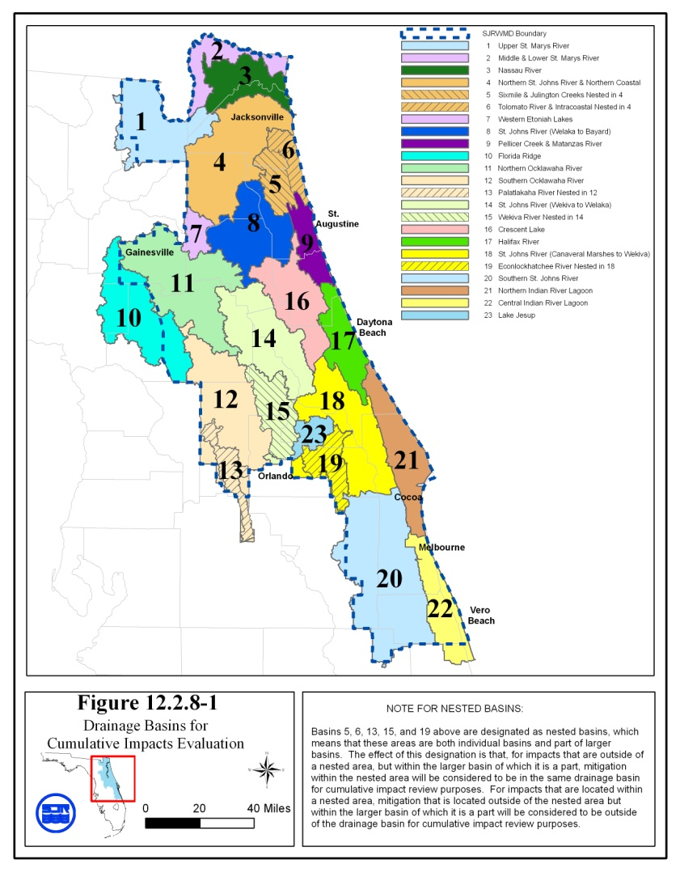
Revised 11/5/08

12.2.8 Cumulative Impacts

Pursuant to paragraph 12.1.1(g), an applicant must provide reasonable assurances that a regulated activity will not cause unacceptable cumulative impacts upon wetlands and other surface waters within the same drainage basin as the regulated activity for which a permit is sought. The impact on wetlands and other surface waters shall be reviewed by evaluating the impacts to water quality as set forth in subsection 12.1.1(c) and by evaluating the impacts to functions identified in subsection 12.2.2. If an applicant proposes to mitigate these adverse impacts within the same drainage basin as the impacts, and if the mitigation fully offsets these impacts, then the Department District will consider the regulated activity to have no unacceptable cumulative impacts upon wetlands and other surface waters, and consequently, the condition for issuance in paragraph 12.1.1(g) will be satisfied. The drainage basins within the District are identified on Figure 12.2.8-1.

When adverse impacts to water quality or adverse impacts to the functions of wetlands and other surface waters, as referenced in the paragraph above, are not fully offset within the same drainage basin as the impacts, then aAn applicant must provide reasonable assurance that the proposed system, when considered with the following activities, will not result in unacceptable cumulative impacts to water quality or the functions of wetlands and other surface waters, within the same drainage basin:

(a) projects which are existing or activities regulated under part IV, chapter 373 which are under construction or projects for which permits or determinations pursuant to sections 373.421 or 403.914 have been sought.

(b) activities which are under review, approved, or vested pursuant to section 380.06, or other activities regulated under part IV, chapter 373 which may reasonably be expected to be located within wetlands or other surface waters, in the same drainage basin, based upon the comprehensive plans, adopted pursuant to chapter 163, of the local governments having jurisdiction over the activities, or applicable land use restrictions and regulations.

Only those activities listed in paragraphs (a) and (b) which have similar types of impacts (adverse effects) to those which will be caused by the proposed system will be considered. (All citations in paragraphs (a) and (b) refer to provisions of Florida Statutes.)

The cumulative impact evaluation is conducted using an assumption that reasonably expected future applications with like impacts will be sought, thus necessitating equitable distribution of acceptable impacts among future applications.

12.2.8.1 Cumulative impacts are considered unacceptable when the proposed system, considered in conjunction with the past, present, and future activities as described in 12.2.8 would then result in a violation of state water quality standards as set forth in subsection 12.1.1(c), or significant adverse impacts to functions of wetlands or other surface waters identified in subsection 12.2.2, within the same drainage basin when considering the basin as a whole. This analysis asks the question whether the proposed system, considered in conjunction with past, present and future activities, would be the proverbial "straw that breaks the camel's back" regarding the above referenced water quality or wetland and other surface water functions in the basin.

12.2.8.2 Applicants may propose measures such as preservation to prevent cumulative impacts. Such preservation shall comply with the land preservation provisions in subsection 12.3.8. If unacceptable cumulative impacts are expected to occur, based on an evaluation conducted in accordance with subsection 12.2.8, the applicant may propose mitigation measures as provided for in sections 12.3-12.3.8.

12.3 Mitigation

Protection of wetlands and other surface waters is preferred to destruction and mitigation due to the temporal loss of ecological value and uncertainty regarding the ability to recreate certain functions associated with these features. Mitigation will be approved only after the applicant has complied with the requirements of subsection 12.2.1 regarding practicable modifications to eliminate or reduce adverse impacts. However, any mitigation proposal submitted for review shall be reviewed concurrently with the analysis of any modification pursuant to subsection 12.2.1. This section establishes criteria to be followed in evaluating mitigation proposals.

Mitigation as described in sections 12.3 - 12.3.8 is required only to offset the adverse impacts to the functions identified in sections 12.2 - 12.2.8.2 caused by regulated activities. In certain cases, mitigation cannot offset impacts sufficiently to yield a permittable project. Such cases often include activities which significantly degrade Outstanding Florida Waters, adversely impact habitat for listed species, or adversely impact those wetlands or other surface waters not likely to be successfully recreated.

Applicants are encouraged to consult with Department District staff in pre-application conferences or during the application process to identify appropriate mitigation options.

12.3.1 Types of Mitigation

Mitigation usually consists of restoration, enhancement, creation, or preservation of wetlands, other surface waters or uplands. In some cases, a combination of mitigation types is the best approach to offset adverse impacts resulting from the regulated activity.

12.3.1.1 In general, mitigation is best accomplished through creation, restoration, enhancement, or preservation of ecological communities similar to those being impacted. However, when the area proposed to be impacted is degraded, compared to its historic condition, mitigation is best accomplished through creation, restoration, enhancement or preservation of the ecological community which was historically present. Mitigation involving other ecological communities is acceptable if impacts are offset and the applicant demonstrates that greater improvement in ecological value will result.

12.3.1.2 In general, mitigation is best accomplished when located on-site or in close proximity to the area being impacted. Off-site mitigation will only be accepted if adverse impacts are offset and the applicant demonstrates that:

(a) on-site mitigation opportunities are not expected to have comparable long-term viability due to such factors as unsuitable hydrologic conditions or ecologically incompatible existing adjacent land uses or future land uses identified in a local comprehensive plan adopted according to chapter 163, F.S.; or

(b) off-site mitigation would provide greater improvement in ecological value than on-site mitigation.

12.3.1.3 Mitigation through participation in a mitigation bank shall be in accordance with Chapter 62-342, F.A.C. section 12.4 (Mitigation Banks).

12.3.1.4 In instances where an applicant is unable to meet water quality standards because existing ambient water quality does not meet standards and the system will contribute to this existing condition, mitigation for water quality impacts can consist of water quality enhancement. In these cases, the applicant must implement mitigation measures that will cause net improvement of the water quality in the receiving waters for those parameters which do not meet standards. (see paragraph 373.414(1)(b), F.S.)

12.3.1.5 To offset adverse secondary impacts from regulated activities to habitat functions that uplands provide to bald eagles (Haliaeetus leucocephalus) for nesting and to listed species evaluated as provided in paragraph 12.2.7(b), mitigation can include the implementation of management plans, participation in a wildlife mitigation park established by the FWC FGFWFC, or other measures. Measures to offset adverse secondary impacts on wetlands and other surface waters resulting from use of a system can include the incorporation of culverts or bridged crossings designed to facilitate wildlife movement, fencing to limit access, reduced speed zones, or other measures designed to offset the secondary impact.

12.3.1.6 Mitigation for certain mining activities shall be in accordance with subsection 373.414(6), F.S.

12.3.1.7 Except as provided in subsection 373.414(6), F.S., mitigation or reclamation required or approved by other agencies for a specific project will be acceptable to the District to the extent that such mitigation or reclamation fulfills the requirements of sections 12.3-12.3.8 and offsets adverse impacts of the same project in accordance with the criteria in sections 12.2-12.2.8.2

12.3.1.8 Innovative mitigation proposals which deviate from the standard practices described in sections 12.3-12.3.6 may be proposed by an applicant; however to receive District approval they must offset the adverse impacts to the functions identified in section 12.2-12.3.8.2 caused by regulated activities. The donation of money is not considered to be an acceptable method of mitigation, unless cash payments are specified for use in a District or Department of Environmental Protection endorsed environmental preservation, enhancement or restoration project and the payments initiate a project or supplement an ongoing project. The project or portion of the project funded by the donation of money must offset the impacts of the proposed system.

12.3.2 Mitigation Ratio Guidelines

For applications received on or after February 2, 2004, except as provided in Rule 62-345, F.A.C., Sections 12.3.2 - 12.3.2.4 are superseded by Rule 62-345, F.A.C.

Subsections 12.3.2 - 12.3.2.2 establish ratios for the acreage of mitigation required compared to the acreage which is adversely impacted by regulated activities. Ranges of ratios are provided below for certain specific types of mitigation, including creation, restoration, enhancement and preservation. The difference between the ranges of ratios provided for mitigation types is based on the degree of improvement in ecological value expected from each type. Creation and restoration are assigned the lowest range of ratios as these activities, when successfully conducted, add new wetlands or other surface waters which provide the same or similar functions as the areas adversely impacted. The range of ratios established for enhancement is higher than that for creation and restoration, as the area being enhanced currently provides a degree of the desired functions, and this type of mitigation serves to increase, rather than create, those functions. Preservation differs from the other types of mitigation in that it does not serve to improve the existing ecological value of an area in the short term. However, preservation does provide benefits as it can ensure that the values of the preserved area are protected and maintained in the long term, particularly when these values are not fully protected under existing regulatory programs. Therefore, the range of ratios established for preservation is higher than those for other types of mitigation. These ratios are provided as guidelines for preliminary planning purposes only. The actual ratio needed to offset adverse impacts may be higher or lower based on a consideration of the factors listed in subsections 12.3.2.1 and 12.3.2.2. For example, in instances where the proposed system results in only a small loss of ecological value in the impacted area, such as cases involving impacts to areas of low ecological value or cases where the proposed system results in a small reduction of ecological value of the impacted area, then the actual mitigation ratio would normally be in the lower end of or below the range. For other types of mitigation, ratios will be determined based upon the reduction in quality and relative value of the functions of the areas adversely impacted as compared to the expected improvement in quality and value of the functions of the mitigation area.

12.3.2.1 Creation, Restoration and Enhancement

When considering creation, restoration and enhancement as mitigation, the following factors will be considered to determine whether the mitigation proposal will offset the proposed impacts and to determine the appropriate mitigation ratio:

(a) The reduction in quality and relative value of the function of the areas adversely impacted, including the factors listed in subsection 12.2.2.3, as compared to the proposed improvement in quality and value of the functions of the area to be created, restored or enhanced.

(b) Any special designation or classification of the affected area.

(c) The presence and abundance of nuisance and exotic plants within the area to be adversely impacted.

(d) The hydrologic condition of the area to be adversely impacted and the degree to which it has been altered relative to the historic condition.

(e) The length of time expected to elapse before the functions of the area adversely impacted will be offset.

(f) The likelihood of mitigation success.

(g) For mine reclamation activities subject to chapter 211, F.S., part II, whether the ratio is consistent with the mine reclamation plan submitted pursuant to chapter 378, F.S.

12.3.2.1.1 Creation and restoration have the potential to result in similar benefits, if they can be successfully accomplished. Therefore, the ratio ranges given below for these two types of mitigation are the same. Restoration is usually preferred over creation as it often has a greater chance of success due to soil characteristic, hydrologic regime, landscape position or other factors that favor re-establishment of wetland or other surface water communities. Restoration ratios will generally be at the lower end of the ratio ranges within the guidelines below. The following ratio guidelines will be used to estimate the acreage of wetland restoration or creation required:

(a) Mangrove swamps, cypress swamps, and hardwood swamps - 2:1 to 5:1 (acres created or restored: acres impacted).

(b) Saltwater marshes and freshwater marshes - 1.5:1 to 4:1 (acres created or restored: acres impacted).

12.3.2.1.2 The ratio guidelines for use in the estimation of the acreage of wetland enhancement will range from 4:1 to 20:1 (acres enhanced: acres impacted).

12.3.2.2 Preservation

(a) Preservation of important ecosystems can provide an improved level of protection over current regulatory programs. The Department District will consider as mitigation the preservation, by donation or conservation easement or other comparable land use restriction, of wetlands, other surface waters, or uplands. Conservation easements or restrictions must be consistent with the requirements of subsection 12.3.8. In many cases it is not expected that preservation alone will be sufficient to offset adverse impacts. Preservation will most frequently be approved in combination with other mitigation measures.

(b) When considering preservation as mitigation, the following factors will be considered to determine whether the preservation parcel would offset the proposed impacts and to determine the appropriate mitigation ratio.

1. The reduction in quality and relative value of the functions of the areas adversely impacted, including those factors listed in subsection 12.2.2.3, as compared to the quality and value of the functions of the area to be preserved and the additional protection provided to these functions by the proposed preservation. Factors used in determining this additional level of protection include the extent and likelihood that the land to be preserved would be adversely impacted if it were not preserved, considering the protection provided by existing regulations and land use restrictions.

2. Any special designation or classification of the affected area.

3. The presence and abundance of nuisance and exotic plants within the area to be adversely impacted.

4. The ecological and hydrological relationship between wetlands, other surface waters, and uplands to be preserved.

5. The extent to which proposed management activities on the area to be preserved promote natural ecological conditions, such as natural fire patterns.

6. The proximity of the area to be preserved to areas of national, state, or regional ecological significance, such as national or state parks, Outstanding Florida Waters, and other regionally significant ecological resources or habitats, such as lands acquired or to be acquired through governmental or non-profit land acquisition programs for environmental conservation, and whether the areas to be preserved include corridors between these habitats.

7. The extent to which the preserved area provides habitat for fish and wildlife, especially listed species.

8. Any special designation or classification of the area to be preserved.

9. The extent of invasion of nuisance and exotic species within the area to be preserved.

(c) Wetland and other surface water preservation ratios. Since wetlands and other surface waters are, to a large extent, protected by existing regulations, the ratio guideline for preservation of wetlands and other surface waters is substantially higher than for restoration and creation. The ratio guideline for wetland and other surface water preservation will be 10:1 to 60:1 (acreage wetlands and other surface waters preserved to acreage impacted).

(d) Upland preservation ratios. Many wildlife species that are aquatic or wetland dependent spend critical portions of their life cycles in uplands. Uplands function as the contributing watershed to wetlands and are necessary to maintain the ecological value of those wetlands. Because of these values, the preservation of certain uplands may be appropriate for full or partial mitigation of wetland impacts, impacts to the upland portion of the riparian habitat protection zones described in subsections 11.3.5 and 11.4.4, and impacts to uplands that are used by listed aquatic or wetland dependent species as described in subsection 12.2.7(b). The ratio guideline for upland preservation will be 3:1 to 20:1 (acreage of uplands preserved to acreage impacted).

12.3.2.3 To the extent that the area to be preserved offsets the adverse impact and otherwise meets the requirements of this section, wetland, other surface water, or upland habitat which is proposed to be preserved in order to prevent secondary or cumulative impacts can be considered as part of the mitigation plan to offset other adverse impacts of the system.

12.3.3 Mitigation Proposals

12.3.3.1 Applicants shall provide reasonable assurance that proposed mitigation will:

(a) offset adverse impacts due to regulated activities; and

(b) achieve mitigation success by providing viable and sustainable ecological and hydrological functions.

12.3.3.2 Applicants shall submit detailed plans describing proposed construction, establishment, and management of mitigation areas. These plans shall include the following information, as appropriate for the type of mitigation proposed:

(a) A soils map of the mitigation area and other soils information pertinent to the specific mitigation actions proposed.

(b) A topographic map of the mitigation area and adjacent hydrologic contributing and receiving areas.

(c) A hydrologic features map of the mitigation area and adjacent hydrologic contributing and receiving areas.

(d) A description of current hydrologic conditions affecting the mitigation area.

(e) A map of vegetation communities in and around the mitigation area.

(f) Construction drawings detailing proposed topographic alterations and all structural components associated with proposed activities.

(g) Proposed construction activities, including a detailed schedule for implementation.

(h) A vegetation planting scheme if planting is proposed, and schedule for implementation.

(i) Sources of plants and soils used in wetland creation.

(j) Measures to be implemented during and after construction to avoid adverse impacts related to proposed activities.

(k) A management plan comprising all aspects of operation and maintenance, including water management practices, vegetation establishment, exotic and nuisance species control, fire management, and control of access.

(l) A proposed monitoring plan to demonstrate mitigation success.

(m) A description of the activities proposed to control exotic and nuisance species should these become established in the mitigation area. The mitigation proposal must include reasonable measures to assure that these species do not invade the mitigation area in such numbers as to affect the likelihood of success of the project.

(n) a description of anticipated site conditions in and around the mitigation area after the mitigation plan is successfully implemented.

(o) a comparison of current fish and wildlife habitat to expected habitat after the mitigation plan is successfully implemented.

(p) For mitigation plans with projected implementation costs in excess of $25,000.00, an itemized estimate of the cost of implementing mitigation as set forth in subsection 12.3.7.78.

12.3.4 Monitoring Requirements for Mitigation Areas

Applicants shall monitor the progress of mitigation areas until success can be demonstrated as provided in subsection 12.3.6. Monitoring parameters, methods, schedules, and reporting requirements will be specified in permit conditions.

12.3.5 Protection of Mitigation Areas

Applicants shall propose and be responsible for implementing methods that assure that mitigation areas will not be adversely impacted by incidental encroachment or secondary activities which might compromise mitigation success.

12.3.6 Mitigation Success

Mitigation success will be measured in terms of whether the objectives of the mitigation can be realized. The success criteria to be included in permit conditions will specify the minimum requirements necessary to attain a determination of success. The mitigation shall be deemed successful by the Department District when all applicable water quality standards are met, the mitigation area has achieved viable and sustainable ecological and hydrological functions and the specific success criteria contained in the permit are met. If success is not achieved within the time frame specified within the permit, remedial measures shall be required. Monitoring and maintenance requirements shall remain in effect until success is achieved.

12.3.7 Financial Responsibility for Mitigation.

As part of compliance with paragraph 40C-4.301(1)(j), F.A.C., where an applicant proposes mitigation, the applicant shall provide proof of financial responsibility to:

(a) conduct the mitigation activities;

(b) conduct any necessary management of the mitigation site;

(c) conduct monitoring of the mitigation; and

(d) conduct any necessary corrective action indicated by the monitoring.

12.3.7.1 Applicants not subject to financial responsibility requirements.

The following applicants shall not be subject to the financial responsibility requirements in subsections 12.3.7-12.3.7.9:

(a) Applicants whose mitigation is deemed successful pursuant to subsection 12.3.6 of this Handbook prior to undertaking the construction activities authorized under the permit issued pursuant to part IV, chapter 373, F.S.

(b) Applicants whose mitigation is estimated to cost less than $25,000.00.

(c) Federal, state, county and municipal governments, state political subdivisions, investor-owned utilities regulated by the Public Service Commission and rural electric cooperative.

(d) Mitigation banks which comply with the financial responsibility provisions of section 12.4 of this Handbook.

12.3.7.2 Amount of financial responsibility.

The amount of financial responsibility provided by the applicant shall be in an amount equal to 110 percent of the cost estimate determined pursuant to subsection 12.3.7.78 below, for each phase of the mitigation plan submitted under the requirements of sections 12.3 - 12.3.8.

12.3.7.3 Documentation.

The permit applicant shall provide draft documentation of the required financial responsibility mechanism described below with the permit application, and shall submit to the District the executed or finalized documentation within the time frames specified in the permit.

12.3.7.4 General Terms for Financial Responsibility Mechanisms.

In addition to the specific provisions regarding financial responsibility mechanisms set forth in subsection 12.3.7.6 below, the following, as they relate to the specific mechanism proposed, shall be complied with:

(a) The form and content of all financial responsibility mechanisms shall be approved by the Department District if they satisfy their requirements specified in subsections 12.3.7 – 12.3.7.9.

(b) The financial mechanisms shall name the Department District as sole beneficiary or shall be payable solely to the Department District. If the financial mechanism is of a type which is retained by the beneficiary according to industry standards, the original financial responsibility mechanism shall be retained by the Department District.

(c) The financial responsibility mechanisms shall be established with a state or national bank, savings and loan association, or other financial institution, licensed in this state. In the case of letters of credit, the letter of credit must be issued by an entity which has authority to issue letters of credit and whose letter of credit operations are regulated and examined by a federal or state agency. In the case of a surety bond, the surety bond must be issued by a surety company registered with the state of Florida.

(d) The financial responsibility mechanisms shall be effective on or prior to the date that the activity authorized by the permit commences and shall continue to be effective through the date of notification of final release by the District in accordance with subsection 12.3.7.7.2 below of this Handbook.

(e) The financial responsibility mechanisms shall provide that they cannot be revoked, terminated or cancelled without first providing an alternative financial responsibility mechanism which meets the requirements of subsections 12.3.7 - 12.3.7.9. Within 90 days of receipt by the permittee of actual or constructive notice of revocation, termination or cancellation of a financial responsibility mechanism or other actual or constructive notice of cancellation, the permittee shall provide such an alternate financial responsibility mechanism.

12.3.7.5 If the permittee fails to comply with the terms and conditions of the permit, subsection 12.3.7 or fails to complete the mitigation and monitoring within the timeframes specified in the permit conditions or any extension thereof, such failure shall be deemed a violation of chapter 40C-4, F.A.C., and the permit issued thereunder. In addition to any other remedies for such violation as the Department District may have, the Department District, upon notice as provided in the mechanism or if none, upon reasonable notice, may draw upon the financial mechanism.

12.3.7.6 Financial Responsibility Mechanisms.

Financial responsibility for the mitigation, monitoring and corrective action for each phase of the project may be established by any of the following methods, at the discretion of the applicant:

(a) Performance bond;

(b) Irrevocable letter of credit;

(c) Trust fund agreement;

(d) Deposit of cash or cash equivalent into an escrow account;

(e) An audited annual financial statement submitted by a Certified Public Accountant representing that the applicant has a tangible net worth equal to or in excess of the cost of the mitigation plan. For purposes of this subparagraph, "tangible net worth" means total assets, not including intangibles such as goodwill and right to patents or royalties, minus total liabilities, computed in accordance with generally accepted accounting principles.

(f) A demonstration that the applicant meets the financial test and corporate guarantee requirements set forth in 40 C.F.R. Section 264.143(f) incorporated herein by reference. Where the referenced test is used to provide evidence of financial resources necessary to conduct mitigation activities the term "closure and post-closure cost estimates" as set forth therein, shall be construed to mean "mitigation cost estimates."

(g) Guarantee bond;

(h) Insurance certificate;

(i) A demonstration that the applicant meets the self-bonding provisions set forth at 30 C.F.R. Section 800.23 incorporated herein by reference. Where the referenced provisions are used to provide evidence of financial responsibility to conduct mitigation activities, the term "surface coal mining and reclamation operations," as set forth therein, shall be construed to mean "mitigation activities."

12.3.7.7 Cost estimates.

For the purposes of determining the amount of financial responsibility that is required by this subsection, the applicant shall submit a detailed written estimate, in current dollars, of the total cost of conducting the mitigation, including any maintenance and monitoring activities, and the applicant shall comply with the following:

(a) The cost estimate for conducting the mitigation and monitoring shall include all associated costs for each phase thereof, including earthmoving, planting, structure installation, maintaining and operating any structures, controlling nuisance or exotic species, fire management, consultant fees, monitoring activities and reports.

(b) The applicant shall submit the estimates, together with verifiable documentation, to the Department District along with the draft of the financial responsibility mechanism.

(c) The costs shall be estimated based on a third party performing the work and supplying materials at the fair market value of the services and materials. The source of any cost estimates shall be indicated.

12.3.7.7.1 Partial Releases.

The permittee may request the Department District to release portions of the financial responsibility mechanism as phases of the mitigation plan, such as earth moving or other construction or activities for which cost estimates were submitted in accordance with subsection 12.3.7.7, are successfully completed. The request shall be in writing and include documentation that the phase or phases have been completed and have been paid for or will be paid for upon release of the applicable portion of the financial responsibility mechanism. The Department District shall authorize the release of the portion requested upon verification that the construction or activities have been completed in accordance with the mitigation plans.

12.3.7.7.2 Final Release.

Within thirty (30) days of the Department District determining that the mitigation is successful in accordance with subsection 12.3.6, the Department District shall so notify the permittee and shall authorize the return and release of all funds held or give written authorization to the appropriate third party for the cancellation or termination of the financial responsibility mechanism.

12.3.7.8 Financial Responsibility Conditions.

For applicants subject to the financial responsibility of subsections 12.3.7 - 12.3.7.9, the Department District will include the following conditions on the permit:

(a) A permittee must notify the Department District by certified mail of the commencement of a voluntary or involuntary proceeding under Title XI (Bankruptcy), U.S. Code naming the permittee as debtor within 10 business days after the commencement of the proceeding.

(b) A permittee who fulfills the requirements of subsections 12.3.7 - 12.3.7.9 by obtaining a letter of credit or performance bond will be deemed to be without the required financial assurance in the event of bankruptcy, insolvency or suspension or revocation of the license or charter of the issuing institution. The permittee must reestablish in accordance with subsections 12.3.7 - 12.3.7.9 a financial responsibility mechanism within 60 days after such event.

(c) When transferring a permit in accordance with Rule 62-343.130 section 40C-4.351, F.A.C., the new owner or person with legal control shall submit documentation to satisfy the financial responsibility requirements of subsections 12.3.7 - 12.3.7.9. The prior owner or person with legal control of the project shall continue the financial responsibility mechanism until the Department District has approved the permit transfer and substitute financial responsibility mechanism.

12.3.7.9 Financial Responsibility Mechanisms For Multiple Projects.

An applicant may use a mechanism specified in subsection 12.3.7.6 above to meet the financial responsibility requirement for multiple projects. The financial responsibility mechanism must include a list of projects and the amount of funds assured for each project. The mechanism must be no less than the sum of the funds that would be necessary in accordance with subsection 12.3.7.2 above, as if separate mechanisms had been established for each project. As additional permits are issued which require mitigation, the amount of the financial responsibility mechanism may be increased in accordance with subsection 12.3.7.2, above and the project added to the list.

12.3.8 Real property conveyances.

(a) All conservation easements shall be granted in perpetuity without encumbrances, unless such encumbrances do not adversely affect the ecological viability of the mitigation. All liens against the conservation easement site shall release, be subordinated to, or joined with the conservation easement. All conservation easements shall be consistent with section 704.06, F.S., and shall contain restrictions that ensure the ecological viability of the site.

(b) All real property conveyances shall be in fee simple and by statutory warranty deed, special warranty deed, or other deed, without encumbrances that adversely affect the integrity of the preservation. The District shall also accept a quit claim deed if necessary to aid in clearing minor title defects or otherwise resolving boundary questions.

12.4 THIS SECTION NOT ADOPTED FOR USE BY THE DEPARTMENT

12.5 THIS SECTION NOT ADOPTED FOR USE BY THE DEPARTMENT

PART III
METHODOLOGIES

13.0 Methodologies for Calculating Peak Discharge

13.1 Rainfall

(a) Duration: See subsection 10.3.3 of this Handbook for duration to be used.

(b) Frequency: See subsection 10.3.2 of this Handbook for frequency to be used.

(c) Intensity: See subsection 14.0 of this Handbook for discussion of rainfall intensity and distribution.

13.2 Antecedent Moisture Conditions

Use average wet season (AMC II). This average condition is defined by SCS as 1.4 to 2.1 inches of rainfall in the five day period prior to a storm event. Further information on antecedent moisture can be obtained in USDA, Soil Conservation Service, 1972. National Engineering Handbook, section 4, Hydrology.

13.3 Upper Soil Zone Storage

Soil storage is taken into account through use of the SCS curve number (see section 13.8). In areas of sandy soils, the standard SCS method may not accurately predict the available soil storage. A shallow water table or hardpan confining layer may reduce the amount of available soil storage. A deep water table and no confining layer will allow storage of a large amount of water in the soil.

For projects on sandy soils where the depth to the average wet season water table or to a confining layer has been accurately determined, the original curve number may be modified to reflect these conditions.

13.4 Surface Storage

Surface storage in depressional areas may be considered if stage-storage calculations are included. Discharge from these areas during storm events must also be considered and appropriate stage-discharge calculations must also be provided.

13.5 Time of Concentration

Many of the accepted runoff computation methods require determination of the time of concentration. A recommended method for this is described in publications of the Soil Conservation Service (TR 55, Chapter 3 and National Engineering Handbook, Section 4, Chapter 15). It involves dividing the flow into three types: overland, storm sewer, and channel flow.

(a) Overland flow: The travel time for overland flow is the time it takes water to travel from the uppermost part of the watershed to a storm sewer system or defined channel. This type of flow is significant in small watersheds because a higher proportion of the travel time is due to overland flow. If the slope and land use of the overland segment are known, the average flow velocity can be read from Figure 13.5-1. The travel time is then computed by dividing the overland flow length by the average velocity.

(b) Storm sewer flow: The average flow velocity in storm sewers can be determined during Manning's equation with average conduit sizes and slopes. The travel time through the storm sewers is computed by dividing the length of flow by the average velocity.

(c) Channel flow: The average velocity in an open channel can be determined using Manning's equation (see Section 15.3). Flow depth to be used can be the design flow or bankfull flow. The travel time in an open channel is computed by dividing the channel length by the average velocity.

13.6 Tailwater Conditions

Receiving water stage can affect the amount of flow which will discharge from the project to the receiving water. This stage may be such that tailwater exists in portions of the project system, reducing the effective flow or storage area. Typical examples of this are illustrated in Figures 13.6-1 (gravity) and 13.6-2 (pumped).
Figure 13.5-1. (Source: USDA, SCA, National Engineering Handbook, Chapter 4)
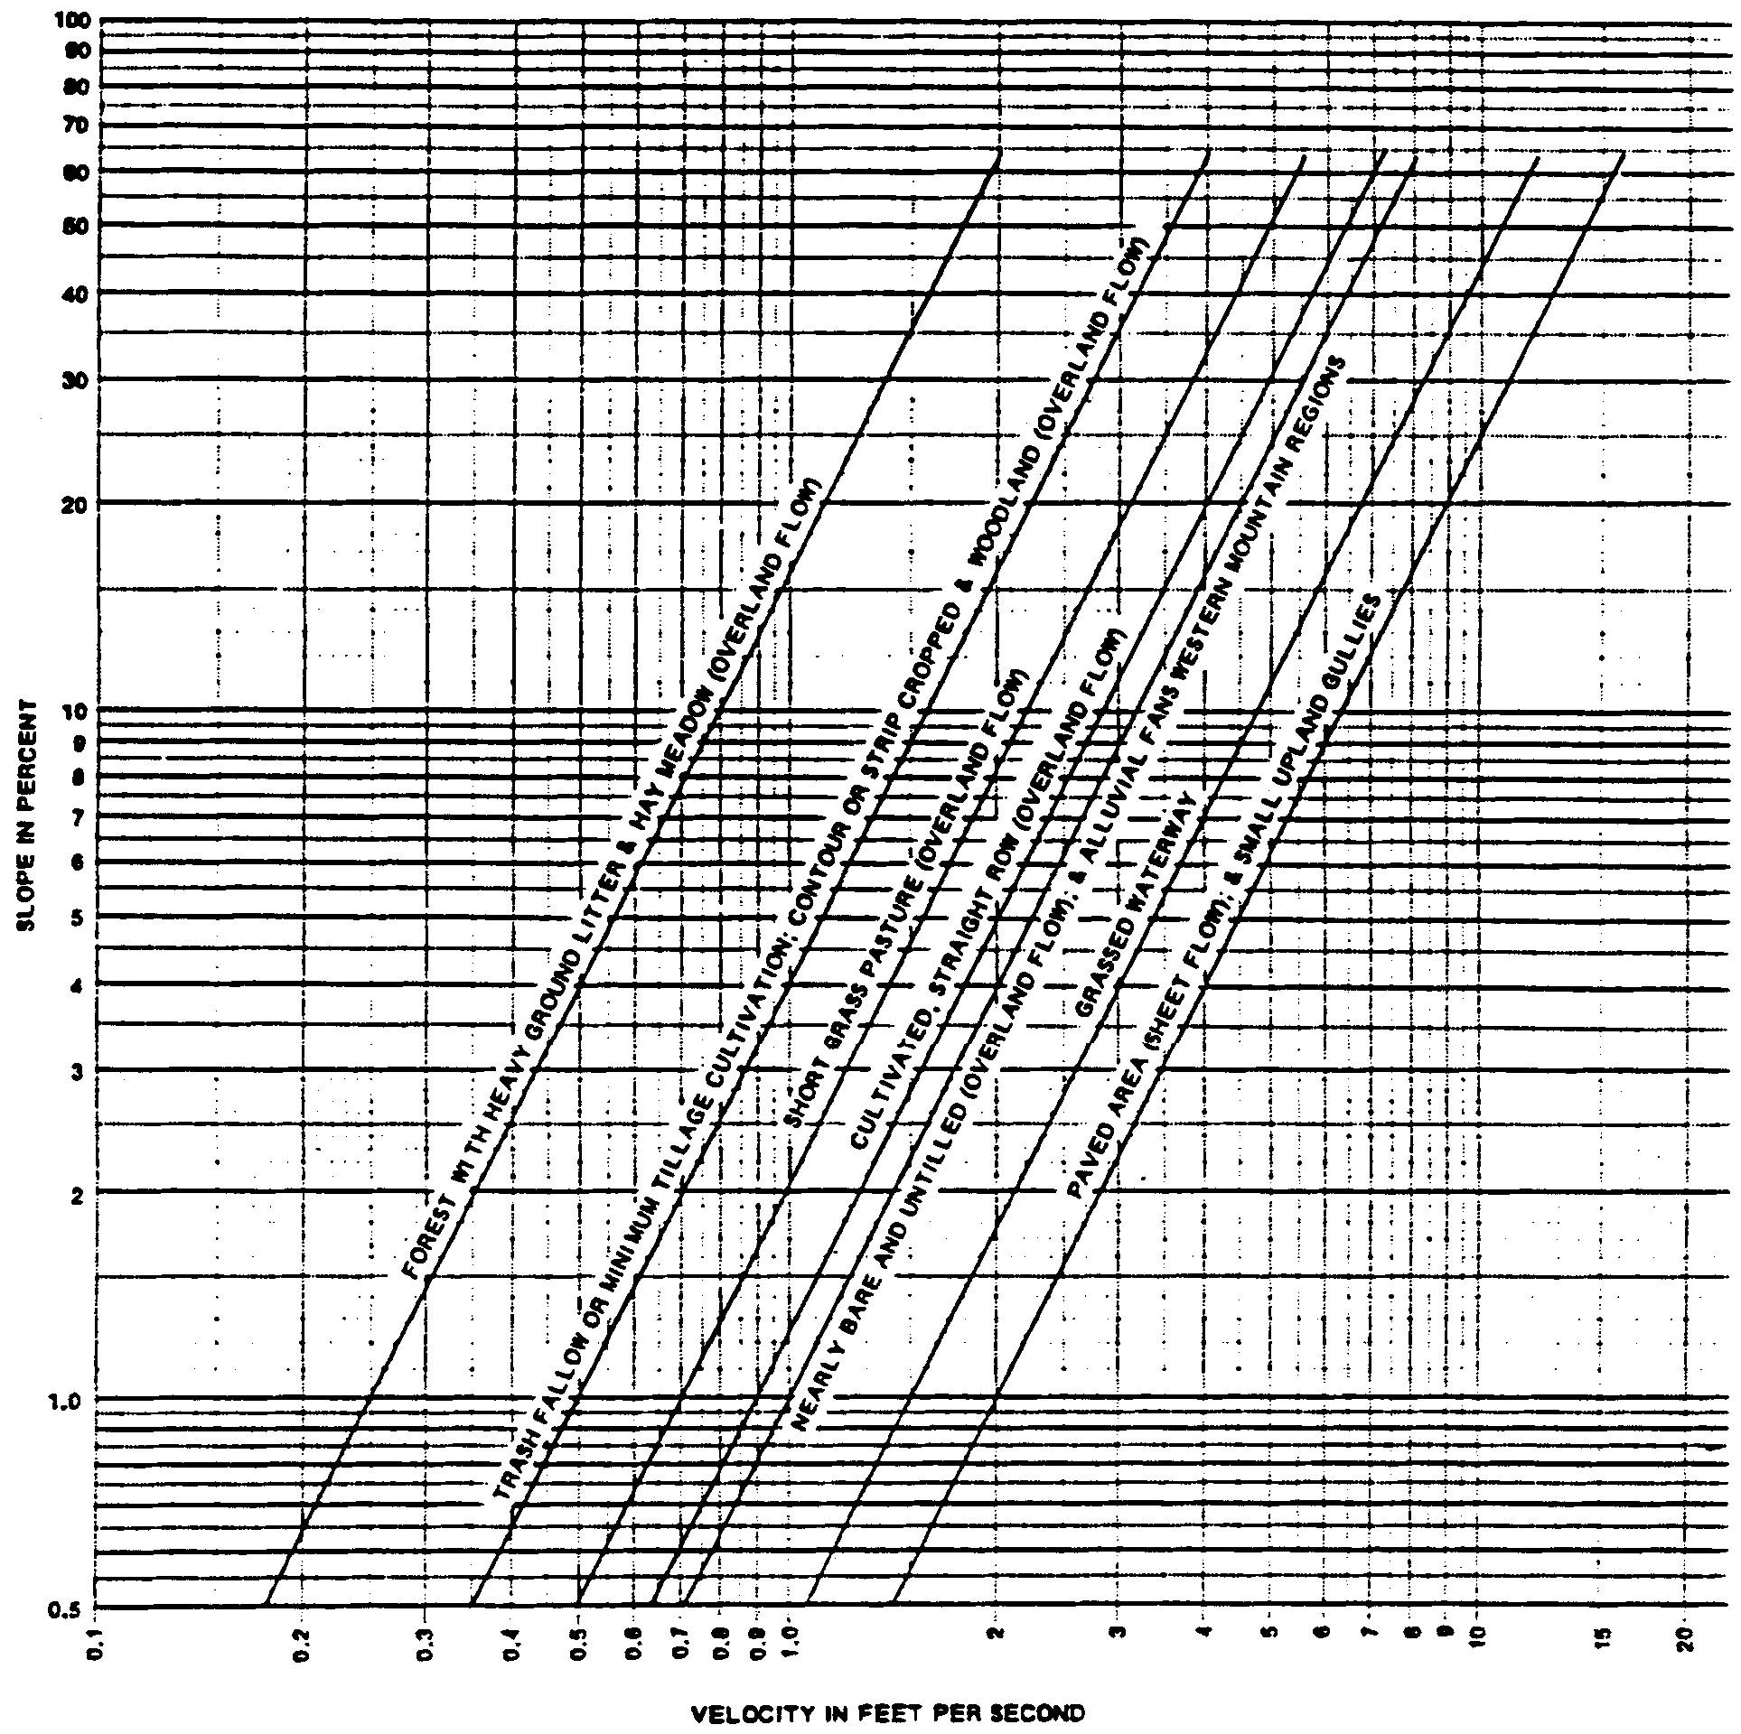

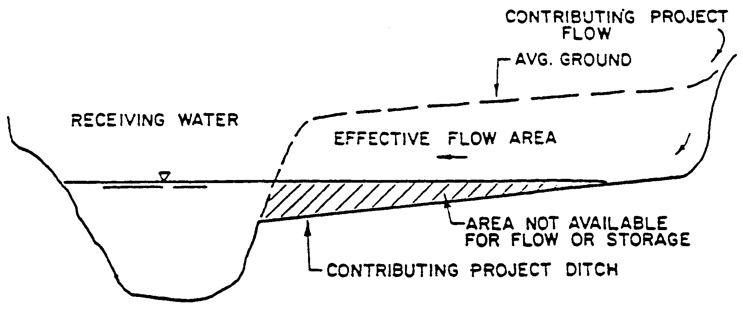

Figure 13.6-1

The stage in the receiving water should be considered to be the maximum stage which would exist in the receiving water from a storm equal to the project design storm. Lower stages may be used if the applicant can show that the flow from his project will reach the receiving water prior to the time of maximum stage in the receiving water.

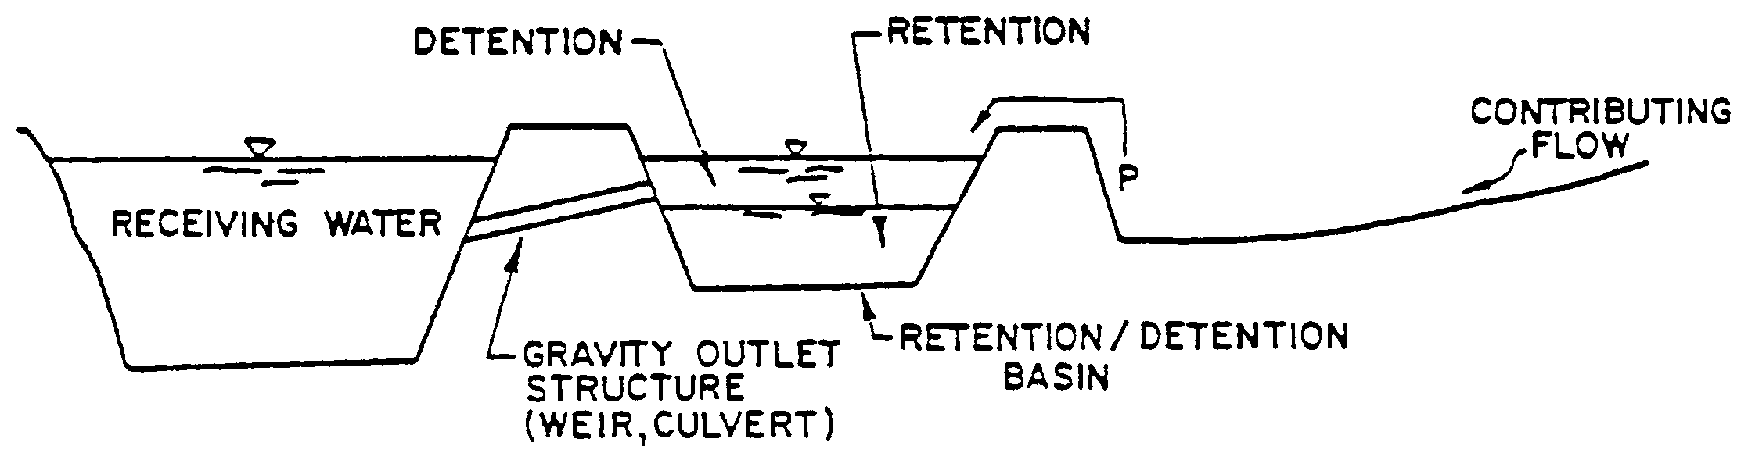
Figure 13.6-2

13.7 Changes in Land Use

Post-development conditions will generally include changes in land use and land cover from the pre-development conditions. All curve numbers, calculations of time of concentration, etc. should reflect these changes.

13.8 Runoff Estimation

One of the recommended methods for estimation of runoff volume from rainfall information has been developed by the United States Department of Agriculture's Soil Conservation Service (SCS).

The runoff equation used by SCS was developed by Victor Mockus and others and presented in the Soil Conservation Service's National Engineering Handbook, Section 4, Hydrology. The relationship between accumulated rainfall and accumulated runoff was derived from experimental data for numerous soils, vegetative cover and land treatment measures.

The equation is:

where: R = accumulated direct runoff (inches)
P = accumulated rainfall (inches)
Ia = initial abstraction including surface storage, interception, and infiltration prior to runoff (inches)
S = potential maximum retention (inches)

The relationship between Ia and S was developed from experimental watershed data. The empirical relationship used in the SCS runoff equation is:

Substituting 0.2S for Ia in the runoff equation, above, yields:

Figure 13.8-1 (Source: USDA, SCA, National Engineering Handbook, Chapter 4)
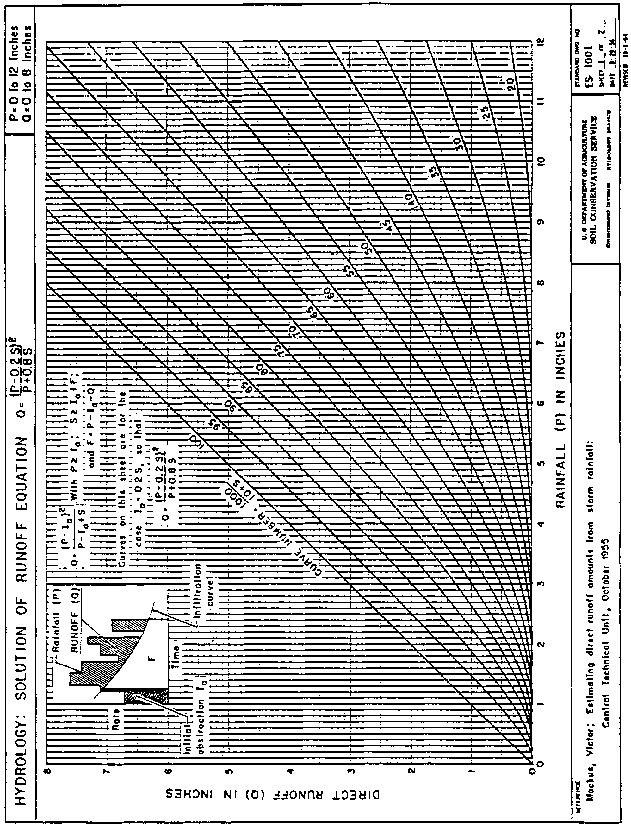

Table 13.9-1
Peak Discharge / Inch Runoff For Florida
(cfs / inch)

 |  | Drainage Area in Acres
Slope | CN  (Curve  Numbers) | 2 | 4 | 6 | 8 | 10 | 20 | 40 | 60 | 80 | 100 | 200 | 400
Flat | 60 | 1 | 3 | 3 | 4 | 5 | 8 | 14 | 18 | 22 | 25 | 39 | 61
 | 65 | 2 | 3 | 4 | 5 | 5 | 9 | 15 | 19 | 24 | 27 | 43 | 67
 | 70 | 2 | 3 | 4 | 5 | 6 | 10 | 16 | 21 | 26 | 30 | 48 | 74
 | 75 | 2 | 3 | 4 | 5 | 6 | 10 | 17 | 23 | 28 | 33 | 53 | 83
 | 80 | 2 | 3 | 4 | 6 | 7 | 11 | 19 | 25 | 31 | 36 | 58 | 92
 | 85 | 2 | 3 | 5 | 6 | 8 | 12 | 21 | 28 | 34 | 40 | 65 | 104
 | 90 | 2 | 3 | 5 | 6 | 8 | 13 | 23 | 31 | 38 | 45 | 74 | 118
 | 95 | 2 | 4 | 5 | 7 | 8 | 15 | 26 | 35 | 43 | 51 | 85 | 138
Moderate | 60 | 2 | 3 | 5 | 6 | 7 | 12 | 21 | 28 | 34 | 40 | 64 | 102
 | 65 | 2 | 3 | 5 | 6 | 7 | 13 | 22 | 30 | 37 | 43 | 70 | 112
 | 70 | 2 | 3 | 5 | 6 | 8 | 14 | 23 | 32 | 40 | 47 | 76 | 123
 | 75 | 2 | 4 | 5 | 7 | 8 | 14 | 25 | 34 | 43 | 50 | 83 | 135
 | 80 | 2 | 4 | 5 | 7 | 8 | 15 | 27 | 37 | 46 | 54 | 91 | 148
 | 85 | 2 | 4 | 5 | 7 | 9 | 16 | 29 | 40 | 50 | 59 | 100 | 164
 | 90 | 2 | 4 | 6 | 7 | 9 | 17 | 31 | 43 | 54 | 64 | 110 | 184
 | 95 | 2 | 4 | 6 | 8 | 9 | 18 | 33 | 47 | 59 | 71 | 123 | 208
Steep | 60 | 2 | 4 | 5 | 7 | 9 | 16 | 28 | 39 | 49 | 59 | 98 | 162
 | 65 | 2 | 4 | 6 | 7 | 9 | 17 | 30 | 42 | 52 | 62 | 106 | 175
 | 70 | 2 | 4 | 6 | 7 | 9 | 17 | 31 | 44 | 55 | 66 | 113 | 189
 | 75 | 2 | 4 | 6 | 8 | 9 | 18 | 33 | 46 | 58 | 70 | 121 | 204
 | 80 | 2 | 4 | 6 | 8 | 9 | 18 | 34 | 48 | 61 | 74 | 129 | 221
 | 85 | 2 | 4 | 6 | 8 | 9 | 19 | 35 | 50 | 65 | 78 | 139 | 240
 | 90 | 2 | 4 | 6 | 8 | 9 | 19 | 36 | 53 | 68 | 83 | 149 | 261
 | 95 | 2 | 4 | 6 | 8 | 9 | 19 | 37 | 55 | 72 | 88 | 161 | 287

Source: USDA, SCS "Interim Runoff Procedure for Florida," Florida Bulletin 210-1-2
A graphical solution of this equation is shown in Figure 13.8-1. The S values are transformed into curve numbers (CN) by the following equation:

Peak discharges can be determined from the runoff volume using Table 13.8-1. Peak discharge (cfs) per inch of runoff volume are given for various drainage areas, slopes and curve numbers. This table should be used for watersheds of less than 600 acres. Larger or non-homogeneous watersheds should be subdivided into hydrologic sub-areas and their peak discharges determined by any of the flood-routing methods listed in Section 10.3.5 of this Handbook.

These peak discharges can be further modified to account for parameters such as actual land slope, watershed shape and depressional surface storage. Further information concerning the use of these modifications is given in the sample problems at the end of this section and in reference number six.

13.9 Detention Basin Design

One of the most common procedures for assuring that post- development peak discharge rates do not exceed pre-development rates is the use of detention basins. These basins store the runoff and release it off-site through a control structure at the required rate. Detention is defined as the collection and temporary storage of stormwater with subsequent gradual release at a specified rate. In addition, the purpose of detention basins can be expanded to include partial treatment to improve water quality by removal of pollutants. Retention and filtration, if properly designed, are the primary techniques used to accomplish these means. Retention is defined as the prevention of discharge of a given volume of stormwater runoff by complete on-site storage. Removal of the water is caused only by percolation, evaporation, or evapotranspiration. Filtration is the selective removal of suspended matter from stormwater by passing it through fine textured granular media such as porous soil, sand and gravel, or other aggregate, which may be used in conjunction with filter fabric and/or underdrain pipe.

The following discussion relates to detention only and the water quantity considerations involved in design. For water quantity control, detention basins require some type of spillway outlet structure. This may be a culvert, weir, or vegetated overflow. These control structures must be designed to discharge at a rate not to exceed the pre-development rate for the required design storm. Discharge rates are a function of the headwater in the basin and the tailwater outside the basin. Tailwater conditions outside the basin should be considered to be the maximum stage which would exist in the receiving water from a storm equal to the project design storm. Lower stages may be used if the applicant can show that the flow from his project will reach the receiving water prior to the time of maximum stage in the receiving water. The headwater in the basin is a function of the inflow, available storage, and outflow. Modeling of the relationships between these variables can be accomplished using any conventional flood routing technique. Stage-storage and stage-discharge curves for the basin and outlet structure are required. When constructing a stage-discharge curve, it must be determined what portion of the outlet structure will control the flow rate for various headwater conditions. For example, a culvert with a flashboard riser will initially be controlled by the capacity of the riser (weir control). As headwater increases the control will shift to the hydraulic capacity of the culvert (pipe control). Culvert flow may be controlled by the entrance conditions (inlet control) or the tailwater conditions (outlet control). In all the above situations, whichever control allows the smallest discharge must be used.

Basin criteria require that when designing an outlet structure to control discharge for a large storm event (25 year frequency) the structure's performance during less severe storm events (10 year frequency) must also be checked. If an outlet is sized to meet the pre- and post-development peak discharge criteria for a 25 year storm event, during a 10 year event the headwater/tailwater condition may be such that the structure will discharge substantially more than the pre-development peak rate. This is illustrated in the following example:

On-site storage is to be provided to meet the pre-and post-development peak discharge criteria for the 10 and 25 year frequency storms (see Figure 13.9-1). The 25 year pre-development discharge is 100 cfs and the 10 year is 50 cfs. The 25 year tailwater elevation in the receiving water is 10.0 ft. and the 10 year is 5.0 ft. The detention basin has a 48" CMP outlet and is sized so that the 25 year stage is elevation 12.5 ft. and the 10 year is 9.0 ft. This gives a 25 year outflow of 100 cfs for 2.5 feet of head and outlet control. Checking the outflow for the 10 year storm gives a discharge of 65 cfs for 4 feet of head and inlet control, an increase over the 50 cfs pre-development flow.
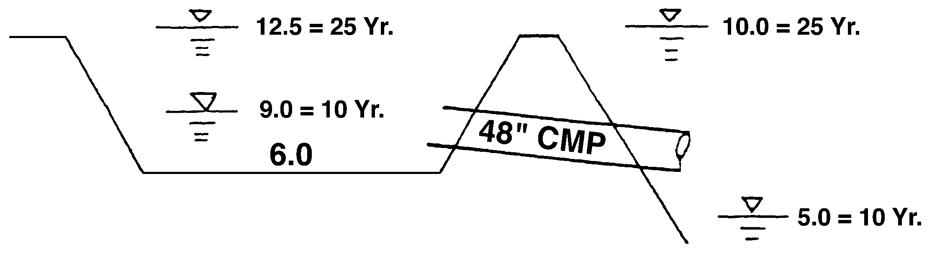

Figure 13.9-1

In a situation such as this it may be necessary to use a smaller pipe or revise the outlet structure design to incorporate additional features such as a two-stage outlet. This will insure that pre-development discharge does not exceed post-development discharge for both the 10 year and 25 year storm events.

Another requirement for detention basins is to be able to draw down the water level to restore storage capacity within a maximum of 14 days following a storm event. If this cannot be accomplished with the primary outlet structure, a small bleed-down pipe equipped with gate valve may be required.

Other recommended design considerations include:

(a) anti-vortex devices on riser culverts;

(b) basin side slopes of 4:1 or flatter;

(c) maximum depths of four to six feet over 80% of the basin area;

(d) seeding and mulching, if necessary, of all exposed earth surfaces;

(e) erosion control measures at the spillway inlet and outlet;

(f) layouts which avoid rectangular shapes and blend in with the natural contours;

(g) provisions should be made for prompt maintenance including mowing of vegetation and visual inspection of the outlet structure for possible problems; and

(h) trash racks on the outlet structure if the possibility exists for debris to accumulate and block the opening.
13.10 References for Section 13

1. Linsley, Kohler and Paulhus, 1975. Hydrology for Engineers. McGraw Hill Book Company, New York. 460 pp.

2. Peck, Hanson and Thornburg, 1974. Foundation Engineering. John Wiley and Sons, Inc., New York. 486 pp.

3. South Florida Water Management District. 1982. Permit Information Manual - Volume IV, Management and Storage of Surface Waters.

4. South Florida Water Management District. 1978. Technical Memorandum 7610-352, Storage Under Impervious Surfaces.

5. USDA, Soil Conservation Service. 1972. National Engineering Handbook, Section 4, Hydrology.

6. USDA, Soil Conservation Service. 1975. Urban Hydrology for Small Watersheds. Technical Release No. 55.

7. USDA, Soil Conservation Service. 1980. Interim Runoff Procedure for Florida. Florida Bulletin 210-1-2.

8. USDA, Soil Conservation Service. Soil Surveys of Various Counties.

14.0 Methodologies for Calculating Rainfall Data

14.1 24-Hour Storms

14.1.1 Rainfall depth: Rainfall depths for 24-hour duration events can be found in any of the sources listed in paragraph 10.3.6(a) of this Handbook.

14.1.2 Rainfall Distributions: For 24-hour rainfall events, recommended methods for distribution of this rainfall throughout the 24 hours are:

(a) A statistical analysis of the historical hourly rainfall data.

(b) The SCS-Type II distribution: This method has been described in the SCS TP-149 publication (see Reference 11). See Table 14.1-1 for a breakdown of this distribution. The accumulative distribution is shown in Figure 14.1-1.

(c) The SCS Interim Runoff Procedure for Florida (Modified NRCS-Type II Distribution): This method is described in an SCS report by Roger Cronshey, Hydraulic Engineer (May 1980). This distribution was developed on the same lines as the SCS type II rainfall, but uses the data from HYDRO-35. A generalized depth-duration curve was derived for the State of Florida in the form of ratios of t-hour depth to 24-hour depth. The ratios are given by:

Ratio = 0.5 t^{0.74} 0 <t<.65 hrs.

Ratio = 0.411 t 0.28 0.65 hr. <t< 24 hrs.

in which t = duration in hours. Incremental depths (for the required time step) are calculated on the basis of the foregoing relations and rearranged so that the largest depth occurs prior to 12 hours in the distribution. The second largest is placed after the first and the third placed before the first. Alternating the remaining rainfall amounts continued in the same manner until the entire 24-hour distribution has been established. See Table 14.1-1 for a breakdown of this distribution.

Table 14.1-1. Rainfall Ratios (Accumulated Total/24 Hour Total)

Time (hr.) | NRCS Type II | NRCS Type II FL. Modified
0.0 | .000 | .000
0.5 | .005 | .006
1.0 | .011 | .012
1.5 | .017 | .019
2.0 | .022 | .025
2.5 | .029 | .032
3.0 | .035 | .039
3.5 | .042 | .047
4.0 | .048 | .054
4.5 | .056 | .062
5.0 | .064 | .071
5.5 | .072 | .080
6.0 | .080 | .089
6.5 | .090 | .099
7.0 | .100 | .110
7.5 | .110 | .122
8.0 | .120 | .134
8.5 | .134 | .148
9.0 | .147 | .164
9.5 | .163 | .181
10.0 | .181 | .201
10.5 | .204 | .226
11.0 | .235 | .258
11.5 | .283 | .308
12.0 | .663 | .607
12.5 | .735 | .719
13.0 | .772 | .757
13.5 | .799 | .785
14.0 | .820 | .807
14.5 | .835 | .826
15.0 | .850 | .842
15.5 | .865 | .857
16.0 | .880 | .870
16.5 | .889 | .882
17.0 | .898 | .893
17.5 | .907 | .904
18.0 | .916 | .913
18.5 | .925 | .923
19.0 | .934 | .931
19.5 | .943 | .940
20.0 | .952 | .948
20.5 | .958 | .955
21.0 | .964 | .962
21.5 | .970 | .969
22.0 | .976 | .976
22.5 | .982 | .983
23.0 | .988 | .989
23.5 | .994 | .995
24.0 | 1.000 | 1.000

Figure 14.1-1 Twenty-four Hour Rainfall Distribution (SCS)
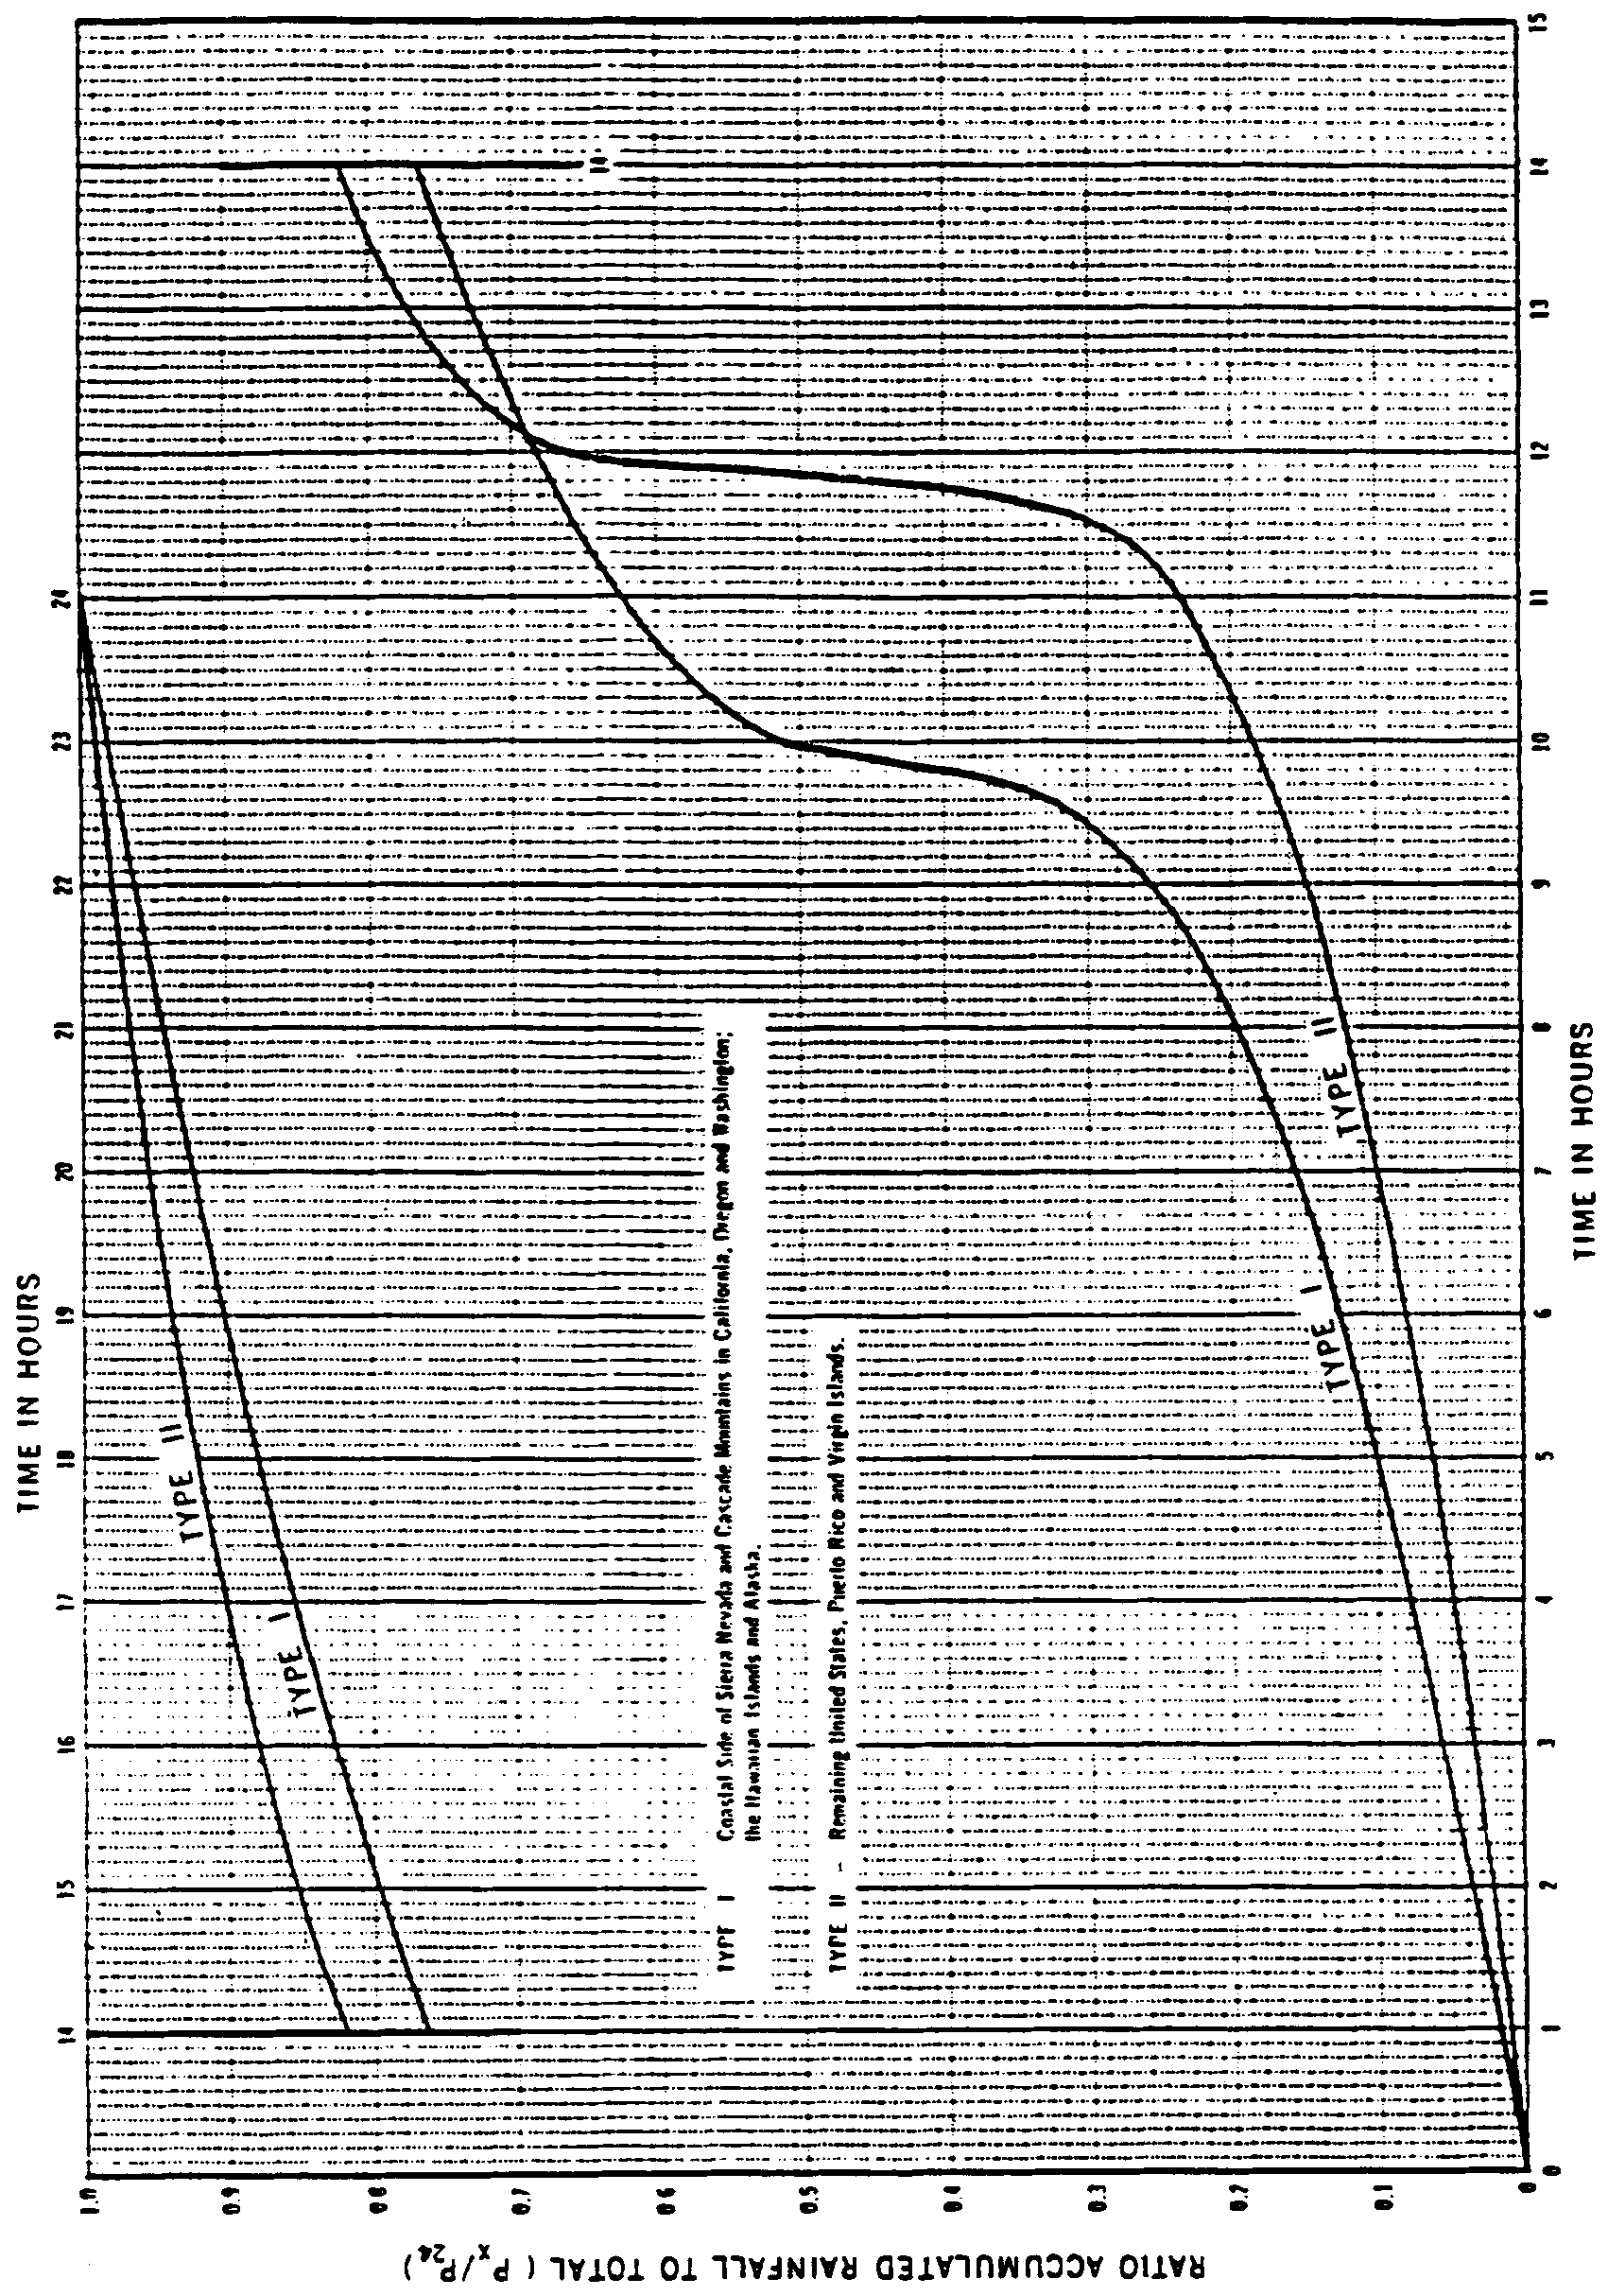

Figure 14.1-2 Arrangement of Incremental Depths in a Synthetic Storm (HEC-1)
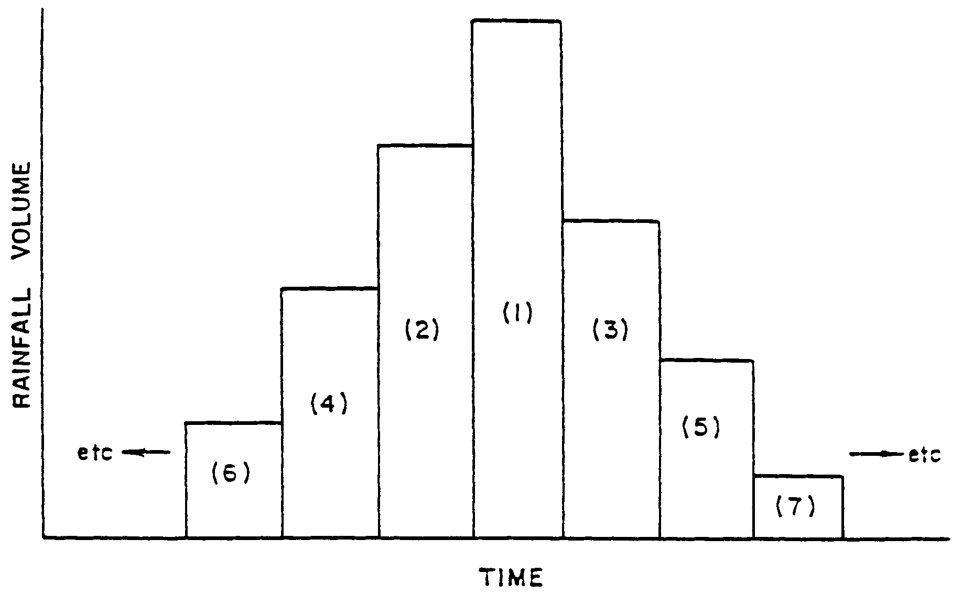

(d) Derivation from depth-duration curve (HEC-1 Type): When depth-duration data are available, HEC-1 manual recommends the following procedure:

1. Compute incremental precipitation depths at the desired time steps, and

2. Rearrange incremental depths so that the second largest value precedes the largest value, the third largest value follows the largest value, the fourth largest precedes the second largest, etc. This arrangement is shown in Figure 14.1-2. Numbers (1), (2), etc. in Figure 14.1-2 represent the order of incremental depths with (1) for the largest.

(e) HEC-1 PMP (Probable Maximum Precipitation) type distribution: The HEC-1 Manual describes the following procedure for distributing PMP.

1. Divide each 24-hour period into four 6-hour periods and distribute 24-hour rainfall according to the following ratios among 6-hour periods:

First 6 hour period:

Second 6-hour period:

Third 6-hour period:

Fourth 6-hour period:

in which R6, R12, and R24 are the maximum 6-hour, 12-hour, and 24-hour rainfall amounts, respectively.

2. Assume uniform distribution in each 6-hour period except during the peak 6-hour period.

3. For distributing the peak 6-hour rainfall, the HEC-1 manual provides default values. These default values may be used only if other satisfactory distribution is not available.

(f) Any other generally accepted and well documented method.

14.2 Four Day Storms

14.2.1 Rainfall Depth: The District has developed a dimensionless four day rainfall distribution in terms of the peak 24-hour rainfall. This is presented in subsection 14.2.3. The applicant may use this distribution or may develop his own as described in the following sections.

Rainfall depths for a given return period can be obtained either from the generalized charts published by the National Weather Service or by detailed statistical analysis of station data. The NWS publications HYDRO-35 (1977), TP-40 (1961), and TP-49 (1964) generalized charts published by the National Weather Service or by detailed statistical analysis of station data. The NWS publications HYDRO-35 (1977), TP-40 (1961), and TP-49 (1964) provide the necessary generalized data. HYDRO-35 provides 5-, 10-, 15-, 30-, and 60-minute rainfall values; TP-40 provides 2-, 3-, 6-, 12-, and 24-hour values, while TP-49 provides 2-, 4-, 7-, and 10-day values. TP-40 also includes 30-minute and 1-hour values, but these should be ignored since HYDRO-35 contains updated data.

Considerable additional data have been added since the publication of TP-40 and TP-49 for rain gage stations throughout the District. Thus, the estimates of rainfall depths based on present data may be regarded as more accurate. However, while the determination of rainfall depths by statistical analysis is encouraged, the designer should exercise care in judiciously selecting the necessary techniques since these are not standardized. The following example illustrates some of the available procedures.

Example: Determine 100-year rainfall depths for different durations for the City of Palatka.

(a) Rainfall depths from the NWS charts.

The following rainfall depths are read from the NWS publications:

Table 14.2-1

Duration | 100-Year Rainfall Depth  (inches) | Source
5 minutes | 0.85 | HYDRO-35
10 minutes | 1.53 | HYDRO-35
15 minutes | 2.00 | HYDRO-35
30 minutes | 3.18 | HYDRO-35
60 minutes | 4.40 | HYDRO-35
2 hours | 5.2 (5.4) | TP-40
3 hours | 6.0 | TP-40
6 hours | 7.1 | TP-40
12 hours | 8.9 (8.5) | TP-40
24 hours | 10.4 (10.2) | TP-40
2 days | 12.2 | TP-49
4 days | 14.5 | TP-49

Plot a rainfall depth-duration curve with the above data on a log-log graph paper and smoothen the values for consistency. The depth-duration curve for the above data (Table 14.2-1) shows that the 2-hour, 12-hour, and 24-hour values should be slightly adjusted; the adjusted values are shown in parentheses in the above table.

(b) Rainfall Depths by Statistical Analysis

This method consists of deriving annual series of maximum precipitation for each duration from the observed data and conducting frequency analysis on the annual series of data. However, most stations in the District, including Palatka, have only non-recording rain gages which provide "observational-day" amounts. Thus, data for less than 24 hours are not available for most stations. Even for 24-hour and greater durations, the observational-day amounts need to be adjusted to obtain n-hour precipitation because the actual storms do not exactly confine to observational-days. For example, the 24-hour maximum rainfall of a given year may commence to occur at any clock hour of an observational-day and extend into the next observational-day. As a result, this rainfall amount will be reported on two observational-days. If no other rainfall is associated, all of the rainfall reported on the two consecutive days comes from this 24-hour event; this is an extreme case. In practice, the observational-day amounts are converted into n-hour values either by multiplying the former by a factor or by adding a portion of the adjacent day rainfall to the former. In the present example (Palatka data), 1-, 2-, 3-, and 4-(observational) day maximum rainfall amounts were converted into 24-, 48-, 72-, and 96-hour precipitation by adding one half of the larger adjacent day precipitation as recommended by Hershfield (1963). Results of frequency analysis by log Pearson type 3 distribution (Rao, 1980) are shown below:

Table 14.2-2. Rainfall Frequency Analysis for Palatka (1949-1980)

Duration | Rainfall  10 yr | Depth for Return Period |  | Maximum Observed | Values  N-Hour
Duration | Rainfall  10 yr | 25 yr. | 100 yr. | Maximum Observed | Values  N-Hour
(1) | (2) | (3) | (4) | (5) | (6)
24-hr | 7.0 (7.0) | 8.9 (8.2) | 12.2 (10.4) | 8.6 | 11.3
48-hr | 7.7 (8.1) | 9.8 (9.9) | 13.5 (12.2) | 14.1 | 14.5
72-hr | 8.7 | 11.1 | 15.4 | 14.9 | 16.5
96-hr | 9.6 (9.5) | 12.3 (11.8) | 17.1 (14.5) | 18.1 | 18.2

The NWS values are shown in parentheses (Cols. 2-4) for a comparison. A comparison of 100-year rainfall estimates with maximum observed values (Col. 5) indicates that the NWS values are underestimates. For obtaining consistency of results, the NWS suggests to plot the values obtained by frequency analysis as a depth duration curve on a log-log graph paper and smoothen the curve if necessary. This is shown for 100-year values in Figure 14.2-1 (dashed line). The 24-hour value falls away from the line, thus this value needs adjustment. The (dashed) line is extended backwards until it smoothly joined the NWS curve in the less-than-24-hour portion. The accepted curve consists of the dashed portion, and the NWS curve for other durations. The values read from the accepted curve are as follows:

TABLE 14.2-3
Figure 14.2-1 Rainfall Depth Duration Curve for Palatka (T=100 Yr.)
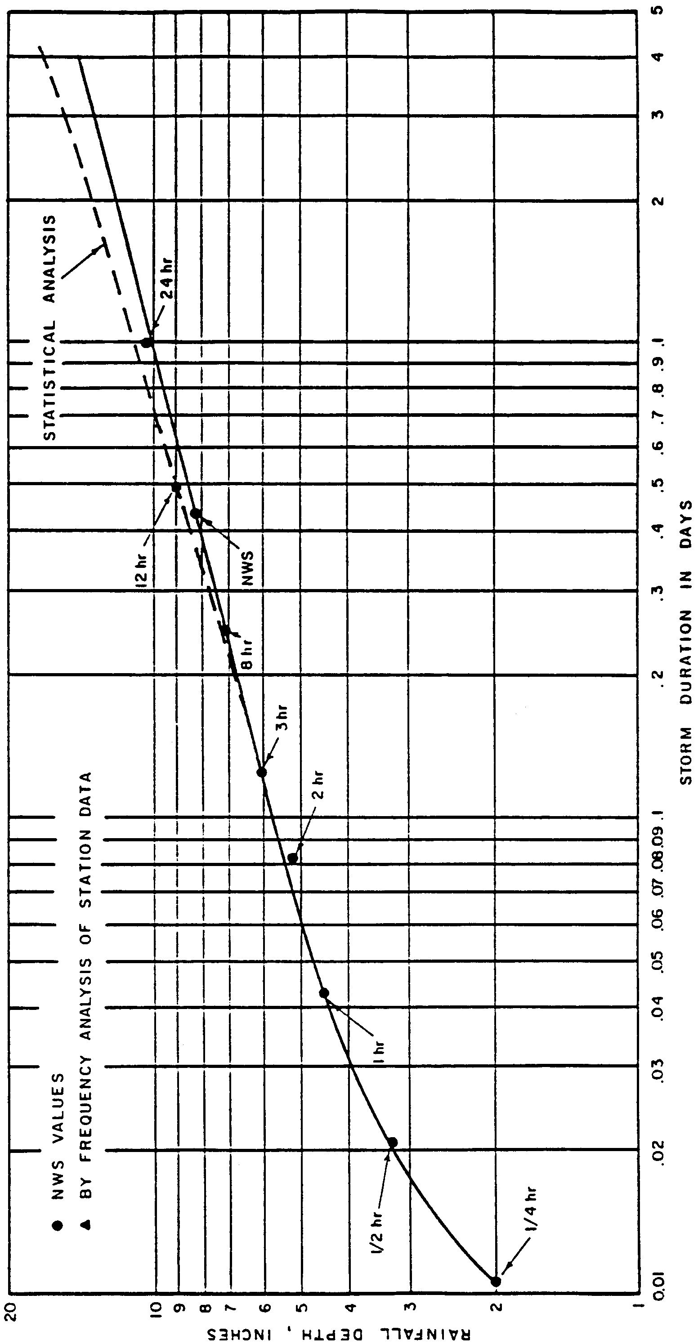

Duration | 100-Yr. Rainfall (Inches)
5 minutes | 0.85 (Accepted from HYDRO-35)
10 minutes | 1.53 (Accepted from HYDRO-35)
15 minutes | 2.0 (Accepted from HYDRO-35)
30 minutes | 3.2 (Accepted from HYDRO-35)
60 minutes | 4.4 (Accepted from HYDRO-35)
2 hours | 5.4
3 hours | 6.0
6 hours | 7.3
12 hours | 8.9
24 hours | 11.1
48 hours | 13.5
72 hours | 15.4
96 hours | 17.1

14.2.2 Rainfall Distribution

The 4-day duration rainfall distribution shall be calculated assuming:

(a) The maximum 24-hour rainfall occurs on day three of the 4-day duration storm;

(b) Difference between the 2-day rainfall and the 24-hour rainfall occurs on day two, and;

(c) The difference between the 3-day rainfall and the 2-day rainfall occurs on day four;

(d) The difference between the 4-day rainfall and the 3-day rainfall occurs on the first day.

Example: For the City of Palatka, for the values determined by frequency analysis the 24-hour, 100-year depths are as follows:

Time  (hrs) | Rainfall Depth  (in.) | Incremental Depth  (in.)
24 | 11.1 | 11.1
48 | 13.5 | 2.4
72 | 15.4 | 1.9
96 | 17.1 | 1.7

The four day distribution as suggested above is shown in Figure 14.2-2.

The distribution for each day of the four day period shall be calculated:

(a) For day three (maximum 24-hour rainfall) use any one of the methods described in Subsection 14.1.2 for a 24-hour duration.

(b) For other days use the above or a uniform distribution for each day.

14.2.3 Four Day Dimensionless Rainfall Distribution

This distribution has been developed by the District using NWS rainfall amounts and a distribution as described in Subsection 14.2.2. The distribution is in terms of accumulated rainfall as a percentage of the peak 24-hour rainfall. It uses an NRCS Type II distribution on the third day and a uniform distribution for the remaining days. Table 14.2-4 shows this distribution.

Figure 14.2-2 Four Day Rainfall Distribution (Basis COE HEC-1)

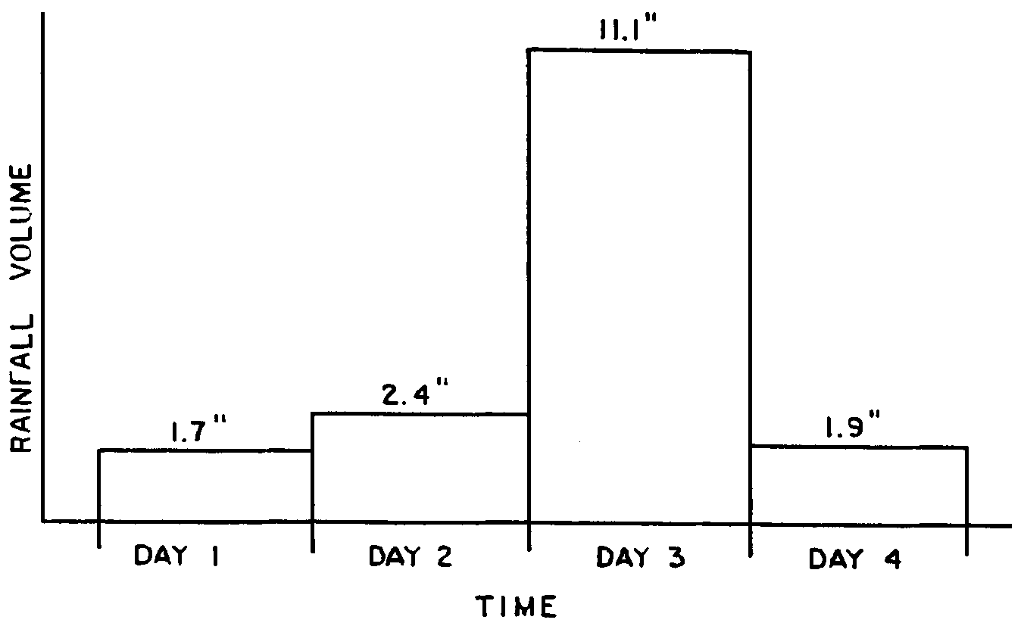

Table 14.2-4

Time  (hours) | Accumulated Total/Peak  24 Hour Total  (%)
0 | 0
4 | 1.4
8 | 2.8
12 | 4.2
16 | 5.6
20 | 7.0
24 | 8.4
28 | 11.7
32 | 15.1
36 | 18.4
40 | 21.7
44 | 25.1
48 | 28.4
50 | 30.6
52 | 33.2
54 | 36.4
56 | 40.4
58 | 46.5
59 | 51.9
59.5 | 56.7
60 | 94.7
60.5 | 101.9
61 | 105.6
62 | 110.4
64 | 116.4
66 | 120.0
68 | 123.6
70 | 126.0
72 | 128.4
76 | 130.9
80 | 133.4
84 | 135.9
88 | 138.4
92 | 140.9
96 | 143.4

14.3 References for Section 14*

1. "Computer Program for Project Formulation - Hydrology," , SCS, Engineering Division, Technical Release No. 20, May 1965.

2. Frederick, R.H., Myers, V.A., Auciello, E.P., "Five-to- 60-Minute Precipitation Frequency for the Eastern and Central United States," NOAA Technical Memorandum NWS HYDRO-35, U.S. Department of Commerce, June 1977.

3. "HEC-1 Flood Hydrograph Package," Users Manual, U.S. Army Corps of Engineers,September 1981.

4. Hershfield, D.M., "Rainfall Atlas of the United States," Weather Bureau Technical Paper No. 40, U.S. Department of Commerce, May 1961.

5. Hershfield, D.M., "Estimating the Probable Maximum Precipitation," ASCE Transactions Paper No. 3431, Vol. 126, Part I, 1963.

6. Miller, J.F., "Two-to Ten-Day Precipitation for Return Periods of 2 to 100 Years in the Contiguous United States," Weather Bureau Technical Paper No. 49, U.S. Department of Commerce, 1964.

7. Rao, D.V., "Log Pearson Type 3 Distribution: Method of Mixed Moments," Journal of the Hydraulics Division, ASCE, June 1980.

8. Rao, D.V., "Procedures for Determining 24-Hour and 96-Hour Synthetic Storms," Technical Memorandum No. 7, Water Resources Department, St. Johns River Water Management District, June 1982.

9. USDA, Soil Conservation Service, "Rainfall Frequency Atlas for Alabama, Florida, Georgia, and South Carolina," 1973.

10. USDA, Soil Conservation Service, "Interim Runoff Procedure for Florida," Florida Bulletin 210-1-2, 1980.

11. USDA, Soil Conservation Service, "A Method for Estimating Volume and Rate of Runoff in Small Watersheds," Technical Paper 149, 1973.

*Copies of these referenced materials are available for use at the District Headquarters, 4049 Reid Street, Palatka, Florida.

15.0 Procedure for Determination of Floodplain Elevations and Floodway Encroachment Limits Using Normal Depth Analysis

15.1 Introduction

This section provides guidelines for the determination of floodplain elevations and floodway encroachment limits along watercourses where such determinations are not currently available. The procedure recommended is based on a direct application of Manning's equation and is commonly referred to as Normal Depth Analysis.

In order to assess the impact of a proposed project on the water resources (as discussed in section 10.5), the following must be determined: The flood stage elevations and the extent of the floodplain during storms with 10 and 100 year frequencies, and the floodway. The floodway is the channel of a watercourse, plus any adjacent floodplain areas that must be kept free from encroachment in order to convey the 100 year flood without substantial increases in floodstages. A District-wide minimum standard limits the increase in floodstage to a one foot maximum increase.

NOTE: The one foot increase cited above is used in the initial determination of the floodway itself and is not meant to allow subsequent heightening of the 100 year flood elevation, once the limits of the floodway have been so set. That is, in order to determine that portion of the floodplain which will be designated as the floodway, one begins at the outer limits of the floodplain and assumes full development inward, toward the river or stream channel, on both sides of the flood hazard area, until the point is reached where development will cause the 100 year flood elevation to rise by one foot. The area remaining between this boundary and the channel is the floodway, and because any further development here would necessarily increase the 100 year flood elevation by more than one foot, no such development can be permitted.

Normal depth analysis provides a reasonable estimate of flood stages. It is a relatively simple procedure requiring a minimal amount of data. It assumes a uniform flow condition wherein the discharge, waterway cross section, mean velocity, and depth remain essentially constant through a reach of stream. While these circumstances rarely exist under natural conditions, normal depth analysis provides a reasonable close approximation in most cases. The exception is where there is a downstream control such as a bridge or a dam, which obstructs the flow and causes a backwater effect or when non-uniform flow is evident in the stream reach. In those cases, a detailed analysis of the backwater effect and non-uniform flow conditions must be provided by the applicant when establishing the floodplain and floodway. The use of the Corps of Engineers HEC-2 model for such an analysis is discussed in reference (1) and (2). Any other acceptable method may also be used.

15.2 Data Required for Analysis

The following information is required for the use of normal depth analysis in determining the floodplain elevations during the 10 year and 100 year storms and floodway encroachment limits:

(a) The 10 year and 100 year flood flows: These flood discharges should be determined from a frequency analysis where streamflow data are available. When streamflow data are available, the flood flows can be determined by using regression equation or any other acceptable procedure. The District will, if requested by the applicant, determine the 10 year and 100 year peak discharge.

(b) One or more representative channel cross sections (including channel and overbank flow areas) at the area of interest. The cross section should be taken perpendicular to the direction of the flood flow. The cross section should be representative of the reach of stream in the vicinity of the area of concern. If the stream reach adjacent to the area of interest is more than 300 feet in length, more than one cross section should be taken.

(c) Slope of water surface determined from known flood profiles or average channel bed slope in the reach by field survey. Figure 15.2-1 depicts a typical situation and illustrates some of the data requirements.
Figure 15.2-1 Typical Floodplain Encroachment
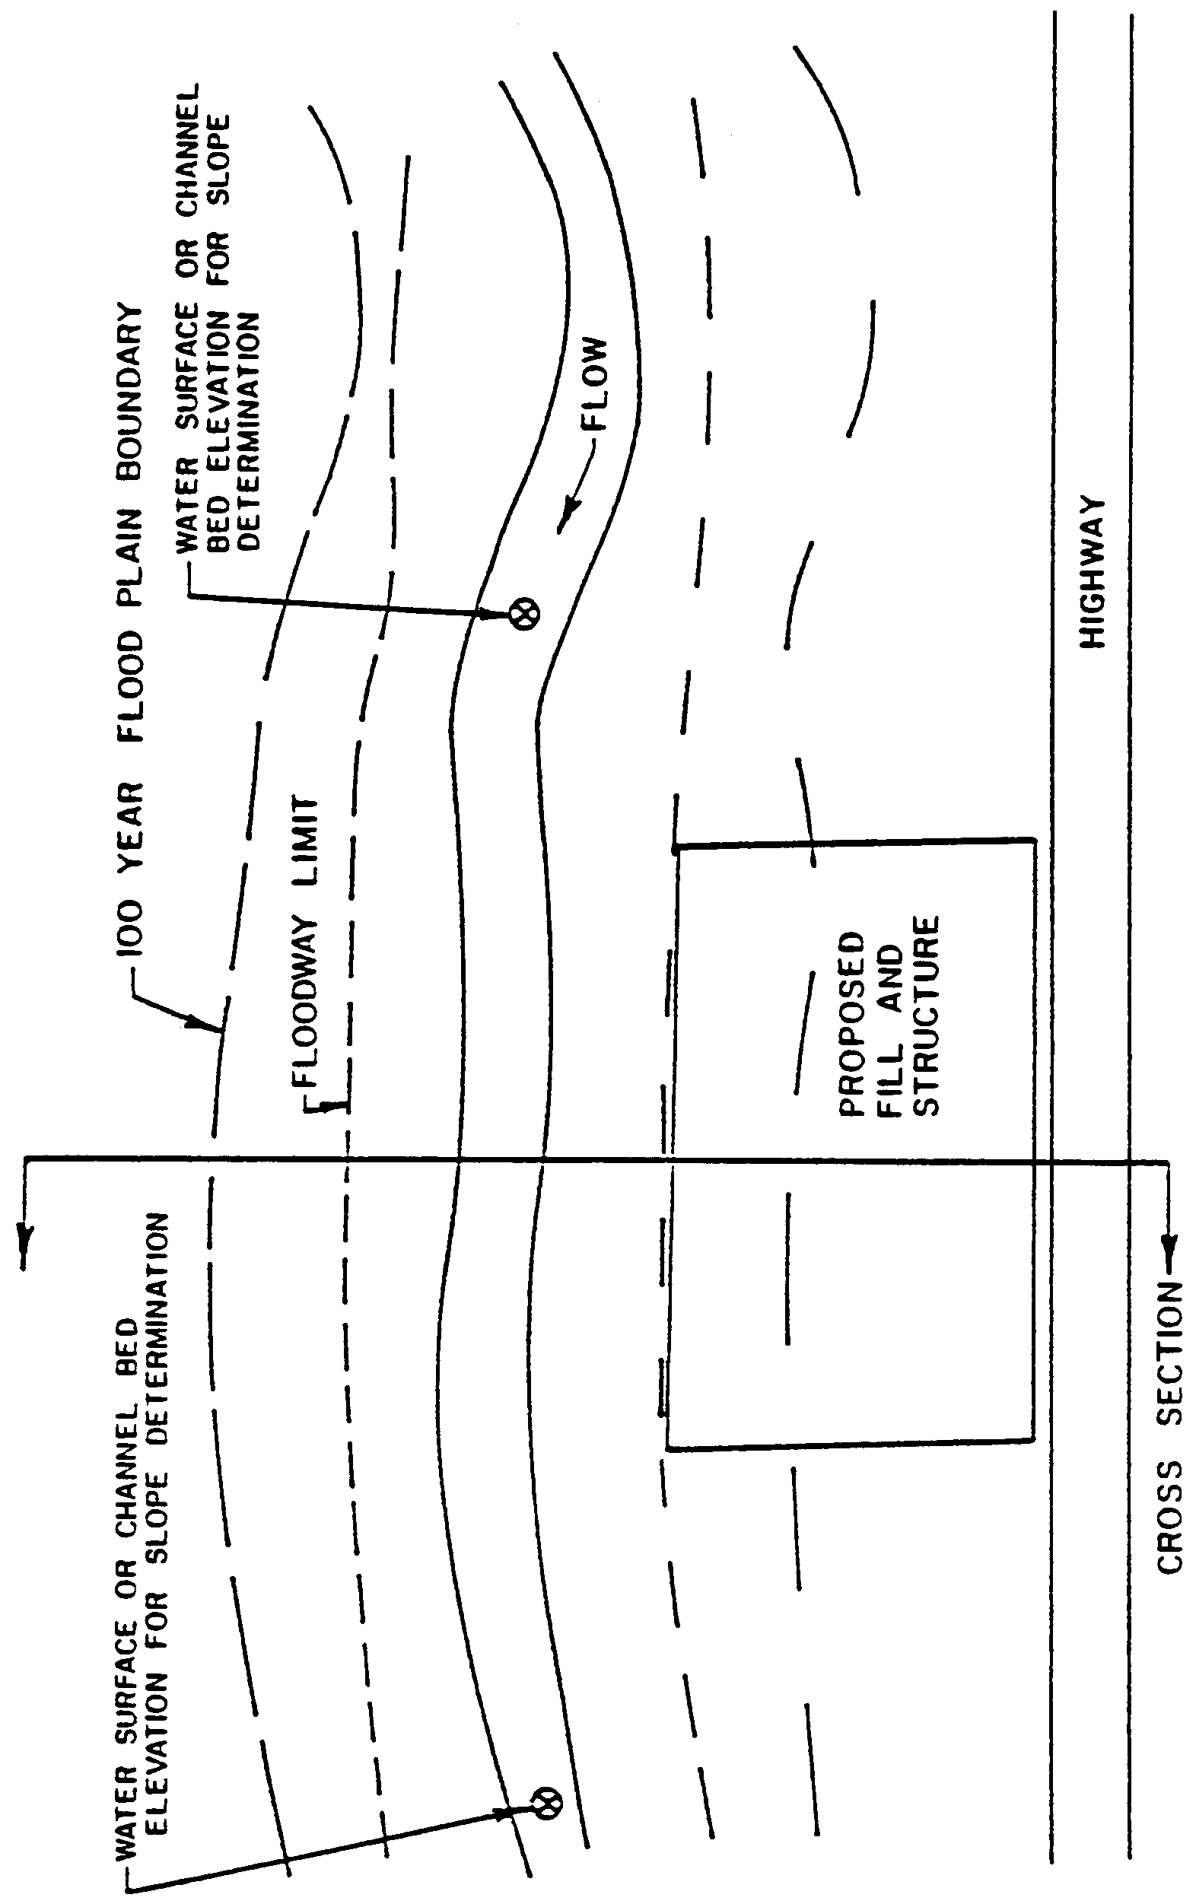
15.3 Manning's Equation

The basic formula in determining flood stage and floodway encroachment limits is Manning's equation:

(1)
in which:

Q = Discharge in cubic feet per second,
K = Conveyance of the channel section =
n = Manning's roughness coefficient,
R = Hydraulic radius in feet = A/P,
A = Cross sectional area through which flow occurs in square feet
P = Wetted perimeter in feet,
S = Slope of the energy gradient of streamflow in feet per foot.

The roughness coefficient "n" in eq. (1) is to be evaluated from field investigation by an experienced engineer. For further discussion and assistance in the selection of an appropriate "n" value reference (3) and (4) will be helpful.

During uniform flow, the slopes of the energy gradient of streamflow, the water surface profile, and the river bed are equal. As a result, the slope of the energy gradient, S, can be approximated as either the channel bed slope or the water surface slope.

15.4 Procedure for the Determination of Flood Stage

(a) Divide the channel section into several Subsections or segments each having a reasonably uniform roughness coefficient, A₁, A₂, A₃, --A_{n} as is shown in Figure 15.4-1.

(b) Determine "n" value for each individual Subsection.

(c) Select a flood stage, y₁ as a first estimate.

(d) Determine cross section area, hydraulic radius and compute conveyance, K, for each Subsection based on floodstage y₁.

(e) Calculate the total discharge Q1 that corresponds to the stage y₁; as described in Table 15.4-1.

(f) If Q₁₀₀>Q1, increase flood stage y₂ by small increment.
If Q₁₀₀<Q1, decrease flood stage y₂ by small increment.
Follow steps (d) and (e) to determine Q₂.

(g) Repeat step (f) until several Q values above and below Q₁₀₀ are established.

(h) Plot a stage vs. discharge curve from which a stage corresponding to Q₁₀₀ can be determined.

Example 1: A representative cross section for a reach of stream adjacent to a newly proposed development is shown in Figure 15.4-1. The roughness coefficients for each segment of the cross section are also shown in the figure. The slope of channel bed in this stream reach is about 0.36%. Determine the 100 year flood elevation for Q₁₀₀=7,900 cfs.

Solution: Detailed calculation is shown in Table 15.4-1 for y₁and y₂.

At stage y₁ = 121.0 ft., Q = 7,154 cfs.

At stage y₂ = 122.0 ft., Q = 8,639 cfs.

At stage y₃ = 121.5 ft., Q = 7,875 cfs.

A stage - discharge curve for y₁, y₂, and y₃ is used to estimate the flood stage for Q₁₀₀ as 121.52 ft. (Figure 15.4-2)

TABLE 15.4-1. NORMAL DEPTH ANALYSIS

Stage | Sub-sect  no. | A | P | R | R^{2/3} | n | k
121.0(y₁) | 1 | 118 | 44 | 2.68 | 1.93 | 0.07 | 4,846
 | 2 | 120 | 20 | 6.0 | 3.30 | 0.07 | 8,427
 | 3 | 237 | 25 | 9.48 | 4.47 | 0.07 | 22,544
 | 4 | 230 | 24 | 9.58 | 4.50 | 0.035 | 44,060
 | 5 | 160 | 20 | 8.0 | 4.0 | 0.09 | 10,592
 | 6 | 90 | 15 | 6.0 | 3.30 | 0.09 | 4,915
 | 7 | 280 | 40 | 7.0 | 3.65 | 0.09 | 16,914
 | 8 | 144 | 29 | 4.97 | 2.91 | 0.09 | 6,935
 |  |  |  |  |  |  | 119,233

Q₁ = KS^{1/2} = 119,233 х 0.06 = 7,154 cfs

122.0(y₂) | 1 | 163 | 47 | 3.47 | 2.30 | 0.07 | 7,978
 | 2 | 140 | 20 | 7.0 | 3.65 | 0.07 | 10,874
 | 3 | 262 | 25 | 10.48 | 4.8 | 0.07 | 26,762
 | 4 | 245 | 24 | 10.20 | 4.7 | 0.035 | 49,019
 | 5 | 180 | 20 | 9.0 | 4.33 | 0.09 | 12,899
 | 6 | 105 | 15 | 7.0 | 3.65 | 0.09 | 6,343
 | 7 | 320 | 40 | 8.0 | 4.0 | 0.09 | 21,184
 | 8 | 174 | 32 | 5.44 | 3.10 | 0.09 | 8,927
 |  |  |  |  |  |  | 143,986

Q₂ = KS^{1/2} = 145,217 х 0.06 = 8,639 cfs

15.5 Determination of Floodway Limits

To determine floodway encroachment limits, it is first necessary to estimate the total conveyance capacity that can be lost due to encroachment without increasing the 100 year flood stage by more than one foot. Floodway limits are then determined based on the assumption that the entire conveyance capacity outside of the floodway will eventually be lost. Whenever possible, the floodway limits should be set so that an equal degree of encroachment (loss of conveyance) can occur on both sides of the stream course. In some cases, equal encroachment on both sides may not be possible because the conveyance of the overbank flow area on one side of the channel is relatively small in comparison with that of the other side. In this situation, the floodway limits should be further adjusted so that each limit will lie at a minimum distance away from the permanent channel. The minimum distance is one channel width. The floodway limits can be determined using the following procedure. The 100 year floodplain and flood stage must already be determined from existing reports, or if necessary, the Normal Depth Analysis used in Example 1. The summarized steps are outlined as follows:

(a) Add allowable increment in stage (one foot) to the 100 year flood stage to obtain a new flood stage.

(b) Calculate new conveyance K' and discharge Q' for the entire cross section under new flood stage and determine the increases in conveyance, K = K' - K, and discharge, Q = Q' - Q.

(c) Adjust the floodway limits by trial and error, so that the decrease in conveyance within the floodplain on each side of the channel due to assumed filling equals K2/2 as computed in step (b).

(d) If necessary, further adjust floodway encroachment limits so that each limit is at least one channel width away from the permanent channel.

Example 2: Define the floodway limits for the problem in Example 1.

Solution:

Regulatory flood discharge, Q = 7,900 cfs

Regulatory (100 year) flood stage = 121.5 feet

Permissible flood stage after assumed filling = 121.5 ft. + 1.0ft. = 122.5 ft.

Conveyance of the stream at stage y = 121.5 ft., K = Q/(S^{1/2}) = 7,900/0.06 = 131,700

Calculation of conveyance at stage y = 122.5 is shown in Table 15.4-2.
Figure 15.4-1 Typical Channel Cross Section
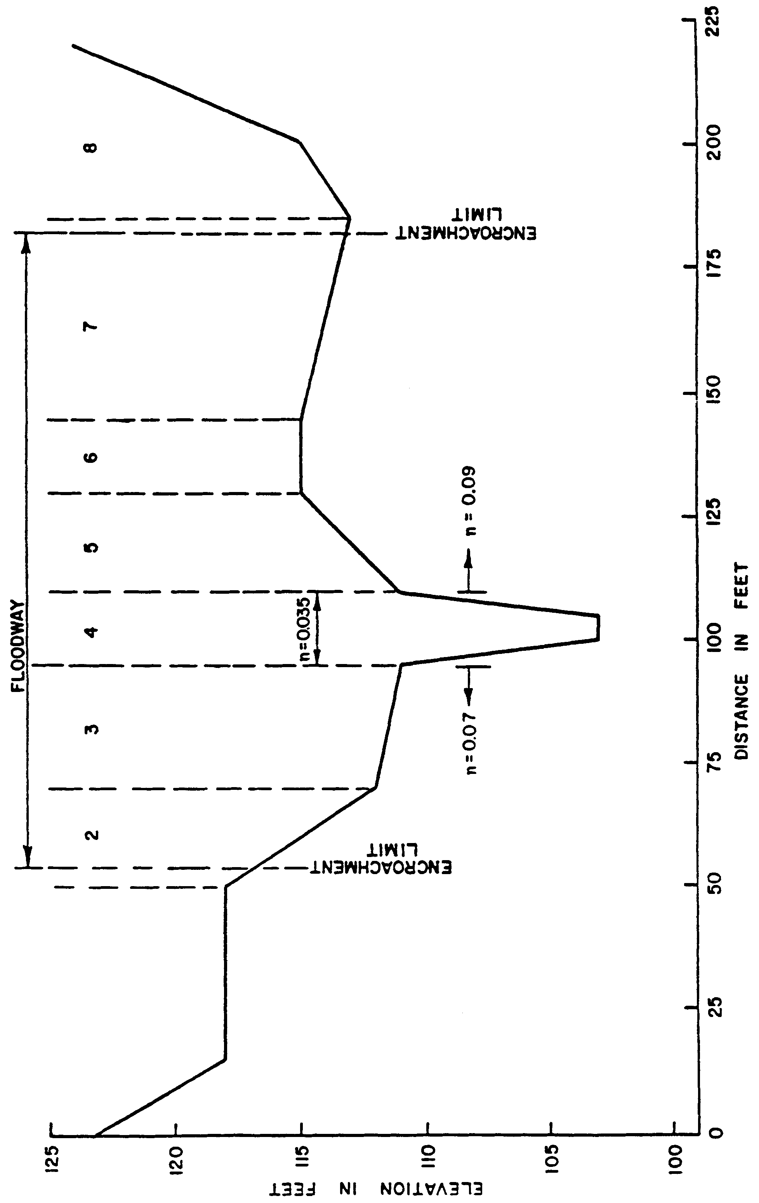
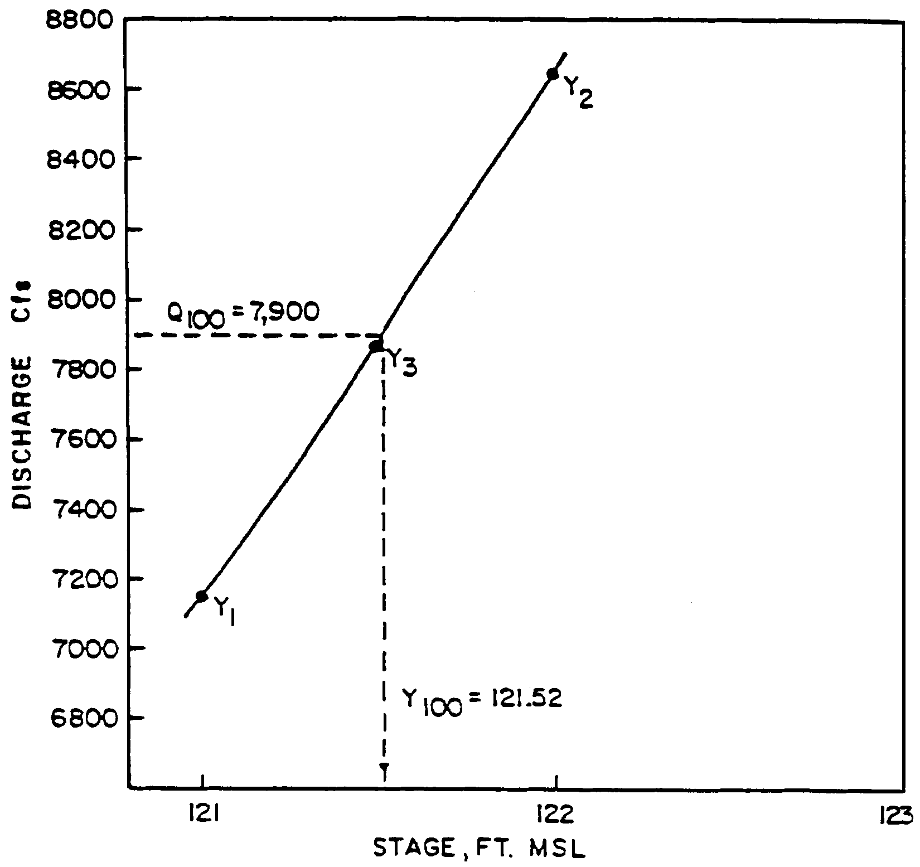

Figure 15.4-2 Stage-Discharge Relatioship
Table 15.4-2

Stage | Sub-sect  No. | A | P | R | R^{2/3} | n | k
122.5 | 1 | 187 | 49 | 3.82 | 2.44 | 07 | 9,714
 | 2 | 150 | 20 | 7.5 | 3.82 | 07 | 12,199
 | 3 | 274.5 | 25 | 11 | 4.95 | 07 | 28,982
 | 4 | 252.5 | 24 | 10.5 | 4.8 | 035 | 51,595
 | 5 | 190 | 20 | 9.5 | 4.5 | .09 | 14,159
 | 6 | 112.5 | 15 | 7.5 | 3.82 | 09 | 7,117
 | 7 | 340 | 40 | 8.5 | 4.16 | .09 | 23,422
 | 8 | 188 | 34 | 5.53 | 3.12 | 09 | 9,127
 |  |  |  |  |  |  | 156,315

Increase in conveyance by allowing one foot increase in stage above regulatory flood stage, K = 156,315 - 131,700 = 24,615.

The permitted decrease in conveyance due to encroachment in either side of the channel is K/2 = 12,308.

From Table 15.4-2, one can anticipate the lines of floodway limit to be within Subsections 2 and 7, which are shown in Figure 15.2-1. The exact location of the floodway limits is determined by trial and error.

15.6 References for Section 15

1. Bonner, Vernon R., Floodway Determinations Using Computer Program HEC-2. U.S. Army Corps of Engineers Training Documents 5, May 1974.

2. U.S. Army Corps of Engineers, HEC-2 Water Surface Profiles Users Manual (with supplement)., November, 1976, Exhibit 9A: Users Manual Supplement for Floodway Determinations.

3. Barns, Harry H., "Roughness Characteristics of Natural Channels," U.S. Geological Survey Water Supply Paper No. 1849, 1967.

4. Chow, Ven Te, "Open-Channel Hydraulics," McGraw-Hill Book Company, Inc., 1959, Chapter 5.

16.0 Design and Operation of Multi-Purpose Impoundments to Provide Low Flow Benefits

16.1 Determination of 5-Year 30-Day Low Flow

The objective is to determine the 5-year 30-day low flow from the project under pre-development conditions. The 5-year 30- day low flow is the average flow during the most critical 30- day period of a drought with 5-year return frequency. If substantial streamflow records exist at the project site, the 5-year 30-day flow can be determined using statistical analysis. In most cases, however, such data does not exist and one of the following procedures may be used by the applicant.

Method 1: Use average 5-year, 30-day flow contribution based on location of project.

1. Determine the total land area (both project acreage and other off-site land) contributing water to stream at the location of the impoundment (square miles).

2. From Figure 16.1-1, determine the average 5-year, 30-day low flow per square mile in the region of the project, q (cfs/sq.mi.).

3. Q(cfs) = Area Contributing to Impoundment X q.

Method 2: Use nearest streamflow data.

1. Determine the total land area (both project and other lands draining into project) contributing water to the stream at the location of the impoundment.

2. Obtain the following information from the District:

a. The 5-year, 30-day low flow in the receiving water at the nearest stream gage location to the project site.

b. The total area contributing streamflow to the receiving water at the stream gage location.

3. Determine the pre-development 5-year low flow from the project site as:

Q = Area Contributing to Impoundment x 5-year, 30 day low
Area Contributing to Stream Gage flow at stream gage
Figure 16.1-1 Average 5-Year, 30-Day Low Flow Contribution Per Square Mile
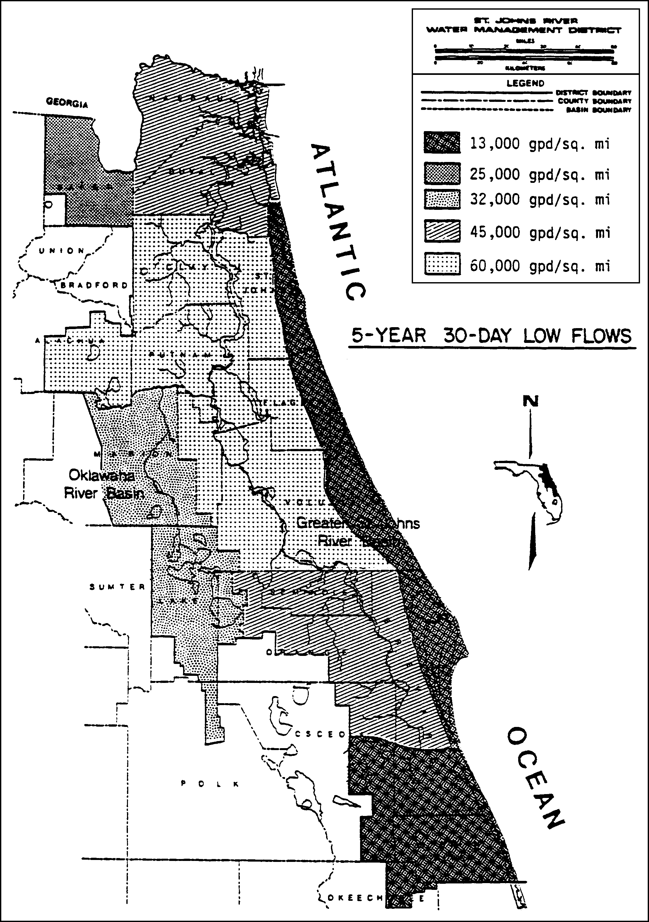
An example: A 6.2 square mile agricultural project is proposed in eastern Osceola County as shown in Figure 16.1-2. An impoundment of a stream (with streamflow during the 5-year, 30- day drought frequency) is proposed for stormwater management and irrigation benefits. The pre-development 5-year, 30-day low flow at the outlet of the impoundment is calculated below:

Using Method 1: (see Figure 16.1-1)

Q = 8.4 sq. mi. X 0.07 cfs/sq. mi. = 0.6 cfs

Using Method 2:

At stream gage, 5-year, 30-day low flow = 1.4 cfs

16.2 Design Guidelines

The criteria in Subsection 10.6.2 specifies that the structure must be designed so as to provide a minimum low flow discharge as determined in the previous section. The following guidelines should be considered in the design: 1) the outlet structure should provide the capability of discharging the 5- year, 30-day low flow (as calculated in the previous section) when the water storage is at the average dry season design stage (the stage corresponding to the average conservation storage during the dry season); 2) the outlet structure should provide for the discharge of all available impounded water.

A typical design of an impoundment according to these guidelines is shown in Figure 16.2-1. A gated culvert is at the bottom of the impoundment to provide for discharge of available water to maintain historical low flows. The culvert would be sized to discharge the 5-year, 30-day low flow discharge when the impoundment is at the average dry season design stage (the stage corresponding to the permanent storage during the dry season).

16.3 Operation of Impoundment to Provide Necessary Low Flow

In order to assist in the preservation of existing low flow conditions in the receiving water, the minimum low flow discharge should occur whenever water is available in the impoundment. However, low flow discharge may be discontinued, if desired, during periods when low streamflow conditions are not critical. This period will be presumed to be during the months of June through October unless a water shortage condition is declared by the District.

The actual low flow discharge made from the impoundment will depend on the current water stage in the impoundment. When water storage in the impoundment is below the average dry season design stage, actual discharge may be less than the 5- year, 30-day low flow discharge. The discharge will be made according to the stage-discharge relationship (provided by the applicant) for the particular outlet structure.
Figure 16.1-2 Example 6.2 Square Mile Agricultural Project
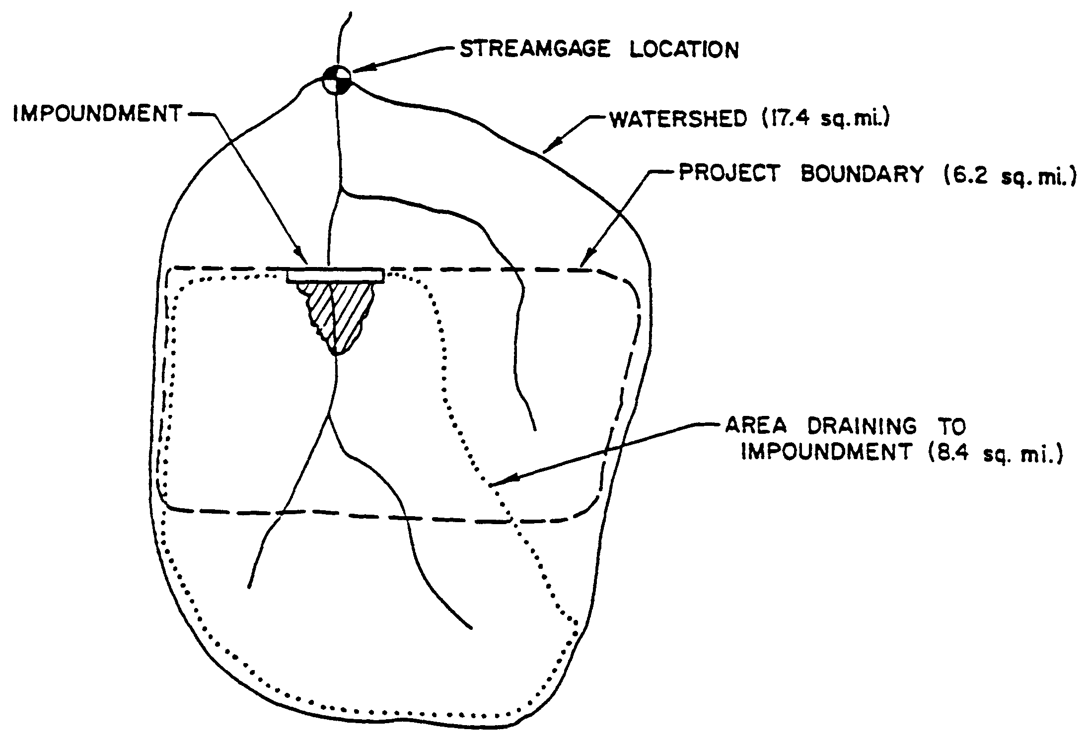
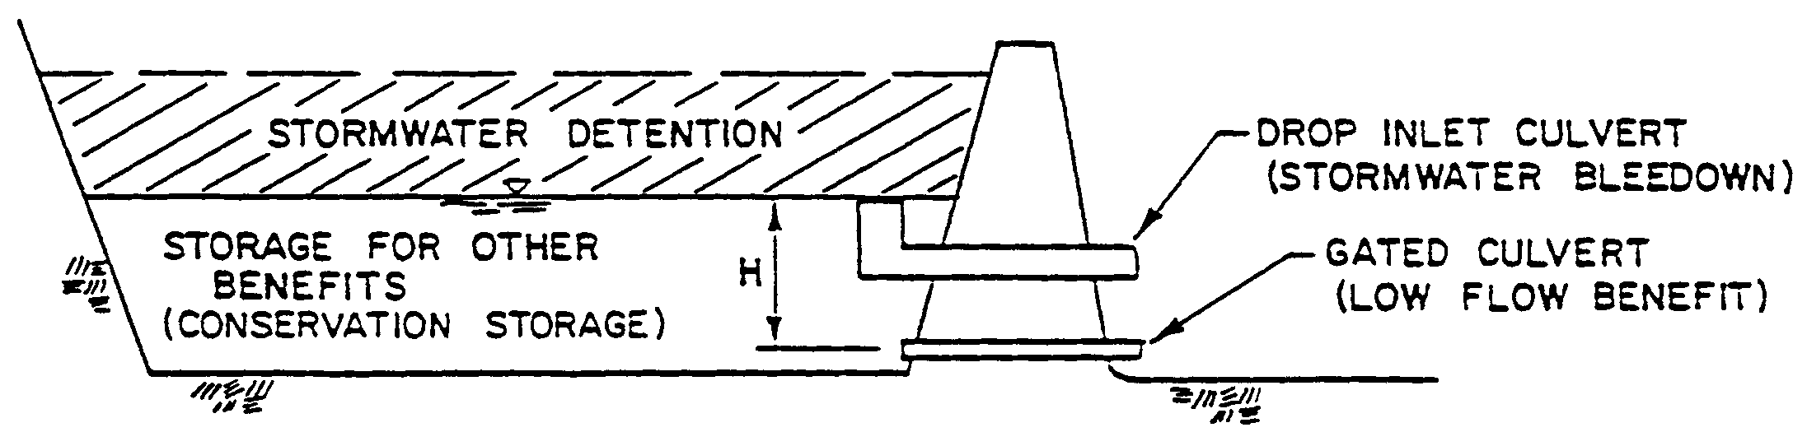

Figure 16.2-1 Typical Design Elements in Multi-Purpose Impoundment

17.0 Standards for Dams and Impoundments

17.1 Hazard Classification

Every structure will be given hazard potential classification to reflect the damage which might occur in the event of a structural or operational failure. The damage potential will take into account a number of factors including, but not limited to: physical characteristics and degree of development of the site and area downstream; relationship of the site to industrial and residential areas; use of downstream properties throughout the reach of the potential damage; geological considerations; public and private uses of the impoundment or reservoir; probable future downstream development, and natural resources in the site area.

The following broad categories are established to permit the association of criteria with the damage that might result from a failure:

Class A. Structures located in rural or agricultural areas where failure may damage farm buildings, agricultural land or other agricultural resources. No loss of human life would be expected.

Class B. Structures located in predominantly rural or agricultural areas where failure would damage private or public property but such damage would be relatively minor and of short duration. Loss of human life would be possible but unlikely.

Class C. Structures located where failure will likely cause any of the following: Loss of human life or serious damage to homes, industrial and commercial buildings, important public utilities, primary highways or major railroads.

17.2 Storage Capacity

The storage capacity is defined as the volume of water impounded by the structure below the emergency spillway crest; or if no emergency spillway is used, the volume of water impounded below the top of the structure, less any freeboard.

17.3 Height

The height of the structure is defined as the vertical distance as measured from the lowest elevation of the structure crest to the lowest point of natural ground, including any stream channel, along the downstream toe of the structure.

17.4 Probable Maximum Precipitation (PMP)

In some situations where substantial risk of loss of life exists, it is appropriate to evaluate a structure against what appears to be the worst possible condition. The probable maximum precipitation is accepted as the standard for this type of evaluation. The PMP is almost always beyond the possibility of control with conventional flood protection measures. If it were to occur, flooding would be extensive and damage would be severe. Consideration of the PMP in design serves only to eliminate the possibility of the addition of a sudden structural failure to already serious flood conditions.

The 24-hour PMP value to be used for projects in the SJRWMD is 31.0 inches. This value is for drainage areas of 200 square miles. Apply the following adjustment factors for other drainage areas:

Drainage Area (mi2) | % of 200 mi² PMP
500 | 92
100 | 105
50 | 111
20 | 118
10 | 123

The 24-hour rainfall distribution is to be determined as explained in section 14.0.

17.5 References for Section 17

1. Linsley, Kohler and Paulhus, 1975. Hydrology for Engineers. McGraw Hill Book Company, New York. 460 pp.

2. U.S. Department of Interior, Bureau of Reclamation, Design of Small Dams, 1974.

3. U.S. Weather Bureau, Hydrometeorological Report 33, "Seasonal Variation of the Probable Maximum Precipitation East of the 105th Meridian...," 1956.

18.0 Additional Basin Criteria Wekiva River Hydrologic Basin Criteria

18.1 Type “A” Soils as defined by the Natural Resources Conservation Service (NRCS) Soil Survey in the following NRCS publications: Soil Survey of Flagler County Area, Florida (1997); Soil Survey of Lake County Area, Florida (1975); Soil Survey of Orange County Area, Florida (1989); Soil Survey of Seminole County Area, Florida (1990); and Soil Survey of Volusia County Area, Florida (1980), which are hereby incorporated by reference.

Flagler County
Orsino
Astatula
Tavares
Palm Beach Sand
Welaka
Cocoa
Bulow
Paola

Lake County
Apopka
Apopka Urban Land
Astaula
Chandler
Chandler Urban Land
Kendrick
Lake
Lake Urban Land
Orlando
Orsino
Paola
Paola Urban Land
St. Lucie
St. Lucie Urban Land
Tavares
Tavares Urban Land

Orange County
Archbold
Apopka
Candler
Candler Urban Land
Florahome
Florahome Urban Land
Lake
Millhopper
Millhopper Urban Land
St. Lucie
St. Lucie Urban Land
Tavares
Tavares Urban Land

Seminole County
Apopka
Astatula
Millhopper
Paola
St. Lucie
Tavares

Volusia County
Apopka
Arents
Astatula
Astatula Urban Land
Bulow
Cocoa
Cocoa Urban
Deland
Orsino
Palm Beach
Palm Beach Urban Land
Paola
Paola Urban Land
St. Lucie
Tavares

18.1 Soil types within Most Effective Recharge Area
Lake County Astaula Sand (AsB), (AtB), (AtD), (AtF) Paola Sand (PaB), (PaD) Tavares Sand (Ta), (Te)
Ocala National Forest Astatula Sand (AsB), (AsD), (AtB), (AtD), (AuB), (AwB) Paola Sand (PIB), (PID), (PmA)
Orange County Blanton Fine Sand (Ba), (Bc), (Be), (Bf), (Bb), (Bd), (Bg) Blanton and Esotorine Sands (Bh) Eustis Fine Sand (Ea), (Eb) Lakeland Fine Sand (La), (Lb), (Lc), (Ld), (Le) Orlando Fine Sand (Ob), (Oc) St. Lucie Fine Sand (Sb)
Seminole County Blanton Fine Sand (BfB), (BfC), (BfD), (BnB), (BnC) Lakeland Fine Sand (LaB), (LaC), (LaD) Lakewood Sand (LdB), (LdC) St. Lucie Fine Sand (SfB)

18.2 Erosion and Sediment Control Principles

Factors which influence erosion potential include soil characteristics, vegetative cover, topography, and climatic conditions. The following principles must be considered in planning and undertaking construction and alteration of surface water management systems:

(a) Plan the development to fit topography, soils, and drainage patterns;

(b) Minimize the extent of area exposed at one time and the duration of exposure;

(c) Schedule areas with greatest erosion potential for dry, rather than wet, season exposure;

(d) Apply erosion control practices to minimize erosion from disturbed areas;

(e) Apply perimeter controls to protect disturbed area from off-site runoff and to trap eroded material on-site to prevent sedimentation in downstream areas;

(f) Keep runoff velocities low and retain runoff on-site;

(g) Stabilize disturbed areas immediately after final grade has been attained or during interim periods of inactivity resulting from construction delays; and

(h) Implement a thorough maintenance and follow-up program.

18.3 Erosion and Sediment Control Plan

A plan must be prepared prior to construction and alteration for certain systems and submitted with the permit application to minimize erosion and retain sediment on-site. The details and scope of the plan will depend on the potential for erosion. Projects with larger exposed areas, long duration of construction, steep slopes, erosive soils, or close proximity to streams and other watercourses will require more detailed and comprehensive plans. The plan must include consideration of the site specific erosion potential, including slopes, soil erodability, vegetative cover, and runoff characteristics. The following is a listing of the minimum information, which must be included in the plan, to be shown on construction or alteration plans, detail sheets, or other appropriate documents:

(a) The existing and proposed topography;

(b) A general description of the predominant soil types on the site, and the corresponding erodability potential as described by the appropriate soil survey information or on-site investigation;

(c) Schedule and general description of each construction phase of the project. At a minimum, the following applicable phases must be addressed: clearing, excavation earthwork, embankment earthwork, site utilities, roads, site grading and stabilization. The schedule must include estimated starting date and duration. Description must include limits of area impacted by each phase; and

(d) For each construction phase, a description of the following:

1. Storm drainage characteristics, including flow patterns and the peak velocity and discharge from the 1-in-2 year 24 hour storm, at all locations where control measures are proposed and at points of off-site discharge; and

2. Individual control measures (to be shown on construction plans or detail sheets):

a. Estimated date of installation and removal,

b. Location,

c. Purpose of measure and area served,

d. Detailed construction drawings and specifications,

e. Operation and maintenance schedule, and

f. All supporting calculations and documentation including referenced design standards and specifications.

18.4 References For Erosion and Sediment Control

The following references provide detailed information on erosion and sediment control plans, including standards and specifications for specific best management practices:

(a) Florida Department of Environmental Regulation, The Florida Land Development Manual: A Guide to Sound Land and Water Management (FDER 1988). Chapter 6. Stormwater and Erosion and Sediment Control Best Management Practices for Developing Areas.

(b) Goldman, Jackson and Bursztynsky, 1986. Erosion and Sediment Control Handbook. McGraw-Hill Book Company. New York.

(c) Florida Department of Transportation (FDOT), Florida Department of Environmental Protection (FDEP), The Florida Stormwater, Erosion, and Sediment Control Inspector’s Manual (FDEP and FDOT 1999)

Appendes A THIS APPENDIX NOT INCORPORATED BY REFERENCE

Appendix B THIS APPENDIX NOT INCORPORATED BY REFERENCE

Appendix C THIS APPENDIX NOT INCORPORATED BY REFERENCE

Appendix D THIS APPENDIX NOT INCORPORATED BY REFERENCE

Appendix E THIS APPENDIX NOT INCORPORATED BY REFERENCE

Appendix F THIS APPENDIX NOT INCORPORATED BY REFERENCE

Appendix G THIS APPENDIX NOT INCORPORATED BY REFERENCE

Appendix H THIS APPENDIX NOT INCORPORATED BY REFERENCE

Appendix I THIS APPENDIX NOT INCORPORATED BY REFERENCE

Appendix J THIS APPENDIX NOT INCORPORATED BY REFERENCE

Appendix K Hydrologic Basin Boundaries Legal Description of the Wekiva River Hydrologic Basin

Appendix L THIS APPENDIX NOT INCORPORATED BY REFERENCE

Appendix M THIS APPENDIX NOT INCORPORATED BY REFERENCE

Appendix A

THIS APPENDIX NOT INCORPORATED BY REFERENCE

Appendix B

Application Forms and Notice of Intent

THIS APPENDIX NOT INCORPORATED BY REFERENCE

Appendix C

Chapter 373, F.S.

THIS APPENDIX NOT INCORPORATED BY REFERENCE

Appendix D

Chapter 120, F.S.

THIS APPENDIX NOT INCORPORATED BY REFERENCE

Appendix E

Sections 403.021, 403.812 - 403.8135, F.S.

THIS APPENDIX NOT INCORPORATED BY REFERENCE

Appendix F

Chapter 40C-1, F.A.C., and
Chapter 28-101 through 28-110, F.S.,
Uniform Rules of Procedure
THIS APPENDIX NOT INCORPORATED BY REFERENCE

Appendix G

Chapter 62-340, F.A.C., Delineation of the Landward
Extent of Wetlands and Surface Waters

THIS APPENDIX NOT INCORPORATED BY REFERENCE

Appendix H

Agricultural Practices

THIS APPENDIX NOT INCORPORATED BY REFERENCE

AGRICULTURAL PRACTICES

Following is a brief description of conservation practices. Detailed information is in Natural Resources Conservation Service Field Office Technical Guides. Practices 52 to 66 are not NRCS Conservation Practices, but are recognized Best Management Practices for agriculture.

1. Access Road - A road constructed to minimize soil erosion while providing needed access.

2. Brush Management - Management and manipulation of brush to improve or restore a quality plant cover to reduce sediment and improve watershed quality.

3. Chiseling and Subsoiling - Loosening the soil to shatter restrictive layers and thereby improve water and root penetration.

4. Conservation Cropping System - Growing crops in combination with needed cultural and management measures to improve the soil and protect the soil during periods when erosion occurs.

5. Contour Farming - Farming sloping land in such a way that all operations are done on the contour in order to reduce erosion and control water.

6. Critical Area Planting - Planting vegetation to stabilize the soil and reduce damage from sediment and runoff to downstream areas.

7. Crop Residue Use - Using plant residues to protect cultivated areas during critical erosion periods.

8. Debris Basin - A barrier or berm constructed across a waterway or at other suitable locations to form a silt or sediment basin.

9. Deferred Grazing - Postponing grazing or resting grazing land for a prescribed period to improve hydrologic conditions and reduce soil loss.

10. Diversion - A channel with a supporting ridge on the lower side constructed across the slope to divert water and help control soil erosion and runoff.

11. Fencing - Enclosing an area of land with fencing to exclude or control livestock.

12. Field Border - A border or strip of permanent vegetation established as field edges to control soil erosion.

13. Field Windbreak - A strip or belt of trees established to reduce soil blowing.

14. Firebreak - Strips of bare land to protect soil, water and plants from damage by fire.

15. Floodwater Retarding Structure - A structure providing for temporary storage of floodwater and for its controlled release.

16. Grade Stabilization Structure - A structure to stabilize the grade or to control erosion in natural or artificial channels.

17. Grassed Waterway or Outlet - A natural or constructed waterway or outlet shaped and established in vegetation to safely dispose of water and runoff in order to prevent soil erosion.

18. Irrigation Water Conveyance - A pipeline constructed to prevent erosion, loss of water quality and quantity; or to convey water for livestock use.

19. Irrigation Pit or Regulating Reservoir - A small storage reservoir constructed to regulate or store a supply of water until it can be used beneficially.

20. Irrigation Water Management - Determining and controlling the rate, amount, and timing of irrigation water application to soil for plant needs in order to minimize soil erosion and control water quality and quantity.

21. Lined Waterway or Outlet - A waterway or outlet with an erosion resistant lining to provide for safe disposal or water runoff without erosion. Applicable to situations where unlined or grassed waterways would be inadequate.

22. Livestock Exclusion - Excluding livestock from an area to maintain soil and water resources.

23. Minimum Tillage - Limiting the number of cultured operations to produce a crop and also prevent soil damage.

24. Mulching - Applying plant residues or other suitable materials to the soil surface in order to reduce water runoff and soil erosion.

25. Pasture and Hayland Management - Proper treatment and use of pastureland or hayland to protect the soil and reduce water loss.

26. Pasture and Hayland Planting - Establishing forage plants to adjust land use, produce high quality forage and reduce erosion.

27. Planned Grazing Systems - A system in which two or more grazing units are alternately rested from grazing in a planned sequence to improve forage production and for watershed protection.

28. Pond - A water impoundment made by constructing a dam or by excavating a pit.

29. Pond Sealing or Lining - Installed fixed lining or impervious materials or soil treatment to prevent excessive water loss and thereby creating a pond.

30. Prescribed Burning - Using fire under condition where the intensity of the fire is controlled for a quality plant cover to reduce sediment and improve watershed quality.

31. Proper Grazing Use - Grazing non-woodland areas at an intensity which will maintain enough vegetative cover to conserve soil and water resources.

32. Proper Woodland Grazing - Grazing woodland areas at an intensity which will maintain adequate cover to conserve soil and water resources.

33. Pumping Plant for Water Control - A pumping facility installed for controlling water levels on land or to provide a water supply for livestock.

34. Range Seeding - Establishing adapted plants on rangeland to prevent excessive soil and water loss; and to produce more forage.

35. Regulating Water in Drainage Systems - Controlling removal or impoundment of water, primarily through the operation of water control structures.

36. Streambank Protection - Stabilizing and protecting banks of streams, lakes, estuaries or excavated channels against scour and erosion by vegetative or structural means.

37. Stripcropping - Growing crops in a systematic arrangement of strips or bands to reduce water and wind erosion.

38. Structure for Water Control - A structure in a water management system that controls the direction or rate of flow, or maintains a desired water surface elevation in a natural or artificial channel.

39. Subsurface Drain - A conduit, such as tile, installed beneath the ground surface and which collects and/or conveys water.

40. Terrace - An earth embankment, channel or a combination ridge and channel constructed across the slope to reduce erosion and sediment content in runoff water.

41. Tree Planting - Planting trees to conserve soil and moisture, or protect a watershed.

42. Trough or Tank - A trough or tank installed to provide drinking water for livestock at selected locations to bring about protection of vegetation and water resources.

43. Waste Management System - A planned system to manage waste in a manner which does not degrade air, soil or water resources.

44. Waste Storage Pond - An impoundment made by excavation or earthfill for temporary storage of animal or other agricultural waste.

45. Waste Storage Structure - A fabricated structure for temporary storage of animal or other agricultural waste.

46. Waste Treatment Lagoon - An impoundment made by excavation or earthfill for biological treatment of animal or other agricultural waste.

47. Waste Utilization - Using agricultural or other wastes on land in an acceptable manner while maintaining or improving soil, water and plant resources.

48. Well - A well constructed or improved to provide water for livestock and other agricultural uses.

49. Woodland Improved Harvesting - Systematically removing some of the merchantable trees from an immature stand or all the trees from a designated part of a woodlot to encourage the regeneration and normal development of a new stand.
50. Woodland Improvement - Improving woodland by removing unwanted trees to fully use the potential of a site for production while protecting soil, water and plant resources.

51. Woodland Site Preparation - Treating areas to encourage natural seeding of desirable trees or to permit reforestation by planting.

52. Artificial Barriers - Fencing, boardwalks, earthen banks and similar items that provide temporary protection for highly erodible areas.

53. Biological Control for Pests - Use of natural enemies as a factor in controlling pests.

54. Correct Pesticide Container Disposal - Follow federal regulations on pesticide container disposal and education on proper methods.

55. Correct Usage of Pesticides - Maximizing incorporation of pesticide into the soil and use of low soluble materials that are less subject to drift and volitalization.

56. Cultural Practices Effect on Pests - Using cultural practices, such as elimination of host sites and adjustment of planting schedules, to partly substitute for pesticides.

57. Filter Strips - Establish and maintain a filter strip of lush vegetation between non-point sources of pollution and water courses.

58. Insect Attractants - Trapping insects by use of insect attractants.

59. Land Absorption Areas and Use of Natural Wetland Systems - Providing an adequate land absorption area downslope from polluted areas to absorb plant nutrients in the soil and through plant utilization.

60. Shade Areas - Provide shade, using trees or artificial shelters at locations to lessen the need for animals to enter water for relief from heat.

61. Resistant Crop Varieties - Use of plant varieties that are resistant to diseases, insects and nematodes to solve pest problems.

62. Salt, Mineral and Feed Supplement Site Location - Locating feeders a reasonable distance from streams and water courses and disperse for proper grazing use.

63. Slow Release Fertilizer - Utilizing slow release fertilizers to minimize possible nitrogen losses on soils subject to leaching.

64. Soil Testing and Plant Analysis - Testing to determine how much and rates of fertilizer needed.

65. Timing and Placement of Fertilizers - Timing and placement of fertilizers for maximum utilization by plants and to minimize leaching or movement by surface erosion.

66. Water Supply Dispersal - Locating waterers a reasonable distance from streams and water courses and disperse for proper grazing use.

*SOURCE: Department of Environmental Regulation, "A Manual of Reference Management Practices for Agricultural Activities," (November 1978).

Appendix I

Criteria/Performance Criteria

THIS APPENDIX NOT INCORPORATED BY REFERENCE

CRITERIA/PERFORMANCE CRITERIA

The following is intended to provide the applicant/consultant an abbreviated compilation of the performance criteria outlined within the rule and Handbook. Refer to the Applicant's Handbook section noted.

I. Peak Discharge: Post-development peak rate of discharge must not exceed pre-development peak rate of discharge for a 24-hour duration storm with certain storm frequencies (10.3).

A. No Discharge Requirement: Those systems which discharge directly into certain tidal and coastal areas (10.3.2(a)).

B. 25 Year Frequency: Those systems located elsewhere in the District except in the Upper St. Johns River Hydrologic Basin, the Ocklawaha River Hydrologic Basin and the Wekiva River Hydrologic Basin, (10.3.2(b)).

C. 25 Year and 10 Year Frequency: Those systems within the Upper St. Johns River Hydrologic Basin, the Ocklawaha River Hydrologic Basin and the Wekiva River Hydrologic Basin, (11.1.1, 11.2.1 and 11.3.1).

II. Volume: Post-development volume of direct runoff must not exceed the pre-development volume of direct runoff (10.4) for a 4-day design storm with storm frequencies as specified under Peak Discharge (10.3).

A. Pre-development volume will not be increased by proposed system - Those systems discharging into land-locked impoundments which are adjacent to properties of more than one ownership (10.4.2).

B. Total pumped volume must not exceed pre-development volume for 4-day period beginning the 3rd day of the design storm event - Those systems within the Upper St. Johns River Hydrologic Basin, Ocklawaha River Hydrologic Basin (11.1.2, 11.2.2).

C. No volume requirement for those systems not in A and B above.

III. Storage and Conveyance (10.5)

A. A system may not cause a net reduction in flood storage within a 10 year floodplain (10.5.2(a)).

B. A system may not cause a reduction of flood conveyance capabilities within a floodway (10.5.2(b)).

C. For exceptions refer to 10.5.2(a), 10.5.2(b) and 10.5.2(c).

IV. Low Flow and Base Flow Maintenance (10.6)

A. System will be designed to discharge the off-site pre- development 5-year, 30-day historical low flow - Those systems using multipurpose impoundments (10.6.2).

B. System will not cause the ground water table to decline more than three feet lower than the average dry season low water table or at any location, more than five feet lower than the average dry season low water table (10.6.3).

C. System will not cause the ground water table to be lowered to a level that would drain adjacent surface water bodies below a minimum level established by the Governing Board (10.6.3).

V. Environmental Considerations

A. No adverse impact to off-site aquatic-dependent species (10.7.4).

B. No water quality degradation below Chapter 62.302, 62-4, F.A.C., standards (10.7.6).

- Compliance with Chapter 62-25, F.A.C., for quality of water discharged off-site (10.7.6).

Appendix J

Sample Conditions Compliance Forms

THIS APPENDIX NOT INCORPORATED BY REFERENCE

Appendix K

Hydrologic Basin Boundaries Legal Description of the Wekiva River Hydrologic Basin

LEGAL DESCRIPTION
UPPER ST. JOHNS RIVER HYDROLOGIC BASIN

Begin at the southeast corner of Section 33, Township 33 South, Range 38 East; thence west along the township section line between Township 33 and 34 South to the northwest corner of Section 6, Township 34 South, Range 37 East; thence south along the range line between Ranges 36 and 37 East to the southeast corner of Section 1, Township 34 South, Range 36 East; thence west along the section line to the northwest corner of Section 10, Township 34 South, Range 36 East; thence south along the section line to the southeast corner of Section 9, Township 34 South, Range 36 East; thence west along the section lines to the northwest corner of Section 18, Township 34 South, Range 36 East; thence south along the range line between Ranges 35 and 36 East to the southeast corner of Section 12, Township 34 South, Range 35 East; thence west along the section line to the northwest corner of Section 13, Township 34 South, Range 35 East; thence south along the section lines to the southwest corner of Section 35, Township 34 South, Range 35 East; thence west along the township line between Townships 34 and 35 South to the southwest corner of Section 35, Township 34 South, Range 34 East; thence north along the section lines to the Okeechobee and Osceola County line; thence west along the Okeechobee and Osceola County line to the southwest corner of Section 31, Township 32 South, Range 34 East; thence north along the section lines to the northeast corner of Section 1, Township 32 South, Range 33 East; thence west along the section lines to the southwest corner of Section 34, Township 31 South, Range 33 East; thence north along the section lines to the northwest corner of Section 3, Township 31 South, Range 33 East; thence east along the township line between Township 30 and Township 31 South to the southeast corner of Section 36, Township 30 South, Range 33 East; thence north along the range line between Ranges 33 and 34 East to the northeast corner of Section 1, Township 30 South, Range 33 East; thence west along the township line between Townships 29 and 30 South to the southwest corner of Section 31, Township 29 South, Range 33 East; thence north along the range line between Ranges 32 and 33 East to the northwest corner of Section 6, Township 28 South, Range 33 East; thence east along the township line between Townships 27 and 28 South to the southeast corner of Section 36, Township 27 South, Range 32 East; thence north along the range line between Ranges 32 and 33 East to the northeast corner of Section 1, Township 26 South, Range 32 East; thence west along the township line between Townships 25 and 26 South to the southwest corner of Section 35, Township 25 South, Range 32 East; thence north along the section lines to the northwest corner of Section 11, Township 25 South, Range 32 East; thence east along the section line to the southeast corner of Section 2, Township 25 South, Range 32 East; thence north along the section lines to the northwest corner of Section 24, Township 24 South, Range 32 East; thence east along the section line to the southeast corner of Section 13, Township 24 South, Range 32 East; thence north along the range line between Ranges 32 and 33 East to the northeast corner of Section 25, Township 22 South, Range 32 East; thence west along the section lines to the southwest corner of Section 23, Township 22 South, Range 32 East; thence north along the section lines to the northwest corner of Section 2, Township 22 South, Range 32 East; thence east along the township line between Townships 21 and 22 South to the southeast corner of Section 35, Township 21 South, Range 32 East; thence north along the section lines to the northwest corner of Section 13, Township 21 South, Range 32 East; thence east along the section lines to the southeast corner of Section 7, Township 21 South, Range 33 East; thence north along the section line to the northwest corner of Section 8, Township 21 South, Range 33 East, thence east along the section line to the southeast corner of Section 5, Township 21 South, Range 33 East; thence north along the section line to the northwest corner, Section 4, Township 21 South, Range 33 East; thence east along the township line between Township 20 and 21 South to the southeast corner of Section 33, Township 20 South, Range 33 East; thence north along the section lines to the northwest corner of Section 22, Township 20 South, Range 33 East; thence east along the section line to the southeast corner of Section 15, Township 20 South, Range 33 East; thence east along the section lines to the south east corner of Section 1, Township 20 South, Range 33 East; thence north along the range line between Ranges 33 and 34 East to the northwest corner of Section 30, Township 19 South, Range 34 East; thence east along the section lines to the northeast corner of Section 28, Township 19 South, Range 34 East; thence northerly along the boundary line between Section 21, Township 19 South, Range 34 East, and John H. McIntosh Grant to the northeast corner of Section 21, Township 19 South, Range 34; thence easterly along the boundary line between John Low Grant and John H. McIntosh Grant to the westerly right-of-way line of Interstate Highway 95; thence southerly along the westerly right-of-way line of Interstate Highway 95 to the Brevard-Volusia County line; thence east along the Brevard-Volusia County line to the westerly right-of-way line of U.S. Route No. 1; thence southerly along the westerly right-of-way line of U.S. Route No. 1 to the northerly right-of-way line of State Route No. 50; thence west along the northerly right-of-way line of State Route No. 50 to the northwest corner of Section 27, Township 22 South, Range 35 East; thence south along the section lines to the southwest corner of Section 34, Township 22 South, Range 35 East; thence east along the township line between Townships 22 and 23 South to the northeast corner of Section 3, Township 23 South, Range 35 East; thence south along the section lines to the southwest corner of Section 14, Township 23 South, Range 35 East; thence east along the section lines to the northeast corner of Section 24, Township 23 South, Range 35 East; thence south along the range line between Ranges 35 and 36 East to the southwest corner of Section 7, Township 24 South, Range 36 East; thence east along the section line to the northeast corner of Section 18, Township 24 South, Range 36 East; thence south along the section lines to the southwest corner of Section 17, Township 25 South, Range 36 East; thence east along the section lines to the westerly right-of-way line of U.S. Route No. 1, thence southerly along the westerly right-of-way line of U.S. Route No. 1 to the range line between Ranges 36 and 37 East; thence south along the range line between Ranges 36 and 37 East to the northeast corner of Section 13, Township 27 South, Range 36 and 37 East to the northeast corner of Section 13, Township 27 South, Range 36 East; thence west along the section line to the northwest corner of Section 13, Township 27 South, Range 36 East; thence south along the section line to the southeast corner of Section 14, Township 27 South, Range 36 East; thence west to the easterly right-of-way line of Interstate Highway 95; thence south along the easterly right-of-way line of Interstate Highway 95 to the township line between Townships 27 and 28 South; thence east along the township line between Townships 27 and 28 South to the north quarter corner of Section 6, Township 28 South, Range 37 East; thence south to the center of Section 7, Township 28 South, Range 37 East; thence east to the east quarter corner of said section; thence south along the section line to the southwest corner of Section 8, Township 28 South, Range 37 East; thence east along the section line to the north quarter corner of Section 17, Township 28 South, Range 37 East; thence south to the south quarter corner of said section; thence east along the section line to the northeast corner of Section 20, Township 28 South, Range 37 East; thence south along the section lines to the southwest corner of Section 28, Township 28 South, Range 37 East; thence east along the section lines to north quarter corner of Section 34, Township 28 South, Range 37 East; thence south to the south quarter corner of Section 3, Township 29 South, Range 37 East; thence west along the section line to the easterly right-of-way line of Interstate Highway 95; thence southerly along the easterly right-of-way line of Interstate Highway 95 to the section line between Sections 22 and 23, Township 29 South, Range 37 East; thence south along the section lines to the township line between Townships 29 and 30 South; thence west along the township line between Townships 29 and 30 South to the northwest corner of Section 3, Township 30 South, Range 37 East; thence south along the section lines to the southwest corner of Section 34, Township 30 South, Range 37 East; thence east along the township line between Townships 30 and 31 South to the southwest boundary of the Fleming Grant; thence southeast along the southwest boundary of the Fleming Grant to the range line between Ranges 37 and 38 East; thence south along the range line between Ranges 37 and 38 East to the southwest corner of Section 19, Township 32 South, Range 38 East; thence east along the section line to the northeast corner of Section 30, Township 32 South, Range 38 East; thence south along the section lines to the southwest corner of Section 5, Township 33 South, Range 38 East; thence east along the section line to the northeast corner of Section 8, Township 33 South, Range 38 East; thence south along the section line to the southwest corner of Section 9, Township 33 South, Range 38 East; thence east along the section line to the northeast corner of Section 16, Township 33 South, Range 38 East; thence south along the section line to the southeast corner of Section 33, Township 33 South, Range 38 East.
NOTE: This description based on Florida Department of Transportation County Maps.
LEGAL DESCRIPTION
OKLAWAHA RIVER HYDROLOGIC BASIN
Begin at the northeast corner of Section 13, Township 25 South, Range 26 East; thence south along the range line between Ranges 26 and 27 East to the southwest corner of Section 18, Township 26 South, Range 27 East; thence east along the section line to the northeast corner of Section 19, Township 26 South, Range 27 East; thence south along the section lines to the southwest corner of Section 32, Township 26 South, Range 27 East; thence east along the township line between Townships 26 and 27 South to the northeast corner of Section 5, Township 27 South, Range 27 East; thence south along the section lines to the southerly right-of-way line of State Road 600; thence westerly along the southerly right-of-way line of said State Road 600 to the west boundary of Section 27, Township 27 South, Range 26 East; thence north along the section lines to the northeast corner of Section 16, Township 25 South, Range 26 East; thence west along the section line to the southwest corner of Section 9, Township 25 South, Range 26 East; thence north along the section lines to the Lake and Polk County line; thence west along the county line to the southwest corner of Section 32, Township 24 South, Range 26 East; thence into Lake County, north along the section lines to the northeast corner of Section 30, Township 24 South, Range 26 East; thence west along the section lines to the northeast corner of Section 28, Township 24 South, Range 25 East; thence north along the section lines to the northeast corner of Section 16, Township 24 South, Range 25 East; thence west along the section line to the northwest corner of Section 16, Township 24 South, Range 25 East; thence north along the section line to the northeast corner of Section 8, Township 24 South, Range East; thence west along the section lines to the range line between Ranges 24 and 25; thence north along the range line to the northeast corner of Section 12, Township 22 South, Range 24 East; thence west along the section lines to the southwest corner of Section 2, Township 22 South, Range 24 East; thence north along the section lines to the northeast corner of Section 27, Township 21 South, Range 24 East; thence west along the section lines to the southwest corner of Section 20, Township 21 South, Range 24 East; thence north along the section lines to the northeast corner of Section 18, Township 21 South, Range 24 East; thence west along the section line to the northwest corner of Section 18, Township 21 South, Range 24 East; also being the Sumter and Lake County line; thence north along the Sumter and Lake County line, also being the range line between Ranges 23 and 24 East to the northwest corner of Section 30, Township 19 South, Range 24 East; thence east along the section line to the northeast corner of Section 30, Township 19 South, Range 24 East; thence north along the section line to the northwest corner of Section 20, Township 19 South, Range 24 East; thence east along the section line to the northeast corner of Section 20, Township 19 South, Range 24 East; thence north along the section lines to the northwest corner of Section 33, Township 18 South, Range 24 East; thence east along the section line to the northeast corner of Section 33, Township 18 South, Range 24 East; thence north along the section line to the northwest corner of Section 27, Township 18 South, Range 24 East; thence east along the section line to the southeast corner of Section 22, Township 18 South, Range 24 East; thence north along the section lines to the northeast corner of Section 15, Township 18 South, Range 24 East; thence west along the section lines to the northwest corner of Section 18, Township 18 South, Range 24 East also being the Sumter and Lake County line; thence north along the Sumter and Lake County line to the northeast corner of Section 1, Township 18 South, Range 23 East and the Marion County line; thence west along the Sumter and Marion County line, also being the township line between Township 17 and 18 South, to the southwest corner of Section 32, Township 17 South, Range 23 East; thence north along the section lines to the northwest corner of Section 8, Township 17 South, Range 23 East; thence east along the section line to the southeast corner of Section 5, Township 17 South, Range 23 East; thence north along the section lines to the northeast corner of Section 8, Township 16 South, Range 23 East; thence west along the section lines to the southwest corner of Section 6, Township 16 South, Range 23 East; thence north along the range lines between Range 22 and 23 East to the northeast corner of Section 24, Township 15 South, Range 22 East; thence west along the section lines to the northwest corner of Section 19, Township 15 South, Range 22 East; thence south along the range lines between Ranges 21 and 22 East to the Southeast corner of Section 24, Township 16 South, Range 21 East; thence west along the section lines to the westerly right-of-way line of Interstate Highway 75; thence northerly along the westerly right-of-way line of Interstate Highway 75 to the north boundary of Section 9, Township 14 South, Range 21 East; thence east along the section lines to the northeast corner of Section 12, Township 14 South, Range 21 East; thence south along the range line between Ranges 21 and 22 to the southwest corner of Section 7, Township 14 South, Range 22 East; thence east along the section line to the northeast corner of Section 18, Township 14 South, Range 22 East; thence south along the section line to the southwest corner of Section 17, Township 14 South, Range 22 East; thence east along the section line the northeast corner of Section 20, Township 14 South, Range 22 East; thence south along the section line to the southwest corner of Section 21, Township 14 South, Range 22 East; thence east along the section lines to the southeast corner of Section 24, Township 14 South, Range 22 East; thence north along the range line between Ranges 22 and 23 East to the northwest corner of Section 18, Township 14 South, Range 23 East to the northwest corner of Section 18, Township 14 South, Range 23 East; thence east along the section lines to the southeast corner of Section 9, Township 14 South, Range 23 East' thence north along the section lines to the northeast corner of Section 4, Township 14 South, Range 23 East; thence west along the township line between Townships 13 and 14 South of the southwest corner of Section 33, Township 13 South, Range 23 East; thence north along the section lines to the southerly right-of-way line or Florida Highway 316; thence easterly along the southerly right-of-way line of Florida Highway 316 to the east line of Section 14, Township 13 South, Range 24 East; thence south along the section lines to the southwest corner of Section 36, Township 13 South, Range 24 East; thence east along the township line between Township 13 and 14 South to the northeast corner of Section 1, Township 14 South, Range 24 East; thence south along the range line between Ranges 24 and 25 East to the southwest corner of Section 31, Township 14 South, Range 25 East; thence along the township line between Townships 14 and 15 South to the northeast corner of Section 2, Township 15 South, Range 25 East; thence south along the section lines to the southwest corner of Section 24, Township 15 South, Range 25 East; thence east along the section line to the northeast corner of section 25, Township 15 South, Range 25 East; thence south along the range line between Ranges 25 and 25 1/2 South to the township line between Townships 15 and 16 South; thence south along the range line between Ranges 25 and 26 East to the southwest corner of Section 7, Township 17 South, Range 26 East; thence east along the section lines to the northeast corner of Section 15, Township 17 South, Range 26 East; thence south along the section lines to the southwest corner of Section 35, Township 17 South, Range 26 East; thence east along the section lines to the northeast corner of Section 5, Township 18 South, Range 27 East; thence south along the section lines to the southwest corner of Section 33, Township 18 South, Range 27 East; thence east along the township line between Townships 18 and 19 South to the northeast corner of Section 3, Township 19 South, Range 27 East; thence south along the section lines to the southwest corner of section 35, Township 19 South, Range 27 East; thence east along the township line between Townships 19 and 20 South to the northeast corner of Section 2, Township 20 South, Range 26 East; thence south along the section lines to the southwest corner of Section 25, Township 20 South, Range 27 East; thence east along the section lines to the northeast corner of Section 33, Township 20 South, Range 28 East; thence south along the section lines to the southeast corner of Section 28, Township 21 South, Range 28 East; thence west along the section line to the northwest corner of Section 33, Township 21 South, Range 28 East; thence south along the section lines to the southeast corner of Section 8, Township 22 South, Range 28 East; thence west along the section line to the northeast corner of Section 18, Township 22 South, Range 28 East; thence south along the section lines to the southeast corner of Section 31, Township 22 South, Range 28 East; thence west along the township line between Townships 22 and 23 South to the northwest corner of Section 1, Township 23 South, Range 27 East; thence south along the section lines to the southeast corner of Section 11, Township 23 South, Range 27 East; thence west along the section lines to the northwest corner of Section 18, Township 23 South, Range 27 East; thence south along the range line between Ranges 26 and 27 East to the northeast corner of Section 24, Township 23 South, Range 26 East; thence west along the section line to the northwest corner of Section 24, Township 23 South, Range 26 East; thence south along the section line to the southeast corner of Section 23, Township 23 South, Range 26 East; thence west along the section lines to the northwest corner of Section 28, Township 23 South, Range 26 East; thence south along the section lines to the southwest corner of Section 16, Township 24 South, Range 26 East; thence east along the section lines to the northeast corner of Section 22, Township 24 South, Range 26 East; thence south along the section lines to the southwest corner of Section 16, Township 24 South, Range 26 East; thence east along the section lines to the northeast corner of Section 22, Township 24 South, Range 26 East; thence south along the section lines to southeast corner of Section 26, Township 24 South, Range 26 East; thence east along the section line to the northeast corner of Section 35, Township 24 South, Range 26 East; thence south along the section lines to the southwest corner of Section 12, Township 25 South, Range 26 East; thence east along the section line to the northeast corner of Section 13, Township 25 South, Range 26 East.
NOTE: This description based on Florida Department of County Maps.
LEGAL DESCRIPTION
WEKIVA RIVER HYDROLOGIC BASIN

Begin at the southeast corner of Section 31, Township 22 South, Range 28 East; thence east along the Township line between Townships 22 and 23 South to the center line of the State Highway 435, Township 22 South, Range 28 East; thence northerly along the center line of State Highway 435 to the center line of State Highway 50; thence east along the center line of State Highway 50 to the southeast corner of Section 22, Township 22 South, Range 29 East; thence north along the section line to the northeast corner of Section 22, Township 22 South, Range 29 East; thence east along the section line to center line of Interstate 4; thence northerly along the center line of Interstate 4 to the Seminole and Orange County line; thence east along the Seminole and Orange County line to the center line of State Highway 427, thence north along the center line of State Highway 427 to the center line of State Highway 436, thence east along the center line of State Highway 436 to the center line of State Highway 427; thence northeasterly along the center line of State Highway 427 to the southeast corner of Section 6, Township 21 South, Range 30 East; thence west along the section lines to the southeast corner of Section 2, Township 21 South, Range 29 East; thence north along the section lines to the center line of Interstate 4; thence north along the center line of Interstate 4 to the center line of State Highway 46A; thence west along the center line of State Highway 46A to the southwest corner of Section 31, Township 19 South, Range 30 East; thence north along the section lines also being the range line between Ranges 29 and 30 East to the Township line between Townships 18 and 19 South; thence west along the Township line between Townships 18 and 19 South to the Lake and Seminole County line, thence west along the Township line between Townships 18 and 19 South to the southwest corner of Section 33, Township 18 South, Range 29 East; thence north along the section lines to the north corner of Section 16, Townships 17 South, Range 29 East; thence northwesterly along section line to the northwest corner of Section 39 Township 17 South, Range 28 East (also being the Domingo Fernandez Grant line): thence west along Township line between Townships 16 and 17 South to the northeast corner of Section 2, Township 17 South, Range 28 East; thence south along the section lines to the southeast corner of Section 11, Township 17 South, Range 28 East; thence west along the section lines to the southwest corner of Section 10, Township 17 South, Range 28 East; thence south along the section lines to the southeast corner of Section 21, Township 17 South, Range 28 East; thence west along the section line to the southwest corner of Section 21, Township 17 South, Range 28 East; thence south along the section line to the southeast corner of Section 29, Township 17 South, Range 28 East; thence west along the section line to the southwest corner of Section 29, Township 17 South, Range 28 East; thence north along the section line to the northeast corner of Section 30, Township 17 South, Range 28 East; thence west along the section line to the northwest corner of Section 30, Township 17 South, Range 28 East; thence north along the section line to the northeast corner of Section 24, Township 17 South, Range 27 East; thence west along the section lines to the northwest corner of Section 23, Township 17 South, Range 27 East; thence north along the section lines to the northeast corner of Section 10, Township 17 South, Range 27 East; thence west along the section line to the northwest corner of Section 10, Township 17 South, Range 27 East; thence north along the section line to the northwest corner of Section 4, Township 17 South, Range 27 East; also being the Township line between Townships 16 and 17 South; thence west along the section line to the southwest corner of Section 31, Township 16 South, Range 27 East; thence north along the section line to the northwest corner of Section 31, Township 16 South, Range 27 East; also being the Lake and Marion County line; thence west along the section line to the northwest corner of Section 36, Township 16 South, Range 26 East; thence south along the section lines to the southwest corner of Section 1, Township 17 South, Range 26 East; thence west along the section line to the northwest corner of Section 11, Township 17 South, Range 26 East; thence south along the section lines to the southwest corner of Section 35, Township 17 South, Range 26 East; also being the Marion and Lake County line; thence east along the section lines to the northwest corner of Section 5, Township 18 South, Range 27 East; thence south along the section lines to the southwest corner of Section 33, Township 18 South, Range 27 East; thence east along the Township line between Townships 18 and 19 South to the northeast corner of Section 3, Township 19 South, Range 27 East; thence south along the section lines to the southwest corner of Section 35, Township 19 South, Range 27 East; thence east along the Township line between Townships 19 and 20 South to the northeast corner of Section 2, Township 20 South, Range 27 East; thence south along the section lines to the southwest corner of Section 25, Township 20 South, Range 27 East; thence east along the section lines to the northeast corner of Section 33, Township 20 South, Range 28 East; thence south along the section lines to the southeast corner of Section 28, Township 21 South, Range 28 East; thence west along the section line to the northwest corner of Section 33, Township 21 South, Range 28 East; thence south along the section lines to the southeast corner of Section 8, Township 22 South, Range 28 East; thence west along the section line to the northeast corner of Section 18, Township 22 South, Range 28 East; thence south along the section lines to the southeast corner of Section 31, Township 22 South, Range 28 East, which is also the point of beginning.

LEGAL DESCRIPTION
WEKIVA RECHARGE PROTECTION BASIN

Begin at the northwest corner of Section 6, Township 18 South, Range 28 East, Lake County, Florida, said corner lying on the north line of Township 18 South; thence Easterly along said north line of Township 18 South to the northeast corner of Section 5, Township 18 South, Range 29 East; thence Southerly along the east line of said Section 5 to the northeast corner of Section 8, Township 18 South, Range 29 East; thence Southerly along the east line of said Section 8 to the northeast corner of Section 17, Township 18 South, Range 29 East; thence Southerly along the east line of said Section 17 to the northeast corner of Section 20, Township 18 South, Range 29 East; thence Southerly along the east line of said Section 20 to the northeast corner of Section 29, Township 18 South, Range 29 East; thence Southerly along the east line of said Section 29 to the northeast corner of Section 32, Township 18 South, Range 29 East; thence Southerly along the east line of said Section 32 to the southeast corner thereof, said corner lying on the south line of Township 18 South; thence Easterly along the south line of said Township 18 South to an intersection with the east line of Range 29 East; thence Southerly along the east line of said Range 29 East to the southeast corner of Section 24, Township 21 South, Range 29 East; thence Westerly along the south line of said Section 24 to the southeast corner of Section 23, Township 21 South, Range 29 East; thence Westerly along the south line of said Section 23, to an intersection with the centerline of Interstate Highway No. 4; thence generally Southerly along the centerline of Interstate Highway No. 4 to an intersection with the south line of Section 13, Township 22 South, Range 29 East; thence Westerly along the south line of said Section 13 to the southeast corner of Section 14, Township 22 South, Range 29 East; thence Westerly along the south line of said Section 14 to the southeast corner of Section 15, Township 22 South, Range 29 East; thence Westerly along the south line of said Section 15 to the northeast corner of Section 21, Township 22 South, Range 29 East; thence Southerly along the east line of said Section 21 to an intersection with the centerline of State Road No. 50; thence Westerly along the centerline of said State Road No. 50 to the northeast corner of Section 30, Township 22 South, Range 28 East; thence Southerly along the east line of said Section 30 to the northeast corner of Section 31, Township 22 South, Range 28 East; thence Southerly along the east line of said Section 31 to the southeast corner thereof, said corner lying on the south line of Township 22 South; thence Westerly along said south line of Township 22 South to the northeast corner of Section 2, Township 23 South, Range 27 East; thence Southerly along the east line of said Section 2 to the northeast corner of Section 11, Township 23 South, Range 27 East; thence Southerly along the east line of said Section 11 to the southeast corner thereof; thence Westerly along the south line of said Section 11 to the southeast corner of Section 10, Township 23 South, Range 27 East; thence Westerly along the south line of said Section 10 to the southeast corner of Section 9, Township 23 South, Range 27 East; thence Westerly along the south line of said Section 9 to the Southeast corner of Section 8, Township 23 South, Range 27 East; thence Westerly along the south line of said Section 8 to the southeast corner of Section 7, Township 23 South, Range 27 East; thence Westerly along the south line of said Section 7 to the southwest corner thereof, said corner lying on the line of demarcation between Orange County and Lake County; thence generally Northerly and along said county line to the northeast corner of Section 12, Township 20 South, Range 26 East, said corner lying on the east line of Range 26 East; thence generally Northerly and along said east line of Range 26 East to the southeast corner of Section 24, Township 19 South, Range 26 East; thence Westerly along the south line of said Section 24 to the southeast corner of Section 23, Township 19 South, Range 26 East; thence Westerly along the south line of said Section 23 to the southwest corner thereof; thence Northerly along the west line of said Section 23 to the southwest corner of Section 14, Township 19 South, Range 26 East; thence Northerly along the west line of said Section 14 to the southwest corner of Section 11, Township 19 South, Range 26 East; thence generally Northeasterly to the southwest corner of Section 1, Township 19 South, Range 26 East; thence generally Northeasterly to the southwest corner of Section 31, Township 18 South, Range 27 East; thence generally Northeasterly to the southwest corner of Section 29, Township 18 South, Range 27 East; thence generally Northeasterly to the northwest corner of Section 28, Township 18 South, Range 27 East; thence Easterly along the north line of said Section 28 to the northwest corner of Section 27, Township 18 South, Range 27 East; thence Easterly along the north line of said Section 27 to the northwest corner of Section 26, Township 18 South, Range 27 East; thence Easterly along the north line of said Section 26 to the northwest corner of Section 25, Township 18 South, Range 27 East; thence Easterly along the north line of said Section 25 to an intersection with the west line of Range 28 East; thence Northerly along the west line of said Range 28 East, to the northwest corner of Section 6, Township 18 South, Range 28 East, and the Point of Beginning.
LEGAL DESCRIPTION
ECONLOCKHATCHEE RIVER HYDROLOGIC BASIN

Begin at the Northeast corner of Section 1, Township 26 South, Range 32 East; thence West along the Township line between Township 25 South and Township 26 South to the Southwest corner of Section 33, Township 25 South, Range 32 East; thence North along the Section lines to the Osceola and Orange County line; thence West along the Osceola and Orange County line to the South quarter corner of Section 31, Township 4 South, Range 32 East; thence North along the quarter section lines to the center of Section 18, Township 24 South, Range 32 East; thence West along the quarter section line to the Northwest corner of the Northeast quarter of the Southwest quarter of Section 18, Township 24 South, Range 32 East; thence North along the quarter quarter section lines to the Northeast corner of the Southwest quarter of the Southwest quarter of Section 7, Township 24 South, Range 32 East; thence West along the North line of the Southwest quarter of the Southwest quarter of Section 7, Township 24 South, Range 32 East to the range line between Range 31 East and Range 32 East; thence North along the range line between Range 31 East and Range 32 East to the Northerly Right-of-Way line of State Road 528, also known as the Bee Line Expressway; thence Westerly along the Northerly Right-of-Way line of State Road 528 to the Southwest Right-of-Way line of State Road 15; thence Northwesterly, Westerly and Northerly along the Southwest Right-of-Way line of State Road 15 to the South line of Section 8, Township 23 South, Range 30 East; thence East along the Section lines to the South quarter corner of Section 9, Township 23 South, Range 30 East; thence North along the quarter section lines to the center of Section 33, Township 22 South, Range 30 East; thence West along the quarter section lines to the center of Section 31, Township 22 South, Range 30 East; thence North along the quarter Section lines to the center of Section 19, Township 22 South, Range 30 East; thence East to the East quarter corner of Section 19, Township 22 South, Range 30 East; thence North along the Section lines to the Southwest corner of Section 8, Township 22 South, Range 30 East; thence East along the Section line to the Southeast corner of Section 8, Township 22 South, Range 30 East; thence North along the Section lines to the Northeast corner of Section 5, Township 22 South, Range 30 East; thence West along the Section line to the South quarter corner of Section 32, Township 21 South, Range 30 East; thence North to the North quarter corner of Section 32, Township 21 South, Range 30 East; thence East along the Section lines to the North quarter corner of Section 35, Township 21 South, Range 30 East; thence South along the quarter section lines to the South quarter corner of Section 2, Township 22 South, Range 30 East; thence East along the Section line to the Southwest corner of Section 1, Township 22 South, Range 30 East; thence North along the Section line to the Northwest corner of the South 1/2 of the South 1/2 of Section 1, Township 22 South, Range 30 East; thence East to the Northwest corner of the South 1/2 of the South 1/2 of Section 6, Township 22 South, Range 31 East; thence East to the Northeast corner of the South 1/2 of the South 1/2 of Section 6, Township 22 South, Range 31 East; thence North along the Section lines to the Northwest corner of Section 32, Township 21 South, Range 31 East; thence East along the Section lines to the West Right-of-Way line of State Road 520; thence North along the West Right-of-Way line of State Road 520 to the East West quarter section line of Section 27, Township 21 South Range 31 East; thence East to the center of Section 27, Township 21 South, Range 31 East; thence North along the quarter section lines to the North quarter corner of Section 22, Township 21 South, Range 31 East; thence East to the Southeast corner of Section 15, Township 21 South, Range 31 East; thence North along the Section lines to the North Right-of-Way line of State Road 426; thence East and Northeasterly along the North Right-of-Way line of State Road 426 to the West Section line of Section 5, Township 21 South, Range 32 East; thence North along the Section lines to the West quarter corner of Section 20, Township 20 South, Range 32 East; thence East to the East quarter corner of Section 20, Township 20 South, Range 32 East; thence East to the center of Section 21, Township 20 South, Range 32 East; thence North along the North-South quarter line of Section 21, Township 20 South, Range 32 East to the North Right-of-Way line of State Road 46; thence Southeasterly along the North Right-of-Way line of State Road 46 to the North-South quarter line of Section 26, Township 20 South, Range 32 East; thence South along the quarter section lines to the center of Section 2, Township 21 South, Range 32 East; thence East along the quarter Section lines to the center of Section 1, Township 21 South, Range 32 East; thence North along the quarter Section lines to the center of Section 36, Township 20 South, Range 32 East; thence East along the quarter section lines to the center of Section 33, Township 20 South, Range 33 East; thence South along the quarter section lines to the South quarter corner of Section 4, Township 21 South, Range 33 East; thence West along the Section lines to the Northeast corner of Section 7, Township 21 South, Range 33 East; thence South along the Section line to the Southeast corner of Section 7, Township 21 South, Range 33 East; thence West along the section line to the Southwest corner of Section 7, Township 21 South, Range 33 East; thence South along the Range line between Range 32 East and Range 33 East to the Southeast corner of Section 13, Township 21 South, Range 32 East; thence West along the Section line to the Northeast Corner of Section 23, Township 21 South, Range 32 East; thence South along the section lines to the Southeast corner of Section 2, Township 22 South, Range 32 East; thence West along the section line to the South quarter corner of Section 2, Townships 22 South, Range 32 East; thence South along the quarter section lines to the South quarter corner of Section 23, Township 22 South, Range 32 East; thence East along the Section lines to the Northeast corner of Section 30, Township 22 South, Range 33 East; thence South along the Section lines to the South Right-of-Way line of State Road 50; thence West along the South Right-of-Way line of State Road 50 to the North-South quarter Section line of Section 31, Township 22 South, Range 33 East; thence South along the quarter Section lines to the South quarter corner of Section 7, Township 23 South, Range 33 East; thence West to the Southwest corner of Section 7, Township 23 South, Range 33 East; thence South along the Range line between Range 32 East and Range 33 East to the Southwest corner of Section 19, Township 23 South, Range 33 East; thence East along the section line to the North quarter corner of Section 30, Township 23 South, Range 33 East; thence South along the quarter section lines to the South quarter corner of Section 6, Township 24 South, Range 33 East; thence East along the section line to the Southeast corner of Section 6, Township 24 South, Range 33 East; thence South along the section lines to the East quarter corner of Section 31, Township 24 South, Range 33 East; thence West along the quarter section lines to the West quarter corner of Section 36, Township 24 South, Range 32 East; thence South along the Section lines to the West quarter corner of Section 1, Township 25 South, Range 32 East; thence East along the quarter section lines to the East quarter corner of Section 6, Township 25 South, Range 33 East; thence South along the Section lines to the Southeast corner of Section 19, Township 25 South, Range 33 East; thence West along the section line to the Southwest corner of Section 19, Township 25 South, Range 33 East; thence South along the range line between Range 32 East and Range 33 East to the Northeast corner of Section 1, Township 26 South, Range 32 East which is also the Point of Beginning.
NOTE: This description is based on U.S. Geological Survey 7.5 minute series quadrant maps and Florida Department of Transportation County Maps.
LEGAL DESCRIPTION
MARION COUNTY KARST AREA

BEGIN at the intersection of the westerly right-of-way line of Interstate Highway 75 with the Sumter-Marion County line; thence northerly along the westerly right-of-way line of Interstate Highway 75 to the intersection of said westerly right-of-way line with the northerly right-of-way line of State Road 318; thence northeasterly and easterly along the northerly right-of-way line of State Road 318 to the intersection of said right-of-way line with the westerly line of Section 28, Township 12 South, Range 21 East;l thence north along the section line to the northwest corner of Section 28, Township 12 South, Range 21 East; thence east along he section lines to the Alachua-Marion County line; thence easterly along the Alachua-Marion County line (following the meanderings thereof) to the range line between Range 22 and Range 23 East, the same being the Alachua-Marion County line; thence north along the Alachua-Marion County line and the range line between Range 22 and Range 23 East to the northwest corner of Section 18, Township 12 South, Range 23 East; thence east along the section line to the northeast corner of Section 18, Township 12 South, Range 23 East; thence south along the section lines to the southwest corner of Section 20, Township 12 South, Range 23 East; thence east along the section line to the southeast corner of Section 20, Township 12 South, Range 23 East; thence south along the section line to the northwest corner of Section 33, Township 12 South, Range 23 East; thence east along the section line to the northeast corner of Section 33, Township 12 South, Range 23 East, thence south along the section lines to the southwest corner of Section 3, Township 13 South, Range 23 East; thence east along the section lines to the southeast corner of Section 1, Township 13 South, Range 23 East; thence south along the range line between Range 23 and Range 24 East to the southeast corner of Section 1, Township 14 South, Range 23 East; thence west along the section line to the southeast corner of Section 2, Township 14 South, Range 23 East; thence south along the section lines to the southeast corner of Section 14, Township 14 South, Range 23 East; thence west along the section line to the southwest corner of Section 14, Township 14 South, Range 23 East; thence south along the section lines to the southeast corner of Section 34, Township line between Townships 14 and 15 South to the northeast corner of Section 4, Township 15 South, Range 23 East; thence south along the section line to the southeast corner of Section 4, Township 15 South, Range 23 East; thence west along the section line to the southwest corner of Section 4, Township 15 South, Range 23 East; thence south along the section lines to the southwest corner of Section 21, Township 15 South, Range 23 East; thence east along the section line to the southeast corner of Section 21, Township 15 South, Range 23 East; thence south along the section line to the northwest corner of Section 34, Township 15 South, Range 23 East; thence east along the section line to the northeast corner of Section 34, Township 15 South, Range 23 East; thence south along the section lines to the northwest corner of Section 11, Township 16 South; Range 23 East; thence east along the section line to the northeast corner of Section 11, Township 16 South, Range 23 East; thence south along the section lines to the northwest corner of Section 24, Township 16 South, Range 23 East; thence east along the section line to the northeast corner of Section 24, Township 16 South, Range 23 East; thence south along the range line between Range 23 and Range 24 East to the northwest corner of Section 31, Township 16 South, Range 24 East; thence east along the section line to the northeast corner of Section 31, Township 16 South, Range 24 East; thence south along the section lines to the intersection of the division line between Sections 5 and 6, Township 17 South, Range 24 East with the waters of Lake Weir; thence south crossing the water of Lake Weir to the intersection of the division line between Sections 19 and 20, Township 17 South, Range 24 East with the waters of Lake Weir; thence south along the section lines to the southeast corner of Section 31, Township 17 South, Range 24 East, and the Marion-Lake County line, also being the township line between Townships 17 and 18 South; thence west along the Marion-Lake County line and west along the Sumter-Marion County line, also being the township line between Townships 17 and 18 South, to the POINT OF BEGINNING.
NOTE: This description is based on U.S. Geological Survey 7.5 minute series quadrangle maps and Florida Department of Transportation County Maps.
LEGAL DESCRIPTION
ALACHUA COUNTY KARST AREA

BEGIN at the southeast corner of Section 36, Township 11 South, Range 18 East on the Alachua-Levy County line; thence north along the range line between Range 18 and Range 19 East to the northwest corner of Section 19, Township 9 South, Range 19 East; thence east along the section lines to the northeast corner of Section 20, Township 9 South, Range 19 East; thence south along the section lines to the southeast corner of Section 29, Township 9 South, Range 19 East; thence east along the section lines to the northeast corner of Section 36, Township 9 South, Range 19 east; thence south along the range line between Range 19 and Range 20 East to the southeast corner of Section 36, Township 9 South, Range 19 East; thence east along the township line between Township 9 and Township 10 South to the intersection of said township line with the easterly right-of-way line of State Road No. 25 (U.S. Route No. 441); thence south along the easterly right-of-way line of State Road No. 25 (U.S. Route No. 441) to the intersection of said easterly right-of-way line with the northerly right-of-way line of State Road No. 26; thence east along said northerly right-of-way line to the intersection of said northerly right-of-way line with the division line between Section 4 and Section 5, Township 10 South, Range 20 East; thence south along the section lines to the southwest corner of Section 9, Township 10 South, Range 20 East; thence south to the northwest corner of Section 21 Township 10 South, Range 20 East; thence east along the section lines to the northeast corner of Section 22, Township 10 South, Range 20 East; thence south along the section lines and along a southerly prolongation of the east line of Section 27, Township 10 South, Range 20 East, to the intersection of said southerly prolongation with an easterly prolongation of the north line of Section 6, Township 11 South, Range 20 East; thence west along said easterly prolongation to the northeast corner of Section 6, Township 11 South, Range 20 East; thence west along the township line between Township 10 and Township 11 South, to the northwest corner of Section 1, Township 11 South, Range 19 East; thence south along the section lines to the southeast corner of Section 14, Township 11 South, Range 19 East; thence west along the section line to the southwest corner of Section 14, Township 11 South, Range 19 East; thence south along the section lines to the southeast corner of Section 34, Township 11 South, Range 19 East, and the Alachua Marion County line, also being the township line between Township 11 and Township 12 South; thence west along the Alachua-Marion County line and west along the Alachua-Levy County line to the POINT OF BEGINNING.
NOTE: This description is based on U.S. Geological Survey 7.5 minute series Quadrangle maps and Florida Department of Transportation County Maps.
LEGAL DESCRIPTION
LAKE APOPKA Hydrologic BASIN

Begin at the Northeast corner of Section 29, Township 22 South, Range 28 East; thence South along the Section lines to the Southeast corner of the Northeast quarter of Section 32, Township 22 South, Range 28 East; thence west along the quarter section line to the Southeast corner of the Northwest quarter of Section 31, Township 22 South, Range 28 East; thence South along the quarter section line to the Southeast corner of the Southwest quarter of Section 31, Township 22 South, Range 28 East; thence West along the Section lines to the Southwest corner of the Southeast quarter of Section 36, Township 22 South, Range 27 East; thence South along the quarter section line to the Southeast corner of the Southwest quarter of Section 1, Township 23 South, Range 27 East; thence West along the Section line to the Southeast corner of Section 2, Township 23 South, Range 27 East; thence South along the Section line to the Southeast corner of Section 11, Township 23 South, Range 27 East; thence West along the Section lines to the Southeast corner of the Southwest quarter of Section 7, Township 23 South, Range 27 East; thence South along the quarter section line to the Southeast corner of the Northeast quarter of the Northwest quarter of Section 18, Township 23 South, Range 27 East; thence West along the south line of the Northeast quarter of the Northwest quarter and along the south line of the Northwest quarter of the Northwest quarter, to the Southwest corner of the Northwest quarter of the Northwest quarter of Section 18, Township 23 South, Range 27 East; thence North along the Section line to the Southwest corner of Section 7, Township 23 South, Range 27 East: thence West along the Section line to the Southwest corner of the Southeast quarter of Section 12, Township 23 South, Range 26 East; thence North along the quarter section line to the Southeast corner of the Southwest quarter of Section 1, Township 23 South, Range 26 East; thence West along the Section lines to the Southwest corner of the Southeast quarter of Section 6, Township 23 South, Range 26 East; thence North along the quarter section line to the Northwest corner of the Northeast quarter of Section 6, Township 23 South, Range 26 East; thence East along the Section line to the Southwest corner of Section 32, Township 22 South, Range 26 East; thence North along the Section line to the Northwest corner of Section 32, Township 22 South, Range 26 East; thence East along the Section line to the Southwest corner of Section 28, Township 22 South, Range 26 East; thence North along the Section line to the Southeast corner of the Northeast Quarter of Section 5, Township 22 South, Range 26 East; thence West along the quarter section line to the Southwest corner of the Northwest Quarter of Section 5, Township 22 South, Range 26 East; thence North along the Section lines to the Northwest corner of Section 32, Township 21 South, Range 26 East; thence East along the Section line to the Northeast corner of the Northwest quarter of Section 32, Township 21 South, Range 26 East; thence North along the quarter section lines to the Northwest corner of the Northeast quarter of Section 20, Township 21 South, Range 26 East; thence East along the Section line to the Southwest corner of Section 16, Township 21 South, Range 26 East; thence North along the Section line to the Northwest corner of Section 16, Township 21 South, Range 26 East; thence East along the Section line to the Southwest corner of the Southeast quarter of Section 9, Township 21 South, Range 26 East; thence North along the quarter section line to the Northwest corner of the Southeast quarter of Section 4, Township 21 South, Range 26 East; thence West along the quarter section line to the Southwest corner of the Northwest quarter of Section 4, Township 21 South, Range 26 East; thence North along the Section line to the Northwest corner of Section 4, Township 21 South, Range 26 East and the South line of Section 33, Township 20 South, Range 26 East; thence West along said South line to the Southwest corner of said Section 33, Township 20 South, Range 26 East; thence North along the section lines to the Northwest corner of Section 28, Township 20 South, Range 26 East; thence East along the section lines to the Southwest corner of the Southeast quarter of Section 24, Township 20 South, Range 26 East; thence North along the quarter section line to the Northwest corner of the Southeast quarter of Section 24, Township 20 South, Range 26 East; thence East along the quarter section line to the Northeast corner of the Southeast quarter of Section 24, Township 20 South, Range 26 East; thence North along the Section line to the Northwest corner of Section 19, Township 20 South, Range 27 East; thence East along the Section lines to the Northwest corner of Section 21, Township 20 South, Range 27 East; thence North along the Section line to the Northwest corner of the Southwest quarter of Section 16, Township 20 South, Range 27 East; thence East along the quarter section line to the Northeast corner of the Southeast quarter of Section 16, Township 20 South, Range 27 East; thence North along the Section line to the Northwest corner of Section 15, Township 20 South, Range 27 East; thence East along the Section line to the Northeast corner of Section 14, Township 20 South, Range 27 East; thence South along the Section lines to the Southeast corner of Section 23, Township 20 South, Range 27 East; thence West along the Section line to the Southwest corner of the Southeast quarter of Section 23, Township 20 South, Range 27 East; thence South along the quarter section line to the Northwest corner of the Northeast quarter of Section 35, Township 20 South, Range 27 East; thence East along the Section line to the Northeast corner of Section 35, Township 20 South, Range 27 East; thence South along the Section line to the Southeast corner of Section 35, Township 20 South, Range 27 East; thence East along the Section line to the Southwest corner of the Southeast quarter of Section 36, Township 20 South, Range 27 East; thence North along the quarter section line to the Northwest corner of the Southeast quarter of Section 36, Township 20 South, Range 27 East; thence East along the quarter section line to the Northeast corner of the Southeast quarter of Section 36, Township 20 South, Range 27 East; thence North along the Section line to the Northwest corner of Section 31, Township 20 South, Range 28 East; thence East along the Section lines to the Northeast corner of the Northwest quarter of Section 33, Township 20 South, Range 28 East; thence South along the quarter section lines to the Southeast corner of the Southwest quarter of Section 9, Township 21 South, Range 28 East; thence East along the Section line to the Northwest corner of the Northeast quarter of the Northeast quarter of Section 16, Township 21 South, Range 28 East; thence South along the quarter-quarter Section lines to the Southwest corner of the Southeast quarter of the Southeast quarter of Section 16, Township 21 South, Range 28 East; thence West along the Section line to the Southwest corner of the Southeast quarter of Section 16, Township 21 South, Range 28 East; thence South along the quarter section line to the Southeast corner of the Southwest quarter of Section 21, Township 21 South, Range 28 East; thence West along the Section line to the Southeast corner of Section 20, Township 21 South, Range 28 East; thence South along the Section line to the Southeast corner of Section 32, Township 21 South, Range 28 East; thence West along the Section line to the Southwest corner of the Southeast quarter of Section 32, Township 21 South, Range 28 East; thence South along the quarter section line to the Southwest corner of the Northeast quarter of Section 8, Township 22 South, Range 28 East; thence East along the quarter section line to the Southeast corner of the Northeast quarter of Section 8, Township 22 South, Range 28 East; thence South along the Section line to the Southeast corner of Section 8, Township 22 South, Range 28 East; thence West along the Section line to the Southeast corner of Section 7, Township 22 South, Range 28 East; thence South along the Section line to the Southeast corner of the Northeast quarter of Section 18, Township 22 South, Range 28 East; thence West along the quarter section line to the Northeast corner of the Southeast quarter of Section 13, Township 22 South, Range 27 East; thence South along the Section line to the Southeast corner of Section 13, Township 22 South, Range 27 East; thence West along the Section line to the Southwest corner of the Southeast quarter of Section 13, Township 22 South, Range 27 East; thence South along the quarter section line to the Northwest corner of the Northeast quarter of Section 25, Township 22 South, Range 27 East; thence East along the Section lines to the Northeast corner of Section 29, Township 22 South, Range 28 East, and the Point of Beginning.

NOTE: This description is based on U.S. Geological Survey 7.5 minute series quadrangle maps and St. Johns River Water Management District Hydrologic Basin maps.
LEGAL DESCRIPTION
TOMOKA RIVER HYDROLOGIC BASIN

Begin at the intersection of the West line of the Northeast 1/4 of Section 35, Township 15 South, Range 32 East, and the southerly right-of-way line of State Road 400. Thence Northerly along said West line of said Northeast 1/4, to the Northwest corner of said Northeast corner of said Section 35; Thence Northerly to the Southmost corner of Section 39, Township15 South, Range 32 East; Thence Northeasterly along the Southeast line of said Section 39, a distance of 5400 feet to a point; Thence Northwesterly to a point on the Northwest line of said Section 39, said point lying 4600 feet northeast of the Westmost corner of said Section as measured along the Northwesterly line thereof; Thence Northeasterly to the Northmost corner of Section 13, Township 15 South, Range 32 East; Thence Northeasterly and perpendicular to the Southwest line of Section 38, Township 15 South, Range 32 East, a distance of 2000 feet; Thence Northwesterly and parallel to the Southwest line of said Section 38, a distance of 2000 feet; Thence Northeasterly and perpendicular to the Southwest line of said Section 38, a distance of 2000 feet; Thence Northwesterly to the Southwest corner of Section 1, Township 15 South, Range 32 East; Thence Northerly along the West line of said Section 1, to an intersection with the Southwest line of Section 37, Township 15 South, Range 32 East; Thence Northwesterly along the Southwest line of said Section 37 and the Southwest line of Section 42, Township 14 South , Range 32 East, to the Northwest corner of said Section 42; Thence Northeasterly along the Northwest line of said Section 42, to an intersection with the east right-of-way of U.S. Highway No. 1; Thence Northwesterly along said east right-of-way line, to an intersection with the south right-of-way of State Road No. 40; Thence Northeasterly along said south right-of-way, a distance of 1200 feet, more or less, to a point 1300 feet southwest of the southwesterly edge of water of the Halifax River, as depicted on USGS Quadrangle Map “Ormond Beach, FLA”, photorevised 1980; Thence Northwesterly and parallel to said southwesterly edge of water, a distance of 26,000 feet; Thence Southwesterly a distance of 9200 feet to an intersection with a point on the Southwest line of Section 40, Township 13 South, Range 32 East, said point lying 4000 feet southeast of the Northwest corner of said Section 40 as measured along said Southwest line; Thence Northwesterly along the Southwest line of said Section 40 and Section 39, Township 13 South, Range 32 East, a distance of 6100 feet; Thence Northwesterly a distance of 6800 feet more or less to the intersection of the west right-of-way line of Interstate Highway No. 95, and the west line of Section 24, Township 13 South, Range 31 East; Thence Northwesterly along said west right-of-way line of Interstate Highway No. 95, a distance of 2600 feet; Thence Southwesterly to the Southeast corner of the Southwest 1/4 of the Southwest 1/4 of Section 23, Township 13 South, Range 31 East; Thence Southerly to the intersection of the southwest right-of-way line of U.S. Highway No. 1 and the south line of the North 1/2 of Section 26, Township 13 South, Range 31 East; Thence Easterly along said south line of the North 1/2 of Section 26, to the Northwest corner of the Southwest 1/4 of said Section 26; Thence Easterly to the Northwest corner of the Northeast 1/4 of the Southwest 1/4 of Section 27, Township 13 South, Range 31 East; Thence Southwesterly to the Southwest corner of the Northeast 1/4 of Section 33, Township 13 South, Range 31 East; Thence Easterly to the Southwest corner of the Northeast 1/4 of the Northeast 1/4 of Section 32, Township 13 South, Range 31 East; Thence Southeasterly to the Southeast corner of said Section 32; Thence Southerly to the Southeast corner of Section 8, Township 14 South, Range 31 East; Thence Southwesterly to the Northwest corner of the Southwest 1/4 of the Southwest 1/4 of Section 19, Township 14 South, Range 31 East; Thence Southerly to the Southwest corner of said Section 19; Thence Southeasterly to the intersection of the North line of the South 1/4 of Section 30, Township 14 South, Range 31 East, and the south right-of-way line of State Road No. 40; Thence Easterly along said south right-of-way line of State Road No. 40 to a point 500 feet west of the East line of said Section 30, as measured along said south right-of-way line; Thence Southerly to a point on the south line of said Section 30, said point lying 700 feet west of the Southeast corner of said Section 30; Thence Southwesterly to the Southwest corner of the Northeast 1/4 of Section 31, Township 14 South, Range 31 East; Thence Southeasterly to a point on the East line of said Section 31, said point lying 600 feet north of the Southeast corner of said Section 31; Thence Southeasterly to the Northwest corner of Section 3, Township 15 South, Range 31 East; Thence Southeasterly to the Southwest corner of the Southeast 1/4 of said Section 3; Thence Southeasterly to the Southeast corner of Section 10, Township 15 South, Range 31 East; Thence Southeasterly to the Northwest corner of the Northeast 1/4 of the Southwest 1/4 of Section 14, Township 15 South, Range 31 East; Thence Easterly to the Northeast corner of the Southwest 1/4 of said Section 14; Thence Southerly to the Southeast corner of the Southwest 1/4 of said Section 14; Thence Southeasterly to a point on the South line of Section 23, Township 15 South, Range 31 East, said point lying 750 feet west of the Southeast corner of said Section 23; Thence Southeasterly to the Southeast corner of the Northeast 1/4 of Section 26, Township 15 South, Range 31 East; Thence Southwesterly to the Southwest corner of the Southeast 1/4 of the Southeast 1/4 of said Section 26; Thence Southeasterly to the Southeast corner of the Northeast 1/4 of Section 35, Township 15 South, Range 31 East; Thence Southwesterly to the Southwest corner of the Northeast 1/4 of the Northeast 1/4 of Section 9, Township 16 South, Range 31 East; Thence Southwesterly to the Southeast corner of the Northeast 1/4 of the Southwest 1/4 of said Section 9; Thence Westerly to the Southwest corner of the Northeast 1/4 of the Southwest 1/4 of said Section 9; Thence Southerly to the Southwest corner of the Southeast 1/4 of the Southwest 1/4 of said Section 9; Thence Southwesterly to the Northwest corner of the Southwest 1/4 of Section 16, Township 16 South, Range 31 East; Thence Southerly to the Southwest corner of the Northwest 1/4 of the Southwest 1/4 of said Section 16; Thence Southeasterly to the Northwest corner of the Northeast 1/4 of Section 21, Township 16 South, Range 31 East; Thence Southeasterly to the Southeast corner of said Section 21; Thence Southeasterly to a point on the South line of the North 1/2 of Section 34, Township 16 South, Range 31 East, said point lying 600 feet west of the East line of said Section 34, as measured along said South line of said North 1/2 of Section 34; Thence Southerly and parallel to the East line of Section 34, Township 16 South, Range 31 East, and Section 3, Township 17 South, Range 31 East, a distance of 7100 feet; Thence Southeasterly to the Southeast corner of the Northeast 1/4 of the Southeast 1/4 of Section 11, Township 17 South, Range 31 East; Thence Southeasterly to the Southeast corner of the Northwest 1/4 of Section 13, Township 17 South, Range 31 East; Thence Northeasterly to the Northeast corner of said Section 13; Thence Northerly to the Northwest corner of the Southwest 1/4 of the Southwest 1/4 of Section 7, Township 17 South, Range 32 East; Thence Easterly to the Southeast corner of the Northeast 1/4 of the Southwest 1/4 of said Section 7; Thence Northerly to the Northwest corner of the Northeast 1/4 of said Section 7; Thence Northwesterly to the Northwest corner of Section 6, Township 17 South, Range 32 East; Thence Northeasterly to the Northwest corner of the Northeast 1/4 of the Southwest 1/4 of Section 31, Township 16 South, Range 32 East; Thence Southeasterly to the Southeast corner of the Southwest 1/4 of the Southwest 1/4 of Section 32, Township 16 South, Range 32 East; Thence northerly to the Northeast corner of said Southwest 1/4 of said Southwest 1/4 of Section 32; Thence northwesterly to a point on the South line of Section 29, Township 16 South, Range 32 East, said point lying 600 feet easterly of the Southwest corner of said Section 29 as measured along the South line thereof; Thence northwesterly to the Northwest corner of the Southwest 1/4 of the Southwest 1/4 of said Section 29; Thence northwesterly to the Northwest corner of the Northeast 1/4 of the Northeast 1/4 of Section 30, Township 16 South, Range 32 East; Thence northwesterly to the Northeast corner of the Northwest 1/4 of the Northwest 1/4 of Section 19, Township 16 South, Range 32 East; Thence northeasterly to the Northeast corner of the Southeast 1/4 of the Southwest 1/4 of Section 18, Township 16 South, Range 32 East; Thence northerly to the Northeast corner of the Southwest 1/4 of said Section 18; Thence northeasterly to the Southeast corner of the Northeast 1/4 of the Northeast 1/4 of said Section 18; Thence easterly to the Southeast corner of the Northeast 1/4 of the Northwest 1/4 of Section 17, Township 16 South, Range 32 East; Thence northerly to the Northeast corner of the Northwest 1/4 of Section 17; Thence northeasterly to the Northeast corner of the Southwest 1/4 of the Southeast 1/4 of Section 8, Township 16 South, Range 32 East; Thence southeasterly to the Southeast corner of said Section 8; Thence southeasterly to the Southeast corner of the Northeast 1/4 of the Northwest 1/4 of Section 16, Township 16 South, Range 32 East; Thence easterly to the Southeast corner of the Northeast 1/4 of the Northwest 1/4 of Section 15, Township 16 South, Range 32 East; Thence southeasterly to the Northwest corner of the Southeast 1/4 of the Southeast 1/4 of said Section 15; Thence northeasterly to a point on the East line of said Section 15, lying 600 feet south of the Northeast corner of said Section as measured along the East line thereof; Thence southeasterly to the Southeast corner of the Southwest 1/4 of the Northwest 1/4 of Section 14, Township 16 South, Range 32 East; Thence northeasterly to a point on the North line of said Section 14, lying 1800 feet east of the Northwest corner of said Section as measured along the North line thereof; Thence easterly to the Southwest corner of the Southeast 1/4 of the Southeast 1/4 of Section 11, Township 16 South, Range 32 East; Thence northerly to the Northwest corner of said Southeast 1/4 of said Southeast 1/4 of said Section 11; Thence northeasterly to a point on the East line of said Section 11, lying 2000 feet north of the Southeast corner of said Section as measured along the East line thereof; Thence northeasterly to the Southeast corner of the Northeast 1/4 of the Northwest 1/4 of Section 12, Township 16 South, Range 32 East; Thence easterly to the Southeast corner of the Northwest 1/4 of the Northeast 1/4 of said Section 12; Thence northwesterly to the Northeast corner of the Southeast 1/4 of the Southwest 1/4 of Section 1, Township 16 South, Range 32 East; Thence westerly to the Northwest corner of said Southeast 1/4 of said Southwest 1/4 of Section 1; Thence northwesterly to the point of intersection of the West line of the Northeast 1/4 of Section 35, Township 15 South, Range 32 East and the south right-of-way line of State Road 400, and the Point of Beginning.
NOTE: This description is based on U.S. Geological Survey 7.5 minute series quadrant maps and St. Johns River Water Management District Hydrologic Basin maps.
LEGAL DESCRIPTION
SPRUCE CREEK HYDROLOGIC BASIN

Begin at the intersection of the West line of the Northeast 1/4 of Section 35, Township 15 South, Range 32 East, and the southerly right-of-way line of State Road 400. Thence northeasterly along said southerly right of way line of State Road 400, to an intersection with the North line of the South 1/2 of Section 30, Township 15 South, Range 33 East; Thence southerly along the East line of the Southwest 1/4 of said Section 30, to the Northeast corner of the Northwest 1/4 of Section 31, Township 15 South, Range 33 East; Thence southerly along the East line of the West 1/2 of said Section 31, to the Northeast corner of the Northwest 1/4 of Section 6, Township 16 South, Range 33 East; Thence southeasterly to a point on the East line of said Section 6, lying 500 feet north of the Southeast corner of said Section as measured along the East line thereof; Thence southeasterly to a point on the North line of Section 8, Township 16 South, Range 33 East, said point lying 500 feet east of the Northwest corner of said Section as measured along the North line thereof; Thence southerly to a point on the South line of said Section 8, said point lying 500 feet east of the Southwest corner of said Section as measured along the South line thereof; Thence southeasterly to the Southwest corner of the Southeast 1/4 of the Southeast 1/4 of Section 17, Township 16 South, Range 33 East; Thence easterly to the Northeast corner of the Northwest 1/4 of the Northwest 1/4 of Section 21, Township 16 South, Range 33 East; Thence southeasterly to the Southwest corner of the Southeast 1/4 of the Southeast 1/4 of said Section 21; Thence southeasterly to the west-most corner of Section 38, Township 16 South, Range 33 East; Thence easterly to an intersection with a southerly projection of the East line of the West 1/2 of Section 22, Township 16 South, Range 33 East; Thence northerly to the Northeast corner of the Southwest 1/4 of said Section 22; Thence easterly along the South line of the North 1/2 of said Section 22 and the easterly prolongation thereof, to an intersection with the West right-of-way line of U.S. Highway No. 1; Thence southerly and southeasterly along said West right-of-way line, to an intersection with a northerly projection of the West line of Section 36, Township 16 South, Range 33 East; Thence southerly to the Southwest corner of the Northwest 1/4 of said Section 36; Thence easterly to the Southeast corner of the Northwest 1/4 of said Section 36; Thence southeasterly to an intersection with a point on the Southeast line of Section 40, Township 17 South, Range 33 East, said point lying 9400 feet northeasterly of the southmost corner of said Section 40 as measured along the Southeast line thereof; Thence southerly to the Northeast corner of the Southwest 1/4 of Section 12, Township 17 South, Range 33 East; Thence southeasterly to an intersection with a point on the southeasterly right-of-way line of State Road 44, said point also lying on the East line of the West 1/2 of Section 19, Township 17 South, Range 34 East; Thence southerly to the westmost corner of Section 48, Township 17 South, Range 34 East; Thence southwesterly along the southwesterly prolongation of the Northwest line of said Section 48, a distance of 1000 feet to a point; Thence southwesterly to an intersection with a point on the South line of Section 44, Township 17 South, Range 33 East, said point lying 2300 feet easterly of the Southwest corner of said Section 44 as measured along the South line thereof; Thence southerly for 3800 feet to a point in the Ambrose Hull Grant Section 52, Township 17 South, Range 34 East, said point lying 1800 feet northwest of the Southeasterly line of said Section 52, and 1400 feet northeast of the Southwesterly line of said Section 52; Thence southwesterly to a point on the West line of the East 1/2 of Section 1, Township 18 South, Range 33 East, said point lying 2200 feet south of the North line of said Section 1 as measured along the West line of the East 1/2 thereof; Thence northerly to the Southwest corner of the Southeast 1/4 of Section 27, Township 17 South, Range 33 East; Thence northwesterly to the Northwest corner of said Section 27; Thence northerly along the line dividing Sections 21 and 22, Township 17 South, Range 33 East, to the north right-of-way line of State Road No. 44; Thence westerly along said north right-of-way line to the West line of Section 20, Township 17 South, Range 33 East; Thence northerly along the West line of said Section 20 to a point 1000 feet south of the Northwest corner thereof; Thence westerly and parallel to the North lines of Section 19, Township 17 South, Range 33 East, and Section 24, Township 17 South, Range 32 East, to an intersection with the West line of the East 1/2 of said Section 24; Thence southerly along said West line of said East 1/2, to an intersection with the north right-of-way line of State Road No. 44; Thence westerly along said north right-of-way line to an intersection with the west right-of-way line of State Road No. 415; Thence southwesterly to the Northwest corner of the Southwest 1/4 of the Southwest 1/4 of Section 23, Township 17 South, Range 32 East; Thence westerly to the Northeast corner of the Northwest 1/4 of the Southwest 1/4 of Section 22, Township 17 South, Range 32 East; Thence southwesterly to the Northwest corner of the Southwest 1/4 of the Southwest 1/4 of said Section 22; Thence westerly to the Northwest corner of the Southeast 1/4 of the Southeast 1/4 of Section 21, Township 17 South, Range 32 East; Thence northerly to the Northwest corner of the Northeast 1/4 of the Northeast 1/4 of said Section 21; Thence northwesterly to the Northwest corner of the Southeast 1/4 of Section 16, Township 17 South, Range 32 East; Thence westerly to the Northwest corner of the Northeast 1/4 of the Southwest 1/4 of said Section 16; Thence northwesterly to the Northwest corner of said Section 16; Thence northwesterly to the Northwest corner of the Northeast 1/4 of the Northeast 1/4 of Section 8, Township 17 South, Range 32 East; Thence northwesterly to the Southeast corner of the Southwest 1/4 of the Southwest 1/4 of Section 32, Township 16 South, Range 32 East; Thence northerly to the Northeast corner of said Southwest 1/4 of said Southwest 1/4 of Section 32; Thence northwesterly to a point on the South line of Section 29, Township 16 South, Range 32 East, said point lying 600 feet easterly of the Southwest corner of said Section 29 as measured along the South line thereof; Thence northwesterly to the Northwest corner of the Southwest 1/4 of the Southwest 1/4 of said Section 29; Thence northwesterly to the Northwest corner of the Northeast 1/4 of the Northeast 1/4 of Section 30, Township 16 South, Range 32 East; Thence northwesterly to the Northeast corner of the Northwest 1/4 of the Northwest 1/4 of Section 19, Township 16 South, Range 32 East; Thence northeasterly to the Northeast corner of the Southeast 1/4 of the Southwest 1/4 of Section 18, Township 16 South, Range 32 East; Thence northerly to the Northeast corner of the Southwest 1/4 of said Section 18; Thence northeasterly to the Southeast corner of the Northeast 1/4 of the Northeast 1/4 of said Section 18; Thence easterly to the Southeast corner of the Northeast 1/4 of the Northwest 1/4 of Section 17, Township 16 South, Range 32 East; Thence northerly to the Northeast corner of the Northwest 1/4 of Section 17; Thence northeasterly to the Northeast corner of the Southwest 1/4 of the Southeast 1/4 of Section 8, Township 16 South, Range 32 East; Thence southeasterly to the Southeast corner of said Section 8; Thence southeasterly to the Southeast corner of the Northeast 1/4 of the Northwest 1/4 of Section 16, Township 16 South, Range 32 East; Thence easterly to the Southeast corner of the Northeast 1/4 of the Northwest 1/4 of Section 15, Township 16 South, Range 32 East; Thence southeasterly to the Northwest corner of the Southeast 1/4 of the Southeast 1/4 of said Section 15; Thence northeasterly to a point on the East line of said Section 15, lying 600 feet south of the Northeast corner of said Section as measured along the East line thereof; Thence southeasterly to the Southeast corner of the Southwest 1/4 of the Northwest 1/4 of Section 14, Township 16 South, Range 32 East; Thence northeasterly to a point on the North line of said Section 14, lying 1800 feet east of the Northwest corner of said Section as measured along the North line thereof; Thence easterly to the Southwest corner of the Southeast 1/4 of the Southeast 1/4 of Section 11, Township 16 South, Range 32 East; Thence northerly to the Northwest corner of said Southeast 1/4 of said Southeast 1/4 of said Section 11; Thence northeasterly to a point on the East line of said Section 11, lying 2000 feet north of the Southeast corner of said Section as measured along the East line thereof; Thence northeasterly to the Southeast corner of the Northeast 1/4 of the Northwest 1/4 of Section 12, Township 16 South, Range 32 East; Thence easterly to the Southeast corner of the Northwest 1/4 of the Northeast 1/4 of said Section 12; Thence northwesterly to the Northeast corner of the Southeast 1/4 of the Southwest 1/4 of Section 1, Township 16 South, Range 32 East; Thence westerly to the Northwest corner of said Southeast 1/4 of said Southwest 1/4 of Section 1; Thence northwesterly to the point of intersection of the West line of the Northeast 1/4 of Section 35, Township 15 South, Range 32 East and the south right-of-way line of State Road 400, and the Point of Beginning.
NOTE: This description is based on U.S. Geological Survey 7.5 minute series quadrant maps and St. Johns River Water Management District Hydrologic Basin maps.

Appendix L

Chapter 40C-8, F.A.C., Minimum Flows and Levels

THIS APPENDIX NOT ADOPTED FOR USE BY THE DEPARTMENT

Appendix M

Regional Watershed

THIS APPENDIX NOT INCORPORATED BY REFERENCE

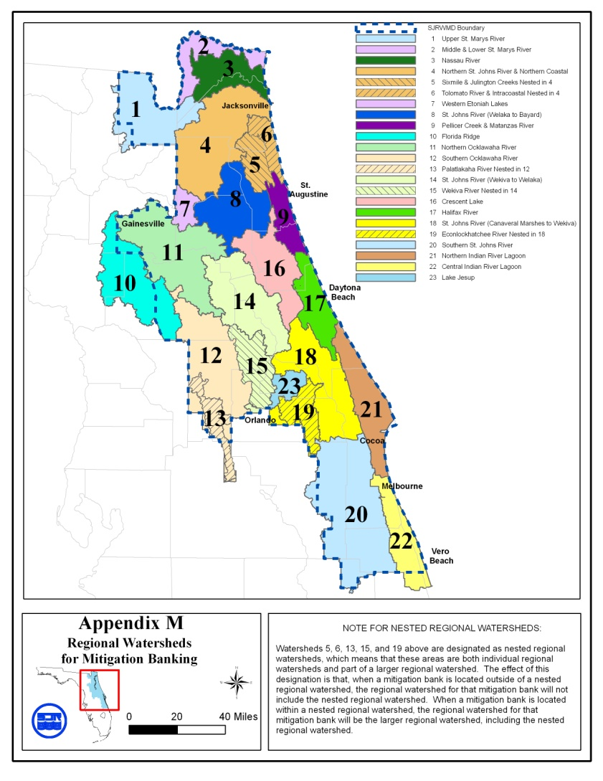
Revised 11/5/08

This legal description is for the same area defined as the “Wekiva Study Area” in Section 369.316, Florida Statutes.

