Classifications of Florida’s Land Uses
Stephanie Lisl Hinrichs
Introduction:
Florida’s landscape is a mosaic of ecosystems comprised of a variety of flora and fauna. According to the April 2002 States of the Union: Ranking America’s Biodiversity, Florida is ranked seventh out of the fifty states for the most biodiversity (Stein, B.A., 2002). The Florida Panhandle is especially diverse and is considered to be one of the top-five biodiversity hotspots in North America (Blaustein, E.J., 2008). Much of this biodiversity is attributed to the wetland systems of Florida. Wetlands have been lost at an alarming rate to where only 30% of Florida is now wetlands. (SWFWMD) Therefore, laws have been put in place to protect this resource. With these laws in place it is important to be able to identify and delineate wetlands. So people have over the years worked to classify Florida’s diverse ecosystems. Some of these classification systems are the National Wetland Inventory (NWI), Florida Land Use, Cover and Forms Classification System (FLUCCS), and the Natural Resources Conservation Service (NRCS) Soil Maps. These three classification systems either delineate wetlands or some part of the wetland equation.
The wetland equation is a simple determination based on the State wetland definition according to Rule 62-340, Florida Administrative Code (FAC) where wetlands are defined as…
“those areas that are inundated or saturated by surface water or ground water at a frequency and a duration sufficient to support, and under normal circumstances do support, a prevalence of vegetation typically adapted for life in saturated soils.” (subsection 62-340.200(19), F.A.C.)
The wetland equation consists of three criteria: hydrophytic vegetation, hydric soils, and wetland hydrology. To meet the State’s accepted definition an area must meet two out of the three criteria under normal circumstances. (FDEP) The classification systems have labeled areas as wetlands, but they may or may not be wetlands according to the State wetland definition.
The classification systems can be separated into two categories: vegetation distributions and soil distributions. NWI and FLUCCS are both vegetation distribution classification systems. Both systems are hierarchal in nature and were created from aerial photointerpretation. NWI was developed in 1986 by the U.S. Fish and Wildlife Service and provides a general overview of the wetland areas which can be broken down into subcategories such as Estuarine, Lacustrine, Marine, Palustrine, and Riverine (U.S. FWS). FLUCCS was developed in 1976 by a committee of eight state agencies and classifies Florida’s land uses in more detail than the NWI since non-aerial data was also used to verify the photointerpretations. The three FLUCCS subcategories of interest are 300: Rangeland, 400: Upland Forest, and 600: Wetlands. (FDOT) The NRCS Soil Maps are a soil distribution classification system. Soils are classified from Soil Orders down to Soil Series. Series categories are the most specific unit of the classification system. NRCS has taken these defined soil series in Florida and combined them with different phases (e.g. degree of slope of the landscape) to create soil map units. (NRCS-USDA) The soil map unit categories of interest are the hydric or nonhydric classification.
Rationale and Significance:
The classification systems all divide Florida using different methods and scales. These delineations of Florida are available for public use. The pubic often inquires whether these classification systems may be substituted for ground truthing which is the currently accepted way to determine if an area meets the State wetland definition. It is important to note the reliability of the information provided for this purpose. If the classification systems agree with the State’s wetland definition then the wetland categories, distinguished by wetland vegetation, should align with the hydric soil categories. Thus meeting two out of the three criteria. Also, if the classification systems accurately depict the Florida landscape then the more detailed classification system should be interchangeable with the broader overview classification system. The significance of this project is to illustrate the reliability and exchangeability of the data to each other. If the data is truly uniform and accurate then areas labeled as hydric soils according to NRCS should also be areas labeled as wetlands by FLUCCS and these areas should be contained within the wetland category of NWI.
Objectives:
The objective of this GIS project are to determine how well FLUCCS’s delineation of wetlands matches the accepted State criteria of wetlands. Under normal circumstances the wetland categories of FLUCCS should have a hydric soil while the upland categories of FLUCCS should have a nonhydric soil. This project will show what percentage of FLUCCS wetlands have hydric soils and non-hydric soils as well as what percentage of FLUCCS uplands have hydric soils and nonhydric soils for each of the five Water Management Districts.
The other objective of this GIS project is the determination of how well FLUCCS and NWI relate. If the FLUCCS delineated wetlands correlate significantly to the broader NWI delineation then FLUCCS wetlands should be contained with NWI boundaries while FLUCCS uplands should be outside of NWI boundaries. This project will look at the Northwest Florida Water Management District (NWFWMD) and determine for each FLUCCS wetland and upland subcategory what the area and percentage of it is comprised of NWI wetlands and its subcategories. Also, what percentage of the FLUCCS subcategories are comprised of hydric and nonhydric soils with an elevation breakdown that will help give weight to the soil classifications. Hydric soils should occur on average at a lower elevation that the nonhydric soils.
Materials:
Sources of the dataset used:
- NWFWMD 2009-2010 Land Use dataset which was created by the Florida Department of Environmental Protection’s (FDEP) Bureau of Watershed Restoration from 2009 and/or 2010 Florida Ortho Quarter Quad Aerial Imagery, published in 2011 at a 1:24,000 scale.
- Suwannee River Water Management District (SRWMD) 2010-2011 Land Use dataset which was created by the Florida Department of Environmental Protection’s Bureau of Watershed Restoration from 2010 or 2011 true color photography, published December 17, 2012 at a scale of 1:12,000.
- St. Johns River Water Management District (SJRWMD) 2008-2009 Land Use dataset which was created by the SJRWMD from 2009 color infrared aerial photography, published in 2011 at a 1:12,000 scale.
- Southwest Florida Water Management District (SWFWMD) 2011 Land Use dataset which was created by the SWFWMD from photo-interpreting features from 2011 1-ft color infrared (CIR) digital aerial photographs at a 1:8,000 scale.
- South Florida Water Management District (SFWMD) 2008-2009 Land Use dataset which was created by the SFWMD from photo-interpreted features from 2008-2009 aerial photography, published on September 30, 2011 at a 1:12,000 scale.
- The SSURGO Soils was a single dataset that was then split into the five Water Management District groups to make the dataset more manageable. Therefore, each SSURGO Soils dataset has the same source information. These datasets were created by the Florida Department of Environmental Protection from soil data layers pulled off of the Soil Data Mart and compiled from 2010 – 2011 at a 1:24,000 scale.
- NWI dataset was created by the U.S. Fish and Wildlife Service from 1977 to 2012, published in September 2012 at a scale of 1:24,000.
- The Topography dataset was a part of a larger dataset called Elevation Contours and Depressions created by United States Geological Survey, Mid-Continent Mapping Center from 1950 to 1980 at a scale of 1:24,000. This dataset may not be reliable in populated areas since it is more than 20 years old. This data was compiled by the Water Management Districts excluding NWFWMD and by FDEP. The data was reviewed and corrected through the use of Quality Assurances supplied by the FDEP’s Florida Geological Survey and the Division of Water Resource Management in 2012.
Comparison of FLUCCS to NRCS Soils
The process of the creation of the maps looking at the relation of FLUCCS to the NRCS soils is outlined below.
- Each Water Management District (WMD) Land Use dataset input into the Union tool to create the borders
- Selected from each WMD are all the 6000 Land Uses and the all the 3000 and 4000 Land Uses using Select Attributes
- Created a layer from the selected features and then exported the layers to shapefiles, which gave a Wetland Land Use and an Upland Land Use shapefile for each WMD
- Selected from the SSURGO Soils dataset all the polygons that had a hydric rating and then selected from that selection using Select by Location those polygons that intersected with the Wetland Land Use dataset and created a layer from that final selection and then exported that layer to create the FLUCCS Wetland with Hydric Soils
- Repeated the previous step with different selections to create the Wetland Land Use with Nonhydric Soils, Upland Land Use with Hydric Soils, and Upland Land Use with Nonhydric Soils.
- Then selected from the Wetland Land Use those areas that intersect with previously created shapefiles. Opened up the selections’ attribute tables, created a new field for the Hydric Soils and the Nonhydric Soils, and then populated each field with the appropriate category. Repeated for the Upland Land Use.
- Then the boundaries and the Wetland Land Use with Hydric Soils, Wetland Land Use with Nonhydric Soils, Upland Land Use with Hydric Soils, and Upland Land Use with Nonhydric Soils for SJRWMD, SRWMD, and SWFWMD were clipped using the Erase tool against the neighboring WMD boundaries since they overlapped. Then created maps.
Comparison of NWFWMD FLUCCS to NWI
The process of the creation of the map and table looking at the relation of FLUCCS to NWI and NRCS soils, and NRCS soils to elevations is outlined below.
- All NWFWMD data from previous maps were used as well as a Topography dataset and a NWI dataset which was clipped to match the NWFWMD boundary.
- Selected from the Wetland Land Use dataset those polygons that intersected with the NWI dataset and created a layer from that selection then exported it to a shapefile called Wetland Land Use intersect with NWI. Then within the selected features of the Wetland Land Use a new field was created in the attribute table and was populated with Wetland by the Field Calculator. Then selected by attributes those polygons that do not have Wetland in the newly created field and populated that selection with Upland by the Field Calculator.
- Selected from the Upland Land Use dataset those polygons that intersected with the NWI dataset and created a layer from that selection then exported it to a shapefile called Upland Land Use intersect with NWI. Then within the selected features of the Upland Land Use a new field was created in the attribute table and was populated with Wetland by the Field Calculator. Then selected by attributes those polygons that do not have Wetland in the newly created field and populated that selection with Upland by the Field Calculator.
- Created a map from the NWI, Upland Land Use, Wetland Land Use, Upland Land Use intersect with NWI, and Wetland Land Use intersect with NWI.
- Then selected by attributes every land use classification in the Wetland Land Use dataset and created a layer file for them. Then selected by attributes every land use classification in the Upland Land Use dataset and created a layer file for them.
- Then selected the areas in the NWI shapefile that intersected with each land use classification layer file previously created. Then exported the attribute table for the selected areas.
- Then selected the areas in the each land use classification layer file that were hydric and then from those selections, selected the areas from the Topography dataset that intersected the previous selection. Used the Statistic button to determine the Maximum, Average, and Minimum contours by feet for the selected features. Repeated for the nonhydric soils in the layer files.
- Exported the Wetland Land Use attribute table as well as the Upland Land Use attribute table to excel so that more analysis could be run.
- Created a table showing for each FLUCCS land use the percent area comprised of NWI wetlands and uplands, percent area of type of NWI wetlands, percent area of hydric and nonhydric soils, and the maximum, average, and minimum elevation per soil type.
Results:
Comparison of FLUCCS to NRCS Soils
Only areas in FLUCCS that were under categories 3000, 4000, and 6000 were used to compare to only areas in NRCS soil maps that were labeled as hydric and nonhydric. As shown in Figure 1, Northwest Florida Water Management District and Suwannee River Water Management District have the heaviest areas populated by those two requirements. South Florida Water Management District had the lightest areas populated by those two requirements. Most of the Water Management Districts had the highest percent area comprised of FLUCCS Uplands with Nonhydric Soils and the lowest percent area comprised of FLUCCS Uplands with Hydric Soils. (see Table 1) Most of the percent areas for each category are relatively similar to each other. On average they are within a 10% distance for one another. There are two big outliers in the dataset and both of them occur in the Northwest Florida Water Management District data. The FLUCCS Uplands with Nonhydric Soils accounted for 54% of the area in Northwest Florida Water Management District while on average most of the categories were in the mid-30% range. The other outlier is FLUCCS Wetlands with Nonhydric Soils. It equaled 6% of the area in Northwest Florida Water Management District while most of the categories were ranging from the mid-20% to the mid-30% range. (see Figure 2) Overall the data remained relatively consistent between the different FLUCCS and soil categories.
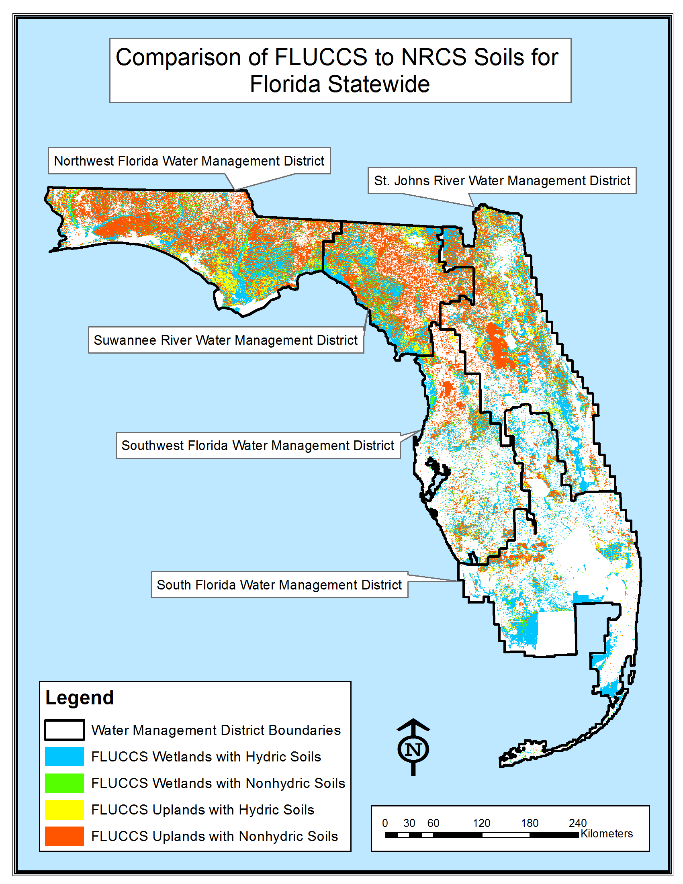
Figure 1: This map is a depiction of the Florida Land Use, Cover and Forms Classification System (FLUCCS) in comparison to the Natural Resources Conservation Service (NRCS) soils for Florida. The map illustrates the areas by Water Management District which have FLUCCS wetlands and hydric soils as defined by NRCS, FLUCCS wetlands and nonhydric soils, FLUCCS uplands and hydric soils, and FLUCCS uplands and nonhydric soils. The source for the data used to make this map is outlined under the methods section of this paper. Datasets 1 through 6 were used in the creation of this map.
Table 1: For Florida’s five Water Management Districts, the area and percent area for each FLUCCS and Soil category as well as the total Water Management District area.
Water Management Districts | Total Area  (sq km) | Categories | Area*  (sq km) | Area*  (%)
State Wide | 401,692.43 | FLUCCS Wetlands with Hydric Soils | 45,724.18 | 22
State Wide | 401,692.43 | FLUCCS Wetlands with Nonhydric Soils | 50,714.39 | 25
State Wide | 401,692.43 | FLUCCS Uplands with Hydric Soils | 41,319.15 | 20
State Wide | 401,692.43 | FLUCCS Uplands with Nonhydric Soils | 68,839.85 | 33
Total Category Area |  |  | 206,597.57 | 100
NWFWMD | 30,953.64 | FLUCCS Wetlands with Hydric Soils | 5,610.79 | 16
NWFWMD | 30,953.64 | FLUCCS Wetlands with Nonhydric Soils | 1,981.34 | 6
NWFWMD | 30,953.64 | FLUCCS Uplands with Hydric Soils | 8,306.30 | 24
NWFWMD | 30,953.64 | FLUCCS Uplands with Nonhydric Soils | 18,886.88 | 54
Total Category Area |  |  | 34,785.31 | 100
SRWMD | 19,780.76 | FLUCCS Wetlands with Hydric Soils | 6,392.87 | 18
SRWMD | 19,780.76 | FLUCCS Wetlands with Nonhydric Soils | 10,730.88 | 30
SRWMD | 19,780.76 | FLUCCS Uplands with Hydric Soils | 6,184.32 | 17
SRWMD | 19,780.76 | FLUCCS Uplands with Nonhydric Soils | 12,756.32 | 35
Total Category Area |  |  | 36,064.39 | 100
SJRWMD | 35,218.08 | FLUCCS Wetlands with Hydric Soils | 11,664.37 | 23
SJRWMD | 35,218.08 | FLUCCS Wetlands with Nonhydric Soils | 14,186.09 | 27
SJRWMD | 35,218.08 | FLUCCS Uplands with Hydric Soils | 10,249.89 | 20
SJRWMD | 35,218.08 | FLUCCS Uplands with Nonhydric Soils | 15,283.86 | 30
Total Category Area |  |  | 51,384.21 | 100
SWFWMD | 274,227.12 | FLUCCS Wetlands with Hydric Soils | 6,599.16 | 17
SWFWMD | 274,227.12 | FLUCCS Wetlands with Nonhydric Soils | 13,732.07 | 36
SWFWMD | 274,227.12 | FLUCCS Uplands with Hydric Soils | 5,038.23 | 13
SWFWMD | 274,227.12 | FLUCCS Uplands with Nonhydric Soils | 13,279.27 | 34
Total Category Area |  |  | 38,648.73 | 100
SFWMD | 41,512.83 | FLUCCS Wetlands with Hydric Soils | 15,456.99 | 34
SFWMD | 41,512.83 | FLUCCS Wetlands with Nonhydric Soils | 10,084.01 | 22
SFWMD | 41,512.83 | FLUCCS Uplands with Hydric Soils | 11,540.41 | 25
SFWMD | 41,512.83 | FLUCCS Uplands with Nonhydric Soils | 8,633.52 | 19
Total Category Area |  |  | 45,714.93 | 100
*Some of the Land Use polygons for the five Water Management Districts have both Hydric Soils and Nonhydric Soils in them, which is why the Total Category Area does not equal the Total Water Management District Area. Therefore, they were labeled with both and the percent area was calculated for each category in the Water Management Districts. That way the polygons with both Hydric Soils and Nonhydric Soils would cancel each other out and a true representation of the area percentage for the five Water Management Districts is obtained.

Figure 2: Graphical depiction of the relationship between FLUCCS and NRCS Soils for Florida statewide and the five water management districts: Northwest Florida Water Management District, Suwannee River Water Management District, St. Johns River Water Management District, Southwest Florida Water Management District, South Florida Water Management District.
Comparison of NWFWMD FLUCCS to NWI
Only areas in FLUCCS that were under categories 3000, 4000, and 6000 were used to compare to the NWI. In Figure 3, it can be seen that the majority of NWFWMD area is comprised of FLUCCS uplands that are within the boundaries of the NWI limits. No recognizable areas of FLUCCS wetlands not contained within the NWI boundaries appears to be present in the map. However, as shown in Figure 4, 1% of the FLUCCS wetlands are not considered wetlands according to NWI. In Figure 5, 76% of FLUCCS uplands are considered to be wetlands according to NWI. Soils on average for the individual subcategories of wetlands were split 50/50 with no increase or decrease of percent area based on FLUCCS wetlands or uplands except for a few outliers. However, hydric soils generally had a lower average elevation than the nonhydric soils. Areas existed with No Soils, which are neither hydric nor nonhydric soils, but these were normally under 1% of the area if they were present. (see Table 2 and 3)
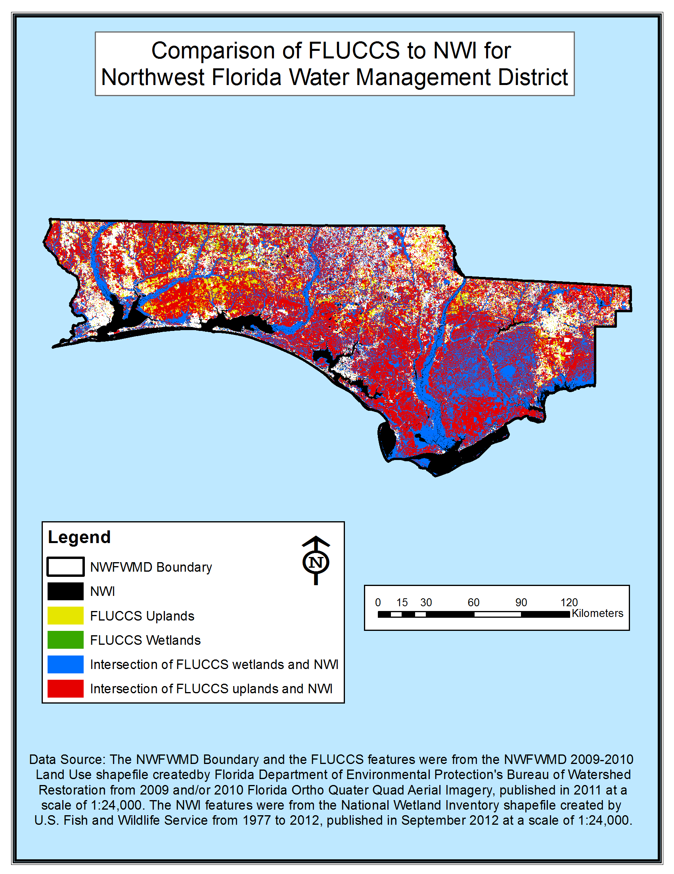
Figure 3: This map depicts the Florida Land Use, Cover and Forms Classification System (FLUCCS) in comparison to the National Wetland Inventory (NWI) for Northwest Florida Water Management District (NWFWMD). The map illustrates where FLUCCS wetlands and uplands intersect with the NWI delineated area.

Table 2: FLUCCS Wetlands subcategories
FLUCCS | Land Use | Area  (sq km) | NWI | NWI Wetland | Soil | Average Contour (ft)
 |  |  |  |  |  | Max | Avg | Min
6110 | Bay Swamps | 10.5 | Wetland: 10.4 (99.0%)  Upland: 0.1 (1.0%) | Palustrine: 100.0% | Hydric: 64.8% | 240.0 | 94.8 | 5.0
 |  |  |  |  | Nonhydric: 35.2% | 270.0 | 99.8 | 5.0
6130 | Gum Swamps | 65.2 | Wetland: 65.1 (99.8%)  Upland: 0.1 (0.2%) | Lacustrine: 4.6%  Palustrine: 93.0%  Riverine: 2.4% | Hydric: 45.3% | 300.0 | 93.7 | 6.6
 |  |  |  |  | Nonhydric: 54.7% | 300.0 | 99.2 | 6.6
6140 | Titi Swamps | 24.7 | Wetland: 24.5 (99.3%)  Upland: 0.2 (0.69%) | Estuarine: 0.2%  Palustrine: 99.8% | Hydric: 58.3% | 290.0 | 84.8 | 3.3
 |  |  |  |  | Nonhydric: 41.7% | 290.0 | 89.6 | 3.3
6150 | Stream and Lake Swamps (Bottomland) | 940.8 | Wetland: 940.8 (100.0%) | Estuarine: 42.9%  Lacustrine: 3.1%  Palustrine: 51.2%  Riverine: 2.8% | Hydric: 52.7% | 240.0 | 43.2 | -8.2
 |  |  |  |  | Nonhydric: 47.3% | 240.0 | 44.9 | -8.2
6170 | Mixed Wetland Hardwoods | 513.2 | Wetland: 506.8 (98.8%)  Upland: 6.4 (1.3%) | Estuarine: 19.2%  Lacustrine: 1.9%  Marine: 13.0%  Palustrine: 65.1%  Riverine: 0.8% | Hydric: 51.4% | 340.0 | 100.2 | -16.4
 |  |  |  |  | Nonhydric: 48.6 | 340.0 | 104.0 | -16.4
6180 | Willow and Elderberry | 2.4 | Wetland: 2.4 (100%) | Estuarine: 88.5%  Palustrine: 11.5% | Hydric: 54.8% | 90.0 | 13.1 | 3.3
 |  |  |  |  | Nonhydric: 45.2% | 90.0 | 19.2 | 3.3
6210 | Cypress | 332.5 | Wetland: 330.8 (99.5%)  Upland: 1.7 (0.5%) | Estuarine: 21.5%  Lacustrine: 2.7%  Palustrine: 74.6%  Riverine: 1.2% | No Soil: 0.3% | No Soil
 |  |  |  |  | Hydric: 51.8% | 310.0 | 84.0 | 3.3
 |  |  |  |  | Nonhydric: 47.9% | 310.0 | 91.2 | 3.3
6250 | Hydric Pine Flatwoods | 1299.0 | Wetland: 1279.2 (98.5%)  Upland: 19.9 (1.5%) | Estuarine: 26.2%  Lacustrine: 1.7%  Marine: 3.3%  Palustrine: 68.4%  Riverine: 0.4 | Hydric: 51.1% | 310 | 90.4 | 3.3
 |  |  |  |  | Nonhydric: 48.9% | 320.0 | 95.2 | -1.6
6300 | Wetland Forested Mixed | 2800.8 | Wetland: 2769.8 (98.9%)  Upland: 31.0 (1.1%) | Estuarine: 20.39%  Lacustrine: 1.80%  Palustrine: 76.9%  Riverine: 0.9% | Hydric: 49.8% | 340.0 | 111.1 | 3.3
 |  |  |  |  | Nonhydric: 50.2% | 340.0 | 113.9 | 3.3
6410 | Freshwater Marshes | 129.6 | Wetland: 127.5 (98.4%)  Upland: 2.1 (1.6%) | Estuarine: 37.8%  Lacustrine: 5.6%  Palustrine: 55.2%  Riverine: 1.4% | No Soil: 1.1% | No Soil
 |  |  |  |  | Hydric: 54.8% | 310.0 | 80.1 | -3.3
 |  |  |  |  | Nonhydric: 44.2% | 310.0 | 88.2 | 3.3
6420 | Saltwater Marshes | 232.0 | Wetland: 231.8 (99.9%)  Upland: 0.2 (0.1%) | Estuarine: 54.5%  Lacustrine: 0.1%  Marine: 36.2%  Palustrine: 9.1%  Riverine: 0.1% | No Soil: 0.6% | No Soil
 |  |  |  |  | Hydric: 60.3% | 35.0 | 4.8 | 13.1
 |  |  |  |  | Nonhydric: 39.1% | 25.0 | 4.6 | -13.1
6430 | Wet Prairies | 214.2 | Wetland: 207.4 (96.8%)  Upland: 6.8 (3.2%) | Estuarine: 22.5%  Lacustrine: 2.8%  Marine: 27.6%  Palustrine: 46.5%  Riverine: 0.7% | No Soil: 0.4% | No Soil
 |  |  |  |  | Hydric: 51.1% | 300.0 | 88.6 | -3.3
 |  |  |  |  | Nonhydric: 48.5% | 320.0 | 100.1 | -3.3
6440 | Emergent Aquatic Vegetation | 67.9 | Wetland: 67.4 (99.2%)  Upland: 0.5 (0.8%) | Estuarine: 1.4%  Lacustrine:25.0%  Palustrine: 73.0%  Riverine: 0.6% | No Soil: 3.9% | No Soil
 |  |  |  |  | Hydric: 46.7% | 300.0 | 106.3 | 3.3
 |  |  |  |  | Nonhydric: 49.4% | 300.0 | 119.5 | 3.4
6460 | Treeless Hydric Savannah | 1095.2 | Wetland: 1078.8 (98.5%)  Upland: 16.4 (1.5%) | Estuarine: 21.2%  Lacustrine: 1.6%  Marine: 15.1%  Palustrine: 61.6%  Riverine: 0.6% | No Soil: 0.1% | No Soil
 |  |  |  |  | Hydric: 52.5% | 310.0 | 86.03 | -9.8
 |  |  |  |  | Nonhydric: 47.4% | 320.0 | 93.7 | -9.8
6500 | Non-vegetated | 32.5 | Wetland: 32.4 (99.7%)  Upland: 0.1 (0.3%) | Estuarine: 90.1%  Lacustrine: 2.2%  Marine: 0.3%  Palustrine: 7.3% | No Soil: 0.7% | No Soil
 |  |  |  |  | Hydric: 51.7% | 260.0 | 34.3 | -3.3
 |  |  |  |  | Nonhydric: 47.7% | 260.0 | 48.0 | -3.3
6510 | Tidal Flats | 52.0 | Wetland: 52.0 (100.0%) | Estuarine: 60.1%  Lacustrine: 0.1%  Marine: 38.7%  Palustrine: 1.2% | No Soil: 2.2% | No Soil
 |  |  |  |  | Hydric: 53.4% | 13.1 | 1.2 | -16.4
 |  |  |  |  | Nonhydric: 44.4% | 20.0 | 1.8 | -16.4
6530 | Intermittent Ponds | 13.8 | Wetland: 13.5 (97.6%)  Upland: 0.3 (2.5%) | Estuarine: 6.7%  Lacustrine: 4.0%  Palustrine: 89.3% | No Soil: 0.3% | No Soil
 |  |  |  |  | Hydric: 41.4% | 270.0 | 109.22 | 6.6
 |  |  |  |  | Nonhydric: 58.4% | 210.0 | 99.6 | 6.6
6540 | Oyster Bars | 1.2 | Wetland: 1.2 (100.0%) | Estuarine: 100.0% | No Soil: 88.9% | No Soil
 |  |  |  |  | Hydric: 11.1% | NA | NA | NA
Table 3: FLUCCS Uplands subcategories
FLUCCS | Land Use | Area  (sq km) | NWI (sq km) | NWI Wetland | Soil | Average Contour (ft)
 |  |  |  |  |  | Max | Avg | Min
3100 | Herbaceous (Dry Prairie) | 385.1 | Wetland: 228.5 (59.3%)  Upland: 156.7 (40.7%) | Estuarine: 52.1%  Lacustrine: 1.2%  Palustrine: 46.0%  Riverine: 0.6% | No Soil: 0.2% | No Soil
 |  |  |  |  | Hydric: 35.9% | 310.0 | 130.5 | 3.3
 |  |  |  |  | Nonhydric: 63.9% | 340.0 | 144.1 | 3.3
3200 | Shrub and Brushland | 429.9 | Wetland: 297.7 (69.3%)  Upland: 132.1 (30.7%) | Estuarine: 45.9%  Lacustrine: 0.7%  Palustrine: 53.0%  Riverine: 0.4% | Hydric: 39.7% | 330.0 | 128.6 | -3.3
 |  |  |  |  | Nonhydric: 60.3% | 330.0 | 140.2 | 3.3
3210 | Palmetto Prairies | 1.4 | Wetland: 1.4 (100.0%) | Palustrine: 100.0% | Hydric: 48.4% | 100.0 | 71.7 | 10.0
 |  |  |  |  | Nonhydric: 51.6% | 100.0 | 67.1 | 4.9
3220 | Coastal Scrub | 35.3 | Wetland: 33.0 (93.6%)  Upland: 2.2 (6.4%) | Estuarine: 94.7%  Lacustrine: 0.1%  Marine: 0.6%  Palustrine: 4.7% | No Soil: 1.2% | No Soil
 |  |  |  |  | Hydric: 46.1% | 65.0 | 13.4 | -1.6
 |  |  |  |  | Nonhydric: 52.7% | 250.0 | 14.5 | -1.6
3300 | Mixed Rangeland | 424.9 | Wetland: 273.1 (64.3%)  Upland: 151.8 (35.7%) | Estuarine: 17.7%  Lacustrine: 0.2%  Palustrine: 81.0%  Riverine: 1.1% | No Soil: 0.1% | No Soil
 |  |  |  |  | Hydric: 38.0% | 320.0 | 139.0 | 3.3
 |  |  |  |  | Nonhydric: 62.0% | 320.0 | 146.1 | 3.3
4100 | Upland Coniferous Forests | 2067.6 | Wetland: 1870.3 (90.5%)  Upland: 197.3 (9.5%) | Estuarine: 36.6%  Lacustrine: 2.4%  Palustrine: 60.4%  Riverine: 0.7% | No Soil 0.01% | No Soil
 |  |  |  |  | Hydric: 47.5% | 340.0 | 129.7 | 3.3
 |  |  |  |  | Nonhydric: 52.5% | 340.0 | 135.2 | -1.6
4110 | Pine Flatwoods | 726.5 | Wetland: 577.8 (79.5%)  Upland: 148.7 (20.5%) | Estuarine: 42.9%  Lacustrine: 1.5%  Marine: 0.2%  Palustrine: 54.9%  Riverine: 0.5% | No Soil: 0.1% | No Soil
 |  |  |  |  | Hydric: 44.1% | 310.0 | 70.0 | 3.3
 |  |  |  |  | Nonhydric: 55.9% | 340.0 | 88.9 | 3.3
4120 | Longleaf Pine – Xeric Oak | 178.5 | Wetland: 118.9 (66.6%)  Upland: 59.6 (33.4%) | Estuarine: 90.0%  Lacustrine: 0.1%  Palustrine: 9.9% | Hydric: 40.7% | 310.0 | 169.2 | 3.3
 |  |  |  |  | Nonhydric: 59.3% | 310.0 | 167.3 | 3.3
4130 | Sand Pine | 6.7 | Wetland: 3.8 (56.7%)  Upland: 2.9 (43.3%) | Estuarine: 93.4%  Palustrine: 6.7% | No Soil: 0.9% | No Soil
 |  |  |  |  | Hydric: 33.6% | 230 | 105.0 | 3.3
 |  |  |  |  | Nonhydric: 65.6% | 270.0 | 112.65 | 3.3
4190 | Other Pines | 307.3 | Wetland: 300.6 (97.8%)  Upland: 6.8 (2.2%) | Lacustrine: 15.4%  Palustrine: 84.6% | Hydric: 48.1% | 290.0 | 165.30 | 50.0
 |  |  |  |  | Nonhydric: 51.9% | 290.0 | 164.53 | 50.0
4200 | Upland Hardwood Forests | 247.1 | Wetland: 158.3 (64.0%)  Upland: 88.9 (36.0%) | Estuarine: 58.1%  Lacustrine: 3.5%  Palustrine: 37.4%  Riverine: 1.0% | No Soil: 0.1% | No Soil
 |  |  |  |  | Hydric: 36.7% | 320.0 | 133.2 | 3.3
 |  |  |  |  | Nonhydric: 63.2% | 340.0 | 137.7 | 3.3
4210 | Xeric Oak | 148.9 | Wetland: 94.5 (63.5%)  Upland: 54.4 (36.5%) | Lacustrine: 0.4%  Palustrine: 99.6% | Hydric: 36.9% | 310.0 | 155.2 | 10.0
 |  |  |  |  | Nonhydric: 63.1% | 320.0 | 159.5 | 10.0
4270 | Live Oak | 5.7 | Wetland: 2.0 (34.4%)  Upland: 3.7 (65.6%) | Estuarine: 1.2%  Lacustrine: 1.6%  Palustrine: 97.2% | No Soil: 0.2% | No Soil
 |  |  |  |  | Hydric: 21.7% | 260.0 | 115.0 | 5.0
 |  |  |  |  | Nonhydric: 78.1% | 260.0 | 126.8 | 3.3
4280 | Cabbage Palm | 0.9 | Wetland: 0.9 (100.0%) | Estuarine: 31.5%  Palustrine: 68.5% | Hydric: 54.1% | 95.0 | 66.2 | 4.9
 |  |  |  |  | Nonhydric: 45.9% | 95.0 | 80.0 | 65.0
4340 | Hardwood – Conifer Mixed | 1966.5 | Wetland: 1580.5 (80.3%)  Upland: 385.9 (19.6%) | Estuarine: 28.0%  Lacustrine: 4.0%  Palustrine: 66.6%  Riverine: 1.4% | No Soil: 0.1% | No Soil
 |  |  |  |  | Hydric: 42.6% | 330.0 | 136.6 | -1.6
 |  |  |  |  | Nonhydric: 57.4% | 340.0 | 138.2 | -1.6
4410 | Coniferous Plantations | 6403.8 | Wetland: 5806.9 (90.7%)  Upland: 597.0 (9.3%) | Estuarine: 20.4%  Lacustrine: 1.6%  Palustrine: 77.7%  Riverine: 0.3% | Hydric: 47.6% | 330.0 | 116.9 | 3.3
 |  |  |  |  | Nonhydric: 52.36% | 330.0 | 123.5 | 3.3
4430 | Forest Regeneration Areas | 2129.1 | Wetland: 1762.8 (82.8%)  Upland: 366.3 (17.2%) | Estuarine: 6.6%  Lacustrine: 0.37%  Palustrine: 93.0% | Hydric: 97.2% | 320.0 | 127.2 | 3.3
 |  |  |  |  | Nonhydric: 54.7% | 340.0 | 134.6 | 3.3

Figure 4: Graphical representation showing the breakdown of the percent area of FLUCCS Wetlands that are considered either wetlands or uplands according to NWI.

Figure 5: Graphical representation showing the breakdown of the percent area of FLUCCS Uplands that are considered either wetlands or uplands according to NWI.

Discussion:
In working through the first objective, comparing FLUCCS to NRCS soils, it was noticed that there was not a significant correlation between the different categories. For each of the five Water Management Districts as well as statewide the four categories; FLUCCS Wetlands with Hydric Soils, FLUCCS Wetlands with Nonhydric Soils, FLUCCS Uplands with Hydric Soils, and FLUCCS Uplands with Nonhydric Soils; all stayed within approximately 10% of each other. Even though FLUCCS Uplands with Nonhydric Soils was normally the highest category for the majority of Water Management Districts, it was not significantly higher. Also, a quirk in the data presented some unexpected occurrences. The summed area for the hydric and nonhydric soils in each Water Management District did not equal the FLUCCS Wetlands and FLUCCS Uplands like expected. This is due to the land use polygons in some places having both hydric and nonhydric soils, therefore percentages more accurately depicted the data than acreages. This may possibly be rectified by initially clipping the land use to the extent of the soils shapefile. That way when the analysis was run the datasets will equal the same area from the beginning.
In working through the second objective, comparing FLUCCS to NWI, it was noticed that while NWI readily agreed with the FLUCCS wetland designation (99%), it also designated the majority of the FLUCCS uplands as wetlands (74%). This disputed the reliability of the datasets being exchangeable as well as the NWI dataset being used for purposes other than a general overview of an area. It was noticed that the soils per land use subcategory ranged on average 50/50 per hydric and nonhydric soil classification, which was expected after seeing the results of the first objective. However, the soil data matched up fairly well with the elevation data. Hydric soils were at lower average elevations and nonhydric soils were at higher average elevations as would be expected. This was intriguing especially since the elevation data is more than twenty years old. This dataset was used because glitches kept occurring in the process of trying to run analysis with a Digital Elevation Model as well as with transforming LIDAR into the proper projection. The Digital Elevation Model would not clip either by mask or by raster clipping and statistical analysis produced errors. The LIDAR was collected by county for the NWFWMD region and then each county dataset was transformed. Every dataset transformed except for Washington County. Even exporting the data into a new shapefile using the Data Frame’s projection did not work. These issues could be due to the data being protect for the former issue and/or corrupted for the latter issue. Human error is also a possibility. The elevation data used gives good information, but would have been better if the data was more recent.
Conclusions:
Overall, there was no significant correlation between FLUCCS types and soils types so therefore FLUCCS is not reliable to be used for determining wetland boundaries for State regulatory purposes according to Rule 62-340, F.A.C. FLUCCS is much more appropriate as a tool for general ecological boundary determinations. It can be used as a helpful aid in the identification of wetlands, but not as a substitution for ground truthing State regulated wetland boundaries. The NWI dataset does not have a significant correlation with the FLUCCS boundaries and therefore the datasets are not interchangeable. NWI is useful as a way to generally categorize an area, but if more detail is desired in the study of the general ecology of the area then FLUCCS or NRCS soil maps should be the selected dataset. Since NWI is so general an overview it is not an acceptable way to determine the wetland boundaries for State regulatory purposes. It also may be used as a helpful general tool in the identification of wetlands. However, for the most precise and accurate identification and delineation of wetlands for State regulatory purposes, ground truthing is still the best and most reliable method.
References:
- Blaustein, R.J. 2008. Biodiversity Hotspots: The Florida Panhandle. BioScience. 58(9): 784-790.
- Florida Department of Transportation (FDOT). 1999. Florida Land Use, Cover and Forms Classification System. Available at: http://www.dot.state.fl.us/surveyingandmapping/documentsandpubs/fluccmanual1999.pdf (verified: 11/29/2013)
- Florida Department of Environmental Protection (FDEP). Chapter 62-340, F.A.C. Available at: http://www.dep.state.fl.us/legal/Rules/surfacewater/62-340/62-340.pdf (verified: 12/1/2013)
- Natural Resources Conservation Service (NRCS) – United States Department of Agriculture (USDA). 1993. Soil Survey Manual. U.S. Government Printing Office, Washington DC.
- Southwest Florida Water Management District (SWFWMD). Available at: http://www.swfwmd.state.fl.us/education/splash/wetland_foryour_thoughts.html (verified: 11/30/2013)
- Stein, B.A. 2002. States of the Union: Ranking America’s Biodiversity. Nature Serve, Virginia.
- U.S. Fish and Wildlife Service (U.S. FWS). National Wetland Inventory. Available at: http://www.fws.gov/wetlands/NWI/Overview.html (verified: 12/1/2013)

