STATE OF FLORIDA
DEPARTMENT
OF
ENVIRONMENTAL PROTECTION



Conditions of Certification

Hardee Power Partners Limited
Tampa Electric Company
Seminole Electric Cooperative, Inc.
Florida Power & Light Company

Hardee Power Station

PA89-25J

XXXXXXXX, 2022
Table of Contents

SECTION A: GENERAL CONDITIONS 1
I. SCOPE Replaces Condition I. General, B. Identification of Permittees Responsible for Compliance; Condition XIX. Certified Site, and Mod I Attachments A and C 1
1. Generation Facilities (Refer to Attachment A - Figure 1) 1
2. Transmission Lines (further described below): 1
3. Linear Natural Gas and Liquid Fuel Pipelines 3
II. APPLICABLE DEPARTMENT RULES Replaces Condition I. General, C., and Condition XXVIII. Compliance 4
III. REVISIONS TO DEPARTMENT STATUTES AND RULES New 5
IV. DEFINITIONS Replaces Condition I. General, A. Definitions 6
V. FEDERALLY DELEGATED OR APPROVED PERMIT PROGRAMS Replaces Conditions II. Air; III. Surface Water Discharges; V. Control Measures During Construction, paragraphs B. and C. 7
VI. DESIGN AND PERFORMANCE CRITERIA Replaces Condition XXIII. Effect of Certification 8
VII. NOTIFICATION Replaces Condition XI. Noncompliance Notification 8
VIII. EMERGENCY CONDITION NOTIFICATION AND RESTORATION Replaces Condition XXI. Modification of Conditions, paragraph B. 8
IX. CONSTRUCTION PRACTICES New 9
A. Local Building Codes 9
B. Open Burning 9
C. Vegetation 9
D. Existing Underground Utilities 9
E. Electric and Magnetic Fields (EMF) 10
G. Existing Wells 10
H. Abandonment of Existing Septic Tanks 10
X. RIGHT OF ENTRY Replaces Conditions XIV. Right of Entry and XXXV. Project Surface Water and Stormwater Management Facilities, paragraph A.5 10
XI. DISPUTE RESOLUTION Replaces Condition XXX. Dispute Resolution 10
A. General 10
B. Modifications 11
C. Post-Certification Submittals 11
XII. SEVERABILITY Replaces Condition XVIII. Severability 11
XIII. ENFORCEMENT Replaces Condition XXV. Enforcement 11
XIV. REVOCATION OR SUSPENSION Replaces Conditions XV. Revocation or Suspension, and XX. Review of Site Certification 12
XV. REGULATORY COMPLIANCE Replaces Condition VI. Safety 12
XVI. CIVIL AND CRIMINAL LIABILITY Replaces Condition XVI. Civil and Criminal Liability 12
XVII. USE OF STATE LANDS Replaces Condition XVII. Property Rights 12
XVIII. PROCEDURAL RIGHTS New 13
XIX. AGENCY ADDRESSES FOR POST-CERTIFICATION SUBMITTALS AND NOTICES New 13
XX. PROFESSIONAL CERTIFICATION New 15
XXI. PROCEDURES FOR POST-CERTIFICATION SUBMITTALS Replaces Conditions XXXI. Post-Certification Submittals and XXXV. Project Surface Water and Stormwater Management Facilities, paragraph A. 3 15
A. Purpose of Submittals 15
B. Filings 15
C. Completeness 16
D. Interagency Meetings 16
E. Determination of Compliance 16
F. Commencement of Construction 16
G. Revisions to Design Previously Reviewed for Compliance 17
XXII. POST-CERTIFICATION SUBMITTAL REQUIREMENTS SUMMARY New 17
XXIII. POST CERTIFICATION AMENDMENTS New 17
XXIV. MODIFICATION OF CERTIFICATION Replaces Condition X. Change in Discharge; Moved from Condition XXI. Modification of Conditions, paragraph A. and replaces paragraphs B-E 18
XXV. COASTAL ZONE CONSISTENCY New 18
XXVI. WATER QUALITY CERTIFICATION New 18
XXVII. TRANSFER OF CERTIFICATION New 19
XXVIII. LABORATORIES AND QUALITY ASSURANCE New 19
XXIX. ENVIRONMENTAL RESOURCES Replaces Conditions V. Control Measures During Construction, paragraph C.; XXIX. ROW Delineation and Compliance Verification; XXXII. Transmission and Pipeline ROWs; Portions of XXXV. Project Surface Water and Stormwater Management Facilities, paragraphs A. all of B. and C.; and XXXVIII. Charlotte County, paragraphs C. and D. 19
A. General 19
B. Surface Water Management Systems 21
C. Wetland and Other Surface Water Impacts 23
XXX. THIRD PARTY IMPACTS New 23
XXXI. FACILITY OPERATION Replaces Condition XII. Facilities Operation 23
XXXII. RECORDS MAINTAINED AT THE FACILITY New 23
XXXIII. WATER DISCHARGES New 24
A. Discharges 24
B. Wastewater Incident Reporting 24
C. Bypass Provisions 26
D. Upset Provisions 27
XXXIV. SOLID AND HAZARDOUS WASTE Replaces Conditions VIII. Toxic, Deleterious or Hazardous Materials, and IX. Solid Waste Storage and Disposal 28
A. Solid Waste 28
B. Hazardous Waste, Used Oil, Petroleum Contact Water and Spent Mercury 28
C. Hazardous Substance Release Notification 28
D. Contaminated Site Cleanup 28
XXXV. STORAGE TANK SYSTEMS New 29
A. Incident Notification Requirements. 29
B. Discharge Reporting Requirements 29
C. Discharge Cleanup 29
D. Out of Service and Closure Requirements 29
SECTION B. SPECIFIC CONDITIONS 30
I. DEPARTMENT OF ENVIRONMENTAL PROTECTION 30
A. Groundwater Monitoring Requirements Replaced Condition IV. Ground Water, paragraph H. 30
B. Wastewater Facilities New 31
C. Wastewater Treatment New 33
D. Zone of Discharge Moved with revisions from Condition IV. Ground Water, paragraph I. 33
E. Environmental Control Program Moved from Condition V. Control Measures during Construction, paragraph B. 33
F. ROW Delineation and Compliance Verification Moved from Condition XXIX. 33
G. Transmission Line Operation Moved from Condition XXXII. Transmission and Pipeline ROWs, paragraph B. 34
H. Sinkhole Discovery New 34
II. DEPARTMENT OF TRANSPORTATION Moved from Condition XLII. Road Crossings and Mod I. Attachment A. 34
III. SOUTHWEST FLORIDA WATER MANAGEMENT DISTRICT Moved from Condition IV. Ground Water with revisions 35
A. Water Well Construction Permit 35
B. Well Criteria, Tagging and Wellfield Operating Plan 35
C. Maximum Annual Withdrawals 35
D. Water Use Transfer 35
E. Emergency Shortages 36
F. Monitoring and Reporting 36
1. Report Submission 36
2. Flow Meters 36
G. Sampling and Analysis Report 36
H. Water Samples 37
I. SWFWMD Access 37
J. Surface Water Reduction 37
K. Conservation 37
L. Special Regulations 37
M. Legal Use Impacts Mitigation 38
N. Environmental Impact Mitigation 38
O. Alternative Source Investigation 38
IV. FLORIDA FISH AND WILDLIFE CONSERVATION COMMISSION Replaces XXVI. Endangered and Threatened Species 38
A. General Listed Species Survey 38
B. Specific Listed Species Surveys 39
C. Listed Species Locations 40
D. Fred C. Babcock-Cecil M. Webb Wildlife Management Area Moved from XXXVI. E. and from Mod H – Attachment A with correct name and minor revisions 40
V. DEPARTMENT OF STATE – DIVISION OF HISTORICAL RESOURCES Replaces XXXII. Transmission and Pipeline ROWs, A.5. 41
VI. DEPARTMENT OF AGRICULTURE AND CONSUMER SERVICES Paragraph A replaces XXXII. Transmission and Pipeline ROWs, B.2 42
VII. DESOTO COUNTY Moved from XXXIX. Desoto County and Mod I. Attachment C 42
VIII. HARDEE COUNTY 42
IX. CHARLOTTE COUNTY Moved from XXXVIII. Charlotte County and Mod I Attachment A, paragraph G. Charlotte County and Attachment C, paragraph G. Charlotte County 43
X. LEE COUNTY Moved from XLI. Lee County and Mod I Attachment A 43
HISTORY 44

ATTACHMENTS
Attachment A Certified Site/ Facilities Delineation Map(s)
Figure 1 Site Layout
Figure 2 Pebbledale Transmission Line ROW (TEC)
Figure 3 Vandolah Transmission Line ROW (SECI)
Figure 4 Lee Transmission Line ROW (SECI and FPL)
Figure 4a Charlotte-Lee Transmission Line (FPL)
Figure 4b Vandolah-Charlotte Transmission Line 1 (SECI)
Figure 4c Vandolah-Charlotte Transmission Line 2 (FPL)
Figure 5 Hardee Power Station Lateral Natural Gas Pipeline (TEC)
Figure 6 Liquid Fuel Pipeline (TEC)
Attachment B Surface Water Management System Plan(s)
Attachment C Mitigation Plan(s)
Attachment D Groundwater Monitoring Requirements
Attachment E Groundwater Monitoring Plan

SECTION A: GENERAL CONDITIONS

I. SCOPE Replaces Condition I. General, B. Identification of Permittees Responsible for Compliance; Condition XIX. Certified Site, and Mod I Attachments A and C
A. Pursuant to the Florida Electrical Power Plant Siting Act (PPSA), Sections 403.501-518, Florida Statutes (F.S.), and Chapter 62-17, Florida Administrative Code (F.A.C.) this certification is issued to Seminole Electric Cooperative, Inc. (SECI), Hardee Power Partners Limited (HPPL), and Florida Power & Light Company (FPL) as owners/operators and Licensees of Hardee Power Station and directly associated facilities. Subject to the requirements contained in these Conditions of Certification (Conditions), HPPL will operate a nominal 370 MW facility consisting of a 2-on-1 combined cycle unit, comprised of two nominal 75 MW combustion turbines (Units CT-1A & CT-1B) with associated heat recovery steam generators and a nominal 70 MW steam turbine-electric generator; two nominal 75 MW combustion turbines (Units CT-2A & CT-2B); and Tampa Electric Company (TEC), SECI and FPL will operate other directly associated facilities as described in the site certification application (SCA), inclusive of linear associated facilities as described below. All units use natural gas as its primary fuel source, with low sulfur distillate oil (No. 2 fuel oil) serving as a backup source. Cooling water for the facility is provided by a 570-acre cooling reservoir. The cooling reservoir has been designed to operate as a closed-loop circulation cooling water system that discharges during extreme or cumulative storm events in excess of the 10-year, 24-hour storm event. Specific owners/operators for portions of certified transmission lines are identified in paragraph B. The electric generating units and plant support facilities are located on a 1,300-acre site at 6695 North County Road 663 in Bowling Green, Hardee County, Florida. The UTM coordinates are: Zone 17; 405 East; 3,057 km North; and the latitude/longitude coordinates are: 22°38’02 North/81°57’46” West. The Department does not intend, solely by the incorporation of these General Conditions, to require the retrofitting of existing Certified Facilities.
B. The Certified Facility includes but is not limited to the following;

1. Generation Facilities (Refer to Attachment A - Figure 1)
- Power Block (7 acres)
- Switchyard (6 acres)
- Water Treatment Building (0.5 acres)
- Administration Building (0.3 acres)
- Fuel Oil Storage Tank and Containment (2 acres)
- Warehouse (3 acres)
- Stormwater Pond (6 acres)
- Cooling Reservoir (570 acres)

2. Transmission Lines (further described below):
- HPS to Pebbledale substation (Pebbledale) - a total of 16 miles in Polk County owned and maintained by TEC
- HPS to Vandolah substation (Vandolah) – a total of 8 miles in Hardee County owned and maintained by SECI
- Vandolah to Lee substation (Lee) – approximately 73 miles in DeSoto, Charlotte, and Lee counties owned and maintained by SECI and FPL. FPL owns approximately 52 miles of this line. SECI owns approximately 21 miles. Further descriptions follow:

a. Pebbledale Transmission Line ROW (TEC)
One 230 kV transmission line originating at the Hardee Power Station connecting to the Pebbledale Substation located in Polk County north of the plant site (Attachment A – Figure 2).

b. Vandolah Transmission Line ROW (SECI)
Two 230 kV transmission lines originating at the Hardee Power Station connecting to the Vandolah substation in Hardee County located south of the plant (Attachment A – Figure 3).

c. Lee Transmission Line ROW (SECI and FPL)
One 230 kV line originating at the Vandolah substation connecting to the Lee substation south of the plant (Attachment A – Figure 4).

Charlotte-Lee Transmission Line (CLTL)
Florida Power and Light Company (FPL) is owner/operator and Licensee of the CLTL, a subset of the Lee Transmission Line ROW, and is 22 miles in length (shown in Attachment A -Figure 4a) east of the Florida Power & Light Substation in Charlotte County, Florida to the LCEC Substation in Lee County, Florida, including 79 structures in Charlotte County, Florida and 58 structures in Lee County, Florida. The specific coordinates of the CLTL are as follows:
At the point just south of STR. 346B where easement ownership is conveyed to FPL:
Lat: 26°56'43.53"N
Long: 81°57'22.30"W
UTM: 17R 405.082 kmE 2980.749 kmN

At the fence line of Lee Sub:
Lat: 26°41'56.86"N
Long: 81°55'0.95"W
UTM: 17R 408.783 kmE 2953.439 kmN

Vandolah-Charlotte Transmission Line 1 (VCTL1)
SECI is owner/operator and Licensee of the VCTL2, a subset of the Lee Transmission Line ROW, is approximately 21 miles, and runs from Vandolah substation to Structure #200, just south of SR70. Refer to Attachment A – Figure 4b

3) Vandolah-Charlotte Transmission Line 2 (VCTL2)
FPL is owner/operator and Licensee of the VCTL1, a subset of the Lee Transmission Line ROW, and is approximately 30 miles in length (shown in Attachment A -Figure 4c). The VCTL2 begins at Structure #200, south of State Road 70 (SR70) in DeSoto County, Florida to the Charlotte Substation, and then to FPL’s 230 kV transmission line heading south to FPL’s Saddlewood Substation in Charlotte County, Florida. The specific coordinates of the VCTL2 are as follows:
At the point just south of SR70 (Vandolah):
Lat: 27°13’.39.123”N
Long: 81°53’31.056”W
At the point of connection to FPL’s transmission line continuing on to the Saddlewood Substation (via the FPL Charlotte Substation):
Lat: 26°57’10.379”N
Long: 81°58’34.942”W

3. Linear Natural Gas and Liquid Fuel Pipelines
- Natural Gas Pipeline (Hardee Power Station Lateral) - a total of 49 miles in Polk county from Hardee Power Station connecting into existing pipeline system north of Polk City owned and maintained by TEC and Florida Gas Transmission (FGT) shown in Attachment A – Figure 5.
- Liquid Fuel Pipeline – a total of 43 miles from Port Manatee to the Hardee Power Station owned and maintained by TEC, going through Manatee, Hardee and Polk counties shown in Attachment A – Figure 6.
C. These Conditions, unless specifically amended or modified, are binding upon the Licensee and shall apply to the construction, operation and maintenance of the Certified Facility. If a conflict should occur between the design criteria of this Certified Facility and the Conditions, the Conditions shall prevail unless amended or modified. In any conflict between any of these Conditions, the more specific condition governs.
D. Within 60 days after completion of construction of the electrical power plant as defined by 403.503(14), F.S., but excluding off-site linear and non-linear associated facilities, the Licensee shall provide to the Department in pdf format: a survey map signed by a professional land surveyor, or acceptable equivalent documentation such as an official legal description, delineating the boundaries of the site as defined by Section 403.503(28), F.S., and an aerial photograph delineating the boundaries of the site. The survey map and aerial photograph shall be labelled as the “Site Delineation Map” and attached hereto as part of Attachment A.
E. The Licensee shall notify the Department of any change to the site boundary depicted in the Site Delineation in Attachment A. The notification shall be accompanied by an updated land survey map or legal description and aerial photograph delineating the new boundaries of the site for review by the Department. Such changes may constitute a modification and may require additional land use and zoning reviews by the local government. If a modification is required, it will be processed pursuant to Section 403.516, F.S.
F If both certified and uncertified Facilities lie within the boundaries of the site, the Licensee shall also comply with the requirements of this paragraph. Within 60 days after completion of construction of the plant and on-site associated facilities, but excluding off-site linear and non-linear associated facilities, the Licensee shall provide to the Department in pdf format: an acceptable documentation delineating the boundaries of the certified areas within the site such as an aerial photograph delineating these areas. The boundaries of the site shall include both the certified electrical power plant’s generating facilities as defined in Section 403.503(28), F.S., and its on-site certified associated facilities (including on-site linear facilities) as defined by Section 403.503(7), F.S. The document shall be labelled as the “Certified Facilities Identification Map” and attached hereto as part of Attachment A.
G. Within 120 days after completion of construction of any certified off-site associated non-linear facilities, the Licensee shall provide to the Department in .pdf format; a survey map signed by a professional land surveyor, or acceptable equivalent documentation such as an official legal description, delineating the site boundaries for each off-site non-linear facility. The survey map or other documents shall be labelled as the “Delineation of the Boundaries of the Certified Off-site Non-linear Facilities” and attached hereto as part of Attachment A.
H. Within 180 days after completion of construction of any new off-site associated linear facilities, as defined by Section 403.503(7), F.S., the Licensee shall provide; an aerial photograph or map at a scale of at least 1:400, or acceptable equivalent documentation such as an official legal description or survey map signed by a professional land surveyor, delineating the boundaries of the certified linear facilities, following acquisition of all necessary property interests and the corridor narrowing as described in Section 403.503(11), F.S., which shall be labelled as the “Delineation of Certified Off-Site Linear Facilities” and attached as part of Attachment A.
I. Following any post-certification approvals that require a change to the boundaries of the certified facilities depicted in the Delineation of Certified Off-Site Linear Facilities in Attachment A, the Licensee shall submit an updated aerial photograph/map, survey map or legal description.
[Sections 403.511, 403.5113, F.S.; subsections 62-4.160(1-2) and 62-17.205(2), F.A.C.]

II. APPLICABLE DEPARTMENT RULES Replaces Condition I. General, C., and Condition XXVIII. Compliance
The construction, operation, and maintenance of the Certified Facility shall be in accordance with all applicable non-procedural provisions of Florida Statutes and Florida Administrative Code, including, but not limited to, the applicable non-procedural portions of the following regulations, except to the extent a variance, exception, exemption or other relief is granted in the final order of certification or in a subsequent modification to the Conditions, under any federal permit, or as otherwise provided under Chapter 403:
Florida Administrative Code:
18-2 (Management of Uplands Vested in the Board of Trustees)
18-14 (Administrative Fines for Damaging State Lands)
18-20 (Aquatic Preserves)
18-21 (Sovereign Submerged Lands Management)
62-4 (Permits)
62-17 (Electrical Power Plant Siting)
62-40 (Water Resource Implementation Rule)
62-150 (Hazardous Substance Release Notification)
62-160 (Quality Assurance)
62-204 (Air Pollution Control-General Provisions)
62-210 (Stationary Sources-General Requirements)
62-212 (Stationary Sources-Preconstruction Review)
62-213 (Operation Permits for Major Sources of Air Pollution)
62-214 (Requirements for Sources Subject to the Federal Acid Rain Program)
62-256 (Open Burning)
62-296 (Stationary Sources-Emission Standards)
62-297 (Stationary Sources-Emission Monitoring)
62-302 (Surface Water Quality Standards)
62-303 (Identification of Impaired Surface Waters)
62-304 (Total Maximum Daily Loads)
62-330 (Environmental Resource Permitting)
62-340 (Delineation of the Landward Extent of Wetlands and Surface Waters)
62-342 (Mitigation Banks)
62-345 (Uniform Mitigation Assessment Method)
62-520 (Groundwater Classes, Standards and Exemptions)
62-528 (Underground Injection Control)
62-531 (Water Well Contractor Licensing Requirements)
62-532 (Water Well Permitting and Construction Requirements)
62-550 (Drinking Water Standards, Monitoring and Reporting)
62-555 (Permitting, Construction, Operation, and Maintenance of Public Water Systems)
62-560 (Requirements for Public Water Systems That Are Out of Compliance)
62-600 (Domestic Wastewater Facilities)
62-601 (Domestic Wastewater Treatment Plant Monitoring)
62-604 (Collection Systems and Transmission Facilities)
62-610 (Reuse of Reclaimed Water and Land Application)
62-620 (Wastewater Facility and Activities Permitting)
62-621 (Generic Permits)
62-650 (Water Quality Based Effluent Limitations)
62-660 (Industrial Wastewater Facilities)
62-699 (Classification and Staffing of Water or Domestic Wastewater Treatment Plants and Water Distribution Systems)
62-701 (Solid Waste Management Facilities)
62-710 (Used Oil Management)
62-730 (Hazardous Waste)
62-737 (Management of Spent Mercury-Containing Lamps and Devices Destined For Recycling)
62-740 (Petroleum Contact Water)
62-761 (Underground Storage Tank Systems)
62-762 (Aboveground Storage Tank Systems)
62-769 (Florida Petroleum Liability and Restoration Insurance Program)
62-777 (Contaminant Cleanup Target Levels)
62-780 (Contaminated Site Clean-Up Criteria)
62-814 (Electric and Magnetic Fields)

III. REVISIONS TO DEPARTMENT STATUTES AND RULES New
A. The Licensee shall comply with rules adopted by the Department subsequent to the issuance of the certification under the PPSA which prescribe new or stricter criteria, to the extent that the rules are applicable to electrical power plants. Except when express variances, exceptions, exemptions, or other relief have been granted, subsequently adopted Department rules which prescribe new or stricter criteria shall operate as automatic modifications to the certification.
B. Upon written notification to the Department, the Licensee may choose to operate the certified electrical power plant in compliance with any rule subsequently adopted by the Department which prescribes criteria more lenient than the criteria required by the terms and conditions in the certification which are not site-specific.
[Section 403.511(5)(a) and (b), F.S; subsection 62-4.160(10), F.A.C.]

IV. DEFINITIONS Replaces Condition I. General, A. Definitions
The meaning of terms used herein shall be governed by the applicable definitions contained in Chapters 253, 373, 379 and 403, F.S., and any regulation adopted pursuant thereto. In the event of any dispute over the meaning of a term used in these Conditions which is not defined in such statutes or regulations, such dispute shall be resolved by reference to the most relevant definitions contained in any other state or federal statute or regulation or, in the alternative by the use of the commonly accepted meaning. As used herein, the following shall apply:
A. “Application” or “SCA” as defined in Section 403.503(6), F.S. For purposes of this license, “Application” shall also include materials submitted for post-certification amendments and petitions for modification to the Conditions of Certification, as well as supplemental applications.
B. “Associated Facilities” as defined by Section 403.503(7), F.S.
C. “Certified Facility” or “Certified Facilities” means the certified electrical power generation facilities and all on- or off-site associated structures and facilities identified/described in the Application, in the final order of certification, or in a post-certification amendment or modification.
D. “Charlotte-Lee Transmission Line” or “CLTL” shall mean the transmission line, a subset of the Lee Transmission Line ROW, which is 22 miles in length in Charlotte and Lee counties shown in Attachment A.
E. “DEO” means the Florida Department of Economic Opportunity.
F. “DEM” shall mean the Florida Division of Emergency Management.
G. “DEP” or “Department” means the Florida Department of Environmental Protection.
H. “DHR” means the Florida Department of State, Division of Historical Resources.
I. “DOT” means the Florida Department of Transportation.
J. “Emergency conditions” or “Emergency reporting” means urgent circumstances involving potential adverse consequences to human life or property as a result of weather conditions or other calamity.
K. “Feasible” or “practicable” means reasonably achievable considering a balance of land use impacts, environmental impacts, engineering constraints, and costs.
L. “FWC” means the Florida Fish and Wildlife Conservation Commission.
M. "Lee Transmission Line ROW" shall mean the transmission line right-of-way from Vandolah substation to the Lee substation (approximately 78 miles) depicted in Attachment A.
N. “Licensee” means an applicant that has obtained a certification order for the subject project.
O. "Pebbledale Transmission Line ROW" shall mean the transmission line right-of-way from HPS to the Pebbledale substation (16 miles) depicted in Attachment A.
P. “Post-certification submittal” shall mean a submittal made by the Licensee pursuant to a Condition of Certification.
Q. “ROW” means the right-of-way to be selected by the Licensee within the certified corridor in accordance with the Conditions of Certification and as defined in Section 403.503(27), F.S.
S. “Site” as defined in Section 403.503(28).
T. “State Water Quality Standards” shall mean the numerical and narrative criteria applied to specific water uses or classifications set forth in Chapters 62-302, and 62-520, F.A.C.
W. “Surface Water Management System” or “System” means a stormwater management system, dam, impoundment, reservoir, appurtenant work, or works, or any combination thereof. The terms “surface water management system” or “system” include areas of dredging or filling, as those terms are defined in Sections 373.403(13) and (14), F.S.
X. “SWD” shall mean the Southwest DEP district office.
Y. “SWFWMD” means the Southwest Florida Water Management District.
Z. "Vandolah to Charlotte Transmission Line" or “VCTL” shall mean the transmission line, a subset of the Lee Transmission Line ROW, which is approximately 30 miles in length in DeSoto and Charlotte counties shown in Attachment A.
AA. “Vandolah Transmission Line ROW” shall mean the transmission line right-of-way from HPS to Vandolah substation (8 miles) depicted in Attachment A.
BB. “Wetlands” shall mean those areas meeting the definition set forth in Section 373.019(27), F.S., as delineated pursuant to Chapter 62-340, F.A.C.

V. FEDERALLY DELEGATED OR APPROVED PERMIT PROGRAMS Replaces Conditions II. Air; III. Surface Water Discharges; V. Control Measures During Construction, paragraphs B. and C.
Subject to the conditions set forth herein, this certification shall constitute the sole license of the state and any agency as to the approval of the location of the site and any associated facility and the construction and operation of the proposed electrical power plant, except for the issuance of department licenses required under any federally delegated or approved permit program. This certification is not a waiver of any other Department approval that may be required under federally delegated or approved programs. In the event of a conflict between the certification process and federally required procedures, the applicable federal requirements shall control.
[Sections 403.5055, 403.508(8), and 403.511(1), F.S.]

VI. DESIGN AND PERFORMANCE CRITERIA Replaces Condition XXIII. Effect of Certification
Certification, including these Conditions, is predicated upon preliminary designs, concepts, and performance criteria described in the SCA or in testimony and exhibits in support of certification. Final engineering design will be consistent and in substantial compliance with the preliminary information described in the SCA or as explained at the certification hearing (if any). Conformance to those criteria, unless specifically modified in accordance with Sections 403.516, F.S., and Rule 62-17.211, F.A.C., is binding upon the Licensee in the design, construction, operation and maintenance of the Certified Facility.
[Sections 403.511 (2)(a), 403.516 F.S.; Rules 62-4.160(2), 62-17.211, F.A.C.]

VII. NOTIFICATION Replaces Condition XI. Noncompliance Notification
A. If, for any reason, the Licensee does not comply with or will be unable to comply with any condition or limitation specified in this license, the Licensee shall provide the appropriate DEP District and/or Branch Office with the following information:
1. A description of and cause of noncompliance; and
2. The period of noncompliance, including dates and times; or, if not corrected, the anticipated time the noncompliance is expected to continue, and steps being taken to reduce, eliminate, and prevent recurrence of the noncompliance. The Licensee shall be responsible for any and all damages which may result and may be subject to enforcement action by the Department for penalties or for revocation of this certification.
All notifications which are made in writing shall additionally be provided to the Siting Coordination Office (SCO) via email to SCO@dep.state.fl.us.
[subsection 62-4.160(8), F.A.C.]
B. The Licensee shall promptly notify the SCO in writing (email acceptable) of any previously submitted information concerning the Certified Facility that is later discovered to be inaccurate.
[subsection 62-4.160(15), F.A.C.]
C. Within 60 days after certification of an associated linear facility the Licensee shall file a notice of the certified route with the Department’s clerk - Office of General Counsel and the clerk of the circuit court for each county through which the corridor will pass.
The notice shall consist of maps or aerial photographs in the scale of 1:24,000 which clearly show the location of the certified route and shall state that the certification of the corridor will result in the acquisition of rights-of-way within the corridor.
[Section 403.5112, F.S.]

VIII. EMERGENCY CONDITION NOTIFICATION AND RESTORATION Replaces Condition XXI. Modification of Conditions, paragraph B.
If the Licensee is temporarily unable to comply with any of the conditions of the License due to breakdown of equipment or destruction by hazard of fire, wind or following an emergency as defined by Sections 252.34(3), (6), (7) or (9), F.S., the Licensee shall immediately notify the Department. Notification shall include pertinent information as to the cause of the problem, and what steps are being taken to correct the problem and to prevent its recurrence, and where applicable, the owner's intent toward reconstruction of destroyed facilities. Such notification does not release the Licensee from any liability for failure to comply with Department rules. Any exceedances and/or violations recorded during emergency conditions shall be reported as such, but the Department acknowledges that it intends to use its enforcement discretion during this timeframe. This acknowledgement by the Department does not constitute a waiver or variance from any requirements of any federal permit. Relief from any federal agency must be separately sought.
[Section 62-4.130, F.A.C.]

IX. CONSTRUCTION PRACTICES New

A. Local Building Codes
Subject to the conditions set forth herein, this certification constitutes the sole license of the state and any agency as to the approval of the location of the site and any associated facility and the construction and operation of any Certified Facility. The Licensee is not required to obtain building permits for Certified Facilities. However, this certification shall not affect in any way the right of any local government to charge appropriate fees or require that construction of installations used by the electric utility that are not an integral part of a generating plant, substation, or control center (such as, office buildings, warehouses, garages, machine shops, and recreational buildings) be in compliance with applicable building construction codes.
[Section 403.511(4), F.S.]

B. Open Burning
Prior to open burning in connection with land clearing, the Licensee shall seek authorization from the Florida Forest Service in accordance with the requirements of Chapters 62-256 and 5I-2, F.A.C.
[Chapters 5I-2 and 62-256, F.A.C.]

C. Vegetation
For areas located in any Florida Department of Transportation (DOT) ROW, Chapter 4.6 of the Florida DOT Utility Accommodation Manual available on the DOT website (http://www.dot.state.fl.us/programmanagement/utilities/UAM.shtm) shall serve as guidelines for best management practices.

D. Existing Underground Utilities
The Licensee must follow all applicable portions of the Underground Facility Damage Prevention and Safety Act, Chapter 556, F.S. The Licensee shall provide the affected local government and the SCO with copies of valid tickets obtained from Sunshine State One Call of Florida upon request. Tickets shall be available for request until the underground work is completed for the affected area.
[Chapter 556, F.S.]

E. Electric and Magnetic Fields (EMF)
Any associated transmission lines and electrical substations shall comply with the applicable requirements of Chapter 62-814, F.A.C.
[Chapter 62-814, F.A.C.]

G. Existing Wells
Any existing wells to be impacted in the path of construction of Certified Facilities that will no longer be used shall be abandoned by a licensed well contractor. All abandoned wells shall be filled and sealed in accordance with subsection 62-532.500(5), F.A.C., or with the rules of the authorizing agency, or consistent with these Conditions.
[subsections 62-532.400 and 62-532.500(5), F.A.C.]

H. Abandonment of Existing Septic Tanks
Any existing septic tanks to be impacted by construction and that will no longer be used shall be abandoned in accordance with Rule 64E-6.011, F.A.C., unless these Conditions provide otherwise.
[Chapter 64E-6, F.A.C.]

X. RIGHT OF ENTRY Replaces Conditions XIV. Right of Entry and XXXV. Project Surface Water and Stormwater Management Facilities, paragraph A.5
A. Upon presentation of credentials or other documents as may be required by law, the Licensee shall allow authorized representatives of the Department or other agencies with jurisdiction over a portion of the Certified Facility and any authorized off-site mitigation/compensation or otherwise associated areas:
1. At reasonable times, to enter upon the Certified Facility in order to monitor activities within their respective jurisdictions for purposes of assessing compliance with this certification; or
2. During business hours, to enter the Licensee’s premises in which records are required to be kept under this certification; and to have access to and copy any records required to be kept under this certification.
B. When requested by the Department, on its own behalf or on behalf of another agency with regulatory jurisdiction, the Licensee shall within 10 working days, or such longer period as may be mutually agreed upon by the Department and the Licensee, furnish any information required by law, which is needed to determine compliance with the certification.
[paragraph 62-4.160(7)(a) and subsection 62-4.160(15), F.A.C.]

XI. DISPUTE RESOLUTION Replaces Condition XXX. Dispute Resolution

A. General
If a situation arises in which mutual agreement between either the Department and the Licensee, or, the Department and an agency with substantive regulatory jurisdiction over a matter cannot be reached, the Department can act as a facilitator in an attempt to resolve the issue. If the dispute is not resolved in this initial informal meeting, Licensee may request a second informal meeting in which both Licensee and the agency with substantive regulatory jurisdiction over the matter at issue can participate in an attempt to resolve the issue. If, after such meetings, a mutual agreement cannot be reached between the parties, then the matter shall be referred to the Division of Administrative Hearings (DOAH) for disposition in accordance with the provisions of Chapter 120, F.S. The Licensee or the Department may request DOAH to establish an expedited schedule for the processing of such a dispute. Any filing with DOAH shall state with particularity the specific project and geographic location to which the dispute relates. Work unrelated to the specific project and in areas other than the location to which the dispute relates will not be affected by the dispute.

B. Modifications
If written objections are filed regarding a modification, and the objections address only a portion of a requested modification, then the Department shall issue a Final Order approving the portion of the modification to which no objections were filed, unless that portion of the requested modification is substantially related to or necessary to implement the portion to which written objections are filed.

C. Post-Certification Submittals
If it is determined, after assessment of a post-certification submittal, that compliance with the Conditions will not be achieved for a particular portion of a submittal, the Department may make a separate assessment of other portions of the submittal, unless those portions of the submittal are substantially related to or necessary to implement that portion for which it has been determined that compliance with the Conditions will not be achieved.
[Sections 120.57, F.S. and Rule 62-17.211, F.A.C.]

XII. SEVERABILITY Replaces Condition XVIII. Severability
The provisions of this certification are severable, and if any provision of this certification or the application of any provision of this certification to any circumstance is held invalid, the remainder of the certification or the application of such provision to other circumstances shall not be affected thereby.

XIII. ENFORCEMENT Replaces Condition XXV. Enforcement
A. The terms, conditions, requirements, limitations, and restrictions set forth in these Conditions are binding and enforceable pursuant to Sections 403.141, 403.161, 403.514, 403.727, and 403.859 through 403.861, F.S., as applicable. Any noncompliance by the Licensee with these Conditions constitutes a violation of Chapter 403, F.S., and is grounds for enforcement action, license termination, license revocation, or license revision. The Licensee is placed on notice that the Department may review this certification periodically and may initiate enforcement action for any violation of these Conditions.
B. All records, notes, monitoring data, and other information relating to the construction or operation of the Certified Facility which are submitted to the Department may be used by the Department as evidence in any enforcement case involving the Certified Facility and arising under the Florida Statutes or Department rules, subject to the restrictions in Sections 403.111 and 403.73, F.S. During enforcement actions, the retention period for all records will be extended automatically unless otherwise stipulated by the Department. Such evidence shall only be used to the extent it is consistent with the Florida Rules of Civil Procedure and appropriate evidentiary rules.
[Sections 403.121, 403.131, 403.141, 403.151, 403.161, 403.514, F.S.; subsections 62-4.160(1) and 62-4.160(9), F.A.C.]

XIV. REVOCATION OR SUSPENSION Replaces Conditions XV. Revocation or Suspension, and XX. Review of Site Certification
The certification shall be final unless revised, revoked or suspended pursuant to law. This certification may be suspended or revoked pursuant to Sections 403.512, F.S. This certification is valid only for the specific processes and operations identified in the SCA and approved in the final order of certification and indicated in the testimony and exhibits in support of certification or approved in a subsequent amendment or modification of the certification. Any unauthorized deviation from the approved drawings, exhibits, specifications, or conditions of this approval may constitute grounds for revocation and enforcement action by the Department. Any enforcement action, including suspension and revocation, shall only affect the portion(s) of the Certified Facility that are the cause of such action, and other portions of the Certified Facility shall remain unaffected by such action.
[Sections 403.512, F.S.; subsection 62-4.160(2), F.A.C.]

XV. REGULATORY COMPLIANCE Replaces Condition VI. Safety
As provided in Sections 403.087(7) and 403.722(5), F.S., except as specifically provided in the final order of certification, a subsequent modification or amendment, or these conditions, the issuance of this license does not convey any vested rights or any exclusive privileges. Neither does it authorize any injury to public or private property or any invasion of personal rights, nor any infringement of federal, state, or local laws or regulations. This license is not a waiver of or approval of any other Department license/permit that may be required for other aspects of the Certified Facility which are not addressed in this license. This license does not relieve the Licensee from liability for harm or injury to human health or welfare, animal, or plant life, or public or private property caused by the construction or operation of the Certified Facility, or from penalties therefore.
[subsections 62-4.160(3) and 62-4.160(5), F.A.C.]

XVI. CIVIL AND CRIMINAL LIABILITY Replaces Condition XVI. Civil and Criminal Liability
Except to the extent a variance, exception, exemption or other relief is granted in the final order of certification, in a subsequent modification to these Conditions, or as otherwise provided under Chapter 403, F.S, this certification does not relieve the Licensee from civil or criminal penalties for noncompliance with any condition of certification, applicable rules or regulations of the Department, or any other state statutes or regulations which may apply.
[Sections 403.141, 403.161, 403.511, F.S.]

XVII. USE OF STATE LANDS Replaces Condition XVII. Property Rights
A. Except as specifically provided in the final order of certification or these conditions, the issuance of this license conveys no title to land or water, does not constitute State recognition or acknowledgment of title, and does not constitute authority for the use of submerged lands unless the necessary title or leasehold interests have been obtained from the State. Only the Trustees of the Internal Improvement Trust Fund may express State opinion as to title.
B. If any portion of the Certified Facility is located on sovereign submerged lands, state-owned uplands, or within an aquatic preserve, then the Licensee must comply with the applicable portions of Chapters 18-2, 18-20, and 18-21, F.A.C., and Chapters 253 and 258, F.S., except as specifically provided in the final order of certification or these conditions. If any portion of the Certified Facility is located on sovereign submerged lands, the Licensee must submit section F of the Joint Application for Environmental Resource Permits to the Department prior to construction. If any portion of the Certified Facility is located on state-owned uplands, the Licensee must submit an Upland Easement Application to the Department prior to construction.
C. If a portion of the Certified Facility is located on sovereign submerged lands or state-owned uplands owned by the Board of Trustees of the Internal Improvement Trust Fund, pursuant to Article X, Section 11 of the Florida Constitution, then the proposed activity on such lands requires a proprietary authorization. Under such circumstances, the proposed activity is not exempt from the need to obtain a proprietary authorization. Unless otherwise provided in the final order of certification or these conditions, the Department has the responsibility to review and take action on requests for proprietary authorization in accordance with Rules 18-2.018 or 18-21.0051, F.A.C.
D. The Licensee is hereby advised that Florida law states: “A person may not commence any excavation, construction, or other activity involving the use of sovereign or other lands of the state, the title to which is vested in the board of trustees of the Internal Improvement Trust Fund under this chapter, until the person has received the required lease, license, easement, or other form of consent authorizing the proposed use.” Pursuant to Chapter 18-14, F.A.C., if such work is done without consent, or if a person otherwise damages state land or products of state land, the Board of Trustees may levy administrative fines of up to $10,000 per offense.
E. The terms, conditions, and provisions of any required lease or easement issued by the State shall be met. Any construction activity associated with the Certified Facility shall not commence on sovereign submerged lands or state-owned uplands, title to which is held by the Board of Trustees of the Internal Improvement Trust Fund, until all required lease or easement documents have been executed.
[Chapters 253 and 258, F.S.; Chapters 18-2, 18-14, 18-21, 62-340, and subsections 62-330.060(1) and 62-4.160(4), F.A.C.]

XVIII. PROCEDURAL RIGHTS New
Except as specified in Chapter 403, F.S., or Chapter 62-17, F.A.C., no term or condition of certification shall be interpreted to preclude the post-certification exercise by any party of whatever procedural rights it may have under Chapter 120, F.S., including those related to rule-making proceedings.
[Sections 403.511(5)(c), F.S.]

XIX. AGENCY ADDRESSES FOR POST-CERTIFICATION SUBMITTALS AND NOTICES New
Where a condition requires post-certification submittals and/or notices to be sent to a specific agency, the following agency addresses shall be used unless the Conditions specify otherwise or unless the Licensee and the Department are notified in writing of an agency’s change in address for such submittals and notices:
Florida Department of Environmental Protection
Siting Coordination Office, MS 5500
2600 Blair Stone Rd.
Tallahassee, FL 32399-3000
SCO@dep.state.fl.us

Florida Department of Environmental Protection
Southwest District Office
13051 N. Telecom Parkway
Temple Terrace, FL 33637

Florida Department of Economic Opportunity
Bureau of Community Planning and Growth
107 East Madison St.
Tallahassee, FL 32399-2100

Florida Fish & Wildlife Conservation Commission
Conservation Planning Services
620 South Meridian Street, MS 5B5
Tallahassee, FL 32399-1600
ConservationPlanningServices@myfwc.com

Florida Department of Transportation
District Administration
605 Suwannee Street
Tallahassee, FL 32399-0450

Florida Department of Agriculture and Consumer Services
Office of General Counsel
407 S. Calhoun St.
Tallahassee, FL 32399-0800

Southwest Florida Water Management District
Office of General Counsel
2379 Broad Street
Brooksville, FL 34604

Florida Department of State
Division of Historical Resources
500 S. Bronough Street
Tallahassee, FL 32399-0250
compliancepermits@dos.myflorida.com

Charlotte County
County Attorney’s Office
18500 Murdock Circle
Port Charlotte, FL 33948
County.Attorney@CharlotteCountyFL.gov
Hardee County
County Attorney’s Office
424 W Main St.
Wauchula, FL 33873
Desoto County
County Attorney’s Office
201 E. Oak St Suite 201
Arcadia, FL 34266
Lee County
County Attorney’s Office
2115 Second St.
Fort Myers, FL 33901
[Section 403.511, F.S.]

XX. PROFESSIONAL CERTIFICATION New
To ensure protection of public health, safety, and welfare, any construction, modification, or operation of an installation which may be a source of pollution, or of a public drinking water supply, shall be in accordance with sound professional engineering practices pursuant to Chapter 471, F.S.; and all final geological papers or documents involving the practice of the profession of geology shall be in accordance with sound professional geological practices pursuant to Chapter 492, F.S. Where required by Chapter 471 or 492, F.S., applicable portions of amendment requests, petitions for modifications, post certification submittals, and supporting documents which are submitted to the Department for public record shall be signed and sealed by the professional(s) who prepared or approved them.
[62-4.050, F.A.C.]

XXI. PROCEDURES FOR POST-CERTIFICATION SUBMITTALS Replaces Conditions XXXI. Post-Certification Submittals and XXXV. Project Surface Water and Stormwater Management Facilities, paragraph A. 3

A. Purpose of Submittals
Conditions which provide for the post-certification submittal of information to DEP or other agencies by the Licensee are for the purpose of facilitating the agencies’ monitoring of the effects arising from the location of the Certified Facility and the construction and maintenance of the Certified Facility. This monitoring is for DEP to assure, in consultation with other agencies with applicable regulatory jurisdiction, continued compliance with these Conditions, without further agency action. A submittal of information or determination of compliance pursuant to a post-certification submittal under this Condition does not provide a point of entry for a third party.

B. Filings
All post-certification submittals of information by Licensee are to be filed with the SWD DEP District Office(s) and any other agency that is entitled to receive a submittal pursuant to these Conditions. The SCO shall be copied on all post-certification submittals in electronic .pdf format only, unless otherwise requested, via email to SCO@dep.state.fl.us. Each submittal shall clearly identify the Certified Facility name, PA#, and the condition number/s (i.e. Section X, Condition XX.y.(z)) requiring the submittal. As required by Section 403.5113(2), F.S., each post-certification submittal will be reviewed by each agency with regulatory authority over the matters addressed in the submittal on an expedited and priority basis.
[Section 403.5113, F.S., subsection 62-17.191(3), F.A.C.]

C. Completeness
DEP shall review each post-certification submittal for completeness. This review may include consultation with the other agency/ies receiving the post-certification submittal with regulatory jurisdiction over the matter addressed in the submittal. DEP’s finding of completeness shall specify the area of the Certified Facility affected and shall not delay further processing of the post-certification submittal for non-affected areas.
If any portion of a post-certification submittal is found to be incomplete, the Licensee shall be so notified. Failure to issue such a notice within 30 days after filing of the submittal shall constitute a finding of completeness. Subsequent findings of incompleteness, if any, shall address only the newly filed information.
[subparagraph 62-17.191(1)(c) 2, F.A.C.]

D. Interagency Meetings
DEP may conduct an interagency meeting with other agencies that received a post-certification submittal. The purpose of such an interagency meeting shall be for the agencies with regulatory jurisdiction over the matters addressed in the post-certification submittal to discuss whether compliance with these Conditions has been provided. Failure of DEP to conduct an interagency meeting or failure of any agency to attend an interagency meeting shall not be grounds for DEP to withhold a determination of compliance with these Conditions nor to delay the timeframes for review established by these Conditions. At DEP’s request, a field inspection shall be conducted with the Licensee and the agency representative in conjunction with the interagency meeting.

E. Determination of Compliance
DEP shall give written notification within 90 days, to the Licensee and the other agency(ies) to which the post-certification information was submitted of DEP’s determination of whether there is demonstration of compliance with these Conditions. If it is determined that compliance with the Conditions has not been provided, the Licensee shall be notified with particularity of the deficiencies and possible corrective measures suggested. Failure to notify Licensee in writing within 90 days of receipt of a complete post-certification submittal shall constitute a determination of compliance. A post-certification compliance review may be the basis for initiating modifications to the relevant Condition or to other related Conditions.

F. Commencement of Construction
If DEP does not object within the time period specified in paragraph E. above, Licensee may begin construction pursuant to the terms of these Conditions and the subsequently submitted construction details.

G. Revisions to Design Previously Reviewed for Compliance
If revisions to site-specific designs occur after submittal, the Licensee shall submit revised plans prior to construction for review in accordance with the post-certification process specified in this Condition.
[Sections 120.569, 373.413, 373.416, 403.511, F.S.; Rules 62-17.191 and 62-17.205, F.A.C.]

XXII. POST-CERTIFICATION SUBMITTAL REQUIREMENTS SUMMARY New
Within 90 days after certification, and within 90 days after any subsequent modification or certification, the Licensee shall provide the SCO a complete summary of those post-certification submittals that are identified in these Conditions when due-dates for the information required of the Licensee have been identified. A summary shall be provided as a separate document for each transmission line, if any. Such submittals shall include, but are not limited to, monitoring reports, management plans, wildlife surveys, etc. The summary shall be provided to the SCO, in a sortable spreadsheet, electronically, in the format shown below or equivalent. For subsequent modifications and certifications, a Post-Certification Submittal Requirements Summary shall be required for only those resulting in new or altered post-certification requirements.
Condition Number | Requirement and Timeframe | Due Date | Name of Agency or Agency Subunit to whom the submittal is required to be provided
[Section 403.5113, F.S.; Subsection 62-17.191(3), F.A.C.]

XXIII. POST CERTIFICATION AMENDMENTS New
If, subsequent to certification, the Licensee proposes any material change to the SCA and revisions or amendments thereto, as certified, the Licensee shall submit a written request for amendment and a description of the proposed change to the SCA to the Department. Within 30 days after the receipt of a complete request for an amendment, the Department shall determine whether the proposed change to the SCA requires a modification to the Conditions.
A. If the Department concludes that the change would not require a modification to the Conditions, the Department shall provide written notification of the approval of the proposed amendment to the Licensee, all agencies, and all other parties to the certification.
B. If the Department concludes that the change would require a modification to the Conditions, the Department shall provide written notification to the Licensee that the proposed change to the SCA requires a request for modification pursuant to Sections 403.516, F.S.
[Section 403.5113, F.S]

XXIV. MODIFICATION OF CERTIFICATION Replaces Condition X. Change in Discharge; Moved from Condition XXI. Modification of Conditions, paragraph A. and replaces paragraphs B-E
A. Pursuant to Sections 403.516(1)(a), F.S., and Rule 62-17.211, F.A.C., the Siting Board hereby delegates the authority to the Department to modify, upon application by the Licensee and after notice and opportunity for hearing, any conditions pertaining to monitoring; sampling; mixing zone; zone of discharge; surface water, groundwater, and air effluent or emission limitations; variances or exemptions to water quality standards; and transmission lines.
B. The Department may modify Conditions, in accordance with Section 403.516(1)(b), F.S., which are inconsistent with the terms of any subsequent and separately DEP-issued permits, permit amendments, permit modifications, or permit renewals under a federally delegated or federally approved permit program. Such modification may be made without further notice if the matter has been previously noticed under the requirements for any federally delegated or approved permit program.
C. In accordance with Section 403.516(1)(c), F.S., the Licensee may file a petition for modification with the Department, or the Department may initiate the modification upon its own initiative.
D. Any anticipated facility expansions, production increases, or process modifications which may result in new, different, or increased discharge or emission of pollutants, change in fuel, or expansion in generating capacity must be reported by submission of an appropriate request for an amendment, modification, or certification.
E. Any anticipated facility change that results in a change to the Site Delineation, attached hereto as part of Attachment A (Maps), must be accompanied by a map or aerial photo showing the proposed new boundaries of the certified site. Within 120 days after completion of construction of the approved facility change, the Licensee shall provide the information required by Section A. General Conditions, Condition I. Scope, paragraphs D, E, F, or G, as appropriate.
[Section 403.516, F.S.; Rule 62-17.211, F.A.C.]

XXV. COASTAL ZONE CONSISTENCY New
Pursuant to Sections 373.428 and 403.511, F.S., certification of the facility constitutes the State’s concurrence that the licensed activity or use is consistent with the federally approved program under the Florida Coastal Management Act.
[Sections 373.428, 380.23 and 403.511(7), F.S.]

XXVI. WATER QUALITY CERTIFICATION New
Pursuant to the Operating Agreement between the Department, United States Army Corps of Engineers (USACE) and water management districts, the written final order granting certification under the Florida Electrical Power Plant Siting Act, sections 403.501-.518, F.S., also constitutes certification of compliance with state water quality standards pursuant to section 401 of the Clean Water Act, 33 U.S.C.
[2012 Operating Agreement, Jacksonville District USACOE, DEP and Water Management Districts, Section II.A.1.(f)]

XXVII. TRANSFER OF CERTIFICATION New
A. This certification is transferable in whole or in part, upon Department approval, to an entity determined to be able to comply with these Conditions. A transfer of certification of all or part of the Certified Facility may be initiated by the Licensee’s filing of a Notice of Intent to Transfer Certification with the Department’s Siting Coordination Office. The notice of intent shall: identify the intended new certification holder or Licensee; identify current, and new entity responsible for compliance with the certification; and include a written agreement from the intended Licensee/Transferee to abide by all Conditions of Certification, as well as, applicable laws and regulations. Upon receiving a complete notice of intent, the transfer shall be approved by the Department unless the Department objects to the transfer on the grounds that the new Licensee will be unable to comply with the Conditions of Certification, specifies in writing its reasons for its objections, and gives notice and an opportunity to petition and administrative hearing pursuant to Section 120.57, F.S. Upon approval, the Department will initiate a modification to the Conditions to reflect the change in ownership in accordance with Rule 62-17.211, F.A.C.
B. In the event of the dissolution of the Licensee, the Department may transfer certification to successor entities which are determined to be competent to construct, operate and maintain the Certified Facility in accordance with the conditions of certification and which are proper applicants as defined by the PPSA. Upon determination that such a successor entity complies with the requirements for transfer of certification, the Department will initiate a modification to the Conditions to reflect the change in ownership in accordance with Rule 62-17.211, F.A.C.
[Chapter 120, F.S.; Rule 62-17.211, F.A.C]

XXVIII. LABORATORIES AND QUALITY ASSURANCE New
Chemical, physical, biological, microbiological and toxicological data collected as a requirement of these Conditions must be reliable and collected and analyzed by scientifically sound procedures. Unless otherwise specified in these Conditions, the Licensee shall adhere to the minimum field and laboratory quality assurance, methodological and reporting requirements of the Department as set forth in Chapter 62-160, F.A.C. Standard Operating Procedures can be downloaded from the following website: http://www.dep.state.fl.us/water/sas/sop/sops.htm.
[Chapter 62-160, F.A.C.]

XXIX. ENVIRONMENTAL RESOURCES Replaces Conditions V. Control Measures During Construction, paragraph C.; XXIX. ROW Delineation and Compliance Verification; XXXII. Transmission and Pipeline ROWs; Portions of XXXV. Project Surface Water and Stormwater Management Facilities, paragraphs A. all of B. and C.; and XXXVIII. Charlotte County, paragraphs C. and D.

A. General
1. Submittals for Construction Activities
a. Prior to the commencement of construction of new facilities and/or new Associated facilities the Licensee shall provide to the DEP XXX District for review, all information necessary for a complete Application for Individual and Conceptual Approval Environmental Resource Permit and Authorization to Use State-Owned Lands (ERP), DEP Form 62-330.060(1), F.A.C., or other applicable ERP authorization form. A copy of the submittal shall also be provided to the SCO.
b. This form may: 1) be submitted concurrently with a SCA; 2) be submitted as part of an amendment request or a petition for modification; or 3) be submitted as a post-certification submittal following approval of a Project through certification, modification, or amendment. Such ERP submittals, once received, shall be reviewed in accordance with the non-procedural standards and criteria for issuance of an ERP, including all the provisions related to reduction and elimination of impacts, conditions for issuance, additional conditions for issuance, and mitigation contained in Chapter 62-330, F.A.C., as applicable, unless otherwise stated in these Conditions. While the information is provided for review via submittal of the ERP form, consistent with Section 403.511, F.S., a separate ERP is not required for certified facilities, and therefore, a separate ERP will not be issued.
c. Those forms submitted as part of a SCA, an amendment, or modification, shall be processed concurrently with the respective SCA, amendment, or modification, in compliance with the applicable PPSA procedures. Those forms submitted as a post-certification submittal (after certification, modification, or amendment and prior to construction) shall be processed in accordance with Section A. General Conditions, Condition XXI., Procedures for Post-Certification Submittals. Post-certification submittal information may be submitted for discrete portions of the certified facilities for a determination of compliance with these Conditions.
d. No construction shall commence on a project feature, or in a particular segment of a linear facility, until the Department has determined that there is a demonstration of compliance with these Conditions. For post-certification submittal reviews, the Department’s determination is governed by Section A, General Conditions, Condition XXI, Procedures for Post-Certification Submittals.
e. Concurrent with submittal of the DEP form required in subparagraph A.1.a., above, the Licensee shall submit, as applicable, a survey of wetland and surface water areas as delineated in accordance with Chapter 62-340, F.A.C., and verified by appropriate agency staff for Department compliance review. Available DEP-approved wetland and surface water delineations within the boundaries of a certified site or a portion thereof may be used and reproduced for this delineation submittal and verification. Formal DEP-approved wetland and surface water delineations are valid only for a period of five years.
[Section 373.416, F.S.; Chapters 62-330 and 62-340, F.A.C.]
2. Construction, operation, and maintenance of the proposed project (including any access roads and structures constructed within wetlands and other surface waters, and/or associated facilities) shall satisfy any applicable non-procedural requirements in the Department rules.
[Section 373.414(1)(a), F.S.]
3. Any delineation of the extent of a wetland or other surface water submitted as part of the DEP ERP Application Form required by Subparagraph A.1.a. above, including plans or other supporting documentation, shall not be considered binding on the Department unless a specific condition of this Certification or a formal wetlands jurisdictional determination under Section 373.421(2), F.S., provides otherwise.
[Sections 373.421, 403.504, F.S.]
4. Silt screens, hay bales, turbidity screens/barriers or other such sediment control measures shall be utilized during construction. The selected sediment control measure shall be installed landward of all protected wetlands and other surface waters and shall be properly "trenched" etc. All areas shall be stabilized and vegetated immediately after construction to prevent erosion into wetlands and other surface waters.
[Chapter 62-330, F.A.C.]

B. Surface Water Management Systems
1. Information regarding surface water management systems (SWMS) will be reviewed for consistency with the applicable non-procedural requirements of Part IV of Chapter 373, F.S., following submittal of Form 62-330.060(1) F.A.C., to the appropriate DEP district.
2. All construction, operation, and maintenance of the SWMS(s) for the Certified Facilities shall be as set forth in the plans, specifications and performance criteria contained in the SCA and other materials presented during the certification proceeding, post-certification submittals, and as otherwise approved. If specific requirements are necessary for construction, operation, and/or maintenance of an approved SWMS, those requirements shall be incorporated into a SWMS Plan for that system and included in Attachment B (Surface Water Management System Plans). Any alteration or modification to the SWMS Plan or the SWMS as certified requires prior approval from the Department.
3. To allow for stabilization of all disturbed areas, immediately prior to construction, during construction of the SWMS, and for the period of time after construction of the SWMS, the Licensee shall implement and maintain erosion and sediment control best management practices, such as silt fences, erosion control blankets, mulch, sediment traps, polyacrylamide (PAM), temporary grass seed, permanent sod, and floating turbidity screens to retain sediment on-site and to prevent violations of state water quality standards. These devices shall be installed, used, and maintained at all locations where the possibility exists of transferring suspended solids into the receiving waterbody due to the licensed work, and shall remain in place at all locations until construction in that location is completed and soils are permanently stabilized. All best management practices shall be in accordance with the guidelines and specifications described in the State of Florida Erosion and Sediment Control Designer and Reviewer Manual (Florida Department of Transportation and Florida Department of Environmental Protection, by HydroDynamics Incorporated in cooperation with Stormwater Management Academy, June 2007) unless a project-specific erosion and sediment control plan is approved as part of this License. If project-specific Conditions require additional measures during any phase of construction or operation to prevent erosion or control sediments beyond those specified in the approved erosion and sediment control plan, the Licensee shall implement additional best management practices as necessary, in accordance with the guidelines and specifications in the State of Florida Erosion and Sediment Control Designer and Reviewer Manual. The Licensee shall correct any erosion or shoaling that causes adverse impacts to the water resources as soon as feasible. Once project construction is complete in an area, including the re-stabilization of all side slopes, embankments and other disturbed areas, and before conversion to the operation and maintenance phase, all silt screens and fences, temporary baffles, and other materials that are no longer required for erosion and sediment control shall be removed.
4. The Licensee shall complete construction of all aspects of the SWMS described in the ERP Application Form, submitted as part of a post-certification submittal, amendment, modification, or certification application including water quality treatment features, and discharge control facilities prior to use of the portion of the Certified Facility being served by the SWMS.
5. At least 48 hours prior to beginning the authorized activities, the Licensee shall submit to the Agency a fully executed Form 62-330.350(1), “Construction Commencement Notice,” (October 1, 2013), (http://www.flrules.org/Gateway/reference.asp?No=Ref-02505), incorporated by reference herein, indicating the expected start and completion dates. A copy of this form may be obtained from the Agency, as described in subsection 62-330.010(5), F.A.C., and shall be submitted electronically or by mail to the Agency. However, for activities involving more than one acre of construction that also require a NPDES stormwater construction general permit, submittal of the Notice of Intent to Use Generic Permit for Stormwater Discharge from Large and Small Construction Activities, DEP Form 62-621.300(4)(b), shall also serve as notice of commencement of construction under this chapter and, in such a case, submittal of Form 62-330.350(1) is not required.
6 Each phase or independent portion of the approved system must be completed in accordance with the submitted DEP Form prior to the operation of the portion of the Certified Facility being served by that portion or phase of the system.
7. Within 30 days, or such other date as agreed to by DEP and the Licensee, after completion of construction of any new portions of the SWMS, the Licensee shall submit to the appropriate DEP District, and copy the SCO, a written statement of completion and certification by a registered professional engineer (P.E.), or other appropriate registered professional, as authorized by law, utilizing the required “As-Built Certification and Request for Conversion to Operation Phase” (DEP Form 62-330.310(1), F.A.C.). Additionally, if deviations from the approved drawings are discovered, the As-Built Certification must be accompanied by a copy of the approved drawings with deviations noted.
8. Any substantial deviation from the approved drawings, exhibits, specifications or Conditions, may constitute grounds for revocation or enforcement action by the Department.
9. The operation phase of any new SWMS approved by the Department shall not become effective until the Licensee has complied with the requirements of the conditions herein, the Department determines the system to be in compliance with the approved plans, and the entity approved by the Department accepts responsibility for operation and maintenance of the system.
10. The DEP District must be notified in advance of any proposed construction dewatering. If the dewatering activity is likely to result in offsite discharge or sediment transport into wetlands or surface waters, a written dewatering plan must be submitted to and approved by the Department prior to the dewatering event.
[Section 373.414, F.S.; Chapters 62-25, 62-302, 62-330, and Rule 62-4.242, F.A.C.]

C. Wetland and Other Surface Water Impacts
1. All Certified Facilities shall be constructed in a manner which will eliminate or reduce adverse impacts to on-site and/or adjacent wetlands or other surface waters to the extent practicable or otherwise comply with substantive criteria for elimination or reduction. When impacts to wetlands will occur as a result of a future amendment, modification, or certification, and cannot be practicably eliminated or reduced, the Licensee may propose and the Department or Board shall consider mitigation to offset otherwise unpermittable activities under the Environmental Resource Permit review process pursuant to Condition XXVIII. A.1. above.
2. Proposed mitigation plans submitted with the DEP ERP Application forms required in Condition XXVIII. A.1.a. above, or submitted and approved as part of an amendment, modification, or certification, and that are deemed acceptable by DEP, shall include applicable construction conditions, success criteria, monitoring plans, and remedial actions (if applicable), and shall be incorporated into these Conditions as Attachment C (Wetland Mitigation Plans).
[Sections 373.413, 373.414, 373.4145, 403.511, and 403.814(6), F.S.; Chapters 62-312, 62-330, 62-340, 62-342, and 62-345, F.A.C.]

XXX. THIRD PARTY IMPACTS New
The Licensee is responsible for maintaining compliance with these Conditions even when third party activities authorized by the Licensee occur in or on the certified site/area.
[Section 403.506(1), F.S.]

XXXI. FACILITY OPERATION Replaces Condition XII. Facilities Operation
The Licensee shall properly operate and maintain the certified facility and systems of treatment and control (and related appurtenances) that are installed and used by the Licensee to achieve compliance with these Conditions, as required by the final order of certification, these Conditions, or a post-certification amendment or modification. This provision includes the operation of backup or auxiliary facilities or similar systems when necessary to achieve compliance with the final order of certification, these Conditions, or a post-certification amendment or modification. Further, the Licensee shall take all reasonable steps to minimize any adverse impact resulting from noncompliance with any limitation specified in this certification, including such accelerated or additional monitoring as necessary to determine the nature and impact of the noncomplying event.
[subsection 62-4.160(6), F.A.C.]

XXXII. RECORDS MAINTAINED AT THE FACILITY New
A. These Conditions or a copy thereof shall be kept at the site.
B. The Licensee shall hold at the site, or other location designated by these Conditions, records of all monitoring information, including all calibration and maintenance records and all original strip chart recordings for continuous monitoring instrumentation required by these Conditions, copies of all reports required by these Conditions, and records of all data used to complete the SCA for this approval. These materials shall be retained at least three (3) years from the date of the sample, measurement, report, or application unless otherwise specified by Department rule.
C. Records of monitoring information shall include:
1. the date, exact place, and time of sampling or measurements;
2. the person responsible for performing the sampling or measurements;
3. the dates analyses were performed;
4. the person responsible for performing the analyses;
5. the analytical techniques or methods used; and,
6. the results of such analyses.
[subsection 62-4.160(12) and paragraph 62-4.160(14)(b), F.A.C.]

XXXIII. WATER DISCHARGES New

A. Discharges
1. Except as otherwise authorized by a permit issued by the Department under a federally approved or delegated program or to the extent a variance, exception, exemption or other relief is granted or authorized by these Conditions, the Licensee shall not discharge to surface or ground waters of the State, wastes in concentrations, which, alone or in combinations with other substances or components of discharges (whether thermal or non-thermal), are carcinogenic, mutagenic, or teratogenic to human beings (unless specific criteria are established for such components in Rule 62-520.400, F.A.C.) or are acutely toxic to indigenous species of significance to the aquatic community within surface waters affected by the ground water at the point of contact with surface waters.
2. Except as otherwise authorized by a permit issued by the Department under a federally approved or delegated program or to the extent a variance, exception, exemption, or other relief is granted or authorized by these Conditions, all discharges and activities must be conducted so as to not cause a violation of the water quality standards set forth in Chapters 62-4, 62-302, 62-520, 62-550, and 62-620, F.A.C., including the provisions of Rules 62-4.243, 62-4.244, and 62-4.246, F.A.C., the antidegradation provisions of Rules 62-4.242(1)(a), (1)(b), and 62-302.300, F.A.C., and any special standards for Outstanding Florida Waters and Outstanding National Resource Waters set forth in Rules 62-4.242(2) and (3), F.A.C.
3. Except as otherwise authorized by a permit issued by the Department under a federally approved or delegated program or to the extent a variance, exception, exemption, or other relief is granted or authorized by these Conditions, all dewatering discharges must be in compliance with Rule 62-621.300, F.A.C.
[Chapters 62-4, 62-302, 62-520, 62-550, 62-620, and 62-621, F.A.C.]

B. Wastewater Incident Reporting
The Licensee shall report to the Department any noncompliance which may endanger health or the environment. Any information shall be provided orally within 24 hours from the time the Licensee becomes aware of the circumstances. A written submission shall also be provided within five days of the time the Licensee becomes aware of the circumstances. The written submission shall contain a description of the noncompliance and its cause; the period of noncompliance including exact dates and times, and if the noncompliance has not been corrected, the anticipated time it is expected to continue; clean up actions taken and status; and steps taken or planned to reduce, eliminate, and prevent recurrence of the noncompliance. For noncompliance events related to sanitary sewer overflows, bypass events, or unauthorized discharges, these reports must include the data described above (with the exception of time of discovery) as well as the type of event (e.g., sanitary sewer overflow, bypass, unauthorized discharge); type of sanitary sewer overflow structure (e.g., manhole); the discharge location address and latitude/longitude; type of water discharged; discharge volumes and volumes recovered; volume discharged to surface waters and receiving waterbody name; types of human health and environmental impacts of the sanitary sewer overflow, bypass event, or unauthorized discharge (e.g., beach closure); whether the noncompliance was caused by a third party; and whether the noncompliance was related to wet weather. The written submission may be provided electronically using the Department’s Business Portal at http://www.fldepportal.com/go/ (via “Submit” followed by “Report” or “Registration/Notification”). Notice required for public notice of pollution under paragraph (d) may be provided together with the written submission using the Business Portal. All noncompliance events related to sanitary sewer overflows or bypass events submitted after (September 14, 2021), shall be submitted electronically.
1. The following shall be included as information which must be reported within 24 hours under this condition:
a. Any unanticipated bypass which causes any reclaimed water or the effluent to exceed any permit limitation or results in an unpermitted discharge,
b. Any upset which causes any reclaimed water or the effluent to exceed any limitation in the permit,
c. Violation of a maximum daily discharge limitation for any of the pollutants specifically listed in the permit for such notice; and,
d. Any unauthorized discharge to surface or ground waters, except for discharges to ground water of reclaimed water meeting Part III or Part V treatment standards under Chapter 62-610, F.A.C.
2. Oral reports as required by this subsection shall be provided as follows:
a. For unauthorized releases or spills of treated or untreated wastewater reported pursuant to subparagraph 1.d. above, that are in excess of 1,000 gallons per incident, or where information indicates that public health or the environment will be endangered, oral reports shall be provided to the Department by calling the State WATCH OFFICE toll free number (800)320-0519, as soon as practicable, but no later than 24 hours from the time the Licensee becomes aware of the discharge. The Licensee, to the extent known, shall provide the following information to the State Watch Office:
(1) Name, address, and telephone number of person reporting,
(2) Name, address, and telephone number of Licensee or responsible person for the discharge,
(3) Date and time of the discharge and status of discharge (ongoing or ceased),
(4) Characteristics of the wastewater spilled or released (untreated or treated, industrial or domestic wastewater),
(5) Estimated amount of the discharge,
(6) Location or address of the discharge,
(7) Source and cause of the discharge,
(8) Whether the discharge was contained on-site, and cleanup actions taken to date,
(9) Description of area affected by the discharge, including name of water body affected, if any; and,
(10) Other persons or agencies contacted.
b. Oral reports, not otherwise required to be provided pursuant to subparagraph 2.a., above, shall be provided to the Department within 24 hours from the time the Licensee becomes aware of the circumstances.
3. If the oral report has been received within 24 hours, the noncompliance has been corrected, and the noncompliance did not endanger health or the environment, the Department shall waive the written report.
4. In accordance with Section 403.077, F.S., unauthorized releases or spills reportable to the State Watch Office pursuant to subparagraph 2.a. above shall also be reported to the Department within 24 hours from the time the Licensee becomes aware of the discharge. The Licensee shall provide to the Department information reported to the State Watch Office. Notice of unauthorized releases or spills may be provided to the Department through the Department’s Public Notice of Pollution web page at https://floridadep.gov/pollutionnotice or by reporting electronically using the Department’s Business Portal at http://www.fldepportal.com/go/ (via “Submit” followed by “Report” or “Registration/Notification”).
a. If, after providing notice pursuant to paragraph (d) above, the Licensee determines that a reportable unauthorized release or spill did not occur or that an amendment to the notice is warranted, the Licensee may submit a letter to the Department documenting such determination at pollution.notice@floridadep.gov.
b. If, after providing notice pursuant to paragraph 4. above, the Licensee discovers that a reportable unauthorized release or spill has migrated outside the property boundaries of the installation, the Licensee must provide an additional notice to the Department that the release has migrated outside the property boundaries within 24 hours after its discovery of the migration outside of the property boundaries.
5. Unless discharged to surface waters, a spill, release, discharge, upset or bypass involving reclaimed water meeting Part III or Part V treatment standards under Chapter 62-610, F.A.C., shall not be considered to endanger health or the environment and shall be reported under subsection (21) of Rule 62-610, F.A.C..
[Chapter 403, F.S.; Rule 62-620.610(20), F.A.C.]

C. Bypass Provisions
1. Bypass is prohibited, and the Department may take enforcement action against a Licensee for bypass, unless the Licensee affirmatively demonstrates that:
a. Bypass was unavoidable to prevent loss of life, personal injury, or severe property damage; and,
b. There were no feasible alternatives to the bypass, such as the use of auxiliary treatment facilities, retention of untreated wastes, or maintenance during normal periods of equipment downtime. This condition is not satisfied if adequate back-up equipment should have been installed in the exercise of reasonable engineering judgment to prevent a bypass which occurred during normal periods of equipment downtime or preventive maintenance; and,
c. The Licensee submitted notices as required under Condition XXXIV. Water Discharges, paragraph C.2.
2. If the Licensee knows in advance of the need for a bypass, it shall submit prior notice to the Department, if possible at least 10 days before the date of the bypass. The Licensee shall submit notice of an unanticipated bypass within 24 hours of learning about the bypass as required in Condition XXXIV. Water Discharges, paragraph B, above. A notice shall include a description of the bypass and its cause; the period of the bypass, including exact dates and times; if the bypass has not been corrected, the anticipated time it is expected to continue; and the steps taken or planned to reduce, eliminate, and prevent recurrence of the bypass.
3. The Department shall approve an anticipated bypass, after considering its adverse effect, if the Licensee demonstrates that it will meet the three conditions listed in Condition XXXIV. Water Discharges, paragraph C.1., above.
4. A Licensee may allow any bypass to occur which does not cause reclaimed water or effluent limitations to be exceeded if it is for essential maintenance to assure efficient operation. These bypasses are not subject to the provision of Condition XXXIV. Water Discharges, paragraph C.1., above.
[Chapter 403, F.S.; Rule 62-620.610(22), F.A.C.]

D. Upset Provisions
1. A Licensee who wishes to establish the affirmative defense of upset shall demonstrate, through properly signed, contemporaneous operating logs, or other relevant evidence that:
a. An upset occurred and that the Licensee can identify the cause(s) of the upset,
b. The certified facility was at the time being properly operated,
c. The License submitted notice of the upset as required in Condition XXXIV. Water Discharges, paragraph B.; and,
d. The Licensee complied with any remedial measures required.
2. In any enforcement proceeding, the burden of proof for establishing the occurrence of an upset rests with the Licensee.
3. Before an enforcement proceeding is instituted, no representation made during the Department review of a claim that noncompliance was caused by an upset is final agency action subject to judicial review.
[Chapter 403, F.S.; Rule 62-620.610(23), F.A.C.]

XXXIV. SOLID AND HAZARDOUS WASTE Replaces Conditions VIII. Toxic, Deleterious or Hazardous Materials, and IX. Solid Waste Storage and Disposal

A. Solid Waste
The Licensee shall comply with all applicable non-procedural provisions of Chapter 62-701, F.A.C., for any solid waste generated within the Certified Facility during construction, operation, maintenance, and closure.
[Chapters 62-701, F.A.C.]

B. Hazardous Waste, Used Oil, Petroleum Contact Water and Spent Mercury
The Licensee shall comply with all applicable non-procedural provisions of DEP Chapter 62-730, F.A.C., for any hazardous waste generated within the Certified Facility. An EPA identification number must be obtained before beginning hazardous waste activities unless the facility is a Very Small Quantity Generator (VSQG). VSQGs generate no more than 100 kg (220 lbs) of hazardous waste in any month.
The Licensee shall comply with all applicable non-procedural provisions of DEP Chapter 62-710, F.A.C., for any used oil and used oil filters generated within the Certified Facility.
The Licensee shall comply with all applicable non-procedural provisions of DEP Chapter 62-737, F.A.C., for any spent mercury-containing lamps and devices generated within the Certified Facility.
The Licensee shall comply with all applicable provisions of DEP Chapter 62-740, F.A.C. for any petroleum contact water located within the Certified Facility.
[Chapters 62-710, 62-730, 62-737, and 62-740, F.A.C.]

C. Hazardous Substance Release Notification
1. Any owner or operator of a facility who has knowledge of any release of a hazardous substance from a Certified Facility in a quantity equal to or exceeding the reportable quantity in any 24-hour period shall notify the Department by calling the STATE WARNING POINT NUMBER, (800) 320-0519, as soon as possible, but not later than one working day of discovery of the release.
2. Releases of mixtures and solutions are subject to these notification requirements only where a component hazardous substance of the mixture or solution is released in a quantity equal to or greater than its reportable quantity.
3. Notification of the release of a reportable quantity of solid particles of antimony, arsenic, beryllium, cadmium, chromium, copper, lead, nickel, selenium, silver, thallium, or zinc is not required if the mean diameter of the particles released is larger than 100 micrometers (0.004 inches).
[Chapter 62-150, F.A.C.]

D. Contaminated Site Cleanup
The Licensee shall comply with all applicable non-procedural provisions of Chapter 62-780, F.A.C., for any violations of relevant provisions of Chapter 376 or 403, F.S., that result in legal responsibility for site rehabilitation pursuant to those chapters. This responsibility for site rehabilitation does not affect any activity or discharge permitted or exempted pursuant to Chapter 376 or 403, F.S., or rules promulgated pursuant to Chapter 376 or 403, F.S.
[Chapter 62-780, F.A.C.]

XXXV. STORAGE TANK SYSTEMS New
Registration, construction, installation, operation, maintenance, repair, closure, and disposal of storage tank systems within a Certified Area that store regulated substances shall be in accordance with Chapters 62-761 and 62-762, F.A.C., in order to minimize the occurrence and environmental risks of releases and discharges. Mineral acid storage tank systems are subject only to Rule 62-762.891, F.A.C.

A. Incident Notification Requirements.
Notification of any condition or situation indicating that a release or discharge may have occurred from a storage tank system or system component shall be made to the County in writing or electronic format on Form 62-761.900(6), Incident Notification Form (INF) within 72 hours of discovery or before the close of the County’s next business day.

B. Discharge Reporting Requirements
Notification of the discovery of a discharge of a regulated substance shall be made to the county in writing or electronic format on Form 62-761.900(1), Discharge Report Form (DRF) within 24 hours of the discovery or before the close of the County’s next business day, unless the discovery is a non-petroleum, de minimis discharge referenced in Rule 62-780.550, F.A.C., or a petroleum or petroleum product de minimis discharge referenced in Rule 62-780.580(1), F.A.C. A de minimis discharge is exempt from the notification requirements as long as discharge is removed and properly treated or properly disposed, or otherwise remediated pursuant to the applicable provisions of Chapter 62-780, F.A.C.

C. Discharge Cleanup
If a discharge of a regulated substance occurs at a certified facility, actions shall be taken immediately to contain, remove, and abate the discharge under all applicable Department rules. The Licensee is advised that other federal, state, or local requirements may apply to these activities. If the contamination present is subject to the provisions of Chapter 62-780, F.A.C., corrective action, including free product recovery, shall be performed in accordance with that Chapter.

D. Out of Service and Closure Requirements
Storage tank systems shall be taken out-of-service and/or closed as necessary in accordance with Rules 62-761.800 and 62-762.801, F.A.C., as applicable.
[Chapters 62-761, 62-762, and 62-780, F.A.C.]

SECTION B. SPECIFIC CONDITIONS

I. DEPARTMENT OF ENVIRONMENTAL PROTECTION

A. Groundwater Monitoring Requirements Replaced Condition IV. Ground Water, paragraph H.
The Licensee shall abide by the applicable portions of Chapters 62-520 and 62-620, F.A.C. and the conditions of the approved site-wide Ground Water Monitoring Requirements (GWMR) hereby incorporated as Attachment D and any subsequent revisions thereof for the continued authorized discharge of industrial wastewater to ground water. Such provisions shall be fully enforceable as conditions of this certification. Any violation of such provisions, where it is determined that Hardee is the cause, shall be a violation of these Conditions of Certification.
1. The requirements of the GWMR shall include, but not be limited to, at least the following:
a. discharge limitations,
b. monitoring requirements,
c. monitoring well construction requirements,
d. updated aerial showing all monitoring wells (existing and new).
e. a description of the complete IWW system including IWW treatment systems, monitoring wells and percolation ponds,
f. sampling locations and parameters to be sampled at each monitoring well and percolation pond location,
g. monitoring frequencies,
h. reporting and recordkeeping requirements, and
i. operational requirements such as testing requirements, land application area maintenance, impoundment operation and maintenance, and impoundment integrity.
2. The GWMR shall be revised to comply with the provisions contained in Rules 62-620.325, F.A.C., if applicable. At a minimum, projects which involve the following shall be reviewed for a determination of whether a modification to these Conditions is required. Modifications shall be processed in accordance with Section 403.516(1)(c), F.S., and Rule 62-17.211, F.A.C. as applicable.
a. New major sources or deletion of existing major sources of wastewater with changes to water quality standards;
b. Improvements made to existing, or new wastewater treatment facilities including those which provide for a new or expanded land application system which will result in an increase in the permitted capacity;
c. Projects that cause or may cause changes to the quantity and/or quality of discharges to groundwater as a result of solid waste disposal or industrial wastewater treatment;
d. Incorporation of newly promulgated applicable rules which are not currently reflected in the License or promulgated rules which are more stringent than the existing conditions in the License;
e. Pollutants not addressed in the GWMR or these Conditions; and/or
f. Applications for a new Water Quality Criteria exemption pursuant to Rule 62-520.500, F.A.C.
3. All other revisions or updates to the GWMR shall be submitted to the DEP Southwest District Office Industrial Wastewater Program and/or the DEP Solid Waste Program as appropriate for review and approval with copies to the Siting Office. Review shall be in accordance with Section A, Condition XX. Procedures for Post-Certification Submittals unless otherwise determined by the Department that a modification is necessary. Additionally, the GWMR may be updated to adjust effluent limitations or monitoring requirements should future Water Quality Based Effluent Limitation determinations, water quality studies, DEP approved changes in water quality standards, or other information show a need for a different limitation or monitoring requirement. The Department may develop a Total Maximum Daily Load (TMDL). Once a TMDL has been established and adopted by rule, the Department shall revise the GWMR or these Conditions to incorporate the final findings of the TMDL.
4. Pursuant to Rule 62-520.600, F.A.C. the licensee shall submit a ground water monitoring plan that meet the requirements indicated in Attachment D.
5. Any revisions to the GWMP shall meet the applicable requirements of Rules 62-520.600 and 62-660, F.A.C., and be reviewed by the SWD for approval through the post-certification process outlined in Condition XX, Procedures for Post-Certification Submittals, unless it is determined by the Department that the requested revision requires an amendment to the SCA or a modification to these Conditions. The Licensee shall submit proposed revisions to the GWMP to the SWD office for review and approval at DEP_SWD@floridadep.gov and copy SCO@floridadep.gov. At least once every five years, the Licensee shall evaluate the GWMP and submit an evaluation report to the SWD including any proposed revisions, or a recommendation of no revisions. Revisions will be incorporated into Attachment D as necessary based on approved and updated GWMPs.
6. The licensee’s discharge to ground water shall not cause a violation of water quality standards for ground waters at the boundary of the zone of discharge in accordance with Rules 62-520.400 and 62-520.420, F.A.C.
[Rules 62-520.400 and 62-520.420(4), F.A.C.]
7. If the concentration of any constituent listed in GWMR (Attachment D) in the natural background quality of the ground water is greater than the stated maximum, or in the case of pH is also less than the minimum, the representative background quality shall be the prevailing standard.
[Chapter 62-520.420(2), F.A.C.]

B. Wastewater Facilities New
1. The wastewater facilities shall be operated under the supervision of a person who is qualified by formal training and/or practical experience in the field of water pollution control.
[Rule 62-620.320(6), F.A.C.]
2. The Licensee shall maintain the following records and make them available for inspection on the site of the licensed facility.
a. Records of all compliance monitoring information, including all calibration and maintenance records and all original strip chart recordings for continuous monitoring instrumentation, including, if applicable, a copy of the laboratory certification showing the certification number of the laboratory, for at least three years from the date the sample or measurement was taken;
b. Copies of all reports required by the licensee for at least three years from the date the report was prepared;
c. Records of all data, including reports and documents, used to complete the application for the license for at least three years from the date the application was filed;
d. A copy of the current Conditions of Certification;
e. A copy of any required record drawings; and
f. Copies of the logs and schedules showing plant operations and equipment maintenance for three years from the date of the logs or schedules.
[Rule 62-620.350, F.A.C.]
3. Existing manufacturing, commercial, mining, and silvicultural wastewater facilities or activities that discharge into surface waters shall notify the Department as soon as they know or have reason to believe:
a. That any activity has occurred or will occur which would result in the discharge, on a routine or frequent basis, of any toxic pollutant which is not limited in the license, if that discharge will exceed the highest of the following levels;
(1) One hundred micrograms per liter,
(2) Two hundred micrograms per liter for acrolein and acrylonitrile; five hundred micrograms per liter for 2, 4-dinitrophenol and for 2-methyl-4, 6-dinitrophenol; and one milligram per liter for antimony, or
(3) Five times the maximum concentration value reported for that pollutant in the license application; or
b. That any activity has occurred or will occur which would result in any discharge, on a non-routine or infrequent basis, of a toxic pollutant which is not limited in the licensee, if that discharge will exceed the highest of the following levels;
(1) Five hundred micrograms per liter,
(2) One milligram per liter for antimony, or
(3) Ten times the maximum concentration value reported for that pollutant in the licensee application.
[Rule 62-620.625(1), F.A.C.]

C. Wastewater Treatment New
Low volume waste and contaminated runoff from fuel oil storage areas generated during the operation of the station are treated prior to discharge into the on-site cooling reservoir. Treatment of the various low volume waste streams consist of neutralization, sedimentation, and oil and grease removal. Contaminated runoff from the fuel oil storage areas is routed through an oil/water separator. Domestic wastewater is discharged to an on-site septic tank and drainfield.

D. Zone of Discharge Moved with revisions from Condition IV. Ground Water, paragraph I.
For the G-001 land application system (Cooling Reservoir), all ground water quality criteria specified in Chapter 62-520, F.A.C., shall be met at the edge of the zone of discharge. The zone of discharge shall extend horizontally to the facility´s property line and vertically to the base of the surficial aquifer.
[Rules 62-520.200(27) and 62-520.465, F.A.C.]

E. Environmental Control Program Moved from Condition V. Control Measures during Construction, paragraph B.
Each Licensee shall establish an environmental control program under the supervision of a qualified person to assure that all construction activities conform to good environmental practices and the applicable conditions of certification. A written plan for controlling pollution during construction shall be submitted to DEP within sixty days of issuance of the Certification. The plan shall identify and describe all pollutants and waste generated during construction and the methods for control, treatment and disposal. Each Licensee shall notify the Department's Southwest District Office by telephone within 24 hours if possible if unexpected harmful effects or evidence of irreversible environmental damage are detected by it during construction, shall immediately report in writing to the Department, and shall within two weeks provide an analysis of the problem and a plan to eliminate or significantly reduce the harmful effects or damage and a plan to prevent reoccurrence.

F. ROW Delineation and Compliance Verification Moved from Condition XXIX.
TEC is responsible for compliance with this Condition with respect to the natural gas pipeline and the Pebbledale Transmission Line. SECI is responsible for complying with this Condition with respect to the Vandolah Transmission Lines. FPL is responsible for complying with this Condition with respect to the Charlotte-Lee Transmission Line and the Vandolah to Charlotte Transmission Line.
At least 90 days prior to commencement of construction, three copies of blue-line reproductions of aerial photographs of at least 1:400 scale shall be submitted to DEP and one copy to each water management district (insofar as an area within its jurisdiction is involved) delineating the ROW routes selected, boundaries, preliminary pole and pad locations, and access roads. The Licensee shall notify all parties of such filing. These photographs shall be submitted prior to commencement of construction on the various segments of the linear facility; it is recommended that this information be submitted in segments rather than waiting until the entire ROW is acquired. DEP, the water management districts, and any other party who requests to do so shall have 30 days from receipt of notice to review the photographs and to call any apparent conflicts with the requirements of the Conditions of Certification to the Licensee's attention. However, this paragraph shall not operate to avoid the need for post-certification submittals and compliance reviews otherwise required by the Conditions of Certification.
If DEP or any substantially affected party has reason to believe that the construction of the linear facility and access roads within the Licensee's designated ROW cannot be accomplished in compliance with the Conditions of Certification, the Licensee shall be so notified in writing. Failure of such a notice to be served on Licensee within 30 days from the notice of filing of the various segments in the aerial photographs with DEP constitutes acknowledgment that construction of the linear facility and access roads can be accomplished in compliance with the Conditions of Certification within the designated ROW or the various segments of ROW submitted for review.
The acquisition of a particular ROW or the expenditure of funds toward acquisition of a particular ROW prior to post-certification review pursuant to this Condition will be at the Licensee's risk, and no party will be estopped by such acquisition to seek disapproval of the construction of the linear facility or access roads within the ROW in accordance with these Conditions of Certification.

G. Transmission Line Operation Moved from Condition XXXII. Transmission and Pipeline ROWs, paragraph B.
Ground vehicles to be used in wetlands for maintenance access shall be low ground pressure vehicles unless limited to the access roads and structure pads.

H. Sinkhole Discovery New
The Licensee shall provide verbal notice to the Department's Southwest District Office as soon as practical after discovery of a sinkhole or other karst feature within an area for the management or application of wastewater, or wastewater sludges. The Licensee shall immediately implement measures appropriate to control the entry of contaminants and shall detail these measures to the Department's Southwest District Office in a written report within 7 days of the sinkhole discovery.
[Rule 62-620.320(6, F.A.C.)]

II. DEPARTMENT OF TRANSPORTATION Moved from Condition XLII. Road Crossings and Mod I. Attachment A.
A. All crossings of highways, streets, and roads shall be as nearly perpendicular to, and all transmission line structures shall be as far from state, county, and city road ROWs as practicable, while still maintaining proper road clearance, in order to allow future widening of those roads.
B. In accordance with Section 403.509(3), F.S., within 30 days of entry of certification, DOT and cities and counties that are parties to this proceeding shall issue any required permits or other approvals required for use, connection to, or crossing of highways, streets, and roads.
C. For all locations where permits or other approvals to use, cross, or connect to county or city highways, streets, or roads are required generally for transmission lines and access roads, the applicant shall submit the applicable and required information to the county or city engineer 30 days prior to construction so that the county or city may monitor compliance with applicable requirements. The Licensee shall comply with all applicable nonprocedural county or city regulations pertaining to roadway crossings or connections by transmission lines and access roads.
D. For all locations where the transmission line will cross state highways, the applicant shall submit the data requested pursuant to the Department of Transportation’s (DOT) “Utility Accommodation Guide” to DOT within 30 days prior to starting construction for a particular crossing. The Licensee shall comply with the criteria in the Utility Accommodation Guide and with all applicable regulations pertaining to roadway crossings by transmission lines, including these conditions of certification, unless the DOT and the Licensee agree to change those requirements for good cause shown.

III. SOUTHWEST FLORIDA WATER MANAGEMENT DISTRICT Moved from Condition IV. Ground Water with revisions

A. Water Well Construction Permit
Prior to the construction, modification, or abandonment of a production well for the HPS, the Licensee must notify the SWFWMD pursuant to Chapter 40D-4, Florida Administrative Code. Construction, modification, or abandonment of a production well will require modification of the HPS consumptive use conditions when such construction, modification or abandonment is other than that specified and described on HPS consumptive use information as addressed in the application. The construction, modification, or abandonment of a monitor well specified in Condition III.F. below will require the prior approval of the Department.

B. Well Criteria, Tagging and Wellfield Operating Plan
Leaking or inoperative well casings, valves, or controls must be repaired or replaced as required to put the system back in an operative condition acceptable to the SWFWMD. Failure to make such repairs will be cause for deeming the well abandoned in accordance with Chapter 62-532, Florida Administrative Code, Chapter 373.309, Florida Statutes. Wells deemed abandoned will require plugging according to applicable regulations.
A SWFWMD-issued identification tag must be prominently displayed at each withdrawal site by permanently affixing such tag to the pump, headgate, valve or other withdrawal facility as provided by Section 40D-2, Florida Administrative Code. The HPS must notify the SWFWMD in the event that a replacement tag is needed.

C. Maximum Annual Withdrawals
The use of groundwater from the proposed wellfield shall not exceed 3.8 million gallons per day ("mgd") on an average daily basis (averaged over a 12-month period) or a maximum 8.64 mgd on any day.
The use of the Floridan aquifer potable water for control of fugitive dust emissions is prohibited when alternatives are available, such as treated discharges, shallow aquifer wells, or stormwater. The use of Floridan aquifer potable water for the sole purpose of waste stream dilution is prohibited.

D. Water Use Transfer
The SWFWMD must be notified, in writing, within 90 days of the transfer of this certification. All transfers are subject to the provisions of Chapter 40D-2, Florida Administrative Code, which state that all terms and conditions of the permit shall be binding of the transferee.

E. Emergency Shortages
Nothing in this certification is to be construed to limit the authority of the SWFWMD to declare a water shortage and issue orders pursuant to Section 373.175, Florida Statutes, or to formulate a plan for implementation during periods of water shortage, pursuant to Section 373.246, Florida Statutes. In the event of a water shortage, as declared by the District Governing Board, the HPS shall adhere to reductions in water withdrawals as specified by the SWFWMD.
In the event SWFWMD declares that a water shortage exists pursuant to Chapter 40D-21, FAC, SWFWMD may alter, modify, or declare inactive all or parts of this certification as necessary to address the water shortage, after notice and a reasonable opportunity for compliance.

F. Monitoring and Reporting

1. Report Submission
All required reports of data shall be submitted to SWFWMD on or before the tenth day of each month and shall be addressed to:
Southwest Florida Water Management District
Tampa Service Office, Water Use Permit Bureau
7601 U.S. Hwy. 301 North
Tampa, Florida 33637-6759

2. Flow Meters
HPS wells identified with District withdrawal Nos. 1, 2, and 3 shall be equipped with totalizing flow meters or other flow measuring devices as approved in writing by the Director, Bartow Permitting Department, Resource Regulation. Such devices shall have and maintain an accuracy within 5 percent of actual flow. Those designated withdrawal points not equipped with such devices on the date the site certification is granted must be equipped within 120 days of the site certification date or upon completion of construction of the withdrawal facility, unless an extension is approved in writing by the Bureau Chief, Water Use Permit Bureau, Tampa Service Office.
3. Total withdrawal from each monitored source shall be recorded on a monthly basis and reported to SWFWMD (using District forms) on or before the tenth day of the following month.

G. Sampling and Analysis Report
1. The Licensee shall submit a report describing the sampling and analytical methodologies employed. The report shall address all parameters for which analyses are performed. The report shall be included with the first data submitted after the date the site certification is granted and upon any change in sampling and/or analytical method.
2. Reports of the analyses shall be submitted to SWFWMD (using District forms) on or before the tenth day of the following month. The parameters and frequency of sampling and analysis may be modified by SWFWMD staff as necessary to ensure the protection of the resource. Water quality samples shall be collected and analyzed for the specified withdrawal point, parameter, and frequency.
District I.D. No. | Parameter | Sampling Frequency
1 | Chlorides, Sulfates, Total Dissolved Solids | Quarterly

Analyses shall be performed according to procedures outlined in the current edition of Standard Methods for the Examination of Water and Wastewater by the American Public Health Association - American Water Works Association - Water Pollution Control Federation (APHA - AWWA - WPCF) or Methods for Chemical Analyses of Water and Wastes by the U.S. Environmental Protection Agency (EPA).

H. Water Samples
SWFWMD may collect water samples from any withdrawal point listed in the certificate or may require the Licensee to submit water samples when SWFWMD determines there is a potential for adverse impacts to water quality.

I. SWFWMD Access
The Licensee shall provide access to an authorized SWFWMD representative to enter the property at any reasonable time to inspect the facility and make environmental or hydrologic assessments. The Licensee shall either accompany SWFWMD staff onto the property or make provision for access onto the property.

J. Surface Water Reduction
The Licensee shall cease or reduce surface water withdrawal as directed by SWFWMD if water levels in lakes, other than the cooling reservoir, fall below applicable minimum water level established in Chapter 40D-8, F.A.C., or rates of flow in streams fall below the minimum levels established in Chapter 40D-8, F.A.C.

K. Conservation
The Licensee shall cease or reduce withdrawal as directed by SWFWMD if water levels in aquifers fall below the minimum levels established by the SWFWMD Governing Board.
The Licensee shall practice water conservation to increase the efficiency of transport, application, and use, as well as to decrease waste and to minimize runoff from the property. At such time as the SWFWMD Governing Board adopts specific conservation requirements for the Licensee's water use classification, the Licensee shall be subject to those requirements upon notice and after a reasonable period for compliance.

L. Special Regulations
SWFWMD may establish special regulations for Water-Use Caution Areas. At such time as the SWFWMD Governing Board adopts such provisions, the Licensee shall be subject to them upon notice and after a reasonable period for compliance.

M. Legal Use Impacts Mitigation
The Licensee shall mitigate, to the satisfaction of SWFWMD, any adverse impact to existing legal uses caused by withdrawals. When adverse impacts occur or are imminent, SWFWMD may require the Licensee to mitigate the impacts. Adverse impacts include:
1. A reduction in water levels which impairs the ability of a well to produce water;
2. Significant reduction in levels or flows in water bodies such as lakes, impoundments, wetlands, springs, streams or other watercourses; or
3. Significant inducement of natural or manmade contaminants into a water supply or into a usable portion of an aquifer or water body.

N. Environmental Impact Mitigation
The Licensee shall mitigate to the satisfaction of SWFWMD any adverse impact to environmental features or offsite land uses as a result of withdrawals. When adverse impacts occur or are imminent, SWFWMD may require the Licensee to mitigate the impacts. Adverse impacts include the following:
1. Significant reduction in levels or flows in water bodies such as lakes, impoundments, wetlands, springs, streams, or other watercourses;
2. Sinkholes or subsidence caused by reduction in water levels;
3. Damage to crops and other vegetation causing financial harm to the owner; and
4. Damage to the habitat of endangered or threatened species.

O. Alternative Source Investigation
The Licensee shall investigate alternate sources of water supply on an on-going basis in an effort to reduce groundwater withdrawals. SWFWMD may direct the Licensee to report on the investigation through a written request and allow the Licensee adequate time to prepare such a report.
[Sections 373.016, 373.219 and 373.223, F.S; Rules 40D-2.091, 40D-2.301 and 40D-2.381, F.A.C.; WUP Applicant’s Handbook]

IV. FLORIDA FISH AND WILDLIFE CONSERVATION COMMISSION Replaces XXVI. Endangered and Threatened Species

General Listed Species Survey
1. The Licensee shall follow the current survey protocols for all listed species that may occur within the Certified facility area to be impacted, as well as accessible appropriate buffers within the Licensee property or rights-of-way as defined by the listed species survey protocols, prior to conducting detailed surveys. Guidance related to general and species-specific survey protocols can be found in FWC’s Florida Wildlife Conservation Guide (FWCG) at http://myfwc.com/conservation/value/fwcg/.
2. Surveys shall be conducted prior to clearing and construction in accordance with the survey protocols. The results of those surveys shall be provided to the FWC in a report and coordination shall occur with the FWC on appropriate impact avoidance, minimization, or mitigation methodologies. Reports may be sent to: ConservationPlanningServices@MyFWC.com.
[Article IV, Section 9, Florida Constitution; Sections 379.2291, 403.507, F.S.; Chapter 68A-27 and Rule 62-17.191, F.A.C.]

B. Specific Listed Species Surveys
1. For any new construction, or associated land clearing within a Certified facility(ies) area to be impacted, the Licensee shall conduct an assessment for terrestrial listed species and shall note all habitat, occurrence, or evidence of listed species. Wildlife surveys shall be conducted during the reproductive or "Active" season for each species that falls before the projected clearing activity schedule unless otherwise approved by the FWC. For species that are difficult to detect, the Licensee may make the assumption that the species is present and plan appropriate avoidance/mitigation measures for FWC post-Certification review and approval at least 60 days prior to commencing clearing or construction activities within the surveyed area. The surveys required by these Conditions of Certification may also be conducted prior to issuance of the final order of certification, in which case this Condition would be considered satisfied.
2. These surveys shall be conducted in accordance with U.S. Fish and Wildlife Service (USFWS) or FWC guidelines and methodologies by a person or firm that is knowledgeable and experienced in conducting flora and fauna surveys for each potentially occurring listed species. FWC’s survey protocols may be downloaded from https://myfwc.com/wildlifehabitats/wildlife/species-guidelines/.
3. FWC’s permitting guidelines for the gopher tortoise may be downloaded from https://myfwc.com/media/11854/gt-permitting-guidelines.pdf.
4. These surveys shall identify locations of breeding sites, nests, and burrows for listed wildlife species. Nests and burrows shall be recorded with global positioning system (GPS) coordinates, identified on an aerial photograph, and submitted with the final listed species report. Locations should be physically marked so that clearing and construction shall avoid impacting them.
5. These surveys shall include an estimate of the acreage and percent cover of each existing vegetation community that is contained within the Certified Site area to be impacted prior to land clearing and construction activities using a geographic information system (GIS). Examples of such wildlife-based habitat classification schemes include Florida's State Wildlife Action Plan¹ (FWC 2019) or the Natural Communities Guide² (Florida Natural Areas Inventory 2010).
[Article IV, Section 9, Florida Constitution; Sections 379.2291, F.S.; Chapters 68A-4, 68A-16, 68A-27, and Rule 62-17.191, F.A.C.]
1 Florida Fish and Wildlife Conservation Commission (FWC). 2019. Florida’s Wildlife Legacy Initiative: Florida’s State Wildlife Action Plan. Tallahassee, Florida.
2 Florida Natural Areas Inventory. 2010. Guide to the Natural Communities of Florida: 2010 edition. Florida Natural Areas Inventory, Tallahassee, Florida.

C. Listed Species Locations
1. Where any suitable habitat and evidence is found of the presence of listed species within the Certified Facility, the Licensee will report those locations to, and confer with, the FWC to determine whether additional pre-clearing surveys are warranted and to identify potential avoidance, minimization, or mitigation recommendations. If pre-clearing surveys are required, they shall occur in the reproductive season prior to the anticipated date for the start of construction within the Certified Site to be impacted. The Licensee will not construct in areas where evidence of listed species was identified during the initial survey until the particular listed species issues have been resolved.
2. If listed wildlife species are found, their presence shall be reported to the DEP Siting Coordination Office, the FWC's Office of Conservation Planning Services, and the USFWS.
3. If avoidance is not feasible, the Licensee shall consult with DEP, FWC, and, if necessary, the USFWS for listed wildlife species to determine the steps appropriate for the species involved which are to be taken to avoid, minimize, mitigate, or otherwise appropriately address impacts within each agency’s respective jurisdiction. For wildlife species, these steps shall be memorialized in a Wildlife Management Plan and submitted to DEP and FWC.
[Article IV, Section 9, Florida Constitution; Section 379.2291, F.S.; Chapter 68A-27and Rule 62-17.191, F.A.C.]

D. Fred C. Babcock-Cecil M. Webb Wildlife Management Area Moved from XXXVI. E. and from Mod H – Attachment A with correct name and minor revisions
1. The transmission line right of way (ROW) in Fred C. Babcock-Cecil M. Webb Wildlife Management Area (Babcock-Webb WMA) is depicted in Attachment A – Figures 4 and 5. and shall, except where specifically agreed to by the Commission, directly adjoin the property boundary of the Babcock-Webb WMA.
2. Yellow aviation marker balls or their equivalent shall be placed on each of the two ground wires at 100-foot intervals in a staggered fashion in any area, identified by the Commission, and as shown generally on the transmission line location map contained in Attachment A – Figure 1, where bird collisions are reasonably possible. Final locations of marker balls may be adjusted depending upon field surveys.
3. Single pole transmission structures shall be utilized in the area of the I-75/Tucker’s Grade Interchange as generally depicted in Attachment A – Figure 1, the ROW in this area shall not, absent Commission approval, exceed 100 (one hundred) feet in width.
4. FPL shall install and, in conjunction with the Commission’s prescribed burning plans for the Babcock-Webb WMA, annually (by November 1 of each year) maintain fire lanes, (which may include the access road) no less than 15 feet in width, along and within the ROW boundary.
5. FPL shall control vegetation in the ROW as dictated by fire safety considerations; provided, however, that no herbicides shall be used in the Babcock-Webb WMA without written approval of the Commission.
6. FPL shall coordinate with Commission personnel during any prescribed burns so as to minimize the possibility of interference between use of the ROW by Seminole and the prescribed burning activities of the Commission.
7. FPL will be responsible for the maintenance of the CLTL and VCTL across the Babcock-Webb WMA, including the right to trim, cut and clear such trees, limbs, and undergrowth along the line and trees adjacent thereto as may endanger the proper operation of the CLTL and VCTL. FPL has the reasonable right to enter upon Commission Land impacted by the CLTL and VCTL in order to properly maintain the line. Moved from Attachment A, paragraph F and Attachment C, paragraph F.
8. FPL shall install gates with high security locks at the entrance and exit of the ROW through the Babcock-Webb WMA, and at all interior fences crossed by the ROW, in order to prevent unauthorized user access.
9. FPL shall protect all affected Commission boundary and interior fences during utilization of the ROW and shall be responsible for all fence repairs necessitated by utilization of the ROW.
10. To the extent necessary to maintain the natural flow of water through the ROW, FPL shall, in consultation with the Commission, install culverts or such other water control structures as may be required. Approval for such projects may need to be submitted to DEP as Amendments or Modifications to the SCA pursuant to Section A. Conditions XXIII and XXIV.
11. FPL shall coordinate with the FWCC to assure that maintenance of the transmission line and its right-of-way on the Babcock-Webb WMA shall, to the extent practicable, be conducted in a manner which does not interfere with public hunting or other recreational use of the area. Activities occurring during established hunting seasons for maintenance shall be coordinated in order to avoid interference with public use or hazards to area users or Seminole employees or agents.
12. H-frame transmission line structures emplaced within the Babcock-Webb WMA may be constructed of steel.
[Chapter 379, F.S.]

V. DEPARTMENT OF STATE – DIVISION OF HISTORICAL RESOURCES Replaces XXXII. Transmission and Pipeline ROWs, A.5.
A. Prior to new construction in areas not previously surveyed, the Licensee shall conduct a survey of sensitive cultural resource areas, as determined in consultation with the Department of State, Division of Historical Resources (DHR). A qualified cultural resources consultant will identify an appropriate work plan for this project based on a thorough review of the Certified Facility. Prior to beginning any field work, the work plan will be reviewed in consultation with DHR. Upon completion of the survey, the results will be compiled into a report which shall be submitted to DHR. If feasible, sites considered to be eligible for the National Register shall be avoided during construction of the project and access roads, and subsequently during maintenance. If avoidance of any discovered sites is not feasible, impact shall be mitigated through archaeological salvage operations or other methods acceptable to DHR, as appropriate.
B. If historical or archaeological artifacts or features are discovered at any time within the Certified Facility, the Licensee shall notify the appropriate DEP District office (s) and the DHR, R.A. Gray Building, 500 S. Bronough Street, Rm 423, Tallahassee, Florida 32399-0250, telephone number (850) 245-6333, and the Licensee shall consult with DHR to determine appropriate action.
[Sections 267.061, 403.531, and 872.02, F.S.]

VI. DEPARTMENT OF AGRICULTURE AND CONSUMER SERVICES Paragraph A replaces XXXII. Transmission and Pipeline ROWs, B.2
Only herbicides registered by the U.S. Environmental Protection Agency and the Florida Department of Agriculture and Consumer Services shall be used at Certified Facilities. Herbicide applications will be in accordance with label directions and will be carried out by a licensed applicator, in compliance with all federal, state and local regulations. Herbicide applications shall be selectively applied to targeted vegetation. Broadcast application of herbicide shall not be used unless effects on non-targeted vegetation are minimized.
[Chapter 487, F.S.]

VII. DESOTO COUNTY Moved from XXXIX. Desoto County and Mod I. Attachment C
A. Seminole Electric Cooperative, Inc. shall comply with DeSoto County Ordinance No. 87-19, Sec. 2-6.
B. FPL shall comply with DeSoto County Ordinance No. 2001-11, Sections 11.40 and 11.43.
C. Consistent with sound transmission line design and ROW location practices, the VCTL shall be located and constructed in a manner that minimizes impacts on adjacent land uses. To the extent feasible, FPL shall locate the ROWs so as to avoid the taking of homes.

VIII. HARDEE COUNTY
A. The Hardee Power Station and all associated facilities shall be operated in conformance with the substantive performance standards set forth in Section 2.13 of Hardee County Ordinance No. 82-2. Moved from Condition XL. Hardee County
B. Disposal of sanitary wastes from construction toilet facilities shall be in accordance with applicable regulations of the Department and the Hardee County Health Department. Moved from Condition V. Control Measures during Construction, paragraph A.
C. The Licensee shall provide screening of the site to the extent feasible through the use of aesthetically acceptable structures, vegetated earthen walls and/or existing or planted vegetation. Moved from Condition VII. Screening
D. The plant and associated facilities shall be constructed in such a manner as to comply with the Hardee County flood protection requirements. Moved from Condition XXII. Flood Control Protection
E. To mitigate the effects of noise produced by the steam blowout of steam boiler tubes, the Licensees shall conduct public awareness campaigns prior to such activities to forewarn the public of the estimated time and duration of the noise. Moved from Condition XXIV. Noise

IX. CHARLOTTE COUNTY Moved from XXXVIII. Charlotte County and Mod I Attachment A, paragraph G. Charlotte County and Attachment C, paragraph G. Charlotte County
A. The Lee transmission line shall comply with the upland buffer zone requirements set forth at Section 7.B. of Ordinance No. 89-54. The natural vegetative buffer adjacent to Shell Creek shall be managed in accordance with environmentally acceptable techniques given in the site-specific conditions of the transmission line ROW.
B. FPL shall be responsible for the correction of any sedimentation, turbidity, erosions, and/or shoaling problems that result from the operation and/or maintenance of the project.
C. It is the responsibility of FPL to provide reasonable measures to assure that unauthorized adverse off-site water resource related impacts do not occur during operation and/or maintenance of the project
D. FPL shall, where practicable, utilize adjacent existing roads for access to the linear facility ROWs for operation and/or maintenance purposes.
E. Access road construction in Charlotte County shall include culverts as necessary and feasible to preserve preconstruction hydric flows.

X. LEE COUNTY Moved from XLI. Lee County and Mod I Attachment A
A. Prior to any project related land clearing or ground disturbing activities, any level two archeological areas crossed by the ROW, as identified in An Archaeological Site Inventory and Zone Management Plan for Lee County, Florida (1987), will be subjected to a professional archaeological survey. Prior to conduction this survey, FPL’s project archaeologist will consult with Lee County staff and coordinate regarding appropriate field methodology. The survey report shall be forwarded to the Lee County Department of Community Development. If avoidance is not feasible, FPL shall mitigate impacts through archaeological salvage excavation or by other methods acceptable to Lee County.
B. If any additional access roads providing entry into previously inaccessible areas of Lee County north of Cape Coral are required, they shall be gated, if the owner of the subject property consents.
C. If any access road construction is necessary for the operation and/or maintenance of the line within wetlands regulated under the Lee County Wetlands Protection Ordinance shall be at grade where feasible; culverts shall be included as necessary and feasible to preserve preconstruction hydric flows.
D. Where not inconsistent with restraints imposed under the Lee County Protected Species Ordinance, as many shrubs as practicable shall be retained within the Lee County portion of the CLTL.
E. The CLTL shall be sited, to the extent feasible, so as to avoid scrub inhabited by Florida scrub jays near the Lee substation.
F. Prior to any project related land clearing or ground disturbing activities, the ROW will be surveyed for plant and animal species of special concern, threatened, or endangered species as identified in the Protected Species Ordinance (No. 89-29). Prior to conducting this survey, FPL’s project biologist will consult with Lee County staff and coordinate regarding proper survey areas and methodology. The resulting survey report shall include aerial depictions of appropriate FLUCCS registers, transects walked and applicable visibility limits, and locations of sitings within the ROW. The survey report shall also include tables indicating the percentage of the area surveyed, calculated densities and abundance, dates and times the survey was conducted, and the name(s) of the surveyor(s). The survey report shall be submitted to Lee County’s Department of Community Development. If listed species are determined to be present within the CLTL, the FPL shall consult with the Lee County Department of Community Development and FWCC to determine appropriate procedure to minimize and/or mitigate for any adverse impacts.

HISTORY
Certification Issued 11/27/90; signed by Governor Martinez
Modified 08/12/91; signed by Secretary Browner
Modified 10/28/91; signed by Secretary Browner
Modified 08/21/00; signed by Deputy Secretary Green
Modified 07/08/03; signed by Program Administrator Oven
Modified 08/09/06; signed by Siting Administrator Oven
Modified 11/1/13; signed by Siting Administrator Mulkey
Modified 1/21/14; signed by Siting Administrator Mulkey
Modified 1/23/15; signed by Siting Administrator Mulkey
Modified 12/6/18; signed by Siting Administrator Mulkey
Modified XX/XX/XX; signed by Siting Administrator Mulkey
ATTACHMENT A: Maps
Figure 1 - Map of Hardee Power Plant showing site and certified facilities
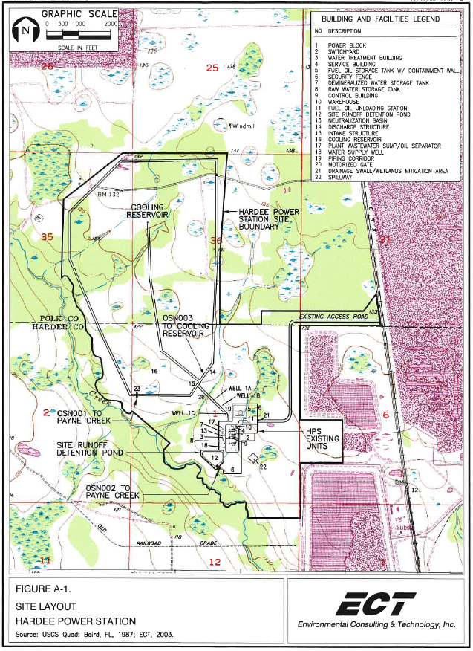

Attachment A.
Figure 2 -Pebbledale Transmission Line ROW – owned by TECO from original Site Certification Application
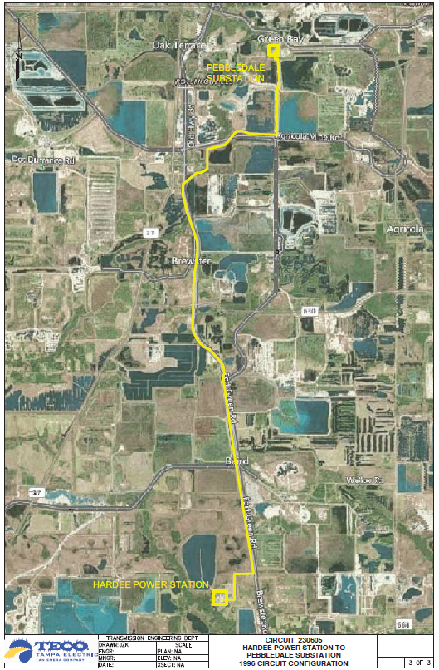
Attachment A.
Figure 3 - Vandolah Transmission Line ROW – owned by SECI
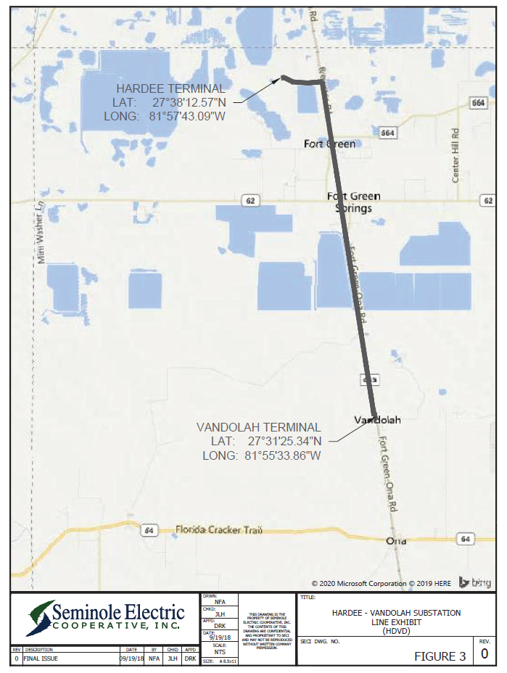

Attachment A.
Figure 4 - Lee Transmission Line ROW – owned by both SECI and FPL from original Site Certification Application
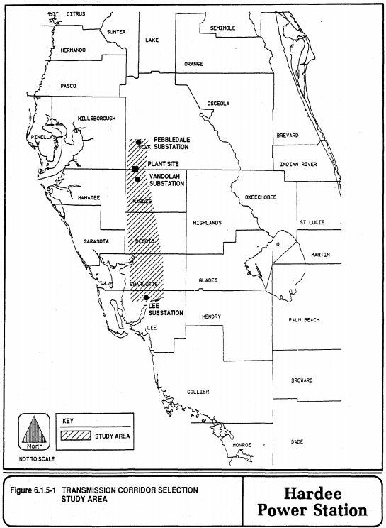

Attachment A
Figure 4a Charlotte-Lee Transmission Line (CLTL) subset of Lee Transmission Line owned by FPL
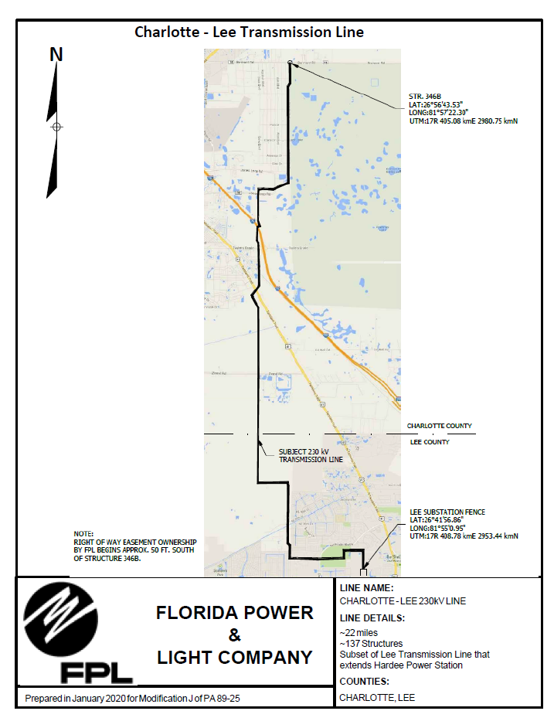

Attachment A
Figure 4b Vandolah – Charlotte Transmission Line (VCTL1) subset of Lee Transmission Line owned by SECI
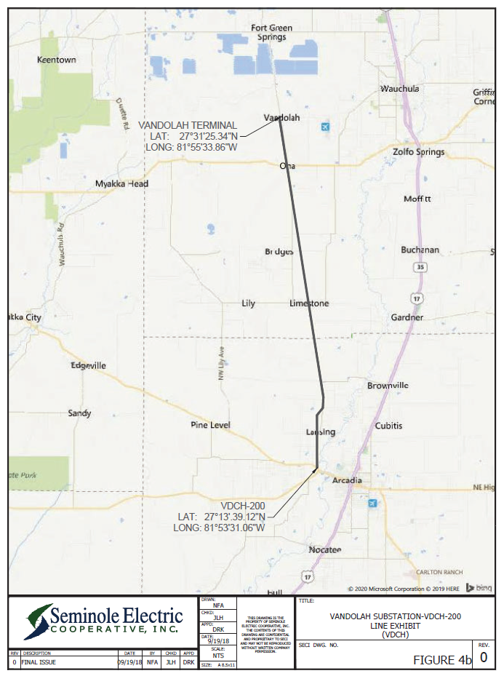

Attachment A.
Figure 4c – Vandolah – Charlotte Transmission Line (VCTL2) owned by FPL
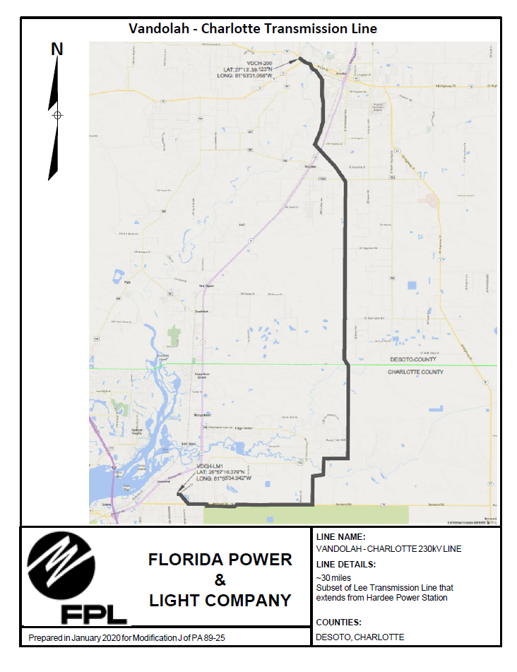

Attachment A
Figure 5 – Hardee Lateral Natural Gas Pipeline ROW – from Original Site Certification Application (owned by TEC)
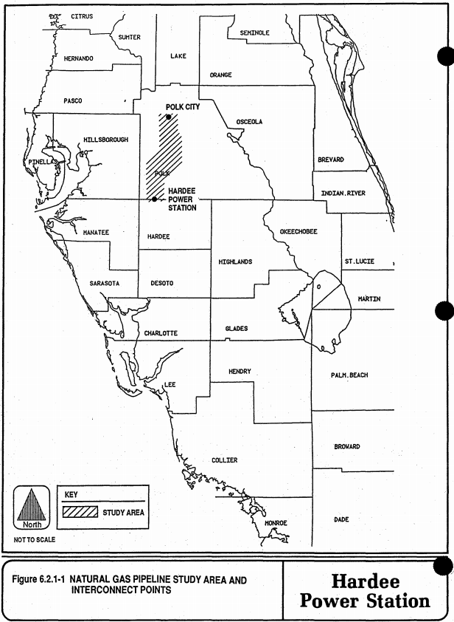

Attachment A.
Figure 6 - Liquid Fuel Pipeline ROW – from Original Site Certification Application (owned by TEC)
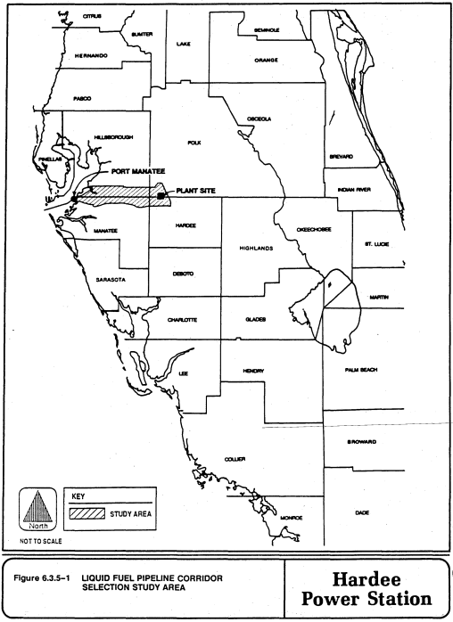

ATTACHMENT B: Surface Water Management System Operation and Maintenance Requirements

1. In accordance with Section 373.416(2), F.S., unless revoked or abandoned, all stormwater management systems, dams, impoundments, reservoirs, appurtenant works, or works permitted under Part IV of Chapter 373, F.S., must be operated and maintained in perpetuity. The operation and maintenance shall be in accordance with the designs, plans, calculations, and other specifications that are submitted with any amendment or modification and approved by the Department.
2. A registered professional must perform inspections annually after conversion of the project to the operation and maintenance phase to identify if there are any deficiencies in structural integrity, degradation due to insufficient maintenance, or improper operation of the stormwater management system or other surface water management systems that may endanger public health, safety, or welfare, or the water resources, and to insure that systems are functioning as designed and approved. Within 30 days of the inspection, a report shall be submitted electronically or in writing to the Department using Form 62-330.311(1), “Operation and Maintenance Inspection Certification”.
3. If deficiencies are found, the Licensee will be responsible for correcting the deficiencies so that the project is returned to the operational functions as designed and approved. The corrections must be done a timely manner to prevent compromises to flood protection and water quality.
4. If the operational maintenance and corrective measures are insufficient to enable the systems to meet the performance standards of this chapter, the Licensee must either replace the systems or construct an alternative design.
5. The Licensee shall provide for periodic inspections in addition to the annual inspections, especially after heavy rain. It must maintain a record of each inspection, including the date of inspection, the name and contact information of the inspector, whether the system was functioning as designed and approved, and make such record available upon request of the Department. Within 30 days of any failure of any system or deviation from the permit, a report shall be submitted electronically or in writing to the Department using Form 62-330.311(1), “Operation and Maintenance Inspection Certification,” describing the remedial actions taken to resolve the failure or deviation.
- The Licensee shall immediately notify the Department by telephone whenever a serious problem occurs at this facility. Notification shall be made to the Southwest District Office at (813) 470-5700. Within 7 days of telephone notification, a report shall be submitted electronically or in writing to the Department using Form 62-330.311(1), “Operation and Maintenance Inspection Certification,” describing the extent of the problem, its cause, the remedial actions taken to resolve the problem.
7. The following operational maintenance activities shall be performed on approved systems on a regular basis or as needed:
- Removal of trash and debris from the surface water management systems,
(2) Inspection of culverts, culvert risers, pipes and screwgates for damage, blockage, excessive leakage or deterioration, if applicable,
(3) Inspection of stormwater berms, if applicable,
(4) Inspection of pipes for evidence of lateral seepage,
(5) Inspection of flapgates for excessive backflow or deterioration, if applicable,
(6) Removal of sediments when the storage volume or conveyance capacity of the surface water management system is below design levels,
(7) Stabilization and restoration of eroded areas,
(8) Inspection of pump stations for structural integrity and leakage of fuel or oil to the ground or surface water, if applicable, and
(9) Inspection of monitoring equipment, including pump hour meters and staff gauges, for damage and operational status, if applicable.
8. In addition to the practices listed above, specific operational maintenance activities are required, if applicable, depending on the type of approved system, as follows:
(1) Overland flow systems shall include provisions for:
a. Mowing and removal of clippings, and
b. Maintenance of spreader swales and overland flow areas to prevent channelization.
(2) Spray irrigation systems for reuse/disposal shall include provisions for:
a. Inspection of the dispersal system, including the sprayheads or perforated pipe for damage or clogging, and
b. Maintenance of the sprayfield to prevent channelization.
(3) Treatment systems which incorporate isolated wetlands shall include provisions for:
a. Stabilization and restoration of channelized areas, and
b. Removal of sediments which interfere with the function of the wetland or treatment system.

ATTACHMENT C: Mitigation Plan
Seminole Electric Cooperative, Inc. (SECI) and TECO Power Services (TPS) certified the Hardee Power Station and associated transmission line corridors through the Florida Electric Power Plant Siting Act. The certification PA 89-25 was approved by the Governor and Cabinet on November 27, 1990.
History of wetland impacts and mitigation:
Project | Impacts | Mitigation | Status | Project Completed
HPS to Pebbledale Substation Transmission Line | .28 acres of clearing in reclaimed forested wetlands | No mitigation required. The NOC included a caveat regarding potential mitigation over areas to be restored at IMC Mine. On May 8, 1991, DER sent an additional memo regarding the mining sites, indicating that the issue would be resolved in a future Dredge and Fill Permit. | Applied for a Post Certification Review (PCR) on January 22, 1991. The Notification of Compliance (NOC) was issued by SWFWMD on February 14, 1991. | Yes
HPS to Vandolah Substation Transmission Line | Fill: 0.84 acre of shrub  Clearing: 3.2 acres of forested wetlands and 4.19 acres of shrub  Ty | See paragraph below | Applied for PCR on August 12, 1991.  The mitigation plan was approved by DER on June 19, 1992. | Yes
Vandolah Substation to South Arcadia Transmission Line | Fill: 0.27 acres of forested wetlands, 1.03 acres of shrub and .05 acres of marsh  Clearing: 10.22 acres of forested wetlands and 3.49 acres of shrub | See paragraph below | Applied for the PCR on December 23, 1991.  The mitigation plan was approved by DER on June 19, 1992. | Yes
South Arcadia to Lee Transmission Line | Fill: 0.69 acres of marsh  Clearing: 3.42 acres of forested wetlands and 0.59 acres of shrub | See paragraph below | Applied for the PCR on December 13, 1991.  The mitigation plan was approved by DER on June 19, 1992. | Yes
Natural Gas Pipeline | Temporary impacts to 0.129 acre of ditches and 0.141 acre of herbaceous wetlands | No mitigation required per memo from DER on June 18, 1991 | Applied for PCR on May 29, 1991. SWFWMD sent an NOC on June 12, 1991 | Yes

HPS to Vandolah to Lee Transmission Lines - To mitigate for wetland impacts associated with the line, certification conditions from the Florida Department of Environmental Protection (FDEP), the Southwest Florida Water Management District (SWFWMD), and the U.S. Army Corps of Engineers (USACOE) required a wetland mitigation area to be constructed. The mitigation area is located within the Fred C. Babcock-Cecil M. Webb Wildlife Management Area, Charlotte County, Florida. The transmission line project impacted approximately 3.49 acres of wetlands by filling and 25.11 acres of clearing. To compensate for these impacts, 12.7 acres of forested wetlands and 6.64 acres of herbaceous wetlands were created and 102 acres of a historic slough system - Myrtle Slough - were restored.
The mitigation area was deemed successful and released from further monitoring on August 15, 2005. On August 9, 2019 the water control structures (weirs) were released by FWC from any further activities.

ATTACHMENT D: Groundwater Monitoring Requirements (DEP)

ATTACHMENT E: Current Groundwater Monitoring Plan (from Licensee)

