February 26, 2009

Mr. Kenneth B. Hill
Maintenance Department
8008 Mobley Road
Brooksville, FL 34601

Dear Mr. Hill;

Thank you for your letter dated February 12, 2009 concerning Progress Energy Florida’s Application for the Levy County Power Plant and its associated transmission line corridors. Your concerns appear to relate to the 3 mile stretch along Sunshine Grove Road in Brooksville; the area between the Brookridge and Brooksville Substations.
Please be aware that the Department does not advocate for any individual position in a Siting Application process. The responsibilities of the Department are to implement the provisions of the Electrical Power Plant Siting act, including rules setting forth environmental precautions to be followed in relation to the location, construction, and operation of electrical power plants. You may want to learn more about the Electrical power Plant Siting Act from this web site; http://www.dep.state.fl.us/siting/Information/Power_Plant_General_Information.htm
During the application process there are numerous opportunities for the public to express their concerns or to show their support of power plants and/or transmission line applications under review. For this case, the public hearing for Hernando County will be held from 3pm – 8pm on Wednesday, March 11, 2009, at Brooksville Elks Lodge located on 14494 Cortez Boulevard in Brooksville. I encourage you to attend so as to ensure that your concerns are properly raised.
For your information, the state of Florida is one of only a handful of states which has requirements intended to reasonably protect the public health and welfare from the electric and magnetic fields of transmission lines. Existing 230 kilovolts (kV) or greater electrical transmission lines, new 230 kV and greater electrical transmission lines as well as new or existing electrical transmission or distribution lines with voltage less than 230 kV, and substation facilities have to comply with Chapter 62-814 of the Florida Administrative Code. You can learn more about Electric Magnetic Fields here; http://www.dep.state.fl.us/siting//Programs/EMF.htm
Lastly, you should be aware that every affected state and local agency has reviewed the application for the Progress Energy Florida Levy Nuclear Plant and recommended approval of the plant and associated transmission lines, including Hernando County. The following is an excerpt from Hernando County's report to the Department:
"Hernando County recommends that the proposed PEF transmission line corridors through its jurisdiction be approved, provided that such approval includes the Conditions of Certification set forth in Appendix I to minimize the impacts referenced above."
The Conditions of Certification referred to in the above excerpt is the license by which, if approved by the Governor and Cabinet, Progress Energy will have to comply concerning the construction and operation of the Levy Nuclear Power plant and associated transmission lines.
For further questions on this topic, you may contact the Case Manager, Ms. Ann Seiler at 850/245-2002. Thank you again for your interest and concern.

Sincerely,
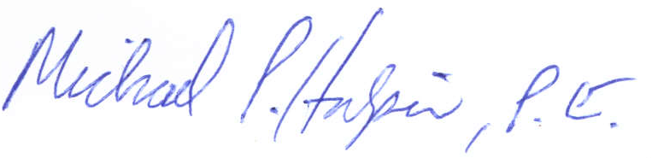
Michael P. Halpin, P.E.
Administrator, Siting Coordination Office

